# DAFTAR PUSTAKA

Apriyani, N., & Muhsin, A. (2017). Analisis Pengendalian Persediaan Bahan Baku Dengan Metode Economic Order Quantity Dan Kanban Pada Pt Adyawinsa Stamping Industries. In *Opsi* (Vol. 10, Issue 2, p. 128). https://doi.org/10.31315/opsi.v10i2.2108

Chandra, A., Kristina, H. J., & . A. (2022). Analisis Pengendalian Persediaan Bahan Baku Akrilik Menggunakan Metode Eoq Probabilistik Dan Simulasi Monte Carlo Pada Pt. Xyz. *Jurnal Mitra Teknik Industri*, *1*(1), 94–105. https://doi.org/10.24912/jmti.v1i1.18750

Ciswondo, dan A. L. M. (2019). *Pengendalian Persediaan Bahan Baku Impor dengan Menggunakan Metode EOQ Probabilistik pada Perusahaan Cat Industri*. *4*(2), 100–112.

Lutfi, F. A. S., & Pulansari, F. (2022). Rancangan Sistem Multi Item Multi Supplier Sebagai Proses Pengendalian Persediaan Bahan Baku Dengan Metode Economic Order Quantity. *Juminten*, *3*(1), 133–144. https://doi.org/10.33005/juminten.v3i1.386

Prihasdi, R. D., & Rahardjo, S. N. (2012). Efisiensi Metode Economical Order Quantity (Eoq) Dalam Pengambilan Keputusan Pembelian Bahan Baku Dan Pengaruhnya Terhadap Total Biaya Pembelian Pada Pt Amitex (Amanah Mitra Industri) Buaran Kabupaten Pekalongan. *Diponegoro Journal of Accounting*, *1*(1), 1–12. http://ejournal-s1.undip.ac.id/index.php/accounting

Putra, F. U. D., Maksum, A. H., & Hamdani, H. (2021). Analisis Penerapan Manajemen Persediaan Bahan Baku Arm Rear Brake Kyea dengan Metode EOQ. *Jurnal Serambi Engineering*, *7*(1), 2561–2570. https://doi.org/10.32672/jse.v7i1.3713

Santosa, S., Satriyono, G., & Bambang, R. N. (2019). Analisis Metode Economic Order Quantity (Eoq) Sebagai Dasar Pengendalian Persediaan Bahan Baku (Studi Pada Yankees Bakery, Kecamatan Kertosono). *JIMEK : Jurnal Ilmiah Mahasiswa Ekonomi*, *1*(1), 79–93. https://doi.org/10.30737/jimek.v1i1.281

Sari, A. N., Ilhamsah, H. A., & Mu’alim. (2020). Economic Order Quantity (EOQ) Menggunakan Algoritma Genetika (AG) (Studi Kasus: PT. XYZ). *Jurnal Teknologi Penerbangan*, *4*(1), 1–10.

Simbolon, L. D. (2021). *Pengendalian Persediaan* (Edisi Pert). Forum PemudaAswaja.

Sulaiman, F., & Nanda, N. (2015). Pengendalian Persediaan Bahan Baku Dengan Menggunakan Metode EOQ Pada UD. Adi Mabel. *Jurnal Teknovasi*, *2*(1), 1–11.

Susanto, H. D., Ilhamsah, H. A., & Cahyadi, I. (2023). Perencanaan Dan Pengendalian Bahan Baku Dengan Menggunakan Metode Eoq (Economic Order Quantity) Probabilistik Dan Simulasi Monte Carlo Pada Pabrik Tahu Bk Ngadirejo. *Jendela Teknik Industri*, *26*(1), 22–39.

Wiriyani, E. R. E. (2020). Analisis pengendalian persedian bahan baku crumb rubber dengan metode EOQ (economic order quantity) pada PT. golden energi mandiangin. *Jurnal Inovator*, *3*(1), 31–36. https://doi.org/10.37338/ji.v3i1.77

# LAMPIRAN

**Lampiran 1** Penggunaan Tepung

| **Data Penggunaan Bahan Baku Tepung (Kg)** | | | | |
| --- | --- | --- | --- | --- |
| **Hari Ke-** | **Tepung (kg)** | **Hari Ke-** | **Tepung (kg)** |
| 1 | 800 | 53 | 800 |
| 2 | 1040 | 54 | 1040 |
| 3 | 560 | 55 | 880 |
| 4 | 880 | 56 | 720 |
| 5 | 720 | 57 | 1120 |
| 6 | 1440 | 58 | 1440 |
| 7 | 1040 | 59 | 640 |
| 8 | 960 | 60 | 960 |
| 9 | 1200 | 61 | 800 |
| 10 | 800 | 62 | 1040 |
| 11 | 640 | 63 | 1440 |
| 12 | 1360 | 64 | 880 |
| 13 | 720 | 65 | 560 |
| 14 | 1120 | 66 | 1120 |
| 15 | 960 | 67 | 1440 |
| 16 | 640 | 68 | 960 |
| 17 | 480 | 69 | 1200 |
| 18 | 1200 | 70 | 800 |
| 19 | 1040 | 71 | 560 |
| 20 | 560 | 72 | 960 |
| 21 | 880 | 73 | 720 |
| 22 | 1440 | 74 | 1120 |
| 23 | 480 | 75 | 1440 |
| 24 | 1120 | 76 | 960 |
| 25 | 960 | 77 | 640 |
| 26 | 1200 | 78 | 1200 |
| 27 | 800 | 79 | 1040 |
| 28 | 1040 | 80 | 1440 |
| 29 | 560 | 81 | 880 |
| 30 | 880 | 82 | 1120 |
| 31 | 1120 | 83 | 560 |
| 32 | 1200 | 84 | 720 |
| 33 | 1280 | 85 | 960 |
| 34 | 960 | 86 | 1200 |
| 35 | 480 | 87 | 1040 |
| 36 | 800 | 88 | 560 |
| 37 | 560 | 89 | 880 |
| 38 | 880 | 90 | 1120 |
| 39 | 1440 | 91 | 1120 |
| 40 | 1120 | 92 | 1040 |
| 41 | 480 | 93 | 960 |
| 42 | 1360 | 94 | 480 |
| 43 | 1200 | 95 | 800 |
| 44 | 800 | 96 | 560 |
| 45 | 1040 | 97 | 880 |
| 46 | 560 | 98 | 720 |
| 47 | 880 | 99 | 1120 |
| 48 | 720 | 100 | 480 |
| 49 | 960 | 101 | 1440 |
| 50 | 640 | 102 | 1200 |
| 51 | 960 | 103 | 960 |
| 52 | 1200 |  |  |

**Lampiran** 2 Penggunaan Ubi

| **Data Penggunaan Bahan Baku Ubi (Kg)** | | | |
| --- | --- | --- | --- |
| **Hari Ke-** | **Ubi (kg)** | **Hari Ke-** | **Ubi (kg)** |
| 1 | 602 | 53 | 603 |
| 2 | 750 | 54 | 754 |
| 3 | 453 | 55 | 650 |
| 4 | 651 | 56 | 552 |
| 5 | 554 | 57 | 801 |
| 6 | 1002 | 58 | 1004 |
| 7 | 753 | 59 | 503 |
| 8 | 701 | 60 | 700 |
| 9 | 850 | 61 | 602 |
| 10 | 604 | 62 | 751 |
| 11 | 502 | 63 | 1003 |
| 12 | 951 | 64 | 654 |
| 13 | 553 | 65 | 450 |
| 14 | 800 | 66 | 802 |
| 15 | 704 | 67 | 1001 |
| 16 | 502 | 68 | 704 |
| 17 | 401 | 69 | 853 |
| 18 | 853 | 70 | 600 |
| 19 | 754 | 71 | 452 |
| 20 | 450 | 72 | 701 |
| 21 | 651 | 73 | 553 |
| 22 | 1002 | 74 | 804 |
| 23 | 403 | 75 | 1000 |
| 24 | 804 | 76 | 702 |
| 25 | 700 | 77 | 501 |
| 26 | 852 | 78 | 854 |
| 27 | 601 | 79 | 753 |
| 28 | 754 | 80 | 1000 |
| 29 | 453 | 81 | 652 |
| 30 | 650 | 82 | 801 |
| 31 | 802 | 83 | 453 |
| 32 | 851 | 84 | 554 |
| 33 | 903 | 85 | 700 |
| 34 | 704 | 86 | 852 |
| 35 | 400 | 87 | 751 |
| 36 | 602 | 88 | 454 |
| 37 | 451 | 89 | 653 |
| 38 | 654 | 90 | 800 |
| 39 | 1003 | 91 | 802 |
| 40 | 800 | 92 | 751 |
| 41 | 402 | 93 | 703 |
| 42 | 951 | 94 | 404 |
| 43 | 853 | 95 | 600 |
| 44 | 604 | 96 | 452 |
| 45 | 750 | 97 | 651 |
| 46 | 452 | 98 | 554 |
| 47 | 651 | 99 | 803 |
| 48 | 554 | 100 | 400 |
| 49 | 703 | 101 | 1002 |
| 50 | 500 | 102 | 851 |
| 51 | 702 | 103 | 703 |
| 52 | 851 |  |  |

**Lampiran** 3 Penggunaan Perisai Cabai

| **Data Penggunaan Bahan Baku Perisai Cabai (Kg)** | | | |
| --- | --- | --- | --- |
| **Hari Ke-** | **Perisai Cabai (kg)** | **Hari Ke-** | **Perisai Cabai (kg)** |
| 1 | 20 | 53 | 20 |
| 2 | 26 | 54 | 26 |
| 3 | 14 | 55 | 22 |
| 4 | 22 | 56 | 18 |
| 5 | 18 | 57 | 28 |
| 6 | 36 | 58 | 36 |
| 7 | 26 | 59 | 16 |
| 8 | 24 | 60 | 24 |
| 9 | 30 | 61 | 20 |
| 10 | 20 | 62 | 26 |
| 11 | 16 | 63 | 36 |
| 12 | 34 | 64 | 22 |
| 13 | 18 | 65 | 14 |
| 14 | 28 | 66 | 28 |
| 15 | 24 | 67 | 36 |
| 16 | 16 | 68 | 24 |
| 17 | 12 | 69 | 30 |
| 18 | 30 | 70 | 20 |
| 19 | 26 | 71 | 14 |
| 20 | 14 | 72 | 24 |
| 21 | 22 | 73 | 18 |
| 22 | 36 | 74 | 28 |
| 23 | 12 | 75 | 36 |
| 24 | 28 | 76 | 24 |
| 25 | 24 | 77 | 16 |
| 26 | 30 | 78 | 30 |
| 27 | 20 | 79 | 26 |
| 28 | 26 | 80 | 36 |
| 29 | 14 | 81 | 22 |
| 30 | 22 | 82 | 28 |
| 31 | 28 | 83 | 14 |
| 32 | 30 | 84 | 18 |
| 33 | 32 | 85 | 24 |
| 34 | 24 | 86 | 30 |
| 35 | 12 | 87 | 26 |
| 36 | 20 | 88 | 14 |
| 37 | 14 | 89 | 22 |
| 38 | 22 | 90 | 28 |
| 39 | 36 | 91 | 28 |
| 40 | 28 | 92 | 26 |
| 41 | 12 | 93 | 24 |
| 42 | 34 | 94 | 12 |
| 43 | 30 | 95 | 20 |
| 44 | 20 | 96 | 14 |
| 45 | 26 | 97 | 22 |
| 46 | 14 | 98 | 18 |
| 47 | 22 | 99 | 28 |
| 48 | 18 | 100 | 12 |
| 49 | 24 | 101 | 36 |
| 50 | 16 | 102 | 30 |
| 51 | 24 | 103 | 24 |
| 52 | 30 |  |  |

**Lampiran** 4 Permintaan Selama Lead Time Tepung

| **Data Penggunaan Bahan Baku Tepung(Kg)** | | | | |
| --- | --- | --- | --- | --- |
| **Hari Ke-** | **Tepung (kg)** | **2 Hari (Kg)** | **3 Hari (Kg)** | **4 Hari (Kg)** |
| 1 | 800 | 1840 | 2400 | 3280 |
| 2 | 1040 | 1600 | 2480 | 3200 |
| 3 | 560 | 1440 | 2160 | 3600 |
| 4 | 880 | 1600 | 3040 | 4080 |
| 5 | 720 | 2160 | 3200 | 4160 |
| 6 | 1440 | 2480 | 3440 | 4640 |
| 7 | 1040 | 2000 | 3200 | 4000 |
| 8 | 960 | 2160 | 2960 | 3600 |
| 9 | 1200 | 2000 | 2640 | 4000 |
| 10 | 800 | 1440 | 2800 | 3520 |
| 11 | 640 | 2000 | 2720 | 3840 |
| 12 | 1360 | 2080 | 3200 | 4160 |
| 13 | 720 | 1840 | 2800 | 3440 |
| 14 | 1120 | 2080 | 2720 | 3200 |
| 15 | 960 | 1600 | 2080 | 3280 |
| 16 | 640 | 1120 | 2320 | 3360 |
| 17 | 480 | 1680 | 2720 | 3280 |
| 18 | 1200 | 2240 | 2800 | 3680 |
| 19 | 1040 | 1600 | 2480 | 3920 |
| 20 | 560 | 1440 | 2880 | 3360 |
| 21 | 880 | 2320 | 2800 | 3920 |
| 22 | 1440 | 1920 | 3040 | 4000 |
| 23 | 480 | 1600 | 2560 | 3760 |
| 24 | 1120 | 2080 | 3280 | 4080 |
| 25 | 960 | 2160 | 2960 | 4000 |
| 26 | 1200 | 2000 | 3040 | 3600 |
| 27 | 800 | 1840 | 2400 | 3280 |
| 28 | 1040 | 1600 | 2480 | 3600 |
| 29 | 560 | 1440 | 2560 | 3760 |
| 30 | 880 | 2000 | 3200 | 4480 |
| 31 | 1120 | 2320 | 3600 | 4560 |
| 32 | 1200 | 2480 | 3440 | 3920 |
| 33 | 1280 | 2240 | 2720 | 3520 |
| 34 | 960 | 1440 | 2240 | 2800 |
| 35 | 480 | 1280 | 1840 | 2720 |
| 36 | 800 | 1360 | 2240 | 3680 |
| 37 | 560 | 1440 | 2880 | 4000 |
| 38 | 880 | 2320 | 3440 | 3920 |
| 39 | 1440 | 2560 | 3040 | 4400 |
| 40 | 1120 | 1600 | 2960 | 4160 |
| 41 | 480 | 1840 | 3040 | 3840 |
| 42 | 1360 | 2560 | 3360 | 4400 |
| 43 | 1200 | 2000 | 3040 | 3600 |
| 44 | 800 | 1840 | 2400 | 3280 |
| 45 | 1040 | 1600 | 2480 | 3200 |
| 46 | 560 | 1440 | 2160 | 3120 |
| 47 | 880 | 1600 | 2560 | 3200 |
| 48 | 720 | 1680 | 2320 | 3280 |
| 49 | 960 | 1600 | 2560 | 3760 |
| 50 | 640 | 1600 | 2800 | 3600 |
| 51 | 960 | 2160 | 2960 | 4000 |
| 52 | 1200 | 2000 | 3040 | 3920 |
| 53 | 800 | 1840 | 2720 | 3440 |
| 54 | 1040 | 1920 | 2640 | 3760 |
| 55 | 880 | 1600 | 2720 | 4160 |
| 56 | 720 | 1840 | 3280 | 3920 |
| 57 | 1120 | 2560 | 3200 | 4160 |
| 58 | 1440 | 2080 | 3040 | 3840 |
| 59 | 640 | 1600 | 2400 | 3440 |
| 60 | 960 | 1760 | 2800 | 4240 |
| 61 | 800 | 1840 | 3280 | 4160 |
| 62 | 1040 | 2480 | 3360 | 3920 |
| 63 | 1440 | 2320 | 2880 | 4000 |
| 64 | 880 | 1440 | 2560 | 4000 |
| 65 | 560 | 1680 | 3120 | 4080 |
| 66 | 1120 | 2560 | 3520 | 4720 |
| 67 | 1440 | 2400 | 3600 | 4400 |
| 68 | 960 | 2160 | 2960 | 3520 |
| 69 | 1200 | 2000 | 2560 | 3520 |
| 70 | 800 | 1360 | 2320 | 3040 |
| 71 | 560 | 1520 | 2240 | 3360 |
| 72 | 960 | 1680 | 2800 | 4240 |
| 73 | 720 | 1840 | 3280 | 4240 |
| 74 | 1120 | 2560 | 3520 | 4160 |
| 75 | 1440 | 2400 | 3040 | 4240 |
| 76 | 960 | 1600 | 2800 | 3840 |
| 77 | 640 | 1840 | 2880 | 4320 |
| 78 | 1200 | 2240 | 3680 | 4560 |
| 79 | 1040 | 2480 | 3360 | 4480 |
| 80 | 1440 | 2320 | 3440 | 4000 |
| 81 | 880 | 2000 | 2560 | 3280 |
| 82 | 1120 | 1680 | 2400 | 3600 |
| 83 | 560 | 1280 | 2480 | 3520 |
| 84 | 720 | 1920 | 2960 | 3520 |
| 85 | 1200 | 2240 | 2800 | 3680 |
| 86 | 1040 | 1600 | 2480 | 3600 |
| 87 | 560 | 1440 | 2560 | 3680 |
| 88 | 880 | 2000 | 3120 | 4160 |
| 89 | 1120 | 2240 | 3280 | 4240 |
| 90 | 1120 | 2160 | 3120 | 3600 |
| 91 | 1040 | 2000 | 2480 | 3280 |
| 92 | 960 | 1440 | 2240 | 2800 |
| 93 | 480 | 1280 | 1840 | 2720 |
| 94 | 800 | 1360 | 2240 | 2960 |
| 95 | 560 | 1440 | 2160 | 3280 |
| 96 | 880 | 1600 | 2720 | 3200 |
| 97 | 720 | 1840 | 2320 | 3760 |
| 98 | 1120 | 1600 | 3040 | 4240 |
| 99 | 480 | 1920 | 3120 | 4080 |
| 100 | 1440 | 2640 | 3600 |  |
| 101 | 1200 | 2160 |  |  |
| 102 | 960 |  |  |  |

**Lampiran** 5 Permintaan Selama Lead Time Ubi

| **Data Penggunaan Bahan Baku Ubi(Kg)** | | | | |
| --- | --- | --- | --- | --- |
| **Hari Ke-** | **Ubi (kg)** | **3 Hari (Kg)** | **4 Hari (Kg)** | **5 Hari (Kg)** |
| 1 | 602 | 1805 | 2456 | 3010 |
| 2 | 750 | 1854 | 2408 | 3410 |
| 3 | 453 | 1658 | 2660 | 3413 |
| 4 | 651 | 2207 | 2960 | 3661 |
| 5 | 554 | 2309 | 3010 | 3860 |
| 6 | 1002 | 2456 | 3306 | 3910 |
| 7 | 753 | 2304 | 2908 | 3410 |
| 8 | 701 | 2155 | 2657 | 3608 |
| 9 | 850 | 1956 | 2907 | 3460 |
| 10 | 604 | 2057 | 2610 | 3410 |
| 11 | 502 | 2006 | 2806 | 3510 |
| 12 | 951 | 2304 | 3008 | 3510 |
| 13 | 553 | 2057 | 2559 | 2960 |
| 14 | 800 | 2006 | 2407 | 3260 |
| 15 | 704 | 1607 | 2460 | 3214 |
| 16 | 502 | 1756 | 2510 | 2960 |
| 17 | 401 | 2008 | 2458 | 3109 |
| 18 | 853 | 2057 | 2708 | 3710 |
| 19 | 754 | 1855 | 2857 | 3260 |
| 20 | 450 | 2103 | 2506 | 3310 |
| 21 | 651 | 2056 | 2860 | 3560 |
| 22 | 1002 | 2209 | 2909 | 3761 |
| 23 | 403 | 1907 | 2759 | 3360 |
| 24 | 804 | 2356 | 2957 | 3711 |
| 25 | 700 | 2153 | 2907 | 3360 |
| 26 | 852 | 2207 | 2660 | 3310 |
| 27 | 601 | 1808 | 2458 | 3260 |
| 28 | 754 | 1857 | 2659 | 3510 |
| 29 | 453 | 1905 | 2756 | 3659 |
| 30 | 650 | 2303 | 3206 | 3910 |
| 31 | 802 | 2556 | 3260 | 3660 |
| 32 | 851 | 2458 | 2858 | 3460 |
| 33 | 903 | 2007 | 2609 | 3060 |
| 34 | 704 | 1706 | 2157 | 2811 |
| 35 | 400 | 1453 | 2107 | 3110 |
| 36 | 602 | 1707 | 2710 | 3510 |
| 37 | 451 | 2108 | 2908 | 3310 |
| 38 | 654 | 2457 | 2859 | 3810 |
| 39 | 1003 | 2205 | 3156 | 4009 |
| 40 | 800 | 2153 | 3006 | 3610 |
| 41 | 402 | 2206 | 2810 | 3560 |
| 42 | 951 | 2408 | 3158 | 3610 |
| 43 | 853 | 2207 | 2659 | 3310 |
| 44 | 604 | 1806 | 2457 | 3011 |
| 45 | 750 | 1853 | 2407 | 3110 |
| 46 | 452 | 1657 | 2360 | 2860 |
| 47 | 651 | 1908 | 2408 | 3110 |
| 48 | 554 | 1757 | 2459 | 3310 |
| 49 | 703 | 1905 | 2756 | 3359 |
| 50 | 500 | 2053 | 2656 | 3410 |
| 51 | 702 | 2156 | 2910 | 3560 |
| 52 | 851 | 2208 | 2858 | 3410 |
| 53 | 603 | 2007 | 2559 | 3360 |
| 54 | 754 | 1956 | 2757 | 3761 |
| 55 | 650 | 2003 | 3007 | 3510 |
| 56 | 552 | 2357 | 2860 | 3560 |
| 57 | 801 | 2308 | 3008 | 3610 |
| 58 | 1004 | 2207 | 2809 | 3560 |
| 59 | 503 | 1805 | 2556 | 3559 |
| 60 | 700 | 2053 | 3056 | 3710 |
| 61 | 602 | 2356 | 3010 | 3460 |
| 62 | 751 | 2408 | 2858 | 3660 |
| 63 | 1003 | 2107 | 2909 | 3910 |
| 64 | 654 | 1906 | 2907 | 3611 |
| 65 | 450 | 2253 | 2957 | 3810 |
| 66 | 802 | 2507 | 3360 | 3960 |
| 67 | 1001 | 2558 | 3158 | 3610 |
| 68 | 704 | 2157 | 2609 | 3310 |
| 69 | 853 | 1905 | 2606 | 3159 |
| 70 | 600 | 1753 | 2306 | 3110 |
| 71 | 452 | 1706 | 2510 | 3510 |
| 72 | 701 | 2058 | 3058 | 3760 |
| 73 | 553 | 2357 | 3059 | 3560 |
| 74 | 804 | 2506 | 3007 | 3861 |
| 75 | 1000 | 2203 | 3057 | 3810 |
| 76 | 702 | 2057 | 2810 | 3810 |
| 77 | 501 | 2108 | 3108 | 3760 |
| 78 | 854 | 2607 | 3259 | 4060 |
| 79 | 753 | 2405 | 3206 | 3659 |
| 80 | 1000 | 2453 | 2906 | 3460 |
| 81 | 652 | 1906 | 2460 | 3312 |
| 82 | 801 | 1808 | 2660 | 3411 |
| 83 | 453 | 1859 | 2610 | 3064 |
| 84 | 554 | 2157 | 2611 | 3264 |
| 85 | 852 | 2057 | 2710 | 3510 |
| 86 | 751 | 1858 | 2658 | 3460 |
| 87 | 454 | 1907 | 2709 | 3460 |
| 88 | 653 | 2255 | 3006 | 3709 |
| 89 | 800 | 2353 | 3056 | 3460 |
| 90 | 802 | 2256 | 2660 | 3260 |
| 91 | 751 | 1858 | 2458 | 2910 |
| 92 | 703 | 1707 | 2159 | 2810 |
| 93 | 404 | 1456 | 2107 | 2661 |
| 94 | 600 | 1703 | 2257 | 3060 |
| 95 | 452 | 1657 | 2460 | 2860 |
| 96 | 651 | 2008 | 2408 | 3410 |
| 97 | 554 | 1757 | 2759 | 3610 |
| 98 | 803 | 2205 | 3056 | 3759 |
| 99 | 400 | 2253 | 2956 |  |
| 100 | 1002 | 2556 |  |  |
| 101 | 851 |  |  |  |
| 102 | 703 |  |  |  |

**Lampiran** 6 Permintaan Selama Lead Time Perisai Cabai

| **Data Penggunaan Bahan Baku Perisai Cabai(Kg)** | | | | | |
| --- | --- | --- | --- | --- | --- |
| **Hari Ke-** | **Perisai Cabai (Kg)** | **3 Hari (Kg)** | **4 Hari (Kg)** | **5 Hari (Kg)** | **6 Hari (Kg)** |
| 1 | 20 | 60 | 82 | 100 | 136 |
| 2 | 26 | 62 | 80 | 116 | 142 |
| 3 | 14 | 54 | 90 | 116 | 140 |
| 4 | 22 | 76 | 102 | 126 | 156 |
| 5 | 18 | 80 | 104 | 134 | 154 |
| 6 | 36 | 86 | 116 | 136 | 152 |
| 7 | 26 | 80 | 100 | 116 | 150 |
| 8 | 24 | 74 | 90 | 124 | 142 |
| 9 | 30 | 66 | 100 | 118 | 146 |
| 10 | 20 | 70 | 88 | 116 | 140 |
| 11 | 16 | 68 | 96 | 120 | 136 |
| 12 | 34 | 80 | 104 | 120 | 132 |
| 13 | 18 | 70 | 86 | 98 | 128 |
| 14 | 28 | 68 | 80 | 110 | 136 |
| 15 | 24 | 52 | 82 | 108 | 122 |
| 16 | 16 | 58 | 84 | 98 | 120 |
| 17 | 12 | 68 | 82 | 104 | 140 |
| 18 | 30 | 70 | 92 | 128 | 140 |
| 19 | 26 | 62 | 98 | 110 | 138 |
| 20 | 14 | 72 | 84 | 112 | 136 |
| 21 | 22 | 70 | 98 | 122 | 152 |
| 22 | 36 | 76 | 100 | 130 | 150 |
| 23 | 12 | 64 | 94 | 114 | 140 |
| 24 | 28 | 82 | 102 | 128 | 142 |
| 25 | 24 | 74 | 100 | 114 | 136 |
| 26 | 30 | 76 | 90 | 112 | 140 |
| 27 | 20 | 60 | 82 | 110 | 140 |
| 28 | 26 | 62 | 90 | 120 | 152 |
| 29 | 14 | 64 | 94 | 126 | 150 |
| 30 | 22 | 80 | 112 | 136 | 148 |
| 31 | 28 | 90 | 114 | 126 | 146 |
| 32 | 30 | 86 | 98 | 118 | 132 |
| 33 | 32 | 68 | 88 | 102 | 124 |
| 34 | 24 | 56 | 70 | 92 | 128 |
| 35 | 12 | 46 | 68 | 104 | 132 |
| 36 | 20 | 56 | 92 | 120 | 132 |
| 37 | 14 | 72 | 100 | 112 | 146 |
| 38 | 22 | 86 | 98 | 132 | 162 |
| 39 | 36 | 76 | 110 | 140 | 160 |
| 40 | 28 | 74 | 104 | 124 | 150 |
| 41 | 12 | 76 | 96 | 122 | 136 |
| 42 | 34 | 84 | 110 | 124 | 146 |
| 43 | 30 | 76 | 90 | 112 | 130 |
| 44 | 20 | 60 | 82 | 100 | 124 |
| 45 | 26 | 62 | 80 | 104 | 120 |
| 46 | 14 | 54 | 78 | 94 | 118 |
| 47 | 22 | 64 | 80 | 104 | 134 |
| 48 | 18 | 58 | 82 | 112 | 132 |
| 49 | 24 | 64 | 94 | 114 | 140 |
| 50 | 16 | 70 | 90 | 116 | 138 |
| 51 | 24 | 74 | 100 | 122 | 140 |
| 52 | 30 | 76 | 98 | 116 | 144 |
| 53 | 20 | 68 | 86 | 114 | 150 |
| 54 | 26 | 66 | 94 | 130 | 146 |
| 55 | 22 | 68 | 104 | 120 | 144 |
| 56 | 18 | 82 | 98 | 122 | 142 |
| 57 | 28 | 80 | 104 | 124 | 150 |
| 58 | 36 | 76 | 96 | 122 | 158 |
| 59 | 16 | 60 | 86 | 122 | 144 |
| 60 | 24 | 70 | 106 | 128 | 142 |
| 61 | 20 | 82 | 104 | 118 | 146 |
| 62 | 26 | 84 | 98 | 126 | 162 |
| 63 | 36 | 72 | 100 | 136 | 160 |
| 64 | 22 | 64 | 100 | 124 | 154 |
| 65 | 14 | 78 | 102 | 132 | 152 |
| 66 | 28 | 88 | 118 | 138 | 152 |
| 67 | 36 | 90 | 110 | 124 | 148 |
| 68 | 24 | 74 | 88 | 112 | 130 |
| 69 | 30 | 64 | 88 | 106 | 134 |
| 70 | 20 | 58 | 76 | 104 | 140 |
| 71 | 14 | 56 | 84 | 120 | 144 |
| 72 | 24 | 70 | 106 | 130 | 146 |
| 73 | 18 | 82 | 106 | 122 | 152 |
| 74 | 28 | 88 | 104 | 134 | 160 |
| 75 | 36 | 76 | 106 | 132 | 168 |
| 76 | 24 | 70 | 96 | 132 | 154 |
| 77 | 16 | 72 | 108 | 130 | 158 |
| 78 | 30 | 92 | 114 | 142 | 156 |
| 79 | 26 | 84 | 112 | 126 | 144 |
| 80 | 36 | 86 | 100 | 118 | 148 |
| 81 | 22 | 64 | 82 | 112 | 138 |
| 82 | 28 | 60 | 90 | 116 | 130 |
| 83 | 14 | 62 | 88 | 102 | 124 |
| 84 | 18 | 74 | 88 | 110 | 138 |
| 85 | 30 | 70 | 92 | 120 | 148 |
| 86 | 26 | 62 | 90 | 118 | 144 |
| 87 | 14 | 64 | 92 | 118 | 142 |
| 88 | 22 | 78 | 104 | 128 | 140 |
| 89 | 28 | 82 | 106 | 118 | 138 |
| 90 | 28 | 78 | 90 | 110 | 124 |
| 91 | 26 | 62 | 82 | 96 | 118 |
| 92 | 24 | 56 | 70 | 92 | 110 |
| 93 | 12 | 46 | 68 | 86 | 114 |
| 94 | 20 | 56 | 74 | 102 | 114 |
| 95 | 14 | 54 | 82 | 94 | 130 |
| 96 | 22 | 68 | 80 | 116 | 146 |
| 97 | 18 | 58 | 94 | 124 | 148 |
| 98 | 28 | 76 | 106 | 130 |  |
| 99 | 12 | 78 | 102 |  |  |
| 100 | 36 | 90 |  |  |  |
| 101 | 30 |  |  |  |  |
| 102 | 24 |  |  |  |  |

**Lampiran** 7 Probability of Stock Out Tepung

| **Probability of Stockout Bahan Baku Tepung** | | | | | |
| --- | --- | --- | --- | --- | --- |
| **No** | **Permintaan Selama Lead Time** | **Frekuensi** | **P(M)** | **Probabilitas Permintaan Selama Lead Time** | ***Probability of Stockout P(M>B)*** |
| 1 | 1120 | 1 | 0,0033 | 3,7333 | 0,9967 |
| 2 | 1280 | 3 | 0,0100 | 12,8000 | 0,9867 |
| 3 | 1360 | 3 | 0,0100 | 13,6000 | 0,9767 |
| 4 | 1440 | 11 | 0,0367 | 52,8000 | 0,9400 |
| 5 | 1520 | 1 | 0,0033 | 5,0667 | 0,9367 |
| 6 | 1600 | 17 | 0,0567 | 90,6667 | 0,8800 |
| 7 | 1680 | 5 | 0,0167 | 28,0000 | 0,8633 |
| 8 | 1760 | 1 | 0,0033 | 5,8667 | 0,8600 |
| 9 | 1840 | 13 | 0,0433 | 79,7333 | 0,8167 |
| 10 | 1920 | 4 | 0,0133 | 25,6000 | 0,8033 |
| 11 | 2000 | 11 | 0,0367 | 73,3333 | 0,7667 |
| 12 | 2080 | 5 | 0,0167 | 34,6667 | 0,7500 |
| 13 | 2160 | 10 | 0,0333 | 72,0000 | 0,7167 |
| 14 | 2240 | 10 | 0,0333 | 74,6667 | 0,6833 |
| 15 | 2320 | 9 | 0,0300 | 69,6000 | 0,6533 |
| 16 | 2400 | 7 | 0,0233 | 56,0000 | 0,6300 |
| 17 | 2480 | 11 | 0,0367 | 90,9333 | 0,5933 |
| 18 | 2560 | 13 | 0,0433 | 110,9333 | 0,5500 |
| 19 | 2640 | 3 | 0,0100 | 26,4000 | 0,5400 |
| 20 | 2720 | 9 | 0,0300 | 81,6000 | 0,5100 |
| 21 | 2800 | 11 | 0,0367 | 102,6667 | 0,4733 |
| 22 | 2880 | 4 | 0,0133 | 38,4000 | 0,4600 |
| 23 | 2960 | 7 | 0,0233 | 69,0667 | 0,4367 |
| 24 | 3040 | 11 | 0,0367 | 111,4667 | 0,4000 |
| 25 | 3120 | 5 | 0,0167 | 52,0000 | 0,3833 |
| 26 | 3200 | 10 | 0,0333 | 106,6667 | 0,3500 |
| 27 | 3280 | 14 | 0,0467 | 153,0667 | 0,3033 |
| 28 | 3360 | 6 | 0,0200 | 67,2000 | 0,2833 |
| 29 | 3440 | 7 | 0,0233 | 80,2667 | 0,2600 |
| 30 | 3520 | 8 | 0,0267 | 93,8667 | 0,2333 |
| 31 | 3600 | 12 | 0,0400 | 144,0000 | 0,1933 |
| 32 | 3680 | 5 | 0,0167 | 61,3333 | 0,1767 |
| 33 | 3760 | 5 | 0,0167 | 62,6667 | 0,1600 |
| 34 | 3840 | 4 | 0,0133 | 51,2000 | 0,1467 |
| 35 | 3920 | 7 | 0,0233 | 91,4667 | 0,1233 |
| 36 | 4000 | 9 | 0,0300 | 120,0000 | 0,0933 |
| 37 | 4080 | 4 | 0,0133 | 54,4000 | 0,0800 |
| 38 | 4160 | 8 | 0,0267 | 110,9333 | 0,0533 |
| 39 | 4240 | 6 | 0,0200 | 84,8000 | 0,0333 |
| 40 | 4320 | 1 | 0,0033 | 14,4000 | 0,0300 |
| 41 | 4400 | 3 | 0,0100 | 44,0000 | 0,0200 |
| 42 | 4480 | 2 | 0,0067 | 29,8667 | 0,0133 |
| 43 | 4560 | 2 | 0,0067 | 30,4000 | 0,0067 |
| 44 | 4640 | 1 | 0,0033 | 15,4667 | 0,0033 |
| 45 | 4720 | 1 | 0,0033 | 15,7333 | 0,0000 |
|  | 133120 | 300 | 1 |  |  |

**Lampiran** 8 Probability of Stock Out Ubi

| **Probability of Stockout Bahan Baku Ubi** | | | | | |
| --- | --- | --- | --- | --- | --- |
| **No** | **Permintaan Selama Lead Time** | **Frekuensi** | **P(M)** | **Probabilitas Permintaan Selama Lead Time** | ***Probability of Stockout P(M>B)*** |
| 1 | 1453 | 1 | 0,0034 | 4,8923 | 0,9966 |
| 2 | 1456 | 1 | 0,0034 | 4,9024 | 0,9933 |
| 3 | 1607 | 1 | 0,0034 | 5,4108 | 0,9899 |
| 4 | 1657 | 2 | 0,0067 | 11,1582 | 0,9832 |
| 5 | 1658 | 1 | 0,0034 | 5,5825 | 0,9798 |
| 6 | 1703 | 1 | 0,0034 | 5,7340 | 0,9764 |
| 7 | 1706 | 2 | 0,0067 | 11,4882 | 0,9697 |
| 8 | 1707 | 2 | 0,0067 | 11,4949 | 0,9630 |
| 9 | 1753 | 1 | 0,0034 | 5,9024 | 0,9596 |
| 10 | 1756 | 1 | 0,0034 | 5,9125 | 0,9562 |
| 11 | 1757 | 2 | 0,0067 | 11,8316 | 0,9495 |
| 12 | 1805 | 2 | 0,0067 | 12,1549 | 0,9428 |
| 13 | 1806 | 1 | 0,0034 | 6,0808 | 0,9394 |
| 14 | 1808 | 2 | 0,0067 | 12,1751 | 0,9327 |
| 15 | 1853 | 1 | 0,0034 | 6,2391 | 0,9293 |
| 16 | 1854 | 1 | 0,0034 | 6,2424 | 0,9259 |
| 17 | 1855 | 1 | 0,0034 | 6,2458 | 0,9226 |
| 18 | 1857 | 1 | 0,0034 | 6,2525 | 0,9192 |
| 19 | 1858 | 2 | 0,0067 | 12,5118 | 0,9125 |
| 20 | 1859 | 1 | 0,0034 | 6,2593 | 0,9091 |
| 21 | 1905 | 3 | 0,0101 | 19,2424 | 0,8990 |
| 22 | 1906 | 2 | 0,0067 | 12,8350 | 0,8923 |
| 23 | 1907 | 2 | 0,0067 | 12,8418 | 0,8855 |
| 24 | 1908 | 1 | 0,0034 | 6,4242 | 0,8822 |
| 25 | 1956 | 2 | 0,0067 | 13,1717 | 0,8754 |
| 26 | 2003 | 1 | 0,0034 | 6,7441 | 0,8721 |
| 27 | 2006 | 2 | 0,0067 | 13,5084 | 0,8653 |
| 28 | 2007 | 2 | 0,0067 | 13,5152 | 0,8586 |
| 29 | 2008 | 2 | 0,0067 | 13,5219 | 0,8519 |
| 30 | 2053 | 2 | 0,0067 | 13,8249 | 0,8451 |
| 31 | 2056 | 1 | 0,0034 | 6,9226 | 0,8418 |
| 32 | 2057 | 5 | 0,0168 | 34,6296 | 0,8249 |
| 33 | 2058 | 1 | 0,0034 | 6,9293 | 0,8215 |
| 34 | 2103 | 1 | 0,0034 | 7,0808 | 0,8182 |
| 35 | 2107 | 3 | 0,0101 | 21,2828 | 0,8081 |
| 36 | 2108 | 2 | 0,0067 | 14,1953 | 0,8013 |
| 37 | 2153 | 2 | 0,0067 | 14,4983 | 0,7946 |
| 38 | 2155 | 1 | 0,0034 | 7,2559 | 0,7912 |
| 39 | 2156 | 1 | 0,0034 | 7,2593 | 0,7879 |
| 40 | 2157 | 3 | 0,0101 | 21,7879 | 0,7778 |
| 41 | 2159 | 1 | 0,0034 | 7,2694 | 0,7744 |
| 42 | 2203 | 1 | 0,0034 | 7,4175 | 0,7710 |
| 43 | 2205 | 2 | 0,0067 | 14,8485 | 0,7643 |
| 44 | 2206 | 1 | 0,0034 | 7,4276 | 0,7609 |
| 45 | 2207 | 4 | 0,0135 | 29,7239 | 0,7475 |
| 46 | 2208 | 1 | 0,0034 | 7,4343 | 0,7441 |
| 47 | 2209 | 1 | 0,0034 | 7,4377 | 0,7407 |
| 48 | 2253 | 2 | 0,0067 | 15,1717 | 0,7340 |
| 49 | 2255 | 1 | 0,0034 | 7,5926 | 0,7306 |
| 50 | 2256 | 1 | 0,0034 | 7,5960 | 0,7273 |
| 51 | 2257 | 1 | 0,0034 | 7,5993 | 0,7239 |
| 52 | 2303 | 1 | 0,0034 | 7,7542 | 0,7205 |
| 53 | 2304 | 2 | 0,0067 | 15,5152 | 0,7138 |
| 54 | 2306 | 1 | 0,0034 | 7,7643 | 0,7104 |
| 55 | 2308 | 1 | 0,0034 | 7,7710 | 0,7071 |
| 56 | 2309 | 1 | 0,0034 | 7,7744 | 0,7037 |
| 57 | 2353 | 1 | 0,0034 | 7,9226 | 0,7003 |
| 58 | 2356 | 2 | 0,0067 | 15,8653 | 0,6936 |
| 59 | 2357 | 2 | 0,0067 | 15,8721 | 0,6869 |
| 60 | 2360 | 1 | 0,0034 | 7,9461 | 0,6835 |
| 61 | 2405 | 1 | 0,0034 | 8,0976 | 0,6801 |
| 62 | 2407 | 2 | 0,0067 | 16,2088 | 0,6734 |
| 63 | 2408 | 5 | 0,0168 | 40,5387 | 0,6566 |
| 64 | 2453 | 1 | 0,0034 | 8,2593 | 0,6532 |
| 65 | 2456 | 2 | 0,0067 | 16,5387 | 0,6465 |
| 66 | 2457 | 2 | 0,0067 | 16,5455 | 0,6397 |
| 67 | 2458 | 4 | 0,0135 | 33,1044 | 0,6263 |
| 68 | 2459 | 1 | 0,0034 | 8,2795 | 0,6229 |
| 69 | 2460 | 3 | 0,0101 | 24,8485 | 0,6128 |
| 70 | 2506 | 2 | 0,0067 | 16,8754 | 0,6061 |
| 71 | 2507 | 1 | 0,0034 | 8,4411 | 0,6027 |
| 72 | 2510 | 2 | 0,0067 | 16,9024 | 0,5960 |
| 73 | 2556 | 3 | 0,0101 | 25,8182 | 0,5859 |
| 74 | 2558 | 1 | 0,0034 | 8,6128 | 0,5825 |
| 75 | 2559 | 2 | 0,0067 | 17,2323 | 0,5758 |
| 76 | 2606 | 1 | 0,0034 | 8,7744 | 0,5724 |
| 77 | 2607 | 1 | 0,0034 | 8,7778 | 0,5690 |
| 78 | 2609 | 2 | 0,0067 | 17,5690 | 0,5623 |
| 79 | 2610 | 2 | 0,0067 | 17,5758 | 0,5556 |
| 80 | 2611 | 1 | 0,0034 | 8,7912 | 0,5522 |
| 81 | 2656 | 1 | 0,0034 | 8,9428 | 0,5488 |
| 82 | 2657 | 1 | 0,0034 | 8,9461 | 0,5455 |
| 83 | 2658 | 1 | 0,0034 | 8,9495 | 0,5421 |
| 84 | 2659 | 2 | 0,0067 | 17,9057 | 0,5354 |
| 85 | 2660 | 4 | 0,0135 | 35,8249 | 0,5219 |
| 86 | 2661 | 1 | 0,0034 | 8,9596 | 0,5185 |
| 87 | 2708 | 1 | 0,0034 | 9,1178 | 0,5152 |
| 88 | 2709 | 1 | 0,0034 | 9,1212 | 0,5118 |
| 89 | 2710 | 2 | 0,0067 | 18,2492 | 0,5051 |
| 90 | 2756 | 2 | 0,0067 | 18,5589 | 0,4983 |
| 91 | 2757 | 1 | 0,0034 | 9,2828 | 0,4949 |
| 92 | 2759 | 2 | 0,0067 | 18,5791 | 0,4882 |
| 93 | 2806 | 1 | 0,0034 | 9,4478 | 0,4848 |
| 94 | 2809 | 1 | 0,0034 | 9,4579 | 0,4815 |
| 95 | 2810 | 3 | 0,0101 | 28,3838 | 0,4714 |
| 96 | 2811 | 1 | 0,0034 | 9,4646 | 0,4680 |
| 97 | 2857 | 1 | 0,0034 | 9,6195 | 0,4646 |
| 98 | 2858 | 3 | 0,0101 | 28,8687 | 0,4545 |
| 99 | 2859 | 1 | 0,0034 | 9,6263 | 0,4512 |
| 100 | 2860 | 4 | 0,0135 | 38,5185 | 0,4377 |
| 101 | 2906 | 1 | 0,0034 | 9,7845 | 0,4343 |
| 102 | 2907 | 3 | 0,0101 | 29,3636 | 0,4242 |
| 103 | 2908 | 2 | 0,0067 | 19,5825 | 0,4175 |
| 104 | 2909 | 2 | 0,0067 | 19,5892 | 0,4108 |
| 105 | 2910 | 2 | 0,0067 | 19,5960 | 0,4040 |
| 106 | 2956 | 1 | 0,0034 | 9,9529 | 0,4007 |
| 107 | 2957 | 2 | 0,0067 | 19,9125 | 0,3939 |
| 108 | 2960 | 3 | 0,0101 | 29,8990 | 0,3838 |
| 109 | 3006 | 2 | 0,0067 | 20,2424 | 0,3771 |
| 110 | 3007 | 2 | 0,0067 | 20,2492 | 0,3704 |
| 111 | 3008 | 2 | 0,0067 | 20,2559 | 0,3636 |
| 112 | 3010 | 3 | 0,0101 | 30,4040 | 0,3535 |
| 113 | 3011 | 1 | 0,0034 | 10,1380 | 0,3502 |
| 114 | 3056 | 3 | 0,0101 | 30,8687 | 0,3401 |
| 115 | 3057 | 1 | 0,0034 | 10,2929 | 0,3367 |
| 116 | 3058 | 1 | 0,0034 | 10,2963 | 0,3333 |
| 117 | 3059 | 1 | 0,0034 | 10,2997 | 0,3300 |
| 118 | 3060 | 2 | 0,0067 | 20,6061 | 0,3232 |
| 119 | 3064 | 1 | 0,0034 | 10,3165 | 0,3199 |
| 120 | 3108 | 1 | 0,0034 | 10,4646 | 0,3165 |
| 121 | 3109 | 1 | 0,0034 | 10,4680 | 0,3131 |
| 122 | 3110 | 4 | 0,0135 | 41,8855 | 0,2997 |
| 123 | 3156 | 1 | 0,0034 | 10,6263 | 0,2963 |
| 124 | 3158 | 2 | 0,0067 | 21,2660 | 0,2896 |
| 125 | 3159 | 1 | 0,0034 | 10,6364 | 0,2862 |
| 126 | 3206 | 2 | 0,0067 | 21,5892 | 0,2795 |
| 127 | 3214 | 1 | 0,0034 | 10,8215 | 0,2761 |
| 128 | 3259 | 1 | 0,0034 | 10,9731 | 0,2727 |
| 129 | 3260 | 5 | 0,0168 | 54,8822 | 0,2559 |
| 130 | 3264 | 1 | 0,0034 | 10,9899 | 0,2525 |
| 131 | 3306 | 1 | 0,0034 | 11,1313 | 0,2492 |
| 132 | 3310 | 6 | 0,0202 | 66,8687 | 0,2290 |
| 133 | 3312 | 1 | 0,0034 | 11,1515 | 0,2256 |
| 134 | 3359 | 1 | 0,0034 | 11,3098 | 0,2222 |
| 135 | 3360 | 4 | 0,0135 | 45,2525 | 0,2088 |
| 136 | 3410 | 6 | 0,0202 | 68,8889 | 0,1886 |
| 137 | 3411 | 1 | 0,0034 | 11,4848 | 0,1852 |
| 138 | 3413 | 1 | 0,0034 | 11,4916 | 0,1818 |
| 139 | 3460 | 7 | 0,0236 | 81,5488 | 0,1582 |
| 140 | 3510 | 7 | 0,0236 | 82,7273 | 0,1347 |
| 141 | 3559 | 1 | 0,0034 | 11,9832 | 0,1313 |
| 142 | 3560 | 6 | 0,0202 | 71,9192 | 0,1111 |
| 143 | 3608 | 1 | 0,0034 | 12,1481 | 0,1077 |
| 144 | 3610 | 5 | 0,0168 | 60,7744 | 0,0909 |
| 145 | 3611 | 1 | 0,0034 | 12,1582 | 0,0875 |
| 146 | 3659 | 2 | 0,0067 | 24,6397 | 0,0808 |
| 147 | 3660 | 2 | 0,0067 | 24,6465 | 0,0741 |
| 148 | 3661 | 1 | 0,0034 | 12,3266 | 0,0707 |
| 149 | 3709 | 1 | 0,0034 | 12,4882 | 0,0673 |
| 150 | 3710 | 2 | 0,0067 | 24,9832 | 0,0606 |
| 151 | 3711 | 1 | 0,0034 | 12,4949 | 0,0572 |
| 152 | 3759 | 1 | 0,0034 | 12,6566 | 0,0539 |
| 153 | 3760 | 2 | 0,0067 | 25,3199 | 0,0471 |
| 154 | 3761 | 2 | 0,0067 | 25,3266 | 0,0404 |
| 155 | 3810 | 4 | 0,0135 | 51,3131 | 0,0269 |
| 156 | 3860 | 1 | 0,0034 | 12,9966 | 0,0236 |
| 157 | 3861 | 1 | 0,0034 | 13,0000 | 0,0202 |
| 158 | 3910 | 3 | 0,0101 | 39,4949 | 0,0101 |
| 159 | 3960 | 1 | 0,0034 | 13,3333 | 0,0067 |
| 160 | 4009 | 1 | 0,0034 | 13,4983 | 0,0034 |
| 161 | 4060 | 1 | 0,0034 | 13,6700 | 0,0000 |
|  | 430604 | 297 | 1 |  |  |

**Lampiran** 9 Probability of Stock Out Perisai Cabai

| **Probability of Stockout Bahan Baku Perisai Cabai** | | | | | | |
| --- | --- | --- | --- | --- | --- | --- |
| **No** | **Permintaan Selama Lead Time** | **Frekuensi** | **P(M)** | **Probabilitas Permintaan Selama Lead Time** | ***Probability of Stockout P(M>B)*** |
| 1 | 46 | 2 | 0,0051 | 0,2335 | 0,9949 |
| 2 | 52 | 1 | 0,0025 | 0,1320 | 0,9924 |
| 3 | 54 | 3 | 0,0076 | 0,4112 | 0,9848 |
| 4 | 56 | 5 | 0,0127 | 0,7107 | 0,9721 |
| 5 | 58 | 4 | 0,0102 | 0,5888 | 0,9619 |
| 6 | 60 | 5 | 0,0127 | 0,7614 | 0,9492 |
| 7 | 62 | 7 | 0,0178 | 1,1015 | 0,9315 |
| 8 | 64 | 8 | 0,0203 | 1,2995 | 0,9112 |
| 9 | 66 | 2 | 0,0051 | 0,3350 | 0,9061 |
| 10 | 68 | 9 | 0,0228 | 1,5533 | 0,8832 |
| 11 | 70 | 11 | 0,0279 | 1,9543 | 0,8553 |
| 12 | 72 | 4 | 0,0102 | 0,7310 | 0,8452 |
| 13 | 74 | 7 | 0,0178 | 1,3147 | 0,8274 |
| 14 | 76 | 11 | 0,0279 | 2,1218 | 0,7995 |
| 15 | 78 | 5 | 0,0127 | 0,9898 | 0,7868 |
| 16 | 80 | 10 | 0,0254 | 2,0305 | 0,7614 |
| 17 | 82 | 14 | 0,0355 | 2,9137 | 0,7259 |
| 18 | 84 | 6 | 0,0152 | 1,2792 | 0,7107 |
| 19 | 86 | 8 | 0,0203 | 1,7462 | 0,6904 |
| 20 | 88 | 8 | 0,0203 | 1,7868 | 0,6701 |
| 21 | 90 | 12 | 0,0305 | 2,7411 | 0,6396 |
| 22 | 92 | 7 | 0,0178 | 1,6345 | 0,6218 |
| 23 | 94 | 7 | 0,0178 | 1,6701 | 0,6041 |
| 24 | 96 | 5 | 0,0127 | 1,2183 | 0,5914 |
| 25 | 98 | 9 | 0,0228 | 2,2386 | 0,5685 |
| 26 | 100 | 11 | 0,0279 | 2,7919 | 0,5406 |
| 27 | 102 | 7 | 0,0178 | 1,8122 | 0,5228 |
| 28 | 104 | 13 | 0,0330 | 3,4315 | 0,4898 |
| 29 | 106 | 7 | 0,0178 | 1,8832 | 0,4721 |
| 30 | 108 | 2 | 0,0051 | 0,5482 | 0,4670 |
| 31 | 110 | 9 | 0,0228 | 2,5127 | 0,4442 |
| 32 | 112 | 9 | 0,0228 | 2,5584 | 0,4213 |
| 33 | 114 | 8 | 0,0203 | 2,3147 | 0,4010 |
| 34 | 116 | 9 | 0,0228 | 2,6497 | 0,3782 |
| 35 | 118 | 10 | 0,0254 | 2,9949 | 0,3528 |
| 36 | 120 | 9 | 0,0228 | 2,7411 | 0,3299 |
| 37 | 122 | 8 | 0,0203 | 2,4772 | 0,3096 |
| 38 | 124 | 11 | 0,0279 | 3,4619 | 0,2817 |
| 39 | 126 | 5 | 0,0127 | 1,5990 | 0,2690 |
| 40 | 128 | 6 | 0,0152 | 1,9492 | 0,2538 |
| 41 | 130 | 9 | 0,0228 | 2,9695 | 0,2310 |
| 42 | 132 | 9 | 0,0228 | 3,0152 | 0,2081 |
| 43 | 134 | 4 | 0,0102 | 1,3604 | 0,1980 |
| 44 | 136 | 9 | 0,0228 | 3,1066 | 0,1751 |
| 45 | 138 | 6 | 0,0152 | 2,1015 | 0,1599 |
| 46 | 140 | 12 | 0,0305 | 4,2640 | 0,1294 |
| 47 | 142 | 7 | 0,0178 | 2,5228 | 0,1117 |
| 48 | 144 | 6 | 0,0152 | 2,1929 | 0,0964 |
| 49 | 146 | 8 | 0,0203 | 2,9645 | 0,0761 |
| 50 | 148 | 5 | 0,0127 | 1,8782 | 0,0635 |
| 51 | 150 | 6 | 0,0152 | 2,2843 | 0,0482 |
| 52 | 152 | 6 | 0,0152 | 2,3147 | 0,0330 |
| 53 | 154 | 3 | 0,0076 | 1,1726 | 0,0254 |
| 54 | 156 | 2 | 0,0051 | 0,7919 | 0,0203 |
| 55 | 158 | 2 | 0,0051 | 0,8020 | 0,0152 |
| 56 | 160 | 3 | 0,0076 | 1,2183 | 0,0076 |
| 57 | 162 | 2 | 0,0051 | 0,8223 | 0,0025 |
| 58 | 168 | 1 | 0,0025 | 0,4264 | 0,0000 |
|  | 6206 | 394 | 1 |  |  |

**Lampiran** 10 Bilangan Random Penggunaan Tepung

| **No** | **Hasil pembangkitan bilangan random penggunaan tepung kg** | | | | |
| --- | --- | --- | --- | --- | --- |
| **Replikasi 1** | **Replikasi 2** | **Replikasi 3** | **Replikasi 4** | **Replikasi 5** |
| 1 | 910 | 1184 | 1071 | 1208 | 423 |
| 2 | 1262 | 667 | 996 | 492 | 917 |
| 3 | 619 | 744 | 1010 | 869 | 1042 |
| 4 | 878 | 1097 | 1362 | 1055 | 1041 |
| 5 | 1063 | 1093 | 1017 | 597 | 850 |
| 6 | 959 | 939 | 840 | 1020 | 1146 |
| 7 | 879 | 969 | 1102 | 1046 | 840 |
| 8 | 713 | 776 | 1122 | 1020 | 695 |
| 9 | 868 | 599 | 1413 | 1174 | 1106 |
| 10 | 985 | 1015 | 726 | 972 | 1051 |
| 11 | 1023 | 888 | 1124 | 838 | 1059 |
| 12 | 1186 | 1180 | 1035 | 887 | 717 |
| 13 | 1064 | 1105 | 1068 | 735 | 851 |
| 14 | 1071 | 985 | 1084 | 904 | 1221 |
| 15 | 632 | 1049 | 819 | 513 | 878 |
| 16 | 1065 | 1248 | 1133 | 764 | 1015 |
| 17 | 708 | 1069 | 613 | 1274 | 961 |
| 18 | 826 | 1244 | 1419 | 746 | 1048 |
| 19 | 1040 | 1403 | 872 | 869 | 1081 |
| 20 | 1110 | 707 | 1148 | 769 | 1063 |
| 21 | 823 | 553 | 1159 | 1233 | 1360 |
| 22 | 975 | 1106 | 657 | 1179 | 925 |
| 23 | 1016 | 192 | 979 | 620 | 952 |
| 24 | 512 | 924 | 805 | 744 | 878 |
| 25 | 908 | 1417 | 1129 | 927 | 1360 |
| 26 | 1019 | 670 | 1219 | 1317 | 995 |
| 27 | 1059 | 670 | 876 | 1080 | 896 |
| 28 | 592 | 854 | 606 | 897 | 1368 |
| 29 | 946 | 948 | 930 | 1303 | 1314 |
| 30 | 1000 | 642 | 1336 | 885 | 770 |
| 31 | 862 | 660 | 736 | 247 | 621 |
| 32 | 413 | 1158 | 842 | 1204 | 1046 |
| 33 | 1054 | 1134 | 662 | 294 | 1260 |
| 34 | 1013 | 1297 | 962 | 1166 | 876 |
| 35 | 992 | 427 | 979 | 1346 | 264 |
| 36 | 943 | 952 | 1222 | 1070 | 1386 |
| 37 | 840 | 640 | 472 | 793 | 721 |
| 38 | 877 | 799 | 991 | 422 | 530 |
| 39 | 1059 | 1372 | 1330 | 502 | 895 |
| 40 | 407 | 644 | 665 | 748 | 1117 |
| 41 | 588 | 912 | 1000 | 935 | 1734 |
| 42 | 1007 | 1088 | 856 | 1125 | 741 |
| 43 | 762 | 1361 | 983 | 985 | 876 |
| 44 | 470 | 1334 | 707 | 977 | 460 |
| 45 | 585 | 508 | 1213 | 1149 | 1055 |
| 46 | 983 | 1350 | 851 | 1338 | 916 |
| 47 | 1059 | 506 | 1206 | 618 | 738 |
| 48 | 923 | 888 | 1182 | 826 | 791 |
| 49 | 599 | 955 | 1060 | 933 | 899 |
| 50 | 927 | 813 | 861 | 982 | 1232 |
| 51 | 993 | 993 | 1016 | 935 | 589 |
| 52 | 785 | 876 | 810 | 1158 | 1295 |
| 53 | 970 | 1016 | 935 | 1412 | 309 |
| 54 | 1000 | 933 | 1120 | 1021 | 847 |
| 55 | 1110 | 1320 | 472 | 1295 | 916 |
| 56 | 860 | 759 | 1207 | 811 | 530 |
| 57 | 781 | 1309 | 1068 | 803 | 1061 |
| 58 | 1051 | 863 | 807 | 1237 | 1082 |
| 59 | 1095 | 1445 | 775 | 953 | 1045 |
| 60 | 559 | 1467 | 561 | 872 | 1249 |
| 61 | 608 | 1174 | 1153 | 738 | 706 |
| 62 | 537 | 747 | 1102 | 1091 | 1077 |
| 63 | 635 | 642 | 1273 | 1145 | 1186 |
| 64 | 1170 | 506 | 1286 | 973 | 1033 |
| 65 | 1184 | 284 | 1320 | 950 | 1248 |
| 66 | 1072 | 899 | 856 | 1029 | 913 |
| 67 | 662 | 770 | 926 | 1347 | 919 |
| 68 | 747 | 1016 | 1581 | 780 | 776 |
| 69 | 852 | 1303 | 1273 | 929 | 593 |
| 70 | 522 | 507 | 797 | 960 | 1090 |
| 71 | 619 | 875 | 889 | 1114 | 982 |
| 72 | 704 | 1236 | 1009 | 522 | 552 |
| 73 | 1232 | 1019 | 650 | 1222 | 844 |
| 74 | 1295 | 360 | 969 | 887 | 1381 |
| 75 | 1501 | 754 | 810 | 992 | 1450 |
| 76 | 1349 | 258 | 1297 | 701 | 777 |
| 77 | 840 | 986 | 909 | 1149 | 752 |
| 78 | 1013 | 1206 | 1052 | 708 | 864 |
| 79 | 766 | 1409 | 578 | 1249 | 719 |
| 80 | 1387 | 663 | 909 | 833 | 613 |
| 81 | 1032 | 1032 | 713 | 498 | 1331 |
| 82 | 847 | 205 | 938 | 535 | 833 |
| 83 | 1264 | 878 | 942 | 1131 | 1148 |
| 84 | 1086 | 1184 | 1023 | 1107 | 667 |
| 85 | 623 | 1087 | 1043 | 942 | 723 |
| 86 | 1330 | 792 | 859 | 1112 | 1120 |
| 87 | 811 | 627 | 962 | 1099 | 1274 |
| 88 | 1232 | 975 | 1015 | 1031 | 1105 |
| 89 | 1349 | 345 | 669 | 1162 | 1200 |
| 90 | 723 | 1014 | 396 | 929 | 899 |
| 91 | 812 | 1637 | 1164 | 1087 | 637 |
| 92 | 594 | 900 | 1028 | 728 | 529 |
| 93 | 1111 | 1239 | 1527 | 964 | 674 |
| 94 | 1359 | 530 | 1238 | 699 | 1346 |
| 95 | 892 | 677 | 745 | 970 | 513 |
| 96 | 904 | 917 | 1007 | 744 | 911 |
| 97 | 1138 | 923 | 1039 | 505 | 470 |
| 98 | 1155 | 762 | 722 | 871 | 1467 |
| 99 | 689 | 989 | 1105 | 990 | 701 |
| 100 | 1122 | 1279 | 952 | 770 | 621 |
| 101 | 663 | 763 | 460 | 948 | 934 |
| 102 | 865 | 1170 | 1046 | 775 | 1074 |
| 103 | 1090 | 899 | 960 | 768 | 1319 |

**Lampiran** 11 Bilangan Random Penggunaan Ubi

| **No** | **Hasil pembangkitan bilangan random penggunaan ubi kg** | | | | |
| --- | --- | --- | --- | --- | --- |
| **Replikasi 1** | **Replikasi 2** | **Replikasi 3** | **Replikasi 4** | **Replikasi 5** |
| 1 | 498 | 766 | 685 | 839 | 649 |
| 2 | 719 | 465 | 727 | 614 | 577 |
| 3 | 713 | 762 | 436 | 627 | 520 |
| 4 | 739 | 793 | 710 | 877 | 743 |
| 5 | 761 | 566 | 736 | 717 | 877 |
| 6 | 764 | 668 | 356 | 646 | 613 |
| 7 | 500 | 593 | 729 | 520 | 904 |
| 8 | 729 | 548 | 764 | 688 | 621 |
| 9 | 807 | 532 | 1067 | 712 | 833 |
| 10 | 572 | 775 | 694 | 810 | 654 |
| 11 | 433 | 555 | 760 | 596 | 621 |
| 12 | 846 | 593 | 1034 | 698 | 977 |
| 13 | 974 | 721 | 700 | 775 | 694 |
| 14 | 531 | 475 | 811 | 713 | 779 |
| 15 | 610 | 992 | 672 | 999 | 528 |
| 16 | 497 | 534 | 676 | 643 | 1043 |
| 17 | 742 | 809 | 856 | 599 | 786 |
| 18 | 614 | 562 | 1004 | 612 | 1066 |
| 19 | 688 | 535 | 647 | 618 | 896 |
| 20 | 516 | 699 | 862 | 370 | 619 |
| 21 | 804 | 537 | 490 | 793 | 488 |
| 22 | 877 | 783 | 685 | 947 | 671 |
| 23 | 760 | 952 | 684 | 653 | 554 |
| 24 | 213 | 626 | 864 | 796 | 662 |
| 25 | 792 | 535 | 640 | 528 | 672 |
| 26 | 558 | 640 | 590 | 355 | 806 |
| 27 | 466 | 491 | 596 | 719 | 711 |
| 28 | 756 | 745 | 757 | 639 | 657 |
| 29 | 599 | 444 | 772 | 792 | 814 |
| 30 | 729 | 785 | 700 | 567 | 697 |
| 31 | 726 | 616 | 520 | 556 | 764 |
| 32 | 517 | 730 | 593 | 914 | 427 |
| 33 | 623 | 873 | 952 | 634 | 594 |
| 34 | 619 | 406 | 836 | 626 | 555 |
| 35 | 881 | 666 | 800 | 889 | 911 |
| 36 | 464 | 837 | 644 | 1003 | 742 |
| 37 | 434 | 715 | 806 | 544 | 728 |
| 38 | 735 | 845 | 882 | 694 | 834 |
| 39 | 643 | 589 | 850 | 573 | 673 |
| 40 | 624 | 725 | 626 | 637 | 701 |
| 41 | 626 | 913 | 644 | 541 | 720 |
| 42 | 906 | 494 | 527 | 449 | 816 |
| 43 | 527 | 733 | 1050 | 831 | 589 |
| 44 | 553 | 474 | 584 | 754 | 968 |
| 45 | 784 | 773 | 726 | 841 | 816 |
| 46 | 840 | 595 | 732 | 888 | 694 |
| 47 | 594 | 712 | 693 | 624 | 709 |
| 48 | 898 | 612 | 802 | 500 | 484 |
| 49 | 741 | 538 | 868 | 535 | 768 |
| 50 | 479 | 484 | 569 | 619 | 510 |
| 51 | 728 | 695 | 497 | 867 | 637 |
| 52 | 887 | 961 | 625 | 453 | 525 |
| 53 | 475 | 698 | 919 | 801 | 492 |
| 54 | 537 | 712 | 709 | 820 | 617 |
| 55 | 748 | 995 | 459 | 853 | 682 |
| 56 | 810 | 729 | 683 | 547 | 718 |
| 57 | 817 | 529 | 677 | 532 | 591 |
| 58 | 727 | 476 | 500 | 354 | 852 |
| 59 | 578 | 610 | 884 | 607 | 653 |
| 60 | 886 | 844 | 504 | 733 | 799 |
| 61 | 429 | 895 | 620 | 790 | 585 |
| 62 | 931 | 574 | 899 | 820 | 795 |
| 63 | 306 | 891 | 595 | 590 | 586 |
| 64 | 836 | 726 | 868 | 610 | 859 |
| 65 | 427 | 788 | 612 | 600 | 819 |
| 66 | 728 | 680 | 515 | 700 | 518 |
| 67 | 666 | 825 | 874 | 400 | 544 |
| 68 | 899 | 727 | 686 | 561 | 924 |
| 69 | 714 | 514 | 505 | 728 | 813 |
| 70 | 575 | 641 | 628 | 664 | 579 |
| 71 | 557 | 556 | 557 | 440 | 454 |
| 72 | 412 | 781 | 577 | 700 | 678 |
| 73 | 947 | 952 | 498 | 635 | 929 |
| 74 | 571 | 729 | 496 | 765 | 503 |
| 75 | 581 | 328 | 809 | 690 | 656 |
| 76 | 721 | 499 | 827 | 721 | 557 |
| 77 | 500 | 694 | 615 | 687 | 805 |
| 78 | 525 | 552 | 619 | 443 | 647 |
| 79 | 444 | 809 | 935 | 381 | 561 |
| 80 | 698 | 360 | 825 | 543 | 601 |
| 81 | 703 | 693 | 466 | 494 | 910 |
| 82 | 815 | 783 | 960 | 770 | 591 |
| 83 | 602 | 743 | 745 | 688 | 750 |
| 84 | 663 | 628 | 838 | 623 | 582 |
| 85 | 501 | 724 | 673 | 421 | 975 |
| 86 | 819 | 414 | 707 | 684 | 409 |
| 87 | 688 | 510 | 639 | 475 | 804 |
| 88 | 723 | 991 | 978 | 530 | 738 |
| 89 | 770 | 531 | 550 | 592 | 765 |
| 90 | 834 | 711 | 694 | 815 | 702 |
| 91 | 721 | 897 | 853 | 933 | 722 |
| 92 | 431 | 659 | 766 | 824 | 596 |
| 93 | 777 | 570 | 675 | 579 | 601 |
| 94 | 882 | 816 | 548 | 414 | 332 |
| 95 | 720 | 595 | 722 | 617 | 704 |
| 96 | 968 | 752 | 721 | 574 | 898 |
| 97 | 846 | 775 | 853 | 590 | 714 |
| 98 | 511 | 642 | 499 | 823 | 556 |
| 99 | 693 | 689 | 1120 | 757 | 907 |
| 100 | 1082 | 568 | 743 | 722 | 605 |
| 101 | 483 | 808 | 638 | 642 | 455 |
| 102 | 424 | 388 | 666 | 773 | 1101 |
| 103 | 676 | 815 | 492 | 572 | 457 |

**Lampiran** 12 Bilangan Random Penggunaan Perisai Cabai

| **No** | **Hasil pembangkitan bilangan random penggunaan perisai cabai kg** | | | | |
| --- | --- | --- | --- | --- | --- |
| **Replikasi 1** | **Replikasi 2** | **Replikasi 3** | **Replikasi 4** | **Replikasi 5** |
| 1 | 18 | 21 | 13 | 35 | 12 |
| 2 | 39 | 31 | 42 | 21 | 24 |
| 3 | 17 | 14 | 22 | 16 | 22 |
| 4 | 28 | 16 | 16 | 32 | 25 |
| 5 | 21 | 16 | 33 | 34 | 27 |
| 6 | 22 | 21 | 20 | 28 | 26 |
| 7 | 24 | 21 | 25 | 16 | 28 |
| 8 | 33 | 33 | 20 | 20 | 29 |
| 9 | 17 | 13 | 16 | 19 | 30 |
| 10 | 25 | 16 | 17 | 24 | 15 |
| 11 | 21 | 19 | 21 | 32 | 22 |
| 12 | 17 | 24 | 21 | 23 | 15 |
| 13 | 25 | 21 | 32 | 22 | 19 |
| 14 | 21 | 22 | 22 | 33 | 29 |
| 15 | 23 | 23 | 41 | 38 | 13 |
| 16 | 25 | 30 | 31 | 23 | 27 |
| 17 | 23 | 26 | 21 | 24 | 31 |
| 18 | 22 | 18 | 15 | 19 | 13 |
| 19 | 24 | 32 | 19 | 21 | 23 |
| 20 | 22 | 23 | 18 | 35 | 24 |
| 21 | 19 | 14 | 26 | 17 | 20 |
| 22 | 25 | 25 | 24 | 30 | 26 |
| 23 | 20 | 27 | 30 | 19 | 24 |
| 24 | 26 | 26 | 19 | 25 | 20 |
| 25 | 28 | 30 | 32 | 20 | 24 |
| 26 | 19 | 21 | 26 | 27 | 35 |
| 27 | 28 | 17 | 18 | 28 | 22 |
| 28 | 19 | 23 | 23 | 27 | 28 |
| 29 | 19 | 24 | 27 | 20 | 20 |
| 30 | 20 | 23 | 12 | 28 | 14 |
| 31 | 27 | 20 | 24 | 29 | 26 |
| 32 | 23 | 22 | 18 | 16 | 18 |
| 33 | 30 | 38 | 30 | 15 | 22 |
| 34 | 8 | 28 | 28 | 20 | 36 |
| 35 | 33 | 29 | 19 | 11 | 37 |
| 36 | 14 | 25 | 25 | 24 | 29 |
| 37 | 37 | 20 | 22 | 17 | 26 |
| 38 | 24 | 19 | 19 | 31 | 29 |
| 39 | 23 | 12 | 34 | 25 | 26 |
| 40 | 22 | 15 | 25 | 20 | 17 |
| 41 | 7 | 36 | 27 | 33 | 13 |
| 42 | 24 | 18 | 31 | 18 | 20 |
| 43 | 21 | 28 | 22 | 20 | 21 |
| 44 | 29 | 32 | 26 | 24 | 19 |
| 45 | 15 | 14 | 15 | 20 | 17 |
| 46 | 20 | 24 | 21 | 22 | 23 |
| 47 | 25 | 23 | 22 | 15 | 27 |
| 48 | 21 | 17 | 17 | 19 | 29 |
| 49 | 32 | 24 | 29 | 21 | 27 |
| 50 | 21 | 27 | 19 | 11 | 30 |
| 51 | 26 | 26 | 31 | 29 | 16 |
| 52 | 22 | 22 | 20 | 19 | 21 |
| 53 | 19 | 15 | 14 | 31 | 19 |
| 54 | 28 | 27 | 9 | 23 | 32 |
| 55 | 27 | 22 | 19 | 21 | 37 |
| 56 | 24 | 15 | 16 | 19 | 25 |
| 57 | 16 | 14 | 25 | 23 | 15 |
| 58 | 13 | 16 | 11 | 21 | 30 |
| 59 | 31 | 29 | 32 | 17 | 34 |
| 60 | 21 | 25 | 21 | 14 | 21 |
| 61 | 20 | 34 | 33 | 22 | 21 |
| 62 | 34 | 19 | 22 | 11 | 23 |
| 63 | 20 | 15 | 12 | 14 | 24 |
| 64 | 15 | 25 | 26 | 8 | 23 |
| 65 | 24 | 20 | 22 | 16 | 23 |
| 66 | 24 | 28 | 33 | 24 | 21 |
| 67 | 39 | 26 | 21 | 22 | 18 |
| 68 | 31 | 30 | 34 | 31 | 15 |
| 69 | 10 | 31 | 22 | 23 | 34 |
| 70 | 28 | 3 | 24 | 26 | 3 |
| 71 | 33 | 22 | 23 | 20 | 35 |
| 72 | 22 | 28 | 17 | 12 | 26 |
| 73 | 31 | 19 | 16 | 21 | 37 |
| 74 | 29 | 22 | 28 | 38 | 24 |
| 75 | 21 | 16 | 18 | 10 | 20 |
| 76 | 14 | 20 | 34 | 19 | 32 |
| 77 | 27 | 14 | 26 | 25 | 23 |
| 78 | 17 | 32 | 27 | 16 | 31 |
| 79 | 26 | 22 | 38 | 27 | 18 |
| 80 | 20 | 13 | 22 | 27 | 17 |
| 81 | 14 | 23 | 17 | 24 | 15 |
| 82 | 26 | 28 | 23 | 26 | 41 |
| 83 | 21 | 20 | 26 | 20 | 11 |
| 84 | 20 | 19 | 27 | 27 | 17 |
| 85 | 27 | 23 | 14 | 19 | 28 |
| 86 | 18 | 24 | 24 | 26 | 22 |
| 87 | 27 | 18 | 32 | 19 | 21 |
| 88 | 19 | 30 | 22 | 26 | 39 |
| 89 | 19 | 24 | 16 | 24 | 25 |
| 90 | 15 | 25 | 33 | 20 | 18 |
| 91 | 29 | 36 | 23 | 22 | 23 |
| 92 | 33 | 18 | 26 | 24 | 23 |
| 93 | 33 | 17 | 24 | 20 | 15 |
| 94 | 14 | 40 | 13 | 21 | 13 |
| 95 | 22 | 30 | 17 | 22 | 16 |
| 96 | 29 | 20 | 20 | 22 | 22 |
| 97 | 30 | 26 | 14 | 23 | 10 |
| 98 | 17 | 22 | 16 | 18 | 18 |
| 99 | 22 | 33 | 24 | 20 | 24 |
| 100 | 19 | 13 | 28 | 25 | 44 |
| 101 | 18 | 25 | 27 | 14 | 20 |
| 102 | 42 | 20 | 23 | 25 | 30 |
| 103 | 23 | 23 | 32 | 24 | 14 |

**Lampiran** 13 Validasi Permintaan Bahan Baku Tepung Replikasi 1 – 5

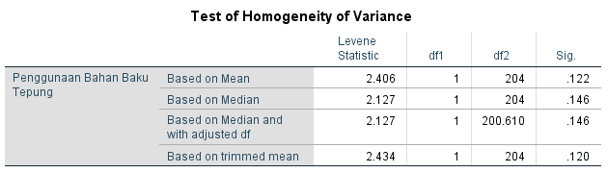

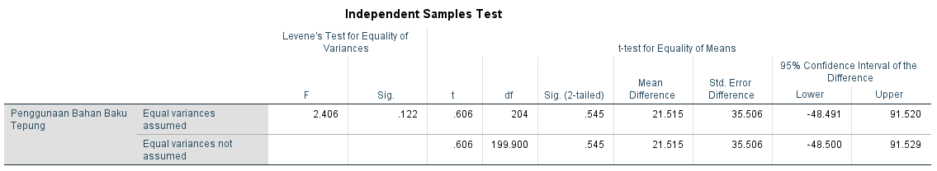

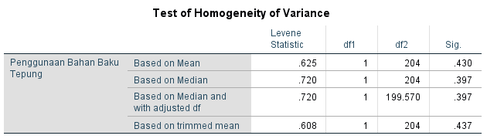

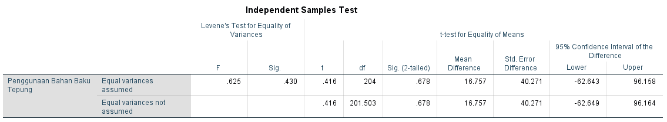

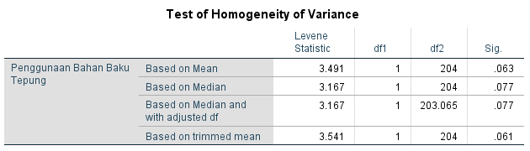

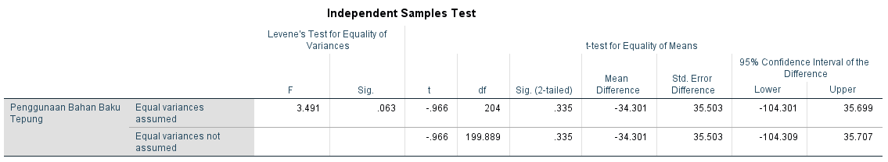

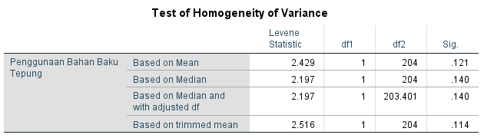

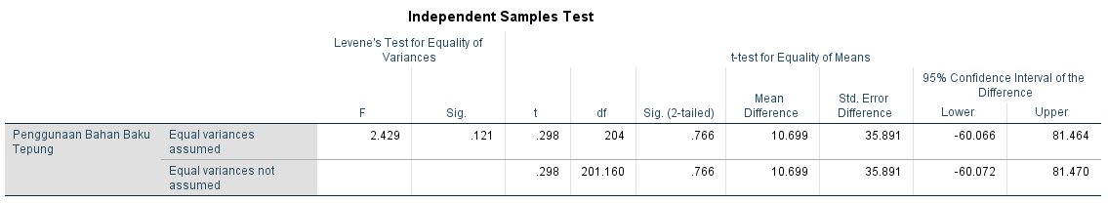

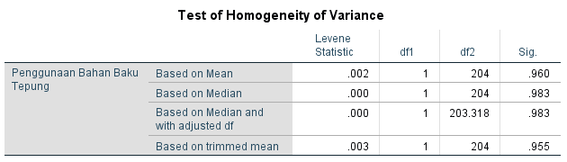

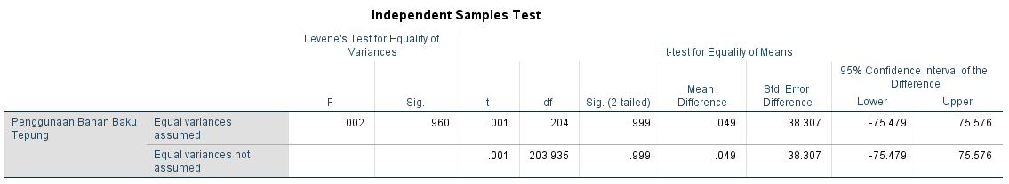

**Lampiran** 14 Validasi Permintaan Bahan Baku Ubi Replikasi 1 – 5

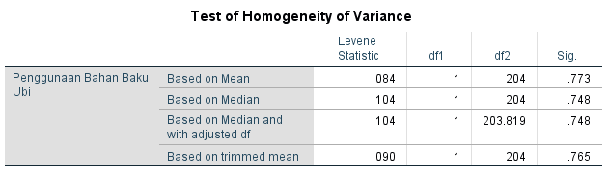

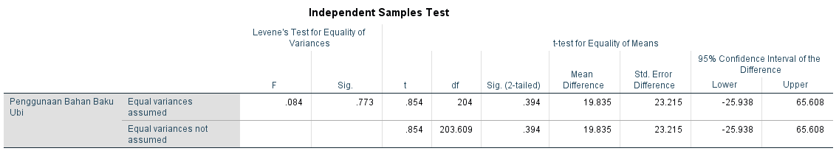

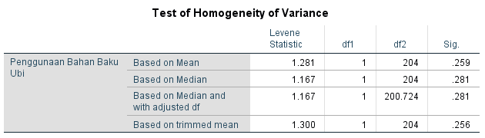

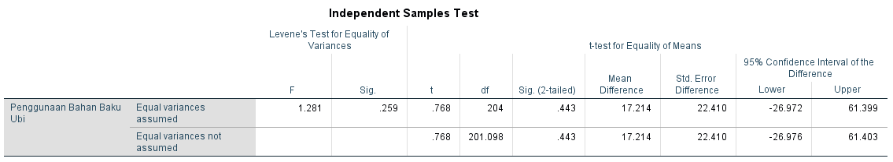

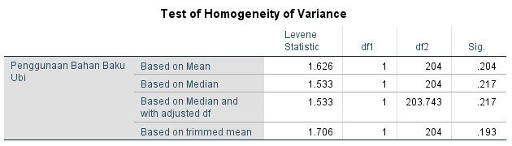

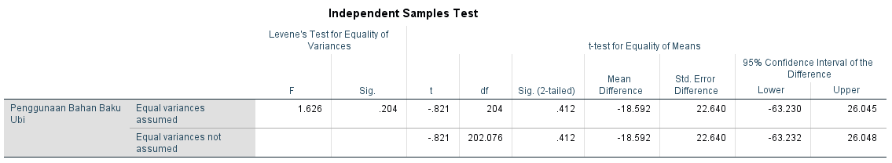

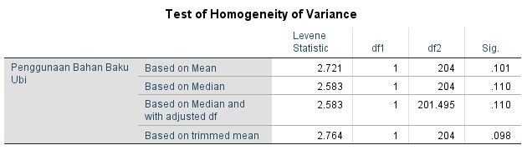

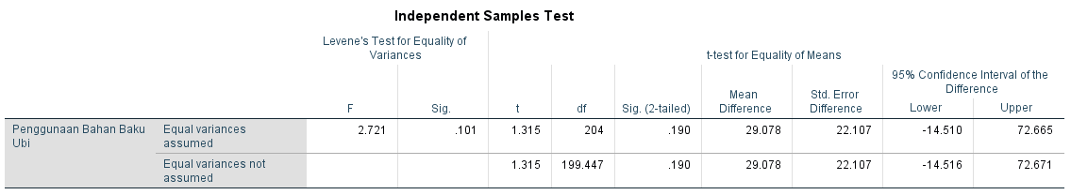

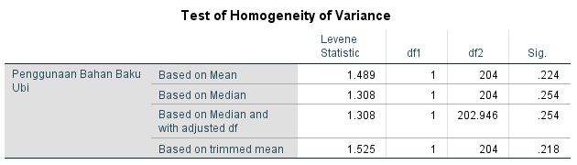

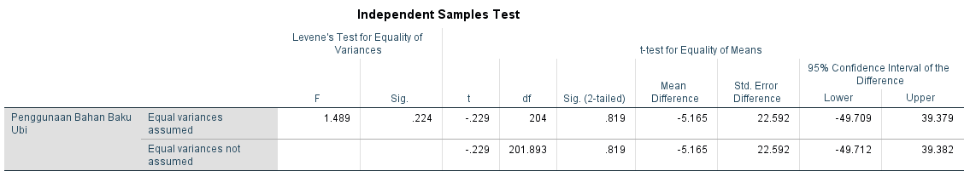

**Lampiran** 15 Validasi Permintaan Bahan Baku Perisai Cabai Replikasi 1 – 5

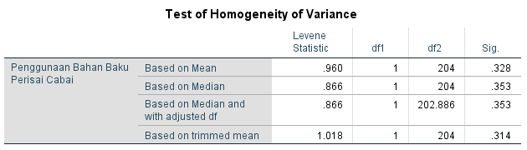

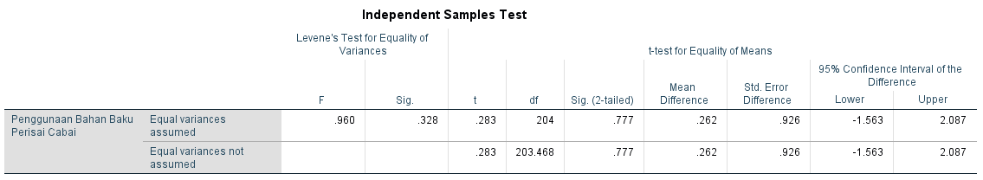

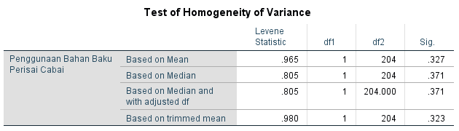

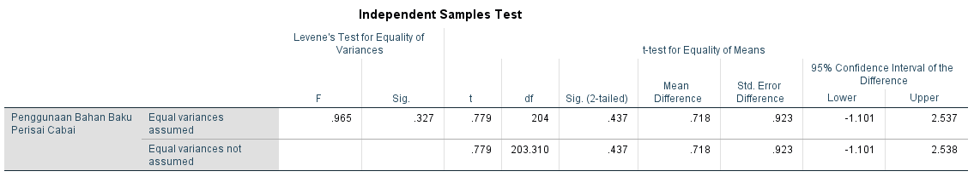

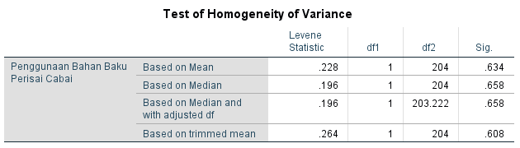

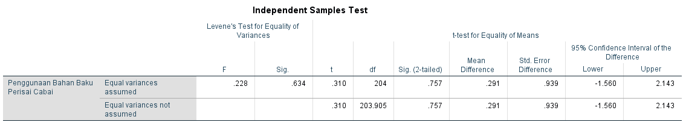

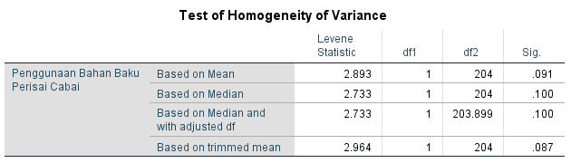

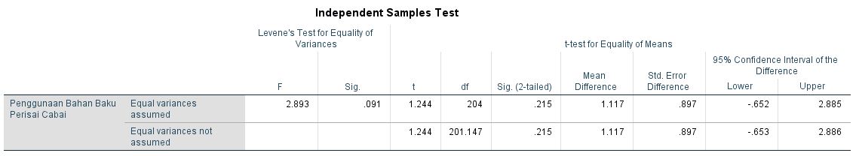

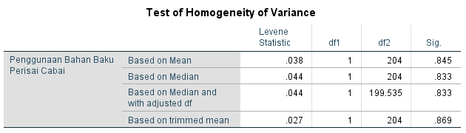

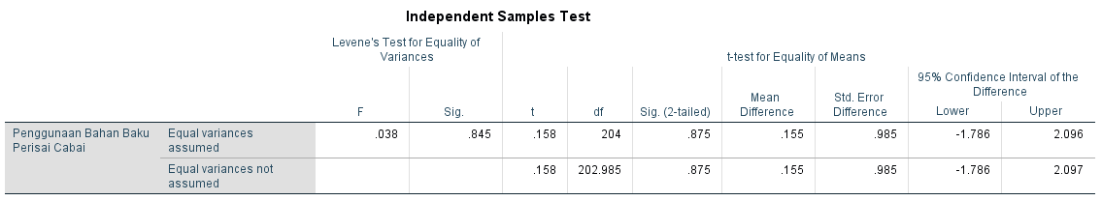

**Lampiran** 16 Perbandingan Frekuensi Bangkitan Dengan Frekuensi Harapan Lead Time Tepung Replikasi 1 – 5

|  |  |  |  |  |
| --- | --- | --- | --- | --- |
| **Lead Time** | **Frekuensi** | **Frekuensi Realitas** | **Frekuensi Bangkit** | **Frekuensi Harapan** |
| 2 | 7 | 0,5 | 3 | 7,5 |
| 3 | 6 | 0,4 | 8 | 6,4 |
| 4 | 1 | 0,1 | 4 | 1,1 |
|  | 14 | 1 | 15 | 15 |

|  |  |  |  |  |
| --- | --- | --- | --- | --- |
| **Lead Time** | **Frekuensi** | **Frekuensi Realitas** | **Frekuensi Bangkit** | **Frekuensi Harapan** |
| 2 | 7 | 0,5 | 5 | 7,5 |
| 3 | 6 | 0,4 | 5 | 6,4 |
| 4 | 1 | 0,1 | 5 | 1,1 |
|  | 14 | 1 | 15 | 15 |

|  |  |  |  |  |
| --- | --- | --- | --- | --- |
| **Lead Time** | **Frekuensi** | **Frekuensi Realitas** | **Frekuensi Bangkit** | **Frekuensi Harapan** |
| 2 | 7 | 0,5 | 3 | 7,5 |
| 3 | 6 | 0,4 | 11 | 6,4 |
| 4 | 1 | 0,1 | 1 | 1,1 |
|  | 14 | 1 | 15 | 15 |

|  |  |  |  |  |
| --- | --- | --- | --- | --- |
| **Lead Time** | **Frekuensi** | **Frekuensi Realitas** | **Frekuensi Bangkit** | **Frekuensi Harapan** |
| 2 | 7 | 0,5 | 3 | 7,5 |
| 3 | 6 | 0,4 | 8 | 6,4 |
| 4 | 1 | 0,1 | 4 | 1,1 |
|  | 14 | 1 | 15 | 15 |

|  |  |  |  |  |
| --- | --- | --- | --- | --- |
| **Lead Time** | **Frekuensi** | **Frekuensi Realitas** | **Frekuensi Bangkit** | **Frekuensi Harapan** |
| 2 | 7 | 0,5 | 4 | 7,5 |
| 3 | 6 | 0,4 | 8 | 6,4 |
| 4 | 1 | 0,1 | 3 | 1,1 |
|  | 14 | 1 | 15 | 15 |

**Lampiran** 17 Uji Chi Square Lead Time Bahan Baku Tepung Replikasi 1 – 5

|  |  |  |  |  |  |
| --- | --- | --- | --- | --- | --- |
| **No** | **Fo** | **Fe** | **Fo-Fe** | **(Fo-Fe)^2** | **(Fo-Fe)^2/Fe** |
| 1 | 3 | 5,25 | -2,25 | 5,06 | 0,9643 |
| 2 | 8 | 7,21 | 0,79 | 0,62 | 0,0856 |
| 3 | 4 | 2,54 | 1,46 | 2,14 | 0,8456 |
| 4 | 7,5 | 5,25 | 2,25 | 5,06 | 0,9643 |
| 5 | 6,4 | 7,21 | -0,79 | 0,62 | 0,0856 |
| 6 | 1,1 | 2,54 | -1,46 | 2,14 | 0,8456 |
| TOTAL | | | | | 3,7909 |

|  |  |  |  |  |  |
| --- | --- | --- | --- | --- | --- |
| **No** | **Fo** | **Fe** | **Fo-Fe** | **(Fo-Fe)^2** | **(Fo-Fe)^2/Fe** |
| 1 | 5 | 6,25 | -1,25 | 1,56 | 0,2500 |
| 2 | 5 | 5,71 | -0,71 | 0,51 | 0,0893 |
| 3 | 5 | 3,04 | 1,96 | 3,86 | 1,2710 |
| 4 | 7,5 | 6,25 | 1,25 | 1,56 | 0,2500 |
| 5 | 6,4 | 5,71 | 0,71 | 0,51 | 0,0893 |
| 6 | 1,1 | 3,04 | -1,96 | 3,86 | 1,2710 |
| TOTAL | | | | | 3,2206 |

|  |  |  |  |  |  |
| --- | --- | --- | --- | --- | --- |
| **No** | **Fo** | **Fe** | **Fo-Fe** | **(Fo-Fe)^2** | **(Fo-Fe)^2/Fe** |
| 1 | 3 | 5,25 | -2,25 | 5,063 | 0,9643 |
| 2 | 11 | 8,71 | 2,29 | 5,224 | 0,5995 |
| 3 | 1 | 1,04 | -0,04 | 0,001 | 0,0012 |
| 4 | 7,5 | 5,25 | 2,25 | 5,063 | 0,9643 |
| 5 | 6,4 | 8,71 | -2,29 | 5,224 | 0,5995 |
| 6 | 1,1 | 1,04 | 0,04 | 0,001 | 0,0012 |
| TOTAL | | | | | 3,1301 |

|  |  |  |  |  |  |
| --- | --- | --- | --- | --- | --- |
| **No** | **Fo** | **Fe** | **Fo-Fe** | **(Fo-Fe)^2** | **(Fo-Fe)^2/Fe** |
| 1 | 3 | 5,25 | -2,25 | 5,063 | 0,9643 |
| 2 | 8 | 7,21 | 0,79 | 0,617 | 0,0856 |
| 3 | 4 | 2,54 | 1,46 | 2,144 | 0,8456 |
| 4 | 7,5 | 5,25 | 2,25 | 5,063 | 0,9643 |
| 5 | 6,4 | 7,21 | -0,79 | 0,617 | 0,0856 |
| 6 | 1,1 | 2,54 | -1,46 | 2,144 | 0,8456 |
| TOTAL | | | | | 3,7909 |

|  |  |  |  |  |  |
| --- | --- | --- | --- | --- | --- |
| **No** | **Fo** | **Fe** | **Fo-Fe** | **(Fo-Fe)^2** | **(Fo-Fe)^2/Fe** |
| 1 | 4 | 5,75 | -1,75 | 3,063 | 0,5326 |
| 2 | 8 | 7,21 | 0,79 | 0,617 | 0,0856 |
| 3 | 3 | 2,04 | 0,96 | 0,930 | 0,4568 |
| 4 | 7,5 | 5,75 | 1,75 | 3,063 | 0,5326 |
| 5 | 6,4 | 7,21 | -0,79 | 0,617 | 0,0856 |
| 6 | 1,1 | 2,04 | -0,96 | 0,930 | 0,4568 |
| TOTAL | | | | | 2,1499 |

**Lampiran** 18 Perbandingan Frekuensi Bangkitan Dengan Frekuensi Harapan Lead Time Ubi Replikasi 1 – 5

|  |  |  |  |  |
| --- | --- | --- | --- | --- |
| **Lead Time** | **Frekuensi** | **Frekuensi Realitas** | **Frekuensi Bangkit** | **Frekuensi Harapan** |
| **3** | **2** | **0,2** | **6** | **2,7** |
| **4** | **7** | **0,6** | **5** | **9,5** |
| **5** | **2** | **0,2** | **4** | **2,7** |
|  | **11** | **1** | **15** | **15** |

|  |  |  |  |  |
| --- | --- | --- | --- | --- |
| **Lead Time** | **Frekuensi** | **Frekuensi Realitas** | **Frekuensi Bangkit** | **Frekuensi Harapan** |
| 3 | 7 | 0,5 | 3 | 7,5 |
| 4 | 6 | 0,4 | 8 | 6,4 |
| 5 | 1 | 0,1 | 4 | 1,1 |
|  | 14 | 1 | 15 | 15 |

|  |  |  |  |  |
| --- | --- | --- | --- | --- |
| **Lead Time** | **Frekuensi** | **Frekuensi Realitas** | **Frekuensi Bangkit** | **Frekuensi Harapan** |
| 3 | 7 | 0,5 | 3 | 7,5 |
| 4 | 6 | 0,4 | 7 | 6,4 |
| 5 | 1 | 0,1 | 5 | 1,1 |
|  | 14 | 1 | 15 | 15 |

|  |  |  |  |  |
| --- | --- | --- | --- | --- |
| **Lead Time** | **Frekuensi** | **Frekuensi Realitas** | **Frekuensi Bangkit** | **Frekuensi Harapan** |
| 3 | 7 | 0,5 | 9 | 7,5 |
| 4 | 6 | 0,4 | 5 | 6,4 |
| 5 | 1 | 0,1 | 1 | 1,1 |
|  | 14 | 1 | 15 | 15 |

|  |  |  |  |  |
| --- | --- | --- | --- | --- |
| **Lead Time** | **Frekuensi** | **Frekuensi Realitas** | **Frekuensi Bangkit** | **Frekuensi Harapan** |
| 3 | 7 | 0,5 | 2 | 7,5 |
| 4 | 6 | 0,4 | 9 | 6,4 |
| 5 | 1 | 0,1 | 4 | 1,1 |
|  | 14 | 1 | 15 | 15 |

**Lampiran** 19 Uji Chi Square Lead Time Bahan Baku Ubi Replikasi 1 – 5

|  |  |  |  |  |  |
| --- | --- | --- | --- | --- | --- |
| **No** | **Fo** | **Fe** | **Fo-Fe** | **(Fo-Fe)^2** | **(Fo-Fe)^2/Fe** |
| 1 | 6 | 4,36 | 1,64 | 2,68 | 0,6136 |
| 2 | 5 | 7,27 | -2,27 | 5,17 | 0,7102 |
| 3 | 4 | 3,36 | 0,64 | 0,40 | 0,1204 |
| 4 | 2,7 | 4,36 | -1,64 | 2,68 | 0,6136 |
| 5 | 9,5 | 7,27 | 2,27 | 5,17 | 0,7102 |
| 6 | 2,7 | 3,36 | -0,64 | 0,40 | 0,1204 |
| TOTAL | | | | | 2,8885 |

|  |  |  |  |  |  |
| --- | --- | --- | --- | --- | --- |
| **No** | **Fo** | **Fe** | **Fo-Fe** | **(Fo-Fe)^2** | **(Fo-Fe)^2/Fe** |
| 1 | 3 | 5,25 | -2,25 | 5,063 | 0,9643 |
| 2 | 8 | 7,21 | 0,79 | 0,617 | 0,0856 |
| 3 | 4 | 2,54 | 1,46 | 2,144 | 0,8456 |
| 4 | 7,5 | 5,25 | 2,25 | 5,063 | 0,9643 |
| 5 | 6,4 | 7,21 | -0,79 | 0,617 | 0,0856 |
| 6 | 1,1 | 2,54 | -1,46 | 2,144 | 0,8456 |
| TOTAL | | | | | 3,7909 |

|  |  |  |  |  |  |
| --- | --- | --- | --- | --- | --- |
| **No** | **Fo** | **Fe** | **Fo-Fe** | **(Fo-Fe)^2** | **(Fo-Fe)^2/Fe** |
| 1 | 3 | 5,25 | -2,25 | 5,063 | 0,9643 |
| 2 | 7 | 6,71 | 0,29 | 0,082 | 0,0122 |
| 3 | 5 | 3,04 | 1,96 | 3,858 | 1,2710 |
| 4 | 7,5 | 5,25 | 2,25 | 5,063 | 0,9643 |
| 5 | 6,4 | 6,71 | -0,29 | 0,082 | 0,0122 |
| 6 | 1,1 | 3,04 | -1,96 | 3,858 | 1,2710 |
| TOTAL | | | | | 4,4949 |

|  |  |  |  |  |  |
| --- | --- | --- | --- | --- | --- |
| **No** | **Fo** | **Fe** | **Fo-Fe** | **(Fo-Fe)^2** | **(Fo-Fe)^2/Fe** |
| 1 | 9 | 8,25 | 0,75 | 0,563 | 0,0682 |
| 2 | 5 | 5,71 | -0,71 | 0,510 | 0,0893 |
| 3 | 1 | 1,04 | -0,04 | 0,001 | 0,0012 |
| 4 | 7,5 | 8,25 | -0,75 | 0,563 | 0,0682 |
| 5 | 6,4 | 5,71 | 0,71 | 0,510 | 0,0893 |
| 6 | 1,1 | 1,04 | 0,04 | 0,001 | 0,0012 |
| TOTAL | | | | | 0,3174 |

|  |  |  |  |  |  |
| --- | --- | --- | --- | --- | --- |
| **No** | **Fo** | **Fe** | **Fo-Fe** | **(Fo-Fe)^2** | **(Fo-Fe)^2/Fe** |
| 1 | 2 | 4,75 | -2,75 | 7,563 | 1,5921 |
| 2 | 9 | 7,71 | 1,29 | 1,653 | 0,2143 |
| 3 | 4 | 2,54 | 1,46 | 2,144 | 0,8456 |
| 4 | 7,5 | 4,75 | 2,75 | 7,563 | 1,5921 |
| 5 | 6,4 | 7,71 | -1,29 | 1,653 | 0,2143 |
| 6 | 1,1 | 2,54 | -1,46 | 2,144 | 0,8456 |
| TOTAL | | | | | 5,3039 |

**Lampiran** 20 Perbandingan Frekuensi Bangkitan Dengan Frekuensi Harapan Lead Time Perisai Cabai Replikasi 1 – 5

|  |  |  |  |  |
| --- | --- | --- | --- | --- |
| **Lead Time** | **Frekuensi** | **Frekuensi Realitas** | **Frekuensi Bangkit** | **Frekuensi Harapan** |
| 3 | 2 | 0,3 | 4 | 4,3 |
| 4 | 2 | 0,3 | 5 | 4,3 |
| 5 | 2 | 0,3 | 6 | 4,3 |
| 6 | 1 | 0,1 | 0 | 2,1 |
|  | 7 | 1 | 15 | 15 |

|  |  |  |  |  |
| --- | --- | --- | --- | --- |
| **Lead Time** | **Frekuensi** | **Frekuensi Realitas** | **Frekuensi Bangkit** | **Frekuensi Harapan** |
| 3 | 2 | 0,3 | 4 | 4,3 |
| 4 | 3 | 0,4 | 6 | 6,4 |
| 5 | 1 | 0,1 | 4 | 2,1 |
| 6 | 1 | 0,1 | 1 | 2,1 |
|  | 7 | 1 | 15 | 15 |

|  |  |  |  |  |
| --- | --- | --- | --- | --- |
| **Lead Time** | **Frekuensi** | **Frekuensi Realitas** | **Frekuensi Bangkit** | **Frekuensi Harapan** |
| 3 | 2 | 0,3 | 7 | 4,3 |
| 4 | 3 | 0,4 | 5 | 6,4 |
| 5 | 1 | 0,1 | 3 | 2,1 |
| 6 | 1 | 0,1 | 0 | 2,1 |
|  | 7 | 1 | 15 | 15 |

|  |  |  |  |  |
| --- | --- | --- | --- | --- |
| **Lead Time** | **Frekuensi** | **Frekuensi Realitas** | **Frekuensi Bangkit** | **Frekuensi Harapan** |
| 3 | 2 | 0,3 | 4 | 4,3 |
| 4 | 3 | 0,4 | 4 | 6,4 |
| 5 | 1 | 0,1 | 4 | 2,1 |
| 6 | 1 | 0,1 | 3 | 2,1 |
|  | 7 | 1 | 15 | 15 |

|  |  |  |  |  |
| --- | --- | --- | --- | --- |
| **Lead Time** | **Frekuensi** | **Frekuensi Realitas** | **Frekuensi Bangkit** | **Frekuensi Harapan** |
| 3 | 2 | 0,3 | 7 | 4,3 |
| 4 | 3 | 0,4 | 3 | 6,4 |
| 5 | 1 | 0,1 | 3 | 2,1 |
| 6 | 1 | 0,1 | 2 | 2,1 |
|  | 7 | 1 | 15 | 15 |

**Lampiran** 21 Uji Chi Square Lead Time Bahan Baku Perisai cabai Replikasi 1 – 5

|  |  |  |  |  |  |
| --- | --- | --- | --- | --- | --- |
| **No** | **Fo** | **Fe** | **Fo-Fe** | **(Fo-Fe)^2** | **(Fo-Fe)^2/Fe** |
| 1 | 4 | 4,14 | -0,14 | 0,02 | 0,0049 |
| 2 | 5 | 4,64 | 0,36 | 0,13 | 0,0275 |
| 3 | 6 | 5,14 | 0,86 | 0,73 | 0,1429 |
| 4 | 0 | 1,07 | -1,07 | 1,15 | 1,0714 |
| 5 | 4,3 | 4,14 | 0,14 | 0,02 | 0,0049 |
| 6 | 4,3 | 4,64 | -0,36 | 0,13 | 0,0275 |
| 7 | 4,3 | 5,14 | -0,86 | 0,73 | 0,1429 |
| 8 | 2,1 | 1,07 | 1,07 | 1,15 | 1,0714 |
| TOTAL | | | | | 2,4934 |

|  |  |  |  |  |  |
| --- | --- | --- | --- | --- | --- |
| **No** | **Fo** | **Fe** | **Fo-Fe** | **(Fo-Fe)^2** | **(Fo-Fe)^2/Fe** |
| 1 | 4 | 4,14 | -0,14 | 0,02 | 0,0049 |
| 2 | 6 | 6,21 | -0,21 | 0,05 | 0,0074 |
| 3 | 4 | 3,07 | 0,93 | 0,86 | 0,2807 |
| 4 | 1 | 1,57 | -0,57 | 0,33 | 0,2078 |
| 5 | 4,3 | 4,14 | 0,14 | 0,02 | 0,0049 |
| 6 | 6,4 | 6,21 | 0,21 | 0,05 | 0,0074 |
| 7 | 2,1 | 3,07 | -0,93 | 0,86 | 0,2807 |
| 8 | 2,1 | 1,57 | 0,57 | 0,33 | 0,2078 |
| TOTAL | | | | | 1,0017 |

|  |  |  |  |  |  |
| --- | --- | --- | --- | --- | --- |
| **No** | **Fo** | **Fe** | **Fo-Fe** | **(Fo-Fe)^2** | **(Fo-Fe)^2/Fe** |
| 1 | 7 | 5,64 | 1,36 | 1,84 | 0,3264 |
| 2 | 5 | 5,71 | -0,71 | 0,51 | 0,0893 |
| 3 | 3 | 2,57 | 0,43 | 0,18 | 0,0714 |
| 4 | 0 | 1,07 | -1,07 | 1,15 | 1,0714 |
| 5 | 4,3 | 5,64 | -1,36 | 1,84 | 0,3264 |
| 6 | 6,4 | 5,71 | 0,71 | 0,51 | 0,0893 |
| 7 | 2,1 | 2,57 | -0,43 | 0,18 | 0,0714 |
| 8 | 2,1 | 1,07 | 1,07 | 1,15 | 1,0714 |
| TOTAL | | | | | 3,1171 |

|  |  |  |  |  |  |
| --- | --- | --- | --- | --- | --- |
| **No** | **Fo** | **Fe** | **Fo-Fe** | **(Fo-Fe)^2** | **(Fo-Fe)^2/Fe** |
| 1 | 4 | 4,14 | -0,14 | 0,02 | 0,0049 |
| 2 | 4 | 5,21 | -1,21 | 1,47 | 0,2828 |
| 3 | 4 | 3,07 | 0,93 | 0,86 | 0,2807 |
| 4 | 3 | 2,57 | 0,43 | 0,18 | 0,0714 |
| 5 | 4,3 | 4,14 | 0,14 | 0,02 | 0,0049 |
| 6 | 6,4 | 5,21 | 1,21 | 1,47 | 0,2828 |
| 7 | 2,1 | 3,07 | -0,93 | 0,86 | 0,2807 |
| 8 | 2,1 | 2,57 | -0,43 | 0,18 | 0,0714 |
| TOTAL | | | | | 1,2797 |

|  |  |  |  |  |  |
| --- | --- | --- | --- | --- | --- |
| **No** | **Fo** | **Fe** | **Fo-Fe** | **(Fo-Fe)^2** | **(Fo-Fe)^2/Fe** |
| 1 | 7 | 5,64 | 1,36 | 1,84 | 0,3264 |
| 2 | 3 | 4,71 | -1,71 | 2,94 | 0,6234 |
| 3 | 3 | 2,57 | 0,43 | 0,18 | 0,0714 |
| 4 | 2 | 2,07 | -0,07 | 0,01 | 0,0025 |
| 5 | 4,3 | 5,64 | -1,36 | 1,84 | 0,3264 |
| 6 | 6,4 | 4,71 | 1,71 | 2,94 | 0,6234 |
| 7 | 2,1 | 2,57 | -0,43 | 0,18 | 0,0714 |
| 8 | 2,1 | 2,07 | 0,07 | 0,01 | 0,0025 |
| TOTAL | | | | | 2,0473 |

**Lampiran** 22 Simulasi Monte Carlo Tepung Replikasi 1 – 5

| **Simulasi Monte Carlo Tepung Replikasi 1** | | | | | | | |
| --- | --- | --- | --- | --- | --- | --- | --- |
| **Hari** | **Stok Awal** | **Penggunaan Bahan Baku** | **Stok Akhir** | **Pesan** | ***Lead Time*** | **Sampai** | ***Shortage*** |
| 1 | 7.550 | 910 | 6.640 |  |  |  |  |
| 2 | 6.640 | 1.262 | 5.378 |  |  |  |  |
| 3 | 5.378 | 619 | 4.759 |  |  |  |  |
| 4 | 4.759 | 878 | 3.881 | Pesan | 3 |  |  |
| 5 | 3.881 | 1.063 | 2.818 |  |  |  |  |
| 6 | 2.818 | 959 | 1.859 |  |  |  |  |
| 7 | 1.859 | 879 | 14.130 |  |  | 13.150 |  |
| 8 | 14.130 | 713 | 13.417 |  |  |  |  |
| 9 | 13.417 | 868 | 12.549 |  |  |  |  |
| 10 | 12.549 | 985 | 11.564 |  |  |  |  |
| 11 | 11.564 | 1.023 | 10.541 |  |  |  |  |
| 12 | 10.541 | 1.186 | 9.355 |  |  |  |  |
| 13 | 9.355 | 1.064 | 8.291 |  |  |  |  |
| 14 | 8.291 | 1.071 | 7.220 |  |  |  |  |
| 15 | 7.220 | 632 | 6.588 |  |  |  |  |
| 16 | 6.588 | 1.065 | 5.523 |  |  |  |  |
| 17 | 5.523 | 708 | 4.815 |  |  |  |  |
| 18 | 4.815 | 826 | 3.989 | Pesan | 4 |  |  |
| 19 | 3.989 | 1.040 | 2.949 |  |  |  |  |
| 20 | 2.949 | 1.110 | 1.839 |  |  |  |  |
| 21 | 1.839 | 823 | 1.016 |  |  |  |  |
| 22 | 1.016 | 975 | 13.191 |  |  | 13.150 |  |
| 23 | 13.191 | 1.016 | 12.175 |  |  |  |  |
| 24 | 12.175 | 512 | 11.663 |  |  |  |  |
| 25 | 11.663 | 908 | 10.755 |  |  |  |  |
| 26 | 10.755 | 1.019 | 9.736 |  |  |  |  |
| 27 | 9.736 | 1.059 | 8.677 |  |  |  |  |
| 28 | 8.677 | 592 | 8.085 |  |  |  |  |
| 29 | 8.085 | 946 | 7.139 |  |  |  |  |
| 30 | 7.139 | 1.000 | 6.139 |  |  |  |  |
| 31 | 6.139 | 862 | 5.277 |  |  |  |  |
| 32 | 5.277 | 413 | 4.864 |  |  |  |  |
| 33 | 4.864 | 1.054 | 3.810 | Pesan | 3 |  |  |
| 34 | 3.810 | 1.013 | 2.797 |  |  |  |  |
| 35 | 2.797 | 992 | 1.805 |  |  |  |  |
| 36 | 1.805 | 943 | 14.012 |  |  | 13.150 |  |
| 37 | 14.012 | 840 | 13.172 |  |  |  |  |
| 38 | 13.172 | 877 | 12.295 |  |  |  |  |
| 39 | 12.295 | 1.059 | 11.236 |  |  |  |  |
| 40 | 11.236 | 407 | 10.829 |  |  |  |  |
| 41 | 10.829 | 588 | 10.241 |  |  |  |  |
| 42 | 10.241 | 1.007 | 9.234 |  |  |  |  |
| 43 | 9.234 | 762 | 8.472 |  |  |  |  |
| 44 | 8.472 | 470 | 8.002 |  |  |  |  |
| 45 | 8.002 | 585 | 7.417 |  |  |  |  |
| 46 | 7.417 | 983 | 6.434 |  |  |  |  |
| 47 | 6.434 | 1.059 | 5.375 |  |  |  |  |
| 48 | 5.375 | 923 | 4.452 | Pesan | 2 |  |  |
| 49 | 4.452 | 599 | 3.853 |  |  |  |  |
| 50 | 3.853 | 927 | 16.076 |  |  | 13.150 |  |
| 51 | 16.076 | 993 | 15.083 |  |  |  |  |
| 52 | 15.083 | 785 | 14.298 |  |  |  |  |
| 53 | 14.298 | 970 | 13.328 |  |  |  |  |
| 54 | 13.328 | 1.000 | 12.328 |  |  |  |  |
| 55 | 12.328 | 1.110 | 11.218 |  |  |  |  |
| 56 | 11.218 | 860 | 10.358 |  |  |  |  |
| 57 | 10.358 | 781 | 9.577 |  |  |  |  |
| 58 | 9.577 | 1.051 | 8.526 |  |  |  |  |
| 59 | 8.526 | 1.095 | 7.431 |  |  |  |  |
| 60 | 7.431 | 559 | 6.872 |  |  |  |  |
| 61 | 6.872 | 608 | 6.264 |  |  |  |  |
| 62 | 6.264 | 537 | 5.727 |  |  |  |  |
| 63 | 5.727 | 635 | 5.092 |  |  |  |  |
| 64 | 5.092 | 1.170 | 3.922 | Pesan | 2 |  |  |
| 65 | 3.922 | 1.184 | 2.738 |  |  |  |  |
| 66 | 2.738 | 1.072 | 14.816 |  |  | 13.150 |  |
| 67 | 14.816 | 662 | 14.154 |  |  |  |  |
| 68 | 14.154 | 747 | 13.407 |  |  |  |  |
| 69 | 13.407 | 852 | 12.555 |  |  |  |  |
| 70 | 12.555 | 522 | 12.033 |  |  |  |  |
| 71 | 12.033 | 619 | 11.414 |  |  |  |  |
| 72 | 11.414 | 704 | 10.710 |  |  |  |  |
| 73 | 10.710 | 1.232 | 9.478 |  |  |  |  |
| 74 | 9.478 | 1.295 | 8.183 |  |  |  |  |
| 75 | 8.183 | 1.501 | 6.682 |  |  |  |  |
| 76 | 6.682 | 1.349 | 5.333 |  |  |  |  |
| 77 | 5.333 | 840 | 4.493 | Pesan | 3 |  |  |
| 78 | 4.493 | 1.013 | 3.480 |  |  |  |  |
| 79 | 3.480 | 766 | 2.714 |  |  |  |  |
| 80 | 2.714 | 1.387 | 14.477 |  |  | 13.150 |  |
| 81 | 14.477 | 1.032 | 13.445 |  |  |  |  |
| 82 | 13.445 | 847 | 12.598 |  |  |  |  |
| 83 | 12.598 | 1.264 | 11.334 |  |  |  |  |
| 84 | 11.334 | 1.086 | 10.248 |  |  |  |  |
| 85 | 10.248 | 623 | 9.625 |  |  |  |  |
| 86 | 9.625 | 1.330 | 8.295 |  |  |  |  |
| 87 | 8.295 | 811 | 7.484 |  |  |  |  |
| 88 | 7.484 | 1.232 | 6.252 |  |  |  |  |
| 89 | 6.252 | 1.349 | 4.903 |  |  |  |  |
| 90 | 4.903 | 723 | 4.180 | Pesan | 3 |  |  |
| 91 | 4.180 | 812 | 3.368 |  |  |  |  |
| 92 | 3.368 | 594 | 2.774 |  |  |  |  |
| 93 | 2.774 | 1.111 | 14.713 |  |  | 13.150 |  |
| 94 | 14.713 | 1.359 | 13.354 |  |  |  |  |
| 95 | 13.354 | 892 | 12.462 |  |  |  |  |
| 96 | 12.462 | 904 | 11.558 |  |  |  |  |
| 97 | 11.558 | 1.138 | 10.420 |  |  |  |  |
| 98 | 10.420 | 1.155 | 9.265 |  |  |  |  |
| 99 | 9.265 | 689 | 8.576 |  |  |  |  |
| 100 | 8.576 | 1.122 | 7.454 |  |  |  |  |
| 101 | 7.454 | 663 | 6.791 |  |  |  |  |
| 102 | 6.791 | 865 | 5.926 |  |  |  |  |
| 103 | 5.926 | 1.090 | 4.836 |  |  |  |  |
| TOTAL | | | 862.886 | 7 |  | 92.050 |  |

| **Simulasi Monte Carlo Tepung Replikasi 2** | | | | | | | |
| --- | --- | --- | --- | --- | --- | --- | --- |
| **Hari** | **Stok Awal** | **Penggunaan Bahan Baku** | **Stok Akhir** | **Pesan** | ***Lead Time*** | **Sampai** | ***Shortage*** |
| 1 | 7.550 | 1.184 | 6.366 |  |  |  |  |
| 2 | 6.366 | 667 | 5.699 |  |  |  |  |
| 3 | 5.699 | 744 | 4.955 |  |  |  |  |
| 4 | 4.955 | 1.097 | 3.858 | Pesan | 3 |  |  |
| 5 | 3.858 | 1.093 | 2.765 |  |  |  |  |
| 6 | 2.765 | 939 | 1.826 |  |  |  |  |
| 7 | 1.826 | 969 | 14.007 |  |  | 13.150 |  |
| 8 | 14.007 | 776 | 13.231 |  |  |  |  |
| 9 | 13.231 | 599 | 12.632 |  |  |  |  |
| 10 | 12.632 | 1.015 | 11.617 |  |  |  |  |
| 11 | 11.617 | 888 | 10.729 |  |  |  |  |
| 12 | 10.729 | 1.180 | 9.549 |  |  |  |  |
| 13 | 9.549 | 1.105 | 8.444 |  |  |  |  |
| 14 | 8.444 | 985 | 7.459 |  |  |  |  |
| 15 | 7.459 | 1.049 | 6.410 |  |  |  |  |
| 16 | 6.410 | 1.248 | 5.162 |  |  |  |  |
| 17 | 5.162 | 1.069 | 4.093 | Pesan | 4 |  |  |
| 18 | 4.093 | 1.244 | 2.849 |  |  |  |  |
| 19 | 2.849 | 1.403 | 1.446 |  |  |  |  |
| 20 | 1.446 | 707 | 739 |  |  |  |  |
| 21 | 739 | 553 | 13.336 |  |  | 13.150 |  |
| 22 | 13.336 | 1.106 | 12.230 |  |  |  |  |
| 23 | 12.230 | 192 | 12.038 |  |  |  |  |
| 24 | 12.038 | 924 | 11.114 |  |  |  |  |
| 25 | 11.114 | 1.417 | 9.697 |  |  |  |  |
| 26 | 9.697 | 670 | 9.027 |  |  |  |  |
| 27 | 9.027 | 670 | 8.357 |  |  |  |  |
| 28 | 8.357 | 854 | 7.503 |  |  |  |  |
| 29 | 7.503 | 948 | 6.555 |  |  |  |  |
| 30 | 6.555 | 642 | 5.913 |  |  |  |  |
| 31 | 5.913 | 660 | 5.253 |  |  |  |  |
| 32 | 5.253 | 1.158 | 4.095 | Pesan | 2 |  |  |
| 33 | 4.095 | 1.134 | 2.961 |  |  |  |  |
| 34 | 2.961 | 1.297 | 14.814 |  |  | 13.150 |  |
| 35 | 14.814 | 427 | 14.387 |  |  |  |  |
| 36 | 14.387 | 952 | 13.435 |  |  |  |  |
| 37 | 13.435 | 640 | 12.795 |  |  |  |  |
| 38 | 12.795 | 799 | 11.996 |  |  |  |  |
| 39 | 11.996 | 1.372 | 10.624 |  |  |  |  |
| 40 | 10.624 | 644 | 9.980 |  |  |  |  |
| 41 | 9.980 | 912 | 9.068 |  |  |  |  |
| 42 | 9.068 | 1.088 | 7.980 |  |  |  |  |
| 43 | 7.980 | 1.361 | 6.619 |  |  |  |  |
| 44 | 6.619 | 1.334 | 5.285 |  |  |  |  |
| 45 | 5.285 | 508 | 4.777 |  |  |  |  |
| 46 | 4.777 | 1.350 | 3.427 | Pesan | 4 |  |  |
| 47 | 3.427 | 506 | 2.921 |  |  |  |  |
| 48 | 2.921 | 888 | 2.033 |  |  |  |  |
| 49 | 2.033 | 955 | 1.078 |  |  |  |  |
| 50 | 1.078 | 813 | 13.415 |  |  | 13.150 |  |
| 51 | 13.415 | 993 | 12.422 |  |  |  |  |
| 52 | 12.422 | 876 | 11.546 |  |  |  |  |
| 53 | 11.546 | 1.016 | 10.530 |  |  |  |  |
| 54 | 10.530 | 933 | 9.597 |  |  |  |  |
| 55 | 9.597 | 1.320 | 8.277 |  |  |  |  |
| 56 | 8.277 | 759 | 7.518 |  |  |  |  |
| 57 | 7.518 | 1.309 | 6.209 |  |  |  |  |
| 58 | 6.209 | 863 | 5.346 |  |  |  |  |
| 59 | 5.346 | 1.145 | 4.201 | Pesan | 4 |  |  |
| 60 | 4.201 | 1.267 | 2.934 |  |  |  |  |
| 61 | 2.934 | 1.174 | 1.760 |  |  |  |  |
| 62 | 1.760 | 747 | 1.013 |  |  |  |  |
| 63 | 1.013 | 642 | 13.521 |  |  | 13.150 |  |
| 64 | 13.521 | 506 | 13.015 |  |  |  |  |
| 65 | 13.015 | 284 | 12.731 |  |  |  |  |
| 66 | 12.731 | 899 | 11.832 |  |  |  |  |
| 67 | 11.832 | 770 | 11.062 |  |  |  |  |
| 68 | 11.062 | 1.016 | 10.046 |  |  |  |  |
| 69 | 10.046 | 1.303 | 8.743 |  |  |  |  |
| 70 | 8.743 | 507 | 8.236 |  |  |  |  |
| 71 | 8.236 | 875 | 7.361 |  |  |  |  |
| 72 | 7.361 | 1.236 | 6.125 |  |  |  |  |
| 73 | 6.125 | 1.019 | 5.106 |  |  |  |  |
| 74 | 5.106 | 360 | 4.746 |  |  |  |  |
| 75 | 4.746 | 754 | 3.992 | Pesan | 2 |  |  |
| 76 | 3.992 | 258 | 3.734 |  |  |  |  |
| 77 | 3.734 | 986 | 15.898 |  |  | 13.150 |  |
| 78 | 15.898 | 1.206 | 14.692 |  |  |  |  |
| 79 | 14.692 | 1.409 | 13.283 |  |  |  |  |
| 80 | 13.283 | 663 | 12.620 |  |  |  |  |
| 81 | 12.620 | 1.032 | 11.588 |  |  |  |  |
| 82 | 11.588 | 205 | 11.383 |  |  |  |  |
| 83 | 11.383 | 878 | 10.505 |  |  |  |  |
| 84 | 10.505 | 1.184 | 9.321 |  |  |  |  |
| 85 | 9.321 | 1.087 | 8.234 |  |  |  |  |
| 86 | 8.234 | 792 | 7.442 |  |  |  |  |
| 87 | 7.442 | 627 | 6.815 |  |  |  |  |
| 88 | 6.815 | 975 | 5.840 |  |  |  |  |
| 89 | 5.840 | 345 | 5.495 |  |  |  |  |
| 90 | 5.495 | 1.014 | 4.481 | Pesan | 4 |  |  |
| 91 | 4.481 | 1.637 | 2.844 |  |  |  |  |
| 92 | 2.844 | 900 | 1.944 |  |  |  |  |
| 93 | 1.944 | 1.239 | 705 |  |  |  |  |
| 94 | 705 | 530 | 13.325 |  |  | 13.150 |  |
| 95 | 13.325 | 677 | 12.648 |  |  |  |  |
| 96 | 12.648 | 917 | 11.731 |  |  |  |  |
| 97 | 11.731 | 923 | 10.808 |  |  |  |  |
| 98 | 10.808 | 762 | 10.046 |  |  |  |  |
| 99 | 10.046 | 989 | 9.057 |  |  |  |  |
| 100 | 9.057 | 1.279 | 7.778 |  |  |  |  |
| 101 | 7.778 | 763 | 7.015 |  |  |  |  |
| 102 | 7.015 | 1.170 | 5.845 |  |  |  |  |
| 103 | 5.845 | 899 | 4.946 |  |  |  |  |
| TOTAL | | | 824.441 | 7 |  | 92.050 |  |

| **Simulasi Monte Carlo Tepung Replikasi 3** | | | | | | | |
| --- | --- | --- | --- | --- | --- | --- | --- |
| **Hari** | **Stok Awal** | **Penggunaan Bahan Baku** | **Stok Akhir** | **Pesan** | ***Lead Time*** | **Sampai** | ***Shortage*** |
| 1 | 7.550 | 1.071 | 6.479 |  |  |  |  |
| 2 | 6.479 | 996 | 5.483 |  |  |  |  |
| 3 | 5.483 | 1.010 | 4.473 | Pesan | 3 |  |  |
| 4 | 4.473 | 1.362 | 3.111 |  |  |  |  |
| 5 | 3.111 | 1.017 | 2.094 |  |  |  |  |
| 6 | 2.094 | 840 | 14.404 |  |  | 13.150 |  |
| 7 | 14.404 | 1.102 | 13.302 |  |  |  |  |
| 8 | 13.302 | 1.122 | 12.180 |  |  |  |  |
| 9 | 12.180 | 1.413 | 10.767 |  |  |  |  |
| 10 | 10.767 | 726 | 10.041 |  |  |  |  |
| 11 | 10.041 | 1.124 | 8.917 |  |  |  |  |
| 12 | 8.917 | 1.035 | 7.882 |  |  |  |  |
| 13 | 7.882 | 1.068 | 6.814 |  |  |  |  |
| 14 | 6.814 | 1.084 | 5.730 |  |  |  |  |
| 15 | 5.730 | 819 | 4.911 | Pesan | 3 |  |  |
| 16 | 4.911 | 1.133 | 3.778 |  |  |  |  |
| 17 | 3.778 | 613 | 3.165 |  |  |  |  |
| 18 | 3.165 | 1.419 | 14.896 |  |  | 13.150 |  |
| 19 | 14.896 | 872 | 14.024 |  |  |  |  |
| 20 | 14.024 | 1.148 | 12.876 |  |  |  |  |
| 21 | 12.876 | 1.159 | 11.717 |  |  |  |  |
| 22 | 11.717 | 657 | 11.060 |  |  |  |  |
| 23 | 11.060 | 979 | 10.081 |  |  |  |  |
| 24 | 10.081 | 805 | 9.276 |  |  |  |  |
| 25 | 9.276 | 1.129 | 8.147 |  |  |  |  |
| 26 | 8.147 | 1.219 | 6.928 |  |  |  |  |
| 27 | 6.928 | 876 | 6.052 |  |  |  |  |
| 28 | 6.052 | 606 | 5.446 |  |  |  |  |
| 29 | 5.446 | 930 | 4.516 | Pesan | 3 |  |  |
| 30 | 4.516 | 1.336 | 3.180 |  |  |  |  |
| 31 | 3.180 | 736 | 2.444 |  |  |  |  |
| 32 | 2.444 | 842 | 14.752 |  |  | 13.150 |  |
| 33 | 14.752 | 662 | 14.090 |  |  |  |  |
| 34 | 14.090 | 962 | 13.128 |  |  |  |  |
| 35 | 13.128 | 979 | 12.149 |  |  |  |  |
| 36 | 12.149 | 1.222 | 10.927 |  |  |  |  |
| 37 | 10.927 | 472 | 10.455 |  |  |  |  |
| 38 | 10.455 | 991 | 9.464 |  |  |  |  |
| 39 | 9.464 | 1.330 | 8.134 |  |  |  |  |
| 40 | 8.134 | 665 | 7.469 |  |  |  |  |
| 41 | 7.469 | 1.000 | 6.469 |  |  |  |  |
| 42 | 6.469 | 856 | 5.613 |  |  |  |  |
| 43 | 5.613 | 983 | 4.630 | Pesan | 3 |  |  |
| 44 | 4.630 | 707 | 3.923 |  |  |  |  |
| 45 | 3.923 | 1.213 | 2.710 |  |  |  |  |
| 46 | 2.710 | 851 | 15.009 |  |  | 13.150 |  |
| 47 | 15.009 | 1.206 | 13.803 |  |  |  |  |
| 48 | 13.803 | 1.182 | 12.621 |  |  |  |  |
| 49 | 12.621 | 1.060 | 11.561 |  |  |  |  |
| 50 | 11.561 | 861 | 10.700 |  |  |  |  |
| 51 | 10.700 | 1.016 | 9.684 |  |  |  |  |
| 52 | 9.684 | 810 | 8.874 |  |  |  |  |
| 53 | 8.874 | 935 | 7.939 |  |  |  |  |
| 54 | 7.939 | 1.120 | 6.819 |  |  |  |  |
| 55 | 6.819 | 472 | 6.347 |  |  |  |  |
| 56 | 6.347 | 1.207 | 5.140 |  |  |  |  |
| 57 | 5.140 | 1.068 | 4.072 | Pesan | 2 |  |  |
| 58 | 4.072 | 807 | 3.265 |  |  |  |  |
| 59 | 3.265 | 775 | 15.640 |  |  | 13.150 |  |
| 60 | 15.640 | 561 | 15.079 |  |  |  |  |
| 61 | 15.079 | 1.153 | 13.926 |  |  |  |  |
| 62 | 13.926 | 1.102 | 12.824 |  |  |  |  |
| 63 | 12.824 | 1.273 | 11.551 |  |  |  |  |
| 64 | 11.551 | 1.286 | 10.265 |  |  |  |  |
| 65 | 10.265 | 1.320 | 8.945 |  |  |  |  |
| 66 | 8.945 | 856 | 8.089 |  |  |  |  |
| 67 | 8.089 | 926 | 7.163 |  |  |  |  |
| 68 | 7.163 | 1.581 | 5.582 |  |  |  |  |
| 69 | 5.582 | 1.273 | 4.309 | Pesan | 3 |  |  |
| 70 | 4.309 | 797 | 3.512 |  |  |  |  |
| 71 | 3.512 | 889 | 2.623 |  |  |  |  |
| 72 | 2.623 | 1.009 | 14.764 |  |  | 13.150 |  |
| 73 | 14.764 | 650 | 14.114 |  |  |  |  |
| 74 | 14.114 | 969 | 13.145 |  |  |  |  |
| 75 | 13.145 | 810 | 12.335 |  |  |  |  |
| 76 | 12.335 | 1.297 | 11.038 |  |  |  |  |
| 77 | 11.038 | 909 | 10.129 |  |  |  |  |
| 78 | 10.129 | 1.052 | 9.077 |  |  |  |  |
| 79 | 9.077 | 578 | 8.499 |  |  |  |  |
| 80 | 8.499 | 909 | 7.590 |  |  |  |  |
| 81 | 7.590 | 713 | 6.877 |  |  |  |  |
| 82 | 6.877 | 938 | 5.939 |  |  |  |  |
| 83 | 5.939 | 942 | 4.997 |  |  |  |  |
| 84 | 4.997 | 1.023 | 3.974 | Pesan | 3 |  |  |
| 85 | 3.974 | 1.043 | 2.931 |  |  |  |  |
| 86 | 2.931 | 859 | 2.072 |  |  |  |  |
| 87 | 2.072 | 962 | 14.260 |  |  | 13.150 |  |
| 88 | 14.260 | 1.015 | 13.245 |  |  |  |  |
| 89 | 13.245 | 669 | 12.576 |  |  |  |  |
| 90 | 12.576 | 396 | 12.180 |  |  |  |  |
| 91 | 12.180 | 1.164 | 11.016 |  |  |  |  |
| 92 | 11.016 | 1.028 | 9.988 |  |  |  |  |
| 93 | 9.988 | 1.527 | 8.461 |  |  |  |  |
| 94 | 8.461 | 1.238 | 7.223 |  |  |  |  |
| 95 | 7.223 | 745 | 6.478 |  |  |  |  |
| 96 | 6.478 | 1.007 | 5.471 |  |  |  |  |
| 97 | 5.471 | 1.039 | 4.432 | Pesan | 2 |  |  |
| 98 | 4.432 | 722 | 3.710 |  |  |  |  |
| 99 | 3.710 | 1.105 | 15.755 |  |  | 13.150 |  |
| 100 | 15.755 | 952 | 14.803 |  |  |  |  |
| 101 | 14.803 | 460 | 14.343 |  |  |  |  |
| 102 | 14.343 | 1.046 | 13.297 |  |  |  |  |
| 103 | 13.297 | 960 | 12.337 |  |  |  |  |
| TOTAL | | | 910.485 | 8 |  | 105.200 |  |

| **Simulasi Monte Carlo Tepung Replikasi 4** | | | | | | | |
| --- | --- | --- | --- | --- | --- | --- | --- |
| **Hari** | **Stok Awal** | **Penggunaan Bahan Baku** | **Stok Akhir** | **Pesan** | ***Lead Time*** | **Sampai** | ***Shortage*** |
| 1 | 7.550 | 1.208 | 6.342 |  |  |  |  |
| 2 | 6.342 | 492 | 5.850 |  |  |  |  |
| 3 | 5.850 | 869 | 4.981 |  |  |  |  |
| 4 | 4.981 | 1.055 | 3.926 | Pesan | 2 |  |  |
| 5 | 3.926 | 597 | 3.329 |  |  |  |  |
| 6 | 3.329 | 1.020 | 15.459 |  |  | 13.150 |  |
| 7 | 15.459 | 1.046 | 14.413 |  |  |  |  |
| 8 | 14.413 | 1.020 | 13.393 |  |  |  |  |
| 9 | 13.393 | 1.174 | 12.219 |  |  |  |  |
| 10 | 12.219 | 972 | 11.247 |  |  |  |  |
| 11 | 11.247 | 838 | 10.409 |  |  |  |  |
| 12 | 10.409 | 887 | 9.522 |  |  |  |  |
| 13 | 9.522 | 735 | 8.787 |  |  |  |  |
| 14 | 8.787 | 904 | 7.883 |  |  |  |  |
| 15 | 7.883 | 513 | 7.370 |  |  |  |  |
| 16 | 7.370 | 764 | 6.606 |  |  |  |  |
| 17 | 6.606 | 1.274 | 5.332 |  |  |  |  |
| 18 | 5.332 | 746 | 4.586 | Pesan | 3 |  |  |
| 19 | 4.586 | 869 | 3.717 |  |  |  |  |
| 20 | 3.717 | 769 | 2.948 |  |  |  |  |
| 21 | 2.948 | 1.233 | 14.865 |  |  | 13.150 |  |
| 22 | 14.865 | 1.179 | 13.686 |  |  |  |  |
| 23 | 13.686 | 620 | 13.066 |  |  |  |  |
| 24 | 13.066 | 744 | 12.322 |  |  |  |  |
| 25 | 12.322 | 927 | 11.395 |  |  |  |  |
| 26 | 11.395 | 1.317 | 10.078 |  |  |  |  |
| 27 | 10.078 | 1.080 | 8.998 |  |  |  |  |
| 28 | 8.998 | 897 | 8.101 |  |  |  |  |
| 29 | 8.101 | 1.303 | 6.798 |  |  |  |  |
| 30 | 6.798 | 885 | 5.913 |  |  |  |  |
| 31 | 5.913 | 247 | 5.666 |  |  |  |  |
| 32 | 5.666 | 1.204 | 4.462 | Pesan | 3 |  |  |
| 33 | 4.462 | 294 | 4.168 |  |  |  |  |
| 34 | 4.168 | 1.166 | 3.002 |  |  |  |  |
| 35 | 3.002 | 1.346 | 14.806 |  |  | 13.150 |  |
| 36 | 14.806 | 1.070 | 13.736 |  |  |  |  |
| 37 | 13.736 | 793 | 12.943 |  |  |  |  |
| 38 | 12.943 | 422 | 12.521 |  |  |  |  |
| 39 | 12.521 | 502 | 12.019 |  |  |  |  |
| 40 | 12.019 | 748 | 11.271 |  |  |  |  |
| 41 | 11.271 | 935 | 10.336 |  |  |  |  |
| 42 | 10.336 | 1.125 | 9.211 |  |  |  |  |
| 43 | 9.211 | 985 | 8.226 |  |  |  |  |
| 44 | 8.226 | 977 | 7.249 |  |  |  |  |
| 45 | 7.249 | 1.149 | 6.100 |  |  |  |  |
| 46 | 6.100 | 1.338 | 4.762 |  |  |  |  |
| 47 | 4.762 | 618 | 4.144 | Pesan | 4 |  |  |
| 48 | 4.144 | 826 | 3.318 |  |  |  |  |
| 49 | 3.318 | 933 | 2.385 |  |  |  |  |
| 50 | 2.385 | 982 | 1.403 |  |  |  |  |
| 51 | 1.403 | 935 | 13.618 |  |  | 13.150 |  |
| 52 | 13.618 | 1.158 | 12.460 |  |  |  |  |
| 53 | 12.460 | 1.412 | 11.048 |  |  |  |  |
| 54 | 11.048 | 1.021 | 10.027 |  |  |  |  |
| 55 | 10.027 | 1.295 | 8.732 |  |  |  |  |
| 56 | 8.732 | 811 | 7.921 |  |  |  |  |
| 57 | 7.921 | 803 | 7.118 |  |  |  |  |
| 58 | 7.118 | 1.237 | 5.881 |  |  |  |  |
| 59 | 5.881 | 953 | 4.928 |  |  |  |  |
| 60 | 4.928 | 872 | 4.056 | Pesan | 2 |  |  |
| 61 | 4.056 | 738 | 3.318 |  |  |  |  |
| 62 | 3.318 | 1.091 | 15.377 |  |  | 13.150 |  |
| 63 | 15.377 | 1.145 | 14.232 |  |  |  |  |
| 64 | 14.232 | 973 | 13.259 |  |  |  |  |
| 65 | 13.259 | 950 | 12.309 |  |  |  |  |
| 66 | 12.309 | 1.029 | 11.280 |  |  |  |  |
| 67 | 11.280 | 1.347 | 9.933 |  |  |  |  |
| 68 | 9.933 | 780 | 9.153 |  |  |  |  |
| 69 | 9.153 | 929 | 8.224 |  |  |  |  |
| 70 | 8.224 | 960 | 7.264 |  |  |  |  |
| 71 | 7.264 | 1.114 | 6.150 |  |  |  |  |
| 72 | 6.150 | 522 | 5.628 |  |  |  |  |
| 73 | 5.628 | 1.222 | 4.406 | Pesan | 4 |  |  |
| 74 | 4.406 | 887 | 3.519 |  |  |  |  |
| 75 | 3.519 | 992 | 2.527 |  |  |  |  |
| 76 | 2.527 | 701 | 1.826 |  |  |  |  |
| 77 | 1.826 | 1.149 | 13.827 |  |  | 13.150 |  |
| 78 | 13.827 | 708 | 13.119 |  |  |  |  |
| 79 | 13.119 | 1.249 | 11.870 |  |  |  |  |
| 80 | 11.870 | 833 | 11.037 |  |  |  |  |
| 81 | 11.037 | 498 | 10.539 |  |  |  |  |
| 82 | 10.539 | 535 | 10.004 |  |  |  |  |
| 83 | 10.004 | 1.131 | 8.873 |  |  |  |  |
| 84 | 8.873 | 1.107 | 7.766 |  |  |  |  |
| 85 | 7.766 | 942 | 6.824 |  |  |  |  |
| 86 | 6.824 | 1.112 | 5.712 |  |  |  |  |
| 87 | 5.712 | 1.099 | 4.613 | Pesan | 4 |  |  |
| 88 | 4.613 | 1.031 | 3.582 |  |  |  |  |
| 89 | 3.582 | 1.162 | 2.420 |  |  |  |  |
| 90 | 2.420 | 929 | 1.491 |  |  |  |  |
| 91 | 1.491 | 1.087 | 13.354 |  |  | 13.150 |  |
| 92 | 13.354 | 728 | 12.626 |  |  |  |  |
| 93 | 12.626 | 964 | 11.662 |  |  |  |  |
| 94 | 11.662 | 699 | 10.963 |  |  |  |  |
| 95 | 10.963 | 970 | 9.993 |  |  |  |  |
| 96 | 9.993 | 744 | 9.249 |  |  |  |  |
| 97 | 9.249 | 505 | 8.744 |  |  |  |  |
| 98 | 8.744 | 871 | 7.873 |  |  |  |  |
| 99 | 7.873 | 990 | 6.883 |  |  |  |  |
| 100 | 6.883 | 770 | 6.113 |  |  |  |  |
| 101 | 6.113 | 948 | 5.165 |  |  |  |  |
| 102 | 5.165 | 775 | 4.390 | Pesan | 3 |  |  |
| 103 | 4.390 | 768 | 3.622 |  |  |  |  |
| TOTAL | | | 851.777 | 8 |  | 105.200 |  |

| **Simulasi Monte Carlo Tepung Replikasi 5** | | | | | | | |
| --- | --- | --- | --- | --- | --- | --- | --- |
| **Hari** | **Stok Awal** | **Penggunaan Bahan Baku** | **Stok Akhir** | **Pesan** | ***Lead Time*** | **Sampai** | ***Shortage*** |
| 1 | 7.550 | 423 | 7.127 |  |  |  |  |
| 2 | 7.127 | 917 | 6.210 |  |  |  |  |
| 3 | 6.210 | 1.042 | 5.168 |  |  |  |  |
| 4 | 5.168 | 1.041 | 4.127 | Pesan | 3 |  |  |
| 5 | 4.127 | 850 | 3.277 |  |  |  |  |
| 6 | 3.277 | 1.146 | 2.131 |  |  |  |  |
| 7 | 2.131 | 840 | 14.441 |  |  | 13.150 |  |
| 8 | 14.441 | 695 | 13.746 |  |  |  |  |
| 9 | 13.746 | 1.106 | 12.640 |  |  |  |  |
| 10 | 12.640 | 1.051 | 11.589 |  |  |  |  |
| 11 | 11.589 | 1.059 | 10.530 |  |  |  |  |
| 12 | 10.530 | 717 | 9.813 |  |  |  |  |
| 13 | 9.813 | 851 | 8.962 |  |  |  |  |
| 14 | 8.962 | 1.221 | 7.741 |  |  |  |  |
| 15 | 7.741 | 878 | 6.863 |  |  |  |  |
| 16 | 6.863 | 1.015 | 5.848 |  |  |  |  |
| 17 | 5.848 | 961 | 4.887 | Pesan | 4 |  |  |
| 18 | 4.887 | 1.048 | 3.839 |  |  |  |  |
| 19 | 3.839 | 1.081 | 2.758 |  |  |  |  |
| 20 | 2.758 | 1.063 | 1.695 |  |  |  |  |
| 21 | 1.695 | 1.360 | 13.485 |  |  | 13.150 |  |
| 22 | 13.485 | 925 | 12.560 |  |  |  |  |
| 23 | 12.560 | 952 | 11.608 |  |  |  |  |
| 24 | 11.608 | 878 | 10.730 |  |  |  |  |
| 25 | 10.730 | 1.360 | 9.370 |  |  |  |  |
| 26 | 9.370 | 995 | 8.375 |  |  |  |  |
| 27 | 8.375 | 896 | 7.479 |  |  |  |  |
| 28 | 7.479 | 1.368 | 6.111 |  |  |  |  |
| 29 | 6.111 | 1.314 | 4.797 |  |  |  |  |
| 30 | 4.797 | 770 | 4.027 | Pesan | 3 |  |  |
| 31 | 4.027 | 621 | 3.406 |  |  |  |  |
| 32 | 3.406 | 1.046 | 2.360 |  |  |  |  |
| 33 | 2.360 | 1.260 | 14.250 |  |  | 13.150 |  |
| 34 | 14.250 | 876 | 13.374 |  |  |  |  |
| 35 | 13.374 | 264 | 13.110 |  |  |  |  |
| 36 | 13.110 | 1.386 | 11.724 |  |  |  |  |
| 37 | 11.724 | 721 | 11.003 |  |  |  |  |
| 38 | 11.003 | 530 | 10.473 |  |  |  |  |
| 39 | 10.473 | 895 | 9.578 |  |  |  |  |
| 40 | 9.578 | 1.117 | 8.461 |  |  |  |  |
| 41 | 8.461 | 1.734 | 6.727 |  |  |  |  |
| 42 | 6.727 | 741 | 5.986 |  |  |  |  |
| 43 | 5.986 | 876 | 5.110 |  |  |  |  |
| 44 | 5.110 | 460 | 4.650 |  |  |  |  |
| 45 | 4.650 | 1.055 | 3.595 | Pesan | 2 |  |  |
| 46 | 3.595 | 916 | 2.679 |  |  |  |  |
| 47 | 2.679 | 738 | 15.091 |  |  | 13.150 |  |
| 48 | 15.091 | 791 | 14.300 |  |  |  |  |
| 49 | 14.300 | 899 | 13.401 |  |  |  |  |
| 50 | 13.401 | 1.232 | 12.169 |  |  |  |  |
| 51 | 12.169 | 589 | 11.580 |  |  |  |  |
| 52 | 11.580 | 1.295 | 10.285 |  |  |  |  |
| 53 | 10.285 | 309 | 9.976 |  |  |  |  |
| 54 | 9.976 | 847 | 9.129 |  |  |  |  |
| 55 | 9.129 | 916 | 8.213 |  |  |  |  |
| 56 | 8.213 | 530 | 7.683 |  |  |  |  |
| 57 | 7.683 | 1.061 | 6.622 |  |  |  |  |
| 58 | 6.622 | 1.082 | 5.540 |  |  |  |  |
| 59 | 5.540 | 1.045 | 4.495 | Pesan | 3 |  |  |
| 60 | 4.495 | 1.249 | 3.246 |  |  |  |  |
| 61 | 3.246 | 706 | 2.540 |  |  |  |  |
| 62 | 2.540 | 1.077 | 14.613 |  |  | 13.150 |  |
| 63 | 14.613 | 1.186 | 13.427 |  |  |  |  |
| 64 | 13.427 | 1.033 | 12.394 |  |  |  |  |
| 65 | 12.394 | 1.248 | 11.146 |  |  |  |  |
| 66 | 11.146 | 913 | 10.233 |  |  |  |  |
| 67 | 10.233 | 919 | 9.314 |  |  |  |  |
| 68 | 9.314 | 776 | 8.538 |  |  |  |  |
| 69 | 8.538 | 593 | 7.945 |  |  |  |  |
| 70 | 7.945 | 1.090 | 6.855 |  |  |  |  |
| 71 | 6.855 | 982 | 5.873 |  |  |  |  |
| 72 | 5.873 | 552 | 5.321 |  |  |  |  |
| 73 | 5.321 | 844 | 4.477 | Pesan | 3 |  |  |
| 74 | 4.477 | 1.381 | 3.096 |  |  |  |  |
| 75 | 3.096 | 1.450 | 1.646 |  |  |  |  |
| 76 | 1.646 | 777 | 14.019 |  |  | 13.150 |  |
| 77 | 14.019 | 752 | 13.267 |  |  |  |  |
| 78 | 13.267 | 864 | 12.403 |  |  |  |  |
| 79 | 12.403 | 719 | 11.684 |  |  |  |  |
| 80 | 11.684 | 613 | 11.071 |  |  |  |  |
| 81 | 11.071 | 1.331 | 9.740 |  |  |  |  |
| 82 | 9.740 | 833 | 8.907 |  |  |  |  |
| 83 | 8.907 | 1.148 | 7.759 |  |  |  |  |
| 84 | 7.759 | 667 | 7.092 |  |  |  |  |
| 85 | 7.092 | 723 | 6.369 |  |  |  |  |
| 86 | 6.369 | 1.120 | 5.249 |  |  |  |  |
| 87 | 5.249 | 1.274 | 3.975 | Pesan | 2 |  |  |
| 88 | 3.975 | 1.105 | 2.870 |  |  |  |  |
| 89 | 2.870 | 1.200 | 14.820 |  |  | 13.150 |  |
| 90 | 14.820 | 899 | 13.921 |  |  |  |  |
| 91 | 13.921 | 637 | 13.284 |  |  |  |  |
| 92 | 13.284 | 529 | 12.755 |  |  |  |  |
| 93 | 12.755 | 674 | 12.081 |  |  |  |  |
| 94 | 12.081 | 1.346 | 10.735 |  |  |  |  |
| 95 | 10.735 | 513 | 10.222 |  |  |  |  |
| 96 | 10.222 | 911 | 9.311 |  |  |  |  |
| 97 | 9.311 | 470 | 8.841 |  |  |  |  |
| 98 | 8.841 | 1.467 | 7.374 |  |  |  |  |
| 99 | 7.374 | 701 | 6.673 |  |  |  |  |
| 100 | 6.673 | 621 | 6.052 |  |  |  |  |
| 101 | 6.052 | 934 | 5.118 |  |  |  |  |
| 102 | 5.118 | 1.074 | 4.044 | Pesan | 3 |  |  |
| 103 | 4.044 | 1.319 | 2.725 |  |  |  |  |
| TOTAL | | | 859.929 | 8 |  | 105.200 |  |

**Lampiran** 23 Simulasi Monte Carlo Ubi Replikasi 1 – 5

| **Simulasi Monte Carlo Ubi Replikasi 1** | | | | | | | |
| --- | --- | --- | --- | --- | --- | --- | --- |
| **Hari** | **Stok Awal** | **Penggunaan Bahan Baku** | **Stok Akhir** | **Pesan** | ***Lead Time*** | **Sampai** | ***Shortage*** |
| 1 | 5.575 | 498 | 5.077 |  |  |  |  |
| 2 | 5.077 | 719 | 4.358 |  |  |  |  |
| 3 | 4.358 | 713 | 3.645 | Pesan | 3 |  |  |
| 4 | 3.645 | 739 | 2.906 |  |  |  |  |
| 5 | 2.906 | 761 | 2.145 |  |  |  |  |
| 6 | 2.145 | 764 | 12.933 |  |  | 11.552 |  |
| 7 | 12.933 | 500 | 12.433 |  |  |  |  |
| 8 | 12.433 | 729 | 11.704 |  |  |  |  |
| 9 | 11.704 | 807 | 10.897 |  |  |  |  |
| 10 | 10.897 | 572 | 10.325 |  |  |  |  |
| 11 | 10.325 | 433 | 9.892 |  |  |  |  |
| 12 | 9.892 | 846 | 9.046 |  |  |  |  |
| 13 | 9.046 | 974 | 8.072 |  |  |  |  |
| 14 | 8.072 | 531 | 7.541 |  |  |  |  |
| 15 | 7.541 | 610 | 6.931 |  |  |  |  |
| 16 | 6.931 | 497 | 6.434 |  |  |  |  |
| 17 | 6.434 | 742 | 5.692 |  |  |  |  |
| 18 | 5.692 | 614 | 5.078 |  |  |  |  |
| 19 | 5.078 | 688 | 4.390 |  |  |  |  |
| 20 | 4.390 | 516 | 3.874 | Pesan | 4 |  |  |
| 21 | 3.874 | 804 | 3.070 |  |  |  |  |
| 22 | 3.070 | 877 | 2.193 |  |  |  |  |
| 23 | 2.193 | 760 | 1.433 |  |  |  |  |
| 24 | 1.433 | 213 | 12.772 |  |  | 11.552 |  |
| 25 | 12.772 | 792 | 11.980 |  |  |  |  |
| 26 | 11.980 | 558 | 11.422 |  |  |  |  |
| 27 | 11.422 | 466 | 10.956 |  |  |  |  |
| 28 | 10.956 | 756 | 10.200 |  |  |  |  |
| 29 | 10.200 | 599 | 9.601 |  |  |  |  |
| 30 | 9.601 | 729 | 8.872 |  |  |  |  |
| 31 | 8.872 | 726 | 8.146 |  |  |  |  |
| 32 | 8.146 | 517 | 7.629 |  |  |  |  |
| 33 | 7.629 | 623 | 7.006 |  |  |  |  |
| 34 | 7.006 | 619 | 6.387 |  |  |  |  |
| 35 | 6.387 | 881 | 5.506 |  |  |  |  |
| 36 | 5.506 | 464 | 5.042 |  |  |  |  |
| 37 | 5.042 | 434 | 4.608 |  |  |  |  |
| 38 | 4.608 | 735 | 3.873 | Pesan | 4 |  |  |
| 39 | 3.873 | 643 | 3.230 |  |  |  |  |
| 40 | 3.230 | 624 | 2.606 |  |  |  |  |
| 41 | 2.606 | 626 | 1.980 |  |  |  |  |
| 42 | 1.980 | 906 | 12.626 |  |  | 11.552 |  |
| 43 | 12.626 | 527 | 12.099 |  |  |  |  |
| 44 | 12.099 | 553 | 11.546 |  |  |  |  |
| 45 | 11.546 | 784 | 10.762 |  |  |  |  |
| 46 | 10.762 | 840 | 9.922 |  |  |  |  |
| 47 | 9.922 | 594 | 9.328 |  |  |  |  |
| 48 | 9.328 | 898 | 8.430 |  |  |  |  |
| 49 | 8.430 | 741 | 7.689 |  |  |  |  |
| 50 | 7.689 | 479 | 7.210 |  |  |  |  |
| 51 | 7.210 | 728 | 6.482 |  |  |  |  |
| 52 | 6.482 | 887 | 5.595 |  |  |  |  |
| 53 | 5.595 | 475 | 5.120 |  |  |  |  |
| 54 | 5.120 | 537 | 4.583 |  |  |  |  |
| 55 | 4.583 | 748 | 3.835 | Pesan | 3 |  |  |
| 56 | 3.835 | 810 | 3.025 |  |  |  |  |
| 57 | 3.025 | 817 | 2.208 |  |  |  |  |
| 58 | 2.208 | 727 | 13.033 |  |  | 11.552 |  |
| 59 | 13.033 | 578 | 12.455 |  |  |  |  |
| 60 | 12.455 | 886 | 11.569 |  |  |  |  |
| 61 | 11.569 | 429 | 11.140 |  |  |  |  |
| 62 | 11.140 | 931 | 10.209 |  |  |  |  |
| 63 | 10.209 | 306 | 9.903 |  |  |  |  |
| 64 | 9.903 | 836 | 9.067 |  |  |  |  |
| 65 | 9.067 | 427 | 8.640 |  |  |  |  |
| 66 | 8.640 | 728 | 7.912 |  |  |  |  |
| 67 | 7.912 | 666 | 7.246 |  |  |  |  |
| 68 | 7.246 | 899 | 6.347 |  |  |  |  |
| 69 | 6.347 | 714 | 5.633 |  |  |  |  |
| 70 | 5.633 | 575 | 5.058 |  |  |  |  |
| 71 | 5.058 | 557 | 4.501 |  |  |  |  |
| 72 | 4.501 | 412 | 4.089 |  |  |  |  |
| 73 | 4.089 | 947 | 3.142 | Pesan | 5 |  |  |
| 74 | 3.142 | 571 | 2.571 |  |  |  |  |
| 75 | 2.571 | 581 | 1.990 |  |  |  |  |
| 76 | 1.990 | 721 | 1.269 |  |  |  |  |
| 77 | 1.269 | 500 | 769 |  |  |  |  |
| 78 | 769 | 525 | 11.796 |  |  | 11.552 |  |
| 79 | 11.796 | 444 | 11.352 |  |  |  |  |
| 80 | 11.352 | 698 | 10.654 |  |  |  |  |
| 81 | 10.654 | 703 | 9.951 |  |  |  |  |
| 82 | 9.951 | 815 | 9.136 |  |  |  |  |
| 83 | 9.136 | 602 | 8.534 |  |  |  |  |
| 84 | 8.534 | 663 | 7.871 |  |  |  |  |
| 85 | 7.871 | 501 | 7.370 |  |  |  |  |
| 86 | 7.370 | 819 | 6.551 |  |  |  |  |
| 87 | 6.551 | 688 | 5.863 |  |  |  |  |
| 88 | 5.863 | 723 | 5.140 |  |  |  |  |
| 89 | 5.140 | 770 | 4.370 |  |  |  |  |
| 90 | 4.370 | 834 | 3.536 | Pesan | 4 |  |  |
| 91 | 3.536 | 721 | 2.815 |  |  |  |  |
| 92 | 2.815 | 431 | 2.384 |  |  |  |  |
| 93 | 2.384 | 777 | 1.607 |  |  |  |  |
| 94 | 1.607 | 882 | 12.277 |  |  | 11.552 |  |
| 95 | 12.277 | 720 | 11.557 |  |  |  |  |
| 96 | 11.557 | 968 | 10.589 |  |  |  |  |
| 97 | 10.589 | 846 | 9.743 |  |  |  |  |
| 98 | 9.743 | 511 | 9.232 |  |  |  |  |
| 99 | 9.232 | 693 | 8.539 |  |  |  |  |
| 100 | 8.539 | 1082 | 7.457 |  |  |  |  |
| 101 | 7.457 | 483 | 6.974 |  |  |  |  |
| 102 | 6.974 | 424 | 6.550 |  |  |  |  |
| 103 | 6.550 | 676 | 5.874 |  |  |  |  |
| TOTAL | | | 736.610 | 6 |  | 69.312 |  |

| **Simulasi Monte Carlo Ubi Replikasi 2** | | | | | | | |
| --- | --- | --- | --- | --- | --- | --- | --- |
| **Hari** | **Stok Awal** | **Penggunaan Bahan Baku** | **Stok Akhir** | **Pesan** | ***Lead Time*** | **Sampai** | ***Shortage*** |
| 1 | 5.575 | 766 | 4.809 |  |  |  |  |
| 2 | 4.809 | 465 | 4.344 |  |  |  |  |
| 3 | 4.344 | 762 | 3.582 | Pesan | 5 |  |  |
| 4 | 3.582 | 793 | 2.789 |  |  |  |  |
| 5 | 2.789 | 566 | 2.223 |  |  |  |  |
| 6 | 2.223 | 668 | 1.555 |  |  |  |  |
| 7 | 1.555 | 593 | 962 |  |  |  |  |
| 8 | 962 | 548 | 11.966 |  |  | 11.552 |  |
| 9 | 11.966 | 532 | 11.434 |  |  |  |  |
| 10 | 11.434 | 775 | 10.659 |  |  |  |  |
| 11 | 10.659 | 555 | 10.104 |  |  |  |  |
| 12 | 10.104 | 593 | 9.511 |  |  |  |  |
| 13 | 9.511 | 721 | 8.790 |  |  |  |  |
| 14 | 8.790 | 475 | 8.315 |  |  |  |  |
| 15 | 8.315 | 992 | 7.323 |  |  |  |  |
| 16 | 7.323 | 534 | 6.789 |  |  |  |  |
| 17 | 6.789 | 809 | 5.980 |  |  |  |  |
| 18 | 5.980 | 562 | 5.418 |  |  |  |  |
| 19 | 5.418 | 535 | 4.883 |  |  |  |  |
| 20 | 4.883 | 699 | 4.184 |  |  |  |  |
| 21 | 4.184 | 537 | 3.647 | Pesan | 4 |  |  |
| 22 | 3.647 | 783 | 2.864 |  |  |  |  |
| 23 | 2.864 | 952 | 1.912 |  |  |  |  |
| 24 | 1.912 | 626 | 1.286 |  |  |  |  |
| 25 | 1.286 | 535 | 12.303 |  |  | 11.552 |  |
| 26 | 12.303 | 640 | 11.663 |  |  |  |  |
| 27 | 11.663 | 491 | 11.172 |  |  |  |  |
| 28 | 11.172 | 745 | 10.427 |  |  |  |  |
| 29 | 10.427 | 444 | 9.983 |  |  |  |  |
| 30 | 9.983 | 785 | 9.198 |  |  |  |  |
| 31 | 9.198 | 616 | 8.582 |  |  |  |  |
| 32 | 8.582 | 730 | 7.852 |  |  |  |  |
| 33 | 7.852 | 873 | 6.979 |  |  |  |  |
| 34 | 6.979 | 406 | 6.573 |  |  |  |  |
| 35 | 6.573 | 666 | 5.907 |  |  |  |  |
| 36 | 5.907 | 837 | 5.070 |  |  |  |  |
| 37 | 5.070 | 715 | 4.355 |  |  |  |  |
| 38 | 4.355 | 845 | 3.510 | Pesan | 4 |  |  |
| 39 | 3.510 | 589 | 2.921 |  |  |  |  |
| 40 | 2.921 | 725 | 2.196 |  |  |  |  |
| 41 | 2.196 | 913 | 1.283 |  |  |  |  |
| 42 | 1.283 | 494 | 12.341 |  |  | 11.552 |  |
| 43 | 12.341 | 733 | 11.608 |  |  |  |  |
| 44 | 11.608 | 474 | 11.134 |  |  |  |  |
| 45 | 11.134 | 773 | 10.361 |  |  |  |  |
| 46 | 10.361 | 595 | 9.766 |  |  |  |  |
| 47 | 9.766 | 712 | 9.054 |  |  |  |  |
| 48 | 9.054 | 612 | 8.442 |  |  |  |  |
| 49 | 8.442 | 538 | 7.904 |  |  |  |  |
| 50 | 7.904 | 484 | 7.420 |  |  |  |  |
| 51 | 7.420 | 695 | 6.725 |  |  |  |  |
| 52 | 6.725 | 961 | 5.764 |  |  |  |  |
| 53 | 5.764 | 698 | 5.066 |  |  |  |  |
| 54 | 5.066 | 712 | 4.354 |  |  |  |  |
| 55 | 4.354 | 995 | 3.359 | Pesan | 5 |  |  |
| 56 | 3.359 | 729 | 2.630 |  |  |  |  |
| 57 | 2.630 | 529 | 2.101 |  |  |  |  |
| 58 | 2.101 | 476 | 1.625 |  |  |  |  |
| 59 | 1.625 | 610 | 1.015 |  |  |  |  |
| 60 | 1.015 | 844 | 11.723 |  |  | 11.552 |  |
| 61 | 11.723 | 895 | 10.828 |  |  |  |  |
| 62 | 10.828 | 574 | 10.254 |  |  |  |  |
| 63 | 10.254 | 891 | 9.363 |  |  |  |  |
| 64 | 9.363 | 726 | 8.637 |  |  |  |  |
| 65 | 8.637 | 788 | 7.849 |  |  |  |  |
| 66 | 7.849 | 680 | 7.169 |  |  |  |  |
| 67 | 7.169 | 825 | 6.344 |  |  |  |  |
| 68 | 6.344 | 727 | 5.617 |  |  |  |  |
| 69 | 5.617 | 514 | 5.103 |  |  |  |  |
| 70 | 5.103 | 641 | 4.462 |  |  |  |  |
| 71 | 4.462 | 556 | 3.906 | Pesan | 4 |  |  |
| 72 | 3.906 | 781 | 3.125 |  |  |  |  |
| 73 | 3.125 | 952 | 2.173 |  |  |  |  |
| 74 | 2.173 | 729 | 1.444 |  |  |  |  |
| 75 | 1.444 | 328 | 12.668 |  |  | 11.552 |  |
| 76 | 12.668 | 499 | 12.169 |  |  |  |  |
| 77 | 12.169 | 694 | 11.475 |  |  |  |  |
| 78 | 11.475 | 552 | 10.923 |  |  |  |  |
| 79 | 10.923 | 809 | 10.114 |  |  |  |  |
| 80 | 10.114 | 360 | 9.754 |  |  |  |  |
| 81 | 9.754 | 693 | 9.061 |  |  |  |  |
| 82 | 9.061 | 783 | 8.278 |  |  |  |  |
| 83 | 8.278 | 743 | 7.535 |  |  |  |  |
| 84 | 7.535 | 628 | 6.907 |  |  |  |  |
| 85 | 6.907 | 724 | 6.183 |  |  |  |  |
| 86 | 6.183 | 414 | 5.769 |  |  |  |  |
| 87 | 5.769 | 510 | 5.259 |  |  |  |  |
| 88 | 5.259 | 991 | 4.268 |  |  |  |  |
| 89 | 4.268 | 531 | 3.737 | Pesan | 3 |  |  |
| 90 | 3.737 | 711 | 3.026 |  |  |  |  |
| 91 | 3.026 | 897 | 2.129 |  |  |  |  |
| 92 | 2.129 | 659 | 13.022 |  |  | 11.552 |  |
| 93 | 13.022 | 570 | 12.452 |  |  |  |  |
| 94 | 12.452 | 816 | 11.636 |  |  |  |  |
| 95 | 11.636 | 595 | 11.041 |  |  |  |  |
| 96 | 11.041 | 752 | 10.289 |  |  |  |  |
| 97 | 10.289 | 775 | 9.514 |  |  |  |  |
| 98 | 9.514 | 642 | 8.872 |  |  |  |  |
| 99 | 8.872 | 689 | 8.183 |  |  |  |  |
| 100 | 8.183 | 568 | 7.615 |  |  |  |  |
| 101 | 7.615 | 808 | 6.807 |  |  |  |  |
| 102 | 6.807 | 388 | 6.419 |  |  |  |  |
| 103 | 6.419 | 815 | 5.604 |  |  |  |  |
| TOTAL | | | 714.678 | 6 |  | 69.312 |  |

| **Simulasi Monte Carlo Ubi Replikasi 3** | | | | | | | |
| --- | --- | --- | --- | --- | --- | --- | --- |
| **Hari** | **Stok Awal** | **Penggunaan Bahan Baku** | **Stok Akhir** | **Pesan** | ***Lead Time*** | **Sampai** | ***Shortage*** |
| 1 | 5.575 | 685 | 4.890 |  |  |  |  |
| 2 | 4.890 | 727 | 4.163 |  |  |  |  |
| 3 | 4.163 | 436 | 3.727 | Pesan | 5 |  |  |
| 4 | 3.727 | 710 | 3.017 |  |  |  |  |
| 5 | 3.017 | 736 | 2.281 |  |  |  |  |
| 6 | 2.281 | 356 | 1.925 |  |  |  |  |
| 7 | 1.925 | 729 | 1.196 |  |  |  |  |
| 8 | 1.196 | 764 | 11.984 |  |  | 11.552 |  |
| 9 | 11.984 | 1067 | 10.917 |  |  |  |  |
| 10 | 10.917 | 694 | 10.223 |  |  |  |  |
| 11 | 10.223 | 760 | 9.463 |  |  |  |  |
| 12 | 9.463 | 1034 | 8.429 |  |  |  |  |
| 13 | 8.429 | 700 | 7.729 |  |  |  |  |
| 14 | 7.729 | 811 | 6.918 |  |  |  |  |
| 15 | 6.918 | 672 | 6.246 |  |  |  |  |
| 16 | 6.246 | 676 | 5.570 |  |  |  |  |
| 17 | 5.570 | 856 | 4.714 |  |  |  |  |
| 18 | 4.714 | 1004 | 3.710 | Pesan | 4 |  |  |
| 19 | 3.710 | 647 | 3.063 |  |  |  |  |
| 20 | 3.063 | 862 | 2.201 |  |  |  |  |
| 21 | 2.201 | 490 | 1.711 |  |  |  |  |
| 22 | 1.711 | 685 | 12.578 |  |  | 11.552 |  |
| 23 | 12.578 | 684 | 11.894 |  |  |  |  |
| 24 | 11.894 | 864 | 11.030 |  |  |  |  |
| 25 | 11.030 | 640 | 10.390 |  |  |  |  |
| 26 | 10.390 | 590 | 9.800 |  |  |  |  |
| 27 | 9.800 | 596 | 9.204 |  |  |  |  |
| 28 | 9.204 | 757 | 8.447 |  |  |  |  |
| 29 | 8.447 | 772 | 7.675 |  |  |  |  |
| 30 | 7.675 | 700 | 6.975 |  |  |  |  |
| 31 | 6.975 | 520 | 6.455 |  |  |  |  |
| 32 | 6.455 | 593 | 5.862 |  |  |  |  |
| 33 | 5.862 | 952 | 4.910 |  |  |  |  |
| 34 | 4.910 | 836 | 4.074 | Pesan | 4 |  |  |
| 35 | 4.074 | 800 | 3.274 |  |  |  |  |
| 36 | 3.274 | 644 | 2.630 |  |  |  |  |
| 37 | 2.630 | 806 | 1.824 |  |  |  |  |
| 38 | 1.824 | 882 | 12.494 |  |  | 11.552 |  |
| 39 | 12.494 | 850 | 11.644 |  |  |  |  |
| 40 | 11.644 | 626 | 11.018 |  |  |  |  |
| 41 | 11.018 | 644 | 10.374 |  |  |  |  |
| 42 | 10.374 | 527 | 9.847 |  |  |  |  |
| 43 | 9.847 | 1050 | 8.797 |  |  |  |  |
| 44 | 8.797 | 584 | 8.213 |  |  |  |  |
| 45 | 8.213 | 726 | 7.487 |  |  |  |  |
| 46 | 7.487 | 732 | 6.755 |  |  |  |  |
| 47 | 6.755 | 693 | 6.062 |  |  |  |  |
| 48 | 6.062 | 802 | 5.260 |  |  |  |  |
| 49 | 5.260 | 868 | 4.392 |  |  |  |  |
| 50 | 4.392 | 569 | 3.823 | Pesan | 5 |  |  |
| 51 | 3.823 | 497 | 3.326 |  |  |  |  |
| 52 | 3.326 | 625 | 2.701 |  |  |  |  |
| 53 | 2.701 | 919 | 1.782 |  |  |  |  |
| 54 | 1.782 | 709 | 1.073 |  |  |  |  |
| 55 | 1.073 | 459 | 12.166 |  |  | 11.552 |  |
| 56 | 12.166 | 683 | 11.483 |  |  |  |  |
| 57 | 11.483 | 677 | 10.806 |  |  |  |  |
| 58 | 10.806 | 500 | 10.306 |  |  |  |  |
| 59 | 10.306 | 884 | 9.422 |  |  |  |  |
| 60 | 9.422 | 504 | 8.918 |  |  |  |  |
| 61 | 8.918 | 620 | 8.298 |  |  |  |  |
| 62 | 8.298 | 899 | 7.399 |  |  |  |  |
| 63 | 7.399 | 595 | 6.804 |  |  |  |  |
| 64 | 6.804 | 868 | 5.936 |  |  |  |  |
| 65 | 5.936 | 612 | 5.324 |  |  |  |  |
| 66 | 5.324 | 515 | 4.809 |  |  |  |  |
| 67 | 4.809 | 874 | 3.935 |  |  |  |  |
| 68 | 3.935 | 686 | 3.249 | Pesan | 4 |  |  |
| 69 | 3.249 | 505 | 2.744 |  |  |  |  |
| 70 | 2.744 | 628 | 2.116 |  |  |  |  |
| 71 | 2.116 | 557 | 1.559 |  |  |  |  |
| 72 | 1.559 | 577 | 12.534 |  |  | 11.552 |  |
| 73 | 12.534 | 498 | 12.036 |  |  |  |  |
| 74 | 12.036 | 496 | 11.540 |  |  |  |  |
| 75 | 11.540 | 809 | 10.731 |  |  |  |  |
| 76 | 10.731 | 827 | 9.904 |  |  |  |  |
| 77 | 9.904 | 615 | 9.289 |  |  |  |  |
| 78 | 9.289 | 619 | 8.670 |  |  |  |  |
| 79 | 8.670 | 935 | 7.735 |  |  |  |  |
| 80 | 7.735 | 825 | 6.910 |  |  |  |  |
| 81 | 6.910 | 466 | 6.444 |  |  |  |  |
| 82 | 6.444 | 960 | 5.484 |  |  |  |  |
| 83 | 5.484 | 745 | 4.739 |  |  |  |  |
| 84 | 4.739 | 838 | 3.901 | Pesan | 3 |  |  |
| 85 | 3.901 | 673 | 3.228 |  |  |  |  |
| 86 | 3.228 | 707 | 2.521 |  |  |  |  |
| 87 | 2.521 | 639 | 13.434 |  |  | 11.552 |  |
| 88 | 13.434 | 978 | 12.456 |  |  |  |  |
| 89 | 12.456 | 550 | 11.906 |  |  |  |  |
| 90 | 11.906 | 694 | 11.212 |  |  |  |  |
| 91 | 11.212 | 853 | 10.359 |  |  |  |  |
| 92 | 10.359 | 766 | 9.593 |  |  |  |  |
| 93 | 9.593 | 675 | 8.918 |  |  |  |  |
| 94 | 8.918 | 548 | 8.370 |  |  |  |  |
| 95 | 8.370 | 722 | 7.648 |  |  |  |  |
| 96 | 7.648 | 721 | 6.927 |  |  |  |  |
| 97 | 6.927 | 853 | 6.074 |  |  |  |  |
| 98 | 6.074 | 499 | 5.575 |  |  |  |  |
| 99 | 5.575 | 1120 | 4.455 |  |  |  |  |
| 100 | 4.455 | 743 | 3.712 | Pesan | 4 |  |  |
| 101 | 3.712 | 638 | 3.074 |  |  |  |  |
| 102 | 3.074 | 666 | 2.408 |  |  |  |  |
| 103 | 2.408 | 492 | 1.916 |  |  |  |  |
| TOTAL | | | 705.124 | 7 |  | 80.864 |  |

| **Simulasi Monte Carlo Ubi Replikasi 4** | | | | | | | |
| --- | --- | --- | --- | --- | --- | --- | --- |
| **Hari** | **Stok Awal** | **Penggunaan Bahan Baku** | **Stok Akhir** | **Pesan** | ***Lead Time*** | **Sampai** | ***Shortage*** |
| 1 | 5.575 | 839 | 4.736 |  |  |  |  |
| 2 | 4.736 | 614 | 4.122 |  |  |  |  |
| 3 | 4.122 | 627 | 3.495 | Pesan | 5 |  |  |
| 4 | 3.495 | 877 | 2.618 |  |  |  |  |
| 5 | 2.618 | 717 | 1.901 |  |  |  |  |
| 6 | 1.901 | 646 | 1.255 |  |  |  |  |
| 7 | 1.255 | 520 | 735 |  |  |  |  |
| 8 | 735 | 688 | 11.599 |  |  | 11.552 |  |
| 9 | 11.599 | 712 | 10.887 |  |  |  |  |
| 10 | 10.887 | 810 | 10.077 |  |  |  |  |
| 11 | 10.077 | 596 | 9.481 |  |  |  |  |
| 12 | 9.481 | 698 | 8.783 |  |  |  |  |
| 13 | 8.783 | 775 | 8.008 |  |  |  |  |
| 14 | 8.008 | 713 | 7.295 |  |  |  |  |
| 15 | 7.295 | 999 | 6.296 |  |  |  |  |
| 16 | 6.296 | 643 | 5.653 |  |  |  |  |
| 17 | 5.653 | 599 | 5.054 |  |  |  |  |
| 18 | 5.054 | 612 | 4.442 |  |  |  |  |
| 19 | 4.442 | 618 | 3.824 | Pesan | 3 |  |  |
| 20 | 3.824 | 370 | 3.454 |  |  |  |  |
| 21 | 3.454 | 793 | 2.661 |  |  |  |  |
| 22 | 2.661 | 947 | 13.266 |  |  | 11.552 |  |
| 23 | 13.266 | 653 | 12.613 |  |  |  |  |
| 24 | 12.613 | 796 | 11.817 |  |  |  |  |
| 25 | 11.817 | 528 | 11.289 |  |  |  |  |
| 26 | 11.289 | 355 | 10.934 |  |  |  |  |
| 27 | 10.934 | 719 | 10.215 |  |  |  |  |
| 28 | 10.215 | 639 | 9.576 |  |  |  |  |
| 29 | 9.576 | 792 | 8.784 |  |  |  |  |
| 30 | 8.784 | 567 | 8.217 |  |  |  |  |
| 31 | 8.217 | 556 | 7.661 |  |  |  |  |
| 32 | 7.661 | 914 | 6.747 |  |  |  |  |
| 33 | 6.747 | 634 | 6.113 |  |  |  |  |
| 34 | 6.113 | 626 | 5.487 |  |  |  |  |
| 35 | 5.487 | 889 | 4.598 |  |  |  |  |
| 36 | 4.598 | 1003 | 3.595 | Pesan | 4 |  |  |
| 37 | 3.595 | 544 | 3.051 |  |  |  |  |
| 38 | 3.051 | 694 | 2.357 |  |  |  |  |
| 39 | 2.357 | 573 | 1.784 |  |  |  |  |
| 40 | 1.784 | 637 | 12.699 |  |  | 11.552 |  |
| 41 | 12.699 | 541 | 12.158 |  |  |  |  |
| 42 | 12.158 | 449 | 11.709 |  |  |  |  |
| 43 | 11.709 | 831 | 10.878 |  |  |  |  |
| 44 | 10.878 | 754 | 10.124 |  |  |  |  |
| 45 | 10.124 | 841 | 9.283 |  |  |  |  |
| 46 | 9.283 | 888 | 8.395 |  |  |  |  |
| 47 | 8.395 | 624 | 7.771 |  |  |  |  |
| 48 | 7.771 | 500 | 7.271 |  |  |  |  |
| 49 | 7.271 | 535 | 6.736 |  |  |  |  |
| 50 | 6.736 | 619 | 6.117 |  |  |  |  |
| 51 | 6.117 | 867 | 5.250 |  |  |  |  |
| 52 | 5.250 | 453 | 4.797 |  |  |  |  |
| 53 | 4.797 | 801 | 3.996 | Pesan | 3 |  |  |
| 54 | 3.996 | 820 | 3.176 |  |  |  |  |
| 55 | 3.176 | 853 | 2.323 |  |  |  |  |
| 56 | 2.323 | 547 | 13.328 |  |  | 11.552 |  |
| 57 | 13.328 | 532 | 12.796 |  |  |  |  |
| 58 | 12.796 | 354 | 12.442 |  |  |  |  |
| 59 | 12.442 | 607 | 11.835 |  |  |  |  |
| 60 | 11.835 | 733 | 11.102 |  |  |  |  |
| 61 | 11.102 | 790 | 10.312 |  |  |  |  |
| 62 | 10.312 | 820 | 9.492 |  |  |  |  |
| 63 | 9.492 | 590 | 8.902 |  |  |  |  |
| 64 | 8.902 | 610 | 8.292 |  |  |  |  |
| 65 | 8.292 | 600 | 7.692 |  |  |  |  |
| 66 | 7.692 | 700 | 6.992 |  |  |  |  |
| 67 | 6.992 | 400 | 6.592 |  |  |  |  |
| 68 | 6.592 | 561 | 6.031 |  |  |  |  |
| 69 | 6.031 | 728 | 5.303 |  |  |  |  |
| 70 | 5.303 | 664 | 4.639 |  |  |  |  |
| 71 | 4.639 | 440 | 4.199 |  |  |  |  |
| 72 | 4.199 | 700 | 3.499 | Pesan | 3 |  |  |
| 73 | 3.499 | 635 | 2.864 |  |  |  |  |
| 74 | 2.864 | 765 | 2.099 |  |  |  |  |
| 75 | 2.099 | 690 | 12.961 |  |  | 11.552 |  |
| 76 | 12.961 | 721 | 12.240 |  |  |  |  |
| 77 | 12.240 | 687 | 11.553 |  |  |  |  |
| 78 | 11.553 | 443 | 11.110 |  |  |  |  |
| 79 | 11.110 | 381 | 10.729 |  |  |  |  |
| 80 | 10.729 | 543 | 10.186 |  |  |  |  |
| 81 | 10.186 | 494 | 9.692 |  |  |  |  |
| 82 | 9.692 | 770 | 8.922 |  |  |  |  |
| 83 | 8.922 | 688 | 8.234 |  |  |  |  |
| 84 | 8.234 | 623 | 7.611 |  |  |  |  |
| 85 | 7.611 | 421 | 7.190 |  |  |  |  |
| 86 | 7.190 | 684 | 6.506 |  |  |  |  |
| 87 | 6.506 | 475 | 6.031 |  |  |  |  |
| 88 | 6.031 | 530 | 5.501 |  |  |  |  |
| 89 | 5.501 | 592 | 4.909 |  |  |  |  |
| 90 | 4.909 | 815 | 4.094 |  |  |  |  |
| 91 | 4.094 | 933 | 3.161 | Pesan | 4 |  |  |
| 92 | 3.161 | 824 | 2.337 |  |  |  |  |
| 93 | 2.337 | 579 | 1.758 |  |  |  |  |
| 94 | 1.758 | 414 | 1.344 |  |  |  |  |
| 95 | 1.344 | 617 | 12.279 |  |  | 11.552 |  |
| 96 | 12.279 | 574 | 11.705 |  |  |  |  |
| 97 | 11.705 | 590 | 11.115 |  |  |  |  |
| 98 | 11.115 | 823 | 10.292 |  |  |  |  |
| 99 | 10.292 | 757 | 9.535 |  |  |  |  |
| 100 | 9.535 | 722 | 8.813 |  |  |  |  |
| 101 | 8.813 | 642 | 8.171 |  |  |  |  |
| 102 | 8.171 | 773 | 7.398 |  |  |  |  |
| 103 | 7.398 | 572 | 6.826 |  |  |  |  |
| TOTAL | | | 757.777 | 6 |  | 69.312 |  |

| **Simulasi Monte Carlo Ubi Replikasi 5** | | | | | | | |
| --- | --- | --- | --- | --- | --- | --- | --- |
| **Hari** | **Stok Awal** | **Penggunaan Bahan Baku** | **Stok Akhir** | **Pesan** | ***Lead Time*** | **Sampai** | ***Shortage*** |
| 1 | 5.575 | 649 | 4.926 |  |  |  |  |
| 2 | 4.926 | 577 | 4.349 |  |  |  |  |
| 3 | 4.349 | 520 | 3.829 | Pesan | 4 |  |  |
| 4 | 3.829 | 743 | 3.086 |  |  |  |  |
| 5 | 3.086 | 877 | 2.209 |  |  |  |  |
| 6 | 2.209 | 613 | 1.596 |  |  |  |  |
| 7 | 1.596 | 904 | 12.244 |  |  | 11.552 |  |
| 8 | 12.244 | 621 | 11.623 |  |  |  |  |
| 9 | 11.623 | 833 | 10.790 |  |  |  |  |
| 10 | 10.790 | 654 | 10.136 |  |  |  |  |
| 11 | 10.136 | 621 | 9.515 |  |  |  |  |
| 12 | 9.515 | 977 | 8.538 |  |  |  |  |
| 13 | 8.538 | 694 | 7.844 |  |  |  |  |
| 14 | 7.844 | 779 | 7.065 |  |  |  |  |
| 15 | 7.065 | 528 | 6.537 |  |  |  |  |
| 16 | 6.537 | 1043 | 5.494 |  |  |  |  |
| 17 | 5.494 | 786 | 4.708 |  |  |  |  |
| 18 | 4.708 | 1066 | 3.642 | Pesan | 4 |  |  |
| 19 | 3.642 | 896 | 2.746 |  |  |  |  |
| 20 | 2.746 | 619 | 2.127 |  |  |  |  |
| 21 | 2.127 | 488 | 1.639 |  |  |  |  |
| 22 | 1.639 | 671 | 12.520 |  |  | 11.552 |  |
| 23 | 12.520 | 554 | 11.966 |  |  |  |  |
| 24 | 11.966 | 662 | 11.304 |  |  |  |  |
| 25 | 11.304 | 672 | 10.632 |  |  |  |  |
| 26 | 10.632 | 806 | 9.826 |  |  |  |  |
| 27 | 9.826 | 711 | 9.115 |  |  |  |  |
| 28 | 9.115 | 657 | 8.458 |  |  |  |  |
| 29 | 8.458 | 814 | 7.644 |  |  |  |  |
| 30 | 7.644 | 697 | 6.947 |  |  |  |  |
| 31 | 6.947 | 764 | 6.183 |  |  |  |  |
| 32 | 6.183 | 427 | 5.756 |  |  |  |  |
| 33 | 5.756 | 594 | 5.162 |  |  |  |  |
| 34 | 5.162 | 555 | 4.607 |  |  |  |  |
| 35 | 4.607 | 911 | 3.696 | Pesan | 4 |  |  |
| 36 | 3.696 | 742 | 2.954 |  |  |  |  |
| 37 | 2.954 | 728 | 2.226 |  |  |  |  |
| 38 | 2.226 | 834 | 1.392 |  |  |  |  |
| 39 | 1.392 | 673 | 12.271 |  |  | 11.552 |  |
| 40 | 12.271 | 701 | 11.570 |  |  |  |  |
| 41 | 11.570 | 720 | 10.850 |  |  |  |  |
| 42 | 10.850 | 816 | 10.034 |  |  |  |  |
| 43 | 10.034 | 589 | 9.445 |  |  |  |  |
| 44 | 9.445 | 968 | 8.477 |  |  |  |  |
| 45 | 8.477 | 816 | 7.661 |  |  |  |  |
| 46 | 7.661 | 694 | 6.967 |  |  |  |  |
| 47 | 6.967 | 709 | 6.258 |  |  |  |  |
| 48 | 6.258 | 484 | 5.774 |  |  |  |  |
| 49 | 5.774 | 768 | 5.006 |  |  |  |  |
| 50 | 5.006 | 510 | 4.496 |  |  |  |  |
| 51 | 4.496 | 637 | 3.859 | Pesan | 5 |  |  |
| 52 | 3.859 | 525 | 3.334 |  |  |  |  |
| 53 | 3.334 | 492 | 2.842 |  |  |  |  |
| 54 | 2.842 | 617 | 2.225 |  |  |  |  |
| 55 | 2.225 | 682 | 1.543 |  |  |  |  |
| 56 | 1.543 | 718 | 12.377 |  |  | 11.552 |  |
| 57 | 12.377 | 591 | 11.786 |  |  |  |  |
| 58 | 11.786 | 852 | 10.934 |  |  |  |  |
| 59 | 10.934 | 653 | 10.281 |  |  |  |  |
| 60 | 10.281 | 799 | 9.482 |  |  |  |  |
| 61 | 9.482 | 585 | 8.897 |  |  |  |  |
| 62 | 8.897 | 795 | 8.102 |  |  |  |  |
| 63 | 8.102 | 586 | 7.516 |  |  |  |  |
| 64 | 7.516 | 859 | 6.657 |  |  |  |  |
| 65 | 6.657 | 819 | 5.838 |  |  |  |  |
| 66 | 5.838 | 518 | 5.320 |  |  |  |  |
| 67 | 5.320 | 544 | 4.776 |  |  |  |  |
| 68 | 4.776 | 924 | 3.852 | Pesan | 3 |  |  |
| 69 | 3.852 | 813 | 3.039 |  |  |  |  |
| 70 | 3.039 | 579 | 2.460 |  |  |  |  |
| 71 | 2.460 | 454 | 13.558 |  |  | 11.552 |  |
| 72 | 13.558 | 678 | 12.880 |  |  |  |  |
| 73 | 12.880 | 929 | 11.951 |  |  |  |  |
| 74 | 11.951 | 503 | 11.448 |  |  |  |  |
| 75 | 11.448 | 656 | 10.792 |  |  |  |  |
| 76 | 10.792 | 557 | 10.235 |  |  |  |  |
| 77 | 10.235 | 805 | 9.430 |  |  |  |  |
| 78 | 9.430 | 647 | 8.783 |  |  |  |  |
| 79 | 8.783 | 561 | 8.222 |  |  |  |  |
| 80 | 8.222 | 601 | 7.621 |  |  |  |  |
| 81 | 7.621 | 910 | 6.711 |  |  |  |  |
| 82 | 6.711 | 591 | 6.120 |  |  |  |  |
| 83 | 6.120 | 750 | 5.370 |  |  |  |  |
| 84 | 5.370 | 582 | 4.788 |  |  |  |  |
| 85 | 4.788 | 975 | 3.813 | Pesan | 4 |  |  |
| 86 | 3.813 | 409 | 3.404 |  |  |  |  |
| 87 | 3.404 | 804 | 2.600 |  |  |  |  |
| 88 | 2.600 | 738 | 1.862 |  |  |  |  |
| 89 | 1.862 | 765 | 12.649 |  |  | 11.552 |  |
| 90 | 12.649 | 702 | 11.947 |  |  |  |  |
| 91 | 11.947 | 722 | 11.225 |  |  |  |  |
| 92 | 11.225 | 596 | 10.629 |  |  |  |  |
| 93 | 10.629 | 601 | 10.028 |  |  |  |  |
| 94 | 10.028 | 332 | 9.696 |  |  |  |  |
| 95 | 9.696 | 704 | 8.992 |  |  |  |  |
| 96 | 8.992 | 898 | 8.094 |  |  |  |  |
| 97 | 8.094 | 714 | 7.380 |  |  |  |  |
| 98 | 7.380 | 556 | 6.824 |  |  |  |  |
| 99 | 6.824 | 907 | 5.917 |  |  |  |  |
| 100 | 5.917 | 605 | 5.312 |  |  |  |  |
| 101 | 5.312 | 455 | 4.857 |  |  |  |  |
| 102 | 4.857 | 1101 | 3.756 | Pesan | 5 |  |  |
| 103 | 3.756 | 457 | 3.299 |  |  |  |  |
| TOTAL | | | 729.153 | 7 |  | 80.864 |  |

**Lampiran** 24 Simulasi Monte Carlo Perisai Cabai Replikasi 1 – 5

| **Simulasi Monte Carlo Perisai Cabai Replikasi 1** | | | | | | | |
| --- | --- | --- | --- | --- | --- | --- | --- |
| **Hari** | **Stok Awal** | **Penggunaan Bahan Baku** | **Stok Akhir** | **Pesan** | ***Lead Time*** | **Sampai** | ***Shortage*** |
| 1 | 245 | 18 | 227 |  |  |  |  |
| 2 | 227 | 39 | 188 |  |  |  |  |
| 3 | 188 | 17 | 171 |  |  |  |  |
| 4 | 171 | 28 | 143 | Pesan | 5 |  |  |
| 5 | 143 | 21 | 122 |  |  |  |  |
| 6 | 122 | 22 | 100 |  |  |  |  |
| 7 | 100 | 24 | 76 |  |  |  |  |
| 8 | 76 | 33 | 43 |  |  |  |  |
| 9 | 43 | 17 | 471 |  |  | 445 |  |
| 10 | 471 | 25 | 446 |  |  |  |  |
| 11 | 446 | 21 | 425 |  |  |  |  |
| 12 | 425 | 17 | 408 |  |  |  |  |
| 13 | 408 | 25 | 383 |  |  |  |  |
| 14 | 383 | 21 | 362 |  |  |  |  |
| 15 | 362 | 23 | 339 |  |  |  |  |
| 16 | 339 | 25 | 314 |  |  |  |  |
| 17 | 314 | 23 | 291 |  |  |  |  |
| 18 | 291 | 22 | 269 |  |  |  |  |
| 19 | 269 | 24 | 245 |  |  |  |  |
| 20 | 245 | 22 | 223 |  |  |  |  |
| 21 | 223 | 19 | 204 |  |  |  |  |
| 22 | 204 | 25 | 179 |  |  |  |  |
| 23 | 179 | 20 | 159 | Pesan | 5 |  |  |
| 24 | 159 | 26 | 133 |  |  |  |  |
| 25 | 133 | 28 | 105 |  |  |  |  |
| 26 | 105 | 19 | 86 |  |  |  |  |
| 27 | 86 | 28 | 58 |  |  |  |  |
| 28 | 58 | 19 | 484 |  |  | 445 |  |
| 29 | 484 | 19 | 465 |  |  |  |  |
| 30 | 465 | 20 | 445 |  |  |  |  |
| 31 | 445 | 27 | 418 |  |  |  |  |
| 32 | 418 | 23 | 395 |  |  |  |  |
| 33 | 395 | 30 | 365 |  |  |  |  |
| 34 | 365 | 8 | 357 |  |  |  |  |
| 35 | 357 | 33 | 324 |  |  |  |  |
| 36 | 324 | 14 | 310 |  |  |  |  |
| 37 | 310 | 37 | 273 |  |  |  |  |
| 38 | 273 | 24 | 249 |  |  |  |  |
| 39 | 249 | 23 | 226 |  |  |  |  |
| 40 | 226 | 22 | 204 |  |  |  |  |
| 41 | 204 | 7 | 197 |  |  |  |  |
| 42 | 197 | 24 | 173 |  |  |  |  |
| 43 | 173 | 21 | 152 | Pesan | 4 |  |  |
| 44 | 152 | 29 | 123 |  |  |  |  |
| 45 | 123 | 15 | 108 |  |  |  |  |
| 46 | 108 | 20 | 88 |  |  |  |  |
| 47 | 88 | 25 | 508 |  |  | 445 |  |
| 48 | 508 | 21 | 487 |  |  |  |  |
| 49 | 487 | 32 | 455 |  |  |  |  |
| 50 | 455 | 21 | 434 |  |  |  |  |
| 51 | 434 | 26 | 408 |  |  |  |  |
| 52 | 408 | 22 | 386 |  |  |  |  |
| 53 | 386 | 19 | 367 |  |  |  |  |
| 54 | 367 | 28 | 339 |  |  |  |  |
| 55 | 339 | 27 | 312 |  |  |  |  |
| 56 | 312 | 24 | 288 |  |  |  |  |
| 57 | 288 | 16 | 272 |  |  |  |  |
| 58 | 272 | 13 | 259 |  |  |  |  |
| 59 | 259 | 31 | 228 |  |  |  |  |
| 60 | 228 | 21 | 207 |  |  |  |  |
| 61 | 207 | 20 | 187 |  |  |  |  |
| 62 | 187 | 34 | 153 | Pesan | 5 |  |  |
| 63 | 153 | 20 | 133 |  |  |  |  |
| 64 | 133 | 15 | 118 |  |  |  |  |
| 65 | 118 | 24 | 94 |  |  |  |  |
| 66 | 94 | 24 | 70 |  |  |  |  |
| 67 | 70 | 39 | 476 |  |  | 445 |  |
| 68 | 476 | 31 | 445 |  |  |  |  |
| 69 | 445 | 10 | 435 |  |  |  |  |
| 70 | 435 | 28 | 407 |  |  |  |  |
| 71 | 407 | 33 | 374 |  |  |  |  |
| 72 | 374 | 22 | 352 |  |  |  |  |
| 73 | 352 | 31 | 321 |  |  |  |  |
| 74 | 321 | 29 | 292 |  |  |  |  |
| 75 | 292 | 21 | 271 |  |  |  |  |
| 76 | 271 | 14 | 257 |  |  |  |  |
| 77 | 257 | 27 | 230 |  |  |  |  |
| 78 | 230 | 17 | 213 |  |  |  |  |
| 79 | 213 | 26 | 187 |  |  |  |  |
| 80 | 187 | 20 | 167 |  |  |  |  |
| 81 | 167 | 14 | 153 | Pesan | 3 |  |  |
| 82 | 153 | 26 | 127 |  |  |  |  |
| 83 | 127 | 21 | 106 |  |  |  |  |
| 84 | 106 | 20 | 531 |  |  | 445 |  |
| 85 | 531 | 27 | 504 |  |  |  |  |
| 86 | 504 | 18 | 486 |  |  |  |  |
| 87 | 486 | 27 | 459 |  |  |  |  |
| 88 | 459 | 19 | 440 |  |  |  |  |
| 89 | 440 | 19 | 421 |  |  |  |  |
| 90 | 421 | 15 | 406 |  |  |  |  |
| 91 | 406 | 29 | 377 |  |  |  |  |
| 92 | 377 | 33 | 344 |  |  |  |  |
| 93 | 344 | 33 | 311 |  |  |  |  |
| 94 | 311 | 14 | 297 |  |  |  |  |
| 95 | 297 | 22 | 275 |  |  |  |  |
| 96 | 275 | 29 | 246 |  |  |  |  |
| 97 | 246 | 30 | 216 |  |  |  |  |
| 98 | 216 | 17 | 199 |  |  |  |  |
| 99 | 199 | 22 | 177 |  |  |  |  |
| 100 | 177 | 19 | 158 | Pesan | 4 |  |  |
| 101 | 158 | 18 | 140 |  |  |  |  |
| 102 | 140 | 42 | 98 |  |  |  |  |
| 103 | 98 | 23 | 75 |  |  |  |  |
| TOTAL | | | 28.204 | 6 |  | 2.670 |  |

| **Simulasi Monte Carlo Perisai Cabai Replikasi 2** | | | | | | | |
| --- | --- | --- | --- | --- | --- | --- | --- |
| **Hari** | **Stok Awal** | **Penggunaan Bahan Baku** | **Stok Akhir** | **Pesan** | ***Lead Time*** | **Sampai** | ***Shortage*** |
| 1 | 245 | 21 | 224 |  |  |  |  |
| 2 | 224 | 31 | 193 |  |  |  |  |
| 3 | 193 | 14 | 179 |  |  |  |  |
| 4 | 179 | 16 | 163 |  |  |  |  |
| 5 | 163 | 16 | 147 | Pesan | 4 |  |  |
| 6 | 147 | 21 | 126 |  |  |  |  |
| 7 | 126 | 21 | 105 |  |  |  |  |
| 8 | 105 | 33 | 72 |  |  |  |  |
| 9 | 72 | 13 | 504 |  |  | 445 |  |
| 10 | 504 | 16 | 488 |  |  |  |  |
| 11 | 488 | 19 | 469 |  |  |  |  |
| 12 | 469 | 24 | 445 |  |  |  |  |
| 13 | 445 | 21 | 424 |  |  |  |  |
| 14 | 424 | 22 | 402 |  |  |  |  |
| 15 | 402 | 23 | 379 |  |  |  |  |
| 16 | 379 | 30 | 349 |  |  |  |  |
| 17 | 349 | 26 | 323 |  |  |  |  |
| 18 | 323 | 18 | 305 |  |  |  |  |
| 19 | 305 | 32 | 273 |  |  |  |  |
| 20 | 273 | 23 | 250 |  |  |  |  |
| 21 | 250 | 14 | 236 |  |  |  |  |
| 22 | 236 | 25 | 211 |  |  |  |  |
| 23 | 211 | 27 | 184 |  |  |  |  |
| 24 | 184 | 26 | 158 | Pesan | 5 |  |  |
| 25 | 158 | 30 | 128 |  |  |  |  |
| 26 | 128 | 21 | 107 |  |  |  |  |
| 27 | 107 | 17 | 90 |  |  |  |  |
| 28 | 90 | 23 | 67 |  |  |  |  |
| 29 | 67 | 24 | 488 |  |  | 445 |  |
| 30 | 488 | 23 | 465 |  |  |  |  |
| 31 | 465 | 20 | 445 |  |  |  |  |
| 32 | 445 | 22 | 423 |  |  |  |  |
| 33 | 423 | 38 | 385 |  |  |  |  |
| 34 | 385 | 28 | 357 |  |  |  |  |
| 35 | 357 | 29 | 328 |  |  |  |  |
| 36 | 328 | 25 | 303 |  |  |  |  |
| 37 | 303 | 20 | 283 |  |  |  |  |
| 38 | 283 | 19 | 264 |  |  |  |  |
| 39 | 264 | 12 | 252 |  |  |  |  |
| 40 | 252 | 15 | 237 |  |  |  |  |
| 41 | 237 | 36 | 201 |  |  |  |  |
| 42 | 201 | 18 | 183 |  |  |  |  |
| 43 | 183 | 28 | 155 | Pesan | 3 |  |  |
| 44 | 155 | 32 | 123 |  |  |  |  |
| 45 | 123 | 14 | 109 |  |  |  |  |
| 46 | 109 | 24 | 530 |  |  | 445 |  |
| 47 | 530 | 23 | 507 |  |  |  |  |
| 48 | 507 | 17 | 490 |  |  |  |  |
| 49 | 490 | 24 | 466 |  |  |  |  |
| 50 | 466 | 27 | 439 |  |  |  |  |
| 51 | 439 | 26 | 413 |  |  |  |  |
| 52 | 413 | 22 | 391 |  |  |  |  |
| 53 | 391 | 15 | 376 |  |  |  |  |
| 54 | 376 | 27 | 349 |  |  |  |  |
| 55 | 349 | 22 | 327 |  |  |  |  |
| 56 | 327 | 15 | 312 |  |  |  |  |
| 57 | 312 | 14 | 298 |  |  |  |  |
| 58 | 298 | 16 | 282 |  |  |  |  |
| 59 | 282 | 29 | 253 |  |  |  |  |
| 60 | 253 | 25 | 228 |  |  |  |  |
| 61 | 228 | 34 | 194 |  |  |  |  |
| 62 | 194 | 19 | 175 |  |  |  |  |
| 63 | 175 | 15 | 160 | Pesan | 4 |  |  |
| 64 | 160 | 25 | 135 |  |  |  |  |
| 65 | 135 | 20 | 115 |  |  |  |  |
| 66 | 115 | 28 | 87 |  |  |  |  |
| 67 | 87 | 26 | 506 |  |  | 445 |  |
| 68 | 506 | 30 | 476 |  |  |  |  |
| 69 | 476 | 31 | 445 |  |  |  |  |
| 70 | 445 | 3 | 442 |  |  |  |  |
| 71 | 442 | 22 | 420 |  |  |  |  |
| 72 | 420 | 28 | 392 |  |  |  |  |
| 73 | 392 | 19 | 373 |  |  |  |  |
| 74 | 373 | 22 | 351 |  |  |  |  |
| 75 | 351 | 16 | 335 |  |  |  |  |
| 76 | 335 | 20 | 315 |  |  |  |  |
| 77 | 315 | 14 | 301 |  |  |  |  |
| 78 | 301 | 32 | 269 |  |  |  |  |
| 79 | 269 | 22 | 247 |  |  |  |  |
| 80 | 247 | 13 | 234 |  |  |  |  |
| 81 | 234 | 23 | 211 |  |  |  |  |
| 82 | 211 | 28 | 183 |  |  |  |  |
| 83 | 183 | 20 | 163 |  |  |  |  |
| 84 | 163 | 19 | 144 | Pesan | 3 |  |  |
| 85 | 144 | 23 | 121 |  |  |  |  |
| 86 | 121 | 24 | 97 |  |  |  |  |
| 87 | 97 | 18 | 524 |  |  | 445 |  |
| 88 | 524 | 30 | 494 |  |  |  |  |
| 89 | 494 | 24 | 470 |  |  |  |  |
| 90 | 470 | 25 | 445 |  |  |  |  |
| 91 | 445 | 36 | 409 |  |  |  |  |
| 92 | 409 | 18 | 391 |  |  |  |  |
| 93 | 391 | 17 | 374 |  |  |  |  |
| 94 | 374 | 40 | 334 |  |  |  |  |
| 95 | 334 | 30 | 304 |  |  |  |  |
| 96 | 304 | 20 | 284 |  |  |  |  |
| 97 | 284 | 26 | 258 |  |  |  |  |
| 98 | 258 | 22 | 236 |  |  |  |  |
| 99 | 236 | 33 | 203 |  |  |  |  |
| 100 | 203 | 13 | 190 |  |  |  |  |
| 101 | 190 | 25 | 165 |  |  |  |  |
| 102 | 165 | 20 | 145 | Pesan | 5 |  |  |
| 103 | 145 | 23 | 122 |  |  |  |  |
| TOTAL | | | 29.902 | 6 |  | 2.670 |  |

| **Simulasi Monte Carlo Perisai Cabai Replikasi 3** | | | | | | | |
| --- | --- | --- | --- | --- | --- | --- | --- |
| **Hari** | **Stok Awal** | **Penggunaan Bahan Baku** | **Stok Akhir** | **Pesan** | ***Lead Time*** | **Sampai** | ***Shortage*** |
| 1 | 245 | 13 | 232 |  |  |  |  |
| 2 | 232 | 42 | 190 |  |  |  |  |
| 3 | 190 | 22 | 168 |  |  |  |  |
| 4 | 168 | 16 | 152 | Pesan | 5 |  |  |
| 5 | 152 | 33 | 119 |  |  |  |  |
| 6 | 119 | 20 | 99 |  |  |  |  |
| 7 | 99 | 25 | 74 |  |  |  |  |
| 8 | 74 | 20 | 54 |  |  |  |  |
| 9 | 54 | 16 | 483 |  |  | 445 |  |
| 10 | 483 | 17 | 466 |  |  |  |  |
| 11 | 466 | 21 | 445 |  |  |  |  |
| 12 | 445 | 21 | 424 |  |  |  |  |
| 13 | 424 | 32 | 392 |  |  |  |  |
| 14 | 392 | 22 | 370 |  |  |  |  |
| 15 | 370 | 41 | 329 |  |  |  |  |
| 16 | 329 | 31 | 298 |  |  |  |  |
| 17 | 298 | 21 | 277 |  |  |  |  |
| 18 | 277 | 15 | 262 |  |  |  |  |
| 19 | 262 | 19 | 243 |  |  |  |  |
| 20 | 243 | 18 | 225 |  |  |  |  |
| 21 | 225 | 26 | 199 |  |  |  |  |
| 22 | 199 | 24 | 175 |  |  |  |  |
| 23 | 175 | 30 | 145 | Pesan | 3 |  |  |
| 24 | 145 | 19 | 126 |  |  |  |  |
| 25 | 126 | 32 | 94 |  |  |  |  |
| 26 | 94 | 26 | 513 |  |  | 445 |  |
| 27 | 513 | 18 | 495 |  |  |  |  |
| 28 | 495 | 23 | 472 |  |  |  |  |
| 29 | 472 | 27 | 445 |  |  |  |  |
| 30 | 445 | 12 | 433 |  |  |  |  |
| 31 | 433 | 24 | 409 |  |  |  |  |
| 32 | 409 | 18 | 391 |  |  |  |  |
| 33 | 391 | 30 | 361 |  |  |  |  |
| 34 | 361 | 28 | 333 |  |  |  |  |
| 35 | 333 | 19 | 314 |  |  |  |  |
| 36 | 314 | 25 | 289 |  |  |  |  |
| 37 | 289 | 22 | 267 |  |  |  |  |
| 38 | 267 | 19 | 248 |  |  |  |  |
| 39 | 248 | 34 | 214 |  |  |  |  |
| 40 | 214 | 25 | 189 |  |  |  |  |
| 41 | 189 | 27 | 162 |  |  |  |  |
| 42 | 162 | 31 | 131 | Pesan | 3 |  |  |
| 43 | 131 | 22 | 109 |  |  |  |  |
| 44 | 109 | 26 | 83 |  |  |  |  |
| 45 | 83 | 15 | 513 |  |  | 445 |  |
| 46 | 513 | 21 | 492 |  |  |  |  |
| 47 | 492 | 22 | 470 |  |  |  |  |
| 48 | 470 | 17 | 453 |  |  |  |  |
| 49 | 453 | 29 | 424 |  |  |  |  |
| 50 | 424 | 19 | 405 |  |  |  |  |
| 51 | 405 | 31 | 374 |  |  |  |  |
| 52 | 374 | 20 | 354 |  |  |  |  |
| 53 | 354 | 14 | 340 |  |  |  |  |
| 54 | 340 | 9 | 331 |  |  |  |  |
| 55 | 331 | 19 | 312 |  |  |  |  |
| 56 | 312 | 16 | 296 |  |  |  |  |
| 57 | 296 | 25 | 271 |  |  |  |  |
| 58 | 271 | 11 | 260 |  |  |  |  |
| 59 | 260 | 32 | 228 |  |  |  |  |
| 60 | 228 | 21 | 207 |  |  |  |  |
| 61 | 207 | 33 | 174 |  |  |  |  |
| 62 | 174 | 22 | 152 | Pesan | 3 |  |  |
| 63 | 152 | 12 | 140 |  |  |  |  |
| 64 | 140 | 26 | 114 |  |  |  |  |
| 65 | 114 | 22 | 537 |  |  | 445 |  |
| 66 | 537 | 33 | 504 |  |  |  |  |
| 67 | 504 | 21 | 483 |  |  |  |  |
| 68 | 483 | 34 | 449 |  |  |  |  |
| 69 | 449 | 22 | 427 |  |  |  |  |
| 70 | 427 | 24 | 403 |  |  |  |  |
| 71 | 403 | 23 | 380 |  |  |  |  |
| 72 | 380 | 17 | 363 |  |  |  |  |
| 73 | 363 | 16 | 347 |  |  |  |  |
| 74 | 347 | 28 | 319 |  |  |  |  |
| 75 | 319 | 18 | 301 |  |  |  |  |
| 76 | 301 | 34 | 267 |  |  |  |  |
| 77 | 267 | 26 | 241 |  |  |  |  |
| 78 | 241 | 27 | 214 |  |  |  |  |
| 79 | 214 | 38 | 176 |  |  |  |  |
| 80 | 176 | 22 | 154 | Pesan | 4 |  |  |
| 81 | 154 | 17 | 137 |  |  |  |  |
| 82 | 137 | 23 | 114 |  |  |  |  |
| 83 | 114 | 26 | 88 |  |  |  |  |
| 84 | 88 | 27 | 506 |  |  | 445 |  |
| 85 | 506 | 14 | 492 |  |  |  |  |
| 86 | 492 | 24 | 468 |  |  |  |  |
| 87 | 468 | 32 | 436 |  |  |  |  |
| 88 | 436 | 22 | 414 |  |  |  |  |
| 89 | 414 | 16 | 398 |  |  |  |  |
| 90 | 398 | 33 | 365 |  |  |  |  |
| 91 | 365 | 23 | 342 |  |  |  |  |
| 92 | 342 | 26 | 316 |  |  |  |  |
| 93 | 316 | 24 | 292 |  |  |  |  |
| 94 | 292 | 20 | 272 |  |  |  |  |
| 95 | 272 | 17 | 255 |  |  |  |  |
| 96 | 255 | 20 | 235 |  |  |  |  |
| 97 | 235 | 14 | 221 |  |  |  |  |
| 98 | 221 | 16 | 205 |  |  |  |  |
| 99 | 205 | 24 | 181 |  |  |  |  |
| 100 | 181 | 28 | 153 | Pesan | 4 |  |  |
| 101 | 153 | 27 | 126 |  |  |  |  |
| 102 | 126 | 23 | 103 |  |  |  |  |
| 103 | 103 | 32 | 71 |  |  |  |  |
| TOTAL | | | 29.964 | 6 |  | 2.670 |  |

| **Simulasi Monte Carlo Perisai Cabai Replikasi 4** | | | | | | | |
| --- | --- | --- | --- | --- | --- | --- | --- |
| **Hari** | **Stok Awal** | **Penggunaan Bahan Baku** | **Stok Akhir** | **Pesan** | ***Lead Time*** | **Sampai** | ***Shortage*** |
| 1 | 245 | 35 | 210 |  |  |  |  |
| 2 | 210 | 21 | 189 |  |  |  |  |
| 3 | 189 | 16 | 173 |  |  |  |  |
| 4 | 173 | 32 | 141 | Pesan | 4 |  |  |
| 5 | 141 | 34 | 107 |  |  |  |  |
| 6 | 107 | 28 | 79 |  |  |  |  |
| 7 | 79 | 16 | 63 |  |  |  |  |
| 8 | 63 | 20 | 488 |  |  | 445 |  |
| 9 | 488 | 19 | 469 |  |  |  |  |
| 10 | 469 | 24 | 445 |  |  |  |  |
| 11 | 445 | 32 | 413 |  |  |  |  |
| 12 | 413 | 23 | 390 |  |  |  |  |
| 13 | 390 | 22 | 368 |  |  |  |  |
| 14 | 368 | 33 | 335 |  |  |  |  |
| 15 | 335 | 38 | 297 |  |  |  |  |
| 16 | 297 | 23 | 274 |  |  |  |  |
| 17 | 274 | 24 | 250 |  |  |  |  |
| 18 | 250 | 19 | 231 |  |  |  |  |
| 19 | 231 | 21 | 210 |  |  |  |  |
| 20 | 210 | 35 | 175 |  |  |  |  |
| 21 | 175 | 17 | 158 | Pesan | 4 |  |  |
| 22 | 158 | 30 | 128 |  |  |  |  |
| 23 | 128 | 19 | 109 |  |  |  |  |
| 24 | 109 | 25 | 84 |  |  |  |  |
| 25 | 84 | 20 | 509 |  |  | 445 |  |
| 26 | 509 | 27 | 482 |  |  |  |  |
| 27 | 482 | 28 | 454 |  |  |  |  |
| 28 | 454 | 27 | 427 |  |  |  |  |
| 29 | 427 | 20 | 407 |  |  |  |  |
| 30 | 407 | 28 | 379 |  |  |  |  |
| 31 | 379 | 29 | 350 |  |  |  |  |
| 32 | 350 | 16 | 334 |  |  |  |  |
| 33 | 334 | 15 | 319 |  |  |  |  |
| 34 | 319 | 20 | 299 |  |  |  |  |
| 35 | 299 | 11 | 288 |  |  |  |  |
| 36 | 288 | 24 | 264 |  |  |  |  |
| 37 | 264 | 17 | 247 |  |  |  |  |
| 38 | 247 | 31 | 216 |  |  |  |  |
| 39 | 216 | 25 | 191 |  |  |  |  |
| 40 | 191 | 20 | 171 |  |  |  |  |
| 41 | 171 | 33 | 138 | Pesan | 4 |  |  |
| 42 | 138 | 18 | 120 |  |  |  |  |
| 43 | 120 | 20 | 100 |  |  |  |  |
| 44 | 100 | 24 | 76 |  |  |  |  |
| 45 | 76 | 20 | 501 |  |  | 445 |  |
| 46 | 501 | 22 | 479 |  |  |  |  |
| 47 | 479 | 15 | 464 |  |  |  |  |
| 48 | 464 | 19 | 445 |  |  |  |  |
| 49 | 445 | 21 | 424 |  |  |  |  |
| 50 | 424 | 11 | 413 |  |  |  |  |
| 51 | 413 | 29 | 384 |  |  |  |  |
| 52 | 384 | 19 | 365 |  |  |  |  |
| 53 | 365 | 31 | 334 |  |  |  |  |
| 54 | 334 | 23 | 311 |  |  |  |  |
| 55 | 311 | 21 | 290 |  |  |  |  |
| 56 | 290 | 19 | 271 |  |  |  |  |
| 57 | 271 | 23 | 248 |  |  |  |  |
| 58 | 248 | 21 | 227 |  |  |  |  |
| 59 | 227 | 17 | 210 |  |  |  |  |
| 60 | 210 | 14 | 196 |  |  |  |  |
| 61 | 196 | 22 | 174 |  |  |  |  |
| 62 | 174 | 11 | 163 |  |  |  |  |
| 63 | 163 | 14 | 149 | Pesan | 6 |  |  |
| 64 | 149 | 8 | 141 |  |  |  |  |
| 65 | 141 | 16 | 125 |  |  |  |  |
| 66 | 125 | 24 | 101 |  |  |  |  |
| 67 | 101 | 22 | 79 |  |  |  |  |
| 68 | 79 | 31 | 48 |  |  |  |  |
| 69 | 48 | 23 | 470 |  |  | 445 |  |
| 70 | 470 | 26 | 444 |  |  |  |  |
| 71 | 444 | 20 | 424 |  |  |  |  |
| 72 | 424 | 12 | 412 |  |  |  |  |
| 73 | 412 | 21 | 391 |  |  |  |  |
| 74 | 391 | 38 | 353 |  |  |  |  |
| 75 | 353 | 10 | 343 |  |  |  |  |
| 76 | 343 | 19 | 324 |  |  |  |  |
| 77 | 324 | 25 | 299 |  |  |  |  |
| 78 | 299 | 16 | 283 |  |  |  |  |
| 79 | 283 | 27 | 256 |  |  |  |  |
| 80 | 256 | 27 | 229 |  |  |  |  |
| 81 | 229 | 24 | 205 |  |  |  |  |
| 82 | 205 | 26 | 179 |  |  |  |  |
| 83 | 179 | 20 | 159 | Pesan | 5 |  |  |
| 84 | 159 | 27 | 132 |  |  |  |  |
| 85 | 132 | 19 | 113 |  |  |  |  |
| 86 | 113 | 26 | 87 |  |  |  |  |
| 87 | 87 | 19 | 68 |  |  |  |  |
| 88 | 68 | 26 | 487 |  |  | 445 |  |
| 89 | 487 | 24 | 463 |  |  |  |  |
| 90 | 463 | 20 | 443 |  |  |  |  |
| 91 | 443 | 22 | 421 |  |  |  |  |
| 92 | 421 | 24 | 397 |  |  |  |  |
| 93 | 397 | 20 | 377 |  |  |  |  |
| 94 | 377 | 21 | 356 |  |  |  |  |
| 95 | 356 | 22 | 334 |  |  |  |  |
| 96 | 334 | 22 | 312 |  |  |  |  |
| 97 | 312 | 23 | 289 |  |  |  |  |
| 98 | 289 | 18 | 271 |  |  |  |  |
| 99 | 271 | 20 | 251 |  |  |  |  |
| 100 | 251 | 25 | 226 |  |  |  |  |
| 101 | 226 | 14 | 212 |  |  |  |  |
| 102 | 212 | 25 | 187 |  |  |  |  |
| 103 | 187 | 24 | 163 |  |  |  |  |
| TOTAL | | | 28.459 | 5 |  | 2.225 |  |

| **Simulasi Monte Carlo Perisai Cabai Replikasi 5** | | | | | | | |
| --- | --- | --- | --- | --- | --- | --- | --- |
| **Hari** | **Stok Awal** | **Penggunaan Bahan Baku** | **Stok Akhir** | **Pesan** | ***Lead Time*** | **Sampai** | ***Shortage*** |
| 1 | 245 | 12 | 233 |  |  |  |  |
| 2 | 233 | 24 | 209 |  |  |  |  |
| 3 | 209 | 22 | 187 |  |  |  |  |
| 4 | 187 | 25 | 162 |  |  |  |  |
| 5 | 162 | 27 | 135 | Pesan | 3 |  |  |
| 6 | 135 | 26 | 109 |  |  |  |  |
| 7 | 109 | 28 | 81 |  |  |  |  |
| 8 | 81 | 29 | 497 |  |  | 445 |  |
| 9 | 497 | 30 | 467 |  |  |  |  |
| 10 | 467 | 15 | 452 |  |  |  |  |
| 11 | 452 | 22 | 430 |  |  |  |  |
| 12 | 430 | 15 | 415 |  |  |  |  |
| 13 | 415 | 19 | 396 |  |  |  |  |
| 14 | 396 | 29 | 367 |  |  |  |  |
| 15 | 367 | 13 | 354 |  |  |  |  |
| 16 | 354 | 27 | 327 |  |  |  |  |
| 17 | 327 | 31 | 296 |  |  |  |  |
| 18 | 296 | 13 | 283 |  |  |  |  |
| 19 | 283 | 23 | 260 |  |  |  |  |
| 20 | 260 | 24 | 236 |  |  |  |  |
| 21 | 236 | 20 | 216 |  |  |  |  |
| 22 | 216 | 26 | 190 |  |  |  |  |
| 23 | 190 | 24 | 166 |  |  |  |  |
| 24 | 166 | 20 | 146 | Pesan | 6 |  |  |
| 25 | 146 | 24 | 122 |  |  |  |  |
| 26 | 122 | 35 | 87 |  |  |  |  |
| 27 | 87 | 22 | 65 |  |  |  |  |
| 28 | 65 | 28 | 37 |  |  |  |  |
| 29 | 37 | 20 | 17 |  |  |  |  |
| 30 | 17 | 14 | 448 |  |  | 445 |  |
| 31 | 448 | 26 | 422 |  |  |  |  |
| 32 | 422 | 18 | 404 |  |  |  |  |
| 33 | 404 | 22 | 382 |  |  |  |  |
| 34 | 382 | 36 | 346 |  |  |  |  |
| 35 | 346 | 37 | 309 |  |  |  |  |
| 36 | 309 | 29 | 280 |  |  |  |  |
| 37 | 280 | 26 | 254 |  |  |  |  |
| 38 | 254 | 29 | 225 |  |  |  |  |
| 39 | 225 | 26 | 199 |  |  |  |  |
| 40 | 199 | 17 | 182 |  |  |  |  |
| 41 | 182 | 13 | 169 |  |  |  |  |
| 42 | 169 | 20 | 149 | Pesan | 3 |  |  |
| 43 | 149 | 21 | 128 |  |  |  |  |
| 44 | 128 | 19 | 109 |  |  |  |  |
| 45 | 109 | 17 | 537 |  |  | 445 |  |
| 46 | 537 | 23 | 514 |  |  |  |  |
| 47 | 514 | 27 | 487 |  |  |  |  |
| 48 | 487 | 29 | 458 |  |  |  |  |
| 49 | 458 | 27 | 431 |  |  |  |  |
| 50 | 431 | 30 | 401 |  |  |  |  |
| 51 | 401 | 16 | 385 |  |  |  |  |
| 52 | 385 | 21 | 364 |  |  |  |  |
| 53 | 364 | 19 | 345 |  |  |  |  |
| 54 | 345 | 32 | 313 |  |  |  |  |
| 55 | 313 | 37 | 276 |  |  |  |  |
| 56 | 276 | 25 | 251 |  |  |  |  |
| 57 | 251 | 15 | 236 |  |  |  |  |
| 58 | 236 | 30 | 206 |  |  |  |  |
| 59 | 206 | 34 | 172 |  |  |  |  |
| 60 | 172 | 21 | 151 | Pesan | 4 |  |  |
| 61 | 151 | 21 | 130 |  |  |  |  |
| 62 | 130 | 23 | 107 |  |  |  |  |
| 63 | 107 | 24 | 83 |  |  |  |  |
| 64 | 83 | 23 | 505 |  |  | 445 |  |
| 65 | 505 | 23 | 482 |  |  |  |  |
| 66 | 482 | 21 | 461 |  |  |  |  |
| 67 | 461 | 18 | 443 |  |  |  |  |
| 68 | 443 | 15 | 428 |  |  |  |  |
| 69 | 428 | 34 | 394 |  |  |  |  |
| 70 | 394 | 3 | 391 |  |  |  |  |
| 71 | 391 | 35 | 356 |  |  |  |  |
| 72 | 356 | 26 | 330 |  |  |  |  |
| 73 | 330 | 37 | 293 |  |  |  |  |
| 74 | 293 | 24 | 269 |  |  |  |  |
| 75 | 269 | 20 | 249 |  |  |  |  |
| 76 | 249 | 32 | 217 |  |  |  |  |
| 77 | 217 | 23 | 194 |  |  |  |  |
| 78 | 194 | 31 | 163 |  |  |  |  |
| 79 | 163 | 18 | 145 | Pesan | 4 |  |  |
| 80 | 145 | 17 | 128 |  |  |  |  |
| 81 | 128 | 15 | 113 |  |  |  |  |
| 82 | 113 | 41 | 72 |  |  |  |  |
| 83 | 72 | 11 | 506 |  |  | 445 |  |
| 84 | 506 | 17 | 489 |  |  |  |  |
| 85 | 489 | 28 | 461 |  |  |  |  |
| 86 | 461 | 22 | 439 |  |  |  |  |
| 87 | 439 | 21 | 418 |  |  |  |  |
| 88 | 418 | 39 | 379 |  |  |  |  |
| 89 | 379 | 25 | 354 |  |  |  |  |
| 90 | 354 | 18 | 336 |  |  |  |  |
| 91 | 336 | 23 | 313 |  |  |  |  |
| 92 | 313 | 23 | 290 |  |  |  |  |
| 93 | 290 | 15 | 275 |  |  |  |  |
| 94 | 275 | 13 | 262 |  |  |  |  |
| 95 | 262 | 16 | 246 |  |  |  |  |
| 96 | 246 | 22 | 224 |  |  |  |  |
| 97 | 224 | 10 | 214 |  |  |  |  |
| 98 | 214 | 18 | 196 |  |  |  |  |
| 99 | 196 | 24 | 172 |  |  |  |  |
| 100 | 172 | 44 | 128 | Pesan | 6 |  |  |
| 101 | 128 | 20 | 108 |  |  |  |  |
| 102 | 108 | 30 | 78 |  |  |  |  |
| 103 | 78 | 14 | 64 |  |  |  |  |
| TOTAL | | | 28.380 | 6 |  | 2.670 |  |

**Lampiran** 25 Grafik Hasil Simulasi Tepung Replikasi 1-5

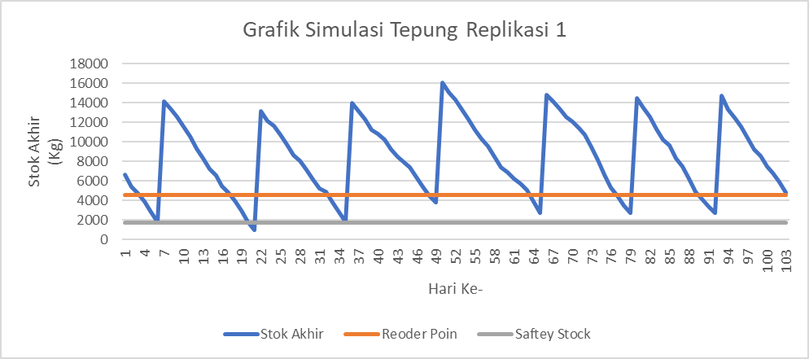

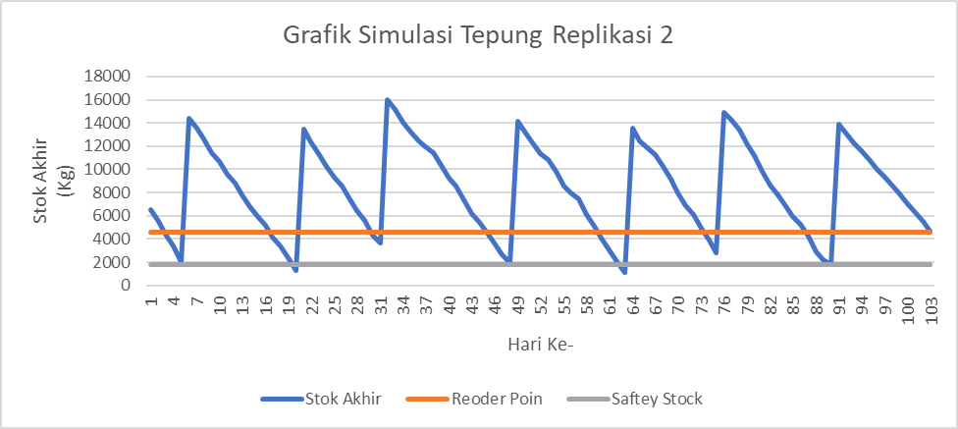

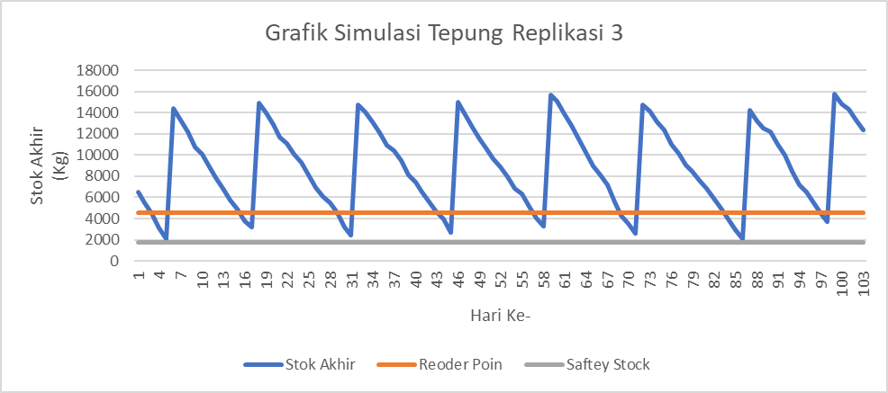

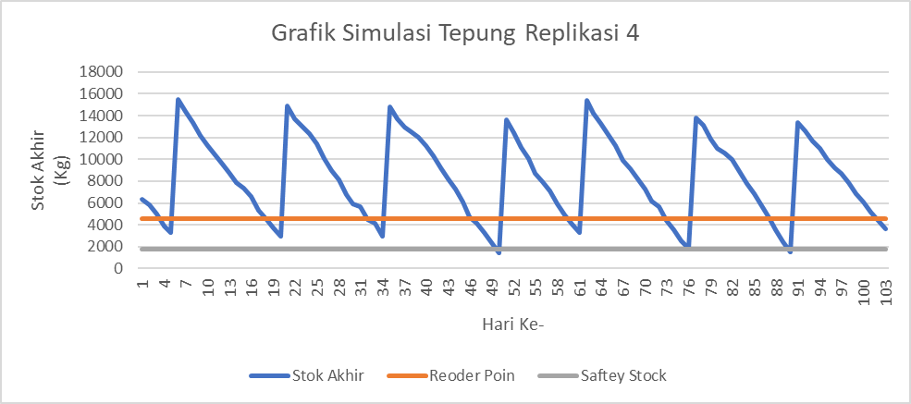

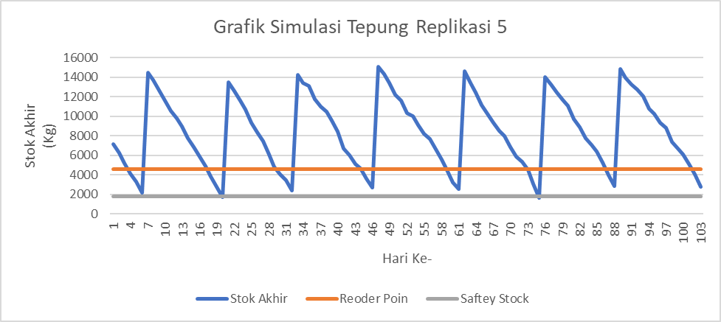

**Lampiran** 26 Grafik Hasil Simulasi Ubi Replikasi 1-5

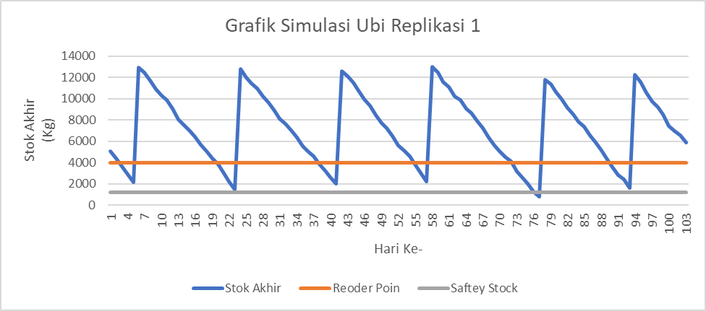

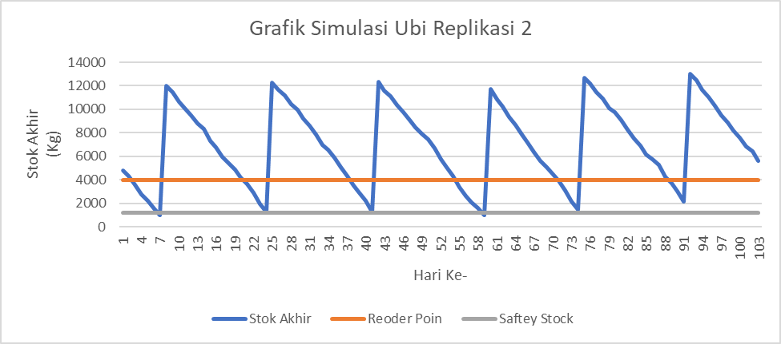

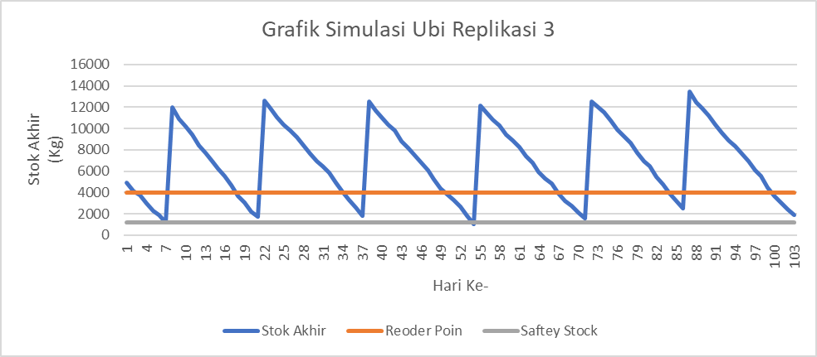

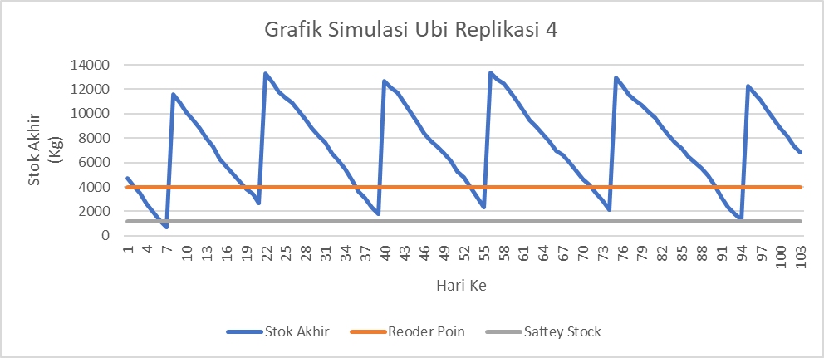

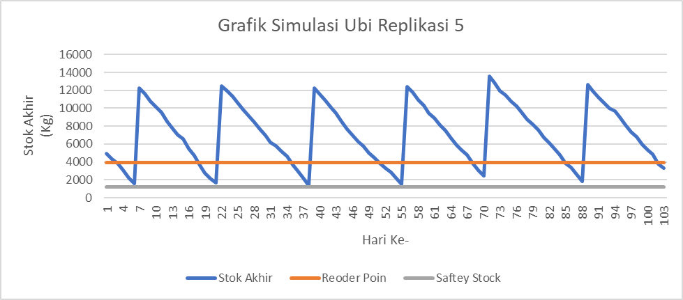

**Lampiran** 27 Grafik Hasil Simulasi Perisai Cabai Replikasi 1-5

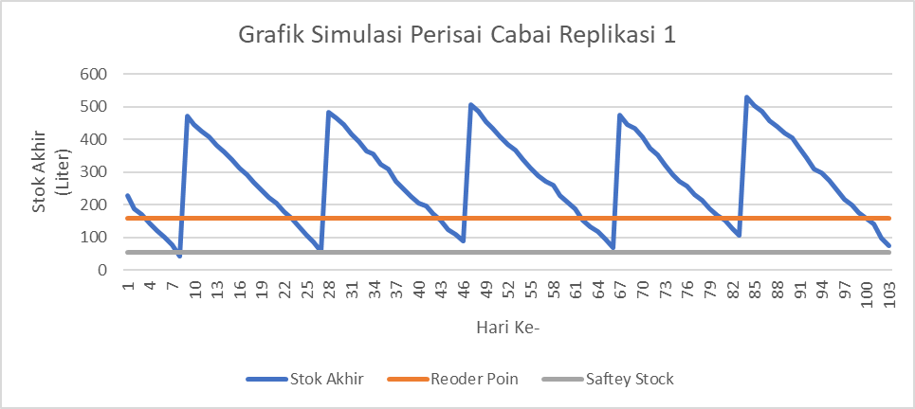

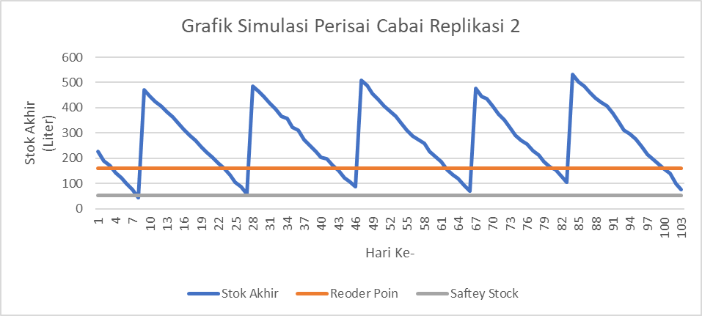

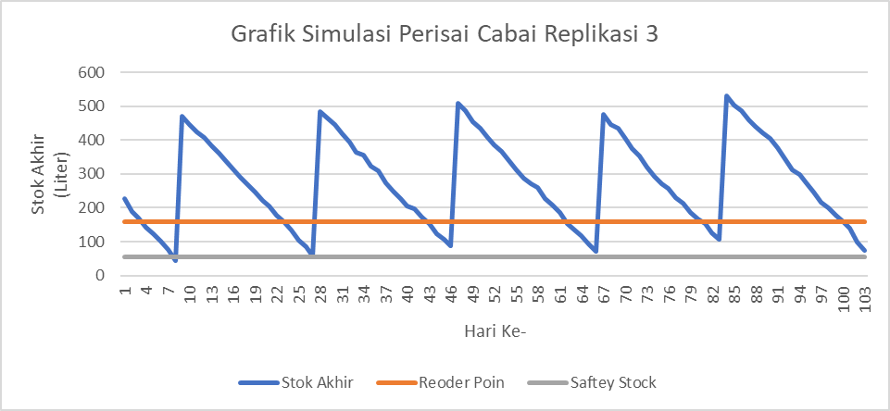

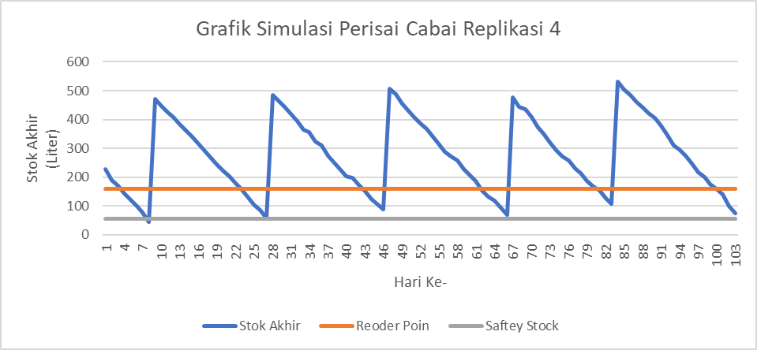

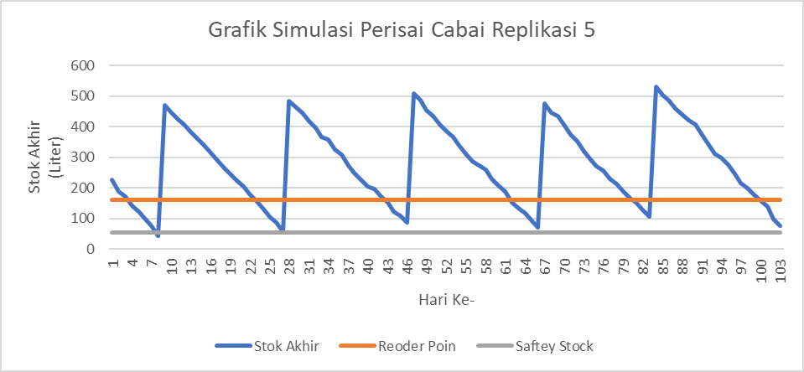

**Lampiran** 28 Kondisi Existing Tepung

| **Penggunaan Bahan Baku Tepung** | | | | | | | | |
| --- | --- | --- | --- | --- | --- | --- | --- | --- |
| **Tanggal** | **Hari** | **Stok Awal** | **Penggunaan Bahan Baku** | **Stok Akhir** | **Pesan** | ***Lead Time*** | **Sampai** | ***Shortage*** |
| 01/01/2024 | 1 | 7.550 | 800 | 6.750 |  |  |  |  |
| 02/01/2024 | 2 | 6.750 | 1040 | 5.710 |  |  |  |  |
| 03/01/2024 | 3 | 5.710 | 560 | 5.150 |  |  |  |  |
| 04/01/2024 | 4 | 5.150 | 880 | 4.270 |  |  |  |  |
| 05/01/2024 | 5 | 4.270 | 720 | 3.550 |  |  |  |  |
| 06/01/2024 | 6 | 3.550 | 1440 | 2.110 | Pesan | 2 |  |  |
| 07/01/2024 | 7 | 2.110 | 0 | 2.110 |  |  |  |  |
| 08/01/2024 | 8 | 2.110 | 1040 | 9.070 |  |  | 8000 |  |
| 09/01/2024 | 9 | 9.070 | 960 | 8.110 |  |  |  |  |
| 10/01/2024 | 10 | 8.110 | 1200 | 6.910 |  |  |  |  |
| 11/01/2024 | 11 | 6.910 | 800 | 6.110 |  |  |  |  |
| 12/01/2024 | 12 | 6.110 | 640 | 5.470 |  |  |  |  |
| 13/01/2024 | 13 | 5.470 | 1360 | 4.110 | Pesan | 4 |  |  |
| 14/01/2024 | 14 | 4.110 | 0 | 4.110 |  |  |  |  |
| 15/01/2024 | 15 | 4.110 | 720 | 3.390 |  |  |  |  |
| 16/01/2024 | 16 | 3.390 | 1120 | 2.270 |  |  |  |  |
| 17/01/2024 | 17 | 2.270 | 960 | 8.310 |  |  | 7000 |  |
| 18/01/2024 | 18 | 8.310 | 640 | 7.670 |  |  |  |  |
| 19/01/2024 | 19 | 7.670 | 480 | 7.190 |  |  |  |  |
| 20/01/2024 | 20 | 7.190 | 1200 | 5.990 |  |  |  |  |
| 21/01/2024 | 21 | 5.990 | 0 | 5.990 |  |  |  |  |
| 22/01/2024 | 22 | 5.990 | 1040 | 4.950 | Pesan | 3 |  |  |
| 23/01/2024 | 23 | 4.950 | 560 | 4.390 |  |  |  |  |
| 24/01/2024 | 24 | 4.390 | 880 | 3.510 |  |  |  |  |
| 25/01/2024 | 25 | 3.510 | 1440 | 9.570 |  |  | 7500 |  |
| 26/01/2024 | 26 | 9.570 | 480 | 9.090 |  |  |  |  |
| 27/01/2024 | 27 | 9.090 | 1120 | 7.970 |  |  |  |  |
| 28/01/2024 | 28 | 7.970 | 0 | 7.970 |  |  |  |  |
| 29/01/2024 | 29 | 7.970 | 960 | 7.010 |  |  |  |  |
| 30/01/2024 | 30 | 7.010 | 1200 | 5.810 |  |  |  |  |
| 31/01/2024 | 31 | 5.810 | 800 | 5.010 | Pesan | 3 |  |  |
| 01/02/2024 | 32 | 5.010 | 1040 | 3.970 |  |  |  |  |
| 02/02/2024 | 33 | 3.970 | 560 | 3.410 |  |  |  |  |
| 03/02/2024 | 34 | 3.410 | 880 | 9.530 |  |  | 7000 |  |
| 04/02/2024 | 35 | 9.530 | 0 | 9.530 |  |  |  |  |
| 05/02/2024 | 36 | 9.530 | 1120 | 8.410 |  |  |  |  |
| 06/02/2024 | 37 | 8.410 | 1200 | 7.210 |  |  |  |  |
| 07/02/2024 | 38 | 7.210 | 1280 | 5.930 |  |  |  |  |
| 08/02/2024 | 39 | 5.930 | 960 | 4.970 |  |  |  |  |
| 09/02/2024 | 40 | 4.970 | 480 | 4.490 |  |  |  |  |
| 10/02/2024 | 41 | 4.490 | 800 | 3.690 | Pesan | 2 |  |  |
| 11/02/2024 | 42 | 3.690 | 0 | 3.690 |  |  |  |  |
| 12/02/2024 | 43 | 3.690 | 560 | 9.630 |  |  | 6500 |  |
| 13/02/2024 | 44 | 9.630 | 880 | 8.750 |  |  |  |  |
| 14/02/2024 | 45 | 8.750 | 1440 | 7.310 |  |  |  |  |
| 15/02/2024 | 46 | 7.310 | 1120 | 6.190 |  |  |  |  |
| 16/02/2024 | 47 | 6.190 | 480 | 5.710 |  |  |  |  |
| 17/02/2024 | 48 | 5.710 | 1360 | 4.350 | Pesan | 2 |  |  |
| 18/02/2024 | 49 | 4.350 | 0 | 4.350 |  |  |  |  |
| 19/02/2024 | 50 | 4.350 | 1200 | 10.150 |  |  | 7000 |  |
| 20/02/2024 | 51 | 10.150 | 800 | 9.350 |  |  |  |  |
| 21/02/2024 | 52 | 9.350 | 1040 | 8.310 |  |  |  |  |
| 22/02/2024 | 53 | 8.310 | 560 | 7.750 |  |  |  |  |
| 23/02/2024 | 54 | 7.750 | 880 | 6.870 |  |  |  |  |
| 24/02/2024 | 55 | 6.870 | 720 | 6.150 | Pesan | 3 |  |  |
| 25/02/2024 | 56 | 6.150 | 0 | 6.150 |  |  |  |  |
| 26/02/2024 | 57 | 6.150 | 960 | 5.190 |  |  |  |  |
| 27/02/2024 | 58 | 5.190 | 640 | 11.550 |  |  | 7000 |  |
| 28/02/2024 | 59 | 11.550 | 960 | 10.590 |  |  |  |  |
| 29/02/2024 | 60 | 10.590 | 1200 | 9.390 |  |  |  |  |
| 01/03/2024 | 61 | 9.390 | 800 | 8.590 |  |  |  |  |
| 02/03/2024 | 62 | 8.590 | 1040 | 7.550 | Pesan | 4 |  |  |
| 03/03/2024 | 63 | 7.550 | 0 | 7.550 |  |  |  |  |
| 04/03/2024 | 64 | 7.550 | 880 | 6.670 |  |  |  |  |
| 05/03/2024 | 65 | 6.670 | 720 | 5.950 |  |  |  |  |
| 06/03/2024 | 66 | 5.950 | 1120 | 10.830 |  |  | 6000 |  |
| 07/03/2024 | 67 | 10.830 | 1440 | 9.390 |  |  |  |  |
| 08/03/2024 | 68 | 9.390 | 640 | 8.750 |  |  |  |  |
| 09/03/2024 | 69 | 8.750 | 960 | 7.790 |  |  |  |  |
| 10/03/2024 | 70 | 7.790 | 0 | 7.790 |  |  |  |  |
| 11/03/2024 | 71 | 7.790 | 800 | 6.990 | Pesan | 3 |  |  |
| 12/03/2024 | 72 | 6.990 | 1040 | 5.950 |  |  |  |  |
| 13/03/2024 | 73 | 5.950 | 1440 | 4.510 |  |  |  |  |
| 14/03/2024 | 74 | 4.510 | 880 | 9.630 |  |  | 6000 |  |
| 15/03/2024 | 75 | 9.630 | 560 | 9.070 |  |  |  |  |
| 16/03/2024 | 76 | 9.070 | 1120 | 7.950 |  |  |  |  |
| 17/03/2024 | 77 | 7.950 | 0 | 7.950 |  |  |  |  |
| 18/03/2024 | 78 | 7.950 | 1440 | 6.510 |  |  |  |  |
| 19/03/2024 | 79 | 6.510 | 960 | 5.550 | Pesan | 3 |  |  |
| 20/03/2024 | 80 | 5.550 | 1200 | 4.350 |  |  |  |  |
| 21/03/2024 | 81 | 4.350 | 800 | 3.550 |  |  |  |  |
| 22/03/2024 | 82 | 3.550 | 560 | 9.490 |  |  | 6500 |  |
| 23/03/2024 | 83 | 9.490 | 960 | 8.530 |  |  |  |  |
| 24/03/2024 | 84 | 8.530 | 0 | 8.530 |  |  |  |  |
| 25/03/2024 | 85 | 8.530 | 720 | 7.810 |  |  |  |  |
| 26/03/2024 | 86 | 7.810 | 1120 | 6.690 |  |  |  |  |
| 27/03/2024 | 87 | 6.690 | 1440 | 5.250 |  |  |  |  |
| 28/03/2024 | 88 | 5.250 | 960 | 4.290 | Pesan | 2 |  |  |
| 29/03/2024 | 89 | 4.290 | 640 | 3.650 |  |  |  |  |
| 30/03/2024 | 90 | 3.650 | 1200 | 9.450 |  |  | 7000 |  |
| 31/03/2024 | 91 | 9.450 | 0 | 9.450 |  |  |  |  |
| 01/04/2024 | 92 | 9.450 | 1040 | 8.410 |  |  |  |  |
| 02/04/2024 | 93 | 8.410 | 1440 | 6.970 |  |  |  |  |
| 03/04/2024 | 94 | 6.970 | 880 | 6.090 |  |  |  |  |
| 04/04/2024 | 95 | 6.090 | 1120 | 4.970 |  |  |  |  |
| 05/04/2024 | 96 | 4.970 | 560 | 4.410 |  |  |  |  |
| 06/04/2024 | 97 | 4.410 | 720 | 3.690 | Pesan | 2 |  |  |
| 07/04/2024 | 98 | 3.690 | 960 | 2.730 |  |  |  |  |
| 08/04/2024 | 99 | 2.730 | 1200 | 8.030 |  |  | 6500 |  |
| 09/04/2024 | 100 | 8.030 | 0 | 8.030 |  |  |  |  |
| 10/04/2024 | 101 | 8.030 | 0 | 8.030 |  |  |  |  |
| 11/04/2024 | 102 | 8.030 | 1040 | 6.990 |  |  |  |  |
| 12/04/2024 | 103 | 6.990 | 560 | 6.430 |  |  |  |  |
| 13/04/2024 | 104 | 6.430 | 880 | 5.550 |  |  |  |  |
| 14/04/2024 | 105 | 5.550 | 0 | 5.550 |  |  |  |  |
| 15/04/2024 | 106 | 5.550 | 1120 | 4.430 | Pesan | 3 |  |  |
| 16/04/2024 | 107 | 4.430 | 1120 | 3.310 |  |  |  |  |
| 17/04/2024 | 108 | 3.310 | 1040 | 2.270 |  |  |  |  |
| 18/04/2024 | 109 | 2.270 | 960 | 7.310 |  |  | 6000 |  |
| 19/04/2024 | 110 | 7.310 | 480 | 6.830 |  |  |  |  |
| 20/04/2024 | 111 | 6.830 | 800 | 6.030 |  |  |  |  |
| 21/04/2024 | 112 | 6.030 | 0 | 6.030 |  |  |  |  |
| 22/04/2024 | 113 | 6.030 | 560 | 5.470 | Pesan | 4 |  |  |
| 23/04/2024 | 114 | 5.470 | 880 | 4.590 |  |  |  |  |
| 24/04/2024 | 115 | 4.590 | 720 | 3.870 |  |  |  |  |
| 25/04/2024 | 116 | 3.870 | 1120 | 2.750 |  |  |  |  |
| 26/04/2024 | 117 | 2.750 | 480 | 9.770 |  |  | 7500 |  |
| 27/04/2024 | 118 | 9.770 | 1440 | 8.330 |  |  |  |  |
| 28/04/2024 | 119 | 8.330 | 0 | 8.330 |  |  |  |  |
| 29/04/2024 | 120 | 8.330 | 1200 | 7.130 |  |  |  |  |
| 30/04/2024 | 121 | 7.130 | 960 | 6.170 |  |  |  |  |

**Lampiran** 29 Kondisi Existing Ubi

| **Penggunaan Bahan Baku Ubi** | | | | | | | | |
| --- | --- | --- | --- | --- | --- | --- | --- | --- |
| **Tanggal** | **Hari** | **Stok Awal** | **Penggunaan Bahan Baku** | **Stok Akhir** | **Pesan** | ***Lead Time*** | **Sampai** | ***Shortage*** |
| 01/01/2024 | 1 | 5.575 | 602 | 4.973 |  |  |  |  |
| 02/01/2024 | 2 | 4.973 | 750 | 4.223 |  |  |  |  |
| 03/01/2024 | 3 | 4.223 | 453 | 3.770 |  |  |  |  |
| 04/01/2024 | 4 | 3.770 | 651 | 3.119 |  |  |  |  |
| 05/01/2024 | 5 | 3.119 | 554 | 2.565 | Pesan | 3 |  |  |
| 06/01/2024 | 6 | 2.565 | 1002 | 1.563 |  |  |  |  |
| 07/01/2024 | 7 | 1.563 | 0 | 1.563 |  |  |  |  |
| 08/01/2024 | 8 | 1.563 | 753 | 7.010 |  |  | 6200 |  |
| 09/01/2024 | 9 | 7.010 | 701 | 6.309 |  |  |  |  |
| 10/01/2024 | 10 | 6.309 | 850 | 5.459 |  |  |  |  |
| 11/01/2024 | 11 | 5.459 | 604 | 4.855 |  |  |  |  |
| 12/01/2024 | 12 | 4.855 | 502 | 4.353 |  |  |  |  |
| 13/01/2024 | 13 | 4.353 | 951 | 3.402 |  |  |  |  |
| 14/01/2024 | 14 | 3.402 | 0 | 3.402 | Pesan | 4 |  |  |
| 15/01/2024 | 15 | 3.402 | 553 | 2.849 |  |  |  |  |
| 16/01/2024 | 16 | 2.849 | 800 | 2.049 |  |  |  |  |
| 17/01/2024 | 17 | 2.049 | 704 | 1.345 |  |  |  |  |
| 18/01/2024 | 18 | 1.345 | 502 | 6.843 | 12.843 |  | 6000 |  |
| 19/01/2024 | 19 | 6.843 | 401 | 6.442 |  |  |  |  |
| 20/01/2024 | 20 | 6.442 | 853 | 5.589 |  |  |  |  |
| 21/01/2024 | 21 | 5.589 | 0 | 5.589 |  |  |  |  |
| 22/01/2024 | 22 | 5.589 | 754 | 4.835 |  |  |  |  |
| 23/01/2024 | 23 | 4.835 | 450 | 4.385 |  |  |  |  |
| 24/01/2024 | 24 | 4.385 | 651 | 3.734 |  |  |  |  |
| 25/01/2024 | 25 | 3.734 | 1002 | 2.732 |  |  |  |  |
| 26/01/2024 | 26 | 2.732 | 403 | 2.329 | Pesan | 3 |  |  |
| 27/01/2024 | 27 | 2.329 | 804 | 1.525 |  |  |  |  |
| 28/01/2024 | 28 | 1.525 | 0 | 1.525 |  |  |  |  |
| 29/01/2024 | 29 | 1.525 | 700 | 7.325 | 13.825 |  | 6500 |  |
| 30/01/2024 | 30 | 7.325 | 852 | 6.473 |  |  |  |  |
| 31/01/2024 | 31 | 6.473 | 601 | 5.872 |  |  |  |  |
| 01/02/2024 | 32 | 5.872 | 754 | 5.118 |  |  |  |  |
| 02/02/2024 | 33 | 5.118 | 453 | 4.665 | Pesan | 5 |  |  |
| 03/02/2024 | 34 | 4.665 | 650 | 4.015 |  |  |  |  |
| 04/02/2024 | 35 | 4.015 | 0 | 4.015 |  |  |  |  |
| 05/02/2024 | 36 | 4.015 | 802 | 3.213 |  |  |  |  |
| 06/02/2024 | 37 | 3.213 | 851 | 2.362 |  |  |  |  |
| 07/02/2024 | 38 | 2.362 | 903 | 7.459 | 13.459 |  | 6000 |  |
| 08/02/2024 | 39 | 7.459 | 704 | 6.755 |  |  |  |  |
| 09/02/2024 | 40 | 6.755 | 400 | 6.355 |  |  |  |  |
| 10/02/2024 | 41 | 6.355 | 602 | 5.753 |  |  |  |  |
| 11/02/2024 | 42 | 5.753 | 0 | 5.753 |  |  |  |  |
| 12/02/2024 | 43 | 5.753 | 451 | 5.302 |  |  |  |  |
| 13/02/2024 | 44 | 5.302 | 654 | 4.648 |  |  |  |  |
| 14/02/2024 | 45 | 4.648 | 1003 | 3.645 |  |  |  |  |
| 15/02/2024 | 46 | 3.645 | 800 | 2.845 | Pesan | 4 |  |  |
| 16/02/2024 | 47 | 2.845 | 402 | 2.443 |  |  |  |  |
| 17/02/2024 | 48 | 2.443 | 951 | 1.492 |  |  |  |  |
| 18/02/2024 | 49 | 1.492 | 0 | 1.492 |  |  |  |  |
| 19/02/2024 | 50 | 1.492 | 853 | 7.139 | 13.639 |  | 6500 |  |
| 20/02/2024 | 51 | 7.139 | 604 | 6.535 |  |  |  |  |
| 21/02/2024 | 52 | 6.535 | 750 | 5.785 |  |  |  |  |
| 22/02/2024 | 53 | 5.785 | 452 | 5.333 |  |  |  |  |
| 23/02/2024 | 54 | 5.333 | 651 | 4.682 |  |  |  |  |
| 24/02/2024 | 55 | 4.682 | 554 | 4.128 |  |  |  |  |
| 25/02/2024 | 56 | 4.128 | 0 | 4.128 |  |  |  |  |
| 26/02/2024 | 57 | 4.128 | 703 | 3.425 |  |  |  |  |
| 27/02/2024 | 58 | 3.425 | 500 | 2.925 | Pesan | 3 |  |  |
| 28/02/2024 | 59 | 2.925 | 702 | 2.223 |  |  |  |  |
| 29/02/2024 | 60 | 2.223 | 851 | 1.372 |  |  |  |  |
| 01/03/2024 | 61 | 1.372 | 603 | 6.769 | 12.769 |  | 6000 |  |
| 02/03/2024 | 62 | 6.769 | 754 | 6.015 |  |  |  |  |
| 03/03/2024 | 63 | 6.015 | 0 | 6.015 |  |  |  |  |
| 04/03/2024 | 64 | 6.015 | 650 | 5.365 |  |  |  |  |
| 05/03/2024 | 65 | 5.365 | 552 | 4.813 |  |  |  |  |
| 06/03/2024 | 66 | 4.813 | 801 | 4.012 |  |  |  |  |
| 07/03/2024 | 67 | 4.012 | 1004 | 3.008 |  |  |  |  |
| 08/03/2024 | 68 | 3.008 | 503 | 2.505 | Pesan | 4 |  |  |
| 09/03/2024 | 69 | 2.505 | 700 | 1.805 |  |  |  |  |
| 10/03/2024 | 70 | 1.805 | 0 | 1.805 |  |  |  |  |
| 11/03/2024 | 71 | 1.805 | 602 | 1.203 |  |  |  |  |
| 12/03/2024 | 72 | 1.203 | 751 | 7.952 | 15.452 |  | 7500 |  |
| 13/03/2024 | 73 | 7.952 | 1003 | 6.949 |  |  |  |  |
| 14/03/2024 | 74 | 6.949 | 654 | 6.295 |  |  |  |  |
| 15/03/2024 | 75 | 6.295 | 450 | 5.845 |  |  |  |  |
| 16/03/2024 | 76 | 5.845 | 802 | 5.043 |  |  |  |  |
| 17/03/2024 | 77 | 5.043 | 0 | 5.043 |  |  |  |  |
| 18/03/2024 | 78 | 5.043 | 1001 | 4.042 |  |  |  |  |
| 19/03/2024 | 79 | 4.042 | 704 | 3.338 |  |  |  |  |
| 20/03/2024 | 80 | 3.338 | 853 | 2.485 | Pesan | 5 |  |  |
| 21/03/2024 | 81 | 2.485 | 600 | 1.885 |  |  |  |  |
| 22/03/2024 | 82 | 1.885 | 452 | 1.433 |  |  |  |  |
| 23/03/2024 | 83 | 1.433 | 701 | 732 |  |  |  |  |
| 24/03/2024 | 84 | 732 | 0 | 732 |  |  |  |  |
| 25/03/2024 | 85 | 732 | 553 | 6.179 | 12.179 |  | 6000 |  |
| 26/03/2024 | 86 | 6.179 | 804 | 5.375 |  |  |  |  |
| 27/03/2024 | 87 | 5.375 | 1000 | 4.375 |  |  |  |  |
| 28/03/2024 | 88 | 4.375 | 702 | 3.673 |  |  |  |  |
| 29/03/2024 | 89 | 3.673 | 501 | 3.172 | Pesan | 3 |  |  |
| 30/03/2024 | 90 | 3.172 | 854 | 2.318 |  |  |  |  |
| 31/03/2024 | 91 | 2.318 | 0 | 2.318 |  |  |  |  |
| 01/04/2024 | 92 | 2.318 | 753 | 8.065 | 14.565 |  | 6500 |  |
| 02/04/2024 | 93 | 8.065 | 1000 | 7.065 |  |  |  |  |
| 03/04/2024 | 94 | 7.065 | 652 | 6.413 |  |  |  |  |
| 04/04/2024 | 95 | 6.413 | 801 | 5.612 |  |  |  |  |
| 05/04/2024 | 96 | 5.612 | 453 | 5.159 |  |  |  |  |
| 06/04/2024 | 97 | 5.159 | 554 | 4.605 |  |  |  |  |
| 07/04/2024 | 98 | 4.605 | 700 | 3.905 |  |  |  |  |
| 08/04/2024 | 99 | 3.905 | 852 | 3.053 | Pesan | 4 |  |  |
| 09/04/2024 | 100 | 3.053 | 0 | 3.053 |  |  |  |  |
| 10/04/2024 | 101 | 3.053 | 751 | 2.302 |  |  |  |  |
| 11/04/2024 | 102 | 2.302 | 454 | 1.848 |  |  |  |  |
| 12/04/2024 | 103 | 1.848 | 653 | 8.195 | 15.195 |  | 7000 |  |
| 13/04/2024 | 104 | 8.195 | 0 | 8.195 |  |  |  |  |
| 14/04/2024 | 105 | 8.195 | 800 | 7.395 |  |  |  |  |
| 15/04/2024 | 106 | 7.395 | 802 | 6.593 |  |  |  |  |
| 16/04/2024 | 107 | 6.593 | 751 | 5.842 |  |  |  |  |
| 17/04/2024 | 108 | 5.842 | 703 | 5.139 |  |  |  |  |
| 18/04/2024 | 109 | 5.139 | 404 | 4.735 |  |  |  |  |
| 19/04/2024 | 110 | 4.735 | 600 | 4.135 |  |  |  |  |
| 20/04/2024 | 111 | 4.135 | 0 | 4.135 |  |  |  |  |
| 21/04/2024 | 112 | 4.135 | 452 | 3.683 |  |  |  |  |
| 22/04/2024 | 113 | 3.683 | 651 | 3.032 | Pesan | 5 |  |  |
| 23/04/2024 | 114 | 3.032 | 554 | 2.478 |  |  |  |  |
| 24/04/2024 | 115 | 2.478 | 803 | 1.675 |  |  |  |  |
| 25/04/2024 | 116 | 1.675 | 400 | 1.275 |  |  |  |  |
| 26/04/2024 | 117 | 1.275 | 1002 | 273 |  |  |  |  |
| 27/04/2024 | 118 | 273 | 0 | 6.773 | 13.273 |  | 6500 |  |
| 28/04/2024 | 119 | 6.773 | 851 | 5.922 |  |  |  |  |
| 29/04/2024 | 120 | 5.922 | 703 | 5.219 |  |  |  |  |
| 30/04/2024 | 121 | 5.219 | 604 | 4.615 |  |  |  |  |

**Lampiran** 30 Kondisi Existing Perisai Cabai

| **Penggunaan Bahan Baku Perisai Cabai** | | | | | | | | |
| --- | --- | --- | --- | --- | --- | --- | --- | --- |
| **Tanggal** | **Hari** | **Stok Awal** | **Penggunaan Bahan Baku** | **Stok Akhir** | **Pesan** | ***Lead Time*** | **Sampai** | ***Shortage*** |
| 01/01/2024 | 1 | 245 | 20 | 225 |  |  |  |  |
| 02/01/2024 | 2 | 225 | 26 | 199 |  |  |  |  |
| 03/01/2024 | 3 | 199 | 14 | 185 |  |  |  |  |
| 04/01/2024 | 4 | 185 | 22 | 163 |  |  |  |  |
| 05/01/2024 | 5 | 163 | 18 | 145 |  |  |  |  |
| 06/01/2024 | 6 | 145 | 36 | 109 |  |  |  |  |
| 07/01/2024 | 7 | 109 | 0 | 109 |  |  |  |  |
| 08/01/2024 | 8 | 109 | 26 | 83 | Pesan | 3 |  |  |
| 09/01/2024 | 9 | 83 | 24 | 59 |  |  |  |  |
| 10/01/2024 | 10 | 59 | 30 | 29 |  |  |  |  |
| 11/01/2024 | 11 | 29 | 20 | 309 |  |  | 300 |  |
| 12/01/2024 | 12 | 309 | 16 | 293 |  |  |  |  |
| 13/01/2024 | 13 | 293 | 34 | 259 |  |  |  |  |
| 14/01/2024 | 14 | 259 | 0 | 259 |  |  |  |  |
| 15/01/2024 | 15 | 259 | 18 | 241 |  |  |  |  |
| 16/01/2024 | 16 | 241 | 28 | 213 |  |  |  |  |
| 17/01/2024 | 17 | 213 | 24 | 189 |  |  |  |  |
| 18/01/2024 | 18 | 189 | 16 | 173 |  |  |  |  |
| 19/01/2024 | 19 | 173 | 12 | 161 |  |  |  |  |
| 20/01/2024 | 20 | 161 | 30 | 131 | Pesan | 6 |  |  |
| 21/01/2024 | 21 | 131 | 0 | 131 |  |  |  |  |
| 22/01/2024 | 22 | 131 | 26 | 105 |  |  |  |  |
| 23/01/2024 | 23 | 105 | 14 | 91 |  |  |  |  |
| 24/01/2024 | 24 | 91 | 22 | 69 |  |  |  |  |
| 25/01/2024 | 25 | 69 | 36 | 33 |  |  |  |  |
| 26/01/2024 | 26 | 33 | 12 | 371 |  |  | 350 |  |
| 27/01/2024 | 27 | 371 | 28 | 343 |  |  |  |  |
| 28/01/2024 | 28 | 343 | 0 | 343 |  |  |  |  |
| 29/01/2024 | 29 | 343 | 24 | 319 |  |  |  |  |
| 30/01/2024 | 30 | 319 | 30 | 289 |  |  |  |  |
| 31/01/2024 | 31 | 289 | 20 | 269 |  |  |  |  |
| 01/02/2024 | 32 | 269 | 26 | 243 |  |  |  |  |
| 02/02/2024 | 33 | 243 | 14 | 229 |  |  |  |  |
| 03/02/2024 | 34 | 229 | 22 | 207 |  |  |  |  |
| 04/02/2024 | 35 | 207 | 0 | 207 |  |  |  |  |
| 05/02/2024 | 36 | 207 | 28 | 179 |  |  |  |  |
| 06/02/2024 | 37 | 179 | 30 | 149 | Pesan | 4 |  |  |
| 07/02/2024 | 38 | 149 | 32 | 117 |  |  |  |  |
| 08/02/2024 | 39 | 117 | 24 | 93 |  |  |  |  |
| 09/02/2024 | 40 | 93 | 12 | 81 |  |  |  |  |
| 10/02/2024 | 41 | 81 | 20 | 461 |  |  | 400 |  |
| 11/02/2024 | 42 | 461 | 0 | 461 |  |  |  |  |
| 12/02/2024 | 43 | 461 | 14 | 447 |  |  |  |  |
| 13/02/2024 | 44 | 447 | 22 | 425 |  |  |  |  |
| 14/02/2024 | 45 | 425 | 36 | 389 |  |  |  |  |
| 15/02/2024 | 46 | 389 | 28 | 361 |  |  |  |  |
| 16/02/2024 | 47 | 361 | 12 | 349 |  |  |  |  |
| 17/02/2024 | 48 | 349 | 34 | 315 |  |  |  |  |
| 18/02/2024 | 49 | 315 | 0 | 315 |  |  |  |  |
| 19/02/2024 | 50 | 315 | 30 | 285 |  |  |  |  |
| 20/02/2024 | 51 | 285 | 20 | 265 |  |  |  |  |
| 21/02/2024 | 52 | 265 | 26 | 239 |  |  |  |  |
| 22/02/2024 | 53 | 239 | 14 | 225 |  |  |  |  |
| 23/02/2024 | 54 | 225 | 22 | 203 | Pesan | 5 |  |  |
| 24/02/2024 | 55 | 203 | 18 | 185 |  |  |  |  |
| 25/02/2024 | 56 | 185 | 0 | 185 |  |  |  |  |
| 26/02/2024 | 57 | 185 | 24 | 161 |  |  |  |  |
| 27/02/2024 | 58 | 161 | 16 | 145 |  |  |  |  |
| 28/02/2024 | 59 | 145 | 24 | 496 |  |  | 375 |  |
| 29/02/2024 | 60 | 496 | 30 | 466 |  |  |  |  |
| 01/03/2024 | 61 | 466 | 20 | 446 |  |  |  |  |
| 02/03/2024 | 62 | 446 | 26 | 420 |  |  |  |  |
| 03/03/2024 | 63 | 420 | 0 | 420 |  |  |  |  |
| 04/03/2024 | 64 | 420 | 22 | 398 |  |  |  |  |
| 05/03/2024 | 65 | 398 | 18 | 380 |  |  |  |  |
| 06/03/2024 | 66 | 380 | 28 | 352 |  |  |  |  |
| 07/03/2024 | 67 | 352 | 36 | 316 |  |  |  |  |
| 08/03/2024 | 68 | 316 | 16 | 300 |  |  |  |  |
| 09/03/2024 | 69 | 300 | 24 | 276 |  |  |  |  |
| 10/03/2024 | 70 | 276 | 0 | 276 |  |  |  |  |
| 11/03/2024 | 71 | 276 | 20 | 256 | Pesan | 4 |  |  |
| 12/03/2024 | 72 | 256 | 26 | 230 |  |  |  |  |
| 13/03/2024 | 73 | 230 | 36 | 194 |  |  |  |  |
| 14/03/2024 | 74 | 194 | 22 | 172 |  |  |  |  |
| 15/03/2024 | 75 | 172 | 14 | 488 |  |  | 330 |  |
| 16/03/2024 | 76 | 488 | 28 | 460 |  |  |  |  |
| 17/03/2024 | 77 | 460 | 0 | 460 |  |  |  |  |
| 18/03/2024 | 78 | 460 | 36 | 424 |  |  |  |  |
| 19/03/2024 | 79 | 424 | 24 | 400 |  |  |  |  |
| 20/03/2024 | 80 | 400 | 30 | 370 |  |  |  |  |
| 21/03/2024 | 81 | 370 | 20 | 350 |  |  |  |  |
| 22/03/2024 | 82 | 350 | 14 | 336 |  |  |  |  |
| 23/03/2024 | 83 | 336 | 24 | 312 |  |  |  |  |
| 24/03/2024 | 84 | 312 | 0 | 312 |  |  |  |  |
| 25/03/2024 | 85 | 312 | 18 | 294 |  |  |  |  |
| 26/03/2024 | 86 | 294 | 28 | 266 |  |  |  |  |
| 27/03/2024 | 87 | 266 | 36 | 230 | Pesan | 5 |  |  |
| 28/03/2024 | 88 | 230 | 24 | 206 |  |  |  |  |
| 29/03/2024 | 89 | 206 | 16 | 190 |  |  |  |  |
| 30/03/2024 | 90 | 190 | 30 | 160 |  |  |  |  |
| 31/03/2024 | 91 | 160 | 0 | 160 |  |  |  |  |
| 01/04/2024 | 92 | 160 | 26 | 494 |  |  | 360 |  |
| 02/04/2024 | 93 | 494 | 36 | 458 |  |  |  |  |
| 03/04/2024 | 94 | 458 | 22 | 436 |  |  |  |  |
| 04/04/2024 | 95 | 436 | 28 | 408 |  |  |  |  |
| 05/04/2024 | 96 | 408 | 14 | 394 |  |  |  |  |
| 06/04/2024 | 97 | 394 | 18 | 376 |  |  |  |  |
| 07/04/2024 | 98 | 376 | 24 | 352 |  |  |  |  |
| 08/04/2024 | 99 | 352 | 30 | 322 |  |  |  |  |
| 09/04/2024 | 100 | 322 | 0 | 322 |  |  |  |  |
| 10/04/2024 | 101 | 322 | 0 | 322 |  |  |  |  |
| 11/04/2024 | 102 | 322 | 26 | 296 |  |  |  |  |
| 12/04/2024 | 103 | 296 | 14 | 282 |  |  |  |  |
| 13/04/2024 | 104 | 282 | 22 | 260 | Pesan | 3 |  |  |
| 14/04/2024 | 105 | 260 | 0 | 260 |  |  |  |  |
| 15/04/2024 | 106 | 260 | 28 | 232 |  |  |  |  |
| 16/04/2024 | 107 | 232 | 28 | 554 |  |  | 350 |  |
| 17/04/2024 | 108 | 554 | 26 | 528 |  |  |  |  |
| 18/04/2024 | 109 | 528 | 24 | 504 |  |  |  |  |
| 19/04/2024 | 110 | 504 | 12 | 492 |  |  |  |  |
| 20/04/2024 | 111 | 492 | 20 | 472 |  |  |  |  |
| 21/04/2024 | 112 | 472 | 0 | 472 |  |  |  |  |
| 22/04/2024 | 113 | 472 | 14 | 458 |  |  |  |  |
| 23/04/2024 | 114 | 458 | 22 | 436 |  |  |  |  |
| 24/04/2024 | 115 | 436 | 18 | 418 |  |  |  |  |
| 25/04/2024 | 116 | 418 | 28 | 390 |  |  |  |  |
| 26/04/2024 | 117 | 390 | 12 | 378 |  |  |  |  |
| 27/04/2024 | 118 | 378 | 36 | 342 |  |  |  |  |
| 28/04/2024 | 119 | 342 | 0 | 342 |  |  |  |  |
| 29/04/2024 | 120 | 342 | 30 | 312 |  |  |  |  |
| 30/04/2024 | 121 | 312 | 24 | 288 |  |  |  |  |

**Lampiran** 31 Dokumentasi Penelitian

