DAFTAR PUSTAKA
Adityarini, C. (2022). Pengaruh Komunikasi Interpersonal dan Self Efficacy Terhadap Kinerja Pegawai. https://journal-nusantara.com/index.php/JIM/article/view/357
Afandi, P. (2018). MANAJEMEN SUMBER DAYA MANUSIA (Teori, Konsep dan Indikator). ZANAFA PUBLISHING.
Aprialitrama, H. . (2024). Pengaruh Stres, Motivasi, dan Kepuasan Terhadap Kinerja Pegawai YOI CONA CAFE SPACE Surabaya. Jurnal Ilmu Dan Riset Manajemen. http://jurnalmahasiswa.stiesia.ac.id/index.php/jirm/article/view/5509
Ariasih, S., Suryani, M. (2024). Pengaruh Kepemimpinan, Komunikasi Interpersonal, dan Self Efficacy Terhadap Kinerja Pegawai Warung Mina Dalung. Jurnal EMAS. https://e-journal.unmas.ac.id/index.php/emas/article/view/4176
Bangun, W. (2012). Manajemen Sumber Daya Manusia. Erlangga.
Busro, M. (2013). Teori-Teori Manajamen Sumber Daya Manusia. Prenamedia Group.
Fahmi. (2017). Manajemen Sumber Daya Manusia. Alfabeta.
Handoko, H. (2024). Manajemen Personalia & Sumber Daya Manusia (edisi ke 2). BPEE-Yogyakarta.
Hasibuan. (2018a). Pengaruh Kompetensi, Motivasi, Komunikasi dan Kesejahteraan terhadap Kinerja Pegawai Dinas Pendidikan. https://ejurnal.unisri.ac.id/index.php/Manajemen/article/view/88
Hasibuan, M. S. (2018b). Manajemen Sumber Daya Manusia. Bumi Aksara.
Ivancevich , J. K., M. (2006). Perilaku dan Manajemen Organisasi. Erlangga.
Juniarti, A. P. (2020). Pengaruh Pelatihan, Kompensasi, dan Disiplin Kerja Terhadap Kinerja Pegawai PT Sari Coffee Indonesia. Jurnal Ilmu Dan Riset Manajemen. http://jurnalmahasiswa.stiesia.ac.id/index.php/jirm/article/view/3543
Khifni Nasif, I. N. (2016). Analisis Reward Outsourcing Dalam Perspektif Pegawai PT Spirit Krida Indonesia. https://smartlib.umri.ac.id/assets/uploads/files/88392-1956-8639-1-pb.pdf
Mahdi, R. F., Setiawati, I., Puspitasari, R. H. (2024). Pengaruh Komunikasi Interpersonal, Self Efficacy, dan Keselamatan Kerja Terhadap Kinerja Driver Grab Di Kota Semarang. Jurnal Manajemen Dan Bisnis, 01–09. https://journal.yp3a.org/index.php/manabis/article/view/1542
Mangkunegara. (2013). Manajemen Sumber Daya Manusia Perusahaan. Rosdakarya.
Mangkunegara. (2017). Evaluasi Kinerja SDM. Refika Aditama.
Nawawi, H. (2017). Manajemen Sumber Daya Manusia. Universitas Gadjah Mada.
Nompo, V. G., Pandowow, M. H. (2020). Pengaruh Komunikasi Interpersonal, Self Efficacy, dan Disiplin Kerja Terhadap Kinerja Pegawai Di PT.Pegadaian (Persero) Kanwil V Manado. Jurnal Ekonomi, Manajemen, Bisnis, Dan Akuntansi, 288–299. https://ejournal.unsrat.ac.id/index.php/emba/article/view/30754
Panggabean, M. S. (2013). Manajemen Sumber Daya Manusia Perusahaan. Rosdakarya.
Pratama, F. Y. (2024). Pengaruh Kesejahteraan dan Semangat Kerja Terhadap Kinerja Pegawai CV.Gawanta Sejahtera Gemilang Kabupaten Kediri. Jurnal Manajemen Dan Ekonomi Syariah, 149–159. https://journal.staiypiqbaubau.ac.id/index.php/Maslahah/article/view/259
Purnomo, S. (2021). PENGARUH KOMUNIKASI INTERPERSONAL DAN SELF EFFICACYTERHADAP KINERJA PEGAWAI PADA PT PLN (PERSERO)UNIT PELAKSANA PELAYANAN PELANGGAN (UP3) BOGOR. https://ojspustek.org/index.php/SJR/article/view/375
Purwanto, M. N. (2021). Prinsip - Prinsip dan Teknik Evaluasi Pengajaran. Rosdakarya.
Radjapati, T. Y., Soepeno, D., & Tumbuan, W. J. F. A. (2018). Pengaruh Periklanan , Promosi Penjualan dan Personal Selling Terhadap Keputusan Pembelian Kartu Telkomsel di Tobelo The Influence Of Advertising , Sales Promotion and Personal Selling Buying Decision Simcard Telkomsel in Tobelo. Jurnal EMBA, 6(4).
Rivai. (2014). Manajemen Sumber Daya Manusia Untuk Perusahaan dari Teori ke Praktik. Raja Grafindo Persada.
Robbins , S. P., & Judge, T. A. (2016). Perilaku Organisasi (edisi 16). Salemba Empat.
Saidah, M. (2017). Pengaruh Pendidikan, Kompetensi, Disiplin, dan Reward Terhadap Kinerja Pegawai Supermarket Sakinah Surabaya. Jurnal Ekonomi Islam, 261–274. https://jurnal.yudharta.ac.id/v2/index.php/malia/article/download/3395/2261
Saputra, Nurlina, & H. (2017). Pengaruh Komunikasi Interpersonal Dan Self Efficacy Terhadap Kinerja Pegawai. https://repository.uin-suska.ac.id/48808/2/SKRIPSI LENGKAP KECUALI BAB V.pdf
Sari, S. S. M. (2021). PENGARUH MOTIVASI, KOMUNIKASI INTERPERSONAL DAN SELF EFFICACY TERHADAP KINERJA PEGAWAI (STUDI KASUS KLINIK KECANTIKAN PUSPITA BANDAR LAMPUNG). https://jurnal.saburai.id/index.php/JIMS/article/view/1070
Sedarmayanti. (2017). Manajemen Sumber Daya Manusia, Reformasi Birokrasi, dan Manajemen Pegawai Negeri Sipil. Refika Aditama.
Sengkey, E. A., Dotulong, L., & Lumintang, G. (2021). engaruh Komunikasi Interpersonal, Self Efficacy, dan Komunikasi Terhadap Kinerja Pegawai PT. Bank SalutGo Cabang Tomohon. Jurnal Ekonomi, Manajemen, Bisnis, Dan Akuntansi, 1692–1702. https://ejournal.unsrat.ac.id/index.php/emba/article/view/35951
Sidik, R. F., Hernawati, J., & Kurniawan, S. (2021). Pengaruh Komitmen Organisasional, Kepuasan Kerja, dan Budaya Organisasi Terhadap Kinerja Pegawai Pada Bento Kopi Yogyakarta. Jurnal Widya Manajemen, 86–96. https://ejournal.unhi.ac.id/index.php/widyamanajemen/article/view/1227
Sofyandi, H. (2008). Manajemen Sumber Daya manusia. Graha Ilmu.
Suak, R., Adolfina, & Uhing, Y. (2021). Pengaruh Komunikasi Interpersonal Dan Self Efficacy Terhadap Kinerja Pegawai Sutanraja Hotel Amurang. Jurnal Ekonomi Manajemen Bisnis Dan Akuntansi, 1050–1059. https://ejournal.unsrat.ac.id/index.php/emba/article/view/16062
Sugiyono. (2019). Metode Penelitian Kuantitatif, Kualitatif Dan R&D. MPKK.
Syifaurrahmah, A., Ayuningtyas, H. G., & Indiyati, D. (2022). Pengaruh Kesejahteraan dan Motivasi Kerja Terhadap Kinerja Pegawai Dinas Tanaman Pangan dan Hortikultura Provinsi Jawa Barat. Management. https://openlibrarypublications.telkomuniversity.ac.id/index.php/management/article/view/18392
Wahyuni, S. R. (2019). Pengaruh Gaya Kepemimpinan, Komunikasi Interpersonal, dan Self Efficacy Terhadap Kinerja Pegawai Badan Pengembangan Sumber Daya Manusia Provinsi Sumatera Barat. Jurnal Ekonomi, 1–11. http://ojs.itbhas.ac.id/index.php/JE/article/view/79

LAMPIRAN

Lampiran 1 Lembar Kuesioner
Perihal : Permohonan Pengisian Kuesioner
Judul Penelitian : Pengaruh Komunikasi Interpersonal, Self Efficacy, Reward Dan Punishment Terhadap Kinerja Pegawai Pada Dinas Kependudukan Dan Pencatatan Sipil Kota Tegal.
Kepada Yth
Sdr. Responden
Di tempat

Dengan Hormat,
Dalam rangka menyelesaikan penelitian, saya Mahasiswa Fakultas Ekonomi dan Bisnis Universitas Pancasakti Tegal, mohon partisipasi dari Sdr untuk mengisi kuesioner yang telah saya sediakan. Adapun data yang saya minta adalah sesuai dengan kondisi yang dirasakan Sdr selama ini. Saya akan menjaga kerahasiaan karena data ini hanya untuk kepentingan penelitian. Setiap jawaban yang diberikan merupakan bantuan yang tidak ternilai harganya bagi penelitian ini. Atas perhatian dan bantuannya, saya ucapkan banyak terimakasih.

Tegal, 24 Mei 2024
Hormat Saya,

Riska Aling Eka Putri
KARAKTERISTIK RESPONDEN

- Nama :
- Jenis Kelamin
- Perempuan
- Laki-laki
- Usia
- 21-30 tahun
- 31-40 tahun
- > 40 tahun
- Pendidikan
- D3
- S1
- S2
- Lama bekerja
- 1-5 tahun
- 5–10 tahun
- 10–15 tahun
- > 15 tahun

Petunjuk Pengisian
Berilah tanda check list (√ ) pada salah satu jawaban yang paling sesuai dengan pendapat saudaras
Kinerja Pegawai (Y)
No | Pernyataan | SS | S | N | TS | STS
1 | Saya mempunyai pengetahuan untuk menyelesaikan pekerjaan
2 | Saya memiliki kemampuan dalam mengerjakan tugas yang diberikan
3 | Saya mempunyai ketrampilan untuk mempercepat dalam menyelesaikan pekerjaan
4 | Saya mampu bekerjasama dalam menyelesaikan pekerjaan
5 | Tingkat kehadiran saya sudah lebih baik
6 | Saya mampu menyelesaikan pekerjaan sesuai batas waktu yang diberikan perusahaan
7 | Saya mampu bekerja secara efektif dan menghasilkan pekerjaan yang sesuai standar instansi

Komunikasi Interpersonal (X1)
No | Pernyataan | Jawaban
 |  | SS | S | N | TS | STS
1 | Saya merasa yakin dapat membantu memenuhi target pekerjaan
2 | Saya dapat melakukan pekerjaan yang dirasakan sulit
3 | Saya dapat memilih pekerjaan yang dirasakan sesuai
4 | Saya mempunyai keyakinan diri mampu berusaha keras
5 | Saya maimpunyai keyakinan yang gigih
6 | Saya mempunyai keyakinan yang tekun
7 | Saiyai mempunyai keyaikinain yaing optimis dailaim menghaidaipi haimbaitain dain kesulitan
8 | Saya mempunyai keyakinan menyelesaiikain tugais yaing memiliki rainge yaing luais aitaiupun sempit
9 | Saiyai selalu bersikap tenaing dailaim menghaidaipi pekerjaiain yaing sulit

Self Efficacy (X2)
No | Pernyataan | Jawaban
 |  | SS | S | N | TS | STS
1 | Saiyai merasa yakin dapat membantu memenuhi target pekerjaan
2 | Saya dapat melakukan pekerjaan yang dirasakan sulit
3 | Saya dapat memilih pekerjaan yang dirasakan sesuai
4 | Saya mempunyai keyakinan diri mampu berusaha keras
5 | Saya mampunyai keyakinan yang gigih dalam menyelesaikan tugas
6 | Saiyai mempunyai keyakinan yang tekun dalam bekerja
7 | Saiyai mempunyai keyakinan yaing optimis dalam menghadapi hambatan dain kesulitan
8 | Saiyai mempunyai keyakinan menyelesaiikain tugais yaing memiliki rainge yang luais ataupun sempit
9 | Saya selalu bersikap tenaing dailaim menghaidaipi pekerjaiain yang sulit

Reward (X3)
No | Pernyataan | Jawaban
 |  | SS | S | N | TS | STS
1 | Gaji yang saya terima sesuai dengan kapasitas pekerjaan saya
2 | Saya mendapatkan insentif jika mampu menyelesaikan pekerjaan
3 | Saya mendapatakan tunjangan hari raya
4 | Pimpinan memberika saya pengerhargaan atas prestasi yang saya punya
5 | Pimpinan memberikan peluang promosi bagi pegawai yang berprestasi

Punishment (X4)
No | Pernyataan | Jawaban
 |  | SS | S | N | TS | STS
1 | Saya sangat hati-hati dalam melakukan pekerjaan yang diberikan
2 | Saya berusaha mencari cara untuk mengatasi agar tidak melakukan kesalahan dalam menjalankan pekerjaan
3 | Saya menjalankan pekerjaan dengan sepenuh hati
4 | Ketika melakukan kesalahan secara berulang-ulang maka pemimpinan bisa memberikan sanksi
5 | Saya berusaha memperbaiki kualitas kerja setelah di berikan sanksi dari pimpinan
6 | Saya bersedia mendapatkan sanksi karna terbukti melalukan kesalahan yang fatal
7 | Pegawai diberikan keringanan setelah menjelaskan sebab terjadinya pelanggaran yang terjadi
8 | Pimpinan harus memikirkan baik – baik sebelum memberikan sanksi kepada bawahannya setelah terbukti melakukan kesalahan
9 | Pimpinan menjelaskan pelanggangaran sebelum menjatuhkan hukuman
10 | Pegawai diberikan sanksi apabila terbukti melakukan penyimpangan
11 | Pegawai diberikan hukuman yang setimpal sesuai dengan pelanggaran yang diperbuat
12 | Hukuman segera diberikan kepada pegawai yang terbukti melanggar aturan yang telah ditetapkan oleh instanti

Lampiran 2
Data Uji Validitas dan Reliabilitas Variabel Kinerja Pegawai
No Responden | Kinerja Pegawai (Y)
 | Y.1 | Y.2 | Y.3 | Y.4 | Y.5 | Y.6 | Y.7 | TOTAL
1 | 4 | 5 | 4 | 5 | 4 | 5 | 4 | 31
2 | 4 | 4 | 3 | 4 | 4 | 4 | 3 | 26
3 | 4 | 3 | 4 | 4 | 5 | 5 | 5 | 30
4 | 3 | 2 | 3 | 2 | 3 | 2 | 3 | 18
5 | 5 | 5 | 5 | 4 | 5 | 5 | 4 | 33
6 | 3 | 3 | 4 | 4 | 3 | 3 | 3 | 23
7 | 3 | 3 | 4 | 4 | 3 | 4 | 3 | 24
8 | 5 | 5 | 4 | 5 | 4 | 5 | 5 | 33
9 | 4 | 4 | 3 | 3 | 3 | 3 | 4 | 24
10 | 4 | 4 | 4 | 4 | 4 | 4 | 4 | 28
11 | 4 | 5 | 3 | 4 | 4 | 5 | 4 | 29
12 | 5 | 5 | 4 | 5 | 4 | 4 | 5 | 32
13 | 3 | 4 | 4 | 4 | 4 | 4 | 3 | 26
14 | 4 | 4 | 4 | 4 | 4 | 4 | 4 | 28
15 | 5 | 5 | 5 | 4 | 5 | 5 | 5 | 34
16 | 3 | 4 | 5 | 4 | 4 | 4 | 4 | 28
17 | 3 | 2 | 3 | 4 | 4 | 3 | 3 | 22
18 | 4 | 4 | 4 | 4 | 3 | 3 | 4 | 26
19 | 4 | 4 | 4 | 4 | 4 | 4 | 5 | 29
20 | 5 | 4 | 4 | 4 | 3 | 3 | 4 | 27
21 | 4 | 3 | 3 | 4 | 3 | 4 | 4 | 25
22 | 4 | 3 | 4 | 4 | 4 | 4 | 1 | 24
23 | 2 | 2 | 2 | 2 | 2 | 2 | 2 | 14
24 | 5 | 4 | 5 | 5 | 5 | 5 | 4 | 33
25 | 5 | 3 | 4 | 5 | 3 | 4 | 4 | 28
26 | 5 | 4 | 5 | 4 | 4 | 5 | 4 | 31
27 | 4 | 4 | 4 | 4 | 4 | 4 | 4 | 28
28 | 5 | 5 | 5 | 5 | 5 | 5 | 5 | 35
29 | 4 | 4 | 1 | 4 | 1 | 4 | 4 | 22
30 | 4 | 4 | 4 | 4 | 5 | 4 | 3 | 28

Lampiran 3
Data Uji Validitas dan Reliabilitas Variabel Komunikasi Interpersonal
No. Responden | Komunikasi Interpersonal (X1)
 | X1.1 | X1.2 | X1.3 | X1.4 | X1.5 | X1.6 | X1.7 | X1.8 | X1.9 | TOTAL
1 | 4 | 5 | 4 | 5 | 4 | 3 | 4 | 5 | 4 | 38
2 | 3 | 3 | 5 | 3 | 3 | 3 | 3 | 3 | 2 | 28
3 | 4 | 5 | 5 | 5 | 4 | 4 | 4 | 4 | 4 | 39
4 | 3 | 3 | 3 | 2 | 4 | 4 | 3 | 3 | 2 | 27
5 | 4 | 4 | 3 | 3 | 4 | 5 | 4 | 4 | 4 | 35
6 | 5 | 4 | 5 | 4 | 3 | 3 | 3 | 3 | 4 | 34
7 | 4 | 3 | 3 | 3 | 3 | 3 | 4 | 4 | 3 | 30
8 | 5 | 4 | 5 | 4 | 5 | 3 | 5 | 5 | 5 | 41
9 | 3 | 3 | 4 | 3 | 3 | 3 | 3 | 3 | 3 | 28
10 | 4 | 4 | 4 | 4 | 4 | 3 | 4 | 4 | 4 | 35
11 | 4 | 4 | 4 | 4 | 4 | 4 | 4 | 4 | 2 | 34
12 | 5 | 5 | 5 | 4 | 5 | 4 | 5 | 4 | 5 | 42
13 | 3 | 4 | 4 | 3 | 4 | 3 | 3 | 4 | 3 | 31
14 | 4 | 4 | 4 | 4 | 4 | 4 | 4 | 4 | 4 | 36
15 | 4 | 5 | 5 | 4 | 4 | 4 | 4 | 3 | 4 | 37
16 | 3 | 4 | 3 | 4 | 3 | 4 | 3 | 3 | 4 | 31
17 | 5 | 5 | 5 | 4 | 5 | 5 | 5 | 5 | 4 | 43
18 | 5 | 5 | 4 | 4 | 4 | 3 | 5 | 4 | 4 | 38
19 | 3 | 4 | 5 | 5 | 4 | 4 | 3 | 5 | 4 | 37
20 | 5 | 5 | 4 | 4 | 5 | 4 | 5 | 5 | 5 | 42
21 | 5 | 5 | 5 | 4 | 4 | 4 | 5 | 4 | 4 | 40
22 | 5 | 5 | 4 | 5 | 4 | 4 | 5 | 4 | 4 | 40
23 | 4 | 5 | 4 | 5 | 5 | 4 | 4 | 4 | 2 | 37
24 | 4 | 5 | 4 | 5 | 4 | 3 | 4 | 3 | 5 | 37
25 | 4 | 4 | 4 | 4 | 5 | 4 | 4 | 4 | 5 | 38
26 | 5 | 5 | 5 | 5 | 5 | 5 | 5 | 5 | 5 | 45
27 | 4 | 4 | 4 | 5 | 4 | 5 | 4 | 5 | 4 | 39
28 | 4 | 4 | 5 | 5 | 5 | 5 | 4 | 5 | 5 | 42
29 | 4 | 4 | 5 | 5 | 4 | 4 | 4 | 5 | 1 | 36
30 | 4 | 4 | 4 | 4 | 4 | 5 | 4 | 4 | 1 | 34

No. Responden | Self Efficacy(X2)
 | X2.1 | X2.2 | X2.3 | X2.4 | X2.5 | X2.6 | X2.7 | X2.8 | X2.9 | TOTAL
1 | 5 | 5 | 5 | 4 | 4 | 4 | 4 | 4 | 4 | 39
2 | 5 | 5 | 4 | 4 | 5 | 4 | 4 | 4 | 3 | 38
3 | 4 | 4 | 5 | 5 | 4 | 4 | 4 | 4 | 4 | 38
4 | 5 | 5 | 4 | 5 | 5 | 4 | 5 | 5 | 4 | 42
5 | 4 | 4 | 4 | 4 | 4 | 4 | 4 | 5 | 4 | 37
6 | 5 | 5 | 5 | 4 | 4 | 4 | 4 | 5 | 4 | 40
7 | 5 | 4 | 4 | 5 | 5 | 4 | 4 | 4 | 4 | 39
8 | 4 | 4 | 5 | 4 | 4 | 4 | 3 | 4 | 3 | 35
9 | 4 | 4 | 5 | 5 | 4 | 5 | 4 | 4 | 5 | 40
10 | 5 | 5 | 5 | 5 | 5 | 4 | 4 | 5 | 5 | 43
11 | 4 | 4 | 4 | 5 | 4 | 4 | 4 | 4 | 4 | 37
12 | 4 | 3 | 4 | 4 | 4 | 5 | 4 | 4 | 3 | 35
13 | 4 | 4 | 5 | 4 | 4 | 4 | 4 | 3 | 4 | 36
14 | 4 | 5 | 4 | 4 | 5 | 4 | 4 | 5 | 4 | 39
15 | 4 | 4 | 5 | 4 | 5 | 5 | 5 | 4 | 5 | 41
16 | 4 | 4 | 4 | 5 | 5 | 5 | 5 | 4 | 5 | 41
17 | 5 | 5 | 5 | 4 | 4 | 4 | 4 | 5 | 4 | 40
18 | 4 | 4 | 5 | 5 | 5 | 4 | 4 | 5 | 5 | 41
19 | 4 | 4 | 4 | 5 | 5 | 5 | 4 | 5 | 4 | 40
20 | 4 | 4 | 4 | 4 | 4 | 4 | 4 | 4 | 4 | 36
21 | 4 | 4 | 4 | 4 | 5 | 4 | 4 | 4 | 4 | 37
22 | 4 | 4 | 4 | 4 | 4 | 4 | 3 | 4 | 4 | 35
23 | 3 | 3 | 3 | 4 | 4 | 3 | 3 | 3 | 3 | 29
24 | 4 | 4 | 3 | 3 | 4 | 3 | 4 | 3 | 3 | 31
25 | 5 | 5 | 4 | 3 | 4 | 4 | 4 | 5 | 4 | 38
26 | 4 | 4 | 4 | 4 | 5 | 4 | 4 | 4 | 4 | 37
27 | 4 | 4 | 4 | 5 | 5 | 5 | 5 | 5 | 4 | 41
28 | 4 | 4 | 4 | 5 | 4 | 5 | 4 | 4 | 4 | 38
29 | 4 | 4 | 4 | 4 | 4 | 4 | 5 | 4 | 4 | 37
30 | 3 | 4 | 4 | 4 | 4 | 3 | 4 | 3 | 4 | 33
Lampiran 4
Data Uji Validitas dan Reliabilitas Variabel Self Efficacy
No. Responden | Reward (X3)
 | X3.1 | X3.2 | X3.3 | X3.4 | X3.5 | TOTAL
1 | 5 | 5 | 5 | 5 | 5 | 25
2 | 5 | 5 | 4 | 5 | 4 | 23
3 | 4 | 5 | 4 | 4 | 4 | 21
4 | 5 | 5 | 5 | 4 | 4 | 23
5 | 5 | 5 | 5 | 5 | 4 | 24
6 | 5 | 5 | 5 | 4 | 4 | 23
7 | 5 | 5 | 5 | 5 | 4 | 24
8 | 4 | 4 | 4 | 4 | 4 | 20
9 | 4 | 4 | 4 | 5 | 4 | 21
10 | 5 | 4 | 4 | 5 | 5 | 23
11 | 5 | 4 | 4 | 4 | 4 | 21
12 | 4 | 5 | 4 | 4 | 4 | 21
13 | 5 | 5 | 4 | 5 | 5 | 24
14 | 4 | 4 | 4 | 3 | 4 | 19
15 | 4 | 4 | 4 | 4 | 4 | 20
16 | 4 | 4 | 4 | 4 | 5 | 21
17 | 4 | 4 | 4 | 4 | 5 | 21
18 | 5 | 4 | 4 | 5 | 4 | 22
19 | 5 | 5 | 4 | 5 | 4 | 23
20 | 4 | 4 | 4 | 4 | 5 | 21
21 | 4 | 4 | 4 | 4 | 4 | 20
22 | 5 | 5 | 4 | 5 | 4 | 23
23 | 4 | 4 | 4 | 4 | 4 | 20
24 | 4 | 3 | 3 | 4 | 3 | 17
25 | 4 | 4 | 4 | 4 | 3 | 19
26 | 4 | 4 | 4 | 4 | 4 | 20
27 | 4 | 5 | 4 | 4 | 4 | 21
28 | 4 | 4 | 5 | 4 | 5 | 22
29 | 4 | 4 | 5 | 5 | 5 | 23
30 | 5 | 4 | 5 | 5 | 4 | 23
Lampiran 5
Data Uji Validitas dan Reliabilitas Variabel Reward Pegawai
No. Responden | Punishment (X4)
 | X4.1 | X4.2 | X4.3 | X4.4 | X4.5 | X4.6 | X4.7 | X4.8 | X4.9 | X4.10 | X4.11 | X4.12 | TOTAL
1 | 4 | 5 | 4 | 4 | 4 | 4 | 4 | 4 | 4 | 4 | 4 | 3 | 48
2 | 2 | 3 | 4 | 4 | 4 | 4 | 4 | 3 | 4 | 3 | 3 | 3 | 41
3 | 4 | 4 | 4 | 4 | 4 | 4 | 4 | 3 | 3 | 3 | 4 | 4 | 45
4 | 4 | 4 | 4 | 4 | 4 | 4 | 3 | 4 | 4 | 4 | 5 | 4 | 48
5 | 4 | 4 | 4 | 5 | 5 | 5 | 1 | 3 | 3 | 3 | 4 | 5 | 46
6 | 3 | 3 | 4 | 4 | 4 | 3 | 4 | 4 | 3 | 4 | 4 | 4 | 44
7 | 3 | 4 | 4 | 4 | 4 | 4 | 4 | 4 | 4 | 4 | 1 | 4 | 44
8 | 2 | 2 | 2 | 2 | 3 | 2 | 4 | 2 | 2 | 2 | 2 | 2 | 27
9 | 4 | 5 | 5 | 5 | 5 | 5 | 5 | 5 | 5 | 5 | 4 | 5 | 58
10 | 3 | 4 | 5 | 5 | 4 | 5 | 5 | 4 | 3 | 4 | 4 | 5 | 51
11 | 4 | 5 | 4 | 5 | 4 | 5 | 5 | 5 | 4 | 5 | 4 | 5 | 55
12 | 4 | 4 | 4 | 4 | 4 | 4 | 4 | 4 | 4 | 4 | 4 | 4 | 48
13 | 5 | 5 | 5 | 5 | 5 | 5 | 4 | 5 | 5 | 5 | 5 | 5 | 59
14 | 4 | 1 | 4 | 1 | 1 | 4 | 1 | 4 | 1 | 4 | 4 | 4 | 33
15 | 4 | 4 | 4 | 1 | 4 | 5 | 1 | 1 | 5 | 4 | 3 | 4 | 40
16 | 5 | 4 | 5 | 4 | 5 | 4 | 5 | 5 | 4 | 5 | 4 | 4 | 54
17 | 4 | 3 | 4 | 2 | 3 | 3 | 3 | 4 | 4 | 4 | 3 | 4 | 41
18 | 3 | 4 | 4 | 4 | 5 | 5 | 5 | 5 | 5 | 5 | 5 | 4 | 54
19 | 2 | 3 | 2 | 2 | 4 | 3 | 3 | 2 | 3 | 2 | 3 | 3 | 32
20 | 5 | 5 | 4 | 4 | 3 | 3 | 3 | 5 | 5 | 5 | 4 | 5 | 51
21 | 3 | 4 | 4 | 4 | 4 | 4 | 4 | 3 | 3 | 3 | 3 | 3 | 42
22 | 3 | 4 | 4 | 3 | 4 | 4 | 4 | 4 | 3 | 4 | 3 | 3 | 43
23 | 5 | 4 | 5 | 5 | 5 | 5 | 4 | 5 | 4 | 5 | 5 | 5 | 57
24 | 4 | 3 | 3 | 3 | 3 | 3 | 3 | 3 | 3 | 3 | 4 | 4 | 39
25 | 4 | 4 | 4 | 4 | 4 | 4 | 3 | 4 | 4 | 4 | 4 | 4 | 47
26 | 5 | 3 | 4 | 2 | 5 | 4 | 4 | 5 | 4 | 5 | 4 | 4 | 49
27 | 5 | 4 | 5 | 5 | 5 | 4 | 5 | 4 | 4 | 4 | 5 | 5 | 55
28 | 4 | 4 | 4 | 3 | 3 | 4 | 3 | 4 | 4 | 4 | 3 | 3 | 43
29 | 4 | 4 | 4 | 4 | 4 | 4 | 4 | 4 | 4 | 4 | 4 | 4 | 48
30 | 5 | 5 | 4 | 4 | 5 | 4 | 4 | 5 | 5 | 5 | 5 | 5 | 56
Lampiran 6
Data Uji Validitas dan Reliabilitas Variabel Punishment Pegawai
Lampiran 7
Hasil Uji Validitas Variabel Kinerja Pegawai
Correlations
 |  | Y.1 | Y.2 | Y.3 | Y.4 | Y.5 | Y.6 | Y.7 | TOTAL
Y.1 | Pearson Correlation | 1 | ,662** | ,475** | ,651** | ,421* | ,636** | ,609** | ,809**
 | Sig. (2-tailed) |  | ,000 | ,008 | ,000 | ,021 | ,000 | ,000 | ,000
 | N | 30 | 30 | 30 | 30 | 30 | 30 | 30 | 30
Y.2 | Pearson Correlation | ,662** | 1 | ,421* | ,587** | ,438* | ,694** | ,613** | ,811**
 | Sig. (2-tailed) | ,000 |  | ,021 | ,001 | ,016 | ,000 | ,000 | ,000
 | N | 30 | 30 | 30 | 30 | 30 | 30 | 30 | 30
Y.3 | Pearson Correlation | ,475** | ,421* | 1 | ,482** | ,761** | ,520** | ,327 | ,739**
 | Sig. (2-tailed) | ,008 | ,021 |  | ,007 | ,000 | ,003 | ,078 | ,000
 | N | 30 | 30 | 30 | 30 | 30 | 30 | 30 | 30
Y.4 | Pearson Correlation | ,651** | ,587** | ,482** | 1 | ,423* | ,716** | ,478** | ,779**
 | Sig. (2-tailed) | ,000 | ,001 | ,007 |  | ,020 | ,000 | ,008 | ,000
 | N | 30 | 30 | 30 | 30 | 30 | 30 | 30 | 30
Y.5 | Pearson Correlation | ,421* | ,438* | ,761** | ,423* | 1 | ,635** | ,303 | ,742**
 | Sig. (2-tailed) | ,021 | ,016 | ,000 | ,020 |  | ,000 | ,104 | ,000
 | N | 30 | 30 | 30 | 30 | 30 | 30 | 30 | 30
Y.6 | Pearson Correlation | ,636** | ,694** | ,520** | ,716** | ,635** | 1 | ,514** | ,862**
 | Sig. (2-tailed) | ,000 | ,000 | ,003 | ,000 | ,000 |  | ,004 | ,000
 | N | 30 | 30 | 30 | 30 | 30 | 30 | 30 | 30
Y.7 | Pearson Correlation | ,609** | ,613** | ,327 | ,478** | ,303 | ,514** | 1 | ,708**
 | Sig. (2-tailed) | ,000 | ,000 | ,078 | ,008 | ,104 | ,004 |  | ,000
 | N | 30 | 30 | 30 | 30 | 30 | 30 | 30 | 30
TOTAL | Pearson Correlation | ,809** | ,811** | ,739** | ,779** | ,742** | ,862** | ,708** | 1
 | Sig. (2-tailed) | ,000 | ,000 | ,000 | ,000 | ,000 | ,000 | ,000
 | N | 30 | 30 | 30 | 30 | 30 | 30 | 30 | 30
**. Correlation is significant at the 0.01 level (2-tailed).
*. Correlation is significant at the 0.05 level (2-tailed).

Lampiran 8
Hasil Uji Validitas Variabel Komunikasi Interpersonal
Correlations
 |  | X1.1 | X1.2 | X1.3 | X1.4 | X1.5 | X1.6 | X1.7 | X1.8 | X1.9 | TOTAL
X1.1 | Pearson Correlation | 1 | ,644** | ,364* | ,344 | ,490** | ,159 | ,870** | ,380* | ,450* | ,764**
 | Sig. (2-tailed) |  | ,000 | ,048 | ,063 | ,006 | ,401 | ,000 | ,038 | ,013 | ,000
 | N | 30 | 30 | 30 | 30 | 30 | 30 | 30 | 30 | 30 | 30
X1.2 | Pearson Correlation | ,644** | 1 | ,351 | ,633** | ,543** | ,209 | ,676** | ,301 | ,449* | ,783**
 | Sig. (2-tailed) | ,000 |  | ,057 | ,000 | ,002 | ,267 | ,000 | ,106 | ,013 | ,000
 | N | 30 | 30 | 30 | 30 | 30 | 30 | 30 | 30 | 30 | 30
X1.3 | Pearson Correlation | ,364* | ,351 | 1 | ,447* | ,316 | ,073 | ,259 | ,301 | ,197 | ,526**
 | Sig. (2-tailed) | ,048 | ,057 |  | ,013 | ,088 | ,702 | ,167 | ,106 | ,298 | ,003
 | N | 30 | 30 | 30 | 30 | 30 | 30 | 30 | 30 | 30 | 30
X1.4 | Pearson Correlation | ,344 | ,633** | ,447* | 1 | ,370* | ,259 | ,353 | ,511** | ,290 | ,687**
 | Sig. (2-tailed) | ,063 | ,000 | ,013 |  | ,044 | ,167 | ,056 | ,004 | ,120 | ,000
 | N | 30 | 30 | 30 | 30 | 30 | 30 | 30 | 30 | 30 | 30
X1.5 | Pearson Correlation | ,490** | ,543** | ,316 | ,370* | 1 | ,457* | ,646** | ,620** | ,396* | ,777**
 | Sig. (2-tailed) | ,006 | ,002 | ,088 | ,044 |  | ,011 | ,000 | ,000 | ,030 | ,000
 | N | 30 | 30 | 30 | 30 | 30 | 30 | 30 | 30 | 30 | 30
X1.6 | Pearson Correlation | ,159 | ,209 | ,073 | ,259 | ,457* | 1 | ,272 | ,400* | ,027 | ,444*
 | Sig. (2-tailed) | ,401 | ,267 | ,702 | ,167 | ,011 |  | ,146 | ,028 | ,889 | ,014
 | N | 30 | 30 | 30 | 30 | 30 | 30 | 30 | 30 | 30 | 30
X1.7 | Pearson Correlation | ,870** | ,676** | ,259 | ,353 | ,646** | ,272 | 1 | ,515** | ,419* | ,808**
 | Sig. (2-tailed) | ,000 | ,000 | ,167 | ,056 | ,000 | ,146 |  | ,004 | ,021 | ,000
 | N | 30 | 30 | 30 | 30 | 30 | 30 | 30 | 30 | 30 | 30
X1.8 | Pearson Correlation | ,380* | ,301 | ,301 | ,511** | ,620** | ,400* | ,515** | 1 | ,223 | ,680**
 | Sig. (2-tailed) | ,038 | ,106 | ,106 | ,004 | ,000 | ,028 | ,004 |  | ,236 | ,000
 | N | 30 | 30 | 30 | 30 | 30 | 30 | 30 | 30 | 30 | 30
X1.9 | Pearson Correlation | ,450* | ,449* | ,197 | ,290 | ,396* | ,027 | ,419* | ,223 | 1 | ,628**
 | Sig. (2-tailed) | ,013 | ,013 | ,298 | ,120 | ,030 | ,889 | ,021 | ,236 |  | ,000
 | N | 30 | 30 | 30 | 30 | 30 | 30 | 30 | 30 | 30 | 30
TOTAL | Pearson Correlation | ,764** | ,783** | ,526** | ,687** | ,777** | ,444* | ,808** | ,680** | ,628** | 1
 | Sig. (2-tailed) | ,000 | ,000 | ,003 | ,000 | ,000 | ,014 | ,000 | ,000 | ,000
 | N | 30 | 30 | 30 | 30 | 30 | 30 | 30 | 30 | 30 | 30
**. Correlation is significant at the 0.01 level (2-tailed).
*. Correlation is significant at the 0.05 level (2-tailed).

Lampiran 9
Hasil Uji Validitas Variabel Self Efficacy
Correlations
 |  | X2.1 | X2.2 | X2.3 | X2.4 | X2.5 | X2.6 | X2.7 | X2.8 | X2.9 | TOTAL
X2.1 | Pearson Correlation | 1 | ,773** | ,365* | ,021 | ,201 | ,131 | ,192 | ,546** | ,107 | ,602**
 | Sig. (2-tailed) |  | ,000 | ,047 | ,912 | ,287 | ,489 | ,309 | ,002 | ,575 | ,000
 | N | 30 | 30 | 30 | 30 | 30 | 30 | 30 | 30 | 30 | 30
X2.2 | Pearson Correlation | ,773** | 1 | ,365* | -,084 | ,201 | -,088 | ,192 | ,546** | ,213 | ,563**
 | Sig. (2-tailed) | ,000 |  | ,047 | ,659 | ,287 | ,645 | ,309 | ,002 | ,258 | ,001
 | N | 30 | 30 | 30 | 30 | 30 | 30 | 30 | 30 | 30 | 30
X2.3 | Pearson Correlation | ,365* | ,365* | 1 | ,258 | -,024 | ,304 | ,053 | ,303 | ,503** | ,578**
 | Sig. (2-tailed) | ,047 | ,047 |  | ,169 | ,901 | ,103 | ,781 | ,104 | ,005 | ,001
 | N | 30 | 30 | 30 | 30 | 30 | 30 | 30 | 30 | 30 | 30
X2.4 | Pearson Correlation | ,021 | -,084 | ,258 | 1 | ,395* | ,486** | ,267 | ,279 | ,493** | ,570**
 | Sig. (2-tailed) | ,912 | ,659 | ,169 |  | ,031 | ,006 | ,154 | ,136 | ,006 | ,001
 | N | 30 | 30 | 30 | 30 | 30 | 30 | 30 | 30 | 30 | 30
X2.5 | Pearson Correlation | ,201 | ,201 | -,024 | ,395* | 1 | ,291 | ,425* | ,375* | ,354 | ,565**
 | Sig. (2-tailed) | ,287 | ,287 | ,901 | ,031 |  | ,119 | ,019 | ,041 | ,055 | ,001
 | N | 30 | 30 | 30 | 30 | 30 | 30 | 30 | 30 | 30 | 30
X2.6 | Pearson Correlation | ,131 | -,088 | ,304 | ,486** | ,291 | 1 | ,433* | ,382* | ,411* | ,610**
 | Sig. (2-tailed) | ,489 | ,645 | ,103 | ,006 | ,119 |  | ,017 | ,037 | ,024 | ,000
 | N | 30 | 30 | 30 | 30 | 30 | 30 | 30 | 30 | 30 | 30
X2.7 | Pearson Correlation | ,192 | ,192 | ,053 | ,267 | ,425* | ,433* | 1 | ,259 | ,451* | ,576**
 | Sig. (2-tailed) | ,309 | ,309 | ,781 | ,154 | ,019 | ,017 |  | ,167 | ,012 | ,001
 | N | 30 | 30 | 30 | 30 | 30 | 30 | 30 | 30 | 30 | 30
X2.8 | Pearson Correlation | ,546** | ,546** | ,303 | ,279 | ,375* | ,382* | ,259 | 1 | ,354 | ,746**
 | Sig. (2-tailed) | ,002 | ,002 | ,104 | ,136 | ,041 | ,037 | ,167 |  | ,055 | ,000
 | N | 30 | 30 | 30 | 30 | 30 | 30 | 30 | 30 | 30 | 30
X2.9 | Pearson Correlation | ,107 | ,213 | ,503** | ,493** | ,354 | ,411* | ,451* | ,354 | 1 | ,706**
 | Sig. (2-tailed) | ,575 | ,258 | ,005 | ,006 | ,055 | ,024 | ,012 | ,055 |  | ,000
 | N | 30 | 30 | 30 | 30 | 30 | 30 | 30 | 30 | 30 | 30
TOTAL | Pearson Correlation | ,602** | ,563** | ,578** | ,570** | ,565** | ,610** | ,576** | ,746** | ,706** | 1
 | Sig. (2-tailed) | ,000 | ,001 | ,001 | ,001 | ,001 | ,000 | ,001 | ,000 | ,000
 | N | 30 | 30 | 30 | 30 | 30 | 30 | 30 | 30 | 30 | 30
**. Correlation is significant at the 0.01 level (2-tailed).
*. Correlation is significant at the 0.05 level (2-tailed).

Lampiran 10
Hasil Uji Validitas Variabel Reward Pegawai
Correlations
 |  | X3.1 | X3.2 | X3.3 | X3.4 | X3.5 | TOTAL
X3.1 | Pearson Correlation | 1 | ,521** | ,403* | ,644** | ,050 | ,763**
 | Sig. (2-tailed) |  | ,003 | ,027 | ,000 | ,794 | ,000
 | N | 30 | 30 | 30 | 30 | 30 | 30
X3.2 | Pearson Correlation | ,521** | 1 | ,422* | ,331 | ,090 | ,698**
 | Sig. (2-tailed) | ,003 |  | ,020 | ,074 | ,636 | ,000
 | N | 30 | 30 | 30 | 30 | 30 | 30
X3.3 | Pearson Correlation | ,403* | ,422* | 1 | ,299 | ,323 | ,710**
 | Sig. (2-tailed) | ,027 | ,020 |  | ,108 | ,082 | ,000
 | N | 30 | 30 | 30 | 30 | 30 | 30
X3.4 | Pearson Correlation | ,644** | ,331 | ,299 | 1 | ,203 | ,732**
 | Sig. (2-tailed) | ,000 | ,074 | ,108 |  | ,283 | ,000
 | N | 30 | 30 | 30 | 30 | 30 | 30
X3.5 | Pearson Correlation | ,050 | ,090 | ,323 | ,203 | 1 | ,498**
 | Sig. (2-tailed) | ,794 | ,636 | ,082 | ,283 |  | ,005
 | N | 30 | 30 | 30 | 30 | 30 | 30
TOTAL | Pearson Correlation | ,763** | ,698** | ,710** | ,732** | ,498** | 1
 | Sig. (2-tailed) | ,000 | ,000 | ,000 | ,000 | ,005
 | N | 30 | 30 | 30 | 30 | 30 | 30
**. Correlation is significant at the 0.01 level (2-tailed).
*. Correlation is significant at the 0.05 level (2-tailed).

Lampiran 11
Hasil Uji Validitas Variabel Punishment Pegawai
Correlations
 |  | X4.1 | X4.2 | X4.3 | X4.4 | X4.5 | X4.6 | X4.7 | X4.8 | X4.9 | X4.10 | X4.11 | X4.12 | TOTAL
X4.1 | Pearson Correlation | 1 | ,421* | ,587** | ,234 | ,262 | ,305 | -,022 | ,569** | ,438* | ,694** | ,613** | ,662** | ,653**
 | Sig. (2-tailed) |  | ,021 | ,001 | ,213 | ,162 | ,102 | ,906 | ,001 | ,016 | ,000 | ,000 | ,000 | ,000
 | N | 30 | 30 | 30 | 30 | 30 | 30 | 30 | 30 | 30 | 30 | 30 | 30 | 30
X4.2 | Pearson Correlation | ,421* | 1 | ,482** | ,681** | ,601** | ,502** | ,381* | ,422* | ,761** | ,520** | ,327 | ,475** | ,773**
 | Sig. (2-tailed) | ,021 |  | ,007 | ,000 | ,000 | ,005 | ,038 | ,020 | ,000 | ,003 | ,078 | ,008 | ,000
 | N | 30 | 30 | 30 | 30 | 30 | 30 | 30 | 30 | 30 | 30 | 30 | 30 | 30
X4.3 | Pearson Correlation | ,587** | ,482** | 1 | ,581** | ,430* | ,688** | ,313 | ,611** | ,423* | ,716** | ,478** | ,651** | ,796**
 | Sig. (2-tailed) | ,001 | ,007 |  | ,001 | ,018 | ,000 | ,092 | ,000 | ,020 | ,000 | ,008 | ,000 | ,000
 | N | 30 | 30 | 30 | 30 | 30 | 30 | 30 | 30 | 30 | 30 | 30 | 30 | 30
X4.4 | Pearson Correlation | ,234 | ,681** | ,581** | 1 | ,600** | ,470** | ,561** | ,509** | ,363* | ,334 | ,441* | ,552** | ,759**
 | Sig. (2-tailed) | ,213 | ,000 | ,001 |  | ,000 | ,009 | ,001 | ,004 | ,048 | ,071 | ,015 | ,002 | ,000
 | N | 30 | 30 | 30 | 30 | 30 | 30 | 30 | 30 | 30 | 30 | 30 | 30 | 30
X4.5 | Pearson Correlation | ,262 | ,601** | ,430* | ,600** | 1 | ,505** | ,494** | ,305 | ,590** | ,356 | ,385* | ,382* | ,697**
 | Sig. (2-tailed) | ,162 | ,000 | ,018 | ,000 |  | ,004 | ,006 | ,101 | ,001 | ,054 | ,035 | ,037 | ,000
 | N | 30 | 30 | 30 | 30 | 30 | 30 | 30 | 30 | 30 | 30 | 30 | 30 | 30
X4.6 | Pearson Correlation | ,305 | ,502** | ,688** | ,470** | ,505** | 1 | ,094 | ,311 | ,397* | ,518** | ,400* | ,556** | ,644**
 | Sig. (2-tailed) | ,102 | ,005 | ,000 | ,009 | ,004 |  | ,623 | ,094 | ,030 | ,003 | ,029 | ,001 | ,000
 | N | 30 | 30 | 30 | 30 | 30 | 30 | 30 | 30 | 30 | 30 | 30 | 30 | 30
X4.7 | Pearson Correlation | -,022 | ,381* | ,313 | ,561** | ,494** | ,094 | 1 | ,507** | ,284 | ,317 | ,166 | ,088 | ,526**
 | Sig. (2-tailed) | ,906 | ,038 | ,092 | ,001 | ,006 | ,623 |  | ,004 | ,128 | ,088 | ,381 | ,642 | ,003
 | N | 30 | 30 | 30 | 30 | 30 | 30 | 30 | 30 | 30 | 30 | 30 | 30 | 30
X4.8 | Pearson Correlation | ,569** | ,422* | ,611** | ,509** | ,305 | ,311 | ,507** | 1 | ,405* | ,847** | ,522** | ,543** | ,775**
 | Sig. (2-tailed) | ,001 | ,020 | ,000 | ,004 | ,101 | ,094 | ,004 |  | ,026 | ,000 | ,003 | ,002 | ,000
 | N | 30 | 30 | 30 | 30 | 30 | 30 | 30 | 30 | 30 | 30 | 30 | 30 | 30
X4.9 | Pearson Correlation | ,438* | ,761** | ,423* | ,363* | ,590** | ,397* | ,284 | ,405* | 1 | ,635** | ,303 | ,421* | ,700**
 | Sig. (2-tailed) | ,016 | ,000 | ,020 | ,048 | ,001 | ,030 | ,128 | ,026 |  | ,000 | ,104 | ,021 | ,000
 | N | 30 | 30 | 30 | 30 | 30 | 30 | 30 | 30 | 30 | 30 | 30 | 30 | 30
X4.10 | Pearson Correlation | ,694** | ,520** | ,716** | ,334 | ,356 | ,518** | ,317 | ,847** | ,635** | 1 | ,514** | ,636** | ,816**
 | Sig. (2-tailed) | ,000 | ,003 | ,000 | ,071 | ,054 | ,003 | ,088 | ,000 | ,000 |  | ,004 | ,000 | ,000
 | N | 30 | 30 | 30 | 30 | 30 | 30 | 30 | 30 | 30 | 30 | 30 | 30 | 30
X4.11 | Pearson Correlation | ,613** | ,327 | ,478** | ,441* | ,385* | ,400* | ,166 | ,522** | ,303 | ,514** | 1 | ,609** | ,667**
 | Sig. (2-tailed) | ,000 | ,078 | ,008 | ,015 | ,035 | ,029 | ,381 | ,003 | ,104 | ,004 |  | ,000 | ,000
 | N | 30 | 30 | 30 | 30 | 30 | 30 | 30 | 30 | 30 | 30 | 30 | 30 | 30
X4.12 | Pearson Correlation | ,662** | ,475** | ,651** | ,552** | ,382* | ,556** | ,088 | ,543** | ,421* | ,636** | ,609** | 1 | ,750**
 | Sig. (2-tailed) | ,000 | ,008 | ,000 | ,002 | ,037 | ,001 | ,642 | ,002 | ,021 | ,000 | ,000 |  | ,000
 | N | 30 | 30 | 30 | 30 | 30 | 30 | 30 | 30 | 30 | 30 | 30 | 30 | 30
TOTAL | Pearson Correlation | ,653** | ,773** | ,796** | ,759** | ,697** | ,644** | ,526** | ,775** | ,700** | ,816** | ,667** | ,750** | 1
 | Sig. (2-tailed) | ,000 | ,000 | ,000 | ,000 | ,000 | ,000 | ,003 | ,000 | ,000 | ,000 | ,000 | ,000
 | N | 30 | 30 | 30 | 30 | 30 | 30 | 30 | 30 | 30 | 30 | 30 | 30 | 30
*. Correlation is significant at the 0.05 level (2-tailed).
**. Correlation is significant at the 0.01 level (2-tailed).

Lampiran 12 Hasil Uji Reliabilitas
Kinerja Pegawai

Case Processing Summary
 |  | N | %
Cases | Valid | 30 | 100,0
 | Excludedª | 0 | ,0
 | Total | 30 | 100,0
a. Listwise deletion based on all variables in the procedure.

Reliability Statistics
Cronbach's Alpha | N of Items
,889 | 7

Komunikasi Interpersonal

Case Processing Summary
 |  | N | %
Cases | Valid | 30 | 100,0
 | Excludedª | 0 | ,0
 | Total | 30 | 100,0
a. Listwise deletion based on all variables in the procedure.

Reliability Statistics
Cronbach's Alpha | N of Items
,839 | 9

Self Efficacy

Case Processing Summary
 |  | N | %
Cases | Valid | 30 | 100,0
 | Excludedª | 0 | ,0
 | Total | 30 | 100,0
a. Listwise deletion based on all variables in the procedure.

Reliability Statistics
Cronbach's Alpha | N of Items
,794 | 9

Reward

Case Processing Summary
 |  | N | %
Cases | Valid | 30 | 100,0
 | Excludedª | 0 | ,0
 | Total | 30 | 100,0
a. Listwise deletion based on all variables in the procedure.

Reliability Statistics
Cronbach's Alpha | N of Items
,706 | 5

Punishment

Case Processing Summary
 |  | N | %
Cases | Valid | 30 | 100,0
 | Excludedª | 0 | ,0
 | Total | 30 | 100,0
a. Listwise deletion based on all variables in the procedure.

Reliability Statistics
Cronbach's Alpha | N of Items
,907 | 12

Lampiran 13
Tabulasi Data Penelitian Kinerja Pegawai
No Responden | Kinerja Pegawai (Y)
 | Y.1 | Y.2 | Y.3 | Y.4 | Y.5 | Y.6 | Y.7 | TOTAL
1 | 4 | 4 | 4 | 3 | 4 | 3 | 3 | 25
2 | 4 | 3 | 3 | 4 | 3 | 4 | 3 | 24
3 | 4 | 4 | 4 | 3 | 4 | 4 | 4 | 27
4 | 4 | 4 | 3 | 4 | 3 | 4 | 3 | 25
5 | 4 | 4 | 3 | 4 | 4 | 4 | 3 | 26
6 | 3 | 4 | 4 | 2 | 4 | 4 | 4 | 25
7 | 4 | 4 | 2 | 5 | 4 | 3 | 4 | 26
8 | 3 | 4 | 2 | 4 | 3 | 2 | 4 | 22
9 | 3 | 4 | 3 | 2 | 4 | 2 | 5 | 23
10 | 4 | 3 | 3 | 4 | 4 | 4 | 3 | 25
11 | 4 | 4 | 3 | 4 | 2 | 4 | 5 | 26
12 | 4 | 4 | 3 | 3 | 2 | 2 | 4 | 22
13 | 4 | 2 | 4 | 3 | 2 | 4 | 3 | 22
14 | 4 | 4 | 3 | 4 | 3 | 4 | 3 | 25
15 | 4 | 4 | 4 | 4 | 4 | 4 | 4 | 28
16 | 3 | 3 | 4 | 3 | 3 | 3 | 4 | 23
17 | 5 | 4 | 3 | 4 | 5 | 2 | 3 | 26
18 | 3 | 4 | 3 | 4 | 4 | 4 | 4 | 26
19 | 4 | 4 | 2 | 5 | 4 | 4 | 5 | 28
20 | 4 | 2 | 3 | 4 | 4 | 4 | 4 | 25
21 | 4 | 3 | 4 | 5 | 4 | 2 | 4 | 26
22 | 4 | 4 | 4 | 4 | 3 | 4 | 3 | 26
23 | 2 | 4 | 4 | 4 | 4 | 4 | 4 | 26
24 | 4 | 4 | 4 | 4 | 2 | 4 | 4 | 26
25 | 4 | 4 | 5 | 4 | 4 | 4 | 3 | 28
26 | 4 | 4 | 4 | 4 | 4 | 3 | 4 | 27
27 | 4 | 5 | 2 | 4 | 3 | 4 | 4 | 26
28 | 4 | 2 | 5 | 4 | 3 | 4 | 4 | 26
29 | 3 | 4 | 3 | 4 | 3 | 3 | 3 | 23
30 | 3 | 4 | 3 | 4 | 3 | 4 | 4 | 25
31 | 3 | 3 | 4 | 4 | 5 | 4 | 2 | 25
32 | 4 | 5 | 3 | 5 | 3 | 5 | 3 | 28
33 | 3 | 4 | 2 | 4 | 4 | 3 | 3 | 23
34 | 4 | 3 | 4 | 2 | 4 | 2 | 4 | 23
35 | 3 | 4 | 4 | 4 | 4 | 4 | 5 | 28
36 | 5 | 3 | 4 | 3 | 3 | 3 | 3 | 24
37 | 5 | 4 | 2 | 3 | 5 | 4 | 3 | 26
38 | 5 | 3 | 3 | 4 | 5 | 4 | 4 | 28
39 | 5 | 2 | 3 | 4 | 4 | 4 | 2 | 24
40 | 2 | 4 | 5 | 3 | 5 | 4 | 4 | 27
41 | 3 | 4 | 2 | 4 | 4 | 3 | 4 | 24
42 | 4 | 4 | 3 | 3 | 2 | 3 | 2 | 21
43 | 2 | 4 | 3 | 4 | 4 | 4 | 2 | 23
44 | 4 | 4 | 3 | 2 | 4 | 3 | 4 | 24
45 | 2 | 3 | 3 | 4 | 4 | 2 | 4 | 22
46 | 3 | 4 | 4 | 4 | 4 | 2 | 4 | 25
47 | 3 | 4 | 4 | 4 | 5 | 3 | 4 | 27
48 | 4 | 4 | 4 | 4 | 4 | 3 | 4 | 27
49 | 4 | 5 | 4 | 2 | 4 | 2 | 5 | 26
50 | 2 | 4 | 4 | 4 | 4 | 4 | 4 | 26
51 | 3 | 5 | 3 | 5 | 4 | 4 | 4 | 28
52 | 4 | 4 | 2 | 4 | 4 | 3 | 4 | 25
53 | 5 | 4 | 4 | 4 | 4 | 4 | 3 | 28
54 | 5 | 4 | 2 | 4 | 5 | 4 | 3 | 27
55 | 4 | 4 | 3 | 5 | 4 | 2 | 4 | 26
56 | 4 | 3 | 4 | 3 | 5 | 3 | 3 | 25
57 | 5 | 3 | 3 | 4 | 3 | 4 | 3 | 25
58 | 4 | 4 | 3 | 4 | 4 | 2 | 4 | 25
59 | 3 | 4 | 2 | 4 | 4 | 4 | 3 | 24
60 | 3 | 4 | 3 | 4 | 4 | 4 | 3 | 25
61 | 3 | 3 | 3 | 4 | 4 | 4 | 2 | 23
62 | 3 | 3 | 4 | 4 | 4 | 4 | 5 | 27
63 | 4 | 2 | 4 | 3 | 4 | 3 | 3 | 23
64 | 3 | 4 | 3 | 4 | 4 | 3 | 3 | 24
65 | 4 | 4 | 3 | 5 | 4 | 3 | 3 | 26
66 | 3 | 3 | 4 | 2 | 4 | 4 | 3 | 23
67 | 3 | 3 | 3 | 4 | 4 | 2 | 4 | 23
68 | 4 | 4 | 5 | 4 | 4 | 5 | 2 | 28
69 | 2 | 4 | 3 | 4 | 4 | 4 | 4 | 25
70 | 4 | 5 | 3 | 2 | 4 | 4 | 4 | 26
71 | 4 | 4 | 2 | 4 | 5 | 4 | 4 | 27
72 | 2 | 4 | 5 | 2 | 3 | 4 | 4 | 24
73 | 4 | 4 | 4 | 3 | 4 | 2 | 4 | 25
74 | 3 | 4 | 3 | 4 | 4 | 4 | 3 | 25
75 | 5 | 4 | 3 | 4 | 2 | 4 | 3 | 25
76 | 4 | 4 | 5 | 2 | 4 | 3 | 5 | 27
77 | 4 | 2 | 4 | 2 | 5 | 4 | 3 | 24
78 | 3 | 4 | 5 | 4 | 4 | 4 | 4 | 28
79 | 2 | 4 | 4 | 2 | 4 | 2 | 4 | 22
80 | 3 | 2 | 2 | 4 | 4 | 2 | 3 | 20
81 | 3 | 4 | 3 | 2 | 4 | 2 | 4 | 22
82 | 3 | 2 | 4 | 4 | 3 | 4 | 5 | 25
83 | 4 | 4 | 3 | 3 | 5 | 4 | 2 | 25
84 | 3 | 4 | 4 | 3 | 3 | 4 | 5 | 26
85 | 3 | 4 | 4 | 2 | 3 | 4 | 2 | 22
86 | 5 | 4 | 3 | 3 | 4 | 4 | 3 | 26
87 | 3 | 4 | 2 | 4 | 4 | 5 | 3 | 25
88 | 4 | 4 | 4 | 2 | 2 | 4 | 3 | 23
89 | 4 | 3 | 4 | 3 | 5 | 3 | 4 | 26
90 | 3 | 3 | 3 | 4 | 3 | 4 | 5 | 25

Lampiran 14
Tabulasi Data Penelitian Komunikasi Interpersonal
No. Responden | Komunikasi Interpersonal (X1)
 | X1.1 | X1.2 | X1.3 | X1.4 | X1.5 | X1.6 | X1.7 | X1.8 | X1.9 | TOTAL
1 | 5 | 5 | 5 | 5 | 5 | 5 | 5 | 5 | 5 | 45
2 | 4 | 4 | 4 | 4 | 4 | 4 | 4 | 4 | 5 | 37
3 | 4 | 5 | 4 | 4 | 4 | 5 | 4 | 5 | 4 | 39
4 | 5 | 4 | 5 | 4 | 5 | 4 | 5 | 4 | 5 | 41
5 | 4 | 4 | 4 | 3 | 4 | 5 | 5 | 5 | 4 | 38
6 | 4 | 5 | 4 | 4 | 4 | 5 | 5 | 4 | 5 | 40
7 | 5 | 5 | 5 | 5 | 4 | 5 | 5 | 5 | 4 | 43
8 | 4 | 4 | 4 | 4 | 3 | 4 | 4 | 4 | 4 | 35
9 | 5 | 4 | 4 | 5 | 5 | 5 | 4 | 5 | 4 | 41
10 | 5 | 4 | 4 | 4 | 4 | 4 | 4 | 5 | 3 | 37
11 | 4 | 4 | 4 | 4 | 4 | 4 | 4 | 4 | 4 | 36
12 | 5 | 4 | 5 | 4 | 5 | 5 | 4 | 5 | 4 | 41
13 | 5 | 5 | 4 | 5 | 4 | 5 | 4 | 4 | 5 | 41
14 | 4 | 4 | 4 | 4 | 5 | 4 | 4 | 3 | 4 | 36
15 | 4 | 4 | 3 | 4 | 4 | 4 | 4 | 4 | 4 | 35
16 | 4 | 3 | 4 | 5 | 4 | 4 | 4 | 5 | 4 | 37
17 | 4 | 4 | 4 | 4 | 4 | 4 | 4 | 4 | 3 | 35
18 | 4 | 5 | 4 | 4 | 4 | 4 | 4 | 5 | 5 | 39
19 | 4 | 4 | 5 | 5 | 5 | 5 | 4 | 5 | 4 | 41
20 | 4 | 5 | 5 | 5 | 5 | 4 | 4 | 4 | 4 | 40
21 | 5 | 4 | 5 | 4 | 5 | 4 | 4 | 4 | 4 | 39
22 | 5 | 4 | 4 | 5 | 4 | 5 | 4 | 5 | 4 | 40
23 | 4 | 4 | 4 | 5 | 4 | 4 | 4 | 4 | 5 | 38
24 | 4 | 4 | 4 | 4 | 5 | 4 | 3 | 4 | 4 | 36
25 | 4 | 5 | 4 | 4 | 4 | 3 | 4 | 5 | 4 | 37
26 | 3 | 3 | 3 | 3 | 3 | 4 | 4 | 4 | 4 | 31
27 | 3 | 3 | 4 | 3 | 4 | 5 | 4 | 4 | 4 | 34
28 | 4 | 5 | 4 | 5 | 4 | 4 | 5 | 5 | 5 | 41
29 | 4 | 4 | 4 | 5 | 4 | 5 | 5 | 5 | 5 | 41
30 | 4 | 5 | 4 | 4 | 5 | 4 | 5 | 4 | 5 | 40
31 | 4 | 4 | 4 | 4 | 4 | 4 | 4 | 5 | 4 | 37
32 | 4 | 4 | 4 | 4 | 4 | 4 | 4 | 5 | 4 | 37
33 | 4 | 4 | 5 | 4 | 4 | 5 | 4 | 4 | 5 | 39
34 | 4 | 4 | 4 | 4 | 4 | 5 | 4 | 4 | 4 | 37
35 | 4 | 4 | 4 | 4 | 4 | 3 | 3 | 3 | 3 | 32
36 | 5 | 4 | 5 | 4 | 5 | 3 | 3 | 3 | 3 | 35
37 | 4 | 4 | 4 | 5 | 4 | 5 | 5 | 5 | 4 | 40
38 | 5 | 5 | 4 | 5 | 4 | 5 | 5 | 5 | 5 | 43
39 | 5 | 4 | 5 | 4 | 5 | 4 | 4 | 4 | 5 | 40
40 | 5 | 5 | 4 | 5 | 5 | 5 | 5 | 5 | 5 | 44
41 | 4 | 5 | 4 | 5 | 4 | 4 | 4 | 4 | 4 | 38
42 | 4 | 3 | 3 | 4 | 3 | 3 | 4 | 4 | 4 | 32
43 | 4 | 2 | 4 | 2 | 4 | 4 | 4 | 4 | 4 | 32
44 | 4 | 3 | 4 | 4 | 3 | 4 | 5 | 5 | 5 | 37
45 | 5 | 5 | 4 | 5 | 5 | 4 | 5 | 4 | 5 | 42
46 | 4 | 4 | 4 | 4 | 4 | 4 | 4 | 4 | 4 | 36
47 | 4 | 4 | 4 | 4 | 4 | 5 | 5 | 5 | 5 | 40
48 | 4 | 4 | 4 | 4 | 4 | 4 | 4 | 4 | 4 | 36
49 | 5 | 4 | 5 | 4 | 5 | 5 | 4 | 5 | 4 | 41
50 | 5 | 5 | 4 | 5 | 4 | 5 | 4 | 4 | 5 | 41
51 | 4 | 4 | 4 | 4 | 5 | 4 | 4 | 3 | 4 | 36
52 | 4 | 4 | 3 | 4 | 4 | 4 | 4 | 4 | 4 | 35
53 | 4 | 3 | 4 | 5 | 4 | 4 | 4 | 5 | 4 | 37
54 | 4 | 4 | 4 | 4 | 4 | 4 | 4 | 4 | 3 | 35
55 | 4 | 5 | 4 | 4 | 4 | 4 | 4 | 5 | 5 | 39
56 | 4 | 4 | 5 | 5 | 5 | 5 | 4 | 5 | 4 | 41
57 | 4 | 5 | 5 | 5 | 5 | 4 | 4 | 4 | 4 | 40
58 | 5 | 4 | 5 | 4 | 5 | 4 | 4 | 4 | 4 | 39
59 | 4 | 4 | 5 | 5 | 4 | 4 | 4 | 5 | 5 | 40
60 | 4 | 4 | 4 | 4 | 5 | 4 | 5 | 4 | 3 | 37
61 | 5 | 5 | 5 | 5 | 4 | 5 | 4 | 5 | 5 | 43
62 | 4 | 4 | 4 | 4 | 4 | 4 | 5 | 5 | 4 | 38
63 | 4 | 4 | 4 | 5 | 4 | 5 | 5 | 5 | 4 | 40
64 | 4 | 5 | 4 | 4 | 5 | 4 | 4 | 4 | 3 | 37
65 | 5 | 4 | 4 | 5 | 4 | 4 | 5 | 5 | 3 | 39
66 | 4 | 4 | 4 | 5 | 4 | 5 | 4 | 4 | 3 | 37
67 | 4 | 5 | 4 | 4 | 4 | 4 | 4 | 4 | 4 | 37
68 | 5 | 5 | 4 | 4 | 4 | 5 | 4 | 5 | 4 | 40
69 | 4 | 3 | 4 | 4 | 4 | 5 | 4 | 4 | 3 | 35
70 | 4 | 4 | 4 | 4 | 4 | 3 | 5 | 4 | 4 | 36
71 | 5 | 4 | 4 | 4 | 4 | 4 | 4 | 4 | 4 | 37
72 | 4 | 4 | 4 | 5 | 5 | 3 | 4 | 4 | 4 | 37
73 | 4 | 4 | 4 | 4 | 5 | 4 | 4 | 4 | 4 | 37
74 | 5 | 5 | 4 | 4 | 4 | 5 | 5 | 4 | 5 | 41
75 | 4 | 5 | 5 | 5 | 4 | 4 | 4 | 4 | 4 | 39
76 | 5 | 4 | 3 | 5 | 5 | 4 | 5 | 4 | 4 | 39
77 | 4 | 4 | 4 | 5 | 4 | 4 | 4 | 4 | 4 | 37
78 | 4 | 4 | 3 | 5 | 5 | 3 | 3 | 4 | 4 | 35
79 | 4 | 5 | 4 | 4 | 5 | 5 | 4 | 4 | 5 | 40
80 | 5 | 4 | 4 | 5 | 5 | 4 | 4 | 5 | 5 | 41
81 | 4 | 4 | 5 | 4 | 4 | 4 | 4 | 4 | 4 | 37
82 | 3 | 4 | 4 | 4 | 4 | 5 | 4 | 4 | 3 | 35
83 | 4 | 4 | 4 | 4 | 4 | 4 | 4 | 3 | 4 | 35
84 | 5 | 3 | 4 | 5 | 4 | 5 | 4 | 5 | 4 | 39
85 | 4 | 4 | 5 | 4 | 5 | 4 | 5 | 4 | 5 | 40
86 | 4 | 4 | 4 | 5 | 4 | 5 | 5 | 4 | 5 | 40
87 | 5 | 4 | 5 | 5 | 5 | 4 | 4 | 5 | 4 | 41
88 | 4 | 4 | 5 | 5 | 5 | 5 | 4 | 5 | 5 | 42
89 | 4 | 4 | 4 | 4 | 3 | 5 | 4 | 5 | 4 | 37
90 | 4 | 4 | 4 | 4 | 4 | 4 | 4 | 4 | 4 | 36

Lampiran 15
Tabulasi Data Penelitian variabel Self Efficacy
No. Responden | Self Efficacy (X2)
 | X2.1 | X2.2 | X2.3 | X2.4 | X2.5 | X2.6 | X2.7 | X2.8 | X2.9 | TOTAL
1 | 4 | 4 | 5 | 4 | 5 | 4 | 5 | 4 | 5 | 40
2 | 5 | 4 | 4 | 4 | 4 | 5 | 4 | 4 | 5 | 39
3 | 5 | 4 | 5 | 5 | 5 | 4 | 5 | 5 | 4 | 42
4 | 4 | 4 | 5 | 4 | 4 | 5 | 5 | 4 | 4 | 39
5 | 4 | 5 | 5 | 5 | 5 | 4 | 5 | 5 | 4 | 42
6 | 5 | 4 | 5 | 4 | 5 | 4 | 5 | 4 | 4 | 40
7 | 4 | 5 | 5 | 5 | 5 | 4 | 5 | 5 | 5 | 43
8 | 3 | 3 | 3 | 4 | 3 | 4 | 3 | 4 | 4 | 31
9 | 5 | 5 | 5 | 4 | 4 | 4 | 5 | 4 | 4 | 40
10 | 4 | 4 | 4 | 4 | 3 | 3 | 4 | 4 | 4 | 34
11 | 5 | 5 | 5 | 4 | 5 | 4 | 5 | 4 | 4 | 41
12 | 4 | 3 | 4 | 3 | 3 | 3 | 4 | 3 | 4 | 31
13 | 3 | 4 | 4 | 4 | 4 | 4 | 4 | 4 | 4 | 35
14 | 4 | 4 | 5 | 5 | 5 | 4 | 5 | 5 | 4 | 41
15 | 3 | 4 | 4 | 4 | 3 | 4 | 4 | 4 | 4 | 34
16 | 4 | 4 | 4 | 4 | 4 | 3 | 4 | 4 | 4 | 35
17 | 4 | 5 | 5 | 5 | 4 | 4 | 5 | 5 | 5 | 42
18 | 5 | 5 | 5 | 5 | 4 | 4 | 5 | 5 | 5 | 43
19 | 4 | 5 | 5 | 5 | 5 | 5 | 5 | 5 | 4 | 43
20 | 5 | 5 | 4 | 4 | 5 | 4 | 4 | 4 | 5 | 40
21 | 5 | 5 | 5 | 5 | 5 | 4 | 5 | 5 | 5 | 44
22 | 5 | 4 | 4 | 5 | 5 | 5 | 4 | 5 | 5 | 42
23 | 5 | 4 | 5 | 4 | 4 | 4 | 5 | 4 | 5 | 40
24 | 4 | 5 | 4 | 4 | 5 | 5 | 4 | 4 | 5 | 40
25 | 4 | 5 | 5 | 4 | 5 | 4 | 5 | 4 | 4 | 40
26 | 4 | 5 | 5 | 5 | 5 | 5 | 5 | 5 | 4 | 43
27 | 5 | 5 | 5 | 5 | 4 | 5 | 5 | 5 | 5 | 44
28 | 4 | 4 | 4 | 4 | 4 | 5 | 4 | 4 | 5 | 38
29 | 4 | 4 | 4 | 4 | 4 | 4 | 4 | 4 | 4 | 36
30 | 4 | 4 | 4 | 4 | 4 | 4 | 4 | 4 | 4 | 36
31 | 4 | 5 | 4 | 5 | 5 | 5 | 4 | 5 | 4 | 41
32 | 4 | 5 | 5 | 5 | 4 | 4 | 5 | 5 | 5 | 42
33 | 5 | 4 | 4 | 5 | 4 | 5 | 4 | 5 | 4 | 40
34 | 4 | 4 | 4 | 4 | 4 | 4 | 4 | 4 | 4 | 36
35 | 5 | 4 | 5 | 5 | 4 | 4 | 5 | 5 | 5 | 42
36 | 5 | 4 | 4 | 5 | 4 | 4 | 4 | 5 | 4 | 39
37 | 4 | 4 | 5 | 5 | 4 | 4 | 5 | 5 | 4 | 40
38 | 5 | 5 | 5 | 5 | 5 | 5 | 5 | 5 | 4 | 44
39 | 5 | 4 | 5 | 4 | 4 | 5 | 5 | 4 | 5 | 41
40 | 5 | 5 | 4 | 5 | 5 | 5 | 4 | 5 | 5 | 43
41 | 4 | 5 | 5 | 4 | 5 | 4 | 5 | 4 | 4 | 40
42 | 4 | 3 | 4 | 4 | 3 | 3 | 4 | 4 | 4 | 33
43 | 3 | 4 | 4 | 4 | 4 | 4 | 4 | 4 | 4 | 35
44 | 4 | 4 | 5 | 5 | 5 | 4 | 5 | 5 | 4 | 41
45 | 4 | 4 | 4 | 4 | 4 | 4 | 4 | 4 | 5 | 37
46 | 4 | 4 | 4 | 4 | 4 | 4 | 4 | 4 | 4 | 36
47 | 4 | 5 | 5 | 5 | 5 | 4 | 5 | 5 | 5 | 43
48 | 5 | 5 | 5 | 5 | 4 | 4 | 5 | 5 | 5 | 43
49 | 5 | 5 | 5 | 5 | 4 | 5 | 5 | 5 | 5 | 44
50 | 5 | 5 | 5 | 4 | 5 | 4 | 5 | 4 | 5 | 42
51 | 5 | 5 | 5 | 5 | 5 | 4 | 5 | 5 | 5 | 44
52 | 5 | 4 | 5 | 4 | 4 | 5 | 5 | 4 | 5 | 41
53 | 5 | 4 | 5 | 4 | 4 | 4 | 5 | 4 | 5 | 40
54 | 4 | 5 | 4 | 4 | 5 | 5 | 4 | 4 | 5 | 40
55 | 5 | 4 | 5 | 4 | 5 | 4 | 5 | 4 | 4 | 40
56 | 4 | 5 | 4 | 5 | 5 | 5 | 4 | 5 | 5 | 42
57 | 5 | 5 | 5 | 5 | 5 | 5 | 5 | 5 | 4 | 44
58 | 4 | 4 | 4 | 4 | 4 | 5 | 4 | 4 | 5 | 38
59 | 4 | 4 | 4 | 4 | 4 | 4 | 4 | 4 | 4 | 36
60 | 4 | 4 | 4 | 4 | 4 | 4 | 4 | 4 | 4 | 36
61 | 4 | 4 | 4 | 4 | 3 | 3 | 4 | 4 | 4 | 34
62 | 4 | 5 | 5 | 4 | 5 | 4 | 5 | 4 | 4 | 40
63 | 4 | 4 | 4 | 3 | 3 | 3 | 4 | 3 | 4 | 32
64 | 3 | 4 | 4 | 4 | 4 | 4 | 4 | 4 | 4 | 35
65 | 4 | 4 | 4 | 5 | 5 | 5 | 4 | 5 | 4 | 40
66 | 4 | 4 | 4 | 4 | 4 | 4 | 4 | 4 | 4 | 36
67 | 4 | 4 | 4 | 4 | 4 | 3 | 4 | 4 | 4 | 35
68 | 4 | 5 | 5 | 5 | 4 | 4 | 5 | 5 | 5 | 42
69 | 5 | 5 | 5 | 5 | 4 | 4 | 5 | 5 | 5 | 43
70 | 5 | 5 | 5 | 4 | 5 | 5 | 5 | 4 | 5 | 43
71 | 5 | 5 | 4 | 4 | 5 | 4 | 4 | 4 | 5 | 40
72 | 5 | 5 | 5 | 5 | 5 | 4 | 5 | 5 | 5 | 44
73 | 5 | 4 | 5 | 5 | 4 | 5 | 5 | 5 | 5 | 43
74 | 5 | 4 | 5 | 4 | 4 | 4 | 5 | 4 | 5 | 40
75 | 4 | 5 | 4 | 4 | 5 | 5 | 4 | 4 | 5 | 40
76 | 5 | 4 | 5 | 4 | 5 | 4 | 5 | 4 | 4 | 40
77 | 4 | 5 | 4 | 5 | 5 | 5 | 4 | 5 | 4 | 41
78 | 5 | 5 | 4 | 5 | 5 | 5 | 4 | 5 | 5 | 43
79 | 4 | 4 | 4 | 4 | 4 | 5 | 4 | 4 | 5 | 38
80 | 4 | 4 | 4 | 4 | 4 | 4 | 4 | 4 | 4 | 36
81 | 4 | 4 | 4 | 4 | 4 | 4 | 4 | 4 | 4 | 36
82 | 4 | 5 | 4 | 5 | 5 | 5 | 4 | 5 | 4 | 41
83 | 4 | 5 | 5 | 5 | 4 | 4 | 5 | 5 | 5 | 42
84 | 5 | 4 | 4 | 5 | 5 | 5 | 4 | 5 | 4 | 41
85 | 4 | 4 | 4 | 4 | 4 | 4 | 4 | 4 | 4 | 36
86 | 5 | 4 | 5 | 5 | 4 | 5 | 5 | 5 | 4 | 42
87 | 5 | 4 | 4 | 4 | 4 | 5 | 4 | 4 | 5 | 39
88 | 4 | 4 | 5 | 5 | 4 | 4 | 5 | 5 | 4 | 40
89 | 5 | 4 | 5 | 5 | 5 | 5 | 5 | 5 | 4 | 43
90 | 5 | 4 | 5 | 4 | 4 | 4 | 5 | 4 | 5 | 40

Lampiran 16
Tabulasi Data Penelitian variabel Rewar
No. Responden | Reward (X3)
 | X3.1 | X3.2 | X3.3 | X3.4 | X3.5 | TOTAL
1 | 4 | 5 | 5 | 4 | 5 | 23
2 | 4 | 4 | 5 | 5 | 5 | 23
3 | 4 | 5 | 5 | 5 | 5 | 24
4 | 4 | 5 | 5 | 4 | 5 | 23
5 | 5 | 4 | 5 | 4 | 5 | 23
6 | 4 | 5 | 5 | 4 | 5 | 23
7 | 5 | 5 | 5 | 5 | 4 | 24
8 | 3 | 4 | 3 | 3 | 4 | 17
9 | 4 | 5 | 5 | 4 | 5 | 23
10 | 4 | 3 | 4 | 4 | 3 | 18
11 | 5 | 4 | 5 | 4 | 4 | 22
12 | 3 | 4 | 4 | 4 | 3 | 18
13 | 4 | 4 | 4 | 5 | 4 | 21
14 | 4 | 4 | 5 | 5 | 4 | 22
15 | 3 | 4 | 4 | 5 | 4 | 20
16 | 4 | 4 | 4 | 4 | 4 | 20
17 | 4 | 5 | 5 | 5 | 5 | 24
18 | 4 | 5 | 5 | 5 | 4 | 23
19 | 4 | 5 | 5 | 5 | 5 | 24
20 | 5 | 5 | 4 | 5 | 4 | 23
21 | 5 | 5 | 5 | 5 | 4 | 24
22 | 4 | 5 | 5 | 5 | 4 | 23
23 | 4 | 5 | 5 | 5 | 4 | 23
24 | 5 | 5 | 4 | 5 | 5 | 24
25 | 4 | 5 | 5 | 4 | 5 | 23
26 | 5 | 4 | 5 | 5 | 5 | 24
27 | 5 | 5 | 5 | 5 | 5 | 25
28 | 4 | 5 | 4 | 4 | 4 | 21
29 | 4 | 4 | 4 | 4 | 3 | 19
30 | 4 | 4 | 4 | 4 | 4 | 20
31 | 5 | 4 | 5 | 5 | 4 | 23
32 | 5 | 4 | 4 | 5 | 5 | 23
33 | 4 | 4 | 5 | 4 | 4 | 21
34 | 4 | 4 | 4 | 5 | 3 | 20
35 | 5 | 5 | 5 | 4 | 4 | 23
36 | 4 | 5 | 5 | 4 | 4 | 22
37 | 4 | 5 | 5 | 5 | 4 | 23
38 | 5 | 5 | 5 | 5 | 5 | 25
39 | 4 | 5 | 5 | 5 | 4 | 23
40 | 5 | 5 | 4 | 5 | 5 | 24
41 | 5 | 4 | 4 | 4 | 4 | 21
42 | 4 | 4 | 3 | 4 | 3 | 18
43 | 4 | 4 | 4 | 5 | 4 | 21
44 | 4 | 5 | 5 | 4 | 4 | 22
45 | 4 | 4 | 4 | 4 | 4 | 20
46 | 4 | 4 | 4 | 4 | 4 | 20
47 | 4 | 5 | 5 | 5 | 5 | 24
48 | 5 | 5 | 4 | 5 | 4 | 23
49 | 4 | 5 | 5 | 5 | 5 | 24
50 | 4 | 5 | 5 | 5 | 4 | 23
51 | 5 | 5 | 5 | 5 | 4 | 24
52 | 4 | 5 | 5 | 5 | 4 | 23
53 | 5 | 4 | 5 | 5 | 4 | 23
54 | 5 | 5 | 5 | 5 | 5 | 25
55 | 4 | 5 | 5 | 4 | 5 | 23
56 | 5 | 4 | 5 | 5 | 5 | 24
57 | 4 | 5 | 5 | 5 | 5 | 24
58 | 5 | 4 | 4 | 4 | 4 | 21
59 | 4 | 4 | 4 | 4 | 3 | 19
60 | 4 | 4 | 3 | 4 | 4 | 19
61 | 4 | 4 | 3 | 4 | 3 | 18
62 | 5 | 4 | 5 | 4 | 4 | 22
63 | 3 | 4 | 4 | 4 | 3 | 18
64 | 4 | 4 | 4 | 5 | 4 | 21
65 | 4 | 5 | 5 | 4 | 4 | 22
66 | 4 | 4 | 4 | 4 | 4 | 20
67 | 4 | 4 | 4 | 4 | 4 | 20
68 | 5 | 4 | 5 | 5 | 5 | 24
69 | 5 | 5 | 4 | 5 | 4 | 23
70 | 5 | 5 | 4 | 5 | 5 | 24
71 | 5 | 5 | 4 | 5 | 4 | 23
72 | 5 | 4 | 5 | 5 | 4 | 23
73 | 4 | 5 | 5 | 5 | 4 | 23
74 | 4 | 5 | 5 | 5 | 4 | 23
75 | 5 | 5 | 4 | 5 | 5 | 24
76 | 4 | 5 | 5 | 5 | 5 | 24
77 | 5 | 4 | 5 | 5 | 5 | 24
78 | 5 | 5 | 5 | 5 | 5 | 25
79 | 4 | 5 | 4 | 4 | 4 | 21
80 | 4 | 5 | 4 | 4 | 3 | 20
81 | 4 | 4 | 4 | 4 | 4 | 20
82 | 5 | 5 | 5 | 5 | 4 | 24
83 | 5 | 5 | 4 | 5 | 5 | 24
84 | 5 | 4 | 5 | 4 | 4 | 22
85 | 3 | 4 | 4 | 5 | 4 | 20
86 | 4 | 5 | 5 | 5 | 4 | 23
87 | 4 | 4 | 5 | 5 | 4 | 22
88 | 4 | 5 | 4 | 5 | 5 | 23
89 | 5 | 5 | 4 | 5 | 5 | 24
90 | 5 | 5 | 5 | 5 | 4 | 24

Lampiran 17
Tabulasi Data Penelitian variabel Punishment Pegawai
No. Responden | Punishment (X4)
 | X4.1 | X4.2 | X4.3 | X4.4 | X4.5 | X4.6 | X4.7 | X4.8 | X4.9 | X4.10 | X4.11 | X4.12 | TOTAL
1 | 4 | 5 | 4 | 5 | 5 | 5 | 4 | 5 | 4 | 5 | 4 | 4 | 54
2 | 4 | 5 | 5 | 5 | 4 | 4 | 5 | 5 | 5 | 5 | 4 | 4 | 55
3 | 5 | 4 | 4 | 5 | 4 | 5 | 4 | 5 | 4 | 5 | 4 | 5 | 54
4 | 4 | 4 | 4 | 4 | 4 | 4 | 4 | 4 | 4 | 4 | 5 | 5 | 50
5 | 5 | 4 | 5 | 5 | 4 | 4 | 5 | 5 | 5 | 5 | 5 | 5 | 57
6 | 5 | 4 | 4 | 5 | 4 | 4 | 4 | 5 | 4 | 5 | 5 | 5 | 54
7 | 4 | 4 | 5 | 5 | 4 | 4 | 5 | 5 | 4 | 4 | 5 | 5 | 54
8 | 5 | 5 | 5 | 5 | 5 | 5 | 5 | 5 | 4 | 5 | 5 | 4 | 58
9 | 5 | 4 | 5 | 4 | 4 | 5 | 5 | 4 | 5 | 5 | 5 | 4 | 55
10 | 5 | 5 | 4 | 5 | 5 | 5 | 4 | 5 | 5 | 4 | 4 | 5 | 56
11 | 4 | 5 | 5 | 4 | 5 | 4 | 5 | 4 | 4 | 5 | 5 | 4 | 54
12 | 4 | 3 | 4 | 4 | 3 | 3 | 4 | 4 | 4 | 4 | 4 | 5 | 46
13 | 3 | 4 | 4 | 4 | 4 | 4 | 4 | 4 | 4 | 4 | 5 | 5 | 49
14 | 4 | 4 | 5 | 5 | 5 | 4 | 5 | 5 | 4 | 5 | 4 | 4 | 54
15 | 4 | 4 | 4 | 4 | 4 | 4 | 4 | 4 | 5 | 4 | 4 | 4 | 49
16 | 4 | 4 | 4 | 4 | 4 | 4 | 4 | 4 | 4 | 4 | 4 | 4 | 48
17 | 4 | 5 | 5 | 5 | 5 | 4 | 5 | 5 | 5 | 5 | 4 | 5 | 57
18 | 5 | 5 | 5 | 5 | 4 | 4 | 5 | 5 | 5 | 5 | 4 | 5 | 57
19 | 5 | 5 | 5 | 5 | 4 | 5 | 5 | 5 | 5 | 5 | 5 | 4 | 58
20 | 5 | 5 | 5 | 4 | 5 | 4 | 5 | 4 | 5 | 4 | 4 | 4 | 54
21 | 5 | 5 | 5 | 5 | 5 | 4 | 5 | 5 | 5 | 5 | 5 | 4 | 58
22 | 5 | 4 | 5 | 4 | 4 | 5 | 5 | 4 | 5 | 4 | 5 | 4 | 54
23 | 5 | 4 | 5 | 4 | 4 | 4 | 5 | 4 | 5 | 5 | 4 | 4 | 53
24 | 4 | 5 | 4 | 4 | 5 | 5 | 4 | 4 | 5 | 5 | 5 | 4 | 54
25 | 5 | 4 | 5 | 4 | 5 | 4 | 5 | 4 | 4 | 5 | 5 | 4 | 54
26 | 4 | 5 | 4 | 5 | 5 | 5 | 4 | 5 | 5 | 4 | 4 | 5 | 55
27 | 5 | 5 | 5 | 5 | 5 | 5 | 5 | 5 | 4 | 5 | 4 | 5 | 58
28 | 4 | 4 | 4 | 4 | 4 | 5 | 4 | 4 | 5 | 4 | 4 | 3 | 49
29 | 4 | 4 | 4 | 4 | 4 | 4 | 4 | 4 | 4 | 4 | 3 | 4 | 47
30 | 4 | 4 | 4 | 4 | 4 | 4 | 4 | 4 | 4 | 4 | 4 | 4 | 48
31 | 4 | 4 | 4 | 4 | 3 | 3 | 4 | 4 | 4 | 3 | 3 | 4 | 44
32 | 4 | 5 | 5 | 4 | 5 | 4 | 5 | 4 | 4 | 5 | 4 | 4 | 53
33 | 4 | 4 | 4 | 3 | 3 | 3 | 4 | 3 | 4 | 4 | 4 | 5 | 45
34 | 3 | 4 | 4 | 4 | 4 | 4 | 4 | 4 | 4 | 4 | 5 | 5 | 49
35 | 4 | 4 | 4 | 5 | 5 | 5 | 4 | 5 | 4 | 5 | 5 | 5 | 55
36 | 5 | 4 | 5 | 4 | 5 | 5 | 4 | 4 | 5 | 4 | 5 | 5 | 55
37 | 5 | 5 | 5 | 5 | 4 | 4 | 4 | 5 | 4 | 5 | 5 | 4 | 55
38 | 5 | 5 | 5 | 5 | 5 | 4 | 5 | 4 | 5 | 4 | 4 | 4 | 55
39 | 5 | 4 | 5 | 5 | 5 | 5 | 5 | 5 | 5 | 5 | 5 | 5 | 59
40 | 5 | 4 | 5 | 4 | 5 | 4 | 5 | 4 | 5 | 5 | 5 | 5 | 56
41 | 5 | 5 | 5 | 4 | 5 | 5 | 5 | 5 | 5 | 5 | 5 | 5 | 59
42 | 4 | 5 | 4 | 4 | 4 | 4 | 4 | 4 | 4 | 4 | 4 | 4 | 49
43 | 5 | 4 | 5 | 4 | 5 | 5 | 4 | 5 | 4 | 5 | 4 | 5 | 55
44 | 4 | 5 | 4 | 5 | 5 | 5 | 4 | 5 | 5 | 4 | 4 | 4 | 54
45 | 4 | 4 | 4 | 4 | 5 | 4 | 4 | 4 | 5 | 4 | 4 | 4 | 50
46 | 4 | 3 | 5 | 5 | 4 | 4 | 4 | 5 | 4 | 5 | 5 | 4 | 52
47 | 5 | 4 | 4 | 5 | 5 | 5 | 4 | 4 | 5 | 5 | 5 | 5 | 56
48 | 4 | 4 | 4 | 4 | 4 | 3 | 4 | 3 | 4 | 4 | 4 | 4 | 46
49 | 5 | 4 | 4 | 4 | 4 | 4 | 4 | 4 | 4 | 4 | 4 | 5 | 50
50 | 5 | 5 | 5 | 5 | 5 | 4 | 4 | 5 | 4 | 4 | 4 | 5 | 55
51 | 4 | 4 | 4 | 4 | 4 | 4 | 4 | 4 | 4 | 4 | 4 | 4 | 48
52 | 5 | 5 | 4 | 5 | 5 | 5 | 4 | 5 | 5 | 4 | 5 | 5 | 57
53 | 5 | 4 | 5 | 4 | 4 | 5 | 4 | 5 | 5 | 5 | 5 | 5 | 56
54 | 4 | 4 | 4 | 4 | 4 | 4 | 4 | 4 | 4 | 4 | 4 | 4 | 48
55 | 5 | 5 | 4 | 4 | 5 | 4 | 4 | 4 | 4 | 4 | 4 | 5 | 52
56 | 5 | 4 | 5 | 5 | 5 | 5 | 4 | 5 | 5 | 5 | 4 | 5 | 57
57 | 4 | 5 | 5 | 4 | 5 | 4 | 4 | 4 | 4 | 4 | 4 | 4 | 51
58 | 4 | 4 | 4 | 4 | 4 | 4 | 3 | 4 | 4 | 4 | 4 | 4 | 47
59 | 5 | 4 | 4 | 4 | 4 | 4 | 4 | 5 | 4 | 3 | 4 | 5 | 50
60 | 5 | 5 | 5 | 5 | 4 | 4 | 4 | 4 | 4 | 4 | 5 | 5 | 54
61 | 4 | 5 | 4 | 4 | 5 | 4 | 4 | 4 | 4 | 5 | 4 | 4 | 51
62 | 5 | 4 | 4 | 4 | 4 | 4 | 5 | 5 | 4 | 4 | 4 | 5 | 52
63 | 5 | 5 | 5 | 5 | 5 | 5 | 5 | 5 | 4 | 5 | 4 | 5 | 58
64 | 5 | 5 | 5 | 4 | 5 | 5 | 5 | 4 | 5 | 4 | 4 | 5 | 56
65 | 4 | 5 | 4 | 4 | 5 | 4 | 4 | 4 | 4 | 4 | 4 | 4 | 50
66 | 4 | 5 | 4 | 5 | 4 | 4 | 4 | 4 | 4 | 4 | 5 | 4 | 51
67 | 5 | 4 | 4 | 4 | 5 | 4 | 4 | 4 | 3 | 5 | 4 | 5 | 51
68 | 4 | 4 | 4 | 4 | 5 | 4 | 4 | 4 | 4 | 4 | 5 | 4 | 50
69 | 3 | 3 | 2 | 3 | 3 | 4 | 4 | 4 | 5 | 5 | 3 | 2 | 41
70 | 4 | 3 | 3 | 3 | 4 | 5 | 5 | 5 | 5 | 4 | 3 | 3 | 47
71 | 5 | 4 | 4 | 4 | 4 | 5 | 4 | 4 | 4 | 5 | 4 | 5 | 52
72 | 5 | 4 | 4 | 4 | 4 | 5 | 5 | 5 | 4 | 4 | 4 | 4 | 52
73 | 5 | 5 | 4 | 4 | 4 | 4 | 4 | 5 | 5 | 5 | 5 | 5 | 55
74 | 4 | 4 | 4 | 4 | 4 | 4 | 5 | 5 | 5 | 5 | 4 | 4 | 52
75 | 4 | 4 | 4 | 4 | 4 | 4 | 5 | 5 | 5 | 5 | 5 | 4 | 53
76 | 4 | 4 | 4 | 3 | 5 | 3 | 4 | 3 | 3 | 3 | 4 | 4 | 44
77 | 4 | 4 | 4 | 4 | 4 | 4 | 4 | 3 | 4 | 4 | 4 | 4 | 47
78 | 4 | 4 | 4 | 5 | 5 | 4 | 4 | 4 | 4 | 4 | 4 | 4 | 50
79 | 5 | 5 | 5 | 5 | 4 | 5 | 5 | 5 | 5 | 5 | 5 | 5 | 59
80 | 5 | 4 | 4 | 4 | 5 | 3 | 3 | 4 | 4 | 4 | 4 | 5 | 49
81 | 5 | 5 | 5 | 4 | 4 | 4 | 4 | 3 | 3 | 3 | 5 | 5 | 50
82 | 4 | 4 | 4 | 4 | 5 | 4 | 4 | 4 | 5 | 4 | 4 | 4 | 50
83 | 4 | 3 | 5 | 5 | 4 | 4 | 4 | 5 | 4 | 5 | 5 | 4 | 52
84 | 5 | 4 | 4 | 5 | 5 | 5 | 4 | 4 | 5 | 5 | 5 | 5 | 56
85 | 4 | 4 | 4 | 4 | 4 | 3 | 4 | 3 | 4 | 4 | 4 | 4 | 46
86 | 5 | 4 | 4 | 4 | 4 | 4 | 4 | 4 | 4 | 4 | 4 | 5 | 50
87 | 5 | 5 | 5 | 5 | 5 | 4 | 4 | 5 | 4 | 4 | 4 | 5 | 55
88 | 4 | 5 | 4 | 3 | 4 | 4 | 4 | 4 | 4 | 5 | 5 | 5 | 51
89 | 5 | 4 | 5 | 5 | 4 | 5 | 5 | 5 | 5 | 4 | 4 | 4 | 55
90 | 4 | 5 | 5 | 4 | 5 | 4 | 4 | 4 | 4 | 4 | 4 | 5 | 52

Lampiran 18 Transformasi Data MSI
Succesive Interval
Y.1 | Y.2 | Y.3 | Y.4 | Y.5 | Y.6 | Y.7 | Total
3,243 | 3,145 | 3,254 | 1,834 | 3,075 | 1,882 | 2,151 | 18,584
3,243 | 1,887 | 2,166 | 2,906 | 1,922 | 3,000 | 2,151 | 17,274
3,243 | 3,145 | 3,254 | 1,834 | 3,075 | 3,000 | 3,273 | 20,823
3,243 | 3,145 | 2,166 | 2,906 | 1,922 | 3,000 | 2,151 | 18,532
3,243 | 3,145 | 2,166 | 2,906 | 3,075 | 3,000 | 2,151 | 19,685
2,119 | 3,145 | 3,254 | 1,000 | 3,075 | 3,000 | 3,273 | 18,865
3,243 | 3,145 | 1,000 | 4,407 | 3,075 | 1,882 | 3,273 | 20,024
2,119 | 3,145 | 1,000 | 2,906 | 1,922 | 1,000 | 3,273 | 15,364
2,119 | 3,145 | 2,166 | 1,000 | 3,075 | 1,000 | 4,515 | 17,019
3,243 | 1,887 | 2,166 | 2,906 | 3,075 | 3,000 | 2,151 | 18,427
3,243 | 3,145 | 2,166 | 2,906 | 1,000 | 3,000 | 4,515 | 19,974
3,243 | 3,145 | 2,166 | 1,834 | 1,000 | 1,000 | 3,273 | 15,660
3,243 | 1,000 | 3,254 | 1,834 | 1,000 | 3,000 | 2,151 | 15,482
3,243 | 3,145 | 2,166 | 2,906 | 1,922 | 3,000 | 2,151 | 18,532
3,243 | 3,145 | 3,254 | 2,906 | 3,075 | 3,000 | 3,273 | 21,895
2,119 | 1,887 | 3,254 | 1,834 | 1,922 | 1,882 | 3,273 | 16,170
4,515 | 3,145 | 2,166 | 2,906 | 4,486 | 1,000 | 2,151 | 20,368
2,119 | 3,145 | 2,166 | 2,906 | 3,075 | 3,000 | 3,273 | 19,683
3,243 | 3,145 | 1,000 | 4,407 | 3,075 | 3,000 | 4,515 | 22,383
3,243 | 1,000 | 2,166 | 2,906 | 3,075 | 3,000 | 3,273 | 18,662
3,243 | 1,887 | 3,254 | 4,407 | 3,075 | 1,000 | 3,273 | 20,138
3,243 | 3,145 | 3,254 | 2,906 | 1,922 | 3,000 | 2,151 | 19,621
1,000 | 3,145 | 3,254 | 2,906 | 3,075 | 3,000 | 3,273 | 19,652
3,243 | 3,145 | 3,254 | 2,906 | 1,000 | 3,000 | 3,273 | 19,820
3,243 | 3,145 | 4,445 | 2,906 | 3,075 | 3,000 | 2,151 | 21,964
3,243 | 3,145 | 3,254 | 2,906 | 3,075 | 1,882 | 3,273 | 20,777
3,243 | 4,828 | 1,000 | 2,906 | 1,922 | 3,000 | 3,273 | 20,172
3,243 | 1,000 | 4,445 | 2,906 | 1,922 | 3,000 | 3,273 | 19,788
2,119 | 3,145 | 2,166 | 2,906 | 1,922 | 1,882 | 2,151 | 16,291
2,119 | 3,145 | 2,166 | 2,906 | 1,922 | 3,000 | 3,273 | 18,530
2,119 | 1,887 | 3,254 | 2,906 | 4,486 | 3,000 | 1,000 | 18,651
3,243 | 4,828 | 2,166 | 4,407 | 1,922 | 4,691 | 2,151 | 23,409
2,119 | 3,145 | 1,000 | 2,906 | 3,075 | 1,882 | 2,151 | 16,278
3,243 | 1,887 | 3,254 | 1,000 | 3,075 | 1,000 | 3,273 | 16,732
2,119 | 3,145 | 3,254 | 2,906 | 3,075 | 3,000 | 4,515 | 22,013
4,515 | 1,887 | 3,254 | 1,834 | 1,922 | 1,882 | 2,151 | 17,445
4,515 | 3,145 | 1,000 | 1,834 | 4,486 | 3,000 | 2,151 | 20,130
4,515 | 1,887 | 2,166 | 2,906 | 4,486 | 3,000 | 3,273 | 22,231
4,515 | 1,000 | 2,166 | 2,906 | 3,075 | 3,000 | 1,000 | 17,661
1,000 | 3,145 | 4,445 | 1,834 | 4,486 | 3,000 | 3,273 | 21,182
2,119 | 3,145 | 1,000 | 2,906 | 3,075 | 1,882 | 3,273 | 17,399
3,243 | 3,145 | 2,166 | 1,834 | 1,000 | 1,882 | 1,000 | 14,269
1,000 | 3,145 | 2,166 | 2,906 | 3,075 | 3,000 | 1,000 | 16,291
3,243 | 3,145 | 2,166 | 1,000 | 3,075 | 1,882 | 3,273 | 17,783
1,000 | 1,887 | 2,166 | 2,906 | 3,075 | 1,000 | 3,273 | 15,306
2,119 | 3,145 | 3,254 | 2,906 | 3,075 | 1,000 | 3,273 | 18,772
2,119 | 3,145 | 3,254 | 2,906 | 4,486 | 1,882 | 3,273 | 21,064
3,243 | 3,145 | 3,254 | 2,906 | 3,075 | 1,882 | 3,273 | 20,777
3,243 | 4,828 | 3,254 | 1,000 | 3,075 | 1,000 | 4,515 | 20,915
1,000 | 3,145 | 3,254 | 2,906 | 3,075 | 3,000 | 3,273 | 19,652
2,119 | 4,828 | 2,166 | 4,407 | 3,075 | 3,000 | 3,273 | 22,867
3,243 | 3,145 | 1,000 | 2,906 | 3,075 | 1,882 | 3,273 | 18,523
4,515 | 3,145 | 3,254 | 2,906 | 3,075 | 3,000 | 2,151 | 22,046
4,515 | 3,145 | 1,000 | 2,906 | 4,486 | 3,000 | 2,151 | 21,202
3,243 | 3,145 | 2,166 | 4,407 | 3,075 | 1,000 | 3,273 | 20,308
3,243 | 1,887 | 3,254 | 1,834 | 4,486 | 1,882 | 2,151 | 18,737
4,515 | 1,887 | 2,166 | 2,906 | 1,922 | 3,000 | 2,151 | 18,546
3,243 | 3,145 | 2,166 | 2,906 | 3,075 | 1,000 | 3,273 | 18,807
2,119 | 3,145 | 1,000 | 2,906 | 3,075 | 3,000 | 2,151 | 17,395
2,119 | 3,145 | 2,166 | 2,906 | 3,075 | 3,000 | 2,151 | 18,561
2,119 | 1,887 | 2,166 | 2,906 | 3,075 | 3,000 | 1,000 | 16,152
2,119 | 1,887 | 3,254 | 2,906 | 3,075 | 3,000 | 4,515 | 20,755
3,243 | 1,000 | 3,254 | 1,834 | 3,075 | 1,882 | 2,151 | 16,439
2,119 | 3,145 | 2,166 | 2,906 | 3,075 | 1,882 | 2,151 | 17,444
3,243 | 3,145 | 2,166 | 4,407 | 3,075 | 1,882 | 2,151 | 20,068
2,119 | 1,887 | 3,254 | 1,000 | 3,075 | 3,000 | 2,151 | 16,486
2,119 | 1,887 | 2,166 | 2,906 | 3,075 | 1,000 | 3,273 | 16,425
3,243 | 3,145 | 4,445 | 2,906 | 3,075 | 4,691 | 1,000 | 22,505
1,000 | 3,145 | 2,166 | 2,906 | 3,075 | 3,000 | 3,273 | 18,564
3,243 | 4,828 | 2,166 | 1,000 | 3,075 | 3,000 | 3,273 | 20,584
3,243 | 3,145 | 1,000 | 2,906 | 4,486 | 3,000 | 3,273 | 21,052
1,000 | 3,145 | 4,445 | 1,000 | 1,922 | 3,000 | 3,273 | 17,784
3,243 | 3,145 | 3,254 | 1,834 | 3,075 | 1,000 | 3,273 | 18,824
2,119 | 3,145 | 2,166 | 2,906 | 3,075 | 3,000 | 2,151 | 18,561
4,515 | 3,145 | 2,166 | 2,906 | 1,000 | 3,000 | 2,151 | 18,882
3,243 | 3,145 | 4,445 | 1,000 | 3,075 | 1,882 | 4,515 | 21,304
3,243 | 1,000 | 3,254 | 1,000 | 4,486 | 3,000 | 2,151 | 18,134
2,119 | 3,145 | 4,445 | 2,906 | 3,075 | 3,000 | 3,273 | 21,962
1,000 | 3,145 | 3,254 | 1,000 | 3,075 | 1,000 | 3,273 | 15,747
2,119 | 1,000 | 1,000 | 2,906 | 3,075 | 1,000 | 2,151 | 13,251
2,119 | 3,145 | 2,166 | 1,000 | 3,075 | 1,000 | 3,273 | 15,777
2,119 | 1,000 | 3,254 | 2,906 | 1,922 | 3,000 | 4,515 | 18,715
3,243 | 3,145 | 2,166 | 1,834 | 4,486 | 3,000 | 1,000 | 18,872
2,119 | 3,145 | 3,254 | 1,834 | 1,922 | 3,000 | 4,515 | 19,788
2,119 | 3,145 | 3,254 | 1,000 | 1,922 | 3,000 | 1,000 | 15,440
4,515 | 3,145 | 2,166 | 1,834 | 3,075 | 3,000 | 2,151 | 19,885
2,119 | 3,145 | 1,000 | 2,906 | 3,075 | 4,691 | 2,151 | 19,087
3,243 | 3,145 | 3,254 | 1,000 | 1,000 | 3,000 | 2,151 | 16,793
3,243 | 1,887 | 3,254 | 1,834 | 4,486 | 1,882 | 3,273 | 19,858
2,119 | 1,887 | 2,166 | 2,906 | 1,922 | 3,000 | 4,515 | 18,513

Succesive Interval
X1.1 | X1.2 | X1.3 | X1.4 | X1.5 | X1.6 | X1.7 | X1.8 | X1.9 | Total
4,410 | 4,862 | 4,251 | 4,615 | 4,109 | 3,898 | 4,369 | 3,984 | 3,817 | 38,185
2,832 | 3,388 | 2,687 | 3,118 | 2,607 | 2,455 | 2,786 | 2,515 | 3,817 | 23,114
2,832 | 4,862 | 2,687 | 3,118 | 2,607 | 3,898 | 2,786 | 3,984 | 2,407 | 29,949
4,410 | 3,388 | 4,251 | 3,118 | 4,109 | 2,455 | 4,369 | 2,515 | 3,817 | 32,099
2,832 | 3,388 | 2,687 | 1,690 | 2,607 | 3,898 | 4,369 | 3,984 | 2,407 | 28,381
2,832 | 4,862 | 2,687 | 3,118 | 2,607 | 3,898 | 4,369 | 2,515 | 3,817 | 30,812
4,410 | 4,862 | 4,251 | 4,615 | 2,607 | 3,898 | 4,369 | 3,984 | 2,407 | 34,613
2,832 | 3,388 | 2,687 | 3,118 | 1,000 | 2,455 | 2,786 | 2,515 | 2,407 | 23,323
4,410 | 3,388 | 2,687 | 4,615 | 4,109 | 3,898 | 2,786 | 3,984 | 2,407 | 29,256
4,410 | 3,388 | 2,687 | 3,118 | 2,607 | 2,455 | 2,786 | 3,984 | 1,000 | 28,698
2,832 | 3,388 | 2,687 | 3,118 | 2,607 | 2,455 | 2,786 | 2,515 | 2,407 | 25,847
4,410 | 3,388 | 4,251 | 3,118 | 4,109 | 3,898 | 2,786 | 3,984 | 2,407 | 33,446
4,410 | 4,862 | 2,687 | 4,615 | 2,607 | 3,898 | 2,786 | 2,515 | 3,817 | 29,219
2,832 | 3,388 | 2,687 | 3,118 | 4,109 | 2,455 | 2,786 | 1,000 | 2,407 | 24,547
2,832 | 3,388 | 1,000 | 3,118 | 2,607 | 2,455 | 2,786 | 2,515 | 2,407 | 29,606
2,832 | 1,984 | 2,687 | 4,615 | 2,607 | 2,455 | 2,786 | 3,984 | 2,407 | 24,619
2,832 | 3,388 | 2,687 | 3,118 | 2,607 | 2,455 | 2,786 | 2,515 | 1,000 | 22,114
2,832 | 4,862 | 2,687 | 3,118 | 2,607 | 2,455 | 2,786 | 3,984 | 3,817 | 29,078
2,832 | 3,388 | 4,251 | 4,615 | 4,109 | 3,898 | 2,786 | 3,984 | 2,407 | 33,998
2,832 | 4,862 | 4,251 | 4,615 | 4,109 | 2,455 | 2,786 | 2,515 | 2,407 | 30,812
4,410 | 3,388 | 4,251 | 3,118 | 4,109 | 2,455 | 2,786 | 2,515 | 2,407 | 28,06
4,410 | 3,388 | 2,687 | 4,615 | 2,607 | 3,898 | 2,786 | 3,984 | 2,407 | 31,578
2,832 | 3,388 | 2,687 | 4,615 | 2,607 | 2,455 | 2,786 | 2,515 | 3,817 | 28,97
2,832 | 3,388 | 2,687 | 3,118 | 4,109 | 2,455 | 1,000 | 2,515 | 2,407 | 24,97
2,832 | 4,862 | 2,687 | 3,118 | 2,607 | 1,000 | 2,786 | 3,984 | 2,407 | 29,445
1,000 | 1,984 | 1,000 | 1,690 | 1,000 | 2,455 | 2,786 | 2,515 | 2,407 | 16,944
1,000 | 1,984 | 2,687 | 1,690 | 2,607 | 3,898 | 2,786 | 2,515 | 2,407 | 20,275
2,832 | 4,862 | 2,687 | 4,615 | 2,607 | 2,455 | 4,369 | 3,984 | 3,817 | 35,006
2,832 | 3,388 | 2,687 | 4,615 | 2,607 | 3,898 | 4,369 | 3,984 | 3,817 | 31,601
2,832 | 4,862 | 2,687 | 3,118 | 4,109 | 2,455 | 4,369 | 2,515 | 3,817 | 33,607
2,832 | 3,388 | 2,687 | 3,118 | 2,607 | 2,455 | 2,786 | 3,984 | 2,407 | 25,327
2,832 | 3,388 | 2,687 | 3,118 | 2,607 | 2,455 | 2,786 | 3,984 | 2,407 | 30,051
2,832 | 3,388 | 4,251 | 3,118 | 2,607 | 3,898 | 2,786 | 2,515 | 3,817 | 26,167
2,832 | 3,388 | 2,687 | 3,118 | 2,607 | 3,898 | 2,786 | 2,515 | 2,407 | 25,731
2,832 | 3,388 | 2,687 | 3,118 | 2,607 | 1,000 | 1,000 | 1,000 | 1,000 | 21,529
4,410 | 3,388 | 4,251 | 3,118 | 4,109 | 1,000 | 1,000 | 1,000 | 1,000 | 20,365
2,832 | 3,388 | 2,687 | 4,615 | 2,607 | 3,898 | 4,369 | 3,984 | 2,407 | 32,103
4,410 | 4,862 | 2,687 | 4,615 | 2,607 | 3,898 | 4,369 | 3,984 | 3,817 | 36,615
4,410 | 3,388 | 4,251 | 3,118 | 4,109 | 2,455 | 2,786 | 2,515 | 3,817 | 29,092
4,410 | 4,862 | 2,687 | 4,615 | 4,109 | 3,898 | 4,369 | 3,984 | 3,817 | 37,992
2,832 | 4,862 | 2,687 | 4,615 | 2,607 | 2,455 | 2,786 | 2,515 | 2,407 | 26,221
2,832 | 1,984 | 1,000 | 3,118 | 1,000 | 1,000 | 2,786 | 2,515 | 2,407 | 16,404
2,832 | 1,000 | 2,687 | 1,000 | 2,607 | 2,455 | 2,786 | 2,515 | 2,407 | 17,796
2,832 | 1,984 | 2,687 | 3,118 | 1,000 | 2,455 | 4,369 | 3,984 | 3,817 | 24,3
4,410 | 4,862 | 2,687 | 4,615 | 4,109 | 2,455 | 4,369 | 2,515 | 3,817 | 31,184
2,832 | 3,388 | 2,687 | 3,118 | 2,607 | 2,455 | 2,786 | 2,515 | 2,407 | 27,232
2,832 | 3,388 | 2,687 | 3,118 | 2,607 | 3,898 | 4,369 | 3,984 | 3,817 | 31,672
2,832 | 3,388 | 2,687 | 3,118 | 2,607 | 2,455 | 2,786 | 2,515 | 2,407 | 26,312
4,410 | 3,388 | 4,251 | 3,118 | 4,109 | 3,898 | 2,786 | 3,984 | 2,407 | 32,63
4,410 | 4,862 | 2,687 | 4,615 | 2,607 | 3,898 | 2,786 | 2,515 | 3,817 | 32,622
2,832 | 3,388 | 2,687 | 3,118 | 4,109 | 2,455 | 2,786 | 1,000 | 2,407 | 27,884
2,832 | 3,388 | 1,000 | 3,118 | 2,607 | 2,455 | 2,786 | 2,515 | 2,407 | 21,993
2,832 | 1,984 | 2,687 | 4,615 | 2,607 | 2,455 | 2,786 | 3,984 | 2,407 | 29,418
2,832 | 3,388 | 2,687 | 3,118 | 2,607 | 2,455 | 2,786 | 2,515 | 1,000 | 23,835
2,832 | 4,862 | 2,687 | 3,118 | 2,607 | 2,455 | 2,786 | 3,984 | 3,817 | 30,033
2,832 | 3,388 | 4,251 | 4,615 | 4,109 | 3,898 | 2,786 | 3,984 | 2,407 | 30,472
2,832 | 4,862 | 4,251 | 4,615 | 4,109 | 2,455 | 2,786 | 2,515 | 2,407 | 28,967
4,410 | 3,388 | 4,251 | 3,118 | 4,109 | 2,455 | 2,786 | 2,515 | 2,407 | 30,574
2,832 | 3,388 | 4,251 | 4,615 | 2,607 | 2,455 | 2,786 | 3,984 | 3,817 | 31,802
2,832 | 3,388 | 2,687 | 3,118 | 4,109 | 2,455 | 4,369 | 2,515 | 1,000 | 29,08
4,410 | 4,862 | 4,251 | 4,615 | 2,607 | 3,898 | 2,786 | 3,984 | 3,817 | 35,651
2,832 | 3,388 | 2,687 | 3,118 | 2,607 | 2,455 | 4,369 | 3,984 | 2,407 | 30,691
2,832 | 3,388 | 2,687 | 4,615 | 2,607 | 3,898 | 4,369 | 3,984 | 2,407 | 31,871
2,832 | 4,862 | 2,687 | 3,118 | 4,109 | 2,455 | 2,786 | 2,515 | 1,000 | 25,398
4,410 | 3,388 | 2,687 | 4,615 | 2,607 | 2,455 | 4,369 | 3,984 | 1,000 | 31,525
2,832 | 3,388 | 2,687 | 4,615 | 2,607 | 3,898 | 2,786 | 2,515 | 1,000 | 24,404
2,832 | 4,862 | 2,687 | 3,118 | 2,607 | 2,455 | 2,786 | 2,515 | 2,407 | 24,582
4,410 | 4,862 | 2,687 | 3,118 | 2,607 | 3,898 | 2,786 | 3,984 | 2,407 | 34,533
2,832 | 1,984 | 2,687 | 3,118 | 2,607 | 3,898 | 2,786 | 2,515 | 1,000 | 21,66
2,832 | 3,388 | 2,687 | 3,118 | 2,607 | 1,000 | 4,369 | 2,515 | 2,407 | 25,481
4,410 | 3,388 | 2,687 | 3,118 | 2,607 | 2,455 | 2,786 | 2,515 | 2,407 | 28,173
2,832 | 3,388 | 2,687 | 4,615 | 4,109 | 1,000 | 2,786 | 2,515 | 2,407 | 23,204
2,832 | 3,388 | 2,687 | 3,118 | 4,109 | 2,455 | 2,786 | 2,515 | 2,407 | 24,646
4,410 | 4,862 | 2,687 | 3,118 | 2,607 | 3,898 | 4,369 | 2,515 | 3,817 | 31,893
2,832 | 4,862 | 4,251 | 4,615 | 2,607 | 2,455 | 2,786 | 2,515 | 2,407 | 27,902
4,410 | 3,388 | 1,000 | 4,615 | 4,109 | 2,455 | 4,369 | 2,515 | 2,407 | 30,621
2,832 | 3,388 | 2,687 | 4,615 | 2,607 | 2,455 | 2,786 | 2,515 | 2,407 | 23,168
2,832 | 3,388 | 1,000 | 4,615 | 4,109 | 1,000 | 1,000 | 2,515 | 2,407 | 24,217
2,832 | 4,862 | 2,687 | 3,118 | 4,109 | 3,898 | 2,786 | 2,515 | 3,817 | 28,615
4,410 | 3,388 | 2,687 | 4,615 | 4,109 | 2,455 | 2,786 | 3,984 | 3,817 | 26,851
2,832 | 3,388 | 4,251 | 3,118 | 2,607 | 2,455 | 2,786 | 2,515 | 2,407 | 24,413
1,000 | 3,388 | 2,687 | 3,118 | 2,607 | 3,898 | 2,786 | 2,515 | 1,000 | 21,262
2,832 | 3,388 | 2,687 | 3,118 | 2,607 | 2,455 | 2,786 | 1,000 | 2,407 | 20,879
4,410 | 1,984 | 2,687 | 4,615 | 2,607 | 3,898 | 2,786 | 3,984 | 2,407 | 30,033
2,832 | 3,388 | 4,251 | 3,118 | 4,109 | 2,455 | 4,369 | 2,515 | 3,817 | 28,435
2,832 | 3,388 | 2,687 | 4,615 | 2,607 | 3,898 | 4,369 | 2,515 | 3,817 | 31,633
4,410 | 3,388 | 4,251 | 4,615 | 4,109 | 2,455 | 2,786 | 3,984 | 2,407 | 32,445
2,832 | 3,388 | 4,251 | 4,615 | 4,109 | 3,898 | 2,786 | 3,984 | 3,817 | 31,418
2,832 | 3,388 | 2,687 | 3,118 | 1,000 | 3,898 | 2,786 | 3,984 | 2,407 | 25,124
2,832 | 3,388 | 2,687 | 3,118 | 2,607 | 2,455 | 2,786 | 2,515 | 2,407 | 23,698

Succesive Interval
X2.1 | X2.2 | X2.3 | X2.4 | X2.5 | X2.6 | X2.7 | X2.8 | X2.9 | Total
2,484 | 2,660 | 4,410 | 2,757 | 3,798 | 2,486 | 4,410 | 2,757 | 2,600 | 28,143
3,945 | 2,660 | 2,856 | 2,757 | 2,379 | 3,940 | 2,856 | 2,757 | 2,600 | 24,78
3,945 | 2,660 | 4,410 | 4,290 | 3,798 | 2,486 | 4,410 | 4,290 | 1,000 | 31,73
2,484 | 2,660 | 4,410 | 2,757 | 2,379 | 3,940 | 4,410 | 2,757 | 1,000 | 27,076
2,484 | 4,173 | 4,410 | 4,290 | 3,798 | 2,486 | 4,410 | 4,290 | 1,000 | 31,293
3,945 | 2,660 | 4,410 | 2,757 | 3,798 | 2,486 | 4,410 | 2,757 | 1,000 | 27,855
2,484 | 4,173 | 4,410 | 4,290 | 3,798 | 2,486 | 4,410 | 4,290 | 2,600 | 32,702
1,000 | 1,000 | 1,000 | 2,757 | 1,000 | 2,486 | 1,000 | 2,757 | 1,000 | 14,248
3,945 | 4,173 | 4,410 | 2,757 | 2,379 | 2,486 | 4,410 | 2,757 | 1,000 | 25,889
2,484 | 2,660 | 2,856 | 2,757 | 1,000 | 1,000 | 2,856 | 2,757 | 1,000 | 21,075
3,945 | 4,173 | 4,410 | 2,757 | 3,798 | 2,486 | 4,410 | 2,757 | 1,000 | 30,651
2,484 | 1,000 | 2,856 | 1,000 | 1,000 | 1,000 | 2,856 | 1,000 | 1,000 | 15,112
1,000 | 2,660 | 2,856 | 2,757 | 2,379 | 2,486 | 2,856 | 2,757 | 1,000 | 18,86
2,484 | 2,660 | 4,410 | 4,290 | 3,798 | 2,486 | 4,410 | 4,290 | 1,000 | 29,651
1,000 | 2,660 | 2,856 | 2,757 | 1,000 | 2,486 | 2,856 | 2,757 | 1,000 | 24,081
2,484 | 2,660 | 2,856 | 2,757 | 2,379 | 1,000 | 2,856 | 2,757 | 1,000 | 19,938
2,484 | 4,173 | 4,410 | 4,290 | 2,379 | 2,486 | 4,410 | 4,290 | 2,600 | 31,319
3,945 | 4,173 | 4,410 | 4,290 | 2,379 | 2,486 | 4,410 | 4,290 | 2,600 | 33,06
2,484 | 4,173 | 4,410 | 4,290 | 3,798 | 3,940 | 4,410 | 4,290 | 1,000 | 34,537
3,945 | 4,173 | 2,856 | 2,757 | 3,798 | 2,486 | 2,856 | 2,757 | 2,600 | 27,855
3,945 | 4,173 | 4,410 | 4,290 | 3,798 | 2,486 | 4,410 | 4,290 | 2,600 | 33,277
3,945 | 2,660 | 2,856 | 4,290 | 3,798 | 3,940 | 2,856 | 4,290 | 2,600 | 31,444
3,945 | 2,660 | 4,410 | 2,757 | 2,379 | 2,486 | 4,410 | 2,757 | 2,600 | 28,747
2,484 | 4,173 | 2,856 | 2,757 | 3,798 | 3,940 | 2,856 | 2,757 | 2,600 | 27,977
2,484 | 4,173 | 4,410 | 2,757 | 3,798 | 2,486 | 4,410 | 2,757 | 1,000 | 30,65
2,484 | 4,173 | 4,410 | 4,290 | 3,798 | 3,940 | 4,410 | 4,290 | 1,000 | 32,957
3,945 | 4,173 | 4,410 | 4,290 | 2,379 | 3,940 | 4,410 | 4,290 | 2,600 | 32,673
2,484 | 2,660 | 2,856 | 2,757 | 2,379 | 3,940 | 2,856 | 2,757 | 2,600 | 27,312
2,484 | 2,660 | 2,856 | 2,757 | 2,379 | 2,486 | 2,856 | 2,757 | 1,000 | 21,693
2,484 | 2,660 | 2,856 | 2,757 | 2,379 | 2,486 | 2,856 | 2,757 | 1,000 | 24,006
2,484 | 4,173 | 2,856 | 4,290 | 3,798 | 3,940 | 2,856 | 4,290 | 1,000 | 29,482
2,484 | 4,173 | 4,410 | 4,290 | 2,379 | 2,486 | 4,410 | 4,290 | 2,600 | 35,116
3,945 | 2,660 | 2,856 | 4,290 | 2,379 | 3,940 | 2,856 | 4,290 | 1,000 | 25,821
2,484 | 2,660 | 2,856 | 2,757 | 2,379 | 2,486 | 2,856 | 2,757 | 1,000 | 21,793
3,945 | 2,660 | 4,410 | 4,290 | 2,379 | 2,486 | 4,410 | 4,290 | 2,600 | 32,945
3,945 | 2,660 | 2,856 | 4,290 | 2,379 | 2,486 | 2,856 | 4,290 | 1,000 | 24,973
2,484 | 2,660 | 4,410 | 4,290 | 2,379 | 2,486 | 4,410 | 4,290 | 1,000 | 28,848
3,945 | 4,173 | 4,410 | 4,290 | 3,798 | 3,940 | 4,410 | 4,290 | 1,000 | 35,242
3,945 | 2,660 | 4,410 | 2,757 | 2,379 | 3,940 | 4,410 | 2,757 | 2,600 | 28,532
3,945 | 4,173 | 2,856 | 4,290 | 3,798 | 3,940 | 2,856 | 4,290 | 2,600 | 33,763
2,484 | 4,173 | 4,410 | 2,757 | 3,798 | 2,486 | 4,410 | 2,757 | 1,000 | 26,631
2,484 | 1,000 | 2,856 | 2,757 | 1,000 | 1,000 | 2,856 | 2,757 | 1,000 | 16,003
1,000 | 2,660 | 2,856 | 2,757 | 2,379 | 2,486 | 2,856 | 2,757 | 1,000 | 19,305
2,484 | 2,660 | 4,410 | 4,290 | 3,798 | 2,486 | 4,410 | 4,290 | 1,000 | 28,692
2,484 | 2,660 | 2,856 | 2,757 | 2,379 | 2,486 | 2,856 | 2,757 | 2,600 | 21,834
2,484 | 2,660 | 2,856 | 2,757 | 2,379 | 2,486 | 2,856 | 2,757 | 1,000 | 23,717
2,484 | 4,173 | 4,410 | 4,290 | 3,798 | 2,486 | 4,410 | 4,290 | 2,600 | 33,517
3,945 | 4,173 | 4,410 | 4,290 | 2,379 | 2,486 | 4,410 | 4,290 | 2,600 | 34,009
3,945 | 4,173 | 4,410 | 4,290 | 2,379 | 3,940 | 4,410 | 4,290 | 2,600 | 34,485
3,945 | 4,173 | 4,410 | 2,757 | 3,798 | 2,486 | 4,410 | 2,757 | 2,600 | 31,478
3,945 | 4,173 | 4,410 | 4,290 | 3,798 | 2,486 | 4,410 | 4,290 | 2,600 | 36,219
3,945 | 2,660 | 4,410 | 2,757 | 2,379 | 3,940 | 4,410 | 2,757 | 2,600 | 29,225
3,945 | 2,660 | 4,410 | 2,757 | 2,379 | 2,486 | 4,410 | 2,757 | 2,600 | 30,629
2,484 | 4,173 | 2,856 | 2,757 | 3,798 | 3,940 | 2,856 | 2,757 | 2,600 | 28,642
3,945 | 2,660 | 4,410 | 2,757 | 3,798 | 2,486 | 4,410 | 2,757 | 1,000 | 28,795
2,484 | 4,173 | 2,856 | 4,290 | 3,798 | 3,940 | 2,856 | 4,290 | 2,600 | 29,825
3,945 | 4,173 | 4,410 | 4,290 | 3,798 | 3,940 | 4,410 | 4,290 | 1,000 | 32,436
2,484 | 2,660 | 2,856 | 2,757 | 2,379 | 3,940 | 2,856 | 2,757 | 2,600 | 26,211
2,484 | 2,660 | 2,856 | 2,757 | 2,379 | 2,486 | 2,856 | 2,757 | 1,000 | 22,617
2,484 | 2,660 | 2,856 | 2,757 | 2,379 | 2,486 | 2,856 | 2,757 | 1,000 | 24,369
2,484 | 2,660 | 2,856 | 2,757 | 1,000 | 1,000 | 2,856 | 2,757 | 1,000 | 19,501
2,484 | 4,173 | 4,410 | 2,757 | 3,798 | 2,486 | 4,410 | 2,757 | 1,000 | 30,07
2,484 | 2,660 | 2,856 | 1,000 | 1,000 | 1,000 | 2,856 | 1,000 | 1,000 | 16,67
1,000 | 2,660 | 2,856 | 2,757 | 2,379 | 2,486 | 2,856 | 2,757 | 1,000 | 20,537
2,484 | 2,660 | 2,856 | 4,290 | 3,798 | 3,940 | 2,856 | 4,290 | 1,000 | 29,173
2,484 | 2,660 | 2,856 | 2,757 | 2,379 | 2,486 | 2,856 | 2,757 | 1,000 | 20,772
2,484 | 2,660 | 2,856 | 2,757 | 2,379 | 1,000 | 2,856 | 2,757 | 1,000 | 19,909
2,484 | 4,173 | 4,410 | 4,290 | 2,379 | 2,486 | 4,410 | 4,290 | 2,600 | 34,718
3,945 | 4,173 | 4,410 | 4,290 | 2,379 | 2,486 | 4,410 | 4,290 | 2,600 | 31,969
3,945 | 4,173 | 4,410 | 2,757 | 3,798 | 3,940 | 4,410 | 2,757 | 2,600 | 33,37
3,945 | 4,173 | 2,856 | 2,757 | 3,798 | 2,486 | 2,856 | 2,757 | 2,600 | 29,672
3,945 | 4,173 | 4,410 | 4,290 | 3,798 | 2,486 | 4,410 | 4,290 | 2,600 | 31,85
3,945 | 2,660 | 4,410 | 4,290 | 2,379 | 3,940 | 4,410 | 4,290 | 2,600 | 31,958
3,945 | 2,660 | 4,410 | 2,757 | 2,379 | 2,486 | 4,410 | 2,757 | 2,600 | 27,918
2,484 | 4,173 | 2,856 | 2,757 | 3,798 | 3,940 | 2,856 | 2,757 | 2,600 | 27,155
3,945 | 2,660 | 4,410 | 2,757 | 3,798 | 2,486 | 4,410 | 2,757 | 1,000 | 29,247
2,484 | 4,173 | 2,856 | 4,290 | 3,798 | 3,940 | 2,856 | 4,290 | 1,000 | 27,822
3,945 | 4,173 | 2,856 | 4,290 | 3,798 | 3,940 | 2,856 | 4,290 | 2,600 | 33,936
2,484 | 2,660 | 2,856 | 2,757 | 2,379 | 3,940 | 2,856 | 2,757 | 2,600 | 23,166
2,484 | 2,660 | 2,856 | 2,757 | 2,379 | 2,486 | 2,856 | 2,757 | 1,000 | 18,04
2,484 | 2,660 | 2,856 | 2,757 | 2,379 | 2,486 | 2,856 | 2,757 | 1,000 | 20,779
2,484 | 4,173 | 2,856 | 4,290 | 3,798 | 3,940 | 2,856 | 4,290 | 1,000 | 28,663
2,484 | 4,173 | 4,410 | 4,290 | 2,379 | 2,486 | 4,410 | 4,290 | 2,600 | 30,368
3,945 | 2,660 | 2,856 | 4,290 | 3,798 | 3,940 | 2,856 | 4,290 | 1,000 | 30,794
2,484 | 2,660 | 2,856 | 2,757 | 2,379 | 2,486 | 2,856 | 2,757 | 1,000 | 20,027
3,945 | 2,660 | 4,410 | 4,290 | 2,379 | 3,940 | 4,410 | 4,290 | 1,000 | 31,487
3,945 | 2,660 | 2,856 | 2,757 | 2,379 | 3,940 | 2,856 | 2,757 | 2,600 | 27,343
2,484 | 2,660 | 4,410 | 4,290 | 2,379 | 2,486 | 4,410 | 4,290 | 1,000 | 26,014
3,945 | 2,660 | 4,410 | 4,290 | 3,798 | 3,940 | 4,410 | 4,290 | 1,000 | 32,326
3,945 | 2,660 | 4,410 | 2,757 | 2,379 | 2,486 | 4,410 | 2,757 | 2,600 | 26,998

Succesive Interval
X3.1 | X3.2 | X3.3 | X3.4 | X3.5 | Total
2,545 | 4,340 | 3,806 | 2,711 | 3,824 | 17,071
2,545 | 2,785 | 3,806 | 4,273 | 3,824 | 15,89
2,545 | 4,340 | 3,806 | 4,273 | 3,824 | 19,365
2,545 | 4,340 | 3,806 | 2,711 | 3,824 | 17,038
4,024 | 2,785 | 3,806 | 2,711 | 3,824 | 17,147
2,545 | 4,340 | 3,806 | 2,711 | 3,824 | 16,928
4,024 | 4,340 | 3,806 | 4,273 | 2,408 | 18,851
1,000 | 2,785 | 1,000 | 1,000 | 2,408 | 8,124
2,545 | 4,340 | 3,806 | 2,711 | 3,824 | 15,945
2,545 | 1,000 | 2,341 | 2,711 | 1,000 | 11,038
4,024 | 2,785 | 3,806 | 2,711 | 2,408 | 16,326
1,000 | 2,785 | 2,341 | 2,711 | 1,000 | 10,556
2,545 | 2,785 | 2,341 | 4,273 | 2,408 | 12,93
2,545 | 2,785 | 3,806 | 4,273 | 2,408 | 15,826
1,000 | 2,785 | 2,341 | 4,273 | 2,408 | 15,541
2,545 | 2,785 | 2,341 | 2,711 | 2,408 | 12,469
2,545 | 4,340 | 3,806 | 4,273 | 3,824 | 18,659
2,545 | 4,340 | 3,806 | 4,273 | 2,408 | 17,03
2,545 | 4,340 | 3,806 | 4,273 | 3,824 | 19,768
4,024 | 4,340 | 2,341 | 4,273 | 2,408 | 16,928
4,024 | 4,340 | 3,806 | 4,273 | 2,408 | 18,638
2,545 | 4,340 | 3,806 | 4,273 | 2,408 | 17,222
2,545 | 4,340 | 3,806 | 4,273 | 2,408 | 17,373
4,024 | 4,340 | 2,341 | 4,273 | 3,824 | 18,988
2,545 | 4,340 | 3,806 | 2,711 | 3,824 | 18,325
4,024 | 2,785 | 3,806 | 4,273 | 3,824 | 18,978
4,024 | 4,340 | 3,806 | 4,273 | 3,824 | 19,337
2,545 | 4,340 | 2,341 | 2,711 | 2,408 | 15,156
2,545 | 2,785 | 2,341 | 2,711 | 1,000 | 10,847
2,545 | 2,785 | 2,341 | 2,711 | 2,408 | 14,003
4,024 | 2,785 | 3,806 | 4,273 | 2,408 | 16,741
4,024 | 2,785 | 2,341 | 4,273 | 3,824 | 18,558
2,545 | 2,785 | 3,806 | 2,711 | 2,408 | 12,91
2,545 | 2,785 | 2,341 | 4,273 | 1,000 | 12,897
4,024 | 4,340 | 3,806 | 2,711 | 2,408 | 17,973
2,545 | 4,340 | 3,806 | 2,711 | 2,408 | 14,987
2,545 | 4,340 | 3,806 | 4,273 | 2,408 | 17,424
4,024 | 4,340 | 3,806 | 4,273 | 3,824 | 20,621
2,545 | 4,340 | 3,806 | 4,273 | 2,408 | 16,266
4,024 | 4,340 | 2,341 | 4,273 | 3,824 | 19,382
4,024 | 2,785 | 2,341 | 2,711 | 2,408 | 13,316
2,545 | 2,785 | 1,000 | 2,711 | 1,000 | 9,001
2,545 | 2,785 | 2,341 | 4,273 | 2,408 | 13,152
2,545 | 4,340 | 3,806 | 2,711 | 2,408 | 15,346
2,545 | 2,785 | 2,341 | 2,711 | 2,408 | 11,917
2,545 | 2,785 | 2,341 | 2,711 | 2,408 | 13,859
2,545 | 4,340 | 3,806 | 4,273 | 3,824 | 19,258
4,024 | 4,340 | 2,341 | 4,273 | 2,408 | 17,505
2,545 | 4,340 | 3,806 | 4,273 | 3,824 | 19,242
2,545 | 4,340 | 3,806 | 4,273 | 2,408 | 17,239
4,024 | 4,340 | 3,806 | 4,273 | 2,408 | 20,109
2,545 | 4,340 | 3,806 | 4,273 | 2,408 | 16,613
4,024 | 2,785 | 3,806 | 4,273 | 2,408 | 18,315
4,024 | 4,340 | 3,806 | 4,273 | 3,824 | 20,321
2,545 | 4,340 | 3,806 | 2,711 | 3,824 | 17,397
4,024 | 2,785 | 3,806 | 4,273 | 3,824 | 18,412
2,545 | 4,340 | 3,806 | 4,273 | 3,824 | 18,218
4,024 | 2,785 | 2,341 | 2,711 | 2,408 | 14,605
2,545 | 2,785 | 2,341 | 2,711 | 1,000 | 11,308
2,545 | 2,785 | 1,000 | 2,711 | 2,408 | 12,185
2,545 | 2,785 | 1,000 | 2,711 | 1,000 | 10,25
4,024 | 2,785 | 3,806 | 2,711 | 2,408 | 17,035
1,000 | 2,785 | 2,341 | 2,711 | 1,000 | 10,335
2,545 | 2,785 | 2,341 | 4,273 | 2,408 | 13,768
2,545 | 4,340 | 3,806 | 2,711 | 2,408 | 16,586
2,545 | 2,785 | 2,341 | 2,711 | 2,408 | 12,386
2,545 | 2,785 | 2,341 | 2,711 | 2,408 | 12,455
4,024 | 2,785 | 3,806 | 4,273 | 3,824 | 20,359
4,024 | 4,340 | 2,341 | 4,273 | 2,408 | 16,485
4,024 | 4,340 | 2,341 | 4,273 | 3,824 | 19,185
4,024 | 4,340 | 2,341 | 4,273 | 2,408 | 17,836
4,024 | 2,785 | 3,806 | 4,273 | 2,408 | 15,925
2,545 | 4,340 | 3,806 | 4,273 | 2,408 | 16,479
2,545 | 4,340 | 3,806 | 4,273 | 2,408 | 16,959
4,024 | 4,340 | 2,341 | 4,273 | 3,824 | 18,578
2,545 | 4,340 | 3,806 | 4,273 | 3,824 | 19,623
4,024 | 2,785 | 3,806 | 4,273 | 3,824 | 17,911
4,024 | 4,340 | 3,806 | 4,273 | 3,824 | 20,468
2,545 | 4,340 | 2,341 | 2,711 | 2,408 | 13,083
2,545 | 4,340 | 2,341 | 2,711 | 1,000 | 11,02
2,545 | 2,785 | 2,341 | 2,711 | 2,408 | 12,39
4,024 | 4,340 | 3,806 | 4,273 | 2,408 | 18,332
4,024 | 4,340 | 2,341 | 4,273 | 3,824 | 18,184
4,024 | 2,785 | 3,806 | 2,711 | 2,408 | 16,397
1,000 | 2,785 | 2,341 | 4,273 | 2,408 | 12,013
2,545 | 4,340 | 3,806 | 4,273 | 2,408 | 17,243
2,545 | 2,785 | 3,806 | 4,273 | 2,408 | 16,171
2,545 | 4,340 | 2,341 | 4,273 | 3,824 | 16,007
4,024 | 4,340 | 2,341 | 4,273 | 3,824 | 18,663
4,024 | 4,340 | 3,806 | 4,273 | 2,408 | 18,499
Lampiran 19 Uji Asumsi Klasik
Uji Normalitas
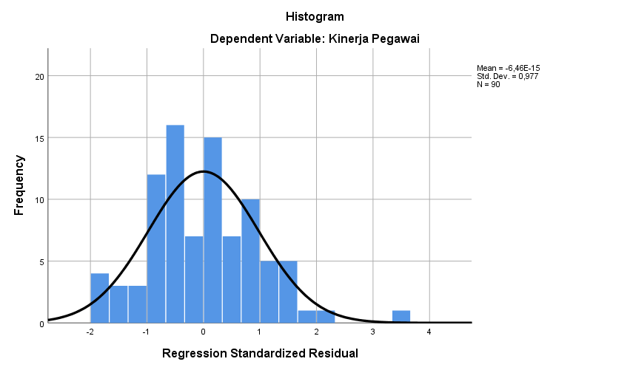

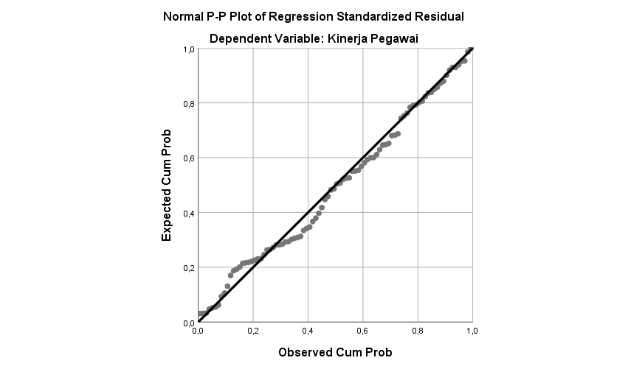

One-Sample Kolmogorov-Smirnov Test
 |  | Unstandardized Residual
N |  | 90
Normal Parameters^{a,b} | Mean | ,0000000
 | Std. Deviation | ,99309983
Most Extreme Differences | Absolute | ,069
 | Positive | ,069
 | Negative | -,060
Test Statistic |  | ,069
Asymp. Sig. (2-tailed) |  | ,200^{c,d}
a. Test distribution is Normal.
b. Calculated from data.
c. Lilliefors Significance Correction.
d. This is a lower bound of the true significance.

Uji Multikolinearitas

Coefficientsª
Model |  | Unstandardized Coefficients |  | Standardized Coefficients | t | Sig. | Collinearity Statistics
 |  | B | Std. Error | Beta |  |  | Tolerance | VIF
1 | (Constant) | 5,942 | ,973 |  | 6,109 | ,000
 | Komunikasi Interpersonal | ,049 | ,024 | ,106 | 2,056 | ,043 | ,965 | 1,037
 | Self Efficacy | ,153 | ,049 | ,376 | 3,098 | ,003 | ,174 | 5,749
 | Reward Pegawai | ,325 | ,086 | ,456 | 3,801 | ,000 | ,178 | 5,619
 | Punishment Pegawai | ,055 | ,018 | ,159 | 3,006 | ,003 | ,919 | 1,088
a. Dependent Variable: Kinerja Pegawai

Uji Autokorelasi
Model Summary^{b}
Model | R | R Square | Adjusted R Square | Std. Error of the Estimate | Durbin-Watson
1 | ,884ª | ,782 | ,772 | 1,016198 | 1,887
a. Predictors: (Constant), Punishment Pegawai, Komunikasi Interpersonal, Reward Pegawai, Self Efficacy
b. Dependent Variable: Kinerja Pegawai

Uji Heterokedastisitas
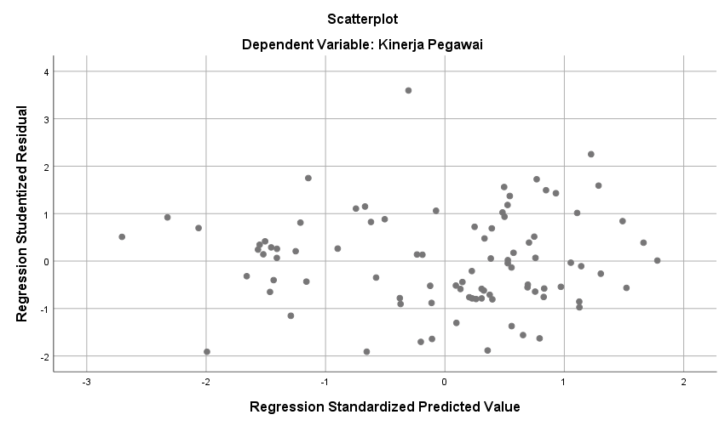

Lampiran 20 Output SPSS 25

Analisis Regresi Linier Berganda

Model |  | Unstandardized Coefficients |  | Standardized Coefficients | t | Sig.
 |  | B | Std. Error | Beta
1 | (Constant) | 5,942 | ,973 |  | 6,109 | ,000
 | Komunikasi Interpersonal | ,049 | ,024 | ,106 | 2,056 | ,043
 | Self Efficacy | ,153 | ,049 | ,376 | 3,098 | ,003
 | Reward Pegawai | ,325 | ,086 | ,456 | 3,801 | ,000
 | Punishment Pegawai | ,055 | ,018 | ,159 | 3,006 | ,003

Uji Parsial (Uji t)

Model |  | Unstandardized Coefficients |  | Standardized Coefficients | t | Sig.
 |  | B | Std. Error | Beta
1 | (Constant) | 5,942 | ,973 |  | 6,109 | ,000
 | Komunikasi Interpersonal | ,049 | ,024 | ,106 | 2,056 | ,043
 | Self Efficacy | ,153 | ,049 | ,376 | 3,098 | ,003
 | Reward Pegawai | ,325 | ,086 | ,456 | 3,801 | ,000
 | Punishment Pegawai | ,055 | ,018 | ,159 | 3,006 | ,003

Uji Simultan (Uji F)

ANOVAª
Model |  | Sum of Squares | df | Mean Square | F | Sig.
1 | Regression | 314,794 | 4 | 78,698 | 76,209 | ,000^{b}
 | Residual | 87,776 | 85 | 1,033
 | Total | 402,570 | 89
a. Dependent Variable: Kinerja Pegawai
b. Predictors: (Constant), Punishment Pegawai, Komunikasi Interpersonal, Reward Pegawai, Self Efficacy

Analisis Koefisien Determinasi

Model Summary^{b}
Model | R | R Square | Adjusted R Square | Std. Error of the Estimate | Durbin-Watson
1 | ,884ª | ,782 | ,772 | 1,016198 | 1,887
a. Predictors: (Constant), Punishment Pegawai, Komunikasi Interpersonal, Reward Pegawai, Self Efficacy
b. Dependent Variable: Kinerja Pegawai

Lampiran 21 Surat Ijin Penelitian

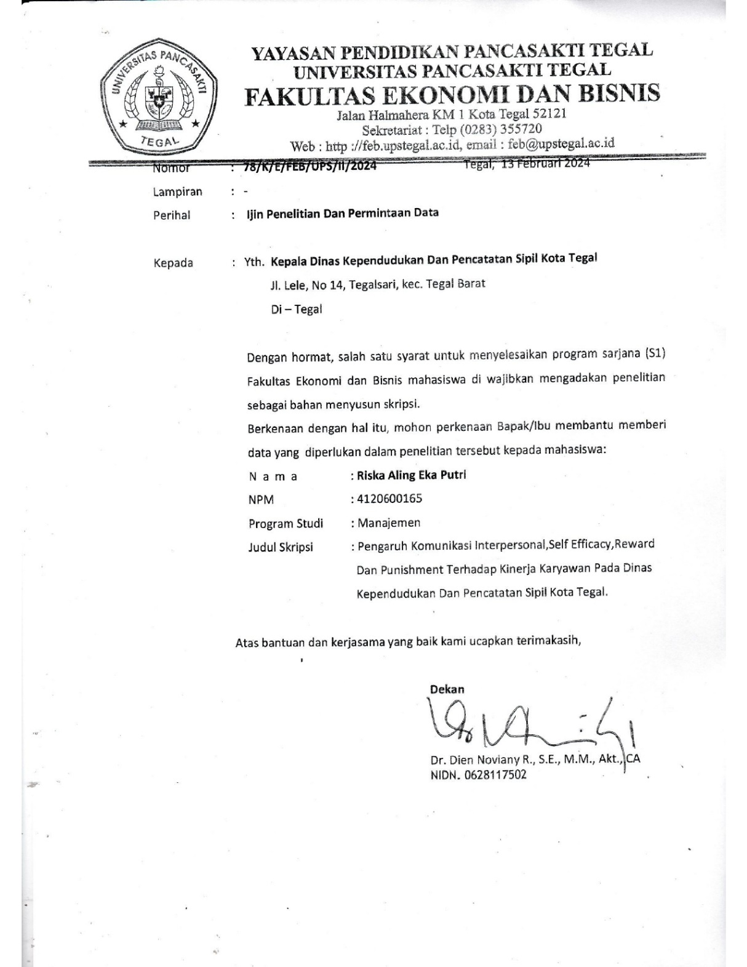

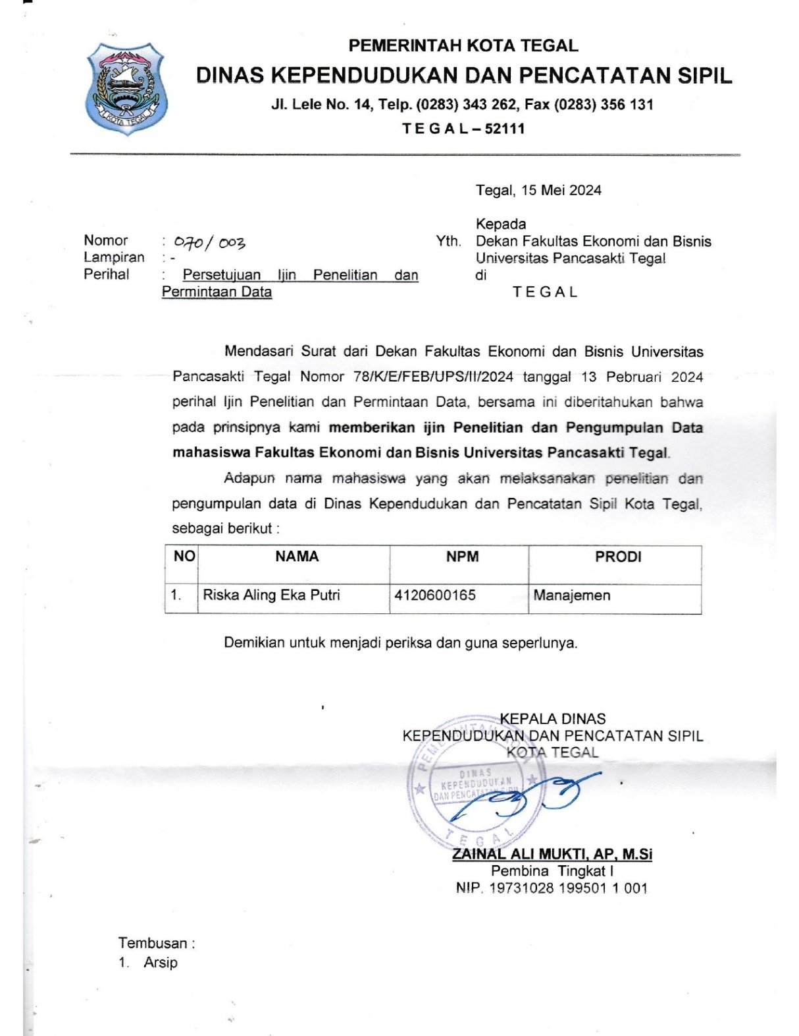
Lampiran 22 Dokumentasi Penelitian

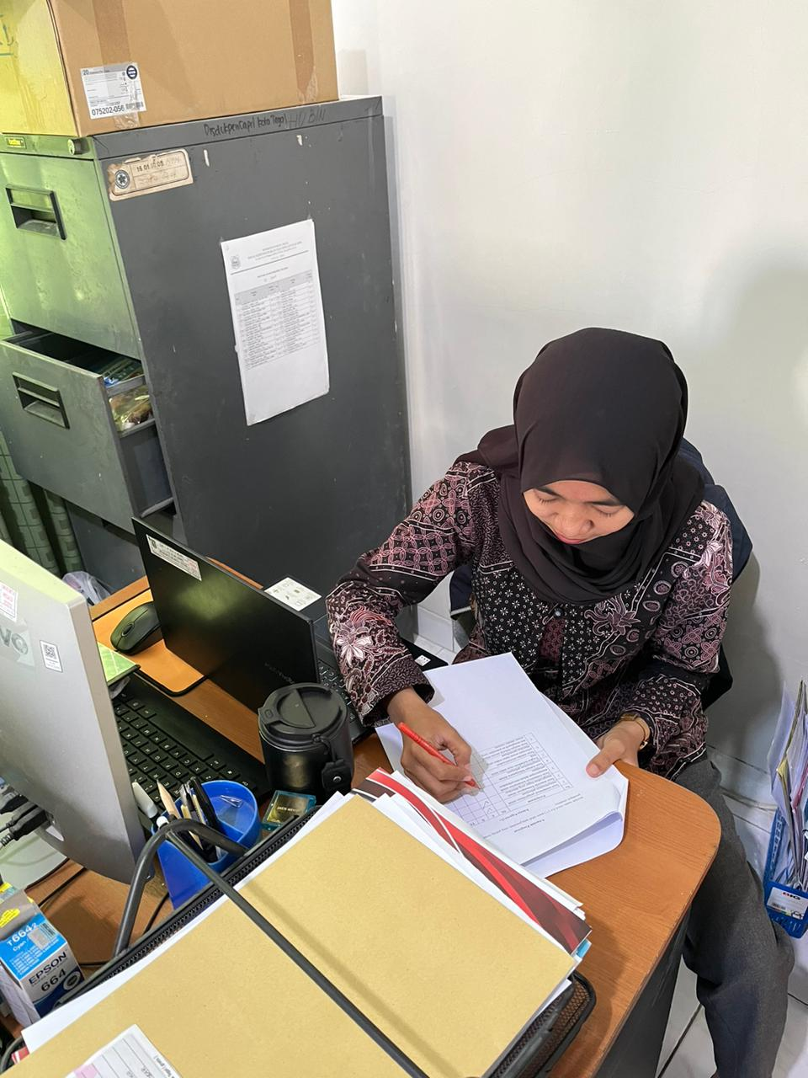

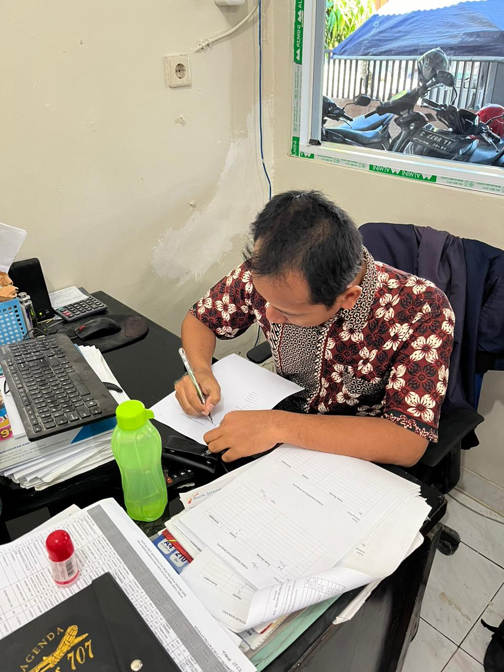
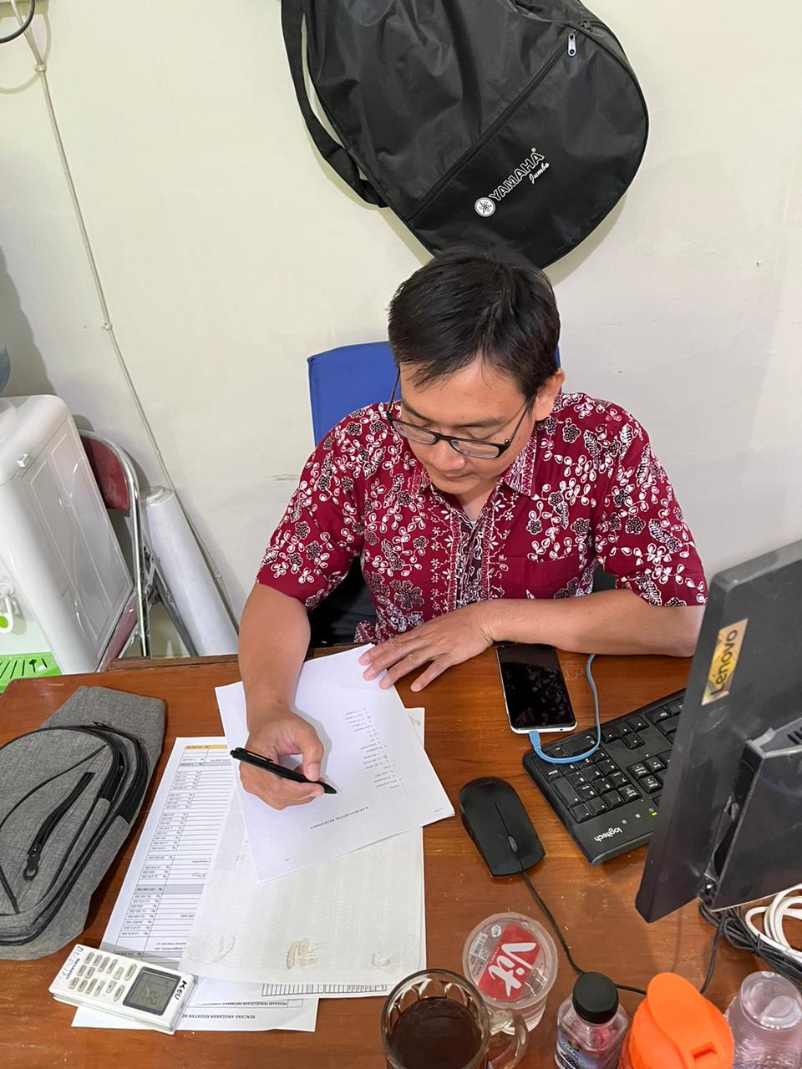

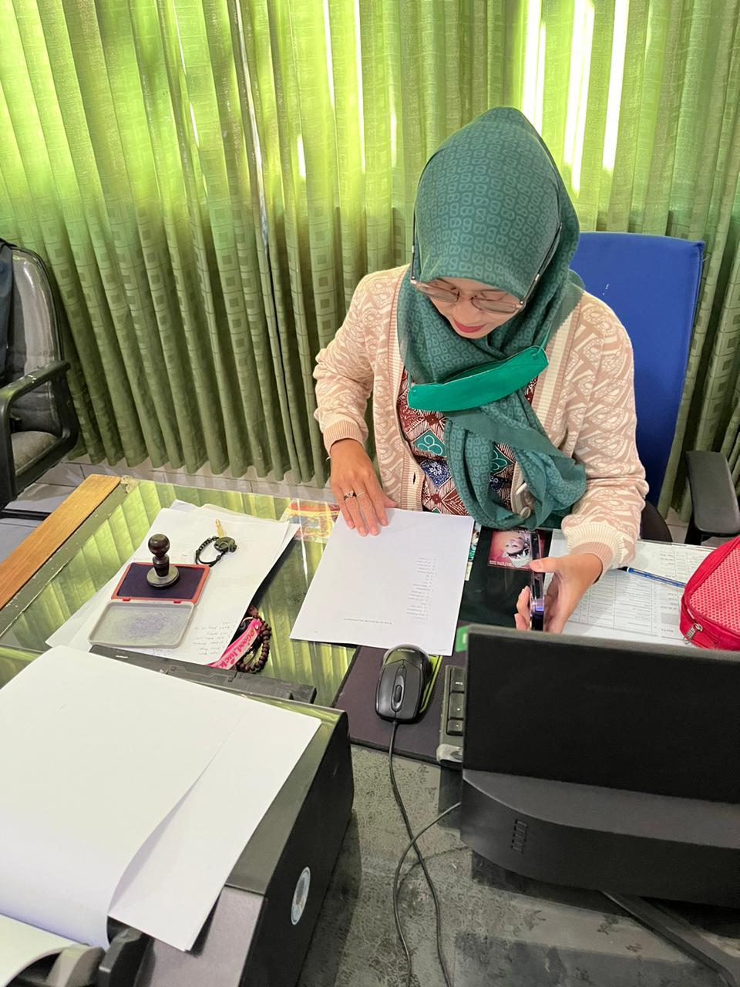

Lampiran 23
Data Absensi Dinas Kependudukan Dan Pencatatan Sipil Kota Tegal 2023

Tabel 1
Data Absensi dan Keterlambatan Pegawai Dinas Kependudukan Dan Pencatatan Sipil Kota Tegal 2023
No | Bulan | Jumlah Pegawai  (orang) | Izin  (orang) | Sakit  (orang) | Terlambat  (orang)
1 | Januari | 90 | 3 | 2 | 3
2 | Februari | 90 | 2 | 1 | 2
3 | Maret | 90 | 4 | 2 | 4
4 | April | 90 | 3 | 4 | 3
5 | Mei | 90 | - | - | -
6 | Juni | 90 | 2 | 2 | 5
7 | Juli | 90 | 3 | - | 3
8 | Agustus | 90 | - | 3 | 5
9 | September | 90 | 3 | 1 | 7
10 | Oktober | 90 | 3 | 2 | 6
11 | November | 90 | 2 | 5 | 5
12 | Desember | 90 | 4 | 2 | 11
Sumber : Dinas Kependudukan Dan Pencatatan Sipil Kota Tegal 2023

Lampiran 24 r_{tabel}
Distribusi Nilai r_{tabel}
Signifikansi 5% dan 1%
N | The Level of Significance |  | N | The Level of Significance
 | 5% | 1% |  | 5% | 1%
3 | 0.997 | 0.999 | 38 | 0.320 | 0.413
4 | 0.950 | 0.990 | 39 | 0.316 | 0.408
5 | 0.878 | 0.959 | 40 | 0.312 | 0.403
6 | 0.811 | 0.917 | 41 | 0.308 | 0.398
7 | 0.754 | 0.874 | 42 | 0.304 | 0.393
8 | 0.707 | 0.834 | 43 | 0.301 | 0.389
9 | 0.666 | 0.798 | 44 | 0.297 | 0.384
10 | 0.632 | 0.765 | 45 | 0.294 | 0.380
11 | 0.602 | 0.735 | 46 | 0.291 | 0.376
12 | 0.576 | 0.708 | 47 | 0.288 | 0.372
13 | 0.553 | 0.684 | 48 | 0.284 | 0.368
14 | 0.532 | 0.661 | 49 | 0.281 | 0.364
15 | 0.514 | 0.641 | 50 | 0.279 | 0.361
16 | 0.497 | 0.623 | 55 | 0.266 | 0.345
17 | 0.482 | 0.606 | 60 | 0.254 | 0.330
18 | 0.468 | 0.590 | 65 | 0.244 | 0.317
19 | 0.456 | 0.575 | 70 | 0.235 | 0.306
20 | 0.444 | 0.561 | 75 | 0.227 | 0.296
21 | 0.433 | 0.549 | 80 | 0.220 | 0.286
22 | 0.432 | 0.537 | 85 | 0.213 | 0.278
23 | 0.413 | 0.526 | 90 | 0.207 | 0.267
24 | 0.404 | 0.515 | 95 | 0.202 | 0.263
25 | 0.396 | 0.505 | 100 | 0.195 | 0.256
26 | 0.388 | 0.496 | 125 | 0.176 | 0.230
27 | 0.381 | 0.487 | 150 | 0.159 | 0.210
28 | 0.374 | 0.478 | 175 | 0.148 | 0.194
29 | 0.367 | 0.470 | 200 | 0.138 | 0.181
30 | 0.361 | 0.463 | 300 | 0.113 | 0.148
31 | 0.355 | 0.456 | 400 | 0.098 | 0.128
32 | 0.349 | 0.449 | 500 | 0.088 | 0.115
33 | 0.344 | 0.442 | 600 | 0.080 | 0.105
34 | 0.339 | 0.436 | 700 | 0.074 | 0.097
35 | 0.334 | 0.430 | 800 | 0.070 | 0.091
36 | 0.329 | 0.424 | 900 | 0.065 | 0.086
37 | 0.325 | 0.418 | 1000 | 0.062 | 0.081

Lampiran 25 t_{tabel}
df=(n-k) | α = 0.05 | α = 0.025
1 | 6,314 | 12,706
2 | 2,920 | 4,303
3 | 2,353 | 3,182
4 | 2,132 | 2,776
5 | 2,015 | 2,571
6 | 1,943 | 2,447
7 | 1,895 | 2,365
8 | 1,860 | 2,306
9 | 1,833 | 2,262
10 | 1,812 | 2,228
11 | 1,796 | 2,201
12 | 1,782 | 2,179
13 | 1,771 | 2,160
14 | 1,761 | 2,145
15 | 1,753 | 2,131
16 | 1,746 | 2,120
17 | 1,740 | 2,110
18 | 1,734 | 2,101
19 | 1,729 | 2,093
20 | 1,725 | 2,086
21 | 1,721 | 2,080
22 | 1,717 | 2,074
23 | 1,714 | 2,069
24 | 1,711 | 2,064
25 | 1,708 | 2,060
26 | 1,706 | 2,056
27 | 1,703 | 2,052
28 | 1,701 | 2,048
29 | 1,699 | 2,045
30 | 1,697 | 2,042
31 | 1,988 | 1,988
32 | 1,694 | 2,037
33 | 1,692 | 2,035
34 | 1,691 | 2,032
35 | 1,690 | 2,030
36 | 1,688 | 2,028
37 | 1,687 | 2,026
38 | 1,686 | 2,024
39 | 1,685 | 2,023
40 | 1,684 | 2,021
41 | 1,683 | 2,020
42 | 1,682 | 2,018
43 | 1,681 | 2,017
44 | 1,680 | 2,015
45 | 1,679 | 2,014
46 | 1,679 | 2,013
47 | 1,678 | 2,012
48 | 1,677 | 1,988
49 | 1,677 | 2,010
df=(n-k) | α = 0.05 | α = 0.025
51 | 1,675 | 2,008
52 | 1,675 | 2,007
53 | 1,674 | 2,006
54 | 1,674 | 2,005
55 | 1,673 | 2,004
56 | 1,673 | 2,003
57 | 1,672 | 2,002
58 | 1,672 | 2,002
59 | 1,671 | 2,001
60 | 1,671 | 2,000
61 | 1,670 | 2,000
62 | 1,670 | 1,999
63 | 1,669 | 1,998
64 | 1,669 | 1,998
65 | 1,669 | 1,997
66 | 1,668 | 1,997
67 | 1,668 | 1,996
68 | 1,668 | 1,995
69 | 1,667 | 1,995
70 | 1,667 | 1,994
71 | 1,667 | 1,994
72 | 1,666 | 1,993
73 | 1,666 | 1,993
74 | 1,666 | 1,993
75 | 1,665 | 1,992
76 | 1,665 | 1,992
77 | 1,665 | 1,991
78 | 1,665 | 1,991
79 | 1,664 | 1,990
80 | 1,664 | 1,990
81 | 1,664 | 1,990
82 | 1,664 | 1,989
83 | 1,663 | 1,989
84 | 1,663 | 1,989
85 | 1,663 | 1,988
86 | 1,663 | 1,988
87 | 1,663 | 1,988
88 | 1,662 | 1,988
89 | 1,662 | 1,988
90 | 1,662 | 1,988
91 | 1,662 | 1,986
92 | 1,662 | 1,986
93 | 1,661 | 1,986
94 | 1,661 | 1,986
95 | 1,661 | 1,985
96 | 1,661 | 1,985
97 | 1,661 | 1,985
98 | 1,661 | 1,984
99 | 1,660 | 1,984

Lampiran 26 F_{tabel}
α = 0,05 | df1=(k1)
df2=(n  -k- 1) | 1 | 2 | 3 | 4 | 5 | 6 | 7 | 8
1 | 161.448 | 199,500 | 215.707 | 224,583 | 230,162 | 233.986 | 236,768 | 238,883
2 | 18,513 | 19,000 | 19,164 | 19,247 | 19,296 | 19,330 | 19,353 | 19,371
3 | 10,128 | 9,552 | 9,277 | 9,117 | 9,013 | 8,941 | 8,887 | 8,845
4 | 7,709 | 6,944 | 6,591 | 6,388 | 6,256 | 6,163 | 6,094 | 6,041
5 | 6,608 | 5,786 | 5,409 | 5,192 | 5,050 | 4,950 | 4,876 | 4,818
6 | 5,987 | 5,143 | 4,757 | 4,534 | 4,387 | 4,284 | 4,207 | 4,147
7 | 5,591 | 4,737 | 4,347 | 4,120 | 3,972 | 3,866 | 3,787 | 3,726
8 | 5,318 | 4,459 | 4,066 | 3,838 | 3,687 | 3,581 | 3,500 | 3,438
9 | 5,117 | 4,256 | 3,863 | 3,633 | 3,482 | 3,374 | 3,293 | 3,230
10 | 4,965 | 4,103 | 3,708 | 3,478 | 3,326 | 3,217 | 3,135 | 3,072
11 | 4,844 | 3,982 | 3,587 | 3,357 | 3,204 | 3,095 | 3,012 | 2,948
12 | 4,747 | 3,885 | 3,490 | 3,259 | 3,106 | 2,996 | 2,913 | 2,849
13 | 4,667 | 3,806 | 3,411 | 3,179 | 3,025 | 2,915 | 2,832 | 2,767
14 | 4,600 | 3,739 | 3,344 | 3,112 | 2,958 | 2,848 | 2,764 | 2,699
15 | 4,543 | 3,682 | 3,287 | 3,056 | 2,901 | 2,790 | 2,707 | 2,641
16 | 4,494 | 3,634 | 3,239 | 3,007 | 2,852 | 2,741 | 2,657 | 2,591
17 | 4,451 | 3,592 | 3,197 | 2,965 | 2,810 | 2,699 | 2,614 | 2,548
18 | 4,414 | 3,555 | 3,160 | 2,928 | 2,773 | 2,661 | 2,577 | 2,510
19 | 4,381 | 3,522 | 3,127 | 2,895 | 2,740 | 2,056 | 2,544 | 2,477
20 | 4,351 | 3,493 | 3,098 | 2,866 | 2,711 | 2,599 | 2,514 | 2,447
21 | 4,325 | 3,467 | 3,072 | 2,840 | 2,685 | 2,573 | 2,488 | 2,420
22 | 4,301 | 3,443 | 3,049 | 2,817 | 2,661 | 2,549 | 2,464 | 2,397
23 | 4,279 | 3,422 | 3,028 | 2,796 | 2,640 | 2,528 | 2,442 | 2,375
24 | 4,260 | 3,403 | 3,009 | 2,776 | 2,621 | 2,508 | 2,423 | 2,355
25 | 4,242 | 3,385 | 2,991 | 2,759 | 2,603 | 2,490 | 2,405 | 2,337
26 | 4,225 | 3,369 | 2,975 | 2,743 | 2,587 | 2,474 | 2,388 | 2,321
27 | 4,210 | 3,354 | 2,960 | 2,728 | 2,572 | 2,459 | 2,373 | 2,056
28 | 4,196 | 3,340 | 2,947 | 2,714 | 2,558 | 2,445 | 2,359 | 2,291
29 | 4,183 | 3,328 | 2,934 | 2,701 | 2,545 | 2,432 | 2,346 | 2,278
30 | 4,171 | 3,316 | 2,922 | 2,690 | 2,534 | 2,421 | 2,334 | 2,266
31 | 4,160 | 3,305 | 2,479 | 2,679 | 2,523 | 2,409 | 2,323 | 2,255
32 | 4,149 | 3,295 | 2,901 | 2,668 | 2,512 | 2,399 | 2,313 | 2,244
33 | 4,139 | 3,285 | 2,892 | 2,659 | 2,503 | 2,389 | 2,303 | 2,235
34 | 4,130 | 3,276 | 2,883 | 2,650 | 2,494 | 2,380 | 2,294 | 2,225
35 | 4,121 | 3,267 | 2,874 | 2,641 | 2,485 | 2,372 | 2,285 | 2,217
36 | 4,113 | 3,259 | 2,866 | 2,634 | 2,477 | 2,364 | 2,277 | 2,209
37 | 4,105 | 3,252 | 2,859 | 2,626 | 2,470 | 2,356 | 2,270 | 2,201
38 | 4,098 | 3,245 | 2,852 | 2,619 | 2,463 | 2,349 | 2,262 | 2,194
39 | 4,091 | 3,238 | 2,845 | 2,612 | 2,456 | 2,342 | 2,255 | 2,187
40 | 4,085 | 3,232 | 2,839 | 2,606 | 2,449 | 2,336 | 2,249 | 2,180
41 | 4,079 | 3,226 | 2,833 | 2,600 | 2,443 | 2,330 | 2,243 | 2,174
42 | 4,073 | 3,220 | 2,827 | 2,594 | 2,438 | 2,324 | 2,237 | 2,168
43 | 4,067 | 3,214 | 2,822 | 2,589 | 2,432 | 2,318 | 2,232 | 2,163
44 | 4,062 | 3,209 | 2,816 | 2,584 | 2,427 | 2,313 | 2,226 | 2,157
45 | 4,057 | 3,204 | 2,812 | 2,579 | 2,422 | 2,308 | 2,221 | 2,152
46 | 4,052 | 3,200 | 2,807 | 2,574 | 2,417 | 2,304 | 2,216 | 2,147
47 | 4,047 | 3,195 | 2,802 | 2,570 | 2,413 | 2,299 | 2,212 | 2,143
48 | 4,043 | 3,191 | 2,479 | 2,565 | 2,409 | 2,295 | 2,207 | 2,138
49 | 4,038 | 3,187 | 2,794 | 2,561 | 2,404 | 2,290 | 2,203 | 2,134
50 | 4,034 | 3,183 | 2,790 | 2,557 | 2,400 | 2,286 | 2,199 | 2,130
51 | 4,030 | 3,179 | 2,786 | 2,553 | 2,397 | 2,283 | 2,195 | 2,126
52 | 4,027 | 3,175 | 2,783 | 2,550 | 2,393 | 2,279 | 2,192 | 2,122
53 | 4,023 | 3,172 | 2,779 | 2,546 | 2,389 | 2,275 | 2,188 | 2,119
54 | 4,020 | 3,168 | 2,776 | 2,543 | 2,386 | 2,272 | 2,185 | 2,115
55 | 4,016 | 3,165 | 2,773 | 2,540 | 2,383 | 2,269 | 2,181 | 2,112
56 | 4,013 | 3,162 | 2,769 | 2,537 | 2,380 | 2,266 | 2,178 | 2,109
57 | 4,010 | 3,159 | 2,766 | 2,534 | 2,377 | 2,263 | 2,175 | 2,106
58 | 4,007 | 3,156 | 2,764 | 2,531 | 2,374 | 2,260 | 2,172 | 2,103
59 | 4,004 | 3,153 | 2,761 | 2,528 | 2,371 | 2,257 | 2,169 | 2,100
60 | 4,001 | 3,150 | 2,758 | 2,525 | 2,368 | 2,254 | 2,167 | 2,097
61 | 3,998 | 3,148 | 2,755 | 2,523 | 2,366 | 2,251 | 2,164 | 2,094
62 | 3,996 | 3,145 | 2,753 | 2,520 | 2,363 | 2,249 | 2,161 | 2,092
63 | 3,993 | 3,143 | 2,751 | 2,518 | 2,361 | 2,246 | 2,159 | 2,089
64 | 3,991 | 3,140 | 2,748 | 2,515 | 2,358 | 2,244 | 2,156 | 2,087
65 | 3,989 | 3,138 | 2,746 | 2,513 | 2,356 | 2,242 | 2,154 | 2,084
66 | 3,986 | 3,136 | 2,744 | 2,511 | 2,354 | 2,239 | 2,152 | 2,082
67 | 3,984 | 3,134 | 2,742 | 2,509 | 2,352 | 2,237 | 2,150 | 2,080
68 | 3,982 | 3,132 | 2,740 | 2,507 | 2,350 | 2,235 | 2,148 | 2,078
69 | 3,980 | 3,130 | 2,737 | 2,505 | 2,348 | 2,233 | 2,145 | 2,076
70 | 3,978 | 3,128 | 2,736 | 2,503 | 2,346 | 2,231 | 2,143 | 2,074
71 | 3,976 | 3,126 | 2,734 | 2,501 | 2,344 | 2,229 | 2,142 | 2,072
72 | 3,974 | 3,124 | 2,732 | 2,499 | 2,342 | 2,227 | 2,140 | 2,070
73 | 3,972 | 3,122 | 2,730 | 2,497 | 2,340 | 2,226 | 2,138 | 2,068
74 | 3,970 | 3,120 | 2,728 | 2,495 | 2,338 | 2,224 | 2,136 | 2,066
75 | 3,968 | 3,119 | 2,727 | 2,494 | 2,337 | 2,222 | 2,134 | 2,064
76 | 3,967 | 3,117 | 2,725 | 2,492 | 2,335 | 2,220 | 2,133 | 2,063
77 | 3,965 | 3,115 | 2,723 | 2,490 | 2,333 | 2,219 | 2,131 | 2,061
78 | 3,963 | 3,114 | 2,722 | 2,489 | 2,332 | 2,217 | 2,129 | 2,059
79 | 3,962 | 3,112 | 2,720 | 2,487 | 2,330 | 2,216 | 2,128 | 2,058
80 | 3,960 | 3,111 | 2,719 | 2,486 | 2,329 | 2,214 | 2,126 | 2,056
81 | 3,959 | 3,109 | 2,717 | 2,484 | 2,327 | 2,213 | 2,125 | 2,055
82 | 3,957 | 3,108 | 2,716 | 2,483 | 2,326 | 2,211 | 2,123 | 2,053
83 | 3,956 | 3,107 | 2,715 | 2,482 | 2,324 | 2,210 | 2,122 | 2,052
84 | 3,955 | 3,105 | 2,713 | 2,480 | 2,323 | 2,209 | 2,121 | 2,051
85 | 3,953 | 3,104 | 2,712 | 2,479 | 2,322 | 2,207 | 2,119 | 2,049
86 | 3,952 | 3,103 | 2,711 | 2,478 | 2,321 | 2,206 | 2,118 | 2,048
87 | 3,951 | 3,101 | 2,709 | 2,476 | 2,319 | 2,205 | 2,117 | 2,047
88 | 3,949 | 3,100 | 2,708 | 2,479 | 2,318 | 2,203 | 2,115 | 2,045
89 | 3,948 | 3,099 | 2,707 | 2,474 | 2,317 | 2,202 | 2,114 | 2,044
90 | 3,947 | 3,098 | 2,706 | 2,473 | 2,316 | 2,201 | 2,113 | 2,043
91 | 3,946 | 3,097 | 2,705 | 2,472 | 2,315 | 2,200 | 2,112 | 2,042
92 | 3,945 | 3,095 | 2,704 | 2,471 | 2,313 | 2,199 | 2,111 | 2,041
93 | 3,943 | 3,094 | 2,703 | 2,470 | 2,312 | 2,198 | 2,110 | 1,988
94 | 3,942 | 3,093 | 2,701 | 2,469 | 2,311 | 2,197 | 2,109 | 2,038
95 | 3,941 | 3,092 | 2,700 | 2,467 | 2,310 | 2,196 | 2,108 | 2,037
96 | 3,940 | 3,091 | 2,699 | 2,466 | 2,309 | 2,195 | 2,106 | 2,036
97 | 3,939 | 3,090 | 2,698 | 2,465 | 2,308 | 2,194 | 2,105 | 2,035
98 | 3,938 | 3,089 | 2,697 | 2,465 | 2,307 | 2,193 | 2,104 | 2,034
99 | 3,937 | 3,088 | 2,696 | 2,464 | 2,306 | 2,192 | 2,103 | 2,033
100 | 3,936 | 3,087 | 2,696 | 2,463 | 2,056 | 2,191 | 2,103 | 2,032

