**DAFTAR PUSTAKA**

Afsari, S., Safitri, I., Harahap, S. K., & Munthe, L. S. (2021). SYSTEMATIC LITERATURE REVIEW: EFEKTIVITAS PENDEKATAN PENDIDIKAN MATEMATIKA REALISTIK PADA PEMBELAJARAN MATEMATIKA. *IJI PUBLICATION*, 189-197.

Amri, S. (2018). Pengaruh Kepercayaan Diri (Self Confidence) Berbasis Ekstrakurikuler Pramuka terhadap Prestasi Belajar Matematika Siswa SMA Negeri 6 Kota Bengkulu. *Jurnal Pendidikan Matematika Raflesia*, 156 170.

Arikunto, S., & Yatim, R. (2020). Dokumentasi. Dalam Ponoharjo, *Metode Penelitian Pendidikan Matematika* (hal. 87-88). Tegal: Badan Penerbitan Universitas Pancasakti Tegal.

Eliyah, S. (2018). *Keefektifan Model Pembelajaran Kooperatif Tipe Caurse Review Horay Berbantuan Microsoft Power Point terhadap Kepercayaan Diri dan Prestasi Belajar Matematika Siswa.* Tegal: Universitas Pancasakti.

Erhamwilda. (2018). *Psikologi Belajar Islam.* Yogyakarta: Psikosain.

Fitriyani, Pranoto, B. A., & Nurbaeti, R. U. (2020). PENGARUH MOTIVASI BELAJAR DAN PERCAYA DIRI TERHADAP HASIL BELAJAR SISWA KELAS V. *KONTEKSTUAL*, 29-35.

Hamalik, O. (2019). Motivasi Belajar. Dalam O. Hamalik, *Kurikulum dan Pembelajaran* (hal. 108). Jakarta: Bumi Aksara.

Hamalik, P. D. (2019). *Kurikulum dan Pembelajaran.* Jakarta: Bumi Aksara.

Hamdu, G., & Agustina, L. (2011). Pengaruh motivasi belajar siswa terhadap prestasi belajar IPA di sekolah dasar. *Jurnal Penelitian Pendidikan*, 90-96.

Kurniasih, F. (2022). *Pengaruh Kemampuan Awal terhadap Minat dan Prestasi Belajar Matematika Siswa SMP Kota Tegal.* Tegal: Universitas Pancasakti.

Lengkana, A. S., Tangkudung, J., & Asmawi, M. (2018). The Effect of Power Limbs, Speed Reaction, Flexibility and Self Confidence on The Achievement of Elite Athletes Athletic West Java in The Track Number. *JIPES-Journal of Indonesian Physical Education and Sport*, 20-25.

Muhamad, N. (2016). Pengaruh Metode Discovery Learning untuk Meningkatkan Representasi Matematis dan Percaya Diri Siswa. *Jurnal Pendidikan Universitas Garut*, 9-22.

Mulya, G., & Lengkana, A. S. (2020). Pengaruh Kepercayaan Diri, Motivasi Belajar Terhadap Prestasi Belajar Pendidikan Jasmani. *Competitor : Jurnal Pendidikan Kepelatihan Olahraga*, 83-94.

Novianti, C., Sadipun, B., & Balan, J. M. (2020). PENGARUH MOTIVASI BELAJAR TERHADAP HASIL BELAJAR MATEMATIKA PESERTA DIDIK. *SPEJ*, 57-75.

Ponoharjo. (2020). *Metode Penelitian Pendidikan Matematika.* (S. D. Mumpuni, Y. Arfiani, A. Habibullah, & A. Zainudin, Penyunt.) Tegal, Jawa Tengah, Indonesia: Badan Penerbitan Universitas Pancasakti.

Putra, A. K., & Frianto, A. (2013). Pengaruh Motivasi Intrinsik dan Motivasi Ekstrinsik terhadap Kepuasan Kerja. *BISMA (Bisnis dan Manajemen)*, 59-66.

Sari, N. K., & Hasibuan, N. H. (2019). Pengaruh Kedisiplinan, Rasa Percaya Diri, dan Kecerdasan Logis Matematis terhadap Hasil Belajar Matematika Siswa. *Pythagoras*, 49-59.

Susongko, P. (2015). *Pengantar Metodologi Penelitian Pendidikan.* Tegal: Badan Penerbit Universitas Pancasakti Tegal.

Susrikha. (2018). PENINGKATAN HASIL BELAJAR SISWA MELALUI MODEL PEMBELAJARAN STUDENT TEAMS ACHIEVEMENT DIVISIONS (STAD) PADA MATERI BUMIKU SISWA KELAS VI SD NEGERI SISALAM 02 TAHUN PELAJARAN 2015/2016. *JP OKTADIKA PLUS* , 1.

Warti, E. (2016). PENGARUH MOTIVASI BELAJAR SISWA TERHADAP HASIL BELAJAR MATEMATIKA SISWA DI SD ANGKASA 10 HALIM PERDANA KUSUMA JAKARTA TIMUR. *Mosharafa*, 177-185.

**L**

**A**

**M**

**P**

**I**

**R**

**A**

**N**

**Lampiran 1. Daftar Nama Siswa Kelas Penelitian**

|  |  |  |  |  |  |
| --- | --- | --- | --- | --- | --- |
| Daftar Nama Siswa Kelas VII A | |  | Daftar Nama Siswa Kelas VII B | | |
| **No** | **Nama Siswa** |  | **No** | **Nama Siswa** | |
| 1 | Andre Nikola Saputra |  | 1 | Al. Baihaqi Haly | |
| 2 | Ashyfa Sinta Aulia |  | 2 | Alvino Ihza P. W. | |
| 3 | Avi Rani Perwira |  | 3 | Amelia Nur Faizah | |
| 4 | Ayu Dwi Khasanah |  | 4 | Andika Prastiyo Ardiansyah | |
| 5 | Azira Rahma Khabibah |  | 5 | Aqilah El Kamilah | |
| 6 | Ciko Nur Fais |  | 6 | Azham Barokah | |
| 7 | Dewi Nawang Wulan |  | 7 | Chalista Anum M. | |
| 8 | Diah Ayu Pengukir |  | 8 | Dedi Komara | |
| 9 | Dinda Putri Ramadhani |  | 9 | Faqih Risky Pratama | |
| 10 | Dwi Dika Maulana |  | 10 | Faqrel | |
| 11 | Eva Lutfiani |  | 11 | Friska Amelia N. | |
| 12 | Fitri Aliyu Hidayat |  | 12 | Haikal Agam Pratama | |
| 13 | Hamzah Khoerul Anam |  | 13 | Hana Putri S. G | |
| 14 | M. abdul Guntur |  | 14 | Jesika Naila Putri | |
| 15 | M. Azriel Firmansyah |  | 15 | Kahyang Bilgah A. | |
| 16 | M. Edy Supriyanto |  | 16 | M. Azka Saputra | |
| 17 | M. Faizal Ali Akbar |  | 17 | M. Hadi Saputra | |
| 18 | M. Faqih Fian Syah Pratama |  | 18 | M. Iqbal Hibatullah | |
| 19 | M. Isneani S.R |  | 19 | M. Tolkha Khasan | |
| 20 | M. Niko Zakaria |  | 20 | Nur Oktaviani | |
| 21 | M. Sugiharto |  | 21 | Rafli Mulia Apriliansyah | |
| 22 | M. Syifa Ahmadani Aripin |  | 22 | Rama Dhani Pratama | |
| 23 | M. Zidni Ilman Nafi |  | 23 | Rhafa Abiadi Wardoyo | |
| 24 | Marcelino Egi Pratama |  | 24 | Rizka Nisfi Sya’bana | |
| 25 | Muhasir |  | 25 | Rizkiya Nuraeni | |
| 26 | Nur Puspa Wati |  | 26 | Rohmatun Nazilah | |
| 27 | Rakha Adi Syaputra |  | 27 | Saskia Dwi Kartika | |
| 28 | Ranu Dwi Pratama |  | 28 | Serli Anindia | |
| 29 | Sarah Eviani |  | 29 | Siti Syarifah M. | |
| 30 | Syifa Az – Zahra |  | 30 | Vries Cilla Febri Erlano | |
| 31 | Sytta Sanjana Alysia |  | 31 | Zahri Syafa Adina | |
| 32 | Umi Takhwifah |  | 32 | Zulfa Natania Ramadhani | |
| **No** | **Nama Siswa** |  |
| 33 | Wahyu Setya Ningrum |  |
| 34 | Wildan Dwi Anggoro |  |  | |  | |
| 35 | Zahra Ayudia Putri |  |  |  | |
| 36 | Zahwatul Atiqoh Laila Risny |  |  |  | |
| 37 | Zasqia. A. |  |  |  | |

**Lampiran 2. Lembar Kisi – kisi Angket Kepercayaan Diri**

**KISI – KISI ANGKET KEPERCAYAAN DIRI SISWA**

Satuan Pendidikan : SMP NU Sunan Kalijaga Adiwerna

Kelas / Semester : VII / Ganjil

Alokasi Waktu : $1×60$ menit

|  |  |  |  |  |
| --- | --- | --- | --- | --- |
| **No** | **Indikator** | **Nomor Item** | | **Jumlah Item** |
| **Positif** | **Negatif** |
| 1 | Percaya pada kemampuan diri sendiri | 1, 3 | 2, 4, 5 | 5 |
| 2 | Bertindak mandiri dalam mengambil keputusan | 6, 8, 10 | 7, 9 | 5 |
| 3 | Memiliki konsep diri yang positif | 12, 14 | 11, 13, 15 | 5 |
| 4 | Berani mengemukakan pendapat | 16, 18, 20 | 17, 19 | 5 |
| **Jumlah** | | **10** | **10** | **20** |

**PENSKORAN ANGKET KEPERCAYAAN DIRI**

|  |  |  |
| --- | --- | --- |
| **Jawaban** | **Skor Positif** | **Skor Negatif** |
| Sangat Setuju | 4 | 1 |
| Setuju | 3 | 2 |
| Tidak Setuju | 2 | 3 |
| Sangat Tidak Setuju | 1 | 4 |

**Lampiran 3. Lembar Kisi – kisi Angket Motivasi Belajar**

**KISI – KISI ANGKET MOTIVASI BELAJAR SISWA**

Satuan Pendidikan : SMP NU Sunan Kalijaga Adiwerna

Kelas / Semester : VII / Ganjil

Alokasi Waktu : $1×60$ menit

|  |  |  |  |  |
| --- | --- | --- | --- | --- |
| **No** | **Indikator** | **Nomor Item** | | **Jumlah Item** |
| **Positif** | **Negatif** |
| 1 | Adanya hasrat dan keinginan untuk berhasil | 1, 3 | 2 | 3 |
| 2 | Adanya dorongan dan kebutuhan dalam belajar | 5, 7 | 4,6 | 4 |
| 3 | Adanya harapan dan cita – cita masa depan | 9 | 8 | 2 |
| 4 | Adanya penghargaan dalam belajar | 10, 12 | 11, 14 | 4 |
| 5 | Adanya kegiatan yang menarik dalam belajar | 15, 16 | 13, 17 | 4 |
| 6 | Adanya lingkungan belajar yang kondusif | 18 | 19, 20 | 3 |
| **Jumlah** | | **10** | **10** | **20** |

**PENSKORAN ANGKET MOTIVASI BELAJAR**

|  |  |  |
| --- | --- | --- |
| **Jawaban** | **Skor Positif** | **Skor Negatif** |
| Sangat Setuju | 4 | 1 |
| Setuju | 3 | 2 |
| Tidak Setuju | 2 | 3 |
| Sangat Tidak Setuju | 1 | 4 |

**Lampiran 4. Lembar Angket Kepercayaan Diri**

**INSTRUMEN ANGKET KEPERCAYAAN DIRI**

Petunjuk:

* + - 1. Pilihlah salah satu jawaban yang sesuai dengan tanda centang (🗸) pada kolom SS (Sangat Setuju), S (Setuju), TS (Tidak Setuju), STS (Sangat Tidak Setuju) yang disediakan.
      2. Setiap jawaban anda adalah benar, sehingga jangan terpengaruh dengan jawaban teman – teman.
      3. Isian angket ini tidak berpengaruh dengan nilai tes maupun nilai raport.
      4. Tanyakan jika ada pertanyaan yang kurang jelas.

|  |  |  |  |  |  |
| --- | --- | --- | --- | --- | --- |
| **No** | **Pernyataan** | **SS** | **S** | **TS** | **STS** |
| 1 | Saya mengerjakan PR matematika sendiri |  |  |  |  |
| 2 | Saya ragu dengan jawaban saya |  |  |  |  |
| 3 | Saya merasa senang jika ditunjuk guru untuk menerangkan materi matematika kembali |  |  |  |  |
| 4 | Saya malu menuliskan jawaban di depan karena tulisan saya jelek |  |  |  |  |
| 5 | Saya ragu jika mengerjakan ulangan matematika sendiri |  |  |  |  |
| 6 | Saya selalu hadir tepat waktu pada pelajaran matematika |  |  |  |  |
| 7 | Saya tidak suka matematika karena gurunya jelek |  |  |  |  |
| 8 | Saya selalu mengerjakan tugas matematika tepat waktu |  |  |  |  |
| 9 | Saya bolos pelajaran matematika karena belum mengerjakan PR matematika |  |  |  |  |
| 10 | Saya suka belajar matematika sendiri pada jam kosong |  |  |  |  |
| 11 | Saya merasa pusing ketika ada materi matematika yang sulit |  |  |  |  |
| 12 | Saya suka matematika karena mudah |  |  |  |  |
| 13 | Saya mudah bosan jika materi matematika susah dimengerti |  |  |  |  |
| 14 | Saya ingin mendapatkan nilai tinggi pada pelajaran matematika |  |  |  |  |
| 15 | Saya tidak mengerjakan PR matematika karena soalnya sulit |  |  |  |  |
| 16 | Saya berani berbicara saat diskusi |  |  |  |  |
| 17 | Saya malu ketauan bahwa saya tidak bisa mengerjakan matematika |  |  |  |  |
| 18 | Saya yakin jika ditunjuk untuk memimpin diskusi |  |  |  |  |
| 19 | Menjelaskan di depan kelas adalah hal yang menyebalkan |  |  |  |  |
| 20 | Saya berani berbicara di depan kelas sendirian |  |  |  |  |

**Lampiran 5. Lembar Angket Motivasi Belajar**

**INSTRUMEN ANGKET MOTIVASI BELAJAR**

Petunjuk:

Pilihlah salah satu jawaban yang sesuai dengan tanda centang (🗸) pada kolom SS (Sangat Setuju), S (Setuju), TS (Tidak Setuju), STS (Sangat Tidak Setuju) yang disediakan.

Setiap jawaban anda adalah benar, sehingga jangan terpengaruh dengan jawaban teman – teman.

Isian angket ini tidak berpengaruh dengan nilai tes maupun nilai raport.

Tanyakan jika ada pertanyaan yang kurang jelas.

|  |  |  |  |  |  |
| --- | --- | --- | --- | --- | --- |
| **No** | **Pernyataan** | **SS** | **S** | **TS** | **STS** |
| 1 | Saya akan mempelajari materi matematika yang akan diajarkan oleh guru |  |  |  |  |
| 2 | Saya belajar matematika hanya jika akan diadakan ulangan |  |  |  |  |
| 3 | Saya selalu berusaha mengerjakan soal matematika yang sulit sampai saya bisa |  |  |  |  |
| 4 | Saya akan berhenti mengerjakan soal atau tugas matematika jika mengalami kesulitan dalam mengerjakan soal tersebut |  |  |  |  |
| 5 | Saya suka mengerjakan soal – soal matematika yang ada di buku LKS |  |  |  |  |
| 6 | Saya tidak mempunyai keinginan yang kuat untuk belajar matematika |  |  |  |  |
| 7 | Saya akan bertanya jika ada pokok bahasan dalam matematika yang belum saya pahami |  |  |  |  |
| 8 | Jika ada PR matematika maka saya lebih suka meminta jawaban dari teman daripada harus mengerjakan sendiri |  |  |  |  |
| 9 | Saya selalu siap, jika guru mengadakan ulangan secara mendadak |  |  |  |  |
| 10 | Orang tua saya akan menanyakan hasil ulangan matematika |  |  |  |  |
| 11 | Saya tidak akan mendapat pujian atau hadiah dari orang tua jika nilai matematika tinggi |  |  |  |  |
| 12 | Guru memberi pujian jika saya bisa mengerjakan soal matematika |  |  |  |  |
| 13 | Saya merasa tidak tertarik dengan setiap pokok bahasan dalam matematika |  |  |  |  |
| 14 | Saya berdiskusi dengan teman ketika ada ulangan matematika |  |  |  |  |
| 15 | Saya merasa tertarik jika pembahasan didahului dengan tanya jawab |  |  |  |  |
| 16 | Saya merasa tertarik karena jika mengalami kesulitan maka guru akan memberikan bantuan secara individu |  |  |  |  |
| 17 | Saya lebih suka bercanda dengan teman ketika guru sedang menjelaskan tentang materi |  |  |  |  |
| 18 | Saya lebih suka lingkungan belajar yang jauh dari kebisingan atau kegaduhan |  |  |  |  |
| 19 | Jika guru memberikan tugas di kelas, saya tidak mengerjakan dan lebih suka bergurau dengan teman |  |  |  |  |
| 20 | Orang tua saya tidak menciptakan suasana rumah yang tenang saat saya akan ulangan matematika |  |  |  |  |

**Lampiran 6. Daftar Nilai Siswa Penelitian**

|  |  |  |  |  |
| --- | --- | --- | --- | --- |
| Daftar Nama Siswa Kelas VII A | |  | Daftar Nama Siswa Kelas VII B | |
| **No. Siswa** | **Nilai** |  | **No. Siswa** | **Nilai** |
| 1 | 69 |  | 1 | 68 |
| 2 | 73 |  | 2 | 44 |
| 3 | 63 |  | 3 | 66 |
| 4 | 70 |  | 4 | 51 |
| 5 | 41 |  | 5 | 59 |
| 6 | 59 |  | 6 | 57 |
| 7 | 57 |  | 7 | 45 |
| 8 | 66 |  | 8 | 54 |
| 9 | 49 |  | 9 | 60 |
| 10 | 79 |  | 10 | 54 |
| 11 | 68 |  | 11 | 50 |
| 12 | 48 |  | 12 | 48 |
| 13 | 53 |  | 13 | 50 |
| 14 | 53 |  | 14 | 44 |
| 15 | 45 |  | 15 | 58 |
| 16 | 45 |  | 16 | 52 |
| 17 | 59 |  | 17 | 62 |
| 18 | 55 |  | 18 | 58 |
| 19 | 59 |  | 19 | 62 |
| 20 | 45 |  | 20 | 52 |
| 21 | 53 |  | 21 | 52 |
| 22 | 37 |  | 22 | 60 |
| 23 | 47 |  | 23 | 49 |
| 24 | 45 |  | 24 | 45 |
| 25 | 43 |  | 25 | 43 |
| 26 | 47 |  | 26 | 45 |
| 27 | 49 |  | 27 | 39 |
| 28 | 88 |  | 28 | 58 |
| 29 | 83 |  | 29 | 52 |
| 30 | 57 |  | 30 | 62 |
| 31 | 69 |  | 31 | 58 |

|  |  |  |  |  |  |
| --- | --- | --- | --- | --- | --- |
| Daftar Nama Siswa Kelas VII A | | |  | Daftar Nama Siswa Kelas VII B | |
| **No. Siswa** | | **Nilai** |  | **No. Siswa** | **Nilai** |
| 32 | | 68 |  | 32 | 60 |
| 33 | | 76 |  |
| 34 | | 81 |  |
| 35 | | 68 |  |
| 36 | | 76 |  |
| 37 | | 81 |  |
|  |
|  |
|  |
|  |
|  |
|  |
|  |
|  |
|  |
|  |
|  |
|  |
|  |
|  |
|  |
|  |
|  |
|  |
|  |
|  |
|  |
|  |
|  |
|  |
|  |

**Lampiran 7. Hasil Uji Validitas Angket Kepercayaan Diri Uji Coba**

|  |  |  |  |  |  |
| --- | --- | --- | --- | --- | --- |
| **responden** | **X1** | **Y** | **X12** | **Y2** | **XY** |
| **1** | 3 | 53 | **9** | **2809** | **159** |
| **2** | 2 | 49 | **4** | **2401** | **98** |
| **3** | 3 | 52 | **9** | **2704** | **156** |
| **4** | 2 | 42 | **4** | **1764** | **84** |
| **5** | 3 | 65 | **9** | **4225** | **195** |
| **6** | 3 | 56 | **9** | **3136** | **168** |
| **7** | 3 | 50 | **9** | **2500** | **150** |
| **8** | 3 | 47 | **9** | **2209** | **141** |
| **9** | 2 | 49 | **4** | **2401** | **98** |
| **10** | 3 | 61 | **9** | **3721** | **183** |
| **11** | 3 | 53 | **9** | **2809** | **159** |
| **12** | 4 | 53 | **16** | **2809** | **212** |
| **13** | 3 | 41 | **9** | **1681** | **123** |
| **14** | 3 | 64 | **9** | **4096** | **192** |
| **15** | 3 | 45 | **9** | **2025** | **135** |
| **16** | 3 | 44 | **9** | **1936** | **132** |
| **17** | 2 | 43 | **4** | **1849** | **86** |
| **18** | 3 | 54 | **9** | **2916** | **162** |
| **19** | 4 | 51 | **16** | **2601** | **204** |
| **20** | 3 | 60 | **9** | **3600** | **180** |
| **21** | 2 | 50 | **4** | **2500** | **100** |
| **22** | 3 | 55 | **9** | **3025** | **165** |
| **23** | 2 | 51 | **4** | **2601** | **102** |
| **24** | 3 | 59 | **9** | **3481** | **177** |
| **25** | 3 | 56 | **9** | **3136** | **168** |
| **26** | 4 | 64 | **16** | **4096** | **256** |
| **27** | 3 | 59 | **9** | **3481** | **177** |
| **28** | 2 | 49 | **4** | **2401** | **98** |
| **29** | 3 | 53 | **9** | **2809** | **159** |
| **30** | 2 | 36 | **4** | **1296** | **72** |
| **31** | 3 | 42 | **9** | **1764** | **126** |
| **32** | 2 | 52 | **4** | **2704** | **104** |
| **JUMLAH** | **90** | **1658** | **264** | **87486** | **4721** |

Menghitung rhitung :

Keterangan :

r : koefisien korelasi

n : jumlah responden

X : skor item

Y : skor total

* 1. Menentukan rtabel

Untuk menentukan rtabel, menghitung df lalu menentukan dengan α : 5%

df : n – 2

df : 32 – 2

df : 30

lalu kita sesuaikan dengan α : 5%, maka rtabel adalah 0,325

|  |  |  |  |
| --- | --- | --- | --- |
| **No. Pertanyaan** | **rhitung** | **rtabel** | **keterangan** |
| 1 | **0,441** | **0,325** | Valid |
| 2 | **0,597** | **0,325** | Valid |
| 3 | **0,226** | **0,325** | tidak valid |
| 4 | **0,514** | **0,325** | Valid |
| 5 | **0,600** | **0,325** | Valid |
| 6 | **0,439** | **0,325** | Valid |
| 7 | **0,399** | **0,325** | Valid |
| 8 | **0,468** | **0,325** | Valid |
| 9 | **0,487** | **0,325** | Valid |
| 10 | **0,560** | **0,325** | Valid |
| 11 | **0,490** | **0,325** | Valid |
| 12 | **0,488** | **0,325** | Valid |
| 13 | **0,447** | **0,325** | Valid |
| 14 | **0,119** | **0,325** | tidak valid |
| 15 | **0,658** | **0,325** | Valid |
| 16 | **-0,057** | **0,325** | tidak valid |
| 17 | **0,136** | **0,325** | tidak valid |
| 18 | **0,235** | **0,325** | tidak valid |
| 19 | **0,713** | **0,325** | Valid |
| 20 | **0,380** | **0,325** | Valid |

|  |  |  |  |
| --- | --- | --- | --- |
| **No. Pertanyaan** | **rhitung** | **rtabel** | **keterangan** |
| 1 | **0,408** | **0,325** | Valid |
| 2 | **0,659** | **0,325** | Valid |
| 3 | **0,536** | **0,325** | Valid |
| 4 | **0,644** | **0,325** | Valid |
| 5 | **0,394** | **0,325** | Valid |
| 6 | **0,397** | **0,325** | Valid |
| 7 | **0,484** | **0,325** | Valid |
| 8 | **0,461** | **0,325** | Valid |
| 9 | **0,576** | **0,325** | Valid |
| 10 | **0,576** | **0,325** | Valid |
| 11 | **0,443** | **0,325** | Valid |
| 12 | **0,543** | **0,325** | Valid |
| 13 | **0,695** | **0,325** | Valid |
| 14 | **0,801** | **0,325** | Valid |
| 15 | **0,334** | **0,325** | Valid |

**Lampiran 8. Hasil Uji Validitas Angket Motivasi Belajar Uji Coba**

|  |  |  |  |  |  |
| --- | --- | --- | --- | --- | --- |
| **RESPONDEN** | **X1** | **Y** | **X12** | **Y2** | **XY** |
| **1** | 4 | 55 | **16** | **3025** | **220** |
| **2** | 3 | 55 | **9** | **3025** | **165** |
| **3** | 3 | 69 | **9** | **4761** | **207** |
| **4** | 3 | 58 | **9** | **3364** | **174** |
| **5** | 3 | 60 | **9** | **3600** | **180** |
| **6** | 3 | 59 | **9** | **3481** | **177** |
| **7** | 3 | 68 | **9** | **4624** | **204** |
| **8** | 3 | 58 | **9** | **3364** | **174** |
| **9** | 4 | 75 | **16** | **5625** | **300** |
| **10** | 4 | 60 | **16** | **3600** | **240** |
| **11** | 4 | 47 | **16** | **2209** | **188** |
| **12** | 2 | 62 | **4** | **3844** | **124** |
| **13** | 4 | 74 | **16** | **5476** | **296** |
| **14** | 4 | 63 | **16** | **3969** | **252** |
| **15** | 4 | 60 | **16** | **3600** | **240** |
| **16** | 4 | 61 | **16** | **3721** | **244** |
| **17** | 4 | 58 | **16** | **3364** | **232** |
| **18** | 3 | 58 | **9** | **3364** | **174** |
| **19** | 4 | 65 | **16** | **4225** | **260** |
| **20** | 3 | 54 | **9** | **2916** | **162** |
| **21** | 4 | 71 | **16** | **5041** | **284** |
| **22** | 2 | 36 | **4** | **1296** | **72** |
| **23** | 4 | 68 | **16** | **4624** | **272** |
| **24** | 4 | 71 | **16** | **5041** | **284** |
| **25** | 3 | 66 | **9** | **4356** | **198** |
| **26** | 4 | 54 | **16** | **2916** | **216** |
| **27** | 4 | 71 | **16** | **5041** | **284** |
| **28** | 4 | 64 | **16** | **4096** | **256** |
| **29** | 4 | 73 | **16** | **5329** | **292** |
| **30** | 3 | 51 | **9** | **2601** | **153** |
| **31** | 3 | 56 | **9** | **3136** | **168** |
| **32** | 3 | 53 | **9** | **2809** | **159** |
| **JUMLAH** | **111** | **1953** | **397** | **121443** | **6851** |

Menghitung rhitung :

Keterangan :

r : koefisien korelasi

n : jumlah responden

X : skor item

Y : skor total

* + - * 1. Menentukan rtabel

Untuk menentukan rtabel, menghitung df lalu menentukan dengan α : 5%

df : n – 2

df : 32 – 2

df : 30

lalu kita sesuaikan dengan α : 5%, maka rtabel adalah 0,325

|  |  |  |  |
| --- | --- | --- | --- |
| **No. Pertanyaan** | **rhitung** | **rtabel** | **keterangan** |
| 1 | **0,467** | **0,325** | Valid |
| 2 | **0,558** | **0,325** | Valid |
| 3 | **0,560** | **0,325** | Valid |
| 4 | **0,515** | **0,325** | Valid |
| 5 | **0,667** | **0,325** | Valid |
| 6 | **0,500** | **0,325** | Valid |
| 7 | **0,251** | **0,325** | tidak valid |
| 8 | **0,748** | **0,325** | Valid |
| 9 | **0,563** | **0,325** | Valid |
| 10 | **0,591** | **0,325** | Valid |
| 11 | **0,458** | **0,325** | Valid |
| 12 | **0,416** | **0,325** | Valid |
| 13 | **0,502** | **0,325** | Valid |
| 14 | **0,196** | **0,325** | tidak valid |
| 15 | **0,019** | **0,325** | tidak valid |
| 16 | **0,248** | **0,325** | tidak valid |
| 17 | **0,765** | **0,325** | Valid |
| 18 | **0,480** | **0,325** | Valid |
| 19 | **0,676** | **0,325** | Valid |
| 20 | **0,583** | **0,325** | Valid |

|  |  |  |  |
| --- | --- | --- | --- |
| **No. Pertanyaan** | **rhitung** | **rtabel** | **keterangan** |
| 1 | **0,494** | **0,325** | Valid |
| 2 | **0,526** | **0,325** | Valid |
| 3 | **0,545** | **0,325** | Valid |
| 4 | **0,526** | **0,325** | Valid |
| 5 | **0,678** | **0,325** | Valid |
| 6 | **0,514** | **0,325** | Valid |
| 7 | **0,729** | **0,325** | Valid |
| 8 | **0,607** | **0,325** | Valid |
| 9 | **0,601** | **0,325** | Valid |
| 10 | **0,445** | **0,325** | Valid |
| 11 | **0,392** | **0,325** | Valid |
| 12 | **0,492** | **0,325** | Valid |
| 13 | **0,783** | **0,325** | Valid |
| 14 | **0,479** | **0,325** | Valid |
| 15 | **0,718** | **0,325** | Valid |
| 16 | **0,664** | **0,325** | Valid |

**Lampiran 9. Data Penelitian Angket Kepercayaan Diri**

|  |  |  |  |  |  |  |  |  |  |  |  |  |  |  |  |  |
| --- | --- | --- | --- | --- | --- | --- | --- | --- | --- | --- | --- | --- | --- | --- | --- | --- |
|  | **1** | **2** | **3** | **4** | **5** | **6** | **7** | **8** | **9** | **10** | **11** | **12** | **13** | **14** | **15** | **Total** |
| **1** | 3 | 2 | 2 | 2 | 3 | 3 | 4 | 3 | 3 | 1 | 3 | 3 | 3 | 3 | 2 | 40 |
| **2** | 2 | 2 | 1 | 1 | 4 | 2 | 3 | 2 | 2 | 2 | 4 | 3 | 2 | 1 | 2 | 33 |
| **3** | 3 | 1 | 2 | 2 | 3 | 3 | 4 | 3 | 3 | 1 | 3 | 2 | 3 | 3 | 2 | 38 |
| **4** | 2 | 2 | 2 | 1 | 4 | 3 | 2 | 4 | 2 | 1 | 2 | 2 | 2 | 2 | 1 | 32 |
| **5** | 3 | 2 | 4 | 4 | 4 | 4 | 4 | 4 | 4 | 4 | 3 | 4 | 3 | 4 | 2 | 53 |
| **6** | 3 | 3 | 1 | 2 | 4 | 3 | 3 | 4 | 3 | 2 | 3 | 3 | 3 | 3 | 2 | 42 |
| **7** | 3 | 2 | 3 | 1 | 4 | 1 | 2 | 3 | 4 | 1 | 3 | 2 | 2 | 1 | 4 | 36 |
| **8** | 3 | 1 | 4 | 2 | 4 | 4 | 2 | 3 | 2 | 1 | 1 | 1 | 2 | 1 | 1 | 32 |
| **9** | 2 | 1 | 2 | 3 | 4 | 4 | 2 | 3 | 3 | 1 | 2 | 1 | 1 | 2 | 2 | 33 |
| **10** | 3 | 2 | 1 | 3 | 4 | 4 | 3 | 4 | 2 | 2 | 4 | 4 | 3 | 3 | 2 | 44 |
| **11** | 3 | 2 | 2 | 2 | 4 | 4 | 2 | 4 | 2 | 2 | 2 | 2 | 3 | 3 | 3 | 40 |
| **12** | 4 | 1 | 2 | 2 | 4 | 4 | 3 | 4 | 2 | 1 | 2 | 4 | 3 | 2 | 2 | 40 |
| **13** | 3 | 1 | 1 | 2 | 3 | 2 | 2 | 3 | 1 | 1 | 1 | 1 | 2 | 1 | 1 | 25 |
| **14** | 3 | 2 | 4 | 3 | 3 | 4 | 3 | 4 | 3 | 2 | 3 | 3 | 3 | 3 | 3 | 46 |
| **15** | 3 | 1 | 1 | 2 | 3 | 3 | 3 | 3 | 2 | 1 | 2 | 2 | 2 | 2 | 2 | 32 |
| **16** | 3 | 1 | 2 | 1 | 2 | 2 | 2 | 3 | 2 | 1 | 2 | 2 | 3 | 2 | 3 | 31 |
| **17** | 2 | 2 | 1 | 1 | 4 | 4 | 2 | 4 | 1 | 1 | 2 | 2 | 2 | 2 | 2 | 32 |
| **18** | 3 | 2 | 2 | 3 | 3 | 3 | 2 | 4 | 2 | 2 | 4 | 4 | 3 | 3 | 2 | 42 |
| **19** | 4 | 1 | 1 | 3 | 4 | 4 | 2 | 4 | 2 | 1 | 3 | 1 | 1 | 1 | 3 | 35 |
| **20** | 3 | 3 | 4 | 4 | 4 | 3 | 3 | 2 | 4 | 4 | 3 | 4 | 3 | 4 | 1 | 49 |
| **21** | 2 | 3 | 1 | 3 | 4 | 3 | 4 | 3 | 2 | 2 | 3 | 1 | 2 | 2 | 2 | 37 |
| **22** | 3 | 2 | 3 | 1 | 3 | 4 | 2 | 4 | 2 | 2 | 3 | 3 | 3 | 3 | 3 | 41 |
|  | **1** | **2** | **3** | **4** | **5** | **6** | **7** | **8** | **9** | **10** | **11** | **12** | **13** | **14** | **15** | **Total** |
| **23** | **2** | **2** | **3** | **1** | **4** | **4** | **4** | **3** | **2** | **2** | **3** | **2** | **3** | **2** | **2** | **39** |
| **24** | 3 | 3 | 4 | 1 | 4 | 4 | 2 | 4 | 2 | 2 | 3 | 2 | 4 | 3 | 2 | 43 |
| **25** | 3 | 1 | 2 | 3 | 4 | 4 | 3 | 3 | 2 | 4 | 2 | 3 | 3 | 3 | 3 | 43 |
| **26** | 4 | 2 | 4 | 4 | 4 | 3 | 3 | 4 | 3 | 4 | 1 | 2 | 4 | 4 | 3 | 49 |
| **27** | 3 | 3 | 1 | 2 | 4 | 4 | 3 | 3 | 2 | 4 | 3 | 3 | 3 | 3 | 3 | 44 |
| **28** | 2 | 2 | 2 | 2 | 2 | 3 | 2 | 2 | 2 | 2 | 3 | 3 | 1 | 3 | 2 | 33 |
| **29** | 3 | 2 | 2 | 3 | 3 | 3 | 2 | 4 | 2 | 2 | 2 | 3 | 4 | 4 | 3 | 42 |
| **30** | 2 | 2 | 1 | 1 | 2 | 2 | 2 | 1 | 2 | 4 | 1 | 2 | 1 | 2 | 1 | 26 |
| **31** | 3 | 1 | 2 | 2 | 2 | 4 | 1 | 2 | 1 | 1 | 1 | 4 | 2 | 1 | 2 | 29 |
| **32** | 2 | 2 | 3 | 3 | 3 | 3 | 2 | 3 | 2 | 3 | 3 | 3 | 3 | 3 | 2 | 40 |
| **33** | 2 | 2 | 4 | 2 | 4 | 3 | 2 | 3 | 2 | 1 | 3 | 2 | 2 | 3 | 1 | 36 |
| **34** | 2 | 3 | 2 | 2 | 3 | 3 | 2 | 3 | 2 | 2 | 2 | 2 | 2 | 2 | 4 | 36 |
| **35** | 3 | 2 | 2 | 2 | 4 | 4 | 2 | 3 | 2 | 2 | 3 | 1 | 2 | 2 | 1 | 35 |
| **36** | 2 | 3 | 2 | 3 | 3 | 3 | 2 | 4 | 2 | 1 | 2 | 2 | 2 | 1 | 1 | 33 |
| **37** | 3 | 2 | 2 | 2 | 3 | 4 | 3 | 3 | 2 | 2 | 3 | 2 | 2 | 2 | 1 | 36 |
| **38** | 3 | 2 | 2 | 2 | 3 | 3 | 4 | 3 | 3 | 1 | 3 | 3 | 3 | 1 | 2 | 38 |
| **39** | 2 | 2 | 1 | 1 | 4 | 2 | 3 | 2 | 2 | 2 | 4 | 3 | 2 | 3 | 2 | 35 |
| **40** | 3 | 1 | 2 | 2 | 3 | 3 | 4 | 3 | 3 | 1 | 3 | 2 | 3 | 3 | 2 | 38 |
| **41** | 2 | 1 | 2 | 1 | 4 | 3 | 2 | 4 | 2 | 1 | 2 | 2 | 2 | 3 | 1 | 32 |
| **42** | 3 | 3 | 4 | 4 | 4 | 4 | 4 | 4 | 4 | 4 | 3 | 4 | 3 | 2 | 2 | 52 |
| **43** | 3 | 1 | 1 | 2 | 4 | 3 | 3 | 4 | 3 | 2 | 3 | 3 | 3 | 3 | 2 | 40 |
| **44** | 3 | 1 | 3 | 1 | 4 | 1 | 2 | 3 | 4 | 1 | 3 | 2 | 2 | 2 | 4 | 36 |
| **45** | 3 | 1 | 4 | 2 | 4 | 4 | 2 | 3 | 2 | 1 | 1 | 1 | 2 | 1 | 1 | 32 |
| **46** | 2 | 2 | 2 | 3 | 4 | 4 | 2 | 3 | 3 | 1 | 2 | 1 | 1 | 4 | 2 | 36 |
| **47** | 3 | 3 | 1 | 3 | 4 | 4 | 3 | 4 | 2 | 2 | 4 | 4 | 3 | 4 | 2 | 46 |
| **48** | 3 | 2 | 2 | 2 | 4 | 4 | 2 | 4 | 2 | 2 | 2 | 2 | 3 | 1 | 3 | 38 |
| **49** | 4 | 2 | 2 | 2 | 4 | 4 | 3 | 4 | 2 | 1 | 2 | 4 | 3 | 3 | 2 | 42 |
| **50** | 3 | 1 | 1 | 2 | 3 | 2 | 2 | 3 | 1 | 1 | 1 | 1 | 2 | 2 | 1 | 26 |
| **51** | 3 | 3 | 4 | 3 | 3 | 4 | 3 | 4 | 3 | 2 | 3 | 3 | 3 | 3 | 3 | 47 |
| **52** | 3 | 1 | 1 | 2 | 3 | 3 | 3 | 3 | 2 | 1 | 2 | 2 | 2 | 3 | 2 | 33 |
| **53** | 3 | 2 | 2 | 1 | 2 | 2 | 2 | 3 | 2 | 1 | 2 | 2 | 3 | 3 | 3 | 33 |
| **54** | 2 | 1 | 1 | 1 | 4 | 4 | 2 | 4 | 1 | 1 | 2 | 2 | 2 | 2 | 2 | 31 |
| **55** | 3 | 3 | 2 | 3 | 3 | 3 | 2 | 4 | 2 | 2 | 4 | 4 | 3 | 1 | 2 | 41 |
| **56** | 4 | 2 | 1 | 3 | 4 | 4 | 2 | 4 | 2 | 1 | 3 | 1 | 1 | 3 | 3 | 38 |
| **57** | 3 | 3 | 4 | 4 | 4 | 3 | 3 | 2 | 4 | 4 | 3 | 4 | 3 | 2 | 1 | 47 |
| **58** | 2 | 2 | 1 | 3 | 4 | 3 | 4 | 3 | 2 | 2 | 3 | 1 | 2 | 3 | 2 | 37 |
| **59** | 3 | 2 | 3 | 1 | 3 | 4 | 2 | 4 | 2 | 2 | 3 | 3 | 3 | 4 | 3 | 42 |
| **60** | 2 | 2 | 3 | 1 | 4 | 4 | 4 | 3 | 2 | 2 | 3 | 2 | 3 | 1 | 2 | 38 |
| **61** | 3 | 2 | 4 | 1 | 4 | 4 | 2 | 4 | 2 | 2 | 3 | 2 | 4 | 4 | 2 | 43 |
| **62** | 3 | 3 | 2 | 3 | 4 | 4 | 3 | 3 | 2 | 4 | 2 | 3 | 3 | 4 | 3 | 46 |
| **63** | 4 | 2 | 4 | 4 | 4 | 3 | 3 | 4 | 3 | 4 | 1 | 2 | 4 | 4 | 3 | 49 |
| **64** | 3 | 2 | 1 | 2 | 4 | 4 | 3 | 3 | 2 | 4 | 3 | 3 | 3 | 2 | 3 | 42 |
| **65** | 2 | 3 | 2 | 2 | 2 | 3 | 2 | 2 | 2 | 2 | 3 | 3 | 1 | 3 | 2 | 34 |
| **66** | 3 | 2 | 2 | 3 | 3 | 3 | 2 | 4 | 2 | 2 | 2 | 3 | 4 | 4 | 3 | 42 |
| **67** | 2 | 2 | 1 | 1 | 2 | 2 | 2 | 1 | 2 | 4 | 1 | 2 | 1 | 1 | 1 | 25 |
| **68** | 3 | 1 | 2 | 2 | 2 | 4 | 1 | 2 | 1 | 1 | 1 | 4 | 2 | 3 | 2 | 31 |
| **69** | 2 | 2 | 3 | 3 | 3 | 3 | 2 | 3 | 2 | 3 | 3 | 3 | 3 | 1 | 2 | 38 |
| **70** | 2 | 2 | 4 | 2 | 4 | 3 | 2 | 3 | 2 | 1 | 3 | 2 | 2 | 3 | 1 | 36 |
| **71** | 2 | 3 | 2 | 2 | 3 | 3 | 2 | 3 | 2 | 2 | 2 | 2 | 2 | 2 | 4 | 36 |

**Lampiran 10. Uji Validitas Kepercayaan Diri**

|  |  |  |  |  |  |
| --- | --- | --- | --- | --- | --- |
| **RESPONDEN** | **X1** | **Y** | **X12** | **Y2** | **XY** |
| **1** | 3 | 40 | **9** | **1600** | **120** |
| **2** | 2 | 33 | **4** | **1089** | **66** |
| **3** | 3 | 38 | **9** | **1444** | **114** |
| **4** | 2 | 32 | **4** | **1024** | **64** |
| **5** | 3 | 53 | **9** | **2809** | **159** |
| **6** | 3 | 42 | **9** | **1764** | **126** |
| **7** | 3 | 36 | **9** | **1296** | **108** |
| **8** | 3 | 32 | **9** | **1024** | **96** |
| **9** | 2 | 33 | **4** | **1089** | **66** |
| **10** | 3 | 44 | **9** | **1936** | **132** |
| **11** | 3 | 40 | **9** | **1600** | **120** |
| **12** | 4 | 40 | **16** | **1600** | **160** |
| **13** | 3 | 25 | **9** | **625** | **75** |
| **14** | 3 | 46 | **9** | **2116** | **138** |
| **15** | 3 | 32 | **9** | **1024** | **96** |
| **16** | 3 | 31 | **9** | **961** | **93** |
| **17** | 2 | 32 | **4** | **1024** | **64** |
| **18** | 3 | 42 | **9** | **1764** | **126** |
| **19** | 4 | 35 | **16** | **1225** | **140** |
| **20** | 3 | 49 | **9** | **2401** | **147** |
| **21** | 2 | 37 | **4** | **1369** | **74** |
| **22** | 3 | 41 | **9** | **1681** | **123** |
| **23** | 2 | 39 | **4** | **1521** | **78** |
| **24** | 3 | 43 | **9** | **1849** | **129** |
| **25** | 3 | 43 | **9** | **1849** | **129** |
| **26** | 4 | 49 | **16** | **2401** | **196** |
| **27** | 3 | 44 | **9** | **1936** | **132** |
| **28** | 2 | 33 | **4** | **1089** | **66** |
| **29** | 3 | 42 | **9** | **1764** | **126** |
| **30** | 2 | 26 | **4** | **676** | **52** |
| **31** | 3 | 29 | **9** | **841** | **87** |
| **32** | 2 | 40 | **4** | **1600** | **80** |
| **33** | 2 | 36 | 4 | **1296** | **72** |
| **34** | 2 | 36 | 4 | **1296** | **72** |
| **35** | 3 | 35 | **9** | **1225** | **105** |
| **RESPONDEN** | **X1** | **Y** | **X12** | **Y2** | **XY** |
| **36** | 2 | 33 | **4** | **1089** | **66** |
| **37** | 3 | 36 | **9** | **1296** | **108** |
| **38** | 3 | 38 | **9** | **1444** | **114** |
| **39** | 2 | 35 | **4** | **1225** | **70** |
| **40** | 3 | 38 | **9** | **1444** | **114** |
| **41** | 2 | 32 | **4** | **1024** | **64** |
| **42** | 3 | 52 | **9** | **2704** | **156** |
| **43** | 3 | 40 | **9** | **1600** | **120** |
| **44** | 3 | 36 | **9** | **1296** | **108** |
| **45** | 3 | 32 | **9** | **1024** | **96** |
| **46** | 2 | 36 | **4** | **1296** | **72** |
| **47** | 3 | 46 | **9** | **2116** | **138** |
| **48** | 3 | 38 | **9** | **1444** | **114** |
| **49** | 4 | 42 | **16** | **1764** | **168** |
| **50** | 3 | 26 | **9** | **676** | **78** |
| **51** | 3 | 47 | **9** | **2209** | **141** |
| **52** | 3 | 33 | **9** | **1089** | **99** |
| **53** | 3 | 33 | **9** | **1089** | **99** |
| **54** | 2 | 31 | **4** | **961** | **62** |
| **55** | 3 | 41 | **9** | **1681** | **123** |
| **56** | 4 | 38 | **16** | **1444** | **152** |
| **57** | 3 | 47 | **9** | **2209** | **141** |
| **58** | 2 | 37 | **4** | **1369** | **74** |
| **59** | 3 | 42 | **9** | **1764** | **126** |
| **60** | 2 | 38 | **4** | **1444** | **76** |
| **61** | 3 | 43 | **9** | **1849** | **129** |
| **62** | 3 | 46 | **9** | **2116** | **138** |
| **63** | 4 | 49 | **16** | **2401** | **196** |
| **64** | 3 | 42 | **9** | **1764** | **126** |
| **65** | 2 | 34 | **4** | **1156** | **68** |
| **66** | 3 | 42 | **9** | **1764** | **126** |
| **67** | 2 | 25 | 4 | **625** | **50** |
| **68** | 3 | 31 | 9 | **961** | **93** |
| **69** | 2 | 38 | **4** | **1444** | **76** |
| **70** | 2 | 36 | **4** | **1296** | **72** |
| **71** | 2 | 36 | **4** | **1296** | **72** |
| **JUMLAH** | **196** | **2697** | **566** | **105181** | **7556** |

Menghitung rhitung :

Keterangan :

r : koefisien korelasi

n : jumlah responden

X : skor item

Y : skor total

Menentukan rtabel

Untuk menentukan rtabel, menghitung df lalu menentukan dengan α : 5%

df : n – 2

df : 71 – 2

df : 69

lalu kita sesuaikan dengan α : 5%, maka rtabel adalah 0,2335

|  |  |  |
| --- | --- | --- |
| **rhitung** | **rtabel** | **keterangan** |
| **0,424** | **0,2335** | Valid |
| **0,487** | **0,2335** | Valid |
| **0,485** | **0,2335** | Valid |
| **0,605** | **0,2335** | Valid |
| **0,420** | **0,2335** | Valid |
| **0,386** | **0,2335** | Valid |
| **0,485** | **0,2335** | Valid |
| **0,473** | **0,2335** | Valid |
| **0,576** | **0,2335** | Valid |
| **0,551** | **0,2335** | Valid |
| **0,433** | **0,2335** | Valid |
| **0,529** | **0,2335** | Valid |
| **0,703** | **0,2335** | Valid |
| **0,557** | **0,2335** | Valid |
| **0,323** | **0,2335** | Valid |

**Lampiran 11. Uji Reliabilitas Kepercayaan Diri**

* + - * 1. Menghitung variansi item
 $$=var\left({Σx}_{1}\right)$$

 $$=var\left(blok semua nilai X_{1}\right)$$

$$=var(B3:B73)$$

$$=0,356$$

1. Menghitung jumlah varian

=Sum(blok semua nilai varian)

* 1. Menghitung variansi total

$$=var(blok semua nilai Y)$$

$$=var(Q3:Q73)$$

$$=39,043$$

|  |  |
| --- | --- |
| **No. Pertanyaan** | **Varian** |
| 1 | 0,356 |
| 2 | 0,483 |
| 3 | 1,149 |
| 4 | 0,837 |
| 5 | 0,481 |
| 6 | 0,605 |
| 7 | 0,594 |
| 8 | 0,585 |
| 9 | 0,535 |
| 10 | 1,127 |
| 11 | 0,711 |
| 12 | 0,910 |
| 13 | 0,654 |
| 14 | 0,968 |
| 15 | 0,676 |
| **jumlah varian** | **10,668** |
| **varian total** | **39,043** |

|  |  |  |
| --- | --- | --- |
| **Kriteria Pengujian** | | |
| **Nilai Acuan** | **Nilai Cronbach Alpha** | **Kesimpulan** |
| **0,7** | $$0,737$$ | **Reliabel** |

**Lampiran 12. Data Penelitian Angket Motivasi Belajar**

|  |  |  |  |  |  |  |  |  |  |  |  |  |  |  |  |  |  |
| --- | --- | --- | --- | --- | --- | --- | --- | --- | --- | --- | --- | --- | --- | --- | --- | --- | --- |
|  | **1** | **2** | **3** | **4** | **5** | **6** | **7** | **8** | **9** | **10** | **11** | **12** | **13** | **14** | **15** | **16** | **Total** |
| **1** | 4 | 2 | 2 | 4 | 3 | 1 | 3 | 4 | 3 | 2 | 3 | 3 | 2 | 2 | 2 | 1 | 41 |
| **2** | 3 | 3 | 3 | 2 | 3 | 3 | 3 | 2 | 3 | 4 | 3 | 3 | 3 | 1 | 2 | 2 | 43 |
| **3** | 3 | 3 | 4 | 3 | 3 | 4 | 3 | 2 | 3 | 4 | 4 | 3 | 4 | 4 | 4 | 4 | 55 |
| **4** | 3 | 3 | 2 | 3 | 3 | 3 | 3 | 3 | 2 | 3 | 4 | 3 | 3 | 2 | 3 | 3 | 46 |
| **5** | 3 | 1 | 4 | 3 | 3 | 3 | 3 | 1 | 3 | 1 | 3 | 3 | 4 | 4 | 3 | 3 | 45 |
| **6** | 3 | 2 | 4 | 3 | 3 | 3 | 2 | 4 | 3 | 3 | 3 | 3 | 3 | 4 | 3 | 1 | 47 |
| **7** | 3 | 4 | 3 | 3 | 2 | 4 | 4 | 2 | 4 | 4 | 4 | 3 | 4 | 4 | 3 | 3 | 54 |
| **8** | 3 | 3 | 3 | 3 | 2 | 2 | 2 | 4 | 3 | 3 | 3 | 2 | 3 | 4 | 4 | 4 | 48 |
| **9** | 4 | 4 | 4 | 4 | 4 | 4 | 4 | 4 | 4 | 2 | 4 | 4 | 4 | 4 | 4 | 4 | 62 |
| **10** | 4 | 1 | 4 | 4 | 3 | 4 | 3 | 4 | 2 | 1 | 4 | 4 | 4 | 1 | 2 | 4 | 49 |
| **11** | 4 | 3 | 4 | 3 | 1 | 3 | 2 | 1 | 2 | 1 | 2 | 2 | 2 | 4 | 2 | 1 | 37 |
| **12** | 2 | 3 | 4 | 3 | 3 | 3 | 3 | 3 | 2 | 3 | 3 | 3 | 4 | 3 | 4 | 3 | 49 |
| **13** | 4 | 4 | 4 | 4 | 3 | 3 | 4 | 4 | 4 | 4 | 4 | 3 | 4 | 4 | 4 | 4 | 61 |
| **14** | 4 | 3 | 4 | 2 | 3 | 3 | 2 | 3 | 3 | 2 | 4 | 3 | 4 | 4 | 3 | 3 | 50 |
| **15** | 4 | 3 | 3 | 3 | 3 | 2 | 4 | 2 | 4 | 2 | 1 | 3 | 4 | 2 | 4 | 4 | 48 |
| **16** | 4 | 3 | 4 | 3 | 3 | 2 | 4 | 3 | 2 | 1 | 3 | 3 | 3 | 3 | 3 | 3 | 47 |
| **17** | 4 | 2 | 4 | 3 | 4 | 1 | 3 | 3 | 3 | 1 | 4 | 2 | 4 | 2 | 3 | 4 | 47 |
| **18** | 3 | 3 | 3 | 3 | 2 | 2 | 2 | 4 | 3 | 3 | 3 | 2 | 3 | 4 | 4 | 4 | 48 |
| **19** | 4 | 2 | 4 | 4 | 4 | 2 | 3 | 4 | 3 | 1 | 3 | 3 | 4 | 4 | 4 | 4 | 53 |
| **20** | 3 | 1 | 3 | 1 | 2 | 4 | 2 | 1 | 4 | 1 | 3 | 4 | 3 | 4 | 4 | 4 | 44 |
| **21** | 4 | 3 | 4 | 4 | 4 | 4 | 4 | 4 | 3 | 2 | 4 | 4 | 4 | 4 | 4 | 4 | 60 |
| **22** | 2 | 2 | 1 | 1 | 1 | 1 | 1 | 1 | 1 | 1 | 3 | 3 | 1 | 1 | 2 | 1 | 23 |
| **23** | 4 | 3 | 4 | 4 | 4 | 4 | 3 | 4 | 3 | 2 | 4 | 3 | 3 | 4 | 3 | 3 | 55 |
|  | **1** | **2** | **3** | **4** | **5** | **6** | **7** | **8** | **9** | **10** | **11** | **12** | **13** | **14** | **15** | **16** | **Total** |
| **24** | 4 | 4 | 4 | 4 | 3 | 4 | 4 | 3 | 4 | 3 | 2 | 4 | 3 | 4 | 4 | 4 | 58 |
| **25** | 3 | 4 | 2 | 4 | 4 | 3 | 4 | 3 | 3 | 3 | 3 | 4 | 3 | 3 | 4 | 3 | 53 |
| **26** | 4 | 3 | 2 | 3 | 3 | 3 | 3 | 3 | 3 | 2 | 2 | 2 | 3 | 2 | 3 | 3 | 44 |
| **27** | 4 | 4 | 4 | 1 | 3 | 3 | 4 | 4 | 4 | 4 | 4 | 3 | 4 | 4 | 4 | 4 | 58 |
| **28** | 4 | 3 | 4 | 3 | 3 | 3 | 3 | 3 | 3 | 3 | 3 | 3 | 4 | 3 | 4 | 3 | 52 |
| **29** | 4 | 4 | 4 | 3 | 3 | 4 | 3 | 3 | 4 | 3 | 4 | 4 | 4 | 4 | 4 | 3 | 58 |
| **30** | 3 | 3 | 4 | 2 | 1 | 3 | 1 | 1 | 3 | 2 | 3 | 1 | 2 | 4 | 2 | 1 | 36 |
| **31** | 3 | 3 | 2 | 3 | 3 | 3 | 2 | 3 | 2 | 3 | 4 | 2 | 3 | 3 | 3 | 3 | 45 |
| **32** | 3 | 1 | 3 | 2 | 2 | 4 | 1 | 1 | 4 | 2 | 3 | 3 | 3 | 4 | 3 | 4 | 43 |
| **33** | 3 | 3 | 3 | 2 | 1 | 1 | 1 | 2 | 3 | 2 | 3 | 3 | 3 | 3 | 3 | 3 | 39 |
| **34** | 2 | 1 | 2 | 1 | 2 | 1 | 1 | 1 | 3 | 4 | 3 | 1 | 3 | 4 | 1 | 3 | 33 |
| **35** | 3 | 3 | 3 | 2 | 2 | 3 | 3 | 2 | 3 | 4 | 4 | 2 | 1 | 2 | 4 | 2 | 43 |
| **36** | 2 | 1 | 2 | 3 | 2 | 3 | 1 | 2 | 3 | 3 | 4 | 2 | 1 | 2 | 2 | 1 | 34 |
| **37** | 3 | 3 | 3 | 2 | 2 | 3 | 3 | 2 | 3 | 1 | 3 | 3 | 3 | 4 | 3 | 3 | 44 |
| **38** | 4 | 2 | 2 | 4 | 3 | 3 | 4 | 4 | 3 | 3 | 3 | 3 | 2 | 2 | 2 | 1 | 45 |
| **39** | 3 | 3 | 3 | 2 | 3 | 2 | 1 | 2 | 3 | 4 | 4 | 3 | 3 | 1 | 2 | 2 | 41 |
| **40** | 3 | 3 | 4 | 3 | 3 | 3 | 3 | 2 | 3 | 3 | 3 | 3 | 4 | 4 | 4 | 4 | 52 |
| **41** | 3 | 3 | 2 | 3 | 3 | 3 | 2 | 3 | 2 | 2 | 4 | 3 | 3 | 2 | 3 | 3 | 44 |
| **42** | 3 | 1 | 4 | 3 | 3 | 4 | 4 | 1 | 3 | 1 | 4 | 3 | 4 | 4 | 3 | 3 | 48 |
| **43** | 3 | 2 | 4 | 3 | 3 | 3 | 3 | 4 | 3 | 1 | 2 | 3 | 3 | 4 | 3 | 1 | 45 |
| **44** | 3 | 4 | 3 | 3 | 2 | 2 | 3 | 2 | 4 | 3 | 3 | 3 | 4 | 4 | 3 | 3 | 49 |
| **45** | 3 | 3 | 3 | 3 | 2 | 3 | 2 | 4 | 3 | 4 | 4 | 2 | 3 | 4 | 4 | 4 | 51 |
| **46** | 4 | 4 | 4 | 4 | 4 | 2 | 2 | 4 | 4 | 2 | 4 | 4 | 4 | 4 | 4 | 4 | 58 |
| **47** | 4 | 1 | 4 | 4 | 3 | 4 | 3 | 4 | 2 | 2 | 1 | 4 | 4 | 1 | 2 | 4 | 47 |
| **48** | 4 | 3 | 4 | 3 | 1 | 2 | 4 | 1 | 2 | 1 | 3 | 2 | 2 | 4 | 2 | 1 | 39 |
|  | **1** | **2** | **3** | **4** | **5** | **6** | **7** | **8** | **9** | **10** | **11** | **12** | **13** | **14** | **15** | **16** | **Total** |
| **49** | 2 | 3 | 4 | 3 | 3 | 3 | 4 | 3 | 2 | 1 | 4 | 3 | 4 | 3 | 4 | 3 | 49 |
| **50** | 4 | 4 | 4 | 4 | 3 | 3 | 3 | 4 | 4 | 3 | 3 | 3 | 4 | 4 | 4 | 4 | 58 |
| **51** | 4 | 3 | 4 | 2 | 3 | 3 | 3 | 3 | 3 | 1 | 3 | 3 | 4 | 4 | 3 | 3 | 49 |
| **52** | 4 | 3 | 3 | 3 | 3 | 3 | 3 | 2 | 4 | 1 | 3 | 3 | 4 | 2 | 4 | 4 | 49 |
| **53** | 4 | 3 | 4 | 3 | 3 | 3 | 3 | 3 | 2 | 2 | 4 | 3 | 3 | 3 | 3 | 3 | 49 |
| **54** | 4 | 2 | 4 | 3 | 4 | 3 | 1 | 3 | 3 | 1 | 3 | 2 | 4 | 2 | 3 | 4 | 46 |
| **55** | 3 | 3 | 3 | 3 | 2 | 3 | 3 | 4 | 3 | 2 | 4 | 2 | 3 | 4 | 4 | 4 | 50 |
| **56** | 4 | 2 | 4 | 4 | 4 | 3 | 3 | 4 | 3 | 3 | 2 | 3 | 4 | 4 | 4 | 4 | 55 |
| **57** | 3 | 1 | 3 | 1 | 2 | 4 | 4 | 1 | 4 | 3 | 3 | 4 | 3 | 4 | 4 | 4 | 48 |
| **58** | 4 | 3 | 4 | 4 | 4 | 1 | 3 | 4 | 3 | 2 | 2 | 4 | 4 | 4 | 4 | 4 | 54 |
| **59** | 2 | 2 | 1 | 1 | 1 | 2 | 3 | 1 | 1 | 4 | 4 | 3 | 1 | 1 | 2 | 1 | 30 |
| **60** | 4 | 3 | 4 | 4 | 4 | 3 | 3 | 4 | 3 | 3 | 3 | 3 | 3 | 4 | 3 | 3 | 54 |
| **61** | 4 | 4 | 4 | 4 | 3 | 4 | 3 | 3 | 4 | 3 | 4 | 4 | 3 | 4 | 4 | 4 | 59 |
| **62** | 3 | 4 | 2 | 4 | 4 | 4 | 3 | 3 | 3 | 2 | 3 | 4 | 3 | 3 | 4 | 3 | 52 |
| **63** | 4 | 3 | 2 | 3 | 3 | 3 | 4 | 3 | 3 | 3 | 4 | 2 | 3 | 2 | 3 | 3 | 48 |
| **64** | 4 | 4 | 4 | 1 | 3 | 3 | 3 | 4 | 4 | 2 | 3 | 3 | 4 | 4 | 4 | 4 | 54 |
| **65** | 4 | 3 | 4 | 3 | 3 | 4 | 2 | 3 | 3 | 2 | 3 | 3 | 4 | 3 | 4 | 3 | 51 |
| **66** | 4 | 4 | 4 | 3 | 3 | 2 | 4 | 3 | 4 | 4 | 3 | 4 | 4 | 4 | 4 | 3 | 57 |
| **67** | 3 | 3 | 4 | 2 | 1 | 2 | 3 | 1 | 3 | 4 | 4 | 1 | 2 | 4 | 2 | 1 | 40 |
| **68** | 3 | 3 | 2 | 3 | 3 | 1 | 1 | 3 | 2 | 3 | 4 | 2 | 3 | 3 | 3 | 3 | 42 |
| **69** | 3 | 1 | 3 | 2 | 2 | 3 | 3 | 1 | 4 | 1 | 3 | 3 | 3 | 4 | 3 | 4 | 43 |
| **70** | 3 | 3 | 3 | 3 | 3 | 2 | 1 | 4 | 3 | 3 | 3 | 2 | 2 | 2 | 2 | 3 | 42 |
| **71** | 3 | 2 | 3 | 2 | 2 | 3 | 2 | 1 | 2 | 4 | 4 | 2 | 4 | 3 | 3 | 4 | 44 |

**Lampiran 13. Hasil Uji Validitas Angket Motivasi Belajar+**

|  |  |  |  |  |  |
| --- | --- | --- | --- | --- | --- |
| **RESPONDEN** | **X1** | **Y** | **X12** | **Y2** | **XY** |
| **1** | 4 | 41 | **16** | **1681** | **82** |
| **2** | 3 | 43 | **9** | **1849** | **129** |
| **3** | 3 | 55 | **9** | **3025** | **165** |
| **4** | 3 | 46 | **9** | **2116** | **138** |
| **5** | 3 | 45 | **9** | **2025** | **45** |
| **6** | 3 | 47 | **9** | **2209** | **94** |
| **7** | 3 | 54 | **9** | **2916** | **216** |
| **8** | 3 | 48 | **9** | **2304** | **144** |
| **9** | 4 | 62 | **16** | **3844** | **248** |
| **10** | 4 | 49 | **16** | **2401** | **49** |
| **11** | 4 | 37 | **16** | **1369** | **111** |
| **12** | 2 | 49 | **4** | **2401** | **147** |
| **13** | 4 | 61 | **16** | **3721** | **244** |
| **14** | 4 | 50 | **16** | **2500** | **150** |
| **15** | 4 | 48 | **16** | **2304** | **144** |
| **16** | 4 | 47 | **16** | **2209** | **141** |
| **17** | 4 | 47 | **16** | **2209** | **94** |
| **18** | 3 | 48 | **9** | **2304** | **144** |
| **19** | 4 | 53 | **16** | **2809** | **106** |
| **20** | 3 | 44 | **9** | **1936** | **44** |
| **21** | 4 | 60 | **16** | **3600** | **180** |
| **22** | 2 | 23 | **4** | **529** | **46** |
| **23** | 4 | 55 | **16** | **3025** | **165** |
| **24** | 4 | 58 | **16** | **3364** | **232** |
| **25** | 3 | 53 | **9** | **2809** | **212** |
| **26** | 4 | 44 | **16** | **1936** | **132** |
| **27** | 4 | 58 | **16** | **3364** | **232** |
| **28** | 4 | 52 | **16** | **2704** | **156** |
| **29** | 4 | 58 | **16** | **3364** | **232** |
| **30** | 3 | 36 | **9** | **1296** | **108** |
| **31** | 3 | 45 | **9** | **2025** | **135** |
| **32** | 3 | 43 | **9** | **1849** | **43** |
| **33** | 3 | 39 | **9** | **1521** | **117** |
| **34** | 2 | 33 | **4** | **1089** | **33** |
| **35** | 3 | 43 | **9** | **1849** | **129** |
| **RESPONDEN** | **X1** | **Y** | **X12** | **Y2** | **XY** |
| **36** | 2 | 34 | **4** | **1156** | **34** |
| **37** | 3 | 44 | **9** | **1936** | **132** |
| **38** | 4 | 45 | **16** | **2025** | **90** |
| **39** | 3 | 41 | **9** | **1681** | **123** |
| **40** | 3 | 52 | **9** | **2704** | **156** |
| **41** | 3 | 44 | **9** | **1936** | **132** |
| **42** | 3 | 48 | **9** | **2304** | **48** |
| **43** | 3 | 45 | **9** | **2025** | **90** |
| **44** | 3 | 49 | **9** | **2401** | **196** |
| **45** | 3 | 51 | **9** | **2601** | **153** |
| **46** | 4 | 58 | **16** | **3364** | **232** |
| **47** | 4 | 47 | **16** | **2209** | **47** |
| **48** | 4 | 39 | **16** | **1521** | **117** |
| **49** | 2 | 49 | **4** | **2401** | **147** |
| **50** | 4 | 58 | **16** | **3364** | **232** |
| **51** | 4 | 49 | **16** | **2401** | **147** |
| **52** | 4 | 49 | **16** | **2401** | **147** |
| **53** | 4 | 49 | **16** | **2401** | **147** |
| **54** | 4 | 46 | **16** | **2116** | **92** |
| **55** | 3 | 50 | **9** | **2500** | **150** |
| **56** | 4 | 55 | **16** | **3025** | **110** |
| **57** | 3 | 48 | **9** | **2304** | **48** |
| **58** | 4 | 54 | **16** | **2916** | **162** |
| **59** | 2 | 30 | **4** | **900** | **60** |
| **60** | 4 | 54 | **16** | **2916** | **162** |
| **61** | 4 | 59 | **16** | **3481** | **236** |
| **62** | 3 | 52 | **9** | **2704** | **208** |
| **63** | 4 | 48 | **16** | **2304** | **144** |
| **64** | 4 | 54 | **16** | **2916** | **216** |
| **65** | 4 | 51 | **16** | **2601** | **153** |
| **66** | 4 | 57 | **16** | **3249** | **228** |
| **67** | 3 | 40 | **9** | **1600** | **120** |
| **68** | 3 | 42 | **9** | **1764** | **126** |
| **69** | 3 | 43 | **9** | **1849** | **43** |
| **70** | 3 | 42 | **9** | **1764** | **126** |
| **71** | 3 | 44 | **9** | **1936** | **88** |
| **JUMLAH** | **241** | **3394** | **847** | **166132** | **9629** |

* + - * 1. Menghitung rhitung :

Keterangan :

r : koefisien korelasi

n : jumlah responden

X : skor item

Y : skor total

* + - * 1. Menentukan rtabel

Untuk menentukan rtabel, menghitung df lalu menentukan dengan α : 5%

df : n – 2

df : 71 – 2

df : 69

lalu kita sesuaikan dengan α : 5%, maka rtabel adalah 0,2335

|  |  |  |
| --- | --- | --- |
| **rhitung** | **rtabel** | **keterangan** |
| **0,583** | **0,2335** | Valid |
| **0,533** | **0,2335** | Valid |
| **0,579** | **0,2335** | Valid |
| **0,555** | **0,2335** | Valid |
| **0,669** | **0,2335** | Valid |
| **0,455** | **0,2335** | Valid |
| **0,549** | **0,2335** | Valid |
| **0,603** | **0,2335** | Valid |
| **0,566** | **0,2335** | Valid |
| **0,445** | **0,2335** | Valid |
| **0,392** | **0,2335** | Valid |
| **0,539** | **0,2335** | Valid |
| **0,714** | **0,2335** | Valid |
| **0,470** | **0,2335** | Valid |
| **0,751** | **0,2335** | Valid |
| **0,644** | **0,2335** | Valid |

**Lampiran 14. Hasil Uji Reliabilitas Angket Motivasi Belajar**

Menghitung variansi item

$$=var\left({Σx}_{1}\right)$$

$$=var\left(b3:b73\right)$$

$$=0,414$$

Menghitung jumlah varian

= sum(blok semua hasil varian)

Menghitung variansi total

$$=var(ΣY)$$

$$=var(r3:r73)$$

$$=55,561$$

|  |  |
| --- | --- |
| **No. Pertanyaan** | **Varian** |
| 1 | 0,414 |
| 2 | 0,870 |
| 3 | 0,731 |
| 4 | 0,816 |
| 5 | 0,728 |
| 6 | 0,790 |
| 7 | 0,920 |
| 8 | 1,242 |
| 9 | 0,557 |
| 10 | 1,107 |
| 11 | 0,542 |
| 12 | 0,587 |
| 13 | 0,720 |
| 14 | 1,055 |
| 15 | 0,655 |
| 16 | 1,083 |
| jumlah varian | 12,815 |
| varian total | 55,561 |

|  |  |  |
| --- | --- | --- |
| **Kriteria Pengujian** | | |
| **Nilai Acuan** | **Nilai Cronbach Alpha** | **Kesimpulan** |
| **0,7** | $$0,780$$ | **Reliabel** |

**Lampiran 15. Hasil Uji Normalitas Data**

|  |  |  |  |  |
| --- | --- | --- | --- | --- |
| **One-Sample Kolmogorov-Smirnov Test** | | | | |
|  | | Kepercayaan Diri | Motivasi Belajar | Prestasi Belajar |
| N | | 71 | 71 | 71 |
| Normal Parametersa,b | Mean | 37.99 | 47.80 | 56.87 |
| Std. Deviation | 6.248 | 7.454 | 11.350 |
| Most Extreme Differences | Absolute | .077 | .077 | .098 |
| Positive | .077 | .070 | .098 |
| Negative | -.061 | -.077 | -.069 |
| Test Statistic | | .077 | .077 | .098 |
| Asymp. Sig. (2-tailed) | | .200c,d | .200c,d | .086c |
| a. Test distribution is Normal. | | | | |
| b. Calculated from data. | | | | |
| c. Lilliefors Significance Correction. | | | | |
| d. This is a lower bound of the true significance. | | | | |

**Lampiran 16. Hasil Uji Heteroskesiditas Kepercayaan Diri dan Motivasi Belajar terhadap Prestasi Belajar**

|  |  |  |  |
| --- | --- | --- | --- |
| **Variables Entered/Removeda** | | | |
| Model | Variables Entered | Variables Removed | Method |
| 1 | Motivasi Belajar (X2), Kepercayaan Diri (X1)b | . | Enter |
| a. Dependent Variable: abs_RES | | | |
| b. All requested variables entered. | | | |

|  |  |  |  |  |
| --- | --- | --- | --- | --- |
| **Model Summary** | | | | |
| Model | R | R Square | Adjusted R Square | Std. Error of the Estimate |
| 1 | .073a | .005 | -.024 | 5.85797 |
| a. Predictors: (Constant), Motivasi Belajar (X2), Kepercayaan Diri (X1) | | | | |

|  |  |  |  |  |  |  |
| --- | --- | --- | --- | --- | --- | --- |
| **ANOVAa** | | | | | | |
| Model | | Sum of Squares | df | Mean Square | F | Sig. |
| 1 | Regression | 12.514 | 2 | 6.257 | .182 | .834b |
| Residual | 2333.474 | 68 | 34.316 |  |  |
| Total | 2345.989 | 70 |  |  |  |
| a. Dependent Variable: abs_RES | | | | | | |
| b. Predictors: (Constant), Motivasi Belajar (X2), Kepercayaan Diri (X1) | | | | | | |

|  |  |  |  |  |  |  |  |
| --- | --- | --- | --- | --- | --- | --- | --- |
| **Coefficientsa** | | | | | | | |
| Model | | Unstandardized Coefficients | | Standardized Coefficients | t | Sig. |
| B | Std. Error | Beta |
| 1 | (Constant) | 8.499 | 6.108 |  | 1.391 | .169 |
| Kepercayaan Diri (X1) | .063 | .112 | .068 | .565 | .574 |
| Motivasi Belajar (X2) | .022 | .094 | .028 | .235 | .815 |
| a. Dependent Variable: abs_RES | | | | | | | |

|  |  |  |  |  |
| --- | --- | --- | --- | --- |
| **Coefficient Correlationsa** | | | | |
| Model | | | Motivasi Belajar (X2) | Kepercayaan Diri (X1) |
| 1 | Correlations | Motivasi Belajar (X2) | 1.000 | -.040 |
| Kepercayaan Diri (X1) | -.040 | 1.000 |
| Covariances | Motivasi Belajar (X2) | .009 | .000 |
| Kepercayaan Diri (X1) | .000 | .013 |
| a. Dependent Variable: abs_RES | | | | |

|  |  |  |  |  |  |  |
| --- | --- | --- | --- | --- | --- | --- |
| **Collinearity Diagnosticsa** | | | | | | |
| Model | Dimension | Eigenvalue | Condition Index | Variance Proportions | | |
| (Constant) | Kepercayaan Diri (X1) | Motivasi Belajar (X2) |
| 1 | 1 | 2.968 | 1.000 | .00 | .00 | .00 |
| 2 | .024 | 11.176 | .00 | .58 | .46 |
| 3 | .009 | 18.562 | 1.00 | .42 | .53 |
| a. Dependent Variable: abs_RES | | | | | | |

**Lampiran 17. Persamaan Regresi Sederhana Kepercayaan Diri terhadap Prestasi Belajar**

|  |  |  |  |  |  |  |  |  |  |  |  |  |
| --- | --- | --- | --- | --- | --- | --- | --- | --- | --- | --- | --- | --- |
| **Variables Entered/Removeda** | | | | | | | | | | | | |
| Model | | Variables Entered | | | Variables Removed | | | | Method | | | |
| 1 | | Kepercayaan Diri (X1)b | | | . | | | | Enter | | | |
| a. Dependent Variable: Prestasi Belajar (Y) | | | | | | | | | | | | |
| b. All requested variables entered. | | | | | | | | | | | | |
| **Model Summary** | | | | | | | | | | | | | | |
| Model | | R | R Square | | | | Adjusted R Square | | | | Std. Error of the Estimate | | | |
| 1 | | .279a | .078 | | | | .064 | | | | 10.978 | | | |
| a. Predictors: (Constant), Kepercayaan Diri (X1) | | | | | | | | | | | | | | |
| **ANOVAa** | | | | | | | | | | | | | | | | | | |
| Model | | | | Sum of Squares | | | | df | | | | Mean Square | | | | F | Sig. | |
| 1 | Regression | | | 702.007 | | | | 1 | | | | 702.007 | | | | 5.825 | .018b | |
| Residual | | | 8315.852 | | | | 69 | | | | 120.520 | | | |  |  | |
| Total | | | 9017.859 | | | | 70 | | | |  | | | |  |  | |
| a. Dependent Variable: Prestasi Belajar (Y) | | | | | | | | | | | | | | | | | | |
| b. Predictors: (Constant), Kepercayaan Diri (X1) | | | | | | | | | | | | | | | | | | |
| **Coefficientsa** | | | | | | | | | | | | | | | | | | | | |
| Model | | | | | | Unstandardized Coefficients | | | | | | | | Standardized Coefficients | | | | t | | Sig. |
| B | | | | Std. Error | | | | Beta | | | |
| 1 | (Constant) | | | | | 76.125 | | | | 8.083 | | | |  | | | | 9.418 | | .000 |
| Kepercayaan Diri (X1) | | | | | .507 | | | | .210 | | | | .279 | | | | 2.413 | | .018 |
| a. Dependent Variable: Prestasi Belajar (Y) | | | | | | | | | | | | | | | | | | | | |

**Lampiran 18. Persamaan Regresi Sederhana Motivasi Belajar terhadap Prestasi Belajar**

|  |  |  |  |
| --- | --- | --- | --- |
| **Variables Entered/Removeda** | | | |
| Model | Variables Entered | Variables Removed | Method |
| 1 | Motivasi Belajar (X2)b | . | Enter |
| a. Dependent Variable: Prestasi Belajar (Y) | | | |
| b. All requested variables entered. | | | |

|  |  |  |  |  |
| --- | --- | --- | --- | --- |
| **Model Summary** | | | | |
| Model | R | R Square | Adjusted R Square | Std. Error of the Estimate |
| 1 | .161a | .026 | .012 | 11.283 |
| a. Predictors: (Constant), Motivasi Belajar (X2) | | | | |

|  |  |  |  |  |  |  |
| --- | --- | --- | --- | --- | --- | --- |
| **ANOVAa** | | | | | | |
| Model | | Sum of Squares | df | Mean Square | F | Sig. |
| 1 | Regression | 233.898 | 1 | 233.898 | 1.837 | .180b |
| Residual | 8783.961 | 69 | 127.304 |  |  |
| Total | 9017.859 | 70 |  |  |  |
| a. Dependent Variable: Prestasi Belajar (Y) | | | | | | |
| b. Predictors: (Constant), Motivasi Belajar (X2) | | | | | | |

|  |  |  |  |  |  |  |
| --- | --- | --- | --- | --- | --- | --- |
| **Coefficientsa** | | | | | | |
| Model | | Unstandardized Coefficients | | Standardized Coefficients | t | Sig. |
| B | Std. Error | Beta |
| 1 | (Constant) | 68.596 | 8.752 |  | 7.838 | .000 |
| Motivasi Belajar (X2) | .245 | .181 | .161 | 1.355 | .180 |
| a. Dependent Variable: Prestasi Belajar (Y) | | | | | | |

**Lampiran 19. Hasil Persamaan Regresi Berganda**

|  |  |  |  |
| --- | --- | --- | --- |
| **Variables Entered/Removeda** | | | |
| Model | Variables Entered | Variables Removed | Method |
| 1 | Motivasi Belajar (X2), Kepercayaan Diri (X1)b | . | Enter |
| a. Dependent Variable: Prestasi Belajar (Y) | | | |
| b. All requested variables entered. | | | |

|  |  |  |  |  |
| --- | --- | --- | --- | --- |
| **Model Summary** | | | | |
| Model | R | R Square | Adjusted R Square | Std. Error of the Estimate |
| 1 | .317a | .100 | .074 | 10.923 |
| a. Predictors: (Constant), Motivasi Belajar (X2), Kepercayaan Diri (X1) | | | | |

|  |  |  |  |  |  |  |
| --- | --- | --- | --- | --- | --- | --- |
| **ANOVAa** | | | | | | |
| Model | | Sum of Squares | Df | Mean Square | F | Sig. |
| 1 | Regression | 905.301 | 2 | 452.650 | 3.794 | .027b |
| Residual | 8112.558 | 68 | 119.302 |  |  |
| Total | 9017.859 | 70 |  |  |  |
| a. Dependent Variable: Prestasi Belajar (Y) | | | | | | |
| b. Predictors: (Constant), Motivasi Belajar (X2), Kepercayaan Diri (X1) | | | | | | |

|  |  |  |  |  |  |  |
| --- | --- | --- | --- | --- | --- | --- |
| **Coefficientsa** | | | | | | |
| Model | | Unstandardized Coefficients | | Standardized Coefficients | t | Sig. |
| B | Std. Error | Beta |
| 1 | (Constant) | 86.653 | 11.389 |  | 7.608 | .000 |
| Kepercayaan Diri (X1) | .496 | .209 | .273 | 2.372 | .021 |
| Motivasi Belajar (X2) | .229 | .175 | .150 | 1.305 | .196 |
| a. Dependent Variable: Prestasi Belajar (Y) | | | | | | |

**Lampiran 20. Tabel r**

|  |  |  |  |  |  |
| --- | --- | --- | --- | --- | --- |
| **df = (N-2)** | **Tingkat signifikansi untuk uji satu arah** | | | | |
| **0.05** | **0.025** | **0.01** | **0.005** | **0.0005** |
| **Tingkat signifikansi untuk uji dua arah** | | | | |
| **0.1** | **0.05** | **0.02** | **0.01** | **0.001** |
| **1** | 0.9877 | 0.9969 | 0.9995 | 0.9999 | 1.0000 |
| **2** | 0.9000 | 0.9500 | 0.9800 | 0.9900 | 0.9990 |
| **3** | 0.8054 | 0.8783 | 0.9343 | 0.9587 | 0.9911 |
| **4** | 0.7293 | 0.8114 | 0.8822 | 0.9172 | 0.9741 |
| **5** | 0.6694 | 0.7545 | 0.8329 | 0.8745 | 0.9509 |
| **6** | 0.6215 | 0.7067 | 0.7887 | 0.8343 | 0.9249 |
| **7** | 0.5822 | 0.6664 | 0.7498 | 0.7977 | 0.8983 |
| **8** | 0.5494 | 0.6319 | 0.7155 | 0.7646 | 0.8721 |
| **9** | 0.5214 | 0.6021 | 0.6851 | 0.7348 | 0.8470 |
| **10** | 0.4973 | 0.5760 | 0.6581 | 0.7079 | 0.8233 |
| **11** | 0.4762 | 0.5529 | 0.6339 | 0.6835 | 0.8010 |
| **12** | 0.4575 | 0.5324 | 0.6120 | 0.6614 | 0.7800 |
| **13** | 0.4409 | 0.5140 | 0.5923 | 0.6411 | 0.7604 |
| **14** | 0.4259 | 0.4973 | 0.5742 | 0.6226 | 0.7419 |
| **15** | 0.4124 | 0.4821 | 0.5577 | 0.6055 | 0.7247 |
| **16** | 0.4000 | 0.4683 | 0.5425 | 0.5897 | 0.7084 |
| **17** | 0.3887 | 0.4555 | 0.5285 | 0.5751 | 0.6932 |
| **18** | 0.3783 | 0.4438 | 0.5155 | 0.5614 | 0.6788 |
| **19** | 0.3687 | 0.4329 | 0.5034 | 0.5487 | 0.6652 |
| **20** | 0.3598 | 0.4227 | 0.4921 | 0.5368 | 0.6524 |
| **21** | 0.3515 | 0.4132 | 0.4815 | 0.5256 | 0.6402 |
| **22** | 0.3438 | 0.4044 | 0.4716 | 0.5151 | 0.6287 |
| **23** | 0.3365 | 0.3961 | 0.4622 | 0.5052 | 0.6178 |
| **24** | 0.3297 | 0.3882 | 0.4534 | 0.4958 | 0.6074 |
| **25** | 0.3233 | 0.3809 | 0.4451 | 0.4869 | 0.5974 |
| **26** | 0.3172 | 0.3739 | 0.4372 | 0.4785 | 0.5880 |
| **27** | 0.3115 | 0.3673 | 0.4297 | 0.4705 | 0.5790 |
| **28** | 0.3061 | 0.3610 | 0.4226 | 0.4629 | 0.5703 |
| **29** | 0.3009 | 0.3550 | 0.4158 | 0.4556 | 0.5620 |
| **30** | 0.2960 | 0.3494 | 0.4093 | 0.4487 | 0.5541 |
| **31** | 0.2913 | 0.3440 | 0.4032 | 0.4421 | 0.5465 |
| **32** | 0.2869 | 0.3388 | 0.3972 | 0.4357 | 0.5392 |
| **33** | 0.2826 | 0.3338 | 0.3916 | 0.4296 | 0.5322 |
| **34** | 0.2785 | 0.3291 | 0.3862 | 0.4238 | 0.5254 |
| **35** | 0.2746 | 0.3246 | 0.3810 | 0.4182 | 0.5189 |
| **36** | 0.2709 | 0.3202 | 0.3760 | 0.4128 | 0.5126 |
| **37** | 0.2673 | 0.3160 | 0.3712 | 0.4076 | 0.5066 |
| **38** | 0.2638 | 0.3120 | 0.3665 | 0.4026 | 0.5007 |
| **39** | 0.2605 | 0.3081 | 0.3621 | 0.3978 | 0.4950 |
| **40** | 0.2573 | 0.3044 | 0.3578 | 0.3932 | 0.4896 |
| **41** | 0.2542 | 0.3008 | 0.3536 | 0.3887 | 0.4843 |
| **42** | 0.2512 | 0.2973 | 0.3496 | 0.3843 | 0.4791 |
| **43** | 0.2483 | 0.2940 | 0.3457 | 0.3801 | 0.4742 |
| **44** | 0.2455 | 0.2907 | 0.3420 | 0.3761 | 0.4694 |
| **45** | 0.2429 | 0.2876 | 0.3384 | 0.3721 | 0.4647 |
| **46** | 0.2403 | 0.2845 | 0.3348 | 0.3683 | 0.4601 |
| **47** | 0.2377 | 0.2816 | 0.3314 | 0.3646 | 0.4557 |
| **48** | 0.2353 | 0.2787 | 0.3281 | 0.3610 | 0.4514 |
| **49** | 0.2329 | 0.2759 | 0.3249 | 0.3575 | 0.4473 |
| **50** | 0.2306 | 0.2732 | 0.3218 | 0.3542 | 0.4432 |
| **51** | 0.2284 | 0.2706 | 0.3188 | 0.3509 | 0.4393 |
| **52** | 0.2262 | 0.2681 | 0.3158 | 0.3477 | 0.4354 |
| **53** | 0.2241 | 0.2656 | 0.3129 | 0.3445 | 0.4317 |
| **54** | 0.2221 | 0.2632 | 0.3102 | 0.3415 | 0.4280 |
| **55** | 0.2201 | 0.2609 | 0.3074 | 0.3385 | 0.4244 |
| **56** | 0.2181 | 0.2586 | 0.3048 | 0.3357 | 0.4210 |
| **57** | 0.2162 | 0.2564 | 0.3022 | 0.3328 | 0.4176 |
| **58** | 0.2144 | 0.2542 | 0.2997 | 0.3301 | 0.4143 |
| **59** | 0.2126 | 0.2521 | 0.2972 | 0.3274 | 0.4110 |
| **60** | 0.2108 | 0.2500 | 0.2948 | 0.3248 | 0.4079 |
| **61** | 0.2091 | 0.2480 | 0.2925 | 0.3223 | 0.4048 |
| **62** | 0.2075 | 0.2461 | 0.2902 | 0.3198 | 0.4018 |
| **63** | 0.2058 | 0.2441 | 0.2880 | 0.3173 | 0.3988 |
| **64** | 0.2042 | 0.2423 | 0.2858 | 0.3150 | 0.3959 |
| **65** | 0.2027 | 0.2404 | 0.2837 | 0.3126 | 0.3931 |
| **66** | 0.2012 | 0.2387 | 0.2816 | 0.3104 | 0.3903 |
| **67** | 0.1997 | 0.2369 | 0.2796 | 0.3081 | 0.3876 |
| **68** | 0.1982 | 0.2352 | 0.2776 | 0.3060 | 0.3850 |
| **69** | 0.1968 | 0.2335 | 0.2756 | 0.3038 | 0.3823 |
| **70** | 0.1954 | 0.2319 | 0.2737 | 0.3017 | 0.3798 |
| **71** | 0.1940 | 0.2303 | 0.2718 | 0.2997 | 0.3773 |
| **72** | 0.1927 | 0.2287 | 0.2700 | 0.2977 | 0.3748 |
| **73** | 0.1914 | 0.2272 | 0.2682 | 0.2957 | 0.3724 |
| **74** | 0.1901 | 0.2257 | 0.2664 | 0.2938 | 0.3701 |
| **75** | 0.1888 | 0.2242 | 0.2647 | 0.2919 | 0.3678 |
| **76** | 0.1876 | 0.2227 | 0.2630 | 0.2900 | 0.3655 |
| **77** | 0.1864 | 0.2213 | 0.2613 | 0.2882 | 0.3633 |
| **78** | 0.1852 | 0.2199 | 0.2597 | 0.2864 | 0.3611 |
| **79** | 0.1841 | 0.2185 | 0.2581 | 0.2847 | 0.3589 |
| **80** | 0.1829 | 0.2172 | 0.2565 | 0.2830 | 0.3568 |

**Lampiran 21. Tabel t**

|  |  |  |  |  |  |  |  |
| --- | --- | --- | --- | --- | --- | --- | --- |
| **Pr** | **0.25** | **0.10** | **0.05** | **0.025** | **0.01** | **0.005** | **0.001** |
| **df** | **0.50** | **0.20** | **0.10** | **0.050** | **0.02** | **0.010** | **0.002** |
| **1** | 1.00000 | 3.07768 | 6.31375 | 12.70620 | 31.82052 | 63.65674 | 318.30884 |
| **2** | 0.81650 | 1.88562 | 2.91999 | 4.30265 | 6.96456 | 9.92484 | 22.32712 |
| **3** | 0.76489 | 1.63774 | 2.35336 | 3.18245 | 4.54070 | 5.84091 | 10.21453 |
| **4** | 0.74070 | 1.53321 | 2.13185 | 2.77645 | 3.74695 | 4.60409 | 7.17318 |
| **5** | 0.72669 | 1.47588 | 2.01505 | 2.57058 | 3.36493 | 4.03214 | 5.89343 |
| **6** | 0.71756 | 1.43976 | 1.94318 | 2.44691 | 3.14267 | 3.70743 | 5.20763 |
| **7** | 0.71114 | 1.41492 | 1.89458 | 2.36462 | 2.99795 | 3.49948 | 4.78529 |
| **8** | 0.70639 | 1.39682 | 1.85955 | 2.30600 | 2.89646 | 3.35539 | 4.50079 |
| **9** | 0.70272 | 1.38303 | 1.83311 | 2.26216 | 2.82144 | 3.24984 | 4.29681 |
| **10** | 0.69981 | 1.37218 | 1.81246 | 2.22814 | 2.76377 | 3.16927 | 4.14370 |
| **11** | 0.69745 | 1.36343 | 1.79588 | 2.20099 | 2.71808 | 3.10581 | 4.02470 |
| **12** | 0.69548 | 1.35622 | 1.78229 | 2.17881 | 2.68100 | 3.05454 | 3.92963 |
| **13** | 0.69383 | 1.35017 | 1.77093 | 2.16037 | 2.65031 | 3.01228 | 3.85198 |
| **14** | 0.69242 | 1.34503 | 1.76131 | 2.14479 | 2.62449 | 2.97684 | 3.78739 |
| **15** | 0.69120 | 1.34061 | 1.75305 | 2.13145 | 2.60248 | 2.94671 | 3.73283 |
| **16** | 0.69013 | 1.33676 | 1.74588 | 2.11991 | 2.58349 | 2.92078 | 3.68615 |
| **17** | 0.68920 | 1.33338 | 1.73961 | 2.10982 | 2.56693 | 2.89823 | 3.64577 |
| **18** | 0.68836 | 1.33039 | 1.73406 | 2.10092 | 2.55238 | 2.87844 | 3.61048 |
| **19** | 0.68762 | 1.32773 | 1.72913 | 2.09302 | 2.53948 | 2.86093 | 3.57940 |
| **20** | 0.68695 | 1.32534 | 1.72472 | 2.08596 | 2.52798 | 2.84534 | 3.55181 |
| **21** | 0.68635 | 1.32319 | 1.72074 | 2.07961 | 2.51765 | 2.83136 | 3.52715 |
| **22** | 0.68581 | 1.32124 | 1.71714 | 2.07387 | 2.50832 | 2.81876 | 3.50499 |
| **23** | 0.68531 | 1.31946 | 1.71387 | 2.06866 | 2.49987 | 2.80734 | 3.48496 |
| **24** | 0.68485 | 1.31784 | 1.71088 | 2.06390 | 2.49216 | 2.79694 | 3.46678 |
| **25** | 0.68443 | 1.31635 | 1.70814 | 2.05954 | 2.48511 | 2.78744 | 3.45019 |
| **26** | 0.68404 | 1.31497 | 1.70562 | 2.05553 | 2.47863 | 2.77871 | 3.43500 |
| **27** | 0.68368 | 1.31370 | 1.70329 | 2.05183 | 2.47266 | 2.77068 | 3.42103 |
| **28** | 0.68335 | 1.31253 | 1.70113 | 2.04841 | 2.46714 | 2.76326 | 3.40816 |
| **29** | 0.68304 | 1.31143 | 1.69913 | 2.04523 | 2.46202 | 2.75639 | 3.39624 |
| **30** | 0.68276 | 1.31042 | 1.69726 | 2.04227 | 2.45726 | 2.75000 | 3.38518 |
| **31** | 0.68249 | 1.30946 | 1.69552 | 2.03951 | 2.45282 | 2.74404 | 3.37490 |
| **32** | 0.68223 | 1.30857 | 1.69389 | 2.03693 | 2.44868 | 2.73848 | 3.36531 |
| **33** | 0.68200 | 1.30774 | 1.69236 | 2.03452 | 2.44479 | 2.73328 | 3.35634 |
| **34** | 0.68177 | 1.30695 | 1.69092 | 2.03224 | 2.44115 | 2.72839 | 3.34793 |
| **35** | 0.68156 | 1.30621 | 1.68957 | 2.03011 | 2.43772 | 2.72381 | 3.34005 |
| **36** | 0.68137 | 1.30551 | 1.68830 | 2.02809 | 2.43449 | 2.71948 | 3.33262 |
| **37** | 0.68118 | 1.30485 | 1.68709 | 2.02619 | 2.43145 | 2.71541 | 3.32563 |
| **38** | 0.68100 | 1.30423 | 1.68595 | 2.02439 | 2.42857 | 2.71156 | 3.31903 |
| **39** | 0.68083 | 1.30364 | 1.68488 | 2.02269 | 2.42584 | 2.70791 | 3.31279 |
| **40** | 0.68067 | 1.30308 | 1.68385 | 2.02108 | 2.42326 | 2.70446 | 3.30688 |
| **41** | 0.68052 | 1.30254 | 1.68288 | 2.01954 | 2.42080 | 2.70118 | 3.30127 |
| **42** | 0.68038 | 1.30204 | 1.68195 | 2.01808 | 2.41847 | 2.69807 | 3.29595 |
| **43** | 0.68024 | 1.30155 | 1.68107 | 2.01669 | 2.41625 | 2.69510 | 3.29089 |
| **44** | 0.68011 | 1.30109 | 1.68023 | 2.01537 | 2.41413 | 2.69228 | 3.28607 |
| **45** | 0.67998 | 1.30065 | 1.67943 | 2.01410 | 2.41212 | 2.68959 | 3.28148 |
| **46** | 0.67986 | 1.30023 | 1.67866 | 2.01290 | 2.41019 | 2.68701 | 3.27710 |
| **47** | 0.67975 | 1.29982 | 1.67793 | 2.01174 | 2.40835 | 2.68456 | 3.27291 |
| **48** | 0.67964 | 1.29944 | 1.67722 | 2.01063 | 2.40658 | 2.68220 | 3.26891 |
| **49** | 0.67953 | 1.29907 | 1.67655 | 2.00958 | 2.40489 | 2.67995 | 3.26508 |
| **50** | 0.67943 | 1.29871 | 1.67591 | 2.00856 | 2.40327 | 2.67779 | 3.26141 |
| **51** | 0.67933 | 1.29837 | 1.67528 | 2.00758 | 2.40172 | 2.67572 | 3.25789 |
| **52** | 0.67924 | 1.29805 | 1.67469 | 2.00665 | 2.40022 | 2.67373 | 3.25451 |
| **53** | 0.67915 | 1.29773 | 1.67412 | 2.00575 | 2.39879 | 2.67182 | 3.25127 |
| **54** | 0.67906 | 1.29743 | 1.67356 | 2.00488 | 2.39741 | 2.66998 | 3.24815 |
| **55** | 0.67898 | 1.29713 | 1.67303 | 2.00404 | 2.39608 | 2.66822 | 3.24515 |
| **56** | 0.67890 | 1.29685 | 1.67252 | 2.00324 | 2.39480 | 2.66651 | 3.24226 |
| **57** | 0.67882 | 1.29658 | 1.67203 | 2.00247 | 2.39357 | 2.66487 | 3.23948 |
| **58** | 0.67874 | 1.29632 | 1.67155 | 2.00172 | 2.39238 | 2.66329 | 3.23680 |
| **59** | 0.67867 | 1.29607 | 1.67109 | 2.00100 | 2.39123 | 2.66176 | 3.23421 |
| **60** | 0.67860 | 1.29582 | 1.67065 | 2.00030 | 2.39012 | 2.66028 | 3.23171 |
| **61** | 0.67853 | 1.29558 | 1.67022 | 1.99962 | 2.38905 | 2.65886 | 3.22930 |
| **62** | 0.67847 | 1.29536 | 1.66980 | 1.99897 | 2.38801 | 2.65748 | 3.22696 |
| **63** | 0.67840 | 1.29513 | 1.66940 | 1.99834 | 2.38701 | 2.65615 | 3.22471 |
| **64** | 0.67834 | 1.29492 | 1.66901 | 1.99773 | 2.38604 | 2.65485 | 3.22253 |
| **65** | 0.67828 | 1.29471 | 1.66864 | 1.99714 | 2.38510 | 2.65360 | 3.22041 |
| **66** | 0.67823 | 1.29451 | 1.66827 | 1.99656 | 2.38419 | 2.65239 | 3.21837 |
| **67** | 0.67817 | 1.29432 | 1.66792 | 1.99601 | 2.38330 | 2.65122 | 3.21639 |
| **68** | 0.67811 | 1.29413 | 1.66757 | 1.99547 | 2.38245 | 2.65008 | 3.21446 |
| **69** | 0.67806 | 1.29394 | 1.66724 | 1.99495 | 2.38161 | 2.64898 | 3.21260 |
| **70** | 0.67801 | 1.29376 | 1.66691 | 1.99444 | 2.38081 | 2.64790 | 3.21079 |
| **71** | 0.67796 | 1.29359 | 1.66660 | 1.99394 | 2.38002 | 2.64686 | 3.20903 |
| **72** | 0.67791 | 1.29342 | 1.66629 | 1.99346 | 2.37926 | 2.64585 | 3.20733 |
| **73** | 0.67787 | 1.29326 | 1.66600 | 1.99300 | 2.37852 | 2.64487 | 3.20567 |
| **74** | 0.67782 | 1.29310 | 1.66571 | 1.99254 | 2.37780 | 2.64391 | 3.20406 |
| **75** | 0.67778 | 1.29294 | 1.66543 | 1.99210 | 2.37710 | 2.64298 | 3.20249 |
| **76** | 0.67773 | 1.29279 | 1.66515 | 1.99167 | 2.37642 | 2.64208 | 3.20096 |
| **77** | 0.67769 | 1.29264 | 1.66488 | 1.99125 | 2.37576 | 2.64120 | 3.19948 |
| **78** | 0.67765 | 1.29250 | 1.66462 | 1.99085 | 2.37511 | 2.64034 | 3.19804 |
| **79** | 0.67761 | 1.29236 | 1.66437 | 1.99045 | 2.37448 | 2.63950 | 3.19663 |
| **80** | 0.67757 | 1.29222 | 1.66412 | 1.99006 | 2.37387 | 2.63869 | 3.19526 |

**Lampiran 22. Tabel f**

|  |  |  |  |  |  |  |  |  |  |  |  |  |  |  |  |
| --- | --- | --- | --- | --- | --- | --- | --- | --- | --- | --- | --- | --- | --- | --- | --- |
| **Titik Persentase Distribusi F untuk Probabilita = 0,05** | | | | | | | | | | | | | | | |
|  | | | | | | | | | | | | | | | |
| **df untuk**  **penyebut (N2)** | **df untuk pembilang (N1)** | | | | | | | | | | | | | | |
| **1** | **2** | **3** | **4** | **5** | **6** | **7** | **8** | **9** | **10** | **11** | **12** | **13** | **14** | **15** |
| **1** | 161 | 199 | 216 | 225 | 230 | 234 | 237 | 239 | 241 | 242 | 243 | 244 | 245 | 245 | 246 |
| **2** | 18.51 | 19.00 | 19.16 | 19.25 | 19.30 | 19.33 | 19.35 | 19.37 | 19.38 | 19.40 | 19.40 | 19.41 | 19.42 | 19.42 | 19.43 |
| **3** | 10.13 | 9.55 | 9.28 | 9.12 | 9.01 | 8.94 | 8.89 | 8.85 | 8.81 | 8.79 | 8.76 | 8.74 | 8.73 | 8.71 | 8.70 |
| **4** | 7.71 | 6.94 | 6.59 | 6.39 | 6.26 | 6.16 | 6.09 | 6.04 | 6.00 | 5.96 | 5.94 | 5.91 | 5.89 | 5.87 | 5.86 |
| **5** | 6.61 | 5.79 | 5.41 | 5.19 | 5.05 | 4.95 | 4.88 | 4.82 | 4.77 | 4.74 | 4.70 | 4.68 | 4.66 | 4.64 | 4.62 |
| **6** | 5.99 | 5.14 | 4.76 | 4.53 | 4.39 | 4.28 | 4.21 | 4.15 | 4.10 | 4.06 | 4.03 | 4.00 | 3.98 | 3.96 | 3.94 |
| **7** | 5.59 | 4.74 | 4.35 | 4.12 | 3.97 | 3.87 | 3.79 | 3.73 | 3.68 | 3.64 | 3.60 | 3.57 | 3.55 | 3.53 | 3.51 |
| **8** | 5.32 | 4.46 | 4.07 | 3.84 | 3.69 | 3.58 | 3.50 | 3.44 | 3.39 | 3.35 | 3.31 | 3.28 | 3.26 | 3.24 | 3.22 |
| **9** | 5.12 | 4.26 | 3.86 | 3.63 | 3.48 | 3.37 | 3.29 | 3.23 | 3.18 | 3.14 | 3.10 | 3.07 | 3.05 | 3.03 | 3.01 |
| **10** | 4.96 | 4.10 | 3.71 | 3.48 | 3.33 | 3.22 | 3.14 | 3.07 | 3.02 | 2.98 | 2.94 | 2.91 | 2.89 | 2.86 | 2.85 |
| **11** | 4.84 | 3.98 | 3.59 | 3.36 | 3.20 | 3.09 | 3.01 | 2.95 | 2.90 | 2.85 | 2.82 | 2.79 | 2.76 | 2.74 | 2.72 |
| **12** | 4.75 | 3.89 | 3.49 | 3.26 | 3.11 | 3.00 | 2.91 | 2.85 | 2.80 | 2.75 | 2.72 | 2.69 | 2.66 | 2.64 | 2.62 |
| **13** | 4.67 | 3.81 | 3.41 | 3.18 | 3.03 | 2.92 | 2.83 | 2.77 | 2.71 | 2.67 | 2.63 | 2.60 | 2.58 | 2.55 | 2.53 |
| **14** | 4.60 | 3.74 | 3.34 | 3.11 | 2.96 | 2.85 | 2.76 | 2.70 | 2.65 | 2.60 | 2.57 | 2.53 | 2.51 | 2.48 | 2.46 |
| **15** | 4.54 | 3.68 | 3.29 | 3.06 | 2.90 | 2.79 | 2.71 | 2.64 | 2.59 | 2.54 | 2.51 | 2.48 | 2.45 | 2.42 | 2.40 |
| **16** | 4.49 | 3.63 | 3.24 | 3.01 | 2.85 | 2.74 | 2.66 | 2.59 | 2.54 | 2.49 | 2.46 | 2.42 | 2.40 | 2.37 | 2.35 |
| **17** | 4.45 | 3.59 | 3.20 | 2.96 | 2.81 | 2.70 | 2.61 | 2.55 | 2.49 | 2.45 | 2.41 | 2.38 | 2.35 | 2.33 | 2.31 |
| **18** | 4.41 | 3.55 | 3.16 | 2.93 | 2.77 | 2.66 | 2.58 | 2.51 | 2.46 | 2.41 | 2.37 | 2.34 | 2.31 | 2.29 | 2.27 |
| **19** | 4.38 | 3.52 | 3.13 | 2.90 | 2.74 | 2.63 | 2.54 | 2.48 | 2.42 | 2.38 | 2.34 | 2.31 | 2.28 | 2.26 | 2.23 |
| **20** | 4.35 | 3.49 | 3.10 | 2.87 | 2.71 | 2.60 | 2.51 | 2.45 | 2.39 | 2.35 | 2.31 | 2.28 | 2.25 | 2.22 | 2.20 |
| **21** | 4.32 | 3.47 | 3.07 | 2.84 | 2.68 | 2.57 | 2.49 | 2.42 | 2.37 | 2.32 | 2.28 | 2.25 | 2.22 | 2.20 | 2.18 |
| **22** | 4.30 | 3.44 | 3.05 | 2.82 | 2.66 | 2.55 | 2.46 | 2.40 | 2.34 | 2.30 | 2.26 | 2.23 | 2.20 | 2.17 | 2.15 |
| **23** | 4.28 | 3.42 | 3.03 | 2.80 | 2.64 | 2.53 | 2.44 | 2.37 | 2.32 | 2.27 | 2.24 | 2.20 | 2.18 | 2.15 | 2.13 |
| **24** | 4.26 | 3.40 | 3.01 | 2.78 | 2.62 | 2.51 | 2.42 | 2.36 | 2.30 | 2.25 | 2.22 | 2.18 | 2.15 | 2.13 | 2.11 |
| **25** | 4.24 | 3.39 | 2.99 | 2.76 | 2.60 | 2.49 | 2.40 | 2.34 | 2.28 | 2.24 | 2.20 | 2.16 | 2.14 | 2.11 | 2.09 |
| **26** | 4.23 | 3.37 | 2.98 | 2.74 | 2.59 | 2.47 | 2.39 | 2.32 | 2.27 | 2.22 | 2.18 | 2.15 | 2.12 | 2.09 | 2.07 |
| **27** | 4.21 | 3.35 | 2.96 | 2.73 | 2.57 | 2.46 | 2.37 | 2.31 | 2.25 | 2.20 | 2.17 | 2.13 | 2.10 | 2.08 | 2.06 |
| **28** | 4.20 | 3.34 | 2.95 | 2.71 | 2.56 | 2.45 | 2.36 | 2.29 | 2.24 | 2.19 | 2.15 | 2.12 | 2.09 | 2.06 | 2.04 |
| **29** | 4.18 | 3.33 | 2.93 | 2.70 | 2.55 | 2.43 | 2.35 | 2.28 | 2.22 | 2.18 | 2.14 | 2.10 | 2.08 | 2.05 | 2.03 |
| **30** | 4.17 | 3.32 | 2.92 | 2.69 | 2.53 | 2.42 | 2.33 | 2.27 | 2.21 | 2.16 | 2.13 | 2.09 | 2.06 | 2.04 | 2.01 |
| **31** | 4.16 | 3.30 | 2.91 | 2.68 | 2.52 | 2.41 | 2.32 | 2.25 | 2.20 | 2.15 | 2.11 | 2.08 | 2.05 | 2.03 | 2.00 |
| **32** | 4.15 | 3.29 | 2.90 | 2.67 | 2.51 | 2.40 | 2.31 | 2.24 | 2.19 | 2.14 | 2.10 | 2.07 | 2.04 | 2.01 | 1.99 |
| **33** | 4.14 | 3.28 | 2.89 | 2.66 | 2.50 | 2.39 | 2.30 | 2.23 | 2.18 | 2.13 | 2.09 | 2.06 | 2.03 | 2.00 | 1.98 |
| **34** | 4.13 | 3.28 | 2.88 | 2.65 | 2.49 | 2.38 | 2.29 | 2.23 | 2.17 | 2.12 | 2.08 | 2.05 | 2.02 | 1.99 | 1.97 |
| **35** | 4.12 | 3.27 | 2.87 | 2.64 | 2.49 | 2.37 | 2.29 | 2.22 | 2.16 | 2.11 | 2.07 | 2.04 | 2.01 | 1.99 | 1.96 |
| **36** | 4.11 | 3.26 | 2.87 | 2.63 | 2.48 | 2.36 | 2.28 | 2.21 | 2.15 | 2.11 | 2.07 | 2.03 | 2.00 | 1.98 | 1.95 |
| **37** | 4.11 | 3.25 | 2.86 | 2.63 | 2.47 | 2.36 | 2.27 | 2.20 | 2.14 | 2.10 | 2.06 | 2.02 | 2.00 | 1.97 | 1.95 |
| **38** | 4.10 | 3.24 | 2.85 | 2.62 | 2.46 | 2.35 | 2.26 | 2.19 | 2.14 | 2.09 | 2.05 | 2.02 | 1.99 | 1.96 | 1.94 |
| **39** | 4.09 | 3.24 | 2.85 | 2.61 | 2.46 | 2.34 | 2.26 | 2.19 | 2.13 | 2.08 | 2.04 | 2.01 | 1.98 | 1.95 | 1.93 |
| **40** | 4.08 | 3.23 | 2.84 | 2.61 | 2.45 | 2.34 | 2.25 | 2.18 | 2.12 | 2.08 | 2.04 | 2.00 | 1.97 | 1.95 | 1.92 |
| **41** | 4.08 | 3.23 | 2.83 | 2.60 | 2.44 | 2.33 | 2.24 | 2.17 | 2.12 | 2.07 | 2.03 | 2.00 | 1.97 | 1.94 | 1.92 |
| **42** | 4.07 | 3.22 | 2.83 | 2.59 | 2.44 | 2.32 | 2.24 | 2.17 | 2.11 | 2.06 | 2.03 | 1.99 | 1.96 | 1.94 | 1.91 |
| **43** | 4.07 | 3.21 | 2.82 | 2.59 | 2.43 | 2.32 | 2.23 | 2.16 | 2.11 | 2.06 | 2.02 | 1.99 | 1.96 | 1.93 | 1.91 |
| **44** | 4.06 | 3.21 | 2.82 | 2.58 | 2.43 | 2.31 | 2.23 | 2.16 | 2.10 | 2.05 | 2.01 | 1.98 | 1.95 | 1.92 | 1.90 |
| **45** | 4.06 | 3.20 | 2.81 | 2.58 | 2.42 | 2.31 | 2.22 | 2.15 | 2.10 | 2.05 | 2.01 | 1.97 | 1.94 | 1.92 | 1.89 |
| **46** | 4.05 | 3.20 | 2.81 | 2.57 | 2.42 | 2.30 | 2.22 | 2.15 | 2.09 | 2.04 | 2.00 | 1.97 | 1.94 | 1.91 | 1.89 |
| **47** | 4.05 | 3.20 | 2.80 | 2.57 | 2.41 | 2.30 | 2.21 | 2.14 | 2.09 | 2.04 | 2.00 | 1.96 | 1.93 | 1.91 | 1.88 |
| **48** | 4.04 | 3.19 | 2.80 | 2.57 | 2.41 | 2.29 | 2.21 | 2.14 | 2.08 | 2.03 | 1.99 | 1.96 | 1.93 | 1.90 | 1.88 |
| **49** | 4.04 | 3.19 | 2.79 | 2.56 | 2.40 | 2.29 | 2.20 | 2.13 | 2.08 | 2.03 | 1.99 | 1.96 | 1.93 | 1.90 | 1.88 |
| **50** | 4.03 | 3.18 | 2.79 | 2.56 | 2.40 | 2.29 | 2.20 | 2.13 | 2.07 | 2.03 | 1.99 | 1.95 | 1.92 | 1.89 | 1.87 |
| **51** | 4.03 | 3.18 | 2.79 | 2.55 | 2.40 | 2.28 | 2.20 | 2.13 | 2.07 | 2.02 | 1.98 | 1.95 | 1.92 | 1.89 | 1.87 |
| **52** | 4.03 | 3.18 | 2.78 | 2.55 | 2.39 | 2.28 | 2.19 | 2.12 | 2.07 | 2.02 | 1.98 | 1.94 | 1.91 | 1.89 | 1.86 |
| **53** | 4.02 | 3.17 | 2.78 | 2.55 | 2.39 | 2.28 | 2.19 | 2.12 | 2.06 | 2.01 | 1.97 | 1.94 | 1.91 | 1.88 | 1.86 |
| **54** | 4.02 | 3.17 | 2.78 | 2.54 | 2.39 | 2.27 | 2.18 | 2.12 | 2.06 | 2.01 | 1.97 | 1.94 | 1.91 | 1.88 | 1.86 |
| **55** | 4.02 | 3.16 | 2.77 | 2.54 | 2.38 | 2.27 | 2.18 | 2.11 | 2.06 | 2.01 | 1.97 | 1.93 | 1.90 | 1.88 | 1.85 |
| **56** | 4.01 | 3.16 | 2.77 | 2.54 | 2.38 | 2.27 | 2.18 | 2.11 | 2.05 | 2.00 | 1.96 | 1.93 | 1.90 | 1.87 | 1.85 |
| **57** | 4.01 | 3.16 | 2.77 | 2.53 | 2.38 | 2.26 | 2.18 | 2.11 | 2.05 | 2.00 | 1.96 | 1.93 | 1.90 | 1.87 | 1.85 |
| **58** | 4.01 | 3.16 | 2.76 | 2.53 | 2.37 | 2.26 | 2.17 | 2.10 | 2.05 | 2.00 | 1.96 | 1.92 | 1.89 | 1.87 | 1.84 |
| **59** | 4.00 | 3.15 | 2.76 | 2.53 | 2.37 | 2.26 | 2.17 | 2.10 | 2.04 | 2.00 | 1.96 | 1.92 | 1.89 | 1.86 | 1.84 |
| **60** | 4.00 | 3.15 | 2.76 | 2.53 | 2.37 | 2.25 | 2.17 | 2.10 | 2.04 | 1.99 | 1.95 | 1.92 | 1.89 | 1.86 | 1.84 |
| **61** | 4.00 | 3.15 | 2.76 | 2.52 | 2.37 | 2.25 | 2.16 | 2.09 | 2.04 | 1.99 | 1.95 | 1.91 | 1.88 | 1.86 | 1.83 |
| **62** | 4.00 | 3.15 | 2.75 | 2.52 | 2.36 | 2.25 | 2.16 | 2.09 | 2.03 | 1.99 | 1.95 | 1.91 | 1.88 | 1.85 | 1.83 |
| **63** | 3.99 | 3.14 | 2.75 | 2.52 | 2.36 | 2.25 | 2.16 | 2.09 | 2.03 | 1.98 | 1.94 | 1.91 | 1.88 | 1.85 | 1.83 |
| **64** | 3.99 | 3.14 | 2.75 | 2.52 | 2.36 | 2.24 | 2.16 | 2.09 | 2.03 | 1.98 | 1.94 | 1.91 | 1.88 | 1.85 | 1.83 |
| **65** | 3.99 | 3.14 | 2.75 | 2.51 | 2.36 | 2.24 | 2.15 | 2.08 | 2.03 | 1.98 | 1.94 | 1.90 | 1.87 | 1.85 | 1.82 |
| **66** | 3.99 | 3.14 | 2.74 | 2.51 | 2.35 | 2.24 | 2.15 | 2.08 | 2.03 | 1.98 | 1.94 | 1.90 | 1.87 | 1.84 | 1.82 |
| **67** | 3.98 | 3.13 | 2.74 | 2.51 | 2.35 | 2.24 | 2.15 | 2.08 | 2.02 | 1.98 | 1.93 | 1.90 | 1.87 | 1.84 | 1.82 |
| **68** | 3.98 | 3.13 | 2.74 | 2.51 | 2.35 | 2.24 | 2.15 | 2.08 | 2.02 | 1.97 | 1.93 | 1.90 | 1.87 | 1.84 | 1.82 |
| **69** | 3.98 | 3.13 | 2.74 | 2.50 | 2.35 | 2.23 | 2.15 | 2.08 | 2.02 | 1.97 | 1.93 | 1.90 | 1.86 | 1.84 | 1.81 |
| **70** | 3.98 | 3.13 | 2.74 | 2.50 | 2.35 | 2.23 | 2.14 | 2.07 | 2.02 | 1.97 | 1.93 | 1.89 | 1.86 | 1.84 | 1.81 |
| **71** | 3.98 | 3.13 | 2.73 | 2.50 | 2.34 | 2.23 | 2.14 | 2.07 | 2.01 | 1.97 | 1.93 | 1.89 | 1.86 | 1.83 | 1.81 |
| **72** | 3.97 | 3.12 | 2.73 | 2.50 | 2.34 | 2.23 | 2.14 | 2.07 | 2.01 | 1.96 | 1.92 | 1.89 | 1.86 | 1.83 | 1.81 |
| **73** | 3.97 | 3.12 | 2.73 | 2.50 | 2.34 | 2.23 | 2.14 | 2.07 | 2.01 | 1.96 | 1.92 | 1.89 | 1.86 | 1.83 | 1.81 |
| **74** | 3.97 | 3.12 | 2.73 | 2.50 | 2.34 | 2.22 | 2.14 | 2.07 | 2.01 | 1.96 | 1.92 | 1.89 | 1.85 | 1.83 | 1.80 |
| **75** | 3.97 | 3.12 | 2.73 | 2.49 | 2.34 | 2.22 | 2.13 | 2.06 | 2.01 | 1.96 | 1.92 | 1.88 | 1.85 | 1.83 | 1.80 |
| **76** | 3.97 | 3.12 | 2.72 | 2.49 | 2.33 | 2.22 | 2.13 | 2.06 | 2.01 | 1.96 | 1.92 | 1.88 | 1.85 | 1.82 | 1.80 |
| **77** | 3.97 | 3.12 | 2.72 | 2.49 | 2.33 | 2.22 | 2.13 | 2.06 | 2.00 | 1.96 | 1.92 | 1.88 | 1.85 | 1.82 | 1.80 |
| **78** | 3.96 | 3.11 | 2.72 | 2.49 | 2.33 | 2.22 | 2.13 | 2.06 | 2.00 | 1.95 | 1.91 | 1.88 | 1.85 | 1.82 | 1.80 |
| **79** | 3.96 | 3.11 | 2.72 | 2.49 | 2.33 | 2.22 | 2.13 | 2.06 | 2.00 | 1.95 | 1.91 | 1.88 | 1.85 | 1.82 | 1.79 |
| **80** | 3.96 | 3.11 | 2.72 | 2.49 | 2.33 | 2.21 | 2.13 | 2.06 | 2.00 | 1.95 | 1.91 | 1.88 | 1.84 | 1.82 | 1.79 |

**Lampiran 23. Dokumentasi**

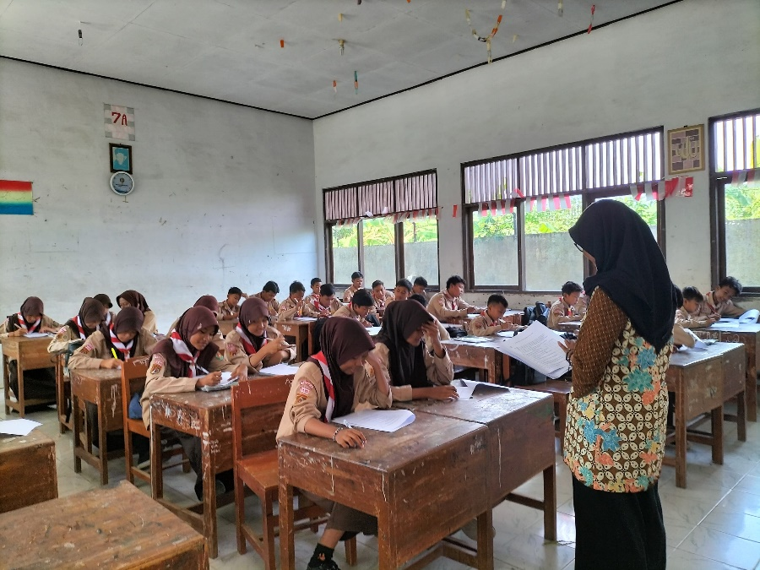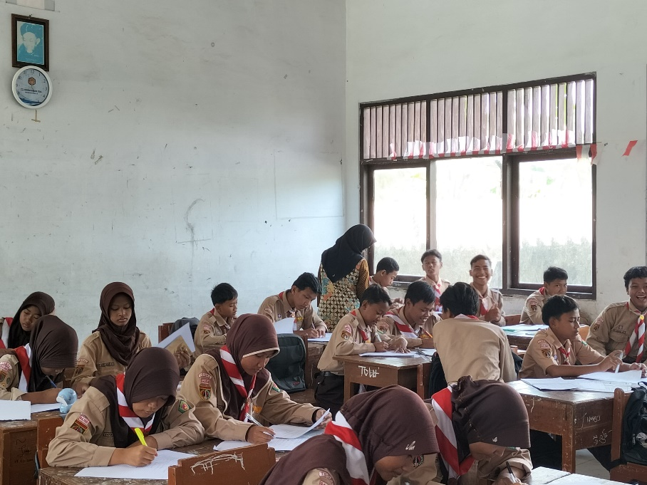

**Lampiran 24. Jurnal Bimbingan Skripsi**

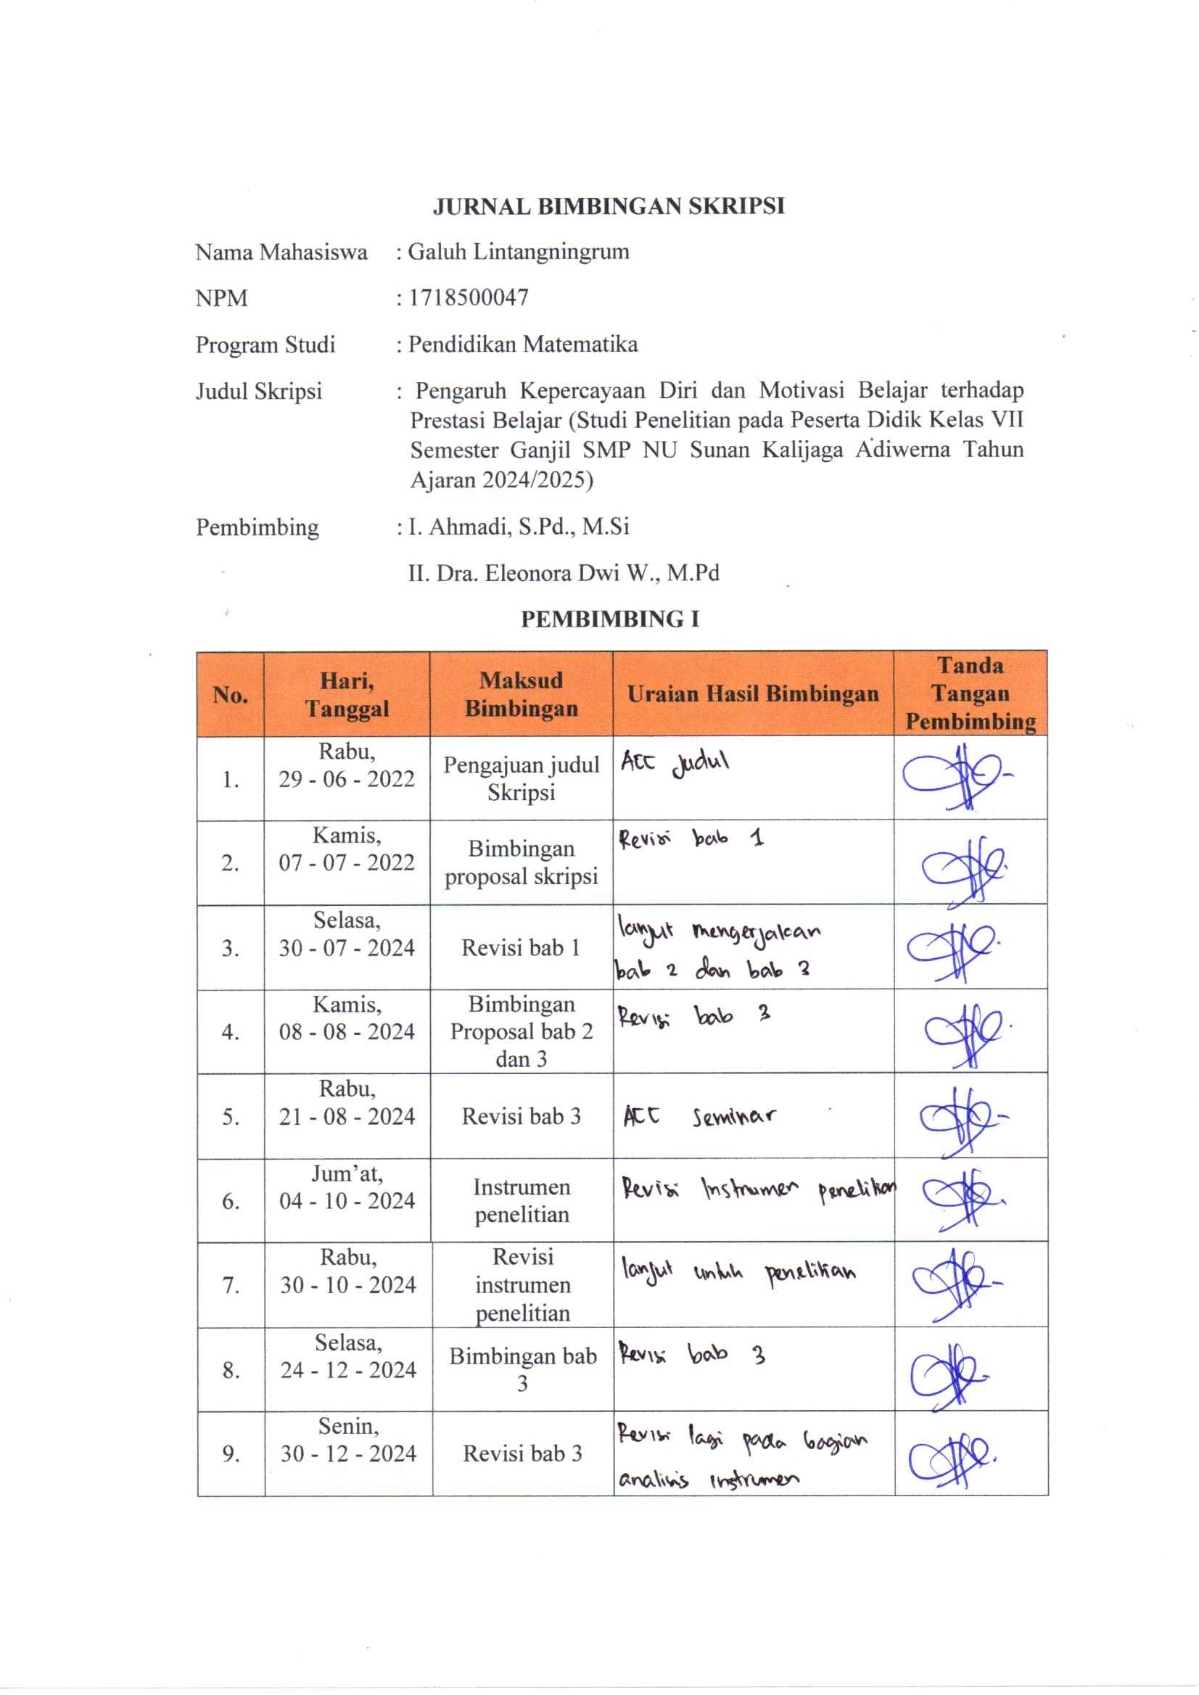

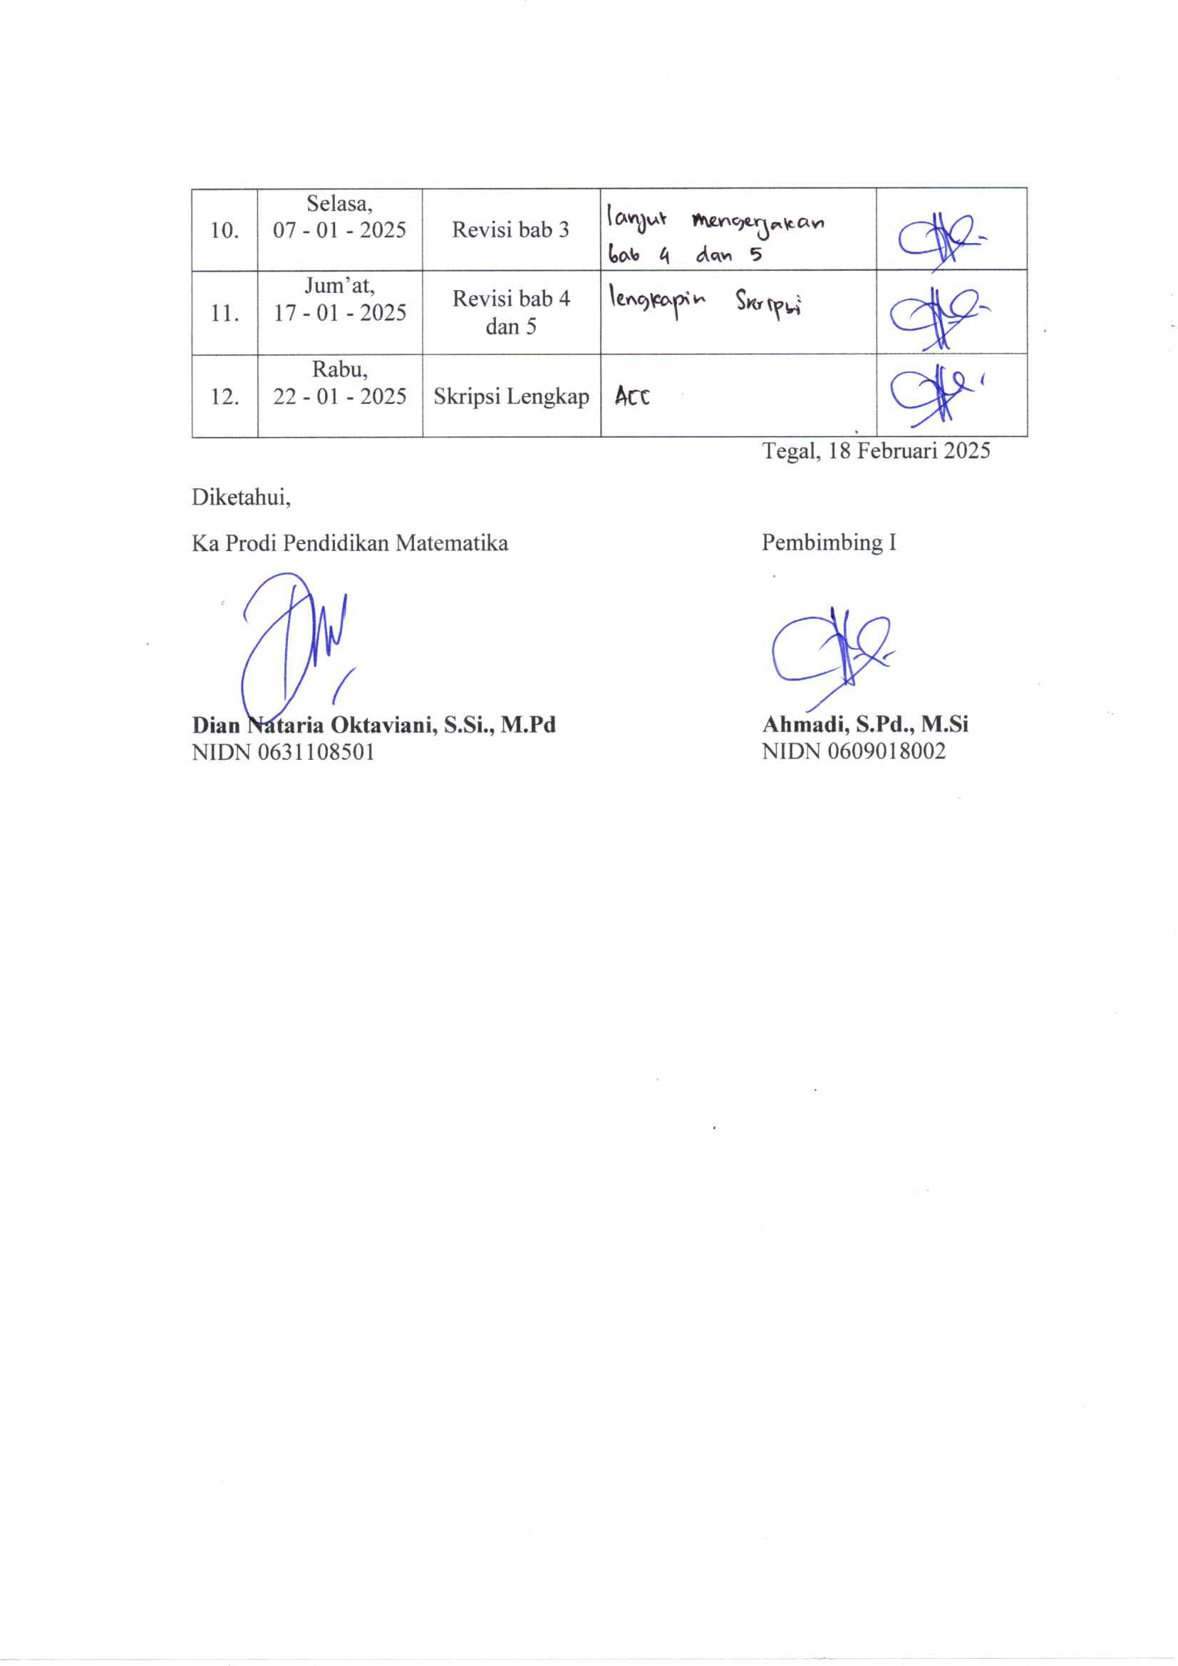

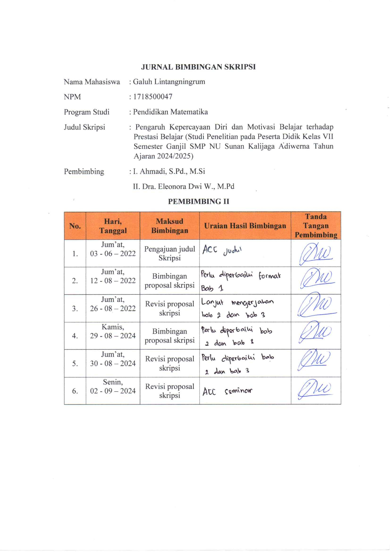

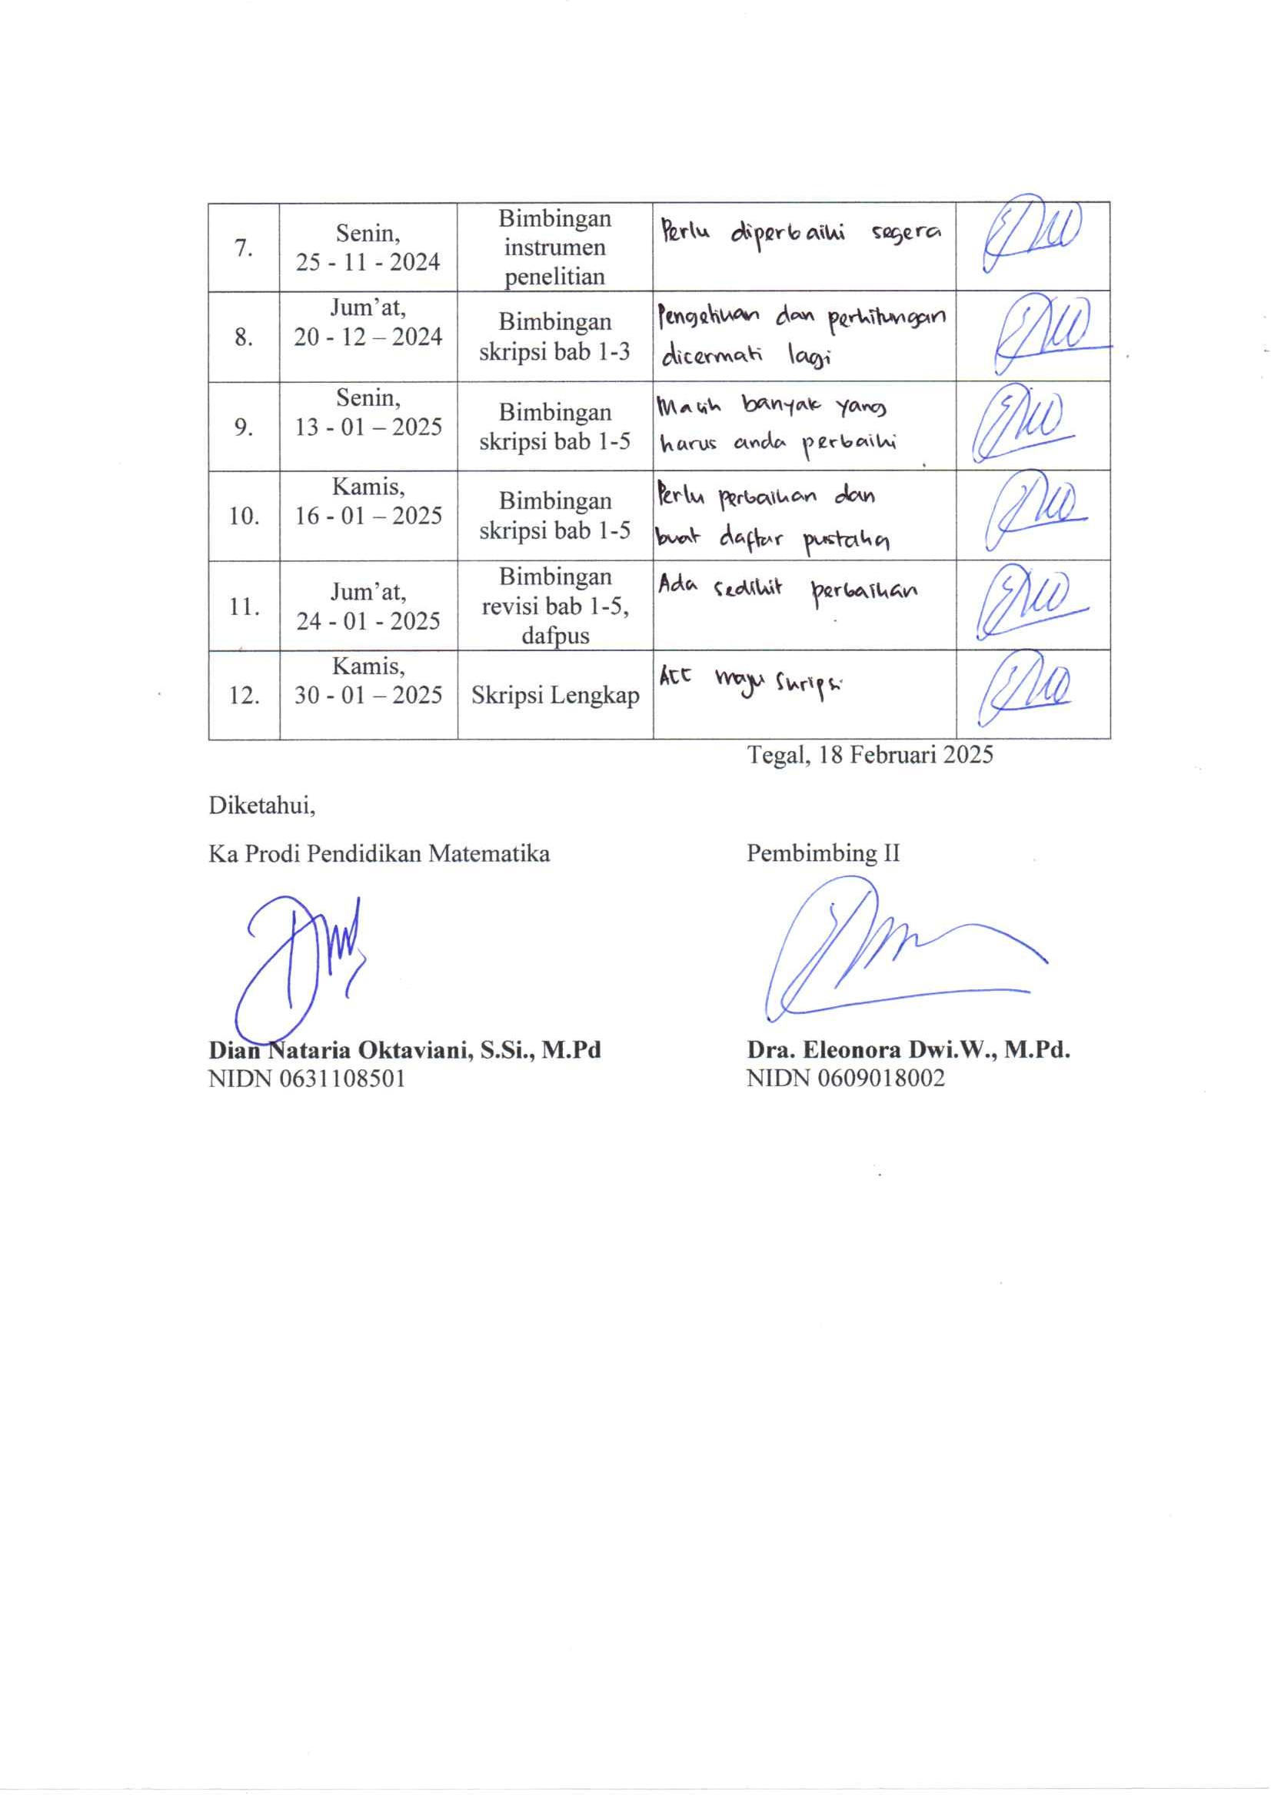

**Lampiran 25. Berita Acara Bimbingan Skripsi**

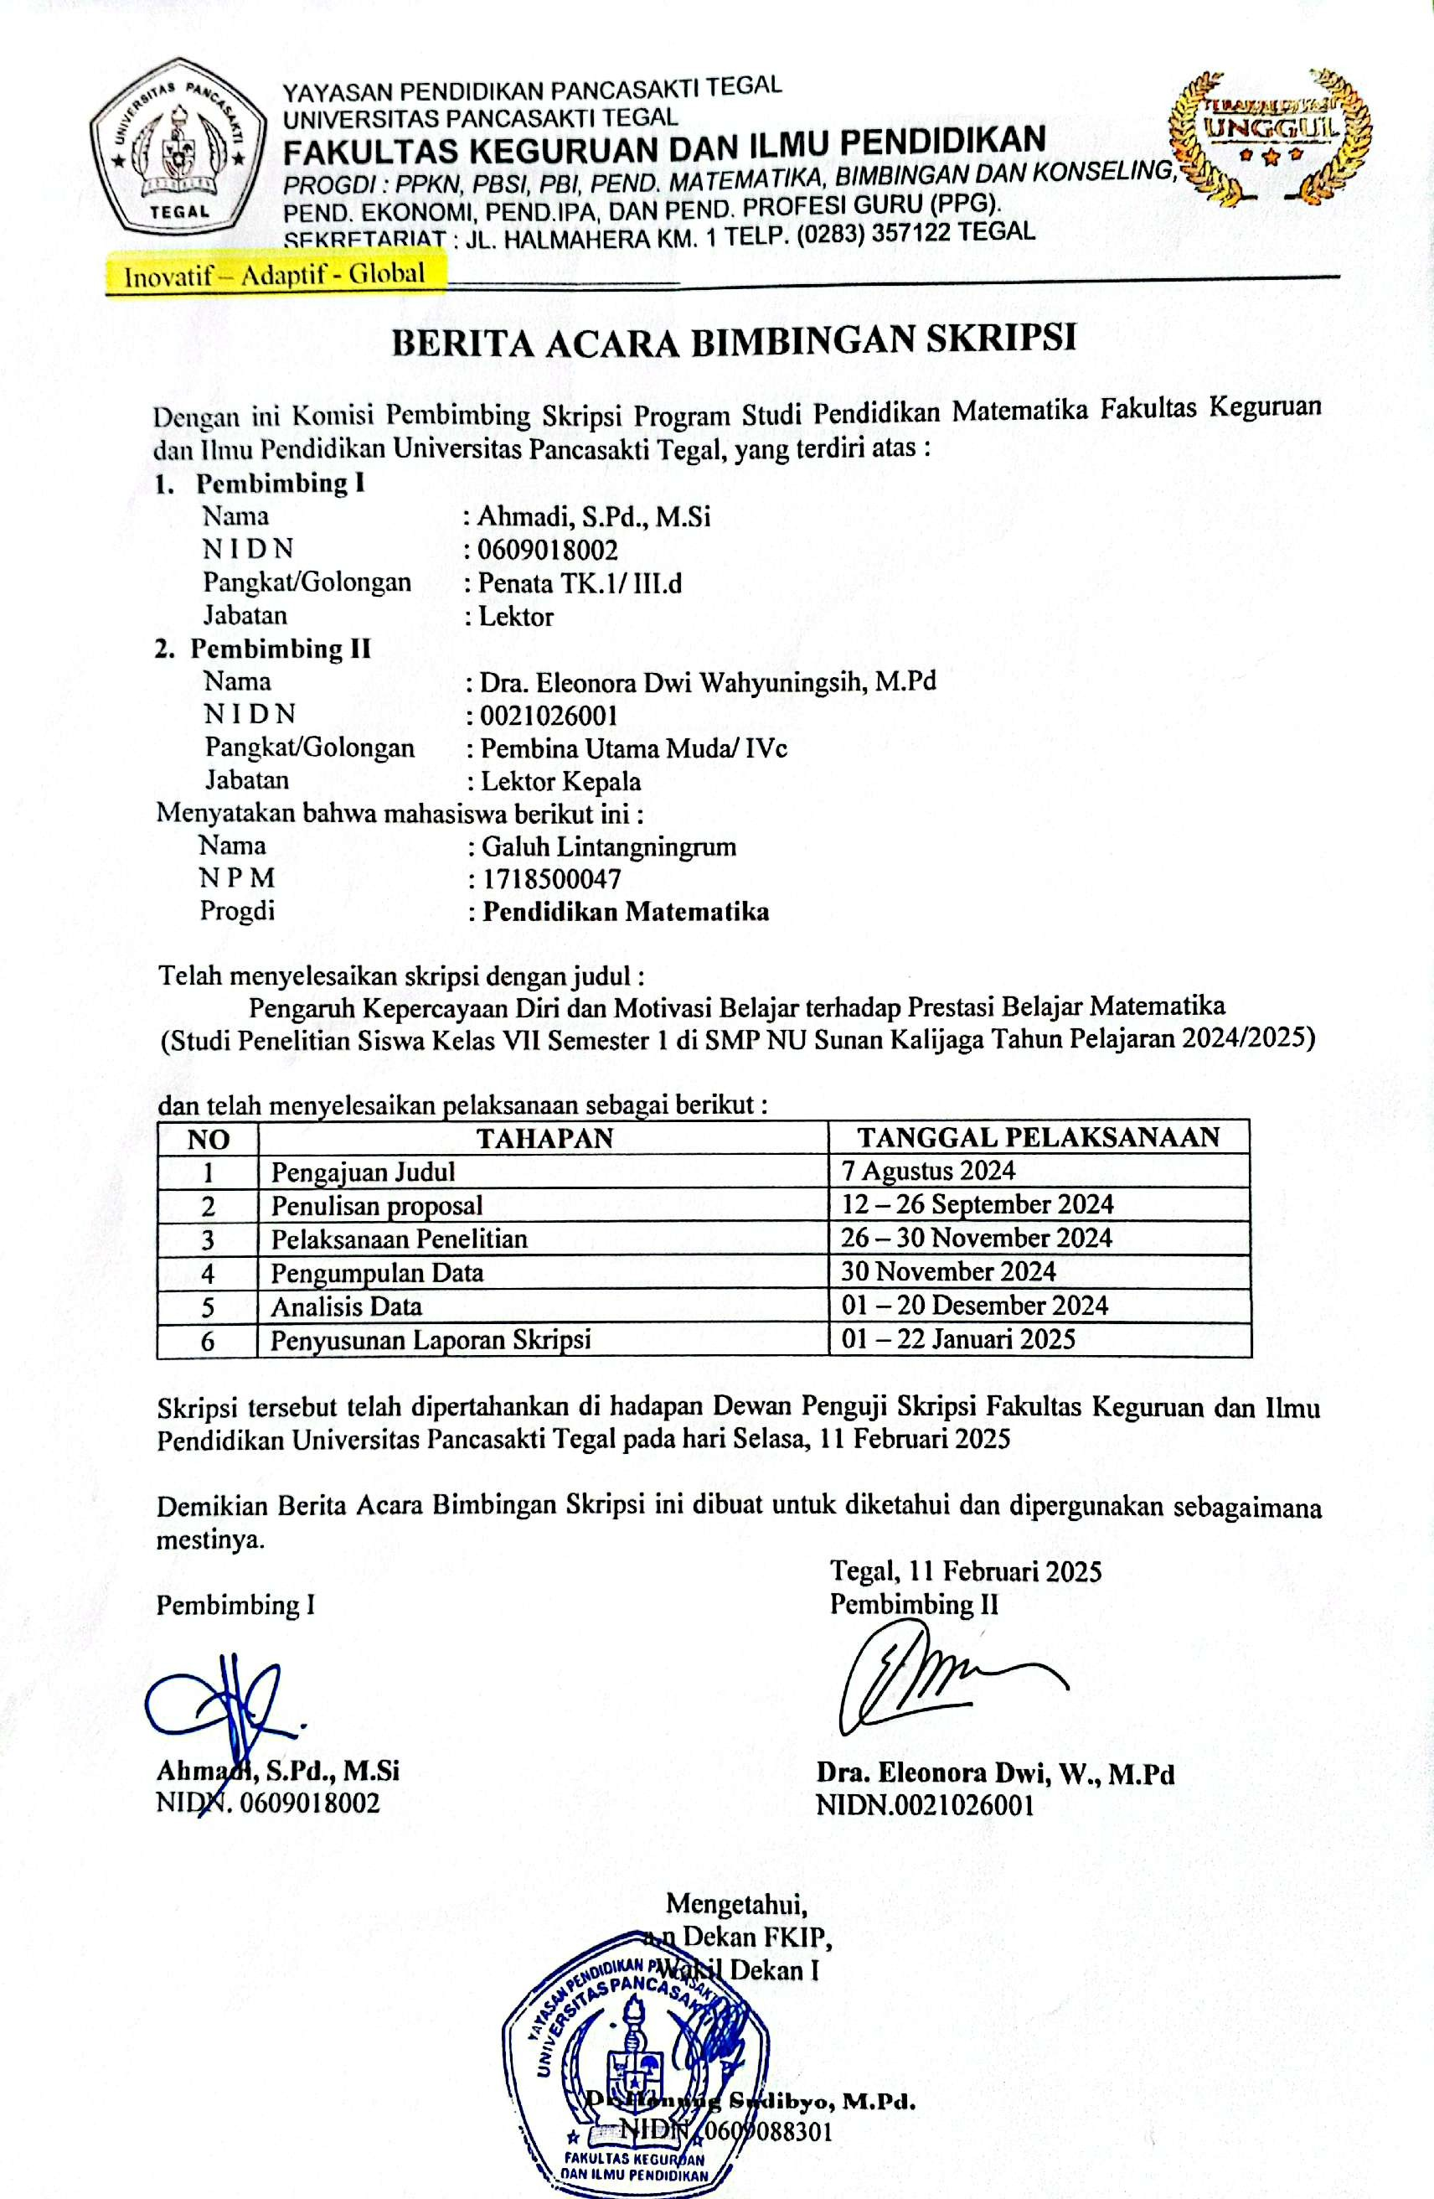

**Lampiran 26. Berita Acara Ujian Skripsi**

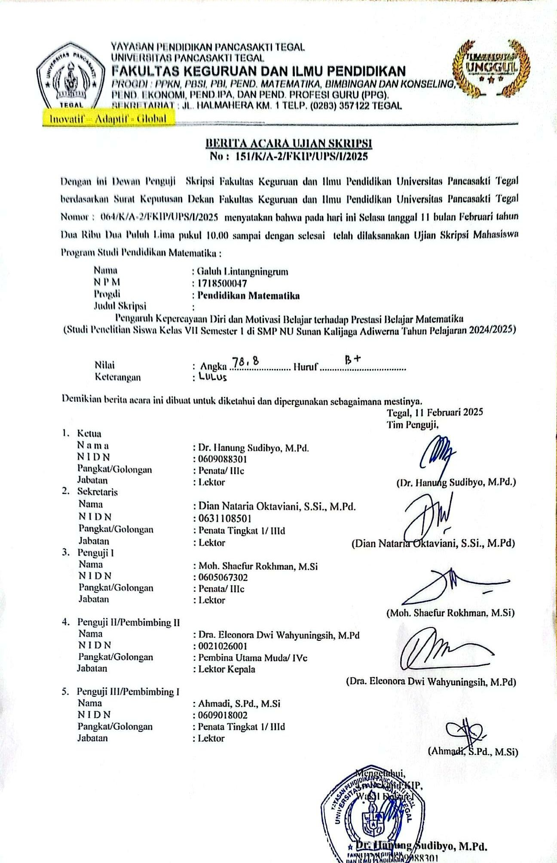

**Lampiran 27. Surat Plagiasi**