

**THE EFFECT OF THE GUESSING GAME METHOD ON SPEAKING SKILLS FOR EIGHTH GRADE STUDENTS OF SMP MUHAMMADIYAH 1 KOTA TEGAL**

(An Experimental Research at SMP Muhammadiyah 1 Kota Tegal in Academic Year 2023/2024)

# RESEARCH PROJECT

## Submitted as Partial Fulfilment of the Requirement for the Degree of

***Sarjana Pendidikan* in English Education**

By

# NAUFAL DHARMAWAN DICKY NPM 1619500035

**ENGLISH EDUCATION PROGRAM TEACHER TRAINING AND EDUCATION FACULTY**

**PANCASAKTI UNIVERSITY TEGAL**

**2025**

i

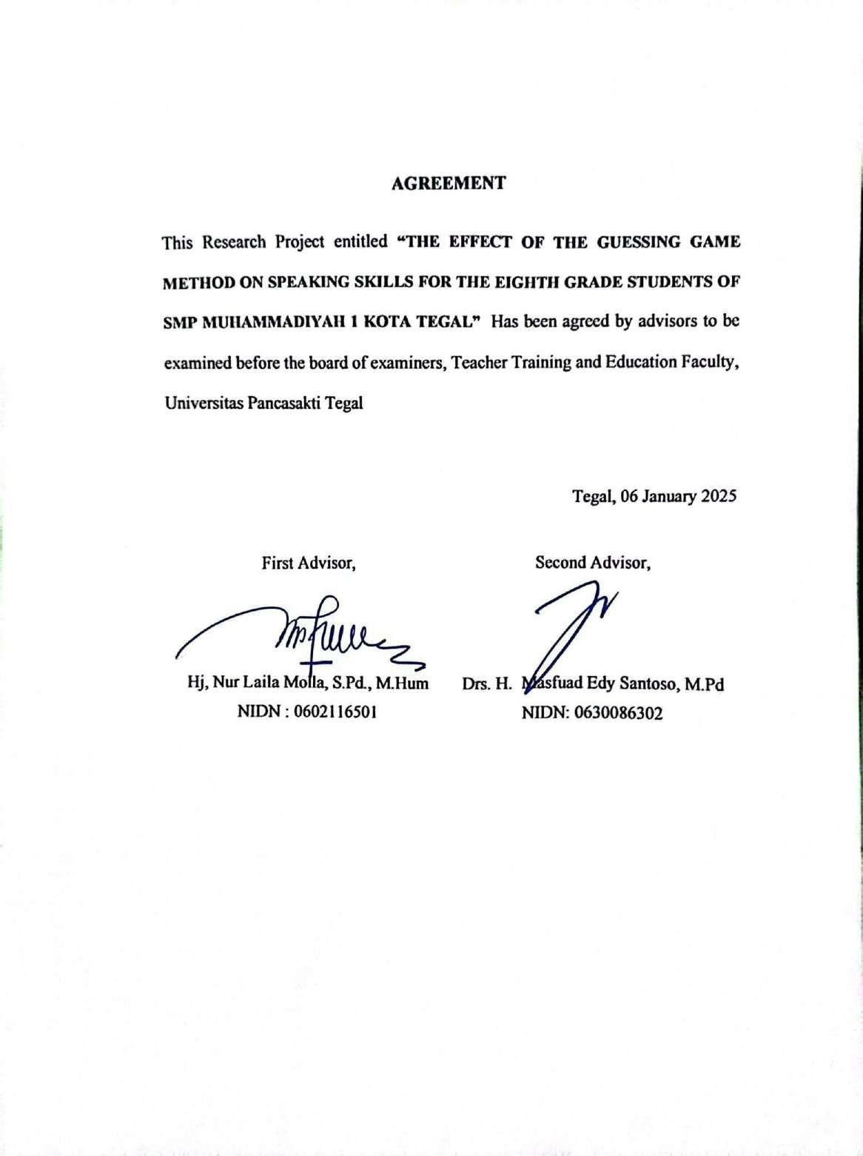

# AGREEMENT

ii

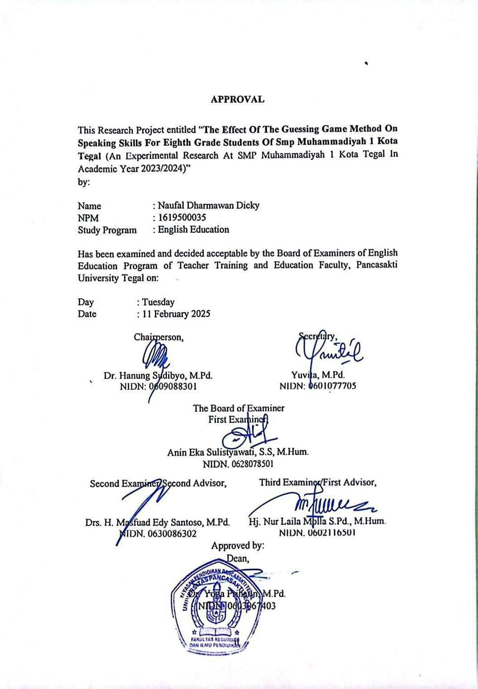

# APPROVAL

iii

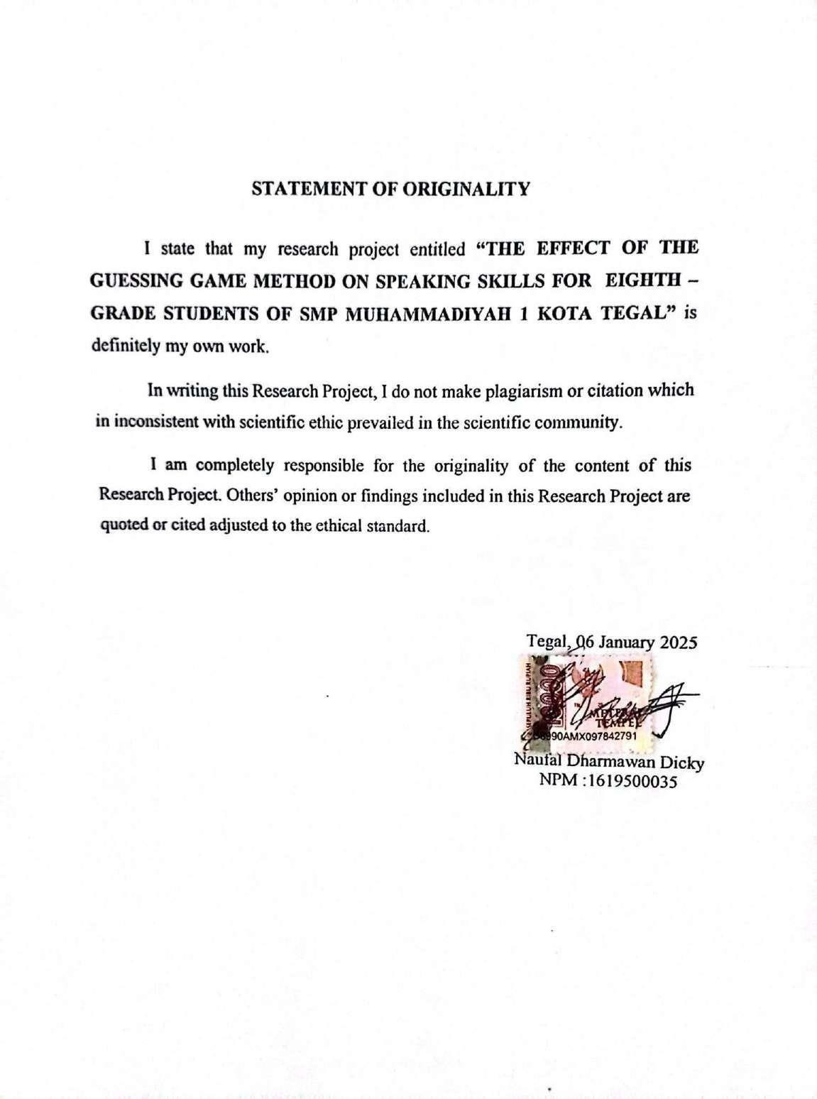

iv

# PREFACE

Praise be to Allah SWT for His Mercy and Grace to all of us so that we can complete the research project with the title **"The Effect Of The Guessing Game Method On Speaking Skills For Eighth Grade Students Of SMP Muhammadiyah 1 Kota Tegal".**

This research project is prepared as one of the requirements to obtain a bachelor's degree in the Strata-1 program in the English Language Education Department, Faculty of Teacher Training and Education, Pancasakti University, Tegal.

The researcher understands that without the assistance of numerous parties, the preparation of this research project cannot be finished. Therefore, we would like to express our gratitude to:

1. Mr. Dr. Taufiqulloh, M.Hum, as the Rector of Pancasakti University Tegal.
2. Mrs. Dr. Yoga Prihatin, M.Pd, as the Dean of Teacher Training and Education Faculty of Universitas Pancasakti Tegal.
3. Mrs. Yuvita, M.Pd., as the Head of English Education Department, Faculty of Teacher Training and Education, Universitas Pancasakti Tegal.
4. Mrs. Hj. Nur Laila Molla, S.Pd., M.Hum as the First advisor for the guidance, advice, and motivation.
5. Mr. Drs. H. Masfuad Edy Santoso, M.Pd, as the Second advisor for guidance, advice, and motivation.

v

1. All lecturers of the English Education Department who have given their knowledge to the author.

My parents, and siblings, for their prayers, guidance, and love that have always been poured out during this time

1. The big family of English Education Students, especially our friends in English Education, for all their support, enthusiasm, and cooperation.

We acknowledge that there are a number of problems with this research project. In order for this research project to ultimately benefit the field of education and application in the field and be further developed, the researcher hopes for suggestions and criticisms for the sake of perfection and improvement.

Tegal, 2025

Researcher

vi

# MOTTO AND DEDICATION

**MOTTO**

"Don't judge me by success, but judge me by how many times I fall and get back up." – Nelson Mandela

# DEDICATION

This final project is dedicated to:

* Allah SWT for the reason that I’m here.
* My beloved parents (alm. H. Edy Marudianto & Sri Rejeki).
* All teachers and lecturers who ever taught me.
* All relatives and friends who supported me.

vii

# ABSTRACT

**Dicky, Dharmawan Naufal. 2025 1619500035**: “The Effect Of The Guessing Game Method On Speaking Skills For Eighth Grade Students Of SMP Muhammadiyah 1 Kota Tegal (An Experimental Research at SMP Muhammadiyah 1 Kota Tegal in Academic Year 2023/2024)”. Research Project. Strata 1 Program, Faculty of Teacher Training and Education, Pancasakti University Tegal. The first Advisor is Hj. Nur Laila Molla, S,Pd., M.Hum. and the second advisor is Drs. H. Masfuad Edy Santoso., M.Pd

Keywords: *Guessing Game, Speaking Skills, Junior High School*

The objectives of this research are 1), to analyze the application of the Guessing Game method on speaking skills at the eighth-grade students of SMP Muhammadiyah 1 Kota Tegal. and 2) to discover the significance effect of the Guessing Game in eighth-grade students for speaking skills.

This research was conducted through an experimental approach with a true- experimental design. The population is 51 students in the eighth grade of SMP Muhammadiyah 1 Kota Tegal. The samples are 25 students in the experimental group and 26 students in the control group. The researcher used purposive sampling with two categories: the experimental group who were taught using Guessing Game Method, and the control group who were taught without Guessing Game Method. The data collecting technique consists of a pretest and posttest with a speaking test. SPSS 22 program was used to analyze the data.

The result of the average score of the posttest experimental group is higher than the control group (67,36> 60,27 ). The result of Independent Samples T-Test showing sig. (2-tailed) value is 0.000 < 0,05, it means there is a significant effect on students’ speaking skills inthe experimental group than in the control group. Thus, Guessing Game Method is effective for students’ speaking skills.

Furthermore, the writer suggests: 1) The English teachers should use an appropriate media in teaching-learning process to enhance students’ interest in learning English, and 2) Further research should try and develop the use of Guessing Game method for speaking skills.

viii

# ABSTRAK

**Dicky, Dharmawan Naufal. 2025** 1619500035: “Pengaruh Metode Permainan Tebak-tebakan terhadap Keterampilan Berbicara Siswa Kelas VIII SMP Muhammadiyah 1 Kota Tegal (Penelitian Eksperimen di SMP Muhammadiyah 1 Kota Tegal Tahun Ajaran 2023/2024)”. Proyek Penelitian. Program Strata 1, Fakultas Keguruan dan Ilmu Pendidikan, Universitas Pancasakti Tegal. Pembimbing pertama adalah Hj. Nur Laila Molla, S,Pd., M.Hum. dan pembimbing kedua adalah Drs. H. Masfuad Edy Santoso., M.Pd

Kata Kunci: *Permainan Tebak-tebakan, Keterampilan Berbicara, Sekolah Menengah Pertama*

Tujuan penelitian ini adalah 1) menganalisis penerapan metode Permainan Tebak-tebakan terhadap keterampilan berbicara siswa kelas VIII SMP Muhammadiyah 1 Kota Tegal. dan 2) menemukan signifikansi pengaruh Permainan Tebak-tebakan terhadap keterampilan berbicara siswa kelas VIII SMP Muhammadiyah 1 Kota Tegal. Penelitian ini dilakukan melalui pendekatan eksperimen dengan rancangan true-experimental. Populasi penelitian ini adalah siswa kelas VIII SMP Muhammadiyah 1 Kota Tegal yang berjumlah 51 orang. Sampel yang digunakan adalah kelompok eksperimen sebanyak 25 orang dan kelompok kontrol sebanyak 26 orang. Peneliti menggunakan purposive sampling dengan dua kategori yaitu kelompok eksperimen yang diajar dengan menggunakan Metode Permainan Tebak dan kelompok kontrol yang diajar tanpa Metode Permainan Tebak. Teknik pengumpulan data menggunakan pretest dan posttest dengan tes berbicara. Data dianalisis menggunakan program SPSS 22.

Hasil rerata skor posttest kelompok eksperimen lebih tinggi dibandingkan kelompok kontrol (67,36 > 60,27). Hasil uji Independent T-Test menunjukkan nilai sig. (2-tailed) sebesar 0,000 < 0,05, artinya terdapat pengaruh yang signifikan terhadap keterampilan berbicara siswa pada kelompok eksperimen dibandingkan kelompok kontrol.

Dengan demikian, Metode Permainan Tebak efektif untuk keterampilan berbicara siswa. Lebih lanjut, penulis menyarankan: 1) Guru bahasa Inggris hendaknya menggunakan media yang tepat dalam proses belajar mengajar untuk meningkatkan minat siswa dalam belajar bahasa Inggris, dan 2) Penelitian selanjutnya hendaknya mencoba dan mengembangkan penggunaan metode Permainan Tebak untuk keterampilan berbicara.

ix

# TABLE OF CONTENTS

## Contents

COVER i

AGREEMENT ii

APPROVAL iii

STATEMENT OF ORIGINALITY iv

PREFACE .v

MOTTO AND DEDICATION vii

ABSTRACT viii

ABSTRAK ix

TABLE OF CONTENTS x

LIST OF TABLES xii

LIST OF FIGURES xiii

CHAPTER I INTRODUCTION 1

* 1. Background of the Problems 1
  2. Identification of the Problems 2
  3. Limitation of the Problems 3
  4. Statements of the Problems 3
  5. Objectives of the Research 4
  6. Significance of the Research 4
     1. Theoretical Significance 4
     2. Practical Significance 4

CHAPTER II REVIEW OF RELATED STORIES, THEORETICAL FRAMEWORK, AND HYPOTHESIS 6

* 1. Previous Studies 6
  2. Review of Related Theories 14
     1. Guessing Game 14
     2. Speaking 20
  3. Theoretical Framework 27
  4. Hypothesis 29

CHAPTER III RESEARCH METHODOLOGY 30

* 1. Approach, Type, and Design of the Research 30

x

* + 1. Approach of The Research 30
    2. Type of the Research 30
    3. Design of The Research 31
  1. Population, Sample and Technique of Sampling 31
     1. Population 31
     2. Sample 32
     3. Technique of Sampling 32
  2. Research Variable 32
  3. Data Collecting Technique 33
  4. Research Instrument 34
  5. Technique of Analyzing Data 35

CHAPTER IV RESEARCH RESULT AND DISCUSSION 37

* 1. Research Result 37
     1. Pre-Test 37
  2. Data Analysis 38
     1. Treatment 42
     2. Post-Test 45
  3. Discussion 45

CHAPTER V CONCLUSION AND SUGGESTION 47

* 1. Conclusion 47
  2. Suggestion 48

REFERENCES 50

APPENDIX

xi

# LIST OF TABLES

Table 3.1 Population Of Research 31

Table 4.1 Descriptive Analysis 38

Table 4.2 Normality Test 40

Table 4.3 Homogenity Test 40

Tabel 4.4 Independent Sample T-Test 41

xii

# LIST OF FIGURES

Figure 1 Theoretical Framework 28

xiii

# CHAPTER I INTRODUCTION

This section presents a detailed summary of the research. It also discusses the background, identification, limitations, statements, objectives, and significance of the research.

## Background of the Problems

According to Harchegani and Biria (2013), one thing you must master in English is how to speak. It can be used to increase knowledge and be brave enough to speak in public. Speaking is a crucial skill to cultivate, playing a pivotal role in facilitating effective interaction between individuals, benefiting both the speaker and the listener (Leong & Ahmadi, 2017). Speaking is currently a key component of language learning, but in the future, there will be a significant change in the way that speaking abilities are seen and taught. In this case, it is argued that speaking skills are indispensable and the most important and necessary skill.

For Junior High School Students, studying English is a difficulty since it is a required course they have to finish. According to the results of the observation, which was conducted in grade 8 at SMP Muhammadiyah 1 Kota Tegal, some students participate in the process of learning. while others are more passive and willing to participate in class activities. They believe that teaching English is difficult and tedious. They are of the opinion that the

1

methods that the teacher uses to teach English are difficult for the students to comprehend.

In order for students to comprehend the material with ease and accuracy, researchers must create an environment that is both stimulating and engaging.

Guessing Game is a useful method for improving your English language skills. This method is very easy and can be understood by all students, especially middle school students. The important thing students can understand English vocabulary and other students can try to guess the words. The Guessing Game is a game that is very easy to understand. The key is for each guesser or answerer to have knowledge of the question. (Klippel, 1984). According to Kurniati and Erfina (2019), they said that this game method can mean students' attention and interest in speaking up and students feel happy because they can participate actively in this game.

According to the background above, the researcher decided to take the title “The Effect of The Guessing Game Method on Speaking Skills for Eighth Grade Students of SMP Muhammadiyah 1 Kota Tegal”.

## Identification of the Problems

In light of this background, researcher has pointed out three problems conserning the guessing game method on speaking skills. The problems are as outlined:

1. The students don't like speaking in English and feel embarrassed when they have to.
2. The students encounter challenges in engaging with learning the English language.
3. The students complain that the methods taught by teachers at school are difficult to understand.

## Limitation of the Problems

When restricting the problems to students' speaking skills, the researcher can use some of the issues mentioned in the aforementioned statements as an indication. The researcher picks the Eighth Class Students in SMP Muhammadiyah 1 Kota Tegal and investigate how eighth grade English students' ability to speak were affected by conducting a guessing game.

## Statements of the Problems

It is possible to formulate the problem statement within the context of the problem that was mentioned earlier as follows:

1. How is the Application of the Guessing Game method on speaking skills at the eighth-grade students of SMP Muhammadiyah 1 Kota Tegal?
2. Does the Guessing Game method significantly impact eighth-grade students' speaking skills?

## Objectives of the Research

This research seeks to address the statement of problems concerning the students of SMP Muhammadiyah 1 Kota Tegal. The main objective of the research are listed below:

1. To analyze the application of the Guessing Game method on speaking skills at the eighth-grade students of SMP Muhammadiyah 1 Kota Tegal.
2. To discover the significance effect of the Guessing Game in eighth-grade students for speaking skills.

## Significance of the Research

## Theoretical Significance

This research adds to the literature by presenting the guessing game as a potential strategy for improving eighth graders' oral communication skills.The research findings give additional knowledge, support, and enrich the theory about the guessing game method. It is intended to serve as a reference and informational resource for readers and educators, particularly with regard to the guessing game technique for enhancing speaking skills.

## Practical Significance

The outcomes of this research can give many kinds of advantages in all aspects. Here are the advantages:

* + - 1. For students

The findings of this research are supposted to be of significant benefit to students, making them more likely to be interested in English language learning , especially when it comes to speaking. Through this research, students are excited in learning English, because improving their speaking skills in English is not difficult because it uses a method that is very simple, interesting, exciting and easy to understand if using a game method like this guessing game.

* + - 1. For teachers

English teachers should use innovative and rarely used techniques, such as the guessing game method, to avoid English classes from boredom and monotony. This research can be expected to give inspiration and guidance that guessing game is an alternative media in teaching speaking skills in eighth grade.

* + - 1. For other researchers

This research aims to furnish future researchers with knowledge, a model, a reference, and inspiration regarding the guessing game technique and speaking skills.

# CHAPTER II

**REVIEW OF RELATED STORIES, THEORETICAL FRAMEWORK, AND HYPOTHESIS**

This section reviews the literature, develops the conceptual framework, and presents the hypothesis. The Review of Related Theories compares previous studies pertinent to this research. The Theoretical Framework identifies the rationale comprising theories, facts, observations, and literature reviews that underpin the development of a research project. The Hypothesis seeks to identify a preliminary way out of the issue examined by the researcher.

## Previous Studies

The first previous study was carried out by Junaid (2019) from the English Language Education Study Program Cokroaminoto University Palopo research entitled “The Effectiveness of Guessing Game Technique in Improving Students Speaking Skills” his research was designed to evaluate the efficacy of speaking skills. A speaking test was employed to obtain data from a sample of twenty-five tenth-grade students. The speaking test was administered randomly, and the research method employed was quantitative research, utilizing the speaking test as the instrument. This study set out to ascertain how effective speaking skills are. Twenty-five randomly selected 10th graders provided the data. The data were gathered using a speaking test, and the study approach was quantitative research with a pre-experiment design that included the speaking test as an instrument. The test was partitioned into two segments: the pre-test and the post-test. Every test consists in three section.

6

The first section is about students' self-identity which consists of 5 questions. The data collection technique employs a speaking test, utilizing a quantitative research method and a speaking test as the instrument in a pre-experimental study design. Every test consists in three section .The first section is about the student's self-identity consisting of 5 questions, the second section is about the student's favorite Idol figure consisting of 3 questions, and the last section is about a memorable experience for the student himself consisting of 3 questions. The researcher then records the students who are speaking at the last of the study. The researcher gave 11 questions to 25 students one by one in front of the class This outcome is significant; The circumstances before and after treatment are distinct from one another. The pre-test average score after the test was 62.00, up from 41.80 before. Based on the t-test results, The p-value falls below the 0.05 significance level, which is set at 0.00.The researcher concludes that using guessing games to improve SMAN 1 Palopo students' public speaking abilities is a fruitful strategy based on these findings.

The second previous study was carried out by Ni Putu Widiari Kusuma Dewi, Putu Ayu Paramita Dharmayanti, I Nengah Astawa (2019), who did the research “Using Guessing Games to Improve Students' Speaking Skill” This study was conducted to discover whether this method is very useful or not to implement guessing game in speaking skills.This study was led at SMPN 1 Kuta Utara in the 2019/2020 academic term. Here the object of study was 36 students consisting of 12 females and 12 males. This study also applied classroom action research (CAR) design. This study also employed a

questionnaire, had two rounds of testing (pre- and post-tests), and used qualitative research methods. The average scores of the students on the pre-test ranged from 49.72 to 64.86 on the first post-test, and they reached 75.69 on the second post-test. At the end of cycle II, the researcher also distributed a questionnaire to collect extra supporting data. This demonstrates that the students were supportive, and the survey findings suggest that 60.68 percent of respondents strongly felt that the guessing game would be useful. Overall, guessing games are a great way for SMPN 8 Kuta Utara students to enhance their speaking skills.

The third previous study was carried out by Marcilia Dorotea Uba, Ike Dian Puspitasari (2022),who did the research “The Effect of Using A Guessing Game on Students Speaking Ability at SMP Kertanegara Malang” This study seeks to determine the impact of the Guessing Game on the speaking skills of eighth-grade students at SMP Kertanegara Malang during the 2021/2022 academic year. This study uses quantitative methods and uses a true experimental. The classes are separated into two categories: experimental and control. In contrast to the control group, which does not make use of the researcher's methodology or treatment, the experimental group is the one that receives the treatment. The findings of the study provide the researchers with the ability to determine the degree of dissimilarity that exists among the experimental group and the control group. After the implementation of games and treatment, the scores of the experimental class showed a significant improvement, increasing from an average of 66.50 in the pre-test to an average

of 83.38 in the post-test. The conclusion was reached through the analysis ofdata conducted with SPSS version 20. There was a 0.66485922888 difference between the experimental and control groups' post-test values, with the control group's pre-test value being 64.75. This means that the t-score is greater than

0.05. The students' use of guessing games during the 2021/2022 school year at SMP Kertanegara Malang was found to be correlated with their speaking abilities, according to this study.

The fourth previous study was carried out by Hismadewi (2022), who did the research “The Use of Guessing Game to Improve Students' Speaking Skill at SMP Negeri 14 Palopo**”** The purpose of this study is to analyze how SMP Negeri 14 Palopo students' speaking skills were improved through the use of a word guessing game. This study aims to evaluate the effectiveness of the guessing game in improving student speaking skills at SMP Negeri 14 Palopo. In this study, 60 eighth-graders made up the population. The researcher used purpose sampling. The researcher picked the eighth grade and used quantitative pre experimental design. As a result of the students' limited capacity to speak English in an appropriate and correct manner, the researcher decided to focus their attention on this particular class. According to the results, the probability is between 0.000 and 0.05.This indicates that h0 has been rejected, which clarifies why the approach is ineffective. Here, there is a difference between the class's average pre-test score of 23.60 and post-test score of 45.47. Thus, the guessing game technique aids students in developing their skills in speaking.

The fifth previous study was carried out by Zahriyatun Nabila (2023), who did the research “The Implementation of Guessing Games to Train Vocational High School Students Speaking Skills in Merdeka Belajar Curricullum” The objective of this study is to ascertain the effectiveness of the Guessing Game method in enhancing the speaking skills of eleventh-grade vocational high school students. The study employs a quantitative approach, utilizing two groups: the experimental group and the control group. The procedure consists of four meetings: the first one was for the pretest, the second and third meetings were for treatment, and the final meeting was for the posttest. In the treatment phase, both groups encountered identical learning material; however, the experimental group utilized the Guessing Game technique, whereas the control group followed the traditional method of listening to the teacher's discourse and completing exercise questions.The main technique used for data analysis was a T-test, whereas observations were employed to obtain more comprehensive information. A t-test was utilized to analyze the results, based on a sample of 52 students for data collection. The t- test results indicate a significant difference (p = 0.000 < 0.05) between the T table value of 2.009 and the T count value of 3.101.The findings suggest that students in class XI vocational high school are showing improvement when the guessing game method is utilized.

The sixth previous study was carried out by Made Utami Murtiningrum, Ni Putu Meri Dewi Pendit, and I Wayan Mawa (2020), who did the research “Improving The Tenth Grade Students' Speaking Ability Through Guessing Game at SMK Saraswati 3 Tabanan” The objective of this study is to enhance students' speaking skills through the implementation of a guessing game. This study was carried out utilizing Classroom Action Research (CAR) focusing on the X TB 1 class students of SMK Saraswati Tabanan, comprising a total of 31 students. This aims to evaluate the enhancement of students' speaking skills prior to and following the implementation of the guessing game. A combination of qualitative and quantitative methods is utilized to analyze the data.The guessing game serves as an engaging method to enhance students' skills in articulating descriptive text. The activity requires students to interpret clues and produce a descriptive video centered around a specific subject, individual, or location. The study's results demonstrated that the observed enhancement in ability is evident in the average scores, with the initial test averaging 51.1, which grew to 65.4 in the final test of cycle I, and further increased to 74.2 in the final assessment of cycle II. Additionally, the quantity of students who exceeded the minimum completion standards increased from 4 students (12.9%) in the initial assessment to 15 students (48.4%) in the concluding evaluation of cycle I, and subsequently escalated to 27 students (87.1%) in the final assesment of cycle II. Thus, the application of guessing games can positively impact learning at school and increase students' motivation to learn to speak English.

The researcher inferred the similarities and differences. The similarity lies in the instrument (speaking test) and the goal of the research is located in the first, second, third, fourth, fifth, and sixth journals. The first, third, and fifth journals also found similarities, namely using quantitative research methods. All of these journals also have the same goal of finding out about the effectiveness of the method and the positive impact on students from the application of guessing games in improving speaking in the second, third, and fourth journals, there are similarities in the level of students for research, namely in junior high school. And the differences This difference is seen from the research method and the level of students. for the second journal using qualitative methods and classroom action research (CAR) In contrast, the sixth journal employs classroom action research (CAR) in addition to a combination of qualitative and quantitative methodologies. The distinction made regarding student levels is that the first journal is at the higher secondary level, the second, third and fourth journal at the junior high school level, and the fifth and sixth journal at the vocational school level.

Even though the Guessing Game method has been shown to be effective in enhancing the speaking skills of learners, there are still certain research gaps that need to be filled. Junaid (2019) conducted a pre-experimental study focusing on tenth grade students, but the study did not have a control group for comparison. Meanwhile, Ni Putu Widiari Kusuma Dewi, Putu Ayu Paramita Dharmayanti, I Nengah Astawa (2019), and Made Utami Murtiningrum, Ni Putu Meri Dewi Pendit, and I Wayan Mawa (2020), applied Classroom Action

Research (CAR) to assess the improvement of students' speaking skills, but their research focused more on repeated teaching cycles rather than measuring the direct effect of the method in a controlled environment. In addition, Marcilia Dorotea Uba, Ike Dian Puspitasari (2022), & and Hismadewi (2022), applied a true experimental design, but their research was conducted in different schools with different student populations, so their findings are less generalizable to the context of this study. Zahriyatun Nabila (2023), examined the impact of the Guessing Game method in a vocational high school level which is different from this study's focus on junior high school students. Furthermore, the previous study mainly measured the overall effectiveness of the Guessing Game without specifically addressing Asking and Giving Opinions, which are important aspects of communicative English. The current research used a true experimental design to close this gap, focusing on eighth graders at SMP Muhammadiyah 1 Kota Tegal, focusing on Asking and Giving Opinions as part of their English learning curriculum. This research intends to close this gap by offering a more thorough understanding of how the Guessing Game method enhances the speaking skills of students in a methodical and quantifiable ways. Based on a survey at SMP Muhammadiyah 1 Kota Tegal, this school uses the Kurikulum Merdeka. The material in the syllabus for grade eight is Asking for Giving Opinion. Students are asked to use the English language to express their opinions in this syllabus.

Furthermore, the 2013 English curriculum included the skills of listening, speaking, reading, and writing.

## Review of Related Theories

## Guessing Game

* + - 1. **Definition of Guessing Game**

According to Klippel (1984),. ". The basic rules of this game of guessing is straightforward: one player has information that the other player is interested in learning." On the other hand, in a guessing game, individuals or teams try to come up with answers using words that are related to the word. Guessing Game can be utilized to establish and reinforce key concepts to discover the issue. However, the most crucial role is to provide practice speaking and communicating. Guessing games are a frequently used teaching tool since they are typically based on real-life situation. The game offers a chance to practice realistic use of language to communicate Amato (1995) in Maqfirah & Sarah Fitriani (2018).

In essence, a Guessing Game is a game where players either work alone or in small groups to identify and guess various objects.

Here are some concepts about guessing games that are applicable to teaching speaking. According to Klippel (1984), “Among them is a guessing game that can be used in various communities”

According to Saputri et al., (2022) cite in Lee in Betteridge and Buckby (1990). it can be said that diverse societies can practice various forms of guessing games, including:

1. Guess what is it? Is it?

It has the capability to attempt to identify nearby known objects for the student.

In order to indicate their response, students will raise their hands.

* 1. Is it my face?
  2. Is it the pool?
  3. Is it the Airport?
  4. Is it Ahmad’s desk?

1. Guess who I am? What is my name?

In this game, everyone fantasizes about becoming someone who is famous. I can be doctor, lecturer, etc. After this, everyone makes a sentence about themselves. For example:

* 1. I….. lived….. About…. years
  2. I was a teacher /lecturer/doctor etc.

1. Guess where is it?

In this game, students close their eyes while one or more things, such as coins, rings, toys, candy, and dolls, are hidden.The child's teacher calls one of the students and instructs the student to give a clue about the object. And the rest of the students will imagine and try to imagine the question.

In other hand, Doff Adrian (1988) explained that speaking classes include a variety of teaching and learning activities.

There are many kinds of guessing games:

1. Guessing the picture

In this game, the teacher sets up various pictures or flashcards. The teacher chooses one a picture arrangge. The students then provide clues about the picture to the teacher without knowing what it means. Students can answer questions and give reasons about the answers to the questions.

1. Guessing the sentence

This one is very likely to be similar to guessing pictures, but the difference is in the material and the content. Guessing sentences uses sentences but guessing pictures uses pictures.

1. Guessing mime

Within this game the teacher calls on students to come forward and tells the students to do something and spell out verbs, nouns etc. Then, the other students attempt to answer the question by utilizing activities and gestures in accordance with the condition of the student who provided the clue. Subsequently, other students attempt to address the inquiry by employing gestures and activities that are indicative of the student's condition.

Bruce Marsland (2009) in Paramitha (2020) clarified that numerous guessing games revolve around the idea of one individual possessing knowledge while the entire class attempts to make informed guesses. In all these particular cases, the

underlying question is to pin down whether the answer is "yes" or "no", it's kind of a guessing game:

* 1. I-Spy

In this activity, a player who is familiar with a specific item begins by revealing the initial letter of that item. The remaining participants then try to guess the object. This game usually starts with the first player saying, "I spy, with my little eye, something that starts with A," with the letter "A" representing the player's choice.

* 1. Twenty Question

Also referred to as "animals, plants, stones," this game involves specifying a category of objects, and it falls within one of the three mentioned categories.After guessing the category, students have twenty chances to obtain details regarding the object before making their final guess. For more advanced participants, there is a fourth option called the "Abstract" category, which includes emotion nouns and similar concepts.

* 1. The Coffee-pot Game

Despite the fact that verbs are extremely important, they are frequently used in language classes. The phrase "coffee pot" is always used as a stand-in for the actual word

the questioner is attempting to infer, assuming that this is what the "knower" may have written down.

* 1. Guessing the Story

Numerous brief narratives suitable for a guessing game like this can be found, and potential sources materials are provided in the bibliography at the conclusion of this book. Or, you may opt for engaging news stories or magazine articles. The game involves offering two or three-word clues extracted from the narrative, prompting the entire class to pose "yes/no" inquiries in an attempt to discern the story's subject. To provide a challenge, set a time restriction or limit the amount of questions before the class reconstructs the story orally. Only correctly stated questions should be answered.

* 1. Guessing “who” game

This activity falls into the category of guessing games, with simple rules. To organize the game, divide the class into groups, pairs, or individuals. The participant designated as the "guesser" receives a paper with someone's name on it. Next, the "guesser" (another student) formulates a guess by asking questions such as, "Do you have a square face?" or "Do you have dark eyes?" The "guesser" may only answer "yes" or "no" to each question.

## Benefit of Guessing Game

A guessing game is useful to improve or strengthen concepts, to provide distraction from routine activities, or just to break the ice. Of course, offering practice in communication serves a vital function, as pointed out by Amato (1995) . He claims that guessing games can bring interest and pleasure, preventing students from becoming bored while learning in the classroom. However, The most significant aspect is that it allows students to enhance their English skills. The guessing game has several advantages, Students can enjoy learning English since the teacher also plays interesting games and clarifies the material. Students could use this game to get better in speaking.

## Advantages and Disadvantages of Guessing Games

* + - * 1. Advantages

According to Sukerni et al., (2019), there are several advantages of guessing games:

All students actively participated in this activity because students have equal opportunities in speaking.

This game can develop their speaking skills because it demands students to be innovative.

This game encourages students to communicate by creating a friendly classroom environment and removing pressure.and can enjoy the class comfortably.

* + - * 1. Disadvantages

In addition to the advantages listed above, there are some disadvantages to using guessing games. Constraints arise when teachers are unable to use time effectively and efficiently.

## Speaking

* + - 1. **Definition of Speaking**

During the latter part of the twentieth century, acquisition of language research prompted us to consider some of the long-term advantages of the way individuals are able to speak. Some research suggests that we have the basic concept in reverse: people do not acquire sections of language and then combine them to form a conversation. Instead, newborns acquiring their first language and those learning a second language learn parts of language through frequent interaction with others. Second language learners learn the bits of language by communicating with other human beings. Nunan (2003)

Brown (2003) states, that speaking is one of the producing abilities in English that can be examined directly and experimentally, the accuracy and efficacy of listening skill test participants demonstrate the need for the reliability and validity of oral production assessments.

Speaking is a proficient skills that allows students to create a range of linguistic patterns using sound. Some of the difficulties that might be encountered when learning to speak include a shortage of vocabulary, fear of making mistakes, shyness, self-confidence, insecurity, and anxiety.

Rezky Pratama et al., (2022). Speaking is one of the productive aspects of language, where a person has the ability to convey ideas, ideas, opinions, or feelings that the speaker's ideas can be understood by others. this can be interpreted to express ideas actively or direct messages. this can also be interpreted as communication activities between the speaker and his partner. Everyone wants to be able to speak or communicate orally. However, not everyone has the skills to speak well and correctly. Therefore speaking lessons should receive particular attention in the teaching of language skills Laila Molla N (2020).

## Types of Speaking

Brown (2003) outlines some efficient methods and standards for evaluation, these have been classified into different forms of speech performance:

1. Imitation

Imitation is one of the ability to imitate words or sentences said by a teacher. The teacher said a sentence or word, and then the student imitated what the teacher said.

1. Intensive

Intensive speaking is a style of examination that emphasizes grammatical, phrasal, lexical, and phonological competence.

1. Responsive

Responsive is an ability where students must be able to respond to questions from the teacher. Here, the teacher asks students to make a simple conversation.

1. Interactive

The duration and complexity of the contact, which frequently involves several participants, distinguishes responsive from interactive.

1. Extensive

Extensive can be said to be speaking ultimately. It is an activity that allows the speaker to convey information to the audience. Speeches, presentations, and storytelling are all examples of extensive communication.

## Components of Speaking

According to Brown (2004) in Bohari (2019), he explained that there are several important components in speaking: Comprehension, Grammar, Vocabulary, Pronunciation and Fluency.

1. Comprehension

This comprehension is critical in the components of speech. When speaking, both the individual who speaks and those who listen must have a solid comprehension in order for the listener to comprehend what the speaker is saying.

1. Grammar

Grammar is the rules in making sentences or words that are good and easy to understand in language rules, both oral and written. By learning grammar, speakers are supposed to understand how to gain competence in language.

1. Vocabulary

Vocabulary is very necessary but not the first thing to be first point to look at if speaking is taking place is the very beginning phase. Vocabulary is the entire amount of phrases in a language.

1. Pronunciation

Pronunciation is also defined as sounds of words that are clearly produced in a defined language. This involves stress, intonation and tone. It also deals with oral communication as it influences the phonological process in defining variations and sound structures and patterns in language. Specifically, it refers to the manner in which sound produced by the speaker. By being a pro at pronunciation, it will make it simpler to interact with other language societies.

1. Fluency

Fluency implies an individual's capacity to articulate clearly, smoothly, and coherently. The student's objective in acquiring spoken language skills.

Fluency in speaking is characterized by how quickly students can communicate ideas or information in English orally with little or no pauses.

## Function of Speaking

According to Brown & Yule (1983) in Pharcharuen (2022) elucidates that speaking serves three functions: talk as interaction, talk as transaction, and talk as performance.

1. Talk as interaction

This is referred to as dialogue or small talk, which has a social purpose. When people meet, they greet each other and share facts about each other. . The focus is on the speakers and their self-presentation, rather than the message's content. Depending on the speaker and the context, these conversations can range from casual to professional.

1. Talk as transaction

Talk as transaction denotes an occasion where the focus is on the content being communicated or conveyed. The primary focus is on the clarity and precision of the conveyed message, rather than on the interactions among participants.

1. Talk as performance

Performance talk is a type of talk in which information is presented in the presence of an audience, which includes lecture presentations, general announcements, and speeches, and is typically delivered by one speaker to a group of listeners.

## Problems in Speaking English

As stated by Soreh et al. (2022), there are problems with speaking English, which fall into two groups: lingustic and non-linguistic problems.

1. Linguistic Problems
   1. Vocabulary

Vocabulary is an important aspect of English study since it allows students to communicate their ideas. This might be read as indicating that vocabulary is a vital component that students should cultivate. Many of students suffer difficulties in speaking English due to an insufficient vocabulary.

* 1. Grammar

Grammar is obviously important when it comes to sentence formation. Grammar focuses on helping us comprehend nouns, pronouns, verbs, adverbs, adjectives, verb forms, propositions, verb forms,degrees, etc. Learning grammar takes some time and effort, and may make students a little bored to learn it.

* 1. Pronunciation

Pronunciation is particularly crucial for students since it allows others to comprehend exactly what they are saying. To develop speech, correct pronunciation is required. In reality, many students surrounding us cannot pronounce well.

1. Non-Linguistic Problems
   1. Shyness

Shyness is an emotion that influences how a person feels and acts around other people. Many students feel this emotional state when they are were required to speak in English in the classroom.

* 1. Lack of Self Confidence

Emotional issues, such as diminished self-confidence, can impede students' language acquisition process. during the language acquisition process. Many factors influence students' lack of confidence when speaking English, such as: uncertainty in sentence structure, fear of vocabulary, grammar, validated pronunciation, feeling shy or afraid of the response of classmates when getting it wrong in speaking English and insufficient preparation before English class starts.

## Strategy of Teaching Speaking

According to Wulandari H (2022), it is very essential to meet the needs of junior high school students when teaching them to speak. As a

result, two of the three teachers consider their students' wishes before beginning to educate or speak to them. Each teacher has a distinct method of achieving this: The teacher concentrates on the skills need to be developed because he or she is concerned with speaking. there is even a teacher who gives students asked to read sentences and the teacher checks how the pronunciation is good or not then there is also a teacher who makes a student needs analysis. Teachers in junior high school focus more on pronunciation because it is beneficial for students, which means students can pronounce English well, and some focus on the grammar aspect which is also beneficial for students, which means students can pronounce English according to English grammar properly and correctly. The following are some of the methods that can be utilized to teach speaking in English: role play, guessing games, story telling, and discussions.

## Theoretical Framework

The guessing game method is the independent variable to determine whether the guessing game method has an effect on speaking skills (dependent variable). This research involves testing and implementing the guessing game method. The outcomes reveal how the guessing game affected the students' ability to speak. Additionally, the theoretical framework is illustrated below:

Input

Process

Output

***Figure 1 Theoretical Framework***

1. To see a result of the effect of the guessing game method on speaking skills.
2. Implementing Guessing Game Method
3. Test
4. Guessing Game Method

## Hypothesis

The researcher sets out the following hypothesis to address the problems mentioned above, they are:

1. H0 (Null Hypothesis): There is no significant positive effect of applicating guessing game method on speaking skills in eighth grade at SMP Muhammadiyah 1 Kota Tegal.
2. Ha (Alternative Hypothesis): There is a significant positive effect applicating guessing game method on speaking skills in eighth grade at SMP Muhammadiyah 1 Kota Tegal.

# CHAPTER III

# 

# RESEARCH METHODOLOGY

This chapter delineates the research methodology, methods, variables, population, samples, data collecting technique , and analysis.

## Approach, Type, and Design of the Research

## Approach of The Research

The current study utilized quantitative research methods. Quantitative research generates numerical results. According to Sugiyono (2017:14), it defines quantitative research methods as positivist-based methods used to study specific populations or samples.

Sampling techniques primarily rely on randomness, data collection is typically carried out using research instruments, and statistical data analysis aims to confirm established hypotheses.

## Type of the Research

To this end, the researcher opted to utilize an experimental research design. According to Sugiyono (2017:107) The experimental method is a research strategy that looks at how a certain behavior affects other people in a controlled environment.

.

30

## Design of The Research

The researchers used a true experimental approach throughout the research To gather data, the researcher separated participants through two groups: experimental and control. Among the various treatments that were administered to the groups, the experimental group was instructed in the guessing game method, whereas the control group did not receive any instruction.

## Population, Sample and Technique of Sampling

## Population

According to Sugiyono (2017:117), A large collection of items or people with particular traits and attributes that researchers choose for examination and analysis is referred to as the population Eighth graders from SMP Muhamadiyah 1 Kota Tegal in the 2023–2024 school year comprise the population of this study., specifically those enrolled in two classes, with a total of 51 students.

*Table 3.1 Population of Research*

|  |  |  |
| --- | --- | --- |
| No | Class | Number of Students |
| 1 | VIII A | 25 |
| 2 | VIII B | 26 |
| Total | | 51 |

## Sample

According to Sugiyono (2017:118), sample is a statistically valid representation of the features of a larger population drawn from a smaller subset of that population.

Class VIII A serves as the experimental group for the experiment, while class VIII B serves as the control group. This research will include participation from these two groups that were selected.

## Technique of Sampling

This research employs purposive sampling, where the sample is selected based on specific criteria. Sugiyono (2017:124). The researcher chose eighth-grade students in the English subject at SMP Muhammadiyah 1 Kota Tegal because they are required to master Asking and Giving Opinion as part of their curriculum.

## Research Variable

A variable is an input shaped by the researcher for study, intending to acquire information and make conclusions Sugiyono (2017:60).

The research encompasses two different variables: one that is independent and another that is dependent.

The independent variable is responsible for causing or influencing changes in the dependent variable. At the same time, Both the independent and dependent variables are affected by and determined by one another.

In contrast, the independent variable impacts and determines the changes in the dependent variable. Sugiyono (2017:61).

1. The independent variable is the use of The Guessing Game Method. (X)
2. The dependent variable is the student’s speaking skills. (Y)

## Data Collecting Technique

Data collecting technique are particularly beneficial to the continuation of research. It can assist researchers in gathering data and information about The Effect of the Guessing Game Method on Students' Speaking Skills. To collect data, the researcher employed a speaking test for this study.

1. Pre-test

The pre-test involved an oral speaking examination in which students articulated their preferences. The pre-test consisted of an oral speaking evaluation in which students were required to articulate an opinion and identify the image on the paper.

Following the researcher's directions, the students were instructed to present to the class. The researcher then assessed their performance using a scoring rubric. These results were used to evaluate the method prior to administering the treatment.

1. Post-test

The post-test was carried out after the treatment had been completed. This post-test students are asked to express opinions given through picture media in English with the Guessing Game method.

Within this, there are two key elements for testing a research instrument are validity and reliability.

* 1. Validity

Validity is an instrument that may be used to compare the data that occurs on the item to the data that researchers can acquire. Researchers used content validity and contruct validity because it is in accordance with the syllabus at school and is suitable for testing. Construct validity was used by the researcher because the instrument addresses each facet of the specific objectives contained in the lesson plan.

* 1. Reliability

According to Sugiyono (2017:14), reliability is what if the data is similar at different times in a research. The researcher used Brown speaking score rubric. The evaluation indicators are in pronunciation, grammar, vocabulary, fluency, etc.

## Research Instrument

The instrument is any tool or resource used to gather data in research. In this study, researchers utilized a speaking test as an instrument. The speaking test was used to see if the guessing game method worked.

## Technique of Analyzing Data

This data was analyzed using various techniques from the SPSS 22 software, which involved data analysis and interpreting the results. In this study, several statistical tests have been used such as descriptive statistics, normality test, homogeneity and hypothesis test.

## Normality Test

This test is intended to quantify whether data from the pre-test and post- test are regularly distributed or not. To figure out if the data follows a normal distribution, the Shapiro-Wilk test was utilized, which considers results greater than 0.05 to be normal and results less than 0.05 to be abnormal.

1. **Homogeinity Test**

This test is employed to quantify the acquisition of data from the same population and determine whether there is any variation and is also called homogeneous and has equality. Researchers used this test using SPSS 22 after the normality test was completed. Among experimental and control groups took to the homogeneity test.

## Descriptive Statistics

Descriptive statistics have been used by researchers to explain and analyze data. It has used the total of people and samples, highest and lowest scores, mean, standard deviation. This data was taken during the pretest and post test in each group.

## Hypothesis Test

This study employed hypothesis testing to evaluate the proposed hypothesis. An analysis of the data was conducted using an Independent Samples T-Test. Their role was to determine the importance of the study. The T-test was performed following the completion of the normality and homogeinity tests.