

THE EFFECT OF USING SHORT STORY VIDEOS ON YOUTUBE TOWARDS STUDENT LISTENING SKILLS
(An Experimental Research on Eight Grade Student of SMP N 6 Tegal)

RESEARCH PROJECT
Submitted as Partial Fulfilment of the Requirement for the Degree of Sarjana Pendidikan in English Education”
By
Muhammad Farkhannudin
NPM. 1619500061

ENGLISH EDUCATION PROGRAM FACULTY OF TEACHER
TRAINING AND EDUCATION
PANCASAKTI UNIVERSITY TEGAL 2025

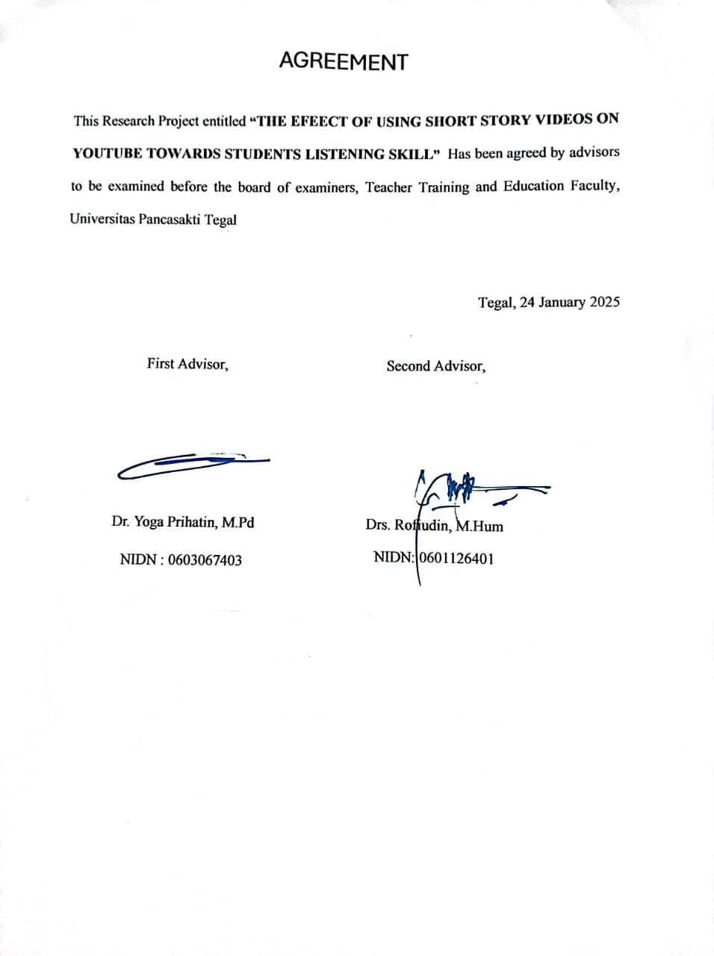
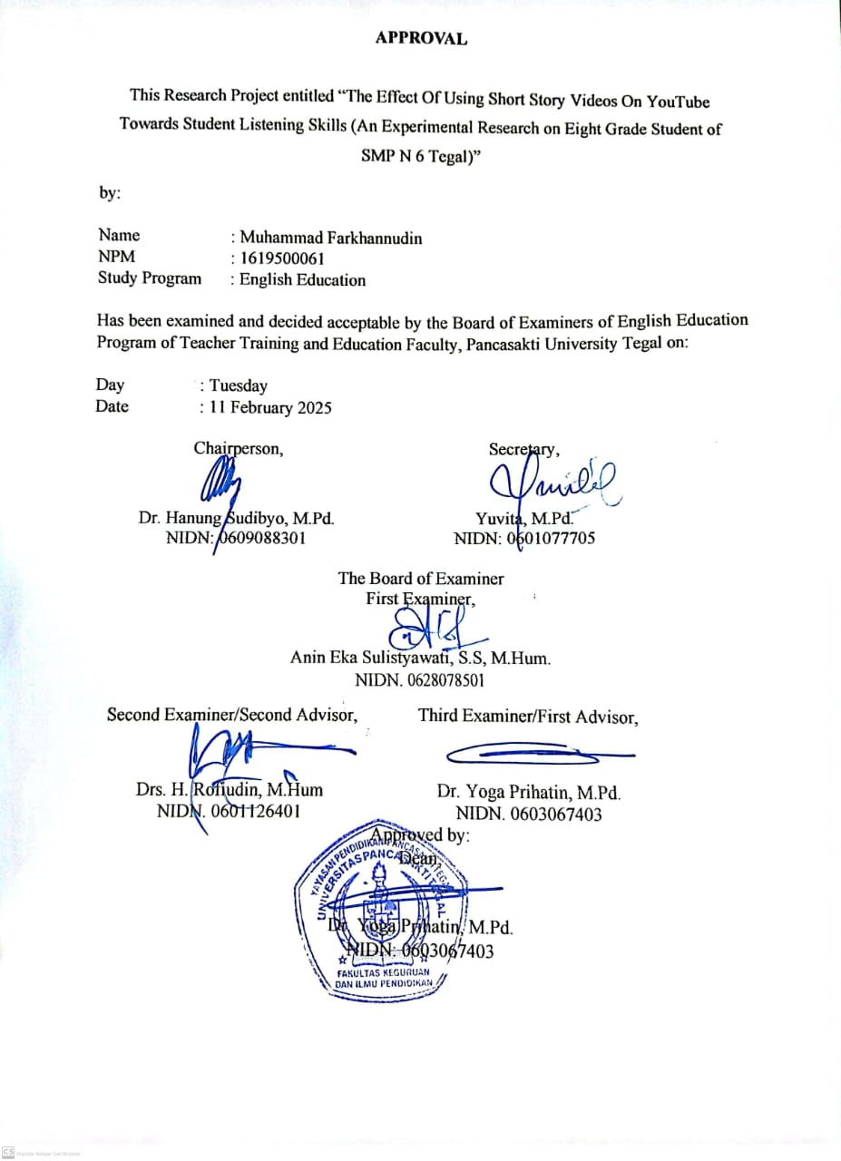
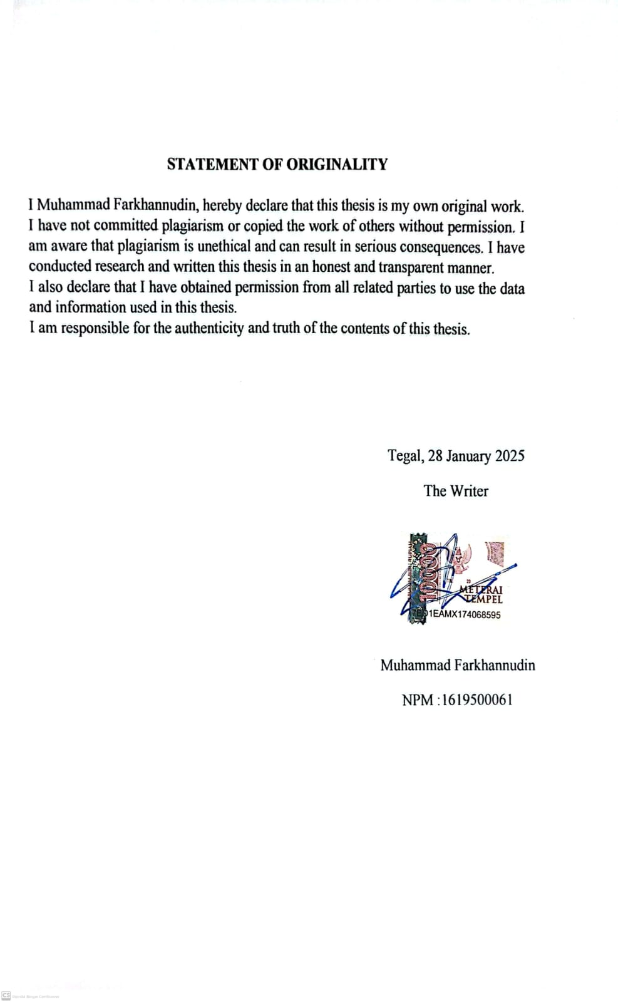

PREFACE

In the name of Allah SWT, the Almighty and the Most Merciful, I would like to express my gratitude for the opportunity to complete my education. I would also like to convey prayers and greetings to the Prophet Muhammad SAW, who has brought us from darkness to light.I would like to express my deepest gratitude to my parents, Syhiabudin and Siti Asriyah, who have given their prayers, affection, support, material, and motivation during my education process. The title of my research is "THE EFFECT OF USING SHORT STORY VIDEOS ON YOUTUBE TOWARDS STUDENT LISTENING SKILLS (An Experimental Research of Eight Grade Student SMP N 6 Tegal)", which aims to fulfill one of the requirements to obtain a Bachelor of Education degree from the English Department.In writing this thesis, I have experienced many obstacles and problems, and I would not have been able to complete it without the help of various parties. Therefore, I would like to express my gratitude to:
- Dr. Taufiqullah, M.Hum, as the Rector of Universitas Pancasakti Tegal.
- Dr. Yoga Prihatin, M.Pd, as dean of Teacher Training and Education Faculty
- Yuvita, M.Pd, M.Pd, as the Head of English Education Department.
- Dr. Yoga Prihatin, M.Pd, as the first advisor.
- Drs. Rofiudin, M.Hum., as the second advisor.
- Anin Eka Sulistyawati, SS,M.Hum, as the examiner.
- All the lecturer of English Education Department at Universitas Pancasakti Tegal.

MOTTO AND DEDICATION

MOTTO

"Allah does not burden a person beyond his capacity." - Al Baqarah 286
Education is the most powerful weapon which you can use to change the world." - Nelson Mandela
Success is the result of hard work, perseverance, and learning from failure." - Colin Powell

DEDICATION

1. Allah SWT for the reason that I’m here.
2. My beloved parents
3. All teachers and lecturers who ever taught me.
4. All relatives and friends who supported me.

ABSTRACT

Muhammad Farkhannudin. 2025. 1619500061 "the effect of using short story videos on youtube towards student listening skills" Which was conducted at SMP Negeri 6 Tegal City in the 2024/2025 academic year. Project Research. Layer 1 Program, Faculty of Teacher Training and Education, Pancasakti University Tegal. The first supervisor is Dr. Yoga Prihatin, M.Pd and the second supervisor is Drs. Rofiudin, M.Hum.

keywords: short story videos, YouTube, listening skills

This study aims to determine the effect of using short story videos on YouTube on students' listening skills. This study uses an experimental method with a post-test design. The subjects of this study were 30 8th grade junior high school students in each class. For class B as the Control class and Class D as the experimental class. the results of the study indicate that the use of short story videos on YouTube can improve students' listening skills. There is a difference in value between the control and experimental classes. The control class that only learned using sound got an average of 57 and the experimental class got a higher average score of 79.

ABSTRAK

Muhammad Farkhannudin. 2025. 1619500061 "pengaruh penggunaan video cerita pendek di youtube terhadap kemampuan mendengar siswa" Yang dilakukan di smp negeri 6 kota tegal tahun ajaran 2024/2025. Penelitian Proyek. Lapisan 1 Program, Fakultas Keguruan dan Ilmu Pendidikan, Universitas Pancasakti Tegal. Pembimbing pertama adalah Dr. Yoga Prihatin, M.Pd dan pembimbing kedua adalah Drs. Rofiudin, M.Hum.

kata kunci: video cerita pendek, youtube, kemampuan mendengar

penelitian ini bertujuan untuk mengetahui pengaruh penggunaan video cerita pendek di youtube terhadap kemampuan mendengar siswa. penelitian ini menggunakan metode eksperimen dengan desain post-test. subjek penelitian ini adalah siswa kelas 8 SMP yang berjumlah 30 orang dimasing-masing kelas. Untuk kelas B sebagai kelas Control dan Kelas D sebagai kelas eksperimental. hasil penelitian menunjukkan bahwa penggunaan video cerita pendek di youtube dapat meningkatkan kemampuan mendengar siswa. Ada perbedaan nilai antara kelass control dan ekperimental. Kelas control yang hanya belajat menggunakan suara mendapatkan rata-rata 57 dan kelas ekperimental mendapatkan nilai lebih rata-rata yang lebih tinggi yaitu 79.

TABLE OF CONTENTS
Page
COVER i
ARGREEMENT ii
STATEMENT OF ORIGINALY.......................................................................... iii
PREFACE.................................................................................................................iv
MOTTO AND DEDICATION v
ABSTRACT vi
ABSTRAK vii
TABLE OF CONTENTS viii
CHAPTER I. INTRODUCTION
- Background of the problem 1
- Identification of the Problem 5
- Limitation Of Problem 5
- Statement Of Problem 5
- Objective Of the Research 6
- Significance of the Research 6

CHAPTER II. PREVIOUS STUDIES, REVIEW OF RELATEDTHEORIES, THEORETICAL FRAMEWORK, AND HYPOTHESIS
- Previous Studies 8
- Review Of Related Theories 14
- Theoretical Framework……………………………………………… 30
- Hypothesis 30

CHAPTER III. RESEARCH METHODOLOGY
- Research Approach,Type And Disgn Of Research 31
- Populatiom And Sample 34
- Research Variabel 36
- Technique Of Collecting Data 37
- Instrument Research 38
- Technique Analysis Data 38

CHAPTER IV. RESEARCH RESULT AND DISCUSSIONS
- Research Result 40
- Instrument Testing 40
- Discussions 44

CHAPTER V. CONCLUSION AND SUGGESTION
- CONCLUSION 46
- SUGGESTION 47

REFERENCES 48
APPENDIX 51

CHAPTER I
INTRODUCTION

Listening skills is the process of receiving information conveyed by a speaker with the intention of understanding the conversation objectively. Having well-polished listening skills is one of the most essential features among the vast variety of requirements a teacher must fulfill in order to offer a high quality education. The researchers started describing the problem and provided background information about the listening skills and how to improve them by focusing in the listening sub-skills through the use of YouTube.
Listening is considered as the most important skill in the field of English language teaching and learning. It is the most frequently used language skill in daily life (Jyoti R, 2020). Given the significance of listening in understanding spoken communication, instructional strategies for listening must be incorporated into English language education.
This chapter consists of background of the problem, statement of the problems, limitations of the problem, objectives of the research, conceptual definition and research significances.

- Background of the Problem
Listening is a process of hearing to verbal symbols with full attention, understanding, appreciation, and interpretation to obtain information, capture content or messages and understand the meaning of the communication conveyed by the speaker through Tarigan's utterances (2008: 31).
According Russel & Russell in Tarigan (2008:30) listening means listen with full attention and understanding and appreciation. In listening, we must know the stages of listening which is understanding, interpretating, evaluating and responding in communication because we learn listening from childhood. Today, for listening activity we can use audio or video as media.
In the realm of second language learning and teaching, the emphasis on listening is often overlooked. Consequently, students may receive limited or no dedicated guidance, possibly attributed to inadequate preparation, time constraints, or insufficient materials. Additionally, among the myriad of prerequisites a teacher must meet to address students' needs in enhancing their listening skills, well-developed attention skills stand out as crucial. It is imperative to recognize that listening transcends mere auditory perception of sounds; it entails the identification, comprehension, and interpretation of spoken languages (Gilakjani & Ahmadi, 2011).
Listening is one of the hardest English skills, especially for newcomers (Cahyono, 2017). Listening is one of the trickier parts of learning English, especially for those who don't know the language. If the discussion was recorded by a native speaker with a different accent and speech rate, it will be harder to listen to. Following recordings made by native speakers with different accents and speaking speeds may be more difficult. One action that requires listening is hearing spoken words or listening to them (Lestari, J. A., 2019).
Listening ability for experts is defined as the ability to capture all the information and meaning of a speaker. This ability is needed when communicating with others. Listening is defined as a collection of “overlapping types of processing” (Rost, 2011, p. 9) that a listener may experience when encountering spoken language. Over the past three decades, various models have been proposed to depict the process of listening.
In the syllabus material there is a narrative text which will make it easier for students to learn this material using short stories. What's more, short stories are still suitable as learning media for junior high school children because short stories are also entertainment.
According to Tan et al. (2020), students can improve their listening skills in the modern environment by using digital media. Learning media, according to Mustadi (Romadhon et al., 2021), is a tool or middleman that may help students choose the goals and learning objectives of a class. According to Premana et al. (2021), the use of learning media in the classroom helps pupils overcome obstacles, limitations, and inactive attitudes. The researcher will exclusively utilize YouTube as a medium for this investigation. YouTube is one of the most popular and enticing types of media to get students interested in learning. When it comes to authentic materials, YouTube is a terrific resource, particularly for English courses. This might encourage students to participate in educational video conversations. (Permana, D., Hidayatullah, H., & Qomariyah, S., 2021).
Youtube is involved by specialists as a learning medium in light of the fact that the vast majority are know about YouTube, while another explanation is that it is not difficult to get to and modest for most people.Youtube is involved by scientists as a learning medium in light of the fact that the vast majority are know all about YouTube, while another explanation is that it is not difficult to get to and modest for a great many people.
According to an interview with Khomarudin, an English teacher at SMP N 6 Tegal grade 8 for the 2023/2024 school year, he said that listening in English for Tegal 6th grade students was lacking in mastery.
There are many media that can help in learning to listen, for example YouTube, most people use YouTube to watch various videos for entertainment when they are free, but YouTube can also be a medium to help junior high school students learn English, such as playing videos in English. By using YouTube as a medium, it is hoped that junior high school students will realize that YouTube can also be a good source of learning.
According to an interview with Khomarudin, an English teacher at SMP N 6 Tegal grade 8 for the 2023/2024 school year, he said that listening to English is rarely taught to junior high school students. This opens the opportunity to introduce it earlier to junior high school students at SMP N 6 Tegal.
- Identification of the Problem
Related to the background mentioned above, the writer formulates the problem identification as follows:
- Can YouTube video users improve students listening skills?
- Can the use of YouTube videos make students more active in improve listening skills?
- How YouTube videos can be an innovation in learning listening?

- Limitation of Problems
The author limits the problem in this study which focuses on the effectiveness of short story videos on YouTube on listening learning for class VIII students of SMP N 6 Tegal in the 2023/2024 academic year. The author teaches to find information contained in YouTube videos.

- Statement of Problems
Based on the limitations of the problem above, the authors formulate a statement of the problem as follows:
- How is the effect of using short story videos on Youtube towards the strudents' listening skill?
- Is there any significant difference on students. who are taught by using short story videos on youtube towards the students' listeng skill?

- Objectives of the Research
Based on the limitation of the problems and the statement of the problem above, this study aims to answer the formulation of the problem above, namely:
- To determine the influence of short story videos on YouTube on students' listening skills.
- To find significant differences in students who are taught using short stories on YouTube on students' listening skills.

- Significance of the Research
This study has significance in the field of education, especially in teaching English listening skills. The use of short story videos on YouTube as a learning medium is expected to improve students' understanding of spoken language, vocabulary, and pronunciation more effectively than conventional methods.
The results of this study can provide benefits for:
- Masters and Teachers - As a reference in choosing interesting and interactive learning strategies to improve students' listening skills.
- Students - Helping students improve their English listening comprehension through more interesting and easily accessible media.
- Educational Institutions - Providing insight into the effectiveness of using technology in language learning, so that it can be applied in the curriculum.
- Other Researchers - As a reference for further research related to the use of computerized media in language teaching.
With this study, it is hoped that the use of short story videos on YouTube can be an innovative alternative in improving students' listening skills more effectively and enjoyably.

CHAPTER II
PREVIOUS STUDIES, REVIEW OF RELATEDTHEORIES, THEORETICAL FRAMEWORK, AND HYPOTHESIS

This chapter consists of previous studies, review of related theories, theoretical framework, and hypothesis.

- Previous Studies
Almurashi (2016) termed it "The Effective use of Youtube Video for Teaching English Language in Classroom as Supplementary Material at Taibah Univetsity in Alula" . This project aims to increase student activity and independence in the learning process by using YouTube videos as supplemental material for English language instruction. The study's findings indicate that using YouTube to teach English significantly improves students' comprehension of the subject. It can raise students' proficiency in English language classes and enhance their performance.
Muhamadiyah University Tangerang's Arjulayana (2018) titled "The Use of Video in Teaching Listening" The study was carried out by eighth graders at SMP 15 Tangerang. The findings of the study indicate that, in the end, audiovisual aids can accommodate a wide variety of student learning styles. Therefore, teachers can use video instruction to teach listening skills and make listening classes more engaging and understandable. It is possible to achieve process study objectives. Secondly, using videos to teach listening is a great approach to support and develop students' interest in and abilities related to listening.
Rizka (2018) entitled "The Effect of using Youtuber as a Teach Media on The Studebts Listening skill" the purpose of this research is to identify whether using YouTube is more effective rather than using audio in teaching listening skills. The population of this study were second semester students in the English department. Researchers analyzed data using Analysis of Variance (ANOVA). The results of this study indicate that using Youtube is more effective than using audio to teach understanding and there is interaction between teaching materials in teaching listening to understanding to students.
Sembiring (2023) entitled "The Use of Youtube English Education Video in Improving Listening Comprehension" the purpose of this research is to find out how students can use YouTube English educational videos to improve their listening skills. This research uses quantitative methods while Google forms are used as the research methodology.The results of this study showed that students' hearing comprehension was enhanced by watching instructional English videos on YouTube, and that YouTube undoubtedly helps students grasp English listening. The majority of students think that YouTube helps them get better at listening, based on the evidence. Because YouTube is so easy to use for study and listening, people could be more encouraged to study English as a result of this application.Furthermore, statistical evidence supported the opinions of students in grades 10, 11, and 12 about the use of YouTube English Educational Videos to enhance listening comprehension.
Shafwati (2021) entitled "The Use of YouTube Video toward Students' Listening Ability". This research is focused on identifying the influence of YouTube videos, as a listening learning media. In this study, pre-experiments quantitative, with one group pre-test post-test, was applied. The subjects were 23 undergraduate students of the English Department, University of Lampung. The results of the study indicated that all participants assumed they were using YouTube videos make listening classes more enjoyable
Hanna (2023) entitled "The Use of Youtube English Education Video in Improving Listening Comprehension" The purpose of this research is to find out how students can use YouTube English educational videos to improve their listening skills. This research uses quantitative methods while Google forms are used as the research methodology. According to the findings of this study, watching English educational videos on YouTube improved students' listening comprehension, and that YouTube definitely aids students' understanding of English listening. According to the data, the majority of students believe that YouTube helps them improve their listening skills. Individuals may become more motivated to study English as a result of this application due to the ease with which they can use YouTube to study and listen.Furthermore, students' perceptions of using YouTube English Educational Videos to improve listening comprehension among grades 10, 11, and 12 were statistically proven.
Dian (2021) entitled "The Use of YouTube Video toward Students' Listening Ability". This research is focused on identifying the influence of YouTube videos, as a listening learning media. In this study, pre-experiments quantitative, with one group pre-test post-test, was applied. The subjects were 23 undergraduate students of the English Department, University of Lampung. The results of the study indicated that all participants assumed they were using YouTube videos make listening classes more enjoyable.
Agus (2021) entitled "The Content of Tolerance Education in Short Story Learning inHigh Schools" This study examines the integration of tolerance education in short story appreciation for high school students in Surakarta. Using a descriptive qualitative method, the findings reveal that: (1) all Indonesian teachers perceive tolerance education as essential in short story learning; (2) tolerance values are explicitly included in syllabi and lesson plans, often under "caring" and "openness to others' opinions" in 86% of cases; and (3) only 9% of short story teaching materials contain explicit tolerance education, though many materials have the potential to incorporate it through activities and stories.
Shaden (2024) entitled "The Effectiveness of Using Video as Learning Media for Listening Comprehension in Narrative Text"Summary’’ This study explores how watching fairy tale movies improves students' listening comprehension skills. Using a pre-experimental quantitative research design, the research involved 36 ninth-grade students and used listening material adapted from Alice in Wonderland. The study aimed to assess improvements in understanding narrative text structure and message delivery. Results showed a significant increase in post-test scores, with averages rising from 72.79 to 88.82. The findings confirm that using videos as a learning tool effectively enhances students' listening skills and comprehension of narrative texts
Zeynep (2020) entitle "Effects of Digital Short Stories on the Development of Listening Skills: An Action Research "This ponder investigated whether advanced brief stories can improve dialect learners' tuning in abilities and inspected understudy teachers' recognitions of their utilize in dialect classrooms. Conducted as activity investigate, the think about utilized pre-tests, post-tests, and organized interviews to gather both quantitative and subjective information. The research took put within the 2016-2017 scholastic year at a Turkish state college, including preliminary course understudies from the English dialect instructing office. Over eight weeks, understudies locked in with computerized brief stories composed by well-known American creators and described by local English speakers. Extra worksheets and freebees were arranged by the analyst. Discoveries shown that advanced brief stories: Given locks in substance, Bolstered lexicon learning, Progressed tuning in abilities, Made a difference understudies get it complex linguistic use structures, Expanded presentation to distinctive societies, Were well-received by members. In this study there are differences and similarities with previous studies journal.
Rahmawatu (2022) etitle "Impact of Short Story on the listening skills of the first year tertiary students in Indonesia" This consider looks at the viability of brief stories as elective sort to lock in understudies in tuning in hone. By utilizing quantitative approach, pre-experimental plan was chosen to test the impact of brief stories sound toward tuning in abilities change. The members of the inquire about are to begin with year college understudies of English Office in an Indonesian college. The stages in earning the information was begun with pre-test, taken after by a outlined treatment, and finished up with post-test to evaluate the impact. The result demonstrates that students' scores have expanded after the treatment. The calculation of information with SPSS by considering Wilcoxon Rank Test comes about that there's enhancement which post-test scores are higher than pre-test ones, which is 53.70> 80.87, and the centrality is 0.000< 0.05. It proposes that brief story is altogether compelling for locks in understudies in tuning in hone and it encourage emphatically gives affect on tuning in abilities. Therefore, short story may well be an elective sort utilized within the classroom because it conceivably enthralls understudies to lock in in tuning in action.
The differences in this study lie in place, school, and sample. The main similarity of the first journal is that it uses YouTube as a source of learning material, the similarity of listening to the second journal is that the listening class is more enjoyable and easier to understand, because of the audio-visual aids. The similarity of the third journal is to test the effectiveness of YouTube as a source for learning listening, the similarity of the fourth journal is to prove that students' listening skills improve by using YouTube. The fifth journal equation is that it uses pre-test post-test in its research

- Review of Related Theories
To support this study, it explores the theories Youtube, Short Story and Listening
- Youtube
Youtube is a site for different recordings that was sent off in February 2005, this site was established by 3 previous paypay representatives specifically by Chad Hurley, Steve Chen, and Jawed Karim. There are different sorts of recordings on YouTube, for example, video blogs, instructional exercises, music, etc. Because of simple clients, YouTube is one of the sites that is much of the time utilized by many individuals.
Youtube is a media website that is used to share videos by online. Youtube is very popular among internet users around the world. Youtube can be used by various groups, from young people to children among adults. People who use YouTube or better known as YouTubers can upload videos, search for videos, view videos, discuss various things through videos or for those who like songs can view and share video clips songs without having to pay. On every day there are many people from different countries who using youtube. It can be said with certainty and certainty that youtube indeed very popular also the potential to be used as a medium during the process study activities. Besides that, YouTube media is considered to be able to provide something that can be seen and heard. In the process of learning this can motivate students to learn and also provide new experiences.
- Youtube as a Learning Resource
YouTube media can be an effective medium for learning (Budiman, 2017). In addition, through YouTube, teachers can take videos related to English learning materials to make it easier for teachers to deliver material that will be delivered by students so that students can create creative and innovative learning atmosphere these methods are used so that students can better understand the material through the videos. Teaching has become more engaging thanks to the availability of instructional tools and user-produced videos posted on YouTube. Additionally.
To enrich the material, apart from books, videos from Youtube is used as a source of learning and also as a source of data. There is many of the videos shown during the lesson are adapted to the topic discussed every week. Apart from that, other videos are also shown, for example, about interviews with various people from around the world so that it can make it easier for students to learn English.
- The benefits of using YouTube as teaching material
Increase the enthusiasm and motivation of students in teaching and learning activities, because with the use of media during the process of teaching and learning activities take place make students' attention and concentration more focused on learning activities teach.
The conveyance of material is more extensive, without being restricted by spot and time make understudies additional dynamic while doing gaining exercises from the comprehension and clarification of the importance of "learning media" from a few specialists, it very well may be presumed that: "learning media is everything as an instrument material that can assist with passing on a message or reason in an action learning outside or in the homeroom so that learning targets can be accomplished successfully and productively.
YouTube videos have a number of benefits for educational reasons. According to Jalaluddin (2016) these benefits are listed below.
- As an approach for learning references in the classroom.
- YouTube is a useful resource for learning.
- As a resource for educationally inspiring tools that engage students and encourage contemporary learning styles.
- Short Story
Short stories usually deal with a single effect delivered in one or several key episodes or scenes. This form encourages understated settings, creates concise narratives, and eliminates complex plots. Characters are represented in action and dramatic encounters, but are rarely fully developed. In spite of the fact that their degree is generally restricted, brief tales are many times decided by their capacity to treat characters and subjects in a "entirety" or palatable way.
Meanwhile, according to experts, short stories are short fiction that can be read in one sitting. Short stories have only one meaning, one crisis and one effect for their readers. Short story writing just wants to point out something sharply Jacob (2001). Short story is a story that can be read in one sitting, approximately between half and two hours. Something that would not be possible in a novel. Burhan also mentioned that the length of the short stories varies. There are short short stories and long short stories (Burhan N., 2012).
- Components within the Short Story
- Subject → The most thought or center of the story. Illustrations:companionship, battle, love.
- Characters and Characterization → Characters within the story and how they are portrayed (hero, adversary, tritagonist).
- Plot → The course of the story from starting to conclusion. Can be forward, in reverse (flashback), or blended.
- Setting → Put, time, and climate where the story takes put.
- Point of See → The way the creator passes on the story, for illustration to begin with individual point of see ("I"), third individual all-knowing, or third individual restricted.
- Fashion → Choice of words and how the creator passes on the story, counting figures of discourse and diction.
- Message → The ethical message the creator needs to communicate to the peruser.

- The function short story
  - Entertainment – ​​Short stories provide entertainment for readers with an interesting storyline, strong conflict, and a satisfying resolution.
  - Education and Ethics – Many short stories contain ethical messages or life values ​​that can be used as lessons by readers.
  - Social Reflection – Short stories often reflect social, cultural, or historical realities, so they can be a reflection of the condition of society.
  - Exploration of Creativity – Writers use short stories as a means to express their ideas, feelings, or imaginations in a shorter form than novels.
  - Improving Literacy – Reading short stories can help improve reading skills, understand implied meanings, and develop vocabulary and critical thinking skills.
  - Literary Experiments – For writers, short stories can be a place to experiment with language style, narrative techniques, or themes before writing longer works.
- Type of Short story.
- Fable
A story that gives a ethical lesson, regularly utilizing creatures, legendary animals,strengths of nature, or lifeless objects to come to life (Brothers Grimm,Aesop) Tales are a sort of story that tells the life of creatures or other animals that are given human characteristics, such as talking, considering, and acting like people. Tales ordinarily have an moral message or lesson that they need to communicate to the peruser. Characteristics of fables:
- Uses animals or other creatures as the main characters.
- Gives human characteristics to animal characters.
- Tells the life or adventures of animal characters.
- Has an ethical message or lesson.
- Usually written in prose or poetry
- Flash fiction
A story between 5 to 2,000 words that lacks traditional plot structure or character development and is often characterized by a surprise or twist of fate (Lydia Davis) Mini saga: A type of micro-fiction using exactly 50 words (!) to tell a story ables are a type of story that tells the life of animals or other creatures that are given human characteristics, such as speaking, thinking, and acting like humans. Flash fiction is a very short type of story, usually no more than 500 words. This story must have a complete structure, including a beginning, middle, and end, and have clear characters, plot, and theme. Characteristics of flash fiction:
- Short: No more than 500 words.
- Complete: Has a complete structure, including a beginning, middle, and end.
- Dense: Uses effective and efficient language.
- Focus: Has a clear focus on character, plot, and theme.
- Vignette
A expressive scene or characterizing minute that does not contain a total plot or story but uncovers an vital detail around a character or thought (Sandra Cisneros). A vignette is usually a short, concise description that depicts a particular moment or atmosphere. In writing, vignettes are often used to:
- Describe the background or atmosphere of a story.
- Develop characters or figures in the story.
- Create a certain impression or atmosphere in the story.
- Modernism
Experimenting with narrative form, style, and chronology (inner monologues, stream of consciousness) to capture the experience of an individual (James Joyce, Virginia Woolf)
Postmodernism: Using fragmentation, paradox, or unreliable narrators to explore the relationship between the author, reader, and text (Donald Barthelme, Jorge Luis Borges)
- Magical realism
Combining realistic narrative or setting with elements of surrealism, dreams, or fantasy (Gabriel García Márquez)
Minimalism: Writing characterized by brevity, straightforward language, and a lack of plot resolutions (Raymond Carver, Amy Hempel). Magical Realism is a literary genre that combines realistic and fantastic elements in a story. This genre is often used to describe everyday life in a unique and interesting way. Characteristics of Magical Realism:
- Combines realistic and fantastic elements.
- Describes everyday life in a unique and interesting way.
- Often uses magical or supernatural elements.
- There is no clear boundary between reality and fantasy.
- Often used to describe life in Latin American countries.
- Fantastic!
Fantastic is a literary genre that involves imaginative elements, such as magic, monsters, and parallel worlds. This genre is often used to describe unusual or unreal life. Fantasy is "the formation of mental images that are not based on reality, but have a certain psychological function". (Sigmund Freud). Characteristics of Fantastic:
- Contains imaginative elements.
- Describes unusual or unreal life.
- Often involves magic, monsters, and parallel worlds.
- Uses creative and imaginative language.

- Listening
Ariani (2021) Listening skill is a process of listening to spoken sound symbols with full attention, understanding, appreciation, interpretation to obtain information, capture content or messages and understand the meaning of communication that has been conveyed by the speaker through speech or other language.
Setiwati (2019) Listening is a language skill that is active receptive. This means that in listening activities a person must activate their mind to be able to identify language sounds, understand them, and interpret their meaning so that the message conveyed by the speaker is captured.
Students hear oral speech, divide sounds, classify them into lexical and syntactic units, and comprehend the message. Listening is a process of receiving what the speaker says, making and showing meaning, negotiating meaning with the speaker and answering, and creating meaning by participation, creativity, and empathy.
Worthington (2018) states that listening has three components, namely affective, behavioral and cognitive. The affective component includes the way listeners think about listening, listening motivation, and enjoyment of the activity; behavioral components include listener responses such as eye contact with the speaker, or showing signs of listener interest in the speaker by asking questions; The cognitive component of listening is an internal process that functions to enable the individual. Listening is the process of paying attention, understanding, and responding to voices, messages, or information conveyed by others through spoken or written language. Listening is one of the most important communication skills in interacting with others.
- Purpose of listening:
- Comprehension of information
A clear understanding of the message being conveyed.
Example: I listen to the lecturer explain the lecture material and understand the concepts being taught.
- Improved Interpersonal Communication
Understanding the feelings, thoughts, and perspectives of others. Example: Listening to a friend talk about a problem shows empathy and support.
- Avoid misunderstanding
To avoid misunderstandings, make sure your message is received correctly.
Example: I follow my boss's instructions to ensure that I carry out my duties as expected.
- Analyze and Evaluate Information
Evaluate the truth, relevance, or quality of the message being sent.
Example: Listen to a political debate and evaluate each argument.
- Improved Learning Ability
Gain new knowledge and insights through listening.
Example: Listen to podcasts and seminars to gain a better understanding of a particular field.
- Enjoying and appreciating arts and entertainment
Enjoying music, poetry, stories, or spoken word performances.
Example: Listen to classical music or enjoy an audiobook to relax.
- Supporting the decision-making process
Gather information from multiple sources before making an informed decision.
Example: Listen to your colleagues before developing your business strategy.
- Improves Language Skills
Listening helps you build vocabulary, improve grammar, and understand pronunciation.
Example: When learning a foreign language, listening helps you understand accents and intonation.
- Build Better Relationships
Good listening shows respect and consideration for others and strengthens social and professional relationships.
Example: Listening carefully when your partner or friend is talking can help build trust.

- Improves concentration and attention
Listening teaches you to focus on one thing at a time, which helps in many aspects of life.
Example: Listening to a lecture without being distracted improves your concentration and memory.
- Develops Problem-Solving Skills
Better understanding other people’s problems and situations helps you find better solutions.
Example: A leader who listens to his employees’ complaints can find the best solutions to improve team productivity.
- Improved Emotional and Social Awareness
Listening helps you better understand emotions and social situations. Example: Psychologists use active listening to understand their patients’ psychological states.
- Supports Collaboration and Teamwork
In the workplace, good listening can help teams communicate more effectively.
Example: Listen to team members’ ideas in meetings so you can work together more effectively.
- Facilitates Adaptation to a New Environment
Listening helps you understand the norms, culture, and rules of your new environment.
Example: When you start working at a new company, listening to your coworkers helps you familiarize yourself with the work culture.
- Listening Type
Transactions have the main objective of transferring information, while the main function of interaction is the maintenance of social relations.
- One way listening
The transactional function of language influences listening learning in L2. Monologues in learning listening are very important, especially in academics such as lectures or teaching at school. This can be summed up as "listening to learn something." A common situation is one-way listening when the teacher is explaining, watching TV or listening to the radio.
- Two-way listening
Yongqi Gu (2018) Two-way tuning in alludes to the listener's dynamic association in a communicative circumstance where at slightest one other questioner is included. In two-way tuning in, meaning is seen, inferenced and anticipated, synthesized, arranged, and co-constructed with conversationalists. In expansion to comprehension and translation of meaning, the cognitive prepare is went with by the quick and fitting trade of listener/speaker parts so that social purposes and passionate equalizations are accomplished
- Critical Listening
Critical Listening is a listening process that involves analyzing, evaluating, and assessing the information presented. Critical listening requires the ability to distinguish between accurate and inaccurate information, and to understand the context and nuances involved.

- The listening process
- Receiving
The process of translating certain sounds into meaningful words is called hearing, and while the noises we hear may not always have meaning, hearing is a crucial part of listening.
- Understanding
The second process in the listening process is understanding. The purpose of this process is that we understand what the context is talking about or what is heard.
- Evaluation
During the evaluation stage, the listener determines whether the information obtained from the speaker has been conveyed correctly or not.

- Responding
During the Responding stage, a listener responds to the speaker verbally and non-verbally. Responding non-verbally can be seen from body gestures such as smiling, agitated, or maybe angry while responding verbally can be through questions to get more detailed information.
- Attention (Presence)
The brain filters incoming sounds, focusing attention on sounds that are considered important and ignoring irrelevant background noise. This focus of attention is influenced by factors such as interests, needs, and environmental conditions.
- Comprehension
After a sound is received and attended to, the brain begins to interpret its meaning. This process involves processing language, context, and past experiences to understand the information being communicated.
- Interpretation
The listener tries to understand the speaker's intent and feelings based on tone, emphasis, and context. This includes the ability to recognize implied meanings such as sarcasm and emotional expressions.
- Response
The listener provides feedback both verbally (e.g., answering, asking questions) and nonverbally (e.g., nodding, facial expressions). This response indicates that the information has been received and understood.
- Remembering
The final stage is to store the information you have understood in your memory. Elements such as repetition, linking to past experiences, and taking notes can help you strengthen your memory of the information you have heard.
- Problems in Listening
- Distractions and interruptions - Noise, wandering thoughts, or outside distractions can affect your ability to concentrate while listening.
- Speaker Speed ​​- If the speaker speaks too quickly or with an accent that is difficult to understand, it can be difficult to understand what they mean.
- Unfamiliar Vocabulary - If you don't understand many words, it can be difficult to understand the overall meaning.
- Lack of Interest - If the topic is not interesting, it is easy to get distracted.
- Too Much Information - If the information presented is too dense or complicated, it is difficult to understand it all at once.
- Lack of Context - It is difficult to follow a conversation without having background information about the topic being discussed. Effective listening requires practice and strategies such as: B. Staying fully focused, taking notes, and asking questions if you don't understand something

- Theoretical Framework
Listening is the most important ability of the basic skills that must be possessed to master a foreign language. It is different from hearing, which is just listening to random sounds. Listening is an act or process of understanding a meaning or intent from a speaker's words. Therefore the selection of material using short stories is the right choice because with short stories it is hoped that SMP 6 students will be more interested in learning foreign languages, especially English.

- Hypothesis
Based on the problems above, the authors formulate a hypothesis about
H₁: Short Story Video there is an effect on listening skills
H₀: Short Story Video there not effect on listening skills

CHAPTER III
RESEARCH METHODOLOGY
This chapter presents approach research, type research, design research, variable, population and sample research, technique collecting data, instrument research and technique of analyzing data.

- Research Approach, Type and Design of the Research
- Research Approach
This research approach is a quantitative approach. The quantitative method is a way to gain knowledge or solve problems systematically and the data is collected in the form of a series of numbers. Quantitative research is is defined as a research method based on the philosophy of positivism, which is used To examine a particular population or sample, data collection uses research instrument, quantitative/statistical data analysis, with the aim hypothesis testing has been set by Sugiyono (2009) whereas according to (Creswell, 2009). Quantitative research is a theory that becomes a conceptual framework for research that is carried out as a whole, becomes the basis for formulating research questions or hypotheses, and becomes Basis for selecting data collection procedures. Therefore data collection can be in the form of questionnaires and or tests or trials. n this study, a quantitative approach is used to calculate the data. According to Yusuf (2014:58), a quantitative approach is an objective and measurable approach that involves human behavior and predictable social realities. The use of quantitative research using valid and reliable instruments and appropriate and accurate statistical analysis will produce results that do not deviate from the actual situation. Reedy & Ormrod (2001) Williams (2011) quoted in Apuke (2017) stated that "quantitative research involves collecting data to measure information and subjecting it to statistical treatment to support or refute alternative knowledge claims." According to Salkind (2013), the purpose of quantitative research is very different from the purpose of qualitative research to gain a better understanding of a situation or event. In quantitative research questions, researchers try to describe the current situation, find relationships between variables, and sometimes explain the cause-and-effect relationships between variables. There are several types of quantitative approaches, including exploratory research, quantitative descriptive research, correlational research, comparative causal research, action research, and experimental research.

- Research Type
This research uses a type of experimental research that aims to prove cause and effect by using one or more conditions and observing the effect or influence to one or more dependent variables on students. According to Sugiyono (2009) experimental research can be interpreted as research method used to find the effect of certain treatments on others under controlled conditions.

- Research Design
In this study the writer used a true experimental research design with a Posttest Control Group Design. Where in this design is there two groups, namely the experimental group and the control group. Sugiyono (2010: 112) argues that it is said to be a true experimental design because in this design the researcher can control all the external variables that influence it. The main feature of a true experiment is that the sample used for both the experiment and the control group is taken randomly from a certain population. The form of the design used in this research is the posttest control group designIn this approach, two randomly chosen groups are provided learning via YouTube as a listening exercise, whereas the other group receives information without using YouTube for listening practice.

Tabel 3.1 Design of the Research
Technique Sampling | Group | Variabel Independent | Pos-tes
R | experimental | X₁ | Y_{1E}
 | Control | X₂ | Y_{1K}
(Purwo Susongko, 2016)
Explanation:
X₁ : Classes are taught using videos
X₂ : Classes where learning only uses sound
Y_{1E} : Results from learning classes using video
Y_{1K} : The results of the class are learning using sound

This inquire about plan has a few characteristics, to be specific:
- this ponder has one gather of test subjects or treatment gather and a control gather
- one gather is compared with two times of perception estimations of the subordinate variable
- both bunches are measured as it were once after giving preparing, specifically the post-test
- estimation of the subordinate variable in both bunches is carried out at the same time with the same test; and
- the test gather is controlled with certain medicines.

- Population and Sample
- Population
Arikunto (2010: 173) argues that the population is the entire research subject. Meanwhile, according to Sugiyono (2011: 119), population can be defined as a generalized area consisting of objects or subjects that have certain quantities andcharacteristics determined by researchers to be studied and then drawn conclusions. In this case in this study, the population is students in the even semester of SMP N 6 Tegal for the 2024/2025 academic year. SMP 6 Tegal is located at Jl. Cinde Kencana No. 1 Smp 6 consists of 3 levels. Class 7,8,9. Each level has classes from A to H. For class 7 has 247 consisting of 127 male students and 120 female students. Then class 8 has 254 students consisting of 127 male students and 127 female students, while class 9 has 252 consisting of 108 male students and 144 female students. If the total number of students at SMP 6 Tegal is 753 consisting of 362 male students and 391 female students in the 2024/2025 academic period

- Sample
The sample is part of the number and characteristics possessed population (Sugiyono, 2013). The research sample is set in three grades. One class for try-out class, one class for the experimental class the experimental class is the class that gets teaching using video, the class for the control class is the class that is accepted without learning using video or sound only. The class that will be the try out class is class 8A, while the class that will get the control class B and the class that will get the experimental class is D. with the following numbers
Table 3.2 Sample
No | Class | Number of Students
1 | VIII B | 32
2 | VIII D | 32
Total |  | 64
.
- Technique of Sampling
The researcher using cluster random sampling technique in the experimental research. Cluster Random Sampling is a sampling technique in groups and not individually. Samples taken from the same environment but in different treatment or action. The score taken is not in the form of an individual but the score taken is the average score in a group.

- Research Variables
- Independent variables
Independent variables are variables that influence or are the cause of changes or emergence of dependent variables (Sugiyono: 2019). Short story on Youtube video is independent variables in this research.

- Dependent variable
The dependent variable is a variable that is influenced or becomes a consequence, because of the existence of an independent variable (Sugiyono: 2019). So the dependent variable in this research is listening skills.

- Technique of Collecting Data
- Test
The test methodology is a data gathering method that involves providing the subject whose data is requested with a set of questions, assignments, and other tools. The test used is a formative test. This test is a test of learning outcomes whose purpose is to find out how far students have mastered the lesson after following the learning process within the specified timeframe.

- Documentation
Researchers was use recordings during the teaching and learning process. This was be used to document all research processes.

- Validity
Validity is the method of checking or demonstrating that something is genuine, substantial, or in agreement with built up measures. In different settings, approval is utilized to guarantee the exactness of data, the legitimacy of a archive, or the precision of a strategy some time recently it is connected. For illustration, in inquire about, approval is required to guarantee that the instrument utilized really measures what it is assumed to degree.

- Instrument Research
The instrument of this research is a listening test, a tool used by the researchers in collecting data to make their work easier and to get better, complete and systematic results so that the data is easy to process. In this study, speaking and recording tests were used as instruments.
The researcher obtained data using a listening test device. In this study there is two types of instruments, namely the instrument for the experimental group and the instrument for the control group. The researcher uses an assessment system for students' understanding of the information contained in the video. The data collection using a test as an instrument. Measuring tools are referred to as instruments by researchers (tests, questionnaires, checklists, etc.). Instrumental research is the process of developing, testing and using devices in tests. researchers used a formative test. The test consists of students' memory skills and students' ability to understand the meaning of the sounds they hear. Researchers uses a rating scale to measure students' listening skills in students.
There are 45 multiple choice test questions but only valid questions will be selected. The total value calculation can be as below in the table.

Table 3.3 The Classification of Tests’ Score
No. | The Score | Level Categories
1 | 80 – 100 | Very Good
2 | 66 – 79 | Good
3 | 56 – 65 | Enough
4 | 40 – 55 | Less
5 | 30 – 39 | Fail
(Adopted from Arikunto 2013)

- Technique Analysis Data
Data analysis techniques are techniques used to process and analyze research data. In analyzing the data in this study, researchers analyze significant differences between groups in terms of listening ability, and measuring how much influence YouTube has on students' learning abilities on listening skills.

- T-test
T-test may be a statistical strategy utilized to test whether there's a critical distinction between two groups or populaces. T-test expect that the information being tried incorporates a typical dispersion and has the same fluctuation.

