

**EXPLORING EIGHT GRADERS` DIFFICULTIES IN SPEAKING ENGLISH AT SMP NEGERI 3 KERSANA**

**RESEARCH PROJECT**

**Submitted as Partial Fulfillment of the Requirement for the Degree of *Sarjana Pendidikan* in English Education.**

**By**

**RATNA AGUSTINA WIKO KUSUMAWARDHANI**

**NPM 1618500013**

# COVER

**ENGLISH EDUCATION PROGRAM**

**TEACHER TRAINING AND EDUCATION FACULTY**

**PANCASAKTI UNIVERSITY TEGAL**

**2025**

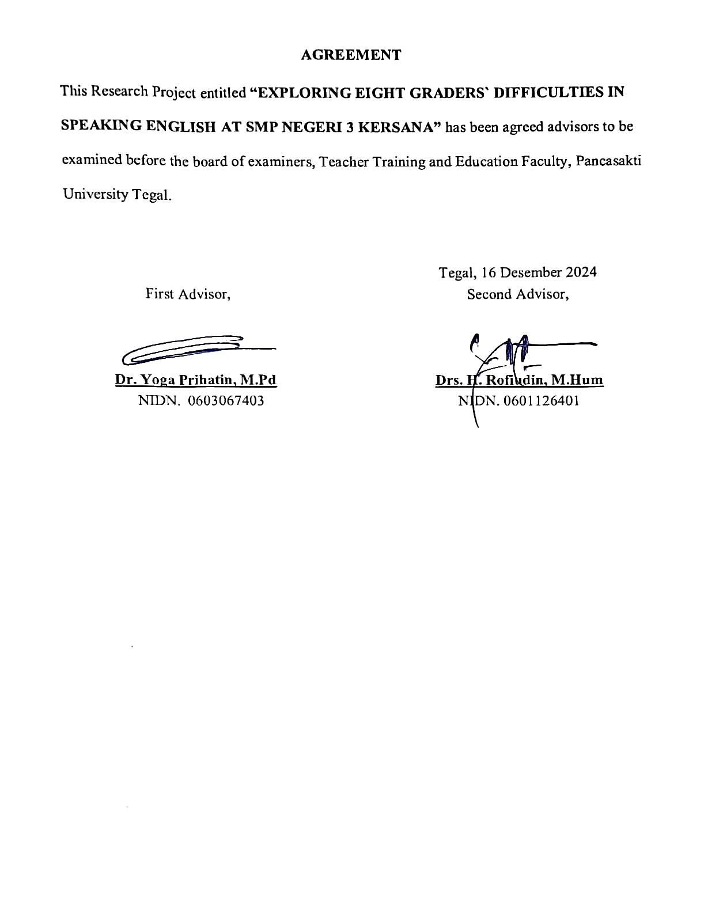

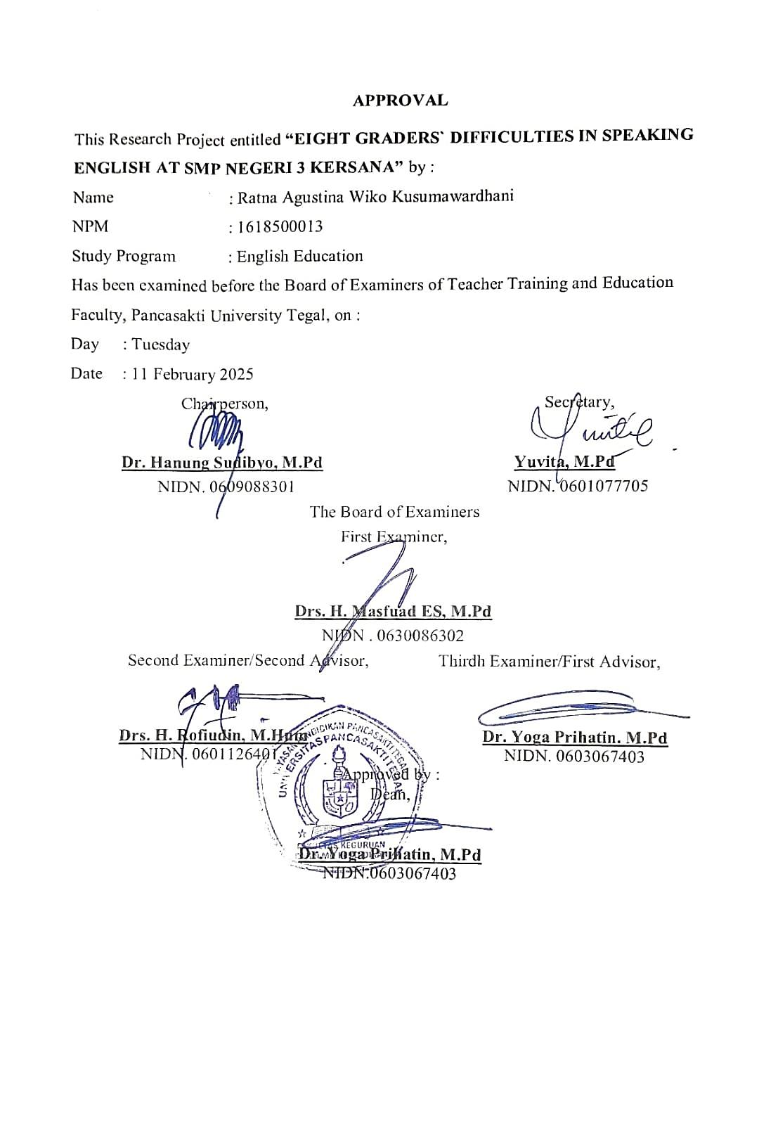

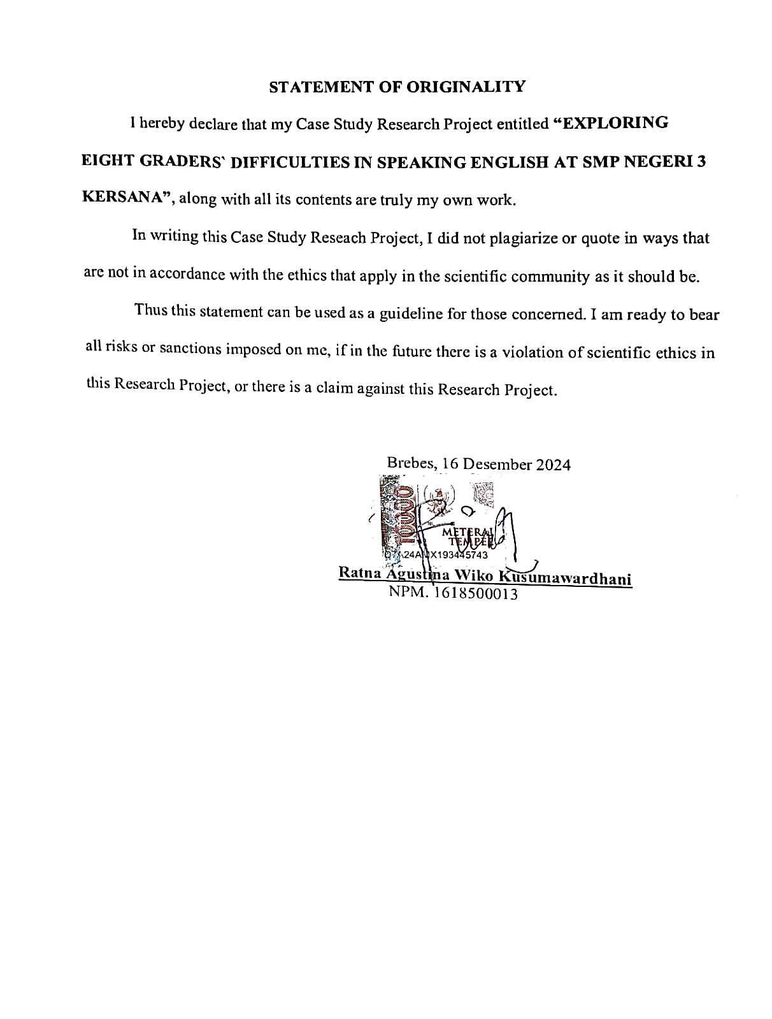

**MOTTO AND DEDICATION**

**MOTTO**

"Allah will elevate those who believe and have knowledge several degrees"

(Q.S Al-Mujadalah Verse 11).

"Allah will not change the fate of a people unless they change themselves"

(Q.S Ar-Ra'd Verse 11).

"We must be ready to face all challenges" - Jenderal Sudirman.

"Failure is an opportunity to start again more intelligently"

by Eko Suci Hartono, S.E.

"Live as if you will leave tomorrow, learn as if you will live forever"

by Eko Suci Hartono, S.E.

"I came, I tutored, I examed, I revised, and I won" by Eko Hartono, S.E.

**DEDICATION**

I would like to dedicate My Research Project to:

1. Allah SWT who always gives me ease and blessings, so that I can complete this Research Project.
2. My beloved parents who always encourage and support me to complete this Research Project.
3. All lecturers who have given me very valuable knowledge for my future.
4. My friends of English Education always give me motivation and support in completing my Research Project.
5. I myself who have struggled hard to complete this Research.
6. Dear Readers, who always faithfully read my Research Project work.

**ABSTRACT**

**Kusumawardhani, Ratna Agustina Wiko. 2025. 1618500013** : *Exploring Eight Graders’ Difficulties in Speaking English at SMP Negeri 3 Kersana.* Research Project Strata 1 Program. English Education. The First Advisor is Dr. Yoga Prihatin and The Second Advisor is Drs. H. Rofiudin, M.Hum

**Keyword** : Speaking, Difficulties, Eight Graders’

The objectives of this research the first is to find out Non-Linguistic factors analysis in speaking English at SMP Negeri 3 Kersana. The second is to find out the Linguistic factors analysis that influence difficulties in speaking English at SMP Negeri 3 Kersana.

This research used qualitative with case study methods as research design. Qualitative methods are used for studies involving narrative data obtained through observations and documentation. The researcher chose a qualitative case study approach because of its relevance to the current scientific phenomenon or issue, namely the English language difficulties of 8D grade students at SMP Negeri 3 Kersana. Data for the study were obtained through a series of questions using a Likert scale as a questionnaire. Respondents were only asked to choose one point out of five points, namely: *Strongly Agree, Agree, Neutral, Disagree and Strongly Disagree* on the choice of points that had been provided in the Google form. This is a type of closed qu estion because it is not asked directly by students but through a Google form questionnaire. To understand more deeply about the difficulties of speaking English of eighth grade students, the researcher applied a random questionnaire.

The results of this study produce speaking difficulties. In other words, there are two factors, namely Non-Linguistic Factors and Linguistic Factors. This is a linguistic factor in which there are five criteria. There are 31 students who experience these two factors, including. For Non-Linguistic factors, 4 students are afraid of speaking English incorrectly, 5 students feel embarrassed to speak English, 3 students have anxiety in speaking English, 5 students lack confidence, 4 students lack motivation. Then in the Linguistic Factor there are 3 criteria. There are 3 students who experience a lack of vocabulary in English, 3 students lack mastery of grammar, and 4 students are less precise in pronunciation.

It is concluded that there are various statements submitted to students to identify students' difficulties in speaking English. These questions cover Linguistic aspects, namely (Lack of Vocabulary, Lack of Grammar Knowledge, and Pronunciation). In addition, there are Non-Linguistic factors, including (Fear of Being Mistakes, Feeling of Shy, Anxiety, Lack of Self-Confidence, and Lack of Motivation. The focus of this study is to explore students' difficulties in speaking English in terms of Linguistic Factors and Non-Linguistic factors

# ABSTRAK

Kusumawardhani, Ratna Agustina Wiko. 2025. 1618500013: **Exploring Eight Graders’ Difficulties in Speaking English at SMP Negeri 3 Kersana. Skripsi Program S1. Pendidikan Bahasa Inggris. Pembimbing Pertama is Dr. Yoga Prihatin and Pembimbing Kedua is Drs. H. Rofiudin, M.Hum**

*Kata Kunci* ***: Speaking, Difficulties, Eight Graders’***

Tujuan dari penelitian ini adalah pertama untuk mengetahui analisis faktor-faktor Non-Linguistik dalam berbicara Bahasa Inggris di SMP Negeri 3 Kersana. Kedua untuk mengetahui analisis faktor-faktor Linguistik yang mempengaruhi kesulitan berbicara Bahasa Inggris di SMP Negeri 3 Kersana.

Penelitian ini menggunakan metode kualitatif dengan metode studi kasus sebagai desain penelitian. Metode kualitatif digunakan untuk penelitian yang melibatkan data naratif yang diperoleh melalui observasi dan dokumentasi. Peneliti memilih pendekatan studi kasus kualitatif karena relevansinya dengan fenomena atau isu ilmiah terkini, yaitu kesulitan berbahasa Inggris siswa kelas 8D di SMP Negeri 3 Kersana. Data penelitian diperoleh melalui serangkaian pertanyaan dengan menggunakan skala Likert sebagai kuesioner. Responden hanya diminta untuk memilih satu poin dari lima poin yaitu: Sangat Setuju, Setuju, Netral, Tidak Setuju dan Sangat Tidak Setuju pada pilihan poin yang telah disediakan di google form. Ini merupakan jenis pertanyaan tertutup karena tidak ditanyakan secara langsung oleh siswa melainkan melalui angket google form. Untuk memahami lebih dalam tentang kesulitan berbicara bahasa Inggris siswa kelas VIII, peneliti menerapkan angket acak.

Hasil penelitian ini menghasilkan kesulitan berbicara. Dengan kata lain terdapat dua faktor yaitu Faktor Non-Linguistik dan Faktor Linguistik. Ini merupakan Faktor Linguistik yang di dalamnya terdapat lima kriteria. Terdapat 31 siswa yang mengalami kedua faktor tersebut, diantaranya. Untuk Faktor Non-Linguistik terdapat 4 siswa takut berbicara bahasa Inggris dengan tidak tepat, 5 siswa merasa malu untuk berbicara bahasa Inggris, 3 siswa mengalami kecemasan dalam berbicara bahasa Inggris, 5 siswa kurang percaya diri, 4 siswa kurang motivasi. Kemudian pada Faktor Linguistik terdapat 3 kriteria. Terdapat 3 siswa yang mengalami kekurangan kosakata dalam Bahasa Inggris, 3 siswa kurang menguasai tata bahasa, dan 4 siswa kurang tepat dalam pengucapan.

Disimpulkan bahwa terdapat berbagai pernyataan yang diajukan kepada siswa untuk mengidentifikasi kesulitan siswa dalam berbicara Bahasa Inggris. Pertanyaan-pertanyaan tersebut meliputi aspek Linguistik, yaitu (Kekurangan Kosakata, Kurangnya Pengetahuan Tata Bahasa, dan Pengucapan). Selain itu, terdapat faktor Non-Linguistik, meliputi (Takut Salah, Merasa Malu, Cemas, Kurang Percaya Diri, dan Kurangnya Motivasi. Fokus penelitian ini adalah untuk mengeksplorasi kesulitan siswa dalam berbicara Bahasa Inggris dari segi Faktor Linguistik dan Faktor Non-Linguistik.

**PREFACE**

Praise be to Allah, the Almighty God for His guidance and grace, so that the researcher can complete this Case Study Research Project in order to complete the Undergraduate Study *(S1)* to obtain a Bachelor of Education *(S.Pd)* degree in the English Language Education Study Program, Faculty of Teacher Training and Education, Pancasakti University Tegal.

In completing Reseach Project, the researcher always received very valuable guidance and assistance from various parties, both morally and materially. On this occasion, the researcher would like to express his sincere gratitude to:

1. Mr. Dr. Taufiqulloh, M.Hum as the Rector of Pancasakti University Tegal who has given the researcher the opportunity to pursue education.
2. Mrs. Dr. Yoga Prihatin, M.Pd as the Dean of the Facult y of Teacher Training and Education, Pancasakti University Tegal.
3. Mrs. Yuvita, M.Pd as the Head of the English Language Education Study Program, Pancasakti University Tegal.
4. Mrs. Dr. Yoga Prihatin, M.Pd as the First Advisor, who has provided a lot of guidance and suggestions, so that this Research Project can be better. Thank you for all your patience, kindness and time, Mrs. Yoga provided to guide me. May Allah SWT always bestow Her blessings on Mrs. Yoga and family.
5. Mr. Drs. H. Rofiudin, M.Hum as the Second Advisor, who has taken the time to patiently guide me so that this Research Project is well structured. Thank you for your patience, kindness and motivation, Mr. Rofi gave it. May Allah always bestow His blessings on Mr. Rofi and family.
6. Lecturers of the English Language Education Study Program, Pancasakti University Tegal along with their staff and employees.
7. All friends of English Education Faculty of Teacher Training and Education, Pancasakti University Tegal who have helped and provided motivation to complete this Research Project.
8. Mr. Sularna, S.Pd as the Principal of SMP Negeri 3 Kersana who has given approval and permission to conduct research at this school.
9. Mrs. Widarsi, S.Sos, S.Pd as the Research Advisor Teacher of SMP Negeri 3 Kersana who has helped the Researcher in providing guidance and research data, which are needed for writing this Research Project.
10. My beloved parents. My father, Pak Eko Suci Hartono S.E and my mother, Bu Widarsi, S.Sos, S.Pd who have cared for and raised me with affection, love, advice and sincere attention even though Bapak and Mama are tired. There are no words that can express my gratitude for everything Bapak and Mama have given me. Forgive me for my behavior that makes Bapak and Ma ma angry, sad and disappointed. Bapak and Mama are an inspiration for me to be better in life. Everything becomes more beautiful when with Bapak and Mama. May Allah give Bapak and Mama health, happiness and make me a pious child, useful and able to make Bapak and Mama happy in this world and in the hereafter. Aamiin.
11. My beloved little sister, Dek Rani Febriany Pancawati who has provided encouragement and enthusiasm for the completion of this Research Project.
12. All parties that the researcher cannot mention one by one who have helped the researcher in completing this Research Project.

Hopefully the help of Mr. and Mrs. and relatives that have been given to the Researcher will be rewarded by Allah SWT. The researcher hopes that this Research Project can be useful for all readers, Aamiin.

Finally, the researcher realizes that the contents of this Research Project are far from perfect. Therefore, the researcher expects suggestions and criticisms for improvement in the future.

# TABLE OF CONTENTS

COVER i

AGREEMENT ii

APPROVAL iii

STATEMENT OF ORIGINALITY iv

MOTTO AND DEDICATION v

ABSTRACT vii

ABSTRAK ix

PREFACE xi

TABLE OF CONTENTS xiv

LIST OF TABLE AND FIGURE xvi

LIST OF APPENDICES xvii

CHAPTER I INTRODUCTION 1

1.1. Background of The Study 1

1.2. Problem Formulation 3

1.3. Definitions of Conseptual 4

1.4. Research Objectives 5

1.5. Research Significances 5

CHAPTER II LITERATURE REVIEW 7

2.1. Previous Studies Review. 7

2.2. Review Related Theories 10

CHAPTER III RESEARCH METHODOLOGY 27

3.1. Approach of The Research 27

3.2. Design of The Research 28

3.3. Subject of the Researcher 29

3.4. Role of the Researcher 29

3.5. Type of Data 30

3.9. Data Analysis Procedure 34

3.10. Methods for Data Report 35

CHAPTER IV RESEARCH RESULT AND DISCUSSION 36

4.1. Research Results 36

4.2. Discussion 45

CHAPTER V CONCLUSION AND SUGGESTION 50

5.1. Conclusion 50

5.2. Suggestion 51

REFERENCES 53

APPENDIX 57

# LIST OF TABLE AND FIGURE

Table 3.1.5 Point Likert Scale 28

Table 4.1.1 Table General Result of Questionnaire 37

Figure 4.1.2 General Result of Questionnaire 38

Figure 4.2.3 Distribution Score of Item “Fear of mistake” 40

Figure 4.1.4 Distribution Score of Item “Feeling of Shy” 41

Figure 4.1.5 Distribution Score of Item “Anxiety” 41

Figure 4.1.6 Distribution Score of Item “Lack of Self Confident” 42

Figure 4.1.7 Distribution Score of Item “Lack of Motivation” 42

Figure 4.1.8 Distribution Score of Item “Lack of Vocabulary” 43

Figure 4.1.9 Distribution Score of Item “Lack of Grammar Master” 44

Figure 4.1.10 Distribution Score of Item “Pronunciation” 44

# LIST OF APPENDICES

Appendix 1. Questionnaire of Eight Graders` Difficulties in Speaking English 57

Appendix 2. The result of validity of the test questionnaire. 62

Appendix 3. The result of reliability of the test questionnaire 64

Appendix 4 **:** Result of Non-Linguistics Questionnaire 65

Appendix 5 : Result of linguistics Questionnaire 76

Appendix 6. Names of 8D class students at SMP Negeri 3 Kersana 83

Appendix 7. Documentation of Class 8D 84

# 

# CHAPTER I INTRODUCTION

This section explains the research background, problem formulation, research concept, research objectives, and meaning of research.

## Background of The Study

Language is a multifaceted tool that serves as a means of communication, expression, and understanding. In the realm of language acquisition, four main skills play a central role: speaking, listening, reading, and writing. Each of these skills makes a unique contribution to a person's language proficiency and plays an important role in various aspects of life. One of the language skills in English is Speaking. In this study, we will discuss Speaking.

Speaking is the act of delivering language in any form through the mouth. Its function to communicate allows students to interact with one another. It can also be used as a tool to assess students' speaking abilities and limitations, particularly in the English language.

According to Nunan (2003), speaking is a productive aural/oral talent that may be observed both directly and indirectly. Students might be considered good in English if they can speak it properly. Speaking successfully requires some mastery components, such as vocabulary mastery, fluency, pronunciation, grammatical understanding, and so on. However, the kids felt problems in speaking English, as did the eighth-grade junior high school students at SMP Negeri 3 Kersana.

In English, speaking skills are considered as the main ability that students must have because people who master the language are believed to be able to speak the language, so mastery of speaking skills is considered very important. Sangaji (2019). According to Nunan (1999), speaking is the most important language to master when learning another language, and students' progress is measured by their ability to have meaningful conversations in the language.

Since speaking is a meaningful act of speaking, every word must be understood. This is especially true when it comes to using a foreign language. Speaking skills help you put interesting ideas into words. However, in reality, there are still many students, especially second-grade junior high school students, who are unable to understand sentences or words spoken in English. Students often have difficulty learning English. There are several factors that cause this: One reason is because in high school, English is only an additional subject, so there is less time and practice to learn it.

According to Al-Roud (2016) component that can affect the performance of the learners in speaking: lack of vocabulary, shyness, nervousness, fear of being wrong when speaking, and lack of confidence. Difficulties in learning to speak English often occur due to several factors, namely: psychological, use of vocabulary, students do not use English in everyday life, difficulties in pronunciation, grammar, and finally personality. It is crucial to research the challenges associated with learning English.

According to Riadil (2020), difficulties in speaking English can result in decreased academic achievement of students. Students who are less able to speak may face challenges in linguistic aspects such as vocabulary, grammar, and improper pronunciation. These obstacles hinder students from improving their public speaking skills.

SMP Negeri 3 Kersana is one of the Junior High Schools in Brebes Regency, where one of the subjects taught is English. After conducting observations before the study, the researcher found that some students had difficulty speaking English. The researcher wanted to explore the causes that made students at SMP Negeri 3 Kersana experience challenges in speaking English. By considering this context, the researcher will conduct a study to identify various factors that influence the difficulties experienced by eighth grade students at SMP Negeri 3 Kersana when speaking English.

The researcher took a sample of students from Class VIII of SMP Negeri 3 Kersana because first, they had already taken English lessons in class, second, the limited time of 60 minutes in two hours of English lessons resulted in limited material being taught, and finally, there were deficiencies in the speaking learning process t hat caused them to have difficulty speaking English.

Based on the above explanation, the researcher determines the focus on linguistic and nonlinguistic issues that affect students' English speaking ability at SMP Negeri 3 Kersana. This study was conducted on students in the eighth grade of SMP Negeri 3 Kersana.

## Problem Formulation

Based on the background above, the researcher asks the following problem formulation questions :

1. What Non Linguistic factors influence students difficulty to speak English at SMP Negeri 3 Kersana?
2. What Linguistic factors influence students difficulty to speak English at SMP Negeri 3 Kersana?

## Definitions of Conseptual

1. Speaking Skill

According to Bueno In Dalem (2020) Communicating in English fluently is a common obstacle faced by non-native speakers. One of the most difficult skills for English students to master is speaking. Speaking is the most important skill among the four language skills. Some students feel that even though they have been studying for years, they still have difficulty speaking and understanding English well.

Bueno In Dalem (2020) revealed that non-native speakers often have difficulty communicating fluently in English. Speaking is the most important skill to master of the four skills. Speaking is one of the most challenging skills for language learners to master. Many students express that, even though they have studied English for years, they still feel unable to speak or understand English well.

1. Difficulty in Speaking

According to Bashor (2019), difficulty in speaking is a fear when having to speak to one or several people at once, especially in front of a crowd. Individuals who have difficulty speaking usually tend to reduce or even avoid speaking and feel extreme anxiety and discomfort when having to speak in front of a group of people. This difficulty in speaking occurs because they are worried that it will be difficult to be understood when speaking.

## Research Objectives

Considering the Statement, its objectives are :

1. To find out the Non - Linguistic factors analysis that influences difficulties in speaking English at SMP Negeri 3 Kersana.
2. To find out the Linguistic factors that influences difficulties in speaking English at SMP Negeri 3 Kersana.

## Research Significances

The researchers hope that this study can be useful both in theory and practice, as follows:

## Theoretical Significant

The researcher believes that this study will provide insight into the difficulties experienced by students when learning to speak English. In addition, this study can also provide useful information for further studies with similar situations. So that it can be used as a reference for subsequent researchers.

## Practical Significant

In practice, this study is expected to provide participation to :

* + - 1. For Teacher

This study is expected to provide benefits for English teachers in deepening their knowledge of eighth graders' difficulties in speaking English, both from linguistic and non-linguistic aspects. With their understanding of the challenges experienced by students, they can find ways to overcome them.

* + - 1. For Students

The findings of this study provide an opportunity for students to gain a deeper understanding of the challenges they experience in learning to speak English, seen from both linguistic and non-linguistic aspects. It is hoped that students can improve their speaking skills through this learning process.

* + - 1. For Researchers

The findings of this study are expected to be a new reference for other researchers who want to investigate the challenges faced by students in speaking English, both in terms of linguistics and non-linguistics. So that new researchers can find ways to overcome the problems experienced by these students.

# 

# CHAPTER II LITERATURE REVIEW

This chapter presents previous studies, reviews of related theories, regarding SMP Negeri 3 Kersana, challenges in the process of learning to speak, linguistic elements that make it difficult for eighth grade students to communicate in English, and the Linguistic and Non-Linguistic aspects faced by students in learning to speak.

## Previous Studies Review.

In this study, researchers refer to several previous studies from other journals as a guide in conducting the study. Zainurrahman and Sumarni Sangaji (STKIP Kie Raha Ternate) 2019 conducted a study entitled "A Study on the University Students in Speaking Difficulties" with the aim of determining the difficulties experienced by students in speaking skills. This study applies a qualitative method with population data collected from students of the English Department of STKIP Kie Raha Ternate in the 2017/2018 academic year, involving 14 students who were randomly selected as samples using performance tests and evaluations through speaking rubrics. From this study, it was found that there are several factors that influence the difficulties experienced by students in learning English. Among these factors are linguistic aspects, students' understanding of English grammar, and also psychological aspects. Sangaji (2019).

Dr. Ahmad Maher Mahmoud Al Nakhalah, 2016, from Al Quds Open University, conducted a study entitled "Problems and Difficulties in Speaking Faced by English Language Students at Al-Quds Open University." In this study, he attempted to explore the factors that cause challenges in speaking faced by English language students at Al Quds Open University. The research method chosen was experimental, with interviews as a data collection tool. The subjects of this study were English language students from Al-Quds University Gaza in the academic year 2014/2015. The sample used consisted of English language students who were taken randomly. This study showed that there are several challenges in speaking English, including fear of making mistakes, embarrassment, anxiety, and lack of self-confidence (Al Nakhalah, 2016).

Ikrar Genidal Riadil, 2020 from Tidar University Magelang, Indonesia, wrote a thesis entitled "Student Perception Study: Identifying EFL Learners' Problems in Speaking English," with the aim of identifying the difficulties experienced by students in mastering English speaking skills. This study applied a qualitative approach. A questionnaire was used as a data collection tool in this study. A total of 31 randomly selected Tidar University Magelang students became the subjects of the study. The findings of the study showed that the most influential factor in the challenges faced by EFL students was the use of their mother tongue, where 77% of students used another language when taking English classes, and 83% agreed that learning their mother tongue was easier than learning English Riadil (2020).

Lingga et al., 2020 from Universitas Prima Indonesia with the title "Student Approach in the Process of Learning Speaking Skills at SMP NASRANI 3 MEDAN". The focus of this study is to identify the challenges experienced by students in the process of learning speaking skills at SMP NASRANI 3 MEDAN..

English and exploration of the ways applied to overcome these challenges. A total of 17 students from grade 9 of SMP Kristen 3 Medan were involved as research objects in this study, which applied a qualitative descriptive approach. The results of this study indicate that students face difficulties in speaking English due to limited vocabulary, improper pronunciation, fear of other people's responses, nervousness, lack of self-confidence, and shame. Lingga et al. (2020).

Based on the previous studies that have been explained, the similarities and differences can be identified as follows: the first study entitled “A Study on the University Students Speaking Difficulties” has similarities in the use of qualitative methods, and relies on performance tests and speaking rubrics as evaluation tools. On the other hand, the difference lies in the research subjects involving English major students. The second study entitled “Problems and Difficulties in Speaking Faced by English Students at Al-Quds Open University” has similarities in the use of qualitative methods but is different because it utilizes interviews as a data collection tool. The third study entitled “Student Perception Study: Identifying Problems of EFL Learners in Speaking Skills” only has similarities in using qualitative methods and applying questionnaires as research instruments. The last study entitled “Students’ Strategic In Learning Speaking Skills At SMP NASRANI 3 MEDAN” has similarities in the use of qualitative descriptive, while the difference lies in the research subjects covering junior high school students.

## Review Related Theories

* + 1. **Speaking Review**
       1. The Importance for Speaking

One of the most important language skills to learn is speaking. Language users in this context are known as speakers. Speaking is seen as more than just a physical function that produces sound through pronunciation and breathing, but also a mental process. Speaking becomes a thinking process for someone because what is said has been processed in the mind and brain first. Progress in speaking skills lies not only in the fluency of speech, but also in the maturity of the individual's mindset. In addition, speaking is defined as a productive ability in oral form to convey ideas, emotions, opinions, thoughts, and events to others in a direct, logical, systematic, and clear way so that the other person can easily understand it. According to several experts, there are several explanations regarding speaking, including :

1. Speaking is an oral communication skill that involves the use of symbols, both verbal and nonverbal, with various constructions and meanings.
2. Based on Nunan et al. (2003) as quoted by Mart (2012), speaking is a verbal communication skill used by someone to relate or express information, then according to Pratiwi (2021) it states that interacting with others effectively or conveying messages to others in a way that makes it easier to understand.
3. Fletcher (2003), Speaking is a form of oral communication with other people using language.
4. Brown (2003) Speaking is a skill that can be developed in a clear and easily assessed way. Andriani Putri et al (2020) stated that this observation is influenced by the accuracy and effectiveness of the listener's listening skills which require agreement and validity testing in speaking.
   * + 1. The Aim for Speaking

Speaking is generally done as a form of communication, so many argue that language plays a major role in the process. A speaker needs to understand the importance of everything they want to express in order to convey their thoughts. The speaker's ability to evaluate the impact of their words on others and understand the concepts underlying the discussion, both generally and specifically. Speaking is mainly used to convey ideas through creative forms of communication. Rao (2019) states that speaking provides an opportunity for individuals to exchange knowledge, inspire others, persuade and influence them, entertain, and reach mutual understanding and agreement.

Speaking skills are actually more complex than just saying words. Speaking skills are divided into five aspects, namely: pronunciation, grammar, vocabulary, fluency, and comprehension. In order to become an effective speaker, especially for English learners, you need to master each of these aspects.

* + - 1. Speaking Skill Types

H. D. Brown (2004) Speaking is a skill that can be measured directly and objectively. However, this observation is often influenced by the extent to which the examinee can listen well and effectively. This clearly reduces the validity and consistency aspects of oral tests. Depending on how the class is organized, speaking in learning can involve interactions between students or also between teachers. Unlike reading and writing skills (which are generally considered written language and are receptive in nature), speaking has several unique advantages. Azlina ET AL (2015) stated that when speaking, a speaker rarely constructs complete sentences, and the vocabulary they use is usually less focused than when writing.

H. D. Brown (2004) states that there are several basic types of speech, including:

1. Imitation.

The ability to copy a word, phrase, or even sentence lies at one end of the spectrum of speech activity types. Assessment criteria may include aspects of language quality such as prosody, lexicon, and grammar, although this level of speech output is phonetic in nature.

1. Intensive.

Composing a short speech example that aims to show that the writer has a deep understanding of a series of grammatical relationships, expressions, vocabulary, or certain phonological aspects.

1. Responsive.

Evaluation of interaction and understanding is part of the ability to respond, although in a limited scope, such as short dialogues, self-introductions, and general casual conversations, as well as direct directions and responses. This is a form of short response that provides instructions and directions in response to questions or statements raised by the teacher or student. Generally, the responses are quite adequate and full of insight.

1. Interactive.

Responsive speaking and interactive speaking differ in terms of time and how complex the communication is. This communication can involve multiple parties or forms of exchange. The interaction between these people will be attempted to be maintained.

* + - 1. Speaking Aspect

H. D. Brown stated that as a speaker, there are a number of factors that need to be considered when speaking. Furthermore, there are four speaking factors that must be considered by the speaker, including :

1. Fluency

Fluency in speech refers to the ability to communicate clearly and quickly. Fluency is generally defined as the ability to convey a message orally without hesitation. When a teacher wants to evaluate a student’s fluency during a lesson or exam, they will provide opportunities to speak without interruption. The goal is to encourage children to speak clearly and fluently. Because too much editing can distract students and disrupt the flow of speech, teachers will not immediately correct mistakes.

1. Accurasy

The ability H.D. Brown (2001) The ability to construct logical arguments with appropriate language and terms is known as accuracy. Accuracy is achieved by focusing the speaker's attention on grammatical and vocal aspects. By introducing students to real-world communication tasks and activities, such as talking, acting, and debating, the element of accuracy in speaking lessons is formed. These types of activities can sometimes invite children into daily activities.

1. Pronunciation

The third aspect relates to the use of pronunciation. This facilitates the pronunciation of words correctly in everyday interactions, especially in terms of understanding. When communicating, students can use pronunciation to make their language more understandable. This shows that even though they have limitations in vocabulary and grammatical understanding, students can speak clearly and with an appropriate tone. Based on the statement, the pronunciation used by students helps improve clarity when they speak. This statement leads to the understanding that pronunciation includes various aspects, including pronunciation, rhythm, intonation, and speaking style, and involves gestures, body language, and eye interaction.

1. Vocabulary

The last factor is vocabulary. This is one of the most important aspects of learning a foreign language. Knowledge of words and their meanings is referred to as vocabulary. The word consists of two forms, spoken and printed. Spoken vocabulary includes words we recognize and understand that will be used for listening and speaking. Printed vocabulary includes the words we will use in reading and writing. A limited vocabulary will also result in poor speaking, reading, listening, and writing comprehension in the person. Furthermore, if you have a limited vocabulary, it is hard to communicate with simply a few words. Without a strong vocabulary, it is difficult to communicate effectively with technology and journalists. Because we wouldn't be able to use the structure and function we may have learn to communicate without a large and diverse vocabulary, vocabulary is crucial tothe successful use of a second language. in a way that is simple to comprehend. It should go without saying that vocabulary strength is the secret to effective communication. Lam & Tuyen (2021).

* + - 1. The Element for Speaking Skill

Based on Azlina et al (2015), speaking contains three elements, including :

1. The speaker

The individual who produces sound is known as a speaker. They serve as a tool to convey emotions or views to the audience. Thus, without speakers, there would be no perspective or feelings that could be expressed.

1. The Listener

A listener is an individual who receives or understands the views or feelings of the information giver. Without a listener, the presenter will record their thoughts in written form.

1. Utterance

A statement or sentence from someone that shows his/her view is known as an expression. Both the speaker and the listener will use signals if there is no expression.

* + 1. **Junior High School**

Su (2012) stated that one important problem in the world of education is the curriculum. The curriculum is considered as the result of an accidental event; the curriculum is not specifically designed to achieve a particular goal. On the other hand, changes in the curriculum occur because of the increasingly complex decision-making process in education.

We must be able to communicate in English. Therefore, in English lessons for Grade Eight D, it is important to master English language skills such as reading, writing, listening, and speaking. For example, when learning to write or understand various tenses, the choice of grammar and vocabulary must be correct. In terms of listening, when participating in activities or simply listening to English, listeners can repeat back what the speaker said.

* + 1. **Difficulties in Learning to Speak**

Difficulty in communication is an issue that prevents individuals from speaking well. Problems in speaking can be characterized by various difficulties that arise between the speaker and the listener. In line with the explanation above, Maji et al (2022) also explained that barriers in language use can prevent students from developing their language skills. The main factors that may contribute to language barriers are problems with grammar, vocabulary, and poor pronunciation. These issues are linguistic elements. Lack of self-confidence, fear of mistakes, feelings of shame, anxiety, and low motivation are additional problems that can arise when speaking.

These issues arise due to psychological factors. In a study conducted by Juhana (2012), he revealed that several psychological characteristics, such as feelings of shame, anxiety, and fear of making mistakes, hinder students from speaking English in the classroom environment. This shows that psychological aspects and lack of language knowledge play a role in influencing students' ability to speak.

Fitriani and her colleagues (2015) in their study revealed that language factors contributed 19.59%, while psycholinguistic variables contributed 20.70% related to speaking barriers. Students need to make an effort to speak well. In addition, there are various obstacles that can prevent individuals from mastering speaking skills when learning a foreign language. The article discusses students' challenges related to vocabulary, pronunciation, grammar, and fluency. Many studies have shown the obstacles faced by students when communicating in English, which are one of the factors causing their failure to demonstrate speaking skills. Speaking difficulties are problems that prevent students from communicating well. These obstacles serve as barriers for them, hindering proficiency in speaking English. It is explained that one of the speaking skills is choosing words and sentence structures that are appropriate to the social situation, listener, opportunity, and the right context. Therefore, to speak effectively, a person needs to develop both verbal and non-verbal speaking skills. One of the main reasons for low learning achievement is related to language problems. These problems include linguistic difficulties such as lack of vocabulary, grammatical errors, and improper pronunciation, as well as psychological problems such as lack of self-confidence, shyness, worry about mistakes, anxiety, speaking in the first language, and lack of motivation to learn. All of these factors contribute to students' failure to speak English well. The findings of Heriansyah Hendra's (2012) study, which explored five problems and their causes that are considered to contribute to speaking barriers also support this statement, including :

1. Reluctance to speak. Discomfort in speaking and lack of confidence in communicating are the main causes.
2. Lack of confidence when speaking is caused by the fear of making mistakes.
3. Fear of making mistakes causes fear of speaking because they are not used to conversing in English in class.
4. Lack of confidence so worried about making English mistakes.

In closing, it can be concluded that the challenges faced by students come from themselves. Psychological factors such as lack of self-confidence, shyness, and fear of making mistakes can hinder their ability to communicate. The solution to this problem is to establish an English club, encourage children to be more active in speaking in class, practice more intensively with friends, and so on.

* + 1. **Non-Linguistic Factors Students Face in Speaking Learning**

English language incompetence often stems from a lack of enthusiasm to learn the language. Mastering English is not easy. A person needs to work hard to achieve fluency and deep understanding in communicating. So they need to learn many things such as vocabulary, pronunciation, grammar rules, and have the determination to learn. With various aspects that need to be considered in learning English, many students often find it difficult in the learning process.

Additionally, Rababah (2005) argues that several factors play a role in the challenges of speaking English. Some of these aspects are related to the students themselves, teaching methods, curriculum content, and learning atmosphere. Another factor that hinders the continuity of interaction is inadequate communication methods and skills. For example, many students cannot maintain interaction because they lack the vocabulary needed to convey ideas.

1. Afraid of Being Wrong

Fear of making mistakes is one of the main causes of students having difficulty when learning to speak English. Related to the issue of fear of making mistakes, Mas Darul Ihsan (2016) stated that this anxiety is related to the problem of negative criticism and assessment. Often, students think that if they make mistakes, they will be the subject of ridicule from friends and teachers. To avoid this situation, they choose not to study. However, mistakes can actually be a means of learning for them, so that they can understand where their mistakes lie. For professors or teachers, it is very important to convince students that making mistakes is normal.

1. Feeling of Shy

Some students feel shy when asked to communicate in English in the classroom. This shows that the student's learning process, especially in speaking activities, can be hampered by feelings of awkwardness. Therefore, attention to these aspects is crucial to support the ability to speak English effectively in the classroom. According to Gebhard (2000), the emergence of feelings of fear and embarrassment when speaking in English causes them to lose concentration and worry about forgetting what they want to express. They expressed that their awkwardness contributed greatly to their inability to display their speaking skills.

1. Anxiety

Ahmed (2020) stated that speaking anxiety is the most common issue faced by foreign language learners that can affect their ability and learning outcomes in the target language. Because it often leads to failure, speaking anxiety can be detrimental to an individual's self-confidence. This prevents people from communicating and showing off their knowledge. Speaking anxiety is the fear of expressing oneself verbally.

1. Less Confidence

Students’ less confidence when working in groups or individually can be seen when they have difficulty understanding or when they cannot follow the conversation of others, which makes them lose confidence. The lack of confidence in their communication skills is reflected in their silence while others are talking. According to Nunan (2019), students who experience communication anxiety generally lack confidence in speaking English. This shows that increasing students’ confidence is a primary focus for teachers. Thus, instructors also need to study theoretical and practical sources to be able to help build students’ confidence.

1. Less Motivation

Nunan (2019) highlighted that the lack of student motivation in the learning process can greatly impact students' lack of courage to speak English. In this context, motivation determines the extent to which students are ready to interact. Various studies have shown that children who are highly motivated to succeed will continue to persist in their education and achieve better test scores compared to students who are less motivated, which shows the importance for teachers to encourage their students' enthusiasm for learning.

* + 1. **Linguistic Factors Students Face in Speaking Learning**

Asworo (2019) stated that students face various challenges when they try to speak English, which can be divided into language-related and non-language-related problems. Language-related problems include limited vocabulary, lack of understanding of grammar, and difficulty in pronunciation.

1. Lack of Vocabulary

Based on Lando et al (2019), vocabulary can be interpreted as words in a language that include single words, phrases, and groups of words that have certain meanings. Vocabulary is a crucial element in teaching English as a second language because it gives students the opportunity to express their ideas. This shows that it is important for students to work on improving their vocabulary. However, in practice, many students experience difficulties in communicating due to poor language proficiency.

1. Lack of Grammar Mastery

Grammar have an important role in forming sentence structures. Through grammar, we can better understand various elements such as nouns, pronouns, verbs, adverbs, adjectives, tenses, prepositions, variations of verb forms, levels, and so on. The process of learning grammar takes a lot of time and can be boring for students. The guidelines and norms that determine how a language works can be referred to as grammar F. Lengkoan & P. L. Hampp (2022).

1. Pronunciation

Pronunciation plays a crucial role for individuals learning English because it can make it easier for the other person to understand the meaning. As stated by Pikirang et al (2021), English learners need to learn various characteristics of new English sounds. Pronunciation correctly to develop speaking skills. In fact, some students can pronounce well.

* + 1. **Framework for Theory**

The theoretical framework is a general explanation from the researcher about this study. The theoretical framework serves as a guide for researchers when conducting research. Students who study English as their subject often encounter difficulties when speaking English. As a result, they try to understand, remember, and learn vocabulary correctly and precisely. To overcome this problem, the researcher conducted a study to identify the difficulties experienced by class 8D students at SMP Negeri 3 Kersana who will be the subjects of this study. The following is the theoretical framework of this study. The data analysis method applied by the author is descriptive analysis to obtain relative frequencies presented in the form of percentage tables

Fear of Mistake

Lack of Grammar Mastery

Lack of Vocabulary

LINGUISTICS

NON LINGUISTICS

Factor students speaking difficulties

Anxiety

Shyness

Pronunciation

Students speaking difficulties

Lack of Motivation

Lack of Confidence

**Charts of 2. 2. 4 and 2. 2. 5 Factor of Linguistics and Non-linguistics**

**Resource : Rababah, 2005 and Asworo, 2019**

# CHAPTER III RESEARCH METHODOLOGY

This chapter presents the research methodology and data analysis. Includes research approach, research design, research subjects, role of researchers, types of data, data collection techniques, Questionnaire Validity and Reliability, research instruments, procedures of Analyzing Data, and data reporting techniques.

## Approach of The Research

This research is a qualitative research conducted with a case study approach. The overall approach applied in qualitative research is discovery. Qualitative methods are used for studies involving narrative data obtained through observations and documentation. Crewel (2012), qualitative research is described as a form of study that occurs naturally, which allows researchers to explore and engage in real experiences. Qualitative research methodology for researchers who explore new areas of study or simply to identify emerging problems.

The researcher chose a qualitative case study approach because of its relevance to the current scientific phenomenon or issue, namely the English language difficulties of eighth grade students at SMP Negeri 3 Kersana. Data for the study were obtained through a series of questions using a Likert scale as a questionnaire. Respondents were only asked to choose one point out of five points, namely: *Strongly Agree, Agree, Neutral, Disagree and Strongly Disagree* on the choice of points that had been provided in the Google form. This is a type of closed question because it is not asked directly by students but through a Google form questionnaire. To understand more deeply about the difficulties of speaking English of eighth grade students, the researcher applied a random questionnaire. Cakrawati (2017) stated that the percentage of each statement from the respondent's closed survey was calculated statistically and analyzed using a descriptive method.

**Table 3.1. 5-Point Likert Scale**

|  |  |
| --- | --- |
| **Score** | **Answer** |
| **1** | **Strongly Disagree** |
| **2** | **Disagree** |
| **3** | **Netral** |
| **4** | **Agree** |
| **5** | **Strongly Agree** |

Each statement asked the subject to rate it on a scale ranging from Strongly agree (5), Agree (4), Disagree or disagree (3), Disagree (2), and Strongly disagree (1). This questionnaire ill be given to students. The questionnaire will be tested for validity and reliability.

## Design of The Research

This study applies a qualitative research method with a descriptive approach. This type of qualitative descriptive research utilizes qualitative information that is conveyed in detail. The researcher distributed questionnaires to participants, namely class 8D at SMP Negeri 3 Kersana as research subjects.

## Subject of the Researcher

According to Arikunto in (Dhillon et al) (2020) states that A sample is a subset of something, someone, or anything that doesn't represent the complete population. The sample is part of the population to be studied.

Arikunto Dhillon et al (2020) stated that a sample is part of the group to be studied, but does not reflect the entire population.

The subjects studied in this study were students from class 8D at SMP Negeri 3 Kersana. The target of this study was students in Grade Eight at SMP Negeri 3 Kersana. This study focused on analyzing the difficulties experienced by students when speaking English in class 8D. There were 34 students in Class 8D at SMP Negeri 3 Kersana. To test the validity and reliability of the questionnaire, the researcher applied the random sampling method. After the testing process, the questionnaire designed in Google Form format was distributed from the researcher to respondents or students.

## Role of the Researcher

In qualitative studies, researchers perform three functions, the first is as an information collector, namely by distributing questionnaires to 8D grade students online using Google Form, to ask about the challenges they face when learning to speak English. The second role is as an information analyst, namely reviewing the results of the questionnaires that have been filled out by students, and the last is to compile a report based on the results of the data analysis in order to produce conclusions.

## Type of Data

The type of data applied in this study is qualitative data, namely the results of a survey distributed to class 8D students at SMP Negeri 3 Kersana.

* 1. **Methods of Data Collection**

The data collection technique applied by the researcher in this study is using a questionnaire. A questionnaire is a data collection technique consisting of a series of questions designed to obtain information from 8D grade students as participants. Given its effectiveness and adaptability, the use of questionnaires as a data collection method is very suitable for collecting large amounts of data. The goal of the questionnaire is to obtain the information needed by respondents in order to meet the objectives of the survey.

The researchers in this study used Google Forms to design a questionnaire or survey for participants. The researchers also plan to analyze the questionnaire with SPSS 25 to confirm its validity and consistency. The number of questions considered non-valid and non-reliable will be reduced.

* 1. **Validity and Reliability Questionnaire**

Mohajan (2020) stated that there are two most crucial and fundamental aspects that must be considered in assessing any measuring instrument or instrument, namely reliability and validity. Validity assesses what the instrument actually measures and how precise the instrument is. The level of validity describes how much confidence can be given to the data produced by the instrument and is related to how well the measuring instrument can correct random errors.

Validity and dependability in qualitative research can increase transparency and reduce the possibility of researchers. Including a review of the data collection process, a thorough evaluation of the validity and reliability of each secondary data is carried out. In clinical practice, research, teaching, and administration, there is a positive relationship between the use of psychometric instruments such as symptom scales, questionnaires, educational assessments, and observer evaluations to exam

These ideas play an important role in current studies. Because, these ideas strengthen objectivity in the assessment and evaluation of a research effort. Without measuring the validity and reliability of a study. Researchers will face difficulties in evaluating the influence of incorrect measurements on the theoretical relationships being studied. By applying various methods in collecting data to obtain accurate information, researchers can increase the validity and reliability of the data that researchers have collected.

Mohajan (2020) stated that researchers often forget to communicate the reliability of their measurements and the importance of the relationship between the validity of the measuring instrument and the effectiveness of the study. Observations are measured by giving numerical values ​​to evaluate a phenomenon. This process involves creating variables, quantifying them with tools or questionnaires, and constructing the tools. Research can be done more thoroughly if new methods are implemented. Variables can be measured accurately to produce reliable research. Many errors can occur in measuring scale variables, so the use of imperfect scales is important for high-quality research. Inaccuracies in measurement can hinder the ability to detect significant results and affect the role of scores in building good research. Assessment of validity and reliability in research only serves to ensure that the data is accurate. So that it can be retested and reliable. To conduct testing, researchers use the SPSS 25 program. The testing technique commonly used by researchers is the Pearson Bi variate correlation to test validity (Pearson moment product). This analysis is produced by comparing the results of each item with the total results.

The final score is the accumulation of all aspects of the item. Researchers can convey everything they want to express if the items in the question have a significant relationship with the researcher's total score. A question is considered valid if the calculated r value is greater than or equal to the r table (two-tailed test with a significance level of 0.05), which indicates that there is a significant relationship between the instrument or item in the question and the total score, so that the instrument or item in the question is declared valid.

Meanwhile, the reliability test of the questionnaire was conducted using the Cronbach's Alpha method. If the Cronbach's Alpha value is more than 0.60, then the items in the questionnaire are considered reliable or consistent. Researchers will delete items in the questionnaire that are invalid or unreliable. SPSS 25 is used to test the validity and reliability of the questionnaire. Only questionnaires that are valid and have passed the reliability and validity tests may be distributed to respondents.

* 1. **Research Instrument**

In this study, the researcher applied a questionnaire as a data collection tool. The purpose of this questionnaire is to identify the English speaking difficulties of eighth grade students at SMP Negeri 3 Keresana. Sugiyono (2020) stated that the questionnaire involves data collection when students are asked to answer a number of written questions or statements. The types of questions in the questionnaire are divided into two categories: open-ended and closed-ended questions. Open-ended questions ask students to provide written explanations regarding a particular topic in their answers. Meanwhile, closed-ended questions require students to provide short answers or choose one of several available options related to each topic or item being discussed. According to Sugiono (2020), closed-ended questions themselves refer to questions in the questionnaire that are expected to produce them in the form of nominal, ordinal, or interval data.

The survey applied in this study is a closed survey, where students are only asked to check one of the five choices that are considered appropriate. The research instrument functions as a tool used by researchers in assessing an event that has taken place. In this study, the statements listed in the questionnaire were used to collect data from students in the form of their answers.

Attitudes, views, and perceptions of individuals or groups related to social phenomena are measured through a Likert Scale. This scale allows to determine the tendency of students, whether they agree or disagree. In this study, the Likert Scale has the lowest value of 1 and the highest value of 5 where the explanation is Strongly Disagree, Disagree, Neutral, Agree and Strongly Agree. Where each score reflects a different response. Thus, it is expected that the results from students as respondents will be more appropriate and relevant.

## Data Analysis Procedure

In this study, the researcher used several steps to collect data such as:

* + 1. Preparing a number of questionnaires for the study.

First, the researcher prepared several questionnaires that would be applied in this study.

* + 1. The questionnaire has been validated.

Second, the research supervisor will check the questions to ensure that they are in line with the research focus.

* + 1. Creating a research questionnaire form using Google Form

Third, researcher need to design a questionnaire in Google Form and then distribute the survey link to participants.

* + 1. Analyze questionnaire results.

And the last, the data was collected by the researcher in the form of a questionnaire. The researcher will use the Statistical Package Program for Social Sciences, or SPSS to analyze it.

## Methods for Data Report

The method used to collect information in this study is through a questionnaire. Thus, the method of presenting data in this study is done by collecting all the results of student filling in via Google Form, then analyzing the results obtained. The researcher also presents the results in the form of numbers to increase data accuracy.