

**THE EFFECT OF PORTFOLIO ASSESSMENT ON STUDENTS’ WRITING ACHIEVEMENT AT SENIOR HIGH SCHOOL**

(An Experimental Study at the Eleventh Grades of SMA Al-Irsyad Tegal)

**A THESIS**

**Submitted as Partial Fuilfilment of the Requirements to Conduct a Research**

**By**

**PARASDITA AJENG MAHARANI**

**NPM 1620600026**

**ENGLISH EDUCATION PROGRAM**

**TEACHER TRAINING AND EDUCATION FACULTY**

**UNIVERSITAS PANCASAKTI TEGAL**

**2025**

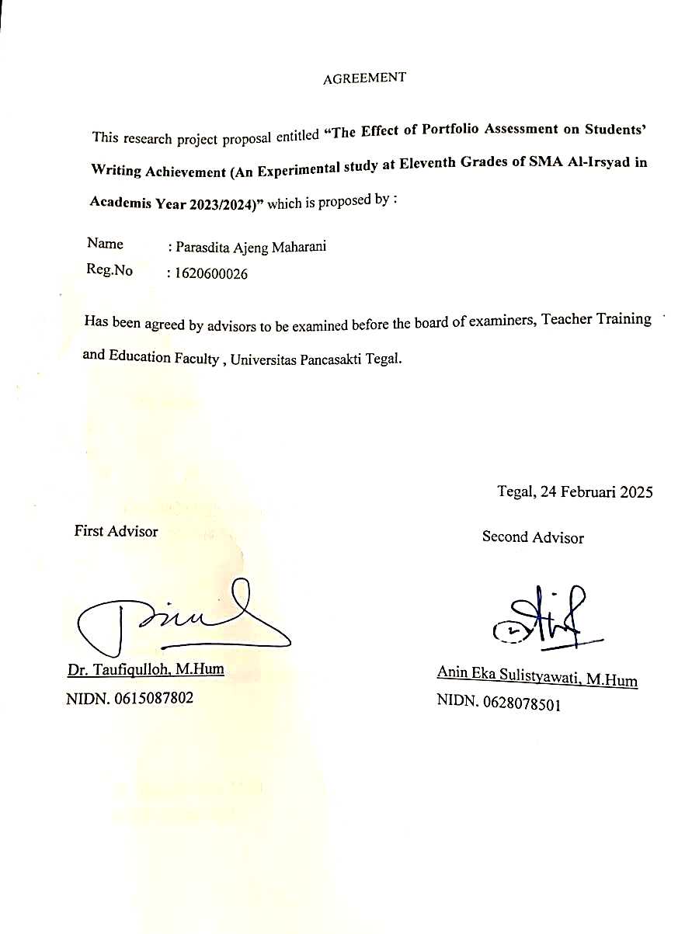

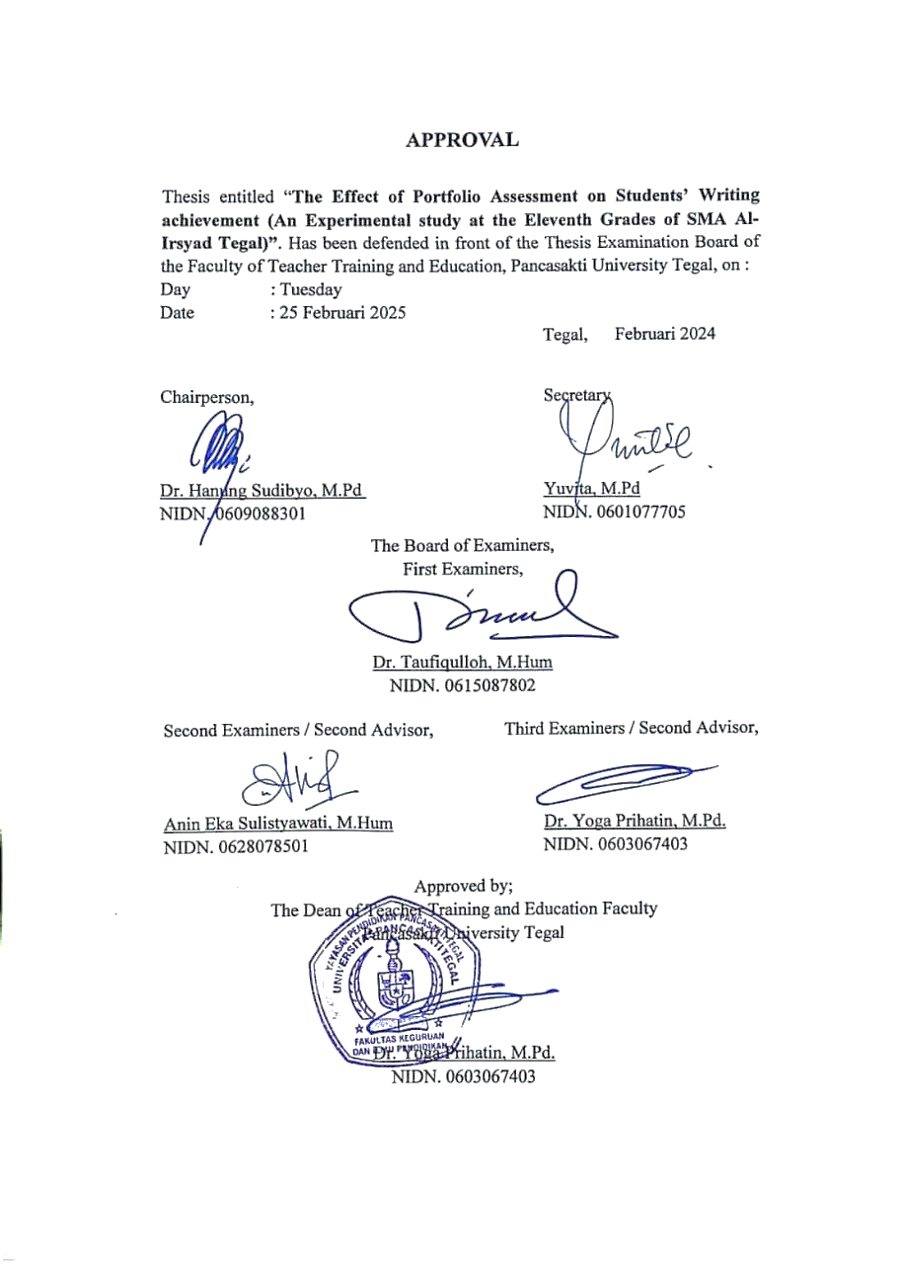

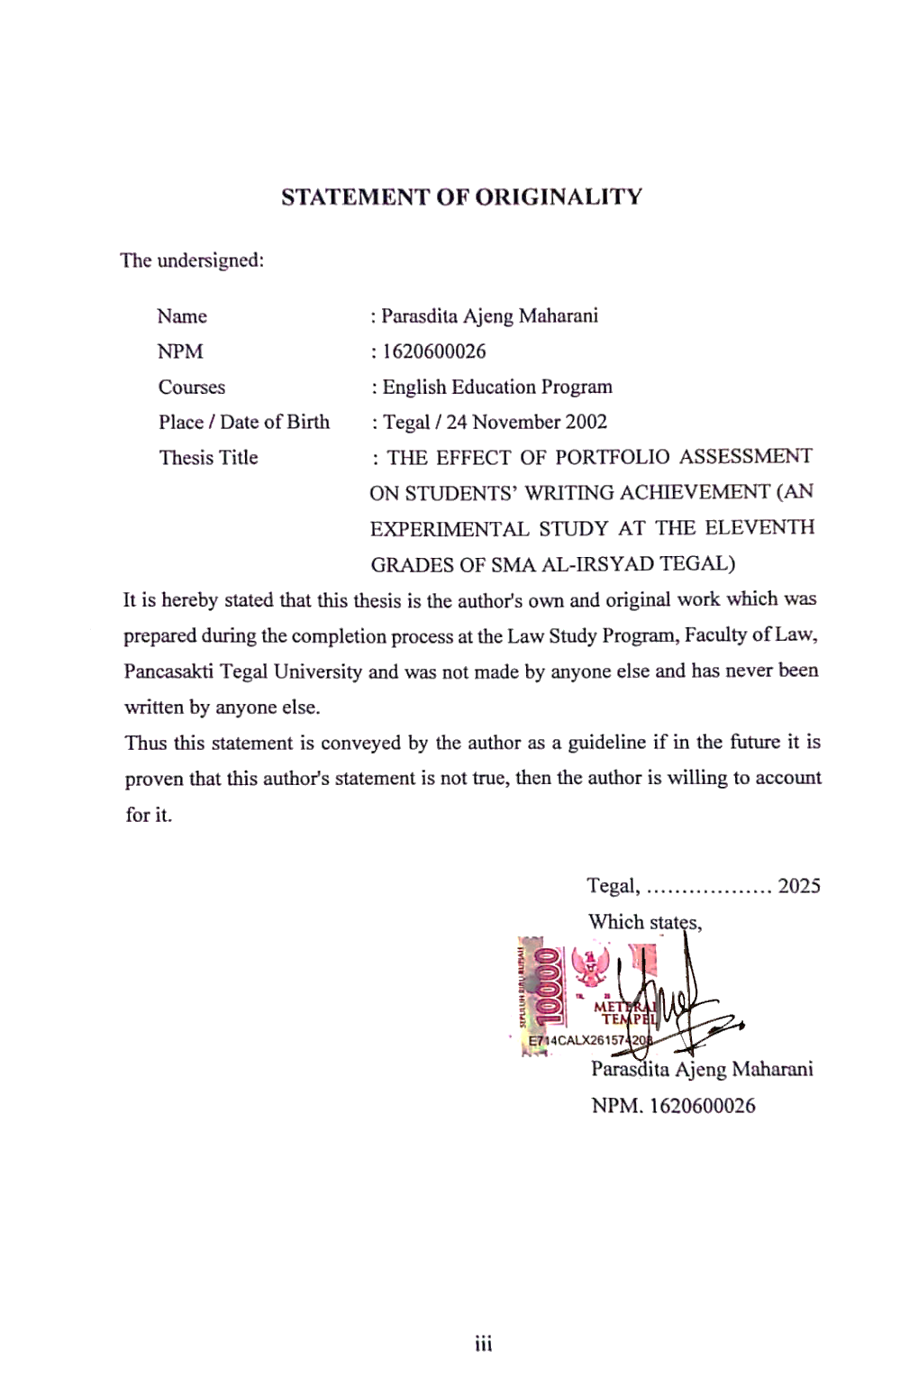

# MOTTO AND DEDICATION

# *Do everything calmly, but surely*

**OFFERING**

***Assalamu’alaikum warahmatullahi wabarakatuh*…**

With all humility, let me open this offering by offering praise and gratitude to the presence of Allah Subhanahu wa Ta'ala, the Almighty, the Most Merciful and the Most Merciful. Thanks to the abundance of His grace, guidance, and inayah, I was able to complete this thesis with patience and ease. I am Parasdita Ajeng Maharani, this thesis I dedicate to my parents and my brothers and sisters who have tirelessly supported all the decisions and choices in my life and never stopped praying for me. And don't forget the patient Supervisor who has guided and given input and suggestions so far, so that I can complete this thesis.

In closing, I pray to Allah Subhanahu wa Ta'ala that all the knowledge in this thesis can be beneficial, both in this world and the hereafter. May Allah be merciful to our every step in seeking knowledge and make our deeds the ballast of goodness in Yaumul Akhir..

***Wassalamu’alaikum warahmatullahi wabarakatuh…***

# *ABSTRACT*

*Stated that writing can be considered as the most difficult skill since there are many aspects such us punctuation, spelling, and grammar. The students have to pay attention to those aspects to produce good writing. Considering that doing writing is not only about how the students put the words in a paper. But also organize ideas to persuade, inform, and entertain readers. In writing learning, students are expected to be able to transfer ideas in writen from correctly. But, in fact, some students have not mastered this skill. In the teaching of writing, alternative assessment is in direct contrasts to what is known as traditional assessment, standardized assessment, etc. students, teacher, and sometimes parents are involved in this assessment. Portfolio assessment is used to encourage students’ involvement and improvement in their learning process.This research examines the impact of portfolio assessment on the writing achievement of eleventh-grade students at SMA Al-Irsyad Tegal. Two groups participated in the study: Class A, which applied portfolio assessment, and Class B, which utilized a game-based approach (portfolio games) in writing instruction. The study aimed to assess the effectiveness of portfolio assessment in improving students' writing abilities in five major aspects Content, Organization, Vocabulary, Grammar, and Mechanics. A pre-test and post-test were administered to both groups to measure the changes in writing performance over the course of the intervention. The results indicate that portfolio assessment significantly enhanced students' writing achievements, particularly in the areas of Content and Grammar. The structured and reflective nature of portfolio assessment allowed students to revise and improve their writing consistently, fostering a deeper understanding of grammar rules and better organization of ideas. On the other hand, the game-based approach, although motivating, showed more varied results, with some students performing well while others struggled, especially in grammar and organization. These findings highlight the advantages of using a process-based assessment model, such as portfolio assessment, in improving students' writing skills, suggesting that it is more effective in providing consistent, long-term improvements compared to more gamified instructional methods*.

***Keywords: Portfolio Assessment, Writing Achievement, Experimental Study***

ABSTRAK

Dinyatakan bahwa menulis dapat dianggap sebagai keterampilan yang paling sulit karena ada banyak aspek seperti tanda baca, ejaan, dan tata bahasa. Para siswa harus memperhatikan aspek-aspek tersebut untuk menghasilkan tulisan yang baik. Mengingat bahwa menulis tidak hanya tentang bagaimana siswa meletakkan kata-kata dalam sebuah kertas. Tetapi juga mengatur ide-ide untuk membujuk, memberi tahu, dan menghibur pembaca. Dalam pembelajaran menulis, siswa diharapkan dapat mentransfer ide-ide dalam bentuk tulisan dengan benar. Namun, pada kenyataannya, beberapa siswa belum menguasai keterampilan ini. Dalam pengajaran menulis, penilaian alternatif sangat kontras dengan apa yang dikenal sebagai penilaian tradisional, penilaian standar, dll. Siswa, guru, dan terkadang orang tua terlibat dalam penilaian ini. Penilaian portofolio digunakan untuk mendorong keterlibatan dan peningkatan siswa dalam proses pembelajaran mereka. Penelitian ini meneliti dampak penilaian portofolio terhadap pencapaian menulis

siswa kelas sebelas SMA Al-Irsyad Tegal. Dua kelompok berpartisipasi dalam penelitian ini: Kelas A, yang menerapkan penilaian portofolio, dan Kelas B, yang menggunakan pendekatan berbasis permainan (permainan portofolio) dalam pengajaran menulis. Penelitian ini bertujuan untuk menilai efektivitas penilaian portofolio dalam meningkatkan kemampuan menulis siswa dalam lima aspek utama Konten, Organisasi, Kosakata, Tata Bahasa, dan Mekanika. Tes awal dan tes akhir diberikan kepada kedua kelompok untuk mengukur perubahan dalam kinerja menulis selama intervensi. Hasilnya menunjukkan bahwa penilaian portofolio secara signifikan meningkatkan prestasi menulis siswa, khususnya di bidang Konten dan Tata Bahasa. Sifat penilaian portofolio yang terstruktur dan reflektif memungkinkan siswa untuk merevisi dan

meningkatkan kemampuan menulis mereka secara konsisten, menumbuhkan pemahaman yang lebih mendalam tentang aturan tata bahasa dan pengorganisasian ide yang lebih baik. Di sisi lain, pendekatan berbasis permainan, meskipun memotivasi, menunjukkan hasil yang lebih bervariasi, dengan beberapa siswa berprestasi baik sementara yang lain kesulitan, terutama dalam tata bahasa dan pengorganisasian. Temuan ini menyoroti keuntungan menggunakan model penilaian berbasis proses, seperti penilaian portofolio, dalam meningkatkan keterampilan menulis siswa, yang menunjukkan bahwa model ini lebih efektif dalam memberikan peningkatan yang konsisten dan jangka panjang dibandingkan dengan metode pengajaran yang lebih bersifat gamifikasi.

Kata Kunci: Penilaian Portofolio, Prestasi Menulis, Studi Eksperimen

# PREFACE

Alhamdulillah, all the praise and gratitude of the author is the presence of Allah S.W.T. who has bestowed welfare, health, and guidance on the author, so that the author can complete the writing of the thesis with the title "VICTIMOLOGICAL ASPECTS OF SCAMMER CRIME IN NON-FUNGIBLE TOKEN BUYING AND SELLING TRANSACTIONS". The purpose of writing this thesis is as one of the requirements to obtain a Bachelor of Science I (S1) degree in the English Education Study Program, Pancasakti Tegal University.

The preparation of this thesis was realized thanks to the help of various parties both morally and materially. Therefore, on this occasion the author would like to express his gratitude to:

1. Mr. Dr. Taufiqulloh M.Hum., as Rector of Pancasakti Tegal University
2. Mrs. Dr. Yoga Prihatin, M.Pd., as the Dean of the Faculty of Teacher Training and Education
3. Mrs. c., as the Head of the Faculty of Teacher Training and Education
4. Mrs. Anin Eka Sulistyawati, S.S., M.Hum., as Secretary of the Faculty of Teacher Training and Education
5. To Mr. Dr. Taufiqulloh M.Hum, as Supervisor I and Mrs. Anin Eka Sulistyawati, S.S., M.Hum., as Supervisor II who have been willing to provide guidance, direction, and have spent a lot of time and thought so that this paper can be completed*.*
6. All Lecturers of the Faculty of Teacher Training and Education, English Education Study Program who have been providing knowledge to the author so that they can complete the Strata I Study Program in English Education
7. All Administrative / Library Employees within Pancasakti Tegal University, especially the English Education Study Program who have provided academic services
8. All parties who provide motivation in pursuing the study and in the preparation of this thesis that the author cannot mention one by one that have helped the smooth running of the research and preparation of this thesis.

Hopefully all the help and guidance they have provided will be a charity and get a reward from Allah SWT. Finally, criticism, suggestions and inputs from all parties who use this article are very much hoped by the author for the perfection of this thesis final project.

Tegal, ………………. 2025

Writer,

Parasdita Ajeng Maharani

NPM. 1620600026

TABLE OF CONTENTS

AGREEMENT. .......................................................................................................ii

APROVAL. ............................................................................................................iii

STATEMENT OF ORIGINALITY........................................................................iv

*MOTTO AND DEDICATION OFFERING*..............................................................v

ABSTRACT............................................................................................................vi

ABSTRAK.............................................................................................................vii

PREFACE.............................................................................................................viii

TABLE OF CONTENTS.......................................................................................x

LIST OF TABLE....................................................................................................xi

LIST OF FIGURES...............................................................................................xii

CHAPTER 1 1

INTRODUCTION 1

1.1 Background of the Problems 1

1.2 Identification of the Problems 5

1.3 Limitation of the Problems 5

1.4 Statement of the Problems 5

1.5 Objectives of the Research 6

1.6 Significances of the Research 6

CHAPTER 2 8

REVIEW OF RELATED THEORIES, THEORETICAL FRAMEWORK, AND HYPOTHESIS 8

2.1 Previous Studies 8

2.2 Review of Related Theories 11

2.2.1 Portfolio Assessment 11

a. Definition of Portfolio 11

b. Portfolio as Assessment Model 11

c. The Advantages of Portfolio Assessment 13

d. The Disadvantages of Portfolio Assessment 15

e. The Characteristics of Portfolio 16

f. The Procedures of Using Portfolio Assessment 18

2.2.2 Writing 19

a. Definition of Writing 19

b. The Process of Writing 20

c. The Important of Writing 22

d. The Purpose of Writing 23

e. The problems of Writing 24

f. Teaching Writing at Senior High School 25

2.2.3 Narrative Text 26

a. Definition of Narrative Text 26

b. Generic Structure of Narrative text 27

c. Resolution 28

d. Re-orientation / Evaluation 28

e. Example of Narrative Text 29

f. Analysis of Narrative Text 30

g. Theoretical Framework 32

h. Hypothesis 35

CHAPTER 3 36

RESEARCH METHOLODOGY 36

3.1 Approach, Type, and Design of the Research 36

3.1.1 Research Approach 36

3.1.2 Research Type 36

3.1.3 Research Design 37

3.2 Population, Sample, And Technique ff Sampling 38

3.2.1 Population In This Research 38

3.2.2 The Sample in This Research 38

3.2.3 Technique of Sampling 39

3.2.4 Research Variables 39

3.2.5 Data Collecting Technique 39

3.2.6 Research Instrument 41

3.2.7 Technique of Analyzing Data 43

CHAPTER IV 47

RESEARCH RESULTS AND DISCUSSION 47

4.1 Data Description 47

4.2 Result 50

4.2.1 A Pre-Hypothesis Testing 50

4.2.2 Hypothesis Testing 52

4.3 Discussion 56

4.3.1 The Use Of Portfolio Assessment Give Any Positive Effect On Students’ Writing Achievement 56

4.3.2 Any Signficant Difference In Writing Achievement Between Students Taught By Using Portfolio Assessment And Those Who Are 70

CHAPTER V 75

CLOSING 75

5.1 Conclusion 75

5.2 Suggestion 76

REFERENCES 77

APPENDICES 79

# LIST OF TABLE

Table 1 - Analysis of Narrative Text 30

Table 2 - Pretest-Posttest Control Group Design 37

Table 3 - Rating Scale 42

Table 4 – Schedule for Portfolio Assessment Implementation (8 Days) 53

Table 5 – Paired Sample T-Test 57

Table 6 – Independent Sample T-Test 58

Table 7 – Average Scores Class A 61

Table 8 – Average Scores Class B 59

Table 9 - Aspects of Student Data Assessment 70

Table 9 - Implications of the Approach Method 70

Table 9 - Average Score 70

# LIST OF FIGURES

Image 1 - Theoretical Framework 34

Image 2 – Student Learning Process 82

Image 3 – The Learning Process of Class A Students 82

Image 4 – Class B Learning Process 83

Image 5 – Comparison Data of Class A and Class B Grades 61

Image 6 – Identification of Problems for Class A and Class B Students 63

# CHAPTER 1

# INTRODUCTION

This chapter consists of background d of the problem, identification of the problem, limitation of the problem, formulation of the problem, objecives of the research,and significance of the research.

## Background of the Problems

Writing is one of the English skill that should be mastered by students in English learning. There are several reasons why students have to master writing skills (Sahar, 2019). First, writing is one of the most important means of communication. It is very benefical for the students. Students who want to continue international school or college must have good writing skills because it is used many lessons in their studies. The next reasons is that writing can help people to express their feelings. They can use writing to express their opinions such us describing people, places, things, writing novel, other forms of written products, and by writing they can generate ideas. Sometimes, people can get ideas when they start to writing.

(Sahar, 2019) Stated that writing can be considered as the most difficult skill since there are many aspects such us punctuation, spelling, and grammar. The students have to pay attention to those aspects to produce good writing. Considering that doing writing is not only about how the students put the words in a paper. But also organize ideas to persuade, inform, and entertain readers. In writing learning, students are expected to be able to transfer ideas in writen from correctly. But, in fact, some students have not mastered this skill. (Jamaludin, 2018) Therefore, teacher must be creative to improve their students in writing. One thing that teacher can be use o improve students’ writing skills is to choose good assessments to assess and evaluate students achievement.

In teaching writing, the teacher must have general good knowledge, writing skills, and teaching techniques that are appropriate to what sudents need in all conditions (Jamaludin, 2018). With good general knowledge, teacher can explain and present many understanding about writing and the teacher can provide examples of good writing to students. It makes the student to understand the subject rather than just memorise it. The teacher must have a quick response in choosing appropriate techniques to solve students’ problems in writing.

However, most of the teacher only focused on the result rather than the process. It can be shown from the way most of the teacher only ask the students to write a text in short time after explaining the material without direct them to make any plan before (Umim, 2017). On the other hand, because it only focuses on the product, monitoring of student learning in teaching writing is rarely carried out by teachers (Biggs 1998). Thus making students less able to understand the process of writing. Meanwhile, to get satisfactory results, they have to go through a good process too. There some kind of writing processes has been proposed by many expert. One of which is Sundem (Sundem, 2006) argues that there are five steps in writing process such us pre-writing, drafting, revising, editing, and publishing. However, Oshima (1994) states that there are four steps in writing process such as pre-writing, planning, writing, revising, and rewriting.

The common alternative assessment that applies to the classroom is portfolio, journal, diaries, writing folders, teacher observations, peer and teacher-student conferences, checklists, and self-assessments (Mukhsinah, 2020) The study focuses on portfolios. Portfolio assessment can have several positive impacts on student abilities, especially in terms of writing. From their result or their work in portfolio, they can see their mistakes, and they can find solutions to their mistakes for the next assignment.

In the teaching of writing, alternative assessment is in direct contrasts to what is known as traditional assessment, standardized assessment, etc. students, teacher, and sometimes parents are involved in this assessment. Portfolio assessment is used to encourage students’ involvement and improvement in their learning process (Weinbaum, 1991). It also leads to students monitoring their own progress. Beside, portfolio contains a record of concrete examples of students’ work over time, they can accurately demonstrate students’ progress in the target language, give students the opportunity to reflect on their own progress and work collaboratively with peers even after the actual assessment has been given, and help students take the responsibility for their own progress toward both class oriented and personal learning goals (Apple & Shimo, 2002)

The effectiveness of writing portfolio supported by some previous researchers. According to (Romova & Andrew, 2011), Portfolio can be an effective assessment tool to give the students feeedback and help them understand their writing process. Portfolio also keeping improved vocabulary, grammar, reading skills, organization of the paragraph, punctuation, and capitalization of the participants (Sahar, 2019). In addition, research findings show that student motivation increases. This is because the implementation of a portfolio integrates writing as a process, not as a product.

Based on an interview with one of the teachers at SMA Al-Irsyad Tegal, The class that has been used as the object of this research is very suitable for the problem, namely about the writing ability of students. Eleventh grade students at SMA Al-Irsyad Tegal have several problems which are related to writing skills. The problems are the students doesn't motivation in learning writing, they does difficult to transfer ideas in writen. The teacher uses traditional technique and the students needs the other resources to enrich their knowledge about English.

And the portfolio assessment method is one of the method that can solve these problems because with this method, researchers found two advantages. Firstly, when using portfolio assessment method with students,it is easier for students to learn new vocabulary, grammar, reading skills, organization of paragraph, and students can remember a word easily to spelling, and secondly, this method gives a more interesting impression because students benefit from self-reflection and self-assessment. They can also be more self-aware and have better understanding of what they have learned by reviewing their work.

Based on the background above, the researcher tries to take the theme of the students’ achievement entitled “The Effect of Portfolio Assessment on Students’ Writing Achievementat Senior High School”

## Identification of the Problems

Based on the background of the problem mentioned above the researcher can identify some problems. The problem in this research are as follows :

1. Some students can not pour their idea when they have perspective in writing text
2. Some students have no great interest to write in English
3. Students cannot use their own idea and understand to describe things based on their sense
4. Students was confused about changing the verbs from present forms intopast forms

## Limitation of the Problems

Limitations in assessing the impact of portfolio assessment on writing achievement may include factors such as differences in student engagement, individual learning styles, and the possible influence of foreign language learning activities. Students may experience difficulties in learning a foreign language.

## Statement of the Problems

Based on the analysis of limitation of the problem, the researcher makes the statement of the problem as follow :

1. Does the use of portfolio assessment give any positive effect on students’ writing achievement?
2. Is there any signficant difference in writing achievement between students taught by using portfolio assessment and those who are not ?

## Objectives of the Research

Based on the statement of the problem above, the researcher can be presented as follow

1. To find out whether or not the use of portfolio assessment gives any positive effect on students’ writing achievement.
2. To find out whether or not there is a signifcant difference in students writing achievement between students taught by using portfolio assessment and those who are not.

## Significances of the Research

It is expected that the results of this research will provide useful infomation and contribute to the development of educational guidelines. The researcher expect that this research can give signficance both theoretically and practically for the teacher, students, and readers. To the first, theoretical significance. Theoretically, the researcher hopes the result of his research might give understanding to teachers to develop the eachig teaching technique. Furthermore, this study cane used as the references for those who want to conduct a researchin writing especially using portfolio assessment.

And the second is practical significances. Practically, the result of this study an be useful for the students, teachers, and researchers. First, for the students, especially for students who have problems in writing, this research can help improve their writing skills and provide them with new information that they didn’t know about the specific writing process and also students will be motivated to learning and writing english. Second, for the teacher, to the teachers, portfolio assessment will give the teacher information about the students’ writing problems. So, the teacher can determine effective teaching strategies or techniques to solve students’ problem in writing. And the third, for the next researcher,The findings of this research, can enrich their knowledge of educational research, In adition, it gives their experience in doing the research and working with others.

# 

# CHAPTER 2

# REVIEW OF RELATED THEORIES, THEORETICAL FRAMEWORK, AND HYPOTHESIS

This chapter consist of review of related theories, previous study, frame of thinking, and hypothesis of the research.

## Previous Studies

Previous study helps the researcher to take more references in the research. There are some previous studies about portfolio assessment that have ever done. They found that the portfolios were considered as an effective in language teaching and learning to improve writing skills. First study was conducted by (Ardina Shofiyah, 2014) entitled “Using Portfolio Assessment to Improve the Writing Skills of Grade VIII Students of SMP N 2 Piyungan in the Academic Year of 2013\2014”. This study was action research that was conducted two cycles. There were four meetings in the first cycle and five meetings in the second one. This research implemented five criteria of validity,namely democratic validity, outcome validity, process validity, catalytic validity, and dialogic validity. The results of this research show that the use of portfolio assessment was proven to be able to improve students’ writing skills in five aspects of writing, namely content, organitation, vocabulary, language use, and mechanics.

Second, *The Effects of Portfolio Assessment on Writing of EFL Students*by (Nezakatgoo, 2011), the problem that discusses in the study about addressing the development of EFL students’ mechanics of writing in portfolio-based assessment. The result of the study confirmed that students whose work was evaluated by portfolio system (portfolio-based assessment) had improved in their writing and gained higher scoresin final examination when compared to those students whose work was evaluated by the more traditional evaluation system (non portfolio-based assessment). The findings also revealed that there was a positive correlation berween the dependent scorer of final examination and the independent scorer of portfolio assessment.

Third, entitled *“The Implementation of Portfolio Assessment in Teaching ar SMA N 12 BONE”* from (Sahar, 2019). This study focuses on one case which is portfolio assessment in teaching writing implemented by a teacher, case study is an ideal guiding framework as is is used in many situations that focus on particular group or an individual. The participant was selected among six teachers through some consideration. Specifically, the participant has joined the training of the 2013 curriculum, he was cooperative teacher, and he is a teacher of English who has gone through five years of formal training at a University level; therefore, their proficiency level in English is at least upper-intermediate or above. The researcher used descriptive analysis in analyzing data, in which the researcher analyzed tha data that were collected through the instruments previously mentioned.

Based on the research above, it can be concluded that this research and previous research have differences. The differences between the researchers are that in the first research, Ardina Shofiyah (2014) focused on developing students' writing skills, the researchfocus was on the data were obtained from the observation and interview with the english teacher, the collaborator, and the students. The researcher also used qualitative research as a method, while in the second research, (Alibakhshi *et.al*., 2021) the problem that discusses in the study is about addressing the development of EFL students’ mechanics of writing in portfolio-based assessment. The findings also revealed that there was a positive correlation between the dependent scorer of final examination and the independent scorer of portfolio assessment. And the latest research, Sahar (2019), The researcher used descriptive analysis in analyzing data, in which the researcher analyzed tha data that were collected through the instruments previously mentioned.

Related to the gap in this study, the researcher used portfolio assessment, this is because some studies have shown some interesting result. A study regarding the use of portfolio assessment in the context of language learning found that the method can help improve students’ understanding writing achievement. This is due to the active interaction with words in a fun and enganging context, which can strengthen vocabulary recall and understanding. However, it is important to remember that this effect may vary depending on the design of the method, the level of difficulty, and usage accompanied by appropriate practice. Therefore, the role of the teacher in directing the use of portfolio assessment in writing learning is also important to maximize their benefits.

Even this experiment takes similar terms and purpose, the experiment is different with other experiments that have ever done before. Therefore, researcher are interested in conducting research entitled “The Effect of Portfolo Assesssment on students’ Writing Achievement at Senior High School”

## Review of Related Theories

### Portfolio Assessment

#### Definition of Portfolio

The portfolio is a collection of students’ work representing a selection of performance. It often documents a students best work. It may also include informations such as drafts of his/her work, his/herself assessment of work, and parents’ assessment.

Portfolio requires students to collect an reflect on examples of their work providing both instructional components to the curriculum and offering the opportunity for authentic assessment. It provides evidence of a student’s learning and uses it as an assessment of learning, Thus, it is concluded that portfolio assessment is collection of instances of learning by the teacher and using it for assessment of learning.

#### Portfolio as Assessment Model

Portfolio assessment is one of assessment model where students are engaged in their own assessment. The student collects his or her work and has been evaluated by teachers and students who have a portfolio, the basic of portfolio assessment is to evaluate students work individually on a period for a subject of learning. On the last period, those work result are collected and evaluated by teacher and students self. Based on the development information on portfolio, teacher and student can assess development of students ability and continue to make improvement.

Portfolio are often describe as a more authentic means of assessment than the traditional classroom test. Rather than showing that the learner knows what has been taught that the students can do what has been taught. By using portfolio assessment, teacher and students can see the development or progress of students work. Portfolio also shows the ability of students.

Portfolio is an assessment model that has some characteristic that make it appropriate to apply in assessing students’ ability and competences. Portfolio can be an show that they do their work and they also can show their skill development. By using portfolio teacher aslo see do the students get the goals o learning or not.

Based on the characteristic above, it shows that the portfolio assessment helps students to improve their ability and competency. One of the goal of using portfolio is students are expected to becomes persons who have responsibility, because students are asked to evaluate their own works. From their own evaluation students also can measure their capability level.

Portfolio assessment truly is assessment for learning. As the students selects and reflects on the artifact included in a portfolio, teachers have the opportunity to o view and construct a picture of each student’s knowloedge and accomplishments. The teacher then uses this information to guide instructional decision making for the individual student, group of students, or the calss as o whole. In this way, portfolios provide opportunities for the continuous integration if instruction and assessment.

By using protfolio teacher shouls be able to grow responsibility and fun in learning to students. It will be happen based on the implementation of interactive portfolio, possessive feeling of students,and students control in review process (Ganesess & Upshur, 1997:103).

The other important thing that shoukd be understood by teacher is implementation of portfolio interactively isn’t automatically happened. So, teacher needs to make good planning systematically :

Engaged students in all of making decision in portfolio, students needs to select the work sheets that they will include in their portfolio, plan the portfolio conference periodically so that student can review their work with their teacher and gather to formulate the goals, teacher need to support their students to reviw and share their portfolio with other students (Suwandi, 2010:100-101).

#### The Advantages of Portfolio Assessment

There are many experts that describe the advantages of portfolio assessment. (Moya & O’malley, 1994) say that portfolio assessment is an alternative assessment that can be used to see the strengths and weaknesses of the students. Moreover, (Öztürk & Çeçen, 2007) state that portfolio provides the real information about the students’ learning development because it keeps records of the students’ knowledge and skills.

Besides, the students can also get the advantages of using portfolio assessment. They can observe their own progress in learning and know their strength and weaknesses because it focuses on multidrafting, feedback, and revision (Hyland, 2003). Moreover, Stecher in (Evers & Walberg, 2004) says that portfolios can encourage the students to do self-reflection and self-evaluation. By reviewing their own work, they can be moreself-aware and will have better understanding of what they have learned.

Being more detail, Brown (2004) mentions some advantages of portfolioassessment.

1. It can promote the students’ intrinsic motivation, responsibility, andownership.
2. It can increase the interaction between the students and the teacher.
3. It can prepare for learning and celebrate the uniqueness of the studentsindividually.
4. It offers the real information of the students’ work.
5. It helps critical thinking, self-assessment, and revision process.
6. It gives opportunities for the students to work with their peers.
7. It can allow assessment of multiple dimensions of language learning.

In conclusion, portfolio assessment has many advantages for languagelearning. For the students, it can promote their intrinsic motivation since they get regular feedback from the teacher and they will get opportunities to revise their writing. In addition, the students will get benefit by doing self-reflection and self- assessment. It allows them to find what they can do and what they cannot do in their learning. They can also be more self-aware and will have better understanding of what they have learned by reviewing their work. Moreover, portfolio can help the teacher see the students’ progress of their learning and identify the strengths and weaknesses of the students.

#### The Disadvantages of Portfolio Assessment

Faculty time required to prepare the portfolio assignment and assist students as they prepare them. Logistics are challenging, students must retain and compile their own work, usually outside of class. Motivating students to take the portfolio seriously may be difficult, transfer students may have difficulties meeting program-portfolio requirements, storage demands can overwhelm (which is one reason why e-portfolios are chosen).

#### The Characteristics of Portfolio

Portfolio is not just simply an activity of collecting students’ woks in a period of time. Hamp- Lyons and Condon as cited in Weigle (2002:199) explain are several characteristics of portfolios as follow:

1. A portfolio is a collection of written works, rather than a single writing sample.
2. It enables the researcher to display a range of writing performances, in different genres and for different audiences and purposes.
3. A portfolio possesses context richness insofar as it reflects closely the learning situation and demonstrates what the researcher has accomplished within that context.
4. An important characteristic of most portfolio programs is delayed evaluation, giving students both the opportunity and the motivation to revise written products before a final evaluation is given.
5. Portfolios generally involve selection of the pieces to be included in the portfolio, usually by the student with some guidance from the instructor.
6. Delayed evaluation and selection offer opportunities for students- centered control, in that students can select which pieces best fulfil the established evaluation criteria and can revise them before putting them into their portfolios.
7. A portfolio usually involves reflection and self-assessment, in that students must reflect on their work in deciding how to arrange the portfolio, and are frequently asked to write a reflective essay about their development as researchers and how the pieces in the portfolio represent that development.
8. Portfolios can provide a means for measuring growth along specific parameters, such as linguistic accuracy or the ability to organise and develop an argument.
9. Portfolios provide a means for measuring development over time in ways that neither the teacher nor the student may have anticipated.

Hamp-Lyons and Condon state that from those characteristics, the most important aspects of portfolio are collection, reflection, and selection. Nunan (2004), additionally, explains that the following items are some characteristics of using portfolios to assess students’ learning.

* 1. The teacher and the students should work together in the assessment.
  2. The portfolios should contain specific items.
  3. The students’ work included in the portfolios should show the progress ofstudents’ learning.
  4. The students have to get a clear explanation about the content and assessmentcriteria at the beginning of using portfolios.

In summary, the characteristics of portfolio mentioned above are verybeneficial to improve the students’ writing skills. The students will get benefits if portfolio is implemented in teaching writing. Some of the benefits are that the students are given opportunities to revise their work before the final evaluation is given. Moreover, portfolio involves reflection and self-assessment which will be very useful for the students to evaluate their strengths and weaknesses.

#### The Procedures of Using Portfolio Assessment

1. Collect

The first part of the portfolio process is collection. Students should keep all [evidence of learning](https://masteryportfolio.com/glossary/evidence-of-learning/) in one place. Whether it is in a create with folders if paper or in Google drive organized by folders, students should maintain all oftheir work in every state of completion.

1. Select

The selection process will largely depend on the determined success criteria. Portfolios can be used to demonstrate success, achievement, growth or improvement or a combination of any of those ideas. Depending on the age and level of students, open upa dialogue about what their portfolios should represent about them as a learner.

1. Reflect

Once students have selected the evidence for their portfolio, students should reflect on why they selected the pieces they did. What does the work demonstrate? How do they know? Are their goals that these pieces show being met? Is it their best work? What students are most proud of? Or does it demonstrate how far they have come?

1. Connect

This is specifically on here for schools that employ portfolio systems in different classes or for elementary aged students where they can connect evidence of learning a particular [skill](https://masteryportfolio.com/glossary/skill/) or content in multiple areas of their learning.

### Writing

#### Definition of Writing

Writing skills are specifics abilities which help researchers put their thoughts into words in a meaningful form and to mentally interact with the message. There are some different definitions of writing explained by some different linguists. Writing is an integral part of a larger activity where the focus is on something else such as language practice, acting out or speaking (Harmer, 2007:33)

On the other hand, writing is the representation of the language in textual medium through the use of a set of sign or symbols. Some people consider that writing is difficult. Elbow (1981:9) states that writing calls on the ability to create words and ideas out of yourself, but it also calls on the ability to criticize them in order to describe which ones to use.

Writing is the nature of the composing process of writing. Written products are often the result of thinking, drafting and revising procedures that require specialized skills, skills that not every speaker develops naturally (Brown, 2003:335). Based on the explanation above, it can be concluded that the definition of writing is process of inventing ideas, thinking about how to express them, and organizing them into statements and paragraphs which the purpose is used to communicate something with the other people indirectly, student gets effort to express mind through language in writing.

#### The Process of Writing

The process approach describes four steps of pre-writing,drafting, revising, and editing. These stages are recursive, occurring in the course of composing many times. This approach emphasizes revision as well as input from others, and students can produce a lot of drafts with a lot of phrasing and flipping through pages. Correcting spelling and punctuation in the early stages is not of central importance. The process approach has some stages of activities in the writing classroom which is treat writing as a creative activity that needs time and positive feedback to be done. Sundem (2006) proposed that the process approach has five stages: pre-writing, drafting, revising, editing and publishing.

1. Pre-writing

Pre writing is any activity of writing before students starts writing. In this stage, student has to choose what topic they want to develop. There are two activities in pre-writing. Teachers should guide them to make an outline of their topic have been chosen and brainstorming their idea to elaborate on their ideas dealing with the topic.

1. Drafting

After doing the pre-writing activity, the student begins to making a draft of their writing. In this stage, student have to develop their ideas into a good paragraph. After that, teachers give the comment and feedback about that.

1. Revising

By following the teacher’s feedback, students try to revise their draft based on the comment. The revising stage deals with the content and the organization of the text itself. Therefore, in this stage student do not need to write again, but they just re-think and organize their writing.

1. Editing

The next stage is editing. Here absolutely student work is editing the writing in grammatical dan mechanics term.

1. Publishing

After the student’s writing are revised and edited, it can be submitted to theteacher or perform it as a presentation to other students.

Good writing is not only considered by good grammatical, spelling, and punctuation butalso it should behave a suitable vocabulary and well organization. Based on the English curriculum in Indonesia, the student must be able to compose some texts in English. One of the texts that should be produced is a narrative text.

#### The Important of Writing

Written communication is an exceptional characteristic of the human species. Over hundreds of years, writing has helped individuals to inform, collaborate and alert other, while societies benefitted from written history, culture and knowledge. In our time, how you successfully use the gift of writing, depends on you.

Writing is a life skill, not only an essential job-related skill, because it is often the basis upon which others judge your learning, your values, your ideas and your contribution to society. Regardless of your career or occupation, everyone has to write to communicate with others, whether it is a friendly email, a formal business memo, a report, a job application, a press release or a message of condolence. Your writing skills determine if you receive the desired reaction from your reader. Did you inform, persuade, calm or entertain as you hoped? The effectiveness of your communication can affect your daily life and your life course outcomes. So, miscommunication can have serious consequences and unintended effects.

Writing is personal. It represents us when we are absent in space and in time. Writing expresses who we are, even after our life time. It makes our knowledge, our personal aspirations and our work for the future visible to others. Writing is the means to explain our ideas to ourselves and to others while preserving our personal experiences and our memories. No one else can do it for you. In this way, writing connects you with yourself. Writing is not fleeting; it is permanent. It is a record of what you wished to communicate at a point in time.

#### The Purpose of Writing

In writing, the researcher has purpose to convey messages to the reader. No matter what kind of writing the researcher does, he/she should has a specific and clear purpose. It can be done by selecting right words and suitable sentences structure to convey the intended meaning. The purpose of a piece of writing will determine therheotical form choosen for it.

According to Grenville, there are three purpose of writing : to entertain, toinfoem, and to persuade

1. To entertain

Writing to entertain generally takes the form of imagnary or creative writing. It means that the researcher needs touse his/her creativity. It must not make the leaderslaugh, but engage their feeling in some ways.

1. To inform

Writing to inform has purpose to tell the reader about something. This kind of informative writing can focus on objects, places, procedures, and events. It can be seen in newspaper and articles, scientific or business reports, instructions or procedures, and essays for school and university.

1. To persuade

The researcher tries to convince the reader of something that a point of view is valid by presenting the fact/data so that readers follow researcher’s opinions and act upon it. In conclusion, the purpose of writing is not only to express the ideas, feeling or thought in written symbol but it has also specific purposes such as to entertain, to inform and to persuade the readers.

#### The problems of Writing

Writing is the hardwork, because in writing the researchers can take one ours even more in one paragraf. That is why many problems see by the teacher and students. There are 3 categories problems that make writing skill becom difficult to master based on Gebhard.

Less proficient researcher

Less competent authors often forgo prewriting procedures to develop ideas. Students may take a long time to jot down their ideas. A suggestion to address this issue, teachers should teach less proficient researchers about the writing process. Teachers should give students complete attention and demonstrate prewriting practices to help them plan their writing.

I can’t write English

Students often give up on writing and assume they can't write.The solution is for teachers to apply the writing process to students. Teachers can guide students through pre-writing, drafting, and revision activities. This approach helps children understand that writing is a gradual process that requires time and effort.

Teacher response

Writing teachers often spend hours reading and grading students' writings. To address this issue, teachers might facilitate student-to-student conferences to help pupils improve their writing skills.

#### Teaching Writing at Senior High School

In Indonesia, teaching English as a foreign language prioritizes writing abilities over other linguistic proficiency.

Writing is now partof the senior high school English curriculum. In senior high school, Writing is taught along with other abilities. Writing aims to improve students' ability to articulate brief and basic messages in numerous genres, including descriptive, process, recount, narrative, and report texts.

### Narrative Text

#### Definition of Narrative Text

Oshima and Hogue (2007) state that narration is writing a story. In a narrative paragraph or essay, events or incidents are described in chronological sequence. To put it another way, you organize your sentences into a narrative paragraph by using time order. In can be said that a narration is a story writing about events or incidents use time order.

Meanwhile, Keraf (1989) state that the narrative is a type of composition with specific goals. A narrative text is one that tells a story to educate, entertain, inspire, or train the reader. The narrative may be real or fictional. In narrative texts, true stories can be an individual's adventure or an event. Fictions are stories that people make up out of their fantasies and imaginations. According to these points of view, a narrative text is typically the result of writing that is evolve and woven into a story about an event that occurred in the past.

Character, setting, and action are present in narrative text. Typically, the narrative's problem, setting, and characters are introduced at the beginning. In the middle, the issue reaches its highest point. The issue is solved by the conclusion. Reading narrative means understanding a whole or what is in the narrative text. Both the storyline, characters, setting, and also the message of the text.

Additionally, narrative texts impart a moral lesson to the readers. Characters typically represent the polar opposites of evil and good, villain and hero, weak and strong, or foolish and wise. They are perfect examples of these polar opposites. Due to the trait of the text, which indicates contrary, narrative texts always contain conflicts and complications. For instance, a good person and a bad person.

#### Generic Structure of Narrative text

Derewianka (1990) states that the generic structure of narrative are:

1. Orientation

Orientation sets the stage for the story. Ideally, the orientation should answer the questions “who,”*“where,*and “when.”So, when reading the orientation part, we should be able to identify the character and setting (both time and place) of the story.

1. Complication

This section contains the problems that occur within a story. It is divided into three parts, namely:

1. Rising action: Problems begin to emerge
2. Climax: Peak of the problem
3. Falling action: The tension of the problem begins to decrease, and the solution starts to emerge

#### Resolution

The resolution is the part of the narrative where the conflict or problem introduced earlier in the story is resolved or addressed. This may involve characters finding a solution to their issues, overcoming obstacles, or experiencing personal growth. The resolution helps tie up loose ends, providing closure for the reader and allowing them to see how the events of the story have impacted the characters.

#### Re-orientation / Evaluation

Re-orientation, also known as evaluation, is an optional component of a narrative text that serves to reflect on the story and its events, reinforcing the moral lesson or theme. This section typically appears at the end of the story, providing a summary or commentary on the characters’ experiences and the consequences of their actions.It helps the reader understand the significance ofthe story and encourages them to consider the message or lesson the author intesnded to convey.

The points mentioned above are the basic components of a narrative text structure, but it is important to note that not all narrative texts follow this exact structure. Some narratives may include additional elements, such as flashbacks, multiple perspectives, or non-linear timelines. Nevertheless, the basic structure described above provides a useful framework for understanding and analyzing narrative texts.

#### Example of Narrative Text

“Pinocchio”

In the past, there was a puppeteer whose name was Geppetto. He is eager to have a son very much but his wife passed away several years ago. One day, he got the idea to make a puppet in order not to be lonely again. He made a puppet all day long. Finally, in the morning he had finished his work and he named the puppet Pinocchio. Soon he felt lonely again since Pinocchio couldn’t walk or talk by himself. O ne night, Geppetto prayed to God to become a real boy. He always thought it on his mind in his dream.

The next morning, he was surprised that Pinocchio was alive. He taught Pinocchio how to walk, how to read, how to speak, and to do other things as a human. He then studied at an elementary school. One day, Pinocchio felt bored and it made him go home late. When Pinocchio finally came home, Geppetto asked him. He said that he was at school but he wasn’t. Instantly, Pinocchio's nose grew longer and longer and it meant that Pinocchio had lied.

The next morning, Pinocchio was kidnapped by the owner of the circus. Pinocchio soon became a slave for the circus. He was so famous because he was a puppet who could talk. Geppetto worried about him because Pinocchio had not been going home for almost two days. He tried to find Pinocchio everywhere but he found nothing. When he searched for him on the sea, a big wave smashed him. He was then in a whale’s stomach when he awoke. He couldn't find a way to go out.

On the other side, Pinocchio finally could escape from the circus. He came home but nobody was there. Later on, he searched for Geppetto in the sea. He had the same accident as Geppetto and he met Geppetto in a whale’s stomach. Both of them got out of their stomachs by making a fire. In the end of the story, they went home together and lived happily ever after.

#### Analysis of Narrative Text

Narrative text has generic structure such as orientation, complication, and resolution. Here are the analysis of narrative text based on its generic structure:

Table 1 - Analysis of Narrative Text

|  |  |
| --- | --- |
| **Narrative Text** | **Analysis** |
| **Orientation** | In the past, there was a puppeteer whose name was Geppetto. He is eager to have a son very much but his wife passed away several years ago. One day, he got the idea to make a puppet in order not to be lonely again. He made a puppet all day long. Finally, in the morning he had finished his work and he named the puppet Pinocchio. Soon he felt lonely again since Pinocchio couldn’t walk or talk by himself. O ne night, Geppetto prayed to God to become a real boy. He always thought it on his mind in his dream. |
| **Complication** | The next morning, he was surprised that Pinocchio was alive. He taught Pinocchio how to walk, how to read, how to speak, and to do other things as a human. He then studied at an elementary school. One day, Pinocchio felt bored and it made him go home late. When Pinocchio finally came home, Geppetto asked him. He said that he was at school but he wasn’t. Instantly, Pinocchio's nose grew longer and longer and it meant that Pinocchio had lied.  The next morning, Pinocchio was kidnapped by the owner of the circus. Pinocchio soon became a slave for the circus. He was so famous because he was a puppet who could talk. Geppetto worried about him because Pinocchio had not been going home for almost two days. He tried to find Pinocchio everywhere but he found nothing. When he searched for him on the sea, a big wave smashed him. He was then in a whale’s stomach when he awoke. He couldn't find a way to go out. |
| Resolution | On the other side, Pinocchio finally could escape from the circus. He came home but nobody was there. Later on, he searched for Geppetto in the sea. He had the same accident as Geppetto and he met Geppetto in a whale’s stomach. Both of them got out of their stomachs by making a fire. In the end of the story, they went home together and lived happily ever after. |

#### Theoretical Framework

Writing as one of the important skills in English has many benefits for thelanguage learners. First, writing can be used as a tool to reinforce the other skills of English. Second, the students can express their feelings and thoughts freely without being distracted when they are writing. Another benefit is that writing is one of the indicators that determines their success in language learning because writing is one of the vital skills of English.

Eleventh grade students at SMA Al-Irsyad Tegal have several problems which are related to writing skills. The problems are the students doesn't motivation in learning writing, they does difficult to transfer ideas in writen. The teacher uses traditional technique and the students needs the other resources to enrich their knowledge about English.

Based on that explanation, the teachers should choose the best way to teach Englis writing. Therefore, this technique could improve their motivation in learning writing. Using portfolio method is interesting technique since the learning process not only teacher as central but also students the students as the central of teaching learning process.

Moreover, the used of portfoilo assessment strategy could be created communicative situation in teaching learning process. From the theories above, the researcher believes that applying portfolio asssessmentmethod could be improved the students' ability and motivation in teaching learning process.

Image 1 - Theoretical Framework

INPUT PRE-TEST

(Writing test)

PROCESS

(Treatment)

Teaching writing with portfolio assessment

Teaching writing using portfolio games

OUTPUT POST-TEST

(Writing test)

The effect of using portfolio assessment on students’ writing achievement

#### Hypothesis

The purpose of statistical inference is to draw conclusion about a population on the basis of data obtained from a sample of that population. The first step in testing hypothesis is the transformation of the research question into a null hypothesis (Ho), and alternative hypothesis (H1) (Davis, 2006), the hypothesis of this research are formulated as follows:

* 1. Null Hypothesis (Ho) The use of portfolio assessment does not significantly improve the students’ vocabulary and grammatically mastery.
  2. Alternative Hypothesis (H1) The use of portfolio assessment significantly improve the students’ vocabulary and grammatically mastery.

# 

# CHAPTER 3

# RESEARCH METHOLODOGY

In this chapter, the researcher explains the research method that is used in this research. This research method consists of several sections. They are the research approach, type, and design, setting population and sample. It also consists of research variable, instrument of the research, technique of collecting data, technique of analyzing data and statistical hypothesis.

## Approach, Type, and Design of the Research

### Research Approach

This study uses quantitative research to measure the effect of portfolio assessment to achievement students’ writing narrative text. According to (Pritha Bhandari, 2020) Quantitavive research is the process of collecting and analyzing numerical data. It can be used to find patterns and averages, make predictions, test causal relationship, and generalize results to wider populations.

This research examines a certain population or sample to test a hypothesis. The data collection process is conducted using thorough research instrument, followed by accurate data analysis.

### Research Type

This study uses experimental research. This experimental research investigates how one treatment impacts another under controlled conditions. According to Sugiyono (2010:107), experimental study is research method that is used to looking for the effect of certain treatment in a control situation.

The type of this experimental research is true experimental design. There are two randomly selected groups. First group is the experimental group and second group is control group.

### Research Design

The design of the research that is used in this research is two group design. One class as experimental class and one class as control class. The researcher used pre-test to measure the ability of the students before giving the treatment. Pre-test given to measure the condition before treatment period. Post-test given after the researcher applies the treatment to the experimental group and control group. Post-test given to know how significance of applying portfolio assessment on students’ writing skills.

Table 2 - Pretest-Posttest Control Group Design

|  |  |  |  |
| --- | --- | --- | --- |
| **Group** | **Pre-test** | **Treatment** | **Post-test** |
| Experimental group | O1 | X | O2 |
| Control group | O3 | - | O4 |

Explanation:

X =Treatment (usingporfolio assessment for experimental group)

O1 = pre-test experimenal group

O2 = post-test experimental group

O3 = pre-test control group

O4 =posttest control group

R = Random

## Population, Sample, And Technique ff Sampling

### Population In This Research

“Population is a generalization area consisting of: objects or subjects that have certain qualities and characteristics that set by researchers to study and draw conclusion” (Sugiyono, 2013).

The target population of this research is all students of eleventh grade students’ of SMA Al-Irsyad Tegal in the academic year of 2023/2024. The population in this research consist of 360 students.

### The Sample in This Research

Sample is a part of the target population that the researcher wants to study in order to make generalizations about the target population. Regarding the number of participants, there are few experts’ statements. Creswell (2013) says a correlation study must have at least 30 participants to establish the relationship.

Researchers have taken two classes as samples to conduct this study. First class as Experimental group (who were taught by using portfolio method) and second class as Control group (who were taught using portfolio method). An example of this research has been taken from eleventh grade students of Al-Irsyad Tegal High School for the 2023/2024 academic year.

### Technique of Sampling

The researcher uses the purposive sampling in selecting two classes among the population to become experimental and control class. (Sugiyono, 2013) purposive sampling technique requires some thought. It means, the researcher can choose the classes which have the same average basic knowledge and ability.

### Research Variables

Research variables are divided into two categories: independent and dependent variables. Independent variables are variables that are manipulated to determine their effectiveness on the dependent variable. The dependent variable is the variable that appears as a result of the independent variable.

In this research, the researcher use two variables to determine experimental result as variable X and variable Y. Independent variable is using portfolio method (variable X), dependent variable is students’ writing skills (variable Y).

### Data Collecting Technique

The researcher use test to be applied for getting the data. Before conducting the test, the researcher had conducted try out test first to get the validity and reliability of the instrument to another group. After the instrument is valid and reliable, the pre-test had given to both of groups. After that, the researcher started the research. In this research the researcher delivered the material by using portfolio method to experimental group andcontrol group. At the end of the lesson, the researcher conducted post-test to both of groups. Here are some of the techniques that have been used in collecting research data, including :

* 1. Pre-test

Before applying portfolio assessment as a writing teaching method, the researcher conducted a pre-test. This pretest was intended to show students' basic writing skills, especially writing narrative text. The pre-test, administered in both the experimental and control group. The purpose of using tests with the same format for both pre-test and post-test is to ensure the accuracy of students’ abilities and show the effect of the treatment.

* 1. Post-test

After doing a treatment, the researcher gives a post-test to them. The post-test is used to examine the improvement of students’ writing skills in experimental group and control group after receiving treatment. This post-est has been given to the control group and the experimental group. Final tests have been used to determine whether or not the treatment given to the two groups can have an impact on giving very different outcomes.

* 1. Questionnaire

According to Pritha Bhandari (2021) A questionnaire is a list questions or items used to gather data from responden about their attitudes, experience, or opinions. Questionnaire can be used to collect quantitative and/or qualitative information. A questionnaire is a specific tool or instrument for collecting the data. Designing a questionnaire means creating valid and reliable quetions that address your research qbjectives, playing them in a useful order, and selecting an appropriate method for administration.

### Research Instrument

A tool used to measure, observe, or collect quantitative data is called an instrument. Arikunto defines a test as a tool or method used to determine or measure a student's performance using a set of methods and rules. The purpose of this test is to find out whether the portfolio assessment has a significant effect on students' reading skills.

Written tests that have been used in this study. This written test intends to find out the difference between students who are taught by using portfolio assessment method and group two is control group consisting of students who are taught without using portfolio assessment method. Both groups had been taught the same material about narrative texts but the methods were different. Furthermore, the test is given when both groups after receiving treatment. Researchers have assessed student results using the assessment rubric.

Weigle (2002) says that analytical scoring is used to assess the students’writing based on the aspects of writing such as content, organisation, vocabulary, language use, and mechanics. The advantage of using this type of scoring is that it is more useful to diagnose the students’ writing ability than holistic scoring. Therefore, the researcher adapted this scoring method in the research. One of the most popular analytical scoring rubrics is made by Jacob et al. in Weigle, (2002:115).

Table 3 – Rating Scale

|  |  |  |
| --- | --- | --- |
| **No** | **Components** | **Score** |
| 1 | Content | 30 |
| 2 | Organization | 20 |
| 3 | Vocabulary | 20 |
| 4 | Grammar | 25 |
| 5 | Mechanics | 5 |
|  | **Total** | **100** |

In evaluate a research instrument, two elements must be examine, namely validity and reliability. Reliability and validity are two most important and fundamental features in the evaluation of any mesurement instrument or tool for a good research. The following is an explanation of validity and reliability :

1. Validity

The legitimacy of an instrument is decided by its ability to dependably degree information from a quantifiable variable. In case, a test measures what it is implied to degree, it is substantial.

The substance of the investigate instrument was assessed a master judgement method. In this sense, the standard strategy for surveying the quality of an instrument is to consult experts which entail analyzing the instrument using a technique known as expert judgement.

1. Reliability

Realiability in research is like the accuracy and consistency of the medical test produce consistent and accurate results that physicians can trust to make informed decisions about patient care, a highly reliable study produces consistent and precise findings that researchers can trust to make knowledgeable conclusions about a particular phenomenon. To ensure reliability in a study, researchers must carefully select appropriate measures and establish protocols for administering the measures consistently. They must also take steps to control for extraneous variables that may impact the results.

### Technique of Analyzing Data

In this research, Researchers have measured the difference in student outcomes between the experimental group and the control group. The treatment is carried out in two phases. Each treatment has used a different teaching method, that is in teaching learning process in the experimental group is conducted by using Riddles and the control group is not conducted by using Riddles.

To analyze the data from the result of the test, while the measurement of those two groups' uses:

1. Paired Sample T-Test

The paired sample t-test, sometimes called the dependent sample t-test, is a statistical procedure used to determine whether the mean difference between two sets of observations is zero. In a paired sample t-test, each subject or entity is measured twice, resulting in pairs of observations. Common applications of the paired sample t-test include case-control studies or repeated-measures designs. Suppose you are interested in evaluating the effectiveness of a company training program. One approach you might consider would be to measure the performance of a sample of employees before and after completing the program and analyze the differences using a paired sample t-test.

According to (NCSS & LLC, n.d.) The assumptions of the paired t-test are:

1. The data are continuous (not discrete).
2. The data, i.e., the differences for the matched-pairs, follow a normal probability distribution.
3. The sample of pairs is a simple random sample from itspopulation. Each individual in the population has an equal probability of being selected in the sample.
4. Independent Sample T-Test

The independent sample t-test is a member of the t-test family, which consists of tests that compare mean value (s) of continuous-level (interval or ratio data), normally distributed data. The independent sample t-test compares two means. It assumes a model where the variables in the analysis are split into independent and dependent variables. The model assumes that a difference in the mean score of the dependent variable is found because of the influence of the independent variable. Thus, the independent sample t-test is an analysis of dependence. It is one of the most widely used statistical tests and is sometimes erroneously called the independent variable t-test.

The independent samples t-test is also called unpaired t-test. It is the t- test to use when two separate independent and identically distributed variables are measured. Independent samples are easiest obtained when selecting the participants by random sampling. According to (Stata & Park, 2005) You should check three assumptions first when testing the mean difference of two independent samples. First, the samples are drawn from normally distributed populations with unknown parameters. Second, the two samples are independent in the sense that they are drawn from different populations and/or the elements of one sample are not related to those of the other sample.

The independent samples t-test is similar to the dependent sample t-test, which compares the mean score of paired observations these are typically obtained when either re-testing or conducting repeated measurements, or when grouping similar participants in a treatment-control study to account for differences in the baseline. However, the pairing information needs to be present in the sample and therefore a paired sample can always be analyzed with an independent samples t-test but not the other way around.