# REFERENCES

Alibakhshi, G., Abdollahi, H., &Nezakatgoo, B. (2021). Exploring the antecedents of English language teachers’ teaching self-efficacy: a qualitative study. *Qualitative Research Journal*, *21*(3), 286–303.

Apple, M., & Shimo, E. (2002). LearnerstoTeachers: Portfolio, please. *Perceptions of Portfolio Assessment in EFL Classroom. Retrievewed From*.

Ardina Shofiyah. (2014). *using portfolio assessment to improve students’ wriin skills of grade VIII students of SMP N 2 Piyungan*. universitas negeri yogyakarta.

Arter, J. A., & Spandel, V. (2005). Using Portfolios of Student Work in Instruction and Assessment. Educational Leadership, 57(5), 36-40.

Brown, H. D. (2003). Language assessment: Principles and classroom practices. Pearson Education.

Brown, H. D. (2004). Language assessment: Principles and classroom practices. Pearson Education.

Davis, J. (2006). Writing: Process and practice. Heinemann.

Derewianka, B. (1990). Exploring how texts work. PETA.

Dörnyei, Z., & Ushioda, E. (2021). Teaching and Researching Motivation (3rd ed.). Routledge.

Evers, B., & Walberg, H. J. (2004). Why not put schools to the test. *Christian Science Monitor*, *9*.

Hyland, K. (2003). Second language writing. Cambridge University Press.

Hamp-Lyons, L., & Condon, W. (2000). Assessing the Portfolio: Principles for Practice, Theory, and Research. Hampton Press.

Hyland, K. (2016). Second Language Writing (2nd ed.). Cambridge University Press.

Jamaludin. (2018). *the efffect of using portfolio assessment towards students’ achievement in writing recount text*. universitas pancasaktitegal.

Lam, R. (2018). Portfolio Assessment for the Teaching and Learning of Writing. Springer.

Moya, S. S., & O’malley, J. M. (1994). A portfolio assessment model for ESL. *The Journal of Educational Issues of Language Minority Students*, *13*(1), 13–36.

Mukhsinah, A. F. (2020). The Use of E-portfolio Assessment To Improve Students’ Writing Ability. *RETAIN*, *8*(2), 164–170.

Nation, P. (2020). Learning Vocabulary in Another Language (2nd ed.). Cambridge University Press.

Nezakatgoo, B. (2011). The Effects of Portfolio Assessment on Writing of EFL Students. *English Language Teaching*, *4*(2), 231–241.

Oztürk, H., & Çeçen, S. (2007). The effects of portfolio keeping on writing anxiety of EFL students. *Journal of Language and Linguistic Studies*, *3*(2), 218–236.

Pallant, J. (2020). SPSS Survival Manual: A Step-by-Step Guide to Data Analysis Using IBM SPSS (7th ed.). Open University Press.

Pritha Bhandari. (2020). Quantitative research: Definition, methods, types, and examples. Research Methodology.

Romova, Z., & Andrew, M. (2011). Teaching and assessing academic writing via the portfolio: Benefits for learners of English as an additional language. *Assessing Writing*, *16*(2), 111–122.

Sahar, muhammadbasri, basojabu. (2019). the implementation of portfolio assessment in teaching writing at sman 12 bone. *Thesis*, 2–2.

Sundem, G. (2006). *Improving student writing skills*. Shell Education.

Weigle, S. C. (2002). Assessing writing. Cambridge University Press.

Weinbaum, K. (1991). Portfolios as a vehicle for student empowerment and teacher change. *Portfolios: Process and Product*, 206–214.

Zhang, W. (2020). Portfolio-Based Writing Assessment: A Case Study in EFL Contexts. Journal of English for Academic Purposes, 45, 100840.

# APPENDICES

* + 1. **Appendix**. Scoring Rubrics ff Writing

|  |  |  |  |
| --- | --- | --- | --- |
| **Aspect of**  **Writing** | **Score** | **Category** | **Criteria** |
| Content | 30-27 | Excellent to very good | knowledgeable; substantive; through development of thesis; and relevant to assigned topic |
|  | 26-22 | Good to average | some knowledge of subject; adequate range; limited development of thesis; mostly relevant to topic but lacks detail |
|  | 21-17 | Fair to poor | limited knowledge of subject; little substance; inadequate development of topic |
|  | 16-13 | Very poor | does not show knowledge of subject; non-substantive; not pertinent; or not enough to evaluate |
| organisation | 20-18 | Excellent to very good | fluent expression; ideas clearly stated/supported; succinct; well- organised; logical sequencing; cohesive |
|  | 17-14 | Good to average | somewhat choppy; loosely organized but main ideas stand out; limited support; logical but incomplete sequencing |
|  | 13-10 | Fair to poor | non-fluent; ideas confused or disconnected; lacks logical sequencing and development |
|  | 9-7 | Very poor | does not communicate; no organisation; or not enough to evaluate |
| Vocabulary | 20-18 | Excellent to good | sophisticated range; effective word/idiom choice and usage; word form mastery; appropriate register |
|  | 17-14 | Good to average | adequate range; occasional errors of word/idiom form, choice, usage but meaning not obscured |
|  | 13-10 | Fair to poor | limited range; frequent errors of word/idiom form, choice, usage; meaning confused or obscured |
|  | 9-7 | Very poor | essentially translation; little knowledge of English vocabulary, idioms, word form; or not enough to evaluate |
| Language use | 25-22 | Excellent to very good | effective complex constructions; few errors of agreement, tense, number, word order/function, articles, pronouns, prepositions |
|  | 21-18 | Good to average | effective but simple constructions; minor problems in complex constructions; several errors of agreement, tense, number, word order/function, articles, pronouns, prepositions but meaning seldom obscured |
|  | 17-11 | Fair to poor | major problems in sample/complex constructions; frequent errors of negation, agreement, tense, number, word order/function, articles, pronouns, prepositions and/or fragments, run-ons, deletions; meaning confused or obscured |
|  | 10-5 | Very poor | virtually no mastery of sentence construction rules; dominated by errors; does not communicate; or not enough to evaluate |
| Mechanics | 5 | Excellent to very good | demonstrate mastery of conventions; few errors of spelling, punctuation, capitalisation, paragraphing |
|  | 4 | Good to average | occasional errors of spelling, punctuation, capitalisation paragraphing but meaning not obscured |
|  | 3 | Fair to poor | frequent errors of spelling, punctuation, capitalisation, paragraphing; poor handwriting; meaning confused or obscured |
|  | 2 | Very poor | no mastery of conventions; dominated by errors of spelling, punctuation, capitalisation, paragraphing; handwriting illegible; or not enough to evaluate |

* + 1. **Appendix**. Student Learning Process

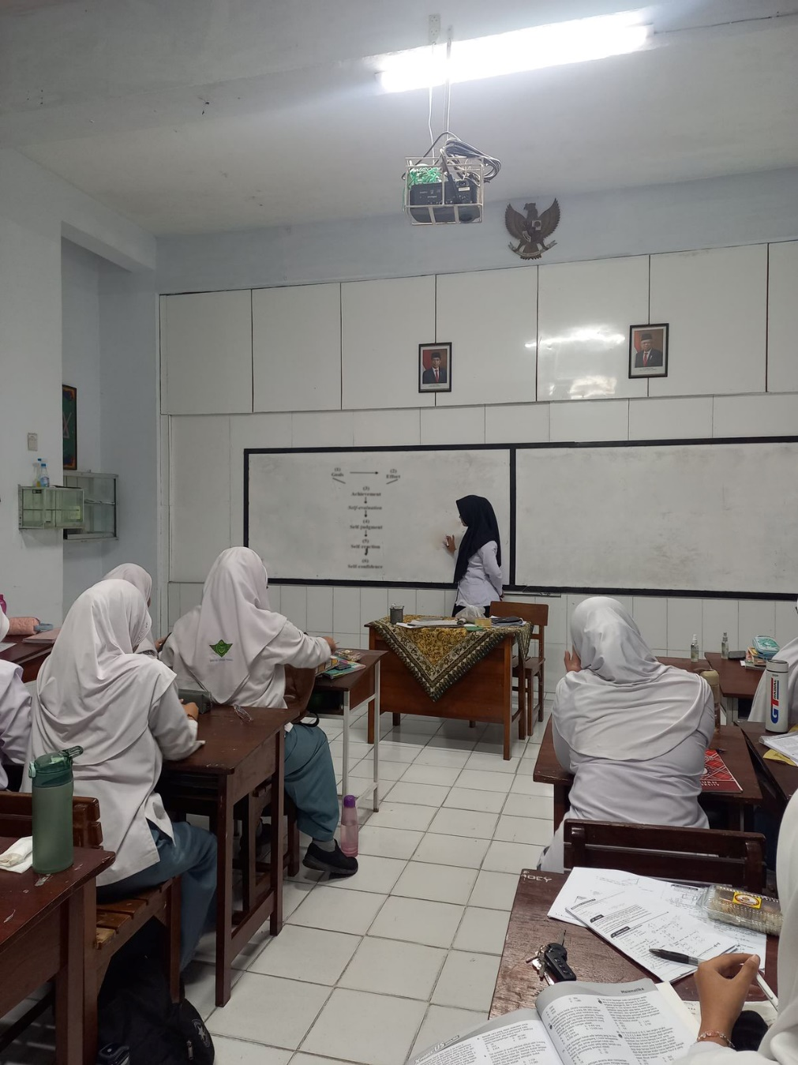

Image 4 – Student Learning Process

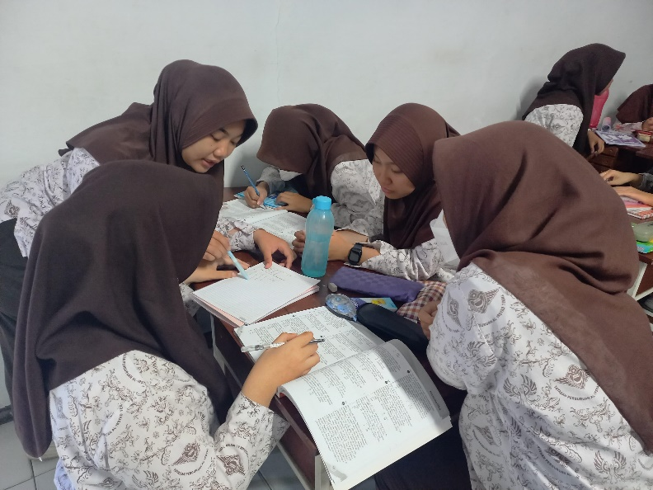

Image 5 – The Learning Process of Class A Students

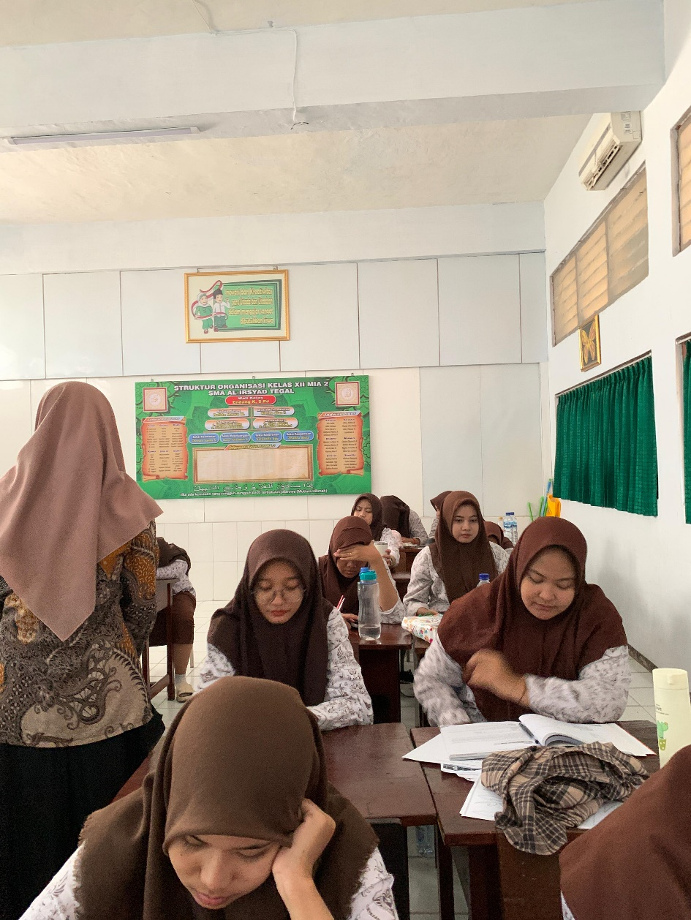

Image 6 – Class B Learning Process

