

ANALYSIS OF DEIXIS IN SELMA (2014) BY PAUL WEBB

**RESEARCH PROJECT**

**Submitted as Partial Fulfillment of the Requirements for**

**The Degree of *Sarjana Pendidikan* in English Education**

**By**

**RAMADHANI SYAZALI SIRA**

**NPM 1618500051**

**ENGLISH EDUCATION PROGRAM**

**TEACHER TRAINING AND EDUCATION FACULTY**

**PANCASAKTI UNIVERSITY TEGAL**

**2025**

# C:\Users\foto copy flores1\Pictures\img20250226_13030803.jpgAGREEMENT

This Research Project entitled “Analysis of Deixis In Selma Movie (2014) by Paul Webb” Has been agreed by advisors to be examined before the board of examiners,Teacher Training and Education Faculty, Universitas Pancasakti Tegal.

|  |  |
| --- | --- |
|  | Tegal, 24 Febuari 2025 |
| First Advisor | Second Advisor, |
|  |  |
| Dr. Yoga Prihatin, M.Pd | N.L. Molla, S.pd, M.Hum |
| NIDN 0603067403 | NIDN 06021161501 |

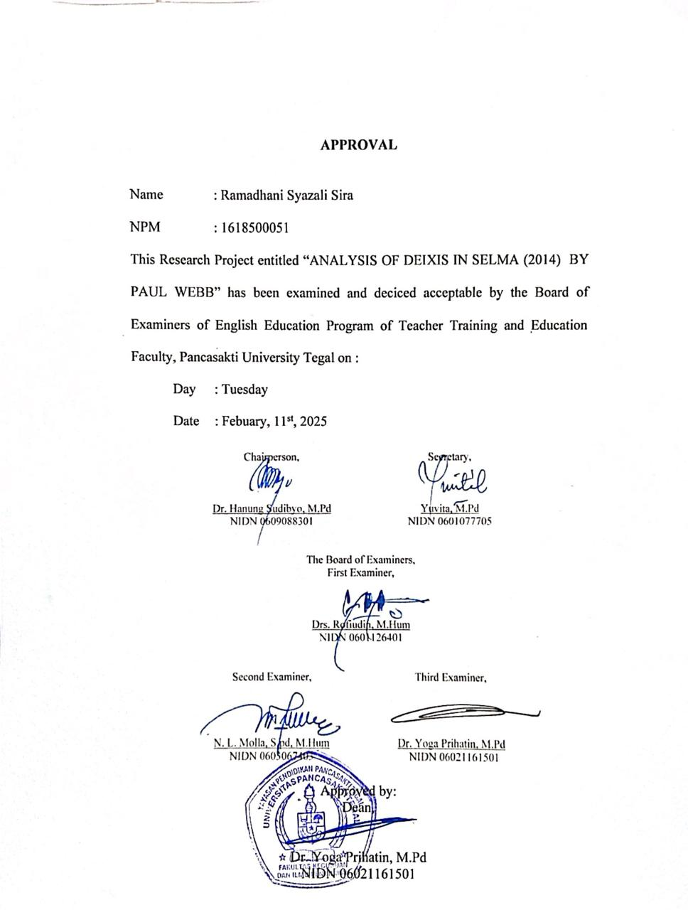

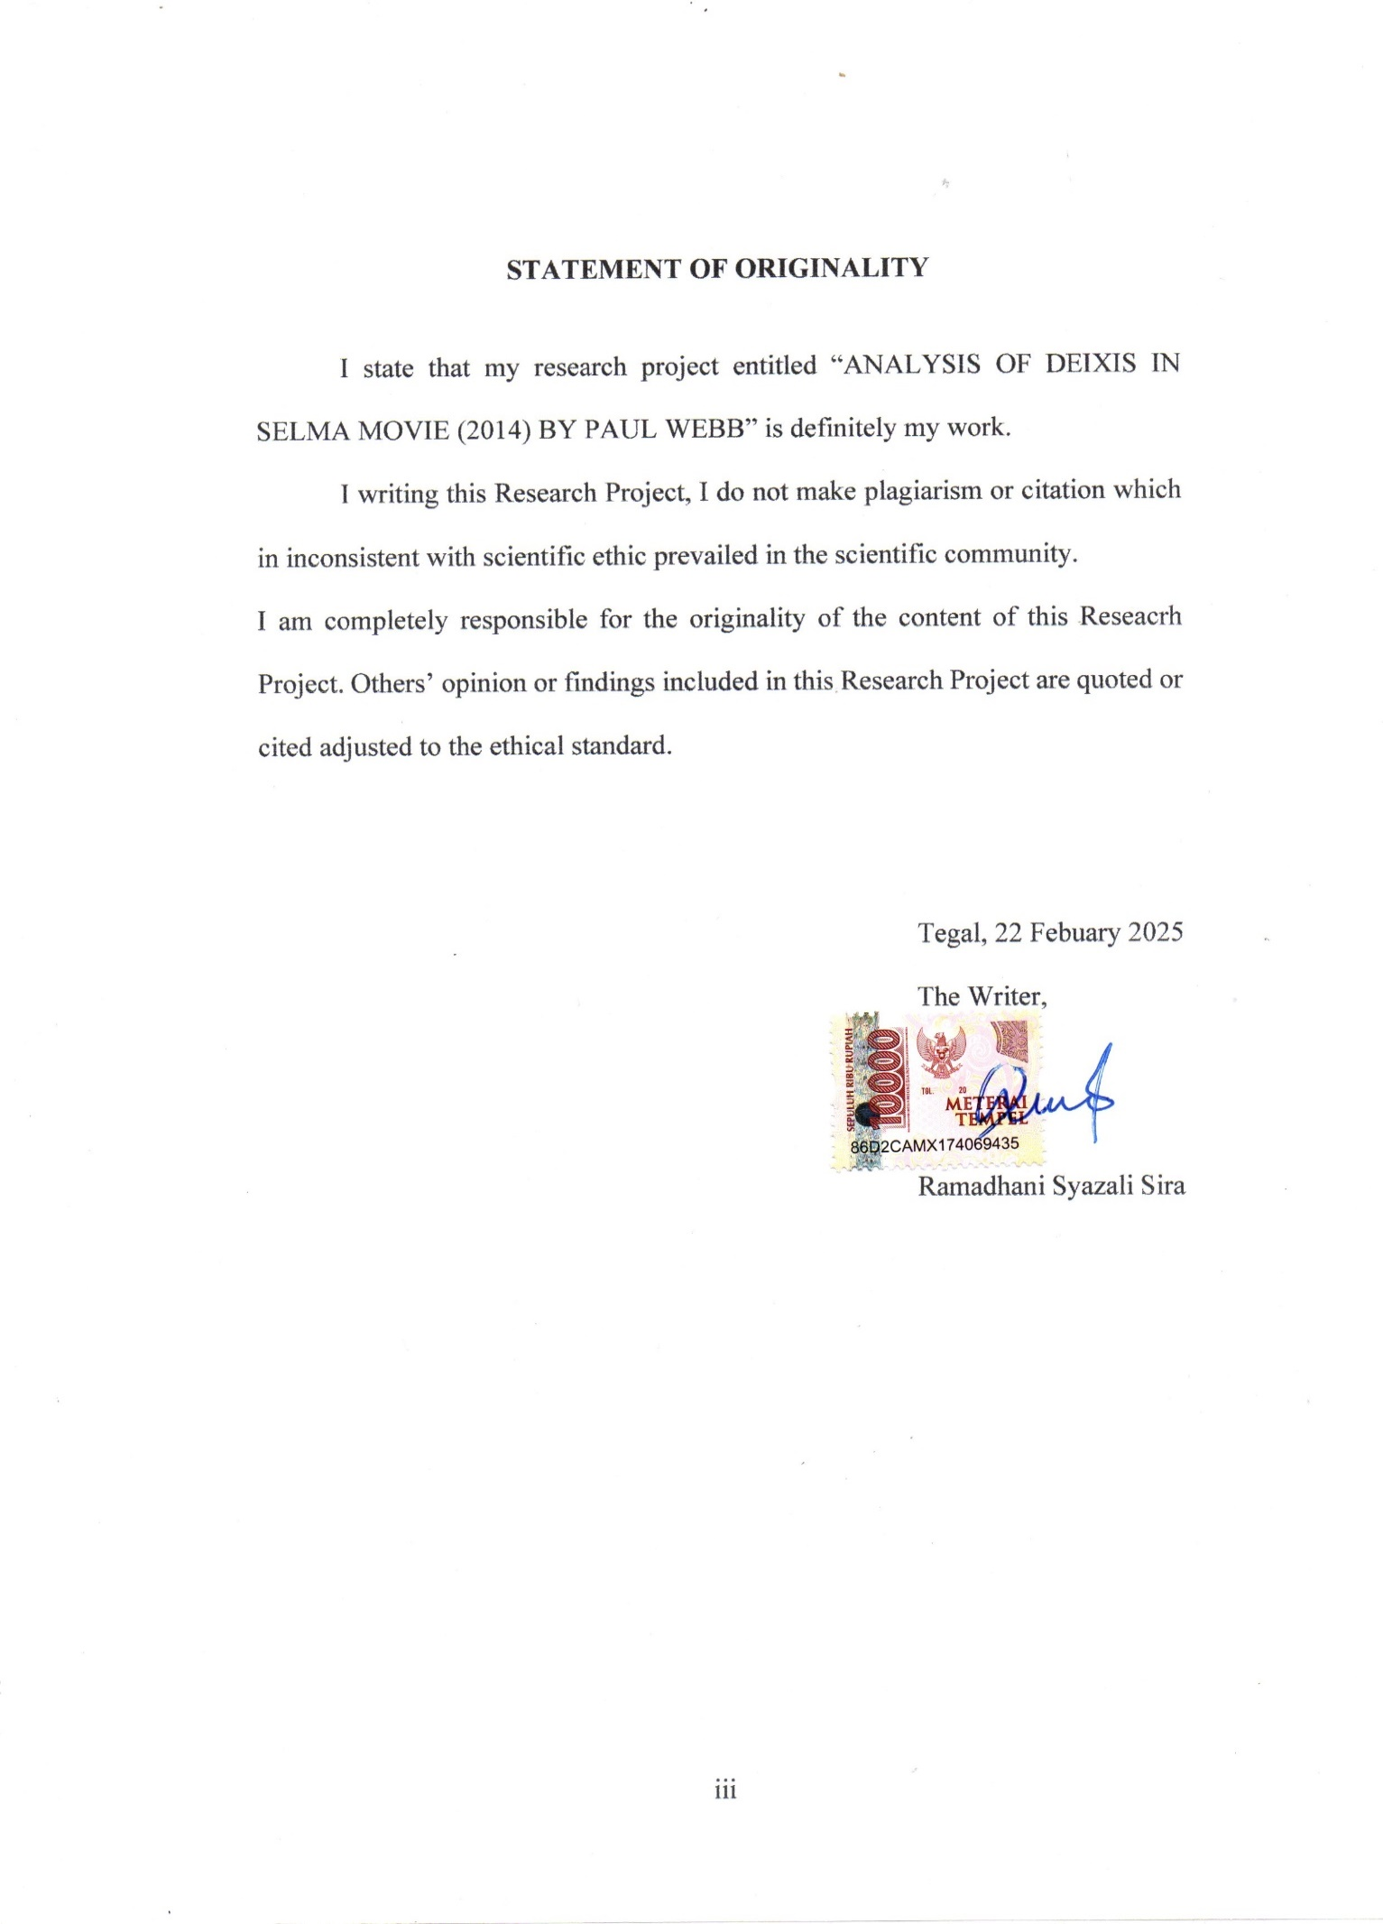

# MOTTO AND DEDICATION

**MOTTO :**

“Allah does not burden a soul beyond that it can bear.”

DEDICATION :

This Reseacrh Project dedicated to :

1. The love of my life, my parents, my sisters. Thank you for your encouragement in everything, endless patience, even though we are having a difficult time, but you all keep supporting me in many ways. Thank you my unexplainable love. Thousand of words can’t be describing how much I love you all.
2. Mrs. Drs. Yoga Prihatin, M.Pd and Mrs. N. L. Molla, S.Pd., M.Hum, as the first and second advisor, who provide invaluable guidance, encouragement, and expertise in completing this research.
3. All of the leaturers of English Education Departement, who always shared their knowledge and guidance throughout my learning process at university.
4. Endless thanks to my countless love, who always helping me to finish this Research. Her name is Virra Indah Sari.
5. All of my friends, anyone who support me from many circle. Thanks for cadre and elder from my organization Indonesian National Student Movement (GMNI). Especially for Thoriq Wahyu Saputra.

# PREFACE

Praise and gratitude to Allah SWT for His unlimited graces and guidance, which have enabled the researcher to complete this final project titled "Analysis of Deixis in Selma Movie (2014) by Paul Webb". The researcher understands that the completion of this study endeavor was made possible by the help and advice provided by various sources. Because of this, the researcher expresses heartfelt gratitude to:

1. Mr. Dr. Taufiqulloh, M.Hum., as the Rector of Pancasakti University Tegal
2. Mrs. Dr. Yoga Prihatin, M.Pd., as the Dean Teacher Training and Education Faculty of University Pancasakti Tegal.
3. Mrs. Yuvita, M.Pd., as the Head of English Department of Teacher Training and Education Faculty of Universitas Pancasakti Tegal.
4. Mrs. Dr. Yoga Prihatin, M.Pd., as my first advisor, thank you for your invaluable guidance and wisdom, encouragement, and exprertise in completing this research.
5. Mrs. N. L. Molla, S.Pd, M.Hum as my second advisor, thank you for your invaluable guidance, encouragement, and exprertise in completing this research.
6. All of the lectures of the English Education Department of Universitas Pancasakti Tegal.

# 

# ABSTRACT

Sira, Ramadhani Sira. 2025.1618500051: “*Analysis of Deixis in Selma (2014) By Paul Webb*”. Graduating paper. Strata I Program , Faculty of Teacher Training English Education, Pancasakti University Tegal, The First Advisor is Dr. Yoga Priyahatin, And the second advisor N.L. Molla, S.pd, M.Hum

Keywords: *Pragmatic, Deixis, Types of Deixis, Movie, Selma*

This research aims to know the deixis found in Selma movie, there is so much linguistic expression in this movie, but the research only focuses to find the dectic expression in the movie.

There are two objectives of the research: 1) To know what are the types of deixis found in the Selma movie 2) To know what is the Dominant Deixis Found in the Selma Movie.

The researcher used a descriptive qualitative method. The following steps, it applied was the first, the researcher look for the movie, the second, the researcher watched the movie, then, looked for the movie script of the movie Frozen II, the fourth, the researcher identified the sentence of the movie script based on five types of deixis.

The result of the research found 1608 deictic expression and person deixis is the dominant deictic expression in the movie. The number of person deixis 1197 deicis expression, 69 deictic expression of place deixis, 84 deictic expression of time deixis, 193 deictic expression of discourse deixis, and 67 deictic expression of social deixis.

The research identified the setences of the movie script based on five types of deixis. From the result, it is found that there are five types; personal deixis, spatial deixis, temporal deixis, social deixis, and discourse deixis and the most dominant deixis used in Selma Movie is personal deixis.

# ABSTRAK

Sira, Ramadhani Sira. 2025.1618500051: “*Analysis of Deixis in Selma (2014) By Paul Webb*”. Graduating paper. Strata I Program , Faculty of Teacher Training English Education, Pancasakti University Tegal, The First Advisor is Dr. Yoga Priyahatin, And the second advisor N.L. Molla, S.pd, M.Hum

Keywords: *Pragmatik, Deikis, Tipe Deikis, Film, Selma*

Penelitian ini bertujuan untuk mengetahui deiksis yang terdapat dalam film Selma, banyak sekali ekspresi linguistik yang terdapat dalam film ini, namun penelitian ini hanya fokus untuk menemukan ekspresi detik yang terdapat dalam film tersebut.

Tujuan penelitian ada dua: 1) Untuk mengetahui jenis-jenis deiksis apa saja yang terdapat dalam film Selma 2) Untuk mengetahui Deiksis Dominan apa saja yang terdapat dalam Film Selma.

Peneliti menggunakan metode deskriptif kualitatif. Langkah-langkah penerapannya adalah pertama, peneliti mencari filmnya, kedua, peneliti menonton filmnya, kemudian mencari naskah film dari film Frozen II, yang keempat, peneliti mengidentifikasi kalimat naskah film tersebut berdasarkan lima jenis deiksis.

Hasil penelitian menemukan 1608 ekspresi deiksis dan deiksis persona merupakan ekspresi deiksis yang dominan dalam film tersebut. Jumlah deiksis orang 1.197 deiksis ungkapan, 69 deiksis ungkapan deiksis tempat, 84 deiksis ungkapan deiksis waktu, 193 deiksis ungkapan deiksis wacana, dan 67 deiksis ungkapan deiksis sosial.

Penelitian ini mengidentifikasi latar belakang naskah film berdasarkan lima jenis deiksis. Dari hasil penelitian ditemukan lima jenis; deiksis personal, deiksis spasial, deiksis temporal, deiksis sosial, dan deiksis wacana dan deiksis yang paling dominan digunakan dalam Film Selma adalah deiksis personal.

# TABLE OF CONTENTS

[AGREEMENT i](#_Toc191260274)

[APPROVAL ii](#_Toc191260275)

[STATEMENT OF ORIGINALITY iii](#_Toc191260276)

[MOTTO AND DEDICATION iv](#_Toc191260277)

[PREFACE v](#_Toc191260278)

[ABSTRACT vi](#_Toc191260279)

[ABSTRAK vii](#_Toc191260280)

[TABLE OF CONTENTS vii](#_Toc191260281)

[CHAPTER I 1](#_Toc191260282)

[INTRODUCTION 1](#_Toc191260283)

[1.1 Background Of The Problems 1](#_Toc191260284)

[1.2 Statement of the Problems 5](#_Toc191260285)

[1.3 Conceptual/Operational Definitions 5](#_Toc191260286)

[1.4 Objectives of the Research 7](#_Toc191260287)

[1.5 Significances of the Research 7](#_Toc191260288)

[1.5.1 Theoretical Significances 7](#_Toc191260289)

[1.5.2 Practical Significances 7](#_Toc191260290)

[CHAPTER II 9](#_Toc191260291)

[REVIEW OF RELATED LITERATURE 9](#_Toc191260292)

[2.1 Review of the Previous Studies 9](#_Toc191260293)

[2.2 Review of Related Theories 12](#_Toc191260294)

[3. Movie 19](#_Toc191260295)

[CHAPTER III 20](#_Toc191260296)

[RESEARCH METHODOLOGY 20](#_Toc191260297)

[3.1 Approach and Design of the Research 20](#_Toc191260298)

[3.2 Subject of the Research 21](#_Toc191260299)

[3.3 Role of the Researcher 22](#_Toc191260300)

[3.4 Type of Data 22](#_Toc191260301)

[3.5 Data Collecting Technique 23](#_Toc191260302)

[3.6 Instrument of Research 25](#_Toc191260303)

[3.7 Procedures for Analyzing Data 25](#_Toc191260304)

[3.8 Technique of Repoting Data 26](#_Toc191260305)

[CHAPTER IV 28](#_Toc191260306)

[RESEARCH RESULT AND DISCUSSION 28](#_Toc191260307)

[A. Research Result 28](#_Toc191260308)

[B. Discussion 30](#_Toc191260309)

[CHAPTER V 46](#_Toc191260310)

[CONCLUSION AND SUGGESTION 46](#_Toc191260311)

[A. Conclusion 46](#_Toc191260312)

[B. Suggestion 47](#_Toc191260313)

[REFERENCE 49](#_Toc191260314)

# CHAPTER I

# INTRODUCTION

The background of the issue, problem formulation, conceptual/operational understanding, research objectives, and final research objectives are covered in this chapter. The subsequent sections provide detailed explanations of the topics mentioned.

## Background of the Problems

Language is a communication tool between people. The use of language is crucial as it enables the communication of human thoughts, ideas, and emotions through various means such as sounds, gestures, and the written word, serving a wide range of purposes. Language can be conveyed verbally, through hand-written forms, or written using human characters. According to (Saputri, 2016): “Pragmatism is the study of sensible aspects in the context of meaning that summarizes the order in the formation of a logical way”. This implies that pragmatism is a linguistic field that focuses on the practical application of language and its significance, particularly concerning expression and language through deixis, speech acts, meaning, reference, and their interpretation. Understanding deixis in practical terms is significant for analysis, as we have studied about it.

The speaker and listener can gain a clear understanding of language by thoroughly discussing the meaning of a word within the context of the situation, especially when the listener is familiar with the context. Studying deictic as a teaching aid can facilitate students' comprehension and analysis of films, as it focuses on understanding the meaning of words in a sentence.

In the literature, three types of deictic have been identified, which are personal deictic, spatial deictic, and temporal deictic. The first and second pronouns typically refer to the individuals involved in the spoken and heard language, while the third pronoun refers to the non-speaking or spoken individual. The active participants are the speaker and the addressee, while the third person is not an active participant in the Speech Act. The researcher's study will focus on the person deictic, place deictic, social deictic, discourse deictic, and time deictic as analyzed in the script of *Selma* (2014).

Movies are a form of visual communication that presents both video and audio, conveying cultural, moral, educational, lifestyle, political, and historical aspects. They have gained immense popularity worldwide, appealing to people of all ages. Movies serve as a means to both inform and entertain audiences. Families often come together to enjoy movies, spanning various genres such as action, romance, and comedy. It is important for parents to be mindful of the content their children are exposed to. Regardless of genre, movies always convey a moral message, which viewers can interpret for themselves. Furthermore, movies are generally easier to comprehend compared to novels or books due to their clarity and conciseness.

Implementing this study in schools can be highly beneficial, as teachers can utilize it for instructional purposes, and students will be captivated, particularly when using the popular film " *SELMA* (2014)." Which is a biographical movie, that tells the story of Martin Luther King Jr.'s campaign for voting rights in 1965.

A biographical movie, also known as a biopic, is a film that dramatizes the life of a real person or group of people. Biopics often focus on well-known historical figures, such as monarchs, political leaders, artists, athletes, or scientists. However, they can also be about ordinary people whose lives were interesting or dramatic in some way. Biographical movie also focus on one protagonist: A biopic focuses on one person and tells their life story over many years. Use the real name: The central character's real name is used in the film. And capturing significant events: Biopics capture the person's significant achievements, challenges, and personal aspects.

Biopics can be informative and entertaining, and can shed light on the complexities of real-life personalities. Some examples of biopics include *Selma* (2014), *Jeanne* *d'Arc*/*Joan* *of* *Arc* (1900), *Queen* *Elizabeth* (1912), *Danton* (1920), *Anne* *Boleyn* (1920), *Napoleon* (1927), and *The* *Private* *Life* *of* *Henry* *VIII* (1933). Exceptional biopics have earned accolades such as nominations and awards at film festivals and prestigious award shows.

*Selma* (2014) is a historical drama film directed by Ava DuVernay about the civil rights struggle, with its focus on 1965. *Selma* (2014) is a film about Martin Luther King Jr.'s battle for voting rights in 1965. The film delves into themes of racism, civil rights, riots and protests, friendship and family, and sacrifice. During his fight for voting rights, King meets with President Johnson multiple times (a startling but effective Tom Wilkinson). Their scenes, as well as Johnson's scenes with J. Edgar Hoover (Dylan Baker), revolve around the political maneuvering required to effect change. "*Selma*" draws attention to how easily the media can be used to manipulate the American public's hearts and minds. King is aware of this media power, and the way his crew responds to it foreshadows the social media antics of today.

The movie stars David Oyelowo as Martin Luther King Jr., Carmen Ejogo as Coretta Scott King, and Tom Wilkinson as President Lyndon Johnson. The movie follows the three months between Martin Luther King Jr.'s Nobel Peace Prize acceptance in 1964 and the *Selma* to Montgomery march in 1965. The march was a result of a chain of events that began when four Black girls were killed in a church bombing by the Ku Klux Klan. The march galvanized American public opinion and led to President Johnson signing the Voting Rights Act of 1965.

This is an emotional movie that aims to anger, sadden and inspire viewers, sometimes in the same scene. “*Selma*” takes no prisoners and, while it welcomes moviegoers of all hues, it has no intention of sugarcoating its horrors for politically correct comforting. This film—one of the year’s best—is an announcement of a major talent in Ms. DuVernay, but its core message will not be lost nor hidden by the accolades it receives. Through the noise, “*Selma*” speaks to us: From the top of the hill of progress, it is just as easy to slide down backwards as it is to move forward. Attention must be paid.

Through this study we can conclude that another literary work, such as movie could be analyze with deixis. This goals of this study is to discover the types and context of deixis that used by *Selma* film.

The academic motivation for analyzing deixis in this study is to increase the ability to show the complexity of language use, power relations, social identity, and narrative structure. In a historically and politically charged film like *Selma* (2014), deixis is an important instrument for communicating themes of solidarity, resistance, and struggle. By examining how deictic phrases function in the screenplay, academics can learn how language defines characters' identities, builds social interactions, and influences audience views, so giving useful insights to both linguistic and cinematic studies.

## Statement of the Problems

The researcher creates a formula to determine the issues based on the study's background, and it looks like this:

1. . What are the types of deixis in the *Selma* (2014) by Paul Webb.
2. .What is the major deixis found in the film *Selma* (2014) by Paul Webb.

## Conceptual/Operational Definitions

Conceptual definitions provide a broader and deeper understanding of a concept or term used in the research. In this section, the researcher provides a theoretical explanation based on related literature.

1. Deixis

Deixis is a phenomenon in linguistics that refers to the use of words or expressions whose meaning depends on the context in which they are used, including who is speaking, who is being spoken to, the time, place, or specific situation. Deixis includes several types, such as person deixis (deixis of persons), time deixis (deixis of time), place deixis (deixis of place), discourse deixis (deixis of discourse), and social deixis (deixis of social relationships).

1. *Selma* Film: *Selma* (2014)

is a historical drama film depicting an important event in the history of the United States, particularly the civil rights movement for Black voting rights led by Dr. Martin Luther King Jr. The film focuses on events that occurred in 1965, especially the protests and marches from *Selma* to Montgomery, Alabama.

1. Deixis in the *Selma* Film:

In the context of the film *Selma*, deixis refers to the use of words or expressions that depend on a specific context, such as who is speaking (person deixis), when the event occurs (time deixis), where the event takes place (place deixis), and how the social relationships between characters in the film are reflected through the language they use (social deixis). The researcher will identify and analyze instances of these deictic expressions in the dialogues and interactions between characters in the film

## Objectives of the Research

1. To provide information about the types of deixis that have been used in the *Selma* (2014) by Paul Webb.
2. To provide information about the dominant of deixis that have been used in the *Selma* (2014) by Paul Webb.

## Significances of the Research

It is expected that:

### **Theoretical Significances**

The researcher hopes that by conducting this study, people will be better able to comprehend and learn more about deixis. Learning deixis can help students become better writers. English language learners are encouraged by this study to comprehend the context of expression. Speech happens when the speaker and the listener are aware of the time and location. Those researching the topic should be able to access the information and references provided by the study's findings.

### **Practical Significances**

In practice, the researcher has divided the study's goal among the reader, researcher, teacher, and student. The following are the usefulness in practice:

1. For students

Students can use this research as a reference in their practice, particularly when identifying the types of deixis, grammar, and sexual expression. Students can also use it to communicate in their everyday activities or social lives.

1. For Teachers

This study may help teachers improve their students' reading abilities, particularly when employing the qualitative descriptive method. Additionally, teachers can use engaging films or videos as teaching tools to pique students' interest.

c). Researchers

Other researchers can use this research as a reference to enhance their own research and possibly improve their vocabulary in English. Other researchers could also comprehend a sentence in the context of deictic with ease thanks to this research.

d). Readers

This research may serve as a useful tool to help readers become more proficient readers of English. Reading this research could also helps the readers improve their vocabulary in English and their understanding of deictic expression.

# 

# CHAPTER II

# REVIEW OF RELATED LITERATURE

This chapter will explain about the review of preview studies and review of related theories. The reviews help this research could be done. Here are detailsand explanations of some the sections offended.

## Review of the Previous Studies

The research takes a review of previous research from outher journals and analysis research in other to gain reference. The journals below will explain previous research which has the same study with the research.

The study, according to (Ardeatika & Setiawan, 2019) researched with title “Deixis in the script of The Spiderwick Chronicles movie”, This study looked at the most frequently in the context of deixis and their usage in the Spider Week Chronicle setting.

A qualitative descriptive method was employed in this study. Studying the film was the first step, followed by watching it, finding the "Chronicles of the Week of the Spiders" script, and then reading the words "From the script." Four categories are identified by the analysis: discrursive, local, temporal, and individual deixis.

Andi Wiguna, Hera Anggraeni, Reyka Nurmalia, and Irma Savitri Sadikin (Institute of Teacher Training and Education Salatiga, 2018) conducted research under the title "Deixis in Maleficent Movie Script." In order to communicate with and collaborate with other organisms in our daily and social lives, researchers have determined that we require a language. This is due to the fact that daily activities and activities have some sort of direct or indirect interaction.

This study looks at place deixis, time deixis, discourse deixis, and individual deixis (first-, second-, and third-person deixis). The study also tried to look at the movie's script. Finding out the kind and frequency of deixis used in the screenplay of films with a male preponderance is the aim of this study. The source of this script is the Internet..

The researcher chose to use a qualitative approach in this investigation. The steps for data analysis are as follows: first, the study looks for movies; second, it examines the movies; third, it looks for the "Maleficient" movie script; and fourth, it follows the film script according to four clear instructions and finds syntax. The survey's findings indicate that individual deictic is effective. I, you, us, King Stephen, he, she, and us. According to the findings, the location, timing, and discourse deixis are dominated by the distinct deictic of the movie's script.

Kurnia Saputri (University of Muhammadiya, Palembang, 2016) researched the topic "Deixis in Black Swan Screenplays". The researcher has concluded that the goal of this study is to identify the type of deixis and ascertain its prevalence in the script of the film "Black Swan." This study only looked at the film's screenplay. Finding the deixis type and ruler used in the "Black Swan" movie script was the aim of this study. This film's script was obtained from the internet.

In this study, we employed a descriptive qualitative approach. The following actions are: The researcher first searched for a movie in this survey, then searched for a movie in this survey, and finally searched for a Black Swan movie script. Fourth, based on four different types of deixis, the survey found ideas for movie scripts. The researcher discovered four types as a result of the analysis. In Black Swan writing, personal deixis, spatial deixis, temporal deixis, and audio deixis are the most frequently utilized deixis.

Eliza Fadlilah and Rika Septiani (Siliwangi Teacher Training and Education Institute, 2018) researched the topic "Deixis Analysis Using Beauty and Beast Scenarios". The goal of research is to identify the frequency of each deixis and analyze its various types. Beauty and the Beast is a film. This is what the researcher has concluded to be true.

This survey was conducted in a descriptive qualitative format. The source for the Beauty and the Beast date was taken from a screenplay. Data is collected using documentary technology. Consequently, the Beauty and the Beast movie script contains three different kinds of deixis, with a frequency of nine deixis. In other words, the movie's researcher discovered that some people experienced deixis more frequently than others..

The previous journal and analysis research conducted research on the same subject and used the same method as this research, which is qualitative descriptive. The aforementioned journals and analysis research carried out research on a different object, which is Paul Webb 's *Selma*. Because they share issues and objectives of educating readers about the types of deixis and dominant deictic found in *Selma* by Paul Webb, the two studies are related to this one. As a result, the researcher will make use of the aforementioned references whenever feasible.

## Review of Related Theories

it is essential to ground the study in relevant linguistic theories. These theories help explain how deixis operates within the context of the film and how it is used to shape social, political, and emotional meanings. Below is a review of the key theories related to deixis that are relevant to the analysis of Selma. Here are details about related theories that have been used in this research :

1. Pragmatics

The goal of pragmatics linguistics, and general pragmatism is linguistic pragmatism, which focuses in examples on language and language use while investigating practical mechanisms and universal principles in terms of action theory, rationality, and intentionality.. As the journal of (Saputri, 2016) writes, “Language pragmatism is defined as the science of using language, and just as human behavior changes existing reality, linguistic behavior changes the word”. Verbal theory is a way of communicating. Is a method of communicating with other social beings using text or text. Language is a component of literature and includes semantics, pragmatics, prepositions, speech acts, deixis, and so on. (Wiguna et al., 2018) states, “ Pragmatics is a systematic study of meaning in or dependin on the use of language. The core research topics of pragmatics are implications, assumptions, speech acts, and direct indication.”

The relation between languages and contexts that may be learned by the reader or listener through grammatical or structural encryption is known as pragmatics. According to (Fadlilah & Septyani, 2018), “contextual meaning study is informed by the speaker or writer and accepted by the listener or reader.”

Pragmatics is meta-psychology in practice. Which the listener evaluates and interprets the statement's supporting evidence. According to (Sperber & Wilson, 2002), “practical interpretation is ultimately an exercise in psychology, in which the listener derives the meaning that the speaker intended from the evidence provided for the purpose”.

Pragmatics is a study that examines the meaning of language used in conversation. According to (Grundy, 2013), “If reality is the study of the use of language, the semantics is the study of the meaning of the sentence. Practicality is the study of the meaning of the speaker, that is, the meaning resulting from our use of language”.

1. Deixis

Deixis can be defined as a conversation between two or more persons at the same time and in the same location. As written in the journal (Wiguna et al., 2018), argue that “Deixis is conceived in terms of the ideal cognitive model, and deixis creates a mental space in which the speaker and receiver coexist at a certain moment, deixis by energy by energy”.

Erving Goffman's concept of "face" is another key theory in the study of deixis, particularly social deixis. Goffman points out that interactions are dictated by the desire to preserve one's social identity or "face" in front of others. This theory emphasizes that individuals perform their social roles in interactions, frequently using deixis to assert or protect their faces.

Deixis is the spance and identity of individuals, objects, events, processes, and activities that are stated or referred as the speaker utters or the listener hears them. (Dwipayani et al., 2020) “The idea of deixis is the ideal cognitive model, and critical expression creates a mental space in which the speaker and the addressee are together at certain times, including the mental space caused by mental expression when the speaker and listener are in the same place and time, alike”.

1. Person deixis

“Induvidual or personal deixis is concerned with coding of the role participants in the speech event, in which the words in question are spoken”, stated by (Ardeatika & Setiawan, 2019). In other words, some speakers and listeners occur in one room where the audience asks a question during the question and answer session. According to (Saputri, 2016), “The grammatical category of a person directly reflects the varios roles than a individual plays in a linguistic event, such as the speaker and the receiver”.

“Personal deixis is the speakers, it is called the first person, the second person. The recipient is called, and the other important participant in the state of speech, the third person, the speaker of listener, is not mentioned”, stated by (Sinambela et al., 2015). From the explanation above, there will be described below types of person deixis.

1. First person deixis

“In the first person, deixis is contemptible, so the speaker is accompanied by both the speaker and the reference group”, stated by (Sinambela et al., 2015)

For example:

*Potty : “Oh, I threw out that old Betamax machine”*

1. Second person deixis

“The other person in respectful to one or more people (you, your, yours, yourselves) who are identified as recipients of the deixis”, stated by(Wiguna et al., 2018). This means that the first person in a conversation with the second person will frequently use you, yours, and yourselves.

For example:

*Patchy : "You what?!”*

1. third person deixis

“The third person deixis is displaying for a different person that is not recognized as the speaker or the addressee”, stated by (Wiguna et al., 2018). Third-person deictic refers to the person or targets being addressed. Here, the first, second, and third person categories represent the fundamental grammatical differences. The addressee (he/his, she/her, and they/them) was identified by the third person, deixis. Below are more thorough examples:

*Mr. King : “Because they’re protected by white officials*.

1. Spatial deixis

“The aforementioned concept of distance is related to spatial deixis, where the relative position of people and objects is indicated”, stated by (Saputri, 2016). This contept is also called spatial deixis. “Place deixis is also described as Spatial Deixis, which indicates the relative position of people and things. This is generally expressed in: this, these, those, there and here”, (Fadlilah & Septyani, 2018). A relative link examines people and places based on their relationship to the speaker, whereas an absolute link locates an object or person on a specific line of longitude and latitude.

For example:

*Johnson : “I’m lost here.”*

e. Temporal deixis

Temporary deixis, also known as time deixis, refers to both the speaker's words and the listener's "now," or the moment they hear the sound. In English, tense is one of the most significant verb tenses. There are only two primary forms of the verb in English, whereas there are numerous variations in many other languages in various positions. Tensions from the past and present. “The present tension is of the near and the past is of the distant. A form tempory deixis such as now, then, tomorrow, today, tonight, in the coming weeks, in the last weeks and this week” according to Saputri, 2016.

For example:

*Johnson : “Just for a while.”*

*Mr. King : “I understand, Mr. President”*

f. Discourse deixis

Discourse deixis refers to expressions that indicate references not explicitly presented in the text. Instead, these references are linked to the current, prior, or forthcoming parts of the speech. For example, pronunciation plays a role in this, as illustrated by our earlier example of discourse deixis. (Accius, 2017) explains that discourse deixis involves using expressions that point to specific segments of the speech or text. Common examples of discourse deictic expressions include words like "that," "this," "but," "therefore," "in conclusion," "on the contrary," "still," "however," "really," "in all," "then," and others..

According to Accius Theory (2017) discourse deixis enables an utterance to reference specific points in speech, both in relation to the speaker and the context. Researchers have identified certain expressions used by the characters in the movie Selma that act as deictic references. These expressions appear distant from the speaker's location and the audience's proximity. After analyzing 193 data points, the researchers categorized them into nine different types of discourse deixis. In practice, however, everything functions well in the context of the speech. Let's review the data presented below.

*Lewis :"You’re far out, man. You’re off base with “This” "*

*Forman :" No, “This” nonsense ain’t what SNCC is about”*

g. Social deixis

Social deixis is connected to various social perceptions, such as social status and familial roles. There are two main categories of social deixis: relative social deixis and absolute social deixis. For example, the term "grandfather" is a type of relative social deixis, which reflects the speaker’s family relationships. The film successfully both entertains and informs its audience. From the 67 social deictic expressions found in the movie, the researcher identified 10 distinct types of social deixis, including ”President,” “Pastor,” "friend," “Husband,” “Wife.” "Grandfather," "father," "mother," “Grandmother "brother," “ Sister,” “ and "daughter," “Son,” The detailed data and analysis can be found in the section below.

*Lewis :"And if the people want to march, I’m marching with ‘em"*

*Forman : "Then “Brother”, you’re marching as John Lewis "* .

## Movie

Movies are one form of media that can be used to gather information while also entertaining viewers. Movies can also be used as a learning tool. According to Merriam-Webster, a film tells a story and is a recoding of videos that people watch on screen or on television. This indicates that the film is a moving image or the material used to record the film. In other cases, the film is primarily used in oral language, but it is more technical and suitable for all contexts. So it makes no difference whether it is an animation or a photograph. Film is a term used to describe photos that keep moving. Synonyms for "movie" include film, flick, flicker, motion picture, moving picture, and picture.

# CHAPTER III

# RESEARCH METHODOLOGY

The section will explain the approach and design of the research subject, the researcher's role, the type of data, the data collection technique, the research instrument, the data analysis procedures, and the technique for reporting data.

More details will be explained below.

## Approach and Design of the Research

Rather than concentrating on the big picture, qualitative researchers attempt to comprehend an event by dissecting it into its component variables. In-depth comprehension and a complete picture are more important than digital data analysis. This study employed a descriptive qualitative methodology. This indicates that the information is presented using words, sentences, and tables, and that its meaning is deduced through semantic interpretation. This study will be thoroughly examined from both the inside and the outside. According to Magister, M. W., Pendidikan, A., Kristen, U., & Wacana, S. (n.d.) .(2023) “Qualitative research is also defined as a strategy for searching for meaning, meaning, concept, characteristics, symptoms, symbols and descriptions of something phenomena, focused and multimethod, natural and holistic, prioritizing quality,

using several methods, and presented narratively in scientific research”

## Subject of the Research

In this research, the researchers trying to analyze the deictic of Paul Webb’s film “*Selma* (2014)”. Paul Webb is a British screenwriter and playwright. He is known for writing the screenplay for the 2014 film *Selma*. for which he won the Central Ohio Film Critics Association Award for Best Original Screenplay. He also wrote for the 2017 BET miniseries Madiba. The duration of the film is about half an hour. The data in this study is a conversation line, consisting of three types of deixis: person, place, and time.

The data source are the source from which the data is obtaine. The researcher employs secondary sources. It means that the data references will be the transcript of the movie, which is taking from the internet.

(<https://assets.scriptslug.com/live/pdf/scripts/selma-2014.pdf>)

## Role of the Researcher

“The significant role of the researcher in the qualitativeresearch process seems to unify the barriers the archive will meet”. (Fink, 2015)

The data for this research is accumulated which use dialogue from Paul Webb's film script *Selma* (2014). The researcher collects data by taking on the role of a viewer, as follows:

1. The researcher is searching for the movie
2. The researcher observes the movie
3. The researcher observes the movie script of the movie “*Selma* (2014)” by Paul Webb.
4. The researcher identifies the sentence of movie script based on five types of deixis which are person deictic, place deictic, discourse deictic, social deictic, and time deictic.

## Type of Data

“The embodied information in terms of figures or facts used to analyze for different calculations and finally gain a result to address the study question or hypothesis testing is known as data” (Hurrell, 2005)

The term document refers to a wide range of written, physical, and visual materials that other authors can use. It can take many forms, such as numbers, text, images, or even sounds, and is typically used to inform decision-making, research, and problem-solving in various fields. This also can be a personal document like a biography, diary, or letter. Official files, reports, memoranda, minutes, and other popular culture documents, such as books, movies, and videos. Document analysis based on written or textual samples (textbooks, novels, journals, appointment minutes, logs, announcements, policy statements, newspapers, tapes, birth certificates, marriage records, budgets, letters, e-mail messages) or non-text can be written— Written recordings include images, audio tapes, videotapes, computer images, websites, music performances, television political speeches, YouTube videos, and virtual world settings. This survey collects data from movies and websites.

## Data Collecting Technique

The researcher uses a qualitative method in this study, because the goal is to understand the different types of deixis in the film. In addition, researchers use a hands-on approach to data analysis. The researcher also mentions actual stats, focusing on the direct types. Qualitative research reports, typically rich with detail and insights into participants’ experiences of the world, “can be epistemologically in harmony with the reader’s experience ”MC Hoepfl, 2017.

To make sure the quality the of each deixis, the researcher also presents a simple qualitative method. To review the data, the the researcher will follow this approach. This research was conducted with using the library study method (library research), which focuses on exploration and analysis of the literature relevant. Special characteristics that become the basis for development research knowledge involves the following aspects: this research directly related to the data or documented text, does not involve data collection field or directly from witnesses eyes related to an event. Data used in this research obtained from sources secondary, such as books, articles, or previous research”. (Kholidah, Hidayat, Jamaludin, Leksono & ISSN, 2023)

Data for the deixis analysis will be collected through the film’s transcript and by watching the film itself. The researcher will mark and analyze the use of deixis in the context of conversations and the film's narrative, focusing on linguistic elements that indicate the relationships between characters, time, and place.

1. The researcher organizes the data and collects all the data in the film which contains the deixis
2. Classify the data into categories five
3. Analyze data consisting of five types of deixis: person deictic, time dectic, discourse deictic, place deictic, and social deictic
4. The researcher presents the research result in each category
5. Summarize data

## Instrument of Research

In qualitative research, the research instrument is the researcher themselves. In this case, humans as researchers act as the very instrument to collect the data needed in the research. [1](Asiva Noor Rachmayani, 2015).

The study data is analyzed in he steps below in accordance with the research question. The researcher examines the film with subtitles first, and then within the interaction analysis.

The film itself is the primary source of data. Analyzing specific scenes in *Selma* will provide the context in which deixis is used by the characters. The researcher will need to watch the film carefully, paying attention to dialogues, body language, and the setting in order to identify key deictic expressions in context. And also the transcript (or screenplay) of *Selma* (2014) would be an important instrument for extracting precise dialogue.

## Procedures for Analyzing Data

The procedure is one of the important things in this analysis; Procedures demonstrate how the researcher does the analysis. There few steps that the researcher takes. First, the researcher investigates and learns the film. Second, researchers watch a film. Third, researchers are looking for a screenplay for the Paul Webb film *Selma* (2014).

“The part of the qualitative data material which has a physical existence, e.g.recordings, transcripts and notes, is data as words/conversation—a kind of data that intuitively is regarded as much more complex to analyse than numerical data” (Fink, 2015)

The final step for the researcher is to identify the text of a five-deictic in the film script. Once deictic expressions are identified, the next step is to provide contextual analysis. This involves examining how these expressions are used in the film, who the speakers are, their relationships, and the social, political, and emotional contexts surrounding the speech.

## Technique of Repoting Data

There are four methods for validating data in qualitative research: visualization, transfer, reliability, and reliability. Reliability has been employed by researchers in their data reviews. To convince trust that they have correctly documented the incident in the review, the researcher has implemented some of the following precautions:

1. Long-term engagement. Researchers have agreed to improve the research by rereading the data. This data is acquired from the dialogue in Paul Webb's film script *Selma* (2014). When examining data, the researcher spends extra time reading to make sure its validity. Triangulation can be classified into four types: data, enumerators, theoretical, and methodological triangles. The researcher used a theorerical triangle, which indicated the employment of more than one theoretical framework to analyze the data.
2. Triangulation contains four sorts of triangles: data, invesigators, and theorical triangle, It suggests the use of different theoretical frameworks for data interpretation.
3. Peer debriefing. The researcher discuss the research, open and welcomed new chances. This technique is meant to help to researchers improve their methodology, develop a better knowledge of research design, and strengthen their discussions in response to comments. Conversation with Professionals Using this method, specialists and their advisors were able to comprehend the ideas that the researchers had developed. The conversation gave experts a dashboard to develop their concepts and perspectives.