REFERENCES
Abarca, R. M. (2021). 済無No Title No Title No Title. Nuevos Sistemas de Comunicación e Información, 2013–2015.
Aji, M. P. P. (2017). English Listening Blended Learning: the Implementation of Blended Learning in Teaching Listening To University Students. Kajian Linguistik Dan Sastra, 2(1), 25. https://doi.org/10.23917/kls.v2i1.5349
Aryana, S., & Apsari, Y. (2018). Analysing Teacher’S Difficulties in Teaching Listening. ELTIN JOURNAL, Journal of English Language Teaching in Indonesia, 6(2), 100. https://doi.org/10.22460/eltin.v6i2.p100-106
Devi Krishnan, P., & Md Yunus, M. (2018). 207 Series 1 Innovation for Sustainable Growth Chapter 54 Animated Cartoons to Develop Listening Skills & Vocabulary. 207–209.
Ghonivita, Y., Pahamzah, J., & Ayu Wijayanti, M. (2021). Improving Students’ Listening Skills and Vocabulary Mastery through Contextual Teaching and Learning by Using Online Learning. Journal of English Language Teaching and Cultural Studies, 4(1), 10–21. https://doi.org/10.48181/jelts.v4i1.10557
Hakim, M. A. L. (2015). Peran Persepsi Manajemen Perusahaan Terhadap Self Efficacy Karyawan Pt. Cendana Teknika Utama. Nhk技研, 151(X), 10–17.
Hidayati, L. N. (2019). Flipped learning to develop students ’ listening performance at the secondary level. Proceeding of 1st Conference of English Language and Literature (CELL), 1–15.
Hwaider, S. M. (2017). Problems of Teaching the Listening Skill to Yemeni EFL Learners. International Journal of Scientific and Research Publications, 7(6), 140.
Kamalitdinovna, D. N. (2021). Teaching Listening Skills With Online Digital Tools. Mental Enlightment Scientific_Methodological Journal, 1(4), 30–39.

Kariuki, P., & Taylor, J. (2018). The Effects of Pictionary and Traditional Vocabulary Strategies on Student Performance in a 9th Grade ELA Classroom. Online Submission.
Kırbas, A. (2018). The effect of interactive whiteboard applications supported by visual materials on middle school students’ listening comprehension and persistence of learning. Universal Journal of Educational Research, 6(11), 2552–2561. https://doi.org/10.13189/ujer.2018.061120
Longva, K. K., & Foss, L. (2018). Measuring impact through experimental design in entrepreneurship education: A literature review and research agenda. Industry and Higher Education, 32(6), 358–374. https://doi.org/10.1177/0950422218804912
Rahma, D.U, D. (2020). The Practicality Of Interactive CD-Based Audiovisual Media To Improve Listening Skill. Journal Of Teaching And Learning, 5(2), 103–117. https://doi.org/10.22216/jcc.2020.v5i2.5358
Rahman, M. S. (2016). The Advantages and Disadvantages of Using Qualitative and Quantitative Approaches and Methods in Language “Testing and Assessment” Research: A Literature Review. Journal of Education and Learning, 6(1), 102. https://doi.org/10.5539/jel.v6n1p102
Rara Saraswaty, D. (2018). Learners’ Difficulties & Strategies in Listening Comprehension. English Community Journal, 2(1), 139–152.
Ratminingsih, N. M. (2011). Boosting elementary school students’ listening skill through specially created songs. Lingua Scientia, 18(1), 1–21.
Sinaga, J. B. (2020). the Effect of Watching English Movie To Improve Students’ Listening Skill. ANGLO-SAXON: Jurnal Ilmiah Program Studi Pendidikan Bahasa Inggris, 11(1), 110. https://doi.org/10.33373/as.v11i1.2449
Syafii, M. L., Kusnawan, W., & Syukroni, A. (2020). Enhancing Listening Skills Using Games. International Journal on Studies in Education, 2(2), 78–107.
https://doi.org/10.46328/ijonse.21
Zarei, A. A. (2019). Cite this paper Related papers Learners’ List ening Comprehension Difficult ies in English Language Learning: A Lit erat ure Revi… RANIE JAEN A Qualit at ive St udy of t he Impact of Cognit ive and Met acognit ive St rat egies on EFL Learners’ List enin…. International Journal of Trend in Scientific Research and Development-IJTSRD International Journal of Trend in Scientific Research and Development, 3(6), 883–887.

APPENDICES
Appendix 1.Lesson Plan

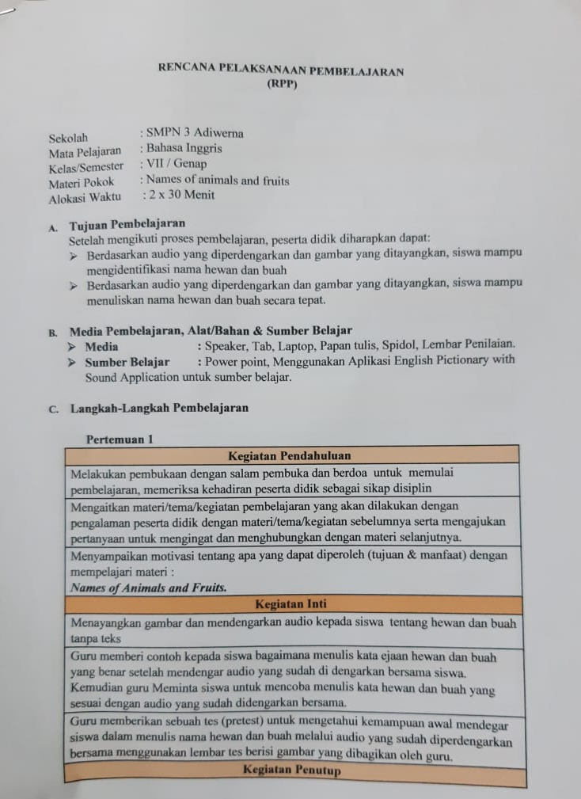

.
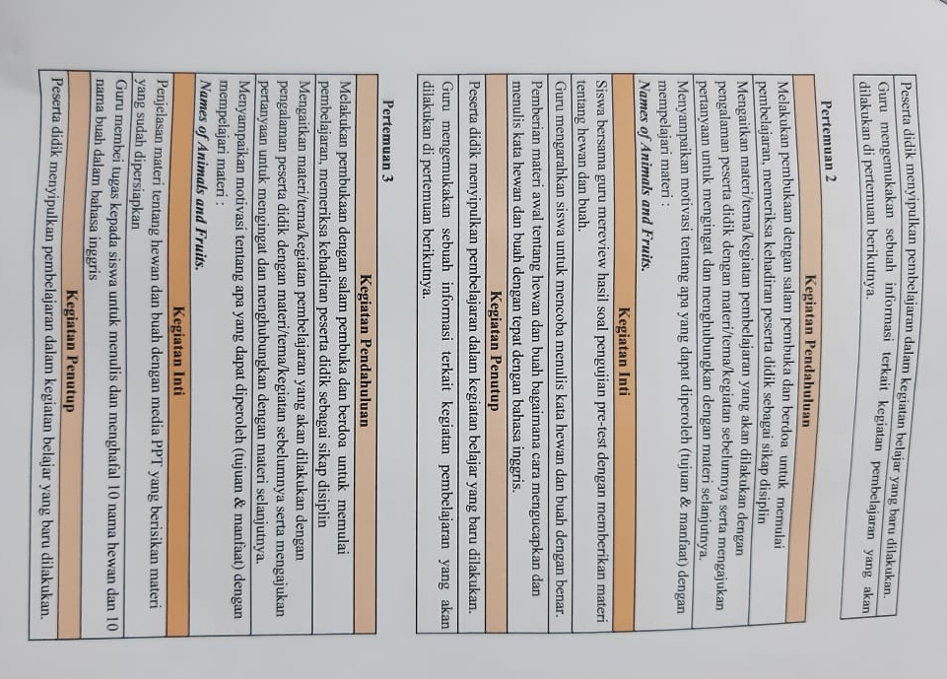

.
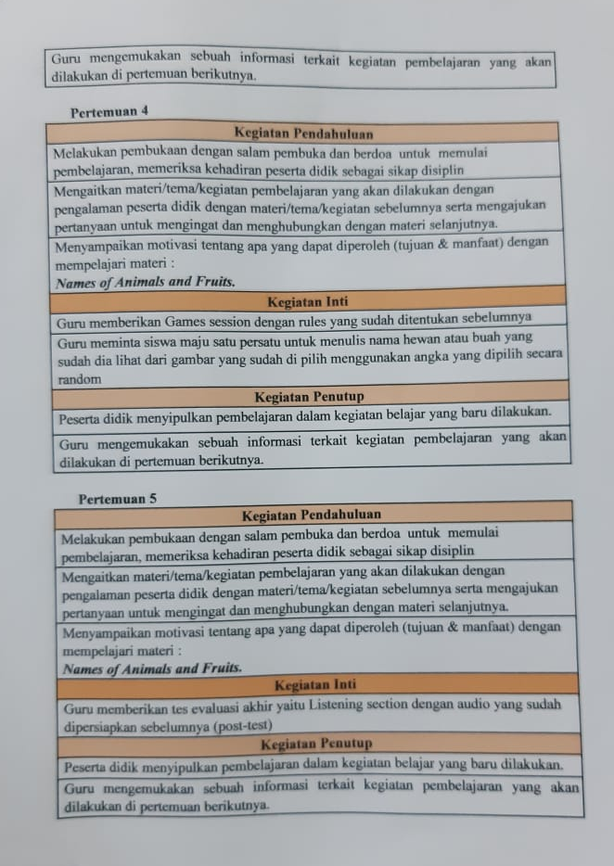

.
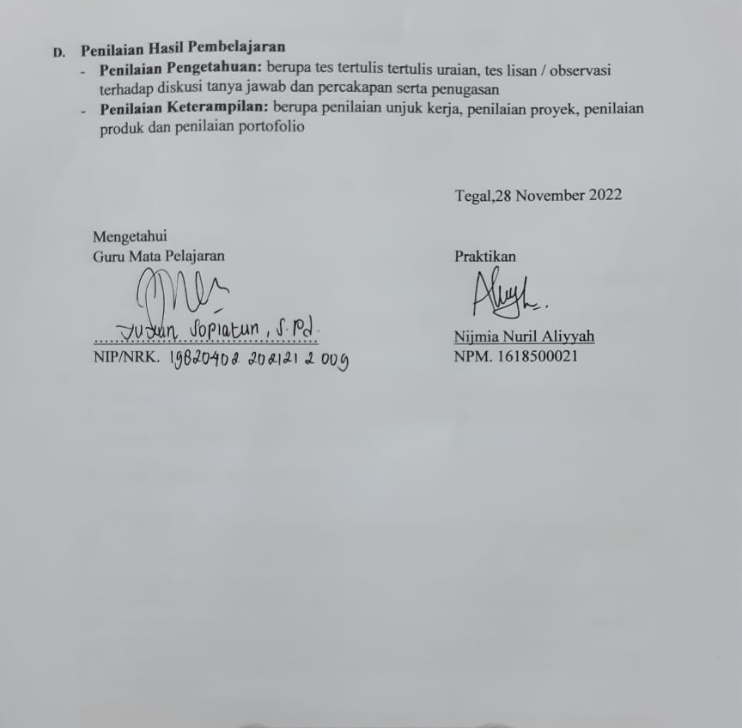

Appendix 2. Instrument Listening Test

PRE-TEST
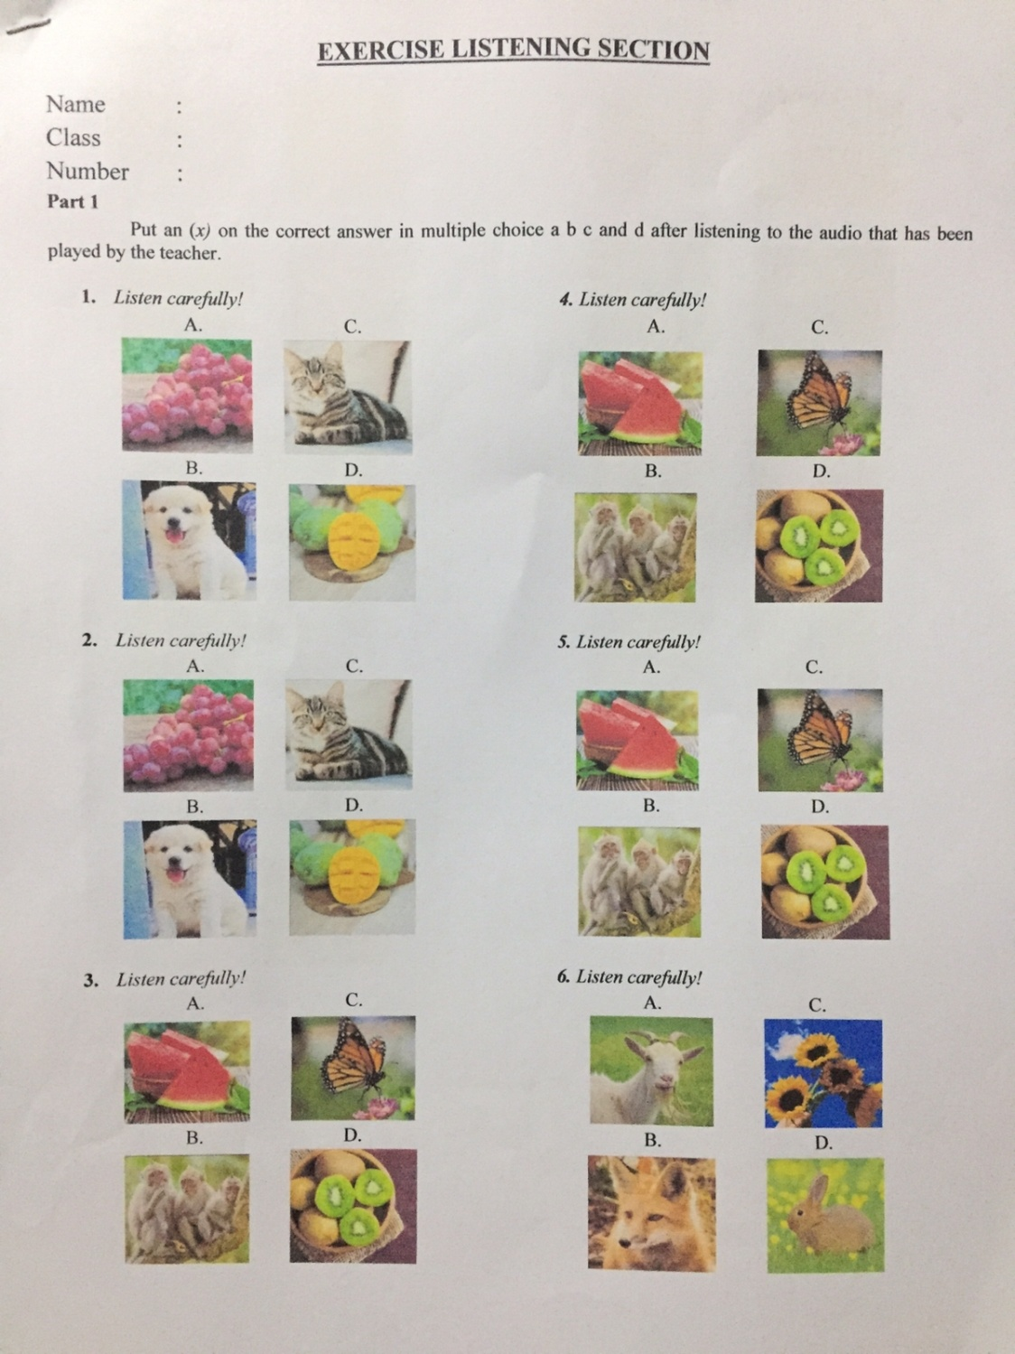

.
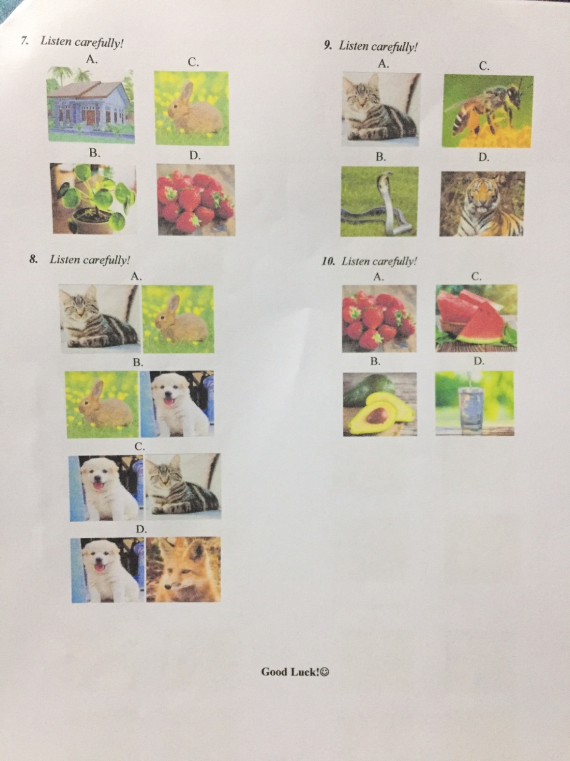
POST-TEST
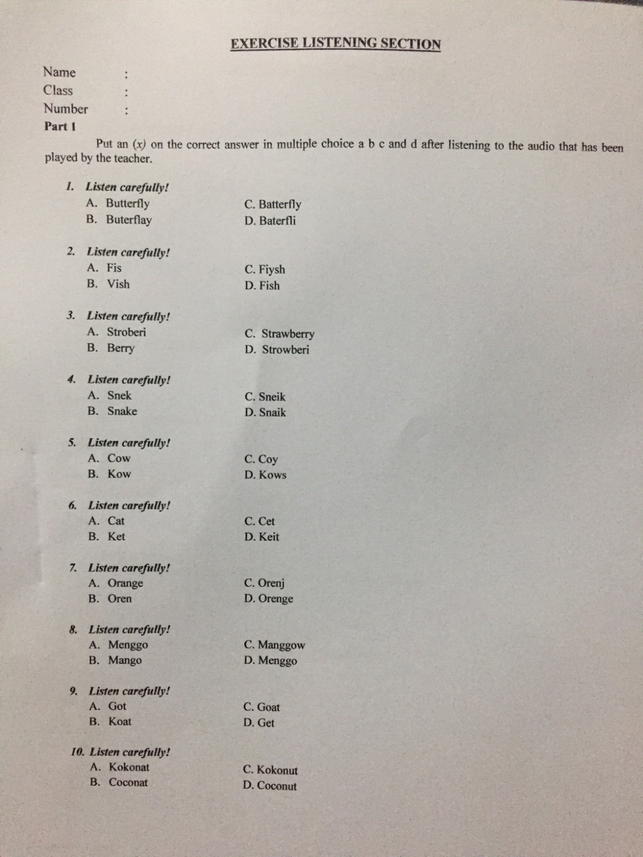

Appendix 3.Key Answer
KEY ANSWER PRE-TEST
- Listen carefully!
Jane : hi bim, where are you going?
Bim : hi jane, I want to go to the petshop.
Jane : petshop? What for?
Bim : my sister wants to buy a cat.
Jane : really? Ok take care bim.
Bim : ok jane, bye
Jane : bye
A. C.
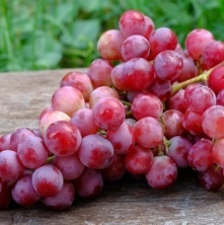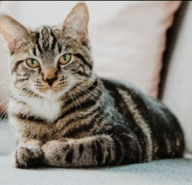
B. D.
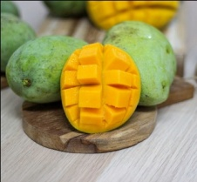

- Listen carefully!
Wil : hi han, do you like some fruits?
Hani : hi wil, not really why?
Wil : its’s oke han
Hani : why?
Wil : I have some mango for you, do you like it?
Hani : ah really? I like it, thank you wil
Wil : you’re welcome han
A. C.
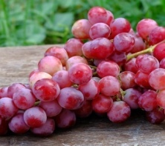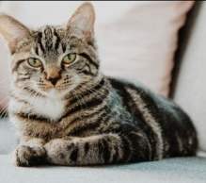
B. D.
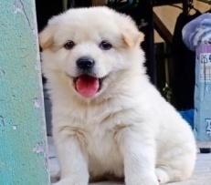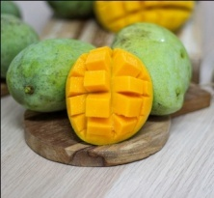

- Listen carefully!
Bani : did you see it?
Jovan : what’s that?
Bani : that’s beautiful butterfly
Jovan : lemme see
Bani : look at this
Jovan : omg beautiful
A. C.
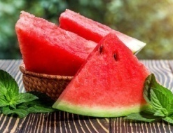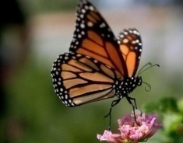
B. D.
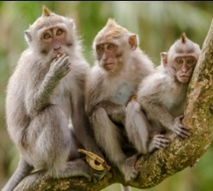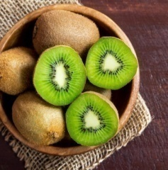

- Listen carefully!
Joerel : what’s your favorite fruits?
Carol : emm, my favorite fruits is watermelon
Joerel : waw same with me this fruit so sweet right?
Carol : that’s right.
- C.
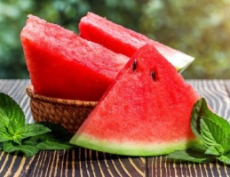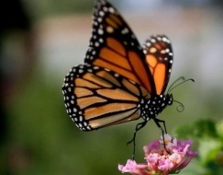
B. D.
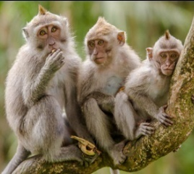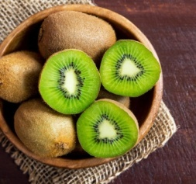

- Listen carefully!
Cate : I just finished eating salad
Din : what salad?
Cate : fruit salad, it tastes really good but something is bothering me. A monkey suddenly came to me and made me fall

Din : Really? Then how did you get hurt?
Cate : only my knee hurts
- C.
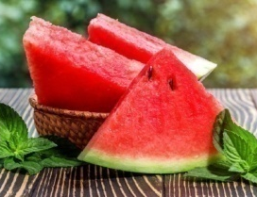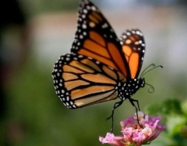
B. D.
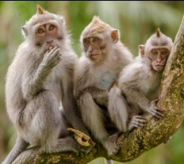

- Listen carefully!
Wil : when I climb the mountain there are many beautiful flowers, but I see something.
Nuri : what's wrong?
Wil : a fox approached me
Nuri : then, are you ok?
Will : I'm fine

A. C.
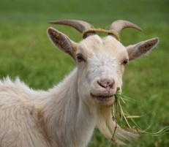
B. D.
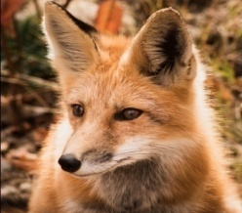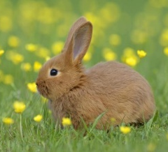

- Listen carefully!
Dea : I have a very nice plant in my house
Max : oh? What plant is that?
Dea : flower plants, besides that there are also strawberry fruit plants if you like, you can come to my house this afternoon
Max : Ok dea

- C.
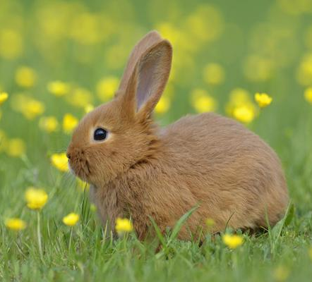
- D.
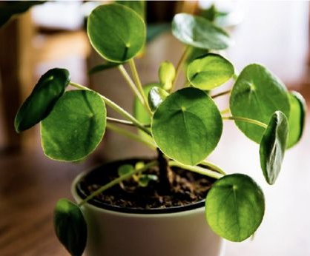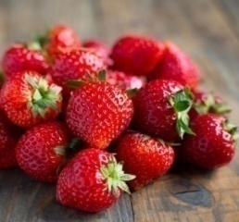

- Listen carefully!
Karin : how is your cat?
Oyi : he is fine, then what about your dog?
Karin : it almost fell down the stairs
Oyi : then how? Is it okay?
Karin : it's fine

A.
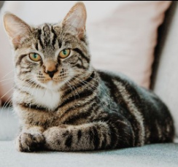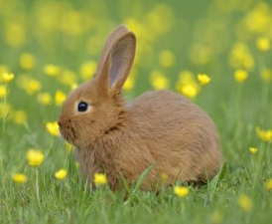
B.
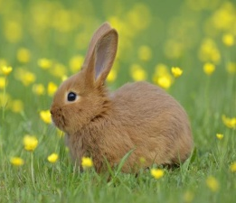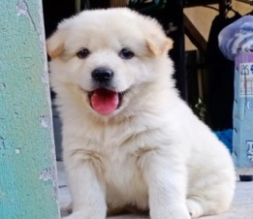
C.

D.
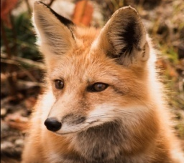

- Listen carefully!
When I was gardening, I was very surprised when I see something, I see snake. But he turned out to be gone, I was afraid he would finish me off, but he didn't.
A. C.
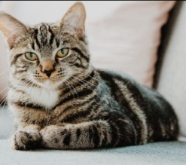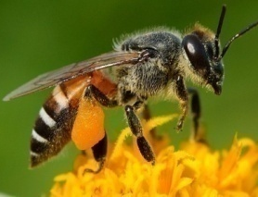
B. D.
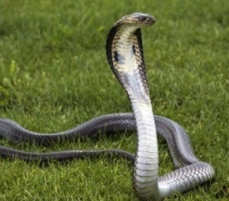

- Listen carefully!
I think one of the fruits that has a lot of water is watermelon but it has a very thick skin so, it has to be peeled first using a knife.
A. C.
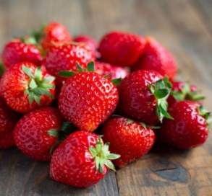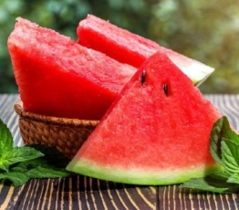
B. D.
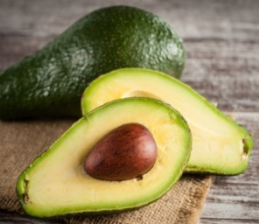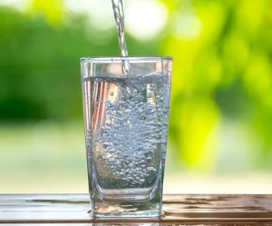

KEY ANSWER POST-TEST
FOR TEACHER
Part 1
Put an (x) ​​on the correct answer in multiple choice a b c and d.

- Listen carefully!
“Hi, Jessica, you are really beautiful with that butterfly necklace”
- Butterfly C. Batterfly.
- Buterflay D. Baterfli

- Listen carefully!
“Hi mom i just bought a very cute fish”
- Fis C. Fiysh
- Vish D.Fish

- Listen carefully!
“Hi jasondo you like strawberry fruit?”
- Stroberi C. Strawberry
- Berry D. Strowberi

- Listen carefully!
“Panji just made youtube content with snake”
- Snek C. Sneik
- Snake D. Snaik

- Listen carefully!
“onEid al-Adha many cow in front of the mosque”
- Cow C. Coy
- Kow D. Kows

- Listen carefully!
“hiselina would you accompany me to the pet shop to buy some food for my cat?”
- Cat C. Cet
- Ket D. Keit

- Listen carefully!
“in front of my grandmother's house there is a very sweet orange tree”
- Orange C. Orenj
- Oren D. Orenge

- Listen carefully!
“Mango is a very sweet and delicious fruit”
- Menggo C. Manggow
- Mango D. Menggo

- Listen carefully!
“my father bought a very cute little goat”
- Got C. Goat

- Koat D. Get

- Listen carefully!
“Inside the coconut there is very fresh coconut water”
- Kokonat C. Kokonut
- Coconat D. Coconut

Appendix 4.Teaching Documentation

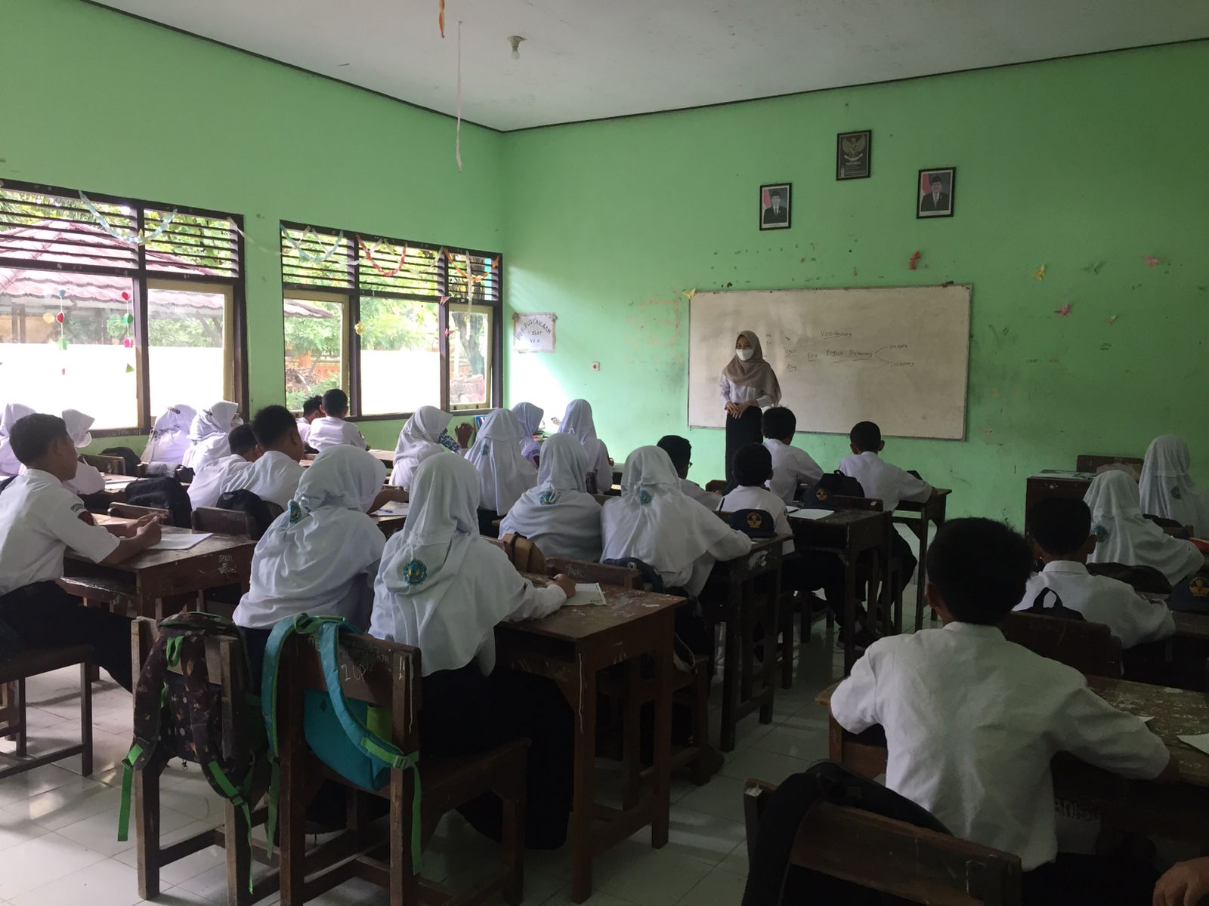
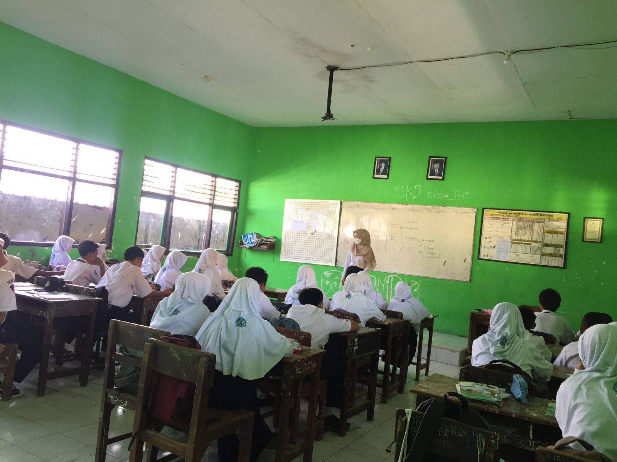

.
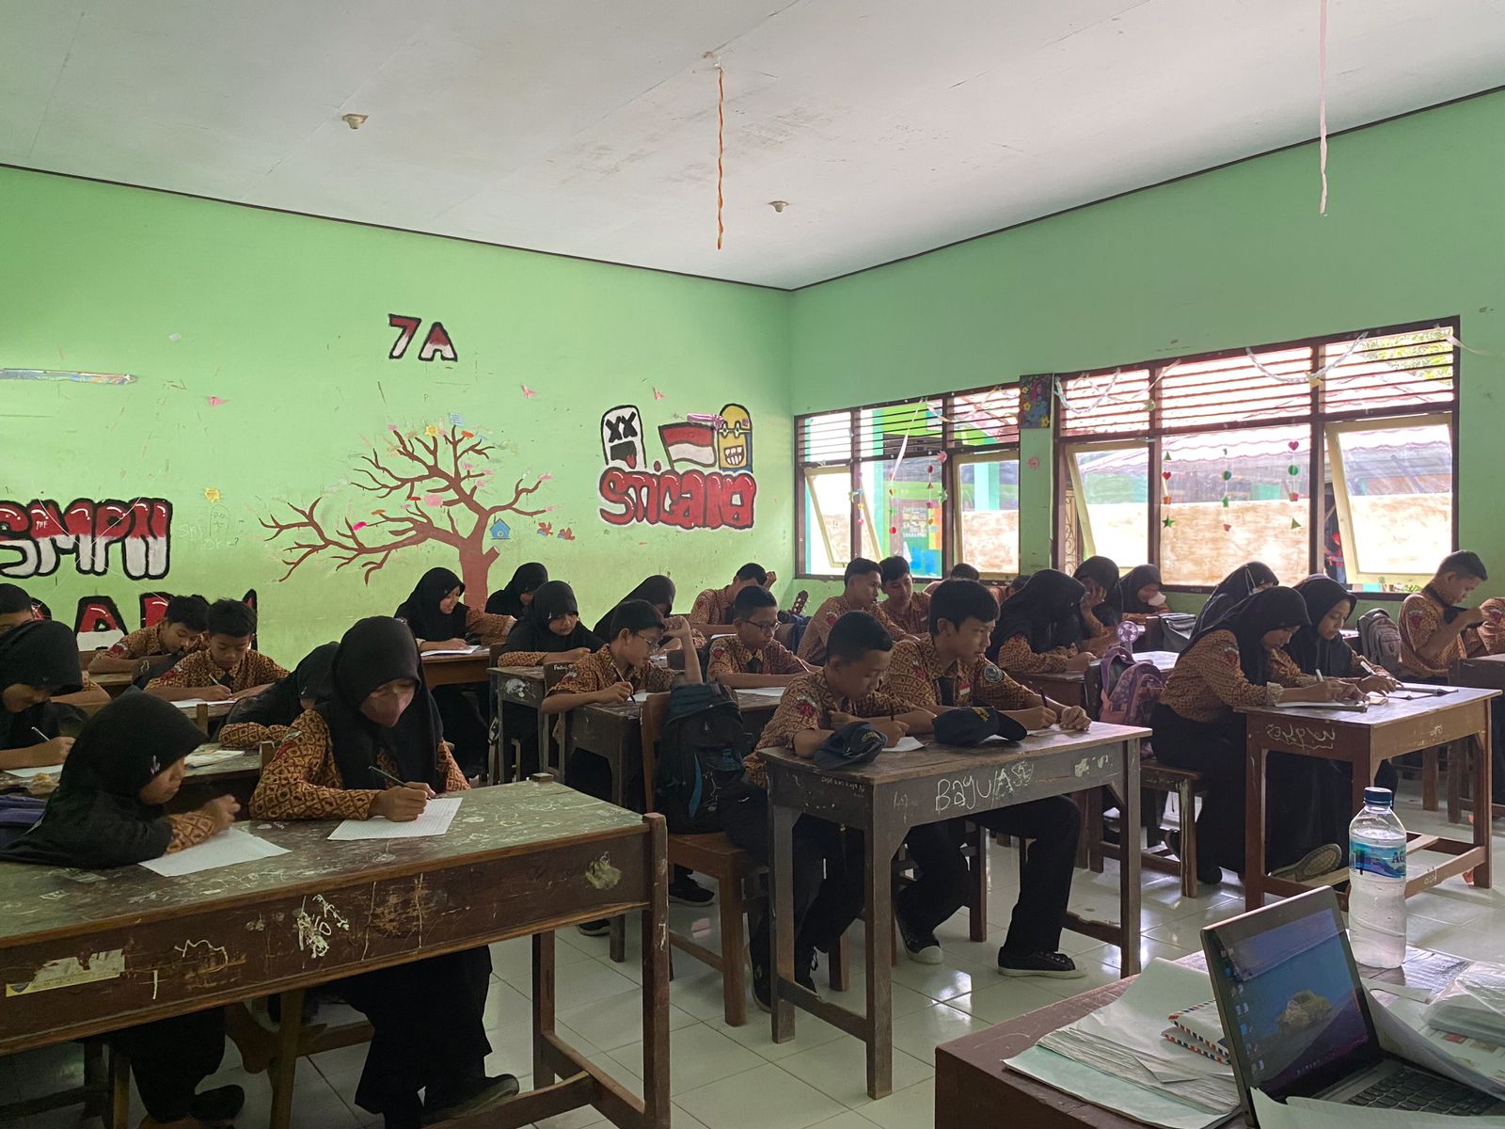
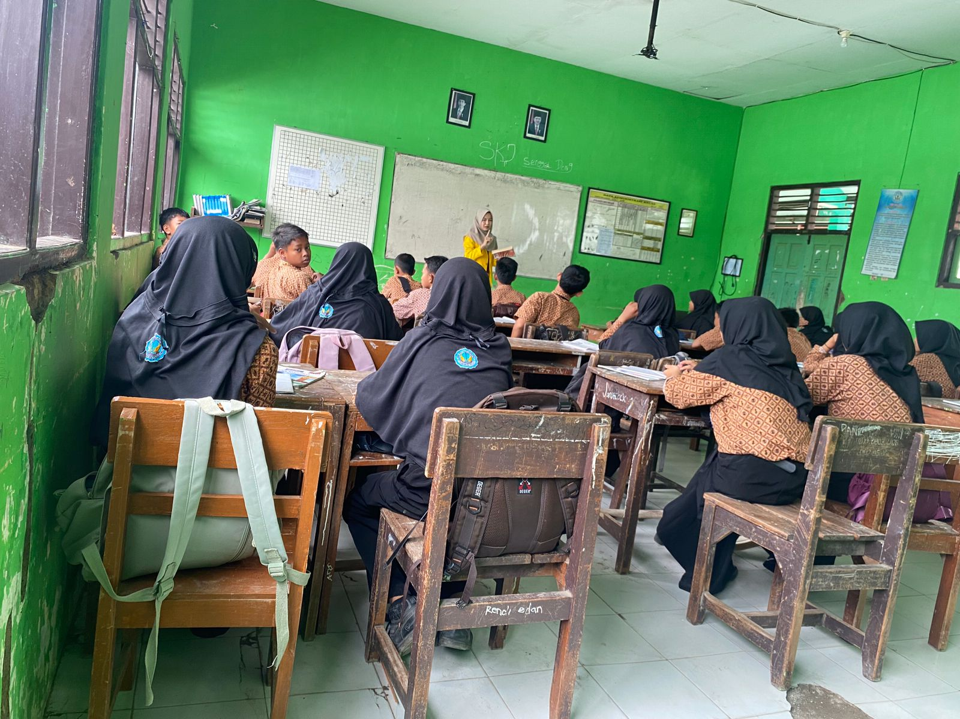

.
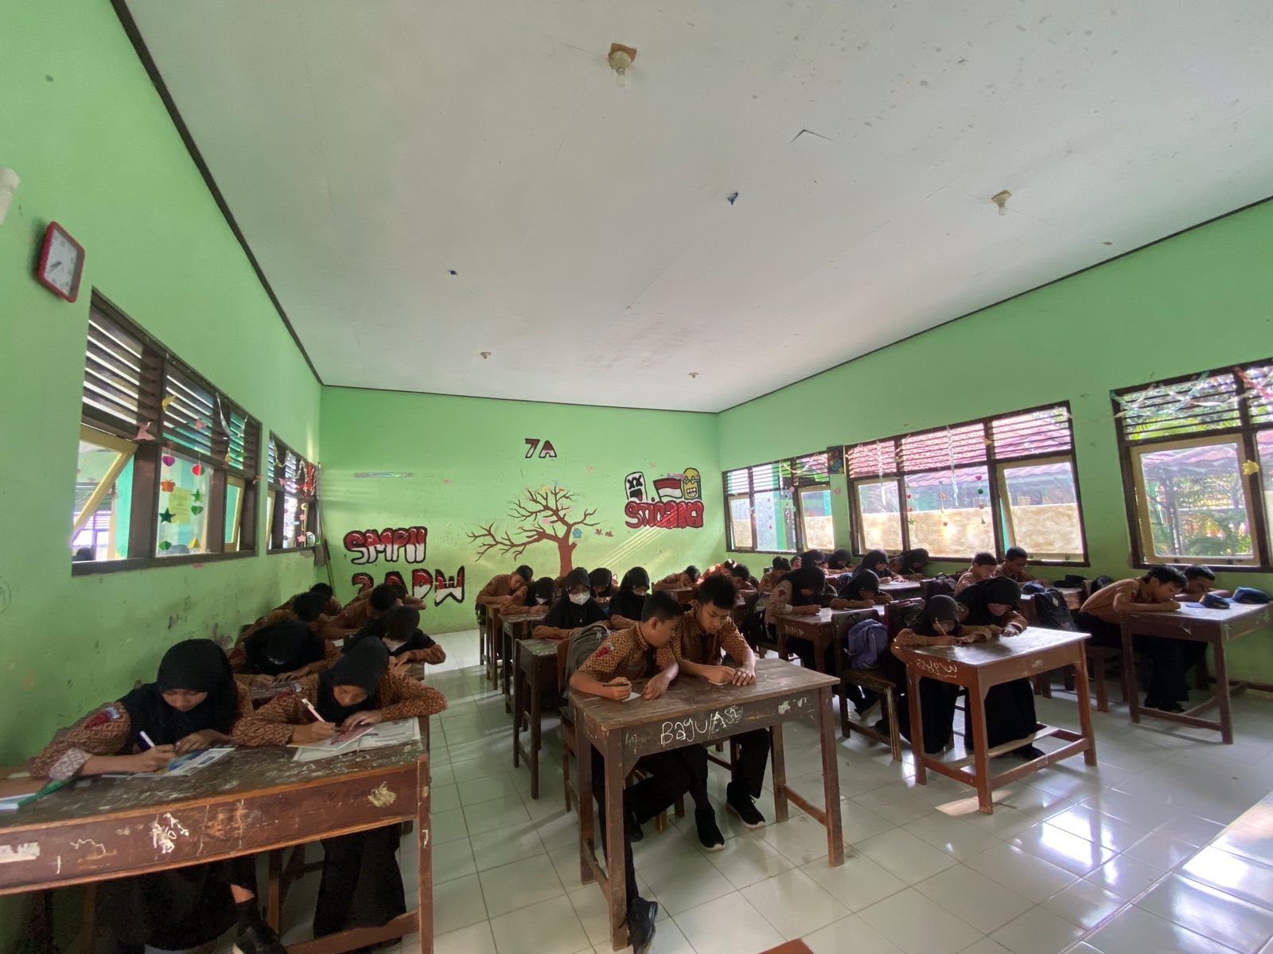
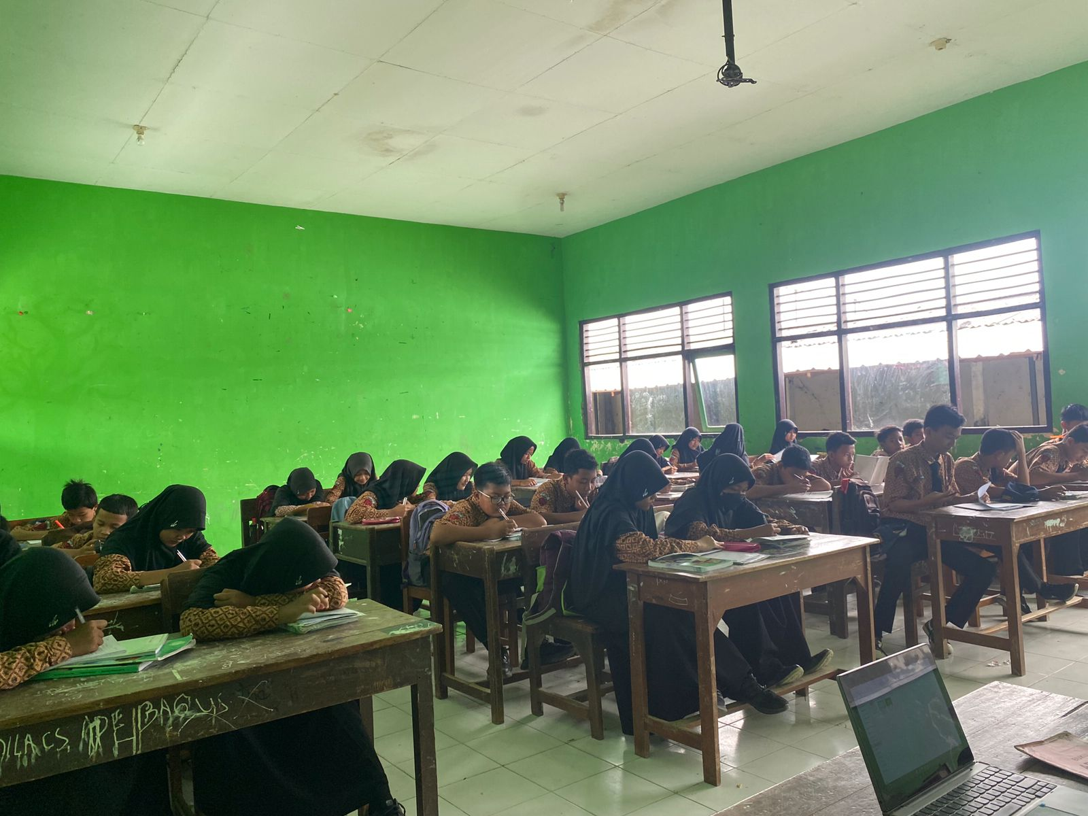

.
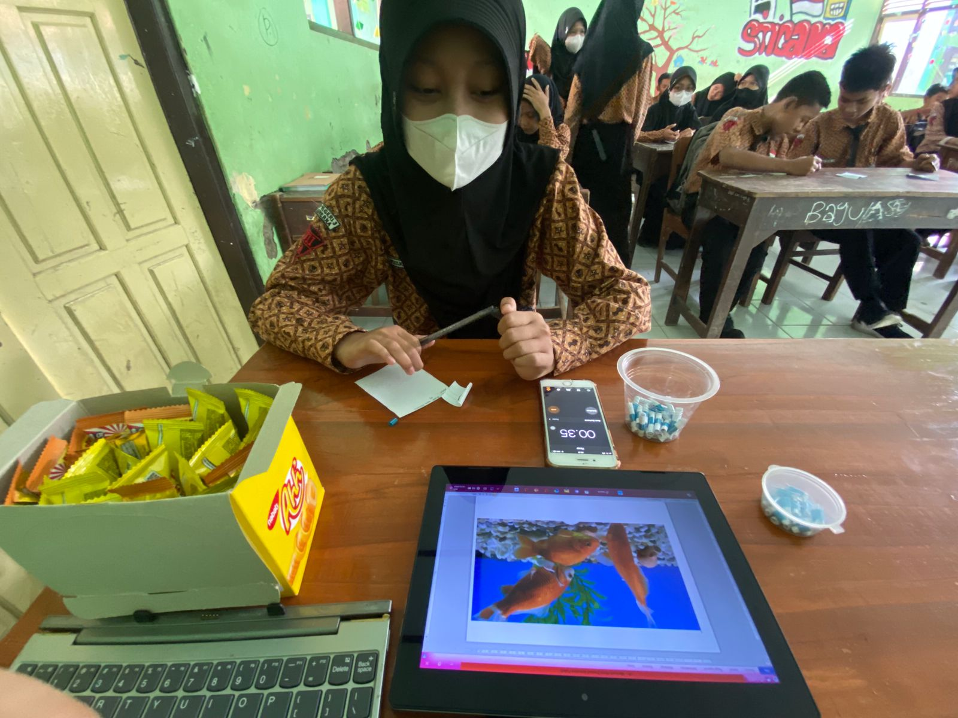

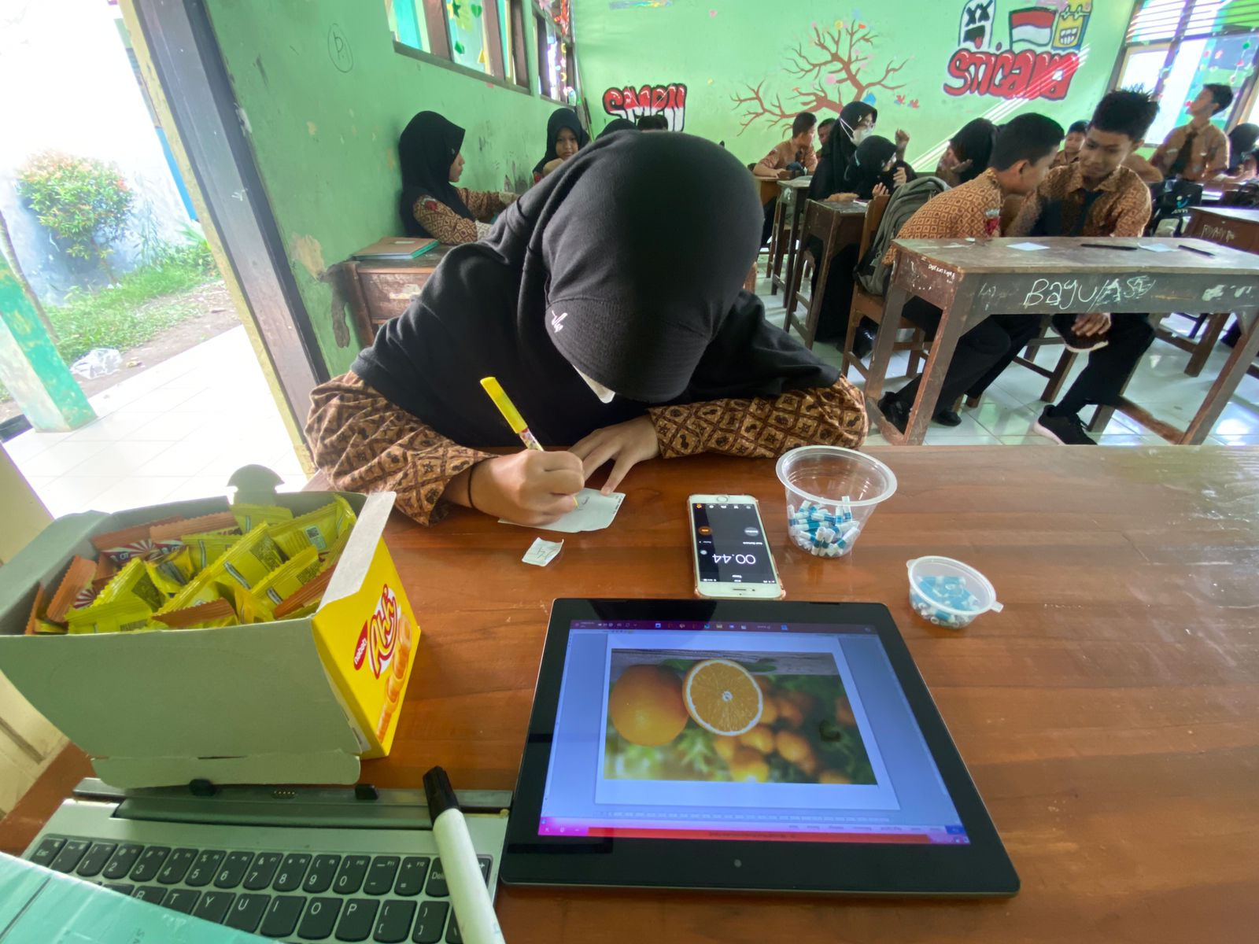

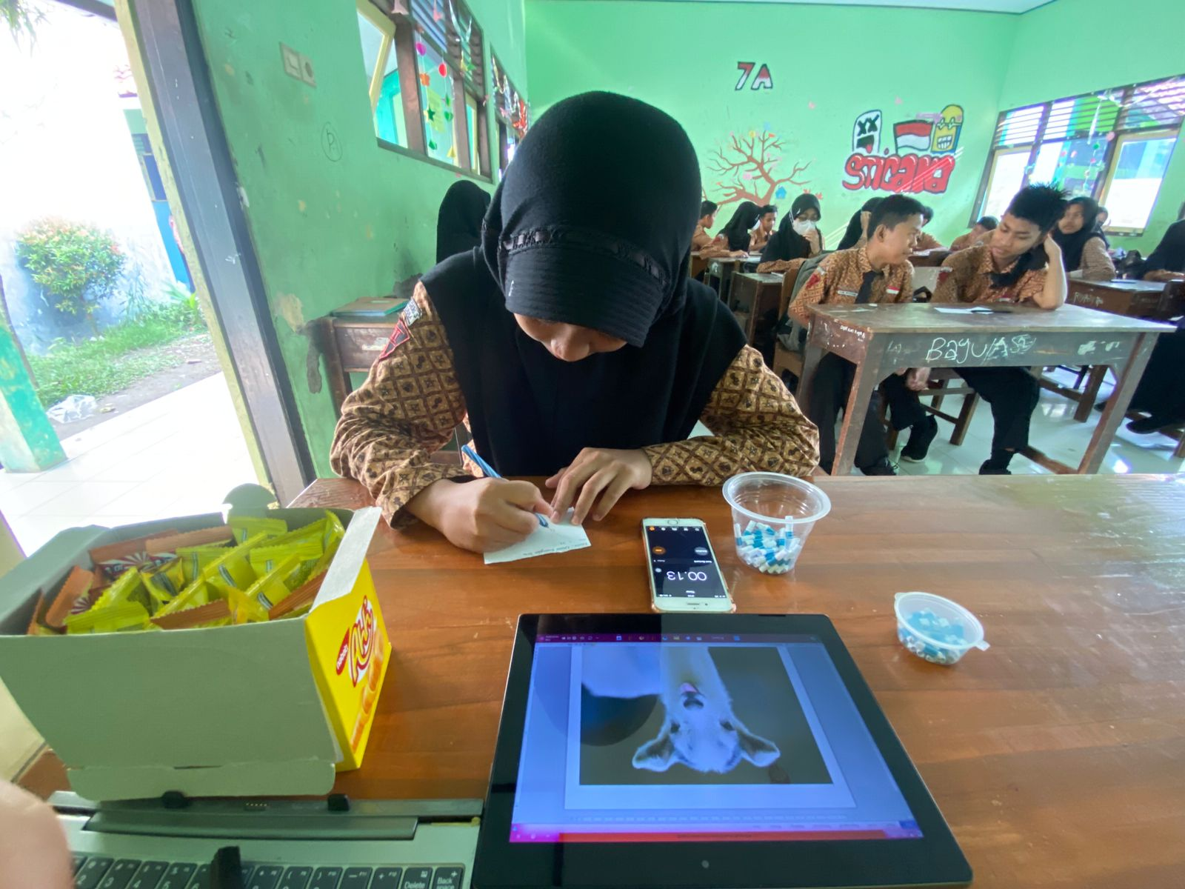
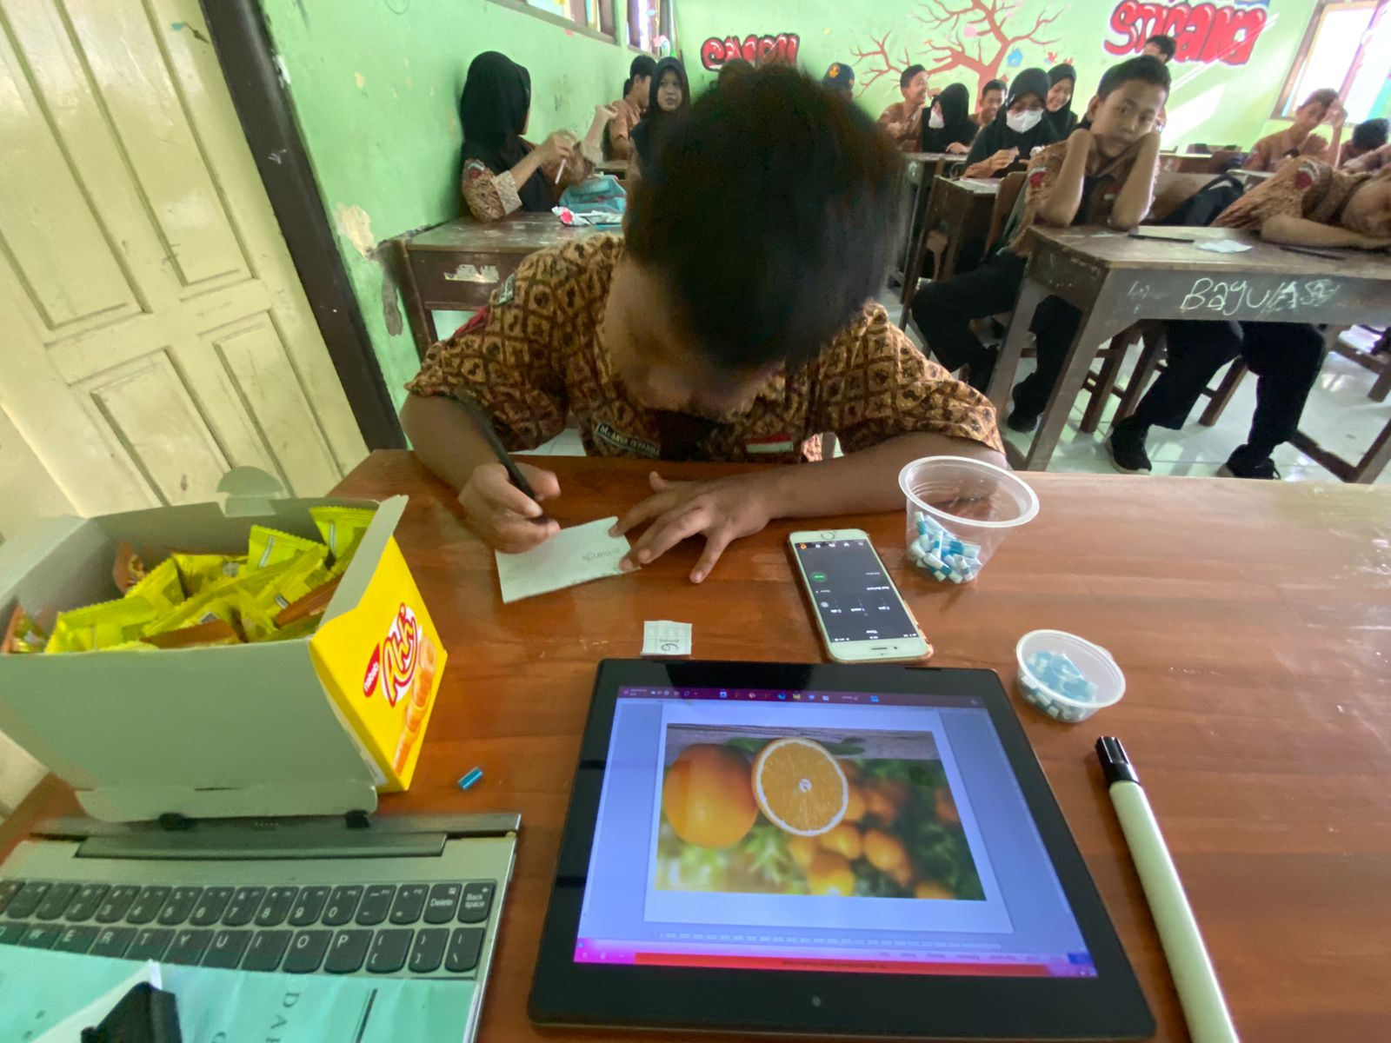

Appendix 5.Students Pre-Test Score Result (Experimental Group)

Number | Students’ Code | Score
1 | StP01 | 7
2 | StP02 | 8
3 | StP03 | 10
4 | StP04 | 7
5 | StP05 | 5
6 | StP06 | 6
7 | StP07 | 10
8 | StP08 | 6
9 | StP09 | 7
10 | StP10 | 10
11 | StP11 | 5
12 | StP12 | 5
13 | StP13 | 6
14 | StP14 | 6
15 | StP15 | 9
16 | StP16 | 5
17 | StP17 | 9
18 | StP18 | 8
19 | StP19 | 9
20 | StP20 | 7
21 | StP21 | 2
22 | StP22 | 9
23 | StP23 | 7
24 | StP24 | 5
25 | StP25 | 6
26 | StP26 | 10
27 | StP27 | 6
28 | StP28 | 6
29 | StP29 | 6
30 | StP30 | 8
31 | StP31 | 4
32 | StP32 | 4
TOTAL SCORE: |  | 218

Appendix 6.Students Post-Test Score Result (Experimental Group)

Number | Students’ Code | Post-test
1 | StP01 | 10
2 | StP02 | 9
3 | StP03 | 10
4 | StP04 | 10
5 | StP05 | 9
6 | StP06 | 10
7 | StP07 | 10
8 | StP08 | 9
9 | StP09 | 10
10 | StP10 | 10
11 | StP11 | 10
12 | StP12 | 10
13 | StP13 | 9
14 | StP14 | 9
15 | StP15 | 9
16 | StP16 | 6
17 | StP17 | 10
18 | StP18 | 8
19 | StP19 | 6
20 | StP20 | 10
21 | StP21 | 6
22 | StP22 | 10
23 | StP23 | 10
24 | StP24 | 5
25 | StP25 | 10
26 | StP26 | 10
27 | StP27 | 8
28 | StP28 | 8
29 | StP29 | 9
30 | StP30 | 10
31 | StP31 | 10
32 | StP32 | 10
TOTAL SCORE: |  | 290

Appendix 7.Students Pre-Test Score Result (Control Group)

Number. | Students’ Code | Score
1 | StP01 | 5
2 | StP02 | 5
3 | StP03 | 6
4 | StP04 | 7
5 | StP05 | 4
6 | StP06 | 6
7 | StP07 | 4
8 | StP08 | 6
9 | StP09 | 8
10 | StP10 | 3
11 | StP11 | 3
12 | StP12 | 8
13 | StP13 | 4
14 | StP14 | 5
15 | StP15 | 7
16 | StP16 | 4
17 | StP17 | 6
18 | StP18 | 5
19 | StP19 | 4
20 | StP20 | 7
21 | StP21 | 4
22 | StP22 | 4
23 | StP23 | 6
24 | StP24 | 5
25 | StP25 | 5
26 | StP26 | 6
27 | StP27 | 8
28 | StP28 | 5
29 | StP29 | 5
30 | StP30 | 8
31 | StP31 | 9
32 | StP32 | 6
TOTAL SCORE: |  | 178

Appendix 8.Students Post-Test Score Result (Control Group)

Number | Students’ Code | Score
1 | StP01 | 7
2 | StP02 | 6
3 | StP03 | 8
4 | StP04 | 7
5 | StP05 | 5
6 | StP06 | 8
7 | StP07 | 10
8 | StP08 | 8
9 | StP09 | 6
10 | StP10 | 4
11 | StP11 | 5
12 | StP12 | 6
13 | StP13 | 5
14 | StP14 | 4
15 | StP15 | 7
16 | StP16 | 6
17 | StP17 | 10
18 | StP18 | 5
19 | StP19 | 5
20 | StP20 | 6
21 | StP21 | 9
22 | StP22 | 10
23 | StP23 | 5
24 | StP24 | 7
25 | StP25 | 8
26 | StP26 | 5
27 | StP27 | 6
28 | StP28 | 8
29 | StP29 | 5
30 | StP30 | 6
31 | StP31 | 5
32 | StP32 | 5
TOTAL SCORE: |  | 207

Appendix 9.Validity Test Result

Correlations
 |  | Qs1 | Qs2 | Qs3 | Qs4 | Qs5 | Qs6 | Qs7 | Qs8 | Qs9 | Qs10 | Total
Qs1 | Pearson Correlation | 1 | .066 | .000 | .438* | .070 | .000 | .070 | -.126 | -.129 | .063 | .315
 | Sig. (2-tailed) |  | .721 | 1.000 | .012 | .705 | 1.000 | .705 | .492 | .481 | .733 | .079
 | N | 32 | 32 | 32 | 32 | 32 | 32 | 32 | 32 | 32 | 32 | 32
Qs2 | Pearson Correlation | .066 | 1 | .290 | .152 | -.014 | .119 | -.014 | -.108 | .119 | .284 | .403*
 | Sig. (2-tailed) | .721 |  | .107 | .405 | .941 | .517 | .941 | .557 | .517 | .115 | .022
 | N | 32 | 32 | 32 | 32 | 32 | 32 | 32 | 32 | 32 | 32 | 32
Qs3 | Pearson Correlation | .000 | .290 | 1 | .323 | .009 | .098 | .009 | -.143 | .098 | -.055 | .350*
 | Sig. (2-tailed) | 1.000 | .107 |  | .071 | .962 | .595 | .962 | .435 | .595 | .764 | .049
 | N | 32 | 32 | 32 | 32 | 32 | 32 | 32 | 32 | 32 | 32 | 32
Qs4 | Pearson Correlation | .438* | .152 | .323 | 1 | .170 | .210 | .309 | .323 | .210 | .373* | .752**
 | Sig. (2-tailed) | .012 | .405 | .071 |  | .353 | .248 | .085 | .071 | .248 | .036 | .000
 | N | 32 | 32 | 32 | 32 | 32 | 32 | 32 | 32 | 32 | 32 | 32
Qs5 | Pearson Correlation | .070 | -.014 | .009 | .170 | 1 | .377* | -.082 | .149 | .233 | .309 | .462**
 | Sig. (2-tailed) | .705 | .941 | .962 | .353 |  | .033 | .655 | .416 | .199 | .085 | .008
 | N | 32 | 32 | 32 | 32 | 32 | 32 | 32 | 32 | 32 | 32 | 32
Qs6 | Pearson Correlation | .000 | .119 | .098 | .210 | .377* | 1 | .233 | .228 | .067 | .210 | .534**
 | Sig. (2-tailed) | 1.000 | .517 | .595 | .248 | .033 |  | .199 | .210 | .717 | .248 | .002
 | N | 32 | 32 | 32 | 32 | 32 | 32 | 32 | 32 | 32 | 32 | 32

Qs7 | Pearson Correlation | .070 | -.014 | .009 | .309 | -.082 | .233 | 1 | .149 | .090 | .309 | .431*
 | Sig. (2-tailed) | .705 | .941 | .962 | .085 | .655 | .199 |  | .416 | .625 | .085 | .014
 | N | 32 | 32 | 32 | 32 | 32 | 32 | 32 | 32 | 32 | 32 | 32
Qs8 | Pearson Correlation | -.126 | -.108 | -.143 | .323 | .149 | .228 | .149 | 1 | .098 | .071 | .350*
 | Sig. (2-tailed) | .492 | .557 | .435 | .071 | .416 | .210 | .416 |  | .595 | .699 | .049
 | N | 32 | 32 | 32 | 32 | 32 | 32 | 32 | 32 | 32 | 32 | 32
Qs9 | Pearson Correlation | -.129 | .119 | .098 | .210 | .233 | .067 | .090 | .098 | 1 | .469** | .477**
 | Sig. (2-tailed) | .481 | .517 | .595 | .248 | .199 | .717 | .625 | .595 |  | .007 | .006
 | N | 32 | 32 | 32 | 32 | 32 | 32 | 32 | 32 | 32 | 32 | 32
Qs10 | Pearson Correlation | .063 | .284 | -.055 | .373* | .309 | .210 | .309 | .071 | .469** | 1 | .642**
 | Sig. (2-tailed) | .733 | .115 | .764 | .036 | .085 | .248 | .085 | .699 | .007 |  | .000
 | N | 32 | 32 | 32 | 32 | 32 | 32 | 32 | 32 | 32 | 32 | 32
Total | Pearson Correlation | .315 | .403* | .350* | .752** | .462** | .534** | .431* | .350* | .477** | .642** | 1
 | Sig. (2-tailed) | .079 | .022 | .049 | .000 | .008 | .002 | .014 | .049 | .006 | .000
 | N | 32 | 32 | 32 | 32 | 32 | 32 | 32 | 32 | 32 | 32 | 32
*. Correlation is significant at the 0.05 level (2-tailed).
**. Correlation is significant at the 0.01 level (2-tailed).

Appendix 10.Reliability Test Result

Reliability Statistics
Cronbach's Alpha | N of Items
.612 | 10

Appendix 11.Cetificate of Research Completion

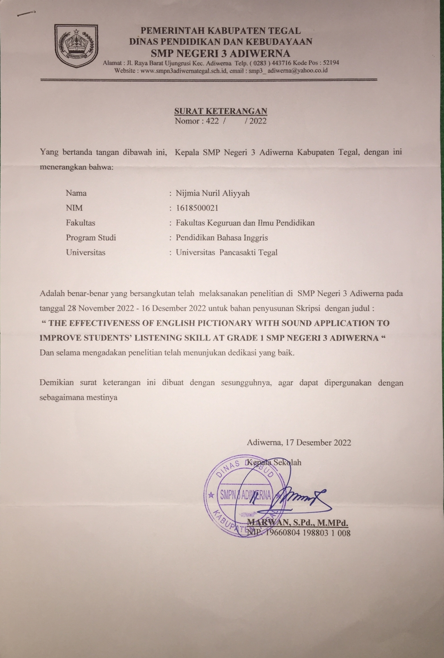

Appendix 12.Observation Perimission

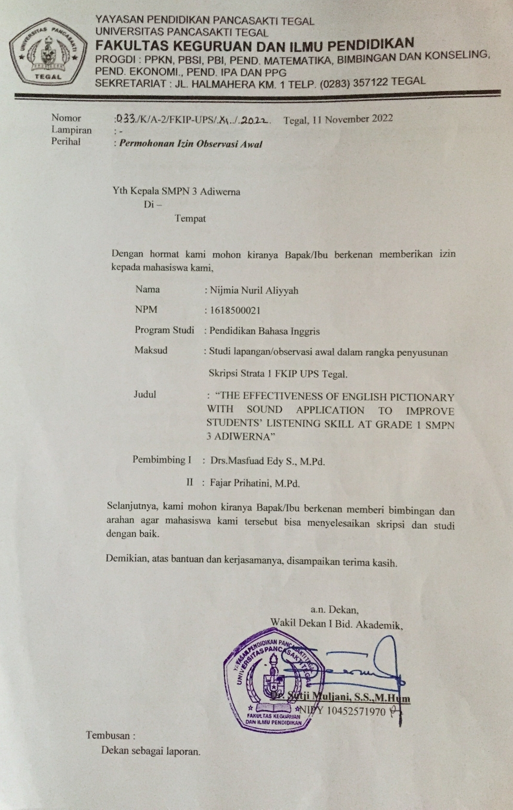

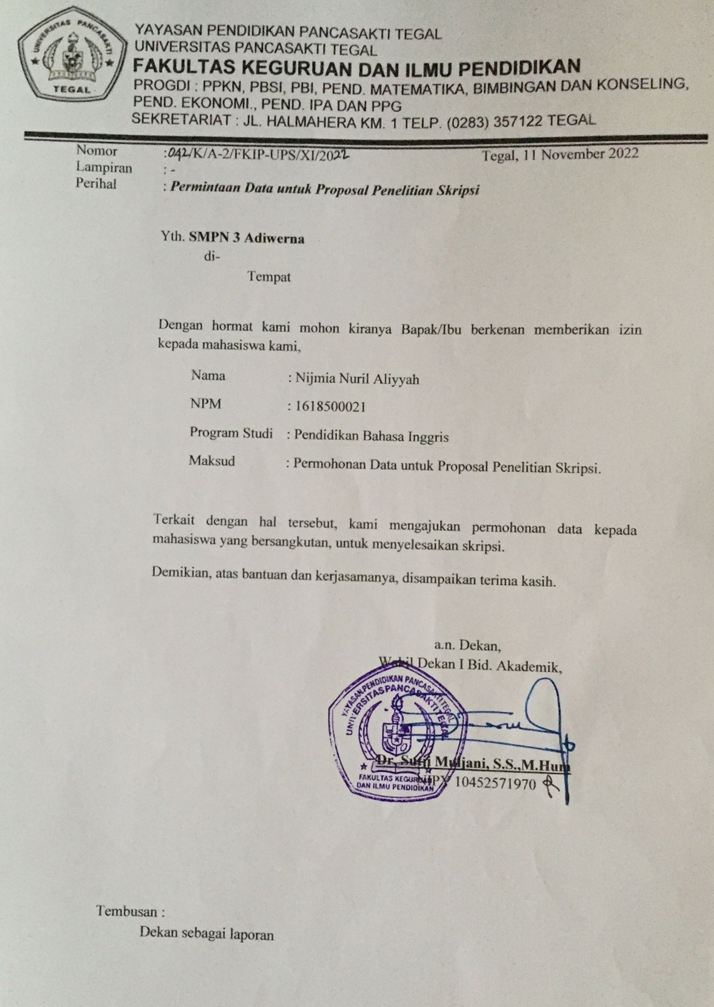

Appendix 13. English Pictionary

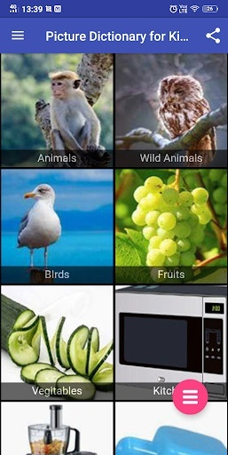

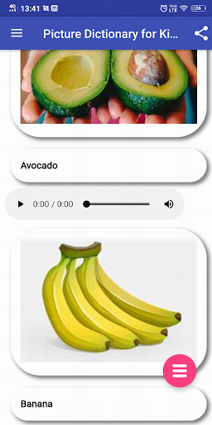

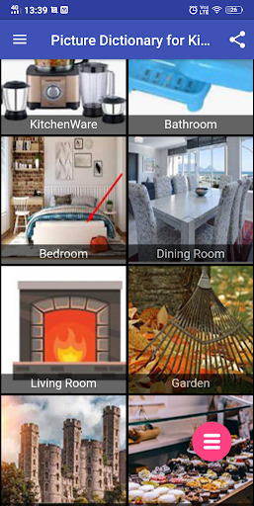

Appendix 14. Voice Maker




