# DAFTAR PUSTAKA

Adnyana Mahaputra, I. N. K. (2012). Pengaruh Rasio-Rasio Keuangan Terhadap Pertumbuhan Laba Pada Perusahaan Manufaktur Yang Terdaftar Di Bei. *Jurnal Ilmiah Akuntansi Dan Bisnis*, *7*(2), 243–254. https://ojs.unud.ac.id/index.php/jiab/article/download/9238/6970

Arista, T. M. (2019). *Pengaruh Rasio Likuiditas, Rasio Solvabilitas, Dan Rasio Aktivitas Terhadap Pertumbuhan Laba Perusahaan Manufaktur Yang Terdaftar Di Bursa Efek Indonesia* (Doctoral dissertation, STIE Perbanas Surabaya). http://eprints.perbanas.ac.id/5178/

Astuty, W. (2018). Pengaruh Solvabilitas Terhadap Perubahan Laba Pada Perusahaan Asuransi Yang Terdaftar Di Bursa Efek Indonesia. *Jurnal Manajemen*. http://jurnal.umsu.ac.id/index.php/kumpulandosen/article/view/2781/pdf_686

Badriyah, S. R., & Amanah, L. (2021). Pengaruh kinerja keuangan terhadap pertumbuhan laba. *Jurnal Ilmu Dan RIset Akuntansi*, *10*(7), 1–15. http://jurnalmahasiswa.stiesia.ac.id/index.php/jira/article/view/4104

Darmawan, M. (2020). *Dasar-Dasar Memahami Rasio dan Laporan Keuangan* . Yogyakarta: UNY PRESS.

Darminto, D. P. (2019). *Analisis Laporan Keuangan*. Yogyakarta: UPP STIM YKPN.

Fitriah, R., & Suprihhadi, H. (2018). Pengaruh Likuiditas, Solvabilitas dan Aktivitas terhadap Pertumbu han Laba. *Jurnal Ilmu Dan Riset Manajemen*, *7*(2), 1–15. http://jurnalmahasiswa.stiesia.ac.id/index.php/jirm/article/view/3 097/3112

Ghozali, I. (2013). *Aplikasi Analisis Multivariate dengan Program IBM SPSS 21*. Semarang: Badan Penebit Universtas Diponogoro.

Hery. (2021). *Analisis Laporan Keuangan.* Jakarta: *Gramedia Widiasarana Indonesia*.

Hidayati, H., & Putri, C. W. (2022). *Asuransi Yang Terdaftar Pada Bursa Efek Indonesia Periode 2016-2020*. *jurnal Ekonomika* https://www.google.com/url?sa=t&rct=j&q=&esrc=s&source=web&cd=&ved=2ahUKEwjKreapvq78AhWlRmwGHQ7CDR0QFnoECBMQAQ&url=https%3A%2F%2Fwww.jbbe.lppmbinabangsa.id%2Findex.php%2Fjbbe%2Farticle%2Fdownload%2F210%2F141&usg=AOvVaw1Rv80Uz_ibPZZyYvN6_gYp

Ifada, L. M., & Puspitasari, T. (2016). Analisis Pengaruh Rasio Keuangan Terhadap Perubahan Laba. Universitas Islam Sultan Agung. *Jurnal Akuntansi Dan Auditing*, *13*(1), 97–108. https://ejournal.undip.ac.id/index.php/akuditi/article/view/13873

Irham, F. (2014). *Manajemen Keuangan Perusahaan dan Pasar Modal*. Jakrata: Mitra Wacana Media.

Nurhadi. (2011). *Pendekatan dalam Penilaian.* Jakarta: Pustaka Sinar Harapan.

Ottay, M. C., & Alexander, S. W. (2015). Analisis Laporan Keuangan untuk Menilai Kinerja Keuangan. *Jurnal EMBA*, *3*(1), 923–932. https://ejournal.unsrat.ac.id/index.php/emba/article/view/7621

P. Hamidu, N. (2011). *Pengaruh Kinerja Keuangan Terhadap Pertumbuhan Laba Pada Perbankan di Bei*. *Jurnal EMBA*, *1*(3). https://ejournal.unsrat.ac.id/index.php/emba/article/view/1878

Rahmad Syafril. (2020). Pengaruh Rasio Likuiditas Solvabilitas, Dan Aktivitas Terhadap Pertumbuhan Laba. *Jurnal Ilmu Dan Riset Manajemen*, *9*(6), 1–6. http://jurnalmahasiswa.stiesia.ac.id/index.php/jirm/article/view/3097

Rudikson, R., Muslimin, M., & Faisal, M. (2018). Pengaruh Rasio Likuiditas, Leverage Dan Aktivitas Terhadap Pertumbuhan Laba Perusahaan Makanan Dan Minuman Di Bei. *Jurnal Ilmu Manajemen Universitas Tadulako (JIMUT)*, *4*(2), 151–158. https://doi.org/10.22487/jimut.v4i2.116

Santoso, S. (2020). *Panduan Lengkap SPSS 26*. Jakarta: Elex Media Komputindo.

Sapariyah, R. A. (2020). Pengaruh Rasiocapital, Assets, Earning Dan Liquidityterhadappertumbuhan Laba Pada Perbankandi Indonesia (Study Empiris Pada Perbankan Di Indonesia). *jurnal Manajemen*. https://www.neliti.com/publications/161249/pengaruh-rasio-capital-assetsear ning-dan-liquidity-terhadap-pertumbuhan-laba-pa

Saputri, A. N. (2019). Pengaruh Rasio Likuiditas, Solvabilitas, da Aktivitas Terhadap Perubahan Laba Pada Perusahaan Yang Terdaftar Di Bursa Efek Indonesia (BEI). *Jurnal STIE YKPN*. https://core.ac.uk/download/pdf/33513 714.pdf

Subagyo, D. P. (2011). *Statistik Induktif.* Yogyakarta: Penerbit BPFE.

Sulistyani, I., Wijaya, L. A., & Novitasari, M. (2019). Pengaruh Rasio Likuiditas, Solvabilitas, dan Aktivitas Terhadap Pertumbuhan Laba Dimoderasi oleh Ukuran Perusahaan. *Unipma: Simba Seminar Inovasi Manajemen, Bisnis Dan Akuntansi I*, 73–86. http://prosiding.unipma.ac.id/index.php/SIMBA/arti cle/view/1134

Syahyunan. (2013). Manajemen Keuangan: Perencanaan, Analisis, dan. Medan: USU Press.

# **LAMPIRAN**

Lampiran 1   
Hasil Sampel Pertumbuhan Laba 2017-2021



Lampiran 2   
Hasil Sampel Rasio Likuiditas/Current Ratio 2017-2021



Lampiran 3   
Hasil Sampel Rasio Solvabilitas/Debt To Assest Ratio 2017/2021



Lampiran 4   
Hasil Sampel Ratio Aktivitas/Total Assest Trun Over 2017-2021



Lampiran 5   
Input SPSS

|  |  |  |  |  |
| --- | --- | --- | --- | --- |
| PERUSAHAAN | PERTUMBUHAN LABA | CR | DAR | TATO |
| APII 2017 | -.123 | 1.503 | .415 | .397 |
| APII 2018 | 1.184 | 1.651 | .388 | .481 |
| APII 2019 | -.153 | 1.607 | .386 | .495 |
| APII 2020 | .171 | 1.786 | .349 | .486 |
| APII 2021 | -.314 | 1.854 | .330 | .465 |
| ARNA 2017 | .337 | 1.626 | .357 | 1.082 |
| ARNA 2018 | .295 | 1.473 | .337 | 1.193 |
| ARNA 2019 | .376 | 2.047 | .346 | 1.196 |
| ARNA 2020 | .499 | 1.964 | .338 | 1.123 |
| ARNA 2021 | .459 | 2.400 | .299 | 1.139 |
| ASGR 2017 | .008 | 1.848 | .452 | 1.625 |
| ASGR 2018 | .051 | 2.434 | .347 | 1.792 |
| ASGR 2019 | -.072 | 1.963 | .439 | 1.647 |
| ASGR 2020 | -.810 | 2.838 | .317 | 1.463 |
| ASGR 2021 | .827 | 2.364 | .387 | 1.242 |
| ASII 2017 | .266 | 1.229 | .471 | .697 |
| ASII 2018 | .182 | 1.126 | .509 | .712 |
| ASII 2019 | -.027 | 1.291 | .469 | .674 |
| ASII 2020 | -.039 | 1.543 | .422 | .518 |
| ASII 2021 | .868 | 1.544 | .413 | .636 |
| BHIT 2017 | -.381 | 1.069 | .574 | .240 |
| BHIT 2018 | .801 | 1.117 | .566 | .261 |
| BHIT 2019 | 1.209 | 1.088 | .500 | .277 |
| BHIT 2020 | -.269 | 1.037 | .472 | .249 |
| BHIT 2021 | .538 | 1.201 | .407 | .258 |
| BMTR 2017 | .340 | 2.186 | .490 | .391 |
| BMTR 2018 | .282 | 1.349 | .506 | .404 |
| BMTR 2019 | .715 | 1.371 | .424 | .429 |
| BMTR 2020 | -.223 | 1.869 | .356 | .374 |
| BMTR 2021 | .361 | 1.406 | .294 | .402 |
| ICON 2017 | 2.477 | 1.610 | .585 | .341 |
| ICON 2018 | 1.034 | 1.907 | .483 | .501 |
| ICON 2019 | .177 | 2.650 | .352 | .551 |
| ICON 2020 | -.843 | 1.991 | .339 | .387 |
| ICON 2021 | -.958 | 2.046 | .342 | .379 |
| IMPC 2017 | -.274 | 3.606 | .438 | .520 |
| IMPC 2018 | .156 | 3.564 | .421 | .589 |
| IMPC 2019 | -.117 | 2.452 | .437 | .598 |
| IMPC 2020 | .243 | 2.074 | .456 | .666 |
| IMPC 2021 | .784 | 2.162 | .414 | .778 |
| JTPE 2017 | .030 | 1.191 | .422 | 1.215 |
| JTPE 2018 | .471 | 1.438 | .404 | 1.168 |
| JTPE 2019 | .513 | 1.669 | .353 | 1.248 |
| JTPE 2020 | -.593 | 2.080 | .258 | .943 |
| JTPE 2021 | .301 | 2.385 | .249 | .887 |
| MARK 2017 | 1.402 | 2.444 | .267 | 1.054 |
| MARK 2018 | .741 | 2.219 | .253 | 1.023 |
| MARK 2019 | .074 | 3.059 | .322 | .819 |
| MARK 2020 | .639 | 1.192 | .431 | .786 |
| MARK 2021 | 1.720 | 2.142 | .310 | 1.107 |
| SCCO 2017 | -.208 | 1.742 | .320 | 1.106 |
| SCCO 2018 | -.058 | 1.908 | .301 | 1.239 |
| SCCO 2019 | .195 | 2.095 | .286 | 1.296 |
| SCCO 2020 | -.216 | 4.400 | .125 | 1.234 |
| SCCO 2021 | -.405 | 6.822 | .063 | 1.069 |
| UNTR 2017 | .503 | 1.804 | .422 | .785 |
| UNTR 2018 | .498 | 1.141 | .509 | .728 |
| UNTR 2019 | -.032 | 1.560 | .453 | .756 |
| UNTR 2020 | -.494 | 2.110 | .367 | .605 |
| UNTR 2021 | .883 | 1.988 | .362 | .706 |
| KBLI 2017 | .074 | 1.974 | .407 | 1.057 |
| KBLI 2018 | -.344 | 2.464 | .374 | 1.307 |
| KBLI 2019 | .676 | 2.909 | .330 | 1.265 |
| KBLI 2020 | -1.187 | 5.292 | .219 | .654 |
| KBLI 2021 | -2.267 | 11.762 | .100 | .646 |
| KBLM 2017 | 1.071 | 1.263 | .359 | .984 |
| KBLM 2018 | -.075 | 1.304 | .367 | .958 |
| KBLM 2019 | -.050 | 1.364 | .339 | .895 |
| KBLM 2020 | -.830 | 1.907 | .180 | .861 |
| KBLM 2021 | -2.981 | 1.547 | .190 | .811 |

Lampiran 6   
Statistik Deskriptif

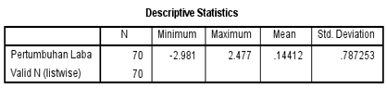

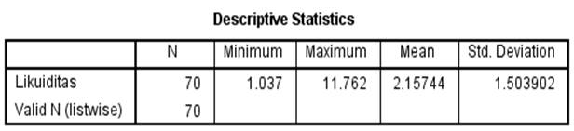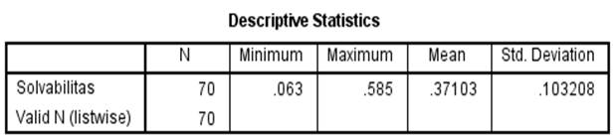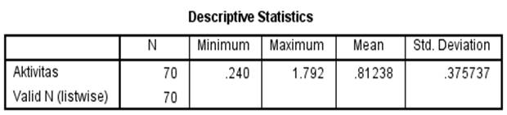

`

Lampiran 7   
Uji Normalitas Histogram

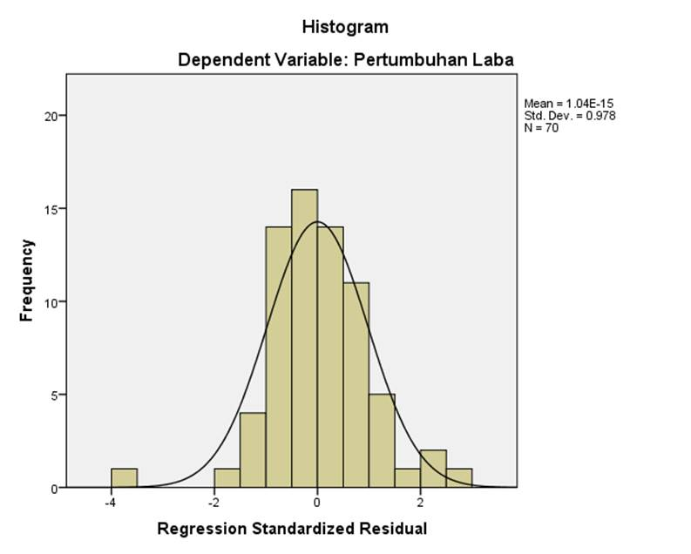

Lampiran 8   
Uji Normalitas P-P Plot

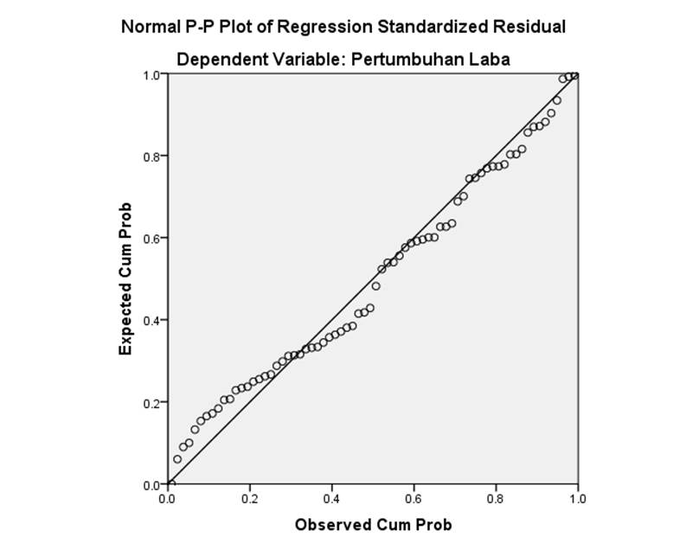

Lampiran 9   
Uji Normalitas One-Sample Kolmogorov-smirnov

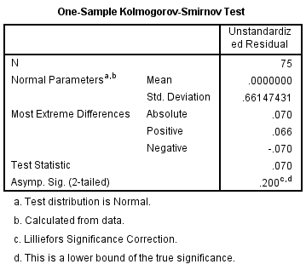

Lampiran 10   
Uji Multikolinearitas

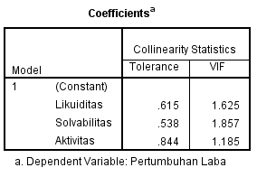

Lampiran 11   
Uji Autokorelasi

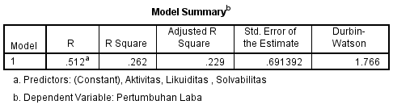

Lampiran 12   
Uji Heteroskedastisitas

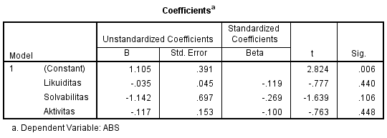

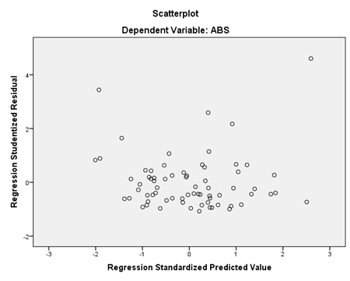

Lampiran 13   
Analisis Regresi Linier Berganda

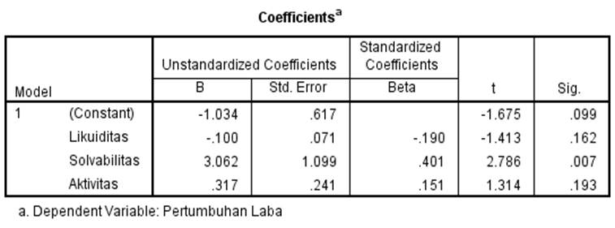

Lampiran 14   
Uji Statistik t



Lampiran 15   
Uji Statistik F

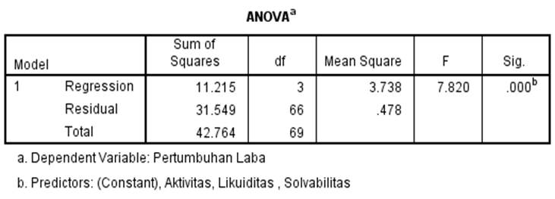

Lampiran 16   
Uji Koefisien Determinasi R2

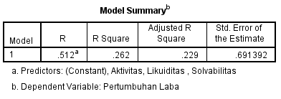

Lampiran 17   
t Tabel

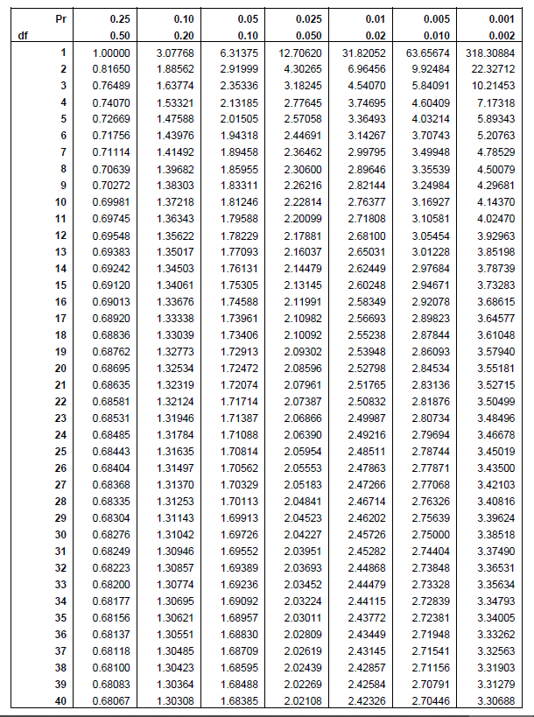

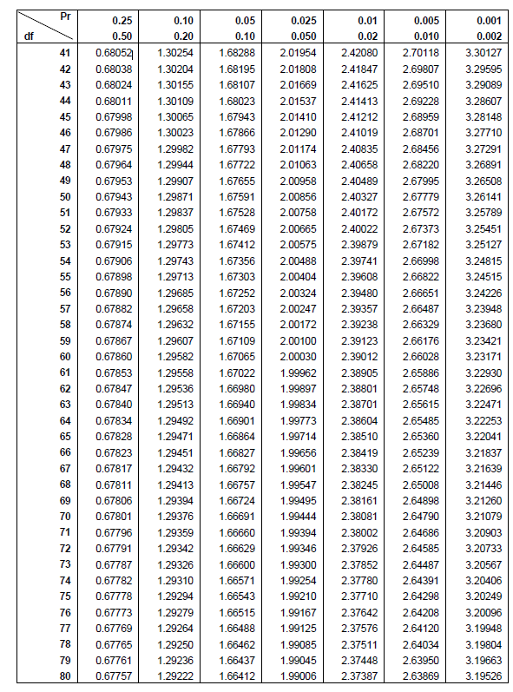

Lampiran 18   
Data Mentah Pertumbuhan Laba





Lampiran 19   
Data Mentah CR







Lampiran 20   
Data Mentah DAR







Lampiran 21   
Data Mentah TATO





