# DAFTAR PUSTAKA

Adi Putra, A. D., & Lestari, P. V. (2016). Pengaruh Kebijakan Dividen, Likuiditas, Profitabilitas dan Ukuran Perusahaan Terhadap Nilai Perusahaan. *E-Jurnal Manajemen Unud, 5*, 4044-4070. Retrieved from http://download.garuda.kemdikbud.go.id/

Brigham, E. F. (2010). *Dasar-Dasar Manajemen Keuangan* (edisi kesebelas ed.). Jakarta: Salemba Empat.

Brigham, E. F., & Houston, B. F. (2014). *Dasar-Dasar Manajemen Keuangan.* Jakarta: Salemba Empat.

Brigham, E. F., & Houston, J. F. (2011). *Dasar-Dasar Manajemen Keuangan.* Jakarta: Salemba Empat.

Dewi, V. S., & Ekadjaja, A. (2020). Pengaruh Profitabilitas, Likuiditas dan Ukuran Perusahaan Terhadap Nilai Perusahaan Pada Perusahaan Manufaktur. *Jurnal Multiparadigma Akuntansi Tarumanegara, 2*, 118-126. Retrieved from https://journal.untar.ac.id/index.php/jpa/article/view/7139

Fahmi, I. (2017). Analisis Laporan Keuangan. In I. Fahmi, *Analisis Laporan Keuangan* (pp. 127-129). Bandung: Alfabeta.

Ghozali, I. (2018). *Aplikasi Analisis Multivariate Dengan Program IBM SPSS 25* (9 ed.). Semarang: Undip.

Kasmir. (2015). *Analisis Laporan Keuangan* (8nd ed.). Jakarta: PT RajaGrafindo Persada.

Lumoly, S., Murni, S., & Untu, V. N. (2018). Pengaruh Likuiditas, Ukuran Perusahaan dan Profitabilitas Terhadap Nilai Perusahaan (Studi pada Perusahaan Logam dan Sejenisnya yang Terdaftar di Bursa Efek Indonesia). *Jurnal EMBA, 6*, 1108-1117. Retrieved from https://ejournal.unsrat.ac.id/index.php/emba/article/view/20072

Maryam, S., Mus, A. R., & Priliyadi, A. (2020). Pengaruh Ukuran Perusahaan, Pertumbuhan Perusahaan, dan Kebijakan Dividen Terhadap Nilai Perusahaan. *CENTER OF ECONOMIC STUDENT JOURNAL*, 91-109.

Nurminda, A., Isynuwardhana, D., & Nurbaiti, A. (2017). Pengaruh Profitabilitas, Leverage, dan Ukuran Perusahaan Terhadap Nilai Perusahaan (Studi pada

Perusahaan Manufaktur Sub Sektor Barang dan Konsumsi yang Terdaftar di BEI Periode 2012-2015). *e-Proceeding of Management, 4*, 542-549. Retrieved from https://openlibrarypublications.telkomuniversity.ac.id/index.php/management/article/view/4484

Prastowo, D. (2011). *Analisis Laporan Keuangan Konsep dan Aplikasi* (3 ed.). Yogyakarta: Sekolah Tinggi Ilmu Manajemen YKPN.

Prastuti, N. R., & Sudiartha, I. M. (2016). Pengaruh Struktur Modal, Kebijakan Dividen, Dan Ukuran Perusahaan Terhadap Nilai Perusahaan Pada Perusahaan Manufaktur. *E-Jurnal Manajemen Unud, 5*, 1572-1598. Retrieved from http://ojs.unud.ac.id/

Rai Prastuti, N., & Sudiartha, I. M. (2016). Pengaruh Struktur Modal, Kebijakan Dividen, dan Ukuran Perusahaan Terhadap Nilai Perusahaan Pada Perusahaan Manufaktur. *E-Jurnal Manajemen Unud*, 1572-1598. Retrieved from http://ojs.unud.ac.id/

Ramdhonah, Z., Solikin, I., & Sari, M. (2019). Pengaruh Struktur Modal , Ukuran Perusahaan, Pertumbuhan Perusahaan, dan Profitabilitas Terhadap Nilai Perusahaan (Studi Empiris Pada Perusahaan Sektor Pertambangan Yang Terdaftar Di Bursa Efek Indonesia Tahun 2011-2017). *Jurnal Riset Akuntansi dan Keuangan, 7*, 67-81. Retrieved from https://ejournal.upi.edu/index.php/JRAK/article/view/15117

Saputri, C. K., & Giovanni, A. (2021). Pengaruh Profitabilitas, Pertumbuhan Perusahaan dan Likuiditas Terhadap Nilai Perusahaan. *Journal Of Mangement Studies, 15*, 90-108. Retrieved from https://journal.trunojoyo.ac.id/kompetensi/article/view/10563

Sudana, I. M. (2015). *Teori & Praktik Manajemen Keuangan Perusahaan.* Jakarta: ERLANGGA.

Susilo, B. (2009). *Pasar Modal Mekanisme Perdagangan Saham, Analisis Sekuritas, dan Strategi Investasi Di Bursa Efek Indonesia (BEI)* (1 ed.). Yogyakarta: UPP STIM YKPN Yogyakarta.

Sutama, D. R., & Lisa, E. (2018). Pengaruh Leverage dan Profitabilitas Terhadap Nilai Perusahaan (Studi Pada Perusahaan Sektor Manufaktur Food And Beverage Yang Terdaftar DI Bursa Efek Indonesia). *Jurnal Sains Manajemen & Akuntansi, 10*, 21-39. Retrieved from http://ojs.stan-im.ac.id/index.php/JSMA/article/view/26

www.idx.co.id. (2022). *Laporan Keuangan Tahunan*. Retrieved from PT Bursa Efek Indonesia: https://www.idx.co.id/id-id/perusahaan-tercatat/laporan-keuangan-dan-tahunan/

www.katadata.co.id. (2019, Januari 10). Retrieved from Perkembangan Sektor Barang dan Konsumsi: https://katadata.co.id/happyfajrian/finansial/5e9a5576c5234/sektor-barang-konsumi-melesat-nyaris-2-ihsg-tembus-632871

www.wikipedia.org. (n.d.). *Perkembangan Bursa Efek Indonesia*. Retrieved from wikipedia: https://id.m.wikipedia.org/wiki/Bursa_Efek_Indonesia

**LAMPIRAN**

LAMPIRAN 1

Hasil Perhitungan Rumus ROE

Tahun 2018 – 2021



LAMPIRAN 2

Hasil Perhitungan Rumus DER

Tahun 2018 – 2021





LAMPIRAN 3

Hasil Perhitungan Rumus GROWTH

Tahun 2018 – 2021





LAMPIRAN 4

Hasil Perhitungan Rumus FS

Tahun 2018 – 2021





LAMPIRAN 5

Hasil Perhitungan Rumus PBV

Tahun 2018 – 2021

K,

LAMPIRAN 6

Data Perkembangan *return on equity* (ROE)

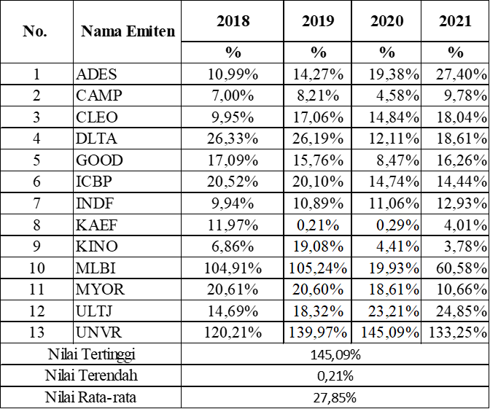

LAMPIRAN 7

Data Perkembangan *Debt to Equity Ratio* (DER)

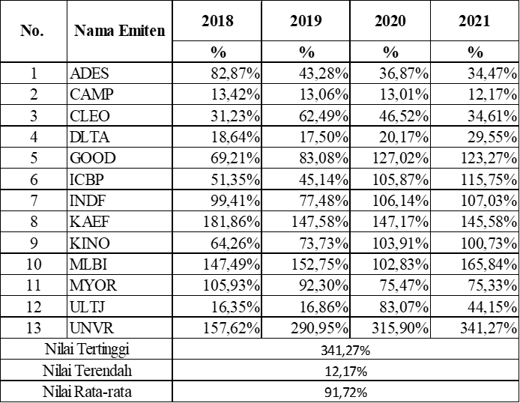

LAMPIRAN 8

Data Perkembangan *growth*

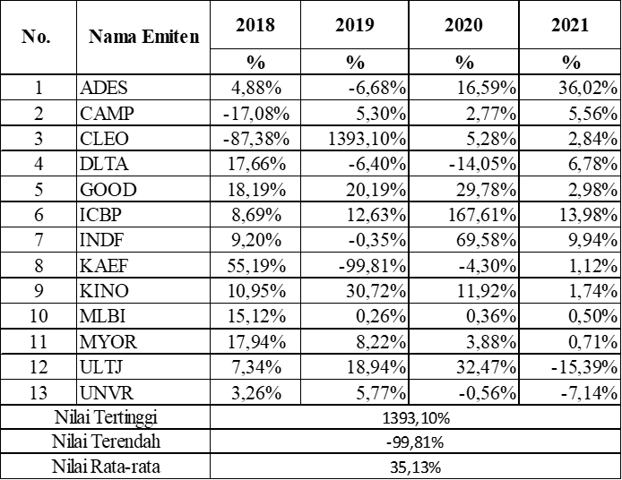

LAMPIRAN 9

Data Perkembangan *Firm Size*

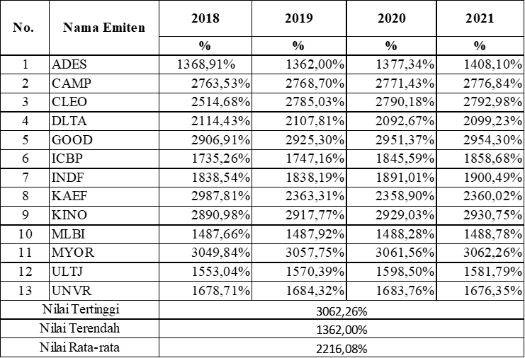

LAMPIRAN 10

Data Perkembangan *price to book value* (PBV)

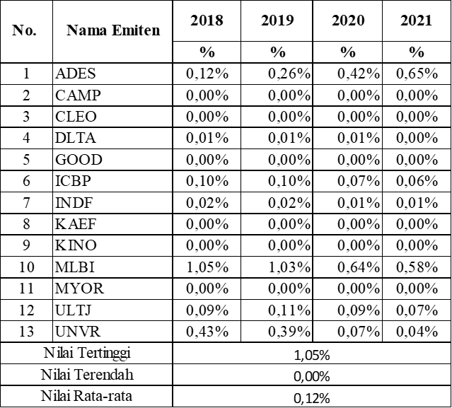

LAMPIRAN 11

Hasil Uji Normalitas

1. Grafik Histogram Uji Normalitas

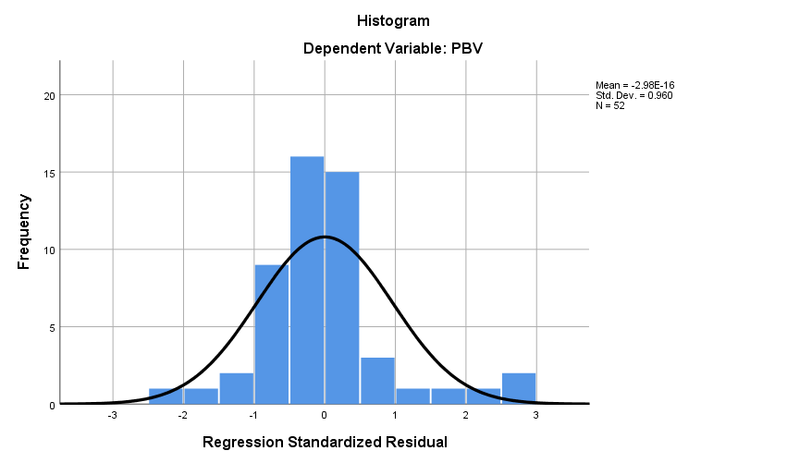

1. Grafik Normal P-Plot of Regression Standardized Residual

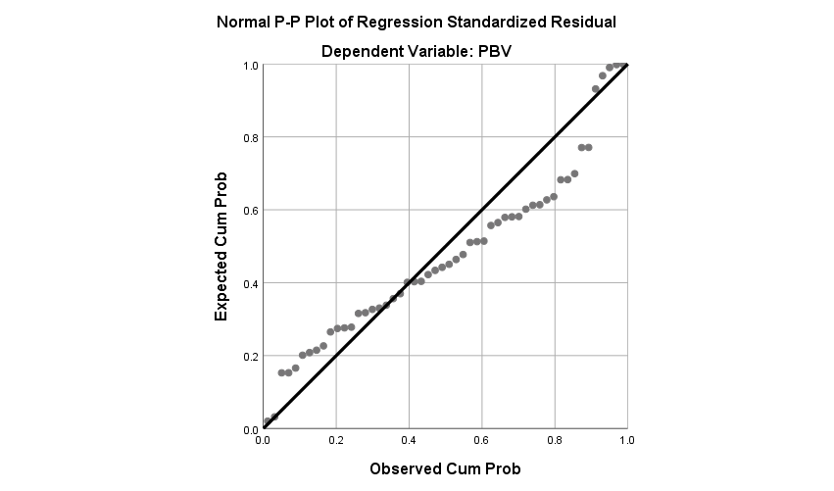

LAMPIRAN 12

Hasil Uji Normalitas

|  |  |  |  |
| --- | --- | --- | --- |
| **One-Sample Kolmogorov-Smirnov Test** | | | |
|  | | | Unstandardized Residual |
| N | | | 41 |
| Normal Parametersa,b | Mean | | .0000000 |
| Std. Deviation | | .01241913 |
| Most Extreme Differences | Absolute | | .091 |
| Positive | | .091 |
| Negative | | -.045 |
| Test Statistic | | | .091 |
|  | | |  |
| Asymp. Sig. (2-tailed) | | | .200c,d |
| Monte Carlo Sig. (2-tailed) | Sig. | | .859e |
| 99% Confidence Interval | Lower Bound | .850 |
| Upper Bound | .868 |
| a. Test distribution is Normal. | | | |
| b. Calculated from data. | | | |
| c. Lilliefors Significance Correction. | | | |
| d. This is a lower bound of the true significance. | | | |
| e. Based on 10000 sampled tables with starting seed 299883525. | | | |

LAMPIRAN 13

Hasil Uji Multikolonieritas

|  |  |  |  |  |  |  |  |  |  |
| --- | --- | --- | --- | --- | --- | --- | --- | --- | --- |
| **Coefficientsa** | | | | | | | | | |
| Model | | Unstandardized Coefficients | | | Standardized Coefficients | t | Sig. | Collinearity Statistics | |
| B | | Std. Error | Beta | Tolerance | VIF |
| 1 | (Constant) | | .005 | .001 |  | 3.730 | .001 |  |  | |
| ROE | | .004 | .001 | .567 | 3.286 | .002 | .378 | 2.648 | |
| DER | | -.001 | .001 | -.262 | -1.653 | .105 | .446 | 2.243 | |
| GRO | | -5.689E-6 | .000 | -.004 | -.041 | .967 | .983 | 1.017 | |
| FS | | .000 | .000 | -.385 | -3.192 | .003 | .771 | 1.298 | |
| a. Dependent Variable: PBV | | | | | | | | | |

LAMPIRAN 14

Hasil Uji Autokorelasi

|  |  |  |  |  |  |
| --- | --- | --- | --- | --- | --- |
| **Model Summaryb** | | | | | |
| Model | R | R Square | Adjusted R Square | Std. Error of the Estimate | Durbin-Watson |
| 1 | .687a | .472 | .427 | .0018974 | 1.781 |
| a. Predictors: (Constant), FS, GRO, DER, ROE | | | | | |
| b. Dependent Variable: PBV | | | | | |

LAMPIRAN 15

Hasil Uji Heteroskadastisitas

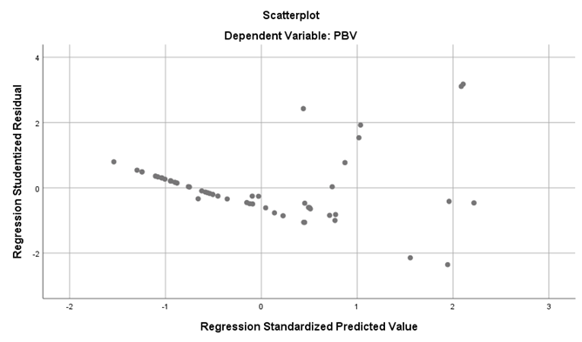

LAMPIRAN 16

Hasil Analisis Regresi Berganda

|  |  |  |  |  |  |  |  |
| --- | --- | --- | --- | --- | --- | --- | --- |
| **Coefficientsa** | | | | | | | |
| Model | | Unstandardized Coefficients | | Standardized Coefficients | t | Sig. |
| B | Std. Error | Beta |
| 1 | (Constant) | .005 | .001 |  | 3.730 | .001 |
| ROE | .004 | .001 | .567 | 3.286 | .002 |
| DER | -.001 | .001 | -.262 | -1.653 | .105 |
| GRO | -5.689E-6 | .000 | -.004 | -.041 | .967 |
| FS | .000 | .000 | -.385 | -3.192 | .003 |
| a. Dependent Variable: PBV | | | | | | | |

LAMPIRAN 17

Hasil Uji Signifikan Secara Parsial (Uji t)

|  |  |  |  |  |  |  |  |
| --- | --- | --- | --- | --- | --- | --- | --- |
| **Coefficientsa** | | | | | | | |
| Model | | Unstandardized Coefficients | | Standardized Coefficients | t | Sig. |
| B | Std. Error | Beta |
| 1 | (Constant) | .005 | .001 |  | 3.730 | .001 |
| ROE | .004 | .001 | .567 | 3.286 | .002 |
| DER | -.001 | .001 | -.262 | -1.653 | .105 |
| GRO | -5.689E-6 | .000 | -.004 | -.041 | .967 |
| FS | .000 | .000 | -.385 | -3.192 | .003 |
| a. Dependent Variable: PBV | | | | | | | |

LAMPIRAN 18

Hasil Uji Signifikan Secara Simultan (Uji F)

|  |  |  |  |  |  |  |
| --- | --- | --- | --- | --- | --- | --- |
| **ANOVAa** | | | | | | |
| Model | | Sum of Squares | Df | Mean Square | F | Sig. |
| 1 | Regression | .000 | 4 | .000 | 10.507 | .000b |
| Residual | .000 | 47 | .000 |  |  |
| Total | .000 | 51 |  |  |  |
| a. Dependent Variable: PBV | | | | | | |
| b. Predictors: (Constant), FS, GRO, DER, ROE | | | | | | |