REFERENCES

Arikunto, Suharsimi, Prosedur penelitian: suatu pendekatan praktik, Edisi Revisi VI, Jakarta: PT Rineka Cipta, 2006.

Agarid, W. R., & Nurzahra, M. (2018). Analyzing podcast application to improve listening ability. PROJECT (Professional Journal of English Education), 1(3), 175. https://doi.org/10.22460/project.v1i3.p175-180

Al Qasim, N., & Al Fadda, H. (2013). From CALL to MALL: The effectiveness of podcast on EFL higher education students’ listening comprehension. English Language Teaching, 6(9), 30–41. https://doi.org/10.5539/elt.v6n9p30

Başaran, S., Cabaroglu, N., Öğrenme, D., İngilizce Öz-Yeterlik, P., Etkisi, A., & Cabaroğlu, N. (2014). The effect of language learning podcasts on english self- efficacy international journal of language academy the effect of language learning podcasts on english self-efficacy. International Journal of LanguageAcademy,January.https://www.researchgate.net/publication/28178 1072

Cebeci, Z., & Tekdal, M. (2006). Using podcasts as audio learning objects. Interdisciplinary Journal of E-Skills and Lifelong Learning, 2(December), 047–057. https://doi.org/10.28945/400

Creswell, John W.. 2014. Research Design : Qualitative, quantitative, and mixed methods approaches. Los Angeles : SAGE Publications

Gao, X. (2020). Teachers’ perceptions of effective strategies for developing intercultural competence. Global Chinese, 6(2), 333–358. https://doi.org/10.1515/glochi-2020-0017

Gilakjani, A. P., & Sabouri, N. B. (2016). Learners’ listening comprehension difficulties in english language learning: a literature review. English Language Teaching, 9(6), 123. https://doi.org/10.5539/elt.v9n6p123

Heryanto, G., & Rahayu, S. (2021). The influence of powtoon media in teaching listening. PROJECT (Professional Journal of English Education), 4(1), 86. https://doi.org/10.22460/project.v4i1.p86-90

Horváthová, B., & Krištofovičová, K. (2020). Using podcasts to support learners` positive attitude to listening comprehension in tefl. Educational Role of Language Journal, 3(September). https://doi.org/10.36534/erlj.2020.01.07

Kurniasih, E. (2017). Writing anxiety in relation to high performing students’.
Linguistics and Literature, 1(1), 1–8.

Kusuma, C. S. D. (2018). Integrasi bahasa inggris dalam proses pembelajaran (chusnu syarifa diah kusuma). Jurnal Efisiensi-Kajian Ilmu Administrasi Edisi Agustus, XV(2), 43–50.

Melati, E., Sari, Y. R., & Siregar, S. D. (2020). Utilizing podcast to improve informatics management students’ listening comprehension and participation at amik mitra gama. Journal of English Education and Linguistics, 1(2), 64– 71.

Setyawarno, D. (2016). Panduan statistik terapan untuk penelitian pendidikan: analisis data penelitian dalam bidang pendidikan dengan aplikasi SPSS Versi
22. Pendidikan IPA FMIPA UNY, 116.

Tyagi, B. (2013). Listening: an important skill and its various aspects. The Criterion: An International Journal in English, 12(1), 1–8. www.the- criterion.com

APPENDIX

APPENDIX 1. INSTRUMENTS VALIDATION AND TRY OUT INSTRUMENTS

Appendix 1. Instruments Validation and Try Out Process

The researcher carried out several processes to find out that the instrument that had been made was validated and reliable for use in research. The following is the process and schedule for instrument validation:
- Monday, September 12, 2022. The researcher divides the class to take samples or students to try out the instrument with a total of 15 students using cluster random sampling.
- Thursday, September 15, 2022. The researcher conducted a pretest instrument test and it was carried out at the time after class hours, students using google form for multiple choice questions totaling 25 questions and audio files sent through WhatsApp group.
- Monday, September 19, 2022. The researcher conducted an instrument validation for experimental class treatment questions with the theme "British culture club episode Tea time" and carried out after class hours, students were given a google form for multiple choice questions totaling 25 questions and audio files were sent in WhatsApp group.
- Thursday, September 29, 2022. The researcher conducted an instrument experiment for control class treatment questions with the theme "British English podcast bitesize Ep30 – Let's talk about British Sweets" and was carried out after class hours, students were given a google form for multiple choice questions totaling 25 questions and audio files were sent through WhatsApp group.

- Monday, October 3, 2022. The researcher conducted a posttest instrument test and it was carried out at the time after class hours, students using google form for multiple choice questions totaling 25 questions and audio files sent in WhatsApp group.
- Tuesday, October 4, 2022. The researcher analyzed the pretest, posttest, and treatment questions using SPSS 25 to find out whether the items were valid and reliable instruments or not.

Validation and Reliability Decision

- Validation

An instrument said to be valid if can be reveal the data of the variables studied:
  - If the significance value < 0.05, then the instrument is declared valid

  - If the significance value > 0.05, then the instrument is declared invalid Comparing the value of pearson correlation table with R-table:
  - If the value of Pearson Correlation > r table product moment, then the instrument is declared valid
  - If the value of Pearson Correlation < r table product moment, then the instrument is declared invalid.

Table 1. R-Table Product Moment of Distribution
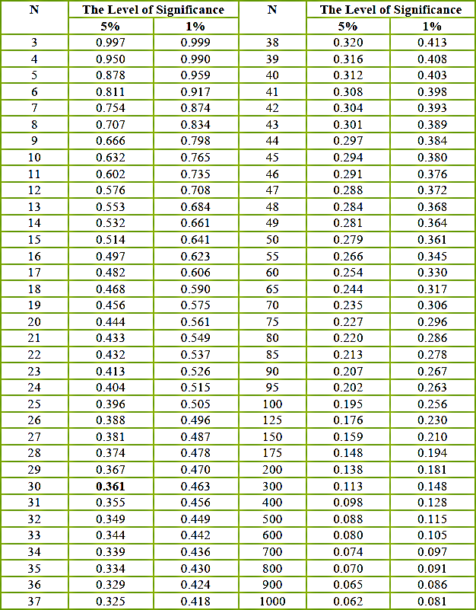

Reliability

There are said that the basis for a decision in the reliability test as follows:

  - If the value of Cronbach's Alpha> 0.700 items dictated reliable.

  - If the value of Cronbach's Alpha< 0.700 items dictated unreliable.

Validity and Reliability for Experimental Class Treatment Instruments

Based on the output in mind some values like: Pearson correlation Correlation value between of the item and a total score that Sig. (2- tailed) with significance level of 5%, while N in R-table is 46. Thus, R-table N=46 with significance level of 5% is 0.291. Here the following of R-table product moment:

Table 2. The Results of Instruments Validation for Experimental Class Treatment Based on R-Table
N  Item | Pearson Correlation | R-table 5%  (N 46) | Sig. 2- tailed | Status
1 | .742 | 0.291 | 0.002 | VALID
2 | .874 | 0.291 | 0.000 | VALID
3 | .874 | 0.291 | 0.000 | VALID
4 | .874 | 0.291 | 0.000 | VALID
5 | .874 | 0.291 | 0.000 | VALID
6 | .874 | 0.291 | 0.000 | VALID
7 | .874 | 0.291 | 0.000 | VALID
8 | .874 | 0.291 | 0.000 | VALID
9 | .874 | 0.291 | 0.000 | VALID
10 | .874 | 0.291 | 0.000 | VALID
11 | .874 | 0.291 | 0.000 | VALID
12 | .874 | 0.291 | 0.000 | VALID
13 | .874 | 0.291 | 0.000 | VALID
14 | .874 | 0.291 | 0.000 | VALID
15 | .874 | 0.291 | 0.000 | VALID
16 | .641 | 0.291 | 0.010 | VALID
17 | .483 | 0.291 | 0.068 | INVALID
18 | .483 | 0.291 | 0.068 | INVALID
19 | .874 | 0.291 | 0.000 | VALID
20 | .874 | 0.291 | 0.000 | VALID
21 | .874 | 0.291 | 0.000 | VALID
22 | .874 | 0.291 | 0.000 | VALID
23 | .874 | 0.291 | 0.000 | VALID
24 | .550 | 0.291 | 0.034 | VALID
25 | .550 | 0.291 | 0.034 | VALID
26 | .773 | 0.291 | 0.001 | VALID
27 | .674 | 0.291 | 0.006 | VALID
28 | .604 | 0.291 | 0.017 | VALID
29 | .874 | 0.291 | 0.000 | VALID
30 | .657 | 0.291 | 0.008 | VALID
31 | .657 | 0.291 | 0.008 | VALID
32 | .657 | 0.291 | 0.008 | VALID
33 | .657 | 0.291 | 0.008 | VALID
34 | .657 | 0.291 | 0.008 | VALID

35 | .657 | 0.291 | 0.008 | VALID
36 | .657 | 0.291 | 0.008 | VALID
37 | .874 | 0.291 | 0.000 | VALID
38 | .839 | 0.291 | 0.000 | VALID
39 | .874 | 0.291 | 0.000 | VALID
40 | .874 | 0.291 | 0.000 | VALID
41 | .874 | 0.291 | 0.000 | VALID
42 | .874 | 0.291 | 0.000 | VALID
43 | .874 | 0.291 | 0.000 | VALID
44 | .302 | 0.291 | 0.274 | INVALID
45 | .302 | 0.291 | 0.274 | INVALID

Table 3. The Result of Reliability Treatment Instrument for Experimental Class.

Reliability Statistics
Cronbach's Alpha | Cronbach's Alpha Based on Standardized  Items | N of Items
.711 | .643 | 46

Validity and Reliability for Control Class Treatment Instruments

Based on the output in mind some values like: Pearson correlation Correlation value between of the item and a total score that Sig. (2- tailed) with significance level of 5%, while N in R-table is 46. Thus, R-table N=46 with significance level of 5% is 0.291. Here the following of R-table product moment:
Table 2. The Results of Instruments Validation for Experimental Class Treatment Based on R-Table
N  Item | Pearson  Correlation | R-table 5%  (N 46) | Sig. 2-  tailed | Status
1 | .742 | 0.291 | 0.004 | VALID
2 | .874 | 0.291 | 0.001 | VALID
3 | .874 | 0.291 | 0.001 | VALID

4 | .874 | 0.291 | 0.007 | VALID
5 | .874 | 0.291 | 0.001 | VALID
6 | .874 | 0.291 | 0.102 | INVALID
7 | .874 | 0.291 | 0.023 | VALID
8 | .874 | 0.291 | 0.184 | INVALID
9 | .874 | 0.291 | 0.001 | VALID
10 | .874 | 0.291 | 0.001 | VALID
11 | .874 | 0.291 | 0.001 | VALID
12 | .874 | 0.291 | 0.001 | VALID
13 | .874 | 0.291 | 0.001 | VALID
14 | .874 | 0.291 | 0.001 | VALID
15 | .874 | 0.291 | 0.001 | VALID
16 | .641 | 0.291 | 0.024 | VALID
17 | .483 | 0.291 | 0.078 | INVALID
18 | .483 | 0.291 | 0.078 | INVALID
19 | .874 | 0.291 | 0.001 | VALID
20 | .874 | 0.291 | 0.001 | VALID
21 | .874 | 0.291 | 0.001 | VALID
22 | .874 | 0.291 | 0.001 | VALID
23 | .874 | 0.291 | 0.001 | VALID
24 | .550 | 0.291 | 0.132 | INVALID
25 | .550 | 0.291 | 0.132 | INVALID
26 | .773 | 0.291 | 0.000 | VALID
27 | .674 | 0.291 | 0.001 | VALID
28 | .604 | 0.291 | 0.019 | VALID
29 | .874 | 0.291 | 0.001 | VALID
30 | .657 | 0.291 | 0.000 | VALID
31 | .657 | 0.291 | 0.000 | VALID
32 | .657 | 0.291 | 0.000 | VALID
33 | .657 | 0.291 | 0.000 | VALID
34 | .657 | 0.291 | 0.000 | VALID
35 | .657 | 0.291 | 0.000 | VALID
36 | .657 | 0.291 | 0.000 | VALID
37 | .874 | 0.291 | 0.000 | VALID
38 | .839 | 0.291 | 0.000 | VALID
39 | .874 | 0.291 | 0.000 | VALID
40 | .874 | 0.291 | 0.000 | VALID
41 | .874 | 0.291 | 0.000 | VALID

42 | .874 | 0.291 | 0.000 | VALID
43 | .874 | 0.291 | 0.000 | VALID
44 | .302 | 0.291 | 0.147 | INVALID
45 | .302 | 0.291 | 0.112 | INVALID

Table 3. The Result of Reliability Treatment Instrument for Experimental Class.

Reliability Statistics
Cronbach's Alpha | Cronbach's Alpha Based on Standardized  Items | N of Items
.743 | .700 | 46

Validity and Reliability for Pretest Instruments

- Pretest Validation

Based on the output in mind some values like: Pearson correlation Correlation value between of the item and a total score that Sig. (2- tailed) with significance level of 5%, while N in R-table is 26. Thus, R-table N=26 with significance level of 5% is 0.388. Here the following of R-table product moment:
Table 5. The Results of Instruments Validation for Pretest
N  Item | Pearson  Correlation | R-table 5%  (N 26) | Sig. 2-  tailed | Status
1 | .982 | 0.388 | 0.000 | VALID
2 | .733 | 0.388 | 0.002 | VALID
3 | .982 | 0.388 | 0.000 | VALID
4 | .982 | 0.388 | 0.000 | VALID
5 | .982 | 0.388 | 0.000 | VALID
6 | .982 | 0.388 | 0.000 | VALID
7 | .982 | 0.388 | 0.000 | VALID
8 | .982 | 0.388 | 0.000 | VALID
9 | .982 | 0.388 | 0.000 | VALID
10 | .982 | 0.388 | 0.000 | VALID

11 | .982 | 0.388 | 0.000 | VALID
12 | .982 | 0.388 | 0.000 | VALID
13 | .982 | 0.388 | 0.000 | VALID
14 | .982 | 0.388 | 0.000 | VALID
15 | .982 | 0.388 | 0.000 | VALID
16 | .735 | 0.388 | 0.002 | VALID
17 | .615 | 0.388 | 0.015 | VALID
18 | .615 | 0.388 | 0.015 | VALID
19 | .735 | 0.388 | 0.002 | VALID
20 | .982 | 0.388 | 0.000 | VALID
21 | .735 | 0.388 | 0.002 | VALID
22 | .982 | 0.388 | 0.000 | VALID
23 | .735 | 0.388 | 0.002 | VALID
24 | .733 | 0.388 | 0.002 | VALID
25 | .982 | 0.388 | 0.000 | VALID

Reliability for Pretest

Table 3. The Result of Reliability Pretest Instrument

Reliability Statistics
Cronbach's Alpha | Cronbach's Alpha Based on Standardized  Items | N of Items
.755 | .949 | 26

Validity and Reliability for Posttest Instruments

- Posttest Validation

Based on the output in mind some values like: Pearson correlation Correlation value between of the item and a total score that Sig. (2- tailed) with significance level of 5%, while N in R-table is 26. Thus, R-table N=26 with significance level of 5% is 0.388. Here the following of R-table product moment:

Table 5. The Results of Instruments Validation for Posttest
N  Item | Pearson Correlation | R-table 5%  (N 26) | Sig. 2- tailed | Status
1 | .919 | 0.388 | 0.000 | VALID
2 | .919 | 0.388 | 0.000 | VALID
3 | .919 | 0.388 | 0.000 | VALID
4 | .865 | 0.388 | 0.000 | VALID
5 | .737 | 0.388 | 0.002 | VALID
6 | .737 | 0.388 | 0.002 | VALID
7 | .865 | 0.388 | 0.000 | VALID
8 | .919 | 0.388 | 0.000 | VALID
9 | .865 | 0.388 | 0.000 | VALID
10 | .919 | 0.388 | 0.000 | VALID
11 | .865 | 0.388 | 0.000 | VALID
12 | .720 | 0.388 | 0.002 | VALID
13 | .919 | 0.388 | 0.000 | VALID
14 | .919 | 0.388 | 0.000 | VALID
15 | .919 | 0.388 | 0.000 | VALID
16 | .865 | 0.388 | 0.000 | VALID
17 | .737 | 0.388 | 0.002 | VALID
18 | .737 | 0.388 | 0.002 | VALID
19 | .865 | 0.388 | 0.000 | VALID
20 | .919 | 0.388 | 0.000 | VALID
21 | .865 | 0.388 | 0.000 | VALID
22 | .919 | 0.388 | 0.000 | VALID
23 | .865 | 0.388 | 0.000 | VALID
24 | .720 | 0.388 | 0.002 | VALID
25 | .919 | 0.388 | 0.000 | VALID

Reliability for Posttest

Table 3. The Result of Reliability Posttest Instrument
Reliability Statistics
Cronbach's Alpha | Cronbach's Alpha Based on Standardized  Items | N of Items
.754 | .942 | 26

APPENDIX 2. LESSON PLAN

Appendix 2. Lesson Plan

- LESSON PLAN FOR EXPERIMENTAL CLASS

 | SEMESTER 4 STUDY PLAN | Start from:
 | UNIVERSITAS PANCASAKTI TEGAL | November 4th, 2022
  - Subject Identity
Faculty : Faculty of teacher training and education Study Program : English education study program Subject : Comprehensive Listening
Semester 4
Lecturer : Anin Eka Sulistiyawati M.Hum, S.S.
Room : -

  - Study Objectives
By using a scientific approach and discovery learning models, students are expected to be able to understand, determine, and solve problems related to podcasts and their use as listening media.
  - Study Plan / Activities
Students will be given a question sheet in the form of a google form and also a link that will be directly connected to the app of the British Culture Club Podcast. which aims to listen to podcasts and answer questions.
  - Study Methods
The study method used is through several processes starting with knowing what a podcast is, the types of podcasts and finally listening to podcasts.
  - Study Evaluation
Evaluate during study and practice about understanding and what difficulties students face when listening to podcasts.

LESSON PLAN FOR CONTROL CLASS

 | SEMESTER 4 STUDY PLAN | Start from:
 | UNIVERSITAS PANCASAKTI TEGAL | November 4th, 2022
  - Subject Identity
Faculty : Faculty of teacher training and education Study Program : English education study program Subject : Comprehensive Listening
Semester 4
Lecturer : Anin Eka Sulistiyawati M.Hum, S.S.
Room : -

  - Study Objectives
By using a scientific approach and discovery learning models, students are expected to be able to understand, determine, and solve problems related to podcasts and their use as listening media.
  - Study Plan / Activities
Students will be given a question sheet in the form of a google form and also a link that will be directly connected to the app of the British English Podcast. which aims to listen to podcasts and answer questions.
  - Study Methods
The study method used is through several processes starting with knowing what a podcast is, the types of podcasts and finally listening to podcasts.
  - Study Evaluation

Evaluate during study and practice about understanding and what difficulties students face when listening to podcasts.

APPENDIX 3. LISTENING TEST WORKSHEETS

Appendix 3. Listening Test Worksheets

- PRETEST WORKSHEETS

Pretest worksheet - Green Tea Power by Nutrition Facts with Dr. Greger

- on the podcast did the host mention that green tea can treat cancer?
  - a. not mentioned on podcast b. Yes, it is true
c. no that's wrong

- on the podcast did the host explain about the benefits of green tea for lowering cholesterol?
  - not mentioned on podcast
  - no that's wrong c. Yes, it is true

- on the podcast did the host explain about the benefits of green tea for weight loss and improving the immune system?
  - not mentioned on podcast b. Yes, it is true
c. no that's wrong

- did the host explain on the podcast about the ancient belief that green tea is a weapon to kill viruses and disease?
  - Yes, it is true
  - not mentioned on podcast
  - no that's wrong

- Green tea can increase the level of collagen in the skin is that true?
  - Yes, it is true
  - not mentioned on podcast
  - no that's wrong

- the host explains on the podcast that tea is the best drink in the world
  - Yes, it is true
  - not mentioned on podcast
  - no that's wrong

- the host explained that tea came to the UK in 1984
  - Yes, it is true
  - no that's wrong
  - not mentioned on podcast

- tea is a very expensive spice in ancient times
  - Yes, it is true
  - no that's wrong
  - not mentioned on podcast

- Green tea is very good for children's brain development a. not mentioned on podcast
b. no that's wrong
c. Yes, it is true

- In 1906 green tea has been known to be used as an anti-infective is that true?
- not mentioned on podcast
- no that's wrong c. Yes, it is true

- Was it mentioned in the podcast about consuming 6 tablespoons of tea a day can improve the body's immune system?
- not mentioned on podcast
- Yes, it is true
- no that's wrong

- Fourteen minutes after consuming tea our bodies will begin to react with the benefits of tea, especially the immune system is that true?
- not mentioned on podcast
- Yes, it is true
- no that's wrong

- For people who have the flu it is not recommended to drink tea is that true? a. not mentioned on podcast
b. Yes, it is true
c. no that's wrong

- By regularly consuming green tea, you can minimize stroke, heart disease, and sudden death. Is that true?
a. not mentioned on podcast b. Yes, it is true
c. no that's wrong

- The host explained that if humans drink one cup of tea a day, it can make humans healthier and fitter
- Yes, it is true
- not mentioned on podcast
- no that's wrong

- Tea can make human hair thicker
- Yes, it is true
- not mentioned on podcast
- no that's wrong

- Drinking green tea with ice can activate cancer cells in the human body
- Yes, it is true
- not mentioned on podcast c. no that's wrong

- Tea is a plant native to the mountains of Africa
- Yes, it is true
- not mentioned on podcast c. no that's wrong

- Tea is used as a traditional medicine in mainland China a. Yes, it is true
b. not mentioned on podcast
c. no that's wrong

- According to research, consuming green tea regularly can reduce the risk of developing cancer
- Yes, it is true
- not mentioned on podcast
- no that's wrong

- In women, drinking green tea too often can cause breast cancer cells to activate
- Yes, it is true
- not mentioned on podcast c. no that's wrong

- Green tea can make skin look younger
- Yes, it is true
- not mentioned on podcast
- no that's wrong

- According to the podcast, green tea is able to regenerate damaged DNA cells a. Yes, it is true
b. not mentioned on podcast
c. no that's wrong

- Drinking tea an hour before doing activities can increase morale a. Yes, it is true
b. not mentioned on podcast
c. no that's wrong

- Anti-inflammatory in green tea can be used to relieve pain in wisdom teeth
- no that's wrong
- not mentioned on podcast c. Yes, it is true

TREATMENT WORKSHEETS FOR EXPERIMENTAL GROUP

Treatment worksheet Experimental class ( British culture club episode Tea time )

- Was tea imported to the UK in the 17th century?
  - not mentioned on podcast b. Yes, it is true
c. no that's wrong

- According to the first informant, tea is a drink that can be drunk at any time, is that true?
  - no that's wrong b. Yes, it is true
c. not mentioned on podcast

- is it true that the meaning of "afternoon tea" is literally drinking tea in the afternoon? a. no that's wrong
b. Yes, it is true
c. not mentioned on podcast

- is it true that the meaning of "tea time" is the time that is used to drink tea only? a. no that's wrong
b. Yes, it is true
c. not mentioned on podcast

- Is it true that "tea time" is just an activity to drink tea? a. no that's wrong
b. Yes, it is true
c. not mentioned on podcast

- According to informant named Ann, the meaning of "tea time" is the same as "happy time" is that true?
  - no that's wrong b. Yes, it is true
c. not mentioned on podcast

- According to Ann “tea time” not only about snacks but also have to have good nutrition is that true?
  - no that's wrong b. Yes, it is true
c. not mentioned on podcast

- According to informant named Ann, cake , cheese , and fruit are complementary foods when doing " tea time " is that true ?
  - no that's wrong b. Yes, it is true
c. not mentioned on podcast

- According to Ann, there are many types of drinks that use tea at "tea time" activities according to their country. Is that true?
  - no that's wrong b. Yes, it is true
c. not mentioned on podcast

- According to Ann, cream tea is part of "afternoon tea" is that true?
a. no that's wrong b. Yes, it is true
c. not mentioned on podcast

- According to Marry "afternoon tea time" is very popular in the UK is that true?
a. no that's wrong b. Yes, it is true
c. not mentioned on podcast

- According to Marry pastry is the food most often served at the time of "afternoon tea" is that true?
a. no that's wrong b. Yes, it is true
c. not mentioned on podcast

- According to Marry " afternoon tea time " is usually done to celebrate birthdays , graduation events , or family parties is that true ?
a. no that's wrong b. Yes, it is true
c. not mentioned on podcast

- According to Marry the right way to make the best "cup of tea" is to use the classic style is that true?
a. no that's wrong b. Yes, it is true
c. not mentioned on podcast

- According to Marry three keys to success to make the best "cup of tea" is it true?
- no that's wrong
- not mentioned on podcast c. Yes, it is true

- Does tea come from the UK? a. no is not
b. Yes it is
c. not mentioned on podcast

- Did Ann also explain about the types of tea?
- Yes she is
- No she didn’t
- not mentioned on podcast

- Did Ann tell the host how to make good tea?
a. No she didn’t b. Yes, she is
c. not mentioned on podcast

- Did Ann explain what ingredients she uses to make tea during "tea time?"
a. No she didn’t b. Yes she is
c. not mentioned on podcast

- Does Ann have a special recipe for making tea-based drinks?
- No she didn’t
- not mentioned on podcast c. Yes she is

- According to Marry, is making food and drink an art? a. Yes
b. not mentioned on podcast
c. No

- Does Marry give any tips for serving special meals to her guests at the restaurant where she works for "afternoon tea?"
- no she didn’t
- not mentioned on podcast c. Yes, she is

- Does Marry provide an explanation of the price given for each meal she serves at "afternoon tea?"
- no that's wrong
- not mentioned on podcast
- Yes, she is

- Did Marry explain about the special recipes of the food and drinks she serves in the hotel where she works?
- Yes, she is
- not mentioned on podcast
- No she didn’t

- Based on the results of the discussion between the host and the resource person named Anne when the supper usually served ?
a. Half seven b. Five
c. Eleven
d. Half five

- Where is Julia's shop located? a. Bath
b. London
c. Liverpool

- Julia: Well, I think England, as much as I love it, tends to be a bit grey and wet at this time of year.
Pay attention to the underlined sentence, what do you think the sentence is related to?
- the price of the gift
- the color of the wrapping paper c. rainy season

- Based on the podcast chrismas episode what activities do UK people usually do at Christmas? Except !
- decorate christmas tree
- give gifts to other family members c. sunbathing on the beach

- Based on the podcast chrismas episode during what season do UK people usually celebrate Christmas?
- Autumn
- Fall
- Winter

- What decorations are commonly installed at Christmas? except !
- Christmas tree
- Santa Claus statue c. Loudspeaker

- Based on the podcast christmas episode, Where is the big Christmas tree installed? a. The abbey
b. Town square
c. Shopping center
- Based on the podcast christmas episode, when do UK residents usually come to The Abbey to see the big Christmas tree?
- Monday morning
- Tuesday night
- Saturday afternoon

- What is Julia's favorite activity to celebrate Christmas? a. dinner and chatting with extended family
b. wash dishes
c. sleep every day

- Where does Su usually watch the Christmas choir performance in Bath ?
- shopping center
- beach c. Circus

- What food is usually served at Christmas in UK? except !
- milk pie
- gingerbread c. spaghetti

- What activities do they not do at Christmas? Except !
- make a sand castle
- sunbathing on the beach c. sing christmas carol

- What colors are usually used to decorate a Christmas tree? a. silver and gold
b. black and brown
c. white and black

- When is Christmas usually celebrated? a. December
b. January
c. August

- Activities that are often done at Christmas are a. give gifts to each other
b. playing hide and seek
c. prank friends

- What are the characteristics of Christmas? Except !
- Santa Claus and his stag carriage
- Christmas tree c. horror story

- Christmas nuances at Beth UK are synonymous with what kind of atmosphere?
- sad atmosphere
- happy atmosphere
- scary atmosphere

- how does santa claus look like?
a. skinny old man with gift bag b. fat old man with white beard
c. old woman with long nose

- What kind of tree are Christmas trees usually made of?
a. cactus tree b. spruce
c. bamboo tree

- Where do they usually celebrate Christmas?
- in the hospital and in the office
- in the garden and in the parking lot c. at home and at church

- What song do they usually sing at Christmas?
a. romantic song b. spiritual songs
c. pop song

TREATMENT WORKSHEETS FOR CONTROL CLASS

Treatment worksheet ( British English podcast bitesize Ep30 – Let’s talk about British Sweets )

- Based on the podcast, does the UK have different types of food which is eaten as a side dish when drinking tea?
  - Yes, it is true
  - no that's wrong
  - not mentioned on podcast

- Is chocolate one of the foods that are often eaten by the people of the UK?
  - no that's wrong b. Yes, it is true
c. not mentioned on podcast

- Did the interviewee explain the various types of chocolate on the podcast?
  - Perhaps
  - Yes, it is true
  - not mentioned on podcast

- Did the interviewee mention a chocolate brand named Willy Wonka on the podcast?
  - no that's wrong
  - Yes, it is true
  - not mentioned on podcast

- Did the interviewees explain the various famous chocolate brands on the podcast? a. Yes, it is true
b. Perhaps
c. not mentioned on podcast

- Is chocolate usually a side dish for drinking tea by the UK community? a. no that's wrong
b. Yes, it is true
c. not mentioned on podcast

- Do people in the UK like to mix syrup into their tea?
  - no that's wrong b. Yes, it is true
c. not mentioned on podcast

- Do people in the UK like to mix chocolate in their tea? a. no that's wrong
b. Yes, it is true
c. not mentioned on podcast

- Did the informant explain about egg-shaped chocolate?
  - no that's wrong b. Yes, it is true
c. not mentioned on podcast

- Did the informant explain that the egg-shaped chocolate contains syrup?
a. no that's wrong b. Yes, it is true
c. not mentioned on podcast

- Is it true that ice cream is the UK's favorite food in the summer?
a. no that's wrong b. Yes, it is true
c. not mentioned on podcast

- Did the informant explain in detail about the temperature needed to make ice cream ?
a. no that's wrong b. Yes, it is true
c. not mentioned on podcast

- Do people in the UK prefer a cup of tea to ice cream?
- no that's wrong
- Yes, it is true
- not mentioned on podcast

- Did the informant explain about the ice cream flavor variant that he likes?
a. no that's wrong b. Yes, it is true
c. not mentioned on podcast

- Is tea the drink that is most often drunk than ice cream? a. no that's wrong
b. Yes, it is true
c. not mentioned on podcast

- Did the interviewee explain about the ice cream truck on this podcast?
a. no that's wrong b. Yes, it is true
c. not mentioned on podcast

- Did the interviewees explain about the various flavors of tea on the podcast?
- no that's wrong
- Yes, it is true
- not mentioned on podcast

- Did the informant explain about ice cream that has a tea flavor?
a. no that's wrong b. Yes, it is true
c. not mentioned on podcast

- Is java cake a food that is often consumed by the people of the UK?
a. no that's wrong b. Yes, it is true
c. not mentioned on podcast

- Does the interviewee really like chocolate with an orange flavor?
a. no that's wrong
b. Yes, it is true
c. not mentioned on podcast

- According to the informant, java cake has similarities with the sponge cake he explained on the podcast, is that true?
a. no that's wrong
b. Yes, it is true
c. not mentioned on podcast

- Did the informant explain that biscuits are foods that are usually consumed as a companion when drinking tea ?
a. no that's wrong
b. Yes, it is true
c. not mentioned on podcast

- Did the interviewee explain the differences between biscuits and cakes on the podcast?
a. no that's wrong
b. Yes, it is true
c. not mentioned on podcast

- Did the interviewee explain about the different textures of cakes, biscuits, and java cakes on the podcast?
a. no that's wrong
b. Yes, it is true
c. not mentioned on podcast

- Did the informant explain how to eat the cake the right way?
a. no that's wrong b. Yes, it is true
c. not mentioned on podcast

- Did the informants explain the difference in the Christmas atmosphere in the UK and Australia ?
a. no that's wrong b. Yes, it is true
c. not mentioned on podcast

- When celebrating Christmas, do UK and Australia have different seasons?
a. no that's wrong b. Yes, it is true
c. not mentioned on podcast

- On the podcast, the speaker discussed "sky rocket" the meaning of the word "sky rocket" is to go very fast is that true?
- no that's wrong
- Yes, it is true
- not mentioned on podcast

- The meaning of "sky rocket" is the discount that is in the store at Christmas is that true?
a. no that's wrong b. Yes, it is true
c. not mentioned on podcast

- Do the UK people gather in front of the big ben clock when celebrating Christmas and New Years?
a. no that's wrong b. Yes, it is true
c. not mentioned on podcast

- Does the interviewee have many friends who are of the same faith in the UK?
a. no that's wrong b. Yes, it is true
c. not mentioned on podcast

- Does the UK require people to celebrate Christmas with their families?
a. no that's wrong b. Yes, it is true
c. not mentioned on podcast

- Is it true that in ancient times the tradition of celebrating Christmas in the UK had to be with the family and if not the person would be punished?
a. no that's wrong b. Yes, it is true
c. not mentioned on podcast

- Does the Christmas holiday tradition in the UK start at the end of November?
a. no that's wrong b. Yes, it is true
c. not mentioned on podcast

- Did the informant explain about an advertisement for the brand "coca cola" which is only played during the Christmas holidays?
- no that's wrong
- not mentioned on podcast c. Yes, it is true

- The tradition of decorating the Christmas tree is something that the family of the informant must do, is that true?
- no that's wrong
- not mentioned on podcast c. Yes, it is true

- Does the interviewee only want to use real fir trees when celebrating Christmas?
a. no that's wrong b. Yes, it is true
c. not mentioned on podcast

- What playstation games did the interviewees play during the Christmas holidays? a. Violent & football games
b. Adventure & farming games
c. Fantasy & magical games

- Do people in the UK think that Christmas is a special day?
a. no that's wrong b. Yes, it is true
c. not mentioned on podcast

- Did the interviewees think that the children of the previous generation were more interested in Christmas than the children of the current generation?
- Yes, it is true
- no that's wrong
- not mentioned on podcast

- The interviewees thought that opening present at Christmas was a very interesting activity. Is that true?
- not mentioned on podcast
- no that's wrong c. Yes, it is true

- Did the informant tell about his childhood celebrating Christmas by having dinner at the pub with his family?
- no that's wrong
- not mentioned on podcast c. Yes, it is true

- The informant said that his friends who live in Europe also open gifts only on Christmas Eve. Is that true?
a. not mentioned on podcast b. Yes, it is true
c. no that's wrong

- The informant said that when he was a child he could only open one gift when he woke up in the morning. Is that true?
- Yes, it is true
- not mentioned on podcast
- no that's wrong

- The informant explained that at Christmas in the UK the gifts would be placed on the bed, unlike in America the gifts would be put in socks that were hung near the fireplace. Is that true?
- Yes, it is true
- no that's wrong
- not mentioned on podcast

POSTTEST WORKSHEETS

Postest worksheet podcast episode - Drink tea and carry on by Thinking nutrition
- Does tea have health benefits for the body?
  - not mentioned on podcast b. Yes, it is true
c. no that's wrong

- Does the podcast mention some chronic diseases that can be prevented by consuming tea?
  - no that's wrong
  - not mentioned on podcast c. yes it is mentioned

- Are heart disease, diabetes, cancer and improving mental health a disease that can be minimized by regularly consuming tea?
  - Yes, it is true
  - not mentioned on podcast
  - no that's wrong

- Does the podcast only explain about the camellia sinensis tea variety??
  - not mentioned on podcast
  - no that's wrong c. Yes, it is true

- Are black tea, green tea, oolong tea and white tea the most popular types of tea?
  - not mentioned on podcast
  - no that's wrong c. Yes, it is true

- Is herbal tea included in the type of tea? a. no that's wrong
b. not mentioned on podcast
c. Yes, it is true

- Is herbal tea made of chamomile and peppermint ?
  - no that's wrong
  - not mentioned on podcast c. Yes, it is true

- Is the tea plant a native plant originating from China and India?
  - not mentioned on podcast b. Yes, it is true
c. no that's wrong

- Does the podcast explain that tea contains polyphenols and caffeine which have benefits for the body?
  - Yes, it is true
  - no that's wrong
  - not mentioned on podcast

- Black tea, green tea, and oolong tea come from the same type of plant is that true?
- no that's wrong
- not mentioned on podcast c. Yes, it is true

- On the podcast it is explained that all types of tea have a different taste depending on how they are processed. Is that true?
- no that's wrong
- not mentioned on podcast c. Yes, it is true
- Is it true that when the tea has been oxidized the color will turn brown?
- no that's wrong
- not mentioned on podcast c. Yes, it is true

- Black tea is a type of tea that has the highest caffeine content among other types of tea. Is that true?
- Yes, it is true
- no that's wrong
- not mentioned on podcast

- Polyphenols are the best tea content for the human body is that true?
- Yes, it is true
- no that's wrong
- not mentioned on podcast

- Polyphenols in tea have the benefit of regenerating dead body cells. Is that true?
- Yes, it is true
- no that's wrong

- not mentioned on podcast
- On the podcast mentioned if tea has benefits for reducing bad cholesterol levels is that true?
- not mentioned on podcast
- no that's wrong
- Yes, it is true

- Does the podcast describe a good way to drink tea? a. not mentioned on podcast
b. no that's wrong
c. Yes, it is true

- Is it true that tea can inhibit the growth of cancer cells according to the researchers?
- no that's wrong
- not mentioned on podcast c. Yes, it is true

- Green tea is believed by people to be useful for reducing weight, is it true?
- no that's wrong
- not mentioned on podcast c. Yes, it is true

- On the podcast mentioned if consuming green tea can reduce weight within 3 months is that true?
- not mentioned on podcast
- Yes, it is true
- no that's wrong

- On the podcast mentioned that tea can reduce the level of depression is that true?
- not mentioned on podcast
- Yes, it is true
- no that's wrong

- Is it true that oolong tea is very good for skin health? a. not mentioned on podcast
b. Yes, it is true
c. no that's wrong

- Tea is the most widely consumed beverage in the world is that true? a. not mentioned on podcast
b. Yes, it is true
c. no that's wrong

- Tea is the most profitable commodity to be used as a business field is that true? a. not mentioned on podcast
b. Yes, it is true
c. no that's wrong

- Oolong tea is the most sought after tea in the whole world is it true? a. not mentioned on podcast
b. Yes, it is true
c. no that's wrong

APPENDIX 4. STUDENTS’ LISTENING SCORE

Appendix 4. Students’ Listening Score

- STUDENTS’ LISTENING SCORE CATEGORY BASED ON IRUBRIC ASSESSMENT

Experimental Class

No. | NAME | METTING/SCORE
 |  | M1 | M2 | M3 | M4 | M5
1. | Parasdita ajeng maharani (1620600026) | 1 | 1 | 3 | 4 | 4
2. | Sofyan Hanif (1620600035) | 2 | 1 | 2 | 3 | 4
3. | Tarisna Dwi (1620600041) | 1 | 1 | 2 | 3 | 4
4. | Zainmiswa Pamungkas (1620600039) | 2 | 2 | 3 | 4 | 4
5. | Putri Imellia (1620600045) | 1 | 1 | 2 | 3 | 3
6. | Nurdina Erinne Mahardini (1620600019) | 1 | 2 | 2 | 3 | 4
7. | Royin Tanjalin Nasfar (1620600028) | 1 | 2 | 2 | 3 | 3
8. | Lutfiatul Maulidah (1620600043) | 1 | 1 | 2 | 3 | 3
9. | Retno Setianingrum (1620600003) | 2 | 2 | 2 | 3 | 4
10. | Sherlin Melvia Reica (1620600001) | 1 | 2 | 2 | 2 | 3
11. | Siti Nur' Azizah (1620600018) | 1 | 1 | 2 | 3 | 4
12. | Laellatul Sadiyah (1620600048) | 2 | 2 | 3 | 2 | 4
13. | Robi'atul Adawiyah (1620600034) | 1 | 1 | 1 | 3 | 4
14. | Atalia Zahra (1620600049) | 1 | 2 | 2 | 2 | 3
15. | Rodhotul Janah (1620600033) | 1 | 2 | 3 | 3 | 4
16. | Halfi Azzahra (1620600027) | 2 | 1 | 2 | 2 | 3
17. | Ayyasy Shihabbudin (1620600046) | 2 | 2 | 2 | 3 | 3
18. | Naufal Rafi Saputra (1620600012) | 2 | 2 | 2 | 2 | 4
19. | Rega Bela Karisma (1620600006) | 1 | 2 | 2 | 3 | 3
20. | Rindam Pramudya Kusuma (1620600025) | 2 | 2 | 1 | 3 | 4
21. | Highya Syamsidar Asror (1622600025) | 2 | 1 | 2 | 2 | 3

  - Control Class

No. | NAME | SCORE
 |  | M1 | M2 | M3 | M4 | M5
1. | Zalza Fina Oktafiana (1620600007) | 1 | 2 | 2 | 3 | 4
2. | Berliana Sefy Anggraeni (1620600011) | 2 | 2 | 3 | 3 | 4
3. | Erni Arnika (1620600015) | 1 | 1 | 2 | 3 | 4
4. | Aulia Nailin Ni’mah (1620600005) | 2 | 1 | 2 | 2 | 3
5. | Gigih Indra Ramadhan (1620600024) | 2 | 1 | 1 | 3 | 4
6. | Dewi Sinta Nuriyah Agustina (1619500062) | 1 | 1 | 2 | 3 | 4
7. | Almanda Tiara Mahdani (1620600017) | 2 | 2 | 2 | 3 | 4
8. | Isnani Liza Afifah (1620600009) | 1 | 2 | 2 | 2 | 3
9. | Putri amalia amanda (1620600042) | 2 | 2 | 2 | 3 | 4
10. | Hilwa Azzahro Salsabillah (1620600014) | 2 | 2 | 1 | 2 | 3
11. | Gilang Ardiansyah (1619500027) | 2 | 1 | 1 | 2 | 3
12. | Izatul Ganiasih (1620600004) | 1 | 1 | 3 | 2 | 3
13. | Bagas Johan (1620600023) | 2 | 2 | 2 | 2 | 3
14. | M Irsan Lazuardi (1620600036) | 1 | 2 | 2 | 3 | 4
15. | Nur Sya'bandiah (1620600013) | 2 | 1 | 1 | 2 | 4
16. | Nadiya Noviyanti (1620600002) | 2 | 2 | 2 | 3 | 4

STUDENTS’ LISTENING SCORE DURING TREATMENT

  - Experimental Class

No. | NAME | SCORE
1. | Parasdita ajeng maharani (1620600026) | 70
2. | Sofyan Hanif (1620600035) | 68
3. | Tarisna Dwi (1620600041) | 75

4. | Zainmiswa Pamungkas (1620600039) | 78
5. | Putri Imellia (1620600045) | 60
6. | Nurdina Erinne Mahardini (1620600019) | 60
7. | Royin Tanjalin Nasfar (1620600028) | 67
8. | Lutfiatul Maulidah (1620600043) | 71
9. | Retno Setianingrum (1620600003) | 63
10. | Sherlin Melvia Reica (1620600001) | 69
11. | Siti Nur' Azizah (1620600018) | 76
12. | Laellatul Sadiyah (1620600048) | 72
13. | Robi'atul Adawiyah (1620600034) | 74
14. | Atalia Zahra (1620600049) | 65
15. | Rodhotul Janah (1620600033) | 75
16. | Halfi Azzahra (1620600027) | 68
17. | Ayyasy Shihabbudin (1620600046) | 74
18. | Naufal Rafi Saputra (1620600012) | 75
19. | Rega Bela Karisma (1620600006) | 70
20. | Rindam Pramudya Kusuma (1620600025) | 70
21. | Highya Syamsidar Asror (1622600025) | 71

Control Class

No. | NAME | SCORE
1. | Zalza Fina Oktafiana (1620600007) | 69
2. | Berliana Sefy Anggraeni (1620600011) | 75
3. | Erni Arnika (1620600015) | 80
4. | Aulia Nailin Ni’mah (1620600005) | 80

5. | Gigih Indra Ramadhan (1620600024) | 77
6. | Dewi Sinta Nuriyah Agustina (1619500062) | 88
7. | Almanda Tiara Mahdani (1620600017) | 65
8. | Isnani Liza Afifah (1620600009) | 71
9. | Putri amalia amanda (1620600042) | 73
10. | Hilwa Azzahro Salsabillah (1620600014) | 75
11. | Gilang Ardiansyah (1619500027) | 67
12. | Izatul Ganiasih (1620600004) | 80
13. | Bagas Johan (1620600023) | 60
14. | M Irsan Lazuardi (1620600036) | 64
15. | Nur Sya'bandiah (1620600013) | 79
16. | Nadiya Noviyanti (1620600002) | 78

- STUDENTS’ LISTENING SCORE IN PRETEST

Experimental Class

No. | NAME | SCORE
1. | Parasdita ajeng maharani (1620600026) | 68
2. | Sofyan Hanif (1620600035) | 62
3. | Tarisna Dwi (1620600041) | 62
4. | Zainmiswa Pamungkas (1620600039) | 82
5. | Putri Imellia (1620600045) | 60
6. | Nurdina Erinne Mahardini (1620600019) | 60
7. | Royin Tanjalin Nasfar (1620600028) | 65
8. | Lutfiatul Maulidah (1620600043) | 67
9. | Retno Setianingrum (1620600003) | 63
10. | Sherlin Melvia Reica (1620600001) | 69
11. | Siti Nur' Azizah (1620600018) | 55
12. | Laellatul Sadiyah (1620600048) | 60
13. | Robi'atul Adawiyah (1620600034) | 55

14. | Atalia Zahra (1620600049) | 65
15. | Rodhotul Janah (1620600033) | 68
16. | Halfi Azzahra (1620600027) | 68
17. | Ayyasy Shihabbudin (1620600046) | 65
18. | Naufal Rafi Saputra (1620600012) | 63
19. | Rega Bela Karisma (1620600006) | 68
20. | Rindam Pramudya Kusuma (1620600025) | 55
21. | Highya Syamsidar Asror (1622600025) | 66

  - Control Class

No. | NAME | SCORE
1. | Zalza Fina Oktafiana (1620600007) | 65
2. | Berliana Sefy Anggraeni (1620600011) | 70
3. | Erni Arnika (1620600015) | 80
4. | Aulia Nailin Ni’mah (1620600005) | 80
5. | Gigih Indra Ramadhan (1620600024) | 75
6. | Dewi Sinta Nuriyah Agustina (1619500062) | 81
7. | Almanda Tiara Mahdani (1620600017) | 70
8. | Isnani Liza Afifah (1620600009) | 67
9. | Putri amalia amanda (1620600042) | 72
10. | Hilwa Azzahro Salsabillah (1620600014) | 75
11. | Gilang Ardiansyah (1619500027) | 65
12. | Izatul Ganiasih (1620600004) | 80
13. | Bagas Johan (1620600023) | 60
14. | M Irsan Lazuardi (1620600036) | 63
15. | Nur Sya'bandiah (1620600013) | 77
16. | Nadiya Noviyanti (1620600002) | 75

STUDENTS’ LISTENING SCORE IN POSTTEST

  - Experimental Class

No. | NAME | SCORE
1. | Parasdita ajeng maharani (1620600026) | 80
2. | Sofyan Hanif (1620600035) | 77
3. | Tarisna Dwi (1620600041) | 75
4. | Zainmiswa Pamungkas (1620600039) | 86
5. | Putri Imellia (1620600045) | 75
6. | Nurdina Erinne Mahardini (1620600019) | 72
7. | Royin Tanjalin Nasfar (1620600028) | 73
8. | Lutfiatul Maulidah (1620600043) | 77
9. | Retno Setianingrum (1620600003) | 75
10. | Sherlin Melvia Reica (1620600001) | 83
11. | Siti Nur' Azizah (1620600018) | 75
12. | Laellatul Sadiyah (1620600048) | 77
13. | Robi'atul Adawiyah (1620600034) | 70
14. | Atalia Zahra (1620600049) | 80
15. | Rodhotul Janah (1620600033) | 77
16. | Halfi Azzahra (1620600027) | 82
17. | Ayyasy Shihabbudin (1620600046) | 73
18. | Naufal Rafi Saputra (1620600012) | 75
19. | Rega Bela Karisma (1620600006) | 80
20. | Rindam Pramudya Kusuma (1620600025) | 70
21. | Highya Syamsidar Asror (1622600025) | 76

  - Control Class

No. | NAME | SCORE
1. | Zalza Fina Oktafiana (1620600007) | 70
2. | Berliana Sefy Anggraeni (1620600011) | 76

3. | Erni Arnika (1620600015) | 70
4. | Aulia Nailin Ni’mah (1620600005) | 72
5. | Gigih Indra Ramadhan (1620600024) | 76
6. | Dewi Sinta Nuriyah Agustina (1619500062) | 83
7. | Almanda Tiara Mahdani (1620600017) | 67
8. | Isnani Liza Afifah (1620600009) | 73
9. | Putri amalia amanda (1620600042) | 75
10. | Hilwa Azzahro Salsabillah (1620600014) | 77
11. | Gilang Ardiansyah (1619500027) | 68
12. | Izatul Ganiasih (1620600004) | 82
13. | Bagas Johan (1620600023) | 65
14. | M Irsan Lazuardi (1620600036) | 66
15. | Nur Sya'bandiah (1620600013) | 80
16. | Nadiya Noviyanti (1620600002) | 75

APPENDIX 5. STUDENTS’ WORKS AND DOCUMENTATION

Appendix 5. Students’ Works and Documentation

- Experimental Class

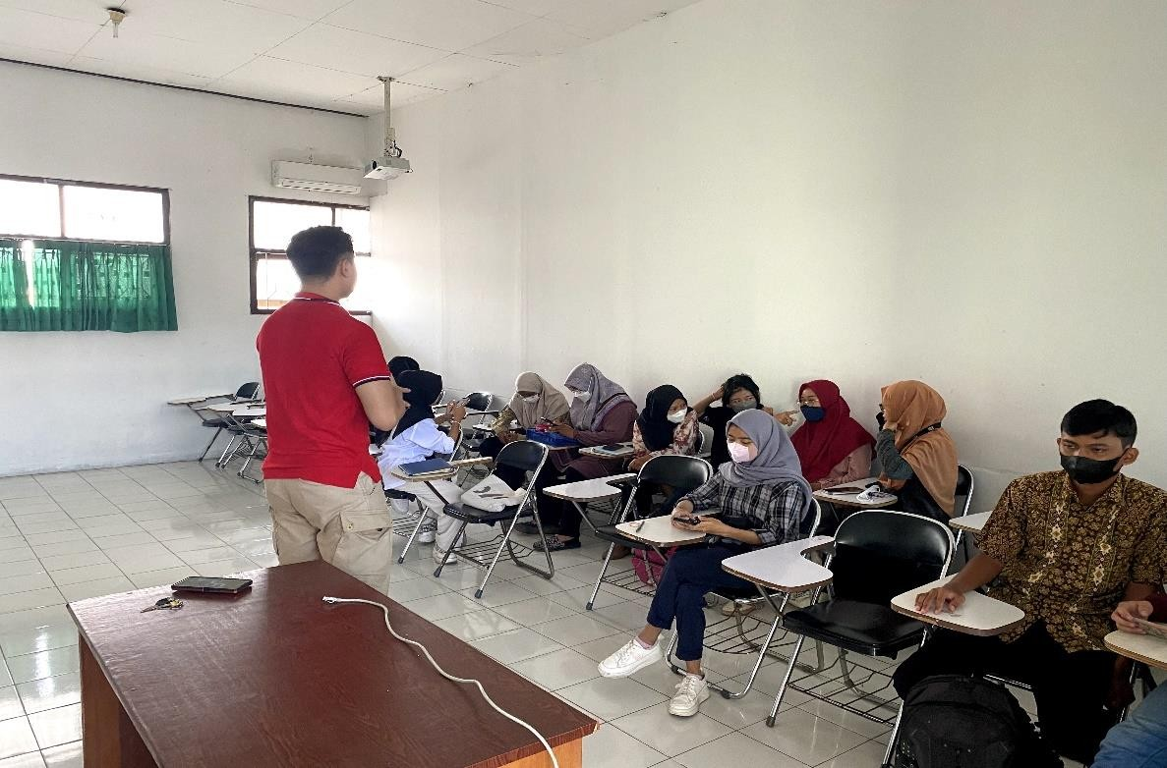

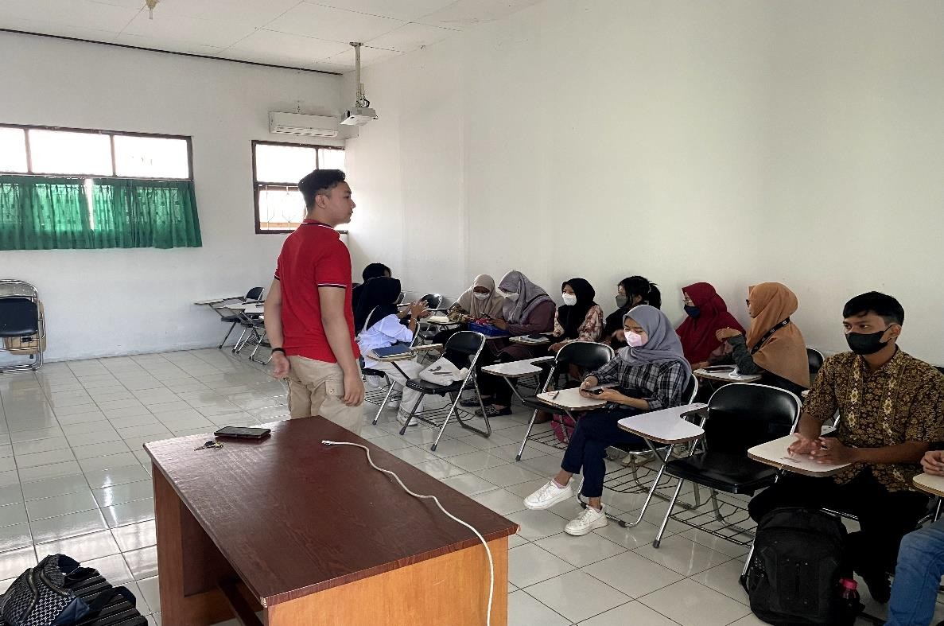

- Control Class
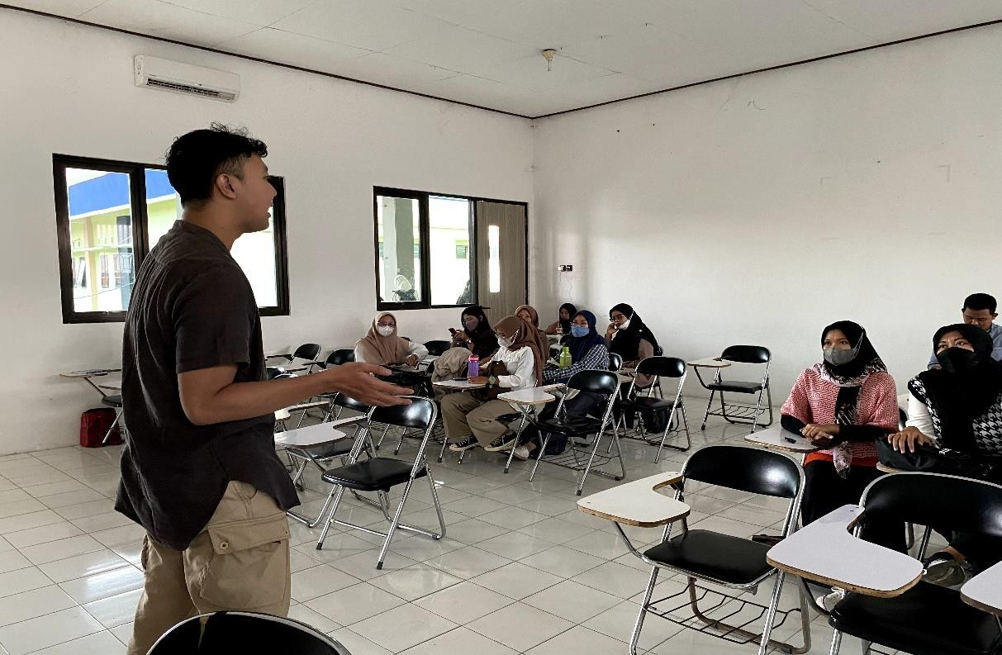

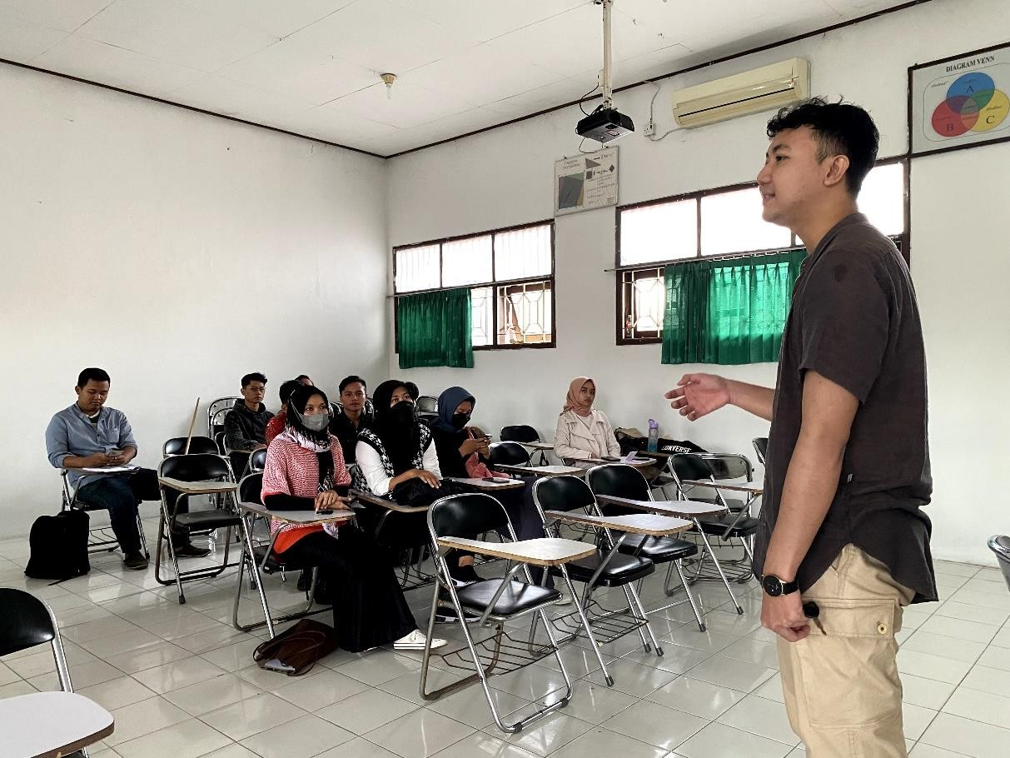

APPENDIX 6. BERITA ACARA UJIAN SKRIPSI DAN BIMBINGAN

Appendix 6. Berita Acara Ujian Skripsi Dan Bimbingan

  - Berita acara ujian skripsi
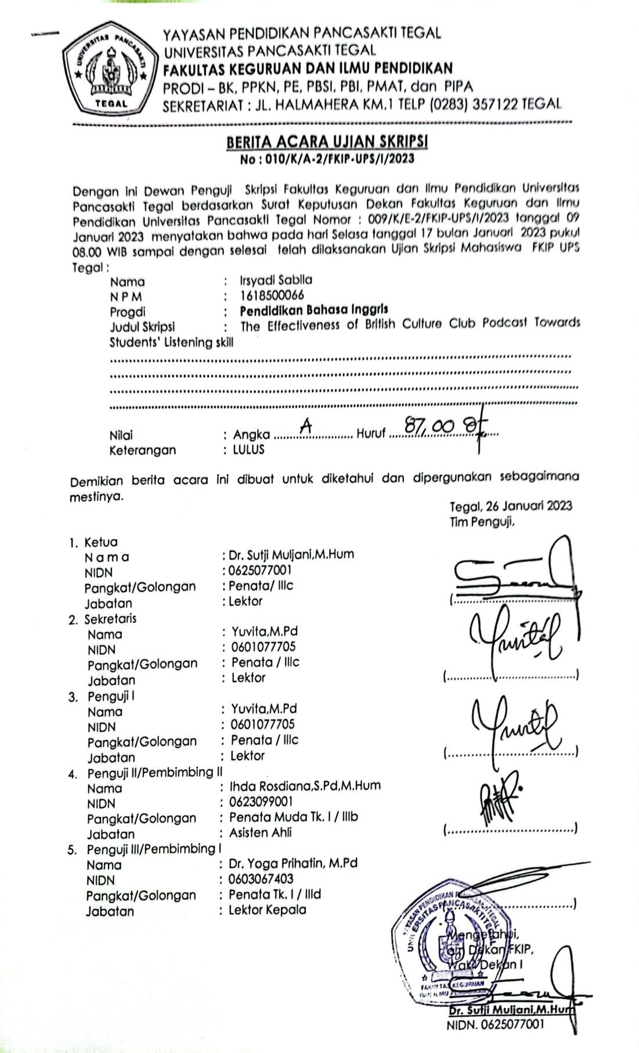

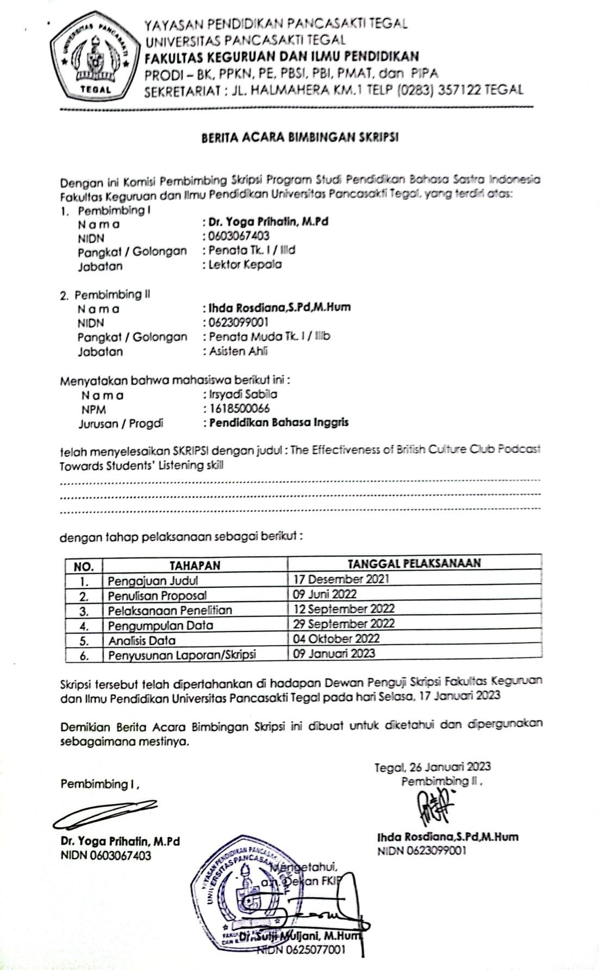
  - Berita acara bimbingan skripsi

