**DAFTAR PUSTAKA**

Ajzen, Icek. "The theory of planned behavior." *Organizational behavior and human decision processes* 50.2 (1991): 179-211.

AlfitriAnti, Mellinia, and Eko Setyanto. "PENGARUH PENGETAHUAN PERPAJAKAN DAN SANKSI PAJAK TERHADAP KEPATUHAN WAJIB PAJAK PELAKU UMKM DI KOTA BANDUNG." *Progress: Jurnal Pendidikan, Akuntansi dan Keuangan* 6.1 (2023): 64-75.

Ariani, M., & Biettant, R. (2018). Pengaruh pelayanan fiskus terhadap kepatuhan wajib pajak dengan variabel intervening kepuasan wajib pajak. *Jurnal Informasi, Perpajakan, Akuntansi, Dan Keuangan Publik*, *13*(1), 15-30.

Ariyanto, D., & Nuswantara, D. A. (2020). Pengaruh persepsi tarif pajak terhadap kepatuhan wajib pajak UMKM. AKUNESA: Jurnal Akuntansi Unesa, 8(3), 1-9.

Astuti, T., & Panjaitan, I. (2018). Pengaruh moral wajib pajak dan demografi wajib pajak terhadap kepatuhan wajib pajak UMKM dengan sanksi perpajakan sebagai pemoderasi. *Media Akuntansi Perpajakan*, *3*(1), 58-73

Aswati, W. O., Mas’Ud, A., & Nudi, T. N. (2018). Pengaruh kesadaran wajib pajak, pengetahuan pajak, dan akuntabilitas pelayanan publik terhadap kepatuhan wajib pajak kendaraan bermotor (Studi kasus kantor UPTB SAMSAT Kabupaten Muna). *Jurnal Akuntansi Dan Keuangan*, *3*(1), 27-39.

Budhiarsana, I. W., Dwirandra, A. A. N., & Putra, I. N. W. A. (2016). Kepuasan Sebagai Pemoderasi Pengaruh Keadilan Distributif, Penegakan Sanksi pada Kepatuhan Wajib Pajak Hotel dan Restoran. *E-Jurnal Ekonomi Dan Bisnis Universitas Udayana*, *4*, 721-748.

Dharma, G. P. E., & Suardana, K. A. (2014). Pengaruh kesadaran wajib pajak, sosialisasi perpajakan, kualitas pelayanan pada kepatuhan wajib pajak. E-Jurnal Akuntansi Universitas Udayana, 6(1), 340-353.

Djou, L. G. (2019). Analisis pengaruh literasi keuangan, sikap keuangan dan kepribadian terhadap perilaku pengelolaan keuangan UMKM di Kabupaten Ende. Jurnal Magisma, 7(2), 1-12.

Faidah, F. (2019). Pengaruh literasi keuangan dan faktor demografi terhadap minat investasi mahasiswa. *Journal of Applied Business and Economic*, *5*(3), 251-263.

Fatimah, N., & Susanti, S. (2018). Pengaruh Pembelajaran Akuntansi Keuangan, Literasi Keuangan, Dan Pendapatan Terhadap Perilaku Keuangan Mahasiswa Fakultas Ekonomi Universitas Muhammadiyah Gresik. Jurnal Pendidikan Akuntansi (JPAK), 6(1), 48-57.

Fitrianingsih, Fita, S. Sudarno, and Taufik Kurrohman. "Analisis pengaruh pengetahuan perpajakan, pelayanan fiskus dan sanksi denda terhadap kepatuhan wajib pajak dalam membayar pajak bumi dan bangunan perdesaan dan perkotaan di Kota Pasuruan." *E-Journal Ekonomi Bisnis Dan Akuntansi* 5.1 (2018): 100-104.

Fuadi, A. O., & Mangoting, Y. (2013). Pengaruh kualitas pelayanan petugas pajak, sanksi perpajakan dan biaya kepatuhan pajak terhadap kepatuhan wajib pajak UMKM. Tax & Accounting Review, 1(1), 18**.**

Hani, D. A. U., & Furqon, I. K. (2021). Pengaruh Sanksi Pajak Serta Pengetahuan Masyarakat Tentang Pajak Terhadap Kepatuhan Membayar Wajib Pajak. *UTILITY: Jurnal Ilmiah Pendidikan dan Ekonomi*, *5*(01), 10-15.

Herryanto, M., & Toly, A. A. (2013). Pengaruh kesadaran wajib pajak, kegiatan sosialisasi perpajakan, dan pemeriksaan pajak terhadap penerimaan pajak penghasilan di KPP Pratama Surabaya Sawahan. *Tax & Accounting Review*, *1*(1), 124.\

Indrawan, R., & Binekas, B. (2018). Pengaruh Pemahaman Pajak dan Pengetahuan Pajak Terhadap Kepatuhan Wajib Pajak UMKM. Jurnal Riset Akuntansi dan Keuangan, 6(3), 419-428.

Irmawati, J., & Hidayatulloh, A. (2019). Determinan kepatuhan wajib pajak UMKM di Kota Yogyakarta. *Jurnal Sikap*, *3*(2), 112-121.

JOTOPURNOMO, Cindy; MANGOTING, Yenni. Pengaruh kesadaran wajib pajak, kualitas pelayanan fiskus, sanksi perpajakan, lingkungan wajib pajak berada terhadap kepatuhan wajib pajak orang pribadi di Surabaya. *Tax & Accounting Review*, 2013, 1.1: 49.

Kusumadewi, D. R., & Dyarini, D. (2022). Pengaruh Literasi Pajak, Modernisasi Sistem Administrasi, Insentif Pajak dan Moral Pajak Terhadap Kepatuhan Wajib Pajak UMKM. *Jurnal Akuntansi Dan Keuangan*, *10*(2), 171-182.

Lianty, Meiska, Dini Wahjoe Hapsari, and K. Kurnia. "Pengetahuan perpajakan, sosialisasi perpajakan, dan pelayanan fiskus terhadap kepatuhan wajib pajak." *JRAK* 9.2 (2017): 55-65.

Mansur, Fitrini, et al. "Pengaruh pengetahuan pajak, kesadaran pajak dan tarif pajak terhadap kepatuhan pajak wajib Pajak UKM Kota Jambi." *E-Jurnal Perspektif Ekonomi Dan Pembangunan Daerah* 11.1 (2022): 69-82.

MEI, Magdalena; FIRMANSYAH, Amrie. Kepatuhan wajib pajak dari sudut pandang pengetahuan pajak, kualitas pelayanan, sanksi pajak: pemoderasi preferensi risiko. *E-Jurnal Akuntansi*, 2022, 32.11: 3272-3288.

Mukhlis, I., & Simanjuntak, T. H. (2018). The relationship between capital expend.

*Lampiran 1****Lampiran 1***

**Data Penelitian Variabel Literasi Pajak**

|  |  |  |  |  |  |  |  |  |  |  |
| --- | --- | --- | --- | --- | --- | --- | --- | --- | --- | --- |
| **Responden** |  | **Literasi** |  | **Pajak** |  |  |  |  | | **X1** |
|  | **P1** | **P2** | **P3** | **P4** | **P5** | **P6** | **P7** | **P8** | **TOTAL** | |
| R 1 | 4 | 5 | 5 | 5 | 5 | 4 | 5 | 4 | 37 | |
| R 2 | 4 | 4 | 4 | 4 | 4 | 4 | 5 | 4 | 33 | |
| R 3 | 4 | 4 | 4 | 4 | 4 | 4 | 4 | 4 | 32 | |
| R 4 | 4 | 5 | 5 | 4 | 4 | 4 | 5 | 4 | 35 | |
| R 5 | 4 | 5 | 5 | 4 | 4 | 4 | 5 | 4 | 35 | |
| R 6 | 5 | 5 | 5 | 4 | 4 | 4 | 4 | 4 | 35 | |
| R 7 | 5 | 5 | 4 | 4 | 4 | 4 | 4 | 4 | 34 | |
| R 8 | 5 | 5 | 5 | 4 | 4 | 4 | 4 | 4 | 35 | |
| R 9 | 4 | 5 | 5 | 4 | 4 | 4 | 4 | 4 | 34 | |
| R 10 | 4 | 5 | 5 | 4 | 4 | 4 | 4 | 4 | 34 | |
| R 11 | 4 | 5 | 5 | 5 | 4 | 4 | 4 | 4 | 35 | |
| R 12 | 4 | 5 | 5 | 4 | 4 | 4 | 4 | 4 | 34 | |
| R 13 | 4 | 5 | 5 | 5 | 4 | 4 | 4 | 5 | 36 | |
| R 14 | 4 | 5 | 5 | 4 | 4 | 4 | 4 | 4 | 34 | |
| R 15 | 4 | 5 | 5 | 5 | 4 | 4 | 4 | 4 | 35 | |
| R 16 | 4 | 5 | 5 | 4 | 4 | 4 | 4 | 4 | 34 | |
| R 17 | 4 | 4 | 5 | 5 | 4 | 4 | 4 | 4 | 34 | |
| R 18 | 4 | 5 | 5 | 4 | 4 | 4 | 4 | 4 | 34 | |
| R 19 | 5 | 4 | 5 | 5 | 5 | 4 | 5 | 5 | 38 | |
| R 20 | 4 | 4 | 4 | 5 | 5 | 4 | 5 | 4 | 35 | |
| R 21 | 4 | 4 | 5 | 4 | 4 | 4 | 5 | 4 | 34 | |
| R 22 | 5 | 4 | 4 | 5 | 4 | 4 | 5 | 4 | 35 | |
| R 23 | 4 | 4 | 5 | 5 | 4 | 4 | 4 | 5 | 35 | |
| R 24 | 4 | 5 | 4 | 4 | 5 | 4 | 4 | 4 | 34 | |
| R 25 | 4 | 4 | 4 | 4 | 5 | 4 | 4 | 4 | 33 | |
| R 26 | 4 | 4 | 4 | 3 | 5 | 4 | 4 | 4 | 32 | |
| R 27 | 4 | 4 | 4 | 5 | 5 | 4 | 4 | 4 | 34 | |
| R 28 | 4 | 5 | 4 | 4 | 5 | 4 | 4 | 4 | 34 | |
| R 29 | 4 | 4 | 4 | 4 | 5 | 4 | 4 | 5 | 34 | |
| R 30 | 4 | 4 | 4 | 4 | 5 | 4 | 4 | 4 | 33 | |
| R 31 | 4 | 4 | 4 | 4 | 5 | 4 | 4 | 4 | 33 | |
| R 32 | 4 | 4 | 4 | 4 | 5 | 4 | 4 | 4 | 33 | |
| R 33 | 4 | 4 | 4 | 4 | 4 | 4 | 4 | 4 | 32 | |
| R 34 | 4 | 4 | 4 | 4 | 5 | 4 | 4 | 5 | 34 | |
| R 35 | 4 | 4 | 4 | 4 | 4 | 4 | 4 | 4 | 32 | |
| R 36 | 4 | 4 | 4 | 4 | 5 | 4 | 4 | 4 | 33 | |
| R 37 | 4 | 4 | 4 | 5 | 3 | 4 | 4 | 5 | 33 | |
| R 38 | 4 | 4 | 4 | 5 | 5 | 4 | 4 | 4 | 34 | |
| R 39 | 4 | 4 | 4 | 4 | 3 | 4 | 4 | 4 | 31 | |
| R 40 | 4 | 4 | 4 | 5 | 5 | 4 | 4 | 5 | 35 | |
| R 41 | 4 | 4 | 4 | 3 | 5 | 4 | 4 | 4 | 32 | |
| R 42 | 4 | 4 | 4 | 4 | 3 | 4 | 4 | 5 | 32 | |
| R 43 | 4 | 4 | 4 | 5 | 5 | 4 | 4 | 4 | 34 | |
| R 44 | 4 | 4 | 4 | 5 | 3 | 4 | 4 | 4 | 32 | |
| R 45 | 4 | 4 | 4 | 5 | 5 | 4 | 4 | 5 | 35 | |
| R 46 | 4 | 4 | 4 | 3 | 4 | 4 | 4 | 4 | 31 | |
| R 47 | 4 | 4 | 4 | 5 | 3 | 4 | 4 | 5 | 33 | |
| R 48 | 4 | 4 | 4 | 3 | 3 | 4 | 4 | 5 | 31 | |
| R 49 | 4 | 4 | 4 | 5 | 3 | 4 | 4 | 4 | 32 | |
| R 50 | 4 | 4 | 4 | 5 | 5 | 4 | 4 | 4 | 34 | |
| R 51 | 4 | 4 | 4 | 3 | 3 | 4 | 4 | 5 | 31 | |
| R 52 | 4 | 4 | 4 | 4 | 5 | 4 | 4 | 5 | 34 | |
| R 53 | 4 | 4 | 4 | 5 | 5 | 4 | 4 | 4 | 34 | |
| R 54 | 4 | 4 | 4 | 4 | 4 | 4 | 4 | 4 | 32 | |
| R 55 | 4 | 4 | 4 | 5 | 3 | 4 | 4 | 4 | 32 | |
| R 56 | 4 | 4 | 4 | 3 | 4 | 4 | 4 | 5 | 32 | |
| R 57 | 4 | 4 | 4 | 3 | 4 | 4 | 4 | 5 | 32 | |
| R 58 | 4 | 4 | 4 | 5 | 3 | 4 | 4 | 4 | 32 | |
| R 59 | 4 | 4 | 4 | 3 | 4 | 4 | 4 | 5 | 32 | |
| R 60 | 4 | 4 | 4 | 3 | 3 | 4 | 4 | 5 | 31 | |
| R 61 | 4 | 4 | 4 | 5 | 4 | 4 | 4 | 4 | 33 | |
| R 62 | 4 | 4 | 4 | 5 | 5 | 4 | 4 | 5 | 35 | |
| R 63 | 4 | 4 | 4 | 5 | 4 | 4 | 4 | 4 | 33 | |
| R 64 | 4 | 4 | 4 | 5 | 5 | 4 | 4 | 4 | 34 | |
| R 65 | 4 | 4 | 4 | 3 | 3 | 4 | 4 | 5 | 31 | |
| R 66 | 4 | 4 | 4 | 5 | 5 | 4 | 4 | 5 | 35 | |
| R 67 | 4 | 4 | 4 | 5 | 5 | 4 | 4 | 5 | 35 | |
| R 68 | 4 | 4 | 4 | 5 | 5 | 4 | 4 | 4 | 34 | |
| R 69 | 4 | 4 | 4 | 5 | 3 | 4 | 4 | 5 | 33 | |
| R 70 | 4 | 4 | 4 | 4 | 5 | 4 | 4 | 5 | 34 | |
| R 71 | 4 | 4 | 4 | 4 | 4 | 4 | 4 | 4 | 32 | |
| R 72 | 4 | 4 | 4 | 5 | 5 | 4 | 4 | 4 | 34 | |
| R 73 | 4 | 4 | 4 | 5 | 4 | 4 | 4 | 5 | 34 | |
| R 74 | 4 | 4 | 4 | 4 | 5 | 4 | 4 | 4 | 33 | |
| R 75 | 4 | 4 | 4 | 5 | 4 | 4 | 4 | 5 | 34 | |
| R 76 | 4 | 4 | 4 | 5 | 4 | 4 | 4 | 5 | 34 | |
| R 77 | 4 | 4 | 4 | 3 | 4 | 4 | 4 | 4 | 31 | |
| R 78 | 4 | 4 | 4 | 3 | 3 | 4 | 4 | 5 | 31 | |
| R 79 | 4 | 4 | 4 | 5 | 4 | 4 | 4 | 4 | 33 | |
| R 80 | 4 | 4 | 4 | 5 | 5 | 4 | 4 | 4 | 34 | |
| R 81 | 4 | 4 | 4 | 5 | 5 | 4 | 4 | 5 | 35 | |
| R 82 | 4 | 4 | 4 | 4 | 4 | 4 | 4 | 4 | 32 | |
| R 83 | 4 | 4 | 4 | 3 | 3 | 4 | 4 | 4 | 30 | |
| R 84 | 4 | 4 | 4 | 3 | 4 | 4 | 4 | 4 | 31 | |
| R 85 | 4 | 4 | 4 | 3 | 3 | 4 | 4 | 5 | 31 | |
| R 86 | 4 | 4 | 4 | 5 | 5 | 4 | 4 | 4 | 34 | |
| R 87 | 4 | 4 | 4 | 5 | 5 | 4 | 4 | 4 | 34 | |
| R 88 | 4 | 4 | 4 | 5 | 5 | 4 | 4 | 5 | 35 | |
| R 89 | 4 | 4 | 4 | 5 | 5 | 4 | 4 | 4 | 34 | |
| R 90 | 4 | 4 | 4 | 5 | 5 | 4 | 4 | 4 | 34 | |
| R 91 | 4 | 4 | 4 | 5 | 5 | 4 | 4 | 5 | 35 | |
| R 92 | 4 | 4 | 4 | 5 | 5 | 4 | 4 | 5 | 35 | |
| R 93 | 4 | 4 | 4 | 5 | 5 | 4 | 4 | 4 | 34 | |
| R 94 | 4 | 4 | 4 | 3 | 3 | 4 | 4 | 5 | 31 | |
| R 95 | 4 | 4 | 4 | 3 | 4 | 4 | 4 | 5 | 32 | |
| R 96 | 4 | 4 | 4 | 5 | 5 | 4 | 4 | 5 | 35 | |
| R 97 | 4 | 4 | 4 | 5 | 3 | 4 | 4 | 4 | 32 | |
| R 98 | 4 | 4 | 4 | 5 | 5 | 4 | 4 | 4 | 34 | |
| R 99 | 4 | 4 | 4 | 5 | 5 | 4 | 4 | 4 | 34 | |
| R 100 | 4 | 4 | 4 | 5 | 5 | 4 | 4 | 4 | 34 | |
| R 101 | 4 | 4 | 4 | 5 | 5 | 4 | 4 | 4 | 34 | |
| R 102 | 4 | 4 | 4 | 5 | 3 | 4 | 4 | 4 | 32 | |
| R 103 | 4 | 4 | 4 | 3 | 5 | 4 | 4 | 4 | 32 | |
| R 104 | 4 | 4 | 4 | 5 | 5 | 4 | 4 | 4 | 34 | |
| R 105 | 4 | 4 | 4 | 5 | 3 | 4 | 4 | 4 | 32 | |
| R 106 | 4 | 4 | 3 | 3 | 3 | 4 | 4 | 4 | 29 | |
| R 107 | 4 | 4 | 4 | 5 | 5 | 4 | 4 | 5 | 35 | |
| R 108 | 4 | 4 | 3 | 5 | 5 | 4 | 4 | 4 | 33 | |
| R 109 | 4 | 4 | 4 | 5 | 5 | 4 | 4 | 5 | 35 | |
| R 110 | 4 | 4 | 4 | 5 | 5 | 4 | 4 | 4 | 34 | |
| R 111 | 4 | 4 | 4 | 5 | 5 | 4 | 4 | 4 | 34 | |
| R 112 | 4 | 4 | 4 | 3 | 5 | 4 | 4 | 4 | 32 | |
| R 113 | 4 | 4 | 4 | 5 | 5 | 4 | 4 | 5 | 35 | |
| R 114 | 4 | 4 | 4 | 5 | 5 | 4 | 4 | 4 | 34 | |
| R 115 | 4 | 4 | 4 | 5 | 5 | 4 | 4 | 4 | 34 | |
| R 116 | 4 | 4 | 4 | 3 | 5 | 4 | 4 | 5 | 33 | |
| R 117 | 4 | 4 | 4 | 5 | 5 | 4 | 4 | 4 | 34 | |
| R 118 | 4 | 4 | 4 | 5 | 4 | 4 | 4 | 4 | 33 | |
| R 119 | 4 | 4 | 4 | 5 | 5 | 4 | 4 | 5 | 35 | |
| R 120 | 4 | 4 | 4 | 5 | 5 | 4 | 4 | 4 | 34 | |
| R 121 | 4 | 4 | 4 | 5 | 5 | 4 | 4 | 4 | 34 | |
| R 122 | 4 | 4 | 4 | 5 | 4 | 4 | 4 | 4 | 33 | |
| R 123 | 4 | 4 | 4 | 5 | 3 | 4 | 4 | 5 | 33 | |
| R 124 | 4 | 4 | 4 | 5 | 5 | 4 | 4 | 5 | 35 | |
| R 125 | 4 | 4 | 4 | 5 | 3 | 4 | 4 | 4 | 32 | |
| R 126 | 4 | 4 | 4 | 5 | 5 | 4 | 4 | 5 | 35 | |
| R 127 | 4 | 4 | 4 | 5 | 5 | 4 | 4 | 4 | 34 | |
| R 128 | 4 | 4 | 4 | 5 | 3 | 4 | 4 | 4 | 32 | |
| R 129 | 4 | 4 | 4 | 5 | 4 | 4 | 4 | 4 | 33 | |
| R 130 | 4 | 4 | 4 | 5 | 4 | 4 | 4 | 4 | 33 | |
| R 131 | 4 | 4 | 4 | 5 | 5 | 4 | 4 | 4 | 34 | |
| R 132 | 4 | 4 | 4 | 5 | 3 | 4 | 4 | 4 | 32 | |
| R 133 | 4 | 4 | 4 | 3 | 3 | 4 | 4 | 5 | 31 | |
| R 134 | 4 | 4 | 4 | 5 | 5 | 4 | 4 | 4 | 34 | |
| R 135 | 4 | 4 | 4 | 5 | 3 | 4 | 4 | 5 | 33 | |
| R 136 | 4 | 4 | 4 | 3 | 3 | 4 | 4 | 5 | 31 | |
| R 137 | 4 | 4 | 4 | 5 | 5 | 4 | 4 | 4 | 34 | |
| R 138 | 4 | 4 | 4 | 3 | 3 | 4 | 4 | 4 | 30 | |
| R 139 | 4 | 4 | 4 | 5 | 3 | 4 | 4 | 4 | 32 | |
| R 140 | 4 | 4 | 3 | 5 | 5 | 4 | 4 | 4 | 33 | |
| R 141 | 4 | 4 | 4 | 5 | 3 | 4 | 4 | 4 | 32 | |
| R 142 | 4 | 4 | 4 | 5 | 3 | 4 | 4 | 4 | 32 | |
| R 143 | 4 | 4 | 4 | 5 | 5 | 4 | 4 | 4 | 34 | |
| R 144 | 4 | 4 | 4 | 5 | 3 | 4 | 4 | 4 | 32 | |
| R 145 | 4 | 4 | 4 | 5 | 5 | 4 | 4 | 5 | 35 | |
| R 146 | 4 | 4 | 4 | 5 | 3 | 4 | 4 | 4 | 32 | |
| R 147 | 4 | 4 | 4 | 3 | 5 | 4 | 4 | 4 | 32 | |
| R 148 | 4 | 4 | 4 | 5 | 5 | 4 | 4 | 5 | 35 | |
| R 149 | 4 | 4 | 4 | 5 | 5 | 4 | 4 | 4 | 34 | |
| R 150 | 4 | 4 | 4 | 5 | 5 | 4 | 4 | 4 | 34 | |
| R 151 | 4 | 4 | 4 | 5 | 5 | 4 | 4 | 5 | 35 | |
| R 152 | 4 | 4 | 4 | 5 | 5 | 4 | 4 | 4 | 34 | |
| R 153 | 4 | 4 | 4 | 3 | 5 | 4 | 4 | 5 | 33 | |
| R 154 | 4 | 4 | 4 | 4 | 4 | 4 | 4 | 4 | 32 | |
| R 155 | 4 | 4 | 4 | 5 | 5 | 4 | 4 | 4 | 34 | |
| R 156 | 4 | 4 | 4 | 4 | 3 | 4 | 4 | 5 | 32 | |
| R 157 | 4 | 4 | 4 | 5 | 4 | 4 | 4 | 4 | 33 | |
| R 158 | 4 | 4 | 4 | 3 | 5 | 4 | 4 | 5 | 33 | |
| R 159 | 4 | 4 | 4 | 5 | 5 | 4 | 4 | 4 | 34 | |
| R 160 | 4 | 4 | 4 | 5 | 5 | 4 | 4 | 5 | 35 | |
| R 161 | 4 | 4 | 4 | 5 | 5 | 4 | 4 | 4 | 34 | |
| R 162 | 4 | 4 | 4 | 5 | 5 | 4 | 4 | 4 | 34 | |
| R 163 | 4 | 4 | 4 | 4 | 5 | 4 | 5 | 4 | 34 | |
| R 164 | 5 | 4 | 5 | 5 | 5 | 4 | 5 | 5 | 38 | |
| R 165 | 4 | 4 | 4 | 4 | 4 | 4 | 5 | 4 | 33 | |
| R 166 | 4 | 4 | 5 | 5 | 5 | 4 | 5 | 4 | 36 | |
| R 167 | 5 | 4 | 5 | 5 | 4 | 4 | 5 | 5 | 37 | |
| R 168 | 4 | 4 | 4 | 5 | 3 | 4 | 5 | 5 | 34 | |
| R 169 | 4 | 4 | 3 | 4 | 4 | 4 | 5 | 5 | 33 | |
| R 170 | 5 | 4 | 4 | 4 | 3 | 4 | 5 | 4 | 33 | |
| R 171 | 4 | 4 | 4 | 4 | 4 | 4 | 5 | 4 | 33 | |
| R 172 | 4 | 4 | 5 | 5 | 5 | 4 | 5 | 5 | 37 | |
| R 173 | 4 | 4 | 5 | 5 | 5 | 4 | 5 | 5 | 37 | |
| R 174 | 4 | 4 | 5 | 5 | 5 | 4 | 5 | 4 | 36 | |
| R 175 | 4 | 4 | 5 | 5 | 5 | 4 | 5 | 4 | 36 | |
| R 176 | 4 | 4 | 5 | 5 | 5 | 4 | 5 | 5 | 37 | |
| R 177 | 4 | 4 | 5 | 5 | 5 | 4 | 5 | 4 | 36 | |
| R 178 | 4 | 4 | 5 | 5 | 5 | 4 | 5 | 4 | 36 | |
| R 179 | 4 | 4 | 5 | 5 | 5 | 4 | 5 | 5 | 37 | |
| R 180 | 4 | 4 | 5 | 5 | 5 | 4 | 5 | 4 | 36 | |
| R 181 | 4 | 4 | 5 | 5 | 5 | 4 | 5 | 5 | 37 | |
| R 182 | 4 | 4 | 5 | 5 | 5 | 4 | 5 | 4 | 36 | |
| R 183 | 4 | 4 | 5 | 5 | 5 | 4 | 5 | 4 | 36 | |
| R 184 | 4 | 4 | 5 | 5 | 5 | 4 | 5 | 4 | 36 | |
| R 185 | 4 | 4 | 5 | 5 | 5 | 4 | 5 | 5 | 37 | |
| R 186 | 4 | 4 | 5 | 5 | 5 | 4 | 5 | 4 | 36 | |
| R 187 | 5 | 4 | 5 | 4 | 3 | 4 | 5 | 4 | 34 | |
| R 188 | 5 | 4 | 4 | 4 | 5 | 4 | 5 | 4 | 35 | |
| R 189 | 5 | 4 | 5 | 4 | 4 | 4 | 5 | 4 | 35 | |
| R 190 | 4 | 4 | 5 | 3 | 4 | 4 | 5 | 4 | 33 | |
| R 191 | 4 | 4 | 5 | 4 | 4 | 4 | 5 | 5 | 35 | |
| R 192 | 4 | 4 | 5 | 4 | 5 | 4 | 5 | 5 | 36 | |
| R 193 | 5 | 4 | 5 | 4 | 3 | 4 | 5 | 3 | 33 | |
| R 194 | 5 | 4 | 5 | 4 | 3 | 4 | 5 | 4 | 34 | |
| R 195 | 5 | 4 | 55 | 4 | 4 | 4 | 5 | 4 | 85 | |
| R 196 | 5 | 4 | 4 | 4 | 4 | 4 | 5 | 5 | 35 | |
| R 197 | 4 | 4 | 4 | 4 | 3 | 4 | 4 | 4 | 31 | |
| R 198 | 4 | 4 | 5 | 4 | 4 | 4 | 5 | 4 | 34 | |
| R 199 | 5 | 4 | 5 | 4 | 3 | 4 | 5 | 5 | 35 | |
| R 200 | 4 | 4 | 4 | 4 | 3 | 4 | 5 | 4 | | |

*Lampiran 2****Lampiran 2***

**Data Penelitian Pengetahuan Pajak**

|  |  |  |  |  |  |  |  |  |  |
| --- | --- | --- | --- | --- | --- | --- | --- | --- | --- |
| **Responden** |  |  | **Pengetahuan** | **Pajak** |  |  |  |  | **X2** |
|  | **P1** | **P2** | **P3** | **P4** | **P5** | **P6** | **P7** | **P8** | **Total X2** |

|  |  |  |  |  |  |  |  |  |  |
| --- | --- | --- | --- | --- | --- | --- | --- | --- | --- |
| R 1 | 4 | 4 | 4 | 5 | 5 | 5 | 4 | 4 | 35 |
| R 2 | 5 | 5 | 4 | 4 | 5 | 5 | 5 | 5 | 38 |
| R 3 | 5 | 5 | 5 | 5 | 5 | 5 | 5 | 5 | 40 |
| R 4 | 4 | 4 | 4 | 4 | 4 | 4 | 4 | 4 | 32 |
| R 5 | 5 | 5 | 5 | 5 | 4 | 4 | 4 | 4 | 36 |
| R 6 | 4 | 4 | 4 | 5 | 5 | 5 | 4 | 4 | 35 |
| R 7 | 4 | 4 | 4 | 5 | 5 | 5 | 4 | 4 | 35 |
| R 8 | 4 | 4 | 4 | 5 | 5 | 5 | 4 | 4 | 35 |
| R 9 | 4 | 4 | 4 | 5 | 5 | 5 | 4 | 4 | 35 |
| R 10 | 4 | 4 | 4 | 5 | 5 | 5 | 4 | 4 | 35 |
| R 11 | 4 | 4 | 4 | 5 | 5 | 5 | 4 | 4 | 35 |
| R 12 | 4 | 4 | 4 | 5 | 5 | 5 | 4 | 4 | 35 |
| R 13 | 4 | 4 | 4 | 5 | 5 | 5 | 4 | 4 | 35 |
| R 14 | 4 | 4 | 4 | 5 | 5 | 5 | 4 | 4 | 35 |
| R 15 | 4 | 4 | 4 | 5 | 5 | 4 | 4 | 4 | 34 |
| R 16 | 4 | 4 | 4 | 5 | 5 | 5 | 4 | 4 | 35 |
| R 17 | 4 | 4 | 3 | 5 | 5 | 5 | 4 | 4 | 34 |
| R 18 | 4 | 3 | 3 | 5 | 5 | 5 | 4 | 3 | 32 |
| R 19 | 4 | 3 | 4 | 5 | 3 | 3 | 4 | 4 | 30 |
| R 20 | 4 | 4 | 4 | 3 | 3 | 5 | 4 | 4 | 31 |
| R 21 | 4 | 4 | 4 | 5 | 5 | 5 | 3 | 4 | 34 |
| R 22 | 4 | 3 | 4 | 5 | 3 | 5 | 3 | 4 | 31 |
| R 23 | 4 | 4 | 4 | 3 | 3 | 5 | 3 | 4 | 30 |
| R 24 | 4 | 4 | 4 | 3 | 5 | 5 | 3 | 4 | 32 |
| R 25 | 5 | 4 | 4 | 5 | 3 | 4 | 4 | 4 | 33 |
| R 26 | 4 | 5 | 5 | 4 | 5 | 4 | 4 | 3 | 34 |
| R 27 | 5 | 4 | 5 | 4 | 4 | 4 | 5 | 5 | 36 |
| R 28 | 4 | 4 | 4 | 4 | 4 | 5 | 5 | 4 | 34 |
| R 29 | 4 | 4 | 3 | 5 | 5 | 5 | 4 | 4 | 34 |
| R 30 | 5 | 4 | 4 | 3 | 4 | 4 | 5 | 5 | 34 |
| R 31 | 5 | 4 | 5 | 4 | 4 | 3 | 4 | 4 | 33 |
| R 32 | 5 | 4 | 5 | 3 | 4 | 3 | 4 | 4 | 32 |
| R 33 | 4 | 4 | 4 | 4 | 4 | 5 | 3 | 4 | 32 |
| R 34 | 4 | 4 | 4 | 4 | 3 | 4 | 4 | 4 | 31 |
| R 35 | 5 | 5 | 5 | 3 | 5 | 5 | 4 | 4 | 36 |
| R 36 | 4 | 4 | 4 | 4 | 5 | 4 | 5 | 3 | 33 |
| R 37 | 4 | 4 | 4 | 4 | 5 | 3 | 4 | 3 | 31 |
| R 38 | 5 | 5 | 4 | 4 | 4 | 4 | 4 | 4 | 34 |
| R 39 | 4 | 5 | 5 | 4 | 4 | 5 | 4 | 4 | 35 |
| R 40 | 4 | 4 | 5 | 4 | 4 | 4 | 4 | 4 | 33 |
| R 41 | 5 | 5 | 5 | 5 | 5 | 4 | 4 | 4 | 37 |
| R 42 | 4 | 5 | 4 | 5 | 4 | 4 | 4 | 4 | 34 |
| R 43 | 4 | 5 | 4 | 5 | 4 | 4 | 4 | 4 | 34 |
| R 44 | 4 | 5 | 4 | 5 | 4 | 4 | 4 | 4 | 34 |
| R 45 | 4 | 5 | 4 | 5 | 4 | 4 | 4 | 4 | 34 |
| R 46 | 4 | 5 | 4 | 5 | 4 | 5 | 4 | 4 | 35 |
| R 47 | 4 | 5 | 4 | 5 | 4 | 5 | 5 | 4 | 36 |
| R 48 | 4 | 5 | 4 | 5 | 4 | 4 | 3 | 4 | 33 |
| R 49 | 4 | 5 | 4 | 5 | 4 | 3 | 3 | 4 | 32 |
| R 50 | 4 | 5 | 4 | 5 | 4 | 5 | 5 | 4 | 36 |
| R 51 | 4 | 5 | 4 | 5 | 3 | 3 | 3 | 4 | 31 |
| R 52 | 4 | 5 | 4 | 5 | 4 | 4 | 4 | 4 | 34 |
| R 53 | 4 | 5 | 4 | 5 | 4 | 5 | 4 | 4 | 35 |
| R 54 | 4 | 5 | 4 | 5 | 5 | 4 | 4 | 4 | 35 |
| R 55 | 4 | 5 | 4 | 5 | 4 | 3 | 3 | 4 | 32 |
| R 56 | 4 | 5 | 4 | 5 | 4 | 4 | 4 | 4 | 34 |
| R 57 | 4 | 5 | 4 | 5 | 4 | 4 | 5 | 4 | 35 |
| R 58 | 4 | 5 | 4 | 5 | 4 | 4 | 3 | 4 | 33 |
| R 59 | 4 | 5 | 4 | 5 | 4 | 3 | 5 | 5 | 35 |
| R 60 | 4 | 5 | 4 | 5 | 4 | 4 | 4 | 4 | 34 |
| R 61 | 4 | 5 | 4 | 5 | 4 | 4 | 4 | 4 | 34 |
| R 62 | 4 | 5 | 4 | 5 | 4 | 4 | 4 | 4 | 34 |
| R 63 | 4 | 5 | 4 | 5 | 4 | 4 | 5 | 4 | 35 |
| R 64 | 5 | 5 | 4 | 4 | 4 | 4 | 4 | 3 | 33 |
| R 65 | 5 | 5 | 4 | 4 | 5 | 4 | 4 | 4 | 35 |
| R 66 | 4 | 5 | 4 | 5 | 5 | 4 | 4 | 5 | 36 |
| R 67 | 4 | 5 | 4 | 5 | 5 | 4 | 4 | 5 | 36 |
| R 68 | 4 | 5 | 4 | 5 | 5 | 4 | 4 | 5 | 36 |
| R 69 | 4 | 5 | 4 | 5 | 5 | 4 | 4 | 5 | 36 |
| R 70 | 4 | 5 | 4 | 5 | 5 | 4 | 4 | 5 | 36 |
| R 71 | 4 | 5 | 4 | 5 | 5 | 4 | 4 | 5 | 36 |
| R 72 | 4 | 5 | 4 | 5 | 5 | 4 | 4 | 5 | 36 |
| R 73 | 4 | 5 | 4 | 5 | 5 | 4 | 4 | 5 | 36 |
| R 74 | 4 | 5 | 4 | 5 | 5 | 3 | 3 | 5 | 34 |
| R 75 | 4 | 5 | 4 | 5 | 5 | 4 | 3 | 5 | 35 |
| R 76 | 4 | 5 | 4 | 5 | 4 | 4 | 4 | 5 | 35 |
| R 77 | 4 | 5 | 4 | 5 | 5 | 5 | 4 | 5 | 37 |
| R 78 | 4 | 5 | 4 | 5 | 5 | 5 | 4 | 5 | 37 |
| R 79 | 4 | 5 | 4 | 5 | 3 | 4 | 5 | 5 | 35 |
| R 80 | 4 | 5 | 4 | 5 | 5 | 4 | 4 | 5 | 36 |
| R 81 | 4 | 5 | 4 | 5 | 5 | 4 | 4 | 5 | 36 |
| R 82 | 4 | 5 | 4 | 5 | 5 | 4 | 4 | 5 | 36 |
| R 83 | 4 | 5 | 4 | 5 | 5 | 4 | 4 | 5 | 36 |
| R 84 | 4 | 5 | 4 | 5 | 5 | 5 | 4 | 5 | 37 |
| R 85 | 4 | 5 | 4 | 5 | 5 | 4 | 4 | 5 | 36 |
| R 86 | 4 | 5 | 4 | 5 | 3 | 4 | 5 | 5 | 35 |
| R 87 | 4 | 5 | 4 | 5 | 5 | 4 | 4 | 5 | 36 |
| R 88 | 4 | 5 | 4 | 5 | 5 | 4 | 4 | 5 | 36 |
| R 89 | 4 | 5 | 4 | 3 | 5 | 3 | 4 | 5 | 33 |
| R 90 | 4 | 5 | 4 | 5 | 5 | 4 | 4 | 5 | 36 |
| R 91 | 4 | 5 | 4 | 5 | 3 | 4 | 4 | 5 | 34 |
| R 92 | 4 | 5 | 4 | 5 | 5 | 4 | 4 | 5 | 36 |
| R 93 | 4 | 5 | 4 | 5 | 5 | 4 | 4 | 5 | 36 |
| R 94 | 4 | 5 | 4 | 5 | 5 | 4 | 4 | 5 | 36 |
| R 95 | 4 | 5 | 4 | 5 | 5 | 4 | 4 | 5 | 36 |
| R 96 | 4 | 5 | 4 | 5 | 5 | 4 | 4 | 5 | 36 |
| R 97 | 4 | 5 | 4 | 5 | 5 | 4 | 4 | 5 | 36 |
| R 98 | 4 | 5 | 4 | 5 | 3 | 3 | 3 | 5 | 32 |
| R 99 | 4 | 5 | 4 | 5 | 5 | 4 | 4 | 5 | 36 |
| R 100 | 4 | 5 | 4 | 5 | 5 | 3 | 3 | 5 | 34 |
| R 101 | 4 | 5 | 4 | 5 | 5 | 4 | 4 | 5 | 36 |
| R 102 | 4 | 5 | 4 | 5 | 5 | 4 | 4 | 5 | 36 |
| R 103 | 4 | 5 | 4 | 5 | 5 | 4 | 4 | 5 | 36 |
| R 104 | 4 | 5 | 4 | 5 | 5 | 4 | 4 | 5 | 36 |
| R 105 | 4 | 5 | 4 | 5 | 5 | 4 | 4 | 5 | 36 |
| R 106 | 4 | 5 | 4 | 5 | 5 | 4 | 4 | 5 | 36 |
| R 107 | 4 | 5 | 4 | 5 | 5 | 4 | 4 | 5 | 36 |
| R 108 | 4 | 5 | 4 | 5 | 5 | 4 | 4 | 5 | 36 |
| R 109 | 4 | 5 | 4 | 5 | 5 | 4 | 4 | 5 | 36 |
| R 110 | 4 | 5 | 4 | 5 | 5 | 4 | 4 | 5 | 36 |
| R 111 | 4 | 5 | 4 | 5 | 5 | 4 | 4 | 5 | 36 |
| R 112 | 4 | 5 | 5 | 5 | 5 | 3 | 4 | 5 | 36 |
| R 113 | 4 | 5 | 4 | 5 | 5 | 4 | 4 | 5 | 36 |
| R 114 | 4 | 5 | 5 | 5 | 5 | 4 | 4 | 4 | 36 |
| R 115 | 4 | 5 | 4 | 5 | 5 | 4 | 5 | 5 | 37 |
| R 116 | 4 | 5 | 4 | 5 | 5 | 4 | 4 | 5 | 36 |
| R 117 | 4 | 5 | 4 | 5 | 5 | 4 | 4 | 5 | 36 |
| R 118 | 4 | 5 | 4 | 5 | 5 | 4 | 4 | 5 | 36 |
| R 119 | 4 | 5 | 4 | 5 | 5 | 4 | 4 | 5 | 36 |
| R 120 | 4 | 5 | 4 | 5 | 5 | 4 | 4 | 5 | 36 |
| R 121 | 4 | 5 | 4 | 5 | 5 | 4 | 4 | 5 | 36 |
| R 122 | 4 | 5 | 4 | 5 | 5 | 4 | 4 | 5 | 36 |
| R 123 | 4 | 5 | 4 | 5 | 5 | 4 | 4 | 5 | 36 |
| R 124 | 4 | 5 | 4 | 5 | 5 | 4 | 4 | 5 | 36 |
| R 125 | 4 | 5 | 4 | 3 | 5 | 3 | 4 | 5 | 33 |
| R 126 | 4 | 5 | 4 | 3 | 5 | 3 | 4 | 5 | 33 |
| R 127 | 4 | 5 | 4 | 5 | 5 | 4 | 4 | 5 | 36 |
| R 128 | 4 | 5 | 4 | 5 | 5 | 4 | 3 | 5 | 35 |
| R 129 | 4 | 5 | 4 | 5 | 5 | 4 | 4 | 5 | 36 |
| R 130 | 4 | 5 | 4 | 5 | 5 | 4 | 4 | 5 | 36 |
| R 131 | 4 | 5 | 4 | 5 | 5 | 4 | 4 | 5 | 36 |
| R 132 | 4 | 5 | 4 | 5 | 5 | 4 | 4 | 5 | 36 |
| R 133 | 4 | 5 | 4 | 5 | 5 | 4 | 4 | 5 | 36 |
| R 134 | 4 | 5 | 4 | 5 | 5 | 4 | 4 | 5 | 36 |
| R 135 | 4 | 5 | 4 | 33 | 5 | 4 | 4 | 5 | 64 |
| R 136 | 4 | 5 | 4 | 5 | 3 | 4 | 4 | 5 | 34 |
| R 137 | 4 | 5 | 4 | 3 | 5 | 5 | 5 | 5 | 36 |
| R 138 | 4 | 5 | 4 | 5 | 5 | 4 | 4 | 5 | 36 |
| R 139 | 4 | 5 | 5 | 5 | 5 | 5 | 5 | 5 | 39 |
| R 140 | 4 | 5 | 4 | 5 | 5 | 4 | 4 | 5 | 36 |
| R 141 | 4 | 5 | 4 | 5 | 5 | 4 | 4 | 5 | 36 |
| R 142 | 4 | 5 | 4 | 5 | 5 | 4 | 4 | 5 | 36 |
| R 143 | 4 | 5 | 4 | 5 | 5 | 4 | 4 | 5 | 36 |
| R 144 | 4 | 5 | 4 | 5 | 5 | 4 | 4 | 5 | 36 |
| R 145 | 4 | 5 | 4 | 5 | 5 | 4 | 4 | 4 | 35 |
| R 146 | 4 | 5 | 4 | 5 | 4 | 4 | 4 | 5 | 35 |
| R 147 | 4 | 5 | 4 | 5 | 4 | 4 | 4 | 5 | 35 |
| R 148 | 4 | 5 | 4 | 4 | 5 | 3 | 3 | 4 | 32 |
| R 149 | 4 | 5 | 4 | 5 | 5 | 4 | 4 | 5 | 36 |
| R 150 | 4 | 5 | 4 | 5 | 5 | 4 | 4 | 5 | 36 |
| R 151 | 4 | 5 | 4 | 5 | 5 | 4 | 4 | 5 | 36 |
| R 152 | 4 | 5 | 4 | 5 | 5 | 4 | 4 | 5 | 36 |
| R 153 | 4 | 5 | 4 | 5 | 5 | 4 | 4 | 5 | 36 |
| R 154 | 4 | 5 | 4 | 5 | 5 | 4 | 3 | 5 | 35 |
| R 155 | 4 | 5 | 4 | 3 | 3 | 4 | 4 | 5 | 32 |
| R 156 | 4 | 5 | 4 | 5 | 5 | 3 | 4 | 5 | 35 |
| R 157 | 4 | 5 | 4 | 5 | 5 | 4 | 4 | 5 | 36 |
| R 158 | 4 | 5 | 4 | 5 | 5 | 4 | 4 | 5 | 36 |
| R 159 | 4 | 5 | 3 | 5 | 5 | 4 | 4 | 5 | 35 |
| R 160 | 4 | 4 | 5 | 4 | 5 | 5 | 5 | 5 | 37 |
| R 161 | 5 | 4 | 4 | 4 | 4 | 5 | 4 | 4 | 34 |
| R 162 | 5 | 4 | 4 | 4 | 4 | 5 | 4 | 4 | 34 |
| R 163 | 5 | 4 | 4 | 4 | 4 | 5 | 4 | 4 | 34 |
| R 164 | 5 | 4 | 4 | 4 | 4 | 5 | 4 | 4 | 34 |
| R 165 | 5 | 4 | 3 | 4 | 4 | 3 | 4 | 4 | 31 |
| R 166 | 5 | 4 | 4 | 4 | 3 | 4 | 4 | 4 | 32 |
| R 167 | 5 | 4 | 4 | 4 | 4 | 5 | 4 | 4 | 34 |
| R 168 | 5 | 4 | 4 | 4 | 4 | 4 | 4 | 4 | 33 |
| R 169 | 5 | 4 | 4 | 4 | 3 | 5 | 4 | 4 | 33 |
| R 170 | 5 | 4 | 5 | 4 | 3 | 4 | 4 | 3 | 32 |
| R 171 | 5 | 4 | 4 | 4 | 4 | 4 | 5 | 3 | 33 |
| R 172 | 5 | 4 | 5 | 4 | 4 | 5 | 5 | 5 | 37 |
| R 173 | 5 | 4 | 5 | 4 | 4 | 5 | 5 | 4 | 36 |
| R 174 | 5 | 4 | 5 | 4 | 3 | 3 | 4 | 4 | 32 |
| R 175 | 5 | 4 | 3 | 3 | 4 | 4 | 4 | 4 | 31 |
| R 176 | 5 | 4 | 4 | 4 | 4 | 4 | 5 | 5 | 35 |
| R 177 | 5 | 4 | 4 | 4 | 3 | 4 | 4 | 4 | 32 |
| R 178 | 5 | 4 | 4 | 4 | 3 | 4 | 4 | 5 | 33 |
| R 179 | 5 | 4 | 3 | 4 | 3 | 3 | 4 | 5 | 31 |
| R 180 | 5 | 4 | 4 | 4 | 4 | 5 | 4 | 5 | 35 |
| R 181 | 5 | 4 | 4 | 4 | 4 | 4 | 4 | 5 | 34 |
| R 182 | 5 | 4 | 4 | 5 | 4 | 5 | 4 | 5 | 36 |
| R 183 | 5 | 4 | 4 | 4 | 5 | 5 | 4 | 5 | 36 |
| R 184 | 5 | 4 | 4 | 4 | 5 | 5 | 3 | 4 | 34 |
| R 185 | 5 | 4 | 5 | 4 | 5 | 5 | 4 | 4 | 36 |
| R 186 | 5 | 4 | 5 | 4 | 4 | 5 | 4 | 4 | 35 |
| R 187 | 5 | 4 | 3 | 4 | 4 | 3 | 3 | 4 | 30 |
| R 188 | 5 | 4 | 4 | 4 | 3 | 3 | 4 | 4 | 31 |
| R 189 | 5 | 4 | 4 | 4 | 3 | 5 | 5 | 4 | 34 |
| R 190 | 5 | 4 | 4 | 4 | 5 | 4 | 4 | 5 | 35 |
| R 191 | 5 | 4 | 4 | 4 | 3 | 4 | 4 | 4 | 32 |
| R 192 | 5 | 4 | 5 | 4 | 5 | 5 | 4 | 5 | 37 |
| R 193 | 5 | 4 | 3 | 4 | 4 | 4 | 4 | 4 | 32 |
| R 194 | 5 | 4 | 5 | 4 | 5 | 3 | 4 | 3 | 33 |
| R 195 | 5 | 4 | 3 | 3 | 3 | 5 | 4 | 5 | 32 |
| R 196 | 5 | 4 | 5 | 4 | 5 | 4 | 4 | 5 | 36 |
| R 197 | 5 | 4 | 3 | 4 | 3 | 4 | 3 | 3 | 29 |
| R 198 | 5 | 4 | 3 | 3 | 4 | 4 | 4 | 4 | 31 |
| R 199 | 5 | 4 | 5 | 4 | 4 | 3 | 3 | 4 | 32 |
| R 200 | 5 | 4 | 5 | 4 | 4 | 4 | 4 | 4 | 34 |

*Lampiran 3Lampiran 4****Lampiran 3***

**Data Penelitian Variabel Pelayanan Fiskus**

|  |  |  |  |  |  |  |  |  |  |
| --- | --- | --- | --- | --- | --- | --- | --- | --- | --- |
| responden | Pelayanana Fiskus (X3) | Pelayanan Fiskus | | | | | | | |
| X3.1 | X3.2 | X3.3 | X3.4 | X3.5 | X3.6 | X3.7 | X3.8 | Jumlah |
| R 1 | 4 | 4 | 5 | 5 | 5 | 5 | 5 | 5 | 38 |
| R 2 | 4 | 4 | 4 | 4 | 5 | 5 | 5 | 5 | 36 |
| R 3 | 4 | 4 | 5 | 4 | 5 | 5 | 5 | 5 | 37 |
| R 4 | 4 | 4 | 4 | 5 | 5 | 5 | 5 | 4 | 36 |
| R 5 | 4 | 4 | 5 | 5 | 4 | 5 | 4 | 4 | 35 |
| R 6 | 4 | 4 | 4 | 5 | 4 | 5 | 4 | 4 | 34 |
| R 7 | 4 | 4 | 4 | 4 | 4 | 5 | 5 | 5 | 35 |
| R 8 | 5 | 5 | 4 | 5 | 5 | 5 | 4 | 4 | 37 |
| R 9 | 4 | 3 | 5 | 4 | 4 | 4 | 4 | 4 | 32 |
| R 10 | 4 | 4 | 5 | 5 | 4 | 4 | 4 | 4 | 34 |
| R 11 | 4 | 4 | 5 | 5 | 5 | 4 | 5 | 4 | 36 |
| R 12 | 4 | 4 | 5 | 5 | 5 | 5 | 4 | 4 | 36 |
| R 13 | 5 | 4 | 5 | 4 | 5 | 5 | 4 | 4 | 36 |
| R 14 | 4 | 4 | 4 | 4 | 4 | 4 | 5 | 5 | 34 |
| R 15 | 4 | 4 | 4 | 5 | 5 | 5 | 5 | 4 | 36 |
| R 16 | 4 | 4 | 4 | 4 | 3 | 5 | 5 | 5 | 34 |
| R 17 | 4 | 4 | 5 | 5 | 4 | 5 | 5 | 4 | 36 |
| R 18 | 4 | 4 | 4 | 4 | 4 | 4 | 5 | 4 | 33 |
| R 19 | 5 | 4 | 5 | 5 | 4 | 3 | 5 | 4 | 35 |
| R 20 | 3 | 4 | 4 | 4 | 5 | 4 | 4 | 4 | 32 |
| R 21 | 4 | 5 | 5 | 4 | 4 | 4 | 5 | 4 | 35 |
| R 22 | 4 | 5 | 5 | 4 | 4 | 4 | 5 | 4 | 35 |
| R 23 | 4 | 5 | 5 | 4 | 4 | 4 | 5 | 4 | 35 |
| R 24 | 4 | 5 | 5 | 4 | 4 | 4 | 5 | 4 | 35 |
| R 25 | 4 | 5 | 5 | 4 | 4 | 4 | 5 | 4 | 35 |
| R 26 | 4 | 5 | 5 | 4 | 4 | 4 | 5 | 4 | 35 |
| R 27 | 4 | 5 | 5 | 4 | 4 | 4 | 5 | 4 | 35 |
| R 28 | 4 | 5 | 5 | 4 | 4 | 4 | 5 | 4 | 35 |
| R 29 | 4 | 5 | 5 | 4 | 4 | 4 | 5 | 4 | 35 |
| R 30 | 4 | 5 | 5 | 4 | 4 | 4 | 5 | 4 | 35 |
| R 31 | 4 | 5 | 5 | 4 | 4 | 4 | 5 | 4 | 35 |
| R 32 | 4 | 5 | 5 | 4 | 4 | 4 | 5 | 4 | 35 |
| R 33 | 4 | 5 | 5 | 4 | 4 | 4 | 5 | 4 | 35 |
| R 34 | 4 | 5 | 5 | 4 | 4 | 4 | 5 | 4 | 35 |
| R 35 | 4 | 5 | 5 | 4 | 4 | 4 | 5 | 4 | 35 |
| R 36 | 4 | 5 | 5 | 4 | 4 | 4 | 5 | 4 | 35 |
| R 37 | 4 | 5 | 5 | 4 | 4 | 4 | 5 | 4 | 35 |
| R 38 | 4 | 5 | 5 | 4 | 4 | 4 | 5 | 4 | 35 |
| R 39 | 4 | 5 | 5 | 4 | 4 | 4 | 5 | 4 | 35 |
| R 40 | 4 | 5 | 5 | 4 | 4 | 4 | 5 | 4 | 35 |
| R 41 | 4 | 5 | 5 | 4 | 4 | 4 | 5 | 4 | 35 |
| R 42 | 4 | 5 | 5 | 4 | 4 | 4 | 5 | 4 | 35 |
| R 43 | 4 | 5 | 5 | 4 | 4 | 4 | 5 | 4 | 35 |
| R 44 | 4 | 5 | 5 | 4 | 4 | 4 | 5 | 4 | 35 |
| R 45 | 4 | 5 | 5 | 4 | 4 | 4 | 5 | 4 | 35 |
| R 46 | 4 | 5 | 5 | 4 | 4 | 4 | 5 | 4 | 35 |
| R 47 | 4 | 5 | 5 | 4 | 4 | 4 | 5 | 4 | 35 |
| R 48 | 4 | 5 | 5 | 4 | 4 | 4 | 5 | 4 | 35 |
| R 49 | 4 | 5 | 5 | 4 | 4 | 4 | 5 | 4 | 35 |
| R 50 | 4 | 5 | 5 | 4 | 4 | 4 | 5 | 4 | 35 |
| R 51 | 4 | 5 | 5 | 4 | 4 | 4 | 5 | 4 | 35 |
| R 52 | 4 | 5 | 5 | 4 | 4 | 4 | 5 | 4 | 35 |
| R 53 | 4 | 5 | 5 | 4 | 4 | 4 | 5 | 4 | 35 |
| R 54 | 4 | 5 | 5 | 4 | 4 | 4 | 5 | 4 | 35 |
| R 55 | 4 | 5 | 5 | 4 | 4 | 4 | 5 | 4 | 35 |
| R 56 | 4 | 5 | 5 | 4 | 4 | 4 | 5 | 4 | 35 |
| R 57 | 4 | 5 | 5 | 4 | 4 | 4 | 5 | 4 | 35 |
| R 58 | 4 | 5 | 5 | 4 | 4 | 4 | 5 | 4 | 35 |
| R 59 | 4 | 5 | 5 | 4 | 4 | 4 | 5 | 4 | 35 |
| R 60 | 4 | 5 | 5 | 4 | 4 | 4 | 5 | 4 | 35 |
| R 61 | 4 | 5 | 5 | 4 | 4 | 4 | 5 | 4 | 35 |
| R 62 | 4 | 5 | 5 | 4 | 4 | 4 | 5 | 4 | 35 |
| R 63 | 4 | 5 | 5 | 4 | 4 | 4 | 5 | 4 | 35 |
| R 64 | 4 | 5 | 5 | 4 | 4 | 4 | 5 | 4 | 35 |
| R 65 | 4 | 5 | 5 | 4 | 4 | 4 | 5 | 4 | 35 |
| R 66 | 4 | 5 | 5 | 4 | 4 | 4 | 5 | 4 | 35 |
| R 67 | 4 | 5 | 5 | 4 | 4 | 4 | 5 | 4 | 35 |
| R 68 | 4 | 5 | 5 | 4 | 4 | 4 | 5 | 4 | 35 |
| R 69 | 4 | 5 | 5 | 4 | 4 | 4 | 5 | 4 | 35 |
| R 70 | 4 | 5 | 5 | 4 | 4 | 4 | 5 | 4 | 35 |
| R 71 | 4 | 5 | 5 | 4 | 4 | 4 | 5 | 4 | 35 |
| R 72 | 4 | 5 | 5 | 4 | 4 | 4 | 5 | 4 | 35 |
| R 73 | 4 | 5 | 5 | 4 | 4 | 4 | 5 | 4 | 35 |
| R 74 | 4 | 5 | 5 | 4 | 4 | 4 | 5 | 4 | 35 |
| R 75 | 4 | 5 | 5 | 4 | 4 | 4 | 5 | 4 | 35 |
| R 76 | 4 | 5 | 5 | 4 | 4 | 4 | 5 | 4 | 35 |
| R 77 | 4 | 5 | 5 | 4 | 4 | 4 | 5 | 4 | 35 |
| R 78 | 4 | 5 | 5 | 4 | 4 | 4 | 5 | 4 | 35 |
| R 79 | 4 | 5 | 5 | 4 | 4 | 4 | 5 | 4 | 35 |
| R 80 | 4 | 5 | 5 | 4 | 4 | 4 | 5 | 4 | 35 |
| R 81 | 4 | 5 | 5 | 4 | 4 | 4 | 5 | 4 | 35 |
| R 82 | 4 | 5 | 5 | 4 | 4 | 4 | 5 | 4 | 35 |
| R 83 | 4 | 5 | 5 | 4 | 4 | 4 | 5 | 4 | 35 |
| R 84 | 4 | 5 | 5 | 4 | 4 | 4 | 5 | 4 | 35 |
| R 85 | 4 | 5 | 5 | 4 | 4 | 4 | 5 | 4 | 35 |
| R 86 | 4 | 5 | 5 | 4 | 4 | 4 | 5 | 4 | 35 |
| R 87 | 4 | 5 | 5 | 4 | 4 | 4 | 5 | 4 | 35 |
| R 88 | 4 | 5 | 5 | 4 | 4 | 4 | 5 | 4 | 35 |
| R 89 | 4 | 5 | 5 | 4 | 4 | 4 | 5 | 4 | 35 |
| R 90 | 4 | 5 | 5 | 4 | 4 | 4 | 5 | 4 | 35 |
| R 91 | 4 | 5 | 5 | 4 | 4 | 4 | 5 | 4 | 35 |
| R 92 | 4 | 5 | 5 | 4 | 4 | 4 | 5 | 4 | 35 |
| R 93 | 4 | 5 | 5 | 4 | 4 | 4 | 5 | 4 | 35 |
| R 94 | 4 | 5 | 5 | 4 | 4 | 4 | 5 | 4 | 35 |
| R 95 | 4 | 5 | 5 | 4 | 4 | 4 | 5 | 4 | 35 |
| R 96 | 4 | 5 | 5 | 4 | 4 | 4 | 5 | 4 | 35 |
| R 97 | 4 | 5 | 5 | 4 | 4 | 4 | 5 | 4 | 35 |
| R 98 | 4 | 5 | 5 | 4 | 4 | 4 | 5 | 4 | 35 |
| R 99 | 4 | 5 | 5 | 4 | 4 | 4 | 5 | 4 | 35 |
| R 100 | 4 | 5 | 5 | 4 | 4 | 4 | 5 | 4 | 35 |
| R 101 | 4 | 5 | 5 | 4 | 4 | 4 | 5 | 4 | 35 |
| R 102 | 4 | 5 | 5 | 4 | 4 | 4 | 5 | 4 | 35 |
| R 103 | 4 | 5 | 5 | 4 | 4 | 4 | 5 | 4 | 35 |
| R 104 | 4 | 5 | 5 | 4 | 4 | 4 | 5 | 4 | 35 |
| R 105 | 4 | 5 | 5 | 4 | 4 | 4 | 5 | 4 | 35 |
| R 106 | 4 | 5 | 5 | 4 | 4 | 4 | 5 | 4 | 35 |
| R 107 | 4 | 5 | 5 | 4 | 4 | 4 | 5 | 4 | 35 |
| R 108 | 4 | 5 | 5 | 4 | 4 | 4 | 5 | 4 | 35 |
| R 109 | 4 | 5 | 5 | 4 | 4 | 4 | 5 | 4 | 35 |
| R 110 | 4 | 5 | 5 | 4 | 4 | 4 | 5 | 4 | 35 |
| R 111 | 4 | 5 | 5 | 4 | 4 | 4 | 5 | 4 | 35 |
| R 112 | 4 | 5 | 5 | 4 | 4 | 4 | 5 | 4 | 35 |
| R 113 | 4 | 5 | 5 | 4 | 4 | 4 | 5 | 4 | 35 |
| R 114 | 4 | 5 | 5 | 4 | 4 | 4 | 5 | 4 | 35 |
| R 115 | 4 | 5 | 5 | 4 | 4 | 4 | 5 | 4 | 35 |
| R 116 | 4 | 5 | 5 | 4 | 4 | 4 | 5 | 4 | 35 |
| R 117 | 4 | 5 | 5 | 4 | 4 | 4 | 5 | 4 | 35 |
| R 118 | 4 | 5 | 5 | 4 | 4 | 4 | 5 | 4 | 35 |
| R 119 | 4 | 5 | 5 | 4 | 4 | 4 | 5 | 4 | 35 |
| R 120 | 4 | 5 | 5 | 4 | 4 | 4 | 5 | 4 | 35 |
| R 121 | 4 | 5 | 5 | 4 | 4 | 4 | 5 | 4 | 35 |
| R 122 | 4 | 5 | 5 | 4 | 4 | 4 | 5 | 4 | 35 |
| R 123 | 4 | 5 | 5 | 4 | 4 | 4 | 5 | 4 | 35 |
| R 124 | 4 | 5 | 5 | 4 | 4 | 4 | 5 | 4 | 35 |
| R 125 | 4 | 5 | 5 | 4 | 4 | 4 | 5 | 4 | 35 |
| R 126 | 4 | 5 | 5 | 4 | 4 | 4 | 5 | 4 | 35 |
| R 127 | 4 | 5 | 5 | 4 | 4 | 4 | 5 | 4 | 35 |
| R 128 | 4 | 5 | 5 | 4 | 4 | 4 | 5 | 4 | 35 |
| R 129 | 4 | 5 | 5 | 4 | 4 | 4 | 5 | 4 | 35 |
| R 130 | 4 | 5 | 5 | 4 | 4 | 4 | 5 | 4 | 35 |
| R 131 | 4 | 5 | 5 | 4 | 4 | 4 | 5 | 4 | 35 |
| R 132 | 4 | 5 | 5 | 4 | 4 | 4 | 5 | 4 | 35 |
| R 133 | 4 | 5 | 5 | 4 | 4 | 4 | 5 | 4 | 35 |
| R 134 | 4 | 5 | 5 | 4 | 4 | 4 | 5 | 4 | 35 |
| R 135 | 4 | 5 | 5 | 4 | 4 | 4 | 5 | 4 | 35 |
| R 136 | 4 | 5 | 5 | 4 | 4 | 4 | 5 | 4 | 35 |
| R 137 | 4 | 5 | 5 | 4 | 4 | 4 | 5 | 4 | 35 |
| R 138 | 4 | 5 | 5 | 4 | 4 | 4 | 5 | 4 | 35 |
| R 139 | 4 | 5 | 5 | 4 | 4 | 4 | 5 | 4 | 35 |
| R 140 | 4 | 5 | 5 | 4 | 4 | 4 | 5 | 4 | 35 |
| R 141 | 4 | 5 | 5 | 4 | 4 | 4 | 5 | 4 | 35 |
| R 142 | 4 | 5 | 5 | 4 | 4 | 4 | 5 | 4 | 35 |
| R 143 | 4 | 5 | 5 | 4 | 4 | 4 | 5 | 4 | 35 |
| R 144 | 4 | 5 | 5 | 4 | 4 | 4 | 5 | 4 | 35 |
| R 145 | 4 | 5 | 5 | 4 | 4 | 4 | 5 | 4 | 35 |
| R 146 | 4 | 5 | 5 | 4 | 4 | 4 | 5 | 4 | 35 |
| R 147 | 4 | 5 | 5 | 4 | 4 | 4 | 5 | 4 | 35 |
| R 148 | 4 | 5 | 5 | 4 | 4 | 4 | 5 | 4 | 35 |
| R 149 | 4 | 5 | 5 | 4 | 4 | 4 | 5 | 4 | 35 |
| R 150 | 4 | 5 | 5 | 4 | 4 | 4 | 5 | 4 | 35 |
| R 151 | 4 | 5 | 5 | 4 | 4 | 4 | 5 | 4 | 35 |
| R 152 | 4 | 5 | 5 | 4 | 4 | 4 | 5 | 4 | 35 |
| R 153 | 4 | 5 | 5 | 4 | 4 | 4 | 5 | 4 | 35 |
| R 154 | 4 | 5 | 5 | 4 | 4 | 4 | 5 | 4 | 35 |
| R 155 | 4 | 5 | 5 | 4 | 4 | 4 | 5 | 4 | 35 |
| R 156 | 4 | 5 | 5 | 4 | 4 | 4 | 5 | 4 | 35 |
| R 157 | 4 | 5 | 5 | 4 | 4 | 4 | 5 | 4 | 35 |
| R 158 | 4 | 5 | 5 | 4 | 4 | 4 | 5 | 4 | 35 |
| R 159 | 4 | 4 | 3 | 5 | 4 | 4 | 5 | 5 | 34 |
| R 160 | 4 | 4 | 3 | 5 | 4 | 4 | 5 | 5 | 34 |
| R 161 | 5 | 4 | 4 | 4 | 3 | 3 | 3 | 4 | 30 |
| R 162 | 5 | 4 | 4 | 4 | 5 | 5 | 5 | 4 | 36 |
| R 163 | 5 | 4 | 4 | 4 | 5 | 5 | 5 | 4 | 36 |
| R 164 | 4 | 4 | 4 | 4 | 4 | 4 | 5 | 4 | 33 |
| R 165 | 5 | 4 | 4 | 4 | 4 | 5 | 4 | 4 | 34 |
| R 166 | 4 | 4 | 4 | 4 | 4 | 4 | 4 | 4 | 32 |
| R 167 | 5 | 4 | 4 | 4 | 4 | 4 | 4 | 4 | 33 |
| R 168 | 5 | 4 | 4 | 4 | 5 | 5 | 5 | 4 | 36 |
| R 169 | 5 | 4 | 4 | 4 | 4 | 5 | 5 | 4 | 35 |
| R 170 | 4 | 4 | 5 | 4 | 5 | 5 | 5 | 4 | 36 |
| R 171 | 4 | 5 | 4 | 4 | 5 | 4 | 4 | 3 | 33 |
| R 172 | 4 | 4 | 5 | 5 | 4 | 4 | 5 | 4 | 35 |
| R 173 | 5 | 4 | 5 | 5 | 3 | 4 | 5 | 4 | 35 |
| R 174 | 5 | 4 | 5 | 3 | 3 | 3 | 4 | 4 | 31 |
| R 175 | 4 | 4 | 5 | 5 | 4 | 5 | 5 | 4 | 36 |
| R 176 | 5 | 4 | 5 | 5 | 3 | 5 | 5 | 4 | 36 |
| R 177 | 4 | 4 | 5 | 4 | 4 | 5 | 5 | 4 | 35 |
| R 178 | 4 | 4 | 5 | 4 | 5 | 5 | 4 | 4 | 35 |
| R 179 | 5 | 4 | 5 | 4 | 5 | 5 | 4 | 4 | 36 |
| R 180 | 5 | 4 | 5 | 4 | 4 | 4 | 5 | 4 | 35 |
| R 181 | 5 | 4 | 5 | 4 | 3 | 3 | 5 | 4 | 33 |
| R 182 | 5 | 4 | 5 | 5 | 4 | 4 | 4 | 4 | 35 |
| R 183 | 5 | 4 | 5 | 4 | 3 | 5 | 4 | 4 | 34 |
| R 184 | 4 | 4 | 5 | 4 | 4 | 4 | 5 | 4 | 34 |
| R 185 | 5 | 4 | 5 | 4 | 5 | 5 | 5 | 4 | 37 |
| R 186 | 4 | 4 | 5 | 4 | 5 | 5 | 5 | 4 | 36 |
| R 187 | 5 | 4 | 5 | 5 | 5 | 5 | 5 | 4 | 38 |
| R 188 | 4 | 4 | 5 | 4 | 4 | 5 | 5 | 4 | 35 |
| R 189 | 5 | 4 | 5 | 5 | 4 | 4 | 5 | 4 | 36 |
| R 190 | 5 | 4 | 5 | 5 | 4 | 4 | 4 | 4 | 35 |
| R 191 | 4 | 4 | 5 | 4 | 5 | 5 | 4 | 4 | 35 |
| R 192 | 4 | 4 | 5 | 4 | 3 | 5 | 5 | 4 | 34 |
| R 193 | 4 | 4 | 5 | 3 | 5 | 5 | 5 | 4 | 35 |
| R 194 | 5 | 4 | 5 | 5 | 4 | 4 | 5 | 4 | 36 |
| R 195 | 4 | 4 | 5 | 5 | 3 | 4 | 5 | 4 | 34 |
| R 196 | 5 | 4 | 4 | 5 | 5 | 4 | 4 | 4 | 35 |
| R 197 | 5 | 4 | 5 | 4 | 5 | 4 | 4 | 4 | 35 |
| R 198 | 4 | 4 | 5 | 3 | 5 | 4 | 4 | 4 | 33 |
| R 199 | 4 | 4 | 4 | 5 | 5 | 4 | 4 | 4 | 34 |
| R 200 | 5 | 4 | 5 | 5 | 5 | 4 | 4 | 4 | 36 |

**Lampiran 4**

**Data Penelitian Variabel Kepatuhan Wajib Pajak UMKM**

|  |  |  |  |  |  |  |  |  |  |
| --- | --- | --- | --- | --- | --- | --- | --- | --- | --- |
| **Responden** |  | **Kepatuhan** | **wajib** | **Pajak** |  |  |  |  | **Y** |
|  | **P1** | **P2** | **P3** | **P4** | **P5** | **P6** | **P7** | **P8** | **Total Y** |

|  |  |  |  |  |  |  |  |  |  |
| --- | --- | --- | --- | --- | --- | --- | --- | --- | --- |
| R 1 | 5 | 5 | 5 | 4 | 4 | 5 | 5 | 5 | 38 |
| R 2 | 5 | 5 | 5 | 5 | 4 | 4 | 4 | 4 | 36 |
| R 3 | 4 | 4 | 4 | 4 | 4 | 5 | 5 | 5 | 35 |
| R 4 | 4 | 4 | 4 | 4 | 5 | 4 | 4 | 4 | 33 |
| R 5 | 4 | 4 | 4 | 5 | 4 | 5 | 5 | 5 | 36 |
| R 6 | 4 | 4 | 4 | 4 | 4 | 5 | 5 | 5 | 35 |
| R 7 | 5 | 5 | 5 | 5 | 4 | 4 | 4 | 4 | 36 |
| R 8 | 4 | 4 | 4 | 4 | 4 | 5 | 5 | 5 | 35 |
| R 9 | 4 | 4 | 4 | 4 | 4 | 4 | 4 | 4 | 32 |
| R 10 | 5 | 5 | 5 | 5 | 4 | 4 | 4 | 4 | 36 |
| R 11 | 4 | 4 | 4 | 4 | 4 | 4 | 4 | 4 | 32 |
| R 12 | 4 | 4 | 4 | 4 | 5 | 5 | 5 | 4 | 35 |
| R 13 | 5 | 5 | 4 | 4 | 4 | 5 | 5 | 5 | 37 |
| R 14 | 4 | 4 | 4 | 4 | 5 | 4 | 4 | 4 | 33 |
| R 15 | 4 | 4 | 4 | 3 | 4 | 5 | 5 | 3 | 32 |
| R 16 | 5 | 5 | 5 | 5 | 4 | 3 | 4 | 4 | 35 |
| R 17 | 4 | 5 | 5 | 5 | 4 | 4 | 4 | 5 | 36 |
| R 18 | 4 | 4 | 4 | 4 | 5 | 5 | 5 | 4 | 35 |
| R 19 | 4 | 4 | 4 | 4 | 4 | 4 | 5 | 5 | 34 |
| R 20 | 4 | 4 | 4 | 4 | 4 | 4 | 4 | 4 | 32 |
| R 21 | 4 | 4 | 5 | 4 | 4 | 5 | 4 | 4 | 34 |
| R 22 | 4 | 4 | 5 | 4 | 4 | 5 | 4 | 4 | 34 |
| R 23 | 4 | 4 | 5 | 4 | 4 | 5 | 4 | 4 | 34 |
| R 24 | 4 | 4 | 5 | 4 | 4 | 5 | 4 | 4 | 34 |
| R 25 | 4 | 4 | 5 | 4 | 3 | 5 | 4 | 4 | 33 |
| R 26 | 4 | 4 | 5 | 4 | 4 | 5 | 4 | 4 | 34 |
| R 27 | 4 | 4 | 5 | 4 | 3 | 5 | 4 | 4 | 33 |
| R 28 | 4 | 4 | 5 | 3 | 3 | 5 | 4 | 4 | 32 |
| R 29 | 4 | 4 | 5 | 4 | 4 | 5 | 4 | 4 | 34 |
| R 30 | 4 | 4 | 5 | 4 | 4 | 5 | 4 | 4 | 34 |
| R 31 | 4 | 4 | 5 | 3 | 3 | 5 | 4 | 4 | 32 |
| R 32 | 4 | 4 | 5 | 4 | 4 | 5 | 3 | 3 | 32 |
| R 33 | 4 | 4 | 5 | 4 | 4 | 5 | 4 | 4 | 34 |
| R 34 | 4 | 4 | 5 | 4 | 4 | 5 | 4 | 4 | 34 |
| R 35 | 4 | 4 | 5 | 4 | 4 | 5 | 4 | 4 | 34 |
| R 36 | 4 | 4 | 5 | 4 | 4 | 5 | 3 | 3 | 32 |
| R 37 | 4 | 4 | 5 | 3 | 3 | 5 | 4 | 4 | 32 |
| R 38 | 4 | 4 | 5 | 4 | 4 | 5 | 3 | 4 | 33 |
| R 39 | 4 | 4 | 5 | 3 | 4 | 5 | 4 | 4 | 33 |
| R 40 | 4 | 4 | 5 | 4 | 3 | 5 | 3 | 4 | 32 |
| R 41 | 4 | 4 | 5 | 4 | 4 | 5 | 3 | 4 | 33 |
| R 42 | 4 | 4 | 5 | 4 | 4 | 5 | 4 | 4 | 34 |
| R 43 | 4 | 4 | 5 | 3 | 4 | 5 | 3 | 3 | 31 |
| R 44 | 4 | 4 | 5 | 4 | 4 | 5 | 4 | 4 | 34 |
| R 45 | 4 | 4 | 5 | 4 | 4 | 5 | 4 | 4 | 34 |
| R 46 | 4 | 4 | 5 | 3 | 4 | 5 | 4 | 4 | 33 |
| R 47 | 4 | 4 | 5 | 4 | 4 | 5 | 4 | 3 | 33 |
| R 48 | 4 | 4 | 5 | 4 | 4 | 5 | 4 | 4 | 34 |
| R 49 | 4 | 4 | 5 | 3 | 3 | 5 | 4 | 3 | 31 |
| R 50 | 4 | 4 | 5 | 4 | 4 | 5 | 4 | 4 | 34 |
| R 51 | 4 | 4 | 5 | 4 | 4 | 5 | 3 | 3 | 32 |
| R 52 | 4 | 4 | 5 | 4 | 3 | 5 | 3 | 4 | 32 |
| R 53 | 4 | 4 | 5 | 4 | 4 | 5 | 4 | 4 | 34 |
| R 54 | 4 | 4 | 5 | 4 | 4 | 5 | 4 | 4 | 34 |
| R 55 | 4 | 3 | 5 | 3 | 3 | 5 | 3 | 3 | 29 |
| R 56 | 4 | 3 | 5 | 4 | 3 | 5 | 4 | 4 | 32 |
| R 57 | 4 | 4 | 5 | 4 | 4 | 5 | 4 | 5 | 35 |
| R 58 | 4 | 4 | 5 | 4 | 3 | 5 | 4 | 4 | 33 |
| R 59 | 4 | 4 | 5 | 3 | 4 | 5 | 4 | 5 | 34 |
| R 60 | 4 | 4 | 5 | 4 | 4 | 5 | 4 | 4 | 34 |
| R 61 | 4 | 4 | 5 | 4 | 3 | 5 | 4 | 4 | 33 |
| R 62 | 4 | 4 | 5 | 4 | 3 | 5 | 4 | 4 | 33 |
| R 63 | 4 | 4 | 5 | 4 | 4 | 5 | 4 | 4 | 34 |
| R 64 | 4 | 4 | 5 | 4 | 4 | 5 | 4 | 4 | 34 |
| R 65 | 4 | 4 | 5 | 3 | 3 | 5 | 4 | 4 | 32 |
| R 66 | 4 | 4 | 5 | 4 | 4 | 5 | 4 | 4 | 34 |
| R 67 | 4 | 4 | 5 | 3 | 4 | 5 | 5 | 3 | 33 |
| R 68 | 4 | 4 | 5 | 4 | 3 | 5 | 4 | 4 | 33 |
| R 69 | 4 | 4 | 5 | 4 | 4 | 5 | 5 | 5 | 36 |
| R 70 | 4 | 4 | 5 | 4 | 3 | 5 | 4 | 4 | 33 |
| R 71 | 4 | 4 | 5 | 4 | 4 | 5 | 5 | 3 | 34 |
| R 72 | 4 | 4 | 5 | 4 | 3 | 4 | 4 | 4 | 32 |
| R 73 | 4 | 4 | 5 | 4 | 4 | 5 | 4 | 3 | 33 |
| R 74 | 4 | 4 | 5 | 4 | 4 | 5 | 4 | 5 | 35 |
| R 75 | 4 | 4 | 5 | 4 | 4 | 5 | 5 | 4 | 35 |
| R 76 | 4 | 4 | 5 | 4 | 4 | 5 | 5 | 4 | 35 |
| R 77 | 4 | 4 | 5 | 4 | 4 | 5 | 4 | 4 | 34 |
| R 78 | 4 | 4 | 5 | 4 | 4 | 5 | 5 | 5 | 36 |
| R 79 | 4 | 4 | 5 | 4 | 4 | 5 | 4 | 4 | 34 |
| R 80 | 4 | 4 | 5 | 4 | 4 | 5 | 4 | 4 | 34 |
| R 81 | 4 | 4 | 5 | 4 | 4 | 5 | 5 | 5 | 36 |
| R 82 | 4 | 4 | 5 | 4 | 4 | 5 | 4 | 4 | 34 |
| R 83 | 4 | 4 | 5 | 4 | 4 | 5 | 2 | 2 | 30 |
| R 84 | 4 | 4 | 5 | 4 | 4 | 5 | 2 | 4 | 32 |
| R 85 | 4 | 4 | 5 | 4 | 4 | 5 | 4 | 4 | 34 |
| R 86 | 4 | 4 | 5 | 4 | 4 | 5 | 4 | 4 | 34 |
| R 87 | 4 | 4 | 5 | 4 | 4 | 5 | 5 | 4 | 35 |
| R 88 | 4 | 4 | 5 | 4 | 4 | 5 | 4 | 4 | 34 |
| R 89 | 4 | 4 | 5 | 4 | 4 | 5 | 3 | 3 | 32 |
| R 90 | 4 | 4 | 3 | 4 | 4 | 5 | 4 | 4 | 32 |
| R 91 | 4 | 4 | 5 | 4 | 4 | 5 | 3 | 4 | 33 |
| R 92 | 4 | 4 | 3 | 4 | 4 | 5 | 4 | 3 | 31 |
| R 93 | 4 | 4 | 5 | 4 | 4 | 5 | 4 | 4 | 34 |
| R 94 | 4 | 4 | 5 | 4 | 4 | 5 | 4 | 4 | 34 |
| R 95 | 4 | 4 | 3 | 4 | 4 | 5 | 4 | 4 | 32 |
| R 96 | 4 | 4 | 4 | 4 | 4 | 5 | 4 | 4 | 33 |
| R 97 | 4 | 4 | 5 | 4 | 4 | 5 | 4 | 4 | 34 |
| R 98 | 4 | 4 | 3 | 4 | 4 | 5 | 4 | 4 | 32 |
| R 99 | 4 | 4 | 5 | 4 | 4 | 5 | 4 | 4 | 34 |
| R 100 | 4 | 4 | 5 | 4 | 4 | 5 | 4 | 4 | 34 |
| R 101 | 4 | 4 | 5 | 4 | 4 | 5 | 4 | 4 | 34 |
| R 102 | 4 | 4 | 4 | 4 | 4 | 5 | 4 | 4 | 33 |
| R 103 | 4 | 4 | 5 | 4 | 4 | 5 | 4 | 4 | 34 |
| R 104 | 4 | 4 | 5 | 4 | 4 | 5 | 4 | 4 | 34 |
| R 105 | 4 | 4 | 5 | 4 | 4 | 5 | 4 | 4 | 34 |
| R 106 | 4 | 4 | 5 | 4 | 3 | 5 | 4 | 4 | 33 |
| R 107 | 4 | 4 | 5 | 4 | 4 | 5 | 4 | 3 | 33 |
| R 108 | 4 | 4 | 3 | 4 | 4 | 5 | 4 | 3 | 31 |
| R 109 | 4 | 4 | 5 | 4 | 4 | 5 | 4 | 4 | 34 |
| R 110 | 4 | 4 | 5 | 4 | 4 | 5 | 3 | 4 | 33 |
| R 111 | 4 | 4 | 5 | 4 | 4 | 5 | 3 | 3 | 32 |
| R 112 | 4 | 4 | 5 | 3 | 4 | 5 | 4 | 4 | 33 |
| R 113 | 4 | 4 | 5 | 4 | 3 | 5 | 4 | 4 | 33 |
| R 114 | 4 | 4 | 5 | 4 | 4 | 5 | 4 | 4 | 34 |
| R 115 | 4 | 4 | 5 | 4 | 4 | 5 | 4 | 3 | 33 |
| R 116 | 4 | 4 | 5 | 4 | 4 | 5 | 4 | 4 | 34 |
| R 117 | 4 | 4 | 5 | 4 | 4 | 5 | 4 | 4 | 34 |
| R 118 | 4 | 4 | 5 | 4 | 4 | 5 | 4 | 4 | 34 |
| R 119 | 4 | 4 | 5 | 4 | 4 | 5 | 5 | 5 | 36 |
| R 120 | 4 | 4 | 5 | 4 | 4 | 5 | 5 | 4 | 35 |
| R 121 | 4 | 4 | 5 | 4 | 4 | 5 | 5 | 5 | 36 |
| R 122 | 4 | 4 | 5 | 4 | 4 | 5 | 5 | 4 | 35 |
| R 123 | 4 | 4 | 5 | 4 | 4 | 5 | 4 | 4 | 34 |
| R 124 | 4 | 4 | 5 | 4 | 4 | 5 | 4 | 4 | 34 |
| R 125 | 4 | 4 | 5 | 4 | 4 | 5 | 4 | 4 | 34 |
| R 126 | 4 | 4 | 5 | 4 | 4 | 5 | 4 | 4 | 34 |
| R 127 | 4 | 4 | 5 | 4 | 4 | 5 | 4 | 4 | 34 |
| R 128 | 4 | 4 | 5 | 4 | 4 | 5 | 4 | 4 | 34 |
| R 129 | 4 | 4 | 5 | 4 | 4 | 5 | 4 | 4 | 34 |
| R 130 | 4 | 4 | 5 | 4 | 4 | 5 | 4 | 4 | 34 |
| R 131 | 4 | 4 | 5 | 4 | 4 | 5 | 4 | 4 | 34 |
| R 132 | 4 | 4 | 5 | 4 | 4 | 5 | 4 | 4 | 34 |
| R 133 | 4 | 4 | 5 | 4 | 4 | 5 | 4 | 4 | 34 |
| R 134 | 4 | 4 | 5 | 4 | 4 | 5 | 5 | 4 | 35 |
| R 135 | 4 | 4 | 5 | 4 | 4 | 5 | 4 | 4 | 34 |
| R 136 | 4 | 4 | 5 | 4 | 4 | 5 | 4 | 5 | 35 |
| R 137 | 4 | 4 | 5 | 5 | 4 | 5 | 4 | 4 | 35 |
| R 138 | 4 | 4 | 5 | 5 | 5 | 5 | 4 | 4 | 36 |
| R 139 | 4 | 4 | 5 | 4 | 5 | 5 | 5 | 4 | 36 |
| R 140 | 4 | 4 | 5 | 4 | 4 | 5 | 5 | 4 | 35 |
| R 141 | 4 | 4 | 5 | 4 | 4 | 5 | 4 | 4 | 34 |
| R 142 | 4 | 4 | 5 | 4 | 4 | 5 | 4 | 4 | 34 |
| R 143 | 4 | 4 | 5 | 4 | 4 | 5 | 5 | 5 | 36 |
| R 144 | 5 | 4 | 4 | 5 | 4 | 3 | 4 | 4 | 33 |
| R 145 | 4 | 5 | 5 | 4 | 4 | 4 | 4 | 4 | 34 |
| R 146 | 4 | 5 | 5 | 4 | 4 | 5 | 5 | 3 | 35 |
| R 147 | 5 | 4 | 5 | 4 | 4 | 4 | 4 | 4 | 34 |
| R 148 | 4 | 4 | 4 | 5 | 5 | 4 | 5 | 5 | 36 |
| R 149 | 5 | 4 | 4 | 4 | 4 | 4 | 5 | 5 | 35 |
| R 150 | 5 | 4 | 5 | 4 | 4 | 5 | 4 | 4 | 35 |
| R 151 | 4 | 3 | 4 | 3 | 4 | 3 | 3 | 4 | 28 |
| R 152 | 4 | 4 | 5 | 4 | 5 | 4 | 4 | 5 | 35 |
| R 153 | 4 | 5 | 4 | 4 | 4 | 5 | 4 | 4 | 34 |
| R 154 | 4 | 5 | 4 | 4 | 4 | 5 | 4 | 4 | 34 |
| R 155 | 4 | 5 | 4 | 4 | 4 | 5 | 4 | 4 | 34 |
| R 156 | 4 | 5 | 4 | 4 | 4 | 5 | 4 | 4 | 34 |
| R 157 | 4 | 5 | 4 | 4 | 4 | 5 | 4 | 4 | 34 |
| R 158 | 4 | 5 | 4 | 4 | 4 | 5 | 4 | 4 | 34 |
| R 159 | 4 | 5 | 4 | 4 | 4 | 5 | 4 | 4 | 34 |
| R 160 | 4 | 5 | 4 | 4 | 4 | 5 | 4 | 4 | 34 |
| R 161 | 4 | 5 | 4 | 4 | 4 | 5 | 4 | 4 | 34 |
| R 162 | 4 | 5 | 4 | 4 | 4 | 5 | 4 | 4 | 34 |
| R 163 | 4 | 5 | 4 | 4 | 4 | 5 | 4 | 4 | 34 |
| R 164 | 4 | 5 | 4 | 4 | 4 | 5 | 4 | 4 | 34 |
| R 165 | 4 | 5 | 4 | 3 | 3 | 5 | 4 | 4 | 32 |
| R 166 | 4 | 5 | 4 | 4 | 4 | 5 | 4 | 4 | 34 |
| R 167 | 4 | 5 | 4 | 5 | 5 | 5 | 4 | 4 | 36 |
| R 168 | 4 | 5 | 4 | 4 | 4 | 5 | 4 | 4 | 34 |
| R 169 | 4 | 5 | 3 | 4 | 5 | 5 | 4 | 4 | 34 |
| R 170 | 4 | 5 | 4 | 3 | 4 | 5 | 4 | 4 | 33 |
| R 171 | 4 | 5 | 4 | 3 | 4 | 5 | 3 | 4 | 32 |
| R 172 | 4 | 5 | 3 | 4 | 4 | 5 | 3 | 4 | 32 |
| R 173 | 4 | 5 | 4 | 4 | 4 | 5 | 4 | 4 | 34 |
| R 174 | 4 | 3 | 3 | 3 | 5 | 3 | 4 | 3 | 28 |
| R 175 | 5 | 5 | 4 | 5 | 5 | 5 | 4 | 5 | 38 |
| R 176 | 5 | 4 | 3 | 5 | 3 | 3 | 3 | 5 | 31 |
| R 177 | 3 | 3 | 4 | 5 | 5 | 4 | 4 | 4 | 32 |
| R 178 | 4 | 4 | 4 | 4 | 5 | 5 | 4 | 4 | 34 |
| R 179 | 5 | 3 | 4 | 5 | 5 | 5 | 4 | 5 | 36 |
| R 180 | 4 | 4 | 4 | 4 | 5 | 4 | 4 | 5 | 34 |
| R 181 | 4 | 5 | 4 | 5 | 5 | 5 | 4 | 5 | 37 |
| R 182 | 3 | 3 | 4 | 3 | 5 | 3 | 4 | 3 | 28 |
| R 183 | 5 | 3 | 4 | 3 | 3 | 4 | 3 | 4 | 29 |
| R 184 | 4 | 4 | 4 | 3 | 5 | 3 | 5 | 5 | 33 |
| R 185 | 4 | 4 | 4 | 4 | 5 | 4 | 5 | 5 | 35 |
| R 186 | 4 | 5 | 4 | 5 | 3 | 5 | 4 | 5 | 35 |
| R 187 | 4 | 4 | 4 | 5 | 5 | 4 | 3 | 4 | 33 |
| R 188 | 4 | 3 | 4 | 5 | 5 | 5 | 4 | 5 | 35 |
| R 189 | 4 | 4 | 4 | 4 | 5 | 4 | 4 | 4 | 33 |
| R 190 | 5 | 5 | 4 | 3 | 3 | 5 | 3 | 5 | 33 |
| R 191 | 4 | 4 | 3 | 4 | 5 | 4 | 5 | 5 | 34 |
| R 192 | 5 | 5 | 4 | 5 | 5 | 3 | 5 | 4 | 36 |
| R 193 | 4 | 4 | 4 | 4 | 5 | 4 | 4 | 4 | 33 |
| R 194 | 4 | 4 | 5 | 5 | 5 | 4 | 4 | 4 | 35 |
| R 195 | 5 | 5 | 5 | 5 | 4 | 5 | 5 | 5 | 39 |
| R 196 | 4 | 4 | 4 | 4 | 5 | 4 | 4 | 4 | 33 |
| R 197 | 3 | 4 | 4 | 3 | 5 | 3 | 5 | 3 | 30 |
| R 198 | 4 | 55 | 4 | 3 | 5 | 5 | 4 | 5 | 85 |
| R 199 | 4 | 4 | 4 | 4 | 5 | 3 | 4 | 4 | 32 |
| R 200 | 3 | 5 | 4 | 5 | 5 | 5 | 4 | 5 | 36 |

*Lampiran 5****Lampiran 5***

**Hasil Uji Validitas Literasi Pajak**

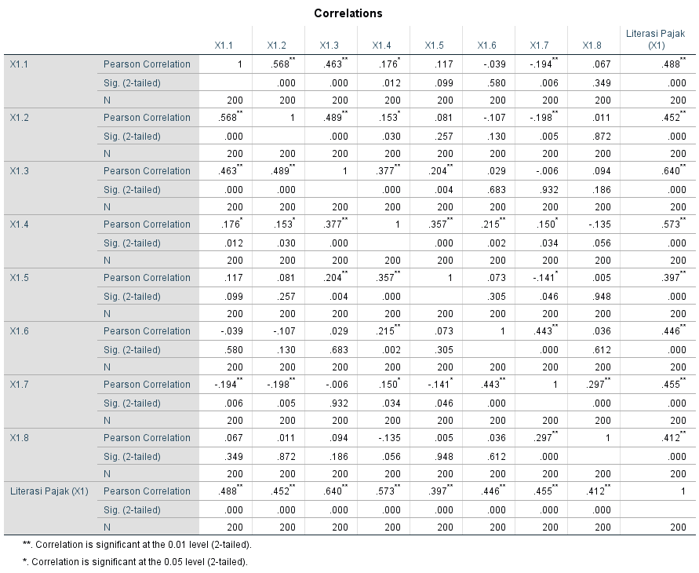

*Lampiran 6****Lampiran 6***

**Hasil Uji Validitas Pengetahuan Pajak**

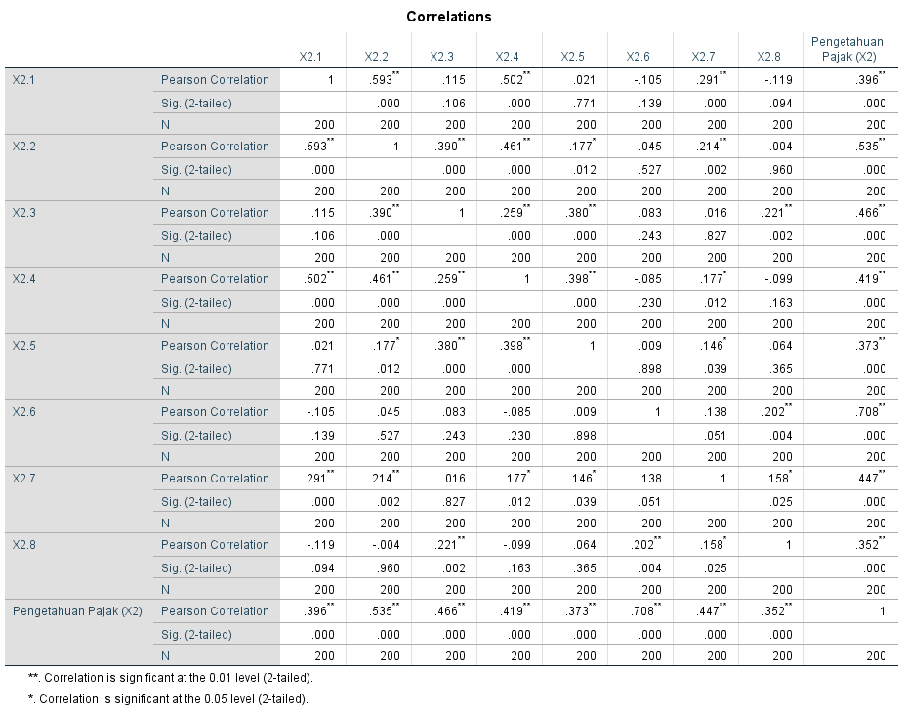

*Lampiran 7****Lampiran 7***

**Hasil Uji Validitas Pelayanan Fiskus**

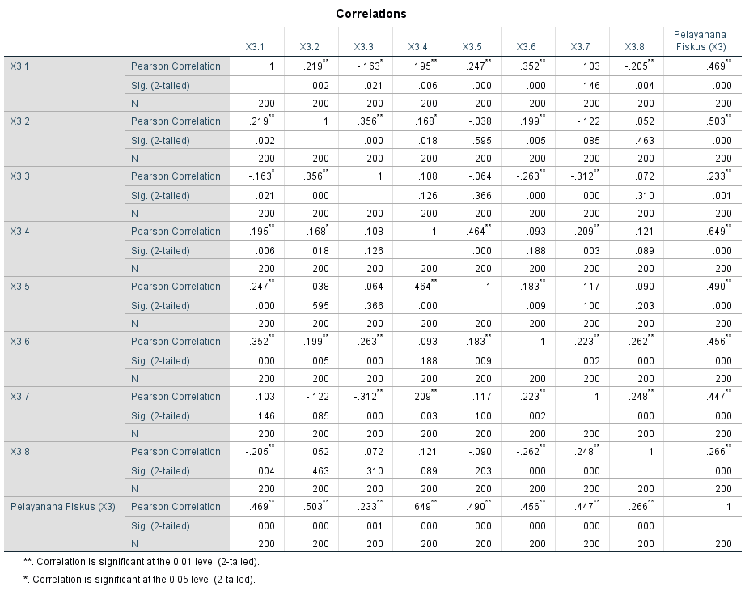

*Lampiran 8****Lampiran 8***

**Uji Validitas Kepatuhan Wajib Pajak**

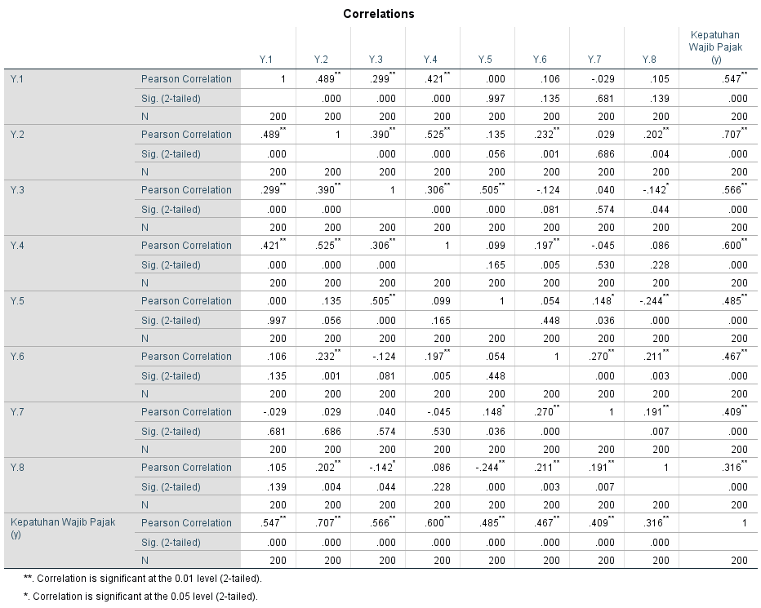

*Lampiran 9Lampiran 10****Lampiran 9***

**Hasil Uji Realibilitas**

1. Realibilitas Literasi Pajak

|  |  |
| --- | --- |
| **Reliability Statistics** | |
| Cronbach's Alpha | N of Items |
| .509 | 8 |

1. Realibilitas Pengetahuan Pajak

|  |  |
| --- | --- |
| **Reliability Statistics** | |
| Cronbach's Alpha | N of Items |
| .376 | 8 |

1. Realibilitas Pelayanan Fiskus

|  |  |
| --- | --- |
| **Reliability Statistics** | |
| Cronbach's Alpha | N of Items |
| .362 | 8 |

1. Realibilitas Kepatuhan Wajib Pajak

|  |  |
| --- | --- |
| **Reliability Statistics** | |
| Cronbach's Alpha | N of Items |
| .582 | 8 |

**Lampiran 10**

**Hasil Uji Asumsi Klasik**

1. **Uji Normalitas**

|  |  |  |
| --- | --- | --- |
| **One-Sample Kolmogorov-Smirnov Test** | | |
|  | | Unstandardized Residual |
| N | | 198 |
| Normal Parametersa,b | Mean | -.2539169 |
| Std. Deviation | 1.66524692 |
| Most Extreme Differences | Absolute | .067 |
| Positive | .065 |
| Negative | -.067 |
| Test Statistic | | .067 |
| Asymp. Sig. (2-tailed) | | .029c |
| a. Test distribution is Normal. | | |
| b. Calculated from data. | | |
| c. Lilliefors Significance Correction. | | |

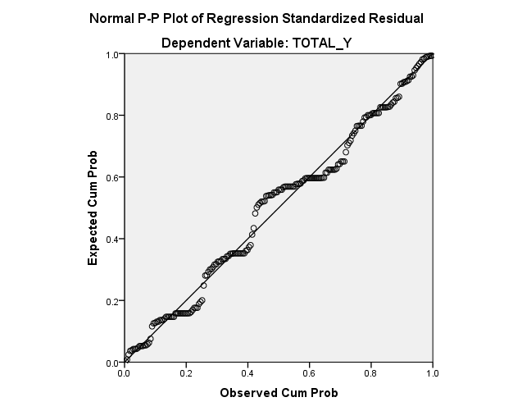

1. Uji Multikolonieritas

|  |  |  |
| --- | --- | --- |
|  | **Collinearity** |  |
| **Model** | **Toleran** | **VIF** |
| Literasi Pajak | .898 | 1.113 |
| Pengetahuan Pajak | .981 | 1.019 |
| Pelayanan Fiskus | .895 | 1.117 |

1. Uji Heteroskedastisitas

|  |  |  |  |  |  |  |
| --- | --- | --- | --- | --- | --- | --- |
| **Coefficientsa** | | | | | | |
| Model | | Unstandardized Coefficients | | Standardized Coefficients | t | Sig. |
| B | Std. Error | Beta |
| 1 | (Constant) | 49.244 | 4.374 |  | 11.260 | .000 |
| Pelayanan fiskus | -.004 | .120 | -.002 | -.030 | .976 |
| Literasi pajak | -.268 | .059 | -.295 | -4.505 | .0001 |
| Pengetahuan Pajak | -.184 | .036 | -.326 | -5.055 | .0001 |

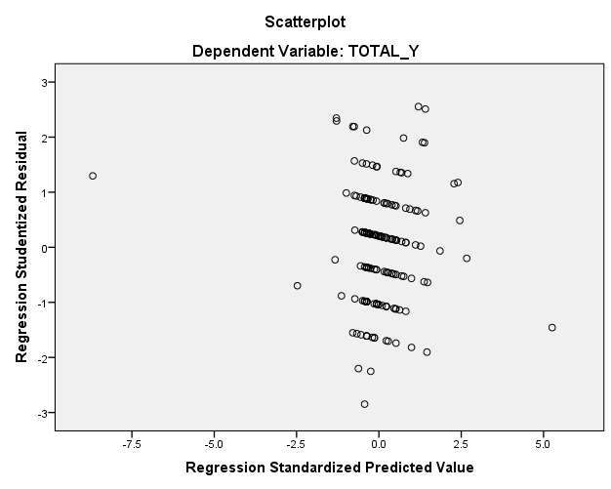

*Lampiran 11****Lampiran 11***



