REFERENCE

Afiqah, N. (2021). Speaking Anxiety and Strategies Used by ESL Learners to Overcome in Their Classroom: a Case Study in Management and Science University (MSU) Shah Alam, Malaysia. 7(4), 785–794.
Akkakoson, S. (2016). Speaking anxiety in english conversation classrooms among Thai students. Malaysian Journal of Learning and Instruction, 13(1), 63–82. https://doi.org/10.32890/mjli2016.13.1.4
Almeida, F., Superior, I., Gaya, P., Queirós, A., & Faria, D. (2017). Strengths and Limitations of Qualitative and Quantitative Research Methods Innovation and Entrepreneurship View project Observatory of Portuguese Academic Spin-offs View project European Journal of Education Studies STRENGTHS AND LIMITATIONS OF QUALITATIV. 369–387. https://doi.org/10.5281/zenodo.887089
Ariyanti. (2016). Psychological Factors Affecting EFL Students ’ Speaking Performance. 1(1), 77–88.
Atmo Kusumo. (2020). Southern Thai Hight School Students’ Anxiety in Speaking Performance. 4(1), 274–282. https://doi.org/10.24905/efj.v4i1.74
Batiha, J. M., Noor, N. M., & Mustaffa, R. (2016). Speaking Anxiety among English as a Foreign Language Learner in Jordan: Quantitative Research. International Journal of Education and Research, 4(10), 63–82. www.ijern.com
Betty Sailun, N. (2021). An Analysis of Students’ Speaking Anxiety in English Classroom at SMAN 2 Siak Hulu. 12(2), 218–229.
Chinpakdee, M. (2015). Thai EFL University Students’ Perspectives on Foreign Language Anxiety. Silpakorn University Journal of Social Sciences, Humanities, and Arts, 15(3), 61–90.
E. Maria & Listyani. (2020). AN ANALYSIS OF STUDENTS’ SPEAKING ANXIETY IN ACADEMIC SPEAKING CLASS. ELTR Journal, e-ISSN2579-8235 , 4(2), 152–170.
Gultom, E. (2015). 111 english language teaching problems in indonesia. 3, 1234–1241.
Harrison, H., Birks, M., Franklin, R., & Mills, J. (2017). Case study research: Foundations and methodological orientations. Forum Qualitative Sozialforschung, 18(1).
Hermaniar, Y., & Azkiya, N. (2021). ANXIETY ISSUES ON ENGLISH SPEAKING CLASS ; THE ANALYSIS OF STUDENTS ’ PROBLEMS OF ENGLISH LANGUAGE EDUCATION. 1, 169–176.
Julfikar Nurdin. (2020). Students’ Speaking Ability Awareness: A Qualitative Study at Zawiyah English Club Iain Langsa. Angewandte Chemie International Edition, 6(11), 951–952., 2(1), 5–24.
Khoshlessan, R. (2017). Analyzing International Students ’ Study Anxiety in Higher Education. 7(2), 311–328.
Leong, L.-M., & Ahmadi, S. M. (2017). An Analysis of Factors Influencing Learners’ English Speaking Skill. International Journal of Research in English Education, 2(1), 34–41. https://doi.org/10.18869/acadpub.ijree.2.1.34
Listyani, L.-, & Kristie, L. S. (2018). Teachers’ Strategies to Improve Students’ Self-Confidence in Speaking: A Study at Two Vocational Schools in Central Borneo. Register Journal, 11(2), 139. https://doi.org/10.18326/rgt.v11i2.139-153
Male, H. (2018). Senior High School Students ’ Anxiety towards Language Learning Skills. 4(1), 1–16.
Mitha, W. D., Amri, Z., & Narius, D. (2018). An analysis of students’ speaking anxiety faced by the fourth semester students of english education study program of english department of Universitas Negeri Padang. Journal of English Language Teaching, 7(3), 465–479.
Mukminin, A., Arif, N., & Mukminin, A. (2015). EFL Speaking Anxiety among Senior High School Students and Policy Recommendations. 9, 217–225.
Naser Oteir, I., & Nijr Al-Otaibi, A. (2019). Foreign Language Anxiety: A Systematic Review. Arab World English Journal, 10(3), 309–317. https://doi.org/10.24093/awej/vol10no3.21
Nurfitria, A., & Rahmawati, E. (2021). The Analysis of Students ’ Dif ficulties in Speaking English of Eight Grade. Proceeding AISELT (Annual International Seminar on English Language Teaching), 6(1), 67–80.
Pokrivčáková, S. (2015). S. Pokrivčáková et al. - Teaching Foreign Languages to Learners with Special Educational Needs.pdf.
Pornthanomwong, K., Tipyasuprat, N., & Kanokwattanameta, N. (2019). English Speaking Anxiety Among Undergraduate Students at Rangsit University. April, 1259–1266.
Putri, A. (2020). A study of students’s anxiety in speaking. ELLITE Journal of Education, Linguistics, Literature and Language Teaching e-ISSN:, 35–47.
Saputra, J. B. (2018). AN ANALYSIS OF STUDENTS ’ SPEAKING ANXIETY TOWARD. 1, 111–123.
Shrestha, N. (2021). Factor Analysis as a Tool for Survey Analysis. American Journal of Applied Mathematics and Statistics, 9(1), 4–11. https://doi.org/10.12691/ajams-9-1-2
Sjaifullah, A. (2019). An analysis of EFL students’ anxiety factors in speaking. International Research Journal of Engineering, IT & Scientific Research, 5(3), 43–48. https://doi.org/10.21744/irjeis.v5n3.655
Subandowo, D. (2017). the Analysis of Causal Factor on Student Speaking Anxiety. UAD TEFL International Conference, 1, 109. https://doi.org/10.12928/utic.v1.158.2017
Subekti, A. S. (2018). An exploration of learners’ foreign language anxiety in the indonesian university context: Learners’ and teachers’ voices. Teflin Journal, 29(2), 219–244. https://doi.org/10.15639/teflinjournal.v29i2/219-244
Sutarsyah, C. (2017). An Analysis of Student’s Speaking Anxiety and its Effect on Speaking Performance. IJELTAL (Indonesian Journal of English Language Teaching and Applied Linguistics), 1(2), 143. https://doi.org/10.21093/ijeltal.v1i2.14
Sutton, J., & Austin, Z. (2015). Qualitative research: Data collection, analysis, and management. Canadian Journal of Hospital Pharmacy, 68(3), 226–231. https://doi.org/10.4212/cjhp.v68i3.1456
Taherdoost, H. (2018). Validity and Reliability of the Research Instrument; How to Test the Validation of a Questionnaire/Survey in a Research. SSRN Electronic Journal, 5(3), 28–36. https://doi.org/10.2139/ssrn.3205040
Tuan, N. H., & Mai, T. N. (2015). Factors affecting students’ speaking performance at le thanh hien high school. 3(2), 8–23.

APPENDICES
Appendix 1: Research Permission
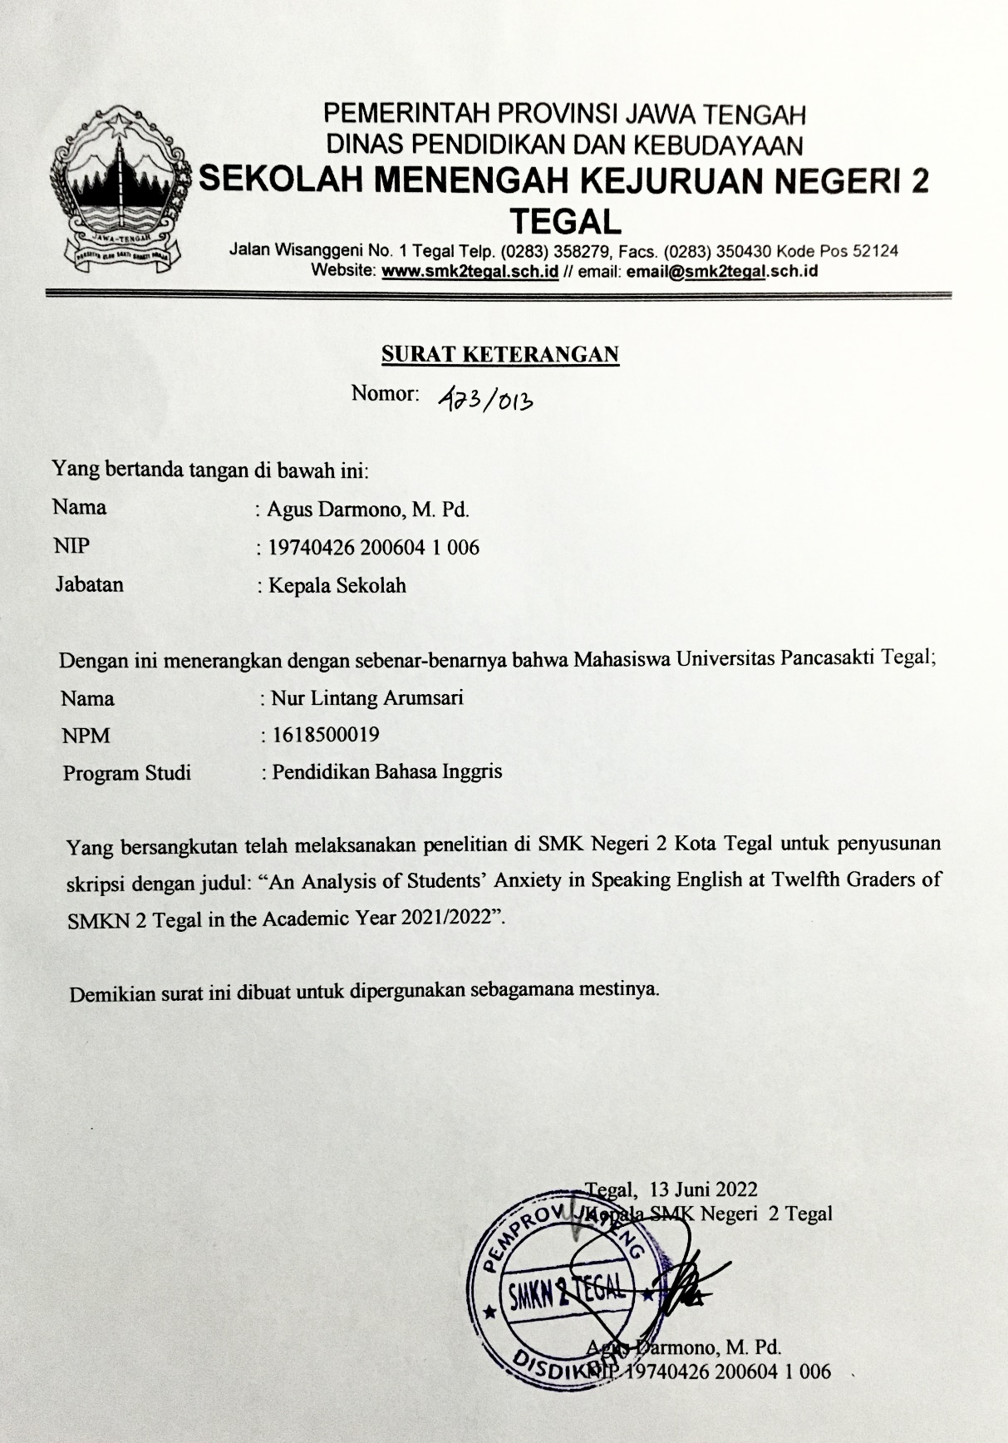
Appendix 2: Instruments of the Research

INSTRUMENTS OF THE RESEARCH
AN ANALYSIS OF STUDENTS' ANXIETY IN SPEAKING ENGLISH AT TWELFTH GRADERS OF SMK N 2 TEGAL IN THE ACADEMIC YEAR 2021/2022
A Questionnaire Adapted from FLCAS (Foreign Language Classroom Anxiety Scale) from Horwitz & Cope in Atmo Kusumo(2020)

Name :
Class :
Instructions
- Read the statement on the following table.
- Give your response toward the statement by checklist () in the column.
SA = Strongly Agree
A = Agree
N = Neither Agree nor Disagree
D = Disagree
SD = Strongly Disagree

Questionnaire of Student Anxiety Factor
No | Statement | Response
 |  | SA | A | N | D | SD
1. | I'm nervous of speaking English since I don't really know how to implement nice and correct wording.
2. | I'm afraid of making errors while speaking English.
3. | I have friends who are unable to communicate in English. As a result, I don't speak English in my daily life.
4. | When I try to speak in a foreign language, I am afraid that the other students would laugh at me.
5. | I'm nervous to speak English since I don't know how to do it properly.
6. | I'm not interested in the topic of English, so I wasn’t motivated to learn English.
7. | I don't like the English lesson, so I was unmotivated to study and practice English at home.
8. | I become fear and confusion when I have to speak English without any preparation.
9. | I am frightened when I have to speak English.
10. | When I speak English, I never feel confident.
11. | I am not interested in anything to do with English language support and advice. It would be like watching an English movies.
12. | I'm worried if I would make grammatical errors noticeable.
13. | I get frightened when I know I am going to be called on to speak English.
14. | I'm anxious to speak English due to fear of mistakes in the use of tenses.
15. | I don't have a lot of words in my vocabulary.
16. | I'm lazy to memorize new English vocabulary and rarely use it.

Questionnaire of Student Strategies to Overcome Anxiety
No | Kind of Strategies | Statement | SA | A | N | D | SD
1. | Peer Seeking | When I know I'm going to be called on in English class, my heart begins to pound.
2. | Positive thinking | I enjoy communicating in English.
3. |  | I feel that being able to communicate in English is quite crucial.
4. |  | When I’m speaking English, I feel more confident.
5. |  | I enjoy listening to English speech / discussions, either in English class or Western films.
6. | Resignation | I would feel so anxious and forget everything that I know in English class.
7. |  | I become nervous and anxious when I don't understand what the English teacher says.
8. |  | I'm absolutely terrified that my English teacher is willing to correct each my English mistake.
9. |  | I become nervous and confused when I'm speaking English
10. |  | I'm hesitant to speak English since I'm not sure how to phrase things correctly in terms of grammar, vocabulary, or pronunciation.

Appendix 3: The Result of Validity Test of the Questionnaire
Factor anxiety
No. Item | Pearson Correlations | Sig. (2-tailed) | Status
1 | 0.444 | 0.329 | Valid
2 | 0.464 | 0.329 | Valid
3 | 0.609 | 0.329 | Valid
4 | 0.478 | 0.329 | Valid
5 | 0.549 | 0.329 | Valid
6 | 0.674 | 0.329 | Valid
7 | 0.649 | 0.329 | Valid
8 | 0.452 | 0.329 | Valid
9 | 0.848 | 0.329 | Valid
10 | 0.478 | 0.329 | Valid
11 | 0.521 | 0.329 | Valid
12 | 0.573 | 0.329 | Valid
13 | 0.750 | 0.329 | Valid
14 | 0.620 | 0.329 | Valid
15 | 0.144 | 0.329 | Invalid
16 | 0.697 | 0.329 | Valid
17 | 0.549 | 0.329 | Valid

Students’ Strategies to Overcome Speaking Anxiety
No. Item | Pearson Correlations | Sig. (2-tailed) | Status
1 | 0.153 | 0.329 | Invalid
2 | 0.308 | 0.329 | Invalid
3 | 0.303 | 0.329 | Invalid
4 | 0.523 | 0.329 | Valid
5 | 0.446 | 0.329 | Valid
6 | 0.615 | 0.329 | Valid
7 | 0.479 | 0.329 | Valid
8 | 0.000 | 0.329 | Invalid
9 | 0.537 | 0.329 | Valid
10 | 0.304 | 0.329 | Invalid
11 | 0.454 | 0.329 | Valid
12 | 0.464 | 0.329 | Valid
13 | 0.526 | 0.329 | Valid
14 | 0.451 | 0.329 | Valid
15 | 0.441 | 0.329 | Valid

Appendix 4: The Result of Reliability Test of Questionnaire
Factor Anxiety
Case Processing Summary
 |  | N | %
Cases | Valid | 36 | 100.0
 | Excludedª | 0 | .0
 | Total | 36 | 100.0
a. Listwise deletion based on all variables in the procedure.

Reliability Statistics
Cronbach's Alpha | N of Items
.843 | 17

Students’ Strategies to Overcome Speaking Anxiety

Case Processing Summary
 |  | N | %
Cases | Valid | 36 | 100.0
 | Excludedª | 0 | .0
 | Total | 36 | 100.0
a. Listwise deletion based on all variables in the procedure.

Reliability Statistics
Cronbach's Alpha | N of Items
.648 | 15

Appendix 5: The result of questionnaire factor
Terrified of making errors |  | TOTAL | Lack of self-confidence |  | TOTAL | Shyness |  | TOTAL | Motivation |  | TOTAL | Inadequate planning |  | TOTAL | Lack of vocabulary |  | TOTAL |  | Grammatical mistakes |  | TOTAL |  | Friends |  | TOTAL
ITEM 2 | ITEM 14 |  | ITEM 5 | ITEM 10 |  | ITEM 9 | ITEM 13 |  | ITEM 6 | ITEM 11 |  | ITEM 7 | ITEM 8 |  | ITEM 15 | ITEM 16 |  | ITEM 1 |  | ITEM 12 |  | ITEM 3 |  | ITEM 4
2 | 4 | 6 | 2 | 2 | 4 | 2 | 2 | 4 | 2 | 2 | 4 | 2 | 4 | 6 | 4 | 2 | 6 | 2 |  | 4 | 6 | 5 |  | 2 | 7
5 | 5 | 10 | 5 | 5 | 10 | 4 | 5 | 9 | 1 | 1 | 2 | 1 | 5 | 6 | 5 | 3 | 8 | 5 |  | 5 | 10 | 5 |  | 5 | 10
4 | 4 | 8 | 4 | 4 | 8 | 4 | 4 | 8 | 3 | 3 | 6 | 3 | 4 | 7 | 4 | 4 | 8 | 4 |  | 4 | 8 | 3 |  | 4 | 7
3 | 4 | 7 | 4 | 3 | 7 | 4 | 4 | 8 | 2 | 4 | 6 | 2 | 4 | 6 | 3 | 3 | 6 | 4 |  | 4 | 8 | 4 |  | 4 | 8
4 | 4 | 8 | 4 | 4 | 8 | 3 | 4 | 7 | 3 | 3 | 6 | 3 | 3 | 6 | 4 | 3 | 7 | 4 |  | 4 | 8 | 5 |  | 4 | 9
4 | 4 | 8 | 4 | 4 | 8 | 3 | 4 | 7 | 3 | 3 | 6 | 3 | 4 | 7 | 3 | 3 | 6 | 3 |  | 4 | 7 | 5 |  | 2 | 7
3 | 4 | 7 | 4 | 4 | 8 | 3 | 4 | 7 | 3 | 2 | 5 | 2 | 4 | 6 | 4 | 3 | 7 | 5 |  | 4 | 9 | 3 |  | 4 | 7
3 | 3 | 6 | 3 | 3 | 6 | 3 | 3 | 6 | 2 | 3 | 5 | 3 | 4 | 7 | 3 | 3 | 6 | 2 |  | 3 | 5 | 5 |  | 2 | 7
3 | 3 | 6 | 2 | 2 | 4 | 1 | 2 | 3 | 1 | 1 | 2 | 2 | 3 | 5 | 2 | 3 | 5 | 3 |  | 3 | 6 | 4 |  | 2 | 6
3 | 4 | 7 | 4 | 3 | 7 | 5 | 5 | 10 | 2 | 3 | 5 | 3 | 5 | 8 | 3 | 4 | 7 | 3 |  | 5 | 8 | 4 |  | 5 | 9
3 | 5 | 8 | 4 | 2 | 6 | 4 | 3 | 7 | 2 | 2 | 4 | 3 | 4 | 7 | 4 | 3 | 7 | 4 |  | 4 | 8 | 3 |  | 4 | 7
5 | 4 | 9 | 3 | 5 | 8 | 3 | 4 | 7 | 3 | 2 | 5 | 1 | 4 | 5 | 3 | 3 | 6 | 4 |  | 5 | 9 | 5 |  | 5 | 10
3 | 4 | 7 | 5 | 4 | 9 | 3 | 4 | 7 | 2 | 2 | 4 | 2 | 3 | 5 | 3 | 1 | 4 | 4 |  | 5 | 9 | 5 |  | 4 | 9
4 | 3 | 7 | 4 | 4 | 8 | 4 | 4 | 8 | 1 | 2 | 3 | 2 | 4 | 6 | 4 | 4 | 8 | 4 |  | 4 | 8 | 4 |  | 5 | 9
4 | 5 | 9 | 5 | 5 | 10 | 5 | 4 | 9 | 3 | 3 | 6 | 3 | 5 | 8 | 5 | 4 | 9 | 4 |  | 4 | 8 | 3 |  | 5 | 8
3 | 4 | 7 | 3 | 3 | 6 | 3 | 4 | 7 | 3 | 2 | 5 | 3 | 3 | 6 | 4 | 3 | 7 | 3 |  | 3 | 6 | 5 |  | 4 | 9
4 | 4 | 8 | 4 | 4 | 8 | 4 | 4 | 8 | 4 | 4 | 8 | 4 | 4 | 8 | 4 | 4 | 8 | 4 |  | 4 | 8 | 5 |  | 4 | 9
4 | 4 | 8 | 4 | 4 | 8 | 4 | 4 | 8 | 4 | 4 | 8 | 4 | 4 | 8 | 4 | 4 | 8 | 4 |  | 4 | 8 | 4 |  | 4 | 8
4 | 5 | 9 | 4 | 4 | 8 | 3 | 3 | 6 | 2 | 2 | 4 | 2 | 3 | 5 | 2 | 2 | 4 | 3 |  | 4 | 7 | 4 |  | 4 | 8
3 | 4 | 7 | 5 | 4 | 9 | 3 | 3 | 6 | 2 | 2 | 4 | 2 | 4 | 6 | 2 | 2 | 4 | 4 |  | 4 | 8 | 4 |  | 4 | 8
4 | 4 | 8 | 2 | 3 | 5 | 3 | 4 | 7 | 3 | 3 | 6 | 3 | 4 | 7 | 3 | 4 | 7 | 3 |  | 4 | 7 | 3 |  | 2 | 5
4 | 4 | 8 | 4 | 5 | 9 | 5 | 4 | 9 | 2 | 2 | 4 | 2 | 4 | 6 | 4 | 3 | 7 | 4 |  | 4 | 8 | 5 |  | 4 | 9
3 | 3 | 6 | 2 | 2 | 4 | 2 | 2 | 4 | 2 | 2 | 4 | 2 | 2 | 4 | 3 | 1 | 4 | 3 |  | 3 | 6 | 5 |  | 3 | 8
3 | 4 | 7 | 3 | 4 | 7 | 4 | 4 | 8 | 3 | 2 | 5 | 3 | 4 | 7 | 3 | 3 | 6 | 4 |  | 3 | 7 | 4 |  | 4 | 8
4 | 5 | 9 | 4 | 4 | 8 | 4 | 4 | 8 | 2 | 2 | 4 | 1 | 4 | 5 | 4 | 2 | 6 | 4 |  | 4 | 8 | 5 |  | 4 | 9
5 | 3 | 8 | 4 | 3 | 7 | 4 | 3 | 7 | 2 | 2 | 4 | 2 | 4 | 6 | 3 | 2 | 5 | 5 |  | 3 | 8 | 4 |  | 3 | 7
3 | 4 | 7 | 4 | 3 | 7 | 3 | 3 | 6 | 3 | 2 | 5 | 3 | 4 | 7 | 4 | 3 | 7 | 4 |  | 4 | 8 | 4 |  | 3 | 7
3 | 4 | 7 | 4 | 3 | 7 | 3 | 4 | 7 | 1 | 1 | 2 | 1 | 3 | 4 | 4 | 2 | 6 | 4 |  | 4 | 8 | 5 |  | 4 | 9
3 | 1 | 4 | 2 | 4 | 6 | 1 | 1 | 2 | 1 | 1 | 2 | 1 | 2 | 3 | 3 | 2 | 5 | 2 |  | 5 | 7 | 3 |  | 5 | 8
3 | 4 | 7 | 4 | 4 | 8 | 4 | 5 | 9 | 3 | 4 | 7 | 4 | 4 | 8 | 4 | 3 | 7 | 3 |  | 5 | 8 | 4 |  | 3 | 7
5 | 5 | 10 | 5 | 4 | 9 | 4 | 5 | 9 | 3 | 4 | 7 | 4 | 5 | 9 | 5 | 5 | 10 | 4 |  | 5 | 9 | 4 |  | 5 | 9
5 | 5 | 10 | 5 | 4 | 9 | 4 | 5 | 9 | 2 | 3 | 5 | 3 | 4 | 7 | 5 | 4 | 9 | 5 |  | 5 | 10 | 5 |  | 5 | 10
4 | 4 | 8 | 4 | 4 | 8 | 4 | 4 | 8 | 2 | 3 | 5 | 3 | 4 | 7 | 4 | 3 | 7 | 4 |  | 4 | 8 | 5 |  | 3 | 8
Total |  | 251 | Total |  | 244 | Total |  | 235 | Total |  | 158 | Total |  | 208 | Total |  | 217 |  | Total |  | 256 |  | Total |  | 266

Appendix 6: Output Analysis Factor

KMO and Bartlett's Test
Kaiser-Meyer-Olkin Measure of Sampling Adequacy. |  | .784
Bartlett's Test of Sphericity | Approx. Chi-Square | 163.279
 | df | 28
 | Sig. | .000
Anti-image Matrices
 |  | Terrified of making errors | Lack of self-confidence | Shyness | Motivation | Inadequate planning | Lack of vocabulary | Gramatical mistakes | Friends
Anti-image Covariance | Terrified of making errors | .421 | -.052 | -.068 | -.014 | -.002 | -.047 | -.082 | -.012
 | Lack of self-confidence | -.052 | .289 | -.055 | -.013 | -.026 | .067 | -.152 | -.102
 | Shyness | -.068 | -.055 | .232 | .016 | -.094 | .005 | -.042 | -.105
 | Motivation | -.014 | -.013 | .016 | .411 | -.146 | .043 | .024 | -.028
 | Inadequate planning | -.002 | -.026 | -.094 | -.146 | .165 | -.133 | .051 | .135
 | Lack of vocabulary | -.047 | .067 | .005 | .043 | -.133 | .355 | -.089 | -.116
 | Gramatical mistakes | -.082 | -.152 | -.042 | .024 | .051 | -.089 | .327 | .004
 | Friends | -.012 | -.102 | -.105 | -.028 | .135 | -.116 | .004 | .451
Anti-image Correlation | Terrified of making errors | .939ª | -.150 | -.217 | -.034 | -.009 | -.121 | -.220 | -.027
 | Lack of self-confidence | -.150 | .826ª | -.214 | -.037 | -.119 | .209 | -.496 | -.282
 | Shyness | -.217 | -.214 | .850ª | .051 | -.480 | .018 | -.151 | -.326
 | Motivation | -.034 | -.037 | .051 | .779ª | -.559 | .113 | .066 | -.064
 | Inadequate planning | -.009 | -.119 | -.480 | -.559 | .617ª | -.548 | .221 | .495
 | Lack of vocabulary | -.121 | .209 | .018 | .113 | -.548 | .779ª | -.260 | -.289
 | Gramatical mistakes | -.220 | -.496 | -.151 | .066 | .221 | -.260 | .812ª | .012
 | Friends | -.027 | -.282 | -.326 | -.064 | .495 | -.289 | .012 | .661ª
a. Measures of Sampling Adequacy(MSA)

Communalities
 | Initial | Extraction
Terrified of making errors | 1.000 | .696
Lack of self-confidence | 1.000 | .790
Shyness | 1.000 | .821
Motivation | 1.000 | .751
Inadequate planning | 1.000 | .921
Lack of vocabulary | 1.000 | .676
Gramatical mistakes | 1.000 | .776
Friends | 1.000 | .702
Extraction Method: Principal Component Analysis.
Total Variance Explained
Component | Initial Eigenvalues |  |  | Extraction Sums of Squared Loadings |  |  | Rotation Sums of Squared Loadings
 | Total | % of Variance | Cumulative % | Total | % of Variance | Cumulative % | Total | % of Variance | Cumulative %
1 | 4.307 | 53.837 | 53.837 | 4.307 | 53.837 | 53.837 | 3.253 | 40.664 | 40.664
2 | 1.827 | 22.841 | 76.677 | 1.827 | 22.841 | 76.677 | 2.881 | 36.013 | 76.677
3 | .486 | 6.078 | 82.755
4 | .469 | 5.860 | 88.614
5 | .343 | 4.292 | 92.907
6 | .279 | 3.483 | 96.390
7 | .188 | 2.352 | 98.742
8 | .101 | 1.258 | 100.000
Extraction Method: Principal Component Analysis.

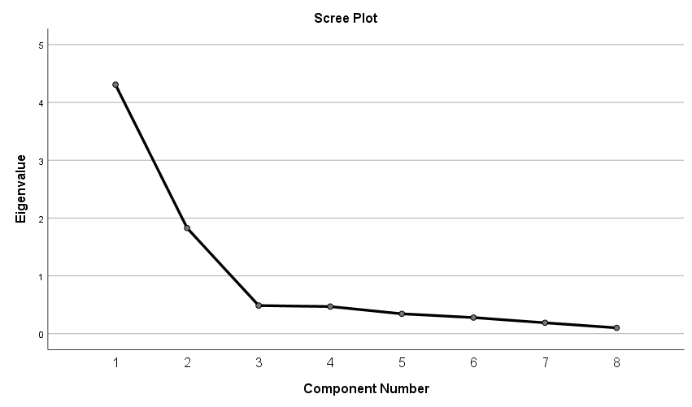
Rotated Component Matrixª
 | Component
 | 1 | 2
Terrified of making errors | .719 | .424
Lack of self-confidence | .851 | .257
Shyness | .655 | .626
Motivation | -.033 | .866
Inadequate planning | .082 | .956
Lack of vocabulary | .394 | .722
Gramatical mistakes | .870 | .139
Friends | .814 | -.198
Extraction Method: Principal Component Analysis.
Rotation Method: Varimax with Kaiser Normalization.ª
a. Rotation converged in 3 iterations.

Component Transformation Matrix
Component | 1 | 2
1 | .758 | .652
2 | -.652 | .758
Extraction Method: Principal Component Analysis.
Rotation Method: Varimax with Kaiser Normalization.

Appendix 7: Table score of the data students’ strategies to overcome anxiety in speaking English.
NO | ITEM | SA | A | N | D | DA | TOTAL
Peer Seeking
1. | When I know I'm going to be called on in English class, my heart begins to pound. | 9 | 15 | 9 | 0 | 0 | 132
Positive Thinking
2. | I enjoy communicating in English. | 3 | 7 | 18 | 5 | 0 | 107
3. | I feel that being able to communicate in English is quite crucial. | 13 | 15 | 5 | 0 | 0 | 140
4. | When I’m speaking English, I feel more confident. | 1 | 3 | 19 | 9 | 1 | 93
5. | I enjoy listening to English speech / discussions, either in English class or Western films. | 3 | 11 | 14 | 5 | 0 | 111
Resignation
6. | I would feel so anxious and forget everything that I know in English class. | 0 | 9 | 15 | 7 | 1 | 96
7. | I become nervous and anxious when I don't understand what the English teacher says | 3 | 16 | 12 | 2 | 0 | 119
8. | I'm absolutely terrified that my English teacher is willing to correct each my English mistake. | 2 | 13 | 14 | 3 | 1 | 111
9. | I become nervous and confused when I'm speaking English | 6 | 12 | 14 | 1 | 0 | 122
10. | I'm hesitant to speak English since I'm not sure how to phrase things correctly in terms of grammar, vocabulary, or pronunciation | 7 | 20 | 5 | 1 | 0 | 132

Appendix 8: Score of students’ strategies to overcome anxiety to speaking
No | item 1 | item 2 | item 3 | item 4 | item 5 | item 6 | item 7 | item 8 | item 9 | item 10 | score total
1 | 3 | 3 | 3 | 3 | 3 | 3 | 3 | 3 | 3 | 3 | 30
2 | 5 | 5 | 5 | 3 | 5 | 2 | 5 | 5 | 5 | 5 | 45
3 | 4 | 4 | 4 | 3 | 3 | 4 | 4 | 4 | 4 | 4 | 38
4 | 4 | 3 | 5 | 4 | 3 | 4 | 4 | 4 | 4 | 4 | 39
5 | 4 | 3 | 4 | 3 | 3 | 3 | 3 | 3 | 3 | 3 | 32
6 | 4 | 3 | 4 | 3 | 3 | 2 | 3 | 3 | 3 | 3 | 31
7 | 4 | 3 | 5 | 3 | 3 | 2 | 4 | 3 | 3 | 4 | 34
8 | 3 | 3 | 4 | 3 | 3 | 3 | 3 | 3 | 3 | 4 | 32
9 | 3 | 4 | 4 | 4 | 4 | 3 | 2 | 2 | 2 | 2 | 30
10 | 3 | 3 | 3 | 3 | 3 | 3 | 3 | 3 | 3 | 3 | 30
11 | 4 | 3 | 5 | 2 | 3 | 2 | 4 | 4 | 4 | 4 | 35
12 | 5 | 3 | 5 | 3 | 3 | 3 | 4 | 4 | 3 | 5 | 38
13 | 4 | 3 | 5 | 2 | 4 | 3 | 5 | 2 | 3 | 5 | 36
14 | 5 | 3 | 5 | 2 | 4 | 2 | 3 | 3 | 4 | 4 | 35
15 | 5 | 2 | 4 | 2 | 2 | 3 | 5 | 5 | 5 | 5 | 38
16 | 3 | 3 | 5 | 3 | 4 | 3 | 3 | 3 | 3 | 3 | 33
17 | 5 | 2 | 4 | 2 | 2 | 4 | 4 | 4 | 5 | 5 | 37
18 | 5 | 2 | 4 | 2 | 2 | 4 | 4 | 4 | 5 | 5 | 37
19 | 3 | 4 | 3 | 3 | 4 | 3 | 4 | 3 | 4 | 4 | 35
20 | 4 | 3 | 5 | 3 | 3 | 2 | 4 | 4 | 3 | 4 | 35
21 | 3 | 4 | 5 | 3 | 4 | 3 | 4 | 4 | 3 | 4 | 37
22 | 4 | 3 | 4 | 1 | 4 | 3 | 3 | 4 | 5 | 4 | 35
23 | 3 | 5 | 5 | 5 | 5 | 3 | 3 | 3 | 3 | 4 | 39
24 | 4 | 2 | 4 | 2 | 2 | 3 | 4 | 3 | 4 | 4 | 32
25 | 4 | 4 | 4 | 3 | 4 | 4 | 3 | 3 | 4 | 4 | 37
26 | 4 | 4 | 4 | 3 | 4 | 4 | 4 | 4 | 4 | 4 | 39
27 | 3 | 3 | 4 | 3 | 3 | 3 | 3 | 2 | 3 | 4 | 31
28 | 4 | 4 | 4 | 4 | 4 | 2 | 4 | 3 | 4 | 4 | 37
29 | 5 | 5 | 5 | 3 | 5 | 1 | 2 | 1 | 4 | 4 | 35
30 | 5 | 3 | 3 | 2 | 4 | 3 | 3 | 4 | 4 | 4 | 35
31 | 5 | 2 | 3 | 2 | 2 | 4 | 4 | 4 | 5 | 5 | 36
32 | 4 | 3 | 4 | 3 | 3 | 4 | 4 | 4 | 4 | 4 | 37
33 | 4 | 3 | 5 | 3 | 3 | 4 | 4 | 3 | 3 | 4 | 36

Appendix 9: Analysis of the data obtained through item of questionnaire
ITEMS | FREQUENCY |  |  |  |  | TOTAL
 | SA | A | N | D | SD
1 | 9 | 15 | 9 | 0 | 0 | 33
2 | 3 | 7 | 18 | 5 | 0 | 33
3 | 13 | 15 | 5 | 0 | 0 | 33
4 | 1 | 3 | 19 | 9 | 1 | 33
5 | 3 | 11 | 14 | 5 | 0 | 33
6 | 0 | 9 | 15 | 7 | 1 | 33
7 | 3 | 16 | 12 | 2 | 0 | 33
8 | 2 | 13 | 14 | 3 | 1 | 33
9 | 6 | 12 | 14 | 1 | 0 | 33
10 | 7 | 20 | 5 | 1 | 0 | 33

Appendix 10: Classroom Situation
