DAFTAR PUSTAKA
Agnes, Sawir. (2013). Analisis Kinerja Keuangan dan Perencanaan Keuangan Perusahaan. Jakarta: PT. Gramedia Pustaka Utama.
Agoes, S. (2012). Auditing: Petunjuk Praktis Pemeriksaan Akuntan oleh Akuntan Publik (4th ed., Vol. 1). Salemba empat.
Agustin, A. P., & Kurnia. (2019). Pengaruh Profitabilitas, Ukuran Perusahaan, dan financial Leverage terhadap Tindakan Income Smoothing. Ilmu Dan Riset Akuntansi, 8(2015).
Algery, A. (2013). Pengaruh Profitabilitas, Financial Leverage, Dan Harga Saham Terhadap Praktek Perataan Laba Pada Perusahaan Manufaktur Yang Terdaftar Di Bursa Efek Indonesia. Program Studi Akuntansi Fakultas Ekonomi Universitas Negeri Padang, 1–20.
Andayani, Tutut Dwi. (2010). Pengaruh Karakteristik Dewan Komisaris Independen Terhadap Manajemen Laba. Tesis Program Studi Magister Sains Akuntansi Universitas Diponegoro.
Anindyah, P. d. (2013). Pengaruh Karakteristik Dewan Komisaris dan Komite Audit Terhadap Manajemen Laba. Diponegoro Journal Of Accounting.Volume 2, Nomor 4, 1-12.
Ardiyati, A. Y. (2005). Pengaruh Manajemen Laba terhadap Return Saham pada perusahaan yang diaudit oleh KAP Big 5 dan KAP Non Big 5. Universitas Atmajaya Yogyakarta. Jurnal Riset Akuntansi Indonesia Vol. 8 No. 3 September 2005, 235-249.
Arens, A. , E. R. J. , & B. M. S. (2012). Auditing And Assurance Services. Jakarta: Salemba Empat.
Arief, Effendy. (2016). The Power of Good Corporate Governance. Jakarta: Salemba Empat.
Arikunto, S. (2013). Prosedur Penelitian Pendekatan Praktek. Jakarta: Rineka Cipta.
Astuti, Y. D., & Fitria, G. N. (2019). Pengaruh Perencanaan Pajak dan Profitabilitas Terhadap Nilai Perusahaan dengan BOD Diversity sebagai Variabel Moderasi. Esensi: Jurnal Bisnis Dan Manajemen, 9(2). https://doi.org/10.15408/ess.v9i2.13339.
Belkaoui, A. 2006. Teori Akuntansi. Edisi Kelima. Jakarta: Salemba Empat.
Bestivano, W. (2012). Pengaruh Ukuran Perusahaan, Umur Perusahaan, Profitabilitas dan Leverage Terhadap Perataan Laba Pada Perusahaan Yang Terdaftar Di Bursa Efek Indonesia. Jurnal Ilmiah Akuntansi Vo;. 1 No. 1 Universitas Padang.
Brigham, Eugene F. dan Joel F Houston. (2013). Manajemen Keuangan. Jakarta: Erlangga.
Budiasih, I.G.A.N. 2009. Faktor-Faktor yang Mempengaruhi Praktik Perataan Laba. Jurnal Ilmiah Akuntansi dan Bisnis. Vol. 4, No. 1, hal. 59-72.
De Angelo, L.E. 1981. “Auditor Independence, “Low Balling”, and Disclosure Regulation”. Journal of Accounting and Economics.h:113-127”.
Dewi, Diastiti Okkarisma. 2010. “Pengaruh Jenis Usaha, Ukuran Perusahaan dan Financial Leverage terhadap Tindakan Perataan Laba pada Perusahaan yang Terdaftar di Bursa Efek Indonesia”. Skripsi. Universitas Diponegoro.
Djoko, D., & Paulus, G. (2017). Pengaruh Ukuran Perusahaan, Leverage, Roa, Dan Net Profit Margin Terhadap Praktik Perataan Laba Pada Perusahaan Manufaktur Yang Terdaftar Di Bursa Efek Indonesia Periode 2012-2014. 12(1), 37–46.
Eckel, N. 1981.The Income smoothing Hypotesis Revisited Abacus, Englewood Clifts, NJ: Prentice-Hall.
Edy Suwito dan Arleen Herawaty. (2005). Analisis Pengaruh Karakterisrik Perusahaan Terhadap Tindakan Perataan Laba yang Dilakukan oleh Perusahaan yang Terdaftar di Bursa Efek Jakarta. Sinopsium Nasional Akuntansi VIII Solo.
Endarwati. (2020). Pengaruh Profitabilitas, Ukuran Perusahaan, Financial Leverage Dan Likuiditas Terhadap Perataan Laba. AKRUAL Jurnal Akuntansi Dan Keuangan Vol. 2 No. 2.
Endiana, I. D. M. (2018). Implementasi Perataan Laba Pada Perusahaan Kategori Indeks Lq 45 Di Bursa Efek Indonesia. Jurnal Ilmiah Manajemen & Akuntansi. Vol 22, No. 1, pp. 1-19.
Eugene F. Brigham dan J.F. Houston. (2010). Dasar-Dasar Manajemen Keuangan. Edisi 11. Jakarta : Salemba Empat.
Fahmi, I. 2013. Analisis Laporan Keuangan. Alfabeta. Bandung.
Fatmawati. 2015. Pengaruh Ukuran Perusahaan, Profitabilitas Dan Financial leverage Terhadap Praktik Perataan Laba Pada Perusahaan Manufaktur Yang Terdaftar Di Bursa Efek Indonesia. Kelola. Vol 2, No. 3, pp.1-11.
Fitriani, A. (2018). Pengaruh Profitabilitas, Ukuran Perusahaan, dan Financial Leverage terhadap Praktik Perataan Laba (Income Smoothing) pada Perusahaan Farmasi yang Terdaftar di Bursa Efek Indonesia Periode 2011-2015. Jurnal Samudra Ekonomi Dan Bisnis, 9(1). https://doi.org/10.33059/jseb.v9i1.461
Hakim, Ifsan L. 2015.https://www.liputan6.com/bisnis/read/2277114/skandal- terungkap-ceo- toshibamundur. (Diakses pada 7 Agustus 2019 pukul 02:58 WIB).
Herlina, S. (2017). Pengaruh Ukuran Perusahaan, Financial Leverage, Net Profit Margin Dan Struktur Kepemilikan Terhadap Tindakan Perataan Laba Padaperusahaan Manufaktur yang Terdaftar Di Bei periode 2011-2014. 4(1), 601–613.
Hery. (2017). Analisis Laporan Keuangan. Jakarta: Bumi Aksara.
Hidayanti, Wahyu. 2017..Pengaruh Ukuran Perusahaan, Profitabilitas, Financial leverage, Dan Deviden Payout Ratio Terhadap Praktik Perataan Laba Pada Perusahaan Manufaktur Yang Terdaftar Di Bursa Efek Indonesia. Skripsi. Program Studi Akuntansi Fakultas Ekonomi Universitas Muhammadiyah. Purwokerto.
Ikatan Akuntan Indonesia (IAI). 2012. Standar Akuntansi Keuangan (PSAK). Salemba Empat. Jakarta
Imam, G. (2011). Aplikasi Analisis Multivariate dengan Program SPSS Cetakan IV. Semarang: Badan Penerbit Universitas Diponegoro, Semarang.
Jin, Liauw She dan Mas’ud Machfoedz.1998. “Faktor-Faktor Yang Mempengaruhi Praktik Perataan laba Pada Perusahaan Yang Terdaftar di Bursa Efek Jakarta”. Jurnal Riset Akuntansi Indonesia. Vol. 1 (2). Hal 174-191.
Jogiyanto, Hartono. 2011. “Metedeologi Penelitian Bisnis Salah Kaprah dan Pengalaman-pengalaman”. Yogyakarta. BPFE Yogyakarta.
Julita, J., Oktariyani, A., Atika, Darminto, Handayani, S. R., Harahap, S. S., Ardian, A. V., Andini, R., Raharjo, K., Efendi, A. F. W., Wibowo, S. S. A., Suharsimi, A., Ginting, M. C., Kasmir, Subramanyam, W., John, J., Ardiyanto, F. D., Hapsari, E. I., Widati, L. W., … Rahar, K. (2014). analisa laporann keuangan. In Bandung : CV Alfabeta (Vol. 3, Issue 1).
Juniarti dan Corolina. 2005. Analisa Faktor-Faktor yang Berpengaruh Terhadap Perataan Laba (Income Smoothing) Pada Perusahaan-perusahaan Go Public. Jurnal Akuntansi dan keuangan, Vol.7(2).
Karina, S. N. (2020). “Pengaruh Risiko Keuangan, Dividen, Kepemilikan Manajerial dan Reputasi Auditor Terhadap Perataan Laba”. Jurnal Akuntansi Bisnis, 18(1), 20-31.
Kartika Ilato. (2013). Pengaruh Karakteristik Perusahaan Terhadap Tindakan Perataan Laba Pada Perusahaan Manufaktur Yang Terdapat di Bursa Efek Indonesia Periode 2008-2012.
Kasmir. (2015). Analisis Laporan Keuangan. Jakarta: Raja Grafindo Persada.
Koch, Bruce, S. 1981. “Income Smoothing: an Experiment”. The Accounting Review, July: 574-586.
Komala, P. S., Endiana, I. D. M., Kumalasari, P. D., & Rahindayati, N. M. (2021). Pengaruh Profitabilitas, Solvabilitas, Likuiditas, Keputusan Investasi Dan Keputusan Pendanaan Terhadap Nilai Perusahaan. KARMA (Karya Riset Mahasiswa Akuntansi), 1(1).
Kristanti, F. T., & Hendratno, H. (2017). “Kepemilikan institusional, kepemilikan manajerial, dan kualitas audit terhadap manajemen laba”. Jurnal Riset Akuntansi Kontemporer, 9(2), 66-70.
Kustono, Alwan Sri (2009), Pengaruh Ukuran, Dividen Payout Ratio, Risiko Spesifik, dan Pertumbuhan Perusahaan terhadap praktik, Perataan Perataan Laba pada Perusahaan Manufaktur Studi Empiris Bursa Efek Jakarta 2002-2006. Jurnal Ekonomi Bisnis, Volume 14 No. 3.
Ladistra, O. P., & Sofie, S. (2017). Pengaruh Leverage, Profitabilitas, Tata Kelola Dan Karakteristik Perusahaan Pada Perataan Laba Perusahaan Yang Terdaftar Di Bursa Efek Indonesia Pada Tahun 2013-2015. Jurnal Akuntansi Trisakti, 4(1). https://doi.org/10.25105/jat.v4i1.5019
Lukman Syamsuddin. 2010. Manajemen Keuangan Perusahaan. Jakarta: PT. Raja Grafindo Persada
Mahardini, N. Y., & Juwita, N. (2018). “Menguji Dampak Net Profit Margin, Debt to Equity Ratio, Dan Retur on Asset Pada Praktik Perataan Laba”. JAK (Jurnal Akuntansi) Kajian Ilmiah Akuntansi, 5(2), 87-95.
Marpaung, C. O. (2014). Pengaruh Dewan Komisaris Independen, Komite Audit, Kualitas Audit dan Kepemilikan Manajerial Pada Perataan Laba. E-Jurnal Akuntansi Udayana, 279–289.
Martono dan H. Agus. 2010. Manajemen keuangan. Edisi 3. Ekonisia. Yogyakarta
Meckling, W. H., & Jensen, M. C. (1976). Managerial behavior, agency costs and ownership structureMeckling, W. H., & Jensen, M. C. (1976). Managerial behavior, agency costs and ownership structure. Journal of Financial Economics. https://doi.org/DOI: 10.1016/0304-405X(76)90026-X. Journal of Financial Economics.
Mulyadi. (2013). Auditing. Jakarta: Salemba Empat.
Munawir, S. (2004). Analisis Laporan Keuangan, Edisi Ke-4, Liberty, Yogyakarta. Ikatan Akuntansi Indonesia (IAI).
Nasser, E.M. & Herlina. 2003. “Pengaruh Size, Profitabilitas dan Leverage terhadap Perataan Laba pada Perusahaan go Publik” Jurnal Ekonomi. vol. 7(3), hal.291- 305.
Natalia, I. (2009). Pengaruh Ukuran Perusahaan, Profitabilitas, Dan Leverage Keuangaiy Teriiadap Praktik. 1(2), 143–166.
Noviana, Sindi Retno dan Etna Nur Afri Yuyetta. 2011. “Analisis Faktor-Faktor Yang Mempengaruhi Praktik Perataan Laba Studi Empiris Perusahaan Manufaktur Yang Terdaftar Di Bei Periode 2006-2010”. Jurnal Akuntansi & Auditing Volume 8
Orisa Paramiga, L. (2017). Pengaruh Leverage, Profitabilitas, Tata Kelola Dan Karakteristik Perusahaan Pada Perataan Laba Perusahaan Yang Terdaftar Di Bursa Efek Indonesia Pada Tahun 2013-2015. Jurnal Akuntansi Trisaksi Vol.4, No.1.
Oscar, R. (2017). Faktor-Faktor Yang Mempengaruhi Income Smoothing Pada Perusahaan Pertambangan Minyak Dan Gas Bumi Yang Terdaftar Pada Bursa Efek Indonesia.
Pertiwi, L. (2019). Pengaruh Ukuran Perusahaan, Debt to Equity Ratio, dan Net Profit Margin Terhadap Income Smoothing Pada Perusahaan Manufaktur Yang Terdaftar di Bursa Efek Indonesia. Skripsi.
Peraturan Otoritas Jasa Keuangan No.11/OJK.03/2016
Prastiti, Anindyah dan Wahyu Meiranto. 2013. Pengaruh Karakteristik Dewan Komisaris Dan Komite Audit Terhadap Manajemen Laba. Diponegoro Journal Of Accounting.Volume 2, Nomor 4, Tahun 2013, Halaman 1-12
Prastiwi, A. (2019). Pemikiran Sony Warsono Tentang Akuntansi Syariah. Universitas Islam Negeri Islam Sumatera Utara.
Pratama, Dika Fajar. 2012. Pengaruh Profitabilitas, Resiko Keuangan, Nilai Perusahaan, Struktur Kepemilikan dan Dividend Payout Ratio Terhadap Perataan Laba. Jurnal Akuntansi & Investasi Vol. 13(1), 35-43.
Pratnatika, Ludmila Sofia.2017. Pengaruh Ukuran Perusahaan, Return on Asset, Leverage Operasi, Likuiditas, Winner/Loser Stock Terhadap Praktik Perataan Laba (Studi Empiris Perusahaan Manufaktur Yang Terdaftar di BEI Tahun 2012-2016). Skripsi. Program Studi Akuntansi Fakultas Ekonomi Universitas Muhammadiyah. Yogyakarta.
Profitabilitas, P., Perusahaan, U., Institusional, K., Kelompok, D., Terhadap, U., Laba, P., Kasus, S., Perusahaan, P., Yang, N.-F., Di, T., Eko, B., Santoso, B., & Salim, S. N. (2012). Pengaruh Profitabilitas, Financial Leverage, Dividen, Ukuran Perusahaan, Kepemilikan Institusional, Dan Kelompok Usaha Terhadap Perataan Laba Studi Kasus. Lppm-Unissula.Com, 1(1).
Puspitasari, Ni Kadek Budi dan I.M.P Dwiana Putra. 2018. Pengaruh Profitabilitas Pada Praktik Perataan Laba dengan Struktur Kepemilikan Sebagai Variabel Pemoderasi. E-Jurnal Akuntansi Universitas Udayana, Vol.23(1).
Qonitin, R. A., & Yudowati, S. P. (2018). Pengaruh Mekanisme Corporate Governance dan Kualitas Audit Terhadap Integritas Laporan Keuangan Pada Perusahaan Pertambangan di Bursa Efek Indonesia.
Rachmawati, Andri dan Hanung Triatmoko. 2007. “Analisis Faktor-Faktor yang Mempengaruhi Kualitas Laba dan Nilai Perusahaan”. Simposium Nasional Akuntansi X, Makassar, 26-28 Juli.
Riyanto, Bambang. 2011.“Dasar-Dasar Pembelanjaan Perusahaan”. Yogyakarta: PT BPFE.
Ria Setiawati. (2017). Pengaruh Dividend Payout Ratio, Financial Leverage, Kualitas Audit Dan Ukuran Perusahaan Terhadap Perataan Laba. Occupational Medicine, 53(4).
Sartono, A.R. 2010. Manajemen Keuangan: Teori dan Aplikasi. Edisi Keempat. Yogyakarta: BPFE.
Setyaningrum, Nina. 2016. Faktor-Faktor Yang Mempengatuhi Praktik Perataan Laba (Income smoothing) Studi Empiris Pada Perusahaan Manufaktur Yang Terdaftar Di Bursa Efek Indonesia (BEI) Tahun 2011 - 2014. Skripsi. Program Studi Akuntansi Fakultas Ekonomi dan Bisnis. Universitas Muhammadiyah. Surakarta.
Setyaningtyas, I. (2014). Analisis Faktor-Faktor Yang Memepengaruhi Perataan Laba (Income Smoothing). Universitas Diponegoro Semarang, Semarang.
Sidharta, Ayu Ratih Maristanda dan N.M Ade Erawati. 2017. Pengaruh Ukuran Perusahaan dan Risiko Keuangan Pada Praktik Perataan Laba dengan Variabel Pemoderasi Jenis Industri. E-Jurnal Akuntansi Universitas Udayana, Vol.20(2).
Sitinjak, E. L. M., Warastuti, Y., & Sulistyanto, H. S. (2014). Earning Per Share, Book Value Equity, Dan Cash Flow Operation Pada Buy Hold Abnormal Return Primary Trend Saham Lq-45 (Periode 2010-2012). Jurnal Akuntansi Bisnis, 13(25).
Subekti, Imam. 2005. ”Asosiasi Antara Praktik Perataan Laba dan Reaksi Pasar Modal di Indonesia ”. SNA VIII Solo. September.
Suciwati, D. P., & Machfoedz, M. (2002). Pengaruh Risiko Nilai Tukar Rupiah terhadap Return Saham: Studi Empiris pada Perusahaan Manufaktur yang terdaftar di BEJ. Journal of Indonesian Economy and Business, 17(4).
Sudana, I.M. 2011. Manajemen Keuangan Perusahaan: Teori dan Praktik. Jakarta: Penerbit Erlangga.
Sugiari, E. & K. (2022). Pengaruh Profitabilitas, Financial Leverage, Ukuran Perusahaan Dan Kepemilikan Manajerial Terhadap Perataan Laba. Jurnal Kharisma.
Sugiyono. (2017). Sugiyono, 2017:60. Journal of Chemical Information and Modeling, 53(9).
Sulistyanto, H. Sri. 2008. Manajemen Laba : Teori dan Model Empiris. Jakarta : PT Gramedia Widiasarana Indonesia.
Sulistiawan, Dedhy. Yeni Januarsi dan Liza Alvia. 2011. Creative Accounting : Mengungkap Manajemen Laba dan Skandal Akuntansi. Jakarta : Salemba Empat.
Sunarni, Meni. 2013. Pengaruh Kepemilikan Manajerial, Profitabilitas, Nilai Perusahaan Dan Resiko Keuangan Terhadap Perataan Laba (Income Smoothing) Pada Perusahaan Manufaktur Yang Terdaftar Di Bursa Efek Indonesia. Skripsi. Program Studi Akuntansi Fakultas Ekonomi Universitas Pendidikan Indonesia.
Sunetri, A. & H. (2022). Pengaruh Ukuran Perusahaan, Financial Leverage dan Kualitas Audit Terhadap Perataan Laba (Income Smoothing) pada Perusahaan Manufaktur Sektor Industri Barang Konsumsi yang Terdaftar di Bursa Efek Indonesia Tahun 2017-2020. Hita Akuntansi Dan Keuangan.
Supriyono. (2018). Akuntansi Keperilakuan. UGM Press.
Suryandani, N.N. 2012. Analisis FaktorFaktor yang Mempengaruhi Income Smoothing. Media Komunikasi FIS. Vol. 11, No. 1, hal. 1-5.
Susanto, Sahid. (2011). Membangun Karakter Lewat Pendidikan. Diakses dari www.googe.com
Suwito, Edy & Herawaty, Arleen. 2005. “Analisis Pengaruh Karakteristik Perusahaan Terhadap Tindakan Perataan Laba yang Dilakukan Oleh Perusahaan yang Terdaftar di Bursa Efek Jakarta.” Proceedings Simposium Nasional Akuntansi VIII. September: Solo.
T. Hani Handoko, 2003. ManajemenKeuangan.Yogyakarta : Balai Penerbitan Fakultas Ekonomi
Tampubolon, M. P. (2012). Manajemen Keuangan. Jakarta: Ghalia Indonesia.
Trisnawati, M. M.R. Nazar dan Siska Priyandani Y. 2017. Pengaruh Profitabilitas, Dividend Payout Ratio dan Financial Leverage Terhadap Praktik Perataan Laba (Studi Pada Perusahaan yang terdaftar pada Indeks LQ45 Tahun 2011- 2016). e-Proceeding of Management,Vol.4(3):2654
Van Horne, 2009. Research Methods For Business,Edisi 4, Buku 2, Jakarta : Salemba Empat
Wahyuni, R. I. el. (2015). Pengaruh Resiko Keuangan, Dividend Payout Ratio dan Nilai Saham Terhadap Perataan Laba Pada Perusahaan Manufaktur di BEI. Jurnal Akuntansi Dan Bisnis, Vol.15(1).
Watts, R, L., and Zimmerman, J, L. 1986, Positive Accounting Theory. New York, Prentice Hall.
Widhanningrum, Purweni. 2012. Perataan Laba dan Variabel-Variabel yang Mempengaruhinya (Studi Empiris Perusahaan Manufaktur Yang Terdaftar Di BEJ). Jurnal Akuntansi dan Pendidikan, Vol.1(1).
Widyaningdyah, Agnes Utari. 2001. Analisis Faktor-Faktor yang Berpengaruh Terhadap Earning Managements pada Perusahaan Go Public di Indonesia. Jurnal Akuntansi dan Keuangan. Vol 3. No.2: 89 – 101.
Wulandari. 2013. “Analisis Faktor-Faktor Yang Mempengaruhi Income Smoothing Dan Pengaruhnya Terhadap Nilai Perusahaan Pada Perusahaan Manufaktur Yang Listed Di Bursa Efek Indonesia”. Skripsi Akuntansi. Universitas Diponegoro. www.idx.co.id. (Laporan keuangan Perusahaan di B
Yusuf, Muhammad dan Soraya. 2004. Faktor-Faktor yang Mempengaruhi Praktik Perataan Laba Pada Perusahaan Asing dan Non Asing di Indonesia. JAAI, Vol.8(1)
Zulaika Wulandari, & Irvan Rolyesh Situmorang. (2020). Pengaruh Profitabilitas, Ukuran Perusahaan Dan Financial Leverage Terhadap Perataan Laba (Studi Pada Perusahaan Manufaktur yang Terdaftar di BEI Tahun 2014-2018). Jurnal Akuntansi Bisnis Eka Prasetya : Penelitian Ilmu Akuntansi, 6(1). https://doi.org/10.47663/abep.v6i1.52

LAMPIRAN

Lampiran 1
DAFTAR PENGAMBILAN SAMPEL
No | Kode | Nama | 2018 | 2019 | 2020 | 2021
1 | AALI | Astra Agro Lestari Tbk. | √ | √ | √ | √
2 | ANDI | Andira Agro Tbk. | √ | √ | √ | √
3 | ANJT | Austindo Nusantara Jaya Tbk. | √ | √ | √ | √
4 | BEEF | Estika Tata Tiara Tbk. | √ | √ | √ | √
5 | BISI | BISI International Tbk. | √ | √ | √ | √
6 | BTEK | Bumi Teknokultura Unggul Tbk. | √ | √ | √
7 | BWPT | Eagle High Plantations Tbk.
8 | CPRO | Central Proteina Prima Tbk. | √ | √ | √
9 | CSRA | Cisadane Sawit Raya Tbk. | √ | √ | √ | √
10 | DSFI | Dharma Samudera Fishing Industry Tbk. | √ | √ | √ | √
11 | DSNG | Dharma Satya Nusantara Tbk. | √ | √ | √ | √
12 | GOLL | Golden Plantations Tbk. | √ | √ | √
13 | GZCO | Gozco Plantations Tbk. | √ | √ | √ | √
14 | IIKP | Inti Agri Resources Tbk |  |  | √ | √
15 | JAWA | Jaya Agra Wattie Tbk.
16 | LSIP | London Sumatra Indonesia Tbk. | √ | √ | √ | √
17 | MAGP | Multi Agro Gemilang Plantations Tbk. | √ |  |  | √
18 | MGRO | Mahkota Group Tbk. | √ | √ | √ | √
19 | PALM | Provident Agro Tbk. | √ | √ | √ | √
20 | PSGO | Palma Serasih Tbk. | √ | √ | √ | √
21 | SGRO | Sampoerna Agro Tbk. | √ | √ | √ | √
22 | SIMP | Salim Ivomas Pratama Tbk. | √ | √ | √ | √
23 | SMAR | Smart Tbk. | √ | √ | √ | √
24 | SSMS | Sawit Sumbermas Sarana Tbk. | √ | √ | √ | √
25 | TBLA | Tunas Baru Lampung Tbk. | √ | √ | √ | √
26 | UNSP | Bakrie Sumatera Plantations Tbk. |  |  |  | √

Keterangan :
: Perusahaan yang memenuhi kriteria

: Perusahaan yang mengalami kerugian selama periode 2018-2021
: Perusahaan yang tidak mencantumkan laporan keuangan selama periode
2018-2021

Lampiran 2
PERHITUNGAN VARIABEL
PERHITUNGAN PROFITABILITAS (X1)
No. | Kode | Tahun | Laba Bersih | Total Aset | ROA
1 | AALI | 2018 | 152072300000 | 26856967000000 | 0.01
 |  | 2019 | 243629000000 | 26974124000000 | 0.01
 |  | 2020 | 389779000000 | 27781231000000 | 0.01
 |  | 2021 | 206736200000 | 30399906000000 | 0.01
2 | ANDI | 2018 | 17199020715 | 405764381469 | 0.04
 |  | 2019 | 12492217169 | 404402732153 | 0.03
 |  | 2020 | 10170233789 | 479224284289 | 0.02
 |  | 2021 | 31213846490 | 482681352132 | 0.06
3 | ANJT | 2018 | 49161200000 | 602204916000 | 0.08
 |  | 2019 | 45581920000 | 625708104000 | 0.07
 |  | 2020 | 22108250000 | 636143812000 | 0.03
 |  | 2021 | 39681460000 | 652650362000 | 0.06
4 | BEEF | 2018 | 30830750626 | 564697027435 | 0.05
 |  | 2019 | 40030808168 | 924849879458 | 0.04
 |  | 2020 | 35073612475 | 677803886415 | 0.05
 |  | 2021 | 18144195810 | 673480916520 | 0.03
5 | BISI | 2018 | 40387000000 | 2765010000000 | 0.01
 |  | 2019 | 30695200000 | 2941056000000 | 0.01
 |  | 2020 | 27566700000 | 2914979000000 | 0.01
 |  | 2021 | 38099200000 | 3132202000000 | 0.01
6 | BTEK | 2018 | 76001730866 | 5165236468706 | 0.01
 |  | 2019 | 83843800594 | 4975248130342 | 0.02
 |  | 2020 | 50950789091 | 4223727970626 | 0.01
 |  | 2021 | 60151198932 | 4173043810054 | 0.01
7 | CSRA | 2018 | 28819203064 | 1279838790265 | 0.02
 |  | 2019 | 29160679173 | 1368558366490 | 0.02
 |  | 2020 | 72366649338 | 1398568521297 | 0.05
 |  | 2021 | 25965028879 | 1753240850009 | 0.01
8 | DSFI | 2018 | 8642591060 | 404997860246 | 0.02
 |  | 2019 | 8460708045 | 391479346685 | 0.02
 |  | 2020 | 5869581850 | 373757193361 | 0.02
 |  | 2021 | 5417169713 | 391754830323 | 0.01
9 | DSNG | 2018 | 427245000000 | 11738892000000 | 0.04
 |  | 2019 | 178164000000 | 11620821000000 | 0.02
 |  | 2020 | 478171000000 | 14151383000000 | 0.03
 |  | 2021 | 739649000000 | 13712160000000 | 0.05
10 | GZCO | 2018 | 35327800000 | 2910873000000 | 0.01
 |  | 2019 | 58449000000 | 1946438000000 | 0.03
 |  | 2020 | 18259200000 | 2143393000000 | 0.01
 |  | 2021 | 14269000000 | 2034452000000 | 0.01
11 | LSIP | 2018 | 329426000000 | 10037294000000 | 0.03
 |  | 2019 | 252630000000 | 10225322000000 | 0.02
 |  | 2020 | 695490000000 | 10922788000000 | 0.06
 |  | 2021 | 990445000000 | 11851182000000 | 0.08
12 | MGRO | 2018 | 84172119363 | 1078147667948 | 0.08
 |  | 2019 | 25609796031 | 1360106993113 | 0.02
 |  | 2020 | 49586190616 | 1433953996487 | 0.03
 |  | 2021 | 89783282574 | 1820202594748 | 0.05
13 | PALM | 2018 | 111498768000 | 1992544414000 | 0.06
 |  | 2019 | 70726016000 | 2330315741000 | 0.03
 |  | 2020 | 199362117000 | 4043604072000 | 0.05
 |  | 2021 | 201437545200 | 5867669837000 | 0.03
14 | PSGO | 2018 | 183156060534 | 3357068735530 | 0.05
 |  | 2019 | 160987619452 | 3255607109573 | 0.05
 |  | 2020 | 26500634368 | 3401723398441 | 0.01
 |  | 2021 | 213841959820 | 3731907652769 | 0.06
15 | SGRO | 2018 | 63608069000 | 9018844952000 | 0.01
 |  | 2019 | 93996290000 | 9466942773000 | 0.01
 |  | 2020 | 91174700000 | 9744680000000 | 0.01
 |  | 2021 | 81471500000 | 9751365000000 | 0.01
16 | SIMP | 2018 | 178067000000 | 34666506000000 | 0.01
 |  | 2019 | 642202000000 | 34910838000000 | 0.02
 |  | 2020 | 340285000000 | 35395264000000 | 0.01
 |  | 2021 | 1333747000000 | 35979302000000 | 0.04
17 | SMAR | 2018 | 597773000000 | 29310310000000 | 0.02
 |  | 2019 | 898690000000 | 27787527000000 | 0.03
 |  | 2020 | 1539798000000 | 35026171000000 | 0.04
 |  | 2021 | 2829418000000 | 40345003000000 | 0.07
18 | SSMS | 2018 | 867709690000 | 11296112298000 | 0.08
 |  | 2019 | 120819590000 | 11845204657000 | 0.01
 |  | 2020 | 580854940000 | 12775930059000 | 0.05
 |  | 2021 | 152687087400 | 13850610076000 | 0.01
19 | TBLA | 2018 | 764380000000 | 16339916000000 | 0.05
 |  | 2019 | 661034000000 | 17363003000000 | 0.04
 |  | 2020 | 680730000000 | 19431293000000 | 0.04
 |  | 2021 | 791916000000 | 21084017000000 | 0.04

PERHITUNGAN FINANCIAL LEVERAGE (X2)
No. | Kode | Tahun | Total Hutang | Total Aset | DAR
1 | AALI | 2018 | 7382445000000 | 26856967000000 | 0.27
 |  | 2019 | 7995597000000 | 26974124000000 | 0.30
 |  | 2020 | 8533437000000 | 27781231000000 | 0.31
 |  | 2021 | 9228733000000 | 30399906000000 | 0.30
2 | ANDI | 2018 | 293688681908 | 501764381469 | 0.59
 |  | 2019 | 228166283605 | 401402732153 | 0.57
 |  | 2020 | 228540995073 | 479224284289 | 0.48
 |  | 2021 | 233415595104 | 482681352132 | 0.48
3 | ANJT | 2018 | 215815703000 | 602204916000 | 0.36
 |  | 2019 | 237000043000 | 625708104000 | 0.38
 |  | 2020 | 240386457000 | 636143812000 | 0.38
 |  | 2021 | 219374097000 | 652650362000 | 0.34
4 | BEEF | 2018 | 335009925656 | 564697027435 | 0.59
 |  | 2019 | 538968838424 | 924849879458 | 0.58
 |  | 2020 | 670554676894 | 677803886415 | 0.99
 |  | 2021 | 847841149220 | 673480916520 | 1.26
5 | BISI | 2018 | 455080000000 | 2765010000000 | 0.16
 |  | 2019 | 624470000000 | 2941056000000 | 0.21
 |  | 2020 | 456592000000 | 2914979000000 | 0.16
 |  | 2021 | 404157000000 | 3132202000000 | 0.13
6 | BTEK | 2018 | 2904707799328 | 5165236468706 | 0.56
 |  | 2019 | 2832632209365 | 4975248130342 | 0.57
 |  | 2020 | 2561356330772 | 4223727970626 | 0.61
 |  | 2021 | 2611453882956 | 4173043810054 | 0.63
7 | CSRA | 2018 | 841726367366 | 1279838790265 | 0.66
 |  | 2019 | 903658317194 | 1368558366490 | 0.66
 |  | 2020 | 826287051831 | 1398568521297 | 0.59
 |  | 2021 | 971947990544 | 1753240850009 | 0.55
8 | DSFI | 2018 | 222727255672 | 404997860246 | 0.55
 |  | 2019 | 194442694006 | 391479346685 | 0.50
 |  | 2020 | 180381388796 | 373757193361 | 0.48
 |  | 2021 | 180348204011 | 391754830323 | 0.46
9 | DSNG | 2018 | 8079930000000 | 11738892000000 | 0.69
 |  | 2019 | 7889229000000 | 11620821000000 | 0.68
 |  | 2020 | 7920634000000 | 14151383000000 | 0.56
 |  | 2021 | 6686697000000 | 13712160000000 | 0.49
10 | GZCO | 2018 | 1840136000000 | 2910873000000 | 0.63
 |  | 2019 | 1125636000000 | 1946438000000 | 0.58
 |  | 2020 | 1118712000000 | 2143393000000 | 0.52
 |  | 2021 | 958764000000 | 2034452000000 | 0.47
11 | LSIP | 2018 | 1705175000000 | 10037294000000 | 0.17
 |  | 2019 | 1726822000000 | 10225322000000 | 0.17
 |  | 2020 | 1636456000000 | 10922788000000 | 0.15
 |  | 2021 | 1678676000000 | 11851182000000 | 0.14
12 | MGRO | 2018 | 412324985321 | 1078147667948 | 0.38
 |  | 2019 | 658649334804 | 1360106993113 | 0.48
 |  | 2020 | 810546275884 | 1433953996487 | 0.57
 |  | 2021 | 1110402314328 | 1820202594748 | 0.61
13 | PALM | 2018 | 379797334000 | 1992544414000 | 0.19
 |  | 2019 | 262899779000 | 2330315741000 | 0.11
 |  | 2020 | 192674823000 | 4043604072000 | 0.05
 |  | 2021 | 399993520000 | 5867669837000 | 0.07
14 | PSGO | 2018 | 2757063950240 | 3357068735530 | 0.82
 |  | 2019 | 2078486201260 | 3255607109573 | 0.64
 |  | 2020 | 2191495435706 | 3401723398441 | 0.64
 |  | 2021 | 2307095621382 | 3731907652769 | 0.62
15 | SGRO | 2018 | 4989995294000 | 9018844952000 | 0.55
 |  | 2019 | 5314244520000 | 9466942773000 | 0.56
 |  | 2020 | 5948624000000 | 9744680000000 | 0.61
 |  | 2021 | 5154666000000 | 9751365000000 | 0.53
16 | SIMP | 2018 | 16379829000000 | 34666506000000 | 0.47
 |  | 2019 | 17129515000000 | 34910838000000 | 0.49
 |  | 2020 | 16905391000000 | 35395264000000 | 0.48
 |  | 2021 | 16193066000000 | 35979302000000 | 0.45
17 | SMAR | 2018 | 17061105000000 | 29310310000000 | 0.58
 |  | 2019 | 16854470000000 | 27787527000000 | 0.61
 |  | 2020 | 22502490000000 | 35026171000000 | 0.64
 |  | 2021 | 25927174000000 | 40345003000000 | 0.64
18 | SSMS | 2018 | 7226929956000 | 11296112298000 | 0.64
 |  | 2019 | 7776637385000 | 11845204657000 | 0.66
 |  | 2020 | 7905143639000 | 12775930059000 | 0.62
 |  | 2021 | 7743102311000 | 13850610076000 | 0.56
19 | TBLA | 2018 | 11556300000000 | 16339916000000 | 0.71
 |  | 2019 | 12000079000000 | 17363003000000 | 0.69
 |  | 2020 | 13542437000000 | 19431293000000 | 0.70
 |  | 2021 | 14591663000000 | 21084017000000 | 0.69

PERHITUNGAN UKURAN PERUSAHAAN (X3)
No. | Kode | Tahun | Total Aset | LN
1 | AALI | 2018 | 2685696700000 | 28.62
 |  | 2019 | 2697412400000 | 28.62
 |  | 2020 | 2778123100000 | 28.65
 |  | 2021 | 3039990600000 | 28.74
2 | ANDI | 2018 | 105764381469 | 25.38
 |  | 2019 | 104402732153 | 25.37
 |  | 2020 | 479224284289 | 26.90
 |  | 2021 | 482681352132 | 26.90
3 | ANJT | 2018 | 602204916000 | 27.12
 |  | 2019 | 625708104000 | 27.16
 |  | 2020 | 636143812000 | 27.18
 |  | 2021 | 652650362000 | 27.20
4 | BEEF | 2018 | 564697027435 | 27.06
 |  | 2019 | 924849879458 | 27.55
 |  | 2020 | 677803886415 | 27.24
 |  | 2021 | 673480916520 | 27.24
5 | BISI | 2018 | 2765010000000 | 28.65
 |  | 2019 | 2941056000000 | 28.71
 |  | 2020 | 2914979000000 | 28.70
 |  | 2021 | 3132202000000 | 28.77
6 | BTEK | 2018 | 5165236468706 | 29.27
 |  | 2019 | 4975248130342 | 29.24
 |  | 2020 | 4223727970626 | 29.07
 |  | 2021 | 4173043810054 | 29.06
7 | CSRA | 2018 | 1279838790265 | 27.88
 |  | 2019 | 1368558366490 | 27.94
 |  | 2020 | 1398568521297 | 27.97
 |  | 2021 | 1753240850009 | 28.19
8 | DSFI | 2018 | 404997860246 | 26.73
 |  | 2019 | 391479346685 | 26.69
 |  | 2020 | 373757193361 | 26.65
 |  | 2021 | 391754830323 | 26.69
9 | DSNG | 2018 | 11738892000000 | 30.09
 |  | 2019 | 11620821000000 | 30.08
 |  | 2020 | 14151383000000 | 30.28
 |  | 2021 | 13712160000000 | 30.25
10 | GZCO | 2018 | 2910873000000 | 28.70
 |  | 2019 | 1946438000000 | 28.30
 |  | 2020 | 2143393000000 | 28.39
 |  | 2021 | 2034452000000 | 28.34
11 | LSIP | 2018 | 10037294000000 | 29.94
 |  | 2019 | 10225322000000 | 29.96
 |  | 2020 | 10922788000000 | 30.02
 |  | 2021 | 11851182000000 | 30.10
12 | MGRO | 2018 | 1078147667948 | 27.71
 |  | 2019 | 1360106993113 | 27.94
 |  | 2020 | 1433953996487 | 27.99
 |  | 2021 | 1820202594748 | 28.23
13 | PALM | 2018 | 1992544414000 | 28.32
 |  | 2019 | 2330315741000 | 28.48
 |  | 2020 | 4043604072000 | 29.03
 |  | 2021 | 5867669837000 | 29.40
14 | PSGO | 2018 | 3357068735530 | 28.84
 |  | 2019 | 3255607109573 | 28.81
 |  | 2020 | 3401723398441 | 28.86
 |  | 2021 | 3731907652769 | 28.95
15 | SGRO | 2018 | 9018844952000 | 29.83
 |  | 2019 | 9466942773000 | 29.88
 |  | 2020 | 9744680000000 | 29.91
 |  | 2021 | 9751365000000 | 29.91
16 | SIMP | 2018 | 34666506000000 | 31.18
 |  | 2019 | 34910838000000 | 31.18
 |  | 2020 | 35395264000000 | 31.20
 |  | 2021 | 35979302000000 | 31.21
17 | SMAR | 2018 | 29310310000000 | 31.01
 |  | 2019 | 27787527000000 | 30.96
 |  | 2020 | 35026171000000 | 31.19
 |  | 2021 | 40345003000000 | 31.33
18 | SSMS | 2018 | 11296112298000 | 30.06
 |  | 2019 | 11845204657000 | 30.10
 |  | 2020 | 12775930059000 | 30.18
 |  | 2021 | 13850610076000 | 30.26
19 | TBLA | 2018 | 16339916000000 | 30.42
 |  | 2019 | 17363003000000 | 30.49
 |  | 2020 | 19431293000000 | 30.60
 |  | 2021 | 21084017000000 | 30.68

PERHITUNGAN KUALITAS AUDIT (X4)
No. | Kode | Tahun | KAP Big four
1 | AALI | 2018 | 1
 |  | 2019 | 1
 |  | 2020 | 1
 |  | 2021 | 1
2 | ANDI | 2018 | 0
 |  | 2019 | 0
 |  | 2020 | 0
 |  | 2021 | 0
3 | ANJT | 2018 | 1
 |  | 2019 | 1
 |  | 2020 | 1
 |  | 2021 | 1
4 | BEEF | 2018 | 0
 |  | 2019 | 0
 |  | 2020 | 0
 |  | 2021 | 0
5 | BISI | 2018 | 1
 |  | 2019 | 1
 |  | 2020 | 1
 |  | 2021 | 1
6 | BTEK | 2018 | 0
 |  | 2019 | 0
 |  | 2020 | 0
 |  | 2021 | 0
7 | CSRA | 2018 | 0
 |  | 2019 | 0
 |  | 2020 | 0
 |  | 2021 | 0
8 | DSFI | 2018 | 0
 |  | 2019 | 0
 |  | 2020 | 0
 |  | 2021 | 0
9 | DSNG | 2018 | 1
 |  | 2019 | 1
 |  | 2020 | 1
 |  | 2021 | 1
10 | GZCO | 2018 | 0
 |  | 2019 | 0
 |  | 2020 | 0
 |  | 2021 | 0
11 | LSIP | 2018 | 1
 |  | 2019 | 1
 |  | 2020 | 1
 |  | 2021 | 1
12 | MGRO | 2018 | 0
 |  | 2019 | 0
 |  | 2020 | 0
 |  | 2021 | 0
13 | PALM | 2018 | 1
 |  | 2019 | 1
 |  | 2020 | 1
 |  | 2021 | 1
14 | PSGO | 2018 | 1
 |  | 2019 | 1
 |  | 2020 | 1
 |  | 2021 | 1
15 | SGRO | 2018 | 1
 |  | 2019 | 1
 |  | 2020 | 1
 |  | 2021 | 1
16 | SIMP | 2018 | 1
 |  | 2019 | 1
 |  | 2020 | 1
 |  | 2021 | 1
17 | SMAR | 2018 | 0
 |  | 2019 | 0
 |  | 2020 | 0
 |  | 2021 | 0
18 | SSMS | 2018 | 1
 |  | 2019 | 1
 |  | 2020 | 1
 |  | 2021 | 1
19 | TBLA | 2018 | 0
 |  | 2019 | 0
 |  | 2020 | 0
 |  | 2021 | 0

PERHITUNGAN PERATAAN LABA (Y)
No. | Kode | Tahun | Laba | Penjualan | Perubahan Laba | Perubahan Penjualan
1 | AALI | 2017 | 211362900000 | 23102900000
 |  | 2018 | 152072300000 | 19084387000 | -59290600000 | -4018513000
 |  | 2019 | 243629000000 | 17452736000 | 91556700000 | -1631651000
 |  | 2020 | 389779000000 | 18807043000 | 146150000000 | 1354307000
 |  | 2021 | 206736200000 | 24322048000 | -183042800000 | 5515005000
2 | ANDI | 2017 | 21136290000 | 337933000000
 |  | 2018 | 17199020715 | 300278949718 | -3937269285 | -37654050282
 |  | 2019 | 12492217169 | 311779628307 | -4706803546 | 11500678589
 |  | 2020 | 10170233789 | 260214446632 | -2321983380 | -51565181675
 |  | 2021 | 31213846490 | 346364995418 | 21043612701 | 86150548786
3 | ANJT | 2017 | 47399525000 | 161797280000
 |  | 2018 | 49161200000 | 151701360000 | 1761675000 | -10095920000
 |  | 2019 | 45581920000 | 130355274000 | -3579280000 | -21346086000
 |  | 2020 | 22108250000 | 164099644000 | -23473670000 | 33744370000
 |  | 2021 | 39681460000 | 266792377000 | 17573210000 | 102692733000
4 | BEEF | 2017 | 29785211164 | 846492646227
 |  | 2018 | 30830750626 | 895932528293 | 1045539462 | 49439882066
 |  | 2019 | 40030808168 | 1316420171957 | 9200057542 | 420487643664
 |  | 2020 | 35073612475 | 728034316374 | -4957195693 | -588385855583
 |  | 2021 | 18144195810 | 142314782595 | -16929416665 | -585719533779
5 | BISI | 2017 | 30428700000 | 231029000000
 |  | 2018 | 40387000000 | 226561500000 | 9958300000 | -4467500000
 |  | 2019 | 30695200000 | 227241000000 | -9691800000 | 679500000
 |  | 2020 | 27566700000 | 181276200000 | -3128500000 | -45964800000
 |  | 2021 | 38099200000 | 201513800000 | 10532500000 | 20237600000
6 | BTEK | 2017 | 42843793031 | 887141290201
 |  | 2018 | 76001730866 | 890045953988 | 33157937835 | 2904663787
 |  | 2019 | 83843800594 | 697914218244 | 7842069728 | -192131735744
 |  | 2020 | 50950789091 | 101302943994 | -32893011503 | -596611274250
 |  | 2021 | 60151198932 | 146942545316 | 9200409841 | 45639601322
7 | CSRA | 2017 | 98464000000 | 614823000000
 |  | 2018 | 28819203064 | 567788663969 | -69644796936 | -47034336031
 |  | 2019 | 29160679173 | 492295715775 | 341476109 | -75492948194
 |  | 2020 | 72366649338 | 607253410714 | 43205970165 | 114957694939
 |  | 2021 | 25965028879 | 895867536708 | -46401620459 | 288614125994
8 | DSFI | 2017 | 6748725135 | 647380916462
 |  | 2018 | 8642591060 | 652519543510 | 1893865925 | 5138627048
 |  | 2019 | 8460708045 | 476786004054 | -181883015 | -175733539456
 |  | 2020 | 5869581850 | 365870902563 | -2591126195 | -110915101491
 |  | 2021 | 5417169713 | 532522855555 | -452412137 | 166651952992
9 | DSNG | 2017 | 172294600000 | 5159911000000
 |  | 2018 | 427245000000 | 4761805000000 | 254950400000 | -398106000000
 |  | 2019 | 178164000000 | 5736684000000 | -249081000000 | 974879000000
 |  | 2020 | 478171000000 | 6698918000000 | 300007000000 | 962234000000
 |  | 2021 | 739649000000 | 7124495000000 | 261478000000 | 425577000000
10 | GZCO | 2017 | 43600000000 | 64694500000
 |  | 2018 | 35327800000 | 56545500000 | -8272200000 | -8149000000
 |  | 2019 | 58449000000 | 38504700000 | 23121200000 | -18040800000
 |  | 2020 | 18259200000 | 40692400000 | -40189800000 | 2187700000
 |  | 2021 | 14269000000 | 70710200000 | -3990200000 | 30017800000
11 | LSIP | 2017 | 763423000000 | 4738022000000
 |  | 2018 | 329426000000 | 4019846000000 | -433997000000 | -718176000000
 |  | 2019 | 252630000000 | 3699439000000 | -76796000000 | -320407000000
 |  | 2020 | 695490000000 | 3536721000000 | 442860000000 | -162718000000
 |  | 2021 | 990445000000 | 4525473000000 | 294955000000 | 988752000000
12 | MGRO | 2017 | 14416356979 | 3947834634650
 |  | 2018 | 84172119363 | 2001284460551 | 69755762384 | -1946550174099
 |  | 2019 | 25609796031 | 1953747315540 | -58562323332 | -47537145011
 |  | 2020 | 49586190616 | 4106566376814 | 23976394585 | 2152819061274
 |  | 2021 | 89783282574 | 7313139597522 | 40197091958 | 3206573220708
13 | PALM | 2017 | 152810000000 | 467408250000
 |  | 2018 | 111498768000 | 446646667000 | -41311232000 | -20761583000
 |  | 2019 | 70726016000 | 189158260000 | -40772752000 | -257488407000
 |  | 2020 | 199362117000 | 238689151000 | 128636101000 | 49530891000
 |  | 2021 | 201437545200 | 316685911000 | 2075428200 | 77996760000
14 | PSGO | 2017 | 257492147870 | 520403352844
 |  | 2018 | 183156060534 | 689687909455 | -74336087336 | 169284556611
 |  | 2019 | 160987619452 | 728562875731 | -22168441082 | 38874966276
 |  | 2020 | 265006343680 | 930503571803 | 104018724228 | 201940696072
 |  | 2021 | 213841959820 | 1766254650794 | -51164383860 | 835751078991
15 | SGRO | 2017 | 30302079000 | 3616482911000
 |  | 2018 | 63608069000 | 3207181767000 | 33305990000 | -409301144000
 |  | 2019 | 93996290000 | 3268127326000 | 30388221000 | 60945559000
 |  | 2020 | 91174700000 | 3502227000000 | -2821590000 | 234099674000
 |  | 2021 | 81471500000 | 5222298000000 | -9703200000 | 1720071000000
16 | SIMP | 2017 | 695433000000 | 1582664800000
 |  | 2018 | 178067000000 | 1405945000000 | -517366000000 | -176719800000
 |  | 2019 | 642202000000 | 1365038800000 | 464135000000 | -40906200000
 |  | 2020 | 340285000000 | 1447470000000 | -301917000000 | 82431200000
 |  | 2021 | 133374700000 | 1965852900000 | -206910300000 | 518382900000
17 | SMAR | 2017 | 103667640000 | 3531810200000
 |  | 2018 | 597773000000 | 3739164300000 | 494105360000 | 207354100000
 |  | 2019 | 898690000000 | 3619810200000 | 300917000000 | -119354100000
 |  | 2020 | 153979800000 | 4043434600000 | -744710200000 | 423624400000
 |  | 2021 | 282941800000 | 5700423400000 | 128962000000 | 1656988800000
18 | SSMS | 2017 | 790922772000 | 3240831859000
 |  | 2018 | 867709690000 | 3710780545000 | 76786918000 | 469948686000
 |  | 2019 | 120819590000 | 3277806795000 | -746890100000 | -432973750000
 |  | 2020 | 580854940000 | 4011130559000 | 460035350000 | 733323764000
 |  | 2021 | 152687087400 | 5203100578000 | -428167852600 | 1191970019000
19 | TBLA | 2017 | 226562300000 | 2236471000000
 |  | 2018 | 764380000000 | 8614889000000 | 537817700000 | 6378418000000
 |  | 2019 | 661034000000 | 8533183000000 | -103346000000 | -81706000000
 |  | 2020 | 680730000000 | 10863256000000 | 19696000000 | 2330073000000
 |  | 2021 | 791916000000 | 15972216000000 | 111186000000 | 5108960000000

PERHITUNGAN PERATAAN LABA (Y)
LANJUTAN
Kode | Rata-rata Perubahan Laba | Standar Deviasi Perubahan Laba | Rata-rata Perubahan Penjualan | Standar Deviasi Perubahan Penjualan | CVΔI | CVΔS | Indeks Perataan laba  $$\frac{CVΔI}{CVΔS}$$ | Status
AALI | -1156675000 | 4110497896 | 304787000 | 4110497896 | 3.55 | 13.49 | 0.26 | 1
ANDI | 2519389123 | 12389404683 | 2107998855 | 62217906027 | 4.92 | 29.52 | 0.17 | 1
ANJT | -1929516250 | 16939633066 | 26248774250 | 56231872064 | 8.78 | 2.14 | 4.10 | 0
BEEF | -2910253839 | 498180968393 | -176044465908 | 498180968393 | 171.18 | 2.83 | 60.49 | 0
BISI | 1917625000 | 9985166533 | -7378800000 | 27838563250 | 5.21 | 3.77 | 1.38 | 0
BTEK | 4326851475 | 27402299607 | -185049686221 | 293244767638 | 6.33 | 1.58 | 4.01 | 0
CSRA | -18124742780 | 50187499712 | 70261134177 | 168006241391 | 2.77 | 2.39 | 1.16 | 0
DSFI | -332888856 | 1834408289 | -28714515227 | 150206105084 | 5.51 | 5.23 | 1.05 | 0
DSNG | 141838600000 | 261370262115 | 491146000000 | 645752773203 | 1.84 | 1.31 | 1.40 | 0
GZCO | -7332750000 | 25942783275 | 1503925000 | 20725860273 | 3.54 | 13.78 | 0.26 | 1
LSIP | 56755500000 | 393484309780 | -53137250000 | 732859879355 | 6.93 | 13.79 | 0.50 | 1
MGRO | 18841731399 | 54972849149 | 841326240718 | 2300488333485 | 2.92 | 2.73 | 1.07 | 0
PALM | 12156886300 | 80269191972 | -37680584750 | 152303229265 | 6.60 | 4.04 | 1.63 | 0
PSGO | -10912547013 | 79537513365 | 311462824488 | 356553909306 | 7.29 | 1.14 | 6.37 | 0
SGRO | 12792355250 | 22213126708 | 401453772250 | 920150017666 | 1.74 | 2.29 | 0.76 | 1
SIMP | -140514575000 | 423508063743 | 95797025000 | 300948865347 | 3.01 | 3.14 | 0.96 | 1
SMAR | 44818540000 | 547077331824 | 542153300000 | 776013280980 | 12.21 | 1.43 | 8.53 | 0
SSMS | -159558921150 | 534435867131 | 490567179750 | 684166079572 | 3.35 | 1.39 | 2.40 | 0
TBLA | 141338425000 | 278551211112 | 3433936250000 | 2889863424906 | 1.97 | 0.84 | 2.34 | 0

Lampiran 3
PERHITUNGAN SPSS
Descriptive Statistics
 | N | Minimum | Maximum | Mean | Std. Deviation
ROA | 76 | .01 | .08 | .0312 | .02116
DAR | 76 | .05 | 1.26 | .4996 | .21088
UP | 76 | 25.37 | 31.33 | 28.8912 | 1.45102
KAP | 76 | .00 | 1.00 | .5263 | .50262
P. LABA | 76 | .00 | 1.00 | .3158 | .46792
Valid N (listwise) | 76

Iteration History^{a,b,c}
Iteration |  | -2 Log likelihood | Coefficients
 |  |  | Constant
Step 0 | 1 | 94.817 | -.737
 | 2 | 94.796 | -.773
 | 3 | 94.796 | -.773
a. Constant is included in the model.
b. Initial -2 Log Likelihood: 94.796
c. Estimation terminated at iteration number 3 because parameter estimates changed by less than .001.

Iteration History^{a,b,c,d}
Iteration |  | -2 Log likelihood | Coefficients
 |  |  | Constant | Profitabilitas | Financial Leverage | Ukuran Perusahaan | Kualitas Audit
Step 1 | 1 | 85.326 | -.554 | -22.044 | -1.590 | .038 | .363
 | 2 | 84.620 | -.847 | -28.491 | -2.130 | .059 | .388
 | 3 | 84.612 | -.917 | -29.341 | -2.202 | .063 | .383
 | 4 | 84.612 | -.919 | -29.354 | -2.203 | .063 | .383
 | 5 | 84.612 | -.919 | -29.354 | -2.203 | .063 | .383

Hosmer and Lemeshow Test
Step | Chi-square | df | Sig.
1 | 12.457 | 8 | .132

Omnibus Tests of Model Coefficients
 |  | Chi-square | Df | Sig.
Step 1 | Step | 10.184 | 4 | .037
 | Block | 10.184 | 4 | .037
 | Model | 10.184 | 4 | .037

Variables in the Equation
 |  | B | S.E. | Wald | df | Sig. | Exp(B)
Step 1ª | Profitabilitas (X1) | -29.354 | 13.883 | 4.471 | 1 | .034 | .000
 | Financial Leverage (X2) | -2.203 | 1.634 | 1.818 | 1 | .178 | .110
 | Ukuran Perusahaan (X3) | .063 | .219 | .083 | 1 | .773 | 1.065
 | Kualitas Audit (X4) | .383 | .700 | .298 | 1 | .585 | 1.466
 | Constant | -.919 | 6.050 | .023 | 1 | .879 | .399
a. Variable(s) entered on step 1: X1, X2, X3, X4.

Model Summary
Step | -2 Log likelihood | Cox & Snell R Square | Nagelkerke R Square
1 | 84.612ª | .125 | .176

Lampiran 4
LAPORAN KEUANGAN
PT. Astra Agro Lestari Tbk (2020-2021)
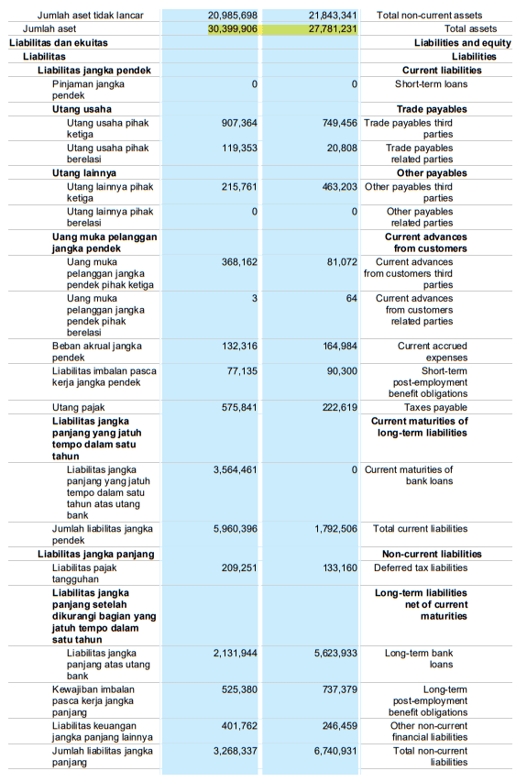

PT. Astra Agro Lestari Tbk (2020-2021)
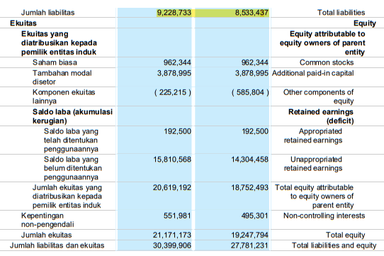

PT. Astra Agro Lestari Tbk (2020-2021)
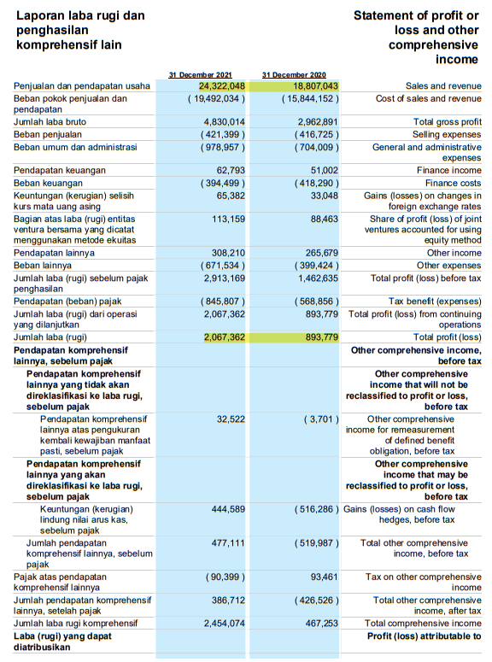

PT Andira Agro Tbk (2018-2019)
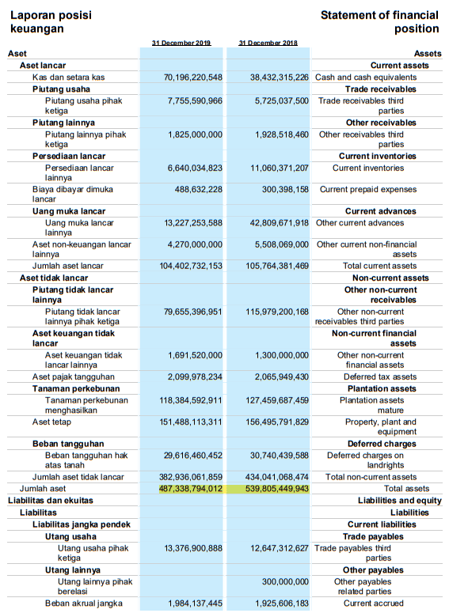

PT Andira Agro Tbk (2018-2019)
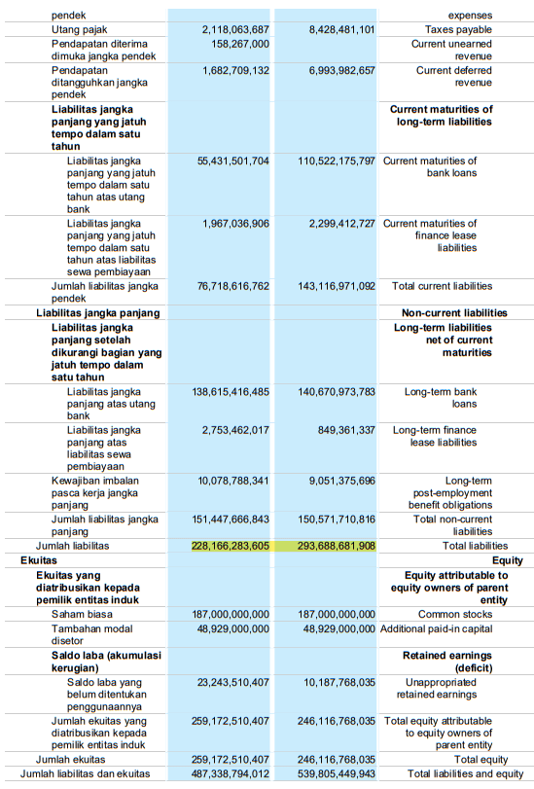

PT Andira Agro Tbk (2018-2019)
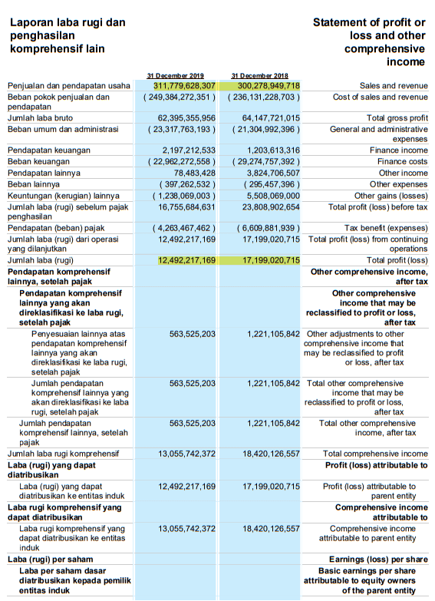

PT Andira Agro Tbk (2020-2021)
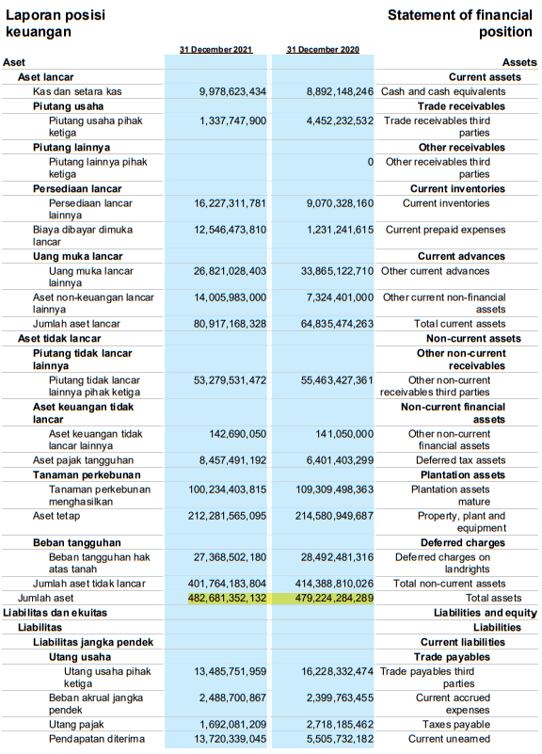

PT Andira Agro Tbk (2020-2021)
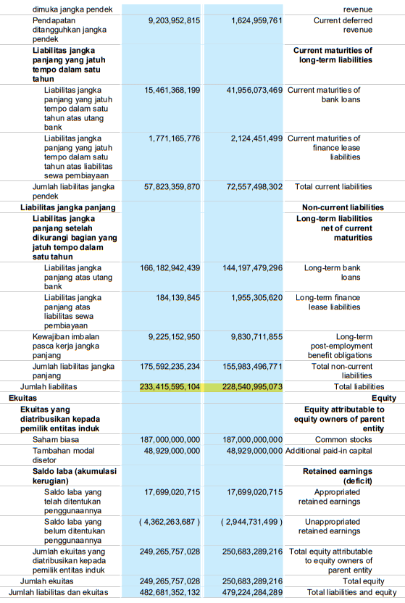

PT Andira Agro Tbk (2020-2021)
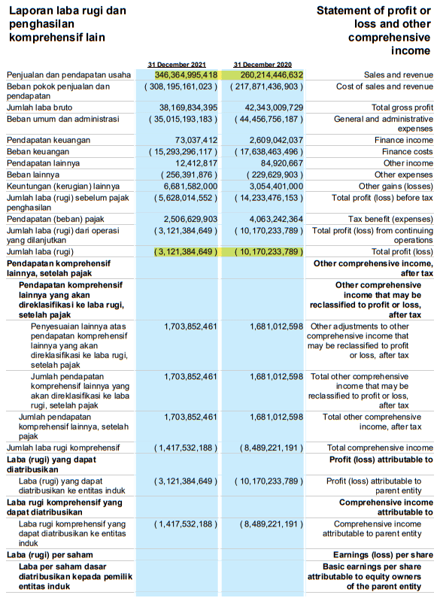

PT Austindo Nusantara Jaya Tbk (2018-2019)
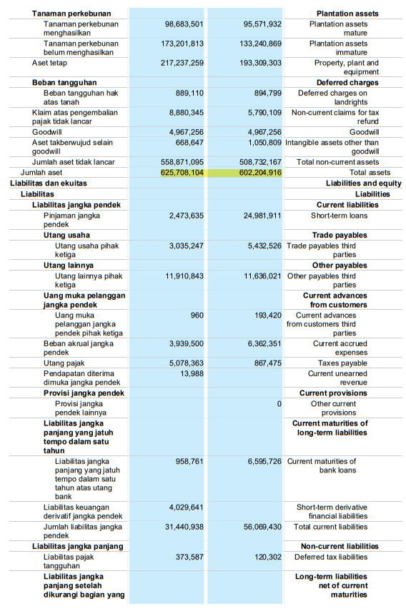
PT Austindo Nusantara Jaya Tbk (2018-2019)
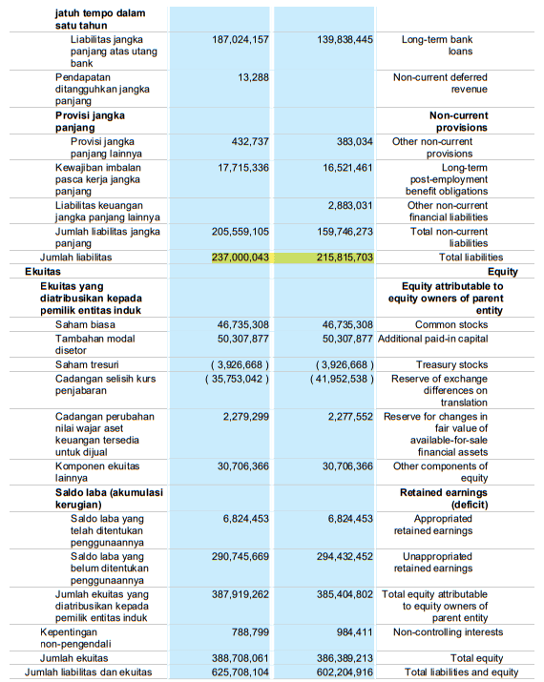

PT Austindo Nusantara Jaya Tbk (2018-2019)
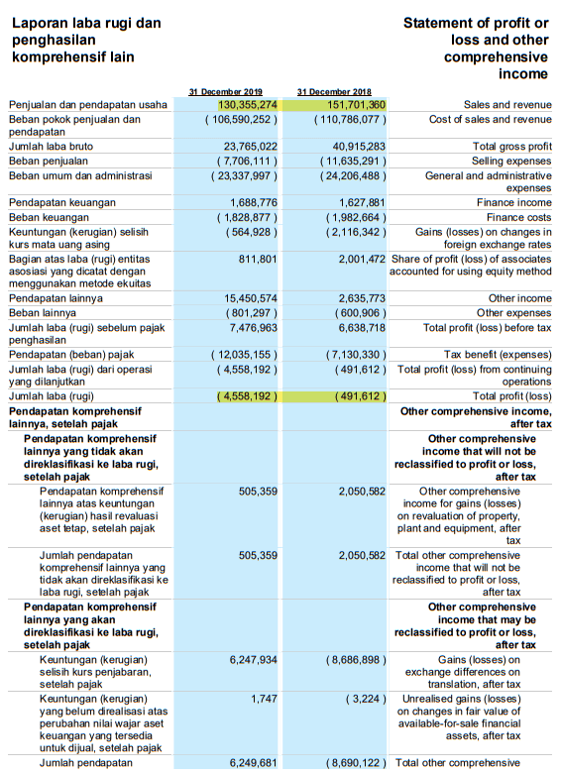

PT Austindo Nusantara Jaya Tbk (2020-2021)
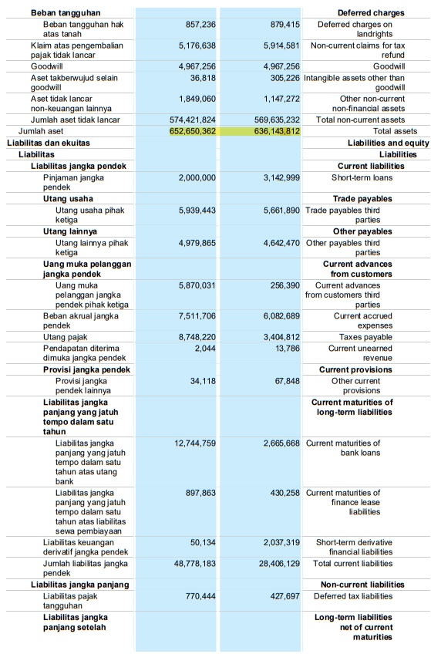
PT Austindo Nusantara Jaya Tbk (2020-2021)
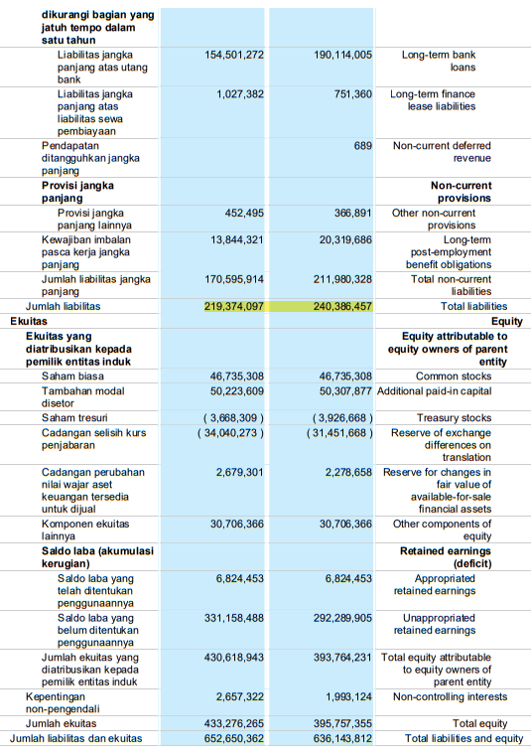

PT Austindo Nusantara Jaya Tbk (2020-2021)
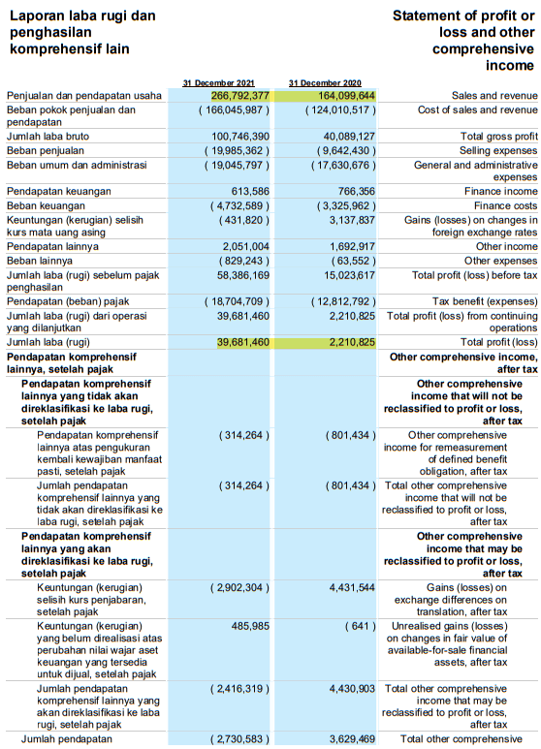

PT Estika Tata Tiara Tbk (2018-2019)
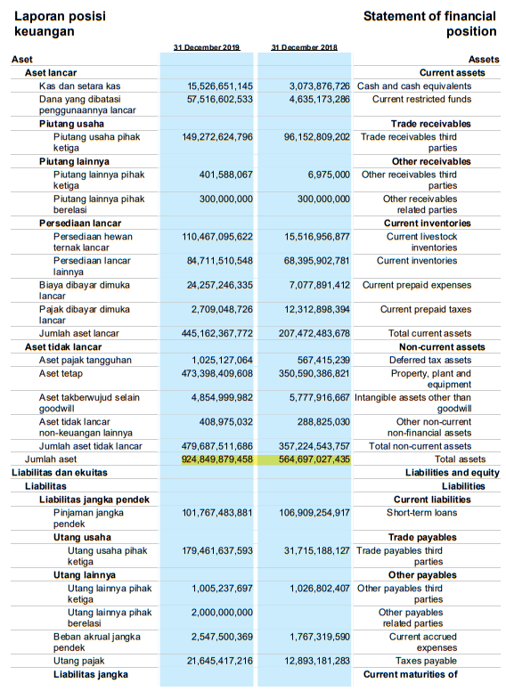

PT Estika Tata Tiara Tbk (2018-2019)
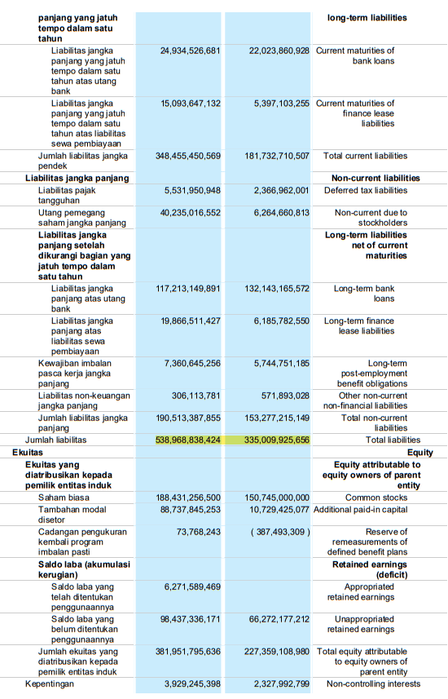
PT Estika Tata Tiara Tbk (2018-2019)
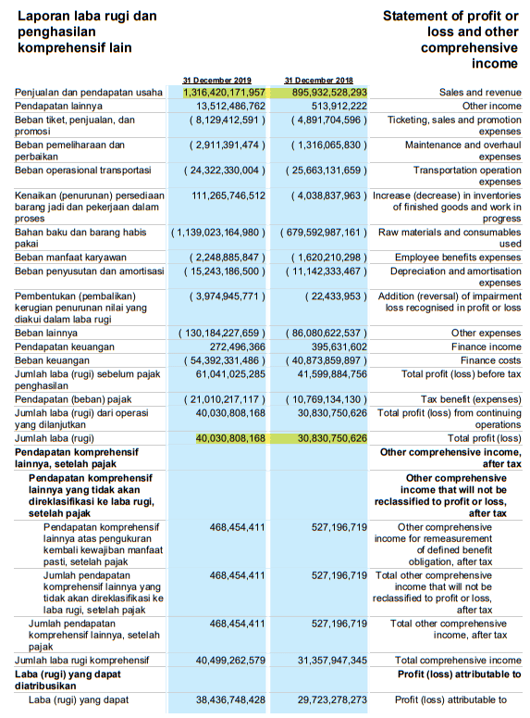

PT Estika Tata Tiara Tbk (2020-2021)
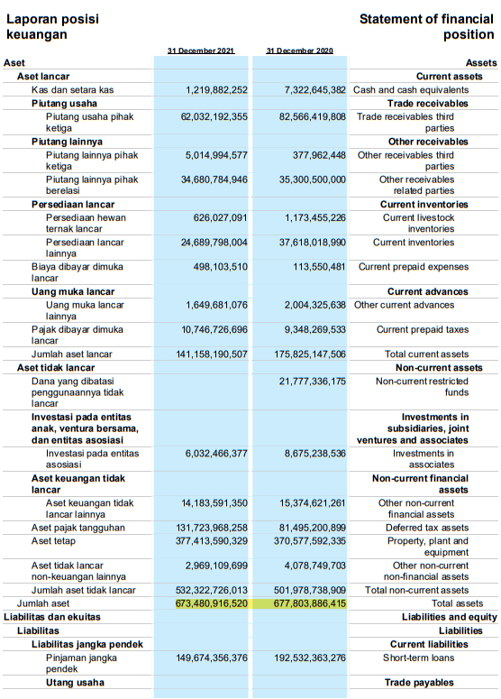

PT Estika Tata Tiara Tbk (2020-2021)
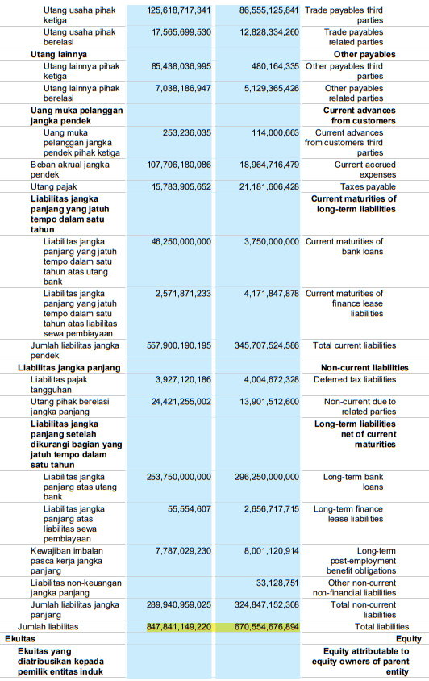

PT Estika Tata Tiara Tbk (2020-2021)
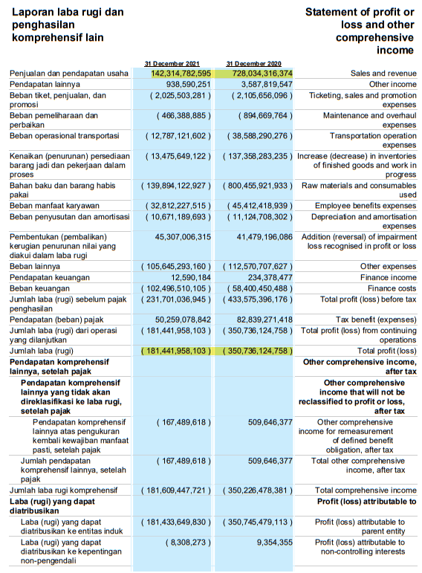

PT Bisi International Tbk (2018-2019)
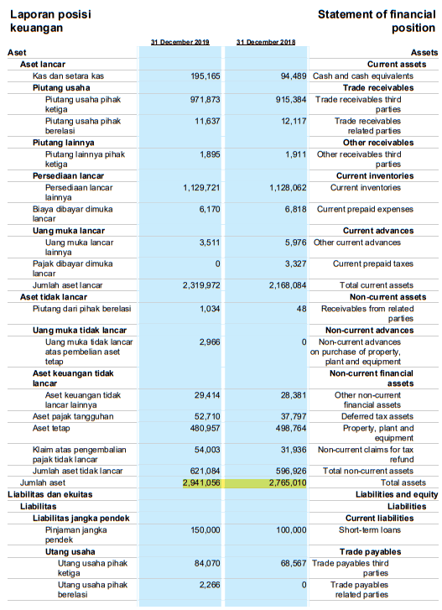

PT Bisi International Tbk (2018-2019)
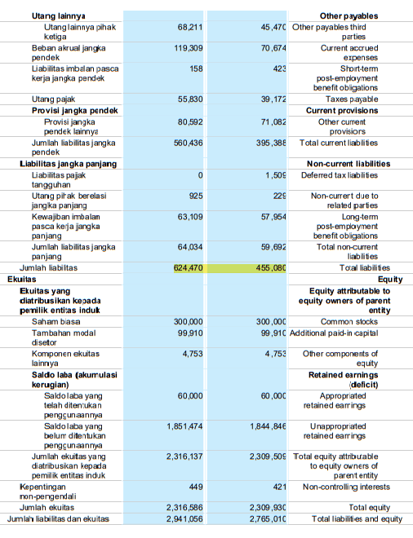

PT Bisi International Tbk (2018-2019)
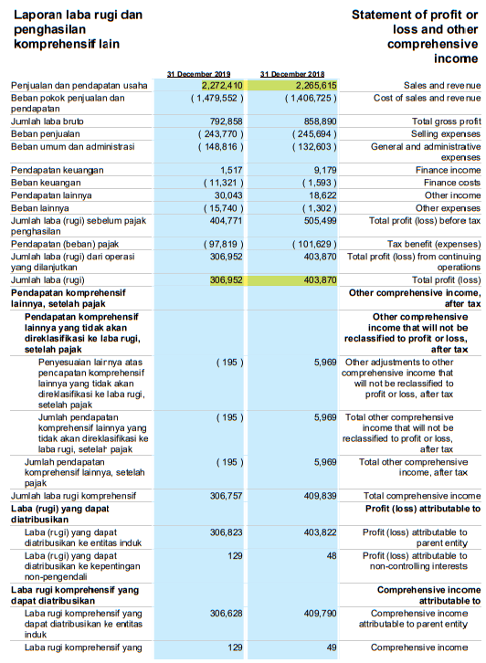

PT Bisi International Tbk (2020-2021)
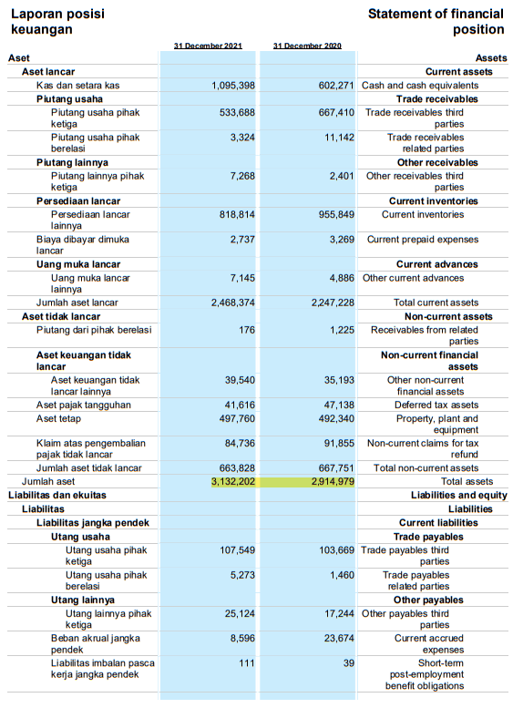

PT Bisi International Tbk (2020-2021)
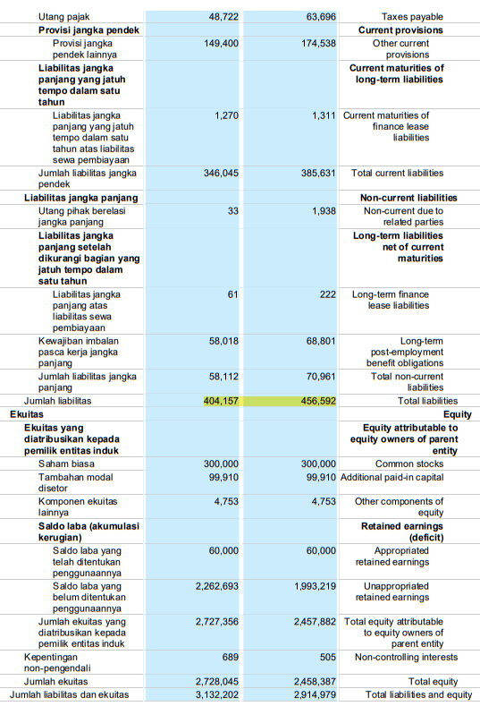

PT Bisi International Tbk (2020-2021)
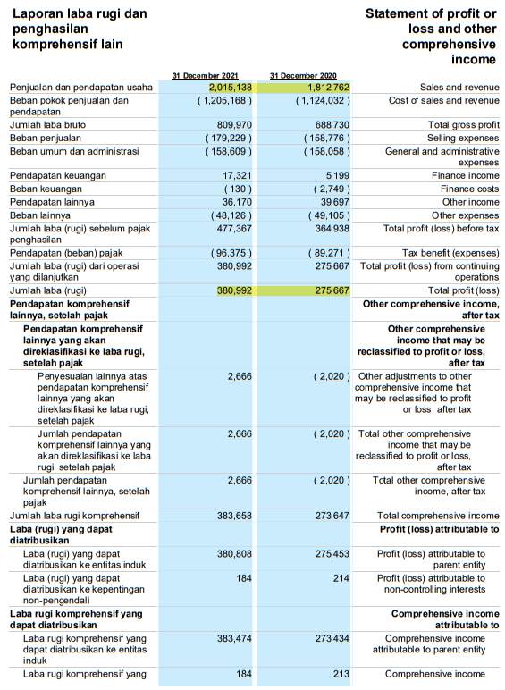

PT Bumi Teknokultura Unggul Tbk (2018-2019)
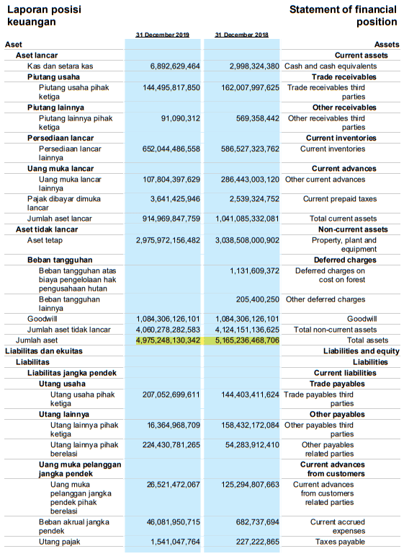

PT Bumi Teknokultura Unggul Tbk (2018-2019)
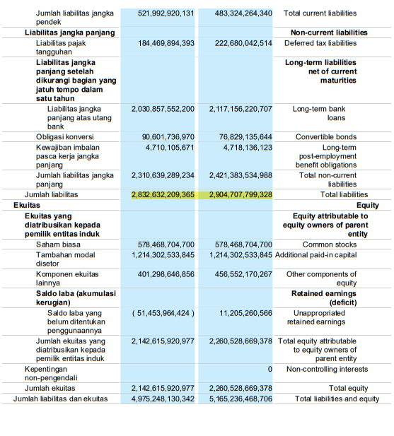

PT Bumi Teknokultura Unggul Tbk (2018-2019)
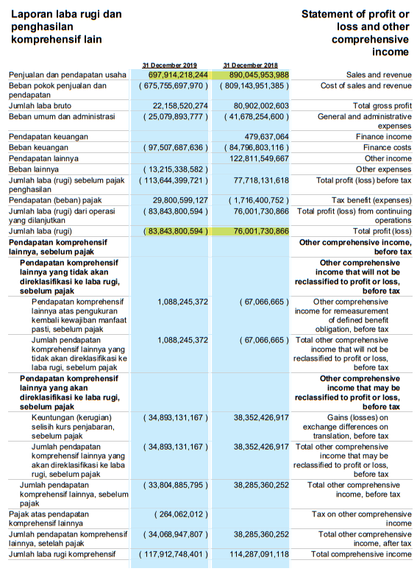

PT Bumi Teknokultura Unggul Tbk (2020-2021)
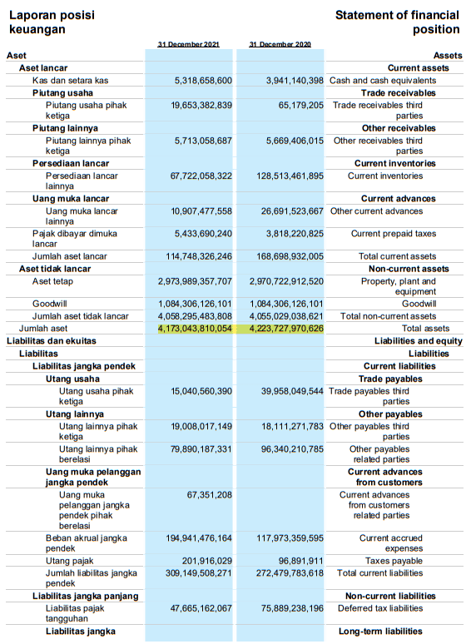

PT Bumi Teknokultura Unggul Tbk (2020-2021)
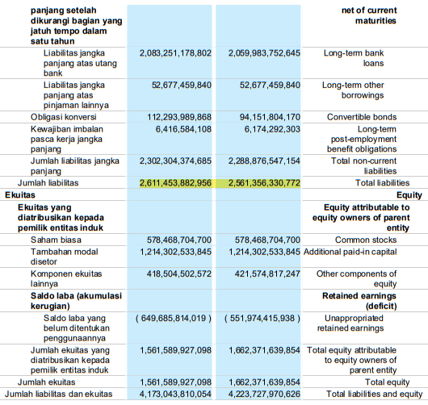

PT Bumi Teknokultura Unggul Tbk (2020-2021)
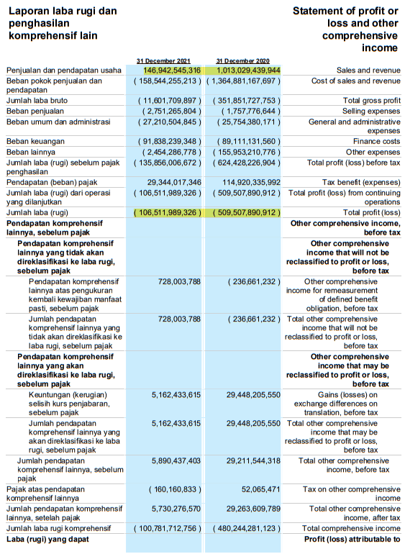

PT Cisadane Sawit Raya Tbk (2018-2019)
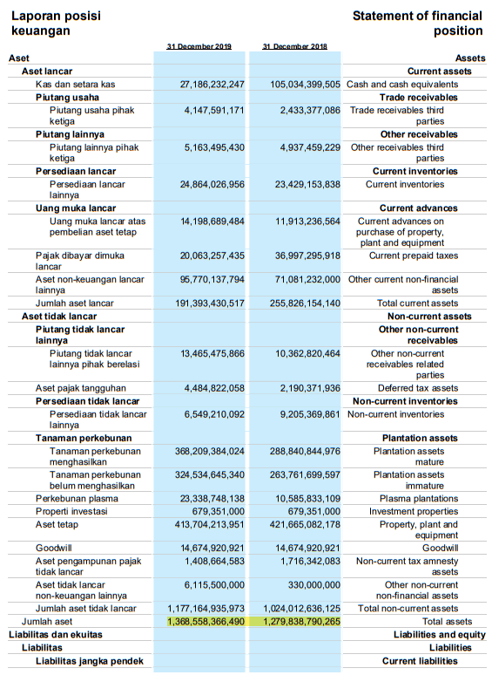

PT Cisadane Sawit Raya Tbk (2018-2019)
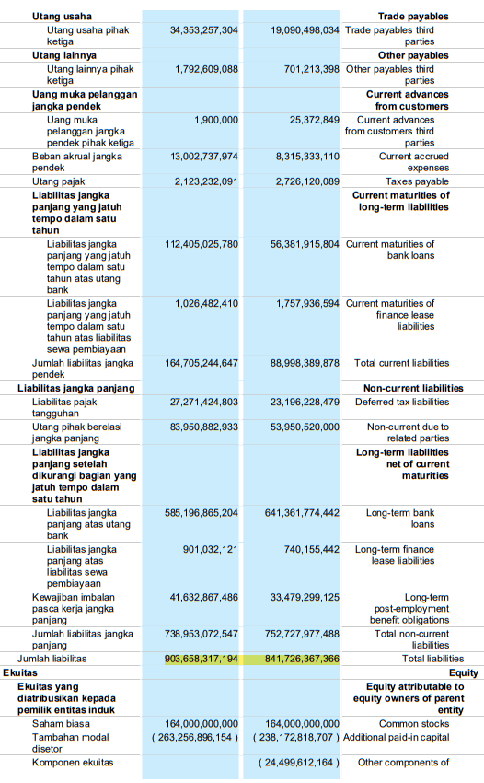

PT Cisadane Sawit Raya Tbk (2018-2019)
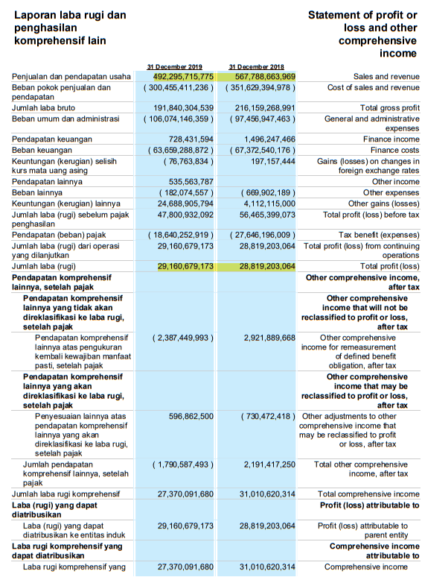

PT Cisadane Sawit Raya Tbk (2020-2021)
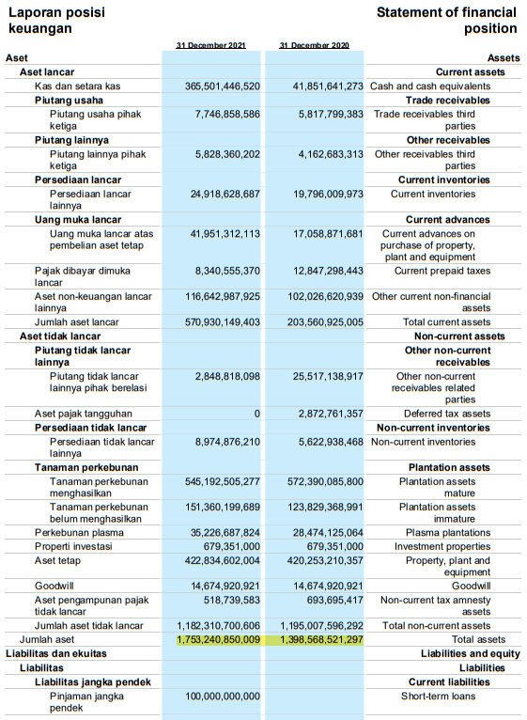

PT Cisadane Sawit Raya Tbk (2020-2021)
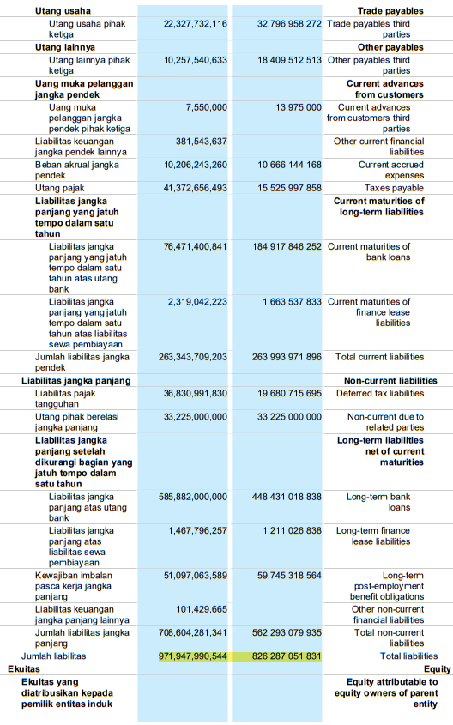
PT Cisadane Sawit Raya Tbk (2020-2021)
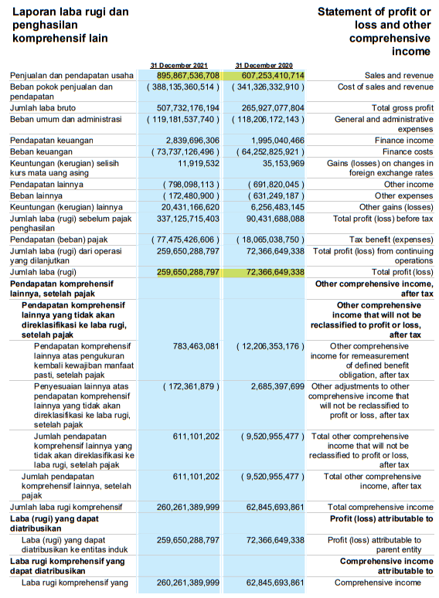

PT Dharma Samudera Fishing Ind. Tbk (2018-2019)
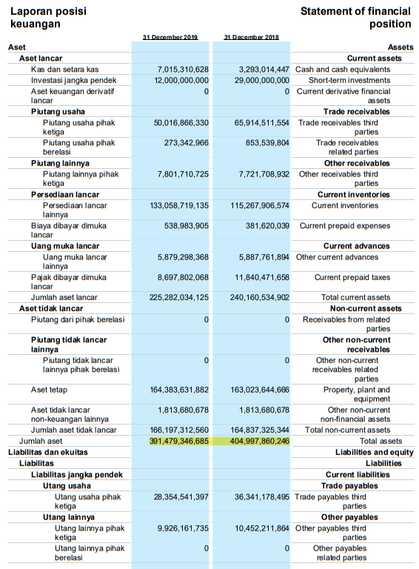

PT Dharma Samudera Fishing Ind. Tbk (2018-2019)
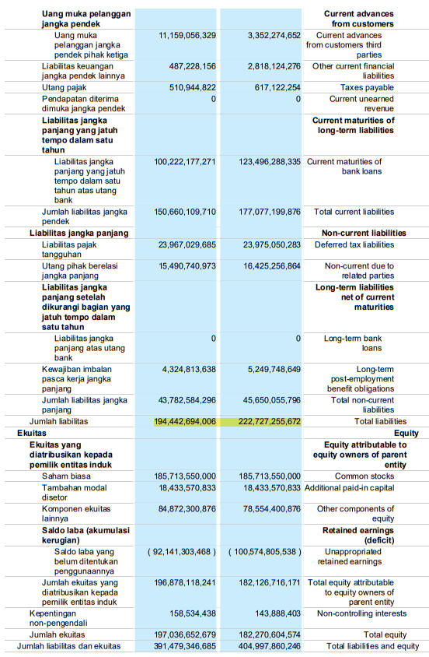
PT Dharma Samudera Fishing Ind. Tbk (2018-2019)
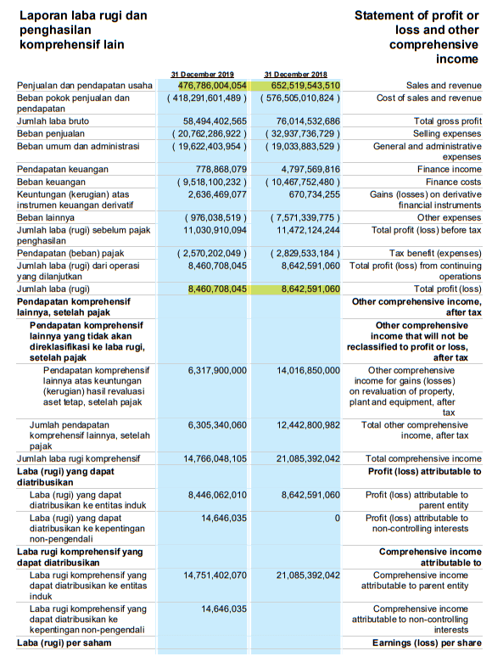
PT Dharma Samudera Fishing Ind. Tbk (2020-2021)
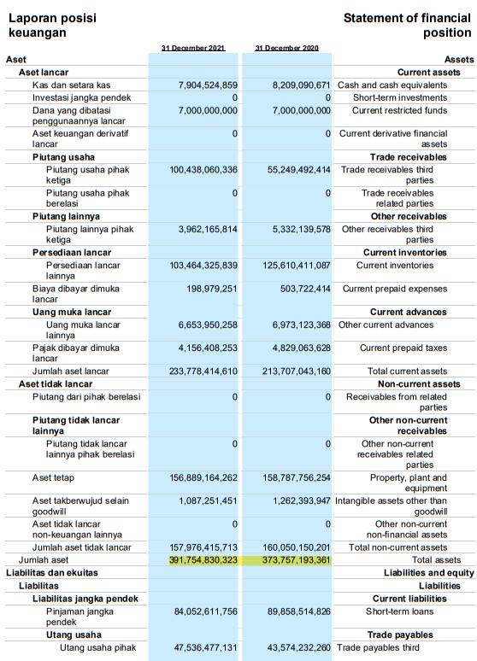

PT Dharma Samudera Fishing Ind. Tbk (2020-2021)
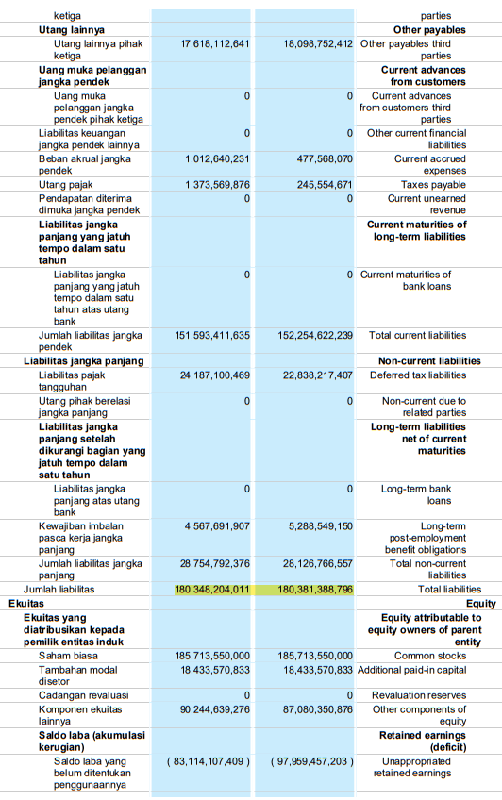

PT Dharma Samudera Fishing Ind. Tbk (2020-2021)
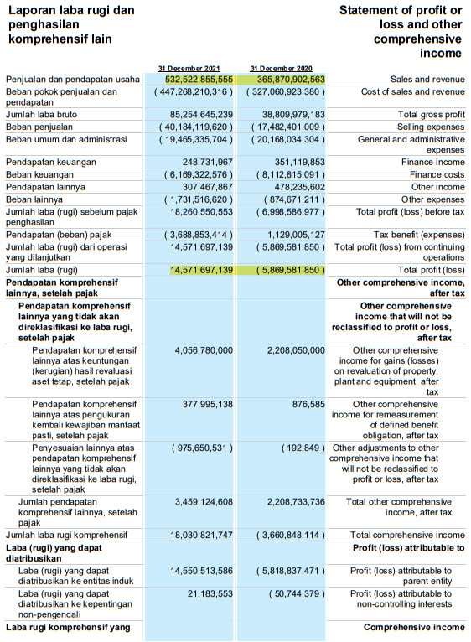

PT Dharma Satya Nusantara Tbk (2018-2019)
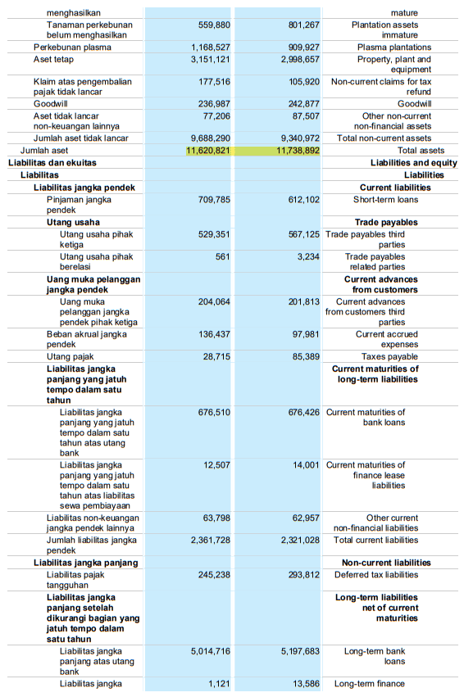

PT Dharma Satya Nusantara Tbk (2018-2019)
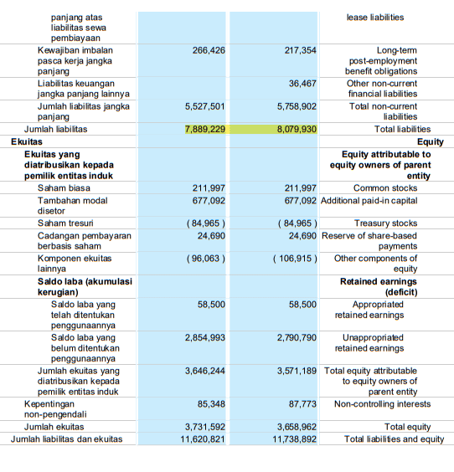

PT Dharma Satya Nusantara Tbk (2018-2019)
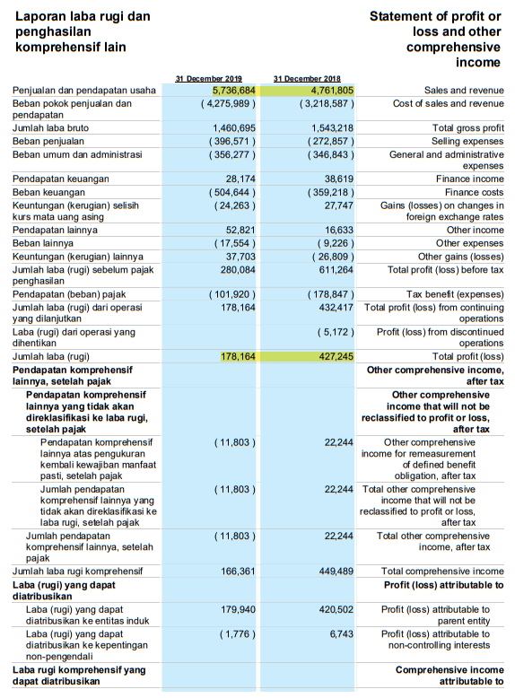

PT Dharma Satya Nusantara Tbk (2020-2021)
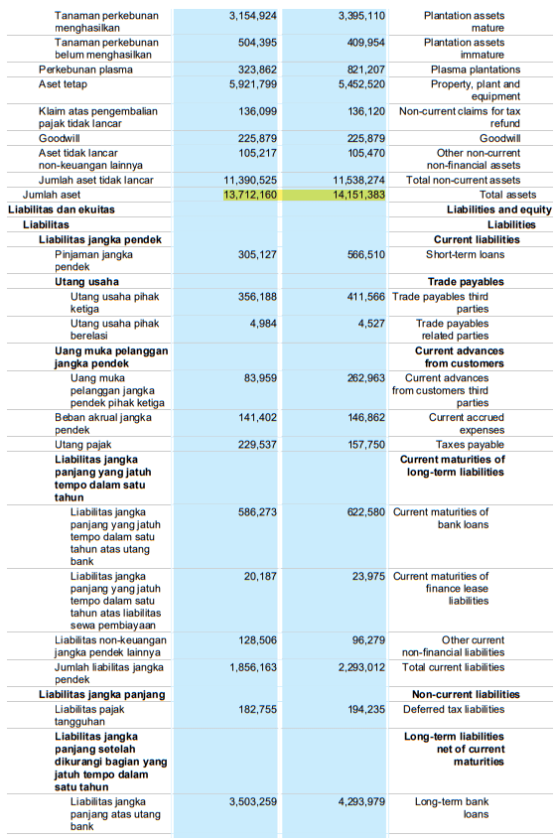
PT Dharma Satya Nusantara Tbk (2020-2021)
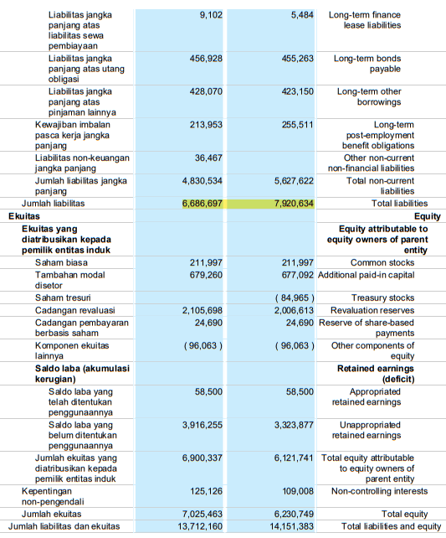

PT Dharma Satya Nusantara Tbk (2020-2021)
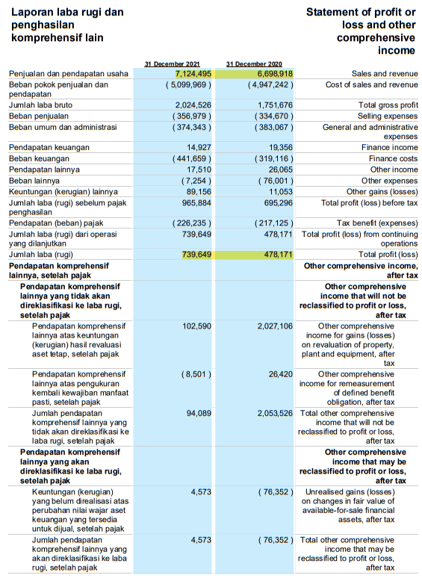

PT Gozco Plantations Tbk (2018-2019)
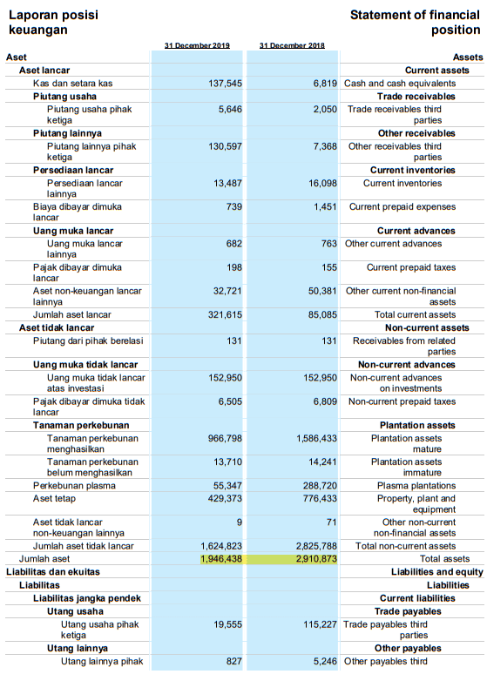

PT Gozco Plantations Tbk (2018-2019)
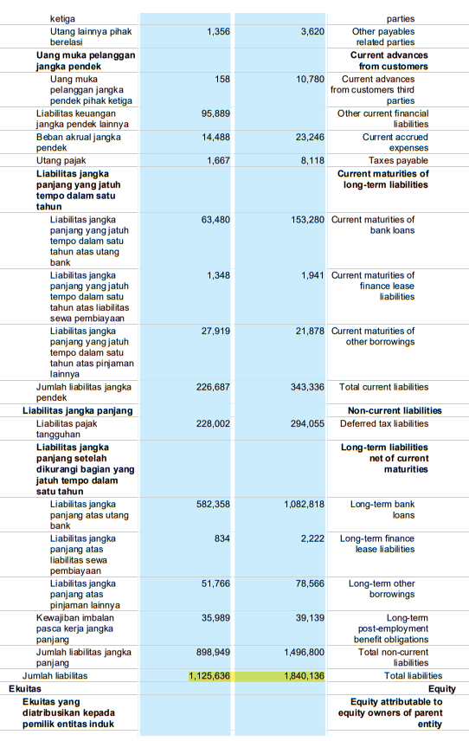
PT Gozco Plantations Tbk (2018-2019)
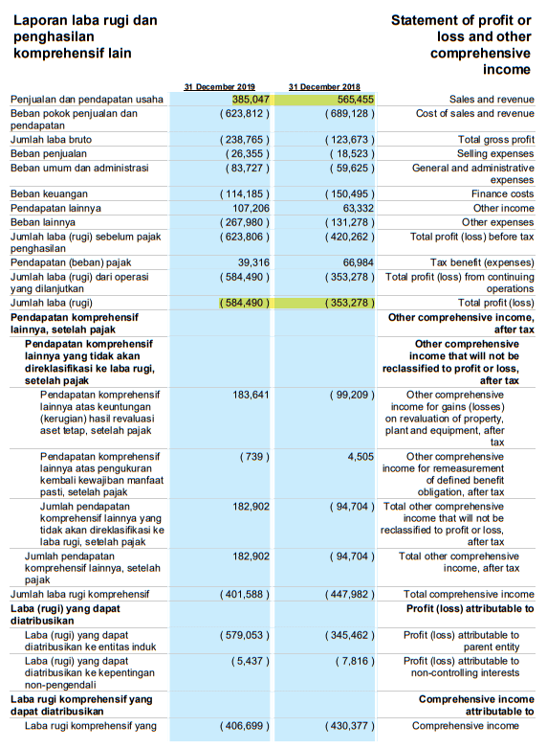

PT Gozco Plantations Tbk (2020-2021)
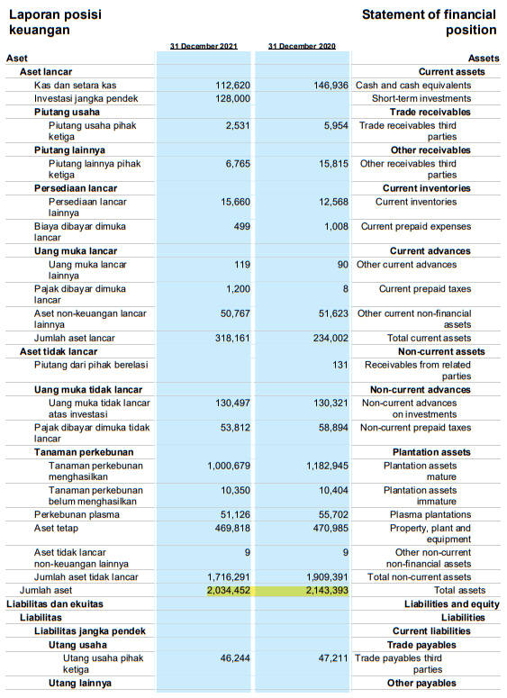

PT Gozco Plantations Tbk (2020-2021)
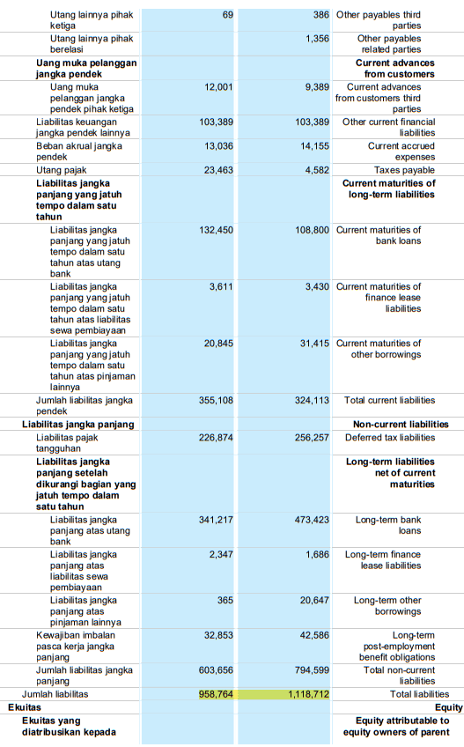
PT Gozco Plantations Tbk (2020-2021)
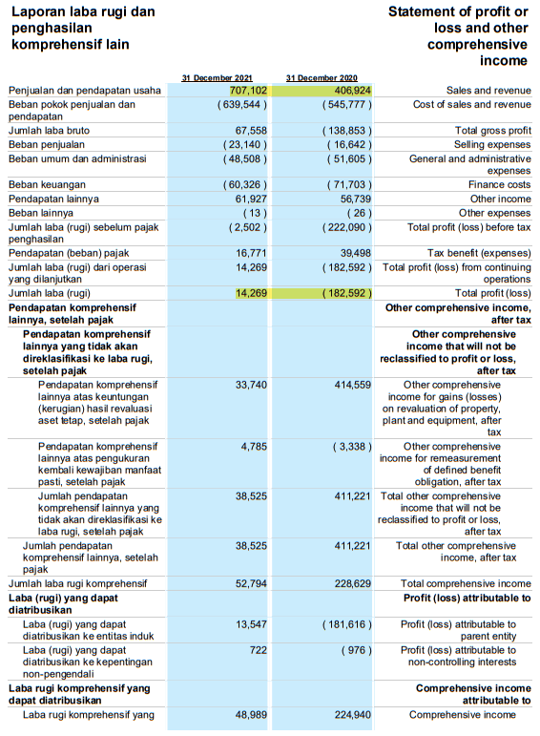

PT London Sumatra Indonesia Tbk (2018-2019)
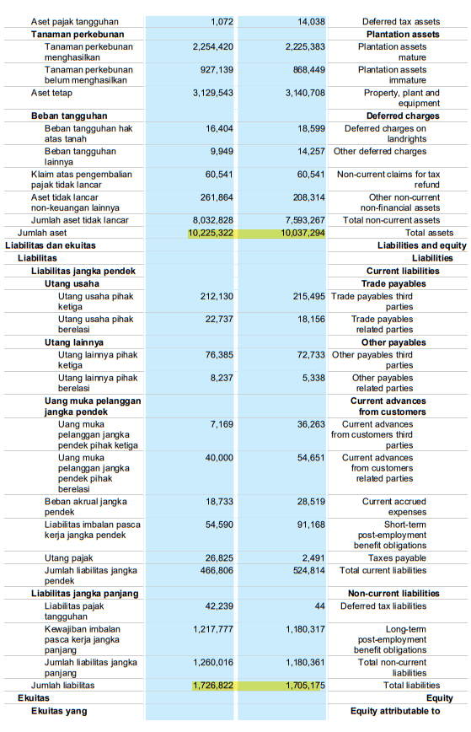
PT London Sumatra Indonesia Tbk (2018-2019)
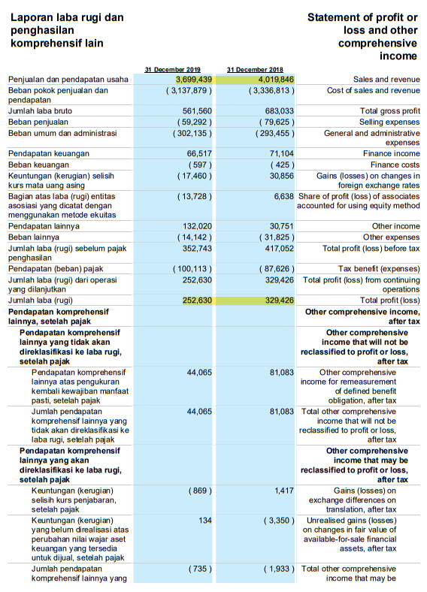
PT London Sumatra Indonesia Tbk (2020-2021)
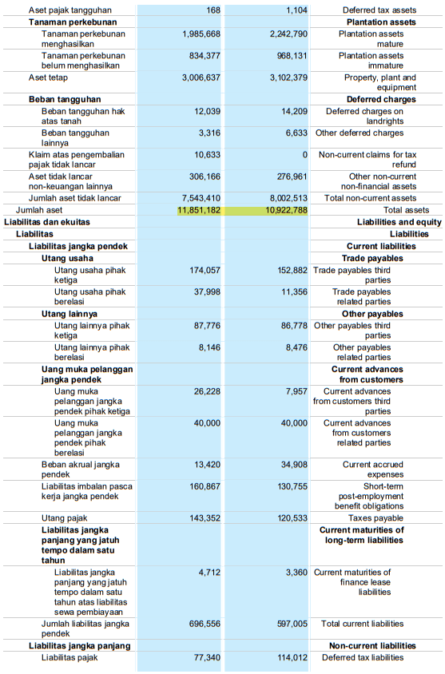
PT London Sumatra Indonesia Tbk (2020-2021)
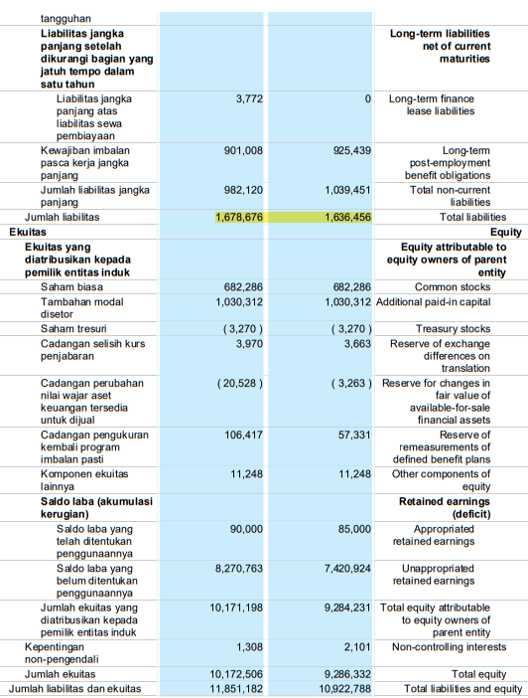

PT London Sumatra Indonesia Tbk (2020-2021)
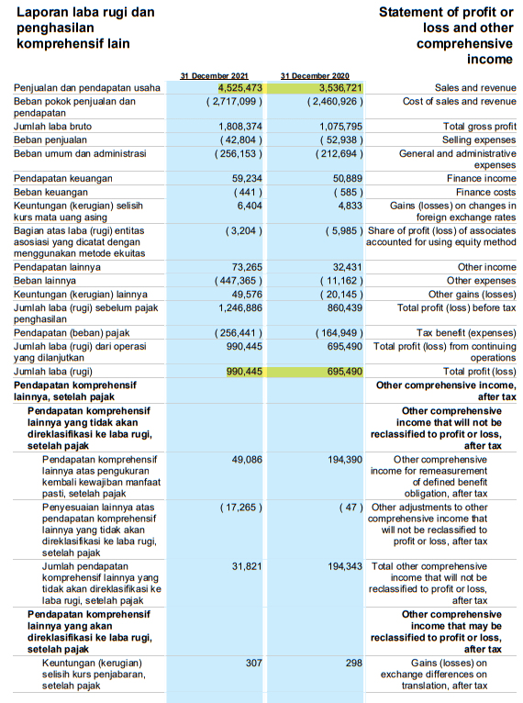

PT Mahkota Group Tbk (2018-2019)
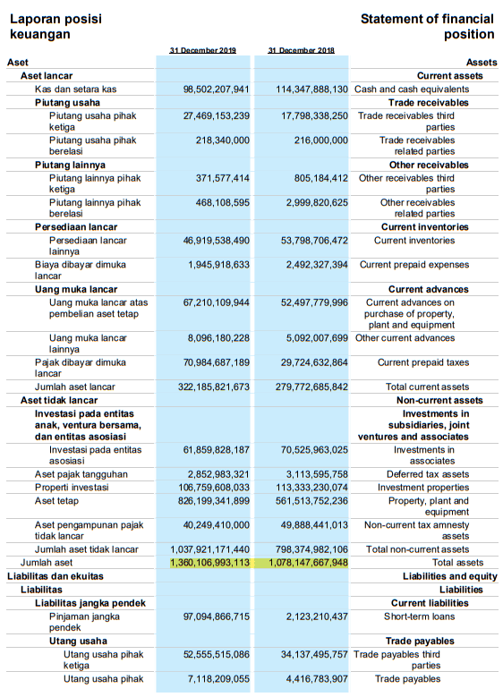
PT Mahkota Group Tbk (2018-2019)
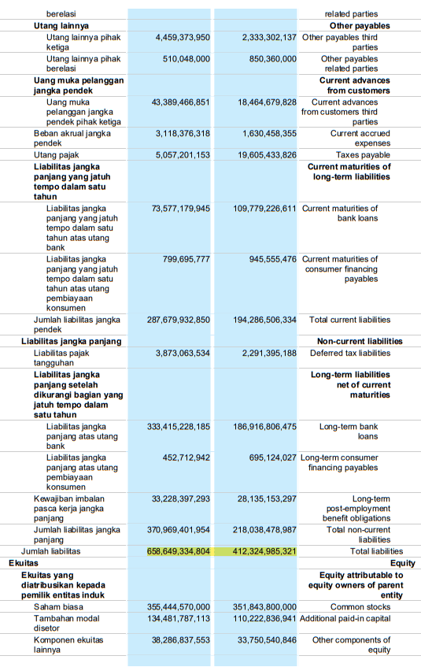
PT Mahkota Group Tbk (2018-2019)
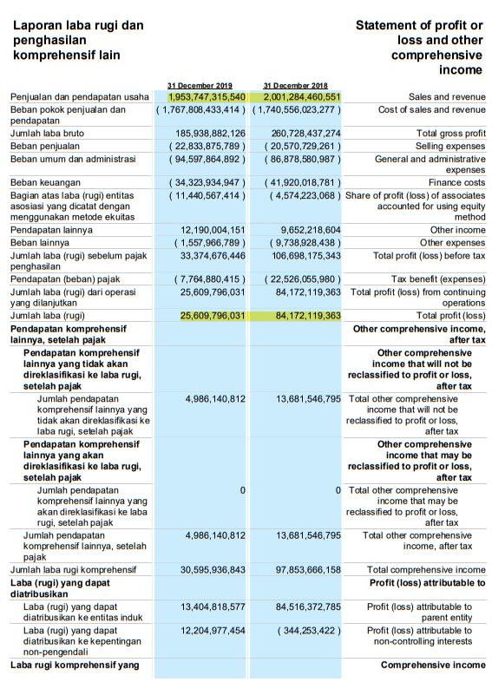

PT Mahkota Group Tbk (2020-2021)
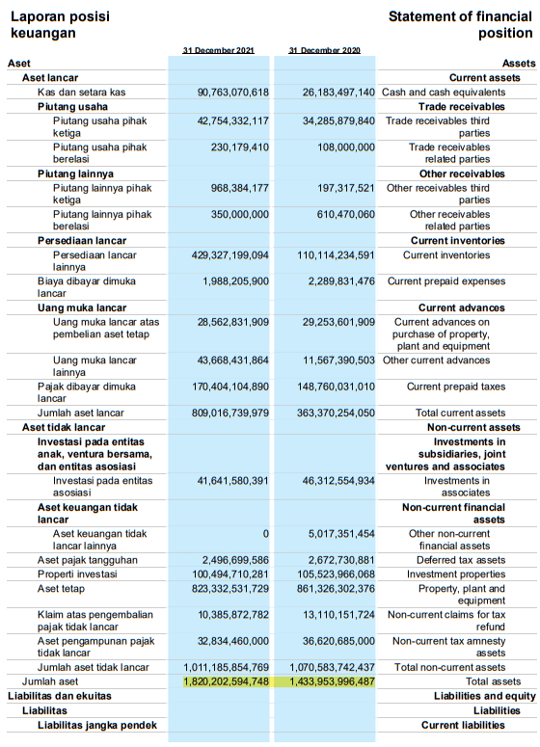

PT Mahkota Group Tbk (2020-2021)
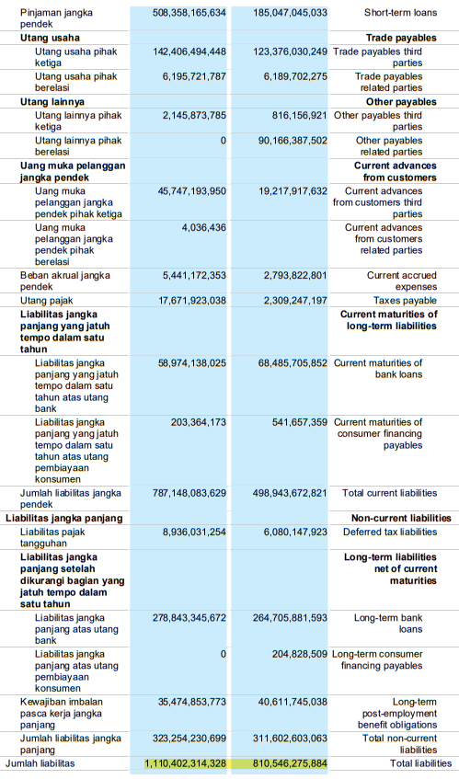
PT Mahkota Group Tbk (2020-2021)
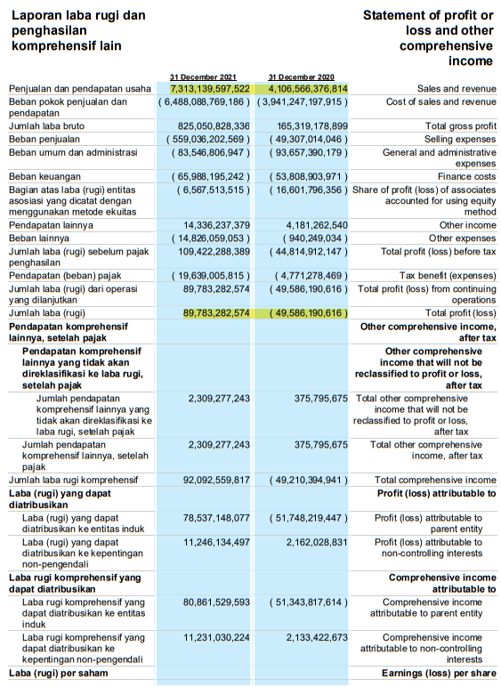

PT Provident Agro Tbk (2018-2019)
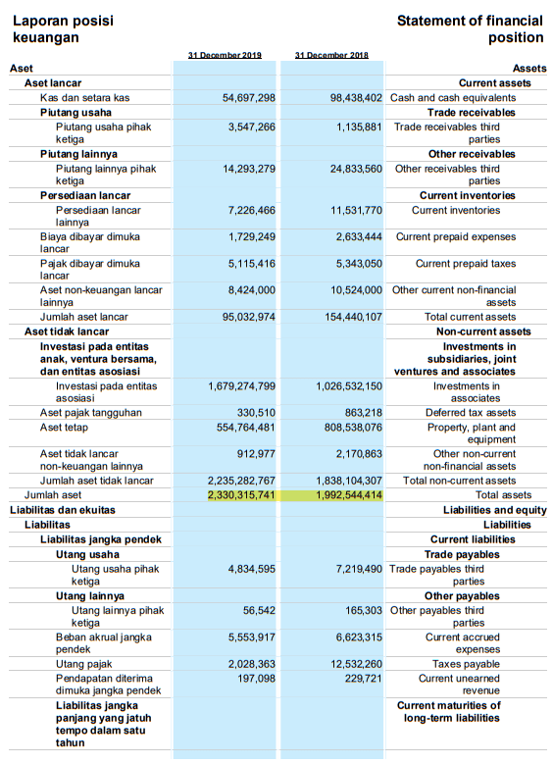
PT Provident Agro Tbk (2018-2019)
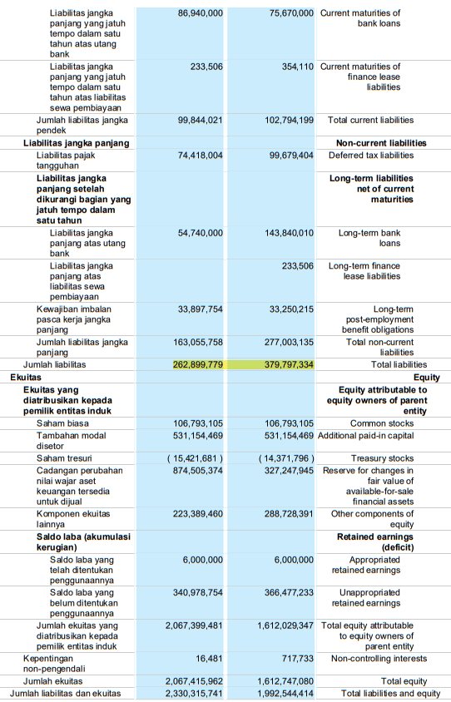
PT Provident Agro Tbk (2018-2019)
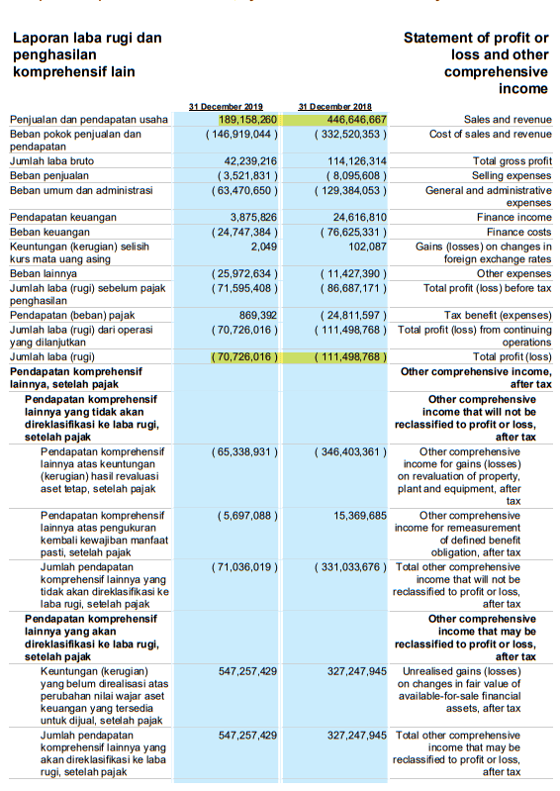

PT Provident Agro Tbk (2020-2021)
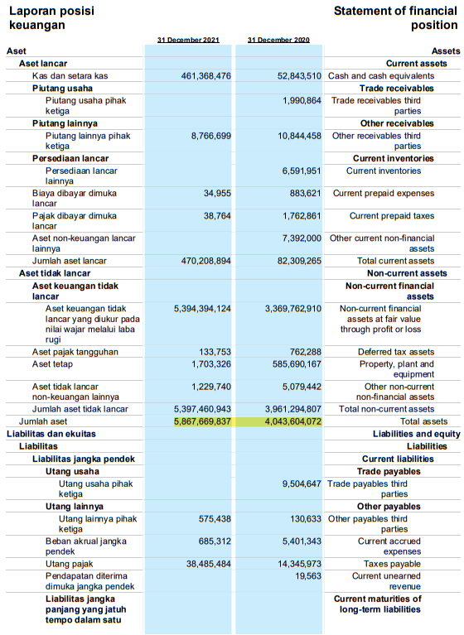

PT Provident Agro Tbk (2020-2021)
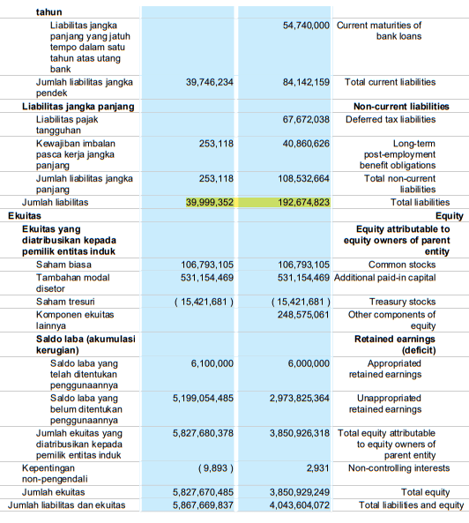

PT Provident Agro Tbk (2020-2021)
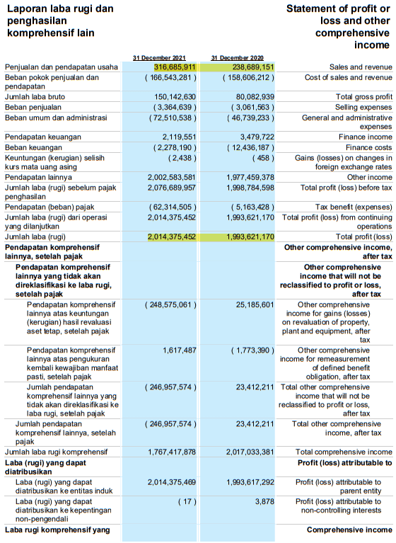

PT Palma Serasih Tbk (2018-2019)
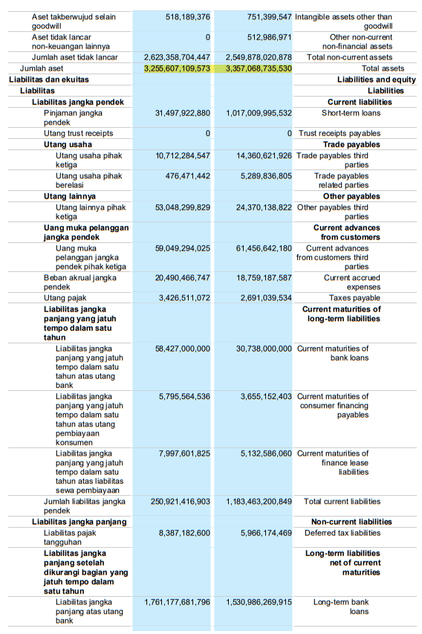

PT Palma Serasih Tbk (2018-2019)
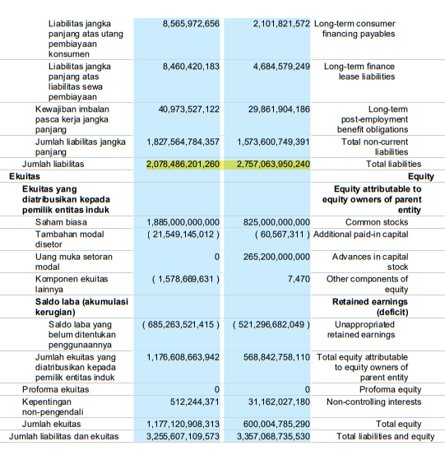
PT Palma Serasih Tbk (2018-2019)
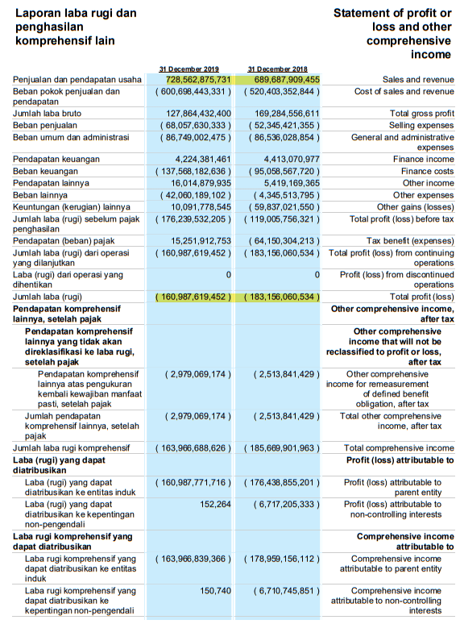

PT Palma Serasih Tbk (2020-2021)
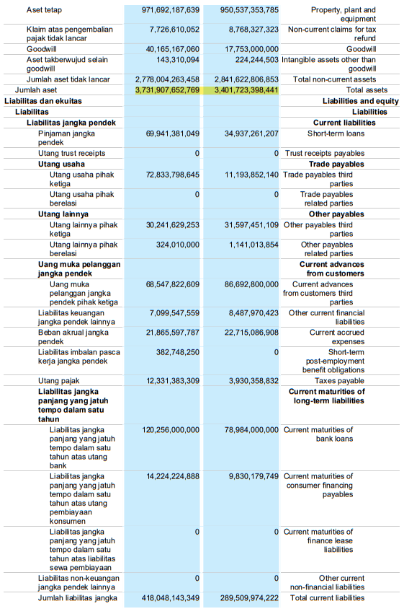
PT Palma Serasih Tbk (2020-2021)
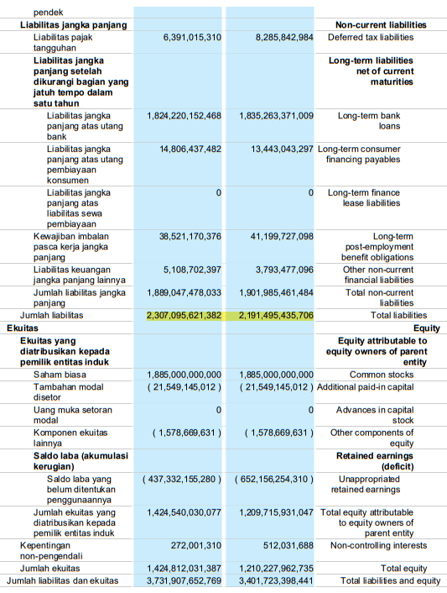

PT Palma Serasih Tbk (2020-2021)
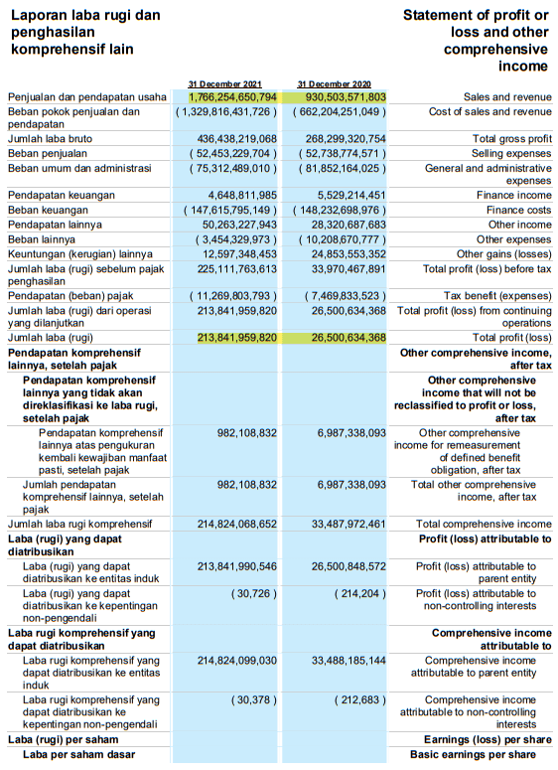

PT Sampoerna Agro Tbk (2018-2019)
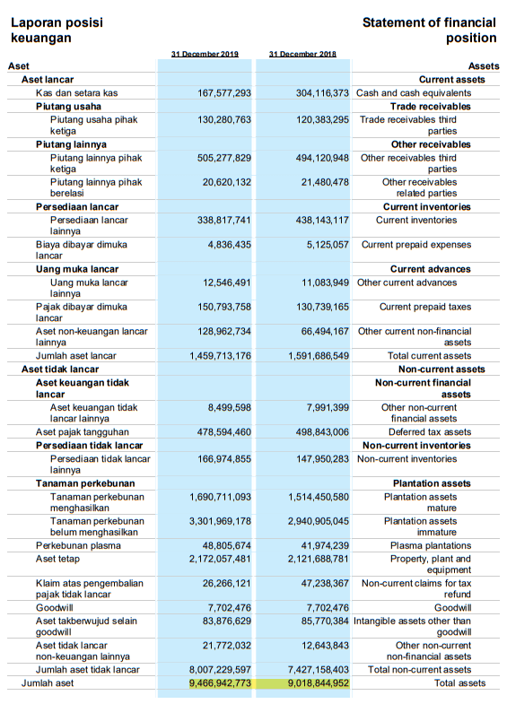
PT Sampoerna Agro Tbk (2018-2019)
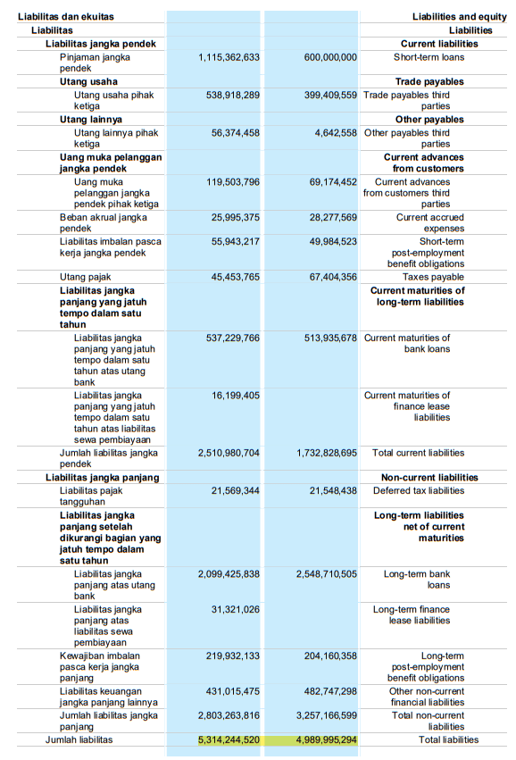

PT Sampoerna Agro Tbk (2018-2019)
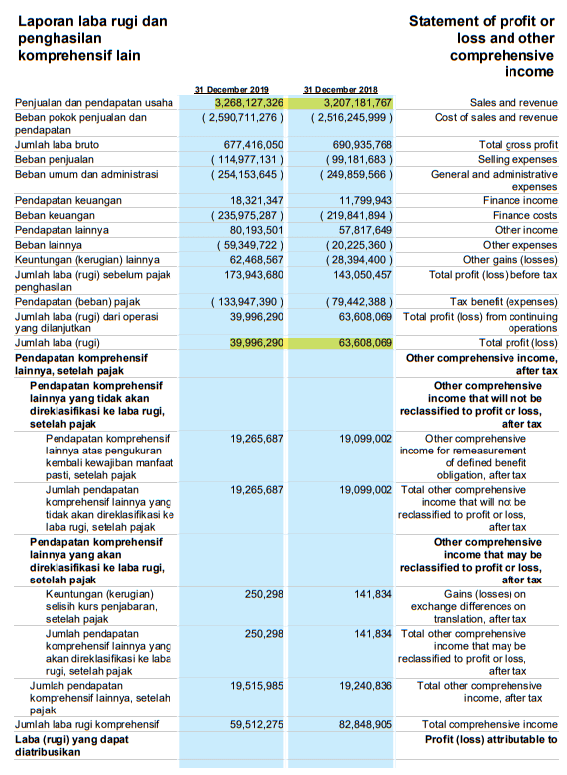

PT Sampoerna Agro Tbk (2020-2021)
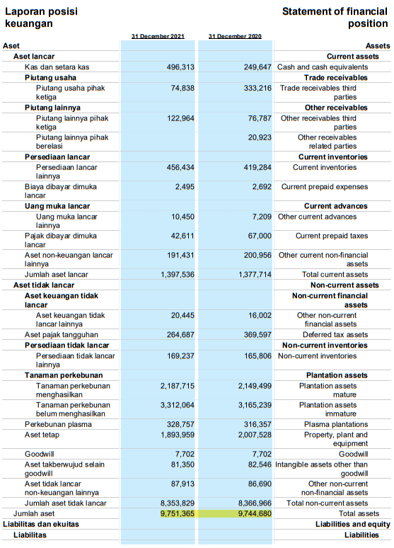

PT Sampoerna Agro Tbk (2020-2021)
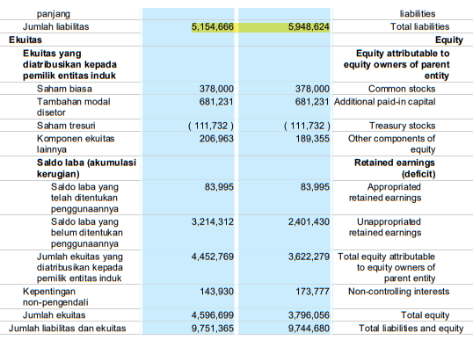

PT Sampoerna Agro Tbk (2020-2021)
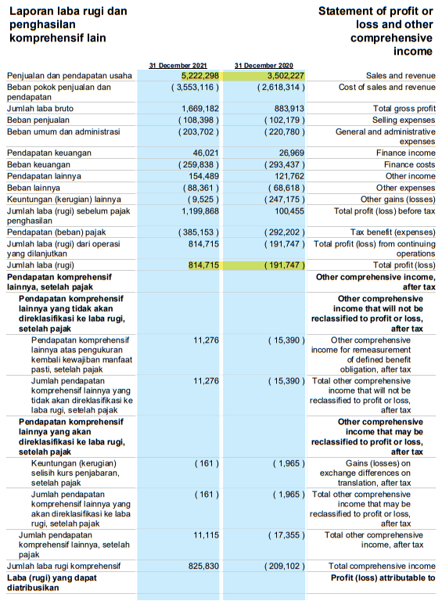

PT Salim Ivomas Pratama Tbk (2018-2019)
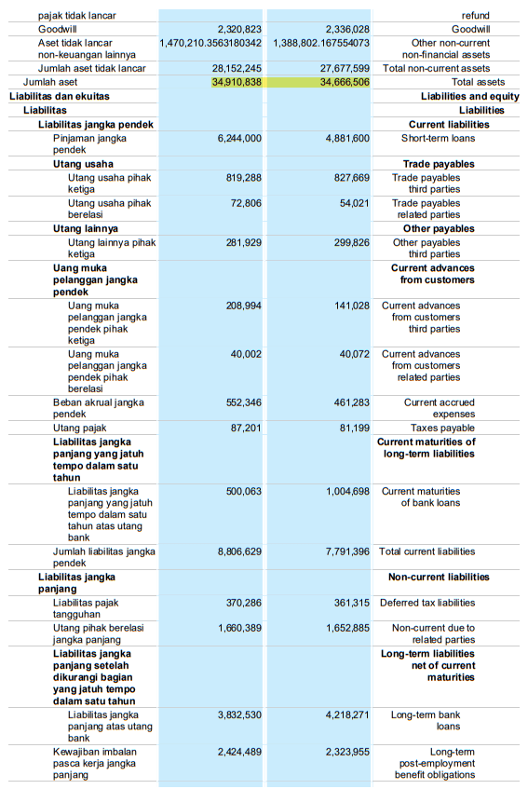

PT Salim Ivomas Pratama Tbk (2018-2019)
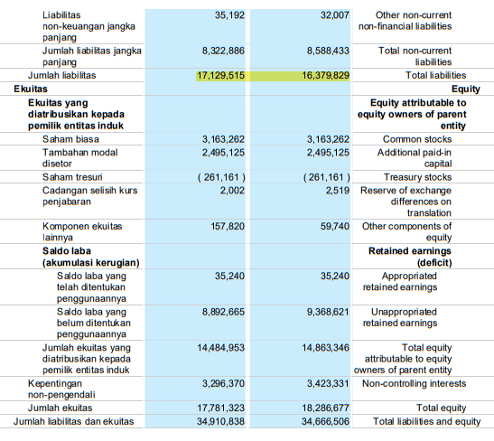
PT Salim Ivomas Pratama Tbk (2018-2019)
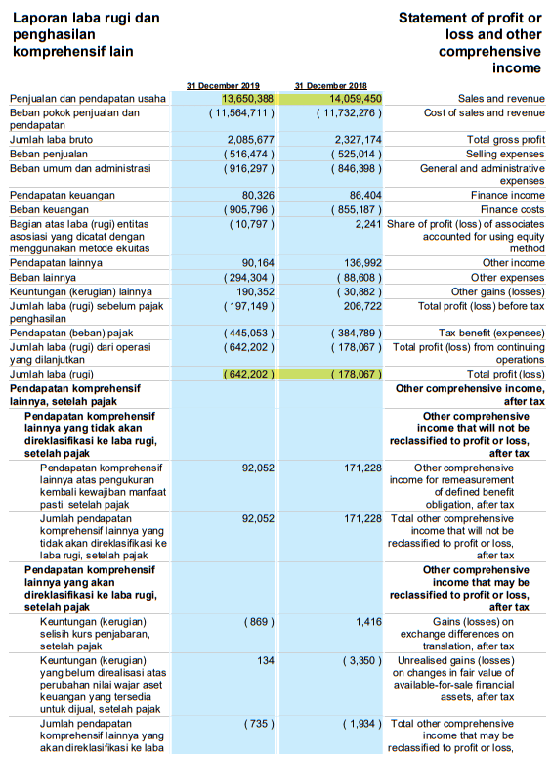

PT Salim Ivomas Pratama Tbk (2020-2021)
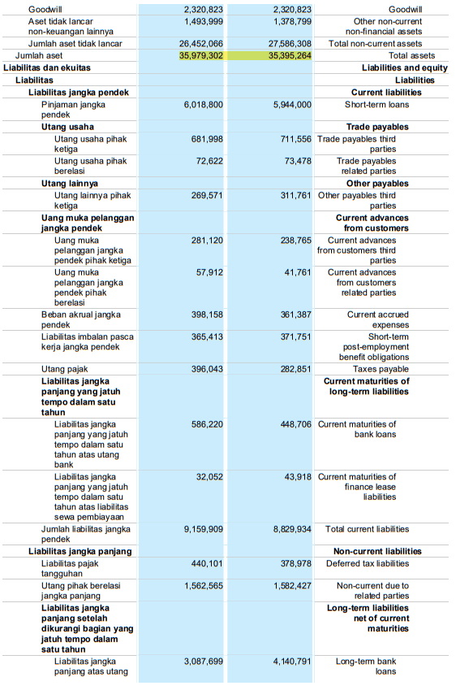
PT Salim Ivomas Pratama Tbk (2020-2021)
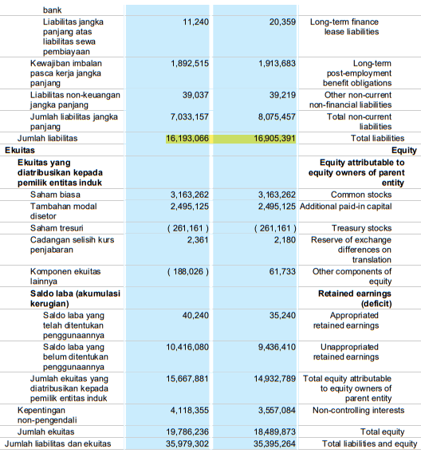

PT Salim Ivomas Pratama Tbk (2020-2021)
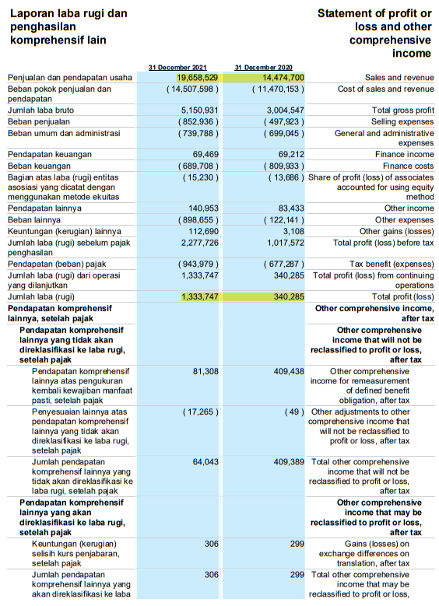

PT SMART Tbk (2018-2019)
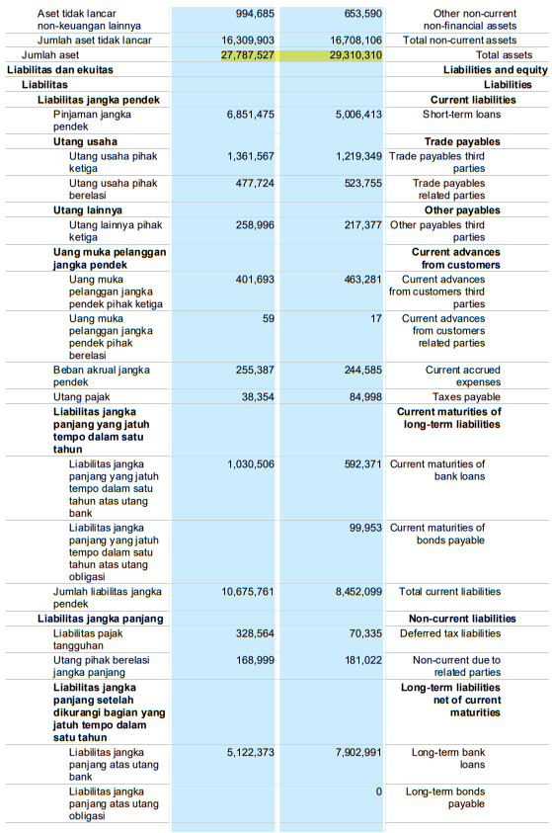
PT SMART Tbk (2018-2019)
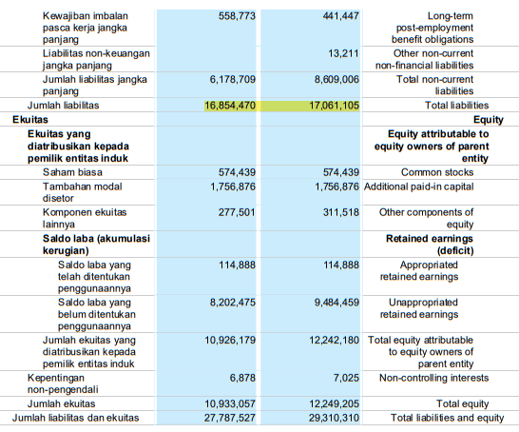

PT SMART Tbk (2018-2019)
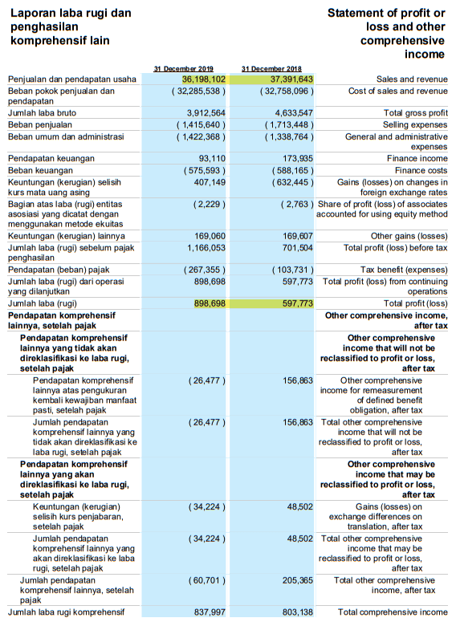

PT SMART Tbk (2020-2021)
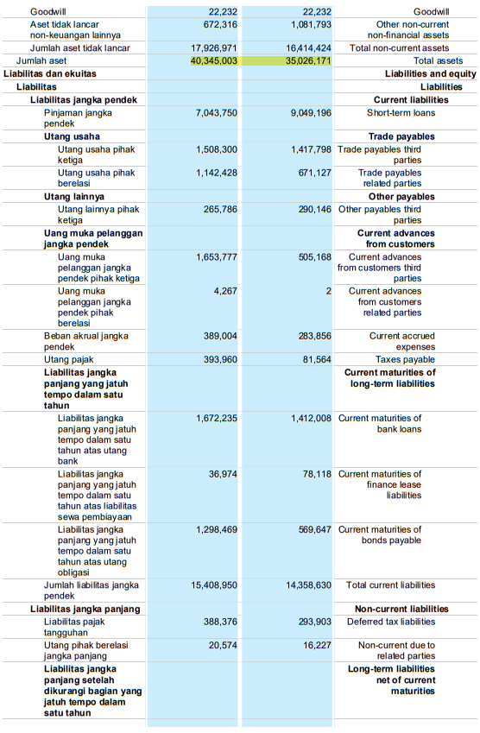
PT SMART Tbk (2020-2021)
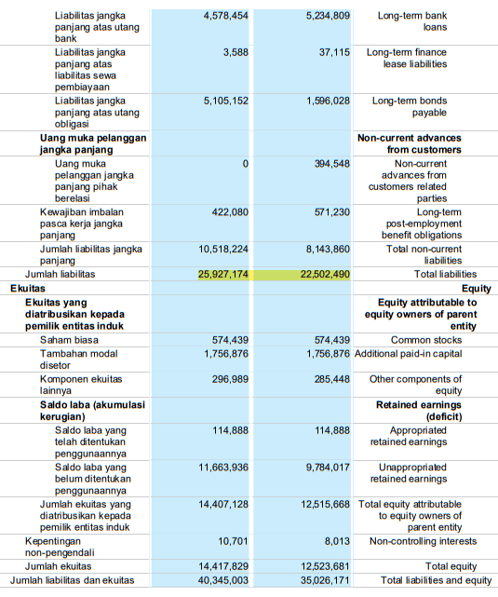
PT SMART Tbk (2020-2021)
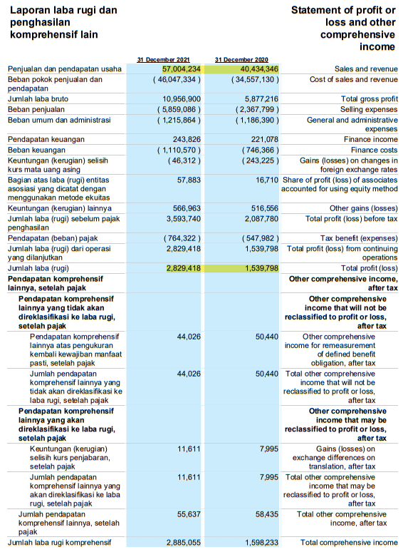
PT Sawit Sumbermas Sarana Tbk (2018-2019)
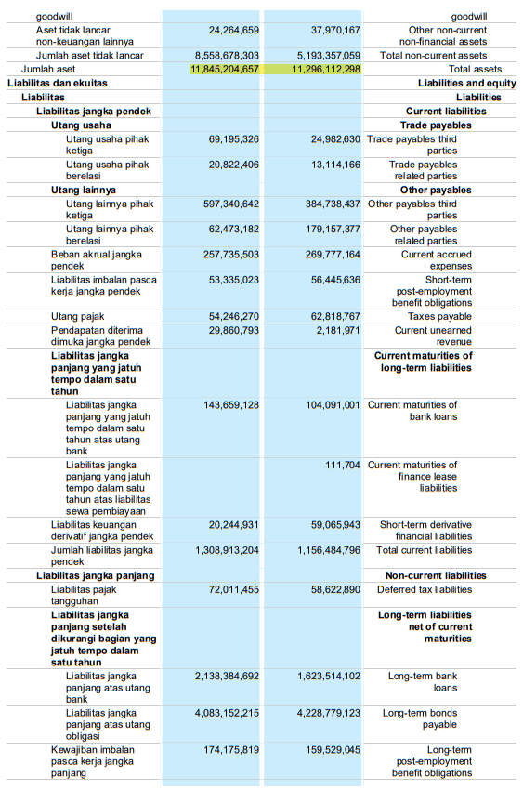
PT Sawit Sumbermas Sarana Tbk (2018-2019)
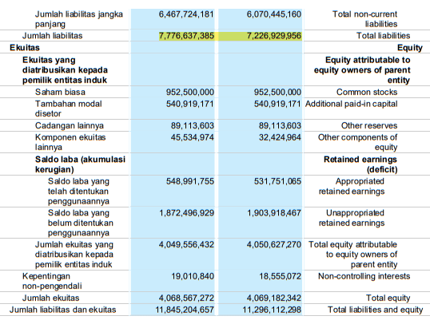
PT Sawit Sumbermas Sarana Tbk (2018-2019)
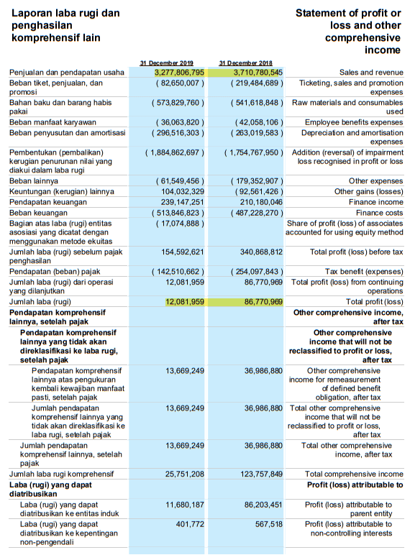

PT Sawit Sumbermas Sarana Tbk (2020-2021)
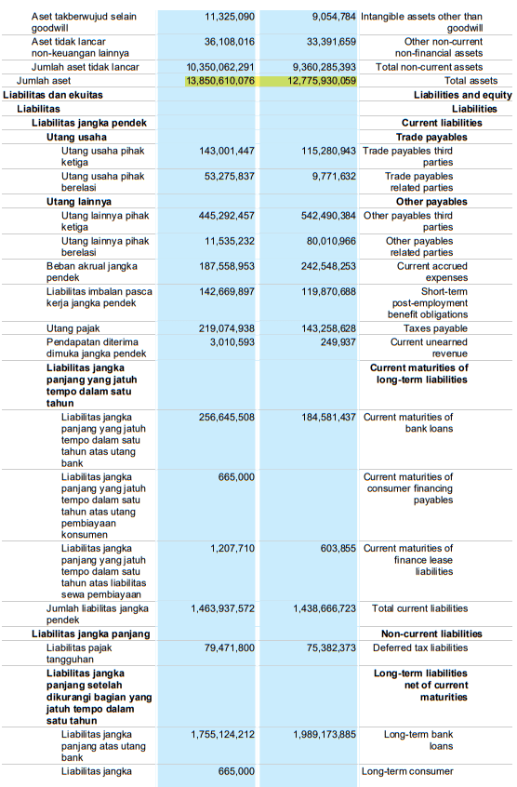
PT Sawit Sumbermas Sarana Tbk (2020-2021)
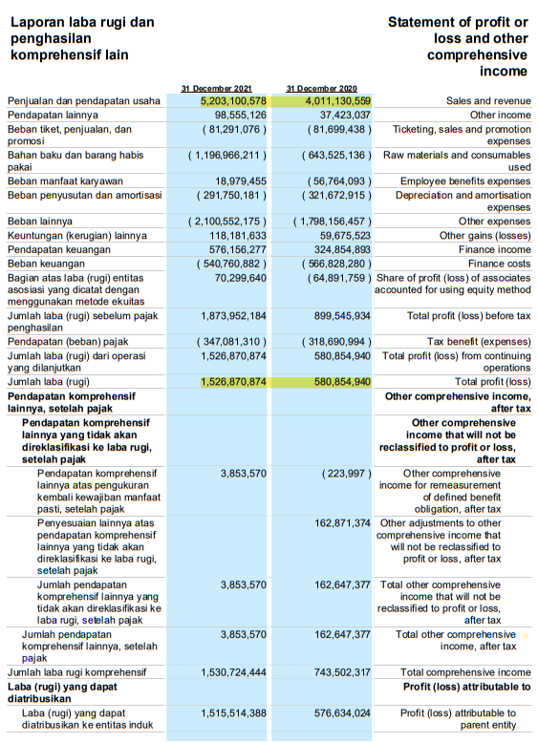

PT Tunas Baru Lampung Tbk (2018-2019)
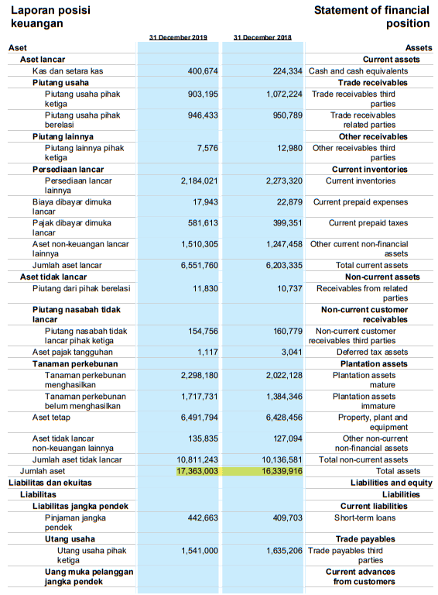

PT Tunas Baru Lampung Tbk (2018-2019)
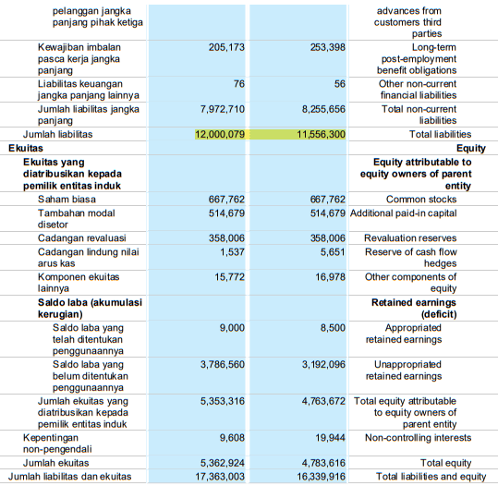

PT Tunas Baru Lampung Tbk (2018-2019)
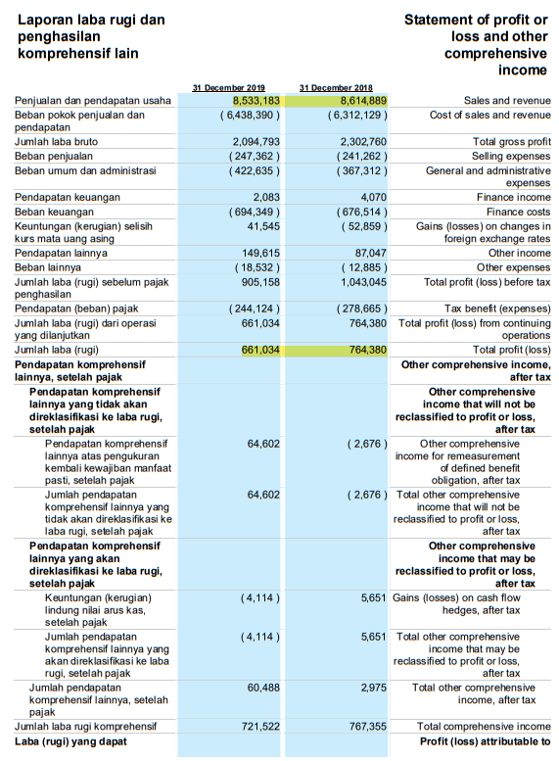

PT Tunas Baru Lampung Tbk (2020-2021)
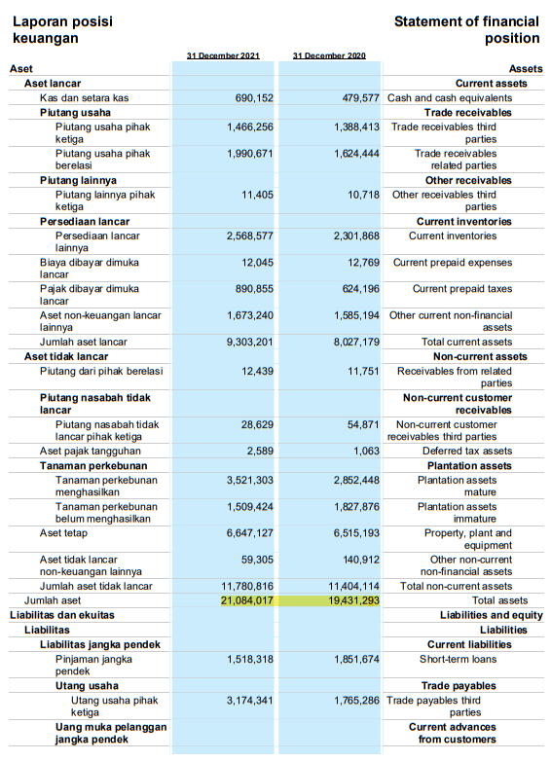
PT Tunas Baru Lampung Tbk (2020-2021)
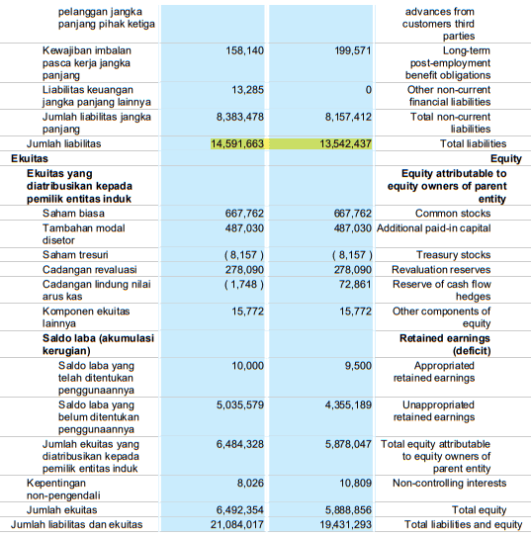
PT Tunas Baru Lampung Tbk (2020-2021)
