DAFTAR PUSTAKA

Abdi, N dan Wahid, M. 2018. “Pengaruh Kompetnsi dan Lingkungan Kerja Tehadap Kinerja Pegawai”. JurnalIlmuEkonomi.Vol. 1.No. 1 (hlm 68)

Ardiansyah,Y.,&Sulistiyowati, L. H. (2018). Pengaruh Kompetensidan Kecerdasan EmosionalTerhadap Kinerja Pegawai. Jurnal Inspirasi Bisnis dan Manajemen,2(1),91.Diambildarihttp://jurnal.ugj.ac.id/index.php/jibm/article/ view/1064

Arikunto, S. (2020). Prosedur Penlitian Suatu Pendekatn Praktik. Jakarta: Rineka Cipta.
Bangun, W. (2012). Manajemen Sumber Daya Manusia. Jakarta: Erlangga. Dhania, D. R. (2010). Pengaruh Stres Kerja , Beban Kerja Terhadp Kepuasan( Studi
Pada Medical Representatf Di Kota Kudus ). Jurnal Psikologi Universitas MuriaKudus,I(1),1523.Diambildarihttps://jurnal.umk.ac.id/index.php/PSI/arti cle/view/21

Diana, Y. (2019). Pengaruh Beban Kerja Terhdap Kinerja Karywan Di Housekeeping Departement Pada Hotel Bintan Lagoon Resort. Jurnal Manajmen Tools, 11(2), 193–205. Diambil dari https://jurnal.pancabudi.ac. id/index.php/JUMANT/article/view/704

Ghozali, I. (2018). Aplikasi Analisis Multivariate Dengan Program IBM SPSS 25 Edisi 9. Semarang: Badan PenerbitUniversitasDiponegoro.

Hutapea, P., & Thoha, N. (2008). Kompetensi Plus. Jakarta: PT Gramedia Pustaka Utama.

Koesomowidjojo, S. R. M. (2017). Analissis Beban Kerja. Jakarta: Raih Asa Sukses.

Marwansyah. (2016). Manajemen Sumber Daya Manusia Edisi Kedua. Bandung: Alfabeta.

Masram, & Mu’ah. (2017). ManajemenSumber Daya Manusia Profesional (1 ed.).
Surabaya: Zifatama.

Moeheriono. (2014). Pengukuran Kinerja Berbasis Kompetensi(Revisi). Jakarta: Rajawali Pers.

Nabawi, R. (2019). Pengaruh LingkunganKerja, Kepuasn Kerja dan BebanKerja Terhadap KinerjaPegawai. Jurnal Ilmiah Magister Manajemen, 2(2), 170–
183. https://doi.org/10.30596/maneggio.v2i2.3667

Paramitadewi, K. (2017). Pengaruh BebanKerja Dan Kompensasi Terhadp Kinerja Pegawai Sekretariat Pemerintah Daerah KabupatenTabanan. E-Jurnal

ManajemenUniversitasUdayana,6(6),255108.Diambildarihttps://ojs.unud.ac. id/index.php/Manajemen/article/view/29949

Polakitang, A. F., Koleangan, R., & Ogi, I. (2019). Pengaruh BebanKerja, LingkunganKerja, Dan StressKerja Terhadap Kineja Karyawan Pada Pt. Esta Group Jaya. Jurnal EMBA: Jurnal Riset Ekonomi, Manajemen, Bisnis dan Akuntansi, 7(3), 4164–4173. Diambil dari https://ejournal.unsrat.ac.id/ index.php/emba/article/view/24960

Prayogi, M. A., Lesmana, M. T., & Siregar, L. H. (2019). PengaruhKompetensi Dan DisplinKerja Terhadap KinerjaPegawai. Prosiding FRIMA (Festival Riset Ilmiah Manajemen & Akuntansi), (2), 665–670. Diambildari https://doi.org/10.55916/frima.v0i2.92

Putra, A. S. (2012). Analisis Pengaruh BebanKerja Terhadap Kineja Karyawan Divisi Marketingdan KreditPT. WOM Finance CabangDepok. Jurnal Studi ManajemenIndonesia,22.

Putra, T. A. A., Suryani, N. N., & Widyawati, S. R. (2021). Pengaruh Kompetensi Dan Beban Kerja Terhadap Kineja KaryawanPada CV. SamasBhakti Pertiwi MengwiBadung. VALUES, 2(3), 721–727.Diambil dari https://e- journal.unmas.ac.id/index.php/value/article/view/3032

Rande, D. (2016). Pengaruh Kompetensi terhadapKinerja Pegwai pada Dinas Perhubungan, Komunikasidan InformatikaKabupaten Mamuju Utara. e Jurnal Katalogi, 4(2), 101–109. Diambil dari http://jurnal.untad.ac.id/jurnal/ index.php/Katalogis/article/view/6537

Rosmaini, R., & Tanjung, H. (2019). Pengaruh Komptensi, Motivasi Dan Kepuasan Kerja Terhadap KinerjaPegawai. Maneggio:Jurnal Ilmiah Magister Manajemen, 2(1), 1–15. https://doi.org/10.30596/maneggio.v2i1. 3366

Sastra, B. A. (2017). Pengaruh Komptensi Karyawan dan Beban Kerja Terhadap Kinerja Karyawan Bank DanamonCabang Tuanku TambusaiPekanbaru. JOM Fekon,4(1),590600.Diambildarihttps://jom.unri.ac.id/index.php/JOMFEKON
/article/view/12960

Sedarmayanti. (2017). Manejemen Sumber Daya Manusia ReformasiBirokrasi dan Manajemen Pegwai Negeri Sipil. Bandung: PT Refika Aditama.

Sholikhati, R. A. (2021). Hubungan Stresor, LevelEducation, Kecerdasan Emosional dan KonfikTerhadap Kinerja Pegawai Honorer di Dinas Perhubungan Kabupaten PemalangSkripsi. (Doctoral dissertation, Universitas Pancasakti Tegal).

Sugiyono. (2013). Metode Penelitian Kuantitatif, Kualitatif Dan R&D. Bandung: Alfabeta.

Suliyanto. (2018). Metode PenelitianBisnis UntukSkripsi, Tesis Dan Disertasi. (A. Cristian, Ed.) (1 ed.). Yogyakarta: ANDI OFFSET.

Wahdaniah, & Gunardi, A. (2018). Pengaruh BebanKerja dan StressKerja Terhadap Kinerja Pegawai Pada Dinas Pekerjan Umum KabupatenMajene. Management DevelopmentandApplied Research Journal, 1(1), 51–65. Diambil dari http://ojs.unsulbar.ac.id/index.php/mandar

Wibowo. (2016). Manajmen Kinerja (5 ed.). Jakarta: PT. RajaGrafindo Persada.

LAMPIRAN

Lampiran 1

Surat Penelitian
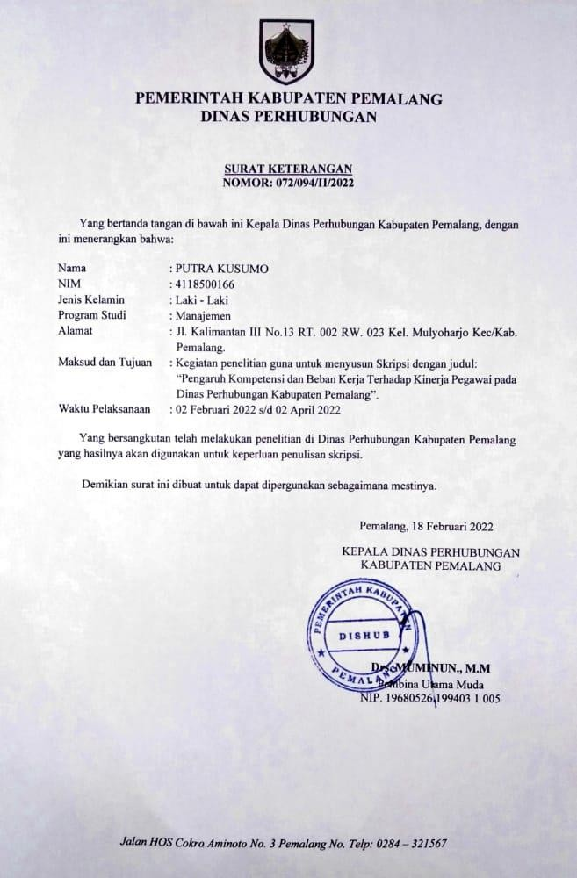

KATA PENGANTAR

Perihal : Permohonan Pengisian Kuesioner
Judul Penelitian : Pengaruh Kompetensi dan Beban Kerja Terhadap Kinerja Pegawai Pada Dinas Perhubungan Kabupaten Pemalang.

Kepada Yth Bapak/Ibu/Sdr Di tempat

Dengan Hormat,
Dalam rangka menyelesaikan penlitian, kami mahasiswa Fakultas Ekonomi Universitas Pancasakti Tegal, mohon partisipasi dari Bapak/Ibu/Sdr untuk mengisi kuesioner yang telah kami sediakan.
Adapun data yang kami minta adalah sesuai dengan kondisi yang dirasakan Bapak/Ibu/Sdr selama ini. Kami akan menjaga kerahasiannya karena data ini hanya untuk kepentingan penelitian.
Setiap jawaban yang diberikan merupakan bantuan yang tidak ternilai harganya bagi penelitian ini. Kami memberikan jangka waktu selama satu minggu setelah kuesioner ini kami sebarkan, agar Bapak/Ibu/Sdr dapat segera mengembalikannya kepada kami.
Atas perhatian dan bantuannya, kami mengucapkan banyak terima kasih.

Tegal, Juni 2022 Hormat Kami,

Putra Kusumo

KARAKTERISTIK RESPONDEN:
- Mohon dengan hormat dan kesediaan Bapak/Ibu/Sdr untuk mengisi indentitas di bawah ini terlebih dahulu
- Beri tandalah (X) pada kolom yang tersedia
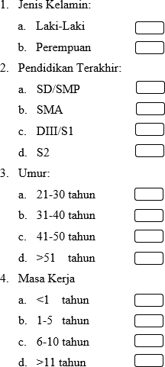

KUESIONER PENELITIAN
- Mohon dengan hormat dan kesediaan Bapak/Ibu/Sdr untuk menanggapi seluruh pertanyaan yang ada.
- Beri tanda (X) pada kolom yang tersedia.
- Ada 5 alternatif jawaban, yaitu:
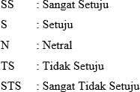

Kinerja Pegawai
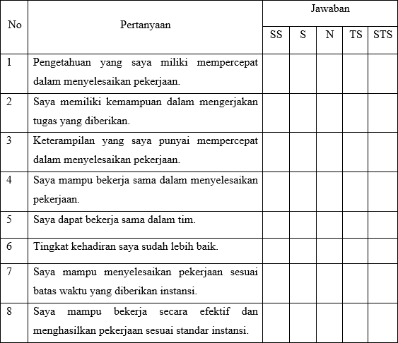

  - Kompetensi

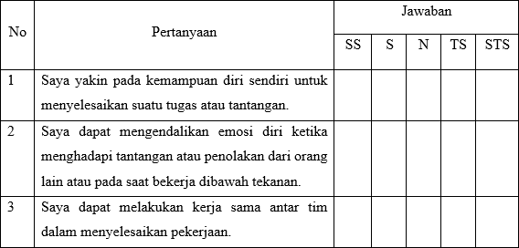

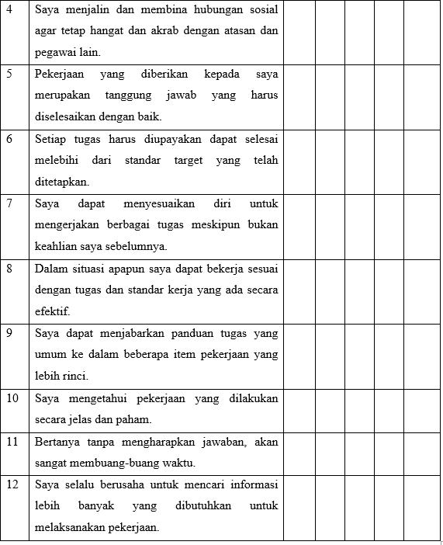

Beban Kerja
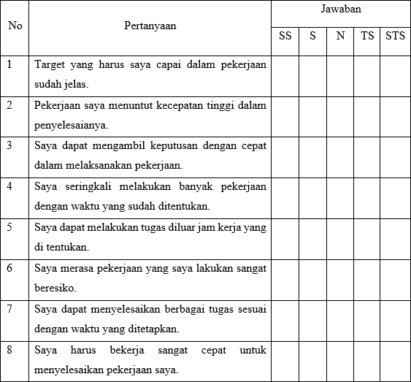

Lampiran 2

Pengolahan Data Ordinal

- Data Hasil Kuesioner Variable KinerjaPegawai (Y)

No | KINERJA PEGAWAI |  |  |  |  |  |  |  | Total
 | Y1 | Y2 | Y3 | Y4 | Y5 | Y6 | Y7 | Y8
1 | 5 | 5 | 4 | 5 | 5 | 5 | 5 | 5 | 39
2 | 4 | 4 | 3 | 4 | 4 | 4 | 4 | 4 | 31
3 | 5 | 4 | 4 | 4 | 5 | 4 | 4 | 5 | 35
4 | 5 | 5 | 5 | 5 | 5 | 4 | 5 | 4 | 38
5 | 4 | 4 | 3 | 4 | 4 | 5 | 3 | 4 | 31
6 | 5 | 4 | 4 | 5 | 4 | 4 | 4 | 4 | 34
7 | 5 | 5 | 4 | 4 | 4 | 4 | 3 | 4 | 33
8 | 3 | 4 | 4 | 4 | 4 | 4 | 4 | 3 | 30
9 | 3 | 4 | 4 | 4 | 5 | 3 | 3 | 3 | 29
10 | 4 | 4 | 4 | 4 | 4 | 4 | 4 | 4 | 32
11 | 4 | 4 | 5 | 4 | 4 | 4 | 4 | 4 | 33
12 | 5 | 4 | 5 | 5 | 5 | 4 | 4 | 5 | 37
13 | 4 | 4 | 4 | 4 | 4 | 4 | 4 | 4 | 32
14 | 4 | 4 | 5 | 5 | 5 | 3 | 4 | 4 | 34
15 | 4 | 5 | 5 | 5 | 5 | 5 | 4 | 5 | 38
16 | 5 | 5 | 4 | 5 | 5 | 4 | 5 | 5 | 38
17 | 4 | 4 | 4 | 4 | 4 | 4 | 4 | 3 | 31
18 | 5 | 4 | 4 | 4 | 5 | 4 | 4 | 4 | 34
19 | 4 | 5 | 5 | 4 | 4 | 4 | 3 | 3 | 32
20 | 3 | 4 | 4 | 4 | 4 | 4 | 4 | 4 | 31
21 | 5 | 5 | 4 | 4 | 4 | 5 | 4 | 3 | 34
22 | 4 | 4 | 4 | 5 | 5 | 4 | 5 | 4 | 35
23 | 5 | 5 | 5 | 5 | 5 | 5 | 5 | 5 | 40
24 | 5 | 5 | 5 | 5 | 5 | 5 | 4 | 5 | 39
25 | 4 | 5 | 4 | 4 | 5 | 4 | 5 | 4 | 35
26 | 5 | 5 | 5 | 5 | 4 | 5 | 5 | 5 | 39
27 | 4 | 5 | 5 | 4 | 4 | 3 | 4 | 5 | 34
28 | 4 | 5 | 5 | 4 | 5 | 5 | 5 | 4 | 37
29 | 5 | 5 | 5 | 5 | 5 | 4 | 5 | 5 | 39
30 | 5 | 5 | 5 | 4 | 5 | 5 | 5 | 5 | 39
31 | 4 | 5 | 4 | 4 | 4 | 3 | 4 | 5 | 33
32 | 5 | 5 | 5 | 5 | 5 | 5 | 5 | 5 | 40
33 | 4 | 4 | 4 | 4 | 4 | 5 | 5 | 5 | 35
34 | 3 | 4 | 3 | 3 | 3 | 3 | 3 | 3 | 25
35 | 4 | 4 | 5 | 4 | 4 | 4 | 5 | 5 | 35
36 | 5 | 4 | 4 | 5 | 4 | 4 | 5 | 5 | 36
37 | 5 | 5 | 4 | 5 | 5 | 5 | 5 | 5 | 39
38 | 4 | 4 | 3 | 4 | 5 | 5 | 4 | 4 | 33
39 | 4 | 3 | 5 | 5 | 5 | 5 | 5 | 5 | 37

40 | 5 | 3 | 5 | 3 | 4 | 3 | 5 | 3 | 31
41 | 4 | 4 | 4 | 5 | 3 | 5 | 5 | 5 | 35
42 | 3 | 3 | 4 | 5 | 3 | 5 | 3 | 5 | 31
43 | 3 | 3 | 4 | 5 | 4 | 3 | 5 | 3 | 30
44 | 3 | 3 | 4 | 5 | 4 | 5 | 3 | 5 | 32
45 | 3 | 3 | 5 | 5 | 4 | 3 | 4 | 5 | 32
46 | 4 | 3 | 4 | 4 | 3 | 5 | 4 | 3 | 30
47 | 3 | 4 | 4 | 4 | 4 | 5 | 5 | 3 | 32
48 | 3 | 5 | 3 | 5 | 5 | 5 | 5 | 4 | 35
49 | 4 | 4 | 4 | 4 | 5 | 4 | 4 | 4 | 33
50 | 4 | 4 | 3 | 4 | 4 | 4 | 3 | 4 | 30
51 | 5 | 5 | 3 | 5 | 4 | 4 | 5 | 5 | 36
52 | 5 | 3 | 5 | 5 | 3 | 4 | 5 | 4 | 34
53 | 5 | 3 | 5 | 5 | 5 | 3 | 5 | 5 | 36
54 | 5 | 5 | 3 | 3 | 3 | 5 | 5 | 5 | 34
55 | 5 | 3 | 3 | 3 | 3 | 3 | 3 | 5 | 28
56 | 4 | 4 | 5 | 3 | 3 | 5 | 3 | 4 | 31
57 | 4 | 4 | 4 | 4 | 4 | 4 | 4 | 5 | 33
58 | 5 | 3 | 5 | 5 | 3 | 3 | 3 | 4 | 31
59 | 5 | 4 | 3 | 3 | 3 | 3 | 4 | 3 | 28
60 | 5 | 4 | 5 | 5 | 5 | 5 | 3 | 5 | 37

- Data Hasil Kuesioner Variabel Kompetensi (X1)

No | Kompetensi |  |  |  |  |  |  |  |  |  |  |  | Total
 | X1.1 | X1.2 | X1.3 | X1.4 | X1.5 | X1.6 | X1.7 | X1.8 | X1.9 | X1.10 | X1.11 | X1.12
1 | 5 | 4 | 4 | 5 | 5 | 3 | 3 | 4 | 4 | 4 | 4 | 4 | 49
2 | 3 | 3 | 4 | 4 | 4 | 4 | 3 | 3 | 3 | 4 | 5 | 4 | 44
3 | 4 | 3 | 5 | 5 | 5 | 5 | 5 | 4 | 4 | 5 | 5 | 5 | 55
4 | 3 | 4 | 5 | 4 | 4 | 4 | 3 | 4 | 3 | 5 | 5 | 4 | 48
5 | 4 | 3 | 4 | 5 | 4 | 4 | 4 | 4 | 3 | 4 | 4 | 3 | 46
6 | 5 | 5 | 4 | 5 | 4 | 4 | 3 | 5 | 4 | 5 | 5 | 4 | 53
7 | 4 | 3 | 4 | 4 | 4 | 4 | 4 | 3 | 3 | 4 | 4 | 5 | 46
8 | 4 | 3 | 4 | 3 | 5 | 3 | 4 | 4 | 3 | 3 | 5 | 4 | 45
9 | 4 | 3 | 4 | 3 | 4 | 2 | 2 | 3 | 4 | 4 | 3 | 4 | 40
10 | 4 | 4 | 4 | 4 | 4 | 4 | 3 | 3 | 4 | 4 | 4 | 4 | 46
11 | 4 | 3 | 4 | 4 | 4 | 4 | 4 | 3 | 4 | 4 | 3 | 3 | 44
12 | 3 | 3 | 4 | 4 | 4 | 5 | 4 | 4 | 3 | 4 | 5 | 4 | 47
13 | 4 | 3 | 4 | 4 | 4 | 3 | 3 | 4 | 3 | 4 | 5 | 3 | 44
14 | 5 | 5 | 5 | 5 | 5 | 4 | 4 | 5 | 4 | 4 | 5 | 5 | 56
15 | 4 | 5 | 5 | 5 | 5 | 4 | 4 | 3 | 5 | 4 | 5 | 4 | 53
16 | 5 | 5 | 4 | 4 | 5 | 2 | 4 | 4 | 3 | 5 | 5 | 3 | 49
17 | 3 | 3 | 3 | 3 | 3 | 3 | 3 | 4 | 3 | 5 | 4 | 4 | 41
18 | 4 | 4 | 4 | 5 | 4 | 4 | 4 | 4 | 4 | 5 | 5 | 5 | 52
19 | 3 | 4 | 4 | 3 | 3 | 3 | 3 | 4 | 3 | 3 | 3 | 3 | 39
20 | 5 | 4 | 4 | 4 | 5 | 3 | 3 | 4 | 4 | 4 | 3 | 5 | 48

21 | 4 | 5 | 5 | 4 | 5 | 4 | 4 | 5 | 4 | 5 | 5 | 4 | 54
22 | 5 | 5 | 5 | 4 | 5 | 4 | 4 | 4 | 5 | 5 | 5 | 5 | 56
23 | 5 | 5 | 5 | 5 | 4 | 4 | 5 | 4 | 5 | 5 | 5 | 5 | 57
24 | 4 | 4 | 5 | 3 | 5 | 4 | 5 | 4 | 4 | 5 | 3 | 5 | 51
25 | 4 | 4 | 5 | 4 | 5 | 3 | 5 | 5 | 4 | 4 | 5 | 5 | 53
26 | 5 | 4 | 5 | 4 | 5 | 4 | 5 | 5 | 4 | 5 | 4 | 4 | 54
27 | 5 | 5 | 5 | 5 | 5 | 4 | 5 | 4 | 5 | 5 | 5 | 4 | 57
28 | 5 | 4 | 5 | 5 | 5 | 5 | 4 | 5 | 4 | 5 | 5 | 5 | 57
29 | 5 | 4 | 5 | 3 | 5 | 4 | 4 | 5 | 5 | 5 | 5 | 5 | 55
30 | 5 | 4 | 4 | 5 | 4 | 5 | 5 | 4 | 5 | 5 | 4 | 3 | 53
31 | 5 | 4 | 5 | 5 | 4 | 2 | 3 | 5 | 5 | 5 | 4 | 5 | 52
32 | 5 | 5 | 5 | 5 | 4 | 5 | 5 | 5 | 5 | 5 | 5 | 5 | 59
33 | 3 | 3 | 3 | 3 | 3 | 3 | 3 | 3 | 3 | 3 | 3 | 3 | 36
34 | 5 | 4 | 4 | 4 | 5 | 2 | 3 | 5 | 5 | 4 | 4 | 3 | 48
35 | 5 | 4 | 3 | 4 | 5 | 3 | 2 | 5 | 3 | 3 | 4 | 5 | 46
36 | 5 | 5 | 5 | 4 | 5 | 4 | 3 | 5 | 5 | 5 | 5 | 5 | 56
37 | 4 | 2 | 4 | 5 | 4 | 2 | 3 | 3 | 3 | 3 | 3 | 3 | 39
38 | 3 | 4 | 3 | 5 | 5 | 3 | 4 | 3 | 4 | 3 | 3 | 4 | 44
39 | 5 | 4 | 3 | 4 | 5 | 5 | 5 | 5 | 5 | 3 | 3 | 4 | 51
40 | 4 | 3 | 5 | 4 | 3 | 3 | 3 | 5 | 5 | 4 | 3 | 5 | 47
41 | 5 | 2 | 5 | 3 | 4 | 2 | 5 | 3 | 4 | 3 | 5 | 3 | 44
42 | 5 | 3 | 3 | 3 | 3 | 5 | 3 | 3 | 4 | 3 | 3 | 3 | 41
43 | 5 | 3 | 5 | 4 | 5 | 5 | 3 | 5 | 2 | 5 | 3 | 5 | 50
44 | 3 | 4 | 4 | 3 | 4 | 4 | 5 | 5 | 2 | 4 | 5 | 3 | 46
45 | 3 | 4 | 4 | 3 | 3 | 3 | 3 | 4 | 4 | 4 | 4 | 3 | 42
46 | 5 | 4 | 5 | 5 | 5 | 3 | 2 | 4 | 4 | 4 | 4 | 5 | 50
47 | 3 | 4 | 3 | 3 | 5 | 5 | 3 | 3 | 4 | 5 | 3 | 4 | 45
48 | 4 | 5 | 4 | 5 | 4 | 4 | 4 | 5 | 4 | 5 | 4 | 5 | 53
49 | 4 | 3 | 3 | 4 | 5 | 3 | 4 | 4 | 4 | 3 | 3 | 2 | 42
50 | 5 | 4 | 3 | 4 | 4 | 5 | 2 | 5 | 4 | 3 | 3 | 4 | 46
51 | 3 | 3 | 5 | 5 | 4 | 2 | 4 | 5 | 3 | 4 | 3 | 2 | 43
52 | 4 | 3 | 4 | 5 | 3 | 4 | 5 | 5 | 5 | 3 | 3 | 5 | 49
53 | 5 | 5 | 5 | 5 | 5 | 4 | 4 | 5 | 3 | 5 | 5 | 3 | 54
54 | 3 | 5 | 4 | 4 | 3 | 3 | 2 | 3 | 5 | 4 | 2 | 2 | 40
55 | 3 | 3 | 3 | 3 | 3 | 3 | 5 | 5 | 3 | 3 | 2 | 3 | 39
56 | 4 | 3 | 3 | 4 | 5 | 3 | 4 | 3 | 2 | 5 | 3 | 3 | 42
57 | 5 | 4 | 3 | 5 | 4 | 2 | 3 | 5 | 3 | 4 | 2 | 5 | 45
58 | 5 | 3 | 5 | 5 | 5 | 3 | 4 | 4 | 4 | 4 | 2 | 4 | 48
59 | 4 | 5 | 5 | 3 | 5 | 2 | 3 | 4 | 4 | 3 | 2 | 3 | 43
60 | 5 | 5 | 5 | 3 | 4 | 4 | 5 | 4 | 5 | 5 | 3 | 5 | 53

- Data Hasil Kuesioner Variabel Beban Kerja (X2)

No | BEBAN KERJA |  |  |  |  |  |  |  | Total
 | X2.1 | X2.2 | X2.3 | X2.4 | X2.5 | X2.6 | X2.7 | X2.8
1 | 5 | 4 | 5 | 4 | 4 | 5 | 4 | 4 | 35
2 | 4 | 3 | 4 | 4 | 3 | 3 | 4 | 5 | 30
3 | 4 | 4 | 4 | 3 | 4 | 2 | 3 | 4 | 28
4 | 5 | 4 | 5 | 4 | 5 | 5 | 4 | 4 | 36
5 | 3 | 3 | 4 | 4 | 3 | 2 | 4 | 4 | 27
6 | 4 | 3 | 3 | 4 | 4 | 2 | 3 | 3 | 26
7 | 4 | 4 | 4 | 5 | 4 | 4 | 4 | 3 | 32
8 | 4 | 3 | 4 | 4 | 3 | 2 | 5 | 3 | 28
9 | 3 | 3 | 3 | 3 | 4 | 3 | 4 | 4 | 27
10 | 4 | 3 | 3 | 4 | 4 | 5 | 4 | 4 | 31
11 | 3 | 3 | 3 | 3 | 3 | 3 | 3 | 3 | 24
12 | 5 | 5 | 5 | 4 | 5 | 4 | 4 | 4 | 36
13 | 4 | 2 | 3 | 4 | 3 | 3 | 4 | 3 | 26
14 | 4 | 5 | 4 | 3 | 3 | 4 | 4 | 3 | 30
15 | 4 | 4 | 3 | 5 | 3 | 5 | 4 | 5 | 33
16 | 4 | 5 | 3 | 4 | 4 | 5 | 3 | 4 | 32
17 | 5 | 4 | 4 | 3 | 4 | 4 | 2 | 4 | 30
18 | 3 | 3 | 3 | 4 | 3 | 3 | 3 | 3 | 25
19 | 3 | 3 | 3 | 3 | 3 | 3 | 3 | 3 | 24
20 | 3 | 4 | 3 | 3 | 3 | 3 | 3 | 3 | 25
21 | 5 | 4 | 4 | 3 | 4 | 4 | 4 | 3 | 31
22 | 5 | 4 | 5 | 5 | 4 | 4 | 4 | 4 | 35
23 | 4 | 5 | 5 | 5 | 5 | 4 | 5 | 5 | 38
24 | 5 | 4 | 3 | 5 | 4 | 4 | 5 | 4 | 34
25 | 4 | 5 | 4 | 5 | 3 | 5 | 4 | 5 | 35
26 | 5 | 5 | 5 | 5 | 4 | 5 | 4 | 5 | 38
27 | 4 | 3 | 4 | 3 | 5 | 5 | 3 | 5 | 32
28 | 4 | 3 | 4 | 5 | 4 | 5 | 5 | 4 | 34
29 | 5 | 5 | 4 | 3 | 4 | 5 | 4 | 4 | 34
30 | 5 | 5 | 5 | 5 | 5 | 5 | 5 | 5 | 40
31 | 3 | 2 | 4 | 3 | 3 | 4 | 4 | 4 | 27
32 | 5 | 5 | 5 | 4 | 5 | 5 | 5 | 5 | 39
33 | 5 | 4 | 5 | 4 | 4 | 4 | 5 | 5 | 36
34 | 3 | 4 | 2 | 2 | 2 | 3 | 3 | 2 | 21
35 | 2 | 5 | 2 | 2 | 4 | 4 | 3 | 3 | 25
36 | 4 | 4 | 4 | 2 | 5 | 4 | 3 | 3 | 29
37 | 3 | 4 | 5 | 4 | 5 | 5 | 2 | 3 | 31
38 | 4 | 5 | 4 | 2 | 3 | 4 | 5 | 2 | 29
39 | 5 | 5 | 3 | 3 | 2 | 5 | 2 | 5 | 30
40 | 3 | 2 | 3 | 3 | 2 | 5 | 3 | 5 | 26
41 | 3 | 3 | 2 | 4 | 2 | 5 | 3 | 2 | 24
42 | 3 | 2 | 4 | 3 | 2 | 4 | 2 | 3 | 23
43 | 2 | 4 | 5 | 3 | 4 | 4 | 4 | 4 | 30

44 | 5 | 4 | 4 | 4 | 4 | 4 | 4 | 4 | 33
45 | 5 | 2 | 3 | 3 | 4 | 4 | 2 | 5 | 28
46 | 3 | 3 | 3 | 3 | 2 | 5 | 4 | 4 | 27
47 | 5 | 4 | 5 | 3 | 3 | 3 | 3 | 3 | 29
48 | 5 | 4 | 5 | 5 | 3 | 3 | 5 | 4 | 34
49 | 3 | 3 | 4 | 4 | 3 | 3 | 3 | 3 | 26
50 | 3 | 3 | 2 | 2 | 3 | 3 | 3 | 3 | 22
51 | 5 | 4 | 5 | 5 | 3 | 4 | 3 | 4 | 33
52 | 5 | 5 | 3 | 4 | 2 | 4 | 5 | 3 | 31
53 | 4 | 4 | 3 | 3 | 4 | 4 | 3 | 3 | 28
54 | 3 | 5 | 4 | 4 | 4 | 3 | 5 | 3 | 31
55 | 3 | 2 | 3 | 3 | 3 | 2 | 4 | 2 | 22
56 | 5 | 3 | 4 | 5 | 3 | 4 | 5 | 3 | 32
57 | 3 | 2 | 5 | 4 | 4 | 3 | 2 | 3 | 26
58 | 3 | 3 | 3 | 3 | 3 | 3 | 3 | 2 | 23
59 | 4 | 3 | 5 | 5 | 3 | 2 | 4 | 3 | 29
60 | 5 | 4 | 5 | 4 | 3 | 3 | 3 | 4 | 31

Lampiran 3 Pengolahan Data Interval

- Hasil Data Interval Variabel Kinerja (Y)

No | Succesive Interval |  |  |  |  |  |  |  | Total Y
 | Y1 | Y2 | Y3 | Y4 | Y5 | Y6 | Y7 | Y8
1 | 3.407 | 3.506 | 2.206 | 3.635 | 3.465 | 3.396 | 3.336 | 3.300 | 26.250
2 | 2.140 | 2.223 | 1.000 | 2.265 | 2.184 | 2.155 | 2.112 | 2.070 | 16.151
3 | 3.407 | 2.223 | 2.206 | 2.265 | 3.465 | 2.155 | 2.112 | 3.300 | 21.133
4 | 3.407 | 3.506 | 3.495 | 3.635 | 3.465 | 2.155 | 3.336 | 2.070 | 25.070
5 | 2.140 | 2.223 | 1.000 | 2.265 | 2.184 | 3.396 | 1.000 | 2.070 | 16.279
6 | 3.407 | 2.223 | 2.206 | 3.635 | 2.184 | 2.155 | 2.112 | 2.070 | 19.992
7 | 3.407 | 3.506 | 2.206 | 2.265 | 2.184 | 2.155 | 1.000 | 2.070 | 18.794
8 | 1.000 | 2.223 | 2.206 | 2.265 | 2.184 | 2.155 | 2.112 | 1.000 | 15.146
9 | 1.000 | 2.223 | 2.206 | 2.265 | 3.465 | 1.000 | 1.000 | 1.000 | 14.159
10 | 2.140 | 2.223 | 2.206 | 2.265 | 2.184 | 2.155 | 2.112 | 2.070 | 17.357
11 | 2.140 | 2.223 | 3.495 | 2.265 | 2.184 | 2.155 | 2.112 | 2.070 | 18.646
12 | 3.407 | 2.223 | 3.495 | 3.635 | 3.465 | 2.155 | 2.112 | 3.300 | 23.792
13 | 2.140 | 2.223 | 2.206 | 2.265 | 2.184 | 2.155 | 2.112 | 2.070 | 17.357
14 | 2.140 | 2.223 | 3.495 | 3.635 | 3.465 | 1.000 | 2.112 | 2.070 | 20.140
15 | 2.140 | 3.506 | 3.495 | 3.635 | 3.465 | 3.396 | 2.112 | 3.300 | 25.049
16 | 3.407 | 3.506 | 2.206 | 3.635 | 3.465 | 2.155 | 3.336 | 3.300 | 25.010
17 | 2.140 | 2.223 | 2.206 | 2.265 | 2.184 | 2.155 | 2.112 | 1.000 | 16.286
18 | 3.407 | 2.223 | 2.206 | 2.265 | 3.465 | 2.155 | 2.112 | 2.070 | 19.904
19 | 2.140 | 3.506 | 3.495 | 2.265 | 2.184 | 2.155 | 1.000 | 1.000 | 17.746
20 | 1.000 | 2.223 | 2.206 | 2.265 | 2.184 | 2.155 | 2.112 | 2.070 | 16.216
21 | 3.407 | 3.506 | 2.206 | 2.265 | 2.184 | 3.396 | 2.112 | 1.000 | 20.076

22 | 2.140 | 2.223 | 2.206 | 3.635 | 3.465 | 2.155 | 3.336 | 2.070 | 21.231
23 | 3.407 | 3.506 | 3.495 | 3.635 | 3.465 | 3.396 | 3.336 | 3.300 | 27.539
24 | 3.407 | 3.506 | 3.495 | 3.635 | 3.465 | 3.396 | 2.112 | 3.300 | 26.315
25 | 2.140 | 3.506 | 2.206 | 2.265 | 3.465 | 2.155 | 3.336 | 2.070 | 21.145
26 | 3.407 | 3.506 | 3.495 | 3.635 | 2.184 | 3.396 | 3.336 | 3.300 | 26.258
27 | 2.140 | 3.506 | 3.495 | 2.265 | 2.184 | 1.000 | 2.112 | 3.300 | 20.003
28 | 2.140 | 3.506 | 3.495 | 2.265 | 3.465 | 3.396 | 3.336 | 2.070 | 23.674
29 | 3.407 | 3.506 | 3.495 | 3.635 | 3.465 | 2.155 | 3.336 | 3.300 | 26.299
30 | 3.407 | 3.506 | 3.495 | 2.265 | 3.465 | 3.396 | 3.336 | 3.300 | 26.170
31 | 2.140 | 3.506 | 2.206 | 2.265 | 2.184 | 1.000 | 2.112 | 3.300 | 18.714
32 | 3.407 | 3.506 | 3.495 | 3.635 | 3.465 | 3.396 | 3.336 | 3.300 | 27.539
33 | 2.140 | 2.223 | 2.206 | 2.265 | 2.184 | 3.396 | 3.336 | 3.300 | 21.050
34 | 1.000 | 2.223 | 1.000 | 1.000 | 1.000 | 1.000 | 1.000 | 1.000 | 9.223
35 | 2.140 | 2.223 | 3.495 | 2.265 | 2.184 | 2.155 | 3.336 | 3.300 | 21.099
36 | 3.407 | 2.223 | 2.206 | 3.635 | 2.184 | 2.155 | 3.336 | 3.300 | 22.446
37 | 3.407 | 3.506 | 2.206 | 3.635 | 3.465 | 3.396 | 3.336 | 3.300 | 26.250
38 | 2.140 | 2.223 | 1.000 | 2.265 | 3.465 | 3.396 | 2.112 | 2.070 | 18.672
39 | 2.140 | 1.000 | 3.495 | 3.635 | 3.465 | 3.396 | 3.336 | 3.300 | 23.767
40 | 3.407 | 1.000 | 3.495 | 1.000 | 2.184 | 1.000 | 3.336 | 1.000 | 16.422
41 | 2.140 | 2.223 | 2.206 | 3.635 | 1.000 | 3.396 | 3.336 | 3.300 | 21.235
42 | 1.000 | 1.000 | 2.206 | 3.635 | 1.000 | 3.396 | 1.000 | 3.300 | 16.536
43 | 1.000 | 1.000 | 2.206 | 3.635 | 2.184 | 1.000 | 3.336 | 1.000 | 15.361
44 | 1.000 | 1.000 | 2.206 | 3.635 | 2.184 | 3.396 | 1.000 | 3.300 | 17.720
45 | 1.000 | 1.000 | 3.495 | 3.635 | 2.184 | 1.000 | 2.112 | 3.300 | 17.726
46 | 2.140 | 1.000 | 2.206 | 2.265 | 1.000 | 3.396 | 2.112 | 1.000 | 15.120
47 | 1.000 | 2.223 | 2.206 | 2.265 | 2.184 | 3.396 | 3.336 | 1.000 | 17.610
48 | 1.000 | 3.506 | 1.000 | 3.635 | 3.465 | 3.396 | 3.336 | 2.070 | 21.408
49 | 2.140 | 2.223 | 2.206 | 2.265 | 3.465 | 2.155 | 2.112 | 2.070 | 18.638
50 | 2.140 | 2.223 | 1.000 | 2.265 | 2.184 | 2.155 | 1.000 | 2.070 | 15.039
51 | 3.407 | 3.506 | 1.000 | 3.635 | 2.184 | 2.155 | 3.336 | 3.300 | 22.523
52 | 3.407 | 1.000 | 3.495 | 3.635 | 1.000 | 2.155 | 3.336 | 2.070 | 20.099
53 | 3.407 | 1.000 | 3.495 | 3.635 | 3.465 | 1.000 | 3.336 | 3.300 | 22.637
54 | 3.407 | 3.506 | 1.000 | 1.000 | 1.000 | 3.396 | 3.336 | 3.300 | 19.945
55 | 3.407 | 1.000 | 1.000 | 1.000 | 1.000 | 1.000 | 1.000 | 3.300 | 12.707
56 | 2.140 | 2.223 | 3.495 | 1.000 | 1.000 | 3.396 | 1.000 | 2.070 | 16.324
57 | 2.140 | 2.223 | 2.206 | 2.265 | 2.184 | 2.155 | 2.112 | 3.300 | 18.586
58 | 3.407 | 1.000 | 3.495 | 3.635 | 1.000 | 1.000 | 1.000 | 2.070 | 16.607
59 | 3.407 | 2.223 | 1.000 | 1.000 | 1.000 | 1.000 | 2.112 | 1.000 | 12.742
60 | 3.407 | 2.223 | 3.495 | 3.635 | 3.465 | 3.396 | 1.000 | 3.300 | 23.920

- Hasil Data Interval Variabel Kompetensi (X1)

No | Succesive Interval |  |  |  |  |  |  |  |  |  |  |  | Total X1
 | X1.1 | X1.2 | X1.3 | X1.4 | X1.5 | X1.6 | X1.7 | X1.8 | X1.9 | X1.10 | X1.11 | X1.12
1 | 3.234 | 3.380 | 2.112 | 3.298 | 3.406 | 2.012 | 2.154 | 2.114 | 3.173 | 2.093 | 2.861 | 3.020 | 32.858
2 | 1.000 | 2.320 | 2.112 | 2.118 | 2.126 | 2.935 | 2.154 | 1.000 | 2.143 | 2.093 | 3.836 | 3.020 | 26.857
3 | 2.048 | 2.320 | 3.336 | 3.298 | 3.406 | 4.053 | 4.152 | 2.114 | 3.173 | 3.278 | 3.836 | 4.089 | 39.103
4 | 1.000 | 3.380 | 3.336 | 2.118 | 2.126 | 2.935 | 2.154 | 2.114 | 2.143 | 3.278 | 3.836 | 3.020 | 31.440
5 | 2.048 | 2.320 | 2.112 | 3.298 | 2.126 | 2.935 | 3.102 | 2.114 | 2.143 | 2.093 | 2.861 | 2.143 | 29.295
6 | 3.234 | 4.498 | 2.112 | 3.298 | 2.126 | 2.935 | 2.154 | 3.308 | 3.173 | 3.278 | 3.836 | 3.020 | 36.970
7 | 2.048 | 2.320 | 2.112 | 2.118 | 2.126 | 2.935 | 3.102 | 1.000 | 2.143 | 2.093 | 2.861 | 4.089 | 28.947
8 | 2.048 | 2.320 | 2.112 | 1.000 | 3.406 | 2.012 | 3.102 | 2.114 | 2.143 | 1.000 | 3.836 | 3.020 | 28.114
9 | 2.048 | 2.320 | 2.112 | 1.000 | 2.126 | 1.000 | 1.000 | 1.000 | 3.173 | 2.093 | 2.104 | 3.020 | 22.995
10 | 2.048 | 3.380 | 2.112 | 2.118 | 2.126 | 2.935 | 2.154 | 1.000 | 3.173 | 2.093 | 2.861 | 3.020 | 29.019
11 | 2.048 | 2.320 | 2.112 | 2.118 | 2.126 | 2.935 | 3.102 | 1.000 | 3.173 | 2.093 | 2.104 | 2.143 | 27.273
12 | 1.000 | 2.320 | 2.112 | 2.118 | 2.126 | 4.053 | 3.102 | 2.114 | 2.143 | 2.093 | 3.836 | 3.020 | 30.038
13 | 2.048 | 2.320 | 2.112 | 2.118 | 2.126 | 2.012 | 2.154 | 2.114 | 2.143 | 2.093 | 3.836 | 2.143 | 27.220
14 | 3.234 | 4.498 | 3.336 | 3.298 | 3.406 | 2.935 | 3.102 | 3.308 | 3.173 | 2.093 | 3.836 | 4.089 | 40.308
15 | 2.048 | 4.498 | 3.336 | 3.298 | 3.406 | 2.935 | 3.102 | 1.000 | 4.334 | 2.093 | 3.836 | 3.020 | 36.905
16 | 3.234 | 4.498 | 2.112 | 2.118 | 3.406 | 1.000 | 3.102 | 2.114 | 2.143 | 3.278 | 3.836 | 2.143 | 32.985
17 | 1.000 | 2.320 | 1.000 | 1.000 | 1.000 | 2.012 | 2.154 | 2.114 | 2.143 | 3.278 | 2.861 | 3.020 | 23.903
18 | 2.048 | 3.380 | 2.112 | 3.298 | 2.126 | 2.935 | 3.102 | 2.114 | 3.173 | 3.278 | 3.836 | 4.089 | 35.490
19 | 1.000 | 3.380 | 2.112 | 1.000 | 1.000 | 2.012 | 2.154 | 2.114 | 2.143 | 1.000 | 2.104 | 2.143 | 22.164
20 | 3.234 | 3.380 | 2.112 | 2.118 | 3.406 | 2.012 | 2.154 | 2.114 | 3.173 | 2.093 | 2.104 | 4.089 | 31.990
21 | 2.048 | 4.498 | 3.336 | 2.118 | 3.406 | 2.935 | 3.102 | 3.308 | 3.173 | 3.278 | 3.836 | 3.020 | 38.057
22 | 3.234 | 4.498 | 3.336 | 2.118 | 3.406 | 2.935 | 3.102 | 2.114 | 4.334 | 3.278 | 3.836 | 4.089 | 40.281
23 | 3.234 | 4.498 | 3.336 | 3.298 | 2.126 | 2.935 | 4.152 | 2.114 | 4.334 | 3.278 | 3.836 | 4.089 | 41.230
24 | 2.048 | 3.380 | 3.336 | 1.000 | 3.406 | 2.935 | 4.152 | 2.114 | 3.173 | 3.278 | 2.104 | 4.089 | 35.015
25 | 2.048 | 3.380 | 3.336 | 2.118 | 3.406 | 2.012 | 4.152 | 3.308 | 3.173 | 2.093 | 3.836 | 4.089 | 36.951
26 | 3.234 | 3.380 | 3.336 | 2.118 | 3.406 | 2.935 | 4.152 | 3.308 | 3.173 | 3.278 | 2.861 | 3.020 | 38.200
27 | 3.234 | 4.498 | 3.336 | 3.298 | 3.406 | 2.935 | 4.152 | 2.114 | 4.334 | 3.278 | 3.836 | 3.020 | 41.441
28 | 3.234 | 3.380 | 3.336 | 3.298 | 3.406 | 4.053 | 3.102 | 3.308 | 3.173 | 3.278 | 3.836 | 4.089 | 41.493
29 | 3.234 | 3.380 | 3.336 | 1.000 | 3.406 | 2.935 | 3.102 | 3.308 | 4.334 | 3.278 | 3.836 | 4.089 | 39.238
30 | 3.234 | 3.380 | 2.112 | 3.298 | 2.126 | 4.053 | 4.152 | 2.114 | 4.334 | 3.278 | 2.861 | 2.143 | 37.085
31 | 3.234 | 3.380 | 3.336 | 3.298 | 2.126 | 1.000 | 2.154 | 3.308 | 4.334 | 3.278 | 2.861 | 4.089 | 36.397
32 | 3.234 | 4.498 | 3.336 | 3.298 | 2.126 | 4.053 | 4.152 | 3.308 | 4.334 | 3.278 | 3.836 | 4.089 | 43.541
33 | 1.000 | 2.320 | 1.000 | 1.000 | 1.000 | 2.012 | 2.154 | 1.000 | 2.143 | 1.000 | 2.104 | 2.143 | 18.877
34 | 3.234 | 3.380 | 2.112 | 2.118 | 3.406 | 1.000 | 2.154 | 3.308 | 4.334 | 2.093 | 2.861 | 2.143 | 32.143
35 | 3.234 | 3.380 | 1.000 | 2.118 | 3.406 | 2.012 | 1.000 | 3.308 | 2.143 | 1.000 | 2.861 | 4.089 | 29.552
36 | 3.234 | 4.498 | 3.336 | 2.118 | 3.406 | 2.935 | 2.154 | 3.308 | 4.334 | 3.278 | 3.836 | 4.089 | 40.526
37 | 2.048 | 1.000 | 2.112 | 3.298 | 2.126 | 1.000 | 2.154 | 1.000 | 2.143 | 1.000 | 2.104 | 2.143 | 22.128
38 | 1.000 | 3.380 | 1.000 | 3.298 | 3.406 | 2.012 | 3.102 | 1.000 | 3.173 | 1.000 | 2.104 | 3.020 | 27.494
39 | 3.234 | 3.380 | 1.000 | 2.118 | 3.406 | 4.053 | 4.152 | 3.308 | 4.334 | 1.000 | 2.104 | 3.020 | 35.109
40 | 2.048 | 2.320 | 3.336 | 2.118 | 1.000 | 2.012 | 2.154 | 3.308 | 4.334 | 2.093 | 2.104 | 4.089 | 30.916
41 | 3.234 | 1.000 | 3.336 | 1.000 | 2.126 | 1.000 | 4.152 | 1.000 | 3.173 | 1.000 | 3.836 | 2.143 | 26.999
42 | 3.234 | 2.320 | 1.000 | 1.000 | 1.000 | 4.053 | 2.154 | 1.000 | 3.173 | 1.000 | 2.104 | 2.143 | 24.182

43 | 3.234 | 2.320 | 3.336 | 2.118 | 3.406 | 4.053 | 2.154 | 3.308 | 1.000 | 3.278 | 2.104 | 4.089 | 34.401
44 | 1.000 | 3.380 | 2.112 | 1.000 | 2.126 | 2.935 | 4.152 | 3.308 | 1.000 | 2.093 | 3.836 | 2.143 | 29.084
45 | 1.000 | 3.380 | 2.112 | 1.000 | 1.000 | 2.012 | 2.154 | 2.114 | 3.173 | 2.093 | 2.861 | 2.143 | 25.043
46 | 3.234 | 3.380 | 3.336 | 3.298 | 3.406 | 2.012 | 1.000 | 2.114 | 3.173 | 2.093 | 2.861 | 4.089 | 33.997
47 | 1.000 | 3.380 | 1.000 | 1.000 | 3.406 | 4.053 | 2.154 | 1.000 | 3.173 | 3.278 | 2.104 | 3.020 | 28.568
48 | 2.048 | 4.498 | 2.112 | 3.298 | 2.126 | 2.935 | 3.102 | 3.308 | 3.173 | 3.278 | 2.861 | 4.089 | 36.826
49 | 2.048 | 2.320 | 1.000 | 2.118 | 3.406 | 2.012 | 3.102 | 2.114 | 3.173 | 1.000 | 2.104 | 1.000 | 25.397
50 | 3.234 | 3.380 | 1.000 | 2.118 | 2.126 | 4.053 | 1.000 | 3.308 | 3.173 | 1.000 | 2.104 | 3.020 | 29.515
51 | 1.000 | 2.320 | 3.336 | 3.298 | 2.126 | 1.000 | 3.102 | 3.308 | 2.143 | 2.093 | 2.104 | 1.000 | 26.829
52 | 2.048 | 2.320 | 2.112 | 3.298 | 1.000 | 2.935 | 4.152 | 3.308 | 4.334 | 1.000 | 2.104 | 4.089 | 32.700
53 | 3.234 | 4.498 | 3.336 | 3.298 | 3.406 | 2.935 | 3.102 | 3.308 | 2.143 | 3.278 | 3.836 | 2.143 | 38.517
54 | 1.000 | 4.498 | 2.112 | 2.118 | 1.000 | 2.012 | 1.000 | 1.000 | 4.334 | 2.093 | 1.000 | 1.000 | 23.167
55 | 1.000 | 2.320 | 1.000 | 1.000 | 1.000 | 2.012 | 4.152 | 3.308 | 2.143 | 1.000 | 1.000 | 2.143 | 22.079
56 | 2.048 | 2.320 | 1.000 | 2.118 | 3.406 | 2.012 | 3.102 | 1.000 | 1.000 | 3.278 | 2.104 | 2.143 | 25.531
57 | 3.234 | 3.380 | 1.000 | 3.298 | 2.126 | 1.000 | 2.154 | 3.308 | 2.143 | 2.093 | 1.000 | 4.089 | 28.825
58 | 3.234 | 2.320 | 3.336 | 3.298 | 3.406 | 2.012 | 3.102 | 2.114 | 3.173 | 2.093 | 1.000 | 3.020 | 32.109
59 | 2.048 | 4.498 | 3.336 | 1.000 | 3.406 | 1.000 | 2.154 | 2.114 | 3.173 | 1.000 | 1.000 | 2.143 | 26.873
60 | 3.234 | 4.498 | 3.336 | 1.000 | 2.126 | 2.935 | 4.152 | 2.114 | 4.334 | 3.278 | 2.104 | 4.089 | 37.200

- Hasil Data Interval Variabel Beban Kerja (X2)

No | Succesive Interval |  |  |  |  |  |  |  | Total X2
 | X2.1 | X2.2 | X2.3 | X2.4 | X2.5 | X2.6 | X2.7 | X2.8
1 | 4.285 | 2.921 | 4.134 | 3.125 | 3.182 | 3.950 | 3.064 | 3.193 | 27.854
2 | 3.227 | 2.034 | 3.069 | 3.125 | 2.152 | 2.001 | 3.064 | 4.240 | 22.912
3 | 3.227 | 2.921 | 3.069 | 2.154 | 3.182 | 1.000 | 2.101 | 3.193 | 20.847
4 | 4.285 | 2.921 | 4.134 | 3.125 | 4.295 | 3.950 | 3.064 | 3.193 | 28.968
5 | 2.292 | 2.034 | 3.069 | 3.125 | 2.152 | 1.000 | 3.064 | 3.193 | 19.928
6 | 3.227 | 2.034 | 2.142 | 3.125 | 3.182 | 1.000 | 2.101 | 2.203 | 19.014
7 | 3.227 | 2.921 | 3.069 | 4.194 | 3.182 | 2.863 | 3.064 | 2.203 | 24.724
8 | 3.227 | 2.034 | 3.069 | 3.125 | 2.152 | 1.000 | 4.155 | 2.203 | 20.964
9 | 2.292 | 2.034 | 2.142 | 2.154 | 3.182 | 2.001 | 3.064 | 3.193 | 20.062
10 | 3.227 | 2.034 | 2.142 | 3.125 | 3.182 | 3.950 | 3.064 | 3.193 | 23.917
11 | 2.292 | 2.034 | 2.142 | 2.154 | 2.152 | 2.001 | 2.101 | 2.203 | 17.079
12 | 4.285 | 3.993 | 4.134 | 3.125 | 4.295 | 2.863 | 3.064 | 3.193 | 28.953
13 | 3.227 | 1.000 | 2.142 | 3.125 | 2.152 | 2.001 | 3.064 | 2.203 | 18.914
14 | 3.227 | 3.993 | 3.069 | 2.154 | 2.152 | 2.863 | 3.064 | 2.203 | 22.725
15 | 3.227 | 2.921 | 2.142 | 4.194 | 2.152 | 3.950 | 3.064 | 4.240 | 25.890
16 | 3.227 | 3.993 | 2.142 | 3.125 | 3.182 | 3.950 | 2.101 | 3.193 | 24.913
17 | 4.285 | 2.921 | 3.069 | 2.154 | 3.182 | 2.863 | 1.000 | 3.193 | 22.667
18 | 2.292 | 2.034 | 2.142 | 3.125 | 2.152 | 2.001 | 2.101 | 2.203 | 18.050
19 | 2.292 | 2.034 | 2.142 | 2.154 | 2.152 | 2.001 | 2.101 | 2.203 | 17.079
20 | 2.292 | 2.921 | 2.142 | 2.154 | 2.152 | 2.001 | 2.101 | 2.203 | 17.966
21 | 4.285 | 2.921 | 3.069 | 2.154 | 3.182 | 2.863 | 3.064 | 2.203 | 23.741
22 | 4.285 | 2.921 | 4.134 | 4.194 | 3.182 | 2.863 | 3.064 | 3.193 | 27.837

23 | 3.227 | 3.993 | 4.134 | 4.194 | 4.295 | 2.863 | 4.155 | 4.240 | 31.101
24 | 4.285 | 2.921 | 2.142 | 4.194 | 3.182 | 2.863 | 4.155 | 3.193 | 26.935
25 | 3.227 | 3.993 | 3.069 | 4.194 | 2.152 | 3.950 | 3.064 | 4.240 | 27.889
26 | 4.285 | 3.993 | 4.134 | 4.194 | 3.182 | 3.950 | 3.064 | 4.240 | 31.042
27 | 3.227 | 2.034 | 3.069 | 2.154 | 4.295 | 3.950 | 2.101 | 4.240 | 25.070
28 | 3.227 | 2.034 | 3.069 | 4.194 | 3.182 | 3.950 | 4.155 | 3.193 | 27.003
29 | 4.285 | 3.993 | 3.069 | 2.154 | 3.182 | 3.950 | 3.064 | 3.193 | 26.889
30 | 4.285 | 3.993 | 4.134 | 4.194 | 4.295 | 3.950 | 4.155 | 4.240 | 33.246
31 | 2.292 | 1.000 | 3.069 | 2.154 | 2.152 | 2.863 | 3.064 | 3.193 | 19.787
32 | 4.285 | 3.993 | 4.134 | 3.125 | 4.295 | 3.950 | 4.155 | 4.240 | 32.177
33 | 4.285 | 2.921 | 4.134 | 3.125 | 3.182 | 2.863 | 4.155 | 4.240 | 28.905
34 | 2.292 | 2.921 | 1.000 | 1.000 | 1.000 | 2.001 | 2.101 | 1.000 | 13.316
35 | 1.000 | 3.993 | 1.000 | 1.000 | 3.182 | 2.863 | 2.101 | 2.203 | 17.342
36 | 3.227 | 2.921 | 3.069 | 1.000 | 4.295 | 2.863 | 2.101 | 2.203 | 21.680
37 | 2.292 | 2.921 | 4.134 | 3.125 | 4.295 | 3.950 | 1.000 | 2.203 | 23.920
38 | 3.227 | 3.993 | 3.069 | 1.000 | 2.152 | 2.863 | 4.155 | 1.000 | 21.459
39 | 4.285 | 3.993 | 2.142 | 2.154 | 1.000 | 3.950 | 1.000 | 4.240 | 22.764
40 | 2.292 | 1.000 | 2.142 | 2.154 | 1.000 | 3.950 | 2.101 | 4.240 | 18.879
41 | 2.292 | 2.034 | 1.000 | 3.125 | 1.000 | 3.950 | 2.101 | 1.000 | 16.502
42 | 2.292 | 1.000 | 3.069 | 2.154 | 1.000 | 2.863 | 1.000 | 2.203 | 15.581
43 | 1.000 | 2.921 | 4.134 | 2.154 | 3.182 | 2.863 | 3.064 | 3.193 | 22.511
44 | 4.285 | 2.921 | 3.069 | 3.125 | 3.182 | 2.863 | 3.064 | 3.193 | 25.702
45 | 4.285 | 1.000 | 2.142 | 2.154 | 3.182 | 2.863 | 1.000 | 4.240 | 20.866
46 | 2.292 | 2.034 | 2.142 | 2.154 | 1.000 | 3.950 | 3.064 | 3.193 | 19.828
47 | 4.285 | 2.921 | 4.134 | 2.154 | 2.152 | 2.001 | 2.101 | 2.203 | 21.952
48 | 4.285 | 2.921 | 4.134 | 4.194 | 2.152 | 2.001 | 4.155 | 3.193 | 27.036
49 | 2.292 | 2.034 | 3.069 | 3.125 | 2.152 | 2.001 | 2.101 | 2.203 | 18.977
50 | 2.292 | 2.034 | 1.000 | 1.000 | 2.152 | 2.001 | 2.101 | 2.203 | 14.783
51 | 4.285 | 2.921 | 4.134 | 4.194 | 2.152 | 2.863 | 2.101 | 3.193 | 25.844
52 | 4.285 | 3.993 | 2.142 | 3.125 | 1.000 | 2.863 | 4.155 | 2.203 | 23.766
53 | 3.227 | 2.921 | 2.142 | 2.154 | 3.182 | 2.863 | 2.101 | 2.203 | 20.793
54 | 2.292 | 3.993 | 3.069 | 3.125 | 3.182 | 2.001 | 4.155 | 2.203 | 24.019
55 | 2.292 | 1.000 | 2.142 | 2.154 | 2.152 | 1.000 | 3.064 | 1.000 | 14.804
56 | 4.285 | 2.034 | 3.069 | 4.194 | 2.152 | 2.863 | 4.155 | 2.203 | 24.955
57 | 2.292 | 1.000 | 4.134 | 3.125 | 3.182 | 2.001 | 1.000 | 2.203 | 18.937
58 | 2.292 | 2.034 | 2.142 | 2.154 | 2.152 | 2.001 | 2.101 | 1.000 | 15.876
59 | 3.227 | 2.034 | 4.134 | 4.194 | 2.152 | 1.000 | 3.064 | 2.203 | 22.008
60 | 4.285 | 2.921 | 4.134 | 3.125 | 2.152 | 2.001 | 2.101 | 3.193 | 23.913

Lampiran 4

Hasil Uji Validitas

  - Uji Validitas Variabel Kinerja (Y)
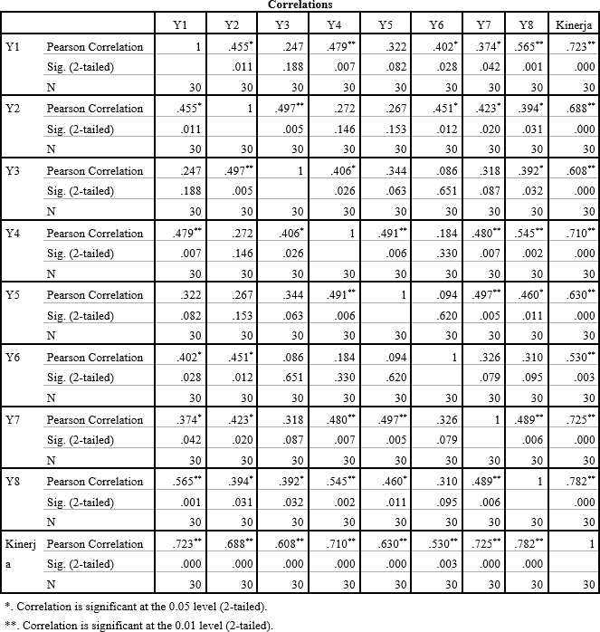

  - Uji Validitas Variabel Kompetensi (X1)

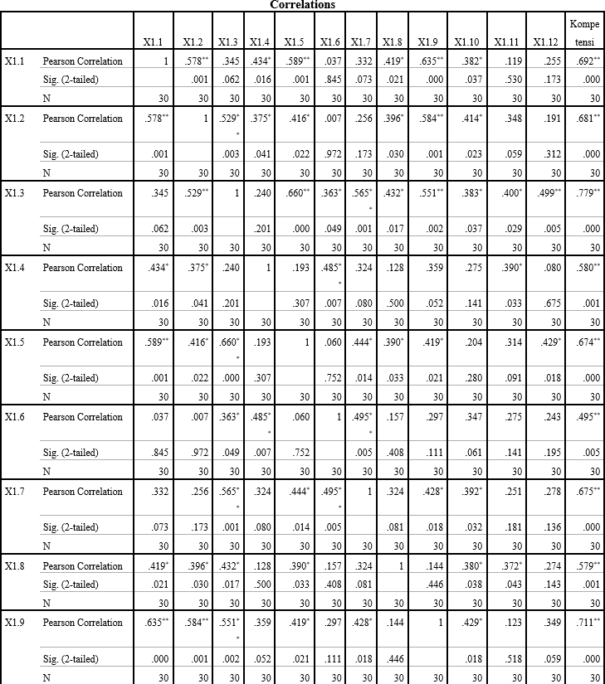

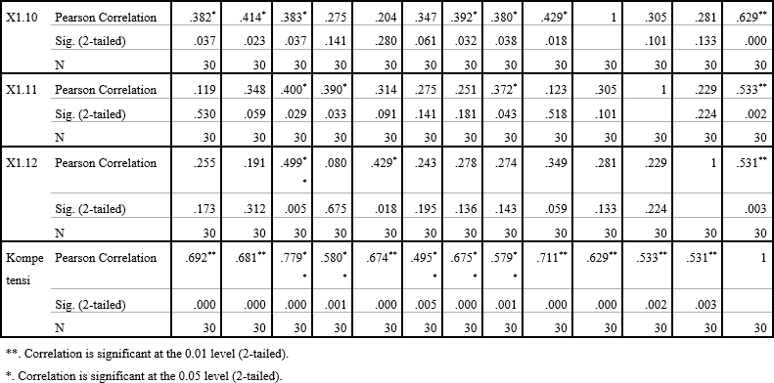

  - Uji Validitas Variabel Beban Kerja (X2)
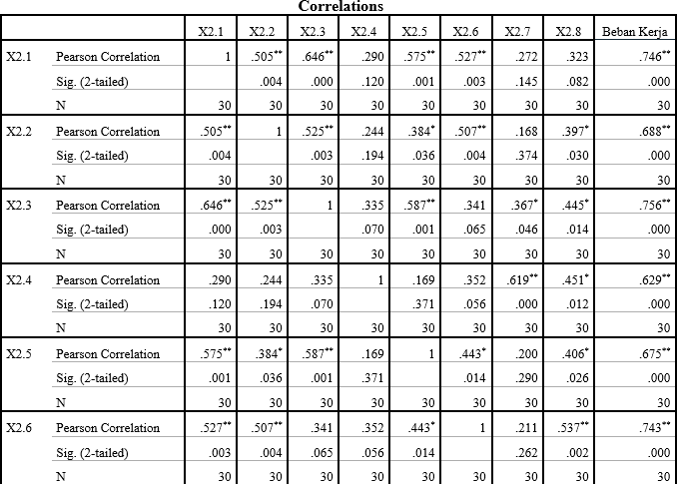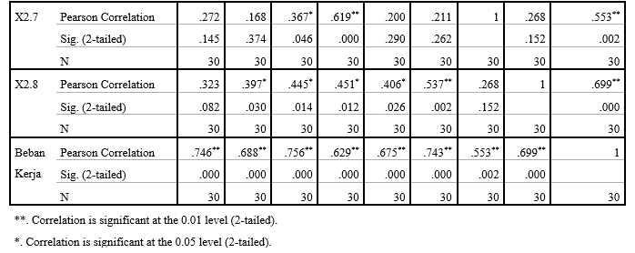

Lampiran 5

- Uji Reliabilitas Kinerja Pegawai (Y)

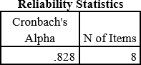

- Uji Reliabilitas Kompetensi (X1)
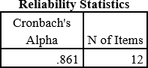

- Uji Reliabilitas Beban Kerja (X2)
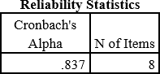

Lampiran 6 Analisis Data
- Uji Asumsi Klasik

  - Uji Normalitas
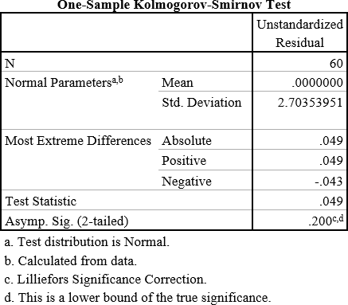

  - Uji Multikolinieritas

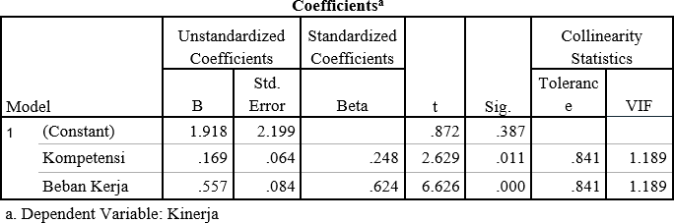

  - Uji Heterokedastisitas

    - Uji Scatterplot

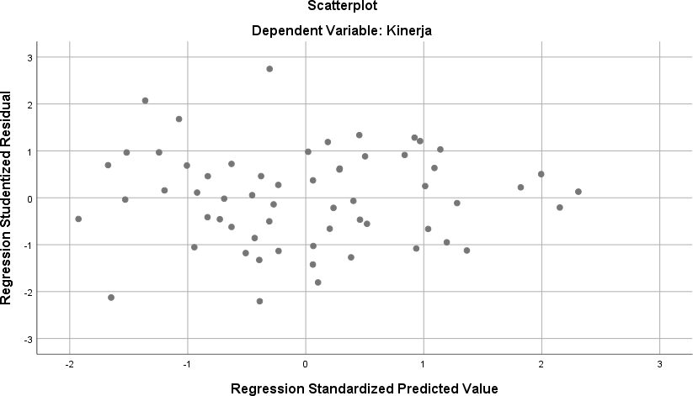
    - Uji Glejser

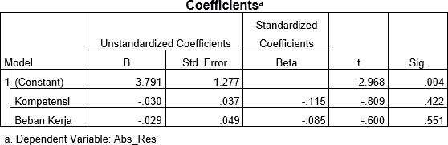

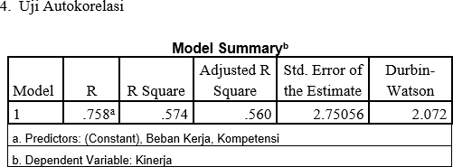

- Analisis Regresi Linier Berganda

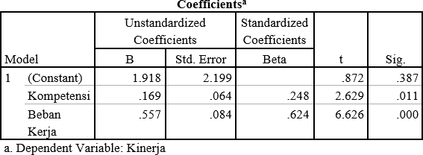

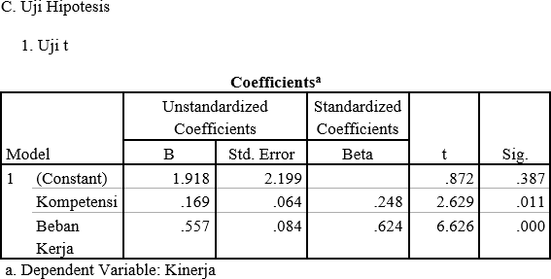

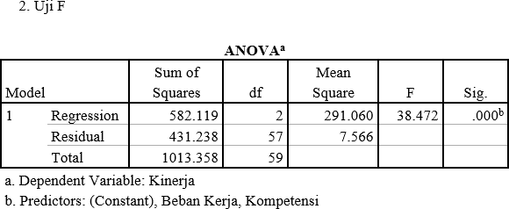

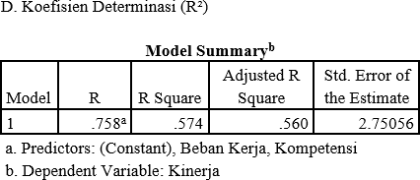

Lampiran 7
