DAFTAR PUSTAKA
Agusti, R.R Dan M. Maulinarhadi. R. (2019). E-Journal Media Bina Ilmiah, 14(3), 2223-223
Budiman, N. A., Indaryani, M., & Mulyani, S. (2020). Dampak Covid-19 dan Pemanfaatan Insentif Pajak terhadap Keberlangsungan Usaha pada UMKM Tenun Troso Jepara. Jurnal Manajemen Dan Keuangan, 9(3), 276-285.
Cahyani, L. P. G., & Noviari, N. (2019). Pengaruh tarif pajak, pemahaman perpajakan, dan sanksi perpajakan terhadap kepatuhan wajib pajak UMKM. E-Jurnal Akuntansi, 26(3), 1885-1911.
Dewi, I.A.S. (2019). Pengaruh Insentif Pajak PPh Badan terhadap Kenaikan Dunia Usaha dan Investasi. Diakses pada 20 Maret 2021, dari https://www.pajakku.com/read/5da003d5b01c4b456747b71a/Pengaruh-Insentif-Pajak-PPh-Badan-terhadap-Kenaikan-Dunia-Usaha-dan-Investasi.
Direktorat Jenderal Pajak (2013). Fasilitas dan Insentif Pajak Penghasilan Indonesia. Edisi: 2. Jakarta
Ekon.go.id (2021). Dukungan Pemerintah Bagi UMKM Agar Pulih di Masa Pandemi. Diakses melalui https://www.ekon.go.id/publikasi/detail/2939/dukungan-pemerintah bagi-umkm-agar-pulih-di-masa-pandemi. Diakses tanggal 28 April 2021, 16:30.
Fadilah, L. Indriastuti, M., Apriyanti, Werdi, H., dan Muthoaroh. (2020). Perpajakan Teori dan Kebijakan. Yogyakarta: Budi Utama.
Fitriya. (2022). “Pajak UMKM Terbaru : Tarif PPh Final UMKM dan Cara Menghitung”. https://klikpajak.id/blog/pajak-umkm-tarif-cara-hitung-bayar-dan-lapor-spt-pajaknya/#Aturan_Sanksi_Pajak_Terbaru. 16 jun 2022.
Forum Pajak (2020). Insentif Pajak Untuk Wajib Pajak Terdampak Pandemi Corona Virus Diseas 2019 (PMK 44 2020) https://forumpajak.org/insentif-pajak-untuk-wajib-pajak-terdampak-pandemi-corona-virus-disease-2019-pmk-44-2020/#lightbox/0/. Diakses pada 04 Mey 2020.
Ghozali, Imam. 2018. Aplikasi Analisis Multivariate dengan Program IBM SPSS. Semarang: Badan Penerbit Universitas Diponegoro.
Hapsari, A., & Kholis, N. (2020). Analisis Faktor-Faktor Kepatuhan Wajib Pajak UMKM di KPP Pratama Karanganyar. Reviu Akuntansi dan Bisnis Indonesia, 4(1), 56-67.
Hapsari, A., & Kholis, N. (2020). Analisis Faktor-Faktor Kepatuhan Wajib Pajak UMKM di KPP Pratama Karanganyar. Jurnal Reviu Akuntansi dan Bisnis Indonesia, 4(1), 56-67.
Indonesia, Kementerian Keuangan Republik. (2020). "Program Pemulihan Ekonomi Nasional (PEN)”.https://pen.kemenkeu.go.id/in/post/mengapa-program-pen.
Indriastuti, M., Apriyanti, Werdi, H., dan Muthoaroh. (2020). Perpajakan Teori dan Kebijakan. Yogyakarta: Budi Utama.
Indriastuti, M., Apriyanti, Werdi, H., dan Muthoaroh. (2020). Perpajakan Teori dan Kebijakan. Yogyakarta: Budi Utama.
Kemenkeu (2020). Program Pemulihan Ekonomi Nasional (PEN). Diakses melalui https://pen.kemenkeu.go.id/in/post/mengapa-program-pen.
Latief, S., Junaidin Zakaria, & Mapparenta. (2020). Pengaruh kepercayaan kepada pemerintah, kebijakan insentif pajak dan manfaat pajak terhadap kepatuhan wajib pajak. Jurnal Analisa Akuntansi Dan Perpajakan, 3(3), 271-289. http://jurnal.fe.umi.ac.id/index.php/CESJ/article/view/581/425
M. Farouq S. (2018). Hukum pajak di Indonesia: suatu pengantar ilmu hukum terapan di bidang perpajakan. Indonesia, Kencana.
Maulida, Rani. 2019. Kriteria UMKM & Pajaknya yang Perlu Anda Ketahui!. https://www.online-pajak.com/seputar-pph-final/kriteria-umkm-dan-pajaknya. diakses tanggal 5 Desember 2019.
Nurmantu, Safri. 2005. Pengantar Perpajakan. ed.3 . Jakarta : Granit.
Oliviandy, N. A., Astuti, T. P., & Siddiq, F. R. (2021). Analisis Faktor-Faktor Yang Mempengaruhi Kepatuhan Wajib Pajak UMKM Selama Pandemi Covid-19. Jurnal Wahana Riset Akuntansi, 9(2), 91-105.
Peraturan Menteri Keuangan Republik Indonesia Nomor 74/Pmk.03/2012. Pasal 2.
Qomaria, S. 2008. Analisis Pengaruh Pengetahuan Tentang Pajak dan Tingkat Pendidikan Wajib Pajak Terhadap Kesadaran Membayar Pajak. Skripsi. Jakarta: UIN Syarif Hidayatullah.
Resmi, S. 2019. Perpajakan Teori & Kasus, Edisi 11 Buku 1. Jakarta: Salemba Empat..
Resmi, Siti. 2016. Perpajakan. Jakarta: Salemba Empat.
Saputro, R., & Meivira, F. (2020). Pengaruh tingkat pendidikan pemilik, praktik akuntansi dan persepsi atas insentif pajak terhadap kepatuhan pajak UMKM. Jurnal EMBA: Jurnal Riset Ekonomi, Manajemen, Bisnis dan Akuntansi, 8(4).
Sekaran, U., & Bougie, R. (2017). Metode Penelitian untuk Bisnis: Pendekatan Pengembangan-Keahlian, Edisi 6 Buku 1. Jakarta : Salemba Empat.
Siti, K. R. (2010). Perpajakan Indonesia. Yogyakarta: Graha Pustaka.
Siti, K. R. (2010). Perpajakan Indonesia. Yogyakarta: Graha Pustaka.
Siti, K. R. 2017. Perpajakan: Konsep dan Aspek Formal. Bandung: Rekayasa Sains.
Sugiyono. (2016). Metode Penelitian Kuantitatif, Kualitatif, dan R&D. (Cetakan 23). Bandung: Alfabeta.
Suliyanto. (2018). Metode Penelitian Bisnis. Yogyakarta: ANDI OFFSET.
Walidain, M. B. (2021). Pengaruh Insentif Pajak, Sosialisasi Pajak dan Self Assesment System terhadap Kepatuhan Wajib Pajak UMKM Saat Pandemi Covid-19. Syntax Literate; Jurnal Ilmiah Indonesia, 6(2), 118-1132.
Widayati dan Nurlis. 2010. “Faktor-Faktor Yang Mempengaruhi Untuk Membayar Pajak Wajib Pajak Orang Pribadi Yang Melakukan Pekerjaan Bebas Studi Kasus Pada KPP Pratama Gambir Tiga”. Proceeding Simposium Nasional Akuntansi XII. Purwokerto.
Widodo, A., & Muniroh, H. (2021). Pengaruh Penurunan Tarif PPh, Pelayanan Pajak, Serta Sanksi Pajak Terhadap Kepatuhan Wajib Pajak UMKM. Fokus Ekonomi: Jurnal Ilmiah Ekonomi, 16(1), 58-78.

LAMPIRAN

Lampiran 1 Kuesioner Penelitian
PERMOHONAN PENGISIAN KUESIONER
Hal : Permohonan Pengisian Kuesioner
Yth : Bapak/Ibu/Saudara/I Responden
Di Tempat

Assalamu’alaikum Wr.Wb.
Dengan Hormat,
Sehubungan dengan kegiatan penelitian untuk menyusun tugas akhir skripsi, sebagai mahasiswa Program Strata Satu (S1) Universitas Pancasakti Tegal, peneliti:
Nama : Mahfidzoh
NPM : 4318500117
Prodi/Jurusan : S1 Akuntansi
Fakultas : Ekonomi dan Bisnis
Bermaksud melakukan penelitian yang digunakan untuk penyusunan skripsi dengan judul “Pengaruh Penerapan Insenstif Pajak Penghasilan (PPh) Final, Pemahaman Peraturan Pajak dan Penurunan Tarif Pajak Terhadap Kepatuhan Wajib Pajak UMKM Pada Masa Pandemi COVID-19 (Studi Kasus Pada KPP Pratama Tegal)”.
Untuk itu, saya mengharapkan kesediaan Bapak/Ibu/Saudara/i dapat memberikan jawaban yang sebenar-benarnya demi membantu saya dalam penelitian ini. Seluruh informasi yang diperoleh dari kuesioenr ini hanya akan saya gunakan untuk keperlua penelitian saja dan saya akan menjaga kerahasiaannya sesuai dengan etika penelitian. Atas waktu dan ketersediaannya Bapa/Ibu saya ucapkan terima kasih.
Brebes, November 2022

Mahfidzoh
(4318500117)

PETUNJUK PENGISIAN KUESIONER

- Sebelum mengisi kuesioner, responden dimohon untuk melengkapi identitas terlebih dahulu.
- Pilihlah jawaban dengan cara memberikan tanda checklist (√) pada jawaban yang dianggap paling sesuai dengan kondisi sebenarnya.
- Responden dimohon untuk mengisi semua butir pertanyaan dan tiap pertanyaan hanya boleh diisi dengan satu jawaban
- Adapun alternatif pilihan jawabannya sebagai berikut :
STS : Sangat Tidak Setuju
TS : Tidak Setuju
N : Netral
S : Setuju
SS : Sangat Setuju

IDENTITAS RESPONDEN

Mohon Bapa/Ibu mengisi idenstitas terlebih dahulu

- Nama Responden :
- Nama Usaha/Pekerjaan :
- Alamat Usaha :
- Usia : | tahun
- Jenis Kelamin : | Laki-Laki Perempuan
- Pendidikan Terakhir : |  | SMA |  | S1
 |  | Diploma |  | Lainnya

DAFTAR PERTANYAAN

Variabel Y : Kepatuhan Wajib Pajak UMKM
No | Pertanyaan | Pilihan Jawaban
 |  | 1 | 2 | 3 | 4 | 5
 |  | STS | TS | N | S | SS
Indikator : Kepatuhan Pajakan Formal
1. | Saya mendaftarkan NPWP atas kemauan sendir
2. | Saya selalu tepat waktu dalam mebayar pajak
3. | Saya memiliki kesadaran dan kepatuhan dalam menyampaikan SPT tepat waktu.
4. | Saya memenuhi kewajiban pajak sesuai dengan ketentuan yang berlaku.
Indikator : Kepatuhan Pajak Material
5. | Saya mampu melakukan perhitungan pajak dengan benar
6. | Saya tidak mempunyai tunggakan pajak
7. | Saya tidak pernah melanggar ketentuan peraturan
8. | Laporan Keuangan diaudit oleh Akuntan Publik atau lembaga pengawasan keuangan
9. | Tidak pernah dipidana karena melakukan tindak pidana di bidang perpajakan
10. | Saya bersedia membayar kewajiban pajak serta tunggakan pajaknya.

Variabel X1 : Insentif Pajak
No | Pertanyaan | Pilihan Jawaban
 |  | 1 | 2 | 3 | 4 | 5
 |  | STS | TS | N | S | SS
Indikator : Pengurangan Pajak
1. | Insentif pajak atau pengurangan pajak menjadi salah satu fasilitas pajak yang digunakan di masa krisis guna membantu para pelaku usaha pada masa pandemi COVID-19.
2. | Saya menyadari insentif pajak atau pengurangan pajak menguntungkan bagi wajib pajak
3. | Saya menyadari dengan adanya insentif pajak ini dapat meningkatkan kesadaran pentingnya membayar pajak.
4. | Insentif pajak yang diberikan pemerintah memberikan kemudahan bagi para pelaku wajib pajak UMKM
5. | Sebagai wajib pajak saya sangat terbantu dengan adanya insentif pajak untuk pelaku UMKM di masa pandemi COVID-19
Indikator : Keringanan Pajak
6. | Saya menyadari Insentif Pajak mengurangi besarnya beban pajak yang harus disetorkan kepada pemerintah
7. | Saya mengerti insentif pajak merupakan kemudahan yang diberikan pemerintah di bidang perpajakan kepada orang pribadi maupun badan
8. | Pemberian insentif memberikan keadilan bagi wajib pajak
9. | Dengan adanya insentif pajak untuk UMKM membuat saya menjadi termotivasi untuk lapor SPT masa dan SPT tahunan tepat waktu
10. | Menurut saya dengan adanya insentif pajak merupakan hal efektif dalam meningkatkan kepatuhan pajak di masa pandemi dan yang akan datang

Variabel X2 : Pemahaman Pajak
No | Pertanyaan | Pilihan Jawaban
 |  | 1 | 2 | 3 | 1 | 5
 |  | STS | TS | N | STS | SS
Indikator : Pengetahuan mengenai ketentuan umum dan tata cara perpajakan
1. | Pengetahuan pajak memudahkan saya memahami aturan pajak yang berlaku.
2. | Mengetahui adanya insentif pajak pada saat pandemi Covid-19 memberikan manfaat bagi waib pajak.
3. | Saya mengetahui Pelaku UMKM mendapat insentif PPh final saat pandemi dengan tarif 0,5% menjadi 0%. Demikian membuat sektor UMKM sangat diringankan.
4. | Kurangnya pengetahuan perpajakan membuat wajib pajak tidak patuh pajak.
5. | Dengan adanya Pengetahuan pajak dalam diri wajib pajak maka akan memberikan kepatuhan wajib pajak.
6. | Saya mengetahui insentif pajak berlaku sejak Maret 2020 dan berlaku sampai dengan bulan Juni 2021 dan di perpanjang lagi Desember 2021 diatur dalam PMK Nomor 82/PMK.03/2021.
7. | Saya mengetahui peraturan mengenai batas waktu pelaporan SPT bagi usaha yang saya jalankan
Indikator : Memahami sistem Perpajakan di Indoneisia
8. | Saya memahami hak dan kewajiban saya sebagai Wajib Pajak
9. | Saya memahami insentif pajak untuk waib pajak terdampak COVID-19
10. | Saya memahami adanya insentif pajak UMKM
11. | Saya paham dalam menghitung membayar, dan melaporkan pajak sendiri menggunakan tarif 0,5% dari peredaran bruto.
Variabel X3 : Penurunan Tarif Pajak
No | Pertanyaan | Pilihan Jawaban
 |  | 1 | 2 | 3 | 1 | 5
 |  | STS | TS | N | STS | SS
Indikator : Presentase dasar pengenaan pajak
1. | Tarif pajak tanpa melihat untung atau rugi usaha dapat merugikan wajib pajak
2. | Peraturan Pemerintah No. 23 Tahun 2018 dengan tarif final 0,5% dari omset meringankan UMKM
3. | Pelaku UMKM mendapat insentif PPh final tarif 0,5%, saat covid-19 menjadi 0% dengan begitu sangat meringankan beban wajib pajak.
4. | Tarif pajak yang terlalu tinggi menyebabkan kecurangan pajak.
Indikator : Penentu pajak yang harus dibayar
65. | Perubahan tarif pajak saat ini menurunkan jumlah pajak terutang
6. | Perubahan tarif pajak dapat meringankan dan memberi kaadilan bagi wajib pajak
7. | Penurunan tarif pajak dapat meningkatkan kemauan membayar pajak
8. | Saya merasa beban administrasi menjadi ringan sejak adanya penurunan tarif pajak 0,5%.
9. | Tarif pajak tidak menentukan besarnya kesadaran membayar pajak

Lampiran 2 Data Penelitian
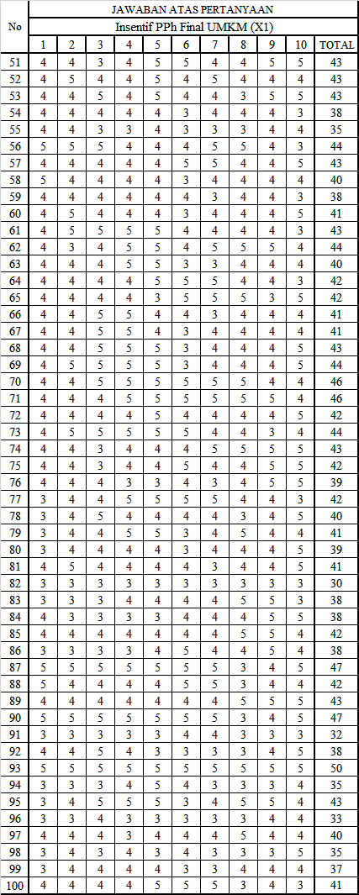
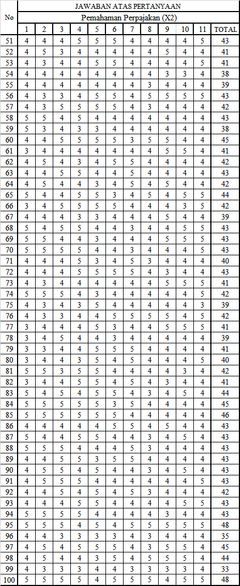
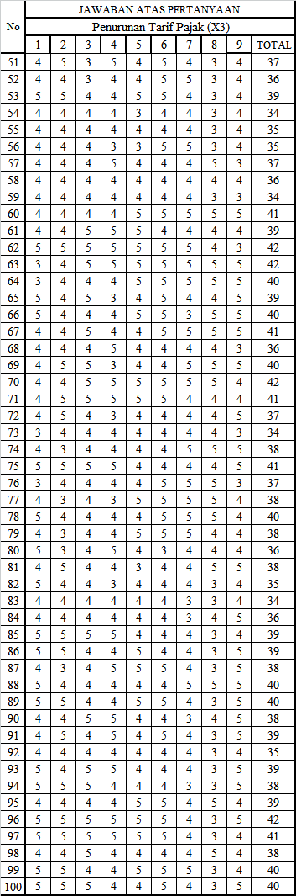
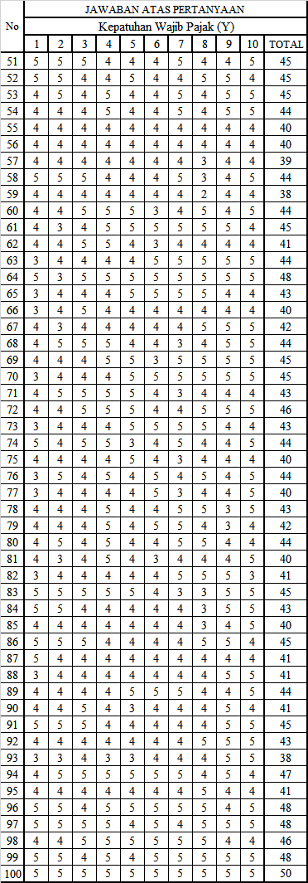
Lampiran 3 Deskripsi Data Penelitian
No | Usaha/Pekerjaan | Jumlah
1 | Karyawan Swasta | 26
2 | Karyawan BUMN | 2
3 | Wiraswasta | 19
4 | Wirausaha | 25
5 | Guru | 28
Jumlah Keseluruhan |  | 100

No | Umur | Jumlah
1 | 19-25 | 7
2 | 26-30 | 14
3 | 31-35 | 21
4 | 36-40 | 25
5 | 41-45 | 17
6 | 46-50 | 16
Jumlah Keseluruhan |  | 100

No | Tempat Tinggal | Jumlah
1 | Kota Tegal | 37
2 | Kabupaten Tegal | 42
3 | Kabupaten Brebs | 21
Jumlah Keseluruhan |  | 100

No | Pendidikan | Jumlah
1 | SMA | 43
2 | Diploma | 19
3 | S1 | 37
4 | Lainnya | 1
Jumlah Keseluruhan |  | 100

No | Jenis Kelamin | Jumlah
1 | Laki-laki | 42
2 | Perempuan | 58
Jumlah Keseluruhan |  | 100

Lampiran 4 Hasil Instrumen Penelitian
- Hasil Uji Validitas
- Penerapan Insentif PPh Final (X1)
Correlations
 |  | X1.1 | X1.2 | X1.3 | X1.4 | X1.5 | X1.6 | X1.7 | X1.8 | X1.9 | X1.10 | X1.11
X1.1 | Pearson Correlation | 1 | .776** | .603** | .530** | .485** | .567** | .645** | .471** | .445** | .468** | .765**
 | Sig. (2-tailed) |  | .000 | .000 | .000 | .000 | .000 | .000 | .000 | .000 | .000 | .000
 | N | 100 | 100 | 100 | 100 | 100 | 100 | 100 | 100 | 100 | 100 | 100
X1.2 | Pearson Correlation | .776** | 1 | .744** | .670** | .601** | .503** | .594** | .474** | .424** | .531** | .810**
 | Sig. (2-tailed) | .000 |  | .000 | .000 | .000 | .000 | .000 | .000 | .000 | .000 | .000
 | N | 100 | 100 | 100 | 100 | 100 | 100 | 100 | 100 | 100 | 100 | 100
X1.3 | Pearson Correlation | .603** | .744** | 1 | .772** | .637** | .391** | .529** | .478** | .489** | .508** | .795**
 | Sig. (2-tailed) | .000 | .000 |  | .000 | .000 | .000 | .000 | .000 | .000 | .000 | .000
 | N | 100 | 100 | 100 | 100 | 100 | 100 | 100 | 100 | 100 | 100 | 100
X1.4 | Pearson Correlation | .530** | .670** | .772** | 1 | .778** | .473** | .614** | .566** | .496** | .473** | .827**
 | Sig. (2-tailed) | .000 | .000 | .000 |  | .000 | .000 | .000 | .000 | .000 | .000 | .000
 | N | 100 | 100 | 100 | 100 | 100 | 100 | 100 | 100 | 100 | 100 | 100
X1.5 | Pearson Correlation | .485** | .601** | .637** | .778** | 1 | .512** | .603** | .528** | .632** | .531** | .825**
 | Sig. (2-tailed) | .000 | .000 | .000 | .000 |  | .000 | .000 | .000 | .000 | .000 | .000
 | N | 100 | 100 | 100 | 100 | 100 | 100 | 100 | 100 | 100 | 100 | 100
X1.6 | Pearson Correlation | .567** | .503** | .391** | .473** | .512** | 1 | .727** | .448** | .478** | .416** | .714**
 | Sig. (2-tailed) | .000 | .000 | .000 | .000 | .000 |  | .000 | .000 | .000 | .000 | .000
 | N | 100 | 100 | 100 | 100 | 100 | 100 | 100 | 100 | 100 | 100 | 100
X1.7 | Pearson Correlation | .645** | .594** | .529** | .614** | .603** | .727** | 1 | .572** | .504** | .400** | .798**
 | Sig. (2-tailed) | .000 | .000 | .000 | .000 | .000 | .000 |  | .000 | .000 | .000 | .000
 | N | 100 | 100 | 100 | 100 | 100 | 100 | 100 | 100 | 100 | 100 | 100
X1.8 | Pearson Correlation | .471** | .474** | .478** | .566** | .528** | .448** | .572** | 1 | .661** | .395** | .725**
 | Sig. (2-tailed) | .000 | .000 | .000 | .000 | .000 | .000 | .000 |  | .000 | .000 | .000
 | N | 100 | 100 | 100 | 100 | 100 | 100 | 100 | 100 | 100 | 100 | 100
X1.9 | Pearson Correlation | .445** | .424** | .489** | .496** | .632** | .478** | .504** | .661** | 1 | .622** | .753**
 | Sig. (2-tailed) | .000 | .000 | .000 | .000 | .000 | .000 | .000 | .000 |  | .000 | .000
 | N | 100 | 100 | 100 | 100 | 100 | 100 | 100 | 100 | 100 | 100 | 100
X1.10 | Pearson Correlation | .468** | .531** | .508** | .473** | .531** | .416** | .400** | .395** | .622** | 1 | .702**
 | Sig. (2-tailed) | .000 | .000 | .000 | .000 | .000 | .000 | .000 | .000 | .000 |  | .000
 | N | 100 | 100 | 100 | 100 | 100 | 100 | 100 | 100 | 100 | 100 | 100
X1.11 | Pearson Correlation | .765** | .810** | .795** | .827** | .825** | .714** | .798** | .725** | .753** | .702** | 1
 | Sig. (2-tailed) | .000 | .000 | .000 | .000 | .000 | .000 | .000 | .000 | .000 | .000
 | N | 100 | 100 | 100 | 100 | 100 | 100 | 100 | 100 | 100 | 100 | 100
**. Correlation is significant at the 0.01 level (2-tailed).

- Pemahaman Perpajakan (X2)
Correlations
 |  | X2.1 | X2.2 | X2.3 | X2.4 | X2.5 | X2.6 | X2.7 | X2.8 | X2.9 | X2.10 | X2.11 | X2.12
X2.1 | Pearson Correlation | 1 | .307** | .159 | .350** | .075 | .156 | .031 | .259** | .066 | .240* | .108 | .482**
 | Sig. (2-tailed) |  | .002 | .115 | .000 | .457 | .122 | .758 | .009 | .515 | .016 | .287 | .000
 | N | 100 | 100 | 100 | 100 | 100 | 100 | 100 | 100 | 100 | 100 | 100 | 100
X2.2 | Pearson Correlation | .307** | 1 | .612** | .256* | .029 | .247* | .131 | -.105 | .398** | .392** | .200* | .630**
 | Sig. (2-tailed) | .002 |  | .000 | .010 | .773 | .013 | .194 | .299 | .000 | .000 | .046 | .000
 | N | 100 | 100 | 100 | 100 | 100 | 100 | 100 | 100 | 100 | 100 | 100 | 100
X2.3 | Pearson Correlation | .159 | .612** | 1 | .356** | .196 | .420** | .081 | -.180 | .335** | .464** | .223* | .669**
 | Sig. (2-tailed) | .115 | .000 |  | .000 | .051 | .000 | .421 | .073 | .001 | .000 | .026 | .000
 | N | 100 | 100 | 100 | 100 | 100 | 100 | 100 | 100 | 100 | 100 | 100 | 100
X2.4 | Pearson Correlation | .350** | .256* | .356** | 1 | .449** | .395** | .091 | .222* | .129 | .271** | .267** | .654**
 | Sig. (2-tailed) | .000 | .010 | .000 |  | .000 | .000 | .370 | .026 | .202 | .006 | .007 | .000
 | N | 100 | 100 | 100 | 100 | 100 | 100 | 100 | 100 | 100 | 100 | 100 | 100
X2.5 | Pearson Correlation | .075 | .029 | .196 | .449** | 1 | .296** | .150 | .131 | .074 | .225* | .217* | .477**
 | Sig. (2-tailed) | .457 | .773 | .051 | .000 |  | .003 | .136 | .194 | .467 | .024 | .030 | .000
 | N | 100 | 100 | 100 | 100 | 100 | 100 | 100 | 100 | 100 | 100 | 100 | 100
X2.6 | Pearson Correlation | .156 | .247* | .420** | .395** | .296** | 1 | .086 | .030 | .434** | .408** | .162 | .654**
 | Sig. (2-tailed) | .122 | .013 | .000 | .000 | .003 |  | .395 | .769 | .000 | .000 | .107 | .000
 | N | 100 | 100 | 100 | 100 | 100 | 100 | 100 | 100 | 100 | 100 | 100 | 100
X2.7 | Pearson Correlation | .031 | .131 | .081 | .091 | .150 | .086 | 1 | .187 | .065 | .117 | .280** | .329**
 | Sig. (2-tailed) | .758 | .194 | .421 | .370 | .136 | .395 |  | .062 | .523 | .246 | .005 | .001
 | N | 100 | 100 | 100 | 100 | 100 | 100 | 100 | 100 | 100 | 100 | 100 | 100
X2.8 | Pearson Correlation | .259** | -.105 | -.180 | .222* | .131 | .030 | .187 | 1 | .113 | .051 | .285** | .266**
 | Sig. (2-tailed) | .009 | .299 | .073 | .026 | .194 | .769 | .062 |  | .263 | .615 | .004 | .008
 | N | 100 | 100 | 100 | 100 | 100 | 100 | 100 | 100 | 100 | 100 | 100 | 100
X2.9 | Pearson Correlation | .066 | .398** | .335** | .129 | .074 | .434** | .065 | .113 | 1 | .597** | .274** | .582**
 | Sig. (2-tailed) | .515 | .000 | .001 | .202 | .467 | .000 | .523 | .263 |  | .000 | .006 | .000
 | N | 100 | 100 | 100 | 100 | 100 | 100 | 100 | 100 | 100 | 100 | 100 | 100
X2.10 | Pearson Correlation | .240* | .392** | .464** | .271** | .225* | .408** | .117 | .051 | .597** | 1 | .328** | .687**
 | Sig. (2-tailed) | .016 | .000 | .000 | .006 | .024 | .000 | .246 | .615 | .000 |  | .001 | .000
 | N | 100 | 100 | 100 | 100 | 100 | 100 | 100 | 100 | 100 | 100 | 100 | 100
X2.11 | Pearson Correlation | .108 | .200* | .223* | .267** | .217* | .162 | .280** | .285** | .274** | .328** | 1 | .417**
 | Sig. (2-tailed) | .287 | .046 | .026 | .007 | .030 | .107 | .005 | .004 | .006 | .001 |  | .000
 | N | 100 | 100 | 100 | 100 | 100 | 100 | 100 | 100 | 100 | 100 | 100 | 100
X2 | Pearson Correlation | .482** | .630** | .669** | .654** | .477** | .654** | .329** | .266** | .582** | .687** | .417** | 1
 | Sig. (2-tailed) | .000 | .000 | .000 | .000 | .000 | .000 | .001 | .008 | .000 | .000 | .000
 | N | 100 | 100 | 100 | 100 | 100 | 100 | 100 | 100 | 100 | 100 | 100 | 100
**. Correlation is significant at the 0.01 level (2-tailed).
*. Correlation is significant at the 0.05 level (2-tailed).

- Penurunan Tarif Pajak
Correlations
 |  | X3.1 | X3.2 | X3.3 | X3.4 | X3.5 | X3.6 | X3.7 | X3.8 | X3.9 | X3.10
X3.1 | Pearson Correlation | 1 | .480** | .434** | .298** | .367** | .244* | .210* | -.041 | .232* | .580**
 | Sig. (2-tailed) |  | .000 | .000 | .003 | .000 | .014 | .036 | .685 | .020 | .000
 | N | 100 | 100 | 100 | 100 | 100 | 100 | 100 | 100 | 100 | 100
X3.2 | Pearson Correlation | .480** | 1 | .504** | .284** | .400** | .355** | .190 | -.041 | .210* | .617**
 | Sig. (2-tailed) | .000 |  | .000 | .004 | .000 | .000 | .058 | .685 | .036 | .000
 | N | 100 | 100 | 100 | 100 | 100 | 100 | 100 | 100 | 100 | 100
X3.3 | Pearson Correlation | .434** | .504** | 1 | .332** | .438** | .402** | .341** | .189 | .315** | .741**
 | Sig. (2-tailed) | .000 | .000 |  | .001 | .000 | .000 | .001 | .060 | .001 | .000
 | N | 100 | 100 | 100 | 100 | 100 | 100 | 100 | 100 | 100 | 100
X3.4 | Pearson Correlation | .298** | .284** | .332** | 1 | .376** | .199* | .226* | .103 | -.043 | .500**
 | Sig. (2-tailed) | .003 | .004 | .001 |  | .000 | .047 | .024 | .310 | .669 | .000
 | N | 100 | 100 | 100 | 100 | 100 | 100 | 100 | 100 | 100 | 100
X3.5 | Pearson Correlation | .367** | .400** | .438** | .376** | 1 | .584** | .405** | .283** | .206* | .738**
 | Sig. (2-tailed) | .000 | .000 | .000 | .000 |  | .000 | .000 | .004 | .040 | .000
 | N | 100 | 100 | 100 | 100 | 100 | 100 | 100 | 100 | 100 | 100
X3.6 | Pearson Correlation | .244* | .355** | .402** | .199* | .584** | 1 | .538** | .133 | .380** | .700**
 | Sig. (2-tailed) | .014 | .000 | .000 | .047 | .000 |  | .000 | .186 | .000 | .000
 | N | 100 | 100 | 100 | 100 | 100 | 100 | 100 | 100 | 100 | 100
X3.7 | Pearson Correlation | .210* | .190 | .341** | .226* | .405** | .538** | 1 | .501** | .051 | .639**
 | Sig. (2-tailed) | .036 | .058 | .001 | .024 | .000 | .000 |  | .000 | .618 | .000
 | N | 100 | 100 | 100 | 100 | 100 | 100 | 100 | 100 | 100 | 100
X3.8 | Pearson Correlation | -.041 | -.041 | .189 | .103 | .283** | .133 | .501** | 1 | .000 | .421**
 | Sig. (2-tailed) | .685 | .685 | .060 | .310 | .004 | .186 | .000 |  | .997 | .000
 | N | 100 | 100 | 100 | 100 | 100 | 100 | 100 | 100 | 100 | 100
X3.9 | Pearson Correlation | .232* | .210* | .315** | -.043 | .206* | .380** | .051 | .000 | 1 | .459**
 | Sig. (2-tailed) | .020 | .036 | .001 | .669 | .040 | .000 | .618 | .997 |  | .000
 | N | 100 | 100 | 100 | 100 | 100 | 100 | 100 | 100 | 100 | 100
X3 | Pearson Correlation | .580** | .617** | .741** | .500** | .738** | .700** | .639** | .421** | .459** | 1
 | Sig. (2-tailed) | .000 | .000 | .000 | .000 | .000 | .000 | .000 | .000 | .000
 | N | 100 | 100 | 100 | 100 | 100 | 100 | 100 | 100 | 100 | 100
**. Correlation is significant at the 0.01 level (2-tailed).
*. Correlation is significant at the 0.05 level (2-tailed).

- Kepatuhan Wajib Pajak UMKM
Correlations
 |  | Y1 | Y2 | Y3 | Y4 | Y5 | Y6 | Y7 | Y8 | Y9 | Y10 | Y11
Y1 | Pearson Correlation | 1 | .506** | .385** | .068 | -.045 | .081 | .157 | -.181 | .223* | .184 | .346**
 | Sig. (2-tailed) |  | .000 | .000 | .501 | .658 | .424 | .118 | .072 | .025 | .066 | .000
 | N | 100 | 100 | 100 | 100 | 100 | 100 | 100 | 100 | 100 | 100 | 100
Y2 | Pearson Correlation | .506** | 1 | .484** | .145 | .102 | .316** | .208* | -.060 | .295** | .219* | .493**
 | Sig. (2-tailed) | .000 |  | .000 | .151 | .314 | .001 | .038 | .552 | .003 | .029 | .000
 | N | 100 | 100 | 100 | 100 | 100 | 100 | 100 | 100 | 100 | 100 | 100
Y3 | Pearson Correlation | .385** | .484** | 1 | .325** | .225* | .288** | .308** | .074 | .355** | .319** | .604**
 | Sig. (2-tailed) | .000 | .000 |  | .001 | .025 | .004 | .002 | .464 | .000 | .001 | .000
 | N | 100 | 100 | 100 | 100 | 100 | 100 | 100 | 100 | 100 | 100 | 100
Y4 | Pearson Correlation | .068 | .145 | .325** | 1 | .562** | .105 | .237* | .537** | .113 | .374** | .630**
 | Sig. (2-tailed) | .501 | .151 | .001 |  | .000 | .299 | .018 | .000 | .263 | .000 | .000
 | N | 100 | 100 | 100 | 100 | 100 | 100 | 100 | 100 | 100 | 100 | 100
Y5 | Pearson Correlation | -.045 | .102 | .225* | .562** | 1 | .256* | .251* | .472** | .206* | .325** | .612**
 | Sig. (2-tailed) | .658 | .314 | .025 | .000 |  | .010 | .012 | .000 | .040 | .001 | .000
 | N | 100 | 100 | 100 | 100 | 100 | 100 | 100 | 100 | 100 | 100 | 100
Y6 | Pearson Correlation | .081 | .316** | .288** | .105 | .256* | 1 | .567** | .098 | .342** | .244* | .544**
 | Sig. (2-tailed) | .424 | .001 | .004 | .299 | .010 |  | .000 | .331 | .000 | .014 | .000
 | N | 100 | 100 | 100 | 100 | 100 | 100 | 100 | 100 | 100 | 100 | 100
Y7 | Pearson Correlation | .157 | .208* | .308** | .237* | .251* | .567** | 1 | .214* | .294** | .294** | .607**
 | Sig. (2-tailed) | .118 | .038 | .002 | .018 | .012 | .000 |  | .033 | .003 | .003 | .000
 | N | 100 | 100 | 100 | 100 | 100 | 100 | 100 | 100 | 100 | 100 | 100
Y8 | Pearson Correlation | -.181 | -.060 | .074 | .537** | .472** | .098 | .214* | 1 | .180 | .377** | .587**
 | Sig. (2-tailed) | .072 | .552 | .464 | .000 | .000 | .331 | .033 |  | .073 | .000 | .000
 | N | 100 | 100 | 100 | 100 | 100 | 100 | 100 | 100 | 100 | 100 | 100
Y9 | Pearson Correlation | .223* | .295** | .355** | .113 | .206* | .342** | .294** | .180 | 1 | .444** | .596**
 | Sig. (2-tailed) | .025 | .003 | .000 | .263 | .040 | .000 | .003 | .073 |  | .000 | .000
 | N | 100 | 100 | 100 | 100 | 100 | 100 | 100 | 100 | 100 | 100 | 100
Y10 | Pearson Correlation | .184 | .219* | .319** | .374** | .325** | .244* | .294** | .377** | .444** | 1 | .665**
 | Sig. (2-tailed) | .066 | .029 | .001 | .000 | .001 | .014 | .003 | .000 | .000 |  | .000
 | N | 100 | 100 | 100 | 100 | 100 | 100 | 100 | 100 | 100 | 100 | 100
Y | Pearson Correlation | .346** | .493** | .604** | .630** | .612** | .544** | .607** | .587** | .596** | .665** | 1
 | Sig. (2-tailed) | .000 | .000 | .000 | .000 | .000 | .000 | .000 | .000 | .000 | .000
 | N | 100 | 100 | 100 | 100 | 100 | 100 | 100 | 100 | 100 | 100 | 100
**. Correlation is significant at the 0.01 level (2-tailed).
*. Correlation is significant at the 0.05 level (2-tailed).

2. Hasil Uji Reliabilitas
Tabel Hasil Uji Reliabilitas
No | Variabel | Jumlah Item | Cronbach’s Alpha | Keterangan
1. | Insentif PPh Final UMKM | 10 | 0,923 | Reliabel
2. | Pemahaman Perpajakan | 11 | 0,762 | Reliabel
3. | Penurunan Tarif Pajak | 9 | 0,766 | Reliabel
4. | Kepatuhan Wajib Pajak | 10 | 0,748 | Reliabel

- Penerapan Insentif Pajak (X1)
Case Processing Summary
 |  | N | %
Cases | Valid | 100 | 100.0
 | Excludedª | 0 | .0
 | Total | 100 | 100.0
a. Listwise deletion based on all variables in the procedure.

Reliability Statistics
Cronbach's Alpha | N of Items
.923 | 10

Item-Total Statistics
 | Scale Mean if Item Deleted | Scale Variance if Item Deleted | Corrected Item-Total Correlation | Cronbach's Alpha if Item Deleted
X1.1 | 35.4600 | 26.514 | .711 | .915
X1.2 | 35.3900 | 26.038 | .763 | .913
X1.3 | 35.4000 | 25.556 | .738 | .913
X1.4 | 35.3400 | 25.479 | .779 | .911
X1.5 | 35.3100 | 24.620 | .769 | .912
X1.6 | 35.4200 | 26.145 | .639 | .919
X1.7 | 35.3900 | 25.675 | .744 | .913
X1.8 | 35.4300 | 26.207 | .654 | .918
X1.9 | 35.4100 | 25.861 | .686 | .916
X1.10 | 35.3300 | 25.839 | .616 | .921

Case Processing Summary
 |  | N | %
Cases | Valid | 100 | 100.0
 | Excludedª | 0 | .0
 | Total | 100 | 100.0
a. Listwise deletion based on all variables in the procedure.

Reliability Statistics
Cronbach's Alpha | N of Items
.762 | 11
- Pemahaman Perpajakan (X2)
Item-Total Statistics
 | Scale Mean if Item Deleted | Scale Variance if Item Deleted | Corrected Item-Total Correlation | Cronbach's Alpha if Item Deleted
X2.1 | 40.0200 | 12.969 | .319 | .756
X2.2 | 40.2500 | 11.866 | .472 | .736
X2.3 | 40.2400 | 11.659 | .523 | .729
X2.4 | 40.1800 | 11.907 | .525 | .729
X2.5 | 40.1100 | 12.927 | .331 | .754
X2.6 | 40.3800 | 11.854 | .499 | .732
X2.7 | 40.0600 | 13.673 | .205 | .767
X2.8 | 40.2600 | 13.972 | .152 | .771
X2.9 | 40.2900 | 12.551 | .464 | .738
X2.10 | 40.2800 | 12.022 | .590 | .723
X2.11 | 40.0300 | 13.039 | .417 | .745

Case Processing Summary
 |  | N | %
Cases | Valid | 100 | 100.0
 | Excludedª | 0 | .0
 | Total | 100 | 100.0
a. Listwise deletion based on all variables in the procedure.

Reliability Statistics
Cronbach's Alpha | N of Items
.766 | 9

- Penurunan Tarif Pajak (X3)

Item-Total Statistics
 | Scale Mean if Item Deleted | Scale Variance if Item Deleted | Corrected Item-Total Correlation | Cronbach's Alpha if Item Deleted
X3.1 | 32.7600 | 9.134 | .452 | .743
X3.2 | 32.8400 | 8.843 | .481 | .738
X3.3 | 32.8900 | 8.119 | .625 | .713
X3.4 | 32.7600 | 9.356 | .347 | .758
X3.5 | 32.7900 | 8.551 | .646 | .716
X3.6 | 32.7500 | 8.674 | .595 | .723
X3.7 | 32.8200 | 8.816 | .513 | .734
X3.8 | 32.9600 | 9.473 | .217 | .783
X3.9 | 32.9500 | 9.301 | .263 | .776

Case Processing Summary
 |  | N | %
Cases | Valid | 100 | 100.0
 | Excludedª | 0 | .0
 | Total | 100 | 100.0
a. Listwise deletion based on all variables in the procedure.

Reliability Statistics
Cronbach's Alpha | N of Items
.748 | 10

- Kepatuhan Wajib Pajak (Y)

Item-Total Statistics
 | Scale Mean if Item Deleted | Scale Variance if Item Deleted | Corrected Item-Total Correlation | Cronbach's Alpha if Item Deleted
Y1 | 37.1600 | 11.408 | .198 | .754
Y2 | 37.0700 | 10.914 | .369 | .734
Y3 | 37.0300 | 10.494 | .496 | .719
Y4 | 37.0300 | 10.332 | .523 | .714
Y5 | 37.2000 | 10.242 | .490 | .717
Y6 | 37.0700 | 10.672 | .423 | .727
Y7 | 37.0600 | 10.198 | .478 | .718
Y8 | 37.6200 | 9.147 | .328 | .768
Y9 | 37.0200 | 10.141 | .457 | .721
Y10 | 36.9900 | 10.131 | .561 | .709

Lampiran 5 Hasil Analisi Data
- Hasil Statistik Deskriptif
Descriptive Statistics
 | N | Minimum | Maximum | Mean | Std. Deviation
Insentif PPh Final UMKM (X1) | 100 | 30 | 50 | 39.32 | 5.619
Pemahaman Perpajakan (X2) | 100 | 30 | 48 | 40.03 | 3.611
Penurunan Tarif Pajak (X3) | 100 | 27 | 45 | 36.94 | 3.312
Kepatuhan Wajib Pajak (Y) | 100 | 30 | 50 | 41.25 | 3.529
Valid N (listwise) | 100

- Hasil Asumsi Klasik
- Hasil Uji Normalitas
One-Sample Kolmogorov-Smirnov Test
 |  | Unstandardized Residual
N |  | 100
Normal Parameters^{a,b} | Mean | .0000000
 | Std. Deviation | 2.72406450
Most Extreme Differences | Absolute | .085
 | Positive | .085
 | Negative | -.056
Test Statistic |  | .085
Asymp. Sig. (2-tailed) |  | .070^{c}
a. Test distribution is Normal.
b. Calculated from data.
c. Lilliefors Significance Correction.

- Hasil Uji Multikolinearitas
Coefficientsª
Model |  | Collinearity Statistics
 |  | Tolerance | VIF
1 | (Constant)
 | Insentif PPh Final UMKM (X1) | .751 | 1.332
 | Pemahaman Perpajakan (X2) | .635 | 1.575
 | Penurunan Tarif Pajak (X3) | .769 | 1.301
a. Dependent Variable: Kepatuhan Wajib Pajak (Y)

- Hasil Uji Heteroskedastisitas
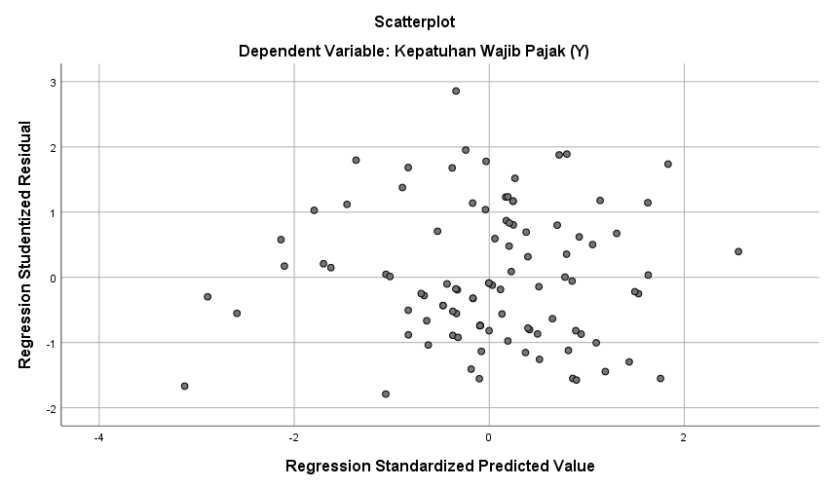
- Hasil Uji Regresi Linier Berganda
 | Coefficientsa
Model |  |  |  | Unstandardized Coefficients |  | Standardized Coefficients |  | t | Sig.
 |  |  |  | B | Std. Error | Beta
1 |  | (Constant) |  | 17.120 | 3.625 |  |  | 4.722 | .000
 |  | Insentif PPh Final UMKM (X1) |  | .213 | .057 | .340 |  | 3.734 | .000
 |  | Pemahaman Perpajakan (X2) |  | .382 | .097 | .391 |  | 3.954 | .000
 |  | Penurunan Tarif Pajak (X3) |  | .466 | .096 | .437 |  | 4.867 | .000
a. Dependent Variable: Kepatuhan Wajib Pajak (Y)
 | Variables Entered/Removedª
 | Model |  | Variables Entered |  |  |  | Variables Removed |  |  | Method
 | 1 |  | Penurunan Tarif Pajak (X3), Insentif PPh Final UMKM (X1), Pemahaman Perpajakan (X2)^{b} |  |  |  | . |  |  | Enter
 | a. Dependent Variable: Kepatuhan Wajib Pajak (Y)
 | b. All requested variables entered.

Model Summary^{b}
Model | R | R Square | Adjusted R Square | Std. Error of the Estimate
1 | .636ª | .404 | .385 | 2.76630
a. Predictors: (Constant), Penurunan Tarif Pajak (X3), Insentif PPh Final UMKM (X1), Pemahaman Perpajakan (X2)
b. Dependent Variable: Kepatuhan Wajib Pajak (Y)

- Hasil Uji Hipotesis
- Hasil Uji Kelayakan Model (Uji F)

ANOVAª
Model |  | Sum of Squares | df | Mean Square | F | Sig.
1 | Regression | 498.118 | 3 | 166.039 | 21.698 | .000^{b}
 | Residual | 734.632 | 96 | 7.652
 | Total | 1232.750 | 99
a. Dependent Variable: Kepatuhan Wajib Pajak (Y)
b. Predictors: (Constant), Penurunan Tarif Pajak (X3), Insentif PPh Final UMKM (X1), Pemahaman Perpajakan (X2)

- Hasil Uji Parsial (Uji T)

Coefficientsª
Model |  | Unstandardized Coefficients |  | Standardized Coefficients | t | Sig.
 |  | B | Std. Error | Beta
1 | (Constant) | 17.120 | 3.625 |  | 4.722 | .000
 | Insentif PPh Final UMKM (X1) | .213 | .057 | .340 | 3.734 | .000
 | Pemahaman Perpajakan (X2) | .382 | .097 | .391 | 3.954 | .000
 | Penurunan Tarif Pajak (X3) | .466 | .096 | .437 | 4.867 | .000
a. Dependent Variable: Kepatuhan Wajib Pajak (Y)

Collinearity Diagnosticsª
Model | Dimen sion | Eigen value | Condition Index | Variance Proportions
 |  |  |  | (Constant) | Insentif PPh Final UMKM (X1) | Pemahaman Perpajakan (X2) | Penurunan Tarif Pajak (X3)
1 | 1 | 3.980 | 1.000 | .00 | .00 | .00 | .00
 | 2 | .012 | 18.010 | .06 | .87 | .01 | .07
 | 3 | .004 | 31.662 | .51 | .02 | .08 | .90
 | 4 | .004 | 32.615 | .43 | .11 | .92 | .03
a. Dependent Variable: Kepatuhan Wajib Pajak (Y)

Residuals Statisticsª
 | Minimum | Maximum | Mean | Std. Deviation | N
Predicted Value | 34.2431 | 46.9829 | 41.2500 | 2.24310 | 100
Std. Predicted Value | -3.124 | 2.556 | .000 | 1.000 | 100
Standard Error of Predicted Value | .291 | 1.087 | .524 | .179 | 100
Adjusted Predicted Value | 34.8819 | 46.8269 | 41.2535 | 2.22757 | 100
Residual | -4.86954 | 7.51480 | .00000 | 2.72406 | 100
Std. Residual | -1.760 | 2.717 | .000 | .985 | 100
Stud. Residual | -1.790 | 2.856 | -.001 | 1.009 | 100
Deleted Residual | -5.03284 | 8.30732 | -.00349 | 2.86262 | 100
Stud. Deleted Residual | -1.811 | 2.970 | .002 | 1.017 | 100
Mahal. Distance | .103 | 14.303 | 2.970 | 2.882 | 100
Cook's Distance | .000 | .215 | .013 | .028 | 100
Centered Leverage Value | .001 | .144 | .030 | .029 | 100
a. Dependent Variable: Kepatuhan Wajib Pajak (Y)
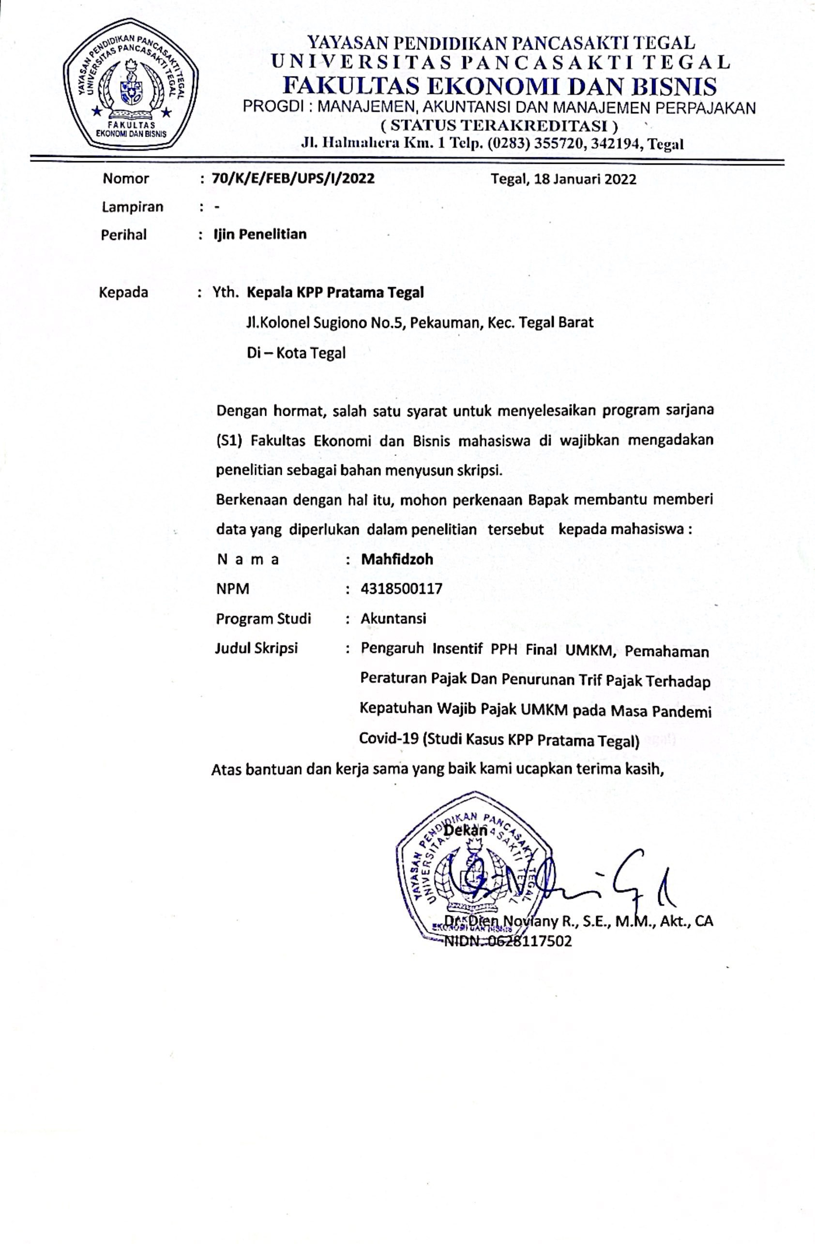
Lampiran 6 Surat Izin Penelitian

Lampiran 7 Surat Balasan Persetujuan Izin Penelitian di KPP Pratama Tegal

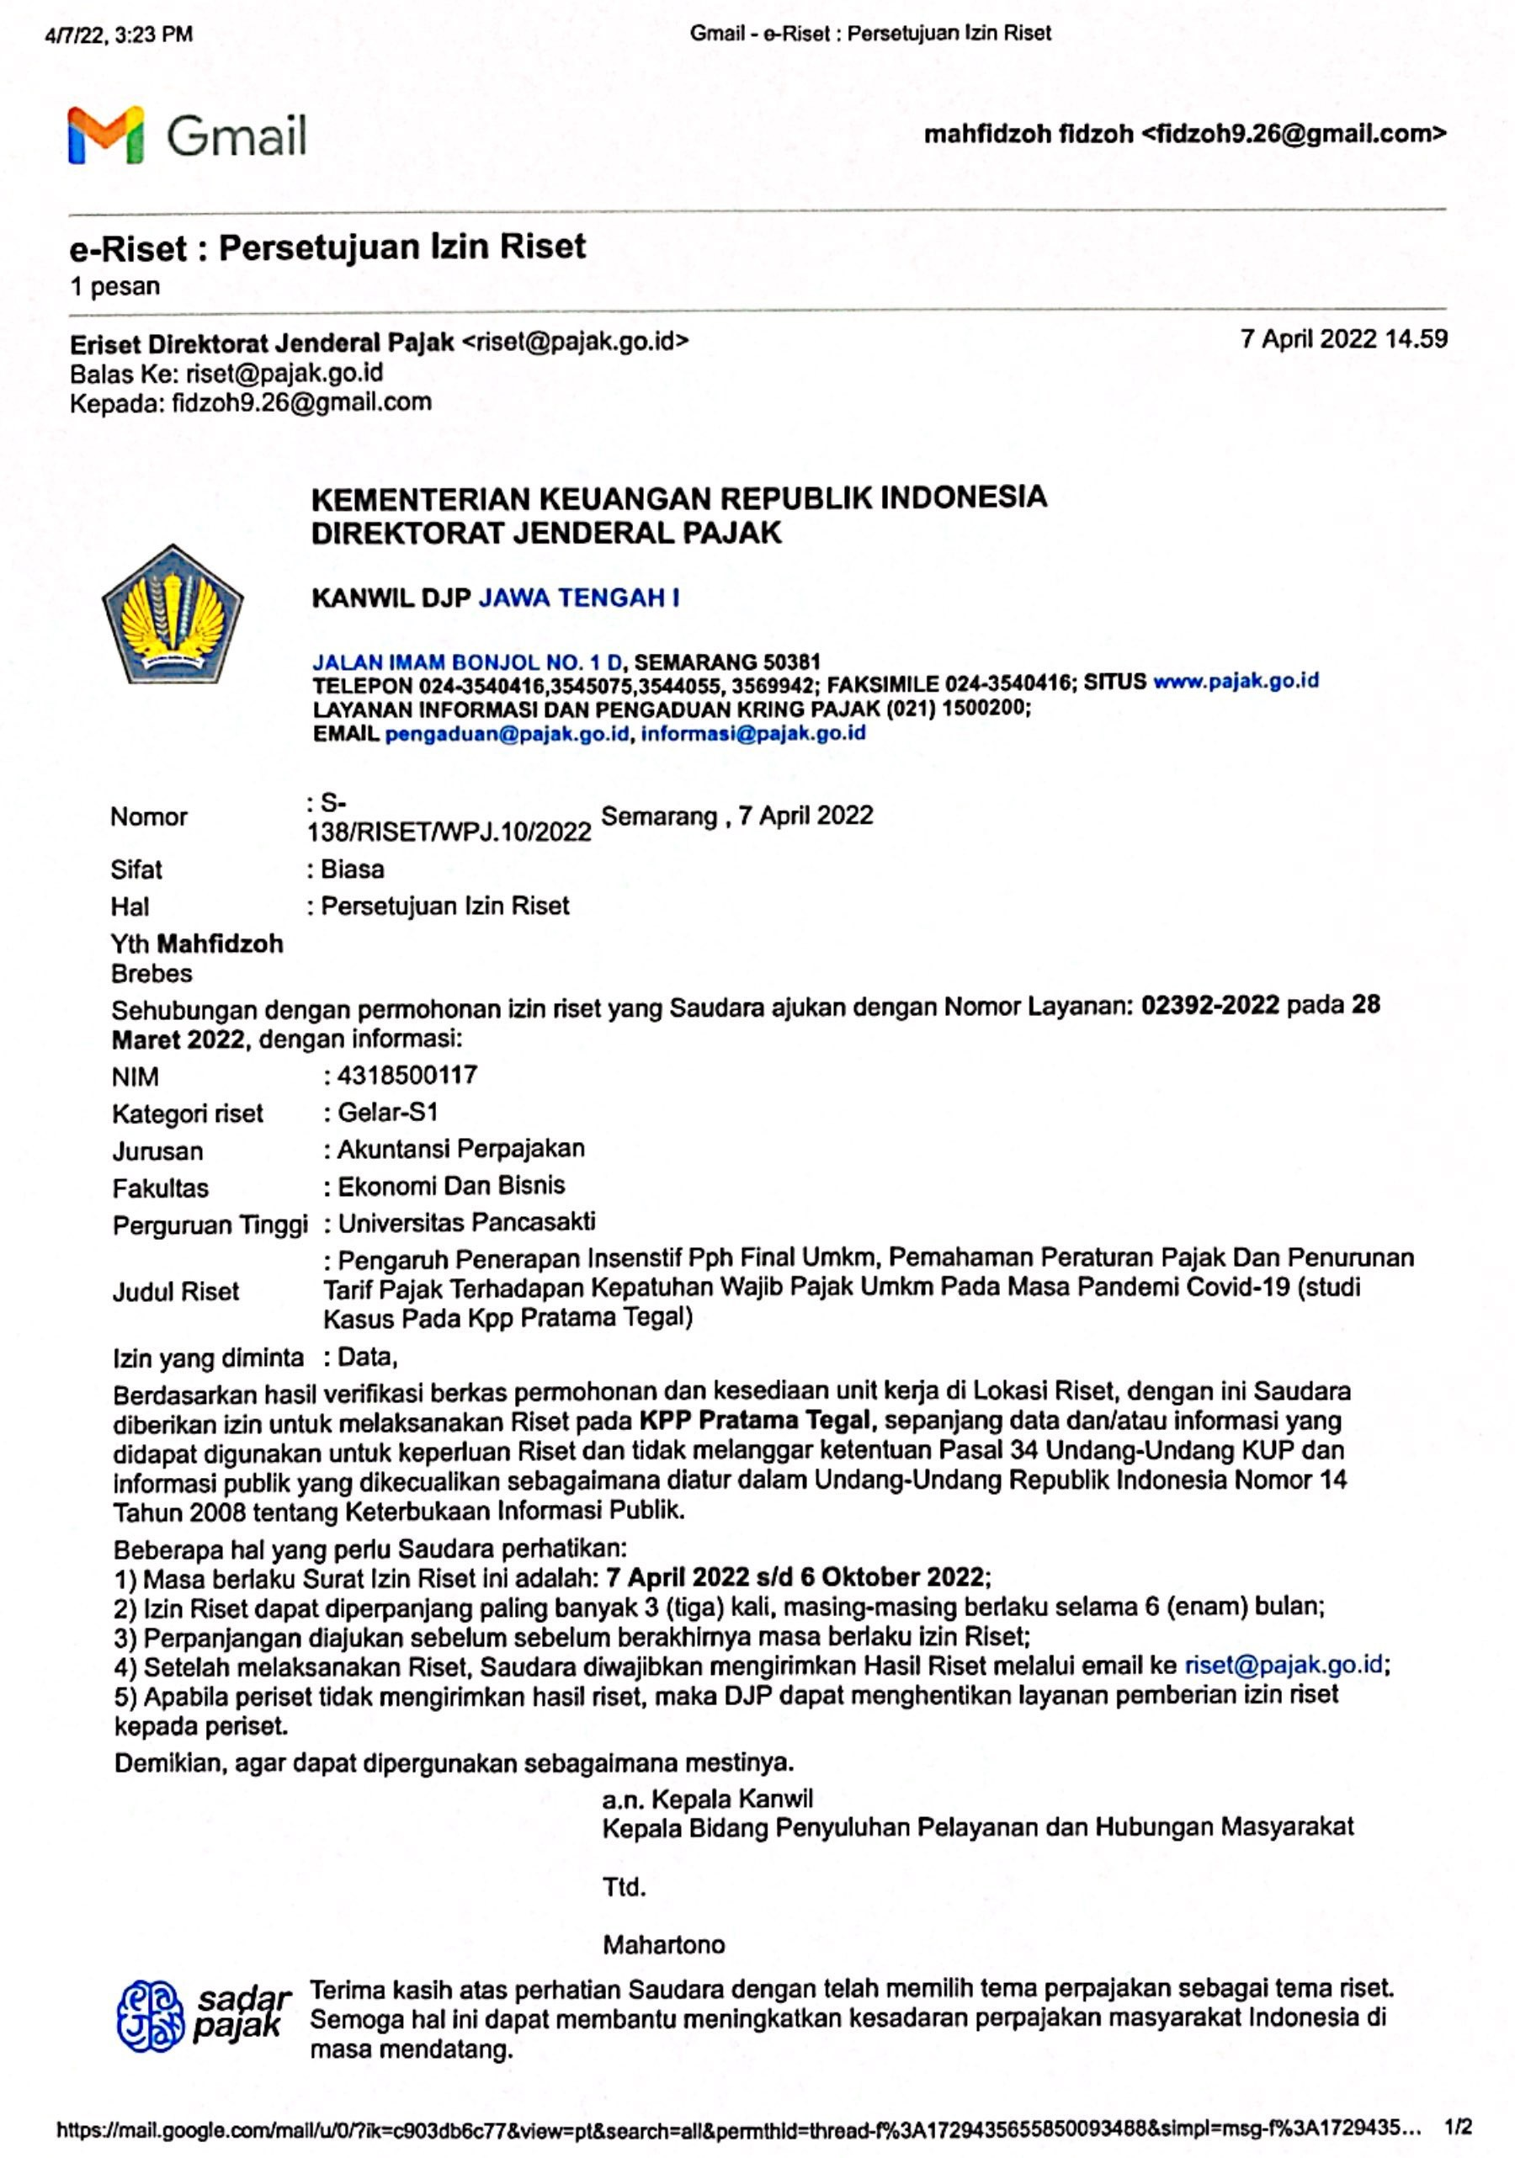

Lampiran 8 Surat Balasan Persetujuan Penyebaran Kuesioner di KPP Pratama Tegal

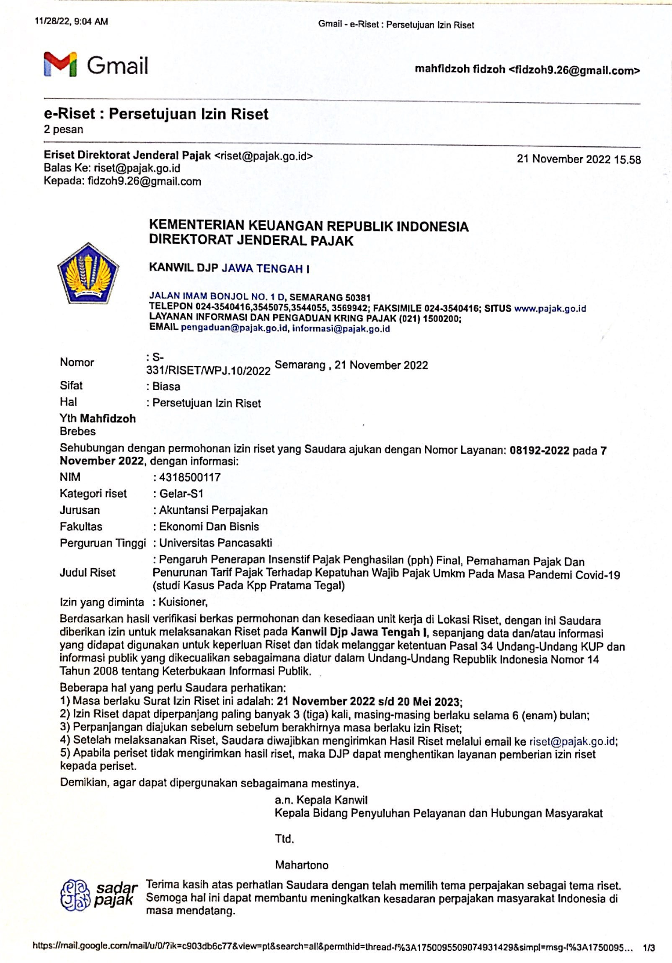

Lampiran 9 Dokumentasi Penyebaran Kuesioner
