REFERENCES

Ahmadi, Seyedeh, M. (2016). The Importance Of Listening Comprehension In Language Learning. International Journal Of Research In English Education, 1(1), 7–10. Http://Ijreeonline.Com/Browse.Php?A_Code=A-10-1-2&

Bingol, M. A., Celik, B., Yildiz, N., & Mart, C. T. (2014). Listening Comprehension Difficulties Encountered By Students. Journal Of Educational And Instructional Studies In The World, 4(4), 1–6.

Darti. (2017). Analyzing Students ’ Difficulties Toward Listening Comprehension Of English Education Department Of Tarbiyah And Teaching Faculty At Uin Alauddin State Islamic University Of Makassar. 1(1), 85.

Diora, L., & Rosa, R. N. (2020). An Analysis Of Students’ Difficulties In Listening Comprehension: A Descriptive Study At English Language And Literature Department Fbs Unp. Journal Of English Language Teaching, 9(1), 85. Https://Doi.Org/10.24036/Jelt.V9i1.107957

Gilakjani, & Ahmadi, M. R. (2011). A Study Of Factors Affecting Efl Learners’ English Listening Comprehension And The Strategies For Improvement. Journal Of Language Teaching And Research, 2(5), 977–988. Https://Doi.Org/10.4304/Jltr.2.5.977-988

Gilakjani, & Sabouri, N. B. (2016). Learners’ Listening Comprehension Difficulties In English Language Learning: A Literature Review. English Language Teaching, 9(6), 123. Https://Doi.Org/10.5539/Elt.V9n6p123

Jyoti, R. (2020). Exploring English Language Students’ Difficulties In Listening Comprehension. Journal La Edusci, 1(3), 1–10. Https://Doi.Org/10.37899/Journallaedusci.V1i3.125

Leong, L.-M., & Ahmadi, S. M. (2017). An Analysis Of Factors Influencing Learners’ English Speaking Skill. International Journal Of Research In English Education, 2(1), 34–41. Https://Doi.Org/10.18869/Acadpub.Ijree.2.1.34

Maresta, M. (2019). An Investigation Of Listening Comprehension Problems Encountered By Third Semester Students Of English Education Study Program At Baturaja University. Edukasi Lingua Sastra, 17(1), 55–71. Https://Doi.Org/10.47637/Elsa.V17i1.106

Nadhira, S., Warni, S., Muhammadiyah, U., & Hamka, P. (2021). Students ’ Listening Difficulties In English As A Foreign Language Learning At Secondary School In Indonesian Context. 547(Icnsse 2020), 186–193.

Thashkulova, Z. (2020). Importance Of Listening Skill In Learning English. 3(Xii), 400–402.

APPENDICES

Appendix 1: Research Permission Letter
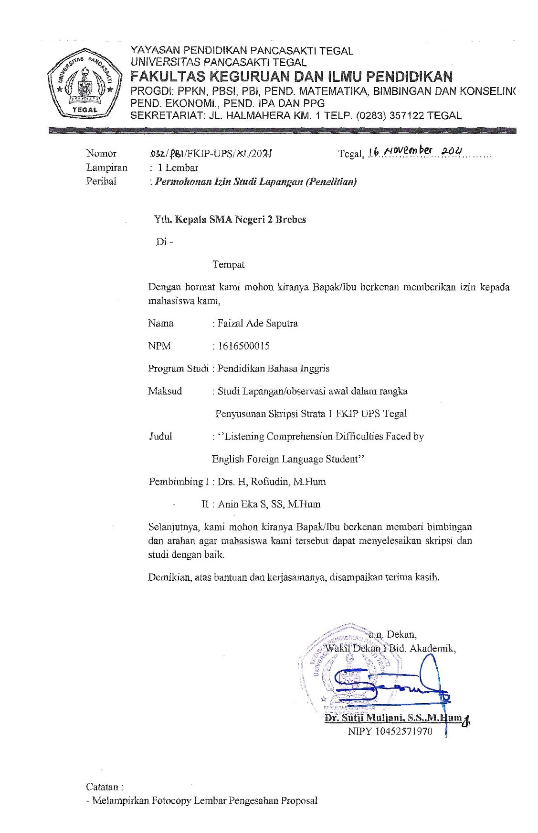
Appendix 2: Instrument of The Research
Observation Framework for Listening Comprehension Difficulties Faced by English Foreign Language Students adapted From Hamouda; Darti (2017)
No | Aspects | Indicators | Conditions |  | Note
 |  |  | Yes | No
1 | Listening Material | There are many unfamiliar words including jargon and idioms.
 |  | Listening comprehension have complex grammatical structure.
 |  | Listening comprehension have unfamiliar topic.
 |  | Students find difficult to understand long conversation.
 |  | The students feel fatigue and distracted when listen a long-spoken text.
 |  | The students use own personal experience to answer the question.
2 | Listener’s Factor | Before doing listening comprehension tasks, the students fear that they cannot understand what they hear.
 |  | The students pay attention while listening.
 |  | The students unable to concentrate when search answer and listen the dialogue at the same time.
 |  | The students lose concentration when think the meaning of new word.
 |  | The student lose concentration because limited time to answer the question.
 |  | The students lose focus to find answer of the talk.
3 | Physical setting | The students lose concentration because the recording poor quality.
 |  | The students find difficult to concentrate with noises around.
 |  | The student finds difficult to understand the meaning of the which are not pronounced clearly.
 |  | The students find difficult to understand when the speaker speak too fast.
 |  | The students find difficult to understand because unable to get things repeated.

Appendix 3: Instrument of The Research
A Questionnaire and Open-Ended Questions of Listening Comprehension Difficulties Adapted from Jyoti (2020) and Maresta (2019)
Name :
Gender: Male Female
Read the statement on the following table. Then, give your response toward the statement by checklist () in the response column. The questionnaire was designed based on a 4-point Likert scale (never, sometimes, often, always), and the respondents were asked to choose just one item that best described their own problem. For each item and their choices are then equated with a numerical value, where Always 4 points, often 3 points, sometimes 2 points, and Never 1 point.
No | Items | Never | Sometimes | Often | Always
Listening Difficulties Related to the Content of the Listening Text
1 | I've encountered a lot of unknown words, such as jargon, idioms, and phrases.
2 | I have difficulty because the texts contain many complex grammatical structures.
3 | When I hear a long text, I feel bored and distracted.
4 | When I face unknown words, I stop listening to the texts and start thinking about the meaning of the word.
5 | I have a problem inferring the meaning of an unknown word while listening.
6 | I have a problem facing the presentation of long-spoken texts.
7 | The texts are not as interested as I expect.
Listening Difficulties Related to Linguistic Features
8 | I have a problem understanding the pronunciation
9 | I failed to recognize the signals related to the movement of the speaker from one point to another
10 | I can’t easily recognize the word boundary in streams of speech.
Listening Difficulties Related to the Listener
11 | I am losing focus because I try to find the answers while listening.
12 | I get distracted by the noises around.
13 | I am losing focus when the text is too long.
14 | I am losing focus on the low quality of the recording.
15 | I have difficulty understanding the spoken text from the first listening.
16 | I have a problem predicting what would come next during listening.
17 | I have a problem recognizing the words from the way they are pronounced.
18 | I have a problem comprehending the meaning without transcripts.
Listening Difficulties Related to the Speaker
19 | I have difficulty with the presence of hesitation and pauses on the part of the speaker.
20 | I have difficulty because of the speaker’s unclear pronunciation.
21 | I become a failure in understanding the meaning without seeing the speaker’s body language.
22 | I have a problem understanding the text when the speaker speaks too fast.
23 | I feel hard to understand the text if there is no repetition.
24 | I have a problem in understanding when the speakers speak with a variety of accents.

Direction:
Answer these questions down below briefly!
- How did you rate your English listening skill?
Answer: ……………………………………………………………………………
………………………………………………………………………………

- What Was Your Perception to the Importance on Listening Comprehension?
Answer: ……………………………………………………………………………
………………………………………………………………………………
- What Were the Problems that Affect Your Listening Comprehension?
Answer: ……………………………………………………………………………
………………………………………………………………………………

Appendix 4: The Result of Open-Ended Questions
How did you rate your English listening skill?

What Was Your Perception to the Importance on Listening Comprehension?
What Were the Problems that Affect Your Listening Comprehension?
Appendix 5: Documentations
