REFERENCES

Abarca, R. M. (2021). Teaching With Digital Video. In Nuevos sistemas de comunicación e información.
Ar Ruhimat, I. (2017). Reinforce Students’ Motivation in Learning Recount Text through Subtitled Animation Video.
Bamford, J., & Day, R. R. (1998). Teaching Reading. Annual Review of Applied Linguistics, 18, 124–141. https://doi.org/10.1017/s0267190500003512
Bell, L., & Bull, G. (2010). Digital Video and Teaching. Contemporary Issues in Technology and Teacher Education, 10, 1–6. http://www.editlib.org/p/34120
Brown, J., Lewis, R. B, and H. (1977). AV Instruction Technology, Media, and Methods.
Brown. (2004). Language Assesment.

Creswell, J. W. (2009). Research Design: Qualitative, quantitative, and mixed method. In SAGE Publications.
Creswell, J. W. (2014). Qualitative, Quantitative, and Mixed Method Approaches.

SAGE Publications.

Crookes, G. (1990). DESIGNING TASKS FOR THE COMMUNICATIVE

CLASSROOM. David Nunan. Cambridge: Cambridge University Press, 1989. Pp. x + 211. In Studies in Second Language Acquisition (Vol. 12, Issue 4, pp. 455–456). https://doi.org/10.1017/s0272263100009578
Derewianka, B. (1990). Exploring How Texts Work. Exploring How Texts Work. Fernanda, D. (2019). The Use of Animation Video to Improve Students’ Reading
Comprehension in Narrative Text to the Second Grade Students Of SMPN 1

Lahat, South Sumatera. November.

Grabe, W. (2009). English reading. In Nation and Narration (pp. 260–274). https://doi.org/10.4324/9780203823064-19
Harun, & Zaidatun. (2004). Teknologi Multimedia dalam Pendidikan. http://www.ctl.utm/my/publication/manuals/mm/elemenMM.pdf.
Hogue, A. O. and A. (2007). Introduction to academic writing : answer key. https://edisclipnas.usp.br/pluginefile.php/3928474/mod_resource/content/1/I ntroduction to Academic Writing.pdf
Jean Gillet. (2004). Understanding Reading Problems, Assessment and Instruction.
Köster, J. (2018). Video in the age of digital learning. In Video in the Age of Digital Learning. https://doi.org/10.1007/978-3-319-93937-7
Martin, F., & Betrus, A. K. K. (2019). Digital media for learning: Theories, processes, and solutions. In Digital Media for Learning: Theories, Processes, and Solutions. https://doi.org/10.1007/978-3-030-33120-7
Mayer. (2002). The Effectiveness of Multimedia Learning. 11(June), 290–302. Mayer, R. E. (2014). Cognitive theory of multimedia learning. The Cambridge
Handbook of Multimedia Learning, Second Edition, May, 43–71. https://doi.org/10.1017/CBO9781139547369.005
Munawaroh, S. (2019). Teaching the Narrative Texts Using Animation Video: Raising Students’ Skills on Reading Comprehension. Utamax : Journal of Ultimate Research and Trends in Education, 1(1), 18–22. https://doi.org/10.31849/utamax.v1i1.2791

Neo, M., & Neo, K. T. K. (2001). Innovative teaching: Using multimedia in a problem-based learning environment. Educational Technology and Society, 4(4), 19–31. https://doi.org/10.12944/cwe.6.1.28
Nurizmawati, C., Apriliaswati, R., & Arifin, Z. (2015). the Use of Animation Video As a Media in Teaching Narrative Text. Jurnal Pendidikan Dan Pembelajaran, 4(3), 1–13.
Nuttall, C. (1982). Teaching reading skills in a foreign language. Panjaitan, M. O. (2010). Penilaian Bhs.
Schnotz, & Lowe. (2014). Animation principles in multimedia learning. Seminar, S., & Daring, N. (2022). Prosiding. 728–736.
Sugiyono. (2013). METODE PENELITIAN KUANTITATIF, KUALITATIF, DAN R&D.
Tarigan, & Guntur, H. (1990). Membaca sebagai Suatu Ketrampilan Berbahasa.

In Angkasa.

Trotman, W. (2006). The TKT Teaching Knowledge Test Course. ELT Journal, 60(1), 93–95. https://doi.org/10.1093/elt/cci090
Widyastuti, C. (2017). Tanggapan Siswa Kelas Vii Terhadap Penggunaan Media Pembelajaran Dalam Pembelajaran Pendidikan Jasmani Olahraga Dan Kesehatan Di Smp Negeri 2 Pleret. Universitas Negeri Yogyakarta, 13(3), 1–
102. http://www.albayan.ae

Zipser, D. E. R. & D. (1985). Feature discovery by competitive learning.

Appendix 1. Lesson Plan (RPP)

RENCANA PELAKSANAAN PEMBELAJARAN

Sekolah | : SMP N 2 Dukuhwaru
Mata Pelajaran Kelas/Semester Alokasi Waktu | : Bahasa Inggris  : VIII/1  : 7 pertemuan (14 JP)

Kompetensi Inti

KI 1 | Menghargai dan menghayati ajaran agama yang dianutnya.
KI 2 | Menunjukkan perilaku jujur, disiplin, tanggung jawab, peduli (toleransi, gotong royong), santun, percaya diri dalam berinteraksi secara efektif dengan lingkungan social dan alam dalam jangkauan pergaulan dan  keberadaannya.
KI 3 | Memahami pengetahuan (faktual, konseptual, dan prosedural)  berdasarkan rasa ingin tahunya tentang ilmu pengetahuan, teknologi, seni, budaya terkait fenomena dan kejadian tampak mata
KI 4 | Mencoba, mengolah, dan menyaji dalam ranah konkret (menggunakan, mengurai, merangkai, memodifikasi, dan membuat) dan ranah abstrak (menulis, membaca, menghitung, menggambar, dan mengarang) sesuai dengan yang dipelajari di sekolah dan sumber lain yang sama dalam  sudut pandang/teori.

- Kompetensi Dasar dan Indikator Pencapaian Kompetensi (IPK)

Kompetensi Dasar |  | Indikator Pencapaian Kompetensi
3.7 | Membandingkan fungsi sosial, struktur teks, dan unsur kebahasaan beberapa teks naratif lisan dan tulis dengan memberi dan meminta informasi terkait  legends and myths, pendek dan | 3.7.1 | Mengidentifikasi fungsi sosial dan struktur teks beberapa teks naratif tulis dengan memberi dan meminta informasi terkait  legend and myths, pendek

 | sederhana, sesuai dengan konteks penggunaannya. |  | dan sederhana, sesuai dengan konteks penggunaannya.
 |  | 3.7.2 | Membandingkan fungsi sosial beberapa teks naratif tulis dengan memberi dan meminta informasi terkait legend and myths, pendek dan sederhana, sesuai dengan konteks.
4.7 | Menangkap makna secara kontekstual terkait fungsi sosial, struktur teks, dan unsur kebahasaan teks naratif, lisan dan tulis, sangat pendek dan sederhana, terkait legend and  myths. | 4.7.1 | Menyusun ulang teks naratif tulis sangat pendek dan sederhana terkait legend and myths.

Nilai karakter yang dikembangkan: Religiositas, tanggung jawab, kerja sama dan percaya diri.

Tujuan Pembelajaran
Melalui pendekatan saintifik dengan menggunakan model Inquiry Learning, peserta didik dapat membandingkan fungsi social dan struktur teks beberapa teks naratif legenda dan mitos dan terampil dalam menangkap makna terkait fungsi sosial, dan struktur teks melalui kegiatan menelaah paragraph dengan penuh rasa ingin tahu, displin, percaya diri selama proses pembelajaran serta mampu berkomunikasi dan bekerjasama dengan baik dalam kelompok.

Metode Pembelajaran
  - Pendekatan : Scientific Learning
  - Model Pembelajaran : Inquiry Learning

Media dan Alat Pembelajaran
  - Learning Materials
  - Laptop
  - LCD Proyektor
  - Lembar Kerja Siswa

Sumber Belajar
Buku Penunjang Kurikulum 2013 Mata Pelajaran Bahasa Inggris, Kamus Bahasa Inggris, Sumber dari Internet.

Materi Pembelajaran 1
Materi Pembelajaran Reguler
  - Fungsi sosial teks Narrative
    - Menghibur pembaca
    - Mengambil teladan nilai-nilai luhur/ pesan moral
  - Struktur teks Narrative
    - Orientation (Orientasi)
    - Complication (Konflik/ Krisis)
    - Resolution (Resolusi)
  - Unsur-unsur kebahasaan teks Narrative
    - Kalimat deklaratif dan interogatif dalam simple past tense
    - Frasa adverbia: a long time ago, once upon a time, in the end, happily ever after
    - Nomina singular dan plural dengan atau tanpa a, the, this, those, my, their, dsb.
    - Ucapan, tekanan kata, intonasi, ejaan, tanda baca, dan tulisan tangan

- Langkah-langkah Pembelajaran
  - Pertemuan ke 1

Pertemuan Ke-1 (2x40 menit) |  | Waktu
Kegiatan Pendahuluan |  | 10 menit
- Pendidik melakukan pembukaan dengan salam pembuka dan berdoa untuk memulai pembelajaran
- Pendidik memeriksa kehadiran peserta didik sebagai sikap disiplin.
- Mengaitkan materi dengan pengalaman peserta didik.
- menginformasikan materi yang akan dipelajari
- menyampaikan tujuan pembelajaran
Kegiatan Inti |  | 60 menit
Sintak Model  Pembelajaran | Kegiatan Pembelajaran
Mengamati | - Menyajikan fenomena Peserta didik diminta untuk mengamati teks narative bergambar yang disajikan.  - Melakukan observasi Beberapa peserta didik secara bergantian di minta untuk membaca nyaring teks narratif berjudul The Legend of Rawa Pening dengan pelafalan dan  intonasi yang benar.
Menanya | Merumuskan masalah

- Pendidik menyajikan masalah: Pendidik memberikan beberapa pertanyaan berupa worksheet terkait dengan teks yang dibaca
- Peserta didik berdiskusi dalam mengidentifikasi isi teks berdasarkan pertanyaan yang telah disediakan sesuai dengan work sheet yang telah disediakan.
Mengajukan hipotesis
- Peserta didik mengajukan jawaban mengenai
pertanyaan pendidik
Mengasosiasi | Mengumpulkan data  - Peserta didik mengumpulkan informasi yang relevan dari isi teks untuk menentukan fungsi sosial dari cerita tersebut dalam kelompok dengan bimbingan guru.  - Peserta didik mencari dan mengumpulkan  informasi tentang

struktur teks naratif dari bahan bacaan (buku teks pelajaran).
Menganalisis data
- Peserta didik dengan bimbingan guru menganalisis struktur teks dari cerita yang telah mereka baca sesuai dengan struktur untuk teks naratif yang telah mereka baca. (Orientation – Events -
Complication –Resolution)
Mengkomunikasikan | Mengkomunikasikan  - Peserta didik mempresentasikan hasil kerja mereka di depan kelas.  - Peserta didik lain di minta memberi apresiasi terhadap hasil kerja yang  dipaparkan oleh temannya.
Kegiatan Penutup |  | 10 menit
- Pendidik memandu peserta didik untuk menyimpulkan hasil pembelajaran.
- Peserta didik mendapatkan umpan balik terhadap proses dan hasil pebelajaran dengan kalimat seperti “Thank you very much for your attention. You did a
good job today. I am very happy with your activity

in the class. How about you? Did you enjoy my class?
- Pendidik menugaskan peserta didik untuk menonton animasi video yang diberikan oleh pendidik melalui link youtube yang diberikan.
- Pendidik menyampaikan salam penutup.

  - Pertemuan ke 2,4, dan 6

Pertemuan Ke-2,4,6 (6x40 menit) |  | Waktu
Kegiatan Pendahuluan |  | 5 menit
- Pendidik melakukan pembukaan dengan salam pembuka dan berdoa untuk memulai pembelajaran
- Pendidik memeriksa kehadiran peserta didik sebagai sikap disiplin.
- Mengaitkan materi dengan pengalaman peserta didik.
- menginformasikan materi yang akan dipelajari
- menyampaikan tujuan pembelajaran
Kegiatan Inti |  | 50 menit
Sintak Model  Pembelajaran | Kegiatan Pembelajaran
Mengamati | - Menyajikan fenomena Peserta didik diminta untuk mengamati teks narative yang disajikan dalam bentuk animasi video.  - Melakukan observasi

Beberapa peserta didik di minta untuk menonton animasi video dengan
seksama.
Menanya | Merumuskan masalah  - Pendidik menyajikan masalah: Pendidik memberikan beberapa pertanyaan berupa worksheet terkait dengan teks yang dibaca  - Peserta didik berdiskusi dalam mengidentifikasi isi teks berdasarkan pertanyaan yang telah disediakan sesuai dengan work sheet yang telah disediakan.  Mengajukan hipotesis  - Peserta didik mengajukan  jawaban mengenai pertanyaan pendidik
Mengasosiasi | Mengumpulkan data  - Peserta didik mengumpulkan informasi yang relevan dari isi teks untuk menentukan fungsi sosial dari cerita  tersebut dalam

kelompok dengan bimbingan guru.
- Peserta didik mencari dan mengumpulkan informasi tentang struktur teks naratif dari bahan bacaan (buku teks pelajaran).
Menganalisis data
- Peserta didik dengan bimbingan guru menganalisis struktur teks dari cerita yang telah mereka baca sesuai dengan struktur untuk teks naratif yang telah mereka baca. (Orientation – Events -
Complication –Resolution)
Mengkomunikasikan | Mengkomunikasikan  - Peserta didik mempresentasikan hasil kerja mereka di depan kelas.  - Peserta didik lain di minta memberi apresiasi terhadap hasil kerja yang  dipaparkan oleh temannya.
Kegiatan Penutup |  | 5 menit
1. Pendidik memandu peserta didik untuk

menyimpulkan hasil pembelajaran.
- Peserta didik mendapatkan umpan balik terhadap proses dan hasil pebelajaran dengan kalimat seperti “Thank you very much for your attention. You did a good job today. I am very happy with your activity in the class. How about you? Did you enjoy my class?
- Pendidik menyampaikan salam penutup.

  - Pertemuan ke 3,5, dan 7.

3x Pertemuan (2x40 menit) |  | Waktu
Kegiatan Pendahuluan |  | 10 menit
- Pendidik melakukan pembukaan dengan salam pembuka dan berdoa untuk memulai pembelajaran
- Pendidik memeriksa kehadiran peserta didik sebagai sikap disiplin.
- Mengaitkan materi dengan pengalaman peserta didik.
- menginformasikan materi yang akan dipelajari
- menyampaikan tujuan pembelajaran
Kegiatan Inti |  | 50 menit
Sintak Model  Pembelajaran | Kegiatan Pembelajaran
Mengamati | - Menyajikan fenomena Peserta didik diminta untuk mengamati teks narrative dalam bentuk  animasi video yang

disajikan.
- Melakukan observasi Peserta didik diminta menonton animasi video
yang disajikan.
Menanya | Merumuskan masalah  - Peserta didik berdiskusi dalam mengidentifikasi isi teks berdasarkan pertanyaan yang telah disediakan sesuai dengan work sheet yang telah disediakan.  Mengajukan hipotesis  - Peserta didik mengajukan jawaban mengenai  pertanyaan pendidik
Mengasosiasi | Mengumpulkan data  - Peserta didik mengumpulkan informasi yang relevan dari isi teks untuk menentukan fungsi sosial dari cerita tersebut dalam kelompok dengan bimbingan guru.  - Peserta didik mencari dan mengumpulkan  informasi tentang

struktur teks naratif dari bahan bacaan (buku teks pelajaran).
Menganalisis data
- Peserta didik dengan bimbingan guru menganalisis kembali struktur teks dari cerita yang telah mereka baca sesuai dengan struktur untuk teks naratif yang telah mereka baca. (Orientation – Events - Complication –
Resolution)
Mengkomunikasikan | Mengkomunikasikan  - Peserta didik mengerjakan exercise yang telah disediakan  oleh pendidik.
Kegiatan Penutup |  | 10 menit
- Pendidik memandu peserta didik untuk menyimpulkan hasil pembelajaran.
- Peserta didik mendapatkan umpan balik terhadap proses dan hasil pebelajaran dengan kalimat seperti “Thank you very much for your attention. You did a good job today. I am very happy with your activity in the class.
How about you? Did you enjoy my class?

- Pendidik menugaskan peserta didik untuk menonton animasi video yang diberikan oleh pendidik melalui link youtube yang diberikan.
- Pendidik menyampaikan salam penutup.

Mengetahui
Guru Mapel SMP Negeri 2 Dukuhwaru Mahasiswa Praktikan

Lutfi Amin, S.Pd. Shela Arum Viana

Appendix 2. Validity and Reliability
Validity of Post-test

No | Pearson Correlation | Nilai sig. | Kesimpulan | Interpretasi
Soal1 | ,664 | ,000 | VALID | Tinggi
Soal2 | -,529 | ,002 | TIDAK  VALID
Soal3 | ,603 | ,000 | VALID | Tinggi
Soal4 | ,600 | ,000 | VALID | Tinggi
Soal5 | ,812 | ,000 | VALID | Sangat Tinggi
Soal6 | ,719 | ,000 | VALID | Tinggi
Soal7 | ,415 | ,018 | VALID | Cukup
Soal8 | ,501 | ,004 | VALID | Cukup
Soal9 | ,484 | ,005 | VALID | Cukup
Soal10 | -,077 | ,675 | TIDAK  VALID
Soal11 | ,698 | ,000 | VALID | Tinggi
Soal12 | -,105 | ,566 | TIDAK  VALID
Soal13 | ,693 | ,000 | VALID | Tinggi
Soal14 | ,411 | ,019 | VALID | Cukup
Soal15 | -,122 | ,505 | TIDAK  VALID
Soal16 | ,481 | ,005 | VALID | Cukup
Soal17 | ,728 | ,000 | VALID | Tinggi
Soal18 | -,270 | ,135 | TIDAK  VALID
Soal19 | ,739 | ,000 | VALID | Tinggi
Soal20 | -,739 | ,449 | TIDAK  VALID
Soal21 | ,705 | ,000 | VALID | Tinggi
Soal22 | ,809 | ,000 | VALID | Sangat Tinggi
Soal23 | -,201 | ,271 | TIDAK  VALID
Soal24 | ,449 | ,010 | VALID | Cukup
Soal25 | ,680 | ,000 | VALID | Tinggi
Soal26 | -,448 | ,010 | TIDAK  VALID
Soal27 | ,644 | ,000 | VALID | Tinggi
Soal28 | -,778 | ,000 | TIDAK  VALID
Soal29 | ,697 | ,000 | VALID | Tinggi
Soal30 | -,644 | ,000 | TIDAK  VALID | -

Reliability Post-Test

Case Processing Summary
 |  | N | %
Cases | Valid | 32 | 100,0
 | Excludedª | 0 | ,0
 | Total | 32 | 100,0
a. Listwise deletion based on all variables in the procedure.

Reliability Statistics
Cronbach's Alpha | Part 1 | Value | ,860
 |  | N of Items | 10ª
 | Part 2 | Value | ,893
 |  | N of Items | 10^{b}
 | Total N of Items |  | 20
Correlation Between Forms |  |  | ,776
Spearman-Brown Coefficient | Equal Length |  | ,874
 | Unequal Length |  | ,874
Guttman Split-Half Coefficient |  |  | ,873
a. The items are: Soal1, Soal3, Soal4, Soal5, Soal6, Soal7, Soal8, Soal9, Soal11, Soal13.
b. The items are: Soal14, Soal16, Soal17, Soal19, Soal21, Soal22,
Soal24, Soal25, Soal27, Soal29.

Validity Questionnaire

No | Pearson Correlation | Nilai sig. | Kesimpulan
1. | ,540 | ,002 | VALID
2. | ,662 | ,000 | VALID
3. | ,437 | ,016 | VALID
4. | ,313 | ,092 | TIDAK VALID
5. | ,383 | ,037 | VALID
6. | ,545 | ,002 | VALID
7. | ,180 | ,341 | TIDAK VALID
8. | ,018 | ,924 | TIDAK VALID
9. | ,586 | ,001 | VALID
10. | ,415 | ,023 | VALID
11. | ,576 | ,001 | VALID
12. | ,559 | ,001 | VALID
13. | ,431 | ,017 | VALID
14. | ,505 | ,004 | VALID
15. | ,309 | ,097 | TIDAK VALID
16. | ,559 | ,001 | VALID
17. | ,326 | ,078 | TIDAK VALID
18. | ,420 | ,021 | VALID
19. | ,544 | ,002 | VALID
20. | ,541 | ,002 | VALID

Reliability of Questionaire

Reliability Statistics
Cronbach's Alpha | N of Items
,846 | 15

Appendix 3. Learning Material Narrative Text
- Definition of narrative text: A text that tells about an imaginative story in the past.
- Social function of narrative text
  - To entertain the readers
  - To teach people moral lesson
- General structure of narrative Text
  - Orientation (Orientasi)
  - Complication (Konflik/ Krisis)
  - Resolution (Resolusi)
- Language elements of Narrative text
  - Declarative and interrogative sentences in the simple past tense
  - Adverb phrases: a long time ago, once upon a time, in the end, happily ever after
  - Singular and plural nouns with or without a, the, this, those, my, their, etc
  - Speech, word stress, intonation, spelling, punctuation and handwriting.

Animation Video 1 : Malin Kundang
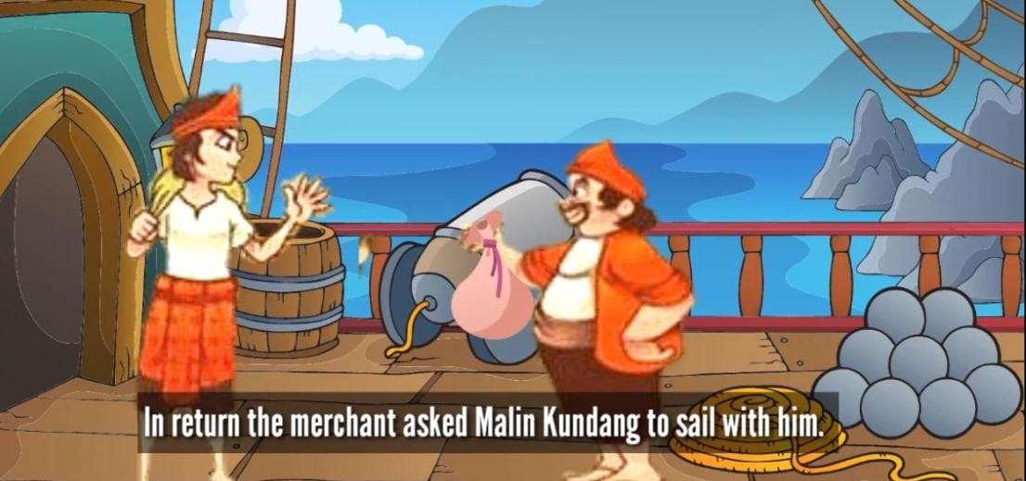

Transkrip :
Malin Kundang

Long time ago, in a small village near the beach in West Sumatra, a woman and her son live. They were Malin Kundang and his mother. His mother was a single parent, because Malin Kundang's father had passed away when he was a baby. Malin Kundang had to live hard with his mother. Malin kundang was a healthy, diligent, and strong boy. He usually went to sea to catch fish. After getting fish he would bring it to his mother or sold the caught fish in the town.
One day when Malin Kundang was sailing, he saw a merchant ship which was being raided by a small band of pirates. He helped the merchant with his brave and power. Malin Kundang defeated the pirates. The merchant was so happy and thanked to him. In return, the merchant asked Malin Kundang to sail with him. To get a better life, Malin Kundang agreed. He left his mother alone.
Many years later, Malin Kundang became wealthy. He had a huge ship and was helped by many ship crews loading trading goods. Perfectly, he had a beautiful wife too. When he was sailing his trading journey, his ship landed on a beach near a small village. The villagers recognize him. The news ran fast in the town. Malin Kundang has become rich and now. He is here. An old woman ran to the beach to meet the new rich merchant. She was Malin Kundang's mother. She wanted to hug him. Unfortunately, when the mother came Malin Kundang who was in front of his well-dressed wife and his ship crews denied meeting that old lonely woman. For three times her mother begged Malin Kundang and for three times he yelled at her. At last Malin Kundang said to her “Enough, old woman! I have never had a mother like you, a dirty and ugly woman!”.
After that he ordered his crews to set sail. He would leave the old mother again, but in that time she was full of both sadness and angriness. Finally, enraged she cursed Malin Kundang that he would turn into a stone if he did not apologize. Malin Kundang just laughed and really set sail. In the quiet sea, suddenly thunderstorm came. His huge ship was wrecked and it was too late for Malin Kundang to apologize. He was thrown by the wave out of his ship. He fell on a small island. It was really too late for him to avoid his curse. Suddenly he turned into a stone. He was punished for not admitting his own mother.

Story 2 : The Origin of Tangkuban Perahu
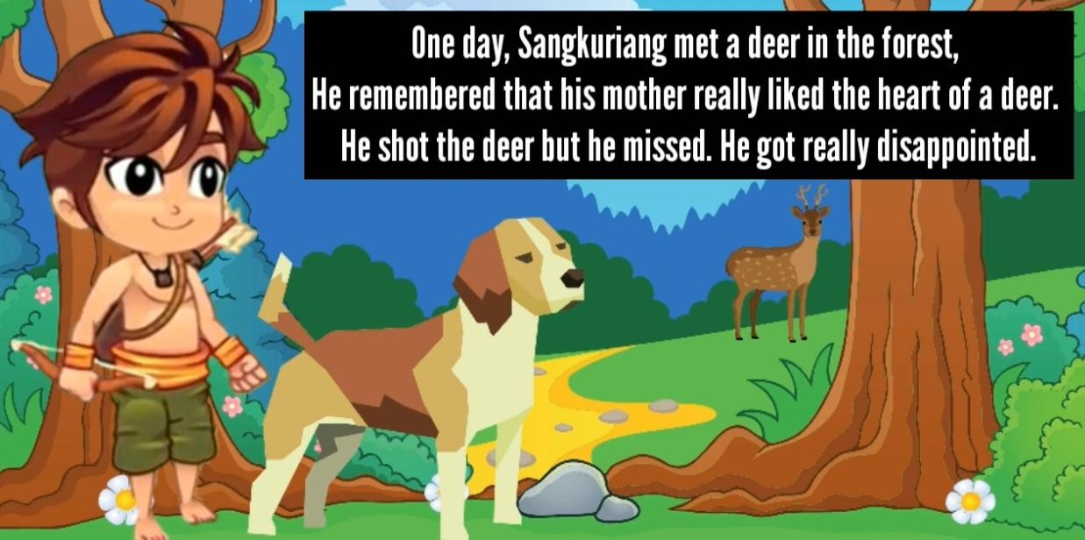

Transcript:
The Origin of Tangkuban Perahu

Long time ago, there was a prince that so in love with the beautiful woman, named Dayang Sumbi. The prince was changed into a dog named Tumang. After marrying Dayang Sumbi and had a son named Sangkuriang. Sangkuriang often went to hunt with Tumang. He did not know that Tumang was his father.
One day, Sangkuriang met a deer in the forest. He remembered that his mother really liked the heart of a deer. He shot the deer, but he missed. He got really disappointed. Then, he shot Tumang and got his heart and brought it to his mother. Dayang Sumbi was very happy until she asked him where Tumang was. Sangkuriang told the truth that it was Tumang's heart. Dayang Sumbi got angry and hit Sangkuriang's forehead. Sangkuriang left the house.
Dayang Sumbi was praying to the God for having the eternal beauty. The God gave what her wish for. After that, she met the mature Sangkuriang and they love each other. They decided to get married. Dayang Sumbi asked about Sangkuriang's scar on his forehead. He answered that he was hit by his mother. Dayang Sumbi was shocked and told him that she was his mother. Sangkuriang did not believe her.
Then Dayang Sumbi agreed that they were still husband and wife with one condition. Sangkuriang had to make a big boat in a night. Sangkuriang said that he was able to do that. However, Dayang Sumbi be made the chicken crowing. It was the sign that Sangkuriang run of the time. Sangkuriang was so mad and kicked the boat. The boat was known as gunung Tangkuban Perahu.

Story 3 : Danau Toba

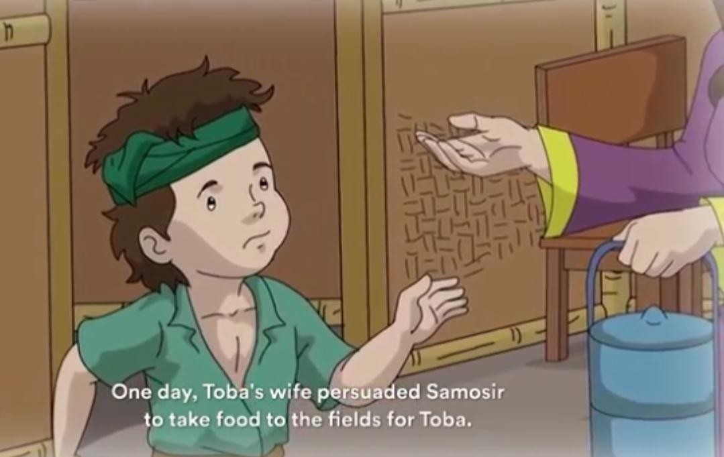
Transcript:
Lake Toba
In a valley in Sumatra that lived a farmer named Toba. He was a diligent farmer but unfortunately his harvest was not always bountiful, and he often went hungry. Because of his hunger, toba went fishing in the river. He waited a long time and became desperate. When Toba was just about to go home, suddenly something tugged on his fishing line. Toba was excited and started reeling in his fishing line. “Wow that's a big fish” said Toba. Sure enough, at the end of the line was a large gold scaly fish. Toba immediately brought the fish home to cook.
At home Toba was disappointed because all of his firewood had been used up. “Ah there's no firewood here, I better go look for some in the fields”. Then Toba placed the fish inside the basin, while he went to the field to collect the firewood. “I will eat well today” said Toba while carrying the firewood behind the house. He lit the fire but when Toba went to take the fish, he was surprised the fish had vanished and instead there were pieces of gold inside the basin. “Where's my fish and whose gold is this?”. Then when Toba opened the door of his room he was surprised, there was a tall woman combing her long hair in front of a mirror. “This woman is so beautiful. Hey who are you?” asked Toba. The woman turned around and Toba was fascinated.
Toba had never seen a woman as beautiful as her. “I am the incarnation of the fish you caught earlier, the gold coins were my scales”. Toba was confused, the woman smiled “I am cursed by the God to be a fish, but thanks to you the curse is gone now, let's go to the kitchen. I'll make you food you must be hungry”. Toba followed her to the kitchen. Deftly, the woman immediately prepared food for Toba. Toba was amazed by the woman's brilliance in the kitchen. He said to himself “If only she wanted to be my wife”. Apparently the woman could read Toba's mind. “I want to be your wife, but I have one condition” said the woman. After finishing his food Toba was shocked to hear what she said. “Just say it what's the condition?”. “If we get married later never bring up my origins as a

fish, I will not be the only one who suffer the consequences if you break this agreement”. Toba agreed for him it was an easy condition. Toba and the woman finally married toba was working so hard in the fields to fill their daily needs. Then his wife became pregnant. Toba was pleased he couldn't wait for the birth of his child.
Not long after a baby boy was born Toba named him Samosir. Samosir grew into a naughty lazy child. All he did was play around. Toba tried to be patient with Samosir’s behavior. Whenever Toba worked in the field Samosir didn't want to deliver the food his wife cooked for him. In the end, it was Toba's wife who delivered the food to Toba. “My wife you can't spoil samosir forever, if he continues to be spoiled it will be harder to control him” Toba's wife smiled and said “be patient my husband one day samosir will change”. “I've been patient enough with him my wife but my patience also has a limit”. One day Toba's wife persuaded Samosir to take food to the fields for Toba. At first, Samosir refused but his mother continued to convince him. Finally Samosir agreed. “All right mom, I'll deliver this food to father”. But on his way Samosir played with his friends instead. After playing Samosir felt hungry. “Oh I'm starving, ah I will eat this food”. Samosir then ate the food that was supposed to be for his father and left him only a little.
In the fields, Toba couldn't wait any longer he was starving. Moreover, he didn't have time to have breakfast because a lot of work needed to be done that day. In the distance, Samosir came running. “Where have you been Samosir? Daddy has been waiting for you for a long time”. Samosir did not answer and immediately gave him the food. Toba was surprised to find only the leftovers. “Hey Samosir! Have you eaten daddy's food? Your behavior is out of line. You little fish! Come here!”. Toba was angry at Samosir without realizing he had spoken of the restrictions his wife had previously warned him off. Toba hit Samosir until he cried loudly. Samosir then ran to the house.
“Mother... mother... mother”. At home Samosir told everything to his mother. “Mother, father said I'm the child of a fish. Is it true mom?”. Toba's wife felt sad because toba had brought her origins. Then she told Samosir to run up the hill. “Samosir quick run up to the hill son before the flood comes”. “Okay mom” Samosir obeyed her. immediately the sky was dark and lightning struck. A flood appeared from the river. Toba’s wife suddenly jumped towards the tide and became a fish again. Toba who was working in the fields, was shocked to see the flood coming towards him. “What's this water why is this happening?”. He didn't have time to escape. Toba drifted and sank into the flood. Soon the surge flooded the entire valley and left only the top of the hill in the middle where Samosir was hidden. The flood had created a lake and Samosir became an island. That’s why the lake is named Lake Toba and the island in the middle is called Samosir.

Appendix 4. Post-Test
- Read the questions below carefully and answer based on the story that given!

Part A (Malin Kundang)
  - What does the story tell about?
    - Malin Kundang who loves his mother
    - Malin Kundang's mother is rich
    - Malin Kundang's Wealth
    - Malin Kundang was a rebellious child
  - Why did Malin Kundang help the merchant’s ship when he was sailing?
    - Because Malin Kundang wanted to show his strength
    - Because the merchant fought the pirates
    - Because the merchant's ship was being raided by a small band of pirates
    - Because the merchant is rich
  - Why did Malin Kundang leave his mother alone?
    - Because he sailed along with the pirates
    - Because he wanted to help the family economy
    - Because his mother asked him to leave
    - Because Malin Kundang is a fisherman
  - What did Malin Kundang say to his mother before he went to the city?
    - Malin Kundang never be back
    - He promise to be back
    - He will forget his mom
    - He will give his mom much money
  - After becoming rich and meeting his mother, what did Malin Kundang do?
    - Hug his mother tight
    - Welcoming his mother
    - Keep quiet to his mother
    - Don't recognize his mother
  - How did Malin Kundang's mother feel when Malin Kundang didn't recognize her?
    - Confused
    - Disappointed
    - Sad and angry
    - Unconcerned

  - What happened if Malin Kundang didn't asked apologize to his mother?
    - He would cried
    - He didn’t care
    - He would regret
    - He would turn into a stone
  - What do you learn from the story of Malin Kundang?
    - Don't be disobedient to your mother
    - Keep believing in yourself
    - Always try and never give up
    - Don’t feel the most powerful

Part B (The Origin of Tangkuban Perahu)
  - Who is the main character of the story?
    - Tumang
    - Dayang Sumbi
    - Sangkuriang
    - Sangkuriang’s father
  - According to the story, who was actually Tumang?
    - Sangkuriang’s father
    - Sangkuriang’s mother
    - Sangkuriang’s grandfather
    - Sangkuriang’s friend
  - Why did Dayang Sumbi refuse sangkuriang proposal?
    - Because Dayang Sumbi didn’t like Sangkuriang
    - Because Dayang Sumbi recognized that he was her son
    - Because Sangkuriang was ugly
    - Because Dayang Sumbi loyal to her husband
  - What made Dayang Sumbi still young?
    - Young man fall in love with her
    - She married a dog
    - She knew how to take care her body
    - God gave her an eternal beauty
  - Why did Dayang Sumbi believe that Sangkuriang was her son?
    - Because of the past story
    - Because his face is similar to his son
    - Because of the scars in Sangkuriang’s forehead
    - Because of sangkuriang's maturity

  - What is the purpose of Dayang Sumbi made the chicken crowding?
    - To make the citizens confuse
    - To help sangkuriang
    - To mess up Sangkuriang's efforts
    - To change the time

Part C (Lake Toba)
  - Based on the story, who is Toba?
    - A fisherman
    - A farmer
    - A villager
    - A trader
  - What happened when Toba was fishing in the river?
    - Toba was desperate and didn’t get fish
    - Something's stuck on Toba’s hook
    - Toba waited a long time and was disappointed
    - Toba got a small fish
  - What happened to the fish caught by Toba?
    - The fish turn into a beautiful woman
    - The fish turn into gold coins
    - The fish turn into a bigger fish
    - Nothing happened
  - What conditions did the fish tell to marry with the fish?
    - Toba should obey the fish
    - Toba should be honest and work hard
    - Never bring up her origins as a fish
    - They must live in harmony and happiness
  - Why did Toba angry with Samosir?
    - Because Samosir liked play
    - Because Samosir ate Toba’s food
    - Because Toba was worked hard
    - Because Toba felt tired
  - What did happen to Toba after the flood?
    - Toba drifted and sank into the flood
    - Toba was getting angry
    - Toba had time to run
    - Toba could swim in flood water

Appendix 5. Questionnaire

LEMBAR KUESIONER

PENGGUNAAN MEDIA ANIMASI VIDEO DALAM PEMBELAJARAN BAHASA INGGRIS PADA KEMAMPUAN MEMBACA NARRATIVE TEXT
DI SMP N 2 DUKUHWARU

Identitas Siswa
Nama | :
Kelas | :
No Absen | :

- Petunjuk Pengisian
  - Isilah daftar identitas yang telah disediakan.
  - Bacalah setiap pertanyaan dengan teliti dan jangan sampai ada soal yang terlewatkan.
  - Jawablah pertanyaan dengan jujur, gunakan hati nurani tanpa pengaruh orang lain
karena jawaban anda tidak akan berpengaruh sama sekali pada nilai Bahasa Inggris.
  - Dalam angket ini tidak ada jawaban benar atau salah.
  - Jawablah dengan memberi tanda check ( √ ) pada salah satu jawaban yang tersedia.
SS : Sangat Setuju
S : Setuju
TS : Tidak Setuju
STS : Sangat Tidak Setuju

No. | Pernyataan | SS | S | TS | STS
1. | Saya merasa senang belajar bahasa inggris khususnya narrative text dengan menggunakan  media audio visual (video animasi)
2. | Dengan menonton video animasi, saya mengetahuidengan jelas apa isi teks naratif  tersebut
3. | Saya menulis poin-poin penting yang ada di  dalam video animasi yang ditampilkan
4. | Saya lebih tertarik belajar teks naratif dengan  menonton video dibanding membaca buku

5. | Saya dapat mengambil nilai-nilai yang terkandung  di dalam video animasi
6. | Saya berminat mengikuti pelajaran bahasa  inggris saat menggunakan media video animasi yang menarik
7. | Saya merasa terbantu dan lebih memahami isi  cerita teks naratif saat menggunakan video animasi
8. | Saya lebih paham saat menonton video animasi  dibandingkan dengan membaca teks panjang
9. | Dengan menggunakan media video animasi saya merasa yakin dapat mengerjakan soal terkait isi  teks naratif
10. | Suasana belajar di kelas menjadi lebih menyenangkan dengan penerapan media video  animasi
11. | Saya menjadi lebih bersemangat saat pembelajaran teks naratif dengan menonton  video animasi
12. | Saya menyukai penerapan media video animasi  pada pembelajaran teks naratif di kelas
13. | Saya merasa video animasi yang digunakan  untuk pembelajaran sudah sesuai dengan materi
14. | Menurut saya, penggunaan media video animasi dapat menghubungkan komunikasi antara guru  dan siswa
15. | Saya aktif dalam mengikuti pembelajaran  dengan media video animasi di kelas

Appendix 6. List Of Attendance
- Experimental Class

NO | Nama | G | P-1 | P-2 | P-3 | P-4 | P-5 | P-6 | P-7 | P-8
1. | Aal Rifai | L | √ | √ | √ | √ | √ | √ | √ | √
2. | Ahsani Faturahman | L | √ | √ | √ | √ | √ | √ | √ | √
3. | Ainurrokhmi | P | √ | √ | √ | √ | √ | √ | √ | √
4. | Akhmad Miftakhur | L | √ | √ | √ | √ | √ | √ | √ | √
5. | Angggita Kiara | P | √ | √ | √ | √ | √ | √ | √ | √
6. | Ani Dwi S. | P | √ | √ | √ | √ | √ | √ | √ | √
7. | Desy Naailatul | P | √ | √ | √ | √ | √ | √ | √ | √
8. | Dewi Lestari | P | √ | √ | √ | √ | √ | √ | √ | √
9. | Fauzan Khafizi | L | √ | √ | √ | √ | √ | √ | √ | √
10. | Imelda Tri C. | P | √ | √ | √ | √ | √ | √ | √ | √
11. | Karlita P. | P | √ | √ | √ | √ | √ | √ | √ | √
12. | Kayla Farah | P | √ | √ | √ | √ | √ | √ | √ | √
13. | Maylina Irene | P | √ | √ | √ | √ | √ | √ | √ | √
14. | Mey Ririn | P | √ | √ | √ | √ | √ | √ | √ | √
15. | Moh Imam | L | √ | √ | √ | √ | √ | √ | √ | √
16. | Muh Faiz | L | √ | √ | √ | √ | √ | √ | √ | √
17. | Muh Fadli | L | √ | √ | √ | √ | √ | √ | √ | √
18. | Muh Satria | L | √ | √ | √ | √ | √ | √ | √ | √
19. | Nadzmi J. | L | √ | √ | √ | √ | √ | √ | √ | √
20. | Nopal Paturahman | L | - | √ | √ | √ | √ | √ | √ | √
21. | Novita Citra D. | P | √ | √ | √ | √ | √ | √ | √ | √
22. | Ovi Deka L. | P | √ | √ | √ | √ | √ | √ | √ | √
23. | Permata Indah | P | √ | √ | √ | √ | √ | √ | √ | √
24. | Reychan Rizki R. | L | √ | - | √ | √ | √ | √ | √ | √
25. | Shafira Ramadhani | P | √ | √ | √ | √ | √ | √ | √ | √
26. | Siska Leni Ana S. | P | √ | √ | √ | √ | √ | √ | √ | √
27. | Siti Nabila | P | √ | √ | √ | √ | √ | √ | √ | √
28. | Velis Zaskia | P | √ | √ | √ | √ | √ | √ | √ | √
29. | Washadi Mulya | L | √ | √ | √ | √ | √ | √ | √ | √
30. | Yumna Lutfiyah N | P | √ | √ | √ | √ | √ | √ | √ | √

- Control Class

NO. | NAMA | G | P-1 | P-2 | P-3 | P-4 | P-5 | P-6 | P-7 | P-8
1. | Ainnun Disti N. | P | √ | √ | √ | √ | √ | √ | √ | √
2. | Alya Putri Kayrina | P | √ | √ | √ | √ | √ | √ | √ | √
3. | Andini Putri Amelia | P | √ | √ | √ | √ | √ | √ | √ | √
4. | Anggi Dwi C. | P | √ | √ | √ | √ | √ | √ | √ | √
5. | Callysta Almira C. | P | √ | √ | √ | √ | √ | √ | √ | √
6. | Desnita Amalia A. | P | √ | √ | √ | √ | √ | √ | √ | √
7. | Dewi Ningsih | P | √ | √ | √ | √ | √ | √ | √ | √
8. | Fahri Maulana A. | L | √ | √ | √ | √ | √ | √ | √ | √
9. | Haya Mutia Lies N. | P | √ | √ | √ | √ | √ | √ | √ | √
10. | Ika Nindi Setiasih | P | √ | √ | √ | √ | √ | √ | √ | √
11. | Ikhsan Maulana | L | √ | √ | √ | √ | √ | √ | √ | √
12. | Keyla Auliatun | P | √ | √ | √ | √ | √ | √ | √ | √
13. | Lucky Hawa Fortuna | P | √ | √ | √ | √ | √ | √ | √ | √
14. | M. Fikri Sahril Ilham | L | √ | √ | √ | √ | √ | √ | √ | √
15. | Merlita Reka Ayu | P | √ | √ | √ | √ | √ | √ | √ | √
16. | Muh. Puji Syukur | L | √ | √ | √ | √ | √ | √ | √ | √
17. | Muh. Dani Frastiyo | L | √ | √ | √ | √ | √ | √ | √ | √
18. | Muh. Fikri S | L | √ | - | √ | √ | √ | √ | √ | √
19. | Muh. Jalaludin | L | √ | √ | √ | √ | √ | √ | √ | √
20. | Muh. Marix | L | √ | √ | √ | √ | √ | √ | √ | √
21. | Muh. Nur Sofa | L | √ | √ | √ | √ | √ | √ | √ | √
22. | Namira Masqi A. | P | √ | √ | √ | √ | √ | √ | √ | √
23. | Rahmat Hidayatullah | L | √ | √ | √ | √ | √ | √ | √ | √
24. | Rechan Wira W. | L | √ | √ | √ | √ | √ | √ | √ | √
25. | Rina Amalia Sari | P | √ | √ | √ | √ | √ | √ | √ | √
26. | Rossa Tria A. | P | √ | √ | √ | √ | √ | √ | √ | √
27. | Ryan Dika A. | L | √ | √ | √ | √ | √ | √ | √ | √
28. | Sani Fridasari | P | √ | √ | √ | √ | √ | √ | √ | √
29. | Wahyu Arginu K. | L | √ | √ | √ | √ | √ | √ | √ | √
30. | Willy Yudha P. | L | √ | √ | √ | √ | √ | √ | √ | √

Appendix 7.
Post-test Score of Experimental Class

No | Name | Score
1. | Aal Rifai | 70
2. | Ahsani Faturahman | 90
3. | Ainurrokhmi | 85
4. | Akhmad Miftakhur | 65
5. | Angggita Kiara | 65
6. | Ani Dwi S. | 75
7. | Desy Naailatul | 75
8. | Dewi Lestari | 90
9. | Fauzan Khafizi | 70
10. | Imelda Tri C. | 80
11. | Karlita P. | 80
12. | Kayla Farah | 80
13. | Maylina Irene | 90
14. | Mey Ririn | 75
15. | Moh Imam | 75
16. | Muh Faiz | 75
17. | Muh Fadli | 80
18. | Muh Satria | 75
19. | Nadzmi J. | 75
20. | Nopal Paturahman | 80
21. | Novita Citra D. | 60
22. | Ovi Deka L. | 65
23. | Permata Indah | 60
24. | Reychan Rizki R. | 70
25. | Shafira Ramadhani | 75
26. | Siska Leni Ana S. | 85
27. | Siti Nabila | 75
28. | Velis Zaskia | 70
29. | Washadi Mulya | 60
30. | Yumna Lutfiyah N | 90

Daftar Nilai Post-test Control Class

No | Name | Score
1. | Ainnun Disti N. | 55
2. | Alya Putri Kayrina | 65
3. | Andini Putri Amelia | 70
4. | Anggi Dwi C. | 60
5. | Callysta Almira C. | 75
6. | Desnita Amalia A. | 60
7. | Dewi Ningsih | 65
8. | Fahri Maulana A. | 65
9. | Haya Mutia Lies N. | 60
10. | Ika Nindi Setiasih | 55
11. | Ikhsan Maulana | 70
12. | Keyla Auliatun | 55
13. | Lucky Hawa Fortuna | 60
14. | M. Fikri Sahril Ilham | 75
15. | Merlita Reka Ayu | 65
16. | Muh. Puji Syukur | 75
17. | Muh. Dani Frastiyo | 50
18. | Muh. Fikri S | 60
19. | Muh. Jalaludin | 50
20. | Muh. Marix | 70
21. | Muh. Nur Sofa | 70
22. | Namira Masqi A. | 55
23. | Rahmat Hidayatullah | 70
24. | Rechan Wira W. | 65
25. | Rina Amalia Sari | 60
26. | Rossa Tria A. | 60
27. | Ryan Dika A. | 55
28. | Sani Fridasari | 50
29. | Wahyu Arginu K. | 70
30. | Willy Yudha P. | 75

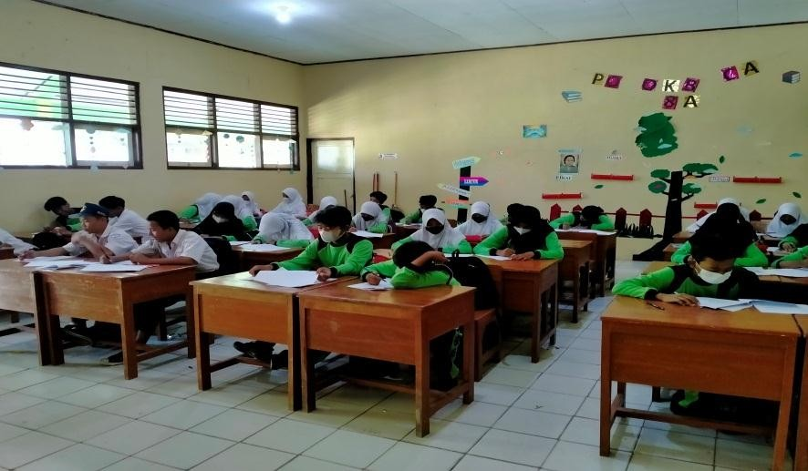
Appendix 8. Documentation

