REFERENCES

Agun, A. (2018). The Implementation of Story Telling to Improve Listening Skill of the 8th Grade Students of SMPN 1 Yogyakarta A Sarjana Pendidikan Thesis Presented as Partial Fulfillment of the Requirements to Obtain the Sarjana Pendidikan Degree in English Language Education.
Alwasilah, S. S. (2019). Creating your animated stories with plotagon: Implementation of project-based learning in narrative writing. International Journal of Learning, Teaching and Educational Research, 18(12), 333–349. https://doi.org/10.26803/ijlter.18.12.19
Amalia Rakhman, F., Samiati Tarjana, S., & Marmanto, S. (2019). Indonesian English Department Students Listening Difficulties and Listening Strategies. IJER, 4(2), 60–67. http://ijer.ftk.uinjambi.ac.id/index.php/ijer
Barrot, J. S. (2016). Current Principles and Concepts in the Teaching of Macroskills.
Beckett, G. H., & Slater, T. (2005). The Project Framework: A tool for language, content, and skills integration. In ELT Journal (Vol. 59, Issue 2, pp. 108–116). https://doi.org/10.1093/eltj/cci024
Cheung, Y. K. (2010). The Importance of Teaching Listening in the EFL Classroom.
Dwiyana Putra, R., & Dewa Gede, I. (2014). A Study on the Implementation of Project-based Learning in Teaching Writing Skills to English Education Department Students of Mahasaraswati University Denpasar in Academic Year 2013/2014 (Vol. 2).
Fang, X. U., & Warschauer, M. (2004). Technology and Curricular Reform in China: A Case Study. In TESOL QUARTERLY (Vol. 38, Issue 2).
Fernández-Gómez, E., Martín-Salvador, A., Luque-Vara, T., Sánchez-Ojeda, M. A., Navarro-Prado, S., & Enrique-Mirón, C. (2020). Content validation through expert judgement of an instrument on the nutritional knowledge, beliefs, and habits of pregnant women. Nutrients, 12(4). https://doi.org/10.3390/nu12041136
H Douglas Brown. (2004). Language Assessment_ Principles and Classroom Practices.
Herlina Dewi, B., & Aceh, B. (2016). Project based learning Techniques to Improve Speaking Skills. In EEJ) (Vol. 7, Issue 3).
Joseph S. Krajcik & Phyllis C. Blumenfeld. (2006). Project-Based Learning.
Kalaa, K., Miles, M. B., Huberman, • A Michael, & Saldaña, J. (1994). Miles Huberman Data analysis Qualitative Data Analysis A Methods Sourcebook Edition.
Kokotsaki, D., Menzies, V., & Wiggins, A. (2016). Project-based learning: A review of the literature. Improving Schools, 19(3), 267–277. https://doi.org/10.1177/1365480216659733
Le, M. A., & Mai, T. (2019). Teaching Listening Skills for English Non-Majored Students at Ba Ria-Vung Tau University: Difficulties and Solutions. IOSR Journal Of Humanities And Social Science (IOSR-JHSS, 24(7), 28–37. https://doi.org/10.9790/0837-2404072837
Mergendoller, J. R., & Thomas, J. W. (2005). Managing Project Based Learning: Principles from the Field. www.bie.org
Mills, N. A., & Mills, N. (2009). A Guide du Routard Simulation: Increasing Self-Efficacy in the Standards through Project-Based Learning A Guide du Routard Simulation: Increasing Self-Efficacy in the Standards Through Project-Based Learning. http://works.bepress.com/nicole_mills/26/
Mustika, V., & Permatasari, H. (2013). Improving Students’ Listening Skills Through Podcasts at Smp Bopkri 1, Yogyakarta Grade VIII, Class A in the Academic Year of 2012/2013.
Puji, M., Aji, P., & Linguistik, K. S. (2017). English Listening Blended Learning: The Implementation of Blended Learning in Teaching Listening to University Students. 2(1). http://journals.ums.ac.id/index.php/
Rasmitadila, Aliyyah, R. R., Rachmadtullah, R., Samsudin, A., Syaodih, E., Nurtanto, M., & Tambunan, A. R. S. (2020). The perceptions of primary school teachers of online learning during the covid-19 pandemic period: A case study in Indonesia. Journal of Ethnic and Cultural Studies, 7(2), 90–109. https://doi.org/10.29333/ejecs/388
Renukadevi, D. (2014). The Role of Listening in Language Acquisition; the Challenges & Strategies in Teaching Listening. In International Journal of Education and Information Studies (Vol. 4, Issue 1). http://www.ripublication.com
Tyagi, B. (2013). Listening : An Important Skill and Its Various Aspects. www.the-criterion.com

APPENDICES

Appendix 1. School Permission

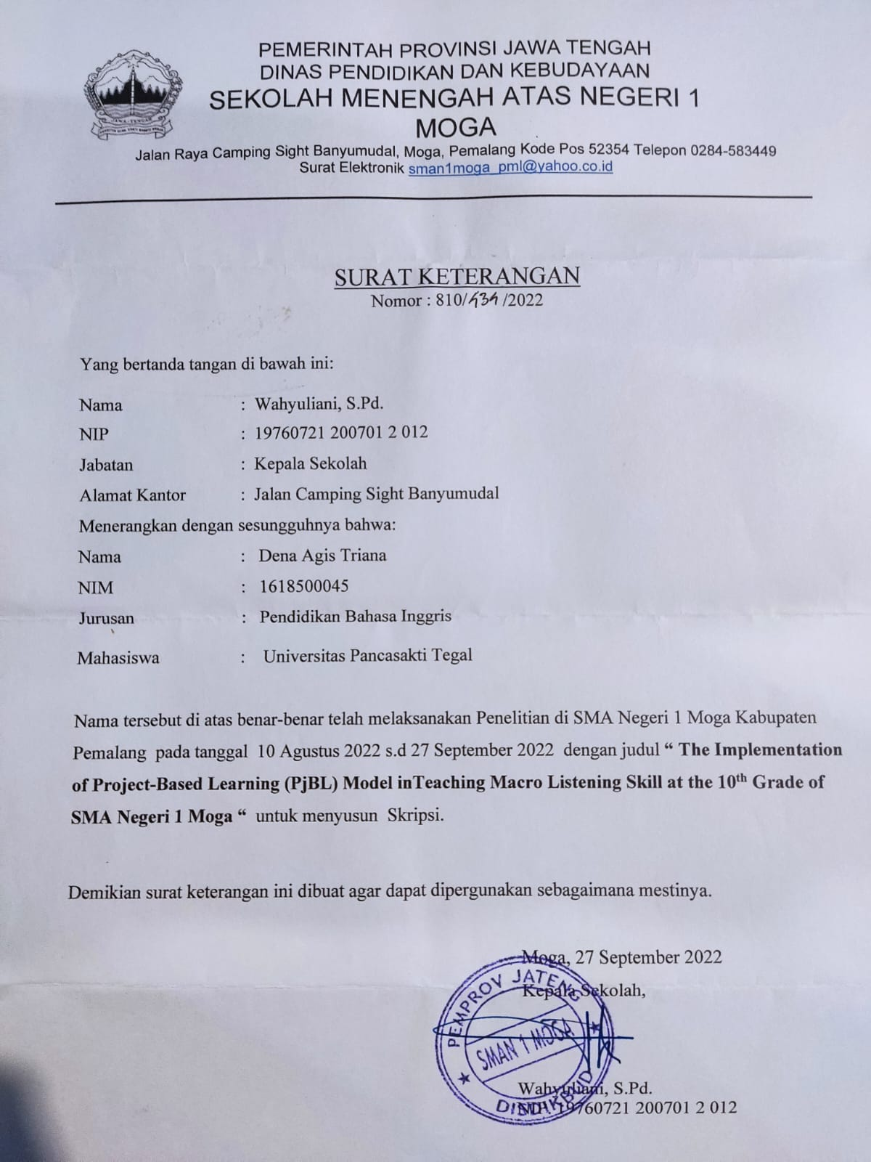

Appendix 2. Instrument of Questionnaire

Petunjuk : Isilah jawaban yang benar sesuai dengan penilaian anda terhadap materi yang telah diajarkan, dengan cara memilih satu pilihan jawaban yang tersedia.
Keterangan pilihan jawaban:
Sangat Setuju = skor 5
Setuju = skor 4
Netral = skor 3
Tidak Setuju = skor 2
Sangat Tidak Setuju = skor 1

- Model pembelajaran yang diberikan oleh guru relevan digunakan dalam proses pembelajaran
- Sangat Setuju
- Setuju
- Netral
- Tidak Setuju
- Sangat Tidak Setuju

- Materi mendengarkan memudahkan siswa untuk menerima materi pembelajaran yang disampaikan oleh guru selama proses pembelajaran berlangsung
- Sangat Setuju
- Setuju
- Netral
- Tidak Setuju
- Sangat Tidak Setuju

- Siswa dapat menentukan gagasan utama dan kesimpulan dari materi yang diberikan selama proses pembelajaran berlangsung
- Sangat Setuju
- Setuju
- Netral
- Tidak Setuju
- Sangat Tidak Setuju
- Model pembelajaran berbasis proyek dapat membantu siswa dalam menemukan ide-ide baru selama proses pembelajaran berlangsung
- Sangat Setuju
- Setuju
- Netral
- Tidak Setuju
- Sangat Tidak Setuju

- Setelah diberikan materi mendengarkan menggunakan model pembelajaran berbasis proyek, siswa lebih aktif dalam pembelajaran
- Sangat Setuju
- Setuju
- Netral
- Tidak Setuju
- Sangat Tidak Setuju

- Model pembelajaran berbasis proyek dapat meningkatkan kemampuan dan motivasi siswa dalam membuat proyek baru selama proses pembelajaran berlangsung
- Sangat Setuju
- Setuju
- Netral
- Tidak Setuju
- Sangat Tidak Setuju

- Setelah diberikan materi mendengarkan menggunakan model pembelajaran berbasis proyek, siswa dapat memprediksi kata dalam bahasa inggris yang disampaikan oleh pembicara
- Sangat Setuju
- Setuju
- Netral
- Tidak Setuju
- Sangat Tidak Setuju

- Siswa dapat mengalokasikan dan memanajemen waktu dalam menyelesaikan proyek selama proses pembelajaran berlangsung
- Sangat Setuju
- Setuju
- Netral
- Tidak Setuju
- Sangat Tidak Setuju

- Setelah diberikan materi mendengarkan, siswa dapat meningkatkan ketrampilan makro dalam mendengarkan
- Sangat Setuju
- Setuju
- Netral
- Tidak Setuju
- Sangat Tidak Setuju

- Ketrampilan mendengarkan makro berpengaruh pada peningkatan pengetahuan siswa terhadap bahasa inggris
- Sangat Setuju
- Setuju
- Netral
- Tidak Setuju
- Sangat Tidak Setuju

- Siswa dapat mengembangkan strategi mendengarkan seperti mendeteksi kata kunci atau menebak arti dari kata dalam konteks kalimat
- Sangat Setuju
- Setuju
- Netral
- Tidak Setuju
- Sangat Tidak Setuju

- Siswa berpartisipasi dengan baik dalam grup selama proses pembelajaran berlangsung
- Sangat Setuju
- Setuju
- Netral
- Tidak Setuju
- Sangat Tidak Setuju

- Model pembelajaran berbasis proyek dapat membantu siswa mengaitkan materi yang diberikan pada kehidupan sehari-hari
- Sangat Setuju
- Setuju
- Netral
- Tidak Setuju
- Sangat Tidak Setuju

- Siswa merasa senang dan antusias selama proses pembelajaran menggunakan model pembelajaran berbasis proyek
- Sangat Setuju
- Setuju
- Netral
- Tidak Setuju
- Sangat Tidak Setuju

- Siswa dapat memahami dan menguasai tipe-tipe dasar dalam mendengarkan seperti, intensive, responsive, selective, dan extensive selama proses pembelajaran berlangsung
- Sangat Setuju
- Setuju
- Netral
- Tidak Setuju
- Sangat Tidak Setuju

Appendix 3. The Result of Validity and Reliability Test of the Questionnaire

No Item | Pearson Correlations | Sig. (2-tailed) | Criteria
1  2  3  4  5  6  7  8  9  10  11  12  13  14  15 | 0.612  0.589  0.517  0.758  0.509  0.775  0.477  0.220  0.264  0.363  0.709  0.248  0.552  0.719  0.225 | 0.001  0.001  0.003  0.001  0.004  0.001  0.005  0.224  0.159  0.049  0.001  0.187  0.002  0.001  0.232 | Valid  Valid  Valid  Valid  Valid  Valid  Valid  Tidak Valid  Tidak Valid  Tidak Valid  Valid  Tidak Valid  Valid  Valid  Tidak Valid

Reliability Statistics
Cronbach's Alpha | N of Items
.868 | 10

Appendix 4. Instrument questionnaire to collect data

Appendix 5. Documentation of Observations

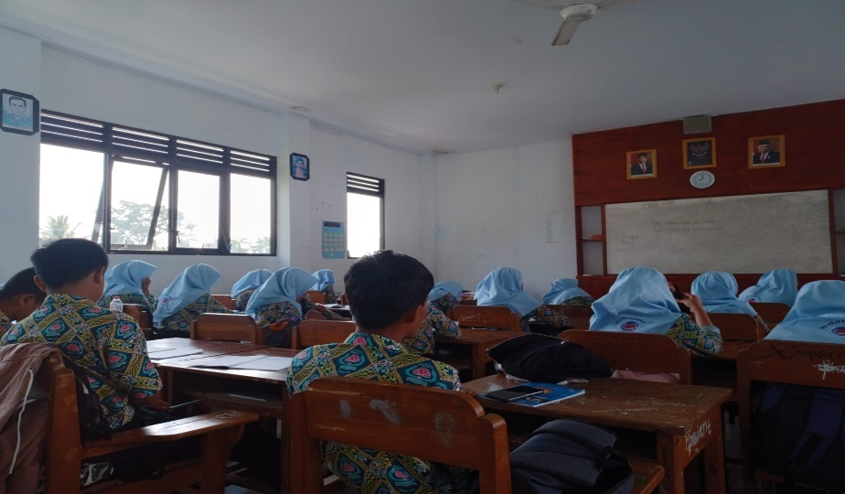

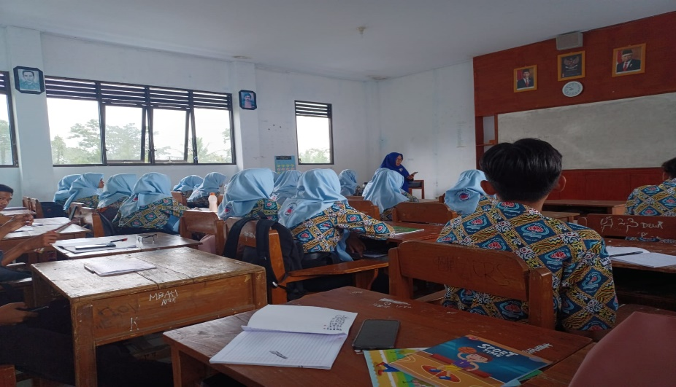

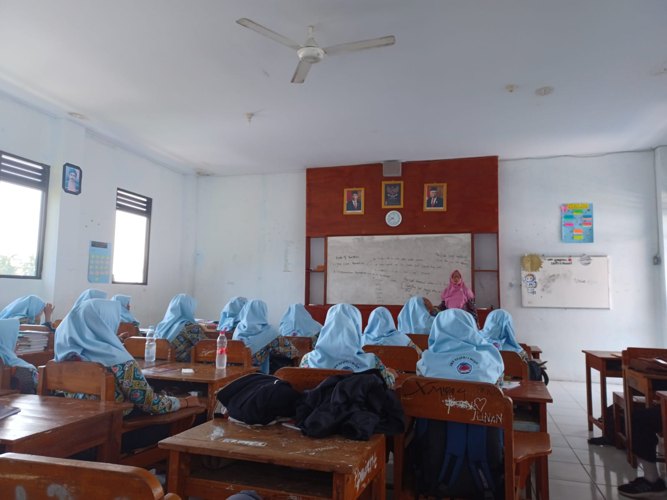
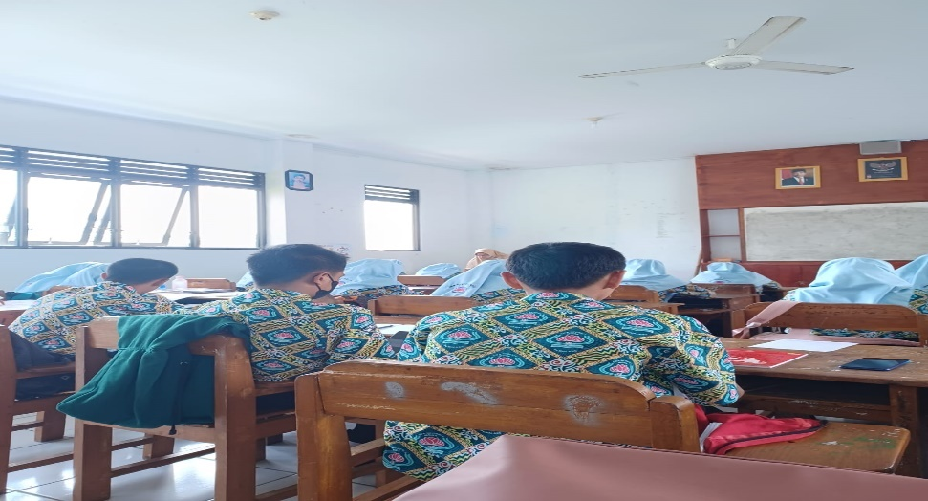
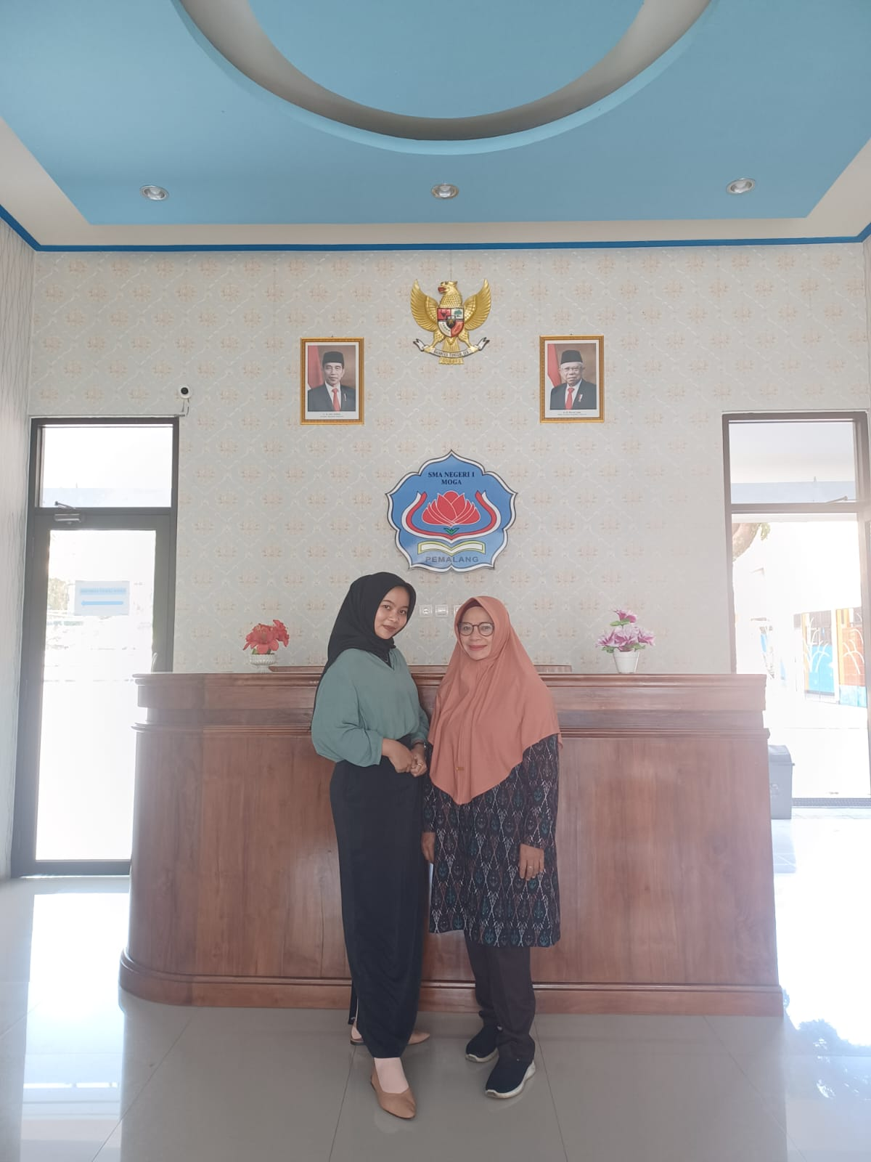

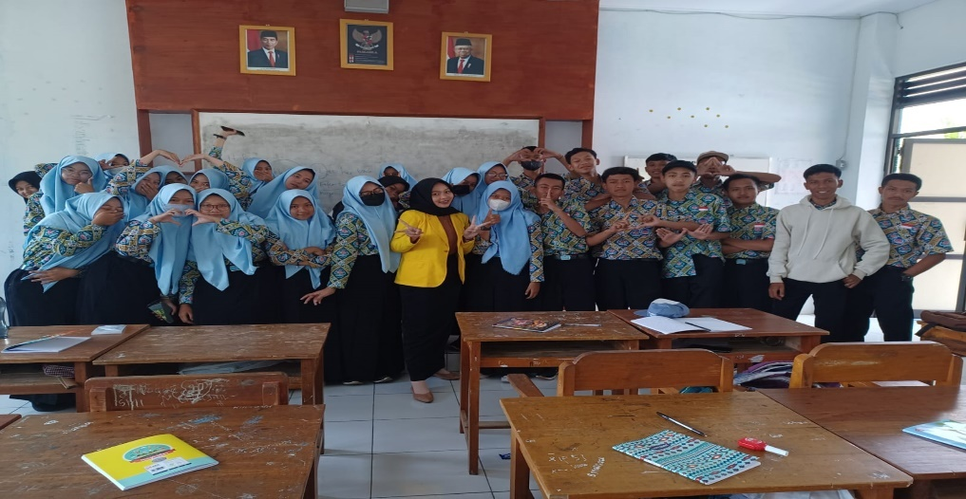
Appendix 6. Instrument Checklist of the Observations

- Students
No. | Indicator | Condition |  |  |  | Note
 |  | Absolutely yes | Absolutely not | Only some of the students | Only a few of the students
1. | The students are ready to start learning in class
2. | Students follow the instructions given by the teacher during learning
3. | The students participated in class during the learning process
4. | Students feel happy and enthusiastic during the learning process

- Learning Process

No. | Indicator | Condition |  |  |  | Note
 |  | Absolutely yes | Sufficiently | confusingly | Absolutely not
1. | The learning process can run well by the lesson plan given
2. | The learning process gives a positive impression on students
3. | The learning process takes place well and achieves the maximum goals

- Teaching Practice
No. | Indicator | Condition |  |  |  | Note
 |  | Perfect | Mostly Perfect | Confusingly | Absolutely no
1. | The teacher explains the material clearly
2. | The teacher mastered the material given to the students
3. | The teacher can control the class well
4. | The learning process delivered by the teacher involves the participation of students

- Materials
No. | Indicator | Condition |  |  |  | Note
 |  | Absolutely yes | Sufficiently | Confusingly | Absolutely not
1. | The materials that are given are appropriate to the student’s level
2. | The material brings students to master the learning given by the teacher
3. | The materials achieve the learning goals of the students

- Implementation of PjBL
No. | Indicator | Condition |  |  |  | Note
 |  | Absolutely yes | Sufficiently | Confusingly | Absolutely no
1. | Project-based learning model provides topics that are relevant for students to start a new project
2. | Project-based learning model involves students in the process of problem-solving that will be carried out in the learning process
3. | Project-based learning model takes time to create a project in the learning process
4. | In a project-based learning class, the teacher monitors students and sees the progress of students in working on the new project given
5. | In learning using a project-based learning model, students are given appreciation for the projects they have worked on
6. | Teachers and students reflect on or evaluate the projects that have been done to find some of the obstacles experienced by students during the learning process

Appendix 7. The Result of the Observations
Table 4.1 Observations of Students Conducted on 10th August
No. | Indicator | Condition |  |  |  | Note
 |  | Absolutely yes | Absolutely not | Only some of the students | Only a few of the students
1. | The students are ready to start learning in class
2. | Students follow the instructions given by the teacher during learning
3. | The students participated in class during the learning process
4. | Students feel happy and enthusiastic during the learning process

Table 4.2 Learning Process Conducted on 10th August
No. | Indicator | Condition |  |  |  | Note
 |  | Absolutely yes | Sufficiently | confusingly | Absolutely not
1. | The learning process can run well by the lesson plan given
2. | The learning process gives a positive impression on students
3. | The learning process takes place well and achieves the maximum goals

Table 4.3 Teaching Practice Conducted on 10th August
No. | Indicator | Condition |  |  |  | Note
 |  | Perfect | Mostly Perfect | Confusingly | Absolutely no
1. | The teacher explains the material clearly
2. | The teacher mastered the material given to the students
3. | The teacher can control the class well
4. | The learning process delivered by the teacher involves the participation of students

Table 4.4 Materials conducted on 10th August
No. | Indicator | Condition |  |  |  | Note
 |  | Absolutely yes | Sufficiently | Confusingly | Absolutely not
1. | The materials that are given are appropriate to the student’s level
2. | The material brings students to master the learning given by the teacher
3. | The materials achieve the learning goals of the students

Table 4.5 Implementation of PjBL on 10th August
No. | Indicator | Condition |  |  |  | Note
 |  | Absolutely yes | Sufficiently | Confusingly | Absolutely no
1. | Project-based learning model provides topics that are relevant for students to start a new project
2. | Project-based learning model involves students in the process of problem-solving that will be carried out in the learning process
3. | Project-based learning model takes time to create a project in the learning process
4. | In a project-based learning class, the teacher monitors students and sees the progress of students in working on the new project given
5. | In learning using a project-based learning model, students are given appreciation for the projects they have worked on
6. | Teachers and students reflect on or evaluate the projects that have been done to find some of the obstacles experienced by students during the learning process

Table 4.6 Observations of Students Conducted on 24th August
No. | Indicator | Condition |  |  |  | Note
 |  | Absolutely yes | Absolutely not | Only some of the students | Only a few of the students
1. | The students are ready to start learning in class
2. | Students follow the instructions given by the teacher during learning
3. | The students participated in class during the learning process
4. | Students feel happy and enthusiastic during the learning process

Table 4.7 Learning Process Conducted on 24th August
No. | Indicator | Condition |  |  |  | Note
 |  | Absolutely yes | Sufficiently | confusingly | Absolutely not
1. | The learning process can run well by the lesson plan given
2. | The learning process gives a positive impression on students
3. | The learning process takes place well and achieves the maximum goals

Table 4.8 Teaching Practice Conducted on 24th August
No. | Indicator | Condition |  |  |  | Note
 |  | Perfect | Mostly Perfect | Confusingly | Absolutely no
1. | The teacher explains the material clearly
2. | The teacher mastered the material given to the students
3. | The teacher can control the class well
4. | The learning process delivered by the teacher involves the participation of students

Table 4.9 Materials Conducted on 24th August
No. | Indicator | Condition |  |  |  | Note
 |  | Absolutely yes | Sufficiently | Confusingly | Absolutely not
1. | The materials that are given are appropriate to the student’s level
2. | The material brings students to master the learning given by the teacher
3. | The materials achieve the learning goals of the students

Table 4.10 Implementation of PjBL Conducted on 24th August
No. | Indicator | Condition |  |  |  | Note
 |  | Absolutely yes | Sufficiently | Confusingly | Absolutely no
1. | Project-based learning model provides topics that are relevant for students to start a new project
2. | Project-based learning model involves students in the process of problem-solving that will be carried out in the learning process
3. | Project-based learning model takes time to create a project in the learning process
4. | In a project-based learning class, the teacher monitors students and sees the progress of students in working on the new project given
5. | In learning using a project-based learning model, students are given appreciation for the projects they have worked on
6. | Teachers and students reflect on or evaluate the projects that have been done to find some of the obstacles experienced by students during the learning process

Table 4.11 Observations of Students Conducted on 31 August
No. | Indicator | Condition |  |  |  | Note
 |  | Absolutely yes | Absolutely not | Only some of the students | Only a few of the students
1. | The students are ready to start learning in class
2. | Students follow the instructions given by the teacher during learning
3. | The students participated in class during the learning process
4. | Students feel happy and enthusiastic during the learning process

Table 4.12 Learning Process Conducted on 31 August
No. | Indicator | Condition |  |  |  | Note
 |  | Absolutely yes | Sufficiently | confusingly | Absolutely not
1. | The learning process can run well by the lesson plan given
3. | The learning process gives a positive impression on students
4. | The learning process takes place well and achieves the maximum goals

Table 4.13 Teaching Practice Conducted on 31 August
No. | Indicator | Condition |  |  |  | Note
 |  | Perfect | Mostly Perfect | Confusingly | Absolutely no
1. | The teacher explains the material clearly
2. | The teacher mastered the material given to the students
3. | The teacher can control the class well
4. | The learning process delivered by the teacher involves the participation of students

Table 4.14 Materials Conducted on 31 August
No. | Indicator | Condition |  |  |  | Note
 |  | Absolutely yes | Sufficiently | Confusingly | Absolutely not
1. | The materials that are given are appropriate to the student’s level
2. | The material brings students to master the learning given by the teacher
3. | The materials achieve the learning goals of the students

Table 4.15 Implementation of PjBL Conducted on 31 August
No. | Indicator | Condition |  |  |  | Note
 |  | Absolutely yes | Sufficiently | Confusingly | Absolutely no
1. | Project-based learning model provides topics that are relevant for students to start a new project
2. | Project-based learning model involves students in the process of problem-solving that will be carried out in the learning process
3. | Project-based learning model takes time to create a project in the learning process
4. | In a project-based learning class, the teacher monitors students and sees the progress of students in working on the new project given
5. | In learning using a project-based learning model, students are given appreciation for the projects they have worked on
6. | Teachers and students reflect on or evaluate the projects that have been done to find some of the obstacles experienced by students during the learning process

Table 4.16 Observations of Students Conducted on 7th September
No. | Indicator | Condition |  |  |  | Note
 |  | Absolutely yes | Absolutely not | Only some of the students | Only a few of the students
1. | The students are ready to start learning in class
2. | Students follow the instructions given by the teacher during learning
3. | The students participated in class during the learning process
4. | Students feel happy and enthusiastic during the learning process

Table 4.17 Learning Process Conducted on 7th September
No. | Indicator | Condition |  |  |  | Note
 |  | Absolutely yes | Sufficiently | confusingly | Absolutely not
1. | The learning process can run well by the lesson plan given
3. | The learning process gives a positive impression on students
4. | The learning process takes place well and achieves the maximum goals

Table 4.18 Teaching Practice Conducted on 7th September
No. | Indicator | Condition |  |  |  | Note
 |  | Perfect | Mostly Perfect | Confusingly | Absolutely no
1. | The teacher explains the material clearly
2. | The teacher mastered the material given to the students
3. | The teacher can control the class well
4. | The learning process delivered by the teacher involves the participation of students

Table 4.19 Materials Conducted on 7th September
No. | Indicator | Condition |  |  |  | Note
 |  | Absolutely yes | Sufficiently | Confusingly | Absolutely not
1. | The materials that are given are appropriate to the student’s level
2. | The material brings students to master the learning given by the teacher
3. | The materials achieve the learning goals of the students

  - Implementation of PjBL Conducted on 7th September
No. | Indicator | Condition |  |  |  | Note
 |  | Absolutely yes | Sufficiently | Confusingly | Absolutely no
1. | Project-based learning model provides topics that are relevant for students to start a new project
2. | Project-based learning model involves students in the process of problem-solving that will be carried out in the learning process
3. | Project-based learning model takes time to create a project in the learning process
4. | In a project-based learning class, the teacher monitors students and sees the progress of students in working on the new project given
5. | In learning using a project-based learning model, students are given appreciation for the projects they have worked on
6. | Teachers and students reflect on or evaluate the projects that have been done to find some of the obstacles experienced by students during the learning process

Appendix 8. Instrument interview

Interview Transcript for Teacher
Instructions : This part contains the interview transcript for the teacher. The interview will be taken by the researcher as the interviewer in this research.
interviewee :
Interviewer :

- What are the difficulties in teaching listening?
- What do you think about teaching using project-based learning?
- How do you apply the project-based learning model in the classroom?
- How are the students’ responses to the implementation of the project-based learning model in teaching listening?
- In your opinion, is the project-based learning model effective in teaching listening?
- In your opinion, does listening learning using a project-based learning model affect students’ macro listening skills?
- What are the positive impacts of teaching listening using a project-based learning model?
- In your opinion, what are the advantages and disadvantages of teaching listening using a project-based learning model?
- Do students play an active role during learning activities using a project-based learning model?
- How can you control the class during the learning process?
- Has the teacher succeeded in applying macro listening skills to students?
- How do you teach macro listening skills to students?
- Can macro listening skills lead students to focus on ideas, make predictions, and listen critically?
- After being given macro listening material, can students develop listening strategies such as detecting keywords or guessing the meaning of words from context?
- Can macro listening skills develop receptive language as the basis for students to communicate?

Appendix 9. Transcript Interview

Interview Transcript for Teacher
Instructions : This part contains the interview transcript for the teacher. The interview will be taken by the researcher as the interviewer in this research.
interviewee :
Interviewer :

- What are the difficulties in teaching listening?
Answer: “so far when I teach listening there are some difficulties that I face. The first is the lack of understanding of the students toward the word listen by the students. It seems that they have difficulty listening to the audio for the first time. then, I can be a resource for them when I read texts or when I give related short messages because they have a very limited vocabulary.
Sometimes, when they know the word and the pronunciation is different maybe when they catch the word in SMP something is different pronounce when they know it in SMA. And the second one is we know that the student’s vocabularies are very limited so, of course, it makes them learn more or understand more something they listen to is very lazy or very boring. Because they are lazy, they do not know the word that strengthens them which makes them bored, and also some students prefer to listen to their teacher. I mean when I give the audio and it seems that they catch more difficulties listening to the audio compared to when I give the listening through my voice (my own voice), because they know my movement of my mouth. However, because they often listen to the short audio texts that I have given and explained, they have become used to hearing. And then maybe when they see the youtube it will be interesting because on youtube they know the person and also usually there are subtitles”.

- What do you think about teaching using project-based learning?
Answer: teaching using a project-based learning model is attractive seems this method involves students being active in conducting their project in groups. Because the project is applied in a group, they will learn from other students they not do it alone. If they catch some difficulties and they can discuss them with another group. I think it’s interesting and attractive, but we need more time in conducting the project. Sometimes we have very limitations in time because there are many things to do. At least we have to pay attention or check the process of student work. It needs much time.

- How do you apply the project-based learning model in the classroom?
Answer: so far, if I apply this project-based learning, especially teaching listening by giving some topics to the students in a group. Each group should explore the topic by having role play or making it a dialogue and writing a script to tell their friends and they record they speech, dialogue, and also, they give some questions to the monologue or the dialogue that they have recorded and then another friend can respond what its question indicated to the text, monologue, or the dialogue given by the students which is the material is the product given by the students. The students can produce their own products and they can share to their friends.

- How are the students’ responses to the implementation of the project-based learning model in teaching listening?
Answer: the student’s responses to this project are good even though a little bit confusing and boring because some of the students are shy to have or listen to their voice recorded. They are afraid if they pronounce the words form. They lack the confidence to record their voice. But, so far students follow the lesson so well.
- In your opinion, is the project-based learning model effective in teaching listening?
Answer: teaching listening using project-based learning is effective but, it needs much time and we have to prepare something that the students need. From the basic one, we have to know their capabilities on the language background. So, its group or its students is not the same in one class. They have multiple knowledge. I mean, their background is also different. One student maybe they have understood this topic and one student no, even the vocabulary they know is very limited.

- In your opinion, does listening learning using a project-based learning model affect students’ macro listening skills?
Answer: I think it affects students’ macro listening skills but sometimes it makes the students bored. If we only focus on listening of course it will increase the capability of the students in macro. But, because it needs a lot of time, the problem is time. We know that to learn or to teach one topic we need not only one meeting, but it also needs more than one meeting as the students’ capability is very different and very complex and we have to choose different material for another group. So, it is something that I face that is very challenging because of the time. We know the English only once a week to our presented, you know the curriculum of SMA. So, I think the English teacher’s problem is we have to make the students able to master this topic but the time is very limited.

- What are the positive impacts of teaching listening using a project-based learning model?
Answer: I think the positive impact of teaching on listening to students is increasing the student’s empathy. If the students in one group cannot understand or cannot do the project and they will help each other. So, in the work of cooperative learning. And then also it increased the student’s self-confidence because self-confidence is very important and then it can be achieved by using the project in a group. If one by one student, they will be afraid and shy but when it conducting in a group other people can help each other. And the last is, I think this project is motivating the students to work in a group. There are some people or some students that categorize as passive learners but when they are learning in a group, they can be active because another person can motivate them. So, they can enjoy the learning process.

- In your opinion, what are the advantages and disadvantages of teaching listening using a project-based learning model?
Answer: as I explained before, the advantages of this project-based learning model are students can motivate each other, work in a group well, and increase student’s empathy and self-confidence. Well, I think the disadvantages are it is much time to set up the project and it needed guidance before teaching or giving the material because some students are low in understanding the word even the sentence given. If we know the students read the material, they read directly they also find the difficulties even when they listen something that they do not know the word especially for visual student learning type they have to know the text but in listening they do not know the text or script it makes them very confused. Like, “what are they speaking about?”

- Do students play an active role during learning activities using a project-based learning model?
Answer: yes, but not all are active some students are passive. It seems that when they do not know the other dialogue we talk about, it makes them confused to answer. And if we guide them to translate or give the definition in another word they have to guess. So, we need another strategy to make them understand.

- How can you control the class during the learning process?
Answer: I give some corrections and repetitions when reading or pronouncing the word. Particularly when they do not know or are not familiar with their word. And of course, I give motivation and encouragement. Listening is part of learning English. There are 4 skills that we have to teach them and they have to master listening in the first type. Learning language listening is the first type. And then after that speaking, reading, and writing. So, we make them know why they have to learn about listening. Like when we learn our mother tongue of course we learn first by listening to our mother speak.

- Has the teacher succeeded in applying macro listening skills to students?
Answer: is not simple, I guess. First, i give some materials for the students to understand and learn like guessing the word from the text that we say or present, and also by making a dialogue. For example, students ask another friend to make a short interview about hobby or their activities at home.

- How do you teach macro listening skills to students?
Answer: using some strategies and some materials, I think it can help the students to understand listening. Listening not only to listen to the voice but also we have to understand what is the message spoken by the speaker. So, I think by giving some materials and strategies the students can understand even if not all students can know about this

- Can macro listening skills lead students to focus on ideas, make predictions, and listen critically?
Answer: I think so. By giving some strategies and material students can focus based on what we going to ask. For example, if they guess the word from the text and mentioning about the message.

- After being given macro listening material, can students develop listening strategies such as detecting keywords or guessing the meaning of words from context?
Answer: yes, I think so. By applying the skills of macro listening by using some materials and methods students can develop their listening compentence. Like, guess the meaning of the word from the context and can answer the question given about the message of the text. A short example is they make a conversation, they can understand the message spoken by their pairs, etc.

- Can macro listening skills develop receptive language as the basis for students to communicate?
Answer: I agree. I think students can develop the skills to receive the meaning of communication or the basic meaning of communication by applying macro listening skills. We need to give it more.

