DAFTAR PUSTAKA
Ahmad, B. (2015). Peningkatan Motivasi Belajar Siswa melalui Konseling Klasik. Abe Kreatifindo.
Aisyah, S. (2013). Pengaruh Manajemen Waktu dan Motivasi Belajar Terhadap Prestasi Belajar Siswa SMK Islam Kader Bangsa Pada Pelatihan Aplikasi MYOB. 1–7.
Arikunto, S. (2020). Prosedur Penelitian Suatu Pendekatan Praktik. PT RINEKA CIPTA.
Fajhriani. N, D. (2020). Manajemen Waktu Belajar di Perguruan Tinggi pada Masa Pandemi Covid-19. JIEMAN: Journal of Islamic Educational Management, 2(2), 169–180. https://doi.org/10.35719/jieman.v2i2.27
Grafiani Pretty, C. (2021). Seni Manajemen Waktu (H. Adamson (ed.)). Anak Hebat Indonesia.
Hamzah, H. (2016). Teori Motivasi dan Pengukurannya.
Harlina Haruna, N., & Muhammad, F. (2021). Pengaruh Manajemen Waktu Terhadap Hasil Belajar Matematika Siswa Kelas XII IPS SMA Peguruan Islam Maar Di Masa Pandemi Covid-19. 6, 13–21.
Kurniawati, A. N., Winarno, & Rejekiningsih, T. (2017). Pengaruh Motivasi Terhadap Kedisiplinan Siswa Dalam Mematuhi Tata Tertib Sekolah di SMA Islam 1 Surakarta. 37–52.
Lidya, V., Elburdah, R. P., Sudarso, E., & Fauziah, G. (2019). Penggunaan Manajemen Waktu Terhadap Peningkatan Prestasi Belajar Di SMP Araisiyah. 1(1), 1–8.
Lomu, L., & Adi Widodo, S. (n.d.). Pengaruh Motivasi Belajar dan Disiplin Belajar terhadap Prestasi belajar matematika siswa. 745–751.
Nasrul, D. F. (2020). Manajemen Waktu Belajar di Perguruan Tinggi Pada Masa Pandemi Covid-19. V(2), 169–180.
Putri Novianti, Y. (2017). Pengaruh manajemen waktu terhadap hasil belajar siswa kelas xii ips mata pelajaran ekonomi man kota blitar.
Sardiman. (2014). Interaksi dan Motivasi Belajar Mengajar. Raja Grafindo Persada.
Sobri, M. (2020). Kontribusi Kemandirian Dan Kedisiplinan Terhadap Hasil Belajar (Guepedia/fz (ed.)). Guepedia.
Suardi, M. (2018). Belajar dan Pembelajaran. Deepublish.
Sugiarto, A. P., & Yulianti, P. D. (2019). Faktor Kedisiplinan Belajar Pada Siswa Kelas X SMK Larenda Brebes. 24(2), 232–238.
Sugiyono. (2019). Metode Penelitian Kuantitatif Kualitatif dan R&D. Alfabeta.
Sugiyono. (2021). Metode Penelitian Kuantitatif dan Kualitatif (Sutopo (ed.); kedua). Alfabeta.
Suhardi. (n.d.). Peran kedisiplinan terhadap peningkatan prestasi olaharaga dan kesehatan siswa sekolah dasar.
Suliyanto. (2018). Metode Penelitian Bisnis (A. Cristian (ed.)). CV. ANDI OFFSET.
Ahmad, B. (2015). Peningkatan Motivasi Belajar Siswa melalui Konseling Klasik. Abe Kreatifindo.S
Aisyah, S. (2013). Pengaruh Manajemen Waktu dan Motivasi Belajar Terhadap Prestasi Belajar Siswa SMK Islam Kader Bangsa Pada Pelatihan Aplikasi MYOB. 1–7.
Arikunto, S. (2020). Prosedur Penelitian Suatu Pendekatan Praktik. PT RINEKA CIPTA.
Grafiani Pretty, C. (2021). Seni Manajemen Waktu (H. Adamson (ed.)). Anak Hebat Indonesia.
Hamzah, H. (2016). Teori Motivasi dan Pengukurannya.
Harlina Haruna, N., & Muhammad, F. (2021). Pengaruh Manajemen Waktu Terhadap Hasil Belajar Matematika Siswa Kelas XII IPS SMA Peguruan Islam Maar Di Masa Pandemi Covid-19. 6, 13–21.
Kurniawati, A. N., Winarno, & Rejekiningsih, T. (2017). Pengaruh Motivasi Terhadap Kedisiplinan Siswa Dalam Mematuhi Tata Tertib Sekolah di SMA Islam 1 Surakarta. 37–52.
Lidya, V., Elburdah, R. P., Sudarso, E., & Fauziah, G. (2019). Penggunaan Manajemen Waktu Terhadap Peningkatan Prestasi Belajar Di SMP Araisiyah. 1(1), 1–8.
Lomu, L., & Adi Widodo, S. (n.d.). Pengaruh Motivasi Belajar dan Disiplin Belajar terhadap Prestasi belajar matematika siswa. 745–751.
Nasrul, D. F. (2020). Manajemen Waktu Belajar di Perguruan Tinggi Pada Masa Pandemi Covid-19. V(2), 169–180.
Putri Novianti, Y. (2017). Pengaruh manajemen waktu terhadap hasil belajar siswa kelas xii ips mata pelajaran ekonomi man kota blitar.
Sardiman. (2014). Interaksi dan Motivasi Belajar Mengajar. Raja Grafindo Persada.
Sobri, M. (2020). Kontribusi Kemandirian Dan Kedisiplinan Terhadap Hasil Belajar (Guepedia/fz (ed.)). Guepedia.
Suardi, M. (2018). Belajar dan Pembelajaran. Deepublish.
Sugiarto, A. P., & Yulianti, P. D. (2019). Faktor Kedisiplinan Belajar Pada Siswa Kelas X SMK Larenda Brebes. 24(2), 232–238.
Sugiyono. (2019). Metode Penelitian Kuantitatif Kualitatif dan R&D. Alfabeta.
Sugiyono. (2021). Metode Penelitian Kuantitatif dan Kualitatif (Sutopo (ed.); kedua). Alfabeta.
Suhardi. (n.d.). Peran kedisiplinan terhadap peningkatan prestasi olaharaga dan kesehatan siswa sekolah dasar.
Suliyanto. (2018). Metode Penelitian Bisnis (A. Cristian (ed.)). CV. ANDI OFFSET.

LAMPIRAN

Lampiran 1
DAFTAR NAMA KELAS X IPS SMA TAKHASSUS AL-QUR’AN TARUB
No. | No Induk | Nama
1 | 0161 | Alfaya Mazia Umami
2 | 0162 | Ananda Devina Putri
3 | 0163 | Ardini Isna Septiani
4 | 0164 | Atikah Fatin
5 | 0165 | Auofi Rafiki
6 | 0166 | Cynthia Mely Yanti
7 | 0167 | Deni Arjuli
8 | 0168 | Diah Ayu Purwanti
9 | 0169 | Dini Risqiyah
10 | 0170 | Hasanah Bulqiyah
11 | 0171 | Iren Salsabila
12 | 0172 | Isfa Rizqi Dwi Rindiyani
13 | 0173 | Khasanatus Shifa
14 | 0174 | Lukman Noor Hakim
15 | 0175 | Lulu Ilmah Sumah
16 | 0176 | Mamnun Aulia Aenurizqi
17 | 0177 | May Nurzihan
18 | 0178 | Muhammad Akbar Muzaki
19 | 0179 | Muhammad Zaenul Arifin
20 | 0180 | Mutiara Dinda Apriyani
21 | 0181 | Nadia Novita Aflah
22 | 0182 | Nailin Nada Alhattani
23 | 0183 | Nuril Widi Aulia
24 | 0184 | Puji Maulana Hidayat
25 | 0185 | Rizqa Adelia
26 | 0186 | Salwa Iswatul Hawa
27 | 0187 | Sirrajudin Abas
28 | 0188 | Soffa Nurul Haq
29 | 0189 | Syafika Afronnyda
30 | 0190 | Wisunarti
31 | 0191 | Zanuba Arifa Chapso
32 | 0192 | Indah Fajar Cahyani
33 | 0193 | Nurul Hidayati
34 | 0194 | Tsuwaibatul Aslamiyah

Lampiran 2
DAFTAR NAMA KELAS XI IPS SMA TAKHASSUS AL-QUR’AN TARUB
No. | Nama
1 | Bayu Ananda Irawan
2 | Dalila Sakinah
3 | Devi Nur Anjani
4 | Izzatul Munafiroh
5 | Muhammad Sulton Nur Alif
6 | Muhammad Faza Zyhrul Anam
7 | Najwa Anin Nada
8 | Putri Puspita Sari
9 | Rendi Aprianto
10 | Sabrina Mutiara Eka M
11 | Siti Musaroh

Lampiran 3
HASIL OBSERVASI AWAL
PENGARUH MANAJEMEN WAKTU DAN MOTIVASI BELAJAR TERHADAP KEDISIPLINAN BELAJAR SISWA IPS SMA TAKHASSUS AL-QUR’AN TARUB
No. | Nama | Manajemen Waktu | Motivasi Belajar | Kedisiplinan siswa
1 | Bayu Ananda Irawan | Baik | Baik | Baik
2 | Dalila Sakinah | Cukup | Kurang | Cukup
3 | Devi Nur Anjani | Baik | Sangat baik | Baik
4 | Izzatul Munafiroh | Kurang | Kurang | Cukup
5 | Muhammad Sulton Nur Alif | Cukup | Cukup | Cukup
6 | Muhammad Faza Zyhrul A | Kurang | Kurang | Kurang
7 | Najwa Anin Nada | Baik | Baik | Baik
8 | Putri Puspita Sari | Baik | Baik | Baik
9 | Rendi Aprianto | Kurang | Kurang | Kurang
10 | Sabrina Mutiara Eka M | Kurang | Cukup | Kurang
11 | Siti Musaroh | Baik | Sangat baik | Baik
12 | Alfaya Mazia Umami | Baik | Cukup | Cukup
13 | Ananda Devina Putri | Kurang | Cukup | Cukup
14 | Ardini Isna Septiani | Kurang | Cukup | Kurang
15 | Atikah Fatin | Cukup | Cukup | Cukup
16 | Auofi Rafiki | Kurang | Cukup | Kurang
17 | Cynthia Mely Yanti | Kurang | Cukup | Cukup
18 | Deni Arjuli | Kurang | Cukup | Baik
19 | Diah Ayu Purwanti | Sangat baik | Sangat baik | Baik
20 | Dini Risqiyah | Kurang | Kurang | Kurang
21 | Hasanah Bulqiyah | Baik | Cukup | Cukup
22 | Iren Salsabila | Kurang | Baik | Kurang
23 | Isfa Rizqi Dwi Rindiyani | Baik | Baik | Baik
24 | Khasanatus Shifa | Cukup | Sangat baik | Baik
25 | Lukman Noor Hakim | Baik | Cukup | Baik
26 | Lulu Ilmah Sumah | Baik | Cukup | Baik
27 | Mamnun Aulia Aenurizqi | Kurang | Kurang | Kurang
28 | May Nurzihan | Baik | Kurang | Kurang
29 | Muhammad Akbar Muzaki | Kurang | Kurang | Kurang
30 | Muhammad Zaenul Arifin | Kurang | Kurang | Kurang
31 | Mutiara Dinda Apriyani | Cukup | Kurang | Kurang
32 | Nadia Novita Aflah | Kurang | Cukup | Kurang
33 | Nailin Nada Alhattani | Cukup | Kurang | Cukup
34 | Nuril Widi Aulia | Baik | Cukup | Kurang
35 | Puji Maulana Hidayat | Kurang | Cukup | Baik
36 | Rizqa Adelia | Kurang | Kurang | Cukup
37 | Salwa Iswatul Hawa | Kurang | Kurang | Kurang
38 | Sirrajudin Abas | Kurang | Kurang | Ckurang
39 | Soffa Nurul Haq | Kurang | Kurang | Kurang
40 | Syafika Afronnyda | Baik | Baik | Baik
41 | Wisunarti | Baik | Baik | Baik
42 | Zanuba Arifa Chapso | Baik | Cukup | Cukup
43 | Indah Fajar Cahyani | Baik | Kurang | Kurang
44 | Nurul Hidayati | Baik | Kurang | Cukup
45 | Tsuwaibatul Aslamiyah | Sangat baik | Sangat baik | Sangat baik

Lampiran 4
ANGKET
PENGARUH MANAJEMEN WAKTU DAN MOTIVASI BELAJAR TERHADAP KEDISIPLINAN BELAJAR SISWA IPS SMA TAKHASSUS AL-QUR’AN TARUB.
- Pengantar
Nama : Nur Homsi Amaliah
NPM : 1318500030
Progdi : Pendidikan Ekonomi
Fakultas : Keguruan dan Ilmu Pendidikan
Almamater : Universitas Pancasakti Tegal
Untuk menyelesaikan penulisan skripsi mengenai “Pengaruh Manajemen Waktu dan Motivasi Belajar terhadap Kedisiplinan Belajar Siswa IPS SMA Takhassus Al-qur’an Tarub” harapan saya kepada siswa kelas X dan XI IPS dapat bersedia mengisi angket yang telah disediakan. insyaAllah jawaban angket saudara dijamin kerahasiaannya dan tidak mempengaruhi saudara sebagai siswa SMA Takhassus Al-qur’an Tarub, Atas kesediaan pengisian angket ini saya ucapkan terima kasih.
- Petunjuk Pengisian
- Isi identitas terlebih dahulu pada kolom yang sudah disediakan.
- Berilah tanda () ceklis pada salah satu jawaban yang menurut saudara sesuai dengan kenyataan yang terjadi.
No. | Pernyataan | SS | S | KS | TS | STS
1. | Saya menyiapkan buku panduan pelajaran

- Kolom terdiri dari 5 jawaban yang sudah tersedia. Dengan penjelasan sebagai berikut:
- Sangat Setuju (SS)
- Setuju (S)
- Kurang Setuju (KS)
- Tidak Setuju (TS)
- Sangat Tidak Setuju (STS)
- Identitas Responden
Nama :
Jenis Kelamis :
Kelas :
No | Pernyataan | Pilihan
 |  | SS | S | KS | TS | STS
1 | Saya menyiapkan buku panduan pelajaran
2 | Saya menyiapkan alat tulis
3 | Saya menyusun jadwal kegiatan setiap hari
4 | Saya membuat daftar tugas mata pelajaran
5 | Saya langsung mengerjakan tugas yang diberikan oleh guru
6 | Saya membaca materi pelajaran sebelum dimulai
7 | Saya menolak mencotek saat ulangan
8 | Saya bersikap jujur dalam segala hal
9 | Saya langsung mengerjakan tugas yang diberikan oleh guru, walaupun guru tidak hadir
10 | Saya langsung mengumpulkan tugas yang sudah saya kerjakan
11 | Saya langsung merangkum pelajaran yang telah diberikan oleh guru
12 | Saya membaca buku diperpustakaan pada jam kosong
- Angket Manajemen Waktu (Variabel X₁)

- Angket Motivasi Belajar (Variabel X₂)
No | PERNYATAAN | Pilihan
 |  | SS | S | KS | TS | STS
1 | Saya menyiapkan alat tulis yang akan dibawa ke sekolah
2 | Saya memeriksa perlengkapan belajar sebelum berangkat sekolah
3 | Saya berangkat ke sekolah dengan penuh semangat
4 | Saya merasa terpaksa belajar
5 | Saya membiasakan diri untuk menjaga kesehatan agar dapat mengikuti proses belajar dengan baik
6 | Saya memakan makanan bergizi
7 | Saya memakai seragam sekolah dengan rapi dan lengkap
8 | Saya membaca materi pelajaran sebelum guru menerangkan dikelas
9 | Saya membaca materi pelajaran setelah guru menerangkannya dikelas
10 | Saya mencari tahu materi pelajaran tambahan untuk memperluas wawasan saya
11 | Saya membuat daftar pertanyaan yang tak terjawab saat belajar dirumah untuk disampaikan kepada guru
12 | Saya mendengarkan guru ketika sedang menerangkan materi pelajaran di kelas
13 | Saya mencatat intisari materi pelajaran yang diterangkan guru pada buku tertentu
14 | Saya menulis pertanyaan-pertanyaan tentang materi pelajaran yang tidak dimengerti dari yang diterangkan guru
15 | Saya berkonsentrasi penuuh dalam memahami apa yang diterangkan guru
16 | Saya menanggapi pertanyaan dari guru yang sesuai dengan mata pelajaran yang sedang dibahas
17 | Saya melaksanakan semua perintah guru yang berkaitan dengan praktik pada materi pelajaran yang bersangkutan
18 | Saya memilih tempat duduk yang dekat dengan guru
19 | Saya memilih tempat yang jauh dari gangguan teman
20 | Saya mengerjakan tugas tepat waktu
21 | Saya mengerjakan tugas sebaik mungkin
22 | Saya sangat bersemangat ketika mengerjakan tugas-tugas yang sulit
23 | Saya merasa tertantang untuk menyelesaikan tugas-tugas pada mata pelajaran yang baru saja dipelajari
24 | Saya menanyakan kembali materi yang sulit kepada teman dan guru
25 | Saya membaca kembali catatan materi pelajaran yang telah diajarkan guru mata pelajaran
26 | Saya berusaha menambah wawasan tentang materi pelajaran melalui internet

- Angket Kedisiplinan Belajar (Variabel Y)
No | Pernyataan | Pilihan
 |  | SS | S | KS | TS | STS
1 | Saya datang 15 menit sebelum pelajaran di mulai
2 | Saya pulang setelah bel pulang berbunyi
3 | Saya datang tepat waktu sesuai jam pelajaran
4 | Saya membawa buku sesuai jadwal pelajaran
5 | Saya tidak meninggalkan kelas pada saat jam pelajaran berlangsung
6 | Saya tidak meninggalkan kelas saat jam kosong
7 | Saya mengumpulkan tugas tepat waktu
8 | Saya bersikap tenang saat jam pelajaran
9 | Saya berkonsentrasi dan tidak tidur saat jam pelajaran sedang berlangsung
10 | Saya bersikap jujur
11 | Saya langsung mengerjakan tugas ketika diberi tugas oleh guru
12 | Saya fokus saat mengerjakan tugas
13 | Saya selalu mencatat penjelasan guru
14 | Saya bertanya pelajaran yang belum paham
15 | Saya menjawab semua pertanyaan guru dan teman

Lampiran 5
DAFTAR NAMA 25 RESPONDEN UJI COBA
INSTRUMEN PENELITIAN
No. | Nama
1 | Bayu Ananda Irawan
2 | Dalila Sakinah
3 | Devi Nur Anjani
4 | Izzatul Munafiroh
5 | Muhammad Sulton Nur Alif
6 | Muhammad Faza Zyhrul Anam
7 | Najwa Anin Nada
8 | Putri Puspita Sari
9 | Rendi Aprianto
10 | Sabrina Mutiara Eka M
11 | Alfaya Mazia Umami
12 | Ananda Devina Putri
13 | Ardini Isna Septiani
14 | Atikah Fatin
15 | Auofi Rafiki
16 | Cynthia Mely Yanti
17 | Deni Arjuli
18 | Diah Ayu Purwanti
19 | Dini Risqiyah
20 | Hasanah Bulqiyah
21 | Iren Salsabila
22 | Isfa Rizqi Dwi Rindiyani
23 | Khasanatus Shifa
24 | Lukman Noor Hakim
25 | Lulu Ilmah Sumah

Lampiran 6
Responden | Butir Pernyataan |  |  |  |  |  |  |  |  |  |  |  | Total skor
 | 1 | 2 | 3 | 4 | 5 | 6 | 7 | 8 | 9 | 10 | 11 | 12
1 | 5 | 5 | 4 | 3 | 4 | 5 | 5 | 3 | 3 | 5 | 3 | 3 | 48
2 | 4 | 4 | 5 | 3 | 4 | 3 | 5 | 4 | 3 | 4 | 3 | 1 | 43
3 | 5 | 5 | 4 | 3 | 4 | 5 | 5 | 3 | 4 | 4 | 3 | 4 | 49
4 | 4 | 5 | 5 | 4 | 4 | 5 | 5 | 5 | 5 | 5 | 4 | 4 | 55
5 | 4 | 4 | 4 | 3 | 4 | 5 | 5 | 4 | 5 | 4 | 4 | 4 | 50
6 | 5 | 4 | 4 | 4 | 4 | 4 | 5 | 4 | 4 | 4 | 4 | 4 | 50
7 | 4 | 4 | 3 | 3 | 2 | 2 | 4 | 3 | 3 | 3 | 3 | 1 | 35
8 | 4 | 3 | 2 | 2 | 3 | 4 | 4 | 3 | 3 | 2 | 4 | 2 | 36
9 | 4 | 4 | 3 | 3 | 2 | 2 | 5 | 3 | 2 | 3 | 3 | 1 | 35
10 | 5 | 4 | 3 | 4 | 4 | 5 | 5 | 5 | 4 | 4 | 4 | 3 | 50
11 | 5 | 4 | 4 | 3 | 3 | 4 | 5 | 4 | 4 | 4 | 4 | 3 | 47
12 | 4 | 3 | 3 | 4 | 4 | 3 | 5 | 4 | 3 | 4 | 3 | 3 | 43
13 | 5 | 5 | 4 | 4 | 3 | 4 | 5 | 3 | 3 | 4 | 3 | 3 | 46
14 | 5 | 5 | 4 | 4 | 3 | 3 | 5 | 4 | 3 | 3 | 3 | 3 | 45
15 | 5 | 4 | 4 | 3 | 4 | 3 | 5 | 4 | 3 | 4 | 4 | 3 | 46
16 | 4 | 4 | 4 | 4 | 3 | 4 | 5 | 3 | 3 | 3 | 3 | 5 | 45
17 | 5 | 5 | 4 | 3 | 3 | 4 | 5 | 3 | 3 | 3 | 3 | 3 | 44
18 | 4 | 4 | 3 | 5 | 4 | 5 | 5 | 4 | 3 | 4 | 4 | 3 | 48
19 | 5 | 4 | 4 | 3 | 3 | 3 | 5 | 3 | 3 | 4 | 3 | 3 | 43
20 | 4 | 4 | 4 | 3 | 3 | 4 | 4 | 3 | 3 | 4 | 3 | 3 | 42
21 | 5 | 5 | 4 | 5 | 4 | 3 | 5 | 4 | 3 | 4 | 3 | 3 | 48
22 | 5 | 4 | 5 | 3 | 4 | 4 | 5 | 4 | 4 | 4 | 3 | 3 | 48
23 | 5 | 4 | 4 | 4 | 4 | 4 | 5 | 3 | 3 | 4 | 4 | 3 | 47
24 | 5 | 5 | 3 | 4 | 4 | 4 | 5 | 3 | 3 | 4 | 4 | 4 | 48
25 | 5 | 5 | 4 | 4 | 4 | 4 | 5 | 4 | 4 | 5 | 4 | 3 | 51
TABULASI DATA UJI COBA 25 RESPONDEN VARIABEL MANAJEMEN WAKTU (X1)

Lampiran 7
TABULASI DATA UJI COBA 25 RESPONDEN VARIABEL MOTIVASI BELAJAR (X2)
Responden | Butir Pernyataan |  |  |  |  |  |  |  |  |  |  |  |  |  |  |  |  |  |  |  |  |  |  |  |  |  | Total Skor
 | 1 | 2 | 3 | 4 | 5 | 6 | 7 | 8 | 9 | 10 | 11 | 12 | 13 | 14 | 15 | 16 | 17 | 18 | 19 | 20 | 21 | 22 | 23 | 24 | 25 | 26
1 | 5 | 4 | 3 | 3 | 3 | 5 | 4 | 3 | 4 | 4 | 3 | 4 | 4 | 3 | 3 | 4 | 4 | 3 | 5 | 3 | 5 | 1 | 4 | 3 | 3 | 3 | 93
2 | 5 | 5 | 4 | 4 | 4 | 5 | 4 | 3 | 4 | 4 | 3 | 5 | 3 | 4 | 5 | 4 | 3 | 4 | 4 | 4 | 3 | 4 | 4 | 3 | 3 | 5 | 103
3 | 5 | 5 | 4 | 3 | 4 | 5 | 4 | 4 | 3 | 4 | 4 | 5 | 4 | 5 | 4 | 4 | 3 | 2 | 5 | 4 | 4 | 3 | 4 | 5 | 4 | 4 | 105
4 | 5 | 5 | 4 | 4 | 4 | 4 | 5 | 5 | 4 | 4 | 4 | 4 | 4 | 5 | 4 | 4 | 4 | 4 | 4 | 4 | 3 | 3 | 3 | 4 | 4 | 4 | 106
5 | 4 | 4 | 5 | 4 | 4 | 5 | 4 | 4 | 3 | 4 | 1 | 4 | 3 | 3 | 4 | 3 | 4 | 4 | 4 | 3 | 4 | 3 | 3 | 3 | 3 | 4 | 94
6 | 4 | 4 | 4 | 4 | 4 | 4 | 4 | 4 | 4 | 4 | 4 | 4 | 4 | 4 | 4 | 4 | 4 | 4 | 4 | 4 | 4 | 4 | 4 | 4 | 4 | 4 | 104
7 | 4 | 4 | 4 | 3 | 4 | 4 | 4 | 3 | 3 | 4 | 3 | 2 | 3 | 2 | 3 | 3 | 3 | 3 | 5 | 2 | 5 | 3 | 4 | 4 | 4 | 4 | 90
8 | 4 | 4 | 3 | 3 | 4 | 4 | 3 | 4 | 3 | 4 | 3 | 4 | 4 | 3 | 4 | 4 | 3 | 3 | 3 | 3 | 4 | 3 | 4 | 3 | 3 | 4 | 91
9 | 4 | 4 | 4 | 4 | 4 | 4 | 4 | 3 | 3 | 3 | 2 | 2 | 3 | 2 | 3 | 3 | 3 | 3 | 4 | 3 | 4 | 3 | 4 | 2 | 3 | 2 | 83
10 | 5 | 4 | 3 | 2 | 4 | 4 | 4 | 3 | 4 | 4 | 4 | 4 | 4 | 4 | 3 | 3 | 3 | 3 | 4 | 3 | 4 | 3 | 4 | 4 | 3 | 4 | 94
11 | 5 | 5 | 5 | 5 | 5 | 5 | 4 | 4 | 4 | 4 | 3 | 5 | 5 | 4 | 5 | 5 | 5 | 5 | 5 | 4 | 5 | 4 | 4 | 4 | 4 | 4 | 117
12 | 5 | 5 | 3 | 3 | 4 | 3 | 4 | 4 | 3 | 3 | 3 | 4 | 3 | 3 | 4 | 4 | 4 | 3 | 5 | 3 | 4 | 3 | 3 | 3 | 3 | 4 | 93
13 | 5 | 5 | 4 | 4 | 4 | 4 | 4 | 3 | 3 | 3 | 3 | 4 | 3 | 3 | 4 | 3 | 3 | 3 | 4 | 3 | 3 | 3 | 3 | 3 | 3 | 3 | 90
14 | 4 | 4 | 4 | 4 | 4 | 4 | 4 | 3 | 3 | 3 | 3 | 4 | 3 | 3 | 3 | 3 | 3 | 3 | 4 | 3 | 3 | 3 | 3 | 4 | 3 | 4 | 89
15 | 4 | 4 | 3 | 3 | 4 | 4 | 4 | 3 | 3 | 4 | 3 | 4 | 3 | 3 | 4 | 4 | 4 | 3 | 3 | 3 | 3 | 3 | 3 | 3 | 3 | 4 | 89
16 | 5 | 5 | 5 | 4 | 3 | 4 | 5 | 4 | 4 | 4 | 3 | 5 | 5 | 3 | 3 | 4 | 5 | 3 | 5 | 3 | 5 | 3 | 4 | 4 | 4 | 4 | 106
17 | 4 | 4 | 3 | 3 | 3 | 3 | 4 | 3 | 4 | 4 | 4 | 3 | 4 | 4 | 3 | 3 | 4 | 2 | 3 | 3 | 3 | 1 | 2 | 4 | 4 | 3 | 85
18 | 5 | 5 | 4 | 4 | 4 | 4 | 4 | 5 | 4 | 4 | 3 | 3 | 4 | 3 | 4 | 2 | 3 | 3 | 3 | 3 | 3 | 3 | 4 | 4 | 4 | 4 | 96
19 | 4 | 4 | 4 | 4 | 4 | 4 | 4 | 3 | 4 | 4 | 3 | 4 | 4 | 3 | 3 | 4 | 4 | 2 | 4 | 3 | 3 | 3 | 3 | 4 | 4 | 3 | 93
20 | 4 | 4 | 4 | 4 | 4 | 4 | 4 | 3 | 3 | 3 | 3 | 4 | 4 | 3 | 4 | 3 | 4 | 3 | 4 | 3 | 4 | 3 | 3 | 3 | 3 | 4 | 92
21 | 4 | 4 | 3 | 3 | 4 | 4 | 3 | 3 | 5 | 4 | 3 | 5 | 3 | 3 | 4 | 4 | 5 | 3 | 4 | 3 | 4 | 3 | 3 | 4 | 4 | 5 | 97
22 | 5 | 4 | 4 | 4 | 4 | 4 | 4 | 3 | 4 | 4 | 4 | 4 | 4 | 4 | 4 | 4 | 4 | 3 | 4 | 3 | 5 | 3 | 4 | 4 | 4 | 5 | 103
23 | 4 | 4 | 4 | 4 | 4 | 5 | 4 | 3 | 4 | 4 | 3 | 4 | 4 | 3 | 3 | 4 | 4 | 3 | 4 | 3 | 4 | 3 | 4 | 4 | 4 | 4 | 98
24 | 5 | 5 | 5 | 4 | 5 | 5 | 5 | 4 | 4 | 4 | 5 | 5 | 5 | 5 | 5 | 4 | 5 | 4 | 5 | 4 | 5 | 3 | 4 | 5 | 5 | 4 | 119
25 | 5 | 4 | 5 | 4 | 5 | 5 | 4 | 4 | 4 | 3 | 4 | 4 | 4 | 3 | 4 | 4 | 3 | 1 | 2 | 3 | 4 | 1 | 4 | 4 | 3 | 4 | 95

Lampiran 8
TABULASI DATA UJI COBA 25 RESPONDEN VARIABEL KEDISIPLINAN BELAJAR (Y)
Responden | Butir Pernyataan |  |  |  |  |  |  |  |  |  |  |  |  |  |  | TOTAL SKOR
 | 1 | 2 | 3 | 4 | 5 | 6 | 7 | 8 | 9 | 10 | 11 | 12 | 13 | 14 | 15
1 | 3 | 5 | 3 | 5 | 4 | 1 | 4 | 4 | 3 | 4 | 4 | 4 | 3 | 4 | 4 | 55
2 | 3 | 4 | 5 | 5 | 5 | 4 | 4 | 5 | 4 | 4 | 3 | 3 | 4 | 4 | 4 | 61
3 | 3 | 4 | 4 | 4 | 4 | 3 | 3 | 4 | 3 | 3 | 4 | 4 | 4 | 4 | 4 | 55
4 | 4 | 4 | 4 | 4 | 4 | 4 | 4 | 4 | 3 | 4 | 4 | 4 | 4 | 4 | 4 | 59
5 | 4 | 4 | 4 | 4 | 4 | 4 | 4 | 4 | 3 | 4 | 3 | 4 | 3 | 4 | 3 | 56
6 | 4 | 4 | 4 | 4 | 4 | 4 | 4 | 4 | 4 | 4 | 5 | 4 | 4 | 4 | 4 | 61
7 | 2 | 2 | 3 | 4 | 4 | 4 | 3 | 3 | 4 | 3 | 4 | 4 | 3 | 4 | 4 | 51
8 | 4 | 4 | 3 | 4 | 4 | 4 | 3 | 4 | 3 | 4 | 4 | 3 | 3 | 4 | 3 | 54
9 | 2 | 3 | 3 | 4 | 3 | 2 | 3 | 3 | 2 | 4 | 3 | 4 | 3 | 3 | 2 | 44
10 | 3 | 3 | 4 | 4 | 4 | 3 | 3 | 4 | 3 | 4 | 3 | 4 | 3 | 4 | 3 | 52
11 | 5 | 5 | 5 | 5 | 4 | 5 | 4 | 5 | 4 | 5 | 4 | 5 | 5 | 4 | 4 | 69
12 | 4 | 3 | 4 | 3 | 3 | 3 | 4 | 4 | 4 | 4 | 4 | 4 | 3 | 3 | 4 | 54
13 | 3 | 4 | 4 | 4 | 4 | 3 | 3 | 3 | 3 | 3 | 3 | 3 | 3 | 3 | 3 | 49
14 | 3 | 4 | 4 | 4 | 3 | 3 | 3 | 3 | 3 | 3 | 3 | 3 | 3 | 4 | 3 | 49
15 | 4 | 4 | 3 | 3 | 4 | 3 | 3 | 3 | 3 | 4 | 4 | 4 | 4 | 3 | 4 | 53
16 | 3 | 4 | 4 | 3 | 4 | 3 | 3 | 5 | 5 | 3 | 3 | 4 | 3 | 5 | 4 | 56
17 | 3 | 3 | 3 | 4 | 4 | 2 | 2 | 3 | 4 | 4 | 3 | 4 | 4 | 4 | 4 | 51
18 | 3 | 5 | 4 | 4 | 3 | 3 | 3 | 4 | 2 | 3 | 3 | 4 | 4 | 2 | 3 | 50
19 | 3 | 4 | 4 | 4 | 4 | 3 | 3 | 4 | 2 | 4 | 3 | 3 | 3 | 4 | 3 | 51
20 | 4 | 4 | 4 | 4 | 4 | 3 | 3 | 4 | 3 | 3 | 3 | 3 | 4 | 3 | 3 | 52
21 | 3 | 4 | 4 | 5 | 5 | 3 | 4 | 4 | 2 | 4 | 3 | 4 | 4 | 4 | 3 | 56
22 | 4 | 4 | 4 | 4 | 4 | 4 | 4 | 4 | 3 | 4 | 4 | 4 | 4 | 4 | 3 | 58
23 | 3 | 5 | 3 | 4 | 5 | 3 | 3 | 3 | 3 | 4 | 3 | 4 | 4 | 4 | 3 | 54
24 | 4 | 4 | 4 | 5 | 5 | 4 | 5 | 5 | 4 | 3 | 3 | 4 | 3 | 5 | 3 | 61
25 | 3 | 5 | 3 | 5 | 4 | 4 | 3 | 4 | 3 | 4 | 4 | 5 | 4 | 5 | 3 | 59

Lampiran 9
UJI VALIDITAS UJI COBA 25 RESPONDEN
MANAJEMEN WAKTU (X1)
Correlations
 |  | X101 | X102 | X103 | X104 | X105 | X106 | X107 | X108 | X109 | X110 | X111 | X112 | Total
X101 | Pearson Correlation | 1 | ,516** | ,236 | ,140 | ,281 | ,130 | ,452* | ,000 | ,071 | ,291 | ,066 | ,261 | ,423*
 | Sig. (2-tailed) |  | ,008 | ,257 | ,504 | ,174 | ,536 | ,023 | 1,000 | ,734 | ,159 | ,755 | ,207 | ,035
 | N | 25 | 25 | 25 | 25 | 25 | 25 | 25 | 25 | 25 | 25 | 25 | 25 | 25
X102 | Pearson Correlation | ,516** | 1 | ,422* | ,319 | ,141 | ,236 | ,377 | -,021 | ,144 | ,407* | -,145 | ,284 | ,489*
 | Sig. (2-tailed) | ,008 |  | ,035 | ,120 | ,500 | ,256 | ,063 | ,921 | ,494 | ,044 | ,490 | ,169 | ,013
 | N | 25 | 25 | 25 | 25 | 25 | 25 | 25 | 25 | 25 | 25 | 25 | 25 | 25
X103 | Pearson Correlation | ,236 | ,422* | 1 | ,050 | ,325 | ,144 | ,426* | ,274 | ,404* | ,531** | -,209 | ,246 | ,523**
 | Sig. (2-tailed) | ,257 | ,035 |  | ,814 | ,113 | ,491 | ,034 | ,185 | ,045 | ,006 | ,315 | ,236 | ,007
 | N | 25 | 25 | 25 | 25 | 25 | 25 | 25 | 25 | 25 | 25 | 25 | 25 | 25
X104 | Pearson Correlation | ,140 | ,319 | ,050 | 1 | ,379 | ,135 | ,450* | ,380 | ,027 | ,346 | ,147 | ,366 | ,503*
 | Sig. (2-tailed) | ,504 | ,120 | ,814 |  | ,062 | ,520 | ,024 | ,061 | ,899 | ,090 | ,482 | ,072 | ,010
 | N | 25 | 25 | 25 | 25 | 25 | 25 | 25 | 25 | 25 | 25 | 25 | 25 | 25
X105 | Pearson Correlation | ,281 | ,141 | ,325 | ,379 | 1 | ,574** | ,492* | ,514** | ,485* | ,656** | ,413* | ,466* | ,785**
 | Sig. (2-tailed) | ,174 | ,500 | ,113 | ,062 |  | ,003 | ,012 | ,009 | ,014 | ,000 | ,040 | ,019 | ,000
 | N | 25 | 25 | 25 | 25 | 25 | 25 | 25 | 25 | 25 | 25 | 25 | 25 | 25
X106 | Pearson Correlation | ,130 | ,236 | ,144 | ,135 | ,574** | 1 | ,213 | ,244 | ,626** | ,429* | ,436* | ,630** | ,709**
 | Sig. (2-tailed) | ,536 | ,256 | ,491 | ,520 | ,003 |  | ,308 | ,239 | ,001 | ,032 | ,029 | ,001 | ,000
 | N | 25 | 25 | 25 | 25 | 25 | 25 | 25 | 25 | 25 | 25 | 25 | 25 | 25
X107 | Pearson Correlation | ,452* | ,377 | ,426* | ,450* | ,492* | ,213 | 1 | ,350 | ,194 | ,460* | ,079 | ,394 | ,618**
 | Sig. (2-tailed) | ,023 | ,063 | ,034 | ,024 | ,012 | ,308 |  | ,086 | ,353 | ,021 | ,706 | ,052 | ,001
 | N | 25 | 25 | 25 | 25 | 25 | 25 | 25 | 25 | 25 | 25 | 25 | 25 | 25
X108 | Pearson Correlation | ,000 | -,021 | ,274 | ,380 | ,514** | ,244 | ,350 | 1 | ,609** | ,413* | ,433* | ,135 | ,578**
 | Sig. (2-tailed) | 1,000 | ,921 | ,185 | ,061 | ,009 | ,239 | ,086 |  | ,001 | ,040 | ,031 | ,520 | ,002
 | N | 25 | 25 | 25 | 25 | 25 | 25 | 25 | 25 | 25 | 25 | 25 | 25 | 25
X109 | Pearson Correlation | ,071 | ,144 | ,404* | ,027 | ,485* | ,626** | ,194 | ,609** | 1 | ,471* | ,475* | ,497* | ,717**
 | Sig. (2-tailed) | ,734 | ,494 | ,045 | ,899 | ,014 | ,001 | ,353 | ,001 |  | ,018 | ,017 | ,011 | ,000
 | N | 25 | 25 | 25 | 25 | 25 | 25 | 25 | 25 | 25 | 25 | 25 | 25 | 25
X110 | Pearson Correlation | ,291 | ,407* | ,531** | ,346 | ,656** | ,429* | ,460* | ,413* | ,471* | 1 | ,210 | ,316 | ,752**
 | Sig. (2-tailed) | ,159 | ,044 | ,006 | ,090 | ,000 | ,032 | ,021 | ,040 | ,018 |  | ,313 | ,123 | ,000
 | N | 25 | 25 | 25 | 25 | 25 | 25 | 25 | 25 | 25 | 25 | 25 | 25 | 25
X111 | Pearson Correlation | ,066 | -,145 | -,209 | ,147 | ,413* | ,436* | ,079 | ,433* | ,475* | ,210 | 1 | ,258 | ,429*
 | Sig. (2-tailed) | ,755 | ,490 | ,315 | ,482 | ,040 | ,029 | ,706 | ,031 | ,017 | ,313 |  | ,214 | ,032
 | N | 25 | 25 | 25 | 25 | 25 | 25 | 25 | 25 | 25 | 25 | 25 | 25 | 25
X112 | Pearson Correlation | ,261 | ,284 | ,246 | ,366 | ,466* | ,630** | ,394 | ,135 | ,497* | ,316 | ,258 | 1 | ,712**
 | Sig. (2-tailed) | ,207 | ,169 | ,236 | ,072 | ,019 | ,001 | ,052 | ,520 | ,011 | ,123 | ,214 |  | ,000
 | N | 25 | 25 | 25 | 25 | 25 | 25 | 25 | 25 | 25 | 25 | 25 | 25 | 25
Total | Pearson Correlation | ,423* | ,489* | ,523** | ,503* | ,785** | ,709** | ,618** | ,578** | ,717** | ,752** | ,429* | ,712** | 1
 | Sig. (2-tailed) | ,035 | ,013 | ,007 | ,010 | ,000 | ,000 | ,001 | ,002 | ,000 | ,000 | ,032 | ,000
 | N | 25 | 25 | 25 | 25 | 25 | 25 | 25 | 25 | 25 | 25 | 25 | 25 | 25
**. Correlation is significant at the 0.01 level (2-tailed).
Lampiran 10
UJI VALIDITAS UJI COBA 25 RESPONDEN
MOTIVASI BELAJAR (X2)
Correlations
 |  | X201 | X202 | X203 | X204 | X205 | X206 | X207 | X208 | X209 | X210 | X211 | X212 | X213 | X214 | X215 | X216 | X217 | X218 | X219 | X220 | X221 | X222 | X223 | X224 | X225 | X226 | Total
X201 | Pearson Correlation | 1 | ,721** | ,237 | ,087 | ,163 | ,257 | ,446* | ,405* | ,241 | ,022 | ,407* | ,400* | ,384 | ,480* | ,384 | ,215 | ,014 | ,097 | ,257 | ,392 | ,220 | -,046 | ,381 | ,256 | ,101 | ,191 | ,538**
 | Sig. (2-tailed) |  | ,000 | ,253 | ,679 | ,435 | ,214 | ,026 | ,044 | ,245 | ,915 | ,043 | ,047 | ,058 | ,015 | ,058 | ,301 | ,949 | ,646 | ,216 | ,052 | ,292 | ,827 | ,060 | ,217 | ,631 | ,359 | ,006
 | N | 25 | 25 | 25 | 25 | 25 | 25 | 25 | 25 | 25 | 25 | 25 | 25 | 25 | 25 | 25 | 25 | 25 | 25 | 25 | 25 | 25 | 25 | 25 | 25 | 25 | 25 | 25
X202 | Pearson Correlation | ,721** | 1 | ,329 | ,299 | ,170 | ,120 | ,494* | ,563** | ,036 | ,031 | ,201 | ,417* | ,277 | ,458* | ,533** | ,165 | ,136 | ,343 | ,392 | ,544** | -,031 | ,335 | ,140 | ,232 | ,286 | ,138 | ,588**
 | Sig. (2-tailed) | ,000 |  | ,108 | ,147 | ,416 | ,569 | ,012 | ,003 | ,865 | ,882 | ,336 | ,038 | ,180 | ,021 | ,006 | ,430 | ,516 | ,093 | ,053 | ,005 | ,882 | ,101 | ,504 | ,265 | ,166 | ,511 | ,002
 | N | 25 | 25 | 25 | 25 | 25 | 25 | 25 | 25 | 25 | 25 | 25 | 25 | 25 | 25 | 25 | 25 | 25 | 25 | 25 | 25 | 25 | 25 | 25 | 25 | 25 | 25 | 25
X203 | Pearson Correlation | ,237 | ,329 | 1 | ,770** | ,475* | ,544** | ,532** | ,367 | ,029 | -,065 | -,040 | ,218 | ,404* | ,131 | ,315 | ,119 | ,207 | ,231 | ,156 | ,285 | ,300 | ,210 | ,317 | ,289 | ,317 | ,068 | ,549**
 | Sig. (2-tailed) | ,253 | ,108 |  | ,000 | ,017 | ,005 | ,006 | ,071 | ,890 | ,756 | ,851 | ,295 | ,045 | ,533 | ,125 | ,571 | ,322 | ,267 | ,456 | ,168 | ,145 | ,315 | ,122 | ,162 | ,122 | ,748 | ,004
 | N | 25 | 25 | 25 | 25 | 25 | 25 | 25 | 25 | 25 | 25 | 25 | 25 | 25 | 25 | 25 | 25 | 25 | 25 | 25 | 25 | 25 | 25 | 25 | 25 | 25 | 25 | 25
X204 | Pearson Correlation | ,087 | ,299 | ,770** | 1 | ,392 | ,346 | ,339 | ,268 | ,087 | -,174 | -,154 | ,160 | ,280 | ,048 | ,378 | ,180 | ,257 | ,380 | ,030 | ,366 | ,024 | ,328 | ,117 | ,011 | ,229 | -,008 | ,430*
 | Sig. (2-tailed) | ,679 | ,147 | ,000 |  | ,053 | ,091 | ,097 | ,195 | ,678 | ,406 | ,461 | ,445 | ,176 | ,820 | ,062 | ,388 | ,216 | ,061 | ,888 | ,072 | ,909 | ,110 | ,579 | ,957 | ,272 | ,970 | ,032
 | N | 25 | 25 | 25 | 25 | 25 | 25 | 25 | 25 | 25 | 25 | 25 | 25 | 25 | 25 | 25 | 25 | 25 | 25 | 25 | 25 | 25 | 25 | 25 | 25 | 25 | 25 | 25
X205 | Pearson Correlation | ,163 | ,170 | ,475* | ,392 | 1 | ,419* | ,000 | ,255 | ,000 | -,191 | ,214 | ,204 | ,126 | ,204 | ,628** | ,261 | ,000 | ,205 | -,106 | ,333 | ,110 | ,320 | ,286 | ,241 | ,143 | ,250 | ,437*
 | Sig. (2-tailed) | ,435 | ,416 | ,017 | ,053 |  | ,037 | 1,000 | ,218 | 1,000 | ,360 | ,304 | ,328 | ,550 | ,328 | ,001 | ,207 | 1,000 | ,325 | ,616 | ,103 | ,602 | ,119 | ,166 | ,245 | ,496 | ,228 | ,029
 | N | 25 | 25 | 25 | 25 | 25 | 25 | 25 | 25 | 25 | 25 | 25 | 25 | 25 | 25 | 25 | 25 | 25 | 25 | 25 | 25 | 25 | 25 | 25 | 25 | 25 | 25 | 25
X206 | Pearson Correlation | ,257 | ,120 | ,544** | ,346 | ,419* | 1 | ,117 | ,094 | ,142 | ,230 | -,039 | ,427* | ,257 | ,222 | ,362 | ,346 | ,042 | ,216 | ,156 | ,391 | ,320 | ,064 | ,555** | ,194 | ,077 | ,180 | ,498*
 | Sig. (2-tailed) | ,214 | ,569 | ,005 | ,091 | ,037 |  | ,579 | ,655 | ,497 | ,268 | ,852 | ,033 | ,216 | ,286 | ,076 | ,091 | ,840 | ,299 | ,458 | ,053 | ,119 | ,760 | ,004 | ,353 | ,716 | ,389 | ,011
 | N | 25 | 25 | 25 | 25 | 25 | 25 | 25 | 25 | 25 | 25 | 25 | 25 | 25 | 25 | 25 | 25 | 25 | 25 | 25 | 25 | 25 | 25 | 25 | 25 | 25 | 25 | 25
X207 | Pearson Correlation | ,446* | ,494* | ,532** | ,339 | ,000 | ,117 | 1 | ,348 | ,058 | ,050 | ,325 | ,112 | ,448* | ,404* | ,033 | ,052 | ,284 | ,217 | ,344 | ,330 | ,130 | ,014 | ,069 | ,308 | ,384 | -,121 | ,470*
 | Sig. (2-tailed) | ,026 | ,012 | ,006 | ,097 | 1,000 | ,579 |  | ,088 | ,783 | ,811 | ,113 | ,593 | ,025 | ,045 | ,875 | ,806 | ,169 | ,298 | ,093 | ,107 | ,535 | ,947 | ,743 | ,134 | ,058 | ,564 | ,018
 | N | 25 | 25 | 25 | 25 | 25 | 25 | 25 | 25 | 25 | 25 | 25 | 25 | 25 | 25 | 25 | 25 | 25 | 25 | 25 | 25 | 25 | 25 | 25 | 25 | 25 | 25 | 25
X208 | Pearson Correlation | ,405* | ,563** | ,367 | ,268 | ,255 | ,094 | ,348 | 1 | ,076 | ,164 | ,154 | ,156 | ,396* | ,375 | ,396* | ,068 | ,099 | ,232 | -,042 | ,434* | ,003 | ,127 | ,188 | ,292 | ,298 | ,149 | ,477*
 | Sig. (2-tailed) | ,044 | ,003 | ,071 | ,195 | ,218 | ,655 | ,088 |  | ,717 | ,434 | ,462 | ,456 | ,050 | ,065 | ,050 | ,747 | ,639 | ,264 | ,842 | ,030 | ,987 | ,544 | ,368 | ,157 | ,149 | ,476 | ,016
 | N | 25 | 25 | 25 | 25 | 25 | 25 | 25 | 25 | 25 | 25 | 25 | 25 | 25 | 25 | 25 | 25 | 25 | 25 | 25 | 25 | 25 | 25 | 25 | 25 | 25 | 25 | 25
X209 | Pearson Correlation | ,241 | ,036 | ,029 | ,087 | ,000 | ,142 | ,058 | ,076 | 1 | ,477* | ,391 | ,359 | ,424* | ,323 | ,093 | ,317 | ,490* | ,065 | -,059 | ,264 | ,124 | -,101 | ,131 | ,437* | ,508** | ,321 | ,441*
 | Sig. (2-tailed) | ,245 | ,865 | ,890 | ,678 | 1,000 | ,497 | ,783 | ,717 |  | ,016 | ,053 | ,078 | ,035 | ,115 | ,659 | ,122 | ,013 | ,758 | ,778 | ,203 | ,556 | ,630 | ,533 | ,029 | ,010 | ,117 | ,027
 | N | 25 | 25 | 25 | 25 | 25 | 25 | 25 | 25 | 25 | 25 | 25 | 25 | 25 | 25 | 25 | 25 | 25 | 25 | 25 | 25 | 25 | 25 | 25 | 25 | 25 | 25 | 25
X210 | Pearson Correlation | ,022 | ,031 | -,065 | -,174 | -,191 | ,230 | ,050 | ,164 | ,477* | 1 | ,177 | ,234 | ,369 | ,398* | ,081 | ,276 | ,338 | ,292 | ,150 | ,229 | ,191 | ,157 | ,223 | ,426* | ,551** | ,327 | ,426*
 | Sig. (2-tailed) | ,915 | ,882 | ,756 | ,406 | ,360 | ,268 | ,811 | ,434 | ,016 |  | ,398 | ,260 | ,070 | ,049 | ,701 | ,182 | ,098 | ,157 | ,474 | ,270 | ,360 | ,455 | ,284 | ,034 | ,004 | ,110 | ,034
 | N | 25 | 25 | 25 | 25 | 25 | 25 | 25 | 25 | 25 | 25 | 25 | 25 | 25 | 25 | 25 | 25 | 25 | 25 | 25 | 25 | 25 | 25 | 25 | 25 | 25 | 25 | 25
X211 | Pearson Correlation | ,407* | ,201 | -,040 | -,154 | ,214 | -,039 | ,325 | ,154 | ,391 | ,177 | 1 | ,262 | ,519** | ,694** | ,197 | ,265 | ,106 | -,163 | -,016 | ,407* | ,104 | -,156 | ,150 | ,691** | ,517** | ,219 | ,459*
 | Sig. (2-tailed) | ,043 | ,336 | ,851 | ,461 | ,304 | ,852 | ,113 | ,462 | ,053 | ,398 |  | ,206 | ,008 | ,000 | ,346 | ,200 | ,612 | ,435 | ,939 | ,044 | ,620 | ,456 | ,473 | ,000 | ,008 | ,294 | ,021
 | N | 25 | 25 | 25 | 25 | 25 | 25 | 25 | 25 | 25 | 25 | 25 | 25 | 25 | 25 | 25 | 25 | 25 | 25 | 25 | 25 | 25 | 25 | 25 | 25 | 25 | 25 | 25
X212 | Pearson Correlation | ,400* | ,417* | ,218 | ,160 | ,204 | ,427* | ,112 | ,156 | ,359 | ,234 | ,262 | 1 | ,385 | ,563** | ,539** | ,640** | ,494* | ,251 | ,259 | ,612** | ,134 | ,261 | ,088 | ,370 | ,175 | ,536** | ,683**
 | Sig. (2-tailed) | ,047 | ,038 | ,295 | ,445 | ,328 | ,033 | ,593 | ,456 | ,078 | ,260 | ,206 |  | ,058 | ,003 | ,005 | ,001 | ,012 | ,226 | ,212 | ,001 | ,522 | ,207 | ,677 | ,069 | ,403 | ,006 | ,000
 | N | 25 | 25 | 25 | 25 | 25 | 25 | 25 | 25 | 25 | 25 | 25 | 25 | 25 | 25 | 25 | 25 | 25 | 25 | 25 | 25 | 25 | 25 | 25 | 25 | 25 | 25 | 25
X213 | Pearson Correlation | ,384 | ,277 | ,404* | ,280 | ,126 | ,257 | ,448* | ,396* | ,424* | ,369 | ,519** | ,385 | 1 | ,492* | ,148 | ,378 | ,483* | ,114 | ,178 | ,402* | ,457* | -,058 | ,362 | ,553** | ,577** | ,026 | ,672**
 | Sig. (2-tailed) | ,058 | ,180 | ,045 | ,176 | ,550 | ,216 | ,025 | ,050 | ,035 | ,070 | ,008 | ,058 |  | ,012 | ,481 | ,062 | ,015 | ,586 | ,394 | ,046 | ,022 | ,783 | ,075 | ,004 | ,003 | ,900 | ,000
 | N | 25 | 25 | 25 | 25 | 25 | 25 | 25 | 25 | 25 | 25 | 25 | 25 | 25 | 25 | 25 | 25 | 25 | 25 | 25 | 25 | 25 | 25 | 25 | 25 | 25 | 25 | 25
X214 | Pearson Correlation | ,480* | ,458* | ,131 | ,048 | ,204 | ,222 | ,404* | ,375 | ,323 | ,398* | ,694** | ,563** | ,492* | 1 | ,492* | ,368 | ,240 | ,264 | ,168 | ,816** | -,013 | ,144 | ,035 | ,606** | ,473* | ,322 | ,700**
 | Sig. (2-tailed) | ,015 | ,021 | ,533 | ,820 | ,328 | ,286 | ,045 | ,065 | ,115 | ,049 | ,000 | ,003 | ,012 |  | ,012 | ,070 | ,248 | ,203 | ,422 | ,000 | ,949 | ,493 | ,868 | ,001 | ,017 | ,117 | ,000
 | N | 25 | 25 | 25 | 25 | 25 | 25 | 25 | 25 | 25 | 25 | 25 | 25 | 25 | 25 | 25 | 25 | 25 | 25 | 25 | 25 | 25 | 25 | 25 | 25 | 25 | 25 | 25
X215 | Pearson Correlation | ,384 | ,533** | ,315 | ,378 | ,628** | ,362 | ,033 | ,396* | ,093 | ,081 | ,197 | ,539** | ,148 | ,492* | 1 | ,378 | ,222 | ,501* | ,019 | ,653** | ,043 | ,425* | ,147 | ,098 | ,147 | ,498* | ,630**
 | Sig. (2-tailed) | ,058 | ,006 | ,125 | ,062 | ,001 | ,076 | ,875 | ,050 | ,659 | ,701 | ,346 | ,005 | ,481 | ,012 |  | ,062 | ,286 | ,011 | ,928 | ,000 | ,838 | ,034 | ,485 | ,640 | ,485 | ,011 | ,001
 | N | 25 | 25 | 25 | 25 | 25 | 25 | 25 | 25 | 25 | 25 | 25 | 25 | 25 | 25 | 25 | 25 | 25 | 25 | 25 | 25 | 25 | 25 | 25 | 25 | 25 | 25 | 25
X216 | Pearson Correlation | ,215 | ,165 | ,119 | ,180 | ,261 | ,346 | ,052 | ,068 | ,317 | ,276 | ,265 | ,640** | ,378 | ,368 | ,378 | 1 | ,527** | ,219 | ,278 | ,497* | ,368 | ,161 | ,229 | ,201 | ,229 | ,287 | ,590**
 | Sig. (2-tailed) | ,301 | ,430 | ,571 | ,388 | ,207 | ,091 | ,806 | ,747 | ,122 | ,182 | ,200 | ,001 | ,062 | ,070 | ,062 |  | ,007 | ,293 | ,178 | ,012 | ,070 | ,443 | ,272 | ,336 | ,272 | ,165 | ,002
 | N | 25 | 25 | 25 | 25 | 25 | 25 | 25 | 25 | 25 | 25 | 25 | 25 | 25 | 25 | 25 | 25 | 25 | 25 | 25 | 25 | 25 | 25 | 25 | 25 | 25 | 25 | 25
X217 | Pearson Correlation | ,014 | ,136 | ,207 | ,257 | ,000 | ,042 | ,284 | ,099 | ,490* | ,338 | ,106 | ,494* | ,483* | ,240 | ,222 | ,527** | 1 | ,389 | ,382 | ,253 | ,419* | ,094 | -,162 | ,257 | ,529** | ,197 | ,546**
 | Sig. (2-tailed) | ,949 | ,516 | ,322 | ,216 | 1,000 | ,840 | ,169 | ,639 | ,013 | ,098 | ,612 | ,012 | ,015 | ,248 | ,286 | ,007 |  | ,055 | ,059 | ,222 | ,037 | ,654 | ,439 | ,215 | ,006 | ,345 | ,005
 | N | 25 | 25 | 25 | 25 | 25 | 25 | 25 | 25 | 25 | 25 | 25 | 25 | 25 | 25 | 25 | 25 | 25 | 25 | 25 | 25 | 25 | 25 | 25 | 25 | 25 | 25 | 25
X218 | Pearson Correlation | ,097 | ,343 | ,231 | ,380 | ,205 | ,216 | ,217 | ,232 | ,065 | ,292 | -,163 | ,251 | ,114 | ,264 | ,501* | ,219 | ,389 | 1 | ,450* | ,472* | ,213 | ,672** | ,165 | -,101 | ,165 | ,250 | ,532**
 | Sig. (2-tailed) | ,646 | ,093 | ,267 | ,061 | ,325 | ,299 | ,298 | ,264 | ,758 | ,157 | ,435 | ,226 | ,586 | ,203 | ,011 | ,293 | ,055 |  | ,024 | ,017 | ,306 | ,000 | ,430 | ,631 | ,430 | ,229 | ,006
 | N | 25 | 25 | 25 | 25 | 25 | 25 | 25 | 25 | 25 | 25 | 25 | 25 | 25 | 25 | 25 | 25 | 25 | 25 | 25 | 25 | 25 | 25 | 25 | 25 | 25 | 25 | 25
X219 | Pearson Correlation | ,257 | ,392 | ,156 | ,030 | -,106 | ,156 | ,344 | -,042 | -,059 | ,150 | -,016 | ,259 | ,178 | ,168 | ,019 | ,278 | ,382 | ,450* | 1 | ,190 | ,562** | ,346 | ,221 | ,177 | ,311 | ,010 | ,441*
 | Sig. (2-tailed) | ,216 | ,053 | ,456 | ,888 | ,616 | ,458 | ,093 | ,842 | ,778 | ,474 | ,939 | ,212 | ,394 | ,422 | ,928 | ,178 | ,059 | ,024 |  | ,363 | ,003 | ,090 | ,289 | ,396 | ,130 | ,964 | ,027
 | N | 25 | 25 | 25 | 25 | 25 | 25 | 25 | 25 | 25 | 25 | 25 | 25 | 25 | 25 | 25 | 25 | 25 | 25 | 25 | 25 | 25 | 25 | 25 | 25 | 25 | 25 | 25
X220 | Pearson Correlation | ,392 | ,544** | ,285 | ,366 | ,333 | ,391 | ,330 | ,434* | ,264 | ,229 | ,407* | ,612** | ,402* | ,816** | ,653** | ,497* | ,253 | ,472* | ,190 | 1 | -,066 | ,384 | ,171 | ,314 | ,314 | ,200 | ,734**
 | Sig. (2-tailed) | ,052 | ,005 | ,168 | ,072 | ,103 | ,053 | ,107 | ,030 | ,203 | ,270 | ,044 | ,001 | ,046 | ,000 | ,000 | ,012 | ,222 | ,017 | ,363 |  | ,755 | ,058 | ,412 | ,127 | ,126 | ,337 | ,000
 | N | 25 | 25 | 25 | 25 | 25 | 25 | 25 | 25 | 25 | 25 | 25 | 25 | 25 | 25 | 25 | 25 | 25 | 25 | 25 | 25 | 25 | 25 | 25 | 25 | 25 | 25 | 25
X221 | Pearson Correlation | ,220 | -,031 | ,300 | ,024 | ,110 | ,320 | ,130 | ,003 | ,124 | ,191 | ,104 | ,134 | ,457* | -,013 | ,043 | ,368 | ,419* | ,213 | ,562** | -,066 | 1 | -,017 | ,576** | ,188 | ,294 | ,145 | ,434*
 | Sig. (2-tailed) | ,292 | ,882 | ,145 | ,909 | ,602 | ,119 | ,535 | ,987 | ,556 | ,360 | ,620 | ,522 | ,022 | ,949 | ,838 | ,070 | ,037 | ,306 | ,003 | ,755 |  | ,936 | ,003 | ,369 | ,154 | ,489 | ,030
 | N | 25 | 25 | 25 | 25 | 25 | 25 | 25 | 25 | 25 | 25 | 25 | 25 | 25 | 25 | 25 | 25 | 25 | 25 | 25 | 25 | 25 | 25 | 25 | 25 | 25 | 25 | 25
X222 | Pearson Correlation | -,046 | ,335 | ,210 | ,328 | ,320 | ,064 | ,014 | ,127 | -,101 | ,157 | -,156 | ,261 | -,058 | ,144 | ,425* | ,161 | ,094 | ,672** | ,346 | ,384 | -,017 | 1 | ,245 | ,003 | ,154 | ,372 | ,410*
 | Sig. (2-tailed) | ,827 | ,101 | ,315 | ,110 | ,119 | ,760 | ,947 | ,544 | ,630 | ,455 | ,456 | ,207 | ,783 | ,493 | ,034 | ,443 | ,654 | ,000 | ,090 | ,058 | ,936 |  | ,237 | ,988 | ,463 | ,067 | ,042
 | N | 25 | 25 | 25 | 25 | 25 | 25 | 25 | 25 | 25 | 25 | 25 | 25 | 25 | 25 | 25 | 25 | 25 | 25 | 25 | 25 | 25 | 25 | 25 | 25 | 25 | 25 | 25
X223 | Pearson Correlation | ,381 | ,140 | ,317 | ,117 | ,286 | ,555** | ,069 | ,188 | ,131 | ,223 | ,150 | ,088 | ,362 | ,035 | ,147 | ,229 | -,162 | ,165 | ,221 | ,171 | ,576** | ,245 | 1 | ,153 | ,142 | ,180 | ,430*
 | Sig. (2-tailed) | ,060 | ,504 | ,122 | ,579 | ,166 | ,004 | ,743 | ,368 | ,533 | ,284 | ,473 | ,677 | ,075 | ,868 | ,485 | ,272 | ,439 | ,430 | ,289 | ,412 | ,003 | ,237 |  | ,465 | ,498 | ,388 | ,032
 | N | 25 | 25 | 25 | 25 | 25 | 25 | 25 | 25 | 25 | 25 | 25 | 25 | 25 | 25 | 25 | 25 | 25 | 25 | 25 | 25 | 25 | 25 | 25 | 25 | 25 | 25 | 25
X224 | Pearson Correlation | ,256 | ,232 | ,289 | ,011 | ,241 | ,194 | ,308 | ,292 | ,437* | ,426* | ,691** | ,370 | ,553** | ,606** | ,098 | ,201 | ,257 | -,101 | ,177 | ,314 | ,188 | ,003 | ,153 | 1 | ,774** | ,366 | ,599**
 | Sig. (2-tailed) | ,217 | ,265 | ,162 | ,957 | ,245 | ,353 | ,134 | ,157 | ,029 | ,034 | ,000 | ,069 | ,004 | ,001 | ,640 | ,336 | ,215 | ,631 | ,396 | ,127 | ,369 | ,988 | ,465 |  | ,000 | ,072 | ,002
 | N | 25 | 25 | 25 | 25 | 25 | 25 | 25 | 25 | 25 | 25 | 25 | 25 | 25 | 25 | 25 | 25 | 25 | 25 | 25 | 25 | 25 | 25 | 25 | 25 | 25 | 25 | 25
X225 | Pearson Correlation | ,101 | ,286 | ,317 | ,229 | ,143 | ,077 | ,384 | ,298 | ,508** | ,551** | ,517** | ,175 | ,577** | ,473* | ,147 | ,229 | ,529** | ,165 | ,311 | ,314 | ,294 | ,154 | ,142 | ,774** | 1 | ,180 | ,637**
 | Sig. (2-tailed) | ,631 | ,166 | ,122 | ,272 | ,496 | ,716 | ,058 | ,149 | ,010 | ,004 | ,008 | ,403 | ,003 | ,017 | ,485 | ,272 | ,006 | ,430 | ,130 | ,126 | ,154 | ,463 | ,498 | ,000 |  | ,388 | ,001
 | N | 25 | 25 | 25 | 25 | 25 | 25 | 25 | 25 | 25 | 25 | 25 | 25 | 25 | 25 | 25 | 25 | 25 | 25 | 25 | 25 | 25 | 25 | 25 | 25 | 25 | 25 | 25
X226 | Pearson Correlation | ,191 | ,138 | ,068 | -,008 | ,250 | ,180 | -,121 | ,149 | ,321 | ,327 | ,219 | ,536** | ,026 | ,322 | ,498* | ,287 | ,197 | ,250 | ,010 | ,200 | ,145 | ,372 | ,180 | ,366 | ,180 | 1 | ,468*
 | Sig. (2-tailed) | ,359 | ,511 | ,748 | ,970 | ,228 | ,389 | ,564 | ,476 | ,117 | ,110 | ,294 | ,006 | ,900 | ,117 | ,011 | ,165 | ,345 | ,229 | ,964 | ,337 | ,489 | ,067 | ,388 | ,072 | ,388 |  | ,018
 | N | 25 | 25 | 25 | 25 | 25 | 25 | 25 | 25 | 25 | 25 | 25 | 25 | 25 | 25 | 25 | 25 | 25 | 25 | 25 | 25 | 25 | 25 | 25 | 25 | 25 | 25 | 25
Total | Pearson Correlation | ,538** | ,588** | ,549** | ,430* | ,437* | ,498* | ,470* | ,477* | ,441* | ,426* | ,459* | ,683** | ,672** | ,700** | ,630** | ,590** | ,546** | ,532** | ,441* | ,734** | ,434* | ,410* | ,430* | ,599** | ,637** | ,468* | 1
 | Sig. (2-tailed) | ,006 | ,002 | ,004 | ,032 | ,029 | ,011 | ,018 | ,016 | ,027 | ,034 | ,021 | ,000 | ,000 | ,000 | ,001 | ,002 | ,005 | ,006 | ,027 | ,000 | ,030 | ,042 | ,032 | ,002 | ,001 | ,018
 | N | 25 | 25 | 25 | 25 | 25 | 25 | 25 | 25 | 25 | 25 | 25 | 25 | 25 | 25 | 25 | 25 | 25 | 25 | 25 | 25 | 25 | 25 | 25 | 25 | 25 | 25 | 25
**. Correlation is significant at the 0.01 level (2-tailed).
*. Correlation is significant at the 0.05 level (2-tailed).

Lampiran 11
UJI VALIDITAS UJI COBA 25 RESPONDEN
KEDISIPLINAN BELAJAR (Y)
Correlations
 |  | Y01 | Y02 | Y03 | Y04 | Y05 | Y06 | Y07 | Y08 | Y09 | Y10 | Y11 | Y12 | Y13 | Y14 | Y15 | Total
Y01 | Pearson Correlation | 1 | ,353 | ,415* | -,008 | ,103 | ,528** | ,498* | ,454* | ,249 | ,387 | ,374 | ,155 | ,404* | ,038 | ,247 | ,667**
 | Sig. (2-tailed) |  | ,083 | ,039 | ,970 | ,624 | ,007 | ,011 | ,023 | ,229 | ,056 | ,066 | ,460 | ,045 | ,857 | ,233 | ,000
 | N | 25 | 25 | 25 | 25 | 25 | 25 | 25 | 25 | 25 | 25 | 25 | 25 | 25 | 25 | 25 | 25
Y02 | Pearson Correlation | ,353 | 1 | ,167 | ,389 | ,196 | ,086 | ,211 | ,330 | -,208 | ,180 | ,046 | ,188 | ,443* | ,069 | -,059 | ,427*
 | Sig. (2-tailed) | ,083 |  | ,425 | ,054 | ,347 | ,682 | ,312 | ,107 | ,319 | ,389 | ,826 | ,367 | ,026 | ,742 | ,780 | ,033
 | N | 25 | 25 | 25 | 25 | 25 | 25 | 25 | 25 | 25 | 25 | 25 | 25 | 25 | 25 | 25 | 25
Y03 | Pearson Correlation | ,415* | ,167 | 1 | ,200 | ,121 | ,470* | ,476* | ,658** | ,201 | ,041 | -,133 | -,121 | ,282 | ,004 | ,169 | ,511**
 | Sig. (2-tailed) | ,039 | ,425 |  | ,338 | ,565 | ,018 | ,016 | ,000 | ,335 | ,845 | ,525 | ,565 | ,171 | ,985 | ,419 | ,009
 | N | 25 | 25 | 25 | 25 | 25 | 25 | 25 | 25 | 25 | 25 | 25 | 25 | 25 | 25 | 25 | 25
Y04 | Pearson Correlation | -,008 | ,389 | ,200 | 1 | ,481* | ,178 | ,409* | ,350 | -,145 | ,236 | -,052 | ,186 | ,276 | ,351 | -,144 | ,453*
 | Sig. (2-tailed) | ,970 | ,054 | ,338 |  | ,015 | ,395 | ,042 | ,086 | ,488 | ,256 | ,804 | ,374 | ,181 | ,085 | ,491 | ,023
 | N | 25 | 25 | 25 | 25 | 25 | 25 | 25 | 25 | 25 | 25 | 25 | 25 | 25 | 25 | 25 | 25
Y05 | Pearson Correlation | ,103 | ,196 | ,121 | ,481* | 1 | ,257 | ,335 | ,325 | ,189 | ,133 | -,123 | ,000 | ,248 | ,524** | ,125 | ,490*
 | Sig. (2-tailed) | ,624 | ,347 | ,565 | ,015 |  | ,215 | ,101 | ,113 | ,366 | ,525 | ,558 | 1,000 | ,233 | ,007 | ,552 | ,013
 | N | 25 | 25 | 25 | 25 | 25 | 25 | 25 | 25 | 25 | 25 | 25 | 25 | 25 | 25 | 25 | 25
Y06 | Pearson Correlation | ,528** | ,086 | ,470* | ,178 | ,257 | 1 | ,398* | ,434* | ,298 | ,179 | ,307 | ,189 | ,346 | ,296 | ,103 | ,666**
 | Sig. (2-tailed) | ,007 | ,682 | ,018 | ,395 | ,215 |  | ,049 | ,030 | ,148 | ,392 | ,135 | ,365 | ,090 | ,151 | ,625 | ,000
 | N | 25 | 25 | 25 | 25 | 25 | 25 | 25 | 25 | 25 | 25 | 25 | 25 | 25 | 25 | 25 | 25
Y07 | Pearson Correlation | ,498* | ,211 | ,476* | ,409* | ,335 | ,398* | 1 | ,601** | ,169 | ,215 | ,242 | ,187 | ,044 | ,244 | ,112 | ,651**
 | Sig. (2-tailed) | ,011 | ,312 | ,016 | ,042 | ,101 | ,049 |  | ,001 | ,419 | ,303 | ,243 | ,372 | ,834 | ,240 | ,595 | ,000
 | N | 25 | 25 | 25 | 25 | 25 | 25 | 25 | 25 | 25 | 25 | 25 | 25 | 25 | 25 | 25 | 25
Y08 | Pearson Correlation | ,454* | ,330 | ,658** | ,350 | ,325 | ,434* | ,601** | 1 | ,377 | ,134 | ,047 | ,172 | ,180 | ,411* | ,238 | ,733**
 | Sig. (2-tailed) | ,023 | ,107 | ,000 | ,086 | ,113 | ,030 | ,001 |  | ,063 | ,523 | ,823 | ,412 | ,388 | ,041 | ,251 | ,000
 | N | 25 | 25 | 25 | 25 | 25 | 25 | 25 | 25 | 25 | 25 | 25 | 25 | 25 | 25 | 25 | 25
Y09 | Pearson Correlation | ,249 | -,208 | ,201 | -,145 | ,189 | ,298 | ,169 | ,377 | 1 | -,060 | ,242 | ,177 | ,019 | ,460* | ,661** | ,476*
 | Sig. (2-tailed) | ,229 | ,319 | ,335 | ,488 | ,366 | ,148 | ,419 | ,063 |  | ,774 | ,244 | ,396 | ,929 | ,021 | ,000 | ,016
 | N | 25 | 25 | 25 | 25 | 25 | 25 | 25 | 25 | 25 | 25 | 25 | 25 | 25 | 25 | 25 | 25
Y10 | Pearson Correlation | ,387 | ,180 | ,041 | ,236 | ,133 | ,179 | ,215 | ,134 | -,060 | 1 | ,310 | ,400* | ,385 | ,098 | ,107 | ,442*
 | Sig. (2-tailed) | ,056 | ,389 | ,845 | ,256 | ,525 | ,392 | ,303 | ,523 | ,774 |  | ,132 | ,048 | ,057 | ,640 | ,612 | ,027
 | N | 25 | 25 | 25 | 25 | 25 | 25 | 25 | 25 | 25 | 25 | 25 | 25 | 25 | 25 | 25 | 25
Y11 | Pearson Correlation | ,374 | ,046 | -,133 | -,052 | -,123 | ,307 | ,242 | ,047 | ,242 | ,310 | 1 | ,375 | ,278 | ,095 | ,517** | ,433*
 | Sig. (2-tailed) | ,066 | ,826 | ,525 | ,804 | ,558 | ,135 | ,243 | ,823 | ,244 | ,132 |  | ,065 | ,178 | ,651 | ,008 | ,031
 | N | 25 | 25 | 25 | 25 | 25 | 25 | 25 | 25 | 25 | 25 | 25 | 25 | 25 | 25 | 25 | 25
Y12 | Pearson Correlation | ,155 | ,188 | -,121 | ,186 | ,000 | ,189 | ,187 | ,172 | ,177 | ,400* | ,375 | 1 | ,418* | ,258 | ,209 | ,455*
 | Sig. (2-tailed) | ,460 | ,367 | ,565 | ,374 | 1,000 | ,365 | ,372 | ,412 | ,396 | ,048 | ,065 |  | ,038 | ,213 | ,317 | ,022
 | N | 25 | 25 | 25 | 25 | 25 | 25 | 25 | 25 | 25 | 25 | 25 | 25 | 25 | 25 | 25 | 25
Y13 | Pearson Correlation | ,404* | ,443* | ,282 | ,276 | ,248 | ,346 | ,044 | ,180 | ,019 | ,385 | ,278 | ,418* | 1 | -,079 | ,297 | ,552**
 | Sig. (2-tailed) | ,045 | ,026 | ,171 | ,181 | ,233 | ,090 | ,834 | ,388 | ,929 | ,057 | ,178 | ,038 |  | ,708 | ,149 | ,004
 | N | 25 | 25 | 25 | 25 | 25 | 25 | 25 | 25 | 25 | 25 | 25 | 25 | 25 | 25 | 25 | 25
Y14 | Pearson Correlation | ,038 | ,069 | ,004 | ,351 | ,524** | ,296 | ,244 | ,411* | ,460* | ,098 | ,095 | ,258 | -,079 | 1 | ,168 | ,507**
 | Sig. (2-tailed) | ,857 | ,742 | ,985 | ,085 | ,007 | ,151 | ,240 | ,041 | ,021 | ,640 | ,651 | ,213 | ,708 |  | ,423 | ,010
 | N | 25 | 25 | 25 | 25 | 25 | 25 | 25 | 25 | 25 | 25 | 25 | 25 | 25 | 25 | 25 | 25
Y15 | Pearson Correlation | ,247 | -,059 | ,169 | -,144 | ,125 | ,103 | ,112 | ,238 | ,661** | ,107 | ,517** | ,209 | ,297 | ,168 | 1 | ,462*
 | Sig. (2-tailed) | ,233 | ,780 | ,419 | ,491 | ,552 | ,625 | ,595 | ,251 | ,000 | ,612 | ,008 | ,317 | ,149 | ,423 |  | ,020
 | N | 25 | 25 | 25 | 25 | 25 | 25 | 25 | 25 | 25 | 25 | 25 | 25 | 25 | 25 | 25 | 25
Total | Pearson Correlation | ,667** | ,427* | ,511** | ,453* | ,490* | ,666** | ,651** | ,733** | ,476* | ,442* | ,433* | ,455* | ,552** | ,507** | ,462* | 1
 | Sig. (2-tailed) | ,000 | ,033 | ,009 | ,023 | ,013 | ,000 | ,000 | ,000 | ,016 | ,027 | ,031 | ,022 | ,004 | ,010 | ,020
 | N | 25 | 25 | 25 | 25 | 25 | 25 | 25 | 25 | 25 | 25 | 25 | 25 | 25 | 25 | 25 | 25
*. Correlation is significant at the 0.05 level (2-tailed).
**. Correlation is significant at the 0.01 level (2-tailed).

Lampiran 12
UJI RELIABILITAS UJI COBA 25 RESPONDEN
MANAJEMEN WAKTU (X1)
Case Processing Summary
 |  | N | %
Cases | Valid | 25 | 100,0
 | Excludedª | 0 | ,0
 | Total | 25 | 100,0
a. Listwise deletion based on all variables in the procedure.

Reliability Statistics
Cronbach's Alpha | N of Items
,838 | 12

Item-Total Statistics
 | Scale Mean if Item Deleted | Scale Variance if Item Deleted | Corrected Item-Total Correlation | Cronbach's Alpha if Item Deleted
X101 | 41,0800 | 22,077 | ,333 | ,837
X102 | 41,4000 | 21,333 | ,385 | ,834
X103 | 41,8800 | 20,777 | ,406 | ,834
X104 | 42,1600 | 20,890 | ,382 | ,835
X105 | 42,1600 | 19,307 | ,725 | ,809
X106 | 41,8400 | 18,473 | ,598 | ,819
X107 | 40,8000 | 22,000 | ,573 | ,829
X108 | 42,0800 | 20,660 | ,480 | ,828
X109 | 42,3200 | 19,477 | ,636 | ,815
X110 | 41,8400 | 19,307 | ,680 | ,812
X111 | 42,2400 | 22,023 | ,339 | ,836
X112 | 42,6800 | 18,143 | ,593 | ,820

Lampiran 13
UJI RELIABILITAS UJI COBA 25 RESPONDEN
MOTIVASI BELAJAR (X2)
Case Processing Summary
 |  | N | %
Cases | Valid | 25 | 100,0
 | Excludedª | 0 | ,0
 | Total | 25 | 100,0
a. Listwise deletion based on all variables in the procedure.

Reliability Statistics
Cronbach's Alpha | N of Items
,895 | 26

Item-Total Statistics
 | Scale Mean if Item Deleted | Scale Variance if Item Deleted | Corrected Item-Total Correlation | Cronbach's Alpha if Item Deleted
X201 | 92,4800 | 75,760 | ,495 | ,891
X202 | 92,6400 | 75,490 | ,551 | ,890
X203 | 93,0800 | 73,993 | ,491 | ,891
X204 | 93,3600 | 75,907 | ,369 | ,893
X205 | 93,0000 | 76,750 | ,390 | ,893
X206 | 92,7600 | 75,440 | ,445 | ,892
X207 | 92,9600 | 76,790 | ,429 | ,892
X208 | 93,4800 | 75,260 | ,417 | ,892
X209 | 93,3600 | 76,240 | ,388 | ,893
X210 | 93,2400 | 77,273 | ,385 | ,893
X211 | 93,7600 | 74,607 | ,387 | ,893
X212 | 93,0000 | 71,083 | ,629 | ,887
X213 | 93,2400 | 72,857 | ,629 | ,887
X214 | 93,6000 | 70,833 | ,649 | ,886
X215 | 93,2400 | 73,357 | ,583 | ,889
X216 | 93,3600 | 74,073 | ,541 | ,890
X217 | 93,2400 | 73,857 | ,485 | ,891
X218 | 93,9200 | 73,327 | ,462 | ,892
X219 | 92,9600 | 74,790 | ,366 | ,894
X220 | 93,8000 | 74,083 | ,707 | ,887
X221 | 93,0800 | 75,077 | ,362 | ,894
X222 | 94,1200 | 75,277 | ,334 | ,895
X223 | 93,4400 | 76,257 | ,375 | ,893
X224 | 93,3200 | 73,477 | ,546 | ,889
X225 | 93,4400 | 74,090 | ,596 | ,889
X226 | 93,1200 | 75,277 | ,407 | ,892

Lampiran 14
UJI RELIABILITAS UJI COBA 25 RESPONDEN
KEDISIPLINAN BELAJAR (Y)
Case Processing Summary
 |  | N | %
Cases | Valid | 25 | 100,0
 | Excludedª | 0 | ,0
 | Total | 25 | 100,0
a. Listwise deletion based on all variables in the procedure.

Reliability Statistics
Cronbach's Alpha | N of Items
,817 | 15

Item-Total Statistics
 | Scale Mean if Item Deleted | Scale Variance if Item Deleted | Corrected Item-Total Correlation | Cronbach's Alpha if Item Deleted
Y01 | 51,4400 | 22,257 | ,581 | ,795
Y02 | 50,8400 | 23,890 | ,300 | ,816
Y03 | 51,0400 | 23,790 | ,418 | ,807
Y04 | 50,6800 | 24,143 | ,353 | ,811
Y05 | 50,8000 | 24,000 | ,398 | ,808
Y06 | 51,5200 | 21,510 | ,558 | ,796
Y07 | 51,4000 | 22,667 | ,569 | ,796
Y08 | 50,9200 | 21,993 | ,664 | ,789
Y09 | 51,6000 | 23,417 | ,349 | ,813
Y10 | 51,0800 | 24,410 | ,351 | ,811
Y11 | 51,3200 | 24,310 | ,334 | ,812
Y12 | 50,9600 | 24,290 | ,364 | ,810
Y13 | 51,2400 | 23,607 | ,465 | ,804
Y14 | 50,9600 | 23,457 | ,398 | ,808
Y15 | 51,4000 | 24,167 | ,367 | ,810

Lampiran 15
DAFTAR NAMA RESPONDEN PENELITIAN
No. | Nama
1 | Bayu Ananda Irawan
2 | Dalila Sakinah
3 | Devi Nur Anjani
4 | Izzatul Munafiroh
5 | Muhammad Sulton Nur Alif
6 | Muhammad Faza Zyhrul A
7 | Najwa Anin Nada
8 | Putri Puspita Sari
9 | Rendi Aprianto
10 | Sabrina Mutiara Eka M
11 | Siti Musaroh
12 | Alfaya Mazia Umami
13 | Ananda Devina Putri
14 | Ardini Isna Septiani
15 | Atikah Fatin
16 | Auofi Rafiki
17 | Cynthia Mely Yanti
18 | Deni Arjuli
19 | Diah Ayu Purwanti
20 | Dini Risqiyah
21 | Hasanah Bulqiyah
22 | Iren Salsabila
23 | Isfa Rizqi Dwi Rindiyani
24 | Khasanatus Shifa
25 | Lukman Noor Hakim
26 | Lulu Ilmah Sumah
27 | Mamnun Aulia Aenurizqi
28 | May Nurzihan
29 | Muhammad Akbar Muzaki
30 | Muhammad Zaenul Arifin
31 | Mutiara Dinda Apriyani
32 | Nadia Novita Aflah
33 | Nailin Nada Alhattani
34 | Nuril Widi Aulia
35 | Puji Maulana Hidayat
36 | Rizqa Adelia
37 | Salwa Iswatul Hawa
38 | Sirrajudin Abas
39 | Soffa Nurul Haq
40 | Syafika Afronnyda
41 | Wisunarti
42 | Zanuba Arifa Chapso
43 | Indah Fajar Cahyani
44 | Nurul Hidayati
45 | Tsuwaibatul Aslamiyah

Lampiran 16
TABULASI UJI 45 RESPONDEN PENELITIAN VARIABEL (X1)
RESPONDEN | BUTIR PERNYATAAN |  |  |  |  |  |  |  |  |  |  |  | TOTAL
 | 1 | 2 | 3 | 4 | 5 | 6 | 7 | 8 | 9 | 10 | 11 | 12
1 | 5 | 5 | 4 | 3 | 4 | 5 | 5 | 3 | 3 | 5 | 3 | 3 | 48
2 | 4 | 4 | 5 | 3 | 4 | 3 | 5 | 4 | 3 | 4 | 3 | 1 | 43
3 | 5 | 5 | 4 | 3 | 4 | 5 | 5 | 3 | 4 | 4 | 3 | 4 | 49
4 | 4 | 5 | 5 | 4 | 4 | 5 | 5 | 5 | 5 | 5 | 4 | 4 | 55
5 | 4 | 4 | 4 | 3 | 4 | 5 | 5 | 4 | 5 | 4 | 4 | 4 | 50
6 | 5 | 4 | 4 | 4 | 4 | 4 | 5 | 4 | 4 | 4 | 4 | 4 | 50
7 | 4 | 4 | 3 | 3 | 2 | 2 | 4 | 3 | 3 | 3 | 3 | 1 | 35
8 | 4 | 3 | 2 | 2 | 3 | 4 | 4 | 3 | 3 | 2 | 4 | 2 | 36
9 | 4 | 4 | 3 | 3 | 2 | 2 | 5 | 3 | 2 | 3 | 3 | 1 | 35
10 | 5 | 4 | 3 | 4 | 4 | 5 | 5 | 5 | 4 | 4 | 4 | 3 | 50
11 | 5 | 4 | 4 | 3 | 3 | 4 | 5 | 4 | 4 | 4 | 4 | 3 | 47
12 | 4 | 3 | 3 | 4 | 4 | 3 | 5 | 4 | 3 | 4 | 3 | 3 | 43
13 | 5 | 5 | 4 | 4 | 3 | 4 | 5 | 3 | 3 | 4 | 3 | 3 | 46
14 | 5 | 5 | 4 | 4 | 3 | 3 | 5 | 4 | 3 | 3 | 3 | 3 | 45
15 | 5 | 4 | 4 | 3 | 4 | 3 | 5 | 4 | 3 | 4 | 4 | 3 | 46
16 | 4 | 4 | 4 | 4 | 3 | 4 | 5 | 3 | 3 | 3 | 3 | 5 | 45
17 | 5 | 5 | 4 | 3 | 3 | 4 | 5 | 3 | 3 | 3 | 3 | 3 | 44
18 | 4 | 4 | 3 | 5 | 4 | 5 | 5 | 4 | 3 | 4 | 4 | 3 | 48
19 | 5 | 4 | 4 | 3 | 3 | 3 | 5 | 3 | 3 | 4 | 3 | 3 | 43
20 | 4 | 4 | 4 | 3 | 3 | 4 | 4 | 3 | 3 | 4 | 3 | 3 | 42
21 | 5 | 5 | 4 | 5 | 4 | 3 | 5 | 4 | 3 | 4 | 3 | 3 | 48
22 | 5 | 4 | 5 | 3 | 4 | 4 | 5 | 4 | 4 | 4 | 3 | 3 | 48
23 | 5 | 4 | 4 | 4 | 4 | 4 | 5 | 3 | 3 | 4 | 4 | 3 | 47
24 | 5 | 5 | 3 | 4 | 4 | 4 | 5 | 3 | 3 | 4 | 4 | 4 | 48
25 | 5 | 5 | 4 | 4 | 4 | 4 | 5 | 5 | 4 | 5 | 4 | 3 | 52
26 | 4 | 4 | 4 | 3 | 3 | 3 | 4 | 3 | 3 | 4 | 3 | 2 | 40
27 | 5 | 5 | 5 | 4 | 5 | 4 | 5 | 5 | 4 | 4 | 5 | 4 | 55
28 | 5 | 5 | 4 | 4 | 4 | 4 | 4 | 4 | 4 | 5 | 4 | 4 | 51
29 | 5 | 4 | 4 | 4 | 4 | 3 | 5 | 4 | 4 | 5 | 4 | 3 | 49
30 | 5 | 5 | 3 | 2 | 2 | 5 | 5 | 5 | 1 | 5 | 2 | 3 | 43
31 | 5 | 5 | 4 | 4 | 4 | 4 | 5 | 4 | 4 | 5 | 5 | 4 | 53
32 | 5 | 4 | 4 | 5 | 3 | 3 | 5 | 5 | 3 | 4 | 5 | 1 | 47
33 | 5 | 5 | 4 | 4 | 4 | 3 | 4 | 4 | 4 | 5 | 3 | 3 | 48
34 | 5 | 4 | 4 | 5 | 5 | 4 | 4 | 5 | 4 | 5 | 4 | 3 | 52
35 | 5 | 5 | 5 | 5 | 5 | 5 | 5 | 5 | 5 | 5 | 4 | 1 | 55
36 | 5 | 4 | 1 | 2 | 4 | 3 | 5 | 4 | 4 | 4 | 5 | 5 | 46
37 | 4 | 4 | 4 | 4 | 4 | 3 | 4 | 4 | 3 | 4 | 3 | 3 | 44
38 | 5 | 5 | 3 | 4 | 4 | 4 | 4 | 4 | 4 | 5 | 3 | 3 | 48
39 | 5 | 5 | 3 | 4 | 4 | 4 | 5 | 4 | 4 | 5 | 3 | 4 | 50
40 | 5 | 4 | 4 | 4 | 4 | 3 | 4 | 5 | 3 | 4 | 4 | 4 | 48
41 | 5 | 4 | 4 | 3 | 4 | 4 | 4 | 4 | 3 | 4 | 4 | 3 | 46
42 | 4 | 4 | 3 | 4 | 4 | 3 | 5 | 4 | 4 | 4 | 5 | 4 | 48
43 | 4 | 4 | 4 | 4 | 5 | 3 | 4 | 4 | 4 | 4 | 4 | 3 | 47
44 | 5 | 5 | 4 | 5 | 5 | 4 | 5 | 5 | 4 | 5 | 4 | 4 | 55
45 | 5 | 4 | 3 | 4 | 4 | 4 | 5 | 4 | 4 | 4 | 4 | 4 | 49

Lampiran 17
TABULASI UJI 45 RESPONDEN PENELITIAN VARIABEL (X2)
RESPONDEN | BUTIR PERNYATAAN |  |  |  |  |  |  |  |  |  |  |  |  |  |  |  |  |  |  |  |  |  |  |  |  |  | TOTAL SKOR
 | 1 | 2 | 3 | 4 | 5 | 6 | 7 | 8 | 9 | 10 | 11 | 12 | 13 | 14 | 15 | 16 | 17 | 18 | 19 | 20 | 21 | 22 | 23 | 24 | 25 | 26
1 | 5 | 4 | 3 | 3 | 3 | 5 | 4 | 3 | 4 | 4 | 3 | 4 | 4 | 3 | 3 | 4 | 4 | 3 | 5 | 3 | 5 | 1 | 4 | 3 | 3 | 3 | 93
2 | 5 | 5 | 4 | 4 | 4 | 5 | 4 | 3 | 4 | 4 | 3 | 5 | 3 | 4 | 5 | 4 | 3 | 4 | 4 | 4 | 3 | 4 | 4 | 3 | 3 | 5 | 103
3 | 5 | 5 | 4 | 3 | 4 | 5 | 4 | 4 | 3 | 4 | 4 | 5 | 4 | 5 | 4 | 4 | 3 | 2 | 5 | 4 | 4 | 3 | 4 | 5 | 4 | 4 | 105
4 | 5 | 5 | 4 | 4 | 4 | 4 | 5 | 5 | 4 | 4 | 4 | 4 | 4 | 5 | 4 | 4 | 4 | 4 | 4 | 4 | 3 | 3 | 3 | 4 | 4 | 4 | 106
5 | 4 | 4 | 5 | 4 | 4 | 5 | 4 | 4 | 3 | 4 | 1 | 4 | 3 | 3 | 4 | 3 | 4 | 4 | 4 | 3 | 4 | 3 | 3 | 3 | 3 | 4 | 94
6 | 4 | 4 | 4 | 4 | 4 | 4 | 4 | 4 | 4 | 4 | 4 | 4 | 4 | 4 | 4 | 4 | 4 | 4 | 4 | 4 | 4 | 4 | 4 | 4 | 4 | 4 | 104
7 | 4 | 4 | 4 | 3 | 4 | 4 | 4 | 3 | 3 | 4 | 3 | 2 | 3 | 2 | 3 | 3 | 3 | 3 | 5 | 2 | 5 | 3 | 4 | 4 | 4 | 4 | 90
8 | 4 | 4 | 3 | 3 | 4 | 4 | 3 | 4 | 3 | 4 | 3 | 4 | 4 | 3 | 4 | 4 | 3 | 3 | 3 | 3 | 4 | 3 | 4 | 3 | 3 | 4 | 91
9 | 4 | 4 | 4 | 4 | 4 | 4 | 4 | 3 | 3 | 3 | 2 | 2 | 3 | 2 | 3 | 3 | 3 | 3 | 4 | 3 | 4 | 3 | 4 | 2 | 3 | 2 | 83
10 | 5 | 4 | 3 | 2 | 4 | 4 | 4 | 3 | 4 | 4 | 4 | 4 | 4 | 4 | 3 | 3 | 3 | 3 | 4 | 3 | 4 | 3 | 4 | 4 | 3 | 4 | 94
11 | 5 | 5 | 5 | 5 | 5 | 5 | 4 | 4 | 4 | 4 | 3 | 5 | 5 | 4 | 5 | 5 | 5 | 5 | 5 | 4 | 5 | 4 | 4 | 4 | 4 | 4 | 117
12 | 5 | 5 | 3 | 3 | 4 | 3 | 4 | 4 | 3 | 3 | 3 | 4 | 3 | 3 | 4 | 4 | 4 | 3 | 5 | 3 | 4 | 3 | 3 | 3 | 3 | 4 | 93
13 | 5 | 5 | 4 | 4 | 4 | 4 | 4 | 3 | 3 | 3 | 3 | 4 | 3 | 3 | 4 | 3 | 3 | 3 | 4 | 3 | 3 | 3 | 3 | 3 | 3 | 3 | 90
14 | 4 | 4 | 4 | 4 | 4 | 4 | 4 | 3 | 3 | 3 | 3 | 4 | 3 | 3 | 3 | 3 | 3 | 3 | 4 | 3 | 3 | 3 | 3 | 4 | 3 | 4 | 89
15 | 4 | 4 | 3 | 3 | 4 | 4 | 4 | 3 | 3 | 4 | 3 | 4 | 3 | 3 | 4 | 4 | 4 | 3 | 3 | 3 | 3 | 3 | 3 | 3 | 3 | 4 | 89
16 | 5 | 5 | 5 | 4 | 3 | 4 | 5 | 4 | 4 | 4 | 3 | 5 | 5 | 3 | 3 | 4 | 5 | 3 | 5 | 3 | 5 | 3 | 4 | 4 | 4 | 4 | 106
17 | 4 | 4 | 3 | 3 | 3 | 3 | 4 | 3 | 4 | 4 | 4 | 3 | 4 | 4 | 3 | 3 | 4 | 2 | 3 | 3 | 3 | 1 | 2 | 4 | 4 | 3 | 85
18 | 5 | 5 | 4 | 4 | 4 | 4 | 4 | 5 | 4 | 4 | 3 | 3 | 4 | 3 | 4 | 2 | 3 | 3 | 3 | 3 | 3 | 3 | 4 | 4 | 4 | 4 | 96
19 | 4 | 4 | 4 | 4 | 4 | 4 | 4 | 3 | 4 | 4 | 3 | 4 | 4 | 3 | 3 | 4 | 4 | 2 | 4 | 3 | 3 | 3 | 3 | 4 | 4 | 3 | 93
20 | 4 | 4 | 4 | 4 | 4 | 4 | 4 | 3 | 3 | 3 | 3 | 4 | 4 | 3 | 4 | 3 | 4 | 3 | 4 | 3 | 4 | 3 | 3 | 3 | 3 | 4 | 92
21 | 4 | 4 | 3 | 3 | 4 | 4 | 3 | 3 | 5 | 4 | 3 | 5 | 3 | 3 | 4 | 4 | 5 | 3 | 4 | 3 | 4 | 3 | 3 | 4 | 4 | 5 | 97
22 | 5 | 4 | 4 | 4 | 4 | 4 | 4 | 3 | 4 | 4 | 4 | 4 | 4 | 4 | 4 | 4 | 4 | 3 | 4 | 3 | 5 | 3 | 4 | 4 | 4 | 5 | 103
23 | 4 | 4 | 4 | 4 | 4 | 5 | 4 | 3 | 4 | 4 | 3 | 4 | 4 | 3 | 3 | 4 | 4 | 3 | 4 | 3 | 4 | 3 | 4 | 4 | 4 | 4 | 98
24 | 5 | 5 | 5 | 4 | 5 | 5 | 5 | 4 | 4 | 4 | 5 | 5 | 5 | 4 | 5 | 4 | 5 | 4 | 4 | 4 | 5 | 3 | 4 | 5 | 5 | 4 | 117
25 | 5 | 4 | 5 | 4 | 5 | 5 | 4 | 4 | 4 | 3 | 4 | 4 | 4 | 3 | 4 | 4 | 3 | 1 | 2 | 3 | 4 | 1 | 4 | 4 | 3 | 4 | 95
26 | 4 | 4 | 4 | 3 | 4 | 4 | 4 | 3 | 3 | 3 | 3 | 4 | 4 | 3 | 3 | 4 | 4 | 3 | 3 | 3 | 4 | 3 | 4 | 4 | 4 | 4 | 93
27 | 5 | 5 | 5 | 4 | 4 | 4 | 5 | 5 | 4 | 5 | 5 | 5 | 4 | 5 | 5 | 5 | 5 | 4 | 5 | 4 | 5 | 5 | 4 | 3 | 4 | 3 | 117
28 | 4 | 4 | 4 | 4 | 4 | 4 | 4 | 4 | 4 | 4 | 4 | 5 | 4 | 5 | 4 | 4 | 4 | 4 | 4 | 4 | 4 | 4 | 4 | 4 | 4 | 4 | 106
29 | 5 | 4 | 4 | 4 | 4 | 4 | 4 | 3 | 4 | 4 | 4 | 5 | 4 | 4 | 5 | 4 | 5 | 5 | 4 | 4 | 5 | 5 | 4 | 5 | 4 | 4 | 111
30 | 5 | 5 | 5 | 3 | 5 | 3 | 3 | 3 | 3 | 3 | 3 | 4 | 5 | 5 | 4 | 5 | 5 | 4 | 5 | 4 | 5 | 4 | 1 | 1 | 4 | 4 | 101
31 | 5 | 4 | 5 | 5 | 5 | 4 | 5 | 4 | 4 | 4 | 5 | 5 | 5 | 4 | 4 | 4 | 5 | 3 | 4 | 4 | 4 | 3 | 4 | 4 | 4 | 5 | 112
32 | 4 | 4 | 3 | 3 | 4 | 2 | 3 | 3 | 3 | 4 | 3 | 4 | 3 | 4 | 4 | 4 | 4 | 4 | 3 | 4 | 4 | 2 | 4 | 4 | 2 | 4 | 90
33 | 5 | 4 | 4 | 4 | 4 | 4 | 5 | 3 | 3 | 4 | 4 | 5 | 4 | 4 | 4 | 4 | 4 | 4 | 4 | 4 | 5 | 4 | 4 | 4 | 4 | 4 | 106
34 | 5 | 4 | 4 | 4 | 5 | 5 | 5 | 5 | 4 | 5 | 5 | 5 | 4 | 4 | 4 | 4 | 4 | 5 | 4 | 4 | 5 | 5 | 5 | 4 | 5 | 4 | 117
35 | 5 | 5 | 5 | 4 | 5 | 5 | 5 | 5 | 4 | 4 | 4 | 5 | 4 | 4 | 5 | 5 | 5 | 5 | 3 | 5 | 4 | 5 | 3 | 4 | 5 | 3 | 116
36 | 4 | 2 | 3 | 5 | 5 | 5 | 2 | 2 | 4 | 3 | 5 | 5 | 5 | 5 | 5 | 5 | 4 | 1 | 5 | 3 | 5 | 5 | 4 | 5 | 5 | 1 | 103
37 | 4 | 4 | 4 | 3 | 4 | 4 | 4 | 3 | 4 | 4 | 3 | 4 | 4 | 3 | 4 | 4 | 4 | 4 | 4 | 4 | 4 | 3 | 3 | 4 | 3 | 4 | 97
38 | 5 | 4 | 4 | 4 | 4 | 5 | 4 | 3 | 4 | 5 | 4 | 4 | 4 | 5 | 4 | 4 | 5 | 4 | 5 | 4 | 5 | 4 | 3 | 4 | 5 | 4 | 110
39 | 5 | 4 | 4 | 4 | 4 | 5 | 4 | 4 | 4 | 3 | 4 | 4 | 4 | 3 | 4 | 3 | 5 | 4 | 4 | 4 | 5 | 3 | 4 | 4 | 4 | 4 | 104
40 | 5 | 4 | 4 | 4 | 4 | 4 | 4 | 3 | 4 | 4 | 3 | 4 | 4 | 4 | 3 | 3 | 5 | 4 | 3 | 4 | 4 | 3 | 3 | 4 | 5 | 5 | 101
41 | 5 | 5 | 3 | 3 | 4 | 3 | 5 | 4 | 3 | 4 | 3 | 5 | 3 | 3 | 3 | 4 | 4 | 3 | 3 | 4 | 5 | 4 | 3 | 5 | 5 | 4 | 100
42 | 5 | 5 | 3 | 3 | 4 | 3 | 5 | 4 | 3 | 4 | 3 | 5 | 3 | 3 | 4 | 3 | 5 | 3 | 4 | 4 | 4 | 3 | 4 | 4 | 4 | 4 | 99
43 | 4 | 4 | 4 | 4 | 5 | 4 | 4 | 3 | 5 | 3 | 4 | 5 | 4 | 4 | 4 | 4 | 5 | 4 | 4 | 4 | 4 | 4 | 4 | 5 | 4 | 5 | 108
44 | 4 | 5 | 4 | 5 | 5 | 4 | 5 | 4 | 4 | 4 | 5 | 5 | 4 | 5 | 4 | 5 | 4 | 5 | 5 | 4 | 5 | 4 | 5 | 4 | 4 | 5 | 117
45 | 5 | 5 | 4 | 5 | 5 | 4 | 5 | 4 | 4 | 4 | 5 | 5 | 4 | 4 | 4 | 4 | 5 | 4 | 4 | 5 | 4 | 4 | 4 | 4 | 4 | 4 | 113

lampiran 18
TABULASI UJI 45 RESPONDEN PENELITIAN VARIABEL (Y)

RESPONDEN | BUTIR PERNYATAAN |  |  |  |  |  |  |  |  |  |  |  |  |  |  | TOTAL SKOR
 | 1 | 2 | 3 | 4 | 5 | 6 | 7 | 8 | 9 | 10 | 11 | 12 | 13 | 14 | 15
1 | 3 | 5 | 3 | 5 | 4 | 1 | 4 | 4 | 3 | 4 | 4 | 4 | 3 | 4 | 4 | 55
2 | 3 | 4 | 5 | 5 | 5 | 4 | 4 | 5 | 4 | 4 | 3 | 3 | 4 | 4 | 4 | 61
3 | 3 | 4 | 4 | 4 | 4 | 3 | 3 | 4 | 3 | 3 | 4 | 4 | 4 | 4 | 4 | 55
4 | 4 | 4 | 4 | 4 | 4 | 4 | 4 | 4 | 3 | 4 | 4 | 4 | 4 | 4 | 4 | 59
5 | 4 | 4 | 4 | 4 | 4 | 4 | 4 | 4 | 3 | 4 | 3 | 4 | 3 | 4 | 3 | 56
6 | 4 | 4 | 4 | 4 | 4 | 4 | 4 | 4 | 4 | 4 | 5 | 4 | 4 | 4 | 4 | 61
7 | 2 | 2 | 3 | 4 | 4 | 4 | 3 | 3 | 4 | 3 | 4 | 4 | 3 | 4 | 4 | 51
8 | 4 | 4 | 3 | 4 | 4 | 4 | 3 | 4 | 3 | 4 | 4 | 3 | 3 | 4 | 3 | 54
9 | 2 | 3 | 3 | 4 | 3 | 2 | 3 | 3 | 2 | 4 | 3 | 4 | 3 | 3 | 2 | 44
10 | 3 | 3 | 4 | 4 | 4 | 3 | 3 | 4 | 3 | 4 | 3 | 4 | 3 | 4 | 3 | 52
11 | 5 | 5 | 5 | 5 | 4 | 5 | 4 | 5 | 4 | 5 | 4 | 5 | 5 | 4 | 4 | 69
12 | 4 | 3 | 4 | 3 | 3 | 3 | 4 | 4 | 4 | 4 | 4 | 4 | 3 | 3 | 4 | 54
13 | 3 | 4 | 4 | 4 | 4 | 3 | 3 | 3 | 3 | 3 | 3 | 3 | 3 | 3 | 3 | 49
14 | 3 | 4 | 4 | 4 | 3 | 3 | 3 | 3 | 3 | 3 | 3 | 3 | 3 | 4 | 3 | 49
15 | 4 | 4 | 3 | 3 | 4 | 3 | 3 | 3 | 3 | 4 | 4 | 4 | 4 | 3 | 4 | 53
16 | 3 | 4 | 4 | 3 | 4 | 3 | 3 | 5 | 5 | 3 | 3 | 4 | 3 | 5 | 4 | 56
17 | 3 | 3 | 3 | 4 | 4 | 2 | 2 | 3 | 4 | 4 | 3 | 4 | 4 | 4 | 4 | 51
18 | 3 | 5 | 4 | 4 | 3 | 3 | 3 | 4 | 2 | 3 | 3 | 4 | 4 | 2 | 3 | 50
19 | 3 | 4 | 4 | 4 | 4 | 3 | 3 | 4 | 2 | 4 | 3 | 3 | 3 | 4 | 3 | 51
20 | 4 | 4 | 4 | 4 | 4 | 3 | 3 | 4 | 3 | 3 | 3 | 3 | 4 | 3 | 3 | 52
21 | 3 | 4 | 4 | 5 | 5 | 3 | 4 | 4 | 2 | 4 | 3 | 4 | 4 | 4 | 3 | 56
22 | 4 | 4 | 4 | 4 | 4 | 4 | 4 | 4 | 3 | 4 | 4 | 4 | 4 | 4 | 3 | 58
23 | 3 | 5 | 3 | 4 | 5 | 3 | 3 | 3 | 3 | 4 | 3 | 4 | 4 | 4 | 3 | 54
24 | 4 | 4 | 4 | 5 | 5 | 4 | 5 | 5 | 4 | 3 | 3 | 4 | 3 | 5 | 3 | 61
25 | 3 | 5 | 3 | 5 | 4 | 4 | 3 | 4 | 3 | 4 | 4 | 5 | 4 | 5 | 3 | 59
26 | 4 | 3 | 4 | 4 | 3 | 3 | 4 | 3 | 3 | 3 | 3 | 3 | 3 | 4 | 3 | 50
27 | 5 | 5 | 5 | 5 | 4 | 3 | 5 | 4 | 4 | 4 | 4 | 4 | 4 | 5 | 4 | 65
28 | 4 | 4 | 3 | 5 | 4 | 3 | 3 | 4 | 3 | 4 | 3 | 4 | 4 | 3 | 3 | 54
29 | 5 | 5 | 4 | 4 | 4 | 3 | 4 | 4 | 5 | 4 | 4 | 5 | 5 | 4 | 4 | 64
30 | 5 | 5 | 5 | 3 | 1 | 1 | 3 | 5 | 1 | 5 | 3 | 3 | 3 | 5 | 1 | 49
31 | 4 | 4 | 4 | 5 | 5 | 3 | 4 | 4 | 4 | 5 | 5 | 4 | 5 | 5 | 5 | 66
32 | 3 | 3 | 3 | 4 | 4 | 4 | 3 | 3 | 4 | 3 | 4 | 2 | 2 | 2 | 2 | 46
33 | 5 | 5 | 5 | 5 | 5 | 5 | 5 | 5 | 4 | 5 | 4 | 4 | 4 | 4 | 4 | 69
34 | 5 | 4 | 5 | 5 | 5 | 5 | 5 | 5 | 4 | 5 | 5 | 5 | 4 | 4 | 4 | 70
35 | 4 | 5 | 5 | 5 | 5 | 5 | 5 | 5 | 5 | 5 | 5 | 5 | 4 | 5 | 3 | 71
36 | 1 | 2 | 1 | 2 | 2 | 2 | 1 | 3 | 2 | 3 | 2 | 4 | 2 | 2 | 1 | 30
37 | 3 | 4 | 4 | 4 | 4 | 3 | 4 | 4 | 3 | 4 | 4 | 3 | 4 | 4 | 3 | 55
38 | 5 | 5 | 4 | 3 | 4 | 4 | 5 | 4 | 5 | 5 | 5 | 5 | 5 | 5 | 3 | 67
39 | 4 | 5 | 4 | 4 | 5 | 4 | 4 | 5 | 5 | 4 | 4 | 5 | 5 | 4 | 4 | 66
40 | 5 | 5 | 5 | 4 | 4 | 5 | 4 | 4 | 5 | 4 | 4 | 4 | 3 | 4 | 3 | 63
41 | 4 | 4 | 4 | 4 | 4 | 5 | 5 | 3 | 3 | 4 | 5 | 5 | 5 | 4 | 4 | 63
42 | 5 | 4 | 5 | 4 | 4 | 4 | 4 | 4 | 5 | 3 | 4 | 4 | 5 | 4 | 3 | 62
43 | 5 | 4 | 4 | 4 | 4 | 4 | 4 | 4 | 4 | 4 | 4 | 4 | 4 | 4 | 3 | 60
44 | 5 | 5 | 4 | 4 | 4 | 5 | 4 | 4 | 4 | 4 | 5 | 3 | 4 | 4 | 4 | 63
45 | 3 | 5 | 3 | 4 | 4 | 4 | 3 | 4 | 4 | 5 | 5 | 5 | 4 | 4 | 3 | 60

lampiran 19
UJI VALIDITAS 45 RESPONDEN INSTRUMEN VARIABEL MANAJEMEN WAKTU (X1)

Correlations
 |  | X01 | X02 | X03 | X04 | X05 | X06 | X07 | X08 | X09 | X10 | X11 | X12 | Total
X01 | Pearson Correlation | 1 | ,509** | ,099 | ,162 | ,234 | ,217 | ,246 | ,274 | ,118 | ,410** | ,138 | ,225 | ,487**
 | Sig. (2-tailed) |  | ,000 | ,517 | ,288 | ,122 | ,153 | ,103 | ,068 | ,439 | ,005 | ,366 | ,137 | ,001
 | N | 45 | 45 | 45 | 45 | 45 | 45 | 45 | 45 | 45 | 45 | 45 | 45 | 45
X02 | Pearson Correlation | ,509** | 1 | ,305* | ,250 | ,156 | ,343* | ,202 | ,170 | ,167 | ,509** | -,129 | ,212 | ,514**
 | Sig. (2-tailed) | ,000 |  | ,042 | ,097 | ,306 | ,021 | ,183 | ,265 | ,272 | ,000 | ,397 | ,162 | ,000
 | N | 45 | 45 | 45 | 45 | 45 | 45 | 45 | 45 | 45 | 45 | 45 | 45 | 45
X03 | Pearson Correlation | ,099 | ,305* | 1 | ,318* | ,289 | ,158 | ,070 | ,215 | ,247 | ,274 | -,079 | -,143 | ,412**
 | Sig. (2-tailed) | ,517 | ,042 |  | ,033 | ,054 | ,300 | ,647 | ,156 | ,101 | ,069 | ,607 | ,349 | ,005
 | N | 45 | 45 | 45 | 45 | 45 | 45 | 45 | 45 | 45 | 45 | 45 | 45 | 45
X04 | Pearson Correlation | ,162 | ,250 | ,318* | 1 | ,524** | ,056 | ,081 | ,441** | ,335* | ,366* | ,283 | ,045 | ,590**
 | Sig. (2-tailed) | ,288 | ,097 | ,033 |  | ,000 | ,713 | ,596 | ,002 | ,025 | ,013 | ,060 | ,767 | ,000
 | N | 45 | 45 | 45 | 45 | 45 | 45 | 45 | 45 | 45 | 45 | 45 | 45 | 45
X05 | Pearson Correlation | ,234 | ,156 | ,289 | ,524** | 1 | ,279 | ,005 | ,479** | ,661** | ,505** | ,476** | ,349* | ,776**
 | Sig. (2-tailed) | ,122 | ,306 | ,054 | ,000 |  | ,064 | ,976 | ,001 | ,000 | ,000 | ,001 | ,019 | ,000
 | N | 45 | 45 | 45 | 45 | 45 | 45 | 45 | 45 | 45 | 45 | 45 | 45 | 45
X06 | Pearson Correlation | ,217 | ,343* | ,158 | ,056 | ,279 | 1 | ,258 | ,207 | ,313* | ,346* | ,043 | ,324* | ,540**
 | Sig. (2-tailed) | ,153 | ,021 | ,300 | ,713 | ,064 |  | ,088 | ,172 | ,036 | ,020 | ,777 | ,030 | ,000
 | N | 45 | 45 | 45 | 45 | 45 | 45 | 45 | 45 | 45 | 45 | 45 | 45 | 45
X07 | Pearson Correlation | ,246 | ,202 | ,070 | ,081 | ,005 | ,258 | 1 | ,085 | ,058 | ,044 | ,124 | ,172 | ,295*
 | Sig. (2-tailed) | ,103 | ,183 | ,647 | ,596 | ,976 | ,088 |  | ,580 | ,704 | ,774 | ,418 | ,257 | ,049
 | N | 45 | 45 | 45 | 45 | 45 | 45 | 45 | 45 | 45 | 45 | 45 | 45 | 45
X08 | Pearson Correlation | ,274 | ,170 | ,215 | ,441** | ,479** | ,207 | ,085 | 1 | ,353* | ,519** | ,396** | ,075 | ,633**
 | Sig. (2-tailed) | ,068 | ,265 | ,156 | ,002 | ,001 | ,172 | ,580 |  | ,017 | ,000 | ,007 | ,624 | ,000
 | N | 45 | 45 | 45 | 45 | 45 | 45 | 45 | 45 | 45 | 45 | 45 | 45 | 45
X09 | Pearson Correlation | ,118 | ,167 | ,247 | ,335* | ,661** | ,313* | ,058 | ,353* | 1 | ,392** | ,498** | ,322* | ,702**
 | Sig. (2-tailed) | ,439 | ,272 | ,101 | ,025 | ,000 | ,036 | ,704 | ,017 |  | ,008 | ,000 | ,031 | ,000
 | N | 45 | 45 | 45 | 45 | 45 | 45 | 45 | 45 | 45 | 45 | 45 | 45 | 45
X10 | Pearson Correlation | ,410** | ,509** | ,274 | ,366* | ,505** | ,346* | ,044 | ,519** | ,392** | 1 | ,098 | ,211 | ,695**
 | Sig. (2-tailed) | ,005 | ,000 | ,069 | ,013 | ,000 | ,020 | ,774 | ,000 | ,008 |  | ,521 | ,164 | ,000
 | N | 45 | 45 | 45 | 45 | 45 | 45 | 45 | 45 | 45 | 45 | 45 | 45 | 45
X11 | Pearson Correlation | ,138 | -,129 | -,079 | ,283 | ,476** | ,043 | ,124 | ,396** | ,498** | ,098 | 1 | ,253 | ,482**
 | Sig. (2-tailed) | ,366 | ,397 | ,607 | ,060 | ,001 | ,777 | ,418 | ,007 | ,000 | ,521 |  | ,094 | ,001
 | N | 45 | 45 | 45 | 45 | 45 | 45 | 45 | 45 | 45 | 45 | 45 | 45 | 45
X12 | Pearson Correlation | ,225 | ,212 | -,143 | ,045 | ,349* | ,324* | ,172 | ,075 | ,322* | ,211 | ,253 | 1 | ,496**
 | Sig. (2-tailed) | ,137 | ,162 | ,349 | ,767 | ,019 | ,030 | ,257 | ,624 | ,031 | ,164 | ,094 |  | ,001
 | N | 45 | 45 | 45 | 45 | 45 | 45 | 45 | 45 | 45 | 45 | 45 | 45 | 45
Total | Pearson Correlation | ,487** | ,514** | ,412** | ,590** | ,776** | ,540** | ,295* | ,633** | ,702** | ,695** | ,482** | ,496** | 1
 | Sig. (2-tailed) | ,001 | ,000 | ,005 | ,000 | ,000 | ,000 | ,049 | ,000 | ,000 | ,000 | ,001 | ,001
 | N | 45 | 45 | 45 | 45 | 45 | 45 | 45 | 45 | 45 | 45 | 45 | 45 | 45
**. Correlation is significant at the 0.01 level (2-tailed).
*. Correlation is significant at the 0.05 level (2-tailed).

lampiran 20
UJI VALIDITAS 45 RESPONDEN INSTRUMEN VARIABEL MOTIVASI BELAJAR (X2)

Corelation
 |  | X01 | X02 | X03 | X04 | X05 | X06 | X07 | X08 | X09 | X10 | X11 | X12 | X13 | X14 | X15 | X16 | X17 | X18 | X19 | X20 | X21 | X22 | X23 | X24 | X25 | X26 | Total
X01 | Pearson Correlation | 1 | ,527** | ,281 | ,091 | ,117 | ,166 | ,450** | ,412** | ,089 | ,223 | ,291 | ,330* | ,252 | ,257 | ,273 | ,071 | ,251 | ,194 | ,123 | ,405** | ,278 | ,140 | ,052 | ,036 | ,294 | ,138 | ,474**
 | Sig. (2-tailed) |  | ,000 | ,061 | ,553 | ,443 | ,276 | ,002 | ,005 | ,561 | ,141 | ,052 | ,027 | ,095 | ,088 | ,069 | ,645 | ,096 | ,201 | ,420 | ,006 | ,064 | ,361 | ,733 | ,812 | ,050 | ,367 | ,001
 | N | 45 | 45 | 45 | 45 | 45 | 45 | 45 | 45 | 45 | 45 | 45 | 45 | 45 | 45 | 45 | 45 | 45 | 45 | 45 | 45 | 45 | 45 | 45 | 45 | 45 | 45 | 45
X02 | Pearson Correlation | ,527** | 1 | ,319* | -,032 | ,036 | -,157 | ,585** | ,590** | -,113 | ,177 | -,034 | ,199 | -,069 | ,077 | ,150 | ,067 | ,125 | ,368* | ,103 | ,380** | -,079 | ,066 | -,091 | -,172 | ,026 | ,312* | ,304*
 | Sig. (2-tailed) | ,000 |  | ,033 | ,833 | ,812 | ,302 | ,000 | ,000 | ,462 | ,244 | ,824 | ,190 | ,652 | ,615 | ,324 | ,663 | ,413 | ,013 | ,500 | ,010 | ,605 | ,667 | ,552 | ,258 | ,865 | ,037 | ,042
 | N | 45 | 45 | 45 | 45 | 45 | 45 | 45 | 45 | 45 | 45 | 45 | 45 | 45 | 45 | 45 | 45 | 45 | 45 | 45 | 45 | 45 | 45 | 45 | 45 | 45 | 45 | 45
X03 | Pearson Correlation | ,281 | ,319* | 1 | ,523** | ,402** | ,402** | ,372* | ,378* | ,144 | ,041 | ,121 | ,160 | ,472** | ,177 | ,301* | ,235 | ,282 | ,317* | ,137 | ,277 | ,205 | ,236 | ,012 | -,102 | ,219 | ,125 | ,505**
 | Sig. (2-tailed) | ,061 | ,033 |  | ,000 | ,006 | ,006 | ,012 | ,010 | ,344 | ,791 | ,428 | ,295 | ,001 | ,244 | ,044 | ,119 | ,061 | ,034 | ,369 | ,066 | ,176 | ,119 | ,940 | ,503 | ,148 | ,414 | ,000
 | N | 45 | 45 | 45 | 45 | 45 | 45 | 45 | 45 | 45 | 45 | 45 | 45 | 45 | 45 | 45 | 45 | 45 | 45 | 45 | 45 | 45 | 45 | 45 | 45 | 45 | 45 | 45
X04 | Pearson Correlation | ,091 | -,032 | ,523** | 1 | ,498** | ,408** | ,226 | ,190 | ,335* | ,003 | ,390** | ,317* | ,403** | ,297* | ,402** | ,263 | ,279 | ,236 | ,181 | ,328* | ,138 | ,403** | ,320* | ,174 | ,329* | -,043 | ,566**
 | Sig. (2-tailed) | ,553 | ,833 | ,000 |  | ,001 | ,005 | ,135 | ,212 | ,024 | ,986 | ,008 | ,034 | ,006 | ,048 | ,006 | ,081 | ,063 | ,118 | ,234 | ,028 | ,366 | ,006 | ,032 | ,253 | ,027 | ,780 | ,000
 | N | 45 | 45 | 45 | 45 | 45 | 45 | 45 | 45 | 45 | 45 | 45 | 45 | 45 | 45 | 45 | 45 | 45 | 45 | 45 | 45 | 45 | 45 | 45 | 45 | 45 | 45 | 45
X05 | Pearson Correlation | ,117 | ,036 | ,402** | ,498** | 1 | ,241 | ,060 | ,209 | ,190 | -,125 | ,468** | ,375* | ,344* | ,343* | ,518** | ,458** | ,234 | ,254 | ,000 | ,447** | ,212 | ,471** | ,179 | ,132 | ,322* | ,095 | ,552**
 | Sig. (2-tailed) | ,443 | ,812 | ,006 | ,001 |  | ,111 | ,695 | ,169 | ,211 | ,412 | ,001 | ,011 | ,020 | ,021 | ,000 | ,002 | ,121 | ,092 | 1,000 | ,002 | ,161 | ,001 | ,238 | ,386 | ,031 | ,534 | ,000
 | N | 45 | 45 | 45 | 45 | 45 | 45 | 45 | 45 | 45 | 45 | 45 | 45 | 45 | 45 | 45 | 45 | 45 | 45 | 45 | 45 | 45 | 45 | 45 | 45 | 45 | 45 | 45
X06 | Pearson Correlation | ,166 | -,157 | ,402** | ,408** | ,241 | 1 | ,059 | ,120 | ,345* | ,127 | ,176 | ,184 | ,304* | ,079 | ,287 | ,143 | -,029 | ,051 | ,177 | ,035 | ,180 | ,177 | ,332* | ,171 | ,277 | -,106 | ,370*
 | Sig. (2-tailed) | ,276 | ,302 | ,006 | ,005 | ,111 |  | ,698 | ,431 | ,020 | ,407 | ,247 | ,225 | ,043 | ,605 | ,056 | ,349 | ,849 | ,739 | ,244 | ,819 | ,237 | ,245 | ,026 | ,260 | ,065 | ,489 | ,012
 | N | 45 | 45 | 45 | 45 | 45 | 45 | 45 | 45 | 45 | 45 | 45 | 45 | 45 | 45 | 45 | 45 | 45 | 45 | 45 | 45 | 45 | 45 | 45 | 45 | 45 | 45 | 45
X07 | Pearson Correlation | ,450** | ,585** | ,372* | ,226 | ,060 | ,059 | 1 | ,601** | ,054 | ,390** | ,304* | ,285 | ,044 | ,042 | -,018 | -,003 | ,246 | ,383** | ,000 | ,423** | ,093 | ,150 | ,253 | ,180 | ,291 | ,249 | ,486**
 | Sig. (2-tailed) | ,002 | ,000 | ,012 | ,135 | ,695 | ,698 |  | ,000 | ,727 | ,008 | ,042 | ,058 | ,774 | ,786 | ,908 | ,982 | ,103 | ,009 | 1,000 | ,004 | ,544 | ,326 | ,094 | ,237 | ,052 | ,099 | ,001
 | N | 45 | 45 | 45 | 45 | 45 | 45 | 45 | 45 | 45 | 45 | 45 | 45 | 45 | 45 | 45 | 45 | 45 | 45 | 45 | 45 | 45 | 45 | 45 | 45 | 45 | 45 | 45
X08 | Pearson Correlation | ,412** | ,590** | ,378* | ,190 | ,209 | ,120 | ,601** | 1 | ,100 | ,378* | ,257 | ,239 | ,117 | ,165 | ,280 | ,088 | ,136 | ,348* | -,085 | ,408** | ,024 | ,206 | ,238 | ,058 | ,238 | ,132 | ,491**
 | Sig. (2-tailed) | ,005 | ,000 | ,010 | ,212 | ,169 | ,431 | ,000 |  | ,513 | ,010 | ,088 | ,114 | ,444 | ,280 | ,063 | ,565 | ,375 | ,019 | ,579 | ,005 | ,874 | ,176 | ,115 | ,704 | ,115 | ,386 | ,001
 | N | 45 | 45 | 45 | 45 | 45 | 45 | 45 | 45 | 45 | 45 | 45 | 45 | 45 | 45 | 45 | 45 | 45 | 45 | 45 | 45 | 45 | 45 | 45 | 45 | 45 | 45 | 45
X09 | Pearson Correlation | ,089 | -,113 | ,144 | ,335* | ,190 | ,345* | ,054 | ,100 | 1 | ,268 | ,460** | ,326* | ,400** | ,313* | ,217 | ,232 | ,414** | ,170 | ,055 | ,247 | ,085 | ,144 | ,211 | ,394** | ,371* | ,201 | ,485**
 | Sig. (2-tailed) | ,561 | ,462 | ,344 | ,024 | ,211 | ,020 | ,727 | ,513 |  | ,075 | ,001 | ,029 | ,006 | ,036 | ,152 | ,125 | ,005 | ,265 | ,718 | ,102 | ,580 | ,344 | ,163 | ,007 | ,012 | ,186 | ,001
 | N | 45 | 45 | 45 | 45 | 45 | 45 | 45 | 45 | 45 | 45 | 45 | 45 | 45 | 45 | 45 | 45 | 45 | 45 | 45 | 45 | 45 | 45 | 45 | 45 | 45 | 45 | 45
X10 | Pearson Correlation | ,223 | ,177 | ,041 | ,003 | -,125 | ,127 | ,390** | ,378* | ,268 | 1 | ,267 | ,242 | ,063 | ,326* | ,139 | ,174 | ,222 | ,378* | ,115 | ,303* | ,203 | ,246 | ,236 | ,196 | ,331* | ,183 | ,448**
 | Sig. (2-tailed) | ,141 | ,244 | ,791 | ,986 | ,412 | ,407 | ,008 | ,010 | ,075 |  | ,076 | ,109 | ,679 | ,029 | ,364 | ,253 | ,143 | ,010 | ,451 | ,043 | ,181 | ,104 | ,119 | ,198 | ,026 | ,229 | ,002
 | N | 45 | 45 | 45 | 45 | 45 | 45 | 45 | 45 | 45 | 45 | 45 | 45 | 45 | 45 | 45 | 45 | 45 | 45 | 45 | 45 | 45 | 45 | 45 | 45 | 45 | 45 | 45
X11 | Pearson Correlation | ,291 | -,034 | ,121 | ,390** | ,468** | ,176 | ,304* | ,257 | ,460** | ,267 | 1 | ,477** | ,517** | ,645** | ,396** | ,424** | ,289 | ,124 | ,142 | ,467** | ,313* | ,365* | ,382** | ,453** | ,492** | ,008 | ,684**
 | Sig. (2-tailed) | ,052 | ,824 | ,428 | ,008 | ,001 | ,247 | ,042 | ,088 | ,001 | ,076 |  | ,001 | ,000 | ,000 | ,007 | ,004 | ,054 | ,418 | ,352 | ,001 | ,036 | ,014 | ,010 | ,002 | ,001 | ,960 | ,000
 | N | 45 | 45 | 45 | 45 | 45 | 45 | 45 | 45 | 45 | 45 | 45 | 45 | 45 | 45 | 45 | 45 | 45 | 45 | 45 | 45 | 45 | 45 | 45 | 45 | 45 | 45 | 45
X12 | Pearson Correlation | ,330* | ,199 | ,160 | ,317* | ,375* | ,184 | ,285 | ,239 | ,326* | ,242 | ,477** | 1 | ,323* | ,521** | ,530** | ,581** | ,505** | ,303* | ,163 | ,615** | ,280 | ,504** | ,248 | ,398** | ,348* | ,242 | ,723**
 | Sig. (2-tailed) | ,027 | ,190 | ,295 | ,034 | ,011 | ,225 | ,058 | ,114 | ,029 | ,109 | ,001 |  | ,030 | ,000 | ,000 | ,000 | ,000 | ,043 | ,286 | ,000 | ,062 | ,000 | ,101 | ,007 | ,019 | ,109 | ,000
 | N | 45 | 45 | 45 | 45 | 45 | 45 | 45 | 45 | 45 | 45 | 45 | 45 | 45 | 45 | 45 | 45 | 45 | 45 | 45 | 45 | 45 | 45 | 45 | 45 | 45 | 45 | 45
X13 | Pearson Correlation | ,252 | -,069 | ,472** | ,403** | ,344* | ,304* | ,044 | ,117 | ,400** | ,063 | ,517** | ,323* | 1 | ,484** | ,243 | ,436** | ,423** | ,059 | ,246 | ,253 | ,409** | ,186 | ,088 | ,184 | ,453** | -,073 | ,551**
 | Sig. (2-tailed) | ,095 | ,652 | ,001 | ,006 | ,020 | ,043 | ,774 | ,444 | ,006 | ,679 | ,000 | ,030 |  | ,001 | ,107 | ,003 | ,004 | ,699 | ,103 | ,094 | ,005 | ,220 | ,566 | ,226 | ,002 | ,634 | ,000
 | N | 45 | 45 | 45 | 45 | 45 | 45 | 45 | 45 | 45 | 45 | 45 | 45 | 45 | 45 | 45 | 45 | 45 | 45 | 45 | 45 | 45 | 45 | 45 | 45 | 45 | 45 | 45
X14 | Pearson Correlation | ,257 | ,077 | ,177 | ,297* | ,343* | ,079 | ,042 | ,165 | ,313* | ,326* | ,645** | ,521** | ,484** | 1 | ,482** | ,559** | ,320* | ,302* | ,298* | ,588** | ,218 | ,454** | ,013 | ,189 | ,397** | ,060 | ,647**
 | Sig. (2-tailed) | ,088 | ,615 | ,244 | ,048 | ,021 | ,605 | ,786 | ,280 | ,036 | ,029 | ,000 | ,000 | ,001 |  | ,001 | ,000 | ,032 | ,044 | ,047 | ,000 | ,151 | ,002 | ,933 | ,214 | ,007 | ,695 | ,000
 | N | 45 | 45 | 45 | 45 | 45 | 45 | 45 | 45 | 45 | 45 | 45 | 45 | 45 | 45 | 45 | 45 | 45 | 45 | 45 | 45 | 45 | 45 | 45 | 45 | 45 | 45 | 45
X15 | Pearson Correlation | ,273 | ,150 | ,301* | ,402** | ,518** | ,287 | -,018 | ,280 | ,217 | ,139 | ,396** | ,530** | ,243 | ,482** | 1 | ,481** | ,309* | ,377* | ,143 | ,494** | ,191 | ,538** | ,152 | ,095 | ,152 | -,020 | ,602**
 | Sig. (2-tailed) | ,069 | ,324 | ,044 | ,006 | ,000 | ,056 | ,908 | ,063 | ,152 | ,364 | ,007 | ,000 | ,107 | ,001 |  | ,001 | ,039 | ,011 | ,350 | ,001 | ,210 | ,000 | ,317 | ,533 | ,317 | ,894 | ,000
 | N | 45 | 45 | 45 | 45 | 45 | 45 | 45 | 45 | 45 | 45 | 45 | 45 | 45 | 45 | 45 | 45 | 45 | 45 | 45 | 45 | 45 | 45 | 45 | 45 | 45 | 45 | 45
X16 | Pearson Correlation | ,071 | ,067 | ,235 | ,263 | ,458** | ,143 | -,003 | ,088 | ,232 | ,174 | ,424** | ,581** | ,436** | ,559** | ,481** | 1 | ,398** | ,250 | ,320* | ,427** | ,436** | ,469** | ,064 | ,033 | ,271 | -,072 | ,583**
 | Sig. (2-tailed) | ,645 | ,663 | ,119 | ,081 | ,002 | ,349 | ,982 | ,565 | ,125 | ,253 | ,004 | ,000 | ,003 | ,000 | ,001 |  | ,007 | ,098 | ,032 | ,003 | ,003 | ,001 | ,677 | ,830 | ,071 | ,639 | ,000
 | N | 45 | 45 | 45 | 45 | 45 | 45 | 45 | 45 | 45 | 45 | 45 | 45 | 45 | 45 | 45 | 45 | 45 | 45 | 45 | 45 | 45 | 45 | 45 | 45 | 45 | 45 | 45
X17 | Pearson Correlation | ,251 | ,125 | ,282 | ,279 | ,234 | -,029 | ,246 | ,136 | ,414** | ,222 | ,289 | ,505** | ,423** | ,320* | ,309* | ,398** | 1 | ,450** | ,206 | ,549** | ,430** | ,336* | -,132 | ,153 | ,506** | ,178 | ,600**
 | Sig. (2-tailed) | ,096 | ,413 | ,061 | ,063 | ,121 | ,849 | ,103 | ,375 | ,005 | ,143 | ,054 | ,000 | ,004 | ,032 | ,039 | ,007 |  | ,002 | ,174 | ,000 | ,003 | ,024 | ,386 | ,317 | ,000 | ,243 | ,000
 | N | 45 | 45 | 45 | 45 | 45 | 45 | 45 | 45 | 45 | 45 | 45 | 45 | 45 | 45 | 45 | 45 | 45 | 45 | 45 | 45 | 45 | 45 | 45 | 45 | 45 | 45 | 45
X18 | Pearson Correlation | ,194 | ,368* | ,317* | ,236 | ,254 | ,051 | ,383** | ,348* | ,170 | ,378* | ,124 | ,303* | ,059 | ,302* | ,377* | ,250 | ,450** | 1 | ,163 | ,637** | ,291 | ,536** | ,141 | -,050 | ,181 | ,370* | ,595**
 | Sig. (2-tailed) | ,201 | ,013 | ,034 | ,118 | ,092 | ,739 | ,009 | ,019 | ,265 | ,010 | ,418 | ,043 | ,699 | ,044 | ,011 | ,098 | ,002 |  | ,283 | ,000 | ,053 | ,000 | ,356 | ,742 | ,233 | ,012 | ,000
 | N | 45 | 45 | 45 | 45 | 45 | 45 | 45 | 45 | 45 | 45 | 45 | 45 | 45 | 45 | 45 | 45 | 45 | 45 | 45 | 45 | 45 | 45 | 45 | 45 | 45 | 45 | 45
X19 | Pearson Correlation | ,123 | ,103 | ,137 | ,181 | ,000 | ,177 | ,000 | -,085 | ,055 | ,115 | ,142 | ,163 | ,246 | ,298* | ,143 | ,320* | ,206 | ,163 | 1 | ,000 | ,473** | ,324* | ,086 | -,119 | ,129 | -,121 | ,325*
 | Sig. (2-tailed) | ,420 | ,500 | ,369 | ,234 | 1,000 | ,244 | 1,000 | ,579 | ,718 | ,451 | ,352 | ,286 | ,103 | ,047 | ,350 | ,032 | ,174 | ,283 |  | 1,000 | ,001 | ,030 | ,575 | ,437 | ,399 | ,429 | ,029
 | N | 45 | 45 | 45 | 45 | 45 | 45 | 45 | 45 | 45 | 45 | 45 | 45 | 45 | 45 | 45 | 45 | 45 | 45 | 45 | 45 | 45 | 45 | 45 | 45 | 45 | 45 | 45
X20 | Pearson Correlation | ,405** | ,380** | ,277 | ,328* | ,447** | ,035 | ,423** | ,408** | ,247 | ,303* | ,467** | ,615** | ,253 | ,588** | ,494** | ,427** | ,549** | ,637** | ,000 | 1 | ,181 | ,508** | ,073 | ,208 | ,379* | ,202 | ,730**
 | Sig. (2-tailed) | ,006 | ,010 | ,066 | ,028 | ,002 | ,819 | ,004 | ,005 | ,102 | ,043 | ,001 | ,000 | ,094 | ,000 | ,001 | ,003 | ,000 | ,000 | 1,000 |  | ,234 | ,000 | ,631 | ,169 | ,010 | ,184 | ,000
 | N | 45 | 45 | 45 | 45 | 45 | 45 | 45 | 45 | 45 | 45 | 45 | 45 | 45 | 45 | 45 | 45 | 45 | 45 | 45 | 45 | 45 | 45 | 45 | 45 | 45 | 45 | 45
X21 | Pearson Correlation | ,278 | -,079 | ,205 | ,138 | ,212 | ,180 | ,093 | ,024 | ,085 | ,203 | ,313* | ,280 | ,409** | ,218 | ,191 | ,436** | ,430** | ,291 | ,473** | ,181 | 1 | ,351* | ,311* | ,140 | ,417** | -,012 | ,509**
 | Sig. (2-tailed) | ,064 | ,605 | ,176 | ,366 | ,161 | ,237 | ,544 | ,874 | ,580 | ,181 | ,036 | ,062 | ,005 | ,151 | ,210 | ,003 | ,003 | ,053 | ,001 | ,234 |  | ,018 | ,038 | ,360 | ,004 | ,938 | ,000
 | N | 45 | 45 | 45 | 45 | 45 | 45 | 45 | 45 | 45 | 45 | 45 | 45 | 45 | 45 | 45 | 45 | 45 | 45 | 45 | 45 | 45 | 45 | 45 | 45 | 45 | 45 | 45
X22 | Pearson Correlation | ,140 | ,066 | ,236 | ,403** | ,471** | ,177 | ,150 | ,206 | ,144 | ,246 | ,365* | ,504** | ,186 | ,454** | ,538** | ,469** | ,336* | ,536** | ,324* | ,508** | ,351* | 1 | ,177 | ,138 | ,518** | -,055 | ,660**
 | Sig. (2-tailed) | ,361 | ,667 | ,119 | ,006 | ,001 | ,245 | ,326 | ,176 | ,344 | ,104 | ,014 | ,000 | ,220 | ,002 | ,000 | ,001 | ,024 | ,000 | ,030 | ,000 | ,018 |  | ,245 | ,365 | ,000 | ,719 | ,000
 | N | 45 | 45 | 45 | 45 | 45 | 45 | 45 | 45 | 45 | 45 | 45 | 45 | 45 | 45 | 45 | 45 | 45 | 45 | 45 | 45 | 45 | 45 | 45 | 45 | 45 | 45 | 45
X23 | Pearson Correlation | ,052 | -,091 | ,012 | ,320* | ,179 | ,332* | ,253 | ,238 | ,211 | ,236 | ,382** | ,248 | ,088 | ,013 | ,152 | ,064 | -,132 | ,141 | ,086 | ,073 | ,311* | ,177 | 1 | ,407** | ,043 | ,103 | ,367*
 | Sig. (2-tailed) | ,733 | ,552 | ,940 | ,032 | ,238 | ,026 | ,094 | ,115 | ,163 | ,119 | ,010 | ,101 | ,566 | ,933 | ,317 | ,677 | ,386 | ,356 | ,575 | ,631 | ,038 | ,245 |  | ,005 | ,778 | ,499 | ,013
 | N | 45 | 45 | 45 | 45 | 45 | 45 | 45 | 45 | 45 | 45 | 45 | 45 | 45 | 45 | 45 | 45 | 45 | 45 | 45 | 45 | 45 | 45 | 45 | 45 | 45 | 45 | 45
X24 | Pearson Correlation | ,036 | -,172 | -,102 | ,174 | ,132 | ,171 | ,180 | ,058 | ,394** | ,196 | ,453** | ,398** | ,184 | ,189 | ,095 | ,033 | ,153 | -,050 | -,119 | ,208 | ,140 | ,138 | ,407** | 1 | ,473** | ,126 | ,370*
 | Sig. (2-tailed) | ,812 | ,258 | ,503 | ,253 | ,386 | ,260 | ,237 | ,704 | ,007 | ,198 | ,002 | ,007 | ,226 | ,214 | ,533 | ,830 | ,317 | ,742 | ,437 | ,169 | ,360 | ,365 | ,005 |  | ,001 | ,410 | ,012
 | N | 45 | 45 | 45 | 45 | 45 | 45 | 45 | 45 | 45 | 45 | 45 | 45 | 45 | 45 | 45 | 45 | 45 | 45 | 45 | 45 | 45 | 45 | 45 | 45 | 45 | 45 | 45
X25 | Pearson Correlation | ,294 | ,026 | ,219 | ,329* | ,322* | ,277 | ,291 | ,238 | ,371* | ,331* | ,492** | ,348* | ,453** | ,397** | ,152 | ,271 | ,506** | ,181 | ,129 | ,379* | ,417** | ,518** | ,043 | ,473** | 1 | -,030 | ,627**
 | Sig. (2-tailed) | ,050 | ,865 | ,148 | ,027 | ,031 | ,065 | ,052 | ,115 | ,012 | ,026 | ,001 | ,019 | ,002 | ,007 | ,317 | ,071 | ,000 | ,233 | ,399 | ,010 | ,004 | ,000 | ,778 | ,001 |  | ,847 | ,000
 | N | 45 | 45 | 45 | 45 | 45 | 45 | 45 | 45 | 45 | 45 | 45 | 45 | 45 | 45 | 45 | 45 | 45 | 45 | 45 | 45 | 45 | 45 | 45 | 45 | 45 | 45 | 45
X26 | Pearson Correlation | ,138 | ,312* | ,125 | -,043 | ,095 | -,106 | ,249 | ,132 | ,201 | ,183 | ,008 | ,242 | -,073 | ,060 | -,020 | -,072 | ,178 | ,370* | -,121 | ,202 | -,012 | -,055 | ,103 | ,126 | -,030 | 1 | ,236
 | Sig. (2-tailed) | ,367 | ,037 | ,414 | ,780 | ,534 | ,489 | ,099 | ,386 | ,186 | ,229 | ,960 | ,109 | ,634 | ,695 | ,894 | ,639 | ,243 | ,012 | ,429 | ,184 | ,938 | ,719 | ,499 | ,410 | ,847 |  | ,118
 | N | 45 | 45 | 45 | 45 | 45 | 45 | 45 | 45 | 45 | 45 | 45 | 45 | 45 | 45 | 45 | 45 | 45 | 45 | 45 | 45 | 45 | 45 | 45 | 45 | 45 | 45 | 45
Total | Pearson Correlation | ,474** | ,304* | ,505** | ,566** | ,552** | ,370* | ,486** | ,491** | ,485** | ,448** | ,684** | ,723** | ,551** | ,647** | ,602** | ,583** | ,600** | ,595** | ,325* | ,730** | ,509** | ,660** | ,367* | ,370* | ,627** | ,236 | 1
 | Sig. (2-tailed) | ,001 | ,042 | ,000 | ,000 | ,000 | ,012 | ,001 | ,001 | ,001 | ,002 | ,000 | ,000 | ,000 | ,000 | ,000 | ,000 | ,000 | ,000 | ,029 | ,000 | ,000 | ,000 | ,013 | ,012 | ,000 | ,118
 | N | 45 | 45 | 45 | 45 | 45 | 45 | 45 | 45 | 45 | 45 | 45 | 45 | 45 | 45 | 45 | 45 | 45 | 45 | 45 | 45 | 45 | 45 | 45 | 45 | 45 | 45 | 45

Lampiran 21
UJI VALIDITAS 45 RESPONDEN INSTRUMEN VARIABEL KEDISIPLINAN BELAJAR (Y)

Correlations
 |  | X01 | X02 | X03 | X04 | X05 | X06 | X07 | X08 | X09 | X10 | X11 | X12 | X13 | X14 | X15 | Total
X01 | Pearson Correlation | 1 | ,568** | ,695** | ,219 | ,173 | ,449** | ,681** | ,472** | ,436** | ,457** | ,490** | ,203 | ,508** | ,400** | ,290 | ,730**
 | Sig. (2-tailed) |  | ,000 | ,000 | ,148 | ,256 | ,002 | ,000 | ,001 | ,003 | ,002 | ,001 | ,180 | ,000 | ,007 | ,053 | ,000
 | N | 45 | 45 | 45 | 45 | 45 | 45 | 45 | 45 | 45 | 45 | 45 | 45 | 45 | 45 | 45 | 45
X02 | Pearson Correlation | ,568** | 1 | ,477** | ,350* | ,257 | ,244 | ,454** | ,514** | ,221 | ,484** | ,374* | ,327* | ,519** | ,424** | ,194 | ,642**
 | Sig. (2-tailed) | ,000 |  | ,001 | ,018 | ,089 | ,106 | ,002 | ,000 | ,145 | ,001 | ,011 | ,028 | ,000 | ,004 | ,201 | ,000
 | N | 45 | 45 | 45 | 45 | 45 | 45 | 45 | 45 | 45 | 45 | 45 | 45 | 45 | 45 | 45 | 45
X03 | Pearson Correlation | ,695** | ,477** | 1 | ,396** | ,249 | ,412** | ,700** | ,621** | ,334* | ,320* | ,284 | ,065 | ,386** | ,465** | ,305* | ,687**
 | Sig. (2-tailed) | ,000 | ,001 |  | ,007 | ,100 | ,005 | ,000 | ,000 | ,025 | ,032 | ,058 | ,669 | ,009 | ,001 | ,042 | ,000
 | N | 45 | 45 | 45 | 45 | 45 | 45 | 45 | 45 | 45 | 45 | 45 | 45 | 45 | 45 | 45 | 45
X04 | Pearson Correlation | ,219 | ,350* | ,396** | 1 | ,643** | ,321* | ,497** | ,358* | ,157 | ,272 | ,225 | ,154 | ,313* | ,325* | ,397** | ,556**
 | Sig. (2-tailed) | ,148 | ,018 | ,007 |  | ,000 | ,031 | ,001 | ,016 | ,303 | ,071 | ,137 | ,311 | ,036 | ,029 | ,007 | ,000
 | N | 45 | 45 | 45 | 45 | 45 | 45 | 45 | 45 | 45 | 45 | 45 | 45 | 45 | 45 | 45 | 45
X05 | Pearson Correlation | ,173 | ,257 | ,249 | ,643** | 1 | ,541** | ,496** | ,300* | ,524** | ,213 | ,366* | ,280 | ,436** | ,301* | ,597** | ,647**
 | Sig. (2-tailed) | ,256 | ,089 | ,100 | ,000 |  | ,000 | ,001 | ,045 | ,000 | ,159 | ,013 | ,063 | ,003 | ,045 | ,000 | ,000
 | N | 45 | 45 | 45 | 45 | 45 | 45 | 45 | 45 | 45 | 45 | 45 | 45 | 45 | 45 | 45 | 45
X06 | Pearson Correlation | ,449** | ,244 | ,412** | ,321* | ,541** | 1 | ,557** | ,306* | ,550** | ,239 | ,574** | ,301* | ,349* | ,179 | ,323* | ,667**
 | Sig. (2-tailed) | ,002 | ,106 | ,005 | ,031 | ,000 |  | ,000 | ,041 | ,000 | ,114 | ,000 | ,044 | ,019 | ,240 | ,031 | ,000
 | N | 45 | 45 | 45 | 45 | 45 | 45 | 45 | 45 | 45 | 45 | 45 | 45 | 45 | 45 | 45 | 45
X07 | Pearson Correlation | ,681** | ,454** | ,700** | ,497** | ,496** | ,557** | 1 | ,484** | ,461** | ,420** | ,586** | ,329* | ,467** | ,506** | ,434** | ,827**
 | Sig. (2-tailed) | ,000 | ,002 | ,000 | ,001 | ,001 | ,000 |  | ,001 | ,001 | ,004 | ,000 | ,027 | ,001 | ,000 | ,003 | ,000
 | N | 45 | 45 | 45 | 45 | 45 | 45 | 45 | 45 | 45 | 45 | 45 | 45 | 45 | 45 | 45 | 45
X08 | Pearson Correlation | ,472** | ,514** | ,621** | ,358* | ,300* | ,306* | ,484** | 1 | ,313* | ,446** | ,197 | ,275 | ,280 | ,479** | ,197 | ,621**
 | Sig. (2-tailed) | ,001 | ,000 | ,000 | ,016 | ,045 | ,041 | ,001 |  | ,036 | ,002 | ,194 | ,067 | ,063 | ,001 | ,195 | ,000
 | N | 45 | 45 | 45 | 45 | 45 | 45 | 45 | 45 | 45 | 45 | 45 | 45 | 45 | 45 | 45 | 45
X09 | Pearson Correlation | ,436** | ,221 | ,334* | ,157 | ,524** | ,550** | ,461** | ,313* | 1 | ,139 | ,528** | ,374* | ,387** | ,337* | ,508** | ,660**
 | Sig. (2-tailed) | ,003 | ,145 | ,025 | ,303 | ,000 | ,000 | ,001 | ,036 |  | ,363 | ,000 | ,011 | ,009 | ,024 | ,000 | ,000
 | N | 45 | 45 | 45 | 45 | 45 | 45 | 45 | 45 | 45 | 45 | 45 | 45 | 45 | 45 | 45 | 45
X10 | Pearson Correlation | ,457** | ,484** | ,320* | ,272 | ,213 | ,239 | ,420** | ,446** | ,139 | 1 | ,529** | ,460** | ,433** | ,430** | ,182 | ,591**
 | Sig. (2-tailed) | ,002 | ,001 | ,032 | ,071 | ,159 | ,114 | ,004 | ,002 | ,363 |  | ,000 | ,001 | ,003 | ,003 | ,231 | ,000
 | N | 45 | 45 | 45 | 45 | 45 | 45 | 45 | 45 | 45 | 45 | 45 | 45 | 45 | 45 | 45 | 45
X11 | Pearson Correlation | ,490** | ,374* | ,284 | ,225 | ,366* | ,574** | ,586** | ,197 | ,528** | ,529** | 1 | ,419** | ,530** | ,347* | ,498** | ,713**
 | Sig. (2-tailed) | ,001 | ,011 | ,058 | ,137 | ,013 | ,000 | ,000 | ,194 | ,000 | ,000 |  | ,004 | ,000 | ,019 | ,001 | ,000
 | N | 45 | 45 | 45 | 45 | 45 | 45 | 45 | 45 | 45 | 45 | 45 | 45 | 45 | 45 | 45 | 45
X12 | Pearson Correlation | ,203 | ,327* | ,065 | ,154 | ,280 | ,301* | ,329* | ,275 | ,374* | ,460** | ,419** | 1 | ,574** | ,320* | ,316* | ,537**
 | Sig. (2-tailed) | ,180 | ,028 | ,669 | ,311 | ,063 | ,044 | ,027 | ,067 | ,011 | ,001 | ,004 |  | ,000 | ,032 | ,034 | ,000
 | N | 45 | 45 | 45 | 45 | 45 | 45 | 45 | 45 | 45 | 45 | 45 | 45 | 45 | 45 | 45 | 45
X13 | Pearson Correlation | ,508** | ,519** | ,386** | ,313* | ,436** | ,349* | ,467** | ,280 | ,387** | ,433** | ,530** | ,574** | 1 | ,341* | ,541** | ,714**
 | Sig. (2-tailed) | ,000 | ,000 | ,009 | ,036 | ,003 | ,019 | ,001 | ,063 | ,009 | ,003 | ,000 | ,000 |  | ,022 | ,000 | ,000
 | N | 45 | 45 | 45 | 45 | 45 | 45 | 45 | 45 | 45 | 45 | 45 | 45 | 45 | 45 | 45 | 45
X14 | Pearson Correlation | ,400** | ,424** | ,465** | ,325* | ,301* | ,179 | ,506** | ,479** | ,337* | ,430** | ,347* | ,320* | ,341* | 1 | ,310* | ,615**
 | Sig. (2-tailed) | ,007 | ,004 | ,001 | ,029 | ,045 | ,240 | ,000 | ,001 | ,024 | ,003 | ,019 | ,032 | ,022 |  | ,038 | ,000
 | N | 45 | 45 | 45 | 45 | 45 | 45 | 45 | 45 | 45 | 45 | 45 | 45 | 45 | 45 | 45 | 45
X15 | Pearson Correlation | ,290 | ,194 | ,305* | ,397** | ,597** | ,323* | ,434** | ,197 | ,508** | ,182 | ,498** | ,316* | ,541** | ,310* | 1 | ,620**
 | Sig. (2-tailed) | ,053 | ,201 | ,042 | ,007 | ,000 | ,031 | ,003 | ,195 | ,000 | ,231 | ,001 | ,034 | ,000 | ,038 |  | ,000
 | N | 45 | 45 | 45 | 45 | 45 | 45 | 45 | 45 | 45 | 45 | 45 | 45 | 45 | 45 | 45 | 45
Total | Pearson Correlation | ,730** | ,642** | ,687** | ,556** | ,647** | ,667** | ,827** | ,621** | ,660** | ,591** | ,713** | ,537** | ,714** | ,615** | ,620** | 1
 | Sig. (2-tailed) | ,000 | ,000 | ,000 | ,000 | ,000 | ,000 | ,000 | ,000 | ,000 | ,000 | ,000 | ,000 | ,000 | ,000 | ,000
 | N | 45 | 45 | 45 | 45 | 45 | 45 | 45 | 45 | 45 | 45 | 45 | 45 | 45 | 45 | 45 | 45
**. Correlation is significant at the 0.01 level (2-tailed).
*. Correlation is significant at the 0.05 level (2-tailed).

Lampiran 22
UJI REALIBILITAS 45 RESPONDEN PENELITIAN VARIABEL MANAJEMEN WAKTU (X1)

Case Processing Summary
 |  | N | %
Cases | Valid | 45 | 100,0
 | Excludedª | 0 | ,0
 | Total | 45 | 100,0
a. Listwise deletion based on all variables in the procedure.

Reliability Statistics
Cronbach's Alpha | N of Items
,790 | 12

Item-Total Statistics
 | Scale Mean if Item Deleted | Scale Variance if Item Deleted | Corrected Item-Total Correlation | Cronbach's Alpha if Item Deleted
X01 | 42,3556 | 20,598 | ,406 | ,780
X02 | 42,6889 | 20,083 | ,418 | ,778
X03 | 43,2889 | 20,119 | ,263 | ,793
X04 | 43,3556 | 18,734 | ,464 | ,772
X05 | 43,2889 | 17,619 | ,701 | ,747
X06 | 43,2889 | 19,074 | ,403 | ,779
X07 | 42,3111 | 21,492 | ,205 | ,792
X08 | 43,1111 | 18,737 | ,528 | ,766
X09 | 43,5556 | 18,071 | ,605 | ,757
X10 | 42,9111 | 18,446 | ,606 | ,758
X11 | 43,4000 | 19,791 | ,354 | ,783
X12 | 43,9333 | 18,882 | ,316 | ,794

Lampiran 23
UJI REALIBILITAS 45 RESPONDEN PENELITIAN VARIABEL MOTIVASI BELAJAR (X2)

Case Processing Summary
 |  | N | %
Cases | Valid | 45 | 100,0
 | Excludedª | 0 | ,0
 | Total | 45 | 100,0
a. Listwise deletion based on all variables in the procedure.

Reliability Statistics
Cronbach's Alpha | N of Items
,891 | 26

Item-Total Statistics
 | Scale Mean if Item Deleted | Scale Variance if Item Deleted | Corrected Item-Total Correlation | Cronbach's Alpha if Item Deleted
X01 | 96,4000 | 87,064 | ,432 | ,888
X02 | 96,6667 | 88,227 | ,246 | ,891
X03 | 97,0222 | 85,295 | ,450 | ,887
X04 | 97,2222 | 84,449 | ,515 | ,886
X05 | 96,8000 | 85,982 | ,512 | ,886
X06 | 96,8444 | 86,907 | ,305 | ,890
X07 | 96,8444 | 85,634 | ,431 | ,887
X08 | 97,4222 | 85,068 | ,430 | ,887
X09 | 97,2889 | 86,483 | ,439 | ,887
X10 | 97,1556 | 87,043 | ,402 | ,888
X11 | 97,4222 | 80,749 | ,631 | ,882
X12 | 96,6889 | 81,446 | ,682 | ,881
X13 | 97,1111 | 85,146 | ,503 | ,886
X14 | 97,3111 | 81,810 | ,592 | ,883
X15 | 97,0889 | 84,310 | ,556 | ,885
X16 | 97,1333 | 84,300 | ,533 | ,885
X17 | 96,8667 | 83,345 | ,547 | ,885
X18 | 97,5556 | 81,525 | ,525 | ,885
X19 | 96,9778 | 87,295 | ,254 | ,892
X20 | 97,4222 | 83,022 | ,698 | ,882
X21 | 96,8000 | 84,891 | ,450 | ,887
X22 | 97,6667 | 80,273 | ,598 | ,883
X23 | 97,3556 | 86,825 | ,300 | ,890
X24 | 97,1556 | 86,453 | ,296 | ,891
X25 | 97,1556 | 83,271 | ,578 | ,884
X26 | 97,0667 | 88,473 | ,159 | ,894

Lampiran 24
UJI REALIBILITAS 45 RESPONDEN PENELITIAN VARIABEL KEDISIPLINAN BEAJAR (Y)

Case Processing Summary
 |  | N | %
Cases | Valid | 45 | 100,0
 | Excludedª | 0 | ,0
 | Total | 45 | 100,0
a. Listwise deletion based on all variables in the procedure.

Reliability Statistics
Cronbach's Alpha | N of Items
,905 | 15

Item-Total Statistics
 | Scale Mean if Item Deleted | Scale Variance if Item Deleted | Corrected Item-Total Correlation | Cronbach's Alpha if Item Deleted
X01 | 53,2222 | 52,722 | ,665 | ,896
X02 | 52,8444 | 55,407 | ,576 | ,899
X03 | 53,0667 | 54,836 | ,627 | ,897
X04 | 52,8444 | 57,407 | ,492 | ,902
X05 | 52,9778 | 55,522 | ,584 | ,899
X06 | 53,4667 | 53,436 | ,589 | ,899
X07 | 53,3111 | 52,446 | ,787 | ,891
X08 | 53,0000 | 56,773 | ,565 | ,900
X09 | 53,4667 | 53,755 | ,582 | ,900
X10 | 53,0444 | 57,134 | ,532 | ,901
X11 | 53,2000 | 54,800 | ,660 | ,896
X12 | 53,0222 | 57,340 | ,467 | ,903
X13 | 53,2222 | 54,722 | ,660 | ,896
X14 | 53,0444 | 56,089 | ,549 | ,900
X15 | 53,6444 | 55,780 | ,553 | ,900

Lampiran 25
ANALISIS DESKRIPTIF VARIABEL MANAJEMEN WAKTU (X1)

Statistics
X1
N | Valid | 45
 | Missing | 0
Mean |  | 47,04
Std. Error of Mean |  | ,708
Median |  | 48,00
Mode |  | 48
Std. Deviation |  | 4,748
Variance |  | 22,543
Range |  | 20
Minimum |  | 35
Maximum |  | 55
Sum |  | 2117

MANAJEMEN WAKTU
 |  | Frequency | Percent | Valid Percent | Cumulative Percent
Valid | 35 | 2 | 4,4 | 4,4 | 4,4
 | 36 | 1 | 2,2 | 2,2 | 6,7
 | 40 | 1 | 2,2 | 2,2 | 8,9
 | 42 | 1 | 2,2 | 2,2 | 11,1
 | 43 | 4 | 8,9 | 8,9 | 20,0
 | 44 | 2 | 4,4 | 4,4 | 24,4
 | 45 | 2 | 4,4 | 4,4 | 28,9
 | 46 | 4 | 8,9 | 8,9 | 37,8
 | 47 | 4 | 8,9 | 8,9 | 46,7
 | 48 | 9 | 20,0 | 20,0 | 66,7
 | 49 | 3 | 6,7 | 6,7 | 73,3
 | 50 | 4 | 8,9 | 8,9 | 82,2
 | 51 | 1 | 2,2 | 2,2 | 84,4
 | 52 | 2 | 4,4 | 4,4 | 88,9
 | 53 | 1 | 2,2 | 2,2 | 91,1
 | 55 | 4 | 8,9 | 8,9 | 100,0
 | Total | 45 | 100,0 | 100,0

Lampiran 26
ANALISIS DESKRIPTIF VARIABEL MOTIVASI BELAJAR (X2)

Statistics
X2
N | Valid | 45
 | Missing | 0
Mean |  | 100,98
Std. Error of Mean |  | 1,425
Median |  | 101,00
Mode |  | 117
Std. Deviation |  | 9,557
Variance |  | 91,340
Range |  | 34
Minimum |  | 83
Maximum |  | 117
Sum |  | 4544

MOTIVASI BELAJAR
 |  | Frequency | Percent | Valid Percent | Cumulative Percent
Valid | 83 | 1 | 2,2 | 2,2 | 2,2
 | 85 | 1 | 2,2 | 2,2 | 4,4
 | 89 | 2 | 4,4 | 4,4 | 8,9
 | 90 | 3 | 6,7 | 6,7 | 15,6
 | 91 | 1 | 2,2 | 2,2 | 17,8
 | 92 | 1 | 2,2 | 2,2 | 20,0
 | 93 | 4 | 8,9 | 8,9 | 28,9
 | 94 | 2 | 4,4 | 4,4 | 33,3
 | 95 | 1 | 2,2 | 2,2 | 35,6
 | 96 | 1 | 2,2 | 2,2 | 37,8
 | 97 | 2 | 4,4 | 4,4 | 42,2
 | 98 | 1 | 2,2 | 2,2 | 44,4
 | 99 | 1 | 2,2 | 2,2 | 46,7
 | 100 | 1 | 2,2 | 2,2 | 48,9
 | 101 | 2 | 4,4 | 4,4 | 53,3
 | 103 | 3 | 6,7 | 6,7 | 60,0
 | 104 | 2 | 4,4 | 4,4 | 64,4
 | 105 | 1 | 2,2 | 2,2 | 66,7
 | 106 | 4 | 8,9 | 8,9 | 75,6
 | 108 | 1 | 2,2 | 2,2 | 77,8
 | 110 | 1 | 2,2 | 2,2 | 80,0
 | 111 | 1 | 2,2 | 2,2 | 82,2
 | 112 | 1 | 2,2 | 2,2 | 84,4
 | 113 | 1 | 2,2 | 2,2 | 86,7
 | 116 | 1 | 2,2 | 2,2 | 88,9
 | 117 | 5 | 11,1 | 11,1 | 100,0
 | Total | 45 | 100,0 | 100,0

Lampiran 27

ANALISIS DESKRIPTIF VARIABEL KEDISIPLINAN BELAJAR (Y)

Statistics
Y
N | Valid | 45
 | Missing | 0
Mean |  | 56,96
Std. Error of Mean |  | 1,183
Median |  | 56,00
Mode |  | 54
Std. Deviation |  | 7,934
Variance |  | 62,953
Range |  | 41
Minimum |  | 30
Maximum |  | 71
Sum |  | 2563

Y
 |  | Frequency | Percent | Valid Percent | Cumulative Percent
Valid | 30 | 1 | 2,2 | 2,2 | 2,2
 | 44 | 1 | 2,2 | 2,2 | 4,4
 | 46 | 1 | 2,2 | 2,2 | 6,7
 | 49 | 3 | 6,7 | 6,7 | 13,3
 | 50 | 2 | 4,4 | 4,4 | 17,8
 | 51 | 3 | 6,7 | 6,7 | 24,4
 | 52 | 2 | 4,4 | 4,4 | 28,9
 | 53 | 1 | 2,2 | 2,2 | 31,1
 | 54 | 4 | 8,9 | 8,9 | 40,0
 | 55 | 3 | 6,7 | 6,7 | 46,7
 | 56 | 3 | 6,7 | 6,7 | 53,3
 | 58 | 1 | 2,2 | 2,2 | 55,6
 | 59 | 2 | 4,4 | 4,4 | 60,0
 | 60 | 2 | 4,4 | 4,4 | 64,4
 | 61 | 3 | 6,7 | 6,7 | 71,1
 | 62 | 1 | 2,2 | 2,2 | 73,3
 | 63 | 3 | 6,7 | 6,7 | 80,0
 | 64 | 1 | 2,2 | 2,2 | 82,2
 | 65 | 1 | 2,2 | 2,2 | 84,4
 | 66 | 2 | 4,4 | 4,4 | 88,9
 | 67 | 1 | 2,2 | 2,2 | 91,1
 | 69 | 2 | 4,4 | 4,4 | 95,6
 | 70 | 1 | 2,2 | 2,2 | 97,8
 | 71 | 1 | 2,2 | 2,2 | 100,0
 | Total | 45 | 100,0 | 100,0

Lampiran 28
UJI REGRESI SEDERHANA VARIABEL MANAJEMEN WAKTU (X1) TERHADAP KEDISIPLINAN BELAJAR (Y)
Model Summary
Model | R | R Square | Adjusted R Square | Std. Error of the Estimate
1 | ,533ª | ,284 | ,268 | 6,78905
a. Predictors: (Constant), X1

ANOVAª
Model |  | Sum of Squares | df | Mean Square | F | Sig.
1 | Regression | 787,987 | 1 | 787,987 | 17,096 | ,000^{b}
 | Residual | 1981,924 | 43 | 46,091
 | Total | 2769,911 | 44
a. Dependent Variable: Y
b. Predictors: (Constant), X1

Coefficientsª
Model |  | Unstandardized Coefficients |  | Standardized Coefficients | t | Sig.
 |  | B | Std. Error | Beta
1 | (Constant) | 15,025 | 10,191 |  | 1,474 | ,148
 | X1 | ,891 | ,216 | ,533 | 4,135 | ,000
a. Dependent Variable: Y

Lampiran 29
UJI REGRESI SEDERHANA VARIABEL MOTIVASI BELAJAR (X2) TERHADAP KEDISIPLINAN BELAJAR (Y)
Model Summary
Model | R | R Square | Adjusted R Square | Std. Error of the Estimate
1 | ,686ª | ,471 | ,458 | 5,83945
a. Predictors: (Constant), X2

ANOVAª
Model |  | Sum of Squares | df | Mean Square | F | Sig.
1 | Regression | 1303,644 | 1 | 1303,644 | 38,231 | ,000^{b}
 | Residual | 1466,267 | 43 | 34,099
 | Total | 2769,911 | 44
a. Dependent Variable: Y
b. Predictors: (Constant), X2

Coefficientsª
Model |  | Unstandardized Coefficients |  | Standardized Coefficients | t | Sig.
 |  | B | Std. Error | Beta
1 | (Constant) | -,555 | 9,342 |  | -,059 | ,953
 | X2 | ,570 | ,092 | ,686 | 6,183 | ,000
a. Dependent Variable: Y

Lampiran 30

UJI REGRESI SEDERHANA VARIABEL MANAJEMEN WAKTU (X1) DAN MOTIVASI BELAJAR (X2) TERHADAP KEDISIPLINAN BELAJAR (Y)
Model Summary
Model | R | R Square | Adjusted R Square | Std. Error of the Estimate
1 | ,695ª | ,483 | ,459 | 5,83732
a. Predictors: (Constant), X2, X1

ANOVAª
Model |  | Sum of Squares | df | Mean Square | F | Sig.
1 | Regression | 1338,790 | 2 | 669,395 | 19,645 | ,000^{b}
 | Residual | 1431,121 | 42 | 34,074
 | Total | 2769,911 | 44
a. Dependent Variable: Y
b. Predictors: (Constant), X2, X1

Coefficientsª
Model |  | Unstandardized Coefficients |  | Standardized Coefficients | t | Sig.
 |  | B | Std. Error | Beta
1 | (Constant) | -4,105 | 9,971 |  | -,412 | ,683
 | X1 | ,249 | ,245 | ,149 | 1,016 | ,316
 | X2 | ,489 | ,122 | ,589 | 4,021 | ,000
a. Dependent Variable: Y

Lampiran 31
DISTRIBUSI NILAI r_{tabel} SIGNIFIKAN 5% DAN 1%
N | The Level of Significance |  | N | The Level of Significance
 | 5% | 1% |  | 5% | 1%
3 | 0.997 | 0.999 | 38 | 0.320 | 0.413
4 | 0.950 | 0.990 | 39 | 0.316 | 0.408
5 | 0.878 | 0.959 | 40 | 0.312 | 0.403
6 | 0.811 | 0.917 | 41 | 0.308 | 0.398
7 | 0.754 | 0.874 | 42 | 0.304 | 0.393
8 | 0.707 | 0.834 | 43 | 0.301 | 0.389
9 | 0.666 | 0.798 | 44 | 0.297 | 0.384
10 | 0.632 | 0.765 | 45 | 0.294 | 0.380
11 | 0.602 | 0.735 | 46 | 0.291 | 0.376
12 | 0.576 | 0.708 | 47 | 0.288 | 0.372
13 | 0.553 | 0.684 | 48 | 0.284 | 0.368
14 | 0.532 | 0.661 | 49 | 0.281 | 0.364
15 | 0.514 | 0.641 | 50 | 0.279 | 0.361
16 | 0.497 | 0.623 | 55 | 0.266 | 0.345
17 | 0.482 | 0.606 | 60 | 0.254 | 0.330
18 | 0.468 | 0.590 | 65 | 0.244 | 0.317
19 | 0.456 | 0.575 | 70 | 0.235 | 0.306
20 | 0.444 | 0.561 | 75 | 0.227 | 0.296
21 | 0.433 | 0.549 | 80 | 0.220 | 0.286
22 | 0.432 | 0.537 | 85 | 0.213 | 0.278
23 | 0.413 | 0.526 | 90 | 0.207 | 0.267
24 | 0.404 | 0.515 | 95 | 0.202 | 0.263
25 | 0.396 | 0.505 | 100 | 0.195 | 0.256
26 | 0.388 | 0.496 | 125 | 0.176 | 0.230
27 | 0.381 | 0.487 | 150 | 0.159 | 0.210
28 | 0.374 | 0.478 | 175 | 0.148 | 0.194
29 | 0.367 | 0.470 | 200 | 0.138 | 0.181
30 | 0.361 | 0.463 | 300 | 0.113 | 0.148
31 | 0.355 | 0.456 | 400 | 0.098 | 0.128
32 | 0.349 | 0.449 | 500 | 0.088 | 0.115
33 | 0.344 | 0.442 | 600 | 0.080 | 0.105
34 | 0.339 | 0.436 | 700 | 0.074 | 0.097
35 | 0.334 | 0.430 | 800 | 0.070 | 0.091
36 | 0.329 | 0.424 | 900 | 0.065 | 0.086
37 | 0.325 | 0.418 | 1000 | 0.062 | 0.081
Lampiran 32
DISTRIBUSI NILAI TABEL F_{0,05}
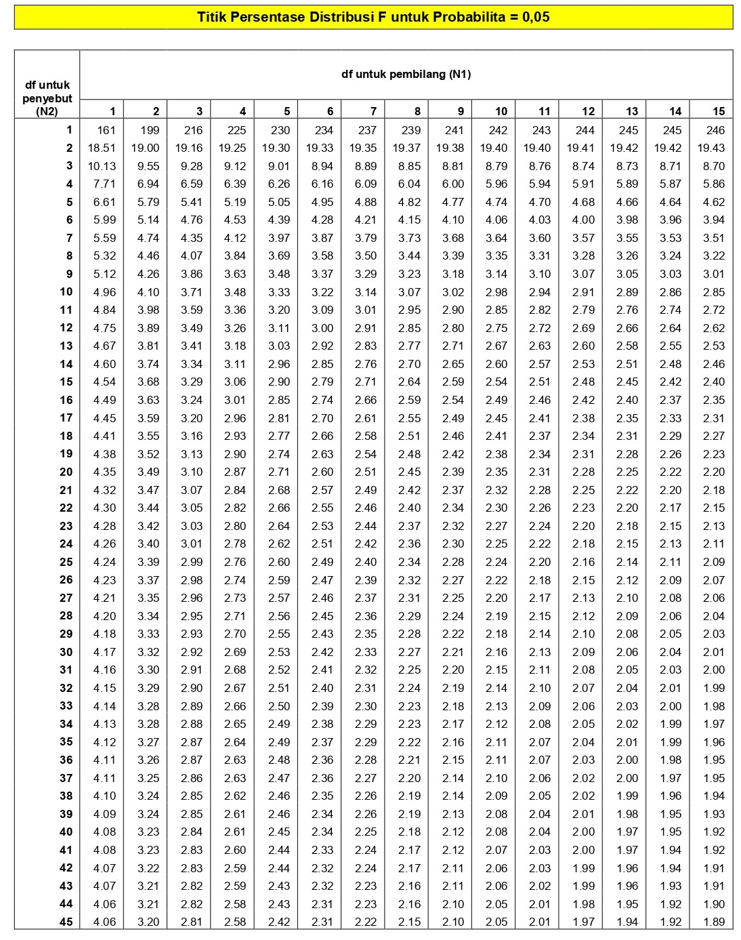

Lampiran 33
DISTRIBUSI NILAI t_{tabel}
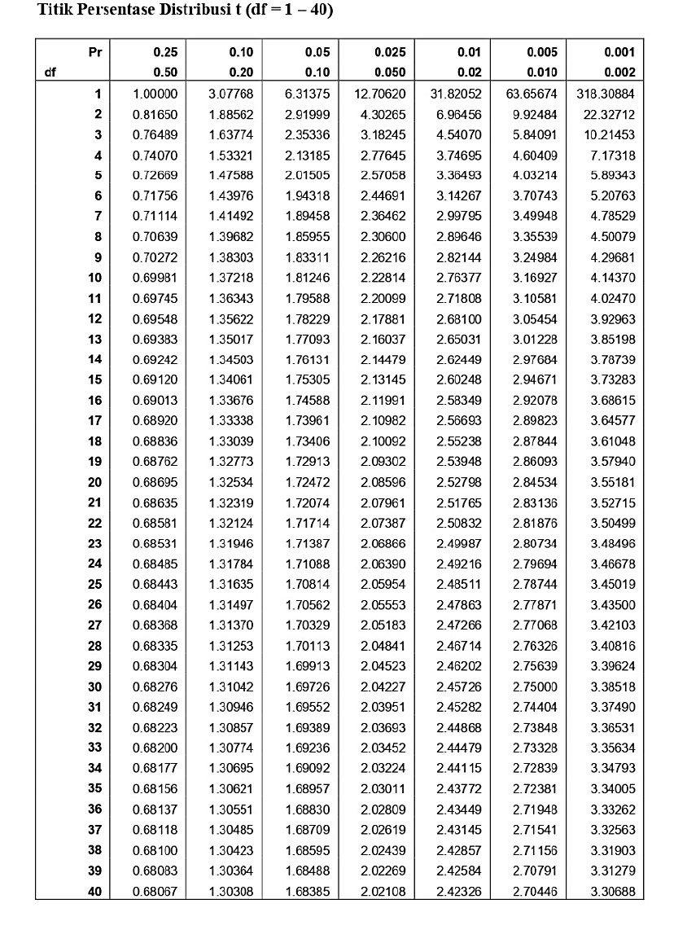

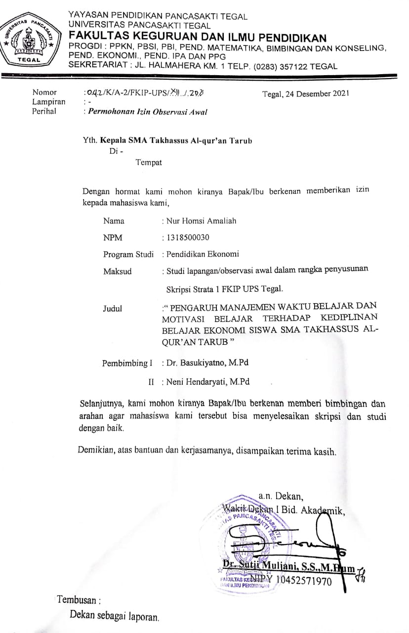

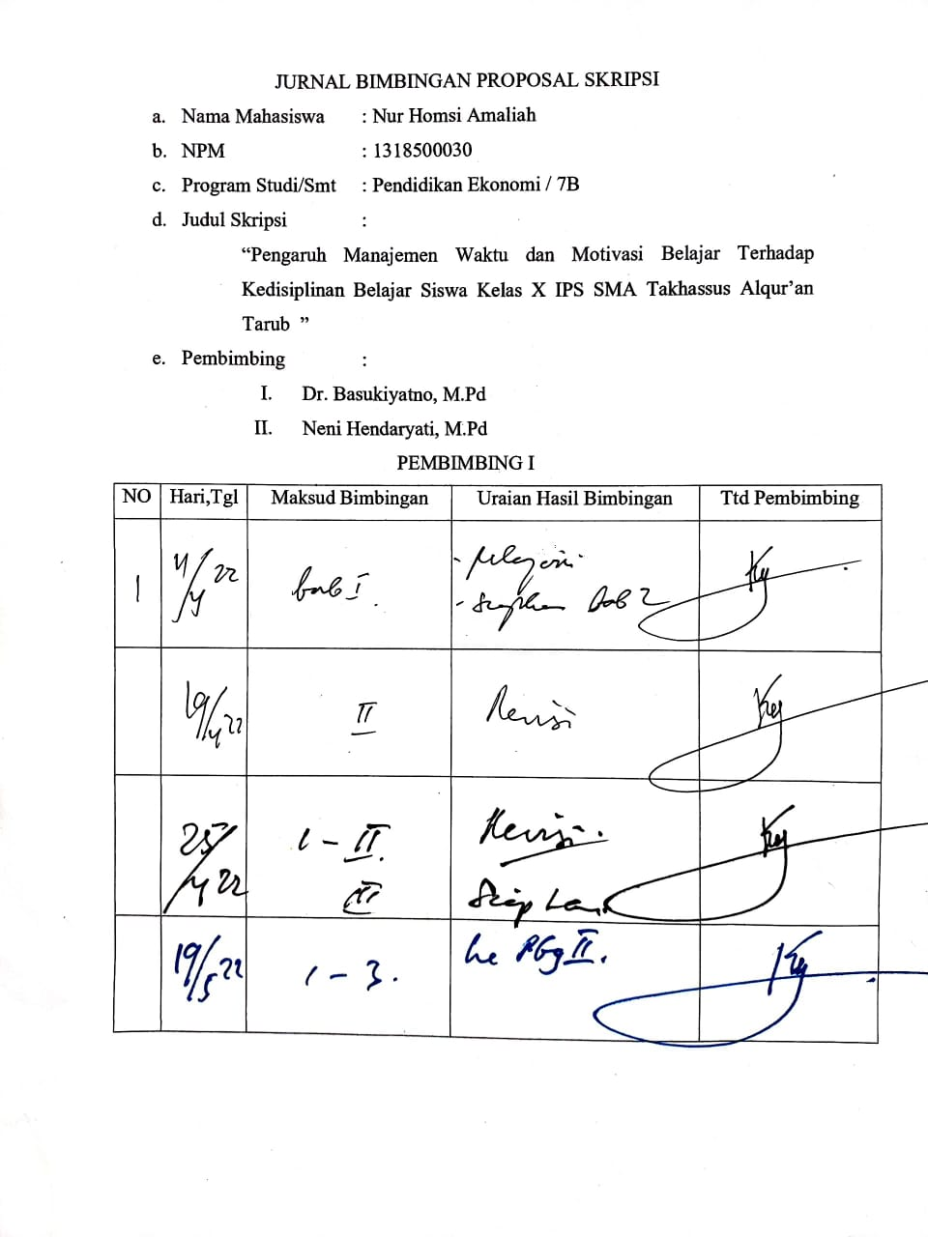

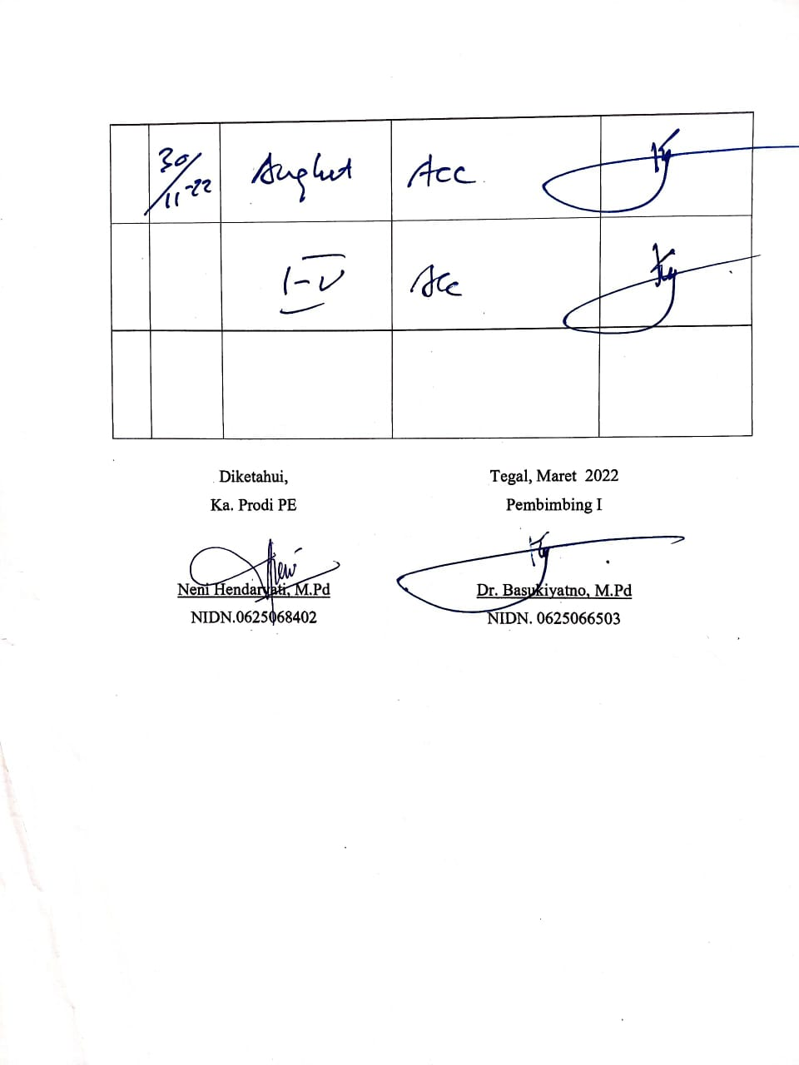

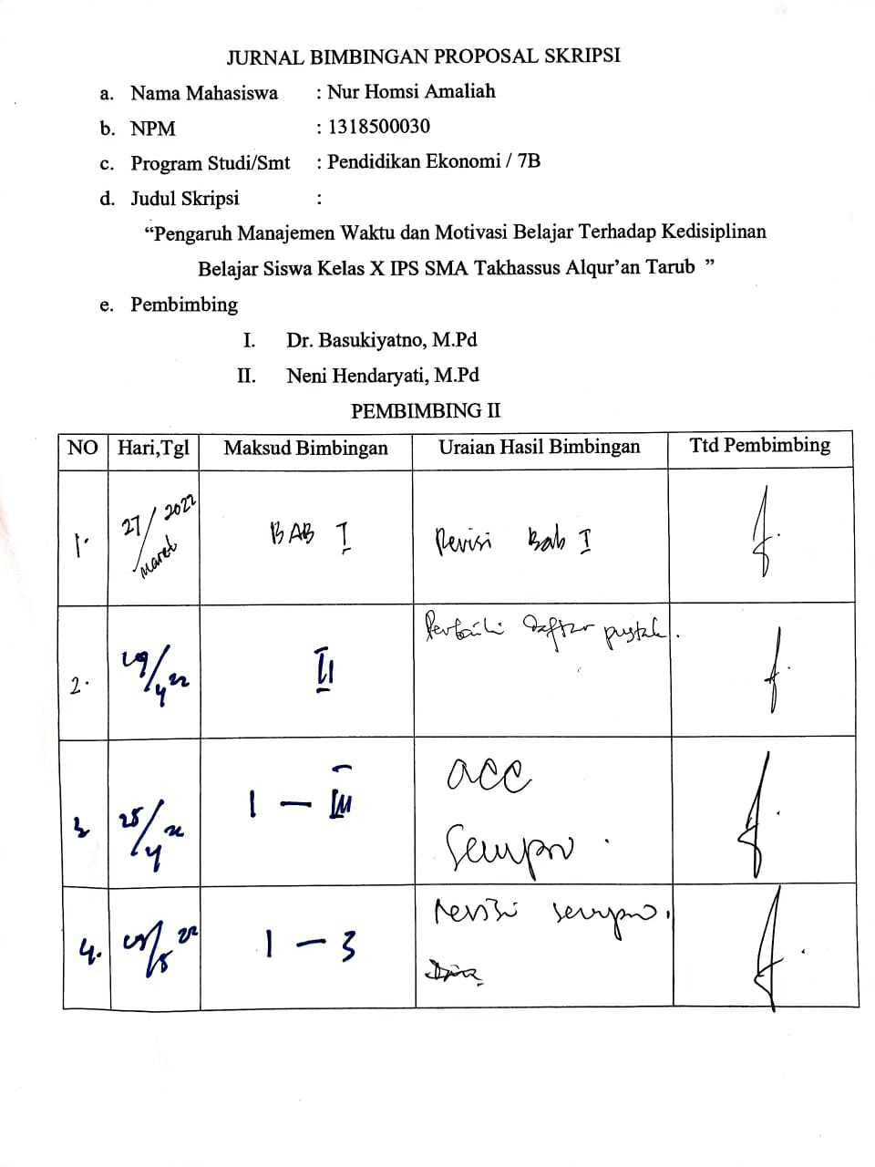

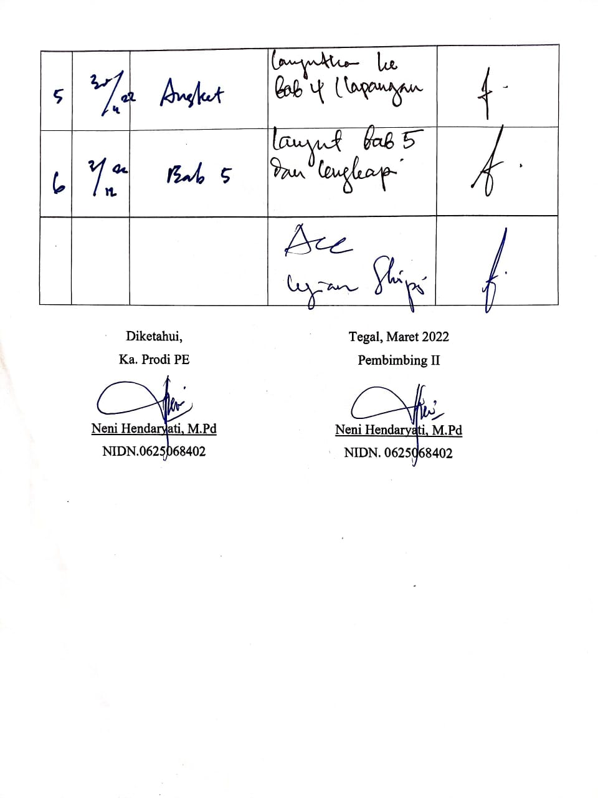

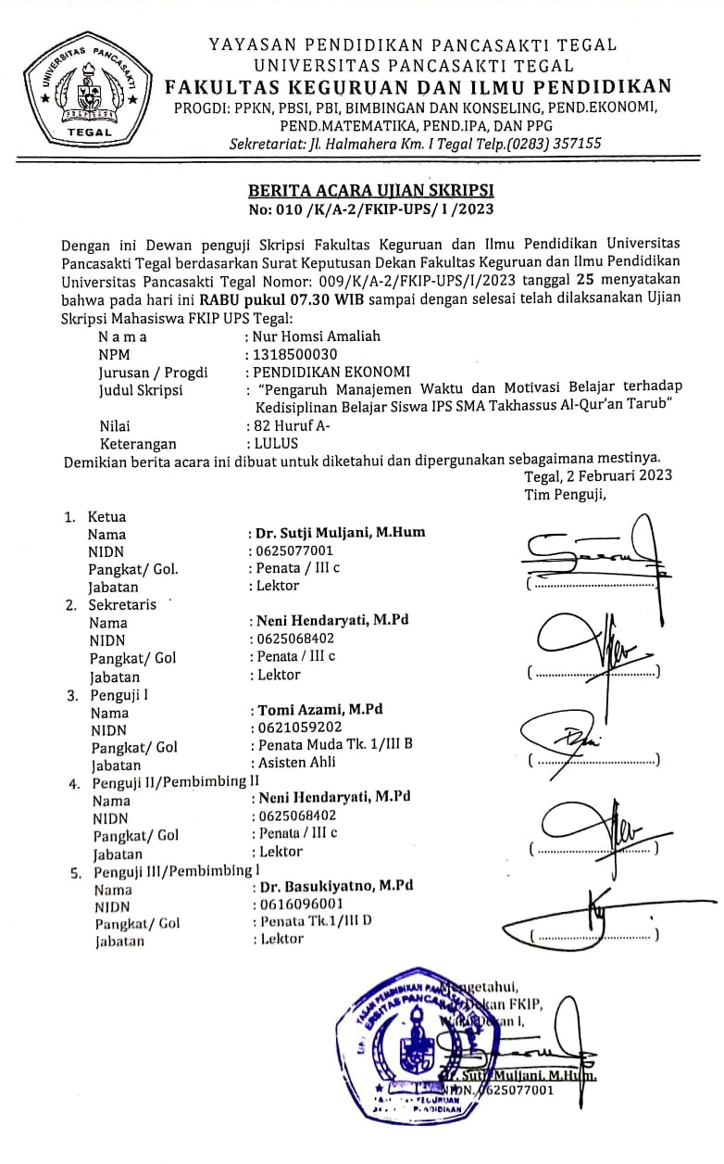
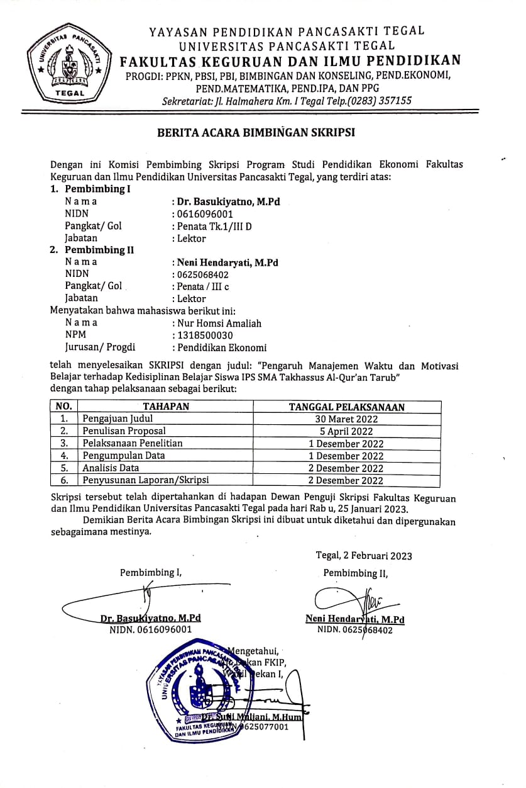

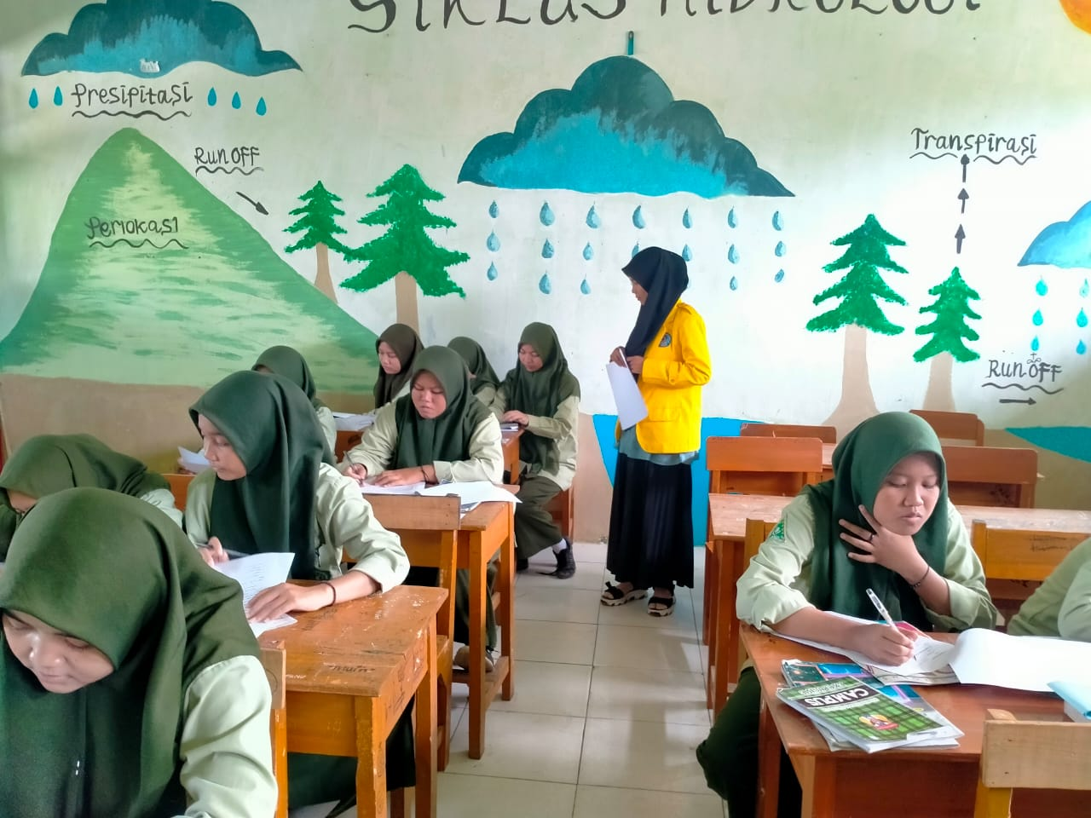

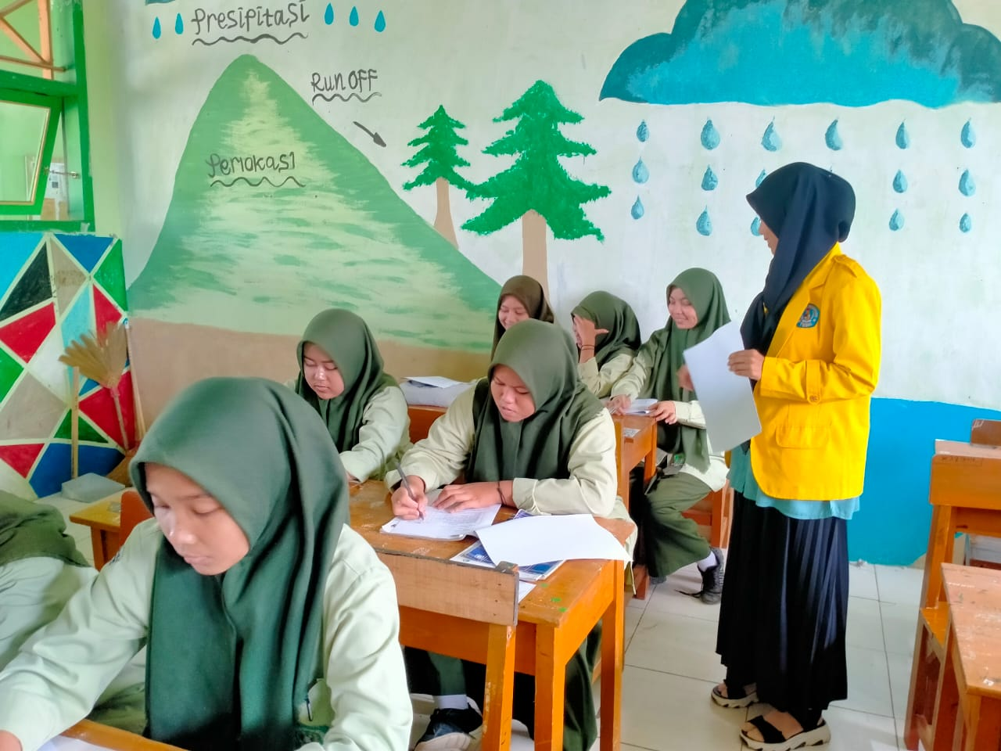

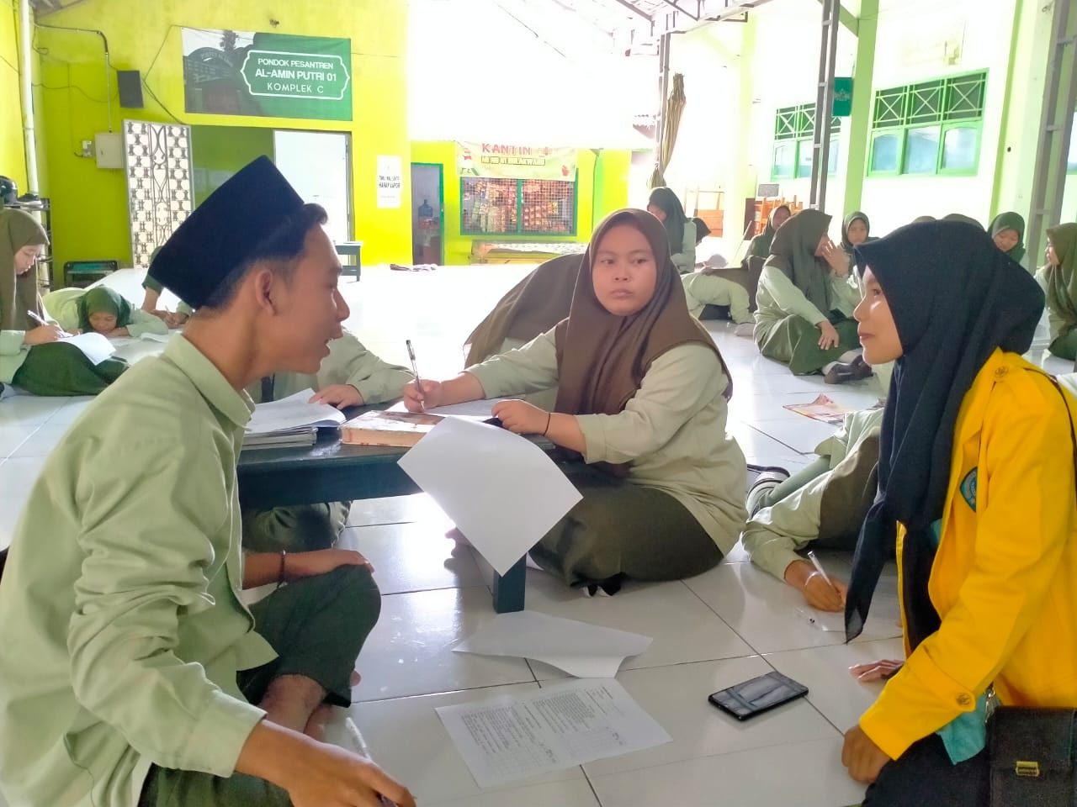
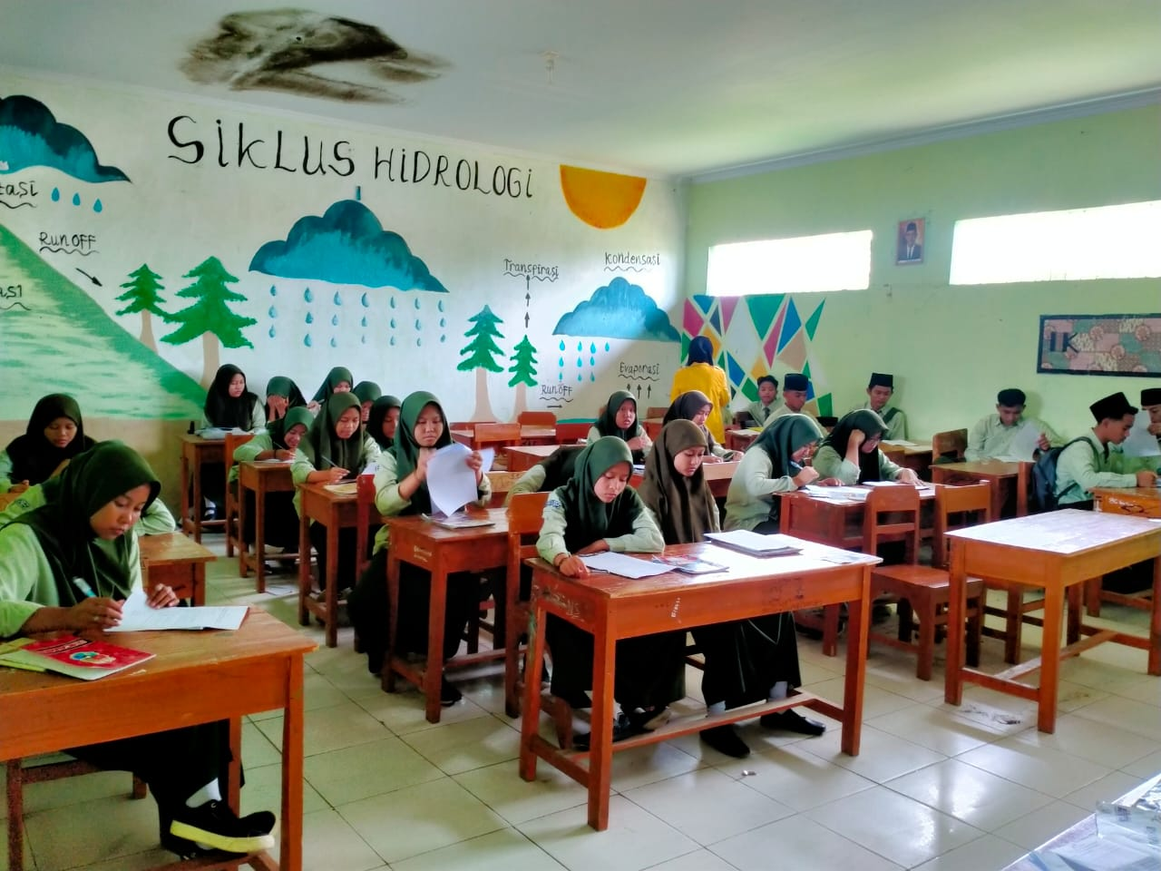

BIODATA PENULIS

Nama : Nur Homsi Amaliah
Tempat, tanggal lahir : Tegal, 07 Mei 1999
Alamat : Jl. Anggrek No. 2, Ds. Bulakwaru, Kec. Tarub, Kab. Tegal
Jenis Kelamin : Perempuan
Agama : Islam

Pendidikan terakhir penulis adalah Strata 1 Universitas Pancasakti Tegal (2018-2022) peneliti berhasil menyelesaikan program studi yang ditekuni pada tahun 2022, dengan judul skripsi “ Pengaruh Manajemen Waktu dan Motivasi Belajar terhadap Kedisiplinan Belajar Siswa IPS SMA Takhassus Al-Qur’an Tarub”. Semoga dengan penulisan tugas akhir skripsi ini mampu memberikan sumbangsih terhadap dunia pendidikan dan menambah referensi penelitian serta bermanfaat bagi pembaca.

