References

Anney, V. N. & Mosha, M. A. (2015). Student’s plagiarisms in higher learning institutions in the era of improved internet access: Case study of developing countries. Journal of Education and Practice, 6(13), 203–216. https://eric.ed.gov/?id=EJ1080502
Australian National University. (2021). How to interpret a Turnitin originality report. Retrieved December 8, 2021, from https://services.anu.edu.au/files/system/Turnitin%20Student%20Guide%2
0%20How%20to%20interpret%20a%20Turnitin%20Originality%20Repor

t.pdf.

Bretag, T. (2005). Implementing plagiarism policy in the internationalised university, part 3. Developing internationalism in the internationalised university: A practitioner research project [Doctoral dissertation, University of South Australia]. Google Scholar.
Bretag, T. & Carapiet, S. (2007). A preliminary study to determine the extent of self-plagiarism in Australian academic research. Plagiary: Cross- Disciplinary study in plagiarism, fabrication and falsification, 2(5), 1-15. https://www.plagiary.org/
Bretag, T. & Mahmud, S. (2009). A model for determining student plagiarism: Electronic detection and academic judgement. Journal of University Teaching and Learning Practice, 6(1), 57-69. https://doi.org/10.53761/1.6.1.6

Bryman, A. & Emma, B. (2011). Business research methods (3rd ed.). Oxford University Press.
Cheah, S.W. & Bretag, T. (2008). Making technology work for academic integrity in Malaysia. Third International Plagiarism Conference [Online]. June 23- 26, Northumbria University, Newcastle upon Tyne, U.K. http://www.plagiarismadvice.org
Coughlin, P. E. (2015). Plagiarism in five universities in Mozambique: Magnitude, detection techniques, and control measures. International Journal for Educational Integrity, 11(1). https://doi.org/10.1007/s40979-
015-0003-5

Council of Writing Program Administrators. (2008). Defining and avoiding plagiarism: The WPA statement on best practices [Publication]. Retrieved December 8, 2021, from www.wpacouncil.org
Culwin, F. (2006). An active introduction to academic misconduct and the measured demographics of misconduct. Assessment & Evaluation in Higher Education, 31(2), 167-182.
Decoo, W. (2001). Crisis on campus: Confronting academic misconduct. MIT Press.
Denzin, N. K. & Lincoln, Y. S. (1994). Competing paradigms in qualitative research; in The SAGE handbook of qualitative research (1st ed.). SAGE Publications.

Denzin, N. K. & Lincoln, Y. S. (2018). Introduction: The discipline and practice of qualitative research; in The SAGE handbook of qualitative research (5th ed.). SAGE Publications.
Deubel, P. (2018). Punishment or policy change: A case of plagiarism in a dissertation. Journal of Educational Research and Practice, 8(1), 101– 112. https://doi.org/10.53761/1.6.1.6
Devlin, M. (2002). Minimising plagiarism. Retrieved December 8, 2021, from http://www.cshe.unimelb.edu.au/assessinglearning/03/plagMain.html
Donnelly, M., Ingalis, R., Morse, T. A., Castner, J. & Stockdell-Giesler, A. M. (2006). (Mis)trusting technology that polices integrity: A critical assessment of Turnitin.com. Inventio, 1(8). http://www.doit.gmu.edu/inventio/issues/ Fall_2006/Donnelly_10.html
Duggan, F. (2003, November 21-22). The plagiarism advisory service: A one-stop shop [Paper presentation]. Asia-Pacific Conference on Educational Integrity: Plagiarism and Other Perplexities, Adelaide, Australia.
Evering, L. C., & Moorman, G. (2012). Rethinking plagiarism in the digital age.

Journal of Adolescent & Adult Literacy, 56(1), 35-44.

Goh, E. (2013). Plagiarism behavior among undergraduate students in hospitality and tourism education. Journal of Teaching in Travel and Tourism, 13(4), 307-322. https://doi.org/10.53761/1.6.1.6
Government of Republic Indonesia. (2010). The regulation of Minister of National Education no. 17 of 2010 on the prevention of and

countermeasures against plagiarism on higher education institutions. Ministry of National Education of Republic Indonesia.
Guba, E. G. (1990). The alternative paradigm dialogue; in The paradigm dialogue. SAGE Publications.
Guba, E. G. & Lincoln, Y. S. (1994). Competing paradigms in qualitative research; in The SAGE handbook of qualitative research (pp. 105-117). SAGE Publications.
Harris, R. A. (2001). The plagiarism handbook: Strategies for preventing, detecting, and dealing with plagiarism. Eyrczak Publishing.
Harris, R. (2015, May 18). Anti-Plagiarism strategies for research papers [Electronic Version]. VirtualSalt. Retrieved on December 8, 2021, from https://www.virtualsalt.com/antiplag.htm
Heckler, N. C., Rice, M., & Hobson, B. C. (2013). Turnitin systems: A deterrent to plagiarism in college classrooms. Journal of Research on Technology in Education, 45(3), 229-248.
Hogue, A. & Oshima, A. (2007). Introduction to academic writing (3rd ed.).

Pearson Education.

ICAI. (1999, updated 2013). Fundamental values project. Retrieved December 8, 2021, from http://www.academicintegrity.org/icai/resources-2.php
Irvin, L. L. (2010). What is “academic” writing?; in Writing spaces: Readings on writing (volume 1). Parlor Press.
Kumar, R. (2011). Research methodology: A step-by-step guide for beginners (3rd ed.). SAGE Publications.

Kutieleh, S., & Adiningrum, T. S. (2011). How different are we? Understanding and managing plagiarism between East and West. Journal of Academic Language and Learning, 5(2), A88-A98.
Levy, M. & Stockwell, G. (2006). CALL dimensions: Options and issues in computer-assisted language learning. Lawrence Erlbaum Associates, Inc.
Liu, M., Yang, D., He, F., Li, M., & Doss, D. A. (2016). Professionalism: Assessing full-time vs. part-time student perceptions of plagiarism. Proceedings of the Academy of Organizational Culture, Communications and Conflict, 21(1), 35). Jordan Whitney Enterprises, Inc.
Lupton, R. A. & Chaqman, K. J. (2002). Russian and American college students' attitudes, perceptions and tendencies towards cheating. Educational Research, 44(1), 17-27.
Marsden, H., Carroll, M., & Neill, J. T. (2005). Who cheats at university? A self- report study of dishonest academic behaviours in a sample of Australian university students. Australian Journal of Psychology, 57(1), 1-10.
Martin, J. A., Reaume, K. M., Reeves, E. M., & Wright, R. D. (2012).

Relationship building with students and instructors of ESL: Bridging the gap for library instruction and services. Reference Services Review, 40(3), 352-367.
McCabe, D. (2005). Cheating among college and university students: A North American perspective. International Journal for Educational Integrity, 1(1). http://ojs.ml.unisa.edu.au/index.php/IJEI/article/ view/14/9

McCabe, D. L., Butterfield, K. D., & Trevino, L. K. (2012). Cheating in college: Why students do it and what educators can do about it. Johns Hopkins University Press.
McCallum, L. and Coombe, C. (2020). The assessment of L2 written English across the MENA region: A synthesis of practice. Springer International Publishing.
McKeever, L. (2006). Online plagiarism detection services – Saviour or scourge?

Assessment & Evaluation in Higher Education, 31(2), 155-165.

Norlina. (2017). The reason of plagiarism tendency on english students’ theses at IAIN Palangka Raya [Sarjana Pendidikan’s thesis, IAIN Palangka Raya]. IAIN Palangka Raya Digital Library. http://digilib.iain-
palangkaraya.ac.id/826/

Park, C. (2004). Rebels without a clause: Towards an institutional framework for dealing with plagiarism by students. Journal of Further and Higher Education, 28(3), 291–306. http://www.lancaster.ac.uk/staff/gyaccp/rebels%20without%20a%20claus
e.pdf

Polit, D. F. & Beck, C. T. (2009). Essentials of nursing research: Appraising evidence for nursing practice. Wolters Kluwer Health.
Ramadhan, Z. (2017). Plagiarism in Master of Education studies at selected East African universities [Master of Education’s thesis, Nelson Mandela Metropolitan University]. CERM-ESA. https://cermesa.uol.de/wp-
content/uploads/2018/05/ZAINABU-RAMADHAN.pdf

Rudaitienė, L. & Vyšniauskienė, D. (2002). Ethical problems in lecturer's academic environment. Socialiniai Mokslai, 3(35).
Scaife, B. (2007). IT consultancy plagiarism detection software report for JISC advisory service. NCC Group.
Singhal, M. (2004). Academic writing and generation 1.5: Pedagogical goals and instructional issues in the college composition classroom. The Reading Matrix, 4(3), 1–13.
Trochim, W. M. & Donnelly, J. P. (2006). The research methods knowledge base.

Thomson Custom Publishing.

University of North Carolina—Charlotte. (2017). Code of student academic integrity. Retrieved December 8, 2021, from https://legal.uncc.edu/policies/up-407
Wahyuni, S. (2012). Qualitative research method: Theory and practice. Salemba Empat.
Zobel, J. & Hamilton, M. (2002). Managing student plagiarism in large academic departments. Australian Universities' Review, 45(2), 23-30.

APPENDIX

APPENDIX A

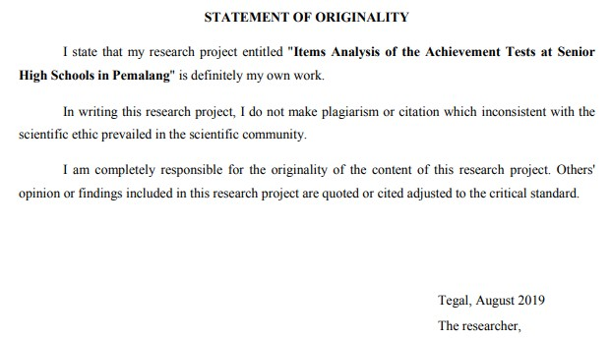Statement of Originality - Student A

APPENDIX B

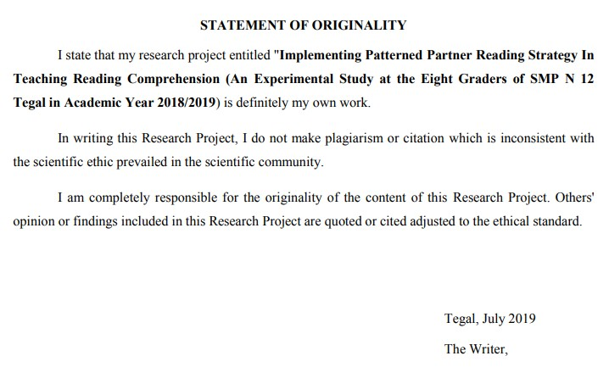Statement of Originality - Student B

APPENDIX C

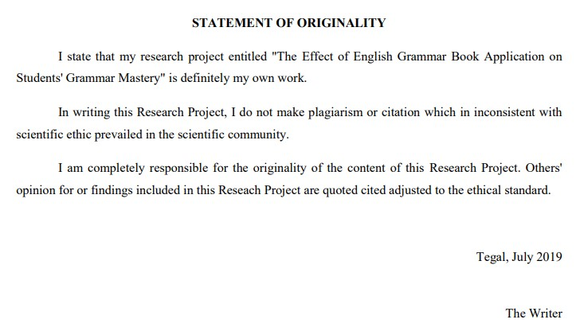Statement of Originality - Student C

APPENDIX D

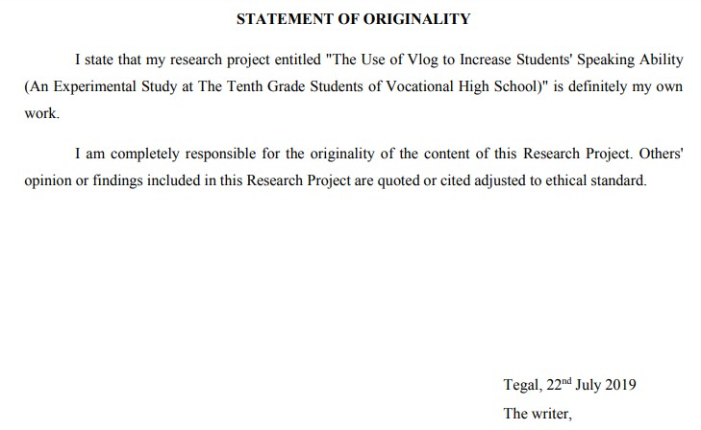Statement of Originality – Student D

APPENDIX E

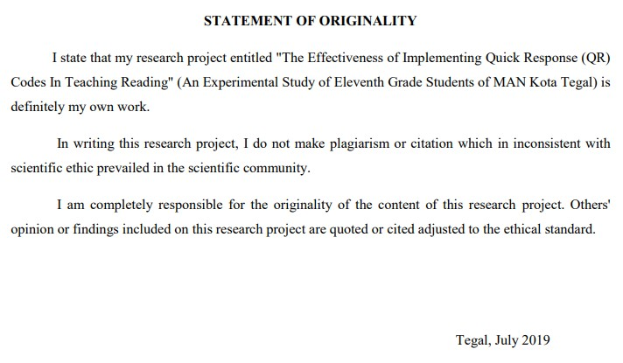Statement of Originality - Student E

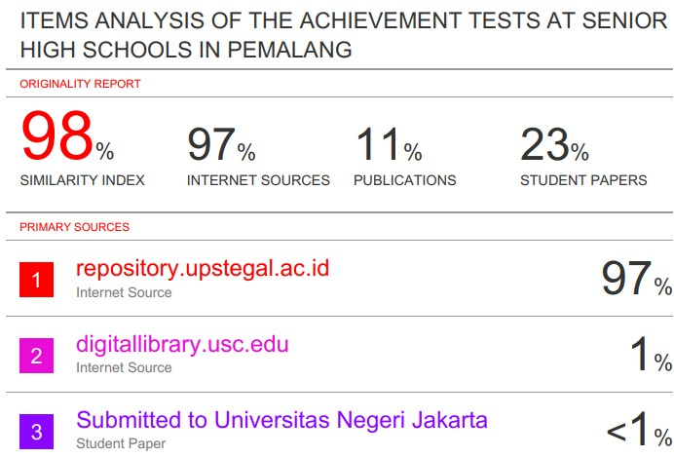

APPENDIX F

Turnitin’s Similarity Report of Student A

APPENDIX G

Turnitin’s Similarity Report of Student B
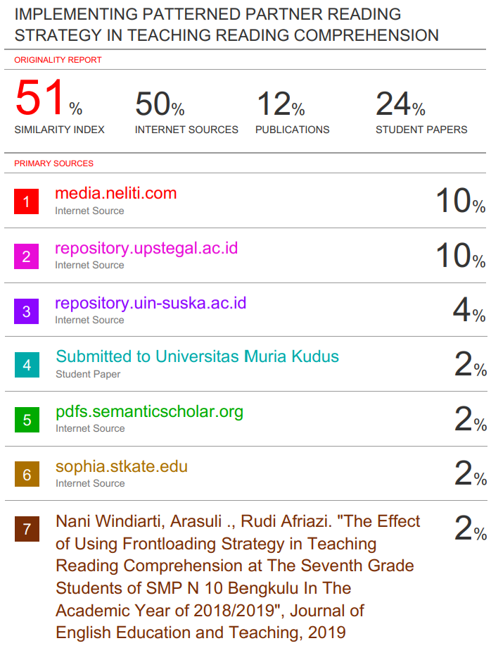

APPENDIX H

Turnitin’s Similarity Report of Student C
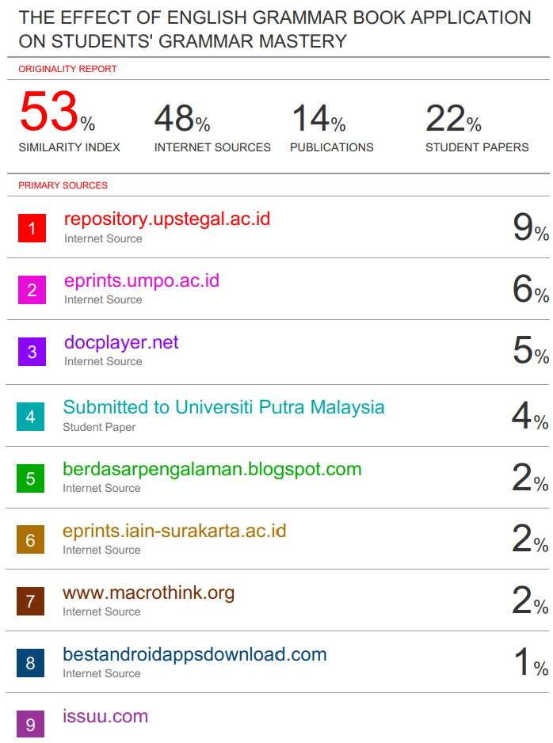

APPENDIX I

Turnitin’s Similarity Report of Student D
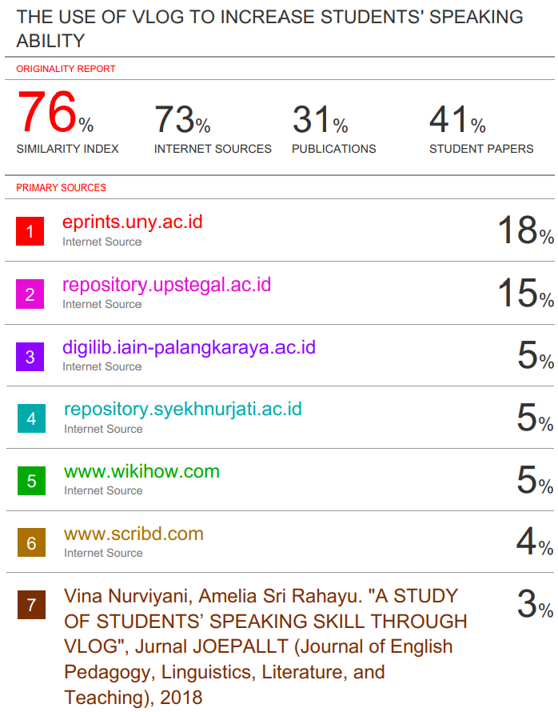

APPENDIX J

Turnitin’s Similarity Report of Student E
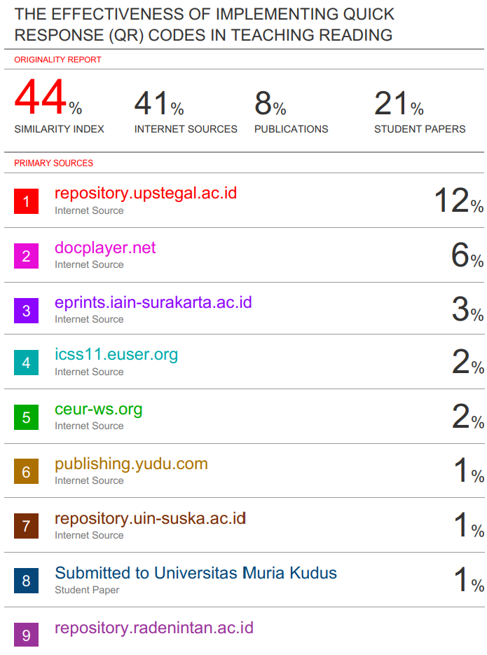

APPENDIX K

The List of Codes (Final Cycle) and Their Instances of Occurrence
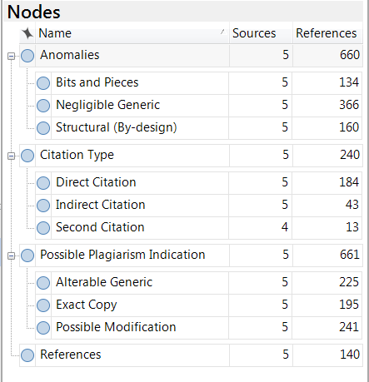

APPENDIX L

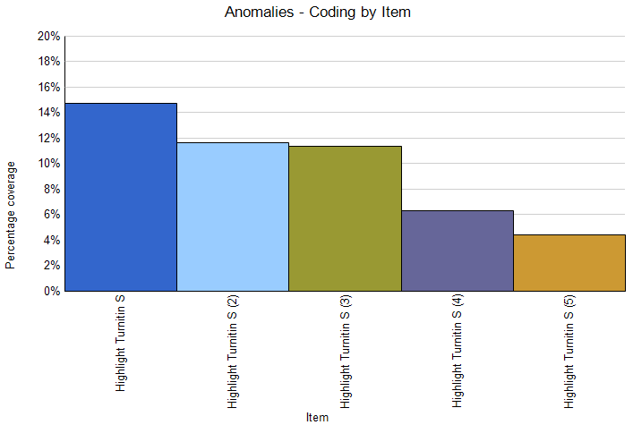The Percentage Count of “Anomalies” Code Among Student A, B, C, D, and E

APPENDIX M

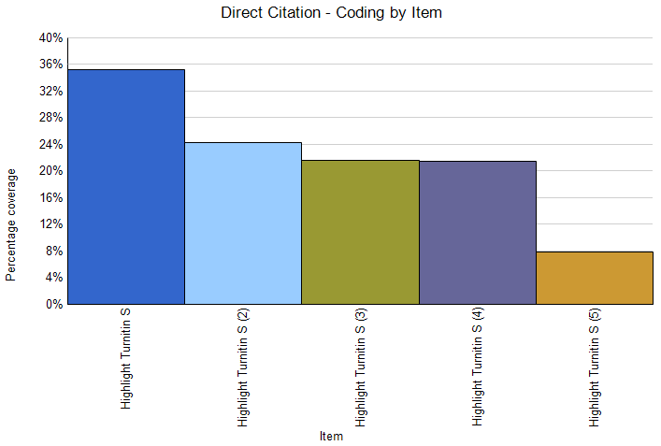The Percentage Count of “Direct Citation” Code Among Student A, B, C, D, and E

APPENDIX N

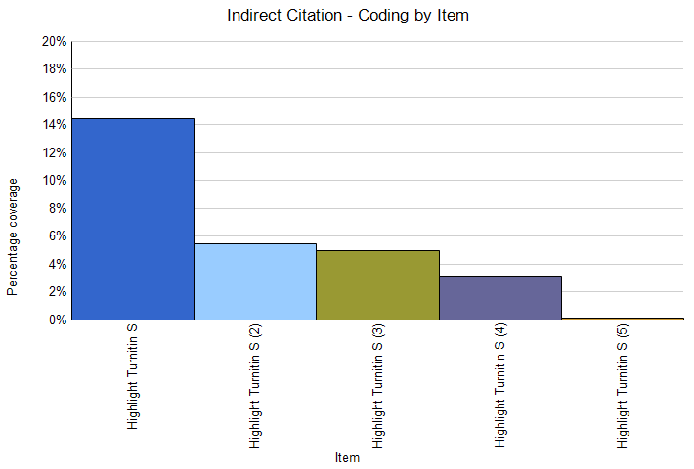The Percentage Count of “Indirect Citation” Code Among Student A, B, C, D, and E

APPENDIX O

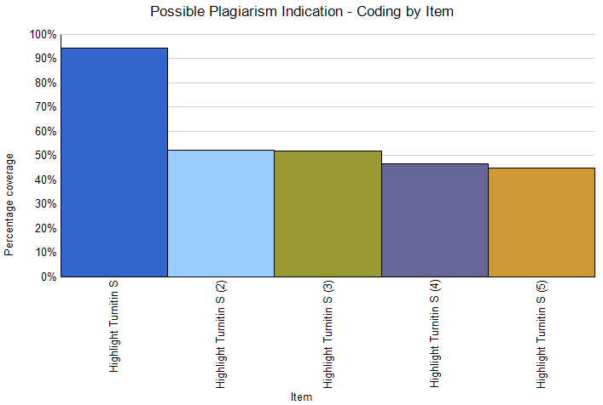The Percentage Count of “Possible Plagiarism” Code Among Student A, B, C, D, and E

