BIBLIOGRAPHY

Abdul, P., Awan, G., & Shafi, M. (2017). Analysis of Teaching Methods of English. Global Journal of HUMAN-SOCIAL SCIENCE: G Linguistics & Education, 16(8), 34–42.
Ahmadzai, S., Katawazai, R., & Sandaran, S. C. (2019). The use of deductive and inductive approaches in teaching grammar for Afghan University students of English and literature studies. International Journal of Engineering and Advanced Technology, 8(5), 1230–1235. https://doi.org/10.35940/ijeat.E1175.0585C19
Alemi, Maedeh & Tavakoli, E. (2019). Audio Lingual Method Maedeh. September, 0–5. http://repo.iain-tulungagung.ac.id/id/eprint/12810
Anabokay, Y. M., & Suryasa, I. W. (2019). TEFL Methods in Indonesia.

International Journal of Linguistics, Literature and Culture, 5(2), 13–24. https://doi.org/10.21744/ijllc.v5n2.612
Andriani, K. (2022). TEACHING MEDIA IN EFL CLASSROOMS: WHAT

ARE THEY AND WHY SELECT THEM? Journal of Language Testing and Assessment, 2(1), 87–97. https://ojs.fkip.unismuh.ac.id/index.php/jlta
Astrid, A., Dwi Amrina, R., Desvitasari, D., Fitriani, U., & Shahab, A. (2019).

|ISSN: 2580-5711 Raden Fatah, South Sumatra, Indonesia. 5. State Polytechnic of Sriwijaya Palembang. South Sumatera IRJE |, 3(1), 2580– 5711.

Bahri, A., Damayanti, C. M., Sirait, Y. H., & Alfarisy, F. (2022). Aplikasi Tiktok Sebagai Media Pembelajaran Bahasa Inggris Di Indonesia. 3(1), 1120– 1130. http://jiss.publikasiindonesia.id/
Bakka, V. (2018). Vinod Bakka-Differences Between Prescriptive and Descriptive Grammars :Contexts of Use DIFFERENCES BETWEEN PRESCRIPTIVE AND DESCRIPTIVE GRAMMARS : CONTEXTS OF USE. International
Journal of Information Movement, 2(X), 23–31. www.ijim.in

Batchwood.herts. (2019). What Are Learning Objectives ? A learning objective should describe what students should know or be able to do at the end of the course that they couldn ’ t do before . http://batchwood.herts.sch.uk.
Bawa, N. (2020). Realia and Its Relevance in the 21 st Century Learning . Realia and Its Relevance in the 21 st Century Learning Esxon Publishers.
November.

Berg, C., Swieciak, T., Philipp, J., Felske, C., Wegener, B., & Phillips, A. (2018). Dialogues for the English Classroom: A How-To With Examples for Middle and Secondary English and Language Arts Teacher Preparation and Professional Development (Issue April 2018).
Bezusa, A., & Samoylyukevych, I. (2020). Innovative Techniques for Teaching Foreign Languages. Теорія І Практика Навчання …, 6(11), 2018–2021. http://eprints.zu.edu.ua/30945/1/Збiрник_студ_конф_2020_правка.pdf#pag e=31

Bimrew Sendekie Belay. (2022). THE USE OF DICTATION TECHNIQUE IN TEACHING WRITING. 3002–3002 ,7202.5.8 ,הארץ.
Bradley, V. M. (2020). Learning Management System (LMS) Use with Online Instruction. International Journal of Technology in Education, 4(1), 68. https://doi.org/10.46328/ijte.36
Busetto, L., Wick, W., & Gumbinger, C. (2020). How to use and assess qualitative research methods. Neurological Research and Practice, 2(1). https://doi.org/10.1186/s42466-020-00059-z
Cahyana, A. A. C. (2020). the Use of Youtube Video in Teaching English for Foreign Language At Vocational High School. Jurnal Pendidikan Bahasa Inggris Indonesia, 8(2), 1–11. https://doi.org/10.23887/jpbi.v8i2.3399
CAHYANINGSI, D. W. I., & Kurniawan, F. (2021). The Difficulties Of Teaching At A Distance Through Youtube-The Video Based Teaching Amidst The Pandemic At SMA 2 Tarakan. Academia Edu, 1–10. http://eprints.ums.ac.id/id/eprint/90778
Daneshfar, S., Aliasin, S. H., & Hashemi, A. (2018). The Effect of Dynamic Assessment on Grammar Achievement of Iranian Third Grade Secondary School EFL Learners. Theory and Practice in Language Studies, 8(3), 295. https://doi.org/10.17507/tpls.0803.04
Daslin, F. H., & Zainil, Y. (2019). Journal of English Language Teaching Teachers ’ Use of Wait Time : A Case Study of Questioning Strategies in

SMAN Padang. 9(4), 718–732. https://doi.org/10.24036/jelt.v9i4.110338

Dewi, N. P. S. S., Padmadewi, N. N., & Santosa, M. H. (2021). The Implementation of Flipped Classroom Model in Teaching English to Junior High School Students. Journal of Educational Research and Evaluation, 5(2), 125–135. https://ejournal.undiksha.ac.id/index.php/JERE
Ekka, P. M. (2021). A review of observation method in data collection process.

6(12), 17–19.

Evaluated, F. M. (2017). Instructional Observation Checklist. April. Fachraini, S. (2018). the Effect of Using Storytelling Technique in Teaching.
Fauziah. (2019). the Effect of Using Dictogloss Technique Towards Students ’ Ability in Writing.
Fay, A. D. A., & Matias, J. (2019). Teaching English Through Youtube: Grammar Video Analysis of Three Brazilian Youtube Channels Dedicated To Efl Teaching. English Review: Journal of English Education, 8(1), 1. https://doi.org/10.25134/erjee.v8i1.2351
Gill, A. K., & . K. (2017). Teaching Approaches, Methods and Strategy. Scholarly Research Journal for Interdisciplinary Studies, 4(36). https://doi.org/10.21922/srjis.v4i36.10014
Hago, S. A. (2020). The Pros and Cons of the Grammar Translation Method on the Performance of Saudi EFL Learners. Arab Journal for Scientific

Publishing (AJSP) ISSN, 2663, 382–392. https://www.ajsp.net/research/The Pros and Cons.pdf
Harris, J. (2018). Presentation Skills for Teachers. Presentation Skills for Teachers. https://doi.org/10.4324/9781315041674
In, V., Grammar, T., & Junior, I. N. (2018). VIDEOS IN TEACHING GRAMMAR IN JUNIOR. 165–170.
Jose, J. (2022). Dictogloss for English Language Teaching: An Experimental Lesson and Reflections. International Journal of Linguistics, 14(1), 73. https://doi.org/10.5296/ijl.v14i1.19605
Journal, I., & Orange, O. N. (2021). Some approaches of teaching grammar. 4–7.

Kadariyah, N. (2019). FUN GRAMMAR TEACHING Nur Laila Kadariyah A Lecturer of English Education Department at Faculty of Tarbiyah and Teachers Training of IAIN Antasari Banjarmasin.
Khan, A., Egbue, O., Palkie, B., & Madden, J. (2017). Active learning: Engaging students to maximize learning in an online course. Electronic Journal of E- Learning, 15(2), 107–115.
Lecturer, A., & Abdulsalam, E. (2018). The Role of Grammar-Translation Method in Enhancing EFL Learning Skills. 197–204. https://doi.org/10.23918/vesal2018.a15
Luo, T., Chen, S., Xu, G., & Zhou, J. (2017). Trust-based Collective View

Prediction. Trust-Based Collective View Prediction, June 2017. https://doi.org/10.1007/978-1-4614-7202-5
Mahmudah, L., & Izzah, L. (2019). Students’ Understanding on Simple Past Tense through VOA Learning English YouTube Channel. English Language in Focus (ELIF), 1(2), 89. https://doi.org/10.24853/elif.1.2.89-94
Mathews, J. R. J. (2019). Student perceptions of teacher credibility: A predictor of academic success. Dissertation Abstracts International Section A: Humanities and Social Sciences, 80(11-A(E)). https://search.ebscohost.com/login.aspx?direct=true&db=psyh&AN=2019- 46353-052&lang=it&site=ehost-live
Megawati. (2017). Academic Year at Private Vocational High School TaposDepok ). The Improving Student ’s Reading Comprehension Through Grammar Translation Method, 2, 95–108.
Megawati, I., Basikin, & Wibawa, S. (2020). Teacher’s strategies of managing classroom and students’ response: A case study. Elementary Education Online, 19(2), 20–33. https://doi.org/10.17051/ilkonline.2020.02.103
Mohamad Razali, R., & Abdul Halim, H. (2021). Integration of YouTube Videos in Learning Present Perfect Tense in an ESL Classroom. Asian Journal of Research in Education and Social Sciences, 3(1), 49–59. http://myjms.mohe.gov.my/index.php/ajress/article/view/12522
Morgan, S. J., Pullon, S. R. H., MacDonald, L. M., McKinlay, E. M., & Gray, B.

V. (2017). Case study observational research: A framework for conducting case study research where observation data are the focus. Qualitative Health Research, 27(7), 1060–1068. https://doi.org/10.1177/1049732316649160
Nicolas, A. (2021). Quantitative Observation in Research. https://www.researchprospect.com/quantitative-observation-in-research/
Paul, S., & Rai, M. (2020). The Palgrave Encyclopedia of Global Security Studies. The Palgrave Encyclopedia of Global Security Studies, March. https://doi.org/10.1007/978-3-319-74336-3
Personal, M., & Archive, R. (2018). Munich Personal RePEc Archive Qualitative Research Methodology in Social Sciences and Related Subjects Qualitative Research Methodology in Social Sciences and Related Subjects. Journal of Economic Development, Environment and People, 7(85654), 23–48.
Phillippi, J., & Lauderdale, J. (2018). A Guide to Field Notes for Qualitative Research: Context and Conversation. Qualitative Health Research, 28(3), 381–388. https://doi.org/10.1177/1049732317697102
Prospective, D., & Corps, P. (2018). Pre-departure TEFL Grammar and Methodology Manual Dear Prospective Peace Corps Volunteers ,. 1–56.
Rahman, F. (2018). Grammar Translation Method. https://www.ptonline.com/articles/how-to-get-better-mfi-results
Rambe, S. (2019). Total Physical Response. English Education : English Journal for Teaching and Learning, 7(01), 45.

https://doi.org/10.24952/ee.v7i01.1652

Robertson Richard Acklam, C., Richard Acklam, B., & Robertson, C. (2018).

Action Plan for Teachers Action Plan for Teachers About the authors. www.bbc.co.uk/worldservice/learningenglish
Roopa, S., & Rani, M. (2018). Questionnaire Designing for a Survey. Journal of Indian Orthodontic Society, 46(4_suppl1), 273–277. https://doi.org/10.1177/0974909820120509s
Sarah Gerges. (2022). Lesson Preparation and Planning. May, 0–8. https://www.researchgate.net/publication/360688235_Lesson_Preparation_a nd_Planning
Sari, E. P. (2018). THE USE OF GAMES AS A STRATEGY TO TEACH ENGLISH

TO YOUNG LEARNERS Presented as Partial Fulfillment of the Requirements to obtain the Sarjana Pendidikan Degree in English Language Education ENGLISH LANGUAGE EDUCATION STUDY PROGRAM DEPARTMENT OF LANGUAGE AND ARTS EDUCATION FACULTY OF TEACHERS TRAINING AND EDUCATION SANATA DHARMA UNIVERSITY YOGYAKARTA 2018 PLAGIAT MERUPAKAN TINDAKAN TIDAK TERPUJI.
Sari, I. Y. K. (2021). Dictation Activities in Teaching English at State Islamic Junior High School Surabaya.
Sarode, R. D. (2018). Teaching Strategies, Styles and Qualities of a Teacher: A

Review for Valuable Higher Education. International Journal of Current Engineering and Scientific Research (IJCESR), 5(5), 58. http://troindia.in/journal/ijcesr/vol5iss5part2/57-62.pdf
Shahibi, M. S., & Rusli, K. N. K. K. (2017). The Influence of Internet Usage on Studentâ™s Academic Performance. International Journal of Academic Research in Business and Social Sciences, 7(8), 873–887. https://doi.org/10.6007/ijarbss/v7-i8/3301
Shanmugavelu, G., Ariffin, K., Vadivelu, M., Mahayudin, Z., & R K Sundaram,

M. A. (2020). Questioning Techniques and Teachers’ Role in the Classroom.

Shanlax International Journal of Education, 8(4), 45–49. https://doi.org/10.34293/education.v8i4.3260
Shukla, S. (2020). Concept of Population and Sample. How to Write a Research Paper, June, 1–6. https://www.researchgate.net/publication/346426707_CONCEPT_OF_POP ULATION_AND_SAMPLE
Soe, K., Aung, M., & Tepsuriwong, S. (2017). Lesson openings : How teachers begin lessons in an English class. Online Proceedings of the International Conference: DRAL 3/19th ESEA 2017, DRAL 3, 252–263.
ola.kmutt.ac.th/dral2017/proceedings/5-6Additional/252-263_Lesson Openings_Khin Soe Myint Aung and Saowaluck Tepsuriwong.pdf
Souisa, T. R., & Yanuarius, L. (2020). Teachers’ strategies on teaching grammar: Facts and expectations of senior high school teachers at ambon. International

Journal of Evaluation and Research in Education, 9(4), 1121–1127. https://doi.org/10.11591/ijere.v9i4.20643
Sri Sulastri. (2018). the Application of Communicative Approach in English Teaching At Smpn 1 Tondong Tallasa,Pangkep. Unismuh, 1–63.
Srivastava, K., & Dey, S. (2018). Role of Digital Technology in Teaching- Learning Process. IOSR Journal Of Humanities And Social Science (IOSR- JHSS, 23(1), 74. https://doi.org/10.9790/0837-2301057479
Srivastava, S. (2018). Definition, Meaning & Characteristic of Organisation.

Swarnananda Gamage, K. G. (2020). The Pedagogical Application of the Grammar Translation Method as an Effective Instructional Methodology in Teaching English as a Second Language. OALib, 07(11), 1–10. https://doi.org/10.4236/oalib.1106913
Syafrizal, S., & Haerudin, H. (2018). the Implementation of Vocabulary Building Strategy in Teaching English Vocabulary To Young Learners. Jo-ELT (Journal of English Language Teaching) Fakultas Pendidikan Bahasa & Seni Prodi Pendidikan Bahasa Inggris IKIP, 5(1), 40. https://doi.org/10.33394/jo-elt.v5i1.2296
Taherdoost, H. (2018). Validity and Reliability of the Research Instrument; How to Test the Validation of a Questionnaire/Survey in a Research. SSRN Electronic Journal, September. https://doi.org/10.2139/ssrn.3205040
Tinoco-Añazco, J. (2017). DIALOGUE-BUILDING TECHNIQUE TO INCREASE

ORAL FLUENCY THROUGH PAIR WORK Maestría en Educación.

Toluwa, O., & Mary, A. O. (2020). Effects Of Analogy-Enhanced Instructional Strategy on Learning Outcomes of Students in Basic Science Practical Skills in Ekiti. 2(4), 41–45.
Torres, T. (2017). No 主観的健康感を中心とした在宅高齢者における健康関連指標に関する共分散構造分析Title. 111.
Waheed, M. (2018). Teaching English Language Methods and approaches. 41. https://www.academia.edu/36425796/Teaching_English_Language_Methods
_and_approaches

Wibowo, F. E. (2020). A Mind Mapping : A Strategy to Enhance Students’ English Grammatical Structure. Al-Lisan, 5(2), 213–229. https://doi.org/10.30603/al.v6i2.1321
Yakub, A. (2019). CYPRUS INTERNATIONAL UNIVERISTY INSTITUTE OF GRADUATE STUDIES AND RESEARH DEPARTMENT OF ARCHITECTURE QUESTIONNAIRE RESEARCH METHOD BY Instructor
Asst . Prof Dr Ayşe ÖZTÜRK. 1–10. https://www.academia.edu/39137163/Questionnaire_Research_Methodology
Yi, D. (2021). Grammar translation and its use in present-day China: Challenges and issues. Journal of Arts & Humanities, 10(5), 28–35.
Zarei, A. A., & Feizollahi, B. (2018). Concept Mapping and Brainstorming Affecting Writing Anxiety and Accuracy. Journal of Modern Research in

English Language Studies, 5(1), 117–144.

APPENDICES

Appendices 1 : Name Ten Graduated Students Of English Education Of Faculty Teacher Training Universitas Pancasakti Tegal .

No | Name | Nickname
1. | Maulida Fortuna Uzma | Uzma
2 | Maya Oktaviana Zaeni | Maya
3 | Rozan Ibnu Muamar Tifa | Ooz
4 | Sherina Yuni Priska | Sherina
5 | Amalia Nur Insani | Insani
6 | Atika Angela Putri | Atika
7 | Alfin Resky Pratama | Alfin
8 | Chandra Bayu Pamungkas | Chandra
9 | Dhecarlo Dahler | Carlo
10 | Ahmad Husain | Husain

Appendices 2 : Sample Questionnaire

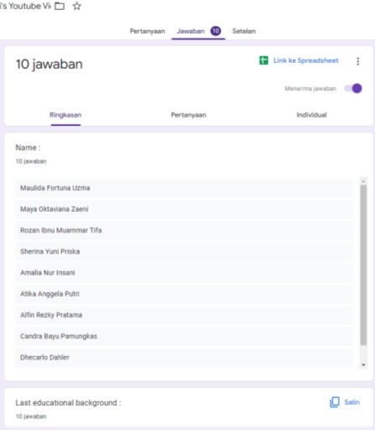

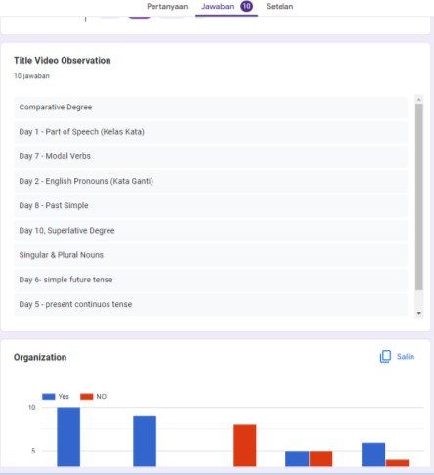

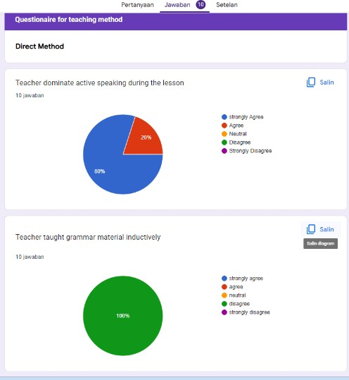

Appendices 3 : Checlist Observation and Questionnaire of Teaching Method And Teaching Strategy
Link the google form : https://forms.gle/7TbQkMnS1c9PHaAu7

