DAFTAR PUSTAKA

Allo, M. R., Alexander, S. W., & Suwetja, I. G. (2021). Pengaruh Likuiditas dan Ukuran Perusahaan Terhadap Agresivitas Pajak. Jurnal EMBA Vol.9 No.1 Januari, 647-657.
Aminah, Chairina, & Sari, Y. Y. (2017 ). The Influence of Company Size, Fixed Asset Intensity, Leverage, Profitability, and Political Connection To Tax Avoidance. AFEBI Accounting Review (AAR) Vol.02 No.02, December 2017.
Anandani, K. F. (2020). Pengaruh Corporate Social Responsibility dan Persaingan Pasar Terhadap Agreivitas Pajak (Studi Empiris pada Perusahaan Manufaktur Sub Sektor Makanan dan Minuman yang Terdaftar di BEI Tahun 2017-2019). Jurnal Akuntasi .
Andhari, P. A., & Sukartha, I. M. (2017). Pengaruh Pengungkapan CSR, Profitabilitas, Capital Intensity, Inventory Intensity dan Leverage Terhadap Agresivitas Pajak. E-Jurnal Akuntansi Universitas Udayana Vol.18.3. Maret, 2115-2142.
Annisa. (2017 ). Pengaruh ROA, Ukuran Perusahaan, Leverage dan Koneksi Politik Terhadap Penghindaran Pajak. JOM Fekon, Vol. 4 No.1 (Februari) .
Fahrani, M., Nurlaela, S., & Chomsatu, Y. (2018). Pengaruh Kepemilikian Terkonsentrasi, Ukuran Perusahaan, Leverage, Capital Intensity dan Inventory Intensity Terhadap Agresivitas Pajak. Jurnal Ekonomi Paradigma Vol. 19 No. 02 Agustus 2017.
Firmansyah, A. (2017). Pengaruh Political Connection, Foreign Activity, dan Real Earnings Management Terhadap Tax Avoidance. Jurna Riset Akuntansi dan Keuangan Vol. 5 (3), 1601-1624.
Ghozali, I. (2013). Aplikasi Analisis Multivariate Dengan Program IBM dan SPSS 21 (Edisi Tujuh). Semarang: 979-704-015-1 .
Kurniawait, E. (2019). Pengaruh CSR,Likuiditas dan Leverage Terhadap Agresivitas Pajak. Jurnal Ekonomi Paradigma Vol. 19 No. 02 Agustus 2017 Vol. 12 No. 3.
Legowo, W. W., Florentina, S., & Firmansyah, A. (2021). Agresivitas Pajak Pada Perusahaan Perdagangan di Indonesia. Jurnal Bina Akuntansi, Januari 2021 Vol. 8 No.1 , 84-108.
Malau, M. S. (2020). Ukuran Perusahaan, Likuiditas, Leverage, Terhadap Agresivitas Pajak. LITERA: Jurnal Literasi Akuntansi.
Mustika. (2017). Pengaruh CSR, Ukuran Perusahaan, Profitabilitas, Leverage, Capital Intensity dan Kepemilikan Keluarga Terhadap Agresivitas Pajak. JOM Fekon, Vol. 4 No. 1 (Februari).
Nastiti, R. S. (2019). Pengaruh Koneksi Politik dan Corporate Governance Terhadap Agresivitas Pajak. Jurnal Akuntansi .
Nuryaningsih, R. A. (2020). Pengaruh Koneksi Politik, Capital Intensity, Ukuran Perusahaan Terhadap Agresivitas Pajak.
Octaviani, R. R., & Sofie. (2018). Pengaruh GCG, Capital Intensity Ratio, Leverage dan Finacial Distress Terhadap Agresivias Pajak. Jurnal Akuntansi Trisakti Volume. 5 Nomor. 2 September, 253-268.
Pradnyadari, I. D. (2015). Pengaruh Pengungkapan Corporate Social Responsibilty Terhadap Agresivitas Pajak . Jurnal Ekonomi dan Bisnis.
Prapitasari, A., & Safrida, L. (2019). The Effect of Profitability, Leverage, Firm Size, Political Connection and Fixed Asset Intensity on Tax Avoidance. Accounting Research Journal of Sutaatmadja Volume 03 Nomor 02 , 247-258.
Prasetyo, A., & Wulandari, S. (2021). Capital Intensity, Leverage, Return on Asset, dan Ukuran Perusahaan Terhadap Agresivitas Pajak. Jurnal Akuntansi Volume 13 Nomor 1, Mei 2021 , 134 - 147 .
Rahmadani, Muda, I., & Abubakar, E. (2020). Pengaruh Ukuran Perusahaan, Profitabilitas, Leverage, dan Manajemen Laba terhadap Penghindaran Pajak Dimoderasi oleh Political Connection. Jurnal Riset Akuntansi dan Keuangan Vol.8 No. 2.
Siciliya, A. R. (2021). Intensitas Persediaan, Ukuran Perusahaan dan Agresivitas Pajak : Koneksi Politik Sebagai Variabel Pemoderasi. LITERA: Jurnal Literasi Akuntansi.
Tabrani, A., Jamaluddin, & Fudoli. (2020). Analisis Faktor yang Mempengaruhi Agresivitas Pajak (Studi Empiris pada Perusahaan LQ45 yang Terdaftar di Bursa Efek Indonesia Tahun 2015-2018). Jurnal REKOMEN (Riset Ekonomi Manajemen) Vol 4 No 1.
Tiaras, I., & Wijaya, H. (2015). Pengaruh Likuiditas, Leverage, Manajemen Laba, Komisaris Independen dan Ukuran Perusahaan Terhadap Agresivitas Pajak. Jurnal Akuntansi/Volume XIX, No. 03, September 2015, 380-397 .
Wicaksono, A. P. (2017). Koneksi Politik dan Aggresivitas Pajak. Akuntabilitas: Jurnal Ilmu Akuntansi Volume 10 (1), April 2017.
Yuliana, I. F., & Wahyudi, D. (2018). Likuiditas, Profitabilitas, Leverage, Ukuran Perusahaan, Capital Intensity dan Inventory Intensity Terhadap Agresivitas Pajak. Dinamika Akuntansi, Keuangan dan Perbankan, Vol. 7 No. 2, 105-120.
LAMPIRAN

Lampiran A Data Tabulasi Penelitian
PC (X1) | FS (X2) | L (X3) | AP (Y) | CSR
0 | 22.992 | 12,87346025 | 0,832818581 | 0,626373626
0 | 15.101 | 0,00847626 | 0,462216625 | 0,494505495
0 | 577.634.595 | 1,098666721 | 0,133563162 | 0,56043956
0 | 327.055 | 0,878414945 | 0,062367865 | 0,604395604
0 | 12.769 | 4,299475292 | 1,897711512 | 0,604395604
0 | 210.137.454 | 0,286701765 | 0,258458344 | 0,505494505
0 | 2.445 | 23,5206544 | 0,295514047 | 0,626373626
0 | 34.563 | 13,11645401 | 1,482235271 | 0,582417582
0 | 401.800.150 | 2,305914762 | 1,210367211 | 0,450549451
0 | 1.093.338.613 | 0,637233793 | 10,39772116 | 0,549450549
0 | 4.855.369 | 0,371433973 | 0,233476738 | 0,615384615
0 | 457.423 | 0,490782055 | 0,367726455 | 0,582417582
0 | 175.558 | 0,763525445 | 0,024523059 | 0,483516484
0 | 471.227.805.037 | 0,722089304 | 0,187705809 | 0,593406593
0 | 228.331 | 1,170038234 | 0,723978754 | 0,571428571
0 | 432.298 | 0,759087481 | 1,021536876 | 0,582417582
0 | 77.968 | 11,48022266 | 2,181367928 | 0,472527473
0 | 22520 | 8,165337201 | 0,418340849 | 0,626373626
0 | 17.533 | 6,774729521 | 0,455259027 | 0,494505495
0 | 514.675.498 | 0,774014358 | 0,001613842 | 0,56043956
0 | 350.065 | 1,029363765 | 0,005527167 | 0,604395604
0 | 66.755 | 11,80042425 | 6,352074967 | 0,604395604
0 | 245.100.202 | 2,584876251 | 0,263025466 | 0,505494505
0 | 145.234.343 | 11535,69047 | 2,644003587 | 0,626373626
0 | 534.343 | 11,73194133 | 0,142300275 | 0,582417582
0 | 415.098.432 | 2,252367225 | 0,542827544 | 0,450549451
0 | 1.603.630.551 | 1,341679068 | 1,378401366 | 0,549450549
0 | 5.657.327 | 2,400094267 | 0,236537266 | 0,615384615
0 | 573.239 | 1,77342701 | 3,550737207 | 0,582417582
0 | 197.359 | 1,370434408 | 0,023583338 | 0,483516484
0 | 480.292.318.443 | 1,414578582 | 0,242284585 | 0,593406593
0 | 104.080 | 0,119537516 | 1,474578563 | 0,571428571
0 | 576.956 | 1,753718958 | 0,450775344 | 0,582417582
0 | 890.564 | 1,205600733 | 7,673671316 | 0,472527473
0 | 2.926.400 | 904,8855906 | 0,340009073 | 0,626373626
0 | 17.532 | 5,910991234 | 0,454806313 | 0,494505495
0 | 500.726.491 | 1,126668654 | 0,004351078 | 0,56043956
0 | 363.952 | 1,144884773 | 0,089360955 | 0,604395604
0 | 16.898 | 5,826896552 | 0,202503682 | 0,604395604
0 | 250.680.316 | 3,119360935 | 2,563575475 | 0,505494505
0 | 534.231 | 0,980888293 | 0,932624113 | 0,626373626
0 | 124.434 | 0,125583085 | 11,50066768 | 0,582417582
0 | 415.098.432 | 2,252367225 | 0,713136362 | 0,450549451
0 | 863.888.032 | 1,489037949 | 1,000504531 | 0,549450549
0 | 6.805.037 | 2,107906574 | 0,02426474 | 0,615384615
0 | 543.257 | 1,601314048 | 0,373253256 | 0,582417582
0 | 203.848 | 1,446643626 | 0,032484383 | 0,483516484
0 | 478.788.186.515 | 1,417034751 | 2,005383923 | 0,593406593
0 | 765.909 | 0,901090614 | 3,413356238 | 0,571428571
0 | 536.006 | 1,687485046 | 0,752379631 | 0,582417582
0 | 325.856 | 0,573231959 | 0,775315306 | 0,472527473
0 | 6.381.566 | 2,626318805 | 0,286543785 | 0,527472527
0 | 20.782.194.476 | 2,595627534 | 0,002661966 | 0,538461538
0 | 320.089 | 0,408316888 | 0,018732498 | 0,56043956
0 | 360.802 | 1,084831684 | 0,249302377 | 0,637362637
0 | 95.968.026 | 1,846756684 | 0,032056169 | 0,692307692
0 | 263.343.768 | 3,609044618 | 0,25266879 | 0,56043956
0 | 12.324.433 | 1,097248952 | 0,62085748 | 0,681318681
0 | 1.110.213.240 | 0,491209036 | 0 | 0,582417582
0 | 550.639.564 | 1,957904146 | 6,156005055 | 0,505494505
0 | 703.672.417 | 0,930515733 | 0,986285243 | 0,593406593
0 | 7.562.422 | 1,978719875 | 0,346296282 | 0,626373626
0 | 313.792.516.918 | 2,059619263 | 0,206698743 | 0,615384615
0 | 222.976.008 | 1,438871488 | 0,164474903 | 0,582417582
0 | 340.099.990 | 0,343540903 | 0,10885333 | 0,571428571
0 | 76.937 | 0,087453353 | 3,259200708 | 0,626373626
0 | 387.998 | 1,400826058 | 13,75485694 | 0,637362637
0 | 185.404.119.806 | 1,891124914 | 58,4710259 | 0,505494505
0 | 7.586.936 | 2,425009613 | 0,307843499 | 0,527472527
0 | 23.542.219.524 | 0,288793909 | 0,005240545 | 0,538461538
0 | 548.980 | 1,127060707 | 1,224741851 | 0,56043956
0 | 369.470 | 0,111828885 | 0,280965645 | 0,637362637
0 | 2.711.784.024 | 15,44682541 | 0,174112218 | 0,692307692
0 | 435.317.388 | 2,382628387 | 0,223512876 | 0,56043956
0 | 5.645.446 | 0,043018745 | 16,48072521 | 0,681318681
0 | 1.206.842.636 | 0,496306667 | 0,027916891 | 0,582417582
0 | 563.496.598 | 1,925536896 | 0,886499238 | 0,505494505
0 | 1.245.705.842 | 1,122973695 | 1,454579372 | 0,593406593
0 | 7.234.857 | 2,092981416 | 0,528272778 | 0,626373626
0 | 280.395.704.974 | 1,500662875 | 0,18168229 | 0,615384615
0 | 223.583.081 | 1,396932726 | 0,137602629 | 0,582417582
0 | 237.917.028 | 19,6247194 | 0,095433327 | 0,571428571
0 | 183.038.083 | 9,513975617 | 0,032765222 | 0,626373626
0 | 298.874.947 | 0,556847302 | 1,726605106 | 0,637362637
0 | 139.180.731.717 | 2,808907344 | 0,775237732 | 0,505494505

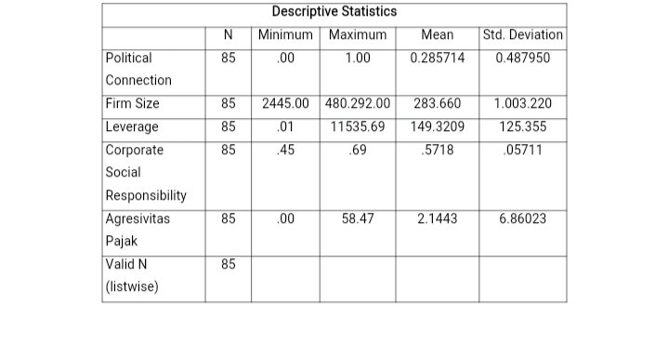
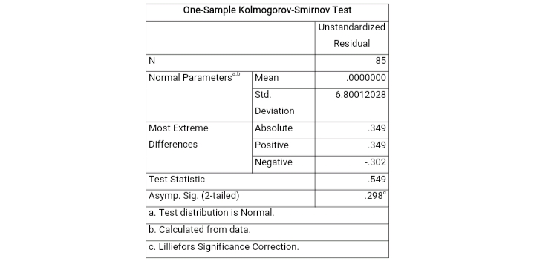

Coefficientsª
Model |  | Unstandardized Coefficients |  | Standardized Coefficients | t | Sig. | Collinearity Statistics
 |  | B | Std. Error | Beta |  |  | Tolerance | VIF
1 | (Constant) | 2.006 | .824 |  | 2.433 | .017
 | Political Connection | .000 | .000 | .000 | .000 | .000 | .000 | .000
 | Firm Size | 8.674E-12 | .000 | .127 | 1.147 | .255 | .992 | 1.008
 | Leverage | 4.261E-5 | .001 | .008 | .071 | .944 | .997 | 1.003
a. Dependent Variable: Agresivitas Pajak

