DAFTAR PUSTAKA

Andrew, O., & Sofian, S. (2012). Individual Factors and Work Outcomes of Employee Engagement. Procedia-Social and Behavioral Sciences, 498-508.
Ardiansyah, F., & Budiono. (2022). Pengaruh Kompensasi terhadap Employee Engagement dan Dampaknya Pada Employee Performance. Jurnal Ilmu Manajemen.
Asford, S. L., & Bobko, P. (1989). Content, Causes, and Consequence of Job insecurity: a Theory-based Meansure and Substantive Test. Academy of Management Journal, 803-829.
Astianto & Suprihadi. (2014). Pengaruh Stres Kerja Dan Beban Kerja Terhadap Kinerja Karyawan PDAM Surabaya. Jurnal Ilmu & Riset Manajemen. 3 (7), 1-17
Azwar, S. (2011). Penyusunan Skala Psikologi Edisi 2. Yogyakarta: Pustaka Pelajar.
Bakker, A. B. (2009). Building Engagement in The Workplace. Rotterndam: Erasmus University.
Bakker, A. B., & Demerouti. (2008). Work Engagement: An Emerging in Occupational Health Psychology. University Library Utrecht, 187-200.
Blackmore, C. dan Kuntz, J.R.C. (2017). Antecedents Of Job Insecurity In Restructuring Organisation: An Empirical Investigation. New Zealand Journal of Psychology, 40, 7-18
Baumruk, R., Marusarz, T. (2004). Employee Engagement: Insights into Why It Matters and What You Can Do About It. Hewitt Associates LLC
Caleb, T. H. (2014). Optimism, Stress, Life Satisfaction, and Job Burnout in Restaurant Managers. The Journal of Psychology Interdisciplinary and Applied. 141
Chang, E. C. (2002). Optimism & Pessimism: Practice. Washington DC: American Psychological Association.
Chaudhary, R., Rangnekar, S., & Baru, M. K. (2013). Engagement Versus Disengagement: The Role of Occupational Self Efficacy. Asian Academy of Management Journal, 91-108.
Davis, K., & Strom. (1999). Perilaku Dalam Organisasi. (Edisi Ke-7). (Agus Dharma,Trans). Jakarta: Erlangga
Dawson, D., Searle, A. K., & Paterson, J. L. (2013). Look Before You (S)Leep: Evaluating The Use Of Fatigue Detection Technologies Wihtin A Fatigue Risk Management System For The Road Transport Industry. Sleep Medicine Review.
Dwivedi, D. (2003). Antifungals From Fluorescens Pseudomonads Biosynthesis And Regulation. Curr. Sci 85, 1693-1703.
Ema, A. (2004). Peranan Dimensi-Dimensi Birokrasi Terhadap Burnout Pada Perawat Rumah Sakit Di Jakarta. Jurnal Psyche. 1(1), 34-43
Federman, B. (2009). Employee Engagement: A Road for Creating Profit, Optimizing Performance and Increasing Loyalty. San Fransisco: Jossey-Bass.
Ferdiansyah, M. (2018). Analisis Pengaruh Gaya Kepemimpinan Transformasional, Kompensasi, dan Program Pelatihan terhadap Employee Engagement Serta Dampaknya terhadap Kinerja Karyawan di PT Angkasa Pura II (Persero). Jurnal Dinamika Manajemen dan Bisnis.
Ferdinand, A. (2016) Metode Penelitian Manajemen Pedoman Penelitian untuk Penulisan Skripsi, Tesis, dan Disertasi Ilmu Manajemen. Semarang: AGF Books Fakultas Ekonomika dan Bisnis Universitas Diponegoro
Ghozali, I. (2018). Aplikasi Analisis Multivariate dengan Program IBM SPSS 25. Edisi 9. Semarang: Universitas Diponegoro.
Goleman, D. (2002). Emotional Intelligence. Jakarta: PT. Gramedia Pustaka Utama.
Gilmer. (1996). Manajemen Sumber Daya Manusia. Edisi Pertama. Jakarta: Kencana Prenada Media Grup.
Greenglass, E. R., Burke, R., & Fiksenbaum, L. (2002). Impact of Restructuring, Job Insecurity and Job Satisfaction in Hospital Nurses. Stress News. 1-7.
Greenhalgh, L., & Rosenblatt, Z. (1984). Job Insecurity: Towards Conseptual Clarity. Academy of Management Review, 438-448.
Hair, J.F., Hult, G.T.M., Ringle, C.M. and Sarstedt, M. (2017) A Primer on Partial Least Squares Structural Equation Modeling (PLS-SEM). 2nd Edition, Sage Publications Inc., Thousand Oaks, CA.
Handoko, T. H. (2000). Manajemen Personalia dan Sumber Daya Manusia, Yogyakarta: BPFE.
Hasibuan, M. S. (2013). Manajemen Sumber Daya Manusia. Jakarta: Bumi Aksara.
Hobfoll, S. E., Johnson, R. J., Ennis, N., & Jackson, A. P. (2003). Resource Loss, Resource Gain, And Emotional Outcomes Among Inner City Women. Journal of Personality and Social Psychology, 632-643.
Imran, R., Majeed, M.,& Ayub, A. (2017). Impact Of Organizational Justice, Job Security, And Job Satisfaction On Organizational Productivity. Journal of Economics, Business, and Management. 3 (1), 843-845
Indrajit, R. E., & Djokopranoto, R. (2003). Proses Bisnis Outsourcing. Jakarta: Grasindo.
Jackson, J. H., & Mathis, R. L. (2006). Human Resource Managemen (10th ed.). Jakarta: Salemba Empat.
Kahn, W. A. (1990). Pscyhological Conditions of Personal Engagement and Disengagement at Work. Academy of Management Journal, 692-724.
Kalisch, B.J., Lee, H.,& Rochman, M. (2017). Nursing Staff Teamwork And Job Satisfaction. Journal of Nursing Management. 1 (8), 938-947
Kaseger, Sendow, & Tawas. (2017). Pengaruh Pengembangan Karir, Pengalaman Kerja dan Keterlibatan Kerja Terhadap Kinerja Karyawan PT Bank Rakyat Indonesia (Persero) Tbk Kantor Cabang Manado. Jurnal Manajemen. 5 (3)
Kumar, D. P., & Swetha, G. (2011). A Prognostic Examination of Employee Engagement from its Historical Roots. Internasional Journal of Trade Economic and Finance, 232-241.
Loockwood, N. (2007). Leveraging Employee Engagement for Competitive Advantage: HR's Strategic Role. HR Magazine, 1-11.
Lopez, & Snyder, C. (2000). Positive Psychological Assessment a Handbook of Models & Measures. Washington DC: APA.
Luthans, F. (2006). Perilaku Organisasi. Yogyakarta: Penerbit Andi.
Man, G. S., & Hadi, C. (2013). Hubungan antara Perceived Organizational Support dengan Work Engagement pada Guru SMA Swasta di Surabaya. Jurnal Psikologi Industri dan Organisasi, 90-99.
Manalu, A. R., Thamrin, R., Hasan, M., Syahputra, D. (2021). Pengaruh Work Engagement Terhadap Kinerja Pegawai BPJS Ketenagakerjaan. Journal Economics and Management (JECMA). 1 (2), 42-49
Mangkunegara, P. (2005). Manajemen Sumber daya Manusia Perusahaan. Bandung: PT Remaja Rosdakarya.
Mangkunegara, P. (2019). Evaluasi Kinerja SDM. Cetakan Ketujuh. Bandung: PT Refika Aditama.
Mardiana, N., Asj'ari, F. (2022). Pengaruh Workload dan Job Insecurity Terhadap Work Fatigue. Journal of Management and Accounting. 5 (1), 68-78
Maslach, C., Schaufeli, W. B., & Leiter, M. P. (2001). Job Burnout. Annual Review of Psychology. 52(1), 397-422.
McGinnis, A. L. (1995). Kekuatan optimisme. Jakarta: Mitra Utama.
Medlin, B., Green, K. J., & Graither, Q. (2010). Developing Optimisms To Improve Performance: A Pilot Study In The Education Sector. Allied Academics International Conference, 38-41.
Mobley, W. H. (2000). Pergantian Karyawan: Sebab, Akibat Dan Pengendaliannya. (Terjemahan). Jakarta: PT Pustaka Binaman Press Indo.
Mounstephen, A., & Sharpe, M. (1997). Chronic Fatigue Syndrome And Occupational Health. Occupationa Med, 217-227.
Murdoko, W. H. (2001). Perubahan dalam Hidup dan Pekerjaan. Jakarta: Elex Media Komputindo.
Noe, R. A., Hollenbeck, J. R., Gerhart, B., & Wright, P. M. (2009). Fundamental Of Human Resource Management (3rd ed). New York: McGraw Hill.
Noviardy, A., & Aliya, S. (2020). Pengaruh Employee Engagement dan Komitmen Organisasi Terhadap Kinerja Karyawan di Bidang Perkebunan Kelapa Sawit (Studi Empiris pada PT Suryabumi Agrolanggeng, Sumatera Selatan). Jurnal Management, Budsiness and Accounting.
Novita, W., Beny, Hanoky, A. (2022). Peran Work Engagement Sebagai Variable Mediasi Terhadap Job Satisfaction. Management Sustainable Development Journal. 4 (2), 69-82
Nugraha, A. (2010). Analisis Pengaruh Ketidakamanan Kerja dan Kepuasan Kompensasi Terhadap Kinerja Karyawan (Studi Pada Karyawan Kontrak PT. Bank Rakyat Indonesia Cabang Semarang Patimura Dan Unit Kerjanya). Skripsi.
Nurmianto, E. (2004). Ergonomi Konsep Dasar dan Aplikasinya. Surabaya: Guna Widya.
Pancasasti, R., & Chaerunissa, E. (2021). Pengaruh Employee Engagement Dan Commitment Organization Terhadap Kinerja Pegawai Melalui Kepuasan Kerja Pegawai Sebagai Variabel Intervening (Studi pada Departemen Operasi PT Cogindo DayaBersama PLTU Pelabuhan Ratu). Jurnal Riset Bisnis dan Manajemen Tirtayasa (JRBMT). 5 (2), 126-146
Robbins, S. (2003). Perilaku Organisasi. Jakarta: Gramedia.
Robbins, S. (2006). Organizational Behaviour. Sevent Edition. New Jersey: Prentice Hall International, Inc.
Robert, D. R., & Davenport, T. O. (2002). Job Engagement: Why It’s Important And How To Improve It. Employment Relations Today, 21-36.
Robinson, Perryman, S., & Hayday. (2004). The Drivers of Employee Engagement. UK: Institute for Employment Studies.
Rothmann, S. (2007). Job Characteristic, Optimism, Burnout, and Ill Health of Support Staff in a Higher Education Institution in South Africa. South African Journal of Psychology, 37(1)
Saito, K. (1999). Measurement of Fatigue in Industries. Industrial Health, 13-42.
Saks, A. M. (2006). Antecedents And Consequences Of Employee Engagement. Canada: University of Toronto.
Salanova, M., Lorente, L., Chambel, M. J., & Martinez, I. M. (2011). Lingking Transformational Leadership To Nurses’ Extra-Role Performance: The Mediating Role Of Self-Efficacy And Work Engagement. Journal Of Advanced Nursing, 2256-2266.
Saleem, S., & Amin, S. (2013). The Impact of Organizational Support for Career Development and Supervisory Support on Employee Performance : An Empirical Study from Pakistani Academic Sector. European Journal of Business and Management, 5(5), 194–207
Sanny & Kristanti. (2012). Pengaruh Lingkungan Kerja Dan Job Insecurity Terhadap Motivasi Kerja dan Dampaknya Pada Kinerja Karyawan Outsourcing Mall Lippo Cikarang. Binus BisnisReview. 3(1), 61-69
Santoso, M. R. & Jatmika, D. (2017) Hubungan Resiliensi Dengan Work Engagement Pada Agen Asuransi PT X. Jurnal Humanitas. 1 (2), 121-132.
Schaufeli, W. B. & Bakker, A. B. (2010). Job Demands, Job Resources, and Their Relationship with Burnout and Engagement: A Multi-Sample Study. Journal of Organizational Behavior. 25 (1), 293-437.
Schaufeli, W. B. dan Bakker, A. B. (2010). Defining And Measuring Work Engagement: Bringing Clarity To The Concept. (Electronic Version). Work Engagement A Handbook of Essential Theory and Research. New York: Psychology Press.
Schaufeli, W. B., Bakker, B. A., & Salanova, M. (2004). The Measurement Of Work Engagement With A Short Questionnaire: A Cross-National Study. Educational And Pstchological Measurement. 66 (1), 701-716.
Seligman, M. E.P. (2006). Learned Optimism: How to Change Your Mind and Your Life. New York: Vintage Books.
Sedarmayanti. (2014). Manajemen Strategi. Bandung: PT. Refika Aditama
Slemp, G. R., & Vella-Brodrick, D. A. (2013). The Job Crafting Questionnaire: A New Scale Tomeasure The Extent To Which Employees Engage In Job Crafting. International Journal of Wellbeing. 3(2), 126–146
Sobaci, F., & Polatci, S. (2020). the Effect of Job Crafting on Job Satisfaction: a Research on Teachers. Journal of Global Strategic Management. 12(1), 49–56
Solichin, M. R. (2018). Analisis Pengaruh Employee Engagement , EmotionalIntelligence, dan Komitmen terhadap Organizational Citizenship Behavior ( OCB ) pada Karyawan PO Efisiensi Cabang Kebumen. Jurnal Ekonomi dan Teknologi STIE Putra Bangsa. 6 (2), 36-47
Sugiyono. (2017). Metode Penelitian Kuantitatif, Kualitatif, dan R&D. Bandung : Alfabeta, CV.
Suma'mur. (2013). Higiene Perusahaan dan Kesehatan Kerja. Jakarta: Sagung Seto.
Suwatno. (2016). Manajemen SDM dalam Organisasi Publik dan Bisnis. Bandung: Alfabeta
Tanujaya, L. R. (2015). Pengaruh pelatihan kerja dan motivasi kerja pada kinerja karyawan departement produksi PT. Coronet Crown. AGORA, 3(1), 1-7. Diakses http://publication.petra.ac.id/index.php/manajemen- bisnis/article/download/2707/2421
Tarwaka, dkk. (2004). Ergonomi untuk Keselamatan Kesehatan Kerja dan Produktivitas. Surakarta: UNIBA Press
Tarwaka. (2014). Keselamatan dan Kesehatan Kerja: Manajemen dan Implementasi K3 di Tempat Kerja. Surakarta: Harapan Press.
Truss, et.al. (2013) Employee engagement, Organizational Performance and Individual Well-being: Exploring The Evidence. Developing The Theory. 24(1), 2657-2669.
Valentino, R., & Himam, F. (2014). Efikasi Diri untuk Meningkatkan Optimisme Terhadap Pencapaian Karir Karyawan PKWT Perusahaan X. Jurnal Intervensi Psikologi. 6 (1), 50-66
Wahyuni, M. (2017). Pengaruh Makna Kerja Dan Occupational Self Efficacy Terhadap Work Engagement Pada Dosen Tetap. Jurnal Psikologi. 1 (1), 39-47
Weinstein, N. D. (1980). Unralistic Optimism About Future Life Events. Journal Of Personality And Social Psychology. 64 (1), 278-282
Wibowo, D. M., Ediati, A., & Masykur, A. M. (2012). Hubungan antara Kecerdasan Emosi dengan Kinerja Guru SMA Negeri 2 Ngawi. E-journal Universitas Diponegoro.
Wijaya, M. (2017). Pengaruh Sistem Rekrutmen dan Pengembangan Karir Terhadap Kepuasan Kerja Karyawan Pada PT Kimia Farma Plant Medan. Jurnal Konsep Bisnis Dan Manajemen. 3 (1), 1-8
Yani. (2017). Kumpulan Executive Summary Mahasiswa Prodi Manajemen Wisuda Ke-68 Agustus 2017. 11 (2)

LAMPIRAN
Lampiran 1. Struktur Organisasi PT GSP
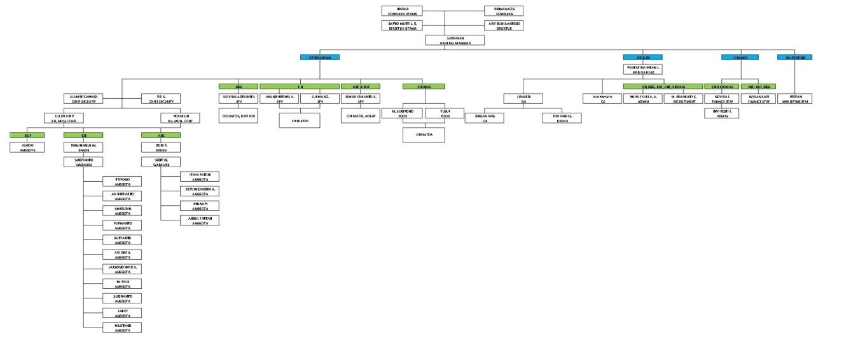
Lampiran 2. Kuesioner Penelitian

Kepada Yth.
Bapak/Ibu Responden Penelitian

Dengan Hormat,
Perkenankanlah kami meminta kesediaan Bapak/ Ibu untuk berpartisipasi dalam mengisi dan menjawab seluruh pertanyaan yang ada dalam kuesioner ini. Penelitian ini bertujuan untuk memperoleh data dari Bapak/Ibu tentang “Pengaruh Optimisme Perkembangan Karir, Job Insecurity, dan Work Engagement Terhadap Kinerja Karyawan Outsourcing PT Gemilang Sapta Perdana dengan Job Fatigue Sebagai Variabel Mediasi”.
Hasil dari penelitian ini hanya diperuntukkan bagi keperluan penulisan ilmiah yang merupakan tugas akhir pada Program Magister Manajemen Universitas Pancasakti Tegal. Oleh karena itu jawaban Bapak/Ibu tidak dipublikasikan dan dijamin kerahasiannya. Setiap jawaban yang Bapak/Ibu berikan merupakan bantuan yang berharga bagi penelitian ini. Untuk bantuan tersebut sebelum dan sesudahnya Saya ucapkan terimakasih.

Peneliti,

Pentarina Intan L.
NPM: 7120800028

Isilah dan berilah tanda silang (X) atau checklist (√) pada isian berikut :
- Umur :
    - Kurang dari 25 tahun
    - 25 – 30 tahun
    - 31 – 35 tahun
    - Lebih dari 35 tahun
- Masa Kerja
    - Kurang dari 1 tahun
    - 1 – 2 tahun
    - Lebih dari 2 tahun
- Jenis Kelamin
a. Laki-Laki b. Perempuan

- Tingkat pendidikan terakhir
a. SMA/Sederajat
b. Diploma
c. Sarjana
d. Pascasarjana

Petunjuk Pengisian Kuesioner
Untuk pertanyaan dibawah ini, berikan jawaban terhadap semua pertanyaan dalam kuesioner ini dengan memberikan penilaian tentang sejauh mana pertanyaan itu sesuai dengan realita. Berilah tanda centan (V) pada SS (Sangat Setuju), Setuju (S), Netral (N), Tidak Setuju (TS), atau Sangat Tidak Setuju (STS).

- Kuesioner Optimisme Perkembangan Karir
No. | Pernyataan | SS | S | N | TS | STS
1 | Saya berusaha untuk tidak berpikir negatif dalam meraih impian saya
2 | Saya semangat bekerja untuk perkembangan karir saya di masa mendatang
3 | Saya yakin mampu menyelesaikan masalah saya sendiri
4 | Saya yakin impian saya dapat terwujud melalui strategi yang saya miliki
5 | Saya akan berjuang sekuat tenaga supaya karir saya berkembang

- Kuesioner Job Insecurity
No. | Pernyataan | SS | S | N | TS | STS
1 | Saya merasa takut apabila tidak dapat mempertahankan pekerjaan ini.
2 | Saya merasa bahwa masa depan saya akan terus terombang-ombang oleh ancaman putus kontrak.
3 | Saya peduli terhadap perubahan-perubahan yang terjadi baik pada vendor maupun perusahaan ini.
4 | Saya tidak berdaya ketika menandatangani kontrak baru sebagai karyawan outsourcing yang baru dan masa kerja yang dihitung mulai dari nol lagi.
5 | Saya merasa masa depan karir saya tidak pasti di perusahaan ini.

- Kuesioner Work Engagement
No. | Pernyataan | SS | S | N | TS | STS
1 | Saya mencurahkan segala tenaga dan mental saya untuk pekerjaan saya
2 | Saya berantusias dalam menjalankan pekerjaan saya
3 | Antara diri saya dan pekerjaan saya telah menyatu
4 | Saya berantusias dalam menjalankan pekerjaan saya
5 | Saya tahan bekerja dalam jangka waktu yang lama

- Kuesioner Job Fatigue
No. | Pernyataan | SS | S | N | TS | STS
1 | Saya sangat terganggu oleh rasa lelah yang saya rasakan
2 | Secara fisik, saya merasa lelah
3 | Saya merasa kesulitan untuk berpikir secara jernih
4 | Saya merasa malas untuk melakukan berbagai kegiatan kerja
5 | Secara mental saya merasa lelah
6 | Ketika saya sedang melakukan kegiatan, saya dengan mudah berkonsentrasi penuh

- Kuesioner Kinerja Karyawan
No. | Pernyataan | SS | S | N | TS | STS
1 | Saya bekerja sesuai dengan target dan menyelesaikan pekerjaan sesuai dengan standar kualitas yang telah ditetapkan perusahaan.
2 | Saya melakukan pekerjaan dengan terampil dan teliti sesuai dengan kuantitas perusahaan.
3 | Saya bekerja dengan fokus dan tepat waktu walaupun tidak ada atasan yang melakukan pengawasan.
4 | Saya dapat bekerja sama dengan sesama karyawan dan atasan.
5 | Saya selalu mencoba hal baru dalam bekerja agar menguasai seluruh bagian departemen produksi dan dapat meningkatkan mutu kinerja.

Lampiran 3. Hasil Olah Data
1. Hasi Uji Validitas Variabel Optimisme Perkembangan Karir (X1)
Correlations
 |  | Soal_01 | Soal_02 | Soal_03 | Soal_04 | Soal_05 | Total
Soal_01 | Pearson Correlation | 1 | .343 | .310 | .364* | .190 | .642**
 | Sig. (2-tailed) |  | .063 | .095 | .048 | .314 | .000
 | N | 30 | 30 | 30 | 30 | 30 | 30
Soal_02 | Pearson Correlation | .343 | 1 | .912** | .474** | .802** | .871**
 | Sig. (2-tailed) | .063 |  | .000 | .008 | .000 | .000
 | N | 30 | 30 | 30 | 30 | 30 | 30
Soal_03 | Pearson Correlation | .310 | .912** | 1 | .525** | .734** | .880**
 | Sig. (2-tailed) | .095 | .000 |  | .003 | .000 | .000
 | N | 30 | 30 | 30 | 30 | 30 | 30
Soal_04 | Pearson Correlation | .364* | .474** | .525** | 1 | .371* | .746**
 | Sig. (2-tailed) | .048 | .008 | .003 |  | .044 | .000
 | N | 30 | 30 | 30 | 30 | 30 | 30
Soal_05 | Pearson Correlation | .190 | .802** | .734** | .371* | 1 | .670**
 | Sig. (2-tailed) | .314 | .000 | .000 | .044 |  | .000
 | N | 30 | 30 | 30 | 30 | 30 | 30
Total | Pearson Correlation | .642** | .871** | .880** | .746** | .670** | 1
 | Sig. (2-tailed) | .000 | .000 | .000 | .000 | .000
 | N | 30 | 30 | 30 | 30 | 30 | 30
*. Correlation is significant at the 0.05 level (2-tailed).
**. Correlation is significant at the 0.01 level (2-tailed).

2. Hasil Uji Reliabiltas Optimisme Perkembangan Karir (X1)
Reliability Statistics
Cronbach's Alpha | Cronbach's Alpha Based on Standardized Items | N of Items
.835 | .835 | 5

3. Hasi Uji Validitas Job Insecurity (X2)
Correlations
 |  | Soal_01 | Soal_02 | Soal_03 | Soal_04 | Soal_05 | Total
Soal_01 | Pearson Correlation | 1 | .599** | .479** | .429* | .539** | .742**
 | Sig. (2-tailed) |  | .000 | .007 | .018 | .002 | .000
 | N | 30 | 30 | 30 | 30 | 30 | 30
Soal_02 | Pearson Correlation | .599** | 1 | .499** | .921** | .582** | .918**
 | Sig. (2-tailed) | .000 |  | .005 | .000 | .001 | .000
 | N | 30 | 30 | 30 | 30 | 30 | 30
Soal_03 | Pearson Correlation | .479** | .499** | 1 | .380* | .512** | .721**
 | Sig. (2-tailed) | .007 | .005 |  | .038 | .004 | .000
 | N | 30 | 30 | 30 | 30 | 30 | 30
Soal_04 | Pearson Correlation | .429* | .921** | .380* | 1 | .452* | .820**
 | Sig. (2-tailed) | .018 | .000 | .038 |  | .012 | .000
 | N | 30 | 30 | 30 | 30 | 30 | 30
Soal_05 | Pearson Correlation | .539** | .582** | .512** | .452* | 1 | .769**
 | Sig. (2-tailed) | .002 | .001 | .004 | .012 |  | .000
 | N | 30 | 30 | 30 | 30 | 30 | 30
Total | Pearson Correlation | .742** | .918** | .721** | .820** | .769** | 1
 | Sig. (2-tailed) | .000 | .000 | .000 | .000 | .000
 | N | 30 | 30 | 30 | 30 | 30 | 30
**. Correlation is significant at the 0.01 level (2-tailed).
*. Correlation is significant at the 0.05 level (2-tailed).

4. Hasil Uji Reliabiltas Job Insecurity (X2)
Reliability Statistics
Cronbach's Alpha | Cronbach's Alpha Based on Standardized Items | N of Items
.854 | .854 | 5

5. Hasi Uji Validitas Work Engagement (X3)
Correlations
 |  | Soal_01 | Soal_02 | Soal_03 | Soal_04 | Soal_05 | Total
Soal_01 | Pearson Correlation | 1 | .810** | .670** | .746** | .714** | .925**
 | Sig. (2-tailed) |  | .000 | .000 | .000 | .000 | .000
 | N | 30 | 30 | 30 | 30 | 30 | 30
Soal_02 | Pearson Correlation | .810** | 1 | .449* | .571** | .519** | .773**
 | Sig. (2-tailed) | .000 |  | .013 | .001 | .003 | .000
 | N | 30 | 30 | 30 | 30 | 30 | 30
Soal_03 | Pearson Correlation | .670** | .449* | 1 | .541** | .493** | .762**
 | Sig. (2-tailed) | .000 | .013 |  | .002 | .006 | .000
 | N | 30 | 30 | 30 | 30 | 30 | 30
Soal_04 | Pearson Correlation | .746** | .571** | .541** | 1 | .921** | .897**
 | Sig. (2-tailed) | .000 | .001 | .002 |  | .000 | .000
 | N | 30 | 30 | 30 | 30 | 30 | 30
Soal_05 | Pearson Correlation | .714** | .519** | .493** | .921** | 1 | .867**
 | Sig. (2-tailed) | .000 | .003 | .006 | .000 |  | .000
 | N | 30 | 30 | 30 | 30 | 30 | 30
Total | Pearson Correlation | .925** | .773** | .762** | .897** | .867** | 1
 | Sig. (2-tailed) | .000 | .000 | .000 | .000 | .000
 | N | 30 | 30 | 30 | 30 | 30 | 30
**. Correlation is significant at the 0.01 level (2-tailed).
*. Correlation is significant at the 0.05 level (2-tailed).

6. Hasil Uji Reliabiltas Work Engagement (X3)
Reliability Statistics
Cronbach's Alpha | Cronbach's Alpha Based on Standardized Items | N of Items
.896 | .900 | 5

7. Hasi Uji Validitas Kinerja Karyawan (Y)
Correlations
 |  | Soal_01 | Soal_02 | Soal_03 | Soal_04 | Soal_05 | Total
Soal_01 | Pearson Correlation | 1 | .238 | .593** | .449* | .059 | .660**
 | Sig. (2-tailed) |  | .206 | .001 | .013 | .758 | .000
 | N | 30 | 30 | 30 | 30 | 30 | 30
Soal_02 | Pearson Correlation | .238 | 1 | .410* | .397* | .480** | .731**
 | Sig. (2-tailed) | .206 |  | .024 | .030 | .007 | .000
 | N | 30 | 30 | 30 | 30 | 30 | 30
Soal_03 | Pearson Correlation | .593** | .410* | 1 | .241 | .160 | .684**
 | Sig. (2-tailed) | .001 | .024 |  | .200 | .397 | .000
 | N | 30 | 30 | 30 | 30 | 30 | 30
Soal_04 | Pearson Correlation | .449* | .397* | .241 | 1 | .403* | .723**
 | Sig. (2-tailed) | .013 | .030 | .200 |  | .027 | .000
 | N | 30 | 30 | 30 | 30 | 30 | 30
Soal_05 | Pearson Correlation | .059 | .480** | .160 | .403* | 1 | .643**
 | Sig. (2-tailed) | .758 | .007 | .397 | .027 |  | .000
 | N | 30 | 30 | 30 | 30 | 30 | 30
Total | Pearson Correlation | .660** | .731** | .684** | .723** | .643** | 1
 | Sig. (2-tailed) | .000 | .000 | .000 | .000 | .000
 | N | 30 | 30 | 30 | 30 | 30 | 30
**. Correlation is significant at the 0.01 level (2-tailed).
*. Correlation is significant at the 0.05 level (2-tailed).

8. Hasil Uji Reliabiltas Kinerja Karyawan (Y)

Reliability Statistics
Cronbach's Alpha | Cronbach's Alpha Based on Standardized Items | N of Items
.716 | .723 | 5

7. Hasi Uji Validitas Job Fatigue (Z)
Correlations
 |  | Soal_01 | Soal_02 | Soal_03 | Soal_04 | Soal_05 | Soal_06 | Total
Soal_01 | Pearson Correlation | 1 | .537** | .835** | .250 | .537** | .223 | .780**
 | Sig. (2-tailed) |  | .002 | .000 | .182 | .002 | .237 | .000
 | N | 30 | 30 | 30 | 30 | 30 | 30 | 30
Soal_02 | Pearson Correlation | .537** | 1 | .410* | .366* | 1.000** | .376* | .842**
 | Sig. (2-tailed) | .002 |  | .024 | .046 | .000 | .041 | .000
 | N | 30 | 30 | 30 | 30 | 30 | 30 | 30
Soal_03 | Pearson Correlation | .835** | .410* | 1 | .099 | .410* | .072 | .654**
 | Sig. (2-tailed) | .000 | .024 |  | .602 | .024 | .705 | .000
 | N | 30 | 30 | 30 | 30 | 30 | 30 | 30
Soal_04 | Pearson Correlation | .250 | .366* | .099 | 1 | .366* | .945** | .658**
 | Sig. (2-tailed) | .182 | .046 | .602 |  | .046 | .000 | .000
 | N | 30 | 30 | 30 | 30 | 30 | 30 | 30
Soal_05 | Pearson Correlation | .537** | 1.000** | .410* | .366* | 1 | .376* | .842**
 | Sig. (2-tailed) | .002 | .000 | .024 | .046 |  | .041 | .000
 | N | 30 | 30 | 30 | 30 | 30 | 30 | 30
Soal_06 | Pearson Correlation | .223 | .376* | .072 | .945** | .376* | 1 | .650**
 | Sig. (2-tailed) | .237 | .041 | .705 | .000 | .041 |  | .000
 | N | 30 | 30 | 30 | 30 | 30 | 30 | 30
Total | Pearson Correlation | .780** | .842** | .654** | .658** | .842** | .650** | 1
 | Sig. (2-tailed) | .000 | .000 | .000 | .000 | .000 | .000
 | N | 30 | 30 | 30 | 30 | 30 | 30 | 30
**. Correlation is significant at the 0.01 level (2-tailed).
*. Correlation is significant at the 0.05 level (2-tailed).

8. Hasil Uji Reliabiltas Job Fatigue (Z)
Reliability Statistics
Cronbach's Alpha | Cronbach's Alpha Based on Standardized Items | N of Items
.835 | .833 | 6

9. Model Persamaan SEM
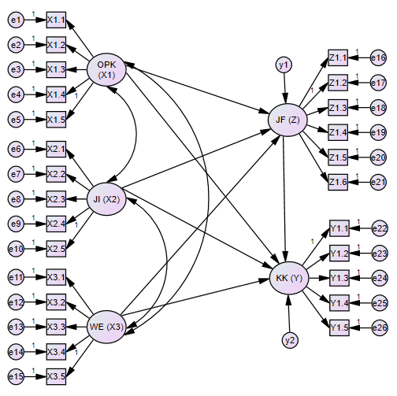
10. Hasil Analisis Konfirmatori
 |  |  | Estimate
X1.1 | <--- | OPK (X1) | 1,000
X1.2 | <--- | OPK (X1) | 1,080
X1.3 | <--- | OPK (X1) | ,647
X1.4 | <--- | OPK (X1) | ,550
X1.5 | <--- | OPK (X1) | ,719
X2.1 | <--- | JI (X2) | 1,000
X2.2 | <--- | JI (X2) | 2,270
X2.3 | <--- | JI (X2) | 0,923
X2.4 | <--- | JI (X2) | 1,206
X2.5 | <--- | JI (X2) | 1,300
X3.1 | <--- | WE (X3) | 1,000
X3.2 | <--- | WE (X3) | 1,258
X3.3 | <--- | WE (X3) | 1,370
X3.4 | <--- | WE (X3) | 1,802
X3.5 | <--- | WE (X3) | 0,866
Z1.1 | <--- | JF (Z) | 1,000
Z1.2 | <--- | JF (Z) | 2,884
Z1.3 | <--- | JF (Z) | 1,926
Z1.4 | <--- | JF (Z) | 2,131
Z1.5 | <--- | JF (Z) | 2,970
Z1.6 | <--- | JF (Z) | 0,481
Y1.1 | <--- | KK (Y) | 1,000
Y1.2 | <--- | KK (Y) | ,945
Y1.3 | <--- | KK (Y) | 1,223
Y1.4 | <--- | KK (Y) | 1,232
Y1.5 | <--- | KK (Y) | ,771

11. Model Pengukuran Variabel
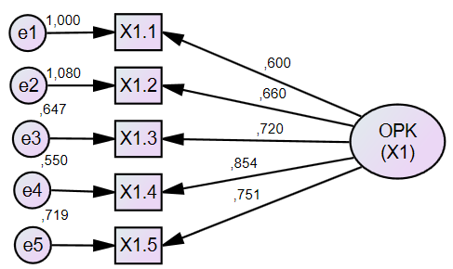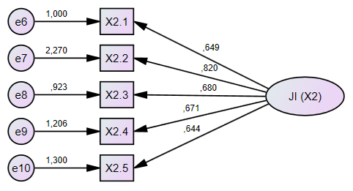
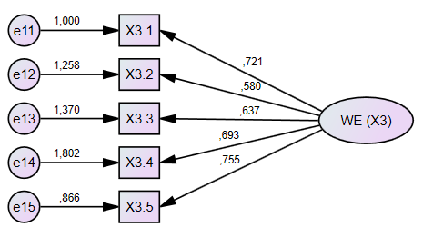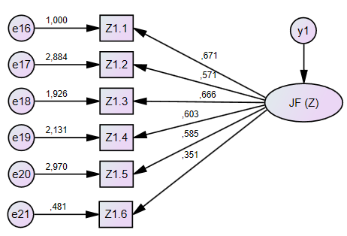
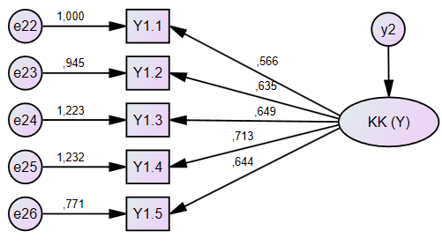

12. Model Persamaan Memenuhi Syarat Convergent Validity SEM
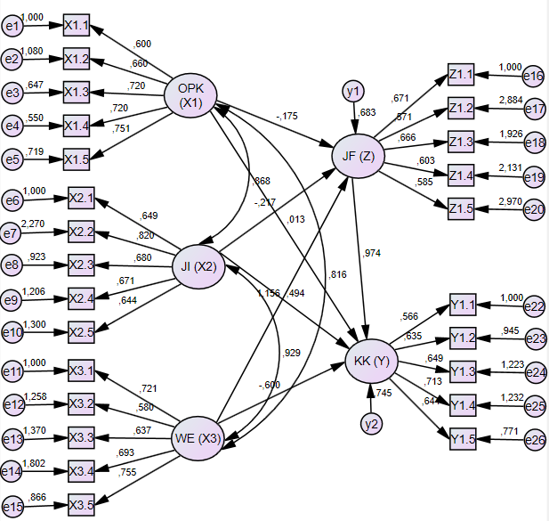

13. Evaluasi Outliers
Observation number | Mahalanobis d-squared | p1 | p2
1 | 122,491 | 0,000 | 0,000
2 | 110,545 | 0,000 | 0,000
4 | 117,282 | 0,000 | 0,000
5 | 154,341 | 0,000 | 0,000
6 | 101,567 | 0,000 | 0,000
8 | 133,42 | 0,000 | 0,000
9 | 149,943 | 0,000 | 0,000
10 | 87,785 | 0,000 | 0,000
11 | 138,865 | 0,000 | 0,000
16 | 87,754 | 0,000 | 0,000
Observation number | Mahalanobis d-squared | p1 | p2
17 | 87,754 | 0,000 | 0,000
18 | 86,066 | 0,000 | 0,000
19 | 124,1 | 0,000 | 0,000
20 | 89,681 | 0,000 | 0,000
22 | 89,043 | 0,000 | 0,000
23 | 85,981 | 0,000 | 0,000
24 | 149,943 | 0,000 | 0,000
26 | 154,341 | 0,000 | 0,000
27 | 198,946 | 0,000 | 0,000
29 | 91,818 | 0,000 | 0,000
30 | 64,213 | 0,000 | 0,000
32 | 77,168 | 0,000 | 0,000
33 | 114,963 | 0,000 | 0,000
34 | 75,276 | 0,000 | 0,000
35 | 123,162 | 0,000 | 0,000
36 | 112,338 | 0,000 | 0,000
37 | 81,436 | 0,000 | 0,000
38 | 57,578 | 0,000 | 0,000
39 | 183,996 | 0,000 | 0,000
41 | 85,428 | 0,000 | 0,000
42 | 84,981 | 0,000 | 0,000
43 | 106,437 | 0,000 | 0,000
44 | 70,962 | 0,000 | 0,000
45 | 136,684 | 0,000 | 0,000
46 | 89,021 | 0,000 | 0,000
47 | 105,003 | 0,000 | 0,000
48 | 66,688 | 0,000 | 0,000
50 | 100,38 | 0,000 | 0,000
51 | 134,295 | 0,000 | 0,000
52 | 91,114 | 0,000 | 0,000
53 | 87,921 | 0,000 | 0,000
54 | 138,865 | 0,000 | 0,000
55 | 133,42 | 0,000 | 0,000
56 | 96,082 | 0,000 | 0,000
57 | 92,234 | 0,000 | 0,000
58 | 124,1 | 0,000 | 0,000
59 | 75,276 | 0,000 | 0,000

Observation number | Mahalanobis d-squared | p1 | p2
60 | 89,024 | 0,000 | 0,000
61 | 89,043 | 0,000 | 0,000
62 | 91,114 | 0,000 | 0,000
63 | 91,818 | 0,000 | 0,000
64 | 117,148 | 0,000 | 0,000
65 | 80,576 | 0,000 | 0,000
68 | 92,463 | 0,000 | 0,000
69 | 100,231 | 0,000 | 0,000
70 | 96,082 | 0,000 | 0,000
72 | 117,815 | 0,000 | 0,000
73 | 114,85 | 0,000 | 0,000
74 | 87,785 | 0,000 | 0,000
75 | 50,121 | 0,000 | 0,000
76 | 96,082 | 0,000 | 0,000
77 | 96,792 | 0,000 | 0,000
78 | 100,231 | 0,000 | 0,000
79 | 84,981 | 0,000 | 0,000
80 | 96,792 | 0,000 | 0,000
81 | 83,713 | 0,000 | 0,000
82 | 86,066 | 0,000 | 0,000
83 | 100,38 | 0,000 | 0,000
84 | 100,786 | 0,000 | 0,000
86 | 81,436 | 0,000 | 0,000
87 | 106,437 | 0,000 | 0,000
88 | 111,133 | 0,000 | 0,000
89 | 85,428 | 0,000 | 0,000
90 | 89,024 | 0,000 | 0,000
91 | 80,576 | 0,000 | 0,000
92 | 114,85 | 0,000 | 0,000
93 | 111,133 | 0,000 | 0,000
94 | 114,963 | 0,000 | 0,000
96 | 117,148 | 0,000 | 0,000
97 | 110,545 | 0,000 | 0,000
98 | 117,282 | 0,000 | 0,000
99 | 136,616 | 0,000 | 0,000
100 | 117,815 | 0,000 | 0,000
101 | 117,96 | 0,000 | 0,000

Observation number | Mahalanobis d-squared | p1 | p2
102 | 87,921 | 0,000 | 0,000
103 | 100,231 | 0,000 | 0,000
104 | 123,162 | 0,000 | 0,000
105 | 78,979 | 0,000 | 0,000
109 | 74,892 | 0,000 | 0,000
110 | 100,786 | 0,000 | 0,000
111 | 156,054 | 0,000 | 0,000
112 | 124,1 | 0,000 | 0,000
113 | 133,42 | 0,000 | 0,000
114 | 136,684 | 0,000 | 0,000
115 | 138,865 | 0,000 | 0,000
117 | 154,341 | 0,000 | 0,000
119 | 156,054 | 0,000 | 0,000
120 | 124,1 | 0,000 | 0,000
121 | 92,463 | 0,000 | 0,000
123 | 183,996 | 0,000 | 0,000
124 | 117,148 | 0,000 | 0,000
125 | 117,96 | 0,000 | 0,000
127 | 81,436 | 0,000 | 0,000
128 | 80,576 | 0,000 | 0,000
130 | 83,219 | 0,000 | 0,000

14. Normalitas Data
Variabel | min | max | skew | c.r. | kurtosis | c.r.
Y1.1 | 2,000 | 5,000 | -1,191 | -5,545 | 1,465 | ,241
Y1.2 | 1,000 | 5,000 | -1,727 | -8,041 | 3,375 | ,369
Y1.3 | 2,000 | 5,000 | -1,613 | -7,509 | 3,669 | -,780
Y1.4 | 2,000 | 5,000 | -1,034 | -4,815 | ,364 | 1,823
Y1.5 | 2,000 | 5,000 | -1,399 | -6,514 | 1,502 | 1,724
Z1.1 | 1,000 | 5,000 | -1,586 | -7,383 | 2,800 | -1,840
Z1.2 | 1,000 | 5,000 | -1,097 | -5,105 | -,816 | 1,900
Z1.3 | 1,000 | 5,000 | -1,283 | -5,972 | 1,578 | -1,152
Z1.4 | 1,000 | 5,000 | -1,369 | -6,374 | 2,010 | -2,206
Z1.5 | 1,000 | 5,000 | -1,098 | -5,111 | ,635 | 1,477
X3.1 | 1,000 | 5,000 | -1,922 | -8,945 | 5,213 | -,653
X3.2 | 1,000 | 5,000 | -1,434 | -6,675 | 2,588 | -1,524
X3.3 | 1,000 | 5,000 | -1,362 | -6,340 | 1,996 | -1,593
Variabel | min | max | skew | c.r. | kurtosis | c.r.
X3.4 | 1,000 | 5,000 | -1,152 | -5,362 | ,753 | -1,536
X3.5 | 1,000 | 5,000 | -2,006 | -9,335 | 5,594 | 1,027
X2.1 | 1,000 | 5,000 | -2,113 | -9,836 | 6,334 | -893
X2.2 | 1,000 | 5,000 | -1,592 | -7,411 | -2905 | -1,680
X2.3 | 1,000 | 5,000 | -1,680 | -7,821 | 3,256 | -2,309
X2.4 | 2,000 | 7,000 | -1,850 | -10,838 | 4,174 | 1,442
X2.5 | 2,000 | 7,000 | -1,218 | -7,136 | ,860 | 2,500
X1.1 | 1,000 | 5,000 | -1,477 | -6,873 | 3,473 | 1,847
X1.2 | 1,000 | 5,000 | -1,690 | -7,866 | 3,785 | 1,393
X1.3 | 1,000 | 5,000 | -1,249 | -5,816 | 1,145 | -920
X1.4 | 1,000 | 5,000 | -1,329 | -6,184 | 2,175 | -558
X1.5 | 1,000 | 5,000 | -1,485 | -6,914 | 4,403 | -1,105
Multivariate |  |  |  |  | 105,333 | ,424

15. Hasil Uji Multicollinearty
 |  |  | Estimate
OPK | <--> | JI | ,085
OPK | <--> | WE | ,063
JI | <--> | WE | ,042

16. Hasil Pengujian Goodness-of-Fit
Goodness of Fit Indeks | Cut off Value | Hasil | Evaluasi Model
Chi-Square | ≤ 939,02 | 342,301 | Memenuhi
DF |  | 242
P-Value | ≥ 0,05 | 0,000 | Tidak Memenuhi
RMSEA | ≤ 0,1 | 0,1 | Memenuhi
GFI | ≥ 0,90 | 0,832 | Tidak Memenuhi
AGFI | ≥ 0,90 | 0,791 | Tidak Memenuhi
CMIN/DF | ≤ 2,0 | 1,414 | Memenuhi
TLI | ≥ 0,95 | 0,710 | Tidak Memenuhi
CFI | ≥ 0,95 | 0,746 | Tidak Memenuhi

17. Regression Weights
 |  |  | Estimate | S.E. | C.R. | P | Label
JF (Z) | <--- | OPK (X1) | ,175 | ,062 | 2,841 | ,004
JF (Z) | <--- | JI (X2) | ,217 | ,130 | ,814 | ,411
JF (Z) | <--- | WE (X3) | 1,156 | ,133 | 3,120 | ,002
KK (Y) | <--- | OPK (X1) | ,013 | ,082 | 4,685 | ***
KK (Y) | <--- | JI (X2) | 1,156 | ,172 | 4,565 | ***
KK (Y) | <--- | WE (X3) | ,600 | ,182 | 2,021 | ,043
KK (Y) | <--- | JF (Z) | ,974 | ,129 | 7,731 | ,118
X1.1 | <--- | OPK (X1) | 1,000
X1.2 | <--- | OPK (X1) | 1,080 | ,054 | 19,619 | ***
X1.3 | <--- | OPK (X1) | ,647 | ,077 | 15,461 | ***
X1.4 | <--- | OPK (X1) | ,550 | ,059 | 20,717 | ***
X1.5 | <--- | OPK (X1) | ,719 | ,057 | 20,431 | ***
X2.1 | <--- | JI (X2) | 1,000
X2.2 | <--- | JI (X2) | 2,270 | ,059 | 14,462 | ***
X2.3 | <--- | JI (X2) | 0,923 | ,057 | 14,918 | ***
X2.4 | <--- | JI (X2) | 1,206 | ,093 | 10,580 | ***
X2.5 | <--- | JI (X2) | 1,300 | ,085 | 12,410 | ***
X3.1 | <--- | WE (X3) | 1,000
X3.2 | <--- | WE (X3) | 1,258 | ,079 | 14,004 | ***
X3.3 | <--- | WE (X3) | 1,370 | ,077 | 13,440 | ***
X3.4 | <--- | WE (X3) | 1,802 | ,058 | 15,654 | ***
X3.5 | <--- | WE (X3) | 0,866 | ,052 | 15,962 | ***
Z1.1 | <--- | JF (Z) | 1,000
Z1.2 | <--- | JF (Z) | 2,884 | ,059 | 18,190 | ***
Z1.3 | <--- | JF (Z) | 1,926 | ,064 | 16,860 | ***
Z1.4 | <--- | JF (Z) | 2,131 | ,062 | 18,674 | ***
Z1.5 | <--- | JF (Z) | 2,970 | ,053 | 14,679 | ***
Y1.1 | <--- | KK (Y) | 1,000
Y1.2 | <--- | KK (Y) | ,945 | ,068 | 15,129 | ***
Y1.3 | <--- | KK (Y) | 1,223 | ,065 | 14,450 | ***
Y1.4 | <--- | KK (Y) | 1,232 | ,057 | 14,751 | ***
Y1.5 | <--- | KK (Y) | ,771 | ,063 | 14,063 | ***

18. Hasil Analisis Standardized Regression Weights SEM
 |  |  | Estimate
JF (Z) | <--- | OPK (X1) | ,237
JF (Z) | <--- | JI (X2) | ,151
JF (Z) | <--- | WE (X3) | ,517
KK (Y) | <--- | OPK (X1) | ,065
KK (Y) | <--- | JI (X2) | -,329
KK (Y) | <--- | WE (X3) | ,850
KK (Y) | <--- | JF (Z) | -,393
X1.1 | <--- | OPK (X1) | ,873
X1.2 | <--- | OPK (X1) | ,911
X1.3 | <--- | OPK (X1) | ,811
X1.4 | <--- | OPK (X1) | ,933
X1.5 | <--- | OPK (X1) | ,927
X2.1 | <--- | JI (X2) | ,779
X2.2 | <--- | JI (X2) | ,880
X2.3 | <--- | JI (X2) | ,900
X2.4 | <--- | JI (X2) | ,688
X2.5 | <--- | JI (X2) | ,783
X3.1 | <--- | WE (X3) | ,817
X3.2 | <--- | WE (X3) | ,813
X3.3 | <--- | WE (X3) | ,790
X3.4 | <--- | WE (X3) | ,873
X3.5 | <--- | WE (X3) | ,884
Z1.1 | <--- | JF (Z) | ,869
Z1.2 | <--- | JF (Z) | ,887
Z1.3 | <--- | JF (Z) | ,855
Z1.4 | <--- | JF (Z) | ,898
Z1.5 | <--- | JF (Z) | ,793
Y1.1 | <--- | KK (Y) | ,799
Y1.2 | <--- | KK (Y) | ,887
Y1.3 | <--- | KK (Y) | ,859
Y1.4 | <--- | KK (Y) | ,871
Y1.5 | <--- | KK (Y) | ,843

19. Model Penelitian Relasi antar Variabel Laten
