DAIFTAIR PUSTAIKA

AIlaim, M. N. (2020). Pengairuh Vairiaisi Waiktu Penaihainain Painais(Holding Time)Paidai Proses Heait Treaitment Menggunaikain Baijai Kairbon Rendaih Paidai Pembuaitain Geair Sepedai Motor. Universitais Paincaisaikti Tegail, 1-117.
AIrifaindi , R., & Pohain, G. D. (2021). Pengairuh Mediai AIraing Kaiyu Baikaiu Maingrove Dain AIraing Kaiyu AIsaim Paidai Proses Perlaikuain Cairburizing Terhaidaip Sifait Mekainik Baijai Kairbon ST-37 . JURNAIL FLYWHEEL Vol 12 (2), 30-37.
AIziz, AI., Daismairwain, & Waigino. (t.thn.). Pengairuh Proses Kairbonaisi Terhaidaip Kekeraisain Sproket Imitaisi Sepedai Motor. Jurusain Teknik Otomotif UNP, 1-5.
Beliu, N. H., Pell, M. Y., & Jaisron, U. J. (2016). AInailisai Kekuaitain Tairik dain Bending paidai Komposit Widuri - Polyester. LONTAIR Jurnail Teknik Mesin Undainai, Vol. 03, No. 02, 11-120.
Dairmo, AI. N., & S. W. (2019). Pengairuh Proses Paick Cairburising Terhaidaip Kekeraisain Baijai Kairbon Rendaih . Prosiding SNST ke-10, 1-6.
Dewai Ngaikain Ketut Putrai Negairai, I. D. (2015). Paick Cairburizing Baijai Kairbon Rendaih . Jurnail Energi dain Mainufaiktur Vol.7, No.1, 1-6.
Faitchurrozy , AI. (2020). Pengairuh Proses Cairburizing Dengain Serbuk Tulaing Saipi Terhaidaip Kekuaitain Mekainik Baijai St 37 Paidai Pembuaitain Baiut E-Bolt Penairik Kaiwait Baijai. Universitais Paincaisaikti Tegail, 1-60.
Gunaiwain, E. (2017). AInailisai Pengairuh Temperaitur Terhaidaip Sifait Mekainis Dain Struktur Mikro Paidai Baijai Kairbon Rendaih (St41) Dengain Metode Paick Cairbirizing . Engineering aind Saiins Journail, Vol. 1, 1-8.
Jokosisworo, S. (2018). Pengairuh Normailizing Dengain Vairiaisi Waiktu Penaihainain Painais (Holding Time) Terhaidaip Sifait Mekainik Baijai ST 46 . Jurnail Ilmu Pengetaihuain & Teknologi Kelaiutain Kaipail, Vol. 15, No. 2, 68-73.
Kairmin, D. (2018). AInailisai Perubaihain Sifait Mekainik Dain Struktur Mikro Multi Quenching Terhaidaip Haisil Paick Cairburizing Baijai Kairbon Rendaih . Jurnail AIustenit , 1-9.

Nurhilail , M. (2017). Pengairuh Temperaitur, Holding Time Proses Paick Cairburizing Baijai Kairbon Terhaidaip Sifait Fisik Dain Mekainik . Jurnail Teknologi, Volume 10 Nomor 2, 153-162.
Nurlinai, N., Bisono, R. M., & Irwain, D. (2020). Pengairuh Vairiaisi Temperaiture Dain Holding Time Paick Cairburizing Menggunaikain Mediai AIraing Serbuk Gergaiji Kaiyu Jaiti Terhaidaip Peningkaitain Sifait Mekainis Baijai Kairbon Rendaih Untuk Maiteriail Pisaiu . JTech 8(2), 129 - 134 .
Rimpung, I. K. (2016). Pengairuh Perlaikuain Painais Terhaidaip Kekeraisain Baijai (St. 42) Dengain Temperaitur Pemainaisain 800◦C, Metode Brinell, Di Laiboraitorium Uji Baihain Politeknik Negeri Baili . Jurnail Logic. VOL. 16. NO. 2. JULI 2016 , 87-91.
Sujitai, S., Sulistyowaiti, E. D., & Waihyu, R. M. (2022). Pengairuh waiktu taihain paick cairburizing dain penggunaiain mediai quenching caine molaisses terhaidaip sifait mekainik dain struktur mikro baijai kairbon rendaih. Dinaimikai Teknik Mesin, Vol. 12, No. 1, 36-44.
Waiais, K., & Waiais , V. D. (2020). Pengairuh Holding Time Dain Vairiaisi Mediai Quenching Terhaidaip Nilaii Kekeraisain Baijai Kairbon Rendaih St 42 Paidai Proses Pengkairbonain Paidait Menggunaikain AIraing Baitok Biji Pailai (Myristicai Faigrains) . Jurnail Simetrik Vol.10, No.1, 269-278.
Wailuyo, J. (2009). Pengairuh Temperaitur dain Waiktu Taihain Paidai Proses Kairburisaisi Caiir Terhaidaip Kekeraisain Baihain AIISIS 1025 Dengain Mediai Pendingin AIir. Universitais Sebelais Mairet Suraikairtai , 1-49.

LAMPIRAN – LAMPIRAN

Perhitungan data Uji kekerasan, Uji Tarik dan Uji bending
- Pengolahan data harga kekerasan raw material titik 1 Baja ST 41
HB = $\frac{2 F}{π D(D-\sqrt{D^{2}+d^{2}}}$

173 = 2 x 187,6
3,14 x 2,5 (2,5-$\sqrt{{6,25}^{}-d^{2}}$)

= 2 F
7,85(2,5-$\sqrt{{6,25}^{}-d^{2}}$)

175 x 7,85 (2,5 -$\sqrt{{6,25}^{}-d^{2}}$) = 375,2
1.358,05(2,5 -$\sqrt{{6,25}^{}-d^{2}}$) = 375,2
2,5 -$\sqrt{{6,25}^{}-d^{2}}$ = 375,2
1.358,05
2,5 -$\sqrt{{6,25}^{}-+d^{2}}$ = 0,2762
2,5 – 0,2762 = $\sqrt{{6,25}^{}-d^{2}}$
2,2238² = $\sqrt{{6,25}^{}-d^{2}}$
4,9452 = $\sqrt{{6,25}^{}-d^{2}}$
d² = 6,25 – 4,9452
d = $\sqrt{{1,3048}^{}{}^{}}$
d = 1,1422 mm
HB = $\frac{2 F}{π D(D-\sqrt{D^{2}+d^{2}}}$
= 2 x 187,6
3,14 x 2,5 (2,5-$\sqrt{{6,25}^{}-d^{2}}$)

= 375,2
3,14 x 2,5 (2,5-$\sqrt{{6,25}^{}-{1,1422}^{2}}$)

= 375,2
7,85 (2,5-$\sqrt{{6,25}^{}-1,3046}$)

= 375,2
7,85 (2,5-$\sqrt{4,9452}$)

= 375,2
7,85 (2,5- 2,2237)

= 375,2
2,168955

= 172,98

= 173 HB

- Perhitungan hasil uji kekerasan raw material titik 2 Baja ST 41
HB = $\frac{2 F}{π D(D-\sqrt{D^{2}+d^{2}}}$

173 = 2 x 187,6
3,14 x 2,5 (2,5-$\sqrt{{6,25}^{}-d^{2}}$)

= 2 F
7,85(2,5-$\sqrt{{6,25}^{}-d^{2}}$)

175 x 7,85 (2,5 -$\sqrt{{6,25}^{}-d^{2}}$) = 375,2
1.358,05(2,5 -$\sqrt{{6,25}^{}-d^{2}}$) = 375,2
2,5 -$\sqrt{{6,25}^{}-d^{2}}$ = 375,2
1.358,05
2,5 -$\sqrt{{6,25}^{}-+d^{2}}$ = 0,2762
2,5 – 0,2762 = $\sqrt{{6,25}^{}-d^{2}}$
2,2238² = $\sqrt{{6,25}^{}-d^{2}}$
4,9452 = $\sqrt{{6,25}^{}-d^{2}}$
d² = 6,25 – 4,9452
d = $\sqrt{{1,3048}^{}{}^{}}$
d = 1,1422 mm
HB = $\frac{2 F}{π D(D-\sqrt{D^{2}+d^{2}}}$
= 2 x 187,6
3,14 x 2,5 (2,5-$\sqrt{{6,25}^{}-d^{2}}$)

= 375,2
3,14 x 2,5 (2,5-$\sqrt{{6,25}^{}-{1,1422}^{2}}$)

= 375,2
7,85 (2,5-$\sqrt{{6,25}^{}-1,3046}$)

= 375,2
7,85 (2,5-$\sqrt{4,9452}$)

= 375,2
7,85 (2,5- 2,2237)

= 375,2
2,168955

= 172,98

= 173 HB

- Perhitungan hasil uji kekerasan raw material titik 3 Baja ST 41
HB = $\frac{2 F}{π D(D-\sqrt{D^{2}+d^{2}}}$

173 = 2 x 187,6
3,14 x 2,5 (2,5-$\sqrt{{6,25}^{}-d^{2}}$)

= 2 F
7,85(2,5-$\sqrt{{6,25}^{}-d^{2}}$)

175 x 7,85 (2,5 -$\sqrt{{6,25}^{}-d^{2}}$) = 375,2
1.358,05(2,5 -$\sqrt{{6,25}^{}-d^{2}}$) = 375,2
2,5 -$\sqrt{{6,25}^{}-d^{2}}$ = 375,2
1.358,05
2,5 -$\sqrt{{6,25}^{}-+d^{2}}$ = 0,2762
2,5 – 0,2762 = $\sqrt{{6,25}^{}-d^{2}}$
2,2238² = $\sqrt{{6,25}^{}-d^{2}}$
4,9452 = $\sqrt{{6,25}^{}-d^{2}}$
d² = 6,25 – 4,9452
d = $\sqrt{{1,3048}^{}{}^{}}$
d = 1,1422 mm
HB = $\frac{2 F}{π D(D-\sqrt{D^{2}+d^{2}}}$
= 2 x 187,6
3,14 x 2,5 (2,5-$\sqrt{{6,25}^{}-d^{2}}$)

= 375,2
3,14 x 2,5 (2,5-$\sqrt{{6,25}^{}-{1,1422}^{2}}$)

= 375,2
7,85 (2,5-$\sqrt{{6,25}^{}-1,3046}$)

= 375,2
7,85 (2,5-$\sqrt{4,9452}$)

= 375,2
7,85 (2,5- 2,2237)

= 375,2
2,168955

= 172,98

= 173 HB

- Perhitungan hasil uji kekerasan titik 1 Baja ST 41 Variasi 20 Menit
HB = $\frac{2 F}{π D(D-\sqrt{D^{2}+d^{2}}}$

167 = 2 x 187,6
3,14 x 2,5 (2,5-$\sqrt{{6,25}^{}-d^{2}}$)

= 2 F
7,85(2,5-$\sqrt{{6,25}^{}-d^{2}}$)

167 x 7,85 (2,5 -$\sqrt{{6,25}^{}-d^{2}}$) = 375,2
1.310,95(2,5 -$\sqrt{{6,25}^{}-d^{2}}$) = 375,2
2,5 -$\sqrt{{6,25}^{}-d^{2}}$ = 375,2
1.310,95
2,5 -$\sqrt{{6,25}^{}-+d^{2}}$ = 0,2862
2,5 – 0,2862 = $\sqrt{{6,25}^{}-d^{2}}$
2,2138² = $\sqrt{{6,25}^{}-d^{2}}$
4,9009 = $\sqrt{{6,25}^{}-d^{2}}$
d² = 6,25 – 4,9009
d = $\sqrt{1,3491{}^{}}$
d = 1,1615 mm
HB = $\frac{2 F}{π D(D-\sqrt{D^{2}+d^{2}}}$
= 2 x 187,6
3,14 x 2,5 (2,5-$\sqrt{{6,25}^{}-d^{2}}$)

= 375,2
3,14 x 2,5 (2,5-$\sqrt{{6,25}^{}-{1,1615}^{2}}$)

= 375,2
7,85 (2,5-$\sqrt{{6,25}^{}-1,3490}$)

= 375,2
7,85 (2,5-$\sqrt{4,901}$)

= 375,2
7,85 (2,5- 2,2138)

= 375,2
2,24667

= 167,00

= 167 HB

- Perhitungan hasil uji kekerasan titik 2 Baja ST 41 Variasi 20 Menit
HB = $\frac{2 F}{π D(D-\sqrt{D^{2}+d^{2}}}$

167 = 2 x 187,6
3,14 x 2,5 (2,5-$\sqrt{{6,25}^{}-d^{2}}$)

= 2 F
7,85(2,5-$\sqrt{{6,25}^{}-d^{2}}$)

166 x 7,85 (2,5 -$\sqrt{{6,25}^{}-d^{2}}$) = 375,2
1.303,1(2,5 -$\sqrt{{6,25}^{}-d^{2}}$) = 375,2
2,5 -$\sqrt{{6,25}^{}-d^{2}}$ = 375,2
1.303,1
2,5 -$\sqrt{{6,25}^{}-+d^{2}}$ = 0,2879
2,5 – 0,2879 = $\sqrt{{6,25}^{}-d^{2}}$
2,2121² = $\sqrt{{6,25}^{}-d^{2}}$
4,8933 = $\sqrt{{6,25}^{}-d^{2}}$
d² = 6,25 – 4,8933
d = $\sqrt{1,3567{}^{}}$
d = 1,1647 mm
HB = $\frac{2 F}{π D(D-\sqrt{D^{2}+d^{2}}}$
= 2 x 187,6
3,14 x 2,5 (2,5-$\sqrt{{6,25}^{}-d^{2}}$)

= 375,2
3,14 x 2,5 (2,5-$\sqrt{{6,25}^{}-{1,1647}^{2}}$)

= 375,2
7,85 (2,5-$\sqrt{{6,25}^{}-1,3565}$)

= 375,2
7,85 (2,5-$\sqrt{4,8935}$)

= 375,2
7,85 (2,5- 2,2121)

= 375,2
2,260015

= 166,01

= 166,01 HB

- Perhitungan hasil uji kekerasan titik 3 Baja ST 41 Variasi 20 Menit
HB = $\frac{2 F}{π D(D-\sqrt{D^{2}+d^{2}}}$

167 = 2 x 187,6
3,14 x 2,5 (2,5-$\sqrt{{6,25}^{}-d^{2}}$)

= 2 F
7,85(2,5-$\sqrt{{6,25}^{}-d^{2}}$)

166 x 7,85 (2,5 -$\sqrt{{6,25}^{}-d^{2}}$) = 375,2
1.303,1(2,5 -$\sqrt{{6,25}^{}-d^{2}}$) = 375,2
2,5 -$\sqrt{{6,25}^{}-d^{2}}$ = 375,2
1.303,1
2,5 -$\sqrt{{6,25}^{}-+d^{2}}$ = 0,2879
2,5 – 0,2879 = $\sqrt{{6,25}^{}-d^{2}}$
2,2121² = $\sqrt{{6,25}^{}-d^{2}}$
4,8933 = $\sqrt{{6,25}^{}-d^{2}}$
d² = 6,25 – 4,8933
d = $\sqrt{1,3567{}^{}}$
d = 1,1647 mm
HB = $\frac{2 F}{π D(D-\sqrt{D^{2}+d^{2}}}$
= 2 x 187,6
3,14 x 2,5 (2,5-$\sqrt{{6,25}^{}-d^{2}}$)

= 375,2
3,14 x 2,5 (2,5-$\sqrt{{6,25}^{}-{1,1647}^{2}}$)

= 375,2
7,85 (2,5-$\sqrt{{6,25}^{}-1,3565}$)

= 375,2
7,85 (2,5-$\sqrt{4,8935}$)

= 375,2
7,85 (2,5- 2,2121)

= 375,2
2,260015

= 166,01

= 166,01 HB

- Perhitungan hasil uji kekerasan titik 1 Baja ST 41 Variasi 30 Menit
HB = $\frac{2 F}{π D(D-\sqrt{D^{2}+d^{2}}}$

170 = 2 x 187,6
3,14 x 2,5 (2,5-$\sqrt{{6,25}^{}-d^{2}}$)

= 2 F
7,85(2,5-$\sqrt{{6,25}^{}-d^{2}}$)

170 x 7,85 (2,5 -$\sqrt{{6,25}^{}-d^{2}}$) = 375,2
1.334,5(2,5 -$\sqrt{{6,25}^{}-d^{2}}$) = 375,2
2,5 -$\sqrt{{6,25}^{}-d^{2}}$ = 375,2
1.334,5
2,5 -$\sqrt{{6,25}^{}-+d^{2}}$ = 0,2811
2,5 – 0,2811 = $\sqrt{{6,25}^{}-d^{2}}$
2,2189² = $\sqrt{{6,25}^{}-d^{2}}$
4,9235 = $\sqrt{{6,25}^{}-d^{2}}$
d² = 6,25 – 4,9235
d = $\sqrt{1,3265{}^{}}$
d = 1,1517 mm
HB = $\frac{2 F}{π D(D-\sqrt{D^{2}+d^{2}}}$

= 2 x 187,6
3,14 x 2,5 (2,5-$\sqrt{{6,25}^{}-d^{2}}$)

= 375,2
3,14 x 2,5 (2,5-$\sqrt{{6,25}^{}-{1,1517}^{2}}$)

= 375,2
7,85 (2,5-$\sqrt{{6,25}^{}-1,3264}$)

= 375,2
7,85 (2,5-$\sqrt{4,9236}$)

= 375,2
7,85 (2,5- 2,2189)

= 375,2
2,20663

= 170,03

= 170 HB

- Perhitungan hasil uji kekerasan titik 2 Baja ST 41 Variasi 30 Menit
HB = $\frac{2 F}{π D(D-\sqrt{D^{2}+d^{2}}}$

170 = 2 x 187,6
3,14 x 2,5 (2,5-$\sqrt{{6,25}^{}-d^{2}}$)

= 2 F
7,85(2,5-$\sqrt{{6,25}^{}-d^{2}}$)

170 x 7,85 (2,5 -$\sqrt{{6,25}^{}-d^{2}}$) = 375,2
1.334,5(2,5 -$\sqrt{{6,25}^{}-d^{2}}$) = 375,2
2,5 -$\sqrt{{6,25}^{}-d^{2}}$ = 375,2
1.334,5
2,5 -$\sqrt{{6,25}^{}-+d^{2}}$ = 0,2811
2,5 – 0,2811 = $\sqrt{{6,25}^{}-d^{2}}$
2,2189² = $\sqrt{{6,25}^{}-d^{2}}$
4,9235 = $\sqrt{{6,25}^{}-d^{2}}$
d² = 6,25 – 4,9235
d = $\sqrt{1,3265{}^{}}$
d = 1,1517 mm
HB = $\frac{2 F}{π D(D-\sqrt{D^{2}+d^{2}}}$
= 2 x 187,6
3,14 x 2,5 (2,5-$\sqrt{{6,25}^{}-d^{2}}$)

= 375,2
3,14 x 2,5 (2,5-$\sqrt{{6,25}^{}-{1,1517}^{2}}$)

= 375,2
7,85 (2,5-$\sqrt{{6,25}^{}-1,3264}$)

= 375,2
7,85 (2,5-$\sqrt{4,9236}$)

= 375,2
7,85 (2,5- 2,2189)

= 375,2
2,20663

= 170,03

= 170 HB

- Perhitungan hasil uji kekerasan titik 3 Baja ST 41 Variasi 30 Menit
HB = $\frac{2 F}{π D(D-\sqrt{D^{2}+d^{2}}}$

180 = 2 x 187,6
3,14 x 2,5 (2,5-$\sqrt{{6,25}^{}-d^{2}}$)

= 2 F
7,85(2,5-$\sqrt{{6,25}^{}-d^{2}}$)

180 x 7,85 (2,5 -$\sqrt{{6,25}^{}-d^{2}}$) = 375,2
1.413(2,5 -$\sqrt{{6,25}^{}-d^{2}}$) = 375,2
2,5 -$\sqrt{{6,25}^{}-d^{2}}$ = 375,2
1.413
2,5 -$\sqrt{{6,25}^{}-+d^{2}}$ = 0,2657
2,5 – 0,2657 = $\sqrt{{6,25}^{}-d^{2}}$
2,2343² = $\sqrt{{6,25}^{}-d^{2}}$
4,9920 = $\sqrt{{6,25}^{}-d^{2}}$
d² = 6,25 – 4,9920
d = $\sqrt{1,2580{}^{}}$
d = 1,1216 mm
HB = $\frac{2 F}{π D(D-\sqrt{D^{2}+d^{2}}}$
= 2 x 187,6
3,14 x 2,5 (2,5-$\sqrt{{6,25}^{}-d^{2}}$)

= 375,2
3,14 x 2,5 (2,5-$\sqrt{{6,25}^{}-{1,1216}^{2}}$)

= 375,2
7,85 (2,5-$\sqrt{{6,25}^{}-1,2579}$)

= 375,2
7,85 (2,5-$\sqrt{4,99421}$)

= 375,2
7,85 (2,5- 2,2347)

= 375,2
2,08260

= 180,159
= 182 HB

- Perhitungan hasil uji kekerasan titik 1 Baja ST 41 Variasi 40 Menit
HB = $\frac{2 F}{π D(D-\sqrt{D^{2}+d^{2}}}$

216 = 2 x 187,6
3,14 x 2,5 (2,5-$\sqrt{{6,25}^{}-d^{2}}$)

= 2 F
7,85(2,5-$\sqrt{{6,25}^{}-d^{2}}$)

216 x 7,85 (2,5 -$\sqrt{{6,25}^{}-d^{2}}$) = 375,2
1.695,6(2,5 -$\sqrt{{6,25}^{}-d^{2}}$) = 375,2
2,5 -$\sqrt{{6,25}^{}-d^{2}}$ = 375,2
1.695,5
2,5 -$\sqrt{{6,25}^{}-+d^{2}}$ = 0,2212
2,5 – 0,2212 = $\sqrt{{6,25}^{}-d^{2}}$
2,2788² = $\sqrt{{6,25}^{}-d^{2}}$
5,1929 = $\sqrt{{6,25}^{}-d^{2}}$
d² = 6,25 – 5,1929
d = $\sqrt{1,0571{}^{}}$
d = 1,0281 mm
HB = $\frac{2 F}{π D(D-\sqrt{D^{2}+d^{2}}}$
= 2 x 187,6
3,14 x 2,5 (2,5-$\sqrt{{6,25}^{}-d^{2}}$)

= 375,2
3,14 x 2,5 (2,5-$\sqrt{{6,25}^{}-{1,0281}^{2}}$)
= 375,2
7,85 (2,5-$\sqrt{{6,25}^{}-1,0569}$)

= 375,2
7,85 (2,5-$\sqrt{5,1931}$)

= 375,2
7,85 (2,5- 2,2788)

= 375,2
1,7364

= 216.07
= 216 HB
- Perhitungan hasil uji kekerasan titik 2 Baja ST 41 Variasi 40 Menit
HB = $\frac{2 F}{π D(D-\sqrt{D^{2}+d^{2}}}$

212 = 2 x 187,6
3,14 x 2,5 (2,5-$\sqrt{{6,25}^{}-d^{2}}$)

= 2 F
7,85(2,5-$\sqrt{{6,25}^{}-d^{2}}$)

212 x 7,85 (2,5 -$\sqrt{{6,25}^{}-d^{2}}$) = 375,2
1.664,2(2,5 -$\sqrt{{6,25}^{}-d^{2}}$) = 375,2
2,5 -$\sqrt{{6,25}^{}-d^{2}}$ = 375,2
1.664,2
2,5 -$\sqrt{{6,25}^{}-+d^{2}}$ = 0,2254
2,5 – 0,2254 = $\sqrt{{6,25}^{}-d^{2}}$
2,2746² = $\sqrt{{6,25}^{}-d^{2}}$
5,1738 = $\sqrt{{6,25}^{}-d^{2}}$
d² = 6,25 – 5,1738
d = $\sqrt{1,0762{}^{}}$
d = 1,0374 mm
HB = $\frac{2 F}{π D(D-\sqrt{D^{2}+d^{2}}}$
= 2 x 187,6
3,14 x 2,5 (2,5-$\sqrt{{6,25}^{}-d^{2}}$)

= 375,2
3,14 x 2,5 (2,5-$\sqrt{{6,25}^{}-{1,0374}^{2}}$)
= 375,2
7,85 (2,5-$\sqrt{{6,25}^{}-1,0761}$)

= 375,2
7,85 (2,5-$\sqrt{5,1739}$)

= 375,2
7,85 (2,5- 2,2746)

= 375,2
1,7693

= 212,06
= 212 HB
- Perhitungan hasil uji kekerasan titik 3 Baja ST 41 Variasi 40 Menit
HB = $\frac{2 F}{π D(D-\sqrt{D^{2}+d^{2}}}$

212 = 2 x 187,6
3,14 x 2,5 (2,5-$\sqrt{{6,25}^{}-d^{2}}$)

= 2 F
7,85(2,5-$\sqrt{{6,25}^{}-d^{2}}$)

212 x 7,85 (2,5 -$\sqrt{{6,25}^{}-d^{2}}$) = 375,2
1.664,2(2,5 -$\sqrt{{6,25}^{}-d^{2}}$) = 375,2
2,5 -$\sqrt{{6,25}^{}-d^{2}}$ = 375,2
1.664,2
2,5 -$\sqrt{{6,25}^{}-+d^{2}}$ = 0,2254
2,5 – 0,2254 = $\sqrt{{6,25}^{}-d^{2}}$
2,2746² = $\sqrt{{6,25}^{}-d^{2}}$
5,1738 = $\sqrt{{6,25}^{}-d^{2}}$
d² = 6,25 – 5,1738
d = $\sqrt{1,0762{}^{}}$
d = 1,0374 mm
HB = $\frac{2 F}{π D(D-\sqrt{D^{2}+d^{2}}}$
= 2 x 187,6
3,14 x 2,5 (2,5-$\sqrt{{6,25}^{}-d^{2}}$)

= 375,2
3,14 x 2,5 (2,5-$\sqrt{{6,25}^{}-{1,0374}^{2}}$)
= 375,2
7,85 (2,5-$\sqrt{{6,25}^{}-1,0761}$)

= 375,2
7,85 (2,5-$\sqrt{5,1739}$)

= 375,2
7,85 (2,5- 2,2746)

= 375,2
1,7693

= 212,06
= 212 HB
Perhitungan data hasil uji tarik raw material ST 41
𝜎 = Pmax
A₀
𝜎 = 34320
74,51
= 460,61 N/mm²
Pmax = A₀ x 𝜎
1000
= 74,51 x 460,61
1000
= 34,320 Kn
= 34320 N
- Perhitungan hasil uji tarik baja ST 41 variasi 20 menit
𝜎 = Pmax
A₀
𝜎 = 39850
73,74
= 540,41 N/mm²
Pmax = A₀ x 𝜎
1000
= 73,74 x 540,41
1000
= 39,849 Kn
= 39840 N

- Perhitungan hasil uji tarik baja ST 41 variasi 20 menit
𝜎 = Pmax
A₀
𝜎 = 42010
71,87
= 584,52 N/mm²
Pmax = A₀ x 𝜎
1000
= 71,87 x 584,52
1000
= 42,009 Kn
= 4210 N
- Perhitungan hasil uji tarik baja ST 41 variasi 20 menit
𝜎 = Pmax
A₀
𝜎 = 40330
76,26
= 528,84 N/mm²
Pmax = A₀ x 𝜎
1000
= 76,26 x 528,84
1000
= 40,329 Kn
= 40330 N
- Perhitungan hasil uji tarik baja ST 41 variasi 30 menit
𝜎 = Pmax
A₀
𝜎 = 40630
75,67
= 536,93 N/mm²
Pmax = A₀ x 𝜎
1000
= 75,67 x 536,93
1000
= 40,629 Kn
= 40630 N
- Perhitungan hasil uji tarik baja ST 41 variasi 20 menit
𝜎 = Pmax
A₀
𝜎 = 40880
75,35
= 542,53 N/mm²
Pmax = A₀ x 𝜎
1000
= 75,35 x 542,53
1000
= 40,879 Kn
= 40880 N
- Perhitungan hasil uji tarik baja ST 41 variasi 20 menit
𝜎 = Pmax
A₀
𝜎 = 40420
75,36
= 536,35 N/mm²
Pmax = A₀ x 𝜎
1000
= 75,36 x 536,35
1000
= 40,419 Kn
= 40420 N
Perhitungan hasil uji bending raw baja ST 41
𝜎 = 3 P L
2 b d²
= 3 x 4180 x 40
2 x 12,73 x (5,94)²
= 501.600
898,320
= 558,375
= 558,38 Mpa

- Perhitungan hasil uji bending baja ST 41 variasi 20 menit
𝜎 = 3 P L
2 b d²
= 3 x 5390 x 40
2 x 12,78 x (5,92)²
= 646800
895,785
= 722,048
= 722,05 Mpa
- Perhitungan hasil uji bending baja ST 41 variasi 20 menit
𝜎 = 3 P L
2 b d²
= 3 x 5210 x 40
2 x 12,57 x (5,93)²
= 625200
884,045
= 707,203
= 707,20 Mpa

- Perhitungan hasil uji bending baja ST 41 variasi 20 menit
𝜎 = 3 P L
2 b d²
= 3 x 5390 x 40
2 x 12,78 x (5,92)²

= 646800
892,143
= 724,99
= 725,00 Mpa

- Perhitungan hasil uji bending baja ST 41 variasi 30 menit
𝜎 = 3 P L
2 b d²
= 3 x 5210 x 40
2 x 12,61 x (5,95)²
= 625200
892,143
= 700,78
= 700,23 Mpa

- Perhitungan hasil uji bending baja ST 41 variasi 30 menit
𝜎 = 3 P L
2 b d²
= 3 x 5340 x 40
2 x 12,59 x (5,91)²
= 640800
879,489
= 728,604
= 728,60 Mpa

- Perhitungan hasil uji bending baja ST 41 variasi 30 menit
𝜎 = 3 P L
2 b d²
= 3 x 5430 x 40
2 x 12,60 x (5,92)²

= 651600
895,785
= 727,406
= 727,41 Mpa

- Perhitungan hasil uji bending baja ST 41 variasi 40 menit
𝜎 = 3 P L
2 b d²
= 3 x 5330 x 40
2 x 12,61 x (5,92)²
= 639600
883,870
= 723,635
= 723,64 Mpa

- Perhitungan hasil uji bending baja ST 41 variasi 40 menit
𝜎 = 3 P L
2 b d²
= 3 x 5440 x 40
2 x 12,54 x (5,96)²
= 652800
890,881
= 732,757
= 732,76 Mpa

- Perhitungan hasil uji bending baja ST 41 variasi 40 menit
𝜎 = 3 P L
2 b d²
= 3 x 5220 x 40
2 x 12,57 x (6,03)²
= 626400
914,113
= 685,254
= 685,25 Mpa

Dokumentasi Gambar Pengujian
Proses Heat treatment
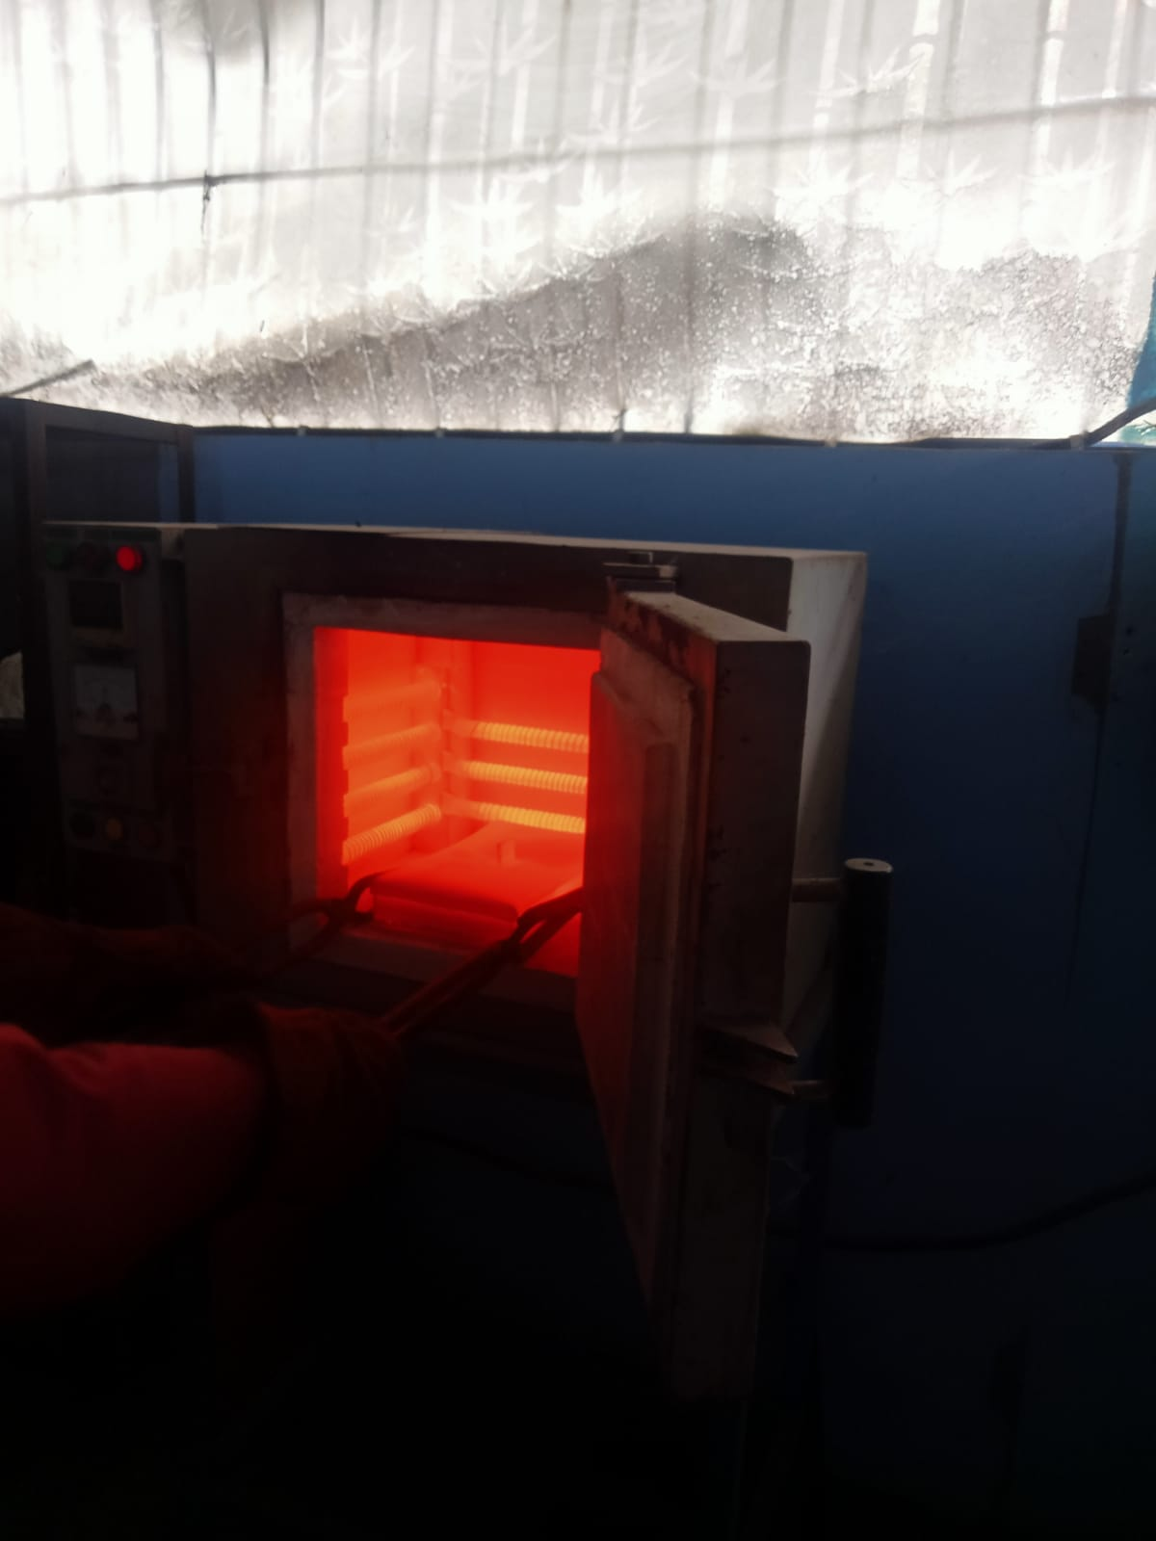

Suhu pemanasan
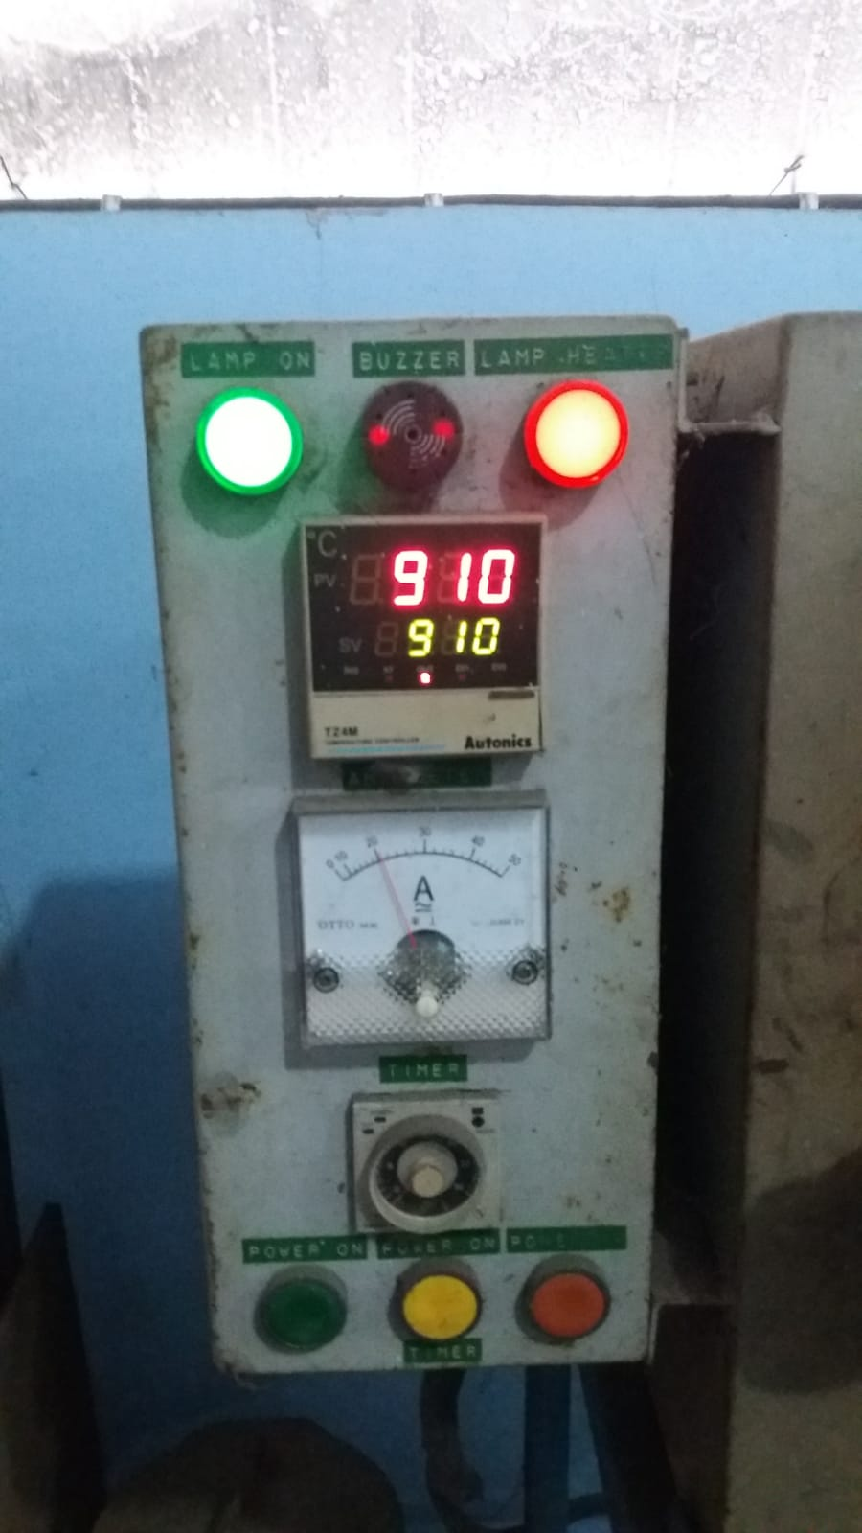

Pendinginan media oli
Pack carburizing (tulang sapi)
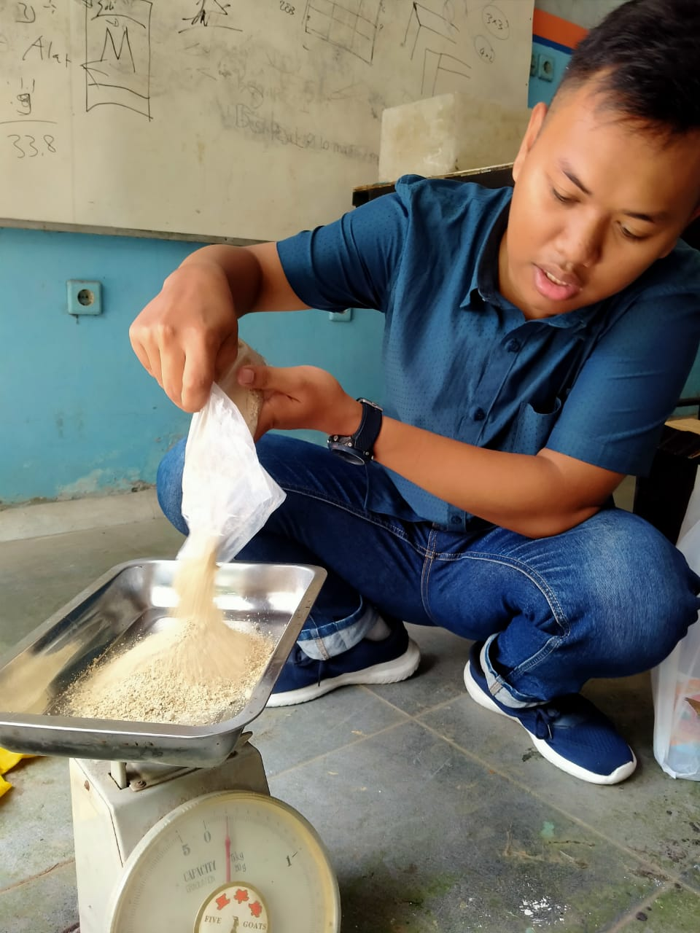
Specimen Uji Tarik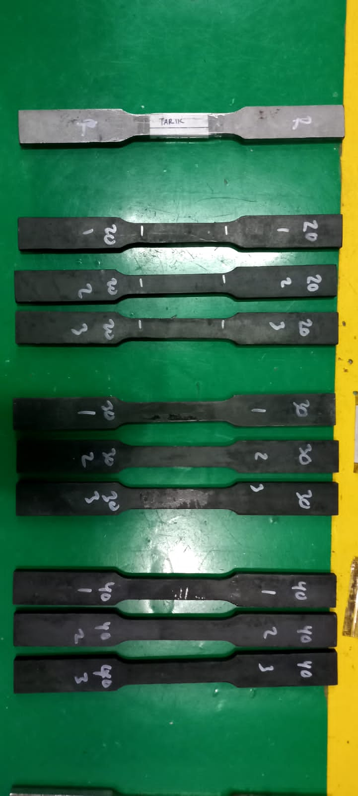

Specimen Uji Bending
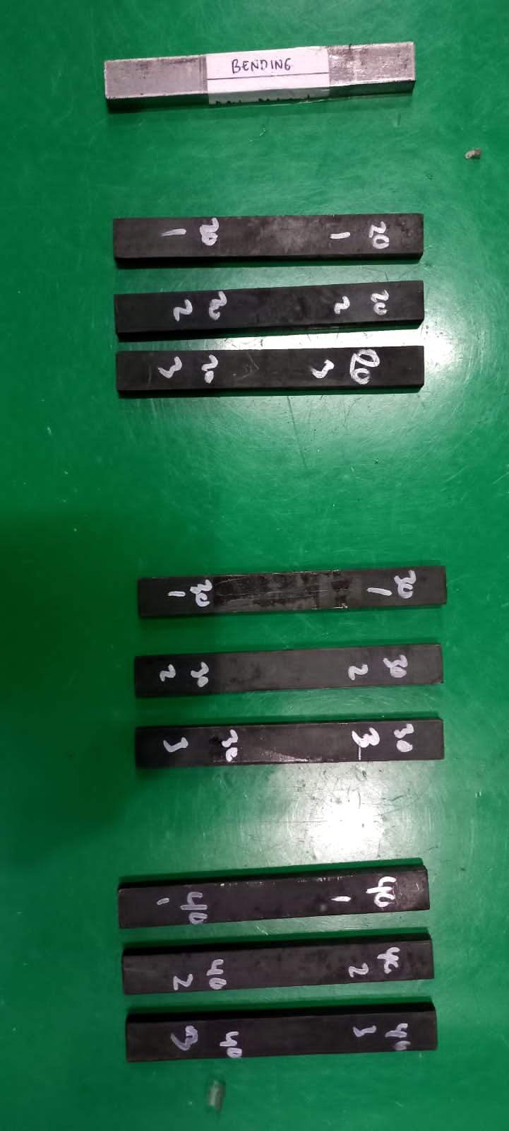

Specimen Uji Kekerasan
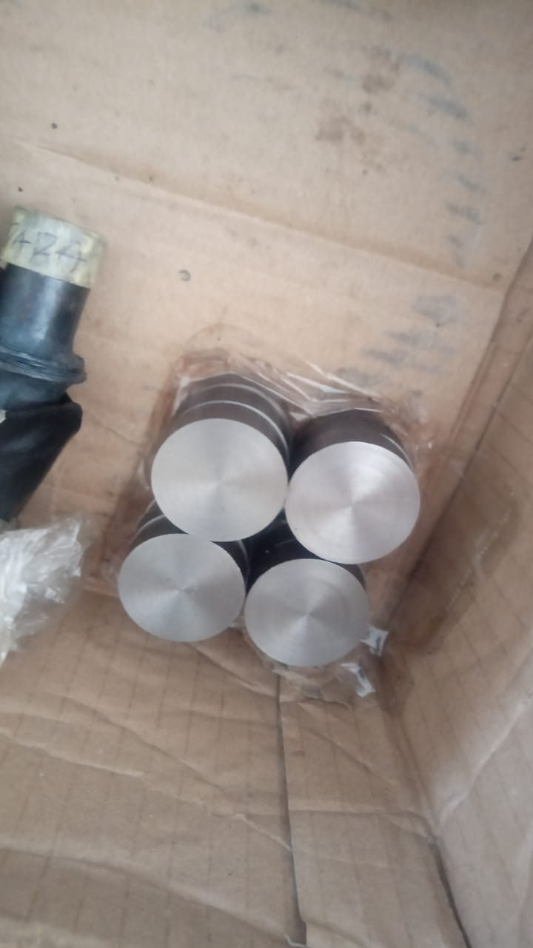
Proses carburizing specimen
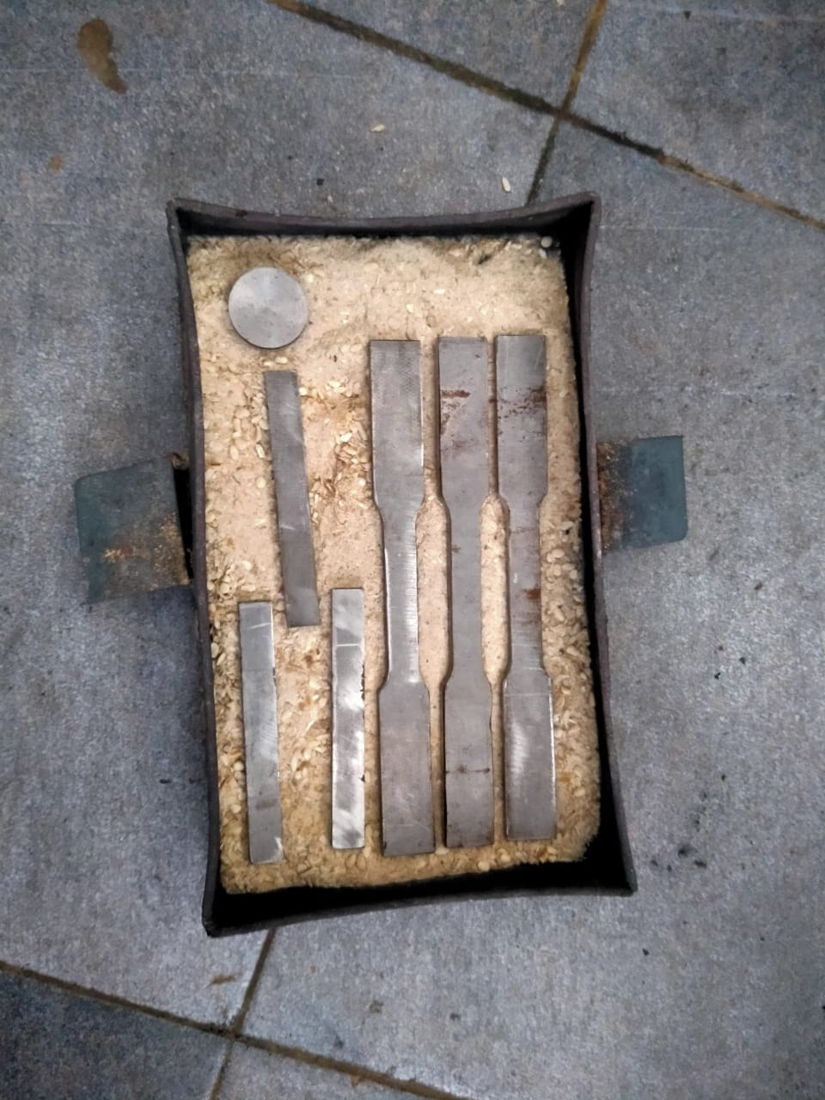

Mesin uji tarik
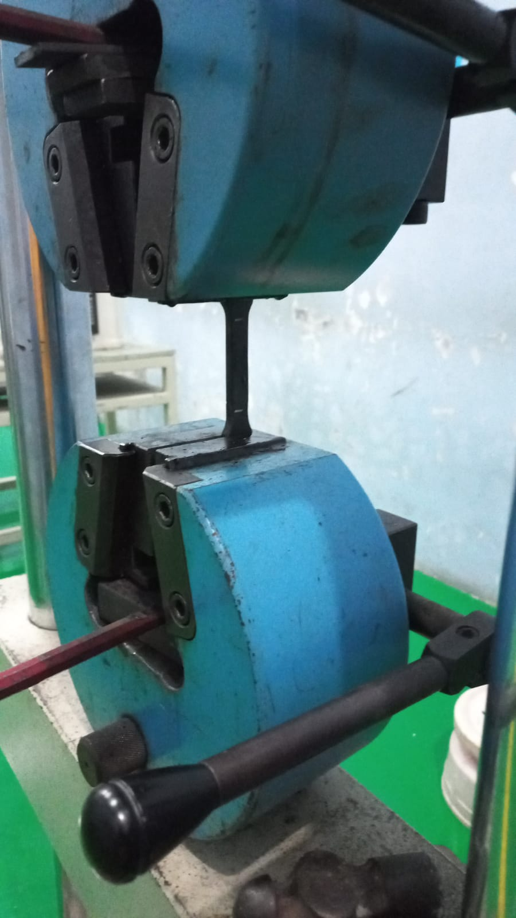

Mesin uji bending
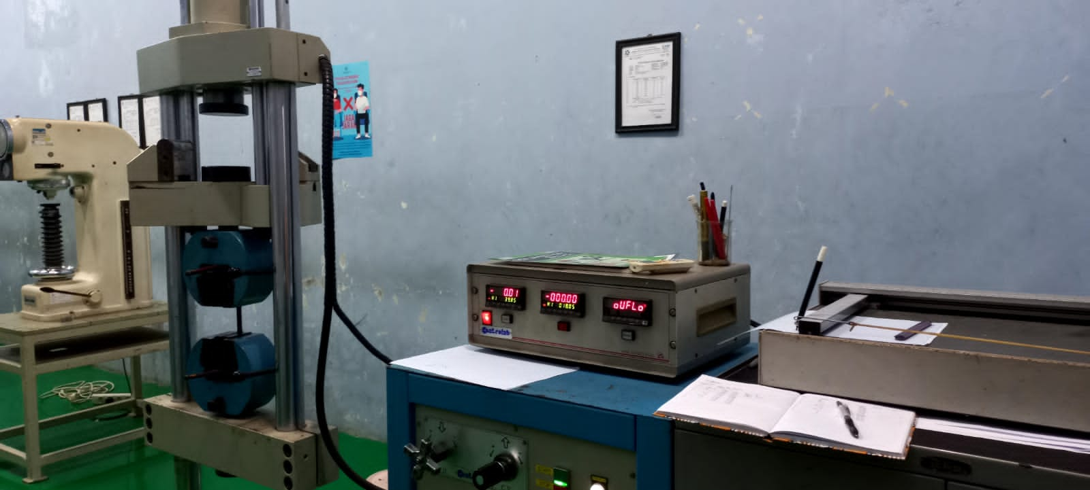
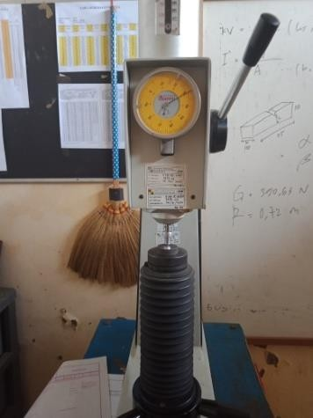
Mesin uji kekerasan

Sertifikat Uji Komposisi ST 41
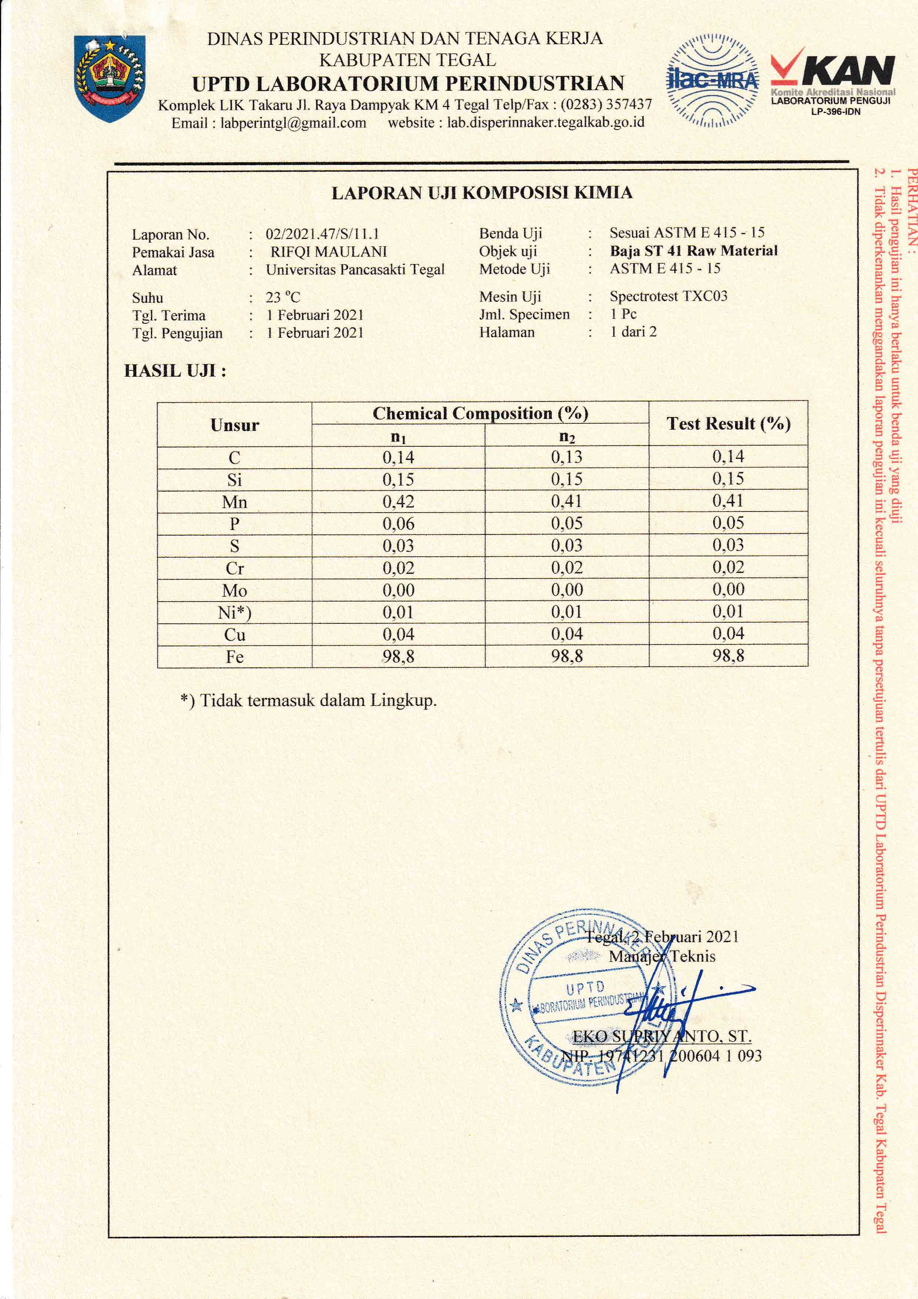

Sertifikat Uji Komposisi kimia sproket gear ST 41

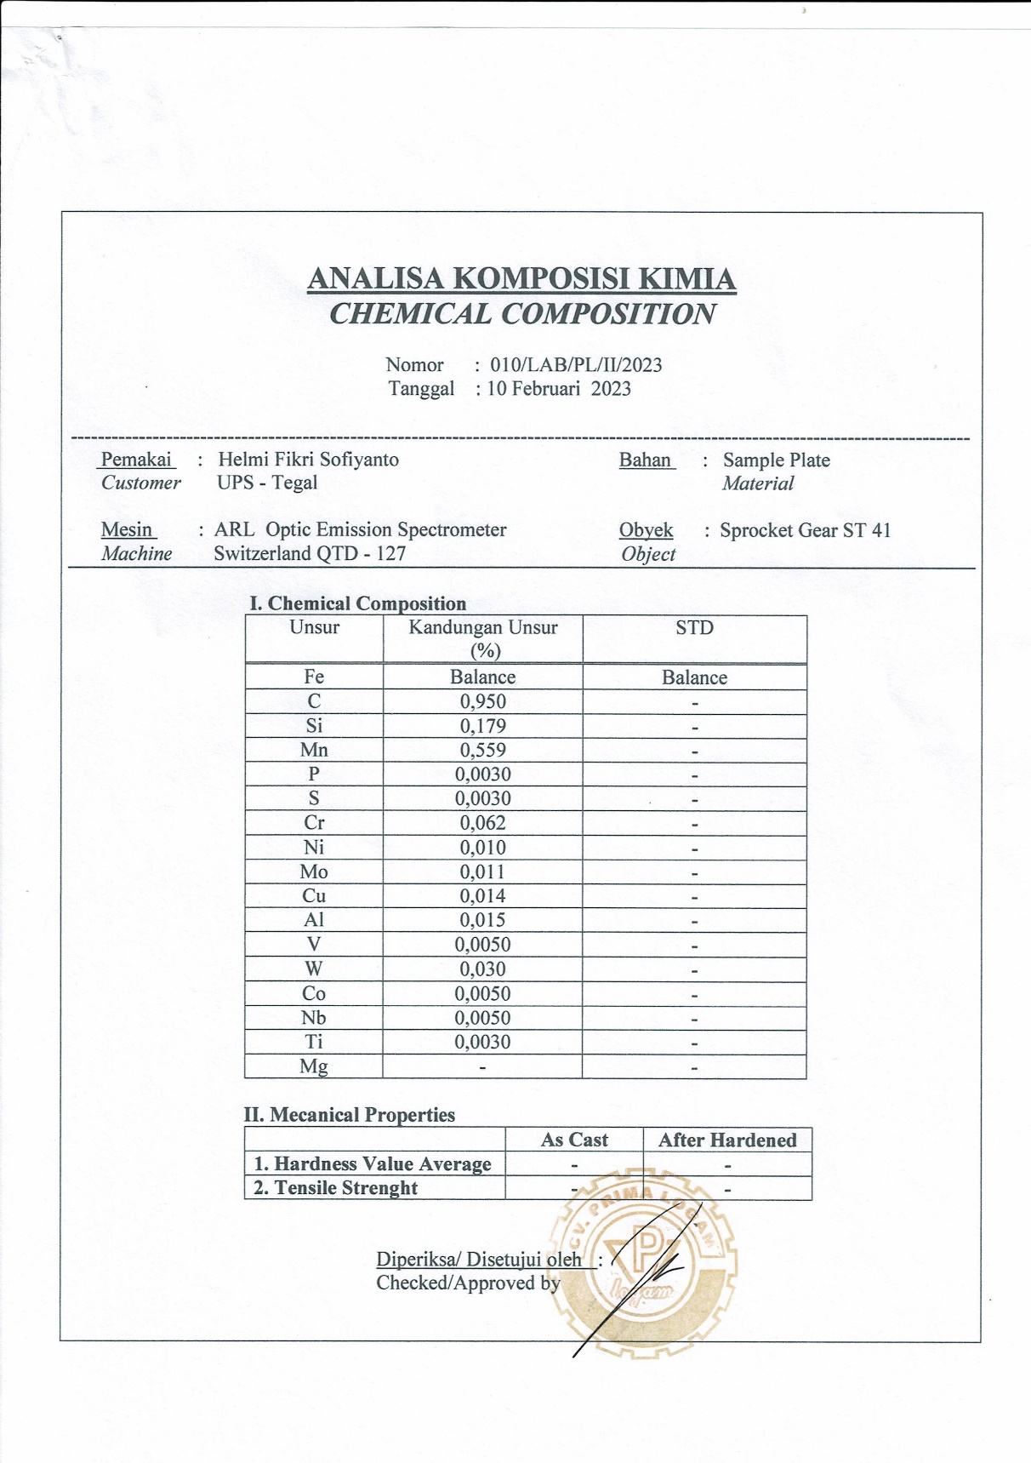

Sertifikat Uji Komposisi kimia sproket gear original
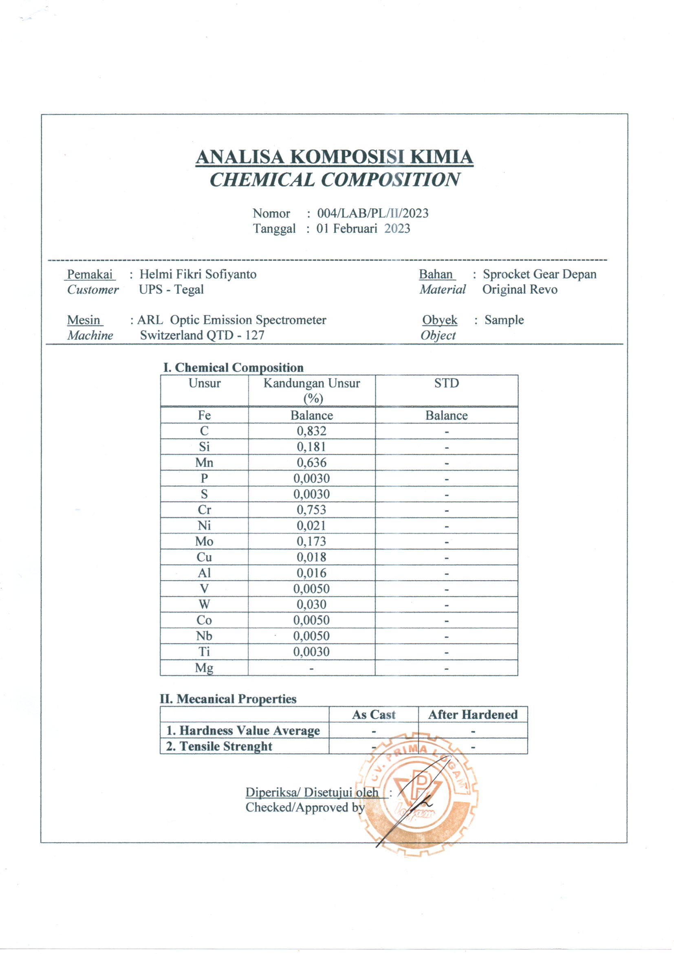

Sertifikat Uji Kekerasan Raw Material ST 41
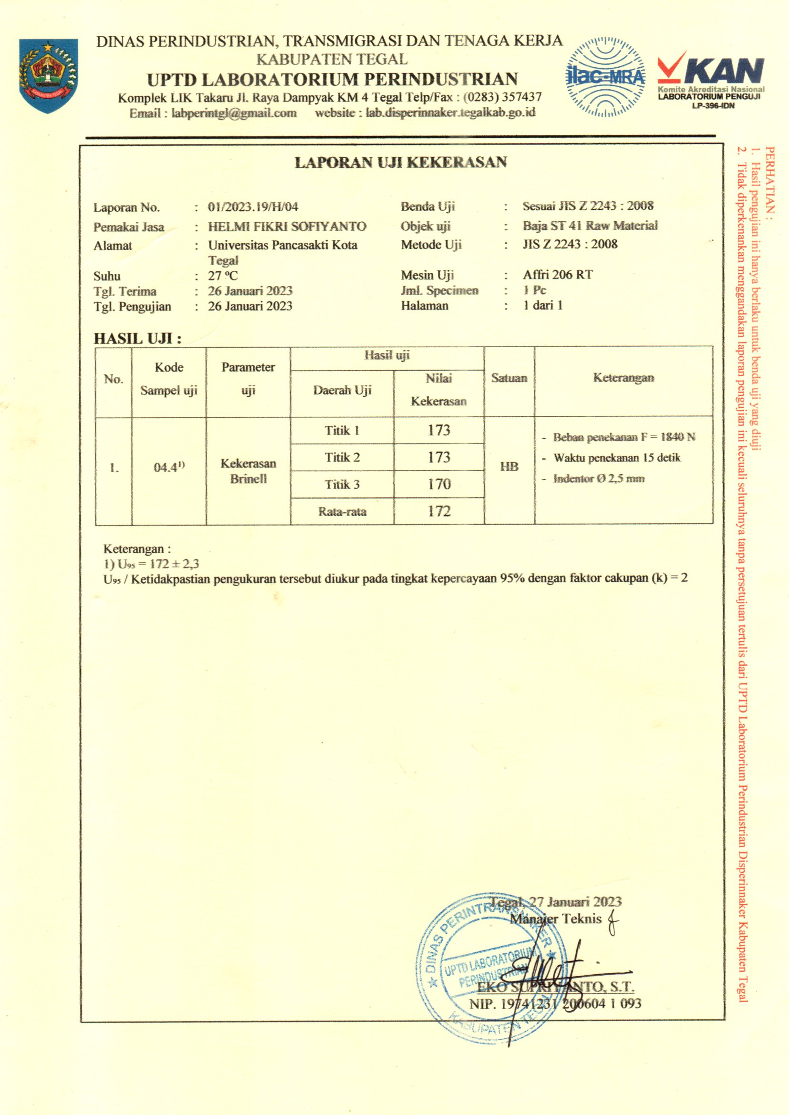

Sertifikat Uji Kekerasan Carburizing ST 41 variasi waktu 20 menit, 30 menit 40 menit
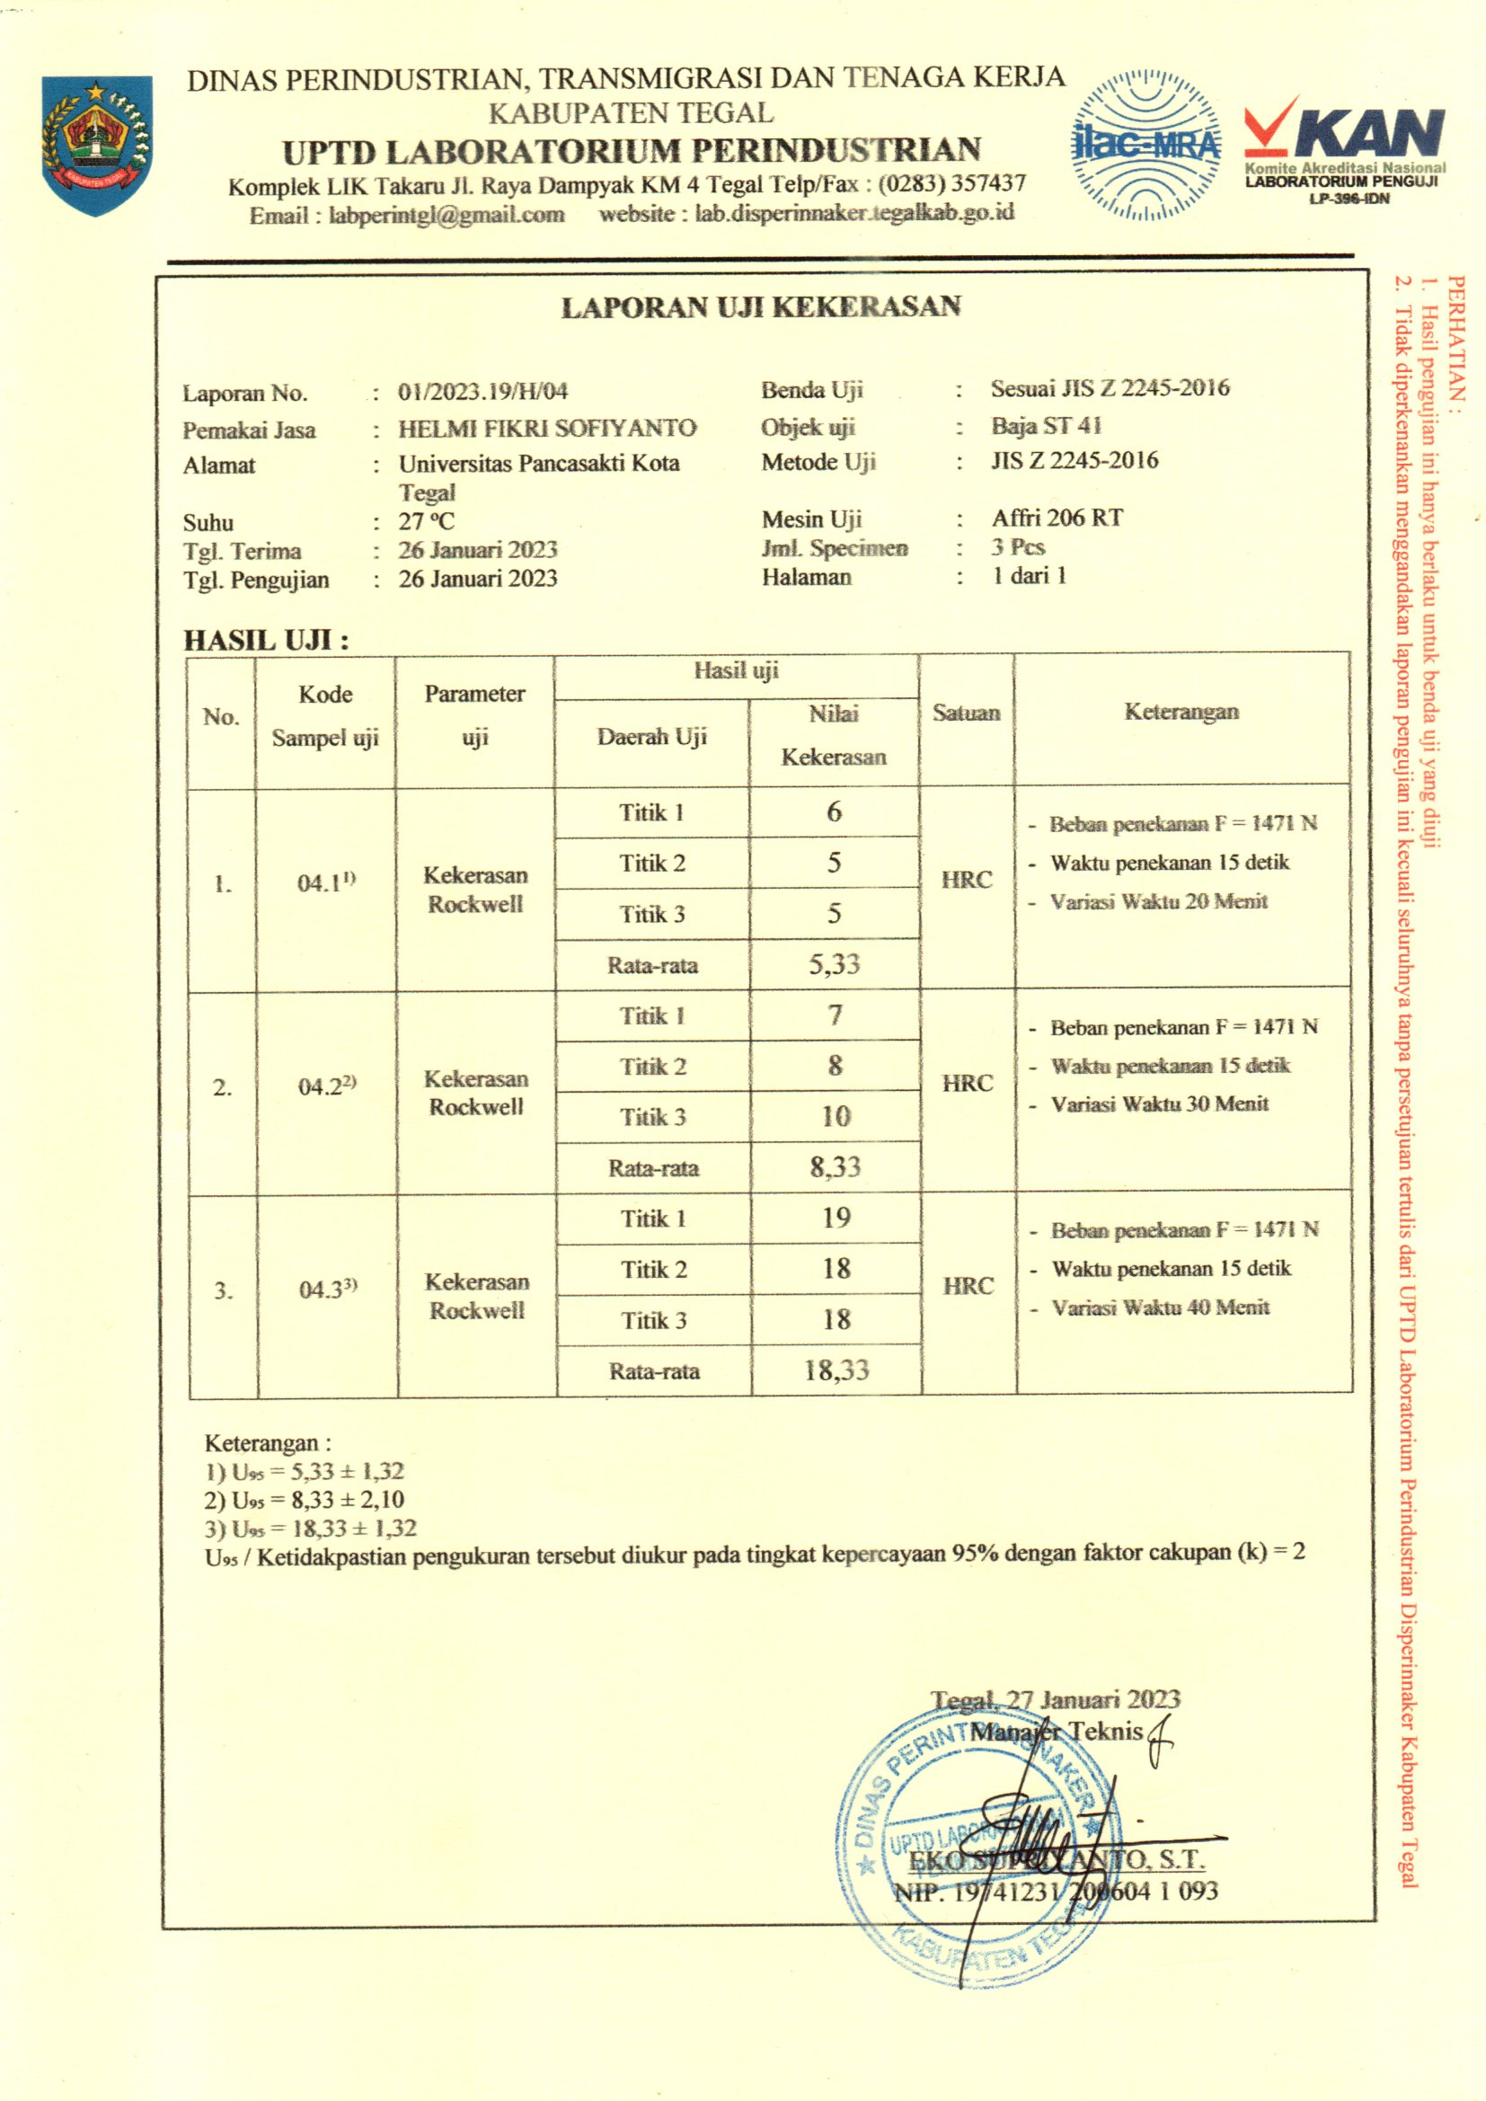

Sertifikat Uji Tarik Carburizing ST 41 variasi waktu 20 menit, 30 menit 40 menit
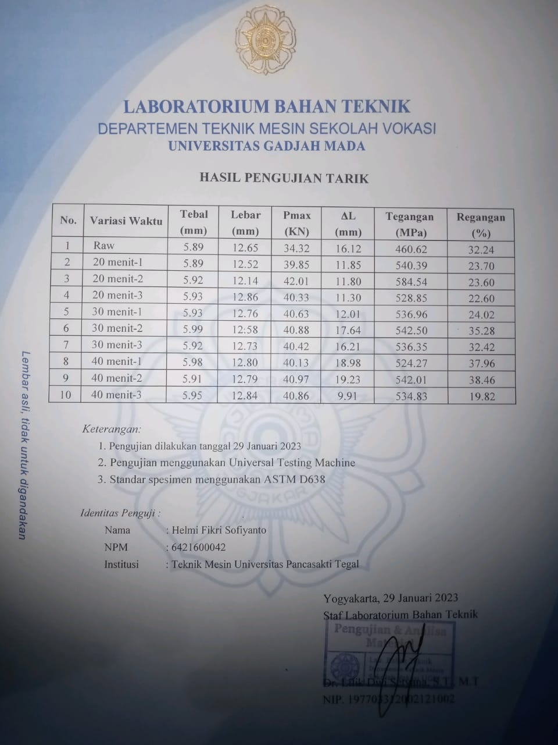

Grafik Uji tarik Carburizing ST 41 variasi waktu 20 menit, 30 menit 40 menit
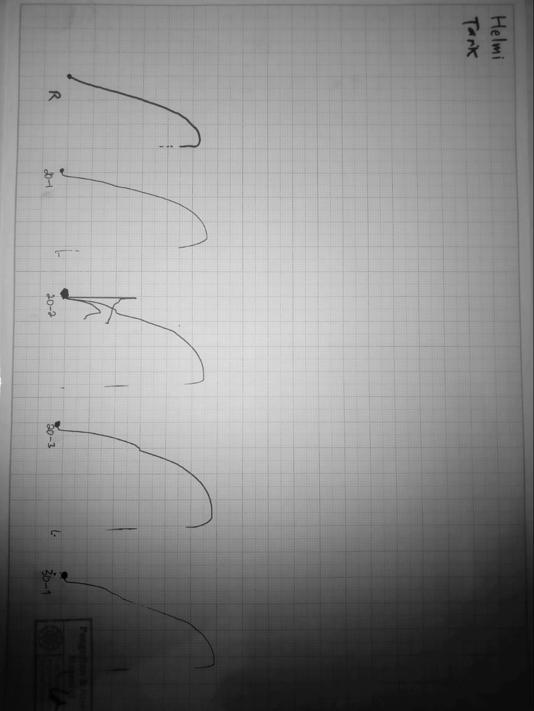

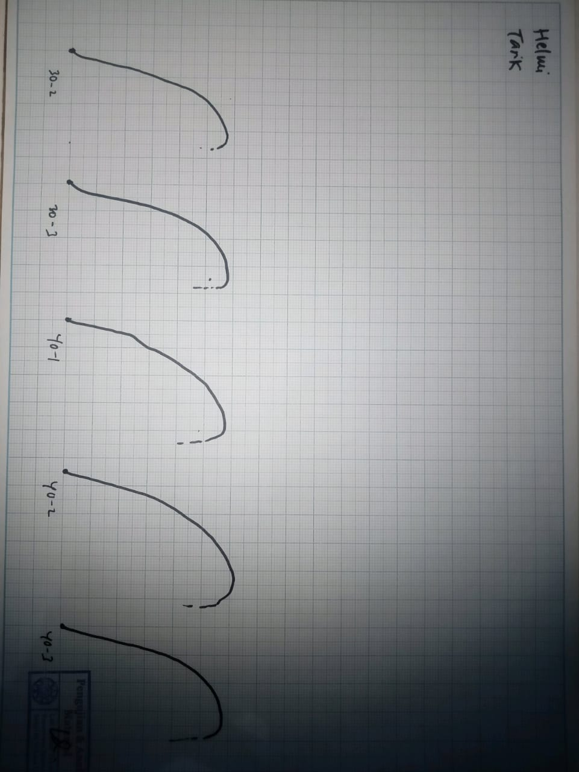

Sertifikat Uji Bending Carburizing ST 41 variasi waktu 20 menit, 30 menit 40 menit
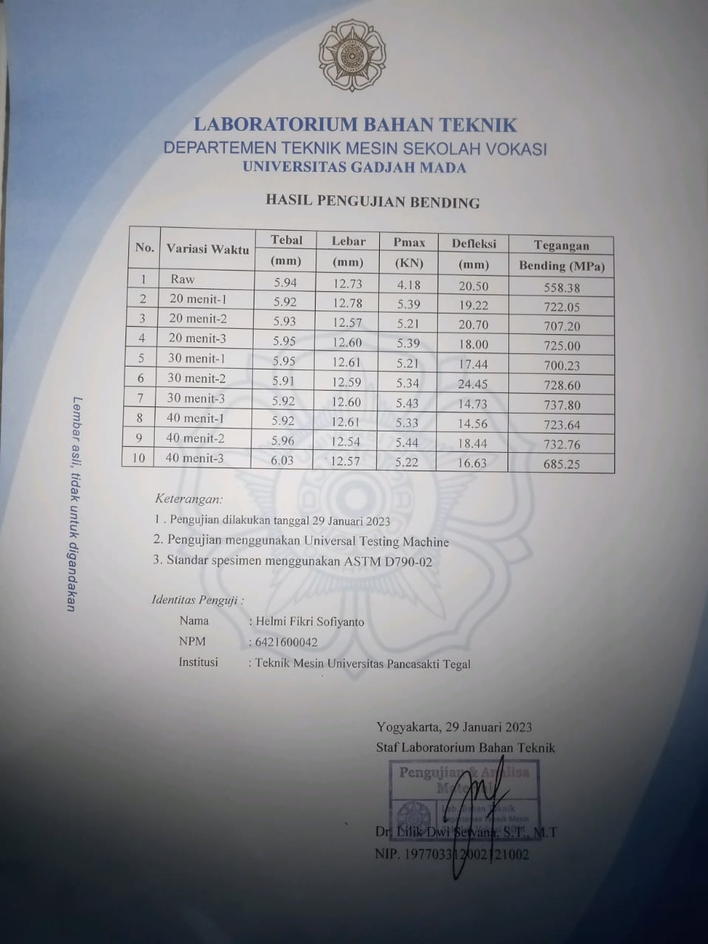

Grafik Uji Bending Carburizing ST 41 variasi waktu 20 menit, 30 menit 40 menit
