DAFTAR PUSTAKA

Adi Wibowo, S. S., Merlin, M., & Handayani, Y. (2021). Pengaruh Perputaran Modal Kerja dan Perputaran Kas Terhadap Profitabilitas. Journal of Applied Accounting and Taxation, 6(1), 79–87. https://doi.org/10.30871/jaat.v6i1.2918
Agustin, F., Suangga, A., & Sugiharto, B. (2018). Pengaruh Premium Growth Ratio, Risk Based Capital Dan Hasil Investasi Terhadap Profitabilitas Perusahaan Asuransi Umum Yang Terdaftar Di Bursa Efek Indonesia Tahun 2010-2014. Accruals, 2(2), 53–65. https://doi.org/10.35310/accruals.v2i2.13
Amrin, A. (2020). Asuransi Syariah: Keberadaan dan Kelebihannya di Tengah Asuransi Konvensional. IKAPI.
Anthony, R., & Govindarajan, V. (2019). Management Control System. Salemba Empat.
Brigham, E. F., & Houston, J. F. (2018). Dasar–Dasar Manajemen Keuangan. Salemba Empat.
Dzaki, N. A. (2018). Terhadap Profitabilitas Perusahaan Asuransi Jiwa Syariah Di Indonesia Tahun 2014-2018.
Fahmi, I. (2019). Analisis Laporan Keuangan. Alfabeta.
Ghozali, I. (2018a). Aplikasi Analisis Multivariat Dengan Program SPSS. BP. UNDIP.
Ghozali, I. (2018b). Aplikasi Analisis Multivariate dengan Program IBM SPSS 25. (Edisi 9). Semarang: Badan Penerbit Universitas Diponegoro.
Gitman, L. (2019). Prinsip Manajemen Keuangan. Salemba Empat.
Harahap, S. S. (2017). Teori Akuntansi. Rajawali Pers.
Hery. (2018). Analisis Laporan Keuangan : Integrated and Comprehensive Edition. Gramedia.
Husnan, S., & Pudjiastuti, E. (2018). Dasar-Dasar Manajemen Keuangan. UPP STIM YKPN.
Jensen, M. C., & Meckling, W. H. (1976). Theory Of The Firm: Managerial Behavior, Agency Costs And Ownership Structure. Journal of Financial Economics 3 (1976) 305-360. https://www.academia.edu/30946980/JENSEN_AND_MECKLING_A_Summary.
Kasmir. (2015). Analisis Laporan Keuangan. PT Raja Grafindo Persada.
Kasmir. (2018). Pengantar Manajemen Keuangan. Kencana.
Khaddafi, M. (2020). Akuntansi Biaya. Madenatera.
Lesmono, B., & Siregar, S. (2021). Studi Literatur Tentang Agency Theory. Ekonomi, Keuangan, Investasi Dan Syariah (EKUITAS), 3(2), 203–210. https://doi.org/10.47065/ekuitas.v3i2.1128
Leviany, T., & Sukiati, W. (2017). Pengaruh Risk Based Capital Terhadap Profitabilitas Pada Perusahaan Asuransi Jiwa. Jurnal ASET (Akuntansi Riset), 6(1), 1. https://doi.org/10.17509/jaset.v6i1.8993
Mulyana, B., & Elisabeth, E. (2019). Implikasi Efisiensi Modal Kerja, Likuiditas Dan Solvabilitas Terhadap Profitabilitas (Sudi Kasus pada PT. Berdikari Insurance). Magister Manajemen, Universitas Mercu Buana, Jakarta, Indonesia. https://publikasi.mercubuana.ac.id/index.php/indikator/article/view/2315
Munawir, S. (2017). Analisa Laporan Keuangan. Liberty.
Nadia, M. (2020). Pengaruh Pendapatan Premi, Hasil Investasi, Dan Risk Based Capital Terhadap Laba Perusahaan Asuransi (Studi Pada Perusahaan Asuransi Yang Terdaftar Di Bursa Efek Indonesia Periode 2015-2018). Jurnal, 1–16. https://jimfeb.ub.ac.id/index.php/jimfeb/article/view/6557
Undang-Undang Nomor 40 Tahun 2014 Tentang Perasuransian, (2022).
Panjaitan, N. D. F., & Devy, H. S. (2021). Pengaruh Pendapatan Premi , Klaim , Invetasi dan Biaya Operasional terhadap Pertumbuhan Aset Perusahaan Asuransi Jiwa Syariah di Indonesia. Velocity Journal of Sharia Finance and Banking, 1(1), 35–43. https://e-journal.iainpekalongan.ac.id/index.php/velocity/article/view/3589/1881
Riyanto, B. (2020). Dasar – dasar Pembelanjaan Perusahaan. BPFE.
Setyaningsih, R., Zanaria, Y., & Septiani, A. (2021). Pengaruh Pendapatan Premi, Hasil Investasi, Hasil Underwriting Dan Risk Based’Capital Terhadap Profitabilitas Perusahaan Asuransi (Study Empiris Pada Perusahaan Asuransi Yang Terdaftar Di Bursa Efek Indonesia Periode 2012-2019). Jurnal Akuntansi AKTIVA, 2(1), 95–103. https://doi.org/10.24127/akuntansi.v2i1.901
Siamat, D. (2015). Manajemen Lembaga Keuangan: Kebijakan Moneter dan Perbankan. Fakultas Ekonomi Universitas Indonesia.
Soniati, M. N., Ruhadi, R., & Syarief, M. E. (2020). Pengaruh Solvabilitas terhadap Profitabilitas (Studi pada Perusahaan Asuransi Kerugian yang Terdaftar di Bursa Efek Indonesia Tahun 2013-2018). Indonesian Journal of Economics and Management, 1(1), 49–61. https://doi.org/10.35313/ijem.v1i1.2417
Sugiyono. (2020). Metode Penelitian Bisnis. Alfabeta.
Suliyanto. (2018). Metode Penelitian Bisnis untuk Skripsi, Tesis, & Disertasi. Andi Offset.
Supriyono, A. E. (2019). Pengaruh Risk Based Terhadap Profitabilitas Pada Perusahaan Asuransi Syariah. Jurnal Aktiva : Riset Akuntansi Dan Keuangan, 1(1), 26–37. https://doi.org/10.52005/aktiva.v1i1.17
Susanto, C., & Parulian, S. R. (2019). Anggaran. Salemba Empat.
Susanto, I., Nangoy, S. C., & Mangantar, M. (2019). Perputaran Modal Kerja Terhadap Profitabilitas Perusahaan Asuransi Yang Terdaftar Di BEI. Jurnal EMBA, 2(4), 482–490. https://ejournal.unsrat.ac.id/index.php/emba/article/view /6355/5873.
Syamsuddin. (2016). Manajemen Keuangan Perusahaan. Raja Grafindo Persada.
Widodo, A., Nazir, A., & Sunarsi, D. (2020). Pengaruh Biaya Operasional Terhadap Profitabilitas Pada PT Tropical di Jakarta. TIN : Terapan Informatika Nusantara, 1(3), 113–117. https://ejurnal.seminar-id.com/index.php/tin/article/view/434.

Lampiran 1

Data Profitabilitas Perusahaan Asuransi Yang Terdaftar Di Bursa Efek Indonesia (BEI) Tahun 2018-2021
No | Kode | 2018 | 2019 | 2020 | 2021
1 | ABDA | 0,52 | 1,44 | 6,89 | 6,67
2 | AHAP | -3,93 | -19,74 | 2,16 | 2,48
3 | AMAG | 0,66 | 1,58 | 2,26 | 0,96
4 | ASBI | 1,59 | 0,93 | 2,71 | 1,73
5 | ASDM | 3,59 | 2,40 | 3,12 | 2,47
6 | ASJT | 5,23 | 0,27 | -2,12 | 0,07
7 | ASMI | 7,21 | 0,96 | -8,93 | 1,99
8 | ASRM | 5,18 | 4,06 | 4,32 | 4,60
9 | LPGI | 2,76 | 3,30 | 3,30 | 3,37
10 | MREI | 5,52 | 6,66 | 4,84 | 7,00
11 | MTWI | -0,26 | 0,17 | 0,44 | 0,62
12 | PNIN | 7,09 | 7,11 | 5,64 | 4,21
13 | VINS | -3,05 | 6,66 | 1,93 | 3,45
Rata-rata |  | 2,47 | 1,22 | 2,04 | 3,05
Sumber: data sekunder diolah, 2022

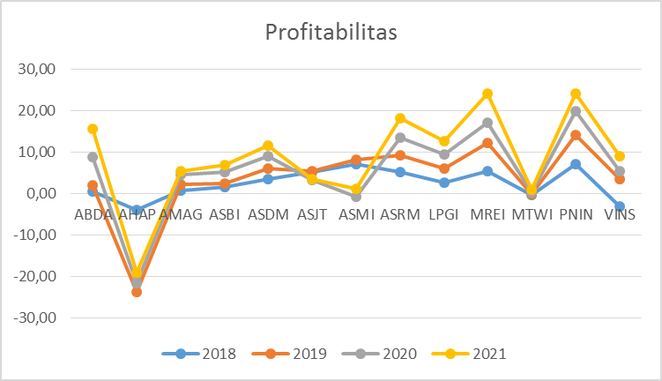
Data Profitabilitas Perusahaan Asuransi Yang Terdaftar Di Bursa Efek Indonesia (BEI) Tahun 2018-2021

Statistik Deskriptif Profitabilitas Perusahaan Asuransi Yang Terdaftar Di Bursa Efek Indonesia (BEI) Tahun 2018-2021

Descriptive Statistics
 | N | Minimum | Maximum | Mean | Std. Deviation
Profitabilitas | 52 | -19.74 | 7.21 | 2.1940 | 4.37704
Valid N (listwise) | 52

Lampiran 2

Data Perputaran modal kerja Perusahaan Asuransi Yang Terdaftar Di Bursa Efek Indonesia (BEI) Tahun 2018-2021
No | Kode | 2018 | 2019 | 2020 | 2021
1 | ABDA | 3,40 | 15,08 | 0,58 | 0,44
2 | AHAP | -1,79 | -0,81 | -0,47 | -0,87
3 | AMAG | -2,40 | -5,72 | 9,59 | 2,23
4 | ASBI | -0,69 | -0,59 | 0,80 | 1,04
5 | ASDM | 2,48 | 1,91 | -23,41 | 3,83
6 | ASJT | -3,36 | -2,91 | -6,82 | 14,27
7 | ASMI | -4,37 | 1,89 | 0,04 | -0,36
8 | ASRM | -0,78 | -0,77 | -0,62 | -1,33
9 | LPGI | -6,10 | -6,37 | -5,22 | -9,18
10 | MREI | 0,21 | 0,29 | 0,16 | 0,17
11 | MTWI | -0,92 | -2,02 | -2,54 | -4,01
12 | PNIN | 1,10 | 1,07 | 1,08 | 1,15
13 | VINS | 0,76 | 0,59 | -0,47 | 3,72
Rata-rata |  | -0,96 | 0,13 | -2,10 | 0,85
Sumber: data sekunder diolah, 2022

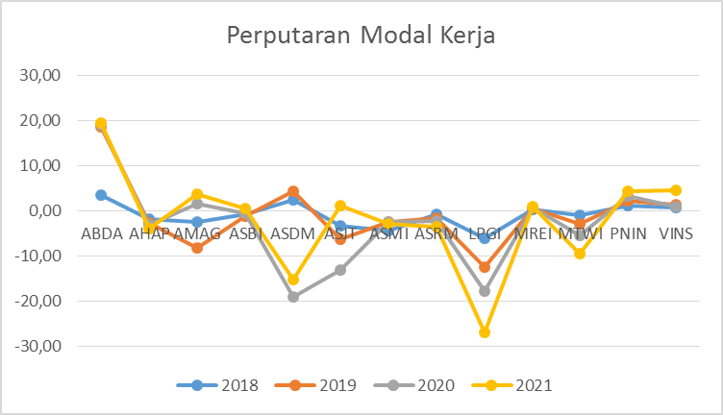
Data Perputaran modal kerja Perusahaan Asuransi Yang Terdaftar Di Bursa Efek Indonesia (BEI) Tahun 2018-2021

Statistik Deskriptif Perputaran modal kerja Perusahaan Asuransi Yang Terdaftar Di Bursa Efek Indonesia (BEI) Tahun 2018-2021

Descriptive Statistics
 | N | Minimum | Maximum | Mean | Std. Deviation
Perputaran Modal Kerja | 52 | -23.41 | 15.08 | -.5196 | 5.37531
Valid N (listwise) | 52

Lampiran 3

Data Underwriting Perusahaan Asuransi Yang Terdaftar Di Bursa Efek Indonesia (BEI) Tahun 2018-2021
No | Kode | 2018 | 2019 | 2020 | 2021
1 | ABDA | 0,01 | 0,03 | 0,19 | 0,21
2 | AHAP | -0,18 | -1,07 | 0,09 | 0,08
3 | AMAG | 0,04 | 0,09 | 0,14 | 0,22
4 | ASBI | 0,09 | 0,06 | 0,14 | 0,10
5 | ASDM | 0,19 | 0,14 | 0,15 | 0,12
6 | ASJT | 0,14 | 0,01 | -0,07 | 0,00
7 | ASMI | 0,52 | 0,05 | 7,88 | 0,19
8 | ASRM | 0,22 | 0,17 | 0,19 | 0,19
9 | LPGI | 0,06 | 0,07 | 0,08 | 0,06
10 | MREI | 0,73 | 0,78 | 0,77 | 0,84
11 | MTWI | -0,02 | 0,02 | 0,02 | 0,04
12 | PNIN | 0,47 | 0,49 | 0,65 | 0,52
13 | VINS | -0,30 | 0,72 | 0,23 | 0,40
Rata-rata |  | 0,15 | 0,12 | 0,81 | 0,23
Sumber: data sekunder diolah, 2022

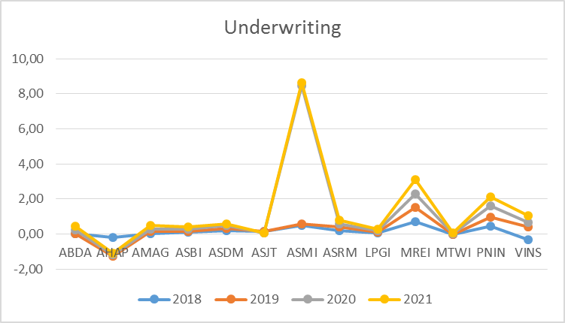

Data Underwriting Perusahaan Asuransi Yang Terdaftar Di Bursa Efek Indonesia (BEI) Tahun 2018-2021

Statistik Deskriptif Underwriting Perusahaan Asuransi Yang Terdaftar Di Bursa Efek Indonesia (BEI) Tahun 2018-2021

Descriptive Statistics
 | N | Minimum | Maximum | Mean | Std. Deviation
Underwriting | 52 | -1.07 | 7.88 | .3267 | 1.11154
Valid N (listwise) | 52

Lampiran 4

Data Pendapatan premi Perusahaan Asuransi Yang Terdaftar Di Bursa Efek Indonesia (BEI) Tahun 2018-2021
No | Kode | 2018 | 2019 | 2020 | 2021
1 | ABDA | 1.241.303.635 | 1.094.421.461 | 903.418.454 | 777.394.503
2 | AHAP | 138.709.796.359 | 107.284.306.329 | 135.250.057.172 | 196.501.415.210
3 | AMAG | 728.317.736 | 779.573.143 | 767.768.686 | 202.667.390
4 | ASBI | 153.064.361 | 133.154.950 | 165.128.494 | 160.427.321
5 | ASDM | 198.649.480 | 204.107.653 | 181.587.155 | 172.428.003
6 | ASJT | 183.165.384.062 | 152.809.529.035 | 107.091.468.350 | 115.490.756.693
7 | ASMI | 135.633.770.098 | 175.174.507.884 | -11.230.313.553 | 101.378.976.176
8 | ASRM | 352.488.318.320 | 359.657.973.516 | 339.072.465.808 | 335.624.261.996
9 | LPGI | 1.132.421.357.486 | 1.167.490.752.228 | 1.220.142.637.207 | 1.753.770.002.196
10 | MREI | 19.989.135.965 | 26.329.018.184 | 20.099.615.994 | 29.119.186.013
11 | MTWI | 33.779.663.734 | 38.487.004.816 | 100.269.824.779 | 78.473.697.520
12 | PNIN | 4.567.854.000 | 4.668.568.000 | 2.975.443.000 | 2.850.555.000
13 | VINS | 26.438.535.537 | 26.117.484.368 | 26.509.968.632 | 30.755.229.522
Rata-rata |  | 156.116.550.059 | 158.479.261.659 | 149.399.928.475 | 203.482.845.965
Sumber: data sekunder diolah, 2022

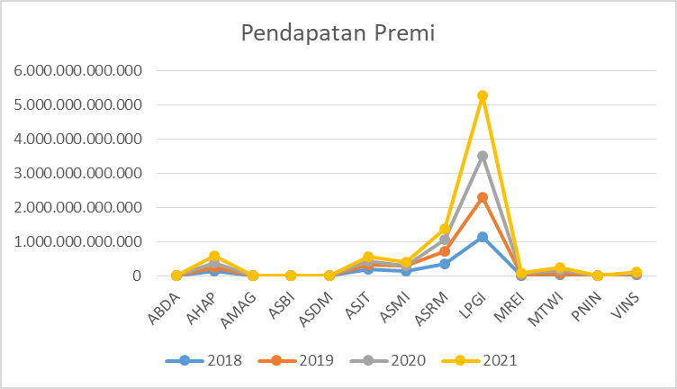
Data Pendapatan premi Perusahaan Asuransi Yang Terdaftar Di Bursa Efek Indonesia (BEI) Tahun 2018-2021

Statistik Deskriptif Pendapatan premi Perusahaan Asuransi Yang Terdaftar Di Bursa Efek Indonesia (BEI) Tahun 2018-2021

Descriptive Statistics
 | N | Minimum | Maximum | Mean | Std. Deviation
Biaya Operasional | 52 | -133.938.000.000.00 | 1.606.510.000.000.00 | 105.547.528.162.1346 | 341.349.613.290.47797
Valid N (listwise) | 52

Lampiran 5

Data Risk based capital Perusahaan Asuransi Yang Terdaftar Di Bursa Efek Indonesia (BEI) Tahun 2018-2021
No | Kode | 2018 | 2019 | 2020 | 2021
1 | ABDA | 316,73 | 363,78 | 372,51 | 374,00
2 | AHAP | 189,00 | 128,00 | 131,07 | 134,22
3 | AMAG | 768,32 | 898,27 | 919,83 | 941,90
4 | ASBI | 131,00 | 133,00 | 136,19 | 139,46
5 | ASDM | 281,4 | 305,1 | 312,42 | 319,92
6 | ASJT | 281,71 | 290,57 | 297,54 | 304,68
7 | ASMI | 454,58 | 383,384 | 392,59 | 402,01
8 | ASRM | 151,00 | 151,00 | 154,62 | 158,33
9 | LPGI | 186,80 | 198,50 | 203,26 | 208,14
10 | MREI | 364,5 | 342,3 | 350,52 | 358,93
11 | MTWI | 365,76 | 275,1 | 281,70 | 65,58
12 | PNIN | 421,80 | 430,24 | 440,56 | 451,14
13 | VINS | 398,24 | 406,20 | 415,95 | 425,94
Rata-rata |  | 331,60 | 331,19 | 339,14 | 329,56
Sumber: data sekunder diolah, 2022

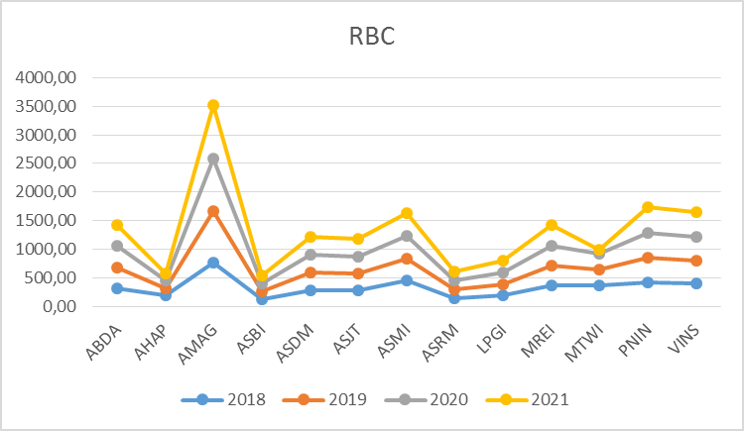
Data Risk based capital Perusahaan Asuransi Yang Terdaftar Di Bursa Efek Indonesia (BEI) Tahun 2018-2021

Statistik Deskriptif Risk based capital Perusahaan Asuransi Yang Terdaftar Di Bursa Efek Indonesia (BEI) Tahun 2018-2021

Descriptive Statistics
 | N | Minimum | Maximum | Mean | Std. Deviation
Risk Based Capital | 52 | 65.58 | 941.90 | 332.8714 | 193.72052
Valid N (listwise) | 52

Lampiran 6

Data Biaya operasional Perusahaan Asuransi Yang Terdaftar Di Bursa Efek Indonesia (BEI) Tahun 2018-2021
No | Kode | 2018 | 2019 | 2020 | 2021
1 | ABDA | 1.166.510.414 | 985.820.015 | 719.037.119 | 585.578.113
2 | AHAP | -79.778.053.280 | -133.938.488.497 | -105.202.030.172 | -111.333.340.725
3 | AMAG | 673.984.388 | 700.639.614 | 643.913.485 | 151.866.821
4 | ASBI | 140.752.768 | 124.308.747 | 144.644.642 | 149.324.085
5 | ASDM | 149.620.879 | 170.460.603 | 127.281.376 | 129.414.968
6 | ASJT | -67.715.518.555 | -67.918.769.628 | -60.759.026.488 | -49.286.316.729
7 | ASMI | 76.025.853.817 | 72.793.612.247 | -91.760.615.438 | -89.734.401.751
8 | ASRM | 300.940.979.082 | 299.073.101.555 | 275.448.589.027 | 277.925.909.089
9 | LPGI | 1.054.327.720.740 | 1.079.716.721.795 | 1.108.228.300.836 | 1.606.506.696.224
10 | MREI | -5.055.434.562 | -5.179.835.649 | -4.238.966.682 | -3.975.428.558
11 | MTWI | 35.435.515.367 | 35.299.361.759 | 72.753.270.228 | 53.459.661.857
12 | PNIN | 3.881.841.000 | 3.939.127.000 | 488.218.000 | 392.017.000
13 | VINS | 13.406.900.449 | 15.315.108.957 | -13.577.579.905 | -14.208.234.062
Rata-rata |  | 102.584.667.116 | 100.083.166.809 | 91.001.156.618 | 128.520.211.256
Sumber: data sekunder diolah, 2022

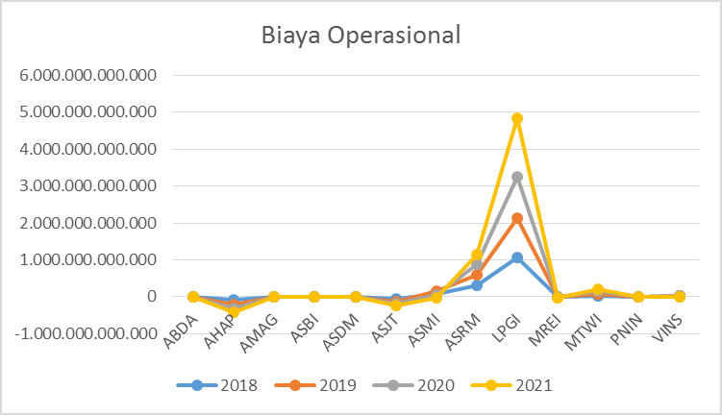
Data Biaya operasional Perusahaan Asuransi Yang Terdaftar Di Bursa Efek Indonesia (BEI) Tahun 2018-2021
\

Statistik Deskriptif Biaya operasional Perusahaan Asuransi Yang Terdaftar Di Bursa Efek Indonesia (BEI) Tahun 2018-2021

Descriptive Statistics
 | N | Minimum | Maximum | Mean | Std. Deviation
Biaya Operasional | 52 | 133.938.000.000.00 | 1.606.510.000.000.00 | 105.547.528.162.1346 | 341.349.613.290.47797
Valid N (listwise) | 52

Lampiran 7
Hasil Perhitungan SPSS

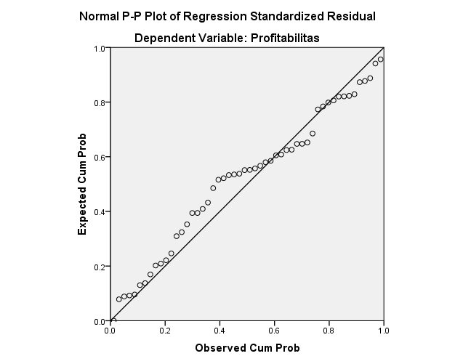
Hasil Uji Normalitas

Hasil Uji Normalitas Dengan Kolmogorov Smirnov
One-Sample Kolmogorov-Smirnov Test
 |  | Unstandardized Residual
N |  | 52
Normal Parameters^{a,b} | Mean | .0000000
 | Std. Deviation | .02812943
Most Extreme Differences | Absolute | .132
 | Positive | .071
 | Negative | -.132
Test Statistic |  | .132
Asymp. Sig. (2-tailed) |  | .054^{c}
a. Test distribution is Normal.
b. Calculated from data.
c. Lilliefors Significance Correction.

Hasil Uji Multikolinieritas
Coefficientsª
Model |  | Collinearity Statistics
 |  | Tolerance | VIF
1 | Perputaran Modal Kerja | .706 | 1.416
 | Pendapatan Premi | .106 | 9.574
 | Underwriting | .118 | 8.506
 | Risk Based Capital | .788 | 1.269
 | Biaya Operasional | .159 | 6.307
a. Dependent Variable: Profitabilitas

Hasil Uji Autokorelasi
Model Summary^{b}
Model | Durbin-Watson
1 | 2.047ª
a. Predictors: (Constant), Biaya Operasional, Underwriting, Risk Based Capital, Perputaran Modal Kerja, Pendapatan Premi
b. Dependent Variable: Profitabilitas

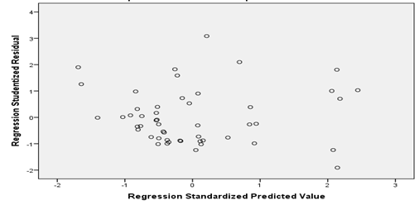
Hasil Uji Heterokedastisitas
Hasil Analisis Regresi Linier Berganda
Coefficientsª
Model |  | Unstandardized Coefficients |  | Standardized Coefficients | t | Sig.
 |  | B | Std. Error | Beta
1 | (Constant) | .020 | .067 |  | .300 | .766
 | Perputaran Modal Kerja | .008 | .009 | .101 | .894 | .376
 | Pendapatan Premi | .057 | .007 | 2.456 | 7.621 | .000
 | Underwriting | .071 | .011 | 1.797 | 6.502 | .000
 | Risk Based Capital | -.005 | .019 | -.025 | -.234 | .816
 | Biaya Operasional | -.059 | .008 | -1.693 | -7.115 | .000
a. Dependent Variable: Profitabilitas

Hasil Uji Hipotesis
Coefficientsª
Model |  | Unstandardized Coefficients |  | Standardized Coefficients | t | Sig.
 |  | B | Std. Error | Beta
1 | (Constant) | .020 | .067 |  | .300 | .766
 | Perputaran Modal Kerja | .008 | .009 | .101 | .894 | .376
 | Pendapatan Premi | .057 | .007 | 2.456 | 7.621 | .000
 | Underwriting | .071 | .011 | 1.797 | 6.502 | .000
 | Risk Based Capital | -.005 | .019 | -.025 | -.234 | .816
 | Biaya Operasional | -.059 | .008 | -1.693 | -7.115 | .000
a. Dependent Variable: Profitabilitas

Hasil Uji simultan (Uji F)
ANOVAª
Model |  | Sum of Squares | df | Mean Square | F | Sig.
1 | Regression | .057 | 5 | .011 | 13.080 | .000^{b}
 | Residual | .040 | 46 | .001
 | Total | .098 | 51
a. Dependent Variable: Profitabilitas
b. Predictors: (Constant), Biaya Operasional, Underwriting, Risk Based Capital, Perputaran Modal Kerja, Pendapatan Premi

Hasil Analisis Koefisien Determinasi
Model Summary
Model | R | R Square | Adjusted R Square | Std. Error of the Estimate
1 | .766ª | .587 | .542 | .02962
a. Predictors: (Constant), Biaya Operasional, Underwriting, Risk Based Capital, Perputaran Modal Kerja, Pendapatan Premi

