DAFTAR PUSTAKA
Ardlani Y. Pengaruh Kompetensi terhadap Kinerja Guru Bersertifikasi di SD Negeri se-Kecamatan Ponjong Kabupaten Gunungkidul. Jurnal Pendidikan Guru Sekolah Dasar, Edisi 22, Tahun Ke-5, 2016.
Elik Y.M. Pengaruh Pembiayaan, Pengelolaan Pendidikan terhadap Mutu Pendidikan di Sekolah Menengah Kejuruan Negeri 4 Kupang. Jurnal Profesi Keguruan, Volume 4, Nomor 2, 2018, hlm. 77-81.
Fadilah, I; R.I. Sari; V. Ramadhani; F.R. Basuki; O. Fitaloka. Ethnoscience Study of the Application and Delivery Procession of Adat Melayu Jambi as Science Learning Resources. Scientiae Educatia. Volume 8, Number 2, 2019, page 141.
Fauzan, M; A Gani; M. Syukri; D.B Aceh; D. Penerapan Model Problem Based Learning pada Pembelajaran Materi Sistem Tata Surya Untuk Meningkatkan Hasil Belajar Siswa. Jurnal Pendidikan Sains Indonesia (Indonesian Journal of Science Education), Volume 5, Nomor 1, 2017, hlm. 27-35.
Forefry, N. 2017. Strategi Pemberdayaan Guru oleh Sekolah (Studi Kasus di SMAN 5 dan SMA Darul Hikam Kota Bandung). Jurnal Administrasi Pendidikan, Volume XXIV, Nomor 1, 2017, hlm. 47-59.
Ghozali, I. 2016. Aplikasi Analisis Multivariate dengan Program IBM SPSS 23. Edisi 8. Semarang: Badan Penerbit Universitas Dipenogoro.
Hartinah D.S; R.A Nugraha; A.W.T Ardyanti. Seamanship Human Resource Development Management Strategy Based on Global Competitiveness at Maritime Secondary School-A Case Study in National Maritime Secondary School Purwokerto. European Journal of Education Studies, Volume 4, Number 2, 2018.
Husna, H. Pengaruh Penerapan Model Pembelajaran Arias Disertai Tugas Awal terhadap Hasil Belajar Fisika Siswa Kelas XI IPA SMAN 8 Padang. Jurnal Pelangi, Volume 3, Nomor 2, 2011.
Jalil, M. The Effectiveness of Simulation Methods on Prospective Teacher’s Professionalism in Science Learning. Scientiae Educatia, Volume 7, Number 2, 2019, page 129.
Liu, P. Chinese Teachers’ Perspectives on Teachers’ Commitment to Change. International Journal of Comparative Education and Development, Volume 18, Number 1, 2016, page 2-18.
Mulyadi dan Fahriana, A.S, 2018. Supervisi Akademik Konsep, Teori, Model Perencanaan, dan Implikasinya. Malang: Madani
Nafiah, Y.N; W. Suyanto. Penerapan Model Problem-Based Learning untuk Meningkatkan Keterampilan Berpikir Kritis dan Hasil Belajar Siswa. Jurnal Pendidikan Vokasi, Volume 4, Nomor 1, 2014. hlm. 125-143.
Nainggolan N.T; R. Siahaan; L.E Nainggolan. Dampak Komitmen Guru terhadap Kinerja Guru pada SMP Negeri 1 Panei. Maker: Jurnal Manajemen, Volume 6, Nomor 1, Juni 2020, hlm. 1-12.
Ningrum K.S.C. Pengaruh Kompetensi Guru terhadap Kinerja Guru SMP Negeri 6 Singaraja. Jurnal Program Studi Pendidikan Ekonomi (JPPE), Volume 7, Nomor 2, Tahun 2016.
Priansa dan Somad. 2014. Manajemen Supervisi dan Kepemimpinan Kepala Sekolah. Bandung: Alfabeta.
Putro P.U.W. Etika Kerja Islam, Komitmen Organisasi, Sikap pada Perubahan Organisasi terhadap Kinerja. Jurnal Manajemen Indonesia, Volume 18, Nomor 2, 2018, hlm. 116–125.
Sahir, S.H. et al. 2020. Keterampilan Manajerial Efektif. Cetakan 1. Medan: Yayasan Kita Menulis.
Sedarmayanti. 2018. Perencanaan dan Pengembangan Sumber Daya Manusia untuk Meningkatkan Kompetensi, Kinerja dan Produktivitas Kerja. Bandung: Refika Aditama.
Sugiyono. 2017. Metode Penelitian Kuantitatif Kualitatif dan R & D. Bandung: Alfabeta.
Suharjanti. Analisis Validitas dan Reliabilitas dengan Skala Likert terhadap Pengembangan SI/TI dalam Penentuan Pengambilan Keputusan Penerapan Strategic Planning pada Industri Garmen. Prosiding Seminar Nasional Aplikasi Sains & Teknologi (SNAST) 2014, Yogyakarta, 15 November 2014.
Suwarjo. (1999). Pendidikan Among Sistem. (1st ed.) Yogyakarta: Majelis Luhur Persatuan Tamansiswa.
Undang-Undang Nomor 20 Tahun 2003 tentang Sistem Pendidikan Nasional: Kementerian Pendidikan dan Kebudayaan.
Wangid, Muhammad Nur. 2009. Sistem Among Pada Masa Kini Kajian Konsep dan Praktik Pendidikan. Jurnal Kependidikan 39(2), 129-140.
Wardani, Kristi. 2010. Peran Guru dalam Pendidikan Karakter Menurut Konsep Pendidikan Ki Hadjar Dewantara. Proceeding of the 4th International Conference on Teacher Education; Join Conference yang diselenggarakan oleh UPI dan UPSI, tanggal 8-10 November 2010.
Widyastono, Heri. 2014. Pengembangan Kurikulum di Era Otonomi Daerah dari Kurikulum 2004, 2006, ke Kurikulum 2013. Jakarta: Bumi Aksara.
Yanuarti, Eka. 2017. Pemikiran pendidikan Ki. Hajar Dewantara dan relevansinya dengan kurikulum 13. Jurnal Penelitian, Vol.2. No. 2 Agustus.
Wahyudi. 2010. Kepemimpinan Kepala Sekolah dalam Organisasi Pembelajar (Learning Organization). Bandung: Alfabeta.
Yusup F. Uji Validitas dan Reliabilitas Instrumen Penelitian Kuantitatif. Jurnal Tarbiyah: Jurnal Ilmiah Kependidikan. Volume 7, Nomor 2, Januari-Juni 2018, hal. 17-23.
Zahara Mustika, Nasrun, & Yasaratodo Wao. Pengaruh Kompetensi Pedagogik, Komitmen Kerja, terhadap Kinerja Guru Sekolah Dasar Negeri di Kota Banda Aceh. JUPIIS: Jurnal Pendidikan Ilmu-ilmu Sosial, 13 (1) (2021): 149-158

Peraturan Pemerintah Nomor 46 Tahun 2011 tentang Penilaian Prestasi Kerja Pegawai Negeri sipil
Arief Furchan, Pengantar Penelitian dalam Pendidikan, (Yogyakarta : Pustaka Pelajar, 2004).
Burhanuddin, Analisis Manajemen dan Kepemimpinan Pendidikan, (Malang : Bumi Aksara, 1994).
M. Ngalim Purwanto, Administrasi Pendidikan, (Jakarta : Mutiara Sumber2 Benih Kecerdasan, 1981). Maman Suherman, Pengembangan Sarana Belajar, (Jakarta : Karunia, 1986).
Maman Ukas, Manajemen Konsep, Prinsip, dan Aplikasi, (Bandung : Ossa Promo, 1999).
Wahjosumidjo, Kepemimpinan Kepala Sekolah (Tinjauan Teoritik dan Permasalahannya, (Jakarta : Raja Grafindo Persada, 1995.
Mujiono, Imam. 2002. Kepemimpinan dan Keorganisasian. Yogyakarta: UII Press.
Mulyasa, E. 2009. Manajemen Berbasis Sekolah. Bandung: PT Remaja Rosdakarya
Fattah DR. Nanang 2009. Landasan Manajemen Pendidikan. Remaja Rosdakarya.

LAMPIRAN 1
Permohonan Ijin Penelitian

LAMPIRAN 2
Balasan Permohonan Ijin Penelitian

LAMPIRAN 3
Dokumentasi Penyebaran Responden Guru
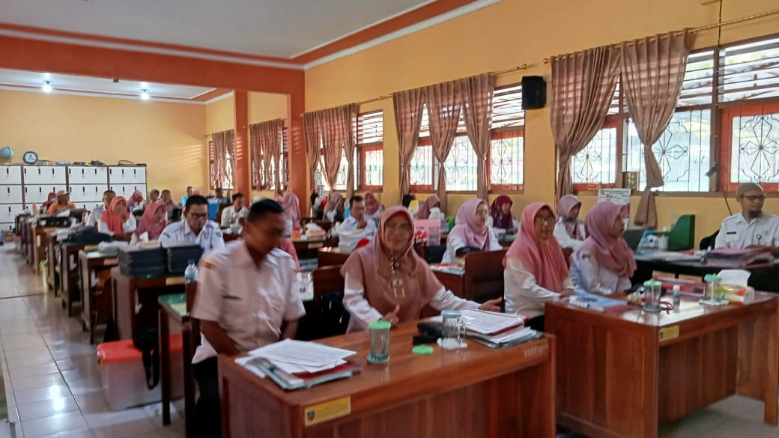

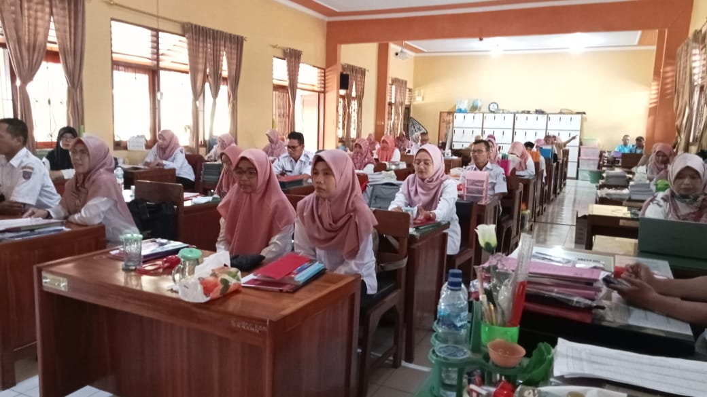

Responden Siswa Kelas VII

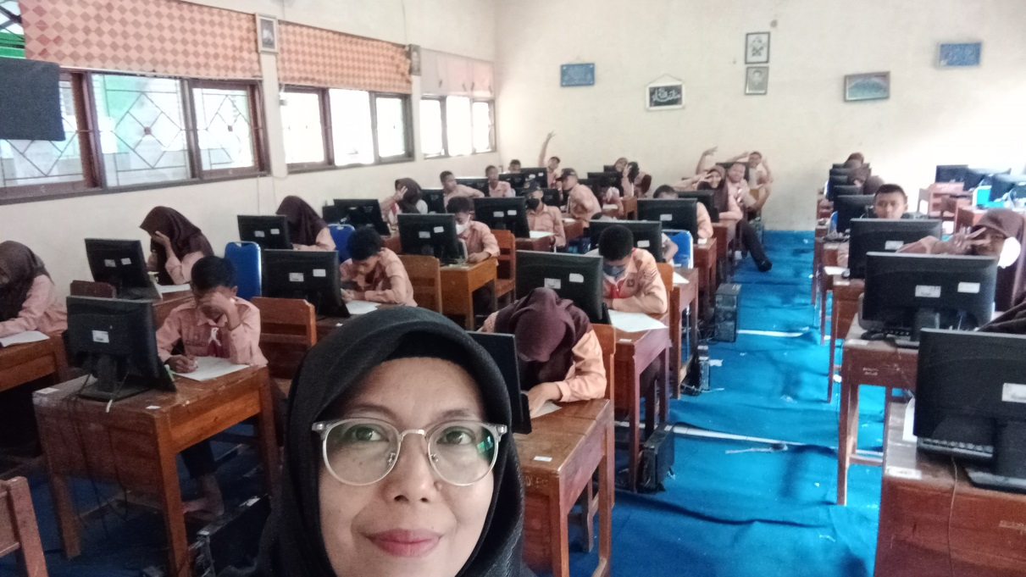

Responden Siswa Kelas VIII
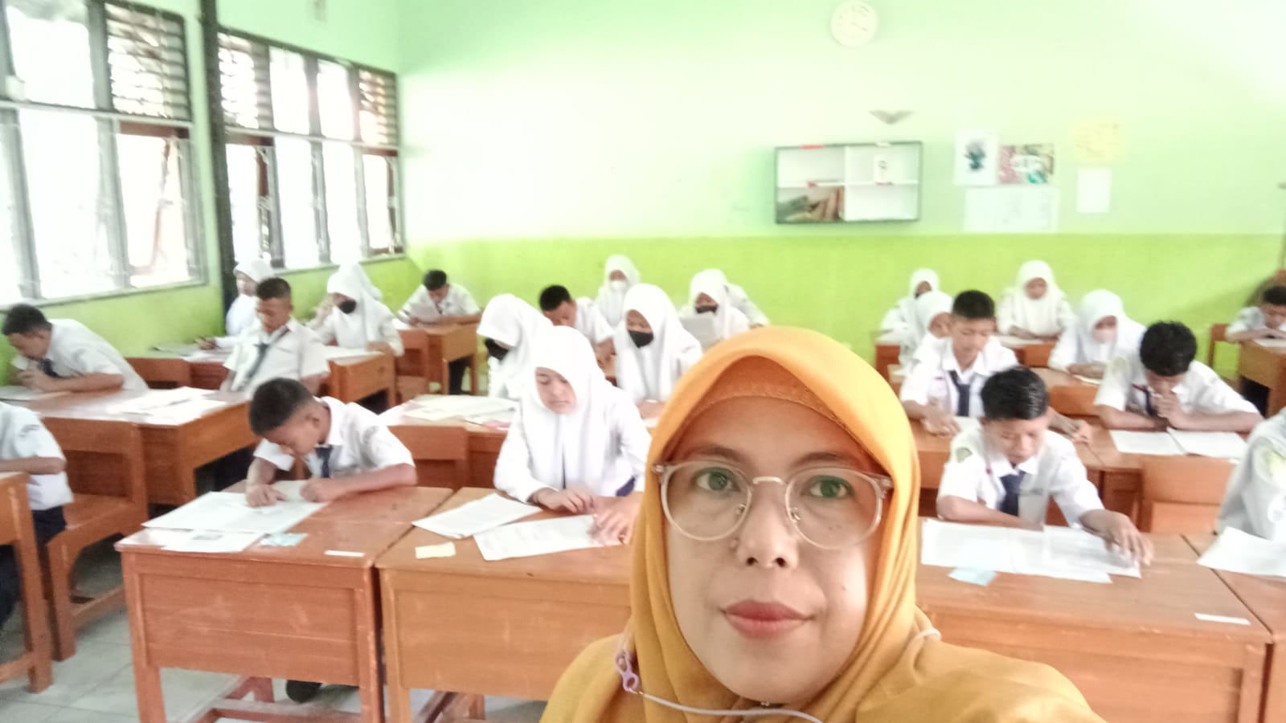

Responden Kelas IX

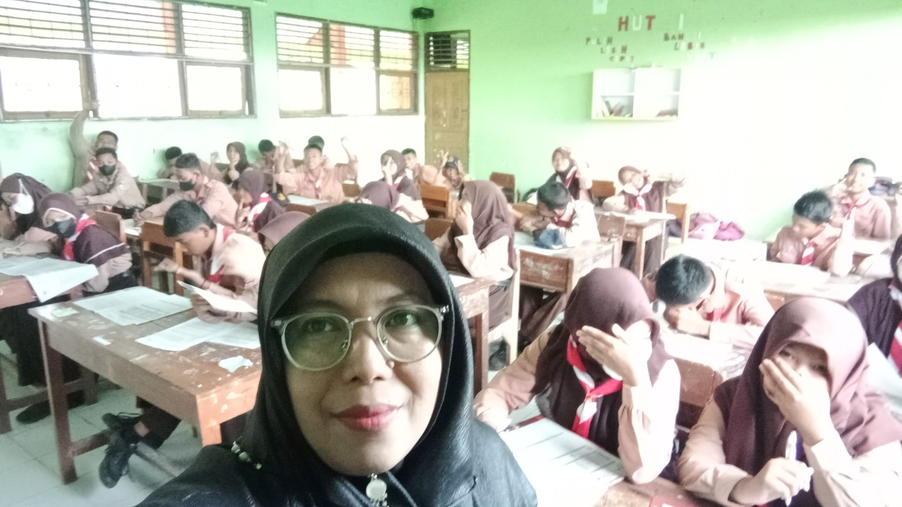

Responden Kelas IX

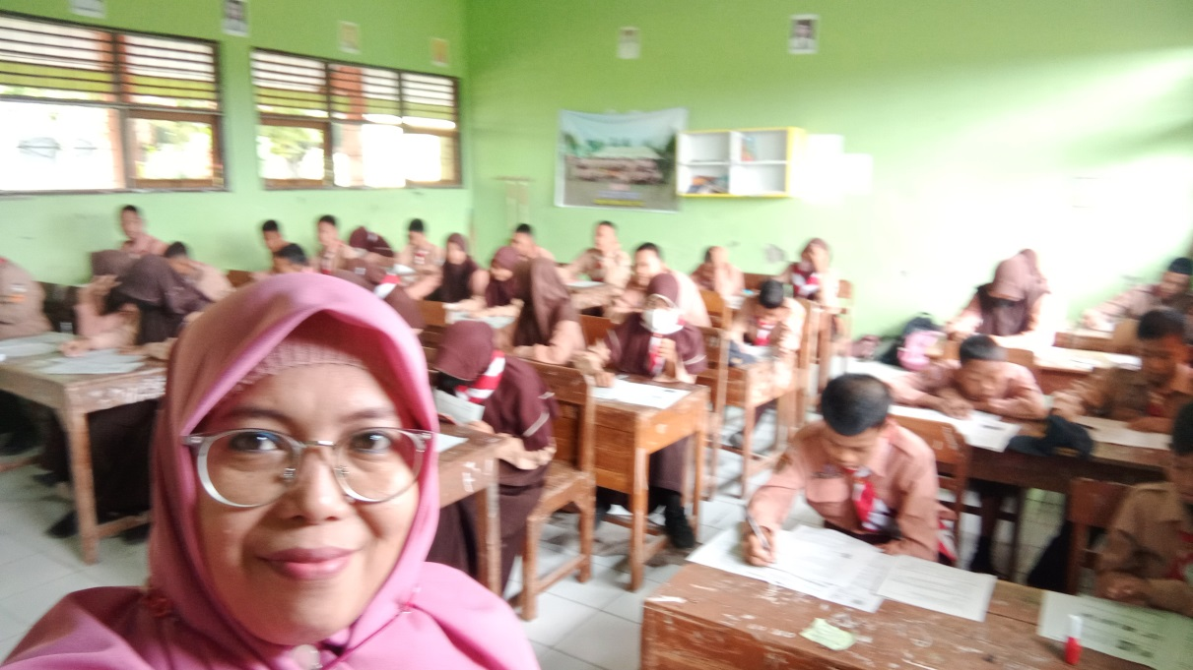

Lampiran 5
Tabulasi Data dan Hasil Pengujian Validitas Instrumen
Variabel Pola Kepemimpinan Berbasis Sistem Among
No Resp. | PKBSA 01 | PKBSA 02 | PKBSA 03 | PKBSA 04 | PKBSA 05 | PKBSA 06 | PKBSA 07 | PKBSA S08 | PKBSA 09 | PKBSA 1 vvtfg5t0 | PKBSA 11 | PKBSA 12 | PKBSA 13 | PKBSA 14 | PKBSA A 15 | PKBSA 16 | PKBSA 17 | PKBSA 18 | PKBSA 19 | PKBSA A 20 | PKBSA
R_1 | 4 | 4 | 5 | 5 | 4 | 4 | 4 | 4 | 4 | 4 | 4 | 4 | 5 | 5 | 3 | 3 | 4 | 5 | 5 | 3 | 66
R_2 | 5 | 2 | 4 | 4 | 4 | 4 | 2 | 2 | 5 | 5 | 4 | 4 | 4 | 4 | 5 | 5 | 4 | 4 | 4 | 5 | 63
R_3 | 4 | 4 | 4 | 4 | 4 | 4 | 2 | 2 | 3 | 3 | 5 | 5 | 4 | 4 | 2 | 2 | 5 | 4 | 4 | 2 | 56
R_4 | 4 | 4 | 5 | 5 | 4 | 4 | 4 | 4 | 2 | 4 | 2 | 2 | 4 | 4 | 3 | 2 | 2 | 4 | 4 | 3 | 57
R_5 | 4 | 4 | 5 | 5 | 5 | 5 | 4 | 4 | 4 | 5 | 3 | 3 | 5 | 5 | 4 | 4 | 3 | 5 | 5 | 4 | 69
R_6 | 4 | 4 | 4 | 4 | 4 | 4 | 3 | 3 | 4 | 4 | 5 | 5 | 4 | 4 | 5 | 5 | 5 | 4 | 4 | 5 | 66
R_7 | 4 | 4 | 4 | 4 | 4 | 4 | 2 | 2 | 4 | 4 | 5 | 5 | 4 | 4 | 4 | 4 | 5 | 4 | 4 | 4 | 62
R_8 | 3 | 3 | 4 | 4 | 4 | 4 | 3 | 3 | 4 | 4 | 4 | 4 | 2 | 2 | 4 | 4 | 4 | 2 | 2 | 4 | 56
R_9 | 4 | 4 | 4 | 4 | 4 | 4 | 5 | 4 | 5 | 5 | 5 | 5 | 5 | 5 | 5 | 5 | 5 | 5 | 5 | 5 | 73
R_10 | 4 | 4 | 4 | 4 | 4 | 4 | 2 | 2 | 5 | 5 | 4 | 4 | 5 | 5 | 5 | 5 | 4 | 5 | 5 | 5 | 66
R_11 | 5 | 2 | 4 | 4 | 4 | 4 | 4 | 4 | 4 | 4 | 4 | 4 | 5 | 5 | 5 | 5 | 4 | 5 | 5 | 5 | 67
R_12 | 4 | 4 | 4 | 4 | 4 | 4 | 3 | 3 | 3 | 3 | 4 | 4 | 3 | 3 | 4 | 2 | 4 | 3 | 3 | 4 | 56
R_13 | 4 | 4 | 5 | 5 | 4 | 4 | 5 | 5 | 4 | 4 | 4 | 4 | 5 | 5 | 4 | 4 | 4 | 5 | 5 | 4 | 70
R_14 | 4 | 4 | 4 | 4 | 4 | 4 | 3 | 3 | 3 | 3 | 3 | 3 | 3 | 3 | 3 | 1 | 3 | 3 | 3 | 1 | 52
R_15 | 3 | 3 | 4 | 4 | 4 | 4 | 4 | 4 | 3 | 3 | 4 | 2 | 4 | 4 | 3 | 3 | 4 | 5 | 5 | 3 | 56
R_16 | 4 | 4 | 4 | 4 | 2 | 2 | 5 | 4 | 3 | 5 | 4 | 4 | 5 | 5 | 5 | 5 | 4 | 4 | 4 | 5 | 65
R_17 | 4 | 4 | 4 | 4 | 5 | 5 | 4 | 4 | 4 | 4 | 4 | 4 | 5 | 5 | 4 | 4 | 5 | 4 | 4 | 2 | 68
R_18 | 4 | 4 | 4 | 4 | 5 | 5 | 4 | 4 | 5 | 5 | 4 | 4 | 4 | 5 | 4 | 4 | 2 | 4 | 4 | 3 | 69
R_19 | 5 | 2 | 4 | 4 | 5 | 5 | 3 | 3 | 4 | 4 | 5 | 5 | 4 | 4 | 5 | 5 | 3 | 5 | 5 | 4 | 67
R_20 | 4 | 4 | 4 | 4 | 4 | 4 | 5 | 5 | 4 | 4 | 5 | 5 | 5 | 5 | 5 | 5 | 5 | 4 | 4 | 5 | 72
R_21 | 4 | 4 | 4 | 4 | 5 | 5 | 4 | 4 | 4 | 4 | 4 | 4 | 4 | 4 | 4 | 4 | 5 | 4 | 4 | 4 | 66
R_22 | 4 | 4 | 4 | 4 | 4 | 4 | 5 | 5 | 4 | 4 | 4 | 4 | 5 | 5 | 4 | 4 | 4 | 2 | 2 | 4 | 68
R_23 | 4 | 4 | 5 | 5 | 4 | 4 | 4 | 4 | 3 | 3 | 4 | 4 | 4 | 4 | 4 | 4 | 5 | 5 | 5 | 5 | 64
R_24 | 5 | 2 | 5 | 5 | 5 | 5 | 4 | 4 | 5 | 5 | 4 | 4 | 4 | 4 | 5 | 5 | 4 | 5 | 5 | 5 | 71
R_25 | 4 | 4 | 5 | 5 | 4 | 4 | 4 | 4 | 4 | 4 | 4 | 4 | 3 | 3 | 3 | 3 | 4 | 5 | 5 | 5 | 62
R_26 | 3 | 3 | 3 | 3 | 3 | 3 | 3 | 2 | 4 | 4 | 4 | 4 | 4 | 4 | 3 | 3 | 4 | 3 | 3 | 4 | 53
R_27 | 3 | 3 | 2 | 2 | 2 | 2 | 1 | 2 | 3 | 3 | 2 | 2 | 3 | 3 | 3 | 3 | 4 | 5 | 5 | 4 | 39
R_28 | 4 | 4 | 5 | 5 | 4 | 4 | 4 | 4 | 5 | 5 | 5 | 5 | 4 | 5 | 5 | 5 | 3 | 3 | 4 | 5 | 73
R_29 | 4 | 4 | 5 | 5 | 4 | 4 | 4 | 4 | 4 | 4 | 4 | 4 | 4 | 4 | 4 | 4 | 4 | 5 | 5 | 3 | 66
R_30 | 3 | 3 | 3 | 3 | 2 | 2 | 3 | 3 | 5 | 5 | 3 | 3 | 3 | 3 | 3 | 3 | 4 | 4 | 4 | 5 | 50

Correlations

Correlations
 |  | PKBSA _1 | PKBSA _2 | PKBSA _3 | PKBSA _4 | PKBSA _5 | PKBSA _6 | PKBSA _7 | PKBSA _8 | PKBSA _9 | PKBSA 10 | PKBSA _11 | PKBSA _12 | PKBSA _13 | PKBSA _14 | PKBSA _15 | PKBSA _16 | PKBSA
PKBSA _1 | Pearson Correlation | 1 | -.292 | .458* | .458* | .534** | .534** | .153 | .165 | .232 | .270 | .315 | .424* | .394* | .384* | .570** | .435* | .606**
 | Sig. (2-tailed) |  | .117 | .011 | .011 | .002 | .002 | .419 | .383 | .218 | .149 | .090 | .020 | .031 | .036 | .001 | .016 | .000
 | N | 54 | 54 | 54 | 54 | 54 | 54 | 54 | 54 | 54 | 54 | 54 | 54 | 54 | 54 | 54 | 54 | 54
PKBSA _2 | Pearson Correlation | -.292 | 1 | .282 | .282 | .033 | .033 | .290 | .278 | -.233 | -.113 | .060 | .116 | .195 | .237 | -.218 | -.262 | .169
 | Sig. (2-tailed) | .117 |  | .131 | .131 | .862 | .862 | .120 | .137 | .215 | .552 | .752 | .540 | .303 | .208 | .248 | .163 | .371
 | N | 54 | 54 | 54 | 54 | 54 | 54 | 54 | 54 | 54 | 54 | 54 | 54 | 54 | 54 | 54 | 54 | 54
PKBSA _3 | Pearson Correlation | .458* | .282 | 1 | 1.000** | .559** | .559** | .530** | .552** | .021 | .173 | .188 | .189 | .276 | .306 | .170 | .125 | .641**
 | Sig. (2-tailed) | .011 | .131 |  | .000 | .001 | .001 | .003 | .002 | .912 | .360 | .320 | .316 | .139 | .100 | .369 | .510 | .000
 | N | 54 | 54 | 54 | 54 | 54 | 54 | 54 | 54 | 54 | 54 | 54 | 54 | 54 | 54 | 54 | 54 | 54
PKBSA _4 | Pearson Correlation | .458* | .282 | 1.000** | 1 | .559** | .559** | .530** | .552** | .021 | .173 | .188 | .189 | .276 | .306 | .170 | .125 | .641**
 | Sig. (2-tailed) | .011 | .131 | .000 |  | .001 | .001 | .003 | .002 | .912 | .360 | .320 | .316 | .139 | .100 | .369 | .510 | .000
 | N | 54 | 54 | 54 | 54 | 54 | 54 | 54 | 54 | 54 | 54 | 54 | 54 | 54 | 54 | 54 | 54 | 54
PKBSA _5 | Pearson Correlation | .534** | .033 | .559** | .559** | 1 | 1.000** | .228 | .296 | .214 | .066 | .325 | .291 | .218 | .264 | .245 | .185 | .606**
 | Sig. (2-tailed) | .002 | .862 | .001 | .001 |  | .000 | .225 | .113 | .257 | .729 | .080 | .118 | .248 | .158 | .192 | .329 | .000
 | N | 54 | 54 | 54 | 54 | 54 | 54 | 54 | 54 | 54 | 54 | 54 | 54 | 54 | 54 | 54 | 54 | 54
PKBSA _6 | Pearson Correlation | .534** | .033 | .559** | .559** | 1.000** | 1 | .228 | .296 | .214 | .066 | .325 | .291 | .218 | .264 | .245 | .185 | .606**
 | Sig. (2-tailed) | .002 | .862 | .001 | .001 | .000 |  | .225 | .113 | .257 | .729 | .080 | .118 | .248 | .158 | .192 | .329 | .000
 | N | 54 | 54 | 54 | 54 | 54 | 54 | 54 | 54 | 54 | 54 | 54 | 54 | 54 | 54 | 54 | 54 | 54
PKBSA _7 | Pearson Correlation | .153 | .290 | .530** | .530** | .228 | .228 | 1 | .937** | .048 | .247 | .168 | .120 | .508** | .524** | .266 | .262 | .653**
 | Sig. (2-tailed) | .419 | .120 | .003 | .003 | .225 | .225 |  | .000 | .802 | .189 | .374 | .529 | .004 | .003 | .155 | .161 | .000
 | N | 54 | 54 | 54 | 54 | 54 | 54 | 54 | 54 | 54 | 54 | 54 | 54 | 54 | 54 | 54 | 54 | 54
PKBSA _8 | Pearson Correlation | .165 | .278 | .552** | .552** | .296 | .296 | .937** | 1 | .000 | .129 | .047 | .000 | .435* | .463** | .211 | .214 | .602**
 | Sig. (2-tailed) | .383 | .137 | .002 | .002 | .113 | .113 | .000 |  | 1.000 | .496 | .807 | 1.000 | .016 | .010 | .263 | .256 | .000
 | N | 54 | 54 | 54 | 54 | 54 | 54 | 54 | 54 | 54 | 54 | 54 | 54 | 54 | 54 | 54 | 54 | 54
PKBSA _9 | Pearson Correlation | .232 | -.233 | .021 | .021 | .214 | .214 | .048 | .000 | 1 | .753** | .390* | .449* | .175 | .281 | .504** | .616** | .496**
 | Sig. (2-tailed) | .218 | .215 | .912 | .912 | .257 | .257 | .802 | 1.000 |  | .000 | .033 | .013 | .355 | .133 | .004 | .000 | .005
 | N | 54 | 54 | 54 | 54 | 54 | 54 | 54 | 54 | 54 | 54 | 54 | 54 | 54 | 54 | 54 | 54 | 54
PKBSA _10 | Pearson Correlation | .270 | -.113 | .173 | .173 | .066 | .066 | .247 | .129 | .753** | 1 | .123 | .234 | .344 | .436* | .556** | .629** | .536**
 | Sig. (2-tailed) | .149 | .552 | .360 | .360 | .729 | .729 | .189 | .496 | .000 |  | .517 | .213 | .063 | .016 | .001 | .000 | .002
 | N | 54 | 54 | 54 | 54 | 54 | 54 | 54 | 54 | 54 | 54 | 54 | 54 | 54 | 54 | 54 | 54 | 54
PKBSA _11 | Pearson Correlation | .315 | .060 | .188 | .188 | .325 | .325 | .168 | .047 | .390* | .123 | 1 | .907** | .273 | .315 | .452* | .510** | .589**
 | Sig. (2-tailed) | .090 | .752 | .320 | .320 | .080 | .080 | .374 | .807 | .033 | .517 |  | .000 | .145 | .090 | .012 | .004 | .001
 | N | 54 | 54 | 54 | 54 | 54 | 54 | 54 | 54 | 54 | 54 | 54 | 54 | 54 | 54 | 54 | 54 | 54
PKBSA _12 | Pearson Correlation | .424* | .116 | .189 | .189 | .291 | .291 | .120 | .000 | .449* | .234 | .907** | 1 | .257 | .302 | .502** | .522** | .605**
 | Sig. (2-tailed) | .020 | .540 | .316 | .316 | .118 | .118 | .529 | 1.000 | .013 | .213 | .000 |  | .170 | .105 | .005 | .003 | .000
 | N | 54 | 54 | 54 | 54 | 54 | 54 | 54 | 54 | 54 | 54 | 54 | 54 | 54 | 54 | 54 | 54 | 54
PKBSA _13 | Pearson Correlation | .394* | .195 | .276 | .276 | .218 | .218 | .508** | .435* | .175 | .344 | .273 | .257 | 1 | .953** | .394* | .481** | .677**
 | Sig. (2-tailed) | .031 | .303 | .139 | .139 | .248 | .248 | .004 | .016 | .355 | .063 | .145 | .170 |  | .000 | .031 | .007 | .000
 | N | 54 | 54 | 54 | 54 | 54 | 54 | 54 | 54 | 54 | 54 | 54 | 54 | 54 | 54 | 54 | 54 | 54
PKBSA _14 | Pearson Correlation | .384* | .237 | .306 | .306 | .264 | .264 | .524** | .463** | .281 | .436* | .315 | .302 | .953** | 1 | .427* | .512** | .737**
 | Sig. (2-tailed) | .036 | .208 | .100 | .100 | .158 | .158 | .003 | .010 | .133 | .016 | .090 | .105 | .000 |  | .019 | .004 | .000
 | N | 54 | 54 | 54 | 54 | 54 | 54 | 54 | 54 | 54 | 54 | 54 | 54 | 54 | 54 | 54 | 54 | 54
PKBSA _15 | Pearson Correlation | .570** | -.218 | .170 | .170 | .245 | .245 | .266 | .211 | .504** | .556** | .452* | .502** | .394* | .427* | 1 | .886** | .684**
 | Sig. (2-tailed) | .001 | .248 | .369 | .369 | .192 | .192 | .155 | .263 | .004 | .001 | .012 | .005 | .031 | .019 |  | .000 | .000
 | N | 54 | 54 | 54 | 54 | 54 | 54 | 54 | 54 | 54 | 54 | 54 | 54 | 54 | 54 | 54 | 54 | 54
PKBSA _16 | Pearson Correlation | .435* | -.262 | .125 | .125 | .185 | .185 | .262 | .214 | .616** | .629** | .510** | .522** | .481** | .512** | .886** | 1 | .697**
 | Sig. (2-tailed) | .016 | .163 | .510 | .510 | .329 | .329 | .161 | .256 | .000 | .000 | .004 | .003 | .007 | .004 | .000 |  | .000
 | N | 54 | 54 | 54 | 54 | 54 | 54 | 54 | 54 | 54 | 54 | 54 | 54 | 54 | 54 | 54 | 54 | 54
PKBSA _17 | Pearson Correlation | .435* | -.262 | .125 | .125 | .185 | .185 | .262 | .214 | .616** | .629** | .510** | .522** | .481** | .512** | .886** | 1 | .697**
 | Sig. (2-tailed) | .016 | .163 | .510 | .510 | .329 | .329 | .161 | .256 | .000 | .000 | .004 | .003 | .007 | .004 | .000 |  | .000
 | N | 54 | 54 | 54 | 54 | 54 | 54 | 54 | 54 | 54 | 54 | 54 | 54 | 54 | 54 | 54 | 54 | 54
PKBSA _18 | Pearson Correlation | .570** | -.218 | .170 | .170 | .245 | .245 | .266 | .211 | .504** | .556** | .452* | .502** | .394* | .427* | 1 | .886** | .684**
 | Sig. (2-tailed) | .001 | .248 | .369 | .369 | .192 | .192 | .155 | .263 | .004 | .001 | .012 | .005 | .031 | .019 |  | .000 | .000
 | N | 54 | 54 | 54 | 54 | 54 | 54 | 54 | 54 | 54 | 54 | 54 | 54 | 54 | 54 | 54 | 54 | 54
PKBSA _19 | Pearson Correlation | .384* | .237 | .306 | .306 | .264 | .264 | .524** | .463** | .281 | .436* | .315 | .302 | .953** | 1 | .427* | .512** | .737**
 | Sig. (2-tailed) | .036 | .208 | .100 | .100 | .158 | .158 | .003 | .010 | .133 | .016 | .090 | .105 | .000 |  | .019 | .004 | .000
 | N | 54 | 54 | 54 | 54 | 54 | 54 | 54 | 54 | 54 | 54 | 54 | 54 | 54 | 54 | 54 | 54 | 54
 | PKBSA _20 | Pearson Correlation | .394* | .195 | .276 | .276 | .218 | .218 | .508** | .435* | .175 | .344 | .273 | .257 | 1 | .953** | .394* | .481**
 |  | Sig. (2-tailed) | .031 | .303 | .139 | .139 | .248 | .248 | .004 | .016 | .355 | .063 | .145 | .170 |  | .000 | .031 | .007
 |  | N | 54 | 54 | 54 | 54 | 54 | 54 | 54 | 54 | 54 | 54 | 54 | 54 | 54 | 54 | 54 | 54
PKBSA | Pearson Correlation | .606** | .169 | .641** | .641** | .606** | .606** | .653** | .602** | .496** | .536** | .589** | .605** | .677** | .737** | .684** | .697** | 1
 | Sig. (2-tailed) | .000 | .371 | .000 | .000 | .000 | .000 | .000 | .000 | .005 | .002 | .001 | .000 | .000 | .000 | .000 | .000
 | N | 54 | 54 | 54 | 54 | 54 | 54 | 54 | 54 | 54 | 54 | 54 | 54 | 54 | 54 | 54 | 54 | 54
*. Correlation is significant at the 0.05 level (2-tailed).
**. Correlation is significant at the 0.01 level (2-tailed).

