DAFTAR PUSTAKA
Alifia, B., Sofa, N., Administrasi Niaga, J., Negeri Jakarta, P., & Siwabessy, J. G. (2020). PENGARUH STORE ATMOSPHERE DAN HARGA TERHADAP MINAT BELI KONSUMEN NAGA SWALAYAN JATIASIH BEKASI. 6(2).
Claudia, D., Simanjuntak, Y., Nasarethsamosir, E., Indah, T., & Simamora, S. (2022). Pengaruh Store Atmosphere, Product Assortment dan Harga Terhadap Minat Beli Pada Lottemart Center Point Medan. Investasi Dan Syariah (EKUITAS), 3(4), 840. https://doi.org/10.47065/ekuitas.v3i4.1558
Effendi, D. R., Fermayani, R., Egim, A. S., Harahap, R. R., & Indonesia, S. P. (2021). Pengaruh Persepsi Konsumen Mengenai Harga , Lokasi , dan Kualitas Pasar Modern Terhadap Minat Beli Konsumen. 4(2), 188–197.
Ferdinand, A. (2006). Metode Penelitian Manajemen. Uinversitas Diponegoro.
Ghozali. (2018). Aplikasi Analisis Multivariate Dengan Program IBM SPSS 25. undip.
Holiq, R. A. (2022). Pengaruh Promosi Dan Lokasi Terhadap Minat Beli Konsumen Toko Swalayan Mitra Mart Tasikmalaya ( Survei Pada Konsumen Toko Swalayan Mitra Mart Kota Tasikmalaya ). 1(5), 562–566.
Husain, N., Karundeng, D. R., & Suyanto, M. A. (2022). Analisis Lokasi , Potongan Harga , Display Produk dan Kualitas Produk Terhadap Minat Beli Pada Alfamart Kayubulan. 10(1), 63–85.
Kurniawan, R., & Krismonita, A. (2020). Pengaruh Kelengkapan Produk dan Lokasi Terhadap Minat Beli Konsumen Pada Giant Expresss Sukabumi ( Studi Kasus konsumen Giant Expresss Sukabumi ). X(2), 145–154.
Mochamad Ainul Yaqin, Udik Jatmiko, & Erwin Syahputra. (2022). Pengaruh Potongan Harga Dan Kelengkapan Produk Terhadap Minat Beli Konsumen Pada Hikmah Mart Wates Kediri. OPTIMAL: Jurnal Ekonomi Dan Manajemen, 2(4), 272–281. https://doi.org/10.55606/optimal.v2i4.749
Nata Atmojo, R., & Gilang Saraswati, T. (2020). The Effect of Store Atmosphere, Product Assortment and Price on Buying Interest in Borma Bandung City Pengaruh Store Atmosphere, Product Assortment dan Price Terhadap Minat Beli di Borma Kota Bandung. In JURNAL SEKRETARIS DAN ADMINISTRASI BISNIS Journal homepage (Issue 1). http://jurnal.asmtb.ac.id/index.php/jsab
Phiilip Kotler & Kevin Lane Keller. (2007). Manajemen Pemasaran edisi 12. PT.INDEKS.
Philip Kotler & Kevin Lane Keller. (2009). Manajemen Pemasaran Edisi 13. Erlangga.
Philip Kotler dan Gary Armstrong. (2007). Prinsip-prinsip Pemasaran edisi ke 12 jilid 2. Erlangga.
Philip Kotler dan Gary Armstrong. (2008). Prinsip-prinsip Pemasaran edisi 12 jilid 1. ERLANGGA.
Rakhmawati, R. K., Ferlina, A., & Trenggana, M. (2018). PENGARUH STORE ATMOSPHERE, PRODUCT ASSORTMENT DAN HARGA TERHADAP MINAT BELI PADA TRANSMART CARREFOUR BUAH BATU BANDUNG. In Jurnal Riset Bisnis dan Manajemen (Vol. 2, Issue 2). http://finance.detik.com
Safitri, R. I., & Gunaningrat, R. (2021). Pengaruh Lokasi , Keragaman Produk Dan Harga Terhadap Minat Beli Konsumen Pada Alfe Toko. 1001–1011.
Sonata, I. (2019). Pengaruh Price Discount Dan in-Store Display Terhadap Keputusan Impulse Buying Pada Produk Miniso. Jurnal Riset Manajemen Dan Bisnis (JRMB), 4(1), 46–53.
Sugiyono. (2015). Metode Penelitian Kuantitatif, Kualitatif R & D. Alfabeta.
Suliyanto. (2018). Metode Penelitian Bisnis Untuk Skripsi, Tesis & disertasi. Andi.
Tjiptono, F. (2008). Strategi Pemasaran. Andi.
Tjiptono, F. (2015). Strategi Pemasaran. ANDI.
Utami, C. W. (2017). Manajemen Ritel Strategi dan Implementasi Binis Ritel Modern di Indonesia. Salemba Empat.
Wiyanti, S., & Hanfan, A. (2022). The Role of Word-Of-Mouth, Shopping Lifestyle and City Walk Concept on Brand Image Mall in Indonesia. International Journal of Entrepreneurship and Business Management, 1(1), 43–50. https://doi.org/10.54099/ijebm.v1i1.124
Sari, D. R., & Faisal, I. (2018). Pengaruh Price Discount, Bonus pack, dan In-store display terhadap keputusan impulse buying pada giant ekstra banjar. Jurnal Sains Manajemen Dan Kewirausahaan, 2(1), 51–60.

Lampiran

Lampiran 1
Kuesioner Penelitian
KUESIONER PENELITIAN SKRIPSI
PENGARUH PERSEPSI LOKASI PERUSAHAAN, PERSEPSI PRODUCT ASSORTMENT DAN PERSEPSI POTONGAN HARGA TERHADAP MINAT BELI KONSUMEN PADA TOSERBA HIKMAH KABUPATEN PEMALANG

Kepada
Yth.Bapak/Ibu/Saudara/i
Di tempat.
Dengan hormat,
Dalam rangka penelitian untuk keperluan skripsi yang berjudul "Pengaruh Persepsi Lokasi Perusahaan, Persepsi Product Assorment, Dan Persepsi Potongan Harga Terhadap Minat Beli Konsumen Pada Toserba Hikmah Kabupaten Pemalang". Bersama dengan ini saya:
Nama : Nisa Sherina Maharani
NPM : 4119500162
Universitas Fakultas: Universitas Pancasakti Tegal/Fakultas Ekonomi dan Bisnis
Maka dengan ini, saya memohon bantuan kepada Bapak/Ibu/Saudara/i untuk berkenan mengisi kuesioner yang telah disediakan dalam rangka mendukung penelitian ini. Tidak ada maksud apapun dibalik pengisian daftar pertanyaan ini, jadi dimohon kesediaan Bapak/Ibu/Saudara/i untuk mengisi pernyataan dibawah ini pada jawaban yung menurut anda sesuai dengan kondisi yang sebenarnya. Segala bentuk jawaban Bapak/Ibu/Saudara/i akan di jaga kerahasiannya. Atas perhatian dan bantuannya saya ucapkan terima kasih.

Hormat saya,

Nisa Sherina Maharani
NPM. 4119500162
IDENTITAS RESPONDEN
No. Responden
- Nama : _________________________________
- Alamat : _________________________________
- Jenis Kelamin :
a. Laki-laki
b. Perempuan
- Usia :
a. 17–30 tahun b. 41– 50 tahun
c. 31– 40 tahun b. > 50 tahun
- Pendidikan :
SMP/Sederajat SLTA/Sederajat

DIII/Diploma S1/Sarjana

S2/Pasca Sarjana Lain-lain…..
- Pekerjaan :
a. Pelajar / Mahasiswa b. Wiraswasta
d. Karyawan e. Pegawai Negeri
c. Ibu Rumah Tangga
- Pendapatan :
<Rp.2.000.000 Rp.2.000.000-Rp.3.000.000
Rp.3.000.000-Rp.4.000.000 >Rp.4.000.000

PETUNJUK PENGISIAN KUESIONER
- Mohon beri tanda checklist (√) pada kolom jawaban bapak/ibu/saudara/i anggap paling sesuai. Pendapat anda dinyatakan dalam sekala 1 s/d 5 yang memiliki bobot/nilai:
Simbol | Kategori | Nilai Bobot
SS | Sangat Setuju | 5
S | Setuju | 4
N | Netral | 3
TS | Tidak Setuju | 2
STS | Sangat Tidak Setuju | 1
- Setiap pertanyaan hanya membutuhkan satu jawaban.
- Mohon memberikan jawaban yang sebenar-benarnya.
- Setelah mengisi kuesioner mohon bapak/ibu/saudara/i berikan kepada yang menyerahkan kuesioner.

FORMULIR KUESIONER

A. Daftar Pertanyaan Minat Beli Konsumen (Y)

No | Pertanyaan | Tanggapan
 |  | SS | S | N | TS | STS
 | Perhatian Dan Ketertarikan
1. | Saya membeli produk karena kualitasnya
2. | Saya tertarik membeli produk yang ada di Toserba Hikmah
 | Merefrensikan
3. | Saya akan merefrensikan produk yang ada kepada orang lain untuk  berbelanja di Toserba Hikmah
4. | Saya menceritakan pengalaman positif setelah berbelanja di toserba hikmah
 | Mencirikan Perilaku Seseorang
5. | Saya memilih menggunakan produk yang ada di toserba hikmah sebagai alternatif utama dalam memenuhi kebutuhan
6. | Toserba Hikmah selalu menanggapi keluhan kami dengan cepat dan tepat
 | Informasi
7. | Saya mengumpulkan informasi lebih banyak mengenai produk yang dijual.
8. | Harga produk sesuai dengan kualitas pelayanan yang saya dapatkan

B. Daftar Pertanyaan Persepsi Lokasi Perusahaan (X1)

NO | Pertanyaan | Tanggapan
 |  | SS | S | N | TS | STS
 | Keterjangkauan dan SaranaTtransportasi
1. | Toserba hikmah terletak di lokasi yang strategis dan mudah dijangkau
2. | Toserba hikmah dapat diakses dengan sarana transportasi umum
 | Kemudahan dan Kelancaran Akses
3. | Akses menuju lokasi toserba hikmah lancar dan tidak rawan kemacetan
4. | Kondisi jalan menuju ke lokasi toserba hikmah mudah di akses
 | Lokasi dan Papan Nama
5. | Toserba hikmah terlihat dari jalan utama sehingga mudah ditemukan
6. | Papan nama Toko memudahkan konsumen mengetahui letak atau lokasi Toko
 | Lahan Parkir
7. | Toserba hikmah menyediakan lahan parkir yang cukup luas
8. | Toserba hikmah menyediakan tempat parkir yang dilengkapi dengan cctv sehingga keamananya terjamin
 | Kebersihan dan Pusat Keramaian
9. | Toserba hikmah memiliki lingkungan toko yang bersih dan harum, sehingga konsumen merasa nyaman
10 | Toserba hikmah saling berdekatan dengan pusat keramaian sehingga memudahkan konsumen berkunjung

C. Daftar Pertanyaan Persepsi Product Assortment (X2)
NO | Pertanyaan | Tanggapan
 |  | SS | S | N | TS | STS
 | Variasi Produk
1. | Saya berbelanja di Toserba Hikmah karena menyediakan berbagai macam jenis produk yang sangat bervariasi
2. | Saya berbelanja di Toserba Hikmah karena variasi produk yang ditawarkan cukup lengkap sesuai dengan keinginan dan kebutuhan konsumen.
 | Keragaman Produk
3. | Saya membeli produk yang ada di Toserba Hikmah karena beranekaragam
4. | Desain produk yang disediakan oleh  Toserba Hikmah menarik dan beragam
 | Ketersediaan Produk
5. | Saya membeli produk di Toserba hikmah karena stok produk yang tersedia cukup lengkap.
6. | Produk yang dicari konsumen selalu tersedia dari anak-anak hingga orang tua, dari kebutuhan seharihari singga kebutuhan rumah tangga tersedia dengan lengkap
 | Jenis Merek
7. | Saya membeli berbagai jenis merek produk yang ditawarkan di Toserba Hikmah
8. | Saya berbelanja di Toserba Hiknah karena produk berasal dari merek yang berkualitas

Daftar Pertanyaan Persepsi Potongan harga (X3)

No | Pertanyaan | Tanggapan
 |  | SS | S | N | TS | STS
Pembayaran Tunai dan Tepat Waktu
1. | Toserba Hikmah memberikan potongan harga untuk produk-produk tertentu yang melakukan pembayaran tunai.
2. | Saya membeli produk yang memberikan diskon dalam pembayaran tepat waktu.
Sistem Potongan Harga
3. | Toserba Hikmah menerapkan sistem potongan harga agar pelanggan mau membeli dalam jumlah banyak.
4. | Saya suka membeli produk dalam jumlah banyak ketika ada diskon.
Harga Khusus Reseller
5. | Toserba Hikmah memberikan potongan harga khusus pada reseller pada bararng – barang harian.
6. | Saya senang mendapatkan barang grosiran dengan diskon tertentu dari produsen.
Pembelian Musiman
7. | Saya akan membeli produk ketika ada diskon musiman
8. | Saya akan membeli produk yang saya sukai diluar musim tertentu saja

Lampiran 2
Data Untuk Uji Validitas Dan Reliabilitas Minat Beli Konsumen
No  Resp | Nomor Pernyataan Pada Kuesioner |  |  |  |  |  |  |  | Total  Skor
 | Y.1 | Y.2 | Y.3 | Y.4 | Y.5 | Y.6 | Y.7 | Y.8
1 | 5 | 5 | 5 | 4 | 4 | 5 | 5 | 4 | 37
2 | 3 | 3 | 2 | 3 | 2 | 1 | 2 | 2 | 18
3 | 5 | 4 | 4 | 5 | 4 | 5 | 5 | 5 | 37
4 | 4 | 4 | 4 | 4 | 4 | 4 | 4 | 4 | 32
5 | 5 | 4 | 4 | 4 | 4 | 5 | 5 | 5 | 36
6 | 2 | 4 | 3 | 4 | 2 | 4 | 2 | 2 | 23
7 | 4 | 4 | 4 | 4 | 4 | 5 | 4 | 4 | 33
8 | 4 | 4 | 5 | 4 | 5 | 5 | 4 | 5 | 36
9 | 4 | 5 | 4 | 5 | 4 | 5 | 4 | 5 | 36
10 | 4 | 4 | 4 | 5 | 4 | 4 | 4 | 4 | 33
11 | 5 | 5 | 5 | 4 | 4 | 4 | 5 | 4 | 36
12 | 5 | 5 | 5 | 4 | 4 | 4 | 4 | 4 | 35
13 | 5 | 3 | 4 | 4 | 4 | 3 | 5 | 5 | 33
14 | 5 | 4 | 5 | 4 | 5 | 4 | 4 | 5 | 36
15 | 4 | 5 | 4 | 4 | 5 | 4 | 4 | 4 | 34
16 | 5 | 5 | 5 | 5 | 5 | 5 | 5 | 5 | 40
17 | 5 | 5 | 5 | 5 | 5 | 5 | 5 | 5 | 40
18 | 4 | 4 | 5 | 4 | 5 | 3 | 3 | 4 | 32
19 | 5 | 5 | 5 | 4 | 5 | 5 | 4 | 5 | 38
20 | 5 | 5 | 5 | 5 | 5 | 5 | 4 | 5 | 39
21 | 5 | 5 | 5 | 5 | 5 | 5 | 5 | 5 | 40
22 | 5 | 5 | 5 | 5 | 5 | 5 | 5 | 5 | 40
23 | 4 | 5 | 5 | 4 | 5 | 5 | 5 | 5 | 38
24 | 5 | 5 | 5 | 5 | 5 | 5 | 5 | 5 | 40
25 | 5 | 5 | 5 | 4 | 4 | 5 | 4 | 4 | 36
26 | 4 | 4 | 5 | 4 | 4 | 4 | 4 | 4 | 33
27 | 3 | 4 | 4 | 4 | 5 | 5 | 3 | 5 | 33
28 | 4 | 3 | 4 | 4 | 5 | 4 | 4 | 4 | 32
29 | 5 | 4 | 5 | 4 | 3 | 3 | 4 | 5 | 33
30 | 4 | 4 | 4 | 5 | 5 | 5 | 4 | 4 | 35

Lampiran 3
No Resp | Nomor Pernyataan Pada Kuesioner |  |  |  |  |  |  |  |  |  | Total  Skor
 | X1.1 | X1.2 | X1.3 | X1.4 | X1.5 | X1.6 | X1.7 | X1.8 | X1.9 | X1.10
1 | 5 | 4 | 5 | 5 | 5 | 5 | 4 | 5 | 5 | 4 | 47
2 | 2 | 4 | 4 | 5 | 3 | 5 | 4 | 5 | 4 | 3 | 39
3 | 4 | 4 | 4 | 4 | 4 | 4 | 4 | 4 | 4 | 4 | 40
4 | 4 | 4 | 4 | 4 | 4 | 4 | 4 | 4 | 4 | 4 | 40
5 | 5 | 5 | 5 | 5 | 5 | 5 | 5 | 5 | 5 | 5 | 50
6 | 4 | 4 | 4 | 4 | 4 | 4 | 3 | 4 | 4 | 4 | 39
7 | 4 | 4 | 4 | 4 | 5 | 5 | 4 | 4 | 4 | 4 | 42
8 | 5 | 5 | 4 | 4 | 5 | 5 | 4 | 5 | 5 | 4 | 46
9 | 4 | 5 | 4 | 5 | 4 | 5 | 4 | 5 | 4 | 5 | 45
10 | 4 | 5 | 5 | 5 | 4 | 4 | 4 | 4 | 5 | 4 | 44
11 | 4 | 5 | 5 | 4 | 5 | 5 | 4 | 5 | 5 | 4 | 46
12 | 5 | 5 | 4 | 4 | 5 | 5 | 5 | 5 | 4 | 4 | 46
13 | 5 | 5 | 4 | 4 | 4 | 4 | 3 | 3 | 4 | 4 | 40
14 | 5 | 5 | 5 | 4 | 5 | 5 | 4 | 5 | 5 | 5 | 48
15 | 4 | 4 | 4 | 4 | 4 | 4 | 5 | 5 | 4 | 4 | 42
16 | 5 | 4 | 5 | 5 | 5 | 5 | 5 | 5 | 5 | 5 | 49
17 | 5 | 5 | 5 | 5 | 5 | 5 | 5 | 5 | 5 | 5 | 50
18 | 4 | 5 | 4 | 4 | 4 | 4 | 3 | 5 | 4 | 4 | 41
19 | 5 | 5 | 5 | 5 | 5 | 4 | 5 | 5 | 4 | 5 | 48
20 | 5 | 5 | 5 | 5 | 5 | 5 | 5 | 5 | 5 | 5 | 50
21 | 5 | 5 | 5 | 5 | 5 | 5 | 5 | 5 | 5 | 5 | 50
22 | 5 | 5 | 5 | 5 | 5 | 4 | 5 | 5 | 5 | 5 | 49
23 | 4 | 4 | 4 | 4 | 5 | 5 | 5 | 5 | 4 | 4 | 44
24 | 5 | 5 | 5 | 5 | 5 | 3 | 5 | 5 | 5 | 5 | 48
25 | 5 | 4 | 4 | 4 | 4 | 5 | 5 | 5 | 4 | 4 | 44
26 | 4 | 5 | 4 | 5 | 4 | 5 | 4 | 5 | 4 | 5 | 45
27 | 4 | 5 | 4 | 4 | 3 | 3 | 5 | 5 | 5 | 4 | 42
28 | 5 | 5 | 4 | 5 | 5 | 5 | 5 | 5 | 3 | 3 | 45
29 | 5 | 4 | 4 | 4 | 5 | 4 | 3 | 4 | 4 | 4 | 41
30 | 5 | 4 | 4 | 5 | 4 | 4 | 4 | 5 | 4 | 4 | 43
Data Untuk Uji Validitas Dan Reliabilitas Persepsi Lokasi Perusahaan

Lampiran 4
Data Untuk Uji Validitas Dan Reliabilitas Persepsi Product Assortment
No Resp | Nomor Pernyataan Pada Kuesioner |  |  |  |  |  |  |  | Total  Skor
 | X2.1 | X2.2 | X2.3 | X2.4 | X2.5 | X2.6 | X2.7 | X2.8
1 | 5 | 5 | 5 | 4 | 5 | 5 | 4 | 5 | 38
2 | 4 | 1 | 3 | 1 | 3 | 5 | 2 | 1 | 20
3 | 5 | 5 | 5 | 5 | 5 | 5 | 5 | 5 | 40
4 | 4 | 4 | 4 | 4 | 4 | 4 | 4 | 4 | 32
5 | 5 | 4 | 4 | 4 | 4 | 4 | 4 | 4 | 33
6 | 3 | 3 | 4 | 4 | 4 | 2 | 2 | 2 | 24
7 | 4 | 5 | 4 | 4 | 5 | 5 | 4 | 4 | 35
8 | 5 | 4 | 5 | 5 | 4 | 5 | 4 | 5 | 37
9 | 5 | 5 | 4 | 5 | 5 | 4 | 5 | 4 | 37
10 | 4 | 4 | 4 | 5 | 5 | 4 | 5 | 4 | 35
11 | 5 | 5 | 4 | 5 | 4 | 5 | 5 | 4 | 37
12 | 4 | 4 | 5 | 5 | 4 | 4 | 4 | 5 | 35
13 | 5 | 3 | 4 | 4 | 4 | 4 | 4 | 4 | 32
14 | 5 | 5 | 5 | 5 | 5 | 5 | 5 | 5 | 40
15 | 4 | 4 | 5 | 4 | 5 | 3 | 4 | 4 | 33
16 | 5 | 5 | 5 | 5 | 5 | 5 | 5 | 5 | 40
17 | 4 | 4 | 4 | 4 | 4 | 4 | 4 | 4 | 32
18 | 4 | 4 | 4 | 4 | 4 | 4 | 3 | 4 | 31
19 | 5 | 5 | 5 | 5 | 5 | 5 | 4 | 4 | 38
20 | 5 | 5 | 5 | 4 | 5 | 5 | 5 | 5 | 39
21 | 5 | 5 | 5 | 4 | 5 | 5 | 4 | 4 | 37
22 | 5 | 5 | 5 | 5 | 5 | 5 | 5 | 5 | 40
23 | 5 | 3 | 4 | 4 | 4 | 5 | 3 | 4 | 32
24 | 5 | 5 | 5 | 5 | 5 | 5 | 5 | 5 | 40
25 | 5 | 4 | 5 | 5 | 5 | 5 | 3 | 4 | 36
26 | 4 | 5 | 4 | 4 | 5 | 4 | 5 | 4 | 35
27 | 4 | 4 | 4 | 5 | 4 | 5 | 5 | 5 | 36
28 | 5 | 5 | 4 | 4 | 5 | 5 | 5 | 4 | 37
29 | 5 | 4 | 4 | 4 | 4 | 4 | 5 | 4 | 34
30 | 5 | 4 | 4 | 4 | 5 | 5 | 4 | 4 | 35

Lampiran 5
Data Untuk Uji Validitas Dan Reliabilitas Persepsi Potongan Harga
No Resp | Nomor Pernyataan Pada Kuesioner |  |  |  |  |  |  |  | Total  Skor
 | X3.1 | X3.2 | X3.3 | X3.4 | X3.5 | X3.6 | X3.7 | X3.8
1 | 5 | 3 | 4 | 4 | 2 | 4 | 5 | 5 | 32
2 | 3 | 4 | 1 | 2 | 5 | 2 | 5 | 1 | 23
3 | 5 | 5 | 5 | 5 | 5 | 5 | 5 | 5 | 40
4 | 4 | 4 | 4 | 4 | 4 | 4 | 4 | 4 | 32
5 | 4 | 4 | 4 | 4 | 4 | 4 | 2 | 2 | 28
6 | 2 | 2 | 4 | 4 | 4 | 4 | 4 | 4 | 28
7 | 4 | 4 | 4 | 5 | 5 | 4 | 4 | 4 | 34
8 | 4 | 5 | 4 | 4 | 5 | 5 | 4 | 5 | 36
9 | 2 | 5 | 4 | 5 | 5 | 4 | 4 | 4 | 33
10 | 5 | 5 | 5 | 4 | 5 | 5 | 4 | 4 | 37
11 | 4 | 4 | 5 | 5 | 4 | 5 | 5 | 5 | 37
12 | 4 | 4 | 5 | 5 | 5 | 5 | 5 | 5 | 38
13 | 4 | 3 | 4 | 4 | 4 | 3 | 5 | 3 | 30
14 | 4 | 5 | 5 | 4 | 5 | 5 | 5 | 4 | 37
15 | 4 | 4 | 5 | 5 | 4 | 4 | 4 | 4 | 34
16 | 5 | 5 | 5 | 5 | 5 | 5 | 5 | 5 | 40
17 | 4 | 5 | 5 | 5 | 4 | 4 | 4 | 5 | 36
18 | 4 | 4 | 4 | 3 | 3 | 4 | 3 | 5 | 30
19 | 5 | 4 | 4 | 5 | 4 | 5 | 4 | 5 | 36
20 | 4 | 5 | 5 | 4 | 5 | 5 | 5 | 5 | 38
21 | 5 | 5 | 5 | 5 | 4 | 4 | 5 | 4 | 37
22 | 5 | 5 | 5 | 5 | 5 | 5 | 5 | 5 | 40
23 | 4 | 4 | 5 | 4 | 4 | 5 | 5 | 5 | 36
24 | 5 | 5 | 5 | 5 | 5 | 5 | 5 | 5 | 40
25 | 5 | 3 | 4 | 4 | 3 | 5 | 4 | 3 | 31
26 | 4 | 4 | 4 | 5 | 5 | 4 | 5 | 5 | 36
27 | 3 | 4 | 5 | 5 | 4 | 4 | 3 | 3 | 31
28 | 4 | 5 | 5 | 5 | 5 | 5 | 5 | 4 | 38
29 | 5 | 4 | 5 | 4 | 4 | 4 | 4 | 4 | 34
30 | 4 | 4 | 4 | 4 | 3 | 3 | 4 | 4 | 30

Lampiran 6
Data Jawaban Responden Variabel Minat Beli
No Responden | Nomor Pernyataan pada Kuesioner |  |  |  |  |  |  |  | Total skor
 | Y.1 | Y.2 | Y.3 | Y.4 | Y.5 | Y.6 | Y.7 | Y.8
1 | 3 | 4 | 4 | 3 | 4 | 5 | 4 | 3 | 30
2 | 4 | 5 | 3 | 5 | 4 | 3 | 4 | 5 | 33
3 | 5 | 4 | 4 | 5 | 3 | 4 | 5 | 4 | 34
4 | 5 | 3 | 5 | 4 | 5 | 3 | 4 | 5 | 34
5 | 4 | 3 | 5 | 4 | 4 | 4 | 5 | 5 | 34
6 | 5 | 4 | 4 | 4 | 3 | 4 | 4 | 5 | 33
7 | 3 | 5 | 4 | 5 | 4 | 4 | 3 | 5 | 33
8 | 4 | 5 | 4 | 3 | 4 | 3 | 5 | 4 | 32
9 | 4 | 5 | 3 | 4 | 5 | 5 | 4 | 4 | 34
10 | 5 | 5 | 4 | 5 | 4 | 5 | 3 | 4 | 35
11 | 5 | 5 | 4 | 5 | 3 | 5 | 4 | 3 | 34
12 | 4 | 5 | 5 | 5 | 4 | 5 | 4 | 3 | 35
13 | 5 | 4 | 5 | 4 | 3 | 3 | 4 | 4 | 32
14 | 5 | 5 | 4 | 3 | 4 | 4 | 5 | 5 | 35
15 | 5 | 3 | 5 | 4 | 5 | 5 | 4 | 5 | 36
16 | 5 | 4 | 4 | 5 | 3 | 4 | 5 | 4 | 34
17 | 4 | 4 | 5 | 4 | 5 | 4 | 5 | 4 | 35
18 | 4 | 5 | 3 | 4 | 4 | 5 | 4 | 5 | 34
19 | 4 | 3 | 3 | 4 | 4 | 3 | 4 | 5 | 30
20 | 4 | 4 | 3 | 4 | 3 | 3 | 4 | 5 | 30
21 | 4 | 5 | 3 | 4 | 4 | 3 | 5 | 5 | 33
22 | 5 | 4 | 5 | 4 | 5 | 3 | 5 | 5 | 36
23 | 5 | 5 | 4 | 4 | 5 | 5 | 4 | 4 | 36
24 | 5 | 4 | 5 | 4 | 5 | 3 | 5 | 5 | 36
25 | 5 | 4 | 4 | 5 | 4 | 5 | 5 | 4 | 36
26 | 4 | 5 | 4 | 5 | 3 | 5 | 4 | 4 | 34
27 | 5 | 3 | 5 | 3 | 5 | 4 | 3 | 4 | 32
28 | 5 | 4 | 5 | 3 | 4 | 5 | 4 | 5 | 35
29 | 4 | 4 | 5 | 4 | 4 | 5 | 3 | 4 | 33
30 | 4 | 4 | 3 | 4 | 4 | 5 | 4 | 5 | 33
31 | 4 | 4 | 3 | 5 | 4 | 3 | 3 | 4 | 30
32 | 4 | 4 | 3 | 4 | 5 | 5 | 5 | 5 | 35
33 | 5 | 5 | 4 | 5 | 4 | 5 | 3 | 5 | 36
34 | 4 | 3 | 4 | 5 | 3 | 5 | 4 | 4 | 32
35 | 5 | 5 | 4 | 4 | 5 | 4 | 4 | 5 | 36
36 | 5 | 5 | 3 | 3 | 5 | 5 | 4 | 5 | 35
37 | 5 | 3 | 5 | 4 | 5 | 4 | 5 | 4 | 35
38 | 4 | 3 | 4 | 3 | 3 | 4 | 5 | 5 | 31
39 | 5 | 4 | 5 | 4 | 3 | 3 | 4 | 5 | 33
40 | 5 | 5 | 5 | 4 | 3 | 3 | 4 | 5 | 34
41 | 5 | 4 | 5 | 4 | 4 | 5 | 4 | 4 | 35
42 | 5 | 4 | 5 | 4 | 4 | 3 | 3 | 3 | 31
43 | 5 | 4 | 4 | 5 | 4 | 5 | 4 | 5 | 36
44 | 5 | 4 | 4 | 4 | 3 | 3 | 4 | 4 | 31
45 | 5 | 5 | 4 | 4 | 4 | 4 | 4 | 4 | 34
46 | 5 | 4 | 5 | 4 | 5 | 4 | 4 | 5 | 36
47 | 5 | 5 | 4 | 4 | 3 | 3 | 4 | 4 | 32
48 | 5 | 5 | 4 | 4 | 4 | 4 | 5 | 4 | 35
49 | 5 | 5 | 4 | 4 | 3 | 3 | 5 | 4 | 33
50 | 5 | 4 | 5 | 4 | 4 | 4 | 4 | 4 | 34
51 | 4 | 5 | 5 | 4 | 4 | 4 | 4 | 5 | 35
52 | 4 | 5 | 4 | 4 | 4 | 3 | 4 | 4 | 32
53 | 4 | 5 | 5 | 4 | 4 | 4 | 5 | 5 | 36
54 | 4 | 5 | 4 | 4 | 4 | 4 | 5 | 5 | 35
55 | 4 | 5 | 5 | 4 | 4 | 4 | 5 | 4 | 35
56 | 5 | 5 | 4 | 4 | 3 | 3 | 4 | 4 | 32
57 | 4 | 4 | 5 | 4 | 5 | 3 | 4 | 4 | 33
58 | 4 | 5 | 5 | 4 | 4 | 4 | 5 | 4 | 35
59 | 4 | 4 | 3 | 4 | 5 | 5 | 4 | 5 | 34
60 | 5 | 5 | 5 | 5 | 4 | 4 | 4 | 4 | 36
61 | 4 | 5 | 4 | 5 | 5 | 4 | 4 | 4 | 35
62 | 4 | 5 | 5 | 4 | 5 | 4 | 3 | 4 | 34
63 | 4 | 5 | 4 | 5 | 4 | 5 | 3 | 5 | 35
64 | 5 | 5 | 4 | 5 | 5 | 4 | 4 | 4 | 36
65 | 3 | 4 | 5 | 5 | 4 | 3 | 3 | 4 | 31
66 | 4 | 5 | 4 | 4 | 4 | 4 | 4 | 4 | 33
67 | 4 | 5 | 4 | 5 | 4 | 5 | 3 | 3 | 33
68 | 3 | 4 | 3 | 4 | 4 | 5 | 5 | 4 | 32
69 | 4 | 5 | 5 | 5 | 4 | 3 | 4 | 4 | 34
70 | 5 | 4 | 4 | 4 | 5 | 3 | 4 | 3 | 32
71 | 4 | 4 | 4 | 5 | 4 | 5 | 4 | 5 | 35
72 | 5 | 5 | 4 | 4 | 4 | 3 | 5 | 4 | 34
73 | 4 | 4 | 5 | 3 | 4 | 4 | 4 | 5 | 33
74 | 5 | 4 | 5 | 5 | 5 | 4 | 4 | 4 | 36
75 | 4 | 5 | 4 | 5 | 5 | 5 | 4 | 5 | 37
76 | 4 | 4 | 5 | 4 | 4 | 4 | 5 | 4 | 34
77 | 5 | 5 | 5 | 4 | 4 | 5 | 4 | 5 | 37
78 | 5 | 5 | 5 | 5 | 4 | 3 | 3 | 4 | 34
79 | 4 | 4 | 5 | 5 | 4 | 4 | 5 | 4 | 35
80 | 4 | 5 | 5 | 4 | 5 | 3 | 5 | 5 | 36
81 | 4 | 4 | 4 | 5 | 5 | 4 | 4 | 4 | 34
82 | 5 | 4 | 4 | 5 | 4 | 5 | 4 | 5 | 36
83 | 5 | 4 | 5 | 4 | 5 | 4 | 3 | 5 | 35
84 | 3 | 4 | 5 | 4 | 5 | 5 | 5 | 3 | 34
85 | 3 | 4 | 5 | 4 | 4 | 5 | 5 | 3 | 33
86 | 5 | 4 | 4 | 5 | 4 | 4 | 3 | 5 | 34
87 | 4 | 5 | 4 | 3 | 5 | 4 | 5 | 5 | 35
88 | 4 | 5 | 3 | 5 | 5 | 5 | 4 | 5 | 36
89 | 5 | 5 | 4 | 5 | 4 | 5 | 5 | 5 | 38
90 | 4 | 5 | 4 | 3 | 4 | 5 | 5 | 5 | 35
91 | 4 | 5 | 4 | 4 | 3 | 5 | 4 | 5 | 34
92 | 3 | 4 | 5 | 4 | 5 | 5 | 5 | 4 | 35
93 | 5 | 5 | 5 | 4 | 4 | 3 | 4 | 5 | 35
94 | 5 | 5 | 4 | 3 | 4 | 5 | 5 | 5 | 36
95 | 5 | 4 | 5 | 5 | 3 | 4 | 5 | 5 | 36
96 | 5 | 4 | 3 | 4 | 5 | 5 | 5 | 4 | 35
97 | 5 | 4 | 3 | 4 | 4 | 5 | 5 | 4 | 34
98 | 5 | 5 | 4 | 4 | 3 | 5 | 4 | 5 | 35
99 | 4 | 5 | 5 | 4 | 5 | 3 | 5 | 4 | 35
100 | 3 | 5 | 4 | 5 | 5 | 5 | 4 | 3 | 34

Lampiran 7
Data Jawaban Responden Variabel Lokasi Perusahaan
No Responden | Nomor Pernyataan pada Kuesioner |  |  |  |  |  |  |  |  |  | Total Skor
 | X1.1 | X1.2 | X1.3 | X1.4 | X1.5 | X1.6 | X1.7 | X1.8 | X1.9 | X1.10
1 | 3 | 4 | 4 | 4 | 3 | 3 | 4 | 4 | 4 | 3 | 36
2 | 4 | 3 | 4 | 3 | 4 | 5 | 4 | 3 | 5 | 4 | 39
3 | 4 | 5 | 4 | 4 | 3 | 3 | 4 | 5 | 4 | 5 | 41
4 | 4 | 3 | 4 | 3 | 4 | 4 | 5 | 5 | 4 | 4 | 40
5 | 5 | 3 | 4 | 5 | 3 | 4 | 3 | 4 | 3 | 5 | 39
6 | 5 | 4 | 4 | 4 | 4 | 4 | 3 | 4 | 3 | 4 | 39
7 | 5 | 4 | 4 | 4 | 4 | 4 | 4 | 3 | 4 | 3 | 39
8 | 4 | 3 | 4 | 4 | 4 | 4 | 3 | 5 | 5 | 4 | 40
9 | 5 | 5 | 3 | 4 | 4 | 4 | 4 | 5 | 3 | 3 | 40
10 | 4 | 5 | 4 | 4 | 4 | 4 | 4 | 4 | 4 | 4 | 41
11 | 3 | 4 | 5 | 3 | 4 | 5 | 4 | 4 | 5 | 4 | 41
12 | 4 | 4 | 4 | 4 | 4 | 4 | 4 | 4 | 4 | 4 | 40
13 | 4 | 4 | 3 | 5 | 4 | 5 | 4 | 5 | 5 | 4 | 43
14 | 5 | 3 | 5 | 3 | 4 | 3 | 5 | 4 | 4 | 3 | 39
15 | 4 | 5 | 4 | 5 | 4 | 4 | 5 | 4 | 3 | 3 | 41
16 | 3 | 4 | 4 | 4 | 4 | 5 | 4 | 4 | 5 | 4 | 41
17 | 4 | 4 | 4 | 4 | 4 | 4 | 4 | 4 | 4 | 4 | 40
18 | 5 | 4 | 3 | 4 | 5 | 4 | 5 | 4 | 4 | 3 | 41
19 | 3 | 3 | 5 | 5 | 4 | 4 | 4 | 5 | 3 | 3 | 39
20 | 4 | 4 | 3 | 4 | 5 | 5 | 4 | 4 | 5 | 4 | 42
21 | 4 | 3 | 5 | 4 | 5 | 4 | 3 | 5 | 4 | 5 | 42
22 | 5 | 3 | 4 | 4 | 4 | 5 | 3 | 5 | 3 | 3 | 39
23 | 5 | 4 | 5 | 4 | 3 | 4 | 3 | 4 | 3 | 4 | 39
24 | 3 | 4 | 3 | 4 | 4 | 5 | 4 | 4 | 5 | 4 | 40
25 | 4 | 5 | 3 | 4 | 4 | 3 | 4 | 5 | 3 | 4 | 39
26 | 5 | 3 | 4 | 4 | 5 | 5 | 3 | 4 | 3 | 4 | 40
27 | 4 | 5 | 3 | 4 | 4 | 4 | 4 | 5 | 5 | 4 | 42
28 | 5 | 3 | 4 | 4 | 5 | 4 | 3 | 4 | 3 | 3 | 38
29 | 4 | 3 | 3 | 5 | 4 | 3 | 5 | 4 | 3 | 4 | 38
30 | 4 | 4 | 5 | 4 | 3 | 4 | 5 | 3 | 4 | 3 | 39
31 | 5 | 5 | 4 | 3 | 4 | 3 | 4 | 3 | 4 | 3 | 38
32 | 4 | 4 | 4 | 5 | 3 | 5 | 4 | 3 | 4 | 5 | 41
33 | 5 | 4 | 4 | 3 | 5 | 3 | 4 | 4 | 3 | 4 | 39
34 | 3 | 4 | 5 | 4 | 5 | 4 | 4 | 5 | 5 | 4 | 43
35 | 3 | 4 | 4 | 5 | 3 | 5 | 4 | 4 | 4 | 4 | 40
36 | 4 | 3 | 4 | 3 | 4 | 5 | 3 | 5 | 3 | 4 | 38
37 | 4 | 5 | 3 | 5 | 4 | 5 | 5 | 5 | 5 | 5 | 46
38 | 4 | 4 | 5 | 4 | 3 | 3 | 4 | 4 | 4 | 3 | 38
39 | 4 | 4 | 5 | 4 | 3 | 5 | 4 | 4 | 3 | 4 | 40
40 | 5 | 3 | 4 | 4 | 4 | 5 | 4 | 5 | 5 | 3 | 42
41 | 5 | 3 | 4 | 4 | 5 | 5 | 3 | 4 | 4 | 4 | 41
42 | 5 | 4 | 3 | 3 | 4 | 4 | 3 | 4 | 4 | 5 | 39
43 | 5 | 4 | 3 | 4 | 4 | 4 | 3 | 4 | 4 | 4 | 39
44 | 5 | 3 | 3 | 4 | 5 | 5 | 3 | 4 | 4 | 4 | 40
45 | 3 | 4 | 4 | 5 | 3 | 4 | 4 | 4 | 5 | 3 | 39
46 | 5 | 4 | 3 | 5 | 4 | 5 | 4 | 3 | 4 | 4 | 41
47 | 3 | 4 | 4 | 5 | 3 | 5 | 3 | 3 | 4 | 4 | 38
48 | 5 | 4 | 4 | 4 | 3 | 5 | 4 | 5 | 4 | 5 | 43
49 | 5 | 4 | 4 | 3 | 4 | 4 | 3 | 4 | 3 | 4 | 38
50 | 5 | 4 | 4 | 3 | 5 | 3 | 4 | 3 | 3 | 5 | 39
51 | 5 | 4 | 5 | 5 | 3 | 3 | 4 | 4 | 4 | 4 | 41
52 | 5 | 3 | 4 | 4 | 3 | 5 | 4 | 4 | 4 | 3 | 39
53 | 5 | 3 | 4 | 3 | 5 | 3 | 4 | 5 | 4 | 4 | 40
54 | 5 | 3 | 3 | 4 | 5 | 4 | 4 | 5 | 4 | 4 | 41
55 | 5 | 4 | 4 | 5 | 4 | 4 | 4 | 3 | 3 | 4 | 40
56 | 5 | 4 | 4 | 5 | 5 | 5 | 4 | 4 | 3 | 4 | 43
57 | 3 | 4 | 3 | 3 | 4 | 4 | 4 | 4 | 4 | 4 | 37
58 | 5 | 4 | 3 | 4 | 4 | 5 | 4 | 5 | 4 | 5 | 43
59 | 5 | 4 | 4 | 3 | 5 | 3 | 4 | 4 | 4 | 4 | 40
60 | 5 | 4 | 3 | 4 | 4 | 4 | 3 | 4 | 5 | 5 | 41
61 | 5 | 4 | 4 | 4 | 4 | 5 | 4 | 3 | 4 | 3 | 40
62 | 4 | 3 | 3 | 4 | 4 | 5 | 4 | 5 | 5 | 4 | 41
63 | 5 | 4 | 4 | 5 | 3 | 4 | 3 | 5 | 5 | 4 | 42
64 | 5 | 4 | 4 | 4 | 5 | 3 | 3 | 5 | 4 | 4 | 41
65 | 5 | 3 | 3 | 4 | 5 | 5 | 3 | 4 | 4 | 5 | 41
66 | 5 | 4 | 3 | 4 | 4 | 5 | 3 | 3 | 4 | 4 | 39
67 | 4 | 3 | 3 | 4 | 4 | 5 | 4 | 4 | 4 | 4 | 39
68 | 5 | 4 | 4 | 3 | 4 | 5 | 4 | 3 | 3 | 4 | 39
69 | 4 | 3 | 3 | 4 | 5 | 4 | 4 | 3 | 5 | 5 | 40
70 | 4 | 4 | 3 | 4 | 4 | 3 | 4 | 5 | 4 | 5 | 40
71 | 3 | 5 | 5 | 4 | 4 | 4 | 5 | 3 | 4 | 4 | 41
72 | 4 | 4 | 4 | 4 | 4 | 5 | 3 | 3 | 5 | 5 | 41
73 | 5 | 4 | 3 | 4 | 3 | 4 | 5 | 3 | 4 | 5 | 40
74 | 4 | 4 | 3 | 4 | 4 | 5 | 4 | 4 | 5 | 5 | 42
75 | 5 | 4 | 4 | 4 | 5 | 3 | 5 | 4 | 3 | 5 | 42
76 | 5 | 3 | 3 | 4 | 4 | 5 | 4 | 5 | 4 | 4 | 41
77 | 5 | 3 | 4 | 4 | 4 | 3 | 4 | 4 | 4 | 4 | 39
78 | 4 | 4 | 5 | 3 | 4 | 4 | 5 | 3 | 4 | 4 | 40
79 | 5 | 4 | 4 | 4 | 4 | 5 | 3 | 4 | 4 | 5 | 42
80 | 4 | 3 | 3 | 4 | 4 | 5 | 4 | 5 | 5 | 5 | 42
81 | 5 | 3 | 4 | 3 | 4 | 5 | 4 | 4 | 4 | 4 | 40
82 | 3 | 5 | 4 | 5 | 5 | 3 | 4 | 3 | 4 | 5 | 41
83 | 5 | 3 | 4 | 4 | 4 | 4 | 4 | 5 | 3 | 3 | 39
84 | 5 | 3 | 5 | 4 | 3 | 5 | 4 | 3 | 5 | 3 | 40
85 | 5 | 4 | 4 | 4 | 3 | 4 | 4 | 5 | 3 | 4 | 40
86 | 4 | 4 | 5 | 3 | 4 | 4 | 4 | 4 | 4 | 3 | 39
87 | 4 | 5 | 3 | 4 | 5 | 4 | 3 | 4 | 5 | 4 | 41
88 | 5 | 4 | 5 | 3 | 4 | 4 | 4 | 5 | 4 | 3 | 41
89 | 4 | 4 | 4 | 3 | 5 | 5 | 4 | 5 | 4 | 4 | 42
90 | 5 | 4 | 3 | 4 | 4 | 5 | 3 | 5 | 3 | 4 | 40
91 | 5 | 3 | 4 | 5 | 3 | 5 | 4 | 5 | 4 | 4 | 42
92 | 5 | 4 | 4 | 5 | 4 | 4 | 4 | 3 | 4 | 3 | 40
93 | 3 | 4 | 5 | 4 | 3 | 5 | 4 | 5 | 4 | 4 | 41
94 | 5 | 4 | 4 | 4 | 5 | 4 | 4 | 5 | 3 | 4 | 42
95 | 5 | 4 | 5 | 4 | 3 | 5 | 4 | 5 | 3 | 4 | 42
96 | 5 | 5 | 4 | 5 | 3 | 4 | 4 | 3 | 4 | 3 | 40
97 | 3 | 4 | 3 | 3 | 4 | 5 | 3 | 4 | 5 | 4 | 38
98 | 5 | 5 | 4 | 3 | 4 | 5 | 3 | 4 | 3 | 5 | 41
99 | 5 | 4 | 3 | 4 | 5 | 4 | 4 | 4 | 3 | 4 | 40
100 | 5 | 3 | 4 | 4 | 4 | 5 | 4 | 4 | 5 | 5 | 43

Lampiran 8
Data Jawaban Responden Variabel Product Assortment
No Responden | Nomor Pernyataan pada Kuesioner |  |  |  |  |  |  |  | Total skor
 | X2.1 | X2.2 | X2.3 | X2.4 | X2.5 | X2.6 | X2.7 | X2.8
1 | 5 | 4 | 4 | 3 | 4 | 5 | 4 | 5 | 34
2 | 4 | 4 | 5 | 5 | 4 | 4 | 5 | 4 | 35
3 | 4 | 4 | 4 | 4 | 4 | 4 | 4 | 4 | 32
4 | 4 | 5 | 5 | 5 | 4 | 4 | 5 | 5 | 37
5 | 3 | 5 | 3 | 4 | 5 | 5 | 4 | 4 | 33
6 | 5 | 4 | 5 | 4 | 4 | 4 | 4 | 4 | 34
7 | 4 | 4 | 4 | 4 | 4 | 4 | 4 | 4 | 32
8 | 4 | 4 | 3 | 4 | 4 | 4 | 5 | 5 | 33
9 | 5 | 5 | 4 | 5 | 4 | 4 | 4 | 4 | 35
10 | 4 | 4 | 4 | 4 | 4 | 4 | 4 | 4 | 32
11 | 5 | 5 | 5 | 5 | 5 | 5 | 5 | 5 | 40
12 | 4 | 4 | 4 | 4 | 4 | 4 | 4 | 4 | 32
13 | 4 | 4 | 4 | 4 | 3 | 4 | 4 | 4 | 31
14 | 5 | 5 | 5 | 5 | 5 | 5 | 5 | 5 | 40
15 | 5 | 4 | 5 | 5 | 5 | 4 | 4 | 5 | 37
16 | 4 | 4 | 4 | 4 | 4 | 4 | 4 | 4 | 32
17 | 4 | 4 | 4 | 4 | 4 | 4 | 4 | 4 | 32
18 | 5 | 5 | 5 | 3 | 4 | 5 | 4 | 4 | 35
19 | 5 | 5 | 5 | 4 | 5 | 5 | 5 | 5 | 39
20 | 4 | 4 | 4 | 4 | 4 | 3 | 3 | 3 | 29
21 | 3 | 4 | 3 | 5 | 3 | 5 | 4 | 4 | 31
22 | 5 | 5 | 5 | 5 | 5 | 5 | 5 | 5 | 40
23 | 4 | 5 | 4 | 5 | 4 | 5 | 4 | 5 | 36
24 | 5 | 5 | 5 | 4 | 5 | 5 | 5 | 5 | 39
25 | 4 | 5 | 5 | 5 | 4 | 5 | 5 | 4 | 37
26 | 5 | 5 | 4 | 4 | 4 | 4 | 4 | 4 | 34
27 | 4 | 5 | 5 | 5 | 5 | 5 | 5 | 4 | 38
28 | 5 | 4 | 5 | 5 | 4 | 4 | 4 | 5 | 36
29 | 4 | 4 | 4 | 4 | 4 | 4 | 4 | 4 | 32
30 | 4 | 4 | 4 | 4 | 4 | 4 | 4 | 4 | 32
31 | 4 | 4 | 5 | 4 | 5 | 4 | 4 | 4 | 34
32 | 5 | 5 | 5 | 5 | 5 | 5 | 5 | 5 | 40
33 | 5 | 4 | 4 | 4 | 5 | 5 | 5 | 5 | 37
34 | 4 | 5 | 4 | 2 | 3 | 3 | 4 | 4 | 29
35 | 5 | 5 | 5 | 4 | 5 | 5 | 4 | 5 | 38
36 | 5 | 5 | 5 | 5 | 4 | 4 | 4 | 5 | 37
37 | 4 | 5 | 5 | 5 | 4 | 5 | 4 | 5 | 37
38 | 4 | 4 | 3 | 4 | 4 | 4 | 4 | 4 | 31
39 | 5 | 4 | 5 | 3 | 4 | 5 | 4 | 5 | 35
40 | 5 | 4 | 4 | 5 | 3 | 3 | 4 | 4 | 32
41 | 5 | 4 | 5 | 4 | 5 | 5 | 4 | 4 | 36
42 | 5 | 5 | 4 | 4 | 5 | 4 | 4 | 4 | 35
43 | 5 | 4 | 5 | 4 | 4 | 4 | 5 | 4 | 35
44 | 5 | 4 | 5 | 4 | 4 | 4 | 5 | 4 | 35
45 | 4 | 5 | 4 | 4 | 5 | 4 | 5 | 4 | 35
46 | 5 | 4 | 5 | 4 | 5 | 5 | 4 | 4 | 36
47 | 5 | 5 | 5 | 4 | 4 | 5 | 4 | 4 | 36
48 | 4 | 5 | 5 | 4 | 4 | 5 | 4 | 4 | 35
49 | 4 | 5 | 5 | 4 | 4 | 5 | 4 | 5 | 36
50 | 4 | 5 | 5 | 4 | 5 | 5 | 3 | 4 | 35
51 | 5 | 4 | 5 | 4 | 5 | 5 | 3 | 3 | 34
52 | 4 | 4 | 5 | 4 | 5 | 5 | 4 | 3 | 34
53 | 4 | 5 | 5 | 3 | 4 | 5 | 4 | 4 | 34
54 | 5 | 5 | 5 | 4 | 5 | 5 | 4 | 4 | 37
55 | 5 | 4 | 5 | 4 | 5 | 5 | 4 | 4 | 36
56 | 5 | 5 | 5 | 4 | 4 | 5 | 4 | 4 | 36
57 | 4 | 3 | 4 | 4 | 4 | 4 | 4 | 4 | 31
58 | 5 | 4 | 5 | 4 | 4 | 5 | 4 | 4 | 35
59 | 5 | 5 | 4 | 4 | 3 | 4 | 3 | 3 | 31
60 | 5 | 4 | 4 | 4 | 4 | 5 | 4 | 4 | 34
61 | 5 | 5 | 5 | 4 | 4 | 5 | 4 | 4 | 36
62 | 5 | 5 | 4 | 4 | 5 | 5 | 3 | 3 | 34
63 | 5 | 4 | 5 | 5 | 5 | 4 | 5 | 4 | 37
64 | 4 | 4 | 5 | 3 | 4 | 4 | 4 | 4 | 32
65 | 4 | 4 | 4 | 5 | 5 | 5 | 3 | 3 | 33
66 | 5 | 4 | 4 | 5 | 5 | 4 | 4 | 4 | 35
67 | 5 | 4 | 4 | 4 | 4 | 4 | 5 | 4 | 34
68 | 5 | 4 | 5 | 4 | 5 | 5 | 4 | 3 | 35
69 | 5 | 5 | 5 | 4 | 4 | 5 | 4 | 5 | 37
70 | 5 | 5 | 4 | 4 | 4 | 5 | 4 | 5 | 36
71 | 5 | 4 | 4 | 5 | 4 | 5 | 4 | 5 | 36
72 | 4 | 4 | 3 | 4 | 4 | 5 | 5 | 4 | 33
73 | 5 | 4 | 4 | 5 | 4 | 4 | 5 | 4 | 35
74 | 5 | 4 | 5 | 5 | 5 | 5 | 4 | 5 | 38
75 | 5 | 5 | 5 | 3 | 5 | 5 | 5 | 4 | 37
76 | 5 | 5 | 4 | 4 | 4 | 5 | 4 | 4 | 35
77 | 5 | 4 | 5 | 4 | 4 | 5 | 4 | 5 | 36
78 | 5 | 4 | 5 | 3 | 3 | 4 | 4 | 4 | 32
79 | 5 | 5 | 5 | 3 | 4 | 4 | 4 | 4 | 34
80 | 5 | 5 | 5 | 4 | 4 | 5 | 4 | 4 | 36
81 | 5 | 5 | 5 | 4 | 4 | 3 | 3 | 4 | 33
82 | 5 | 5 | 5 | 4 | 5 | 5 | 4 | 5 | 38
83 | 5 | 4 | 5 | 5 | 4 | 4 | 4 | 4 | 35
84 | 5 | 4 | 4 | 5 | 4 | 5 | 4 | 5 | 36
85 | 5 | 4 | 5 | 4 | 4 | 5 | 4 | 5 | 36
86 | 5 | 4 | 5 | 4 | 4 | 5 | 4 | 4 | 35
87 | 4 | 5 | 5 | 5 | 4 | 5 | 4 | 5 | 37
88 | 5 | 4 | 5 | 4 | 4 | 4 | 4 | 5 | 35
89 | 5 | 4 | 5 | 4 | 4 | 4 | 5 | 4 | 35
90 | 5 | 5 | 4 | 5 | 4 | 4 | 3 | 4 | 34
91 | 5 | 5 | 4 | 5 | 4 | 5 | 5 | 4 | 37
92 | 4 | 5 | 4 | 5 | 4 | 4 | 5 | 4 | 35
93 | 5 | 4 | 4 | 4 | 4 | 5 | 4 | 4 | 34
94 | 5 | 4 | 5 | 4 | 5 | 5 | 4 | 2 | 34
95 | 5 | 4 | 3 | 4 | 5 | 4 | 5 | 3 | 33
96 | 4 | 5 | 4 | 5 | 4 | 5 | 4 | 4 | 35
97 | 3 | 4 | 5 | 5 | 4 | 3 | 4 | 5 | 33
98 | 5 | 4 | 4 | 5 | 5 | 4 | 4 | 5 | 36
99 | 5 | 4 | 5 | 5 | 4 | 4 | 5 | 4 | 36
100 | 5 | 5 | 5 | 4 | 5 | 4 | 3 | 5 | 36

Lampiran 9
Data Jawaban Responden Variabel Potongan Harga
No Responden | Nomor Pernyataan pada Kuesioner |  |  |  |  |  |  |  | Total skor
 | X3.1 | X3.2 | X3.3 | X3.4 | X3.5 | X3.6 | X3.7 | X3.8
1 | 3 | 4 | 3 | 4 | 4 | 3 | 4 | 5 | 30
2 | 4 | 3 | 4 | 5 | 3 | 4 | 5 | 3 | 31
3 | 3 | 5 | 4 | 3 | 5 | 4 | 4 | 5 | 33
4 | 5 | 4 | 5 | 4 | 5 | 4 | 5 | 5 | 37
5 | 3 | 4 | 3 | 5 | 5 | 5 | 4 | 4 | 33
6 | 4 | 5 | 4 | 5 | 4 | 3 | 4 | 3 | 32
7 | 4 | 4 | 3 | 4 | 5 | 5 | 4 | 5 | 34
8 | 4 | 4 | 4 | 5 | 5 | 5 | 5 | 4 | 36
9 | 5 | 4 | 5 | 5 | 4 | 4 | 5 | 5 | 37
10 | 4 | 5 | 4 | 4 | 3 | 3 | 5 | 3 | 31
11 | 5 | 4 | 4 | 5 | 5 | 4 | 5 | 5 | 37
12 | 4 | 4 | 4 | 4 | 4 | 4 | 4 | 4 | 32
13 | 4 | 5 | 4 | 3 | 5 | 4 | 4 | 5 | 34
14 | 5 | 4 | 5 | 4 | 5 | 3 | 5 | 5 | 36
15 | 5 | 3 | 5 | 3 | 3 | 4 | 4 | 5 | 32
16 | 4 | 5 | 4 | 5 | 4 | 4 | 5 | 3 | 34
17 | 4 | 4 | 5 | 4 | 4 | 5 | 4 | 5 | 35
18 | 5 | 4 | 5 | 4 | 5 | 4 | 4 | 5 | 36
19 | 5 | 4 | 5 | 3 | 5 | 4 | 5 | 4 | 35
20 | 3 | 4 | 4 | 3 | 5 | 4 | 4 | 5 | 32
21 | 5 | 4 | 5 | 4 | 5 | 3 | 4 | 3 | 33
22 | 5 | 4 | 5 | 5 | 5 | 4 | 5 | 3 | 36
23 | 5 | 5 | 4 | 4 | 5 | 5 | 4 | 4 | 36
24 | 5 | 5 | 4 | 3 | 4 | 5 | 4 | 4 | 34
25 | 4 | 5 | 5 | 4 | 4 | 3 | 4 | 3 | 32
26 | 5 | 4 | 4 | 3 | 5 | 5 | 4 | 5 | 35
27 | 5 | 3 | 5 | 3 | 4 | 5 | 4 | 4 | 33
28 | 5 | 4 | 5 | 4 | 5 | 4 | 5 | 4 | 36
29 | 3 | 4 | 3 | 4 | 4 | 3 | 5 | 4 | 30
30 | 4 | 5 | 4 | 4 | 5 | 4 | 3 | 4 | 33
31 | 5 | 4 | 4 | 5 | 4 | 5 | 4 | 3 | 34
32 | 5 | 5 | 4 | 5 | 4 | 5 | 4 | 5 | 37
33 | 4 | 5 | 5 | 4 | 5 | 4 | 3 | 5 | 35
34 | 4 | 4 | 4 | 5 | 4 | 3 | 4 | 3 | 31
35 | 5 | 4 | 4 | 5 | 5 | 4 | 4 | 4 | 35
36 | 4 | 5 | 5 | 5 | 5 | 5 | 4 | 4 | 37
37 | 4 | 5 | 4 | 5 | 4 | 5 | 5 | 4 | 36
38 | 3 | 3 | 4 | 3 | 5 | 5 | 5 | 5 | 33
39 | 5 | 4 | 4 | 4 | 3 | 4 | 4 | 4 | 32
40 | 5 | 4 | 4 | 3 | 4 | 5 | 4 | 5 | 34
41 | 4 | 4 | 3 | 4 | 5 | 4 | 4 | 4 | 32
42 | 5 | 4 | 4 | 3 | 4 | 5 | 3 | 5 | 33
43 | 4 | 5 | 5 | 4 | 3 | 4 | 5 | 4 | 34
44 | 4 | 4 | 3 | 3 | 4 | 5 | 5 | 4 | 32
45 | 4 | 3 | 4 | 5 | 5 | 4 | 5 | 5 | 35
46 | 3 | 4 | 5 | 4 | 5 | 4 | 5 | 4 | 34
47 | 4 | 4 | 5 | 5 | 4 | 4 | 4 | 4 | 34
48 | 5 | 4 | 5 | 4 | 3 | 3 | 4 | 4 | 32
49 | 5 | 5 | 5 | 4 | 4 | 5 | 4 | 4 | 36
50 | 5 | 4 | 5 | 4 | 5 | 3 | 5 | 4 | 35
51 | 5 | 4 | 3 | 4 | 5 | 4 | 4 | 4 | 33
52 | 4 | 5 | 4 | 4 | 5 | 3 | 4 | 4 | 33
53 | 5 | 4 | 3 | 4 | 3 | 5 | 4 | 5 | 33
54 | 5 | 4 | 5 | 5 | 4 | 4 | 5 | 5 | 37
55 | 4 | 4 | 4 | 4 | 3 | 3 | 4 | 4 | 30
56 | 5 | 4 | 4 | 5 | 3 | 3 | 5 | 4 | 33
57 | 3 | 3 | 3 | 4 | 4 | 5 | 4 | 5 | 31
58 | 5 | 4 | 4 | 4 | 4 | 3 | 4 | 4 | 32
59 | 5 | 4 | 4 | 4 | 5 | 4 | 3 | 4 | 33
60 | 5 | 4 | 5 | 4 | 4 | 4 | 4 | 5 | 35
61 | 5 | 4 | 5 | 4 | 5 | 5 | 4 | 5 | 37
62 | 5 | 4 | 4 | 4 | 4 | 5 | 4 | 4 | 34
63 | 5 | 5 | 4 | 4 | 3 | 4 | 5 | 5 | 35
64 | 5 | 4 | 3 | 5 | 4 | 5 | 5 | 3 | 34
65 | 5 | 5 | 4 | 5 | 3 | 3 | 3 | 4 | 32
66 | 5 | 4 | 4 | 5 | 4 | 3 | 3 | 4 | 32
67 | 4 | 5 | 4 | 4 | 4 | 5 | 4 | 4 | 34
68 | 5 | 5 | 4 | 4 | 5 | 4 | 5 | 4 | 36
69 | 4 | 4 | 5 | 4 | 4 | 4 | 4 | 4 | 33
70 | 4 | 4 | 5 | 4 | 4 | 4 | 5 | 5 | 35
71 | 5 | 4 | 4 | 4 | 5 | 5 | 4 | 4 | 35
72 | 5 | 4 | 4 | 5 | 4 | 5 | 4 | 4 | 35
73 | 4 | 4 | 3 | 3 | 4 | 4 | 5 | 5 | 32
74 | 5 | 5 | 4 | 4 | 3 | 3 | 4 | 5 | 33
75 | 5 | 4 | 4 | 3 | 4 | 4 | 3 | 4 | 31
76 | 5 | 4 | 4 | 5 | 4 | 4 | 4 | 4 | 34
77 | 5 | 5 | 4 | 5 | 4 | 3 | 3 | 4 | 33
78 | 5 | 4 | 5 | 5 | 4 | 4 | 5 | 3 | 35
79 | 5 | 4 | 4 | 5 | 4 | 4 | 4 | 5 | 35
80 | 5 | 4 | 4 | 4 | 3 | 3 | 4 | 4 | 31
81 | 5 | 4 | 4 | 3 | 4 | 3 | 4 | 3 | 30
82 | 5 | 5 | 4 | 3 | 3 | 4 | 4 | 3 | 31
83 | 5 | 4 | 3 | 3 | 4 | 4 | 3 | 3 | 29
84 | 5 | 4 | 3 | 4 | 4 | 3 | 3 | 5 | 31
85 | 5 | 4 | 3 | 4 | 3 | 4 | 3 | 4 | 30
86 | 4 | 5 | 4 | 5 | 4 | 3 | 4 | 3 | 32
87 | 5 | 4 | 5 | 5 | 5 | 4 | 4 | 5 | 37
88 | 5 | 5 | 4 | 4 | 3 | 4 | 3 | 5 | 33
89 | 5 | 3 | 4 | 4 | 3 | 4 | 3 | 4 | 30
90 | 4 | 3 | 4 | 4 | 3 | 3 | 4 | 3 | 28
91 | 5 | 4 | 4 | 5 | 3 | 4 | 4 | 5 | 34
92 | 4 | 5 | 5 | 4 | 5 | 4 | 5 | 4 | 36
93 | 5 | 4 | 5 | 4 | 4 | 5 | 4 | 5 | 36
94 | 5 | 4 | 5 | 5 | 4 | 5 | 5 | 4 | 37
95 | 5 | 5 | 4 | 5 | 3 | 4 | 3 | 5 | 34
96 | 5 | 5 | 5 | 4 | 5 | 4 | 5 | 4 | 37
97 | 5 | 5 | 4 | 4 | 5 | 4 | 5 | 4 | 36
98 | 5 | 4 | 5 | 4 | 4 | 5 | 5 | 4 | 36
99 | 4 | 5 | 4 | 5 | 3 | 3 | 4 | 5 | 33
100 | 4 | 3 | 5 | 4 | 3 | 4 | 3 | 4 | 30

Lampiran 10
Hasil Perhitungan MSI Variabel Minat beli
No Resp | Nomor Pernyataan Pada Kuesioner |  |  |  |  |  |  |  | Total Skor
 | Y.1 | Y.2 | Y.3 | Y.4 | Y.5 | Y.6 | Y.7 | Y.8
1 | 1,968 | 2,564 | 3,280 | 2,124 | 2,084 | 1,000 | 1,000 | 2,011 | 16,032
2 | 3,116 | 2,564 | 2,124 | 2,124 | 3,204 | 4,406 | 3,169 | 4,667 | 25,376
3 | 4,495 | 2,564 | 3,280 | 3,413 | 2,084 | 3,281 | 1,920 | 3,270 | 24,307
4 | 4,495 | 4,066 | 4,613 | 3,413 | 4,499 | 4,406 | 3,169 | 4,667 | 33,329
5 | 3,116 | 1,000 | 2,124 | 2,124 | 2,084 | 2,270 | 1,920 | 2,011 | 16,649
6 | 4,495 | 2,564 | 3,280 | 3,413 | 3,204 | 4,406 | 3,169 | 4,667 | 29,199
7 | 1,968 | 4,066 | 4,613 | 4,803 | 4,499 | 4,406 | 4,588 | 4,667 | 33,611
8 | 3,116 | 4,066 | 3,280 | 3,413 | 3,204 | 2,270 | 3,169 | 3,270 | 25,789
9 | 3,116 | 4,066 | 4,613 | 3,413 | 4,499 | 4,406 | 3,169 | 3,270 | 30,553
10 | 4,495 | 4,066 | 3,280 | 4,803 | 4,499 | 4,406 | 4,588 | 4,667 | 34,805
11 | 4,495 | 4,066 | 4,613 | 4,803 | 4,499 | 4,406 | 4,588 | 4,667 | 36,138
12 | 3,116 | 2,564 | 3,280 | 3,413 | 3,204 | 3,281 | 3,169 | 3,270 | 25,298
13 | 4,495 | 2,564 | 3,280 | 3,413 | 1,000 | 2,270 | 1,000 | 3,270 | 21,292
14 | 4,495 | 4,066 | 4,613 | 4,803 | 4,499 | 4,406 | 4,588 | 4,667 | 36,138
15 | 4,495 | 4,066 | 4,613 | 3,413 | 4,499 | 4,406 | 3,169 | 4,667 | 33,329
16 | 4,495 | 2,564 | 3,280 | 3,413 | 2,084 | 3,281 | 1,920 | 3,270 | 24,307
17 | 3,116 | 2,564 | 3,280 | 3,413 | 3,204 | 3,281 | 3,169 | 3,270 | 25,298
18 | 3,116 | 2,564 | 4,613 | 3,413 | 4,499 | 3,281 | 3,169 | 4,667 | 29,323
19 | 3,116 | 1,000 | 2,124 | 2,124 | 3,204 | 2,270 | 3,169 | 4,667 | 21,675
20 | 3,116 | 2,564 | 2,124 | 3,413 | 2,084 | 2,270 | 3,169 | 2,011 | 20,751
21 | 1,000 | 4,066 | 1,000 | 1,000 | 1,000 | 1,000 | 1,000 | 1,000 | 11,066
22 | 4,495 | 4,066 | 4,613 | 4,803 | 4,499 | 4,406 | 4,588 | 4,667 | 36,138
23 | 4,495 | 4,066 | 3,280 | 3,413 | 4,499 | 4,406 | 3,169 | 3,270 | 30,599
24 | 4,495 | 4,066 | 4,613 | 4,803 | 4,499 | 4,406 | 4,588 | 4,667 | 36,138
25 | 4,495 | 2,564 | 3,280 | 4,803 | 3,204 | 4,406 | 4,588 | 3,270 | 30,612
26 | 3,116 | 4,066 | 4,613 | 4,803 | 4,499 | 4,406 | 3,169 | 3,270 | 31,943
27 | 4,495 | 4,066 | 4,613 | 4,803 | 4,499 | 3,281 | 3,169 | 3,270 | 32,197
28 | 4,495 | 2,564 | 4,613 | 4,803 | 3,204 | 4,406 | 3,169 | 4,667 | 31,923
29 | 3,116 | 2,564 | 4,613 | 3,413 | 3,204 | 3,281 | 3,169 | 3,270 | 26,632
30 | 3,116 | 2,564 | 2,124 | 3,413 | 3,204 | 2,270 | 3,169 | 3,270 | 23,131
31 | 3,116 | 2,564 | 2,124 | 2,124 | 3,204 | 2,270 | 1,920 | 3,270 | 20,593
32 | 3,116 | 2,564 | 2,124 | 3,413 | 4,499 | 4,406 | 4,588 | 4,667 | 29,378
33 | 4,495 | 4,066 | 4,613 | 4,803 | 4,499 | 4,406 | 4,588 | 4,667 | 36,138
34 | 3,116 | 1,000 | 3,280 | 2,124 | 2,084 | 1,000 | 3,169 | 2,011 | 17,785
35 | 4,495 | 4,066 | 3,280 | 3,413 | 4,499 | 3,281 | 3,169 | 4,667 | 30,870
36 | 4,495 | 4,066 | 2,124 | 2,124 | 4,499 | 4,406 | 3,169 | 4,667 | 29,551
37 | 4,495 | 4,066 | 4,613 | 4,803 | 4,499 | 3,281 | 3,169 | 3,270 | 32,197
38 | 3,116 | 2,564 | 3,280 | 3,413 | 2,084 | 2,270 | 1,920 | 3,270 | 21,917
39 | 4,495 | 2,564 | 4,613 | 3,413 | 2,084 | 2,270 | 3,169 | 4,667 | 27,275
40 | 4,495 | 4,066 | 4,613 | 3,413 | 2,084 | 2,270 | 3,169 | 4,667 | 28,777
41 | 4,495 | 2,564 | 4,613 | 3,413 | 3,204 | 4,406 | 3,169 | 3,270 | 29,136
42 | 4,495 | 2,564 | 4,613 | 3,413 | 3,204 | 2,270 | 1,920 | 2,011 | 24,491
43 | 4,495 | 2,564 | 3,280 | 4,803 | 3,204 | 4,406 | 3,169 | 4,667 | 30,589
44 | 4,495 | 2,564 | 3,280 | 3,413 | 2,084 | 2,270 | 3,169 | 3,270 | 24,545
45 | 4,495 | 4,066 | 3,280 | 3,413 | 3,204 | 3,281 | 3,169 | 3,270 | 28,179
46 | 4,495 | 2,564 | 4,613 | 3,413 | 4,499 | 3,281 | 3,169 | 4,667 | 30,702
47 | 4,495 | 4,066 | 3,280 | 3,413 | 2,084 | 2,270 | 3,169 | 3,270 | 26,047
48 | 4,495 | 4,066 | 3,280 | 3,413 | 3,204 | 3,281 | 4,588 | 3,270 | 29,598
49 | 4,495 | 4,066 | 3,280 | 3,413 | 2,084 | 2,270 | 4,588 | 3,270 | 27,466
50 | 4,495 | 2,564 | 4,613 | 3,413 | 3,204 | 3,281 | 3,169 | 3,270 | 28,011
51 | 3,116 | 4,066 | 4,613 | 3,413 | 3,204 | 3,281 | 3,169 | 4,667 | 29,530
52 | 3,116 | 4,066 | 3,280 | 3,413 | 3,204 | 2,270 | 3,169 | 3,270 | 25,789
53 | 3,116 | 4,066 | 4,613 | 3,413 | 3,204 | 3,281 | 4,588 | 4,667 | 30,949
54 | 3,116 | 4,066 | 3,280 | 3,413 | 3,204 | 3,281 | 4,588 | 4,667 | 29,616
55 | 3,116 | 4,066 | 4,613 | 3,413 | 3,204 | 3,281 | 4,588 | 3,270 | 29,553
56 | 4,495 | 4,066 | 3,280 | 3,413 | 2,084 | 2,270 | 3,169 | 3,270 | 26,047
57 | 3,116 | 2,564 | 3,280 | 3,413 | 3,204 | 2,270 | 3,169 | 3,270 | 24,287
58 | 3,116 | 4,066 | 4,613 | 3,413 | 3,204 | 3,281 | 4,588 | 3,270 | 29,553
59 | 3,116 | 2,564 | 3,280 | 3,413 | 4,499 | 4,406 | 3,169 | 4,667 | 29,114
60 | 4,495 | 4,066 | 4,613 | 4,803 | 3,204 | 3,281 | 3,169 | 3,270 | 30,903
61 | 3,116 | 4,066 | 3,280 | 4,803 | 4,499 | 3,281 | 3,169 | 3,270 | 29,485
62 | 3,116 | 4,066 | 4,613 | 4,803 | 4,499 | 3,281 | 3,169 | 3,270 | 30,818
63 | 3,116 | 4,066 | 3,280 | 4,803 | 3,204 | 4,406 | 3,169 | 4,667 | 30,712
64 | 4,495 | 4,066 | 3,280 | 4,803 | 4,499 | 3,281 | 3,169 | 3,270 | 30,864
65 | 1,968 | 2,564 | 4,613 | 4,803 | 3,204 | 2,270 | 1,920 | 3,270 | 24,613
66 | 3,116 | 4,066 | 3,280 | 3,413 | 3,204 | 3,281 | 3,169 | 3,270 | 26,800
67 | 3,116 | 4,066 | 3,280 | 3,413 | 3,204 | 3,281 | 1,920 | 2,011 | 24,292
68 | 1,968 | 2,564 | 2,124 | 3,413 | 2,084 | 3,281 | 3,169 | 2,011 | 20,615
69 | 3,116 | 4,066 | 4,613 | 4,803 | 3,204 | 2,270 | 3,169 | 3,270 | 28,512
70 | 4,495 | 2,564 | 3,280 | 3,413 | 4,499 | 2,270 | 3,169 | 2,011 | 25,701
71 | 3,116 | 2,564 | 3,280 | 4,803 | 3,204 | 2,270 | 3,169 | 4,667 | 27,074
72 | 4,495 | 4,066 | 3,280 | 3,413 | 3,204 | 2,270 | 1,920 | 3,270 | 25,918
73 | 3,116 | 2,564 | 4,613 | 2,124 | 3,204 | 3,281 | 3,169 | 4,667 | 26,740
74 | 4,495 | 2,564 | 4,613 | 4,803 | 4,499 | 3,281 | 3,169 | 3,270 | 30,695
75 | 3,116 | 2,564 | 3,280 | 4,803 | 4,499 | 4,406 | 3,169 | 3,270 | 29,108
76 | 3,116 | 2,564 | 4,613 | 3,413 | 3,204 | 3,281 | 4,588 | 3,270 | 28,051
77 | 4,495 | 4,066 | 4,613 | 3,413 | 3,204 | 3,281 | 3,169 | 4,667 | 30,909
78 | 4,495 | 4,066 | 4,613 | 4,803 | 3,204 | 2,270 | 1,920 | 3,270 | 28,642
79 | 3,116 | 2,564 | 4,613 | 4,803 | 3,204 | 3,281 | 1,920 | 3,270 | 26,773
80 | 3,116 | 2,564 | 4,613 | 3,413 | 3,204 | 2,270 | 3,169 | 4,667 | 27,017
81 | 3,116 | 2,564 | 3,280 | 4,803 | 4,499 | 3,281 | 3,169 | 3,270 | 27,983
82 | 4,495 | 2,564 | 3,280 | 4,803 | 3,204 | 4,406 | 3,169 | 4,667 | 30,589
83 | 4,495 | 2,564 | 3,280 | 3,413 | 4,499 | 3,281 | 4,588 | 3,270 | 29,391
84 | 1,968 | 2,564 | 4,613 | 3,413 | 4,499 | 3,281 | 4,588 | 3,270 | 28,197
85 | 1,968 | 2,564 | 4,613 | 3,413 | 3,204 | 4,406 | 4,588 | 3,270 | 28,028
86 | 4,495 | 2,564 | 3,280 | 4,803 | 3,204 | 3,281 | 3,169 | 4,667 | 29,464
87 | 3,116 | 4,066 | 3,280 | 2,124 | 4,499 | 3,281 | 3,169 | 3,270 | 26,806
88 | 3,116 | 4,066 | 2,124 | 4,803 | 4,499 | 4,406 | 3,169 | 4,667 | 30,851
89 | 4,495 | 4,066 | 3,280 | 4,803 | 3,204 | 2,270 | 4,588 | 3,270 | 29,977
90 | 3,116 | 4,066 | 3,280 | 2,124 | 3,204 | 2,270 | 3,169 | 2,011 | 23,241
91 | 3,116 | 4,066 | 3,280 | 3,413 | 2,084 | 3,281 | 1,920 | 4,667 | 25,827
92 | 1,968 | 2,564 | 4,613 | 3,413 | 4,499 | 2,270 | 4,588 | 3,270 | 27,186
93 | 4,495 | 4,066 | 4,613 | 3,413 | 3,204 | 2,270 | 1,920 | 4,667 | 28,648
94 | 3,116 | 4,066 | 3,280 | 2,124 | 3,204 | 4,406 | 4,588 | 3,270 | 28,056
95 | 4,495 | 2,564 | 3,280 | 4,803 | 2,084 | 3,281 | 4,588 | 3,270 | 28,366
96 | 4,495 | 2,564 | 2,124 | 3,413 | 3,204 | 4,406 | 3,169 | 3,270 | 26,647
97 | 4,495 | 2,564 | 2,124 | 3,413 | 3,204 | 4,406 | 3,169 | 3,270 | 26,647
98 | 4,495 | 4,066 | 3,280 | 3,413 | 3,204 | 4,406 | 3,169 | 4,667 | 30,701
99 | 3,116 | 2,564 | 4,613 | 3,413 | 4,499 | 2,270 | 3,169 | 4,667 | 28,311
100 | 1,968 | 4,066 | 3,280 | 2,124 | 4,499 | 4,406 | 3,169 | 4,667 | 28,180

Lampiran 11
Hasil Perhitungan MSI Variabel Lokasi Perusahaan
No Resp | Nomor Pernyataan Pada Kuesioner |  |  |  |  |  |  |  |  |  | Total Skor
 | X1.1 | X1.2 | X1.3 | X1.4 | X1.5 | X1.6 | X1.7 | X1.8 | X1.9 | X1.10
1 | 1,872 | 3,610 | 2,429 | 1,922 | 1,000 | 1,681 | 1,000 | 1,872 | 3,244 | 1,922 | 20,552
2 | 2,789 | 3,610 | 3,665 | 3,276 | 2,913 | 4,309 | 4,741 | 4,447 | 4,704 | 3,235 | 37,691
3 | 2,789 | 3,610 | 3,665 | 3,276 | 1,793 | 2,831 | 3,337 | 3,035 | 3,244 | 3,235 | 30,816
4 | 2,789 | 4,985 | 3,665 | 1,922 | 4,300 | 2,831 | 4,741 | 3,035 | 3,244 | 3,235 | 34,750
5 | 1,872 | 2,306 | 2,429 | 1,922 | 1,793 | 2,831 | 2,057 | 1,872 | 1,872 | 1,922 | 20,875
6 | 4,206 | 4,985 | 3,665 | 3,276 | 2,913 | 2,831 | 3,337 | 3,035 | 3,244 | 3,235 | 34,729
7 | 4,206 | 3,610 | 3,665 | 3,276 | 2,913 | 2,831 | 3,337 | 3,035 | 3,244 | 3,235 | 33,353
8 | 2,789 | 2,306 | 3,665 | 3,276 | 2,913 | 2,831 | 2,057 | 1,872 | 4,704 | 3,235 | 29,649
9 | 4,206 | 4,985 | 3,665 | 3,276 | 4,300 | 2,831 | 3,337 | 4,447 | 4,704 | 4,667 | 40,420
10 | 2,789 | 4,985 | 3,665 | 3,276 | 2,913 | 2,831 | 3,337 | 3,035 | 3,244 | 3,235 | 33,312
11 | 4,206 | 4,985 | 4,961 | 4,723 | 4,300 | 4,309 | 4,741 | 4,447 | 4,704 | 4,667 | 46,045
12 | 2,789 | 3,610 | 3,665 | 3,276 | 2,913 | 2,831 | 3,337 | 3,035 | 3,244 | 3,235 | 31,936
13 | 2,789 | 3,610 | 2,429 | 1,922 | 2,913 | 2,831 | 3,337 | 3,035 | 1,872 | 3,235 | 27,974
14 | 4,206 | 4,985 | 4,961 | 4,723 | 4,300 | 4,309 | 4,741 | 4,447 | 4,704 | 4,667 | 46,045
15 | 2,789 | 4,985 | 3,665 | 4,723 | 4,300 | 2,831 | 4,741 | 3,035 | 3,244 | 4,667 | 38,983
16 | 4,206 | 3,610 | 3,665 | 3,276 | 2,913 | 4,309 | 3,337 | 3,035 | 4,704 | 3,235 | 36,291
17 | 2,789 | 3,610 | 3,665 | 3,276 | 2,913 | 2,831 | 3,337 | 3,035 | 3,244 | 3,235 | 31,936
18 | 4,206 | 3,610 | 4,961 | 3,276 | 4,300 | 2,831 | 4,741 | 4,447 | 3,244 | 1,922 | 37,539
19 | 4,206 | 4,985 | 4,961 | 4,723 | 4,300 | 4,309 | 4,741 | 4,447 | 4,704 | 4,667 | 46,045
20 | 2,789 | 3,610 | 2,429 | 1,922 | 1,793 | 4,309 | 3,337 | 3,035 | 1,872 | 3,235 | 28,331
21 | 1,000 | 1,000 | 1,000 | 1,000 | 1,000 | 1,000 | 1,000 | 1,000 | 1,000 | 1,000 | 10,000
22 | 4,206 | 4,985 | 4,961 | 4,723 | 4,300 | 4,309 | 4,741 | 4,447 | 4,704 | 4,667 | 46,045
23 | 4,206 | 3,610 | 4,961 | 3,276 | 4,300 | 2,831 | 4,741 | 3,035 | 4,704 | 3,235 | 38,900
24 | 4,206 | 4,985 | 4,961 | 4,723 | 4,300 | 4,309 | 3,337 | 4,447 | 4,704 | 4,667 | 44,640
25 | 2,789 | 4,985 | 4,961 | 3,276 | 2,913 | 4,309 | 3,337 | 4,447 | 3,244 | 4,667 | 38,929
26 | 4,206 | 4,985 | 4,961 | 3,276 | 4,300 | 2,831 | 3,337 | 3,035 | 3,244 | 3,235 | 37,412
27 | 2,789 | 4,985 | 4,961 | 4,723 | 4,300 | 4,309 | 3,337 | 4,447 | 4,704 | 3,235 | 41,791
28 | 4,206 | 2,306 | 3,665 | 4,723 | 4,300 | 4,309 | 2,057 | 3,035 | 3,244 | 3,235 | 35,082
29 | 2,789 | 3,610 | 3,665 | 3,276 | 2,913 | 2,831 | 3,337 | 3,035 | 3,244 | 3,235 | 31,936
30 | 2,789 | 3,610 | 3,665 | 3,276 | 2,913 | 2,831 | 3,337 | 3,035 | 3,244 | 3,235 | 31,936
31 | 4,206 | 4,985 | 3,665 | 4,723 | 2,913 | 4,309 | 3,337 | 4,447 | 3,244 | 4,667 | 40,498
32 | 2,789 | 3,610 | 4,961 | 4,723 | 4,300 | 4,309 | 4,741 | 4,447 | 4,704 | 4,667 | 43,252
33 | 4,206 | 4,985 | 4,961 | 4,723 | 4,300 | 4,309 | 3,337 | 4,447 | 4,704 | 4,667 | 44,640
34 | 1,872 | 3,610 | 3,665 | 3,276 | 2,913 | 2,831 | 3,337 | 3,035 | 1,872 | 1,922 | 28,333
35 | 4,206 | 3,610 | 3,665 | 4,723 | 4,300 | 4,309 | 4,741 | 4,447 | 4,704 | 3,235 | 41,942
36 | 2,789 | 3,610 | 3,665 | 3,276 | 2,913 | 4,309 | 3,337 | 4,447 | 4,704 | 3,235 | 36,286
37 | 2,789 | 4,985 | 4,961 | 4,723 | 2,913 | 4,309 | 4,741 | 4,447 | 4,704 | 4,667 | 43,241
38 | 2,789 | 3,610 | 3,665 | 3,276 | 1,793 | 1,681 | 3,337 | 3,035 | 3,244 | 1,922 | 28,352
39 | 4,206 | 3,610 | 4,961 | 3,276 | 2,913 | 4,309 | 3,337 | 4,447 | 3,244 | 3,235 | 37,538
40 | 4,206 | 2,306 | 3,665 | 4,723 | 2,913 | 2,831 | 3,337 | 4,447 | 3,244 | 1,922 | 33,595
41 | 4,206 | 2,306 | 3,665 | 3,276 | 4,300 | 4,309 | 2,057 | 3,035 | 3,244 | 3,235 | 33,634
42 | 4,206 | 3,610 | 2,429 | 3,276 | 2,913 | 4,309 | 2,057 | 3,035 | 3,244 | 4,667 | 33,747
43 | 4,206 | 3,610 | 2,429 | 3,276 | 2,913 | 2,831 | 2,057 | 3,035 | 3,244 | 3,235 | 30,838
44 | 4,206 | 2,306 | 2,429 | 3,276 | 4,300 | 4,309 | 2,057 | 3,035 | 3,244 | 3,235 | 32,399
45 | 4,206 | 3,610 | 3,665 | 4,723 | 4,300 | 2,831 | 3,337 | 3,035 | 4,704 | 4,667 | 39,079
46 | 4,206 | 3,610 | 2,429 | 4,723 | 4,300 | 4,309 | 3,337 | 4,447 | 3,244 | 3,235 | 37,841
47 | 4,206 | 3,610 | 3,665 | 4,723 | 4,300 | 4,309 | 3,337 | 4,447 | 3,244 | 3,235 | 39,077
48 | 4,206 | 3,610 | 2,429 | 3,276 | 4,300 | 4,309 | 3,337 | 3,035 | 4,704 | 3,235 | 36,442
49 | 4,206 | 3,610 | 3,665 | 4,723 | 2,913 | 4,309 | 2,057 | 3,035 | 4,704 | 4,667 | 37,890
50 | 4,206 | 3,610 | 3,665 | 4,723 | 4,300 | 4,309 | 3,337 | 4,447 | 4,704 | 4,667 | 41,969
51 | 4,206 | 3,610 | 4,961 | 4,723 | 4,300 | 4,309 | 3,337 | 4,447 | 3,244 | 3,235 | 40,373
52 | 4,206 | 2,306 | 3,665 | 4,723 | 4,300 | 4,309 | 3,337 | 4,447 | 3,244 | 4,667 | 39,205
53 | 4,206 | 2,306 | 3,665 | 3,276 | 4,300 | 4,309 | 3,337 | 4,447 | 3,244 | 3,235 | 36,326
54 | 4,206 | 2,306 | 2,429 | 3,276 | 4,300 | 2,831 | 3,337 | 4,447 | 3,244 | 3,235 | 33,613
55 | 4,206 | 3,610 | 3,665 | 4,723 | 4,300 | 4,309 | 3,337 | 4,447 | 3,244 | 3,235 | 39,077
56 | 4,206 | 3,610 | 3,665 | 4,723 | 4,300 | 4,309 | 3,337 | 3,035 | 1,872 | 3,235 | 36,293
57 | 1,872 | 3,610 | 2,429 | 1,922 | 2,913 | 2,831 | 3,337 | 3,035 | 3,244 | 3,235 | 28,429
58 | 4,206 | 3,610 | 2,429 | 3,276 | 2,913 | 4,309 | 3,337 | 4,447 | 3,244 | 4,667 | 36,439
59 | 4,206 | 3,610 | 3,665 | 4,723 | 4,300 | 4,309 | 3,337 | 4,447 | 3,244 | 3,235 | 39,077
60 | 4,206 | 3,610 | 2,429 | 3,276 | 2,913 | 2,831 | 2,057 | 3,035 | 3,244 | 4,667 | 32,269
61 | 4,206 | 3,610 | 3,665 | 3,276 | 4,300 | 4,309 | 3,337 | 4,447 | 3,244 | 3,235 | 37,630
62 | 2,789 | 2,306 | 2,429 | 3,276 | 2,913 | 4,309 | 3,337 | 3,035 | 4,704 | 3,235 | 32,334
63 | 4,206 | 3,610 | 3,665 | 4,723 | 4,300 | 2,831 | 3,337 | 4,447 | 3,244 | 3,235 | 37,600
64 | 4,206 | 3,610 | 3,665 | 3,276 | 4,300 | 1,681 | 2,057 | 4,447 | 3,244 | 3,235 | 33,722
65 | 4,206 | 2,306 | 2,429 | 3,276 | 4,300 | 4,309 | 2,057 | 3,035 | 3,244 | 4,667 | 33,830
66 | 4,206 | 3,610 | 2,429 | 3,276 | 2,913 | 4,309 | 4,741 | 3,035 | 3,244 | 3,235 | 35,000
67 | 2,789 | 2,306 | 2,429 | 3,276 | 2,913 | 4,309 | 3,337 | 3,035 | 3,244 | 3,235 | 30,874
68 | 4,206 | 3,610 | 3,665 | 4,723 | 2,913 | 4,309 | 3,337 | 3,035 | 4,704 | 3,235 | 37,738
69 | 4,206 | 2,306 | 2,429 | 3,276 | 4,300 | 2,831 | 3,337 | 4,447 | 4,704 | 4,667 | 36,504
70 | 4,206 | 3,610 | 2,429 | 3,276 | 2,913 | 4,309 | 3,337 | 4,447 | 3,244 | 4,667 | 36,439
71 | 1,872 | 4,985 | 4,961 | 3,276 | 2,913 | 2,831 | 4,741 | 3,035 | 3,244 | 3,235 | 35,095
72 | 2,789 | 3,610 | 3,665 | 3,276 | 2,913 | 4,309 | 2,057 | 1,872 | 4,704 | 4,667 | 33,862
73 | 4,206 | 3,610 | 3,665 | 3,276 | 2,913 | 2,831 | 4,741 | 4,447 | 4,704 | 4,667 | 39,062
74 | 4,206 | 3,610 | 2,429 | 3,276 | 2,913 | 4,309 | 3,337 | 3,035 | 4,704 | 4,667 | 36,487
75 | 4,206 | 3,610 | 3,665 | 3,276 | 2,913 | 4,309 | 4,741 | 3,035 | 4,704 | 4,667 | 39,127
76 | 4,206 | 2,306 | 2,429 | 3,276 | 2,913 | 4,309 | 3,337 | 4,447 | 3,244 | 3,235 | 33,703
77 | 4,206 | 2,306 | 3,665 | 3,276 | 2,913 | 4,309 | 3,337 | 4,447 | 3,244 | 4,667 | 36,371
78 | 2,789 | 4,985 | 4,961 | 4,723 | 2,913 | 2,831 | 4,741 | 4,447 | 3,244 | 3,235 | 38,871
79 | 4,206 | 3,610 | 3,665 | 3,276 | 2,913 | 4,309 | 2,057 | 4,447 | 4,704 | 4,667 | 37,855
80 | 2,789 | 2,306 | 2,429 | 3,276 | 2,913 | 4,309 | 3,337 | 4,447 | 4,704 | 4,667 | 35,178
81 | 4,206 | 3,610 | 3,665 | 4,723 | 2,913 | 4,309 | 4,741 | 3,035 | 4,704 | 4,667 | 40,575
82 | 4,206 | 4,985 | 3,665 | 4,723 | 4,300 | 4,309 | 3,337 | 1,872 | 3,244 | 4,667 | 39,309
83 | 4,206 | 4,985 | 3,665 | 3,276 | 4,300 | 2,831 | 3,337 | 4,447 | 3,244 | 4,667 | 38,960
84 | 4,206 | 2,306 | 4,961 | 3,276 | 4,300 | 4,309 | 3,337 | 3,035 | 4,704 | 4,667 | 39,101
85 | 4,206 | 3,610 | 4,961 | 3,276 | 4,300 | 2,831 | 4,741 | 4,447 | 4,704 | 3,235 | 40,312
86 | 2,789 | 3,610 | 4,961 | 4,723 | 2,913 | 2,831 | 4,741 | 4,447 | 3,244 | 4,667 | 38,927
87 | 2,789 | 4,985 | 2,429 | 3,276 | 4,300 | 2,831 | 2,057 | 3,035 | 4,704 | 3,235 | 33,644
88 | 4,206 | 3,610 | 4,961 | 4,723 | 4,300 | 2,831 | 3,337 | 4,447 | 3,244 | 4,667 | 40,327
89 | 2,789 | 3,610 | 3,665 | 1,922 | 4,300 | 4,309 | 3,337 | 4,447 | 3,244 | 3,235 | 34,859
90 | 4,206 | 3,610 | 3,665 | 3,276 | 2,913 | 4,309 | 4,741 | 4,447 | 3,244 | 3,235 | 37,647
91 | 4,206 | 2,306 | 3,665 | 4,723 | 1,793 | 4,309 | 3,337 | 4,447 | 3,244 | 3,235 | 35,266
92 | 4,206 | 3,610 | 3,665 | 4,723 | 2,913 | 2,831 | 3,337 | 1,872 | 3,244 | 1,922 | 32,324
93 | 1,872 | 3,610 | 4,961 | 3,276 | 1,793 | 4,309 | 3,337 | 4,447 | 3,244 | 3,235 | 34,083
94 | 4,206 | 3,610 | 3,665 | 3,276 | 4,300 | 4,309 | 3,337 | 4,447 | 3,244 | 3,235 | 37,630
95 | 4,206 | 3,610 | 4,961 | 3,276 | 2,913 | 4,309 | 3,337 | 4,447 | 4,704 | 3,235 | 38,998
96 | 4,206 | 4,985 | 3,665 | 4,723 | 1,793 | 2,831 | 3,337 | 4,447 | 3,244 | 4,667 | 37,899
97 | 4,206 | 3,610 | 3,665 | 3,276 | 2,913 | 4,309 | 4,741 | 3,035 | 4,704 | 3,235 | 37,696
98 | 4,206 | 4,985 | 3,665 | 4,723 | 2,913 | 4,309 | 2,057 | 3,035 | 1,872 | 4,667 | 36,433
99 | 4,206 | 3,610 | 3,665 | 3,276 | 4,300 | 4,309 | 3,337 | 4,447 | 3,244 | 3,235 | 37,630
100 | 4,206 | 3,610 | 4,961 | 3,276 | 4,300 | 4,309 | 4,741 | 3,035 | 4,704 | 4,667 | 41,810

Lampiran 12
Hasil Perhitungan MSI Variabel Product Assortment
No Resp | Nomor Pernyataan Pada Kuesioner |  |  |  |  |  |  |  | Total Skor
 | X2.1 | X2.2 | X2.3 | X2.4 | X2.5 | X2.6 | X2.7 | X2.8
1 | 1,000 | 1,000 | 2,246 | 2,011 | 2,552 | 1,000 | 3,492 | 1,938 | 15,239
2 | 2,782 | 3,101 | 3,674 | 4,803 | 2,552 | 3,069 | 3,492 | 3,182 | 26,656
3 | 2,782 | 3,101 | 2,246 | 3,365 | 2,552 | 3,069 | 3,492 | 3,182 | 23,789
4 | 2,782 | 4,596 | 3,674 | 4,803 | 2,552 | 3,069 | 4,961 | 4,580 | 31,018
5 | 1,681 | 1,681 | 1,000 | 3,365 | 1,000 | 1,922 | 2,089 | 1,938 | 14,676
6 | 4,265 | 3,101 | 3,674 | 3,365 | 2,552 | 3,069 | 3,492 | 3,182 | 26,700
7 | 2,782 | 3,101 | 2,246 | 3,365 | 2,552 | 3,069 | 3,492 | 3,182 | 23,789
8 | 2,782 | 3,101 | 1,000 | 3,365 | 2,552 | 3,069 | 4,961 | 4,580 | 25,410
9 | 4,265 | 4,596 | 2,246 | 4,803 | 2,552 | 3,069 | 3,492 | 3,182 | 28,205
10 | 2,782 | 3,101 | 2,246 | 3,365 | 2,552 | 3,069 | 3,492 | 3,182 | 23,789
11 | 4,265 | 4,596 | 3,674 | 4,803 | 4,036 | 4,463 | 4,961 | 4,580 | 35,377
12 | 2,782 | 3,101 | 2,246 | 3,365 | 2,552 | 3,069 | 3,492 | 3,182 | 23,789
13 | 2,782 | 3,101 | 2,246 | 3,365 | 1,000 | 3,069 | 3,492 | 3,182 | 22,237
14 | 4,265 | 4,596 | 3,674 | 4,803 | 4,036 | 4,463 | 4,961 | 4,580 | 35,377
15 | 4,265 | 3,101 | 3,674 | 4,803 | 4,036 | 3,069 | 3,492 | 4,580 | 31,020
16 | 2,782 | 3,101 | 2,246 | 3,365 | 2,552 | 3,069 | 3,492 | 3,182 | 23,789
17 | 2,782 | 3,101 | 2,246 | 3,365 | 2,552 | 3,069 | 3,492 | 3,182 | 23,789
18 | 4,265 | 4,596 | 3,674 | 2,011 | 2,552 | 4,463 | 3,492 | 3,182 | 28,235
19 | 4,265 | 4,596 | 3,674 | 3,365 | 4,036 | 4,463 | 4,961 | 4,580 | 33,939
20 | 2,782 | 3,101 | 2,246 | 3,365 | 2,552 | 1,922 | 2,089 | 1,938 | 19,995
21 | 1,681 | 1,681 | 1,000 | 2,011 | 1,000 | 1,922 | 2,089 | 1,938 | 13,323
22 | 4,265 | 4,596 | 3,674 | 4,803 | 4,036 | 4,463 | 4,961 | 4,580 | 35,377
23 | 2,782 | 4,596 | 2,246 | 4,803 | 2,552 | 4,463 | 3,492 | 4,580 | 29,514
24 | 4,265 | 4,596 | 3,674 | 3,365 | 4,036 | 4,463 | 4,961 | 4,580 | 33,939
25 | 2,782 | 4,596 | 3,674 | 4,803 | 2,552 | 4,463 | 4,961 | 3,182 | 31,013
26 | 4,265 | 4,596 | 2,246 | 3,365 | 2,552 | 3,069 | 3,492 | 3,182 | 26,766
27 | 2,782 | 4,596 | 3,674 | 4,803 | 4,036 | 4,463 | 4,961 | 3,182 | 32,497
28 | 4,265 | 3,101 | 3,674 | 4,803 | 2,552 | 3,069 | 3,492 | 4,580 | 29,536
29 | 2,782 | 3,101 | 2,246 | 3,365 | 2,552 | 3,069 | 3,492 | 3,182 | 23,789
30 | 2,782 | 3,101 | 2,246 | 3,365 | 2,552 | 3,069 | 3,492 | 3,182 | 23,789
31 | 2,782 | 3,101 | 3,674 | 3,365 | 4,036 | 3,069 | 3,492 | 3,182 | 26,701
32 | 4,265 | 4,596 | 3,674 | 4,803 | 4,036 | 4,463 | 4,961 | 4,580 | 35,377
33 | 4,265 | 3,101 | 2,246 | 3,365 | 4,036 | 4,463 | 4,961 | 4,580 | 31,015
34 | 2,782 | 3,101 | 2,246 | 1,000 | 1,000 | 1,922 | 1,000 | 1,000 | 14,051
35 | 4,265 | 4,596 | 3,674 | 3,365 | 4,036 | 4,463 | 3,492 | 4,580 | 32,470
36 | 4,265 | 4,596 | 3,674 | 4,803 | 2,552 | 3,069 | 3,492 | 4,580 | 31,031
37 | 2,782 | 4,596 | 3,674 | 4,803 | 2,552 | 4,463 | 3,492 | 4,580 | 30,943
38 | 2,782 | 3,101 | 1,000 | 3,365 | 2,552 | 3,069 | 3,492 | 3,182 | 22,543
39 | 4,265 | 3,101 | 3,674 | 2,011 | 2,552 | 4,463 | 3,492 | 4,580 | 28,138
40 | 4,265 | 3,101 | 2,246 | 4,803 | 1,000 | 1,922 | 3,492 | 3,182 | 24,011
41 | 4,265 | 3,101 | 3,674 | 3,365 | 4,036 | 4,463 | 3,492 | 3,182 | 29,577
42 | 4,265 | 4,596 | 2,246 | 3,365 | 4,036 | 3,069 | 3,492 | 3,182 | 28,250
43 | 4,265 | 3,101 | 3,674 | 3,365 | 2,552 | 3,069 | 4,961 | 3,182 | 28,169
44 | 4,265 | 3,101 | 3,674 | 3,365 | 2,552 | 3,069 | 4,961 | 3,182 | 28,169
45 | 2,782 | 4,596 | 2,246 | 3,365 | 4,036 | 3,069 | 4,961 | 3,182 | 28,236
46 | 4,265 | 3,101 | 3,674 | 3,365 | 4,036 | 4,463 | 3,492 | 3,182 | 29,577
47 | 4,265 | 4,596 | 3,674 | 3,365 | 2,552 | 4,463 | 3,492 | 3,182 | 29,589
48 | 2,782 | 4,596 | 3,674 | 3,365 | 2,552 | 4,463 | 3,492 | 3,182 | 28,106
49 | 2,782 | 4,596 | 3,674 | 3,365 | 2,552 | 4,463 | 3,492 | 4,580 | 29,504
50 | 2,782 | 4,596 | 3,674 | 3,365 | 4,036 | 4,463 | 2,089 | 3,182 | 28,187
51 | 4,265 | 3,101 | 3,674 | 3,365 | 4,036 | 4,463 | 2,089 | 1,938 | 26,930
52 | 2,782 | 3,101 | 3,674 | 3,365 | 4,036 | 4,463 | 3,492 | 1,938 | 26,851
53 | 2,782 | 4,596 | 3,674 | 2,011 | 2,552 | 4,463 | 3,492 | 3,182 | 26,753
54 | 4,265 | 4,596 | 3,674 | 3,365 | 4,036 | 4,463 | 3,492 | 3,182 | 31,072
55 | 4,265 | 3,101 | 3,674 | 3,365 | 4,036 | 4,463 | 3,492 | 3,182 | 29,577
56 | 4,265 | 4,596 | 3,674 | 3,365 | 2,552 | 4,463 | 3,492 | 3,182 | 29,589
57 | 2,782 | 1,681 | 2,246 | 3,365 | 2,552 | 3,069 | 3,492 | 3,182 | 22,369
58 | 4,265 | 3,101 | 3,674 | 3,365 | 2,552 | 4,463 | 3,492 | 3,182 | 28,094
59 | 4,265 | 4,596 | 2,246 | 3,365 | 1,000 | 3,069 | 2,089 | 1,938 | 22,567
60 | 4,265 | 3,101 | 2,246 | 3,365 | 2,552 | 4,463 | 3,492 | 3,182 | 26,665
61 | 4,265 | 4,596 | 3,674 | 3,365 | 2,552 | 4,463 | 3,492 | 3,182 | 29,589
62 | 4,265 | 4,596 | 2,246 | 3,365 | 4,036 | 4,463 | 2,089 | 1,938 | 26,997
63 | 4,265 | 3,101 | 3,674 | 4,803 | 4,036 | 3,069 | 4,961 | 3,182 | 31,091
64 | 2,782 | 3,101 | 3,674 | 2,011 | 2,552 | 3,069 | 3,492 | 3,182 | 23,864
65 | 2,782 | 3,101 | 2,246 | 4,803 | 4,036 | 4,463 | 2,089 | 1,938 | 25,458
66 | 4,265 | 3,101 | 2,246 | 4,803 | 4,036 | 3,069 | 3,492 | 3,182 | 28,194
67 | 4,265 | 3,101 | 2,246 | 3,365 | 2,552 | 3,069 | 4,961 | 3,182 | 26,740
68 | 4,265 | 3,101 | 3,674 | 3,365 | 4,036 | 4,463 | 3,492 | 1,938 | 28,333
69 | 4,265 | 4,596 | 3,674 | 3,365 | 2,552 | 4,463 | 3,492 | 4,580 | 30,987
70 | 4,265 | 4,596 | 2,246 | 3,365 | 2,552 | 4,463 | 3,492 | 4,580 | 29,558
71 | 4,265 | 3,101 | 2,246 | 4,803 | 2,552 | 4,463 | 3,492 | 4,580 | 29,501
72 | 2,782 | 3,101 | 1,000 | 3,365 | 2,552 | 4,463 | 4,961 | 3,182 | 25,405
73 | 4,265 | 3,101 | 2,246 | 4,803 | 2,552 | 3,069 | 4,961 | 3,182 | 28,178
74 | 4,265 | 3,101 | 3,674 | 4,803 | 4,036 | 4,463 | 3,492 | 4,580 | 32,414
75 | 4,265 | 4,596 | 3,674 | 2,011 | 4,036 | 4,463 | 4,961 | 3,182 | 31,188
76 | 4,265 | 4,596 | 2,246 | 3,365 | 2,552 | 4,463 | 3,492 | 3,182 | 28,160
77 | 4,265 | 3,101 | 3,674 | 3,365 | 2,552 | 4,463 | 3,492 | 4,580 | 29,492
78 | 4,265 | 3,101 | 3,674 | 2,011 | 1,000 | 3,069 | 3,492 | 3,182 | 23,795
79 | 4,265 | 4,596 | 3,674 | 2,011 | 2,552 | 3,069 | 3,492 | 3,182 | 26,842
80 | 4,265 | 4,596 | 3,674 | 3,365 | 2,552 | 4,463 | 3,492 | 3,182 | 29,589
81 | 4,265 | 4,596 | 3,674 | 3,365 | 2,552 | 1,922 | 2,089 | 3,182 | 25,645
82 | 4,265 | 4,596 | 3,674 | 3,365 | 4,036 | 4,463 | 3,492 | 4,580 | 32,470
83 | 4,265 | 3,101 | 3,674 | 4,803 | 2,552 | 3,069 | 3,492 | 3,182 | 28,139
84 | 4,265 | 3,101 | 2,246 | 4,803 | 2,552 | 4,463 | 3,492 | 4,580 | 29,501
85 | 4,265 | 3,101 | 3,674 | 3,365 | 2,552 | 4,463 | 3,492 | 4,580 | 29,492
86 | 4,265 | 3,101 | 3,674 | 3,365 | 2,552 | 4,463 | 3,492 | 3,182 | 28,094
87 | 2,782 | 4,596 | 3,674 | 4,803 | 2,552 | 4,463 | 3,492 | 4,580 | 30,943
88 | 4,265 | 3,101 | 3,674 | 3,365 | 2,552 | 3,069 | 3,492 | 4,580 | 28,098
89 | 4,265 | 3,101 | 3,674 | 3,365 | 2,552 | 3,069 | 4,961 | 3,182 | 28,169
90 | 4,265 | 4,596 | 2,246 | 4,803 | 2,552 | 3,069 | 2,089 | 3,182 | 26,802
91 | 4,265 | 4,596 | 2,246 | 4,803 | 2,552 | 4,463 | 4,961 | 3,182 | 31,067
92 | 2,782 | 4,596 | 2,246 | 4,803 | 2,552 | 3,069 | 4,961 | 3,182 | 28,191
93 | 4,265 | 3,101 | 2,246 | 3,365 | 2,552 | 4,463 | 3,492 | 3,182 | 26,665
94 | 4,265 | 3,101 | 3,674 | 3,365 | 4,036 | 4,463 | 3,492 | 1,000 | 27,395
95 | 4,265 | 3,101 | 1,000 | 3,365 | 4,036 | 3,069 | 4,961 | 1,938 | 25,734
96 | 2,782 | 4,596 | 2,246 | 4,803 | 2,552 | 4,463 | 3,492 | 3,182 | 28,116
97 | 1,681 | 3,101 | 3,674 | 4,803 | 2,552 | 1,922 | 3,492 | 4,580 | 25,806
98 | 4,265 | 3,101 | 2,246 | 4,803 | 4,036 | 3,069 | 3,492 | 4,580 | 29,591
99 | 4,265 | 3,101 | 3,674 | 4,803 | 2,552 | 3,069 | 4,961 | 3,182 | 29,607
100 | 4,265 | 4,596 | 3,674 | 3,365 | 4,036 | 3,069 | 2,089 | 4,580 | 29,673

Lampiran 13
Hasil Perhitungan MSI Variabel Potongan Harga
NO Resp | Nomor Pernyataan Pada Kuesioner |  |  |  |  |  |  |  | Total Skor
 | X3.1 | X3.2 | X3.3 | X3.4 | X3.5 | X3.6 | X3.7 | X3.8
1 | 1,000 | 2,468 | 1,000 | 2,292 | 2,191 | 2,298 | 2,334 | 2,250 | 15,833
2 | 2,131 | 3,914 | 2,340 | 3,609 | 3,363 | 3,591 | 3,682 | 3,527 | 26,156
3 | 1,000 | 1,000 | 2,340 | 1,000 | 3,363 | 2,298 | 2,334 | 2,250 | 15,585
4 | 3,517 | 2,468 | 3,707 | 2,292 | 3,363 | 2,298 | 2,334 | 4,890 | 24,869
5 | 1,000 | 1,000 | 1,000 | 1,000 | 1,000 | 1,000 | 2,334 | 2,250 | 10,584
6 | 2,131 | 2,468 | 2,340 | 2,292 | 2,191 | 2,298 | 2,334 | 3,527 | 19,580
7 | 2,131 | 2,468 | 2,340 | 2,292 | 2,191 | 2,298 | 2,334 | 3,527 | 19,580
8 | 2,131 | 2,468 | 2,340 | 3,609 | 3,363 | 3,591 | 3,682 | 3,527 | 24,710
9 | 3,517 | 2,468 | 3,707 | 3,609 | 2,191 | 2,298 | 3,682 | 4,890 | 26,362
10 | 2,131 | 3,914 | 2,340 | 2,292 | 2,191 | 2,298 | 3,682 | 3,527 | 22,374
11 | 3,517 | 3,914 | 3,707 | 3,609 | 3,363 | 3,591 | 3,682 | 4,890 | 30,273
12 | 2,131 | 2,468 | 2,340 | 2,292 | 2,191 | 2,298 | 2,334 | 3,527 | 19,580
13 | 2,131 | 1,000 | 2,340 | 1,000 | 1,000 | 2,298 | 2,334 | 2,250 | 14,353
14 | 3,517 | 3,914 | 3,707 | 3,609 | 3,363 | 3,591 | 3,682 | 4,890 | 30,273
15 | 3,517 | 1,000 | 2,340 | 1,000 | 1,000 | 2,298 | 2,334 | 4,890 | 18,379
16 | 2,131 | 2,468 | 2,340 | 2,292 | 2,191 | 2,298 | 1,000 | 2,250 | 16,970
17 | 2,131 | 2,468 | 2,340 | 2,292 | 2,191 | 2,298 | 2,334 | 3,527 | 19,580
18 | 3,517 | 2,468 | 3,707 | 2,292 | 3,363 | 2,298 | 2,334 | 4,890 | 24,869
19 | 3,517 | 3,914 | 3,707 | 1,000 | 3,363 | 3,591 | 3,682 | 3,527 | 26,302
20 | 1,000 | 2,468 | 2,340 | 1,000 | 1,000 | 2,298 | 2,334 | 2,250 | 14,690
21 | 1,000 | 1,000 | 1,000 | 1,000 | 1,000 | 1,000 | 1,000 | 2,250 | 9,250
22 | 3,517 | 3,914 | 3,707 | 3,609 | 3,363 | 3,591 | 3,682 | 4,890 | 30,273
23 | 3,517 | 3,914 | 2,340 | 2,292 | 3,363 | 3,591 | 2,334 | 3,527 | 24,877
24 | 3,517 | 3,914 | 2,340 | 1,000 | 2,191 | 3,591 | 2,334 | 3,527 | 22,413
25 | 2,131 | 3,914 | 3,707 | 2,292 | 2,191 | 2,298 | 2,334 | 3,527 | 22,393
26 | 2,131 | 2,468 | 2,340 | 2,292 | 3,363 | 3,591 | 3,682 | 4,890 | 24,757
27 | 3,517 | 3,914 | 3,707 | 3,609 | 2,191 | 2,298 | 2,334 | 3,527 | 25,097
28 | 3,517 | 2,468 | 3,707 | 2,292 | 3,363 | 2,298 | 3,682 | 3,527 | 24,854
29 | 2,131 | 2,468 | 1,000 | 2,292 | 2,191 | 2,298 | 3,682 | 3,527 | 19,589
30 | 2,131 | 2,468 | 2,340 | 2,292 | 2,191 | 2,298 | 2,334 | 3,527 | 19,580
31 | 3,517 | 2,468 | 2,340 | 3,609 | 2,191 | 3,591 | 2,334 | 2,250 | 22,300
32 | 3,517 | 3,914 | 3,707 | 3,609 | 3,363 | 3,591 | 2,334 | 4,890 | 28,925
33 | 2,131 | 3,914 | 3,707 | 2,292 | 3,363 | 3,591 | 3,682 | 4,890 | 27,570
34 | 1,000 | 2,468 | 2,340 | 2,292 | 1,000 | 1,000 | 2,334 | 1,000 | 13,433
35 | 3,517 | 2,468 | 2,340 | 3,609 | 3,363 | 2,298 | 2,334 | 3,527 | 23,455
36 | 2,131 | 3,914 | 3,707 | 3,609 | 3,363 | 3,591 | 2,334 | 3,527 | 26,175
37 | 2,131 | 3,914 | 3,707 | 3,609 | 3,363 | 3,591 | 3,682 | 3,527 | 27,524
38 | 1,000 | 1,000 | 2,340 | 1,000 | 1,000 | 1,000 | 1,000 | 3,527 | 11,866
39 | 3,517 | 2,468 | 2,340 | 2,292 | 1,000 | 2,298 | 2,334 | 3,527 | 19,775
40 | 3,517 | 2,468 | 2,340 | 1,000 | 2,191 | 2,298 | 2,334 | 3,527 | 19,674
41 | 2,131 | 2,468 | 1,000 | 1,000 | 1,000 | 2,298 | 1,000 | 3,527 | 14,424
42 | 3,517 | 2,468 | 2,340 | 1,000 | 1,000 | 1,000 | 1,000 | 2,250 | 14,575
43 | 2,131 | 2,468 | 2,340 | 2,292 | 1,000 | 1,000 | 2,334 | 3,527 | 17,091
44 | 2,131 | 2,468 | 1,000 | 1,000 | 2,191 | 3,591 | 3,682 | 3,527 | 19,590
45 | 2,131 | 2,468 | 2,340 | 3,609 | 3,363 | 2,298 | 2,334 | 4,890 | 23,432
46 | 2,131 | 2,468 | 3,707 | 2,292 | 3,363 | 2,298 | 2,334 | 3,527 | 22,119
47 | 2,131 | 2,468 | 3,707 | 3,609 | 2,191 | 2,298 | 2,334 | 3,527 | 22,264
48 | 3,517 | 2,468 | 3,707 | 2,292 | 1,000 | 1,000 | 2,334 | 3,527 | 19,845
49 | 3,517 | 3,914 | 3,707 | 2,292 | 1,000 | 1,000 | 2,334 | 3,527 | 21,291
50 | 3,517 | 2,468 | 3,707 | 2,292 | 3,363 | 2,298 | 3,682 | 3,527 | 24,854
51 | 3,517 | 2,468 | 1,000 | 2,292 | 1,000 | 2,298 | 1,000 | 3,527 | 17,102
52 | 2,131 | 3,914 | 2,340 | 2,292 | 1,000 | 1,000 | 2,334 | 3,527 | 18,537
53 | 3,517 | 2,468 | 1,000 | 2,292 | 1,000 | 1,000 | 2,334 | 4,890 | 18,501
54 | 3,517 | 2,468 | 3,707 | 3,609 | 2,191 | 2,298 | 3,682 | 4,890 | 26,362
55 | 2,131 | 2,468 | 2,340 | 2,292 | 1,000 | 1,000 | 2,334 | 3,527 | 17,091
56 | 3,517 | 2,468 | 2,340 | 3,609 | 1,000 | 1,000 | 3,682 | 3,527 | 21,143
57 | 1,000 | 1,000 | 1,000 | 2,292 | 2,191 | 2,298 | 2,334 | 3,527 | 15,641
58 | 3,517 | 2,468 | 2,340 | 2,292 | 2,191 | 1,000 | 2,334 | 3,527 | 19,668
59 | 3,517 | 2,468 | 2,340 | 2,292 | 2,191 | 2,298 | 2,334 | 3,527 | 20,966
60 | 3,517 | 2,468 | 3,707 | 2,292 | 2,191 | 2,298 | 2,334 | 4,890 | 23,697
61 | 3,517 | 2,468 | 3,707 | 2,292 | 3,363 | 3,591 | 2,334 | 4,890 | 26,162
62 | 3,517 | 2,468 | 2,340 | 2,292 | 2,191 | 3,591 | 2,334 | 3,527 | 22,259
63 | 3,517 | 3,914 | 2,340 | 2,292 | 1,000 | 1,000 | 3,682 | 4,890 | 22,635
64 | 3,517 | 2,468 | 1,000 | 1,000 | 2,191 | 1,000 | 1,000 | 2,250 | 14,426
65 | 3,517 | 3,914 | 2,340 | 3,609 | 1,000 | 1,000 | 1,000 | 3,527 | 19,906
66 | 3,517 | 2,468 | 2,340 | 3,609 | 2,191 | 1,000 | 1,000 | 3,527 | 19,651
67 | 2,131 | 3,914 | 2,340 | 2,292 | 2,191 | 3,591 | 2,334 | 3,527 | 22,319
68 | 3,517 | 3,914 | 2,340 | 2,292 | 3,363 | 2,298 | 3,682 | 3,527 | 24,933
69 | 2,131 | 2,468 | 3,707 | 2,292 | 2,191 | 2,298 | 2,334 | 3,527 | 20,947
70 | 2,131 | 2,468 | 3,707 | 2,292 | 2,191 | 2,298 | 3,682 | 4,890 | 23,659
71 | 3,517 | 2,468 | 2,340 | 2,292 | 3,363 | 3,591 | 2,334 | 3,527 | 23,431
72 | 3,517 | 2,468 | 2,340 | 3,609 | 2,191 | 3,591 | 2,334 | 3,527 | 23,576
73 | 2,131 | 2,468 | 1,000 | 1,000 | 2,191 | 2,298 | 3,682 | 4,890 | 19,660
74 | 3,517 | 3,914 | 2,340 | 2,292 | 1,000 | 1,000 | 2,334 | 4,890 | 21,286
75 | 3,517 | 2,468 | 2,340 | 1,000 | 2,191 | 2,298 | 1,000 | 3,527 | 18,341
76 | 3,517 | 2,468 | 2,340 | 3,609 | 2,191 | 2,298 | 2,334 | 3,527 | 22,283
77 | 3,517 | 3,914 | 2,340 | 3,609 | 2,191 | 1,000 | 1,000 | 3,527 | 21,097
78 | 3,517 | 2,468 | 3,707 | 3,609 | 2,191 | 2,298 | 3,682 | 2,250 | 23,723
79 | 3,517 | 2,468 | 2,340 | 3,609 | 2,191 | 2,298 | 2,334 | 4,890 | 23,646
80 | 3,517 | 2,468 | 2,340 | 2,292 | 1,000 | 1,000 | 2,334 | 3,527 | 18,477
81 | 3,517 | 2,468 | 2,340 | 1,000 | 2,191 | 1,000 | 2,334 | 2,250 | 17,100
82 | 3,517 | 3,914 | 2,340 | 1,000 | 1,000 | 2,298 | 2,334 | 2,250 | 18,653
83 | 3,517 | 2,468 | 1,000 | 1,000 | 2,191 | 2,298 | 1,000 | 2,250 | 15,724
84 | 3,517 | 2,468 | 1,000 | 2,292 | 2,191 | 1,000 | 1,000 | 4,890 | 18,358
85 | 3,517 | 2,468 | 1,000 | 2,292 | 1,000 | 2,298 | 1,000 | 3,527 | 17,102
86 | 2,131 | 3,914 | 2,340 | 3,609 | 2,191 | 1,000 | 2,334 | 2,250 | 19,768
87 | 3,517 | 2,468 | 3,707 | 3,609 | 3,363 | 2,298 | 2,334 | 4,890 | 26,186
88 | 3,517 | 3,914 | 2,340 | 2,292 | 1,000 | 2,298 | 1,000 | 4,890 | 21,251
89 | 3,517 | 1,000 | 2,340 | 2,292 | 1,000 | 2,298 | 1,000 | 3,527 | 16,974
90 | 2,131 | 1,000 | 2,340 | 2,292 | 1,000 | 1,000 | 2,334 | 2,250 | 14,346
91 | 3,517 | 2,468 | 2,340 | 3,609 | 1,000 | 2,298 | 2,334 | 4,890 | 22,455
92 | 2,131 | 3,914 | 3,707 | 2,292 | 3,363 | 2,298 | 3,682 | 3,527 | 24,914
93 | 3,517 | 2,468 | 3,707 | 2,292 | 2,191 | 3,591 | 2,334 | 4,890 | 24,990
94 | 3,517 | 2,468 | 3,707 | 3,609 | 2,191 | 3,591 | 3,682 | 3,527 | 26,292
95 | 3,517 | 3,914 | 2,340 | 3,609 | 1,000 | 2,298 | 1,000 | 4,890 | 22,568
96 | 3,517 | 3,914 | 3,707 | 2,292 | 3,363 | 2,298 | 3,682 | 3,527 | 26,300
97 | 3,517 | 3,914 | 2,340 | 2,292 | 3,363 | 2,298 | 3,682 | 3,527 | 24,933
98 | 3,517 | 2,468 | 3,707 | 2,292 | 2,191 | 3,591 | 3,682 | 3,527 | 24,976
99 | 2,131 | 3,914 | 2,340 | 3,609 | 1,000 | 1,000 | 2,334 | 4,890 | 21,217
100 | 2,131 | 1,000 | 3,707 | 2,292 | 1,000 | 2,298 | 1,000 | 3,527 | 16,955

Lampiran 14
Hasil Perhitungan SPSS
VALIDITAS MINAT BELI
Correlations
 |  | Y.01 | Y.02 | Y.03 | Y.04 | Y.05 | Y.06 | Y.07 | Y.08 | TOTAL
Y.01 | Pearson Correlation | 1 | .442* | .699** | .368* | .424* | .318 | .805** | .671** | .766**
 | Sig. (2-tailed) |  | .014 | .000 | .045 | .019 | .086 | .000 | .000 | .000
 | N | 30 | 30 | 30 | 30 | 30 | 30 | 30 | 30 | 30
Y.02 | Pearson Correlation | .442* | 1 | .626** | .453* | .387* | .610** | .443* | .355 | .685**
 | Sig. (2-tailed) | .014 |  | .000 | .012 | .035 | .000 | .014 | .054 | .000
 | N | 30 | 30 | 30 | 30 | 30 | 30 | 30 | 30 | 30
Y.03 | Pearson Correlation | .699** | .626** | 1 | .335 | .634** | .502** | .604** | .662** | .822**
 | Sig. (2-tailed) | .000 | .000 |  | .070 | .000 | .005 | .000 | .000 | .000
 | N | 30 | 30 | 30 | 30 | 30 | 30 | 30 | 30 | 30
Y.04 | Pearson Correlation | .368* | .453* | .335 | 1 | .458* | .604** | .502** | .507** | .661**
 | Sig. (2-tailed) | .045 | .012 | .070 |  | .011 | .000 | .005 | .004 | .000
 | N | 30 | 30 | 30 | 30 | 30 | 30 | 30 | 30 | 30
Y.05 | Pearson Correlation | .424* | .387* | .634** | .458* | 1 | .587** | .506** | .703** | .772**
 | Sig. (2-tailed) | .019 | .035 | .000 | .011 |  | .001 | .004 | .000 | .000
 | N | 30 | 30 | 30 | 30 | 30 | 30 | 30 | 30 | 30
Y.06 | Pearson Correlation | .318 | .610** | .502** | .604** | .587** | 1 | .542** | .575** | .775**
 | Sig. (2-tailed) | .086 | .000 | .005 | .000 | .001 |  | .002 | .001 | .000
 | N | 30 | 30 | 30 | 30 | 30 | 30 | 30 | 30 | 30
Y.07 | Pearson Correlation | .805** | .443* | .604** | .502** | .506** | .542** | 1 | .711** | .834**
 | Sig. (2-tailed) | .000 | .014 | .000 | .005 | .004 | .002 |  | .000 | .000
 | N | 30 | 30 | 30 | 30 | 30 | 30 | 30 | 30 | 30
Y.08 | Pearson Correlation | .671** | .355 | .662** | .507** | .703** | .575** | .711** | 1 | .850**
 | Sig. (2-tailed) | .000 | .054 | .000 | .004 | .000 | .001 | .000 |  | .000
 | N | 30 | 30 | 30 | 30 | 30 | 30 | 30 | 30 | 30
TOTAL | Pearson Correlation | .766** | .685** | .822** | .661** | .772** | .775** | .834** | .850** | 1
 | Sig. (2-tailed) | .000 | .000 | .000 | .000 | .000 | .000 | .000 | .000
 | N | 30 | 30 | 30 | 30 | 30 | 30 | 30 | 30 | 30
*. Correlation is significant at the 0.05 level (2-tailed).
**. Correlation is significant at the 0.01 level (2-tailed).

RELIABILITAS MINAT BELI

Case Processing Summary
 |  | N | %
Cases | Valid | 30 | 100.0
 | Excludedª | 0 | .0
 | Total | 30 | 100.0
a. Listwise deletion based on all variables in the procedure.

Reliability Statistics
Cronbach's Alpha | N of Items
.901 | 8

Lampiran 15
Hasil Perhitungan SPSS
VALIDITAS LOKASI PERUSAHAAN

Correlations
 |  | X3.01 | X3.02 | X3.03 | X3.04 | X3.05 | X3.06 | X3.07 | X3.08 | X3.09 | X3.10 | TOTAL
X3.01 | Pearson Correlation | 1 | .304 | .406* | .149 | .682** | .040 | .284 | .097 | .269 | .466** | .623**
 | Sig. (2-tailed) |  | .102 | .026 | .432 | .000 | .833 | .128 | .610 | .150 | .009 | .000
 | N | 30 | 30 | 30 | 30 | 30 | 30 | 30 | 30 | 30 | 30 | 30
X3.02 | Pearson Correlation | .304 | 1 | .389* | .272 | .220 | .000 | .195 | .239 | .344 | .418* | .522**
 | Sig. (2-tailed) | .102 |  | .034 | .146 | .243 | 1.000 | .303 | .203 | .063 | .022 | .003
 | N | 30 | 30 | 30 | 30 | 30 | 30 | 30 | 30 | 30 | 30 | 30
X3.03 | Pearson Correlation | .406* | .389* | 1 | .544** | .549** | .110 | .389* | .292 | .762** | .627** | .802**
 | Sig. (2-tailed) | .026 | .034 |  | .002 | .002 | .563 | .033 | .117 | .000 | .000 | .000
 | N | 30 | 30 | 30 | 30 | 30 | 30 | 30 | 30 | 30 | 30 | 30
X3.04 | Pearson Correlation | .149 | .272 | .544** | 1 | .162 | .162 | .381* | .391* | .241 | .398* | .573**
 | Sig. (2-tailed) | .432 | .146 | .002 |  | .394 | .394 | .038 | .033 | .200 | .029 | .001
 | N | 30 | 30 | 30 | 30 | 30 | 30 | 30 | 30 | 30 | 30 | 30
X3.05 | Pearson Correlation | .682** | .220 | .549** | .162 | 1 | .391* | .308 | .210 | .292 | .413* | .706**
 | Sig. (2-tailed) | .000 | .243 | .002 | .394 |  | .032 | .098 | .265 | .118 | .023 | .000
 | N | 30 | 30 | 30 | 30 | 30 | 30 | 30 | 30 | 30 | 30 | 30
X3.06 | Pearson Correlation | .040 | .000 | .110 | .162 | .391* | 1 | .154 | .315 | .000 | .046 | .372*
 | Sig. (2-tailed) | .833 | 1.000 | .563 | .394 | .032 |  | .417 | .090 | 1.000 | .810 | .043
 | N | 30 | 30 | 30 | 30 | 30 | 30 | 30 | 30 | 30 | 30 | 30
X3.07 | Pearson Correlation | .284 | .195 | .389* | .381* | .308 | .154 | 1 | .621** | .258 | .325 | .650**
 | Sig. (2-tailed) | .128 | .303 | .033 | .038 | .098 | .417 |  | .000 | .168 | .079 | .000
 | N | 30 | 30 | 30 | 30 | 30 | 30 | 30 | 30 | 30 | 30 | 30
X3.08 | Pearson Correlation | .097 | .239 | .292 | .391* | .210 | .315 | .621** | 1 | .259 | .267 | .590**
 | Sig. (2-tailed) | .610 | .203 | .117 | .033 | .265 | .090 | .000 |  | .168 | .154 | .001
 | N | 30 | 30 | 30 | 30 | 30 | 30 | 30 | 30 | 30 | 30 | 30
X3.09 | Pearson Correlation | .269 | .344 | .762** | .241 | .292 | .000 | .258 | .259 | 1 | .555** | .625**
 | Sig. (2-tailed) | .150 | .063 | .000 | .200 | .118 | 1.000 | .168 | .168 |  | .001 | .000
 | N | 30 | 30 | 30 | 30 | 30 | 30 | 30 | 30 | 30 | 30 | 30
X3.10 | Pearson Correlation | .466** | .418* | .627** | .398* | .413* | .046 | .325 | .267 | .555** | 1 | .723**
 | Sig. (2-tailed) | .009 | .022 | .000 | .029 | .023 | .810 | .079 | .154 | .001 |  | .000
 | N | 30 | 30 | 30 | 30 | 30 | 30 | 30 | 30 | 30 | 30 | 30
TOTAL | Pearson Correlation | .623** | .522** | .802** | .573** | .706** | .372* | .650** | .590** | .625** | .723** | 1
 | Sig. (2-tailed) | .000 | .003 | .000 | .001 | .000 | .043 | .000 | .001 | .000 | .000
 | N | 30 | 30 | 30 | 30 | 30 | 30 | 30 | 30 | 30 | 30 | 30
*. Correlation is significant at the 0.05 level (2-tailed).
**. Correlation is significant at the 0.01 level (2-tailed).

RELIABILITAS LOKASI PERUSAHAAN

Case Processing Summary
 |  | N | %
Cases | Valid | 30 | 100.0
 | Excludedª | 0 | .0
 | Total | 30 | 100.0
a. Listwise deletion based on all variables in the procedure.

Reliability Statistics
Cronbach's Alpha | N of Items
.815 | 10

Lampiran 16
Hasil Perhitungan SPSS
VALIDITAS PRODUCT ASSORTMENT

Correlations
 |  | X2.01 | X2.02 | X2.03 | X2.04 | X2.05 | X2.06 | X2.07 | X2.08 | TOTAL
X2.01 | Pearson Correlation | 1 | .418* | .413* | .305 | .364* | .670** | .442* | .490** | .653**
 | Sig. (2-tailed) |  | .021 | .023 | .101 | .048 | .000 | .014 | .006 | .000
 | N | 30 | 30 | 30 | 30 | 30 | 30 | 30 | 30 | 30
X2.02 | Pearson Correlation | .418* | 1 | .594** | .679** | .781** | .312 | .746** | .725** | .886**
 | Sig. (2-tailed) | .021 |  | .001 | .000 | .000 | .093 | .000 | .000 | .000
 | N | 30 | 30 | 30 | 30 | 30 | 30 | 30 | 30 | 30
X2.03 | Pearson Correlation | .413* | .594** | 1 | .610** | .600** | .251 | .318 | .700** | .721**
 | Sig. (2-tailed) | .023 | .001 |  | .000 | .000 | .181 | .087 | .000 | .000
 | N | 30 | 30 | 30 | 30 | 30 | 30 | 30 | 30 | 30
X2.04 | Pearson Correlation | .305 | .679** | .610** | 1 | .502** | .118 | .582** | .754** | .773**
 | Sig. (2-tailed) | .101 | .000 | .000 |  | .005 | .536 | .001 | .000 | .000
 | N | 30 | 30 | 30 | 30 | 30 | 30 | 30 | 30 | 30
X2.05 | Pearson Correlation | .364* | .781** | .600** | .502** | 1 | .248 | .531** | .506** | .737**
 | Sig. (2-tailed) | .048 | .000 | .000 | .005 |  | .187 | .003 | .004 | .000
 | N | 30 | 30 | 30 | 30 | 30 | 30 | 30 | 30 | 30
X2.06 | Pearson Correlation | .670** | .312 | .251 | .118 | .248 | 1 | .319 | .405* | .534**
 | Sig. (2-tailed) | .000 | .093 | .181 | .536 | .187 |  | .086 | .027 | .002
 | N | 30 | 30 | 30 | 30 | 30 | 30 | 30 | 30 | 30
X2.07 | Pearson Correlation | .442* | .746** | .318 | .582** | .531** | .319 | 1 | .712** | .803**
 | Sig. (2-tailed) | .014 | .000 | .087 | .001 | .003 | .086 |  | .000 | .000
 | N | 30 | 30 | 30 | 30 | 30 | 30 | 30 | 30 | 30
X2.08 | Pearson Correlation | .490** | .725** | .700** | .754** | .506** | .405* | .712** | 1 | .893**
 | Sig. (2-tailed) | .006 | .000 | .000 | .000 | .004 | .027 | .000 |  | .000
 | N | 30 | 30 | 30 | 30 | 30 | 30 | 30 | 30 | 30
TOTAL | Pearson Correlation | .653** | .886** | .721** | .773** | .737** | .534** | .803** | .893** | 1
 | Sig. (2-tailed) | .000 | .000 | .000 | .000 | .000 | .002 | .000 | .000
 | N | 30 | 30 | 30 | 30 | 30 | 30 | 30 | 30 | 30
*. Correlation is significant at the 0.05 level (2-tailed).
**. Correlation is significant at the 0.01 level (2-tailed).

RELIABILITAS PRODUCT ASSORTMENT
Case Processing Summary
 |  | N | %
Cases | Valid | 30 | 100.0
 | Excludedª | 0 | .0
 | Total | 30 | 100.0
a. Listwise deletion based on all variables in the procedure.

Reliability Statistics
Cronbach's Alpha | N of Items
.889 | 8

Lampiran 17
Hasil Perhitungan SPSS
VALIDITAS POTONGAN HARGA

Correlations
 |  | X3.01 | X3.02 | X3.03 | X3.04 | X3.05 | X3.06 | X3.07 | X3.08 | TOTAL
X3.01 | Pearson Correlation | 1 | .276 | .374* | .198 | -.117 | .426* | .249 | .346 | .535**
 | Sig. (2-tailed) |  | .141 | .042 | .295 | .540 | .019 | .184 | .061 | .002
 | N | 30 | 30 | 30 | 30 | 30 | 30 | 30 | 30 | 30
X3.02 | Pearson Correlation | .276 | 1 | .380* | .320 | .611** | .392* | .200 | .295 | .660**
 | Sig. (2-tailed) | .141 |  | .038 | .085 | .000 | .032 | .289 | .113 | .000
 | N | 30 | 30 | 30 | 30 | 30 | 30 | 30 | 30 | 30
X3.03 | Pearson Correlation | .374* | .380* | 1 | .688** | .112 | .705** | .123 | .610** | .772**
 | Sig. (2-tailed) | .042 | .038 |  | .000 | .557 | .000 | .517 | .000 | .000
 | N | 30 | 30 | 30 | 30 | 30 | 30 | 30 | 30 | 30
X3.04 | Pearson Correlation | .198 | .320 | .688** | 1 | .264 | .503** | .162 | .507** | .694**
 | Sig. (2-tailed) | .295 | .085 | .000 |  | .159 | .005 | .393 | .004 | .000
 | N | 30 | 30 | 30 | 30 | 30 | 30 | 30 | 30 | 30
X3.05 | Pearson Correlation | -.117 | .611** | .112 | .264 | 1 | .286 | .323 | .052 | .469**
 | Sig. (2-tailed) | .540 | .000 | .557 | .159 |  | .125 | .081 | .784 | .009
 | N | 30 | 30 | 30 | 30 | 30 | 30 | 30 | 30 | 30
X3.06 | Pearson Correlation | .426* | .392* | .705** | .503** | .286 | 1 | .198 | .639** | .802**
 | Sig. (2-tailed) | .019 | .032 | .000 | .005 | .125 |  | .294 | .000 | .000
 | N | 30 | 30 | 30 | 30 | 30 | 30 | 30 | 30 | 30
X3.07 | Pearson Correlation | .249 | .200 | .123 | .162 | .323 | .198 | 1 | .353 | .500**
 | Sig. (2-tailed) | .184 | .289 | .517 | .393 | .081 | .294 |  | .056 | .005
 | N | 30 | 30 | 30 | 30 | 30 | 30 | 30 | 30 | 30
X3.08 | Pearson Correlation | .346 | .295 | .610** | .507** | .052 | .639** | .353 | 1 | .755**
 | Sig. (2-tailed) | .061 | .113 | .000 | .004 | .784 | .000 | .056 |  | .000
 | N | 30 | 30 | 30 | 30 | 30 | 30 | 30 | 30 | 30
TOTAL | Pearson Correlation | .535** | .660** | .772** | .694** | .469** | .802** | .500** | .755** | 1
 | Sig. (2-tailed) | .002 | .000 | .000 | .000 | .009 | .000 | .005 | .000
 | N | 30 | 30 | 30 | 30 | 30 | 30 | 30 | 30 | 30
*. Correlation is significant at the 0.05 level (2-tailed).
**. Correlation is significant at the 0.01 level (2-tailed).

RELIABILITAS POTONGAN HARGA

Case Processing Summary
 |  | N | %
Cases | Valid | 30 | 100.0
 | Excludedª | 0 | .0
 | Total | 30 | 100.0
a. Listwise deletion based on all variables in the procedure.

Reliability Statistics
Cronbach's Alpha | N of Items
.803 | 8

Lampiran 18
Hasil Perhitungan SPSS
STATISTIK DESKRIPTIF
Descriptive Statistics
 | N | Minimum | Maximum | Mean | Std. Deviation
Minat Beli | 100 | 30,00 | 38,00 | 34,1200 | 1,67139
Persepsi Lokasi Perusahaan | 100 | 36,00 | 46,00 | 40,2800 | 1,54449
Persepsi Product Assortment | 100 | 29,00 | 40,00 | 34,8900 | 2,30456
Persepsi Potongan Harga | 100 | 28,00 | 37,00 | 33,6200 | 2,15453
Valid N (listwise) | 100

UJI ASUMSI KLASIK
1. UJI NORMALITAS

One-Sample Kolmogorov-Smirnov Test
 |  | Unstandardized Residual
N |  | 100
Normal Parameters^{a,b} | Mean | ,0000000
 | Std. Deviation | 1,72671273
Most Extreme Differences | Absolute | ,072
 | Positive | ,063
 | Negative | -,072
Test Statistic |  | ,072
Asymp. Sig. (2-tailed) |  | ,200^{c,d}
a. Test distribution is Normal.
b. Calculated from data.
c. Lilliefors Significance Correction.
d. This is a lower bound of the true significance.

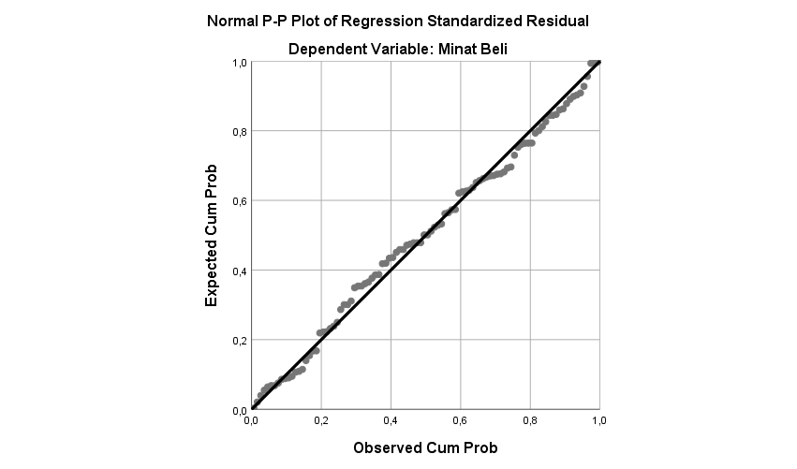

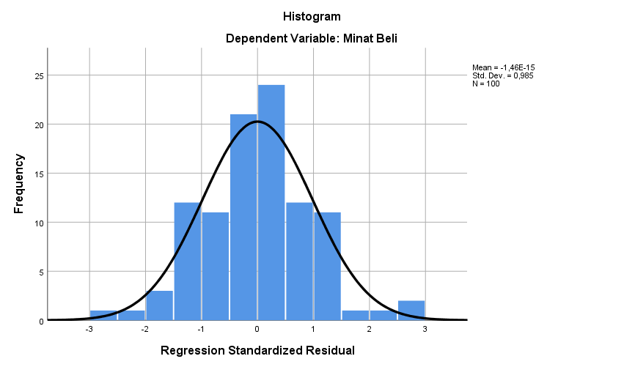
2. UJI MULTIKOLINEARITAS
Coefficientsª
Model |  | Unstandardized Coefficients |  | Standardized Coefficients | t | Sig. | Collinearity Statistics
 |  | B | Std. Error | Beta |  |  | Tolerance | VIF
1 | (Constant) | 13,779 | 4,996 |  | 2,758 | ,007
 | Persepsi Lokasi Perusahaan | ,288 | ,100 | ,266 | 2,880 | ,005 | 1,000 | 1,000
 | Persepsi Product Assortment | ,237 | ,070 | ,326 | 3,398 | ,001 | ,924 | 1,083
 | Persepsi Potongan Harga | ,015 | ,074 | ,019 | ,199 | ,843 | ,924 | 1,083
a. Dependent Variable: Minat Beli

3. UJI HETEROSKEDASTISITAS
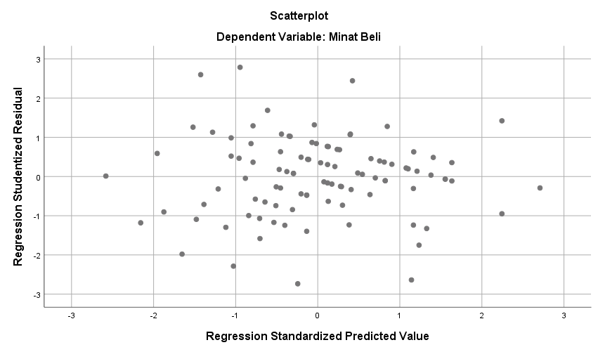
ANALISIS REGRESI LINEAR BERGANDA
Coefficientsª
Model |  | Unstandardized Coefficients |  | Standardized Coefficients | t | Sig. | Collinearity Statistics
 |  | B | Std. Error | Beta |  |  | Tolerance | VIF
1 | (Constant) | 13,779 | 4,996 |  | 2,758 | ,007
 | Persepsi Lokasi Perusahaan | ,288 | ,100 | ,266 | 2,880 | ,005 | 1,000 | 1,000
 | Persepsi Product Assortment | ,237 | ,070 | ,326 | 3,398 | ,001 | ,924 | 1,083
 | Persepsi Potongan Harga | ,015 | ,074 | ,019 | ,199 | ,843 | ,924 | 1,083
a. Dependent Variable: Minat Beli

UJI T
Coefficientsª
Model |  | Unstandardized Coefficients |  | Standardized Coefficients | t | Sig. | Collinearity Statistics
 |  | B | Std. Error | Beta |  |  | Tolerance | VIF
1 | (Constant) | 13,779 | 4,996 |  | 2,758 | ,007
 | Persepsi Lokasi Perusahaan | ,288 | ,100 | ,266 | 2,880 | ,005 | 1,000 | 1,000
 | Persepsi Product Assortment | ,237 | ,070 | ,326 | 3,398 | ,001 | ,924 | 1,083
 | Persepsi Potongan Harga | ,015 | ,074 | ,019 | ,199 | ,843 | ,924 | 1,083
a. Dependent Variable: Minat Beli

UJI F
ANOVAª
Model |  | Sum of Squares | Df | Mean Square | F | Sig.
1 | Regression | 154,496 | 3 | 51,499 | 10,759 | ,000^{b}
 | Residual | 459,504 | 96 | 4,787
 | Total | 614,000 | 99
a. Dependent Variable: Minat Beli
b. Predictors: (Constant), Persepsi Potongan Harga, Persepsi Lokasi perusahaan, Persepsi Product Assortment

KOEFISISIEN REGRESI
Model Summary^{b}
Model | R | R Square | Adjusted R Square | Std. Error of the Estimate
1 | ,751ª | ,564 | ,550 | 2,33606
a. Predictors: (Constant), Persepsi Potongan Harga, Persepsi Lokasi Perusahaan, Persepsi Product Assortment
b. Dependent Variable: Minat Beli

Lampiran 19
Foto penyebaran kuesioner
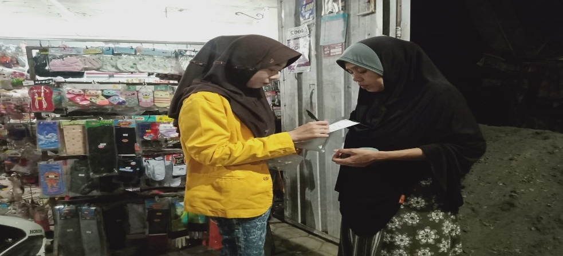
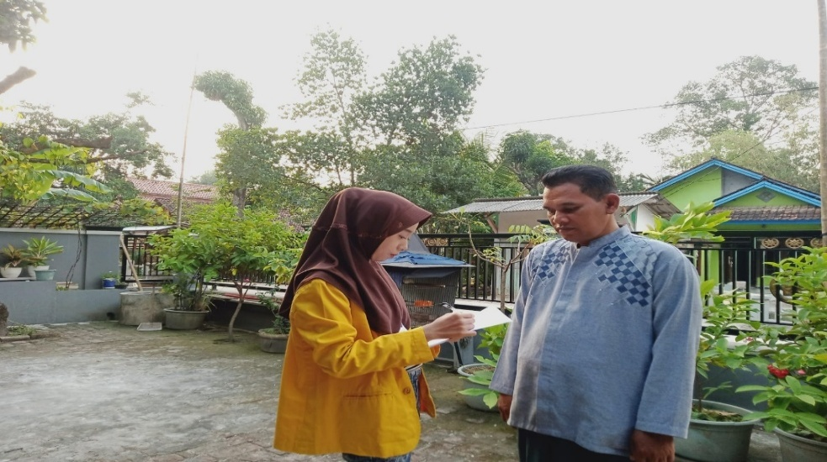
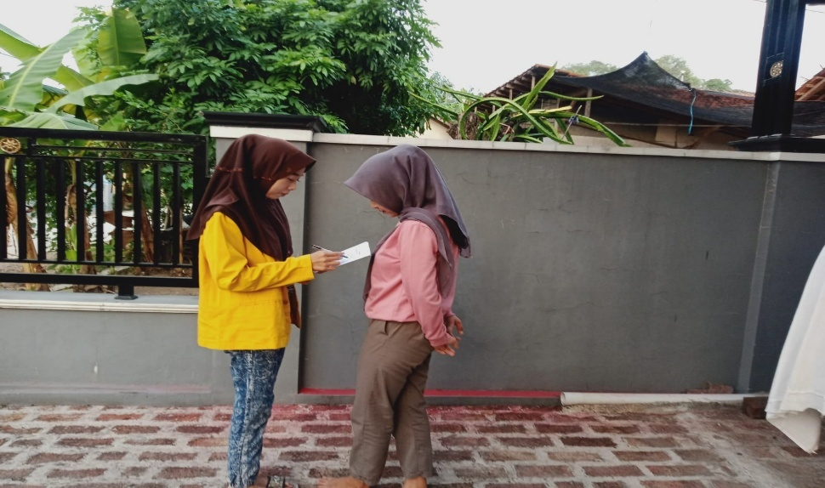
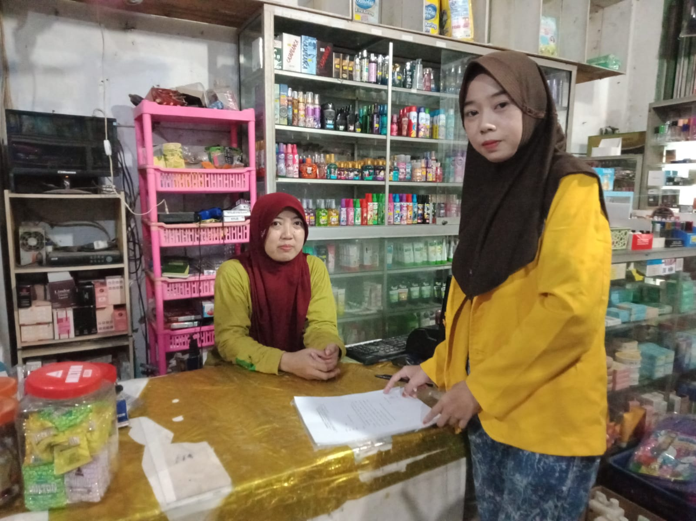

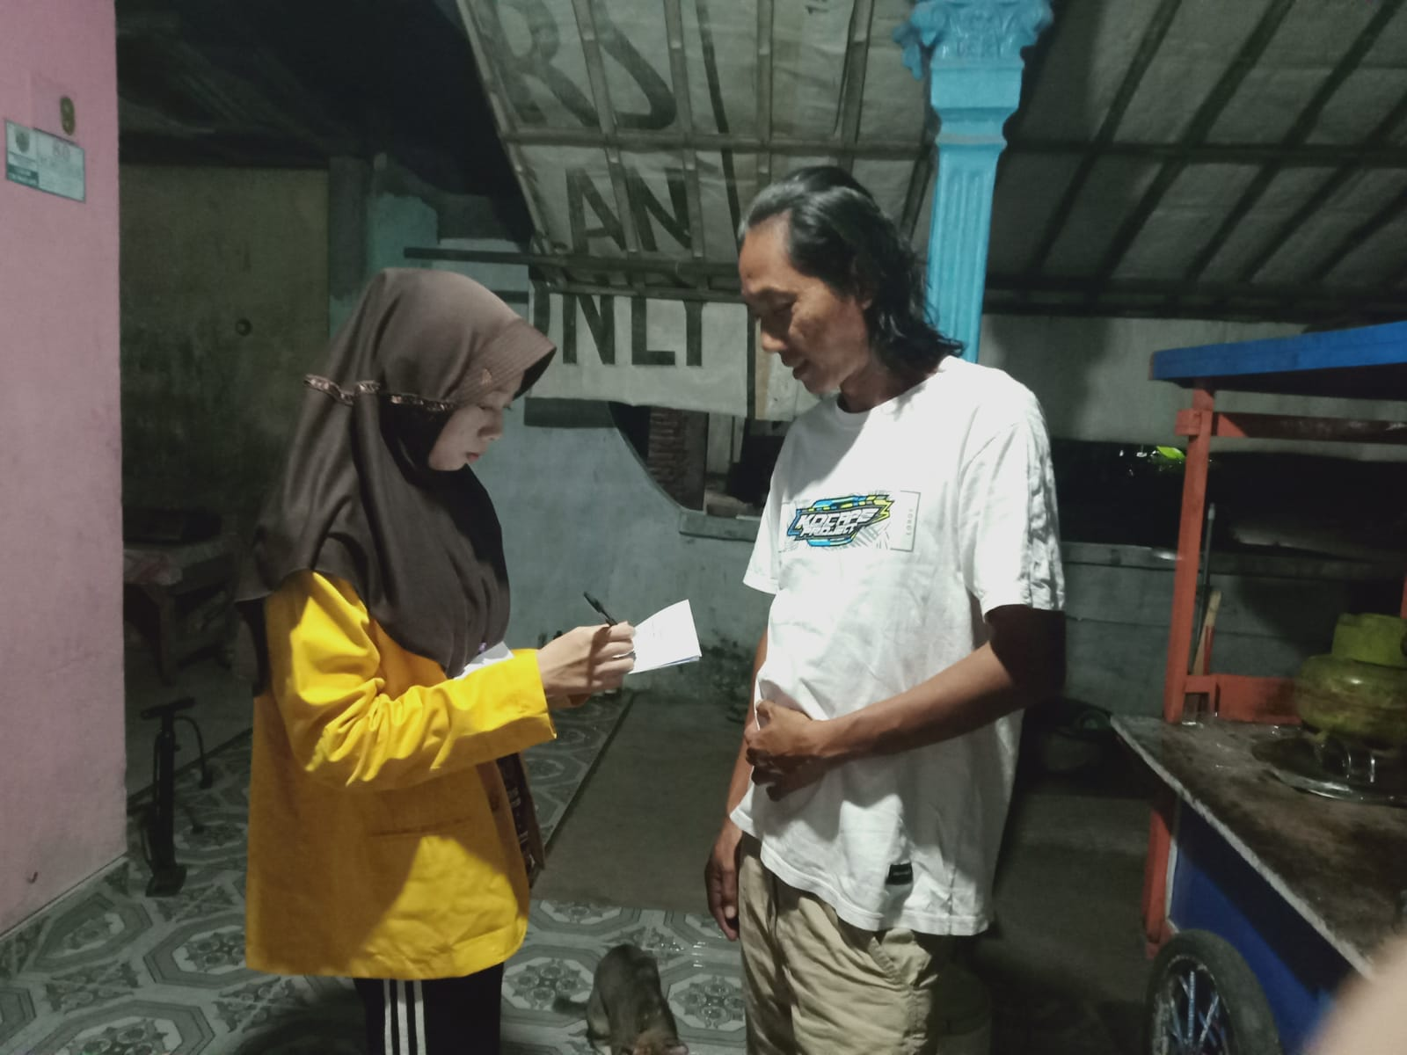
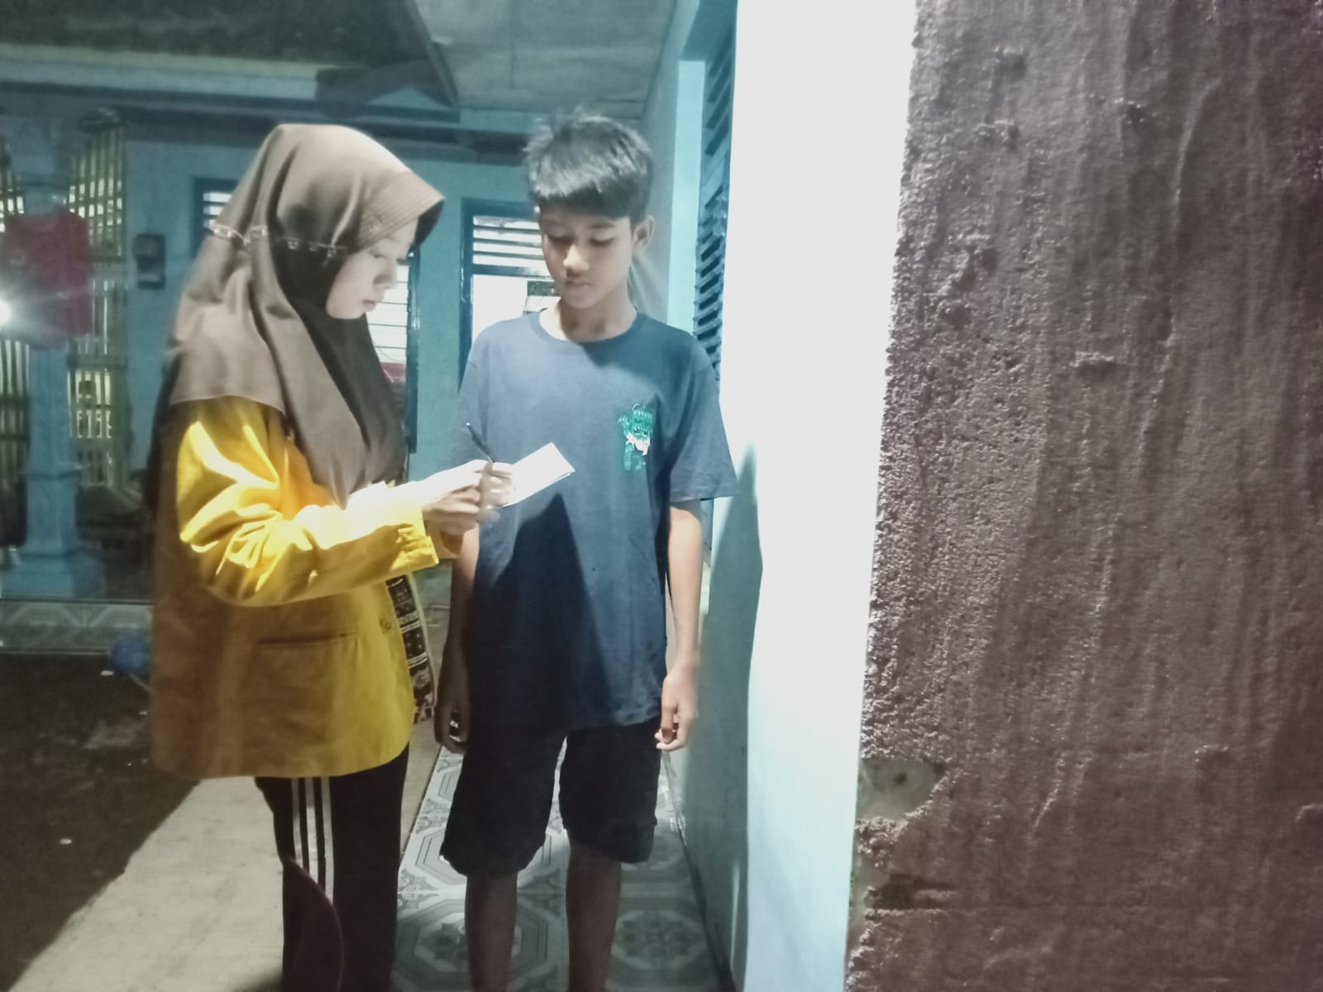

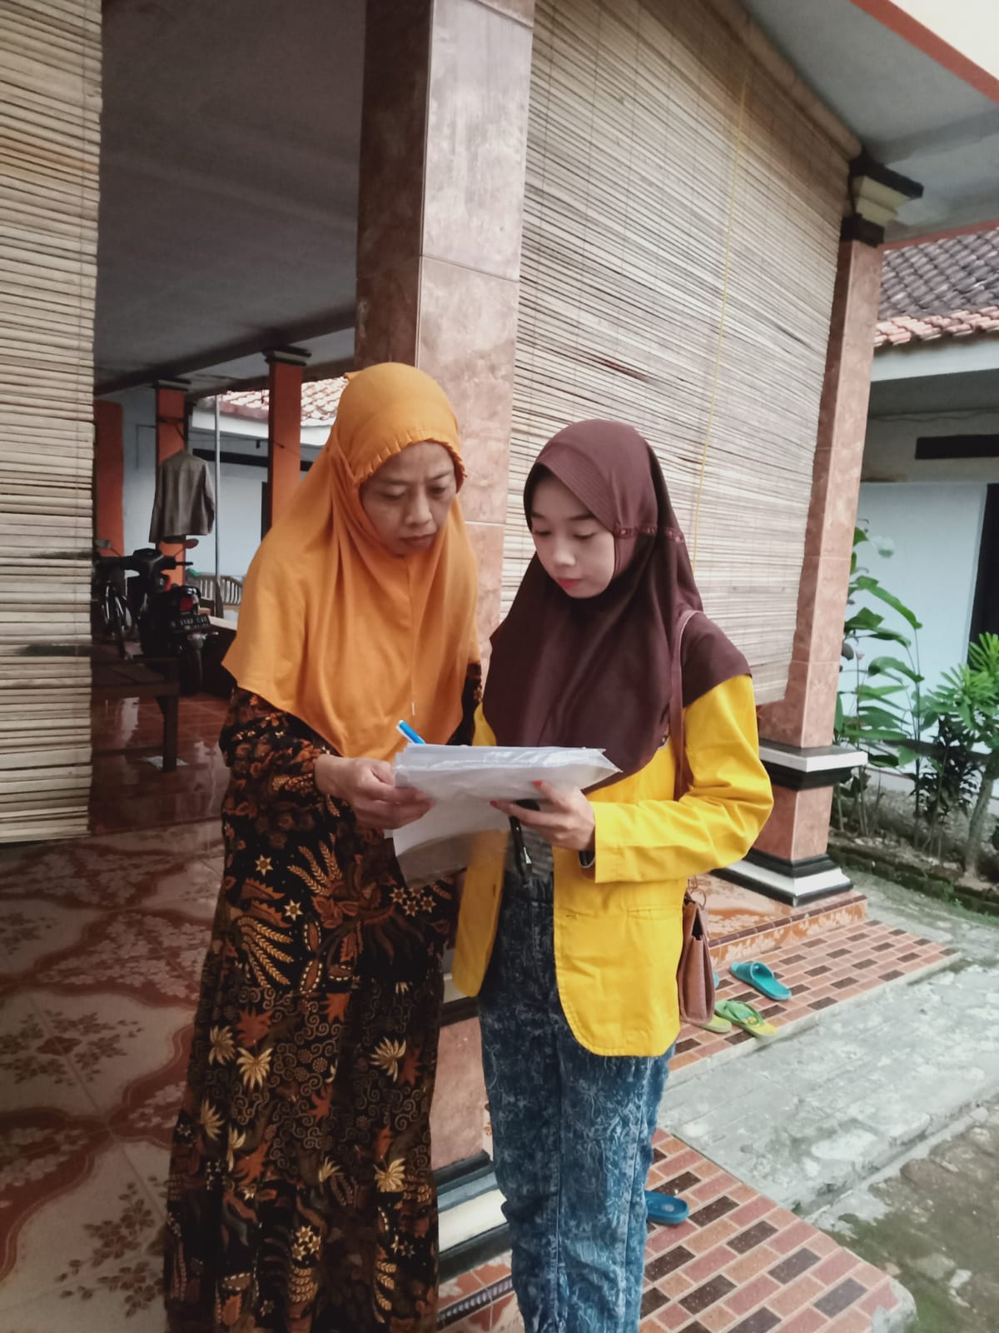

Lampiran 20

Surat Izin Penelitian
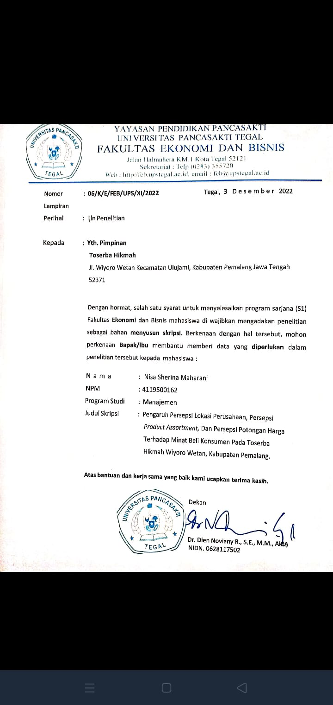

Lampiran 21
Surat Balasan Izin Penelitian
