DAFTAR PUSTAKA

Adi, B.D.N. (2016). Pengaruh Partisipasi Anggaran, Informasi Asimetri, Penekanan Anggaran Terhadap Kesenjangan Anggaran Dengan Komitmen Organisasi Sebagai Variabel Moderasi Pada Instansi Pemerintah Daerah (Studi Pada SKPD Di Pemerintah Kabupaten Purworejo). Skripsi. Universitas Islam Indonesia Fakultas Ekonomi Yogyakarta.
Afdhal, A.M.N., Rahayu, A., & Ardi, D.A. (2021). Pengaruh Partisipasi Anggaran, Penekanan Anggaran, Asimetri Informasi Terhadap Budgetary Slack pada SKPD Kabupaten Soppeng. Jurnal Ilmiah Metansi (Manajemen dan Akuntansi), 4(1), 1-10.
Agustianto, A. A. (2019). Pengaruh Partisipasi Anggaran, Partisipasi Perencanaan Strategis dan Komitmen Organisasi Terhadap Budgetary Slack. Jurnal Riset Akuntansi Tirtayasa, 4(2), 180-195.
Agustina, M.F., Masin, H.S., & Yanuarisa, Y. (2020). Pengaruh Self Esteem, Budget Emphasis, dan Locus Of Control Terhadap Budgetary Slack (Studi Empiris Pada Aparatur Organisasi Perangkat Daerah Di Kota Palangka Raya). Balance Media Informasi Akuntansi dan Keuangan, 12(02),75-89.
Ambarini, E. F., & Mispiyanti, M. (2020). Pengaruh Budget Emphasis, Self Esteem, dan Partisipasi Anggaran Terhadap Budgetary Slack pada OPD Pemerintah Kabupaten Kebumen. Jurnal Ilmiah Mahasiswa Manajemen, Bisnis Dan Akuntansi (JIMMBA), 2(1), 1-9.
Ameliany, N. (2020). Analisis Pengaruh Partisipasi Anggaran terhadap Pemanfaatan Budgetary Slack Kota Lhokseumawe dengan Pertimbangan Etika sebagai Variabel Moderasi. Negotium: Jurnal Ilmu Adimisitrasi Bisnis, 3(1),84-95.
Anggi, P., & Kiyah, M. (2019). Pengaruh Partisipasi, Kejelasan Sasaran, Group Cohesiveness Dan Informasi Asimetri Anggaran Terhadap Budgetary Slack di Seluruh Kecamatan Kota Medan. Jurnal Akuntansi dan Bisnis: Jurnal Program Studi Akuntansi, 5(2), 139-15.
Angreani, N. (2020). Pengaruh Skeptisme Profesional dan Kompetensi terhadap Kemampuan Auditor dalam Mendeteksi Kecurangan (Fraud) dengan Locus Of Control Internal sebagai Variabel Moderasi (Studi pada Inspektorat Kalimantan Utara). (Doctoral dissertation, Universitas Hasanuddin).
Anifudin,o., Juhadi, J., & Sofyan, Y. . (2020). Pengaruh Sistem Pengendalian Internal dan Audit nternal terhadap Pelaksanaan Good Corporate Governance . Jemasi: Jurnal Ekonomi Manajemen dan Akuntansi, 16(2), 17-32 https:/doi.org/10.35449/jemasi.v1612.138.
Ardanari, I.G., & Putra, I.N. . (2014). Pengaruh Partisipasi Penganggaran, Asimetri Informasi, Self Estee dan Budget Emphasis pada Budget Slack. E-Jurnal Akuntansi Universitas Udayana., Vol. 7. No 3.
Ardianti, P.N., Suardikha, I.M.S., & Suputra, I.D.G.D. (2015). Pengaruh Penganggaran Partisipatif Pada Budgetary Slack Dengan Asimetri Informasi, Self Esteem, Locus Of Control dan Kapasitas Individu Sebagai Variabel Moderasi (Studi Pada SKPD Kabupaten Jembrana, Bali). Tesis. Universitas Udayana. Denpasar.
Arthaswadaya, A. (2015). Pengaruh Informasi Asimetri terhadap Budgetary Slack dengan Self Esteem sebagai Variabel Pemoderasi: Studi Eksperimen dalam Konteks Penganggaran Partisipatif. Skripsi. Program S1 Pendidikan Akuntansi Fakultas Ekonomi Universitas Negeri Yogyakarta.
Ashari, D.N. (2018). Pengaruh Partisipasi Penyusunan Anggaran Terhadap Kinerja Manajerial Pada PT. Hadji Kalla Toyota Makassar.
Asih, N. P. Y., Astika, I. B. P., & Putri, I. A. (2016). Pengaruh Partisipasi Penganggaran Terhadap Budgetary Slack Dengan Etika, Budaya Organisasi, Opportunistic Behaviour dan Ketidakpastian Lingkungan Sebagai Pemoderasi. E-Jurnal Ekonomi dan Bisnis Universitas Udayana,, 5(12), 4415-4442.
Badriah, E. (2020). Pengaruh Partisipasi Anggaran Terhadap Budgetary Slack (Studi Kasus pada Satuan Kerja Perangkat Daerah Kabupaten Pangandaran). Moderat: Jurnal Ilmiah Ilmu Pemerintahan, 6(1), 64-78.
Basyir, A. A. (2016). Pengaruh Partisipasi Anggaran, Informasi Asimetri, dan Kapasitas Individu Terhadap Budgetary Slack Pada SKPD Pemerintah Kota Samarinda. Akuntabel,, 13(2),82-102.
Bawono . (2016). Pengaruh Partisipasi Anggaran terhadap Kinerja Manajerial dengan Job Relevant Information (JRI) dan Pengetahuan Manajemen Biaya sebagai Variabel Moderating (Studi Empiris Pada Perusahaan Perbankan di Pekanbaru). Jurnal Ekonomi , 24(3), 17 .
Bougie, U. (2017). Metode Penelitian untuk Bisnis. Jakarta: Salemba Empat.
Damayanti, E.E. (2021). Pengaruh Partisipasi Anggaran terhadap Budgetary Slack dengan Variabel Asimetris Informasi Sebagai Moderasi di Pemerintah Kota Mojokerto. (Doctoral dissertation, STIE PGRI Dewantara).
Dewi, N.P.S., & Sunarsih, N.M. (2017). Analisis Faktor-Faktor yang Mempengaruhi Budgetary Slack. Jurnal Riset Akuntansi, 7(2), 198-210.
Diansari, R. E., & Saraswati, M. (2020). Pengaruh Partisipasi Anggaran, Asimetri Informasi, Penekanan Anggaran, dan Ambiguitas Peran Terhadap Budgetary Slack (Organisasi Perangkat Daerah Kota Yogyakarta). Akmenika: Jurnal Akuntansi dan Manajemen, 17(2).
Fahdita, M.I.Z. (2018). Pengaruh Struktur Desentralisasi dan Partisipasi Anggaran terhadap Kinerja Manajer dengan Job Relevant Information dan Value Orientation Toward Inovation Manajer Sebagai Variabel Moderating (Survey Pada Divisi di bawah Direktur Keuangan dan Kinerja PT. (Doctoral dissertation, Perpustakaan Fakultas Ekonomi dan Bisnis Unpas Bandung).
Fajar, I., & Rusmana, O. (2018). Evaluasi Penerapan Sistem Pengendalian Internal BRI Dengan COSO. Jurnal Ekonomi, Bisnis, dan Akuntansi (JEBA), 20(04).
Febrianti, L. (2020). Pengaruh Partisipasi Anggaran, Informasi Asimetri,Ketidakpastian Lingkungan, Budget Emphasis Dan Locus Of Control (Studi pada Badan Pengelola Keuangan dan Aset Daerah Kabupaten Tegal). (Doctoral dissertation, Universitas).
Fitra, I. (2017). Pengaruh Partisipasi Anggaran Kejelasan Sasaran Anggaran dan Komitmen Organisasi Terhadap Budgetary Slack (Studi Empiris pada SKPD Kota Payakumbuh). Jurnal Akuntansi, 5(2).
Ghozali. (2018). Aplikasi Analisis Multivariate dengan Program IBM SPSS 25. Semarang: Badan Penerbit di Universitas Diponegoro .
Ghozali, I.(2016). Aplikasi Analisis Multivariate Dengan Program SPSS. . Semarang : Badan Penerbit Universitas Diponegoro.
Ghozali. (2013). Aplikasi Analisis Multivariate dengan Program SPSS, Edisi Ketujuh. Semarang: Badan Penerbit Universitas Diponegoro.
Guswandi, F. . (2017). Pengaruh Task Complexity dan Budget Emphasis terhadap Budgetary Slack dengan Self Esteem sebagai Variabel Moderating pada SKPD di Kabupaten Bulukumba. (Doctoral dissertation, Universitas Islam Negeri Alauddin Makassar).
Handayani. (2019). Pengaruh Participation Budgeting, Information Asimetry dan Job Relevant Information terhadap Budget Slack pada Institusi Pendidikan (Studi pada Institusi Pendidikan Universitas Kristen Maranatha). Jurnal Akuntansi, 2(2).
Handayani, S. & Aprliyanti M. (2016). Pengaruh Partisipasi Penyusunan Anggaran terhadap Kinerja Manajerial dengan Job Relevant Information sebagai Variabel Moderating (Studi Pada Dinas Pemerintah Kota Yogyakarta). Nominal Barometer Riset Akuntansi dan Manajemen , 4(2), 136-147.
Hansen & Mowen. (2016). Akuntansi Manajerial. Jakarta: Salemba Empat.
Hapsari A.D. (2020). Pengaruh Partisipasi Anggaran, Asimetri Informasi, Job Relevant Information, dan Budget Emphais terhadap Budgetary Slack (Studi Kasus pada Satuan Kerja Pemerintah Daerah Kota Tegal). (Doctoral dissertation, Universitas Pancasakti Tegal).
Harya, G. (2018). Pengaruh Partisipasi Anggaran terhadap Budgetary Slack yang DimoderasI Oleh Gaya Kepemimpinan Pada KANTOR KEPOLISIAN DAERAH (POLDA) DIY. (Doctoral dissertation, Univesitas Pembangunan Nasional" Veteran" Yogyakarta).
Horngren, C.T. (2017). Pengantar Akuntansi Managemen. Jakarta: Erlangga.
Ida Bagus A.A.P & Ketut Muliarta R.M . (2017). Pengaruh Partisipasi Anggaran, Job Relevant Information, dan Sistem Asimetri Informasi pada Budget Slack. E-Jurnal Akuntansi Universitas Udayana , Vol.20.2 : 1564-1591.
Idawati,W. . (2019). Penerapan Sistem Pengendalian Intern dan Akuntabilitas Keuangan dalam Mewujudkan Kualitas Laporan Keuangan. . Equity,, 22(2), 153-172.
Irfan, M., Santoso, B., & Effendi, L. (2016). Pengaruh Partisipasi Anggaran Terhadap Senjangan Anggaran Dengan Asimetri Informasi, Penekanan Anggaran dan Komitmen Organisasional Sebagai Variabel Pemoderasi. Journal Of Accounting and Investment, 17(2), 158-175.
Junita, A., & Azhar, I. (2021). Determinan Budgetary Slack (Pada Pemerintah Kota Langsa). Jurnal Mahasiswa Akuntansi Samudra,, 2(6), 385-395.
Junjunan, N. A., & Yulianto, A. (2019). Pengaruh Partisipasi Anggaran dan Budget Emphasis Terhadap Budgetary Slack pada Rumah Sakit. Jurnal Kajian Akuntansi,, 3(1), 109-124.
Kahar, S. H., & Hormati, A. (2017). Peran Budget Emphasis Dalam Memoderasi Hubungan Partisipasi Anggaran Terhadap Senjangan dan Kinerja Manajerial (Studi pada 30 SKPD Kota Ternate). Jurnal Akuntansi dan Auditing, 14(1), 71-88.
Keuangan, P. M., Lembaran, T., Republik, N., Lembaran, T., & Republik, N. . (2015). Peraturan Menteri Keuangan Republik Indonesia . 1-31.
Koroy, T.R. (2018). Pendeteksian Kecurangan (Fraud) Laporan Keuangan Oleh Auditor Eksternal. Jurnal Akuntansi dan keuangan, 10(1), 22-23.
Krisnawati, A., Simarmata, N.I.P., Kato, I., Antikasari, T.W., Surya, C.M., Silitonga, H.P., & Anggusti, M. (2021). Dasar-dasar Ilmu Manajemen. Yayasan Kita Menulis.
Kurniawati, H. (2013). Sistem Pengendalian Intern pada Perusahaan Kecil dan Menengah. Binus Business Review, 2(9),923-935. https://jornal.binus.ac.id/index.php/BBR/article/view/1236.
Kusaeri, G., Elim, I., & Mawikere, L.M. (2022). Evaluasi Penerapan Sistem Pengendalian Intern Pemerintah Pada Dinas Perindustrian Dan Perdagangan Daerah Provinsi Sulawesi Utara. Jurnal LPPM Bidang EkoSosBudKum (Ekonomi, Sosial, Budaya, dan Hukum), 5(2).
Kusniawati, H., & Lahaya, I. A. (2017). Pengaruh Partisipasi Anggaran, Penekanan Anggaran, Asimetri Informasi Terhadap Budgetary Slack pada SKPD Kota Samarinda. Akuntabel, 14(2), 144-156.
Listiani, A. (2014). Pengaruh Partisipasi Anggaran Terhadap Senjangan Anggaran dengan Menggunakan Komitmen Organisasi, dan Informasi Asimetri sebagai Variabel Pemoderasi. Jurnal Ekonomi dan Bisnis Islam, Vol. VIII, 200.
Lubis, R. (2017). Pengaruh Akuntabilitas, Transparansi dan Partisipasi Anggaran terhadap Kinerja Anggaran pada Dinas Pemberdayaan Perempuan Anak Pengendalian Penduduk dan KB Kota Banda Aceh. Serambi Kontruktivis, 49(2), 233-243.
Mulyadi. (2016). Sistem Akuntansi Cetakan Kelima. Jakarta: Salemba Empat.
Mulyadi. (2016). Sistem akuntansi Edisi ke-4. Jakarta: Salemba Empat.
Mustofa, S.A., & Suratman, H.S.S. (2018). Pengaruh Locus Of Control dan Sistem Pengendalian Internal terhadap Budgetary Slack (Studi pada PT Kereta Api Indonesia (Persero) Kota Bandung). (Doctoral dissertation, Perpustakaan Fakultas Ekonomi dan Bisnis Unpas Bandung).
Nurrasyid, M.N. . (2015). Pengaruh budgetary participation, information asymmetry, budget emphasis, dan job relevant information terhadap budgetary slack: studi empiris pada Sekolah Menengah Atas di Tangerang Selatan.
Pakpahan, A.F., Prasetio, A., Negara, E.S., Gurning, K., Situmorang, R.F.R., Tasnim, T & Rantung, G.A.J. (2021). Metodologi Penelitian Ilmiah. Yayasan Kita Menulis.
Panjaitan, F. B., Margaret, R., & Carolina, Y. (2019). Faktor-faktor yang Mempengaruhi Budgetary Slack pada Dinas Pengelolaan Keuangan dan Aset Daerah di Provinsi Jawa Barat. Journal of Accounting, Finance, Taxation, and Auditing (JAFTA), 1(1), 75-90.
Peilouw, C.T., Naiola, F.N., & Reinamah, C.M. (2022). Slack Inducing Scheme, Idealism, and Budget Emphasis Upon the Budgetary Slack Behavior at PT BANK NTT. In International Conference on Applied Science and Technology on Social Science 2022. (iCAST-SS 2022) (pp. 76-80). Atlantis Press.
Pratiwi, A.A.C., Suryandari, N.N.A., & Susandya, A.P.G.B.A. (2020). Pengaruh Profesionalisme, Independensi, dan Kompetensi Auditor Terhadap Kualitas Audit pada Kantor Akuntan Publik di Provinsi Bali. Jurnal Kharisma, 2(1), 2716-2710.
Priyetno, A. (2018). Pengaruh Partisipasi Anggaran terhadap Budgetary Slack dengan Gaya Kepemimpinan dan Pertimbangan Etika sebagai Variabel Moderasi (Studi Empiris SKPD Kota Pariaman). Jurnal Akuntansi, 6(1).
Putri, A.M., & Sari, D.P.P. (2020). Pengaruh Pertisipasi Penyusunan Anggaran, Task Complexity dan Budget Emphasis terhadap Budgetary Slack (Studi Empiris pada OPD di Kota Pekanbaru). Accountia Journal (Accounting Trusted, Inspiring, Authentic Journal, 4(02),154-168.
Putri, I.G.A.D. (2019). Pengaruh Kejelasan Sasaran Anggaran dan Budget Emphasis terhadap Senjangan Anggaran pada OPD Kabupaten Bandung. e-Journal Ekonomi dan Bisnis Universitas Udayana, Vol 8. No. 6.
Ramadhani, W. (2018). Pengaruh Self Esteem, Locus Of Control Dan Organizational Commitment terhadap Budgetary Slack dengan Organizational Citizenship Behavior sebagai Variabel Moderating (Studi pada Satuan Kerja Perangkat Daerah Kabupaten Bulukumba). (Doctoral Dissertation, Universitas Islam Negeri Alauddin Makassar).
Ramdhan, M. (2021). Metode penelitian. Cipta Media Nusantara.
Ridwan, M., Suraida, I., Septiawan, B., & Dewi, E.A. (2021). Skeptisisme Auditor dan Dimensi Fraud Triangle Dalam Mendeteksi Kecurangan. . Akurasi: Journal of Accounting and Finance Studies, 4(1).
Riyanto, S., & Hatmawan, A.A. (2020). Metode Riset Penelitian Kuantitatif Penelitian di Bidang Manajemen, Teknik, Pendidikan dan Eksperimen. Deepublish.
Rokhman, M.T.N. (2018). Confirmatory Factor Analysis Job Relevant Information, Partisipasi Anggaran dan Kinerja Aparatur Pemerintah Daerah Kabupaten Malang. JDEP (Jurnal Dinamika Ekonomi Pembangunan), 1(2), 80-87.
Rukajat, A. (2018). Pendekatan Penelitian Kuantitatif: Quantitative Research Approach. Deepublish.
Rukmana, P. (2013). Pengaruh Partisipasi Anggaran dan Asimetri Informasi Terhadap Timbulnya Budget Slack (Studi Empiris pada Pemerintah Kota Padang). Jurnal Akuntansi, 1(1).
Saraswati, G.P., & Aisyah, M.N. (2015). Pengaruh Partisipasi Penyusunan Anggaran terhadap Kinerja Manajerial dengan Job Relevant Information Sebagai Variabel Moderating (Studi pada Dinas Pemerintah Kota Yogyakarta). Nominal Barometer Riset Akuntansi dan Manajemen, 4(2), 136-147.
Sari, A. L., Diana, N., & Mawardi, M.C. (2019). Pengaruh Partisipasi Anggaran, Asimetri Informasi, Budget Emphasis Dan Komitmen Organisasi Terhadap Budgeting Slack. e_Jurnal Ilmiah Riset Akuntansi, 8(03.
Savitri, E., & Sawitri, E. . (2014). Pengaruh Partisipasi Anggaran, Penekanan Anggaran Dan Informasi Asimetri Terhadap Timbulnya Kesenjangan Anggaran. Fakultas Ekonomi Universitas Riau. Akuntansi, 2(2), 210–226.
Sawitri, E., Surya, R. A. S., & Savitri, E. (2014). Budgetary Participation, Budget Emphasis, and Information Asymmetry, On The Incidence Of Budgetary Slack (Study In Kampar District Government On Education). Jurnal Online Mahasiswa (JOM) Bidang Ilmu Ekonomi, 1(1),1-15.
Setyawan, F.E.B. (2017). Pengantar Metodologi Penelitian (statistika praktis). Zifatama Jawara.
Siahaan, M.P. (2016). Pajak Daerah dan Retribusi Daerah. Edisi Revisi. Jakarta: Rajawali.
Siregar, Baldric, Bambang Suripto, Dody Hapsoro, Eko Widodo Lo, dan F.B . (2014). Akuntansi Manajemen. Jakarta: Salemba Empat.
Sofia Helmy, O. (2020). Pengaruh Task Complexity dan Budget Emphasis terhadap Budgetary Slack dengan Self Esteem Sebagai Variabel Moderating (Studi Empiris pada Pegawai di Satuan Kerja Perangkat Daerah Kabupaten Ponorogo). (Doctoral dissertation, Universitas Muhammadiyah Ponorogo).
Sucipto, A. . (2017). Analisis Pengaruh Pengetahuan dan Pengalaman Terhadap Kemampuan Akuntan Pemeriksa dalam Mendeteksi Kekeliruan pada Kantor Akuntan Publik di Surabaya. (Doctoral dissertation, Petra Christian University).
Sugiyono. (2017). Metode Penelitian Kuantitatif, Kualitatif, dan R & D. Yogyakarta.
Suhartono, R & Solichin, A. . (2016). Pengaruh Partisipasi Anggaran, Komitmen Organisasi, Locus Of Control dan Sistem Pengendalian Internal Terhadap Budgetary Slack (Studi Empiris Pada Lembaga Perkreditan Desa (LPD) di Kecamatan Buleleng). JIMAT (Jurnal Ilmiah Mahasiswa Akuntansi) Undiksha, 7(1).
Sukarningsih, S. (2021). Pengaruh Partisipasi Anggaran Dan Kompetensi Sumber Daya Manusia Terhadap Penyerapan Anggaran Dengan Komitmen Organisasi Sebagai Variabel Moderating Pada Polda Sumatera Utara . (Doctoral dissertation).
Sulfita, E., Basri, H., & Faisal, F. (2017). Pengaruh Job Relevan Information, Partisipasi Anggaran dan Komitmen Organisasi Terhadap Budgetary Slack (Studi pada SKPK Pemerintah Kota Banda Aceh). Jurnal Telaah dan Riset Akuntansi, 10(2), 103-110.
Triminarni, T., & Cahyono, Y.T. (2014). Analisis Pengaruh Partisipasi Anggaran, Budget emphasis, dan Informasi Asimetris terhadap Slack Anggaran (Studi pada Satuan Kerja Pemerintah Daerah Kabupaten Wonogiri). (Doctoral dissertation, Universitas Muhammadiyah Surakarta).
Ul’fah Hernaeny, M. (2021). Populasi dan Sampel. Pengantar Statistika, 1, 33.
Vebyana, S. (2014). Hubungan Partisipasi Anggaran Dengan Informasi Job Relevant Serta Pengaruhnya Terhadap Kepuasan Kerja Dan Kinerja Manajerial Di Lingkungan Pemerintah Yogyakarta. Universitas Gadjah Mada Yogyakarta.
Virginia, A. (2021). Pengaruh Partisipasi Anggaran, Locus Of Control, Dan Budget Emphasis Terhadap Bugdetary Slack Dengan Asimetri Informasi Sebagai Variabel Mediating (Studi pada Pejabat Eselon III dan IV di Seluruh SKPD Kabupaten Sragen). Doctoral Dissertation, Universitas Muhammadiyah Surakarta.
Wiratno, A., Ningsih, W., & Putri, N.K. (2016). Partisipasi Anggaran Terhadap Kinerja Manajerial dengan Komitmen Organisasi, Motivasi dan Struktur Desentralisasi Sebagai Variabel Pemoderasi. Jurnal Akuntansi, 20(1), 150-166.
Wirda, D. &. (2013). Pengaruh Sistem Pengendalian Internal terhadap Penerapan Good Corporate Governance (GCG) pada perbankan di kota Banda Aceh. Jurnal Akuntansi Pascasarjana Universitas Syiah Kuala, 1(1), 59-70.
Yanti, H., & Mustoffa, A.F. (2022). Analisis Sistem Informasi Akuntansi Penggajian Dalam Rangka Efektivitas Pengendalian Internal Perusahaan (Studi Kasus Pada PT Daria Dharma Pratama Air Berau). ASSET: Jurnal Manajemen dan Bisnis, 5(1).
Yanti, N.W.M., & Sari, M.M.R. (2016). Asimetri Informasi sebagai Pemoderasi Pengaruh Partisipasi Penganggaran dan Kejelasan Sasaran Anggaran pada Senjangan Anggaran . E-Jurnal Akuntansi Universitas Udayana, 15(1), 257-285.
Yasa, I.N.P. (2017). Pengaruh Locus of Control, Sistem Pengendalian Internal dan Kontrak Psikologi terhadap Budgetary Slack (Studi pada Bank Perkreditan Rakyat (Bpr) di Provinsi Bali). Jurnal Ilmu Manajemen (JUIMA),, 7(1).
Yusrianti, H., Ghozali, I., & Yuyetta, E. (2022). Kecenderungan Penyalahgunaan Aset:Multi-Perspective Fraud Model. (Kajian Pustaka) (Doctoral dissertation, Sriwijaya University).
Zulkarnaini. (2013). Pengaruh Komitmen Organisasi dan Pengendalian Intern terhadap Slack Anggaran Survey pada Aparatur Pemerintah Daerah Kabupaten Bener Meriah dan Pidie Jaya. Jurnal Akuntansi Dan Keuangan, 3 (1), 65-79.

LAMPIRAN

Permohonan Pengisian Kuesioner

Yth. Bapak/Ibu/Saudara/I
Di Tempat
Dengan Hormat,
Saya adalah mahasiswi Program Strata Satu (S1) Fakultas Ekonomi, Jurusan Akuntansi, Universitas Pancasakti Tegal, yang sedang mengadakan penelitian dalam rangka menyusun tugas akhir berupa Skripsi.
Nama : Shella Tri Selviani
NPM : 43195000027
Dalam rangka penelitian untuk skripsi saya yang berjudul “Pengaruh Partisipasi Anggaran, Budget Emphasis, Job Relevant Information, Dan Sistem Pengendalian Internal Terhadap Budgetary Slack (Studi Kasus Pada Organisasi Perangkat Daerah Kota Tegal). Maka saya memohon bantuan dari Bapak/Ibu/Saudara/I untuk berkenan mengisi kuesioner yang saya lampirkan bersama surat ini.
Peneliti menjamin sepenuhnya kerahasiaan identitas seluruh jawaban Bapak/Ibu/Saudara/I sesuai dengan etika penelitian. Peneliti mohon maaf apabila ada yang tidak berkenan atas hadirnya kuesioner ini. Atas kesediaan dan perhatiaan serta kerjasamanya peneliti ucapkan terima kasih
Hormat Saya,

Shella Tri Selviani
KUESIONER PENELITIAN

- IDENTITAS RESPONDEN
Beri tanda (√) pada identitas pengenal Bapak/Ibu/Sdr responden.
- Nama :
- Jenis kelamin :( )Pria ( )Wanita
- Pendidikan terakhir :( )SLTA/Sederajat ( )Diploma
( )S1 ( )S2 ( )S3

- Umur Responden :( )18-28th ( )40-50th
( )29-39th ( )>50th
- Agama :( )Islam ( )Budha
( )Kristen ( )Katolik
( )Hindu

Catatan : jawaban apapun tidak akan mempengaruhi terhadap Bapak/Ibu/Saudara/i. Karena ini hanya digunakan untuk pengembangan sosial.

Tanggal Pengisian :
Tanda tangan

DAFTAR PERNYATAAN
- Budgetary Slack (kesenjangan anggaran)
Mohon Bapak/Ibu memberikan tanda checklist (√) pada salah satu jawaban yang sesuai dengan pendapat dari Bapak/ibu.
STS : Sangat Tidak Setuju : Skor 1
TS : Tidak Setuju : Skor 2
KS : Kurang Setuju : Skor 3
S : Setuju : Skor 4
SS : Sangat Setuju : Skor 5

No | Pernyataan | SS | S | KS | TS | STS
 |  | 5 | 4 | 3 | 2 | 1
1. | Anggaran pada unit yang menjadi tanggung jawab saya dapat dicapai degan mudah
2. | Bagi saya instansi ini adalah yang terbaik dari semua kemungkinan instansi yang dipilih untuk bekerja
3. | Pada keadaan bisnis yang baik, manajer instansi bersedia menerima adanya kesenjangan (slack) sampai dengan level tertentu yang dianggap wajar
4. | Kesenjangan dalam anggaran adalah baik untuk melakukan sesuatu yang tidak dapat dibuktikan secara resmi
5. | Anggaran untuk departemen saya, dapat saya pastikan dapat terlaksana
6. | Standar yang digunakan di dalam anggaran mendorong produktivitas yang tinggi di wilayah tanggung jawab saya
7. | Karena adaya keterbatasan jumlah anggaran yang disediakan, maka saya harus memonitor setiap pengeluaran yang menjadi wewenang saya
8. | Anggaran yang menjadi tanggung jawab saya tidak begitu tinggi tuntutannya
9. | Adanya target anggaran yang harus dicapai, tidak terlalu membuat saya ingin memperbaiki efisiensi
10. | Sasaran yang dijabarkan dalam anggaran mudah untuk dicapai dan direalisasikan
Sumber : (Panjaitan dkk, 2019)
- Partisipasi Anggaran
Mohon Bapak/Ibu memberikan tanda checklist (√) pada salah satu jawaban yang sesuai dengan pendapat dari Bapak/ibu.
STS : Sangat Tidak Setuju : Skor 1
TS : Tidak Setuju : Skor 2
KS : Kurang Setuju : Skor 3
S : Setuju : Skor 4
SS : Sangat Setuju : Skor 5

No | Pernyataan | SS | S | KS | TS | STS
 |  | 5 | 4 | 3 | 2 | 1
1. | Saya ikut serta dalam penyusunan anggaran sesuai dengan tanggung jawab saya
2. | Saya seringkali menyatakan pendapat dan atau usulan sewaktu anggaran disusun
3. | Apabila ada hal-hal yang tidak logis yang berhubungan dengan anggaran, saya selalu mengajukan usulan
4. | Saya sering memberikan pendapat atau usulan tentang anggaran kepada atasan baik diminta ataupun tidak diminta
5. | Pendapat saya merupakan faktor penting dalam penyusunan anggaran
6. | Saya mempunyai pengaruh yang cukup besar dalam menentukan sasaran anggaran saya
7. | Saya mempunyai pengaruh yang sangat kecil dalam menentukan sasaran anggaran saya
8. | Penetapan anggaran sebagian besar dibawah pengendalian saya
9. | Atasan selalu meminta pendapat saya dalam pembahasan usulan anggaran
10. | Menurut saya dilakukannya revisi anggaran adalah masuk akal
Sumber : (Panjaitan dkk, 2019).

- Budget Emphasis
Mohon Bapak/Ibu memberikan tanda checklist (√) pada salah satu jawaban yang sesuai dengan pendapat dari Bapak/ibu.
STS : Sangat Tidak Setuju : Skor 1
TS : Tidak Setuju : Skor 2
KS : Kurang Setuju : Skor 3
S : Setuju : Skor 4
SS : Sangat Setuju : Skor 5

No | Pernyataan | SS | S | KS | TS | STS
 |  | 5 | 4 | 3 | 2 | 1
1. | Saya akan mendapat reward apabila target anggaran tercapai
2. | Terdapat sanksi apabila target anggaran tidak tercapai
3. | Penilaian kinerja saya dinilai dari pencapaian anggaran
4. | Usaha yang saya curahkan untuk pekerjaan saya penting bagi instansi saya
5. | Perhatian saya terhadap kualitas anggaran penting bagi instansi saya.
6. | Anggaran pada unit yang menjadi tanggung jawab saya berfungsi sebagai alat pengendali (pengawasan) kinerja saya
7. | Kemampuan saya dalam mencapai target anggaran penting bagi atasan
8. | Bagi instansi saya, efisiensi saya dalam menjalankan pekerjaan sangat penting
9. | Sikap saya terhadap pekerjaan penting bagi instansi saya
10. | Hubungan saya yang baik dengan kelompok staf penting bagi atasan saya
Sumber : (Panjaitan dkk, 2019)

- Job Relevant Information (JRI)
Mohon Bapak/Ibu memberikan tanda checklist (√) pada salah satu jawaban yang sesuai dengan pendapat dari Bapak/ibu.
STS : Sangat Tidak Setuju : Skor 1
TS : Tidak Setuju : Skor 2
KS : Kurang Setuju : Skor 3
S : Setuju : Skor 4
SS : Sangat Setuju : Skor 5

No | Pernyataan | SS | S | KS | TS | STS
 |  | 5 | 4 | 3 | 2 | 1
1. | Saya selalu merasa jelas tentang informasi yang saya perlukan untuk melakukan yang terbaik atas tugas atau pekerjaan saya
2. | Saya memiliki informasi yang cukup untuk membuat keputusan yang optimal demi tercapainya tujuan aktivitas saya
3. | Saya dapat memperoleh informasi yang strategik yang diperlukan untuk mengevaluasi hasil pekerjaan
4. | Saya selalu mencari informasi yang tepat untuk mendukung penyelesaian pekerjaan saya
5. | Terdapat informasi yang berhubungan dengan kemajuan dan perkembangan organisasi
6. | Informasi yang dibutuhkan tersedia ketika diminta atau dibutuhkan
7. | Informasi yang saya terima dalam bentuk sistematis dan teratur
8. | Terdapat informasi tentang unit/sub unit atau fungsi yang berbeda dalam organisasi (unit/sub unit lain dalam organisasi) yang disampaikan kepada saya
9. | Terdapat Informasi yang harus dapat dibaca oleh pembuat keputusan
10. | Terdapat Informasi yang harus dapat dipahami agar berguna bagi pembuat keputusan
Sumber : Handayani (2016)
- Sistem Pengendalian Internal
Mohon Bapak/Ibu memberikan tanda checklist (√) pada salah satu jawaban yang sesuai dengan pendapat dari Bapak/ibu.
STS : Sangat Tidak Setuju : Skor 1
TS : Tidak Setuju : Skor 2
KS : Kurang Setuju : Skor 3
S : Setuju : Skor 4
SS : Sangat Setuju : Skor 5

No | Pernyataan | SS | S | KS | TS | STS
 |  | 5 | 4 | 3 | 2 | 1
1. | Sistem pengendalian internal dilaksanakan terutama pada pencapaian tujuan umum pemerintah.
2. | Harus menjaga aset organisasi dan melindungi dengan pengendalian yang memadai.
3. | Manajemen harus mendorong efisiensi pengendalian internal
4. | Untuk mencapai tujuan organisasi, manajemen menetapkan kebijakan dan prosedur untuk memberikan jaminan yang memadai
5. | Standar sistem pengendalian internal ditentukan sesuai standar
6. | Menekankan pentingnya pengendalian dan mendorong dipatuhinya kebijakan termasuk dipatuhinya standar operasional perusahaan akan menciptakan lingkungan pengendalian yang efektif
7. | Perusahaan telah memberikan kejelasan tentang wewenang dan tanggungjawab kepada karyawan
8. | Dalam organisasi telah mengidentifikasi resiko dalam penyusunan anggaran
9. | Karyawan bagian akuntansi harus mendapatkan pelatihan yang memadai dan diawasi dalam melaksanakan tugasnya
10 | Setiap kebijakan telah disampaikan dengan detail dan jelas kepada karyawan
Sumber : PMK No 88 Tahun 2015

Lampiran 2 dokumentasi
  - Surat Ijin Penelitian
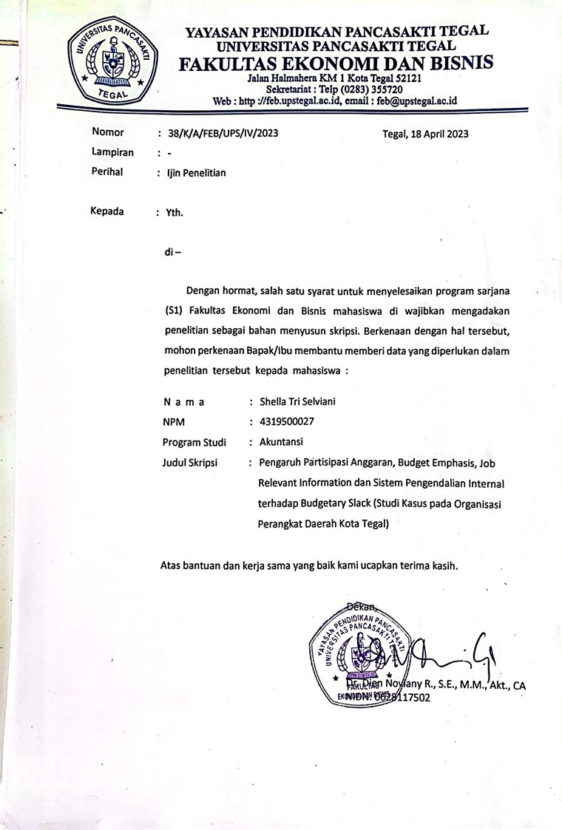
  - Surat Pemberian Ijin Penelitian
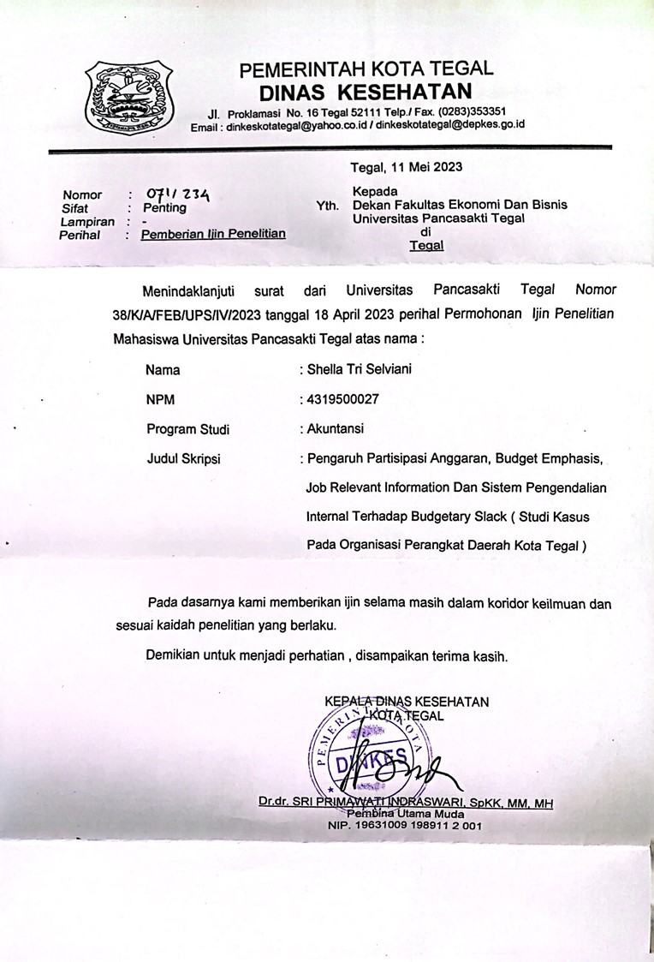

  - Lembar Disposisi Balasan Ijin Penelitian
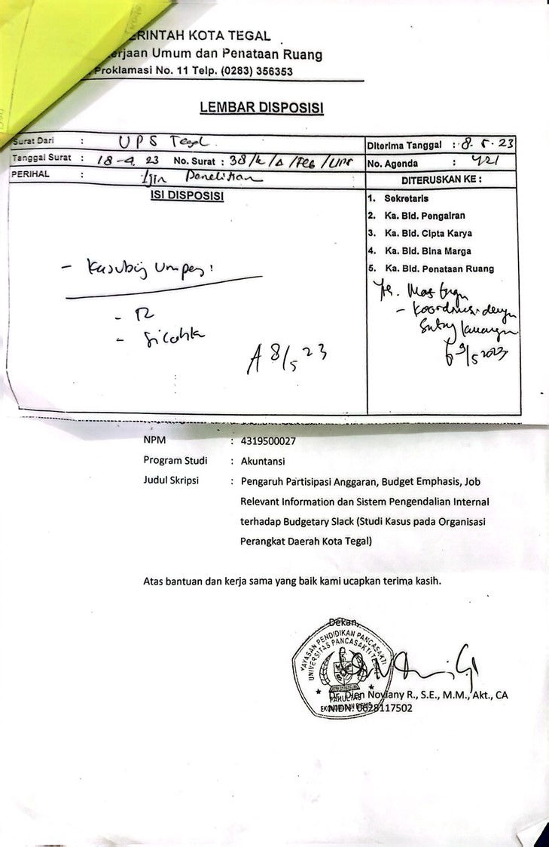
  - Lembar Pengisian Kuesioner
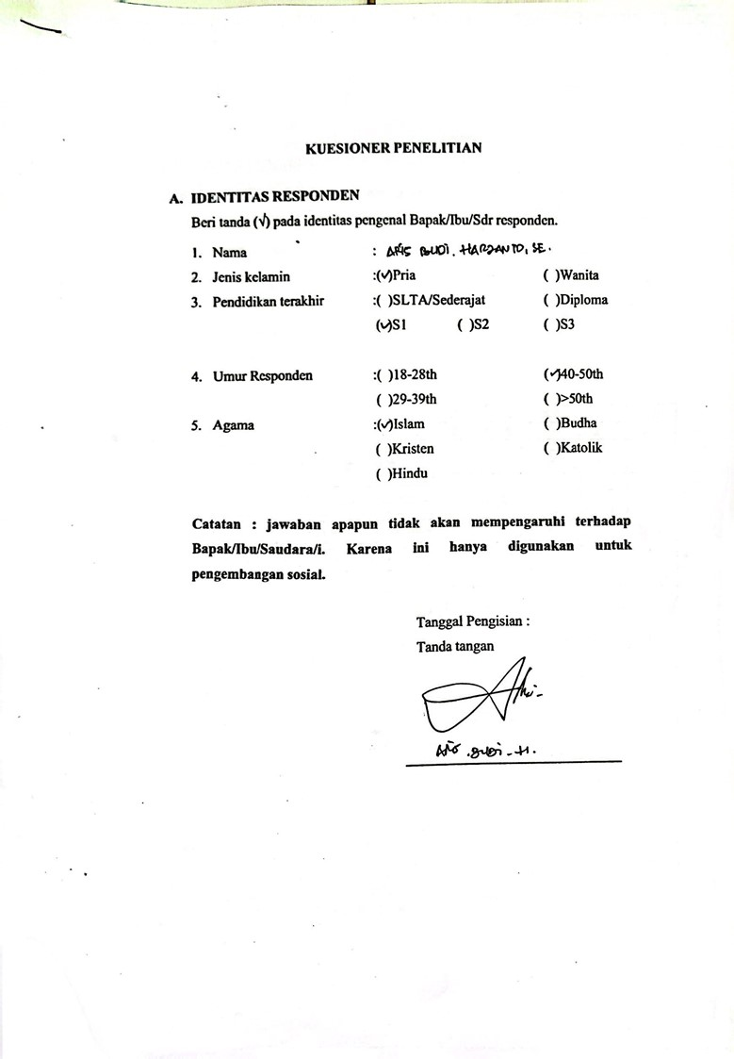

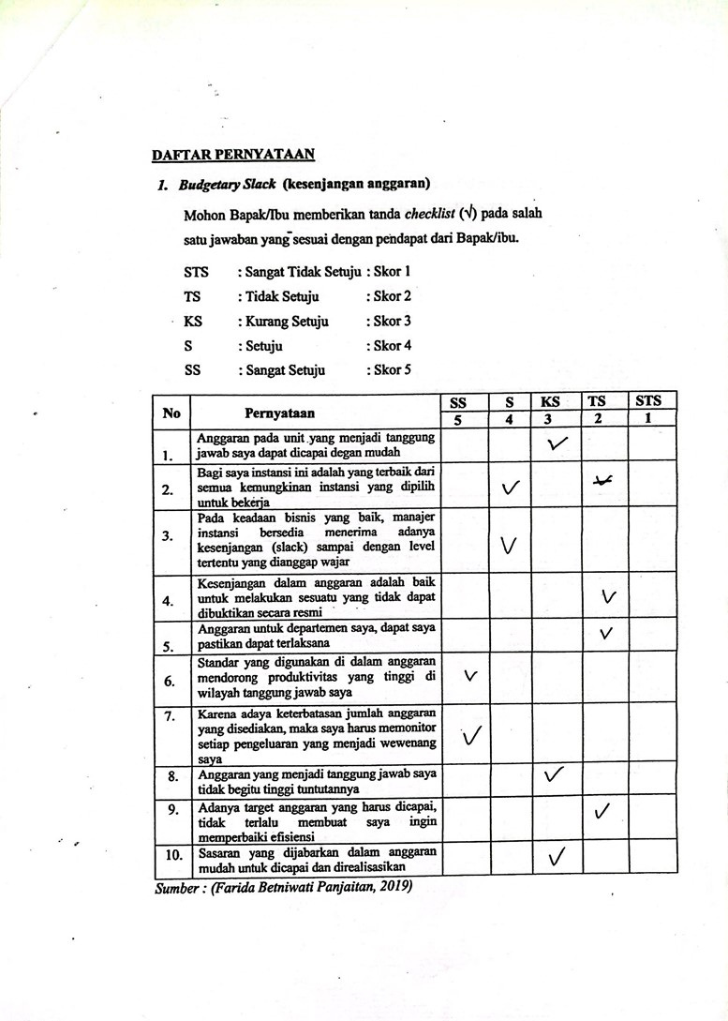

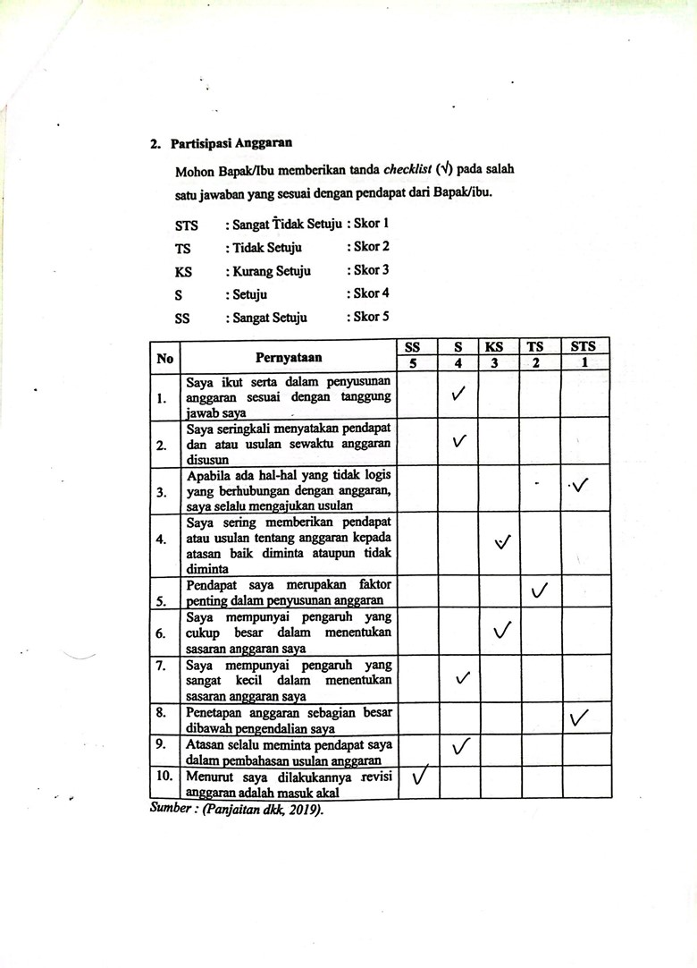

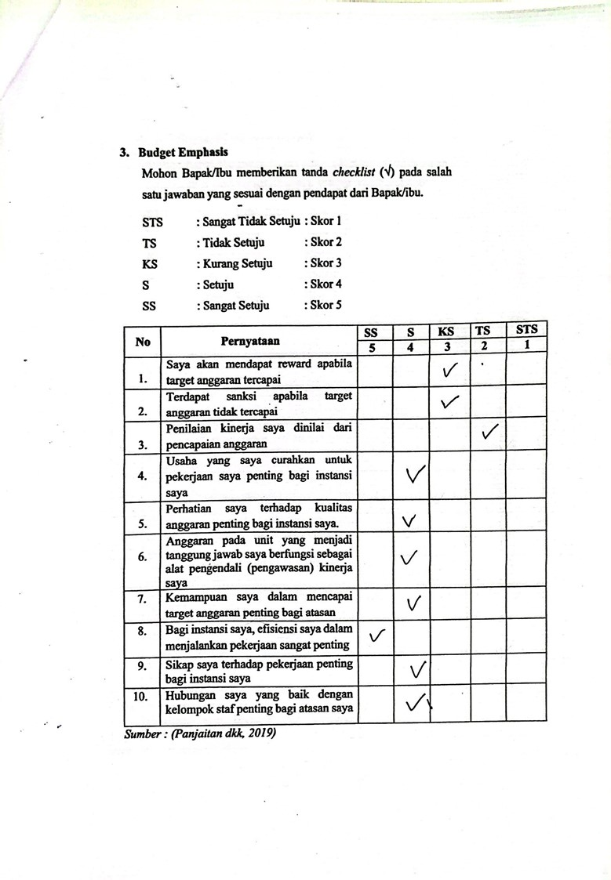

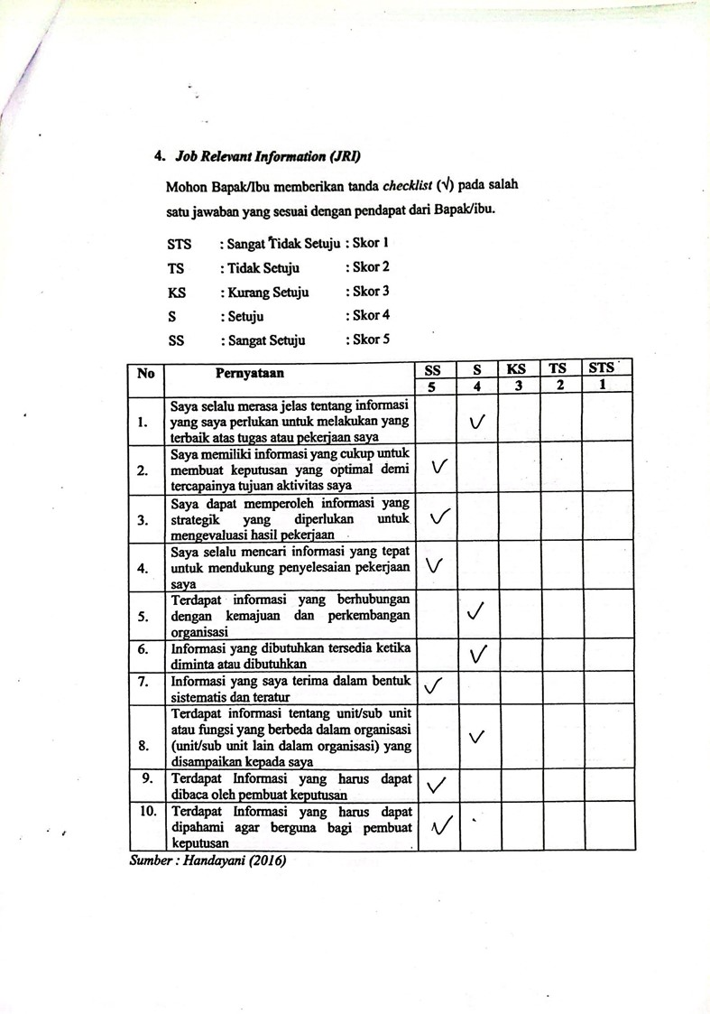

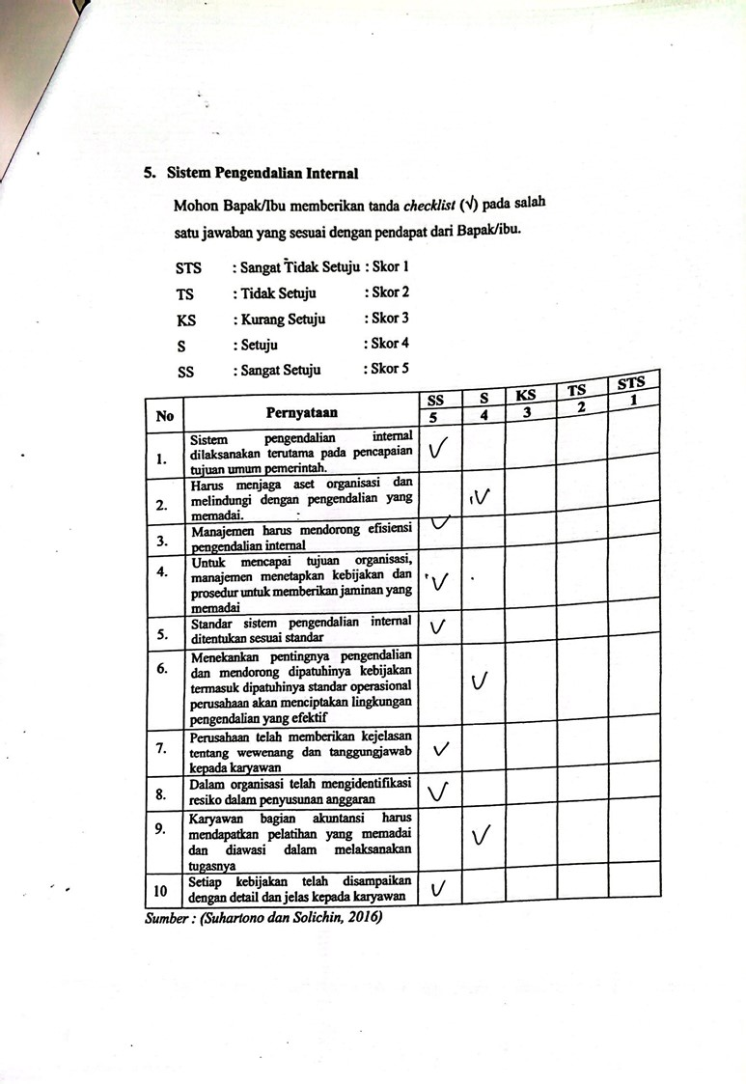

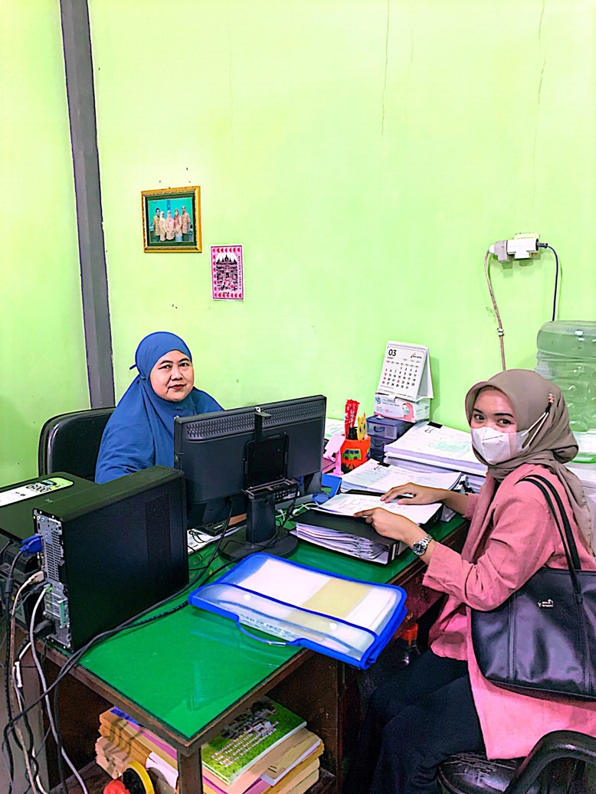
Lampiran 3 Data Peneliti
  - Variabel X1

  - Variabel X2

  - Variabel X3
  - Variabel X4
  - Variabel Y
Lampiran 4 Output SPSS Versi 25
            - Hasil Uji Validitas
              - Partisipasi Anggaran (X1)
Correlations
 |  | X1.1 | X1.2 | X1.3 | X1.4 | X1.5 | X1.6 | X1.7 | X1.8 | X1.9 | X1.10 | TOTAL X1
X1.1 | Pearson Correlation | 1 | .238* | .266* | .282* | .284* | .424** | .739** | .786** | .018 | .204 | .756**
 | Sig. (2-tailed) |  | .044 | .024 | .016 | .015 | .000 | .000 | .000 | .883 | .085 | .000
 | N | 72 | 72 | 72 | 72 | 72 | 72 | 72 | 72 | 72 | 72 | 72
X1.2 | Pearson Correlation | .238* | 1 | .148 | -.023 | .960** | .216 | .152 | .166 | .031 | -.058 | .485**
 | Sig. (2-tailed) | .044 |  | .214 | .847 | .000 | .068 | .201 | .165 | .793 | .629 | .000
 | N | 72 | 72 | 72 | 72 | 72 | 72 | 72 | 72 | 72 | 72 | 72
X1.3 | Pearson Correlation | .266* | .148 | 1 | .058 | .147 | .684** | .354** | .173 | .014 | .000 | .478**
 | Sig. (2-tailed) | .024 | .214 |  | .630 | .217 | .000 | .002 | .147 | .909 | .997 | .000
 | N | 72 | 72 | 72 | 72 | 72 | 72 | 72 | 72 | 72 | 72 | 72
X1.4 | Pearson Correlation | .282* | -.023 | .058 | 1 | .050 | .078 | .177 | .367** | .863** | .099 | .601**
 | Sig. (2-tailed) | .016 | .847 | .630 |  | .679 | .517 | .137 | .002 | .000 | .406 | .000
 | N | 72 | 72 | 72 | 72 | 72 | 72 | 72 | 72 | 72 | 72 | 72
X1.5 | Pearson Correlation | .284* | .960** | .147 | .050 | 1 | .185 | .123 | .260* | .047 | .016 | .538**
 | Sig. (2-tailed) | .015 | .000 | .217 | .679 |  | .121 | .302 | .028 | .697 | .896 | .000
 | N | 72 | 72 | 72 | 72 | 72 | 72 | 72 | 72 | 72 | 72 | 72
X1.6 | Pearson Correlation | .424** | .216 | .684** | .078 | .185 | 1 | .489** | .297* | .056 | -.002 | .574**
 | Sig. (2-tailed) | .000 | .068 | .000 | .517 | .121 |  | .000 | .011 | .642 | .987 | .000
 | N | 72 | 72 | 72 | 72 | 72 | 72 | 72 | 72 | 72 | 72 | 72
X1.7 | Pearson Correlation | .739** | .152 | .354** | .177 | .123 | .489** | 1 | .562** | .042 | .035 | .629**
 | Sig. (2-tailed) | .000 | .201 | .002 | .137 | .302 | .000 |  | .000 | .723 | .768 | .000
 | N | 72 | 72 | 72 | 72 | 72 | 72 | 72 | 72 | 72 | 72 | 72
X1.8 | Pearson Correlation | .786** | .166 | .173 | .367** | .260* | .297* | .562** | 1 | .153 | .084 | .707**
 | Sig. (2-tailed) | .000 | .165 | .147 | .002 | .028 | .011 | .000 |  | .199 | .484 | .000
 | N | 72 | 72 | 72 | 72 | 72 | 72 | 72 | 72 | 72 | 72 | 72
X1.9 | Pearson Correlation | .018 | .031 | .014 | .863** | .047 | .056 | .042 | .153 | 1 | -.061 | .452**
 | Sig. (2-tailed) | .883 | .793 | .909 | .000 | .697 | .642 | .723 | .199 |  | .612 | .000
 | N | 72 | 72 | 72 | 72 | 72 | 72 | 72 | 72 | 72 | 72 | 72
X1.10 | Pearson Correlation | .204 | -.058 | .000 | .099 | .016 | -.002 | .035 | .084 | -.061 | 1 | .266*
 | Sig. (2-tailed) | .085 | .629 | .997 | .406 | .896 | .987 | .768 | .484 | .612 |  | .024
 | N | 72 | 72 | 72 | 72 | 72 | 72 | 72 | 72 | 72 | 72 | 72
TOTAL X1 | Pearson Correlation | .756** | .485** | .478** | .601** | .538** | .574** | .629** | .707** | .452** | .266* | 1
 | Sig. (2-tailed) | .000 | .000 | .000 | .000 | .000 | .000 | .000 | .000 | .000 | .024
 | N | 72 | 72 | 72 | 72 | 72 | 72 | 72 | 72 | 72 | 72 | 72
*. Correlation is significant at the 0.05 level (2-tailed).
**. Correlation is significant at the 0.01 level (2-tailed).

              - Budget Emphasis (X2)

Correlations
 |  | X2.1 | X2.2 | X2.3 | X2.4 | X2.5 | X2.6 | X2.7 | X2.8 | X2.9 | X2.10 | TOTALX2
X2.1 | Pearson Correlation | 1 | .231 | .008 | .032 | .178 | .133 | .452** | .476** | .058 | .503** | .591**
 | Sig. (2-tailed) |  | .051 | .944 | .790 | .134 | .267 | .000 | .000 | .627 | .000 | .000
 | N | 72 | 72 | 72 | 72 | 72 | 72 | 72 | 72 | 72 | 72 | 72
X2.2 | Pearson Correlation | .231 | 1 | .057 | -.094 | .286* | .361** | .143 | .513** | .186 | .395** | .643**
 | Sig. (2-tailed) | .051 |  | .634 | .431 | .015 | .002 | .232 | .000 | .118 | .001 | .000
 | N | 72 | 72 | 72 | 72 | 72 | 72 | 72 | 72 | 72 | 72 | 72
X2.3 | Pearson Correlation | .008 | .057 | 1 | .375** | .126 | .185 | -.135 | -.074 | .283* | .109 | .431**
 | Sig. (2-tailed) | .944 | .634 |  | .001 | .293 | .119 | .258 | .537 | .016 | .362 | .000
 | N | 72 | 72 | 72 | 72 | 72 | 72 | 72 | 72 | 72 | 72 | 72
X2.4 | Pearson Correlation | .032 | -.094 | .375** | 1 | .085 | .058 | -.007 | -.013 | .390** | -.091 | .333**
 | Sig. (2-tailed) | .790 | .431 | .001 |  | .476 | .630 | .950 | .911 | .001 | .447 | .004
 | N | 72 | 72 | 72 | 72 | 72 | 72 | 72 | 72 | 72 | 72 | 72
X2.5 | Pearson Correlation | .178 | .286* | .126 | .085 | 1 | -.026 | .272* | .288* | .035 | -.095 | .412**
 | Sig. (2-tailed) | .134 | .015 | .293 | .476 |  | .826 | .021 | .014 | .772 | .429 | .000
 | N | 72 | 72 | 72 | 72 | 72 | 72 | 72 | 72 | 72 | 72 | 72
X2.6 | Pearson Correlation | .133 | .361** | .185 | .058 | -.026 | 1 | .187 | .561** | -.082 | .192 | .542**
 | Sig. (2-tailed) | .267 | .002 | .119 | .630 | .826 |  | .116 | .000 | .491 | .106 | .000
 | N | 72 | 72 | 72 | 72 | 72 | 72 | 72 | 72 | 72 | 72 | 72
X2.7 | Pearson Correlation | .452** | .143 | -.135 | -.007 | .272* | .187 | 1 | .556** | -.054 | .171 | .467**
 | Sig. (2-tailed) | .000 | .232 | .258 | .950 | .021 | .116 |  | .000 | .654 | .150 | .000
 | N | 72 | 72 | 72 | 72 | 72 | 72 | 72 | 72 | 72 | 72 | 72
X2.8 | Pearson Correlation | .476** | .513** | -.074 | -.013 | .288* | .561** | .556** | 1 | -.058 | .234* | .682**
 | Sig. (2-tailed) | .000 | .000 | .537 | .911 | .014 | .000 | .000 |  | .628 | .048 | .000
 | N | 72 | 72 | 72 | 72 | 72 | 72 | 72 | 72 | 72 | 72 | 72
X2.9 | Pearson Correlation | .058 | .186 | .283* | .390** | .035 | -.082 | -.054 | -.058 | 1 | .195 | .354**
 | Sig. (2-tailed) | .627 | .118 | .016 | .001 | .772 | .491 | .654 | .628 |  | .100 | .002
 | N | 72 | 72 | 72 | 72 | 72 | 72 | 72 | 72 | 72 | 72 | 72
X2.10 | Pearson Correlation | .503** | .395** | .109 | -.091 | -.095 | .192 | .171 | .234* | .195 | 1 | .538**
 | Sig. (2-tailed) | .000 | .001 | .362 | .447 | .429 | .106 | .150 | .048 | .100 |  | .000
 | N | 72 | 72 | 72 | 72 | 72 | 72 | 72 | 72 | 72 | 72 | 72
TOTAL  X2 | Pearson Correlation | .591** | .643** | .431** | .333** | .412** | .542** | .467** | .682** | .354** | .538** | 1
 | Sig. (2-tailed) | .000 | .000 | .000 | .004 | .000 | .000 | .000 | .000 | .002 | .000
 | N | 72 | 72 | 72 | 72 | 72 | 72 | 72 | 72 | 72 | 72 | 72
**. Correlation is significant at the 0.01 level (2-tailed).
*. Correlation is significant at the 0.05 level (2-tailed).

              - Job Relevant Information (X3)

Correlations
 |  | X3.1 | X3.2 | X3.3 | X3.4 | X3.5 | X3.6 | X3.7 | X3.8 | X3.9 | X3.10 | TOTALX3
X3.1 | Pearson Correlation | 1 | .306** | .047 | .159 | .361** | .283* | .151 | .079 | .532** | .070 | .569**
 | Sig. (2-tailed) |  | .009 | .697 | .183 | .002 | .016 | .205 | .509 | .000 | .559 | .000
 | N | 72 | 72 | 72 | 72 | 72 | 72 | 72 | 72 | 72 | 72 | 72
X3.2 | Pearson Correlation | .306** | 1 | .621** | .022 | .103 | .237* | .093 | .481** | .093 | .088 | .575**
 | Sig. (2-tailed) | .009 |  | .000 | .856 | .391 | .045 | .439 | .000 | .436 | .461 | .000
 | N | 72 | 72 | 72 | 72 | 72 | 72 | 72 | 72 | 72 | 72 | 72
X3.3 | Pearson Correlation | .047 | .621** | 1 | .061 | .121 | .424** | .146 | .783** | .085 | .205 | .644**
 | Sig. (2-tailed) | .697 | .000 |  | .609 | .313 | .000 | .220 | .000 | .476 | .084 | .000
 | N | 72 | 72 | 72 | 72 | 72 | 72 | 72 | 72 | 72 | 72 | 72
X3.4 | Pearson Correlation | .159 | .022 | .061 | 1 | .029 | .240* | .106 | .024 | -.056 | .148 | .369**
 | Sig. (2-tailed) | .183 | .856 | .609 |  | .806 | .042 | .377 | .841 | .643 | .215 | .001
 | N | 72 | 72 | 72 | 72 | 72 | 72 | 72 | 72 | 72 | 72 | 72
X3.5 | Pearson Correlation | .361** | .103 | .121 | .029 | 1 | .067 | -.017 | .135 | .153 | .144 | .380**
 | Sig. (2-tailed) | .002 | .391 | .313 | .806 |  | .577 | .890 | .260 | .199 | .227 | .001
 | N | 72 | 72 | 72 | 72 | 72 | 72 | 72 | 72 | 72 | 72 | 72
X3.6 | Pearson Correlation | .283* | .237* | .424** | .240* | .067 | 1 | .051 | .297* | .073 | .016 | .527**
 | Sig. (2-tailed) | .016 | .045 | .000 | .042 | .577 |  | .669 | .011 | .540 | .891 | .000
 | N | 72 | 72 | 72 | 72 | 72 | 72 | 72 | 72 | 72 | 72 | 72
X3.7 | Pearson Correlation | .151 | .093 | .146 | .106 | -.017 | .051 | 1 | .253* | .509** | .743** | .566**
 | Sig. (2-tailed) | .205 | .439 | .220 | .377 | .890 | .669 |  | .032 | .000 | .000 | .000
 | N | 72 | 72 | 72 | 72 | 72 | 72 | 72 | 72 | 72 | 72 | 72
X3.8 | Pearson Correlation | .079 | .481** | .783** | .024 | .135 | .297* | .253* | 1 | .125 | .353** | .650**
 | Sig. (2-tailed) | .509 | .000 | .000 | .841 | .260 | .011 | .032 |  | .294 | .002 | .000
 | N | 72 | 72 | 72 | 72 | 72 | 72 | 72 | 72 | 72 | 72 | 72
X3.9 | Pearson Correlation | .532** | .093 | .085 | -.056 | .153 | .073 | .509** | .125 | 1 | .114 | .475**
 | Sig. (2-tailed) | .000 | .436 | .476 | .643 | .199 | .540 | .000 | .294 |  | .341 | .000
 | N | 72 | 72 | 72 | 72 | 72 | 72 | 72 | 72 | 72 | 72 | 72
X3.10 | Pearson Correlation | .070 | .088 | .205 | .148 | .144 | .016 | .743** | .353** | .114 | 1 | .539**
 | Sig. (2-tailed) | .559 | .461 | .084 | .215 | .227 | .891 | .000 | .002 | .341 |  | .000
 | N | 72 | 72 | 72 | 72 | 72 | 72 | 72 | 72 | 72 | 72 | 72
TOTALX3 | Pearson Correlation | .569** | .575** | .644** | .369** | .380** | .527** | .566** | .650** | .475** | .539** | 1
 | Sig. (2-tailed) | .000 | .000 | .000 | .001 | .001 | .000 | .000 | .000 | .000 | .000
 | N | 72 | 72 | 72 | 72 | 72 | 72 | 72 | 72 | 72 | 72 | 72
**. Correlation is significant at the 0.01 level (2-tailed).
*. Correlation is significant at the 0.05 level (2-tailed).

              - Sistem Pengendalian Internal

Correlations
 |  | X4.1 | X4.2 | X4.3 | X4.4 | X4.5 | X4.6 | X4.7 | X4.8 | X4.9 | X4.10 | TOTALX4
X4.1 | Pearson Correlation | 1 | .127 | -.035 | .018 | .048 | .096 | .139 | .180 | .266* | .100 | .316**
 | Sig. (2-tailed) |  | .287 | .772 | .879 | .690 | .422 | .246 | .131 | .024 | .403 | .007
 | N | 72 | 72 | 72 | 72 | 72 | 72 | 72 | 72 | 72 | 72 | 72
X4.2 | Pearson Correlation | .127 | 1 | .406** | .025 | .533** | .129 | .495** | .400** | .140 | .520** | .640**
 | Sig. (2-tailed) | .287 |  | .000 | .837 | .000 | .280 | .000 | .001 | .240 | .000 | .000
 | N | 72 | 72 | 72 | 72 | 72 | 72 | 72 | 72 | 72 | 72 | 72
X4.3 | Pearson Correlation | -.035 | .406** | 1 | .236* | .284* | .082 | .285* | .096 | .270* | .385** | .520**
 | Sig. (2-tailed) | .772 | .000 |  | .046 | .015 | .494 | .015 | .421 | .022 | .001 | .000
 | N | 72 | 72 | 72 | 72 | 72 | 72 | 72 | 72 | 72 | 72 | 72
X4.4 | Pearson Correlation | .018 | .025 | .236* | 1 | .259* | .259* | .331** | .167 | .130 | .277* | .519**
 | Sig. (2-tailed) | .879 | .837 | .046 |  | .028 | .028 | .005 | .161 | .276 | .018 | .000
 | N | 72 | 72 | 72 | 72 | 72 | 72 | 72 | 72 | 72 | 72 | 72
X4.5 | Pearson Correlation | .048 | .533** | .284* | .259* | 1 | .170 | .680** | .221 | .178 | .797** | .720**
 | Sig. (2-tailed) | .690 | .000 | .015 | .028 |  | .153 | .000 | .062 | .134 | .000 | .000
 | N | 72 | 72 | 72 | 72 | 72 | 72 | 72 | 72 | 72 | 72 | 72
X4.6 | Pearson Correlation | .096 | .129 | .082 | .259* | .170 | 1 | .152 | .152 | .092 | .137 | .427**
 | Sig. (2-tailed) | .422 | .280 | .494 | .028 | .153 |  | .203 | .202 | .442 | .251 | .000
 | N | 72 | 72 | 72 | 72 | 72 | 72 | 72 | 72 | 72 | 72 | 72
X4.7 | Pearson Correlation | .139 | .495** | .285* | .331** | .680** | .152 | 1 | .297* | .244* | .694** | .760**
 | Sig. (2-tailed) | .246 | .000 | .015 | .005 | .000 | .203 |  | .011 | .039 | .000 | .000
 | N | 72 | 72 | 72 | 72 | 72 | 72 | 72 | 72 | 72 | 72 | 72
X4.8 | Pearson Correlation | .180 | .400** | .096 | .167 | .221 | .152 | .297* | 1 | .122 | .262* | .535**
 | Sig. (2-tailed) | .131 | .001 | .421 | .161 | .062 | .202 | .011 |  | .307 | .026 | .000
 | N | 72 | 72 | 72 | 72 | 72 | 72 | 72 | 72 | 72 | 72 | 72
X4.9 | Pearson Correlation | .266* | .140 | .270* | .130 | .178 | .092 | .244* | .122 | 1 | .165 | .457**
 | Sig. (2-tailed) | .024 | .240 | .022 | .276 | .134 | .442 | .039 | .307 |  | .166 | .000
 | N | 72 | 72 | 72 | 72 | 72 | 72 | 72 | 72 | 72 | 72 | 72
X4.10 | Pearson Correlation | .100 | .520** | .385** | .277* | .797** | .137 | .694** | .262* | .165 | 1 | .751**
 | Sig. (2-tailed) | .403 | .000 | .001 | .018 | .000 | .251 | .000 | .026 | .166 |  | .000
 | N | 72 | 72 | 72 | 72 | 72 | 72 | 72 | 72 | 72 | 72 | 72
TOTALX4 | Pearson Correlation | .316** | .640** | .520** | .519** | .720** | .427** | .760** | .535** | .457** | .751** | 1
 | Sig. (2-tailed) | .007 | .000 | .000 | .000 | .000 | .000 | .000 | .000 | .000 | .000
 | N | 72 | 72 | 72 | 72 | 72 | 72 | 72 | 72 | 72 | 72 | 72
*. Correlation is significant at the 0.05 level (2-tailed).
**. Correlation is significant at the 0.01 level (2-tailed).

              - Budgetary Slack (Y)

Correlations
 |  | Y.1 | Y.2 | Y.3 | Y.4 | Y.5 | Y.6 | Y.7 | Y.8 | Y.9 | Y.10 | TOTAL.Y
Y.1 | Pearson Correlation | 1 | .134 | .528** | .124 | .311** | .409** | .570** | .101 | .105 | .086 | .586**
 | Sig. (2-tailed) |  | .262 | .000 | .299 | .008 | .000 | .000 | .398 | .382 | .473 | .000
 | N | 72 | 72 | 72 | 72 | 72 | 72 | 72 | 72 | 72 | 72 | 72
Y.2 | Pearson Correlation | .134 | 1 | .088 | -.191 | .010 | -.044 | -.089 | .432** | .196 | .130 | .342**
 | Sig. (2-tailed) | .262 |  | .461 | .108 | .934 | .713 | .458 | .000 | .100 | .277 | .003
 | N | 72 | 72 | 72 | 72 | 72 | 72 | 72 | 72 | 72 | 72 | 72
Y.3 | Pearson Correlation | .528** | .088 | 1 | .111 | .599** | .813** | .371** | .203 | .104 | .170 | .734**
 | Sig. (2-tailed) | .000 | .461 |  | .352 | .000 | .000 | .001 | .087 | .384 | .154 | .000
 | N | 72 | 72 | 72 | 72 | 72 | 72 | 72 | 72 | 72 | 72 | 72
Y.4 | Pearson Correlation | .124 | -.191 | .111 | 1 | .097 | .123 | .229 | .229 | .040 | .022 | .359**
 | Sig. (2-tailed) | .299 | .108 | .352 |  | .418 | .302 | .053 | .053 | .737 | .854 | .002
 | N | 72 | 72 | 72 | 72 | 72 | 72 | 72 | 72 | 72 | 72 | 72
Y.5 | Pearson Correlation | .311** | .010 | .599** | .097 | 1 | .468** | .367** | .313** | .047 | .076 | .627**
 | Sig. (2-tailed) | .008 | .934 | .000 | .418 |  | .000 | .002 | .007 | .696 | .524 | .000
 | N | 72 | 72 | 72 | 72 | 72 | 72 | 72 | 72 | 72 | 72 | 72
Y.6 | Pearson Correlation | .409** | -.044 | .813** | .123 | .468** | 1 | .393** | .139 | .042 | .213 | .650**
 | Sig. (2-tailed) | .000 | .713 | .000 | .302 | .000 |  | .001 | .245 | .728 | .072 | .000
 | N | 72 | 72 | 72 | 72 | 72 | 72 | 72 | 72 | 72 | 72 | 72
Y.7 | Pearson Correlation | .570** | -.089 | .371** | .229 | .367** | .393** | 1 | .214 | -.046 | .080 | .555**
 | Sig. (2-tailed) | .000 | .458 | .001 | .053 | .002 | .001 |  | .071 | .701 | .502 | .000
 | N | 72 | 72 | 72 | 72 | 72 | 72 | 72 | 72 | 72 | 72 | 72
Y.8 | Pearson Correlation | .101 | .432** | .203 | .229 | .313** | .139 | .214 | 1 | -.014 | .234* | .593**
 | Sig. (2-tailed) | .398 | .000 | .087 | .053 | .007 | .245 | .071 |  | .908 | .048 | .000
 | N | 72 | 72 | 72 | 72 | 72 | 72 | 72 | 72 | 72 | 72 | 72
Y.9 | Pearson Correlation | .105 | .196 | .104 | .040 | .047 | .042 | -.046 | -.014 | 1 | .115 | .323**
 | Sig. (2-tailed) | .382 | .100 | .384 | .737 | .696 | .728 | .701 | .908 |  | .335 | .006
 | N | 72 | 72 | 72 | 72 | 72 | 72 | 72 | 72 | 72 | 72 | 72
Y.10 | Pearson Correlation | .086 | .130 | .170 | .022 | .076 | .213 | .080 | .234* | .115 | 1 | .436**
 | Sig. (2-tailed) | .473 | .277 | .154 | .854 | .524 | .072 | .502 | .048 | .335 |  | .000
 | N | 72 | 72 | 72 | 72 | 72 | 72 | 72 | 72 | 72 | 72 | 72
TOTAL.Y | Pearson Correlation | .586** | .342** | .734** | .359** | .627** | .650** | .555** | .593** | .323** | .436** | 1
 | Sig. (2-tailed) | .000 | .003 | .000 | .002 | .000 | .000 | .000 | .000 | .006 | .000
 | N | 72 | 72 | 72 | 72 | 72 | 72 | 72 | 72 | 72 | 72 | 72
**. Correlation is significant at the 0.01 level (2-tailed).
*. Correlation is significant at the 0.05 level (2-tailed).

            - Hasil Uji Reabilitas
              - Partisipasi Anggaran (X1)
Reliability Statistics
Cronbach's Alpha | N of Items
.730 | 10

              - Budget Emphasis (X2)

Reliability Statistics
Cronbach's Alpha | N of Items
.664 | 10

              - Job Relevant Information (X3)

Reliability Statistics
Cronbach's Alpha | N of Items
.706 | 10

              - Sistem Pengendalian Internal (X4)

Reliability Statistics
Cronbach's Alpha | N of Items
.755 | 10

              - Budgetary Slack (Y)

Reliability Statistics
Cronbach's Alpha | N of Items
.681 | 10

            - Statistik Deskriptif

Descriptive Statistics
 | Mean | Std. Deviation | N
PARTISIPASI ANGGARAN | 42.2361 | 4.15032 | 72
BUDGET EMPHASIS | 41.1250 | 5.17289 | 72
JOB RELEVANT INFORMATION | 43.1528 | 3.83703 | 72
SISTEM PENGENDALIAN INTERNAL | 42.4861 | 4.56253 | 72
BUDGETARY SLACK | 42.1111 | 4.54881 | 72

            - Hasil Uji Asumsi Klasik
              - Hasil Uji Normalitas

One-Sample Kolmogorov-Smirnov Test
 |  | Unstandardized Residual
N |  | 72
Normal Parameters^{a,b} | Mean | .0000000
 | Std. Deviation | 2.03376573
Most Extreme Differences | Absolute | .081
 | Positive | .059
 | Negative | -.081
Test Statistic |  | .081
Asymp. Sig. (2-tailed) |  | .200^{c,d}
a. Test distribution is Normal.
b. Calculated from data.
c. Lilliefors Significance Correction.
d. This is a lower bound of the true significance.

              - Hasil Uji Multikoleniaritas
Coefficientsª
Model |  | Unstandardized Coefficients |  | Standardized Coefficients | t | Sig. | Collinearity Statistics
 |  | B | Std. Error | Beta |  |  | Tolerance | VIF
1 | (Constant) | 4.068 | 3.063 |  | 1.328 | .189
 | PARTISIPASI ANGGARAN | .160 | .067 | .199 | 2.377 | .020 | .511 | 1.956
 | BUDGET EMPHASIS | .262 | .091 | .242 | 2.895 | .005 | .512 | 1.955
 | JOB RELEVANT INFORMATION | -.229 | .105 | -.252 | -2.185 | .032 | .270 | 3.704
 | SISTEM PENGENDALIAN INTERNAL | .713 | .093 | .781 | 7.643 | .000 | .343 | 2.916
a. Dependent Variable: BUDGETARY SLACK

              - Hasil Uji Heteroskedastisitas
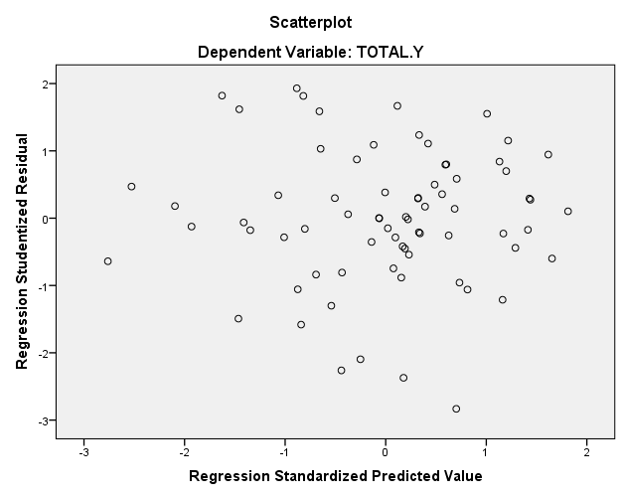

              - Hasil Uji Analisis Regresi Linier Berganda
Coefficientsª
Model |  | Unstandardized Coefficients |  | Standardized Coefficients | t | Sig. | Collinearity Statistics
 |  | B | Std. Error | Beta |  |  | Tolerance | VIF
1 | (Constant) | 4.068 | 3.063 |  | 1.328 | .189
 | PARTISIPASI ANGGARAN | .160 | .067 | .199 | 2.377 | .020 | .511 | 1.956
 | BUDGET EMPHASIS | .262 | .091 | .242 | 2.895 | .005 | .512 | 1.955
 | JOB RELEVANT INFORMATION | -.229 | .105 | -.252 | -2.185 | .032 | .270 | 3.704
 | SISTEM PENGENDALIAN INTERNAL | .713 | .093 | .781 | 7.643 | .000 | .343 | 2.916
a. Dependent Variable: Budgetary Slack

            - Hasil Uji Hipotesis
  - Hasil Uji Signifikansi Parsial (Uji t)

Coefficientsª
Model |  | Unstandardized Coefficients |  | Standardized Coefficients | t | Sig. | Collinearity Statistics
 |  | B | Std. Error | Beta |  |  | Tolerance | VIF
1 | (Constant) | 4.068 | 3.063 |  | 1.328 | .189
 | PARTISIPASI ANGGARAN | .160 | .067 | .199 | 2.377 | .020 | .511 | 1.956
 | BUDGET EMPHASIS | .262 | .091 | .242 | 2.895 | .005 | .512 | 1.955
 | JOB RELEVANT INFORMATION | -.229 | .105 | -.252 | -2.185 | .032 | .270 | 3.704
 | SISTEM PENGENDALIAN INTERNAL | .713 | .093 | .781 | 7.643 | .000 | .343 | 2.916
a. Dependent Variable: Budgetary Slack

  - Hasil Signifikansi Simultan (Uji F)

ANOVAª
Model |  | Sum of Squares | df | Mean Square | F | Sig.
1 | Regression | 929.316 | 4 | 232.329 | 53.005 | .000^{b}
 | Residual | 293.670 | 67 | 4.383
 | Total | 1222.986 | 71
a. Dependent Variable: BUDGETARY SLACK
b. Predictors: (Constant), SISTEM PENGENDALIAN INTERNAL, BUDGET EMPHASIS, PARTISIPASI ANGGARAN, JOB RELEVANT INFORMATION

  - Hasil Koefisien Determinasi

Model Summary^{b}
Model | R | R Square | Adjusted R Square | Std. Error of the Estimate | Durbin-Watson
1 | .872ª | .760 | .746 | 2.09360 | 1.368
a. Predictors: (Constant), SISTEM PENGENDALIAN INTERNAL, BUDGET EMPHASIS, PARTISIPASI ANGGARAN, JOB RELEVANT INFORMATION
b. Dependent Variable: BUDGETARY SLACK

