DAFTAR PUSTAKA

Afandi. (2016). Concept & Indicator Human Resources Management for Management Research. Yogyakarta:Deepublish.

Bangun, W. (2012). Manajemen Sumber Daya Manusia. Jakarta:Erlangga.

Davis, Keith dan William Frederick. (2011). Perilaku Organisasi (Edisi Ke Tujuh). Jakarta: Erlangga.

Hidayat, Syarif., dkk. (2019). Pengaruh Kepemimpinan, Kerjasama Tim dan Kompensasi Terhadap Kinerja Karyawan Melalui Kepuasan Kerja Pada PT. Dunia Barusa Banda Aceh. Jurnal Perspektif Ekonomi. Volume 5 Nomor 1. https://jurnal.usk.ac.id/JPED/article/view/14088/0.

Dayona, G., & Agus, R. (2016). Pengaruh Kompensasi Tidak Langsung Dan Lingkungan Kerja Fisik Terhadap Kepuasan Kerja Pegawai Kontrak Di Kementerian Perencanaan Pembangunan Nasional / Badan Perencanaan Pembangunan Nasional ( Bappenas ). Jurnal Indonesia Membangun. 15(3), 39–60. https://jurnal-inaba.hol.es.

Dessler, G. (2005). Manajemen Sumber Daya Manusia. Jakarta: PT Indeks.

Dewi, S. (2007). Teamwork (Cara Menyenangkan Membangun Tim Impian). Progressio.

Enny W, M. (2019). Manajemen Sumber Daya Manusia. Surabaya:UMBARA Manajemen Press.

Falaah, M., Murad, A. A., & Sunaryo, D. (2018). Pengaruh Program CSR Internal dan Lingkungan Kerja Fisik Terhadap Kepuasan Kerja Karyawan Pada PT Alex Putra Group di Kota Cilegon. Jurnal Manajemen. Vol 8 Nomor 2.

Ghozali, I. (2018). Aplikasi Analisis Multivariate Dengan Program IBM SPSS 25. Semarang:Badan Penerbit Universitas Diponegoro.

Handoko, H. (2000). Manajemen Personalia & Sumberdaya Manusia. Yogyakarta:BPFE.

Hasibuan, M. (2001). Manajemen Sumber Daya Manusia. Jakarta: Bumi Aksara.

Hasibuan, M. (2013). Manajemen Sumber Daya Manusia. Jakarta: Bumi Aksara.

Heizer, Jay dan Barry Render. (2001). Operation Management, 6th edition. New Jersey:Prentice Hall Inc. 23 Maret 2023 melalui https://ejurnal-unespadang.ac.id/index.php/JIEE/article/view/55/49.

Http://setda.tegalkab.go.id/

Luthans, F. (2006). Perilaku Organisasi (Alih bahasa V. A Yuwono). Yogyakarta:Penerbit Andi.

Manullang. (2001). Manajemen Pesonalia (Edisi 3). Yogyakarta: BPEE.

Maryoto Susilo. (2007). Manajemen Sumber Daya Manusia. Yogyakarta: BPFE.

Mathis L, Robert dan Jackson H, John. (2006). Manajemen Sumber Daya Manusia. Jakarta:Salemba Empat.

Moekijat. (1995). Manajemen Kepegawaian. Bandung: Alumni. Jurnal Paradigma, Vol. 2 Nomor 2. 29 Maret 2023.
https://e-journals.unmul.ac.id/index.php/JParadigma/article/view/364/325

Muhraweni, dkk. (2017). Pengaruh Lingkungan Kerja Fisik, Lingkungan Kerja Non Fisik dan Komunikasi Terhadap Kepuasan Kerja Pegawai Bagian Umum Kantor Sekretariat Daerah Kabupaten Soppeng. Jurnal Mirai Management. Vol 2 Nomor 1.

Musriha. (2013). Pengaruh Budaya Organisasi, Pelatihan, Kompensasi dan Motivasi Terhadap Kinerja Pegawai di Departemen Perdagangan Kabupaten Probolinggo. Jurnal Ekonomika, 6, 99.

Nainggolan, N. T., Lie, D., & Nainggolan, L. E. (2020). Pengaruh Kerjasama Tim Terhadap Kepuasan Kerja yang Berdampak pada Kinerja Pegawai UPT SDA Bah Bolon Dinas Sumber Daya Air Cipta Karya dan Tata Ruang Provinsi Sumatera Utara. Al Tijarah: Vol 6 Nomor 3 (Special Issue). Desember 2020

Nimran, U., & Amirullah. (2015). Manajemen Sumber Daya Manusia & Perilaku Organisasi Pendekatan Riset. Malang:Sinar Akademika.

Nitisemito, A. S. (2002). Wawasan Sumber Daya Manusia. Jakarta:Pustaka Utama Grafiti.

Notosudjono, D., Retnowati, R., & Mardiana. (2022). Peningkatan Perilaku Inovatif Guru Melalui Penguatan Kerjasama Tim, Pemberdayaan, dan Kepemimpinan Visioner. Malang:Media Nusa Creative Publishing.

Panggiki, Agatha C. (2017). Pengaruh Kompensasi, Kerjasama Tim dan Kepuasan Kerja Terhadap Kinerja Karyawan Pada AJB Bumi Putera 1912 Cabang Sam Ratulangi. Jurnal EMBA. Vol 5 Nomor 2

Potale, R., & Uhing, Y. (2015). Pengaruh Kompensasi Dan Stres Kerja Terhadap Kepuasan Kerja Karyawan Pada PT. Bank Sulut Cabang Utama Manado. Jurnal EMBA, 3, 63–73.

Robbins. (2002). Perilaku Organisasi: Konsep, Kontraversi. Aplikasi. Jilid II. Alih bahasa: Pujaatmaka, H dan Molan, B. Jakarta: Prenhalido.

Robbins, Stephen. (2007). Perilaku Organisasi (Edisi Terjemahan). Jakarta: Salemba Empat

Sari, Wuri N. (2022) Pengaruh Kerjasama Tim, Lingkungan Kerja, Kesehatan dan Keselamatan Kerja Terhadap Kinerja Karyawan (Studi Kasus Pada Klinik Pratama Rawat Inap Phrisdy). Jurnal Ilmiah Manajemen, Ekonomi dan Bisnis. Volume 1 Nomor 3.

Sedarmayanti. (2011). Sumber Daya Manusia dan Produktivitas Kerja. Bandung:Mandar Maju.

Sharma, Rahul. Mani, Puja. (2012). Effective And Efficient Team Work: Makes Things Happen More Than Anything Else in Organizations.

Siagian, S. P. (2015). Manajemen Sumber Daya Manusia. Jakarta: Bumi Aksara.

Sinambela, Lijan. P. (2016). Manajemen Sumber Daya Manusia: Membangun Tim Kerja yang Solid untuk Meningkatkan Kinerja. Jakarta: Bumi Aksara.

Sugiyono. (2010). Metode Penelitian Pendidikan Pendekatan Kuantitatif, Kualitatif dan R&D. Bandung:Alfabeta.

Sugiyono. (2013). Metode Penelitian Kuantitatif Kualitatif Dan R&D. Bandung:Alfabeta.

Sugiyono. (2015). Metode Penelitian Pendidikan: Pendekatan Kuantitatif, Kualitatif dan R&D. Bandung:Alfabeta.

Sugiyono. (2018). Metode Penelitian Kuantitatif, Kualitatif Dan R&D. Bandung: Alfabeta

Sugiyono. (2019). Metode Penelitian Kuantitatif, Kualitatif Dan R&D. Bandung: Alfabeta

Suliyanto. (2018). Metode Penelitian Bisnis untuk Skripsi, Tesis & Disertasi. Yogyakarta: Andi.

Sutrisno, E. (2014). Manajemen Sumber Daya Manusia. Jakarta: Kencana Media Group.

Sutrisno, E. (2019). Manajemen Sumber Daya Manusia. Jakarta: Kencana Prenada Media Group.

Suwatno, & Priansa, D. J. (2011). Manajemen SDM dalam Organisasi Publik dan Bisnis. Bandung: Alfabeta.

Usman, Bukhari. (2017). Pengaruh Penilaian Prestasi Kerja Terhadap Promosi Jabatan Karyawan. Jurnal Warta. Edisi 5

Wexley, K. N., & Yuki, G. A. (2003). Perilaku Organisasi dan Psikologi Personalia. Jakarta: Rineka Cipta.

Wibowo. (2010). Manajemen Kinerja (Edisi Ketiga). Depok: Raja Grafindo Persada. 19 Maret 2023. Melalui Manoppo, Rivo. (2015). Pengaruh Disiplin Kerja, Motivasi Kerja dan Pengembangan Karir Terhadap Kepuasan Kerja Pada TVRI Sulawesi Utara. Jurnal Emba. Vol. 3. Nomor 3.

Widodo, W. (2015). Manajemen Pengembangan Sumber Daya Manusia. Yogyakarta: Pustaka Pelajar. 30 Maret 2023 https://jurnal.umsu.ac.id/index.php/MANEGGIO/article/viewFile/4866/4392.

LAMPIRAN

Lampiran 1
Keusioner Penelitian
KUISIONER PENELITIAN

Perihal : Permohonan Pengisian Kuesioner

Kepada Yth.
Bapak/Ibu Responden
Unit kerja: Bagian Pemerintah, Begian Hukum, Bagian Kesejahteraan Rakyat, Bagian Ekonomi Pembangunan, Bagian Pengadaan Barang dan Jasa, Bagian Organisasi, Bagian Perencanaan Keuangan, Bagian Prokompim, Bagian Umum.
Di Tempat
Dengan Hormat,
Dalam rangka menyelesaikan Studi Strata Satu (S1) Fakultas Ekonomi Dan Bisnis Program Studi Manajemen, Universitas Pancasakti Tegal, Saya bermaksud mengadakan penelitian skripsi yang berjudul “Pengaruh Kerjasama Tim, Lingkungan Kerja Fisik, dan Promosi Jabatan Terhadap Kepuasan Kerja Pegawai ASN di Kantor Sekretariat Daerah Kabupaten Tegal”
Nama : Windy Listianto
NPM : 4119500289
Fakultas : Ekonomi Dan Bisnis (Program Studi Manajemen)
Penelitian ini menggunakan kuesioner sebagai alat untuk pengumpulan data yang utama. Oleh karena itu, saya mohon bantuan Bapak/Ibu untuk berkenan menjadi responden dengan mengisi kuesioner penelitian ini secara lengkap dan jujur.
Jawaban dari kuesioner ini tidak ada yang salah, sehingga apapun jawaban yang Bapak/Ibu berikan adalah benar. Jawaban atas kuesioner ini semata-mata ditunjukan untuk kepentingan penelitian bukan untuk maksud lain.
Demikian permohonan saya, atas kesediaan dan kerjasama Bapak/Ibu. Saya ucapkan terima kasih.

Tegal,
Hormat saya,

Windy Listianto

Petunjuk Pengisian
- Jawablah masing-masing pertanyaan dibawah ini sesuai dengan penilaian saudara mengenai “Pengaruh Kerjasama Tim, Lingkungan Kerja Fisik, dan Promosi Jabatan Terhadap Kepuasan Kerja Pegawai ASN di Kantor Sekretariat Daerah Kabupaten Tegal”
- Pilihlah salah satu jawaban dari kelima alternative jawaban sesuai dengan cara memberikan tanda (√) pada salah satu kolom pada jawaban yang tersedia.
- Keterangan jawaban sebagai berikut:
Untuk pilihan jawaban variabel kepuasan kerja:
SM : Sangat Memuaskan
M : Memuaskan
CM : Cukup Memuaskan
TM : Tidak Memuaskan
STM : Sangat Tidak Memuaskan
Untuk pilihan variabel kerjasama tim, lingkungan kerja fisik, dan promosi jabatan:
SS : Sangat Setuju
S : Setuju
N : Netral
TS : Tidak Setuju
STS : Sangat Tidak Setuju.

Data Responden
- Nama :
- Jenis Kelamin :
Laki-Laki
Perempuan
- Usia :
< 20 Tahun
21-30 Tahun
31-40 Tahun
> 40 Tahun
- Pendidikan :
SLTA
Diploma
Sarjana (S1)
Sarjana (S2)
- Unit Kerja :
Bagian Pemerintah
Bagian Hukum
Bagian Kesejahteraan Rakyat
Bagian Ekonomi Pembangunan
Bagian Pengadaan Barang dan Jasa
Bagian Organisasi
Bagian Perencanaan Keuangan
Bagian Prokompim
Bagian Umum
Lainnya…………………
PERNYATAAN

- Variabel Kepuasan Kerja (Y)

No | Pernyataan | Jawaban
 |  | SM | M | CM | TM | STM
 | Gaji
1 | Gaji yang saya terima
 | Pekerjaan Itu Sendiri
2 | Beban kerja yang saya terima
 | Rekan Kerja
3 | Hubungan pribadi antar rekan kerja dalam bekerja
4 | Rasa tanggungjawab bersama yang dimiliki rekan kerja dalam bekerja
 | Atasan
5 | Perilaku pimpinan terhadap bawahannya dalam bekerja
6 | Kepribadian pimpinan saat menjalankan tugasnya
 | Promosi
7 | Pemberian kesempatan terhadap peningkatan karir
 | Lingkungan Kerja
8 | Penerangan di tempat kerja
9 | Tata ruang di tempat kerja
10 | Kualitas pegawai yang mengisi jabatan di instansi
11 | Tindakan pimpinan dalam pengambilan keputusan di instansi

- Variabel Kerjasama Tim (X1)

No | Pernyataan | Jawaban
 |  | SS | S | N | TS | STS
 | Tujuan Yang Jelas
1 | Tim kerja di Sekda Kabupaten Tegal bekerjasama dengan baik dalam mencapai tujuan organisasi
2 | Tim kerja di Sekda Kabupaten Tegal dapat bekerjasama dengan baik dalam mencapai visi dan misi organisasi
 | Terbuka dan Jujur dalam Komunikasi
3 | Tim kerja di Sekda Kabupaten Tegal dapat berinteraksi dengan baik terhadap atasan maupun rekan kerjanya
4 | Tim kerja di Sekda Kabupaten Tegal jujur dalam melaksanakan pekerjaannya
 | Pengambilan Keputusan Kooperatif
5 | Tim kerja di Sekda Kabupaten Tegal bersedia berfikir bersama dalam menyelesaikan masalah
6 | Tim kerja di Sekda Kabupaten Tegal menimbang suatu permasalahan secara kooperatif
7 | Tim kerja di Sekda Kabupaten Tegal menilai suatu permasalahan secara kooperatif
 | Suasana Kepercayaan
8 | Tim kerja di Sekda Kabupaten Tegal diberi kepercayaan untuk melaksanakan pekerjaan karena bersikap jujur
9 | Tim kerja di Sekda Kabupaten Tegal diberi kepercayaan untuk melaksanakan pekerjaan karena bersikap kooperatif
 | Rasa Memiliki
10 | Tim kerja di Sekda Kabupaten Tegal mempunyai jiwa korps yang tinggi dalam bekerjasama

- Variabel Lingkungan Kerja Fisik (X2)

No | Pernyataan | Jawaban
 |  | SS | S | N | TS | STS
 | Pencahayaan
1 | Penerangan di ruang kerja baik dan nyaman untuk bekerja
2 | Terdapat jendela sebagai sirkulasi udara di tempat kerja
 | Warna
3 | Tata warna di ruang kerja membuat nyaman untuk bekerja
4 | Dekorasi ruang kerja nyaman untuk bekerja
 | Suara
5 | Suara musik yang diputar tidak mengganggu proses pekerjaan
6 | Ruang kerja tidak bising dan nyaman untuk bekerja
 | Udara
7 | Suhu udara di ruang kerja ideal untuk bekerja
8 | Kelembaban udara di ruang kerja baik dan nyaman untuk bekerja

- Variabel Promosi Jabatan (X3)
No | Pernyataan | Jawaban
 |  | SS | S | N | TS | STS
 | Kepemimpinan
1 | Pimpinan memberikan informasi yang jelas tentang promosi jabatan di instansi
2 | Pimpinan memiliki kesadaran penuh akan pemberian promosi jabatan terhadap pegawai
3 | Pimpinan memberikan reward berupa promosi jabatan terhadap pegawai yang telah mewujudkan visi dan misi organisasi
 | Kinerja
4 | Instansi memberikan promosi jabatan di organisasi terhadap pegawai yang memiliki kinerja yang baik
5 | Instansi memberikan kesempatan promosi jabatan terhadap pegawai yang disiplin
6 | Instansi memberikan kesempatan promosi jabatan terhadap pegawai yang dapat bekerjasama dengan baik
 | Loyalitas
7 | Instansi memberikan kesempatan promosi jabatan kepada pegawai yang jujur
8 | Instansi memberikan kesempatan promosi jabatan kepada pegawai yang loyal
9 | Instansi memberikan kesempatan promosi jabatan kepada pegawai yang mempunyai kesetiaan yang tinggi

Lampiran 2.
Data Uji Coba Kuesioner Untuk Uji Validitas dan Reliabilitas Variabel Kepuasan Kerja (Y)
Kepuasan Kerja
Responden | Y1 | Y2 | Y3 | Y4 | Y5 | Y6 | Y7 | Y8 | Y9 | Y10 | Y11 | Skor Total
1 | 4 | 4 | 4 | 3 | 4 | 4 | 4 | 3 | 4 | 4 | 3 | 41
2 | 3 | 4 | 4 | 4 | 4 | 4 | 4 | 3 | 3 | 3 | 3 | 39
3 | 4 | 4 | 4 | 3 | 4 | 4 | 4 | 3 | 4 | 4 | 3 | 41
4 | 3 | 4 | 4 | 4 | 4 | 4 | 4 | 3 | 3 | 3 | 3 | 39
5 | 4 | 4 | 4 | 4 | 4 | 4 | 4 | 4 | 4 | 4 | 4 | 44
6 | 4 | 3 | 4 | 4 | 4 | 3 | 4 | 3 | 5 | 4 | 4 | 42
7 | 4 | 4 | 3 | 3 | 4 | 5 | 5 | 4 | 3 | 4 | 4 | 43
8 | 4 | 4 | 3 | 4 | 4 | 3 | 4 | 4 | 4 | 4 | 4 | 42
9 | 4 | 4 | 3 | 3 | 3 | 4 | 4 | 3 | 3 | 3 | 4 | 38
10 | 4 | 4 | 4 | 4 | 4 | 4 | 4 | 4 | 4 | 4 | 4 | 44
11 | 4 | 4 | 4 | 4 | 4 | 4 | 4 | 4 | 4 | 4 | 4 | 44
12 | 4 | 4 | 4 | 4 | 4 | 4 | 4 | 4 | 4 | 4 | 4 | 44
13 | 4 | 4 | 4 | 4 | 4 | 4 | 4 | 4 | 4 | 4 | 4 | 44
14 | 4 | 4 | 3 | 3 | 4 | 4 | 5 | 4 | 4 | 3 | 4 | 42
15 | 4 | 4 | 4 | 4 | 4 | 3 | 4 | 4 | 4 | 3 | 3 | 41
16 | 4 | 5 | 5 | 5 | 5 | 5 | 5 | 5 | 5 | 5 | 5 | 54
17 | 5 | 5 | 4 | 4 | 4 | 5 | 5 | 4 | 5 | 4 | 4 | 49
18 | 4 | 4 | 5 | 5 | 5 | 5 | 5 | 5 | 5 | 5 | 5 | 53
19 | 3 | 3 | 3 | 3 | 3 | 3 | 3 | 3 | 3 | 3 | 3 | 33
20 | 4 | 4 | 4 | 4 | 4 | 4 | 4 | 4 | 4 | 4 | 3 | 43
21 | 4 | 4 | 4 | 5 | 5 | 5 | 5 | 4 | 4 | 4 | 4 | 48
22 | 4 | 4 | 4 | 4 | 4 | 4 | 4 | 4 | 4 | 4 | 4 | 44
23 | 4 | 2 | 5 | 4 | 3 | 2 | 4 | 1 | 3 | 4 | 5 | 37
24 | 3 | 4 | 4 | 4 | 4 | 4 | 4 | 4 | 5 | 5 | 4 | 45
25 | 3 | 3 | 4 | 4 | 4 | 4 | 4 | 4 | 4 | 4 | 4 | 42
26 | 5 | 5 | 5 | 5 | 5 | 5 | 5 | 5 | 5 | 5 | 5 | 55
27 | 3 | 3 | 2 | 4 | 2 | 3 | 5 | 4 | 4 | 5 | 4 | 39
28 | 4 | 4 | 4 | 5 | 4 | 5 | 4 | 4 | 4 | 5 | 5 | 48
29 | 4 | 4 | 4 | 4 | 4 | 4 | 4 | 4 | 4 | 4 | 4 | 44
30 | 3 | 3 | 2 | 3 | 3 | 3 | 4 | 4 | 2 | 4 | 5 | 36

Lampiran 3.
Data Uji Coba Kuesioner Untuk Uji Validitas dan Reliabilitas Variabel Kerjasama Tim (X1)
Kerjasama Tim
Responden | X1.1 | X1.2 | X1.3 | X1.4 | X1.5 | X1.6 | X1.7 | X1.8 | X1.9 | X1.10 | Skor Total
1 | 5 | 5 | 4 | 4 | 5 | 5 | 5 | 5 | 5 | 4 | 47
2 | 3 | 3 | 3 | 3 | 3 | 3 | 3 | 3 | 3 | 4 | 31
3 | 4 | 4 | 4 | 4 | 4 | 4 | 4 | 3 | 3 | 4 | 38
4 | 4 | 4 | 4 | 4 | 4 | 4 | 4 | 4 | 4 | 5 | 41
5 | 3 | 3 | 4 | 4 | 4 | 4 | 3 | 4 | 4 | 4 | 37
6 | 4 | 4 | 3 | 4 | 4 | 4 | 4 | 5 | 4 | 4 | 40
7 | 4 | 4 | 4 | 4 | 4 | 4 | 4 | 4 | 4 | 4 | 40
8 | 4 | 4 | 4 | 4 | 4 | 4 | 4 | 3 | 4 | 3 | 38
9 | 4 | 4 | 4 | 4 | 4 | 4 | 4 | 3 | 4 | 4 | 39
10 | 5 | 5 | 5 | 5 | 5 | 5 | 5 | 5 | 5 | 5 | 50
11 | 4 | 4 | 4 | 4 | 4 | 4 | 4 | 4 | 4 | 3 | 39
12 | 4 | 4 | 4 | 4 | 4 | 4 | 5 | 4 | 4 | 4 | 41
13 | 4 | 3 | 3 | 3 | 4 | 4 | 4 | 4 | 4 | 3 | 36
14 | 4 | 4 | 4 | 4 | 4 | 4 | 4 | 4 | 3 | 3 | 38
15 | 5 | 5 | 5 | 4 | 3 | 4 | 4 | 2 | 4 | 4 | 40
16 | 4 | 4 | 4 | 4 | 4 | 4 | 4 | 4 | 4 | 4 | 40
17 | 4 | 4 | 4 | 4 | 4 | 4 | 4 | 3 | 3 | 3 | 37
18 | 5 | 4 | 5 | 4 | 4 | 4 | 4 | 2 | 3 | 2 | 37
19 | 4 | 3 | 3 | 3 | 3 | 3 | 4 | 3 | 4 | 3 | 33
20 | 5 | 5 | 5 | 5 | 5 | 5 | 5 | 5 | 5 | 5 | 50
21 | 4 | 4 | 3 | 4 | 4 | 4 | 4 | 4 | 4 | 4 | 39
22 | 4 | 4 | 4 | 4 | 4 | 4 | 4 | 4 | 4 | 4 | 40
23 | 4 | 3 | 3 | 3 | 3 | 3 | 4 | 4 | 4 | 4 | 35
24 | 5 | 4 | 4 | 5 | 4 | 5 | 4 | 2 | 3 | 4 | 40
25 | 5 | 4 | 4 | 3 | 2 | 2 | 3 | 1 | 4 | 5 | 33
26 | 3 | 5 | 5 | 5 | 5 | 5 | 1 | 1 | 4 | 3 | 37
27 | 5 | 4 | 5 | 4 | 4 | 4 | 4 | 4 | 3 | 2 | 39
28 | 4 | 4 | 4 | 4 | 5 | 5 | 5 | 5 | 4 | 5 | 45
29 | 3 | 3 | 3 | 3 | 3 | 4 | 4 | 3 | 3 | 4 | 33
30 | 3 | 4 | 4 | 4 | 4 | 3 | 4 | 3 | 4 | 4 | 37

Lampiran 4.
Data Uji Coba Kuesioner Untuk Uji Validitas dan Reliabilitas Variabel Lingkungan Kerja Fisik (X2)
Lingkungan Kerja Fisik
Responden | X2.1 | X2.2 | X2.3 | X2.4 | X2.5 | X2.6 | X2.7 | X2.8 | Skor Total
1 | 4 | 5 | 5 | 5 | 5 | 5 | 4 | 4 | 37
2 | 5 | 5 | 5 | 4 | 4 | 5 | 5 | 5 | 38
3 | 4 | 4 | 4 | 4 | 5 | 4 | 4 | 4 | 33
4 | 5 | 5 | 5 | 5 | 4 | 4 | 5 | 5 | 38
5 | 4 | 4 | 5 | 5 | 5 | 4 | 4 | 4 | 35
6 | 4 | 4 | 4 | 3 | 4 | 4 | 4 | 4 | 31
7 | 4 | 4 | 3 | 4 | 4 | 4 | 4 | 4 | 31
8 | 4 | 4 | 4 | 3 | 3 | 3 | 4 | 4 | 29
9 | 4 | 4 | 4 | 4 | 4 | 4 | 4 | 4 | 32
10 | 3 | 4 | 4 | 4 | 2 | 3 | 4 | 3 | 27
11 | 4 | 4 | 2 | 4 | 4 | 5 | 4 | 4 | 31
12 | 4 | 3 | 4 | 4 | 2 | 2 | 4 | 3 | 26
13 | 5 | 4 | 4 | 5 | 4 | 5 | 4 | 4 | 35
14 | 4 | 5 | 5 | 4 | 5 | 4 | 5 | 5 | 37
15 | 4 | 5 | 4 | 4 | 4 | 4 | 4 | 4 | 33
16 | 5 | 4 | 5 | 5 | 5 | 5 | 4 | 4 | 37
17 | 4 | 4 | 4 | 4 | 4 | 4 | 4 | 4 | 32
18 | 4 | 5 | 5 | 4 | 4 | 5 | 5 | 5 | 37
19 | 5 | 4 | 4 | 5 | 4 | 5 | 5 | 5 | 37
20 | 4 | 5 | 4 | 5 | 5 | 4 | 4 | 4 | 35
21 | 5 | 4 | 4 | 5 | 4 | 4 | 5 | 5 | 36
22 | 5 | 5 | 5 | 5 | 4 | 4 | 4 | 4 | 36
23 | 5 | 5 | 4 | 4 | 5 | 4 | 4 | 5 | 36
24 | 4 | 5 | 5 | 5 | 5 | 5 | 5 | 5 | 39
25 | 5 | 5 | 5 | 4 | 5 | 4 | 4 | 4 | 36
26 | 5 | 5 | 4 | 5 | 5 | 4 | 5 | 5 | 38
27 | 4 | 4 | 5 | 4 | 5 | 4 | 4 | 4 | 34
28 | 5 | 4 | 4 | 5 | 4 | 4 | 5 | 4 | 35
29 | 4 | 4 | 4 | 5 | 5 | 4 | 4 | 4 | 34
30 | 5 | 4 | 5 | 4 | 4 | 5 | 5 | 5 | 37

Lampiran 5.
Data Uji Coba Kuesioner Untuk Uji Validitas dan Reliabilitas Variabel Promosi Jabatan (X3)
Promosi Jabatan
Responden | X3.1 | X3.2 | X3.3 | X3.4 | X3.5 | X3.6 | X3.7 | X3.8 | X3.9 | Skor Total
1 | 4 | 4 | 4 | 3 | 3 | 3 | 3 | 3 | 3 | 30
2 | 3 | 3 | 3 | 3 | 3 | 3 | 2 | 2 | 2 | 24
3 | 4 | 4 | 4 | 4 | 4 | 4 | 4 | 4 | 4 | 36
4 | 5 | 5 | 5 | 5 | 5 | 5 | 5 | 5 | 5 | 45
5 | 4 | 4 | 4 | 4 | 5 | 4 | 4 | 5 | 4 | 38
6 | 4 | 5 | 5 | 4 | 4 | 5 | 5 | 5 | 5 | 42
7 | 5 | 5 | 5 | 5 | 5 | 5 | 5 | 5 | 5 | 45
8 | 4 | 4 | 5 | 5 | 5 | 5 | 5 | 5 | 5 | 43
9 | 4 | 4 | 4 | 4 | 3 | 5 | 5 | 4 | 3 | 36
10 | 4 | 3 | 4 | 4 | 4 | 4 | 4 | 4 | 4 | 35
11 | 4 | 3 | 4 | 4 | 4 | 5 | 3 | 3 | 4 | 34
12 | 5 | 5 | 5 | 5 | 4 | 5 | 3 | 5 | 5 | 42
13 | 4 | 3 | 3 | 4 | 4 | 4 | 3 | 3 | 4 | 32
14 | 4 | 3 | 4 | 4 | 4 | 4 | 4 | 4 | 4 | 35
15 | 5 | 4 | 4 | 3 | 4 | 4 | 4 | 4 | 3 | 35
16 | 4 | 5 | 5 | 5 | 4 | 4 | 4 | 4 | 4 | 39
17 | 4 | 4 | 4 | 5 | 4 | 4 | 4 | 4 | 4 | 37
18 | 4 | 2 | 4 | 4 | 4 | 2 | 2 | 4 | 4 | 30
19 | 4 | 5 | 4 | 5 | 4 | 4 | 3 | 3 | 4 | 36
20 | 4 | 2 | 4 | 4 | 4 | 2 | 2 | 4 | 4 | 30
21 | 4 | 4 | 4 | 4 | 4 | 5 | 4 | 5 | 5 | 39
22 | 4 | 2 | 4 | 5 | 5 | 5 | 5 | 4 | 4 | 38
23 | 3 | 4 | 4 | 5 | 5 | 4 | 4 | 5 | 5 | 39
24 | 5 | 4 | 4 | 4 | 4 | 4 | 4 | 4 | 4 | 37
25 | 3 | 4 | 5 | 4 | 4 | 4 | 3 | 5 | 4 | 36
26 | 5 | 3 | 4 | 5 | 4 | 4 | 4 | 5 | 5 | 39
27 | 4 | 4 | 4 | 4 | 4 | 4 | 4 | 4 | 4 | 36
28 | 5 | 5 | 5 | 5 | 5 | 4 | 4 | 4 | 4 | 41
29 | 3 | 3 | 3 | 3 | 3 | 3 | 3 | 3 | 3 | 27
30 | 4 | 3 | 3 | 4 | 5 | 5 | 5 | 4 | 5 | 38

Lampiran 6.
Hasil Uji Validitas Variabel Kepuasan Kerja (Y)
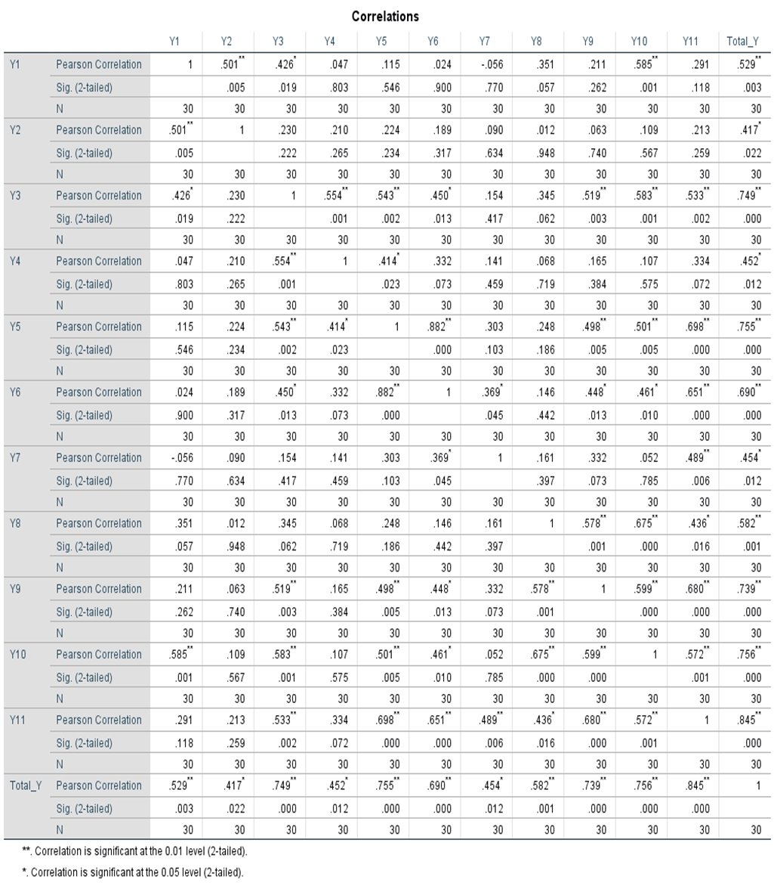

Lampiran 7.
Hasil Uji Validitas Variabel Kerjasama Tim (X1)
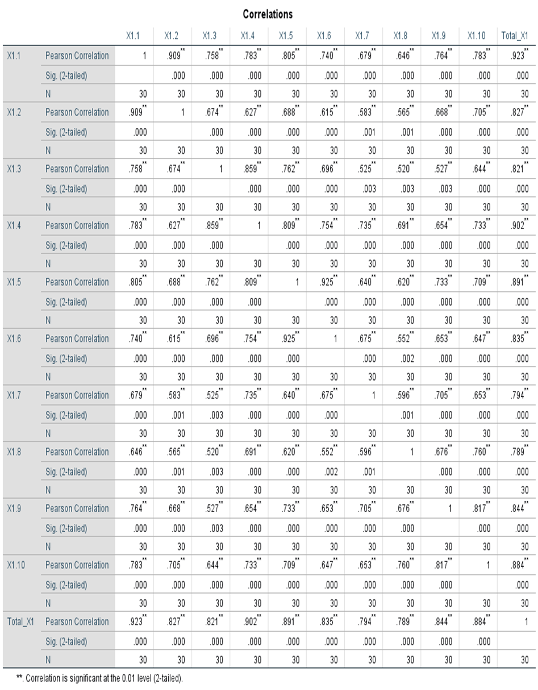

Lampiran 8.

Hasil Uji Validitas Variabel Lingkungan Kerja Fisik (X2)
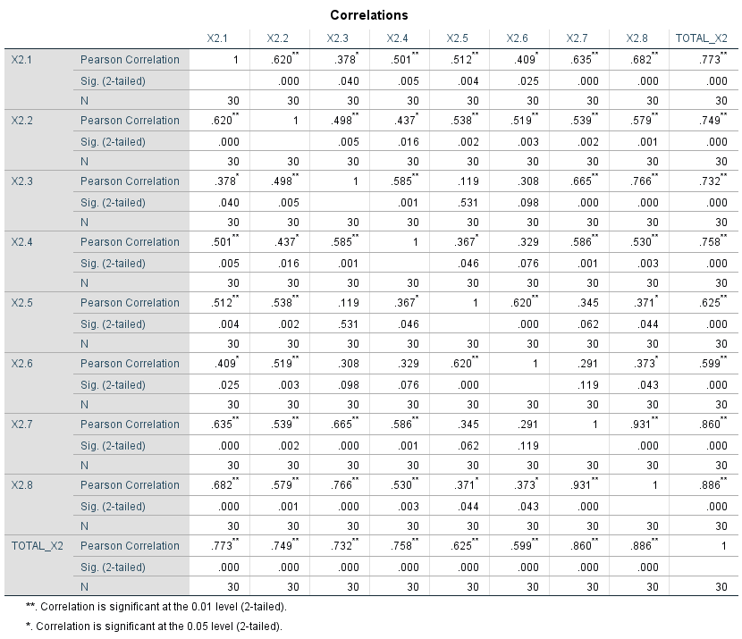

Lampiran 9.
Hasil Uji Validitas Variabel Promosi Jabatan (X3)
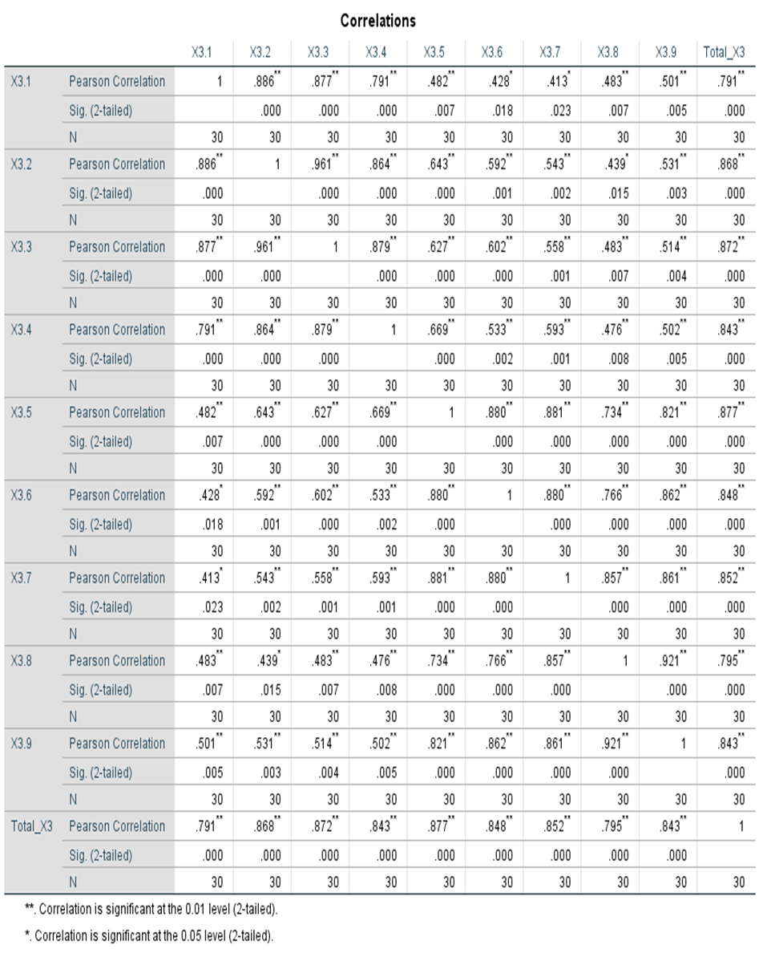

Lampiran 10.
Hasil Uji Reliabilitas Variabel Kepuasan Kerja (Y)

Case Processing Summary
 |  | N | %
Cases | Valid | 30 | 100.0
 | Excludedª | 0 | .0
 | Total | 30 | 100.0
a. Listwise deletion based on all variables in the procedure.

Reliability Statistics
Cronbach's Alpha | N of Items
.840 | 11

Lampiran 11.
Hasil Uji Reliabilitas Variabel Kerjasama Tim (X1)
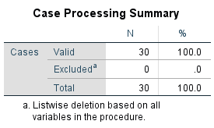

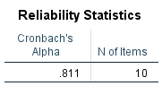

Lampiran 12.
Hasil Uji Reliabilitas Variabel Lingkungan Kerja Fisik (X2)

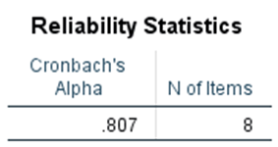

Lampiran 13.
Hasil Uji Reliabilitas Variabel Promosi Jabatan (X3)

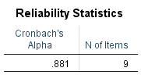

Lampiran 14.
Data Penelitian Variabel Kepuasan Kerja (Y)
Responden | Y1 | Y2 | Y3 | Y4 | Y5 | Y6 | Y7 | Y8 | Y9 | Y10 | Y11 | Total
1 | 4 | 4 | 5 | 5 | 4 | 5 | 3 | 3 | 3 | 4 | 3 | 43
2 | 2 | 3 | 4 | 4 | 4 | 4 | 4 | 4 | 4 | 3 | 4 | 40
3 | 2 | 3 | 4 | 4 | 4 | 4 | 2 | 3 | 3 | 3 | 3 | 35
4 | 2 | 4 | 4 | 5 | 4 | 4 | 3 | 3 | 3 | 3 | 4 | 39
5 | 5 | 5 | 4 | 4 | 4 | 4 | 2 | 3 | 3 | 4 | 4 | 42
6 | 2 | 3 | 4 | 4 | 5 | 5 | 4 | 4 | 4 | 4 | 4 | 43
7 | 3 | 3 | 4 | 4 | 4 | 4 | 4 | 3 | 2 | 3 | 4 | 38
8 | 2 | 5 | 4 | 5 | 5 | 5 | 5 | 3 | 3 | 2 | 4 | 43
9 | 3 | 2 | 4 | 4 | 4 | 4 | 4 | 4 | 4 | 4 | 4 | 41
10 | 3 | 3 | 4 | 3 | 3 | 3 | 3 | 3 | 3 | 3 | 3 | 34
11 | 5 | 4 | 5 | 5 | 5 | 5 | 5 | 5 | 5 | 5 | 5 | 54
12 | 3 | 4 | 3 | 3 | 4 | 4 | 3 | 4 | 3 | 4 | 3 | 38
13 | 3 | 3 | 4 | 4 | 4 | 4 | 2 | 3 | 3 | 3 | 3 | 36
14 | 3 | 3 | 3 | 3 | 3 | 3 | 2 | 4 | 2 | 3 | 2 | 31
15 | 4 | 4 | 4 | 4 | 3 | 3 | 4 | 4 | 2 | 3 | 3 | 38
16 | 3 | 3 | 3 | 5 | 3 | 3 | 2 | 4 | 2 | 3 | 3 | 34
17 | 5 | 5 | 5 | 4 | 5 | 5 | 3 | 5 | 5 | 5 | 5 | 52
18 | 3 | 3 | 5 | 5 | 4 | 4 | 4 | 4 | 4 | 4 | 4 | 44
19 | 4 | 4 | 4 | 4 | 4 | 4 | 4 | 4 | 4 | 4 | 4 | 44
20 | 4 | 4 | 4 | 4 | 4 | 4 | 4 | 4 | 4 | 4 | 4 | 44
21 | 4 | 4 | 4 | 4 | 4 | 4 | 4 | 4 | 4 | 4 | 4 | 44
22 | 3 | 4 | 4 | 4 | 3 | 3 | 4 | 4 | 4 | 3 | 3 | 39
23 | 3 | 3 | 4 | 4 | 4 | 4 | 4 | 4 | 4 | 4 | 4 | 42
24 | 5 | 4 | 5 | 5 | 5 | 4 | 3 | 4 | 3 | 4 | 4 | 46
25 | 3 | 3 | 5 | 5 | 5 | 5 | 3 | 5 | 5 | 5 | 5 | 49
26 | 4 | 4 | 4 | 4 | 3 | 3 | 3 | 4 | 4 | 3 | 4 | 40
27 | 4 | 4 | 5 | 5 | 4 | 3 | 2 | 4 | 4 | 4 | 3 | 42
28 | 4 | 3 | 4 | 3 | 4 | 4 | 3 | 4 | 4 | 4 | 4 | 41
29 | 4 | 4 | 5 | 4 | 4 | 4 | 3 | 5 | 3 | 5 | 4 | 45
30 | 4 | 4 | 4 | 4 | 4 | 4 | 4 | 3 | 3 | 4 | 4 | 42
31 | 3 | 2 | 4 | 4 | 4 | 5 | 4 | 4 | 4 | 4 | 4 | 42
32 | 4 | 4 | 5 | 5 | 4 | 4 | 3 | 4 | 4 | 4 | 4 | 45
33 | 3 | 3 | 4 | 4 | 4 | 4 | 2 | 4 | 4 | 5 | 5 | 42
34 | 5 | 5 | 5 | 5 | 5 | 5 | 5 | 5 | 5 | 5 | 5 | 55
35 | 3 | 3 | 3 | 3 | 3 | 3 | 3 | 3 | 3 | 3 | 3 | 33
36 | 4 | 4 | 5 | 4 | 5 | 5 | 5 | 4 | 4 | 4 | 4 | 48
37 | 4 | 2 | 4 | 3 | 2 | 3 | 2 | 4 | 4 | 2 | 4 | 34
38 | 2 | 4 | 3 | 3 | 4 | 3 | 3 | 4 | 4 | 4 | 5 | 39
39 | 4 | 5 | 4 | 4 | 4 | 4 | 3 | 5 | 4 | 4 | 4 | 45
40 | 5 | 5 | 4 | 4 | 4 | 3 | 3 | 4 | 4 | 4 | 3 | 43
41 | 3 | 3 | 3 | 4 | 4 | 4 | 3 | 3 | 3 | 3 | 4 | 37
42 | 5 | 5 | 5 | 5 | 3 | 3 | 4 | 4 | 4 | 4 | 4 | 46
43 | 4 | 4 | 4 | 4 | 4 | 5 | 5 | 4 | 4 | 4 | 4 | 46
44 | 2 | 2 | 5 | 4 | 3 | 4 | 3 | 4 | 4 | 4 | 4 | 39
45 | 4 | 3 | 4 | 4 | 4 | 3 | 3 | 5 | 4 | 4 | 4 | 42
46 | 3 | 3 | 3 | 4 | 4 | 4 | 2 | 5 | 3 | 4 | 5 | 40
47 | 4 | 3 | 5 | 5 | 5 | 5 | 3 | 3 | 4 | 5 | 5 | 47
48 | 5 | 5 | 4 | 4 | 4 | 4 | 4 | 5 | 5 | 5 | 5 | 50
49 | 5 | 3 | 4 | 4 | 4 | 4 | 5 | 5 | 5 | 4 | 4 | 47
50 | 3 | 3 | 4 | 3 | 4 | 3 | 4 | 3 | 3 | 3 | 3 | 36
51 | 4 | 2 | 3 | 3 | 3 | 3 | 4 | 4 | 4 | 4 | 4 | 38
52 | 4 | 4 | 3 | 3 | 3 | 3 | 3 | 4 | 4 | 4 | 4 | 39
53 | 4 | 3 | 4 | 4 | 4 | 4 | 3 | 4 | 4 | 4 | 4 | 42
54 | 4 | 3 | 3 | 3 | 4 | 4 | 3 | 4 | 4 | 4 | 4 | 40
55 | 3 | 3 | 4 | 4 | 3 | 3 | 3 | 3 | 3 | 3 | 3 | 35
56 | 3 | 2 | 5 | 5 | 3 | 4 | 4 | 4 | 4 | 3 | 3 | 40
57 | 4 | 4 | 4 | 4 | 4 | 4 | 4 | 4 | 4 | 4 | 4 | 44
58 | 5 | 5 | 4 | 5 | 4 | 4 | 3 | 4 | 4 | 4 | 4 | 46

Lampiran 15.
Data Penelitian Variabel Kerjasama Tim (X1)
Responden | X1 | X2 | X3 | X4 | X5 | X6 | X7 | X8 | X9 | X10 | Total
1 | 4 | 3 | 4 | 4 | 4 | 4 | 4 | 4 | 4 | 4 | 39
2 | 4 | 4 | 3 | 3 | 4 | 4 | 4 | 4 | 4 | 4 | 38
3 | 4 | 4 | 4 | 3 | 4 | 4 | 2 | 3 | 3 | 3 | 34
4 | 4 | 4 | 4 | 4 | 4 | 4 | 4 | 3 | 4 | 4 | 39
5 | 2 | 2 | 2 | 2 | 3 | 3 | 3 | 3 | 3 | 2 | 25
6 | 4 | 4 | 4 | 4 | 4 | 4 | 4 | 4 | 4 | 5 | 41
7 | 4 | 4 | 4 | 4 | 4 | 4 | 4 | 4 | 4 | 4 | 40
8 | 4 | 4 | 4 | 4 | 5 | 5 | 4 | 4 | 4 | 4 | 42
9 | 5 | 5 | 4 | 4 | 4 | 4 | 4 | 5 | 5 | 5 | 45
10 | 4 | 4 | 4 | 4 | 4 | 4 | 4 | 4 | 4 | 4 | 40
11 | 5 | 5 | 5 | 5 | 5 | 5 | 5 | 5 | 5 | 5 | 50
12 | 4 | 4 | 3 | 4 | 4 | 4 | 4 | 4 | 4 | 4 | 39
13 | 4 | 4 | 4 | 4 | 4 | 4 | 4 | 4 | 4 | 4 | 40
14 | 4 | 4 | 4 | 4 | 4 | 4 | 4 | 3 | 3 | 3 | 37
15 | 3 | 4 | 3 | 2 | 3 | 3 | 3 | 3 | 3 | 3 | 30
16 | 4 | 4 | 4 | 4 | 4 | 4 | 4 | 4 | 4 | 4 | 40
17 | 5 | 5 | 5 | 5 | 5 | 4 | 4 | 5 | 5 | 5 | 48
18 | 5 | 5 | 5 | 5 | 5 | 5 | 5 | 5 | 5 | 5 | 50
19 | 4 | 4 | 4 | 4 | 4 | 4 | 4 | 4 | 4 | 4 | 40
20 | 4 | 4 | 4 | 4 | 4 | 4 | 4 | 4 | 4 | 4 | 40
21 | 4 | 4 | 4 | 4 | 4 | 4 | 4 | 4 | 4 | 4 | 40
22 | 4 | 4 | 4 | 4 | 4 | 4 | 4 | 4 | 4 | 4 | 40
23 | 4 | 4 | 4 | 4 | 4 | 4 | 4 | 4 | 4 | 3 | 39
24 | 4 | 4 | 5 | 5 | 4 | 4 | 4 | 5 | 3 | 4 | 42
25 | 5 | 5 | 5 | 5 | 5 | 5 | 5 | 5 | 5 | 5 | 50
26 | 4 | 4 | 4 | 4 | 4 | 4 | 4 | 3 | 4 | 4 | 39
27 | 4 | 4 | 4 | 4 | 4 | 4 | 4 | 3 | 4 | 3 | 38
28 | 4 | 4 | 4 | 4 | 4 | 4 | 4 | 4 | 4 | 4 | 40
29 | 4 | 4 | 3 | 4 | 4 | 4 | 4 | 5 | 4 | 4 | 40
30 | 3 | 3 | 4 | 4 | 4 | 4 | 3 | 4 | 4 | 4 | 37
31 | 4 | 4 | 4 | 4 | 4 | 4 | 4 | 4 | 4 | 5 | 41
32 | 4 | 4 | 4 | 4 | 4 | 4 | 4 | 3 | 3 | 4 | 38
33 | 3 | 3 | 3 | 3 | 3 | 3 | 3 | 3 | 3 | 4 | 31
34 | 5 | 5 | 4 | 4 | 5 | 5 | 5 | 5 | 5 | 4 | 47
35 | 4 | 4 | 4 | 4 | 4 | 4 | 4 | 4 | 4 | 3 | 39
36 | 4 | 4 | 4 | 4 | 4 | 4 | 5 | 4 | 4 | 4 | 41
37 | 4 | 3 | 3 | 3 | 4 | 4 | 4 | 4 | 4 | 3 | 36
38 | 4 | 4 | 4 | 4 | 4 | 4 | 4 | 4 | 3 | 3 | 38
39 | 5 | 5 | 5 | 4 | 3 | 4 | 4 | 2 | 4 | 4 | 40
40 | 2 | 5 | 5 | 5 | 4 | 4 | 4 | 5 | 5 | 5 | 44
41 | 4 | 4 | 5 | 2 | 3 | 4 | 4 | 3 | 4 | 4 | 37
42 | 5 | 5 | 4 | 3 | 4 | 3 | 4 | 3 | 4 | 4 | 39
43 | 4 | 4 | 4 | 4 | 4 | 4 | 4 | 4 | 3 | 3 | 38
44 | 5 | 4 | 4 | 4 | 5 | 5 | 4 | 3 | 4 | 3 | 41
45 | 5 | 5 | 4 | 4 | 4 | 3 | 3 | 2 | 4 | 3 | 37
46 | 4 | 4 | 4 | 4 | 5 | 4 | 4 | 3 | 4 | 4 | 40
47 | 3 | 4 | 3 | 4 | 4 | 4 | 4 | 4 | 5 | 5 | 40
48 | 3 | 3 | 3 | 3 | 4 | 4 | 4 | 5 | 5 | 5 | 39
49 | 5 | 5 | 4 | 4 | 4 | 4 | 4 | 4 | 4 | 4 | 42
50 | 4 | 4 | 4 | 4 | 4 | 4 | 4 | 3 | 5 | 5 | 41
51 | 4 | 4 | 4 | 3 | 4 | 4 | 4 | 4 | 4 | 4 | 39
52 | 4 | 4 | 4 | 4 | 3 | 3 | 3 | 5 | 5 | 5 | 40
53 | 4 | 4 | 4 | 4 | 4 | 4 | 3 | 4 | 4 | 4 | 39
54 | 4 | 4 | 4 | 4 | 4 | 4 | 4 | 4 | 4 | 4 | 40
55 | 4 | 4 | 3 | 3 | 4 | 4 | 4 | 4 | 4 | 3 | 37
56 | 4 | 4 | 4 | 3 | 3 | 3 | 4 | 4 | 5 | 5 | 39
57 | 4 | 5 | 5 | 5 | 4 | 3 | 4 | 4 | 3 | 3 | 40
58 | 3 | 3 | 4 | 3 | 3 | 3 | 3 | 4 | 5 | 5 | 36

Lampiran 16.
Data Penelitian Variabel Lingkungan Kerja Fisik (X2)
Responden | X1 | X2 | X3 | X4 | X5 | X6 | X7 | X8 | Total
1 | 4 | 3 | 4 | 3 | 3 | 4 | 4 | 4 | 29
2 | 4 | 4 | 4 | 3 | 4 | 4 | 4 | 4 | 31
3 | 4 | 4 | 4 | 4 | 4 | 4 | 4 | 4 | 32
4 | 4 | 4 | 4 | 4 | 4 | 4 | 4 | 4 | 32
5 | 4 | 4 | 4 | 2 | 3 | 3 | 4 | 4 | 28
6 | 4 | 4 | 4 | 5 | 4 | 4 | 4 | 3 | 32
7 | 4 | 4 | 2 | 2 | 4 | 4 | 3 | 3 | 26
8 | 4 | 5 | 4 | 5 | 5 | 5 | 4 | 4 | 36
9 | 5 | 5 | 5 | 5 | 3 | 3 | 5 | 5 | 36
10 | 4 | 4 | 4 | 3 | 4 | 4 | 4 | 4 | 31
11 | 5 | 5 | 5 | 5 | 5 | 5 | 5 | 5 | 40
12 | 4 | 4 | 4 | 2 | 4 | 4 | 2 | 3 | 27
13 | 4 | 4 | 4 | 4 | 4 | 4 | 4 | 4 | 32
14 | 4 | 4 | 4 | 2 | 2 | 4 | 4 | 4 | 28
15 | 2 | 4 | 4 | 2 | 2 | 4 | 2 | 2 | 22
16 | 4 | 4 | 2 | 2 | 4 | 4 | 1 | 1 | 22
17 | 5 | 5 | 5 | 5 | 3 | 5 | 5 | 5 | 38
18 | 5 | 5 | 5 | 5 | 5 | 5 | 5 | 5 | 40
19 | 4 | 4 | 4 | 4 | 4 | 4 | 4 | 4 | 32
20 | 5 | 5 | 4 | 4 | 4 | 4 | 4 | 4 | 34
21 | 4 | 4 | 4 | 4 | 4 | 4 | 4 | 4 | 32
22 | 4 | 4 | 4 | 3 | 3 | 4 | 2 | 3 | 27
23 | 4 | 4 | 4 | 4 | 4 | 4 | 4 | 4 | 32
24 | 5 | 5 | 4 | 2 | 5 | 5 | 5 | 5 | 36
25 | 5 | 5 | 5 | 5 | 5 | 5 | 5 | 5 | 40
26 | 4 | 4 | 4 | 4 | 3 | 3 | 4 | 4 | 30
27 | 4 | 5 | 4 | 3 | 5 | 4 | 4 | 4 | 33
28 | 5 | 5 | 4 | 4 | 5 | 5 | 5 | 5 | 38
29 | 4 | 5 | 5 | 3 | 4 | 4 | 5 | 5 | 35
30 | 4 | 4 | 3 | 3 | 3 | 3 | 4 | 3 | 27
31 | 5 | 5 | 5 | 4 | 4 | 5 | 5 | 5 | 38
32 | 4 | 4 | 4 | 4 | 3 | 4 | 4 | 4 | 31
33 | 4 | 4 | 3 | 3 | 4 | 4 | 3 | 3 | 28
34 | 5 | 5 | 5 | 5 | 5 | 5 | 5 | 5 | 40
35 | 4 | 4 | 2 | 2 | 3 | 3 | 3 | 3 | 24
36 | 4 | 5 | 4 | 4 | 4 | 4 | 4 | 4 | 33
37 | 4 | 3 | 3 | 3 | 3 | 4 | 4 | 4 | 28
38 | 3 | 3 | 4 | 4 | 4 | 4 | 4 | 4 | 30
39 | 5 | 5 | 5 | 4 | 5 | 5 | 5 | 3 | 37
40 | 3 | 3 | 3 | 3 | 3 | 3 | 3 | 3 | 24
41 | 5 | 5 | 5 | 3 | 5 | 5 | 5 | 5 | 38
42 | 4 | 3 | 3 | 3 | 4 | 5 | 5 | 5 | 32
43 | 4 | 5 | 2 | 2 | 3 | 4 | 4 | 4 | 28
44 | 5 | 4 | 4 | 4 | 3 | 5 | 4 | 4 | 33
45 | 4 | 4 | 4 | 4 | 4 | 4 | 4 | 4 | 32
46 | 5 | 4 | 4 | 3 | 3 | 4 | 4 | 5 | 32
47 | 4 | 5 | 4 | 3 | 4 | 3 | 5 | 5 | 33
48 | 5 | 5 | 4 | 4 | 3 | 3 | 5 | 5 | 34
49 | 5 | 5 | 4 | 4 | 3 | 4 | 4 | 4 | 33
50 | 3 | 3 | 3 | 2 | 2 | 3 | 3 | 3 | 22
51 | 4 | 4 | 4 | 3 | 4 | 4 | 3 | 3 | 29
52 | 4 | 4 | 4 | 4 | 3 | 3 | 3 | 3 | 28
53 | 4 | 4 | 4 | 4 | 3 | 3 | 4 | 3 | 29
54 | 4 | 4 | 4 | 4 | 4 | 4 | 4 | 4 | 32
55 | 4 | 4 | 4 | 4 | 3 | 3 | 4 | 4 | 30
56 | 5 | 5 | 4 | 4 | 2 | 4 | 4 | 4 | 32
57 | 3 | 4 | 3 | 4 | 3 | 4 | 3 | 4 | 28
58 | 3 | 5 | 4 | 3 | 4 | 4 | 4 | 4 | 31

Lampiran 17.
Data Penelitian Variabel Promosi Jabatan (X3)
Responden | X1 | X2 | X3 | X4 | X5 | X6 | X7 | X8 | X9 | Total
1 | 4 | 4 | 4 | 4 | 4 | 4 | 5 | 4 | 4 | 37
2 | 3 | 3 | 3 | 3 | 3 | 3 | 3 | 3 | 3 | 27
3 | 3 | 3 | 3 | 3 | 3 | 3 | 2 | 2 | 2 | 24
4 | 4 | 4 | 4 | 4 | 4 | 4 | 4 | 4 | 4 | 36
5 | 4 | 2 | 2 | 2 | 2 | 2 | 2 | 4 | 4 | 24
6 | 4 | 4 | 4 | 4 | 4 | 4 | 4 | 4 | 4 | 36
7 | 4 | 4 | 4 | 3 | 3 | 3 | 3 | 3 | 3 | 30
8 | 3 | 3 | 3 | 3 | 3 | 3 | 3 | 3 | 3 | 27
9 | 1 | 1 | 1 | 1 | 5 | 5 | 5 | 5 | 5 | 29
10 | 4 | 4 | 4 | 3 | 3 | 3 | 3 | 3 | 3 | 30
11 | 5 | 5 | 5 | 5 | 5 | 5 | 5 | 5 | 5 | 45
12 | 2 | 3 | 3 | 3 | 3 | 3 | 3 | 3 | 3 | 26
13 | 4 | 4 | 4 | 4 | 4 | 4 | 4 | 4 | 4 | 36
14 | 2 | 2 | 2 | 3 | 3 | 3 | 3 | 3 | 3 | 24
15 | 3 | 3 | 3 | 3 | 3 | 3 | 3 | 3 | 3 | 27
16 | 1 | 1 | 1 | 2 | 2 | 2 | 2 | 2 | 2 | 15
17 | 3 | 3 | 3 | 4 | 4 | 4 | 5 | 5 | 5 | 36
18 | 5 | 5 | 5 | 5 | 5 | 5 | 5 | 5 | 5 | 45
19 | 4 | 4 | 4 | 4 | 4 | 4 | 4 | 4 | 4 | 36
20 | 4 | 4 | 4 | 4 | 4 | 4 | 4 | 4 | 4 | 36
21 | 4 | 4 | 4 | 4 | 4 | 4 | 4 | 4 | 4 | 36
22 | 3 | 3 | 3 | 3 | 3 | 3 | 3 | 3 | 3 | 27
23 | 4 | 4 | 4 | 4 | 4 | 4 | 4 | 4 | 4 | 36
24 | 5 | 5 | 4 | 5 | 5 | 3 | 4 | 4 | 4 | 39
25 | 5 | 5 | 5 | 5 | 5 | 5 | 5 | 5 | 5 | 45
26 | 3 | 3 | 2 | 2 | 2 | 3 | 3 | 3 | 3 | 24
27 | 2 | 2 | 2 | 3 | 3 | 2 | 3 | 2 | 2 | 21
28 | 4 | 3 | 3 | 4 | 3 | 3 | 3 | 3 | 3 | 29
29 | 4 | 5 | 4 | 4 | 5 | 5 | 4 | 3 | 5 | 39
30 | 4 | 3 | 3 | 3 | 3 | 3 | 3 | 3 | 3 | 28
31 | 4 | 4 | 4 | 4 | 4 | 4 | 4 | 4 | 4 | 36
32 | 4 | 4 | 4 | 3 | 4 | 4 | 4 | 4 | 4 | 35
33 | 3 | 3 | 3 | 3 | 3 | 3 | 3 | 3 | 3 | 27
34 | 5 | 5 | 5 | 5 | 5 | 5 | 5 | 5 | 5 | 45
35 | 3 | 3 | 3 | 3 | 3 | 3 | 3 | 3 | 3 | 27
36 | 4 | 4 | 4 | 4 | 5 | 5 | 4 | 4 | 5 | 39
37 | 2 | 2 | 1 | 2 | 2 | 2 | 3 | 3 | 3 | 20
38 | 5 | 5 | 4 | 4 | 4 | 4 | 4 | 4 | 4 | 38
39 | 3 | 4 | 4 | 5 | 4 | 5 | 5 | 5 | 3 | 38
40 | 5 | 5 | 4 | 5 | 4 | 3 | 4 | 4 | 5 | 39
41 | 4 | 4 | 4 | 4 | 4 | 4 | 4 | 4 | 4 | 36
42 | 4 | 4 | 3 | 4 | 4 | 4 | 4 | 5 | 4 | 36
43 | 3 | 3 | 3 | 4 | 4 | 4 | 4 | 4 | 5 | 34
44 | 3 | 4 | 4 | 4 | 3 | 4 | 4 | 4 | 2 | 32
45 | 3 | 3 | 3 | 4 | 4 | 3 | 4 | 3 | 3 | 30
46 | 5 | 5 | 5 | 4 | 4 | 4 | 4 | 5 | 5 | 41
47 | 5 | 5 | 3 | 3 | 4 | 4 | 4 | 4 | 4 | 36
48 | 5 | 5 | 5 | 4 | 4 | 4 | 3 | 3 | 5 | 38
49 | 4 | 4 | 4 | 4 | 4 | 4 | 4 | 4 | 4 | 36
50 | 4 | 4 | 4 | 3 | 3 | 3 | 3 | 3 | 3 | 30
51 | 4 | 4 | 4 | 4 | 3 | 3 | 3 | 3 | 3 | 31
52 | 4 | 4 | 4 | 4 | 4 | 4 | 5 | 2 | 3 | 34
53 | 4 | 4 | 4 | 4 | 4 | 4 | 5 | 2 | 5 | 36
54 | 4 | 4 | 4 | 5 | 5 | 5 | 5 | 5 | 5 | 42
55 | 4 | 4 | 4 | 4 | 4 | 4 | 4 | 4 | 4 | 36
56 | 4 | 4 | 5 | 5 | 5 | 5 | 5 | 5 | 5 | 43
57 | 2 | 3 | 3 | 4 | 4 | 4 | 4 | 4 | 4 | 32
58 | 4 | 4 | 4 | 4 | 5 | 4 | 4 | 4 | 4 | 37

Lampiran 18.
Data Hasil Perhitungan MSI Variabel Kepuasan Kerja (Y)
Succesive Interval
Y1 | Y2 | Y3 | Y4 | Y5 | Y6 | Y7 | Y8 | Y9 | Y10 | Y11 | Total
3,034 | 3,204 | 3,732 | 3,680 | 3,597 | 3,603 | 2,163 | 1,000 | 2,071 | 3,454 | 2,312 | 31,849
1,000 | 2,186 | 2,361 | 2,334 | 3,597 | 2,315 | 3,187 | 2,388 | 3,266 | 2,211 | 3,620 | 28,466
1,000 | 2,186 | 2,361 | 2,334 | 3,597 | 2,315 | 1,000 | 1,000 | 2,071 | 2,211 | 2,312 | 22,386
1,000 | 3,204 | 2,361 | 3,680 | 3,597 | 2,315 | 2,163 | 1,000 | 2,071 | 2,211 | 3,620 | 27,221
4,145 | 4,276 | 2,361 | 2,334 | 3,597 | 2,315 | 1,000 | 1,000 | 2,071 | 3,454 | 3,620 | 30,172
1,000 | 2,186 | 2,361 | 2,334 | 5,012 | 3,603 | 3,187 | 2,388 | 3,266 | 3,454 | 3,620 | 32,412
2,070 | 2,186 | 2,361 | 2,334 | 3,597 | 2,315 | 3,187 | 1,000 | 1,000 | 2,211 | 3,620 | 25,881
1,000 | 4,276 | 2,361 | 3,680 | 5,012 | 3,603 | 4,276 | 1,000 | 2,071 | 1,000 | 3,620 | 31,898
2,070 | 1,000 | 2,361 | 2,334 | 3,597 | 2,315 | 3,187 | 2,388 | 3,266 | 3,454 | 3,620 | 29,592
2,070 | 2,186 | 2,361 | 1,000 | 2,274 | 1,000 | 2,163 | 1,000 | 2,071 | 2,211 | 2,312 | 20,648
4,145 | 3,204 | 3,732 | 3,680 | 5,012 | 3,603 | 4,276 | 3,773 | 4,664 | 4,811 | 5,012 | 45,911
2,070 | 3,204 | 1,000 | 1,000 | 3,597 | 2,315 | 2,163 | 2,388 | 2,071 | 3,454 | 2,312 | 25,573
2,070 | 2,186 | 2,361 | 2,334 | 3,597 | 2,315 | 1,000 | 1,000 | 2,071 | 2,211 | 2,312 | 23,456
2,070 | 2,186 | 1,000 | 1,000 | 2,274 | 1,000 | 1,000 | 2,388 | 1,000 | 2,211 | 1,000 | 17,129
3,034 | 3,204 | 2,361 | 2,334 | 2,274 | 1,000 | 3,187 | 2,388 | 1,000 | 2,211 | 2,312 | 25,306
2,070 | 2,186 | 1,000 | 3,680 | 2,274 | 1,000 | 1,000 | 2,388 | 1,000 | 2,211 | 2,312 | 21,121
4,145 | 4,276 | 3,732 | 2,334 | 5,012 | 3,603 | 2,163 | 3,773 | 4,664 | 4,811 | 5,012 | 43,524
2,070 | 2,186 | 3,732 | 3,680 | 3,597 | 2,315 | 3,187 | 2,388 | 3,266 | 3,454 | 3,620 | 33,495
3,034 | 3,204 | 2,361 | 2,334 | 3,597 | 2,315 | 3,187 | 2,388 | 3,266 | 3,454 | 3,620 | 32,761
3,034 | 3,204 | 2,361 | 2,334 | 3,597 | 2,315 | 3,187 | 2,388 | 3,266 | 3,454 | 3,620 | 32,761
3,034 | 3,204 | 2,361 | 2,334 | 3,597 | 2,315 | 3,187 | 2,388 | 3,266 | 3,454 | 3,620 | 32,761
2,070 | 3,204 | 2,361 | 2,334 | 2,274 | 1,000 | 3,187 | 2,388 | 3,266 | 2,211 | 2,312 | 26,608
2,070 | 2,186 | 2,361 | 2,334 | 3,597 | 2,315 | 3,187 | 2,388 | 3,266 | 3,454 | 3,620 | 30,779
4,145 | 3,204 | 3,732 | 3,680 | 5,012 | 2,315 | 2,163 | 2,388 | 2,071 | 3,454 | 3,620 | 35,784
2,070 | 2,186 | 3,732 | 3,680 | 5,012 | 3,603 | 2,163 | 3,773 | 4,664 | 4,811 | 5,012 | 40,705
3,034 | 3,204 | 2,361 | 2,334 | 2,274 | 1,000 | 2,163 | 2,388 | 3,266 | 2,211 | 3,620 | 27,856
3,034 | 3,204 | 3,732 | 3,680 | 3,597 | 1,000 | 1,000 | 2,388 | 3,266 | 3,454 | 2,312 | 30,667
3,034 | 2,186 | 2,361 | 1,000 | 3,597 | 2,315 | 2,163 | 2,388 | 3,266 | 3,454 | 3,620 | 29,385
3,034 | 3,204 | 3,732 | 2,334 | 3,597 | 2,315 | 2,163 | 3,773 | 2,071 | 4,811 | 3,620 | 34,653
3,034 | 3,204 | 2,361 | 2,334 | 3,597 | 2,315 | 3,187 | 1,000 | 2,071 | 3,454 | 3,620 | 30,177
2,070 | 1,000 | 2,361 | 2,334 | 3,597 | 3,603 | 3,187 | 2,388 | 3,266 | 3,454 | 3,620 | 30,880
3,034 | 3,204 | 3,732 | 3,680 | 3,597 | 2,315 | 2,163 | 2,388 | 3,266 | 3,454 | 3,620 | 34,453
2,070 | 2,186 | 2,361 | 2,334 | 3,597 | 2,315 | 1,000 | 2,388 | 3,266 | 4,811 | 5,012 | 31,340
4,145 | 4,276 | 3,732 | 3,680 | 5,012 | 3,603 | 4,276 | 3,773 | 4,664 | 4,811 | 5,012 | 46,982
2,070 | 2,186 | 1,000 | 1,000 | 2,274 | 1,000 | 2,163 | 1,000 | 2,071 | 2,211 | 2,312 | 19,286
3,034 | 3,204 | 3,732 | 2,334 | 5,012 | 3,603 | 4,276 | 2,388 | 3,266 | 3,454 | 3,620 | 37,923
3,034 | 1,000 | 2,361 | 1,000 | 1,000 | 1,000 | 1,000 | 2,388 | 3,266 | 1,000 | 3,620 | 20,670
1,000 | 3,204 | 1,000 | 1,000 | 3,597 | 1,000 | 2,163 | 2,388 | 3,266 | 3,454 | 5,012 | 27,084
3,034 | 4,276 | 2,361 | 2,334 | 3,597 | 2,315 | 2,163 | 3,773 | 3,266 | 3,454 | 3,620 | 34,193
4,145 | 4,276 | 2,361 | 2,334 | 3,597 | 1,000 | 2,163 | 2,388 | 3,266 | 3,454 | 2,312 | 31,296
2,070 | 2,186 | 1,000 | 2,334 | 3,597 | 2,315 | 2,163 | 1,000 | 2,071 | 2,211 | 3,620 | 24,566
4,145 | 4,276 | 3,732 | 3,680 | 2,274 | 1,000 | 3,187 | 2,388 | 3,266 | 3,454 | 3,620 | 35,022
3,034 | 3,204 | 2,361 | 2,334 | 3,597 | 3,603 | 4,276 | 2,388 | 3,266 | 3,454 | 3,620 | 35,137
1,000 | 1,000 | 3,732 | 2,334 | 2,274 | 2,315 | 2,163 | 2,388 | 3,266 | 3,454 | 3,620 | 27,547
3,034 | 2,186 | 2,361 | 2,334 | 3,597 | 1,000 | 2,163 | 3,773 | 3,266 | 3,454 | 3,620 | 30,789
2,070 | 2,186 | 1,000 | 2,334 | 3,597 | 2,315 | 1,000 | 3,773 | 2,071 | 3,454 | 5,012 | 28,811
3,034 | 2,186 | 3,732 | 3,680 | 5,012 | 3,603 | 2,163 | 1,000 | 3,266 | 4,811 | 5,012 | 37,499
4,145 | 4,276 | 2,361 | 2,334 | 3,597 | 2,315 | 3,187 | 3,773 | 4,664 | 4,811 | 5,012 | 40,474
4,145 | 2,186 | 2,361 | 2,334 | 3,597 | 2,315 | 4,276 | 3,773 | 4,664 | 3,454 | 3,620 | 36,724
2,070 | 2,186 | 2,361 | 1,000 | 3,597 | 1,000 | 3,187 | 1,000 | 2,071 | 2,211 | 2,312 | 22,994
3,034 | 1,000 | 1,000 | 1,000 | 2,274 | 1,000 | 3,187 | 2,388 | 3,266 | 3,454 | 3,620 | 25,224
3,034 | 3,204 | 1,000 | 1,000 | 2,274 | 1,000 | 2,163 | 2,388 | 3,266 | 3,454 | 3,620 | 26,404
3,034 | 2,186 | 2,361 | 2,334 | 3,597 | 2,315 | 2,163 | 2,388 | 3,266 | 3,454 | 3,620 | 30,719
3,034 | 2,186 | 1,000 | 1,000 | 3,597 | 2,315 | 2,163 | 2,388 | 3,266 | 3,454 | 3,620 | 28,024
2,070 | 2,186 | 2,361 | 2,334 | 2,274 | 1,000 | 2,163 | 1,000 | 2,071 | 2,211 | 2,312 | 21,982
2,070 | 1,000 | 3,732 | 3,680 | 2,274 | 2,315 | 3,187 | 2,388 | 3,266 | 2,211 | 2,312 | 28,434
3,034 | 3,204 | 2,361 | 2,334 | 3,597 | 2,315 | 3,187 | 2,388 | 3,266 | 3,454 | 3,620 | 32,761
4,145 | 4,276 | 2,361 | 3,680 | 3,597 | 2,315 | 2,163 | 2,388 | 3,266 | 3,454 | 3,620 | 35,265

Lampiran 19.
Data Hasil Perhitungan MSI Variabel Kerjasama Tim (X1)
Succesive Interval
X1.1 | X1.2 | X1.3 | X1.4 | X1.5 | X1.6 | X1.7 | X1.8 | X1.9 | X1.10 | Total
3,138 | 1,946 | 3,500 | 3,199 | 2,597 | 2,616 | 3,582 | 3,332 | 2,408 | 3,475 | 29,793
3,138 | 3,349 | 2,104 | 1,927 | 2,597 | 2,616 | 3,582 | 3,332 | 2,408 | 3,475 | 28,529
3,138 | 3,349 | 3,500 | 1,927 | 2,597 | 2,616 | 1,000 | 2,145 | 1,000 | 2,274 | 23,547
3,138 | 3,349 | 3,500 | 3,199 | 2,597 | 2,616 | 3,582 | 2,145 | 2,408 | 3,475 | 30,009
1,000 | 1,000 | 1,000 | 1,000 | 1,000 | 1,000 | 2,055 | 2,145 | 1,000 | 1,000 | 12,201
3,138 | 3,349 | 3,500 | 3,199 | 2,597 | 2,616 | 3,582 | 3,332 | 2,408 | 4,767 | 32,488
3,138 | 3,349 | 3,500 | 3,199 | 2,597 | 2,616 | 3,582 | 3,332 | 2,408 | 3,475 | 31,196
3,138 | 3,349 | 3,500 | 3,199 | 4,195 | 4,276 | 3,582 | 3,332 | 2,408 | 3,475 | 34,453
4,643 | 4,856 | 3,500 | 3,199 | 2,597 | 2,616 | 3,582 | 4,643 | 3,816 | 4,767 | 38,218
3,138 | 3,349 | 3,500 | 3,199 | 2,597 | 2,616 | 3,582 | 3,332 | 2,408 | 3,475 | 31,196
4,643 | 4,856 | 5,012 | 4,713 | 4,195 | 4,276 | 5,299 | 4,643 | 3,816 | 4,767 | 46,218
3,138 | 3,349 | 2,104 | 3,199 | 2,597 | 2,616 | 3,582 | 3,332 | 2,408 | 3,475 | 29,800
3,138 | 3,349 | 3,500 | 3,199 | 2,597 | 2,616 | 3,582 | 3,332 | 2,408 | 3,475 | 31,196
3,138 | 3,349 | 3,500 | 3,199 | 2,597 | 2,616 | 3,582 | 2,145 | 1,000 | 2,274 | 27,400
1,822 | 3,349 | 2,104 | 1,000 | 1,000 | 1,000 | 2,055 | 2,145 | 1,000 | 2,274 | 17,749
3,138 | 3,349 | 3,500 | 3,199 | 2,597 | 2,616 | 3,582 | 3,332 | 2,408 | 3,475 | 31,196
4,643 | 4,856 | 5,012 | 4,713 | 4,195 | 2,616 | 3,582 | 4,643 | 3,816 | 4,767 | 42,841
4,643 | 4,856 | 5,012 | 4,713 | 4,195 | 4,276 | 5,299 | 4,643 | 3,816 | 4,767 | 46,218
3,138 | 3,349 | 3,500 | 3,199 | 2,597 | 2,616 | 3,582 | 3,332 | 2,408 | 3,475 | 31,196
3,138 | 3,349 | 3,500 | 3,199 | 2,597 | 2,616 | 3,582 | 3,332 | 2,408 | 3,475 | 31,196
3,138 | 3,349 | 3,500 | 3,199 | 2,597 | 2,616 | 3,582 | 3,332 | 2,408 | 3,475 | 31,196
3,138 | 3,349 | 3,500 | 3,199 | 2,597 | 2,616 | 3,582 | 3,332 | 2,408 | 3,475 | 31,196
3,138 | 3,349 | 3,500 | 3,199 | 2,597 | 2,616 | 3,582 | 3,332 | 2,408 | 2,274 | 29,995
3,138 | 3,349 | 5,012 | 4,713 | 2,597 | 2,616 | 3,582 | 4,643 | 1,000 | 3,475 | 34,124
4,643 | 4,856 | 5,012 | 4,713 | 4,195 | 4,276 | 5,299 | 4,643 | 3,816 | 4,767 | 46,218
3,138 | 3,349 | 3,500 | 3,199 | 2,597 | 2,616 | 3,582 | 2,145 | 2,408 | 3,475 | 30,009
3,138 | 3,349 | 3,500 | 3,199 | 2,597 | 2,616 | 3,582 | 2,145 | 2,408 | 2,274 | 28,808
3,138 | 3,349 | 3,500 | 3,199 | 2,597 | 2,616 | 3,582 | 3,332 | 2,408 | 3,475 | 31,196
3,138 | 3,349 | 2,104 | 3,199 | 2,597 | 2,616 | 3,582 | 4,643 | 2,408 | 3,475 | 31,111
1,822 | 1,946 | 3,500 | 3,199 | 2,597 | 2,616 | 2,055 | 3,332 | 2,408 | 3,475 | 26,950
3,138 | 3,349 | 3,500 | 3,199 | 2,597 | 2,616 | 3,582 | 3,332 | 2,408 | 4,767 | 32,488
3,138 | 3,349 | 3,500 | 3,199 | 2,597 | 2,616 | 3,582 | 2,145 | 1,000 | 3,475 | 28,601
1,822 | 1,946 | 2,104 | 1,927 | 1,000 | 1,000 | 2,055 | 2,145 | 1,000 | 3,475 | 18,475
4,643 | 4,856 | 3,500 | 3,199 | 4,195 | 4,276 | 5,299 | 4,643 | 3,816 | 3,475 | 41,901
3,138 | 3,349 | 3,500 | 3,199 | 2,597 | 2,616 | 3,582 | 3,332 | 2,408 | 2,274 | 29,995
3,138 | 3,349 | 3,500 | 3,199 | 2,597 | 2,616 | 5,299 | 3,332 | 2,408 | 3,475 | 32,913
3,138 | 1,946 | 2,104 | 1,927 | 2,597 | 2,616 | 3,582 | 3,332 | 2,408 | 2,274 | 25,925
3,138 | 3,349 | 3,500 | 3,199 | 2,597 | 2,616 | 3,582 | 3,332 | 1,000 | 2,274 | 28,586
4,643 | 4,856 | 5,012 | 3,199 | 1,000 | 2,616 | 3,582 | 1,000 | 2,408 | 3,475 | 31,790
1,000 | 4,856 | 5,012 | 4,713 | 2,597 | 2,616 | 3,582 | 4,643 | 3,816 | 4,767 | 37,601
3,138 | 3,349 | 5,012 | 1,000 | 1,000 | 2,616 | 3,582 | 2,145 | 2,408 | 3,475 | 27,725
4,643 | 4,856 | 3,500 | 1,927 | 2,597 | 1,000 | 3,582 | 2,145 | 2,408 | 3,475 | 30,134
3,138 | 3,349 | 3,500 | 3,199 | 2,597 | 2,616 | 3,582 | 3,332 | 1,000 | 2,274 | 28,586
4,643 | 3,349 | 3,500 | 3,199 | 4,195 | 4,276 | 3,582 | 2,145 | 2,408 | 2,274 | 33,570
4,643 | 4,856 | 3,500 | 3,199 | 2,597 | 1,000 | 2,055 | 1,000 | 2,408 | 2,274 | 27,532
3,138 | 3,349 | 3,500 | 3,199 | 4,195 | 2,616 | 3,582 | 2,145 | 2,408 | 3,475 | 31,607
1,822 | 3,349 | 2,104 | 3,199 | 2,597 | 2,616 | 3,582 | 3,332 | 3,816 | 4,767 | 31,183
1,822 | 1,946 | 2,104 | 1,927 | 2,597 | 2,616 | 3,582 | 4,643 | 3,816 | 4,767 | 29,820
4,643 | 4,856 | 3,500 | 3,199 | 2,597 | 2,616 | 3,582 | 3,332 | 2,408 | 3,475 | 34,207
3,138 | 3,349 | 3,500 | 3,199 | 2,597 | 2,616 | 3,582 | 2,145 | 3,816 | 4,767 | 32,709
3,138 | 3,349 | 3,500 | 1,927 | 2,597 | 2,616 | 3,582 | 3,332 | 2,408 | 3,475 | 29,924
3,138 | 3,349 | 3,500 | 3,199 | 1,000 | 1,000 | 2,055 | 4,643 | 3,816 | 4,767 | 30,467
3,138 | 3,349 | 3,500 | 3,199 | 2,597 | 2,616 | 2,055 | 3,332 | 2,408 | 3,475 | 29,669
3,138 | 3,349 | 3,500 | 3,199 | 2,597 | 2,616 | 3,582 | 3,332 | 2,408 | 3,475 | 31,196
3,138 | 3,349 | 2,104 | 1,927 | 2,597 | 2,616 | 3,582 | 3,332 | 2,408 | 2,274 | 27,328
3,138 | 3,349 | 3,500 | 1,927 | 1,000 | 1,000 | 3,582 | 3,332 | 3,816 | 4,767 | 29,411
3,138 | 4,856 | 5,012 | 4,713 | 2,597 | 1,000 | 3,582 | 3,332 | 1,000 | 2,274 | 31,503
1,822 | 1,946 | 3,500 | 1,927 | 1,000 | 1,000 | 2,055 | 3,332 | 3,816 | 4,767 | 25,165

Lampiran 20.
Data Hasil Perhitungan MSI Variabel Lingkungan Kerja Fisik (X2)
Succesive Interval
X1 | X2 | X3 | X4 | X5 | X6 | X7 | X8 | Total
3,203 | 1,000 | 2,949 | 1,973 | 2,180 | 2,357 | 3,404 | 3,475 | 20,541
3,203 | 2,351 | 2,949 | 1,973 | 3,249 | 2,357 | 3,404 | 3,475 | 22,961
3,203 | 2,351 | 2,949 | 2,905 | 3,249 | 2,357 | 3,404 | 3,475 | 23,893
3,203 | 2,351 | 2,949 | 2,905 | 3,249 | 2,357 | 3,404 | 3,475 | 23,893
3,203 | 2,351 | 2,949 | 1,000 | 2,180 | 1,000 | 3,404 | 3,475 | 19,562
3,203 | 2,351 | 2,949 | 4,078 | 3,249 | 2,357 | 3,404 | 2,372 | 23,964
3,203 | 2,351 | 1,000 | 1,000 | 3,249 | 2,357 | 2,366 | 2,372 | 17,898
3,203 | 3,742 | 2,949 | 4,078 | 4,406 | 3,716 | 3,404 | 3,475 | 28,974
4,649 | 3,742 | 4,406 | 4,078 | 2,180 | 1,000 | 4,726 | 4,726 | 29,506
3,203 | 2,351 | 2,949 | 1,973 | 3,249 | 2,357 | 3,404 | 3,475 | 22,961
4,649 | 3,742 | 4,406 | 4,078 | 4,406 | 3,716 | 4,726 | 4,726 | 34,448
3,203 | 2,351 | 2,949 | 1,000 | 3,249 | 2,357 | 1,734 | 2,372 | 19,215
3,203 | 2,351 | 2,949 | 2,905 | 3,249 | 2,357 | 3,404 | 3,475 | 23,893
3,203 | 2,351 | 2,949 | 1,000 | 1,000 | 2,357 | 3,404 | 3,475 | 19,739
1,000 | 2,351 | 2,949 | 1,000 | 1,000 | 2,357 | 1,734 | 1,523 | 13,913
3,203 | 2,351 | 1,000 | 1,000 | 3,249 | 2,357 | 1,000 | 1,000 | 15,160
4,649 | 3,742 | 4,406 | 4,078 | 2,180 | 3,716 | 4,726 | 4,726 | 32,222
4,649 | 3,742 | 4,406 | 4,078 | 4,406 | 3,716 | 4,726 | 4,726 | 34,448
3,203 | 2,351 | 2,949 | 2,905 | 3,249 | 2,357 | 3,404 | 3,475 | 23,893
4,649 | 3,742 | 2,949 | 2,905 | 3,249 | 2,357 | 3,404 | 3,475 | 26,730
3,203 | 2,351 | 2,949 | 2,905 | 3,249 | 2,357 | 3,404 | 3,475 | 23,893
3,203 | 2,351 | 2,949 | 1,973 | 2,180 | 2,357 | 1,734 | 2,372 | 19,118
3,203 | 2,351 | 2,949 | 2,905 | 3,249 | 2,357 | 3,404 | 3,475 | 23,893
4,649 | 3,742 | 2,949 | 1,000 | 4,406 | 3,716 | 4,726 | 4,726 | 29,913
4,649 | 3,742 | 4,406 | 4,078 | 4,406 | 3,716 | 4,726 | 4,726 | 34,448
3,203 | 2,351 | 2,949 | 2,905 | 2,180 | 1,000 | 3,404 | 3,475 | 21,467
3,203 | 3,742 | 2,949 | 1,973 | 4,406 | 2,357 | 3,404 | 3,475 | 25,509
4,649 | 3,742 | 2,949 | 2,905 | 4,406 | 3,716 | 4,726 | 4,726 | 31,818
3,203 | 3,742 | 4,406 | 1,973 | 3,249 | 2,357 | 4,726 | 4,726 | 28,381
3,203 | 2,351 | 1,779 | 1,973 | 2,180 | 1,000 | 3,404 | 2,372 | 18,261
4,649 | 3,742 | 4,406 | 2,905 | 3,249 | 3,716 | 4,726 | 4,726 | 32,117
3,203 | 2,351 | 2,949 | 2,905 | 2,180 | 2,357 | 3,404 | 3,475 | 22,824
3,203 | 2,351 | 1,779 | 1,973 | 3,249 | 2,357 | 2,366 | 2,372 | 19,649
4,649 | 3,742 | 4,406 | 4,078 | 4,406 | 3,716 | 4,726 | 4,726 | 34,448
3,203 | 2,351 | 1,000 | 1,000 | 2,180 | 1,000 | 2,366 | 2,372 | 15,472
3,203 | 3,742 | 2,949 | 2,905 | 3,249 | 2,357 | 3,404 | 3,475 | 25,284
3,203 | 1,000 | 1,779 | 1,973 | 2,180 | 2,357 | 3,404 | 3,475 | 19,370
1,883 | 1,000 | 2,949 | 2,905 | 3,249 | 2,357 | 3,404 | 3,475 | 21,222
4,649 | 3,742 | 4,406 | 2,905 | 4,406 | 3,716 | 4,726 | 2,372 | 30,921
1,883 | 1,000 | 1,779 | 1,973 | 2,180 | 1,000 | 2,366 | 2,372 | 14,553
4,649 | 3,742 | 4,406 | 1,973 | 4,406 | 3,716 | 4,726 | 4,726 | 32,342
3,203 | 1,000 | 1,779 | 1,973 | 3,249 | 3,716 | 4,726 | 4,726 | 24,371
3,203 | 3,742 | 1,000 | 1,000 | 2,180 | 2,357 | 3,404 | 3,475 | 20,361
4,649 | 2,351 | 2,949 | 2,905 | 2,180 | 3,716 | 3,404 | 3,475 | 25,628
3,203 | 2,351 | 2,949 | 2,905 | 3,249 | 2,357 | 3,404 | 3,475 | 23,893
4,649 | 2,351 | 2,949 | 1,973 | 2,180 | 2,357 | 3,404 | 4,726 | 24,588
3,203 | 3,742 | 2,949 | 1,973 | 3,249 | 1,000 | 4,726 | 4,726 | 25,567
4,649 | 3,742 | 2,949 | 2,905 | 2,180 | 1,000 | 4,726 | 4,726 | 26,876
4,649 | 3,742 | 2,949 | 2,905 | 2,180 | 2,357 | 3,404 | 3,475 | 25,660
1,883 | 1,000 | 1,779 | 1,000 | 1,000 | 1,000 | 2,366 | 2,372 | 12,400
3,203 | 2,351 | 2,949 | 1,973 | 3,249 | 2,357 | 2,366 | 2,372 | 20,820
3,203 | 2,351 | 2,949 | 2,905 | 2,180 | 1,000 | 2,366 | 2,372 | 19,326
3,203 | 2,351 | 2,949 | 2,905 | 2,180 | 1,000 | 3,404 | 2,372 | 20,364
3,203 | 2,351 | 2,949 | 2,905 | 3,249 | 2,357 | 3,404 | 3,475 | 23,893
3,203 | 2,351 | 2,949 | 2,905 | 2,180 | 1,000 | 3,404 | 3,475 | 21,467
4,649 | 3,742 | 2,949 | 2,905 | 1,000 | 2,357 | 3,404 | 3,475 | 24,481
1,883 | 2,351 | 1,779 | 2,905 | 2,180 | 2,357 | 2,366 | 3,475 | 19,295
1,883 | 3,742 | 2,949 | 1,973 | 3,249 | 2,357 | 3,404 | 3,475 | 23,032

Lampiran 21.
Data Hasil Perhitungan MSI Variabel Promosi Jabatan (X3)
Succesive Interval
X1 | X2 | X3 | X4 | X5 | X6 | X7 | X8 | X9 | Total
3,448 | 3,445 | 3,431 | 3,757 | 3,156 | 3,227 | 4,429 | 3,123 | 3,104 | 31,121
2,466 | 2,460 | 2,379 | 2,686 | 2,099 | 2,153 | 2,182 | 2,115 | 2,153 | 20,694
2,466 | 2,460 | 2,379 | 2,686 | 2,099 | 2,153 | 1,000 | 1,000 | 1,000 | 17,243
3,448 | 3,445 | 3,431 | 3,757 | 3,156 | 3,227 | 3,255 | 3,123 | 3,104 | 29,947
3,448 | 1,712 | 1,673 | 1,813 | 1,000 | 1,000 | 1,000 | 3,123 | 3,104 | 17,873
3,448 | 3,445 | 3,431 | 3,757 | 3,156 | 3,227 | 3,255 | 3,123 | 3,104 | 29,947
3,448 | 3,445 | 3,431 | 2,686 | 2,099 | 2,153 | 2,182 | 2,115 | 2,153 | 23,712
2,466 | 2,460 | 2,379 | 2,686 | 2,099 | 2,153 | 2,182 | 2,115 | 2,153 | 20,694
1,000 | 1,000 | 1,000 | 1,000 | 4,354 | 4,406 | 4,429 | 4,253 | 4,175 | 25,618
3,448 | 3,445 | 3,431 | 2,686 | 2,099 | 2,153 | 2,182 | 2,115 | 2,153 | 23,712
4,695 | 4,643 | 4,713 | 5,012 | 4,354 | 4,406 | 4,429 | 4,253 | 4,175 | 40,680
1,769 | 2,460 | 2,379 | 2,686 | 2,099 | 2,153 | 2,182 | 2,115 | 2,153 | 19,997
3,448 | 3,445 | 3,431 | 3,757 | 3,156 | 3,227 | 3,255 | 3,123 | 3,104 | 29,947
1,769 | 1,712 | 1,673 | 2,686 | 2,099 | 2,153 | 2,182 | 2,115 | 2,153 | 18,542
2,466 | 2,460 | 2,379 | 2,686 | 2,099 | 2,153 | 2,182 | 2,115 | 2,153 | 20,694
1,000 | 1,000 | 1,000 | 1,813 | 1,000 | 1,000 | 1,000 | 1,000 | 1,000 | 9,813
2,466 | 2,460 | 2,379 | 3,757 | 3,156 | 3,227 | 4,429 | 4,253 | 4,175 | 30,304
4,695 | 4,643 | 4,713 | 5,012 | 4,354 | 4,406 | 4,429 | 4,253 | 4,175 | 40,680
3,448 | 3,445 | 3,431 | 3,757 | 3,156 | 3,227 | 3,255 | 3,123 | 3,104 | 29,947
3,448 | 3,445 | 3,431 | 3,757 | 3,156 | 3,227 | 3,255 | 3,123 | 3,104 | 29,947
3,448 | 3,445 | 3,431 | 3,757 | 3,156 | 3,227 | 3,255 | 3,123 | 3,104 | 29,947
2,466 | 2,460 | 2,379 | 2,686 | 2,099 | 2,153 | 2,182 | 2,115 | 2,153 | 20,694
3,448 | 3,445 | 3,431 | 3,757 | 3,156 | 3,227 | 3,255 | 3,123 | 3,104 | 29,947
4,695 | 4,643 | 3,431 | 5,012 | 4,354 | 2,153 | 3,255 | 3,123 | 3,104 | 33,770
4,695 | 4,643 | 4,713 | 5,012 | 4,354 | 4,406 | 4,429 | 4,253 | 4,175 | 40,680
2,466 | 2,460 | 1,673 | 1,813 | 1,000 | 2,153 | 2,182 | 2,115 | 2,153 | 18,015
1,769 | 1,712 | 1,673 | 2,686 | 2,099 | 1,000 | 2,182 | 1,000 | 1,000 | 15,121
3,448 | 2,460 | 2,379 | 3,757 | 2,099 | 2,153 | 2,182 | 2,115 | 2,153 | 22,746
3,448 | 4,643 | 3,431 | 3,757 | 4,354 | 4,406 | 3,255 | 2,115 | 4,175 | 33,584
3,448 | 2,460 | 2,379 | 2,686 | 2,099 | 2,153 | 2,182 | 2,115 | 2,153 | 21,675
3,448 | 3,445 | 3,431 | 3,757 | 3,156 | 3,227 | 3,255 | 3,123 | 3,104 | 29,947
3,448 | 3,445 | 3,431 | 2,686 | 3,156 | 3,227 | 3,255 | 3,123 | 3,104 | 28,876
2,466 | 2,460 | 2,379 | 2,686 | 2,099 | 2,153 | 2,182 | 2,115 | 2,153 | 20,694
4,695 | 4,643 | 4,713 | 5,012 | 4,354 | 4,406 | 4,429 | 4,253 | 4,175 | 40,680
2,466 | 2,460 | 2,379 | 2,686 | 2,099 | 2,153 | 2,182 | 2,115 | 2,153 | 20,694
3,448 | 3,445 | 3,431 | 3,757 | 4,354 | 4,406 | 3,255 | 3,123 | 4,175 | 33,395
1,769 | 1,712 | 1,000 | 1,813 | 1,000 | 1,000 | 2,182 | 2,115 | 2,153 | 14,745
4,695 | 4,643 | 3,431 | 3,757 | 3,156 | 3,227 | 3,255 | 3,123 | 3,104 | 32,391
2,466 | 3,445 | 3,431 | 5,012 | 3,156 | 4,406 | 4,429 | 4,253 | 2,153 | 32,752
4,695 | 4,643 | 3,431 | 5,012 | 3,156 | 2,153 | 3,255 | 3,123 | 4,175 | 33,643
3,448 | 3,445 | 3,431 | 3,757 | 3,156 | 3,227 | 3,255 | 3,123 | 3,104 | 29,947
3,448 | 3,445 | 2,379 | 3,757 | 3,156 | 3,227 | 3,255 | 4,253 | 3,104 | 30,026
2,466 | 2,460 | 2,379 | 3,757 | 3,156 | 3,227 | 3,255 | 3,123 | 4,175 | 27,999
2,466 | 3,445 | 3,431 | 3,757 | 2,099 | 3,227 | 3,255 | 3,123 | 1,000 | 25,803
2,466 | 2,460 | 2,379 | 3,757 | 3,156 | 2,153 | 3,255 | 2,115 | 2,153 | 23,896
4,695 | 4,643 | 4,713 | 3,757 | 3,156 | 3,227 | 3,255 | 4,253 | 4,175 | 35,875
4,695 | 4,643 | 2,379 | 2,686 | 3,156 | 3,227 | 3,255 | 3,123 | 3,104 | 30,269
4,695 | 4,643 | 4,713 | 3,757 | 3,156 | 3,227 | 2,182 | 2,115 | 4,175 | 32,663
3,448 | 3,445 | 3,431 | 3,757 | 3,156 | 3,227 | 3,255 | 3,123 | 3,104 | 29,947
3,448 | 3,445 | 3,431 | 2,686 | 2,099 | 2,153 | 2,182 | 2,115 | 2,153 | 23,712
3,448 | 3,445 | 3,431 | 3,757 | 2,099 | 2,153 | 2,182 | 2,115 | 2,153 | 24,783
3,448 | 3,445 | 3,431 | 3,757 | 3,156 | 3,227 | 4,429 | 1,000 | 2,153 | 28,047
3,448 | 3,445 | 3,431 | 3,757 | 3,156 | 3,227 | 4,429 | 1,000 | 4,175 | 30,069
3,448 | 3,445 | 3,431 | 5,012 | 4,354 | 4,406 | 4,429 | 4,253 | 4,175 | 36,953
3,448 | 3,445 | 3,431 | 3,757 | 3,156 | 3,227 | 3,255 | 3,123 | 3,104 | 29,947
3,448 | 3,445 | 4,713 | 5,012 | 4,354 | 4,406 | 4,429 | 4,253 | 4,175 | 38,235
1,769 | 2,460 | 2,379 | 3,757 | 3,156 | 3,227 | 3,255 | 3,123 | 3,104 | 26,231
3,448 | 3,445 | 3,431 | 3,757 | 4,354 | 3,227 | 3,255 | 3,123 | 3,104 | 31,145

Lampiran 22.
Data Output Spss Analisis Regresi Linier Berganda
Variables Entered/Removedª
Model | Variables Entered | Variables Removed | Method
1 | Promosi Jabatan, Lingkungan Kerja Fisik,  Kerjasama Tim^{b} | . | Enter
a. Dependent Variable: Kepuasan Kerja
b. All requested variables entered.

Model Summary^{b}
Model | R | R Square | Adjusted R Square | Std. Error of the Estimate
1 | .702ª | .492 | .464 | 4607.38328
a. Predictors: (Constant), Promosi Jabatan, Lingkungan Kerja Fisik, Kerjasama Tim
b. Dependent Variable: Kepuasan Kerja

ANOVAª
Model |  | Sum of Squares | df | Mean Square | F | Sig.
1 | Regression | 1111944089.992 | 3 | 370648029.997 | 17.460 | .000^{b}
 | Residual | 1146310955.525 | 54 | 21227980.658
 | Total | 2258255045.517 | 57
a. Dependent Variable: Kepuasan Kerja
b. Predictors: (Constant), Promosi Jabatan, Lingkungan Kerja Fisik, Kerjasama Tim

Coefficientsª
Model |  | Unstandardized Coefficients |  | Standardized Coefficients | t | Sig. | Collinearity Statistics
 |  | B | Std. Error | Beta |  |  | Tolerance | VIF
1 | (Constant) | 8795.859 | 3416.601 |  | 2.574 | .013
 | X1 | .069 | .136 | .065 | .505 | .615 | .567 | 1.764
 | X2 | .409 | .148 | .352 | 2.765 | .008 | .579 | 1.727
 | X3 | .352 | .114 | .390 | 3.078 | .003 | .586 | 1.707
a. Dependent Variable: Kepuasan Kerja

Residuals Statisticsª
 | Minimum | Maximum | Mean | Std. Deviation | N
Predicted Value | 20600.1250 | 40379.3320 | 30403.7931 | 4416.76251 | 58
Std. Predicted Value | -2.220 | 2.259 | .000 | 1.000 | 58
Standard Error of Predicted Value | 657.772 | 2175.173 | 1138.539 | 413.124 | 58
Adjusted Predicted Value | 20463.0898 | 41496.1094 | 30378.4334 | 4490.77487 | 58
Residual | -9902.70117 | 7936.14697 | .00000 | 4484.49758 | 58
Std. Residual | -2.149 | 1.722 | .000 | .973 | 58
Stud. Residual | -2.288 | 1.831 | .002 | 1.013 | 58
Deleted Residual | -11219.91016 | 8965.62305 | 25.35975 | 4863.69208 | 58
Stud. Deleted Residual | -2.385 | 1.873 | .000 | 1.026 | 58
Mahal. Distance | .179 | 11.722 | 2.948 | 2.931 | 58
Cook's Distance | .000 | .174 | .022 | .037 | 58
Centered Leverage Value | .003 | .206 | .052 | .051 | 58
a. Dependent Variable: Kepuasan Kerja

Lampiran 23.
Data Output SPSS Uji Asumsi Klasik Normalitas
One-Sample Kolmogorov-Smirnov Test
 |  | Unstandardized Residual
N |  | 58
Normal Parameters^{a,b} | Mean | .0000000
 | Std. Deviation | 4484.49757699
Most Extreme Differences | Absolute | .095
 | Positive | .049
 | Negative | -.095
Test Statistic |  | .095
Asymp. Sig. (2-tailed) |  | .200^{c,d}
a. Test distribution is Normal.
b. Calculated from data.
c. Lilliefors Significance Correction.
d. This is a lower bound of the true significance.

Lampiran 24.
Data Output SPSS Uji Asumsi Klasik Multikolinieritas
Coefficientsª
Model |  | Unstandardized Coefficients |  | Standardized Coefficients | t | Sig. | Collinearity Statistics
 |  | B | Std. Error | Beta |  |  | Tolerance | VIF
1 | (Constant) | 8795.859 | 3416.601 |  | 2.574 | .013
 | X1 | .069 | .136 | .065 | .505 | .615 | .567 | 1.764
 | X2 | .409 | .148 | .352 | 2.765 | .008 | .579 | 1.727
 | X3 | .352 | .114 | .390 | 3.078 | .003 | .586 | 1.707
a. Dependent Variable: Y

Lampiran 25.
Data Output SPSS Uji Asumsi Klasik Heterokedastisitas
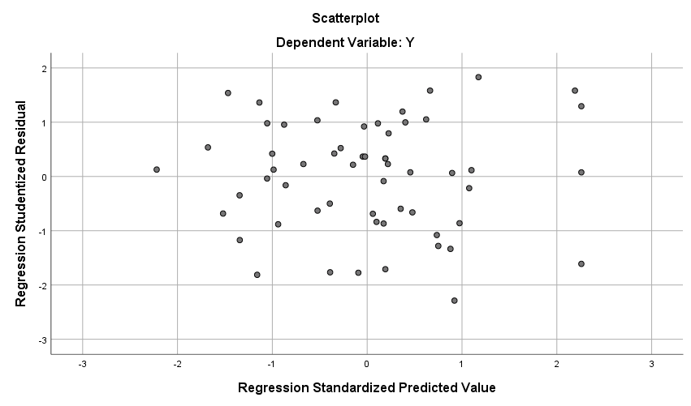

Lampiran 26.
Data Output SPSS Uji Asumsi Klasik Autokorelasi
Model Summary^{b}
Model | R | R Square | Adjusted R Square | Std. Error of the Estimate | Durbin-Watson
1 | .702ª | .492 | .464 | 4607.38328 | 2.014
a. Predictors: (Constant), X3, X2, X1
b. Dependent Variable: Y

Lampiran 27.
Data Output SPSS Koefisien Determinasi
Model Summary^{b}
Model | R | R Square | Adjusted R Square | Std. Error of the Estimate | Durbin-Watson
1 | .702ª | .492 | .464 | 4607.38328 | 2.014
a. Predictors: (Constant), X3, X2, X1
b. Dependent Variable: Y

Lampiran 28.
Surat Ijin Penelitian dan Permintaan Data
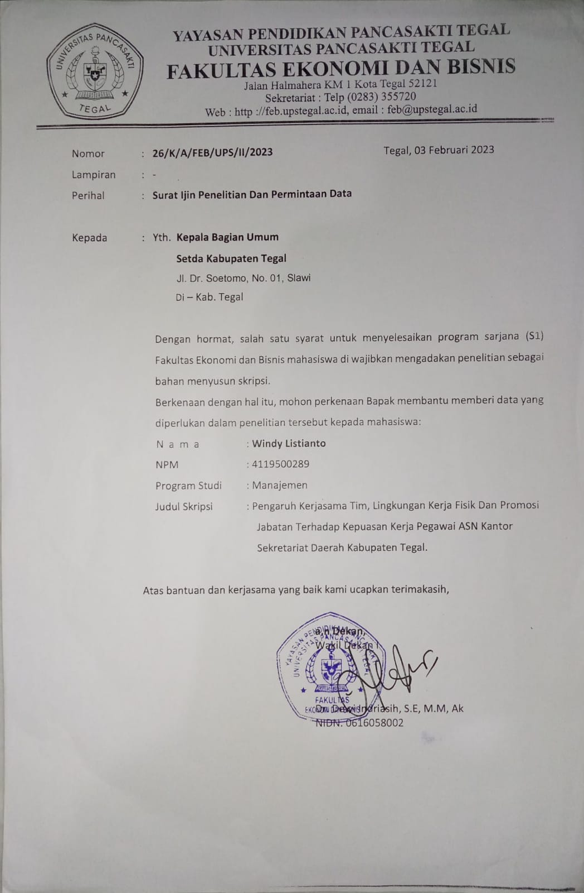
Lampiran 29.
Surat Persetujuan Ijin Penelitian Dari Instansi
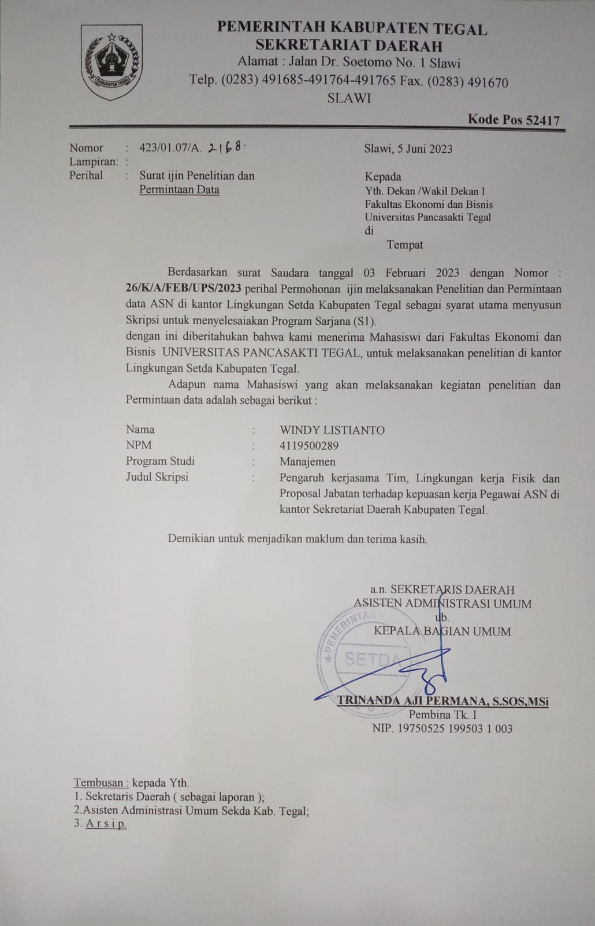
Lampiran 30.
Surat Pernyataan Telah Selesai Melakukan Penelitian Dari Instansi
