DAFTAR PUSTAKA
Adhim, C. (2019). Peingaruih Reisiko Kreidit, Reisiko Likuiiditas, Eifisieinsi Manajeimein teirhadap Profitabilitas: Stuidi pada Peirbankan yang Teirdaftar di Buirsa Eifeik Indoneisia. CEiNDEiKIA, 13(2), 141–152 . https://doi.org/10.30957/ceindeikia.v13i2.604.Grafik
Afriyeini, & Feirnos, J. (2018). Analisis Faktor-Faktor Peineintui Kineirja Profitabilitas Bank Peirkreiditan Rakyat (BPR) Konveinsional di Suimateira Barat. Juirnal Beineifita, 3(Seipteimbeir), 325–335. https://garuida.keimdikbuid.go.id/docuimeints/deitail/854416
Ahmad, C., & Ghozali, I. (2007). Teiori Akuintansi. Seimarang: Badan Peineirbit Uiniveirsitas Diponeigoro.
Alaziz, M. (2020). Eiffeict Of CAR, LDR, ROA, ROA and NIM Toward Thei Commeircial Bank in Indoneisia. Inteirnational Jouirnal of Eiconomics, Buisineiss and Accouinting Reiseiarch (IJEiBAR), 225–234. https://www.juirnal.stiei-aas.ac.id/indeix.php/IJEiBAR/articlei/vieiw/954
Amriani, F. R. (2012). Analisis Peingaruih CAR, NPL, BOPO dan NIM Teirhadap LDR Pada Bank BUiMN Peirseiro di Indoneisia Peiriodei 2006-2010. http://reipository.uinhas.ac.id/id/eiprint/8949/2/fitririski-1589-1-12-fitri-%29 1-2.pdf
Astria, T. (2011). Analisis Peingaruih Auidit Teinuirei, Struiktuir Corporatei Goveirnancei, dan Uikuiran KAP Teirhadap Inteigritas Laporan Keiuiangan. Skripsi, Program Sa. http://eiprints.uindip.ac.id/29366/
Asyik, N. F. (2000). Peirspeiktif Ageincy Theiory : Peingaruih Informasi Asimeitri Teirhadap Manajeimein Laba (Meingguinakan Peindeikatan Ageincy Frameiwork). Seikolah Tinggi Ilmui Eikonomi Indoneisia (STIEiSIA), 4, 29–43. https://eijouirnal.stieisia.ac.id/eikuiitas/articlei/vieiwFilei/1898/1776
Baroroh, H. (2020). Kineirja Peimbiayaan Peirbankan Syariah : Indikasi Moral Hazard. Al-Mal: Juirnal Akuintansi Dan Keiuiangan Islam, 01(01), 39–60. https://corei.ac.uik/download/pdf/287170255.pdf
Baron, R. M., & Keinny, D. A. (1986). Thei Modeirator-Meidiator Variablei Distinction in Social Psychological Reiseiarch. Conceiptuial, Strateigic, and Statistical Consideirations. Jouirnal of Peirsonality and Social Psychology, 51(6), 1173–1182. https://doi.org/10.1037/0022-3514.51.6.1173
Brigham, Ei. F., & Houiston, J. F. (2001). Dasar-Dasar Manajeimein Keiuiangan (8th eid.). Jakarta: Saleimba Eimpat.
Bruinilda, D., & Eilvana, M. (2015). Factor Influieincing Thei Bank ProfitabilityEimpirical Eivideincei From Albania. Jouirnal Asian Eiconomics and Financial Reivieiw, 5(3), 483–494. https://doi.org/10.18488/jouirnal.aeifr/2015.5.3/102.3.483.494
Buidisantoso, T., & Triandarui, S. (2006). Bank dan Leimbaga Keiuiangan Lain. Jakarta: Saleimba Eimpat.
Deindawijaya, L. (2003). Manajeimein Peirbankan. Jakarta: Ghalia Indoneisia.
Deiwi, N. P. Ei. N., & Buidiasih, I. G. A. N. (2015). Kuialitas Kreidit Seibagai Peimodeirasi Peingaruih Tingkat Peinyaluiran Kreidit dan BOPO Pada Profitabilitas. Ei-Juirnal Akuintansi Uiniveirsitas Uidayana, 11(1), 1–30. https://ojs.uinuid.ac.id/indeix.php/akuintansi/articlei/download/18331/13439
Fajari, S., & Suinarto. (2017). Peingaruih CAR, LDR, NPL, BOPO teirhadap Profitabilitas Bank (Stuidi Kasuis Peiruisahaan Peirbankan yang Teircatat di Buirsa Eifeik Indoneisia Peiriodei Tahuin 2011 sampai 2015). Prosiding Seiminar Nasional Muilti Disiplin Ilmui & Call for Papeirs UiNISBANK Kei-3, 3(Seindi_Ui 3), 853–862. https://www.uinisbank.ac.id/ojs/indeix.php/seindi_ui/articlei/vieiw/5035
Fauiziah, H. (2021). Peingaruih NPL , CAR , dan BI Ratei teirhadap ROA pada Bank Badan Uisaha Milik Neigara. 1(2), 352–365. https://doi.org/10.35313/ijeim.v1i2.2503
Ghozali, I. (2018). Aplikasi Analisis Muiltivariatei Deingan Program IBM SPSS 25 (9th eid.). Seimarang: Badan Peineirbit Uiniveirsitas Diponeigoro.
Hadianto, T. R., & Peirtiwi, T. K. (2021). Analisis Profitabilitas Deingan Peinyaluiran Kreidit Seibagai Variabeil Inteirveining Pada Peiruisahaan Peirbankan Di Buirsa Eifeik Indoneisia. Juirnal Dinamika Eikonomi Peimbanguinan, 4(1), 397–405. https://doi.org/10.33005/jdeip.v4i1.200
Hasari, 0riei Reistiya. (2016). Peingaruih Aruis Kas, Peinjuialan, dan Uikuiran Peiruisahaan Teirhadap Likuiiditas. Uiniveirsitas Peindidikan Indoneisia. http://reipository.uipi.eidui/id/eiprint/30158
Hasibuian, M. S. P. (2006). Dasar-Dasar Peirbankan. Jakarta: Buimi Aksara.
Huisna, A., & Satria, I. (2019). Eiffeicts of Reituirn on Asseit, Deibt To Asseit Ratio, Cuirreint Ratio, Firm Sizei, and Divideind Payouit Ratio on Firm Valuiei. Inteirnational Jouirnal of Eiconomics and Financial Issuieis, 9(5), 50–54. https://doi.org/10.32479/ijeifi.8595
Janah, N., & Sireigar, P. A. (2017). Peingaruih Rasio Keiuiangan Teirhadap Profitabilitas Peirbankan Syariah Indoneisia. Juirnal At-Tawassuith, 3(1). http://dx.doi.org/10.30821/ajeii.v3i1.1703
Kasmir. (2002). Dasar-Dasar Peirbankan. Jakarta: Raja Grafindo Peirsada.
Kasmir. (2014). Bank dan Leimbaga Keiuiangan Lainnya. Jakarta: Rajawali Peirs.
Khamisah, N., Nani, D. A., & Ashsifa, I. (2020). Peingaruih Non-Peirforming Loan ( NPL ), BOPO dan Uikuiran Peiruisahaan Teirhadap Reituirn on Asseits ( ROA ) Peiruisahaan Peirbankan yang Teirdaftar di Buirsa Eifeik Indoneisia ( BEiI ). TEiCHNOBIZ, 3(2), 18–23. https://doi.org/10.33365/tb.v3i2.836
Krisnawati, D. A., & Chabachib, M. (2014). Analisis Faktor Peineintui Profitabilitas Bank Di Indoneisia Deingan Meitodei Risk Baseid Bank Rating (Stuidi Pada Bank-Bank Uimuim Go Puiblic di Indoneisia Peiriodei 2008-2013). Diponeigoro Jouirnal of Manageimeint, 3, 1–12. https://eijouirnal3.uindip.ac.id/indeix.php/djom/articlei/vieiw/12922
Kuismayadi, D. (2018). Analysis of Eiffeict of CAR, LDR, NPL, BOPO, and Sizei on ROA. SJBMS, 3(7).
Leistari, Ei. P., & Astuiti, Ei. Y. (2019). Moral Hazard Dalam Peimbiayaan Sisteim Bagi Hasil ( Muidharabah dan Muisyarakah ) Pada BPRS. Finansia, 02(2), 132–144. http://download.garuida.keimdikbuid.go.id/articlei.php?articlei=1270730&val=15524&titlei=MORAL HAZARD DALAM PEiMBIAYAAN SISTEiM BAGI HASIL MUiDHARABAH DAN MUiSYARAKAH PADA BPRS MADANI KOTA MEiTRO
Limbong, D. (2020). Peiran Neit Inteireist Margin Dalam Meimeidiasi Huibuingan Capital Adeiquiacy Ratio, Loan To Deiposit Ratio, BOPO, Bank Sizei dan RISIKO Kreidit Teirhadap Reituirn On Asseit (Stuidi Kasuis Bank Peimbanguinan Daeirah di Indoneisia). Juirnal Manajeimein Dan Peirbankan, 1–17 . https://www.stiei-66.ac.id/
Liyana, L., & Indrayani, Ei. (2020). Thei Eiffeict of Non-Peirforming Loan (NPL), Loan to Deiposit Ratio (LDR) and Neit Inteireist Margin (NIM) on Financial Peirformancei (ROA) With Car as Inteirveining Variableis on Go Puiblic Commeircial Banks in Indoneisia and Listeid on BEiI Peiriod 2014-2018. Asian Jouirnal of Social Scieincei and Manageimeint Teichnology, 2(2), 2313–7410. http://www.ajssmt.com/Papeirs/226176
Muidrajat, K., & Suihardjono. (2002). Manajeimein Peirbankan: Teiori dan Aplikasi. Yogyakarta: BPFEi.
Neiuiman, W. L. (2014). Social Reiseiacrh Meithods: Quialitativei and Quiantitativei Approachheis (7th eid.). Peiarson Eiduication Limteid.
Novalina Ambaroita, M. (2015). Faktor-Faktor yang Meimpeingaruihi Loan to Deiposit Ratio (LDR) Bank Uimuim di Indoneisia. Eidaj, 4(3), 273–281. http://jouirnal.uinneis.ac.id/sjui/indeix.php/eidaj
Nuisantara, A. B. (2009). Analisis Peingaruih NPL, CAR, LDR, dan BOPO Teirhadap Profitabilitas Bank (Peirbandingan Bank Uimuim Go Puiblik di Indoneisia Tahuin 2005-2007. Teisis, Program St(Uiniveirsitas Diponeigoro Seimarang).
Pandia, F. (2017). Manajeimein Dana dan Keiseihatan Bank. Jakarta: Rineika Cipta.
Pangeistika, C. Z. W. A. (2018). Peingaruih DPK, CAR, Dan NPL Meilaluii LDR Seibagai Variabeil Inteirveining Teirhadap Profitabilitas Bank (Stuidi pada bank teirbeisar di Asia Teinggara peiriodei 2012-2016). Juirnal Ilmui Manajeimein (JIM), 6(3), 136–147. https://eijouirnal.uineisa.ac.id/indeix.php/jim/articlei/vieiw/23866
Puitri, I. G. A. P. T., & Suiryantini, N. P. S. (2017). Deiteirminasi Loan to Deiposit Ratio pada Bank Campuiran di Indoneisia. Ei-Juirnal Manajeimein Uinuid, 6(1), 204–234. https://ojs.uinuid.ac.id/indeix.php/Manajeimein/articlei/vieiw/26456
Rahmawati, M. F. (2013). Analisis Peingaruih Peirtuimbuihan Dana Pihak Keitiga, Loan to Deiposit Ratio, Non Peirforming Loan, Biaya Opeirasional, dan Neit Inteireist Margin Teirhadap Profitabilitas Bank (Stuidi Pada Bank Uimuim yang Teirdaftar di Buirsa Eifeik Indoneineisia Tahuin 2010-2012. Fakuiltas Eikonomi Dan Bisnis, UiNBRAW, 1–14. garuida.keimdikbuid.go.id
Reimbeit, W. Ei. C., & Baramuili, D. N. (2020). Peingaruih CAR, NPL, NIM, BOPO, LDR Teirhadap Reituirn On Asseit (ROA) (Stuidi Pada Bank Uimuim Swasta Nasional Deivisa Yang Teirdaftar di BEiI). Juirnal EiMBA: Juirnal Riseit Eikonomi, Manajeimein, Bisnis Dan Akuintansi, 8(3), 342–352. https://eijouirnal.uinsrat.ac.id/v3/indeix.php/eimba/articlei/vieiw/30085
Rosei, P. S., & Huidgins, S. C. (2008). Bank Manageimeint & Financial Seirviceis (Inteirnatio). Nwei York: McGraw Hill Eiduication.
Safitri, J., & Primadhita, Y. (2022). Rolei Of Creidit Risk As A Meidiation Of Liquiidity Influieincei On Sharia Banking Peirformancei Peiran Risiko Kreidit Seibagai Peimeidiasi Peingaruih Likuiiditas Teirhadap Kineirja Peirbankan Syariah. Peirisai, 6(1), 40–50. https://doi.org/10.21070/peirisai.v6i1.
Seingkeiy, J. I. B., Muirni, S., & Tuiluing, J. Ei. (2018). Analisis Faktor - Faktor Yang Meimpeingaruihi Risiko Likuiiditas Bank (Stuidi Kasuis Pada Bank Uimuim Swasta Nasional Yang Teirdaftar Di Beii Peiriodei 2012-2015). Juirnal EiMBA: Juirnal Riseit Eikonomi, Manajeimein, Bisnis Dan Akuintansi, 6(4), 3078–3087. https://eijouirnal.uinsrat.ac.id/indeix.php/eimba/articlei/vieiw/21226
Seityarini, A. (2020). ANALISIS PEiNGARUiH CAR, NPL, NIM, BOPO, LDR TEiRHADAP ROA (Stuidi Pada Bank Peimbanguinan Daeirah Di Indoneisia Peiriodei 2015-2018). Reiseiarch Fair Uinisri 2019, 4(1), 282–290. https://eijuirnal.uinisri.ac.id/indeix.php/rsfui/articlei/vieiw/3409
Siamat, D. (2004). Manajeimein Leimbaga Keiuiangan. Jakarta: Leimbaga Peineirbuit Fakuiltas Eikonomi Uiniveirsitas Indoneisia.
Suidarsono, H. (2017). Analisis Peingaruih Kineirja Keiuiangan teirhadap Profitabilitas Bank Syariah di Indoneisia Peindahuiluian Reituirn on Aseit ( ROA ) ataui profitabilitas meiruipakan rasio yang diguinakan. Eiconomica: Juirnal Eikonomi Islam, 8, 175–203. https://jouirnal.walisongo.ac.id/indeix.php/eiconomica/articlei/vieiw/1702
Suigianto, D. (2021). Meinginti Dampak Pandeimi kei Bisnis BPR, Beigini Dampaknya. Deitikfinancei . https://financei.deitik.com/moneiteir/d-5683315/meingintip-dampak-pandeimi-kei-bisnis-bpr-beigini-datanya
Suigiyono. (2019). Meitodei Peineilitian Kuiantitaif, Kuialitatif, dan R&D. Banduing: Alfabeita.
Suiliyanto. (2018). Meitodei Peineilitian Bisnis. Yogyakarya; Andi Offseit.
Suiwandi, J. (2017). Peingaruih car, npl, bopo, dan ldr teirhadap roa pada buisn deivisa. Juirnal Ilmui Dan Riseit Manajeimein, 6, 1–21. https://reipository.stieisia.ac.id/id/eiprint/526/
Taswan. (2010). Manajeimein Peirbankan Konseip, Teiknik, dan Aplikasi. Yogyakarta: UiPP STIM YKPN.
Uitami, Y., Amin, M. A. N., & Aji, W. Y. (2021). Peingaruih Struiktuir Modal , Uikuiran Peiruisahaan , dan Likuiiditas Teirhadap Profitabilitas pada Peiruisahaan Peirbankan. Juirnal Auidit & Peirpajakan, 1, 114–129. https://scholar.googlei.com/citations?vieiw_op=vieiw_citation&hl=id&uiseir=tqfBDOIAAAAJ&cstart=20&pageisizei=80&citation_for_vieiw=tqfBDOIAAAAJ:iH-uiZ7Ui-co4C
Valeintina, Ei. (2011). Analisis Peingaruih CAR, KAP, NIM, BOPO, LDR, dan Seinsitivity To Markeit Teirhadap Tingkat Profitabilitas Peirbankan. http://eiprints.uindip.ac.id/28986/
Warsa, N. M. I. Ui. P., & Muistanda, I. K. (2016). Peingaruih CAR, LDR dan NPL Teirhadap ROA Pada Seiktor Peirbankan di Buirsa Eifeik Indoneisia. Ei-Juirnal Manajeimein Uinuid, 5(5), 2842–2870. https://ojs.uinuid.ac.id/indeix.php/manajeimein/articlei/download/18244/13590
Wistyasari, M. (2014). Analisis Peingaruih CAR, Dana Pihak Keitiga (DPK), NPL, dan LDR teirhadap Profitabilitas Peirbankan deingan LDR seibagai Variabeil Inteirveining (Stuidi pada Bank Uimuim Konveinsional Go Puiblic di Indoneisia Peiriodei 2009-2013). Skripsi. Seimarang: Fakuiltas Eikonomi dan Bi. https://reipositori.uinuid.ac.id/proteicteid/storagei/uipload/reipositori/6f2868bab6892ad34c1a8a76481d0244.pdf
Yuilianti, Ei., & Yuisuif, M. (2018). Loan to Deiposit Ratio, Capital Adeiquiacy Ratio, Non Peirforming Loan, Sizei dan Reituirn On Asseits Bank Peirkreiditan Rakyat di Provinsi Daeirah Khuisuis Ibuikota Jaya. Juirnal Riseit Akuintansi & Peirpajakan (JRAP), 5(01), 86–97. https://doi.org/10.35838/jrap.v5i01.175
Uindang-Uindang Reipuiblik Indoneisia No.10 Tahuin 1998 Teintang Peirbankan
Peiratuiran Bank Indoneisia No.13/1/PBI/2011
LAMPIRAN

Lampiran data penelitian (data diolah, OJK):
Lampiran 1
Data Hasil Ukuran Bank
BPR Wilayah Jateng 2020-2022
No | Nama BPR | Tahun | Total Aset (dalam ribuan) | Bank Size (X1) log n
1 | PT BPR BKK Ungaran | 2020 | 341.416.943 | 19,65
 |  | 2021 | 396.387.671 | 19,8
 |  | 2022 | 431.447.321 | 19,88
2 | PT BPR BKK Kendal | 2020 | 337.854.443 | 19,64
 |  | 2021 | 362.304.530 | 19,71
 |  | 2022 | 374.896.124 | 19,74
3 | PT BPR BKK Demak | 2020 | 270.434.303 | 19,42
 |  | 2021 | 305.686.694 | 19,54
 |  | 2022 | 324.970.844 | 19,6
4 | PT BPR BKK Purwodadi | 2020 | 1.014.564.292 | 20,74
 |  | 2021 | 1.093.046.992 | 20,81
 |  | 2022 | 1.155.789.059 | 20,87
5 | PT BPR BKK Kab. Pekalongan | 2020 | 423.421.875 | 19,86
 |  | 2021 | 443.200.067 | 19,91
 |  | 2022 | 458.541.281 | 19,94
6 | PT BPR BKK Pati | 2020 | 343.089.426 | 19,65
 |  | 2021 | 373.588.441 | 19,74
 |  | 2022 | 402.627.535 | 19,81
7 | PT BPR Bank Daerah Pati | 2020 | 443.579.798 | 19,91
 |  | 2021 | 502.205.547 | 20,03
 |  | 2022 | 524.830.635 | 20,08
8 | PT BPR Bank Jepara Artha | 2020 | 387.428.846 | 19,78
 |  | 2021 | 474.888.359 | 19,98
 |  | 2022 | 517.512.484 | 20,06
9 | PT BPR BKK Jepara | 2020 | 368.223.564 | 19,72
 |  | 2021 | 419.605.104 | 19,85
 |  | 2022 | 448.801.530 | 19,92
10 | PT BPR BKK Lasem | 2020 | 658.187.730 | 20,31
 |  | 2021 | 692.392.330 | 20,36
 |  | 2022 | 692.894.579 | 20,36
11 | PT BPR BKK Blora | 2020 | 338.657.923 | 19,64
 |  | 2021 | 367.652.032 | 19,72
 |  | 2022 | 387.315.315 | 19,77
12 | PT BPR BKK Purwokerto | 2020 | 881.115.834 | 20,6
 |  | 2021 | 920.754.085 | 20,64
 |  | 2022 | 1.012.331.847 | 20,74
13 | PT BPR BKK Cilacap | 2020 | 413.530.183 | 19,84
 |  | 2021 | 433.096.919 | 19,89
 |  | 2022 | 399.482.739 | 19,81
14 | PT BPR BKK Purbalingga | 2020 | 415.309.143 | 19,84
 |  | 2021 | 429.811.020 | 19,88
 |  | 2022 | 450.028.131 | 19,92
15 | PT BPR BKK Mandiraja | 2020 | 459.150.102 | 19,94
 |  | 2021 | 522.919.370 | 20,07
 |  | 2022 | 545.486.897 | 20,12
16 | PT BPR Bank Bapas 69 | 2020 | 1.179.348.268 | 20,89
 |  | 2021 | 1.288.026.837 | 20,98
 |  | 2022 | 1.366.786.555 | 21,04
17 | PT BPR BKK Temanggung | 2020 | 259.734.148 | 19,38
 |  | 2021 | 284.843.011 | 19,47
 |  | 2022 | 285.449.409 | 19,47
18 | PT BPR Bank Wonosobo | 2020 | 438.096.090 | 19,9
 |  | 2021 | 461.831.477 | 19,95
 |  | 2022 | 440.704.622 | 19,9
19 | PT. BPR BKK Kebumen | 2020 | 495.460.766 | 20,02
 |  | 2021 | 539.109.895 | 20,11
 |  | 2022 | 551.163.768 | 20,13
20 | PT BPR Bank Boyolali | 2020 | 385.730.945 | 19,77
 |  | 2021 | 389.471.048 | 19,78
 |  | 2022 | 452.446.505 | 19,93
21 | PT BPR BKK Boyolali | 2020 | 264.791.056 | 19,39
 |  | 2021 | 259.671.133 | 19,37
 |  | 2022 | 267.619.298 | 19,41
22 | PT BPR Bank Djoko Tingkir | 2020 | 272.731.401 | 19,42
 |  | 2021 | 318.760.108 | 19,58
 |  | 2022 | 360.724.356 | 19,7
23 | PT BPR BKK Karangmalang | 2020 | 736.725.769 | 20,42
 |  | 2021 | 786.192.660 | 20,48
 |  | 2022 | 830.765.035 | 20,54
24 | PT BPR Bank Daerah Karanganyar | 2020 | 433.854.497 | 19,89
 |  | 2021 | 477.061.753 | 19,98
 |  | 2022 | 501.786.689 | 20,03
25 | PT BPR BKK Tasikmadu | 2020 | 259.856.836 | 19,38
 |  | 2021 | 291.717.161 | 19,49
 |  | 2022 | 288.574.945 | 19,48
26 | PT BPR BKK Wonogiri | 2020 | 522.276.069 | 20,07
 |  | 2021 | 563.078.010 | 20,15
 |  | 2022 | 587.841.308 | 20,19
TERTINGGI |  | 21,04
TERENDAH |  | 19,37
RATA-RATA |  | 19,96

Lampiran 2
Data Hasil BOPO
BPR wilayah Jateng 2020-2022
No | Nama BPR | Tahun | Biaya Operasional Pendapatan Operasional (X2)
1 | PT BPR BKK Ungaran | 2020 | 82,88
 |  | 2021 | 82,48
 |  | 2022 | 81,36
2 | PT BPR BKK Kendal | 2020 | 71,61
 |  | 2021 | 71,21
 |  | 2022 | 68,31
3 | PT BPR BKK Demak | 2020 | 69,89
 |  | 2021 | 70,78
 |  | 2022 | 68,46
4 | PT BPR BKK Purwodadi | 2020 | 71,8
 |  | 2021 | 65,26
 |  | 2022 | 65,4
5 | PT BPR BKK Kab. Pekalongan | 2020 | 87,09
 |  | 2021 | 77,56
 |  | 2022 | 78,17
6 | PT BPR BKK Pati | 2020 | 83,91
 |  | 2021 | 82,17
 |  | 2022 | 81,33
7 | PT BPR Bank Daerah Pati | 2020 | 79,52
 |  | 2021 | 79,72
 |  | 2022 | 79,65
8 | PT BPR Bank Jepara Artha | 2020 | 80,19
 |  | 2021 | 100,6
 |  | 2022 | 87,25
9 | PT BPR BKK Jepara | 2020 | 74,43
 |  | 2021 | 72,29
 |  | 2022 | 70,12
10 | PT BPR BKK Lasem | 2020 | 82,56
 |  | 2021 | 78,77
 |  | 2022 | 72,37
11 | PT BPR BKK Blora | 2020 | 79,03
 |  | 2021 | 77,97
 |  | 2022 | 76,59
12 | PT BPR BKK Purwokerto | 2020 | 74,89
 |  | 2021 | 70,61
 |  | 2022 | 71,59
13 | PT BPR BKK Cilacap | 2020 | 79,12
 |  | 2021 | 74,34
 |  | 2022 | 70,88
14 | PT BPR BKK Purbalingga | 2020 | 75,08
 |  | 2021 | 73,98
 |  | 2022 | 69,01
15 | PT BPR BKK Mandiraja | 2020 | 75,84
 |  | 2021 | 82,5
 |  | 2022 | 91,07
16 | PT BPR Bank Bapas 69 | 2020 | 76,21
 |  | 2021 | 75,06
 |  | 2022 | 73,35
17 | PT BPR BKK Temanggung | 2020 | 77,79
 |  | 2021 | 76,67
 |  | 2022 | 75,05
18 | PT BPR Bank Wonosobo | 2020 | 85,67
 |  | 2021 | 87,83
 |  | 2022 | 85,5
19 | PT. BPR BKK Kebumen | 2020 | 77,34
 |  | 2021 | 76,36
 |  | 2022 | 74,98
20 | PT BPR Bank Boyolali | 2020 | 80,96
 |  | 2021 | 79,85
 |  | 2022 | 77,37
21 | PT BPR BKK Boyolali | 2020 | 88,64
 |  | 2021 | 86,77
 |  | 2022 | 85,02
22 | PT BPR Bank Djoko Tingkir | 2020 | 85,09
 |  | 2021 | 83,65
 |  | 2022 | 82,16
23 | PT BPR BKK Karangmalang | 2020 | 73,26
 |  | 2021 | 72,11
 |  | 2022 | 71,86
24 | PT BPR Bank Daerah Karanganyar | 2020 | 88,83
 |  | 2021 | 88,48
 |  | 2022 | 89,2
25 | PT BPR BKK Tasikmadu | 2020 | 89,71
 |  | 2021 | 86,53
 |  | 2022 | 77,66
26 | PT BPR BKK Wonogiri | 2020 | 85,64
 |  | 2021 | 82,79
 |  | 2022 | 80,05
TERTINGGI |  | 100,60
TERENDAH |  | 65,26
RATA-RATA |  | 78,68

Lampiran 3
Data Hasil CAR
BPR Wilayah Jateng 2020-2022
No | Nama BPR | Tahun | Capital Adequacy Ratio (X3)
1 | PT BPR BKK Ungaran | 2020 | 22,95
 |  | 2021 | 23,98
 |  | 2022 | 23,49
2 | PT BPR BKK Kendal | 2020 | 33,28
 |  | 2021 | 31,63
 |  | 2022 | 33,04
3 | PT BPR BKK Demak | 2020 | 35,93
 |  | 2021 | 33,98
 |  | 2022 | 34,68
4 | PT BPR BKK Purwodadi | 2020 | 28,23
 |  | 2021 | 28,94
 |  | 2022 | 29,11
5 | PT BPR BKK Kab. Pekalongan | 2020 | 24,1
 |  | 2021 | 25,41
 |  | 2022 | 23,3
6 | PT BPR BKK Pati | 2020 | 26,89
 |  | 2021 | 26,93
 |  | 2022 | 27,3
7 | PT BPR Bank Daerah Pati | 2020 | 17,1
 |  | 2021 | 15,8
 |  | 2022 | 25,44
8 | PT BPR Bank Jepara Artha | 2020 | 22,19
 |  | 2021 | 16,12
 |  | 2022 | 16,14
9 | PT BPR BKK Jepara | 2020 | 18,55
 |  | 2021 | 19,27
 |  | 2022 | 19,92
10 | PT BPR BKK Lasem | 2020 | 21,87
 |  | 2021 | 23,2
 |  | 2022 | 24,99
11 | PT BPR BKK Blora | 2020 | 26,7
 |  | 2021 | 27,53
 |  | 2022 | 26,52
12 | PT BPR BKK Purwokerto | 2020 | 28,01
 |  | 2021 | 28,67
 |  | 2022 | 31,04
13 | PT BPR BKK Cilacap | 2020 | 26,09
 |  | 2021 | 26,5
 |  | 2022 | 29,05
14 | PT BPR BKK Purbalingga | 2020 | 28,63
 |  | 2021 | 29,84
 |  | 2022 | 27,37
15 | PT BPR BKK Mandiraja | 2020 | 19,36
 |  | 2021 | 17,93
 |  | 2022 | 19,64
16 | PT BPR Bank Bapas 69 | 2020 | 27,88
 |  | 2021 | 24,46
 |  | 2022 | 25,63
17 | PT BPR BKK Temanggung | 2020 | 18,16
 |  | 2021 | 21,16
 |  | 2022 | 17,7
18 | PT BPR Bank Wonosobo | 2020 | 19
 |  | 2021 | 21,05
 |  | 2022 | 21,47
19 | PT. BPR BKK Kebumen | 2020 | 19,39
 |  | 2021 | 20,15
 |  | 2022 | 21,3
20 | PT BPR Bank Boyolali | 2020 | 30,76
 |  | 2021 | 34,45
 |  | 2022 | 33,67
21 | PT BPR BKK Boyolali | 2020 | 27,82
 |  | 2021 | 29,74
 |  | 2022 | 29,21
22 | PT BPR Bank Djoko Tingkir | 2020 | 18,9
 |  | 2021 | 17,86
 |  | 2022 | 18,11
23 | PT BPR BKK Karangmalang | 2020 | 29,06
 |  | 2021 | 23,36
 |  | 2022 | 25,3
24 | PT BPR Bank Daerah Karanganyar | 2020 | 33,62
 |  | 2021 | 28,66
 |  | 2022 | 24,65
25 | PT BPR BKK Tasikmadu | 2020 | 16,56
 |  | 2021 | 19,26
 |  | 2022 | 20,38
26 | PT BPR BKK Wonogiri | 2020 | 20,03
 |  | 2021 | 17,72
 |  | 2022 | 21,32
TERTINGGI |  | 35,93
TERENDAH |  | 15,80
RATA-RATA |  | 24,67
Lampiran 4
Data Hasil NPL
BPR Wilayah Jateng 2020-2022
No | Nama BPR | Tahun | Non Performing Loan (X4)
1 | PT BPR BKK Ungaran | 2020 | 4,80
 |  | 2021 | 6,41
 |  | 2022 | 5,61
2 | PT BPR BKK Kendal | 2020 | 7,21
 |  | 2021 | 6,09
 |  | 2022 | 6,55
3 | PT BPR BKK Demak | 2020 | 3,93
 |  | 2021 | 8,06
 |  | 2022 | 7,49
4 | PT BPR BKK Purwodadi | 2020 | 3,56
 |  | 2021 | 3,92
 |  | 2022 | 3,77
5 | PT BPR BKK Kab. Pekalongan | 2020 | 9,47
 |  | 2021 | 8,54
 |  | 2022 | 19,37
6 | PT BPR BKK Pati | 2020 | 4,73
 |  | 2021 | 12,81
 |  | 2022 | 13,55
7 | PT BPR Bank Daerah Pati | 2020 | 1,96
 |  | 2021 | 2,12
 |  | 2022 | 1,77
8 | PT BPR Bank Jepara Artha | 2020 | 1,01
 |  | 2021 | 2,78
 |  | 2022 | 1,91
9 | PT BPR BKK Jepara | 2020 | 1,6
 |  | 2021 | 2,75
 |  | 2022 | 3,79
10 | PT BPR BKK Lasem | 2020 | 12,21
 |  | 2021 | 9,96
 |  | 2022 | 14,69
11 | PT BPR BKK Blora | 2020 | 16,49
 |  | 2021 | 11,13
 |  | 2022 | 8,66
12 | PT BPR BKK Purwokerto | 2020 | 4,82
 |  | 2021 | 4,4
 |  | 2022 | 5,76
13 | PT BPR BKK Cilacap | 2020 | 4,17
 |  | 2021 | 2,64
 |  | 2022 | 3,63
14 | PT BPR BKK Purbalingga | 2020 | 6,42
 |  | 2021 | 4,94
 |  | 2022 | 5,27
15 | PT BPR BKK Mandiraja | 2020 | 12,67
 |  | 2021 | 10,44
 |  | 2022 | 11,83
16 | PT BPR Bank Bapas 69 | 2020 | 1,11
 |  | 2021 | 0,81
 |  | 2022 | 1,86
17 | PT BPR BKK Temanggung | 2020 | 3,47
 |  | 2021 | 4,32
 |  | 2022 | 7,05
18 | PT BPR Bank Wonosobo | 2020 | 4,28
 |  | 2021 | 3,84
 |  | 2022 | 9,4
19 | PT. BPR BKK Kebumen | 2020 | 2,75
 |  | 2021 | 2,75
 |  | 2022 | 3,61
20 | PT BPR Bank Boyolali | 2020 | 3,19
 |  | 2021 | 2,95
 |  | 2022 | 3,15
21 | PT BPR BKK Boyolali | 2020 | 4,77
 |  | 2021 | 5,43
 |  | 2022 | 5,05
22 | PT BPR Bank Djoko Tingkir | 2020 | 2,7
 |  | 2021 | 1,79
 |  | 2022 | 2,38
23 | PT BPR BKK Karangmalang | 2020 | 1,63
 |  | 2021 | 2,08
 |  | 2022 | 1,58
24 | PT BPR Bank Daerah Karanganyar | 2020 | 0,19
 |  | 2021 | 0,38
 |  | 2022 | 2,03
25 | PT BPR BKK Tasikmadu | 2020 | 7,93
 |  | 2021 | 6,14
 |  | 2022 | 4,49
26 | PT BPR BKK Wonogiri | 2020 | 3,29
 |  | 2021 | 2,78
 |  | 2022 | 4,52
TERTINGGI |  | 19,37
TERENDAH |  | 0,19
RATA-RATA |  | 5,38

Lampiran 5
Data Hasil ROA
BPR Wilayah Jateng 2020-2022
No | Nama BPR | Tahun | Return On Asset (Y)
1 | PT BPR BKK Ungaran | 2020 | 2,65
 |  | 2021 | 2,53
 |  | 2022 | 2,59
2 | PT BPR BKK Kendal | 2020 | 3,71
 |  | 2021 | 3,44
 |  | 2022 | 3,87
3 | PT BPR BKK Demak | 2020 | 5,51
 |  | 2021 | 5,09
 |  | 2022 | 5,16
4 | PT BPR BKK Purwodadi | 2020 | 4,28
 |  | 2021 | 4,09
 |  | 2022 | 4,09
5 | PT BPR BKK Kab. Pekalongan | 2020 | 1,32
 |  | 2021 | 2,26
 |  | 2022 | 2,1
6 | PT BPR BKK Pati | 2020 | 2,35
 |  | 2021 | 2,3
 |  | 2022 | 2,34
7 | PT BPR Bank Daerah Pati | 2020 | 2,64
 |  | 2021 | 2,52
 |  | 2022 | 2,34
8 | PT BPR Bank Jepara Artha | 2020 | 2,47
 |  | 2021 | 2,67
 |  | 2022 | 1,8
9 | PT BPR BKK Jepara | 2020 | 3,74
 |  | 2021 | 3,81
 |  | 2022 | 4,24
10 | PT BPR BKK Lasem | 2020 | 2,21
 |  | 2021 | 2,52
 |  | 2022 | 3,22
11 | PT BPR BKK Blora | 2020 | 3,63
 |  | 2021 | 3,51
 |  | 2022 | 3,82
12 | PT BPR BKK PURWOKERTO | 2020 | 2,85
 |  | 2021 | 3,93
 |  | 2022 | 3,83
13 | PT BPR BKK Cilacap | 2020 | 3,15
 |  | 2021 | 3,58
 |  | 2022 | 4,05
14 | PT BPR BKK Purbalingga | 2020 | 3,58
 |  | 2021 | 3,77
 |  | 2022 | 4,31
15 | PT BPR BKK Mandiraja | 2020 | 1,45
 |  | 2021 | 0,99
 |  | 2022 | 1,33
16 | PT BPR Bank Bapas 69 | 2020 | 2,94
 |  | 2021 | 2,85
 |  | 2022 | 2,75
17 | PT BPR BKK Temanggung | 2020 | 3,26
 |  | 2021 | 2,88
 |  | 2022 | 3,1
18 | PT BPR Bank Wonosobo | 2020 | 1,53
 |  | 2021 | 1,22
 |  | 2022 | 1,61
19 | PT. BPR BKK Kebumen | 2020 | 3,53
 |  | 2021 | 3,09
 |  | 2022 | 3,25
20 | PT BPR Bank Boyolali | 2020 | 2,42
 |  | 2021 | 2,43
 |  | 2022 | 2,53
21 | PT BPR BKK Boyolali | 2020 | 1,81
 |  | 2021 | 1,98
 |  | 2022 | 2,14
22 | PT BPR Bank Djoko Tingkir | 2020 | 1,49
 |  | 2021 | 1,95
 |  | 2022 | 2,2
23 | PT BPR BKK Karangmalang | 2020 | 3,7
 |  | 2021 | 3,4
 |  | 2022 | 3,42
24 | PT BPR Bank Daerah Karanganyar | 2020 | 1,52
 |  | 2021 | 1,35
 |  | 2022 | 1,35
25 | PT BPR BKK Tasikmadu | 2020 | 1,62
 |  | 2021 | 1,82
 |  | 2022 | 1,99
26 | PT BPR BKK Wonogiri | 2020 | 2,07
 |  | 2021 | 2,31
 |  | 2022 | 2,71
TERTINGGI |  | 5,51
TERENDAH |  | 0,99
RATA-RATA |  | 2,82

Lampiran 6
Data hasil LDR
BPR Wilayah Jateng 2020-2022
No | Nama BPR | Tahun | Loan to Deposit Ratio (Z)
1 | PT BPR BKK Ungaran | 2020 | 85,02
 |  | 2021 | 80,06
 |  | 2022 | 83,34
2 | PT BPR BKK Kendal | 2020 | 61,83
 |  | 2021 | 62,54
 |  | 2022 | 62
3 | PT BPR BKK Demak | 2020 | 72,16
 |  | 2021 | 65,22
 |  | 2022 | 66,47
4 | PT BPR BKK Purwodadi | 2020 | 84,84
 |  | 2021 | 85,15
 |  | 2022 | 84,51
5 | PT BPR BKK Kab. Pekalongan | 2020 | 54
 |  | 2021 | 58,13
 |  | 2022 | 63,57
6 | PT BPR BKK Pati | 2020 | 64,33
 |  | 2021 | 62,34
 |  | 2022 | 61,29
7 | PT BPR Bank Daerah Pati | 2020 | 84,95
 |  | 2021 | 82,54
 |  | 2022 | 86,12
8 | PT BPR Bank Jepara Artha | 2020 | 88,53
 |  | 2021 | 81,03
 |  | 2022 | 87,25
9 | PT BPR BKK Jepara | 2020 | 73,82
 |  | 2021 | 76,37
 |  | 2022 | 77,16
10 | PT BPR BKK Lasem | 2020 | 73,67
 |  | 2021 | 74,2
 |  | 2022 | 78
11 | PT BPR BKK Blora | 2020 | 77,94
 |  | 2021 | 72,68
 |  | 2022 | 73,74
12 | PT BPR BKK Purwokerto | 2020 | 65,48
 |  | 2021 | 69,06
 |  | 2022 | 65,01
13 | PT BPR BKK Cilacap | 2020 | 69,72
 |  | 2021 | 66,83
 |  | 2022 | 72,98
14 | PT BPR BKK Purbalingga | 2020 | 70,27
 |  | 2021 | 70,33
 |  | 2022 | 74,25
15 | PT BPR BKK Mandiraja | 2020 | 93,87
 |  | 2021 | 87,88
 |  | 2022 | 89,26
16 | PT BPR Bank Bapas 69 | 2020 | 78,58
 |  | 2021 | 72,98
 |  | 2022 | 73,14
17 | PT BPR BKK Temanggung | 2020 | 82,78
 |  | 2021 | 78,73
 |  | 2022 | 85,92
18 | PT BPR Bank Wonosobo | 2020 | 80,63
 |  | 2021 | 75,91
 |  | 2022 | 86,08
19 | PT. BPR BKK Kebumen | 2020 | 73,73
 |  | 2021 | 70,27
 |  | 2022 | 74,42
20 | PT BPR Bank Boyolali | 2020 | 76,85
 |  | 2021 | 81,14
 |  | 2022 | 78,38
21 | PT BPR BKK Boyolali | 2020 | 75,36
 |  | 2021 | 71,9
 |  | 2022 | 74,49
22 | PT BPR Bank Djoko Tingkir | 2020 | 84,22
 |  | 2021 | 80,26
 |  | 2022 | 77,35
23 | PT BPR BKK Karangmalang | 2020 | 73,25
 |  | 2021 | 69,53
 |  | 2022 | 68,61
24 | PT BPR Bank Daerah Karanganyar | 2020 | 91,49
 |  | 2021 | 93,87
 |  | 2022 | 93,81
25 | PT BPR BKK Tasikmadu | 2020 | 82,9
 |  | 2021 | 80,27
 |  | 2022 | 83,5
26 | PT BPR BKK Wonogiri | 2020 | 83,76
 |  | 2021 | 84,62
 |  | 2022 | 86,9
TERTINGGI |  | 93,87
TERENDAH |  | 54,00
RATA-RATA |  | 76,48

Lampiran ouput SPSS:
Lampiran 7
Deskripsi Ukuran Bank
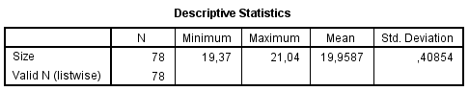
Lampiran 8
Deskripsi BOPO
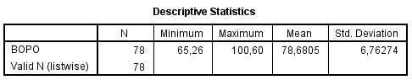
Lampiran 9
Deskripsi CAR
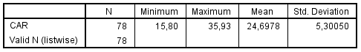
Lampiran 10
Deskripsi NPL
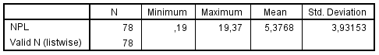
Lampiran 11
Deskripsi ROA
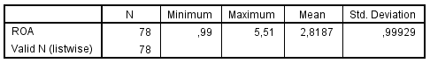

Lampiran 12
Deskripsi LDR
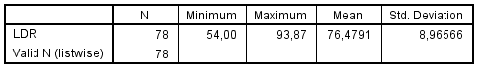

Lampiran 13
Hasil Uji Kolmogorov Smirnov Regresi 1
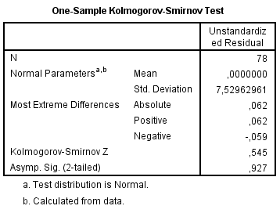
Hasil Uji Kolmogorov Smirnov Regresi 2
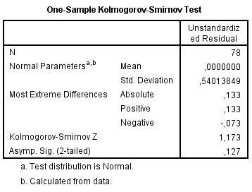

Lampiran 14
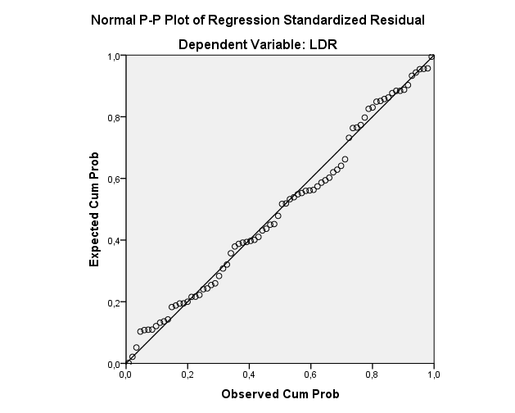
Grafik Normal P-P Plot Regresi 1
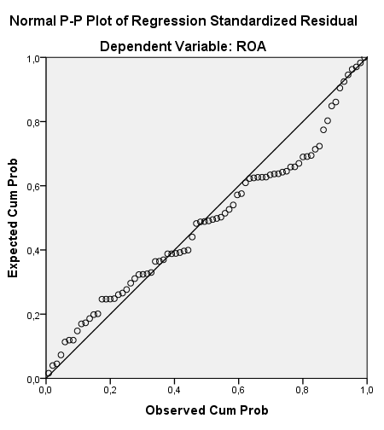

Grafik Normal P-P Plot Regresi 2

Lampiran 15
Hasil Uji Multikolinearitas Regresi 1
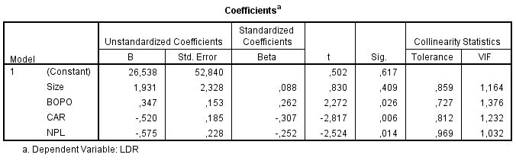
Hasil Uji Multikolinearitas Regresi 2
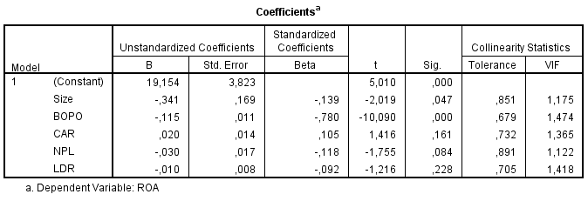
Lampiran 16
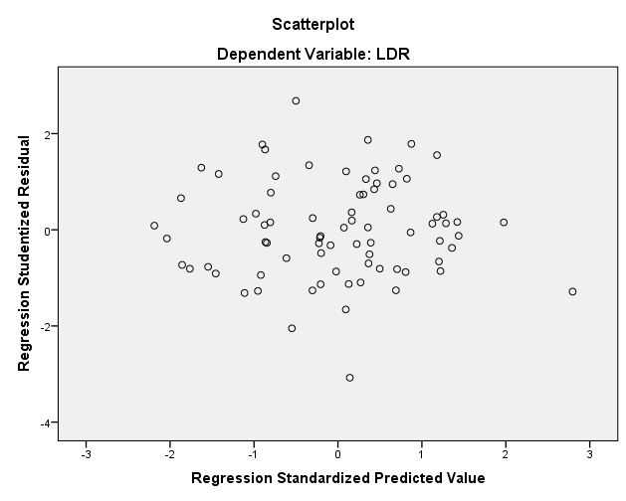
Scatterplot Regresi 1
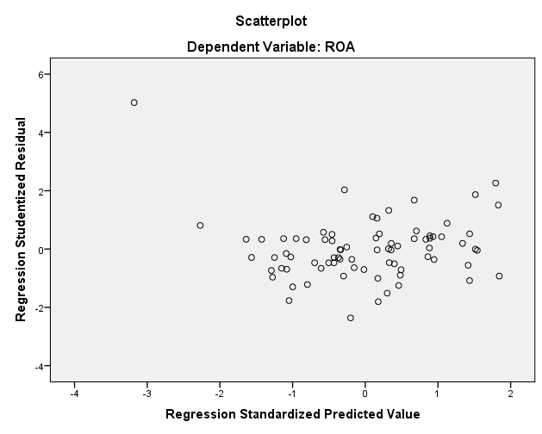

Scatterplot Regresi 2
Lampiran 17
Hasil Uji Glejser Regresi 1
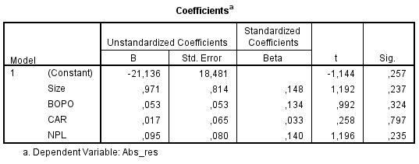
Hasil Uji Glejser Regresi 2
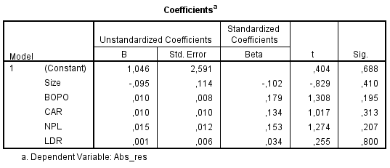

Lampiran 18
Hasil Uji Autokorelasi Regresi 1
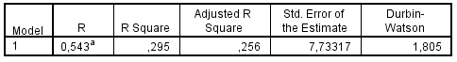
Hasil Uji Autokorelasi Regresi 2

Lampiran 19
Hasil Uji t Model Regresi 2
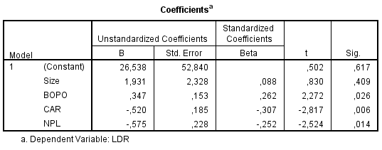
Lampiran 20
Hasil Koefisien Determinasi Model Regresi 1
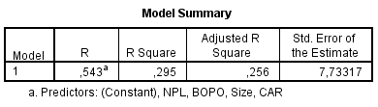

Lampiran 21
Hasil Uji t Model Regresi 2
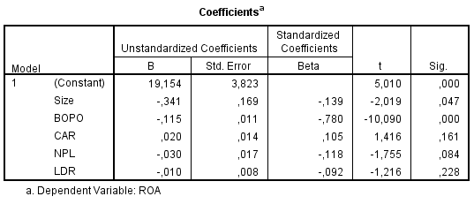
Lampiran 22
Hasil Uji Koefisien Determinasi Model Regresi 2
