DAFTAR PUSTAKA
Anggara, H., & Sukartha, I. M. (2018). Pengaruh Manajemen Laba dan Ukuran Perusahaan pada Beban Pajak Tangguhan. E-Jurnal Akuntansi, 23, 1361. https://doi.org/10.24843/eja.2018.v23.i02.p21
Arisandy, N. (2021). Pengaruh Struktur Modal, Manajemen Laba, Biaya Operasional Dan Perencanaan Pajak Terhadap Pajak Penghasilan Badan Terutang Pada Perusahaan Properti Dan Real Estate Yang Terdaftar Di Bei Tahun 2017-2020. The Journal of Taxation : Tax Center, 1(2), 31–61.
Azis, I. (2020). Motivasi Manajer dalam Melakukan Manajemen Laba Dikaji dalam Pandangan Islam. Jurnal Riset Dan Aplikasi: Akuntansi Dan Manajemen, 4(3), 319–330. https://doi.org/10.33795/jraam.v4i3.008
Darma, S. S., & Fitri, E. N. (2021). Pengaruh Struktur Modal Dan Manajemen Laba. 4(3), 598–606.
Departemen Komunikasi. (2023). Pertumbuhan Ekonomi Indonesia Tetap Kuat. Bank Indonesia. https://www.bi.go.id/id/publikasi/ruang-media/news-release/Pages/sp_252823.aspx
Ghozali, I. (2013). Aplikasi Analisis Multivariate dengan Program IBM SPSS 21 Update PLS Regresi. Badan Penerbit Universitas Diponegoro.
Ghozali, I. (2018). Aplikasi Analisis Multivariate Dengan Program IBM SPSS 25. Semarang : Badan Penerbit Universitas Diponegoro.
Hamijaya, M. (2015). Pengaruh Insentif Pajak Dan Insentif Non Pajak Terhadap Manajemen Laba Saat Terjadi Penurunan Tarif Pajak Penghasilan Badan Pada Perusahaan Manufaktur Yang Terdaftar Di Bursa Efek Indonesia. Jurnal Akuntansi Bisnis, Vol. XIV No. 27 September 2015, 3(1), 1–15. http://dx.doi.org/10.1016/j.bpj.2015.06.056%0Ahttps://academic.oup.com/bioinformatics/article-abstract/34/13/2201/4852827%0Ainternal-pdf://semisupervised-3254828305/semisupervised.ppt%0Ahttp://dx.doi.org/10.1016/j.str.2013.02.005%0Ahttp://dx.doi.org/10.10
Hazanah, S., & Hasanuh, N. (2022). the Effect of Capital Structure and Operational Costs on Agency’S Pph Payable. Jurnal Ilmiah Akuntansi, 6(2). http://www.ejournal.pelitaindonesia.ac.id/ojs32/index.php/BILANCIA/index
Husnan, S., & Pudjiastuti, E. (2015). Dasar-Dasar Manajemen Keuangan. Unit penerbit dan Percetakan (UPP STIM YKPN).
Jensen, M., & Meckling, W. (2012). Theory of the firm: Managerial behavior, agency costs, and ownership structure. The Economic Nature of the Firm: A Reader, Third Edition, 283–303. https://doi.org/10.1017/CBO9780511817410.023
Kasmir. (2017). Analisis Laporan Keuangan (Edisi 1). Raja Grafindo Persada.
Kemenkeu. (2023). Awali Tahun 2023, Pertumbuhan Pajak Sangat Baik. Kementerian Keuangan Republik Indonesia. https://www.kemenkeu.go.id/informasi-publik/publikasi/berita-utama/Awali-Tahun-2023,-Pertumbuhan-Pajak-Sangat-Baik
Mardiasmo. (2019). PERPAJAKAN (Arum Dian (ed.)). Penerbit ANDI Yogyakarta.
Meilia, W., & Rahmatika, D. N. (2020). Pengaruh Ukuran Perusahaan, Likuiditas, Leverage, dan Margin Laba Kotor terhadap Pemilihan Metode Penilaian Persediaan. Permana : Jurnal Perpajakan, Manajemen, Dan Akuntansi, 12(2), 215–232. https://doi.org/10.24905/permana.v12i2.113
Ningsih, R. (2020). Pengaruh Struktur Modal, Profitabilitas, dan Perencanaan Pajak Terhadap Pajak Penghasilan Badan Pada Perusahaan Sektor Industri Barang Konsumsi Yang Terdaftar Di BEI Tahun 2016-2018. Fakultas Ekonomi Universitas WIdya Dharma Klaten, 1–33.
Nisa, K., Khanifah, K., & Alfie, A. A. (2018). Pengaruh Profitabilitas dan Manajemen Laba terhadap Pajak Penghasilan Badan Terutang. AKSES: Jurnal Ekonomi Dan Bisnis, 13(1), 22–29. https://doi.org/10.31942/akses.v13i1.3228
Nisrina Nabilah, N., Mayowan, Y., & Nindya Hapsari, N. (2016). ANALISIS PENERAPAN PERENCANAAN PAJAK PPh 21 SEBAGAI UPAYA PENGHEMATAN BEBAN PAJAK PENGHASILAN BADAN (STUDI KASUS PADA PT Z). Jurnal Perpajakan (JEJAK), 8(1), 12–26.
Pamungkas, L. B., Sumiyarti, S., Anggraini, N., & Muin, M. R. (2021). Pengaruh Profitabilitas dan Struktur Modal terhadap PPh Badan Terutang pada Perusahaan Manufaktur yang terdaftar di Bursa Efek Indonesia Tahun 2015-2019. Jurnal Apresiasi Ekonomi, 9(2), 167–179. https://doi.org/10.31846/jae.v9i2.386
Pohan, C. A. (2016). manajemen PERPAJAKAN Strategi Perencanaan Pajak dan Bisnis. PT Gramedia Pustaka Utama. www.gramediapustakautama.com
Priyatno, D. (2012). Belajar praktis analisis parametrik dan non parametrik dengan SPSS. Gava Media.
Purwono, H. (2010). DASAR-DASAR PERPAJAKAN & AKUNTANSI PAJAK. Erlangga.
Putra, I. M. (2019). Manajemen pajak : strategi pintar merencanakan dan mengelola pajak dan bisnis. Yogyakarta : Quadrant.
Rahmawati, M. (2022). Pajak Penghasilan Badan pada Perusahaan Non-Manufaktur yang terdaftar di Bursa Efek Indonesia.
Rahmi, A. (2013). Kemampuan beban pajak tangguhan dan beban pajak kini dalam mendeteksi manajemen laba pada saat Seasoned Equity Offerings. Jurnal Akuntansi, 1(3), 1–19.
Ramadhani, S. I., & Louise, H. (2022). Pengaruh Penerapan Perencanaan Pajak (Tax Planning) Pajak Penghasilan Pasal 21 Terhadap Pph Badan (Studi Kasus Pt. Tiara Insani Persada). Jurnal Akuntansi Keuangan Dan Perbankan, 3(1), 82–89.
Resmi, S. (2013). Perpajakan Teori dan Kasus (Edisi 7). Salemba Empat.
Santi, D. K., & Wardani, D. K. (2018). Pengaruh Tax Planning, Ukuran Perusahaan, Corporate Social Responsibility (Csr) Terhadap Manajemen Laba. Jurnal Akuntansi, 6(1), 11–24. https://doi.org/10.24964/ja.v6i1.536
Saputra, A. (2020). Analisis Penerapan Perencanaan Pajak (Tax Planning) dalam Upaya Penghematan Beban Pajak Penghasilan Badan pada PT DCM Tahun 2017. Jurnal Pajak Vokasi (JUPASI), 1(2), 112–118. https://doi.org/10.31334/jupasi.v1i2.818
Sophian, S., & Wahyuni, M. (2022). PENGARUH STRUKTUR MODAL TERHADAP PAJAK PENGHASILAN BADAN TERUTANG PADA PERUSAHAAN SEKTOR INDUSTRI BARANG KONSUMSI DI BURSA EFEK INDONESIA PERIODE 2016-2020. JURNAL RISET MANAJEMEN DAN AKUNTANSI, 2(1). file:///C:/Users/Asus/Documents/Semester Akhir/Proposal Penelitian/Referensi/Jurnal/93-100.pdf
Suandy, E. (2017). Perencanaan pajak. Salemba Empat.
Sugiyono. (2022). METODOLOGI PENELITIAN Kuantitatif, Kualitatif, dan R&D. Penerbit Alfabeta Bandung.
Sulistiawan, D., Januarsi, Y., & Alvia, L. (2011). Creative Accounting Mengungkap Manajemen Laba dan Skandal Akuntansi. Salemba Empat, 120.
Sulistyanto, H. S. (2018). MANAJEMEN LABA: TEORI DAN MODEL EMPIRIS. 4(1), 88–100.
Sumarta, R., & Intan, A. U. (2021). Faktor-faktor yang memengaruhi PPh Badan Terutang pada Perusahaan Manufaktur DI BURSA EFEK INDONESIA. Media Bisnis, 12(2), 175–184. https://doi.org/10.34208/mb.v12i2.922
Sumomba, C. R., & Hutomo, Y. S. (2012). Pengaruh Beban Pajak Tangguhan dan Perencanaan Pajak Terhadap Manajemen Laba. INOBIS: Jurnal Inovasi Bisnis Dan Manajemen Indonesia, 4(3), 305–315. https://doi.org/10.31842/jurnalinobis.v4i3.185
Susetyo, B., Subekti, & Prayogi, D. A. (2016). Pengaruh Struktur Aktiva, Profitabilitas, Pertumbuhan Perusahaan Dan Kebijakan Dividen Terhadap Kebijakan Hutang. Jurnal Akuntansi, 7(2), 47–56.
Sutrisno. (2012). Manajemen keuangan: teori konsep dan aplikasi. EKONISIA.
Wardana, A. A. K. (2019). Pengaruh Struktur Modal Terhadap PPh Badan Terutang Pada Perusahaan Makanan dan Minuman Yang Terdaftar Di BEI.
Widyaningsih, E. T. (2019). Pengaruh Manajemen Laba, Debt to Equaity Ratio, dan Return to Asset terhadap PPh Badan Terutang Studi Kasus Pada Perusahaan Yang Terdaftar Dalam BEI Sektor Real Estate dan Property Tahun 2015 – 2016. Jurnal Analisa Akuntansi Dan Perpajakan, 3(1), 72–88. https://doi.org/10.25139/jaap.v3i1.1577
Wild, J., S. J., Hasley, and K. ., & Robert, F. (2004). Financial Statement Analysis (8th ed.). Mc.Graw-Hill.

LAMPIRAN

Lampiran 1: Daftar Data Sampel
No | Kode Perusahaan | Tahun | DER | DA | TTR | Beban Pajak
 | HERO | 2020 | 1.609 | -0.058 | 1.183 | 0.013
1 |  | 2021 | 6.179 | -0.098 | 1.291 | 0.038
 |  | 2022 | 6.366 | -0.079 | -0.061 | 0.013
 | OPMS | 2020 | 0.059 | -0.001 | 0.846 | 0.002
2 |  | 2021 | 0.007 | -0.037 | 0.462 | 0.004
 |  | 2022 | 0.026 | -0.082 | 0.731 | 0.003
 | DAYA | 2020 | 4.897 | -0.024 | 1.062 | 0.004
3 |  | 2021 | 8.579 | -0.023 | 1.091 | 0.006
 |  | 2022 | 19.198 | -0.023 | 1.028 | 0.002
 | SONA | 2020 | 0.214 | 0.004 | 0.774 | 0.035
4 |  | 2021 | 0.142 | -0.001 | 0.613 | 0.042
 |  | 2022 | 0.625 | -0.005 | 0.764 | 0.020
 | RANC | 2020 | 1.423 | -0.053 | 0.806 | 0.019
5 |  | 2021 | 1.982 | -0.042 | 1.155 | 0.001
 |  | 2022 | 2.178 | -0.035 | 0.972 | 0.002
 | MKNT | 2020 | 10.666 | 0.006 | 1.143 | 0.011
6 |  | 2021 | 21.741 | 0.019 | 1.142 | 0.009
 |  | 2022 | -13.644 | -0.002 | 1.082 | 0.007
 | MPPA | 2020 | 23.416 | -0.025 | 0.994 | 0.001
7 |  | 2021 | 6.958 | -0.019 | 1.072 | 0.004
 |  | 2022 | 21.798 | -0.016 | 1.082 | 0.006
 | KOIN | 2020 | 4.339 | -0.006 | 0.779 | 0.018
8 |  | 2021 | 9.849 | -0.019 | 1.107 | 0.004
 |  | 2022 | 41.480 | -0.012 | 1.029 | 0.002
 | ERAA | 2020 | 0.971 | -0.011 | 0.732 | 0.025
9 |  | 2021 | 0.760 | -0.017 | 0.748 | 0.034
 |  | 2022 | 1.368 | -0.023 | 0.719 | 0.037
 | LPPF | 2020 | 9.874 | -0.017 | 0.934 | 0.013
10 |  | 2021 | 4.816 | -0.015 | 0.828 | 0.030
 |  | 2022 | 8.911 | -0.017 | 0.845 | 0.043
 | MAPA | 2020 | 0.801 | -0.020 | -0.478 | 0.003
11 |  | 2021 | 0.646 | -0.019 | 0.670 | 0.021
 |  | 2022 | 0.657 | -0.028 | 0.763 | 0.068
Dilanjutkan
Lanjutan
 | MAPI | 2020 | 1.716 | -0.030 | 0.809 | 0.010
12 |  | 2021 | 1.365 | -0.025 | 0.709 | 0.011
 |  | 2022 | 1.156 | -0.031 | 0.790 | 0.040
 | RALS | 2020 | 0.421 | -0.021 | 0.765 | 0.008
13 |  | 2021 | 0.414 | -0.023 | 0.890 | 0.004
 |  | 2022 | 0.404 | -0.024 | 0.828 | 0.014
 | CSAP | 2020 | 2.709 | -0.061 | 0.530 | 0.008
14 |  | 2021 | 2.755 | -0.063 | 0.782 | 0.008
 |  | 2022 | 2.864 | -0.061 | 0.777 | 0.009
 | TRIO | 2020 | -1.028 | 0.007 | 0.995 | 0.010
15 |  | 2021 | -1.024 | -0.008 | 1.005 | 0.006
 |  | 2022 | -1.023 | -0.015 | 0.943 | 0.252
 | ACES | 2020 | 0.388 | -0.010 | 0.792 | 0.030
16 |  | 2021 | 0.304 | -0.008 | 0.837 | 0.020
 |  | 2022 | 0.222 | -0.009 | 0.821 | 0.021
 | MIDI | 2020 | 3.235 | -0.053 | 1.236 | 0.012
17 |  | 2021 | 2.925 | -0.048 | 1.374 | 0.008
 |  | 2022 | 2.476 | -0.050 | 0.806 | 0.015
 | DIVA | 2020 | 0.309 | -0.010 | 0.947 | 0.003
18 |  | 2021 | 0.099 | -0.016 | 1.000 | 0.000
 |  | 2022 | 0.088 | -0.005 | 0.648 | 0.002
 | UFOE | 2020 | 1.535 | -0.070 | 0.796 | 0.008
19 |  | 2021 | 1.359 | -0.083 | 0.764 | 0.012
 |  | 2022 | 1.184 | -0.064 | 0.731 | 0.011
 | AMRT | 2020 | 2.401 | -0.036 | 0.805 | 0.011
20 |  | 2021 | 2.058 | -0.037 | 0.821 | 0.017
 |  | 2022 | 1.680 | -0.040 | 0.815 | 0.024
 | UVCR | 2020 | 0.617 | -0.043 | 0.731 | 0.015
21 |  | 2021 | 0.230 | -0.128 | 0.752 | 0.038
 |  | 2022 | 0.219 | -0.047 | 0.781 | 0.035
 | NFCX | 2020 | 0.412 | -0.027 | 0.814 | 0.009
22 |  | 2021 | 0.389 | -0.029 | 0.971 | 0.007
 |  | 2022 | 0.354 | -0.021 | 0.750 | 0.004
 | MCAS | 2020 | 0.378 | -0.020 | 0.759 | 0.010
23 |  | 2021 | 0.407 | -0.031 | 0.894 | 0.009
 |  | 2022 | 0.477 | -0.021 | 1.003 | 0.007
Dilanjutkan
Lanjutan
 | DEPO | 2020 | 1.080 | -0.056 | 0.758 | 0.028
24 |  | 2021 | 0.537 | -0.056 | 0.786 | 0.020
 |  | 2022 | 0.521 | -0.043 | 0.807 | 0.015
 | WIRG | 2020 | 0.626 | -0.015 | 0.733 | 0.019
25 |  | 2021 | 0.731 | -0.024 | 0.750 | 0.042
 |  | 2022 | 0.413 | -0.037 | 0.699 | 0.080
 | KIOS | 2020 | 2.780 | 0.142 | 1.024 | 0.010
26 |  | 2021 | 0.285 | 0.046 | 1.209 | 0.006
 |  | 2022 | 0.669 | -0.007 | 0.187 | 0.044
 | ASLC | 2020 | 0.706 | -0.012 | 0.770 | 0.004
27 |  | 2021 | 5.310 | -0.050 | 0.674 | 0.028
 |  | 2022 | 0.120 | -0.059 | 0.649 | 0.005
 | TELE | 2020 | -1.079 | 0.011 | 2.413 | 0.001
28 |  | 2021 | -1.053 | 0.013 | 0.998 | 0.001
 |  | 2022 | -1.030 | 0.010 | 1.003 | 0.004
 | TOOL | 2020 | 1.466 | -0.057 | 0.774 | 0.027
29 |  | 2021 | 0.319 | -0.058 | 0.749 | 0.028
 |  | 2022 | 0.217 | -0.109 | 0.799 | 0.026
 | GLOB | 2020 | -1.013 | 0.062 | 0.999 | 0.007
30 |  | 2021 | -1.016 | -0.004 | 1.000 | 0.001
 |  | 2022 | -1.010 | -0.005 | -1.001 | 0.014
 | BUAH | 2020 | 5.086 | -0.018 | 0.777 | 0.008
31 |  | 2021 | 3.473 | -0.016 | 0.784 | 0.051
 |  | 2022 | 1.246 | -0.023 | 0.760 | 0.034
 | ECII | 2020 | 0.382 | -0.053 | 1.234 | 0.002
32 |  | 2021 | 0.354 | -0.058 | 0.617 | 0.003
 |  | 2022 | 0.419 | -0.052 | 1.047 | 0.0003

Lampiran 2: Contoh Perhitungan Beban Pajak
No | Kode Perusahaan | Tahun | PPh Badan
 |  |  | Beban Pajak Penghasilan | Total Aset t-1 | Hasil
 | HERO | 2020 | 80084 | 6054384 | 0.0132
1 |  | 2021 | 185594 | 4838417 | 0.0384
 |  | 2022 | 81031 | 6273516 | 0.0129
 | OPMS | 2020 | 187581168 | 116186694297 | 0.0016
2 |  | 2021 | 419795549 | 99117797294 | 0.0042
 |  | 2022 | 317367698 | 93904738720 | 0.0034
 | DAYA | 2020 | 2833521 | 730497952 | 0.0039
3 |  | 2021 | 4292339 | 708530092 | 0.0061
 |  | 2022 | 1086086 | 689124704 | 0.0016
 | SONA | 2020 | 38510530050 | 1110366038014 | 0.0347
4 |  | 2021 | 36221306083 | 853905287718 | 0.0424
 |  | 2022 | 14895432063 | 739965067428 | 0.0201
 | RANC | 2020 | 18281679641 | 952496300846 | 0.0192
5 |  | 2021 | 1323071460 | 1319134443995 | 0.0010
 |  | 2022 | 2368732660 | 1512036014160 | 0.0016
 | MKNT | 2020 | 7945314499 | 741824867681 | 0.0107
6 |  | 2021 | 4313634377 | 500766702549 | 0.0086
 |  | 2022 | 3352035329 | 490142330310 | 0.0068
 | MPPA | 2020 | 5537 | 3820809 | 0.0014
7 |  | 2021 | 19438 | 4510511 | 0.0043
 |  | 2022 | 28564 | 4650488 | 0.0061
 | KOIN | 2020 | 11639337668 | 652346214673 | 0.0178
8 |  | 2021 | 2681025325 | 675863759206 | 0.0040
 |  | 2022 | 2091825623 | 1066509702250 | 0.0020
 | ERAA | 2020 | 246144605 | 9747703198 | 0.0253
9 |  | 2021 | 377147615 | 11211369042 | 0.0336
 |  | 2022 | 420784223 | 11372225256 | 0.0370
 | LPPF | 2020 | 61233 | 4832910 | 0.0127
10 |  | 2021 | 190045 | 6319074 | 0.0301
 |  | 2022 | 253664 | 5851229 | 0.0434
 | MAPA | 2020 | 13412 | 4108278 | 0.0033
11 |  | 2021 | 113619 | 5382042 | 0.0211
 |  | 2022 | 363608 | 5319197 | 0.0684

Lampiran 3: Contoh Perhitungan DER
No | Kode Perusahaan | Tahun | DER
 |  |  | Total liabilities | Total Equity | Hasil
 | HERO | 2020 | 2983729 | 1854688 | 1.609
1 |  | 2021 | 5399696 | 873820 | 6.179
 |  | 2022 | 5972429 | 938138 | 6.366
 | OPMS | 2020 | 5492485549 | 93625311745 | 0.059
2 |  | 2021 | 692375584 | 93212363136 | 0.007
 |  | 2022 | 2412879896 | 91899538606 | 0.026
 | DAYA | 2020 | 588386520 | 120143572 | 4.897
3 |  | 2021 | 617180992 | 71943712 | 8.579
 |  | 2022 | 653464291 | 34038783 | 19.198
 | SONA | 2020 | 150391014535 | 703514273183 | 0.214
4 |  | 2021 | 92020129964 | 647944937464 | 0.142
 |  | 2022 | 375187129697 | 599925297671 | 0.625
 | RANC | 2020 | 774629825055 | 544504618940 | 1.423
5 |  | 2021 | 1004972007389 | 507064006771 | 1.982
 |  | 2022 | 928180973526 | 426237663973 | 2.178
 | MKNT | 2020 | 457842864872 | 42923837677 | 10.666
6 |  | 2021 | 468589358123 | 21552972187 | 21.741
 |  | 2022 | 466741373062 | -34208391156 | -13.644
 | MPPA | 2020 | 4325777 | 184734 | 23.416
7 |  | 2021 | 4066083 | 584405 | 6.958
 |  | 2022 | 3618854 | 166017 | 21.798
 | KOIN | 2020 | 549267273182 | 126596486024 | 4.339
8 |  | 2021 | 968203343973 | 98306358277 | 9.849
 |  | 2022 | 1071886158666 | 25841330528 | 41.480
 | ERAA | 2020 | 5523372852 | 5687996190 | 0.971
9 |  | 2021 | 4909863586 | 6462361670 | 0.760
 |  | 2022 | 9855354942 | 7202862872 | 1.368
 | LPPF | 2020 | 5737956 | 581118 | 9.874
10 |  | 2021 | 4845257 | 1005972 | 4.816
 |  | 2022 | 5170053 | 580164 | 8.911
 | MAPA | 2020 | 2392915 | 2989127 | 0.801
11 |  | 2021 | 2088282 | 3230915 | 0.646
 |  | 2022 | 2948813 | 4485474 | 0.657

Lampiran 4: Contoh Perhitungan DA
No | Kode Perusahaan | Tahun | (TAC/Ait-1) | NDA | Hasil
 | HERO | 2020 | 0.0000007421592364444 | 0.0578735242099 | -0.058
1 |  | 2021 | 0.0000003009614165520 | 0.0978463960423 | -0.098
 |  | 2022 | -0.0000000136067318063 | 0.0790497295297 | -0.079
 | OPMS | 2020 | 0.0000000000003673574 | 0.0010686867429 | -0.001
2 |  | 2021 | 0.0000000000015896570 | 0.0365009061797 | -0.037
 |  | 2022 | -0.0000000000523561176 | 0.0818805663677 | -0.082
 | DAYA | 2020 | -0.0000000018830223467 | 0.0240138374022 | -0.024
3 |  | 2021 | 0.0000000029127437599 | 0.0229893268556 | -0.023
 |  | 2022 | -0.0000000004319383182 | 0.0230063353570 | -0.023
 | SONA | 2020 | -0.0000000000118807925 | -0.0039648765832 | 0.004
4 |  | 2021 | 0.0000000000015422309 | 0.0014375798558 | -0.001
 |  | 2022 | -0.0000000000008008297 | 0.0053116127095 | -0.005
 | RANC | 2020 | 0.0000000000002940723 | 0.0527874678240 | -0.053
5 |  | 2021 | 0.0000000000000753247 | 0.0418402045783 | -0.042
 |  | 2022 | -0.0000000000006240467 | 0.0348447018056 | -0.035
 | MKNT | 2020 | 0.0000000000147595118 | -0.0059112158213 | 0.006
6 |  | 2021 | -0.0000000000028976710 | -0.0187986630501 | 0.019
 |  | 2022 | -0.0000000000128647606 | 0.0016265642459 | -0.002
 | MPPA | 2020 | -0.0000002230332335587 | 0.0254295297148 | -0.025
7 |  | 2021 | -0.0000001817657480210 | 0.0192136372132 | -0.019
 |  | 2022 | -0.0000004262742503169 | 0.0162132288052 | -0.016
 | KOIN | 2020 | 0.0000000000011251635 | 0.0058140054305 | -0.006
8 |  | 2021 | 0.0000000000005177561 | 0.0193051931831 | -0.019
 |  | 2022 | 0.0000000000009608294 | 0.0122502879553 | -0.012
 | ERAA | 2020 | 0.0000000000241365228 | 0.0111486216124 | -0.011
9 |  | 2021 | 0.0000000045867871704 | 0.0165756288125 | -0.017
 |  | 2022 | 0.0000000002215478557 | 0.0226183820851 | -0.023
 | LPPF | 2020 | -0.0000020063738198567 | 0.0171317589196 | -0.017
10 |  | 2021 | 0.0000000599811952455 | 0.0152073928870 | -0.015
 |  | 2022 | 0.0000001013962405223 | 0.0173971539996 | -0.017
 | MAPA | 2020 | 0.0000000177006882790 | 0.0201361200484 | -0.020
11 |  | 2021 | 0.0000000484197576986 | 0.0185802619155 | -0.019
 |  | 2022 | 0.0000001340416453349 | 0.0279473559637 | -0.028

Lampiran 5: Contoh Perhitungan TTR
No | Kode Perusahaan | Tahun | Perencanaan Pajak
 |  |  | Laba Bersih | Laba Sebelum Pajak | Hasil
 | HERO | 2020 | -1214602 | -1027133 | 1.183
1 |  | 2021 | -963526000 | -746485000 | 1.291
 |  | 2022 | 59111000 | -963526000 | -0.061
 | OPMS | 2020 | 1031801421 | 1219382589 | 0.846
2 |  | 2021 | -357609290 | -773605409 | 0.462
 |  | 2022 | -860859913 | -1178227611 | 0.731
 | DAYA | 2020 | -48816999 | -45983478 | 1.062
3 |  | 2021 | -51708764 | -47416425 | 1.091
 |  | 2022 | -40023559 | -38937473 | 1.028
 | SONA | 2020 | -131555433792 | -170065963842 | 0.774
4 |  | 2021 | -57300993143 | -93522299226 | 0.613
 |  | 2022 | -48290136664 | -63185568727 | 0.764
 | RANC | 2020 | 76002689458 | 94284369099 | 0.806
5 |  | 2021 | 9838767784 | 8515696324 | 1.155
 |  | 2022 | -83668234859 | -86036967519 | 0.972
 | MKNT | 2020 | -63440559860 | -55495245361 | 1.143
6 |  | 2021 | -34676018586 | -30362384209 | 1.142
 |  | 2022 | -44239084134 | -40887048805 | 1.082
 | MPPA | 2020 | -405307 | -407687 | 0.994
7 |  | 2021 | -337548 | -314915 | 1.072
 |  | 2022 | -429634 | -397032 | 1.082
 | KOIN | 2020 | 41124681020 | 52764018688 | 0.779
8 |  | 2021 | -27840100544 | -25159075219 | 1.107
 |  | 2022 | -73270055868 | -71178230245 | 1.029
 | ERAA | 2020 | 671172137 | 917316742 | 0.732
9 |  | 2021 | 1117917248 | 1495064863 | 0.748
 |  | 2022 | 1076555292 | 1497339515 | 0.719
 | LPPF | 2020 | -873181 | -934404 | 0.934
10 |  | 2021 | 912854 | 1102899 | 0.828
 |  | 2022 | 1383222 | 1636886 | 0.845
 | MAPA | 2020 | 4338 | -9074 | -0.478
11 |  | 2021 | 230395 | 344014 | 0.670
 |  | 2022 | 1173424 | 1537032 | 0.763

Lampiran 6: Hasil Olah Data SPSS
Descriptive Statistics
 | N | Range | Minimum | Maximum | Sum | Mean | Std. Deviation | Variance
Beban Pajak | 96 | .25 | .00 | .25 | 1.76 | .0183 | .02850 | .001
DER | 96 | 55.12 | -13.64 | 41.48 | 263.91 | 2.7490 | 6.39556 | 40.903
DA | 96 | .27 | -.13 | .14 | -2.59 | -.0269 | .03410 | .001
TRR | 96 | 3.41 | -1.00 | 2.41 | 80.38 | .8373 | .35088 | .123
Valid N (listwise) | 96

One-Sample Kolmogorov-Smirnov Test
 |  | Unstandardized Residual
N |  | 96
Normal Parameters^{a,b} | Mean | .0000000
 | Std. Deviation | 1.15381730
Most Extreme Differences | Absolute | .086
 | Positive | .053
 | Negative | -.086
Test Statistic |  | .086
Asymp. Sig. (2-tailed) |  | .076^{c}

Coefficientsª
Model |  | Collinearity Statistics
 |  | Tolerance | VIF
1 | (Constant)
 | DER | .995 | 1.005
 | DA | .165 | 6.067
 | TRR | .165 | 6.078

Model Summary^{b}
Model | R | R Square | Adjusted R Square | Std. Error of the Estimate | Durbin-Watson
1 | .805ª | .649 | .637 | .29312 | 2.201

ANOVAª
Model |  | Sum of Squares | df | Mean Square | F | Sig.
1 | Regression | 14.603 | 3 | 4.868 | 3.541 | .018^{b}
 | Residual | 126.473 | 92 | 1.375
 | Total | 141.076 | 95

Coefficients
Model |  | Unstandardized Coefficients |  | Standardized Coefficients | t | Sig.
 |  | B | Std. Error | Beta
1 | (Constant) | -9.003 | 1.385 |  | -6.500 | .000
 | DER | .287 | .156 | .182 | 1.842 | .069
 | DA | -23.690 | 8.690 | -.663 | -2.726 | .008
 | TRR | 2.331 | .845 | .671 | 2.757 | .007

Model Summary^{b}
Model | R | R Square | Adjusted R Square | Std. Error of the Estimate
1 | .805ª | .649 | .637 | .29312

Residuals Statisticsª
 | Minimum | Maximum | Mean | Std. Deviation | N
Predicted Value | -6.4658 | -4.0519 | -4.6422 | .39207 | 96
Std. Predicted Value | -4.651 | 1.506 | .000 | 1.000 | 96
Standard Error of Predicted Value | .125 | .971 | .200 | .133 | 96
Adjusted Predicted Value | -6.3911 | -3.9811 | -4.6291 | .36500 | 96
Residual | -3.37462 | 2.81218 | .00000 | 1.15382 | 96
Std. Residual | -2.878 | 2.398 | .000 | .984 | 96
Stud. Residual | -2.899 | 2.439 | -.004 | 1.013 | 96
Deleted Residual | -3.42253 | 3.00973 | -.01310 | 1.23518 | 96
Stud. Deleted Residual | -3.024 | 2.508 | -.007 | 1.025 | 96
Mahal. Distance | .094 | 64.138 | 2.969 | 8.625 | 96
Cook's Distance | .000 | 1.054 | .021 | .113 | 96
Centered Leverage Value | .001 | .675 | .031 | .091 | 96
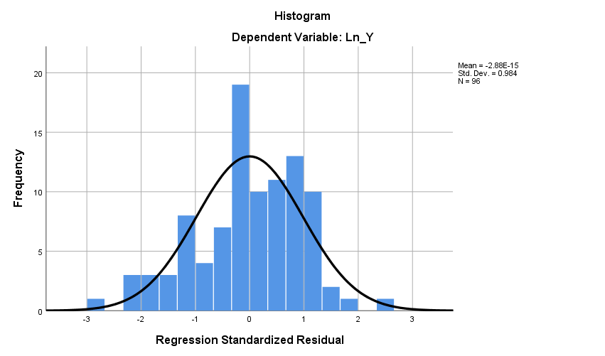
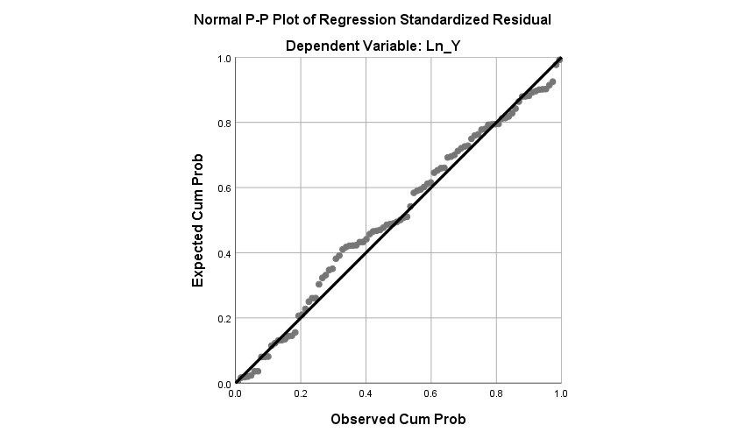

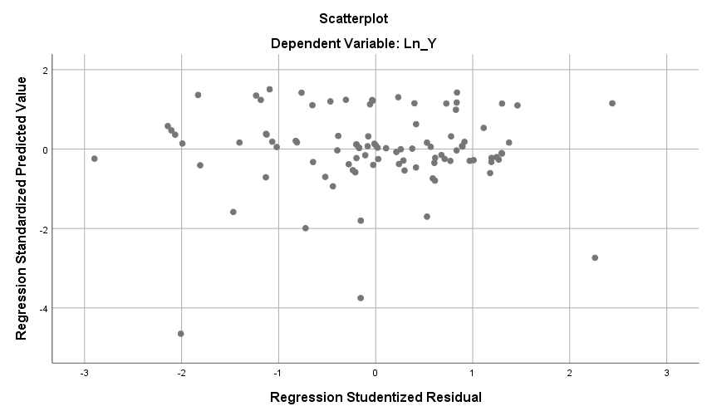

Lampiran 7: Contoh Laporan Keuangan Perusahaan
