DAFTAR PUSTAKA
Alaslan, A. (2022). Analisis Strategi Pemasaran Produk dalam Meningkatkan Volume Penjualan pada Kelompok Usaha Kain Tenun Larsasam, Ebhisa dan Aawy Eras di Kota Saumlaki. Jurnal Ekonomi Dan Bisnis, 10(2), 23–28. https://stiemuttaqien.ac.id/ojs/index.php/OJS/article/download/606/440/
Alma, B. (2020). Manajemen Pemasaran dan Pemasaran Jasa (Ed. Revisi). Bandung: Alfabeta.
Amiruddin, & Fatma, M. (2021). Pengaruh Promosi terhadap Peningkatan Volume Penjualan Kerajinan Kerawang Gayo pada Dekranasda Kabupaten Aceh Tengah. Gajah Putih Journal of Economics Review, 3(2), 65–70. https://doi.org/10.55542/gpjer.v3i2.185
Bambang, P., & Ramadhani, Y. (2021). Pengaruh Kualitas Produk dan Komunikasi Marketing pada Brand Image serta Dampaknya terhadap Loyalitas Pelanggan pada Produk Sarung di Surabaya. Jurnal Manajemen Dan Keuangan, 10(1), 72–96. https://doi.org/10.33059/jmk.v10i1.3031
Bilgies, A. F., & Nasrullah, H. (2019). Pengaruh Faktor Model, Mutu dan Harga terhadap Keputusan Pembelian Produk Sarung Tenun pada Usaha Kecil dan Menengah (UKM) di Parengan Madura Lamongan. HUMANIS: Jurnal Ilmu-Ilmu Sosial Dan Humaniora, 11(1), 1–14. https://doi.org/10.52166/humanis.v11i1.1416
Cahya, F. N. (2018). Pengaruh Kualitas Produk Dan Seni Terhadap Minat Beli Konsumen Sarung Tenun Samarinda. Psikoborneo: Jurnal Ilmiah Psikologi, 6(4), 596–601. https://doi.org/10.30872/psikoborneo.v6i4.4684
Daryono. (2011). Manajemen Pemasaran. Bandung: Yrama Widya.
Ekasari, R., & Pramudita, R. A. (2020). Analisis Pengaruh Kualitas Pelayanan dan Kualitas Produk terhadap Keputusan Pembelian. Ecopreneur.12, 3(1). https://doi.org/10.51804/econ12.v3i1.678
Elan, U., Suyanto, H., & Muchid, A. (2022). Analisis Faktor-Faktor Yang Menimbulkan Minat Beli Mukena Wadimor pada Rumah Grosir Daffa di Gresik. Jurnal Ekonomi Dan Kewirausahaan Kreatif, 7(1), 26–39. http://journal.stienugresik.ac.id/index.php/jek/article/view/69
Ghozali, I. (2018). Aplikasi Analisis Multivariate Dengan Program IBM SPSS 25 (Ed. 9). Semarang: Badan Penerbit Universitas Diponegoro.
Hair, J. F., Black, W. C., Babin, B. J., & Anderson, R. E. (2010). Multivariate Data Analysis (Seventh Ed).
Hayani. (2021). Pengaruh Harga dan Lokasi terhadap Keputusan Pembelian Busana Muslim Oki Setiana Dewi pada Butik Syar’i Haza Lahat. Jurnal Ekonomika, 14(1), 72–87. http://journal.unbara.ac.id/index.php/fe
Italina, C., & Fakhrurrazi. (2019). Pengaruh Strategi Pemasaran terhadap Peningkatan Volume Penjualan Pakaian pada Toko Grosir Kadafi Collection di Kota Sigli Kabupaten Pidie. Jurnal Sains Riset, 9(3), 61–67. https://doi.org/10.47647/jsr.v9i3.160
Khadafi, A. (2017). Kasta Sarung dari Premium Hingga Kluyur. Tirto.Id. https://tirto.id/kasta-sarung-dari-premium-hingga-kluyur-ckPC
Kodrat, D. S. (2009). Manajemen Distribusi: Old Distribution Channel and Postmo Distribution Channel Appoarch. Yogyakarta: Graha Ilmu.
Kotler, P., & Keller, K. L. (2009). Manajemen Pemasaran (Ed. 13). Jakarta: Erlangga.
Lestari, R., Efendi, A., & Hartono. (2021). Pengaruh Utilitarian Shopping Value, Hedonic Shopping Value dan Distribution Channels terhadap Intent to Repurchase pada Konsumen Lady Fame Shop di Bandar Lampung. Jurnal Kompetitif Bisnis, 1(6), 352–364. https://jkb.fisip.unila.ac.id/index.php/jkb/article/download/188/59
Nadine. (2023). Sejarah Asal-Usul Sarung.
Nagara, D. N., & Hendrati. (2022). Pengaruh Bauran Pemasaran terhadap Keputusan Pembelian Produk Pakaian dengan Kualitas Pelayanan Sebagai Variabel Moderasi. Jurnal Riset Manajemen Dan Bisnis, 2(1), 57–64. https://doi.org/10.29313/jrmb.v2i1.1001
Ningsih, W. S. (2020). Pengaruh Strategi Diversifikasi Produk dan Harga terhadap Penjualan pada Industri Kerajinan Tenun dan Batik Zaenal di Kabupaten Tuban. Prosiding Seminar Nasional Penelitian Dan Pengabdian Masyarakat, 5(2), 456–462. http://prosiding.unirow.ac.id/index.php/SNasPPM
Rizaty, M. A. (2022). Industri Tekstil Kembali Melesat 13,74% pada Kuartal II/2022. DataIndonesia.Id. https://dataindonesia.id/sektor-riil/detail/industri-tekstil-kembali-melesat-1374-pada-kuartal-ii2022
Rohmah, A., Setiyono, & Dewi, R. L. (2019). Analisis Harga, Kualitas Produk dan Saluran Distribusi (Studi Kasus pada Konsumen Tenun Ikat “Xyz” Jepara). Jurnal EBBANK, 10(2), 17–28.
Sangadji, E. M., & Sopiah. (2013). Perilaku Konsumen. Yogyakarta: CV Andi Offset.
Sopiani, S., Larashati, I., Juhana, D., & Malik, E. (2022). Pengaruh Promosi dan Saluran Distribusi terhadap Keputusan Pembelian (Survei Produk Fashion pada salah satu Departement Store di Kota Cimahi). Jurnal Bisnis Dan Iptek, 15(1), 15–28. https://doi.org/10.51903/e-bisnis.v15i2
Stanton, W. J. (2018). Prinsip Pemasaran (Ed.7). Jakarta: Erlangga.
Suliyanto. (2011). Ekonomi Terapan-Teori dan Aplikasi dengan SPSS (S. Suyantoro (ed.); 1st ed.). CV ANDI OFFSET.
Suliyanto. (2018). Metode Penelitian Bisnis: untuk Skripsi, Tesis dan Disertasi (Ed. 1). Yogyakarta: CV Andi Offset.
Swastha, B., & Irawan. (2008). Manajemen Pemasaran Modern (Ed. 2). Yogyakarta: Liberty Offset.
Syahyuni, Basri, H., & Putra, D. P. (2021). Pengaruh Produk dan Promosi Penjualan terhadap Volume Penjualan pada PT Delamibrands Kharisma Busana Cabang Palembang. Jurnal Kompetitif, 10(2), 25. https://doi.org/10.52333/kompetitif.v10i2.830
Tjiptono, F. (2001). Total Quality Management (Ed. Revisi). Yogyakarta: CV Andi Offset.
Tjiptono, F. (2008). Strategi Pemasaran (Ed. 3). Yogyakarta: CV Andi Offset.
Trenggana, A. F. M., & Cahyani, L. (2021). Kepuasan Konsumen sebagai Dampak Kualitas Produk, Harga dan Keputusan Pembelian. Jurnal Inspirasi Bisnis Dan Manajemen, 5(2), 163–176. https://doi.org/10.33603/jibm.v5i2.3382
Wijayasari, N., & Mahfudz. (2018). Pengaruh Brand Image, Kualitas, Persepsi Harga dan Variasi Produk terhadap Minat Beli Konsumen. Diponegoro Journal Of Management, 7(2), 1–9. http://ejournal-s1.undip.ac.id/index.php/dbr
Wilujeng, B. S., Hartono, & Irdiana, S. (2019). Pengaruh Bauran Pemasaran Terhadap Keputusan Pembelian Batik Tulis Studi Pada CV. Sekar Agung Desa Kebonagung Kabupaten Lumajang. Progress Conference, 2(1). http://proceedings.stiewidyagamalumajang.ac.id/index.php/progress
Wiyanti, S. (2022). The Effectiveness Quality Of Information Systems And City Walk Concepts Toward City Branding. Jurnal Mantik, 6(3), 3453–3461.

LAMPIRAN
Lampiran 1
KUESIONER PENELITIAN
KATA PENGANTAR
Perihal : Permohonan Pengisian Kuesioner
Judul Penelitian : Pengaruh Product Price, Product Quality dan Distribution Line Terhadap Sales Volume Pada PT Asaputex Jaya Teagl
Kepada Yth
Bapak/Ibu/Sdr Responden Retailer Sarung Pohon Korma
Di tempat

Dengan Hormat,
Dalam rangka menyelesaikan penelitian, kami Mahasiswa Fakultas Ekonomidan BisnisUniversitas Pancasakti Tegal, mohon partisipasi dari Bapak/Ibu/Sdr untuk mengisi kuesioner yang telah kami sediakan.
Adapun data yang kami minta adalah sesuai dengan kondisi yang dirasakan Bapak/Ibu/Sdr selama ini. Kami akan menjaga kerahasiaannya karena data ini hanya untuk kepentingan penelitian.
Atas perhatian dan bantuannya, kami mengucapkan banyak terima kasih.
Tegal, 27 Mei 2023
Hormat Saya,
Ikfi Laelatul Khofifah

- Identitas Responden
Nama Toko :
Nama Pemilik :
Alamat :
Usia :
Pendidikan :
Pendapatan Toko :
- Petunjuk Penelitian
Bapak/Ibu/Sdr dimohon untuk memilih salah satu jawaban dengan memberi tanda (√) pada kolom yang tersedia.
Keterangan :
STS = Sangat Tidak Setuju (Skor 1)
TS = Tidak Setuju (Skor 2)
KS = Kurang Setuju (Skor 3)
S = Setuju (Skor 4)
SS = Sangat Setuju (Skor 5)
SALES VOLUME
No | Pernyataan | Jawaban
 |  | STS | TS | KS | S | SS
BAURAN PEMASARAN
1. | Sarung Pohon Korma PT Asaputex Jaya Tegal kualitasnya baik
2. | Harga Sarung Pohon Korma PT Asaputex Jaya Tegal terjangkau
3. | Sarung Pohon Korma PT Asaputex Jaya Tegal sering memberikan diskon, potongan harga dan promo lainnya
4. | Toko atau retail yang menjual Sarung Pohon Korma PT Asaputex Jaya Tegal mudah untuk ditemui
PROFITABILITAS
5. | Jika sebagai penjual Sarung Pohon Korma PT Asaputex Jaya Tegal, usaha ini termasuk dalam usaha yang menjanjikan (memberikan keuntungan)
6. | Jika sebagai penjual Sarung Pohon Korma PT Asaputex Jaya Tegal, usaha ini mampu berkembang dengan baik
7. | Jika sebagai penjual Sarung Pohon Korma PT Asaputex Jaya Tegal, usaha ini mampu berekspansi secara luas

PRODUCT PRICE
No | Pernyataan | Jawaban
 |  | STS | TS | KS | S | SS
DAYA BELI
1. | Harga Sarung Pohon Korma PT Asaputex Jaya Tegal lebih terjangkau dibandingkan dengan merek lain
2. | Harga Sarung Pohon Korma PT Asaputex Jaya Tegal mampu bersaing dengan sarung merek lain
3. | Harga Sarung Pohon Korma PT Asaputex Jaya Tegal memiliki kisaran harga yang sama dengan toko lain
4. | Harga Sarung Pohon Korma PT Asaputex Jaya Tegal terjangkau dikalangan masyarakat
PERSEPSI KUALITAS
5. | Harga Sarung Pohon Korma PT Asaputex Jaya Tegal sesuai dengan kualitas yang ditawarkan
6. | Kualitas Sarung Pohon Korma PT Asaputex Jaya Tegal sesuai dengan yang konsumen harapkan
7. | Harga Sarung Pohon Korma PT Asaputex Jaya Tegal sebanding dengan manfaatnya
8. | Jenis-jenis Sarung Pohon Kurma PT Asaputex Jaya Tegal yang tersedia sesuai dengan kebutuhan konsumen
PROMOSI
9. | Harga Sarung Pohon Korma PT Asaputex Jaya Tegal sesuai dengan tingkat daya beli konsumen
10. | Sarung Pohon Korma PT Asaputex Jaya Tegal sering memberikan potongan harga, diskon dan promo lainnya

PRODUCT QUALITY
No | Pernyataan | Jawaban
 |  | STS | TS | KS | S | SS
TAMPILAN FISIK
1. | Sarung Pohon Korma PT Asaputex Jaya Tegal memiliki motif, bahan dan warna yang beragam jenisnya
2. | Sarung Pohon Korma PT Asaputex Jaya Tegal memiliki kemasan yang menarik
STANDARISASI
3. | Sarung Pohon Korma PT Asaputex Jaya Tegal dapat digunakan dalam jangka panjang
4. | Kualitas Sarung Pohon Korma PT Asaputex Jaya Tegal dapat digunakan sesuai dengan fungsinya
5. | Kualitas Sarung Pohon Korma PT Asaputex Jaya Tegal sesuai dengan yang ditawarkan
6. | Sarung Pohon Korma PT Asaputex Jaya Tegal mampu digunakan disegala situasi
7. | Sarung Pohon Korma PT Asaputex Jaya Tegal dapat dikembalikan atau ditukar jika ada cacat secara fisik
CIRI KHAS
8. | Sarung Pohon Korma PT Asaputex Jaya Tegal memiliki ciri khas atau keunikan dibandingkan dengan sarung merek lain
9. | Sarung Pohon Korma PT Asaputex Jaya Tegal memiliki desain yang baik
KONDISI KONSUMEN
10. | Kualitas Sarung Pohon Korma PT Asaputex Jaya Tegal sesuai dengan kebutuhan konsumen
11. | Kualitas Sarung Pohon Korma PT Asaputex Jaya Tegal sesuai dengan keinginan konsumen
12. | Harga Sarung Pohon Korma PT Asaputex Jaya Tegal sesuai dengan kondisi keuangan konsumen

DISTRIBUTION LINE
No | Pernyataan | Jawaban
 |  | STS | TS | KS | S | SS
TARGET PENJUALAN
1. | Distributor dan retail Sarung Pohon Korma PT Asaputex Jaya Tegal memberikan pelayanan yang baik
2. | Distributor dan retail Sarung Pohon Korma PT Asaputex Jaya Tegal mampu mentargetkan penjualan
3. | Distributor dan retail Sarung Pohon Korma PT Asaputex Jaya Tegal mampu menyediakan produk yang diinginkan dan dibutuhkan konsumen
4. | Distributor dan retail Sarung Pohon Korma PT Asaputex Jaya Tegal mampu memenuhi target penjualan yang ditentukan
PELAYANAN
5. | Distributor dan retail Sarung Pohon Korma PT Asaputex Jaya Tegal dalam melayani konsumen tidak memaksa (bersifat fleksibel)
6. | Distributor dan retail Sarung Pohon Korma PT Asaputex Jaya Tegal memberikan potongan harga, diskon dan promosi lainnya
7. | Distributor dan retail Sarung Pohon Korma PT Asaputex Jaya Tegal memberikan garansi atau retur
8. | Distributor dan retail Sarung Pohon Korma PT Asaputex Jaya Tegal juga menjual sarung merek lain
9. | Distributor dan retail Sarung Pohon Korma PT Asaputex Jaya Tegal mudah dijangkau oleh konsumen
10. | Distributor dan retail Sarung Pohon Korma PT Asaputex Jaya Tegal menyediakan pembayaran via cash, debit dan kredit

Lampiran 2
HASIL KUESIONER UJI INSTRUMEN SALES VOLUME
 | Y.1 | Y.2 | Y.3 | Y.4 | Y.5 | Y.6 | Y.7 | TOTAL
R1 | 4 | 5 | 5 | 4 | 4 | 4 | 4 | 30
R2 | 5 | 5 | 3 | 5 | 5 | 4 | 5 | 32
R3 | 4 | 4 | 4 | 4 | 4 | 4 | 4 | 28
R4 | 4 | 4 | 4 | 4 | 4 | 4 | 4 | 28
R5 | 4 | 4 | 4 | 5 | 4 | 4 | 4 | 29
R6 | 4 | 4 | 3 | 4 | 4 | 4 | 4 | 27
R7 | 4 | 4 | 3 | 4 | 4 | 4 | 4 | 27
R8 | 4 | 4 | 4 | 4 | 4 | 4 | 4 | 28
R9 | 4 | 5 | 5 | 5 | 5 | 5 | 5 | 34
R10 | 4 | 4 | 3 | 4 | 4 | 4 | 4 | 27
R11 | 4 | 4 | 2 | 5 | 3 | 5 | 5 | 28
R12 | 5 | 4 | 3 | 4 | 4 | 5 | 5 | 30
R13 | 4 | 4 | 4 | 4 | 4 | 4 | 4 | 28
R14 | 4 | 4 | 4 | 4 | 4 | 4 | 4 | 28
R15 | 4 | 4 | 4 | 5 | 5 | 5 | 5 | 32
R16 | 4 | 4 | 4 | 4 | 4 | 4 | 4 | 28
R17 | 4 | 4 | 3 | 4 | 5 | 5 | 4 | 29
R18 | 5 | 4 | 3 | 4 | 4 | 4 | 4 | 28
R19 | 4 | 4 | 5 | 4 | 4 | 4 | 4 | 29
R20 | 4 | 4 | 3 | 4 | 5 | 5 | 4 | 29
R21 | 4 | 4 | 3 | 4 | 4 | 4 | 4 | 27
R22 | 5 | 5 | 5 | 4 | 5 | 5 | 5 | 34
R23 | 4 | 5 | 5 | 5 | 5 | 4 | 5 | 33
R24 | 4 | 4 | 4 | 5 | 5 | 5 | 5 | 32
R25 | 5 | 5 | 4 | 5 | 4 | 4 | 4 | 31
R26 | 5 | 5 | 5 | 5 | 4 | 4 | 4 | 32
R27 | 5 | 5 | 5 | 5 | 5 | 4 | 4 | 33
R28 | 5 | 5 | 5 | 5 | 5 | 5 | 5 | 35
R29 | 5 | 5 | 5 | 5 | 5 | 4 | 4 | 33
R30 | 4 | 4 | 4 | 4 | 4 | 5 | 5 | 30

Lampiran 3
HASIL KUESIONER UJI INSTRUMEN PRODUCT PRICE
 | X1.1 | X1.2 | X1.3 | X1.4 | X1.5 | X1.6 | X1.7 | X1.8 | X1.9 | X1.10 | TOTAL
R1 | 4 | 4 | 4 | 4 | 4 | 4 | 4 | 4 | 4 | 5 | 41
R2 | 5 | 5 | 5 | 5 | 5 | 4 | 5 | 5 | 5 | 3 | 47
R3 | 4 | 4 | 4 | 4 | 4 | 4 | 4 | 4 | 4 | 4 | 40
R4 | 4 | 4 | 4 | 4 | 4 | 4 | 4 | 4 | 4 | 4 | 40
R5 | 4 | 5 | 4 | 4 | 4 | 5 | 4 | 4 | 5 | 4 | 43
R6 | 3 | 4 | 4 | 4 | 4 | 4 | 4 | 4 | 4 | 3 | 38
R7 | 4 | 4 | 4 | 4 | 4 | 4 | 4 | 4 | 4 | 3 | 39
R8 | 3 | 4 | 3 | 4 | 4 | 4 | 4 | 4 | 4 | 4 | 38
R9 | 4 | 4 | 5 | 5 | 5 | 5 | 5 | 5 | 5 | 4 | 47
R10 | 3 | 4 | 4 | 4 | 4 | 4 | 3 | 4 | 4 | 3 | 37
R11 | 3 | 4 | 4 | 4 | 4 | 5 | 5 | 4 | 3 | 2 | 38
R12 | 4 | 4 | 4 | 4 | 4 | 4 | 4 | 4 | 4 | 3 | 39
R13 | 3 | 4 | 4 | 4 | 5 | 4 | 4 | 4 | 4 | 4 | 40
R14 | 4 | 4 | 4 | 4 | 4 | 4 | 4 | 4 | 4 | 4 | 40
R15 | 4 | 4 | 4 | 4 | 5 | 5 | 5 | 5 | 5 | 5 | 46
R16 | 5 | 4 | 4 | 4 | 4 | 4 | 4 | 4 | 4 | 4 | 41
R17 | 4 | 4 | 5 | 4 | 5 | 5 | 5 | 5 | 3 | 3 | 43
R18 | 4 | 4 | 4 | 4 | 4 | 4 | 4 | 4 | 4 | 4 | 40
R19 | 2 | 3 | 2 | 3 | 3 | 3 | 3 | 3 | 3 | 3 | 28
R20 | 4 | 4 | 3 | 4 | 4 | 4 | 4 | 4 | 4 | 3 | 38
R21 | 4 | 4 | 4 | 4 | 4 | 4 | 4 | 4 | 4 | 3 | 39
R22 | 5 | 4 | 4 | 5 | 4 | 4 | 5 | 5 | 4 | 5 | 45
R23 | 4 | 4 | 4 | 4 | 5 | 5 | 5 | 4 | 5 | 5 | 45
R24 | 5 | 3 | 4 | 5 | 5 | 5 | 5 | 4 | 4 | 5 | 45
R25 | 4 | 4 | 4 | 4 | 4 | 4 | 4 | 5 | 5 | 4 | 42
R26 | 5 | 5 | 4 | 5 | 5 | 5 | 5 | 4 | 5 | 5 | 48
R27 | 4 | 4 | 5 | 5 | 5 | 5 | 5 | 4 | 4 | 4 | 45
R28 | 4 | 5 | 5 | 5 | 5 | 5 | 5 | 5 | 5 | 5 | 49
R29 | 5 | 5 | 5 | 5 | 5 | 5 | 5 | 5 | 5 | 5 | 50
R30 | 4 | 4 | 4 | 4 | 4 | 4 | 5 | 4 | 4 | 4 | 41

Lampiran 4
HASIL KUESIONER UJI INSTRUMEN PRODUCT QUALITY
 | X2.1 | X2.2 | X2.3 | X2.4 | X2.5 | X2.6 | X2.7 | X2.8 | X2.9 | X2.10 | X2.11 | X2.12 | Total
R1 | 5 | 4 | 4 | 4 | 4 | 4 | 5 | 4 | 4 | 4 | 5 | 5 | 52
R2 | 5 | 5 | 5 | 5 | 5 | 5 | 5 | 5 | 5 | 5 | 5 | 5 | 60
R3 | 4 | 4 | 4 | 4 | 4 | 4 | 4 | 4 | 4 | 4 | 4 | 4 | 48
R4 | 4 | 4 | 4 | 4 | 4 | 4 | 4 | 4 | 4 | 4 | 4 | 4 | 48
R5 | 5 | 4 | 4 | 4 | 4 | 4 | 4 | 4 | 5 | 4 | 4 | 4 | 50
R6 | 4 | 4 | 4 | 4 | 4 | 4 | 2 | 4 | 4 | 4 | 4 | 4 | 46
R7 | 4 | 4 | 4 | 4 | 4 | 4 | 4 | 4 | 4 | 4 | 4 | 4 | 48
R8 | 4 | 3 | 4 | 4 | 4 | 4 | 4 | 3 | 4 | 4 | 4 | 4 | 46
R9 | 5 | 5 | 5 | 5 | 4 | 4 | 5 | 5 | 5 | 5 | 5 | 4 | 47
R10 | 4 | 4 | 4 | 4 | 4 | 4 | 4 | 3 | 4 | 4 | 4 | 4 | 47
R11 | 5 | 3 | 4 | 4 | 4 | 3 | 3 | 3 | 4 | 4 | 4 | 3 | 44
R12 | 4 | 4 | 4 | 4 | 4 | 4 | 4 | 4 | 4 | 4 | 4 | 4 | 48
R13 | 5 | 5 | 4 | 4 | 4 | 4 | 4 | 4 | 4 | 4 | 4 | 4 | 50
R14 | 4 | 4 | 4 | 4 | 4 | 4 | 4 | 4 | 4 | 4 | 4 | 4 | 48
R15 | 4 | 4 | 5 | 5 | 4 | 4 | 5 | 5 | 5 | 4 | 5 | 5 | 55
R16 | 5 | 5 | 5 | 5 | 5 | 5 | 5 | 5 | 5 | 5 | 4 | 4 | 58
R17 | 4 | 5 | 5 | 5 | 5 | 5 | 5 | 4 | 4 | 4 | 4 | 4 | 54
R18 | 4 | 4 | 4 | 4 | 4 | 4 | 4 | 4 | 4 | 4 | 4 | 4 | 48
R19 | 4 | 4 | 4 | 4 | 4 | 4 | 5 | 4 | 4 | 4 | 4 | 3 | 48
R20 | 4 | 4 | 4 | 4 | 4 | 4 | 4 | 4 | 4 | 4 | 4 | 4 | 48
R21 | 3 | 3 | 4 | 4 | 4 | 3 | 4 | 3 | 3 | 4 | 4 | 4 | 43
R22 | 4 | 4 | 5 | 5 | 5 | 5 | 5 | 4 | 4 | 5 | 5 | 5 | 56
R23 | 5 | 5 | 5 | 4 | 4 | 5 | 5 | 5 | 5 | 5 | 4 | 5 | 57
R24 | 5 | 5 | 5 | 5 | 4 | 4 | 5 | 5 | 5 | 5 | 5 | 5 | 58
R25 | 4 | 4 | 4 | 5 | 5 | 5 | 5 | 5 | 4 | 4 | 5 | 4 | 54
R26 | 4 | 4 | 4 | 5 | 4 | 4 | 4 | 4 | 5 | 5 | 4 | 4 | 51
R27 | 4 | 4 | 5 | 5 | 5 | 5 | 4 | 4 | 4 | 5 | 5 | 4 | 54
R28 | 4 | 4 | 5 | 5 | 5 | 5 | 5 | 4 | 5 | 5 | 5 | 5 | 57
R29 | 4 | 4 | 4 | 4 | 5 | 4 | 4 | 4 | 4 | 4 | 4 | 4 | 49
R30 | 4 | 4 | 4 | 4 | 4 | 4 | 4 | 5 | 4 | 4 | 4 | 4 | 49

Lampiran 5
HASIL KUESIONER UJI INSTRUMEN DISTRIBUTION LINE
 | X3.1 | X3.2 | X3.3 | X3.4 | X3.5 | X3.6 | X3.7 | X3.8 | X3.9 | X3.10 | TOTAL
R1 | 5 | 4 | 4 | 4 | 4 | 4 | 4 | 4 | 5 | 4 | 42
R2 | 5 | 4 | 4 | 4 | 5 | 3 | 5 | 5 | 5 | 4 | 44
R3 | 4 | 4 | 4 | 4 | 4 | 4 | 4 | 4 | 4 | 4 | 40
R4 | 4 | 4 | 4 | 4 | 4 | 4 | 4 | 4 | 4 | 4 | 40
R5 | 4 | 5 | 4 | 4 | 4 | 4 | 4 | 4 | 5 | 5 | 43
R6 | 4 | 3 | 4 | 4 | 4 | 4 | 4 | 4 | 4 | 4 | 39
R7 | 4 | 3 | 4 | 4 | 4 | 3 | 4 | 4 | 4 | 4 | 38
R8 | 4 | 4 | 4 | 4 | 4 | 4 | 4 | 4 | 4 | 4 | 40
R9 | 5 | 4 | 4 | 4 | 5 | 3 | 4 | 5 | 5 | 5 | 44
R10 | 4 | 4 | 4 | 4 | 4 | 3 | 4 | 3 | 4 | 4 | 38
R11 | 4 | 4 | 4 | 5 | 5 | 4 | 5 | 5 | 5 | 2 | 43
R12 | 5 | 4 | 4 | 4 | 4 | 4 | 4 | 4 | 4 | 4 | 41
R13 | 4 | 4 | 4 | 4 | 4 | 4 | 4 | 4 | 4 | 4 | 40
R14 | 4 | 4 | 4 | 4 | 4 | 4 | 4 | 4 | 4 | 4 | 40
R15 | 4 | 4 | 4 | 4 | 4 | 5 | 5 | 5 | 4 | 4 | 43
R16 | 4 | 4 | 4 | 5 | 4 | 4 | 4 | 4 | 4 | 4 | 41
R17 | 5 | 4 | 5 | 4 | 5 | 5 | 5 | 5 | 5 | 5 | 48
R18 | 4 | 4 | 4 | 4 | 4 | 4 | 4 | 2 | 4 | 4 | 38
R19 | 4 | 4 | 4 | 4 | 4 | 4 | 4 | 4 | 4 | 5 | 41
R20 | 4 | 4 | 4 | 4 | 4 | 4 | 4 | 4 | 4 | 4 | 40
R21 | 5 | 4 | 4 | 4 | 4 | 4 | 4 | 4 | 4 | 4 | 41
R22 | 5 | 5 | 4 | 5 | 4 | 5 | 5 | 5 | 5 | 5 | 48
R23 | 4 | 4 | 4 | 4 | 5 | 5 | 5 | 5 | 4 | 4 | 44
R24 | 5 | 4 | 4 | 5 | 5 | 5 | 5 | 4 | 4 | 4 | 45
R25 | 5 | 5 | 5 | 5 | 5 | 5 | 5 | 5 | 5 | 4 | 49
R26 | 4 | 4 | 5 | 5 | 5 | 5 | 5 | 5 | 5 | 4 | 47
R27 | 5 | 5 | 5 | 5 | 5 | 5 | 5 | 5 | 5 | 5 | 50
R28 | 5 | 5 | 5 | 5 | 5 | 5 | 5 | 5 | 5 | 5 | 50
R29 | 4 | 4 | 4 | 4 | 4 | 4 | 4 | 4 | 4 | 4 | 40
R30 | 4 | 4 | 4 | 5 | 4 | 4 | 5 | 4 | 4 | 4 | 42

Lampiran 6
HASIL KUESIONER DATA SALES VOLUME
 | Y.1 | Y.2 | Y.3 | Y.4 | Y.5 | Y.6 | Y.7 | TOTAL
R1 | 4 | 5 | 5 | 4 | 4 | 4 | 4 | 30
R2 | 5 | 5 | 3 | 5 | 5 | 4 | 5 | 32
R3 | 4 | 4 | 4 | 4 | 4 | 4 | 4 | 28
R4 | 4 | 4 | 4 | 4 | 4 | 4 | 4 | 28
R5 | 4 | 4 | 4 | 5 | 4 | 4 | 4 | 29
R6 | 4 | 4 | 3 | 4 | 4 | 4 | 4 | 27
R7 | 4 | 4 | 3 | 4 | 4 | 4 | 4 | 27
R8 | 4 | 4 | 4 | 4 | 4 | 4 | 4 | 28
R9 | 4 | 5 | 5 | 5 | 5 | 5 | 5 | 34
R10 | 4 | 4 | 3 | 4 | 4 | 4 | 4 | 27
R11 | 4 | 4 | 2 | 5 | 3 | 5 | 5 | 28
R12 | 5 | 4 | 3 | 4 | 4 | 5 | 5 | 30
R13 | 4 | 4 | 4 | 4 | 4 | 4 | 4 | 28
R14 | 4 | 4 | 4 | 4 | 4 | 4 | 4 | 28
R15 | 4 | 4 | 4 | 5 | 5 | 5 | 5 | 32
R16 | 4 | 4 | 4 | 4 | 4 | 4 | 4 | 28
R17 | 4 | 4 | 3 | 4 | 5 | 5 | 4 | 29
R18 | 5 | 4 | 3 | 4 | 4 | 4 | 4 | 28
R19 | 4 | 4 | 5 | 4 | 4 | 4 | 4 | 29
R20 | 4 | 4 | 3 | 4 | 5 | 5 | 4 | 29
R21 | 4 | 4 | 3 | 4 | 4 | 4 | 4 | 27
R22 | 5 | 5 | 5 | 4 | 5 | 5 | 5 | 34
R23 | 4 | 5 | 5 | 5 | 5 | 4 | 5 | 33
R24 | 4 | 4 | 4 | 5 | 5 | 5 | 5 | 32
R25 | 5 | 5 | 4 | 5 | 4 | 4 | 4 | 31
R26 | 5 | 5 | 5 | 5 | 4 | 4 | 4 | 32
R27 | 5 | 5 | 5 | 5 | 5 | 4 | 4 | 33
R28 | 5 | 5 | 5 | 5 | 5 | 5 | 5 | 35
R29 | 5 | 5 | 5 | 5 | 5 | 4 | 4 | 33
R30 | 4 | 4 | 4 | 4 | 4 | 5 | 5 | 30
R31 | 4 | 4 | 4 | 4 | 5 | 4 | 5 | 30
R32 | 4 | 4 | 5 | 5 | 5 | 4 | 4 | 31
R33 | 5 | 5 | 4 | 4 | 5 | 4 | 4 | 31
R34 | 5 | 5 | 5 | 4 | 4 | 5 | 5 | 33
R35 | 4 | 5 | 5 | 5 | 4 | 4 | 4 | 31
R36 | 5 | 5 | 5 | 5 | 5 | 5 | 4 | 34
R37 | 5 | 5 | 5 | 5 | 5 | 4 | 4 | 33
R38 | 5 | 5 | 4 | 4 | 4 | 4 | 4 | 30
R39 | 5 | 5 | 5 | 5 | 5 | 5 | 4 | 34
R40 | 5 | 5 | 5 | 5 | 5 | 4 | 4 | 33
R41 | 5 | 5 | 5 | 5 | 5 | 5 | 4 | 34
R42 | 5 | 5 | 5 | 5 | 5 | 4 | 4 | 33
R43 | 4 | 5 | 5 | 5 | 4 | 5 | 5 | 33
R44 | 5 | 5 | 5 | 4 | 4 | 5 | 5 | 33
R45 | 5 | 5 | 5 | 4 | 4 | 5 | 5 | 33
R46 | 5 | 5 | 5 | 4 | 5 | 5 | 4 | 33
R47 | 5 | 4 | 5 | 4 | 5 | 4 | 4 | 31
R48 | 5 | 5 | 5 | 5 | 5 | 5 | 5 | 35
R49 | 4 | 4 | 4 | 5 | 5 | 5 | 5 | 32
R50 | 4 | 4 | 4 | 4 | 4 | 4 | 4 | 28
R51 | 5 | 4 | 3 | 5 | 4 | 4 | 4 | 29
R52 | 5 | 4 | 4 | 5 | 5 | 4 | 4 | 31
R53 | 4 | 4 | 3 | 4 | 4 | 5 | 4 | 28
R54 | 5 | 5 | 3 | 5 | 4 | 4 | 4 | 30
R55 | 4 | 4 | 4 | 5 | 4 | 4 | 3 | 28
R56 | 5 | 4 | 5 | 5 | 5 | 4 | 4 | 32
R57 | 5 | 5 | 5 | 5 | 5 | 5 | 5 | 35
R58 | 5 | 5 | 5 | 5 | 5 | 5 | 5 | 35
R59 | 4 | 4 | 4 | 4 | 4 | 4 | 4 | 28
R60 | 5 | 5 | 5 | 4 | 4 | 4 | 4 | 31
R61 | 4 | 4 | 5 | 5 | 5 | 4 | 4 | 31
R62 | 4 | 4 | 4 | 4 | 4 | 5 | 5 | 30
R63 | 5 | 5 | 5 | 5 | 5 | 4 | 5 | 34
R64 | 4 | 4 | 4 | 5 | 4 | 4 | 4 | 29
R65 | 4 | 4 | 4 | 5 | 4 | 4 | 4 | 29
R66 | 5 | 5 | 5 | 5 | 4 | 4 | 4 | 32
R67 | 5 | 5 | 5 | 5 | 5 | 5 | 5 | 35
R68 | 5 | 4 | 5 | 5 | 5 | 4 | 5 | 33
R69 | 4 | 4 | 4 | 5 | 5 | 4 | 4 | 30
R70 | 4 | 4 | 4 | 4 | 4 | 4 | 4 | 28
R71 | 5 | 5 | 5 | 5 | 5 | 5 | 4 | 34
R72 | 5 | 5 | 5 | 5 | 5 | 5 | 4 | 34
R73 | 5 | 5 | 4 | 5 | 4 | 5 | 5 | 33
R74 | 4 | 4 | 4 | 4 | 4 | 4 | 5 | 29
R75 | 4 | 5 | 5 | 5 | 5 | 5 | 4 | 33
R76 | 5 | 4 | 4 | 4 | 4 | 5 | 5 | 31
R77 | 4 | 4 | 5 | 5 | 5 | 4 | 4 | 31
R78 | 5 | 5 | 5 | 4 | 4 | 5 | 5 | 33
R79 | 5 | 5 | 5 | 4 | 4 | 5 | 5 | 33
R80 | 5 | 5 | 5 | 5 | 4 | 4 | 4 | 32
R81 | 5 | 5 | 5 | 4 | 5 | 5 | 5 | 34
R82 | 5 | 5 | 5 | 5 | 5 | 4 | 4 | 33
R83 | 4 | 4 | 5 | 5 | 4 | 4 | 4 | 30
R84 | 4 | 4 | 4 | 4 | 4 | 5 | 5 | 30
R85 | 4 | 4 | 4 | 4 | 4 | 4 | 4 | 28
R86 | 5 | 4 | 4 | 5 | 4 | 4 | 4 | 30
R87 | 4 | 4 | 3 | 4 | 4 | 4 | 4 | 27
R88 | 5 | 5 | 4 | 4 | 4 | 4 | 4 | 30
R89 | 5 | 5 | 3 | 4 | 5 | 5 | 5 | 32
R90 | 5 | 5 | 5 | 5 | 4 | 5 | 5 | 34

Lampiran 7
HASIL DATA KUESIONER PRODUCT PRICE
 | X1.1 | X1.2 | X1.3 | X1.4 | X1.5 | X1.6 | X1.7 | X1.8 | X1.9 | X1.10 | TOTAL
R1 | 4 | 4 | 4 | 4 | 4 | 4 | 4 | 4 | 4 | 5 | 41
R2 | 5 | 5 | 5 | 5 | 5 | 4 | 5 | 5 | 5 | 3 | 47
R3 | 4 | 4 | 4 | 4 | 4 | 4 | 4 | 4 | 4 | 4 | 40
R4 | 4 | 4 | 4 | 4 | 4 | 4 | 4 | 4 | 4 | 4 | 40
R5 | 4 | 5 | 4 | 4 | 4 | 5 | 4 | 4 | 5 | 4 | 43
R6 | 3 | 4 | 4 | 4 | 4 | 4 | 4 | 4 | 4 | 3 | 38
R7 | 4 | 4 | 4 | 4 | 4 | 4 | 4 | 4 | 4 | 3 | 39
R8 | 3 | 4 | 3 | 4 | 4 | 4 | 4 | 4 | 4 | 4 | 38
R9 | 4 | 4 | 5 | 5 | 5 | 5 | 5 | 5 | 5 | 4 | 47
R10 | 3 | 4 | 4 | 4 | 4 | 4 | 3 | 4 | 4 | 3 | 37
R11 | 3 | 4 | 4 | 4 | 4 | 5 | 5 | 4 | 3 | 2 | 38
R12 | 4 | 4 | 4 | 4 | 4 | 4 | 4 | 4 | 4 | 3 | 39
R13 | 3 | 4 | 4 | 4 | 5 | 4 | 4 | 4 | 4 | 4 | 40
R14 | 4 | 4 | 4 | 4 | 4 | 4 | 4 | 4 | 4 | 4 | 40
R15 | 4 | 4 | 4 | 4 | 5 | 5 | 5 | 5 | 5 | 5 | 46
R16 | 5 | 4 | 4 | 4 | 4 | 4 | 4 | 4 | 4 | 4 | 41
R17 | 4 | 4 | 5 | 4 | 5 | 5 | 5 | 5 | 3 | 3 | 43
R18 | 4 | 4 | 4 | 4 | 4 | 4 | 4 | 4 | 4 | 4 | 40
R19 | 2 | 3 | 2 | 3 | 3 | 3 | 3 | 3 | 3 | 3 | 28
R20 | 4 | 4 | 3 | 4 | 4 | 4 | 4 | 4 | 4 | 3 | 38
R21 | 4 | 4 | 4 | 4 | 4 | 4 | 4 | 4 | 4 | 3 | 39
R22 | 5 | 4 | 4 | 5 | 4 | 4 | 5 | 5 | 4 | 5 | 45
R23 | 4 | 4 | 4 | 4 | 5 | 5 | 5 | 4 | 5 | 5 | 45
R24 | 5 | 3 | 4 | 5 | 5 | 5 | 5 | 4 | 4 | 5 | 45
R25 | 4 | 4 | 4 | 4 | 4 | 4 | 4 | 5 | 5 | 4 | 42
R26 | 5 | 5 | 4 | 5 | 5 | 5 | 5 | 4 | 5 | 5 | 48
R27 | 4 | 4 | 5 | 5 | 5 | 5 | 5 | 4 | 4 | 4 | 45
R28 | 4 | 5 | 5 | 5 | 5 | 5 | 5 | 5 | 5 | 5 | 49
R29 | 5 | 5 | 5 | 5 | 5 | 5 | 5 | 5 | 5 | 5 | 50
R30 | 4 | 4 | 4 | 4 | 4 | 4 | 5 | 4 | 4 | 4 | 41
R31 | 4 | 4 | 4 | 5 | 5 | 5 | 5 | 5 | 5 | 5
R32 | 5 | 5 | 5 | 4 | 4 | 4 | 5 | 4 | 4 | 4 | 44
R33 | 4 | 4 | 5 | 5 | 5 | 5 | 4 | 5 | 5 | 5 | 47
R34 | 5 | 5 | 4 | 4 | 4 | 4 | 5 | 4 | 4 | 5 | 44
R35 | 5 | 5 | 4 | 4 | 4 | 5 | 5 | 5 | 5 | 5 | 47
R36 | 4 | 5 | 5 | 5 | 5 | 5 | 5 | 5 | 5 | 5 | 49
R37 | 5 | 5 | 5 | 5 | 5 | 5 | 5 | 5 | 5 | 5 | 50
R38 | 5 | 5 | 4 | 4 | 5 | 5 | 5 | 4 | 4 | 4 | 45
R39 | 4 | 4 | 4 | 5 | 5 | 4 | 5 | 5 | 5 | 5 | 46
R40 | 4 | 5 | 5 | 5 | 4 | 4 | 5 | 5 | 4 | 5 | 46
R41 | 4 | 5 | 5 | 5 | 4 | 5 | 5 | 5 | 5 | 5 | 48
R42 | 4 | 4 | 4 | 5 | 5 | 5 | 5 | 5 | 5 | 5 | 47
R43 | 4 | 4 | 4 | 5 | 4 | 5 | 4 | 5 | 4 | 5 | 44
R44 | 5 | 5 | 5 | 4 | 5 | 5 | 5 | 5 | 5 | 5 | 49
R45 | 4 | 5 | 5 | 5 | 5 | 4 | 4 | 4 | 5 | 5 | 46
R46 | 5 | 5 | 4 | 4 | 5 | 5 | 5 | 5 | 5 | 5 | 48
R47 | 5 | 4 | 5 | 4 | 5 | 4 | 5 | 4 | 5 | 4 | 45
R48 | 5 | 5 | 5 | 5 | 5 | 5 | 5 | 5 | 5 | 5 | 50
R49 | 4 | 4 | 4 | 5 | 5 | 5 | 5 | 5 | 5 | 5 | 47
R50 | 4 | 4 | 4 | 4 | 4 | 4 | 4 | 4 | 4 | 4 | 40
R51 | 5 | 5 | 5 | 5 | 5 | 5 | 5 | 5 | 4 | 5 | 49
R52 | 4 | 5 | 4 | 5 | 4 | 4 | 4 | 5 | 4 | 3 | 42
R53 | 4 | 4 | 4 | 4 | 5 | 4 | 5 | 5 | 5 | 3 | 43
R54 | 4 | 4 | 4 | 4 | 4 | 4 | 5 | 5 | 5 | 3 | 42
R55 | 4 | 4 | 4 | 4 | 4 | 4 | 4 | 4 | 4 | 3 | 39
R56 | 4 | 4 | 4 | 4 | 5 | 5 | 5 | 5 | 4 | 4 | 44
R57 | 5 | 5 | 5 | 5 | 4 | 5 | 5 | 5 | 5 | 5 | 49
R58 | 5 | 5 | 5 | 5 | 4 | 5 | 5 | 5 | 5 | 5 | 49
R59 | 5 | 5 | 5 | 5 | 4 | 4 | 4 | 4 | 4 | 4 | 44
R60 | 4 | 4 | 5 | 4 | 4 | 4 | 4 | 4 | 4 | 4 | 41
R61 | 5 | 5 | 5 | 5 | 5 | 5 | 5 | 5 | 5 | 5 | 50
R62 | 4 | 4 | 4 | 4 | 4 | 4 | 4 | 4 | 4 | 4 | 40
R63 | 5 | 5 | 5 | 5 | 5 | 5 | 5 | 5 | 5 | 5 | 50
R64 | 5 | 5 | 5 | 4 | 5 | 5 | 5 | 4 | 4 | 5 | 47
R65 | 5 | 5 | 5 | 5 | 5 | 5 | 5 | 5 | 5 | 5 | 50
R66 | 5 | 4 | 4 | 4 | 4 | 4 | 5 | 4 | 4 | 4 | 42
R67 | 4 | 4 | 4 | 4 | 5 | 5 | 5 | 5 | 5 | 5 | 46
R68 | 4 | 5 | 3 | 5 | 5 | 4 | 5 | 4 | 4 | 5 | 44
R69 | 4 | 4 | 4 | 5 | 5 | 5 | 5 | 5 | 5 | 5 | 47
R70 | 4 | 4 | 4 | 4 | 4 | 4 | 4 | 4 | 4 | 4 | 40
R71 | 5 | 5 | 4 | 4 | 4 | 3 | 4 | 5 | 5 | 5 | 44
R72 | 4 | 4 | 5 | 4 | 4 | 4 | 4 | 4 | 5 | 5 | 43
R73 | 5 | 5 | 5 | 4 | 4 | 4 | 4 | 4 | 5 | 5 | 45
R74 | 5 | 5 | 4 | 4 | 4 | 5 | 5 | 5 | 5 | 5 | 47
R75 | 5 | 4 | 4 | 4 | 4 | 3 | 5 | 4 | 5 | 5 | 43
R76 | 4 | 4 | 4 | 5 | 5 | 5 | 4 | 4 | 4 | 4 | 43
R77 | 5 | 5 | 5 | 5 | 5 | 5 | 5 | 5 | 5 | 4 | 49
R78 | 4 | 4 | 5 | 5 | 5 | 5 | 4 | 4 | 4 | 4 | 44
R79 | 4 | 4 | 4 | 5 | 5 | 4 | 4 | 4 | 4 | 4 | 42
R80 | 5 | 5 | 5 | 4 | 4 | 4 | 4 | 5 | 4 | 4 | 44
R81 | 4 | 5 | 5 | 4 | 4 | 4 | 5 | 5 | 5 | 5 | 46
R82 | 4 | 4 | 5 | 5 | 5 | 4 | 4 | 4 | 4 | 4 | 43
R83 | 4 | 4 | 5 | 5 | 4 | 4 | 4 | 4 | 4 | 4 | 42
R84 | 5 | 5 | 5 | 5 | 4 | 5 | 5 | 5 | 5 | 5 | 49
R85 | 4 | 4 | 4 | 4 | 4 | 4 | 4 | 4 | 4 | 4 | 40
R86 | 4 | 4 | 5 | 5 | 5 | 5 | 5 | 5 | 4 | 4 | 46
R87 | 4 | 4 | 4 | 4 | 5 | 5 | 5 | 5 | 5 | 4 | 45
R88 | 4 | 4 | 4 | 4 | 5 | 4 | 4 | 5 | 5 | 4 | 43
R89 | 4 | 5 | 4 | 4 | 5 | 4 | 4 | 4 | 4 | 3 | 41
R90 | 4 | 5 | 5 | 5 | 5 | 5 | 5 | 5 | 5 | 5 | 49

Lampiran 8
HASIL DATA KUESIONER PRODUCT QUALITY
 | X2.1 | X2.2 | X2.3 | X2.4 | X2.5 | X2.6 | X2.7 | X2.8 | X2.9 | X2.10 | X2.11 | X2.12 | TOTAL
R1 | 5 | 4 | 4 | 4 | 4 | 4 | 5 | 4 | 4 | 4 | 5 | 5 | 52
R2 | 5 | 5 | 5 | 5 | 5 | 5 | 5 | 5 | 5 | 5 | 5 | 5 | 60
R3 | 4 | 4 | 4 | 4 | 4 | 4 | 4 | 4 | 4 | 4 | 4 | 4 | 48
R4 | 4 | 4 | 4 | 4 | 4 | 4 | 4 | 4 | 4 | 4 | 4 | 4 | 48
R5 | 5 | 4 | 4 | 4 | 4 | 4 | 4 | 4 | 5 | 4 | 4 | 4 | 50
R6 | 4 | 4 | 4 | 4 | 4 | 4 | 2 | 4 | 4 | 4 | 4 | 4 | 46
R7 | 4 | 4 | 4 | 4 | 4 | 4 | 4 | 4 | 4 | 4 | 4 | 4 | 48
R8 | 4 | 3 | 4 | 4 | 4 | 4 | 4 | 3 | 4 | 4 | 4 | 4 | 46
R9 | 5 | 5 | 5 | 5 | 4 | 4 | 5 | 5 | 5 | 5 | 5 | 4 | 57
R10 | 4 | 4 | 4 | 4 | 4 | 4 | 4 | 3 | 4 | 4 | 4 | 4 | 47
R11 | 5 | 3 | 4 | 4 | 4 | 3 | 3 | 3 | 4 | 4 | 4 | 3 | 44
R12 | 4 | 4 | 4 | 4 | 4 | 4 | 4 | 4 | 4 | 4 | 4 | 4 | 48
R13 | 5 | 5 | 4 | 4 | 4 | 4 | 4 | 4 | 4 | 4 | 4 | 4 | 50
R14 | 4 | 4 | 4 | 4 | 4 | 4 | 4 | 4 | 4 | 4 | 4 | 4 | 48
R15 | 4 | 4 | 5 | 5 | 4 | 4 | 5 | 5 | 5 | 4 | 5 | 5 | 55
R16 | 5 | 5 | 5 | 5 | 5 | 5 | 5 | 5 | 5 | 5 | 4 | 4 | 58
R17 | 4 | 5 | 5 | 5 | 5 | 5 | 5 | 4 | 4 | 4 | 4 | 4 | 54
R18 | 4 | 4 | 4 | 4 | 4 | 4 | 4 | 4 | 4 | 4 | 4 | 4 | 48
R19 | 4 | 4 | 4 | 4 | 4 | 4 | 5 | 4 | 4 | 4 | 4 | 3 | 48
R20 | 4 | 4 | 4 | 4 | 4 | 4 | 4 | 4 | 4 | 4 | 4 | 4 | 48
R21 | 3 | 3 | 4 | 4 | 4 | 3 | 4 | 3 | 3 | 4 | 4 | 4 | 43
R22 | 4 | 4 | 5 | 5 | 5 | 5 | 5 | 4 | 4 | 5 | 5 | 5 | 56
R23 | 5 | 5 | 5 | 4 | 4 | 5 | 5 | 5 | 5 | 5 | 4 | 5 | 57
R24 | 5 | 5 | 5 | 5 | 4 | 4 | 5 | 5 | 5 | 5 | 5 | 5 | 58
R25 | 4 | 4 | 4 | 5 | 5 | 5 | 5 | 5 | 4 | 4 | 5 | 4 | 54
R26 | 4 | 4 | 4 | 5 | 4 | 4 | 4 | 4 | 5 | 5 | 4 | 4 | 51
R27 | 4 | 4 | 5 | 5 | 5 | 5 | 4 | 4 | 4 | 5 | 5 | 4 | 54
R28 | 4 | 4 | 5 | 5 | 5 | 5 | 5 | 4 | 5 | 5 | 5 | 5 | 57
R29 | 4 | 4 | 4 | 4 | 5 | 4 | 4 | 4 | 4 | 4 | 4 | 4 | 49
R30 | 4 | 4 | 4 | 4 | 4 | 4 | 4 | 5 | 4 | 4 | 4 | 4 | 49
R31 | 4 | 4 | 4 | 5 | 5 | 5 | 5 | 5 | 5 | 5 | 5 | 5 | 57
R32 | 5 | 5 | 4 | 4 | 4 | 4 | 5 | 5 | 5 | 4 | 4 | 5 | 54
R33 | 4 | 4 | 4 | 5 | 5 | 5 | 5 | 4 | 4 | 4 | 5 | 5 | 54
R34 | 4 | 4 | 5 | 5 | 5 | 5 | 4 | 4 | 4 | 4 | 5 | 5 | 54
R35 | 4 | 4 | 5 | 5 | 5 | 5 | 4 | 5 | 5 | 5 | 5 | 5 | 57
R36 | 5 | 4 | 5 | 4 | 5 | 4 | 4 | 5 | 5 | 5 | 4 | 4 | 54
R37 | 4 | 4 | 5 | 4 | 4 | 4 | 4 | 4 | 5 | 5 | 4 | 4 | 51
R38 | 4 | 4 | 4 | 5 | 5 | 5 | 4 | 4 | 4 | 4 | 4 | 4 | 51
R39 | 4 | 4 | 4 | 5 | 5 | 5 | 5 | 5 | 5 | 4 | 4 | 5 | 55
R40 | 5 | 5 | 5 | 5 | 4 | 4 | 5 | 5 | 5 | 5 | 5 | 5 | 58
R41 | 5 | 4 | 4 | 4 | 5 | 4 | 5 | 5 | 4 | 5 | 5 | 5 | 55
R42 | 4 | 4 | 4 | 5 | 5 | 5 | 4 | 4 | 4 | 4 | 4 | 4 | 51
R43 | 4 | 4 | 4 | 4 | 4 | 5 | 5 | 5 | 5 | 5 | 5 | 5 | 55
R44 | 5 | 4 | 4 | 4 | 5 | 5 | 5 | 5 | 5 | 4 | 4 | 4 | 54
R45 | 5 | 4 | 4 | 5 | 4 | 4 | 4 | 4 | 5 | 5 | 5 | 5 | 54
R46 | 5 | 4 | 5 | 5 | 5 | 5 | 4 | 5 | 4 | 4 | 4 | 4 | 54
R47 | 5 | 4 | 4 | 5 | 5 | 4 | 5 | 4 | 5 | 4 | 4 | 4 | 53
R48 | 5 | 5 | 5 | 5 | 5 | 5 | 5 | 5 | 5 | 5 | 5 | 5 | 60
R49 | 5 | 5 | 5 | 5 | 4 | 5 | 5 | 5 | 5 | 4 | 5 | 5 | 58
R50 | 5 | 4 | 4 | 4 | 4 | 4 | 4 | 4 | 4 | 4 | 4 | 4 | 49
R51 | 5 | 5 | 5 | 5 | 5 | 5 | 5 | 5 | 5 | 5 | 5 | 5 | 60
R52 | 4 | 4 | 5 | 5 | 4 | 5 | 3 | 4 | 4 | 5 | 4 | 4 | 51
R53 | 4 | 4 | 5 | 5 | 4 | 5 | 3 | 4 | 4 | 5 | 5 | 5 | 53
R54 | 4 | 4 | 5 | 5 | 5 | 3 | 4 | 4 | 4 | 4 | 4 | 5 | 51
R55 | 3 | 4 | 4 | 4 | 4 | 4 | 4 | 4 | 4 | 4 | 4 | 5 | 48
R56 | 5 | 5 | 5 | 5 | 5 | 5 | 5 | 5 | 5 | 5 | 5 | 5 | 60
R57 | 5 | 5 | 5 | 5 | 5 | 4 | 5 | 5 | 5 | 5 | 5 | 5 | 59
R58 | 4 | 5 | 5 | 5 | 5 | 5 | 5 | 5 | 5 | 5 | 5 | 5 | 59
R59 | 5 | 5 | 4 | 4 | 4 | 5 | 5 | 5 | 5 | 4 | 5 | 4 | 55
R60 | 5 | 4 | 4 | 4 | 4 | 4 | 4 | 4 | 5 | 4 | 4 | 4 | 50
R61 | 5 | 5 | 5 | 4 | 5 | 5 | 5 | 5 | 5 | 5 | 5 | 5 | 59
R62 | 4 | 4 | 4 | 4 | 4 | 4 | 5 | 4 | 4 | 4 | 4 | 4 | 49
R63 | 5 | 5 | 5 | 5 | 5 | 4 | 4 | 4 | 4 | 4 | 4 | 4 | 53
R64 | 4 | 5 | 5 | 5 | 5 | 5 | 4 | 5 | 5 | 4 | 4 | 4 | 55
R65 | 4 | 4 | 4 | 4 | 4 | 4 | 5 | 5 | 4 | 4 | 5 | 5 | 52
R66 | 4 | 4 | 4 | 5 | 5 | 4 | 4 | 4 | 4 | 4 | 4 | 4 | 50
R67 | 4 | 4 | 4 | 5 | 4 | 5 | 4 | 5 | 5 | 5 | 5 | 5 | 55
R68 | 5 | 4 | 4 | 4 | 4 | 5 | 5 | 5 | 5 | 5 | 4 | 4 | 54
R69 | 4 | 4 | 4 | 4 | 4 | 4 | 4 | 4 | 4 | 4 | 4 | 4 | 48
R70 | 4 | 4 | 4 | 4 | 4 | 4 | 4 | 4 | 4 | 5 | 4 | 4 | 49
R71 | 5 | 5 | 5 | 4 | 4 | 4 | 5 | 5 | 5 | 4 | 4 | 4 | 54
R72 | 5 | 5 | 5 | 5 | 5 | 4 | 4 | 5 | 5 | 4 | 5 | 5 | 57
R73 | 5 | 5 | 5 | 5 | 4 | 4 | 4 | 5 | 5 | 5 | 5 | 5 | 57
R74 | 5 | 5 | 5 | 5 | 5 | 5 | 4 | 4 | 4 | 5 | 4 | 4 | 55
R75 | 5 | 4 | 4 | 4 | 5 | 5 | 5 | 5 | 5 | 5 | 4 | 5 | 56
R76 | 5 | 5 | 5 | 5 | 4 | 5 | 5 | 5 | 4 | 5 | 5 | 5 | 58
R77 | 5 | 4 | 5 | 5 | 5 | 4 | 5 | 5 | 5 | 4 | 4 | 4 | 55
R78 | 5 | 5 | 5 | 5 | 4 | 4 | 4 | 5 | 5 | 5 | 5 | 5 | 57
R79 | 5 | 5 | 5 | 4 | 4 | 4 | 5 | 5 | 5 | 5 | 5 | 5 | 57
R80 | 5 | 5 | 4 | 5 | 5 | 5 | 4 | 5 | 5 | 5 | 5 | 5 | 58
R81 | 4 | 4 | 4 | 5 | 5 | 5 | 4 | 4 | 4 | 4 | 4 | 4 | 51
R82 | 4 | 4 | 4 | 4 | 4 | 5 | 4 | 4 | 4 | 4 | 4 | 4 | 49
R83 | 5 | 5 | 5 | 4 | 4 | 5 | 5 | 5 | 4 | 5 | 5 | 5 | 57
R84 | 5 | 4 | 4 | 4 | 4 | 4 | 4 | 4 | 4 | 4 | 4 | 4 | 49
R85 | 5 | 5 | 5 | 5 | 5 | 5 | 4 | 4 | 4 | 4 | 4 | 4 | 54
R86 | 5 | 5 | 5 | 5 | 5 | 4 | 4 | 4 | 5 | 5 | 5 | 5 | 57
R87 | 4 | 5 | 5 | 5 | 5 | 5 | 5 | 5 | 5 | 5 | 5 | 5 | 59
R88 | 5 | 5 | 5 | 5 | 5 | 4 | 4 | 4 | 4 | 4 | 4 | 5 | 54
R89 | 5 | 4 | 4 | 4 | 4 | 4 | 4 | 4 | 4 | 4 | 4 | 4 | 49
R90 | 5 | 5 | 5 | 5 | 5 | 5 | 5 | 5 | 5 | 5 | 5 | 5 | 60

Lampiran 9
HASIL DATA KUESIONER DISTRIBUTION LINE
 | X3.1 | X3.2 | X3.3 | X3.4 | X3.5 | X3.6 | X3.7 | X3.8 | X3.9 | X3.10 | TOTAL
R1 | 5 | 4 | 4 | 4 | 4 | 4 | 4 | 4 | 5 | 4 | 42
R2 | 5 | 4 | 4 | 4 | 5 | 3 | 5 | 5 | 5 | 4 | 44
R3 | 4 | 4 | 4 | 4 | 4 | 4 | 4 | 4 | 4 | 4 | 40
R4 | 4 | 4 | 4 | 4 | 4 | 4 | 4 | 4 | 4 | 4 | 40
R5 | 4 | 5 | 4 | 4 | 4 | 4 | 4 | 4 | 5 | 5 | 43
R6 | 4 | 3 | 4 | 4 | 4 | 4 | 4 | 4 | 4 | 4 | 39
R7 | 4 | 3 | 4 | 4 | 4 | 3 | 4 | 4 | 4 | 4 | 38
R8 | 4 | 4 | 4 | 4 | 4 | 4 | 4 | 4 | 4 | 4 | 40
R9 | 5 | 4 | 4 | 4 | 5 | 3 | 4 | 5 | 5 | 5 | 44
R10 | 4 | 4 | 4 | 4 | 4 | 3 | 4 | 3 | 4 | 4 | 38
R11 | 4 | 4 | 4 | 5 | 5 | 4 | 5 | 5 | 5 | 2 | 43
R12 | 5 | 4 | 4 | 4 | 4 | 4 | 4 | 4 | 4 | 4 | 41
R13 | 4 | 4 | 4 | 4 | 4 | 4 | 4 | 4 | 4 | 4 | 40
R14 | 4 | 4 | 4 | 4 | 4 | 4 | 4 | 4 | 4 | 4 | 40
R15 | 4 | 4 | 4 | 4 | 4 | 5 | 5 | 5 | 4 | 4 | 43
R16 | 4 | 4 | 4 | 5 | 4 | 4 | 4 | 4 | 4 | 4 | 41
R17 | 5 | 4 | 5 | 4 | 5 | 5 | 5 | 5 | 5 | 5 | 48
R18 | 4 | 4 | 4 | 4 | 4 | 4 | 4 | 2 | 4 | 4 | 38
R19 | 4 | 4 | 4 | 4 | 4 | 4 | 4 | 4 | 4 | 5 | 41
R20 | 4 | 4 | 4 | 4 | 4 | 4 | 4 | 4 | 4 | 4 | 40
R21 | 5 | 4 | 4 | 4 | 4 | 4 | 4 | 4 | 4 | 4 | 41
R22 | 5 | 5 | 4 | 5 | 4 | 5 | 5 | 5 | 5 | 5 | 48
R23 | 4 | 4 | 4 | 4 | 5 | 5 | 5 | 5 | 4 | 4 | 44
R24 | 5 | 4 | 4 | 5 | 5 | 5 | 5 | 4 | 4 | 4 | 45
R25 | 5 | 5 | 5 | 5 | 5 | 5 | 5 | 5 | 5 | 4 | 49
R26 | 4 | 4 | 5 | 5 | 5 | 5 | 5 | 5 | 5 | 4 | 47
R27 | 5 | 5 | 5 | 5 | 5 | 5 | 5 | 5 | 5 | 5 | 50
R28 | 5 | 5 | 5 | 5 | 5 | 5 | 5 | 5 | 5 | 5 | 50
R29 | 4 | 4 | 4 | 4 | 4 | 4 | 4 | 4 | 4 | 4 | 40
R30 | 4 | 4 | 4 | 5 | 4 | 4 | 5 | 4 | 4 | 4 | 42
R31 | 5 | 5 | 5 | 5 | 5 | 5 | 5 | 5 | 5 | 5 | 50
R32 | 5 | 5 | 5 | 5 | 5 | 5 | 5 | 5 | 5 | 5 | 50
R33 | 4 | 4 | 4 | 5 | 5 | 5 | 5 | 5 | 5 | 5 | 47
R34 | 4 | 4 | 4 | 5 | 5 | 5 | 5 | 5 | 5 | 5 | 47
R35 | 4 | 5 | 5 | 4 | 4 | 5 | 4 | 4 | 4 | 5 | 44
R36 | 4 | 5 | 4 | 5 | 5 | 4 | 5 | 4 | 4 | 4 | 44
R37 | 5 | 5 | 4 | 4 | 4 | 4 | 4 | 5 | 5 | 5 | 45
R38 | 4 | 4 | 4 | 4 | 4 | 4 | 5 | 5 | 5 | 4 | 43
R39 | 5 | 4 | 4 | 5 | 5 | 5 | 5 | 5 | 5 | 5 | 48
R40 | 4 | 4 | 4 | 5 | 5 | 5 | 5 | 5 | 5 | 5 | 47
R41 | 5 | 4 | 4 | 4 | 4 | 5 | 4 | 5 | 5 | 5 | 45
R42 | 5 | 5 | 5 | 5 | 5 | 4 | 4 | 4 | 4 | 4 | 45
R43 | 5 | 5 | 5 | 4 | 4 | 4 | 4 | 4 | 4 | 4 | 43
R44 | 5 | 5 | 4 | 4 | 4 | 5 | 4 | 5 | 4 | 5 | 45
R45 | 5 | 5 | 5 | 4 | 5 | 5 | 5 | 4 | 4 | 4 | 46
R46 | 4 | 4 | 4 | 5 | 5 | 5 | 4 | 4 | 5 | 4 | 44
R47 | 5 | 4 | 4 | 5 | 5 | 5 | 5 | 5 | 5 | 5 | 48
R48 | 5 | 5 | 5 | 5 | 5 | 5 | 5 | 5 | 5 | 5 | 50
R49 | 5 | 4 | 5 | 4 | 5 | 4 | 5 | 4 | 5 | 3 | 44
R50 | 4 | 4 | 4 | 4 | 4 | 4 | 4 | 5 | 4 | 4 | 41
R51 | 5 | 5 | 5 | 5 | 5 | 4 | 5 | 5 | 5 | 5 | 49
R52 | 5 | 5 | 5 | 5 | 5 | 5 | 5 | 5 | 5 | 5 | 50
R53 | 5 | 5 | 5 | 5 | 5 | 5 | 5 | 5 | 5 | 4 | 49
R54 | 5 | 5 | 5 | 5 | 4 | 5 | 5 | 5 | 5 | 5 | 49
R55 | 5 | 5 | 5 | 5 | 5 | 5 | 5 | 5 | 5 | 5 | 50
R56 | 4 | 4 | 4 | 4 | 4 | 4 | 4 | 4 | 4 | 4 | 40
R57 | 4 | 5 | 4 | 4 | 4 | 4 | 4 | 4 | 4 | 4 | 41
R58 | 4 | 5 | 5 | 5 | 5 | 5 | 5 | 5 | 5 | 5 | 49
R59 | 4 | 5 | 4 | 5 | 4 | 5 | 4 | 5 | 4 | 5 | 45
R60 | 5 | 5 | 5 | 4 | 4 | 4 | 4 | 5 | 5 | 5 | 46
R61 | 4 | 5 | 5 | 5 | 5 | 5 | 5 | 5 | 5 | 5 | 49
R62 | 4 | 4 | 4 | 4 | 4 | 5 | 4 | 4 | 4 | 4 | 41
R63 | 5 | 5 | 5 | 4 | 5 | 5 | 5 | 5 | 5 | 5 | 49
R64 | 4 | 4 | 4 | 4 | 4 | 4 | 5 | 5 | 5 | 5 | 44
R65 | 4 | 4 | 4 | 4 | 5 | 4 | 4 | 4 | 4 | 4 | 41
R66 | 4 | 4 | 4 | 4 | 4 | 4 | 4 | 4 | 4 | 4 | 40
R67 | 4 | 4 | 4 | 5 | 5 | 5 | 5 | 5 | 5 | 5 | 47
R68 | 5 | 5 | 4 | 4 | 5 | 5 | 4 | 4 | 4 | 5 | 45
R69 | 4 | 4 | 5 | 5 | 5 | 5 | 5 | 5 | 5 | 5 | 48
R70 | 5 | 4 | 4 | 4 | 4 | 4 | 4 | 4 | 4 | 4 | 41
R71 | 5 | 5 | 5 | 5 | 5 | 5 | 5 | 5 | 5 | 4 | 49
R72 | 5 | 5 | 5 | 5 | 5 | 5 | 4 | 4 | 4 | 4 | 46
R73 | 5 | 5 | 5 | 5 | 4 | 4 | 4 | 5 | 4 | 4 | 45
R74 | 4 | 4 | 5 | 5 | 5 | 5 | 5 | 5 | 5 | 3 | 46
R75 | 4 | 4 | 4 | 4 | 5 | 5 | 5 | 5 | 4 | 3 | 43
R76 | 4 | 4 | 4 | 4 | 4 | 5 | 4 | 4 | 4 | 4 | 41
R77 | 4 | 4 | 5 | 4 | 5 | 4 | 4 | 4 | 4 | 5 | 43
R78 | 4 | 4 | 5 | 5 | 5 | 5 | 5 | 4 | 5 | 5 | 47
R79 | 4 | 4 | 5 | 5 | 5 | 4 | 4 | 4 | 4 | 4 | 43
R80 | 4 | 4 | 4 | 5 | 5 | 5 | 5 | 5 | 5 | 5 | 47
R81 | 5 | 5 | 5 | 5 | 4 | 4 | 4 | 4 | 5 | 5 | 46
R82 | 5 | 4 | 4 | 4 | 4 | 4 | 4 | 4 | 4 | 4 | 41
R83 | 4 | 4 | 5 | 4 | 4 | 4 | 4 | 5 | 5 | 5 | 44
R84 | 4 | 5 | 4 | 4 | 4 | 4 | 4 | 4 | 4 | 4 | 41
R85 | 4 | 4 | 4 | 4 | 4 | 4 | 4 | 4 | 4 | 4 | 40
R86 | 5 | 5 | 5 | 5 | 5 | 5 | 5 | 5 | 5 | 5 | 50
R87 | 5 | 5 | 5 | 5 | 5 | 5 | 5 | 5 | 5 | 5 | 50
R88 | 5 | 4 | 4 | 4 | 4 | 4 | 2 | 4 | 5 | 4 | 40
R89 | 4 | 4 | 4 | 4 | 4 | 3 | 4 | 4 | 4 | 4 | 39
R90 | 3 | 4 | 5 | 1 | 5 | 5 | 5 | 5 | 5 | 2 | 40

Lampiran 10
HASIL DATA MSI KUESIONER SALES VOLUME
 | Y.1 | Y.2 | Y.3 | Y.4 | Y.5 | Y.6 | Y.7 | Total
R1 | 1.000 | 2.596 | 4.445 | 1.000 | 2.957 | 1.000 | 3.087 | 16.086
R2 | 2.596 | 2.596 | 2.211 | 2.597 | 4.518 | 1.000 | 4.677 | 20.196
R3 | 1.000 | 1.000 | 3.197 | 1.000 | 2.957 | 1.000 | 3.087 | 13.242
R4 | 1.000 | 1.000 | 3.197 | 1.000 | 2.957 | 1.000 | 3.087 | 13.242
R5 | 1.000 | 1.000 | 3.197 | 2.597 | 2.957 | 1.000 | 3.087 | 14.839
R6 | 1.000 | 1.000 | 2.211 | 1.000 | 2.957 | 1.000 | 3.087 | 12.256
R7 | 1.000 | 1.000 | 2.211 | 1.000 | 2.957 | 1.000 | 3.087 | 12.256
R8 | 1.000 | 1.000 | 3.197 | 1.000 | 2.957 | 1.000 | 3.087 | 13.242
R9 | 1.000 | 2.596 | 4.445 | 2.597 | 4.518 | 2.610 | 4.677 | 22.443
R10 | 1.000 | 1.000 | 2.211 | 1.000 | 2.957 | 1.000 | 3.087 | 12.256
R11 | 1.000 | 1.000 | 1.000 | 2.597 | 1.000 | 2.610 | 4.677 | 13.884
R12 | 2.596 | 1.000 | 2.211 | 1.000 | 2.957 | 2.610 | 4.677 | 17.051
R13 | 1.000 | 1.000 | 3.197 | 1.000 | 2.957 | 1.000 | 3.087 | 13.242
R14 | 1.000 | 1.000 | 3.197 | 1.000 | 2.957 | 1.000 | 3.087 | 13.242
R15 | 1.000 | 1.000 | 3.197 | 2.597 | 4.518 | 2.610 | 4.677 | 19.599
R16 | 1.000 | 1.000 | 3.197 | 1.000 | 2.957 | 1.000 | 3.087 | 13.242
R17 | 1.000 | 1.000 | 2.211 | 1.000 | 4.518 | 2.610 | 3.087 | 15.426
R18 | 2.596 | 1.000 | 2.211 | 1.000 | 2.957 | 1.000 | 3.087 | 13.852
R19 | 1.000 | 1.000 | 4.445 | 1.000 | 2.957 | 1.000 | 3.087 | 14.490
R20 | 1.000 | 1.000 | 2.211 | 1.000 | 4.518 | 2.610 | 3.087 | 15.426
R21 | 1.000 | 1.000 | 2.211 | 1.000 | 2.957 | 1.000 | 3.087 | 12.256
R22 | 2.596 | 2.596 | 4.445 | 1.000 | 4.518 | 2.610 | 4.677 | 22.442
R23 | 1.000 | 2.596 | 4.445 | 2.597 | 4.518 | 1.000 | 4.677 | 20.833
R24 | 1.000 | 1.000 | 3.197 | 2.597 | 4.518 | 2.610 | 4.677 | 19.599
R25 | 2.596 | 2.596 | 3.197 | 2.597 | 2.957 | 1.000 | 3.087 | 18.031
R26 | 2.596 | 2.596 | 4.445 | 2.597 | 2.957 | 1.000 | 3.087 | 19.279
R27 | 2.596 | 2.596 | 4.445 | 2.597 | 4.518 | 1.000 | 3.087 | 20.840
R28 | 2.596 | 2.596 | 4.445 | 2.597 | 4.518 | 2.610 | 4.677 | 24.040
R29 | 2.596 | 2.596 | 4.445 | 2.597 | 4.518 | 1.000 | 3.087 | 20.840
R30 | 1.000 | 1.000 | 3.197 | 1.000 | 2.957 | 2.610 | 4.677 | 16.441
R31 | 1.000 | 1.000 | 3.197 | 1.000 | 4.518 | 1.000 | 4.677 | 16.392
R32 | 1.000 | 1.000 | 4.445 | 2.597 | 4.518 | 1.000 | 3.087 | 17.648
R33 | 2.596 | 2.596 | 3.197 | 1.000 | 4.518 | 1.000 | 3.087 | 17.995
R34 | 2.596 | 2.596 | 4.445 | 1.000 | 2.957 | 2.610 | 4.677 | 20.881
R35 | 1.000 | 2.596 | 4.445 | 2.597 | 2.957 | 1.000 | 3.087 | 17.683
R36 | 2.596 | 2.596 | 4.445 | 2.597 | 4.518 | 2.610 | 3.087 | 22.450
R37 | 2.596 | 2.596 | 4.445 | 2.597 | 4.518 | 1.000 | 3.087 | 20.840
R38 | 2.596 | 2.596 | 3.197 | 1.000 | 2.957 | 1.000 | 3.087 | 16.434
R39 | 2.596 | 2.596 | 4.445 | 2.597 | 4.518 | 2.610 | 3.087 | 22.450
R40 | 2.596 | 2.596 | 4.445 | 2.597 | 4.518 | 1.000 | 3.087 | 20.840
R41 | 2.596 | 2.596 | 4.445 | 2.597 | 4.518 | 2.610 | 3.087 | 22.450
R42 | 2.596 | 2.596 | 4.445 | 2.597 | 4.518 | 1.000 | 3.087 | 20.840
R43 | 1.000 | 2.596 | 4.445 | 2.597 | 2.957 | 2.610 | 4.677 | 20.882
R44 | 2.596 | 2.596 | 4.445 | 1.000 | 2.957 | 2.610 | 4.677 | 20.881
R45 | 2.596 | 2.596 | 4.445 | 1.000 | 2.957 | 2.610 | 4.677 | 20.881
R46 | 2.596 | 2.596 | 4.445 | 1.000 | 4.518 | 2.610 | 3.087 | 20.853
R47 | 2.596 | 1.000 | 4.445 | 1.000 | 4.518 | 1.000 | 3.087 | 17.647
R48 | 2.596 | 2.596 | 4.445 | 2.597 | 4.518 | 2.610 | 4.677 | 24.040
R49 | 1.000 | 1.000 | 3.197 | 2.597 | 4.518 | 2.610 | 4.677 | 19.599
R50 | 1.000 | 1.000 | 3.197 | 1.000 | 2.957 | 1.000 | 3.087 | 13.242
R51 | 2.596 | 1.000 | 2.211 | 2.597 | 2.957 | 1.000 | 3.087 | 15.449
R52 | 2.596 | 1.000 | 3.197 | 2.597 | 4.518 | 1.000 | 3.087 | 17.996
R53 | 1.000 | 1.000 | 2.211 | 1.000 | 2.957 | 2.610 | 3.087 | 13.865
R54 | 2.596 | 2.596 | 2.211 | 2.597 | 2.957 | 1.000 | 3.087 | 17.045
R55 | 1.000 | 1.000 | 3.197 | 2.597 | 2.957 | 1.000 | 1.000 | 12.752
R56 | 2.596 | 1.000 | 4.445 | 2.597 | 4.518 | 1.000 | 3.087 | 19.244
R57 | 2.596 | 2.596 | 4.445 | 2.597 | 4.518 | 2.610 | 4.677 | 24.040
R58 | 2.596 | 2.596 | 4.445 | 2.597 | 4.518 | 2.610 | 4.677 | 24.040
R59 | 1.000 | 1.000 | 3.197 | 1.000 | 2.957 | 1.000 | 3.087 | 13.242
R60 | 2.596 | 2.596 | 4.445 | 1.000 | 2.957 | 1.000 | 3.087 | 17.682
R61 | 1.000 | 1.000 | 4.445 | 2.597 | 4.518 | 1.000 | 3.087 | 17.648
R62 | 1.000 | 1.000 | 3.197 | 1.000 | 2.957 | 2.610 | 4.677 | 16.441
R63 | 2.596 | 2.596 | 4.445 | 2.597 | 4.518 | 1.000 | 4.677 | 22.430
R64 | 1.000 | 1.000 | 3.197 | 2.597 | 2.957 | 1.000 | 3.087 | 14.839
R65 | 1.000 | 1.000 | 3.197 | 2.597 | 2.957 | 1.000 | 3.087 | 14.839
R66 | 2.596 | 2.596 | 4.445 | 2.597 | 2.957 | 1.000 | 3.087 | 19.279
R67 | 2.596 | 2.596 | 4.445 | 2.597 | 4.518 | 2.610 | 4.677 | 24.040
R68 | 2.596 | 1.000 | 4.445 | 2.597 | 4.518 | 1.000 | 4.677 | 20.834
R69 | 1.000 | 1.000 | 3.197 | 2.597 | 4.518 | 1.000 | 3.087 | 16.400
R70 | 1.000 | 1.000 | 3.197 | 1.000 | 2.957 | 1.000 | 3.087 | 13.242
R71 | 2.596 | 2.596 | 4.445 | 2.597 | 4.518 | 2.610 | 3.087 | 22.450
R72 | 2.596 | 2.596 | 4.445 | 2.597 | 4.518 | 2.610 | 3.087 | 22.450
R73 | 2.596 | 2.596 | 3.197 | 2.597 | 2.957 | 2.610 | 4.677 | 21.231
R74 | 1.000 | 1.000 | 3.197 | 1.000 | 2.957 | 1.000 | 4.677 | 14.831
R75 | 1.000 | 2.596 | 4.445 | 2.597 | 4.518 | 2.610 | 3.087 | 20.853
R76 | 2.596 | 1.000 | 3.197 | 1.000 | 2.957 | 2.610 | 4.677 | 18.037
R77 | 1.000 | 1.000 | 4.445 | 2.597 | 4.518 | 1.000 | 3.087 | 17.648
R78 | 2.596 | 2.596 | 4.445 | 1.000 | 2.957 | 2.610 | 4.677 | 20.881
R79 | 2.596 | 2.596 | 4.445 | 1.000 | 2.957 | 2.610 | 4.677 | 20.881
R80 | 2.596 | 2.596 | 4.445 | 2.597 | 2.957 | 1.000 | 3.087 | 19.279
R81 | 2.596 | 2.596 | 4.445 | 1.000 | 4.518 | 2.610 | 4.677 | 22.442
R82 | 2.596 | 2.596 | 4.445 | 2.597 | 4.518 | 1.000 | 3.087 | 20.840
R83 | 1.000 | 1.000 | 4.445 | 2.597 | 2.957 | 1.000 | 3.087 | 16.087
R84 | 1.000 | 1.000 | 3.197 | 1.000 | 2.957 | 2.610 | 4.677 | 16.441
R85 | 1.000 | 1.000 | 3.197 | 1.000 | 2.957 | 1.000 | 3.087 | 13.242
R86 | 2.596 | 1.000 | 3.197 | 2.597 | 2.957 | 1.000 | 3.087 | 16.435
R87 | 1.000 | 1.000 | 2.211 | 1.000 | 2.957 | 1.000 | 3.087 | 12.256
R88 | 2.596 | 2.596 | 3.197 | 1.000 | 2.957 | 1.000 | 3.087 | 16.434
R89 | 2.596 | 2.596 | 2.211 | 1.000 | 4.518 | 2.610 | 4.677 | 20.208
R90 | 2.596 | 2.596 | 4.445 | 2.597 | 2.957 | 2.610 | 4.677 | 22.479

Lampiran 11
HASIL DATA MSI KUESIONER PRODUCT PRICE
 | X1.1 | X1.2 | X1.3 | X1.4 | X1.5 | X1.6 | X1.7 | X1.8 | X1.9 | X1.10 | Total
R1 | 3.224 | 2.805 | 3.103 | 2.974 | 2.890 | 2.580 | 2.554 | 2.890 | 2.564 | 4.481 | 30.065
R2 | 4.698 | 4.348 | 4.595 | 4.537 | 4.445 | 2.580 | 4.076 | 4.445 | 4.061 | 2.211 | 39.996
R3 | 3.224 | 2.805 | 3.103 | 2.974 | 2.890 | 2.580 | 2.554 | 2.890 | 2.564 | 3.226 | 28.810
R4 | 3.224 | 2.805 | 3.103 | 2.974 | 2.890 | 2.580 | 2.554 | 2.890 | 2.564 | 3.226 | 28.810
R5 | 3.224 | 4.348 | 3.103 | 2.974 | 2.890 | 4.079 | 2.554 | 2.890 | 4.061 | 3.226 | 33.348
R6 | 1.828 | 2.805 | 3.103 | 2.974 | 2.890 | 2.580 | 2.554 | 2.890 | 2.564 | 2.211 | 26.399
R7 | 3.224 | 2.805 | 3.103 | 2.974 | 2.890 | 2.580 | 2.554 | 2.890 | 2.564 | 2.211 | 27.795
R8 | 1.828 | 2.805 | 1.690 | 2.974 | 2.890 | 2.580 | 2.554 | 2.890 | 2.564 | 3.226 | 26.002
R9 | 3.224 | 2.805 | 4.595 | 4.537 | 4.445 | 4.079 | 4.076 | 4.445 | 4.061 | 3.226 | 39.493
R10 | 1.828 | 2.805 | 3.103 | 2.974 | 2.890 | 2.580 | 1.000 | 2.890 | 2.564 | 2.211 | 24.845
R11 | 1.828 | 2.805 | 3.103 | 2.974 | 2.890 | 4.079 | 4.076 | 2.890 | 1.000 | 1.000 | 26.645
R12 | 3.224 | 2.805 | 3.103 | 2.974 | 2.890 | 2.580 | 2.554 | 2.890 | 2.564 | 2.211 | 27.795
R13 | 1.828 | 2.805 | 3.103 | 2.974 | 4.445 | 2.580 | 2.554 | 2.890 | 2.564 | 3.226 | 28.969
R14 | 3.224 | 2.805 | 3.103 | 2.974 | 2.890 | 2.580 | 2.554 | 2.890 | 2.564 | 3.226 | 28.810
R15 | 3.224 | 2.805 | 3.103 | 2.974 | 4.445 | 4.079 | 4.076 | 4.445 | 4.061 | 4.481 | 37.692
R16 | 4.698 | 2.805 | 3.103 | 2.974 | 2.890 | 2.580 | 2.554 | 2.890 | 2.564 | 3.226 | 30.285
R17 | 3.224 | 2.805 | 4.595 | 2.974 | 4.445 | 4.079 | 4.076 | 4.445 | 1.000 | 2.211 | 33.853
R18 | 3.224 | 2.805 | 3.103 | 2.974 | 2.890 | 2.580 | 2.554 | 2.890 | 2.564 | 3.226 | 28.810
R19 | 1.000 | 1.000 | 1.000 | 1.000 | 1.000 | 1.000 | 1.000 | 1.000 | 1.000 | 2.211 | 11.211
R20 | 3.224 | 2.805 | 1.690 | 2.974 | 2.890 | 2.580 | 2.554 | 2.890 | 2.564 | 2.211 | 26.382
R21 | 3.224 | 2.805 | 3.103 | 2.974 | 2.890 | 2.580 | 2.554 | 2.890 | 2.564 | 2.211 | 27.795
R22 | 4.698 | 2.805 | 3.103 | 4.537 | 2.890 | 2.580 | 4.076 | 4.445 | 2.564 | 4.481 | 36.180
R23 | 3.224 | 2.805 | 3.103 | 2.974 | 4.445 | 4.079 | 4.076 | 2.890 | 4.061 | 4.481 | 36.137
R24 | 4.698 | 1.000 | 3.103 | 4.537 | 4.445 | 4.079 | 4.076 | 2.890 | 2.564 | 4.481 | 35.874
R25 | 3.224 | 2.805 | 3.103 | 2.974 | 2.890 | 2.580 | 2.554 | 4.445 | 4.061 | 3.226 | 31.862
R26 | 4.698 | 4.348 | 3.103 | 4.537 | 4.445 | 4.079 | 4.076 | 2.890 | 4.061 | 4.481 | 40.718
R27 | 3.224 | 2.805 | 4.595 | 4.537 | 4.445 | 4.079 | 4.076 | 2.890 | 2.564 | 3.226 | 36.441
R28 | 3.224 | 4.348 | 4.595 | 4.537 | 4.445 | 4.079 | 4.076 | 4.445 | 4.061 | 4.481 | 42.291
R29 | 4.698 | 4.348 | 4.595 | 4.537 | 4.445 | 4.079 | 4.076 | 4.445 | 4.061 | 4.481 | 43.765
R30 | 3.224 | 2.805 | 3.103 | 2.974 | 2.890 | 2.580 | 4.076 | 2.890 | 2.564 | 3.226 | 30.332
R31 | 3.224 | 2.805 | 3.103 | 4.537 | 4.445 | 4.079 | 4.076 | 4.445 | 4.061 | 4.481 | 39.255
R32 | 4.698 | 4.348 | 4.595 | 2.974 | 2.890 | 2.580 | 4.076 | 2.890 | 2.564 | 3.226 | 34.842
R33 | 3.224 | 2.805 | 4.595 | 4.537 | 4.445 | 4.079 | 2.554 | 4.445 | 4.061 | 4.481 | 39.225
R34 | 4.698 | 4.348 | 3.103 | 2.974 | 2.890 | 2.580 | 4.076 | 2.890 | 2.564 | 4.481 | 34.605
R35 | 4.698 | 4.348 | 3.103 | 2.974 | 2.890 | 4.079 | 4.076 | 4.445 | 4.061 | 4.481 | 39.155
R36 | 3.224 | 4.348 | 4.595 | 4.537 | 4.445 | 4.079 | 4.076 | 4.445 | 4.061 | 4.481 | 42.291
R37 | 4.698 | 4.348 | 4.595 | 4.537 | 4.445 | 4.079 | 4.076 | 4.445 | 4.061 | 4.481 | 43.765
R38 | 4.698 | 4.348 | 3.103 | 2.974 | 4.445 | 4.079 | 4.076 | 2.890 | 2.564 | 3.226 | 36.403
R39 | 3.224 | 2.805 | 3.103 | 4.537 | 4.445 | 2.580 | 4.076 | 4.445 | 4.061 | 4.481 | 37.757
R40 | 3.224 | 4.348 | 4.595 | 4.537 | 2.890 | 2.580 | 4.076 | 4.445 | 2.564 | 4.481 | 37.741
R41 | 3.224 | 4.348 | 4.595 | 4.537 | 2.890 | 4.079 | 4.076 | 4.445 | 4.061 | 4.481 | 40.736
R42 | 3.224 | 2.805 | 3.103 | 4.537 | 4.445 | 4.079 | 4.076 | 4.445 | 4.061 | 4.481 | 39.255
R43 | 3.224 | 2.805 | 3.103 | 4.537 | 2.890 | 4.079 | 2.554 | 4.445 | 2.564 | 4.481 | 34.682
R44 | 4.698 | 4.348 | 4.595 | 2.974 | 4.445 | 4.079 | 4.076 | 4.445 | 4.061 | 4.481 | 42.202
R45 | 3.224 | 4.348 | 4.595 | 4.537 | 4.445 | 2.580 | 2.554 | 2.890 | 4.061 | 4.481 | 37.715
R46 | 4.698 | 4.348 | 3.103 | 2.974 | 4.445 | 4.079 | 4.076 | 4.445 | 4.061 | 4.481 | 40.710
R47 | 4.698 | 2.805 | 4.595 | 2.974 | 4.445 | 2.580 | 4.076 | 2.890 | 4.061 | 3.226 | 36.351
R48 | 4.698 | 4.348 | 4.595 | 4.537 | 4.445 | 4.079 | 4.076 | 4.445 | 4.061 | 4.481 | 43.765
R49 | 3.224 | 2.805 | 3.103 | 4.537 | 4.445 | 4.079 | 4.076 | 4.445 | 4.061 | 4.481 | 39.255
R50 | 3.224 | 2.805 | 3.103 | 2.974 | 2.890 | 2.580 | 2.554 | 2.890 | 2.564 | 3.226 | 28.810
R51 | 4.698 | 4.348 | 4.595 | 4.537 | 4.445 | 4.079 | 4.076 | 4.445 | 2.564 | 4.481 | 42.269
R52 | 3.224 | 4.348 | 3.103 | 4.537 | 2.890 | 2.580 | 2.554 | 4.445 | 2.564 | 2.211 | 32.456
R53 | 3.224 | 2.805 | 3.103 | 2.974 | 4.445 | 2.580 | 4.076 | 4.445 | 4.061 | 2.211 | 33.923
R54 | 3.224 | 2.805 | 3.103 | 2.974 | 2.890 | 2.580 | 4.076 | 4.445 | 4.061 | 2.211 | 32.368
R55 | 3.224 | 2.805 | 3.103 | 2.974 | 2.890 | 2.580 | 2.554 | 2.890 | 2.564 | 2.211 | 27.795
R56 | 3.224 | 2.805 | 3.103 | 2.974 | 4.445 | 4.079 | 4.076 | 4.445 | 2.564 | 3.226 | 34.941
R57 | 4.698 | 4.348 | 4.595 | 4.537 | 2.890 | 4.079 | 4.076 | 4.445 | 4.061 | 4.481 | 42.210
R58 | 4.698 | 4.348 | 4.595 | 4.537 | 2.890 | 4.079 | 4.076 | 4.445 | 4.061 | 4.481 | 42.210
R59 | 4.698 | 4.348 | 4.595 | 4.537 | 2.890 | 2.580 | 2.554 | 2.890 | 2.564 | 3.226 | 34.883
R60 | 3.224 | 2.805 | 4.595 | 2.974 | 2.890 | 2.580 | 2.554 | 2.890 | 2.564 | 3.226 | 30.303
R61 | 4.698 | 4.348 | 4.595 | 4.537 | 4.445 | 4.079 | 4.076 | 4.445 | 4.061 | 4.481 | 43.765
R62 | 3.224 | 2.805 | 3.103 | 2.974 | 2.890 | 2.580 | 2.554 | 2.890 | 2.564 | 3.226 | 28.810
R63 | 4.698 | 4.348 | 4.595 | 4.537 | 4.445 | 4.079 | 4.076 | 4.445 | 4.061 | 4.481 | 43.765
R64 | 4.698 | 4.348 | 4.595 | 2.974 | 4.445 | 4.079 | 4.076 | 2.890 | 2.564 | 4.481 | 39.151
R65 | 4.698 | 4.348 | 4.595 | 4.537 | 4.445 | 4.079 | 4.076 | 4.445 | 4.061 | 4.481 | 43.765
R66 | 4.698 | 2.805 | 3.103 | 2.974 | 2.890 | 2.580 | 4.076 | 2.890 | 2.564 | 3.226 | 31.807
R67 | 3.224 | 2.805 | 3.103 | 2.974 | 4.445 | 4.079 | 4.076 | 4.445 | 4.061 | 4.481 | 37.692
R68 | 3.224 | 4.348 | 1.690 | 4.537 | 4.445 | 2.580 | 4.076 | 2.890 | 2.564 | 4.481 | 34.836
R69 | 3.224 | 2.805 | 3.103 | 4.537 | 4.445 | 4.079 | 4.076 | 4.445 | 4.061 | 4.481 | 39.255
R70 | 3.224 | 2.805 | 3.103 | 2.974 | 2.890 | 2.580 | 2.554 | 2.890 | 2.564 | 3.226 | 28.810
R71 | 4.698 | 4.348 | 3.103 | 2.974 | 2.890 | 1.000 | 2.554 | 4.445 | 4.061 | 4.481 | 34.554
R72 | 3.224 | 2.805 | 4.595 | 2.974 | 2.890 | 2.580 | 2.554 | 2.890 | 4.061 | 4.481 | 33.054
R73 | 4.698 | 4.348 | 4.595 | 2.974 | 2.890 | 2.580 | 2.554 | 2.890 | 4.061 | 4.481 | 36.072
R74 | 4.698 | 4.348 | 3.103 | 2.974 | 2.890 | 4.079 | 4.076 | 4.445 | 4.061 | 4.481 | 39.155
R75 | 4.698 | 2.805 | 3.103 | 2.974 | 2.890 | 1.000 | 4.076 | 2.890 | 4.061 | 4.481 | 32.978
R76 | 3.224 | 2.805 | 3.103 | 4.537 | 4.445 | 4.079 | 2.554 | 2.890 | 2.564 | 3.226 | 33.427
R77 | 4.698 | 4.348 | 4.595 | 4.537 | 4.445 | 4.079 | 4.076 | 4.445 | 4.061 | 3.226 | 42.511
R78 | 3.224 | 2.805 | 4.595 | 4.537 | 4.445 | 4.079 | 2.554 | 2.890 | 2.564 | 3.226 | 34.919
R79 | 3.224 | 2.805 | 3.103 | 4.537 | 4.445 | 2.580 | 2.554 | 2.890 | 2.564 | 3.226 | 31.928
R80 | 4.698 | 4.348 | 4.595 | 2.974 | 2.890 | 2.580 | 2.554 | 4.445 | 2.564 | 3.226 | 34.875
R81 | 3.224 | 4.348 | 4.595 | 2.974 | 2.890 | 2.580 | 4.076 | 4.445 | 4.061 | 4.481 | 37.674
R82 | 3.224 | 2.805 | 4.595 | 4.537 | 4.445 | 2.580 | 2.554 | 2.890 | 2.564 | 3.226 | 33.421
R83 | 3.224 | 2.805 | 4.595 | 4.537 | 2.890 | 2.580 | 2.554 | 2.890 | 2.564 | 3.226 | 31.866
R84 | 4.698 | 4.348 | 4.595 | 4.537 | 2.890 | 4.079 | 4.076 | 4.445 | 4.061 | 4.481 | 42.210
R85 | 3.224 | 2.805 | 3.103 | 2.974 | 2.890 | 2.580 | 2.554 | 2.890 | 2.564 | 3.226 | 28.810
R86 | 3.224 | 2.805 | 4.595 | 4.537 | 4.445 | 4.079 | 4.076 | 4.445 | 2.564 | 3.226 | 37.996
R87 | 3.224 | 2.805 | 3.103 | 2.974 | 4.445 | 4.079 | 4.076 | 4.445 | 4.061 | 3.226 | 36.437
R88 | 3.224 | 2.805 | 3.103 | 2.974 | 4.445 | 2.580 | 2.554 | 4.445 | 4.061 | 3.226 | 33.417
R89 | 3.224 | 4.348 | 3.103 | 2.974 | 4.445 | 2.580 | 2.554 | 2.890 | 2.564 | 2.211 | 30.892
R90 | 3.224 | 4.348 | 4.595 | 4.537 | 4.445 | 4.079 | 4.076 | 4.445 | 4.061 | 4.481 | 42.291

Lampiran 12
HASIL DATA MSI KUESIONER PRODUCT QUALITY
 | X3.1 | X3.2 | X3.3 | X3.4 | X3.5 | X3.6 | X3.7 | X3.8 | X3.9 | X3.10 | X3.11 | X3.12 | Total
R1 | 4.180 | 2.723 | 1.000 | 1.000 | 1.000 | 2.613 | 4.518 | 2.490 | 2.907 | 1.000 | 2.604 | 4.252 | 30.288
R2 | 4.180 | 4.254 | 2.597 | 2.597 | 2.598 | 4.116 | 4.518 | 3.963 | 4.463 | 2.602 | 2.604 | 4.252 | 42.745
R3 | 2.658 | 2.723 | 1.000 | 1.000 | 1.000 | 2.613 | 3.040 | 2.490 | 2.907 | 1.000 | 1.000 | 2.724 | 24.155
R4 | 2.658 | 2.723 | 1.000 | 1.000 | 1.000 | 2.613 | 3.040 | 2.490 | 2.907 | 1.000 | 1.000 | 2.724 | 24.155
R5 | 4.180 | 2.723 | 1.000 | 1.000 | 1.000 | 2.613 | 3.040 | 2.490 | 4.463 | 1.000 | 1.000 | 2.724 | 27.233
R6 | 2.658 | 2.723 | 1.000 | 1.000 | 1.000 | 2.613 | 1.000 | 2.490 | 2.907 | 1.000 | 1.000 | 2.724 | 22.115
R7 | 2.658 | 2.723 | 1.000 | 1.000 | 1.000 | 2.613 | 3.040 | 2.490 | 2.907 | 1.000 | 1.000 | 2.724 | 24.155
R8 | 2.658 | 1.000 | 1.000 | 1.000 | 1.000 | 2.613 | 3.040 | 1.000 | 2.907 | 1.000 | 1.000 | 2.724 | 20.942
R9 | 4.180 | 4.254 | 2.597 | 2.597 | 1.000 | 2.613 | 4.518 | 3.963 | 4.463 | 2.602 | 2.604 | 2.724 | 38.115
R10 | 2.658 | 2.723 | 1.000 | 1.000 | 1.000 | 2.613 | 3.040 | 1.000 | 2.907 | 1.000 | 1.000 | 2.724 | 22.665
R11 | 4.180 | 1.000 | 1.000 | 1.000 | 1.000 | 1.000 | 1.690 | 1.000 | 2.907 | 1.000 | 1.000 | 1.000 | 17.777
R12 | 2.658 | 2.723 | 1.000 | 1.000 | 1.000 | 2.613 | 3.040 | 2.490 | 2.907 | 1.000 | 1.000 | 2.724 | 24.155
R13 | 4.180 | 4.254 | 1.000 | 1.000 | 1.000 | 2.613 | 3.040 | 2.490 | 2.907 | 1.000 | 1.000 | 2.724 | 27.208
R14 | 2.658 | 2.723 | 1.000 | 1.000 | 1.000 | 2.613 | 3.040 | 2.490 | 2.907 | 1.000 | 1.000 | 2.724 | 24.155
R15 | 2.658 | 2.723 | 2.597 | 2.597 | 1.000 | 2.613 | 4.518 | 3.963 | 4.463 | 1.000 | 2.604 | 4.252 | 34.989
R16 | 4.180 | 4.254 | 2.597 | 2.597 | 2.598 | 4.116 | 4.518 | 3.963 | 4.463 | 2.602 | 1.000 | 2.724 | 39.613
R17 | 2.658 | 4.254 | 2.597 | 2.597 | 2.598 | 4.116 | 4.518 | 2.490 | 2.907 | 1.000 | 1.000 | 2.724 | 33.460
R18 | 2.658 | 2.723 | 1.000 | 1.000 | 1.000 | 2.613 | 3.040 | 2.490 | 2.907 | 1.000 | 1.000 | 2.724 | 24.155
R19 | 2.658 | 2.723 | 1.000 | 1.000 | 1.000 | 2.613 | 4.518 | 2.490 | 2.907 | 1.000 | 1.000 | 1.000 | 23.909
R20 | 2.658 | 2.723 | 1.000 | 1.000 | 1.000 | 2.613 | 3.040 | 2.490 | 2.907 | 1.000 | 1.000 | 2.724 | 24.155
R21 | 1.000 | 1.000 | 1.000 | 1.000 | 1.000 | 1.000 | 3.040 | 1.000 | 1.000 | 1.000 | 1.000 | 2.724 | 15.764
R22 | 2.658 | 2.723 | 2.597 | 2.597 | 2.598 | 4.116 | 4.518 | 2.490 | 2.907 | 2.602 | 2.604 | 4.252 | 36.664
R23 | 4.180 | 4.254 | 2.597 | 1.000 | 1.000 | 4.116 | 4.518 | 3.963 | 4.463 | 2.602 | 1.000 | 4.252 | 37.945
R24 | 4.180 | 4.254 | 2.597 | 2.597 | 1.000 | 2.613 | 4.518 | 3.963 | 4.463 | 2.602 | 2.604 | 4.252 | 39.644
R25 | 2.658 | 2.723 | 1.000 | 2.597 | 2.598 | 4.116 | 4.518 | 3.963 | 2.907 | 1.000 | 2.604 | 2.724 | 33.410
R26 | 2.658 | 2.723 | 1.000 | 2.597 | 1.000 | 2.613 | 3.040 | 2.490 | 4.463 | 2.602 | 1.000 | 2.724 | 28.910
R27 | 2.658 | 2.723 | 2.597 | 2.597 | 2.598 | 4.116 | 3.040 | 2.490 | 2.907 | 2.602 | 2.604 | 2.724 | 33.658
R28 | 2.658 | 2.723 | 2.597 | 2.597 | 2.598 | 4.116 | 4.518 | 2.490 | 4.463 | 2.602 | 2.604 | 4.252 | 38.220
R29 | 2.658 | 2.723 | 1.000 | 1.000 | 2.598 | 2.613 | 3.040 | 2.490 | 2.907 | 1.000 | 1.000 | 2.724 | 25.754
R30 | 2.658 | 2.723 | 1.000 | 1.000 | 1.000 | 2.613 | 3.040 | 3.963 | 2.907 | 1.000 | 1.000 | 2.724 | 25.628
R31 | 2.658 | 2.723 | 1.000 | 2.597 | 2.598 | 4.116 | 4.518 | 3.963 | 4.463 | 2.602 | 2.604 | 4.252 | 38.096
R32 | 4.180 | 4.254 | 1.000 | 1.000 | 1.000 | 2.613 | 4.518 | 3.963 | 4.463 | 1.000 | 1.000 | 4.252 | 33.243
R33 | 2.658 | 2.723 | 1.000 | 2.597 | 2.598 | 4.116 | 4.518 | 2.490 | 2.907 | 1.000 | 2.604 | 4.252 | 33.465
R34 | 2.658 | 2.723 | 2.597 | 2.597 | 2.598 | 4.116 | 3.040 | 2.490 | 2.907 | 1.000 | 2.604 | 4.252 | 33.584
R35 | 2.658 | 2.723 | 2.597 | 2.597 | 2.598 | 4.116 | 3.040 | 3.963 | 4.463 | 2.602 | 2.604 | 4.252 | 38.215
R36 | 4.180 | 2.723 | 2.597 | 1.000 | 2.598 | 2.613 | 3.040 | 3.963 | 4.463 | 2.602 | 1.000 | 2.724 | 33.504
R37 | 2.658 | 2.723 | 2.597 | 1.000 | 1.000 | 2.613 | 3.040 | 2.490 | 4.463 | 2.602 | 1.000 | 2.724 | 28.910
R38 | 2.658 | 2.723 | 1.000 | 2.597 | 2.598 | 4.116 | 3.040 | 2.490 | 2.907 | 1.000 | 1.000 | 2.724 | 28.854
R39 | 2.658 | 2.723 | 1.000 | 2.597 | 2.598 | 4.116 | 4.518 | 3.963 | 4.463 | 1.000 | 1.000 | 4.252 | 34.889
R40 | 4.180 | 4.254 | 2.597 | 2.597 | 1.000 | 2.613 | 4.518 | 3.963 | 4.463 | 2.602 | 2.604 | 4.252 | 39.644
R41 | 4.180 | 2.723 | 1.000 | 1.000 | 2.598 | 2.613 | 4.518 | 3.963 | 2.907 | 2.602 | 2.604 | 4.252 | 34.961
R42 | 2.658 | 2.723 | 1.000 | 2.597 | 2.598 | 4.116 | 3.040 | 2.490 | 2.907 | 1.000 | 1.000 | 2.724 | 28.854
R43 | 2.658 | 2.723 | 1.000 | 1.000 | 1.000 | 4.116 | 4.518 | 3.963 | 4.463 | 2.602 | 2.604 | 4.252 | 34.900
R44 | 4.180 | 2.723 | 1.000 | 1.000 | 2.598 | 4.116 | 4.518 | 3.963 | 4.463 | 1.000 | 1.000 | 2.724 | 33.286
R45 | 4.180 | 2.723 | 1.000 | 2.597 | 1.000 | 2.613 | 3.040 | 2.490 | 4.463 | 2.602 | 2.604 | 4.252 | 33.565
R46 | 4.180 | 2.723 | 2.597 | 2.597 | 2.598 | 4.116 | 3.040 | 3.963 | 2.907 | 1.000 | 1.000 | 2.724 | 33.447
R47 | 4.180 | 2.723 | 1.000 | 2.597 | 2.598 | 2.613 | 4.518 | 2.490 | 4.463 | 1.000 | 1.000 | 2.724 | 31.907
R48 | 4.180 | 4.254 | 2.597 | 2.597 | 2.598 | 4.116 | 4.518 | 3.963 | 4.463 | 2.602 | 2.604 | 4.252 | 42.745
R49 | 4.180 | 4.254 | 2.597 | 2.597 | 1.000 | 4.116 | 4.518 | 3.963 | 4.463 | 1.000 | 2.604 | 4.252 | 39.545
R50 | 4.180 | 2.723 | 1.000 | 1.000 | 1.000 | 2.613 | 3.040 | 2.490 | 2.907 | 1.000 | 1.000 | 2.724 | 25.677
R51 | 4.180 | 4.254 | 2.597 | 2.597 | 2.598 | 4.116 | 4.518 | 3.963 | 4.463 | 2.602 | 2.604 | 4.252 | 42.745
R52 | 2.658 | 2.723 | 2.597 | 2.597 | 1.000 | 4.116 | 1.690 | 2.490 | 2.907 | 2.602 | 1.000 | 2.724 | 29.105
R53 | 2.658 | 2.723 | 2.597 | 2.597 | 1.000 | 4.116 | 1.690 | 2.490 | 2.907 | 2.602 | 2.604 | 4.252 | 32.238
R54 | 2.658 | 2.723 | 2.597 | 2.597 | 2.598 | 1.000 | 3.040 | 2.490 | 2.907 | 1.000 | 1.000 | 4.252 | 28.864
R55 | 1.000 | 2.723 | 1.000 | 1.000 | 1.000 | 2.613 | 3.040 | 2.490 | 2.907 | 1.000 | 1.000 | 4.252 | 24.025
R56 | 4.180 | 4.254 | 2.597 | 2.597 | 2.598 | 4.116 | 4.518 | 3.963 | 4.463 | 2.602 | 2.604 | 4.252 | 42.745
R57 | 4.180 | 4.254 | 2.597 | 2.597 | 2.598 | 2.613 | 4.518 | 3.963 | 4.463 | 2.602 | 2.604 | 4.252 | 41.242
R58 | 2.658 | 4.254 | 2.597 | 2.597 | 2.598 | 4.116 | 4.518 | 3.963 | 4.463 | 2.602 | 2.604 | 4.252 | 41.223
R59 | 4.180 | 4.254 | 1.000 | 1.000 | 1.000 | 4.116 | 4.518 | 3.963 | 4.463 | 1.000 | 2.604 | 2.724 | 34.822
R60 | 4.180 | 2.723 | 1.000 | 1.000 | 1.000 | 2.613 | 3.040 | 2.490 | 4.463 | 1.000 | 1.000 | 2.724 | 27.233
R61 | 4.180 | 4.254 | 2.597 | 1.000 | 2.598 | 4.116 | 4.518 | 3.963 | 4.463 | 2.602 | 2.604 | 4.252 | 41.148
R62 | 2.658 | 2.723 | 1.000 | 1.000 | 1.000 | 2.613 | 4.518 | 2.490 | 2.907 | 1.000 | 1.000 | 2.724 | 25.633
R63 | 4.180 | 4.254 | 2.597 | 2.597 | 2.598 | 2.613 | 3.040 | 2.490 | 2.907 | 1.000 | 1.000 | 2.724 | 32.001
R64 | 2.658 | 4.254 | 2.597 | 2.597 | 2.598 | 4.116 | 3.040 | 3.963 | 4.463 | 1.000 | 1.000 | 2.724 | 35.011
R65 | 2.658 | 2.723 | 1.000 | 1.000 | 1.000 | 2.613 | 4.518 | 3.963 | 2.907 | 1.000 | 2.604 | 4.252 | 30.239
R66 | 2.658 | 2.723 | 1.000 | 2.597 | 2.598 | 2.613 | 3.040 | 2.490 | 2.907 | 1.000 | 1.000 | 2.724 | 27.351
R67 | 2.658 | 2.723 | 1.000 | 2.597 | 1.000 | 4.116 | 3.040 | 3.963 | 4.463 | 2.602 | 2.604 | 4.252 | 35.019
R68 | 4.180 | 2.723 | 1.000 | 1.000 | 1.000 | 4.116 | 4.518 | 3.963 | 4.463 | 2.602 | 1.000 | 2.724 | 33.290
R69 | 2.658 | 2.723 | 1.000 | 1.000 | 1.000 | 2.613 | 3.040 | 2.490 | 2.907 | 1.000 | 1.000 | 2.724 | 24.155
R70 | 2.658 | 2.723 | 1.000 | 1.000 | 1.000 | 2.613 | 3.040 | 2.490 | 2.907 | 2.602 | 1.000 | 2.724 | 25.757
R71 | 4.180 | 4.254 | 2.597 | 1.000 | 1.000 | 2.613 | 4.518 | 3.963 | 4.463 | 1.000 | 1.000 | 2.724 | 33.312
R72 | 4.180 | 4.254 | 2.597 | 2.597 | 2.598 | 2.613 | 3.040 | 3.963 | 4.463 | 1.000 | 2.604 | 4.252 | 38.162
R73 | 4.180 | 4.254 | 2.597 | 2.597 | 1.000 | 2.613 | 3.040 | 3.963 | 4.463 | 2.602 | 2.604 | 4.252 | 38.165
R74 | 4.180 | 4.254 | 2.597 | 2.597 | 2.598 | 4.116 | 3.040 | 2.490 | 2.907 | 2.602 | 1.000 | 2.724 | 35.106
R75 | 4.180 | 2.723 | 1.000 | 1.000 | 2.598 | 4.116 | 4.518 | 3.963 | 4.463 | 2.602 | 1.000 | 4.252 | 36.416
R76 | 4.180 | 4.254 | 2.597 | 2.597 | 1.000 | 4.116 | 4.518 | 3.963 | 2.907 | 2.602 | 2.604 | 4.252 | 39.591
R77 | 4.180 | 2.723 | 2.597 | 2.597 | 2.598 | 2.613 | 4.518 | 3.963 | 4.463 | 1.000 | 1.000 | 2.724 | 34.978
R78 | 4.180 | 4.254 | 2.597 | 2.597 | 1.000 | 2.613 | 3.040 | 3.963 | 4.463 | 2.602 | 2.604 | 4.252 | 38.165
R79 | 4.180 | 4.254 | 2.597 | 1.000 | 1.000 | 2.613 | 4.518 | 3.963 | 4.463 | 2.602 | 2.604 | 4.252 | 38.046
R80 | 4.180 | 4.254 | 1.000 | 2.597 | 2.598 | 4.116 | 3.040 | 3.963 | 4.463 | 2.602 | 2.604 | 4.252 | 39.670
R81 | 2.658 | 2.723 | 1.000 | 2.597 | 2.598 | 4.116 | 3.040 | 2.490 | 2.907 | 1.000 | 1.000 | 2.724 | 28.854
R82 | 2.658 | 2.723 | 1.000 | 1.000 | 1.000 | 4.116 | 3.040 | 2.490 | 2.907 | 1.000 | 1.000 | 2.724 | 25.658
R83 | 4.180 | 4.254 | 2.597 | 1.000 | 1.000 | 4.116 | 4.518 | 3.963 | 2.907 | 2.602 | 2.604 | 4.252 | 37.994
R84 | 4.180 | 2.723 | 1.000 | 1.000 | 1.000 | 2.613 | 3.040 | 2.490 | 2.907 | 1.000 | 1.000 | 2.724 | 25.677
R85 | 4.180 | 4.254 | 2.597 | 2.597 | 2.598 | 4.116 | 3.040 | 2.490 | 2.907 | 1.000 | 1.000 | 2.724 | 33.504
R86 | 4.180 | 4.254 | 2.597 | 2.597 | 2.598 | 2.613 | 3.040 | 2.490 | 4.463 | 2.602 | 2.604 | 4.252 | 38.291
R87 | 2.658 | 4.254 | 2.597 | 2.597 | 2.598 | 4.116 | 4.518 | 3.963 | 4.463 | 2.602 | 2.604 | 4.252 | 41.223
R88 | 4.180 | 4.254 | 2.597 | 2.597 | 2.598 | 2.613 | 3.040 | 2.490 | 2.907 | 1.000 | 1.000 | 4.252 | 33.529
R89 | 4.180 | 2.723 | 1.000 | 1.000 | 1.000 | 2.613 | 3.040 | 2.490 | 2.907 | 1.000 | 1.000 | 2.724 | 25.677
R90 | 4.180 | 4.254 | 2.597 | 2.597 | 2.598 | 4.116 | 4.518 | 3.963 | 4.463 | 2.602 | 2.604 | 4.252 | 42.745

Lampiran 13
HASIL DATA MSI KUESIONER DISTRIBUTION LINE
 | X3.1 | X3.2 | X3.3 | X3.4 | X3.5 | X3.6 | X3.7 | X3.8 | X3.9 | X3.10 | Total
R1 | 4.518 | 2.837 | 1.000 | 2.957 | 1.000 | 2.389 | 2.907 | 2.888 | 2.596 | 2.832 | 25.924
R2 | 4.518 | 2.837 | 1.000 | 2.957 | 2.596 | 1.000 | 4.463 | 4.410 | 2.596 | 2.832 | 29.208
R3 | 2.957 | 2.837 | 1.000 | 2.957 | 1.000 | 2.389 | 2.907 | 2.888 | 1.000 | 2.832 | 22.768
R4 | 2.957 | 2.837 | 1.000 | 2.957 | 1.000 | 2.389 | 2.907 | 2.888 | 1.000 | 2.832 | 22.768
R5 | 2.957 | 4.388 | 1.000 | 2.957 | 1.000 | 2.389 | 2.907 | 2.888 | 2.596 | 4.290 | 27.373
R6 | 2.957 | 1.000 | 1.000 | 2.957 | 1.000 | 2.389 | 2.907 | 2.888 | 1.000 | 2.832 | 20.931
R7 | 2.957 | 1.000 | 1.000 | 2.957 | 1.000 | 1.000 | 2.907 | 2.888 | 1.000 | 2.832 | 19.542
R8 | 2.957 | 2.837 | 1.000 | 2.957 | 1.000 | 2.389 | 2.907 | 2.888 | 1.000 | 2.832 | 22.768
R9 | 4.518 | 2.837 | 1.000 | 2.957 | 2.596 | 1.000 | 2.907 | 4.410 | 2.596 | 4.290 | 29.110
R10 | 2.957 | 2.837 | 1.000 | 2.957 | 1.000 | 1.000 | 2.907 | 1.495 | 1.000 | 2.832 | 19.985
R11 | 2.957 | 2.837 | 1.000 | 4.518 | 2.596 | 2.389 | 4.463 | 4.410 | 2.596 | 1.000 | 28.766
R12 | 4.518 | 2.837 | 1.000 | 2.957 | 1.000 | 2.389 | 2.907 | 2.888 | 1.000 | 2.832 | 24.328
R13 | 2.957 | 2.837 | 1.000 | 2.957 | 1.000 | 2.389 | 2.907 | 2.888 | 1.000 | 2.832 | 22.768
R14 | 2.957 | 2.837 | 1.000 | 2.957 | 1.000 | 2.389 | 2.907 | 2.888 | 1.000 | 2.832 | 22.768
R15 | 2.957 | 2.837 | 1.000 | 2.957 | 1.000 | 3.834 | 4.463 | 4.410 | 1.000 | 2.832 | 27.290
R16 | 2.957 | 2.837 | 1.000 | 4.518 | 1.000 | 2.389 | 2.907 | 2.888 | 1.000 | 2.832 | 24.328
R17 | 4.518 | 2.837 | 2.613 | 2.957 | 2.596 | 3.834 | 4.463 | 4.410 | 2.596 | 4.290 | 35.113
R18 | 2.957 | 2.837 | 1.000 | 2.957 | 1.000 | 2.389 | 2.907 | 1.000 | 1.000 | 2.832 | 20.879
R19 | 2.957 | 2.837 | 1.000 | 2.957 | 1.000 | 2.389 | 2.907 | 2.888 | 1.000 | 4.290 | 24.225
R20 | 2.957 | 2.837 | 1.000 | 2.957 | 1.000 | 2.389 | 2.907 | 2.888 | 1.000 | 2.832 | 22.768
R21 | 4.518 | 2.837 | 1.000 | 2.957 | 1.000 | 2.389 | 2.907 | 2.888 | 1.000 | 2.832 | 24.328
R22 | 4.518 | 4.388 | 1.000 | 4.518 | 1.000 | 3.834 | 4.463 | 4.410 | 2.596 | 4.290 | 35.017
R23 | 2.957 | 2.837 | 1.000 | 2.957 | 2.596 | 3.834 | 4.463 | 4.410 | 1.000 | 2.832 | 28.885
R24 | 4.518 | 2.837 | 1.000 | 4.518 | 2.596 | 3.834 | 4.463 | 2.888 | 1.000 | 2.832 | 30.486
R25 | 4.518 | 4.388 | 2.613 | 4.518 | 2.596 | 3.834 | 4.463 | 4.410 | 2.596 | 2.832 | 36.768
R26 | 2.957 | 2.837 | 2.613 | 4.518 | 2.596 | 3.834 | 4.463 | 4.410 | 2.596 | 2.832 | 33.655
R27 | 4.518 | 4.388 | 2.613 | 4.518 | 2.596 | 3.834 | 4.463 | 4.410 | 2.596 | 4.290 | 38.226
R28 | 4.518 | 4.388 | 2.613 | 4.518 | 2.596 | 3.834 | 4.463 | 4.410 | 2.596 | 4.290 | 38.226
R29 | 2.957 | 2.837 | 1.000 | 2.957 | 1.000 | 2.389 | 2.907 | 2.888 | 1.000 | 2.832 | 22.768
R30 | 2.957 | 2.837 | 1.000 | 4.518 | 1.000 | 2.389 | 4.463 | 2.888 | 1.000 | 2.832 | 25.884
R31 | 4.518 | 4.388 | 2.613 | 4.518 | 2.596 | 3.834 | 4.463 | 4.410 | 2.596 | 4.290 | 38.226
R32 | 4.518 | 4.388 | 2.613 | 4.518 | 2.596 | 3.834 | 4.463 | 4.410 | 2.596 | 4.290 | 38.226
R33 | 2.957 | 2.837 | 1.000 | 4.518 | 2.596 | 3.834 | 4.463 | 4.410 | 2.596 | 4.290 | 33.500
R34 | 2.957 | 2.837 | 1.000 | 4.518 | 2.596 | 3.834 | 4.463 | 4.410 | 2.596 | 4.290 | 33.500
R35 | 2.957 | 4.388 | 2.613 | 2.957 | 1.000 | 3.834 | 2.907 | 2.888 | 1.000 | 4.290 | 28.835
R36 | 2.957 | 4.388 | 1.000 | 4.518 | 2.596 | 2.389 | 4.463 | 2.888 | 1.000 | 2.832 | 29.031
R37 | 4.518 | 4.388 | 1.000 | 2.957 | 1.000 | 2.389 | 2.907 | 4.410 | 2.596 | 4.290 | 30.455
R38 | 2.957 | 2.837 | 1.000 | 2.957 | 1.000 | 2.389 | 4.463 | 4.410 | 2.596 | 2.832 | 27.441
R39 | 4.518 | 2.837 | 1.000 | 4.518 | 2.596 | 3.834 | 4.463 | 4.410 | 2.596 | 4.290 | 35.061
R40 | 2.957 | 2.837 | 1.000 | 4.518 | 2.596 | 3.834 | 4.463 | 4.410 | 2.596 | 4.290 | 33.500
R41 | 4.518 | 2.837 | 1.000 | 2.957 | 1.000 | 3.834 | 2.907 | 4.410 | 2.596 | 4.290 | 30.349
R42 | 4.518 | 4.388 | 2.613 | 4.518 | 2.596 | 2.389 | 2.907 | 2.888 | 1.000 | 2.832 | 30.649
R43 | 4.518 | 4.388 | 2.613 | 2.957 | 1.000 | 2.389 | 2.907 | 2.888 | 1.000 | 2.832 | 27.493
R44 | 4.518 | 4.388 | 1.000 | 2.957 | 1.000 | 3.834 | 2.907 | 4.410 | 1.000 | 4.290 | 30.304
R45 | 4.518 | 4.388 | 2.613 | 2.957 | 2.596 | 3.834 | 4.463 | 2.888 | 1.000 | 2.832 | 32.089
R46 | 2.957 | 2.837 | 1.000 | 4.518 | 2.596 | 3.834 | 2.907 | 2.888 | 2.596 | 2.832 | 28.965
R47 | 4.518 | 2.837 | 1.000 | 4.518 | 2.596 | 3.834 | 4.463 | 4.410 | 2.596 | 4.290 | 35.061
R48 | 4.518 | 4.388 | 2.613 | 4.518 | 2.596 | 3.834 | 4.463 | 4.410 | 2.596 | 4.290 | 38.226
R49 | 4.518 | 2.837 | 2.613 | 2.957 | 2.596 | 2.389 | 4.463 | 2.888 | 2.596 | 1.606 | 29.463
R50 | 2.957 | 2.837 | 1.000 | 2.957 | 1.000 | 2.389 | 2.907 | 4.410 | 1.000 | 2.832 | 24.289
R51 | 4.518 | 4.388 | 2.613 | 4.518 | 2.596 | 2.389 | 4.463 | 4.410 | 2.596 | 4.290 | 36.781
R52 | 4.518 | 4.388 | 2.613 | 4.518 | 2.596 | 3.834 | 4.463 | 4.410 | 2.596 | 4.290 | 38.226
R53 | 4.518 | 4.388 | 2.613 | 4.518 | 2.596 | 3.834 | 4.463 | 4.410 | 2.596 | 2.832 | 36.768
R54 | 4.518 | 4.388 | 2.613 | 4.518 | 1.000 | 3.834 | 4.463 | 4.410 | 2.596 | 4.290 | 36.630
R55 | 4.518 | 4.388 | 2.613 | 4.518 | 2.596 | 3.834 | 4.463 | 4.410 | 2.596 | 4.290 | 38.226
R56 | 2.957 | 2.837 | 1.000 | 2.957 | 1.000 | 2.389 | 2.907 | 2.888 | 1.000 | 2.832 | 22.768
R57 | 2.957 | 4.388 | 1.000 | 2.957 | 1.000 | 2.389 | 2.907 | 2.888 | 1.000 | 2.832 | 24.319
R58 | 2.957 | 4.388 | 2.613 | 4.518 | 2.596 | 3.834 | 4.463 | 4.410 | 2.596 | 4.290 | 36.665
R59 | 2.957 | 4.388 | 1.000 | 4.518 | 1.000 | 3.834 | 2.907 | 4.410 | 1.000 | 4.290 | 30.304
R60 | 4.518 | 4.388 | 2.613 | 2.957 | 1.000 | 2.389 | 2.907 | 4.410 | 2.596 | 4.290 | 32.068
R61 | 2.957 | 4.388 | 2.613 | 4.518 | 2.596 | 3.834 | 4.463 | 4.410 | 2.596 | 4.290 | 36.665
R62 | 2.957 | 2.837 | 1.000 | 2.957 | 1.000 | 3.834 | 2.907 | 2.888 | 1.000 | 2.832 | 24.212
R63 | 4.518 | 4.388 | 2.613 | 2.957 | 2.596 | 3.834 | 4.463 | 4.410 | 2.596 | 4.290 | 36.665
R64 | 2.957 | 2.837 | 1.000 | 2.957 | 1.000 | 2.389 | 4.463 | 4.410 | 2.596 | 4.290 | 28.899
R65 | 2.957 | 2.837 | 1.000 | 2.957 | 2.596 | 2.389 | 2.907 | 2.888 | 1.000 | 2.832 | 24.363
R66 | 2.957 | 2.837 | 1.000 | 2.957 | 1.000 | 2.389 | 2.907 | 2.888 | 1.000 | 2.832 | 22.768
R67 | 2.957 | 2.837 | 1.000 | 4.518 | 2.596 | 3.834 | 4.463 | 4.410 | 2.596 | 4.290 | 33.500
R68 | 4.518 | 4.388 | 1.000 | 2.957 | 2.596 | 3.834 | 2.907 | 2.888 | 1.000 | 4.290 | 30.378
R69 | 2.957 | 2.837 | 2.613 | 4.518 | 2.596 | 3.834 | 4.463 | 4.410 | 2.596 | 4.290 | 35.113
R70 | 4.518 | 2.837 | 1.000 | 2.957 | 1.000 | 2.389 | 2.907 | 2.888 | 1.000 | 2.832 | 24.328
R71 | 4.518 | 4.388 | 2.613 | 4.518 | 2.596 | 3.834 | 4.463 | 4.410 | 2.596 | 2.832 | 36.768
R72 | 4.518 | 4.388 | 2.613 | 4.518 | 2.596 | 3.834 | 2.907 | 2.888 | 1.000 | 2.832 | 32.094
R73 | 4.518 | 4.388 | 2.613 | 4.518 | 1.000 | 2.389 | 2.907 | 4.410 | 1.000 | 2.832 | 30.575
R74 | 2.957 | 2.837 | 2.613 | 4.518 | 2.596 | 3.834 | 4.463 | 4.410 | 2.596 | 1.606 | 32.430
R75 | 2.957 | 2.837 | 1.000 | 2.957 | 2.596 | 3.834 | 4.463 | 4.410 | 1.000 | 1.606 | 27.660
R76 | 2.957 | 2.837 | 1.000 | 2.957 | 1.000 | 3.834 | 2.907 | 2.888 | 1.000 | 2.832 | 24.212
R77 | 2.957 | 2.837 | 2.613 | 2.957 | 2.596 | 2.389 | 2.907 | 2.888 | 1.000 | 4.290 | 27.434
R78 | 2.957 | 2.837 | 2.613 | 4.518 | 2.596 | 3.834 | 4.463 | 2.888 | 2.596 | 4.290 | 33.592
R79 | 2.957 | 2.837 | 2.613 | 4.518 | 2.596 | 2.389 | 2.907 | 2.888 | 1.000 | 2.832 | 27.537
R80 | 2.957 | 2.837 | 1.000 | 4.518 | 2.596 | 3.834 | 4.463 | 4.410 | 2.596 | 4.290 | 33.500
R81 | 4.518 | 4.388 | 2.613 | 4.518 | 1.000 | 2.389 | 2.907 | 2.888 | 2.596 | 4.290 | 32.108
R82 | 4.518 | 2.837 | 1.000 | 2.957 | 1.000 | 2.389 | 2.907 | 2.888 | 1.000 | 2.832 | 24.328
R83 | 2.957 | 2.837 | 2.613 | 2.957 | 1.000 | 2.389 | 2.907 | 4.410 | 2.596 | 4.290 | 28.956
R84 | 2.957 | 4.388 | 1.000 | 2.957 | 1.000 | 2.389 | 2.907 | 2.888 | 1.000 | 2.832 | 24.319
R85 | 2.957 | 2.837 | 1.000 | 2.957 | 1.000 | 2.389 | 2.907 | 2.888 | 1.000 | 2.832 | 22.768
R86 | 4.518 | 4.388 | 2.613 | 4.518 | 2.596 | 3.834 | 4.463 | 4.410 | 2.596 | 4.290 | 38.226
R87 | 4.518 | 4.388 | 2.613 | 4.518 | 2.596 | 3.834 | 4.463 | 4.410 | 2.596 | 4.290 | 38.226
R88 | 4.518 | 2.837 | 1.000 | 2.957 | 1.000 | 2.389 | 1.000 | 2.888 | 2.596 | 2.832 | 24.017
R89 | 2.957 | 2.837 | 1.000 | 2.957 | 1.000 | 1.000 | 2.907 | 2.888 | 1.000 | 2.832 | 21.378
R90 | 1.000 | 2.837 | 2.613 | 1.000 | 2.596 | 3.834 | 4.463 | 4.410 | 2.596 | 1.000 | 26.348

Lampiran 14
HASIL UJI SPSS versi 21, 2023
Correlations
 |  | Y.1 | Y.2 | Y.3 | Y.4 | Y.5 | Y.6 | Y.7 | TY
Y.1 | Pearson Correlation | 1 | .617** | .222 | .356 | .271 | .000 | .154 | .554**
 | Sig. (2-tailed) |  | .000 | .239 | .053 | .148 | 1.000 | .416 | .001
 | N | 30 | 30 | 30 | 30 | 30 | 30 | 30 | 30
Y.2 | Pearson Correlation | .617** | 1 | .635** | .577** | .482** | -.050 | .250 | .805**
 | Sig. (2-tailed) | .000 |  | .000 | .001 | .007 | .793 | .183 | .000
 | N | 30 | 30 | 30 | 30 | 30 | 30 | 30 | 30
Y.3 | Pearson Correlation | .222 | .635** | 1 | .303 | .412* | -.110 | .055 | .666**
 | Sig. (2-tailed) | .239 | .000 |  | .104 | .024 | .561 | .772 | .000
 | N | 30 | 30 | 30 | 30 | 30 | 30 | 30 | 30
Y.4 | Pearson Correlation | .356 | .577** | .303 | 1 | .380* | .144 | .433* | .691**
 | Sig. (2-tailed) | .053 | .001 | .104 |  | .038 | .447 | .017 | .000
 | N | 30 | 30 | 30 | 30 | 30 | 30 | 30 | 30
Y.5 | Pearson Correlation | .271 | .482** | .412* | .380* | 1 | .351 | .351 | .732**
 | Sig. (2-tailed) | .148 | .007 | .024 | .038 |  | .057 | .057 | .000
 | N | 30 | 30 | 30 | 30 | 30 | 30 | 30 | 30
Y.6 | Pearson Correlation | .000 | -.050 | -.110 | .144 | .351 | 1 | .700** | .393*
 | Sig. (2-tailed) | 1.000 | .793 | .561 | .447 | .057 |  | .000 | .032
 | N | 30 | 30 | 30 | 30 | 30 | 30 | 30 | 30
Y.7 | Pearson Correlation | .154 | .250 | .055 | .433* | .351 | .700** | 1 | .599**
 | Sig. (2-tailed) | .416 | .183 | .772 | .017 | .057 | .000 |  | .000
 | N | 30 | 30 | 30 | 30 | 30 | 30 | 30 | 30
TY | Pearson Correlation | .554** | .805** | .666** | .691** | .732** | .393* | .599** | 1
 | Sig. (2-tailed) | .001 | .000 | .000 | .000 | .000 | .032 | .000
 | N | 30 | 30 | 30 | 30 | 30 | 30 | 30 | 30
**. Correlation is significant at the 0.01 level (2-tailed).
*. Correlation is significant at the 0.05 level (2-tailed).

Correlations
 |  | X1.1 | X1.2 | X1.3 | X1.4 | X1.5 | X1.6 | X1.7 | X1.8 | X1.9 | X1.10 | TX1
X1.1 | Pearson Correlation | 1 | .409* | .530** | .689** | .468** | .380* | .575** | .498** | .488** | .506** | .755**
 | Sig. (2-tailed) |  | .025 | .003 | .000 | .009 | .038 | .001 | .005 | .006 | .004 | .000
 | N | 30 | 30 | 30 | 30 | 30 | 30 | 30 | 30 | 30 | 30 | 30
X1.2 | Pearson Correlation | .409* | 1 | .538** | .470** | .394* | .394* | .338 | .470** | .635** | .195 | .619**
 | Sig. (2-tailed) | .025 |  | .002 | .009 | .031 | .031 | .067 | .009 | .000 | .301 | .000
 | N | 30 | 30 | 30 | 30 | 30 | 30 | 30 | 30 | 30 | 30 | 30
X1.3 | Pearson Correlation | .530** | .538** | 1 | .699** | .723** | .625** | .637** | .699** | .406* | .204 | .786**
 | Sig. (2-tailed) | .003 | .002 |  | .000 | .000 | .000 | .000 | .000 | .026 | .279 | .000
 | N | 30 | 30 | 30 | 30 | 30 | 30 | 30 | 30 | 30 | 30 | 30
X1.4 | Pearson Correlation | .689** | .470** | .699** | 1 | .709** | .584** | .716** | .593** | .516** | .462* | .850**
 | Sig. (2-tailed) | .000 | .009 | .000 |  | .000 | .001 | .000 | .001 | .004 | .010 | .000
 | N | 30 | 30 | 30 | 30 | 30 | 30 | 30 | 30 | 30 | 30 | 30
X1.5 | Pearson Correlation | .468** | .394* | .723** | .709** | 1 | .769** | .752** | .584** | .517** | .448* | .837**
 | Sig. (2-tailed) | .009 | .031 | .000 | .000 |  | .000 | .000 | .001 | .003 | .013 | .000
 | N | 30 | 30 | 30 | 30 | 30 | 30 | 30 | 30 | 30 | 30 | 30
X1.6 | Pearson Correlation | .380* | .394* | .625** | .584** | .769** | 1 | .752** | .459* | .413* | .373* | .753**
 | Sig. (2-tailed) | .038 | .031 | .000 | .001 | .000 |  | .000 | .011 | .023 | .042 | .000
 | N | 30 | 30 | 30 | 30 | 30 | 30 | 30 | 30 | 30 | 30 | 30
X1.7 | Pearson Correlation | .575** | .338 | .637** | .716** | .752** | .752** | 1 | .604** | .349 | .405* | .810**
 | Sig. (2-tailed) | .001 | .067 | .000 | .000 | .000 | .000 |  | .000 | .059 | .026 | .000
 | N | 30 | 30 | 30 | 30 | 30 | 30 | 30 | 30 | 30 | 30 | 30
X1.8 | Pearson Correlation | .498** | .470** | .699** | .593** | .584** | .459* | .604** | 1 | .516** | .300 | .744**
 | Sig. (2-tailed) | .005 | .009 | .000 | .001 | .001 | .011 | .000 |  | .004 | .108 | .000
 | N | 30 | 30 | 30 | 30 | 30 | 30 | 30 | 30 | 30 | 30 | 30
X1.9 | Pearson Correlation | .488** | .635** | .406* | .516** | .517** | .413* | .349 | .516** | 1 | .575** | .724**
 | Sig. (2-tailed) | .006 | .000 | .026 | .004 | .003 | .023 | .059 | .004 |  | .001 | .000
 | N | 30 | 30 | 30 | 30 | 30 | 30 | 30 | 30 | 30 | 30 | 30
X.10 | Pearson Correlation | .506** | .195 | .204 | .462* | .448* | .373* | .405* | .300 | .575** | 1 | .637**
 | Sig. (2-tailed) | .004 | .301 | .279 | .010 | .013 | .042 | .026 | .108 | .001 |  | .000
 | N | 30 | 30 | 30 | 30 | 30 | 30 | 30 | 30 | 30 | 30 | 30
TX1 | Pearson Correlation | .755** | .619** | .786** | .850** | .837** | .753** | .810** | .744** | .724** | .637** | 1
 | Sig. (2-tailed) | .000 | .000 | .000 | .000 | .000 | .000 | .000 | .000 | .000 | .000
 | N | 30 | 30 | 30 | 30 | 30 | 30 | 30 | 30 | 30 | 30 | 30
*. Correlation is significant at the 0.05 level (2-tailed).
**. Correlation is significant at the 0.01 level (2-tailed).

Correlations
 |  | X2.1 | X2.2 | X2.3 | X2.4 | X2.5 | X2.6 | X2.7 | X2.8 | X2.9 | X2.10 | X2.11 | X2.12 | TX2
X2.1 | Pearson Correlation | 1 | .572** | .322 | .144 | -.020 | .168 | .245 | .414* | .619** | .369* | .227 | .208 | .499**
 | Sig. (2-tailed) |  | .001 | .082 | .447 | .918 | .374 | .192 | .023 | .000 | .045 | .227 | .270 | .005
 | N | 30 | 30 | 30 | 30 | 30 | 30 | 30 | 30 | 30 | 30 | 30 | 30 | 30
X2.2 | Pearson Correlation | .572** | 1 | .587** | .435* | .259 | .570** | .498** | .717** | .572** | .492** | .233 | .379* | .744**
 | Sig. (2-tailed) | .001 |  | .001 | .016 | .166 | .001 | .005 | .000 | .001 | .006 | .215 | .039 | .000
 | N | 30 | 30 | 30 | 30 | 30 | 30 | 30 | 30 | 30 | 30 | 30 | 30 | 30
X2.3 | Pearson Correlation | .322 | .587** | 1 | .783** | .533** | .653** | .615** | .534** | .598** | .772** | .617** | .587** | .868**
 | Sig. (2-tailed) | .082 | .001 |  | .000 | .002 | .000 | .000 | .002 | .000 | .000 | .000 | .001 | .000
 | N | 30 | 30 | 30 | 30 | 30 | 30 | 30 | 30 | 30 | 30 | 30 | 30 | 30
X2.4 | Pearson Correlation | .144 | .435* | .783** | 1 | .636** | .613** | .571** | .507** | .549** | .709** | .709** | .420* | .803**
 | Sig. (2-tailed) | .447 | .016 | .000 |  | .000 | .000 | .001 | .004 | .002 | .000 | .000 | .021 | .000
 | N | 30 | 30 | 30 | 30 | 30 | 30 | 30 | 30 | 30 | 30 | 30 | 30 | 30
X2.5 | Pearson Correlation | -.020 | .259 | .533** | .636** | 1 | .752** | .393* | .236 | .128 | .428* | .428* | .241 | .561**
 | Sig. (2-tailed) | .918 | .166 | .002 | .000 |  | .000 | .032 | .210 | .502 | .018 | .018 | .200 | .001
 | N | 30 | 30 | 30 | 30 | 30 | 30 | 30 | 30 | 30 | 30 | 30 | 30 | 30
X2.6 | Pearson Correlation | .168 | .570** | .653** | .613** | .752** | 1 | .553** | .518** | .409* | .564** | .430* | .472** | .771**
 | Sig. (2-tailed) | .374 | .001 | .000 | .000 | .000 |  | .002 | .003 | .025 | .001 | .018 | .008 | .000
 | N | 30 | 30 | 30 | 30 | 30 | 30 | 30 | 30 | 30 | 30 | 30 | 30 | 30
X2.7 | Pearson Correlation | .245 | .498** | .615** | .571** | .393* | .553** | 1 | .531** | .434* | .453* | .558** | .509** | .753**
 | Sig. (2-tailed) | .192 | .005 | .000 | .001 | .032 | .002 |  | .003 | .017 | .012 | .001 | .004 | .000
 | N | 30 | 30 | 30 | 30 | 30 | 30 | 30 | 30 | 30 | 30 | 30 | 30 | 30
X2.8 | Pearson Correlation | .414* | .717** | .534** | .507** | .236 | .518** | .531** | 1 | .625** | .447* | .447* | .448* | .759**
 | Sig. (2-tailed) | .023 | .000 | .002 | .004 | .210 | .003 | .003 |  | .000 | .013 | .013 | .013 | .000
 | N | 30 | 30 | 30 | 30 | 30 | 30 | 30 | 30 | 30 | 30 | 30 | 30 | 30
X2.9 | Pearson Correlation | .619** | .572** | .598** | .549** | .128 | .409* | .434* | .625** | 1 | .653** | .369* | .457* | .743**
 | Sig. (2-tailed) | .000 | .001 | .000 | .002 | .502 | .025 | .017 | .000 |  | .000 | .045 | .011 | .000
 | N | 30 | 30 | 30 | 30 | 30 | 30 | 30 | 30 | 30 | 30 | 30 | 30 | 30
X2.10 | Pearson Correlation | .369* | .492** | .772** | .709** | .428* | .564** | .453* | .447* | .653** | 1 | .524** | .488** | .781**
 | Sig. (2-tailed) | .045 | .006 | .000 | .000 | .018 | .001 | .012 | .013 | .000 |  | .003 | .006 | .000
 | N | 30 | 30 | 30 | 30 | 30 | 30 | 30 | 30 | 30 | 30 | 30 | 30 | 30
X2.11 | Pearson Correlation | .227 | .233 | .617** | .709** | .428* | .430* | .558** | .447* | .369* | .524** | 1 | .627** | .701**
 | Sig. (2-tailed) | .227 | .215 | .000 | .000 | .018 | .018 | .001 | .013 | .045 | .003 |  | .000 | .000
 | N | 30 | 30 | 30 | 30 | 30 | 30 | 30 | 30 | 30 | 30 | 30 | 30 | 30
X2.12 | Pearson Correlation | .208 | .379* | .587** | .420* | .241 | .472** | .509** | .448* | .457* | .488** | .627** | 1 | .674**
 | Sig. (2-tailed) | .270 | .039 | .001 | .021 | .200 | .008 | .004 | .013 | .011 | .006 | .000 |  | .000
 | N | 30 | 30 | 30 | 30 | 30 | 30 | 30 | 30 | 30 | 30 | 30 | 30 | 30
TX2 | Pearson Correlation | .499** | .744** | .868** | .803** | .561** | .771** | .753** | .759** | .743** | .781** | .701** | .674** | 1
 | Sig. (2-tailed) | .005 | .000 | .000 | .000 | .001 | .000 | .000 | .000 | .000 | .000 | .000 | .000
 | N | 30 | 30 | 30 | 30 | 30 | 30 | 30 | 30 | 30 | 30 | 30 | 30 | 30
**. Correlation is significant at the 0.01 level (2-tailed).
*. Correlation is significant at the 0.05 level (2-tailed).

Correlations
 |  | X3.1 | X3.2 | X3.3 | X3.4 | X3.5 | X3.6 | X3.7 | X3.8 | X3.9 | X3.10 | TX3
X3.1 | Pearson Correlation | 1 | .424* | .402* | .257 | .489** | .235 | .367* | .414* | .569** | .376* | .646**
 | Sig. (2-tailed) |  | .019 | .028 | .171 | .006 | .211 | .046 | .023 | .001 | .040 | .000
 | N | 30 | 30 | 30 | 30 | 30 | 30 | 30 | 30 | 30 | 30 | 30
X3.2 | Pearson Correlation | .424* | 1 | .473** | .477** | .299 | .498** | .403* | .332 | .571** | .424* | .700**
 | Sig. (2-tailed) | .019 |  | .008 | .008 | .108 | .005 | .027 | .073 | .001 | .020 | .000
 | N | 30 | 30 | 30 | 30 | 30 | 30 | 30 | 30 | 30 | 30 | 30
X3.3 | Pearson Correlation | .402* | .473** | 1 | .488** | .632** | .585** | .548** | .482** | .588** | .333 | .780**
 | Sig. (2-tailed) | .028 | .008 |  | .006 | .000 | .001 | .002 | .007 | .001 | .072 | .000
 | N | 30 | 30 | 30 | 30 | 30 | 30 | 30 | 30 | 30 | 30 | 30
X3.4 | Pearson Correlation | .257 | .477** | .488** | 1 | .463** | .514** | .653** | .385* | .408* | -.062 | .644**
 | Sig. (2-tailed) | .171 | .008 | .006 |  | .010 | .004 | .000 | .036 | .025 | .743 | .000
 | N | 30 | 30 | 30 | 30 | 30 | 30 | 30 | 30 | 30 | 30 | 30
X3.5 | Pearson Correlation | .489** | .299 | .632** | .463** | 1 | .370* | .722** | .659** | .636** | .040 | .753**
 | Sig. (2-tailed) | .006 | .108 | .000 | .010 |  | .044 | .000 | .000 | .000 | .832 | .000
 | N | 30 | 30 | 30 | 30 | 30 | 30 | 30 | 30 | 30 | 30 | 30
X3.6 | Pearson Correlation | .235 | .498** | .585** | .514** | .370* | 1 | .641** | .436* | .235 | .195 | .693**
 | Sig. (2-tailed) | .211 | .005 | .001 | .004 | .044 |  | .000 | .016 | .211 | .302 | .000
 | N | 30 | 30 | 30 | 30 | 30 | 30 | 30 | 30 | 30 | 30 | 30
X3.7 | Pearson Correlation | .367* | .403* | .548** | .653** | .722** | .641** | 1 | .681** | .508** | .000 | .797**
 | Sig. (2-tailed) | .046 | .027 | .002 | .000 | .000 | .000 |  | .000 | .004 | 1.000 | .000
 | N | 30 | 30 | 30 | 30 | 30 | 30 | 30 | 30 | 30 | 30 | 30
X3.8 | Pearson Correlation | .414* | .332 | .482** | .385* | .659** | .436* | .681** | 1 | .617** | .140 | .762**
 | Sig. (2-tailed) | .023 | .073 | .007 | .036 | .000 | .016 | .000 |  | .000 | .459 | .000
 | N | 30 | 30 | 30 | 30 | 30 | 30 | 30 | 30 | 30 | 30 | 30
X3.9 | Pearson Correlation | .569** | .571** | .588** | .408* | .636** | .235 | .508** | .617** | 1 | .257 | .764**
 | Sig. (2-tailed) | .001 | .001 | .001 | .025 | .000 | .211 | .004 | .000 |  | .170 | .000
 | N | 30 | 30 | 30 | 30 | 30 | 30 | 30 | 30 | 30 | 30 | 30
X3.10 | Pearson Correlation | .376* | .424* | .333 | -.062 | .040 | .195 | .000 | .140 | .257 | 1 | .402*
 | Sig. (2-tailed) | .040 | .020 | .072 | .743 | .832 | .302 | 1.000 | .459 | .170 |  | .028
 | N | 30 | 30 | 30 | 30 | 30 | 30 | 30 | 30 | 30 | 30 | 30
TX3 | Pearson Correlation | .646** | .700** | .780** | .644** | .753** | .693** | .797** | .762** | .764** | .402* | 1
 | Sig. (2-tailed) | .000 | .000 | .000 | .000 | .000 | .000 | .000 | .000 | .000 | .028
 | N | 30 | 30 | 30 | 30 | 30 | 30 | 30 | 30 | 30 | 30 | 30
*. Correlation is significant at the 0.05 level (2-tailed).
**. Correlation is significant at the 0.01 level (2-tailed).

Reliability Statistics
Cronbach's Alpha |  | N of Items
.735 |  | 7
Item-Total Statistics
 | Scale Mean if Item Deleted |  | Scale Variance if Item Deleted |  | Corrected Item-Total Correlation | Cronbach's Alpha if Item Deleted
Y.1 | 25.67 |  | 4.920 |  | .400 | .714
Y.2 | 25.63 |  | 4.309 |  | .716 | .649
Y.3 | 26.03 |  | 3.895 |  | .384 | .752
Y.4 | 25.57 |  | 4.530 |  | .559 | .681
Y.5 | 25.63 |  | 4.309 |  | .598 | .668
Y.6 | 25.63 |  | 5.275 |  | .209 | .750
Y.7 | 25.63 |  | 4.792 |  | .449 | .705

Reliability Statistics
Cronbach's Alpha | N of Items
.906 | 10

Item-Total Statistics
 | Scale Mean if Item Deleted | Scale Variance if Item Deleted | Corrected Item-Total Correlation | Cronbach's Alpha if Item Deleted
X1.1 | 37.77 | 15.840 | .673 | .897
X1.2 | 37.63 | 17.757 | .546 | .904
X1.3 | 37.67 | 16.092 | .721 | .893
X1.4 | 37.50 | 16.603 | .814 | .890
X1.5 | 37.40 | 16.386 | .795 | .890
X1.6 | 37.40 | 16.800 | .693 | .895
X1.7 | 37.37 | 16.102 | .754 | .891
X1.8 | 37.50 | 17.086 | .687 | .896
X1.9 | 37.53 | 16.602 | .649 | .898
X.10 | 37.83 | 16.075 | .504 | .914

Reliability Statistics
Cronbach's Alpha | N of Items
.914 | 12

Item-Total Statistics
 | Scale Mean if Item Deleted | Scale Variance if Item Deleted | Corrected Item-Total Correlation | Cronbach's Alpha if Item Deleted
X2.1 | 46.77 | 19.151 | .406 | .917
X2.2 | 46.90 | 17.679 | .680 | .906
X2.3 | 46.70 | 17.666 | .838 | .900
X2.4 | 46.67 | 17.885 | .760 | .903
X2.5 | 46.77 | 19.151 | .488 | .913
X2.6 | 46.83 | 17.661 | .715 | .904
X2.7 | 46.73 | 16.892 | .674 | .907
X2.8 | 46.90 | 17.266 | .692 | .905
X2.9 | 46.77 | 17.978 | .685 | .906
X2.10 | 46.73 | 18.133 | .737 | .904
X2.11 | 46.73 | 18.478 | .644 | .908
X2.12 | 46.87 | 18.257 | .603 | .909

Reliability Statistics
Cronbach's Alpha | N of Items
.871 | 10

Item-Total Statistics
 | Scale Mean if Item Deleted | Scale Variance if Item Deleted | Corrected Item-Total Correlation | Cronbach's Alpha if Item Deleted
X3.1 | 38.27 | 10.892 | .556 | .861
X3.2 | 38.53 | 10.740 | .622 | .856
X3.3 | 38.47 | 10.947 | .733 | .852
X3.4 | 38.33 | 10.989 | .558 | .861
X3.5 | 38.30 | 10.562 | .686 | .851
X3.6 | 38.47 | 10.120 | .580 | .860
X3.7 | 38.23 | 10.323 | .737 | .847
X3.8 | 38.37 | 9.620 | .660 | .854
X3.9 | 38.27 | 10.478 | .697 | .850
X3.10 | 38.47 | 11.568 | .251 | .887

Descriptive Statistics
 | Mean | Std. Deviation | N
Sales Volume (Y) | 17.99770 | 3.542635 | 90
Product Price (X1) | 34.99368 | 5.794454 | 90
Product Quality (X2) | 32.28490 | 6.445456 | 90
Distribution Line (X3) | 29.54042 | 5.500239 | 90

Variables Entered/Removedª
Model | Variables Entered | Variables Removed | Method
1 | Distribution Line (X3), Product Price (X1), Product Quality (X2)^{b} | . | Enter
a. Dependent Variable: Sales Volume (Y)
b. All requested variables entered.

Model Summary^{b}
Model | R | R Square | Adjusted R Square | Std. Error of the Estimate
1 | .640ª | .409 | .389 | 2.769589
a. Predictors: (Constant), Distribution Line (X3), Product Price (X1), Product Quality (X2)
b. Dependent Variable: Sales Volume (Y)

ANOVAª
Model |  | Sum of Squares | df | Mean Square | F | Sig.
1 | Regression | 457.299 | 3 | 152.433 | 19.872 | .000^{b}
 | Residual | 659.674 | 86 | 7.671
 | Total | 1116.973 | 89
a. Dependent Variable: Sales Volume (Y)
b. Predictors: (Constant), Distribution Line (X3), Product Price (X1), Product Quality (X2)

Coefficientsª
Model |  | Unstandardized Coefficients |  | Standardized Coefficients | t | Sig. | Correlations |  |  | Collinearity Statistics
 |  | B | Std. Error | Beta |  |  | Zero-order | Partial | Part | Tolerance | VIF
1 | (Constant) | 3.311 | 2.017 |  | 1.642 | .104
 | Product Price (X1) | .257 | .065 | .420 | 3.953 | .000 | .598 | .392 | .328 | .609 | 1.641
 | Product Quality (X2) | .140 | .058 | .255 | 2.402 | .018 | .531 | .251 | .199 | .608 | 1.644
 | Distribution Line (X3) | .040 | .062 | .062 | .642 | .523 | .371 | .069 | .053 | .735 | 1.360
a. Dependent Variable: Sales Volume (Y)

One-Sample Kolmogorov-Smirnov Test
 |  | Unstandardized Residual
N |  | 90
Normal Parameters^{a,b} | Mean | .0000000
 | Std. Deviation | 2.72251085
Most Extreme Differences | Absolute | .087
 | Positive | .052
 | Negative | -.087
Kolmogorov-Smirnov Z |  | .827
Asymp. Sig. (2-tailed) |  | .501
a. Test distribution is Normal.
b. Calculated from data.

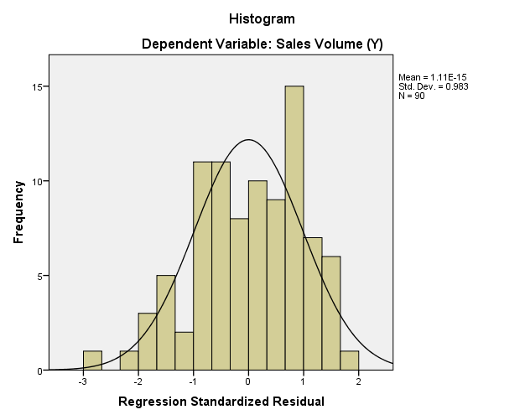

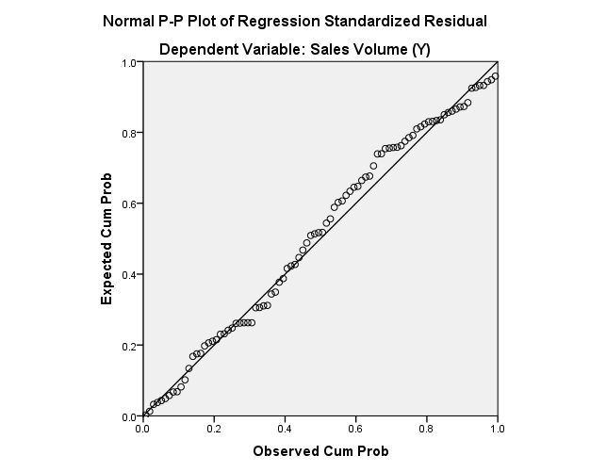

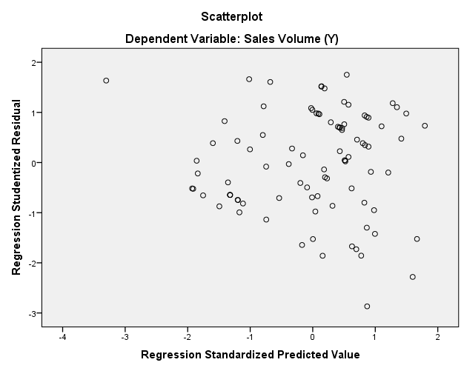
Lampiran 15
FOTO RESPONDEN
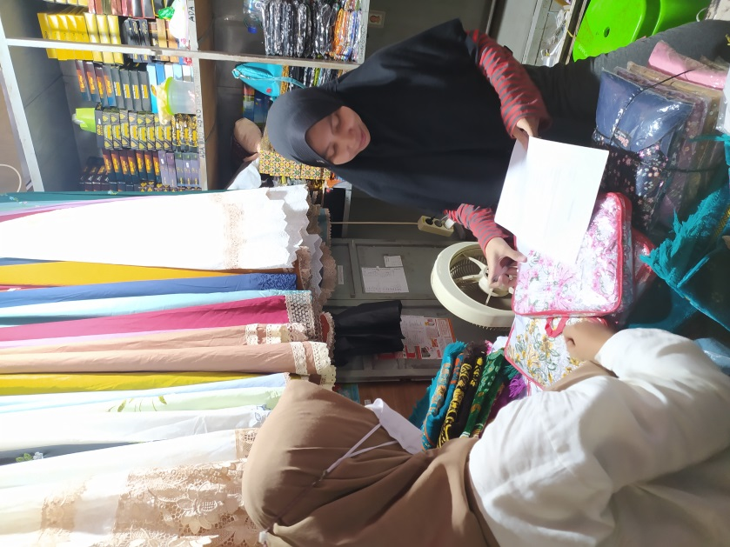
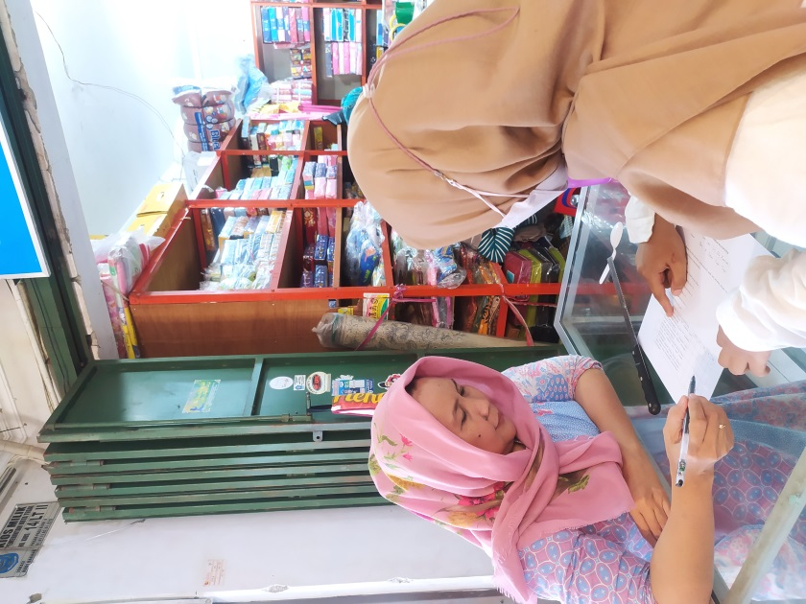
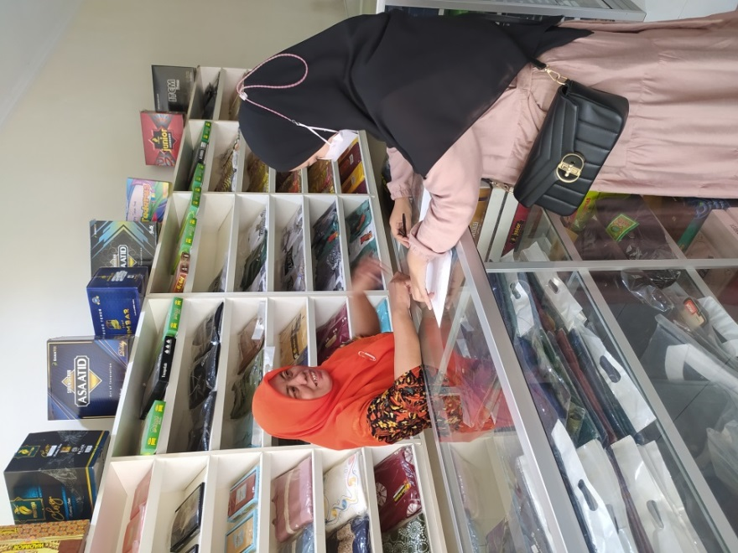
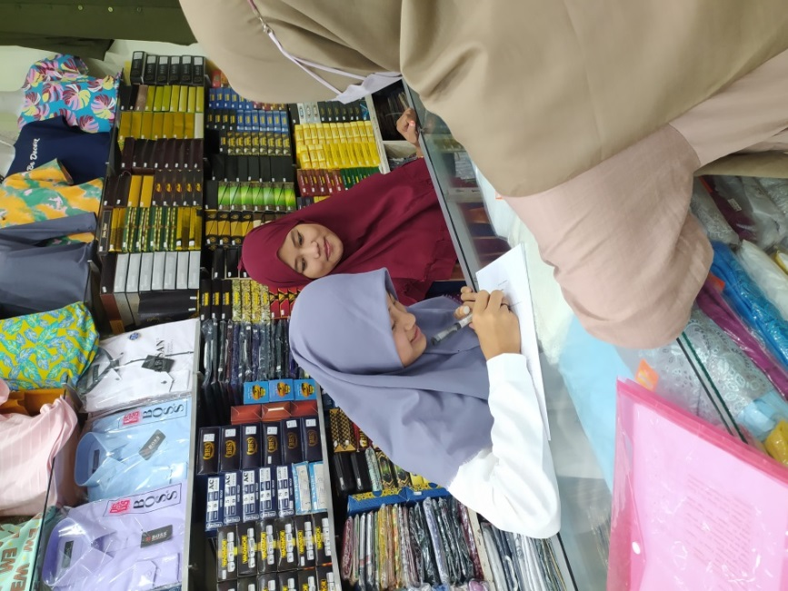
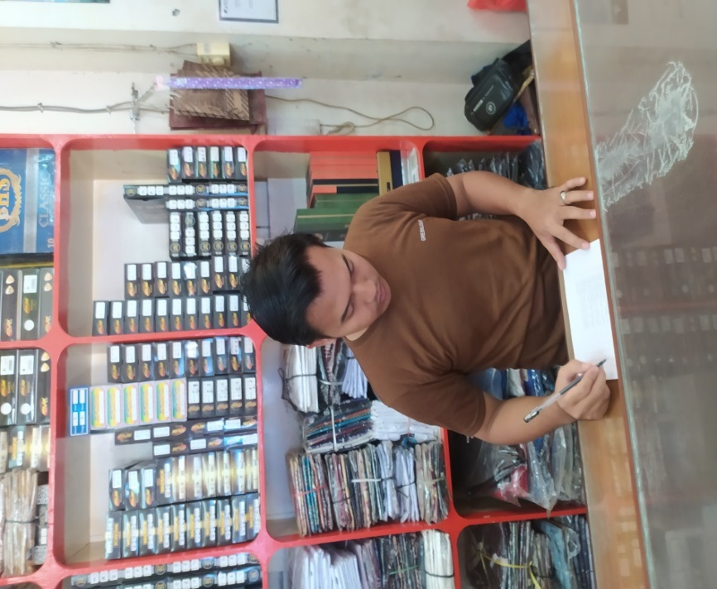
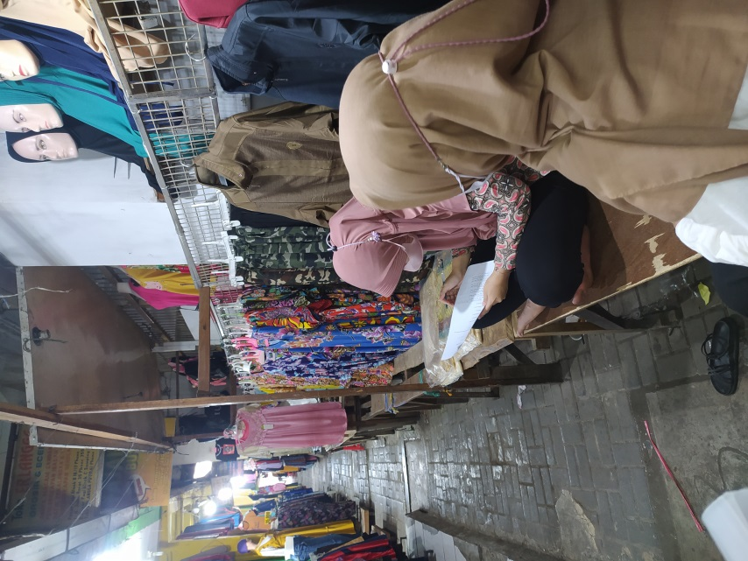
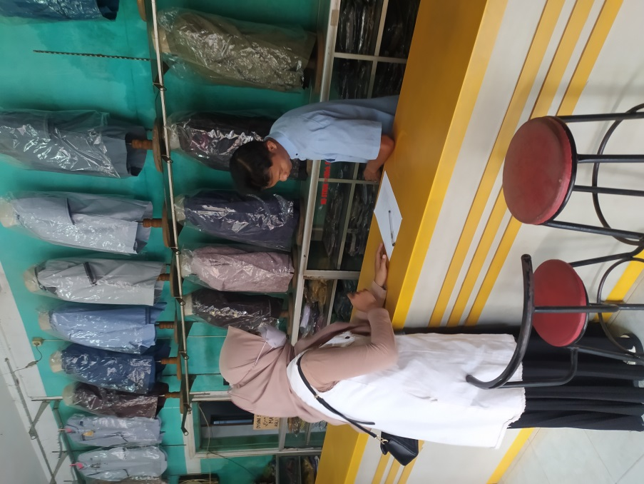
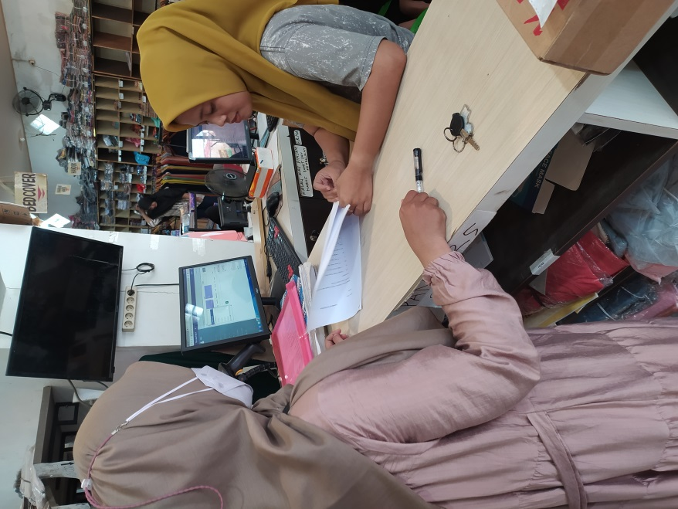
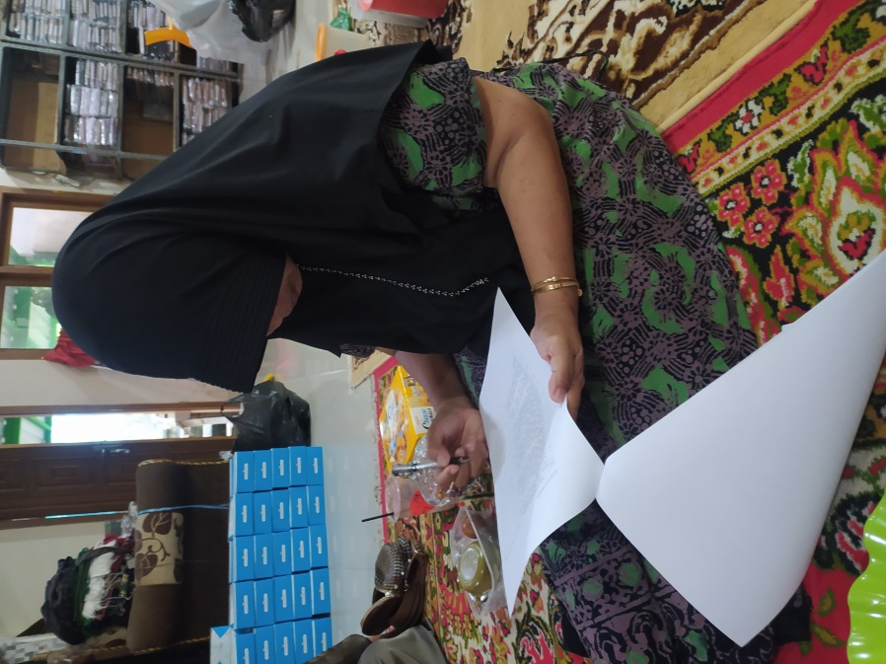
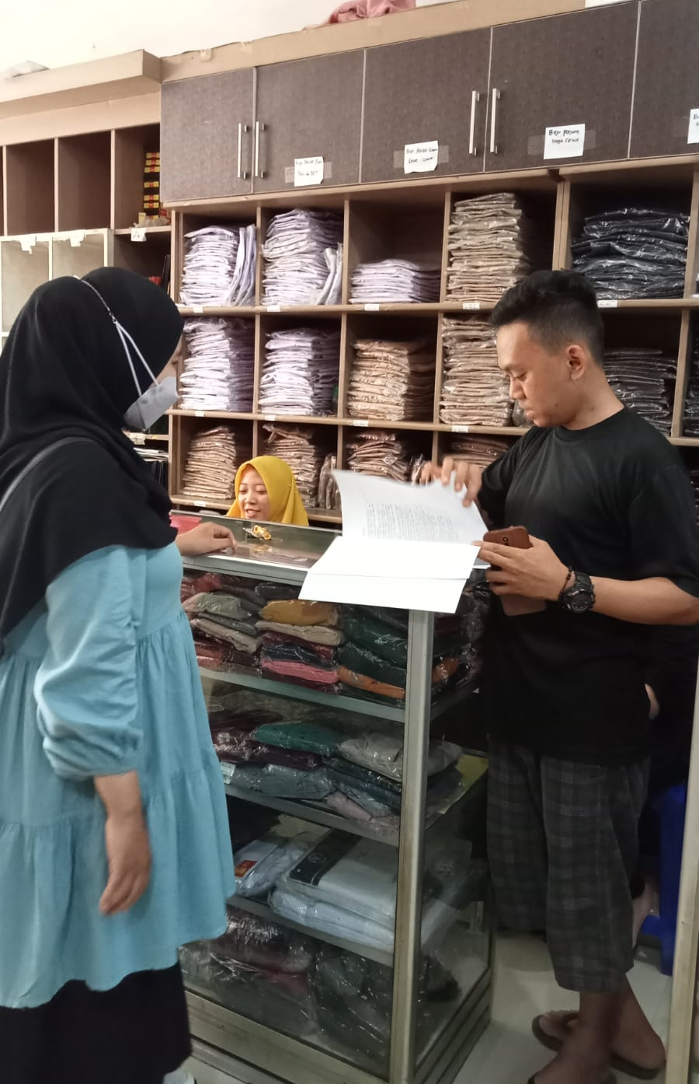
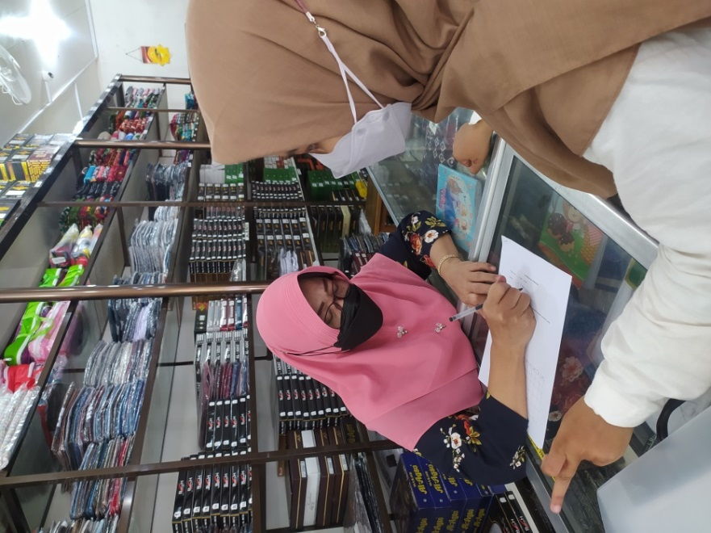
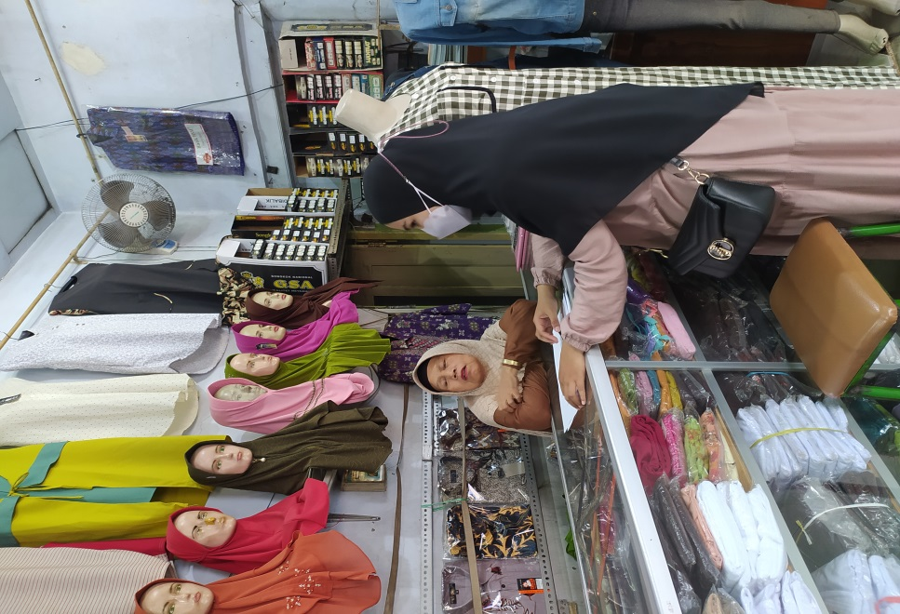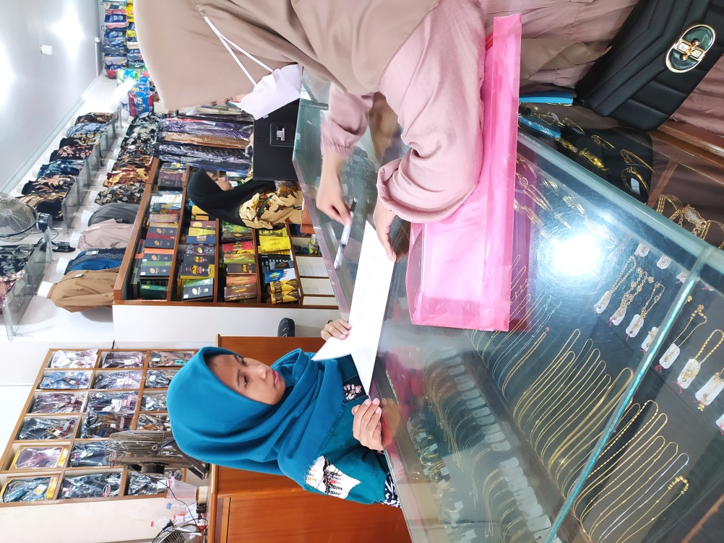
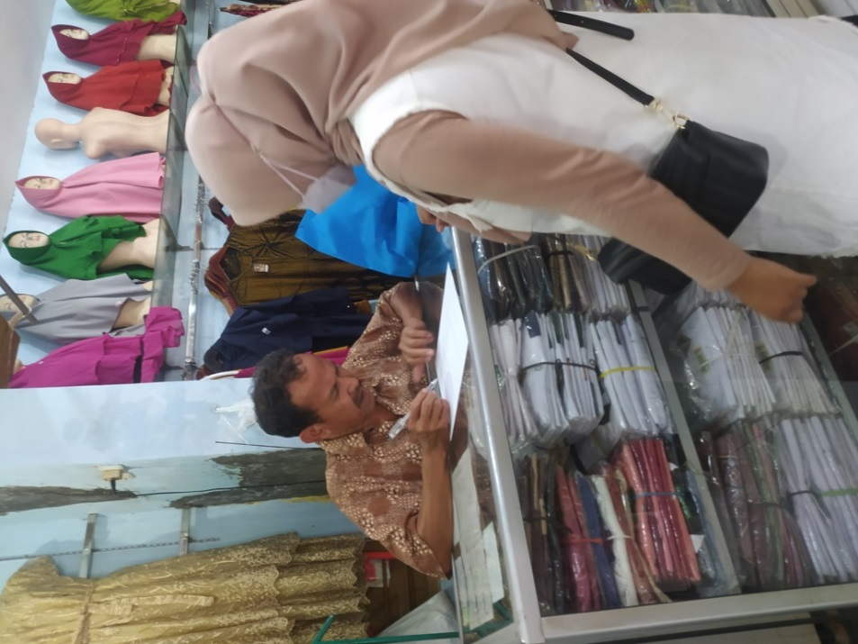

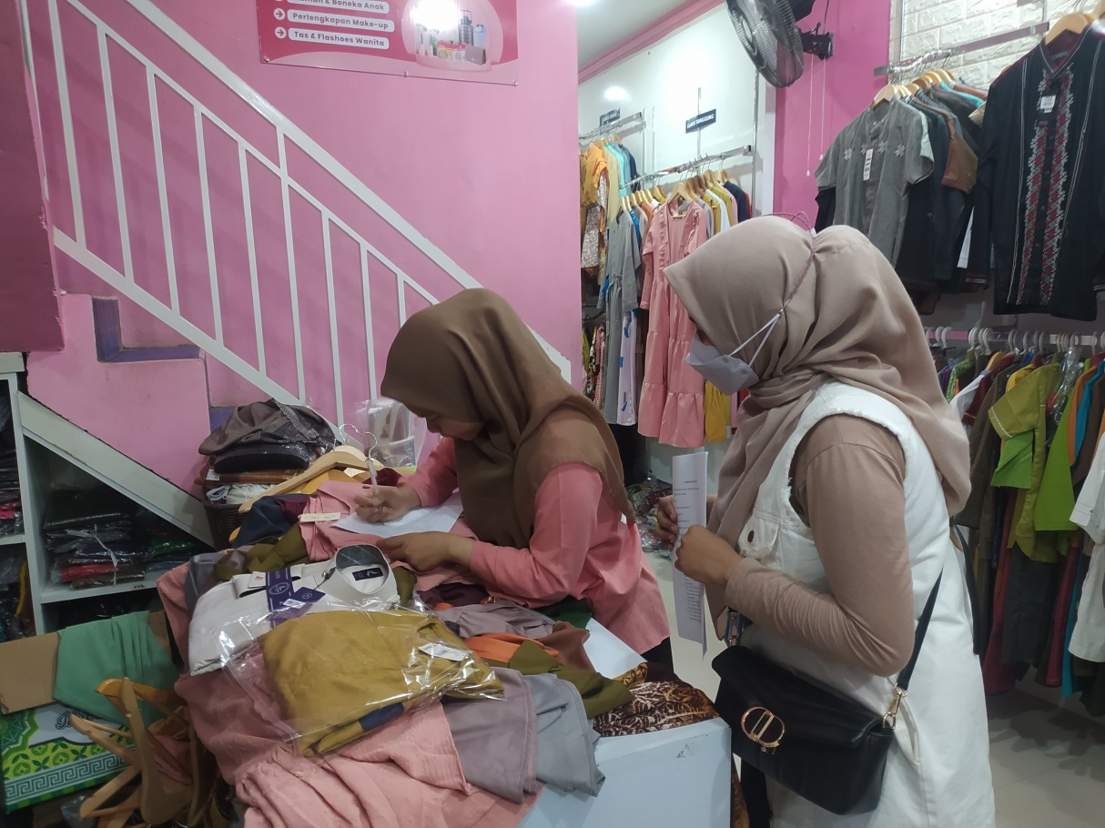
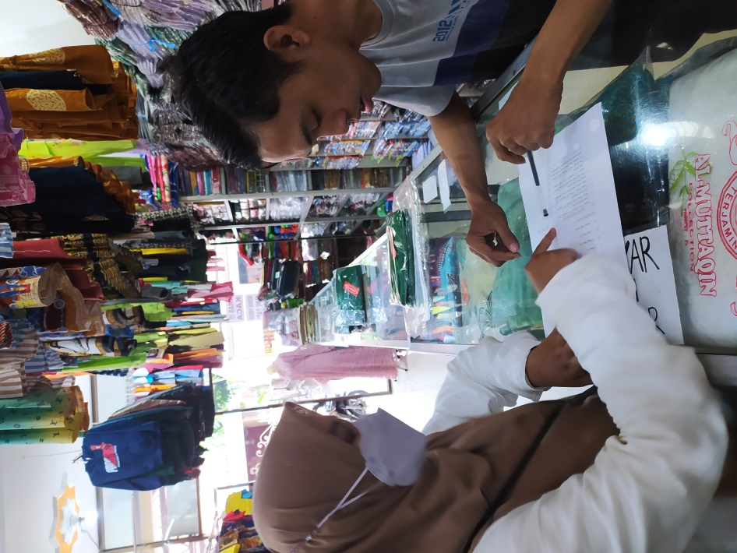

LAMPIRAN 16

 | Tabel Uji F
 | α = 0,05 |  | df1=(k-1)
 | df2=(n  -k- 1) |  | 1 | 2 | 3 | 4 | 5 | 6 | 7 | 8
 | 1 |  | 161.448 | 199,500 | 215.707 | 224,583 | 230,162 | 233.986 | 236,768 | 238,883
 | 2 |  | 18,513 | 19,000 | 19,164 | 19,247 | 19,296 | 19,330 | 19,353 | 19,371
 | 3 |  | 10,128 | 9,552 | 9,277 | 9,117 | 9,013 | 8,941 | 8,887 | 8,845
 | 4 |  | 7,709 | 6,944 | 6,591 | 6,388 | 6,256 | 6,163 | 6,094 | 6,041
 | 5 |  | 6,608 | 5,786 | 5,409 | 5,192 | 5,050 | 4,950 | 4,876 | 4,818
 | 6 |  | 5,987 | 5,143 | 4,757 | 4,534 | 4,387 | 4,284 | 4,207 | 4,147
 | 7 |  | 5,591 | 4,737 | 4,347 | 4,120 | 3,972 | 3,866 | 3,787 | 3,726
 | 8 |  | 5,318 | 4,459 | 4,066 | 3,838 | 3,687 | 3,581 | 3,500 | 3,438
 | 9 |  | 5,117 | 4,256 | 3,863 | 3,633 | 3,482 | 3,374 | 3,293 | 3,230
 | 10 |  | 4,965 | 4,103 | 3,708 | 3,478 | 3,326 | 3,217 | 3,135 | 3,072
 | 11 |  | 4,844 | 3,982 | 3,587 | 3,357 | 3,204 | 3,095 | 3,012 | 2,948
 | 12 |  | 4,747 | 3,885 | 3,490 | 3,259 | 3,106 | 2,996 | 2,913 | 2,849
 | 13 |  | 4,667 | 3,806 | 3,411 | 3,179 | 3,025 | 2,915 | 2,832 | 2,767
 | 14 |  | 4,600 | 3,739 | 3,344 | 3,112 | 2,958 | 2,848 | 2,764 | 2,699
 | 15 |  | 4,543 | 3,682 | 3,287 | 3,056 | 2,901 | 2,790 | 2,707 | 2,641
 | 16 |  | 4,494 | 3,634 | 3,239 | 3,007 | 2,852 | 2,741 | 2,657 | 2,591
 | 17 |  | 4,451 | 3,592 | 3,197 | 2,965 | 2,810 | 2,699 | 2,614 | 2,548
 | 18 |  | 4,414 | 3,555 | 3,160 | 2,928 | 2,773 | 2,661 | 2,577 | 2,510
 | 19 |  | 4,381 | 3,522 | 3,127 | 2,895 | 2,740 | 2,628 | 2,544 | 2,477
 | 20 |  | 4,351 | 3,493 | 3,098 | 2,866 | 2,711 | 2,599 | 2,514 | 2,447
 | 21 |  | 4,325 | 3,467 | 3,072 | 2,840 | 2,685 | 2,573 | 2,488 | 2,420
 | 22 |  | 4,301 | 3,443 | 3,049 | 2,817 | 2,661 | 2,549 | 2,464 | 2,397
 | 23 |  | 4,279 | 3,422 | 3,028 | 2,796 | 2,640 | 2,528 | 2,442 | 2,375
 | 24 |  | 4,260 | 3,403 | 3,009 | 2,776 | 2,621 | 2,508 | 2,423 | 2,355
 | 25 |  | 4,242 | 3,385 | 2,991 | 2,759 | 2,603 | 2,490 | 2,405 | 2,337
 | 26 |  | 4,225 | 3,369 | 2,975 | 2,743 | 2,587 | 2,474 | 2,388 | 2,321
 | 27 |  | 4,210 | 3,354 | 2,960 | 2,728 | 2,572 | 2,459 | 2,373 | 2,305
 | 28 |  | 4,196 | 3,340 | 2,947 | 2,714 | 2,558 | 2,445 | 2,359 | 2,291
 | 29 |  | 4,183 | 3,328 | 2,934 | 2,701 | 2,545 | 2,432 | 2,346 | 2,278
30 |  | 4,171 |  | 3,316 | 2,922 | 2,690 | 2,534 | 2,421 | 2,334 | 2,266
31 |  | 4,160 |  | 3,305 | 2,911 | 2,679 | 2,523 | 2,409 | 2,323 | 2,255
32 |  | 4,149 |  | 3,295 | 2,901 | 2,668 | 2,512 | 2,399 | 2,313 | 2,244
33 |  | 4,139 |  | 3,285 | 2,892 | 2,659 | 2,503 | 2,389 | 2,303 | 2,235
34 |  | 4,130 |  | 3,276 | 2,883 | 2,650 | 2,494 | 2,380 | 2,294 | 2,225
35 |  | 4,121 |  | 3,267 | 2,874 | 2,641 | 2,485 | 2,372 | 2,285 | 2,217
36 |  | 4,113 |  | 3,259 | 2,866 | 2,634 | 2,477 | 2,364 | 2,277 | 2,209
37 |  | 4,105 |  | 3,252 | 2,859 | 2,626 | 2,470 | 2,356 | 2,270 | 2,201
38 |  | 4,098 |  | 3,245 | 2,852 | 2,619 | 2,463 | 2,349 | 2,262 | 2,194
39 |  | 4,091 |  | 3,238 | 2,845 | 2,612 | 2,456 | 2,342 | 2,255 | 2,187
40 |  | 4,085 |  | 3,232 | 2,839 | 2,606 | 2,449 | 2,336 | 2,249 | 2,180
41 |  | 4,079 |  | 3,226 | 2,833 | 2,600 | 2,443 | 2,330 | 2,243 | 2,174
42 |  | 4,073 |  | 3,220 | 2,827 | 2,594 | 2,438 | 2,324 | 2,237 | 2,168
43 |  | 4,067 |  | 3,214 | 2,822 | 2,589 | 2,432 | 2,318 | 2,232 | 2,163
44 |  | 4,062 |  | 3,209 | 2,816 | 2,584 | 2,427 | 2,313 | 2,226 | 2,157
45 |  | 4,057 |  | 3,204 | 2,812 | 2,579 | 2,422 | 2,308 | 2,221 | 2,152
46 |  | 4,052 |  | 3,200 | 2,807 | 2,574 | 2,417 | 2,304 | 2,216 | 2,147
47 |  | 4,047 |  | 3,195 | 2,802 | 2,570 | 2,413 | 2,299 | 2,212 | 2,143
48 |  | 4,043 |  | 3,191 | 2,798 | 2,565 | 2,409 | 2,295 | 2,207 | 2,138
49 |  | 4,038 |  | 3,187 | 2,794 | 2,561 | 2,404 | 2,290 | 2,203 | 2,134
50 |  | 4,034 |  | 3,183 | 2,790 | 2,557 | 2,400 | 2,286 | 2,199 | 2,130
51 |  | 4,030 |  | 3,179 | 2,786 | 2,553 | 2,397 | 2,283 | 2,195 | 2,126
52 |  | 4,027 |  | 3,175 | 2,783 | 2,550 | 2,393 | 2,279 | 2,192 | 2,122
53 |  | 4,023 |  | 3,172 | 2,779 | 2,546 | 2,389 | 2,275 | 2,188 | 2,119
54 |  | 4,020 |  | 3,168 | 2,776 | 2,543 | 2,386 | 2,272 | 2,185 | 2,115
55 |  | 4,016 |  | 3,165 | 2,773 | 2,540 | 2,383 | 2,269 | 2,181 | 2,112
56 |  | 4,013 |  | 3,162 | 2,769 | 2,537 | 2,380 | 2,266 | 2,178 | 2,109
57 |  | 4,010 |  | 3,159 | 2,766 | 2,534 | 2,377 | 2,263 | 2,175 | 2,106
58 |  | 4,007 |  | 3,156 | 2,764 | 2,531 | 2,374 | 2,260 | 2,172 | 2,103
59 |  | 4,004 |  | 3,153 | 2,761 | 2,528 | 2,371 | 2,257 | 2,169 | 2,100
60 |  | 4,001 |  | 3,150 | 2,758 | 2,525 | 2,368 | 2,254 | 2,167 | 2,097
61 |  | 3,998 |  | 3,148 | 2,755 | 2,523 | 2,366 | 2,251 | 2,164 | 2,094
62 |  | 3,996 |  | 3,145 | 2,753 | 2,520 | 2,363 | 2,249 | 2,161 | 2,092
63 |  | 3,993 |  | 3,143 | 2,751 | 2,518 | 2,361 | 2,246 | 2,159 | 2,089
64 |  | 3,991 |  | 3,140 | 2,748 | 2,515 | 2,358 | 2,244 | 2,156 | 2,087
65 |  | 3,989 |  | 3,138 | 2,746 | 2,513 | 2,356 | 2,242 | 2,154 | 2,084
66 |  | 3,986 |  | 3,136 | 2,744 | 2,511 | 2,354 | 2,239 | 2,152 | 2,082
67 |  | 3,984 |  | 3,134 | 2,742 | 2,509 | 2,352 | 2,237 | 2,150 | 2,080
68 |  | 3,982 |  | 3,132 | 2,740 | 2,507 | 2,350 | 2,235 | 2,148 | 2,078
69 |  | 3,980 |  | 3,130 | 2,737 | 2,505 | 2,348 | 2,233 | 2,145 | 2,076
70 |  | 3,978 |  | 3,128 | 2,736 | 2,503 | 2,346 | 2,231 | 2,143 | 2,074
71 |  | 3,976 |  | 3,126 | 2,734 | 2,501 | 2,344 | 2,229 | 2,142 | 2,072
72 |  | 3,974 |  | 3,124 | 2,732 | 2,499 | 2,342 | 2,227 | 2,140 | 2,070
73 |  | 3,972 |  | 3,122 | 2,730 | 2,497 | 2,340 | 2,226 | 2,138 | 2,068
74 |  | 3,970 |  | 3,120 | 2,728 | 2,495 | 2,338 | 2,224 | 2,136 | 2,066
75 |  | 3,968 |  | 3,119 | 2,727 | 2,494 | 2,337 | 2,222 | 2,134 | 2,064
76 |  | 3,967 |  | 3,117 | 2,725 | 2,492 | 2,335 | 2,220 | 2,133 | 2,063
77 |  | 3,965 |  | 3,115 | 2,723 | 2,490 | 2,333 | 2,219 | 2,131 | 2,061
78 |  | 3,963 |  | 3,114 | 2,722 | 2,489 | 2,332 | 2,217 | 2,129 | 2,059
79 |  | 3,962 |  | 3,112 | 2,720 | 2,487 | 2,330 | 2,216 | 2,128 | 2,058
80 |  | 3,960 |  | 3,111 | 2,719 | 2,486 | 2,329 | 2,214 | 2,126 | 2,056
81 |  | 3,959 |  | 3,109 | 2,717 | 2,484 | 2,327 | 2,213 | 2,125 | 2,055
82 |  | 3,957 |  | 3,108 | 2,716 | 2,483 | 2,326 | 2,211 | 2,123 | 2,053
83 |  | 3,956 |  | 3,107 | 2,715 | 2,482 | 2,324 | 2,210 | 2,122 | 2,052
84 |  | 3,955 |  | 3,105 | 2,713 | 2,480 | 2,323 | 2,209 | 2,121 | 2,051
85 |  | 3,953 |  | 3,104 | 2,712 | 2,479 | 2,322 | 2,207 | 2,119 | 2,049
86 |  | 3,952 |  | 3,103 | 2,711 | 2,478 | 2,321 | 2,206 | 2,118 | 2,048
87 |  | 3,951 |  | 3,101 | 2,709 | 2,476 | 2,319 | 2,205 | 2,117 | 2,047
88 |  | 3,949 |  | 3,100 | 2,708 | 2,475 | 2,318 | 2,203 | 2,115 | 2,045
89 |  | 3,948 |  | 3,099 | 2,707 | 2,474 | 2,317 | 2,202 | 2,114 | 2,044
90 |  | 3,947 |  | 3,098 | 2,706 | 2,473 | 2,316 | 2,201 | 2,113 | 2,043
91 |  | 3,946 |  | 3,097 | 2,705 | 2,472 | 2,315 | 2,200 | 2,112 | 2,042
92 |  | 3,945 |  | 3,095 | 2,704 | 2,471 | 2,313 | 2,199 | 2,111 | 2,041
93 |  | 3,943 |  | 3,094 | 2,703 | 2,470 | 2,312 | 2,198 | 2,110 | 2,040
94 |  | 3,942 |  | 3,093 | 2,701 | 2,469 | 2,311 | 2,197 | 2,109 | 2,038
95 |  | 3,941 |  | 3,092 | 2,700 | 2,467 | 2,310 | 2,196 | 2,108 | 2,037
96 |  | 3,940 |  | 3,091 | 2,699 | 2,466 | 2,309 | 2,195 | 2,106 | 2,036
97 |  | 3,939 |  | 3,090 | 2,698 | 2,465 | 2,308 | 2,194 | 2,105 | 2,035
98 |  | 3,938 |  | 3,089 | 2,697 | 2,465 | 2,307 | 2,193 | 2,104 | 2,034
99 |  | 3,937 |  | 3,088 | 2,696 | 2,464 | 2,306 | 2,192 | 2,103 | 2,033
100 |  | 3,936 |  | 3,087 | 2,696 | 2,463 | 2,305 | 2,191 | 2,103 | 2,032

Lampiran 17
Tabel Uji t
df=(n-k) | α = 0.05 | α = 0.025
1 | 6,314 | 12,706
2 | 2,920 | 4,303
3 | 2,353 | 3,182
4 | 2,132 | 2,776
5 | 2,015 | 2,571
6 | 1,943 | 2,447
7 | 1,895 | 2,365
8 | 1,860 | 2,306
9 | 1,833 | 2,262
10 | 1,812 | 2,228
11 | 1,796 | 2,201
12 | 1,782 | 2,179
13 | 1,771 | 2,160
14 | 1,761 | 2,145
15 | 1,753 | 2,131
16 | 1,746 | 2,120
17 | 1,740 | 2,110
18 | 1,734 | 2,101
19 | 1,729 | 2,093
20 | 1,725 | 2,086
21 | 1,721 | 2,080
22 | 1,717 | 2,074
23 | 1,714 | 2,069
24 | 1,711 | 2,064
25 | 1,708 | 2,060
26 | 1,706 | 2,056
27 | 1,703 | 2,052
28 | 1,701 | 2,048
29 | 1,699 | 2,045
30 | 1,697 | 2,042
31 | 1,696 | 2,040
32 | 1,694 | 2,037
33 | 1,692 | 2,035
34 | 1,691 | 2,032
35 | 1,690 | 2,030
36 | 1,688 | 2,028
37 | 1,687 | 2,026
38 | 1,686 | 2,024
39 | 1,685 | 2,023
40 | 1,684 | 2,021
41 | 1,683 | 2,020
42 | 1,682 | 2,018
43 | 1,681 | 2,017
44 | 1,680 | 2,015
45 | 1,679 | 2,014
46 | 1,679 | 2,013
47 | 1,678 | 2,012
48 | 1,677 | 2,011
49 | 1,677 | 2,010
df=(n-k) | α = 0.05 | α = 0.025
51 | 1,675 | 2,008
52 | 1,675 | 2,007
53 | 1,674 | 2,006
54 | 1,674 | 2,005
55 | 1,673 | 2,004
56 | 1,673 | 2,003
57 | 1,672 | 2,002
58 | 1,672 | 2,002
59 | 1,671 | 2,001
60 | 1,671 | 2,000
61 | 1,670 | 2,000
62 | 1,670 | 1,999
63 | 1,669 | 1,998
64 | 1,669 | 1,998
65 | 1,669 | 1,997
66 | 1,668 | 1,997
67 | 1,668 | 1,996
68 | 1,668 | 1,995
69 | 1,667 | 1,995
70 | 1,667 | 1,994
71 | 1,667 | 1,994
72 | 1,666 | 1,993
73 | 1,666 | 1,993
74 | 1,666 | 1,993
75 | 1,665 | 1,992
76 | 1,665 | 1,992
77 | 1,665 | 1,991
78 | 1,665 | 1,991
79 | 1,664 | 1,990
80 | 1,664 | 1,990
81 | 1,664 | 1,990
82 | 1,664 | 1,989
83 | 1,663 | 1,989
84 | 1,663 | 1,989
85 | 1,663 | 1,988
86 | 1,663 | 1,988
87 | 1,663 | 1,988
88 | 1,662 | 1,987
89 | 1,662 | 1,987
90 | 1,662 | 1,987
91 | 1,662 | 1,986
92 | 1,662 | 1,986
93 | 1,661 | 1,986
94 | 1,661 | 1,986
95 | 1,661 | 1,985
96 | 1,661 | 1,985
97 | 1,661 | 1,985
98 | 1,661 | 1,984
99 | 1,660 | 1,984

