DAFTAR PUSTAKA

ASM Handbook Committee. 1985. ASM Handbook Volume 9 Metallography & Microstructures. United States of America

Berbasis, G., & Atmega, M. (2016). JDS, Jilid II No. 2, Oktober 2016. 2, 372–379.

Hafni, H. (2016). Pengaruh Komposisi Arang Aktif Dan Kalsium Karbonat Pada Pack Carburizing Terhadap Microstructure. Jurnal Iptek Terapan, 10(1), 1–8. https://doi.org/10.22216/jit.2016.v10i1.426

Hamzah, M. S., & Iqbal, D. M. (2008). Peningkatan Ketahanan Aus Baja Karbon Rendah Dengan Metode Carburizing. Jurnal SMARTek, 6(3), 169–175.

Isworo, H., & Sumantri, D. (2020). Pengaruh Holding Time Dan Media Pendingin Terhadap Kekerasan Dan Struktur Mikro Baja St41 Pada Proses Carburizing Arang Tempurung Kelapa. Elemen : Jurnal Teknik Mesin, 7(2), 157–166.

Mechanical, J., Teknik, J., Fakultas, M., Universitas, T., & Kunci, K. (2016).150626-ID-proses-pack-carburizing-dengan-media-car.
7(September), 36–41.

Wardani, S., & Rosa, E. (2018). Potensi Limbah Tulang Kambing Sebagai Arang Aktif Yang Teraktivasi Asam Sulfat. Jurnal Serambi Engineering, 3(2). https://doi.org/10.32672/jse.v3i2.714

Wardani, S., Rosa, E., & Mirdayanti, R. (2020). Pengolahan Limbah Tulang Kambing Sebagai Produk Arang Aktif Menggunakan Proses Aktivasi Kimia dan Fisika. Jurnal Ilmu Lingkungan, 18(1), 67–72. https://doi.org/10.14710/jil.18.1.67-72

Yousif, N., Cole, J., Rothwell, J. C., Diedrichsen, J., Zelik, K. E., Winstein, C. J., Kay, D. B., Wijesinghe, R., Protti, D. A., Camp, A. J., Quinlan, E., Jacobs, J. V, Henry, S. M., Horak, F. B., Jacobs, J. V, Fraser, L. E., Mansfield, A., Harris,

60

L. R., Merino, D. M., … Dublin, C. (2018). No Analisis Struktur Kovarians Indeks Terkait Kesehatan untuk Lansia di Rumah, Berfokus pada Perasaan Subyektif Kesehatan.

LAMPIRAN

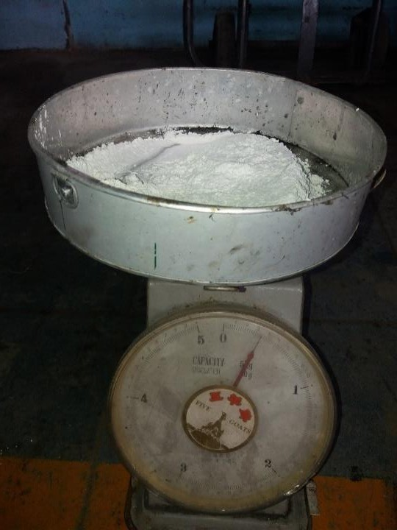
Foto Barium Karbonat

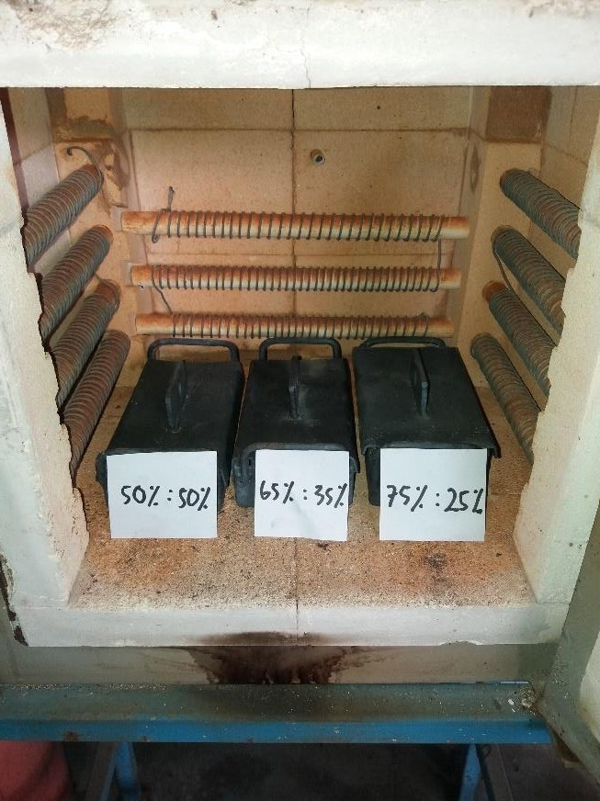
Proses karburizing

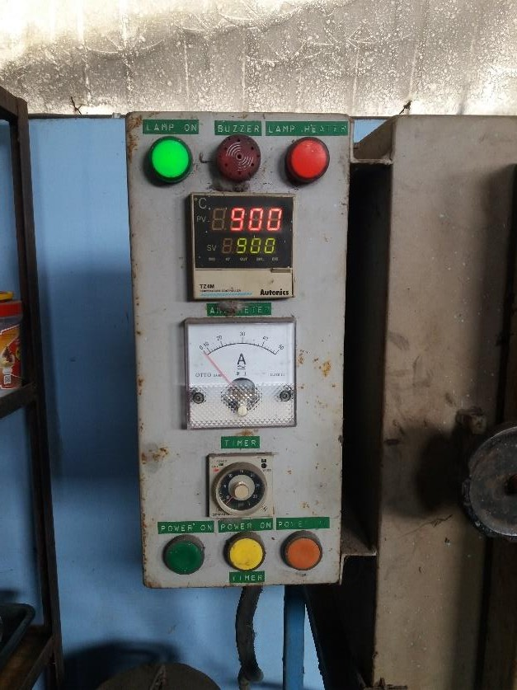

Proses holding time suhu 900 derajad

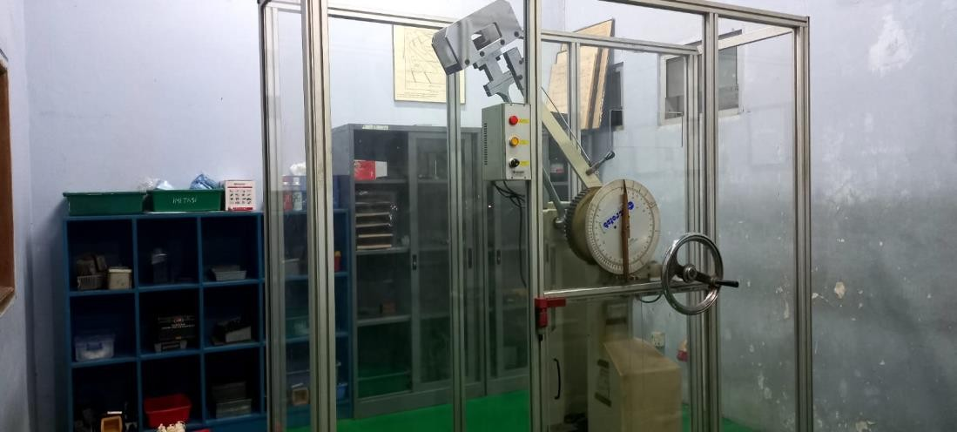
Proses Uji impek

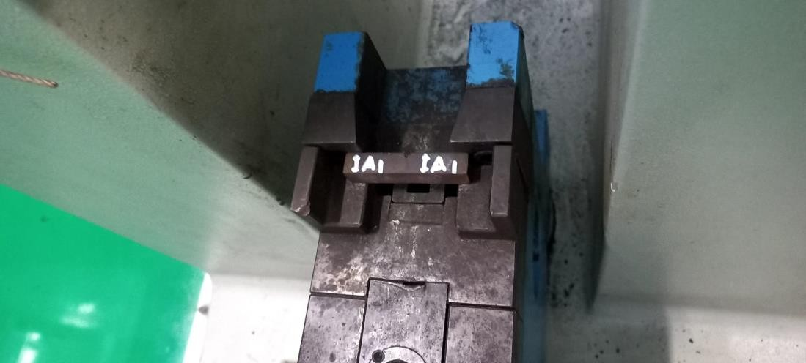

Spesimen siap uji

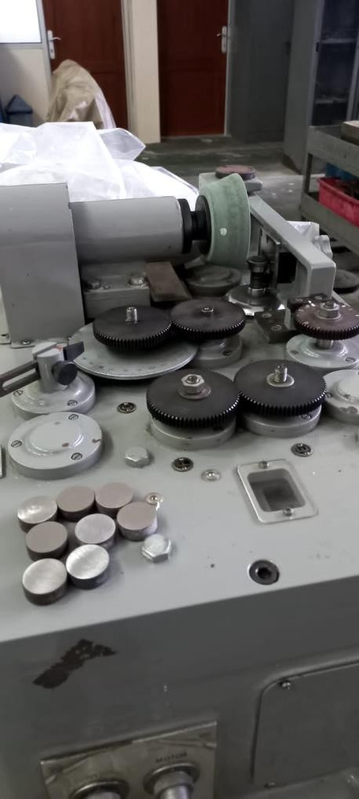

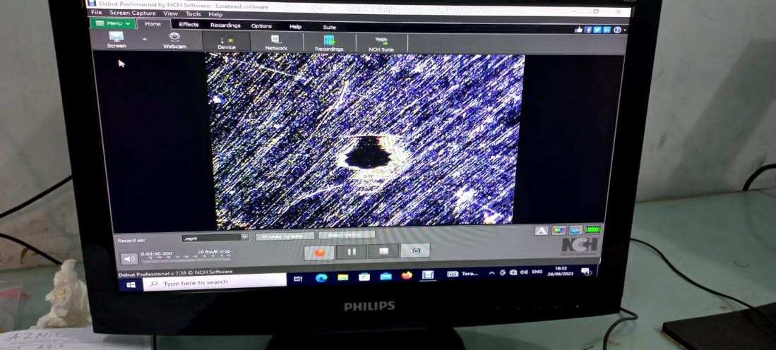

Spesimen hasil uji keausan

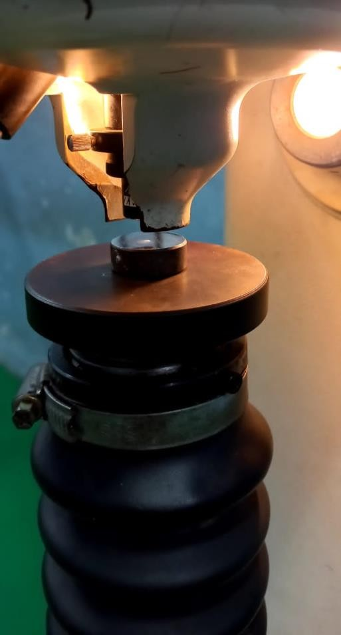

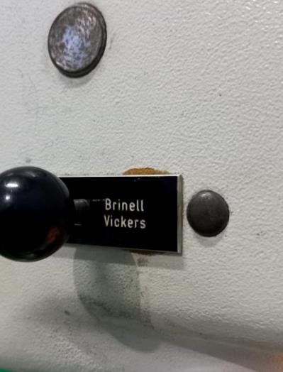

Mesin uji kekarasan (brinel)

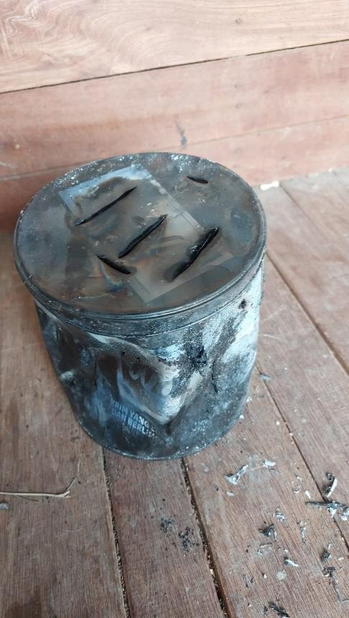

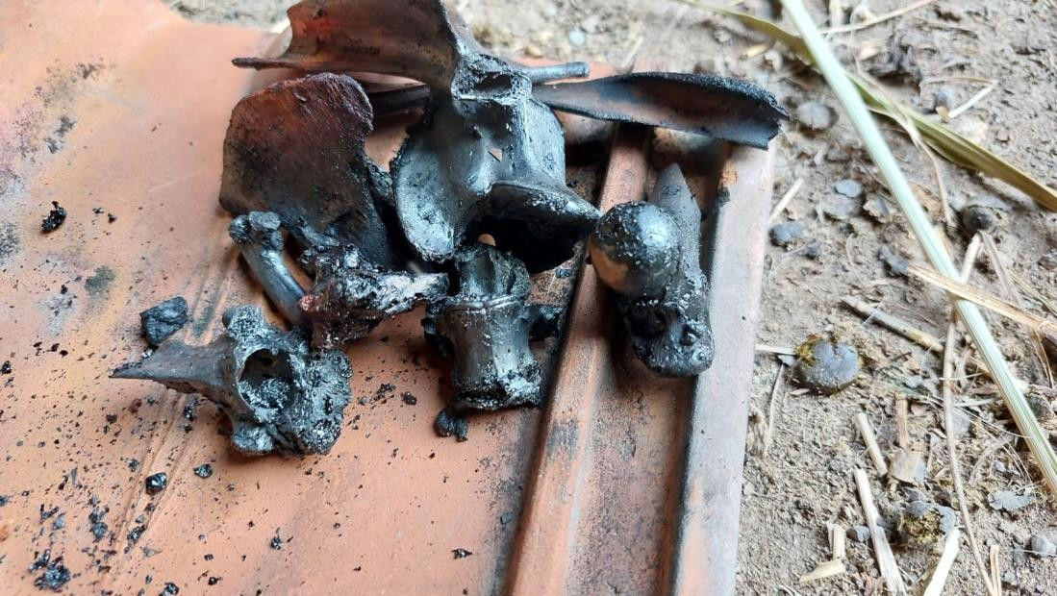
Gambar tulang setelah terbakar

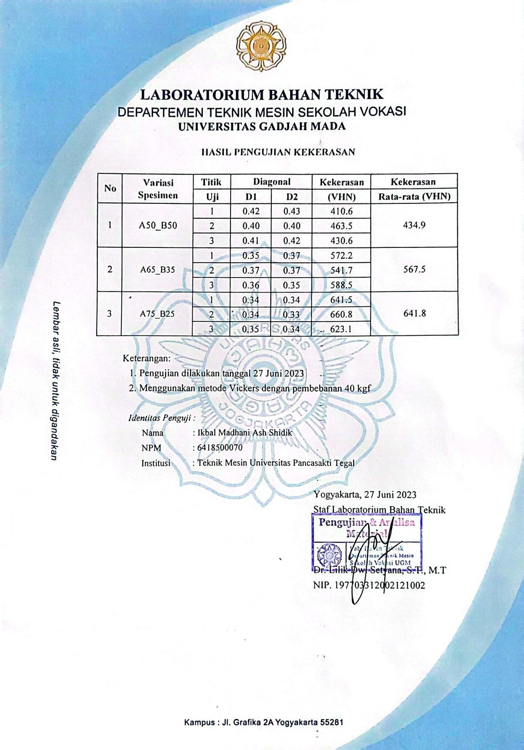

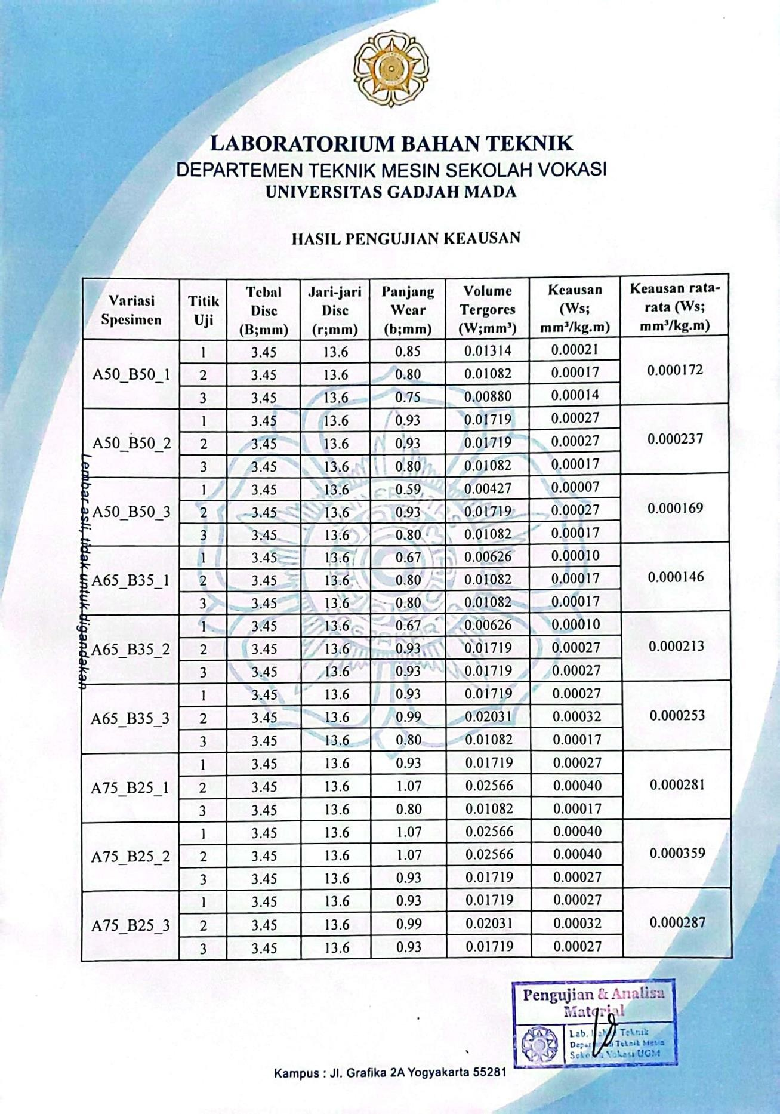

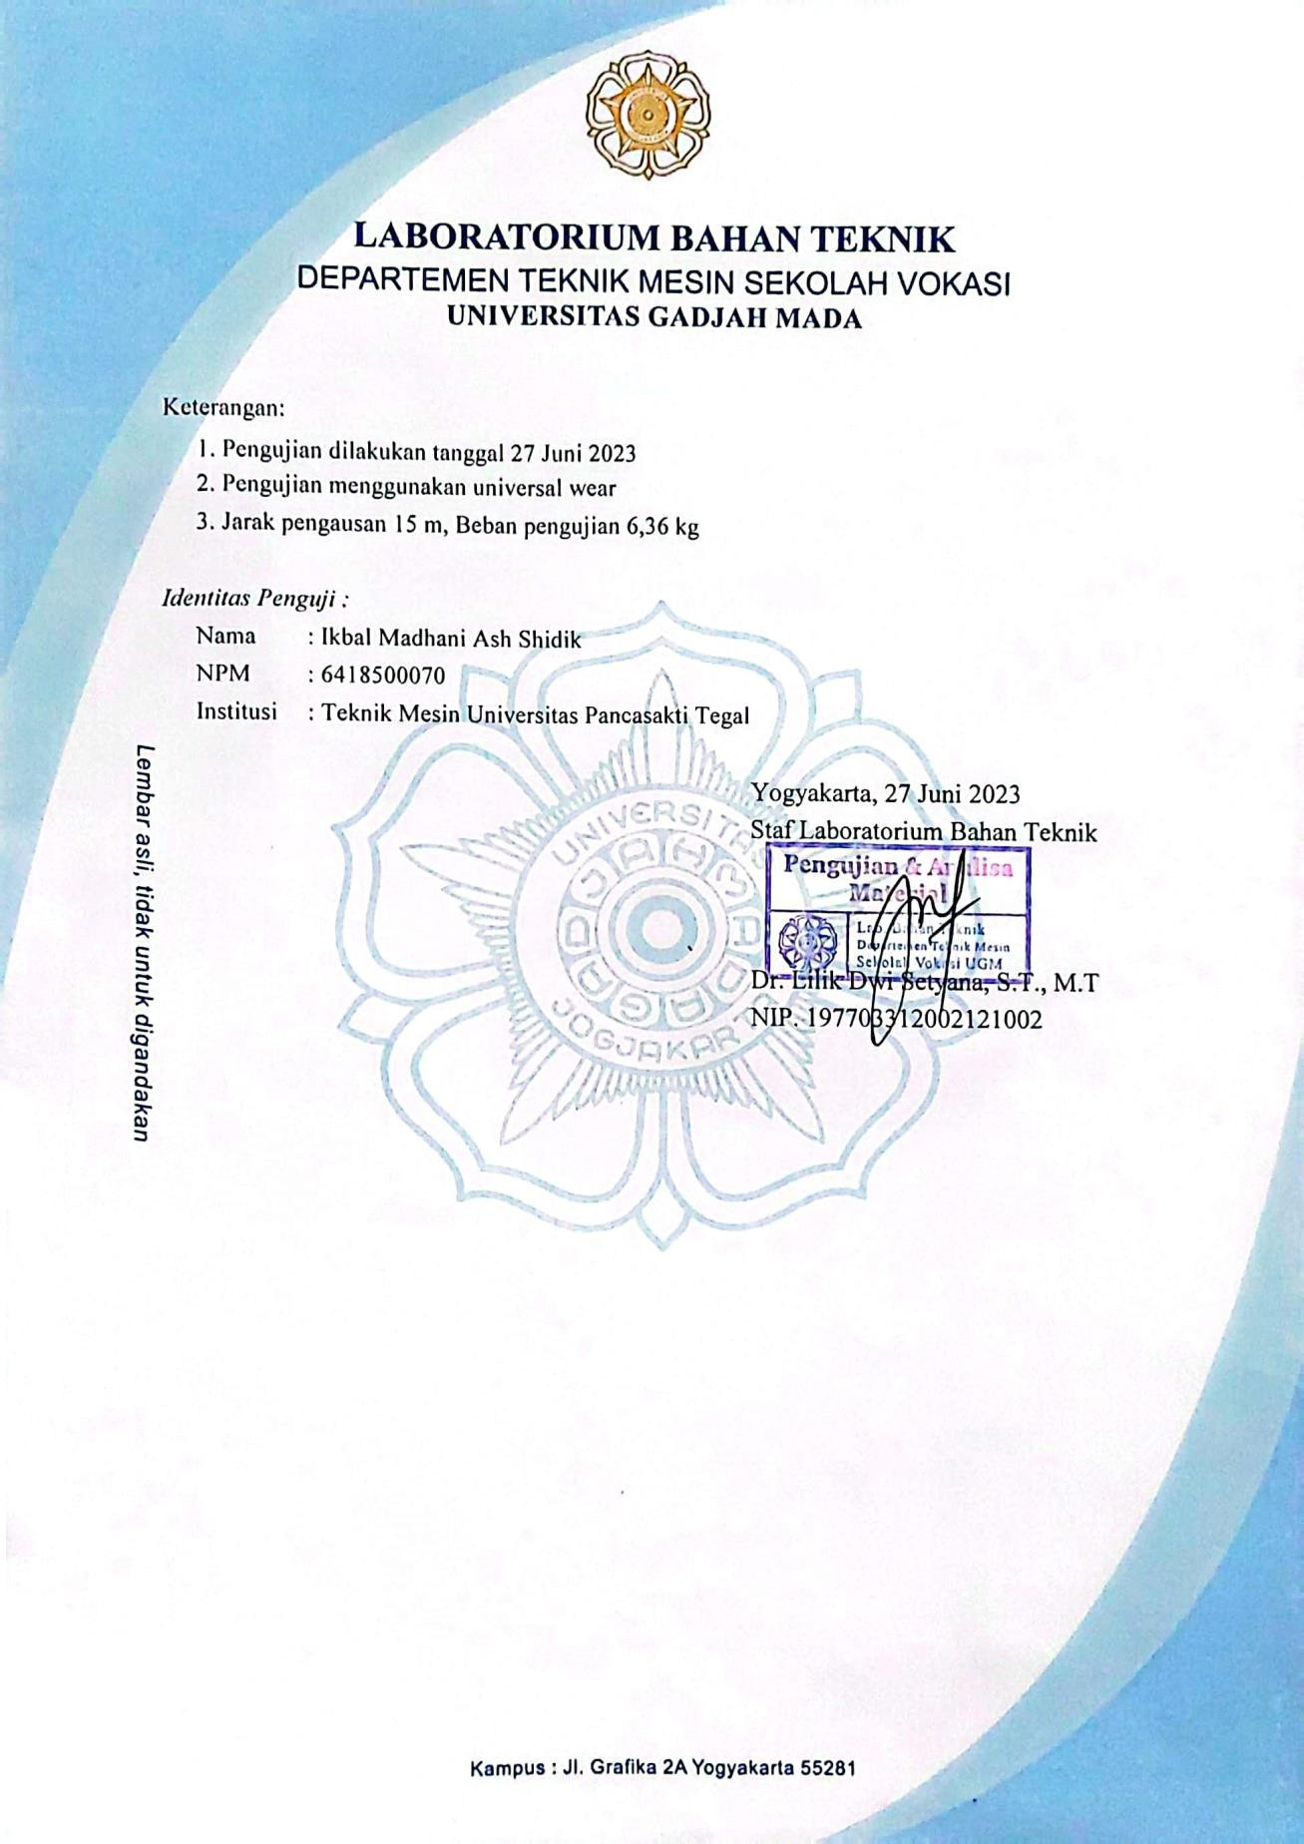

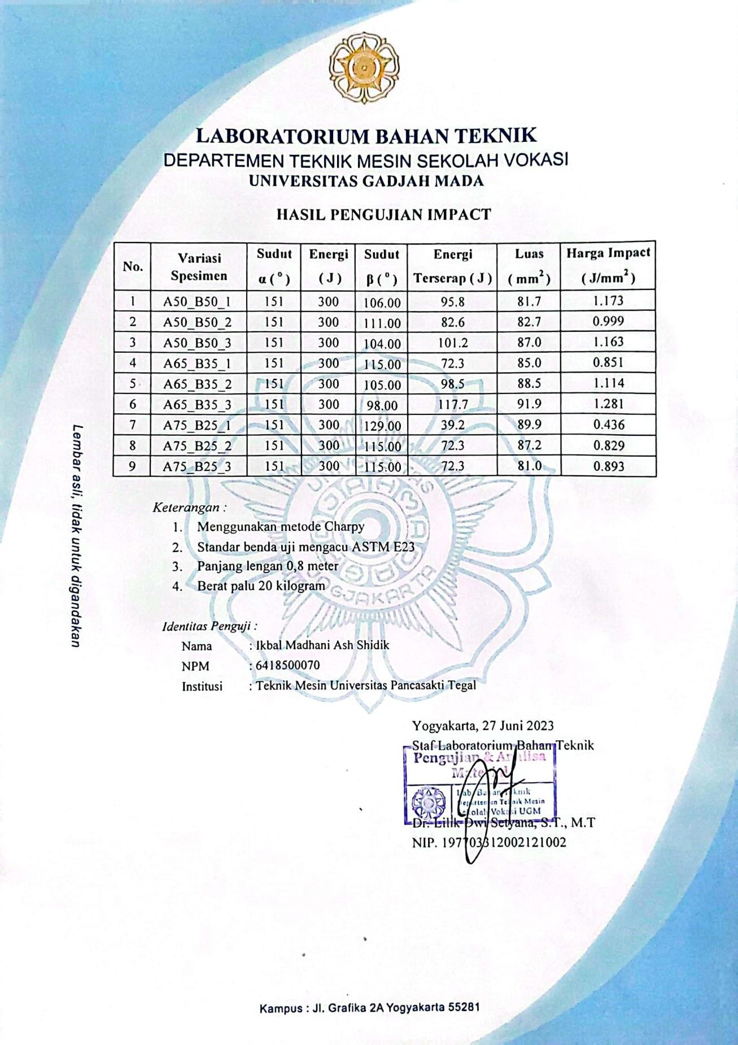

Perhitungan
- Menghitung nilai kekerasan

  - Variasi raw material

VHN=
(1,854)P

𝑑2

Dimana:

P = Beban penekan ( Kgf )

D = Rata-rata diagonal jejak (mm)

Pengolahan data di bawah ini menggunakan baja st 41 dengan variasi perbandingan 650:350 gram

    - VHN=
(1,854)P

𝑑2

= 1,854 𝑥 40
0,682

= 74,16
0,4624

= 160,4 VHN

    - VHN=
(1,854)P

𝑑2

= 1,854 𝑥 40
0,682

= 74,16
0,4624

= 160,4 VHN

    - VHN=
(1,854)P

𝑑2

= 1,854 𝑥 40
0,692

= 74,16
0,4761

= 155,8 VHN

  - Variasi 500 : 500 gram

- VHN=
(1,854)P

𝑑2

= 1,854 𝑥 40
0,4252

= 74,16
0,180625

= 410,6 VHN

- VHN=
(1,854)P

𝑑2

= 1,854 𝑥 40
0,402

=74,16
0,16

= 463,5 VHN

- VHN=
(1,854)P

𝑑2

= 1,854 𝑥 40
0,4152

= 74,16
0,172225

= 430,6 VHN

  - Variasi 650 : 350 gram

- VHN=
(1,854)P

𝑑2

= 1,854 𝑥 40
0,362

= 74,16
0,1296

= 572,2 VHN

- VHN=
(1,854)P

𝑑2

= 1,854 𝑥 40
0,372

= 74,16
0,1369

= 541,7 VHN

- VHN=
(1,854)P

𝑑2

= 1,854 𝑥 40
0,3552

= 74,16
0,126025

= 588,5 VHN

  - Variasi 750 : 250 gram

- VHN=
(1,854)P

𝑑2

= 1,854 𝑥 40
0,342

= 74,16
0,1156

= 641,5 VHN

- VHN=
(1,854)P

𝑑2

= 1,854 𝑥 40
0,3352

= 74,16
0,112225

= 660,8 VHN

- VHN=
(1,854)P

𝑑2

= 1,854 𝑥 40
0,3452

= 74,16
0,119025

= 623,1 VHN

- Menghitung nilai keausan

  - Variasi raw 1 material

1) 𝑤 = 𝐵.𝑏3
8 𝑟.𝑝𝑜.𝑙𝑜

3,45 𝑥1,903
=
8𝑥13,6𝑥6,36𝑥15

= 23,66355
10.379,52

= 0,00228 𝑚𝑚³/𝑘𝑔

2) 𝑤 = 𝐵.𝑏3
8 𝑟.𝑝𝑜.𝑙𝑜

3,45 𝑥1,903
=
8𝑥13,6𝑥6,36𝑥15

= 23,66355
10.379,52

= 0,00228 𝑚𝑚³/𝑘𝑔

3) 𝑤 = 𝐵.𝑏3
8 𝑟.𝑝𝑜.𝑙𝑜

3,45 𝑥2,003
=
8𝑥13,6𝑥6,36𝑥15

= 27,6
10.379,52

= 0,00266 𝑚𝑚³/𝑘𝑔

  - Variasi raw 2 material

1) 𝑤 = 𝐵.𝑏3
8 𝑟.𝑝𝑜.𝑙𝑜

3,45 𝑥1,853
=
8𝑥13,6𝑥6,36𝑥15

= 21,8441063
10.379,52

= 0,00210 𝑚𝑚³/𝑘𝑔

2) 𝑤 = 𝐵.𝑏3
8 𝑟.𝑝𝑜.𝑙𝑜

3,45 𝑥1,903
=
8𝑥13,6𝑥6,36𝑥15

= 23,66355
10.379,52

= 0,00228 𝑚𝑚³/𝑘𝑔

3) 𝑤 = 𝐵.𝑏3
8 𝑟.𝑝𝑜.𝑙𝑜

3,45 𝑥1,853
=
8𝑥13,6𝑥6,36𝑥15

= 21,8441063
10.379,52

= 0,00210 𝑚𝑚³/𝑘𝑔

  - Variasi raw 3 material

1) 𝑤 = 𝐵.𝑏3
8 𝑟.𝑝𝑜.𝑙𝑜

3,45 𝑥1,903
=
8𝑥13,6𝑥6,36𝑥15

= 23,66355
10.379,52

= 0,00228 𝑚𝑚³/𝑘𝑔

2) 𝑤 = 𝐵.𝑏3
8 𝑟.𝑝𝑜.𝑙𝑜

3,45 𝑥1,803
=
8𝑥13,6𝑥6,36𝑥15

= 20,1204
10.379,52

= 0,00194𝑚𝑚³/𝑘𝑔

3) 𝑤 = 𝐵.𝑏3
8 𝑟.𝑝𝑜.𝑙𝑜

3,45 𝑥1,853
=
8𝑥13,6𝑥6,36𝑥15

= 21,8441063
10.379,52

= 0,00210 𝑚𝑚³/𝑘𝑔

  - Variasi 500:500 gram 1

1) 𝑤 = 𝐵.𝑏3
8 𝑟.𝑝𝑜.𝑙𝑜

3,45 𝑥0,853
=
8𝑥13,6𝑥6,36𝑥15

= 2,11873125
10.379,52

= 0,00021 𝑚𝑚³/𝑘𝑔

2) 𝑤 = 𝐵.𝑏3
8 𝑟.𝑝𝑜.𝑙𝑜

3,45 𝑥0,803
=
8𝑥13,6𝑥6,36𝑥15

= 1,7664
10.379,52

= 0,00017𝑚𝑚³/𝑘𝑔

3) 𝑤 = 𝐵.𝑏3
8 𝑟.𝑝𝑜.𝑙𝑜

3,45 𝑥0,753
=
8𝑥13,6𝑥6,36𝑥15

= 1,45546875
10.379,52

= 0,00014 𝑚𝑚³/𝑘𝑔

  - Variasi 500:500 gram 2

1) 𝑤 = 𝐵.𝑏3
8 𝑟.𝑝𝑜.𝑙𝑜

3,45 𝑥0,933
=
8𝑥13,6𝑥6,36𝑥15

= 2,77503165
10.379,52

= 0,00027𝑚𝑚³/𝑘𝑔

2) 𝑤 = 𝐵.𝑏3
8 𝑟.𝑝𝑜.𝑙𝑜

3,45 𝑥0,933
=
8𝑥13,6𝑥6,36𝑥15

= 2,77503165
10.379,52

= 0,00027𝑚𝑚³/𝑘𝑔

3) 𝑤 = 𝐵.𝑏3
8 𝑟.𝑝𝑜.𝑙𝑜

3,45 𝑥0,803
=
8𝑥13,6𝑥6,36𝑥15

= 1,7664
10.379,52

= 0,00017𝑚𝑚³/𝑘𝑔

  - Variasi 500:500 gram 3

1) 𝑤 = 𝐵.𝑏3
8 𝑟.𝑝𝑜.𝑙𝑜

3,45 𝑥0,593
=
8𝑥13,6𝑥6,36𝑥15

= 0,70855755
10.379,52

= 0,00007𝑚𝑚³/𝑘𝑔

2) 𝑤 = 𝐵.𝑏3
8 𝑟.𝑝𝑜.𝑙𝑜

3,45 𝑥0,933
=
8𝑥13,6𝑥6,36𝑥15

= 2,77503165
10.379,52

= 0,00027𝑚𝑚³/𝑘𝑔

3) 𝑤 = 𝐵.𝑏3
8 𝑟.𝑝𝑜.𝑙𝑜

3,45 𝑥0,803
=
8𝑥13,6𝑥6,36𝑥15

= 1,7664
10.379,52

= 0,00017𝑚𝑚³/𝑘𝑔

  - Variasi 650 : 350 gram 1

1) 𝑤 = 𝐵.𝑏3
8 𝑟.𝑝𝑜.𝑙𝑜

3,45 𝑥0,673
=
8𝑥13,6𝑥6,36𝑥15

= 1,03763235
10.379,52

= 0,00010𝑚𝑚³/𝑘𝑔

2) 𝑤 = 𝐵.𝑏3
8 𝑟.𝑝𝑜.𝑙𝑜

3,45 𝑥0,803
=
8𝑥13,6𝑥6,36𝑥15

= 1,7664
10.379,52

= 0,00017𝑚𝑚³/𝑘𝑔

3) 𝑤 = 𝐵.𝑏3
8 𝑟.𝑝𝑜.𝑙𝑜

3,45 𝑥0,803
=
8𝑥13,6𝑥6,36𝑥15

= 1,7664
10.379,52

= 0,00017𝑚𝑚³/kg

  - Variasi 650:350 gram 2

1) 𝑤 = 𝐵.𝑏3
8 𝑟.𝑝𝑜.𝑙𝑜

3,45 𝑥0,673
=
8𝑥13,6𝑥6,36𝑥15

= 1,03763235
10.379,52

= 0,00010𝑚𝑚³/kg

2) 𝑤 = 𝐵.𝑏3
8 𝑟.𝑝𝑜.𝑙𝑜

3,45 𝑥0,933
=
8𝑥13,6𝑥6,36𝑥15

= 2,77503165
10.379,52

= 0,00027𝑚𝑚³/kg

3) 𝑤 = 𝐵.𝑏3
8 𝑟.𝑝𝑜.𝑙𝑜

3,45 𝑥0,933
=
8𝑥13,6𝑥6,36𝑥15

= 2,77503165
10.379,52

= 0,00027𝑚𝑚³/kg

  - Variasi 650:350 gram 3

1) 𝑤 = 𝐵.𝑏3
8 𝑟.𝑝𝑜.𝑙𝑜

3,45 𝑥0,933
=
8𝑥13,6𝑥6,36𝑥15

= 2,77503165
10.379,52

= 0,00027𝑚𝑚³/kg

2) 𝑤 = 𝐵.𝑏3
8 𝑟.𝑝𝑜.𝑙𝑜

3,45 𝑥0,993
=
8𝑥13,6𝑥6,36𝑥15

= 3,34753155
10.379,52

= 0,00032𝑚𝑚³/kg

3) 𝑤 = 𝐵.𝑏3
8 𝑟.𝑝𝑜.𝑙𝑜

3,45 𝑥0,803
=
8𝑥13,6𝑥6,36𝑥15

= 1,7664
10.379,52

= 0,00017𝑚𝑚³/kg

  - Variasi 750:250 gram 1

1) 𝑤 = 𝐵.𝑏3
8 𝑟.𝑝𝑜.𝑙𝑜

3,45 𝑥0,933
=
8𝑥13,6𝑥6,36𝑥15

= 2,77503165
10.379,52

= 0,00027𝑚𝑚³/𝑘𝑔

2) 𝑤 = 𝐵.𝑏3
8 𝑟.𝑝𝑜.𝑙𝑜

3,45 𝑥1,073
=
8𝑥13,6𝑥6,36𝑥15

= 4,22639835
10.379,52

= 0,00040𝑚𝑚³/𝑘𝑔

3) 𝑤 = 𝐵.𝑏3
8 𝑟.𝑝𝑜.𝑙𝑜

3,45 𝑥0,803
=
8𝑥13,6𝑥6,36𝑥15

= 1,7664
10.379,52

= 0,00017𝑚𝑚³/𝑘𝑔

  - Variasi 750:250 gram 2

1) 𝑤 = 𝐵.𝑏3
8 𝑟.𝑝𝑜.𝑙𝑜

3,45 𝑥1,073
=
8𝑥13,6𝑥6,36𝑥15

= 4,22639835
10.379,52

= 0,00040𝑚𝑚³/𝑘𝑔

2) 𝑤 = 𝐵.𝑏3
8 𝑟.𝑝𝑜.𝑙𝑜

3,45 𝑥1,073
=
8𝑥13,6𝑥6,36𝑥15

= 4,22639835
10.379,52

= 0,00040𝑚𝑚³/𝑘𝑔

3) 𝑤 = 𝐵.𝑏3
8 𝑟.𝑝𝑜.𝑙𝑜

3,45 𝑥0,933
=
8𝑥13,6𝑥6,36𝑥15

= 2,77503165
10.379,52

= 0,00027𝑚𝑚³/𝑘𝑔

  - Variasi 750:250 gram 3

1) 𝑤 = 𝐵.𝑏3
8 𝑟.𝑝𝑜.𝑙𝑜

3,45 𝑥0,933
=
8𝑥13,6𝑥6,36𝑥15

= 2,77503165
10.379,52

= 0,00027𝑚𝑚³/𝑘𝑔

2) 𝑤 = 𝐵.𝑏3
8 𝑟.𝑝𝑜.𝑙𝑜

3,45 𝑥0,993
=
8𝑥13,6𝑥6,36𝑥15

= 3,34753155
10.379,52

= 0,00032𝑚𝑚³/kg

3) 𝑤 = 𝐵.𝑏3
8 𝑟.𝑝𝑜.𝑙𝑜

3,45 𝑥0,933
=
8𝑥13,6𝑥6,36𝑥15

= 2,77503165
10.379,52

= 0,00027𝑚𝑚³/kg

- Menghitung energi dan nilai impak

  - Menghitung energy impak

- Raw material

∆E = W . L ( cos β – cos α )

= 200 . 0,8 (cos 46º-cos 151º)

= 160 (0,694658+0,875619)

= 160 x 1,570277

= 251,24432 joule

- Variasi 500:500 gram

∆E = W . L ( cos β – cos α )

= 200 . 0,8 (cos 106º-cos 151º)

= 160 (-0,275637+0,875619)

= 160 x 0,599982

= 95,99712 joule

- Variasi 650:350 gram

∆E = W . L ( cos β – cos α )

= 200 . 0,8 (cos 115º-cos 151º)

= 160 (-0,422618+0,875619)

= 160 x 0,453001

= 72,48016 joule

- Variasi 750:250 gram

∆E = W . L ( cos β – cos α )

= 200 . 0,8 (cos 129º-cos 151º)

= 160 (-0,629320+0,875619)

= 160 x 0,246299

= 39,40784 joule

  - Menghitung nilai impak

- Raw Material

IS =^{𝐸}
𝐴

=147,0
84,91

=1,731 joule/mm²

- Variasi 500:500

IS =^{𝐸}
𝐴

=95,8
81,7

=1,713 joule/mm²

- Variasi 650:350

IS =^{𝐸}
𝐴

=72,3
85,0

=0,85 joule/mm²

- Variasi 750:250

IS =^{𝐸}
𝐴

=^{39,2} = 0,43 joule/mm²
89,9

