DAFTAR PUSTAKA
Bawelle, M., & Sepang, J. (2016). Pengaruh Etos Kerja , Gairah Kerja dan Disiplin Kerja Terhadap Kinerja Karyawan PT. BRI Cabang Tahuna. Jurnal EMBA, 4(5), 353–361.

Dian, L. A. (2019). Pengaruh Karakteristik Pekerjaan, Kompetensi dan Disiplin Kerja Terhadap Kinerja Pegawai Balai Pemantapan Kawasan Hutan Wilayah 1 Medan. Skripsi. Fakultas Sosial Sains, Universitas Pembangunan Panca Budi. Medan.

Edison, Emron, Yohny, A., & Imas, K. (2016). “Manajemen Sumber Daya Manusia: Strategi dan Perubahan dalam Meningkatkan Kinerja Pegawai dan Organisasi”. Jurnal Publik Vol. 11, No. 01, 2017. Diakses pada tanggal 1 Maret 2023 melalui https://journal.uniga.ac.id/index.php/JPB/article/view/122. Alfabeta.

Edison, Emron, Yohny, A., & Imas, K. (2018). “Manajemen Sumber Daya Manusia” Jurnal Media Bisnis Vol. 12, No. 2, September 2020. Alfabeta.

Edy, S. (2016). “Manajemen Sumber Daya Manusia” Jurnal Rezky Atmami Vol. 3, No. 010, Oktober 2017. Diakes pada tanggal 16 April 2023.

Ghozali, I. (2011). Aplikasi Analisis Multivariate dengan Program SPSS. Badan Penerbit Universitas Diponegoro.

Ghozali, I. (2018). Aplikasi Anakisis Multivariate dengan Program IBM SPSS 25.

Griffin. (2015). “Komitmen Organisasi” Jurnal emba Vol. 9, No. 3, Juli 2021. Diakses pada tanggal 9 maret 2023 melalui https://ejournal.unsrat.ac.id/v3/index.php/emba/article/view/35316. Erlangga.

Hasibuan. (2016). “Manajemen Sumber Daya Manusia” Jurnal Fluralis Vol. 1, No. 1,Januari 2022. Diakses pada tanggal 10 Maret 2023 melalui http://jurnal.uf.ac.id/index.php/fjeb/article/view/20. PT Bumi Aksara.

Hanfan, A. (2017). " Membangun Keunggulan Produk Ikonik Untuk Meningkatkan Kinerja Pemasaran UMKM ( Establishing Advantages Of Iconic Products To Improve Marketing Performances Of SMEs" Jurnal Manajemen Vol. 12, No 2. 2017

Kasmir. (2017). Customer Service Excellent. PT Raja Grafindo Persada.

Mangkunegara, A. P. (2017). Manajemen Sumber Daya Manusia Perusahaan. PT. Remaja Rosdakarya.

Mangkunegara, & Octorent. (2015). Implementasi Peraturan Pemerintahan Nomor 94 Tahun 2021 Tentang Disiplin Pegawai Negeri Sipil di Pemerintahan Kabupaten Kutai Barat. Collegium Studiosum Journal, 5. http://ejournal.stih-awanglong.ac.id/index.php/csj/article/view/478

Mangkunegara, & Prabu, A. (2013). Manajemen Sumber Daya Manusia Perusahaan. PT. Remaja Rosdakarya.

Mardah, S. (2021). Pengaruh Kualitas Pelayanan Dan Kinerja Karyawan Terhadap Kepuasan Mahasiswa Pada Universitas Islam Kalimantan Muhammad Arsyad Al Banjari Banjarmasin (Studi Kasus Pada Kegiatan Penerimaan Mahasiswa Baru). Al-Kalam Jurnal Komunikasi, Bisnis Dan Manajemen, 8(2), 78. Https://Doi.Org/10.31602/Al-Kalam.V8i2.5299

Mathis, R., & Jacson, J. (2017). “Human Resource Management” Jurnal Ekombis Review Vol. 10, Maret 2022. Diakses pada tanggal 9 maret 2023 melalui https://jurnal.unived.ac.id/index.php/er/article/view/2046. Salemba Medika.

Moenir. (2015). Manajemen Pelayanan Umum di Indonesia. PT Bumi Aksara.

Musriha. (2013). “Pengaruh Budaya Organisasi, Pelatihan, Kompetensi dan Motivasi terhadap Kinerja Pegawai di Departemen Perdagangan Kabupaten Probolinggo” Jurnal Ilmiah Manajemen, Ekonomi dan Bisnis Vol.1, No. 3 Oktober 2022. Diakses pada tanggal 8 Maret 2023 melalui http. Jurnal Ekonomika.

Permenkes. (2019). Peraturan Menteri Kesehatan Republik Indonesia Nomor 43. https://puskesmaskepung.kedirikab.go.id/Buku/PERMENKES-NO-43-TAHUN-2019-TENTANG-PUSKESMAS_ID32.html

Prawironegoro, D., & Utari, D. (2016). Manajemen SDM abad 21 (sumber daya manusia) Kajian Tentang Sumber Daya Manusia Secara Filsafat, Ekonomi, Sosial, Antropologi, dan Politik. Mitra Wacana Media.

Randi, & Barlian, S. (2018). Perbaikan Proses Layanan Resto Dengan Menggunakan Qfd (Quality Function Deployment) Dan Internal Bencmarking Pada Kober Mie Setan Gresik. https://penerbitdeepublish.com/penelitian-terdahulu/

Ricardianto. (2018). Human Capital Management. In Media.

Robbins, S. P., & Timhoty, J. (2013). Organizational Behaviour. Person Education.

Robby, K., & Angery, E. (2021). Pengaruh Pengembangan Karir, Lingkungan Kerja Dan Disiplin Kerja Terhadap Kinerja Pegawai Puskesmas Padang. Jurnal Ilmiah MEA (Manajemen, Ekonomi, Dan Akuntansi), 5(3), 494–512.

Satrianegara, F. (2014). Organisasi dan Manajemen Pelayanan Kesehatan. Salemba Medika.

Sedarmayanti. (2017). “Manajemen Sumber Daya Manusia” Jurnal Maksipreneur Vol. 8, No. 2, Juni 2019. Diakses pada tanggal 9 Maret 2023 melalui http://ejournal.up45.ac.id/index.php/maksipreneur/article/view/425. Refika Aditama.

Sibarani. (2018). Pengaruh Kerjasama Tim, Kreativutas Dan Budaya Organisasi Terhadap Kinerja Karyawan Pt. Telekomunikasi Indonesia (Telkom) Tbk, Kantor Regional Medan. Universitas Sumatera Utara Medan.

Sinambela, L. P. (2016). MANAJEMEN SUMBER DAYA MANUSIA (Membangun Tim Kerja yang Solid untuk Meningkatkan Kinerja).
Siregar, P., Siregar, M., & Isnaniah. (2020). “Pengaruh Kerjasama Tim dan Kompetensi Terhadap Kinerja Perawat Rumah Sakit Permata Bunda Medan.” Jurnal Ilmiah Manajemen Dan Bisnis, 1(1), 1–13.
Siswanto, H. B. (2013). Pengantar Manajemen. Bumi Aksara.
Sopiah, & Sangadji, E. M. (2018). Manajemen Sumber Daya Manusia Strategik. Andi Yogyakarta.

Sugiono. (2018). Metode Penelitian Kuantitatif Kualitatif.

Sugiyono. (2019). Metode Penelitian Kuantitatif, Kualitatif Dan R&D. Alfabeta.

Suliyanto. (2018). Metode Penelitian Bisnis. ANDI.

Susanto, E. (2018). Pengaruh Efikasi Diri, Disiplin Kerja Dan Pelayanan Terhadap Kinerja Pegawai Puskesmas Di Kecamatan Lempuing Jaya Kabupaten Ogan Komering Ilir. Jurnal Ilmiah FE-UMM, 12(2), 30–41.

Sutrisno, E. (2017). “Manajemen Sumber Daya Manusia” Jurnal Fluralis Vol. 1, No. 1, Januari 2022. Diakses pada tanggal 10 Maret 2023 melalui http://jurnal.uf.ac.id/index.php/fjeb/article/view/20. Kencana.

Suwandika, I. P. N., Martini, L. K. B., & ... (2019). Pengaruh Kompetensi, Komitmen Organisasi Dan Disiplin Kerja Terhadap Kinerja Karyawan Di Uptd Kesehatan/Puskesmas Manggis I. … Nasional Inovasi Dalam …, 873–880. https://eproceeding.undwi.ac.id/index.php/inobali/article/view/78

Susilawati, A.D., & Subroto, S. (2021). Pengaruh Sistem Informasi SDM. Motivasi Dan Disiplin Kerja Terhadap Kinerja Karyawan Pada Universitas Pancasakti Tegal. 5, 1-14, https://doi.org/1025273

Wibowo. (2014). Manajemen Kinerja. Edisi Keempat. Rajawali Pers. http://journal.um-surabaya.ac.id/index.php/JKM/article/view/2203

Wibowo. (2016). “Manajemen Kinerja” Jurnal Fluralis Vol. 1, No. 1, Januari 2022. Diakses pada tanggal 10 Maret 2023 melalui http://jurnal.uf.ac.id/index.php/fjeb/article/view/20. PT. Raja Grafindo Persada.
Wuri, S. N. (2022). Pengaruh Kerjasama Tim, Lingkungan Kerja, Kesehatan Dan Keselamatan Kerja Terhadap Kinerja Karyawan (Studi Kasus Pada Klinik Pratama Rawat Inap PRISDHY). Jurnal Ilmiah Manajemen, 1, 129–139.

Yuwana, S. I. P. (2022). Pengaruh Kerjasama Tim , Komunikasi , Lingkungan dan Kompensasi. 1(12), 4163–4170.

Zaenal, M., & Muhibudin. (2015). Manajemen Pelayanan Publik. Pustaka Setia.

Lampiran 1 Lembar Kuesioner
Lembar kuesioner
Perihal : Permohonan Pengisian Kuesioner
Judul Penelitian : Pengaruh Kerjasama Tim, Kompetensi Kerja, Disiplin Kerja Dan Pelayanan Terhadap Kinerja Pegawai Tenaga Medis Di Puskesmas Kecamatan Slawi Kabupaten Tegal.
Kepada Yth
Bapak/Ibu/Sdr Responden Penelitian
Di tempat
Dengan Hormat,
Dalam rangka menyelesaikan penelitian, kami Mahasiswa Fakultas Ekonomi dan Bisnis Universitas Pancasakti Tegal, mohon partisipasi dari Bapak/Ibu/Sdr untuk mengisi kuesioner yang telah kami sediakan,
Adapun data kami minta adalah sesuai dengan kondisi yang dirasakan Bapak/Ibu/Sdr selama ini. Kami akan menjaga kerahasiaan karena data ini hanya untuk kepentingan penelitian.
Setiap jawaban yang kami berikan merupakan bantuan yang tidak ternilai harganya bagi penelitian ini. Kami memberikan jangka waktu selama satu minggu setelah kuesioner ini kami sebarkan agar Bapak/Ibu/Sdr dapat segera mengembalikannya kepada kami.
Atas perhatian dan bantuannya, kami mengucapkan terima kasih.
Tegal, Juni 2023
Hormat Saya,

Farisha Farma Rizki Ananda
KUESIONER PENELITIAN
- Identitas Responden
- Jenis Kelamin : a. Laki – laki
b. Perempuan
- Pendidikan : a. D-I/DII/DIII
b. S1
c. S2
d. Profesi
- Umur : a. 20-30 tahun
b. 30-40 tahun
c. 40-50 tahun
d. >50 tahun
- Masa Kerja : a.1>5 tahun
b. 6-10 tahun
c. >11 tahun
B. Petunjuk Pengisian
- Mohon dengan hormat dan kesedian Bapak/Ibu/Sdr untuk menanggapi seluruh pernyataan yang ada.
- Beri tanda (√) pada kolom yang tersedia
- Terdapat 5 alternatif jawaban, yaitu :
SS : Sangat Setuju
S : Setuju
N : Netral
TS : Tidak Setuju
STS : Sangat Tidak Setuju

- Pernyataan Kuesioner
1. Variabel Kinerja ( Y )
No | Pernyataan | SS |  | S |  | N |  | TS |  | STS
 | Kualitas Kerja
1 | Mampu mengerjakan pekerjaan dengan baik, teliti dan penuh perhitungan
2 | Selalu menyelesaikan pekerjaan tepat waktu
3 | Dapat menyelesaikan pekerjaan dengan rapi
 | Kuantitas Kerja
1 | Selalu berusaha untuk menyelesaikan tugas dengan rasa penuh tanggung jawab untuk mencapai hasil yang maksimal
2 | Selalu berusaha mencapai target kerja yang ditetapkan puskesmas
 | Inisitaif
1 | Memiliki kemauan dalam diri untuk mendapatkan hasil yang diinginkan
2 | Memiliki kemandirian dalam mengerjakan pekerjaan
 | Kerjasama
1 | Selalu mendiskusikan pada rekan kerja maupun pimpinan terhadap hasil yang akan dicapai
2 | Sudah bekerjasama dengan rekan kerja saat menjalankan tugas

- Variabel Kerjasama Tim ( X1 )
No | Pernyataan | Jawaban
 |  | SS | S | N | TS | STS
 | Kerjasama
1 | Pekerjaan diselesaikan secara tanggung jawab dan dilakukan secara bersama-sama
2 | Apakah saya sudah memiliki hubungan dan berkomunikasi dengan baik dengan semua rekan kerja anda di puskesmas baik diluar maupun didalam lingkungan kerja
3 | Apakah saya sudah mempunyai keinginan untuk tumbuh dan berpengaruh terhadap tim
 | Kepercayaan
1 | Setiap karyawan sudah bekerja dengan saling jujur dan percaya bersama anggota tim lainnya
2 | Apabila terdapat kesulitan dalam proses kerja maka setiap karyawan melakukan kerja sama untuk membantu pekerjaan
3 | Antar karyawan saling berinteraksi dan terbuka informasi mengenai kerja sama untuk mencapai tujuan bersama
 | Kekompakan
1 | Tugas yang diberikan memiliki ketergantungan dengan tugas yang lain untuk dikerjakan bersama-sama
2 | Setiap karyawan saling memberikan kontribusi baik tenaga dan pikiran dalam bekerja
3 | Apakah pegawai sudah memiliki komitmen yang tinggi terhadap organisasi

- Variabel Kompetensi Kerja ( X2 )
No | Pernyataan | Jawaban
 |  | SS | S | N | TS | STS
 | Pengetahuan
1 | Mengetahui tindakan medis terbaru
2 | Memahami prosedur pelayanan kesehatan
3 | Sudah melaksanakan pelayanan kesehatan sesuai dengan peraturan
 | Keahlian/Ketrampilan
1 | Memiliki keahlian dalam memberikan pelayanan
2 | Sudah memberikan informasi yang tepat kepada pasien
3 | Sudah meningkatkan prestasi kemampuan dengan baik
4 | Mampu berpikir seacara analisis
 | Sikap
1 | Memiliki kesopanan dan keramahan sesama pegawai ataupun kepada pasien
2 | Sudah menanggapi keluhan dengan baik

- Variabel Disiplin Kerja ( X3 )
No | Pernyataan | Jawaban
 |  | SS | S | N | TS | STS
 | Taat Terhadap Aturan Waktu
1 | Selalu mengedepankan jam masuk kerja tepat pada waktunya
2 | Selalu mengedepankan jam pulang kerja tepat pada waktunya
 | Taat Terhadap Peraturan Perusahaan
1 | Sudah mematuhi semua aturan yang ditetapkan organisasi
 | Taat Terhadap Aturan Perilaku Dalam Pekerjaan
1 | Sudah menggunakan seragam kerja sesuai dengan ketentuan
2 | Selalu mengedepankan tanggung jawab dalam menyelesaikan pekerjaan
 | Taat Terhadap Peraturan Lainnya
1 | Selalu disiplin dalam menyelesaikan pekerjaan
2 | Sudah mematuhi tata tertib yang berlaku di puskesmas
3 | Saya tidak memperdulikan tata tertib organisasi jika saya memiliki kepentingan yang lebih urgent
4 | Sudah menggunakan jam kerja sesuai dengan peraturan

- Variabel Pelayanan ( X4 )
No | Pernyataan | Jawaban
 |  | SS | S | N | TS | STS
 | Tangible ( Bukti Langsung)
1 | Ruang kerja di puskesmas sudah cukup nyaman
2 | Peralatan medis yang digunakan tertata rapi dan terjamin kebersihannya
 | Reliability (Kehandalan)
1 | Apakah sudah melayani pasien sesuai dengan prosedur yang diberikan
2 | Mampu merespon keluhan pasien dengan cukup baik
3 | Mampu menghadapi kritik dan saran pasien
 | Responsiveness (Daya Tanggap)
1 | Sudah menjalankan pekerjaan sesuai dengan tugas dan tanggung jawabnya
2 | Sudah memberikan perhatian dengan baik kepada pasien
 | Assurance (Jaminan)
1 | Sudah melaksanakn pekerjaan sesuai dengan keahliannya
2 | Mampu menyesuaikan diri dengan kondisi pasien pada saat melakukan pelayanan
3 | Selalu bersikap ramah dan menerapkan 3S (Senyum, Sapa, Salam) kepada pasien pada saat melakukan pelayanan
 | Emphaty (Empati)
1 | Melakukan kunjungan pasien untuk melihat perkembangan kesembuhannya
2 | Terdapat pegawai yang belum melayani pasien dengan baik

Lampiran 2 Pengolahan Data Pernyataan
- Hasil Olah Kuesioner Pernyataan Responden Variabel Kinerja ( Y )
Kinerja ( Y )
No | Y1 | Y2 | Y3 | Y4 | Y5 | Y6 | Y7 | Y8 | Y9 | ∑
1 | 4 | 4 | 4 | 4 | 4 | 4 | 5 | 5 | 5 | 39
2 | 4 | 4 | 3 | 4 | 4 | 4 | 5 | 4 | 5 | 37
3 | 4 | 4 | 4 | 4 | 4 | 4 | 4 | 4 | 4 | 36
4 | 5 | 5 | 5 | 5 | 4 | 4 | 4 | 4 | 4 | 40
5 | 4 | 4 | 4 | 4 | 4 | 4 | 4 | 4 | 4 | 36
6 | 4 | 3 | 4 | 4 | 4 | 4 | 4 | 4 | 4 | 35
7 | 4 | 4 | 4 | 4 | 4 | 4 | 4 | 4 | 4 | 36
8 | 3 | 3 | 3 | 5 | 5 | 5 | 4 | 5 | 5 | 38
9 | 4 | 4 | 4 | 4 | 4 | 4 | 4 | 4 | 4 | 36
10 | 4 | 4 | 4 | 4 | 4 | 4 | 4 | 4 | 4 | 36
11 | 4 | 4 | 4 | 4 | 4 | 4 | 4 | 4 | 4 | 36
12 | 5 | 5 | 5 | 5 | 5 | 5 | 5 | 5 | 5 | 45
13 | 2 | 2 | 2 | 2 | 2 | 2 | 2 | 2 | 2 | 18
14 | 4 | 4 | 4 | 4 | 4 | 4 | 4 | 5 | 5 | 38
15 | 5 | 5 | 5 | 5 | 5 | 5 | 5 | 5 | 5 | 45
16 | 4 | 4 | 4 | 4 | 4 | 4 | 4 | 4 | 4 | 36
17 | 4 | 3 | 3 | 4 | 4 | 4 | 4 | 4 | 4 | 34
18 | 4 | 3 | 3 | 4 | 5 | 5 | 5 | 4 | 5 | 38
19 | 3 | 3 | 3 | 3 | 3 | 3 | 3 | 3 | 3 | 27
20 | 5 | 5 | 5 | 5 | 5 | 4 | 4 | 4 | 4 | 41
21 | 4 | 4 | 4 | 4 | 4 | 4 | 4 | 4 | 4 | 36
22 | 5 | 3 | 4 | 5 | 4 | 4 | 4 | 5 | 5 | 39
23 | 3 | 4 | 5 | 4 | 4 | 4 | 3 | 5 | 4 | 36
24 | 5 | 4 | 4 | 4 | 4 | 4 | 4 | 4 | 4 | 37
25 | 3 | 4 | 4 | 5 | 5 | 4 | 4 | 5 | 5 | 39
26 | 4 | 2 | 4 | 5 | 5 | 5 | 5 | 4 | 4 | 38
27 | 4 | 4 | 4 | 4 | 4 | 5 | 4 | 5 | 5 | 39
28 | 4 | 2 | 4 | 4 | 4 | 2 | 2 | 4 | 4 | 30
29 | 4 | 5 | 4 | 5 | 4 | 4 | 3 | 3 | 4 | 36
30 | 4 | 2 | 4 | 4 | 4 | 2 | 2 | 4 | 4 | 30
31 | 4 | 4 | 4 | 5 | 4 | 4 | 4 | 4 | 4 | 37
32 | 4 | 5 | 5 | 5 | 4 | 4 | 4 | 4 | 4 | 39
33 | 5 | 4 | 4 | 3 | 4 | 4 | 4 | 4 | 3 | 35
34 | 4 | 3 | 4 | 4 | 4 | 4 | 4 | 4 | 4 | 35
35 | 4 | 3 | 3 | 4 | 4 | 4 | 3 | 3 | 4 | 32
36 | 5 | 5 | 5 | 5 | 4 | 5 | 3 | 5 | 5 | 42
37 | 4 | 3 | 4 | 4 | 4 | 5 | 3 | 3 | 4 | 34
38 | 4 | 4 | 4 | 4 | 4 | 4 | 4 | 3 | 4 | 35
39 | 5 | 5 | 5 | 5 | 4 | 5 | 5 | 4 | 4 | 42
40 | 4 | 3 | 4 | 4 | 4 | 4 | 4 | 4 | 4 | 35
41 | 4 | 4 | 4 | 4 | 3 | 5 | 5 | 4 | 3 | 36
42 | 4 | 4 | 5 | 5 | 5 | 5 | 5 | 5 | 5 | 43
43 | 5 | 5 | 5 | 5 | 5 | 5 | 5 | 5 | 5 | 45
44 | 4 | 5 | 5 | 4 | 4 | 5 | 5 | 5 | 5 | 42
45 | 4 | 4 | 4 | 4 | 5 | 4 | 4 | 5 | 4 | 38
46 | 5 | 5 | 5 | 5 | 5 | 5 | 5 | 5 | 5 | 45
47 | 4 | 4 | 4 | 4 | 4 | 4 | 4 | 4 | 4 | 36
48 | 3 | 3 | 3 | 3 | 3 | 3 | 2 | 2 | 2 | 24
49 | 4 | 4 | 4 | 3 | 3 | 3 | 3 | 3 | 3 | 30

- Hasil Olah Kuesioner Pernyataan Responden Variabel Kerjasama Tim ( X1 )
KERJASAMA TIM ( X1 )
No | X1.1 | X1.2 | X1.3 | X1.4 | X1.5 | X1.6 | X1.7 | X1.8 | X1.9 | ∑
1 | 5 | 5 | 4 | 4 | 4 | 5 | 5 | 5 | 5 | 42
2 | 4 | 5 | 4 | 5 | 4 | 4 | 5 | 5 | 4 | 40
3 | 4 | 4 | 4 | 4 | 4 | 4 | 4 | 4 | 4 | 36
4 | 4 | 4 | 4 | 4 | 4 | 4 | 4 | 4 | 4 | 36
5 | 4 | 4 | 4 | 4 | 4 | 4 | 4 | 4 | 4 | 36
6 | 4 | 4 | 3 | 4 | 4 | 4 | 4 | 4 | 3 | 34
7 | 4 | 4 | 4 | 4 | 4 | 4 | 4 | 4 | 4 | 36
8 | 5 | 5 | 5 | 5 | 5 | 5 | 5 | 5 | 4 | 44
9 | 4 | 4 | 4 | 4 | 4 | 4 | 3 | 4 | 4 | 35
10 | 5 | 4 | 4 | 3 | 3 | 4 | 4 | 3 | 3 | 33
11 | 4 | 4 | 4 | 4 | 4 | 4 | 4 | 4 | 4 | 36
12 | 5 | 5 | 5 | 5 | 5 | 5 | 5 | 5 | 5 | 45
13 | 3 | 3 | 4 | 3 | 4 | 4 | 3 | 4 | 4 | 32
14 | 4 | 3 | 4 | 3 | 4 | 4 | 5 | 4 | 4 | 35
15 | 5 | 5 | 5 | 5 | 5 | 5 | 5 | 5 | 5 | 45
16 | 4 | 4 | 4 | 4 | 4 | 4 | 4 | 4 | 4 | 36
17 | 4 | 4 | 4 | 4 | 4 | 3 | 4 | 3 | 3 | 33
18 | 5 | 5 | 4 | 5 | 5 | 5 | 4 | 4 | 5 | 42
19 | 3 | 3 | 3 | 3 | 3 | 3 | 3 | 3 | 3 | 27
20 | 4 | 4 | 3 | 3 | 4 | 4 | 4 | 4 | 3 | 33
21 | 4 | 4 | 4 | 4 | 4 | 4 | 4 | 4 | 4 | 36
22 | 5 | 4 | 4 | 4 | 3 | 4 | 4 | 4 | 4 | 36
23 | 4 | 3 | 4 | 5 | 5 | 5 | 3 | 4 | 3 | 36
24 | 5 | 4 | 3 | 4 | 4 | 4 | 4 | 4 | 3 | 35
25 | 5 | 5 | 4 | 5 | 5 | 5 | 3 | 5 | 5 | 42
26 | 4 | 4 | 5 | 5 | 5 | 5 | 4 | 3 | 2 | 37
27 | 5 | 4 | 5 | 4 | 5 | 4 | 5 | 4 | 5 | 41
28 | 4 | 4 | 3 | 3 | 4 | 4 | 4 | 4 | 4 | 34
29 | 5 | 5 | 4 | 4 | 4 | 5 | 4 | 4 | 3 | 38
30 | 4 | 4 | 3 | 3 | 4 | 4 | 4 | 4 | 4 | 34
31 | 4 | 4 | 4 | 4 | 4 | 4 | 4 | 4 | 4 | 36
32 | 4 | 4 | 3 | 2 | 4 | 4 | 4 | 4 | 4 | 33
33 | 4 | 4 | 4 | 4 | 4 | 4 | 4 | 3 | 2 | 33
34 | 4 | 3 | 3 | 4 | 4 | 4 | 4 | 4 | 3 | 33
35 | 3 | 3 | 4 | 2 | 2 | 3 | 5 | 4 | 3 | 29
36 | 5 | 5 | 5 | 5 | 5 | 5 | 5 | 5 | 5 | 45
37 | 4 | 3 | 4 | 3 | 4 | 4 | 4 | 4 | 3 | 33
38 | 4 | 3 | 4 | 4 | 4 | 4 | 4 | 5 | 4 | 36
39 | 5 | 4 | 4 | 3 | 4 | 5 | 4 | 4 | 4 | 37
40 | 4 | 4 | 4 | 4 | 4 | 4 | 3 | 4 | 3 | 34
41 | 4 | 4 | 4 | 4 | 4 | 4 | 4 | 4 | 4 | 36
42 | 5 | 5 | 5 | 4 | 5 | 5 | 5 | 5 | 4 | 43
43 | 5 | 4 | 4 | 4 | 4 | 4 | 4 | 5 | 5 | 39
44 | 5 | 5 | 5 | 5 | 5 | 5 | 5 | 5 | 5 | 45
45 | 5 | 5 | 5 | 5 | 5 | 5 | 2 | 4 | 4 | 40
46 | 5 | 5 | 4 | 4 | 5 | 5 | 4 | 5 | 5 | 42
47 | 3 | 3 | 4 | 4 | 4 | 4 | 2 | 4 | 3 | 31
48 | 4 | 4 | 4 | 4 | 4 | 4 | 4 | 4 | 4 | 36
49 | 4 | 5 | 5 | 2 | 3 | 3 | 2 | 4 | 4 | 32
- Hasil Olah Kuesioner Pernyataan Responden Variabel Kompetensi Kerja ( X2 )
KOMEPETENSI KERJA ( X2 )
No | X2.1 | X2.2 | X2.3 | X2.4 | X2.5 | X2.6 | X2.7 | X2.8 | X2.9 | ∑
1 | 4 | 4 | 3 | 5 | 3 | 3 | 4 | 4 | 4 | 34
2 | 3 | 5 | 5 | 5 | 3 | 3 | 3 | 3 | 5 | 35
3 | 3 | 3 | 3 | 4 | 3 | 3 | 3 | 4 | 4 | 30
4 | 3 | 4 | 5 | 5 | 4 | 4 | 3 | 3 | 3 | 34
5 | 3 | 3 | 4 | 3 | 3 | 3 | 3 | 3 | 3 | 28
6 | 3 | 3 | 3 | 3 | 3 | 3 | 3 | 3 | 3 | 27
7 | 3 | 3 | 4 | 3 | 3 | 3 | 4 | 5 | 4 | 32
8 | 4 | 4 | 3 | 3 | 3 | 3 | 3 | 3 | 3 | 29
9 | 4 | 4 | 5 | 4 | 3 | 3 | 4 | 5 | 5 | 37
10 | 2 | 2 | 3 | 2 | 2 | 2 | 1 | 2 | 1 | 17
11 | 3 | 4 | 5 | 5 | 5 | 4 | 3 | 5 | 3 | 37
12 | 4 | 4 | 5 | 3 | 3 | 4 | 4 | 3 | 3 | 33
13 | 3 | 3 | 4 | 4 | 5 | 4 | 3 | 5 | 4 | 35
14 | 3 | 4 | 5 | 3 | 3 | 3 | 3 | 3 | 5 | 32
15 | 4 | 4 | 4 | 5 | 5 | 3 | 3 | 3 | 3 | 34
16 | 4 | 4 | 4 | 5 | 3 | 3 | 3 | 3 | 3 | 32
17 | 3 | 5 | 5 | 4 | 4 | 3 | 4 | 3 | 5 | 36
18 | 3 | 4 | 4 | 3 | 4 | 4 | 3 | 5 | 3 | 33
19 | 3 | 4 | 4 | 4 | 4 | 4 | 3 | 5 | 5 | 36
20 | 5 | 4 | 5 | 4 | 4 | 4 | 4 | 4 | 4 | 38
21 | 5 | 4 | 4 | 5 | 4 | 3 | 4 | 4 | 4 | 37
22 | 4 | 5 | 3 | 3 | 3 | 5 | 4 | 5 | 5 | 37
23 | 5 | 4 | 5 | 5 | 4 | 3 | 4 | 4 | 5 | 39
24 | 3 | 4 | 4 | 3 | 3 | 3 | 4 | 4 | 5 | 33
25 | 3 | 4 | 5 | 3 | 4 | 3 | 3 | 3 | 3 | 31
26 | 3 | 4 | 3 | 4 | 4 | 5 | 5 | 4 | 5 | 37
27 | 3 | 4 | 4 | 5 | 5 | 3 | 4 | 3 | 3 | 34
28 | 5 | 5 | 4 | 5 | 4 | 3 | 3 | 3 | 5 | 37
29 | 3 | 5 | 4 | 4 | 4 | 3 | 4 | 4 | 4 | 35
30 | 3 | 5 | 4 | 5 | 4 | 3 | 3 | 3 | 3 | 33
31 | 4 | 4 | 5 | 5 | 5 | 3 | 3 | 4 | 5 | 38
32 | 5 | 4 | 4 | 4 | 4 | 4 | 4 | 5 | 3 | 37
33 | 3 | 3 | 3 | 3 | 3 | 3 | 4 | 3 | 4 | 29
34 | 4 | 4 | 4 | 5 | 5 | 3 | 4 | 4 | 5 | 38
35 | 3 | 3 | 3 | 4 | 5 | 5 | 5 | 5 | 4 | 37
36 | 3 | 4 | 3 | 4 | 5 | 5 | 4 | 5 | 5 | 38
37 | 3 | 4 | 4 | 5 | 4 | 3 | 5 | 4 | 4 | 36
38 | 3 | 3 | 3 | 3 | 4 | 4 | 3 | 3 | 3 | 29
39 | 4 | 4 | 3 | 4 | 5 | 3 | 4 | 3 | 4 | 34
40 | 3 | 4 | 3 | 3 | 4 | 3 | 4 | 4 | 4 | 32
41 | 4 | 4 | 3 | 4 | 3 | 3 | 3 | 3 | 3 | 30
42 | 3 | 3 | 4 | 5 | 4 | 3 | 4 | 4 | 4 | 34
43 | 4 | 4 | 4 | 3 | 3 | 3 | 5 | 3 | 4 | 33
44 | 3 | 3 | 3 | 2 | 2 | 2 | 3 | 2 | 2 | 22
45 | 3 | 2 | 2 | 2 | 2 | 1 | 2 | 2 | 3 | 19
46 | 3 | 4 | 4 | 4 | 3 | 4 | 4 | 5 | 5 | 36
47 | 3 | 4 | 5 | 4 | 4 | 3 | 5 | 4 | 4 | 36
48 | 2 | 2 | 2 | 2 | 1 | 2 | 3 | 3 | 3 | 20
49 | 3 | 2 | 2 | 1 | 2 | 2 | 1 | 1 | 3 | 17

- Hasil Olah Kuesioner Pernyataan Responden Variabel Disiplin Kerja ( X3 )
DISIPLIN KERJA ( X3 )
No | X3.1 | X3.2 | X3.3 | X3.4 | X3.5 | X3.6 | X3.7 | X3.8 | X3.9 | ∑
1 | 4 | 3 | 4 | 4 | 3 | 5 | 5 | 5 | 4 | 37
2 | 3 | 3 | 4 | 3 | 4 | 3 | 4 | 4 | 4 | 32
3 | 5 | 5 | 3 | 4 | 3 | 3 | 3 | 3 | 4 | 33
4 | 4 | 3 | 3 | 5 | 4 | 5 | 5 | 5 | 4 | 38
5 | 5 | 4 | 5 | 3 | 3 | 3 | 3 | 3 | 4 | 33
6 | 5 | 3 | 3 | 3 | 3 | 3 | 4 | 3 | 3 | 30
7 | 4 | 4 | 5 | 5 | 3 | 3 | 3 | 5 | 4 | 36
8 | 4 | 4 | 4 | 3 | 3 | 3 | 3 | 3 | 3 | 30
9 | 3 | 4 | 4 | 5 | 5 | 4 | 5 | 5 | 4 | 39
10 | 2 | 1 | 2 | 2 | 2 | 2 | 2 | 3 | 2 | 18
11 | 4 | 4 | 5 | 3 | 5 | 4 | 4 | 5 | 5 | 39
12 | 5 | 3 | 3 | 3 | 3 | 5 | 4 | 5 | 5 | 36
13 | 3 | 2 | 3 | 3 | 3 | 3 | 3 | 3 | 3 | 26
14 | 5 | 3 | 3 | 3 | 4 | 3 | 4 | 5 | 5 | 35
15 | 4 | 4 | 4 | 4 | 4 | 4 | 4 | 5 | 5 | 38
16 | 3 | 3 | 4 | 4 | 4 | 4 | 3 | 3 | 5 | 33
17 | 3 | 5 | 5 | 5 | 4 | 4 | 3 | 4 | 4 | 37
18 | 3 | 3 | 4 | 3 | 4 | 3 | 5 | 5 | 5 | 35
19 | 4 | 5 | 5 | 4 | 3 | 5 | 5 | 5 | 5 | 41
20 | 5 | 4 | 5 | 3 | 4 | 5 | 5 | 5 | 5 | 41
21 | 3 | 3 | 4 | 3 | 4 | 4 | 3 | 4 | 4 | 32
22 | 5 | 5 | 5 | 3 | 3 | 5 | 5 | 5 | 4 | 40
23 | 4 | 4 | 5 | 4 | 5 | 3 | 5 | 5 | 5 | 40
24 | 3 | 3 | 4 | 3 | 4 | 4 | 3 | 4 | 4 | 32
25 | 5 | 5 | 3 | 3 | 3 | 3 | 3 | 3 | 3 | 31
26 | 4 | 5 | 4 | 4 | 4 | 5 | 4 | 5 | 5 | 40
27 | 5 | 3 | 3 | 3 | 5 | 5 | 5 | 5 | 5 | 39
28 | 3 | 3 | 4 | 3 | 4 | 5 | 4 | 5 | 5 | 36
29 | 4 | 5 | 5 | 4 | 3 | 3 | 3 | 5 | 5 | 37
30 | 5 | 4 | 5 | 3 | 3 | 5 | 3 | 3 | 4 | 35
31 | 5 | 5 | 3 | 3 | 5 | 3 | 5 | 5 | 5 | 39
32 | 4 | 4 | 5 | 5 | 5 | 3 | 3 | 5 | 5 | 39
33 | 5 | 3 | 3 | 3 | 3 | 3 | 3 | 3 | 3 | 29
34 | 3 | 3 | 3 | 4 | 4 | 5 | 3 | 3 | 4 | 32
35 | 3 | 3 | 3 | 4 | 5 | 5 | 5 | 4 | 5 | 37
36 | 4 | 5 | 4 | 3 | 3 | 5 | 5 | 5 | 5 | 39
37 | 5 | 3 | 3 | 3 | 4 | 4 | 3 | 4 | 4 | 33
38 | 5 | 3 | 3 | 3 | 4 | 3 | 3 | 4 | 4 | 32
39 | 4 | 3 | 3 | 3 | 4 | 3 | 3 | 4 | 4 | 31
40 | 4 | 5 | 4 | 3 | 4 | 5 | 3 | 3 | 3 | 34
41 | 5 | 3 | 3 | 3 | 4 | 4 | 3 | 4 | 3 | 32
42 | 3 | 3 | 3 | 3 | 4 | 4 | 3 | 4 | 4 | 31
43 | 5 | 5 | 4 | 3 | 3 | 3 | 3 | 3 | 3 | 32
44 | 3 | 3 | 3 | 2 | 2 | 2 | 2 | 3 | 3 | 23
45 | 3 | 3 | 3 | 2 | 2 | 2 | 2 | 2 | 3 | 22
46 | 3 | 3 | 3 | 3 | 3 | 3 | 5 | 4 | 5 | 32
47 | 3 | 3 | 3 | 4 | 5 | 5 | 5 | 4 | 5 | 37
48 | 3 | 3 | 2 | 2 | 2 | 2 | 2 | 3 | 3 | 22
49 | 2 | 2 | 2 | 2 | 2 | 3 | 2 | 2 | 2 | 19

- Hasil Olah Kuesioner Pernyataan Responden Variabel Pelayanan ( X4 )
PELAYANAN ( X4 )
No | X4.1 | X4.2 | X4.3 | X4.4 | X4.5 | X4.6 | X4.7 | X4.8 | X4.9 | X4.10 | X4.11 | X4.12 | ∑
1 | 4 | 4 | 5 | 5 | 5 | 4 | 4 | 4 | 5 | 5 | 5 | 5 | 55
2 | 3 | 4 | 4 | 4 | 4 | 5 | 4 | 4 | 5 | 5 | 5 | 4 | 51
3 | 4 | 4 | 4 | 4 | 4 | 4 | 4 | 4 | 4 | 4 | 4 | 3 | 47
4 | 3 | 5 | 5 | 5 | 5 | 5 | 5 | 5 | 5 | 5 | 4 | 3 | 55
5 | 4 | 4 | 4 | 4 | 4 | 4 | 4 | 4 | 4 | 4 | 4 | 2 | 46
6 | 2 | 4 | 4 | 4 | 4 | 4 | 4 | 4 | 4 | 4 | 3 | 3 | 44
7 | 3 | 3 | 4 | 4 | 4 | 4 | 4 | 4 | 4 | 4 | 4 | 4 | 46
8 | 4 | 4 | 4 | 4 | 4 | 4 | 4 | 4 | 4 | 4 | 4 | 4 | 48
9 | 3 | 4 | 4 | 5 | 5 | 4 | 4 | 4 | 4 | 4 | 3 | 3 | 47
10 | 3 | 3 | 4 | 4 | 4 | 4 | 4 | 4 | 4 | 4 | 4 | 4 | 46
11 | 4 | 4 | 4 | 4 | 4 | 4 | 4 | 4 | 4 | 4 | 4 | 4 | 48
12 | 5 | 5 | 5 | 5 | 5 | 5 | 5 | 5 | 5 | 5 | 5 | 5 | 60
13 | 3 | 2 | 3 | 3 | 3 | 3 | 3 | 3 | 3 | 3 | 4 | 3 | 36
14 | 3 | 4 | 4 | 4 | 4 | 4 | 4 | 4 | 4 | 4 | 4 | 3 | 46
15 | 3 | 5 | 5 | 5 | 5 | 5 | 5 | 5 | 5 | 5 | 3 | 2 | 53
16 | 4 | 4 | 4 | 4 | 4 | 4 | 4 | 4 | 4 | 4 | 4 | 2 | 46
17 | 4 | 3 | 4 | 4 | 4 | 4 | 4 | 4 | 4 | 4 | 4 | 4 | 47
18 | 4 | 3 | 4 | 4 | 4 | 5 | 4 | 5 | 5 | 4 | 4 | 2 | 48
19 | 3 | 3 | 3 | 3 | 3 | 3 | 3 | 3 | 3 | 3 | 3 | 3 | 36
20 | 4 | 3 | 4 | 4 | 3 | 4 | 4 | 4 | 4 | 4 | 4 | 3 | 45
21 | 4 | 4 | 4 | 4 | 4 | 4 | 4 | 4 | 4 | 4 | 4 | 4 | 48
22 | 2 | 3 | 3 | 4 | 4 | 4 | 4 | 4 | 4 | 4 | 4 | 2 | 42
23 | 2 | 3 | 4 | 4 | 4 | 4 | 4 | 4 | 4 | 5 | 3 | 2 | 43
24 | 4 | 4 | 4 | 4 | 4 | 4 | 4 | 4 | 3 | 4 | 3 | 3 | 45
25 | 5 | 4 | 5 | 5 | 5 | 5 | 5 | 5 | 4 | 5 | 3 | 2 | 53
26 | 4 | 2 | 4 | 5 | 5 | 5 | 5 | 5 | 5 | 5 | 4 | 4 | 53
27 | 3 | 3 | 4 | 4 | 4 | 4 | 4 | 4 | 4 | 4 | 4 | 3 | 45
28 | 4 | 4 | 4 | 4 | 4 | 4 | 4 | 4 | 4 | 4 | 3 | 3 | 46
29 | 4 | 4 | 5 | 5 | 5 | 5 | 5 | 5 | 5 | 5 | 5 | 5 | 58
30 | 4 | 4 | 4 | 4 | 4 | 4 | 4 | 4 | 4 | 4 | 2 | 2 | 44
31 | 3 | 4 | 4 | 4 | 4 | 4 | 4 | 4 | 4 | 4 | 4 | 4 | 47
32 | 4 | 4 | 4 | 4 | 4 | 4 | 4 | 4 | 4 | 4 | 4 | 3 | 47
33 | 2 | 2 | 5 | 4 | 4 | 4 | 4 | 4 | 4 | 4 | 4 | 5 | 46
34 | 4 | 4 | 4 | 4 | 5 | 5 | 4 | 5 | 4 | 5 | 5 | 4 | 53
35 | 2 | 3 | 4 | 4 | 3 | 4 | 4 | 3 | 4 | 3 | 4 | 3 | 41
36 | 4 | 5 | 5 | 5 | 5 | 5 | 5 | 5 | 5 | 5 | 5 | 5 | 59
37 | 3 | 4 | 4 | 4 | 4 | 4 | 4 | 4 | 4 | 5 | 3 | 3 | 46
38 | 3 | 4 | 4 | 4 | 4 | 5 | 5 | 4 | 4 | 4 | 3 | 2 | 46
39 | 2 | 3 | 3 | 3 | 4 | 4 | 4 | 5 | 5 | 4 | 4 | 4 | 45
40 | 4 | 4 | 4 | 4 | 4 | 4 | 5 | 5 | 5 | 5 | 3 | 3 | 50
41 | 4 | 4 | 4 | 3 | 5 | 5 | 5 | 4 | 4 | 3 | 4 | 3 | 48
42 | 5 | 5 | 5 | 5 | 5 | 5 | 5 | 5 | 5 | 5 | 5 | 1 | 56
43 | 5 | 5 | 5 | 5 | 5 | 5 | 5 | 4 | 4 | 5 | 5 | 5 | 58
44 | 4 | 4 | 4 | 4 | 4 | 4 | 4 | 5 | 5 | 5 | 5 | 3 | 51
45 | 3 | 4 | 4 | 4 | 4 | 4 | 4 | 4 | 4 | 5 | 3 | 2 | 45
46 | 4 | 5 | 4 | 5 | 5 | 5 | 5 | 5 | 5 | 5 | 5 | 2 | 55
47 | 5 | 3 | 4 | 4 | 4 | 4 | 4 | 4 | 4 | 4 | 4 | 3 | 47
48 | 3 | 4 | 4 | 4 | 4 | 4 | 4 | 4 | 4 | 4 | 3 | 3 | 45
49 | 4 | 4 | 4 | 4 | 4 | 4 | 5 | 5 | 5 | 5 | 3 | 2 | 49

Lampiran 3 Uji Validitas
- Variabel Kinerja ( Y )
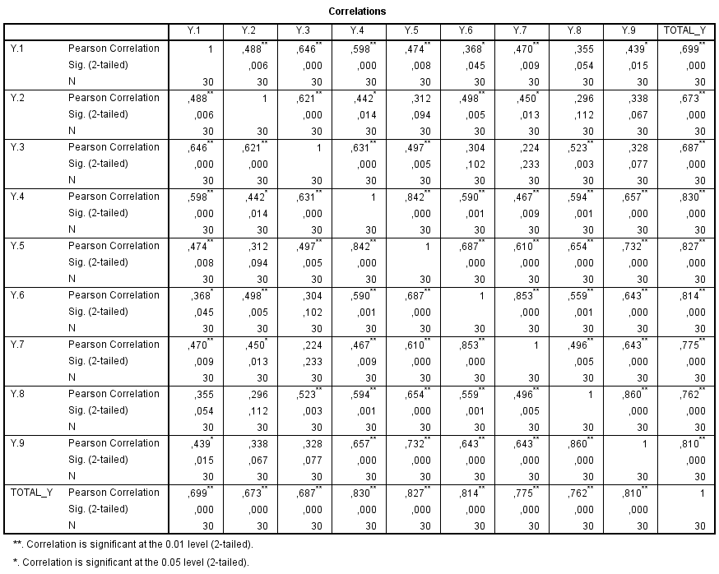
- Variabel Kerjasama Tim ( X1 ) 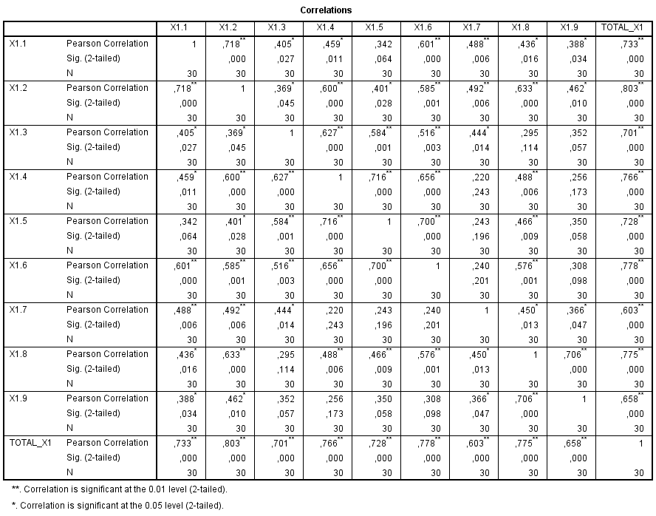

- Variabel Kompetensi Kerja ( X2 )
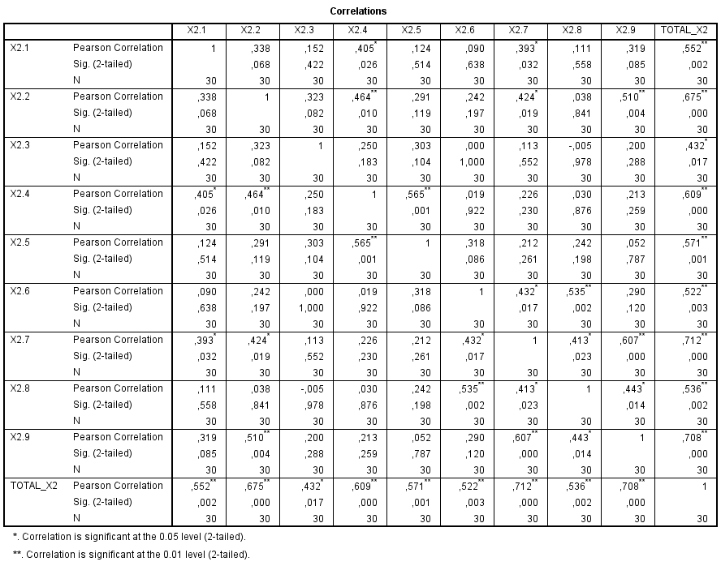

- Variabel Disiplin Kerja ( X3 )
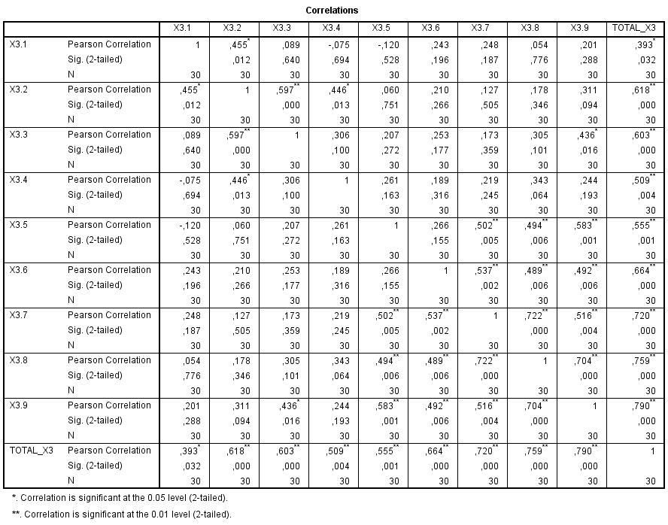

- Variabel Pelayanan ( X4 ) 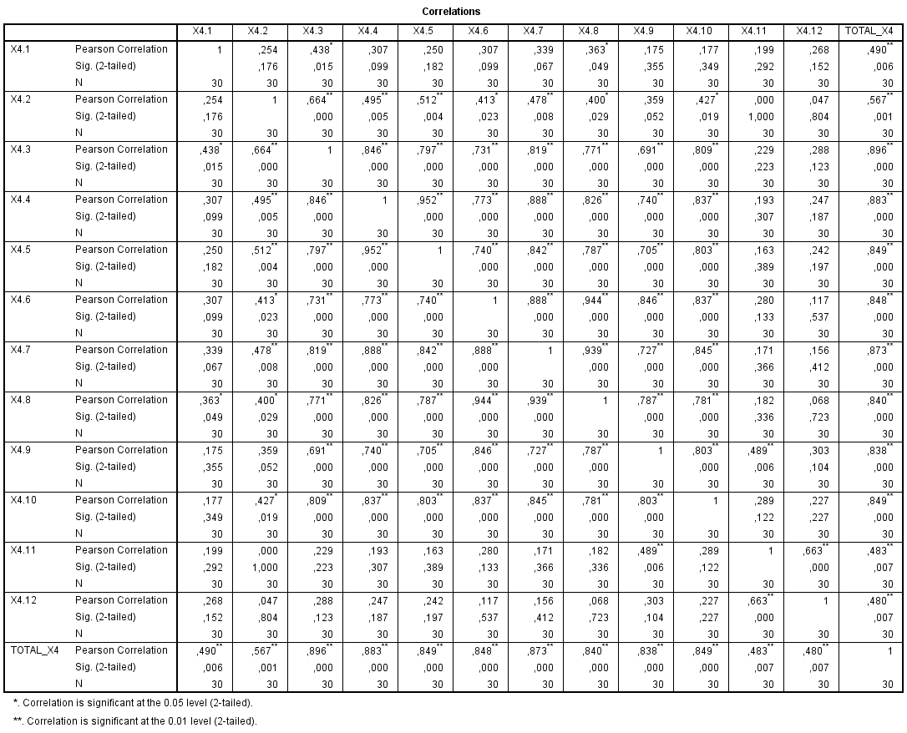
Lampiran 4 Uji Reliabilitas
- Variabel Kinerja ( Y )
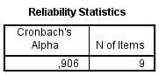
- Variabel Kerjasama Tim ( X1 )
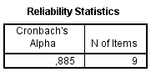
- Variabel Kompetensi Kerja ( X2 )
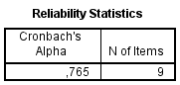

- Variabel Disiplin Kerja ( X3 )
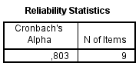
- Variabel Pelayanan ( X4 )
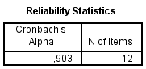
Lampiran 5 Uji Asumsi Klasik
- Uji Normalitas ( Kolmogorov Smirnov )
One-Sample Kolmogorov-Smirnov Test
 |  | Unstandardized Residual
N |  | 49
Normal Parameters^{a,b} | Mean | ,0000000
 | Std. Deviation | 3,76467621
Most Extreme Differences | Absolute | ,095
 | Positive | ,095
 | Negative | -,091
Test Statistic |  | ,095
Asymp. Sig. (2-tailed) |  | ,200^{c,d}
a. Test distribution is Normal.
b. Calculated from data.
c. Lilliefors Significance Correction.
d. This is a lower bound of the true significance.

- Uji Multikolonearitas
Coefficientsª
Model |  | Unstandardized Coefficients |  | Standardized Coefficients | t | Sig. | Collinearity Statistics
 |  | B | Std. Error | Beta |  |  | Tolerance | VIF
1 | (Constant) | 2,251 | ,187 |  | 12,031 | ,000
 | X1 | ,012 | ,006 | ,276 | 2,072 | ,044 | ,581 | 1,721
 | X2 | -,016 | ,009 | -,357 | -1,718 | ,093 | ,237 | 4,214
 | X3 | ,027 | ,009 | ,619 | 2,992 | ,005 | ,240 | 4,167
 | X4 | ,015 | ,004 | ,433 | 3,263 | ,002 | ,583 | 1,715
a. Dependent Variable: Kinerja

- Uji Heterokedastisitas

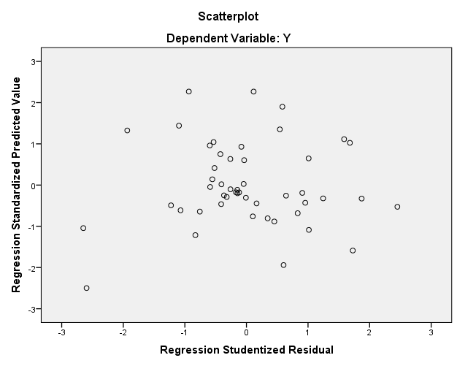
- Uji Autokorelasi
Model Summary^{b}
Model | R | R Square | Adjusted R Square | Std. Error of the Estimate | Durbin-Watson
1 | ,740ª | ,548 | ,507 | ,17560 | 1,855
a. Predictors: (Constant), X4, X3, X1, X2
b. Dependent Variable: Kinerja

Lampiran 6 Uji MSI
- Variabel Kinerja ( Y )
Succesive Interval
Y1 | Y2 | Y3 | Y4 | Y5 | Y6 | Y7 | Y8 | Y9 | Y.TOTAL
3,266 | 2,958 | 3,299 | 3,094 | 3,233 | 2,745 | 4,133 | 4,292 | 4,292 | 31,313
3,266 | 2,958 | 2,033 | 3,094 | 3,233 | 2,745 | 4,133 | 2,950 | 4,292 | 28,703
3,266 | 2,958 | 3,299 | 3,094 | 3,233 | 2,745 | 2,821 | 2,950 | 2,887 | 27,254
4,748 | 4,183 | 4,697 | 4,518 | 3,233 | 2,745 | 2,821 | 2,950 | 2,887 | 32,782
3,266 | 2,958 | 3,299 | 3,094 | 3,233 | 2,745 | 2,821 | 2,950 | 2,887 | 27,254
3,266 | 1,959 | 3,299 | 3,094 | 3,233 | 2,745 | 2,821 | 2,950 | 2,887 | 26,254
3,266 | 2,958 | 3,299 | 3,094 | 3,233 | 2,745 | 2,821 | 2,950 | 2,887 | 27,254
1,908 | 1,959 | 2,033 | 4,518 | 4,748 | 4,166 | 2,821 | 4,292 | 4,292 | 30,737
3,266 | 2,958 | 3,299 | 3,094 | 3,233 | 2,745 | 2,821 | 2,950 | 2,887 | 27,254
3,266 | 2,958 | 3,299 | 3,094 | 3,233 | 2,745 | 2,821 | 2,950 | 2,887 | 27,254
3,266 | 2,958 | 3,299 | 3,094 | 3,233 | 2,745 | 2,821 | 2,950 | 2,887 | 27,254
4,748 | 4,183 | 4,697 | 4,518 | 4,748 | 4,166 | 4,133 | 4,292 | 4,292 | 39,777
1,000 | 1,000 | 1,000 | 1,000 | 1,000 | 1,000 | 1,000 | 1,000 | 1,000 | 9,000
3,266 | 2,958 | 3,299 | 3,094 | 3,233 | 2,745 | 2,821 | 4,292 | 4,292 | 30,001
4,748 | 4,183 | 4,697 | 4,518 | 4,748 | 4,166 | 4,133 | 4,292 | 4,292 | 39,777
3,266 | 2,958 | 3,299 | 3,094 | 3,233 | 2,745 | 2,821 | 2,950 | 2,887 | 27,254
3,266 | 1,959 | 2,033 | 3,094 | 3,233 | 2,745 | 2,821 | 2,950 | 2,887 | 24,987
3,266 | 1,959 | 2,033 | 3,094 | 4,748 | 4,166 | 4,133 | 2,950 | 4,292 | 30,639
1,908 | 1,959 | 2,033 | 1,835 | 1,835 | 1,639 | 1,809 | 1,848 | 1,734 | 16,599
4,748 | 4,183 | 4,697 | 4,518 | 4,748 | 2,745 | 2,821 | 2,950 | 2,887 | 34,297
3,266 | 2,958 | 3,299 | 3,094 | 3,233 | 2,745 | 2,821 | 2,950 | 2,887 | 27,254
4,748 | 1,959 | 3,299 | 4,518 | 3,233 | 2,745 | 2,821 | 4,292 | 4,292 | 31,908
1,908 | 2,958 | 4,697 | 3,094 | 3,233 | 2,745 | 1,809 | 4,292 | 2,887 | 27,624
4,748 | 2,958 | 3,299 | 3,094 | 3,233 | 2,745 | 2,821 | 2,950 | 2,887 | 28,736
1,908 | 2,958 | 3,299 | 4,518 | 4,748 | 2,745 | 2,821 | 4,292 | 4,292 | 31,582
3,266 | 1,000 | 3,299 | 4,518 | 4,748 | 4,166 | 4,133 | 2,950 | 2,887 | 30,966
3,266 | 2,958 | 3,299 | 3,094 | 3,233 | 4,166 | 2,821 | 4,292 | 4,292 | 31,423
3,266 | 1,000 | 3,299 | 3,094 | 3,233 | 1,000 | 1,000 | 2,950 | 2,887 | 21,729
3,266 | 4,183 | 3,299 | 4,518 | 3,233 | 2,745 | 1,809 | 1,848 | 2,887 | 27,789
3,266 | 1,000 | 3,299 | 3,094 | 3,233 | 1,000 | 1,000 | 2,950 | 2,887 | 21,729
3,266 | 2,958 | 3,299 | 4,518 | 3,233 | 2,745 | 2,821 | 2,950 | 2,887 | 28,677
3,266 | 4,183 | 4,697 | 4,518 | 3,233 | 2,745 | 2,821 | 2,950 | 2,887 | 31,300
4,748 | 2,958 | 3,299 | 1,835 | 3,233 | 2,745 | 2,821 | 2,950 | 1,734 | 26,323
3,266 | 1,959 | 3,299 | 3,094 | 3,233 | 2,745 | 2,821 | 2,950 | 2,887 | 26,254
3,266 | 1,959 | 2,033 | 3,094 | 3,233 | 2,745 | 1,809 | 1,848 | 2,887 | 22,874
4,748 | 4,183 | 4,697 | 4,518 | 3,233 | 4,166 | 1,809 | 4,292 | 4,292 | 35,939
3,266 | 1,959 | 3,299 | 3,094 | 3,233 | 4,166 | 1,809 | 1,848 | 2,887 | 25,561
3,266 | 2,958 | 3,299 | 3,094 | 3,233 | 2,745 | 2,821 | 1,848 | 2,887 | 26,152
4,748 | 4,183 | 4,697 | 4,518 | 3,233 | 4,166 | 4,133 | 2,950 | 2,887 | 35,515
3,266 | 1,959 | 3,299 | 3,094 | 3,233 | 2,745 | 2,821 | 2,950 | 2,887 | 26,254
3,266 | 2,958 | 3,299 | 3,094 | 1,835 | 4,166 | 4,133 | 2,950 | 1,734 | 27,434
3,266 | 2,958 | 4,697 | 4,518 | 4,748 | 4,166 | 4,133 | 4,292 | 4,292 | 37,070
4,748 | 4,183 | 4,697 | 4,518 | 4,748 | 4,166 | 4,133 | 4,292 | 4,292 | 39,777
3,266 | 4,183 | 4,697 | 3,094 | 3,233 | 4,166 | 4,133 | 4,292 | 4,292 | 35,356
3,266 | 2,958 | 3,299 | 3,094 | 4,748 | 2,745 | 2,821 | 4,292 | 2,887 | 30,111
4,748 | 4,183 | 4,697 | 4,518 | 4,748 | 4,166 | 4,133 | 4,292 | 4,292 | 39,777
3,266 | 2,958 | 3,299 | 3,094 | 3,233 | 2,745 | 2,821 | 2,950 | 2,887 | 27,254
1,908 | 1,959 | 2,033 | 1,835 | 1,835 | 1,639 | 1,000 | 1,000 | 1,000 | 14,208
3,266 | 2,958 | 3,299 | 1,835 | 1,835 | 1,639 | 1,809 | 1,848 | 1,734 | 20,223

- Variabel Kerjasama Tim ( X1 )
Succesive Interval
X1.1 | X1.2 | X1.3 | X1.4 | X1.5 | X1.6 | X1.7 | X1.8 | X1.9 | X1 TOTAL
3,875 | 3,636 | 2,452 | 3,004 | 3,177 | 3,995 | 4,311 | 4,029 | 4,535 | 33,014
2,439 | 3,636 | 2,452 | 4,311 | 3,177 | 2,523 | 4,311 | 4,029 | 3,284 | 30,162
2,439 | 2,307 | 2,452 | 3,004 | 3,177 | 2,523 | 2,920 | 2,537 | 3,284 | 24,643
2,439 | 2,307 | 2,452 | 3,004 | 3,177 | 2,523 | 2,920 | 2,537 | 3,284 | 24,643
2,439 | 2,307 | 2,452 | 3,004 | 3,177 | 2,523 | 2,920 | 2,537 | 3,284 | 24,643
2,439 | 2,307 | 1,000 | 3,004 | 3,177 | 2,523 | 2,920 | 2,537 | 2,154 | 22,061
2,439 | 2,307 | 2,452 | 3,004 | 3,177 | 2,523 | 2,920 | 2,537 | 3,284 | 24,643
3,875 | 3,636 | 3,899 | 4,311 | 4,649 | 3,995 | 4,311 | 4,029 | 3,284 | 35,988
2,439 | 2,307 | 2,452 | 3,004 | 3,177 | 2,523 | 1,795 | 2,537 | 3,284 | 23,518
3,875 | 2,307 | 2,452 | 1,924 | 1,835 | 2,523 | 2,920 | 1,000 | 2,154 | 20,989
2,439 | 2,307 | 2,452 | 3,004 | 3,177 | 2,523 | 2,920 | 2,537 | 3,284 | 24,643
3,875 | 3,636 | 3,899 | 4,311 | 4,649 | 3,995 | 4,311 | 4,029 | 4,535 | 37,239
1,000 | 1,000 | 2,452 | 1,924 | 3,177 | 2,523 | 1,795 | 2,537 | 3,284 | 19,691
2,439 | 1,000 | 2,452 | 1,924 | 3,177 | 2,523 | 4,311 | 2,537 | 3,284 | 23,647
3,875 | 3,636 | 3,899 | 4,311 | 4,649 | 3,995 | 4,311 | 4,029 | 4,535 | 37,239
2,439 | 2,307 | 2,452 | 3,004 | 3,177 | 2,523 | 2,920 | 2,537 | 3,284 | 24,643
2,439 | 2,307 | 2,452 | 3,004 | 3,177 | 1,000 | 2,920 | 1,000 | 2,154 | 20,453
3,875 | 3,636 | 2,452 | 4,311 | 4,649 | 3,995 | 2,920 | 2,537 | 4,535 | 32,909
1,000 | 1,000 | 1,000 | 1,924 | 1,835 | 1,000 | 1,795 | 1,000 | 2,154 | 12,708
2,439 | 2,307 | 1,000 | 1,924 | 3,177 | 2,523 | 2,920 | 2,537 | 2,154 | 20,981
2,439 | 2,307 | 2,452 | 3,004 | 3,177 | 2,523 | 2,920 | 2,537 | 3,284 | 24,643
3,875 | 2,307 | 2,452 | 3,004 | 1,835 | 2,523 | 2,920 | 2,537 | 3,284 | 24,736
2,439 | 1,000 | 2,452 | 4,311 | 4,649 | 3,995 | 1,795 | 2,537 | 2,154 | 25,332
3,875 | 2,307 | 1,000 | 3,004 | 3,177 | 2,523 | 2,920 | 2,537 | 2,154 | 23,496
3,875 | 3,636 | 2,452 | 4,311 | 4,649 | 3,995 | 1,795 | 4,029 | 4,535 | 33,276
2,439 | 2,307 | 3,899 | 4,311 | 4,649 | 3,995 | 2,920 | 1,000 | 1,000 | 26,520
3,875 | 2,307 | 3,899 | 3,004 | 4,649 | 2,523 | 4,311 | 2,537 | 4,535 | 31,639
2,439 | 2,307 | 1,000 | 1,924 | 3,177 | 2,523 | 2,920 | 2,537 | 3,284 | 22,111
3,875 | 3,636 | 2,452 | 3,004 | 3,177 | 3,995 | 2,920 | 2,537 | 2,154 | 27,750
2,439 | 2,307 | 1,000 | 1,924 | 3,177 | 2,523 | 2,920 | 2,537 | 3,284 | 22,111
2,439 | 2,307 | 2,452 | 3,004 | 3,177 | 2,523 | 2,920 | 2,537 | 3,284 | 24,643
2,439 | 2,307 | 1,000 | 1,000 | 3,177 | 2,523 | 2,920 | 2,537 | 3,284 | 21,187
2,439 | 2,307 | 2,452 | 3,004 | 3,177 | 2,523 | 2,920 | 1,000 | 1,000 | 20,822
2,439 | 1,000 | 1,000 | 3,004 | 3,177 | 2,523 | 2,920 | 2,537 | 2,154 | 20,754
1,000 | 1,000 | 2,452 | 1,000 | 1,000 | 1,000 | 4,311 | 2,537 | 2,154 | 16,454
3,875 | 3,636 | 3,899 | 4,311 | 4,649 | 3,995 | 4,311 | 4,029 | 4,535 | 37,239
2,439 | 1,000 | 2,452 | 1,924 | 3,177 | 2,523 | 2,920 | 2,537 | 2,154 | 21,126
2,439 | 1,000 | 2,452 | 3,004 | 3,177 | 2,523 | 2,920 | 4,029 | 3,284 | 24,828
3,875 | 2,307 | 2,452 | 1,924 | 3,177 | 3,995 | 2,920 | 2,537 | 3,284 | 26,470
2,439 | 2,307 | 2,452 | 3,004 | 3,177 | 2,523 | 1,795 | 2,537 | 2,154 | 22,388
2,439 | 2,307 | 2,452 | 3,004 | 3,177 | 2,523 | 2,920 | 2,537 | 3,284 | 24,643
3,875 | 3,636 | 3,899 | 3,004 | 4,649 | 3,995 | 4,311 | 4,029 | 3,284 | 34,682
3,875 | 2,307 | 2,452 | 3,004 | 3,177 | 2,523 | 2,920 | 4,029 | 4,535 | 28,821
3,875 | 3,636 | 3,899 | 4,311 | 4,649 | 3,995 | 4,311 | 4,029 | 4,535 | 37,239
3,875 | 3,636 | 3,899 | 4,311 | 4,649 | 3,995 | 1,000 | 2,537 | 3,284 | 31,185
3,875 | 3,636 | 2,452 | 3,004 | 4,649 | 3,995 | 2,920 | 4,029 | 4,535 | 33,094
1,000 | 1,000 | 2,452 | 3,004 | 3,177 | 2,523 | 1,000 | 2,537 | 2,154 | 18,847
2,439 | 2,307 | 2,452 | 3,004 | 3,177 | 2,523 | 2,920 | 2,537 | 3,284 | 24,643
2,439 | 3,636 | 3,899 | 1,000 | 1,835 | 1,000 | 1,000 | 2,537 | 3,284 | 20,630

- Variabel Kompetensi Kerja ( X2 )
Succesive Interval
X2.1 | X2.2 | X2.3 | X2.4 | X2.5 | X2.6 | X2.7 | X2.8 | X2.9 | X2.TOTAL
3,927 | 3,081 | 2,142 | 4,560 | 2,786 | 3,149 | 3,687 | 3,761 | 3,572 | 30,663
2,686 | 4,506 | 4,260 | 4,560 | 2,786 | 3,149 | 2,498 | 2,806 | 4,603 | 31,855
2,686 | 1,923 | 2,142 | 3,519 | 2,786 | 3,149 | 2,498 | 3,761 | 3,572 | 26,036
2,686 | 3,081 | 4,260 | 4,560 | 3,767 | 4,339 | 2,498 | 2,806 | 2,595 | 30,592
2,686 | 1,923 | 3,138 | 2,696 | 2,786 | 3,149 | 2,498 | 2,806 | 2,595 | 24,278
2,686 | 1,923 | 2,142 | 2,696 | 2,786 | 3,149 | 2,498 | 2,806 | 2,595 | 23,282
2,686 | 1,923 | 3,138 | 2,696 | 2,786 | 3,149 | 3,687 | 4,748 | 3,572 | 28,385
3,927 | 3,081 | 2,142 | 2,696 | 2,786 | 3,149 | 2,498 | 2,806 | 2,595 | 25,679
3,927 | 3,081 | 4,260 | 3,519 | 2,786 | 3,149 | 3,687 | 4,748 | 4,603 | 33,759
1,000 | 1,000 | 2,142 | 1,835 | 1,835 | 1,835 | 1,000 | 1,752 | 1,000 | 13,399
2,686 | 3,081 | 4,260 | 4,560 | 4,860 | 4,339 | 2,498 | 4,748 | 2,595 | 33,627
3,927 | 3,081 | 4,260 | 2,696 | 2,786 | 4,339 | 3,687 | 2,806 | 2,595 | 30,177
2,686 | 1,923 | 3,138 | 3,519 | 4,860 | 4,339 | 2,498 | 4,748 | 3,572 | 31,283
2,686 | 3,081 | 4,260 | 2,696 | 2,786 | 3,149 | 2,498 | 2,806 | 4,603 | 28,566
3,927 | 3,081 | 3,138 | 4,560 | 4,860 | 3,149 | 2,498 | 2,806 | 2,595 | 30,613
3,927 | 3,081 | 3,138 | 4,560 | 2,786 | 3,149 | 2,498 | 2,806 | 2,595 | 28,539
2,686 | 4,506 | 4,260 | 3,519 | 3,767 | 3,149 | 3,687 | 2,806 | 4,603 | 32,984
2,686 | 3,081 | 3,138 | 2,696 | 3,767 | 4,339 | 2,498 | 4,748 | 2,595 | 29,548
2,686 | 3,081 | 3,138 | 3,519 | 3,767 | 4,339 | 2,498 | 4,748 | 4,603 | 32,379
4,892 | 3,081 | 4,260 | 3,519 | 3,767 | 4,339 | 3,687 | 3,761 | 3,572 | 34,877
4,892 | 3,081 | 3,138 | 4,560 | 3,767 | 3,149 | 3,687 | 3,761 | 3,572 | 33,605
3,927 | 4,506 | 2,142 | 2,696 | 2,786 | 5,263 | 3,687 | 4,748 | 4,603 | 34,357
4,892 | 3,081 | 4,260 | 4,560 | 3,767 | 3,149 | 3,687 | 3,761 | 4,603 | 35,759
2,686 | 3,081 | 3,138 | 2,696 | 2,786 | 3,149 | 3,687 | 3,761 | 4,603 | 29,587
2,686 | 3,081 | 4,260 | 2,696 | 3,767 | 3,149 | 2,498 | 2,806 | 2,595 | 27,539
2,686 | 3,081 | 2,142 | 3,519 | 3,767 | 5,263 | 4,892 | 3,761 | 4,603 | 33,713
2,686 | 3,081 | 3,138 | 4,560 | 4,860 | 3,149 | 3,687 | 2,806 | 2,595 | 30,561
4,892 | 4,506 | 3,138 | 4,560 | 3,767 | 3,149 | 2,498 | 2,806 | 4,603 | 33,919
2,686 | 4,506 | 3,138 | 3,519 | 3,767 | 3,149 | 3,687 | 3,761 | 3,572 | 31,785
2,686 | 4,506 | 3,138 | 4,560 | 3,767 | 3,149 | 2,498 | 2,806 | 2,595 | 29,705
3,927 | 3,081 | 4,260 | 4,560 | 4,860 | 3,149 | 2,498 | 3,761 | 4,603 | 34,698
4,892 | 3,081 | 3,138 | 3,519 | 3,767 | 4,339 | 3,687 | 4,748 | 2,595 | 33,764
2,686 | 1,923 | 2,142 | 2,696 | 2,786 | 3,149 | 3,687 | 2,806 | 3,572 | 25,448
3,927 | 3,081 | 3,138 | 4,560 | 4,860 | 3,149 | 3,687 | 3,761 | 4,603 | 34,765
2,686 | 1,923 | 2,142 | 3,519 | 4,860 | 5,263 | 4,892 | 4,748 | 3,572 | 33,604
2,686 | 3,081 | 2,142 | 3,519 | 4,860 | 5,263 | 3,687 | 4,748 | 4,603 | 34,588
2,686 | 3,081 | 3,138 | 4,560 | 3,767 | 3,149 | 4,892 | 3,761 | 3,572 | 32,605
2,686 | 1,923 | 2,142 | 2,696 | 3,767 | 4,339 | 2,498 | 2,806 | 2,595 | 25,453
3,927 | 3,081 | 2,142 | 3,519 | 4,860 | 3,149 | 3,687 | 2,806 | 3,572 | 30,742
2,686 | 3,081 | 2,142 | 2,696 | 3,767 | 3,149 | 3,687 | 3,761 | 3,572 | 28,540
3,927 | 3,081 | 2,142 | 3,519 | 2,786 | 3,149 | 2,498 | 2,806 | 2,595 | 26,502
2,686 | 1,923 | 3,138 | 4,560 | 3,767 | 3,149 | 3,687 | 3,761 | 3,572 | 30,243
3,927 | 3,081 | 3,138 | 2,696 | 2,786 | 3,149 | 4,892 | 2,806 | 3,572 | 30,046
2,686 | 1,923 | 2,142 | 1,835 | 1,835 | 1,835 | 2,498 | 1,752 | 1,535 | 18,041
2,686 | 1,000 | 1,000 | 1,835 | 1,835 | 1,000 | 1,509 | 1,752 | 2,595 | 15,212
2,686 | 3,081 | 3,138 | 3,519 | 2,786 | 4,339 | 3,687 | 4,748 | 4,603 | 32,587
2,686 | 3,081 | 4,260 | 3,519 | 3,767 | 3,149 | 4,892 | 3,761 | 3,572 | 32,686
1,000 | 1,000 | 1,000 | 1,835 | 1,000 | 1,835 | 2,498 | 2,806 | 2,595 | 15,569
2,686 | 1,000 | 1,000 | 1,000 | 1,835 | 1,835 | 1,000 | 1,000 | 2,595 | 13,951

- Variabel Disiplin Kerja ( X3 )

Succesive Interval
X3.1 | X3.2 | X3.3 | X3.4 | X3.5 | X3.6 | X3.7 | X3.8 | X3.9 | X3.TOTAL
3,225 | 2,881 | 3,324 | 3,558 | 2,118 | 3,995 | 3,935 | 4,098 | 2,987 | 30,122
2,295 | 2,881 | 3,324 | 2,426 | 3,130 | 2,242 | 3,087 | 3,068 | 2,987 | 25,440
4,251 | 4,748 | 2,328 | 3,558 | 2,118 | 2,242 | 2,261 | 2,226 | 2,987 | 26,719
3,225 | 2,881 | 2,328 | 4,491 | 3,130 | 3,995 | 3,935 | 4,098 | 2,987 | 31,070
4,251 | 3,869 | 4,311 | 2,426 | 2,118 | 2,242 | 2,261 | 2,226 | 2,987 | 26,691
4,251 | 2,881 | 2,328 | 2,426 | 2,118 | 2,242 | 3,087 | 2,226 | 2,076 | 23,636
3,225 | 3,869 | 4,311 | 4,491 | 2,118 | 2,242 | 2,261 | 4,098 | 2,987 | 29,601
3,225 | 3,869 | 3,324 | 2,426 | 2,118 | 2,242 | 2,261 | 2,226 | 2,076 | 23,768
2,295 | 3,869 | 3,324 | 4,491 | 4,255 | 3,084 | 3,935 | 4,098 | 2,987 | 32,338
1,000 | 1,000 | 1,000 | 1,000 | 1,000 | 1,000 | 1,000 | 2,226 | 1,000 | 10,226
3,225 | 3,869 | 4,311 | 2,426 | 4,255 | 3,084 | 3,087 | 4,098 | 4,134 | 32,489
4,251 | 2,881 | 2,328 | 2,426 | 2,118 | 3,995 | 3,087 | 4,098 | 4,134 | 29,318
2,295 | 1,655 | 2,328 | 2,426 | 2,118 | 2,242 | 2,261 | 2,226 | 2,076 | 19,628
4,251 | 2,881 | 2,328 | 2,426 | 3,130 | 2,242 | 3,087 | 4,098 | 4,134 | 28,577
3,225 | 3,869 | 3,324 | 3,558 | 3,130 | 3,084 | 3,087 | 4,098 | 4,134 | 31,509
2,295 | 2,881 | 3,324 | 3,558 | 3,130 | 3,084 | 2,261 | 2,226 | 4,134 | 26,894
2,295 | 4,748 | 4,311 | 4,491 | 3,130 | 3,084 | 2,261 | 3,068 | 2,987 | 30,374
2,295 | 2,881 | 3,324 | 2,426 | 3,130 | 2,242 | 3,935 | 4,098 | 4,134 | 28,465
3,225 | 4,748 | 4,311 | 3,558 | 2,118 | 3,995 | 3,935 | 4,098 | 4,134 | 34,122
4,251 | 3,869 | 4,311 | 2,426 | 3,130 | 3,995 | 3,935 | 4,098 | 4,134 | 34,149
2,295 | 2,881 | 3,324 | 2,426 | 3,130 | 3,084 | 2,261 | 3,068 | 2,987 | 25,456
4,251 | 4,748 | 4,311 | 2,426 | 2,118 | 3,995 | 3,935 | 4,098 | 2,987 | 32,868
3,225 | 3,869 | 4,311 | 3,558 | 4,255 | 2,242 | 3,935 | 4,098 | 4,134 | 33,627
2,295 | 2,881 | 3,324 | 2,426 | 3,130 | 3,084 | 2,261 | 3,068 | 2,987 | 25,456
4,251 | 4,748 | 2,328 | 2,426 | 2,118 | 2,242 | 2,261 | 2,226 | 2,076 | 24,676
3,225 | 4,748 | 3,324 | 3,558 | 3,130 | 3,995 | 3,087 | 4,098 | 4,134 | 33,299
4,251 | 2,881 | 2,328 | 2,426 | 4,255 | 3,995 | 3,935 | 4,098 | 4,134 | 32,304
2,295 | 2,881 | 3,324 | 2,426 | 3,130 | 3,995 | 3,087 | 4,098 | 4,134 | 29,370
3,225 | 4,748 | 4,311 | 3,558 | 2,118 | 2,242 | 2,261 | 4,098 | 4,134 | 30,694
4,251 | 3,869 | 4,311 | 2,426 | 2,118 | 3,995 | 2,261 | 2,226 | 2,987 | 28,444
4,251 | 4,748 | 2,328 | 2,426 | 4,255 | 2,242 | 3,935 | 4,098 | 4,134 | 32,417
3,225 | 3,869 | 4,311 | 4,491 | 4,255 | 2,242 | 2,261 | 4,098 | 4,134 | 32,885
4,251 | 2,881 | 2,328 | 2,426 | 2,118 | 2,242 | 2,261 | 2,226 | 2,076 | 22,810
2,295 | 2,881 | 2,328 | 3,558 | 3,130 | 3,995 | 2,261 | 2,226 | 2,987 | 25,662
2,295 | 2,881 | 2,328 | 3,558 | 4,255 | 3,995 | 3,935 | 3,068 | 4,134 | 30,451
3,225 | 4,748 | 3,324 | 2,426 | 2,118 | 3,995 | 3,935 | 4,098 | 4,134 | 32,003
4,251 | 2,881 | 2,328 | 2,426 | 3,130 | 3,084 | 2,261 | 3,068 | 2,987 | 26,416
4,251 | 2,881 | 2,328 | 2,426 | 3,130 | 2,242 | 2,261 | 3,068 | 2,987 | 25,574
3,225 | 2,881 | 2,328 | 2,426 | 3,130 | 2,242 | 2,261 | 3,068 | 2,987 | 24,548
3,225 | 4,748 | 3,324 | 2,426 | 3,130 | 3,995 | 2,261 | 2,226 | 2,076 | 27,411
4,251 | 2,881 | 2,328 | 2,426 | 3,130 | 3,084 | 2,261 | 3,068 | 2,076 | 25,506
2,295 | 2,881 | 2,328 | 2,426 | 3,130 | 3,084 | 2,261 | 3,068 | 2,987 | 24,460
4,251 | 4,748 | 3,324 | 2,426 | 2,118 | 2,242 | 2,261 | 2,226 | 2,076 | 25,672
2,295 | 2,881 | 2,328 | 1,000 | 1,000 | 1,000 | 1,000 | 2,226 | 2,076 | 15,807
2,295 | 2,881 | 2,328 | 1,000 | 1,000 | 1,000 | 1,000 | 1,000 | 2,076 | 14,581
2,295 | 2,881 | 2,328 | 2,426 | 2,118 | 2,242 | 3,935 | 3,068 | 4,134 | 25,428
2,295 | 2,881 | 2,328 | 3,558 | 4,255 | 3,995 | 3,935 | 3,068 | 4,134 | 30,451
2,295 | 2,881 | 1,000 | 1,000 | 1,000 | 1,000 | 1,000 | 2,226 | 2,076 | 14,479
1,000 | 1,655 | 1,000 | 1,000 | 1,000 | 2,242 | 1,000 | 1,000 | 1,000 | 10,897

- Variabel Pelayanan ( X4 )
Succesive Interval
X4.1 | X4.2 | X4.3 | X4.4 | X4.5 | X4.6 | X4.7 | X4.8 | X4.9 | X4.10 | X4.11 | X4.12 | X4.TOTAL
3,114 | 3,204 | 4,238 | 4,133 | 4,039 | 2,743 | 2,772 | 2,613 | 4,123 | 3,837 | 4,802 | 5,071 | 44,687
2,038 | 3,204 | 2,664 | 2,607 | 2,550 | 4,292 | 2,772 | 2,613 | 4,123 | 3,837 | 4,802 | 4,154 | 39,656
3,114 | 3,204 | 2,664 | 2,607 | 2,550 | 2,743 | 2,772 | 2,613 | 2,613 | 2,412 | 3,551 | 3,307 | 34,150
2,038 | 4,556 | 4,238 | 4,133 | 4,039 | 4,292 | 4,336 | 4,123 | 4,123 | 3,837 | 3,551 | 3,307 | 46,571
3,114 | 3,204 | 2,664 | 2,607 | 2,550 | 2,743 | 2,772 | 2,613 | 2,613 | 2,412 | 3,551 | 2,276 | 33,119
1,000 | 3,204 | 2,664 | 2,607 | 2,550 | 2,743 | 2,772 | 2,613 | 2,613 | 2,412 | 2,358 | 3,307 | 30,842
2,038 | 2,038 | 2,664 | 2,607 | 2,550 | 2,743 | 2,772 | 2,613 | 2,613 | 2,412 | 3,551 | 4,154 | 32,755
3,114 | 3,204 | 2,664 | 2,607 | 2,550 | 2,743 | 2,772 | 2,613 | 2,613 | 2,412 | 3,551 | 4,154 | 34,997
2,038 | 3,204 | 2,664 | 4,133 | 4,039 | 2,743 | 2,772 | 2,613 | 2,613 | 2,412 | 2,358 | 3,307 | 34,894
2,038 | 2,038 | 2,664 | 2,607 | 2,550 | 2,743 | 2,772 | 2,613 | 2,613 | 2,412 | 3,551 | 4,154 | 32,755
3,114 | 3,204 | 2,664 | 2,607 | 2,550 | 2,743 | 2,772 | 2,613 | 2,613 | 2,412 | 3,551 | 4,154 | 34,997
4,402 | 4,556 | 4,238 | 4,133 | 4,039 | 4,292 | 4,336 | 4,123 | 4,123 | 3,837 | 4,802 | 5,071 | 51,951
2,038 | 1,000 | 1,000 | 1,000 | 1,000 | 1,000 | 1,000 | 1,000 | 1,000 | 1,000 | 3,551 | 3,307 | 17,895
2,038 | 3,204 | 2,664 | 2,607 | 2,550 | 2,743 | 2,772 | 2,613 | 2,613 | 2,412 | 3,551 | 3,307 | 33,073
2,038 | 4,556 | 4,238 | 4,133 | 4,039 | 4,292 | 4,336 | 4,123 | 4,123 | 3,837 | 2,358 | 2,276 | 44,348
3,114 | 3,204 | 2,664 | 2,607 | 2,550 | 2,743 | 2,772 | 2,613 | 2,613 | 2,412 | 3,551 | 2,276 | 33,119
3,114 | 2,038 | 2,664 | 2,607 | 2,550 | 2,743 | 2,772 | 2,613 | 2,613 | 2,412 | 3,551 | 4,154 | 33,832
3,114 | 2,038 | 2,664 | 2,607 | 2,550 | 4,292 | 2,772 | 4,123 | 4,123 | 2,412 | 3,551 | 2,276 | 36,522
2,038 | 2,038 | 1,000 | 1,000 | 1,000 | 1,000 | 1,000 | 1,000 | 1,000 | 1,000 | 2,358 | 3,307 | 17,740
3,114 | 2,038 | 2,664 | 2,607 | 1,000 | 2,743 | 2,772 | 2,613 | 2,613 | 2,412 | 3,551 | 3,307 | 31,433
3,114 | 3,204 | 2,664 | 2,607 | 2,550 | 2,743 | 2,772 | 2,613 | 2,613 | 2,412 | 3,551 | 4,154 | 34,997
1,000 | 2,038 | 1,000 | 2,607 | 2,550 | 2,743 | 2,772 | 2,613 | 2,613 | 2,412 | 3,551 | 2,276 | 28,176
1,000 | 2,038 | 2,664 | 2,607 | 2,550 | 2,743 | 2,772 | 2,613 | 2,613 | 3,837 | 2,358 | 2,276 | 30,072
3,114 | 3,204 | 2,664 | 2,607 | 2,550 | 2,743 | 2,772 | 2,613 | 1,000 | 2,412 | 2,358 | 3,307 | 31,343
4,402 | 3,204 | 4,238 | 4,133 | 4,039 | 4,292 | 4,336 | 4,123 | 2,613 | 3,837 | 2,358 | 2,276 | 43,851
3,114 | 1,000 | 2,664 | 4,133 | 4,039 | 4,292 | 4,336 | 4,123 | 4,123 | 3,837 | 3,551 | 4,154 | 43,365
2,038 | 2,038 | 2,664 | 2,607 | 2,550 | 2,743 | 2,772 | 2,613 | 2,613 | 2,412 | 3,551 | 3,307 | 31,908
3,114 | 3,204 | 2,664 | 2,607 | 2,550 | 2,743 | 2,772 | 2,613 | 2,613 | 2,412 | 2,358 | 3,307 | 32,956
3,114 | 3,204 | 4,238 | 4,133 | 4,039 | 4,292 | 4,336 | 4,123 | 4,123 | 3,837 | 4,802 | 5,071 | 49,310
3,114 | 3,204 | 2,664 | 2,607 | 2,550 | 2,743 | 2,772 | 2,613 | 2,613 | 2,412 | 1,000 | 2,276 | 30,568
2,038 | 3,204 | 2,664 | 2,607 | 2,550 | 2,743 | 2,772 | 2,613 | 2,613 | 2,412 | 3,551 | 4,154 | 33,921
3,114 | 3,204 | 2,664 | 2,607 | 2,550 | 2,743 | 2,772 | 2,613 | 2,613 | 2,412 | 3,551 | 3,307 | 34,150
1,000 | 1,000 | 4,238 | 2,607 | 2,550 | 2,743 | 2,772 | 2,613 | 2,613 | 2,412 | 3,551 | 5,071 | 33,170
3,114 | 3,204 | 2,664 | 2,607 | 4,039 | 4,292 | 2,772 | 4,123 | 2,613 | 3,837 | 4,802 | 4,154 | 42,220
1,000 | 2,038 | 2,664 | 2,607 | 1,000 | 2,743 | 2,772 | 1,000 | 2,613 | 1,000 | 3,551 | 3,307 | 26,294
3,114 | 4,556 | 4,238 | 4,133 | 4,039 | 4,292 | 4,336 | 4,123 | 4,123 | 3,837 | 4,802 | 5,071 | 50,662
2,038 | 3,204 | 2,664 | 2,607 | 2,550 | 2,743 | 2,772 | 2,613 | 2,613 | 3,837 | 2,358 | 3,307 | 33,305
2,038 | 3,204 | 2,664 | 2,607 | 2,550 | 4,292 | 4,336 | 2,613 | 2,613 | 2,412 | 2,358 | 2,276 | 33,963
1,000 | 2,038 | 1,000 | 1,000 | 2,550 | 2,743 | 2,772 | 4,123 | 4,123 | 2,412 | 3,551 | 4,154 | 31,466
3,114 | 3,204 | 2,664 | 2,607 | 2,550 | 2,743 | 4,336 | 4,123 | 4,123 | 3,837 | 2,358 | 3,307 | 38,965
3,114 | 3,204 | 2,664 | 1,000 | 4,039 | 4,292 | 4,336 | 2,613 | 2,613 | 1,000 | 3,551 | 3,307 | 35,733
4,402 | 4,556 | 4,238 | 4,133 | 4,039 | 4,292 | 4,336 | 4,123 | 4,123 | 3,837 | 4,802 | 1,000 | 47,880
4,402 | 4,556 | 4,238 | 4,133 | 4,039 | 4,292 | 4,336 | 2,613 | 2,613 | 3,837 | 4,802 | 5,071 | 48,932
3,114 | 3,204 | 2,664 | 2,607 | 2,550 | 2,743 | 2,772 | 4,123 | 4,123 | 3,837 | 4,802 | 3,307 | 39,844
2,038 | 3,204 | 2,664 | 2,607 | 2,550 | 2,743 | 2,772 | 2,613 | 2,613 | 3,837 | 2,358 | 2,276 | 32,275
3,114 | 4,556 | 2,664 | 4,133 | 4,039 | 4,292 | 4,336 | 4,123 | 4,123 | 3,837 | 4,802 | 2,276 | 46,294
4,402 | 2,038 | 2,664 | 2,607 | 2,550 | 2,743 | 2,772 | 2,613 | 2,613 | 2,412 | 3,551 | 3,307 | 34,272
2,038 | 3,204 | 2,664 | 2,607 | 2,550 | 2,743 | 2,772 | 2,613 | 2,613 | 2,412 | 2,358 | 3,307 | 31,880
3,114 | 3,204 | 2,664 | 2,607 | 2,550 | 2,743 | 4,336 | 4,123 | 4,123 | 3,837 | 2,358 | 2,276 | 37,934

Lampiran 7 Analisis Regresi Linier Berganda
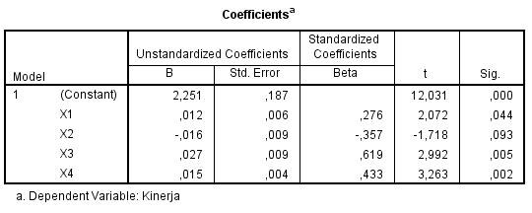
Lampiran 8 Uji Hipotesis
- Uji t ( Uji Parsial )
- Uji F ( Uji Simultan )
ANOVAª
Model |  | Sum of Squares | Df | Mean Square | F | Sig.
1 | Regression | 1053,817 | 4 | 263,454 | 17,040 | ,000^{b}
 | Residual | 680,294 | 44 | 15,461
 | Total | 1734,111 | 48
a. Dependent Variable: Kinerja
b. Predictors: (Constant), X4, X3, X1, X2

Lampiran 9 Uji Koefisien Determinasi ( R² )

Model Summary^{b}
Model | R | R Square | Adjusted R Square | Std. Error of the Estimate
1 | ,740ª | ,548 | ,507 | ,17560
a. Predictors: (Constant), X4, X3, X1, X2
b. Dependent Variable: Kinerja

