DAFTAR PUSTAKA
Ahmad, F. (2020). PENENTUAN METODE PERAMALAN PADA PRODUKSI
PART NEW GRANADA BOWL ST Di PT.X. JISI: Jurnal Integrasi Sistem
Industri, 7(1), 31. https://doi.org/10.24853/jisi.7.1.31-39
Lusiana, A., & Yuliarty, P. (2020). PENERAPAN METODE PERAMALAN
(FORECASTING) PADA PERMINTAAN ATAP di PT X. Industri Inovatif :
Jurnal Teknik Industri, 10(1), 11–20.
https://doi.org/10.36040/industri.v10i1.2530
Ahmed, S. A., Biswas, T. K., & Nundy, C. K. (n.d.). Archive of An Optimization
Model for Aggregate Production Planning and Control : A Genetic Algorithm Approach. https://doi.org/10.22105/riej.2019.192936.1090
Baroto, Teguh. 2002. Perencanaan dan Pengendalian Produksi. Ghalia Indonesia : Jakarta.
Febryanti, A. R., & Rani, A. M. (2019). Penerapan Perencanaan Agregat untuk Meminimumkan Biaya Produksi (Studi pada CV. X). 16(2), 144–150.
Gasperz, Vincent. 2004. Production Planning and inventory Control. Edisi
Empat. Gramedia Pustaka Utama : Jakarta

Ginting, R. 2007. Sistem Produksi. Jakarta : Graha Ilmu
Gitosudarmo, Indriyo. 2000. Sistem Perencanaan dan Pengendalian Produksi Edisi 2. BPFE-Yogyakarta : Yogyakarta.
Haming dan Nurnajamuddin. 2014. Manajemen Produksi modern operasi manufaktur dan jasa. Buku 1 Edisi 3 Bumi Aksara : Jakarta
Haryati, N. E. (2011). Perencanaan Jumlah Produk Menggunakan Metode Fuzzy Mamdani Berdasarkan Prediksi Permintaan. 1–9.
Heizer, B Render. 2004. Manajemen Operasi Edisi ketujuh. Salemba Empat, Jakarta.
Herlina, L. (2021). Perancangan Model Integrasi Perencanaan Produksi Dan Distribusi Pada Rantai Pasok Agroindustri Udang (Kasus Pt X). Disertasi.
Industri, T., Indonesia, U. A., Agregat, P., & Agregat, S. (2019). ANALISIS
PERENCANAAN PRODUKSI PADA PT. ARMSTRONG INDUSTRI INDONESIA DENGAN METODE FORECASTING DAN AGREGAT
PLANNING Fristha Ayu Reicita. 7(3), 160–168.
Kusuma, Hendra. 2004. Manajemen Produksi : Perencanaan dan Pengendalian Produksi. Andi Offset: Yogyakarta.
Manajemen, J., Krisnadwipayana, B., & Indra, H. (2017). STRATEGI PERENCANAAN AGREGAT SEBAGAI PILIHAN KAPASITAS PRODUKSI.
5.
Manurung,Haymans,Adler. 2003. Teknik Peramalan Bisnis dan Ekonomi. Rineka Cipta : Jakarta.
Nisa, A. K., & Kusuma, T. Y. T. (2017). Perencanaan Dan Pengendalian Produksi Dengan Metode Aggrate Planning Di C-Maxi Alloycast. Integrated Lab Journal, 5(2), 51–62. file:/
Patrobas, G., Hassan, A., Pondaag, J., Perencanaan, A., Tepung, P., Pt, P., Coco,
T., Di, P., & Minahasa, L. (2021). DENGAN METODE AGREGAT
PLANNING ANALYSIS OF COCONUT FLOUR PRODUCTION PLANNING USING THE AGGREGATE PLANNING METHOD AT PT .
TROPICA COCO PRIMA AT LELEMA MINAHASA SELATAN . Jurnal EMBA Vol . 9 No . 3 Juli 2021 , Hal . 1173 - 1182. 9(3), 1173–1182.
Syukron, Amin dan Kholil, Muhammad. 2014. Pengantar Teknik Industri. Graha Ilmu : Yogyakarta.

Sarifah, L., Kamilah, S., Khotijah, S., Sains, I., Sains, I., & Sains, I. (2023). Penerapan Metode Single Moving Average Dalam Memprediksi Jumlah Penduduk Miskin Pada Perencanaan Pembangunan Daerah Kabupaten
Pamekasan. 8(2). https://doi.org/10.31102/zeta.2023.8.2.47-54

Solehudin, Asep. 2007. Kajian Perencanaan Produksi Agregat. Skripsi pada departemen manajemen fakultas ekonomi intitut pertanian bogor : Bogor

LAMPIRAN
Lampiran 1 Dokumentasi Proses pengambilan data

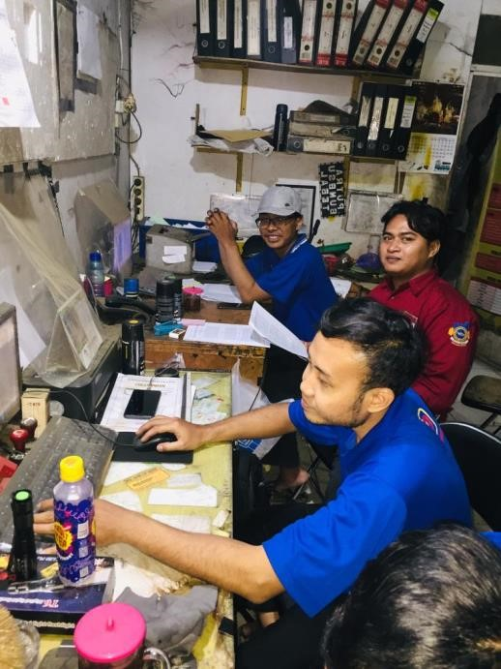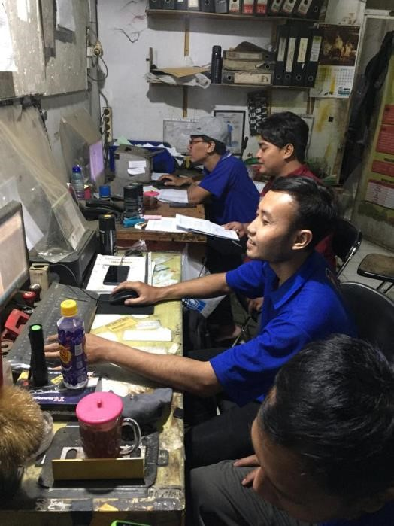
Lampiran 2 Profil Singkat Perusahaan Tempat Penelitian
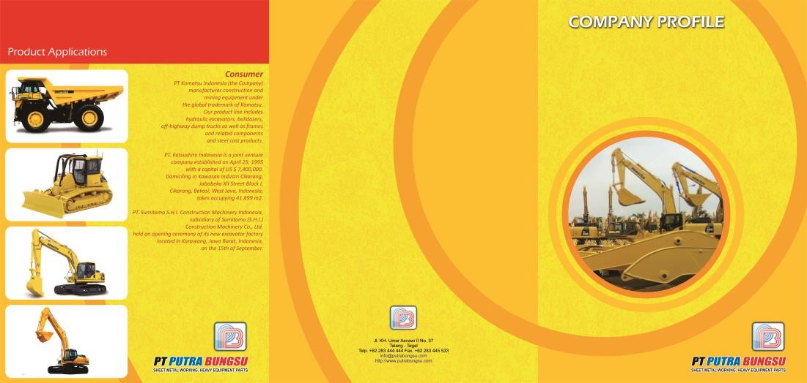

Lampiran 3 Surat balasan dari PT. Putra Bungsu
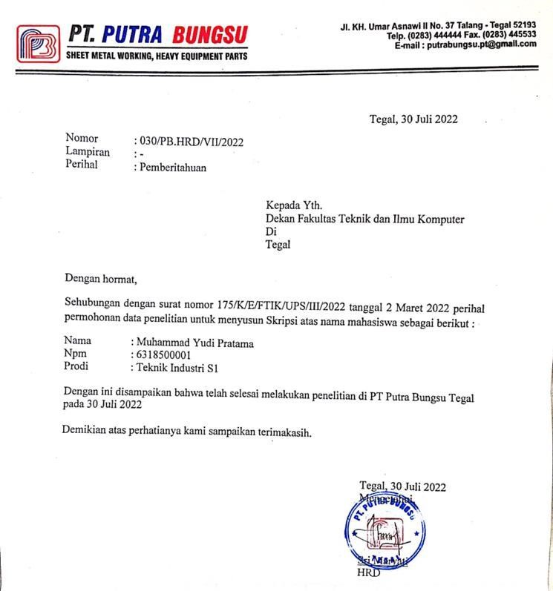

Lampiran 4 Data Permintaan PT. Putra Bungsu
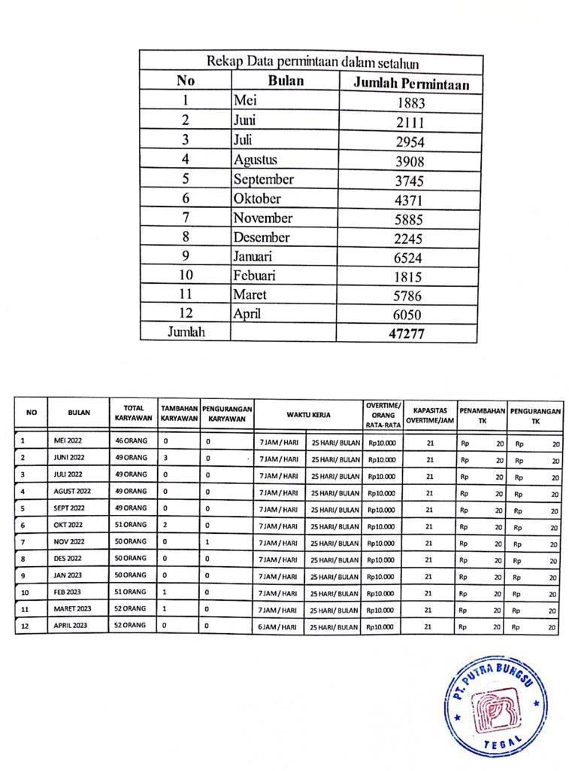

Lampiran 5 Coding pada aplikasi matlab
- Program untuk menghitung forecasting simple moving average, weight moving average dan exponential smoothing
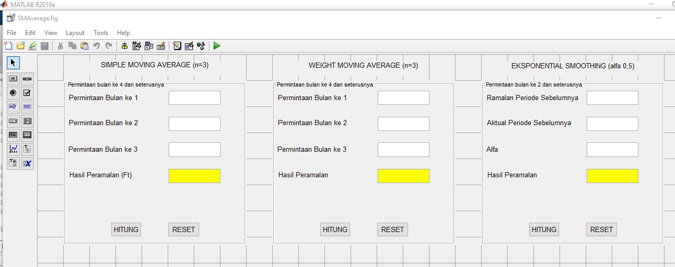

Coding: Simple Moving Average
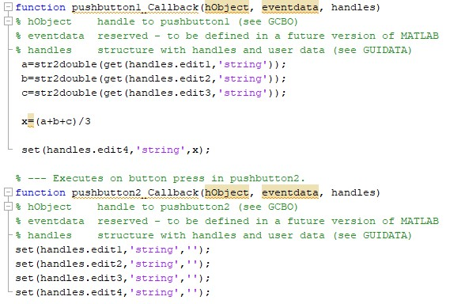

Coding: Weight Moving Average
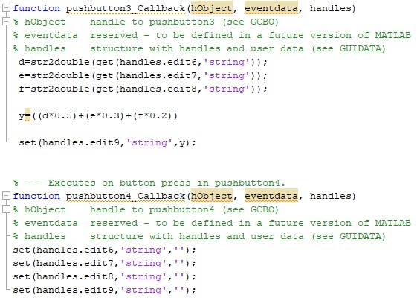

Coding: Exponential Smoothing
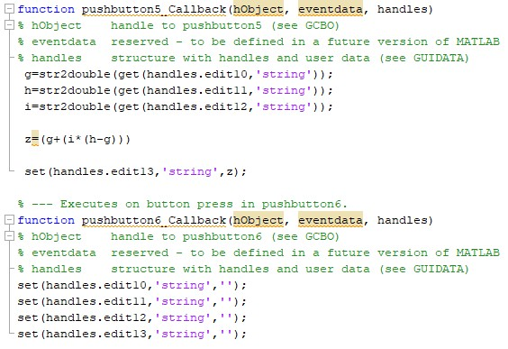

- Program untuk menghitung MAD, MSE dan MAPE
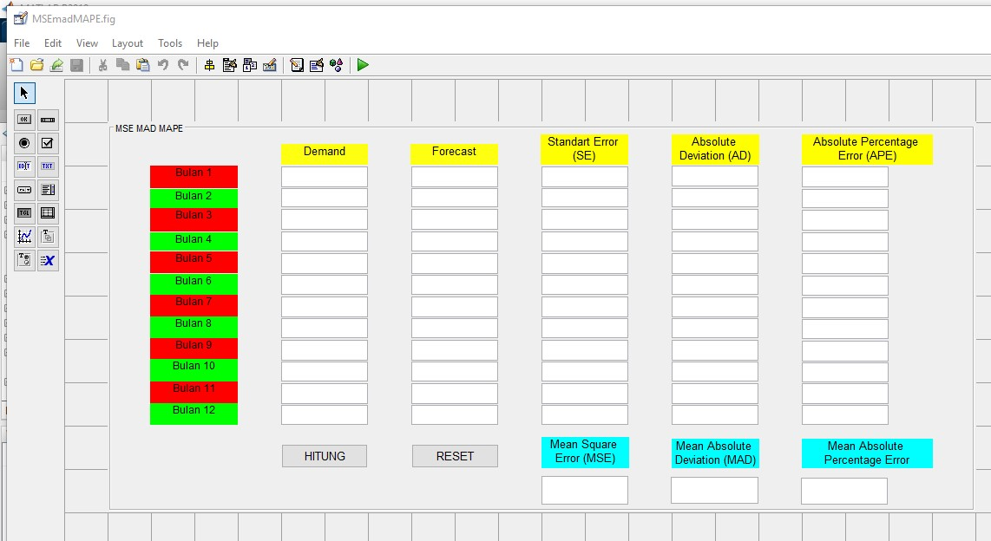
Coding:
% --- Executes on button press in pushbutton1. function pushbutton1_Callback(hObject, eventdata, handles)
% hObject handle to pushbutton1 (see GCBO)
% eventdata reserved - to be defined in a future version of MATLAB
% handles structure with handles and user data (see GUIDATA) a=str2double(get(handles.edit1,'string')); b=str2double(get(handles.edit2,'string')); c=str2double(get(handles.edit3,'string')); d=str2double(get(handles.edit4,'string')); e=str2double(get(handles.edit5,'string')); f=str2double(get(handles.edit6,'string')); g=str2double(get(handles.edit7,'string')); h=str2double(get(handles.edit8,'string')); i=str2double(get(handles.edit9,'string')); j=str2double(get(handles.edit10,'string')); k=str2double(get(handles.edit11,'string')); l=str2double(get(handles.edit12,'string')); aa=str2double(get(handles.edit13,'string')); bb=str2double(get(handles.edit14,'string')); cc=str2double(get(handles.edit15,'string')); dd=str2double(get(handles.edit16,'string')); ee=str2double(get(handles.edit17,'string')); ff=str2double(get(handles.edit18,'string')); gg=str2double(get(handles.edit19,'string')); hh=str2double(get(handles.edit20,'string')); ii=str2double(get(handles.edit21,'string')); jj=str2double(get(handles.edit22,'string')); kk=str2double(get(handles.edit23,'string')); ll=str2double(get(handles.edit24,'string'));
se1=(a-aa)^2 se2=(b-bb)^2 se3=(c-cc)^2 se4=(d-dd)^2 se5=(e-ee)^2 se6=(f-ff)^2 se7=(g-gg)^2 se8=(h-hh)^2 se9=(i-ii)^2 se10=(j-jj)^2 se11=(k-kk)^2 se12=(l-ll)^2 mse=((((a-aa)^2)+((b-bb)^2)+((c-cc)^2)+((d-dd)^2)+((e-ee)^2)+((fff)^2)+((g-gg)^2)+((h-hh)^2)+((i-ii)^2)+((j-jj)^2)+((k-kk)^2)+((lll)^2))/12) ad1=abs(a-aa) ad2=abs(b-bb) ad3=abs(c-cc) ad4=abs(d-dd) ad5=abs(e-ee) ad6=abs(f-ff) ad7=abs(g-gg) ad8=abs(h-hh) ad9=abs(i-ii) ad10=abs(j-jj) ad11=abs(k-kk) ad12=abs(l-ll) mad=(((abs(a-aa))+(abs(b-bb))+(abs(c-cc))+(abs(d-dd))+(abs(eee))+(abs(f-ff))+(abs(g-gg))+(abs(h-hh))+(abs(i-ii))+(abs(jjj))+(abs(k-kk))+(abs(l-ll)))/12) ape1=(abs(a-aa))/a*100 ape2=(abs(b-bb))/b*100 ape3=(abs(c-cc))/c*100 ape4=(abs(d-dd))/d*100 ape5=(abs(e-ee))/e*100 ape6=(abs(f-ff))/f*100 ape7=(abs(g-gg))/g*100 ape8=(abs(h-hh))/h*100 ape9=(abs(i-ii))/i*100 ape10=(abs(j-jj))/j*100 ape11=(abs(k-kk))/k*100 ape12=(abs(l-ll))/l*100 mape=((((abs(a-aa))/a*100)+((abs(b-bb))/b*100)+((abs(ccc))/c*100)+((abs(d-dd))/d*100)+((abs(e-ee))/e*100)+((abs(fff))/f*100)+((abs(g-gg))/g*100)+((abs(h-hh))/h*100)+((abs(iii))/i*100)+((abs(j-jj))/j*100)+((abs(k-kk))/k*100)+((abs(lll))/l*100))/12)

set(handles.edit25,'string',se1); set(handles.edit26,'string',se2); set(handles.edit27,'string',se3); set(handles.edit28,'string',se4); set(handles.edit29,'string',se5); set(handles.edit30,'string',se6); set(handles.edit31,'string',se7); set(handles.edit32,'string',se8); set(handles.edit33,'string',se9); set(handles.edit34,'string',se10); set(handles.edit35,'string',se11); set(handles.edit36,'string',se12); set(handles.edit37,'string',mse); set(handles.edit38,'string',ad1); set(handles.edit39,'string',ad2); set(handles.edit40,'string',ad3); set(handles.edit41,'string',ad4); set(handles.edit42,'string',ad5); set(handles.edit43,'string',ad6); set(handles.edit44,'string',ad7); set(handles.edit45,'string',ad8); set(handles.edit46,'string',ad9); set(handles.edit47,'string',ad10); set(handles.edit48,'string',ad11); set(handles.edit49,'string',ad12); set(handles.edit50,'string',mad); set(handles.edit51,'string',ape1); set(handles.edit52,'string',ape2); set(handles.edit53,'string',ape3); set(handles.edit54,'string',ape4); set(handles.edit55,'string',ape5); set(handles.edit56,'string',ape6); set(handles.edit57,'string',ape7); set(handles.edit58,'string',ape8); set(handles.edit59,'string',ape9); set(handles.edit60,'string',ape10); set(handles.edit61,'string',ape11); set(handles.edit62,'string',ape12);
set(handles.edit63,'string',mape);

- Program untuk menghitung metode aggregate pengendalian tenaga kerja
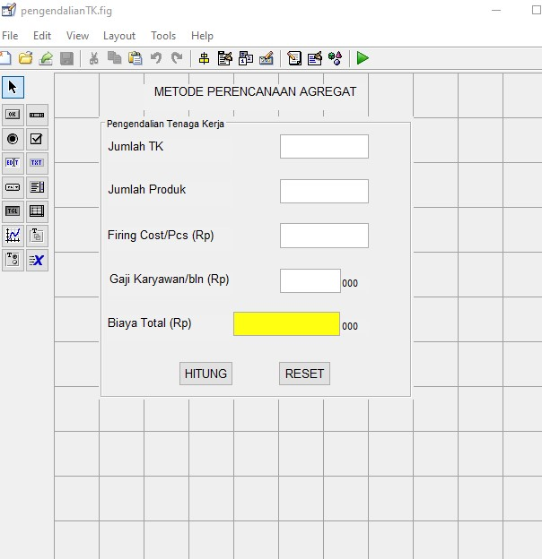
Coding:
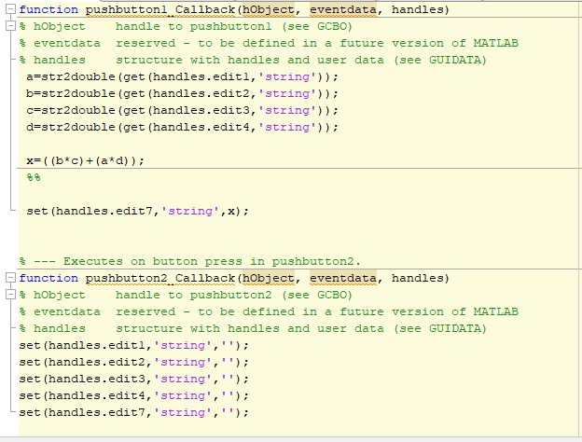

- Program Untuk Menghitung metode agregat Overtime
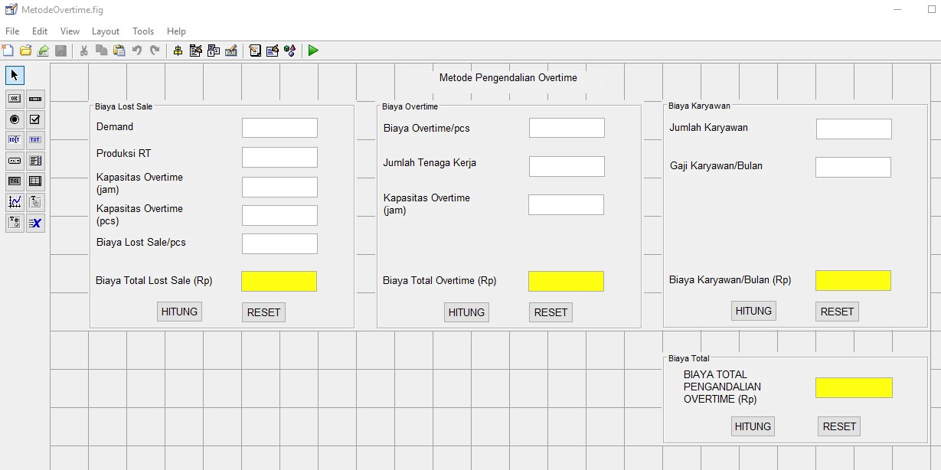

Coding:
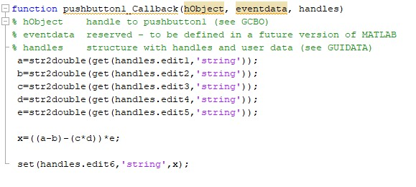

- Program Untuk Menghitung metode agregat Campuran
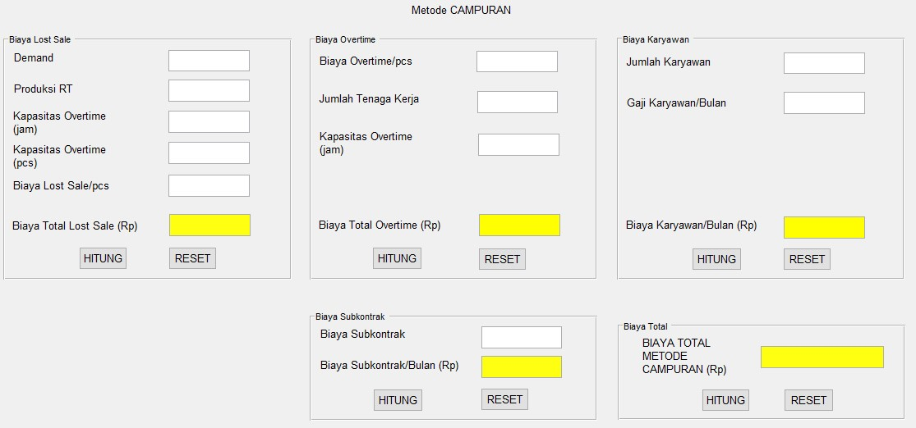
Coding: function pushbutton1_Callback(hObject, eventdata, handles)
% hObject handle to pushbutton1 (see GCBO)
% eventdata reserved - to be defined in a future version of MATLAB
% handles structure with handles and user data (see GUIDATA) a=str2double(get(handles.edit1,'string')); b=str2double(get(handles.edit2,'string')); c=str2double(get(handles.edit3,'string')); d=str2double(get(handles.edit4,'string')); e=str2double(get(handles.edit5,'string'));
x=((a-b)-(c*d))*e;
set(handles.edit6,'string',x);

% --- Executes on button press in pushbutton2. function pushbutton2_Callback(hObject, eventdata, handles)
% hObject handle to pushbutton2 (see GCBO)
% eventdata reserved - to be defined in a future version of MATLAB
% handles structure with handles and user data (see GUIDATA) set(handles.edit1,'string',''); set(handles.edit2,'string',''); set(handles.edit3,'string',''); set(handles.edit4,'string',''); set(handles.edit5,'string',''); set(handles.edit6,'string',''); pushbutton3_Callback(hObject, eventdata, handles)
% hObject handle to pushbutton3 (see GCBO)
% eventdata reserved - to be defined in a future version of
MATLAB
% handles structure with handles and user data (see GUIDATA) f=str2double(get(handles.edit7,'string')); g=str2double(get(handles.edit8,'string')); h=str2double(get(handles.edit9,'string'));
y=f*g*h set(handles.edit10,'string',y);

% --- Executes on button press in pushbutton4. function pushbutton4_Callback(hObject, eventdata, handles)
% hObject handle to pushbutton4 (see GCBO)
% eventdata reserved - to be defined in a future version of
MATLAB
% handles structure with handles and user data (see GUIDATA) set(handles.edit7,'string',''); set(handles.edit8,'string',''); set(handles.edit9,'string','');
set(handles.edit10,'string','');
function pushbutton5_Callback(hObject, eventdata, handles)
% hObject handle to pushbutton5 (see GCBO)
% eventdata reserved - to be defined in a future version of MATLAB
% handles structure with handles and user data (see GUIDATA) i=str2double(get(handles.edit11,'string')); j=str2double(get(handles.edit12,'string'));
z=i*j set(handles.edit13,'string',z);

% --- Executes on button press in pushbutton6. function pushbutton6_Callback(hObject, eventdata, handles)
% hObject handle to pushbutton6 (see GCBO)
% eventdata reserved - to be defined in a future version of
MATLAB
% handles structure with handles and user data (see GUIDATA)

set(handles.edit11,'string',''); set(handles.edit12,'string',''); set(handles.edit13,'string',''); function pushbutton7_Callback(hObject, eventdata, handles)
% hObject handle to pushbutton7 (see GCBO)
% eventdata reserved - to be defined in a future version of MATLAB
% handles structure with handles and user data (see GUIDATA) k=str2double(get(handles.edit14,'string')); l=str2double(get(handles.edit15,'string')); m=str2double(get(handles.edit16,'string'));
xx=k*l*m set(handles.edit17,'string',xx);

% --- Executes on button press in pushbutton8. function pushbutton8_Callback(hObject, eventdata, handles)
% hObject handle to pushbutton8 (see GCBO)
% eventdata reserved - to be defined in a future version of MATLAB
% handles structure with handles and user data (see GUIDATA) set(handles.edit14,'string',''); set(handles.edit15,'string',''); set(handles.edit16,'string',''); set(handles.edit17,'string',''); function pushbutton10_Callback(hObject, eventdata, handles) % hObject handle to pushbutton10 (see GCBO)
% eventdata reserved - to be defined in a future version of MATLAB
% handles structure with handles and user data (see GUIDATA) set(handles.edit1,'string',''); set(handles.edit2,'string',''); set(handles.edit3,'string',''); set(handles.edit4,'string',''); set(handles.edit5,'string',''); set(handles.edit6,'string',''); set(handles.edit7,'string',''); set(handles.edit8,'string',''); set(handles.edit9,'string',''); set(handles.edit10,'string',''); set(handles.edit11,'string',''); set(handles.edit12,'string',''); set(handles.edit13,'string',''); set(handles.edit14,'string',''); set(handles.edit15,'string',''); set(handles.edit16,'string',''); set(handles.edit17,'string',''); set(handles.edit18,'string','');

% --- Executes on button press in pushbutton9. function pushbutton9_Callback(hObject, eventdata, handles)
% hObject handle to pushbutton9 (see GCBO)
% eventdata reserved - to be defined in a future version of
MATLAB
% handles structure with handles and user data (see GUIDATA) i=str2double(get(handles.edit11,'string')); j=str2double(get(handles.edit12,'string')); k=str2double(get(handles.edit14,'string')); l=str2double(get(handles.edit15,'string')); m=str2double(get(handles.edit16,'string')); f=str2double(get(handles.edit7,'string')); g=str2double(get(handles.edit8,'string')); h=str2double(get(handles.edit9,'string'));

s=(i*j)+(k*l*m)+(f*g*h)
set(handles.edit18,'string',s);

Lampiran 6 Lembar Bimbingan SKRIPSI
