DAFTAR PUSTAKA

Afandi, P. (2016). Concept & Indicator Human Resources Management For Management Research. Deepublish.
Aprilia, R. (2019). Pengaruh Motivasi Kerja Dan Budaya Organisasi Terhadap Kinerja Pegawai Di Kantor Polisi Pamong Praja (Satpol PP) Kota Bandung Provinsi Jawa Barat. Jurnal Tatapamong, 1(2), 105–121. https://ejournal.ipdn.ac.id/jurnaltatapamong/article/view/1155
Arikunto, S. (2010). Prosedur Penelitian Suatu Pendekatan Praktek. Rineka Cipta.
Bangun, W. (2012). Manajemen Sumber Daya Manusia (1st ed.). Erlangga.
Danim, S. (2004). Motivasi, Kepemimpinan dan Efektivitas Kelompok. Rineka Cipta.
Fahmi, I. (2016). Manajemen Sumber Daya Manusia. PT. Alfabeta.
Ghozali, I. (2016). Aplikasi Analisis Multivariate Dengan Program SPSS. Badan Penerbit Universitas Dipenegoro.
Ghozali, I. (2018). Aplikasi Analisis Multivariate Dengan Program IBM SPSS 25 (9th ed.). Universitas Dipenegoro.
Gunarsa, S. D. (2008). Psikologi Olahraga Prestasi. Gunung Mulia.
Hasibuan, M. S. . (1996). Organisasi dan Motivasi Dasar Peningkatan Produktivitas. Bumi Aksara.
Kaswan. (2017). Psikologi Industri & Organisasi (Alfabeta (ed.)).
Komaruddin. (1994). Ensiklopedia Manajemen. Alumni.
Latif, I. A., Abubakar, H., & Said, M. (2021). Pengaruh Motivasi Intrinsik, Motivasi Ekstrinsik dan Budaya Organisasi Terhadap Kinerja Karyawan Pada Hotel Ayana Komodo Resort, Waecicu Beach Labuan Bajo Nusa Tenggara Timur. Indonesian Journal of Business and Management, 3(2), 134–138. https://journal.unibos.ac.id/jbm/article/view/594
Luthans. (2006). Perilaku Organisasi (10th ed.). PT. Andi.
Mangkunegara, A. P. (2005). Evaluasi Kinerja SDM. PT. Refika Aditama.
Mangkunegara, A. P. (2011). Manajemen Sumber Daya Perusahaan. Remaja Rosdakarya.
Mangkunegara, A. P. (2017). Evaluasi Kinerja Sumber Daya Manusia. Refika Aditama.
Manullang, M. (2001). Manajemen Personalia. Gajah Mada University Press.
Moeheriono. (2010). Pengukuran Kinerja Berbasis Kompetensi. Ghalia Indonesia.
Potu, J., Lengkong, V. P. ., & Trang, I. (2021). Pengaruh Motivasi Intrinsik Dan Motivasi Ekstrinsik Terhadap Kinerja Karyawan Pada PT. Air Manado. Jurnal EMBA, 9(2), 387–394. https://ejournal.unsrat.ac.id/index.php/emba/article/view/33474
Prasetyo, Y. A., & Wahyudi, C. (2022). Pengaruh Budaya Organisasi, Etika Kerja, dan Loyalitas Kerja Terhadap Kinerja Tenaga Kependidikan Universitas Bhamada Slawi. Konsentrasi: Jurnal Manajemen Dan Bisnis, 2(2), 97–105. https://konsentrasi.upstegal.ac.id/index.php/Konsentrasi/article/download/28/22/
Rahmi, F., & Sovia, A. (2017). Dampak Sistem Pengendalian Internal, Prilaku Tidak Etis, Dan Moralitas Manajemen Terhadap Kecenderungan Kecurangan Akuntansi Pada Perusahaan Developer Di Pekanbaru. Jurnal Al-Iqtishad, 1(13), 48–66. https://ejournal.uin-suska.ac.id/index.php/al-iqtishad/article/view/4388/0
Robbins, S. P. (1998). Organization Behavior, Concepts, Controversies, Application (Seventh Ed). Englewood Cliffs dan PT. Prenhallindo.
Robbins, S. P. (2007). Manajemen. PT. Indeks.
Robbins, S. P., & Coulter, M. (2009). Manajemen (10th ed.). Erlangga.
Robbins, S. P., Judge, T., & Timothy, A. (2008). Organizational Behavior. Pearson.
Safitri, A., & Susanto. (2019). Pengaruh Motivasi Intrinsik,Motivasi Ekstrinsik, Kompetensi dan Komitmen Terhadap Kinerja Karyawan PT. Askrindo Semarang. Majalah Ilmiah Solusi, 17(3), 155–172. https://journals.usm.ac.id/index.php/solusi/article/view/1633
Samuel, T., & Septina, F. (2020). Pengaruh Motivasi Ekstrinsik dan Motivasi Intrinsik terhadap Kinerja Karyawan CV. Muncul Anugerah Jaya. JEMMA (Jurnal of Economic, Management, and Accounting), 3(2), 103–112. http://www.ojs.unanda.ac.id/index.php/jemma/article/view/365
Santrock, J. W. (2003). Adolescance Perkembangan Remaja (S. B. Adlar dkk (ed.)). Erlangga.
Sedarmayanti. (2011). Manajemen Sumber Daya Manusia. PT. Refika Aditama.
Sinambela, L. P. (2018). Manajemen Sumber Daya Manusia. PT. Bumi Aksara.
Siregar, H., Ahmadi, Zainuri, Susanti, Y., & Aritonang, R. (2020). Pengaruh Keterlibatan Kerja, Motivasi Intrinsik dan Budaya Organisasi Terhadap Kinerja Aparatur Sipil Negara (ASN) Di Dinas Lingkungan Hidup Provinsi Sumatera Utara. Jurnal Riset Manajemen Dan Bisnis, 5(2), 214–223. https://jurnal.uisu.ac.id/index.php/JRMB/article/view/3345
Sugiyono. (2017). Metode Penelitian Kuantitatif, Kualitatif dan R & D. CV. Alfabeta.
Sulistiyani, A. T., & Rosidah. (2003). Manajemen Sumber Daya Manusia. Graha Ilmu.
Suliyanto. (2018). Metode Penelitian Bisnis Untuk Skripsi, Tesis dan Disertasi. Andi Offset (Anggota IKAPI).
Suryadi, I., & Efendi, S. (2018). Pengaruh Motivasi Intrinsik, Kepuasan Kerja dan Budaya Organisasi Terhadap Kinerja Pegawai Biro Kepegawaian Di Badan Kepegawaian Negara (BKN) Jakarta. Jurnal Ilmu Manajemen, 14(2), 109–124. http://journal.unas.ac.id/oikonamia/article/view/524
Susanto. (2006). Strategi Organisasi. Amara Books.
Suwatno. (2011). Manajemen SDM dalam Organisasi Publik dan Bisnis. Alfabeta.
Tika, M. P. (2016). Budaya Organisasi dan Peningkatan Kinerja Perusahaan. PT. Bumi Aksara.
Triadi, R., Hidayah, S., & Fasochah. (2019). Pengaruh Motivasi Intrinsik Dan Ekstrinsik Terhadap Kinerja Pegawai Yang Di Mediasi Oleh Komitmen Organisasi (Studi Pada Pegawai Kantor Pertanahan Kota Semarang). Jurnal Ekonomi Manajemen Dan Akuntansi, 26(47), 1–17. https://ejurnal.stiedharmaputra-smg.ac.id/index.php/JEMA/article/view/351
Uno, H. B. (2016). Teori Motivasi dan Pengukurannya Analisis di Bidang Pendidikan. PT. Bumi Aksara.
Widiawaty, I. N., Rajindra, & Kadir, H. A. (2020). Pengaruh Motivasi Intrinsik dan Motivasi Ekstrinsik terhadap Kinerja Pegawai pada Kantor Badan Pendapatan Daerah Provinsi Sulawesi Tengah. Jurnal Kolaboratif Sains, 3(8), 390–400. https://jurnal.unismuhpalu.ac.id/index.php/JKS/article/view/1749
Wirawan. (2007). Budaya dan Iklim Organisasi. Salemba Empat.

Lampiran 1
KATA PENGANTAR
Perihal : Permohonan Lembar Pengisian Kuesioner
Judul Penelitian : Pengaruh Motivasi Intrinsik, Motivasi Ekstrinsik dan Budaya Organisasi Terhadap Kinerja Pegawai Unit Pengelolaan Pendapatan Daerah SAMSAT Slawi Kabupaten Tegal
Kepada Yth, Pegawai UPPD SAMSAT Slawi
Di Tempat
Dengan Hormat,
Dalam rangka untuk menyelesaikan penelitian, saya Mahasiswa Fakultas Ekonomi dan Bisnis Universitas Pancasakti Tegal, memohon partisipasi dari Bapak/Ibu/Sdr untuk dapat mengisi kuesioner yang telah saya sediakan.
Adapun data yang saya minta merupakan data yang sesuai dengan kondisi yang dirasakan oleh Bapak/Ibu/Sdr selama ini. Saya akan menjaga kerahasiaan data ini, karena hanya untuk kepentingan penelitian.
Setiap jawaban yang diberikan merupakan bantuan yang tidak ternilai harganya dan sangat bermanfaat bagi penelitian ini.
Atas perhatian dan bantuannya, saya mengucapkan banyak terimakasih.

Tegal, April 2023
Hormat saya,

Raffi Setyo Putri
Petunjuk Pengisian
- Jawablah masing-masing pertanyaan dibawah ini sesuai dengan kondisi saat ini.
- Pililah salah satu jawaban dibawah ini dengan cara memberikan tanda centang ( √ ) pada salah satu kolom pada jawaban yang tersedia.
Identitas Responden
1. Jenis Kelamin : Laki-laki Perempuan
- Usia : 21-30 th 31-40 th
> 41 th
- Pendidikan Terakhir : SMA/SMK/MA
D1/D2/D3
S1
S2
Pililah salah satu jawaban dari kelima jawaban yang sesuai dengan cara memberikan tanda centang ( √ ) pada salah satu kolom pada jawaban yang tersedia.
Keterangan :
- SS (Sangat Setuju)
- S (Setuju)
- N (Netral)
- TS (Tidak Setuju)
- STS (Sangat Tidak Setuju)

- Pernyataan Variabel Kinerja Pegawai (Y)
No | Pernyataan | Jawaban Responden
 |  | STS | TS | N | S | SS
1 | Pegawai mengerjakan tugas serta wewenang yang diberikan dengan baik
2 | Pegawai menyelesaikan semua tugas dan tanggung jawab pegawai sesuai dengan jumlah yang diberikan
3 | Pegawai menyelesaikan tugas sesuai dengan arahan dan keinginan atasan
4 | Pegawai selalu jujur dalam menjalankan tugas dan kewajiban
5 | Pegawai mampu bekerjasama dengan atasan maupun bawahan
6 | Pegawai mampu bekerjasama dengan rekan kerja
7 | Pegawai memiliki sikap inisiatif dalam bekerja
8 | Pegawai selalu melaksanakan tugas yang diberikan
9 | Pegawai memiliki wawasan yang luas dalam menunjang pekerjaan pegawai
- Pernyataan Variabel Motivasi Intrinsik (X1)
No | Pernyataan | Jawaban Responden
 |  | STS | TS | N | S | SS
1 | Pegawai memiliki kemauan yang tinggi dalam menyelesaikan tugas yang diberikan
2 | Pegawai memiliki semangat dalam menyelesaikan tanggung jawab yang diberikan
3 | Pegawai selalu mendukung keputusan atasan
4 | Pegawai selalu patuh terhadap atasan
5 | Pegawai selalu menghormati atasan
6 | Pegawai senang dalam menjalani pekerjaan
7 | Pegawai percaya diri terhadap pekerjaan yang saya jalani
8 | Pegawai menghargai pekerjaan yang diberikan
9 | Pegawai diberikan kesempatan berpartisipasi pada tugas-tugas tertentu
10 | Pegawai diberikan kesempatan dalam mengekspresikan diri di lingkungan kerja
11 | Pegawai bertanggung jawab terhadap pekerjaan yang dikerjakan
12 | Pegawai ingin mengembangkan diri saya guna menunjang pekerjaan
13 | Pegawai diberikan kesempatan untuk berprestasi di lingkungan kerja
- Pernyataan Variabel Motivasi Ekstrinsik (X2)
No | Pernyataan | Jawaban Responden
 |  | STS | TS | N | S | SS
1 | Pegawai merasa dihargai atas tugas yang saya selesaikan
2 | Pegawai mendapatkan pengakuan atas prestasi yang saya dapatkan
3 | Pegawai mendapatkan kompensasi atas pekerjaan yang pegawai selesaikan
4 | Pegawai mendapatkan imbalan/gaji atas pekerjaan yang diselesaikan
5 | Pegawai mendapatkan peluang untuk mengembangkan diri
6 | Pegawai mendapatkan jenis pekerjaan yang sesuai dengan kemampuan dan minat pegawai
7 | Pegawai mendapatkan peluang untuk meningkatkan pengalaman di lingkungan kerja
8 | Pegawai mendapatkan sikap yang positif dari rekan kerja
- Pernyataan Variabel Budaya Organisasi (X3)
No | Pernyataan | Jawaban Responden
 |  | STS | TS | N | S | SS
1 | Pegawai menerapkan keputusan manajemen
2 | Pegawai sangat agresif dalam bekerja
3 | Pegawai merasa pegawai lain sebagai saingan saya dilingkungan kerja
4 | Pegawai fokus terhadap hasil pekerjaan saja
5 | Pegawai fokus terhadap proses dalam menyelesaikan tugas sebaik mungkin
6 | Pegawai cenderung bekerja dengan mengutamakan kepentingan tim saja
7 | Pegawai bekerja dengan teliti
8 | Pegawai memberikan perhatian mendetil pada pekerjaan yang saya dikerjakan
9 | Pegawai menganalisis terlebih dahulu pekerjaan yang saya akan kerjakan
10 | Pegawai dituntut untuk berpikir inovatif dalam bekerja
11 | Pegawai dituntut untuk berani mengambil resiko saat bekerja

Lampiran 2
SURAT IZIN PENELITIAN
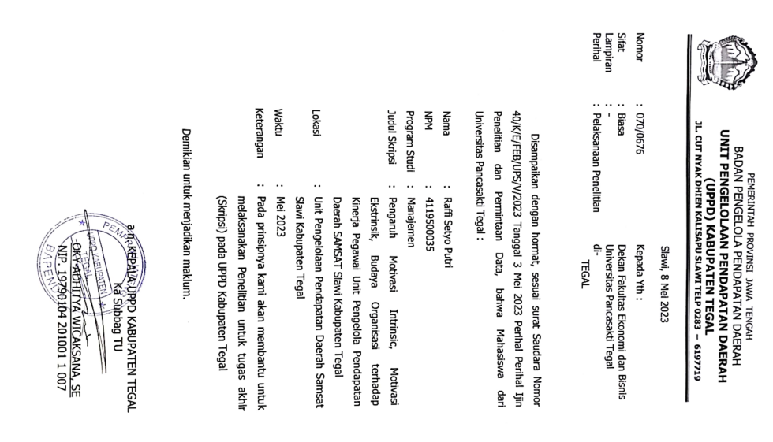
Lampiran 3
FOTO PENYERAHAN KUESIONER KEPADA PEGAWAI
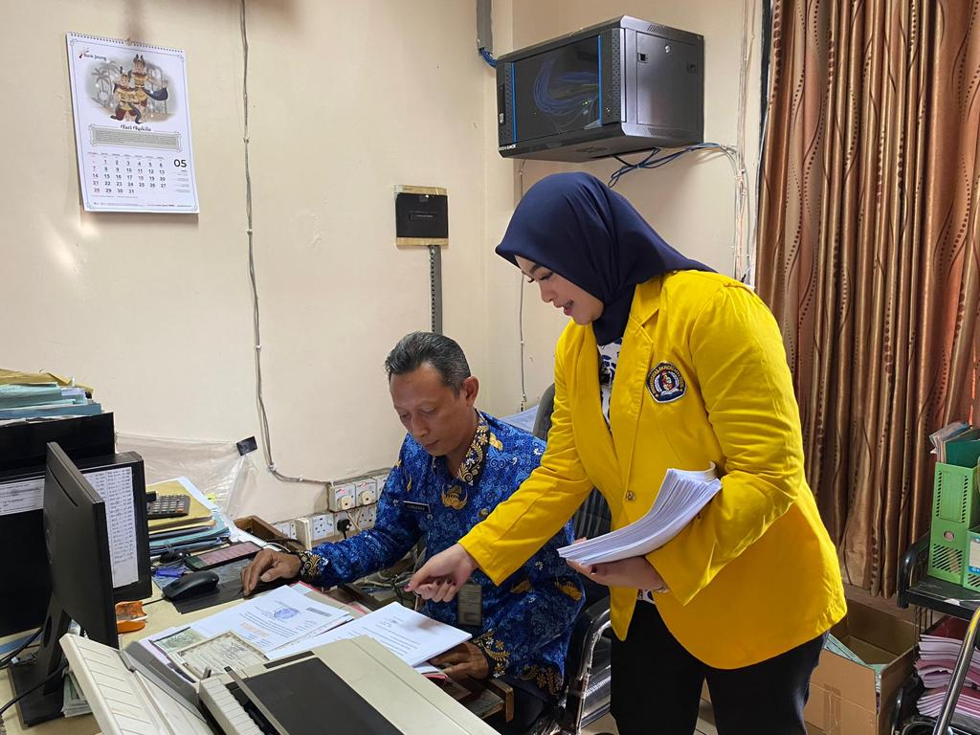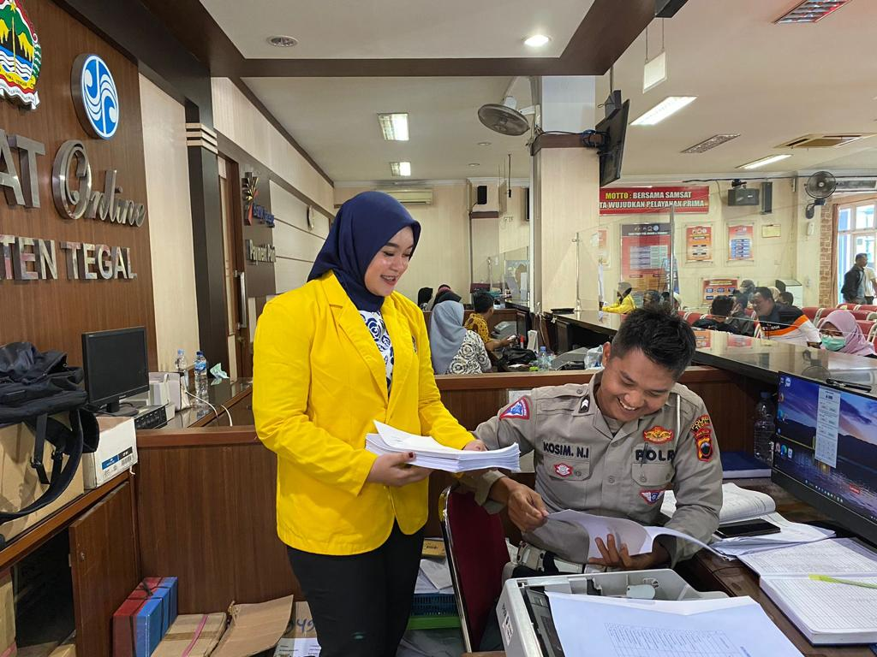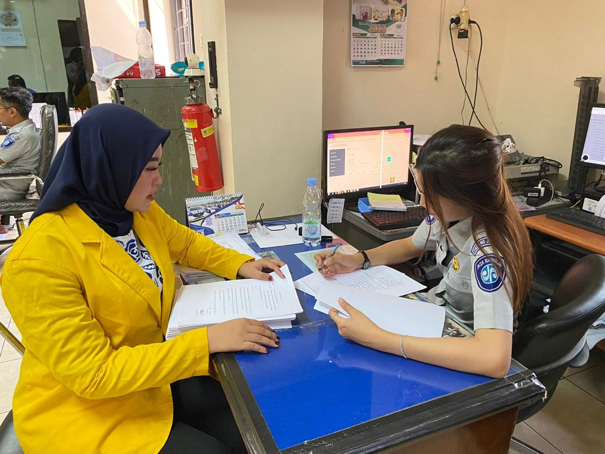
Lampiran 4
HASIL UJI VALIDITAS
- Uji Validitas Variabel Kinerja Pegawai (Y)
Correlations
 |  | Y_P1 | Y_P2 | Y_P3 | Y_P4 | Y_P5 | Y_P6 | Y_P7 | Y_P8 | Y_P9 | Total_Skor
Y_P1 | Pearson Correlation | 1 | .671** | .571** | .479** | .436** | .383** | .349** | .652** | .441** | .741**
 | Sig. (2-tailed) |  | .000 | .000 | .000 | .000 | .002 | .005 | .000 | .000 | .000
 | N | 62 | 62 | 62 | 62 | 62 | 62 | 62 | 62 | 62 | 62
Y_P2 | Pearson Correlation | .671** | 1 | .469** | .491** | .357** | .263* | .370** | .528** | .535** | .706**
 | Sig. (2-tailed) | .000 |  | .000 | .000 | .004 | .039 | .003 | .000 | .000 | .000
 | N | 62 | 62 | 62 | 62 | 62 | 62 | 62 | 62 | 62 | 62
Y_P3 | Pearson Correlation | .571** | .469** | 1 | .583** | .415** | .409** | .601** | .522** | .594** | .763**
 | Sig. (2-tailed) | .000 | .000 |  | .000 | .001 | .001 | .000 | .000 | .000 | .000
 | N | 62 | 62 | 62 | 62 | 62 | 62 | 62 | 62 | 62 | 62
Y_P4 | Pearson Correlation | .479** | .491** | .583** | 1 | .371** | .364** | .351** | .286* | .548** | .673**
 | Sig. (2-tailed) | .000 | .000 | .000 |  | .003 | .004 | .005 | .024 | .000 | .000
 | N | 62 | 62 | 62 | 62 | 62 | 62 | 62 | 62 | 62 | 62
Y_P5 | Pearson Correlation | .436** | .357** | .415** | .371** | 1 | .720** | .548** | .571** | .518** | .739**
 | Sig. (2-tailed) | .000 | .004 | .001 | .003 |  | .000 | .000 | .000 | .000 | .000
 | N | 62 | 62 | 62 | 62 | 62 | 62 | 62 | 62 | 62 | 62
Y_P6 | Pearson Correlation | .383** | .263* | .409** | .364** | .720** | 1 | .693** | .609** | .542** | .740**
 | Sig. (2-tailed) | .002 | .039 | .001 | .004 | .000 |  | .000 | .000 | .000 | .000
 | N | 62 | 62 | 62 | 62 | 62 | 62 | 62 | 62 | 62 | 62
Y_P7 | Pearson Correlation | .349** | .370** | .601** | .351** | .548** | .693** | 1 | .566** | .564** | .751**
 | Sig. (2-tailed) | .005 | .003 | .000 | .005 | .000 | .000 |  | .000 | .000 | .000
 | N | 62 | 62 | 62 | 62 | 62 | 62 | 62 | 62 | 62 | 62
Y_P8 | Pearson Correlation | .652** | .528** | .522** | .286* | .571** | .609** | .566** | 1 | .613** | .795**
 | Sig. (2-tailed) | .000 | .000 | .000 | .024 | .000 | .000 | .000 |  | .000 | .000
 | N | 62 | 62 | 62 | 62 | 62 | 62 | 62 | 62 | 62 | 62
Y_P9 | Pearson Correlation | .441** | .535** | .594** | .548** | .518** | .542** | .564** | .613** | 1 | .796**
 | Sig. (2-tailed) | .000 | .000 | .000 | .000 | .000 | .000 | .000 | .000 |  | .000
 | N | 62 | 62 | 62 | 62 | 62 | 62 | 62 | 62 | 62 | 62
Total_Skor | Pearson Correlation | .741** | .706** | .763** | .673** | .739** | .740** | .751** | .795** | .796** | 1
 | Sig. (2-tailed) | .000 | .000 | .000 | .000 | .000 | .000 | .000 | .000 | .000
 | N | 62 | 62 | 62 | 62 | 62 | 62 | 62 | 62 | 62 | 62

- Uji Validitas Variabel Motivasi Intrinsik (X1)
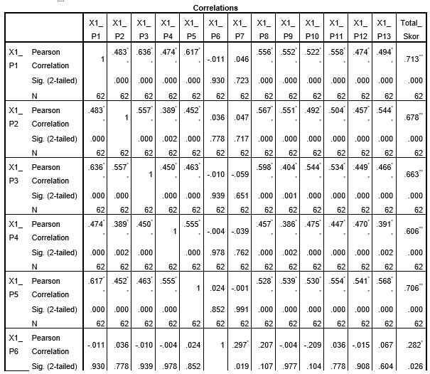

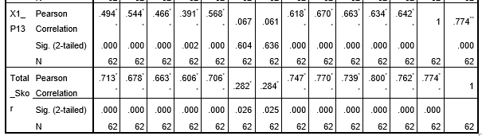
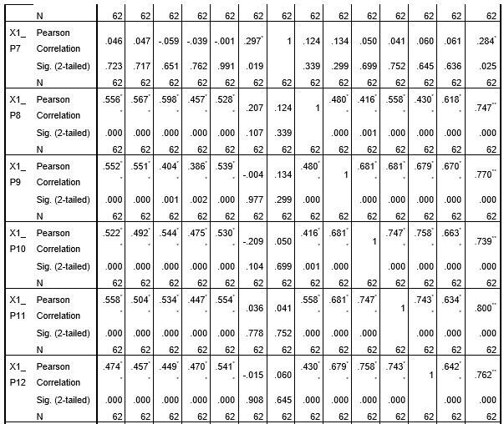

- Uji Validitas Variabel Motivasi Ekstrinsik (X2)
Correlations
 |  | X2_P1 | X2_P2 | X2_P3 | X2_P4 | X2_P5 | X2_P6 | X2_P7 | X2_P8 | Total_Skor
X2_P1 | Pearson Correlation | 1 | .083 | .239 | .285* | .075 | .179 | .060 | .112 | .455**
 | Sig. (2-tailed) |  | .522 | .061 | .025 | .563 | .165 | .644 | .386 | .000
 | N | 62 | 62 | 62 | 62 | 62 | 62 | 62 | 62 | 62
X2_P2 | Pearson Correlation | .083 | 1 | -.021 | -.110 | .139 | .220 | .206 | .160 | .403**
 | Sig. (2-tailed) | .522 |  | .870 | .393 | .281 | .085 | .109 | .215 | .001
 | N | 62 | 62 | 62 | 62 | 62 | 62 | 62 | 62 | 62
X2_P3 | Pearson Correlation | .239 | -.021 | 1 | .234 | .171 | .355** | .275* | .140 | .586**
 | Sig. (2-tailed) | .061 | .870 |  | .068 | .185 | .005 | .031 | .277 | .000
 | N | 62 | 62 | 62 | 62 | 62 | 62 | 62 | 62 | 62
X2_P4 | Pearson Correlation | .285* | -.110 | .234 | 1 | .134 | .284* | -.044 | -.095 | .386**
 | Sig. (2-tailed) | .025 | .393 | .068 |  | .298 | .025 | .734 | .463 | .002
 | N | 62 | 62 | 62 | 62 | 62 | 62 | 62 | 62 | 62
X2_P5 | Pearson Correlation | .075 | .139 | .171 | .134 | 1 | .329** | .087 | .046 | .456**
 | Sig. (2-tailed) | .563 | .281 | .185 | .298 |  | .009 | .499 | .722 | .000
 | N | 62 | 62 | 62 | 62 | 62 | 62 | 62 | 62 | 62
X2_P6 | Pearson Correlation | .179 | .220 | .355** | .284* | .329** | 1 | .287* | .210 | .689**
 | Sig. (2-tailed) | .165 | .085 | .005 | .025 | .009 |  | .024 | .102 | .000
 | N | 62 | 62 | 62 | 62 | 62 | 62 | 62 | 62 | 62
X2_P7 | Pearson Correlation | .060 | .206 | .275* | -.044 | .087 | .287* | 1 | .591** | .626**
 | Sig. (2-tailed) | .644 | .109 | .031 | .734 | .499 | .024 |  | .000 | .000
 | N | 62 | 62 | 62 | 62 | 62 | 62 | 62 | 62 | 62
X2_P8 | Pearson Correlation | .112 | .160 | .140 | -.095 | .046 | .210 | .591** | 1 | .547**
 | Sig. (2-tailed) | .386 | .215 | .277 | .463 | .722 | .102 | .000 |  | .000
 | N | 62 | 62 | 62 | 62 | 62 | 62 | 62 | 62 | 62
Total_Skor | Pearson Correlation | .455** | .403** | .586** | .386** | .456** | .689** | .626** | .547** | 1
 | Sig. (2-tailed) | .000 | .001 | .000 | .002 | .000 | .000 | .000 | .000
 | N | 62 | 62 | 62 | 62 | 62 | 62 | 62 | 62 | 62

- Uji Validitas Variabel Budaya Organsiasi (X3)
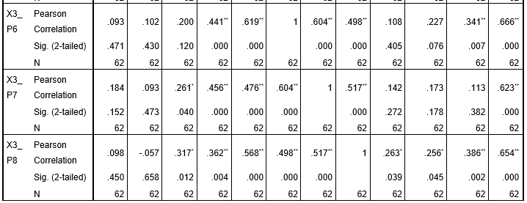
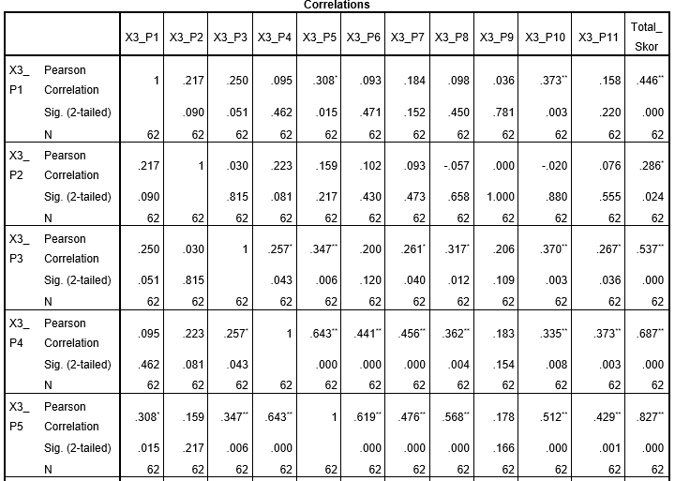

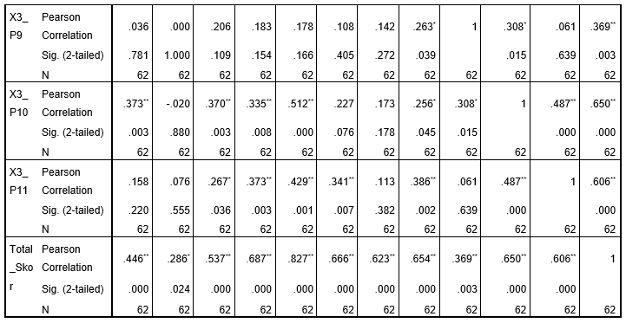

Lampiran 5
HASIL UJI REABILITAS
- Uji Reabilitas Variabel Kinerja Pegawai (Y)
Reliability Statistics
Cronbach’s Alpha | N of Items
.897 | 9
- Uji Reabilitas Variabel Motivasi Intrinsik (X1)
Reliability Statistics
Cronbach’s Alpha | N of Items
.848 | 13
- Uji Reabilitas Variabel Motivasi Ekstrinsik (X2)
Reliability Statistics
Cronbach’s Alpha | N of Items
.618 | 8
- Uji Reabilitas Variabel Budaya Organisasi (X3)
Reliability Statistics
Cronbach’s Alpha | N of Items
.802 | 11

Lampiran 6
HASIL TRANSFORMASI DATA ORDINAL MENJADI INTERVAL
- Data Penelitian Variabel Kinerja Pegawai (Y)
No | Kinerja Pegawai (Y) |  |  |  |  |  |  |  |  | ∑
 | P1 | P2 | P3 | P4 | P5 | P6 | P7 | P8 | P9
1 | 4 | 4 | 3 | 5 | 5 | 5 | 4 | 4 | 5 | 39
2 | 5 | 5 | 4 | 5 | 3 | 4 | 3 | 4 | 4 | 37
3 | 5 | 4 | 5 | 5 | 5 | 5 | 4 | 5 | 5 | 43
4 | 4 | 4 | 3 | 3 | 3 | 3 | 2 | 3 | 3 | 28
5 | 5 | 5 | 5 | 5 | 5 | 5 | 5 | 5 | 5 | 45
6 | 5 | 5 | 5 | 5 | 5 | 4 | 4 | 4 | 4 | 41
7 | 4 | 3 | 4 | 4 | 4 | 4 | 4 | 4 | 4 | 35
8 | 5 | 4 | 4 | 4 | 5 | 4 | 3 | 5 | 4 | 38
9 | 5 | 5 | 5 | 5 | 5 | 5 | 4 | 5 | 5 | 44
10 | 5 | 5 | 5 | 5 | 5 | 5 | 5 | 5 | 4 | 44
11 | 5 | 3 | 4 | 3 | 3 | 4 | 4 | 5 | 3 | 34
12 | 3 | 3 | 4 | 4 | 4 | 4 | 4 | 3 | 3 | 32
13 | 4 | 5 | 5 | 5 | 5 | 5 | 5 | 5 | 5 | 44
14 | 4 | 3 | 4 | 4 | 5 | 5 | 4 | 4 | 4 | 37
15 | 4 | 3 | 4 | 4 | 3 | 5 | 4 | 4 | 4 | 35
16 | 5 | 5 | 5 | 5 | 4 | 5 | 5 | 5 | 5 | 44
17 | 5 | 5 | 5 | 5 | 5 | 5 | 5 | 5 | 5 | 45
18 | 5 | 5 | 5 | 5 | 5 | 5 | 5 | 5 | 5 | 45
19 | 5 | 5 | 5 | 5 | 4 | 4 | 4 | 4 | 5 | 41
20 | 4 | 4 | 4 | 4 | 4 | 4 | 4 | 4 | 4 | 36
21 | 5 | 5 | 5 | 5 | 5 | 5 | 5 | 5 | 5 | 45
22 | 4 | 4 | 4 | 4 | 3 | 4 | 4 | 4 | 4 | 35
23 | 4 | 4 | 4 | 3 | 3 | 3 | 3 | 3 | 3 | 30
24 | 4 | 4 | 4 | 3 | 4 | 4 | 4 | 4 | 4 | 35
25 | 5 | 5 | 5 | 4 | 5 | 5 | 5 | 5 | 5 | 44
26 | 5 | 3 | 4 | 3 | 5 | 5 | 3 | 5 | 4 | 37
27 | 4 | 4 | 4 | 4 | 5 | 5 | 4 | 3 | 4 | 37
28 | 5 | 4 | 5 | 2 | 5 | 5 | 5 | 5 | 4 | 40
29 | 5 | 5 | 5 | 5 | 5 | 5 | 4 | 5 | 5 | 44
30 | 5 | 5 | 5 | 5 | 5 | 5 | 5 | 5 | 5 | 45
31 | 4 | 2 | 5 | 5 | 4 | 4 | 4 | 3 | 4 | 35
32 | 5 | 5 | 4 | 4 | 4 | 4 | 3 | 4 | 4 | 37
33 | 4 | 4 | 4 | 4 | 3 | 4 | 3 | 4 | 4 | 34
34 | 5 | 5 | 5 | 5 | 4 | 4 | 4 | 4 | 4 | 40
35 | 3 | 3 | 3 | 4 | 3 | 3 | 2 | 3 | 3 | 27
36 | 5 | 5 | 4 | 4 | 5 | 5 | 5 | 5 | 5 | 43
37 | 5 | 5 | 5 | 5 | 5 | 5 | 4 | 5 | 5 | 44
38 | 5 | 5 | 4 | 5 | 5 | 5 | 4 | 3 | 4 | 40
39 | 4 | 4 | 4 | 3 | 4 | 5 | 4 | 4 | 4 | 36
40 | 3 | 3 | 3 | 4 | 4 | 4 | 3 | 3 | 3 | 30
41 | 4 | 4 | 3 | 3 | 4 | 4 | 3 | 4 | 4 | 33
42 | 5 | 5 | 5 | 5 | 5 | 4 | 4 | 5 | 5 | 43
43 | 4 | 4 | 4 | 4 | 4 | 4 | 3 | 3 | 3 | 33
44 | 5 | 4 | 4 | 4 | 4 | 4 | 3 | 4 | 4 | 36
45 | 4 | 4 | 4 | 4 | 3 | 3 | 3 | 3 | 3 | 31
46 | 4 | 4 | 4 | 4 | 4 | 5 | 4 | 5 | 4 | 38
47 | 4 | 5 | 3 | 3 | 5 | 5 | 5 | 5 | 4 | 39
48 | 5 | 4 | 4 | 4 | 4 | 4 | 4 | 4 | 3 | 36
49 | 5 | 5 | 5 | 5 | 4 | 5 | 4 | 5 | 4 | 42
50 | 5 | 5 | 5 | 5 | 5 | 5 | 4 | 5 | 4 | 43
51 | 5 | 5 | 5 | 5 | 5 | 5 | 5 | 5 | 4 | 44
52 | 5 | 4 | 4 | 4 | 5 | 5 | 4 | 4 | 3 | 38
53 | 5 | 5 | 4 | 4 | 5 | 4 | 3 | 5 | 4 | 39
54 | 5 | 5 | 5 | 5 | 4 | 4 | 4 | 4 | 5 | 41
55 | 5 | 5 | 4 | 4 | 3 | 4 | 3 | 4 | 4 | 36
56 | 4 | 4 | 4 | 4 | 4 | 5 | 4 | 4 | 4 | 37
57 | 4 | 4 | 4 | 4 | 4 | 4 | 4 | 4 | 4 | 36
58 | 4 | 3 | 4 | 4 | 5 | 5 | 4 | 4 | 4 | 37
59 | 5 | 5 | 4 | 4 | 3 | 3 | 4 | 4 | 4 | 36
60 | 4 | 4 | 4 | 3 | 4 | 4 | 4 | 4 | 3 | 34
61 | 2 | 3 | 4 | 2 | 3 | 3 | 3 | 3 | 4 | 27
62 | 5 | 5 | 4 | 4 | 5 | 4 | 3 | 5 | 4 | 39

No | Kinerja Pegawai (Y) |  |  |  |  |  |  |  |  | ∑
 | P1 | P2 | P3 | P4 | P5 | P6 | P7 | P8 | P9
1 | 2,777 | 3,111 | 1,000 | 4,229 | 3,268 | 3,594 | 3,327 | 2,141 | 3,681 | 27,129
2 | 4,196 | 4,349 | 2,382 | 4,229 | 1,000 | 2,228 | 2,161 | 2,141 | 2,332 | 25,020
3 | 4,196 | 3,111 | 3,789 | 4,229 | 3,268 | 3,594 | 3,327 | 3,397 | 3,681 | 32,593
4 | 2,777 | 3,111 | 1,000 | 1,946 | 1,000 | 1,000 | 1,000 | 1,000 | 1,000 | 13,835
5 | 4,196 | 4,349 | 3,789 | 4,229 | 3,268 | 3,594 | 4,613 | 3,397 | 3,681 | 35,117
6 | 4,196 | 4,349 | 3,789 | 4,229 | 3,268 | 2,228 | 3,327 | 2,141 | 2,332 | 29,861
7 | 2,777 | 2,137 | 2,382 | 2,958 | 2,054 | 2,228 | 3,327 | 2,141 | 2,332 | 22,338
8 | 4,196 | 3,111 | 2,382 | 2,958 | 3,268 | 2,228 | 2,161 | 3,397 | 2,332 | 26,035
9 | 4,196 | 4,349 | 3,789 | 4,229 | 3,268 | 3,594 | 3,327 | 3,397 | 3,681 | 33,831
10 | 4,196 | 4,349 | 3,789 | 4,229 | 3,268 | 3,594 | 4,613 | 3,397 | 2,332 | 33,768
11 | 4,196 | 2,137 | 2,382 | 1,946 | 1,000 | 2,228 | 3,327 | 3,397 | 1,000 | 21,615
12 | 1,727 | 2,137 | 2,382 | 2,958 | 2,054 | 2,228 | 3,327 | 1,000 | 1,000 | 18,814
13 | 2,777 | 4,349 | 3,789 | 4,229 | 3,268 | 3,594 | 4,613 | 3,397 | 3,681 | 33,698
14 | 2,777 | 2,137 | 2,382 | 2,958 | 3,268 | 3,594 | 3,327 | 2,141 | 2,332 | 24,918
15 | 2,777 | 2,137 | 2,382 | 2,958 | 1,000 | 3,594 | 3,327 | 2,141 | 2,332 | 22,649
16 | 4,196 | 4,349 | 3,789 | 4,229 | 2,054 | 3,594 | 4,613 | 3,397 | 3,681 | 33,903
17 | 4,196 | 4,349 | 3,789 | 4,229 | 3,268 | 3,594 | 4,613 | 3,397 | 3,681 | 35,117
18 | 4,196 | 4,349 | 3,789 | 4,229 | 3,268 | 3,594 | 4,613 | 3,397 | 3,681 | 35,117
19 | 4,196 | 4,349 | 3,789 | 4,229 | 2,054 | 2,228 | 3,327 | 2,141 | 3,681 | 29,996
20 | 2,777 | 3,111 | 2,382 | 2,958 | 2,054 | 2,228 | 3,327 | 2,141 | 2,332 | 23,312
21 | 4,196 | 4,349 | 3,789 | 4,229 | 3,268 | 3,594 | 4,613 | 3,397 | 3,681 | 35,117
22 | 2,777 | 3,111 | 2,382 | 2,958 | 1,000 | 2,228 | 3,327 | 2,141 | 2,332 | 22,258
23 | 2,777 | 3,111 | 2,382 | 1,946 | 1,000 | 1,000 | 2,161 | 1,000 | 1,000 | 16,378
24 | 2,777 | 3,111 | 2,382 | 1,946 | 2,054 | 2,228 | 3,327 | 2,141 | 2,332 | 22,301
25 | 4,196 | 4,349 | 3,789 | 2,958 | 3,268 | 3,594 | 4,613 | 3,397 | 3,681 | 33,846
26 | 4,196 | 2,137 | 2,382 | 1,946 | 3,268 | 3,594 | 2,161 | 3,397 | 2,332 | 25,415
27 | 2,777 | 3,111 | 2,382 | 2,958 | 3,268 | 3,594 | 3,327 | 1,000 | 2,332 | 24,751
28 | 4,196 | 3,111 | 3,789 | 1,000 | 3,268 | 3,594 | 4,613 | 3,397 | 2,332 | 29,302
29 | 4,196 | 4,349 | 3,789 | 4,229 | 3,268 | 3,594 | 3,327 | 3,397 | 3,681 | 33,831
30 | 4,196 | 4,349 | 3,789 | 4,229 | 3,268 | 3,594 | 4,613 | 3,397 | 3,681 | 35,117
31 | 2,777 | 1,000 | 3,789 | 4,229 | 2,054 | 2,228 | 3,327 | 1,000 | 2,332 | 22,738
32 | 4,196 | 4,349 | 2,382 | 2,958 | 2,054 | 2,228 | 2,161 | 2,141 | 2,332 | 24,803
33 | 2,777 | 3,111 | 2,382 | 2,958 | 1,000 | 2,228 | 2,161 | 2,141 | 2,332 | 21,092
34 | 4,196 | 4,349 | 3,789 | 4,229 | 2,054 | 2,228 | 3,327 | 2,141 | 2,332 | 28,647
35 | 1,727 | 2,137 | 1,000 | 2,958 | 1,000 | 1,000 | 1,000 | 1,000 | 1,000 | 12,821
36 | 4,196 | 4,349 | 2,382 | 2,958 | 3,268 | 3,594 | 4,613 | 3,397 | 3,681 | 32,439
37 | 4,196 | 4,349 | 3,789 | 4,229 | 3,268 | 3,594 | 3,327 | 3,397 | 3,681 | 33,831
38 | 4,196 | 4,349 | 2,382 | 4,229 | 3,268 | 3,594 | 3,327 | 1,000 | 2,332 | 28,679
39 | 2,777 | 3,111 | 2,382 | 1,946 | 2,054 | 3,594 | 3,327 | 2,141 | 2,332 | 23,667
40 | 1,727 | 2,137 | 1,000 | 2,958 | 2,054 | 2,228 | 2,161 | 1,000 | 1,000 | 16,265
41 | 2,777 | 3,111 | 1,000 | 1,946 | 2,054 | 2,228 | 2,161 | 2,141 | 2,332 | 19,752
42 | 4,196 | 4,349 | 3,789 | 4,229 | 3,268 | 2,228 | 3,327 | 3,397 | 3,681 | 32,466
43 | 2,777 | 3,111 | 2,382 | 2,958 | 2,054 | 2,228 | 2,161 | 1,000 | 1,000 | 19,673
44 | 4,196 | 3,111 | 2,382 | 2,958 | 2,054 | 2,228 | 2,161 | 2,141 | 2,332 | 23,565
45 | 2,777 | 3,111 | 2,382 | 2,958 | 1,000 | 1,000 | 2,161 | 1,000 | 1,000 | 17,390
46 | 2,777 | 3,111 | 2,382 | 2,958 | 2,054 | 3,594 | 3,327 | 3,397 | 2,332 | 25,934
47 | 2,777 | 4,349 | 1,000 | 1,946 | 3,268 | 3,594 | 4,613 | 3,397 | 2,332 | 27,278
48 | 4,196 | 3,111 | 2,382 | 2,958 | 2,054 | 2,228 | 3,327 | 2,141 | 1,000 | 23,399
49 | 4,196 | 4,349 | 3,789 | 4,229 | 2,054 | 3,594 | 3,327 | 3,397 | 2,332 | 31,269
50 | 4,196 | 4,349 | 3,789 | 4,229 | 3,268 | 3,594 | 3,327 | 3,397 | 2,332 | 32,483
51 | 4,196 | 4,349 | 3,789 | 4,229 | 3,268 | 3,594 | 4,613 | 3,397 | 2,332 | 33,768
52 | 4,196 | 3,111 | 2,382 | 2,958 | 3,268 | 3,594 | 3,327 | 2,141 | 1,000 | 25,979
53 | 4,196 | 4,349 | 2,382 | 2,958 | 3,268 | 2,228 | 2,161 | 3,397 | 2,332 | 27,273
54 | 4,196 | 4,349 | 3,789 | 4,229 | 2,054 | 2,228 | 3,327 | 2,141 | 3,681 | 29,996
55 | 4,196 | 4,349 | 2,382 | 2,958 | 1,000 | 2,228 | 2,161 | 2,141 | 2,332 | 23,749
56 | 2,777 | 3,111 | 2,382 | 2,958 | 2,054 | 3,594 | 3,327 | 2,141 | 2,332 | 24,678
57 | 2,777 | 3,111 | 2,382 | 2,958 | 2,054 | 2,228 | 3,327 | 2,141 | 2,332 | 23,312
58 | 2,777 | 2,137 | 2,382 | 2,958 | 3,268 | 3,594 | 3,327 | 2,141 | 2,332 | 24,918
59 | 4,196 | 4,349 | 2,382 | 2,958 | 1,000 | 1,000 | 3,327 | 2,141 | 2,332 | 23,686
60 | 2,777 | 3,111 | 2,382 | 1,946 | 2,054 | 2,228 | 3,327 | 2,141 | 1,000 | 20,969
61 | 1,000 | 2,137 | 2,382 | 1,000 | 1,000 | 1,000 | 2,161 | 1,000 | 2,332 | 14,012
62 | 4,196 | 4,349 | 2,382 | 2,958 | 3,268 | 2,228 | 2,161 | 3,397 | 2,332 | 27,273

- Data Penelitian Variabel Motivasi Intrinsik (X1)
No | Motivasi Interinsik |  |  |  |  |  |  |  |  |  |  |  |  | ∑
 | P1 | P2 | P3 | P4 | P5 | P6 | P7 | P8 | P9 | P10 | P11 | P12 | P13
1 | 3 | 4 | 4 | 5 | 3 | 2 | 4 | 4 | 4 | 4 | 3 | 4 | 4 | 48
2 | 3 | 4 | 4 | 4 | 4 | 3 | 4 | 5 | 3 | 3 | 3 | 2 | 4 | 46
3 | 4 | 4 | 4 | 5 | 4 | 5 | 4 | 4 | 4 | 3 | 4 | 4 | 4 | 53
4 | 3 | 3 | 4 | 3 | 4 | 2 | 4 | 3 | 3 | 3 | 4 | 4 | 2 | 42
5 | 4 | 5 | 4 | 3 | 5 | 3 | 5 | 4 | 5 | 4 | 3 | 4 | 5 | 54
6 | 4 | 4 | 5 | 4 | 4 | 3 | 3 | 4 | 3 | 4 | 3 | 4 | 4 | 49
7 | 4 | 3 | 4 | 3 | 4 | 2 | 3 | 4 | 4 | 3 | 4 | 3 | 4 | 45
8 | 4 | 5 | 4 | 4 | 4 | 1 | 2 | 4 | 5 | 5 | 5 | 5 | 4 | 52
9 | 4 | 5 | 5 | 5 | 5 | 5 | 5 | 5 | 5 | 4 | 5 | 5 | 5 | 63
10 | 4 | 5 | 5 | 5 | 5 | 4 | 5 | 5 | 5 | 5 | 5 | 5 | 5 | 63
11 | 3 | 5 | 4 | 4 | 4 | 4 | 4 | 4 | 3 | 3 | 3 | 4 | 4 | 49
12 | 3 | 4 | 4 | 4 | 4 | 4 | 5 | 4 | 4 | 4 | 4 | 4 | 4 | 52
13 | 5 | 5 | 5 | 5 | 5 | 1 | 5 | 5 | 5 | 5 | 5 | 5 | 5 | 61
14 | 4 | 4 | 4 | 4 | 4 | 1 | 5 | 4 | 4 | 4 | 4 | 4 | 4 | 50
15 | 4 | 5 | 5 | 5 | 5 | 1 | 2 | 4 | 4 | 4 | 4 | 4 | 4 | 51
16 | 5 | 5 | 5 | 5 | 5 | 4 | 5 | 5 | 5 | 5 | 5 | 5 | 5 | 64
17 | 5 | 5 | 5 | 5 | 5 | 2 | 3 | 5 | 5 | 5 | 5 | 5 | 5 | 60
18 | 5 | 5 | 5 | 5 | 5 | 2 | 4 | 5 | 5 | 5 | 5 | 5 | 5 | 61
19 | 5 | 5 | 5 | 5 | 5 | 5 | 5 | 5 | 4 | 4 | 4 | 4 | 4 | 60
20 | 4 | 4 | 4 | 4 | 4 | 3 | 3 | 4 | 4 | 4 | 4 | 4 | 4 | 50
21 | 5 | 5 | 5 | 5 | 5 | 3 | 4 | 5 | 5 | 5 | 5 | 5 | 5 | 62
22 | 4 | 5 | 5 | 5 | 4 | 4 | 5 | 4 | 4 | 4 | 4 | 3 | 3 | 54
23 | 3 | 4 | 3 | 3 | 4 | 1 | 5 | 3 | 3 | 3 | 3 | 3 | 3 | 41
24 | 4 | 4 | 4 | 4 | 4 | 5 | 5 | 4 | 4 | 3 | 3 | 3 | 4 | 51
25 | 5 | 5 | 5 | 5 | 5 | 2 | 4 | 5 | 5 | 5 | 5 | 5 | 5 | 61
26 | 4 | 4 | 5 | 5 | 4 | 1 | 5 | 4 | 5 | 5 | 4 | 5 | 4 | 55
27 | 3 | 5 | 4 | 4 | 4 | 1 | 4 | 4 | 4 | 4 | 4 | 3 | 4 | 48
28 | 4 | 5 | 4 | 4 | 5 | 1 | 5 | 4 | 5 | 5 | 4 | 4 | 4 | 54
29 | 4 | 5 | 5 | 5 | 5 | 2 | 2 | 5 | 5 | 5 | 5 | 5 | 5 | 58
30 | 5 | 5 | 5 | 5 | 5 | 2 | 5 | 5 | 5 | 5 | 5 | 5 | 5 | 62
31 | 3 | 5 | 4 | 4 | 4 | 3 | 3 | 4 | 4 | 4 | 4 | 4 | 5 | 51
32 | 4 | 5 | 5 | 5 | 5 | 3 | 3 | 4 | 4 | 5 | 5 | 5 | 4 | 57
33 | 4 | 4 | 4 | 5 | 5 | 2 | 4 | 4 | 5 | 4 | 4 | 5 | 5 | 55
34 | 4 | 4 | 4 | 5 | 5 | 3 | 4 | 4 | 4 | 4 | 4 | 4 | 4 | 53
35 | 3 | 4 | 3 | 4 | 4 | 5 | 5 | 4 | 4 | 3 | 4 | 4 | 4 | 51
36 | 3 | 5 | 5 | 5 | 5 | 3 | 4 | 5 | 5 | 5 | 5 | 5 | 5 | 60
37 | 4 | 5 | 5 | 5 | 5 | 2 | 4 | 5 | 5 | 5 | 5 | 5 | 5 | 60
38 | 4 | 4 | 4 | 4 | 5 | 4 | 4 | 5 | 4 | 5 | 5 | 5 | 5 | 58
39 | 4 | 5 | 4 | 4 | 4 | 2 | 3 | 5 | 4 | 4 | 4 | 4 | 4 | 51
40 | 3 | 3 | 3 | 4 | 4 | 1 | 2 | 3 | 3 | 3 | 3 | 3 | 3 | 38
41 | 4 | 5 | 4 | 3 | 4 | 5 | 5 | 4 | 5 | 3 | 4 | 4 | 4 | 54
42 | 4 | 5 | 5 | 4 | 5 | 4 | 5 | 5 | 5 | 5 | 5 | 5 | 5 | 62
43 | 4 | 4 | 5 | 3 | 4 | 4 | 4 | 4 | 4 | 3 | 4 | 3 | 4 | 50
44 | 3 | 4 | 3 | 4 | 3 | 4 | 5 | 4 | 4 | 3 | 4 | 4 | 3 | 48
45 | 3 | 3 | 4 | 4 | 4 | 1 | 5 | 4 | 3 | 3 | 3 | 3 | 3 | 43
46 | 5 | 5 | 5 | 4 | 4 | 1 | 5 | 5 | 5 | 5 | 5 | 4 | 5 | 58
47 | 5 | 5 | 5 | 5 | 5 | 1 | 2 | 4 | 5 | 4 | 4 | 4 | 4 | 53
48 | 4 | 5 | 4 | 5 | 5 | 4 | 4 | 5 | 5 | 3 | 4 | 4 | 4 | 56
49 | 5 | 5 | 5 | 5 | 5 | 2 | 5 | 5 | 5 | 5 | 4 | 5 | 4 | 60
50 | 5 | 5 | 5 | 5 | 5 | 2 | 4 | 5 | 5 | 5 | 5 | 5 | 5 | 61
51 | 5 | 5 | 5 | 5 | 5 | 5 | 5 | 5 | 5 | 5 | 5 | 4 | 4 | 63
52 | 4 | 5 | 5 | 4 | 4 | 3 | 3 | 5 | 4 | 3 | 4 | 3 | 4 | 51
53 | 4 | 5 | 5 | 3 | 4 | 3 | 4 | 5 | 5 | 4 | 4 | 5 | 4 | 55
54 | 5 | 5 | 4 | 5 | 5 | 4 | 5 | 4 | 5 | 5 | 5 | 5 | 5 | 62
55 | 4 | 5 | 4 | 4 | 4 | 1 | 5 | 4 | 4 | 4 | 4 | 4 | 4 | 51
56 | 4 | 5 | 5 | 4 | 4 | 5 | 5 | 5 | 3 | 3 | 4 | 4 | 4 | 55
57 | 4 | 5 | 5 | 5 | 4 | 2 | 4 | 4 | 4 | 4 | 4 | 4 | 4 | 53
58 | 3 | 5 | 4 | 4 | 4 | 1 | 5 | 4 | 4 | 4 | 4 | 4 | 4 | 50
59 | 5 | 5 | 5 | 5 | 5 | 1 | 4 | 5 | 3 | 3 | 4 | 4 | 4 | 53
60 | 4 | 5 | 5 | 4 | 4 | 1 | 5 | 4 | 5 | 5 | 5 | 5 | 5 | 57
61 | 4 | 5 | 5 | 4 | 4 | 2 | 2 | 4 | 4 | 4 | 4 | 4 | 4 | 50
62 | 4 | 5 | 4 | 5 | 5 | 2 | 4 | 5 | 5 | 3 | 4 | 4 | 4 | 54

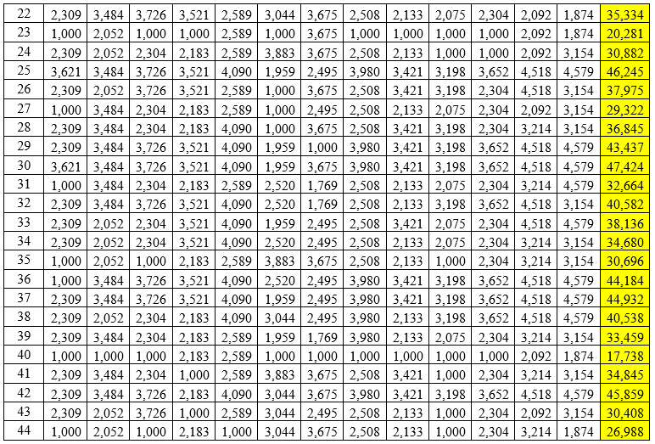
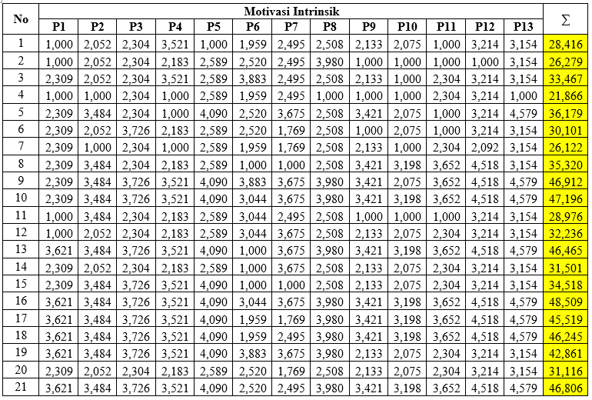

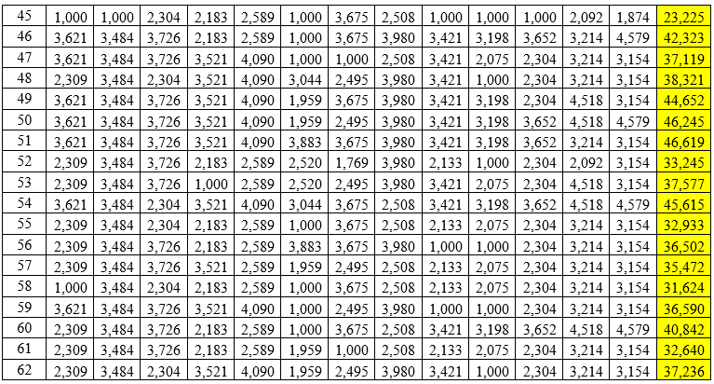

- Data Penelitian Variabel Motivasi Ekstrinsik (X2)
No | Motivasi Ekstrinsik (Y) |  |  |  |  |  |  |  | ∑
 | P1 | P2 | P3 | P4 | P5 | P6 | P7 | P8
1 | 4 | 5 | 3 | 5 | 4 | 3 | 4 | 4 | 32
2 | 3 | 4 | 4 | 3 | 4 | 4 | 5 | 4 | 31
3 | 5 | 4 | 5 | 4 | 4 | 4 | 5 | 4 | 35
4 | 4 | 3 | 3 | 3 | 4 | 3 | 2 | 3 | 25
5 | 3 | 5 | 4 | 4 | 4 | 4 | 4 | 4 | 32
6 | 4 | 4 | 5 | 4 | 4 | 5 | 4 | 4 | 34
7 | 4 | 3 | 2 | 4 | 4 | 4 | 4 | 4 | 29
8 | 4 | 3 | 4 | 4 | 4 | 3 | 4 | 5 | 31
9 | 4 | 5 | 3 | 4 | 5 | 4 | 4 | 5 | 34
10 | 4 | 4 | 3 | 4 | 3 | 4 | 5 | 5 | 32
11 | 4 | 4 | 4 | 4 | 4 | 4 | 4 | 5 | 33
12 | 3 | 4 | 3 | 3 | 3 | 3 | 4 | 3 | 26
13 | 3 | 3 | 3 | 3 | 3 | 3 | 5 | 5 | 28
14 | 4 | 5 | 4 | 4 | 4 | 4 | 4 | 4 | 33
15 | 3 | 3 | 3 | 3 | 3 | 4 | 4 | 4 | 27
16 | 4 | 3 | 3 | 3 | 4 | 3 | 5 | 5 | 30
17 | 4 | 5 | 3 | 3 | 4 | 4 | 5 | 5 | 33
18 | 3 | 4 | 4 | 3 | 5 | 4 | 5 | 5 | 33
19 | 4 | 4 | 4 | 3 | 4 | 3 | 4 | 4 | 30
20 | 4 | 4 | 4 | 4 | 4 | 4 | 4 | 4 | 32
21 | 3 | 4 | 3 | 4 | 4 | 4 | 5 | 5 | 32
22 | 4 | 4 | 4 | 4 | 5 | 4 | 4 | 4 | 33
23 | 4 | 4 | 3 | 4 | 4 | 3 | 3 | 3 | 28
24 | 3 | 3 | 4 | 4 | 4 | 3 | 4 | 4 | 29
25 | 4 | 3 | 5 | 4 | 3 | 4 | 5 | 5 | 33
26 | 4 | 4 | 4 | 3 | 4 | 3 | 3 | 5 | 30
27 | 4 | 4 | 3 | 3 | 3 | 3 | 4 | 3 | 27
28 | 4 | 4 | 4 | 4 | 3 | 3 | 5 | 5 | 32
29 | 4 | 4 | 3 | 3 | 4 | 4 | 4 | 5 | 31
30 | 3 | 4 | 4 | 4 | 4 | 5 | 5 | 5 | 34
31 | 4 | 3 | 3 | 5 | 3 | 3 | 4 | 3 | 28
32 | 3 | 3 | 3 | 4 | 4 | 3 | 3 | 4 | 27
33 | 4 | 3 | 3 | 3 | 3 | 3 | 3 | 4 | 26
34 | 4 | 4 | 4 | 4 | 4 | 4 | 4 | 4 | 32
35 | 3 | 4 | 3 | 4 | 3 | 3 | 2 | 3 | 25
36 | 4 | 3 | 5 | 4 | 4 | 3 | 5 | 5 | 33
37 | 4 | 4 | 4 | 4 | 3 | 3 | 4 | 5 | 31
38 | 3 | 4 | 3 | 3 | 4 | 4 | 3 | 3 | 27
39 | 4 | 4 | 3 | 4 | 3 | 3 | 4 | 4 | 29
40 | 3 | 4 | 3 | 3 | 3 | 2 | 3 | 3 | 24
41 | 4 | 4 | 4 | 3 | 4 | 4 | 3 | 4 | 30
42 | 3 | 4 | 4 | 3 | 3 | 3 | 4 | 5 | 29
43 | 3 | 3 | 4 | 4 | 3 | 4 | 3 | 3 | 27
44 | 4 | 4 | 4 | 5 | 5 | 4 | 4 | 4 | 34
45 | 4 | 4 | 3 | 4 | 4 | 3 | 3 | 4 | 29
46 | 4 | 5 | 4 | 4 | 3 | 3 | 4 | 5 | 32
47 | 4 | 3 | 4 | 4 | 4 | 4 | 4 | 5 | 32
48 | 3 | 4 | 5 | 4 | 4 | 5 | 4 | 4 | 33
49 | 4 | 4 | 4 | 3 | 5 | 4 | 4 | 5 | 33
50 | 4 | 4 | 5 | 4 | 3 | 4 | 4 | 5 | 33
51 | 4 | 5 | 4 | 3 | 4 | 5 | 5 | 5 | 35
52 | 5 | 4 | 5 | 4 | 3 | 4 | 4 | 4 | 33
53 | 4 | 4 | 5 | 5 | 5 | 5 | 4 | 3 | 35
54 | 5 | 5 | 4 | 5 | 4 | 5 | 4 | 4 | 36
55 | 4 | 3 | 4 | 5 | 3 | 4 | 3 | 4 | 30
56 | 5 | 2 | 5 | 5 | 4 | 4 | 4 | 4 | 33
57 | 4 | 5 | 4 | 3 | 4 | 3 | 5 | 4 | 32
58 | 4 | 3 | 5 | 4 | 5 | 3 | 4 | 3 | 31
59 | 3 | 3 | 4 | 5 | 4 | 4 | 4 | 4 | 31
60 | 5 | 4 | 4 | 3 | 3 | 4 | 4 | 4 | 31
61 | 4 | 3 | 3 | 4 | 4 | 3 | 2 | 3 | 26
62 | 5 | 4 | 3 | 5 | 4 | 5 | 4 | 5 | 35

No | Motivasi Ekstrinsik (Y) |  |  |  |  |  |  |  | ∑
 | P1 | P2 | P3 | P4 | P5 | P6 | P7 | P8
1 | 2,472 | 5,070 | 2,575 | 3,652 | 2,409 | 2,630 | 3,054 | 2,181 | 24,042
2 | 1,000 | 3,723 | 3,805 | 1,000 | 2,409 | 3,925 | 4,407 | 2,181 | 22,449
3 | 3,986 | 3,723 | 5,015 | 2,347 | 2,409 | 3,925 | 4,407 | 2,181 | 27,992
4 | 2,472 | 2,429 | 2,575 | 1,000 | 2,409 | 2,630 | 1,000 | 1,000 | 15,515
5 | 1,000 | 5,070 | 3,805 | 2,347 | 2,409 | 3,925 | 3,054 | 2,181 | 23,790
6 | 2,472 | 3,723 | 5,015 | 2,347 | 2,409 | 5,196 | 3,054 | 2,181 | 26,397
7 | 2,472 | 2,429 | 1,000 | 2,347 | 2,409 | 3,925 | 3,054 | 2,181 | 19,816
8 | 2,472 | 2,429 | 3,805 | 2,347 | 2,409 | 2,630 | 3,054 | 3,437 | 22,582
9 | 2,472 | 5,070 | 2,575 | 2,347 | 3,809 | 3,925 | 3,054 | 3,437 | 26,690
10 | 2,472 | 3,723 | 2,575 | 2,347 | 1,000 | 3,925 | 4,407 | 3,437 | 23,887
11 | 2,472 | 3,723 | 3,805 | 2,347 | 2,409 | 3,925 | 3,054 | 3,437 | 25,172
12 | 1,000 | 3,723 | 2,575 | 1,000 | 1,000 | 2,630 | 3,054 | 1,000 | 15,982
13 | 1,000 | 2,429 | 2,575 | 1,000 | 1,000 | 2,630 | 4,407 | 3,437 | 18,478
14 | 2,472 | 5,070 | 3,805 | 2,347 | 2,409 | 3,925 | 3,054 | 2,181 | 25,263
15 | 1,000 | 2,429 | 2,575 | 1,000 | 1,000 | 3,925 | 3,054 | 2,181 | 17,163
16 | 2,472 | 2,429 | 2,575 | 1,000 | 2,409 | 2,630 | 4,407 | 3,437 | 21,359
17 | 2,472 | 5,070 | 2,575 | 1,000 | 2,409 | 3,925 | 4,407 | 3,437 | 25,295
18 | 1,000 | 3,723 | 3,805 | 1,000 | 3,809 | 3,925 | 4,407 | 3,437 | 25,106
19 | 2,472 | 3,723 | 3,805 | 1,000 | 2,409 | 2,630 | 3,054 | 2,181 | 21,273
20 | 2,472 | 3,723 | 3,805 | 2,347 | 2,409 | 3,925 | 3,054 | 2,181 | 23,916
21 | 1,000 | 3,723 | 2,575 | 2,347 | 2,409 | 3,925 | 4,407 | 3,437 | 23,823
22 | 2,472 | 3,723 | 3,805 | 2,347 | 3,809 | 3,925 | 3,054 | 2,181 | 25,316
23 | 2,472 | 3,723 | 2,575 | 2,347 | 2,409 | 2,630 | 1,914 | 1,000 | 19,070
24 | 1,000 | 2,429 | 3,805 | 2,347 | 2,409 | 2,630 | 3,054 | 2,181 | 19,854
25 | 2,472 | 2,429 | 5,015 | 2,347 | 1,000 | 3,925 | 4,407 | 3,437 | 25,032
26 | 2,472 | 3,723 | 3,805 | 1,000 | 2,409 | 2,630 | 1,914 | 3,437 | 21,389
27 | 2,472 | 3,723 | 2,575 | 1,000 | 1,000 | 2,630 | 3,054 | 1,000 | 17,455
28 | 2,472 | 3,723 | 3,805 | 2,347 | 1,000 | 2,630 | 4,407 | 3,437 | 23,821
29 | 2,472 | 3,723 | 2,575 | 1,000 | 2,409 | 3,925 | 3,054 | 3,437 | 22,595
30 | 1,000 | 3,723 | 3,805 | 2,347 | 2,409 | 5,196 | 4,407 | 3,437 | 26,323
31 | 2,472 | 2,429 | 2,575 | 3,652 | 1,000 | 2,630 | 3,054 | 1,000 | 18,812
32 | 1,000 | 2,429 | 2,575 | 2,347 | 2,409 | 2,630 | 1,914 | 2,181 | 17,484
33 | 2,472 | 2,429 | 2,575 | 1,000 | 1,000 | 2,630 | 1,914 | 2,181 | 16,201
34 | 2,472 | 3,723 | 3,805 | 2,347 | 2,409 | 3,925 | 3,054 | 2,181 | 23,916
35 | 1,000 | 3,723 | 2,575 | 2,347 | 1,000 | 2,630 | 1,000 | 1,000 | 15,275
36 | 2,472 | 2,429 | 5,015 | 2,347 | 2,409 | 2,630 | 4,407 | 3,437 | 25,146
37 | 2,472 | 3,723 | 3,805 | 2,347 | 1,000 | 2,630 | 3,054 | 3,437 | 22,468
38 | 1,000 | 3,723 | 2,575 | 1,000 | 2,409 | 3,925 | 1,914 | 1,000 | 17,546
39 | 2,472 | 3,723 | 2,575 | 2,347 | 1,000 | 2,630 | 3,054 | 2,181 | 19,982
40 | 1,000 | 3,723 | 2,575 | 1,000 | 1,000 | 1,000 | 1,914 | 1,000 | 13,213
41 | 2,472 | 3,723 | 3,805 | 1,000 | 2,409 | 3,925 | 1,914 | 2,181 | 21,428
42 | 1,000 | 3,723 | 3,805 | 1,000 | 1,000 | 2,630 | 3,054 | 3,437 | 19,649
43 | 1,000 | 2,429 | 3,805 | 2,347 | 1,000 | 3,925 | 1,914 | 1,000 | 17,420
44 | 2,472 | 3,723 | 3,805 | 3,652 | 3,809 | 3,925 | 3,054 | 2,181 | 26,620
45 | 2,472 | 3,723 | 2,575 | 2,347 | 2,409 | 2,630 | 1,914 | 2,181 | 20,251
46 | 2,472 | 5,070 | 3,805 | 2,347 | 1,000 | 2,630 | 3,054 | 3,437 | 23,815
47 | 2,472 | 2,429 | 3,805 | 2,347 | 2,409 | 3,925 | 3,054 | 3,437 | 23,877
48 | 1,000 | 3,723 | 5,015 | 2,347 | 2,409 | 5,196 | 3,054 | 2,181 | 24,924
49 | 2,472 | 3,723 | 3,805 | 1,000 | 3,809 | 3,925 | 3,054 | 3,437 | 25,225
50 | 2,472 | 3,723 | 5,015 | 2,347 | 1,000 | 3,925 | 3,054 | 3,437 | 24,973
51 | 2,472 | 5,070 | 3,805 | 1,000 | 2,409 | 5,196 | 4,407 | 3,437 | 27,796
52 | 3,986 | 3,723 | 5,015 | 2,347 | 1,000 | 3,925 | 3,054 | 2,181 | 25,230
53 | 2,472 | 3,723 | 5,015 | 3,652 | 3,809 | 5,196 | 3,054 | 1,000 | 27,921
54 | 3,986 | 5,070 | 3,805 | 3,652 | 2,409 | 5,196 | 3,054 | 2,181 | 29,351
55 | 2,472 | 2,429 | 3,805 | 3,652 | 1,000 | 3,925 | 1,914 | 2,181 | 21,377
56 | 3,986 | 1,000 | 5,015 | 3,652 | 2,409 | 3,925 | 3,054 | 2,181 | 25,220
57 | 2,472 | 5,070 | 3,805 | 1,000 | 2,409 | 2,630 | 4,407 | 2,181 | 23,974
58 | 2,472 | 2,429 | 5,015 | 2,347 | 3,809 | 2,630 | 3,054 | 1,000 | 22,756
59 | 1,000 | 2,429 | 3,805 | 3,652 | 2,409 | 3,925 | 3,054 | 2,181 | 22,453
60 | 3,986 | 3,723 | 3,805 | 1,000 | 1,000 | 3,925 | 3,054 | 2,181 | 22,673
61 | 2,472 | 2,429 | 2,575 | 2,347 | 2,409 | 2,630 | 1,000 | 1,000 | 16,862
62 | 3,986 | 3,723 | 2,575 | 3,652 | 2,409 | 5,196 | 3,054 | 3,437 | 28,031

- Data Penelitian Variabel Budaya Organisasi (X3)
No | Budaya Organisasi |  |  |  |  |  |  |  |  |  |  | ∑
 | P1 | P2 | P3 | P4 | P5 | P6 | P7 | P8 | P9 | P10 | P11
1 | 5 | 5 | 5 | 5 | 4 | 4 | 4 | 4 | 4 | 3 | 4 | 47
2 | 3 | 3 | 3 | 4 | 3 | 3 | 2 | 3 | 3 | 3 | 4 | 34
3 | 4 | 4 | 4 | 4 | 3 | 4 | 4 | 4 | 5 | 4 | 4 | 44
4 | 4 | 3 | 4 | 3 | 3 | 3 | 3 | 3 | 5 | 4 | 3 | 38
5 | 4 | 4 | 4 | 3 | 4 | 4 | 4 | 4 | 4 | 5 | 5 | 45
6 | 5 | 5 | 5 | 4 | 5 | 5 | 5 | 5 | 4 | 3 | 4 | 50
7 | 5 | 3 | 4 | 3 | 5 | 5 | 3 | 5 | 3 | 4 | 5 | 45
8 | 4 | 3 | 5 | 4 | 4 | 5 | 4 | 3 | 3 | 4 | 4 | 43
9 | 4 | 4 | 5 | 5 | 5 | 5 | 5 | 4 | 4 | 4 | 3 | 48
10 | 5 | 3 | 4 | 5 | 5 | 5 | 5 | 5 | 5 | 5 | 4 | 51
11 | 4 | 3 | 4 | 4 | 3 | 3 | 4 | 4 | 4 | 4 | 4 | 41
12 | 4 | 4 | 4 | 4 | 4 | 4 | 4 | 4 | 5 | 4 | 4 | 45
13 | 5 | 4 | 4 | 5 | 5 | 5 | 5 | 5 | 4 | 5 | 5 | 52
14 | 4 | 4 | 4 | 4 | 4 | 5 | 5 | 4 | 4 | 3 | 3 | 44
15 | 4 | 3 | 4 | 4 | 4 | 3 | 5 | 4 | 4 | 5 | 2 | 42
16 | 4 | 4 | 4 | 5 | 5 | 4 | 5 | 5 | 4 | 3 | 3 | 46
17 | 3 | 4 | 4 | 5 | 5 | 5 | 5 | 5 | 3 | 4 | 4 | 47
18 | 4 | 4 | 4 | 5 | 5 | 5 | 5 | 5 | 4 | 4 | 4 | 49
19 | 5 | 5 | 3 | 5 | 5 | 4 | 4 | 4 | 5 | 5 | 5 | 50
20 | 3 | 4 | 4 | 4 | 4 | 4 | 4 | 4 | 4 | 4 | 4 | 43
21 | 4 | 2 | 4 | 5 | 5 | 5 | 5 | 5 | 4 | 3 | 3 | 45
22 | 5 | 4 | 5 | 4 | 4 | 3 | 4 | 4 | 5 | 4 | 4 | 46
23 | 5 | 3 | 4 | 3 | 4 | 4 | 4 | 4 | 4 | 4 | 4 | 43
24 | 5 | 3 | 5 | 4 | 4 | 4 | 5 | 4 | 3 | 5 | 4 | 46
25 | 4 | 4 | 5 | 5 | 5 | 5 | 5 | 5 | 4 | 5 | 5 | 52
26 | 5 | 4 | 5 | 5 | 5 | 5 | 5 | 5 | 5 | 5 | 4 | 53
27 | 4 | 2 | 5 | 3 | 4 | 3 | 3 | 4 | 4 | 5 | 3 | 40
28 | 5 | 4 | 3 | 3 | 4 | 4 | 4 | 4 | 4 | 3 | 3 | 41
29 | 3 | 3 | 4 | 5 | 5 | 5 | 5 | 5 | 5 | 5 | 5 | 50
30 | 4 | 2 | 4 | 3 | 4 | 4 | 5 | 5 | 4 | 4 | 4 | 43
31 | 3 | 4 | 4 | 3 | 4 | 4 | 3 | 5 | 4 | 4 | 4 | 42
32 | 3 | 3 | 5 | 5 | 5 | 5 | 4 | 5 | 5 | 5 | 5 | 50
33 | 4 | 3 | 5 | 5 | 5 | 5 | 5 | 5 | 5 | 5 | 5 | 52
34 | 4 | 3 | 5 | 5 | 5 | 5 | 5 | 5 | 5 | 5 | 5 | 52
35 | 3 | 4 | 5 | 5 | 5 | 5 | 4 | 4 | 4 | 4 | 5 | 48
36 | 4 | 3 | 4 | 4 | 4 | 4 | 4 | 4 | 4 | 4 | 4 | 43
37 | 5 | 4 | 5 | 5 | 5 | 5 | 5 | 4 | 4 | 5 | 5 | 52
38 | 4 | 4 | 3 | 4 | 5 | 5 | 5 | 4 | 3 | 3 | 4 | 44
39 | 3 | 3 | 4 | 4 | 3 | 4 | 5 | 4 | 3 | 2 | 5 | 40
40 | 3 | 4 | 4 | 3 | 4 | 4 | 4 | 3 | 4 | 3 | 2 | 38
41 | 4 | 5 | 4 | 3 | 3 | 4 | 4 | 3 | 4 | 4 | 3 | 41
42 | 4 | 4 | 4 | 5 | 5 | 5 | 4 | 4 | 4 | 5 | 4 | 48
43 | 4 | 3 | 3 | 4 | 4 | 4 | 4 | 3 | 4 | 4 | 3 | 40
44 | 5 | 4 | 4 | 4 | 4 | 4 | 4 | 3 | 3 | 4 | 5 | 44
45 | 3 | 3 | 4 | 4 | 4 | 3 | 3 | 3 | 4 | 4 | 4 | 39
46 | 4 | 4 | 5 | 4 | 4 | 4 | 5 | 4 | 4 | 3 | 3 | 44
47 | 3 | 4 | 4 | 3 | 3 | 5 | 5 | 5 | 4 | 3 | 3 | 42
48 | 5 | 4 | 4 | 4 | 4 | 4 | 4 | 4 | 3 | 4 | 3 | 43
49 | 4 | 5 | 4 | 5 | 5 | 4 | 5 | 4 | 4 | 4 | 4 | 48
50 | 4 | 5 | 4 | 5 | 5 | 5 | 5 | 4 | 4 | 5 | 4 | 50
51 | 4 | 4 | 4 | 5 | 5 | 5 | 5 | 5 | 4 | 5 | 5 | 51
52 | 4 | 3 | 4 | 4 | 4 | 5 | 5 | 4 | 5 | 3 | 2 | 43
53 | 4 | 4 | 3 | 4 | 4 | 5 | 4 | 3 | 4 | 4 | 4 | 43
54 | 5 | 4 | 4 | 5 | 5 | 4 | 4 | 4 | 3 | 5 | 4 | 47
55 | 4 | 4 | 4 | 4 | 4 | 3 | 4 | 3 | 4 | 4 | 3 | 41
56 | 4 | 3 | 4 | 4 | 4 | 4 | 5 | 4 | 3 | 4 | 4 | 43
57 | 2 | 3 | 3 | 4 | 4 | 4 | 4 | 4 | 4 | 2 | 3 | 37
58 | 4 | 3 | 3 | 4 | 4 | 5 | 5 | 4 | 4 | 4 | 3 | 43
59 | 4 | 4 | 4 | 4 | 4 | 3 | 3 | 4 | 4 | 3 | 3 | 40
60 | 3 | 3 | 3 | 4 | 3 | 4 | 4 | 4 | 4 | 3 | 4 | 39
61 | 3 | 4 | 3 | 4 | 2 | 3 | 3 | 3 | 3 | 2 | 2 | 32
62 | 4 | 3 | 4 | 4 | 4 | 5 | 4 | 3 | 4 | 4 | 3 | 42

No | Budaya Organisasi |  |  |  |  |  |  |  |  |  |  | ∑
 | P1 | P2 | P3 | P4 | P5 | P6 | P7 | P8 | P9 | P10 | P11
1 | 4,789 | 4,847 | 3,807 | 3,515 | 3,168 | 2,147 | 3,056 | 2,286 | 2,418 | 2,046 | 3,104 | 35,183
2 | 2,258 | 2,294 | 1,000 | 2,226 | 2,043 | 1,000 | 1,000 | 1,000 | 1,000 | 2,046 | 3,104 | 18,971
3 | 3,477 | 3,530 | 2,403 | 2,226 | 2,043 | 2,147 | 3,056 | 2,286 | 3,836 | 3,055 | 3,104 | 31,163
4 | 3,477 | 2,294 | 2,403 | 1,000 | 2,043 | 1,000 | 1,992 | 1,000 | 3,836 | 3,055 | 2,079 | 24,180
5 | 3,477 | 3,530 | 2,403 | 1,000 | 3,168 | 2,147 | 3,056 | 2,286 | 2,418 | 4,256 | 4,285 | 32,026
6 | 4,789 | 4,847 | 3,807 | 2,226 | 4,488 | 3,421 | 4,376 | 3,598 | 2,418 | 2,046 | 3,104 | 39,119
7 | 4,789 | 2,294 | 2,403 | 1,000 | 4,488 | 3,421 | 1,992 | 3,598 | 1,000 | 3,055 | 4,285 | 32,324
8 | 3,477 | 2,294 | 3,807 | 2,226 | 3,168 | 3,421 | 3,056 | 1,000 | 1,000 | 3,055 | 3,104 | 29,607
9 | 3,477 | 3,530 | 3,807 | 3,515 | 4,488 | 3,421 | 4,376 | 2,286 | 2,418 | 3,055 | 2,079 | 36,451
10 | 4,789 | 2,294 | 2,403 | 3,515 | 4,488 | 3,421 | 4,376 | 3,598 | 3,836 | 4,256 | 3,104 | 40,079
11 | 3,477 | 2,294 | 2,403 | 2,226 | 2,043 | 1,000 | 3,056 | 2,286 | 2,418 | 3,055 | 3,104 | 27,363
12 | 3,477 | 3,530 | 2,403 | 2,226 | 3,168 | 2,147 | 3,056 | 2,286 | 3,836 | 3,055 | 3,104 | 32,288
13 | 4,789 | 3,530 | 2,403 | 3,515 | 4,488 | 3,421 | 4,376 | 3,598 | 2,418 | 4,256 | 4,285 | 41,078
14 | 3,477 | 3,530 | 2,403 | 2,226 | 3,168 | 3,421 | 4,376 | 2,286 | 2,418 | 2,046 | 2,079 | 31,429
15 | 3,477 | 2,294 | 2,403 | 2,226 | 3,168 | 1,000 | 4,376 | 2,286 | 2,418 | 4,256 | 1,000 | 28,904
16 | 3,477 | 3,530 | 2,403 | 3,515 | 4,488 | 2,147 | 4,376 | 3,598 | 2,418 | 2,046 | 2,079 | 34,076
17 | 2,258 | 3,530 | 2,403 | 3,515 | 4,488 | 3,421 | 4,376 | 3,598 | 1,000 | 3,055 | 3,104 | 34,746
18 | 3,477 | 3,530 | 2,403 | 3,515 | 4,488 | 3,421 | 4,376 | 3,598 | 2,418 | 3,055 | 3,104 | 37,383
19 | 4,789 | 4,847 | 1,000 | 3,515 | 4,488 | 2,147 | 3,056 | 2,286 | 3,836 | 4,256 | 4,285 | 38,505
20 | 2,258 | 3,530 | 2,403 | 2,226 | 3,168 | 2,147 | 3,056 | 2,286 | 2,418 | 3,055 | 3,104 | 29,651
21 | 3,477 | 1,000 | 2,403 | 3,515 | 4,488 | 3,421 | 4,376 | 3,598 | 2,418 | 2,046 | 2,079 | 32,820
22 | 4,789 | 3,530 | 3,807 | 2,226 | 3,168 | 1,000 | 3,056 | 2,286 | 3,836 | 3,055 | 3,104 | 33,858
23 | 4,789 | 2,294 | 2,403 | 1,000 | 3,168 | 2,147 | 3,056 | 2,286 | 2,418 | 3,055 | 3,104 | 29,721
24 | 4,789 | 2,294 | 3,807 | 2,226 | 3,168 | 2,147 | 4,376 | 2,286 | 1,000 | 4,256 | 3,104 | 33,453
25 | 3,477 | 3,530 | 3,807 | 3,515 | 4,488 | 3,421 | 4,376 | 3,598 | 2,418 | 4,256 | 4,285 | 41,169
26 | 4,789 | 3,530 | 3,807 | 3,515 | 4,488 | 3,421 | 4,376 | 3,598 | 3,836 | 4,256 | 3,104 | 42,719
27 | 3,477 | 1,000 | 3,807 | 1,000 | 3,168 | 1,000 | 1,992 | 2,286 | 2,418 | 4,256 | 2,079 | 26,483
28 | 4,789 | 3,530 | 1,000 | 1,000 | 3,168 | 2,147 | 3,056 | 2,286 | 2,418 | 2,046 | 2,079 | 27,520
29 | 2,258 | 2,294 | 2,403 | 3,515 | 4,488 | 3,421 | 4,376 | 3,598 | 3,836 | 4,256 | 4,285 | 38,728
30 | 3,477 | 1,000 | 2,403 | 1,000 | 3,168 | 2,147 | 4,376 | 3,598 | 2,418 | 3,055 | 3,104 | 29,745
31 | 2,258 | 3,530 | 2,403 | 1,000 | 3,168 | 2,147 | 1,992 | 3,598 | 2,418 | 3,055 | 3,104 | 28,672
32 | 2,258 | 2,294 | 3,807 | 3,515 | 4,488 | 3,421 | 3,056 | 3,598 | 3,836 | 4,256 | 4,285 | 38,813
33 | 3,477 | 2,294 | 3,807 | 3,515 | 4,488 | 3,421 | 4,376 | 3,598 | 3,836 | 4,256 | 4,285 | 41,351
34 | 3,477 | 2,294 | 3,807 | 3,515 | 4,488 | 3,421 | 4,376 | 3,598 | 3,836 | 4,256 | 4,285 | 41,351
35 | 2,258 | 3,530 | 3,807 | 3,515 | 4,488 | 3,421 | 3,056 | 2,286 | 2,418 | 3,055 | 4,285 | 36,118
36 | 3,477 | 2,294 | 2,403 | 2,226 | 3,168 | 2,147 | 3,056 | 2,286 | 2,418 | 3,055 | 3,104 | 29,634
37 | 4,789 | 3,530 | 3,807 | 3,515 | 4,488 | 3,421 | 4,376 | 2,286 | 2,418 | 4,256 | 4,285 | 41,170
38 | 3,477 | 3,530 | 1,000 | 2,226 | 4,488 | 3,421 | 4,376 | 2,286 | 1,000 | 2,046 | 3,104 | 30,953
39 | 2,258 | 2,294 | 2,403 | 2,226 | 2,043 | 2,147 | 4,376 | 2,286 | 1,000 | 1,000 | 4,285 | 26,317
40 | 2,258 | 3,530 | 2,403 | 1,000 | 3,168 | 2,147 | 3,056 | 1,000 | 2,418 | 2,046 | 1,000 | 24,026
41 | 3,477 | 4,847 | 2,403 | 1,000 | 2,043 | 2,147 | 3,056 | 1,000 | 2,418 | 3,055 | 2,079 | 27,526
42 | 3,477 | 3,530 | 2,403 | 3,515 | 4,488 | 3,421 | 3,056 | 2,286 | 2,418 | 4,256 | 3,104 | 35,954
43 | 3,477 | 2,294 | 1,000 | 2,226 | 3,168 | 2,147 | 3,056 | 1,000 | 2,418 | 3,055 | 2,079 | 25,920
44 | 4,789 | 3,530 | 2,403 | 2,226 | 3,168 | 2,147 | 3,056 | 1,000 | 1,000 | 3,055 | 4,285 | 30,659
45 | 2,258 | 2,294 | 2,403 | 2,226 | 3,168 | 1,000 | 1,992 | 1,000 | 2,418 | 3,055 | 3,104 | 24,917
46 | 3,477 | 3,530 | 3,807 | 2,226 | 3,168 | 2,147 | 4,376 | 2,286 | 2,418 | 2,046 | 2,079 | 31,559
47 | 2,258 | 3,530 | 2,403 | 1,000 | 2,043 | 3,421 | 4,376 | 3,598 | 2,418 | 2,046 | 2,079 | 29,171
48 | 4,789 | 3,530 | 2,403 | 2,226 | 3,168 | 2,147 | 3,056 | 2,286 | 1,000 | 3,055 | 2,079 | 29,740
49 | 3,477 | 4,847 | 2,403 | 3,515 | 4,488 | 2,147 | 4,376 | 2,286 | 2,418 | 3,055 | 3,104 | 36,115
50 | 3,477 | 4,847 | 2,403 | 3,515 | 4,488 | 3,421 | 4,376 | 2,286 | 2,418 | 4,256 | 3,104 | 38,590
51 | 3,477 | 3,530 | 2,403 | 3,515 | 4,488 | 3,421 | 4,376 | 3,598 | 2,418 | 4,256 | 4,285 | 39,765
52 | 3,477 | 2,294 | 2,403 | 2,226 | 3,168 | 3,421 | 4,376 | 2,286 | 3,836 | 2,046 | 1,000 | 30,532
53 | 3,477 | 3,530 | 1,000 | 2,226 | 3,168 | 3,421 | 3,056 | 1,000 | 2,418 | 3,055 | 3,104 | 29,454
54 | 4,789 | 3,530 | 2,403 | 3,515 | 4,488 | 2,147 | 3,056 | 2,286 | 1,000 | 4,256 | 3,104 | 34,574
55 | 3,477 | 3,530 | 2,403 | 2,226 | 3,168 | 1,000 | 3,056 | 1,000 | 2,418 | 3,055 | 2,079 | 27,412
56 | 3,477 | 2,294 | 2,403 | 2,226 | 3,168 | 2,147 | 4,376 | 2,286 | 1,000 | 3,055 | 3,104 | 29,535
57 | 1,000 | 2,294 | 1,000 | 2,226 | 3,168 | 2,147 | 3,056 | 2,286 | 2,418 | 1,000 | 2,079 | 22,674
58 | 3,477 | 2,294 | 1,000 | 2,226 | 3,168 | 3,421 | 4,376 | 2,286 | 2,418 | 3,055 | 2,079 | 29,799
59 | 3,477 | 3,530 | 2,403 | 2,226 | 3,168 | 1,000 | 1,992 | 2,286 | 2,418 | 2,046 | 2,079 | 26,625
60 | 2,258 | 2,294 | 1,000 | 2,226 | 2,043 | 2,147 | 3,056 | 2,286 | 2,418 | 2,046 | 3,104 | 24,878
61 | 2,258 | 3,530 | 1,000 | 2,226 | 1,000 | 1,000 | 1,992 | 1,000 | 1,000 | 1,000 | 1,000 | 17,005
62 | 3,477 | 2,294 | 2,403 | 2,226 | 3,168 | 3,421 | 3,056 | 1,000 | 2,418 | 3,055 | 2,079 | 28,597

Lampiran 7
UJI ASUMSI KLASIK
- Uji Normalitas
One-Sample Kolmogorov-Smirnov Test
 |  | Unstandardized Residual
N |  | 62
Normal Parametersª | Mean | .0000000
 | Std. Deviation | 3.08452972
Most Extreme Differences | Absolute | .059
 | Positive | .059
 | Negative | -.059
Kolmogorov-Smirnov Z |  | .468
Asymp. Sig. (2-tailed) |  | .981
a. Test distribution is Normal.
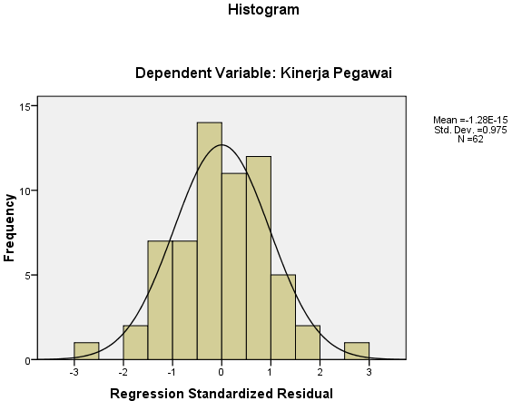

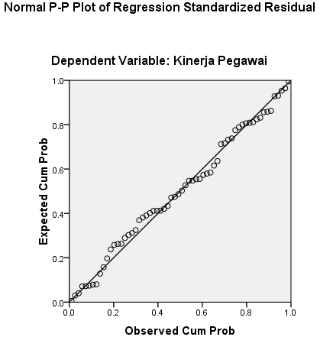
- Uji Multikolinearitas
Coefficientsª
Model |  | Unstandardized Coefficients |  | Standardized Coefficients | t | Sig. | Collinearity Statistics
 |  | B | Std. Error | Beta |  |  | Tolerance | VIF
1 | (Constant) | -8.034 | 3.060 |  | -2.626 | .011
 | Motivasi Intrinsik | .431 | .069 | .544 | 6.255 | .000 | .600 | 1.668
 | Motivasi Ekstrinsik | .544 | .119 | .336 | 4.555 | .000 | .831 | 1.203
 | Budaya Organisasi | .202 | .084 | .194 | 2.407 | .019 | .694 | 1.442
a. Dependent Variable: Kinerja Pegawai
- Uji Heterokesdastisitas
Coefficientsª
Model |  | Unstandardized Coefficients |  | Standardized Coefficients | t | Sig.
 |  | B | Std. Error | Beta
1 | (Constant) | 4.713 | 1.883 |  | 2.503 | .015
 | Motivasi Intrinsik | .032 | .042 | .125 | .752 | .455
 | Motivasi Ekstrinsik | -.082 | .073 | -.157 | -1.110 | .272
 | Budaya Organisasi | -.052 | .052 | -.157 | -1.011 | .316
a. Dependent Variable: ABS_RES1
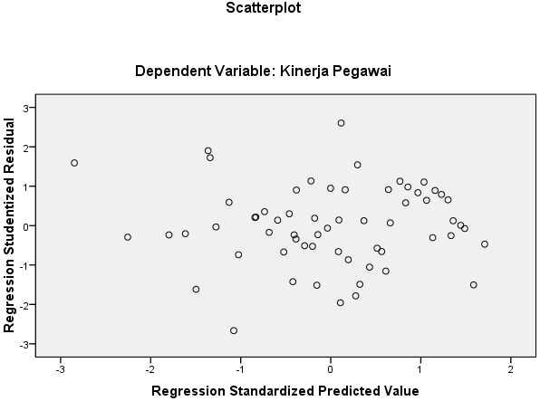

Lampiran 8
UJI REGRESI LINIER BERGANDA
Coefficientsª
Model |  | Unstandardized Coefficients |  | Standardized Coefficients | t | Sig. | Collinearity Statistics
 |  | B | Std. Error | Beta |  |  | Tolerance | VIF
1 | (Constant) | -8.034 | 3.060 |  | -2.626 | .011
 | Motivasi Intrinsik | .431 | .069 | .544 | 6.255 | .000 | .600 | 1.668
 | Motivasi Ekstrinsik | .544 | .119 | .336 | 4.555 | .000 | .831 | 1.203
 | Budaya Organisasi | .202 | .084 | .194 | 2.407 | .019 | .694 | 1.442
a. Dependent Variable: Kinerja Pegawai

Lampiran 9
UJI PARSIAL (Uji t)
Coefficientsª
Model |  | Unstandardized Coefficients |  | Standardized Coefficients | t | Sig. | Collinearity Statistics
 |  | B | Std. Error | Beta |  |  | Tolerance | VIF
1 | (Constant) | -8.034 | 3.060 |  | -2.626 | .011
 | Motivasi Intrinsik | .431 | .069 | .544 | 6.255 | .000 | .600 | 1.668
 | Motivasi Ekstrinsik | .544 | .119 | .336 | 4.555 | .000 | .831 | 1.203
 | Budaya Organisasi | .202 | .084 | .194 | 2.407 | .019 | .694 | 1.442
a. Dependent Variable: Kinerja Pegawai

Lampiran 10
UJI SIMULTAN (Uji F)
ANOVA^{b}
Model |  | Sum of Squares | df | Mean Square | F | Sig.
1 | Regression | 1629.963 | 3 | 543.321 | 54.297 | .000ª
 | Residual | 580.374 | 58 | 10.006
 | Total | 2210.337 | 61
a. Predictors: (Constant), Budaya Organisasi, Motivasi Ekstrinsik, Motivasi Intrinsik
b. Dependent Variable: Kinerja Pegawai

Lampiran 11
UJI KOEFISIEN DETERMINASI
Model Summary^{b}
Model | R | R Square | Adjusted R Square | Std. Error of the Estimate
1 | .859ª | .737 | .724 | 3.163296
a. Predictors: (Constant), Budaya Organisasi, Motivasi Ekstrinsik, Motivasi Intrinsik
b. Dependent Variable: Kinerja Pegawai

Lampiran 12
TABEL r (df = 51 – 100)
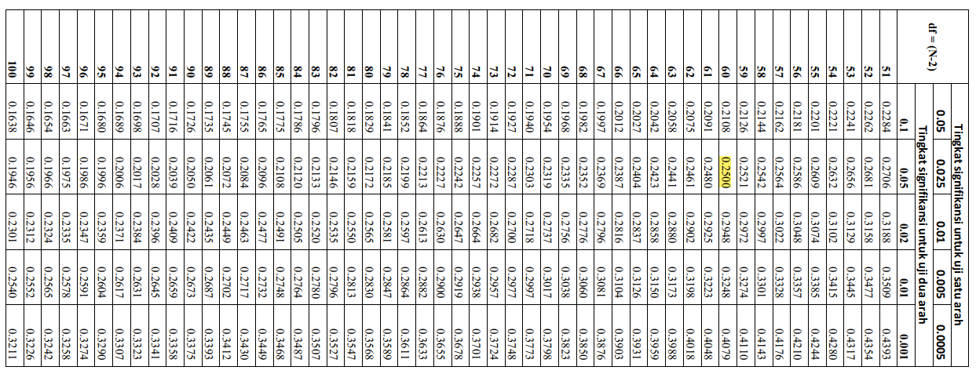
Lampiran 13
TABEL t (df = 41 – 80)
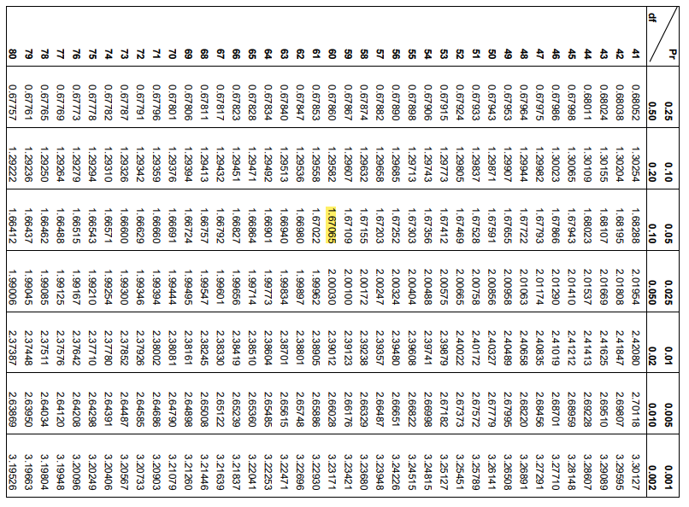

Lampiran 14
TABEL F (df = 46 – 90)
