DAFTAR PUSTAKA

Amin, M. A. N. (2022). Analisis Potensi Abnormal Return Positif Terbesar Saham PT. Kalbe Farma Selama Pandemi Covid-19. Jurnal Valuasi: Jurnal Ilmiah Ilmu Manajemen Dan Kewirausahaan, 2(February 2021), 223–233. https://doi.org/https://doi.org/10.46306/vls.v2i1.93. Diakses pada bulan februari 2023.
Amin, M. A. N. (2022). Reaksi Pasar atas Pengumuman Dividen PT . Kalbe Farma saat Pandemi. Ekonomi, Keuangan, Investasi Dan Syariah (EKUITAS), 3(4), 917–921. https://doi.org/10.47065/ekuitas.v3i4.1585. Diakses pada bulan februari 2023.
Amin, M. A. N. (2022). Analisis Abnormal Return dan Trading Volume Activity Sebelum dan Setelah Pengumuman Dividen PT.Kalbe Farma Saat Pandemi Covid-19. CREATIVE RESEARCH MANAGEMENT JOURNAL, 5(1), 56–63. https://doi.org//doi.org/10.32663/crmj.v5i1.2461. Diakses pada bulan februari 2023.
Amin, M. A. N., Indriasih, D., & Utami, Y. (2022). Pemanfaatan Limbah Plastik Menjadi Kerajinantangan Bagi Ibu-Ibu PKK Desa Mejasem Barat, Kecamatan Keramat, Kabupaten Tegal. Jurnal Pengabdian Masyarakat Nusantara, 1(2), 35–41. https://doi.org/https://doi.org/10.35870/jpmn.v2i1.580. Diakses pada bulan februari 2023.
Amin, M. A. N., & Irawan, B. P. (2021). Apakah Buyback Stock dapat memberikan Keuntungan Tidak Normal saat Pandemi ? PERMANA, 13(1), 46–59.https://doi.org/https://doi.org/10.24905/permana.v13i1.159. Diakses pada bulan februari 2023. Diakses pada bulan februari 2023.
Amin, M. A. N., & Ramdhani, D. (2017). Analysis of Abnormal Return, Stock Return and Stock Liquidity Before and After Buyback Share: Case Study of Companies Listed in Indonesia Stock Exchange in Period of 2011-2015. Rjoas, 11(November), 312–323. https://doi.org/https://doi.org/10.18551/rjoas.2017-11.37. Diakses pada bulan februari 2023.

Amin, M. A. N., & Yunita, E. A. (2022). Analisis Potensi Pajak Hotel dan Pajak Restoran Kabupaten Tegal di Tengah Pandemi. INOVASI : Jurnal Ekonomi , Keuangan Dan Manajemen, 18(2), 232–240. https://doi.org/dx.doi.org/10.29264/jinv.v18i2.10551. Diakses pada bulan februari 2023.
Bursa Efek Indonesia. (2022). Indeks Saham. Online. https://www.idx.co.id/id. Diakses pada bulan januari 2023.
Fadhlurrahman, N., & Yunita, I. (2015). Analisis Pengaruh Capital Adequacy Ratio (CAR), Financing to Deposit Ratio (FDR), Non Pefrorming Financing (NPF), dan Net Interest Margin (NIM) Terhadap Perubahan Laba Komprehensif. E-Proceeding of Management, 2(2), 1369–1375. https://libraryeproceeding.telkomuniversity.ac.id/index.php/management/article/view/182. Diakses pada bulan maret 2023
Febriani, L., & Mufidah, A. (2019). Analisis Determinan Perubahan Laba Bersih Pada Bank Umum Konvensional Di Indonesia Periode 2011–2015. Relasi : Jurnal Ekonomi, 15(1), 19–28. https://doi.org/10.31967/relasi.v15i1.299. Diakses pada bulan maret 2023
Feranita, N. V. (2017). Rasio Keuangan Yang Mempengaruhi Perubahan Laba Perbankan Di Bursa Efek Indonesia. BMC Public Health, 5(1), 1–8. https://ejournal.poltektegal.ac.id/index.php/siklus/article/view/298%0Ahttp://repositorio.unan.edu.ni/2986/1/5624.pdf%0Ahttp://dx.doi.org/10.1016/j.jana.2015.10.005%0Ahttp://www.biomedcentral.com/1471-2458/12/58%0Ahttp://ovidsp.ovid.com/ovidweb.cgi?T=JS&P. Diakses pada bulan maret 2023
Ghozali, I. (2018). Aplikasi Analisis MULTIVARIATE Dengan Progam IBM SPSS 25 (9th ed.). Semarang: Undip. Diakses pada bulan januari 2023.
Harmono. (2019). Manajemen Keuangan Berbasis balanced Scorecard pendekatan teori, kasus, dan riset bisnis. Jakarta:PT Bumi Aksara. Diakses pada bulan maret 2023
Hermanto, B., & Rahayu, S. dkk. (2018). Pengaruh Rasio Keuangan Terhadap Perubahan Laba (Studi Empiris Pada Bank Pembangunan Daerah Se-Sumatera) Tahun 2011-2017. 14, 63–65. https://doi.org/10.15900/j.cnki.zylf1995.2018.02.001. Diakses pada bulan maret 2023
Jamil, N. E., & Amin, M. (2018). Pengaruh Perubahan ROA, BOPO, NPM, DAN LDR Terhadap Perubahan Laba Pada Perusahaan Perbankan Yang Terdaftar Di Bursa Efek Indonesia (Bei) Tahun 2015-2017. 07. http://jim.unisma.ac.id/index.php/jra/article/download/1401/1380. Diakses pada bulan maret 2023
Jensen, M. C., & Meckling, W. H. (1976). Theory of the Firm : Managerial Behavior , Agency Costs and Ownership Structure Theory of the Firm : Managerial Behavior , Agency Costs and Ownership Structure. https://www.sciencedirect.com/science/article/pii/0304405X7690026X?via%3Dihub. Diakses pada bulan maret 2023.
Kasmir. (2017). Bank dan Lembaga Keuangan Lainnnya (edisi revisi 2014). Jakarta:Raja Grafindo Persada. Diakses pada bulan januari 2023.
Marlina, S. (2021). Pengaruh Capital Adequacy Ratio, Loan to Deposit Ratio & Return on Assets terhadap Perubahan Laba (Studi Empiris pada Perusahaan Perbankan yang Listed di BEJ). 2(2). https://ejournal.ugkmb.ac.id/index.php/jce/article/view/44/41. Diakses pada bulan maret 2023.
Martini, L. K. B., & Suardana, I. B. R. (2018). Pengaruh CAR, BOPO, LDR DAN NIM Terhadap ROA Dan Perubahan Laba (Studi Pada Seluruh Pada Bpr Di Bali). 8.
Natalia, E. Y. (2017). Analisis Faktor Yang Mempengaruhi Perubahan Laba Perusahaan Perbankan Yang Terdaftar Di Bei. Jurnal EMA, 2(1), 129–142. https://doi.org/10.47335/ema.v2i1.11. Diakses pada bulan maret 2023.
Otoritas Jasa Keuangan (OJK). Online. https://ojk.go.id/id/Default.aspx. Diakses pada bulan januari 2023
Pandian, F. (2012). Manajemen Dana dan Kesehatan bank. Jakarta:Rineka Cipta. Diakses pada bulan maret 2023.
Pratito, D. W., & Puspitasari, D. (2017). Analisis Pengaruh Kebijakan Giro Wajib Minimum (GWM), Posisi Devisa Netto (PDN), Loan To Deposit Ratio (LDR), Cadangan Kerugian Penurunan Nilai (CKPN), Dan Suku Bunga SBI Terhadap Perubahan Laba (Studi Pada Bank Umum Swasta Nasional Devisa di Indonesia Pe. Jurnal Dinamika Sosial Budaya, 17(2), 228. https://doi.org/10.26623/jdsb.v17i2.488. Diakses pada bulan maret 2023
Putri, R. D. (2017). Pengaruh Capital Adequacy Ratio (CAR), Loan To Deposit Ratio (LDR), Non Performing Loan (NPL), and Net Interest Margin (NIM) terhadap Perubahan Laba (Studi Empiris Pada Perusahaan Perbankan yang Terdaftar di BEI) Penulis. I(April), 172–183. https://ojs.fkipummy.ac.id/index.php/jusie/article/view/147. Diakses pada bulan maret 2023
Suliyanto. (2018). Metode Penelitian Bisnis. Yogyakarta:ANDI OFFSET. Diakses pada bulan januari 2023.
Supriyanti, L., & Astohar. (2015). Pengaruh LDR dan BOPO terhadap Perubahan Laba pada Perbankan Dengan NIM sebagai Variabel Moderating. Jurnal Ilmu Manajemen Dan Akuntansi Terapan (JIMAT), 6(1), 82–96. http://jurnal.stietotalwin.ac.id/index.php/jimat/article/view/94/92. Diakses pada bulan januari 2023.
Undang Undang RI nomor 10 tahun. (1998) tentang Perbankan. Lembaran Negara Republik Indonesia, 182. http://www.bphn.go.id/data/documents/98uu010. Diakses pada bulan maret 2023.
Widyastuti, P. S. (2018). Pengaruh Net Interest Margin (NIM) dan Biaya Operasional Terhadap Pendapatan Operasional (BOPO) Terhadap Perubahan Laba. In ALMANA (Vol. 2, Issue 3). http://journal.unla.ac.id/index.php/almana/article/view/150 Diakses pada bulan maret 2023.

LAMPIRAN

Lampiran 1
DAFTAR PERUSAHAAN SUB SEKTOR PERBANKAN YANG
TERDAFTAR DI BURSA EFEK INDONESIA PERIODE 2018-2023
No. | Kode | Perusahaan
1. | AGRO | Bank Rakyat Indonesia Agroniaga Tbk
2. | AGRS | Bank Ibk Indonesia Tbk
3. | AMAR | Bank Amar Indonesia Tbk
4. | ARTO | Bank Jago Tbk
5. | BABP | Bank MNC Internasional Tbk
6. | BACA | Bank Capital Indonesia Tbk
7. | BANK | Bank Aladin Syariah Indonesia Tbk
8. | BBCA | Bank Central Asia Tbk
9. | BBHI | Allo Bank Indonesia Tbk
10. | BBKP | Bank KBBukopin Tbk
11. | BBMD | Bank Mestika Dharma Tbk
12. | BBNI | Bank Negara Indonesia Tbk
13. | BBRI | Bank Rakyat Indonesia Tbk
14. | BBSI | Bank Bisnis Internasional Tbk
15. | BBTN | Bank Tabungan Negara Tbk
16. | BBYB | Bank Neo Commerce Tbk
17. | BCIC | Bank JTrust Indonesia Tbk
18. | BDMN | Bank Danamon Indonesia Tbk
19. | BEKS | Bank Pembangunan Daerah Banten Tbk
20. | BGTG | Bank Ganesha Tbk
21. | BINA | Bank Ina Perdana Tbk
22. | BJBR | Bank Pembangunan Daerah Jawa Barat Tbk
23. | BJTM | Bank Pembangunan Daerah Jawa Tengah Tbk
24. | BKSW | Bank QNB Indonesia Tbk
25. | BMAS | Bank Maspion Indonesia Tbk
26. | BMRI | Bank Mandiri Indonesia Tbk
27. | BNBA | Bank Bumi Arta Tbk
28. | BNGA | Bank Cimb Niaga Tbk
29. | BNII | Bank Maybank Indonesia Tbk
30. | BNLI | Bank Permata Tbk
31. | BRIS | Bank Syariah Indonesia Tbk
32. | BSIM | Bank Sinarmas Tbk
33. | BSWD | Bank Of India Indonesia Tbk
34. | BTPN | Bank BTPN Tbk
35. | BTPS | Bank BTPN Syariah Tbk
36. | BVIC | Bank Victoria Internasional Tbk
37. | DNAR | Bank Oke Indonesia Tbk
38. | INPC | Bank Arthagraha Internasional Tbk
39. | MASB | Bank Multiarta Santosa Tbk
40. | MYA | Bank Mayapada Internasional Tbk
41. | MCOR | Bank China Contruction Bank Indonesia Tbk
42. | MEGA | Bank Mega Tbk
43. | NISP | BankOCBC NISP Tbk
44. | NOBU | Bank Nation Nobo Tbk
45. | PNBN | Bank Pan Indonesia Tbk
46. | PNBS | Bank Panin Dubai Syariah Tbk
47. | SDRA | Bank Woori Saudara Indonesia 1906 Tbk
Sumber: www.idx.co.id data populasi diolah peneliti (2023)

Lampiran 2
Tabulasi Data Variabel Capital Adequecy Ratio (CAR) periode 2018-2021.
No. | Kode bank | Capital Adequecy Ratio
 |  | 2018 (%) |  | 2019 (%) | 2020 (%) | 2021 (%)
1. | AMAR | 42.43 |  | 55.64 | 45.34 | 29.85
2. | BACA | 18.66 |  | 12.67 | 18.11 | 41.28
3. | BBCA | 23.39 |  | 23.80 | 25.83 | 25.66
4. | BBMD | 34.58 |  | 38.60 | 47.29 | 48.12
5. | BBNI | 48.12 |  | 19.73 | 47.29 | 48.12
6. | BBRI | 21.21 |  | 22.55 | 20.61 | 25.28
7. | BBTN | 18.21 |  | 17.32 | 19.34 | 19.14
8. | BDMN | 22.79 |  | 24.59 | 25.59 | 26.38
9. | BGTG | 31.85 |  | 32.84 | 35.70 | 67.15
10. | BINA | 55.03 |  | 37.41 | 40.08 | 53.14
11. | BJBR | 19.00 |  | 17.71 | 17.00 | 18.00
12. | BJTM | 18.31 |  | 17.70 | 19.70 | 21.01
13. | BMAS | 21.28 |  | 20.19 | 16.53 | 13.69
14. | BMRI | 20.96 |  | 21.39 | 19.90 | 19.60
15. | BNBA | 25.52 |  | 23.55 | 25.80 | 41.73
16. | BNGA | 0.19 |  | 0.21 | 21.24 | 22.29
17. | BNII | 19.09 |  | 21.42 | 24.25 | 26.38
18. | BNLI | 19.44 |  | 19.89 | 35.68 | 34.94
19. | BSIM | 17.60 |  | 17.32 | 17.29 | 29.12
20. | BTPN | 23.69 |  | 23.51 | 25.19 | 24.96
21. | MCOR | 15.69 |  | 17.38 | 35.28 | 37.96
22. | MEGA | 22.79 |  | 23.68 | 31.04 | 27.30
23. | NISP | 17.63 |  | 19.10 | 21.98 | 22.94
24. | PNBN | 23.49 |  | 24.07 | 2.55 | 29.66
25. | SDRA | 23.04 |  | 20.02 | 24.48 | 19.99
Nilai Tertinggi |  |  | 67,15
Nilai Terendah |  |  | 0,19
Nilai Rata-Rata |  |  | 26,130
Sumber: www.idx.co.id Annual Report data diolah peneliti (2023)

Lampiran 3
Tabulasi Data Variabel Loan to Deposit Ratio (LDR) periode 2018-2021.
No. | Kode bank | Loan to Deposit Ratio
 |  | 2018 (%) |  | 2019 (%) | 2020 (%) | 2021 (%)
1. | AMAR | 132.46 |  | 112.86 | 74.32 | 74.70
2. | BACA | 51.96 |  | 60.55 | 39.33 | 12.35
3. | BBCA | 81.58 |  | 80.47 | 65.77 | 61.96
4. | BBMD | 86.93 |  | 88.06 | 72.72 | 71.15
5. | BBNI | 88.76 |  | 91.54 | 72.72 | 71.15
6. | BBRI | 88.96 |  | 88.64 | 83.66 | 83.67
7. | BBTN | 103.49 |  | 113.50 | 93.19 | 92.86
8. | BDMN | 70.85 |  | 82.71 | 83.96 | 84.56
9. | BGTG | 87.81 |  | 82.76 | 64.00 | 40.01
10. | BINA | 69.28 |  | 62.94 | 41.26 | 29.67
11. | BJBR | 92.00 |  | 97.81 | 86.00 | 82.00
12. | BJTM | 110.57 |  | 90.29 | 86.00 | 80.38
13. | BMAS | 100.87 |  | 94.13 | 84.18 | 68.58
14. | BMRI | 96.74 |  | 96.37 | 82.95 | 80.04
15. | BNBA | 84.26 |  | 87.08 | 76.57 | 62.86
16. | BNGA | 0.96 |  | 0.96 | 81.45 | 72.80
17. | BNII | 96.46 |  | 94.13 | 79.25 | 76.28
18. | BNLI | 90.08 |  | 86.32 | 78.69 | 68.97
19. | BSIM | 84.24 |  | 81.95 | 56.97 | 41.22
20. | BTPN | 96.25 |  | 171.32 | 138.17 | 126.22
21. | MCOR | 88.35 |  | 107.86 | 79.82 | 71.46
22. | MEGA | 67.23 |  | 69.67 | 64.04 | 60.96
23. | NISP | 93.51 |  | 94.00 | 72.01 | 71.69
24. | PNBN | 104.15 |  | 107.92 | 83.26 | 88.05
25. | SDRA | 145.26 |  | 139.91 | 162.29 | 141.80
Nilai Tertinggi |  |  | 171,32
Nilai Terendah |  |  | 0,96
Nilai Rata-Rata |  |  | 83,147
Sumber: www.idx.co.id Annual Report data diolah peneliti (2023)

Lampiran 4
Tabulasi Data Variabel Operating Expense to Operating Income (OEOI) periode 2018-2021.
No. | Kode bank | Operating Expense to Operating Income
 |  | 2018 (%) |  | 2019 (%) | 2020 (%) | 2021 (%)
1. | AMAR | 93.69 |  | 89.44 | 96.73 | 99.76
2. | BACA | 92.11 |  | 98.12 | 98.84 | 98.23
3. | BBCA | 58.24 |  | 59.09 | 63.45 | 54.15
4. | BBMD | 68.09 |  | 71.48 | 67.59 | 51.70
5. | BBNI | 70.15 |  | 73.16 | 67.59 | 51.70
6. | BBRI | 68.40 |  | 70.10 | 81.22 | 74.30
7. | BBTN | 85.58 |  | 98.12 | 91.61 | 89.28
8. | BDMN | 70.85 |  | 82.71 | 88.87 | 86.62
9. | BGTG | 97.57 |  | 96.69 | 98.40 | 94.81
10. | BINA | 93.06 |  | 96.08 | 64.82 | 64.16
11. | BJBR | 84.00 |  | 84.23 | 84.00 | 82.00
12. | BJTM | 73.87 |  | 60.69 | 9.44 | 76.89
13. | BMAS | 87.25 |  | 87.15 | 69.09 | 69.24
14. | BMRI | 66.48 |  | 67.44 | 80.03 | 67.29
15. | BNBA | 81.43 |  | 89.55 | 92.12 | 88.45
16. | BNGA | 0.81 |  | 0.83 | 89.63 | 79.86
17. | BNII | 83.85 |  | 89.28 | 88.98 | 84.94
18. | BNLI | 93.36 |  | 87.04 | 88.76 | 90.07
19. | BSIM | 97.62 |  | 119.43 | 11.70 | 97.12
20. | BTPN | 85.40 |  | 90.56 | 91.72 | 85.60
21. | MCOR | 90.60 |  | 91.62 | 97.70 | 92.72
22. | MEGA | 77.78 |  | 74.10 | 65.94 | 56.06
23. | NISP | 74.43 |  | 74.77 | 81.13 | 76.49
24. | PNBN | 75.54 |  | 77.04 | 76.50 | 78.60
25. | SDRA | 70.39 |  | 75.75 | 74.22 | 70.32
Nilai Tertinggi |  |  | 119,43
Nilai Terendah |  |  | 0,81
Nilai Rata-Rata |  |  | 78,254
Sumber: www.idx.co.id Annual Report data diolah peneliti (2023)
Lampiran 5
Tabulasi Data Perubahan laba periode 2018-2021.

Rumus: $ΔYit=\frac{ Yit-Yit-1}{Yit-1}$

(dalam Jutaan Rupiah)
NO | KODE BANK | TAHUN | LABA TAHUN PENELITIAN | LABA TAHUN SEBELUMNYA | PERUBAHAN LABA
1. | AMAR | 2018 | Rp 16.290.612 | Rp 3.731.957 | 337%
 |  | 2019 | Rp 61.426.524 | Rp 16.290.612 | 277%
 |  | 2020 | Rp 8.586.126 | Rp 61.426.524 | -86%
 |  | 2021 | Rp 4.115.012 | Rp 8.586.126 | -52%
2. | BACA | 2018 | Rp 106.500 | Rp 86.140 | 24%
 |  | 2019 | Rp 15.884 | Rp 106.500 | -85%
 |  | 2020 | Rp 61.414 | Rp 15.884 | 287%
 |  | 2021 | Rp 34.785 | Rp 61.414 | -43%
3. | BBCA | 2018 | Rp 24.702.545 | Rp 23.321.150 | 6%
 |  | 2019 | Rp 28.569.974 | Rp 24.702.545 | 16%
 |  | 2020 | Rp 27.147.109 | Rp 28.569.974 | -5%
 |  | 2021 | Rp 31.440.159 | Rp 27.147.109 | 16%
4. | BBMD | 2018 | Rp 265.862 | Rp 264.240 | 1%
 |  | 2019 | Rp 247.573 | Rp 265.862 | -7%
 |  | 2020 | Rp 1.088.942 | Rp 247.573 | 340%
 |  | 2021 | Rp 1.669.280 | Rp 1.088.942 | 53%
5. | BBNI | 2018 | Rp 15.091.763 | Rp 13.770.592 | 10%
 |  | 2019 | Rp 15.508.583 | Rp 15.091.763 | 3%
 |  | 2020 | Rp 3.321.442 | Rp 15.508.583 | -79%
 |  | 2021 | Rp 10.977.051 | Rp 3.321.442 | 230%
6. | BBRI | 2018 | Rp 32.418.486 | Rp 29.044.334 | 12%
 |  | 2019 | Rp 34.413.825 | Rp 32.418.486 | 6%
 |  | 2020 | Rp 18.660.393 | Rp 34.413.825 | -46%
 |  | 2021 | Rp 30.755.766 | Rp 18.660.393 | 65%
7. | BBTN | 2018 | Rp 2.807.923 | Rp 3.027.466 | -7%
 |  | 2019 | Rp 209.263 | Rp 2.807.923 | -93%
 |  | 2020 | Rp 1.602.358 | Rp 209.263 | 666%
 |  | 2021 | Rp 2.376.227 | Rp 1.602.358 | 48%
8. | BDMN | 2018 | Rp 4.107.068 | Rp 3.828.097 | 7%
 |  | 2019 | Rp 4.240.671 | Rp 4.107.068 | 3%
 |  | 2020 | Rp 1.088.942 | Rp 4.240.671 | -74%
 |  | 2021 | Rp 1.669.280 | Rp 1.088.942 | 53%
9. | BGTG | 2018 | Rp 5.600 | Rp 51.140 | -89%
 |  | 2019 | Rp 11.841 | Rp 5.600 | 111%
 |  | 2020 | Rp 3.198 | Rp 11.841 | -73%
 |  | 2021 | Rp 10.866 | Rp 3.198 | 240%
10. | BINA | 2018 | Rp 11.395 | Rp 18.340 | -38%
 |  | 2019 | Rp 7.115 | Rp 11.395 | -38%
 |  | 2020 | Rp 19.376 | Rp 7.115 | 172%
 |  | 2021 | Rp 39.748 | Rp 19.376 | 105%
11. | BJBR | 2018 | Rp 1.552.396 | Rp 1.211.405 | 28%
 |  | 2019 | Rp 1.564.492 | Rp 1.552.396 | 1%
 |  | 2020 | Rp 1.689.996 | Rp 1.564.492 | 8%
 |  | 2021 | Rp 2.018.654 | Rp 1.689.996 | 19%
12. | BJTM | 2018 | Rp 1.260.308 | Rp 1.159.370 | 9%
 |  | 2019 | Rp 1.376.505 | Rp 1.260.308 | 9%
 |  | 2020 | Rp 1.488.962 | Rp 1.376.505 | 8%
 |  | 2021 | Rp 1.523.070 | Rp 1.488.962 | 2%
13. | BMAS | 2018 | Rp 71.013 | Rp 69.497 | 2%
 |  | 2019 | Rp 59.746 | Rp 71.013 | -16%
 |  | 2020 | Rp 66.986 | Rp 59.746 | 12%
 |  | 2021 | Rp 80.162 | Rp 66.986 | 20%
14. | BMRI | 2018 | Rp 25.851.937 | Rp 21.443.042 | 21%
 |  | 2019 | Rp 28.455.592 | Rp 25.851.937 | 10%
 |  | 2020 | Rp 18.398.928 | Rp 28.455.592 | -35%
 |  | 2021 | Rp 30.551.097 | Rp18.398.928 | 66%
15. | BNBA | 2018 | Rp 92.897 | Rp 89.548 | 4%
 |  | 2019 | Rp 5.116 | Rp 92.897 | -94%
 |  | 2020 | Rp 35.053 | Rp 5.116 | 585%
 |  | 2021 | Rp 44.449 | Rp 35.053 | 27%
16. | BNGA | 2018 | Rp 3.482.428 | Rp2.977.738 | 17%
 |  | 2019 | Rp 3.642.935 | Rp 3.482.428 | 5%
 |  | 2020 | Rp 2.011.254 | Rp 3.642.935 | -45%
 |  | 2021 | Rp 4.098.604 | Rp 2.011.254 | 104%
17. | BNII | 2018 | Rp 2.262.245 | Rp1.860.845 | 22%
 |  | 2019 | Rp 1.924.180 | Rp 2.262.245 | -15%
 |  | 2020 | Rp 1.284.392 | Rp 1.924.180 | -33%
 |  | 2021 | Rp 1.679.754 | Rp 1.284.392 | 31%
18. | BNLI | 2018 | Rp 901.252 | Rp 748.433 | 20%
 |  | 2019 | Rp 1.500.420 | Rp 901.252 | 66%
 |  | 2020 | Rp 721.587 | Rp 1.500.420 | -52%
 |  | 2021 | Rp 1.231.127 | Rp 721.587 | 71%
19. | BSIM | 2018 | Rp 50.472 | Rp 318.923 | -84%
 |  | 2019 | Rp 6.752 | Rp50.472 | -87%
 |  | 2020 | Rp 118.522 | Rp 6.752 | 1655%
 |  | 2021 | Rp 127.748 | Rp 118.522 | 8%
20. | BTPN | 2018 | Rp 2.128.064 | Rp 751.758 | 183%
 |  | 2019 | Rp 2.992.418 | Rp 2.128.064 | 41%
 |  | 2020 | Rp 2.005.677 | Rp 2.992.418 | -33%
 |  | 2021 | Rp 3.104.215 | Rp 2.005.677 | 55%
21. | MCOR | 2018 | Rp 89.860 | Rp 73.897 | 22%
 |  | 2019 | Rp 78.967 | Rp 89.860 | -12%
 |  | 2020 | Rp 49.979 | Rp 78.967 | -37%
 |  | 2021 | Rp 79.392 | Rp 49.979 | 59%
22. | MEGA | 2018 | Rp 1.899.534 | Rp 1.300.043 | 46%
 |  | 2019 | Rp 2.437.655 | Rp 1.899.534 | 28%
 |  | 2020 | Rp 3.008.311 | Rp 2.437.655 | 23%
 |  | 2021 | Rp 4.008.051 | Rp 3.008.311 | 33%
23. | NISP | 2018 | Rp 2.638.064 | Rp 2.175.824 | 21%
 |  | 2019 | Rp 2.939.243 | Rp 2.638.064 | 11%
 |  | 2020 | Rp 2.101.671 | Rp 2.939.243 | -28%
 |  | 2021 | Rp 2.519.619 | Rp 2.101.671 | 20%
24. | PNBN | 2018 | Rp 3.187.157 | Rp 1.609.463 | 98%
 |  | 2019 | Rp 3.498.299 | Rp 3.187.157 | 10%
 |  | 2020 | Rp 3.124.205 | Rp 3.498.299 | -11%
 |  | 2021 | Rp 1.816.976 | Rp 3.124.205 | -42%
25. | SDRA | 2018 | Rp 537.971 | Rp 438.725 | 23%
 |  | 2019 | Rp 99.791 | Rp 537.971 | -81%
 |  | 2020 | Rp 536.001 | Rp 99.791 | 437%
 |  | 2021 | Rp 629.168 | Rp 536.001 | 17%
Sumber: www.idx.co.id Laporan Tahunan data diolah peneliti (2023)

Lampiran 6
Tabel Turbin Watson (DW), a=5%
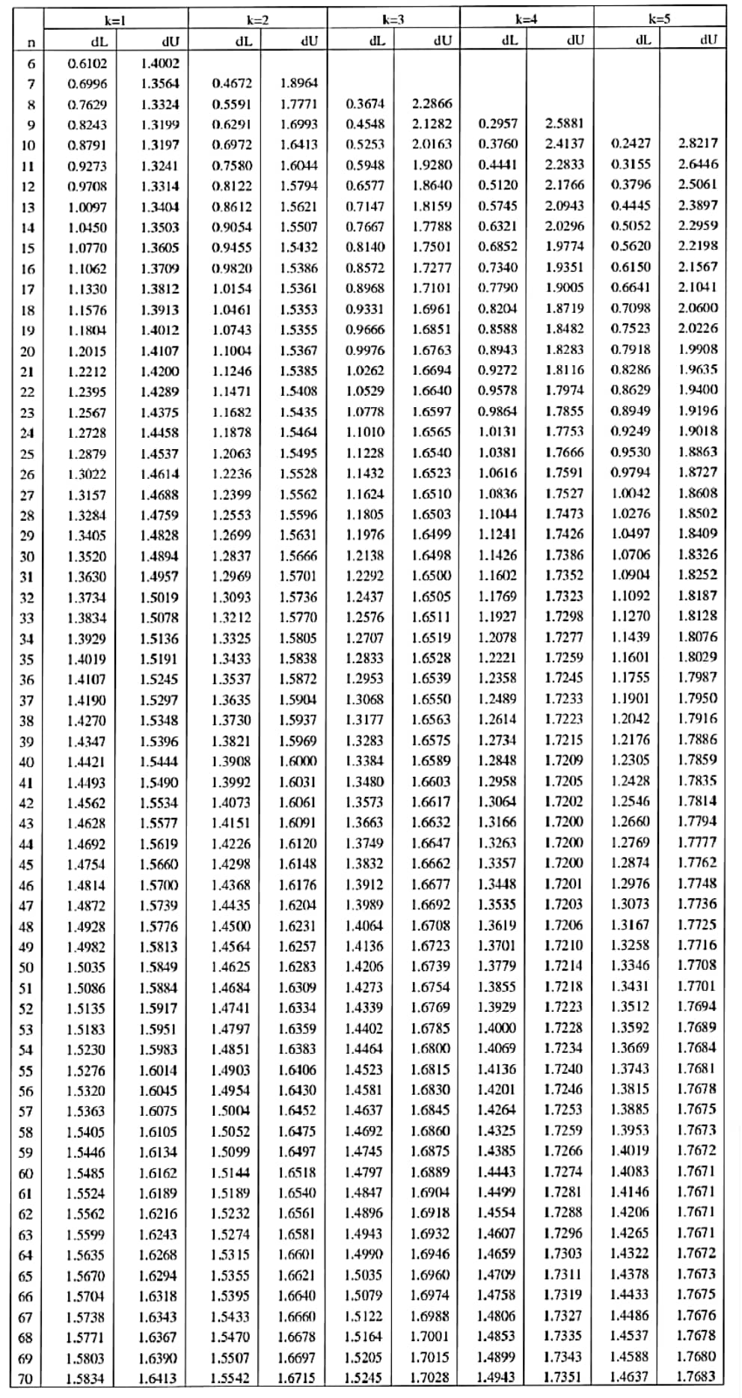
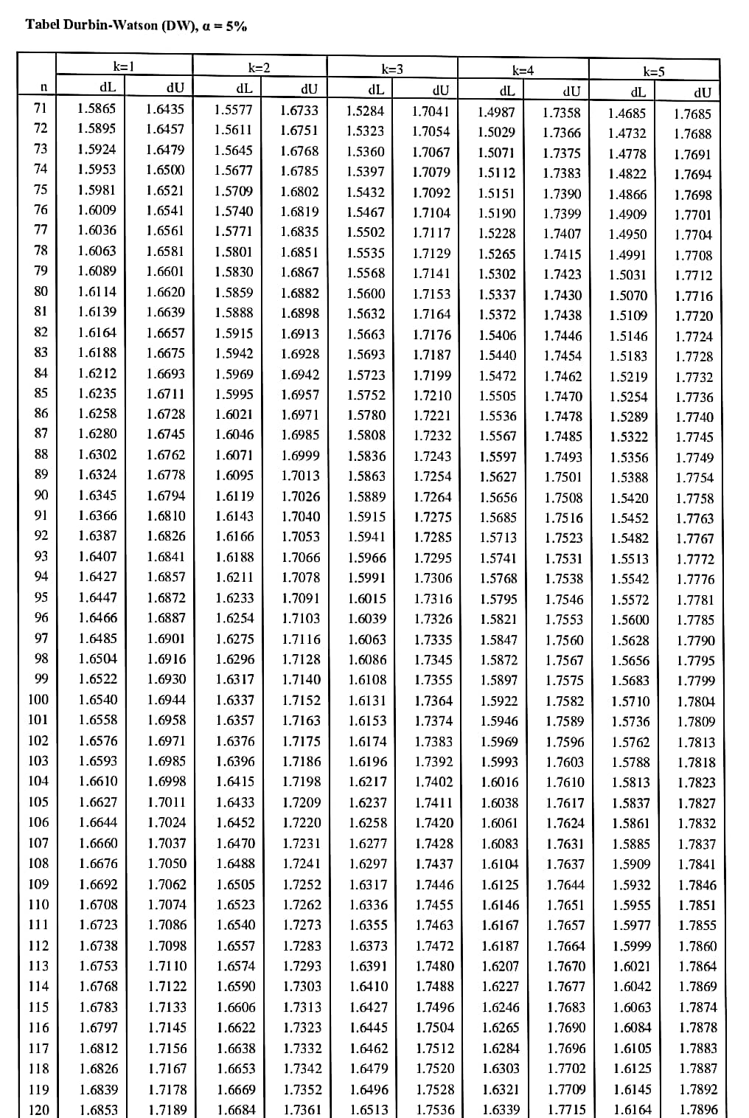
Sumber: tabel dw data diolah tahun (2023)

Lampiran 7
Titik persentase distribusi F
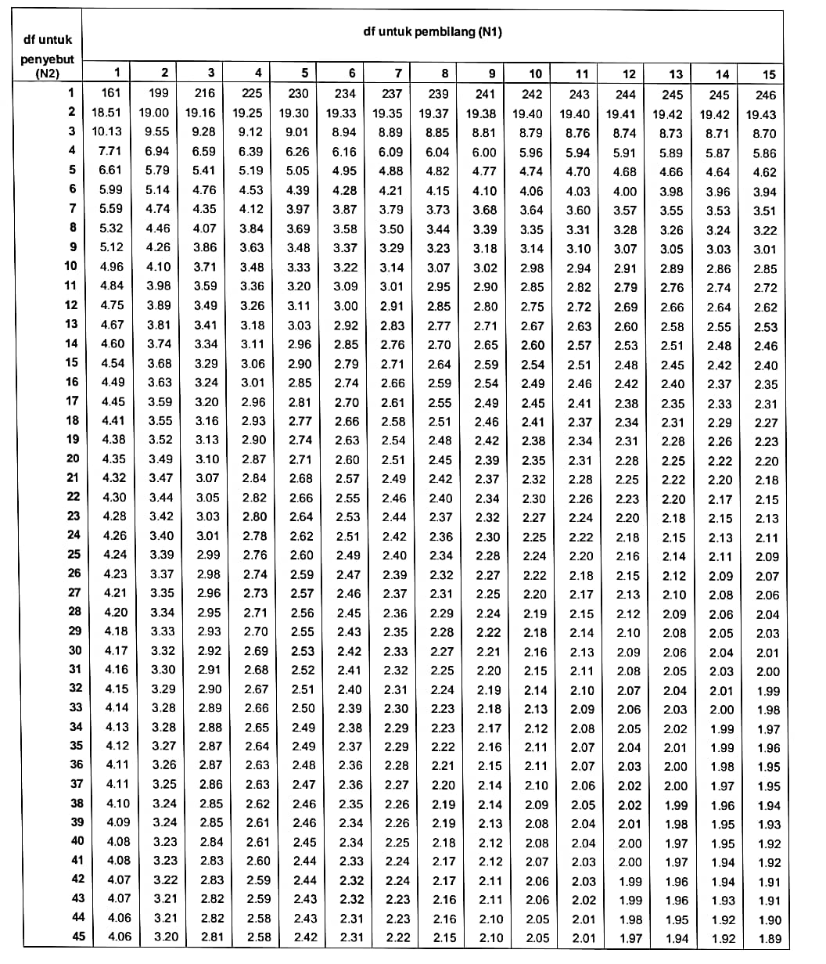

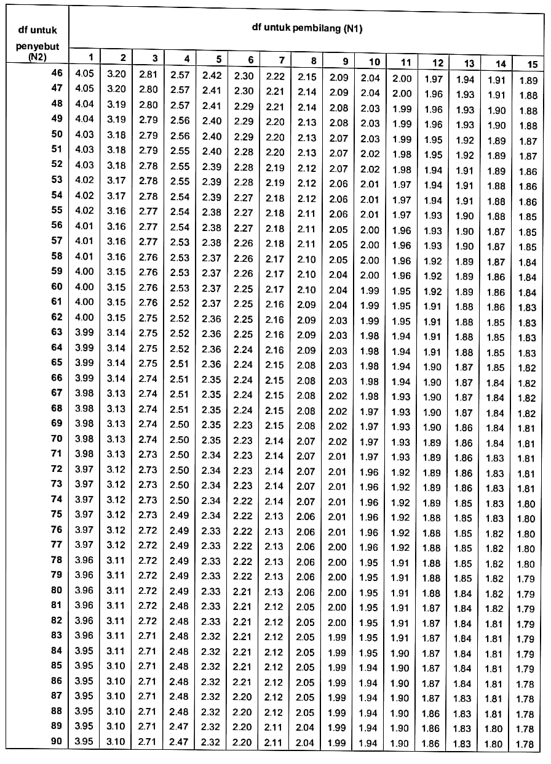Sumber: tabel df data diolah tahun (2023)

Lampiran 8
DATA SPSS
(dalam Persen)
NO | KODE BANK | TAHUN | CAR (X1) | LDR (X2) | OEOI (X3) | PERUBAHAN LABA (Y)
1. | AMAR | 2018 | 42.43 | 132.46 | 93.69 | 337
 |  | 2019 | 55.64 | 112.86 | 89.44 | 227
 |  | 2020 | 45.34 | 74.32 | 96.73 | -86
 |  | 2021 | 29.85 | 74.70 | 99.76 | -52
2. | BACA | 2018 | 18.66 | 51.96 | 92.11 | 24
 |  | 2019 | 12.67 | 60.55 | 98.12 | -85
 |  | 2020 | 18.11 | 39.33 | 98.84 | 287
 |  | 2021 | 41.28 | 12.35 | 98.23 | -43
3. | BBCA | 2018 | 23.39 | 81.58 | 58.24 | 6
 |  | 2019 | 23.80 | 80.47 | 59.09 | 16
 |  | 2020 | 25.83 | 65.77 | 63.45 | -5
 |  | 2021 | 25.66 | 61.96 | 54.15 | 16
4. | BBMD | 2018 | 34.58 | 86.93 | 68.09 | 1
 |  | 2019 | 38.60 | 88.06 | 71.48 | -7
 |  | 2020 | 47.29 | 72.72 | 67.59 | 340
 |  | 2021 | 48.12 | 71.15 | 51.70 | 53
5. | BBNI | 2018 | 48.12 | 88.76 | 70.15 | 10
 |  | 2019 | 19.73 | 91.54 | 73.16 | 3
 |  | 2020 | 47.29 | 72.72 | 67.59 | -79
 |  | 2021 | 48.12 | 71.15 | 51.70 | 230
6. | BBRI | 2018 | 21.21 | 88.96 | 68.40 | 12
 |  | 2019 | 22.55 | 88.64 | 70.10 | 6
 |  | 2020 | 20.61 | 83.66 | 81.22 | -46
 |  | 2021 | 25.28 | 83.67 | 74.30 | 65
7. | BBTN | 2018 | 18.21 | 103.49 | 85.58 | -7
 |  | 2019 | 17.32 | 113.50 | 98.12 | -93
 |  | 2020 | 19.34 | 93.19 | 91.61 | 666
 |  | 2021 | 19.14 | 92.86 | 89.28 | 48
8. | BDMN | 2018 | 22.79 | 70.85 | 70.85 | 7
 |  | 2019 | 24.59 | 82.71 | 82.71 | 3
 |  | 2020 | 25.59 | 83.96 | 88.87 | -74
 |  | 2021 | 26.38 | 84.56 | 86.62 | 53
9. | BGTG | 2018 | 31.85 | 87.81 | 97.57 | -89
 |  | 2019 | 32.84 | 82.76 | 96.69 | 111
 |  | 2020 | 35.70 | 64.00 | 98.40 | -73
 |  | 2021 | 67.15 | 40.01 | 94.81 | 240
10. | BINA | 2018 | 55.03 | 69.28 | 93.06 | -38
 |  | 2019 | 37.41 | 62.94 | 96.08 | -38
 |  | 2020 | 40.08 | 41.26 | 64.82 | 172
 |  | 2021 | 53.14 | 29.67 | 64.16 | 105
11. | BJBR | 2018 | 19.00 | 92.00 | 84.00 | 28
 |  | 2019 | 17.71 | 97.81 | 84.23 | 1
 |  | 2020 | 17.00 | 86.00 | 84.00 | 8
 |  | 2021 | 18.00 | 82.00 | 82.00 | 19
12. | BJTM | 2018 | 18.31 | 110.57 | 73.87 | 9
 |  | 2019 | 17.70 | 90.29 | 60.69 | 9
 |  | 2020 | 19.70 | 86.00 | 9.44 | 8
 |  | 2021 | 21.01 | 80.38 | 76.89 | 2
13. | BMAS | 2018 | 21.28 | 100.87 | 87.25 | 2
 |  | 2019 | 20.19 | 94.13 | 87.15 | -16
 |  | 2020 | 16.53 | 84.18 | 69.09 | 12
 |  | 2021 | 13.69 | 68.58 | 69.24 | 20
14. | BMRI | 2018 | 20.96 | 96.74 | 66.48 | 21
 |  | 2019 | 21.39 | 96.37 | 67.44 | 10
 |  | 2020 | 19.90 | 82.95 | 80.03 | -35
 |  | 2021 | 19.60 | 80.04 | 67.29 | 66
15. | BNBA | 2018 | 25.52 | 84.26 | 81.43 | 4
 |  | 2019 | 23.55 | 87.08 | 89.55 | -94
 |  | 2020 | 25.80 | 76.57 | 92.12 | 585
 |  | 2021 | 41.73 | 62.86 | 88.45 | 27
16. | BNGA | 2018 | 0.19 | 0.96 | 0.81 | 17
 |  | 2019 | 0.21 | 0.96 | 0.83 | 5
 |  | 2020 | 21.24 | 81.45 | 89.63 | -45
 |  | 2021 | 22.29 | 72.80 | 79.86 | 104
17. | BNII | 2018 | 19.09 | 96.46 | 83.85 | 22
 |  | 2019 | 21.42 | 94.13 | 89.28 | -15
 |  | 2020 | 24.25 | 79.25 | 88.98 | -33
 |  | 2021 | 26.38 | 76.28 | 84.94 | 31
18. | BNLI | 2018 | 19.44 | 90.08 | 93.36 | 20
 |  | 2019 | 19.89 | 86.32 | 87.04 | 66
 |  | 2020 | 35.68 | 78.69 | 88.76 | -52
 |  | 2021 | 34.94 | 68.97 | 90.07 | 71
19. | BSIM | 2018 | 17.60 | 84.24 | 97.62 | -84
 |  | 2019 | 17.32 | 81.95 | 119.43 | -87
 |  | 2020 | 17.29 | 56.97 | 11.70 | 1655
 |  | 2021 | 29.12 | 41.22 | 97.12 | 8
20. | BTPN | 2018 | 23.69 | 96.25 | 85.40 | 183
 |  | 2019 | 23.51 | 171.32 | 90.56 | 41
 |  | 2020 | 25.19 | 138.17 | 91.72 | -33
 |  | 2021 | 24.96 | 126.22 | 85.60 | 55
21. | MCOR | 2018 | 15.69 | 88.35 | 90.60 | 22
 |  | 2019 | 17.38 | 107.86 | 91.62 | -12
 |  | 2020 | 35.28 | 79.82 | 97.70 | -37
 |  | 2021 | 37.96 | 71.46 | 92.72 | 59
22. | MEGA | 2018 | 22.79 | 67.23 | 77.78 | 46
 |  | 2019 | 23.68 | 69.67 | 74.10 | 28
 |  | 2020 | 31.04 | 64.04 | 65.94 | 23
 |  | 2021 | 27.30 | 60.96 | 56.06 | 33
23. | NISP | 2018 | 17.63 | 93.51 | 74.43 | 21
 |  | 2019 | 19.10 | 94.00 | 74.77 | 11
 |  | 2020 | 21.98 | 72.01 | 81.13 | -28
 |  | 2021 | 22.94 | 71.69 | 76.49 | 20
24. | PNBN | 2018 | 23.49 | 104.15 | 75.54 | 98
 |  | 2019 | 24.07 | 107.92 | 77.04 | 10
 |  | 2020 | 2.55 | 83.26 | 76.50 | -11
 |  | 2021 | 29.66 | 88.05 | 78.60 | -42
25. | SDRA | 2018 | 23.04 | 145.26 | 70.39 | 23
 |  | 2019 | 20.02 | 139.91 | 75.75 | -81
 |  | 2020 | 24.48 | 162.29 | 74.22 | 437
 |  | 2021 | 19.99 | 141.80 | 70.32 | 17
Sumber: www.idx.co.id Laporan Tahunan data diolah peneliti (2023)

Keterangan: data ekstrim (Outlier) Warna Kuning

Lampiran 9
DATA PENGUJIAN SPSS 26

- Analisis Statistik Deskriptif

Hasil Uji Statistik Deskriptif
Descriptive Statistics
 | N | Minimum | Maximum | Mean | Std. Deviation
X1(CAR) | 100 | 0,19 | 67,15 | 26,1306 | 11,51327
X2(LDR) | 100 | 0,96 | 171,32 | 83,1473 | 27,53572
X3(OEOI) | 100 | 0,81 | 119,43 | 78,2546 | 19,56812
Y(perubahan laba) | 100 | -94 | 1655 | 54,75 | 204,621
Valid N (listwise) | 100
Sumber: Data diolah peneliti tahun 2023

Lampiran 10

Uji Asumsi Klasik
- Uji Normalitas
- Histogram Uji Normalitas
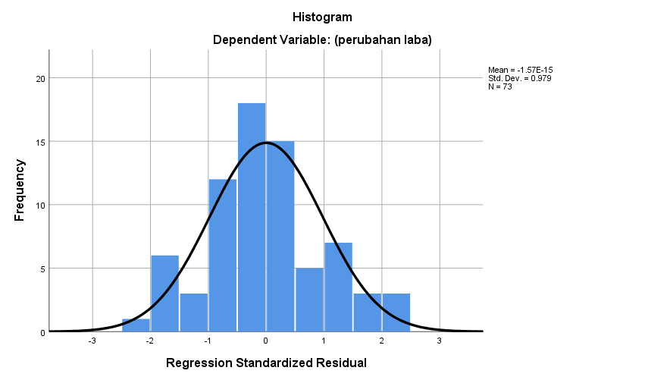
Sumber: Data yang diolah SPSS 26, 2023

- Normal P-Plot
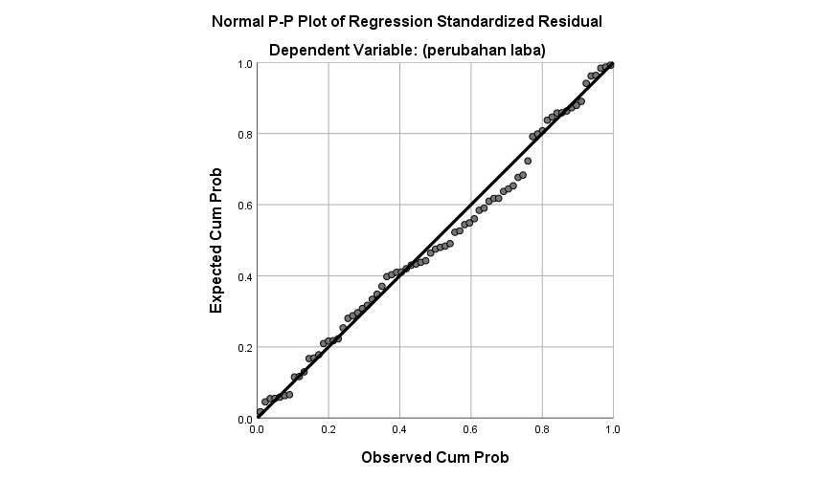
Sumber: Data yang diolah SPSS 26, 2023
- One-Sample Kolmogorov-Smirnov Test

 |  | Unstandardized Residual
N |  | 73
Normal Parameters^{a,b} | Mean | .0000000
 | Std. Deviation | 1.179.349.824
Most Extreme Differences | Absolute | .070
 | Positive | .070
 | Negative | -.039
Test Statistic |  | .070
Asymp. Sig. (2-tailed) |  | .200^{c,d}

a. Test distribution is Normal.
b. Calculated from data.
c. Lilliefors Significance Correction.
d. This is a lower bound of the true significance.
Sumber: Data yang diolah SPSS 26, 2023
- Uji Multikolonieritas
Uji Multikolonieritas
Coefficientsª
Model |  | Collinearity Statistics
 |  | Tolerance | VIF
1 | CAR (X1) | 0,978 | 1,022
 | LDR (X2) | 0,99 | 1,01
 | OEOI (X3) | 0,988 | 1,012
a. Dependent Variable: (perubahan laba)
Sumber: Data yang diolah SPSS 26, 2023
C. Uji Autokorelasi
Uji Autokorelasi
Model Summary^{b}
 |  | R | R Square | Adjusted R Square | Std. Error of the Estimate | Durbin-Watson
 | 1 | .867ª | .752 | .741 | 1.204.715 | 2.286
 | a. Predictors: (Constant), CAR(X1), LDR(X2), OEOI(X3)
 | b. Dependent Variable: (perubahan laba)
Sumber: Data yang diolah SPSS 26, 2023
D. Uji Heteroskedastisitas
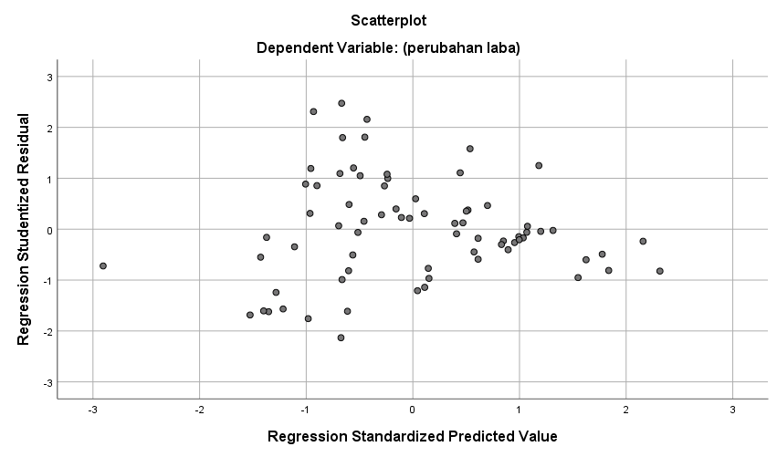
Sumber: Data yang diolah SPSS 26, 2023
Scatterplots Uji Heteroskedastitas

Lampiran 11

3. Analisis Regresi Linier Berganda
Coefficientsa
Model |  | Unstandardized Coefficients |  | Standardized Coefficients
 |  | B | Std. Error | Beta
1 | (Constant) | 149.369 | 11.544
 | (CAR) | -.221 | .174 | -.077
 | (LDR) | -.192 | .075 | -.154
 | (OEOI) | -1.613 | .115 | -.843
- Dependent Variable: (perubahan laba)
Sumber: Data yang diolah SPSS 26, 2023

Lampiran 12

Uji Hipotesis
- Uji Signifikansi Parsial (Uji Statistik T)
Uji Hipotesis Parsial (Uji t)
Coefficientsª
Model |  | Unstandardized Coefficients |  | Standardized Coefficients | T | Sig.
 |  | B | Std. Error | Beta
1 | (Constant) | 149.369 | 11.544 |  | 12.939 | .000
 | (CAR) | -.221 | .174 | -.077 | -1.266 | .210
 | (LDR) | -.192 | .075 | -.154 | -2.556 | .013
 | (OEOI) | -1.613 | .115 | -.843 | -13.972 | .000
- Dependent Variable: (perubahan laba)
Sumber: Data yang diolah SPSS 26, 2023

- Uji Hipotesis Simultan (Uji F)
Uji Hipotesis Parsial (Uji t)
ANOVAª
Model |  | Sum of Squares | Df | Mean Square | F | Sig.
1 | Regression | 30391,040 | 3 | 10130,347 | 69,800 | .000^{b}
 | Residual | 10014,235 | 69 | 145,134
 | Total | 40405,275 | 72

- Dependent Variable: (perubahan laba)
- Predictors: (Constant), (OEOI), (LDR), (CAR).
Sumber: Data yang diolah SPSS 26, 2023

Lampiran 13
- Koefisien Determinasi
Hasil Uji Koefisien Determinasi
Model Summary^{b}
 | Model | R | R Square | Adjusted R Square | Std. Error of the Estimate
 | 1 | .867ª | .752 | .741 | 1.204.715
 | a. Predictors: (Constant), (OEOI), (LDR), (CAR)
 | b. Dependent Variable: (perubahan laba)
Sumber: Data yang diolah SPSS 26, 2023

