DAFTAR PUSTAKA

Akis, A. R., & Mutmainah, S. (2010). Pengaruh Pengumuman Indonesian Sustainability Report Award (ISRA) Terhadap Abnormal Return dan Volume Perdagangan Saham (Studi Kasi pada Perusahaan Peraih Penghargaan ISRA 2009-2010). Jurnal Akuntansi Dan Auditing, 7(2), 122–133. https://doi.org/https://ejournal.undip.ac.id/index.php/akuditi/article/view/4681/4240
Anggraini, D. (2018). The Indonesia Sustainability Reporting Awards (ISRA) Announcement Influence On Abnormal Return and Stock Trade Volume (Empirical Study on ISRA Award-Winning Companies in 2009-2016 Period). Archives of Business Research, 6(8), 61–72. https://doi.org/10.14738/abr.68.4976
Badan Pengawasan Pasar Modal dan Lembaga Keuangan. (2012). Peraturan Bapepam dan LK Nomor Kep-431/BL/2012 Tentang Penyampaian Laporan Tahunan Emiten Atau Perusahaan Publik. Kementerian Keuangan Republik Indonesia. https://www.ojk.go.id/id/regulasi/Documents/Pages/BAPEPAM-XK6-tentang-Penyampaian-Laporan-Tahunan-Emiten-atau-Perusahaan-Publik/X.K.6.pdf
Boonvorachote, T., & Lakmas, K. (2016). Price Volatility, Trading Volume, and Market Depth in Asian Commodity Futures Exchanges. Kasetsart Journal of Social Sciences, 37(1), 53–58. https://doi.org/10.1016/j.kjss.2016.01.004
Brammer, S. J., & Pavelin, S. (2006). Corporate reputation and social performance: The importance of fit. Journal of Management Studies, 43(3), 435–455. https://doi.org/10.1111/j.1467-6486.2006.00597.x
Christensen, H. B., & Leuz, C. (2019). Adoption of CSR and Sustainability Reporting Standards : Economic Analysis and Review. European Corporate Governance Institute, August. https://doi.org/https://ssrn.com/abstract=3315673
Dewi, S. (2019). Pengaruh Ukuran Perusahaan dan Profitabilitas terhadap Pengungkapan Sustainability Report serta Dampaknya Kepada Nilai Perusahaan. Jurnal Studia Akuntansi Dan Bisnis, 7(3), 173–186. https://dx.doi.org/10.55171/jsab.v7i3.361
Elga, R., Murni, S., & Tulung, J. E. (2022). Reaksi Pasar Modal terhadap Peristiwa Sebelum dan Sesudah Pengumuman Covid-19 Di Indonesia (Event Study pada Indeks Lq45). Jurnal EMBA, 10(1), 1052–1060. https://doi.org/https://doi.org/10.35794/emba.v10i1.38703
Eurostat Publication. (2014). The European Union in the world (S. Allen & A. Redpath (eds.); the second). https://doi.org/10.2785/48181
Ghozali, I. (2018). Aplikasi Analisis Multivariate dengan Program IBMM SPSS 25. Badan Penerbit Universitas Diponegoro.
Gunistiyo. (2009). Perilaku Harga Saham (Studi Dampak Reshuffle Kabinet Indonesia Bersatu terhadap Return Saham LQ 45 di Bursa Efek Jakarta). Sosekhum, 6(4), 1–12. http://e-journal.upstegal.ac.id/index.php/Sosekhum/article/view/31/40
Hadi, N. (2015). Pasar Modal (Edisi 2). Graha Ilmu.
Harmoni, A. (2013). Stakeholder-Based Analysis of Sustainability Report: A Case Study on Mining Companies in Indonesia. International Conference on Eurasian Economies 2013, 204–210. https://doi.org/10.36880/c04.00704
Hartono, J. (2017). Teori Portofolio dan Analisis Investasi. BPFE-Anggota IKAPI.
IDX.co.id. (2023). Bursa Efek Indonesia. https://idx.co.id
Indarti, I., & Purba, D. M. B. (2011). Analisis Perbandingan Harga Saham dan Volume Perdagangan Saham Sebelum dan Sesudah Stock Split. Jurnal Ilmiah Aset, 13(1), 57–63. https://doi.org/10.17509/jrak.v6i2.12787
Jao, R., & Jimmiawan, D. (2018). Analisis Perbedaan Abnormal Return, Volume Perdagangan Saham Sebelum dan Sesudah Pengumuman Corporate Image Award. Bongaya Journal for Research in Accounting, 1(2016), 25–31. https://doi.org/10.37888/bjra.v1i2.80
Jogiyanto. (2015). Partial Least Square (PLS) : Alternatif Structural Equation Modeling (SEM) dalam Penelitian Bisnis. Yogyakarta: Andi
Investing.com. (2023). Investing. https://id.investing.com/
Jenawan, S. (2012). Pengaruh Pengungkapan Sustainability Reporting Terhadap Respon Investor. Business Acounting Review, 3(1), 180–189. https://www.neliti.com/id/publications/189782/
Joe, R. (2014). Analisis Perbedaan Harga Saham dan Volume Perdangan Saham Sebelum dan Sesudah Pengumuman Indonesian CSR Award. Profesional Jurnal in Integrity, Knowledge, and Skill, 5(3), 248–253. https://doi.org/10.56708/progres.v6i2.40
Jumady, E., & Halim, A. (2020). Analisis Perbandingan Volume Perdagangan Saham Sebelum dan Sesudah Stock Split pada Perusahaan Manufaktur yang Terdaftar di Bursa Efek Indonesia. Jurnal Ecoment Global, 5(2), 131–140. http://dx.doi.org/10.35908/jeg.v5i2.915
Kehati.or.id. (2023). Kehati. https://kehati.or.id/
Kusuma, A. B. 2012. Asosiasi Pengungkapan CSR dan Kinerja Keuangan Pada Perusahaan Peraih Penghargaan Indonesia Sustainability Reporting Award (ISRA) Periode 2011 dan Terdaftar di Bursa Efek Indonesia (BEI) 2011-2012. Ejurnal.Universitas Negeri Surabaya
Lorraine, N. H. J., Collison, D. J., & Power, D. M. (2004). An Analysis of The Stock Market Impact of Environmental Performance Information. Accounting Forum, 28(1), 7–26. https://doi.org/10.1016/j.accfor.2004.04.002
MacKinlay, A. C. (1997). Event Studies in Economics and Finance. Journal of Economic Literature, 35(1), 13–39. https://www.jstor.org/stable/2729691
Mcwilliams, A., & Siegel, D. (1997). Event Studies in Management Research: Theoretical and Empirical Issues. Academy of Management Journal, 40(3), 626–657. https://doi.org/10.2307/257056
Mediawati, E., & Afiyana, I. F. (2018). Dewan Pengawas Syariah dan Pengungkapan Sukarela pada Bank Umum Syariah di Indonesia. Jurnal Riset Akuntansi & Keuangan, 6(2), 259–268 . https://ejournal.upi.edu/index.php/JRAK/article/view/12787
Munfaqiroh, S. (2006). Pengaruh Publikasi Laporan Keuangan terhadap Volume Perdagangan Saham. Media Riset Akuntansi, Auditing & Informasi, 6(1), 51–74. https://doi.org/10.25105/mraai.v6i1.896
Nabella, O., Nanda, A., & Hayati, N. (2021). Pengaruh Pengungkapan Sustainability Report terhadap Harga Saham Perusahaan LQ45. Jurnal Manajemen Dan Akuntansi, 22(April), 79–87. http://journal.stiei-kayutangi-bjm.ac.id/index.php/jma/article/download/654/300
Permata, C. P., & Ghoni, M. A. (2019). Peranan Pasar Modal Dalam Perekonomian Negara Indonesia. Jurnal Akun Stie, 5(2), 50–61. https://jurnal.univbinainsan.ac.id/index.php/jas/article/view/680/471
Putri, N. A. C., & Martin, A. (2021). Event Study: Reaksi Pasar Modal Sebelum dan Sesudah Aadanya COVID-19 (Studi pada Perusahaan Non-Perbankan yang Terdaftar di BEI Sebagai Anggota LQ45). AKURAT Jurnal Ilmiah Akuntansi, 12(3), 64–73 . https://unibba.ac.id/ejournal/index.php/akurat/article/view/672
Rakhman, A., Zakaria, H. M., & Suhono. (2019). Pengaruh Pengungkapan Laporan Keberlanjutan Terhadap Harga Saham (Studi Empiris pada Perusahaan yang Menerbitkan Laporan Keberlanjutan dan Terdaftar di Bursa Efek Indonesia Tahun 2012 – 2014). Journal of Accounting and Finance, 4(1), 639–651. https://doi.org/10.35706/acc.v4i1.1816
Reddy, K., & Gordon, L. W. (2015). The Effect of Sustainability Reporting on Financial Performance : An Empirical Study Using Listed Companies The Effect of Sustainability Reporting on Financial Performance : An Empirical Study Using Listed Companies. Journal of Asia Entrepreneurship and Sustainability, 6(2), 19–42. https://doi.org/https://www.researchgate.net/publication/255172697_The_Effect_of_Sustainability_Reporting_on_Financial_Performance_An_Empirical_Study_Using_Listed_Companies
Rismayanti, F. (2020). Pengaruh Sustainability Report Terhadap Harga Saham pada Perusahaan yang Terdaftar di Jakarta Islamic Index (JII) Tahun 2016-2019. http://etheses.iainponorogo.ac.id/id/eprint/11026
Saifudin, M. A., & Nurhadi. (2022). Pengaruh Pengungkapan Corporate Social Responsibility terhadap Harga Saham Indeks Sri Kehati dengan Profitabilitas sebagai Pemoderasi. Jurnal Kajian Ekonom Dan Bisnis Islam, 3(5), 908–926. https://doi.org/1047467
Setyawasih, R. (2007). Suatu Tentang Peristiwa (Event Study). Jurnal Optimal, 1(1), 52–58. https://www.neliti.com/id/publications/4425/
Suganda, T. R. (2018). Event Study Teori dan Pembahasan Reaksi Pasar Modal Indonesia (S. R. Wicaksono (ed.)). CV. Seribu Bintang.
Suliyanto. (2018). Metode Penelitian Bisnis: Untuk Skripsi, Tesis, dan Disertasi (A. Cristian, Y. Basuki, D. Noviyanto, & N. Damar (eds.)). CV. Andi Offset.
Sumiyana. (2007). Noise atau Kedatangan Informasi: Sebuah Fenomena Spesifik Perilaku Harga Saham di Pasar Modal Indonesia Studi Empiris Berbasis Data Intraday, Bursa Efek Jakarta 1999-2006. Jurnal Ekonomi & Bisnis Indonesia (Fakultas Ekonomi Dan Bisnis Universitas Gadjah Mada), 22(3), 192–218. https://doi.org/10.22146/jieb.6334
Sustainability Reporting Guidelines. (2011). In Encyclopedia of Corporate Social Responsibility (3.1., pp. 3–5). https://doi.org/10.1007/978-3-642-28036-8_619
Swissia, P., & Darmawan, F. E. P. (2019). Analisis Perbedaan Abnormal Return, Volume, dan Harga Perdagangan Saham Sebelum dan Sesdah Pengumuman Indonesia Ssustainability Reporting Award (ISRA). Jurnal Akuntansi Dan Keuangan, 10(1), 34–35.
Syafrudin, & Panjaitan, M. (2020). Analisis Faktor-Faktor yang Mempengaruhi Indonesia Sustainability Reporting Award (ISRA) (Studi Kasus pada Perusahaan BEI Peraih Penghargaan ISRA 2013-2016). Jurnal Ekonomi Dan Kebijakan Publik, 3(1), 45–56. https://journals.unihaz.ac.id/index.php/pareto/article/download/1399/795/
Tandelilin, E. (2010). Portofolio dan Investasi: Teori dan Aplikasi. Kanisius. http;//scholar.google.co.id/citations?view_op=view_citation&hl=id&user=F40fW3gAAAAJ&citation_for_view=F40fW3gAAAAJ:bEWYMUwl8FkC
Tobing, R. A., Zuhrotun, Z., & Rusherlistyani, R. (2019). Pengaruh Kinerja Keuangan, Ukuran Perusahaan, dan Good Corporate Governance terhadap Pengungkapan Sustainability Report pada Perusahaan Manufaktur yang Terdaftar dalam Bursa Efek Indonesia. Reviw Akuntansi dan Bisnis Indonesia, 3(1), 102–123. https://doi.org/10.18196/rab.030139
TradingView.id. (2023). TradingView. https://tradingview.com
Ulum, Ihyaul. (2017). Intellevtual Capital. Malang:UMM Press
Umi, P. R., Darmayanti, Y., & Wahidil, W. (2020). Perbandingan Abnormal Return dan Volume Perdagangan Saham pada Perusahaan yang Mengikuti Indonesian Sustainability Reporting Award (ISRA). Jurnal Kajian Akuntansi dan Bisnis Terkinisnis Terkini, 1(1), 106–115. http://dx.doi.org/10.31258/jc.1.1.106-116
Widyawati, N., & Ariesta, R. (2020). Analysis of Differences in Stock Price and Stock Volume of Trade Before and After Annual Report Award (ARA) Announcement in 2009-2016 in Award Winning Companies Listing In Indonesia Stock Exchange. The Spirit of Society Journal, 3(2), 68–78. https://doi.org/10.29138/scj.v3i2.1095
Wijanarko, I. (2012). Analisis Pengaruh Pemecahan Saham (Stock Split) Terhadap Likuiditas Saham dan Return Saham (Study Kasus Pada Perusahaan Yang Terdaftar BEI Periode 2007-2011). Diponegoro Journal of Management, 1(2), 189–199. http://ejournal-s1.undip.ac.id/index.php/djom

LAMPIRAN

Lampiran 1 Tanggal Penerbitan Sustainability Report Sampel Penelitian
- PT. Astra Internasional Tbk
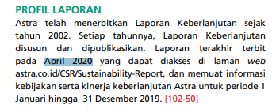
https://www.astra.co.id/Public/Files/Sustainability%20Report/2019/SR%202019%20Astra%20International.pdf
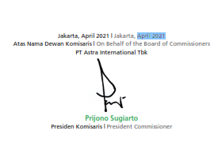
https://www.astra.co.id/Public/sustainability/2020-Sustainability-Report.pdf
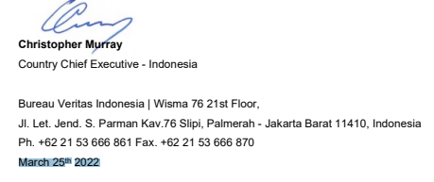
https://www.astra.co.id/Public/sustainability/ASR-Astra-2021.pdf

- PT. Bank Central Asia (Persero) Tbk 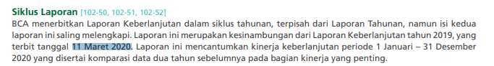
https://www.bca.co.id/-/media/Feature/Report/File/S8/Laporan-Keberlanjutan/ID/20211228-bca-sustainability-report-2020ina.pdf
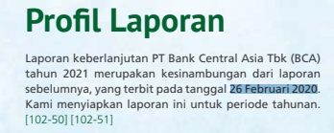
https://www.bca.co.id/-/media/Feature/Report/File/S8/Laporan-Keberlanjutan/2022/20220304-laporan-keberlanjutan-2021-bca-id.pdf
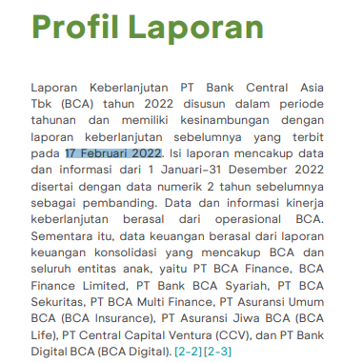
https://www.bca.co.id/-/media/Feature/Report/File/S8/Laporan-Keberlanjutan/2023/20230216-bca-sustainability-report-2022-ina.pdf

- PT. Bank Negara Indonesia (Persero) Tbk
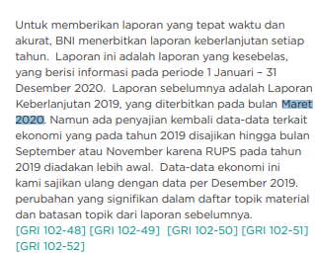
https://bni.co.id/Portals/1/BNI/Perusahaan/HubunganInvestor/Docs/SR-BNI-2020.pdf 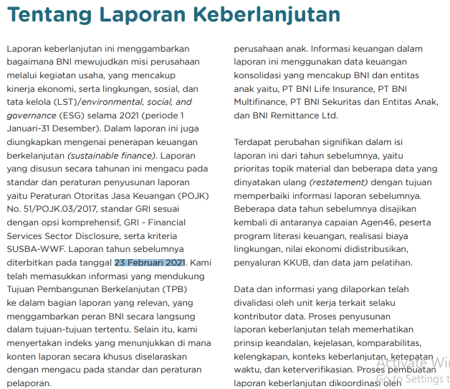 https://www.bni.co.id/Portals/1/BNI/Perusahaan/HubunganInvestor/Docs/SR-BNI-2021-ID.pdf
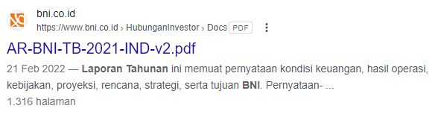
https://www.bni.co.id/Portals/1/BNI/Perusahaan/HubunganInvestor/Docs/AR-BNI-TB-2021-IND-v2.pdf
- PT. Bank Rakyat Indonesia (Persero) Tbk
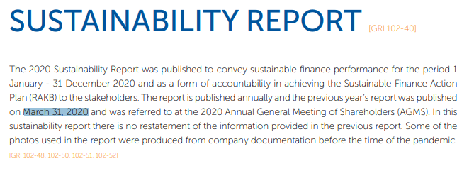
ir-bri.com/misc/SR/SR-20020.pdf
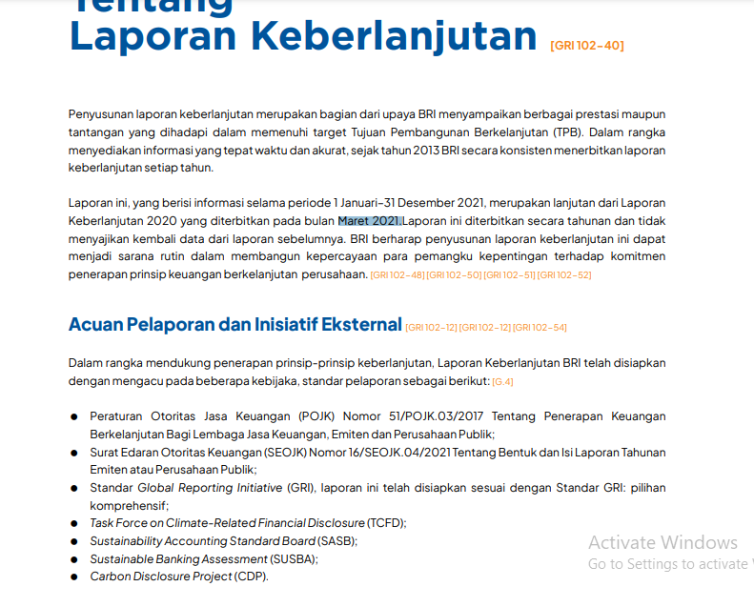
bri.co.id/documents/20123/56786/SR%202021%20Bank%20BRI%20-%20IND.pdf
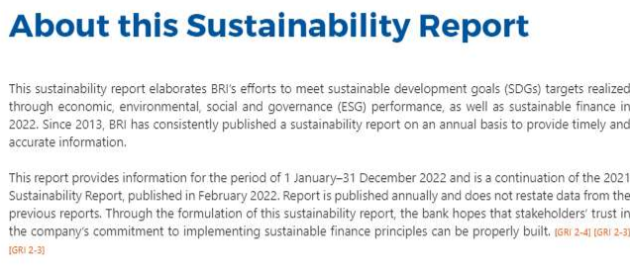
https://bri.co.id/documents/555426/56786/SR%20BRI%202022_ENG.pdf
- PT. Bank Tabungan Negara (Persero) Tbk
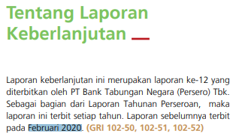
https://www.btn.co.id/-/media/User-Defined/Document/Hubungan-Investor/ind/Laporan-Tahunan/2020/SR-2020--BTN--ID-160221--Ereporting.pdf
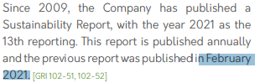
https://www.btn.co.id/-/media/User-Defined/Document/Hubungan-Investor/eng/Annual-Report/2021/SR-BTN-2021---ENG.pdf
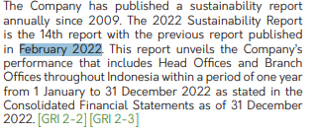
https://www.btn.co.id/-/media/User-Defined/Document/Hubungan-Investor/eng/Annual-Report/2022/SR-BTN-EN---Final---Hi.pdf
- PT. Bank Mandiri (Persero) Tbk
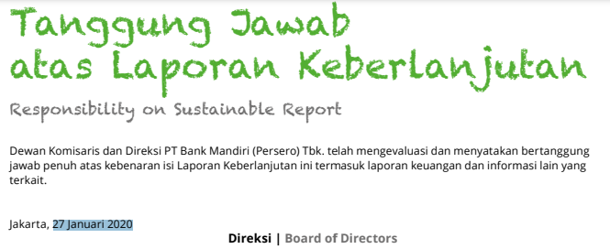
https://www.ojk.go.id/keuanganberkelanjutan/Uploads/Content/Regulasi/Regulasi_22012013133000.pdf
https://www.ojk.go.id/keuanganberkelanjutan/Uploads/Content/Regulasi/Regulasi_22012109150721.pdf
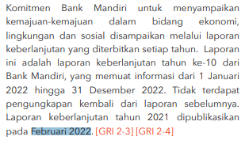
https://bankmandiri.co.id/documents/38265486/0/SR+Mandiri+FEB_20+FEB+23.pdf
- PT. Bumi Serpong Damai Tbk 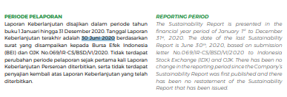https://bsdcity.com/app/uploads/2021/05/Sustainability-Reports-BSDE-2020.pdf
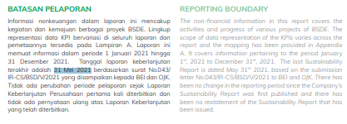
https://bsdcity.com/app/uploads/2022/05/SR-BSDE-2021.pdf
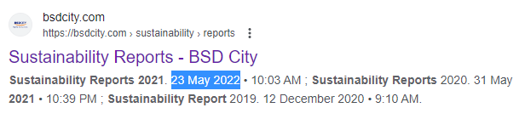
https://bsdcity.com/sustainability/reports/
- PT. Indofood Sukses Makmur Tbk
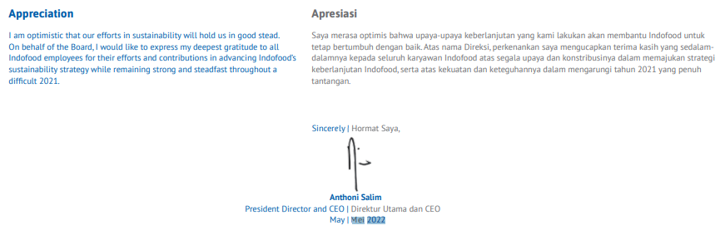
https://www.indofood.com/uploads/file/INDF_SR2021_web.pdf
- PT. Kalbe Farma Tbk
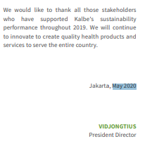
https://www.kalbe.co.id/api-content/File/GetFile/KalbeFarma%20SR%202019-ENG_FA.pdf
https://www.kalbe.co.id/api-content/File/GetFile/2021-06-07%20KalbeFarma%20SR%202020%20Design%20Layout-ENG-LoRes_FINAL%20after%20RUPS.pdf
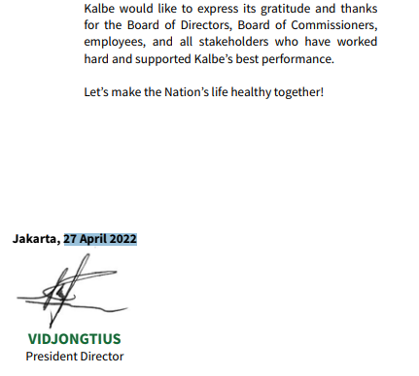
https://www.kalbe.co.id/api-content/File/GetFile/SR%20PT%20Kalbe%20Farma%20Tbk%20English.pdf
- PT. Semen Indonesia Tbk
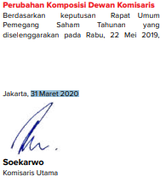
https://www.sig.id/storage/downloads/laporan-tahunan/ar-sig-2019-id.pdf
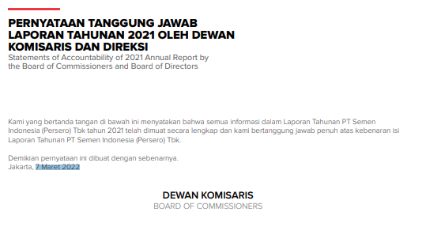
https://www.sig.id/storage/downloads/laporan-tahunan/ar-sig-2021-bilingual.pdf

Lampiran 2 Data Sampel Penelitian
Periode | ASII |  | BBCA |  | BBNI |  | BBRI |  | BBTN |  | BMRI |  | BSDE |  | INDF |  | KLBF |  | SMGR
 | CP | Volume | CP | Volume | CP | Volume | CP | Volume | CP | Volume | CP | Volume | CP | Volume | CP | Volume | CP | Volume | CP | Volume
Event Date | 30 April 2020 |  | 11 Maret 2020 |  | 22 Maret 2020 |  | 30 Maret 2020 |  | 7 Februari 2020 |  | 27 Januari 2020 |  | 30 Juni 2020 |  | 15-Apr-20 |  | 5 Mei 2020 |  | 31 Maret 2020
t-10 | 5350 | 61494300 | 6200 | 92824500 | 4625 | 42861300 | 3030 | 268837000 | 1835 | 13231800 | 3900 | 75399600 | 740 | 71270800 | 6675 | 111236300 | 1320 | 44882900 | 7500 | 4238900
t-9 | 5525 | 78593000 | 6100 | 129254500 | 4290 | 68061300 | 3000 | 178420500 | 1850 | 8707300 | 3860 | 104134400 | 755 | 40508400 | 6475 | 63583600 | 1325 | 34694200 | 7625 | 2188400
t-8 | 5625 | 50406600 | 6200 | 169946500 | 4010 | 82270300 | 3000 | 208568600 | 1825 | 16119000 | 3850 | 89795200 | 810 | 49395300 | 6300 | 59542900 | 1340 | 66130900 | 7675 | 9030900
t-7 | 5450 | 36590700 | 6000 | 144871500 | 3850 | 53293800 | 2750 | 248104200 | 1825 | 10282400 | 3850 | 145432200 | 860 | 24068300 | 6325 | 35382900 | 1390 | 51439800 | 8075 | 6210800
t-6 | 5225 | 76750500 | 5925 | 114663500 | 3680 | 67685900 | 2960 | 137946900 | 1730 | 8218500 | 3760 | 130500200 | 825 | 24986900 | 6525 | 68562800 | 1400 | 43175900 | 7900 | 6431500
t-5 | 5200 | 85068700 | 585 | 83025000 | 3820 | 49165000 | 2950 | 598363000 | 1700 | 18561600 | 3750 | 24031800 | 760 | 17739800 | 6300 | 57568300 | 1400 | 38936000 | 8075 | 8332400
t-4 | 5250 | 49597000 | 5875 | 77583000 | 3720 | 68571000 | 2820 | 164404600 | 1695 | 17314800 | 3780 | 39166600 | 745 | 24686700 | 6275 | 58108500 | 1400 | 61167100 | 8100 | 9943300
t-3 | 5250 | 45682200 | 5800 | 77835500 | 3990 | 72267200 | 2800 | 495129300 | 1725 | 32516500 | 3830 | 122175200 | 740 | 16888100 | 6225 | 39794600 | 1385 | 52010200 | 7675 | 9778300
t-2 | 5250 | 53532700 | 5700 | 140889500 | 3590 | 10953100 | 2860 | 634588200 | 1735 | 14460200 | 3900 | 83127800 | 760 | 10848700 | 6250 | 42772000 | 1385 | 53666000 | 7475 | 4052900
t-1 | 5250 | 40557200 | 5675 | 133667000 | 3160 | 175719600 | 2950 | 480930500 | 1770 | 36589300 | 3880 | 154702000 | 725 | 13063600 | 6050 | 50981100 | 1400 | 46895400 | 7675 | 5186600
t-0
t+1 | 5075 | 71301800 | 5725 | 129845500 | 3640 | 132089300 | 3070 | 314996600 | 1785 | 11125000 | 3700 | 69349600 | 660 | 32550600 | 6450 | 70564600 | 1380 | 55190700 | 7600 | 6605300
t+2 | 5275 | 54983300 | 5700 | 212200000 | 3640 | 190756900 | 2980 | 271743600 | 1740 | 10580800 | 3750 | 109661000 | 690 | 32203100 | 6400 | 44882900 | 1440 | 37146000 | 7400 | 7011900
t+3 | 5300 | 70425000 | 5625 | 180053500 | 3910 | 164991800 | 3020 | 299882400 | 1775 | 15160600 | 3700 | 85395600 | 650 | 28686200 | 6375 | 34694200 | 1470 | 33331300 | 7950 | 3988100
t+4 | 5350 | 63346500 | 5550 | 264419000 | 4200 | 41072600 | 3060 | 293146900 | 1745 | 13266100 | 3625 | 157661000 | 605 | 15070700 | 6250 | 66130900 | 1445 | 30687000 | 6775 | 7254800
t+5 | 5350 | 79511800 | 5575 | 335132000 | 4510 | 99610200 | 3050 | 285099900 | 1805 | 14021400 | 3750 | 87271800 | 625 | 10709400 | 6525 | 51439800 | 1330 | 20203800 | 6100 | 7242200
t+6 | 5350 | 58347900 | 5575 | 217843500 | 4840 | 86485500 | 3090 | 405389200 | 1825 | 35071300 | 3650 | 138857400 | 605 | 66976300 | 6725 | 43175900 | 1255 | 35697000 | 6550 | 6394700
t+7 | 5350 | 44974600 | 5725 | 253971000 | 4700 | 58984400 | 3080 | 292946600 | 1830 | 31694000 | 3650 | 130211200 | 605 | 95299900 | 6600 | 38936000 | 1250 | 25213800 | 7025 | 3664600
t+8 | 5275 | 80570900 | 5750 | 331633000 | 4675 | 47584600 | 3030 | 265787000 | 1845 | 17572900 | 3725 | 111029400 | 625 | 35937200 | 6800 | 61167100 | 1280 | 17406600 | 5850 | 2716200
t+9 | 5400 | 65284900 | 5500 | 269683000 | 4725 | 61479800 | 3060 | 123731400 | 1860 | 23199000 | 3800 | 86438600 | 605 | 23990400 | 6350 | 52010200 | 1210 | 38331600 | 6275 | 8020400
t+10 | 5525 | 88368200 | 5675 | 159964500 | 4800 | 81628300 | 3110 | 219734000 | 1885 | 15009500 | 3625 | 78553800 | 625 | 22669300 | 6350 | 53666000 | 1200 | 50884000 | 6550 | 8354700
Event Date | 13 April 2021 |  | 26 Februari 2021 |  | 23 Februari 2021 |  | 17 Maret 2021 |  | 9 Februari 2021 |  | 11 Februari 2021 |  | 31 Mei 2021 |  | 15 April 2021 |  | 06 April 2021 |  | 31 Maret 2021
t-10 | 5350 | 25164100 | 6626 | 36926000 | 6050 | 22425700 | 4610 | 68358600 | 2030 | 38937700 | 3280 | 135745000 | 1020 | 8259700 | 6525 | 22300400 | 1495 | 29442900 | 10325 | 7743100
t-9 | 5525 | 55842300 | 6675 | 83922000 | 5985 | 43128700 | 4630 | 77295700 | 2020 | 38079300 | 3240 | 334227600 | 1035 | 8225300 | 6675 | 17604600 | 1495 | 37466600 | 10350 | 6031600
t-8 | 5625 | 89835200 | 6775 | 47221000 | 6000 | 15012100 | 4600 | 107177400 | 1930 | 42321900 | 3290 | 242540200 | 1040 | 15919100 | 6525 | 14155000 | 1495 | 34585300 | 10275 | 3597100
t-7 | 5450 | 33323600 | 6700 | 66011500 | 6000 | 13331500 | 4600 | 64715600 | 1860 | 70634000 | 3260 | 160482800 | 1050 | 4526600 | 6675 | 23411100 | 1495 | 36607700 | 10400 | 5014500
t-6 | 5225 | 29142200 | 6600 | 91204000 | 6000 | 26533500 | 4560 | 63560400 | 1815 | 62191000 | 3260 | 167044600 | 1045 | 4817800 | 6750 | 15104900 | 1515 | 11780400 | 10400 | 5158000
t-5 | 5200 | 26040800 | 6725 | 70487500 | 6226 | 37910600 | 4540 | 150476600 | 1795 | 15789600 | 3290 | 139040400 | 1085 | 4508300 | 6675 | 17501800 | 1495 | 30661700 | 10850 | 3858300
t-4 | 5250 | 33361900 | 6800 | 68913000 | 6150 | 44943100 | 4560 | 70367800 | 1810 | 87229000 | 3230 | 97199600 | 1100 | 2748900 | 6775 | 28744400 | 1490 | 23063900 | 11125 | 2704900
t-3 | 5250 | 43680100 | 6725 | 58360000 | 6225 | 32197800 | 4520 | 138506800 | 1860 | 60626500 | 3280 | 125050800 | 1110 | 12902000 | 6750 | 14682200 | 1510 | 22300400 | 11050 | 2724400
t-2 | 5250 | 59348800 | 7025 | 71869000 | 5950 | 25762800 | 4560 | 86801300 | 1790 | 50583200 | 3240 | 208380400 | 1130 | 14057100 | 6750 | 22230800 | 1550 | 17604600 | 11250 | 7079500
t-1 | 5250 | 68211200 | 7050 | 78688000 | 5075 | 34736100 | 4640 | 137296600 | 1670 | 42034700 | 3250 | 102693600 | 1140 | 10980200 | 6700 | 23625400 | 1565 | 14155000 | 11500 | 5372100
t-0
t+1 | 5075 | 39277800 | 6700 | 205539000 | 5925 | 31161800 | 4600 | 86939900 | 1725 | 18803400 | 3250 | 48995200 | 1115 | 22664700 | 6575 | 25365600 | 1555 | 15104900 | 11575 | 4828900
t+2 | 5275 | 34533700 | 6725 | 81446500 | 5550 | 34208200 | 4460 | 151268300 | 1725 | 11347900 | 3250 | 63202000 | 1130 | 23144100 | 6575 | 9322500 | 1550 | 17501800 | 11775 | 2994800
t+3 | 5300 | 38151200 | 6825 | 84470000 | 5675 | 67508500 | 4470 | 60999200 | 1685 | 79006400 | 3290 | 117413600 | 1125 | 24106200 | 6600 | 14811000 | 1550 | 28744400 | 11350 | 2927500
t+4 | 5350 | 30832600 | 6800 | 120802500 | 5675 | 41194400 | 4520 | 104576700 | 1670 | 11664700 | 3290 | 113989000 | 1130 | 13640600 | 6600 | 8530700 | 1570 | 14682200 | 11050 | 2437200
t+5 | 5350 | 46601200 | 6825 | 111871500 | 5625 | 28559600 | 4470 | 109556600 | 1680 | 10933700 | 3280 | 102020400 | 1130 | 15837800 | 6675 | 11533000 | 1540 | 22230800 | 11100 | 2285400
t+6 | 5350 | 47261000 | 6725 | 90883000 | 5525 | 32427500 | 4610 | 86494000 | 1615 | 97525600 | 3290 | 107680600 | 1140 | 48256800 | 6775 | 15203100 | 1540 | 23625400 | 11100 | 7666800
t+7 | 5350 | 86785100 | 6900 | 135582000 | 5525 | 17683400 | 4640 | 97251100 | 1515 | 42597500 | 3240 | 89107800 | 1145 | 25228500 | 6750 | 10788100 | 1580 | 15550100 | 11400 | 4423500
t+8 | 5275 | 95175600 | 6950 | 50302000 | 5625 | 24103600 | 4710 | 97096100 | 1565 | 85176900 | 3240 | 82498600 | 1155 | 50797000 | 6650 | 18573600 | 1590 | 25365600 | 11275 | 1976200
t+9 | 5400 | 65428000 | 6800 | 74328000 | 5750 | 12368900 | 4680 | 195358500 | 1520 | 98159900 | 3290 | 133614800 | 1155 | 32196900 | 6725 | 19011800 | 1525 | 9322500 | 10975 | 4374200
t+10 | 5525 | 41552600 | 6875 | 57416000 | 5550 | 21660000 | 4650 | 293758300 | 1480 | 09303800 | 3290 | 246190600 | 1190 | 20725900 | 6600 | 10495400 | 1575 | 14811000 | 10900 | 4271700
Event Date | 25 Maret 2022 |  | 17 Februari 2022 |  | 21 Februari 2022 |  | 24 Februari 2022 |  | 11 Februari 2022 |  | 10 Februari 2022 |  | 23 Mei 2022 |  | 23 Mei 2022 |  | 27 April 2022 |  | 7 Maret 2022
t-10 | 7000 | 32940500 | 7700 | 35100600 | 7775 | 28583000 | 4610 | 112521600 | 1695 | 23243900 | 3910 | 140636400 | 935 | 36606200 | 6875 | 11379300 | 1585 | 46610200 | 6625 | 7627300
t-9 | 6900 | 61811900 | 7900 | 39324700 | 7800 | 65562700 | 4520 | 103418200 | 1710 | 56907600 | 3930 | 113618000 | 935 | 45433900 | 6975 | 14006900 | 1585 | 34085700 | 6550 | 7944800
t-8 | 7000 | 57193600 | 7975 | 56813200 | 7825 | 55078900 | 4400 | 105260000 | 1700 | 31285100 | 3950 | 121145200 | 945 | 39207200 | 6925 | 14439800 | 1580 | 26345100 | 6625 | 6869700
t-7 | 6900 | 55776300 | 8050 | 61883100 | 7900 | 71313400 | 4570 | 96658500 | 1685 | 13372100 | 3950 | 101700800 | 945 | 43935700 | 6925 | 27810700 | 1580 | 18765800 | 6725 | 8391100
t-6 | 6825 | 53844700 | 8050 | 108922200 | 7775 | 35144800 | 4570 | 89636300 | 1740 | 13827200 | 3940 | 68769000 | 935 | 30694800 | 6675 | 12168900 | 1590 | 42560700 | 6660 | 4600400
t-5 | 6700 | 69493500 | 8000 | 93277000 | 7925 | 36134800 | 4530 | 118305100 | 1730 | 18472100 | 3940 | 60204000 | 945 | 31911800 | 6700 | 19442300 | 1610 | 51769300 | 6750 | 8440000
t-4 | 6575 | 72452300 | 8050 | 71968800 | 8000 | 68247500 | 4520 | 127058000 | 1735 | 41008300 | 3940 | 36629400 | 930 | 7667800 | 6600 | 20679300 | 1685 | 32175900 | 6825 | 4029000
t-3 | 6650 | 39260600 | 7900 | 57710700 | 7825 | 46595600 | 4670 | 133717300 | 1740 | 55955500 | 3950 | 68867800 | 925 | 31087800 | 6450 | 4042200 | 1615 | 57504900 | 6925 | 9507300
t-2 | 6650 | 27348900 | 7950 | 55617000 | 7950 | 20845900 | 4650 | 109060900 | 1750 | 68304700 | 3900 | 158581800 | 915 | 18536500 | 6425 | 8665600 | 1610 | 33865200 | 6400 | 8411900
t-1 | 6700 | 37635100 | 7925 | 77055100 | 7750 | 19829400 | 4650 | 160827800 | 1705 | 34065000 | 3860 | 107360800 | 915 | 18837500 | 6400 | 8163400 | 1630 | 16248100 | 6350 | 9160700
t-0
t+1 | 3700 | 68545500 | 7975 | 56813400 | 7950 | 31443100 | 4480 | 301346400 | 1705 | 22803400 | 3840 | 81582600 | 915 | 17055000 | 6450 | 11788700 | 1670 | 49356100 | 6660 | 9368500
t+2 | 3750 | 24901500 | 7875 | 43821700 | 7900 | 35914200 | 4430 | 494657800 | 1710 | 76532500 | 3810 | 76263200 | 920 | 15657900 | 6450 | 5765400 | 1690 | 11379300 | 6700 | 2494100
t+3 | 3700 | 34320500 | 7700 | 80095500 | 7950 | 83241500 | 4240 | 186635200 | 1685 | 47375300 | 3750 | 67804400 | 900 | 15892900 | 6500 | 13302700 | 1660 | 61712100 | 7075 | 0049900
t+4 | 3625 | 41346500 | 7825 | 99240300 | 7925 | 47150600 | 4180 | 292022600 | 1690 | 13290400 | 3740 | 74785000 | 905 | 22882800 | 6500 | 6964900 | 1655 | 61642000 | 7175 | 6721600
t+5 | 3750 | 35365600 | 7750 | 124947700 | 7700 | 37271500 | 4200 | 224515800 | 1645 | 16398800 | 3740 | 103038800 | 905 | 17141500 | 6450 | 13570400 | 1650 | 36912700 | 6875 | 7085700
t+6 | 3650 | 29374100 | 7950 | 135899900 | 7700 | 39898000 | 4120 | 214870200 | 1600 | 24687900 | 3740 | 81303200 | 905 | 12945600 | 6400 | 16624400 | 1630 | 49342000 | 7175 | 2077800
t+7 | 3650 | 28581200 | 7725 | 136616800 | 7650 | 30289500 | 4100 | 191967100 | 1610 | 27513400 | 3740 | 31720800 | 900 | 42386900 | 6470 | 14638500 | 1610 | 22287100 | 7225 | 5099900
t+8 | 3750 | 48854700 | 7800 | 100301000 | 7575 | 38241400 | 4150 | 225575800 | 1630 | 29570000 | 3830 | 69476600 | 925 | 13650500 | 6400 | 22876600 | 1620 | 32989700 | 7250 | 8593300
t+9 | 3800 | 41492600 | 7725 | 132983400 | 7500 | 43380500 | 4230 | 174251500 | 1675 | 31116100 | 3780 | 85991000 | 915 | 8536900 | 6125 | 22214800 | 1620 | 23066200 | 7325 | 8671800
t+10 | 3625 | 55006300 | 7725 | 130990900 | 7375 | 39051400 | 4250 | 275965300 | 1500 | 26529700 | 3740 | 170297000 | 920 | 14728300 | 6300 | 21830800 | 1630 | 15863900 | 7300 | 5606800

