**DAFTAR PUSTAKA**

**Buku**

Ahmadi, A. (1999). *Psikologi sosial* (2nd ed.). Rineka Cipta.

Ali, M. (2010). *Metodologi dan aplikasi riset pendidikan. Pustaka Cendekia Utama.*

Ghufron, N., & Risnawitaq, R. (2017). *Teori-Teori Psikologi* (R. Kusumaningratri (ed.); Edisi Kedu). Ar-Ruzz Media.

Hakim, T. (2005). *Mengatasi rasa tidak percaya diri* (B. S. Florensia (ed.)). Puspa Swara.

Hurlock, E. B. (1991a). *Masa - Masa Remaja. In Psikologi Perkembangan* (pp. 205–243).

Umar, H. (2008). *Metode penelitian untuk skripsi dan tesis bisnis*.

Sugiyono. (2010). *Metode Penelitian Bisnis. Pendekatan Kuantitatif, kualitatif dan R & D*. In Bandung: Alfabeta (Vol. 15, Issue 2010). Alfabeta.

Sugiyono. (2016). *Metode Penelitian Kuantitatif, Kualitatif, dan R & D. Alfabeta*.

**Skripsi**

Mulyadi, S. (2021). *Minat Fashion Dan Kepercayaan Diri Remaja Dengan Terpaan Media Sebagai Variabel Moderating (Studi Deskriptif Kuantitatif pada Pengikut Akun Twitter@ Ustadchen Terhadap Konten Fashion) (Doctoral dissertation, Universitas Pendidikan Indonesia).*

Ilmiyah, N. H. (2019). *Hasrat Muslimah Milenial terhadap Beauty Vlogger Saritiw perspektif Jacques Lacan* (Doctoral dissertation, UIN Sunan Ampel Surabaya).

Ainussalma, A. (2020). *Pengaruh Fashion Style Dalam Instagram Terhadap Perubahan Gaya Berpakaian Mahasiswi*(Studi Kasus Mahasiswi Pendidikan Ips Uin Jakarta)

Ganevi, A. (2019*). Pemaknaan Gaya Hidup (Fashion) Mahasiswi Surabaya Dalam Media Sosial Instagram*. Surabaya : Universitas Airlangga

Ifdil, I., Denich, U. A., & Ilyas, A. (2017). *Hubungan Body Image dengan Kepercayaan Diri Remaja Putri. Jurnal Kajian Bimbingan Dan Konseling*, 2(3), 107–113.

**Internet**

Databoks.katadata.co.id*. Jumlah Pengguna Internet Terbanyak di Indonesia 2022*<https://databoks.katadata.co.id/datapublish/2022/03/23/ada-2047-juta-pengguna-internet-di-indonesia-awal-2022>. Diakses 23 Februari 2023.

Napoleoncat.com. *Instagram Users In Indonesia.*<https://napoleoncat.com/stats/instagram-users-in-indonesia/2022/01>. Diakses 03 Januari 2023.

Dataindonesia.id. *Jumlah Pengguna Instagram di Indonesia* <https://dataindonesia.id/digital/detail/indonesia-miliki-9738-jutapengguna-instagram-pada-oktober-2022>. Diakses 03 Januari 2023.

Lokadata.beritagar.id. *Negara Dengan Pengguna Instagram Terbanyak*<https://lokadata.beritagar.id/chart/preview/10-negara-dengan-pengguna-instagram-terbanyak-1555736663>. Diakses 03 Januari 2023.

Silvana, H., & Mulyadi, S. (2021). *Terpaan Media Sosial Dalam Minat Fashion*

*Dan Kepercayaan Diri Remaja*[https://ejournal.upi.edu/index.php/gunahumas/article/view/51701](https://ejournal.upi.edu/index.php/gunahumas%20/article/view/51701)

Hendariningrum, R., & Susilo, E. M. (2008*). Fashion dan Gaya Hidup: Identitas dan Komunikasi. Ilmu Komunikas*i, 6(2), 25–32. [http://jurnal.upnyk.ac.id/index.php/komunikasi/article/viewFile/38/42](http://jurnal.upnyk.ac.id/index.php/komunikasi/articl%20e/viewFile/38/42)

Kadeni & Srijani, N. (2018*). Pengaruh Media Sosial dan Teman Sebaya terhadap Perilaku Konsumtif Mahasiswa*. Equilibrium : Jurnal Ilmiah Ekonomi Dan Pembelajarannya, 6(1), 61. <https://doi.org/10.25273/equilibrium.v6i1.2186>

Kamilah, H. Yanto, Sari, S. (2020*). Fenomena Gaya Hidup Ala Selebgram Saritiw Pada Mahasiswa Di Instagram* 7 (2), 61-72

file:///C:/Users/doa%20okd/Downloads/1280-Article%20Text-3429-1-10-20210129%20(3).pdf

Hendariningrum, R., & Susilo, E. M. (2008). *Fashion dan Gaya Hidup: Identitas dan Komunikasi. Ilmu Komunikasi*, 6(2), 25–32. <http://jurnal.upnyk.ac.id/index.php/komunikasi/article/viewFile/38/42>

Trisnawati, T. Y. (2011). *Fashion sebagai Bentuk Ekspresi Diri dalam Komunikasi.* Jurnal The Messenger, 3(2), 36. https://doi.org/10.26623/themessenger.v3i2.268

**LAMPIRAN**

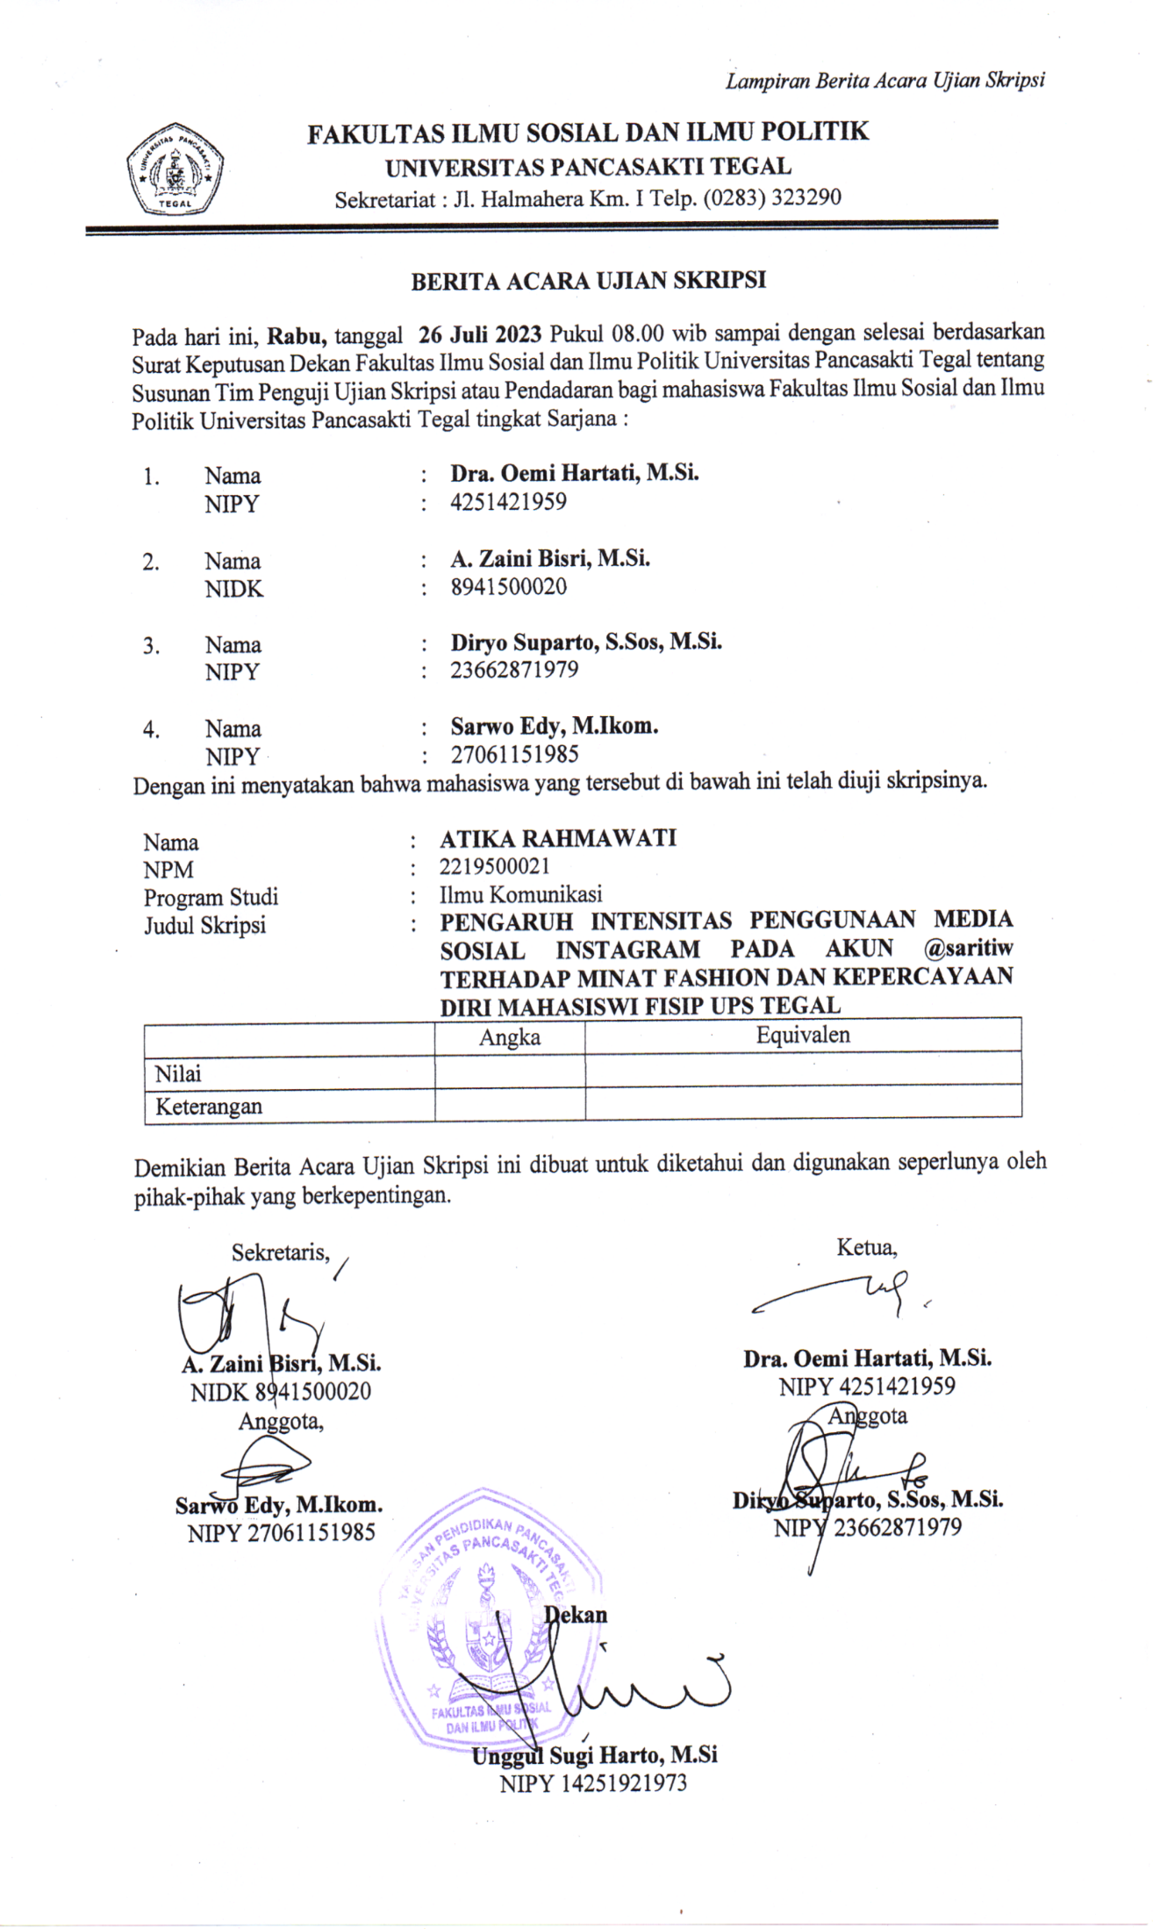

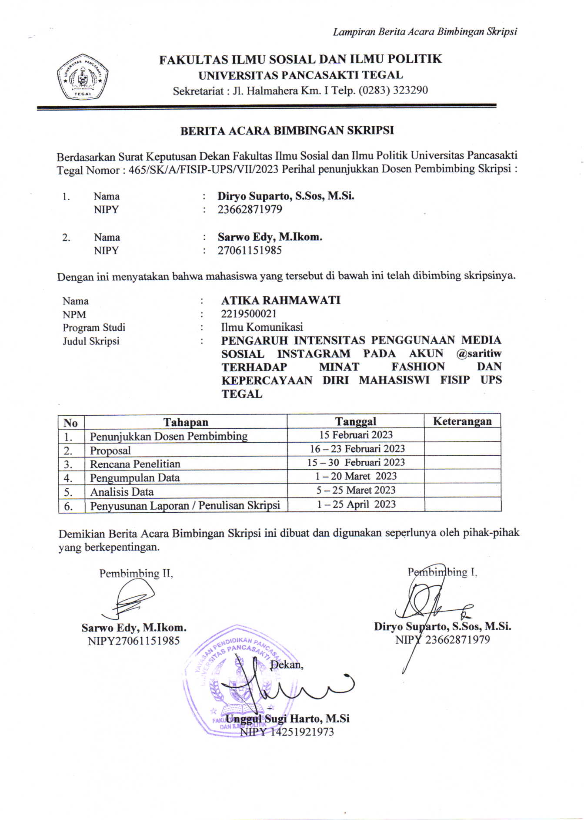

**Pernyataan Kuesioner dan Hasil Kuesioner Penelitian**

KUISIONER PENELITIAN “PENGARUH INTENSITAS MENGAKSES MEDIA SOSIAL INSTAGRAM PADA AKUN @SARITIW TERHADAP MINAT FASHION DAN KEPERCAYAAN DIRI MAHASISWI FAKULTAS ILMU SOSIAL DAN ILMU POLITIK UNIVERSITAS PANCASAKTI TEGAL”

|  |  |  |  |  |  |
| --- | --- | --- | --- | --- | --- |
| **Saya pengguna Instagram aktif** | | | | | |
|  | | Frequency | Percent | Valid Percent | Cumulative Percent |
| Valid | Setuju | 8 | 11,8 | 11,8 | 11,8 |
| sangat setuju | 60 | 88,2 | 88,2 | 100,0 |
| Total | 68 | 100,0 | 100,0 |  |

|  |  |  |  |  |  |
| --- | --- | --- | --- | --- | --- |
| **Saya tertarik dengan tampilan yang ada di Instagram** | | | | | |
|  | | Frequency | Percent | Valid Percent | Cumulative Percent |
| Valid | Setuju | 15 | 22,1 | 22,1 | 22,1 |
| sangat setuju | 53 | 77,9 | 77,9 | 100,0 |
| Total | 68 | 100,0 | 100,0 |  |

|  |  |  |  |  |  |
| --- | --- | --- | --- | --- | --- |
| **Saya menyukai konten-konten yang ada di Instagram** | | | | | |
|  | | Frequency | Percent | Valid Percent | Cumulative Percent |
| Valid | Setuju | 10 | 14,7 | 14,7 | 14,7 |
| sangat setuju | 58 | 85,3 | 85,3 | 100,0 |
| Total | 68 | 100,0 | 100,0 |  |

|  |  |  |  |  |  |
| --- | --- | --- | --- | --- | --- |
| **Saya mengakses Instagram setiap hari** | | | | | |
|  | | Frequency | Percent | Valid Percent | Cumulative Percent |
| Valid | Setuju | 11 | 16,2 | 16,2 | 16,2 |
| sangat setuju | 57 | 83,8 | 83,8 | 100,0 |
| Total | 68 | 100,0 | 100,0 |  |

|  |  |  |  |  |  |
| --- | --- | --- | --- | --- | --- |
| **Saya mendapatkan manfaat dari penggunaan Instagram** | | | | | |
|  | | Frequency | Percent | Valid Percent | Cumulative Percent |
| Valid | Setuju | 7 | 10,3 | 10,3 | 10,3 |
| sangat setuju | 61 | 89,7 | 89,7 | 100,0 |
| Total | 68 | 100,0 | 100,0 |  |

|  |  |  |  |  |  |
| --- | --- | --- | --- | --- | --- |
| **Saya mengikuti perkembangan yang ada di Instagram** | | | | | |
|  | | Frequency | Percent | Valid Percent | Cumulative Percent |
| Valid | Setuju | 7 | 10,3 | 10,3 | 10,3 |
| sangat setuju | 61 | 89,7 | 89,7 | 100,0 |
| Total | 68 | 100,0 | 100,0 |  |

|  |  |  |  |  |  |
| --- | --- | --- | --- | --- | --- |
| **Cara saritiw dalam mempromosikan sebuah produk fashion selalu menarik** | | | | | |
|  | | Frequency | Percent | Valid Percent | Cumulative Percent |
| Valid | Setuju | 9 | 13,2 | 13,2 | 13,2 |
| sangat setuju | 58 | 85,3 | 85,3 | 98,5 |
| 6 | 1 | 1,5 | 1,5 | 100,0 |
| Total | 68 | 100,0 | 100,0 |  |

|  |  |  |  |  |  |
| --- | --- | --- | --- | --- | --- |
| **Saritiw memiliki pengaruh yang sangat besar dalam meningkatkan minat beli sebuah produk fashion yang diiklankan** | | | | | |
|  | | Frequency | Percent | Valid Percent | Cumulative Percent |
| Valid | Setuju | 12 | 17,6 | 17,6 | 17,6 |
| sangat setuju | 56 | 82,4 | 82,4 | 100,0 |
| Total | 68 | 100,0 | 100,0 |  |

|  |  |  |  |  |  |
| --- | --- | --- | --- | --- | --- |
| **Saritiw selalu menjadi panutan dalam memilih sebuah produk terutama mengenai fashion** | | | | | |
|  | | Frequency | Percent | Valid Percent | Cumulative Percent |
| Valid | tidak setuju | 1 | 1,5 | 1,5 | 1,5 |
| Setuju | 7 | 10,3 | 10,3 | 11,8 |
| sangat setuju | 60 | 88,2 | 88,2 | 100,0 |
| Total | 68 | 100,0 | 100,0 |  |

|  |  |  |  |  |  |
| --- | --- | --- | --- | --- | --- |
| **Saya memiliki keinginan untuk membeli produk fashion yang diiklankan saritiw** | | | | | |
|  | | Frequency | Percent | Valid Percent | Cumulative Percent |
| Valid | tidak setuju | 1 | 1,5 | 1,5 | 1,5 |
| Setuju | 11 | 16,2 | 16,2 | 17,6 |
| sangat setuju | 56 | 82,4 | 82,4 | 100,0 |
| Total | 68 | 100,0 | 100,0 |  |

|  |  |  |  |  |  |
| --- | --- | --- | --- | --- | --- |
| **Produk fashion yang diiklankan saritiw sesuai dengan minat saya** | | | | | |
|  | | Frequency | Percent | Valid Percent | Cumulative Percent |
| Valid | Setuju | 3 | 4,4 | 4,4 | 4,4 |
| sangat setuju | 65 | 95,6 | 95,6 | 100,0 |
| Total | 68 | 100,0 | 100,0 |  |

|  |  |  |  |  |  |
| --- | --- | --- | --- | --- | --- |
| **Saya selalu mereferensikan produk fashion yang diiklankan saritiw kepada oranglain** | | | | | |
|  | | Frequency | Percent | Valid Percent | Cumulative Percent |
| Valid | Setuju | 10 | 14,7 | 14,7 | 14,7 |
| sangat setuju | 58 | 85,3 | 85,3 | 100,0 |
| Total | 68 | 100,0 | 100,0 |  |

|  |  |  |  |  |  |
| --- | --- | --- | --- | --- | --- |
| **Fashion yang saya kenakan karena keminatan pada saritiw membuat saya menjadi lebih percaya diri** | | | | | |
|  | | Frequency | Percent | Valid Percent | Cumulative Percent |
| Valid | Setuju | 11 | 16,2 | 16,2 | 16,2 |
| sangat setuju | 57 | 83,8 | 83,8 | 100,0 |
| Total | 68 | 100,0 | 100,0 |  |

|  |  |  |  |  |  |
| --- | --- | --- | --- | --- | --- |
| **Ketertarikan saya pada fashion yang diunggah saritiw membuat saya memandang positif diri saya** | | | | | |
|  | | Frequency | Percent | Valid Percent | Cumulative Percent |
| Valid | Setuju | 7 | 10,3 | 10,3 | 10,3 |
| sangat setuju | 61 | 89,7 | 89,7 | 100,0 |
| Total | 68 | 100,0 | 100,0 |  |

|  |  |  |  |  |  |
| --- | --- | --- | --- | --- | --- |
| **Saya percaya diri memakai produk yang sama dengan saritiw** | | | | | |
|  | | Frequency | Percent | Valid Percent | Cumulative Percent |
| Valid | Setuju | 5 | 7,4 | 7,4 | 7,4 |
| sangat setuju | 63 | 92,6 | 92,6 | 100,0 |
| Total | 68 | 100,0 | 100,0 |  |

|  |  |  |  |  |  |
| --- | --- | --- | --- | --- | --- |
| **Saya menilai konten fashion yang ada didalam Instagram saritiw secara objektif** | | | | | |
|  | | Frequency | Percent | Valid Percent | Cumulative Percent |
| Valid | Setuju | 7 | 10,3 | 10,3 | 10,3 |
| sangat setuju | 61 | 89,7 | 89,7 | 100,0 |
| Total | 68 | 100,0 | 100,0 |  |

|  |  |  |  |  |  |
| --- | --- | --- | --- | --- | --- |
| **Dari keminatan fashion pada saritiw yang saya kenakan, saya lebih berani menunjukkan kemampuan saya** | | | | | |
|  | | Frequency | Percent | Valid Percent | Cumulative Percent |
| Valid | Setuju | 8 | 11,8 | 11,8 | 11,8 |
| sangat setuju | 60 | 88,2 | 88,2 | 100,0 |
| Total | 68 | 100,0 | 100,0 |  |

|  |  |  |  |  |  |
| --- | --- | --- | --- | --- | --- |
| **Saya selalu tertartik untuk membeli fashion yang diiklankan saritiw agar menambah rasa kepercayaan diri saya** | | | | | |
|  | | Frequency | Percent | Valid Percent | Cumulative Percent |
| Valid | Setuju | 3 | 4,4 | 4,4 | 4,4 |
| sangat setuju | 65 | 95,6 | 95,6 | 100,0 |
| Total | 68 | 100,0 | 100,0 |  |

Hasil Output SPSS Uji Reabilitas

|  |  |  |  |  |  |  |  |  |
| --- | --- | --- | --- | --- | --- | --- | --- | --- |
| **Correlations** | | | | | | | | |
|  | | p1 | p2 | p3 | p4 | p5 | p6 | total |
| p1 | Pearson Correlation | 1 | ,136 | ,235 | ,211 | ,027 | ,027 | ,610** |
| Sig. (2-tailed) |  | ,269 | ,054 | ,083 | ,830 | ,830 | ,000 |
| N | 68 | 68 | 68 | 68 | 68 | 68 | 68 |
| p2 | Pearson Correlation | ,136 | 1 | -,121 | -,137 | ,170 | -,064 | ,436** |
| Sig. (2-tailed) | ,269 |  | ,327 | ,264 | ,166 | ,607 | ,000 |
| N | 68 | 68 | 68 | 68 | 68 | 68 | 68 |
| p3 | Pearson Correlation | ,235 | -,121 | 1 | ,269* | -,004 | -,141 | ,477** |
| Sig. (2-tailed) | ,054 | ,327 |  | ,027 | ,974 | ,253 | ,000 |
| N | 68 | 68 | 68 | 68 | 68 | 68 | 68 |
| p4 | Pearson Correlation | ,211 | -,137 | ,269* | 1 | ,114 | -,149 | ,509** |
| Sig. (2-tailed) | ,083 | ,264 | ,027 |  | ,355 | ,226 | ,000 |
| N | 68 | 68 | 68 | 68 | 68 | 68 | 68 |
| p5 | Pearson Correlation | ,027 | ,170 | -,004 | ,114 | 1 | -,115 | ,426** |
| Sig. (2-tailed) | ,830 | ,166 | ,974 | ,355 |  | ,351 | ,000 |
| N | 68 | 68 | 68 | 68 | 68 | 68 | 68 |
| p6 | Pearson Correlation | ,027 | -,064 | -,141 | -,149 | ,115 | 1 | ,461 |
| Sig. (2-tailed) | ,830 | ,607 | ,253 | ,226 | ,351 |  | ,000 |
| N | 68 | 68 | 68 | 68 | 68 | 68 | 68 |
| total | Pearson Correlation | ,610** | ,436** | ,477** | ,509** | ,426** | ,161 | 1 |
| Sig. (2-tailed) | ,000 | ,000 | ,000 | ,000 | ,000 | ,190 |  |
| N | 68 | 68 | 68 | 68 | 68 | 68 | 68 |
| **. Correlation is significant at the 0.01 level (2-tailed). | | | | | | | | |
| *. Correlation is significant at the 0.05 level (2-tailed). | | | | | | | | |

|  |  |  |  |  |  |  |  |  |
| --- | --- | --- | --- | --- | --- | --- | --- | --- |
| **Correlations** | | | | | | | | |
|  | | p7 | p8 | p9 | p10 | p11 | p12 | total |
| p7 | Pearson Correlation | 1 | ,160 | ,098 | ,134 | ,116 | ,095 | ,599** |
| Sig. (2-tailed) |  | ,192 | ,427 | ,276 | ,344 | ,442 | ,000 |
| N | 68 | 68 | 68 | 68 | 68 | 68 | 68 |
| p8 | Pearson Correlation | ,160 | 1 | ,143 | ,153 | -,099 | -,083 | ,488** |
| Sig. (2-tailed) | ,192 |  | ,243 | ,212 | ,420 | ,499 | ,000 |
| N | 68 | 68 | 68 | 68 | 68 | 68 | 68 |
| p9 | Pearson Correlation | ,098 | ,143 | 1 | -,065 | ,114 | -,035 | ,431** |
| Sig. (2-tailed) | ,427 | ,243 |  | ,598 | ,356 | ,775 | ,000 |
| N | 68 | 68 | 68 | 68 | 68 | 68 | 68 |
| p10 | Pearson Correlation | ,134 | ,153 | -,065 | 1 | -,096 | ,396** | ,601** |
| Sig. (2-tailed) | ,276 | ,212 | ,598 |  | ,437 | ,001 | ,000 |
| N | 68 | 68 | 68 | 68 | 68 | 68 | 68 |
| p11 | Pearson Correlation | ,116 | -,099 | ,114 | -,096 | 1 | -,089 | ,576 |
| Sig. (2-tailed) | ,344 | ,420 | ,356 | ,437 |  | ,469 | ,000 |
| N | 68 | 68 | 68 | 68 | 68 | 68 | 68 |
| p12 | Pearson Correlation | ,095 | -,083 | -,035 | ,396** | -,089 | 1 | ,470** |
| Sig. (2-tailed) | ,442 | ,499 | ,775 | ,001 | ,469 |  | ,000 |
| N | 68 | 68 | 68 | 68 | 68 | 68 | 68 |
| total | Pearson Correlation | ,599** | ,488** | ,431** | ,601** | ,176 | ,470** | 1 |
| Sig. (2-tailed) | ,000 | ,000 | ,000 | ,000 | ,151 | ,000 |  |
| N | 68 | 68 | 68 | 68 | 68 | 68 | 68 |
| **. Correlation is significant at the 0.01 level (2-tailed). | | | | | | | | |

|  |  |
| --- | --- |
| **Reliability Statistics** | |
| Cronbach's Alpha | N of Items |
| ,830 | 6 |

|  |  |  |  |  |  |  |  |  |
| --- | --- | --- | --- | --- | --- | --- | --- | --- |
| **Correlations** | | | | | | | | |
|  | | | | | | | | |
|  | | p13 | p14 | p15 | p16 | p17 | p18 | total |
| p13 | Pearson Correlation | 1 | -,017 | -,124 | -,149 | ,087 | -,094 | ,414** |
| Sig. (2-tailed) |  | ,888 | ,315 | ,226 | ,478 | ,444 | ,000 |
| N | 68 | 68 | 68 | 68 | 68 | 68 | 68 |
| p14 | Pearson Correlation | -,017 | 1 | ,090 | ,204 | -,124 | ,163 | ,530** |
| Sig. (2-tailed) | ,888 |  | ,466 | ,096 | ,315 | ,184 | ,000 |
| N | 68 | 68 | 68 | 68 | 68 | 68 | 68 |
| p15 | Pearson Correlation | -,124 | ,090 | 1 | -,095 | ,072 | -,061 | ,316** |
| Sig. (2-tailed) | ,315 | ,466 |  | ,439 | ,560 | ,624 | ,009 |
| N | 68 | 68 | 68 | 68 | 68 | 68 | 68 |
| p16 | Pearson Correlation | -,149 | ,204 | -,095 | 1 | -,124 | ,163 | ,394** |
| Sig. (2-tailed) | ,226 | ,096 | ,439 |  | ,315 | ,184 | ,001 |
| N | 68 | 68 | 68 | 68 | 68 | 68 | 68 |
| p17 | Pearson Correlation | ,087 | -,124 | ,072 | -,124 | 1 | -,078 | ,397** |
| Sig. (2-tailed) | ,478 | ,315 | ,560 | ,315 |  | ,525 | ,001 |
| N | 68 | 68 | 68 | 68 | 68 | 68 | 68 |
| p18 | Pearson Correlation | -,094 | ,163 | -,061 | ,163 | -,078 | 1 | ,322** |
| Sig. (2-tailed) | ,444 | ,184 | ,624 | ,184 | ,525 |  | ,007 |
| N | 68 | 68 | 68 | 68 | 68 | 68 | 68 |
| total | Pearson Correlation | ,414** | ,530** | ,316** | ,394** | ,397** | ,322** | 1 |
| Sig. (2-tailed) | ,000 | ,000 | ,009 | ,001 | ,001 | ,007 |  |
| N | 68 | 68 | 68 | 68 | 68 | 68 | 68 |
| **. Correlation is significant at the 0.01 level (2-tailed). | | | | | | | | |

|  |  |
| --- | --- |
| **Reliability Statistics** | |
| Cronbach's Alpha | N of Items |
| ,772 | 6 |

Tabel hasil jawaban kuesioner Mengakses Media Sosial Instagram (X)

Tabel hasil jawaban kuesioner X Mengakses Media Sosial Instagram

Tabel hasil jawaban kuesioner Y1 Minat Fashion

Tabel Jumlah Jawaban Kuesioner Y2 Kepercayaan Diri

