REFERENCES

Abbas, S. (2006). Pembelajaran Bahasa Indonesia yang Efektif di Sekolah Dasar. Departemen Pendidikan Nasional.
Airasian, P. and L. R. G. (2000). Educational research: Competence for analysis an application (6th ed.). Merrill Prentice Hall.
Almenara, J. . (2013). The Expert’s Judgment Application as A Technique Evaluate Information and Communication Technology (ICT). International Technology, Science, and Society Review, 7(2), 11–22.
Amidon, E. J. (1967). The Role of the Teacher in the Classroom: A manual for understanding and improving teacher’s classroom behavior. Association for Productive Teaching.
Anderson, M. & Anderson, K. (1997). Text Types in English. Macmillan Education Australia.
Anggraeni, A. D., & Pentury, H. J. (2022). Empowering Students’ 21st Century Skills through Canva Application. Jurnal Kependidikan: Jurnal Hasil Penelitian Dan Kajian Kepustakaan Di Bidang Pendidikan, Pengajaran Dan Pembelajaran, 8(1), 50. https://doi.org/10.33394/jk.v8i1.4391
Arikunto, S. (2002). Metodologi Penelitian Suatu Pendekatan Proposal. Rineka Cipta.
Ary, D. (2014). Introduction to research in education (9th ed.). Wadsworth.
Brown, H. D. (2001). Teaching by Principle and Interactive Approach to language pedagogy. Longman Inc.
Brown, J. s. . C. A. . & D. P. (1989). Situated cognition and the culture of learning. Educational Researcher, 18(1), 32–42.
Brown, K. and H. S. (1993). Writing Matters: Writing Skills and Strategies for Students of English. Cambridge University.
Cheung, Y. L. (2016). Teaching Writing. In English Language Education (Vol. 5, pp. 179–194). Springer Science and Business Media B.V. https://doi.org/10.1007/978-3-319-38834-2_13
Creswell, J. W. (2012). Qualitative inquiry & research design: Choosing among five approaches (4th ed.). Sage Publication.
Derewianka, B. (1990). Exploring How Text Works. Primary English Association.
Emilia, E., Habibi, N., & Bangga, L. A. (2018). An anlysis of cohesion of exposition texts: An Indonesian context. Indonesian Journal of Applied Linguistics, 7(3), 515–523. https://doi.org/10.17509/ijal.v7i3.9791
Fauziyah, N. L., Widodo, J. P., & Yappi, S. N. (2016). The Use of ‘ Canva for Education ’ and the Students ’ Perceptions of Its Effectiveness in the Writing Procedure Text. Budapest International Research and Critics Institute-Journal (BIRCI-Journal), 5(1), 6368–6377.
Fraenkel, J. & W. N. & H. H. (2011). How to Design and Evaluate Research in Education (8a ed.). McGraw-Hill Education.
Gopal B and Cooper S. (2022). Peer Instruction in Online Software Testing and Continuous Integration. IEEE/ACM 44th International Conference on Software Engineering: Software Engineering Education and Training (ICSE-SEET).
Hadi, M. S., Izzah, L., & Paulia, Q. (2021). Teaching Writing Through Canva Application To Enhance Students’ Writing Performance. JOLLT Journal of Languages and Language Teaching, 9(2), 228. http://ojs.ikipmataram.ac.id/index.php/jollt/index
Hardy, J. and K. D. (1990). Writing Genres in Secondary School. Cairns Education.
Harmer, J. (1991). The Practice of English Language Teaching: New Edition. Longman.
Harmer, J. (2004a). How to Teach. Pearson Education.
Harmer, J. (2004b). How to Teach. Pearson Education.
Heaton, J. B. (1989). Writing English Language Test . Longman Pub Group.
Hyland, K. (2007). Understanding Writing : Exploring texts, writers and readers. 8, 63–74.
Jacobs, et al. (1981). Testing ESL composition: a practical approach. Newbury House Publishers Inc.
Jacobs, H. L. . W. D. R. . Z. S. A. . & H. V. F. (1981). Testing ESL Composition: A Practical Approach. Newbury House.
Kapp, K. (2012). The Gamification of Learning and Instruction . John Wiley & Sons.
Klimova, B. F. (2011). Evaluating writing in english as a second language. Procedia - Social and Behavioral Sciences, 28, 390–394. https://doi.org/10.1016/j.sbspro.2011.11.074
Larasati, M., & Rustandi, A. (2022). Empowering Student’S Creative Writing Ability By Using Canva (a Case Study Research in One Junior High School in Ciamis). JEEP: Journal of English Education Program, 9(2), 101–110. https://jurnal.unigal.ac.id/index.php/jeep
Le, A. N. N. (2023). Canva-based E-portfolio in L2 Writing Instructions : Investigating the Effects and Students ’ Attitudes. 42(1), 41–62.
Leki, I. (1998). Academic writing: exploring processes and strategies (2nd ed.). Cambridge University.
Martin, M. (2016). Blending Instruction with Technology: A Blueprint for Teachers to Create Unique, Engaging, and Effective Learning Experiences . Rowman & Littlefield.
Meyers, A. (2006). Composing with Confidence: Writing Effective Paragraphs and Essays. Pearson Longman.
Nababan, N. (2020). Pengembangan Media Pembelajaran Berbasis Geogebra Dengan Model Pengembangan Addie Di Kelas XI SMAN 3 Medan. Jurnal Inspiratif, 6(1), 37–50.
Nunan, D. (1992). Research methods in language learning. Cambridge University Press.
Pelangi, G., Syarif, U., & Jakarta, H. (2020). PEMANFAATAN APLIKASI CANVA SEBAGAI MEDIA PEMBELAJARAN BAHASA DAN SASTRA INDONESIA JENJANG SMA/MA. In Jurnal Sasindo Unpam (Vol. 8, Issue 2).
Quinn, C. (2014). Revolutionize Learning & Development: Performance and Innovation Strategy for the Information Age. John Wiley & Sons.
Siahaan, Sanggam, Shinoda, K. (2008). The English paragraph. Graha Ilmu.
Sugiyono. (2011). Metode Penelitian Kuantitatif, Kualitatif dan R&D. Alfabeta.
Sulistyawati, A. E. (2018). THE USE OF COOPERATIVE LEARNING IN SMALL GROUP DISCUSSIONS IN GENRE-BASED READING CLASS). In BELTIC Journal | (Vol. 1, Issue 1).
Taufiqulloh T, Y. Y. Y. I. (2016). The Role of Peer and Teacher Feedback in Academic Writing Class. International Seminar on English Language Teaching, 225–234.
Thyer, B. A. (2010). The Handbook of Social Work Research Methods (2nd Revised edition). Sage Publications Inc.
Waring, S. (2021). Integrating Primary and Secondary Sources into Teaching. Teachers College Publisher.
Watkins, M., Knapp, P. (2005). Genre, Text, Grammar: Technologies for Teaching and Assessing Writing. University of New South Wales Press Ltd.
Yin, R. K. (2011). Qualitative Research from Start to Finish. Guillford Press.
Yundayani, A. . S. & C. (2019). Investigating the Effect of Canva on Student’s Writing Skills. English Review: Journal of English Education, 7(2), 169–176.

APPENDICES

Appendix 1
Instrument Validity by Expert
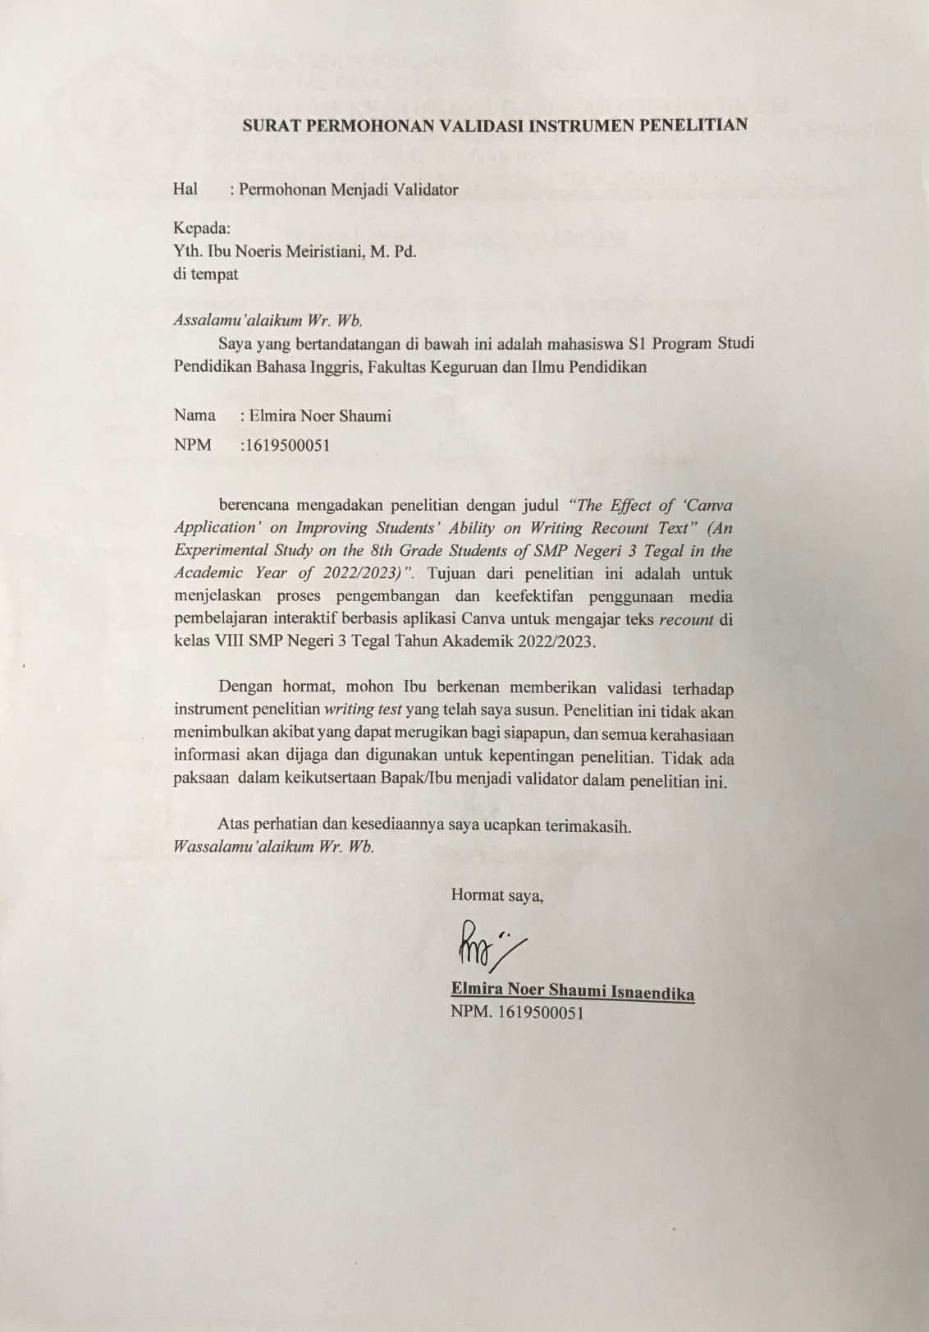

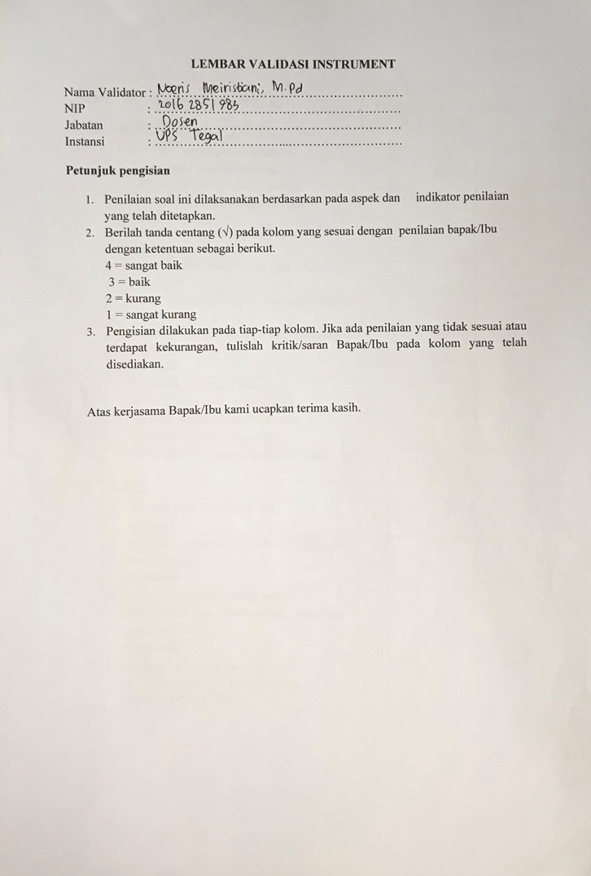

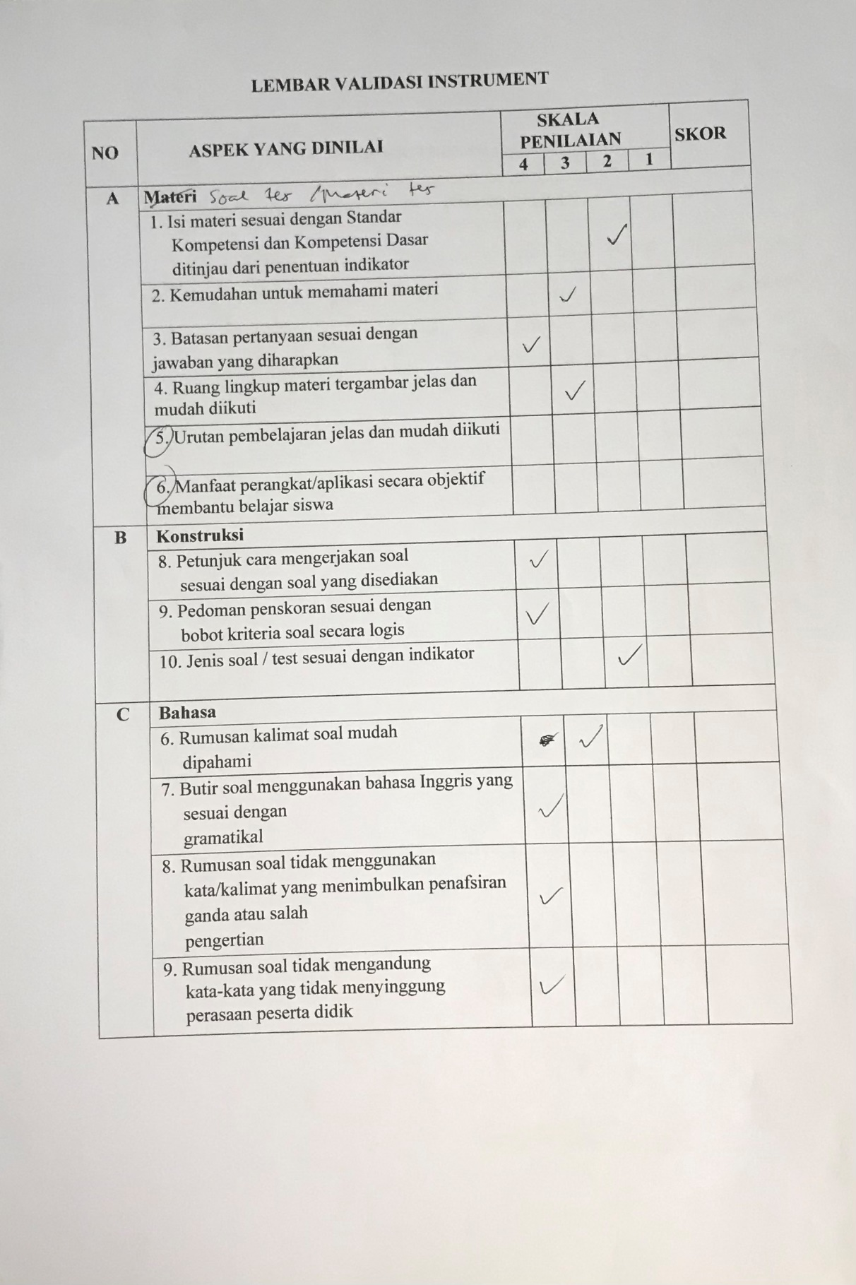

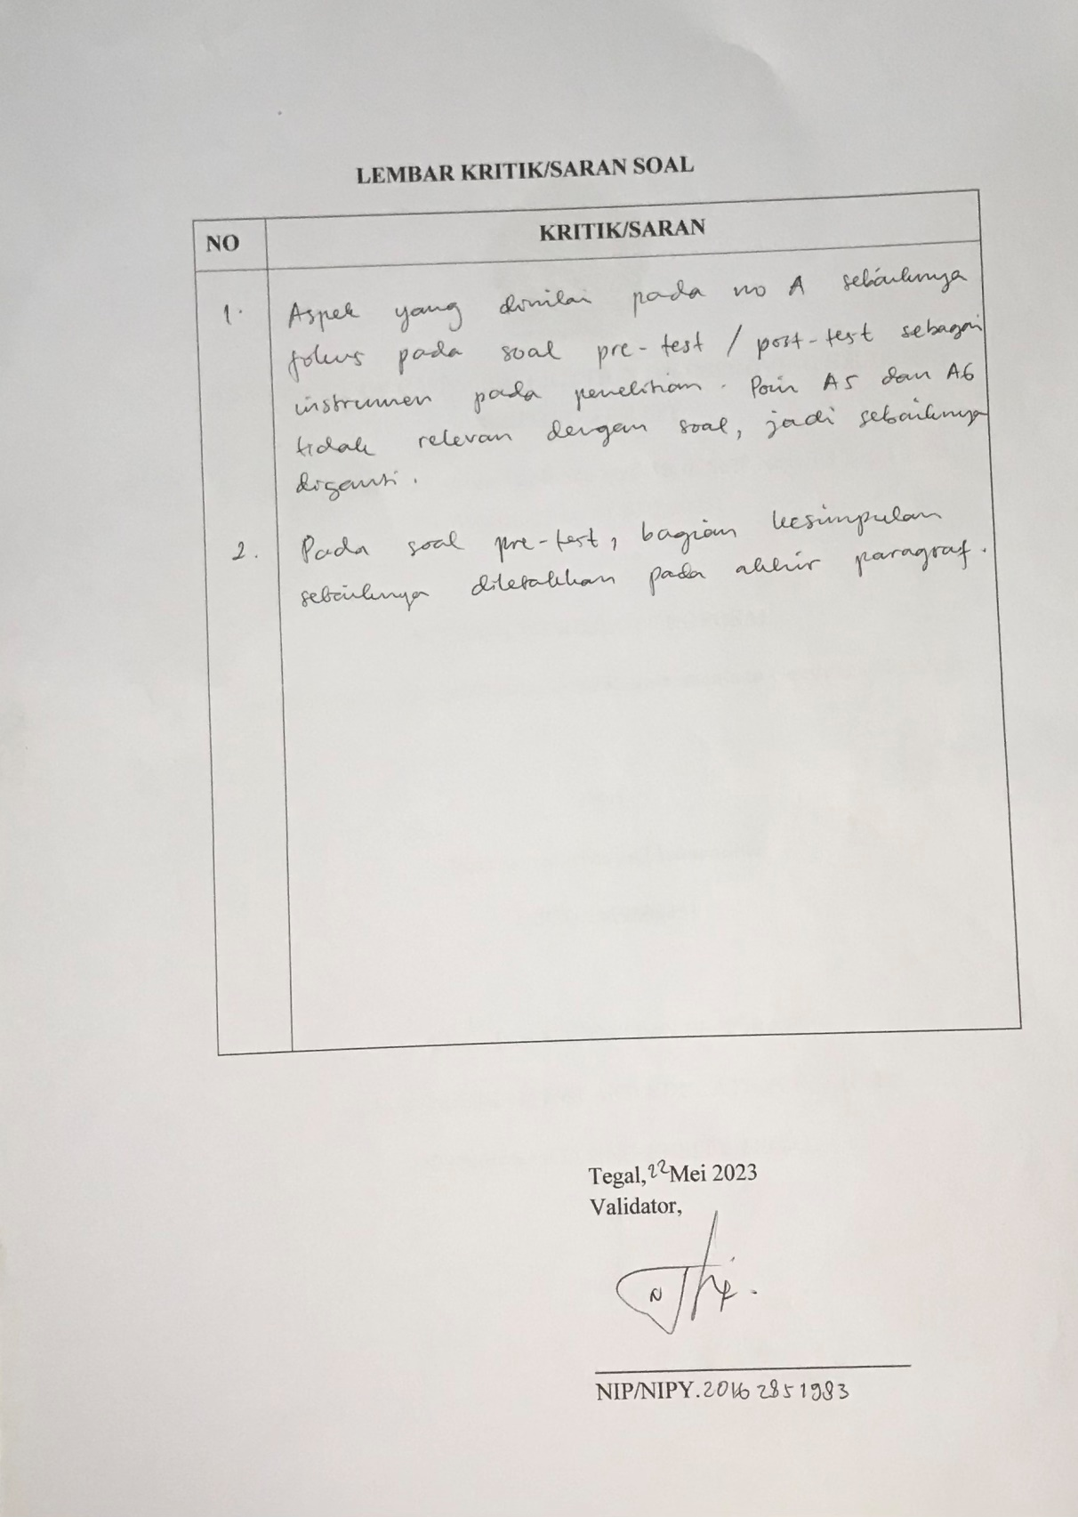

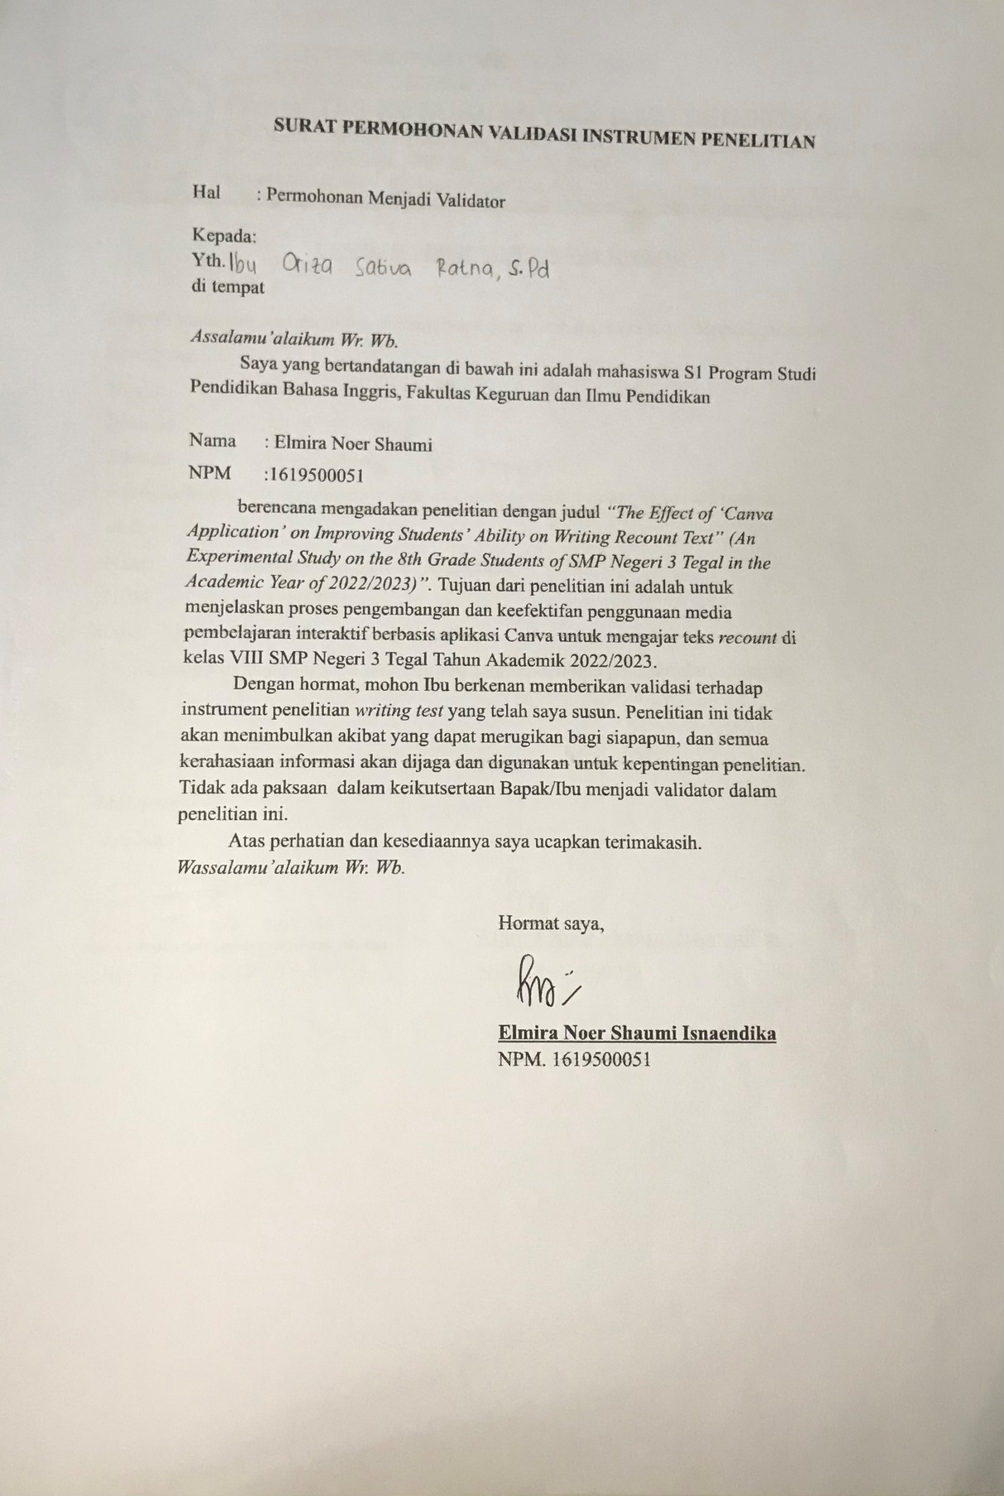

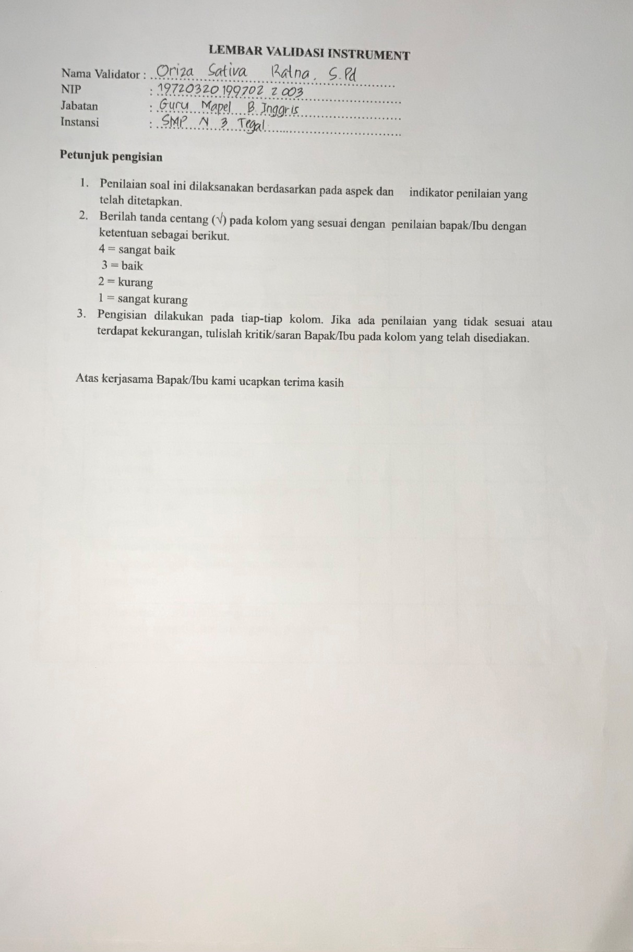

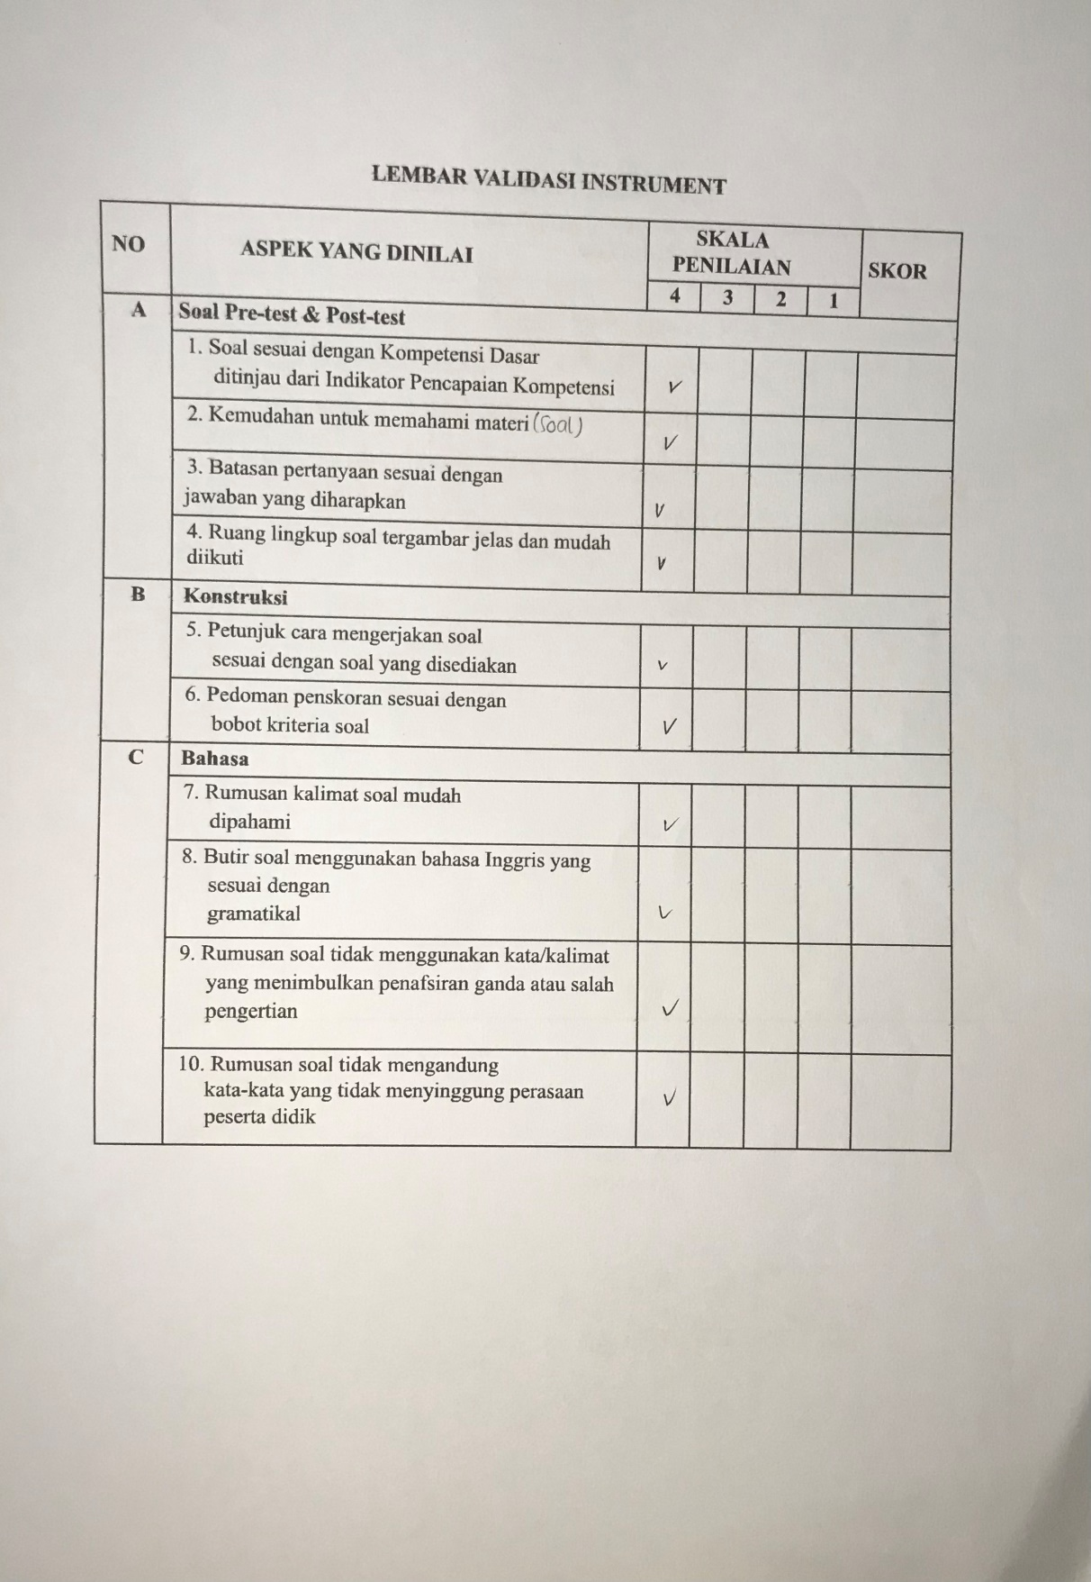

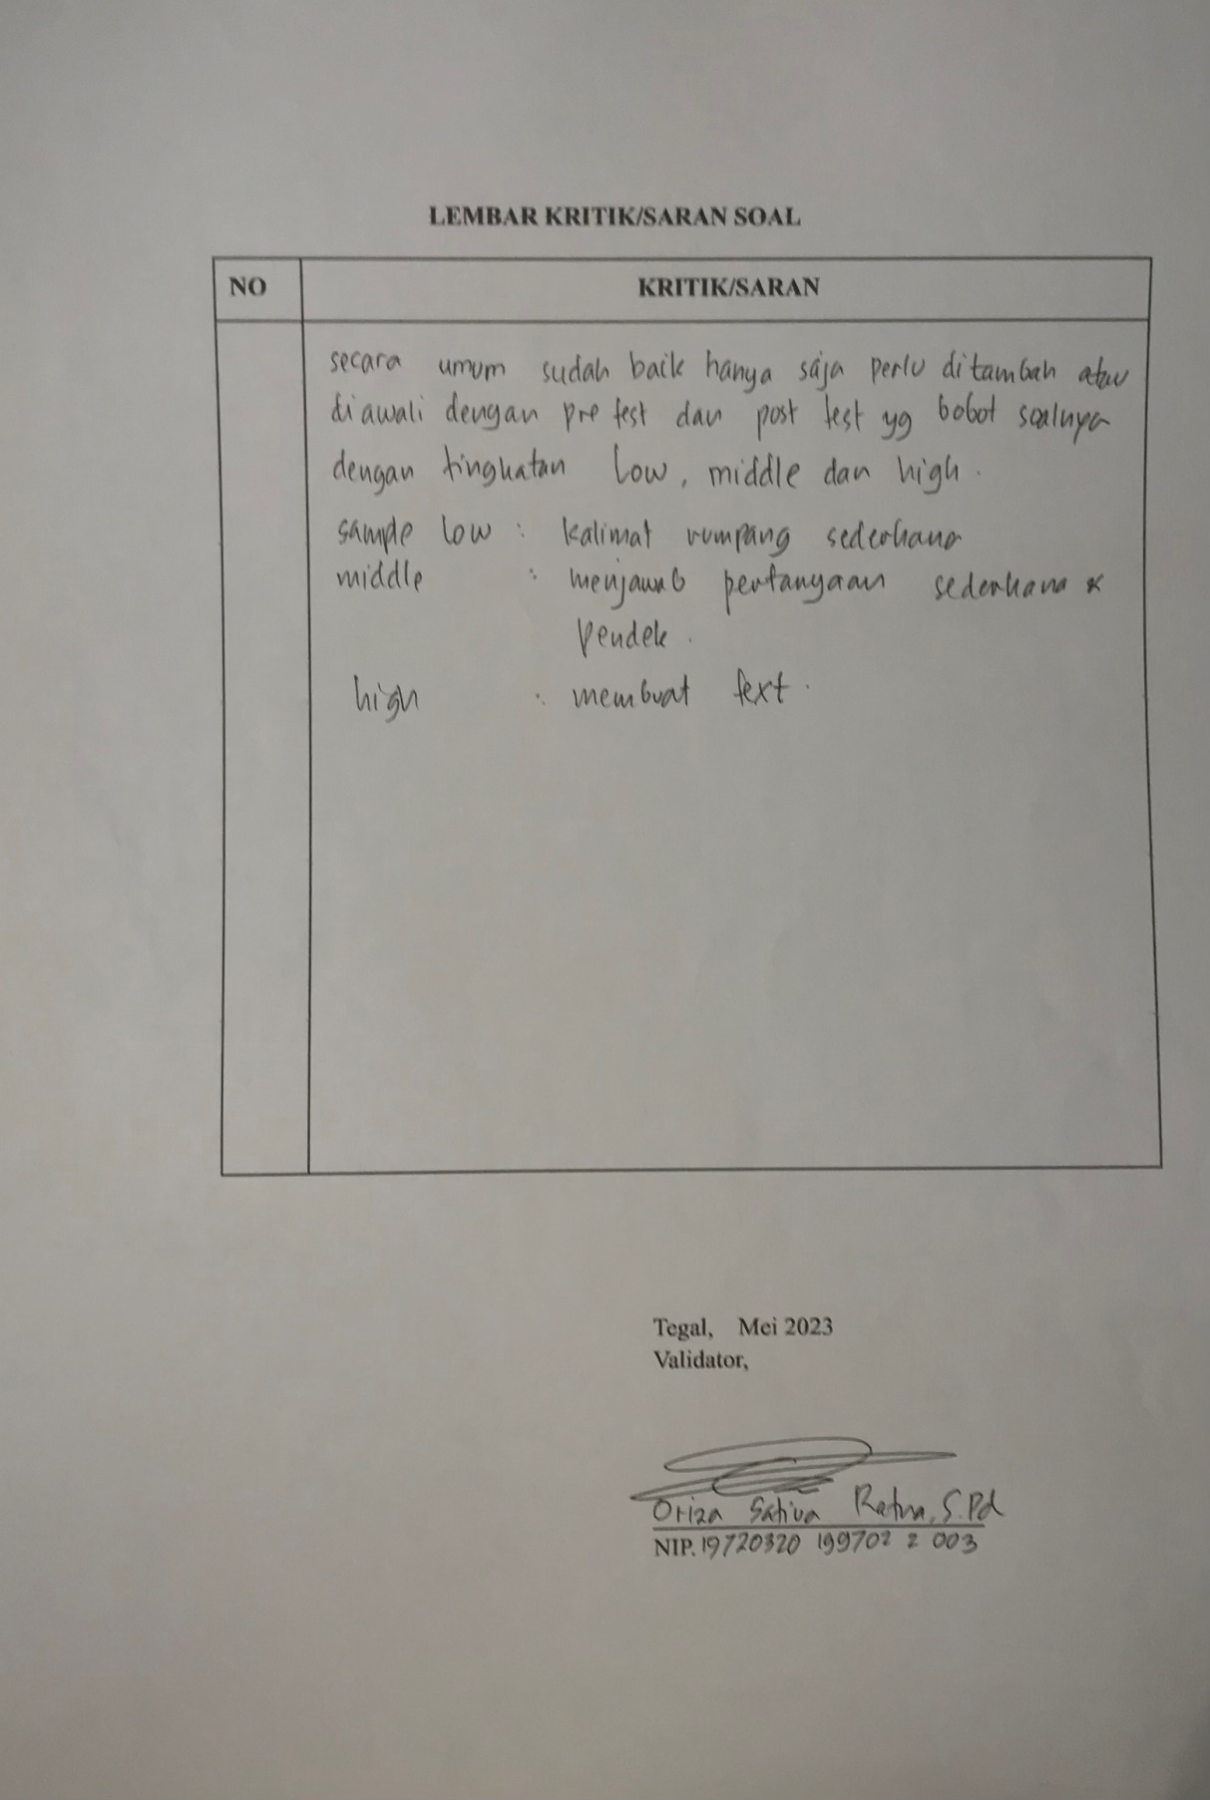

Appendix 2 Research Instrument
Pre-test
Name:
Class:
Number:
Instructions
- Please answer the questions.
Title: Recent Trip/Holiday
- Where did you go for a holiday recently?
- What were you doing while you were there?
- What was your special moment while you were spending your holiday there?
- How did you feel while spending holiday there?
- How did you feel after the activities ended?
- Make a recount text by answering the guided questions above.

Post-test
Instructions
- Answer the questions below.
Topic: Spend Holiday at Home
1. What did you do last holiday?
2. Why did you prefer to stay at home during holiday?
3. What was your special moment while you were spending your holiday at home?
4. How did you feel while spending holiday at home?
5. How did you feel after the activities ended?

- Write a poster of Recount text on Canva.
The text should consist at least 3 paragraphs (orientation, events, and reorientation). Topic: "spend holiday at home". You can choose your own template and insert pictures, stickers or illustrations to make your poster becomes more interesting. You can make it by your own words.

Appendix 3
Student’s Pre-test
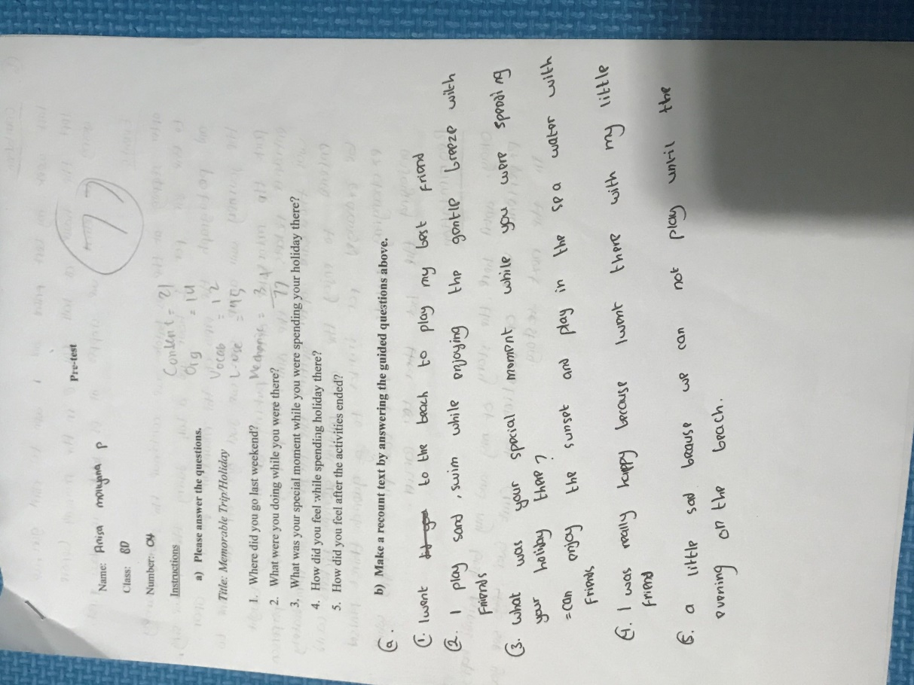
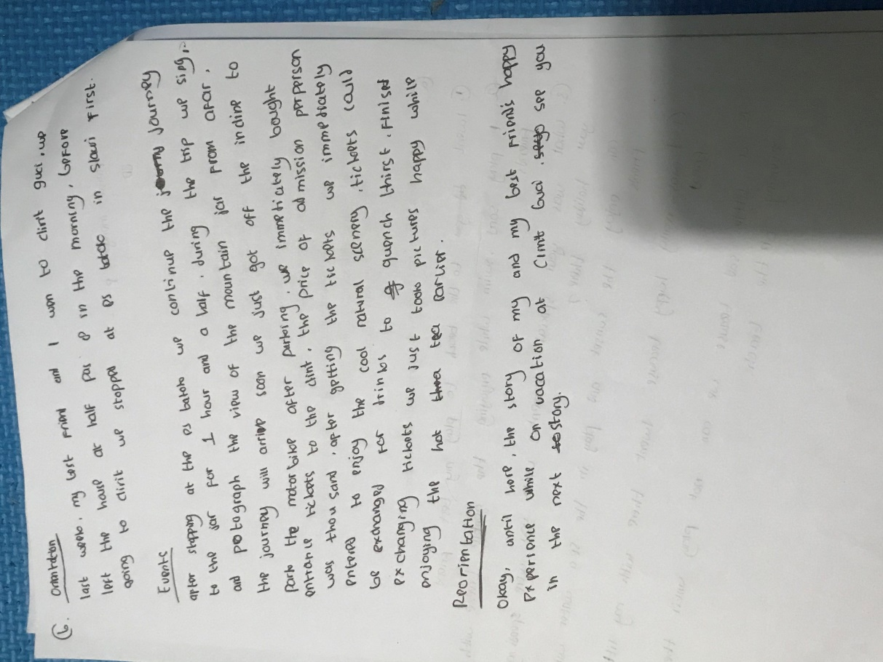

Appendix 4
Student’s Post-test Result
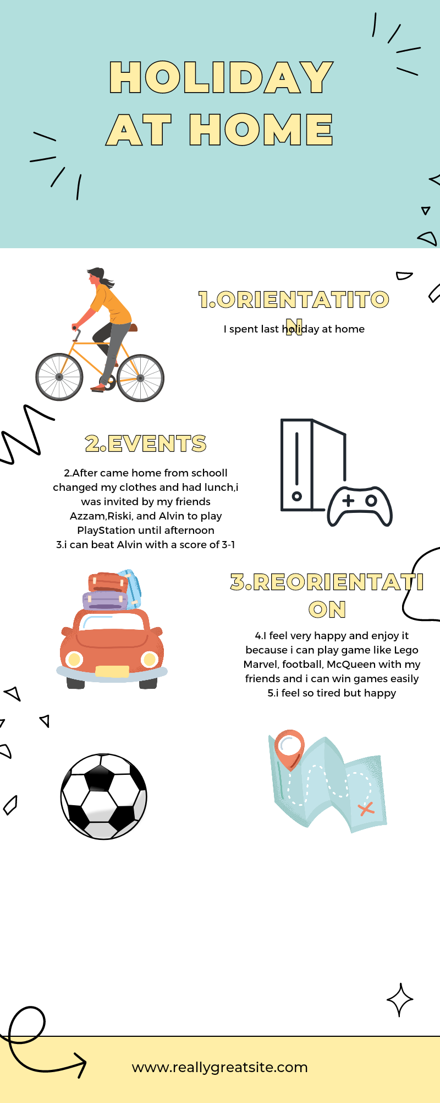

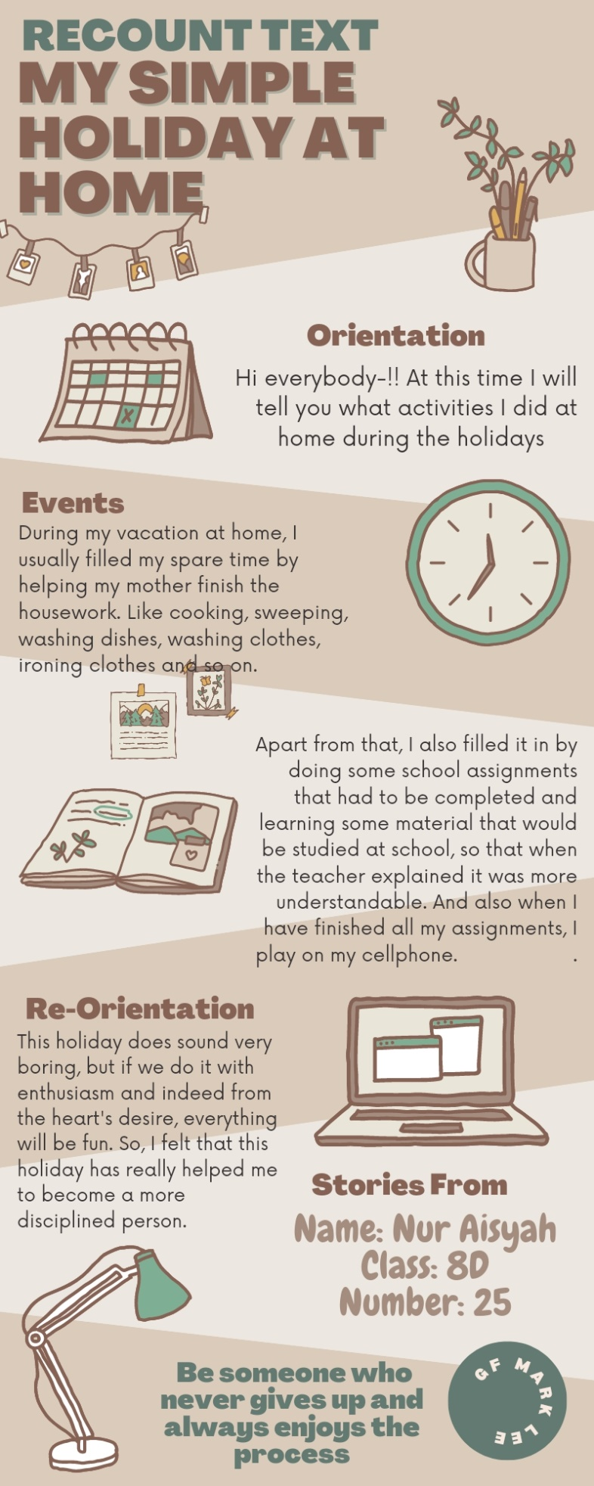
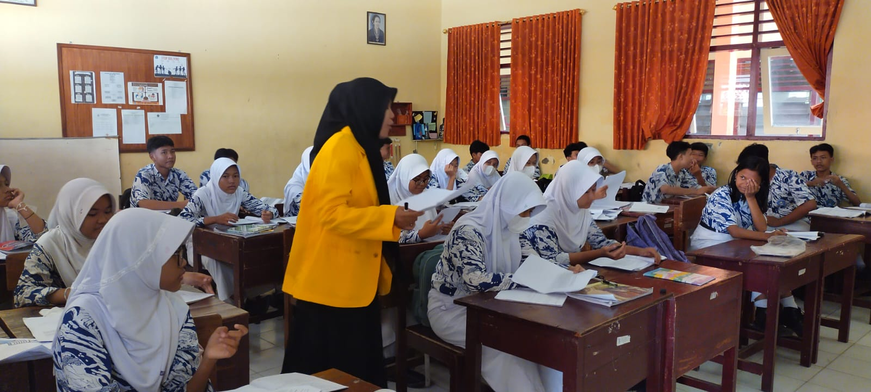
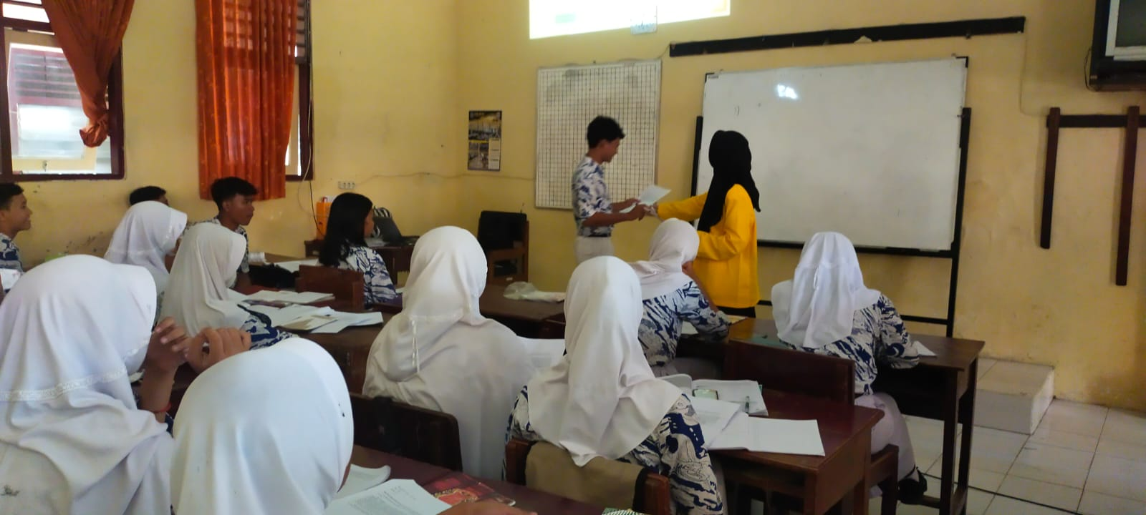

Appendix 6
The score of pre-test & post-test
No | Students | Pretest
1. | AJS | 60
2. | ADJ | 55
3. | AAP | 81
4. | AMP | 77
5. | ARS | 61
6. | DAH | 54
7. | JEF | 54
8. | KAP | 73
9. | KFP | 53
10. | KIP | 79
11. | MNI | 41
12. | MFM | 50
13. | MRM | 59
14. | MRR | 55
15. | NZA | 73
16. | NAB | 62
17. | NNS | 70
18. | NA | 80
19. | NHF | 59
20. | NKS | 51
21. | RZ | 58
22. | SGM | 73

No | Students | Posttest
1. | AJS | 72
2. | ADJ | 68
3. | AAP | 84
4. | AMP | 82
5. | ARS | 67
6. | DAH | 62
7. | JEF | 65
8. | KAP | 78
9. | KFP | 63
10. | KIP | 83
11. | MNI | 55
12. | MFM | 64
13. | MRM | 66
14. | MRR | 60
15. | NZA | 76
16. | NAB | 68
17. | NNS | 74
18. | NA | 90
19. | NHF | 64
20. | NKS | 65
21. | RZ | 70
22. | SGM | 77

Appendix 7
SPSS data
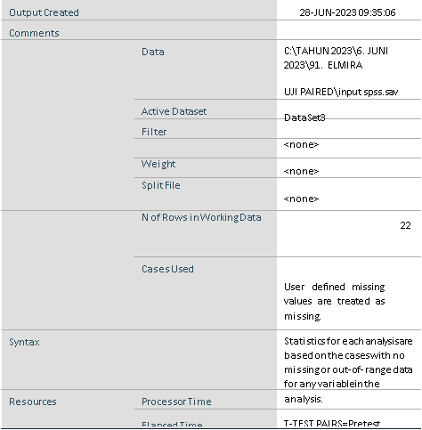
Paired Samples Statistics
Mean |  |  | N | Std. Deviation | Std. Error Mean
Pair 1 | Pretest | 62.6364 | 22 | 11.27384 | 2.40359
 | Posttest | 70.5909 | 22 | 8.89975 | 1.89743

Paired Samples Correlations
Mean |  |  | N | Std. Deviation | Std. Error Mean
Pair 1 | Pretest | 62.6364 | 22 | 11.27384 | 2.40359
 | Posttest | 70.5909 | 22 | 8.89975 | 1.89743

Paired Samples Test
Paired Differences
Mean |  | Std. Deviation | Std. Error Mean | 95% Confidence Interval of the Difference
 |  |  |  | Lower | Upper
Pair 1 Pretest - Posttest | -7.95455 | 3.93370 | .83867 | -9.69865 | -6.21044

Paired Samples Test
 | t | df | Sig. (2-tailed)
Pair 1 Pretest - Posttest | -9.485 | 21 | .000

Appendix 8
Table of Observation Checklist Data
No. | Teaching Learning Activity | Yes | No | Note
1 | The researcher prepares Canva application as learning media. | √
2 | The researcher gives instruction to the students to use their smartphone during the class. | √
3 | The researcher gives an apperception and introduction of Canva application in writing Recount text. | √
4 | The researcher explains the lesson material and Canva application briefly to the students including the students’ activities and  Tasks. | √
5 | The teacher gives the students a topic as an outline in their digital poster task of Recount text. | √
6 | The teacher gives instruction to the students to sign in to Canva using their accounts. | √
7 | The teacher reminds the students to utilize their phone only to open dictionary when they find difficult words and use Canva application as the learning media. | √ |  | There are some students who play game by using their smartphone and do not pay attention to their tasks.
8 | The researcher guides the students the steps about making digital poster of Recount text using Canva. | √
9 | The researcher makes sure that the students  understand the instruction given by explaining the lesson material by switching some difficult English words into Indonesian. | √ |  | Some students are confused because they can not fully understand what the researcher says in English.
10 | The researcher guides the students to write by providing illustration through projector screen. | √
11 | The researcher checks the students’ performance of writing in Canva application one by one. | √
12 | The researcher accommodates questions by students when they find difficulties writing in Canva. | √
13 | The researcher asks student to submit their tasks after time allocation is up. | √
14 | The researcher ends the class by giving conclusion and review about task that they accomplish earlier. | √
15 | The teacher closes learning activities. | √

