i

REFERENCES

(Destrianti, Sabaruddin, and Hati 2019)Cheng, Wei. 2019. “Exploring the Development of English Club Activities in Junior High School English Language Learning.” Journal of Contemporary Educational Research 3(1): 31–34.
Destrianti, Eva, Syafrizal Sabaruddin, and Gita Mutiara Hati. 2019. “The Perception of the English Club Members of the English Department Students Association (Edsa) Toward Their Club.” Journal of English Education and Teaching 2(3): 1–6.
Elbes, Epafras, and Lulud Oktaviani. 2022. “Character Building in English for Daily Conversation Class Materials for English Education Freshmen Students.” Students. Journal of English Language Teaching and Learning 3(1): 36–45. http://jim.teknokrat.ac.id/index.php/english-language-teaching/index.
Eni Suriyah, and Mazulfah. 2022. “Students’ Perception in Learning English through Communicative English Club (CEC) at IAIN Salatiga.” English Education and Literature Journal (E-Jou) 2(01): 58–68.
Koza Ciftçi, S., and Firdevs Melis Cin. 2017. The Factors Effecting Student Achievement: Meta-Analysis of Empirical Studies The Effect of Socioeconomic Status on Students’ Achievement.
Lawn, Murray J., and Etsuko Lawn. 2015. “Increasing English Communicative Competence through Online English Conversation Blended E-Learning.”

International Journal of Information and Education Technology 5(2): 105–12.

Riadi, Muchlisin. 2020. “Populasi Dan Sampel Penelitian (Pengertian, Proses, Teknik Pengambilan Dan Rumus).” populasi dan sampel penelitian (pengertian, proses, teknik pengambilan dan rumus). https://www.kajianpustaka.com/2020/11/populasi-dan-sampel-penelitian.html.
Salmaa. 2021. “Desain Penelitian : Pengertian, Jenis, Dan Contoh Lengkap.” desain penelitian : pengertian, jenis, dan contoh lengkap. https://penerbitdeepublish.com/desain-penelitian/.
Sari Intan Titis. 2018. “Pelaksanaan Kegiatan Ekstrakurikuler English Club Sebagai Upaya Meningkatkan Speaking Skill Siswa Kelas V Sekolah Dasar.”
Suharsih, Siti, and Yanna Supriatna. 2020. “Speaking Activities in English Debating Club: A Case Study at English Conversation and Debating Club of SMKN 1 Pandeglang.” Journal of English Language Teaching and Cultural Studies 3(2): 44–53.
“The Impact of English Club Activities on EFL Students’ Communicative Skills.” 2020. ZANCO Journal of Humanity Sciences 24(4).
University, Sampoerna. 2022. “Teknik Purposive Sampling: Definisi, Tujuan, Dan Syarat.” Teknik Purposive Sampling: Definisi, Tujuan, dan Syarat. https://www.sampoernauniversity.ac.id/id/purposive-sampling-adalah/.

Taufiqulloh T, Y. Y. Y. I. (2016). The Role of Peer and Teacher Feedback in Academic Writing Class. International Seminar on English Language Teaching, Iselt 2016, 225–234.
Elnadeef, E. A. E., & Abdala, A. H. E. H. (2019). The Effectiveness of English Club as Free Voluntary Speaking Activity Strategy in Fostering Speaking Skill in Saudi Arabia Context. Online Submission, 2(1), 231.
https://doi.org/10.32996/ijllt.2019.2.1.28

Hijrah, H., & Musfikar, R. (2021). Application Design Determining Student Achievement Support Factors With the Tau Kendall Method Based on Quadrant Institute Literature. Cyberspace: Jurnal Pendidikan Teknologi Informasi, 5(2), 97. https://doi.org/10.22373/cj.v5i2.9750
Amelia, F., Firdaus, A. Y., & Lailiyah, S. (2017). Peningkatan minat belajar Bahasa Inggris bagi siswa-siswi MA Nurul Huda Paowan melalui English Club. Integritas: Jurnal Pengabdian, 1(2), 107–114.

49

APPENDIX

Table 1.1

Number | Final Test Score
1 | 83
2 | 95
3 | 90
4 | 67
5 | 75
6 | 83
7 | 80
8 | 87
9 | 60
10 | 64
11 | 83
12 | 92
13 | 84
14 | 96
15 | 75
16 | 95
17 | 89
18 | 79
19 | 83

20 | 94
21 | 87
22 | 79
23 | 79
24 | 91
25 | 72
26 | 92
27 | 91
28 | 89
29 | 88
30 | 88
31 | 83
32 | 85
Nilai Rata-Rata | 83,6875

Table 1.2

Number | Final Test Score
1 | 83
3 | 90
4 | 67
5 | 75
6 | 83
7 | 80
8 | 87
9 | 60
10 | 64
11 | 83
13 | 84
14 | 96
15 | 75
16 | 95
17 | 89
18 | 79
19 | 83
20 | 94
21 | 87

22 | 79
23 | 79
25 | 72
27 | 91
28 | 89
29 | 88
31 | 83
32 | 85
Nilai Rata-Rata | 79,29

Image 1.1
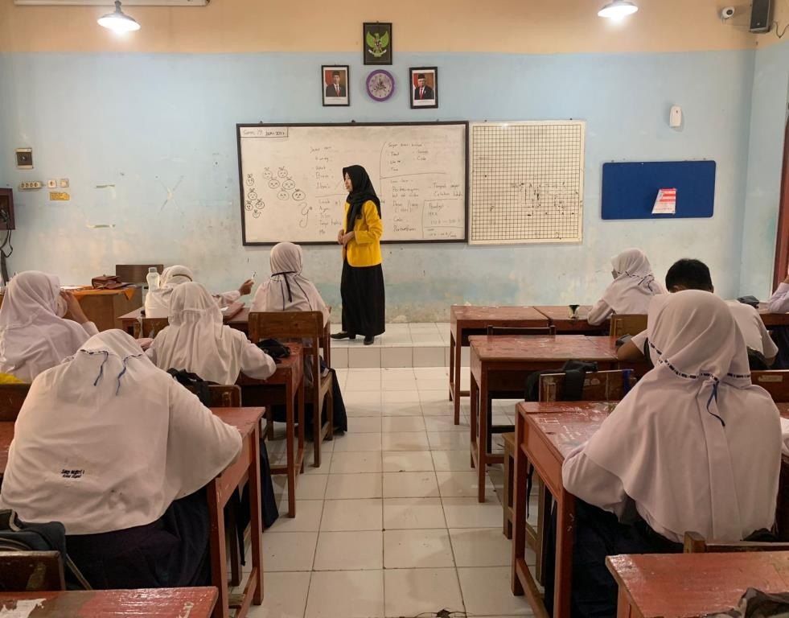

Image 1.2
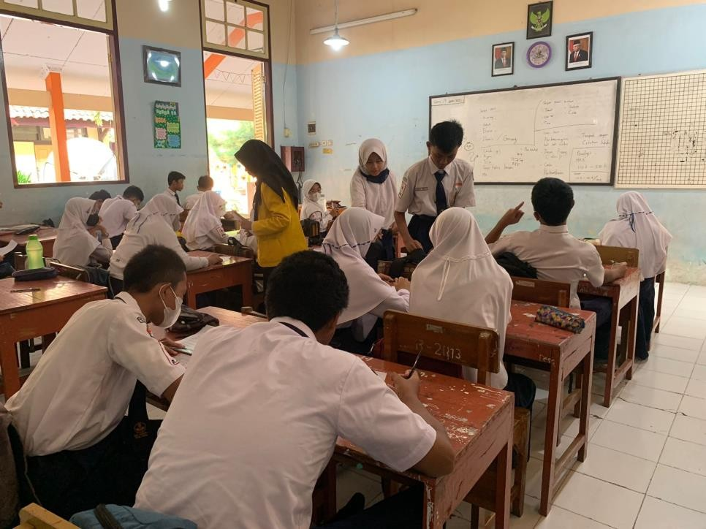

Image 1.3
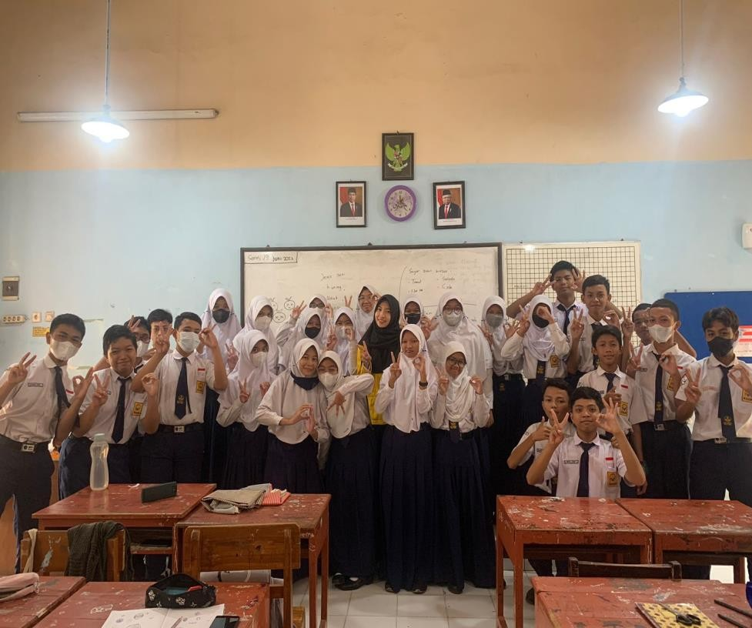

Image 1.4
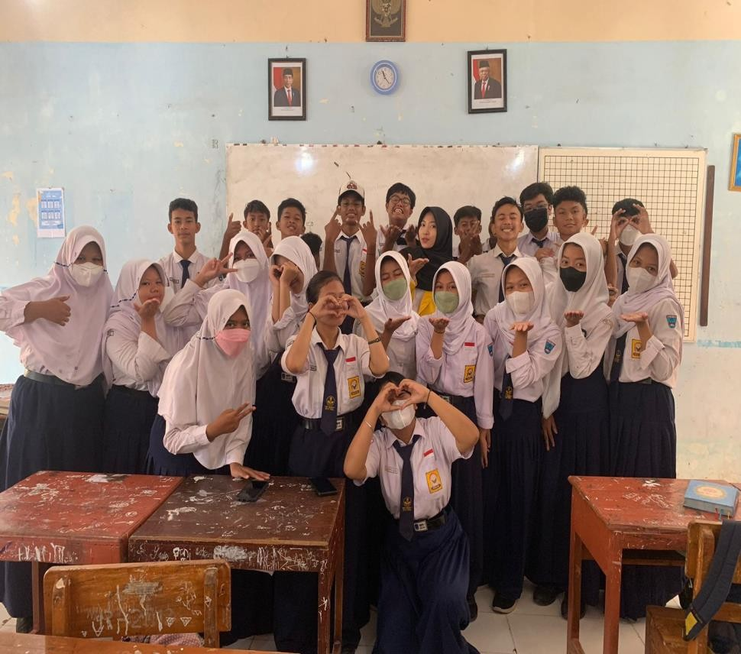

Image 1.5
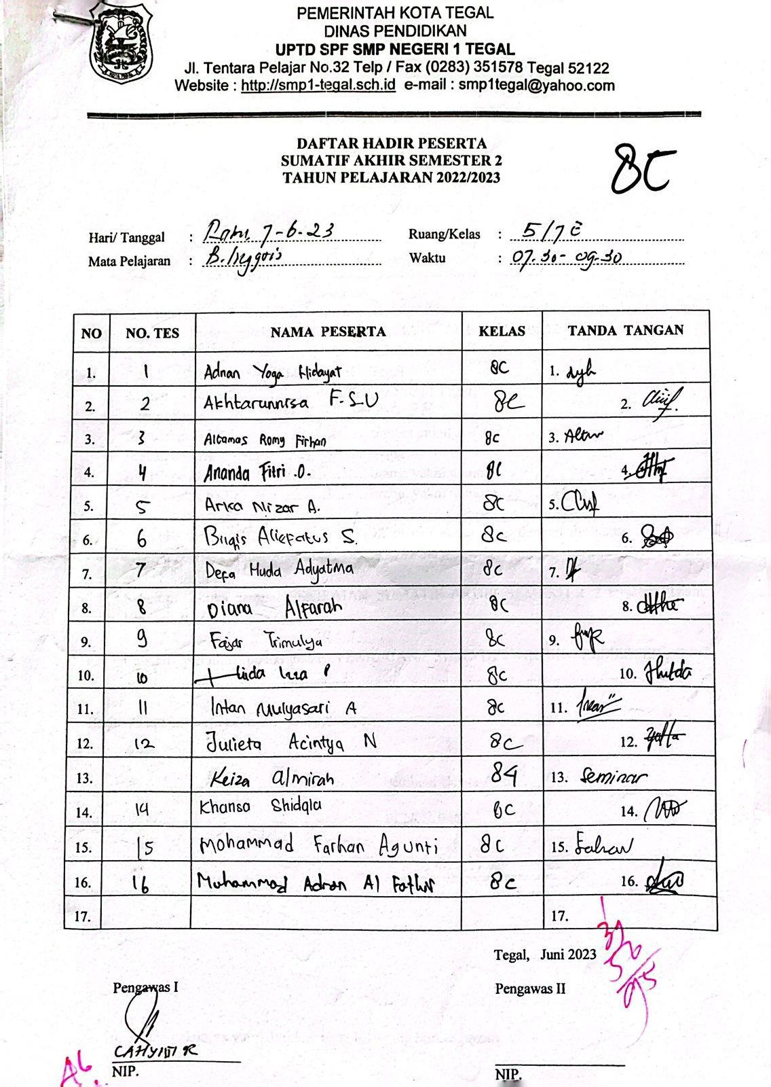

Image 1.6
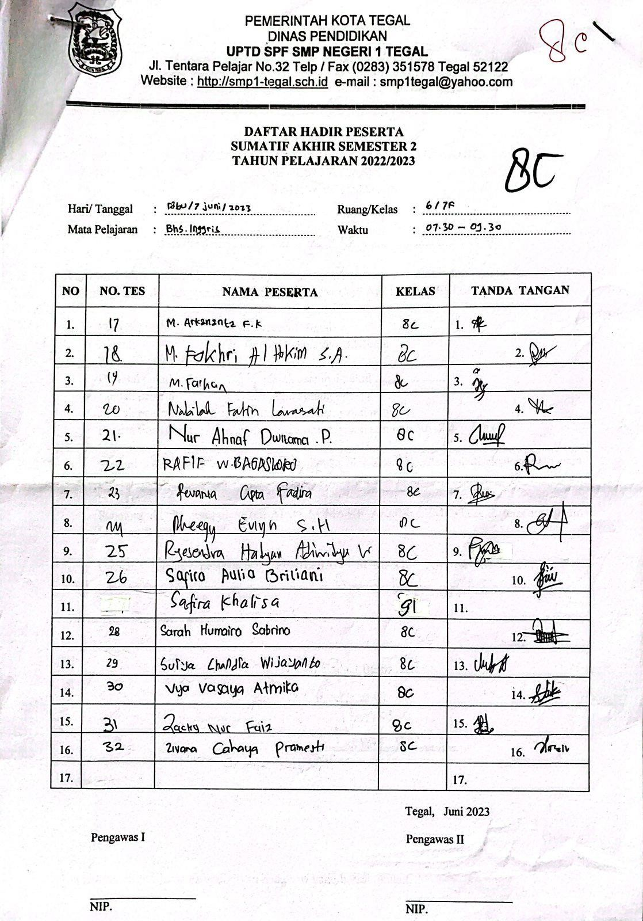

Image 1.7
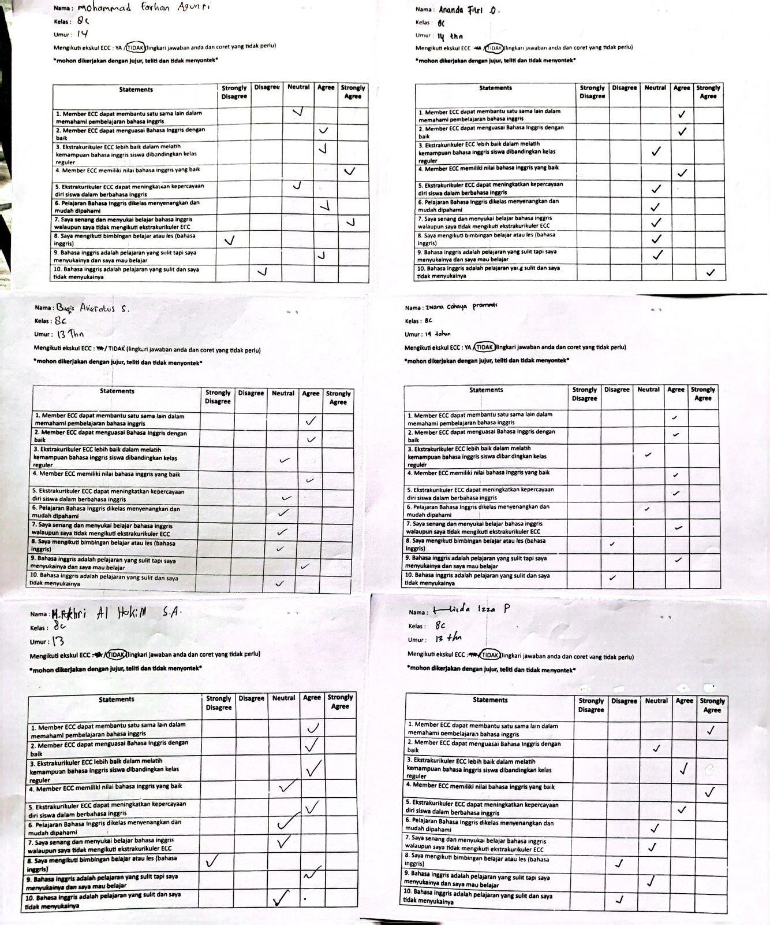

Image 1.8
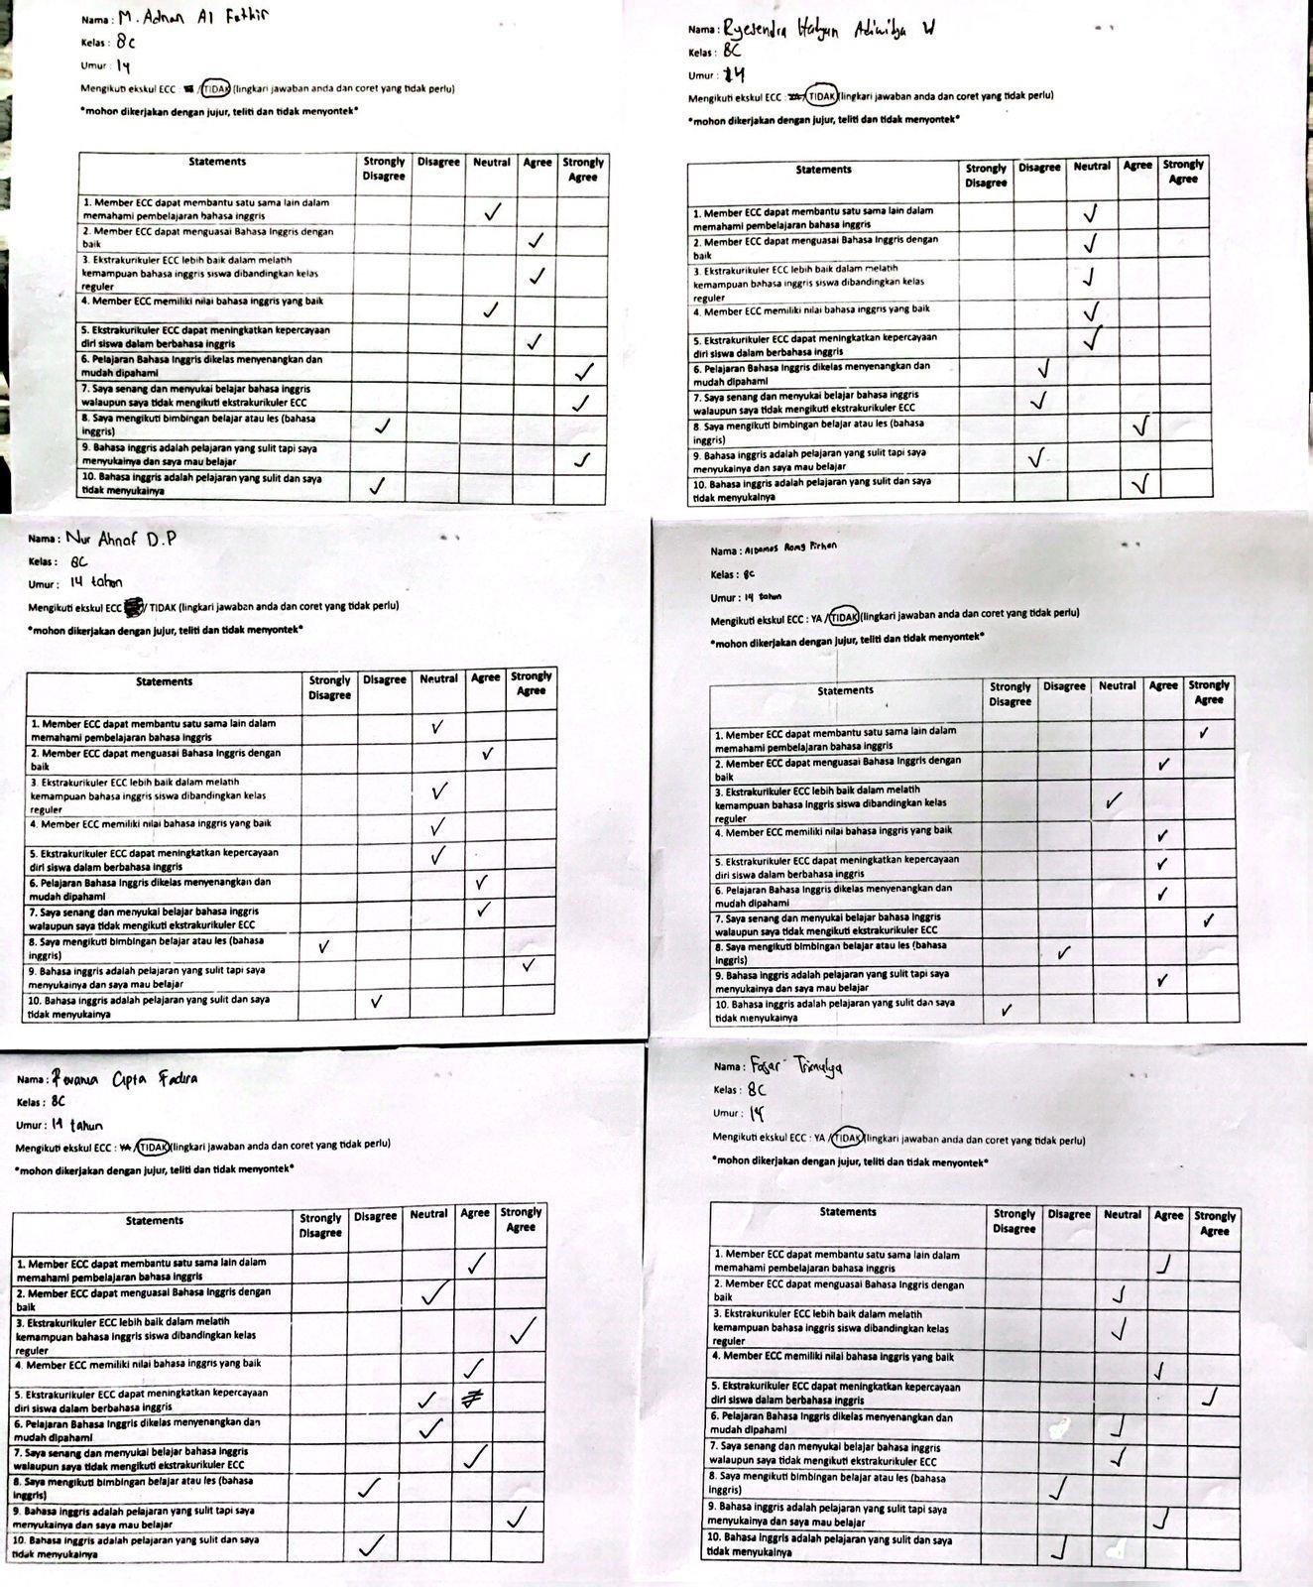

Image 1.9
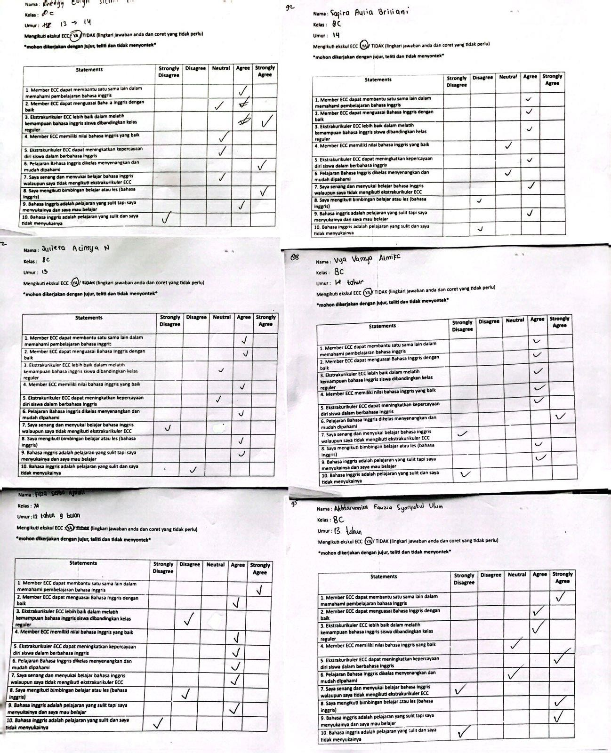

Image 1.10
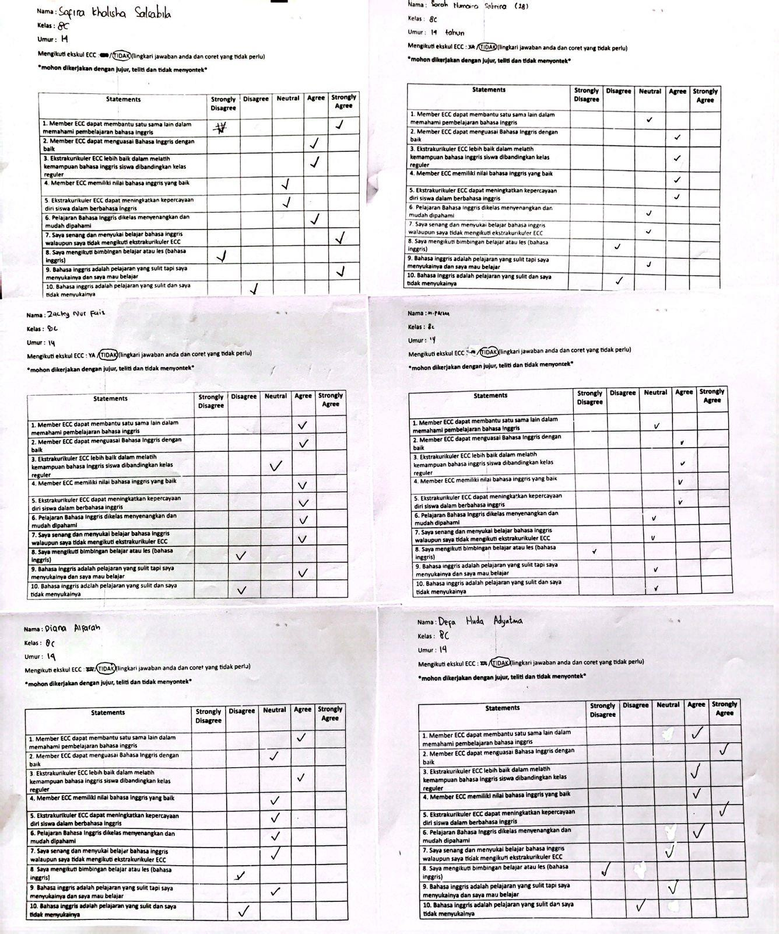

Image 1.11
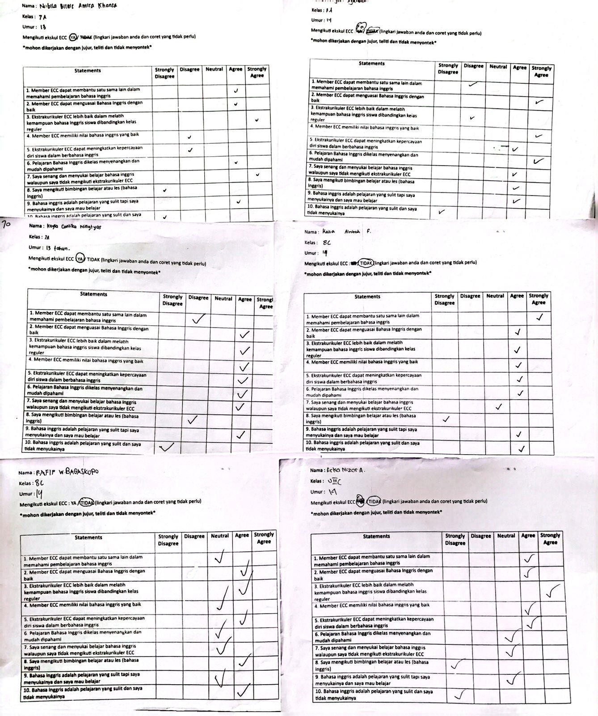

Image 1.12
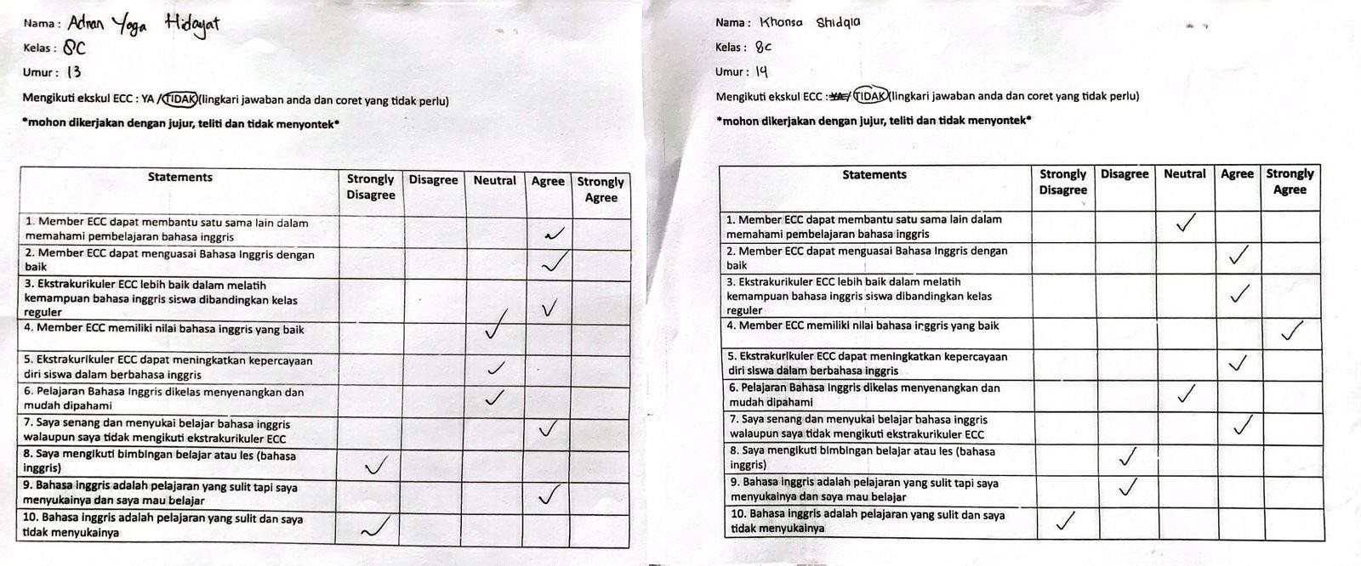

Correlations
66

 |  | ITEM_1 | ITEM_2 | ITEM_3 | ITEM_4 | ITEM_5 | ITEM_6 | ITEM_7 | ITEM_8 | ITEM_9 | ITEM_10 | TOTAL
ITEM_1 | Pearson Correlation | 1 | -.121 | .142 | .146 | .056 | -.024 | .084 | .020 | .270 | .215 | .405*
 | Sig. (2-tailed) |  | .510 | .440 | .425 | .761 | .896 | .647 | .911 | .135 | .238 | .021
 | N | 32 | 32 | 32 | 32 | 32 | 32 | 32 | 32 | 32 | 32 | 32
ITEM_2 | Pearson Correlation | -.121 | 1 | .156 | .111 | .340 | .315 | .338 | .078 | .137 | .030 | .473**
 | Sig. (2-tailed) | .510 |  | .394 | .545 | .057 | .079 | .058 | .671 | .456 | .871 | .006
 | N | 32 | 32 | 32 | 32 | 32 | 32 | 32 | 32 | 32 | 32 | 32
ITEM_3 | Pearson Correlation | .142 | .156 | 1 | -.156 | .095 | .123 | .130 | .115 | .171 | .050 | .385*
 | Sig. (2-tailed) | .440 | .394 |  | .395 | .604 | .502 | .480 | .531 | .348 | .784 | .029
 | N | 32 | 32 | 32 | 32 | 32 | 32 | 32 | 32 | 32 | 32 | 32
ITEM_4 | Pearson Correlation | .146 | .111 | -.156 | 1 | .445* | .188 | -.156 | .043 | .251 | .154 | .434*
 | Sig. (2-tailed) | .425 | .545 | .395 |  | .011 | .304 | .394 | .816 | .165 | .399 | .013
 | N | 32 | 32 | 32 | 32 | 32 | 32 | 32 | 32 | 32 | 32 | 32
ITEM_5 | Pearson Correlation | .056 | .340 | .095 | .445* | 1 | .081 | .343 | .038 | -.086 | .215 | .565**
 | Sig. (2-tailed) | .761 | .057 | .604 | .011 |  | .659 | .055 | .836 | .638 | .238 | .001
 | N | 32 | 32 | 32 | 32 | 32 | 32 | 32 | 32 | 32 | 32 | 32
ITEM_6 | Pearson Correlation | -.024 | .315 | .123 | .188 | .081 | 1 | .365* | -.014 | .335 | -.220 | .402*
 | Sig. (2-tailed) | .896 | .079 | .502 | .304 | .659 |  | .040 | .940 | .061 | .227 | .023
 | N | 32 | 32 | 32 | 32 | 32 | 32 | 32 | 32 | 32 | 32 | 32
ITEM_7 | Pearson Correlation | .084 | .338 | .130 | -.156 | .343 | .365* | 1 | -.037 | .296 | -.234 | .448*
 | Sig. (2-tailed) | .647 | .058 | .480 | .394 | .055 | .040 |  | .840 | .100 | .198 | .010
 | N | 32 | 32 | 32 | 32 | 32 | 32 | 32 | 32 | 32 | 32 | 32
ITEM_8 | Pearson Correlation | .020 | .078 | .115 | .043 | .038 | -.014 | -.037 | 1 | -.082 | .381* | .455**
 | Sig. (2-tailed) | .911 | .671 | .531 | .816 | .836 | .940 | .840 |  | .655 | .032 | .009
 | N | 32 | 32 | 32 | 32 | 32 | 32 | 32 | 32 | 32 | 32 | 32
ITEM_9 | Pearson Correlation | .270 | .137 | .171 | .251 | -.086 | .335 | .296 | -.082 | 1 | -.199 | .415*
 | Sig. (2-tailed) | .135 | .456 | .348 | .165 | .638 | .061 | .100 | .655 |  | .276 | .018
 | N | 32 | 32 | 32 | 32 | 32 | 32 | 32 | 32 | 32 | 32 | 32
ITEM_10 | Pearson Correlation | .215 | .030 | .050 | .154 | .215 | -.220 | -.234 | .381* | -.199 | 1 | .417*
 | Sig. (2-tailed) | .238 | .871 | .784 | .399 | .238 | .227 | .198 | .032 | .276 |  | .018
 | N | 32 | 32 | 32 | 32 | 32 | 32 | 32 | 32 | 32 | 32 | 32
TOTAL | Pearson Correlation | .405* | .473** | .385* | .434* | .565** | .402* | .448* | .455** | .415* | .417* | 1
 | Sig. (2-tailed) | .021 | .006 | .029 | .013 | .001 | .023 | .010 | .009 | .018 | .018
 | N | 32 | 32 | 32 | 32 | 32 | 32 | 32 | 32 | 32 | 32 | 32
*. Correlation is significant at the 0.05 level (2-tailed).
**. Correlation is significant at the 0.01 level (2-tailed).

Reliability Statistics
Cronbach's Alpha | N of Items
.515 | 10

Questionnaire
Nama :
Kelas :
Umur :
Mengikuti ekskul ECC : YA / TIDAK (lingkari jawaban anda dan coret yang tidak perlu)

*mohon dikerjakan dengan jujur, teliti dan tidak menyontek*

Statements | Strongly Disagree | Disagree | Neutral | Agree | Strongly Agree
1. Member ECC dapat membantu satu sama lain
dalam memahami pembelajaran bahasa inggris
2. Member ECC dapat menguasai Bahasa Inggris dengan baik
3. Ekstrakurikuler ECC lebih baik dalam melatih kemampuan bahasa inggris siswa dibandingkan kelas reguler
4. Member ECC memiliki nilai bahasa inggris yang
baik
5. Ekstrakurikuler ECC dapat meningkatkan kepercayaan diri siswa dalam berbahasa inggris
6. Pelajaran Bahasa Inggris dikelas menyenangkan
dan mudah dipahami
7. Saya senang dan menyukai belajar bahasa inggris walaupun saya tidak mengikuti
ekstrakurikuler ECC
8. Saya mengikuti bimbingan belajar atau les
(bahasa inggris)
9. Bahasa inggris adalah pelajaran yang sulit tapi
saya menyukainya dan saya mau belajar
10. Bahasa inggris adalah pelajaran yang sulit dan
saya tidak menyukainya

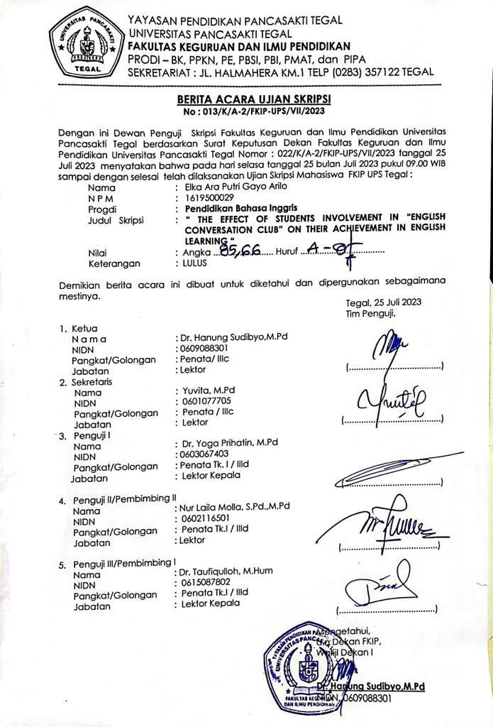
69

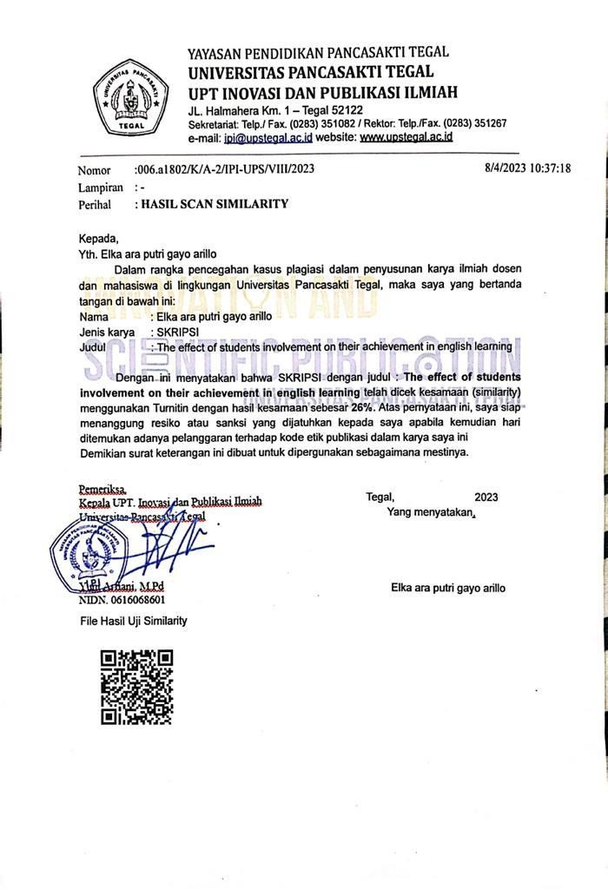
70

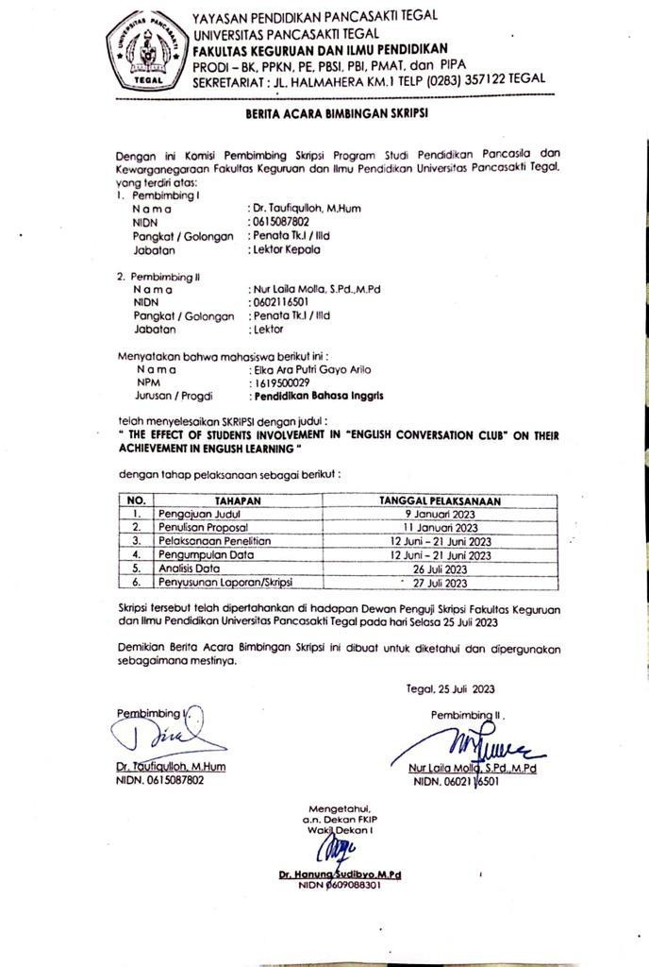
71

