**REFERENCES**

Ahmad, S. R. (2016). *Importance of English communication skills*. *2*, 478–480.

Anugrah, W. P., Wilana, D., & Kareviati, E. (2020). Improving English Speaking Ability *Y*. *3*(1), 43–48.

Bouzar, S. (2019). *Issues in Teaching Speaking to EFL Learners*. *5*(1), 70–79. https://doi.org/10.5296/elr.v5i1.14705

Brown, A (2000). *Teaching by Principles*: *An Interactive Approach to Language Pedagogy*. Second Ed. San Fransisco State University.

Brown, A (2003). *Language Assesment*: *Principles and Classroom Practices*. San Fransisco State University.

Creswell, J. W. (2012). E*ducational research: Planning, conducting, and evaluating quantitative and qualitative researc*h (3rd ed.). Upper Saddle River, NJ: Merrill.

Delahunty, G. P., & Garvey, J. J. (2020). The English Language: From Sound to Sense. In *The English Language: From Sound to Sense*. https://doi.org/10.37514/per-b.2010.2331

Kakharov, K. (2022)*. Special Issue “ Social Sustainability and Innovative Learning Tendencies ” ISSN : 2545-0573 National and International Characteristics on Nonverbal*. 53–58.

Kusumo, A., Prihatin, Y., & Aflahatun, N. (2020). *Southern Thai High School Students ’ Anxiety in Speaking Performance*. *4*(1), 1–13. <https://doi.org/10.24905/efj.v4i1.74>

Meilinda, N. D. (2018). *Youtube Videos and Snowball Throwing Technique to Improve Students ’ Speaking Skill*. *5*(2), 112–126.

Mogea, T. (2023). *Developing Students ’ Speaking Ability through Snowball Throwing Technique*.

Molla, N. L. (2020). *Improvement of Activeness and Learning Outcomes of English Speaking through the Snowball Throwing Learning Model*. *3*(2). https://doi.org/10.24905/efj.v3i2.58

Nation, I. S. P., & Newton, J. (2008). Teaching ESL/EFL Listening and Speaking. In *Teaching ESL/EFL Listening and Speaking*. https://doi.org/10.4324/9780203891704

Nunan, D. (2003). P*ractical English Language Teaching*. New York: Mc Graw Hill

Nurdiawati, D. (2017). The Effectiveness of "Snowball Throwing" *Method in Teaching Writing Procedure Text A. Introduction*. *4*(2), 39–53.

Nurmalasari, M., & Apsari, Y. (2019). Improving Students' Participation in Speaking. *2*(2), 14–20.

Rao, Parupalli Srinivas. 2019. Research Journal Of English (RJOE): *The Role of Englis as a Global Language*. 4(1).

Richards, Jack C. (1990). Conversationally speaking: Approaches to the teaching of conversation. In Jack C. Richards, The Language Teaching Matrix. New York: Cambridge University Press.

Sadiku, L. M. (2015). The importance of four skills reading, speaking, writing, listening in a lesson hour. European Journal of Language and Literature, 1(1).

Salim, D. P., Saini, F., Paputungan, F., & Training, T. (2020). *Improving Students ’ Speaking Skill through Snowball Throwing Technique ( STT ) at Indonesian Junior High School*. *4778*, 198–216. https://doi.org/10.24256/ideas.v8i1.1321

Shoimin, Aris. 2014. 68 Model Pembelajaran Inovatif dalam Kurikulum 2013. Yogyakarta: Ar Ruzz Media.

Suprijono, A. (2013). Cooperative Learning: Teori dan Aplikasi PAIKEM. Yogyakarta: Pustaka Pelajar.

Thornbury, Scott, and Diana Slade (2006). Conversation: From description to Pedagogy. New York: Cambridge University Press.

Trinh, N. B. (2021). *Challenges in Speaking Classrooms among Non-English Majors*. *5*(2), 37–42.

Ur, P. (2000). *A course in Language Teaching: Practice and Theory*. Cambridge: Cambridge University Press.

Wardani, B. R., Rachman, A., & Satriani, I. (2019). Comparing Snowball Throwing Technique with. *2*(2), 100–108.

**APPENDICES**

**Appendix 1.** Lesson Plan

**LESSON PLAN**

|  |  |
| --- | --- |
| School : SMP N 2 Adiwerna | Material : Recount Text |
| Subject : English | Time Allocation : 2 x 40 minutes  (2 meetings) |
| Class/Semester : VIII / II | Academic Year : 2022/2023 |

1. **CORE COMPETENCES**

|  |  |
| --- | --- |
| KI 3 : | Understanding, applying, analyzing factual, conceptual, procedural knowledge based on the curiosity about science, technology, art, culture, and humanities with insight into humanity, nationality, and civilization related to the causes of phenomena and events, as well as applying procedural knowledge in specific fields of study according to their talents and interests to solve problems. |
| KI 4 : | Processing, reasoning, and answering in the concrete and related abstract with the development of what is learned independently and able to use methods according to scientific rules. |

1. **BASIC COMPETENCIES AND INDICATORS OF COMPETENCE ACHIEVEMENT**

|  |  |
| --- | --- |
| **Basic Competencies** | **Indicators of Competence Achievement** |
| |  |  | | --- | --- | | **3.5.1**  3.5.2 | Understanding the recount text in simple way, that contains the text structure and language features related to personal experiences in the past.  Comparing social functions, text structures, and linguistics elements of several oral and written personal recount texts by giving and asking for information related to personal | | |  |  | | --- | --- | | 3.5.1.1  3.5.1.2  3.5.2.1  3.5.2.2 | Determine the definition and social function of simple spoken and written recount text related to personal past experiences.  Determine the structure text of simple spoken and written recount text related to personal experiences in the past.  Identify the text structure and language features of simple spoken and written recount text related to personal experiences in the past.  Comparing social function and linguistics elements of several oral and written personal recount text | |

1. **LEARNING OBJECTIVES**
2. After observing the recount text, students can understand the definition and social function of the recount text and the linguistic structure in a written recount text.
3. After observing the recount text, students can understand text structure and language features of the recount text and the linguistic structure in a written recount text. 3.
4. After observing the written recount text from the power point presentation, students can analyze text structure and language features in a recount text correctly.
5. After learning the recount text, students are able to design a recount text to write their personal experiences according to language methods and elements.
6. **LEARNING MATERIAL**

**Recount Text**

|  |  |
| --- | --- |
| **Definition** | Recount text is a text that contains past events or experiences. |
| **Social Function** | To retell readers or listeners about the past event or experience. |
| **Generic Structure** | ***Orientation :*** Introducing the participants, place and time.  ***Events :*** Describing series of event that happened in the past.  ***Re-orientation :*** Stating personal comment of the writer to the story, whether it would be happy ending or bad ending. |
| **Language Features** | * Introducing personal participants : I, my..., etc * Using Chronological connection : Then, first, etc. * Using linking Verb : Was, were, saw, heard, etc. * Using Action Verb : Look, go, change, etc. * Using past tenses such us simple past tense, past continuous tense, past perfect tense, past perfect continuous tense. |

1. **LEARNING AND TEACHING ACTIVITIES**

|  |  |  |
| --- | --- | --- |
| **Activities** | **Description of the Activities** | **Time Allocation** |
| **Preliminary**  **Activity** | 1. The teacher and students give and answer greetings to each other and convey their respective news.  2. The class is continued by praying. Prayer is led by the leader of the class.  3. Students prepare themselves to be ready to learn and check their tidiness and be disciplined in every learning activity.  4. Students listen to the teacher's perception of the previous lesson and relate it to his experience as a provision for the next lesson.  5. Students ask questions and answers with the teacher regarding the previous material.  6. Students listen to apperception by remembering about (social function, generic structure and language features of previous material). | 10 minutes |

|  |  |  |
| --- | --- | --- |
| **Main**  **Activity** | **Phase 1 orientation of students to problems (critical thinking and creativity)**  **•** Teacher displays a power point slide containing of explanation of recount text.  **Phase 2 organizes students to learn (collaboration)**  • According to the teacher's direction, students are divided into some groups.  • The teacher guides the learners to determine the problem to be sought for answer or solution.  • Students and their groups discuss solving problem assignments that have been summarized by the teacher.  ***Phase.3 guiding individual and group inquiry (collaborative and problem solving)***  ***•*** Through group discussions, with the guidance of teachers, students seek answers to problems discussed in their groups.  • Students gather the questions from group discussions to be collected later.  ***Phase.4 Develop and present the work***  • Learners present the results of group work on social functions and text structure related to text recount  • Other students listen carefully to the question and answer.  ***Phase.5 Analyze and evaluate the problem-solving process***  ***•*** Students and teachers analyze and evaluate the results of group work that has been done  • The teacher confirms about the social function and structure of the text and the linguistic elements of the recount text  • Teachers give awards to study groups. | 60 minutes |

|  |  |  |
| --- | --- | --- |
| **Closing** | **Exercise and Evaluation**   * The teacher gives practice tasks to the group related to the recount of written texts to better direct students to the problems concluded earlier to measure the ability   of students' understanding in mastering the material discussed.   * The teacher assists students by agreeing to the problems found in carrying out the given practice questions. * Students do assignments in their groups together to later be presented in front of other group friends. * Teachers give independent tasks to students by making their own experience stories written in the form of written recount text. | 10 minutes |
|  | **Group Appreciation and Reflection**   * Teachers award in various forms for the best study group. * Before the lesson closes, the teacher asks students to reflect and conclude today's activities. * Students analyze today's learning process to find out the shortcomings for further learning improvement. * The teacher reminds students of the material to be learned at the next meeting. * Students are invited to always be grateful for the blessings given and invite students to always save energy (religiosity). * Learning activities are closed with prayer (religiosity). |  |

1. **LEARNING METHOD AND MODELS**

Approach : Scientific Approach

Learning Method : Snowball Throwing Technique

Learning Model : Assignments, Discussions, Answering (question and answer).

1. **MEDIA AND LEARNING TOOLS**

Learning Media : Power point slides, book, dictionary

Learning Tools : Laptop, projector, white board, makers, papers.

1. **ASSESSMENT**

|  |  |
| --- | --- |
| Knowledge : | Assessment of the understanding of speaking tests in the form of orally in discussions, debriefings, conversations, and assignments. |
| Skill (Ability) : | Assessment in the form of performance appraisal in answering and express opinions, suggestions, and objections. |

Scoring:

Score Result = n x 10

3

**LESSON PLAN**

|  |  |
| --- | --- |
| School : SMP N 2 Adiwerna | Material : Recount Text |
| Subject : English | Time Allocation : 2 x 40 minutes  (2 meetings) |
| Class/Semester : VIII / II | Academic Year : 2022/2023 |

* + - * 1. **CORE COMPETENCES**

|  |  |
| --- | --- |
| KI 3 : | Understanding, applying, analyzing factual, conceptual, procedural knowledge based on the curiosity about science, technology, art, culture, and humanities with insight into humanity, nationality, and civilization related to the causes of phenomena and events, as well as applying procedural knowledge in specific fields of study according to their talents and interests to solve problems. |
| KI 4 : | Processing, reasoning, and answering in the concrete and related abstract with the development of what is learned independently and able to use methods according to scientific rules. |

* + - * 1. **BASIC COMPETENCIES AND INDICATORS OF COMPETENCE ACHIEVEMENT**

|  |  |
| --- | --- |
| **Basic Competencies** | **Indicators of Competence Achievement** |
| |  |  | | --- | --- | | **4.5.1**  4.5.2 | Compose spoken and written recount text in simple way, that contains the text structure and language features related to personal experiences in the past correctly and in context.  Capturing contextual meaning related to social function, the text structure, and language features of simple spoken and written recount text related to personal experiences in the past. | | |  |  | | --- | --- | | **4.5.1.1**  **4.5.1.2** | Make a personal recount text related to personal experiences in the past. Show the result of discussions in front of the class.  Describe the analyzing of the social function, the text structure, and language features of personal experiences in the past orally. | | 4.5.2.1  4.5.2.2 | Each of students of groups, make a question related to recount text-the definition, social function, the text structure, and language features. Then make a question in a paper, crumple it until the shape looks like a snowball paper.  Student who gets the throw of the snowball paper, must answer the question. | |

* + - * 1. **LEARNING OBJECTIVES**

1. After observing the explanation of the recount text, students can identify the social function, structure of the text, and linguistic elements of the personal past experiences correctly.
2. After studying recount text, students can arrange some recount text information in the form of simple paragraphs to make it as a text.
3. After discussing and exchanging opinions with group mates, students can make a question related to the recount text, which contains social functions, text structure, and linguistic elements thoroughly.
4. After receiving questions given by their friends from other groups, students are expected to be able to answer the questions correctly and confidently.
   * + - 1. **LEARNING MATERIAL**

**Recount Text**

|  |  |
| --- | --- |
| **Definition** | Recount text is a text that contains past events or experiences. |
| **Social Function** | To retell readers or listeners about the past event or experience. |
| **Generic Structure** | ***Orientation :*** Introducing the participants, place and time.  ***Events :*** Describing series of event that happened in the past.  ***Re-orientation :*** Stating personal comment of the writer to the story, whether it would be happy ending or bad ending. |
| **Language Features** | * Introducing personal participants : I, my..., etc * Using Chronological connection : Then, first, etc. * Using linking Verb : Was, were, saw, heard, etc. * Using Action Verb : Look, go, change, etc. * Using past tenses such us simple past tense, past continuous tense, past perfect tense, past perfect continuous tense. |

* + - * 1. **LEARNING AND TEACHING ACTIVITIES**

|  |  |  |
| --- | --- | --- |
| **Activities** | **Description of the Activities** | **Time Allocation** |
| **Preliminary**  **Activity** | 1. The teacher and students give and answer greetings to each other and convey their respective news.  2. The class is continued by praying. Prayer is led by the leader of the class.  3. Students prepare themselves to be ready to learn and check their tidiness and be disciplined in every learning activity.  4. Students listen to the teacher's perception of the previous lesson and relate it to his experience as a provision for the next lesson.  5. Students ask questions and answers with the teacher regarding the previous material.  6. Students listen to apperception by remembering about (social function, generic structure and language features of previous material). | 10 minutes |

|  |  |  |
| --- | --- | --- |
| **Main**  **Activity** | **Phase 1 orientation of students to problems (critical thinking and creativity)**  **•** Teacher displays a power point slide containing of explanation of recount text.  **Phase 2 organizes students to learn (collaboration)**  • According to the teacher's direction, students are divided into several groups  • The teacher guides the learners to determine the problem to be sought for answer or solution  • Students and their groups discuss solving problem assignments that have been summarized by the teacher.  ***Phase.3 guiding individual and group inquiry (collaborative and problem solving)***  ***•*** Through group discussions, with the guidance of teachers, students seek answers to problems discussed in their groups.  • Students gather the questions from group discussions to be throwed/questioned later.  ***Phase.4 Develop and present the work***  • Students answer the question given to him/her thoroughly and confidently.  Other students listen carefully to the question and answer.  ***Phase.5 Analyze and evaluate the problem-solving process***  ***•*** Students and teachers analyze and evaluate the results of group work that has been done  • The teacher confirms about the social function and structure of the text and the linguistic elements of the recount text  • Teachers give awards to study groups. | 60 minutes |

|  |  |  |
| --- | --- | --- |
| **Closing** | **Exercise and Evaluation**   * The teacher gives practice tasks to the group related to the recount of written texts to better direct students to the problems concluded earlier to measure the ability   of students' understanding in mastering the material discussed.   * The teacher assists students by agreeing to the problems found in carrying out the given practice questions. * Students do assignments in their groups together to later be presented in front of other group friends. * Teachers give independent tasks to students by making their own experience stories written in the form of written recount text. | 10 minutes |
|  | **Group Appreciation and Reflection**   * Teachers award in various forms for the best study group. * Before the lesson closes, the teacher asks students to reflect and conclude today's activities. * Students analyze today's learning process to find out the shortcomings for further learning improvement. * The teacher reminds students of the material to be learned at the next meeting. * Students are invited to always be grateful for the blessings given and invite students to always save energy (religiosity). * Learning activities are closed with prayer (religiosity). |  |

* + - * 1. **LEARNING METHOD AND MODELS**

Approach : Scientific Approach

Learning Method : Snowball Throwing Technique

Learning Model : Assignments, Discussions, Answering (question and answer).

* + - * 1. **MEDIA AND LEARNING TOOLS**

Learning Media : Power point slides, book, dictionary

Learning Tools : Laptop, projector, white board, makers, papers.

* + - * 1. **ASSESSMENT**

|  |  |
| --- | --- |
| Knowledge : | Assessment of the understanding of speaking tests in the form of orally in discussions, debriefings, conversations, and assignments. |
| Skill (Ability) : | Assessment in the form of performance appraisal in answering and express opinions, suggestions, and objections. |

|  |
| --- |
| Scoring:  Score Result = n x 10  3 |

**LESSON PLAN**

|  |  |
| --- | --- |
| School : SMP N 2 Adiwerna | Material : Recount Text |
| Subject : English | Time Allocation : 2 x 40 minutes |
| Class/Semester : VIII / II | Academic Year : 2022/2023 |

* 1. **CORE COMPETENCES**

|  |  |
| --- | --- |
| KI 3 : | Understanding, applying, analyzing factual, conceptual, procedural knowledge based on the curiosity about science, technology, art, culture, and humanities with insight into humanity, nationality, and civilization related to the causes of phenomena and events, as well as applying procedural knowledge in specific fields of study according to their talents and interests to solve problems. |
| KI 4 : | Processing, reasoning, and answering in the concrete and related abstract with the development of what is learned independently and able to use methods according to scientific rules. |

* 1. **BASIC COMPETENCIES AND INDICATORS OF COMPETENCE ACHIEVEMENT**

|  |  |
| --- | --- |
| **Basic Competencies** | **Indicators of Competence Achievement** |
| |  |  | | --- | --- | | 4.5.2 | Capturing contextual meaning related to social function, the text structure, and language features of simple spoken and written recount text related to personal experiences in the past. | | |  |  | | --- | --- | |  |  | | 4.5.2.1  4.5.2.2 | Each of students of groups, make a question related to recount text-the definition, social function, the text structure, and language features. Then make a question in a paper, crumple it until the shape looks like a snowball paper.  Student who gets the throw of the snowball paper, must answer the question. | |

* 1. **LEARNING OBJECTIVES**

1. After discussing and exchanging opinions with group mates, students can make a question related to the recount text, which contains social functions, text structure, and linguistic elements thoroughly.
2. After receiving questions given by their friends from other groups, students are expected to be able to answer the questions correctly and confidently.
   1. **LEARNING MATERIAL**

**Recount Text**

|  |  |
| --- | --- |
| **Definition** | Recount text is a text that contains past events or experiences. |
| **Social Function** | To retell readers or listeners about the past event or experience. |
| **Generic Structure** | ***Orientation :*** Introducing the participants, place and time.  ***Events :*** Describing series of event that happened in the past.  ***Re-orientation :*** Stating personal comment of the writer to the story, whether it would be happy ending or bad ending. |
| **Language Features** | * Introducing personal participants : I, my..., etc * Using Chronological connection : Then, first, etc. * Using linking Verb : Was, were, saw, heard, etc. * Using Action Verb : Look, go, change, etc. * Using past tenses such us simple past tense, past continuous tense, past perfect tense, past perfect continuous tense. |

* 1. **LEARNING AND TEACHING ACTIVITIES**

|  |  |  |
| --- | --- | --- |
| **Activities** | **Description of the Activities** | **Time Allocation** |
| **Preliminary**  **Activity** | 1. The teacher and students give and answer greetings to each other and convey their respective news.  2. The class is continued by praying. Prayer is led by the leader of the class.  3. Students prepare themselves to be ready to learn and check their tidiness and be disciplined in every learning activity.  4. Students listen to the teacher's perception of the previous lesson and relate it to his experience as a provision for the next lesson.  5. Students ask questions and answers with the teacher regarding the previous material.  6. Students listen to apperception by remembering about (social function, generic structure and language features of previous material). | 10 minutes |

|  |  |  |
| --- | --- | --- |
| **Main**  **Activity** | **Phase 1 orientation of students to problems (critical thinking and creativity)**  **•** Teacher displays a power point slide containing of explanation of recount text.  **Phase 2 organizes students to learn (collaboration)**  • According to the teacher's direction, students are divided into several groups  • The teacher guides the learners to determine the problem to be sought for answer or solution  • Students and their groups discuss solving problem assignments that have been summarized by the teacher.  ***Phase.3 guiding individual and group inquiry (collaborative and problem solving)***  ***•*** Through group discussions, with the guidance of teachers, students seek answers to problems discussed in their groups.  • Students gather the questions from group discussions to be throwed/questioned later.  ***Phase.4 Develop and present the work***  • Students answer the question given to him/her thoroughly and confidently.  Other students listen carefully to the question and answer.  ***Phase.5 Analyze and evaluate the problem-solving process***  ***•*** Students and teachers analyze and evaluate the results of group work that has been done  • The teacher confirms about the social function and structure of the text and the linguistic elements of the recount text  • Teachers give awards to study groups. | 60 minutes |

|  |  |  |
| --- | --- | --- |
| **Closing** | **Exercise and Evaluation**   * The teacher gives practice tasks to the group related to the recount of written texts to better direct students to the problems concluded earlier to measure the ability   of students' understanding in mastering the material discussed.   * The teacher assists students by agreeing to the problems found in carrying out the given practice questions. * Students do assignments in their groups together to later be presented in front of other group friends. * Teachers give independent tasks to students by making their own experience stories written in the form of written recount text. | 10 minutes |
|  | **Group Appreciation and Reflection**   * Teachers award in various forms for the best study group. * Before the lesson closes, the teacher asks students to reflect and conclude today's activities. * Students analyze today's learning process to find out the shortcomings for further learning improvement. * The teacher reminds students of the material to be learned at the next meeting. * Students are invited to always be grateful for the blessings given and invite students to always save energy (religiosity). * Learning activities are closed with prayer (religiosity). |  |

* 1. **LEARNING METHOD AND MODELS**

Approach : Scientific Approach

Learning Method : Snowball Throwing Technique

Learning Model : Assignments, Discussions, Answering (question and answer).

* 1. **MEDIA AND LEARNING TOOLS**

Learning Media : Power point slides, book, dictionary

Learning Tools : Laptop, projector, white board, makers, papers.

* 1. **ASSESSMENT**

|  |  |
| --- | --- |
| Knowledge : | Assessment of the understanding of speaking tests in the form of orally in discussions, debriefings, conversations, and assignments. |
| Skill (Ability) : | Assessment in the form of performance appraisal in answering and express opinions, suggestions, and objections. |

Scoring:

Score Result = n x 10

3

**Appendix 2.** Validation Instrument and Lesson Plan

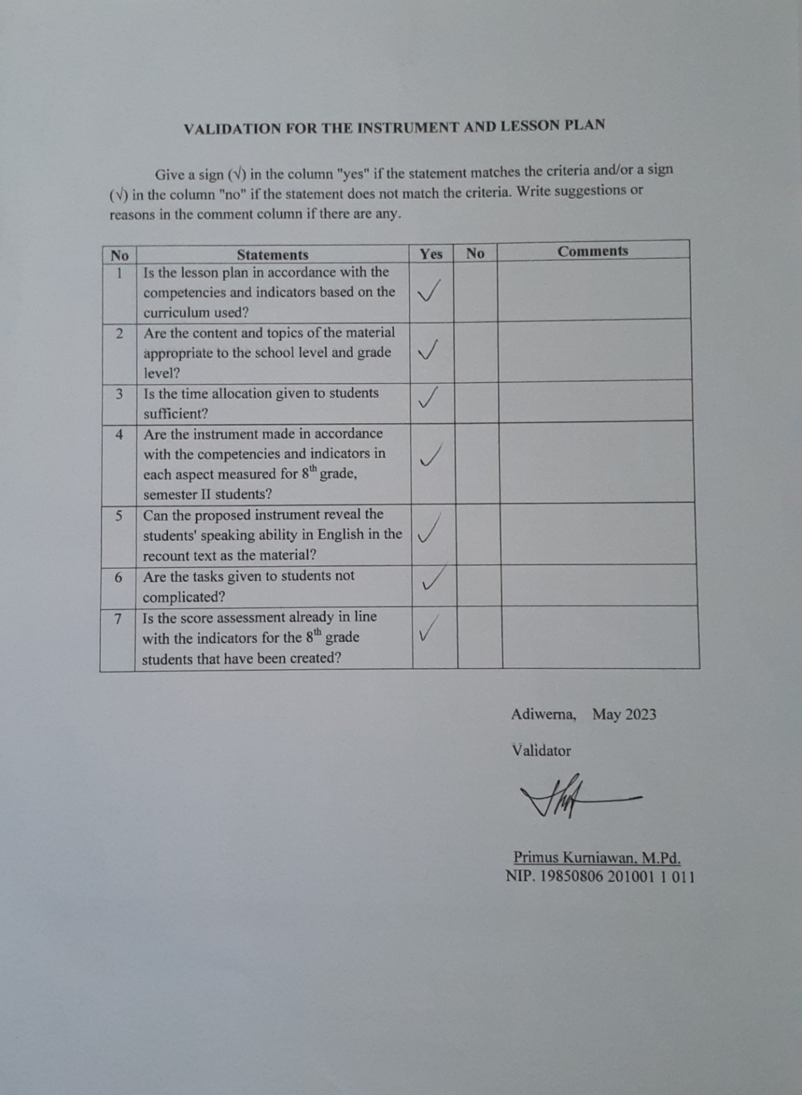

**Appendix 3.**  Instrument (Speaking test)

**SPEAKING TEST**

|  |  |
| --- | --- |
| School : SMP N 2 Adiwerna | Material : Recount Text |
| Subject : English | Academic Year : 2022/2023 |
| Class/Semester : VIII / II | Time Allocation : 2 x 40 minutes |

Please answer these questions below:

1. With whom did you do your last weekend's activities?
2. What kinds of things did you do over the weekend?
3. Where did you go on your last vacation?
4. How did you feel about your previous vacation?
5. Tell me about a memorable experience you had on your recent vacation!

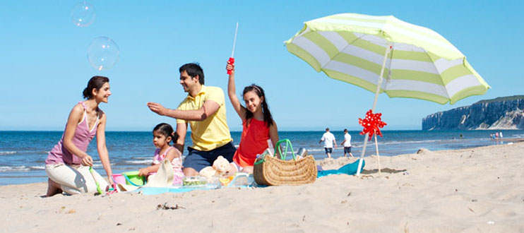

Tell about your personal events or experiences based on the theme you have chosen below. Choose one of the following themes:

1. Birthday event
2. Cooking (alone, with mom or others)
3. Cleaning the house
4. Dinner outside with family or friends
5. Doing homework
6. Holiday
7. Shopping

**Appendix 4** Validity of Instrument (Speaking test)

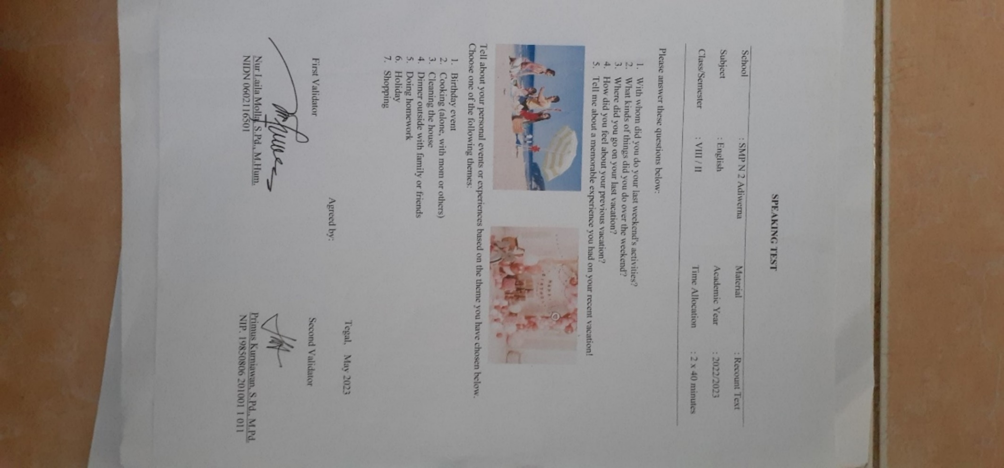

**Appendix 5** Students Pre-Test Score Result (Experimental group)

**Pre-test of the Experimental Group (VIII A)**

|  |  |  |  |  |  |  |  |  |
| --- | --- | --- | --- | --- | --- | --- | --- | --- |
| **No** | **Nama** | **Grammar** | **Vocabulary** | **Comprehension** | **Fluency** | **Pronunciation** | **Task** | **Total**  **Score** |
| 1 | AGUS SAPUTRA | 3 | 4 | 4 | 3 | 3 | 4 | 70 |
| 2 | AKBAR DWI PRASETYO | 3 | 4 | 3 | 3 | 3 | 3 | 63 |
| 3 | ANGGA ARIL SAPUTRA | 3 | 4 | 3 | 3 | 3 | 4 | 67 |
| 4 | ANNISA FITRIANI | 3 | 3 | 3 | 3 | 4 | 3 | 63 |
| 5 | DIANA LUTFI | 3 | 3 | 3 | 3 | 3 | 4 | 67 |
| 6 | DIKA PRAMUDYA | 3 | 3 | 3 | 3 | 3 | 3 | 60 |
| 7 | DIMAS ADLI SETIYAWAN | 3 | 3 | 3 | 3 | 3 | 4 | 63 |
| 8 | DWI JUNIAR RESTUTI | 3 | 3 | 3 | 2 | 3 | 3 | 57 |
| 9 | EZZA FIZABILLILAH | 3 | 4 | 4 | 3 | 3 | 4 | 70 |
| 10 | HUSNUN FAUZIAH | 3 | 3 | 3 | 3 | 3 | 4 | 63 |
| 11 | IJIBILLAH GHOFARU | 2 | 3 | 3 | 3 | 3 | 3 | 60 |
| 12 | JIO ANGGER PRAMONO | 3 | 3 | 3 | 3 | 3 | 4 | 63 |
| 13 | JOFAN MARIQ | 3 | 4 | 3 | 3 | 3 | 4 | 67 |
| 14 | KENZO ADI RISNANDAR | 3 | 4 | 4 | 3 | 3 | 4 | 70 |
| 15 | KISLA NAHLA RAMADHANI | 3 | 4 | 4 | 4 | 4 | 4 | 77 |
| 16 | LAILATUZZAHRA | 3 | 3 | 3 | 2 | 3 | 4 | 60 |
| 17 | LILIS | 3 | 3 | 4 | 3 | 3 | 4 | 67 |
| 18 | LISA AURORA | 3 | 4 | 4 | 3 | 4 | 4 | 73 |
| 19 | M. FAKHRI ALFIANSYACH | 3 | 4 | 4 | 4 | 4 | 4 | 77 |
| 20 | M. RIDHO PRABANDARU | 3 | 4 | 4 | 3 | 4 | 4 | 73 |
| 21 | MAULANA DWI PANGGA | 2 | 3 | 3 | 3 | 3 | 4 | 60 |
| 22 | MOH. DERIL AULIA FERDAUS | 3 | 4 | 4 | 3 | 3 | 4 | 73 |
| 23 | MUHAMAD ARIF FATIKHUL BIRRI | 3 | 3 | 4 | 3 | 3 | 4 | 70 |
| 24 | MUHAMMAD AINUL YAQIN | 3 | 3 | 4 | 3 | 3 | 4 | 70 |
| 25 | MUHAMMAD ARIF NUR DZAKKY | 2 | 4 | 4 | 2 | 3 | 4 | 70 |
| 26 | MUHAMMAD REHAN | 3 | 4 | 4 | 3 | 4 | 4 | 73 |
| 27 | NAURA RAYYANIA UMAR | 3 | 4 | 4 | 4 | 4 | 4 | 77 |
| 28 | NIA ISMA SAFITRI | 3 | 4 | 4 | 3 | 4 | 4 | 73 |
| 29 | NUR KHILFATUZ ZAHRO | 4 | 4 | 4 | 4 | 4 | 5 | 80 |
| 30 | OKTAVIANA FITRIA | 4 | 4 | 4 | 4 | 4 | 5 | 80 |
| 31 | YANNAS IBRAHIM | 2 | 3 | 3 | 2 | 3 | 4 | 57 |

**Appendix 6** Students Post-Test Score Result (Experimental group)

**Post-test of the Experimental Group (VIII A)**

|  |  |  |  |  |  |  |  |  |
| --- | --- | --- | --- | --- | --- | --- | --- | --- |
| **No** | **Nama** | **Grammar** | **Vocabulary** | **Comprehension** | **Fluency** | **Pronunciation** | **Task** | **Total**  **Score** |
| 1 | AGUS SAPUTRA | 3 | 4 | 4 | 3 | 4 | 4 | 73 |
| 2 | AKBAR DWI PRASETYO | 3 | 3 | 3 | 3 | 3 | 4 | 67 |
| 3 | ANGGA ARIL SAPUTRA | 3 | 4 | 4 | 3 | 3 | 4 | 70 |
| 4 | ANNISA FITRIANI | 3 | 4 | 3 | 3 | 3 | 4 | 67 |
| 5 | DIANA LUTFI | 3 | 4 | 4 | 3 | 4 | 4 | 73 |
| 6 | DIKA PRAMUDYA | 3 | 3 | 3 | 3 | 3 | 4 | 63 |
| 7 | DIMAS ADLI SETIYAWAN | 3 | 4 | 3 | 3 | 3 | 4 | 67 |
| 8 | DWI JUNIAR RESTUTI | 3 | 3 | 3 | 3 | 3 | 3 | 60 |
| 9 | EZZA FIZABILLILAH | 3 | 4 | 4 | 4 | 4 | 4 | 77 |
| 10 | HUSNUN FAUZIAH | 3 | 4 | 4 | 3 | 3 | 4 | 70 |
| 11 | IJIBILLAH GHOFARU | 3 | 3 | 3 | 3 | 3 | 4 | 63 |
| 12 | JIO ANGGER PRAMONO | 4 | 4 | 4 | 3 | 3 | 4 | 70 |
| 13 | JOFAN MARIQ | 3 | 4 | 4 | 3 | 4 | 4 | 73 |
| 14 | KENZO ADI RISNANDAR | 4 | 4 | 4 | 3 | 4 | 4 | 77 |
| 15 | KISLA NAHLA RAMADHANI | 4 | 4 | 4 | 4 | 4 | 4 | 80 |
| 16 | LAILATUZZAHRA | 3 | 3 | 3 | 3 | 3 | 4 | 63 |
| 17 | LILIS | 4 | 3 | 3 | 3 | 3 | 4 | 67 |
| 18 | LISA AURORA | 3 | 4 | 4 | 4 | 4 | 4 | 77 |
| 19 | M. FAKHRI ALFIANSYACH | 4 | 4 | 4 | 4 | 4 | 4 | 80 |
| 20 | M. RIDHO PRABANDARU | 3 | 4 | 4 | 3 | 3 | 4 | 70 |
| 21 | MAULANA DWI PANGGA | 3 | 3 | 3 | 3 | 3 | 4 | 63 |
| 22 | MOH. DERIL AULIA FERDAUS | 4 | 4 | 4 | 3 | 4 | 4 | 77 |
| 23 | MUHAMAD ARIF FATIKHUL BIRRI | 4 | 4 | 4 | 3 | 3 | 4 | 73 |
| 24 | MUHAMMAD AINUL YAQIN | 3 | 4 | 4 | 3 | 4 | 4 | 73 |
| 25 | MUHAMMAD ARIF NUR DZAKKY | 4 | 3 | 4 | 3 | 3 | 4 | 70 |
| 26 | MUHAMMAD REHAN | 4 | 4 | 4 | 3 | 3 | 4 | 73 |
| 27 | NAURA RAYYANIA UMAR | 4 | 4 | 4 | 4 | 4 | 5 | 80 |
| 28 | NIA ISMA SAFITRI | 4 | 4 | 4 | 3 | 4 | 4 | 77 |
| 29 | NUR KHILFATUZ ZAHRO | 4 | 4 | 4 | 4 | 4 | 5 | 83 |
| 30 | OKTAVIANA FITRIA | 4 | 4 | 4 | 4 | 5 | 4 | 83 |
| 31 | YANNAS IBRAHIM | 3 | 3 | 3 | 3 | 3 | 3 | 60 |

**Appendix 7** Students Pre-Test Score Result (Control group)

**Pre-test of the Control Group (VIII C)**

|  |  |  |  |  |  |  |  |  |
| --- | --- | --- | --- | --- | --- | --- | --- | --- |
| **No** | **Nama** | **Grammar** | **Vocabulary** | **Comprehension** | **Fluency** | **Pronunciation** | **Task** | **Total**  **Score** |
| 1 | AHMAD FANSUZI | 3 | 4 | 4 | 3 | 4 | 4 | 73 |
| 2 | ALIEF FAHTUR RAMADAN | 3 | 3 | 3 | 3 | 3 | 4 | 67 |
| 3 | AZZA FADILAH | 3 | 4 | 4 | 3 | 3 | 4 | 70 |
| 4 | BINTANG YUNIARSIH | 3 | 4 | 3 | 3 | 3 | 4 | 67 |
| 5 | DEVI SALSA AZIZAH | 3 | 3 | 3 | 3 | 3 | 4 | 63 |
| 6 | DWI FIRMANSYAH | 2 | 3 | 3 | 3 | 3 | 3 | 57 |
| 7 | FATMA SURA NATALLIA | 3 | 3 | 4 | 3 | 4 | 4 | 70 |
| 8 | FATMA SURA NATALLIA | 3 | 4 | 4 | 3 | 3 | 4 | 70 |
| 9 | IHYA 'ULUMIDDIN | 3 | 4 | 3 | 3 | 3 | 4 | 67 |
| 10 | IQBAL MAULANA SYAUQI | 3 | 4 | 4 | 3 | 4 | 4 | 77 |
| 11 | IZZUL RAHEL MUZAKI | 4 | 4 | 4 | 4 | 4 | 4 | 80 |
| 12 | KHOFIFAH DEWI AMBARWATI | 3 | 3 | 3 | 3 | 3 | 3 | 60 |
| 13 | KHOSIVA AULIA SHAHARANI | 4 | 4 | 4 | 4 | 4 | 4 | 80 |
| 14 | M. FAHRI KHOIRUL ROZAK | 2 | 3 | 3 | 3 | 3 | 4 | 60 |
| 15 | M. IQBAL DWI ZADA IRSYADA | 3 | 3 | 3 | 2 | 3 | 4 | 60 |
| 16 | YUGA FAZA FAUZAN AZIMA | 3 | 3 | 3 | 3 | 3 | 4 | 63 |
| 17 | MAY YASYA RYSKY | 3 | 3 | 3 | 2 | 3 | 3 | 57 |
| 18 | MOH.RIZKI ANDRIYANTO | 3 | 3 | 3 | 3 | 3 | 4 | 63 |
| 19 | MOHAMMAD FARIZQI | 3 | 3 | 3 | 2 | 3 | 3 | 60 |
| 20 | MUHAMMAD ARSYI SYAFRIZAL | 3 | 3 | 4 | 3 | 4 | 4 | 70 |
| 21 | MUHAMMAD RIDHO MUSYAFFA | 3 | 4 | 4 | 3 | 3 | 4 | 70 |
| 22 | NABILA FARAFISHA | 3 | 4 | 4 | 3 | 4 | 4 | 73 |
| 23 | NADIA NOVIRA | 2 | 3 | 3 | 3 | 3 | 4 | 60 |
| 24 | RAHMAWATI | 3 | 4 | 4 | 3 | 4 | 4 | 73 |
| 25 | RANDIANSAH | 3 | 3 | 4 | 3 | 3 | 4 | 67 |
| 26 | RAYHAN RIZQY MAULANA | 3 | 4 | 4 | 3 | 3 | 4 | 73 |
| 27 | REGITA NAJWA NUR AZIZAH | 3 | 3 | 4 | 3 | 3 | 4 | 67 |
| 28 | REVALDO AL BAIHAQI | 3 | 3 | 3 | 3 | 4 | 4 | 67 |
| 29 | RIZKI UHLIL PURWENDI | 2 | 3 | 4 | 3 | 3 | 4 | 63 |
| 30 | SILVI ALIYATUL HIKMAH | 3 | 3 | 4 | 3 | 3 | 4 | 67 |
| 31 | SULISTAWATI NINGRUM | 3 | 3 | 4 | 3 | 4 | 4 | 70 |

**Appendix 8** Students Post-Test Score Result (Control group)

**Post-test of the Control Group (VIII C)**

|  |  |  |  |  |  |  |  |  |
| --- | --- | --- | --- | --- | --- | --- | --- | --- |
| **No** | **Nama** | **Grammar** | **Vocabulary** | **Comprehension** | **Fluency** | **Pronunciation** | **Task** | **Total**  **Score** |
| 1 | AHMAD FANSUZI | 4 | 4 | 4 | 3 | 4 | 4 | 77 |
| 2 | ALIEF FAHTUR RAMADAN | 3 | 4 | 4 | 3 | 3 | 4 | 70 |
| 3 | AZZA FADILAH | 3 | 4 | 4 | 4 | 4 | 4 | 77 |
| 4 | BINTANG YUNIARSIH | 3 | 4 | 4 | 3 | 3 | 4 | 70 |
| 5 | DEVI SALSA AZIZAH | 3 | 4 | 3 | 3 | 4 | 3 | 67 |
| 6 | DWI FIRMANSYAH | 2 | 3 | 3 | 3 | 3 | 4 | 60 |
| 7 | FATMA SURA NATALLIA | 3 | 3 | 4 | 3 | 4 | 4 | 73 |
| 8 | FATMA SURA NATALLIA | 4 | 4 | 4 | 3 | 4 | 4 | 77 |
| 9 | IHYA 'ULUMIDDIN | 3 | 4 | 4 | 3 | 3 | 4 | 70 |
| 10 | IQBAL MAULANA SYAUQI | 4 | 4 | 4 | 4 | 4 | 4 | 80 |
| 11 | IZZUL RAHEL MUZAKI | 4 | 4 | 4 | 4 | 5 | 4 | 83 |
| 12 | KHOFIFAH DEWI AMBARWATI | 3 | 3 | 3 | 3 | 3 | 4 | 63 |
| 13 | KHOSIVA AULIA SHAHARANI | 4 | 4 | 5 | 3 | 4 | 5 | 83 |
| 14 | M. FAHRI KHOIRUL ROZAK | 3 | 3 | 3 | 3 | 3 | 4 | 63 |
| 15 | M. IQBAL DWI ZADA IRSYADA | 3 | 3 | 3 | 3 | 3 | 4 | 63 |
| 16 | YUGA FAZA FAUZAN AZIMA | 3 | 3 | 4 | 3 | 3 | 4 | 67 |
| 17 | MAY YASYA RYSKY | 3 | 3 | 3 | 3 | 3 | 3 | 60 |
| 18 | MOH.RIZKI ANDRIYANTO | 3 | 3 | 4 | 3 | 3 | 4 | 67 |
| 19 | MOHAMMAD FARIZQI | 3 | 3 | 3 | 3 | 3 | 4 | 63 |
| 20 | MUHAMMAD ARSYI SYAFRIZAL | 3 | 4 | 4 | 3 | 4 | 4 | 73 |
| 21 | MUHAMMAD RIDHO MUSYAFFA | 3 | 4 | 4 | 3 | 4 | 4 | 73 |
| 22 | NABILA FARAFISHA | 3 | 4 | 4 | 3 | 4 | 4 | 73 |
| 23 | NADIA NOVIRA | 3 | 3 | 4 | 3 | 3 | 4 | 67 |
| 24 | RAHMAWATI | 3 | 4 | 4 | 3 | 4 | 4 | 77 |
| 25 | RANDIANSAH | 3 | 3 | 3 | 3 | 4 | 4 | 73 |
| 26 | RAYHAN RIZQY MAULANA | 3 | 4 | 4 | 3 | 4 | 4 | 77 |
| 27 | REGITA NAJWA NUR AZIZAH | 3 | 3 | 4 | 3 | 4 | 4 | 70 |
| 28 | REVALDO AL BAIHAQI | 3 | 4 | 3 | 3 | 4 | 4 | 70 |
| 29 | RIZKI UHLIL PURWENDI | 3 | 4 | 4 | 3 | 3 | 4 | 70 |
| 30 | SILVI ALIYATUL HIKMAH | 3 | 3 | 4 | 3 | 4 | 4 | 70 |
| 31 | SULISTAWATI NINGRUM | 3 | 4 | 4 | 3 | 4 | 4 | 73 |

**Appendix 9** Validity of the Questionnaire



**Appendix 10** Reliability of the Questionnaire

|  |  |
| --- | --- |
| **Reliability Statistics** | |
| Cronbach's Alpha | N of Items |
| .821 | 15 |

|  |  |  |  |  |
| --- | --- | --- | --- | --- |
| **Item-Total Statistics** | | | | |
|  | Scale Mean if Item Deleted | Scale Variance if Item Deleted | Corrected Item-Total Correlation | Cronbach's Alpha if Item Deleted |
| Q1 | 52.1333 | 32.740 | .367 | .815 |
| Q2 | 52.8000 | 34.303 | .170 | .826 |
| Q3 | 51.9667 | 32.240 | .445 | .810 |
| Q4 | 52.2333 | 29.289 | .651 | .794 |
| Q5 | 52.0333 | 31.551 | .458 | .809 |
| Q6 | 52.3000 | 33.183 | .194 | .831 |
| Q7 | 52.2667 | 34.271 | .144 | .829 |
| Q8 | 52.3000 | 29.872 | .601 | .798 |
| Q9 | 52.3667 | 32.516 | .453 | .810 |
| Q10 | 52.3667 | 31.482 | .505 | .806 |
| Q11 | 52.4333 | 30.116 | .679 | .794 |
| Q12 | 52.1000 | 33.059 | .378 | .814 |
| Q13 | 52.2333 | 29.771 | .631 | .796 |
| Q14 | 52.4000 | 32.593 | .328 | .818 |
| Q15 | 52.0667 | 30.340 | .591 | .800 |

**Appendix 11** Certificate of Research Permission

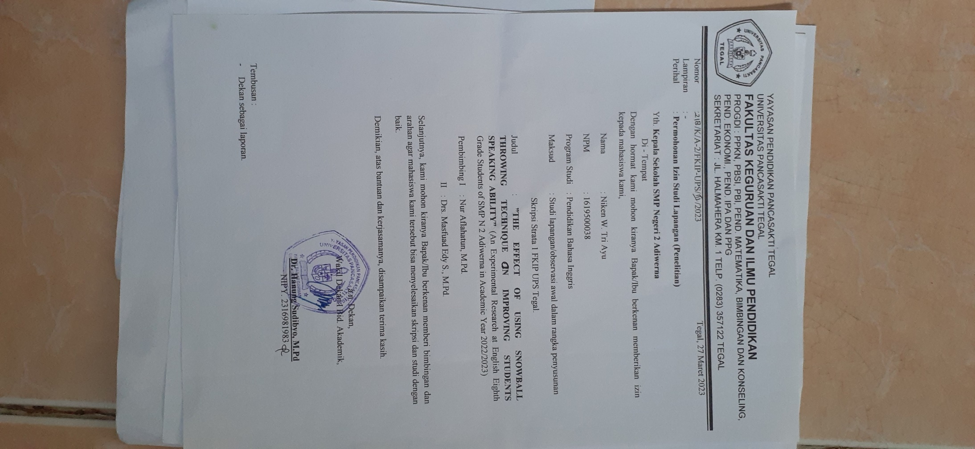

**Appendix 12** Certificate of Research Observation

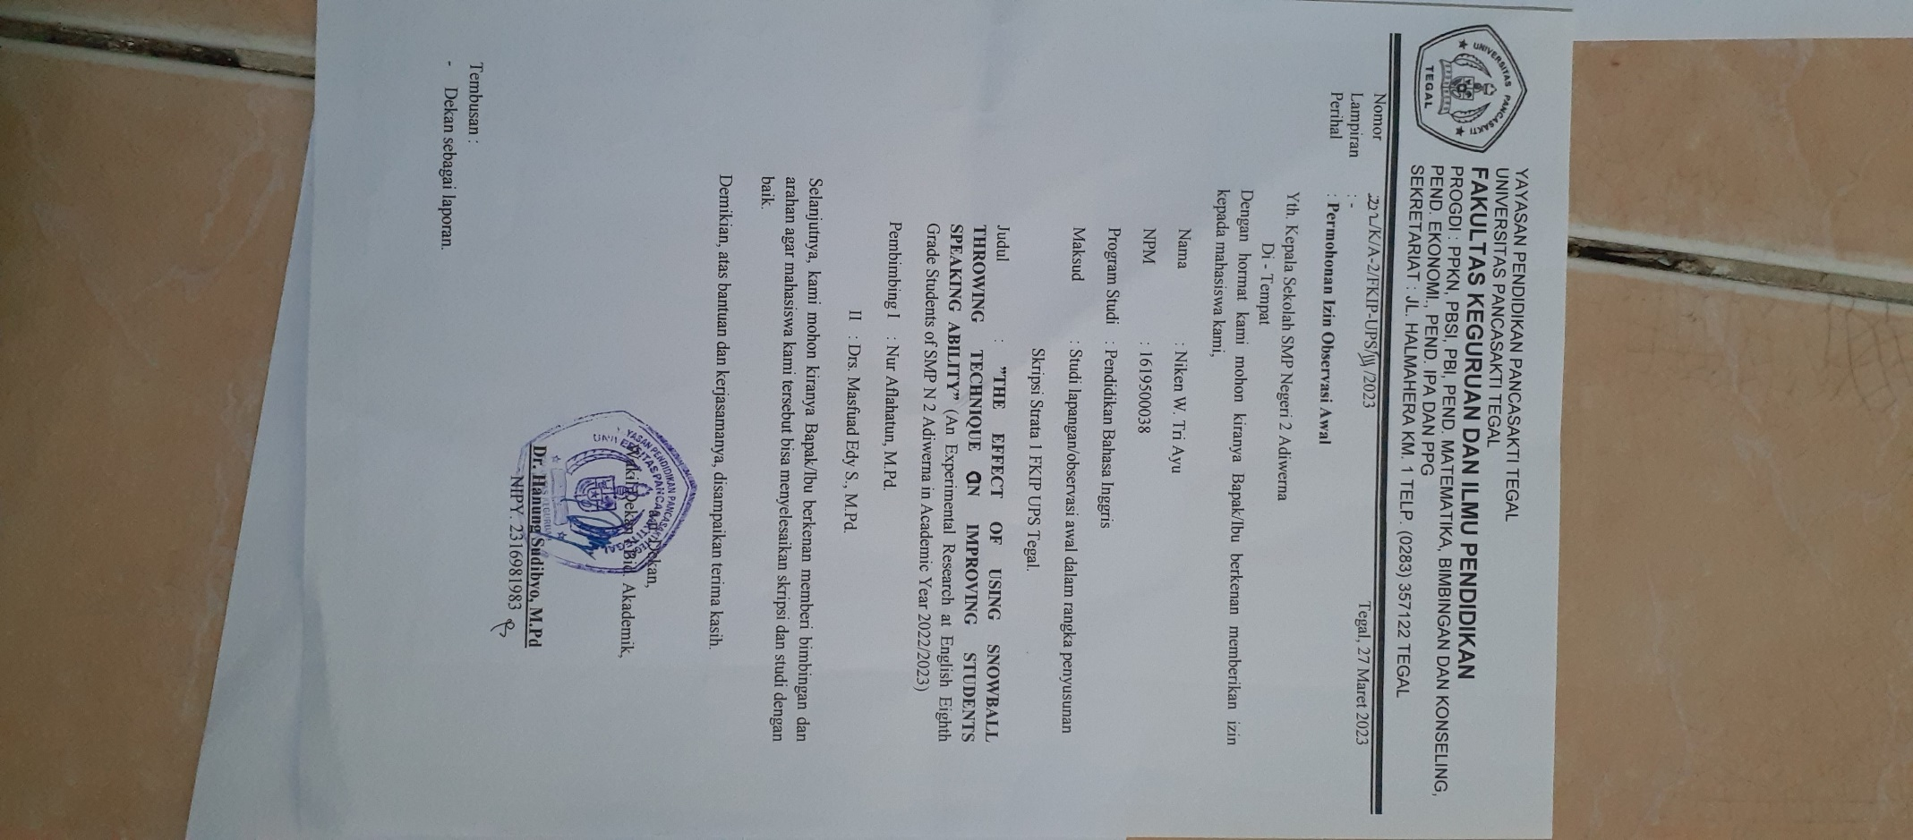

**Appendix 13** Certificate of Research Completion

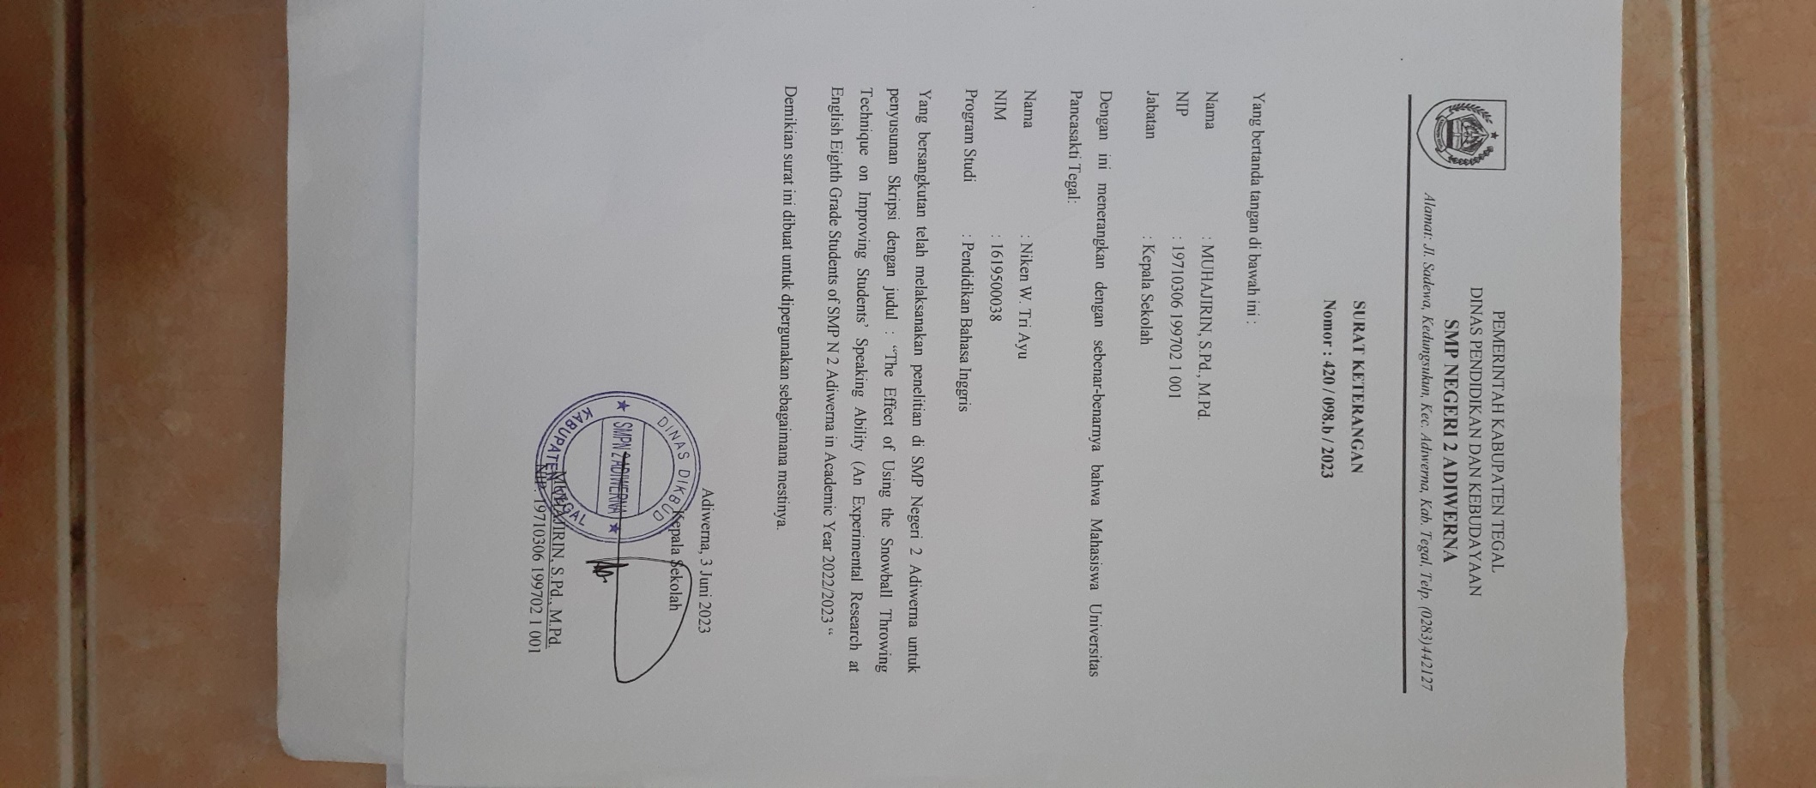

**Appendix 14** Research Documentation

