REFERENCES

ALQAHTANI, M. (2015). The importance of vocabulary in language learning and how to be taught. International Journal of Teaching and Education, III(3), 21–34. https://doi.org/10.20472/te.2015.3.3.002
Anitah, S. (2009). Educational technology. Surakarta : Yuma Pustaka Cohen,Louis, Manion Lawrence (2018). Quantitative data analyses. In Research
Methods in Physical Activity and Health (sixth edit). Canada : British Library Cataloguing
Damanik, J. Y. (2022). English vocabulary size of indonesian high school graduates: curriculum expectation and reality. Indonesian Journal of English Language Teaching and Applied Linguistics, 8(1), 49–58. http://dx.doi.org/10.21093/ijeltal.v3i2.278
Esmaeili, Z., & Shahrokhi, M. (2020). The impact of memrise application on iranian efl learners’ collocation learning and retention. International Journal of Language Education, 4(2), 221–233. https://doi.org/10.26858/ijole.v4i2.10672
Fadhilawati, D. (2016). Learning and reviewing vocabulary through memrise to improve students’ vocabulary achievement. JARES (Journal of Academic Research and Sciences), 1(2), 4. https://doi.org/10.35457/jares.v1i2.419
Fathi, J., Alipour, F., & Saeedian, A. (2018). Enhancing vocabulary learning and self-regulation via a mobile application : An Investigation of the Memrise App. Journal of Modern Research in English Language Studies, 5(1), 27–46. https://doi.org/https://doi.org/10.30479/jmrels.2019.10311.1282
Folse, K. S. (2004). Myths about teaching and learning second language vocabulary: what recent research says. TESL Reporter, 2, 1–13. https://journals.lib.byu.edu/spc/index.php/TESL/article/download/32544/307 04.https://journals.lib.byu.edu/spc/index.php/TESL/article/download/32544/ 30704

71

Hiebert, Elfrieda H. Kamil, M. L. (2005). Teaching and learning vocabulary ( bringing research to practice ). London : Lawrence Erlbaum Associates.
Kainta, E., & Rombot, J. E. (2020). Exploring students’ motivation and vocabulary achievement through labeling method. Journal for Language and Foreign Language Learning, 9(1), 1–17. https://doi.org/10.21580/vjv9i14509
Kassim, H. M., & Said, N. M. (2020). The integration of mobile learning among ESL teachers to enhance vocabulary learning. Journal Indonesian Institute for Counseling, Education and Therapy (IICET), 1(2), 28–36. https://doi.org/https://doi.org/10.2921/07essr55400 Contents
Mukoroli, J. (2011). Effective vocabulary teaching strategies for the english for academic purposes esl classroom. MA TESOL Collection, , 1(1), 53. https://digitalcollections.sit.edu/ipp_collection/501
Musfiqon. (2012). Development of learning media and sources. Prestasi Pustaka Publishers. http://library.iainmataram.ac.id//index.php?p=show_detail&id=16242
Nababan, D. L., & Simanjuntak, Y. L. (2023). The effect of using youtube in teaching vocabulary for first year students at sma negeri 1 tanah Jawa. Indonesian Journal of Education Science and Technology (Nurture), 2(1), 163–174. https://doi.org/https://doi.org/10.55927/nurture.v2i1.3260
Nation, I. S. . (2004). Learning Vocabulary in Another Language I. In The press syndicate of the university of cambridge (Vol. 23, Issue 1). https://doi.org/10.1016/s0889-4906(02)00014-5
Nuralisah, A. S., & Kareviati, E. (2020). The effectiveness of using memrise application in teaching vocabulary. PROJECT (Professional Journal of English Education), 3(4), 494. https://doi.org/10.22460/project.v3i4.p494-
500
Puspitarini, Y. D., & Hanif, M. (2019). Using learning media to increase learning motivation in Elementary School. Anatolian Journal of Education, 4(2), 53– 60. https://doi.org/10.29333/aje.2019.426a

Putri Aulia, M. S. (2022). Students’ perception toward memrise application as media in learning vocabulary. Jurnal Ilmiah Program Studi Pendidikan Bahasa Inggris, 13(1), 97–105.
Read, J. (2000). Assessing Vocabulary. In Cambridge University Press. https://doi.org/10.1017/cbo9780511732942
Rohim, R. F. (2022). The effect of memrise application towards students’ vocabulary mastery. Journal of English Language Learning, 6(2), 194–198. https://doi.org/10.31949/jell.v6i2.3656
Shavkidinova Dilna. (2022). Teaching english vocabulary through vocabulary classification techniques. European International Journal Of Multidisciplinary Research and Management Studies, 2(10 0ctober 2022), 189–201. https://doi.org/DOI: https://doi.org/10.55640/eijmrms-02-10-36
Sudrajat, D. (2020). Pengantar Statistika Pendidikan Disertai Aplikasi Program SPSS. In Pusat Kajian dan Budaya.
Sugiyono. (2010). prof. Dr. Sugiyono, Metode Penelitian Pendidikan, pendekatan kuantitatif. intro ( PDFDrive ).pdf (p. 12).
Taebenu, S. F., & Katemba, C. V. (2021). Vocabulary enhancement through memrise and google classroom. Language Literacy: Journal of Linguistics, Literature, and Language Teaching, 5(1), 228–241. https://doi.org/10.30743/ll.v5i1.3813
Taslim, T., Asrifan, A., Chen, Y., & NR, N. (2019). Correlation between student’s vocabulary mastery and speaking skill. Journal of Advanced English Studies, 2(2), 65. https://doi.org/10.47354/jaes.v2i2.64
Widayanto, A., Pratiwi, H., Leasa, M., & Duran, A. (2023). To boost students ’ motivation and achievement through blended learning. Journal of Physics : Conference Series. https://doi.org/doi :10.1088/1742-6596/1114/1/012046
Yu, X. (2020). English vocabulary teaching techniques at junior middle schools.
English Language Teaching, 13(11), 12. https://doi.org/10.5539/elt.v13n11p12

APPENDIX

Appendix.1 Lesson Plan

MODUL AJAR

MATA PELAJARAN BAHASA INGGRIS

- INFORMASI UMUM

Identitas Modul
Sekolah : SMA Negeri 1 Bulakamba
Tahun : 2022/2023
Kelas/Fase : X / E
Alokasi waktu : 12 x 45 menit
Elemen : Menyimak, Membaca, dan Menulis Unit Kompetensi : Recount Text

Capaian Pembelajaran
Pada akhir fase E, siswa menggunakan teks lisan, tulisan dan visual dalam Bahasa Inggris untuk berkomunikasi sesuai dengan situasi, tujuan, dan permirsa/pembacanya. Berbagai jenis teks seperti narasi, deskripsi, prosedur, eksposisi, recount, report dan teks asli menjadi rujukan utama dalam mempelajari Bahasa Inggris di fase ini. Siswa memproduksi teks tulisan dan visual yang lebih beragam, dengan kesadaran terhadap tujuan dan target pembaca.
  - Sarana dan Prasarana
Sarana : Laptop, LCD, Gawai
Media : PPT, Gambar, Grup WhatsApp, dan aplikasi Memrise
  - Target Peserta Didik 35 peserta didik
  - Pendekatan, model dan metode pembelajaran
Pendekatan pembelajaran : Scientific Approach ( Pendekatan Ilmiah) Model pembelajaran : Problem Based Learning ( PBL )
Metode pembelajaran : Ceramah, Diskusi, Penugasan

- KOMPETENSI INTI
  - Tujuan Pembelajaran
    - Peserta didik mampu menyimpulkan makna (C2) fungsi sosial, struktur text dan unsure kebahasaan dari teks recount tulisan dan visual tentang pengalaman pribadi.
    - Peserta didik mampu menganalis (C4) makna, Gambaran umum dari teks recount terkait topic pengalaman pribadi.
    - Peserta didik mampu mengevaluasi (C5) fungsi sosial, struktur text dan unsure kebahasaan dari teks recount terkait topic pengalaman pribadi .
  - Pemahaman makna
Peserta didik mampu merangkai dan menyampaikan ide komplek dengan mengunakan kosa kata dan tata Bahasa dalam tulisan.
  - Pertanyaan Pemantik
    - Apa hobi anda ketika masih kecil ?
    - Apa pengalaman yang paling berkesan bagi anda saat masih kecil dulu ?

  - Kegiatan Pembelajaran

Pertemuan pertama
Kegiatan Awal (10 Menit)
- Guru menyapa peseta didik
- Guru meminta salah satu peserta didik untuk memimpin do’a.
- Guru mengecek kehadiran peserta didik dan menyampaikan motivasi tentang apa yang dapat diperoleh (tujuan & manfaat) dengan mempelajari materi.
-Guru memberikan beberapa pertanyaan berdasarkan gambar untuk menstimulasi rasa ingin tahu peserta didik tentang topik yang akan dibahas:
- What were your hobbies as a child?
- What was your most memorable experience as a child?
- Guru menyampaikan tujuan pembelajaran yang ingin dicapai.
Kegiatan Inti (70 Menit)
-Peserta didik diminta untuk memirsa cerita tentang personal recount text melalui powerpoint melalui pendekatan saintifik
- Guru memberikan contoh materi personal recount text melalui powepoint untuk dapat dikembangkan peserta didik.
- Peserta didik diminta untuk menyebutkan kosakata dalam cerita tersebut yang mereka ketahui artinya .
- Peserta didik diminta untuk menuliskan kosakata yang sudah merka ketahui artinya dalam buku masing-masing .
- Peserta didik diminta untuk mempresentasikan hasil dari kosakata yang diperoleh didepan kelas .
-Guru mengenalkan dan menjelaskan aplikasi memrise dan meminta siswa untuk mengunduhnya pada masing masing smartphone mereka untuk pembelajaran selanjutnya .

Kegiatan Penutup (10 Menit)
-Peserta didik diminta menyimpulkan hasil pembelajaran.
- Peserta didik diminta membahas kesulitan terkait proses pembelajaran.
-Guru menyampaikan rencana pembelajaran pada pertemuan
berikutnya.

Pertemuan kedua
Kegiatan Awal (10 Menit)
- Guru memberi salam dan mempersilahkan ketua kelas untuk memimpin doa
-Guru mengecek kehadiran peserta didik dan meminta peserta didik untuk mengecek kebersihan kelas
-Guru bersama dengan peserta didik mengulas materi pembelajaran di pertemuan sebelumnya
-Guru memberi motivasi kepada peserta didik untuk memulai
pembelajaran
Kegiatan Inti (70 Menit)
- Guru memberikan beberapa contoh tentang personal recount text.
- Guru menjelaskan unsur kebahasaan yang pertama yaitu : specific participant yang ada dalam contoh cerita personal recount text .
- Guru mengajak siswa untuk mempelajari dan mengingat arti kata serta mendengarkan cara pengucapan kosakata yang dibicarakan oleh native speaker dalam bentuk flashcard yang ada di aplikasi memrise dengan topic tentang “pronouns” .
- Setelah siswa selesai mempelajari kosakata dalam bentuk
flashcard yang ada di aplikasi memrise, guru menjelaskan fungsi sosial dan jenis-jenis pronouns

- Dengan bimbingan dan arahan dari guru siswa diminta untuk membuat kalimat sederhana yang berkaitan dengan teks recount
.
Kegiatan Penutup (10 Menit)
-Peserta didik diminta menyimpulkan hasil pembelajaran.
-Peserta didik diminta membahas kesulitan terkait proses pembelajaran.
-Guru menyampaikan rencana pembelajaran pada pertemuan
berikutnya

Pertemuan ketiga
Kegiatan Awal(10 Menit)
-Guru memberi salam dan mempersilahkan ketua kelas untuk memimpin doa
-Guru mengecek kehadiran peserta didik dan meminta peserta didik untuk mengecek kebersihan kelas
-Guru bersama dengan peserta didik mengulas materi pembelajaran di pertemuan sebelumnya
-Guru memberi motivasi kepada peserta didik untuk memulai
pembelajaran
Kegiatan Inti (70 Menit)
- Guru mengajak siswa mengulas kembali fungsi sosial dari personal recount text
- Guru menjelaskan materi tentang past tense yang termasuk dalam unsur kebahasaan personal recount text
- Guru mengajak siswa untuk mempelajari dan mengingat arti kata serta mendengarkan cara pengucapan kosakata yang dibicarakan oleh native speaker dalam bentuk flashcard yang ada di aplikasi memrise dengan topic tentang “Bercerita tentang
liburan” .

- Guru meminta beberapa siswa untuk menyebutkan kosakata dalam bentuk kata kerja kedua yang telah mereka pelajari di aplikasi memrise
Kegiatan Penutup (10 Menit)
-Peserta didik diminta menyimpulkan hasil pembelajaran.
-Peserta didik diminta membahas kesulitan terkait proses pembelajaran.
Guru menyampaikan rencana pembelajaran pada pertemuanberikutnya

Pertemuan keempat
Kegiatan Awal (10 Menit)
-Guru memberi salam dan mempersilahkan ketua kelas untuk memimpin doa
-Guru mengecek kehadiran peserta didik dan meminta peserta didik untuk mengecek kebersihan kelas
-Guru bersama dengan peserta didik mengulas materi pembelajaran di pertemuan sebelumnya
-Guru memberi motivasi kepada peserta didik untuk memulai
pembelajaran
Kegiatan Inti (70 Menit)
- Guru menjelaskan unsur kebahasaan berikutnya yaitu berkaitan dengan action verb yang ada di personal recount text
- Pemberian materi dan latihan kosakata menggunakan aplikasi memrise dalam bentuk flashcard.
- Peserta didik diminta untuk mengerjakan fitur penyusunan kata
yang benar dalam aplikasi memrise
Kegiatan Penutup (10 Menit )
-Peserta didik diminta menyimpulkan hasil pembelajaran.
-Peserta didik diminta membahas kesulitan terkait proses

pembelajaran.
-Guru menyampaikan rencana pembelajaran pada pertemuan berikutnya
Pertemuan kelima
Kegiatan Awal (10 Menit)
-Guru memberi salam dan mempersilahkan ketua kelas untuk memimpin doa
-Guru mengecek kehadiran peserta didik dan meminta peserta didik untuk mengecek kebersihan kelas
-Guru bersama dengan peserta didik mengulas materi pembelajaran di pertemuan sebelumnya
-Guru memberi motivasi kepada peserta didik untuk memulai
pembelajaran
Kegiatan Inti (70 Menit)
-Guru menjelaskan unsur kebahasaan berikutnya yaitu berkaitan dengan chronological connection yang ada di personal recount text
- Guru meminta siswa untuk mempelajari kosakata yang ada di aplikasi memrise
- Guru meminta siswa menyusun kata yang masih acak hingga benar
yang ada di fitur aplikasi memrise untuk mengetes ingatan siswa
Kegiatan penutup (10 Menit)
- Guru memberikan apresiasi atau umpan balik terhadap proses pembelajaran
-Peserta didik bersama dengan guru membuat kesimpulan dari proses Pembelajaran
-Guru mengakhiri pertemuan dengan memberikan salam

Pertemuan keenam
Kegiatan Awal (10 Menit)
-Guru memberi salam dan mempersilahkan ketua kelas untuk memimpin doa
-Guru mengecek kehadiran peserta didik dan meminta peserta didik untuk mengecek kebersihan kelas
-Guru bersama dengan peserta didik mengulas materi pembelajaran di pertemuan sebelumnya
-Guru memberi motivasi kepada peserta didik untuk memulai
pembelajaran
Kegiatan Inti (70 Menit)
-Guru menjelaskan unsur kebahasaan berikutnya yaitu berkaitan dengan materi adverbs and adverbial phrases yang ada di personal recount text
- Guru meminta siswa untuk mempelajari kosakata yang ada di aplikasi memrise dengan topik “Berwisata”
- Guru meminta siswa menyusun kata yang masih acak hingga benar
yang ada di fitur aplikasi memrise untuk mengetes ingatan siswa
Kegiatan Penutup (10 Menit )
-Guru memberikan apresiasi atau umpan balik terhadap proses pembelajaran
-Peserta didik bersama dengan guru membuat kesimpulan dari proses Pembelajaran
-Guru mengakhiri pertemuan dengan memberikan salam

- Penilaian Hasil Pembelajaran
a. Penilaian Sikap: Observasi dalam proses pembelajaran

No | Nama Siswa |  | Aspek Perilaku yang  Dinilai |  |  |  | Jumlah Skor | Skor Sikap | Kode Nilai
 |  |  | BS | JJ | TJ | DS
1
2
Keterangan:
- BS : Bekerja Sama
- JJ : Jujur
- TJ : Tanggun Jawab
- DS : Disiplin

b.Penilaian Pengetahuan: Tes bentuk pilihan ganda

No | Aspek yang Dinilai | Skor
1 | Keaslian Penulisan
2 | Kesesuaian Jawaban
3 | Kerapihan

c. Penilaian Keterampilan: Praktek pengucapan dengan intonasi dan tekanan kata yang baik dan benar.

No | Aspek yang Dinilai | Skor
1 | Pengucapan (pronounciation)
2 | Intonasi (intonation)
3 | Kelancaran (fluency)
4 | Ketepatan Makna (accuracy)

Skor/Kode Nilai:
75,01 – 100,00 = Sangat Baik (SB)
50,01 – 75,00 = Baik (B)
25,01 – 50,00 = Cukup (C)
00,00 – 25,00 = Kurang (K)

Brebes, … Juni 2023
Mengetahui,  Guru Mata Pelajaran  Mona Elynda, M.Pd  NIP. 197203152008012014 | Mahasiswa Praktikan,  Jayanti Mandasari NPM 1619500064

Appendix. 2 Result Validity (R-Product)

Item | rhitung | rtabel | keterangan
Soal_1 | -0,009 | 0,349 | Tidak valid
Soal_2 | 0,207 | 0,349 | Tidak valid
Soal_3 | 0,318 | 0,349 | Tidak valid
Soal_4 | 0,334 | 0,349 | Tidak valid
Soal_5 | 0,4 | 0,349 | Valid
Soal_6 | 0,286 | 0,349 | Tidak valid
Soal_7 | 0,457 | 0,349 | Valid
Soal_8 | 0,615 | 0,349 | Valid
Soal_9 | 0,753 | 0,349 | Valid
Soal_10 | 0,688 | 0,349 | Valid
Soal_11 | 0,424 | 0,349 | Tidak valid
Soal_12 | 0,275 | 0,349 | Tidak valid
Soal_13 | 0,336 | 0,349 | Valid
Soal_14 | 0,357 | 0,349 | Valid
Soal_15 | 0,201 | 0,349 | Valid
Soal_16 | 0,415 | 0,349 | Valid
Soal_17 | 0,478 | 0,349 | Valid
Soal_18 | 0,715 | 0,349 | Valid
Soal_19 | 0,615 | 0,349 | Valid
Soal_20 | 0,753 | 0,349 | Valid
Soal_21 | 0,688 | 0,349 | Valid
Soal_22 | 0,25 | 0,349 | Tidak valid
Soal_23 | 0,314 | 0,349 | Tidak valid
Soal_24 | 0,98 | 0,349 | Tidak valid
Soal_25 | 0,406 | 0,349 | Valid
Soal_26 | 0,313 | 0,349 | Tidak valid
Soal_27 | 0,318 | 0,349 | Tidak valid
Soal_28 | 0,518 | 0,349 | Valid
Soal_29 | 0,83 | 0,349 | Tidak valid
Soal_30 | 0,32 | 0,349 | Tidak valid
Soal_31 | 0,45 | 0,349 | Tidak valid
Soal_32 | 0,522 | 0,349 | Valid
Soal_33 | 0,254 | 0,349 | Tidak valid
Soal_34 | 0,362 | 0,349 | Valid
Soal_35 | 0,559 | 0,349 | Valid

Soal_36 | 0,384 | 0,349 | Valid
Soal_37 | 0,673 | 0,349 | Valid
Soal_38 | 0,387 | 0,349 | Valid
Soal_39 | 0,603 | 0,349 | Valid
Soal_40 | 0,615 | 0,349 | Valid
Soal_41 | 0,753 | 0,349 | Valid
Soal_42 | 0,688 | 0,349 | Valid
Soal_43 | 0,695 | 0,349 | Valid
Soal_44 | 0,593 | 0,349 | Valid
Soal_45 | 0,429 | 0,349 | Valid
Soal_46 | 0,659 | 0,349 | Valid
Soal_47 | 0,431 | 0,349 | Valid
Soal_48 | 0,564 | 0,349 | Valid
Soal_49 | 0,361 | 0,349 | Valid
Soal_50 | 0,691 | 0,349 | Valid
Soal_51 | 0,593 | 0,349 | Valid
Soal_52 | 0,429 | 0,349 | Valid
Soal_53 | 0,387 | 0,349 | Valid
Soal_54 | 0,414 | 0,349 | Valid
Soal_55 | -0,034 | 0,349 | Tidak valid
Soal_56 | 0,578 | 0,349 | Valid
Soal_57 | 0,615 | 0,349 | Valid
Soal_58 | 0,753 | 0,349 | Valid
Soal_59 | 0,688 | 0,349 | Valid
Soal_60 | 0,211 | 0,349 | Tidak valid

Appendix.3 Instrument Test

INSTRUMENT

The text is for numbers 1-2.
Last week my friend and I were bored after three weeks of holidays, so we rode our bikes to Smith Beach, which is only five kilometers from where I live. When we arrived at the beach, we were surprised to see there was hardly anyone there. After having a quick dip in the ocean, which was really cold, we realized one reason there were not many people there. It was also quite windy.
After we bought some hot chips at the takeaway store nearby, we rode our bikes down the beach for a while, on the hard, damp part of the sand. We had the wind behind us and, before we knew it, we were many miles down the beach. Before we made the long trip back, we decided to paddle our feet in the water for a while, and then sit down for a rest. While we were sitting on the beach, just chatting, it suddenly dawned on us that all the way back, we would be riding into the strong wind.
When we finally made it back home, we were both totally ex- hausted! But we learned so- me good les- sons that day.

- "We were both totally exhausted.... The bold word can be best replaced with .....
  - Happy
  - Amazed
  - very tired
  - pleasure
  - Shock

- “We rode our bike to Smith Beach” Based on the sentence above, which is included in the verb in the sentence
is….?
  - Bike C. Bring E. We
  - Rode D. Our

The text is for numbers 3-5.
Last week was a hectic week. I have been touring East Java and Bali. There were so many things that I've experienced that it's difficult to write about all of them.
I arrived in Yogyakarta, on Sunday. I stayed in a cheap accommodation, a wisma. The room was clean and I could get hot water to bathe. On Monday, I went with a tour group to visit Borobudur and the Hindu temples in Prambanan. Some of these temples are more than twelve hundreds years old. They date well beyond the churches in my hometown in Europe. I was amazed at the enormity of the construction. I'm sure they did not have the heavy machines we have today to raise and lay those huge blocks of stone. The carvings on the walls were another feature of the construction.
I'm getting used to the spicy food served here. I have eaten fresh fish, lamb and beef. I know you don't eat all this but I've got used to it. On Tuesday I decided to go for a hike to Mount Merapi. But I found out it was a difficult climb. So I went to the forest park in Kaliurang. That was a lovely walk that made me hot and tired. But I managed to cool off in a waterfall in the park then walked up to a hill nearby where I could see the smoky, fiery Mount Merapi.
- The writer comes from ....
  - Bali
  - Europe
  - Surabaya
  - East Java
  - Yogyakarta
- “I was amazed at the enormity at the construction.” The bold word mean that the construction is very....

  - Huge
  - Large
  - good.
  - Small
  - Interesting
- From the text we can conclude that the writer ....
  - enjoyed the tour
  - liked mountain climbing
  - had experienced in writing
  - was used to eating spicy food
  - visited Yogyakarta a week before

The text is for questions numbers 6-9.
MY UNLUCKY DAY
Last wednesday, I (6)….. late to my school because play playstation untill 00 am in the night Because that I wake up late.
I woke up about 6.30 am and the class would be begun at 7:00 am I ran to bathroom to take a bath. I usually have a breakfast after took a bath, but in that day, I (7)……do that.
I always go to school by my motorcycle. But in that day, I forget where I put the key. So, I (8)…… to the school by public transportation. It makes me take a longer time. I arrive at school at 7.15 am, I run to my class but I see my teacher has stood in front of the class to teach. I entered my class and of course my teacher was angry to me becausel came late
It (9)… my bad experience and I promised I would not do that again.
- A. is coming
- come
- have came
- came
- did not come
- A. was not
- am not

- did not
- does not
- have not
  - am going
  - went
  - go
  - gone
  - was not go
- A. was
- were
- is
- are
- it

The text is for questions numbers 10-12.

It was my first day of class. I finally 10. my class. The room was already
full of students. On one side of the room, some students 11 busily to each
other. I chose an empty seat in the last row and 12……down.
- A. found
- Find
- had found
- was found
- E. was finding
- A. talked
- talking
- was talking
- were talking
- are talking

- A.sitting
- sat
- was sat
- was sitting
- sit
Arrange the following words into good sentences! At yesterday they the lunch had Restaurant 1 2 3 4 5 6 7
- The correct arrangement is ….. A. 4 – 3 – 5 – 6 – 1 – 2 – 7
B. 4 – 5 – 6 – 1 – 2 – 3 – 4
C. 3 – 6 – 5 – 1 – 4 – 7 – 2
D. 3 – 6 – 5 – 7 – 1 – 4 – 2
E. 3 – 5 – 6 – 4 – 1 – 2 – 7

Arrange the following words into good sentences!
School from the year last I graduated 1 2 3 4 5 6 7
- The correct arrangement is ….. A. 5 – 4 – 3 – 7 – 6 – 2 – 1
B. 5 – 4 – 6 – 1 – 2 – 3 – 7
C. 6 – 7 – 2 – 3 – 1 – 5 – 4
D. 6 – 2 – 7 – 1 – 5 – 3 – 4
E. 7 – 2 – 6 – 3 – 5 – 4 – 1
- “She never gave up.”
What is the closest meaning of the bolded phrase?
  - Felt sorry
  - Surrendered
  - Complained
  - Fought against
  - worry

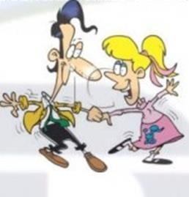
Choose the right answer to the question below! Choose the answer according to the picture
- , please
  - Swim
  - Run
  - Sing
  - Dance
  - Hold
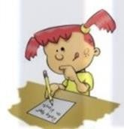
- , please
  - Draw
  - Paint
  - Write
  - Hold
  - Read
- My brother and I – Really – Last year – Was – Fat 1 2 3 4 5
A. 1-4-2-5-3
B. 1-5-4-2-3
C. 1-4-3-2-5
D. 1-2-4-3-5
E. 1-4-3-2-5

Sentences
(1) Last week Wulan asked me to visit her house in
Semarang
(2) One day I went to Bandung with i friend for a
vacation.
(3) We are busy everyday.
(4) we arrived in Cianjur yesterday
(5) We have been in Surabaya before

- From the five sentences above, choose the sentence that belongs to the time marker for the simple past tense !
- 1,3 and 5
- 1,2 and 3
- 1,2, and 5
- 1,2 and 4
- 2,4 and 5
- Did you ….. to Yoga’s wedding 2 days ago?
  - Gone
  - Go
  - Went
  - Going
  - Will go
- I went to Korea ……
  - Last week
  - Tomorrow
  - Next month
  - Now
  - Next week
- She ….. comic last night
  - Reads
  - Reading
  - Read
  - Readed
  - Will read
- Santi and Mira ….. a singer
  - Are
  - Was
  - Were
  - Is
  - Be

- …… didn’t …… a bag 3 days ago
  - Catur ; bought
  - Catur ; buy
  - Last night ; buy
  - Buy ; Catur
  - Bought ; Catur
- …. you watch the new episode last night?
  - Do
  - Does
  - Did
  - Done
  - Didn’t
- Lily …. a representative student last year
  - Were
  - Was
  - Did
  - Are
  - Is
- They ….. about you last night
  - Talk
  - Talking
  - Are talk
  - Talked
  - Will talk
- The following are examples of temporal conjunctions, except...
  - firstly
  - Then
  - Next
  - If
  - After that

- X: When did you do your homework?
Y: I ... my homework when you watched television.
- does
- am doing
- was doing
- has done
- were do
- Sam ... attend math class yesterday.
  - was not
  - were not
  - did not
  - does not
  - do not
- They built this house last year, so this house is ... A.mine
B.yours C.hers D.theirs
E. Ours
32 parents didn’t give him affection. So he will be a bad boy
- her
- he
- me
- his
- its
- Messi kicked the ball, We watched on TV last night
  - Her
  - his
  - him
  - us
  - Hers

- I found his home very
  - easy
  - difficultly
  - frequently
  - slowly
  - badly
- They called the police after the accident.
  - immediately
  - peacefully C.Slowly
D. frequently
E. bravely
- The manager looked at me with an expression when I reached late.
  - sad
  - angry
  - regret
  - happy
  - bashful
- Lina …… the match in Olympic Games. She is so sad.
  - won
  - lost
  - jumped
  - celebrated
  - Watched
- … you home last night?
  - Was
  - Were
  - Are
  - Did
  - is

- Mr. Angga Mr. Joe in the afternoon.
  - Meet
  - Have met
  - Has met
  - Met
  - Had met
- The following are examples of temporal conjunctions, except...
  - firstly
  - Then
  - Next
  - If
  - After that

KEY ANSWERS

1. C | 11. C | 21. A | 31. D
2. B | 12. B | 22. C | 32. D
3. B | 13. D | 23. A | 33. B
4. A | 14. C | 24. B | 34. B
5. C | 15. D | 25. C | 35. A
6. D | 16. D | 26. B | 36. B
7. C | 17. C | 27. D | 37. B
8. B | 18. A | 28. D | 38. B
9. A | 19. D | 29. C | 39. D
10. A | 20. B | 30. C | 40. D

Appendix.4 Results of the control class pretest-posttest

No | Nama | Score
 |  | Pre-test | Post-test
1. | Adam Prasetyo | 58 | 78
2. | Adinda Srihanifa | 70 | 80
3. | Adinda Zafiratuz Zahra | 63 | 83
4. | Ahmad Tohirin Pratama | 53 | 68
5. | Chasta Naila | 65 | 78
6. | Danu Raditiya | 65 | 73
7. | Dewi Anjani | 68 | 70
8. | Dewi Puspita Sari | 58 | 75
9. | Diah Ayu Fitriani | 70 | 78
10. | Fitri Febriani | 68 | 75
11. | Fitria Dwi Ramadhani | 60 | 65
12. | Fitriyani Nur Asari | 60 | 68
13. | Genia Dinara Sadrinah | 58 | 78
14. | Isma Sari | 60 | 70
15. | Kalimi | 78 | 83
16. | M.Tohid Zaenal Abidin | 63 | 68
17. | Mutiara Assyifa | 58 | 70
18. | Nadiyah Nur Hanifah | 65 | 68
19. | Bolivia Fitriani | 65 | 75
20. | Rafikhiar Ramadhan | 68 | 78
21. | Rahmat Tunisa | 78 | 80
22. | Rekhan Sebastian | 75 | 78
23. | Siti Nur Habibah | 75 | 85
24. | Sri Wulan Dari | 78 | 83
25. | Suhendra | 70 | 80
26. | Taniah Wati | 65 | 83
27. | Tiara Maulidiyah | 70 | 73
28. | Tri Maulia Nur Afiani | 73 | 75
29. | Umi Ayu Wulandari | 65 | 70
30. | Wafik Ajijah | 63 | 73
31. | Warsini Asih | 65 | 70
32. | Windi Saputri | 68 | 75
33. | Wisma | 63 | 73
34. | Yhuni Aryani | 68 | 80
35. | Yuni Azzahra | 70 | 83
36. | Yusika Alya Agustin | 73 | 80

Appendix. 5 Results of the experiment class pretest-posttest

No | Nama | Score
 |  | Pre-test | Post-test
1. | Adela Maelani | 68 | 80
2. | Adi Tri Tanjani | 73 | 88
3. | Anisa Eka Yulianti | 68 | 78
4. | Apriliani Al Afiansah | 58 | 80
5. | Asykal Irzava Elka | 70 | 75
6. | Aura Azalea Wahyu | 68 | 75
7. | Badii’atul Khamdi | 68 | 75
8. | Bunga Citra Lestari | 60 | 80
9. | Bunga Ira Isa Bella | 73 | 85
10. | Chelsea Septiana Rifski | 75 | 78
11. | Cinta Aulia | 60 | 75
12. | Dian Novisikin | 58 | 68
13. | Dwi Riski Anti | 60 | 65
14. | Fika Novelia Sari | 63 | 65
15. | Heni Saprika Utami | 78 | 80
16. | Maghfiroh Izzati Maulani | 65 | 70
17. | Meydita Putri Ramadhani | 63 | 78
18. | Mutiara Cinta | 68 | 75
19. | Nabila Syifa | 68 | 78
20. | Nandita Wulan Dari | 68 | 80
21. | Naenah Nurjanah | 78 | 88
22. | Nur Dirgahayu | 75 | 80
23. | Nur Hasan | 80 | 88
24. | Nuril Waheda | 83 | 90
25. | Nurrohman | 78 | 90
26. | Rahma Rhaisatunnisa | 78 | 83
27. | Rama Aditya | 75 | 80
28. | Rasya Aziz Saefullah | 75 | 78
29. | Rini Aprilia | 68 | 80
30. | Ririn Fadillah Nur Ilma | 60 | 68
31. | Risha Nur Fitri Oktavia | 65 | 68
32. | Samroh Hikmatun | 68 | 73
33. | Susilahwati | 70 | 73
34. | Wahyu Maulana Rokhman | 75 | 73
35. | Winayah | 73 | 88

Appendix.6 Attendence List of Students’ Control Group

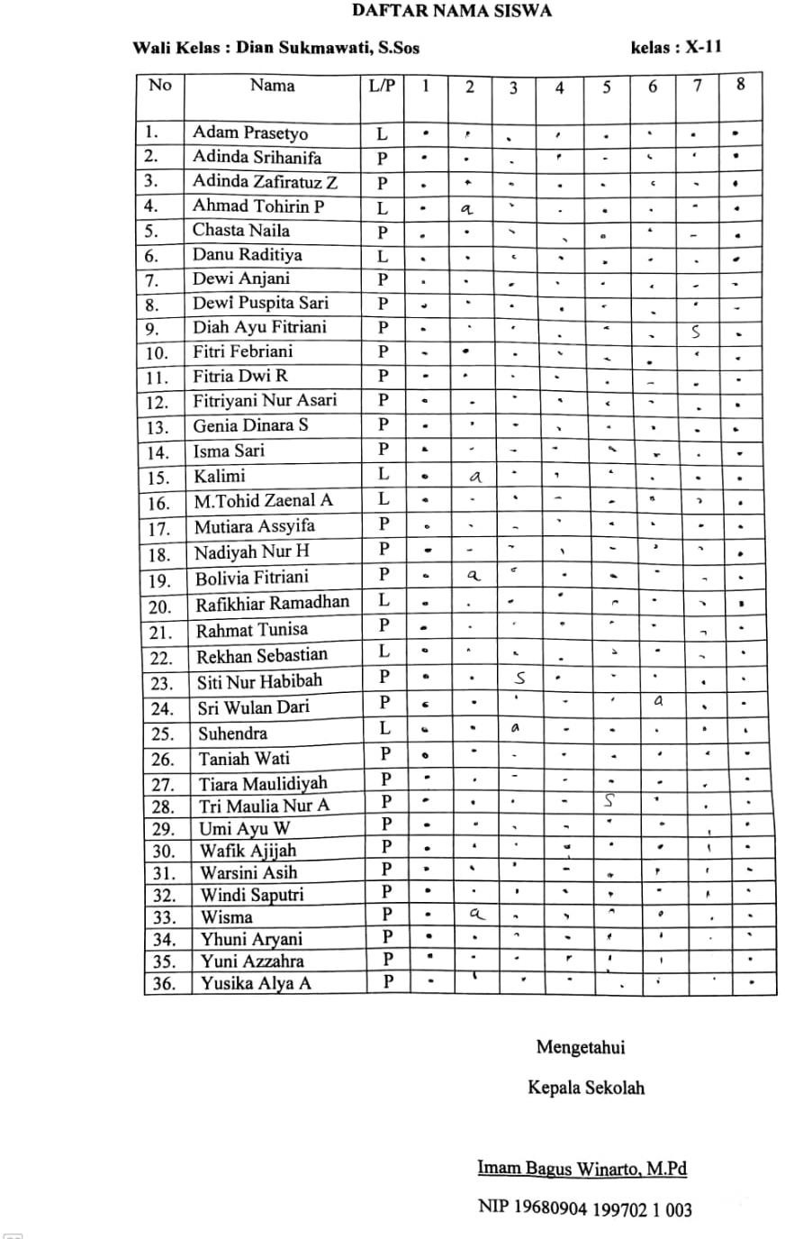

Appendix.7 Attendence List of Students’ Experiment Group

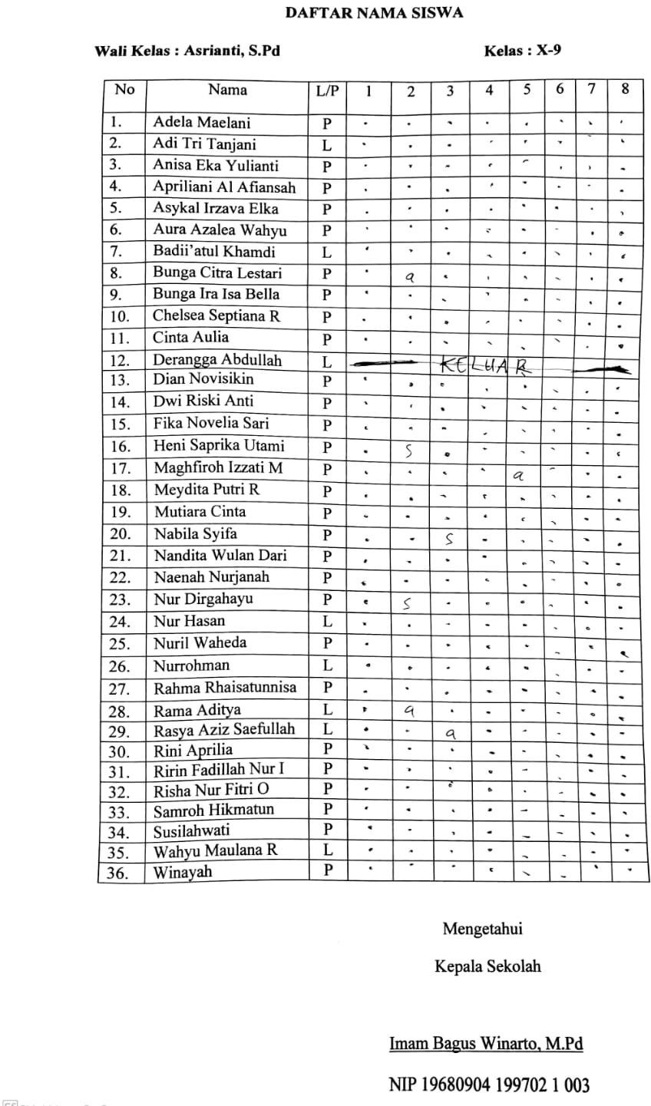

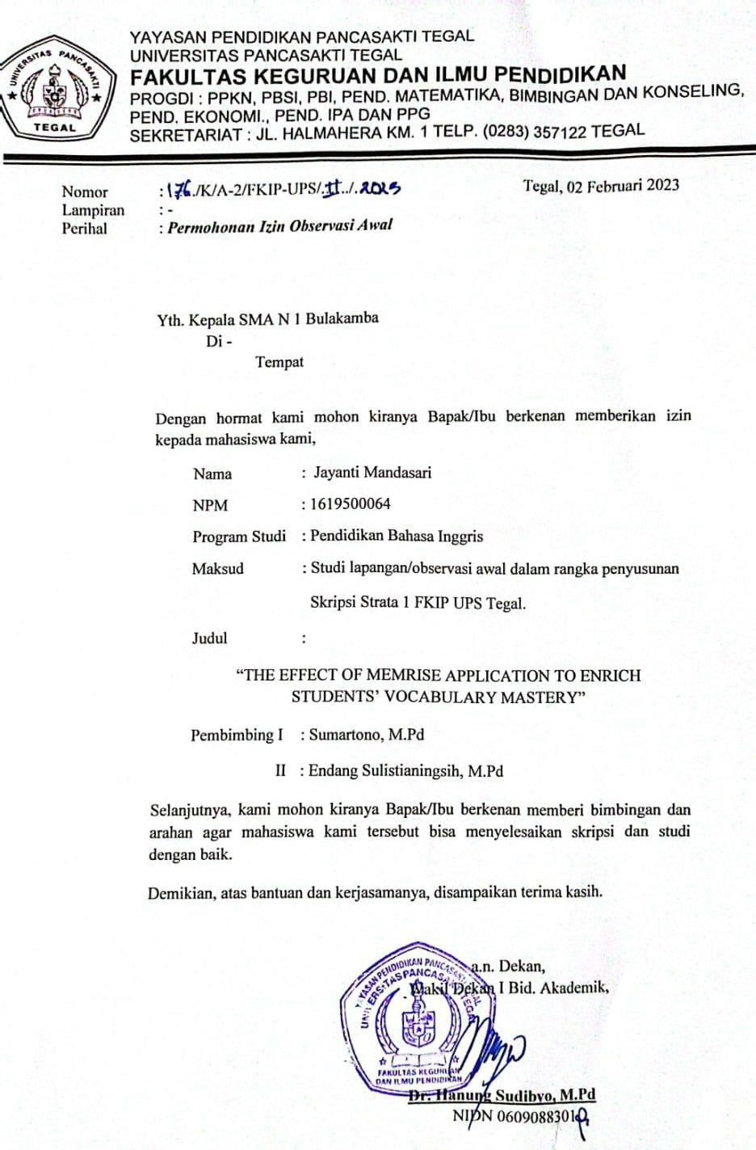

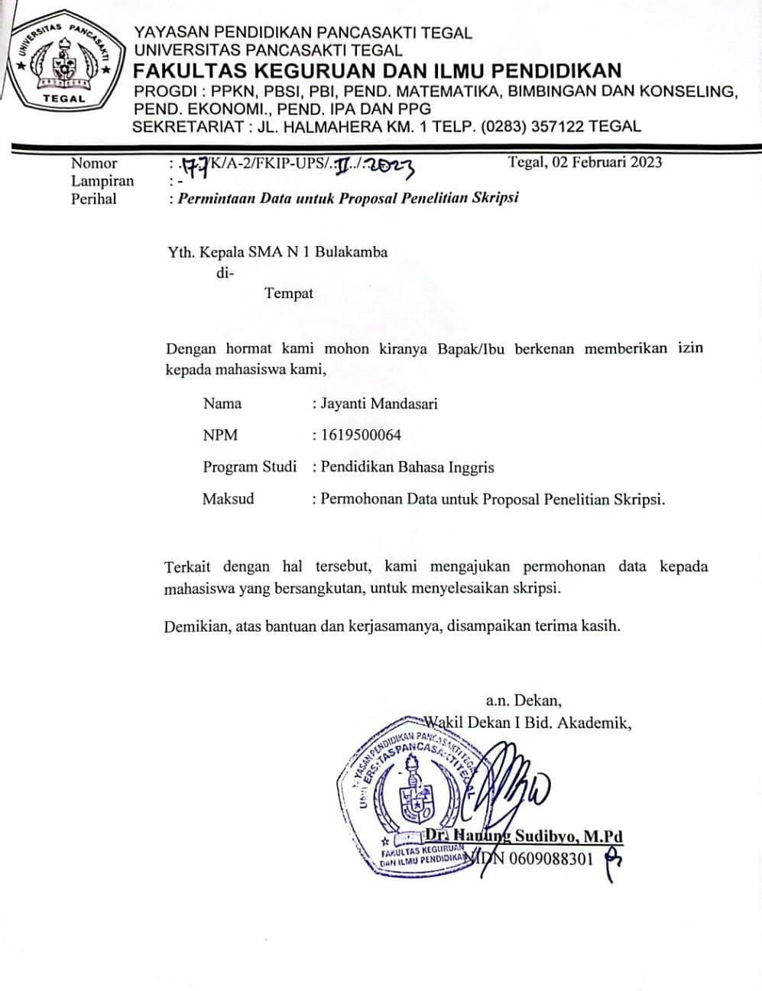

Documentation
