REFERENCES

As’ari, M. D., Budiman, R. A., Alam, R. M. N., & Aliviya, S. (2021). THE IMPLEMENTATION OF GRAMMAR TRANSLATION METHOD (GTM) IN THE DIGITAL LEARNING OF READING COMPREHENSION. 12(1), 29–40.
Audira, W. (2022). The Effectiveness of Using Guided Reading Strategy to Improve Students’ Reading Comprehension. 5(2), 1–9. https://doi.org/E-ISSN 2528-746X
Banditvilai, C. (2020). The Effectiveness Of Reading Strategies On Reading Comprehension. International Journal Of Social Science And Humanity, 10(2), 46–50. Https://Doi.Org/10.18178/Ijssh.2020.V10.1012
Elleman, A. M., & Oslund, E. L. (2019). Reading Comprehension Research: Implications For Practice And Policy. Policy Insights From The Behavioral And Brain Sciences, 6(1), 3–11. Https://Doi.Org/10.1177/2372732218816339
Fauzi, I., & Hanifah, D. (2019). Designing Reading Materials For ESP Students Vocational High School of Medical Science. Loquen: English Studies Journal, 12(1), 31. https://doi.org/10.32678/loquen.v12i1.1765
Grabe, W., & Stoller, F. L. (2013). Teaching And Researching Reading, Second Edition. In Teaching And Researching Reading, Second Edition. Https://Doi.Org/10.4324/9781315833743
Jumoke, O., & -Oyebanji, A. (2020). Research Variables: Types, Uses And Definition Of Terms Evaluation View Project. July. Https://Www.Researchgate.Net/Publication/342897909

Kindy, A. M. Z. Al, Shah, I. M., & Jusoh, A. (2016). Consideration And Methodological Approaches In Studying Transformational Leadership Impact On Work Performance Behaviors. International Journal Of Advanced Research (Ijar), 4(1), 889–907. Http://Www.Journalijar.Com/Uploads/755_Ijar-8565.
Küçükoğlu, H. (2013). Improving Reading Skills Through Effective Reading Strategies. Procedia - Social and Behavioral Sciences, 70(April), 709–714. https://doi.org/10.1016/j.sbspro.2013.01.113
Kurniawan, R., Miftah, M. Z., & Qamariah, Z. (2021). Grammar-translation method affects students’ reading comprehension and motivation. International Journal of Research on English Teaching and Applied Linguistics, 1(1), 7–15. https://doi.org/10.30863/ijretal.v1i1.1194
Megawati. (2017). The improving student ’s reading comprehension Through Grammar Translation Method. The Improving Student ’s Reading Comprehension Through Grammar Translation Method, 2, 95–108. https://doi.org/2503 – 4405
Muhid, A., Amalia, E. R., Hilaliyah, H., Budiana, N., & Wajdi, M. B. N. (2020). The Effect Of Metacognitive Strategies Implementation On Students’ Reading Comprehension Achievement. International Journal Of Instruction, 13(2), 847–862. Https://Doi.Org/10.29333/Iji.2020.13257a
Özdemir, E. Ç., & Akyol, H. (2019). The Development Of A Reading Comprehension Test. Universal Journal Of Educational Research, 7(2), 563–570. Https://Doi.Org/10.13189/Ujer.2019.070229
Sari, D. K., Pratiwi, E., & Thereana, A. (2018). Effective Reading Strategies for Reading Skills. Esteem Journal of English Education Study Programme, 2(2), 112. https://doi.org/10.31851/esteem.v2i2.2429
Sürücü, L. (2020). Validity And Reliability In Quantitative Research Business & Management Studies : October. Https://Doi.Org/10.15295/Bmij.V8i3.1540
Susanti, E. (2020). A Study on English Department Students’ Reading Strategies at English Department UNP. Journal of English Language, 9(2). http://ejournal.unp.ac.id/index.php/jell
Tisngati, U., Meifiani, N. I., Cahyani, D., & Apriyani, N. (2020). Prospective Teachers ’ Understanding And Difficulties In Implementing Research Using Experimental Design. 397(Icliqe 2019), 1077–1086.
Ulker, U. (2017). Reading Comprehension Strategies. International Journal Of Social Sciences & Educational Studies, 4(3), 140–145. Https://Doi.Org/10.23918/Ijsses.V4i3p140
Zulkarnain, & Bidarita, W. (2021). THE EFFECTIVENESS OF GRAMMAR TRANSLATION METHOD IN TEACHING READING AT FIFTH SEMESTER OF AHWAL AS_SYAKHSIYAH OF STIS DARUL FALAH MATARATHE EFFECTIVENESS OF GRAMMAR TRANSLATION METHOD IN TEACHING READING AT FIFTH SEMESTER OF AHWAL AS_SYAKHSIYAH OF STIS DAR. 1(01), 1–9.

APPENDICES

Appendix 1: Research Permission Letter

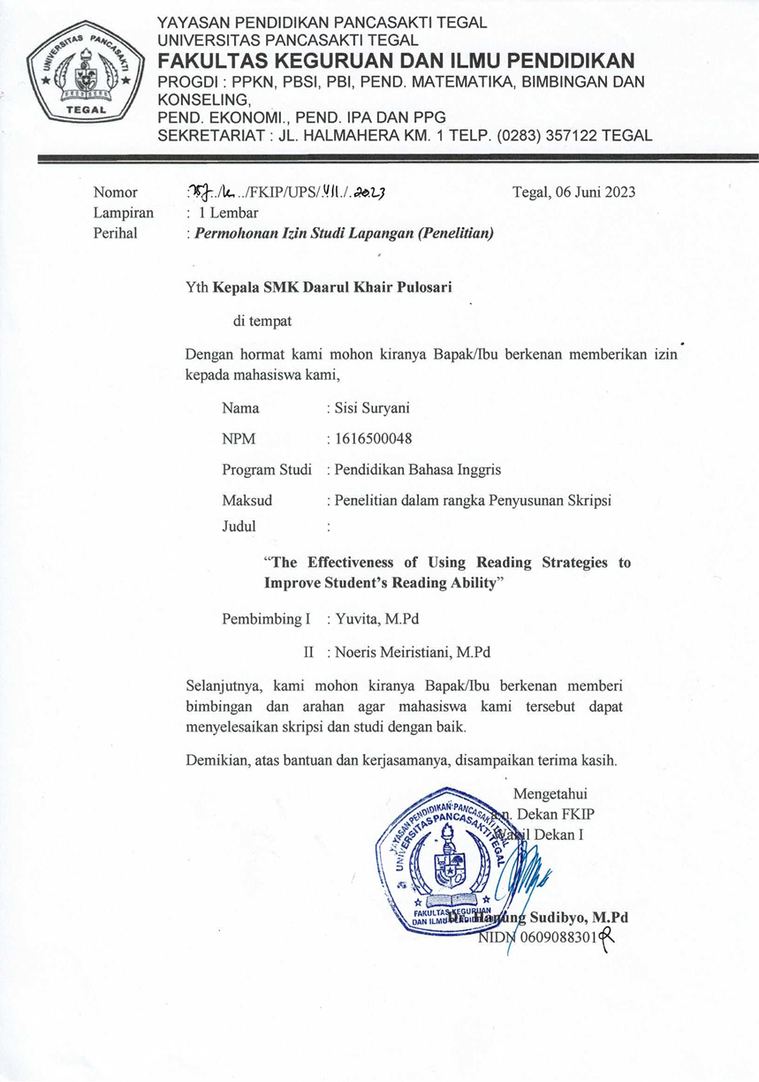

Appendix 2: Lesson Plan

RENCANA PELAKSANAAN PEMBELAJARAN (RPP)

Satuan Pendidikan : SMK Daarul Khair
Mata Pelajaran : Bahasa Inggris
Topik : Narrative Text
Kelas /Semester : X/ Genap

Tahun Pelajaran : 2022/2023

Pembelajaran ke : 1-4

Alokasi Waktu : 360 Menit

- Kompetensi Inti
KI 1. Menghayati dan mengamalkan ajaran agama yang dianutnya

KI 2. Menghayati dan mengamalkan perilaku jujur, disiplin dan tanggung jawab, peduli (gotong royong, kerjasama, toleran, damai) santun, responsif, pro aktif dan menunjukan sikap sebagai bagian atas solusi berbagai permasalahan bangsa dalam berinteraksi secara efektif dengan lingkungan social dan alam semesta dalam menempatkan diri sebagai cerminan bangsa dalam pergaulan dunia

KI 3. Memahami, menerapkan, menganalisis dan mengevaluasi tentang pengetahuan factual, konseptual, procedural, dan metakognitif sesuai dengan bidang dan lingkup kajian Bahasa Inggris pada tingkat teknis spesifik, detil dan kompleks, berkenan dengan ilmu pengetahuan, teknologi, seni, budaya dan humaniora dalam konteks pengembangan potensi diri sebagai bagian dari keluarga, sekolah, dunia kerja, masyarakat nasional, regional dan internasional.

KI 4. Melaksanakan tugas spesifik dengan menggunakan alat, informasi, dan prosedur kerja yang lazim dilakukan serta memecahkan masalah sesuai dengan bidang kajian Bahasa Inggris. Menampilkan kinerja di bawah bimbingan dengan mutu dan kuantitas yang terukur sesuai dengan standar kompetensi kerja. Menunjukkan keterampilan menalar, mengolah, dan menyaji secara efektif, kreatif, produktif, kritis, mandiri, kolaboratif, komunikatif, dan solutif dalam ranah abstrak terkait dengan pengembangan dari yang dipelajarinya di sekolah, serta mampu melaksanakan tugas spesifik di bawah pengawasan langsung. Menunjukkan keterampilan mempersepsi, kesiapan, meniru, membiasakan, gerak mahir, menjadikan gerak alami dalam ranah konkret terkait dengan pengembangan dari yang dipelajarinya di sekolah, serta mampu melaksanakan tugas spesifik di bawah pengawasan langsung.

Kompetensi Dasar
Membedakan fungsi sosial, struktur teks, dan unsur kebahasaan beberapa teks naratif lisan dan tulis dengan memberi dan meminta informasi terkait legenda rakyat sederhana, sesuai dengan konteks penggunaannya

Menyajikan teks naratif pendek dan sederhana terkait legenda rakyat secara lisan dan tulis dengan memperhatikan fungsi sosial, struktur teks dan unsur kebahasaaan secara benar dan sesuai konteks

Indikator Pencapaian Kompetensi
    - Mengidentifikasi jenis teks yang dibaca
    - Memahami fungsi social teks yang dibaca
    - Menganalisis generic structures ( struktur teks) dari teks naratif
    - Menentukan language features (unsur kebahasaan) dari sebuah teks naratif
    - Menemukan informasi tersurat/tersirat yang terdapat dalam sebuah teks naratif yang dibaca
4.8.1 Menuliskan teks naratif sederhana (legenda rakyat) dengan struktur yang benar

Tujuan Pembelajaran
Setelah mengikuti proses pembelajaran peserta didik diharapkan mampu:
    - Mengidentifikasi jenis teks yang dibaca (C1)
    - Memahami fungsi social teks yang dibaca (C2)
    - Menganalisis generic structures ( struktur teks) dari teks naratif (C4)
    - Menentukan language features (unsur kebahasaan) dari sebuah teks naratif (C3)
    - Menemukan informasi tersurat/tersirat yang terdapat dalam sebuah teks naratif yang dibaca (C3)
4.8.1 Menuliskan teks naratif sederhana (legenda rakyat) dengan struktur yang benar (C6)

Indikator Pencapaian Kompetensi
    - Mengidentifikasi jenis teks yang dibaca
    - Memahami fungsi social teks yang dibaca
    - Menganalisis generic structures ( struktur teks) dari teks naratif
    - Menentukan language features (unsur kebahasaan) dari sebuah teks naratif
    - Menemukan informasi tersurat/tersirat yang terdapat dalam sebuah teks naratif yang dibaca
4.8.1 Menuliskan teks naratif sederhana (legenda rakyat) dengan struktur yang benar

Tujuan Pembelajaran
Setelah mengikuti proses pembelajaran peserta didik diharapkan mampu:
    - Mengidentifikasi jenis teks yang dibaca (C1)
    - Memahami fungsi social teks yang dibaca (C2)
    - Menganalisis generic structures ( struktur teks) dari teks naratif (C4)
    - Menentukan language features (unsur kebahasaan) dari sebuah teks naratif (C3)
    - Menemukan informasi tersurat/tersirat yang terdapat dalam sebuah teks naratif yang dibaca (C3)
4.8.1 Menuliskan teks naratif sederhana (legenda rakyat) dengan struktur yang benar (C6)

Materi Pembelajaran

Narrative text bertujuan untuk untuk menghibur pembaca atau pendengar (Entertain the reader) dalam suatu cerita dengan kejadian berurutan yang mengarah ke dalam suatu klimaks, dan akhirnya menemukan penyelesaian.

Generic Structure dari Narrative Text
Narrative text mempunyai 3 susunan struktur seperti berikut ini:
  - Orientation
Bagian Orientation berisi tentang pengenalan tokoh-tokoh, latar belakang tempat dan waktu dari cerita. (siapa, apa, kapan, dan dimana)
  - Complication
Pada bagian complication, masalah-masalah mulai muncul dan harus di selesaikan oleh tokoh utama pada cerita tersebut.
  - Resolution
Resolution adalah dimana cerita berakhir. Pada bagian ini masalah terselesaikan oleh si tokoh utama. Dalam bagian Resolution juga biasanya terdapat moral value atau nasihat dari cerita tersebut atau yang biasa disebut juga dengan Coda.

Berikut beberapa jenis-jenis narrative text:

Fable atau fabel

Fabel merupakan cerita yang berkisah mengenai binatang. Contoh: The Ugly Duckling, The Country of the Mice, A Bear and A Rabbit, The Cat and The Rat, The Greedy Monkey, A Fox and A Little Bird, The Mouse Deer and Crocodile dan lain sebagainya

Myth atau mitos

Mitos merupakan cerita mitos / mite yang berkembang pada masyarakat serta umumnya dianggap sebagai cerita faktual atau benar-benar terjadi. Contoh: Aji Saka and Dewata Cengkar.

Legend atau legenda

Legenda adalah cerita yang mengisahkan mengenai bagaimana asal usul suatu tempat. Contoh: The Legend of Surabaya, The Legend of Candi Prambanan, Story of Lake Toba.

Folktale/ folklore/ cerita rakyat
Ini merupakan cerita yang diturunkan secara turun temurun hingga menjadi bagian tradisi masyarakat. Contohnya Malin Kundang, Golden eggs.

Fairy tales atau dongeng

Dongeng adalah cerita rakyat atau cerita kanak-kanak yang memiliki keajaiban dalam kisah yang diceritakan oleh penulisnya. Contohnya Timun Mas, Tinker Bell, Tumbelina.

Love story atau cerita cinta/roman

Love story adalah cerita yang mengkisahkan (umumnya) perjuangan cinta tokoh utama atau mengenai kisah cinta tokoh-tokohnya. Contohnya, Romeo and Juliet, I’m One of Those Fool Man.

Unsur Kebahasaan

- Menggunakan bentuk tenses Past Tense atau penanda waktu masa lampau, sehingga Verb atau kata kerjanya menggunakan Verb 2 atau kata kerja dalam bentuk kedua (V2).
- Menggunakan Nouns (kata benda) tertentu sebagai kata ganti orang, hewan dan benda tertentu dalam cerita. Misalnya : the princess, the girl, the queen, dsb.
- Menggunakan Adjectives yang membentuk noun phrase. Misalnya : The red riding hood, the poisoned apple, dsb.

- Menggunakan Time Connectives dan Conjunctions untuk mengurutkan kejadian- kejadian. Misalnya : before, after, then, next,soon, dsb.
- Menggunakan Adverbs dan Adverbial Phrase untuk menunjukkan lokasi kejadian atau peristiwa. Misalnya : on the sea, in the mountain, there, happily ever after, dsb

PERTEMUAN PERTAMA

Media :
Media : LKPD
Alat : lembar soal dan jawab

Kegiatan Pembelajaran

Kegiatan | Deskripsi Kegiatan | Alokasi waktu
Pendahuluan | - Guru memberi salam kepada peserta didik  (religious)  - Guru meminta salah satu peserta didik untuk memimpin doa (religious)  - Guru memperkenalkan diri kepada siswa.  - Guru mengecek kehadiran siswa (disiplin)  - Guru mengajukan beberapa pertanyaan tentang pelajaran sebelumnya (responsif)  - Guru menyampaikan serta menjelaskan maksud dan tujuan peniliti, serta apa yang akan dilakukan bersama peserta didik. | 15 menit
Inti | - Guru membagikan lembar jawab dan lembar soal pretest kepada peserta didik.  - Pesrta didik mengerjakan pre-test yang berjudul “Cinderela 1”  - Guru mengumpulkan hasil pre-test siswa untuk dianalisis. | 65 menit
Penutup | - Guru melakukan refleksi terhadap pembelajaran yang telah dilaksanakan  - Menyampaikan rencana kegiatan pada pertemuan berikutnya  Salam Penutup | 10 menit

PERTEMUAN KEDUA

Pendekatan, Model dan Metode Pembelajaran
Pendekatan : Scientific
Model pembelajaran : Reading Strategies
Metode : skimming, scanning

Media :
Media : slide presentasi/ gambar, LKPD
Alat : infokus, notebook/laptop, white board, spidol

Kegiatan Pembelajaran

Kegiatan | Deskripsi Kegiatan | Alokasi waktu
Pendahuluan | - Guru memberi salam kepada peserta didik  (religious)  - Guru meminta salah satu peserta didik untuk memimpin doa (religious)  - Guru mempersiapkan peserta didik secara fisik dan psikis untuk mengikuti proses pembelajaran (disiplin)  - Guru mengecek kehadiran siswa (disiplin)  - Guru mengajukan beberapa pertanyaan tentang pelajaran sebelumnya (responsif)  - Guru memotivasi siswa dengan mengaitkan materi yang akan dipelajari dengan pengalaman peserta didik  - Guru menyampaikan kompetensi dasar dan tujuan pembelajaran yang akan dicapai | 10 menit
Inti | - Guru memperlihatkan sebuah teks naratif sederhana dalam bentuk lembaran kertas dan meminta siswa secara individu menemukan informasi yang berjudul “Malin Kundang” dengan menggunakan metode skimming dan scanning (berpikir kritis dan bekerjasama)  - Peserta didik dibimbing untuk skimming (peserta didik membaca secara singkat teks bacaan untuk mencari poin-poin pokok), scanning (peserta didik membeca secara cepat namun juga secara detail) tentang informasi, fungsi teks recount, menentukan struktur teks, menemukan unsur bahasa teks naratif  - Peserta didik diminta mengerjakan Lembar Kerja Peserta Didik yang berisikan fungsi teks naratif, menentukan struktur teks, menemukan unsur bahasa teks yang telah didiskusikan sebelumnya  - Guru meminta salah seorang dari peserta didik untuk menampilkan jawaban yang sudah diperoleh kemudian peserta didik yang lain diminta untuk menanggapi  - Guru memberikan konfirmasi atas jawaban yang ditampilkan oleh peserta didik  - Peserta didik melalui bimbingan guru menjelaskan informasi, fungsi teks naratif, struktur dan unsur bahasa yang digunakan  - Dengan bimbingan guru, peserta didik membuat kesimpulan berkaitan materi yang dipelajari  Guru memberikan reward / penghargaan terhadap peserta didik yang telah berpartisipasi | 70 menit
Penutup | - Guru melakukan refleksi terhadap pembelajaran yang telah dilaksanakan  - Menyampaikan rencana kegiatan pada pertemuan berikutnya  Salam Penutup | 10 menit

PERTEMUAN KETIGA

Pendekatan, Model dan Metode Pembelajaran
Pendekatan : Scientific
Model pembelajaran : Reading Strategies
Metode : making predictions and questioning strategies

Media :
Media : slide presentasi/ gambar, LKPD
Alat : infokus, notebook/laptop, white board, spidol

Kegiatan Pembelajaran

Kegiatan | Deskripsi Kegiatan | Alokasi waktu
Pendahuluan | - Guru memberi salam kepada peserta didik  (religious)  - Guru meminta salah satu peserta didik untuk memimpin doa (religious)  - Guru mempersiapkan peserta didik secara fisik dan psikis untuk mengikuti proses pembelajaran (disiplin)  - Guru mengecek kehadiran siswa (disiplin)  - Guru mengajukan beberapa pertanyaan tentang pelajaran sebelumnya (responsif)  - Guru memotivasi siswa dengan mengaitkan materi yang akan dipelajari dengan pengalaman peserta didik  - Guru menyampaikan kompetensi dasar dan tujuan pembelajaran yang akan dicapai | 10 menit
Inti | - Guru memperlihatkan sebuah teks naratif sederhana dalam bentuk lembaran kertas dan meinta siswa secara individu menemukan informasi yang berjudul “Snow White dan The Ugly Ducklings” dengan menggunakan metode making predictions and questioning (berpikir kritis dan bekerjasama)  - Peserta didik dibimbing untuk making prediction (peserta didik memprediksi isi cerita berdasarkan gambar, atau judul cerita) dan questioning tentang informasi, fungsi teks recount, menentukan struktur teks, menemukan unsur bahasa teks naratif  - Peserta didik diminta mengerjakan Lembar Kerja Peserta Didik yang berisikan fungsi teks naratif, menentukan struktur teks, menemukan unsur bahasa teks yang telah didiskusikan sebelumnya  - Guru meminta salah seorang dari peserta didik untuk menampilkan jawaban yang sudah diperoleh kemudian peserta didik yang lain diminta untuk menanggapi  - Guru memberikan konfirmasi atas jawaban yang ditampilkan oleh peserta didik  - Peserta didik melalui bimbingan guru menjelaskan informasi, fungsi teks naratif, struktur dan unsur bahasa yang digunakan  - Dengan bimbingan guru, peserta didik membuat kesimpulan berkaitan materi yang dipelajari  Guru memberikan reward / penghargaan terhadap peserta didik yang telah berpartisipasi | 70 menit
Penutup | - Guru melakukan refleksi terhadap pembelajaran yang telah dilaksanakan  - Menyampaikan rencana kegiatan pada pertemuan berikutnya  Salam Penutup | 10 menit

PERTEMUAN KEEMPAT

Media :
Media : LKPD
Alat : lembar jawab dan soal

Kegiatan Pembelajaran

Kegiatan | Deskripsi Kegiatan | Alokasi waktu
Pendahuluan | - Guru memberi salam kepada peserta didik  (religious)  - Guru meminta salah satu peserta didik untuk memimpin doa (religious)  - Guru mengecek kehadiran siswa (disiplin)  - Guru mengajukan beberapa pertanyaan tentang pelajaran sebelumnya (responsif)  - Guru menyampaikan serta menjelaskan maksud tujuan peniliti, serta apa yang akan dilakukan bersama peserta didik. | 15 menit
Inti | - Guru membagikan lembar jawab dan lembar soal post-test kepada peserta didik.  - Pesrta didik mengerjakan post-test yang berjudul “Cinderela 2”  - Guru mengumpulkan hasil post-test siswa untuk dianalisis. | 65 menit
Penutup | - Guru melakukan refleksi terhadap pembelajaran yang telah dilaksanakan  - Menyampaikan terimakasih kepada peserta didik karena telah bekerja sama  Salam Penutup | 10 menit
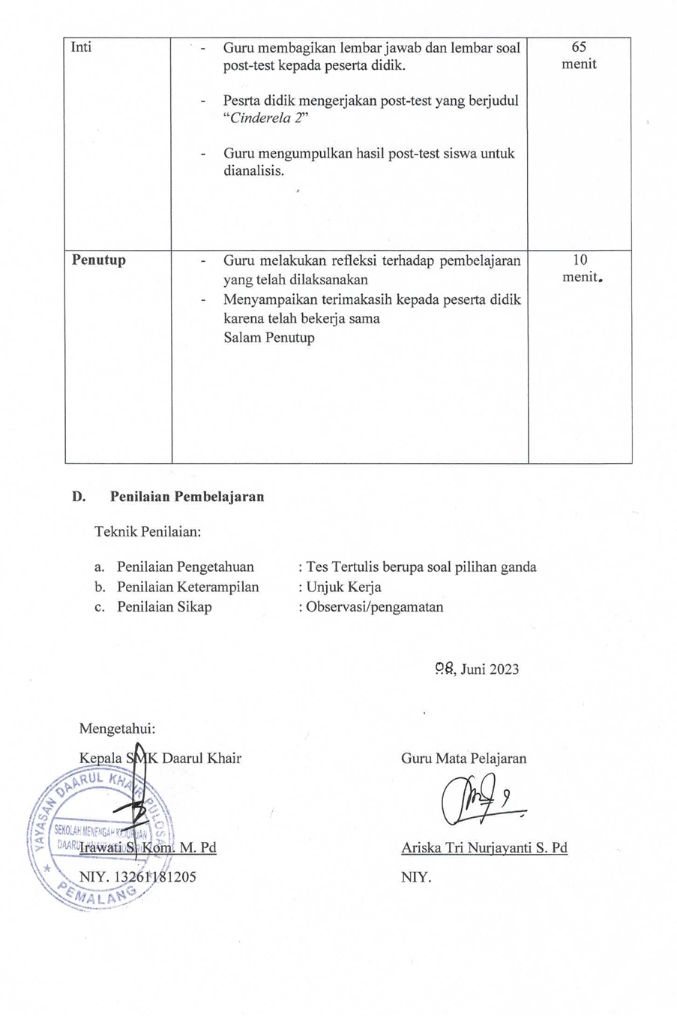
- Penilaian Pembelajaran

Teknik Penilaian:

- Penilaian Pengetahuan : Tes Tertulis berupa soal pilihan ganda
- Penilaian Keterampilan : Unjuk Kerja
- Penilaian Sikap : Observasi/pengamatan

…., Juni 2023

Mengetahui:  Kepala SMK Daarul Khair  Irawati S. Kom. M. Pd  NIY. 13261181205 | Guru Mata Pelajaran  Ariska Tri Nurjayanti S. Pd  NIY.

LEMBAR KERJA PESERTA DIDIK
LKPD

- Kompetensi dasar
3.8 Membedakan fungsi sosial, struktur teks, dan unsur kebahasaan beberapa teks naratif lisan dan tulis dengan memberi dan meminta informasi terkait legenda rakyat, sederhana, sesuai dengan konteks penggunaannya
4.8 Menyajikan teks naratif pendek dan sederhana terkait legenda rakyat secara lisan dan tulis dengan memperhatikan fungsi sosial, struktur teks dan unsur kebahasaaan secara benar dan sesuai konteks

Indikator Pencapaian Kompetensi

    - Mengidentifikasi jenis teks yang dibaca
    - Memahami fungsi social teks yang dibaca
    - Menganalisis generic structures ( struktur teks) dari teks naratif
    - Menentukan language features (unsur kebahasaan) dari sebuah teks naratif
    - Menemukan informasi tersurat/tersirat yang terdapat dalam sebuah teks naratif yang dibaca
4.8.1 Menuliskan teks naratif sederhana (legenda rakyat) dengan struktur yang benar

Tujuan Pembelajaran

Setelah mengikuti proses pembelajaran peserta didik diharapkan mampu:
    - Mengidentifikasi jenis teks yang dibaca
    - Memahami fungsi social teks yang dibaca
    - Menganalisis generic structures ( struktur teks) dari teks naratif
    - Menentukan language features dari sebuah teks naratif
    - Menemukan informasi tersurat/tersirat yang terdapat dalam sebuah teks naratif yang dibaca
4.8.1 Menuliskan teks naratif sederhana (legenda rakyat) dengan struktur yang benar

Petunjuk Kerja
  - Baca dan pahamilah teks naratif berikut ini secara berpasangan!
  - Diskusikanlah maksud dari pertanyaan yang ada pada LKPD!
  - Jawablah pertanyaan berdasarkan teks!
  - Jika ada yang kurang jelas tanyakan kepada guru!
  - Gunakan waktu yang telah disediakan sebaik mungkin!

The Legend of Malin Kundang

A long time ago, in a small village near the beach in West Sumatra, a woman and her son lived. They were Malin Kundang and her mother. Her mother was a single parent because Malin Kundang's father had passed away when he was a baby. Malin Kundang had to live hard with his mother

Malin Kundang was a healthy, dilligent, and strong boy. He usually went to sea to catch fish. After getting fish he would bring it to his mother, or sold the caught fish in the town. One day, when Malin Kundang was sailing, he saw a merchant's ship which was being raided by a small band of pirates. He helped the merchant. With his brave and power, Malin Kundang defeated the pirates. The merchant was so happy and thanked to him. In return the merchant asked Malin Kundang to sail with him. To get a better life, Malin Kundang agreed. He left his mother alone. Many years later, Malin Kundang became wealthy. He had a huge ship and was helped by many ship crews loading trading goods. Perfectly he had a beautiful wife too. When he was sailing his trading journey, his ship landed on a beach near a small village. The villagers recognized him. The news ran fast in the town; “Malin Kundang has become rich and now he is here”. An old woman ran to the beach to meet the new rich merchant. She was Malin Kundang’s mother. She wanted to hug him, released her sadness of being lonely after so long time. Unfortunately, when the mother came, Malin Kundang who was in front of his well dressed wife and his ship crews denied meeting that old lonely woman. For three times her mother begged Malin Kundang and for three times he yelled at her. At last Malin Kundang said to her "Enough, old woman! I have never had a mother like you, a dirty and ugly woman!" After that he ordered his crews to set sail. He would leave the old mother again but in that time she was full of both sadness and angriness. Finally, enraged, she cursed Malin Kundang that he would turn into a stone if he didn't apologize. Malin Kundang just laughed and really set sail

In the quiet sea, suddenly a thunderstorm came. His huge ship was wrecked and it was too late for Malin Kundang to apologize. He was thrown by the wave out of his ship. He fell on a small island. It was really too late for him to avoid his curse. Suddenly, he turned into a stone.

Soal:

Answer the following question based on the text!

- What kind of text is the text above?
  - Report
  - Recount
  - Narrative
  - Descriptive
- What is function of the text?
  - to tell experience in the past
  - to entertain the reader
  - to do something
  - to give an instruction how
  - to make something

- The generic structure of the text is ……….
  - description – identification
  - Identification – description
  - Orientation – events – Reorientation
  - Orientation – complication – resolution
- What is tense is used in the text?
  - Present Tense
  - Present Continuous
  - Past Tense
  - Present perfect
- What Malin said to his mom before he went to the city?
  - Malin never be back
  - He promises to be back
  - He will forget his mom
  - He will give his mom much money
- Who is Malin?
  - A son who loves his mother
  - A son who cares with his mother
  - A son who betrays his mother
  - A son who always with his mother
- What Malin’s wife does?
  - Care with Malin’s mom
  - Love Malin’s mom
  - Did not care with Malin’s mom
  - Talk to Malin’s mom
- Who is the main actor of that story?
  - Malin kundang
  - Malin’s mom
  - Malin’s wife
  - Malin’s society
- Why Malin meets his mom?
  - He misses his mom
  - He will give much money to his mom
  - He accepts a request from his wife
  - He wants hug his mom
- What do you learn from the story of Malin Kundang?
- Never be a cruel son/daughter
- Leave our old mom
- Give our mom money
- Meet our mom

Snow White
Once upon a time there lived a little girl named Snow White. She lived with her aunt and uncle because her parents were dead.
One day she heard her uncle and aunt talking about leaving Snow White in the Castle because they both wanted to go to town and they didn’t have enough money to take Snow White. Snow white did not want her uncle and aunt to do this so she decided it would be best if she ran away. The next morning, she ran away from home when her aunt and uncle were having breakfast. She ran away into the woods.
She was very tired and hungry. Then she saw this little Cottage. She knocked out but no one answered so she went inside and fell asleep. Meanwhile, the seven dwarfs were coming home from work. They went inside. There they found Snow White sleeping. Then Snow White woke up. She saw the dwarfs. The dwarfs said, “what is your name?” Snow white said, “My name is Snow White.” Then Snow White told the dwarfs the whole story and the seven dwarfs lived happily ever after.

- The main character of the story is…
a. Princess
b. Snow White
c. Aunt
d. Dwarfs
e. Cinderella
- After Snow White heard her aunt and uncle talked about her
a. Snow White sleep in the castle
b. she fell asleep
c. she angry with their aunt and uncle
d. she ran away into the woods
e. she likes her aunt and uncle
- Snow White ran away from home
a. in the afternoon
b. in the morning
c. in the evening
d. at noon
e. at night
- When did Snow White run away into the woods?
a. after breakfast
b. at noon
c. mid-day
d. in the morning
e. at night
- The purpose of the text is……
a. to entertain the reader about Snow white
b. to tell the reader
c. to amuse the people
d. to explain the reader
e. to inform the reader

The Ugly Duckling
It was bight summer day. The wheat fields had turned golden in the warm sun. Around the wheat fields, there were meadow of green grass. In the midst of the meadows and fields, stood a farm house. A stream of clean water flowed past the house. In one of those shady spots on the bank the stream, among a cluster of shrubs and plants, a mother duck sat on her eggs to hatch them.
After a few days they shall began to crack and out game five little duckling looked very pretty. The mother duck was very happy. She stood up to see if the all eggs were hatched. No, there was one large egg-the sixth one that remained unhatched. Its shell was harder. But mother was determined to bring every one of her broods into this world.
What a shock she got when the last egg finally cracked. The new bird was very ugly and much bigger than the others. “It cannot my baby” shouted the mother duck “I wonder if he is a turkey!” soon, it seemed that nobody like this duckling. They named him” Ugly Duckling”. The mother duck never approved of this rude and treatment.
His bad days had suddenly ended. He was not an ugly duckling after all. Now he changes a beautiful white swan.

- The topic of the text is……
a. the turkey
b. ugly duckling
c. the bird
d. the swan
e. the goat
- The situation of the first paragraph as living
a. in the country
b. in the village
c. in the woods
d. in the city
e. in the forest
- The genre of this text is………
a. recount
b. news item
c. fable
d. procedure
e. spoof
- In the last story ugly duckling changes to be
a. swan
b. duck
c. bird
d. goose
e. turkey
- A mother duck began to crack her eggs in the
a. first paragraph
b. last paragraph
c. the fourth paragraph
d. second paragraph
e. the third paragraph

Question about the Text:
Choose the best answer from the text below!

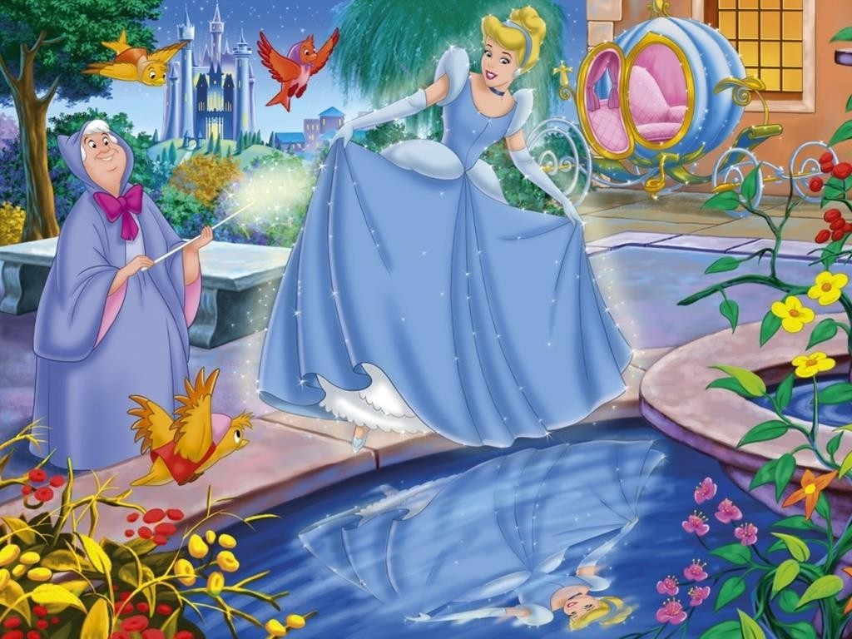

Once upon a time there was a wife of a rich man fell sick, and soon she closed her eyes and departed. Every day, Cinderella went out to her mother’s grave, and wept, and she remained pious and good. When winter came, the snow spread a white sheet over the grave, and by the time the spring sun had drawn it off again, the man had taken another wife. The woman had brought with her into the house two daughters, who were beautiful and fairy of face but vile and black of heart. Since then, a bad time for the poor step-child began.
One day the King gave orders for a festival and all the beautiful young girls in the country were invited, in order that his son might choose himself a bride. When the two step- sisters heard that they were to appear among the number, they were delighted, called Cinderella and made to help them grooming, Cinderella obeyed, but wept, because she too would have liked to go with them to dance, and begged her step-mother said” you cannot go with us, you have no clothes and cannot dance.
When the step-mother and her daughters had gone away, Cinderella went to her mother’s grave and cried, Shiver and Quiver, my little tree, silver and gold throw down over me.” Suddenly a bird threw down a magnificent gold and silver dress to her, and were golden too. At the party her step-sister and the step-mother however did not recognize her, and thought she must be a foreign princess, for she looked so beautiful in the golden dress.

- The story above tells about
- Snow White
- Sleeping Beauty
- Dwarfs
- Cinderella
- Princess
- The first paragraph is the…………of the story
- complication
- reorientation
- orientation
- resolution
- coda
- Why does Cinderella’s mother dead? Because she………
- fell sick
- fell injured
- fell disappointed
- fell ill
- fell wounded
- The genre of the text is…….
- recount
- procedure
- narrative
- legend
- news item
- When the winter came, the snow……
- spread a white sheet
- cover the grave
- spread a dirt
- spread a yellow sheet
- covering white sheet
- Cinderella lived with her
- two step-mother
- her mother
- two step-sister and step- mother
- her sisters
- two step-sister
- How did her step-mother treat Cinderella?
- she allowed go any where
- she doesn’t her to allow
- she allows goes every where
- she didn’t go any where
- she didn’t allow her go

- Why couldn’t Cinderella go to the festival?
- she doesn’t dance
- she has dance
- she didn’t dance
- she didn’t have clothes and couldn’t dance
- she couldn’t dance
- The last story called …
- complication
- orientation
- coda
- resolution
- twist
- The step-mother however did not “recognize” her. The same meaning of the word “recognize” is…
- to see
- to know
- to told
- to talk
- to tell
- Orientation of the story means …
- to begin the story
- to amuse the reader
- to finish the story
- to tell the people
- to end the story
- The purpose of the author to write the story is …
- to tell the reader
- to entertain the reader
- to told the reader
- to explain the reader
- to describe the reader
- What orientation of the third paragraph?
- step-mother gone away
- step-mother and her daughter had gone away
- step-mother passed away
- step-mother and her daughter
- her daughter had gone away
- Finally, Cinderella must be a foreign
- Princess
- daughter
- cousin
- queen
- sister
- The two step-sister always feels….
- upset
- jealous
- wonder
- regret
- angry
- The story of Cinderella talks about
- rich girl
- clever girl
- lazy girl
- proud girl
- beautiful girl
- The daughter of the King is…..
- prince
- witch
- princess
- dwarf
- queen
- Cinderella’s story expresses about
- beautiful girl
- poor girl
- dwarf
- little girl
- rich girl
- Cinderella looked so beautiful in the golden dress. The antonym of “beautiful” is……
- handsome
- smart
- ugly
- wonderful
- nice
- The complication stated in paragraph
….
- One
- two
- three
- four
- first

Appendix 3: Instrument

Instrument and Answer sheet
Choose the correct answer by crossing A, B, C, D, or E!
Soal Narrative Text Cinderella 1 to 20
Once upon a time there was a wife of a rich man fell sick, and soon she closed her eyes and departed. Every day, Cinderella went out to her mother’s grave, and wept, and she remained pious and good. When winter came, the snow spread a white sheet over the grave, and by the time the spring sun had drawn it off again, the man had taken another wife. The woman had brought with her into the house two daughters, who were beautiful and fairy of face but vile and black of heart. Since then, a bad time for the poor step-child began.
One day the King gave orders for a festival and all the beautiful young girls in the country were invited, in order that his son might choose himself a bride. When the two step- sisters heard that they were to appear among the number, they were delighted, called Cinderella and made to help them grooming, Cinderella obeyed, but wept, because she too would have liked to go with them to dance, and begged her step-mother said” you cannot go with us, you have no clothes and cannot dance.
When the step-mother and her daughters had gone away, Cinderella went to her mother’s grave and cried, Shiver and Quiver, my little tree, silver and gold throw down over me.” Suddenly a bird threw down a magnificent gold and silver dress to her, and were golden too. At the party her step-sister and the step-mother however did not recognize her, and thought she must be a foreign princess, for she looked so beautiful in the golden dress.

- The story above tells about
- Snow White
- Sleeping Beauty
- Dwarfs
- Cinderella
- Princess
- The first paragraph is the…………of the story
- complication
- reorientation
- orientation
- resolution
- coda
- Why does Cinderella’s mother dead? Because she………
- fell sick
- fell injured
- fell disappointed
- fell ill
- fell wounded
- The genre of the text is…….
- recount
- procedure
- narrative
- legend
- news item
- When the winter came, the snow……
- spread a white sheet
- cover the grave
- spread a dirt
- spread a yellow sheet
- covering white sheet
- Cinderella lived with her
- two step-mother
- her mother
- two step-sister and step- mother
- her sisters
- two step-sister
- How did her step-mother treat Cinderella?
- she allowed go any where
- she doesn’t her to allow
- she allows goes every where
- she didn’t go any where
- she didn’t allow her go
- Why couldn’t Cinderella go to the festival?
- she doesn’t dance
- she has dance
- she didn’t dance
- she didn’t have clothes and couldn’t dance
- she couldn’t dance
- The last story called …
- complication
- orientation
- coda
- resolution
- twist
- The step-mother however did not “recognize” her. The same meaning of the word “recognize” is…
- to see
- to know
- to told
- to talk
- to tell
- Orientation of the story means …
- to begin the story
- to amuse the reader
- to finish the story
- to tell the people
- to end the story
- The purpose of the author to write the story is …
- to tell the reader
- to entertain the reader
- to told the reader
- to explain the reader
- to describe the reader
- What orientation of the third paragraph?
- step-mother gone away
- step-mother and her daughter had gone away
- step-mother passed away
- step-mother and her daughter
- her daughter had gone away
- Finally, Cinderella must be a foreign
- Princess
- daughter
- cousin
- queen
- sister
- The two step-sister always feels….
- upset
- jealous
- wonder
- regret
- angry
- The story of Cinderella talks about
- rich girl
- clever girl
- lazy girl
- proud girl
- beautiful girl
- The daughter of the King is…..
- prince
- witch
- princess
- dwarf
- queen
- Cinderella’s story expresses about
- beautiful girl
- poor girl
- dwarf
- little girl
- rich girl
- Cinderella looked so beautiful in the golden dress. The antonym of “beautiful” is……
- handsome
- smart
- ugly
- wonderful
- nice
- The complication stated in paragraph ….
- One
- two
- three
- four
- first

Appendix 4: Answer sheet

THE ANSWER SHEET
TRY OUT TEST
SCORE

Name :
Class/Number :
Time Allocation : 60 minutes
School : SMK Daarul Khair Pulosari

Choose the correct answer by crossing (x) A, B, C, D, or E!

- 1 | A | B | C | D | E |  | 11 | A | B | C | D | E
- 2 | A | B | C | D | E |  | 12 | A | B | C | D | E
- 3 | A | B | C | D | E |  | 13 | A | B | C | D | E
- 4 | A | B | C | D | E |  | 14 | A | B | C | D | E
- 5 | A | B | C | D | E |  | 15 | A | B | C | D | E
- 6 | A | B | C | D | E |  | 16 | A | B | C | D | E
- 7 | A | B | C | D | E |  | 17 | A | B | C | D | E
- 8 | A | B | C | D | E |  | 18 | A | B | C | D | E
- 9 | A | B | C | D | E |  | 19 | A | B | C | D | E
- 10 | A | B | C | D | E |  | 20 | A | B | C | D | E

THE ANSWER SHEET
FINAL TEST

Name :
SCORE
Class/Number :
Subject :
Time Allocation : 60 minutes
School : SMK Daarul Khair Pulosari

Choose the correct answer by crossing (x) A, B, C, D, or E!

1 | A | B | C | D | E
2 | A | B | C | D | E
3 | A | B | C | D | E
4 | A | B | C | D | E
5 | A | B | C | D | E
6 | A | B | C | D | E
7 | A | B | C | D | E
8 | A | B | C | D | E
9 | A | B | C | D | E
10 | A | B | C | D | E
11 | A | B | C | D | E
12 | A | B | C | D | E
13 | A | B | C | D | E
14 | A | B | C | D | E
15 | A | B | C | D | E

Appendix 5: Hypothesis Testing
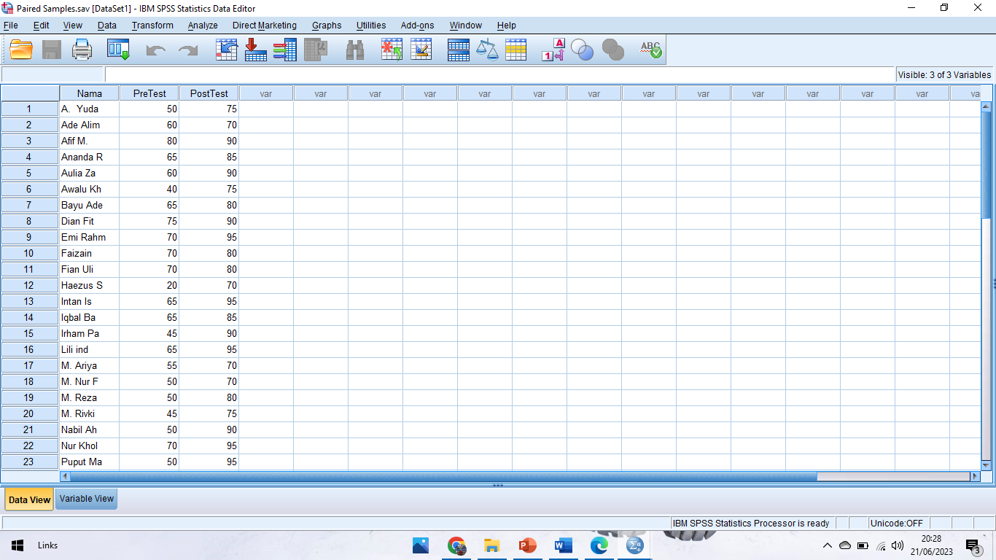

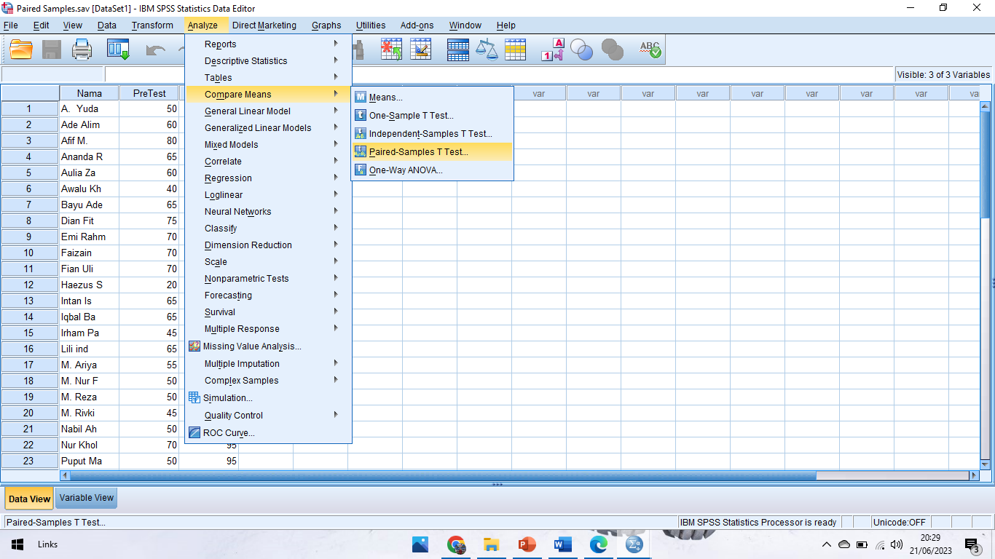

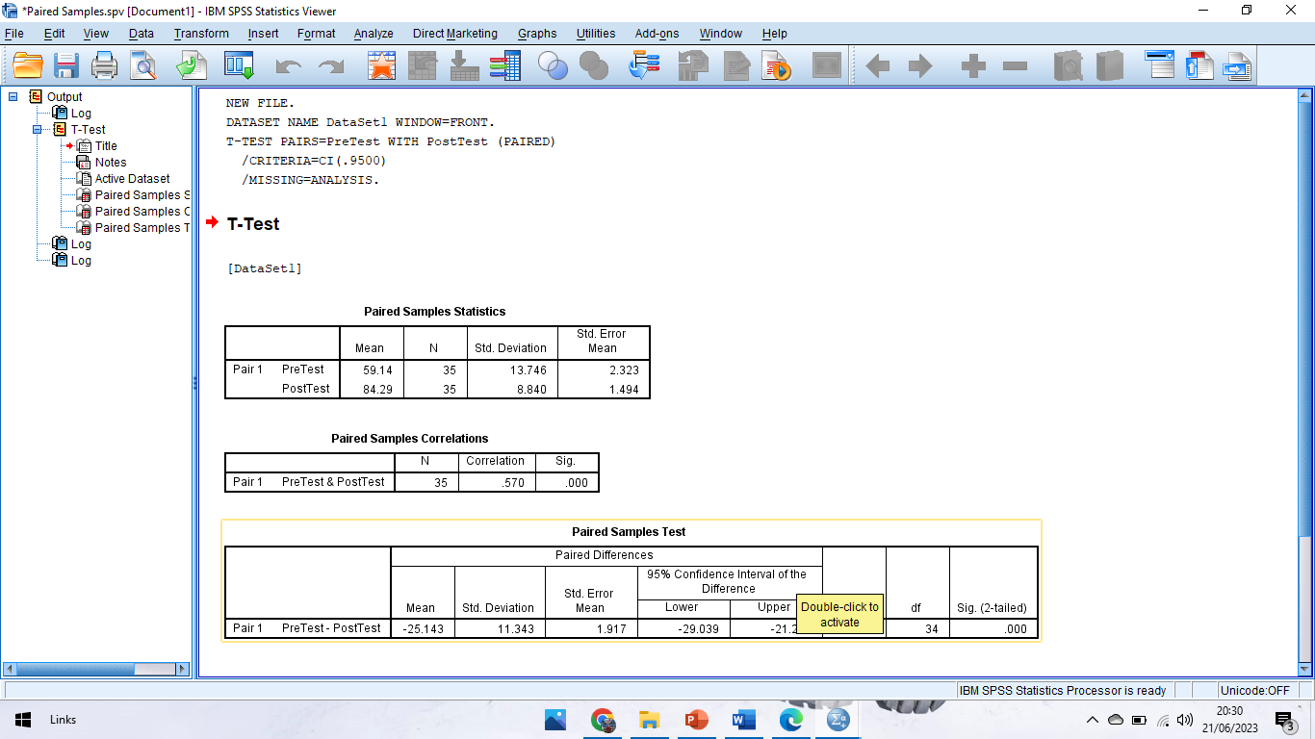
Appendix 6: Students’ Correct Answer of Pre-Test and Post-Test.
Number | Students Name | Pre-test Correct answer | Post test correct answer
 | A. Yuda P. | 10 | 15
 | Ade Alim | 12 | 14
 | Afif M. | 16 | 18
 | Ananda Rian | 13 | 17
 | Aulia Zahwa | 12 | 18
 | Awalu Khasbi | 8 | 15
 | Bayu Ade | 13 | 16
 | Dian Fitria | 15 | 18
 | Emi Rahmawati | 14 | 19
 | Faizain Al | 14 | 16
 | Fian Uli Nuha | 14 | 16
 | Haezus Sarop | 4 | 14
 | Intan Istiqomah | 13 | 19
 | Iqbal Baihaqi | 13 | 17
 | Irham Pakreji | 9 | 18
 | Lili indah | 13 | 19
 | M. Ariyanto | 11 | 14
 | M. Nur Faizin | 10 | 14
 | M. Reza | 10 | 16
 | M. Rivki | 9 | 15
 | Nabil Ahmad | 10 | 18
 | Nur Kholis | 14 | 19
 | Puput Maulidya | 10 | 19
 | Rafi Rahardian | 11 | 15
 | Rendi | 9 | 15
 | Riski Saputri | 6 | 15
 | Sabilan Saniatun | 11 | 19
 | Saefudin | 13 | 16
 | Serli Safitri | 13 | 19
 | Shella Mutiya | 15 | 18
 | Sukma Titis | 15 | 18
 | Tika Al Fariani | 14 | 19
 | Wihandi | 15 | 18
 | Wina Neli E | 15 | 18
 | Yahya | 10 | 16

Appendix 7: The Students’ Scores of Pre-Tests and Post-Test.
Number | Students Name | Score pre test | Score post test
 | A. Yuda P. | 50 | 75
 | Ade Alim | 60 | 70
 | Afif M. | 80 | 90
 | Ananda Rian | 65 | 85
 | Aulia Zahwa | 60 | 90
 | Awalu Khasbi | 40 | 75
 | Bayu Ade | 65 | 80
 | Dian Fitria | 75 | 90
 | Emi Rahmawati | 70 | 95
 | Faizain Al | 70 | 80
 | Fian Uli Nuha | 70 | 80
 | Haezus Sarop | 20 | 70
 | Intan Istiqomah | 65 | 95
 | Iqbal Baihaqi | 65 | 85
 | Irham Pakreji | 45 | 90
 | Lili indah | 65 | 95
 | M. Ariyanto | 55 | 70
 | M. Nur Faizin | 50 | 70
 | M. Reza | 50 | 80
 | M. Rivki | 45 | 75
 | Nabil Ahmad | 50 | 90
 | Nur Kholis | 70 | 95
 | Puput Maulidya | 50 | 95
 | Rafi Rahardian | 55 | 75
 | Rendi | 45 | 75
 | Riski Saputri | 30 | 75
 | Sabilan Saniatun | 55 | 95
 | Saefudin | 65 | 80
 | Serli Safitri | 65 | 95
 | Shella Mutiya | 75 | 90
 | Sukma Titis | 75 | 90
 | Tika Al Fariani | 70 | 95
 | Wihandi | 75 | 90
 | Wina Neli E | 75 | 90
 | Yahya | 50 | 80

Appendix 8: Documentations

