REFERENCES

Acharya Bidhan. (2010). Questionnarie design. In Periodica Polytechnica Electrical Engineering (Vol. 33). https://doi.org/10.2307/2965735
Ahyar, H., Maret, U. S., Andriani, H., Sukmana, D. J., Mada, U. G., Hardani, S.Pd., M. S., … Istiqomah, R. R. (2020). Buku Metode Penelitian Kualitatif & Kuantitatif. Yogyakarta: Pustaka Ilmu.
Aksel, A., & Gürman-Kahraman, F. (2014). Video Project Assignments and their Effectiveness on Foreign Language Learning. Procedia - Social and Behavioral Sciences, 141, 319–324. https://doi.org/10.1016/j.sbspro.2014.05.055
Andriani, R., Putri, A., & Kasriyati, D. (2021). Using Video Subscribe to Improve Students ’ Speaking A bility. ELT-Lectura: Studies and Perspectives in English Language Teaching, 8(1). https://doi.org/https://doi.org/10.31849/elt-lectura.v8i1.6112
Andriani, W., & Angelina, P. (2020). English Language Education Students’ Perception of the Use of English Subtitled Movies. Indonesian Journal of English Language Studies (IJELS), 6(2), 49–59. https://doi.org/10.24071/ijels.v6i2.2824
Asramadhani, & Murni, S. (2019). Improving Students ’ Speaking Skill in Expressing Offering. LEI Nº 16.050, DE 31 DE JULHO DE 2014 - Política de Desenvolvimento Urbano e o Plano Diretor Estratégico Do Município de São Paulo, 10(1), 1–10. https://doi.org/10.24114/tj.v2i2.909
Codó, E. (2018). Interviews and Questionnaires. ReseachGate. https://doi.org/10.1002/9781444301120.ch9
Creswell John W. (2014). Research Design. In SAGE Publications India. California: SAGE Publications.
Devanti, Y. M. (2018). The Use of Video as a Media to Improve Students’ Vocabulary Mastery. ELLITE: Journal of English Language, Literature, and Teaching, 3(1), 42–47. https://doi.org/10.32528/ellite.v3i1.1778
Ferdian, N. R. (2019). Linguists : Journal of Linguistics and Language Teaching Learning Strategies in Making Video Project Assignments in ESP Class. Journal of Linguistics and Language Teaching, 5(1), 18–28. https://doi.org/http://dx.doi.org/10.29300/ling.v5i1.1918
Hafner, C. A., & Miller, L. (2011). Fostering Learner Autonomy in English for Science: A Collaorative Digital Video Project in a Technological Learning Environment. Language Learning & Technology, 15(3), 68–86.
James L. Gibson John M. Ivancevich James H. Donnelly, J. R. K. (2012). Organizations: Behavior, Structure, Processes. New York: McGraw-Hill.
Kearney, M., & Schuck, S. (2006). Spotlight on authentic learning: Student developed digital video projects Background literature. Australasian Journal of Educational Technology, 22(2), 189–208. https://doi.org/http://doi.org/10.14742/ajet.1298
Limeranto, J. T., & Bram, B. (2022). Exploring EFL Graduate Students’ Perspectives and Strategies to Improve English Speaking Skills. Surakarta English and Literature Journal, 5(1), 26. https://doi.org/10.52429/selju.v5i1.813
Madani, R. A. (2019). Analysis of Educational Quality, a Goal of Education for All Policy. Higher Education Studies, 9(1), 100. https://doi.org/10.5539/hes.v9n1p100
Menggo, S., Suastra, I. M., Budiarsa, M., & Padmadewi, N. N. (2019). Speaking for Academic Purposes Course: An Analysis of Language Functions 1Sebastianus. E-Journal of Linguistics, 13(2), 308. https://doi.org/https://doi.org/10.24843/e-jl.2019.v13.i02.p10
Mumtahabah, N. (2014). the Use of Media in Learning English Language in Senior High School. AL HIKMAH Journal of Islamic Studies, Volume 4, Number 1, March 2014, 4(1), 2–14. Retrieved from osf.oi/ptmak
Noble, H., & Heale, R. (2019). Triangulation in research , with examples. Evindence-Based Nursing, 22(3), 67–68. https://doi.org/htttp://dx.doi.org/10.1136/ebnurs-2019-103145
Nurviyani, R. (2020). A Study Of Students ’ Speaking Skill Through Vlog. Jurnal JOEPALLT (Journal of English Pedagogy Linguistics Literature and Teaching). https://doi.org/10.35194/jj.v6i2.398
Priska, S. Y., Wardhani, S., & Sulistyawati, A. E. (2022). Students ’ Perception in the Use of Subtitled Movie in Enriching English Vocabulary. Pancasakti International Seminar on English Language Teaching (PISELT 2022), (July), 161–170.
Putri, R. N., & Rahmani, B. D. (2019). Students Perception on Using Video Recording to Improve Their Speaking Accuracy and Fluency. UHAMKA International Conference on ELT and CALL (UICELL), (November), 21–22.
Saragih, S. M., & Listyani, L.-. (2021). English Language Education Program Second-Year Students’ Speaking Difficulties in an Academic Speaking Class. SAGA: Journal of English Language Teaching and Applied Linguistics, 2(2), 73–88. https://doi.org/10.21460/saga.2021.22.77
Savitri, D., & Ardi, H. (2021). Analysis of Students’ Speaking Ability in Video Project at STKIP Muhammadiyah Muara Bungo. Proceedings of the Ninth International Conference on Language and Arts (ICLA 2020), 539, 47–50. https://doi.org/10.2991/assehr.k.210325.009
Sinaga, O. (2018). Students ’ Perception on the Role of English Day Program in Speaking Skill Development. Journal of English Teaching, 4(2), 104–117. https://doi.org/http://doi.org/10.33541/jet.v4i2.834
Syafrudin, G. and. (2022). Students ’ Perception on theVideo Project Assignment in Practicing Speaking Skill In Senior High School. English Focus: Jurnal of English Language Education, 5(2). https://doi.org/10.24905/efj.v5i2.125
Wicaksono, A. (2018). Using Video Recording to Improve Students’ Speaking Ability. Advances in Social Science, Education and Humanities Research, 145. https://doi.org/10.2991/iconelt-17.2018.5
Yudianto, A. (2017). Penerapan Video Sebagai Media Pembelajaran. Seminar Nasional Pendidikan 2017, 234–237.
Zyoud, M. M. (2016). Theoretical perspective on how to develop speaking skill among university students. An International Multidisciplinary Journal, 2(1), 1–10.

APPENDICES

Appendix 1: Result of The Questionnaire

Questionnaires Blueprint
No. | Criteria | Questions | Answer
 |  |  | SA | A | N | D | SD
1. | Students perceptions of video project as media | - Using video projects as learning media makes learning English more fun. | 27  69.2% | 9  23.1% | 3  7.7% | 0  (0%) | 0  (0%)
 |  | - I like learning English through video projects as a medium. | 22  (56.4%) | 16  (41%) | 1  (2.6%) | 0  (0%) | 0  (0%)
 |  | - Through this video project, I learn to use gadgets for beneficial activities, especially to practice speaking English. | 23  (59%) | 13  (33.3%) | 3  (7.7%) | 0  (0%) | 0  (0%)
 |  | - I had no problem in creating a video project. | 6  (15.4%) | 21  (53.8%) | 4  (10.3%) | 7  (17.9%) | 1  (2.6%)
 |  | - I prefer video recording to do presentations directly in front of friends and teacher in the classroom. | 23  (59%) | 16  (41%) | 0  (0%) | 0  (0%) | 0  (0%)
 |  | - Through this video project, I find a new method to improve my speaking skills. | 24  (61.5%) | 14  (35%) | 1  (3.5%) | 0  (0%) | 0  (0%)
2. | Students perceptions the strength and the weakness of using video project | - Producing this video project has helped me improve my level of understanding the English lesson material | 29  (74.4%) | 9  (23.1%) | 1  (2.6%) | 0  (0%) | 0  (0%)
 |  | - My English speaking skills improved after completing the video project | 14  (64.1%) | 25  (35.9%) | 0  (0%) | 0  (0%) | 0  (0%)
 |  | - Through this video project, it helps me improve my confidence in speaking English | 29  (74.4%) | 9  (23.1%) | 1  (2.5%) | 0  (0%) | 0  (0%)
 |  | - This video project helps me improve my English | 26  (66.7%) | 11  (28.2%) | 2  (5.1%) | 0  (0%) | 0  (0%)
 |  | - Through this video project, I am motivated to be able to speak English better | 17  (43.6%) | 20  (51.3%) | 2  (5.1%) | 0  (0%) | 0  (0%)
 |  | - Before getting this video project, I was not confident to speak in front of the camera | 22  (56.4%) | 13  (33.3%) | 4  (10.3%) | 0  (0%) | 0  (0%)
 |  | - This video project helps me to be more confident in front of camera | 20  (51.3%) | 19  (48.7%) | 0  (0%) | 0  (0%) | 0  (0%)
 |  | - Through this video project, I find my weaknesses in my speaking skills | 19  (48.7%) | 18  (46.2%) | 2  (5.1%) | 0  (0%) | 0  (0%)
 |  | - Through this video project, I find my strengths in my speaking skills | 28  (71.8%) | 11  (28.2%) | 0  (0%) | 0  (0%) | 0  (0%)

Adopted from Gustinawati and Syafrudin (2022) and Sari( 2016).
Appendix 2: The transcript Of The Interview
The Transcript of the Interviews

(Interview 1)
- What benefits do you get from learning English using video projects?
“Sing and listening to people speak English can also have develop confidence in speaking, and can with English learning into deteriorate”
- Do you realize your weakness in speaking English from this project video?
“Yes, sometimes I miss pronounces sentences so the meaning is different”
- What do you think about the video project being applied to the speaking class?
“I agree with them making of videos because to practice speaking the more often speak English the better to pronunciation”
- What are your suggestions for using video projects to improve English speaking skills?
“First we can listen to more English and read English book and articles and then practice speaking in English and also learning through video project”

(Interview 2)

- What benefits do you get from learning English using video projects?
“Honestly learning English by using video project can help me to improve my speaking and pronunciation skills and I can identify mistakes that need improvement”
- Do you realize your weakness in speaking English from this project video?
“Yes of course, I realize my weakness when I speak English such as I am still confused to composing correct word and still afraid to speaking in English”
- What do you think about the video project being applied to the speaking class?
“I think this video assignment is quite practice it can help students who are still nervous to speak directly in English and we can correct the mistakes”
- What are your suggestions for using video projects to improve English speaking skills?
“In my opinion, I can create video presentations on a topic of we have choice and this is will help us to developed our skills in speaking”

(Interview 3)

- What benefits do you get from learning English using video projects?
“I feel more confidence in front of camera”
- Do you realize your weakness in speaking English from this project video?
“Sometimes I miss pronunciation a sentences so I must retake the video”
- What do you think about the video project being applied to the speaking class?
“I think is fun because we can retake the video but sometimes is makes the smartphone very full”
- What are your suggestions for using video projects to improve English speaking skills?
“The teacher must be more careful of in the correcting”

(Interview 4)

- What benefits do you get from learning English using video projects?
“The benefits that I get from this video project is to improve my speaking and pronunciations skills to improve my ability to describe something and beside that it trance me to be more confidence”
- Do you realize your weakness in speaking English from this project video?
“Yes, I realize my weakness in speaking is still starting or not clear and there are pronunciations that are still quite right I think so and I also feel nervous”
- What do you think about the video project being applied to the speaking class?
“I think video assignments are more effective because I can prepare sentence what I want to talk about and need also very suitable for me who like confident speaking in front of the class”
- What are your suggestions for using video projects to improve English speaking skills?
“I think these activities suitable for student who feels less confidence when speaking in front of the class like me and my suggestion is the teacher more attentions to students in making video assignment and perfect input when students make mistakes such as pronunciations, grammar and so on. In addition to improve English skills the test to listening, reading English book and then practicing English often”

(Interview 5)

- What benefits do you get from learning English using video projects?
“When student learns English with video, they get exposure to the actual language of real people. As a result, they can learn the English language as native speakers, enthusiastic o learn English. Learning English with video is way better than learning using books.
- Do you realize your weakness in speaking English from this project video?
“Yes, I realize”
- What do you think about the video project being applied to the speaking class?
“In my opinion, video assignments that are applied in speaking classes really help the teaching staff in achieving learning effectiveness, especially in subjects where the majorities are practical. Maximizing the achievement of learning objectives in a short time”
- What are your suggestions for using video projects to improve English speaking skills?
“Practice more speaking and listening in English”

(Interview 6)

- What benefits do you get from learning English using video projects?
“I think the benefit is I can improve my intonations, my grammar and phrases. And I also can learn much new word”
- Do you realize your weakness in speaking English from this project video?
“Yes realized that my grammar, my intonations is not that accurate”
- What do you think about the video project being applied to the speaking class?
“I think it can help students improve their confident in speaking and providing them with change to practice in control environment like daily life”
- What are your suggestions for using video projects to improve English speaking skills?
“I think video project can stimulated by real life speaking so student can practice in situation there are likely like in daily types”

Appendix 3: Sample of The Questionnaires
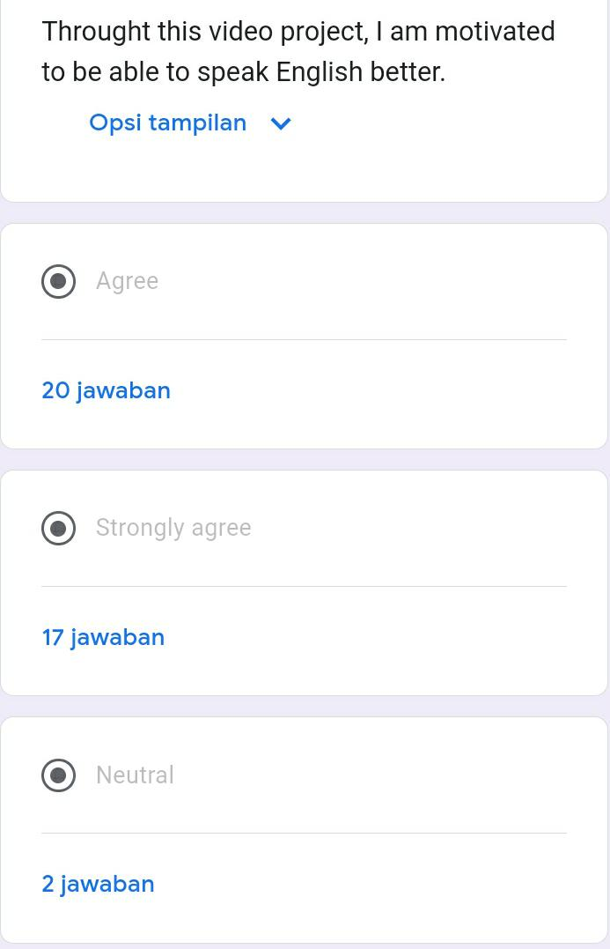
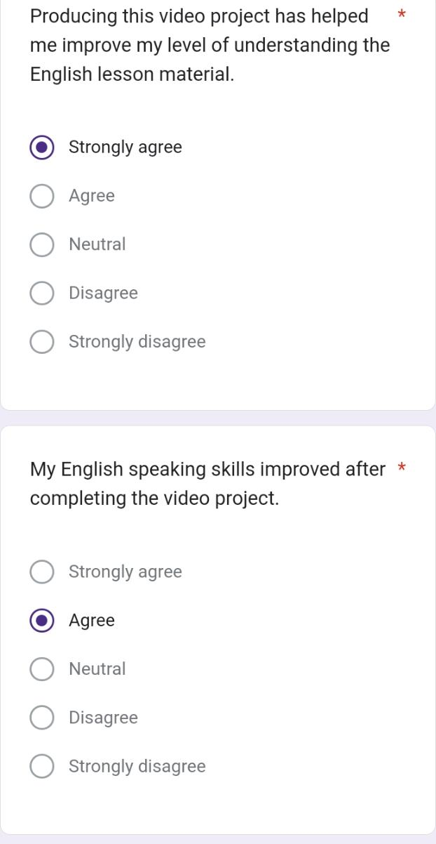

Appendix 4: Links of Students’ Video Project

Link Video Project Class A:
- https://drive.google.com/drive/folders/1yco8OeYhMy6Xz6SoYxHeQfTu24mJ_gFJ
- https://drive.google.com/drive/folders/1Ys5QgTel_XpNgntY_2MOr4Q6W1oVQASe
Link Video Projects Class B:
- https://drive.google.com/drive/folders/1MYZyFQZFHH6mRspPvOQlB3aKM4OqH0hE
- https://drive.google.com/drive/folders/1Z8WCd7l28aXXdrR1hTPg1o0v_oCVpe_L

Appendix 5: Picture Documentation

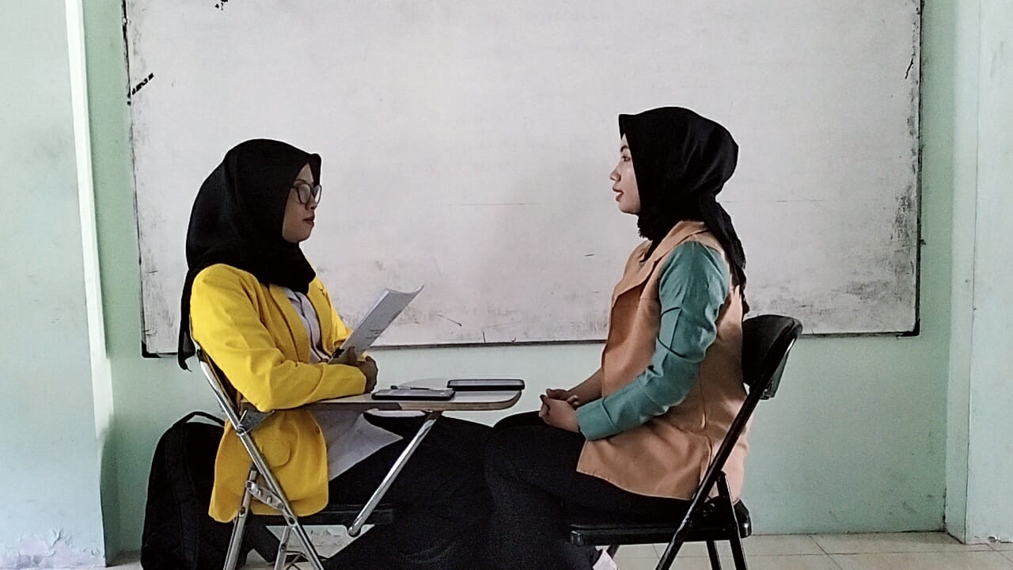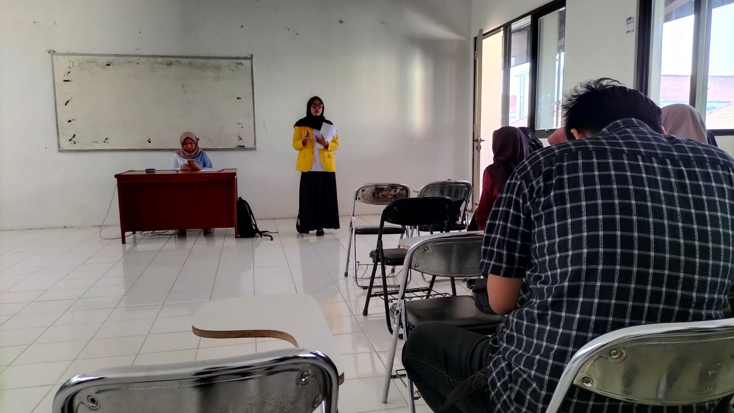

Appendix 6: Surat Bebas Plagiarisme
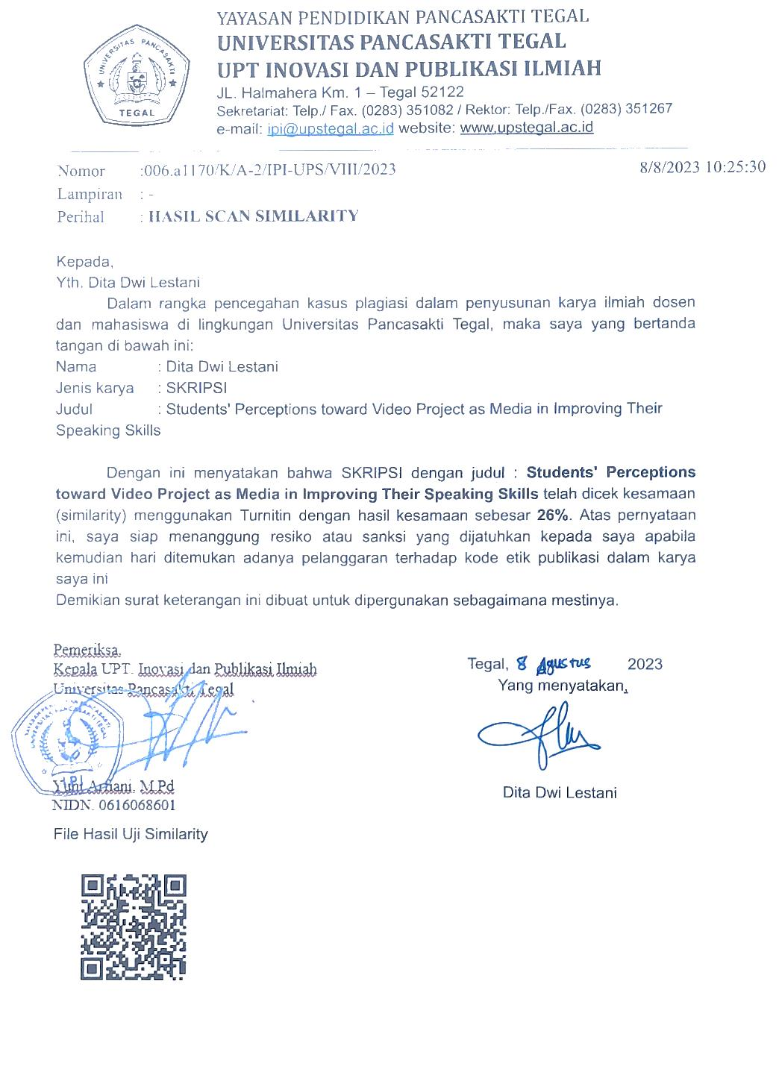
Appendix 7: Berita Acara Ujian Skripsi
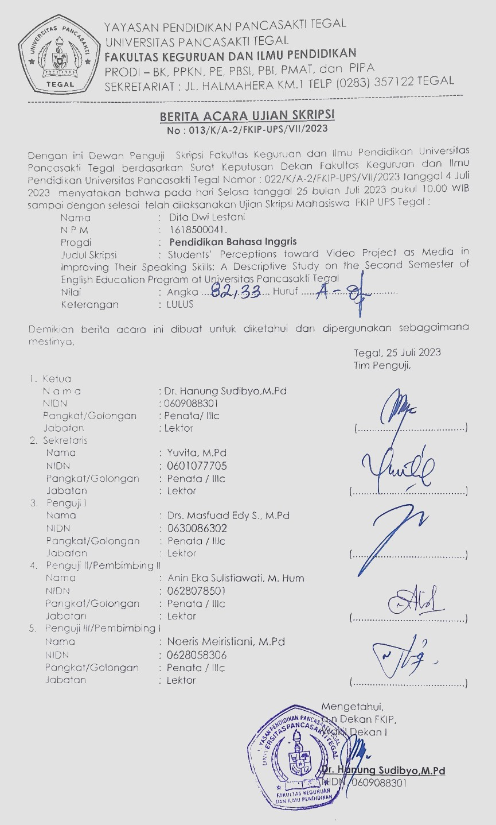
Appendix 8: Berita Acara Bimbingan
