PENGARUH EMPLOYEE ENGAGEMENT, EMOTIONAL INTELLIGENCE DAN KOMITMEN ORGANISASI TERHADAP ORGANIZATIONAL CITIZENSHIP BEHAVIOR (OCB) APARATUR SIPIL NEGARA (ASN) DI LINGKUNGAN BADAN PENGELOLAAN KEUANGAN DAN ASET DAERAH (BPKAD) KABUPATEN BREBES

SKRIPSI

Oleh :
Mila Yuliana Putri
NPM : 4118500331

Diajukan Kepada :

Program Studi Manajemen
Fakultas Ekonomi Dan Bisnis
Universitas Pancasakti Tegal
2023
DAFTAR PUSTAKA

Badan Pengelolaan Keuangan dan Aset Daerah (BPKAD) KABUPATEN BREBES. (2022). Retrieved Februari 18, 2023, from https://bpkad.brebeskab.go.id/web/: https://bpkad.brebeskab.go.id/web/
Albrecht, S. L. (2010). Handbook of Employee Engagement: Perspective, Issues, Research and Practice. UK:. Edward Elgar Publishing Limited.
Aldag, R., dan Reschke,W. (1997). Employee Value Added: Measuring Discretionary Effort and Its Value to The Organization.. Center fo Organization Effectiveness. Inc.608/833-3332, pp. 1-8.
Ali, M. (2011). Memahami Riset Perilaku dan Sosial. Bandung: Pustaka Cendekia Utama.
Arif, G. (2011). Remaja dan Permasalahannya. Yogyakarta: Hanggar Kreator.
Budihardjo, A. (2011). Organisasi Menuju Pencapaian Kinerja Optimum. Jakarta: Prasetiya Mulya Publisihing.
Chunghtai, A. &. (2006). Antecedents and Consequences of Organizational Commitment Among Pakistani University Teachers. Applied HRM Research.
Cooper, Robert K.dan Ayman Sawaf. (2000). Kecerdasan Emosional dalam Kepemimpinan dan organisasi. Jakarta: PT. Gramedia Pustaka Utama.
Darmawan, H. D. (2013). Prinsip- Prinsip Perilaku Organisasi. Surabaya: Pena Semesta.
Febriansyah, H, Ginting, H. (2020). Tujuh Dimensi Employee Engagement, in Tujuh Dimensi Employee Engagement. Prenada.
Ghozali. (2018). Aplikasi Analisis. In Aplikasi Analisis. . Badan Penerbit Universitas Diponegoro.
Ghozali, I & Ratmono, D;. (2017). Analisis Multivariat dan Ekonometrika (Teori, Konsep, dan Aplikasi dengan Eviews 10). In Analisis Multivariat dan Ekonometrika (Teori, Konsep, dan Aplikai dengan Eviews 10). Universitas Diponegoro.
Ghozali, I. (2009). Aplikasi analisis multivariate dengan program SPSS. Semarang: Undip.
Goleman, & Daniel. (2002). Emotional Intellegence (Terjemahan). Jakarta: PT. Gramedia Pustaka Utama.
Goleman, & Daniel. (2002). Working With Emotional Intellegence (terjemahan). Jakarta: PT. Gramedia Pustaka Utama.
Goleman, D. (2005). Working with Emotional Intellegence: Kecerdasan emosi untuk mencapai puncak prestasi. Alih Bahasa: Alex Tri K. Widodo. Jakarta: PT. Gramedia Pustaka Utama.
Goleman, D. (2009). Emotional Intellegence (Terjemahan). Jakarta: PT. Gramedia Pustaka Utama.
Goleman, D. (2009). Kecerdasan Emosional : Mengapa El lebih penting dari pada IQ. Jakarta: PT. Gramedia Pustaka Utama.
Goleman, D. (2016). Emotional Intelligence: Kecerdasan Emosional (Alih Bahasa: T. Hermaya). Jakarta: PT Gramedia Pustaka Utama.
Goleman, Daniel. (2004). Emotional Intelligence (terjemahan). Jakarta: Gramedia Pustaka Utama.
Griffin. (2004). Bisnis. Jakarta: Erlangga.
Hardani., Auliya, N. H.,Andriani, H., Fardani,R. A., Ustiawaty, J., Utami, E. F.,Sukmana, D. J., & Istiqomah, R. R. (2020). METODE PENELITIAN KUALITATIF & KUANTITATIF.In METODE PENELITIAN KUALITATIF & KUANTITATIF. Pustaka Ilmu.
Hasibuan, M. S. (2014). Manajemen Sumber Daya Manusia, Cetakan Keempat Belas. Jakarta: Bumi Aksara.
Ibrahim. (2013, Januari). ) Pengaruh Kecerdasan Emosional Terhadap Organizational Citizenship Behavior Dan Dampaknya Pada Kinerja Perawat Rumah Sakit Umum Antapura & Rumah Sakit Undata Palu. e-Jurnal Katalogis, 1(1), 136-146.
Kartono. (2017). Personality, Employee Engagement, Emotional Intelligence, Job Bornout Pendekatan dalam Melihat Turnover Intention. In Personality, Employee Engagement, Emotional Intelligence, Job Bornout Pendekatan dalam Melihat Turnover Intention. Deepublish.
Kaswan. (2017). Psikologi Industri dan Organisasi . Bandung: Alfabeta.
Kreitner, Robert And Angelo Kinicki. (2005). Perilaku Organisasi , Edisi5, Alih bahasa Erly Suandy. Jakarta: Salemba Empat.
Kruse, K. (2012). Employee Engagement 2.0: How to Motivate your team for high performance . Author Academy Elite.
Kuncoro, M. (2011). Metode Kuantitatif Teori dan Aplikasi Untuk Bisnis & Ekonomi,. Yogyakarta: Sekolah Tinggi Ilmu Manajemen YKPN.
Kuntjoro, H. Zainuddin Sri Drs, Mpsi. (2002). Komitmen organisasi. Jakarta.
Kurniawan, A. W., & Puspitaningtyas, Z. (2016). Metode Penelitian Kuantitatif . In Metode Penlitian Kuantitatif. Pandiva Buku.
Luthans, & Fred. (2005). Organizational Behavior.
Luthans, F. (2006). Perilaku Organisasi, Alih Bahasa V.A Yuwono. Yogyakarta: Andi.
Macey, H., William, dkk. (2009). Employee Engagement:Tools For Analysis,Practice And Competitive Advantages. Singapore: Willey Blackwell.
Mamik, S. S., & Sunarti. (2008). Pengaruh Kedisiplinan, Motivasi Kerja dan,Komitmen Organisasi terhadap Kepuasan Kerja Karyawan. Jurnal Administrasi Kebijakan Kesehatan, 6(2), 93–96.
Markos, S and M.S PSridevi. (2010). Employee Engagement: The Key Improving Performance. Int.J.Bus. Manage., 5: 89-95.
Mathis, R.L & J.H. Jackson. (2006). Human Resource Managemet: Manajemen Sumber Daya. Terjemahan Dian Angelina. Jakarta: Salemba Empat.
McShane, Stephen L and Von Glinow , Mary Ann. (2005). Organizational Behavior: Emerging Realities for the Workplace Revolution,second Ed,. McGrawHill, Irwin.
Meyer , J., & Herskovits, L. (2001). Commitment in the workplace: Toward a general model (Vol. 11). Human Resource Management Review.
Meyer, J., & Allen , N. (1997). Commitment in the workplace theory research and application. California: Sage publications.
Muhdar. (2015). Organizational Citizenship Behavior Perusahaan. Sultan Amai Press.
Ningsih, S & Dukalang, H. (2019). Penerapan Metode Suksesif Interval pada Analisis Regresi Linear Berganda. Jambura Journal of Mathematics, 1 (1), 43-53.
Organ , D. (1988). Organizational Citizenship Behavior: the good soldier syndrome . Lexington, MA: Lexington book.
Organ, D. W. (2006). Organizational Citizenship Behavior: its Nature, Antecedents, and Consequences. California: Sage Publications, Inc.
Organ, D.W. (1997). Organizational Citizenship Behavior: It's Construct Clean-Up Time. human Performance 10.
Paul, &. M. (2010). Carrots and Sticks Don't Work Build a Culture of Employee Engagement with the Principles of RESPECT. In Carrots and Sticks Don't Work Build a Culture of Employee Engagement with the Principles of RESPECT. . The Mc Graw Hill Companies.
Permatasari, D. V. (2017). Pengaruh Kepemimpinan Transforrmasional Terhadap Organizational Citizenship Behavior (OCB) dan Komitmen Organisasi Melalui Kepuasan Kerja Karyawan PT. Bank Panin,Tbk Banjarbaru. Jurnal Bisnis Dan Pembangunan, 6(1), 36–42.
Podsakoff, Philip, M., Scott, B., Juliebeth, P., & Daniel, G. B. (2000). Organizational Citizenship Behaviors: A critical review of the theoretical and empirical literature and suggestions for future research. Journal of management, 26.
Ria Mardiana Yusuf, Darman Syarif. (2017). Komitmen Organisasi:Definisi Dipengaruhi dan Mempengaruhi. Makasar: Nas Media Pustaka.
Robbin Stephen, and Judge, Timothy. (2009). Organizational Behavior 13th edition. (P. International, Ed.)
Robbins P. Stephen. (2008). Perilaku Organization Behavior. Jakarta: Salemba Empat.
Robbins &, J. (2015). Perilaku Organisasi, Edisi 16. Jakarta: Salemba Empat.
Robbins, Stephen P., Timothy A. Judge. (2016). Perilaku Organanisasi Edisi 16. Jakarta: Salemba Empat.
Sagala.Syaiful. (2013). Etika dan Moralitas Pendidikan Peluang dan Tantangan. Jakarta: Kencana Prenadamedia Group.
Schieman,A, W. (2011). Aligment Capability Engagement Pendekatan Baru Talent Management Untuk Mendongkrak Kinerja Organisasi. PPM.
Setiawan, J. (2015). Pengaruh Perbedaan Gender dan Keterampilan Kerja Terhadap Produktivitas Pada PT. BILBARA INSULATION SOUTHEAST ASIA. Jurnal AKMENBIS Akademi Akuntansi Permata Harapan, 4(1), 64-79.
Shapiro. (2001). Mengajarkan Emotional Intelligence pada Anak. Jakarta: Gramedia Pustaka Utama.
Shapiro, L. (1998). Mengajarkan Emotional Intelligence pada Anak. Ahli Bahasa: AI. Kanjoro. Jakarta: Gramedia Pustaka Utama.
Singarimbun, & Efendi. (2005). Metode penelitian survey . indonesia: Pustaka LPJES.
Sopiah. (2010). Perilaku Organisasi. Yogyakarta: Andi Offset.
Sudarmanto. (2009). Kinerja dan Pengembangan Kompetensi SDM. Yogyakarta: Pustaka Pelajar.
Sugiyono. (2010). Metode Penelitian Bisnis dan RND. Bandung : Alfabeta.
Sugiyono. (2014). Metode Penelitian pendidikan pendekatan kuantitatif, kualitatif dan RdanD . Bandung: Alfabeta.
Timothy M. Gardner, M. A.I. (2018). Employee Engagement : A Review and research agenda. In C. Barsade & D.T Schein (Eds.), The Cambridge handbook of workplace affect. Cambridge University Press.
Titisati, P. (2014). Peranan Organizational Citizenship Behavior : Dalam Meningkatkan Kinerja Karyawan. Mitra Wacana Media.
Turner, P. (2020). Employee Engagement in Contemporary Organizations. In Employee Engagement in Contemporary Organizations. Springer Nature Switzerland.
Walgito, B. (2009). Pengantar psikologi pendidikan. Jakarta : Depdikbud.

LAMPIRAN
Lampiran 1 Kuesioner Penelitian
Perihal : Permohonan Pengisian Kuesioner
Judul Penelitian : Pengaruh Employee Engagement, Emotional Intelligence, Dan Komitmen Organisasi terhadap Organizational Citizenship Behavior (OCB) Aparatur Sipil Negara (ASN) Di Lingkungan Badan Pengelolaan Keuangan dan Aset Daerah (BPKAD) Kabupaten Brebes

Kepada Yth
Bapak/Ibu/Sdr
Di tempat

Dengan Hormat
Dalam rangka menyelesaikan penelitian, kami Mahasiswi Fakultas Ekonomi dan Bisnis Universitas Pancasakti Tegal mohon partisipasi dari Bapak/Ibu/Sdr untuk mengisi kuesioner yang telah kami sediakan.
Adapun data yang kami minta adalah sesuai dengan kondisi yang dirasakan Bapak/Ibu/Sdr selama ini. Kami akan menjaga kerahasiannya karena data ini hanya untuk kepentingan penelitian.
Setiap jawaban yang diberikan merupakan bantuan yang tidak ternilai harganya bagi penelitian ini. Kami memberikan jangka waktu selama satu minggu setelah kuesioner ini kami sebarkan, agar Bapak/Ibu/Sdr dapat segera mengembalikannya kepada kami.
Atas perhatian dan bantuannya, kami mengucapkan banyak terima kasih.

Tegal, 21 Maret 2023 Hormat Kami

Mila Yuliana Putri
- Petunjuk Pengisian kuesioner
- Bapak/Ibu/Saudara/i dimohon menjawab setiap pertanyaan dengan memilih satu jawaban pada setiap pernyataan.
- Ketersediaan Bapak/Ibu/Saudara/i untuk mengisi kuesioner ini merupakan suatu kehormatan dan sangat membantu peneliti.
- Jawaban Bapak/Ibu/Saudara/i akan terjamin kerahasiannya.
- Jawablah semua pernyataan dengan jujur,baik dan benar, karena hasil penelitian tidak akan mempengaruhi penilaian pada kinerja.
- Isilah dengan memberikan tanda checklist/centang (√) pada kotak yang tersedia di jawaban yang anda pilih dan sesuai dengan kondisi yang sebenarnya yang ada pada Badan Pengelolaan Keuangan dan Aset Daerah (BPKAD) Kabupaten Brebes.

Keterangan Pilihan jawaban :
SS : Sangat Setuju
S : Setuju
N : Netral
TS : Tidak Setuju
STS : Sangat Tidak Setuju

- Karakteristik Responden
- Nama :
- Jenis Kelamin :
Laki – Laki
Perempuan

- Umur :
20 – 25 tahun
26 – 30 tahun
31 – 35 tahun
36 – 40 tahun
41 – 45 tahun
- Pendidikan Terakhir :
SMA / SMK
DII / DIII
S1
S2
- Masa Kerja :
1 – 5 tahun
6 – 10 tahun
>10 tahun

- Daftar Pernyataan Variabel Organizational Citizenship Behavior (OCB) (Y)
No | Pertanyaan | Jawaban
 |  | SS | S | N | TS | STS
1. | Pegawai akan siap membantu rekan kerja yang membutuhkan bantuan / referensi
2 | Pegawai sering membantu rekan kerja yang pekerjaanya sedang overload
3 | Pegawai akan membantu rekan kerja yang baru untuk beradpatasi meskipun sebenarnya tidak diharuskan
4 | Pegawai selalu berfikiran positif terhadap kebijakan yang ditetapkan instansi
5 | Pegawai selalu mempertimbangkan hal-hal terbaik demi kemajuan instansi kedepannya
6 | Pegawai bersedia memikul tanggung jawab akan pekerjaanya
7. | Pegawai selalu datang lebih awal sebelum jadwal kerja dimulai atau pada agenda yang dilakukan instansi
8 | Pegawai selalu fokus pada hal – hal positif
9 | Pegawai selalu menilai kebijakan yang dilakukan instansi adalah benar dan terbaik untuk pegawai
10 | Pegawai tidak banyak protes dan mengeluh tentang tugas dan kebijakan instansi yang diberikan
11 | Pegawai tidak menyalahgunakan atau menganggu hak-hak rekan kerja yang lain.
12 | Pegawai tidak membesar-besarkan masalah diluar proporsinya
13 | Pegawai mengajak rekan kerja untuk sharing mengenai kendala atau masalah yang dihadapi dalam menyelesaikan tugasnya.
14 | Pegawai selalu menghindari konflik dengan rekan kerja

- Daftar Pernyataan Variabel Employee Engagement (X1)
No | Pernyataan | Jawaban
 |  | SS | S | N | TS | STS
13 | Pegawai merasa bersemangat ketika akan memulai pekerjaan
14 | Pegawai menghadapi permasalahan tugas yang sulit dan kendala yang dihadapi dalam menyelesaikan tugasnya.
15 | Pegawai mempunyai mental yang kuat dalam menghadapi permasalahan tugas yang telah diberikan instansi.
16 | Pegawai merasa sangat antusias dengan pekerjaan ini.
17 | Pegawai merasa pekerjaan ini memberikan inspirasi untuk kedepannya
18 | Pegawai merasa bangga ketika semua deadline pekerjaan sudah selesai tepat waktu
19 | Pegawai menyukai tantangan pekerjaan
20 | Pegawai selalu fokus dengan pekerjaanya
21 | Pegawai bersedia bekerja lembur demi menyelesaikan pekerjaan tepat waktu.
22 | Pegawai merasa jika pekerjaan dilakukan dengan senang hati akan terasa lebih cepat selesai.

- Daftar Pernyataan Variabel Emotional Intelligence (X2)
No | Pernyataan | Jawaban
 |  | SS | S | N | TS | STS
23 | Pegawai dapat memahami emosi yang terjadi pada diri sendiri
24 | Pegawai dapat mengelola dan mengendalikan emosi diri sendiri dalam situasi apapun
25 | Pegawai mampu mengatasi kesulitan dalam menyelesaikan masalah dan kendala yang dihadapi dalam menyelesaikan pekerjaan
26 | Pegawai dapat memotivasi diri sendiri dalam mencapai sasaran karir
27 | Pegawai memiliki rasa optimisme yang tinggi
28 | Pegawai mampu menunjukan rasa empati dan simpati pada rekan kerja ketika mereka merasa kesulitan
29 | Pegawai mampu mendengarkan keluhan rekan kerja tentang pekerjaan yang sulit
30 | Pegawai mempunyai rasa empati yang tinggi
31 | Pegawai selalu berusaha memahami kepentingan dari atasan maupun rekan kerja lainnya.
32 | Pegawai memiliki kemampuan yang baik dalam mengikat jaringan kerja dan dalam hubungan sosial

4. Daftar Pernyataan Variabel Komitmen Organisasi (X3)
No | Pertanyaan | Jawaban
 |  | SS | S | N | TS | STS
38 | Pegawai akan merasa bahagia menghabiskan sisa karir di instansi ini.
39 | Pegawai mempunyai kepeduliaan terhadap masalah yang dihadapi instansi
41 | Pegawai merasa akan lebih menguntungkan untuk tetap bertahan dalam instansi yang sekarang dan hal tersebut menimbulkan komitmen dalam dirinya.
42 | Pegawai selalu berfikir bahwa penyelesaian pekerjaan tepat waktu sangat penting untuk kesuksesan karir
43 | Pegawai loyal terhadap instansi penting untuk dimiliki oleh setiap pegawai
44 | Pegawai mempunyai sikap setia terhadap instansi
45 | Pegawai mempunyai rasa kebanggan bekerja di instansi ini

Lampiran 2
Jawaban Responden Pertanyaan Variabel Organizational Citizenship Behavior (Y)
Resp | Jumlah Jawaban Responden |  |  |  |  |  |  |  |  |  |  |  |  |  | ∑ _{Y}
 | 1 | 2 | 3 | 4 | 5 | 6 | 7 | 8 | 9 | 10 | 11 | 12 | 13 | 14
1 | 4 | 4 | 3 | 5 | 5 | 5 | 5 | 3 | 4 | 5 | 5 | 5 | 5 | 5 | 63
2 | 5 | 5 | 5 | 5 | 5 | 5 | 5 | 5 | 5 | 5 | 5 | 5 | 5 | 5 | 70
3 | 5 | 4 | 5 | 5 | 5 | 4 | 5 | 5 | 4 | 5 | 5 | 5 | 5 | 5 | 67
4 | 4 | 4 | 4 | 4 | 4 | 4 | 4 | 2 | 4 | 4 | 4 | 4 | 4 | 4 | 54
5 | 5 | 5 | 5 | 5 | 5 | 5 | 5 | 5 | 5 | 5 | 5 | 5 | 5 | 5 | 70
6 | 5 | 5 | 5 | 5 | 4 | 4 | 5 | 3 | 5 | 5 | 5 | 5 | 5 | 5 | 66
7 | 4 | 3 | 4 | 5 | 4 | 4 | 5 | 5 | 4 | 4 | 4 | 4 | 4 | 5 | 59
8 | 3 | 3 | 3 | 3 | 3 | 3 | 3 | 3 | 3 | 3 | 3 | 4 | 3 | 3 | 43
9 | 3 | 3 | 3 | 3 | 3 | 3 | 3 | 3 | 3 | 3 | 3 | 3 | 3 | 3 | 42
10 | 5 | 4 | 5 | 5 | 5 | 5 | 4 | 4 | 5 | 5 | 5 | 5 | 4 | 5 | 66
11 | 4 | 4 | 4 | 4 | 4 | 4 | 4 | 4 | 4 | 4 | 4 | 4 | 4 | 4 | 56
12 | 4 | 4 | 4 | 4 | 4 | 4 | 4 | 4 | 4 | 4 | 4 | 4 | 4 | 4 | 56
13 | 5 | 5 | 5 | 5 | 5 | 5 | 5 | 5 | 5 | 5 | 5 | 5 | 5 | 5 | 70
14 | 4 | 4 | 3 | 4 | 4 | 4 | 4 | 3 | 4 | 4 | 4 | 4 | 4 | 4 | 54
15 | 4 | 4 | 3 | 3 | 4 | 4 | 4 | 3 | 4 | 4 | 4 | 4 | 4 | 5 | 54
16 | 5 | 4 | 3 | 5 | 3 | 3 | 3 | 3 | 4 | 5 | 3 | 3 | 5 | 5 | 54
17 | 3 | 3 | 3 | 5 | 3 | 1 | 2 | 3 | 3 | 4 | 4 | 3 | 3 | 3 | 43
18 | 5 | 5 | 5 | 5 | 5 | 5 | 5 | 5 | 5 | 5 | 5 | 5 | 5 | 5 | 70
19 | 5 | 5 | 5 | 5 | 5 | 5 | 5 | 5 | 5 | 5 | 5 | 5 | 5 | 5 | 70
20 | 5 | 5 | 5 | 5 | 5 | 5 | 5 | 5 | 5 | 5 | 5 | 5 | 5 | 5 | 70
21 | 5 | 5 | 5 | 5 | 5 | 5 | 5 | 5 | 5 | 5 | 5 | 5 | 5 | 5 | 70
22 | 4 | 4 | 4 | 3 | 2 | 3 | 4 | 2 | 3 | 4 | 5 | 4 | 4 | 4 | 50
23 | 4 | 5 | 5 | 4 | 5 | 4 | 5 | 4 | 4 | 5 | 4 | 5 | 4 | 4 | 62
24 | 4 | 4 | 4 | 5 | 4 | 4 | 4 | 3 | 3 | 4 | 4 | 4 | 3 | 3 | 53
25 | 5 | 5 | 5 | 4 | 4 | 4 | 4 | 4 | 5 | 4 | 4 | 4 | 4 | 4 | 60
26 | 4 | 4 | 4 | 5 | 4 | 4 | 4 | 2 | 4 | 3 | 4 | 4 | 4 | 4 | 54
27 | 4 | 4 | 4 | 3 | 3 | 4 | 4 | 4 | 4 | 3 | 3 | 3 | 4 | 3 | 50
28 | 4 | 4 | 4 | 5 | 5 | 5 | 4 | 5 | 4 | 5 | 5 | 4 | 4 | 5 | 63
29 | 4 | 4 | 4 | 4 | 4 | 4 | 4 | 4 | 5 | 4 | 4 | 4 | 4 | 4 | 57
30 | 4 | 4 | 5 | 4 | 5 | 4 | 4 | 3 | 5 | 4 | 4 | 4 | 3 | 4 | 57
31 | 5 | 5 | 5 | 5 | 5 | 5 | 5 | 3 | 5 | 5 | 4 | 5 | 5 | 5 | 67
32 | 5 | 4 | 4 | 4 | 3 | 3 | 4 | 5 | 5 | 5 | 4 | 3 | 4 | 5 | 58
33 | 5 | 5 | 4 | 4 | 5 | 5 | 4 | 4 | 4 | 4 | 3 | 5 | 4 | 5 | 61
34 | 5 | 5 | 5 | 5 | 5 | 5 | 5 | 5 | 5 | 5 | 5 | 5 | 5 | 5 | 70
35 | 5 | 5 | 5 | 5 | 5 | 5 | 5 | 5 | 5 | 5 | 5 | 5 | 5 | 5 | 70
36 | 4 | 4 | 3 | 3 | 5 | 3 | 5 | 1 | 5 | 5 | 5 | 3 | 5 | 5 | 56
37 | 5 | 5 | 5 | 5 | 4 | 4 | 5 | 3 | 5 | 5 | 4 | 3 | 3 | 5 | 61
38 | 5 | 5 | 4 | 3 | 4 | 4 | 4 | 3 | 4 | 4 | 5 | 4 | 5 | 4 | 58
39 | 4 | 4 | 3 | 3 | 4 | 3 | 4 | 2 | 3 | 3 | 3 | 4 | 3 | 3 | 46
40 | 4 | 4 | 2 | 4 | 4 | 4 | 4 | 3 | 4 | 2 | 2 | 4 | 3 | 3 | 47
41 | 4 | 4 | 4 | 4 | 4 | 4 | 4 | 4 | 4 | 4 | 4 | 4 | 4 | 4 | 56
42 | 5 | 4 | 4 | 4 | 4 | 4 | 4 | 3 | 4 | 4 | 4 | 5 | 5 | 5 | 59
43 | 5 | 4 | 3 | 4 | 5 | 4 | 4 | 2 | 3 | 3 | 5 | 5 | 5 | 5 | 57
44 | 5 | 5 | 3 | 3 | 4 | 3 | 4 | 4 | 3 | 5 | 4 | 4 | 4 | 3 | 54
45 | 3 | 3 | 3 | 3 | 3 | 3 | 4 | 3 | 4 | 4 | 3 | 4 | 4 | 4 | 48
46 | 4 | 4 | 3 | 3 | 5 | 4 | 4 | 3 | 4 | 4 | 4 | 4 | 4 | 4 | 54
47 | 5 | 5 | 5 | 4 | 4 | 4 | 4 | 4 | 4 | 4 | 5 | 4 | 4 | 4 | 60
48 | 5 | 5 | 4 | 4 | 2 | 5 | 5 | 5 | 5 | 5 | 5 | 5 | 5 | 5 | 65

Lampiran 3
Jawaban Responden Pertanyaan Variabel Employee Engagement (X1)
Resp | Jumlah Jawaban Responden |  |  |  |  |  |  |  |  |  | _{∑ X1}
 | 1 | 2 | 3 | 4 | 5 | 6 | 7 | 8 | 9 | 10
1 | 5 | 4 | 4 | 1 | 3 | 2 | 3 | 1 | 2 | 2 | 27
2 | 4 | 4 | 4 | 1 | 3 | 3 | 5 | 1 | 5 | 4 | 34
3 | 5 | 4 | 5 | 5 | 2 | 3 | 4 | 5 | 5 | 5 | 43
4 | 5 | 5 | 5 | 1 | 2 | 2 | 4 | 1 | 1 | 3 | 29
5 | 4 | 3 | 3 | 2 | 4 | 4 | 4 | 2 | 4 | 4 | 34
6 | 5 | 5 | 5 | 2 | 5 | 4 | 5 | 5 | 5 | 5 | 46
7 | 4 | 3 | 3 | 1 | 2 | 1 | 1 | 2 | 3 | 3 | 23
8 | 5 | 5 | 4 | 2 | 2 | 2 | 3 | 2 | 3 | 2 | 30
9 | 3 | 3 | 3 | 3 | 3 | 3 | 3 | 3 | 3 | 3 | 30
10 | 3 | 2 | 2 | 1 | 1 | 2 | 1 | 1 | 1 | 2 | 16
11 | 3 | 2 | 3 | 3 | 3 | 3 | 3 | 3 | 3 | 3 | 29
12 | 2 | 2 | 2 | 2 | 2 | 2 | 2 | 3 | 3 | 3 | 23
13 | 1 | 1 | 1 | 1 | 1 | 1 | 1 | 1 | 1 | 1 | 10
14 | 4 | 4 | 4 | 1 | 2 | 4 | 2 | 1 | 4 | 4 | 30
15 | 5 | 5 | 5 | 2 | 2 | 2 | 3 | 1 | 2 | 2 | 29
16 | 5 | 4 | 4 | 1 | 4 | 5 | 3 | 1 | 1 | 1 | 29
17 | 5 | 5 | 5 | 3 | 1 | 4 | 1 | 3 | 2 | 2 | 31
18 | 2 | 2 | 2 | 3 | 1 | 1 | 2 | 1 | 3 | 2 | 19
19 | 3 | 2 | 3 | 2 | 1 | 1 | 2 | 2 | 2 | 1 | 19
20 | 5 | 5 | 5 | 2 | 5 | 3 | 4 | 3 | 4 | 3 | 39
21 | 3 | 4 | 4 | 3 | 3 | 3 | 3 | 3 | 4 | 3 | 33
22 | 4 | 3 | 5 | 2 | 4 | 2 | 5 | 2 | 2 | 1 | 30
23 | 4 | 4 | 5 | 4 | 5 | 4 | 3 | 4 | 4 | 4 | 41
24 | 3 | 2 | 2 | 2 | 2 | 2 | 2 | 2 | 3 | 3 | 23
25 | 4 | 4 | 2 | 2 | 2 | 2 | 2 | 2 | 2 | 2 | 24
26 | 4 | 4 | 3 | 2 | 2 | 2 | 2 | 2 | 3 | 3 | 27
27 | 4 | 4 | 3 | 1 | 2 | 1 | 3 | 2 | 3 | 3 | 26
28 | 4 | 3 | 3 | 3 | 3 | 1 | 2 | 1 | 2 | 2 | 24
29 | 2 | 1 | 2 | 2 | 2 | 2 | 2 | 2 | 2 | 2 | 19
30 | 5 | 3 | 3 | 4 | 4 | 3 | 4 | 4 | 5 | 4 | 39
31 | 5 | 5 | 5 | 1 | 2 | 2 | 5 | 1 | 5 | 5 | 36
32 | 5 | 5 | 5 | 2 | 4 | 4 | 3 | 5 | 3 | 4 | 40
33 | 4 | 3 | 4 | 3 | 2 | 1 | 3 | 2 | 3 | 3 | 28
34 | 1 | 1 | 1 | 1 | 1 | 1 | 1 | 1 | 1 | 1 | 10
35 | 3 | 1 | 1 | 1 | 1 | 1 | 2 | 1 | 3 | 2 | 16
36 | 3 | 2 | 1 | 1 | 1 | 1 | 1 | 1 | 1 | 1 | 13
37 | 2 | 2 | 3 | 1 | 1 | 1 | 1 | 1 | 1 | 3 | 16
38 | 3 | 2 | 3 | 1 | 1 | 1 | 2 | 2 | 2 | 3 | 20
39 | 4 | 3 | 4 | 2 | 2 | 1 | 3 | 2 | 3 | 2 | 26
40 | 5 | 5 | 5 | 3 | 4 | 2 | 4 | 2 | 5 | 4 | 39
41 | 5 | 5 | 5 | 2 | 2 | 2 | 4 | 2 | 4 | 4 | 35
42 | 3 | 3 | 3 | 1 | 1 | 1 | 2 | 1 | 1 | 1 | 17
43 | 4 | 3 | 3 | 1 | 1 | 1 | 3 | 1 | 1 | 2 | 20
44 | 4 | 4 | 3 | 4 | 3 | 2 | 3 | 3 | 3 | 3 | 32
45 | 4 | 3 | 3 | 2 | 2 | 2 | 3 | 2 | 3 | 3 | 27
46 | 5 | 4 | 4 | 1 | 2 | 2 | 2 | 1 | 2 | 3 | 26
47 | 4 | 4 | 4 | 1 | 1 | 1 | 1 | 1 | 4 | 4 | 25
48 | 5 | 4 | 5 | 2 | 2 | 2 | 5 | 2 | 2 | 5 | 34

Lampiran 4
Jawaban Responden Pertanyaan Variabel Emotional intelligence (X2)
Resp | Jumlah Jawaban Responden |  |  |  |  |  |  |  |  |  | _{∑ X2}
 | 1 | 2 | 3 | 4 | 5 | 6 | 7 | 8 | 9 | 10
1 | 3 | 4 | 4 | 4 | 4 | 5 | 5 | 5 | 5 | 4 | 43
2 | 5 | 3 | 4 | 5 | 5 | 5 | 5 | 5 | 5 | 5 | 47
3 | 5 | 5 | 5 | 4 | 5 | 5 | 5 | 5 | 5 | 5 | 49
4 | 4 | 4 | 4 | 4 | 4 | 4 | 4 | 4 | 4 | 4 | 40
5 | 5 | 5 | 5 | 5 | 5 | 5 | 5 | 5 | 5 | 5 | 50
6 | 5 | 5 | 5 | 5 | 2 | 5 | 5 | 5 | 5 | 5 | 47
7 | 4 | 4 | 4 | 5 | 3 | 5 | 3 | 4 | 4 | 4 | 40
8 | 3 | 3 | 3 | 3 | 3 | 3 | 3 | 3 | 3 | 3 | 30
9 | 3 | 3 | 3 | 3 | 3 | 3 | 3 | 3 | 3 | 3 | 30
10 | 4 | 4 | 4 | 5 | 4 | 5 | 4 | 4 | 5 | 5 | 44
11 | 4 | 4 | 4 | 4 | 4 | 4 | 4 | 4 | 4 | 4 | 40
12 | 4 | 4 | 4 | 4 | 4 | 4 | 4 | 4 | 4 | 4 | 40
13 | 5 | 5 | 5 | 5 | 5 | 5 | 5 | 5 | 5 | 5 | 50
14 | 4 | 3 | 4 | 4 | 4 | 5 | 3 | 4 | 3 | 4 | 38
15 | 3 | 3 | 3 | 2 | 2 | 4 | 2 | 4 | 2 | 4 | 29
16 | 3 | 3 | 3 | 3 | 3 | 5 | 5 | 3 | 3 | 3 | 34
17 | 4 | 1 | 5 | 5 | 1 | 5 | 3 | 5 | 2 | 4 | 35
18 | 5 | 5 | 5 | 5 | 5 | 5 | 5 | 5 | 5 | 5 | 50
19 | 5 | 3 | 3 | 3 | 2 | 5 | 3 | 5 | 3 | 4 | 36
20 | 4 | 3 | 3 | 5 | 5 | 5 | 5 | 5 | 5 | 5 | 45
21 | 3 | 5 | 5 | 5 | 5 | 5 | 5 | 5 | 5 | 5 | 48
22 | 5 | 4 | 5 | 5 | 5 | 4 | 5 | 4 | 4 | 5 | 46
23 | 4 | 4 | 4 | 4 | 4 | 4 | 4 | 4 | 4 | 4 | 40
24 | 4 | 4 | 3 | 4 | 4 | 4 | 4 | 3 | 3 | 3 | 36
25 | 4 | 4 | 4 | 4 | 4 | 4 | 3 | 4 | 4 | 4 | 39
26 | 3 | 4 | 4 | 3 | 3 | 3 | 3 | 4 | 3 | 4 | 34
27 | 3 | 4 | 4 | 3 | 3 | 3 | 3 | 4 | 3 | 3 | 33
28 | 4 | 4 | 4 | 4 | 4 | 4 | 4 | 4 | 4 | 4 | 40
29 | 3 | 3 | 3 | 3 | 3 | 3 | 3 | 3 | 3 | 3 | 30
30 | 5 | 4 | 4 | 4 | 4 | 4 | 5 | 5 | 4 | 5 | 44
31 | 5 | 5 | 5 | 5 | 5 | 5 | 5 | 5 | 4 | 5 | 49
32 | 4 | 4 | 5 | 5 | 5 | 4 | 4 | 4 | 4 | 4 | 43
33 | 4 | 5 | 5 | 4 | 4 | 5 | 4 | 5 | 5 | 5 | 46
34 | 5 | 5 | 5 | 5 | 5 | 5 | 5 | 5 | 5 | 5 | 50
35 | 5 | 5 | 5 | 5 | 5 | 5 | 5 | 5 | 5 | 5 | 50
36 | 5 | 5 | 5 | 5 | 5 | 5 | 3 | 5 | 5 | 5 | 48
37 | 5 | 5 | 5 | 5 | 3 | 5 | 5 | 3 | 3 | 5 | 44
38 | 4 | 5 | 4 | 4 | 4 | 3 | 3 | 4 | 3 | 4 | 38
39 | 3 | 4 | 4 | 3 | 3 | 4 | 3 | 4 | 3 | 4 | 35
40 | 3 | 4 | 4 | 2 | 2 | 5 | 3 | 4 | 2 | 3 | 32
41 | 3 | 4 | 4 | 2 | 3 | 4 | 3 | 4 | 4 | 4 | 35
42 | 3 | 4 | 4 | 3 | 3 | 4 | 2 | 4 | 2 | 4 | 33
43 | 3 | 4 | 4 | 2 | 2 | 3 | 2 | 3 | 2 | 4 | 29
44 | 3 | 3 | 3 | 3 | 3 | 3 | 4 | 3 | 3 | 3 | 31
45 | 3 | 4 | 4 | 3 | 3 | 4 | 3 | 4 | 3 | 4 | 35
46 | 3 | 4 | 4 | 3 | 4 | 4 | 4 | 4 | 3 | 4 | 37
47 | 3 | 4 | 4 | 3 | 2 | 4 | 2 | 4 | 3 | 4 | 33
48 | 5 | 5 | 5 | 5 | 5 | 5 | 5 | 5 | 5 | 5 | 50

Lampiran 5
Jawaban Responden Pertanyaan Variabel Komitmen Organisasi (X3)
Resp | Jumlah Jawaban Responden |  |  |  |  |  |  | $$\sum{X_{3}}$$
 | 1 | 2 | 3 | 4 | 5 | 6 | 7
1 | 2 | 3 | 3 | 4 | 3 | 2 | 3 | 20
2 | 2 | 3 | 4 | 3 | 4 | 3 | 4 | 23
3 | 4 | 5 | 5 | 5 | 5 | 5 | 5 | 34
4 | 3 | 2 | 3 | 4 | 4 | 2 | 4 | 22
5 | 4 | 4 | 3 | 3 | 3 | 4 | 4 | 25
6 | 5 | 4 | 5 | 5 | 5 | 5 | 5 | 34
7 | 3 | 3 | 3 | 3 | 3 | 3 | 4 | 22
8 | 3 | 3 | 3 | 3 | 3 | 3 | 3 | 21
9 | 3 | 3 | 3 | 3 | 3 | 3 | 3 | 21
10 | 1 | 2 | 1 | 2 | 2 | 2 | 1 | 11
11 | 3 | 3 | 3 | 3 | 3 | 3 | 3 | 21
12 | 3 | 3 | 3 | 4 | 4 | 3 | 3 | 23
13 | 4 | 4 | 4 | 5 | 4 | 4 | 4 | 29
14 | 2 | 3 | 3 | 4 | 4 | 3 | 4 | 23
15 | 5 | 4 | 5 | 5 | 5 | 5 | 5 | 34
16 | 5 | 5 | 5 | 5 | 5 | 5 | 5 | 35
17 | 5 | 5 | 5 | 5 | 5 | 5 | 5 | 35
18 | 5 | 5 | 5 | 5 | 5 | 5 | 5 | 35
19 | 5 | 5 | 5 | 5 | 5 | 5 | 5 | 35
20 | 5 | 5 | 5 | 5 | 5 | 5 | 5 | 35
21 | 5 | 5 | 5 | 5 | 5 | 5 | 5 | 35
22 | 1 | 1 | 2 | 3 | 3 | 2 | 3 | 15
23 | 5 | 5 | 5 | 5 | 5 | 5 | 5 | 35
24 | 2 | 1 | 2 | 3 | 4 | 2 | 2 | 16
25 | 2 | 2 | 2 | 4 | 4 | 3 | 3 | 20
26 | 5 | 5 | 5 | 5 | 5 | 4 | 4 | 33
27 | 5 | 5 | 5 | 4 | 4 | 4 | 4 | 31
28 | 2 | 2 | 2 | 2 | 3 | 2 | 4 | 17
29 | 3 | 2 | 2 | 2 | 2 | 2 | 2 | 15
30 | 2 | 3 | 2 | 5 | 2 | 5 | 5 | 24
31 | 5 | 5 | 5 | 5 | 5 | 5 | 5 | 35
32 | 5 | 5 | 5 | 3 | 4 | 5 | 5 | 32
33 | 3 | 3 | 3 | 4 | 2 | 3 | 1 | 19
34 | 1 | 1 | 1 | 1 | 1 | 1 | 1 | 7
35 | 3 | 2 | 1 | 5 | 5 | 1 | 2 | 19
36 | 3 | 1 | 1 | 5 | 3 | 2 | 2 | 17
37 | 1 | 3 | 1 | 1 | 1 | 1 | 1 | 9
38 | 2 | 1 | 2 | 2 | 3 | 2 | 2 | 14
39 | 3 | 3 | 3 | 4 | 4 | 3 | 2 | 22
40 | 5 | 5 | 5 | 5 | 5 | 5 | 5 | 35
41 | 5 | 5 | 5 | 5 | 5 | 5 | 5 | 35
42 | 3 | 3 | 3 | 3 | 3 | 3 | 3 | 21
43 | 3 | 3 | 4 | 3 | 2 | 2 | 2 | 19
44 | 3 | 3 | 3 | 3 | 3 | 3 | 3 | 21
45 | 3 | 3 | 3 | 4 | 4 | 3 | 4 | 24
46 | 5 | 5 | 5 | 5 | 5 | 4 | 4 | 33
47 | 5 | 5 | 5 | 5 | 5 | 5 | 5 | 35
48 | 4 | 4 | 5 | 5 | 5 | 2 | 5 | 30

Lampiran 6
r tabel
N | The level of significance |  | N | The level of significance
 | 5% | 1% |  | 5% | 1%
3 | 0.997 | 0.999 | 38 | 0.320 | 0.413
4 | 0.950 | 0.990 | 39 | 0.316 | 0.408
5 | 0.878 | 0.959 | 40 | 0.312 | 0.403
6 | 0.811 | 0.917 | 41 | 0.308 | 0.398
7 | 0.754 | 0.874 | 42 | 0.304 | 0.393
8 | 0.707 | 0.834 | 43 | 0.301 | 0.389
9 | 0.666 | 0.798 | 44 | 0.297 | 0.384
10 | 0.632 | 0.765 | 45 | 0.294 | 0.380
11 | 0.602 | 0.735 | 46 | 0.291 | 0.376
12 | 0.576 | 0.708 | 47 | 0.288 | 0.372
13 | 0.553 | 0.684 | 48 | 0.284 | 0.368
14 | 0.532 | 0.661 | 49 | 0.281 | 0.364
15 | 0.514 | 0.641 | 50 | 0.279 | 0.361
16 | 0.497 | 0.623 | 55 | 0.266 | 0.345
17 | 0.482 | 0.606 | 60 | 0.254 | 0.330
18 | 0.468 | 0.590 | 65 | 0.244 | 0.317
19 | 0.456 | 0.575 | 70 | 0. 235 | 0.306
20 | 0.444 | 0.561 | 75 | 0.227 | 0.296
21 | 0.433 | 0.549 | 80 | 0.220 | 0.286
22 | 0.432 | 0.537 | 85 | 0.213 | 0.278
23 | 0.413 | 0.526 | 90 | 0.207 | 0.267
24 | 0.404 | 0.515 | 95 | 0.202 | 0.263
25 | 0.396 | 0.505 | 100 | 0.195 | 0.256
26 | 0.388 | 0.496 | 125 | 0.176 | 0.230
27 | 0.381 | 0.487 | 150 | 0.159 | 0.210
28 | 0.374 | 0.478 | 175 | 0.148 | 0.194
29 | 0.367 | 0.470 | 200 | 0.138 | 0.181
30 | 0.361 | 0.463 | 300 | 0.113 | 0.148
31 | 0.355 | 0.456 | 400 | 0.098 | 0.128
32 | 0.349 | 0.449 | 500 | 0.088 | 0.115
33 | 0.344 | 0.442 | 600 | 0.080 | 0.105
34 | 0.339 | 0.436 | 700 | 0.074 | 0.097
35 | 0.334 | 0.430 | 800 | 0.070 | 0.091
36 | 0.329 | 0.424 | 900 | 0.065 | 0.086
37 | 0.325 | 0.418 | 1000 | 0.062 | 0.081
Lampiran 7
Uji Validitas Variabel Organizational Citizenship Behavior (Y)
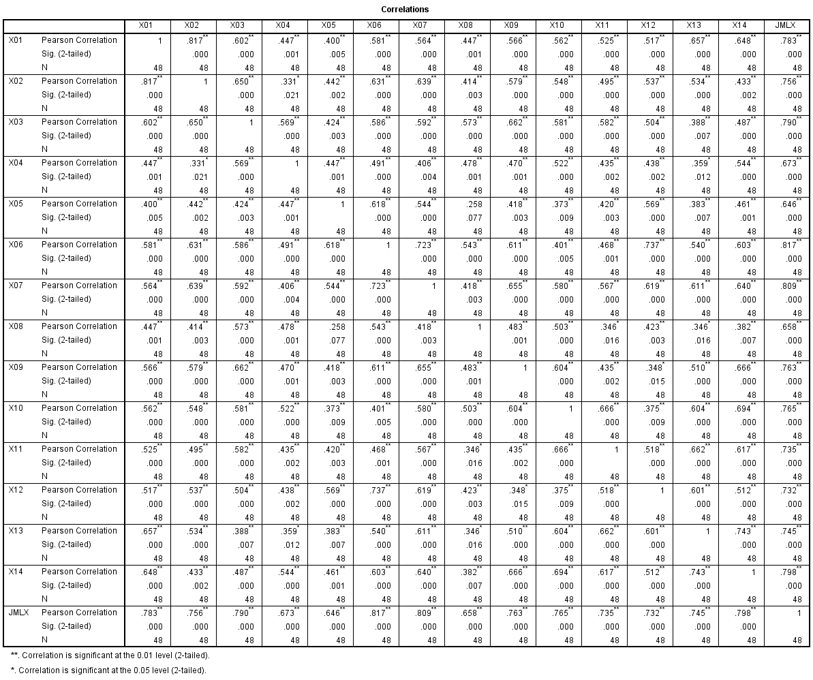

Lampiran 8
Uji Validitas Variabel Employee Engagement (X1)
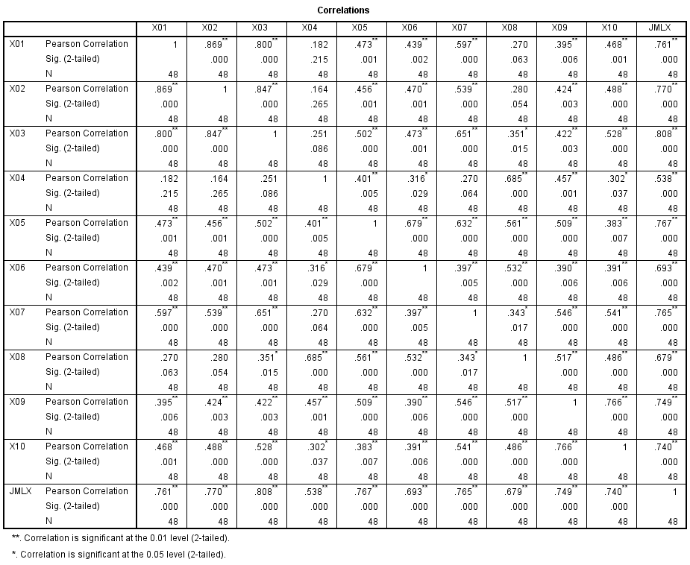

Lampiran 9
Uji Validitas Variabel Emotional Intelligence (X2)
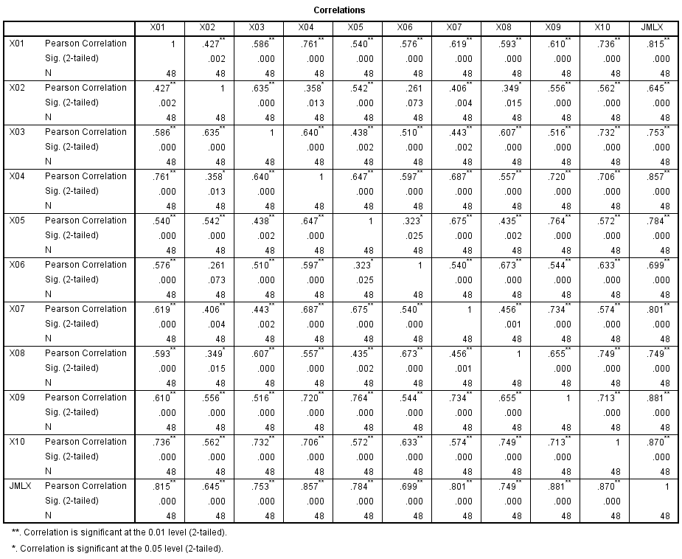

Lampiran 10
Uji Validitas Variabel Komitmen Organisasi (X3)
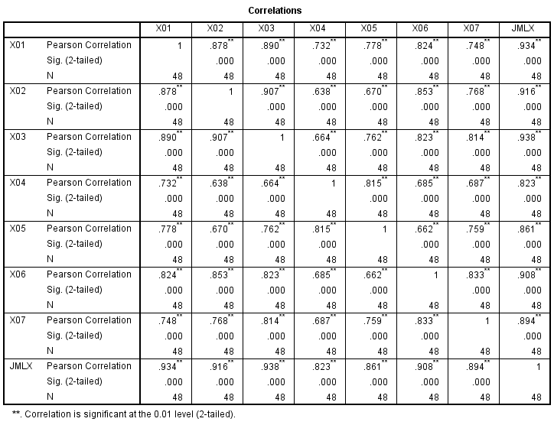

Lampiran 11
Reliabilitas
Hasil Uji Reliabilitas Organizational Citizenship Behavior (Y)
Reliability Statistics
Cronbach's Alpha | N of Items
.958 | 14

Reliability Statistics
Cronbach's Alpha | N of Items
.881 | 10
Hasil Uji Reliabilitas Employee Engagement (X1)

Hasil Uji Reliabilitas Emotional Intelligence (X2)
Reliability Statistics
Cronbach's Alpha | N of Items
.921 | 10

Hasil Uji Reliabilitas Komitmen Organisasi (X3)
Reliability Statistics
Cronbach's Alpha | N of Items
.964 | 7

Lampiran 12
Hasil Uji Normalitas Kolmogorov-Smirnov
One-Sample Kolmogorov-Smirnov Test
 |  | Unstandardized Residual
N |  | 48
Normal Parameters^{a,b} | Mean | .0000000
 | Std. Deviation | 5.14053129
Most Extreme Differences | Absolute | .072
 | Positive | .052
 | Negative | -.072
Test Statistic |  | .072
Asymp. Sig. (2-tailed) |  | .200^{c,d}
Sumber : Data SPSS 22 (2023)

Lampiran 13
Data Uji MSI Organizational Citizenship Behavior (Y)
Resp | Succesive Interval
 | 1 | 2 | 3 | 4 | 5 | 6 | 7 | 8 | 9 | 10 | 11 | 12 | 13 | 14
1 | 4,250 | 4,327 | 3,324 | 5,223 | 5,074 | 4,539 | 5,417 | 2,862 | 4,190 | 5,272 | 5,342 | 5,542 | 5,472 | 5,264
2 | 5,638 | 5,709 | 5,417 | 5,223 | 5,074 | 4,539 | 5,417 | 4,583 | 5,472 | 5,272 | 5,342 | 5,542 | 5,472 | 5,264
3 | 5,638 | 4,327 | 5,417 | 5,223 | 5,074 | 3,266 | 5,417 | 4,583 | 4,190 | 5,272 | 5,342 | 5,542 | 5,472 | 5,264
4 | 4,250 | 4,327 | 4,298 | 4,049 | 3,832 | 3,266 | 3,989 | 1,911 | 4,190 | 3,982 | 4,069 | 4,228 | 4,190 | 4,024
5 | 5,638 | 5,709 | 5,417 | 5,223 | 5,074 | 4,539 | 5,417 | 4,583 | 5,472 | 5,272 | 5,342 | 5,542 | 5,472 | 5,264
6 | 5,638 | 5,709 | 5,417 | 5,223 | 3,832 | 3,266 | 5,417 | 2,862 | 5,472 | 5,272 | 5,342 | 5,542 | 5,472 | 5,264
7 | 4,250 | 3,000 | 4,298 | 5,223 | 3,832 | 3,266 | 5,417 | 4,583 | 4,190 | 3,982 | 4,069 | 4,228 | 4,190 | 5,264
8 | 3,000 | 3,000 | 3,324 | 3,000 | 2,903 | 2,143 | 2,755 | 2,862 | 3,000 | 2,976 | 3,036 | 4,228 | 3,000 | 3,000
9 | 3,000 | 3,000 | 3,324 | 3,000 | 2,903 | 2,143 | 2,755 | 2,862 | 3,000 | 2,976 | 3,036 | 3,000 | 3,000 | 3,000
10 | 5,638 | 4,327 | 5,417 | 5,223 | 5,074 | 4,539 | 3,989 | 3,647 | 5,472 | 5,272 | 5,342 | 5,542 | 4,190 | 5,264
11 | 4,250 | 4,327 | 4,298 | 4,049 | 3,832 | 3,266 | 3,989 | 3,647 | 4,190 | 3,982 | 4,069 | 4,228 | 4,190 | 4,024
12 | 4,250 | 4,327 | 4,298 | 4,049 | 3,832 | 3,266 | 3,989 | 3,647 | 4,190 | 3,982 | 4,069 | 4,228 | 4,190 | 4,024
13 | 5,638 | 5,709 | 5,417 | 5,223 | 5,074 | 4,539 | 5,417 | 4,583 | 5,472 | 5,272 | 5,342 | 5,542 | 5,472 | 5,264
14 | 4,250 | 4,327 | 3,324 | 4,049 | 3,832 | 3,266 | 3,989 | 2,862 | 4,190 | 3,982 | 4,069 | 4,228 | 4,190 | 4,024
15 | 4,250 | 4,327 | 3,324 | 3,000 | 3,832 | 3,266 | 3,989 | 2,862 | 4,190 | 3,982 | 4,069 | 4,228 | 4,190 | 5,264
16 | 5,638 | 4,327 | 3,324 | 5,223 | 2,903 | 2,143 | 2,755 | 2,862 | 4,190 | 5,272 | 3,036 | 3,000 | 5,472 | 5,264
17 | 3,000 | 3,000 | 3,324 | 5,223 | 2,903 | 1,000 | 2,000 | 2,862 | 3,000 | 3,982 | 4,069 | 3,000 | 3,000 | 3,000
18 | 5,638 | 5,709 | 5,417 | 5,223 | 5,074 | 4,539 | 5,417 | 4,583 | 5,472 | 5,272 | 5,342 | 5,542 | 5,472 | 5,264
19 | 5,638 | 5,709 | 5,417 | 5,223 | 5,074 | 4,539 | 5,417 | 4,583 | 5,472 | 5,272 | 5,342 | 5,542 | 5,472 | 5,264
20 | 5,638 | 5,709 | 5,417 | 5,223 | 5,074 | 4,539 | 5,417 | 4,583 | 5,472 | 5,272 | 5,342 | 5,542 | 5,472 | 5,264
21 | 5,638 | 5,709 | 5,417 | 5,223 | 5,074 | 4,539 | 5,417 | 4,583 | 5,472 | 5,272 | 5,342 | 5,542 | 5,472 | 5,264
22 | 4,250 | 4,327 | 4,298 | 3,000 | 2,000 | 2,143 | 3,989 | 1,911 | 3,000 | 3,982 | 5,342 | 4,228 | 4,190 | 4,024
23 | 4,250 | 5,709 | 5,417 | 4,049 | 5,074 | 3,266 | 5,417 | 3,647 | 4,190 | 5,272 | 4,069 | 5,542 | 4,190 | 4,024
24 | 4,250 | 4,327 | 4,298 | 5,223 | 3,832 | 3,266 | 3,989 | 2,862 | 3,000 | 3,982 | 4,069 | 4,228 | 3,000 | 3,000
25 | 5,638 | 5,709 | 5,417 | 4,049 | 3,832 | 3,266 | 3,989 | 3,647 | 5,472 | 3,982 | 4,069 | 4,228 | 4,190 | 4,024
26 | 4,250 | 4,327 | 4,298 | 5,223 | 3,832 | 3,266 | 3,989 | 1,911 | 4,190 | 2,976 | 4,069 | 4,228 | 4,190 | 4,024
27 | 4,250 | 4,327 | 4,298 | 3,000 | 2,903 | 3,266 | 3,989 | 3,647 | 4,190 | 2,976 | 3,036 | 3,000 | 4,190 | 3,000
28 | 4,250 | 4,327 | 4,298 | 5,223 | 5,074 | 4,539 | 3,989 | 4,583 | 4,190 | 5,272 | 5,342 | 4,228 | 4,190 | 5,264
29 | 4,250 | 4,327 | 4,298 | 4,049 | 3,832 | 3,266 | 3,989 | 3,647 | 5,472 | 3,982 | 4,069 | 4,228 | 4,190 | 4,024
30 | 4,250 | 4,327 | 5,417 | 4,049 | 5,074 | 3,266 | 3,989 | 2,862 | 5,472 | 3,982 | 4,069 | 4,228 | 3,000 | 4,024
31 | 5,638 | 5,709 | 5,417 | 5,223 | 5,074 | 4,539 | 5,417 | 2,862 | 5,472 | 5,272 | 4,069 | 5,542 | 5,472 | 5,264
32 | 5,638 | 4,327 | 4,298 | 4,049 | 2,903 | 2,143 | 3,989 | 4,583 | 5,472 | 5,272 | 4,069 | 3,000 | 4,190 | 5,264
33 | 5,638 | 5,709 | 4,298 | 4,049 | 5,074 | 4,539 | 3,989 | 3,647 | 4,190 | 3,982 | 3,036 | 5,542 | 4,190 | 5,264
34 | 5,638 | 5,709 | 5,417 | 5,223 | 5,074 | 4,539 | 5,417 | 4,583 | 5,472 | 5,272 | 5,342 | 5,542 | 5,472 | 5,264
35 | 5,638 | 5,709 | 5,417 | 5,223 | 5,074 | 4,539 | 5,417 | 4,583 | 5,472 | 5,272 | 5,342 | 5,542 | 5,472 | 5,264
36 | 4,250 | 4,327 | 3,324 | 3,000 | 5,074 | 2,143 | 5,417 | 1,000 | 5,472 | 5,272 | 5,342 | 3,000 | 5,472 | 5,264
37 | 5,638 | 5,709 | 5,417 | 5,223 | 3,832 | 3,266 | 5,417 | 2,862 | 5,472 | 5,272 | 4,069 | 3,000 | 3,000 | 5,264
38 | 5,638 | 5,709 | 4,298 | 3,000 | 3,832 | 3,266 | 3,989 | 2,862 | 4,190 | 3,982 | 5,342 | 4,228 | 5,472 | 4,024
39 | 4,250 | 4,327 | 3,324 | 3,000 | 3,832 | 2,143 | 3,989 | 1,911 | 3,000 | 2,976 | 3,036 | 4,228 | 3,000 | 3,000
40 | 4,250 | 4,327 | 2,000 | 4,049 | 3,832 | 3,266 | 3,989 | 2,862 | 4,190 | 2,000 | 2,000 | 4,228 | 3,000 | 3,000
41 | 4,250 | 4,327 | 4,298 | 4,049 | 3,832 | 3,266 | 3,989 | 3,647 | 4,190 | 3,982 | 4,069 | 4,228 | 4,190 | 4,024
42 | 5,638 | 4,327 | 4,298 | 4,049 | 3,832 | 3,266 | 3,989 | 2,862 | 4,190 | 3,982 | 4,069 | 5,542 | 5,472 | 5,264
43 | 5,638 | 4,327 | 3,324 | 4,049 | 5,074 | 3,266 | 3,989 | 1,911 | 3,000 | 2,976 | 5,342 | 5,542 | 5,472 | 5,264
44 | 5,638 | 5,709 | 3,324 | 3,000 | 3,832 | 2,143 | 3,989 | 3,647 | 3,000 | 5,272 | 4,069 | 4,228 | 4,190 | 3,000
45 | 3,000 | 3,000 | 3,324 | 3,000 | 2,903 | 2,143 | 3,989 | 2,862 | 4,190 | 3,982 | 3,036 | 4,228 | 4,190 | 4,024
46 | 4,250 | 4,327 | 3,324 | 3,000 | 5,074 | 3,266 | 3,989 | 2,862 | 4,190 | 3,982 | 4,069 | 4,228 | 4,190 | 4,024
47 | 5,638 | 5,709 | 5,417 | 4,049 | 3,832 | 3,266 | 3,989 | 3,647 | 4,190 | 3,982 | 5,342 | 4,228 | 4,190 | 4,024
48 | 5,638 | 5,709 | 4,298 | 4,049 | 2,000 | 4,539 | 5,417 | 4,583 | 5,472 | 5,272 | 5,342 | 5,542 | 5,472 | 5,264

Lampiran 14
Data Uji MSI Employee Engagement (X1)
Resp | Succesive Interval
 | 1 | 2 | 3 | 4 | 5 | 6 | 7 | 8 | 9 | 10
1 | 4,229 | 3,224 | 3,163 | 1,000 | 2,870 | 2,145 | 2,743 | 1,000 | 1,907 | 1,943
2 | 3,138 | 3,224 | 3,163 | 1,000 | 2,870 | 2,875 | 4,235 | 1,000 | 4,082 | 3,517
3 | 4,229 | 3,224 | 4,062 | 4,379 | 2,141 | 2,875 | 3,438 | 3,941 | 4,082 | 4,409
4 | 4,229 | 4,217 | 4,062 | 1,000 | 2,141 | 2,145 | 3,438 | 1,000 | 1,000 | 2,731
5 | 3,138 | 2,544 | 2,483 | 2,164 | 3,392 | 3,520 | 3,438 | 2,164 | 3,295 | 3,517
6 | 4,229 | 4,217 | 4,062 | 2,164 | 4,190 | 3,520 | 4,235 | 3,941 | 4,082 | 4,409
7 | 3,138 | 2,544 | 2,483 | 1,000 | 2,141 | 1,000 | 1,000 | 2,164 | 2,624 | 2,731
8 | 4,229 | 4,217 | 3,163 | 2,164 | 2,141 | 2,145 | 2,743 | 2,164 | 2,624 | 1,943
9 | 2,381 | 2,544 | 2,483 | 2,960 | 2,870 | 2,875 | 2,743 | 2,913 | 2,624 | 2,731
10 | 2,381 | 1,891 | 1,771 | 1,000 | 1,000 | 2,145 | 1,000 | 1,000 | 1,000 | 1,943
11 | 2,381 | 1,891 | 2,483 | 2,960 | 2,870 | 2,875 | 2,743 | 2,913 | 2,624 | 2,731
12 | 1,736 | 1,891 | 1,771 | 2,164 | 2,141 | 2,145 | 1,967 | 2,913 | 2,624 | 2,731
13 | 1,000 | 1,000 | 1,000 | 1,000 | 1,000 | 1,000 | 1,000 | 1,000 | 1,000 | 1,000
14 | 3,138 | 3,224 | 3,163 | 1,000 | 2,141 | 3,520 | 1,967 | 1,000 | 3,295 | 3,517
15 | 4,229 | 4,217 | 4,062 | 2,164 | 2,141 | 2,145 | 2,743 | 1,000 | 1,907 | 1,943
16 | 4,229 | 3,224 | 3,163 | 1,000 | 3,392 | 4,497 | 2,743 | 1,000 | 1,000 | 1,000
17 | 4,229 | 4,217 | 4,062 | 2,960 | 1,000 | 3,520 | 1,000 | 2,913 | 1,907 | 1,943
18 | 1,736 | 1,891 | 1,771 | 2,960 | 1,000 | 1,000 | 1,967 | 1,000 | 2,624 | 1,943
19 | 2,381 | 1,891 | 2,483 | 2,164 | 1,000 | 1,000 | 1,967 | 2,164 | 1,907 | 1,000
20 | 4,229 | 4,217 | 4,062 | 2,164 | 4,190 | 2,875 | 3,438 | 2,913 | 3,295 | 2,731
21 | 2,381 | 3,224 | 3,163 | 2,960 | 2,870 | 2,875 | 2,743 | 2,913 | 3,295 | 2,731
22 | 3,138 | 2,544 | 4,062 | 2,164 | 3,392 | 2,145 | 4,235 | 2,164 | 1,907 | 1,000
23 | 3,138 | 3,224 | 4,062 | 3,624 | 4,190 | 3,520 | 2,743 | 3,361 | 3,295 | 3,517
24 | 2,381 | 1,891 | 1,771 | 2,164 | 2,141 | 2,145 | 1,967 | 2,164 | 2,624 | 2,731
25 | 3,138 | 3,224 | 1,771 | 2,164 | 2,141 | 2,145 | 1,967 | 2,164 | 1,907 | 1,943
26 | 3,138 | 3,224 | 2,483 | 2,164 | 2,141 | 2,145 | 1,967 | 2,164 | 2,624 | 2,731
27 | 3,138 | 3,224 | 2,483 | 1,000 | 2,141 | 1,000 | 2,743 | 2,164 | 2,624 | 2,731
28 | 3,138 | 2,544 | 2,483 | 2,960 | 2,870 | 1,000 | 1,967 | 1,000 | 1,907 | 1,943
29 | 1,736 | 1,000 | 1,771 | 2,164 | 2,141 | 2,145 | 1,967 | 2,164 | 1,907 | 1,943
30 | 4,229 | 2,544 | 2,483 | 3,624 | 3,392 | 2,875 | 3,438 | 3,361 | 4,082 | 3,517
31 | 4,229 | 4,217 | 4,062 | 1,000 | 2,141 | 2,145 | 4,235 | 1,000 | 4,082 | 4,409
32 | 4,229 | 4,217 | 4,062 | 2,164 | 3,392 | 3,520 | 2,743 | 3,941 | 2,624 | 3,517
33 | 3,138 | 2,544 | 3,163 | 2,960 | 2,141 | 1,000 | 2,743 | 2,164 | 2,624 | 2,731
34 | 1,000 | 1,000 | 1,000 | 1,000 | 1,000 | 1,000 | 1,000 | 1,000 | 1,000 | 1,000
35 | 2,381 | 1,000 | 1,000 | 1,000 | 1,000 | 1,000 | 1,967 | 1,000 | 2,624 | 1,943
36 | 2,381 | 1,891 | 1,000 | 1,000 | 1,000 | 1,000 | 1,000 | 1,000 | 1,000 | 1,000
37 | 1,736 | 1,891 | 2,483 | 1,000 | 1,000 | 1,000 | 1,000 | 1,000 | 1,000 | 2,731
38 | 2,381 | 1,891 | 2,483 | 1,000 | 1,000 | 1,000 | 1,967 | 2,164 | 1,907 | 2,731
39 | 3,138 | 2,544 | 3,163 | 2,164 | 2,141 | 1,000 | 2,743 | 2,164 | 2,624 | 1,943
40 | 4,229 | 4,217 | 4,062 | 2,960 | 3,392 | 2,145 | 3,438 | 2,164 | 4,082 | 3,517
41 | 4,229 | 4,217 | 4,062 | 2,164 | 2,141 | 2,145 | 3,438 | 2,164 | 3,295 | 3,517
42 | 2,381 | 2,544 | 2,483 | 1,000 | 1,000 | 1,000 | 1,967 | 1,000 | 1,000 | 1,000
43 | 3,138 | 2,544 | 2,483 | 1,000 | 1,000 | 1,000 | 2,743 | 1,000 | 1,000 | 1,943
44 | 3,138 | 3,224 | 2,483 | 3,624 | 2,870 | 2,145 | 2,743 | 2,913 | 2,624 | 2,731
45 | 3,138 | 2,544 | 2,483 | 2,164 | 2,141 | 2,145 | 2,743 | 2,164 | 2,624 | 2,731
46 | 4,229 | 3,224 | 3,163 | 1,000 | 2,141 | 2,145 | 1,967 | 1,000 | 1,907 | 2,731
47 | 3,138 | 3,224 | 3,163 | 1,000 | 1,000 | 1,000 | 1,000 | 1,000 | 3,295 | 3,517
48 | 4,229 | 3,224 | 4,062 | 2,164 | 2,141 | 2,145 | 4,235 | 2,164 | 1,907 | 4,409

Lampiran 15
Data Uji MSI Emotional Intelligence (X2)
Resp | Succesive Interval
 | 1 | 2 | 3 | 4 | 5 | 6 | 7 | 8 | 9 | 10
1 | 3,000 | 3,322 | 4,238 | 3,813 | 3,567 | 5,331 | 4,890 | 5,510 | 4,868 | 4,217
2 | 5,144 | 2,192 | 4,238 | 4,851 | 4,583 | 5,331 | 4,890 | 5,510 | 4,868 | 5,510
3 | 5,144 | 4,583 | 5,526 | 3,813 | 4,583 | 5,331 | 4,890 | 5,510 | 4,868 | 5,510
4 | 4,092 | 3,322 | 4,238 | 3,813 | 3,567 | 4,080 | 3,919 | 4,217 | 3,896 | 4,217
5 | 5,144 | 4,583 | 5,526 | 4,851 | 4,583 | 5,331 | 4,890 | 5,510 | 4,868 | 5,510
6 | 5,144 | 4,583 | 5,526 | 4,851 | 1,976 | 5,331 | 4,890 | 5,510 | 4,868 | 5,510
7 | 4,092 | 3,322 | 4,238 | 4,851 | 2,810 | 5,331 | 3,129 | 4,217 | 3,896 | 4,217
8 | 3,000 | 2,192 | 3,000 | 3,032 | 2,810 | 3,000 | 3,129 | 3,000 | 3,096 | 3,000
9 | 3,000 | 2,192 | 3,000 | 3,032 | 2,810 | 3,000 | 3,129 | 3,000 | 3,096 | 3,000
10 | 4,092 | 3,322 | 4,238 | 4,851 | 3,567 | 5,331 | 3,919 | 4,217 | 4,868 | 5,510
11 | 4,092 | 3,322 | 4,238 | 3,813 | 3,567 | 4,080 | 3,919 | 4,217 | 3,896 | 4,217
12 | 4,092 | 3,322 | 4,238 | 3,813 | 3,567 | 4,080 | 3,919 | 4,217 | 3,896 | 4,217
13 | 5,144 | 4,583 | 5,526 | 4,851 | 4,583 | 5,331 | 4,890 | 5,510 | 4,868 | 5,510
14 | 4,092 | 2,192 | 4,238 | 3,813 | 3,567 | 5,331 | 3,129 | 4,217 | 3,096 | 4,217
15 | 3,000 | 2,192 | 3,000 | 2,000 | 1,976 | 4,080 | 2,000 | 4,217 | 2,000 | 4,217
16 | 3,000 | 2,192 | 3,000 | 3,032 | 2,810 | 5,331 | 4,890 | 3,000 | 3,096 | 3,000
17 | 4,092 | 1,000 | 5,526 | 4,851 | 1,000 | 5,331 | 3,129 | 5,510 | 2,000 | 4,217
18 | 5,144 | 4,583 | 5,526 | 4,851 | 4,583 | 5,331 | 4,890 | 5,510 | 4,868 | 5,510
19 | 5,144 | 2,192 | 3,000 | 3,032 | 1,976 | 5,331 | 3,129 | 5,510 | 3,096 | 4,217
20 | 4,092 | 2,192 | 3,000 | 4,851 | 4,583 | 5,331 | 4,890 | 5,510 | 4,868 | 5,510
21 | 3,000 | 4,583 | 5,526 | 4,851 | 4,583 | 5,331 | 4,890 | 5,510 | 4,868 | 5,510
22 | 5,144 | 3,322 | 5,526 | 4,851 | 4,583 | 4,080 | 4,890 | 4,217 | 3,896 | 5,510
23 | 4,092 | 3,322 | 4,238 | 3,813 | 3,567 | 4,080 | 3,919 | 4,217 | 3,896 | 4,217
24 | 4,092 | 3,322 | 3,000 | 3,813 | 3,567 | 4,080 | 3,919 | 3,000 | 3,096 | 3,000
25 | 4,092 | 3,322 | 4,238 | 3,813 | 3,567 | 4,080 | 3,129 | 4,217 | 3,896 | 4,217
26 | 3,000 | 3,322 | 4,238 | 3,032 | 2,810 | 3,000 | 3,129 | 4,217 | 3,096 | 4,217
27 | 3,000 | 3,322 | 4,238 | 3,032 | 2,810 | 3,000 | 3,129 | 4,217 | 3,096 | 3,000
28 | 4,092 | 3,322 | 4,238 | 3,813 | 3,567 | 4,080 | 3,919 | 4,217 | 3,896 | 4,217
29 | 3,000 | 2,192 | 3,000 | 3,032 | 2,810 | 3,000 | 3,129 | 3,000 | 3,096 | 3,000
30 | 5,144 | 3,322 | 4,238 | 3,813 | 3,567 | 4,080 | 4,890 | 5,510 | 3,896 | 5,510
31 | 5,144 | 4,583 | 5,526 | 4,851 | 4,583 | 5,331 | 4,890 | 5,510 | 3,896 | 5,510
32 | 4,092 | 3,322 | 5,526 | 4,851 | 4,583 | 4,080 | 3,919 | 4,217 | 3,896 | 4,217
33 | 4,092 | 4,583 | 5,526 | 3,813 | 3,567 | 5,331 | 3,919 | 5,510 | 4,868 | 5,510
34 | 5,144 | 4,583 | 5,526 | 4,851 | 4,583 | 5,331 | 4,890 | 5,510 | 4,868 | 5,510
35 | 5,144 | 4,583 | 5,526 | 4,851 | 4,583 | 5,331 | 4,890 | 5,510 | 4,868 | 5,510
36 | 5,144 | 4,583 | 5,526 | 4,851 | 4,583 | 5,331 | 3,129 | 5,510 | 4,868 | 5,510
37 | 5,144 | 4,583 | 5,526 | 4,851 | 2,810 | 5,331 | 4,890 | 3,000 | 3,096 | 5,510
38 | 4,092 | 4,583 | 4,238 | 3,813 | 3,567 | 3,000 | 3,129 | 4,217 | 3,096 | 4,217
39 | 3,000 | 3,322 | 4,238 | 3,032 | 2,810 | 4,080 | 3,129 | 4,217 | 3,096 | 4,217
40 | 3,000 | 3,322 | 4,238 | 2,000 | 1,976 | 5,331 | 3,129 | 4,217 | 2,000 | 3,000
41 | 3,000 | 3,322 | 4,238 | 2,000 | 2,810 | 4,080 | 3,129 | 4,217 | 3,896 | 4,217
42 | 3,000 | 3,322 | 4,238 | 3,032 | 2,810 | 4,080 | 2,000 | 4,217 | 2,000 | 4,217
43 | 3,000 | 3,322 | 4,238 | 2,000 | 1,976 | 3,000 | 2,000 | 3,000 | 2,000 | 4,217
44 | 3,000 | 2,192 | 3,000 | 3,032 | 2,810 | 3,000 | 3,919 | 3,000 | 3,096 | 3,000
45 | 3,000 | 3,322 | 4,238 | 3,032 | 2,810 | 4,080 | 3,129 | 4,217 | 3,096 | 4,217
46 | 3,000 | 3,322 | 4,238 | 3,032 | 3,567 | 4,080 | 3,919 | 4,217 | 3,096 | 4,217
47 | 3,000 | 3,322 | 4,238 | 3,032 | 1,976 | 4,080 | 2,000 | 4,217 | 3,096 | 4,217
48 | 5,144 | 4,583 | 5,526 | 4,851 | 4,583 | 5,331 | 4,890 | 5,510 | 4,868 | 5,510

Lampiran 16
Data Uji MSI Komitmen Organisasi (X3)
Resp | Succesive Interval
 | 1 | 2 | 3 | 4 | 5 | 6 | 7
1 | 1,853 | 2,463 | 2,465 | 3,059 | 2,512 | 2,007 | 2,375
2 | 1,853 | 2,463 | 2,920 | 2,444 | 3,164 | 2,780 | 2,919
3 | 3,104 | 3,826 | 3,709 | 4,038 | 4,149 | 4,059 | 3,890
4 | 2,596 | 1,758 | 2,465 | 3,059 | 3,164 | 2,007 | 2,919
5 | 3,104 | 3,028 | 2,465 | 2,444 | 2,512 | 3,260 | 2,919
6 | 3,890 | 3,028 | 3,709 | 4,038 | 4,149 | 4,059 | 3,890
7 | 2,596 | 2,463 | 2,465 | 2,444 | 2,512 | 2,780 | 2,919
8 | 2,596 | 2,463 | 2,465 | 2,444 | 2,512 | 2,780 | 2,375
9 | 2,596 | 2,463 | 2,465 | 2,444 | 2,512 | 2,780 | 2,375
10 | 1,000 | 1,758 | 1,000 | 1,736 | 1,796 | 2,007 | 1,000
11 | 2,596 | 2,463 | 2,465 | 2,444 | 2,512 | 2,780 | 2,375
12 | 2,596 | 2,463 | 2,465 | 3,059 | 3,164 | 2,780 | 2,375
13 | 3,104 | 3,028 | 2,920 | 4,038 | 3,164 | 3,260 | 2,919
14 | 1,853 | 2,463 | 2,465 | 3,059 | 3,164 | 2,780 | 2,919
15 | 3,890 | 3,028 | 3,709 | 4,038 | 4,149 | 4,059 | 3,890
16 | 3,890 | 3,826 | 3,709 | 4,038 | 4,149 | 4,059 | 3,890
17 | 3,890 | 3,826 | 3,709 | 4,038 | 4,149 | 4,059 | 3,890
18 | 3,890 | 3,826 | 3,709 | 4,038 | 4,149 | 4,059 | 3,890
19 | 3,890 | 3,826 | 3,709 | 4,038 | 4,149 | 4,059 | 3,890
20 | 3,890 | 3,826 | 3,709 | 4,038 | 4,149 | 4,059 | 3,890
21 | 3,890 | 3,826 | 3,709 | 4,038 | 4,149 | 4,059 | 3,890
22 | 1,000 | 1,000 | 1,796 | 2,444 | 2,512 | 2,007 | 2,375
23 | 3,890 | 3,826 | 3,709 | 4,038 | 4,149 | 4,059 | 3,890
24 | 1,853 | 1,000 | 1,796 | 2,444 | 3,164 | 2,007 | 1,813
25 | 1,853 | 1,758 | 1,796 | 3,059 | 3,164 | 2,780 | 2,375
26 | 3,890 | 3,826 | 3,709 | 4,038 | 4,149 | 3,260 | 2,919
27 | 3,890 | 3,826 | 3,709 | 3,059 | 3,164 | 3,260 | 2,919
28 | 1,853 | 1,758 | 1,796 | 1,736 | 2,512 | 2,007 | 2,919
29 | 2,596 | 1,758 | 1,796 | 1,736 | 1,796 | 2,007 | 1,813
30 | 1,853 | 2,463 | 1,796 | 4,038 | 1,796 | 4,059 | 3,890
31 | 3,890 | 3,826 | 3,709 | 4,038 | 4,149 | 4,059 | 3,890
32 | 3,890 | 3,826 | 3,709 | 2,444 | 3,164 | 4,059 | 3,890
33 | 2,596 | 2,463 | 2,465 | 3,059 | 1,796 | 2,780 | 1,000
34 | 1,000 | 1,000 | 1,000 | 1,000 | 1,000 | 1,000 | 1,000
35 | 2,596 | 1,758 | 1,000 | 4,038 | 4,149 | 1,000 | 1,813
36 | 2,596 | 1,000 | 1,000 | 4,038 | 2,512 | 2,007 | 1,813
37 | 1,000 | 2,463 | 1,000 | 1,000 | 1,000 | 1,000 | 1,000
38 | 1,853 | 1,000 | 1,796 | 1,736 | 2,512 | 2,007 | 1,813
39 | 2,596 | 2,463 | 2,465 | 3,059 | 3,164 | 2,780 | 1,813
40 | 3,890 | 3,826 | 3,709 | 4,038 | 4,149 | 4,059 | 3,890
41 | 3,890 | 3,826 | 3,709 | 4,038 | 4,149 | 4,059 | 3,890
42 | 2,596 | 2,463 | 2,465 | 2,444 | 2,512 | 2,780 | 2,375
43 | 2,596 | 2,463 | 2,920 | 2,444 | 1,796 | 2,007 | 1,813
44 | 2,596 | 2,463 | 2,465 | 2,444 | 2,512 | 2,780 | 2,375
45 | 2,596 | 2,463 | 2,465 | 3,059 | 3,164 | 2,780 | 2,919
46 | 3,890 | 3,826 | 3,709 | 4,038 | 4,149 | 3,260 | 2,919
47 | 3,890 | 3,826 | 3,709 | 4,038 | 4,149 | 4,059 | 3,890
48 | 3,104 | 3,028 | 3,709 | 4,038 | 4,149 | 2,007 | 3,890

Lampiran 17

t tabel
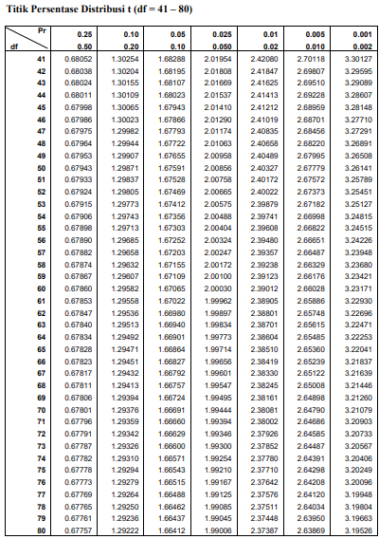

Lampiran 18
F Tabel
Titik Persentase Distribusi F untuk Probabilita = 0,05
Df untuk penyebut (N2) | Df untuk pembilang (N1)
 | 1 | 2 | 3 | 4 | 5 | 6 | 7
40 | 4.08 | 3.23 | 2.84 | 2.61 | 2.45 | 2.34 | 2.25
41 | 4.08 | 3.23 | 2.83 | 2.60 | 2.44 | 2.33 | 2.24
42 | 4.07 | 3.22 | 2.83 | 2.59 | 2.44 | 2.32 | 2.24
43 | 4.07 | 3.21 | 2.82 | 2.59 | 2.43 | 2.32 | 2.23
44 | 4.06 | 3.21 | 2.82 | 2.58 | 2.43 | 2.31 | 2.23
45 | 4.06 | 3.20 | 2.81 | 2.58 | 2.42 | 2.31 | 2.22
46 | 4.05 | 3.20 | 2.81 | 2.57 | 2.42 | 2.30 | 2.22
47 | 4.05 | 3.20 | 2.80 | 2.57 | 2.41 | 2.30 | 2.21
48 | 4.04 | 3.19 | 2.80 | 2.57 | 2.41 | 2.29 | 2.21
49 | 4.04 | 3.19 | 2.79 | 2.56 | 2.40 | 2.29 | 2.20
50 | 4.03 | 3.18 | 2.79 | 2.56 | 2.40 | 2.29 | 2.20
51 | 4.03 | 3.18 | 2.79 | 2.55 | 2.40 | 2.28 | 2.20
52 | 4.03 | 3.18 | 2.78 | 2.55 | 2.39 | 2.28 | 2.19
53 | 4.02 | 3.17 | 2.78 | 2.55 | 2.39 | 2.28 | 2.19
54 | 4.02 | 3.17 | 2.78 | 2.54 | 2.39 | 2.27 | 2.18
55 | 4.02 | 3.16 | 2.77 | 2.54 | 2.38 | 2.27 | 2.18

Lampiran 19
Surat Ijin Penelitian
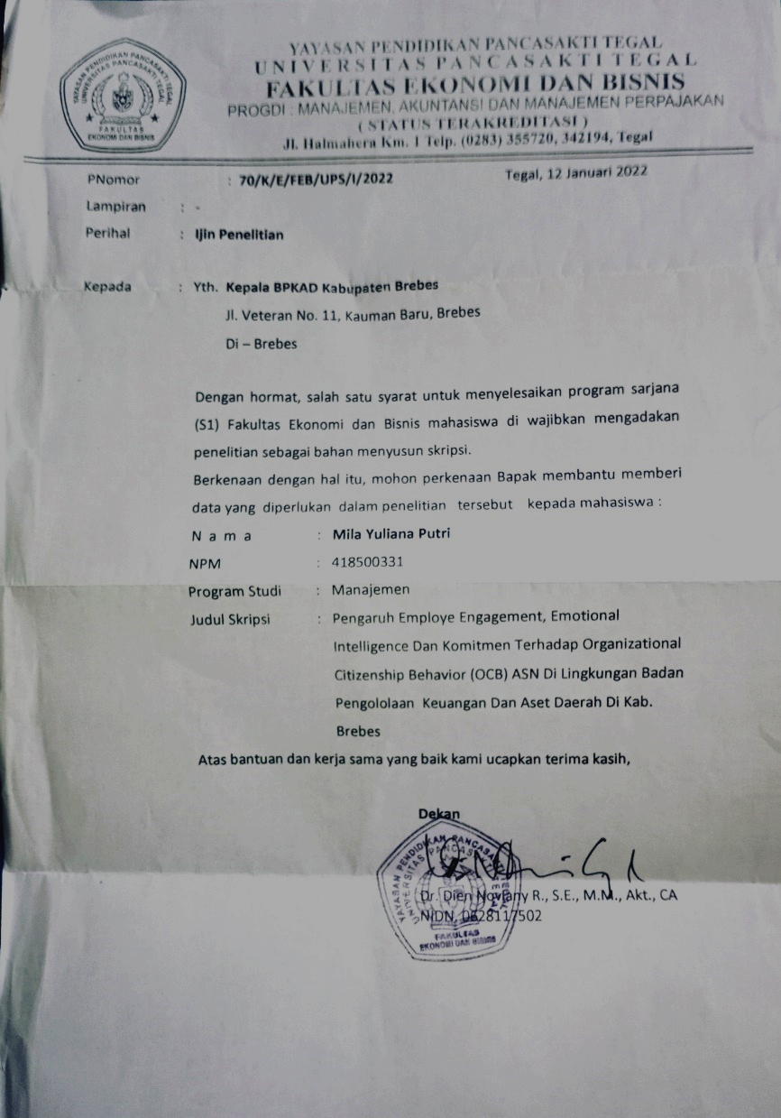

Lampiran 20
Surat Balasan Ijin Penelitian
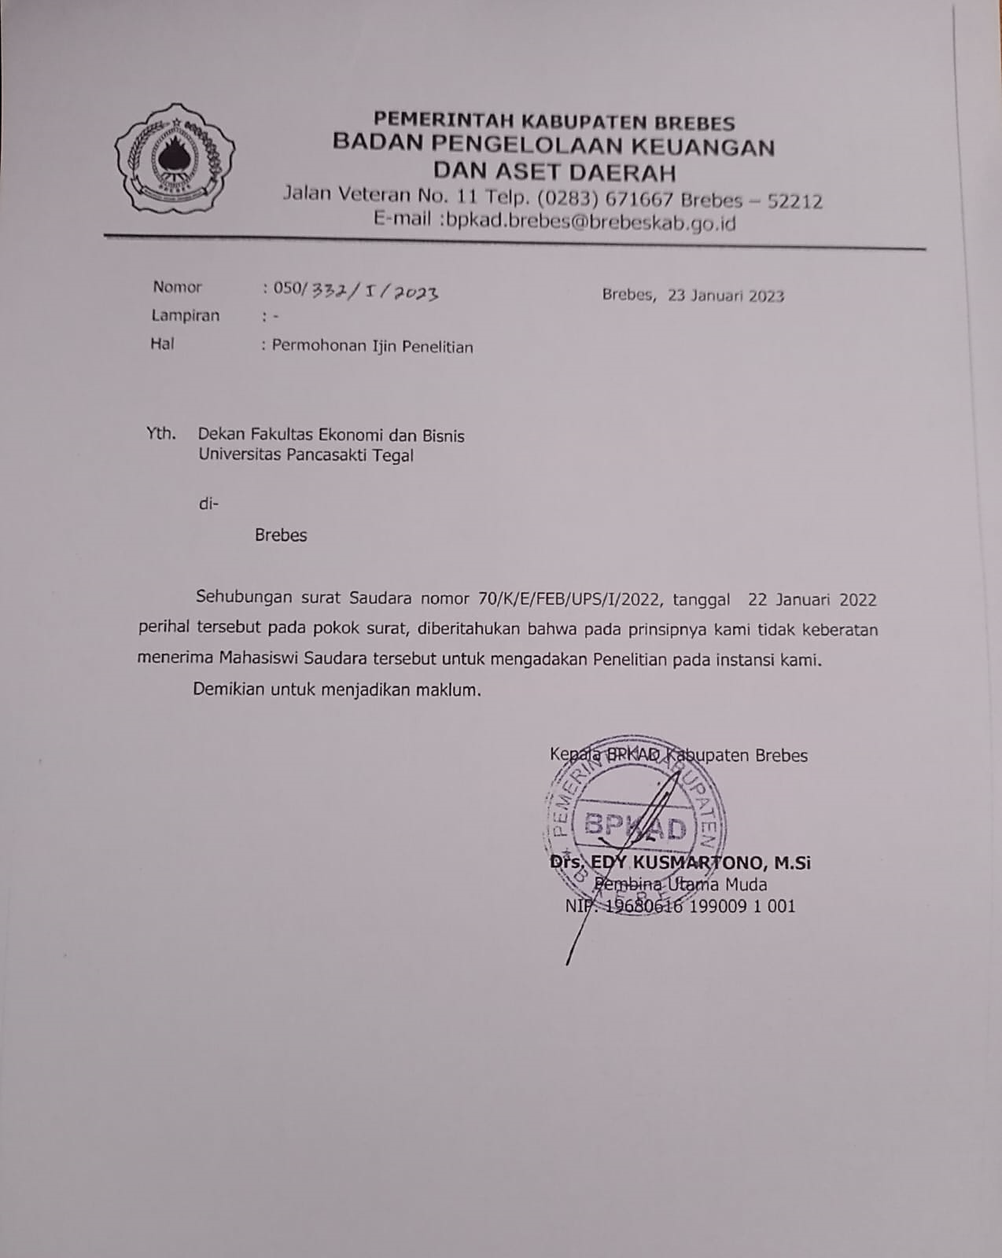

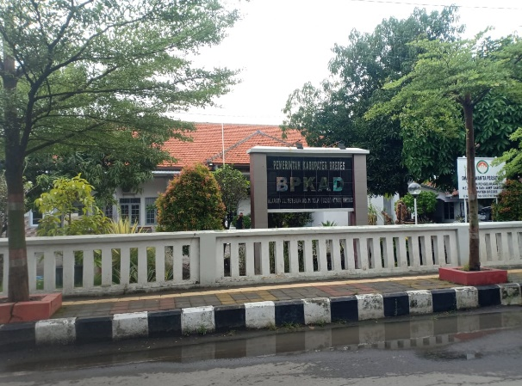

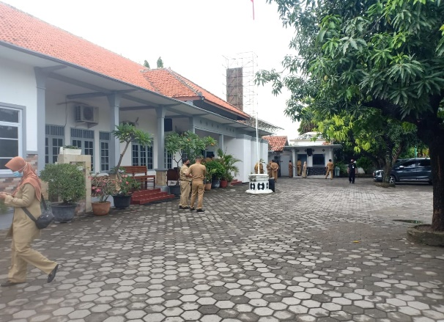

Gambar 10
Objek Penelitian

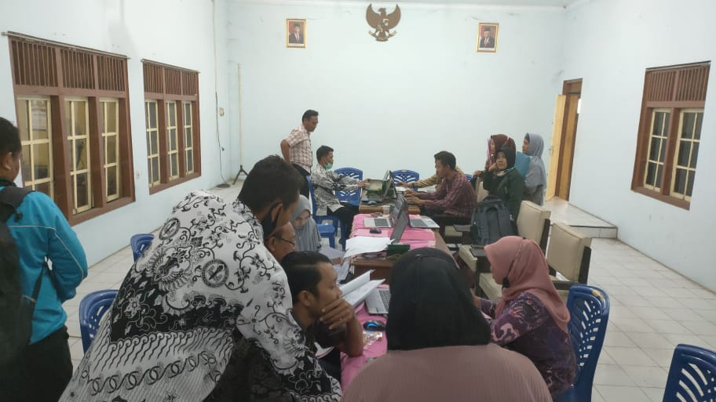

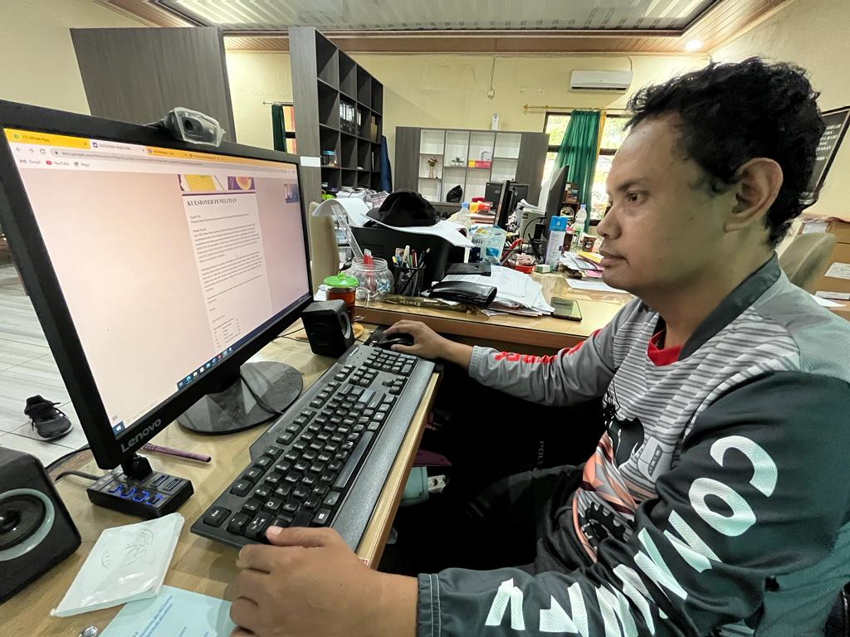
Gambar 11
Pengisian Kuesioner Pegawai

