REFERENCES

Celik, B. 2019. The Role of Extensive Reading in Fostering the Development of Grammar and Vocabulary Knowledge. International Journal of Social Sciences & Educational Studies, 6(1), pp. 215-223. https://doi.org/10.23918/ijsses.v6i1p215
Cervetti, G.N., & Wright, T. S. 2019. The Role of Knowledge in Understanding and Learning from Text (in Press). In E. B. Moje, P. Afflerbach, P. Enciso, & N. K.Lesaux (Eds.), Handbook of Reading Research, Vol. 5. New York: Routledge.
Chedo, Mariyah. 2019. The Influence of Scaffolding Strategy to Develop Students’ Reading Comprehension Skill on Descriptive Text. https://repository.radenintan.ac.id/id/eprint/5333
H., D., Brown,. 2001. Teaching by Principle: An Interactive Approach to Language Pedagogy.New York: Addison Wesley Longman Inc.
Harmer, Jereme. 2007. How to teach English ( New Editions )(China: Pearson Education Limited, 2007).p.99
Herawati, C., Gani, Sofyan, A., Muslim, Asnawi. 2020. The Implementation of Scaffolding Reading Experience Strategy in Increasing Students’ Comprehension. JETLi : Journal Language Teaching And Linguistic. Vol 1 Number 2 December 2020, ISSN: 2723-0961. https://ejournal.unida-aceh.ac.id/index.php/jetli
Gibbons, Pauline. 2002. Scaffolding language, scaffolding learning: Teaching English language learners in the mainstream classroom. Second edition, Portsmouth: Heineman, 2002.
James, Dean Brown. 2005. Testing in Language Program: a Comprehension Guide to English Language Assessment, (New York: McGraw-Hill ESL/ELT, 2005).
Jeffries, Linda & S., Beatrice, M. 2014. Advanced Reading Power 4.
M., F., Fatel, & Praveen, M., Jain. 2008. English Language Teaching ( Methods, Tools and Techniques, ( Suunrice: Jaipur, 2008), p. 114. http://dx.doi.org/10.5539/elt.v10n1p97
Neda, F., Rad & Jalali, Valeh. 2021. ZPD Theory and Scaffolding Teaching Strategy: Iranian EFL Learners Views and Reading Achievement of Short Story as A Way of Literature in Corporation Within Learning Procedure. Critical Literature Studies, Vol III No. 1 Series 5 2021. https://www.doi.org/10.34785/J014.2021.676
Nunan, David. 2003. Practical English Language Teaching, (New York: Mc Graw Hill Companies, 2003), 68
Raymond, E. 2000. Cognitive Characteristics. Learners with Mild Disabilities (pp. 169-201). Needham Heights, MA: Allyn& Bacon, A Pearson Education Company.

Rechel R. Van Der Stuyf. 2002. Scaffolding as a Teaching Strategy. Adolescent Learning and Development Section 0500 A – Fall 2002. November 17, 2002. Page 11-12.
Richard, J., C., and S. Rodgers, Theodore. (2001) Approach and Methods in Language Teaching, (Second Edition) (US: Cambridge University press, 2001), P.41
Rojas, S. P. R., Meneses, A., & Miguel, E. S. (2019). Teachers’ Scaffolding Science Reading Comprehension in Low-Income Schools: How to Improve Achievement in Science. International Journal of Science Education, 41 (13), pp. 1827–1847. https://doi.org/10.1080/09500693.2019.1641855
Sholeh, A., Setyosari, P., Cahyono, B. Y., & Sulthoni. 2019. Effects of Scaffolded Voluntary Reading on EFL Students’ Reading Comprehension. International Journal of Instruction, 12(4), 297-312. https://doi.org/10.29333/iji.2019.12419a
Silberstein, Sandra. 1994. Techniques and Resources in Teaching Reading, (New York: Oxford American English, 1994), 12.
Sugiyono. 2010. Metode Penelitian Pendidikan Pendekatan Kuantitatif, Kualitatif, dan R&D. (Bandung:alfabeta,2010).
Torihoran, Nafan., & Rachmat, Miftahul. 2012. Reading: Pre-Intermediete Reading Skill, (Serang: Loquen Press, 2012), p. 56.
Walqui, A. (2006). Scaffolding Instruction for English Language Learners: A Conceptual Framework. The International Journal of Bilingual Education and Bilingualism, 9(2).
William, Grabe and Stoller, Fredricka L. 2002. Teaching and Researching Reading. New York: Longman, 2002.
Yuvita. 2018. The Use Of Scaffolding Instructions As Teaching Strategy To Increase Students’ Reading Ability. Dialektika Journal. Vol. 6 No.1 March – August 2018 , Page 22-37

APPENDICES

APPENDICES
Appedix 1. Lesson Plan
- GENERAL INFORMATION
- Module Identity
School : SMP N 01 KOTA TEGAL
Writer : Putri Cindy Puspitsari
Year : 2022/2023
Class : VIII H
Time Allocation : 2 x 35 minutes
Elements : Reading, Listening, Speaking and Writing
Competency Unit : Recount Text

- Initial Competence
- Students are able to understand simple recount texts involving stories that happened in the past
- Students are able to identify social functions and linguistic elements from simple recount texts that involve stories that happened in the past

- Pancasila Student Profile
- Critical Reasoning
- Collaborate
- Independent

- Media And Learning Tools
Learning Media : Power point
Learning Tools : Laptop, projector, white board, makers, papers.

- Target Students
32 regular students
- Learning Approach, Method And Models
Approach : Scientif Approach
Learning Method : Scaffolding Strategies
Learning Model : Explanation, discussions, answering and question

- CORE COMPETENCIES
- Learning objectives
- Students (A) are able to identify (C1) social functions, text structures and linguistic elements of Recount text (B) through individual activities (C) correctly and in context (D)
- Students (A) are able to sort (C3) Recount text according to social functions, text structure and linguistic elements (B) through group discussion activities (C) correctly and in context (D)
- Students (A) are able to summarize (C5) Recount text by paying attention to social functions, text structures and linguistic elements (B) through group discussion activities (C) correctly and in context (D)
- Students (A) are able to compose (C6) Recount text by paying attention to social functions, text structure and linguistic elements (B) through group activities (C) correctly and in context (D)

- Meaningful Understanding
Students are able to identify, sort, summarize and compile Recount Text related to personal experiences by paying attention to social functions, text structures and linguistic elements correctly and according to context.

- Starter Questioning
- Do you have an unforgettable moment?
- How would you tell about your unforgettable moment?
- Do you know that your story about an unforgettable moment and arguments follow, it is called “Recount Text”?

- Learning Preparation
  - The teacher prepares everything that is needed during learning
  - The teacher arranges LKPD
  - The teacher prepares students to follow the learning process such as praying, attendance, and preparing textbooks

- Learning Activities
Meetings 1 & 2
Introduction (10 minutes)
- The teacher and learners together with do a prayer together then check the attendance of students
- The teacher links the material/theme/learning activities that will be carried out with experience/basic knowledge using questions (bridging)
- The teacher will inform the subject matter that will be discussed at the meeting
- The teacher conveys the goal competencies that will be achieved to students
Main Activities (50 minutes)
(Meeting 1)
- Learners observe and pay close attention to the explanation of the teacher written on the board
- Learners look at and listen to examples of recount text shown by the teacher
- Teachers and learners discuss to identify related information about the topic, social function and linguistic elements of the recount text example being studied
(Meeting 2)
- The teacher guides learners to read the recount text correctly (read-aloud)
- Learners look for difficult words from the reading text and then write them in their books (read in detail)
- The teacher checks the students' work and asks the students to read the text again. (re-reading & read silently)
Closing (10 minutes)
- The teacher and learners together make a conclusion and reflection of the material that has been learned at this meeting.
- The teacher informs the learners about the learning activity plan for the next meeting.
- The teacher and students end the learning activity by saying greetings and prayers.

Meetings 3 & 4
Introduction (10 minutes)
- the teacher and students together with do a prayer together then check the attendance of students
- The teacher reminds the material/theme/learning activities that will be carried out with the previous material
- The teacher asks some questions about the previous material
- The teacher conveys the goal competencies that will be achieved to students.
Main Activities (50 minutes)
(Meeting 3)
- The teacher guides the learners to create recount texts in groups.
- The teacher asks the learners to analyze the recount text they made in groups
- Learners convert the results of the recount text made in groups from paragraphs into a concept map (Re-presenting)
(Meeting 4)
- Learners present the results of the project on recount text that they made in groups in front of the class.
- Teacher guides the presentation and learners receive feedback from the teacher.
Closing (10 minutes)
- The teacher and learners together make a conclusion and reflection of the material that has been learned at this meeting.
- The teacher informs the learners about the learning activity plan for the next meeting.
- The teacher and students end the learning activity by saying greetings and prayers.

Meetings 5 & 6
Introduction (10 minutes)
- the teacher and students together with do a prayer together then check the attendance of students
- The teacher reminds the material/theme/learning activities that will be carried out with the previous material
- The teacher asks some questions about the previous material
- The teacher conveys the goal competencies that will be achieved to students.
Main Activities (50 minutes)
(Meeting 5)
- The teacher guides the learners to create recount texts in groups
The teacher asks the learners to analyze the recount text they made in groups
(Meeting 6)
- Learners present the results of the project on recount text that they made in groups in front of the class.
Teacher guides the presentation and learners receive feedback from the teacher.
Closing (10 minutes)
- The teacher and learners together make a conclusion and reflection of the material that has been learned at this meeting.
- The teacher informs the learners about the learning activity plan for the next meeting.
- The teacher and students end the learning activity by saying greetings and prayers.

- ASSESSMENT RUBRIC
a. Group Research Rubric
Kriteria | Sangat baik  (4) | Baik  (3) | Cukup  (2) | Perlu pendampingan (1)
Mendengarkan | Selalu menyimak  teman yang sedang  berbicara. | Menyimak teman yang  berbicara, namun  sesekali masih perlu  diingatkan. | Masih perlu  diingatkan untuk  mendengarkan teman  yang sedang  berbicara. | Sering diingatkan  untuk mendengarkan  teman yang sedang  berbicara namun tidak  mengindahkan
Komunikasi  non-verbal  (kontak mata,  bahasa tubuh,  postur, ekspresi  wajah, suara) | Merespon dan  menerapkan komunikasi non-  verbal dengan tepat. | Merespon dengan  tepat terhadap  komunikasi non-verbal  yang ditunjukan  teman. | Sering merespon  kurang tepat terhadap komunikasi non-  verbal yang  ditunjukan teman | Membutuhkan  bantuan dalam  memahami bentuk  komunikasi non-  verbal yang  ditunjukan teman.
Partisipasi  (menyampaikan  ide, perasaan  dan pikiran) | Isi pembicaraan  menginspirasi teman.  Selalu mendukung  dan memimpin  teman lainnya saat  diskusi. | Berbicara dan  menerangkan secara  rinci, merespon sesuai  dengan topik. | Berbicara dan  menerangkan secara  rinci, namun  terkadang merespon  kurang sesuai dengan  topik. | Jarang berbicara  selama proses diskusi  berlangsung.
Skor maksimal = 12
Nilai akhir = (skor Perolehan Peserta Didik x 10) / 12 = hasil akhir x 10
Knowing  Supervising Teacher,  Dian Palupi Kartikasari S.Pd | Brebes, 15 May 2023  Reseacher,  Putri Cindy Puspitasari  NPM 1619500044

Appedix 2. Instrument (Reading Comprehension Test)
Choose the correct answer by crossing (x) a,b c, or d!
The following text is for question 1 to 8
A Day Visit to Yogyakarta
Last week, I went to Yogyakarta with my family. My father drove the car. My mother sat beside him. My sister and I sat in the back seats.
We woke up early in the morning. My father prepared the car in the garage while mother was preparing food for breakfast and some snacks for us. My sister and I packed some clothes. After everything got ready and we had our breakfast, we left the house at six o’clock.
It was about nine A.M. We arrived at Yogyakarta. First of all we visited our uncle. We stayed there for an hour. Then we went to Parangtritis beach. We got there at eleven o’clock. There were a lot of tourists because it was holiday. I saw many foreign visitors too. My parents watched us playing with sand in the beach. We did not swim and take a bath since the wave was rough. After having lunch, we went on our picnic to the museum and Malioboro shopping centre.
We drove back to Semarang at 7 o’clock and arrived home at ten. We were tired but happy.
Taken from
English Text Types OK Book, 2017

- Who did the writer go to the Yogyakarta with?
a. sister c. friends
b.uncle d. family

- What did the writer use to go to Yogyakarta?
a. car c. plane
b. bus d. motorcycle

- What is the main idea of the second paragraph?
a. mother prepred the car c. wake up early in the morning
b. father prepared the food d. visiting the writer uncle’s house
- When the writer arrived in Yogyakarta, what was the first thing he/she did?
a. visiting his/her uncle’s house c. playing sand beach
b. went to parangtritis d. going around Yogyakarta

- After everything got ready and we had our breakfast, ... we left the house at six o’clock.
a. then c. and
b. when d. before

- Why the writer and his/her sister did not swimming in the beach? Because...
a. a lot of tourist c. they palying sand
b. it was holiday d. the wave was rough

- When it’s 11 o’clock, where does the writer go?
a. Parangtritis beach c. Malioboro
b. uncle’s house d.Yogyakarta

- Where do the writer come from?
a. Yogyakarta c. Semarang
b. Solo d. Jakarta
The following text is for question 9 to 12
Last weekend was my luckiest day ever. Many good things were coming to me.
When the morning broke in Sunday morning, I woke up and planned to jog around the neighborhood. So I changed my clothes and went to the bathroom to wash my sleepy face. As I stepped in the bathroom, I landed my foot on soap in the floor and feel down. A perfect morning is for me.
Next, I began my jogging and saw my gorgeous neighbor, jogging to. I thought it was a good fortune to omit the gap between us. So I jogged to him and say hello. But, it‘s how poor of me, it was not him. It just someone I never met before who looked like to him. I was going home with people laugh at me along side of the street. When I got home, the breakfast already settled and I immediately spooned a big portion of rice and ate. After I have done my breakfast my mother came up and said that the meal had not ready yet and she said that I may have a stomachache if I ate it. It was proven. I had a stomachache for the next three days.
I past my weekend lie down on me bed and be served as a queen. That was not really bad, wasn’t it.
Taken from
English Text Types OK Book, 2017

- “... and saw my gorgeous neighbor.”
What is the closest meaning of the bolded word?
a. lazy c. hideos
b. attractive d. terible

- Why does the writer have an stomachache? Because ...
a. big portion of meat c.spooned big portion of rice
b. eat spicy rice d. meal kit

- What happens to the writer in the end?
a. the writer feel happy c. the writer enjoy the weekend
b.the writer feel bad d. the writer spent the weekend with lie down on
the bed

- Why did the writer fal in the bathroom? Because...
a. his/her foot stepped on the soap c.too rushed
b. his/her foot sprained d. slippery floor
The following text is for question 13 to 20
My Holiday in Bali
When I was 2nd grade of Senior High School, my friends and I went to Bali. We were there for three days. I had many impressive experiences during the vacation.
First day, we visited Sanur Beach in the morning. We saw the beautiful sunrise together. It was a great scenery. Then, we checked in to the hotel. After prepared our selves, we went to Tanah Lot. We met so many other tourists there. They were not only domestic but also foreign tourists.
Second day, we enjoyed the day on Tanjung Benoa beach. We played so many water sports such as banana boat, jetsky, speedboat etc. We also went to Penyu island to see many unique animals. They were turtles, snakes, and sea birds. We were very happy. In the afternoon, we went to Kuta Beach to see the amazing sunset and enjoyed the beautiful wave.
The last day, we spent our time in Sangeh. We could enjoy the green and shady forest. There were so many monkeys. They were so tame but sometimes they could be naughty. We could make a close interaction with them. After that, we went to Sukowati market for shopping. That was my lovely time. I bought some Bali T-Shirt and souvenirs.
In the evening, we had to check out from the hotel. We went back home bringing so many amazing memories of Bali.

Taken from
English Text Types OK Book, 2017

- What the writer did in first day?
a. checked in hotel c. went to Tanah Lot
b. visited Sanur Beach d. go to Tanjoeng Benoa

- How long does the writer vacation in Bali?
a. two days c. three weeks
b. three days d. tree hours

- “We could make a close interaction with them.”
The word ‘them’ refers to...
a. monkeys c. turtles
b. sea birds d. snakes

- Where was the writer do shopping?
a. Shopping in Sangeh c. Sanur beach
b. Market shopping d. Sukowati market

- From the text above we can conclude that...
a. The writer play with fish
b. The writer feel happy
c. The writer bought some Kuta T-Shirt
d. The writer had amazing memories in Bali

- What is the main idea of the fourth paragraph?
a. spent their time in Sangeh c. went to the beach
b. wasted time to shopping d. saw many animals

- What did the writer buy while shopping in Bali?
a. some Bali t-shirt c. some souvenirs
b. some Bali t-shirt and souvenirs d. some t-shirt and souvenirs

- In paragraph 2 the word “foreign tourist” referred to...
a. local visitors c. overseas visitors
b. guest d. travelers

Appedix 3. Teaching Documentation
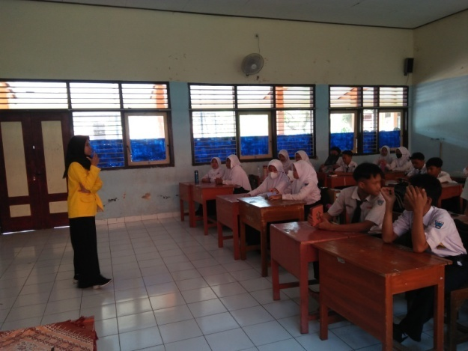 | 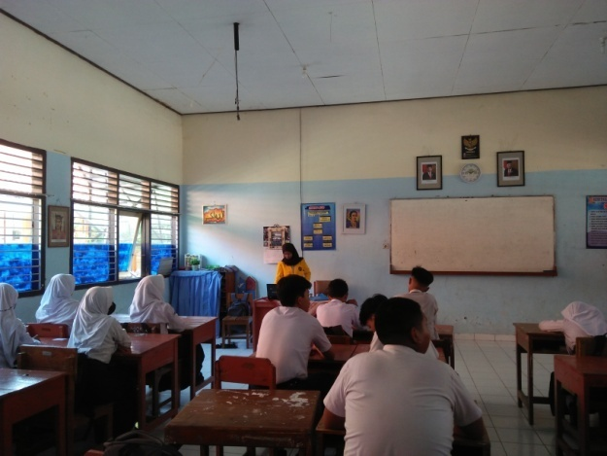
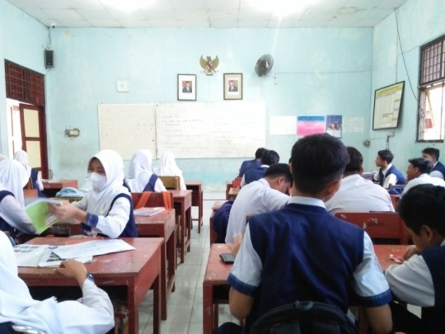 | 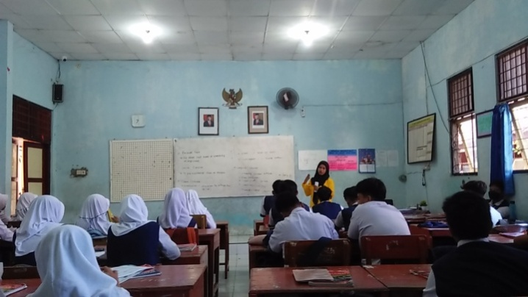
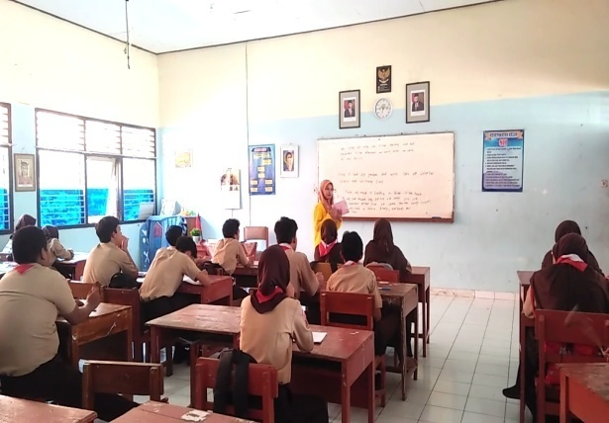 | 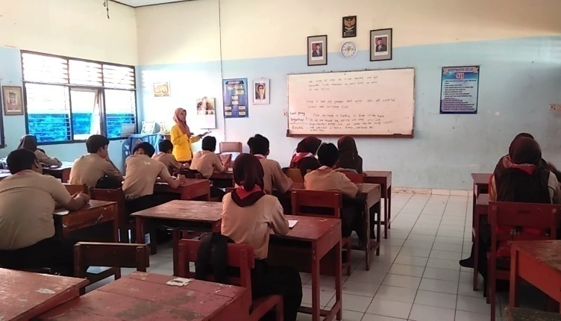

Appedix 4. Students Pre-Test Score Result (Experimental Group)
No. | Name | Score
1 | Adhiyaka Afdalas Ramadhan | 55
2 | Aqila Maitsa Kuputri | 80
3 | Arya Felis | 60
4 | Atalie Shalom Evani Sugiarto | 70
5 | Azzahra Dinda Maharani | 80
6 | Faza Akhsani | 70
7 | Hafidh Aufa Mahfudh | 65
8 | Irviana Putri Stevany | 55
9 | Jannu Radytian Ibrahim | 60
10 | Martiana Nur Afiati | 75
11 | Mochamad Fachry Maulana | 65
12 | Moh Tegar Abdillah Akbar | 65
13 | M. Naadhir Shidqi | 60
14 | M. Sultan Al Muqafi | 60
15 | Naadiyah Jihaan Syafii’ah | 75
16 | Naura Kamalasari | 70
17 | Nayla Shofa Mahendi | 70
18 | Nur Aeni | 75
19 | Putri Syabila Ardani | 70
20 | Qonita Nazwa Fenina | 75
21 | Rafi Syahputra | 60
22 | Raihan Rahul Widiyanto | 65
23 | Riyadi Eka Pratama Putra | 70
24 | Rizky Septian Ramadhan | 70
25 | Rosa Surtinawidi | 80
26 | Sabita Haunna Revita | 65
27 | Salwa Aulia Aryani | 80
28 | Sinta Dian Tantri Wardhani | 75
29 | Tania Ratu Balqiz | 70
30 | Vendy Adyatama Pramata | 70
31 | Yusnia Nasya Zaliya | 75
32 | Zidane Al Rasyid | 65

Appedix 5. Students Post-Test Score Result (Experimental Group)
No. | Name | Score
1 | Adhiyaka Afdalas Ramadhan | 75
2 | Aqila Maitsa Kuputri | 80
3 | Arya Felis | 75
4 | Atalie Shalom Evani Sugiarto | 70
5 | Azzahra Dinda Maharani | 90
6 | Faza Akhsani | 75
7 | Hafidh Aufa Mahfudh | 80
8 | Irviana Putri Stevany | 65
9 | Jannu Radytian Ibrahim | 80
10 | Martiana Nur Afiati | 75
11 | Mochamad Fachry Maulana | 75
12 | Moh Tegar Abdillah Akbar | 65
13 | M. Naadhir Shidqi | 65
14 | M. Sultan Al Muqafi | 80
15 | Naadiyah Jihaan Syafii’ah | 75
16 | Naura Kamalasari | 80
17 | Nayla Shofa Mahendi | 75
18 | Nur Aeni | 85
19 | Putri Syabila Ardani | 80
20 | Qonita Nazwa Fenina | 90
21 | Rafi Syahputra | 80
22 | Raihan Rahul Widiyanto | 85
23 | Riyadi Eka Pratama Putra | 70
24 | Rizky Septian Ramadhan | 70
25 | Rosa Surtinawidi | 90
26 | Sabita Haunna Revita | 70
27 | Salwa Aulia Aryani | 90
28 | Sinta Dian Tantri Wardhani | 85
29 | Tania Ratu Balqiz | 85
30 | Vendy Adyatama Pramata | 85
31 | Yusnia Nasya Zaliya | 85
32 | Zidane Al Rasyid | 85

Appedix 6. Students Pre-Test Score Result (Control Group)
No. | Name | Score
1 | Aditya Dwi Saputra | 65
2 | Aaisyah Citra Gemilang | 55
3 | Aisy Dwizahra Saputri | 70
4 | Anindita Nur Syafira | 70
5 | Aurel Putri Dewanty | 70
6 | Bayu Aji Maulana | 70
7 | Bimo Waskito Wijaya | 65
8 | Damar Daniswara | 60
9 | Danin Zada Falisha | 70
10 | Evanditya Rizki Pratama | 65
11 | Faris Fadhil Nugroho | 65
12 | Hafi Fajar Adzzaki | 75
13 | Haitsya Adde Musiazky | 60
14 | Hanindita Nadia Putri | 65
15 | Harish Rizqu Sahl | 75
16 | Hilmi Aditya Sugiarto | 80
17 | Ibnu Sabil | 75
18 | Imam Santoso | 80
19 | Khoirunnisa Tri Rahansiwi | 70
20 | M. Azhar Fido Prastyo | 75
21 | M. Rafinha Ramadhoni | 65
22 | M. Tukhfatul Atfal | 65
23 | Nabila Fairish Putri | 75
24 | Nabila Rizky Amanda | 70
25 | Putria Kanaya Rahmaningrum | 75
26 | Rahmadiaz Nuzulu Bahagya Susilo | 80
27 | Salsabila Nadhifah Putri | 80
28 | Triandani Zulviana Wati | 70
29 | Verine Maghfirotul Fauziyah | 70
30 | Wilda Haura | 75
31 | Wildan Nopianto | 65
32 | Zahra Khaerussyifa | 70

Appedix 7. Students Post-Test Score Result (Control Group)
No. | Name | Score
1 | Aditya Dwi Saputra | 75
2 | Aaisyah Citra Gemilang | 65
3 | Aisy Dwizahra Saputri | 80
4 | Anindita Nur Syafira | 70
5 | Aurel Putri Dewanty | 70
6 | Bayu Aji Maulana | 85
7 | Bimo Waskito Wijaya | 65
8 | Damar Daniswara | 65
9 | Danin Zada Falisha | 80
10 | Evanditya Rizki Pratama | 75
11 | Faris Fadhil Nugroho | 70
12 | Hafi Fajar Adzzaki | 85
13 | Haitsya Adde Musiazky | 70
14 | Hanindita Nadia Putri | 70
15 | Harish Rizqu Sahl | 65
16 | Hilmi Aditya Sugiarto | 75
17 | Ibnu Sabil | 85
18 | Imam Santoso | 75
19 | Khoirunnisa Tri Rahansiwi | 75
20 | M. Azhar Fido Prastyo | 90
21 | M. Rafinha Ramadhoni | 65
22 | M. Tukhfatul Atfal | 65
23 | Nabila Fairish Putri | 75
24 | Nabila Rizky Amanda | 75
25 | Putria Kanaya Rahmaningrum | 80
26 | Rahmadiaz Nuzulu Bahagya Susilo | 80
27 | Salsabila Nadhifah Putri | 80
28 | Triandani Zulviana Wati | 70
29 | Verine Maghfirotul Fauziyah | 75
30 | Wilda Haura | 80
31 | Wildan Nopianto | 65
32 | Zahra Khaerussyifa | 75

Appedix 8. Certificate of Research Completion
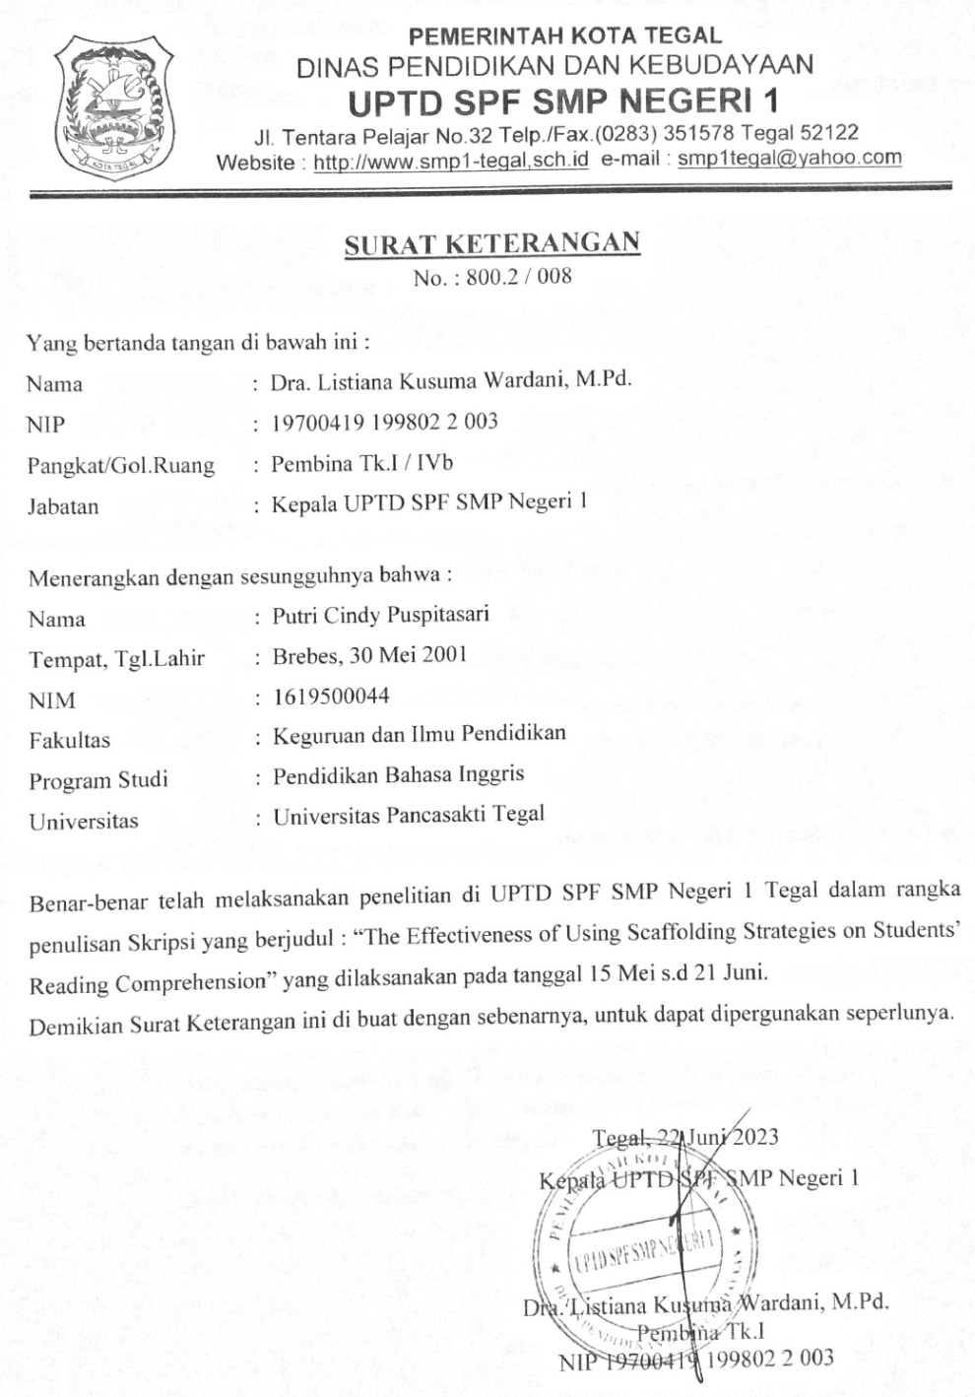

Appedix 9. Validity Test Result (Reading Comprehension Test Instrument)
No. Soal | Pearson Correlation | Nilai Sig. | Kesimpulan | Interpretasi
Soal_1 | 0,452 | 0,009 | VALID | Cukup
Soal_2 | 0,401 | 0,023 | VALID | Cukup
Soal_3 | 0,433 | 0,013 | VALID | Cukup
Soal_4 | 0,675 | 0,000 | VALID | Tinggi
Soal_5 | 0,496 | 0,004 | VALID | Cukup
Soal_6 | 0,641 | 0,000 | VALID | Cukup
Soal_7 | 0,087 | 0,637 | TIDAK VALID | -
Soal_8 | 0,666 | 0,000 | VALID | Tinggi
Soal_9 | 0,160 | 0,383 | TIDAK VALID | -
Soal_10 | 0,547 | 0,001 | VALID | Cukup
Soal_11 | -0,467 | 0,007 | TIDAK VALID | -
Soal_12 | -0,109 | 0,553 | TIDAK VALID | -
Soal_13 | 0,749 | 0,000 | VALID | Tinggi
Soal_14 | -0,008 | 0,967 | TIDAK VALID | -
Soal_15 | 0,457 | 0,009 | VALID | Cukup
Soal_16 | -0,060 | 0,743 | TIDAK VALID | -
Soal_17 | 0,652 | 0,000 | VALID | Tinggi
Soal_18 | 0,155 | 0,397 | TIDAK VALID | -
Soal_19 | 0,609 | 0,000 | VALID | Tinggi
Soal_20 | -0,452 | 0,009 | TIDAK VALID | -
Soal_21 | 0,250 | 0,168 | TIDAK VALID | -
Soal_22 | 0,649 | 0,000 | VALID | Tinggi
Soal_23 | 0,004 | 0,983 | TIDAK VALID | -
Soal_24 | 0,547 | 0,001 | VALID | Cukup
Soal_25 | 0,652 | 0,000 | VALID | Tinggi
Soal_26 | 0,531 | 0,002 | VALID | Cukup
Soal_27 | 0,625 | 0,000 | VALID | Tinggi
Soal_28 | 0,420 | 0,017 | VALID | Cukup
Soal_29 | 0,433 | 0,013 | VALID | Cukup
Soal_30 | 0,615 | 0,000 | VALID | Tinggi

Appedix 10. Reliability Test Result (Reading Comprehension Test Instrument)

Reliability Statistics
Cronbach’s Alpha | N of Items
.898 | 20

Item-Total Statistics
 | Scale Mean if Item Deleted | Scale Variance if Item Deleted | Corrected Item-Total Correlation | Cronbach’s Alpha if Item Deleted
Soal_1 | 14.56 | 21.867 | .452 | .896
Soal_2 | 14.53 | 22.386 | .329 | .898
Soal_3 | 14.72 | 21.176 | .418 | .896
Soal_4 | 14.75 | 20.129 | .670 | .889
Soal_5 | 14.81 | 20.931 | .421 | .897
Soal_6 | 14.78 | 20.434 | .563 | .892
Soal_8 | 14.69 | 20.222 | .726 | .888
Soal_9 | 14.72 | 22.338 | .114 | .905
Soal_13 | 14.75 | 19.742 | .776 | .886
Soal_15 | 15.03 | 20.805 | .412 | .898
Soal_17 | 14.72 | 20.338 | .648 | .890
Soal_19 | 14.75 | 20.581 | .550 | .893
Soal_22 | 14.66 | 20.620 | .660 | .890
Soal_24 | 14.63 | 21.016 | .597 | .892
Soal_25 | 14.72 | 20.273 | .666 | .889
Soal_26 | 14.69 | 20.996 | .499 | .894
Soal_27 | 14.78 | 20.305 | .596 | .891
Soal_28 | 14.88 | 20.758 | .439 | .897
Soal_29 | 14.72 | 20.918 | .488 | .894
Soal_30 | 14.63 | 20.952 | .619 | .892

Appedix 11. Checklist Observervation
OBSERVATION SHEET OF THE IMPLEMENTATION LEARNING FOR EXPERIMENTAL CLASS
Researcher : Putri Cindy Puspitasari
School : SMP N 01 Kota Tegal
Class : VIII H
INSTRUCTIONS!
Put a check mark (√) on the Yes/No coloum of the observed aspects according to the results of observations during learning process!
No. | Observed | Yes | No
1. | Provides opportunities to practice with teacher support and guidance
2. | Matches level of materials to student’s instructional need
3. | Incorporates manipulatives, graphic organizers, an/or hands-on activities
4. | Checks understanding with prompts
5. | Clarifies misconception/reteaches in necessary
6. | Use positive motivating feedback
7. | Provides multiple opportunities for teachers supported and independent practice to prmote automaticity
8. | Makes connection across the material
9. | Frequently monitors students working independently to minimize opportunities for practicing incorrectly

Appedix 12. Checklist Observervation Result
No. | Observed | Yes | No
1. | Provides opportunities to practice with teacher support and guidance | √
2. | Matches level of materials to student’s instructional need | √
3. | Incorporates manipulatives, graphic organizers, an/or hands-on activities | √
4. | Checks understanding with prompts | √
5. | Clarifies misconception/reteaches in necessary | √
6. | Use positive motivating feedback | √
7. | Provides multiple opportunities for teachers supported and independent practice to prmote automaticity | √
8. | Makes connection across the material | √
9. | Frequently monitors students working independently to minimize opportunities for practicing incorrectly | √

Tegal, 20 Juni 2023
The observer,

Syifa

